Mathematics – Stage 1 – Unit 22
Contents
Unit description and duration 5
Student prior learning 5
Lesson overview and resources 6
Lesson 1: Exploring attributes and properties of shapes 13
Daily number sense: Which one does not belong? – 15 minutes 13
Let’s make a shape train together to think about attributes and properties – 10 minutes 17
Shape train challenge! – 30 minutes 18
Problematise the challenge! – 15 minutes 19
Consolidation and meaningful practice: Discuss and connect the mathematics – 5 minutes 21
Lesson 2: What are patterns and how do we describe them? 22
Daily number sense: What can you see? – 10 minutes 23
Patterns repeat over and over and over again – 15 minutes 23
Different kinds of repeating patterns – 20 minutes 25
Shape patterns: What is the missing part? –15 minutes 27
Consolidation and meaningful practice: Discuss and connect the mathematics – 15 minutes 28
Lesson 3: Patterns are all around us 30
Daily number sense: Which one does not belong in this counting pattern? – 10 minutes 30
Patterns found in nature and built patterns – 50 minutes 31
Consolidation and meaningful practice: Discuss and connect the mathematics – 5 minutes 35
Lesson 4: Symmetrical patterns – Mandalas 36
Daily number sense: Counting patterns – 5 minutes 36
Warm-up: Let’s look at symmetry! – 10 minutes 37
Making mandalas 1 – 20 minutes 37
Making mandalas 2 – 30 minutes 38
Consolidation and meaningful practice: Guess what? – 5 minutes 40
Lesson 5: Growing and shrinking – 2D geometric patterns 41
Daily number sense: Squares to stairs – 20 minutes 41
How does it grow or shrink? – 45 minutes 44
Consolidation and meaningful practice: Discuss and connect the mathematics – 5 minutes 46
Lesson 6: Growing and shrinking number patterns 48
Daily number sense: What number comes next? Choral counting by twos – 15 minutes 49
Consolidation and meaningful practice: Discuss and connect the mathematics – 5 minutes 50
Input–output robot – 30 minutes 50
Consolidation and meaningful practice: Discuss and connect the mathematics – 20 minutes 52
Lesson 7: Place value in number patterns 55
Daily number sense: Missing numbers – 10 minutes 55
Window mysteries – 40 minutes 57
Consolidation and meaningful practice: Discuss and connect the mathematics – 10 minutes 58
Lesson 8: Let’s investigate patterns 60
Daily number sense: Dice collection – 15 minutes 60
Let’s frame it! – 50 minutes 61
Consolidation and meaningful practice: Discuss and connect the mathematics – 5 minutes 66
Resource 1: 2D paper shapes 67
Resource 2: Squares to stairs 68
Resource 3: Hundreds chart 69
Resource 4: Rectangular and hexagonal frames 70
Syllabus outcomes and content 71
References 76

Unit description and duration
This two-week unit develops student knowledge, understanding and skills of two-dimensional shapes and their attributes and properties. Students will also explore patterning in nature and number. Students are provided opportunities to:
- sort collections using attributes and properties
- recognise, name and explore properties of two-dimensional shapes
- investigate repeating shape patterns that grow, shrink, radiate and are symmetrical
- investigate repeating number patterns that grow and shrink.
Mathematics K–10 Syllabus © 2022 NSW Education Standards Authority (NESA) for and on behalf of the Crown in right of the State of New South Wales.

Student prior learning
Before engaging in these teaching and learning activities, students would benefit from prior experience with:
- recognising, describing and naming two-dimensional shapes
- identifying repeating patterns and how they repeat over and over and over again
- counting to at least 100 and skip counting by twos, fives and tens.

Lesson overview and resources
The table below outlines the sequence and approximate timing of lessons; syllabus focus areas and content groups; and resources.
Lesson | Syllabus focus area and content groups | Resources
Lesson 1: Exploring attributes and properties of shapes  75 minutes  Attributes and properties can be used to describe similarities and differences between shapes. | Representing whole numbers A  - Use counting sequences of ones with two-digit numbers and beyond  Two-dimensional spatial structure A  - Recognise and classify shapes using obvious features  Two-dimensional spatial structure B  - Represent, combine and separate two-dimensional shapes | - Video: Play School's Marvellous Maths – Sort and classify with Eddie (4:48)  - resolve 1a Class set of attribute blocks [PDF 55KB]  - reSolve 1b Student sets of attribute blocks [PDF 39KB]  - reSolve 2b Student Set of Three-Attributes Blocks [PDF 78.42KB]  - reSolve 2c Train Challenge Reflection [PPT 182KB]  - Class set of 2D geometric shapes  - Student sets of two-dimensional (2D) geometric shapes  - Writing materials
Lesson 2: What are patterns and how do we describe them?  75 minutes  Patterns have a core that repeats over and over and over again and can be represented using letters or symbols. | Two-dimensional spatial structure A  - Recognise and classify shapes using obvious features  Two-dimensional spatial structure B  - Represent, combine and separate two-dimensional shapes | - Anchor chart paper  - Mini whiteboards and markers  - Variety of objects such as 2D geometric shapes, counters, interlocking cubes, craft sticks, beads, blocks  - Writing materials
Lesson 3: Patterns are all around us  65 minutes  Mathematical patterns exist in natural and built environments. | Two-dimensional spatial structure A  - Recognise and classify shapes using obvious features  Two-dimensional spatial structure B  - Represent, combine and separate two-dimensional shapes | - 2D geometric shapes  - Anchor chart paper  - Camera or iPad  - Images and/or real-life objects  - Mini whiteboards and markers  - Writing materials
Lesson 4: Symmetrical patterns – Mandalas  70 minutes  Repeated geometric shapes can be manipulated to represent patterns of symmetry and reflection. | Two-dimensional spatial structure A  - Recognise and classify shapes using obvious features  Two-dimensional spatial structure B  - Represent, combine and separate two-dimensional shapes  Data A  - Gathers and organises data, displays data in lists, tables and picture graphs | - Resource 1: 2D paper shapes  - Video: Making mandalas – Stage 1 (9:10)  - 2D geometric shapes  - Camera or iPad  - Paper shapes for folding  - Writing materials
Lesson 5: Growing and shrinking – 2D geometric patterns  70 minutes  Patterns grow and shrink as the repeated element is added or subtracted. | Combining and separating quantities A  - Use advanced count-by-one strategies to solve addition and subtraction problems  - Use flexible strategies to solve addition and subtraction problems  Combining and separating quantities B  - Represent and reason about additive relations  Two-dimensional spatial structure A  - Recognise and classify shapes using obvious features  Two-dimensional spatial structure B  - Represent, combine and separate two-dimensional shapes  Data A  - Gathers and organises data, displays data in lists, tables and picture graphs | - Resource 2: Squares to stairs  - Website: youcubed Squares to stairs  - 2D geometric shapes  - Interlocking cubes  - Mini whiteboards and markers  - Writing materials
Lesson 6: Growing and shrinking number patterns  70 minutes  A repeating core can grow or shrink a number pattern. | Representing whole numbers A  - Continue and create number patterns  - Represent the structure of groups of ten in whole numbers  Combining and separating quantities A  - Use advanced count-by-one strategies to solve addition and subtraction problems  - Use flexible strategies to solve addition and subtraction problems  Combining and separating quantities B  - Represent and reason about additive relations | - Website: Teacher Education by Design Choral Counting  - 2D geometric shapes and counters  - Mini whiteboards and markers  - Writing materials
Lesson 7: Place value in number patterns  60 minutes  Place value can be used to investigate number patterns. | Representing whole numbers A  - Continue and create number patterns  - Represent the structure of groups of ten in whole numbers  Representing whole numbers B  - Use counting sequences of ones and tens flexibly  Combining and separating quantities A  - Use flexible strategies to solve addition and subtraction problems  Combining and separating quantities B  - Represent and reason about additive relations  - Form multiples of ten when adding and subtracting two-digit numbers  Data A  - Gathers and organises data, displays data in lists, tables and picture graphs  Data B  - Represent and reason about additive relations | - Resource 3: Hundreds chart  - Mini whiteboards and markers  - Small hundreds charts – several per group  - Writing materials
Lesson 8: Let’s investigate patterns  70 minutes  Repeated and growing patterns can be used to solve problems. | Two-dimensional spatial structure A  - Recognise and classify shapes using obvious features  - Represent data with objects and drawings and describe the displays  Two-dimensional spatial structure B  - Represent, combine and separate two-dimensional shapes  Combining and separating quantities A  - Use flexible strategies to solve addition and subtraction problems  Combining and separating quantities B  - Represent and reason about additive relations  Data A  - Gathers and organises data, displays data in lists, tables and picture graphs  Data B  - Create displays of data and interpret them | - Resource 4: Rectangular and hexagonal frames  - 8 six-sided dice of one colour and 8 six-sided dice in a second colour  - Coloured counters  - Hundreds chart  - Mini whiteboards and markers  - Square pieces of paper  - Writing materials

Lesson 1: Exploring attributes and properties of shapes
Core concept: Attributes and properties can be used to describe similarities and differences between shapes.
The table below contains suggested learning intentions and success criteria. These are best co-constructed with students.
Learning intentions | Success criteria
Students are learning that:  - a collection of shapes can be sorted in more than one way, depending on which attributes and properties are selected  - shapes can change when one or more properties are altered  - there are different strategies to solve problems. | Students can:  - sort a collection using attributes  - build a shape train by changing one attribute or property at a time  - predict how a shape may change by identifying properties that can change  - use knowledge of attributes and properties to solve problems in a game.

Daily number sense: Which one does not belong? – 15 minutes
- Build student understanding of the properties of numbers by completing a ‘which one does not belong?’ activity.
- Display the quantities 3, 27, 32, 123 as numbers or with block towers or dots. Discuss with the class how each number may or may not belong in the group.
The table below outlines stimulus prompts to generate conversation about the topic, along with anticipated responses from students.
Prompts | Anticipated student responses
- Which number does not belong? Why?  - If you take out a number, can you see a pattern? | - 3 is the only one-digit number  - 27 is the only number with 7 ones  - 32 is the only even number  - 123 is the only 3-digit number  - If you take away 3, the other numbers all have a 2 in them.
- Show students Figure 1. Discuss how attributes and properties of shapes are alike and unalike. Remind students that in this context, colour is an attribute, but sides and vertices are properties because these attributes are essential to the structure of the shapes.
Attributes: An attribute is a quality, feature or characteristic of an object or shape. Anything that can be described has attributes. Some attributes are mathematical, and some are not.
Properties: Mathematical regularities are based on necessary attributes called properties. For example, having 3 angles and 3 sides are properties of a triangle because they are essential attributes.
- Provide independent thinking time and use ‘Talk moves’ for students to share their thinking.
Figure 1 – Which one does not belong?
The table below outlines stimulus prompts to generate conversation about the topic, along with anticipated responses from students.
Prompts | Anticipated student responses
- How can you describe the attributes of colour and height?  - How can you describe the properties of sides and vertices?  - How are some of these shapes the same? Why?  - Is there a shape that you think does not belong? Why? | - The triangle might be white or it might be clear.  - The square is red, the circle green and the rectangle is orange.  - The sides are straight and the vertices are corners.  - The square, triangle, and circle are the same because they are the same height.  - The circle is the only shape with less than 3 sides.  - The circle does not belong because it is the only shape without vertices.
This table details assessment opportunities and differentiation ideas.
Assessment opportunities | Too hard? | Too easy?
What to look for:  - Can students use attributes and properties to describe a shape? (MA1-2DS-01)  - Can students identify and describe items that do not belong in a collection? (MAO-WM-01, MA1-2DS-01)  What to collect:  - observations of students thinking during discussion (MA1-2DS-01) | Students need further support to understand the term ‘attribute’.  - Watch the video Play School's Marvellous Maths – Sort and classify with Eddie (4:48). Ask students what they notice and wonder.  - Gather everyday objects to discuss attributes. Use a collection of toys to classify using an attribute such as colour or purpose.  Students need further support to understand the meaning of vertices. Explain that mathematicians call corners vertices and support students to identify vertices around the classroom. For example, on books, tables, shelves. | Students can confidently sort and categorise shapes and explain their thinking.  - Prompt students to organise the shapes into new categories. Ask them how many shapes share attributes or properties with other shapes.  - Students compare the attributes and properties of 3 different shapes. Ask them to show how they organise and record the similarities and differences.

Let’s make a shape train together to think about attributes and properties – 10 minutes
This lesson has been adapted from Patterns: Attribute trains at reSolve: Maths by Inquiry (2020).
- Use a collection of 2D geometric shapes on cards, including triangles, squares, circles, and hexagons, and discuss with students how each shape has attributes of colour and properties of sides and vertices. These characteristics help show how shapes are similar or different.
- Select one shape to be the start of a shape train. A student selects a card to add to the shape train. The shape must have one attribute or property that is different and one that is the same. Students need to state whether they are changing an attribute or property. Continue the train, changing one attribute or property each time. See Figure 2.
Figure 2 – Example of a shape train
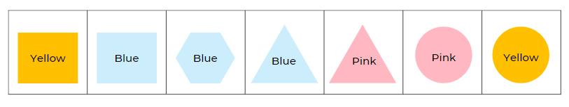
Image adapted from ‘Patterns: Attribute Trains’ by reSolve: Maths by Inquiry © Australian Government Department of Education, Skills and Employment 2022 and licensed under CC BY-NC-SA 4.0
This table details assessment opportunities and differentiation ideas.
Assessment opportunities | Too hard? | Too easy?
What to look for:  - Can students communicate reasoning about attributes and properties as they add shapes? (MAO-WM-01, MA1-2DS-01)  - Can students predict how a shape can change by identifying an attribute or property that can change? (MAO-WM-01, MA1-2DS-01)  - Can students use knowledge of attributes and properties to solve problems in a game? (MAO-WM-01) | Students need further support to understand the terms ‘attribute’ and ‘property’ as they apply to shapes:  - Use a set of 4 squares the same size, but in different colours to model how the attribute of colour changes.  - Use a circle, triangle, square and hexagon of the same colour to discuss the properties of sides and vertices.  - Play the shape train game with students and give them 2 choices to select from for the next card – one correct and one incorrect possibility. | Students can confidently sort and categorise shapes, explain their thinking and apply this to the shape game:  - Ask students if a shape train could be made from all 30 cards. Students investigate this problem in small groups and discuss findings through a gallery walk.  - Play shape trains changing 2 attributes and properties with each new card.  - Play the shape train with the cards in a circle. The connecting card at the end of the train must connect back to the first card.

Shape train challenge! – 30 minutes
- In pairs, students are given one complete set of 24 three-attributes/properties cards (download reSolve’s 2b Student Set of Three-Attributes Blocks [PDF 78.42KB]). Each player takes 5 cards and places the cards face up in front of them. Remaining cards are placed face down in a redraw pile. If necessary, highlight the attributes or properties of a few of the cards. The first card in the redraw pile is flipped over. This is the start of the train. Ask a student to state the 3 attributes or properties of the first card (choosing from sides, colour, vertices, size).
- Players take turns placing a card on the end to continue the train, building from left to right. The card they place in the train must change one attribute or property of the previous card but keep 2 attributes the same. Player states whether they are changing an attribute or a property. If a player cannot place an appropriate card, they must pick up a new card from the redraw pile and add it to theirs.
- Encourage students to identify cards that can’t be used next in the train and move them to one side, leaving suitable cards to select from. The winner is the first player to use all their cards. If there is no clear winner, whoever played the last card wins.
- As students are playing, differentiate the level of challenge. If students cannot predict and describe how a shape may appear when 2 attributes or properties have changed, model the discussion for placing the next card. If students identify and describe how shapes change when 2 attributes or properties have changed, promote strategic thinking. For example, which card might give the best chance of winning or make your partner skip a turn. Students could predict which card their partner might play next and prepare.

Problematise the challenge! – 15 minutes
- Ask students to think about the question from reSolve's 2c Train Challenge Reflection [PPT 182KB] resource. See Figure 3. Encourage students to name the selected shape, identify whether attributes or properties were used, then share their thinking.
Figure 3 –Train challenge reflection
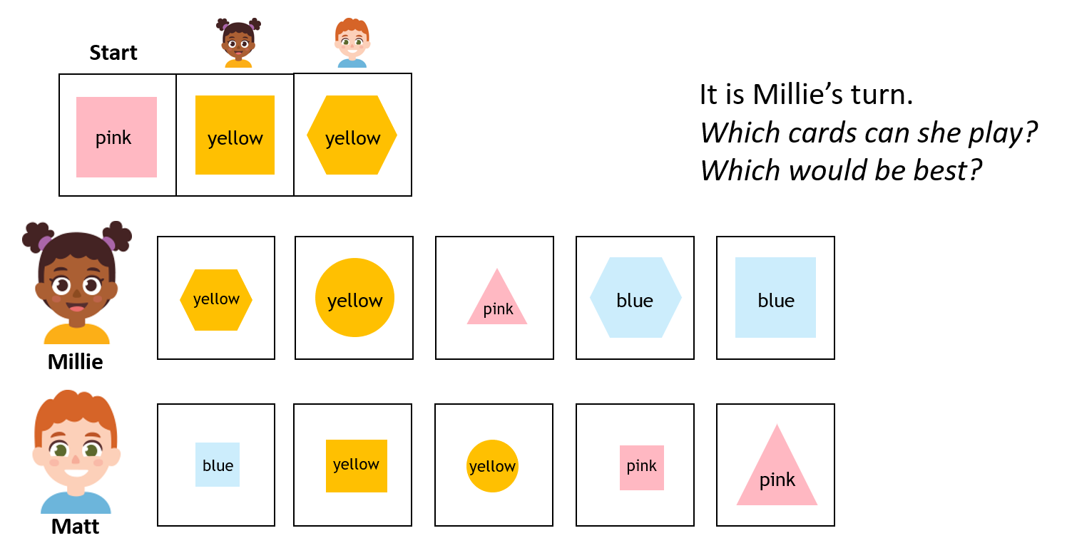
Image adapted from ‘Patterns: Attribute Trains’ by Australian Government Department of Education and licensed under CC BY-NC-SA 4.0.
- Select further questions from reSolve's 2c Train Challenge Reflection [PPT 182KB] to discuss mathematical thinking with students.
This table details assessment opportunities and differentiation ideas.
Assessment opportunities | Too hard? | Too easy?
What to look for:  - Can students use knowledge of attributes and properties to solve problems in a game? (MAO-WM-01)  What to collect:  - observations of student discussion around attributes and properties (MA1-2DS-01)  - student recordings of strategy group discussions (MAO-WM-01) | Students need further support to apply thinking about attributes or properties. Model thinking about a maximum of 2 attributes or properties such as the colour and number of sides. Use annotations to reinforce the difference between an attribute and a property. | Students can confidently sort and categorise shapes and explain their thinking:  - Students further develop strategies using questions from the resource reSolve's 2c Train Challenge Reflection [PPT 182KB].  - Students create own ‘problematise’ shape challenge strategies for another student to solve.  - Introduce polygons such as octagon, trapezium, and rhombus into the game.

Consolidation and meaningful practice: Discuss and connect the mathematics – 5 minutes
- Which attributes and properties did you think about when choosing the cards during the game?
- How did you organise your shapes when playing the game?

Lesson 2: What are patterns and how do we describe them?
Core concept: Patterns have a core that repeats over and over and over again and can be represented using letters or symbols.
The table below contains suggested learning intentions and success criteria. These are best co-constructed with students.
Learning intentions | Success criteria
Students are learning that:  - repeating patterns have a core that repeats over and over and over again  - the part that repeats is called the repeating core and can be represented as a two-part or three-part pattern  - repeating patterns can be represented using letters or symbols such as AB, ABC, ABB, or ABA  - the repeating core allows us to extend or identify missing elements in a pattern. | Students can:  - identify the core of a two-part or three-part repeating pattern  - create a repeating pattern using shapes  - use symbols or letters such as AB, ABC, ABB, or ABA to represent a repeating pattern  - identify a missing part in a pattern.

Daily number sense: What can you see? – 10 minutes
Note: It is important that when you are displaying any pattern to students that the core of the pattern is repeated at least 3 times to reinforce the idea that a pattern is something that must be repeated over and over and over again to trust that we have a regularity.
- Build student understanding of properties of 2D shapes by describing shape patterns.
- Discuss ideas learned from Lesson 1. For example, describing vertices or sides. Do not use the word ‘pattern’, and instead support students to recognise that each sequence is a pattern.
- Display 2D shape sequences as follows:
- square, octagon, square, octagon, square, octagon
- trapezium, trapezium, circle, trapezium, trapezium, circle, trapezium, trapezium, circle
- hexagon, isosceles triangle, hexagon, isosceles triangle, hexagon, isosceles triangle.
- Ask students to describe any patterns and encourage the vocabulary of properties and attributes.
- Display the hexagon, isosceles triangle pattern but with the isosceles triangles rotated in a different orientation each time (upwards, sideways, downwards). Ask students if this is the same pattern or if it has changed?

Patterns repeat over and over and over again – 15 minutes
- Display Figure 4, and support students to make comparisons by asking, ‘What is different? What is the same?’ Think-Pair-Share ideas.
Figure 4 – Four patterns
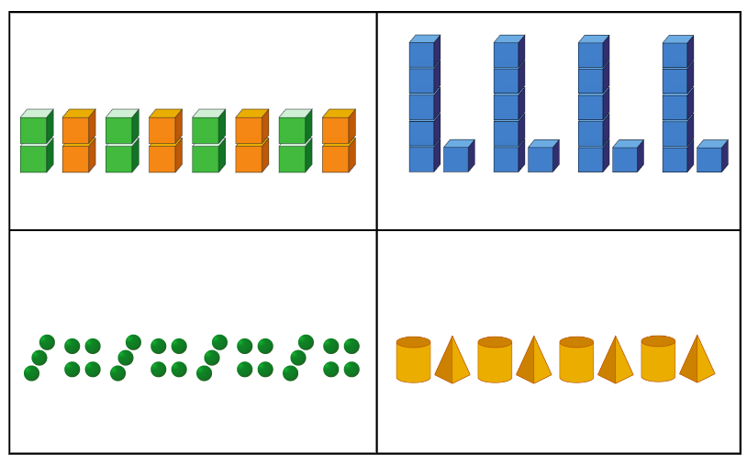
- Explain to the students that a pattern has a core that is repeated over and over and over again, and that mathematicians represent the repeating core of a pattern using letters or symbols. For example, the patterns in Figure 5 can be described as having an AB core with 2 parts. The first pattern has 2 parts that we can describe as A (green) and B (orange). The second pattern has an AB core that we describe as A (tall) and B (short).
Figure 5 – AB patterns
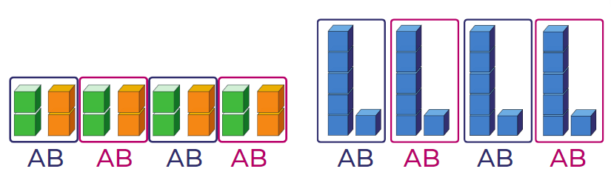
- Discuss how AB patterns can be represented in different ways. For example, clap, click or jump, hop. Students explore and share examples of AB patterns with body percussion, movement, or position.
- Explain that mathematicians use other symbols to communicate patterns. For example, *! *! *! is a pattern using symbols to record an AB pattern. Students create their own symbol AB patterns on mini whiteboards and share with peers.

Different kinds of repeating patterns – 20 minutes
- Discuss different kinds of repeating patterns such as AAB, ABC, ABA and explain how to identify the repeating three-part core of a pattern. Use shape tiles to create a three-part core pattern as in Figure 6.
Figure 6 – AAB pattern shown horizontally
- Ask how this pattern could be described using attributes, properties, names of shapes or letters. For example, 6 vertices, 6 vertices, 4 vertices and so on.
- Explain how to separate the core to clearly show the pattern as in Figure 7.
Figure 7 – Separated core of an AAB pattern
- Explain that the pattern can be seen clearly when the core is arranged vertically, as in Figure 8.
Figure 8 – AAB pattern aligned vertically
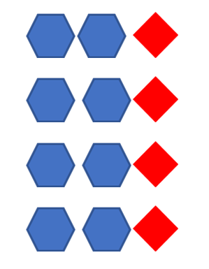
- Use familiar objects and movements to represent an AAB pattern structure. Together consider other AAB patterns. For example, triangle, triangle, square; bag, bag, lunchbox; clap, clap, stomp; 10, 7, 7.
- Co-create patterns that have other core structures (ABA, ABC, ABB). Use manipulation and vertical alignment to identify the repeating core. Create and label visual representations of these patterns.

Shape patterns: What is the missing part? –15 minutes
- Students use 3 kinds of shapes to create a linear three-part pattern. They justify that it is a pattern to a partner by discussing attributes of size and colour and properties of sides and vertices.
- Instruct a student from each pair to cover one part of the pattern. The other student must identify the missing part and prove that the part fits with the rest of the pattern. Vertically align the pattern to check that the core repeats over and over and over again. Ask students to extend the pattern.
- Make a pattern, then rotate the shapes. Discuss whether the pattern is still the same or if it has changed and why.
This table details assessment opportunities and differentiation ideas.
Assessment opportunities | Too hard? | Too easy?
What to look for:  - Can the students describe the core of a two-part or three-part repeating pattern? (MAO-WM-01, MA1-2DS-01)  - Can the students describe a pattern using letters or symbols such as AB, ABC, ABB? (MA1-2DS-01)  - Can the students create and record repeating patterns using shapes? (MAO-WM-01, MA1-2DS-01)  - Can the students identify a missing part of a pattern? (MAO-WM-01, MA1-2DS-01)  What to collect:  - annotated work samples or photographs of student created patterns (MA1-2DS-01)  - observations and recordings of group discussions (MAO-WM-01, MA1-2DS-01) | Students understand the concept of the core but find it hard to use letters or have difficulty forming letters. Students use drawings to represent patterns. Provide paper copies of letters A B C for students to place beside their drawings.  Students cannot find the missing part of a shape pattern. Use coloured blocks in simple two-part AB patterns to begin with and then model three-part patterns with the students. | Students can easily identify and create two-part and three-part patterns and missing elements.  - Students create four-part and five-part patterns with missing elements.  - Students use complex shape patterns, for example, the different types of triangles to create patterns and missing elements.

Consolidation and meaningful practice: Discuss and connect the mathematics – 15 minutes
- Create a class anchor chart about patterns. See example in Figure 9. Support the students to co-construct this and prompt for the following:
- some patterns have a core that repeats over and over and over again
- the parts of a pattern core can be described using letters or symbols. For example, AB, ABB, ABC, *!, *!!, *!#.
Figure 9 – Example of an anchor chart
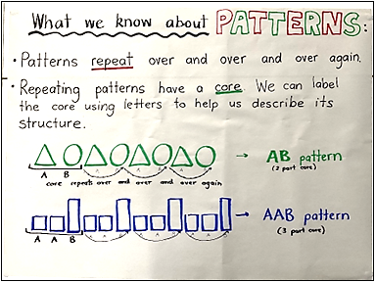

Lesson 3: Patterns are all around us
Core concept: Mathematical patterns exist in natural and built environments.
The table below contains suggested learning intentions and success criteria. These are best co-constructed with students.
Learning intentions | Success criteria
Students are learning that:  - natural and built environments can share similar mathematical properties and attributes  - patterns occur in different contexts, and can repeat, grow, shrink, and combine  - patterns can be orderly, irregular, precise or symmetrical. | Students can:  - identify and describe different kinds of repeated patterns in natural and built environments  - design and describe a repeating pattern.

Daily number sense: Which one does not belong in this counting pattern? – 10 minutes
- Build student understanding of properties of numbers by completing a ‘Which one does not belong?’ activity.
- Start at 17 and count on in odd numbers. Start at 26 and count on in even numbers.
- Show students the numbers 48, 44, 41 and 36. Discuss in a class group which number does not belong, and why?
The table below outlines stimulus prompts to generate conversation about the topic, along with anticipated responses from students.
Prompts | Anticipated student responses
What is one reason why a number doesn't belong? Why? | - 3 of the numbers are even numbers  - 3 numbers have 4 tens but 36 only has 3 tens  - If 41 was 40, you could jump by 4 to either side and it would be a repeating pattern.

Patterns found in nature and built patterns – 50 minutes
- Display images from nature as seen in Figure 10 or refer to objects from nature displayed on a desk. For example, succulents, flowers, pine cones, seashells and beehives.
- Ask students if they see similar shapes in the images from nature and geometric 2D shapes. Do they notice a repeated pattern? In pairs, students select an image or object. Using 'Talk moves', promote meaningful discussion of the following:
- Can you notice and name a 2D shape(s)?
- How is it (are they) being repeated?
- Is it in order or random?
- Can you predict what the next pattern sequence would include?
- What shape would be repeated next? How many more? What colour or size?
Figure 10 – Images from nature
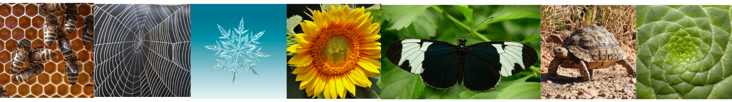
Images sourced from Pixabay and used in accordance with the Pixabay Licence.
- As a class, brainstorm a list of the ‘mathematics’ that appear in the images. For example, 2D shapes, comparing quantities, making groups, symmetry, comparing measurement, counting on, and comparing attributes and properties which are similar and different.
- Use an anchor chart to record suggestions that connect what students see in nature to their mathematical knowledge. For example, the spider web has vertical lines and horizontal lines that cross. The beehive has no gaps in between each hexagon, and the hexagons are all the same size. The tortoiseshell looks like different-sized trapeziums. Each part of the plant has 4 vertices.
- In pairs, students select 2 different images or 2 familiar natural objects. Explain to students they will identify patterns that are repeated and compare what is similar and/or different.
The table below outlines stimulus prompts to generate conversation about the topic, along with anticipated responses from students.
Prompts | Anticipated student responses
- Can you see any attributes (colour, shape) that are the same or different in the 2 patterns you selected?  - Do the patterns combine more than one attribute? For example, colour and shape.  - Is the pattern symmetrical?  - Do the patterns repeat but also increase and grow?  - Are the patterns simple or complex?  - Is the pattern growing or shrinking?  - Can the pattern be interrupted, stopped, or changed?  - Can it grow and go on for ever (infinite)? | - The beehive is made up of repeating hexagons and the spider web is made up of repeating trapeziums.  - The snowflake is symmetrical, but the plant is not.  - As the spider web grows, it has more parts, like the plant.  - The beehive pattern is simple, but the snowflake is complex because there are more shapes, and it grows bigger and moves in more directions.  - The butterfly pattern will not grow or shrink. The beehive can grow because the bees can continue to build it. The snowflake can be interrupted if it shrinks and melts.
- In pairs, students use coloured 2D geometric shapes to create a beehive with hexagons or a brick wall with rectangles to think about patterns in natural and built environments.
- Walk around the school and ask students to record their observations of mathematical features of patterns. Guide the walk past patterns such as alternating brick patterns, the pattern of the wire fence around the basketball court, and shrubs or flowers in a garden bed for students to draw or take photos of. In groups, students annotate drawings and/or take photographs and use them to explain properties and attributes observed to another group. Use the drawings and photographs in a gallery walk to make connections and comparisons.
This table details assessment opportunities and differentiation ideas.
Assessment opportunities | Too hard? | Too easy?
What to look for:  - Can students create and describe a pattern, for example core, radiating or symmetrical? (MAO-WM-01, MA1-2DS-01)  - Can students record similarities and differences in found patterns? (MAO-WM-01, MA1-2DS-01)  What to collect:  - annotated samples of student pattern investigations, for example, drawings, diagrams or photographs. (MAO-WM-01, MA1-2DS-01) | Patterns are too complex for students:  - Support student understanding by explaining the repetition in simple patterns with only 2 attributes or 2 properties, such as a spider web or a beehive.  - Allow students to explore real-life patterns such as a sunflower or a pinecone.  - Model the sounds in nursery rhymes or poems with very simple rhyme schemes.  - Provide opportunities for making two-part and three-part patterns with bead threading. | Students demonstrate understanding of all patterns provided:  - Students investigate fractal patterns through the problem posed in Smaller and Smaller, from NRICH.  - Students work in pairs to develop a creative pattern that grows in various directions, radiates or is symmetrical. Students identify the initial repeating core and use diagrams, drawings, or concrete materials to demonstrate how it repeats, grows, or shrinks.

Consolidation and meaningful practice: Discuss and connect the mathematics – 5 minutes
- Discuss the shapes that students noticed in built and natural environments. Ask if there is a particular 2D shape that is most seen and repeated in patterns. For example, are there more triangles than squares or more rectangles? What do you think the attributes or properties of that shape are? Why is it the most used and repeated in natural patterns?
- Sing nursery rhymes and songs and identify repeated patterns. For example, some rhymes have an ABABAB pattern; many songs use a repeated pattern of verse then chorus. Use body percussion to describe core patterns of rhymes or songs, for example, clap, stomp, clap, stomp. Students create their own repeated pattern using body percussion.

Lesson 4: Symmetrical patterns – Mandalas
Core concept: Repeated geometric shapes can be manipulated to represent patterns of symmetry and reflection.
The table below contains suggested learning intentions and success criteria. These are best co-constructed with students.
Learning intentions | Success criteria
Students are learning that:  - a shape can be identified from its properties, regardless of orientation  - in symmetrical patterns the left side is the same as, or a reflection of, the right side  - shapes can be made by joining (combining) and breaking apart (splitting) existing shapes. | Students can:  - use properties to name shapes  - identify shapes when they are shown in different orientations  - place shapes in an expanded pattern so the pattern continues to show symmetry  - identify shapes that can be split to form new shapes.

Daily number sense: Counting patterns – 5 minutes
- Build student understanding of patterns by skip counting forwards and backwards. Students start at 110 and count forwards by tens. Start at 110 and count backwards by tens.
- Start at 42 and count forwards by twos. Start at 42 and count backwards by twos.

Warm-up: Let’s look at symmetry! – 10 minutes
- As a class, use large sizes of paper equilateral triangles, squares, rectangles and hexagons to fold and explore how many lines of symmetry each shape has.
- Ask students if they can see a pattern between the number of sides of a shape and how many lines of symmetry it has.
- How many lines of symmetry are there in a circle? Fold paper circle and then discuss.

Making mandalas 1 – 20 minutes
- Display an example of a mandala (digital or real-life) and ask students what they notice. Discuss how mandalas can be created using everyday objects or mathematical shapes. Ask students to identify the patterns of symmetry and radiating patterns. See Making mandalas – Stage 1 (9:10) for further information.
- Provide concrete 2D shapes (including triangles, quadrilaterals, circles, pentagons, hexagons and octagons) and have small groups of students create mandalas, paying attention to rotation of shapes. Students use a device to record each expanding symmetrical stage of their mandala.
- Students identify the shapes and record the increase in number of shapes from stage to stage, in a table or with tally marks. See Figure 11.
Figure 11 – Recording number of shapes in an expanding mandala
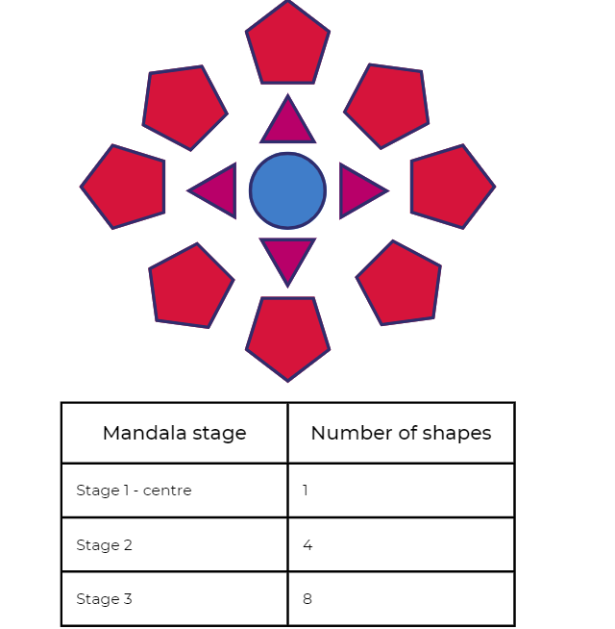

Making mandalas 2 – 30 minutes
- Provide students with a copy of Resource 1: 2D paper shapes and ask if any shapes can be split by cutting into new shapes. For example, a circle can become 2 semi-circles, a hexagon can become 6 triangles.
- Students cut and paste new shapes to create a symmetrical mandala. They choose a property to record at each stage, such as how many vertices or sides appear on the shape.
- Students record the data of the shape’s properties. For example, students record how many vertices or sides are on the shape.
- Students share their ideas, and these are added to or reinforced on the ‘Pattern anchor chart’ as introduced in Lesson 2.
This table details assessment opportunities and differentiation ideas.
Assessment opportunities | Too hard? | Too easy?
What to look for:  - Can students identify common 2D shapes in different orientations? (MAO-WM-01, MA1-2DS-01)  - Are students able to create a symmetrical mandala? (MAO-WM-01, MA1-2DS-01)  - Did students select shapes which could be split to make new shapes, for example, a square into 2 or 4 triangles? (MAO-WM-01, MA1-2DS-02)  What to collect:  - mandala designs demonstrating understanding of symmetry and splitting. (MA1-2DS-02) | Students do not fully understand the concept of symmetry. Provide a large paper circle folded along the diameter and ask students to paint a pattern on one side. Close the circle, then press to print. When re-opened, discuss how the pattern design shows the symmetry. | Students create a symmetrical mandala with ease:  - Pairs of students design half a mandala in a paper circle. Give to another pair to complete with symmetry.  - Design a mandala using a restricted number of shapes, for example, only squares and rectangles. This will require students to explore shape orientation in depth.  - Design a mandala which includes some combined shapes, for example, 2 trapeziums combined to form a hexagon.

Consolidation and meaningful practice: Guess what? – 5 minutes
- A selected student stands up and thinks of a 2D shape. Other students need to ask ‘yes’ and ‘no’ questions about attributes and properties of shapes to determine the selected secret shape. Repeat this with different students.

Lesson 5: Growing and shrinking – 2D geometric patterns
Core concept: Patterns grow and shrink as the repeated element is added or subtracted.
The table below contains suggested learning intentions and success criteria. These are best co-constructed with students.
Learning intentions | Success criteria
Students are learning that:  - growing patterns that grow have an element that gets bigger by the same amount each time  - patterns that shrink have an element that gets smaller by the same amount each time  - data can be collected to identify and continue a growing pattern. | Students can:  - communicate about the repeating core in a growing and/or shrinking pattern  - create patterns that show how the core is growing and/or shrinking  - choose a method to collect data that shows how a pattern grows.

Daily number sense: Squares to stairs – 20 minutes
- Build student understanding of patterns by using youcubed ‘Squares to stairs’ and Thinking mathematically ‘Staircase patterns’.
- Share Resource 2: Squares to stairs (see Figure 12) and explain to students that this is a repeating pattern but something else is happening too.
Figure 12 – Squares to stairs
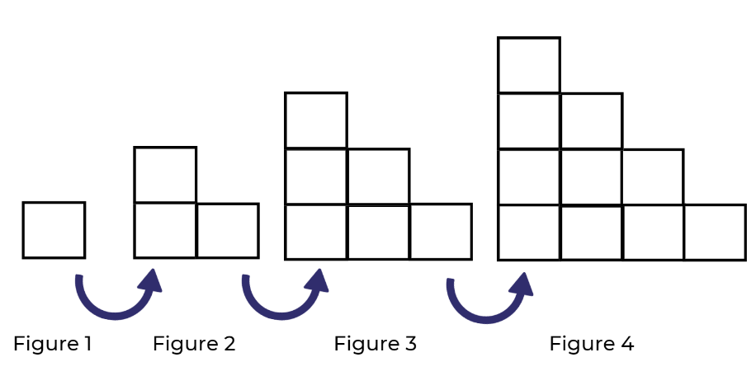
Prompts | Anticipated student responses
- How do we know this is a repeating pattern?  - What is the same? What changes?  - Is this a growing pattern? If yes, then how can you prove it?  - Can you tell me how many squares there would be in Figure 6? How do you know?  - Is there an efficient way to count and work out how many squares are used altogether in the 4 figures? | - The square in the bottom corner is always there and then more squares are added beside it and on top.  - The pattern is growing because it looks like stairs.  - The pattern is growing because each row has one extra square added from the previous pattern – so we added 2, then 3, then 4.  - The next pattern in the stair sequence (Figure 5) has 15 squares, then Figure 6 will have 15 plus 6 more which is 21 squares.  - 1 plus 2 more plus 3 more plus 4 more equals 10.
- Ask the students to share findings and record number patterns using a table and tally marks. See Figure 13. Students use ‘Talk moves’ to meaningfully discuss patterns in the table.
Figure 13 – A suggested idea for recording
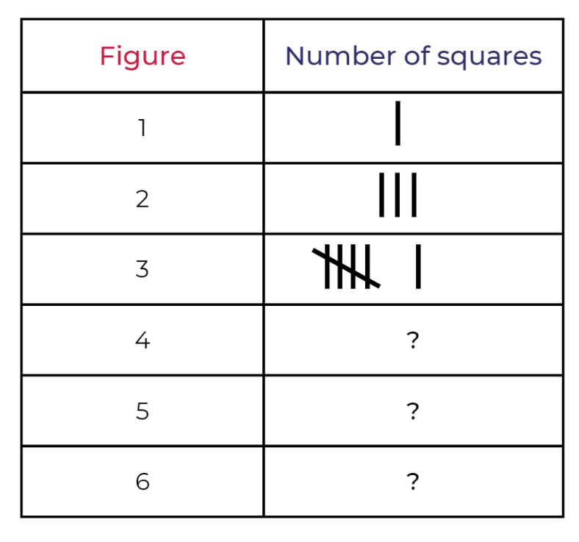
This table details assessment opportunities and differentiation ideas.
Assessment opportunities | Too hard? | Too easy?
What to look for:  - Can students communicate how the stair pattern is growing? (MAO-WM-01, MA1-2DS-01)  - Are students able to collect data to describe how a pattern grows? (MAO-WM-01, MA1-DATA-02)  What to collect:  - observations of discussions and problem-solving strategies applied to identify the growing pattern (MAO-WM-01, MA1-2DS-01)  - work samples of data collection. (MA1-DATA-02) | Students are not able to identify the growing pattern presented in Figure 12 – Squares to stairs:  - Watch the video Staircase Patterns 1 with students  - Use interlocking cubes and create an AB pattern, identifying the repeating core. Then add an extra part to create the three-part pattern ABB. Ask students to identify the change or the growing part of the pattern.  - In pairs, students use concrete examples to create the pattern ABBCCC and identify the core. Ask students to vertically align parts in a tower. For example, A then BB then CCC then DDDD of the pattern in different colours. Show how the pattern is growing one by one. | Students identified the pattern rule of a growing pattern and applied efficient strategies to problem solve. Ask students to imagine a staircase that has 33 levels. Record data in a table with tally marks and explain how the staircase pattern grows and shrinks.

How does it grow or shrink? – 45 minutes
- Display Figure 14, such as beehives, spider webs and snowflakes. Tell students that the next part of the journey in patterns is all about investigating growing and shrinking patterns using geometric shapes.
Figure 14 – Patterns in nature that grow and shrink
Images sourced from Pixabay and used in accordance with the Pixabay Licence.
- Ask students to identify the repeating core and explain how it is growing. Name the specific attributes that are growing. Students may also identify properties, such as the hexagons in the beehive. Ask students to think about:
- how a pattern grows when the pattern core repeats over and over and over again
- how a pattern shrinks when the pattern core parts are repeated less and less
- whether a growing or shrinking pattern needs only one part of the pattern to change
- what could happen for a spider web, snowflake and a beehive to grow and shrink? What core part or geometric shape(s) is repeated more and more or less and less?
- In pairs, students use 2D geometric shapes to create a repeating, growing or symmetrical pattern related to the patterns in nature that they identified. For example, the sun or a whirlpool (see Figure 15).
Figure 15 – Making patterns from nature
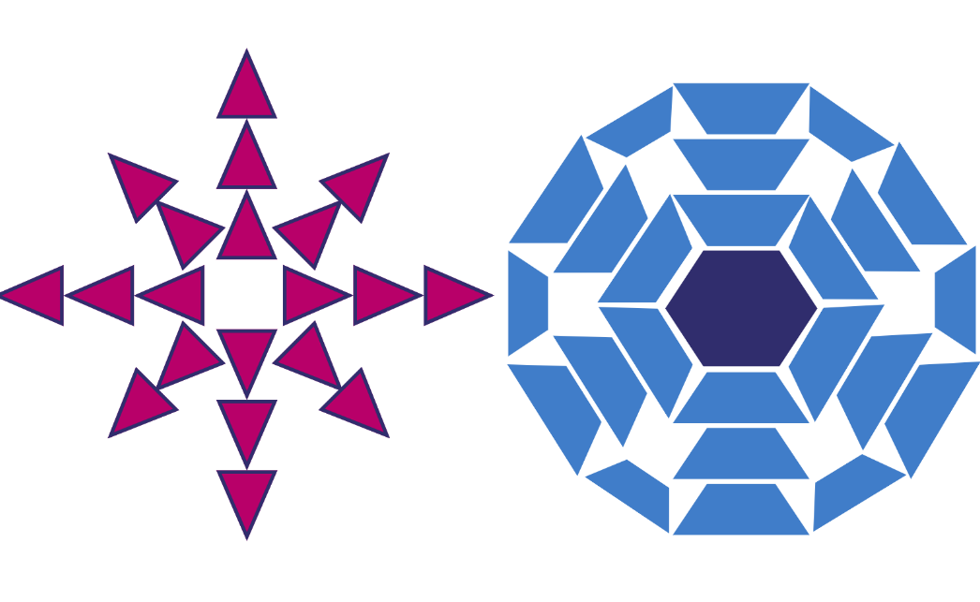

Consolidation and meaningful practice: Discuss and connect the mathematics – 5 minutes
- Ask students to consider and discuss their patterns using these questions:
- What attributes or properties did you use to make your pattern grow?
- How did your pattern grow from layer to layer? For example, by the number of vertices, sides, or shapes.
- What strategies did you use to work this out? For example, skip counting, partitioning.
- How did you record your findings?
- Add or clarify ideas on the ‘Pattern anchor chart’.
This table details assessment opportunities and differentiation ideas.
Assessment opportunities | Too hard? | Too easy?
What to look for:  - What attributes and properties of shapes are used to expand growing patterns? (MAO-WM-01, MA1-2DS-01)  - What strategies are students using to record their pattern? (MAO-WM-01, MA1-CSQ-01)  - How are students proving that their growing pattern is symmetrical? (MAO-WM-01, MA1-2DS-01)  What to collect:  - observations and recordings of vocabulary used by students (MA1-2DS-01, MA1-CSQ-01)  - photos, drawings or videos of growing patterns (MAO-WM-01, MA1-2DS-01, MA1-CSQ-01) | Students are finding it difficult to expand their growing shape pattern past the first 2 layers:  - Support students to identify which 2D shape or colour to use in each layer of the shape pattern.  - Provide students with shape patterns to replicate and then continue. | Students created complex, growing shape patterns that included more than 2 attributes and properties:  - Create a 2D shape pattern that needs to contain less than 20 shapes but more than 60 vertices.  - Create an odd, even, odd, even growing 2D shape pattern.

Lesson 6: Growing and shrinking number patterns
Core concept: A repeating core can grow or shrink a number pattern.
The table below contains suggested learning intentions and success criteria. These are best co-constructed with students.
Learning intentions | Success criteria
Students are learning that:  - growing patterns have an element that gets bigger by the same amount each time  - shrinking patterns have an element that gets smaller by the same amount each time  - flexible addition and subtraction strategies can be used to find and create growing and shrinking patterns  - number patterns can represent a constant difference between numbers in a sequence. | Students can:  - identify and use a repeating core to grow and shrink number patterns  - use addition and subtraction strategies to create growing and shrinking patterns  - identify halving and doubling patterns.

Daily number sense: What number comes next? Choral counting by twos – 15 minutes
Note: For further information on choral counting, refer to Choral Counting at Teacher Education by Design.
- Build student understanding of skip counting by choral counting, adapted from Teacher Education by Design.
- Students choral count, counting forwards by twos up to 50. As they count, use colour to record in horizontal rows with 5 numbers in each row. Ask students to look at the numbers and discuss any patterns they notice. Record student ideas. See Figure 16.
Figure 16 – Record of choral counting by twos
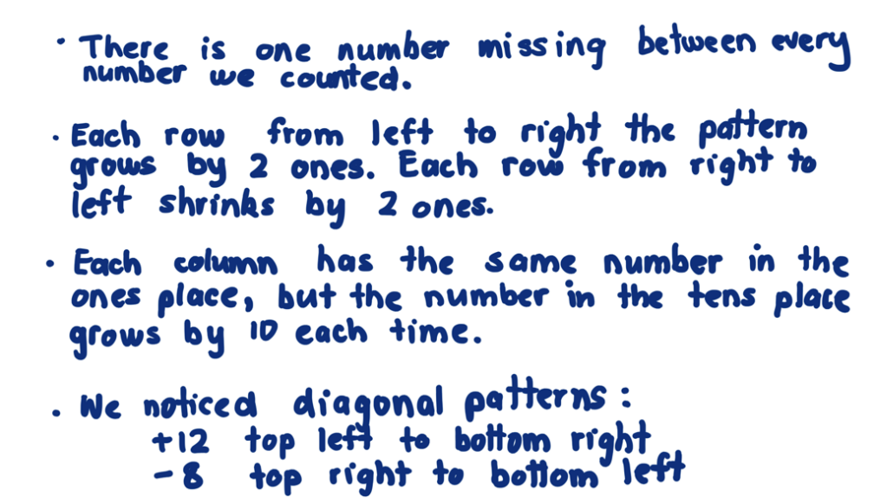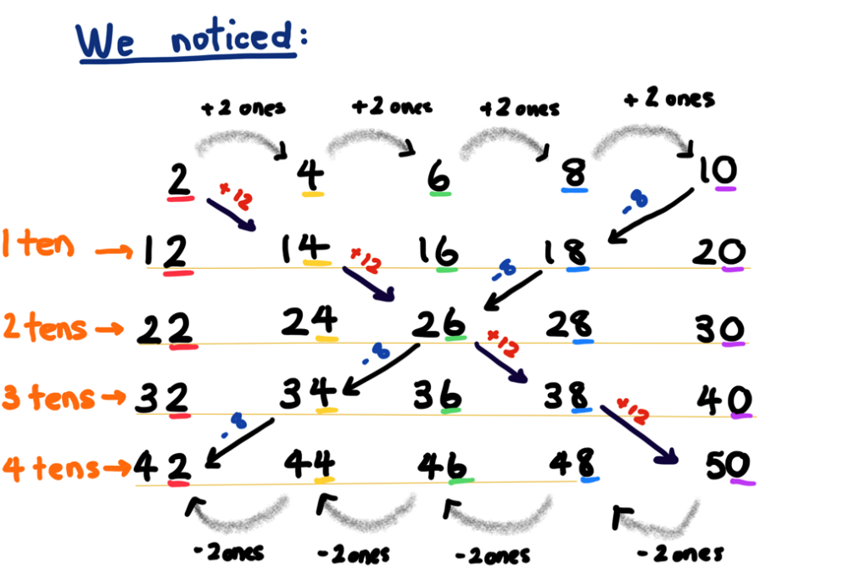
- An optional challenge is to combine choral counts to look for patterns, for example 2 and 4, or 2, 4 and 8.

Consolidation and meaningful practice: Discuss and connect the mathematics – 5 minutes
- Discuss the shapes that students noticed in built and natural environments. Ask if there is a particular 2D shape that is most seen and repeated in patterns. For example, are there more triangles than squares or more rectangles? What do you think the attributes or properties of that shape are? Why is it the most used and repeated in natural patterns?
- Sing nursery rhymes and songs and identify repeated patterns. For example, some rhymes have an ABABAB pattern; many songs use a repeated pattern of verse then chorus (AB). Use body percussion to describe core patterns within rhymes or songs, for example, clap, stomp, clap, stomp. Students create their own repeated patterns using body percussion.

Input–output robot – 30 minutes
- Remind students of growing and shrinking patterns with geometric shapes and ask if there might be growing and shrinking patterns in the number world. Have you seen any?
- Introduce the lesson narrative as follows: ‘I know a robot who loves eating numbers and finding number patterns from them! See Figure 17 For example, we input number 5 and the robot eats it and outputs 15, 25 and 35. What pattern did the robot find? Is this pattern growing or shrinking? How do you know? What other numbers could the robot output using this pattern?’
Figure 17 – Robot eats the number 5!
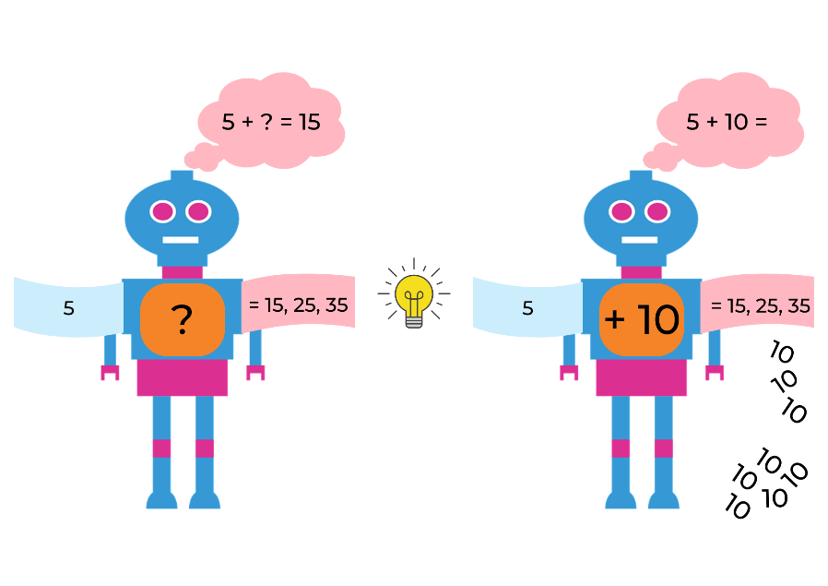
Image adapted from ‘Robots’ by alluregraphicdesign and used in accordance with the Pixabay Licence.
- Next, we input the number 4 and the robot outputs 8,12 and 16. What pattern did the robot find? How do you know? This is a growing pattern. Could the robot have found any other growing patterns? For example, double 4 is 8 and then double again to 16. How is the robot making these patterns?
- Ask students if the robot could have made any shrinking patterns. For example, 4 could have an output of take away 1 each time to get 3, 2, 1 or the robot could halve 4 each time to get 2, then 1.
- If you started with 7 and the robot added 4 each time, what would the 5th number be? What would the 10th number be and how do you know? Do you need to use blocks to find the answer, or can you think of another way? For example, writing out the number pattern.
- Ask students if the robot could have made any other patterns with the quantity 7 such as doubling or adding 10 each time.
- Ask students to offer ideas about how to record input-output numbers. For example, use counters or coloured blocks or sticky notes with numbers.
- In pairs, students choose a number to input and explore the output patterns the robot might make with it. Ask the students to consider these questions:
- Is there more than one pattern the robot could output from your number?
- Could the robot output create growing and shrinking patterns from your input number?
- What number knowledge did you use to find patterns? Addition, subtraction, halving, doubling, skip counting and so on.
- Can you find all the possible patterns the robot could make?
- How can you tell if you have found them all?
- Support students to work with input numbers and patterns that are appropriate for their mathematical ability. Students need to record patterns using numbers.

Consolidation and meaningful practice: Discuss and connect the mathematics – 20 minutes
- Students present input-output patterns and listen to comments and suggestions. Ask the following questions:
- What patterns did you find? What were the consistent differences?
- Did you find growing and shrinking patterns?
- What addition and subtraction strategies did you use to continue a pattern?
- Were there any strategies that didn’t work and why?
- Update the class ‘Pattern anchor chart’.
This table details assessment opportunities and differentiation ideas.
Assessment opportunities | Too hard? | Too easy?
What to look for:  - Can students communicate how they identify and continue growing and shrinking number patterns? (MAO-WM-01, MA1-CSQ-01)  - Are students using addition and subtraction strategies to create growing and shrinking patterns? (MAO-WM-01, MA1-CSQ-01)  - How well do students identify halving and doubling patterns? (MAO-WM-01, MA1-CSQ-01)  What to collect:  - samples of written, drawn or made patterns (MAO-WM-01, MA1-CSQ-01)  - observations and recordings of verbal addition and subtraction strategies used to continue patterns (MAO-WM-01, MA1-CSQ-01) | Students are unable to identify patterns with the number 4. Use input numbers that are easier for students to understand, for example, 2 and 5.  Students are unable to record the robot patterns with numbers. Support students to represent patterns with drawings, counters or 2D geometric shapes. | Students apply many strategies to explore input numbers and are no longer being challenged using their own ideas:  - Use numbers which form patterns with three-digit numbers.  - Explore a two-step output from the robot (for example, add 3, take away 1).  - Use multiplication and division strategies to create patterns with the robot.  - Remove a number from one of their patterns and ask another student to identify and find the missing element.

Lesson 7: Place value in number patterns
Core concept: Place value can be used to investigate number patterns.
The table below contains suggested learning intentions and success criteria. These are best co-constructed with students.
Learning intentions | Success criteria
Students are learning that:  - place value can be used to identify the number before and after a given three-digit number  - using place value of tens and ones is an effective strategy when solving addition problems  - there is a growing pattern every time we rename and regroup beyond a collection of 10 and 100, for example, 20 ones as 2 tens, 20 tens as 2 hundreds. | Students can:  - find the next number in a pattern with three-digit numbers  - use place value to add 2 side-by-side numbers in a hundreds chart  - identify how many more to the next multiple of 10 or 100 in two-digit and three-digit numbers.

Daily number sense: Missing numbers – 10 minutes
- Build student understanding of place value in three-digit numbers by working out a missing number in a sequence.
- Display and ask students what the missing numbers are?
- 135, 136, 137, ?
- 298, 299, 300, ?
- 398, 399, ?, 401
- 551, 550, 549, ?
- 102, 101, ?, 99
- 776, 777, ?, 779
- 412, 411, ?, 409
- Students use mini whiteboards to create a three-digit number sequence with a missing number and ask a partner to find the solution.
This table details assessment opportunities and differentiation ideas.
Assessment opportunities | Too hard? | Too easy?
What to look for:  Can students identify the number before and after a three-digit number? (MA1-RWN-02) | Students are not confident working with three-digit numbers:  - Count on from 100.  - In pairs, count on from one to 100 and, at some point, a partner interrupts the counting and suggests a new number to start from. | Students easily count forwards and backwards by ones. Start with a number and count forwards and backwards by twos, fives or 10 off the decade.

Window mysteries – 40 minutes
This lesson has been adapted from Boaler et al. (2022).
- Show students Figure 18. Explain that a pattern journey is all about finding special patterns within a hundreds chart.
Figure 18 – A window in a number chart
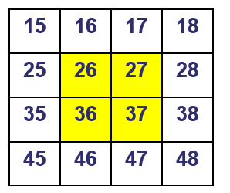
Image adapted from Window mystery by Boaler (2022).
- Explain that a window here is any 2 × 2 square or array in a number chart. Students make observations and then collaborate to find the sum of the numbers. Record different strategies used, for example:
- 26 + 27 + 36 + 37
- double 20 + double 30 + double 6 + double 7
- 26 + 27 = 53 and then 36 + 37 must be 20 more (73) and then add these numbers together
- using jumps to get to the next 10 to make the addition easier.
- Students work in small groups using Resource 3: Hundreds chart, to find a hundreds chart window with a sum of 158. What place value strategies are students using? Support students to think about how to use patterns of tens and ones as in the example above. Ask the students if they can find more than one window with that sum, or if there is only one answer and why.
- Students select a chosen sum and try to find it through a 2 × 2 window. If the number is not present through a 2 × 2 window, ask students to explain why not? Ask students to track and record numbers used to avoid repetition. Listen to student discussions for opportunities to help students use place value patterns. Encourage students to think about how they will apply strategies such as partitioning to larger numbers. Record ideas using numbers and diagrams.

Consolidation and meaningful practice: Discuss and connect the mathematics – 10 minutes
- Ask the students to consider and discuss the following questions:
- What was the best strategy you used when you were using addition with tens and ones patterns to find answers? Why?
- Is it possible to find a window for every possible sum between 1 and 100?
- If not, how many answers are there and how do you know this?
- What is the smallest sum possible? (Answer:1 + 2 + 11 + 12 = 26) Why? Discuss place value.
- What is the biggest sum possible? (Answer: 89 + 90 + 99 + 100 = 378) Why? Discuss place value.
This table details assessment opportunities and differentiation ideas.
Assessment opportunities | Too hard? | Too easy?
What to look for:  - Were students able to use place value to add 2 consecutive numbers? For example, are they counting by ones or partitioning using tens and ones? (MAO-WM-01, MA1-RWN-01, MA1-CSQ-01)  - Can students apply the strategy of moving to the next multiple of 10 or 100 when they are finding the total of a 2 × 2 window? (MAO-WM-01, MA1-CSQ-01, MA1-CSQ-02)  What to collect:  - observations and recordings of investigations into their own choice of window (MAO-WM-01, MA1-RWN-01, MA1-CSQ-01, MA1-CSQ-02) | Students have difficulty working with 4 two-digit numbers:  - Work with the smaller numbers in the hundreds chart.  - Support students to use a 2 × 1 window with smaller numbers from the hundreds chart. | Students have completed an investigation of a 2 × 2 window in depth:  - Explore a different size or shape window; for example, 2 × 3, 3 × 3.  - Students identify sums and patterns that emerge from new windows and compare to the possibilities from a 2 × 2 window.  - Students discuss reasons why patterns are different.

Lesson 8: Let’s investigate patterns
Core concept: Repeated and growing patterns can be used to solve problems.
The table below contains suggested learning intentions and success criteria. These are best co-constructed with students.
Learning intentions | Success criteria
Students are learning that:  - the core of repeating patterns can be used to solve real-world problems  - growing patterns have an element that increases by the same amount each time. | Students can:  - design and create a repeating pattern to solve a real-world problem  - collect data to organise thinking and explain how a pattern grows.

Daily number sense: Dice collection – 15 minutes
- Build student understanding of patterns and subitising using Dice collection from Thinking Mathematically Stage 1.
- Display a collection of 16 dotted dice in a square pattern. For example, see Figure 19.
Figure 19 – 16 dice
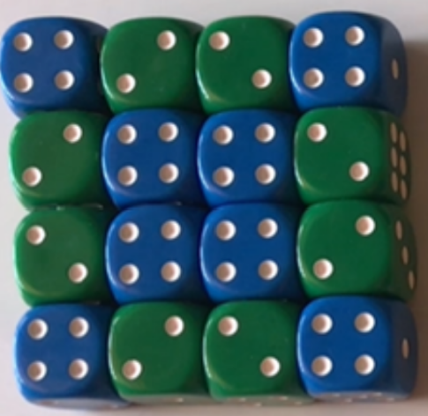
- Using mini whiteboards, students explain in words or drawings what they can see.
- As a whole class, discuss similarities and differences in students’ observations and reasoning. Ask the following questions:
- Can you see what the core of the pattern may be?
- What part of the pattern is repeating over again?
- Is there only one repeated pattern or can you see more patterns?
- Remove dice so an AAB pattern is shown. Describe the pattern using the letters A and B.
- Optional challenge: using the same dice, students create a new pattern.

Let’s frame it! – 50 minutes
- Tell students that the next investigation is about how we can use shape and number patterns together to solve a problem.
- In pairs, students use counters to create a five-column growing pattern that increases by 3 each time. Ask students to record their findings on a mini whiteboard so they can share their strategies with the class. As a class, use a hundreds chart to place a counter on the number pattern students noticed as they created their growing pattern (3, 6, 9, 12, 15). Ask students to predict how many counters there would be if they made a sixth column (18).
- Explain that Xiang, Matthew, Tyler and Rebecca are making picture frames to sell at the school fete. They have small purple, blue and green squares to create repeating patterns that make a border around the outside of each square frame. They have decided that the three-part pattern will be the same around each frame – ABC. They have worked out that the pattern will need to be a growing pattern because the frames get bigger in size. See Figure 20. Ask students how they will collect and record data about the pattern to show that it is growing as the frame gets bigger. Discuss how they can use this data to explain the rule and work out how many more squares they would need for the fourth frame and tenth frame in this pattern. Provide squared paper for investigating and recording ideas.
Note: 4 × 4, 6 × 6, and 8 × 8 photo sizes have been selected as they enable regular placement of coloured blocks for the frames, maintaining the pattern back to the starting position. Smaller photo sizes could be modelled as necessary.
Figure 20 – Patterned photo frame
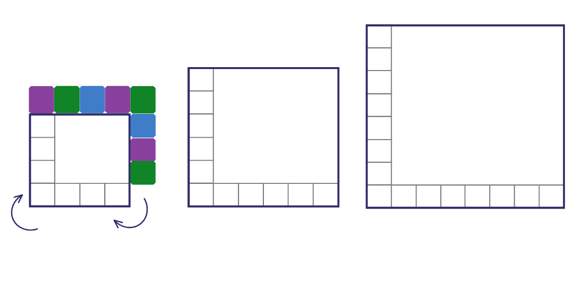
- Ask students what would happen if rectangular frames with small triangles are used to make the border. See Figure 21.
- Ask students what would happen if hexagonal frames with small squares are used to make the border. See Figure 21. Use Resource 4: Rectangular and hexagonal frames. Resize for photocopying as applicable.
Figure 21 – Different frames
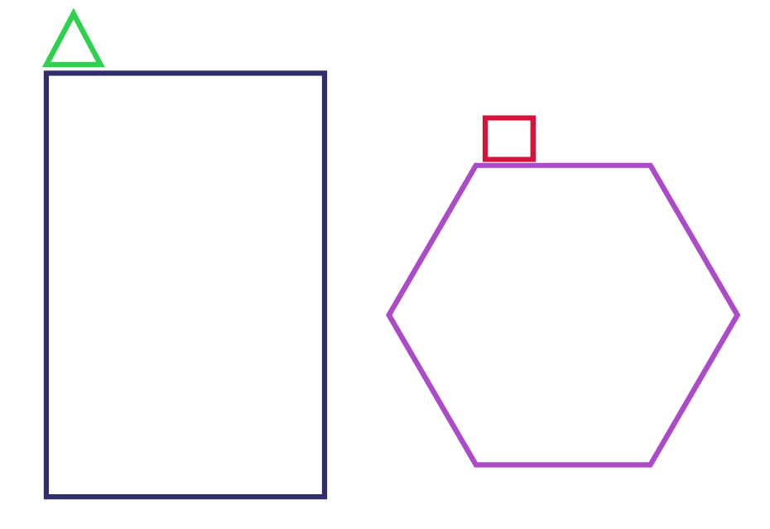
- Students document their thinking and results in a table outlining how many shapes, attributes, and properties. Students can also use diagrams or drawings to explain problem solving strategies.
- Ask students to consider and discuss:
- What patterns did you find?
- How did you record your ideas?
- Were there any problems and how did you solve them?
This table details assessment opportunities and differentiation ideas.
Assessment opportunities | Too hard? | Too easy?
What to look for:  - Are students able to determine how many squares are needed to create the borders? (MAO-WM-01, MA1-2DS-01)  - Can students apply skip counting strategies? (MAO-WM-01, MA1-CSQ-01)  - Could students use repeated addition strategies? (MAO-WM-01, MA1-CSQ-01)  - Can students collect data in a table and interpret results? (MA1-DATA-02)  What to collect:  - observations, photographs and diagrams demonstrating understanding of repeating and growing patterns (MAO-WM-01, MA1-CSQ-01 MA1-2DS-01)  - work samples of data collected during the investigation (MA1-DATA-01) | Students are not able to use repeated addition or efficient skip counting strategies:  - Support students to create a simple border pattern using only 1 or 2 colours.  - Provide students with a template of a square and geometric shapes allowing time for hands-on exploration. | Students can use repeated addition and efficient skip counting strategies to quickly find answers to the frame investigations:  - Students use 4 colours in their border.  - Students create a two-layered border.  - Select another geometric shape and create a border pattern combining 2 other geometric shapes.

Consolidation and meaningful practice: Discuss and connect the mathematics – 5 minutes
- As a class, add to and clarify the ‘Pattern anchor chart’ created in Lesson 2.

Resource 1: 2D paper shapes
Paper shapes for splitting and cutting into new shapes
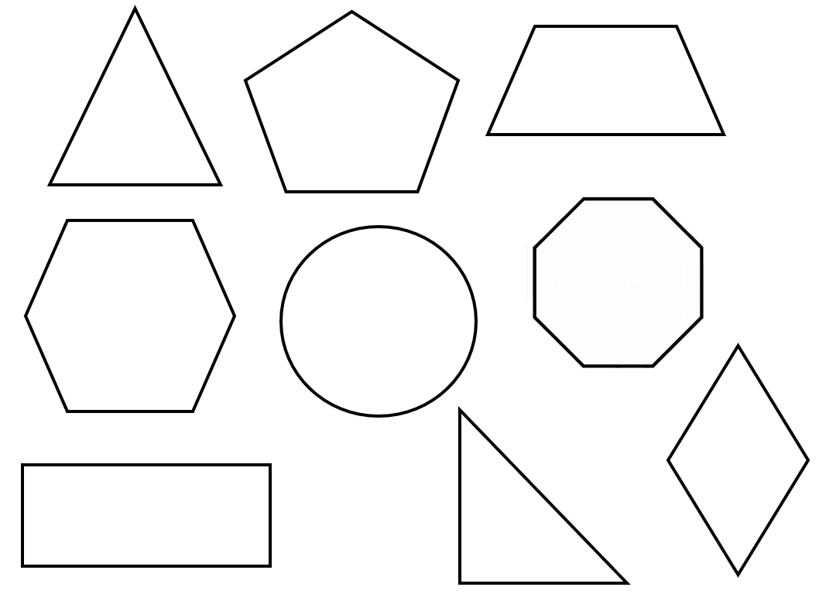

Resource 2: Squares to stairs

Resource 3: Hundreds chart
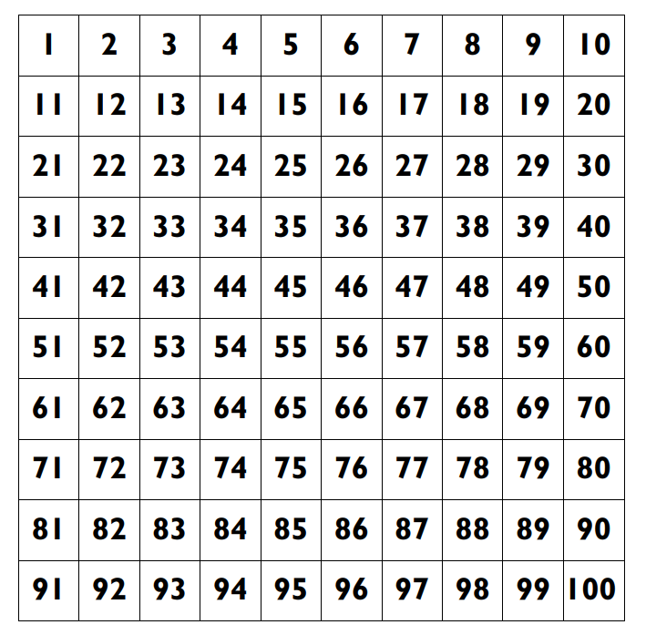

Resource 4: Rectangular and hexagonal frames
Resize to suit the available square geometric shapes or paper shapes.

Syllabus outcomes and content
The table below outlines the syllabus outcomes and range of relevant syllabus content covered in this unit. Content is linked to National Numeracy Learning Progression version (3).
Focus area and outcomes | Content groups and content points | Lessons
Representing whole numbers A  MAO-WM-01  MA1-RWN-01 | Use counting sequences of ones with two-digit numbers and beyond  - identify the number before and after a given two-digit number (CPr5)  - count forwards and backwards by ones from a given number to at least 120 (CPr6) | 1
Representing whole numbers A (cont) | Continue and create number patterns  - model and describe 'odd' and 'even' numbers using items paired in two rows  - count forwards and backwards by twos from any starting point (CPr6, CPr7, MuS2)  Represent the structure of groups of ten in whole numbers  - count large sets of objects by systematically grouping in tens (CPr7)  - partition two-digit numbers to show quantity values | 6–7
Representing whole numbers B  MA1-RWN-02 | Use counting sequences of ones and tens flexibly  - identify the number before and after a given three-digit number  - count forwards and backwards by tens, on and off the decade, with two- and three-digit numbers (CPr7)  - identify how many more to the next multiple of ten within two- and three-digit numbers (AdS7) | 7
Combining and separating quantities A  MAO-WM-01  MA1-CSQ-01 | Use advanced count-by-one strategies to solve addition and subtraction problems  - apply the terms ‘add’, ‘plus’, ‘equals’, ‘is equal to’, ‘is the same as’, ‘take away’, ‘minus’ and ‘the difference between’ to describe combining and separating quantities (AdS1, AdS6)  - record number sentences in a variety of ways using drawings, words, numerals and symbols (AdS6)  - fluently use advanced count-by-one strategies including counting on and counting back to solve addition and subtraction problems involving one- and two-digit numbers (Reasons about relations) (AdS3, AdS4, AdS5) | 5–6
Combining and separating quantities A (cont) | Use flexible strategies to solve addition and subtraction problems  - use non-count-by-one strategies such as using doubles for near doubles and combining numbers that add to ten (AdS6)  - represent addition and subtraction using structured materials such as a bead string or similar model (AdS6, AdS7) | 5–7
Combining and separating quantities B  MA1-CSQ-02 | Represent and reason about additive relations  - create, record and recognise combinations of two numbers that add to numbers from 11 up to and including 20 (AdS7)  - model how addition and subtraction are inverse operations using concrete materials, drawings and diagrams (AdS7)  - recall and use related addition and subtraction number facts to at least 20 (AdS7) | 5–7
Combining and separating quantities B (cont) | Form multiples of ten when adding and subtracting two-digit numbers  - add two-digit numbers by building to multiples of ten (AdS7)  - use quantity values to separate tens and ones for addition (only) [AdS7, AdS8] (AdS7, AdS8) | 7
Two-dimensional spatial structure A  MAO-WM-01  MA1-2DS-01 | Recognise and classify shapes using obvious features  - explore, manipulate and describe features of polygons (UGP3)  - use the terms ‘side’, ‘vertex’ and ‘two-dimensional’ to describe plane (flat) shapes (UGP1, UGP2)  - create repeating linear patterns with shapes, including two-shape and three-shape patterns  - compare, sort and classify polygons according to the number of sides or vertices (UGP3, UGP4)  - select and name a shape from a description of its features, identifying triangles, quadrilaterals, pentagons, hexagons and octagons (Reasons about spatial relations)  - recognise that shapes with the same name may have sides of equal or different lengths (Reasons about spatial relations) identify shapes presented in different orientations (UGP2) | 1–5 and 8
Two-dimensional spatial structure B  MAO-WM-01  MA1-2DS-01  MA1-2DS-02 | Represent, combine and separate two-dimensional shapes  - make representations of two-dimensional shapes and combinations of shapes in different orientations  - combine and split single shapes and arrangements of shapes to form new shapes (Reasons about spatial relations) | 1–5 and 8
Data A  MAO-WM-01  MA1-DATA-01 | Ask questions and gather data  - investigate a topic of interest by choosing suitable questions to obtain appropriate data (IRD2)  - gather data and track what has been counted by using concrete materials, tally marks, lists or symbols (IRD3) | 4, 5, 7 and 8
Data B  MAO-WM-01  MA1-DATA-02 | Identify a question of interest and gather relevant data  - collect data on familiar topics (IRD2)  - sort data into relevant categories (IRD2)  Create displays of data and interpret them  - organise collected data into lists and tables to display information (IRD2)  - represent data in a picture graph using a baseline, equal spacing and same-sized symbols (IRD2)  - interpret information presented in tables and picture graphs (Reasons about relations) (IRD2)  - record answers to questions using the information in tables and picture graphs (IRD2) | 7–8

References
Links to third-party material and websites
Please note that the provided (reading/viewing material/list/links/texts) are a suggestion only and implies no endorsement, by the New South Wales Department of Education, of any author, publisher or book title. School principals and teachers are best placed to assess the suitability of resources that would complement the curriculum and reflect the needs and interests of their students.
If you use the links provided in this document to access a third party's website, you acknowledge that the terms of use, including licence terms set out on the third party's website, apply to the use which may be made of the materials on that third-party website or where permitted by the Copyright Act 1968 (Cth). The department accepts no responsibility for content on third-party websites.
Except as otherwise noted, all material is © State of New South Wales (Department of Education), 2023 and licensed under the Creative Commons Attribution 4.0 International License. All other material (third-party material) is used with permission or under licence. Where the copyright owner of third-party material has not licensed their material under a Creative Commons or similar licence, you should contact them directly for permission to reuse their material.
Mathematics K–10 Syllabus © 2022 NSW Education Standards Authority (NESA) for and on behalf of the Crown in right of the State of New South Wales.
© 2022 NSW Education Standards Authority. This document contains NSW Curriculum and syllabus content. The NSW Curriculum is developed by the NSW Education Standards Authority. This content is prepared by NESA for and on behalf of the Crown in right of the State of New South Wales. The material is protected by Crown copyright.
Please refer to the NESA Copyright Disclaimer for more information.
NESA holds the only official and up-to-date versions of the NSW Curriculum and syllabus documents. Please visit the NSW Education Standards Authority (NESA) website and the NSW Curriculum website.
National Numeracy Learning Progression © Australian Curriculum, Assessment and Reporting Authority (ACARA) 2010 to present, unless otherwise indicated. This material was downloaded from the Australian Curriculum website (National Numeracy Learning Progression) (accessed 3 August 2022) and was not modified. The material is licensed under CC BY 4.0. Version updates are tracked in the ‘Curriculum version history’ section on the 'About the Australian Curriculum' page of the Australian Curriculum website.
ACARA does not endorse any product that uses the Australian Curriculum or make any representations as to the quality of such products. Any product that uses material published on this website should not be taken to be affiliated with ACARA or have the sponsorship or approval of ACARA. It is up to each person to make their own assessment of the product, taking into account matters including, but not limited to, the version number and the degree to which the materials align with the content descriptions and achievement standards (where relevant). Where there is a claim of alignment, it is important to check that the materials align with the content descriptions and achievement standards (endorsed by all education Ministers), not the elaborations (examples provided by ACARA).
Australian Broadcasting Corporation (2021) ‘Sort and Classify with Eddie’ [video], ABC, ABC Kids website, accessed 3 August 2022.
Australian Government Department of Education (2022) ‘Patterns: Attribute Trains', Teaching resources, reSolve website, accessed 3 August 2022.
Boaler J, Munson J and Williams C (2022) Mindset Mathematics: Visualizing and Investigating Big Ideas, Grade 2, Jossey-Bass Inc, New York.
University of Cambridge (Faculty of Mathematics) (2022) Smaller and Smaller, NRICH website, accessed 3 August 2022.
University of Washington (2014) Choral Counting, Teacher Education by Design website, accessed 3 August 2022.
Stanford University (n.d.) ‘Squares To Stairs’, Tasks, youcubed website, accessed 3 August 2022.

