Mathematics – Stage 1 – Unit 21
Contents
Unit description and duration 4
Student prior learning 4
Lesson overview and resources 5
Lesson 1: Adventures in mathematics 13
Daily number sense: Representing numbers – 20 minutes 13
Mathematics explorers – 30 minutes 15
What do mathematicians do? – 15 minutes 18
Lesson 2: Counting the dots 19
Daily number sense: Subitising small collections – 10 minutes 20
How Many Dots – 25 minutes 21
Consolidation and meaningful practice: Dot discussion – 20 minutes 23
Lesson 3: Exploring shapes 24
Daily number sense: 10 minutes 25
Shape jumping – 15 minutes 25
Changing shapes – 30 minutes 26
Consolidation and meaningful practice: Sharing shapes – 15 minutes 29
Lesson 4: Sorting shapes 30
Daily number sense: Order up – 15 minutes 31
Shape attributes – 15 minutes 32
Venn diagram shape sort – 25 minutes 34
Consolidation and meaningful practice: Gallery walk – 15 minutes 35
Lesson 5: Exploring attributes of numbers 37
Daily number sense: Choral counting – 15 minutes 37
Exploring numbers – 10 minutes 42
Venn diagram number sort – 25 minutes 42
Consolidation and meaningful practice: Let’s sort! – 20 minutes 45
Lesson 6: Organising a collection of 10 47
Daily number sense: Race to 100 – 15 minutes 47
Consolidation and meaningful practice: Choral counting – 10 minutes 49
Organising and counting a collection – 30 minutes 51
Lesson 7: Ten-ness of 10 54
Daily number sense: Guess what – 15 minutes 54
Organising, counting, and recording a collection – 20 minutes 55
Fill the stairs – 15 minutes 58
Consolidation and meaningful practice: What is the number? – 15 minutes 61
Lesson 8: Quantifying Collections 62
Daily number sense: Fill the stairs – 15 minutes 63
Flip and match – 15 minutes 63
On and off the train – 15 minutes 66
Consolidation and meaningful practice: Race to 120 – 15 minutes 68
Resource 1: Mathematics around us 71
Resource 2: Be a mathematician 72
Resource 3: Dice patterns 73
Resource 4: Triangle design shapes 74
Resource 5: Number cards 75
Resource 6: Which one doesn't belong? 76
Resource 7: Shape attribute sort 77
Resource 8: Venn diagram 78
Resource 9: Number attribute labels 79
Resource 10: Place value chart 80
Resource 11: Counting collections 81
Resource 12: Ten-frame 82
Resource 13: Fill the stairs 83
Resource 14: Loop cards 84
Resource 15: 0-9 numeral cards 85
Resource 16: Train questions 86
Syllabus outcomes and content 88
Use counting sequences of ones with two-digit numbers and beyond 88
Use flexible strategies to solve addition and subtraction problems 90
Use knowledge of equality to solve related problems 91
References 94

Unit description and duration
This two-week unit introduces students to the big idea that collections of 10 are really useful. Students are provided opportunities to:
- sort objects and numbers according to their attributes
- notice, wonder, and ask questions about objects and collections
- collect and play informally with objects, such as pattern blocks and counters
- count large collections of objects by grouping them into tens
- collect and analyse data.
Mathematics K–10 Syllabus © 2022 NSW Education Standards Authority (NESA) for and on behalf of the Crown in right of the State of New South Wales.

Student prior learning
Before engaging in these teaching and learning activities, students would benefit from prior experience with:
- noticing, wondering, and asking questions about objects and collections
- collecting and playing informally with objects, such as pattern blocks and counters
- counting collections of objects
- 2D geometric shapes and their properties
- subitising small quantities
- collecting, sorting, and analysing data.

Lesson overview and resources
The table below outlines the sequence and approximate timing of lessons; syllabus focus areas and content groups; and resources.
Lesson | Syllabus focus area and content groups | Resources
Lesson 1: Adventures in mathematics  50 minutes  Mathematicians notice, explore and make connections to solve problems. | Representing whole numbers A  - Represent the structure of groups of ten in whole numbers  Representing whole numbers B  - Form, regroup and rename three-digit numbers  Data A  - Ask questions and gather data  Data B  - Identify a question of interest and gather relevant data | - Resource 1: Mathematics around us  - Resource 2: Be a mathematician – 1 enlarged copy  - Virtual manipulatives  - Digital display: Broadway Boogie Woogie by Piet Mondrian  - Video: Popping Balloons (00:19)  - ‘Talk moves’ poster  - Writing materials  - MAB blocks  - Erasable place value chart  - Digital tablet  - Variety of items for investigation, such as: a muffin tray, a soccer ball, a leaf, a seashell, map of a familiar place, a woven basket, 3 different sized jars containing jellybeans  - Sticky notes
Lesson 2: Counting the dots  55 minutes  Smaller quantities can be combined to create groups of 10. | Representing whole numbers A  - Use counting sequences of ones with two-digit numbers and beyond  Combining and separating quantities A  - Use advance count-by-one strategies to solve addition and subtraction problems  - Recognise and recall number bonds up to ten  - Represent equality  Combining and separating quantities B  - Represent and reason about additive relations | - Resource 3: Dice patterns  - 6-sided dot pattern dice – at least 20 per pair of students  - Writing materials  - Digital tablets – one per pair  - Ten-frames
Lesson 3: Exploring shapes  70 minutes  Two-dimensional shapes can be combined to create new two-dimensional shapes. | Two-dimensional (2D) spatial structure A  - Recognise and classify shapes using obvious features  Two-dimensional (2D) spatial structure A  - Represent, combine and separate two-dimensional shapes  Data A  - Ask questions and gather data  - Represent data with objects and drawings and describe the displays | - Resource 4: Triangle design shapes – at least one copy for every student and one copy for teacher. Cut triangles out and place in envelopes.  - Selection of 2D geometric shapes  - Chalk  - Music for movement  - Digital tablets  - Writing materials  - Large cardboard for display  - Glue
Lesson 4: Sorting shapes  70 minutes  Shapes can be sorted and grouped according to their attributes. | Representing whole numbers A  - Represent numbers on a line  Two-dimensional (2D) spatial structure A  - Recognise and classify shapes using obvious features  Data A  - Ask questions and gather data  - Represent data with objects and drawings and describe the displays  Data B  - Identify a question of interest and gather relevant data  - Create displays of data and interpret them | - Resource 5: Number cards – 2 sets  - Resource 6: Which one doesn’t belong?  - Resource 7: Shape attribute sort – one for each child  - Resource 8: Venn diagram – one for each pair of students  - 2 large hoops or an enlarged model of Venn diagram  - Sticky notes  - Scissors – one pair per student  - Glue – one per student  - Digital tablet – for teacher use
Lesson 5: Exploring attributes of numbers  70 minutes  Relationships between numbers can be explored by comparing attributes of numbers | Representing whole numbers A  - Use counting sequence of ones with two-digit numbers and beyond  Representing whole numbers B  - Form, regroup and rename three-digit numbers  Data A  - Ask questions and gather data  - Represent data with objects and drawings and describe the displays  Data B  - Identify a question of interest and gather relevant data  - Create displays of data and interpret them | - Resource 8: Venn diagram  - Resource 5: Number cards  - Resource 9: Number attribute labels  - Writing materials  - Markers – at least 5 different colours  - Scissors – one pair per student  - Glue – one per student  - MAB blocks  - Number charts  - Number lines
Lesson 6: Organising a collection of 10  60 minutes  Organising a large collection into groups of 10 helps support the count | Representing whole numbers A  - Use counting sequence of ones with two-digit numbers and beyond  - Continue and create number patterns  - Represent the structure of groups of ten in whole numbers  Representing whole numbers B  - Use counting sequences of ones and tens flexibly  - Form, regroup and rename three-digit numbers  Combining and separating quantities A  - Recognise and recall number bonds up to ten  - Use flexible strategies to solve addition and subtraction problems  Combining and separating quantities B  - Form multiples of ten when adding and subtracting two-digit numbers | - Resource 10: Place value chart – one per student  - Resource 11: Counting collections  - 6-sided dice  - MAB blocks – about 9 flats, 9 longs and 9 shorts per pair of students  - Writing materials  - Markers – various colours  - Sets of counting collections between 50-150  - Patty pans, cups, bowls, rubber bands – about 40 of each  - Number charts – about 10  - Grids of 100 – about 10
Lesson 7: Ten-ness of 10  70 minutes  Tens and ones are a useful way to organise groups. | Representing whole numbers A  - Use counting sequence of ones with two-digit numbers and beyond  - Represent numbers on a line  - Represent the structure of groups of ten in whole numbers  Representing whole numbers B  - Use counting sequences of ones and tens flexibly  - Form, regroup and rename three-digit numbers  Combining and separating quantities A  - Recognise and recall number bonds up to ten  - Use flexible strategies to solve addition and subtraction problems  Combining and separating quantities B  - Form multiples of ten when adding and subtracting two-digit numbers | - Resource 12: Ten-frame – one per student  - Resource 10: Place value chart – one per student  - Resource 11: Counting collections  - Resource 13: Fill the stairs – one per student  - Resource 14: Loop cards – one set per pair of students  - Magnetic counters and large ten-frame  - 10 counters per student  - Sets of counting collections between 50-150  - Ten-frames in various sizes – about 40  - Patty pans, cups, bowls, rubber bands – about 40 of each  - Number charts – about 10  - Grids of 100 – about 10  - Marker  - Writing materials  - 0-9 sided-dice – 1 per student
Lesson 8: Quantifying Collections  60 minutes  Large collections can be quantified, organised and represented in different ways. | Representing whole numbers A  - Use counting sequences of ones with two-digit numbers and beyond  - Represent numbers on a line  - Represent the structure of groups of ten in whole numbers  Representing whole numbers B  - Use counting sequences of ones and tens flexibly  - Form, regroup and rename three-digit numbers  Combining and separating quantities A  - Use advanced count-by-one strategies to solve addition and subtraction problems  - Use flexible strategies to solve addition and subtraction problems  - Represent equality  Combining and separating quantities B  - Represent and reason about additive strategies  - Use knowledge of equality to solve related problems | - Resource 13: Fill the stairs  - Resource 10: Place value chart – one per student  - Resource 15: 0-9 numeral cards – 3 sets  - Resource 12: Ten-frame – 3 per student  - Resource 16: Train questions – one copy for teacher  - 0-9 sided-dice – one per student  - Writing materials  - MAB blocks – about 9 flats, 9 longs and 9 shorts per pair of students  - Craft sticks in bundles of 10 – 9 bundles of 10 and 9 loose craft sticks for half of students  - Number charts – about 5  - Counters – 24 per student  - 6-sided dice – one per student

Lesson 1: Adventures in mathematics
Core concept: Mathematicians notice, explore and make connections to solve problems.
The table below contains suggested learning intentions and success criteria. These are best co-constructed with students.
Learning intentions | Success criteria
Students are learning that:  - quantities can be grouped using collections of 10 and 100  - groupings of 10 can be represented with numerals, words and images  - mathematical concepts can be noticed and explored  - mathematicians connect mathematical ideas with the world around them. | Students can:  - represent and explain a MAB model on a place value chart for quantities up to 120  - represent quantities with numerals up to 120  - identify and describe mathematical concepts in everyday items and experiences  - use mathematical language to explain mathematical connections.

Daily number sense: Representing numbers – 20 minutes
- Build student understanding of how to represent quantities by modelling, writing, and saying numbers.
- Model quantities 17, 34, 20, 71, 108 and 128 on the board using MAB blocks on a place value chart. Provide students with a small whiteboard. Ask students to write the numeral that matches the representation of the number on their whiteboard and display when they are finished. Use student feedback for pre-assessment data. Ask a selection of students to read the numeral they have written.
Note: Virtual Manipulatives from the Digital Learning Selector are a useful tool for modelling manipulatives, such as MAB blocks.
- Provide students with MAB blocks, an erasable place value chart, and a marker.
- Review the value of each MAB block and the values represented in the place value chart. Model a quantity with students using MAB blocks and corresponding digits in the place value chart.
- Say the number 25 and ask students to represent it with MAB blocks and numerals on the place value chart.
- Select students to share how they have represented the number 25. Ask questions, such as:
- What do the long MAB blocks represent?
- What do the short MAB blocks represent?
- What does each digit represent?
- Would my representation be accurate if I moved the blocks into different columns on the place value chart? Why or why not?
- Repeat using numbers 14, 80, and 116. Record observations of student work with photographs or video for assessment data.
This table details assessment opportunities and differentiation ideas.
Assessment opportunities | Too hard? | Too easy?
What to look for:  - Are students able to accurately represent one-digit, two-digit and three-digit quantities with numerals? (MA1-RWN-01)  - Are students able to accurately represent one-digit, two-digit and three-digit quantities with MAB blocks on a place value chart? (MA1-RWN-01)  What to collect:  - Photographs or videos of student work (MA1-RWN-01) | Students are unable to accurately represent quantities with numerals or MAB blocks.  - Provide 3 sets of 0-9 numeral cards to support students with labelling representations.  - Students use a numeral handwriting reference chart to support accurate formation of numerals.  - Limit assessment to one or two-digit numbers.  - Model re-grouping of ones to tens to reinforce longs as a grouping of 10. | Students quickly and accurately represent all quantities with MAB blocks and numerals.  - Ask students to create a representation of a quantity one more or one less than a given number.  - Ask students to create a representation of a quantity 10 more or 10 less than a given number.

Mathematics explorers – 30 minutes
- Set up a gallery walk with a range of images, items, or videos to stimulate discussion about mathematics around us.
- Ask students the following questions:
- What do you notice?
- What do you wonder?
- Provide students with sticky notes to write or draw ideas about the mathematics they notice as they consider each display. Some suggestions to include in the gallery walk are:
- An artwork displayed on a Smartboard or tablet, such as Broadway Boogie Woogie by Piet Mondrian.
- A short event that tells a story displayed on a Smartboard or tablet, such as Popping Balloons (00:19) from Graham Fletcher Questioning my metacognition.
- Display items such as a muffin tray, a soccer ball, a leaf, a seashell, map of a familiar place, a woven basket and 3 different sized jars containing jellybeans.
Note: Select gallery walk items that have mathematical elements. Students will make mathematical and non-mathematical observations. Accept all responses and use mathematical ideas to build a shared understanding of how mathematics can be noticed and explored around us.
- Observe and record students as they discuss each item on display and make notes as this will provide useful assessment data.
- Bring students together and ask what mathematics they have found to explore. Give students sticky notes to brainstorm ideas. Possible student responses for the soccer ball are included below.
The table below outlines stimulus prompts to generate conversation about the topic, along with anticipated responses from students.
Prompts | Anticipated student responses
- What do you notice?  - What do you notice about the size, shapes, patterns, or quantities?  - What do you wonder?  - Could you ask a question about how many or how much? | - The ball is a sphere  - The ball is a 3D object  - The ball is made up of lots of shapes that seem the same.  - The shapes on the ball have 5 or 6 sides.  - The shapes are in a colour pattern of black and white.  - The shapes all fit together perfectly with no gaps, so the air can’t get out.  - The sides of each shape on the ball are all the same length.  - The ball is about as big as my head.  - I wonder how many shapes cover the surface of the ball altogether?  - I wonder how shapes with straight sides make a curved 3D object when they are all joined together?  - I wonder how much air the ball holds inside?  - I wonder what it would look like if we picked the ball apart to lay out all the shapes flat?
Note: Use student observations to create an anchor chart so that student ideas are organised in categories to sort ideas, such as shapes, patterns, quantities, measurements. This will allow students to begin to explore sorting and categorising data.
- Record ideas on Resource 1: Mathematics around us. Use student responses to discuss the different aspects of mathematics around us and the connections and relationships between the concepts noticed.
This table details assessment opportunities and differentiation ideas.
Assessment opportunities | Too hard? | Too easy?
What to look for:  - Are students able to notice and describe mathematical ideas in the gallery walk items? (MAO-WM-01)  - What language are students using to describe observed mathematical concepts? (MAO-WM-01)  What to collect:  - record of student observations (MAO-WM-01) | Students are not able to identify specific mathematical ideas when exploring the items in the gallery walk.  - Model thinking for students by selecting one item and asking questions about quantities, patterns, shapes, groups, and size.  - Students use ideas about one item to identify similar concepts in a different item. | Students describe many mathematical concepts.  - Students select 2 items that share similar mathematical properties and find mathematical ideas they have in common.  - Ask students to wonder about and investigate an item.

What do mathematicians do? – 15 minutes
- Ask students questions to reflect how mathematicians work effectively, such as:
- What do you notice about exploring mathematics that might tell us what mathematicians do?
- What sorts of questions do mathematicians ask and investigate?
- How do mathematicians find the answers to the questions they ask?
- How do mathematicians work well together and alone?
- Use student responses to record ideas on the anchor chart Resource 2: Be a mathematician.
- Introduce the ‘Talk moves’ poster. Add ideas to the anchor chart.

Lesson 2: Counting the dots
Core concept: Smaller quantities can be combined to create groups of 10.
The table below contains suggested learning intentions and success criteria. These are best co-constructed with students.
Learning intentions | Success criteria
Students are learning that:  - the smaller parts within 10 help us to recognise groups of 10  - grouping smaller parts in tens can help them count larger numbers. | Students can:  - subitise quantities one to 6.  - identify combinations of smaller quantities that equal 10.  - count a large collection of dots using the groupings of 10 to count efficiently.

Daily number sense: Subitising small collections – 10 minutes
This lesson was adapted from Subitising small collections.
- Build student understanding of recognising small collections without counting by subitising small collections.
- Show students Resource 3: Dice patterns. Show students a dice pattern card with one, 2, 3 or 4 dots for one to 2 seconds. Ask students how many dots they saw.
- Show students dice pattern card 5 for 1-2 seconds. Ask students:
- How many dots are there?
- How did you see the dots?
- Share and record the various student responses, circling combinations of dots.
- Repeat for dice pattern card 6.
- Provide students with writing materials.
- Show students 2 dot cards at a time for 2-3 seconds. Ask students:
- How many dots are there altogether?
- How did you see the dots to work out how many altogether?
- Students use writing materials to draw and/or label the dice pattern to show the way they saw the dots and combine the total.
- Select several students to share the different ways they saw the dots. Repeat this process several times with different combinations of 2 cards.

How Many Dots – 25 minutes
This lesson has been adapted from Boaler et al (2021).
- Begin the activity by rolling a collection of at least 10 6-sided dice so that all students can see them. Ask the students how many dots there are and how the dice could be organised to show how many.
- Give students a chance to turn and talk to a partner.
The table below outlines stimulus prompts to generate conversation about the topic, along with anticipated responses from students.
Prompts | Anticipated student responses
- How can we organise these dice to help you count the dots on them?  - How might groups of 10 help you count the dots?  - What is the largest number of dots that can be rolled? How do you know? | - We can organise the dice so that the dots are in groups of 5 or 10.  - Groups of 10 are easy to count because you don’t have to count each dot.  - The largest number of dots is 60 because the highest number on a die is 6 and there are 10 dice.
- Show students some ways of forming equal groups with the dice, especially groups of 5 and 10, to help count the dots, as shown in Figure 1.
Figure 1 – Combinations of 10 with dice
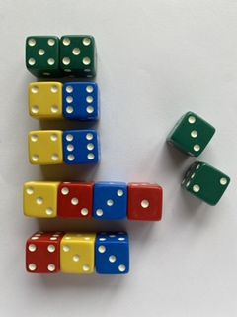
- Students work in pairs. Provide students with 20 dice and writing materials or digital tablets.
- Students roll their collection of dice and arrange them in groupings that total 10. Students record the possibilities for combinations that total 10.
- Students count the number of dots to calculate the total. Circulate amongst students and observe the strategies they use to calculate the total.
This table details assessment opportunities and differentiation ideas.
Assessment opportunities | Too hard? | Too easy?
What to look for:  - How do students organise the dice? (MA1-CSQ-01, MA1-RWN-02)  - How do students count the total number of dots? (MA1-CSQ-01, MA1-RWN-02)  - Are students able to make groups of 10 to support the total count? (MA1-RWN-02)  What to collect:  - records of student work (MA1-CSQ-01, MA1-RWN-02, MAO-WM-01) | Students find it difficult to subitise, organise and efficiently count dots on the dice.  - Reduce the number of dice.  - Ask students to model quantities using fingers and count how many fingers remain to make 10.  - Use counters in ten-frames to support part-whole recognition to 10.  - Provide a number chart to support counting in tens.  - Provide sticky notes to place each set of dice that total 10 before counting the total number of dots. | Students are easily organising their dice into groups of 10.  In partners, students roll the dice. One student organises them into groups and the other talks about how the dice have been organised. They then swap roles and repeat the process with the same roll of the dice.

Consolidation and meaningful practice: Dot discussion – 20 minutes
- Gather the students and share recordings of the way students organised their dice. Ask students questions such as:
- How did you organise your dice to help you count?
- Why did organising your dice in that way support your counting?
- How did you go about counting your total?
- What are some of the combinations to 10 that you discovered?
- Record student ideas for the possibilities of combinations to 10.
- Use dice pattern cards created from Resource 3: Dice patterns. Hold up 2 random cards at a time for 2-3 seconds and ask how many there are altogether.
- Select students to share how they saw the cards and how they worked out the total amount.
- Show students images of individual dice pattern cards and ask how many more you will need to make 10.
- Select students to share how they worked out how many more to 10.

Lesson 3: Exploring shapes
Core concept: Two-dimensional shapes can be combined to create new two-dimensional shapes.
The table below contains suggested learning intentions and success criteria. These are best co-constructed with students.
Learning intentions | Success criteria
Students are learning that:  - shapes can be described by attributes  - shapes can be combined to make new shapes  - mathematicians work within rules to solve problems. | Students can:  - identify shapes according to number of sides and vertices  - describe shapes using attribute language  - accurately label shapes with correct vocabulary  - combine 4 triangles to create new shapes  - solve problems within a set of rules.

Daily number sense: 10 minutes
- From a class need surfaced through formative assessment data, identify a short, focused activity that targets students’ knowledge, understanding and skills. Example activities may be drawn from the following resources:
- Thinking mathematically Stage 1
- Universal Resources Hub

Shape jumping – 15 minutes
- Use chalk to draw 10-15 large shapes on the ground. Some examples of shapes to draw are squares, hexagons, circles and various types of triangles and rectangles. Include at least 2 of each shape.
- Gather students and hold up examples of shapes. Ask questions to review the attributes of each shape, such as:
- What do you notice about this shape?
- How could you describe this shape by the number or length of sides?
- How could you describe this shape by its vertices?
- How is this shape similar to that shape?
- How is this shape different to that shape?
- Review the language used to describe 2D geometric shape attributes as students share their observations.
Attributes are the features of a shape. The attributes of shapes help define the characteristics of the shape both visually, for example colour, and mathematically, for example the length of the sides.
- Play music on a device as students move around the space. When the music stops, call out an attribute. Students stand on the shape that fits the description. Some example attributes include:
- Find a shape that has 4 sides.
- Find a shape that has 3 vertices.
- Find a shape that has all 4 sides the same length.
- Once all students have found the correct shape, ask if they can name the shape and describe one other attribute unique to that shape.
- Continue the game until all attributes and shapes have been named.

Changing shapes – 30 minutes
This lesson has been adapted from Triangle Designs (K-2) by youcubed.
- Use Resource 4: Triangle design shapes and cut out the 4 triangles.
- Show students the 4 triangles and ask them what they notice about the shapes. Select students to share observations of the shapes. Label the triangle as an isosceles triangle.
An isosceles triangle has 2 sides of equal length.
- Demonstrate that the triangles can be moved around and placed next to each other with no gaps to create new shapes. Create one or 2 examples and ask what students notice about this new shape you have made.
- Explain that students will use the 4 triangles to create as many shapes as they can. There are 4 constraints that they must work with:
- Shapes must use all 4 isosceles triangles.
- There cannot be any gaps or overlaps between triangles.
- Each triangle must be touching another triangle.
- Triangles must be touching along the sides of the same length.
Create some examples and non-examples, as shown in Figure 2. Ask students to consider each example and describe why it does or does not meet the constraints.
Figure 2 – Shapes made from triangles
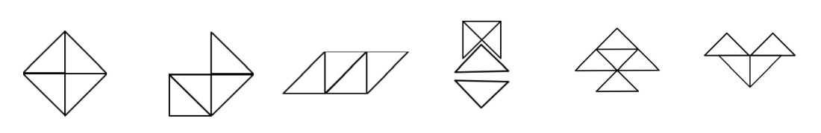
‘Triangle Designs’ by youcubed, Stanford University is licensed under CC BY 4.0
- Students work in pairs. Provide students with Resource 4: Triangle design shapes. Students compare each design against the 4 constraint criteria. If the design satisfies the criteria, students can record the design with photographs, drawings, or by gluing sets of triangles onto a poster display.
This table details assessment opportunities and differentiation ideas.
Assessment opportunities | Too hard? | Too easy?
What to look for:  - What language do students use to describe attributes of shapes? (MA1-2DS-01, MAO-WM-01)  - Are students able to accurately label shapes with shape names? (MA1-2DS-01)  - Are students able to manipulate and combine shapes to create new shapes within constraints provided? (MA1-2DS-01, MAO-WM-01) | Students lack the language to describe shapes by attribute or label the shapes with correct terminology.  - Model the language of attributes, using examples of shapes to demonstrate the language in context.  - Use comparisons of 2 shapes at a time to identify similarities and differences, focusing on specific vocabulary such as sides and vertices.  - Display labelled posters of shapes and regularly review the name of shapes and their attributes in daily routines.  Students find it difficult to manipulate triangles into new shapes within the constraints provided.  - Create shapes with 2 triangles to illustrate constraints then add a third one when students have been able to meet all constraints criteria.  - Identify the triangle that does not meet a constraint. Students play create ideas using the triangle to solve the problem. | Students articulate observations of shapes and readily manipulate triangles to create new shapes.  - Ask students to describe how a design satisfies each constraint.  - Ask students how a non-example does not satisfy each constraint.

Consolidation and meaningful practice: Sharing shapes – 15 minutes
- Each pair selects one shape they have created to share with the class.
- Ask students questions, such as:
- Can you describe the new shape you have created?
- How can you be sure it meets all the constraints of the task?
- Are there other pairs who also created this shape?
- Display the triangle designs.

Lesson 4: Sorting shapes
Core concept: Shapes can be sorted and grouped according to their attributes.
The table below contains suggested learning intentions and success criteria. These are best co-constructed with students.
Learning intentions | Success criteria
Students are learning that:  - numbers can be ordered according to their comparative quantity  - shapes have attributes that can be used to describe and sort them  - shapes can be different but share attributes  - the same shape can be sorted in different ways  - information (data) can be presented in different ways. | Students can:  - compare 2 numbers and identify which quantity is smaller or larger.  - order a set of one-digit, two-digit and three-digit numbers in ascending order  - describe differences and similarities of shapes based on attributes  - sort shapes based on more than one attribute  - use a Venn diagram to sort shapes.

Daily number sense: Order up – 15 minutes
This activity has been adapted from Dacey et al (2016).
- Build student understanding of how to order numbers from smallest to largest by playing ‘Order Up’.
- Students work in 2 teams using 2 sets of Resource 5: Number cards. Deal out 5 cards per team and select a student to place them on a board in front of their team from left to right in the order they were dealt. Place the undealt cards face down in a central pile.
- The aim of the game is to strategically swap one of the 5 cards on display with one picked up from the central pile until the cards are in order from smallest to largest. The first team to have a series of 5 cards in correct ascending order wins.
- Select a student from each team to take turns selecting a card from the central pile. The student asks their team which card from the displayed set they should swap it with and why. The student chooses at least 2 people to suggest ideas and provide reasoning, before deciding which card they will swap it with.
- The teams take it in turn to repeat this process until a team has all 5 cards in order from smallest to largest.
- Invite students to reflect on the process of sharing and negotiating ideas to reach a goal in a mathematical game. Ask if students could add any further ideas to Resource 2: Be a mathematician.
This table details assessment opportunities and differentiation ideas.
Assessment opportunities | Too hard? | Too easy?
What to look for:  - What language do students use to reason and connect ideas? (MAO-WM-01)  - What mathematical behaviours are evident in support of achieving a common mathematical goal? (MA1-RWN-01, MAO-WM-01)  - What strategies do students use to choose which numbers to swap to achieve the goal of ascending order? (MA1-RWN-01, MAO-WM-01) | Students find it difficult to make purposeful choices to order cards and find it challenging to negotiate with peers.  - Use a number line or number chart to support thinking.  - Omit three-digit numeral cards from the game.  - Use a limited set of numeral cards between 0-50.  - Pause the game and scaffold student reasoning with questions that promote explanations for students with differing views. | Students confidently, accurately, and quickly make decisions about positions of cards on behalf of the group.  - Pause the game and ask for at least 2 other ideas and reasons. Have students vote on each idea.  - Students use reasoning skills to justify swaps made during the game to their team.

Shape attributes – 15 minutes
Attributes are the traits or the properties of a shape or an object. The attributes of shapes help us define the characteristics of the shape both visually, for example colour, and mathematically, for example the length of the sides.
- Students work in pairs with a copy of Resource 6: Which one doesn’t belong? Ask students:
- What do you notice?
- How are the shapes similar?
- How are the shapes different?
- Provide time for students to turn and talk. Invite students to share ideas with the whole class. Use student responses to record a list of attributes on the board. Review attributes of shapes and mathematical terms used to describe attributes, such as vertex and sides.
Vertex: Where 2 straight sides of a two-dimensional shape meet. A side is the line segment joining 2 vertices of a two-dimensional shape.
- Ask students to look at the shapes individually and consider which one doesn’t belong.
- Provide thinking time and ask students:
- Why doesn’t the shape belong?
- Which attribute can you describe to explain why it doesn't belong with the other shapes?
- Provide students time to turn and talk to explain and share reasoning with their partner.
- Ask a few students to share the shape their partner chose and the reason it did not belong. Use student responses to highlight the different attributes that help students to think about the information they notice about shapes. This may change how they sort the shapes.

Venn diagram shape sort – 25 minutes
This lesson is adapted from Data Shapes at NRICH.
- Introduce a Venn diagram using 2 overlapping hoops or large diagram on the floor.
Venn diagram: A graphic organisation tool that uses overlapping circles to show the unique traits or relationships within a collection.
- Explain the use of the 4 regions within the rings including the region outside of the rings to organise and sort shapes according to the attribute labels, as shown in Figure 3.
Figure 3 – Venn diagram
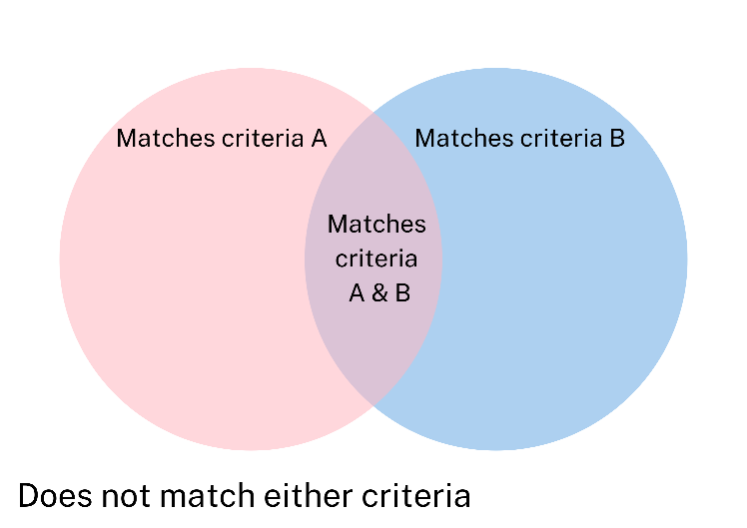
- Use Resource 7: Shape attribute sort to investigate the different attributes of shapes. Ask if students can describe an attribute that might help them group some of the shapes together. Make a list of possible attributes for sorting on the board.
- Demonstrate the use of a Venn diagram. Select 2 attributes to label each ring. Record these on sticky notes and place each one in a ring.
- Present each shape to the students and use ‘Talk moves’ to facilitate the class in sorting each shape into the Venn diagram.
- Students work in pairs with a copy of Resource 7: Shape attribute sort and Resource 8: Venn diagram. Ask students to come up with 2 new attribute labels that they could use to sort the shapes. Students Think-Pair-Share to decide on 2 attributes and record these in each ring.
- Students cut out shapes and work together to sort shapes into the Venn diagram.

Consolidation and meaningful practice: Gallery walk – 15 minutes
- Take students on a gallery walk to view other students’ work. Select a range of students to explain their work and explain how they used attributes to decide how to sort the shapes. Ask questions such as:
- What was it about the shapes that gave you the idea to use these attribute labels?
- Are the attributes you chose mathematical or visual?
- Can you explain how a shape in the ‘both’ section of the Venn diagram shows both attributes?
- Can you prove why this shape belongs in this place in the Venn diagram?
- Do others have a different idea about where they might place one of the shapes in this Venn diagram? Why?
- Take photographs of students’ Venn diagrams and record a video of the explanations that students make about the sorting process to refer to as assessment data.
- Allow students to glue shapes in place on Venn diagrams following the gallery walk discussion and display students’ work.
This table details assessment opportunities and differentiation ideas.
Assessment opportunities | Too hard? | Too easy?
What to look for:  - What language do students use to describe the attributes of shapes? (MAO-WM-01, MA1-2DS-01)  - How do students use attributes to identify the differences between 2 sets of shapes? (MAO-WM-01, MA1-2DS-01)  - Are students able to sort the shapes using a Venn diagram based on different attributes? (MAO-WM-01, MA1-2DS-01)  What to collect:  - photographs and video of student work. (MAO-WM-01, MA1-2DS-01) | Students are unable to accurately sort the shapes based on common attributes.  - Reduce the number of shapes to be sorted into the Venn diagram.  - Use one attribute to word a closed-end question and sort each shape into a yes/no column in response to the question. For example, does the shape have 4 or more sides?  Students are unable to use accurate attribute language to explain reasoning for sorting of shapes:  - Select one attribute to focus on and use questioning to explore that attribute with a group of shapes.  - Model mathematical language to students using shapes to demonstrate use of vocabulary. | Students quickly and accurately sort shapes into a double Venn diagram.  - Ask students to add a third circle and attribute to the Venn diagram to extend the sort.  - Ask students to justify why they have placed specific shapes within specific regions of the Venn diagram, for example, why does this shape meet both criteria?

Lesson 5: Exploring attributes of numbers
Core concept: Relationships between numbers can be explored by comparing the attributes of numbers
The table below contains suggested learning intentions and success criteria. These are best co-constructed with students.
Learning intentions | Success criteria
Students are learning that:  - relationships between attributes of numbers are a type of pattern  - numbers have attributes which can be used to describe and sort them. | Students can:  - identify and explain patterns and relationships between numbers in a recorded count  - identify and explain attributes of numbers  - analyse numbers 0–120 based on simple attributes  - describe similarities and differences between numbers based on attributes.

Daily number sense: Choral counting – 15 minutes
This lesson was adapted from Franke et al (2018) and Choral Counting at Teacher Education by Design.
- Build student understanding of number patterns and relationships by choral counting.
Note: Choral counting activities involve the whole class counting with you as you record the count in a strategic way to support student discussion of emerging patterns in the count. To establish an effective choral counting routine, lead students in counting in unison to match the pace of the written recording of the count, which is visible to all students.
- Lead the students in a choral count beginning at 87 and continuing to 122. Record each numeral in rows of 10, allowing a clear space between each numeral, as shown in Figure 4.
Figure 4 – Choral counting example
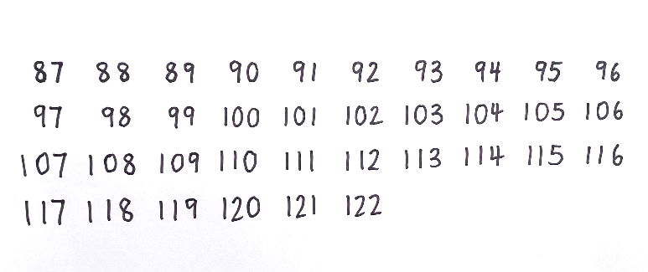
- Ask what students notice, using further questions to prompt discussion. Use coloured markers to record what students notice about patterns, similar to Figure 5.
Figure 5 – Choral counting example with annotations
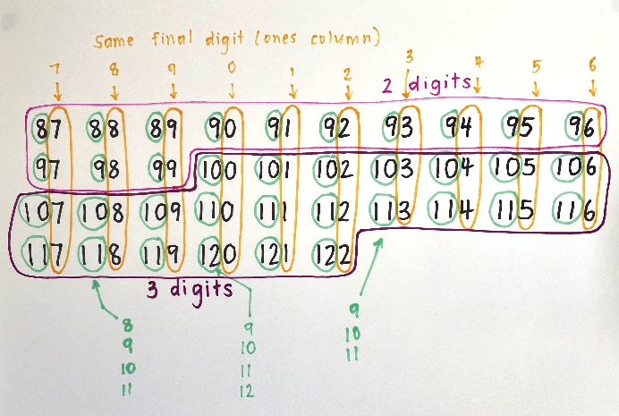
The table below outlines stimulus prompts to generate conversation about the topic, along with anticipated responses from students.
Prompts | Anticipated student responses
- What changes do you notice in the numbers?  - What stays the same?  - Where can you see some similarities?  - Can you describe any patterns that you see?  - Is that pattern happening anywhere else?  - What do you think would come next? | - Some of the numbers at the beginning of the count have 2 digits and after that all the numbers have 3 digits.  - Each row has 10 numbers  - The numbers go up by one each count  - The final digit in the ones column, going down each column, is the same. 7 in this column, then 8 in the next column and so on.  - Each column has a counting pattern at the beginning of each number going down – 8, 9, 10, 11, 12.  - It goes up by 10 each row that you go down
- Draw an empty box below 116 and ask students which number they predict would go there. Students place a thumb up on their chest when they have worked it out.
- Select a student to share their answer and ask other students if they had the same answer. Ask the student to explain how they worked out their answer.
- Use ‘Talk moves’ to guide students in a discussion about their reasoning and allow students to revise their thinking.
- Ask the class if anyone had a different answer. Repeat this process of sharing until all students have shared their answers. Observations of students’ answers and explanations will provide useful assessment data.
Note: Choral counting routines help students to develop number sense. Students build meaningful connections between spoken number word with the assigned symbolic notation recorded carefully by the teacher to support understanding.
This table details assessment opportunities and differentiation ideas.
Assessment opportunities | Too hard? | Too easy?
What to look for:  - Are students able to confidently and accurately participate in the count? (MAO-WM-01, MA1-RWN-01, MA1-RWN-02)  - What do students’ explanations of patterns in the recorded count indicate about their knowledge of number? (MAE-RWN-01, MAE-RWN-02)  - Are students able to accurately predict a number in the count? (MAO-WM-01, MA1-RWN-01, MA1-RWN-02)  - What strategies do students use to predict a future number in the count? (MAO-WM-01, MA1-RWN-01, MA1-RWN-02) | Students have difficulty maintaining participation in the count.  - After completing the initial choral count, read through the count in unison again, to provide further practice and consolidation.  - Select the section of the count in which students seem least confident and read through that section in unison several times for consolidation.  Students have difficulty accurately predicting a future number in the count.  - Select a relevant column or row of numbers that would support a prediction and read through it in unison.  - Use observations of patterns pointed out by other students, such as sequences or repeating digits to support reasoning. | Students confidently and accurately participate in the count and predict a future number in the count.  - Ask students to explain how a predicted number continues a pattern in the recorded count.  - Create an empty box at a strategic place further along in the count or prior to the start of the count and ask students to use their understanding of patterns to predict the number.

Exploring numbers – 10 minutes
- Write the number 52 on the board. Ask students to Think-Pair-Share to discuss what they know about this number. Allow students a couple of minutes to share and circulate to listen to the ideas students are sharing.
- Ask students to share ideas with the whole class. Record each new idea on the board. If necessary, prompt further thinking with targeted questioning. Explain that these features of a number are called the attributes of the number. Write this title at the top of the board.
- Write the numbers 47, 7, and 117 on the board. Ask students to think about what attributes all 3 of these numbers have in common. Allow students time to Think-Pair-Share and circulate to listen to ideas and support discussion using the attributes already listed to prompt thinking.
- Ask students to share ideas with the whole class. Accept responses and use ‘Talk moves’ to explore the shared attributes of this group of numbers.

Venn diagram number sort – 25 minutes
This activity was adapted from the game Number Sort by Dacey et al, 2016.
- Review the Venn diagram structure and the 4 regions for classification.
- Select 2 of the attribute labels from Resource 9: Number attribute labels and place them at the top of each ring. Position a selection of 8 numbers from Resource 5: Number cards above the Venn diagram. Present each number to students and use ‘Talk moves’ to allow students to negotiate where the number should go in the Venn diagram, similar to Figure 6. Observations of students’ ideas and reasoning during this process will provide useful assessment data.
Figure 6 – Number attribute Venn diagram
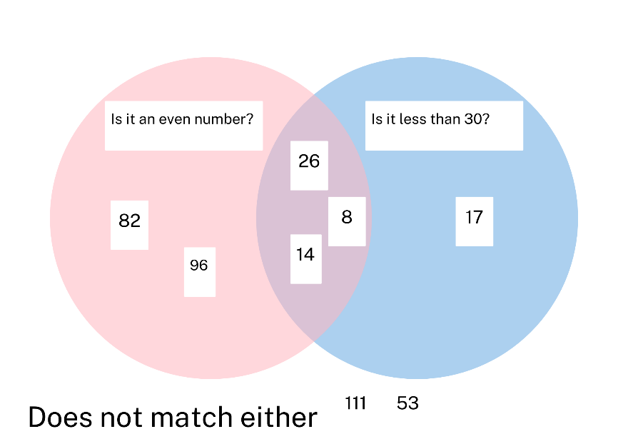
- Discuss the relationships between numbers in each section of the Venn diagram, based on similar or different attributes.
- Place a new selection of numbers in the Venn diagram and turn attribute labels face down at the top of each circle, as shown in Figure 7.
Figure 7 – Number attribute Venn diagram 2
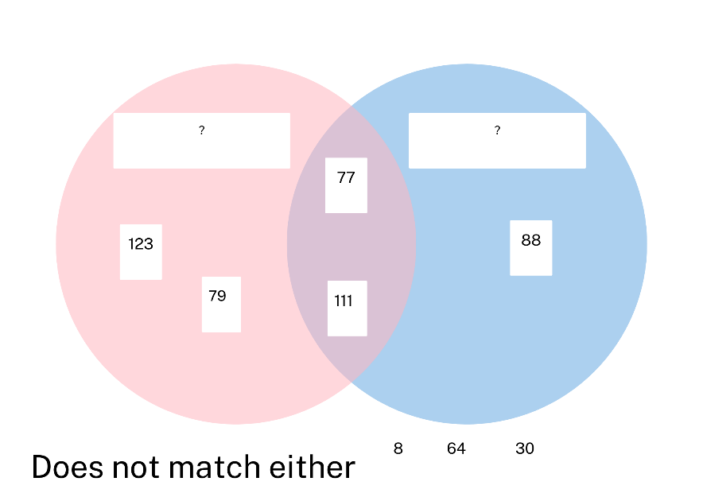
- Point out the ring on the left and ask students how the numbers in the ring are alike. Students share ideas and use ‘Talk moves’ to share reasoning. Compare numbers in other regions of the Venn diagram to confirm or challenge suggestions.
- Repeat this process for the ring on the right, using the numbers in the other regions to confirm or challenge suggestions.
- When students share a strong consensus for the label of the attributes, turn the attribute cards over. Discuss student ideas in comparison with the labels and use the displayed numbers to consolidate understanding of the labelled attributes.
This table details assessment opportunities and differentiation ideas.
Assessment opportunities | Too hard? | Too easy?
What to look for:  - Are students able to analyse a sorted collection of numbers to identify a common attribute? (MA1-RWN-01, MA1-DATA-01, MA1-DATA-02, MAO-WM-01)  - What strategies do students use to compare relationships between numbers based on attributes? (MA1-RWN-01, MA1-DATA-01, MA1-DATA-02, MAO-WM-01) | Students find it difficult to identify attributes in numbers.  - Provide students with one number at a time to analyse against a single attribute.  - Model and explain the attributes, using language that supports understanding, for example the number 18 can be shared into 2 groups evenly, so it is an even number. | Students readily and accurately sort all numbers into a Venn diagram.  - Students use more than one attribute to guide the sort in each ring.  - Students develop further attributes to guide the sort.  - Pairs of students turn over attribute labels and analyse their partner’s sort to establish the label for each ring.

Consolidation and meaningful practice: Let’s sort! – 20 minutes
- Provide each student with a copy of Resource 8: Venn diagram, Resource 9: Number attribute labels and Resource 5: Number cards.
- Students select 2 attribute labels and paste one in each ring. Students cut out a minimum of 8 numbers to sort into the 4 regions of the Venn diagram.
- Students work in pairs to peer review each other’s number sort before gluing numbers into place. Circulate amongst students to listen to discussions and observe students’ problem-solving and reasoning.
This table details assessment opportunities and differentiation ideas.
Assessment opportunities | Too hard? | Too easy?
What to look for:  - Are students able to use attribute labels to analyse and sort numbers into a Venn diagram? (MA1-RWN-01, MA1-DATA-01, MA1-DATA-02, MAO-WM-01)  - What language do students use to explain their reasoning decisions made when sorting numbers? (MA1-RWN-01, MA1-DATA-01, MA1-DATA-02, MAO-WM-01)  What to collect:  - Individual Venn diagram number sort activity (MA1-RWN-01, MA1-DATA-01, MA1-DATA-02, MAO-WM-01) | Students are unable to independently analyse numbers to guide the sorting process.  - Select a range of numbers under 50 to sort.  - Model each number using MAB blocks and place value charts or ten-frames and counters to support attribute analysis of numbers.  - Provide scaffolds such as number charts and number lines.  Students find it difficult share both identify numbers which meet both attributes.  - Ask students to focus on one attribute at a time and write numbers in one ring at a time.  - Look for common numbers in each ring to place in the overlapping rings at the end. | Students readily and accurately sort all numbers into a Venn diagram.  - Students use more than one attribute to guide the sort in each ring.  - Students develop further attributes to guide the sort.  - Pairs of students turn over attribute labels and analyse their partner’s sort to establish the label for each ring.

Lesson 6: Organising a collection of 10
Core concept: Organising a large collection into groups of 10 helps supports the count.
The table below contains suggested learning intentions and success criteria. These are best co-constructed with students.
Learning intentions | Success criteria
Students are learning that:  - a group of 10 ones is the same as one 10  - organising objects into groups of 10 can help count large collections  - smaller parts within 10 remain constant and can be used to create groups of 10. | Students can:  - identify smaller parts that combine to make a group of 10  - organise objects into groups of 10 to help count large collections  - subitise quantities under 5  - identify quantities that combine to make 10 to organise a count in groups of 10.

Daily number sense: Race to 100 – 15 minutes
This lesson has been adapted from Race to One Hundred by youcubed.
- Build student understanding of collections of 10 by playing Race to 100.
- Put students in pairs and give each pair a 6-sided die, MAB blocks and Resource 10: Place value chart.
- Players take turns rolling the die and creating the quantity rolled using MAB blocks. Students place MAB blocks on their place value chart.
- On each new roll, players add the quantity to the previous total, re-making the new total by grouping 10 shorts and replacing these with one long. Students position the growing number of MAB blocks in the correct columns on the place value chart.
- Players continue adding and trading until they have enough longs to trade for a 100-block flat in the hundreds column. The first player to reach 100 is the winner.
This table details assessment opportunities and differentiation ideas.
Assessment opportunities | Too hard? | Too easy?
What to look for:  - Are students able to recognise groups of ten and re-make groups of 10 ones with a long and a group of 10 longs with a flat? (MA1-RWN-02, MA1-CSQ-01)  - Are students able to recognise and name a quantity and the parts that comprise it, based on an MAB block representation? (MA1-RWN-02, MA1-CSQ-01) | Students are not able to explain and manipulate quantities of MAB blocks to represent quantities.  - Provide each student with a ten-frame to place inside the ones column and fill to support recognition of a group of 10.  - Use single-digit numeral cards to label quantities in each column to support understanding of two-digit numbers. | Students confidently and quickly add and represent quantities with MAB blocks on place value chart.  - Provide students with 2 dice to roll for each turn.  - Ask students to begin with 100, modelled with a flat, and subtract the quantity rolled to model each new total, until they reach zero.

Consolidation and meaningful practice: Choral counting – 10 minutes
This lesson was adapted from Franke et al (2018) and Choral Counting by Teacher Education by Design (TEDD).
- Ask students to count by fives in unison. As students count, record the count on a large paper or whiteboard, ensuring the pace of the count matches the written recording. Record the count horizontal rows with 5 numbers in each row.
- Invite students to reflect on the recorded count and ask what they notice. Use coloured markers to record the patterns students notice as well as statements that reflect what they notice, see Figure 8.
Figure 8 – Example of recording choral count by fives
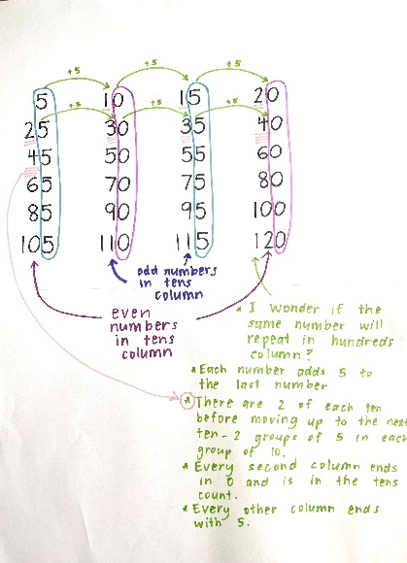

Organising and counting a collection – 30 minutes
This lesson has been adapted from Boaler et al (2021) and Counting Collections by Teacher Education by Design.
Counting collections is an instructional activity that provides a structured opportunity for students to explore methods of counting, organising, and recording a count for a collection of items. Students apply counting to a specific context, exploring and discussing the base-ten structure of the counting system to develop efficient skills in counting.
- Provide students with counting collections and a range of tools that might support counting such as sets of ten-frames, patty pans, cups, rubber bands, place value charts, grids, and number charts.
Note: Counting collections are sets of items which can be stored in snap-lock bags or boxes. The quantity of items varies in each collection to suit the counting range being explored by students. A selection of items such as natural materials, craft materials, recycled items and stationary products can be stored for regular counting routines to support ongoing counting investigations.
- Students work in pairs and select a collection to count. Students estimate how many may be in the count. Ask students:
- How many would be just a bit too high?
- How many would be just a bit too low?
- Students record the range these 2 quantities as the estimate range.
- Ask students to record what they have counted to share with others after the count.
- Students to count the items in their collection. Circulate amongst students to observe and record the strategies students use to count and organise the collection as they count. Ask questions, such as:
- Why have you decided to count your collection that way?
- How are you keeping track of what you have already counted?
- Bring students back together to discuss counting, organising, and recording strategies. Select students to share the methods used. Ask questions, such as:
- How many objects do you think are in your collection?
- Can you describe the way you arranged the items as you counted?
- How did you count your collection and why? For example, did you count by ones, groups of 5 or 10 or some other way?
- Is there a way we could look at the way you have arranged your counted items to confirm your count?
- How did you record your count?
- How does your recording help us to see the way you counted?
- Record student thinking using Resource 11: Counting collections.
- Ask students to think, pair, share and describe ways to improve the count. Ask a selection of students to share one idea with the class and add ideas to the anchor chart.
This table details assessment opportunities and differentiation ideas.
Assessment opportunities | Too hard? | Too easy?
What to look for:  - How do students keep track of their count? (MA1-RWN-02, MAO-WM-01)  - How are students organising their count? (MA1-RWN-02, MAO-WM-01)  - Are students attempting to record the count? (MA1-RWN-02, MAO-WM-01)  What to collect:  - photos of sorted objects (MA1-RWN-02, MAO-WM-01) | Students find it difficult to organise the collection and count accurately.  - Demonstrate the tools available for supporting the count and discuss how these tools could support the organisation of the count.  - Suggest students move items from one place to another when counting to support tracking the count. | Students can confidently organise their objects into consistent groups and keep track of objects counted.  - Ask students to estimate the groups of tens before they count the items.  - Students can group their items into bigger groups, like groups of 20 before they count the total amount.

Lesson 7: Ten-ness of 10
Core concept: Tens and ones are a useful way to organise groups.
The table below contains suggested learning intentions and success criteria. These are best co-constructed with students.
Learning intentions | Success criteria
Students are learning that:  - part-whole can be seen inside a ten-frame  - 10 ones can be grouped to make one 10  - the smaller parts inside larger numbers help quantify collections  - the place a digit holds in a numeral indicates the quantity it represents. | Students can:  - subitise quantities under 10 inside a ten-frame  - collect 10 ones and re-make them as one 10  - describe and compare the size of quantities under 100.

Daily number sense: Guess what – 15 minutes
This lesson is adapted from Number Sense Series: Guess What game at NRICH.
- Build student understanding of part-whole combinations to 10 by playing Guess What.
- Arrange the class into 2 teams. Team 1 selects a volunteer to arrange some magnetic counters in a displayed ten-frame that is concealed from the view of the Team 2 members. Support Team 2 to build a matching model by asking Team 1 closed questions, such as:
- Is the top row full?
- Are there 8 counters in the frame?
- Is there an empty box in the bottom row?
- Select volunteers from team 2 to adjust the counters in the ten-frame based on the information provided in the answers to questions until the models matches.
- Students work in pairs. Provide each student with 10 counters and a copy of Resource 12: Ten-frame.
- Player 1 arranges 1 to 10 counters on a 10 frame and conceals the ten-frame from Player 2.
- Player 2 asks closed questions, using yes or no responses to create an exact match of Player 1’s ten-frame arrangement.
- As players become more skilled, the number of questions can be counted and tallied. The player who requires the fewest questions to create a match is the winner.

Organising, counting, and recording a collection – 20 minutes
This lesson has been adapted from Boaler et al (2021) and Counting Collections by Teacher Education by Design.
- Provide students with counting collections and a range of tools that might support counting, such as sets of ten-frames, patty pans, cups, bowls, rubber bands, place value charts, grids, and number charts.
- Review the Resource 11: Counting collections anchor chart established in the previous lesson.
- Ask students to work with a partner and select a collection to count, using tools that could support the organisation of their count. Provide students with writing materials to record their count.
- As students work, observe the methods students use to count and record the count. Record observations of students’ counting and recording processes.
- Support students to share the counting process and make decisions around the recording of the count. Use questions to develop students’ counting strategies and capacity to work together mathematically, such as:
- Is there a way you can count together?
- How can you record this count so somebody else can see how you counted it?
- Can you describe how someone else might be able to check your count by using looking at your organisation of the count?
- Once students have finished counting and recording, gather the class and ask questions, such as:
- How did you organise the objects in your collection for counting?
- Can you describe what tools you used to help you organise your objects?
- How did you count your objects after they were organised?
- Was there a strategy you used that made it quicker or easier to count your collection?
- Did your partner agree with the final count and how did you check?
- Could someone else look at how your collection is arranged after you counted it and quickly identify the size of the collection?
- Use student feedback to investigate the ways that groups of 10 supported counting a large collection.
- Select one collection in which students have organised the items in groups of 10 and remaining ones. Alternatively, count a collection as a class, grouping sets of 10 in cups or patty pans.
- Present students with a place value chart. Ask students if they know how you could arrange the items on this place value chart. Use student responses to arrange the items on the place value chart.
- Ask a student to write a numeral above each column to indicate the relationship between digits and place value, as shown in Figure 9.
Figure 9 – Collection arranged on place value chart
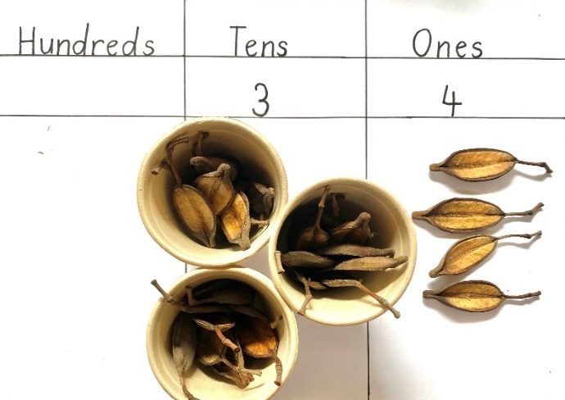
- This table details assessment opportunities and differentiation ideas.
Assessment opportunities | Too hard? | Too easy?
What to look for:  - What strategies are students using to organise and count the collection? (MA1-RWN-02, MAO-WM-01)  - How are students recording the count? (MA1-RWN-01, MAO-WM-01)  - Are students able to share ideas and strategies to problem solve together? (MAO-WM-01)  What to collect:  - recordings of student observations. | Students find it challenging to accurately count and record items in the collection.  - Demonstrate the use of tools provided to support organising the count before counting. For example, place one item on each box of a number chart to keep track of the count.  - Use number charts support numeral recording.  Students find it challenging to work together effectively on a count.  - Assist students to count in unison and move or touch items as they count.  - Suggest one person count and the second person record.  - Suggest one person count and the second person check the count. | Students quickly and accurately count the collection and record the count coherently.  - If the count is less than 100, ask students how many more there are to 100.  - If the count is more than 100, explain that another group has 65 in their count. Ask students how many more are in their count.  - Provide a larger collection for students to organise, count, and record.

Fill the stairs – 15 minutes
The game is adapted from Fill the Stairs by Math For Love.
- Provide each student with writing materials and a blank copy of Resource 13: Fill the stairs. Choose a 0-9 die to be the tens die, and another 0-9 die to be the ones die. When both dice are rolled, students will get a one-digit or two-digit number, see Figure 10.
Figure 10 – Dice forming number 73
Note: Use a place value chart and MAB blocks to review the formation of a one-digit number when the tens die rolls a 0.
- The aim of the game is to write one number on each stair in ascending order.
Note: 0-9 digital dice can be located on Dice and Spinners Interactive by NRICH.
- Roll the dice and read the number together.
- Students strategically choose a place on their staircase to write the number. Ask a few students to share where they placed this number and why.
- Repeat this process pausing every few turns, selecting a few students to share where they have chosen to write new numbers and why.
- As the game progresses, there may be some players who are unable to include a number in the remaining spaces on the staircase. This number should be discarded and written under the stairs.
- The first student to fill the staircase with correctly ascending numbers is the winner.
This table details assessment opportunities and differentiation ideas.
Assessment opportunities | Too hard? | Too easy?
What to look for:  - Are students able to accurately read and write the two-digit numbers generated by the dice? (MA1-RWN-01)  - Are students able to order two-digit numbers in ascending order accurately? (MA1-RWN-01, MAO-WM-01)  - What strategies are students using to select a stair to place each numeral? (MA1-RWN-01, MAO-WM-01)  What to collect:  - student staircase worksheet samples. (MA1-RWN-01) | Students do not accurately read and write numbers to achieve ascending order on the staircase.  - Use a place value chart or number chart to support two-digit numeral understanding.  - Use dice with fewer sides to generate numerals under 60.  - Reduce number of stairs on staircase worksheet. | Students can efficiently and accurately write numbers to achieve ascending order.  - Extend the number of stairs on the staircase worksheet and add a number to 150.  - Ask students to explain how they know that number is bigger than this one.

Consolidation and meaningful practice: What is the number? – 15 minutes
This lesson is adapted from ‘What is the number?’ in Dacey et al (2015).
- Students work in pairs. Provide each pair with a set of Resource 14: Loop cards.
- Students deal the cards evenly between one another. Player 1 selects a card to place down.
- Player 2 reads the question appearing at the bottom of the card placed down to see if they have the card that answers the question.
Note: The answer should be at the top of the card.
- If the player does not have the card, play returns to Player 1. Repeat this cycle. The first player to lay down all their cards wins. The final card should loop back to the first card played.

Lesson 8: Quantifying Collections
Core concept: Large collections can be quantified, organised, and represented in different ways.
The table below contains suggested learning intentions and success criteria. These are best co-constructed with students.
Learning intentions | Success criteria
Students are learning that:  - the digits in numerals represent quantities based on groupings of 10  - numbers can be ordered by ascending and descending quantities  - quantities can be organised to clearly identify the smaller parts in the whole  - numbers can be ordered according to their comparative quantities. | Students can:  - order two-digit numbers in ascending or descending order  - identify and apply efficient methods for counting larger quantities  - use familiar structures to represent and name a large collection of objects  - work with place value units and view numbers as counts of these units rather than collections of ones  - make and record two-digit numbers using equipment, symbols, pictures, and words.

Daily number sense: Fill the stairs – 15 minutes
The lesson is adapted from Fill the Stairs by Math For Love.
- Build student understanding of how to order two-digit numbers in ascending order by playing Fill the stairs.
- Students work in pairs. Provide each student with 2 × 0-9 dice, writing materials, and a blank copy of Resource 13: Fill the stairs.
- Review the aim of the game as well as the strategies required to successfully achieve the goal of the game, which is to write the numbers generated by the dice in ascending order on the staircase.
- Students play the game in pairs. As the students play, circulate amongst the students to observe the strategies students are using to choose the position of each new number. Ask questions to encourage students to explain their reasoning, such as:
- Tell me why you chose to write that number on that step?
- What number are you hoping might be rolled next? Why?
- Are there any choices you wish you made differently now? Why?

Flip and match – 15 minutes
- Provide each student with MAB blocks and/or craft sticks bundled in groups of 10 as well as loose single craft sticks. Provide each child with a copy of Resource 10: Place value chart.
- Divide the class into 2 teams. Students use MAB blocks or craft sticks to model a two-digit number on their individual place value chart. Select a few students and ask what number they have modelled on their chart. Observe students’ models and the quantity they name.
- Use 2 sets of Resource 15: 0-9 numeral cards and place them face down. Flip over one numeral for the tens column and one numeral for the ones column. Place them on a place value chart on display.
- Read the numeral together. Ask students if anyone has a model on their chart which is the exact match of the numeral on the board. If anyone does have an exact match, they score 10 points for their team.
- Ask students if anyone has a match one more or one less. These students score 5 points for their team.
- Ask students if anyone has a match 2 more or 2 less. These students score 2 points for their team.
- Students model a new number and repeat the process of creating a numeral and scoring points several times.
- Introduce the third column for the final round and allow a team representative to model a three-digit number on the place value chart on behalf of their team.
- Use 3 sets of 0-9 numeral cards to flip over 3 numerals to create a three-digit numeral on the displayed place value chart.
- The team with the numeral closest to the three-digit numeral gains a bonus 10 points for their team. Ask students to work in pairs to work out how many more or less their team quantity is than the numeral on display.
- Ask students to share possible answers. Use ‘Talk moves’ to support explanations of thinking and reasoning until each team agrees on an accurate total.
- The team with the most points wins.
This table details assessment opportunities and differentiation ideas.
Assessment opportunities | Too hard? | Too easy?
What to look for:  - Are students able to model two-digit quantities? (MA1-RWN-01, MAO-WM-01)  - Are students able to recognise and say the quantity modelled with MAB blocks on a place value chart? (MA1-RWN-01, MAO-WM-01)  - Are students able to identify a quantity one or 2 more or less than a two-digit number? (MA1-RWN-01, MAO-WM-01)  - What strategies do students use to work out how much more or less a quantity is than a given number? (MA1-RWN-01, MA1-CSQ-01, MAO-WM-01) | Students find it difficult to read and/or model two-digit numerals.  - Create a sample model first and explain what each part of the model represents in a two-digit numeral, before allowing the student to create their own.  - Provide students with their own set of numeral cards to directly label their own model with the digits that match the model for each column.  - Use a number chart to support reading and grouping of tens for two-digit numerals. | Students readily create, read, and compare two-digit numerals.  - Select 2 random models and ask the students which of the 2 models is closest to the displayed numeral on the board.  - Use a third digit for the hundreds column after each round and ask students to read the numeral created.

On and off the train – 15 minutes
This activity is adapted from On and Off the Train by NZ Maths.
- Show students 3 ten-frames sitting end to end and explain that the frames represent a train.
- Place various quantities of counters in the ten-frames, similar to Figure 11.
Figure 11 – Ten-frame train with counters
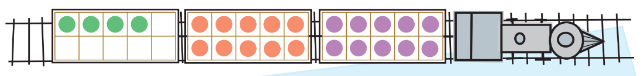
- Explain that the counters represent people and ask how many people are on the train.
- Explain that the story will describe people moving on and off the train at different stops on their way to Paekakariki. Ask students to consider how this model of counters in ten-frames could help them to keep track of how many people are on the train at different times throughout the story. Use student responses to develop a shared understanding of how to use a model to show mathematical thinking.
Note: The names of towns in the story could be adapted to suit the local geographical context.
- Use Resource 16: Train questions to read the story. Read the first step in the story and allow students time to set up their counters on the ten-frames.
- Observe students’ work for assessment data, as students apply strategies to modelling the story.
- Pause after steps one, 2 and 3 and provide students time to model each part of the story before inviting students to share how many people they think were left on the train. Use ‘Talk moves’ to share the ways students came to an answer.
- Compare ways of working mathematically by asking students questions, such as:
- Where did you remove the counters to model the people getting on and off the train?
- Did anyone else arrange their counters differently to model the same thing? Why?
- How many people are in the last carriage?
- Does anyone have a different arrangement?
- How do you check that what you have worked out is accurate?
- Ask students to suggest a number sentence that explains what students have modelled. Record suggestions on the board and re-read the story step to make connections with the number sentences suggested, to establish which number sentence is most accurate.
- Read the final step in the story. Discuss the question and ask students model the story to answer the question.
- Select a few students to share the way they modelled and discuss methods used and suggested answers using ‘Talk moves’.
This table details assessment opportunities and differentiation ideas.
Assessment opportunities | Too hard? | Too easy?
What to look for:  - Are students able to model the steps in the story to establish an answer to a part-whole question? (MAO-WM-01, MA1-CSQ-01)  - Are students able to model the steps in the story to establish a question where the total is known but one part is unknown? (MAO-WM-01, MA1-CSQ-01)  - Are students able to determine the number sentence that reflects a word problem? (MAO-WM-01, MA1-CSQ-01)  What to collect:  - Record of observations of student work (MAO-WM-01, MA1-CSQ-01) | Students find it challenging to follow the word problem and accurately model the story with counters.  - Read the story steps in smaller chunks and highlight the verbs to support student understanding of the action in the story, before linking this action to the movement of the counters.  - Use different coloured counters to model the parts for each story.  - Use questions to ensure comprehension of the story. For example, you could ask how many people got off the train. | Students readily comprehend the story and accurately predict the answer without modelling.  - Ask students to explain how they worked out the answer in their head and show the process of thinking with the modelled counters.  - Adapt the story to include larger quantities in each story step and allow students to model with MAB blocks.

Consolidation and meaningful practice: Race to 120 – 15 minutes
- Students work in pairs. Provide each pair a 6-sided die, MAB blocks and Resource 10: Place value chart.
- Players take turns rolling the die and creating the quantity rolled using MAB blocks. Students place MAB blocks on their place value chart.
- On each new roll, players add the quantity to the previous total, re-making the new total by grouping 10 shorts and replacing these with one long. Students position the growing number of MAB blocks in the correct columns on the place value chart.
- Players continue adding and trading until they have enough longs to trade for a 100-block flat in the hundreds column. The first player to reach 120 is the winner.
- Circulate the room and ask students questions, such as:
- How many do you have modelled on your chart?
- How many do you hope you will roll next? Why?
- How many does your partner need to win?
This table details assessment opportunities and differentiation ideas.
Assessment opportunities | Too hard? | Too easy?
What to look for:  - Are students able to recognise groups of ten and re-make groups of 10 ones with a long and a group of 10 longs with a flat? (MA1-RWN-02, MA1-CSQ-01)  - Are students able to recognise and name a quantity and the parts that comprise it, based on an MAB block representation? (MA1-RWN-02, MA1-CSQ-01) | Students are not able to explain and manipulate quantities of MAB blocks to represent quantities.  - Provide each student with a ten-frame to place inside the ones column and fill to support recognition of a group of 10.  - Use single-digit numeral cards to label quantities in each column to support understanding of two-digit numbers.  - Reduce the quantity the students are aiming for. | Students confidently and quickly add and represent quantities with MAB blocks on place value chart.  - Provide students with 2 dice to roll for each turn and increase the amount they are aiming for.  - Ask students to begin with 120, modelled with a flat and 2 longs, and subtract the quantity rolled to model each new total, until they reach zero.

Resource 1: Mathematics around us
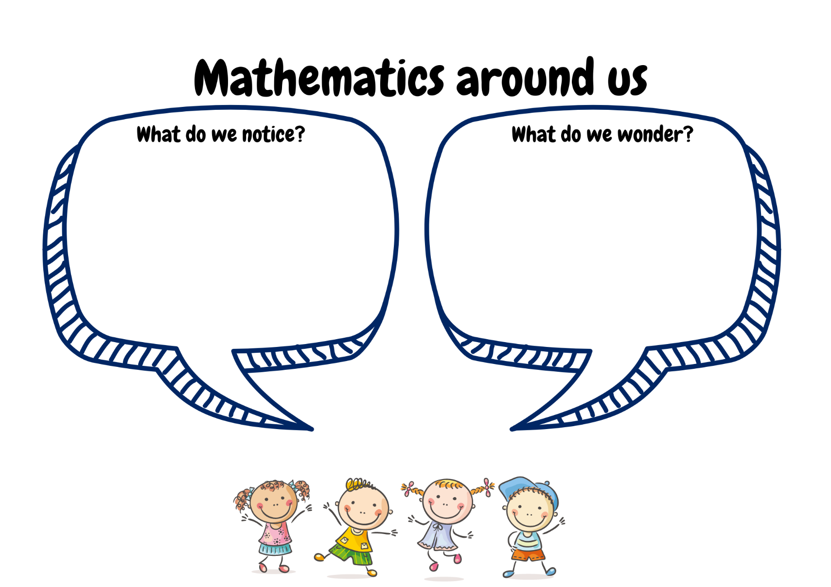
Images sourced from Canva and used in accordance with the Canva Pro Content Licence.

Resource 2: Be a mathematician
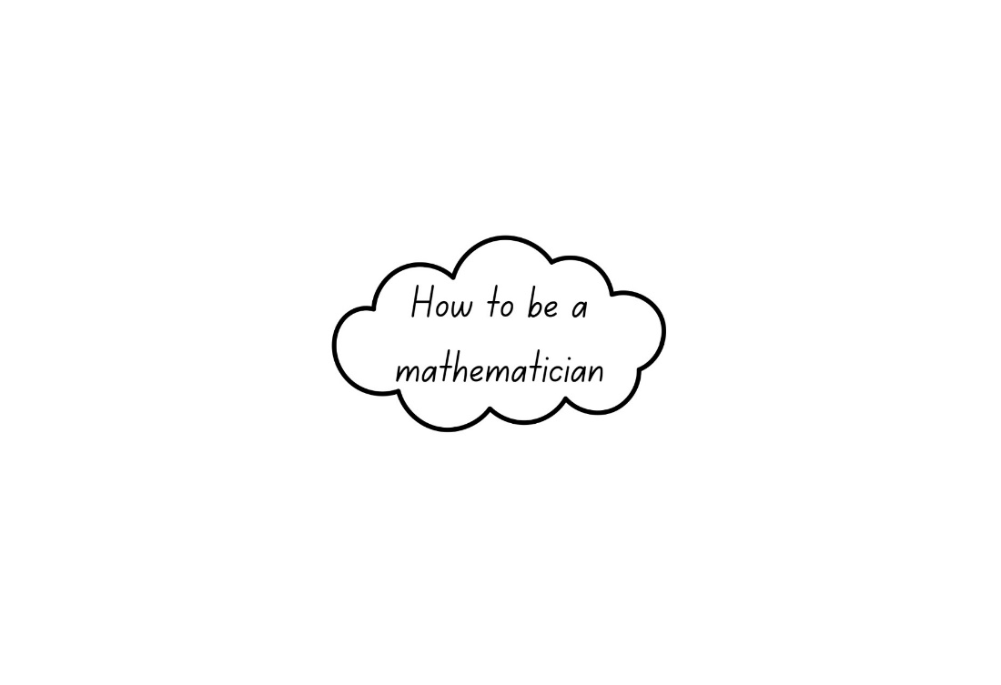

Resource 3: Dice patterns
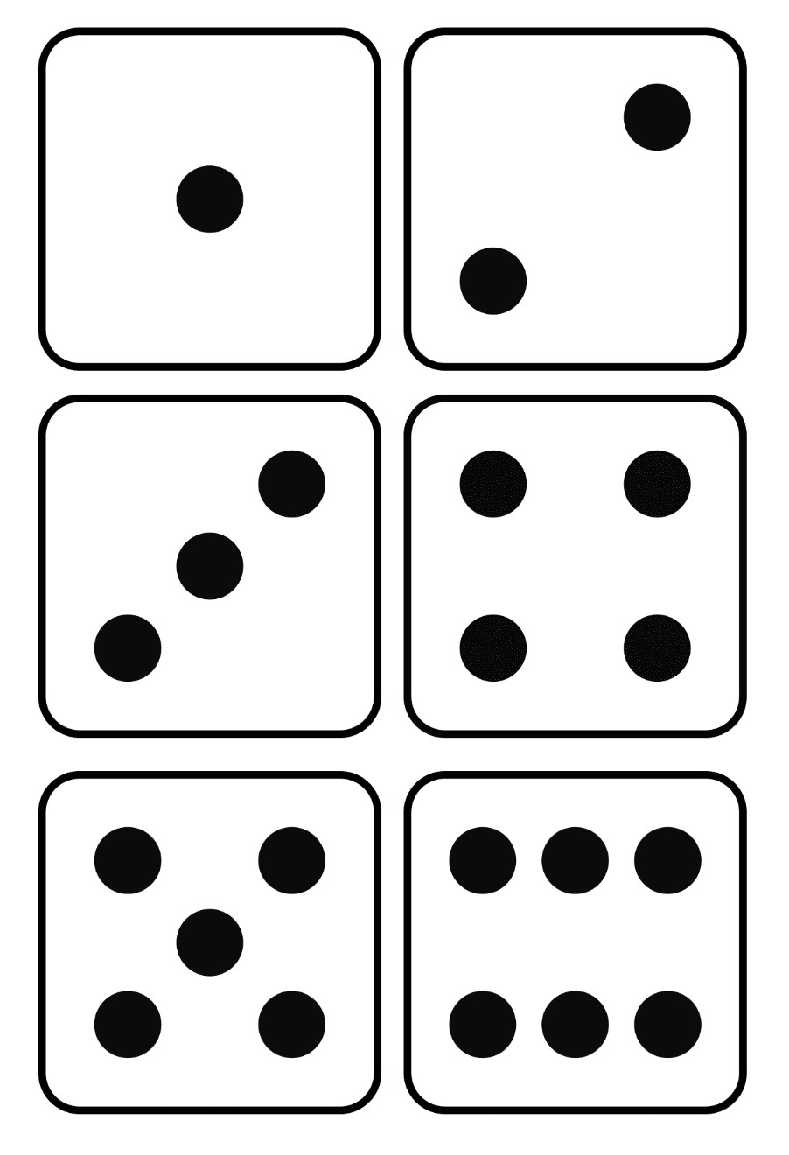

Resource 4: Triangle design shapes
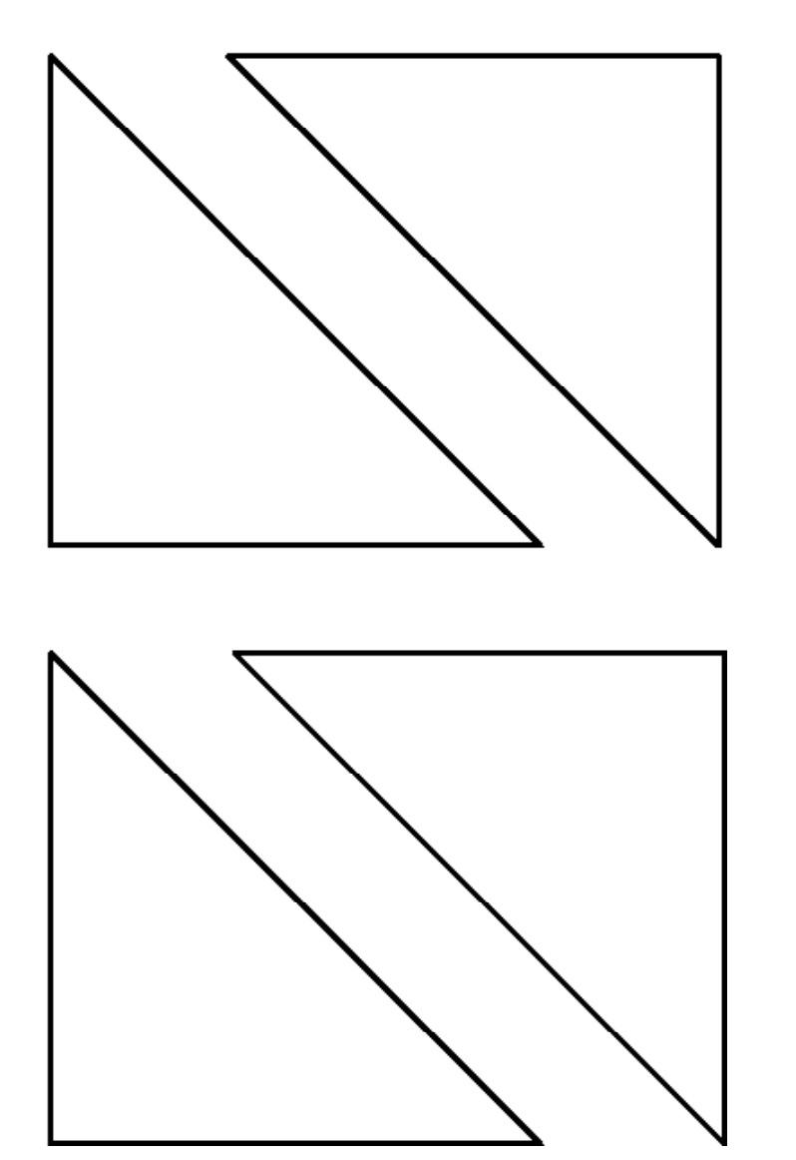
‘Triangle Designs (K-2)’ by youcubed, Stanford University is licensed under CC BY 4.0

Resource 5: Number cards
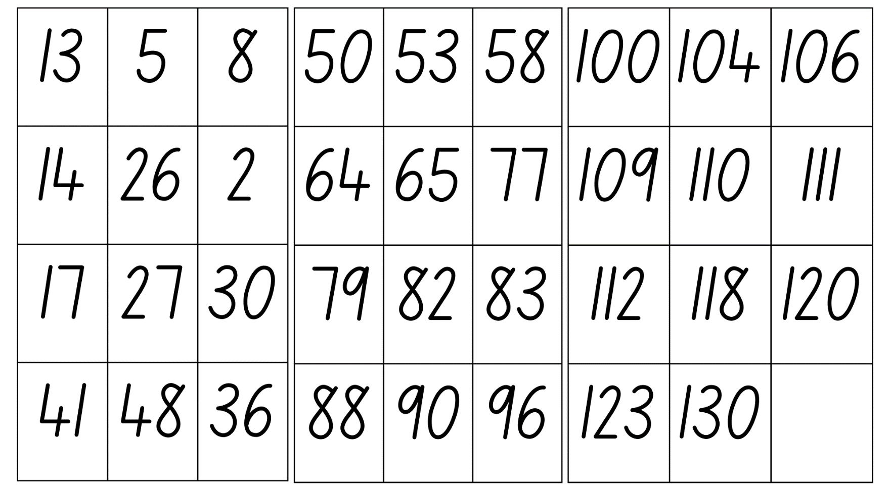

Resource 6: Which one doesn't belong?
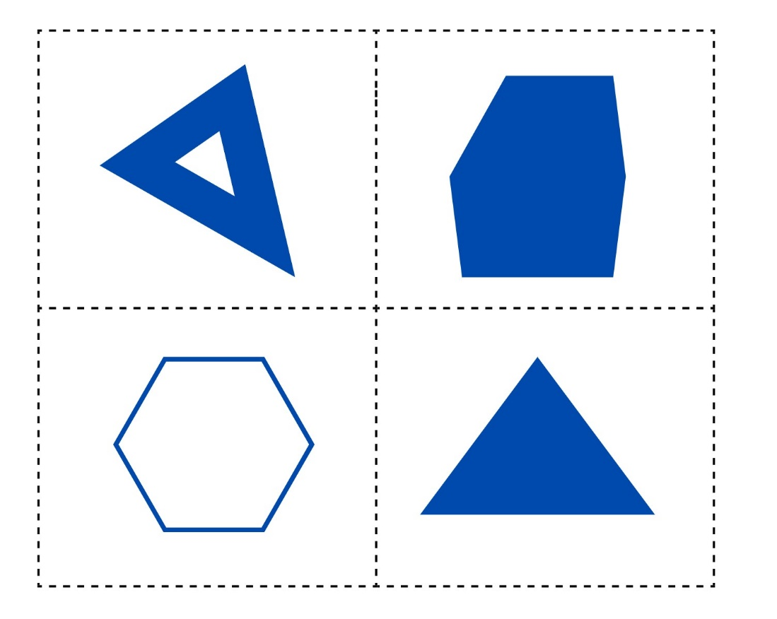

Resource 7: Shape attribute sort
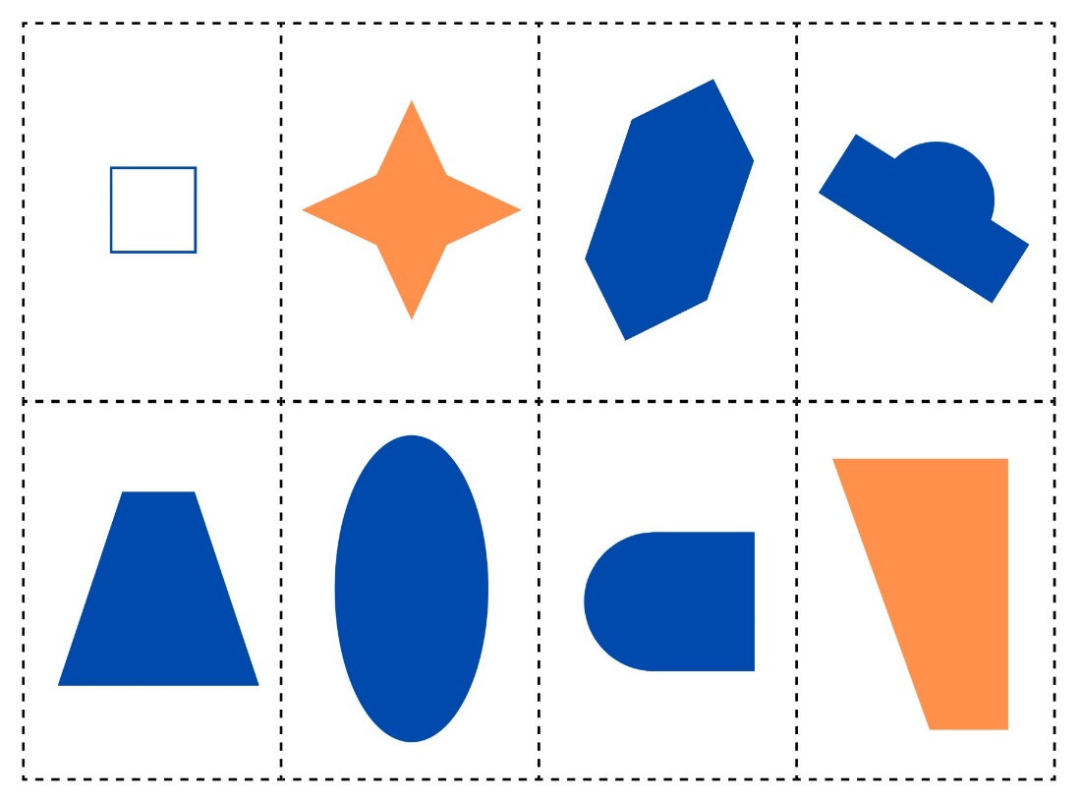

Resource 8: Venn diagram
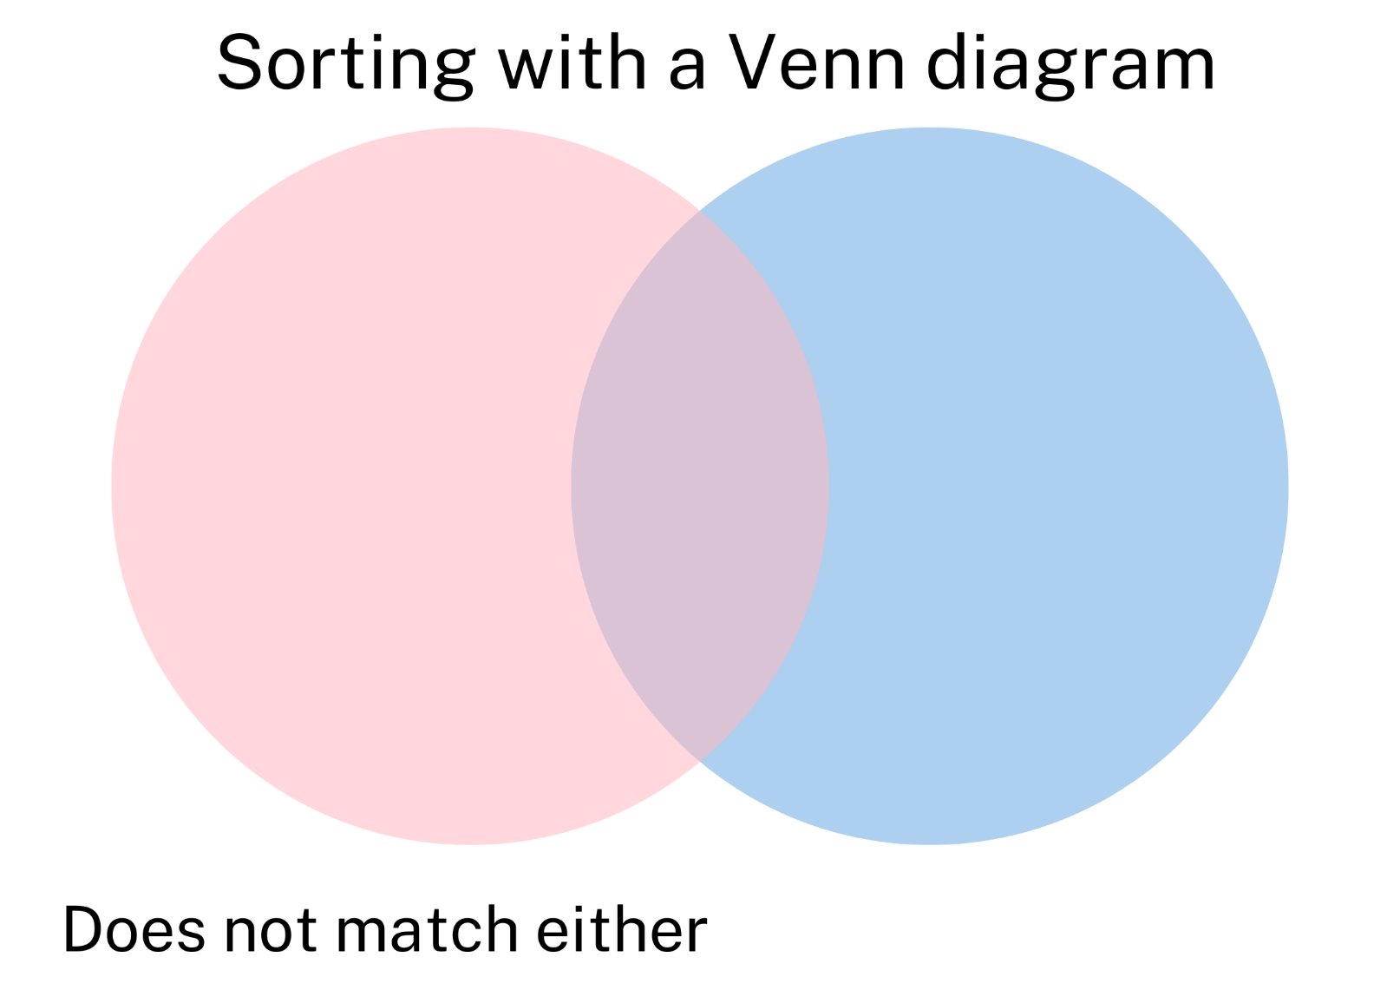

Resource 9: Number attribute labels
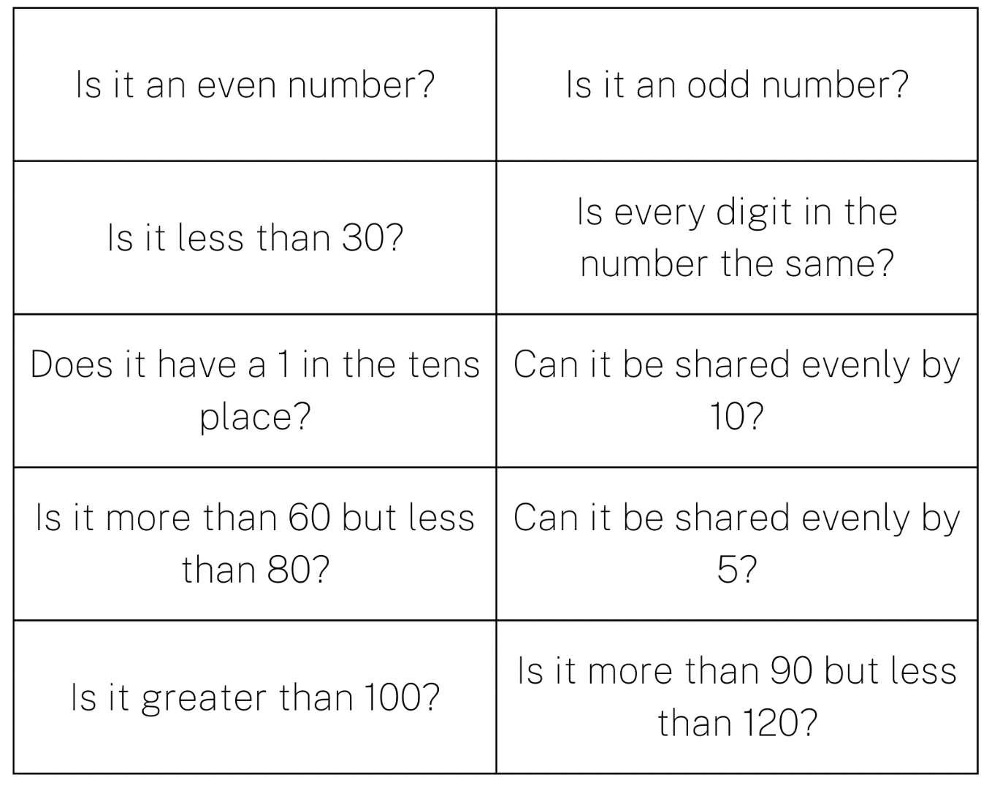

Resource 10: Place value chart
Hundreds | Tens | Ones

Resource 11: Counting collections
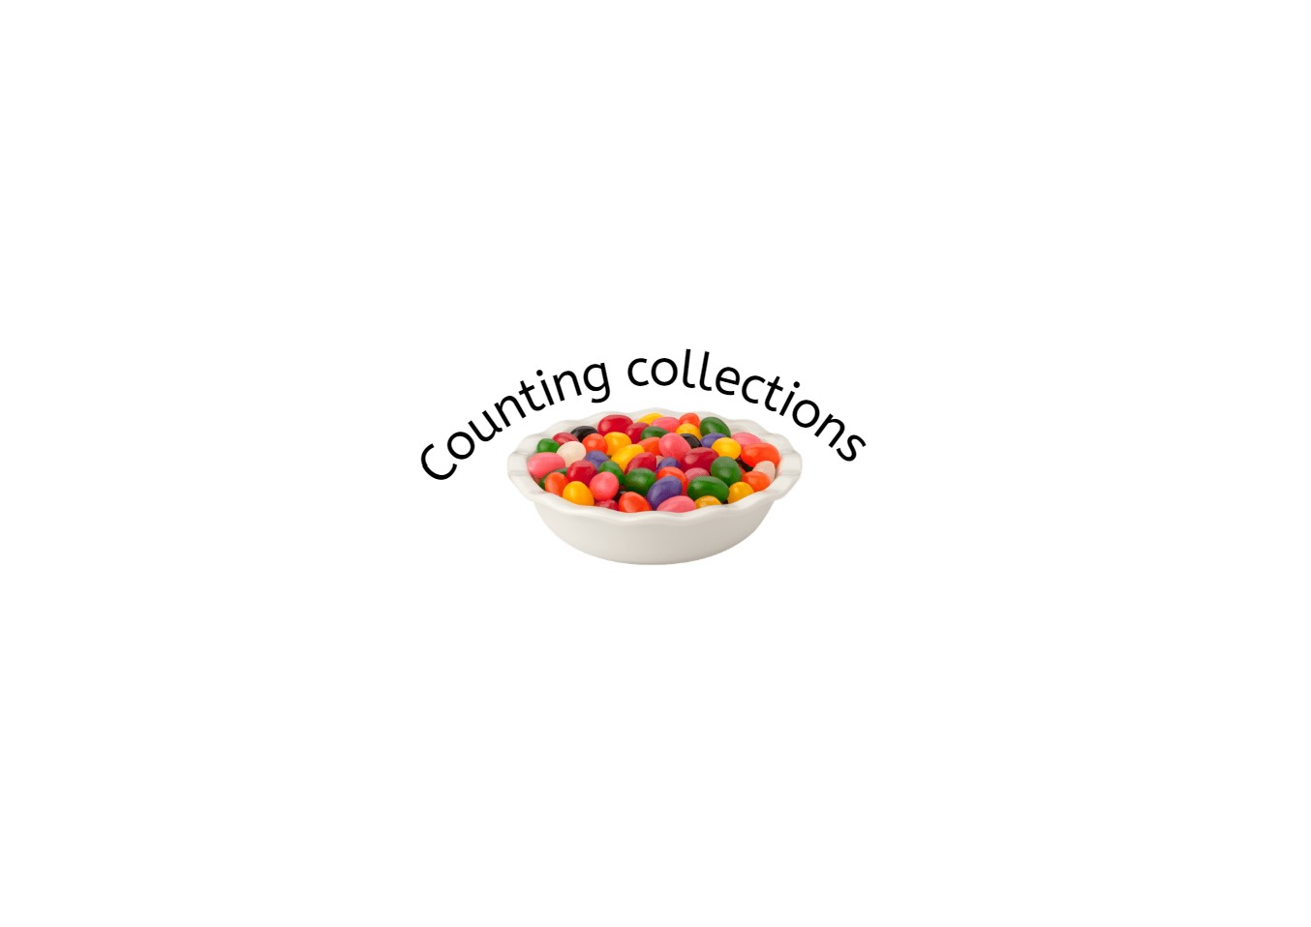
Image sourced from Canva and used in accordance with the Canva Content Licence Agremeent.

Resource 12: Ten-frame

Resource 13: Fill the stairs
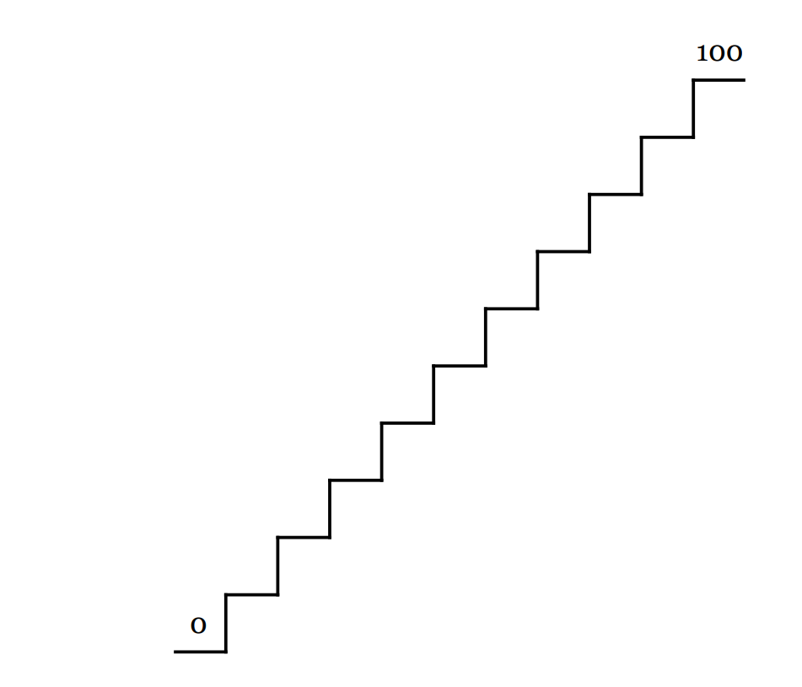

Resource 14: Loop cards
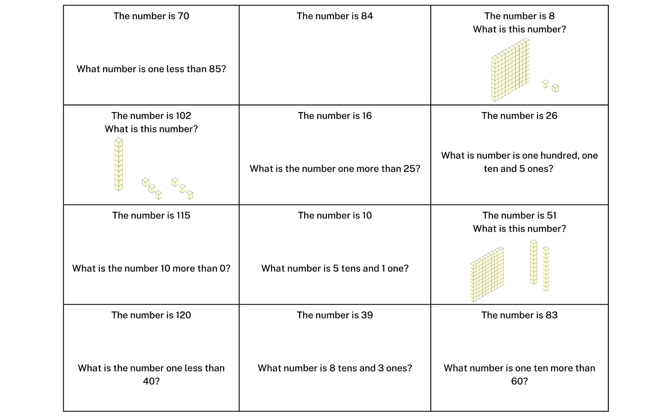
Images sourced from Canva and used in accordance with the Canva Content Licence Agreement.

Resource 15: 0-9 numeral cards
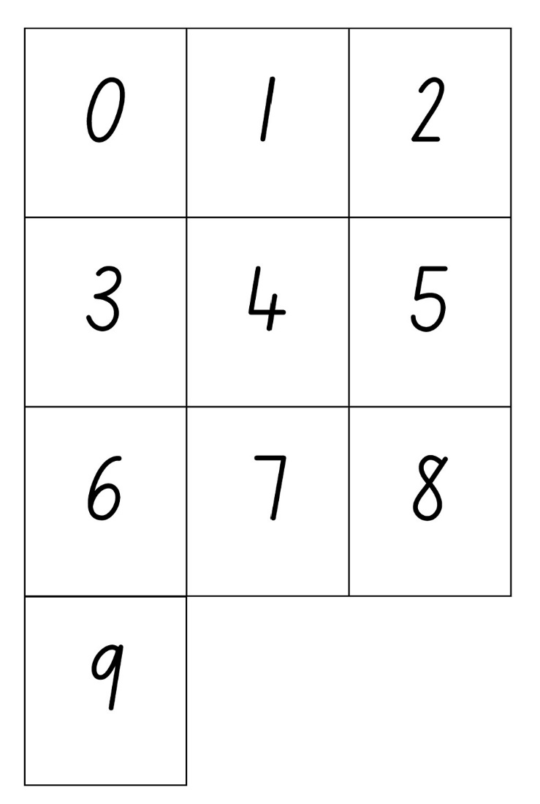

Resource 16: Train questions
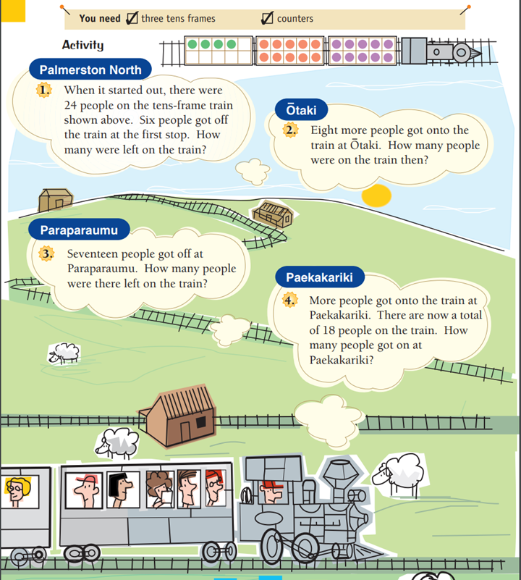
Adapted from NZ Maths.
Transcript:
You need three ten-frames and some counters.
- Palmerston North: When it started out, there were 24 people on the ten-frame train. Six people got off the train at the first stop. How many were left on the train?
- Ōtaki: Eight more people got onto the train at Ōtaki. How many people were on the train then?
- Paraparaumu: Seventeen people got off at Paraparaumu. How many people were there left on the train?
- Paekakariki: More people got onto the train at Paekakariki. There is now a total of 18 people on the train. How many people got on at Paekakariki?

Syllabus outcomes and content
The table below outlines the syllabus outcomes and range of relevant syllabus content covered in this unit. Content is linked to National Numeracy Learning Progression version (3).
Focus area and outcomes | Content groups and content points | Lessons
Representing whole numbers A  MAO-WM-01  MA1-RWN-01  MA1-RWN-02 | Use counting sequences of ones with two-digit numbers and beyond  - count forwards and backwards by ones from a given number to at least 120 (CPr6)  Continue and create number patterns  - model and describe 'odd' and 'even' numbers using items paired in two rows  - count forwards and backwards by twos from any starting point (CPr6-CPr7, MuS2)  Represent numbers on a line  - uses knowledge of place value to order numerals within the range of 0 to at least 100 (NPV4)  - sequence numbers and arrange them on a line by considering the order and size of those numbers (CPr5)  Represent the structure of groups of ten in whole numbers  - recognise that ten ones is the same as one ten (NPV2, NPV4)  - count large sets of objects by systematically grouping in tens (CPr7)  - partition two-digit numbers to show quantity values (NPV4)  - estimate, to the nearest ten, the number of objects in a collection and check by counting in groups of ten (NPV6, CPr7) | 1, 2, 5–8
Representing whole numbers B  MAO-WM-01  MA1-RWN-01  MA1-RWN-02 | Use counting sequences of ones and tens flexibly  - identify the number before and after a given three-digit number (CPr6)  - count forwards and backwards by tens, on and off the decade, with two- and three-digit numbers (CPr7)  - identify how many more to the next multiple of ten within two- and three-digit numbers (CPr7, AdS7)  Form, regroup and rename three-digit numbers  - count and represent large sets of objects by systematically grouping in tens and hundreds (CPr7, NPV5)  - use models such as base 10 material and interlocking cubes to represent and explain grouping (CPR7)  - state the quantity value of digits in numbers of up to three digits (NPV5)  - use place value to partition and rename three-digit numbers in different ways (NPV5) | 1, 5–8
Combining and separating quantities A  MAO-WM-01  MA1-CSQ-01  MA1-CSQ-02 | Use advance count-by-one strategies to solve addition and subtraction problems  - record number sentences in a variety of ways using drawings, words, numerals and symbols (AdS6)  Recognise and recall number bonds up to ten  - recognise, recall and record combinations of two numbers that add up or bond to form 10 (AdS2, AdS6)  - model and record patterns for individual numbers up to ten by making all possible whole-number combinations  Use flexible strategies to solve addition and subtraction problems  - use non-count-by-one strategies such as using doubles or near doubles and combining numbers that add to ten (AdS6)  Represent equality  - recall related addition and subtraction facts for numbers to at least 10 (AdS6) | 2, 6–8
Combining and separating quantities B  MAO-WM-01  MA1-CSQ-01  MA1-CSQ-02 | Represent and reason about additive relations  - create, record and recognise combinations of two numbers that add to numbers from 11 up to and including 20 (AdS7)  Use knowledge of equality to solve related problems  - use number knowledge to solve related problems (AdS7, NPA4)  Form multiples of ten when adding and subtracting two-digit numbers  - add two-digit numbers by building to multiples of ten (AdS7) | 2, 6–8
Two-dimensional spatial structure A  MAO-WM-01  MA1-2DS-01  MA1-2DS-02 | Recognise and classify shapes using obvious features  - explore, manipulate and describe features of polygons (UGP3)  - use the terms ‘side’, ‘vertex’ and ‘two-dimensional’ to describe plane (flat) shapes (UGP1-UGP2)  - compare, sort and classify polygons according to the number of sides or vertices (UGP3-UGP4)  - recognise that shapes with the same name may have sides of equal or different lengths  - identify shapes presented in different orientations (UGP2) | 3 and 4
Two-dimensional spatial structure B  MAO-WM-01  MA1-2DS-01  MA1-2DS-02 | Represent, combine and separate two-dimensional shapes  - make representations of two-dimensional shapes and combinations of shapes in different orientations  - combine and split single shapes and arrangements of shapes to form new shapes | 3
Data A  MAO-WM-01  MA1-DATA-01  MA1-DATA-02 | Ask questions and gather data  - gather data and track what has been counted by using concrete materials, tally marks, lists or symbols (IRD3)  Represent data with objects and drawings and describe the displays  - use concrete materials or pictures of objects as symbols to create data displays where one object or picture represents one data value (IRD2)  - describe information presented in one-to-one data displays (IRD2) | 1, 3–5
Data B  MAO-WM-01  MA1-DATA-01  MA1-DATA-02 | Identify a question of interest and gather relevant data  - sort data into relevant categories (IRD2)  Create displays of data and interpret them  - organise collected data into lists and tables to display information (IRD1)  - interpret information presented in tables and picture graphs (Reasons about relations) (IRD3) | 1, 4 and 5

References
Links to third-party material and websites
Please note that the provided (reading/viewing material/list/links/texts) are a suggestion only and implies no endorsement, by the New South Wales Department of Education, of any author, publisher, or book title. School principals and teachers are best placed to assess the suitability of resources that would complement the curriculum and reflect the needs and interests of their students.
If you use the links provided in this document to access a third-party's website, you acknowledge that the terms of use, including licence terms set out on the third-party's website apply to the use which may be made of the materials on that third-party website or where permitted by the Copyright Act 1968 (Cth). The department accepts no responsibility for content on third-party websites.
Except as otherwise noted, all material is © State of New South Wales (Department of Education), 2023 and licensed under the Creative Commons Attribution 4.0 International License. All other material (third-party material) is used with permission or under licence. Where the copyright owner of third-party material has not licensed their material under a Creative Commons or similar licence, you should contact them directly for permission to reuse their material.
Mathematics K–10 Syllabus © 2022 NSW Education Standards Authority (NESA) for and on behalf of the Crown in right of the State of New South Wales.
© 2022 NSW Education Standards Authority. This document contains NSW Curriculum and syllabus content. The NSW Curriculum is developed by the NSW Education Standards Authority. This content is prepared by NESA for and on behalf of the Crown in right of the State of New South Wales. The material is protected by Crown copyright.
Please refer to the NESA Copyright Disclaimer for more information.
NESA holds the only official and up-to-date versions of the NSW Curriculum and syllabus documents. Please visit the NSW Education Standards Authority (NESA) website and the NSW Curriculum website.
National Numeracy Learning Progression © Australian Curriculum, Assessment and Reporting Authority (ACARA) 2010 to present, unless otherwise indicated. This material was downloaded from the Australian Curriculum website (National Numeracy Learning Progression) (accessed 23 January 2023) and was not modified. The material is licensed under CC BY 4.0. Version updates are tracked in the ‘Curriculum version history’ section on the 'About the Australian Curriculum' page of the Australian Curriculum website.
ACARA does not endorse any product that uses the Australian Curriculum or make any representations as to the quality of such products. Any product that uses material published on this website should not be taken to be affiliated with ACARA or have the sponsorship or approval of ACARA. It is up to each person to make their own assessment of the product, taking into account matters including, but not limited to, the version number and the degree to which the materials align with the content descriptions and achievement standards (where relevant). Where there is a claim of alignment, it is important to check that the materials align with the content descriptions and achievement standards (endorsed by all education Ministers), not the elaborations (examples provided by ACARA).
This resource contains images and content obtained from Canva, and their use outside of this resource is subject to Canva’s Content License Agreement. If you wish to use them separately from the resource, please go to Canva.
Boaler J, Munson M & Williams C (2021) Mindset Mathematics: Visualising and Investigating Big Ideas, Grade 1, John Wiley and Sons Inc, US.
Dacey L, Gartland K and Bamford Lynch J (2016) Well Played, Building Mathematical Thinking Through Number Games and Puzzles Grades K-2, Stenhouse Publishers, Portsmouth, NH.
Fletcher G (3 September 2017) Popping balloons (Act-1), GFletchy, Vimeo, accessed 26 September 2022.
Franke ML, Kazemi E & Chan Turrou A (2018) Choral Counting and Counting Collections: Transforming the PreK-5 Math Classroom, Stenhouse Publishers, Portsmouth, NH.
Math For Love (2019) ‘Fill the Stairs’, Lessons, Math for Love website, accessed 26 September 2022.
New Zealand Ministry of Education (n.d.) ‘On and Off the Train’, Resource Finder, nzmaths website, accessed 26 September 2022.
Piet Mondrian (1942-43) Broadway Boogie Woogie [Oil on canvas], MoMA website, MoMA, Manhattan © Piet Mondrian, courtesy: MoMA, accessed 26 September 2022.
Stanford University (n.d) ‘Race to One Hundred’, Tasks, youcubed website, accessed 26 September 2022.
Stanford University (n.d) ‘Triangle Designs (K-2)’, WIM Resources, youcubed website, accessed 26 September 2022.
Teacher Education by Design, University of Washington (2014) Choral Counting, Teacher Education by Design website, accessed 26 September 2022.
Teacher Education by Design, University of Washington (2014) Counting Collections, Teacher Education by Design website, accessed 26 September 2022.
University of Cambridge (Faculty of Mathematics) (n.d) Data Shapes, NRICH website, accessed 26 September 2022.
University of Cambridge (Faculty of Mathematics) (n.d) Dice & Spinners Interactive, NRICH website, accessed 26 September 2022.
University of Cambridge (Faculty of Mathematics) (n.d) Number Sense Series: A Sense of ‘ten’ and Place Value, NRICH website, accessed 26 September 2022.

