Mathematics – Stage 1 – Unit 9
Contents
Unit description and duration 4
Student prior learning 5
Lesson overview and resources 6
Lesson 1: Symbols can be used to tell a mathematical story 13
Daily number sense: Counting with understanding – 15 minutes 13
Symbol sort – 10 minutes 14
Mathematical story – 15 minutes 15
Problematise – 20 minutes 17
Discuss and connect the mathematics – 10 minutes 19
Lesson 2: Plus, minus, and equal symbols 20
Daily number sense: Number counting – 10 minutes 20
Let's meet some symbols – 40 minutes 21
Discuss and connect the mathematics – 10 minutes 24
Lesson 3: Commutative property 27
Consolidation and meaningful practice: Showing the Story – 10 minutes 27
Number story addition – 20 minutes 28
Subtraction story – 20 minutes 30
Discuss and connect the mathematics – 10 minutes 31
Lesson 4: Part-part-whole 33
Daily number sense: Dot card talk – 10 minutes 34
Consolidation and meaningful practice: Equivalence – 10 minutes 36
Frogs and turtles: How many of each? – 30 minutes 37
Discuss and connect the mathematics – 10 minutes 38
Lesson 5: Equivalence 40
Daily number sense: Balancing numbers – 10 minutes 40
Modifying the problem – 20 minutes 41
Further our understanding with other problems and look for patterns – 20 minutes 42
Discuss and connect the mathematics – 10 minutes 43
Lesson 6: Finding the missing part of the mathematical story 45
Daily number sense: Splat! – 10 minutes 45
Consolidation and meaningful practice: Sarah’s blocks – 10 minutes 45
How can we work out the changes? – 40 minutes 46
Discuss and connect the mathematics – 10 minutes 51
Lesson 7: Uncovering related facts 53
Daily number sense: What’s the same? What’s different? – 10 minutes 53
Consolidation and meaningful practice: Array problems – 40 minutes 54
Discuss and connect the mathematics – 10 minutes 56
Lesson 8: Related number facts can help us uncover missing information 58
Daily number sense: Choose a Splat! – 10 minutes 58
Monkeys in the trees! – 40 minutes 59
Discuss and connect the mathematics – 20 minutes 63
Resource 1: Familiar and unfamiliar symbols 66
Resource 2: +, − and = cards 73
Resource 3: Dot cards 6 and 9 74
Resource 4: Commutative stories 76
Resource 5: Dot talk 77
Resource 6: Dots in array 78
Resource 7: Array problems 79
Resource 8: Thinking bubbles 80
Resource 9: Mathematical stories for students to solve 81
Syllabus outcomes and content 82
References 87
Further reading 90

Unit description and duration
This two-week unit develops student knowledge, understanding, and skills of combining and separating quantities. Students are provided opportunities to:
- represent combining situations in different ways through the use of gesture, enactment, drawings, numbers, and words
- use symbols to describe mathematical quantities, actions, and relationships in efficient ways
- understand that the order in which 2 quantities are combined does not change the result
- recognise that when 2 collections have the same total, they are described as ‘equivalent in value’. Words such as ‘equal’, ‘equivalent’, and ‘is the same as’ can also be used
- use different strategies, such as counting on and counting back, to work out the total when combining and separating quantities
- record equations (number sentences) in different ways using drawings, words, numerals, and symbols
- model the inverse relation between addition and subtraction using concrete materials and drawings
- use knowledge of related facts (number bonds) to determine a missing quantity
- understand that repeated addition involves the structure of equal groups; for example, 2 + 2 + 2 is equivalent in value to 3 twos
- use mathematical tools, such as an equal-arm balance, to determine if the mass of a collection is equivalent.
Mathematics K–10 Syllabus © 2022 NSW Education Standards Authority (NESA) for and on behalf of the Crown in right of the State of New South Wales.

Student prior learning
Before engaging in these teaching and learning activities, students would benefit from prior experience with:
- counting and subitising small collections to find a total
- describing the actions of combining, separating, and comparing
- modelling and recognising combinations for numbers up to 10
- using drawings, words, and numbers to record their thinking
- hefting with everyday objects.

Lesson overview and resources
The table below outlines the sequence and approximate timing of lessons; syllabus focus areas and content groups; and resources.
Lesson | Syllabus focus area and content groups | Resources
Lesson 1: Symbols can be used to tell a mathematical story  70 minutes  A mathematical story can be told using symbols. | Representing whole numbers A  - Use counting sequences of ones with two-digit numbers and beyond  Combining and separating quantities A  - Use advanced count-by-one strategies to solve addition and subtraction problems  - Use flexible strategies to solve addition and subtraction problems  Forming groups A  - Count in multiples using rhythmic and skip counting | - Resource 1: Familiar and unfamiliar symbols  - Video: Counting with understanding up to 100 (16:31)  - Counters  - Writing materials
Lesson 2: Plus, minus and equal symbols  60 minutes  Mathematical symbols are universal and can describe quantities, actions, and relationships. | Representing whole numbers A  - Continue and create number patterns  - Represent numbers on a line  Combining and separating quantities A  - Use advanced count-by-one strategies to solve addition and subtraction problems  - Represent equality  Non-spatial measure A  - Mass: Investigate mass using an equal-arm balance  Non-spatial measure B  - Mass: Compare the masses of objects using an equal-arm balance | - Resource 2: +, − and = cards  - Concrete materials to strengthen counting with understanding  - Counters (different colours), MABs, and craft sticks  - Equal-arm balance  - Interlocking cubes or weights  - Writing materials
Lesson 3: Commutative property  60 minutes  Commutative property – the order in which quantities are combined does not change the result. | Combining and separating quantities A  - Use advanced count-by-one strategies to solve addition and subtraction problems  - Use flexible strategies to solve addition and subtraction problems  - Represent equality  Combining and separating quantities B  - Represent and reason about additive relations  - Use knowledge of equality to solve related problems | - Resource 3: Dot cards 6 and 9  - Resource 4: Commutative stories  - Concrete materials to strengthen counting with understanding  - Counters in different colours  - Writing materials
Lesson 4: Part-part-whole  60 minutes  A quantity is made up of smaller parts that in turn can form part of a larger quantity. | Combining and separating quantities A  - Use advanced count-by-one strategies to solve addition and subtraction problems  - Use flexible strategies to solve addition and subtraction problems  Combining and separating quantities B  - Represent and reason about additive relations  - Use knowledge of equality to solve related problems  Forming groups A  - Count in multiples using rhythmic and skip counting  - Model and use equal groups of objects to represent multiplication  Non-spatial measure A  - Mass: Investigate mass using an equal-arm balance | - Resource 5: Dot talk  - Concrete materials to strengthen counting with understanding  - Different coloured counters  - Equal-arm balance  - Interlocking cubes or weights  - Writing materials
Lesson 5: Equivalence  60 minutes  Compensation is a change that can return equivalence to an equation. | Combining and separating quantities A  - Represent equality  Combining and separating quantities B  - Represent and reason about additive relations  Non-spatial measure A  - Mass: Investigate mass using an equal-arm balance  Non-spatial measure B  - Mass: Compare the masses of objects using an equal-arm balance | - Resource 4: Commutative stories  - Video: Balancing numbers 3: part 1-3 (3:25)  - A5 paper  - Concrete materials to strengthen counting with understanding  - Counters  - Equal-arm balance  - Interlocking cubes or weights  - Writing materials
Lesson 6: Finding the missing part of the mathematical story  70 minutes  Commutative property and equivalence can help find the missing parts of a mathematical story. | Representing whole numbers A  - Use counting sequences of ones with two-digit numbers and beyond  Combining and separating quantities A  - Use advanced count-by-one strategies to solve addition and subtraction problems  - Use flexible strategies to solve addition and subtraction problems  - Represent equality  Combining and separating quantities B  - Represent and reason about additive relations  Non-spatial measure A  - Mass: Investigate mass using an equal-arm balance  Non-spatial measure B  - Mass: Compare the masses of objects using an equal-arm balance | - Video: Splat! (conceptual subitising to 10) (7:13)  - Concrete materials to strengthen counting with understanding  - Different coloured counters  - Equal-arm balance  - Interlocking cubes or weights  - Writing materials
Lesson 7: Uncovering related facts  60 minutes  One number fact uncovers related number facts. | Combining and separating quantities A  - Use advanced count-by-one strategies to solve addition and subtraction problems  - Use flexible strategies to solve addition and subtraction problems  - Represent equality  Combining and separating quantities B  - Represent and reason about additive relations  Forming groups A  - Model and use equal groups of objects to represent multiplication  Forming groups B  - Represent and explain multiplication as the combining of equal groups | - Resource 2: +, − and = cards  - Resource 6: Dots in array  - Resource 7: Array problems  - Concrete materials to strengthen counting with understanding  - Equal-arm balance  - Writing materials
Lesson 8: Related number facts can help us uncover missing information  70 minutes  Commutative property, equivalence, and related number facts help find the missing parts of a mathematical story. | Representing whole numbers A  - Use counting sequences of ones with two-digit numbers and beyond  Combining and separating quantities A  - Use advanced count-by-one strategies to solve addition and subtraction problems  - Use flexible strategies to solve addition and subtraction problems  - Represent equality  Combining and separating quantities B  - Represent and reason about additive relations | - Resource 8: Thinking bubbles  - Resource 9: Mathematical stories for students to solve  - Splat! Set 1.1 [PPT 590KB]  - Splat! Set 1.2 [PPT 590KB]  - Concrete materials to strengthen counting with understanding  - Writing materials

Lesson 1: Symbols can be used to tell a mathematical story
Core concept: A mathematical story can be told using symbols. Symbols are simple drawings that have meaning.
Note: Storytelling is an effective way for students to conceptualise mathematical ideas to construct a rich understanding of the operations, and assists students to recognise the purposeful nature of mathematics in real-world contexts through actions, gestures and manipulation of concrete materials (Lemonidis and Kaiafa 2019; Matthews et al. 2007; Van de Walle et al. 2019).
The table below contains suggested learning intentions and success criteria. These are best co-constructed with students.
Learning intentions | Success criteria
Students are learning that:  - mathematicians use symbols to describe ideas in efficient ways  - symbols are simple drawings that have meaning  - symbols can represent quantity or an action in mathematics. | Students can:  - use simple drawings or symbols to represent a mathematical story  - use symbols to represent and create their own mathematical stories with a start, a change, and a result  - retell their own mathematical stories to others.

Daily number sense: Counting with understanding – 15 minutes
- Build student understanding of estimation and counting strategies by watching Counting with understanding up to 100 (16:31).
- Throughout the video and after, discuss different ways to quantify (count) a collection.

Symbol sort – 10 minutes
- Provide students with Resource 1: Familiar and unfamiliar symbols. Have students identify and sort symbols into those that they know and those they do not. Discuss the meaning of the symbols that students know. Ask students to suggest or draw other familiar symbols and explain their meaning.
Note: Maths as Story Telling [PDF 892.24KB] (MAST) was developed for the Minjerribah Math Project. Working from the storytelling world of the Indigenous student, it enables students to bring their everyday world of symbols into mathematics through to the formal world of algebra. When completing Resource 1: Familiar and unfamiliar symbols, choose to include symbols from your local and Aboriginal and Torres Strait Islander contexts. Involve students and their culture in discussions and allow them to share and explain personal symbols and create symbols that have personal meaning.
- Look at the unfamiliar symbols in the collection and discuss possible meanings. Encourage students to explain their thinking. Share some information about the origin of these symbols and their meaning.
- Jointly define a symbol as a simple drawing that has a meaning.
- Discuss that while some symbols in mathematics represent quantity, the collection can look and be different. For example, the symbol of 7 can be used to represent: 7 cupcakes, 7 cars, 7 friends, 7 days, 7 years, 7 dots on a ten-frame, 7 hundred dollars, and so on.

Mathematical story – 15 minutes
Elements of this activity have been adapted from Matthews (2019).
- Explain that symbols such as numerals and numbers can be used to tell a mathematical story. A mathematical story is made up of a start, a change, and a result (or ending). For example, ‘In this story, our characters are 4 and 2. We start with 4, then we have 2 more. At the end of our story, we have 6.’
- Invite students to act out the story, showing the 2 smaller groups separately, then combining them to create the larger group. For example, ‘We start with a group of 4 students, then 2 more students come along (that’s the change) and now we have 6 students.’
- Ask students, ‘What are some other things that the 4 and 2 could represent? What could the 4 be? What could the 2 be?’ Explain that changing what the 4 and 2 represent will also define what the 6 represents. For example:
- There were 4 dogs playing and 2 more dogs joined them. That means, there ended up being 6 dogs.
- There were 4 dogs walking in the park. They found 2 cats laying in the sun. Now there are 6 animals altogether.
- Ask, ‘What if there were 5 birds and another 9 birds came along? What would that look like using counters?’
Note: In ‘addition’ stories, students sometimes add the same 'thing'. For example, adding frogs with more frogs in a pond. Other times, students will join 2 different things to create a new category. For example, when adding bananas and apples, the new category formed is fruit. Students may need support to recognise joining of items from different categories.
- Explain that mathematicians also use simple symbols and drawings, such as Figure 1, to record stories. Share another mathematical story and ask students to draw their own simple symbols to represent it. Remind students that symbols are simple drawings to avoid distraction by complicated features of their drawings.
Figure 1 – 8 sheep
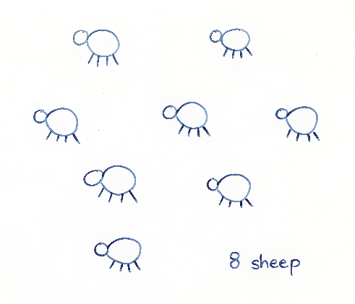
- Students choose 2 one-digit numbers to create a mathematical story. Students turn and talk with a partner to share their story and then draw symbols to represent it. Listen to student stories to ensure that students are combining both small groups, rather than separating them.
Note: One-digit numbers allow students to work within a number range they are comfortable with to explore deep concepts.

Problematise – 20 minutes
Note: Universal symbols are used to represent quantities (numbers), actions (+, −, ×, ÷), and relationships such as equivalence (=). These symbols are used to record mathematical ideas efficiently and can be used with their own symbols to create and interpret mathematical stories.
- Prompt students to reflect on their mathematical stories. Ask, ‘What are the parts (start, change, and result)? What happened to the parts (what was the change and what was the result amount)?’
- Remind students that it is important that all the parts of the story are represented and not just the result (ending). Ask students to imagine that if they only read the end of a book (refer to one that the students know), they wouldn’t know what happened to the characters at the beginning of the story or how the ending came to be (see Figure 2).
Figure 2 – 11 fish
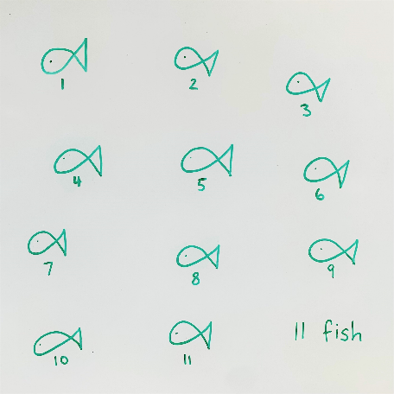
- Use Figure 3 to illustrate the importance of including all the parts in a mathematical story and not just the result (ending). Emphasise the importance of knowing the start amount and the change amount to understand the result amount (end of the story).
Figure 3 – Apples story
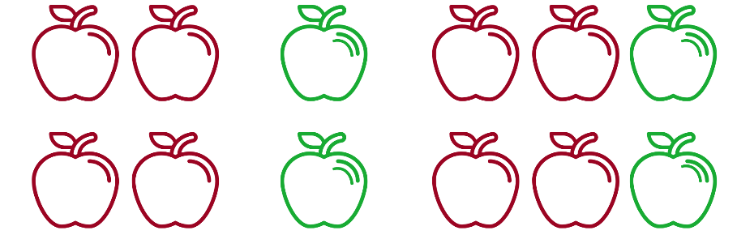
Images sourced from Canva and used in accordance with the Canva Content License Agreement.
- Students think about and revise how they could represent the start, change, and result of their own mathematical stories to ensure that all parts are represented. Invite students to share their mathematical stories with a peer. Select several students to share their stories with the class. Discuss and draw students’ attention to the symbols that represent the different parts of their mathematical stories.
This table details assessment opportunities and differentiation ideas.
Assessment opportunities | Too hard? | Too easy?
What to look for:  - Are students listening to other mathematical stories and able to retell their own stories to others? (MAO-WM-01)  What to collect:  - simple drawings or symbols to represent the parts of a mathematical story (MA1-CSQ-01)  - own mathematical stories with symbols showing a start, a change, and a result (MA1-CSQ-01) | Students are finding the given numbers too difficult to combine.  Support students to follow story using red and green concrete materials to match Figure 3. If 4 and 2 is a challenging number range, use 2 and 1. | Students comprehend the concept and show advanced interest in symbols.  Share A Story about absolutely nothing from NRICH, which explores the origins of number systems and the symbols used. Then have students represent 4 and 2 using one or more number systems, for example, hieroglyphs, and Roman numerals.  Have students record similarities and differences between number systems for numbers 1-10.

Discuss and connect the mathematics – 10 minutes
- Summarise the lesson together, drawing out some key mathematical ideas with students, including that:
- Mathematicians use simple drawings or symbols to describe ideas in efficient ways.
- When we tell mathematical stories, we need to show the start, the change, and the result (end of the story).

Lesson 2: Plus, minus, and equal symbols
Core concept: Mathematical symbols are universal and can describe quantities, actions, and relationships.
The table below contains suggested learning intentions and success criteria. These are best co-constructed with students.
Learning intentions | Success criteria
Students are learning that:  - joining 2 or more collections together to create a new total is a way of combining collections  - adding is combining a starting amount with a change amount  - modelling and representing mathematical stories can help to make sense of them. | Students can:  - combine 2 smaller collections of objects to find a result  - use counters and blocks to model mathematical stories  - talk or write about mathematical stories using symbols (+, −, =) and words (join, combine, add, is equal to, is equivalent in value to)  - use hefting and an equal-arm balance to show equivalence in mathematical stories.

Daily number sense: Number counting – 10 minutes
- Build student understanding of number sequences by counting forwards or backwards, by ones, tens, and twos, on and off the decade using tools to strengthen counting with understanding, for example: hundreds chart, number line, bead strings, and using materials such as counters, MABs, or craft sticks.
- To further strengthen number placement, students draw a 0-20 number line on their whiteboard. Select 3-5 numbers for the students to place on the number line and give reasons for their placement.

Let's meet some symbols – 40 minutes
Elements of this part of the lesson have been adapted from Boaler (2021), Matthews (2019), and Matthews et al. (2007).
- Select a story from the previous lesson and ask, ‘How does the story start?’ Invite students to model the starting quantity using concrete materials. Ask, ‘What happens in the story?’ Select a student to model what happens next using concrete materials, for example, counters or interlocking cubes.
- Place a piece of paper in between the 2 quantities (see Figure 4).
Figure 4 – Hidden symbols
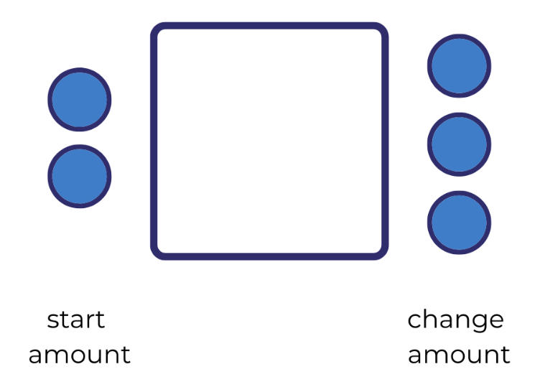
The table below outlines stimulus prompts to generate conversation about the topic, along with anticipated responses from students.
Prompts | Anticipated student responses
- What symbol can we use to represent the 2 groups combined or came together?  - If students use another symbol, acknowledge it as an interesting way to communicate addition. Ask, ‘Why did you choose that symbol to represent coming together?’ | - Students use the + symbol.  - 2 and 3 are equal to 5, 2 and 3 is the same as 5, 2 and 3 are equivalent in value to 5.
- Talk about the + symbol and how people may use different words around the world, but everyone understands that it is a symbol representing the action of coming together or combining. Ask, ‘What are some other words that we can use to describe combining?’ For example, 2 combined with 3, 2 joined with 3, 2 and 3, or 2 plus 3.
- Discuss that students now have a symbol to represent 2 parts or groups combining 2 or more collections. Place a piece of paper in between the ‘change’ part of the story and the result (see Figure 5).
Figure 5 – Hidden result
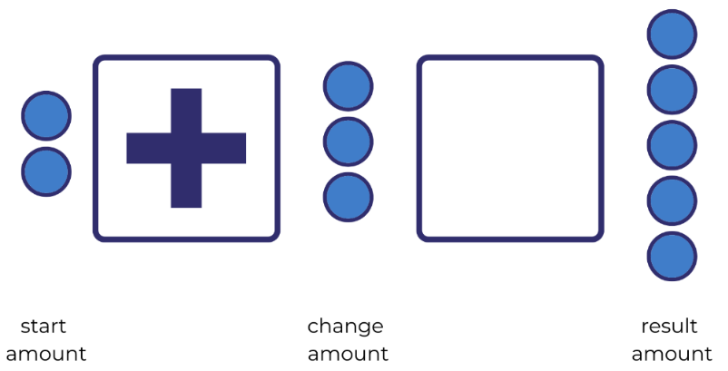
The table below outlines stimulus prompts to generate conversation about the topic, along with anticipated responses from students.
Prompts | Anticipated student responses
- How do we show what happened at the end of the story?  - Is there a symbol we could use?  - What are some ways that we can read this story now? | - Students use the = symbol.  - 2 and 3 are equal to 5, 2 and 3 is the same as 5, 2 and 3 are equivalent in value to 5.
Note: Some students may need double the number of interlocking cubes (or other concrete materials) to represent their start, change, and result amounts. If so, their example can be used to lead into working with balance scales.
- Share some simple real-life mathematical stories with students.
- Students select a story, represent it using concrete materials, and verbalise what is happening as they combine groups. Provide students with Resource 2: +, − and = cards to use in their stories, as well as concrete materials such as interlocking cubes. Invite students to retell their mathematical stories to a peer (see Figure 6).
Figure 6 – A number story with blocks
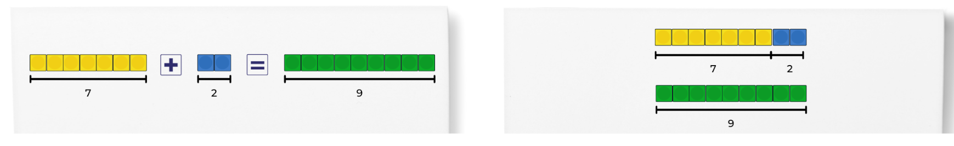
- Ask students, ‘What do you notice? What do you wonder?’ Draw attention to the fact that students need 18 blocks to represent their mathematical story: 9 for the parts and another 9 to represent the result (whole).
- Explain that one way of checking if the parts of an equation (number sentence) are equivalent is by using an equal-arm balance. Have students heft the units that they will use to check that the equation is in balance, for example, interlocking cubes or equal weights. Explain that because the units are the same mass, they can be used to see if the quantities on either side of the equal-arm balance are equivalent.
- Highlight that each side of the equal-arm balance represents a part of the students’ story. One side of the equal-arm balance represents the start and change amounts, and the other side represents the result amount. Ask students to place interlocking cubes or weights to represent the start and change amounts on one side of the equal-arm balance, and then place interlocking cubes or weights on the other side to represent the result amount.
- Invite students to share their findings by asking, ‘What do you notice about the equal-arm balance? Why do you think this has happened? Do you think if we chose another mathematical story with different numbers that it would also balance?’ Students turn and talk before sharing their thoughts with the class. Students then test their ideas using another problem.
- While looking at the equal-arm balance, ask students, ‘What do you notice now? What do you think needs to happen for the arms to balance?’

Discuss and connect the mathematics – 10 minutes
- Ask students to reflect on their exploration of mathematical stories. Guide students to notice that:
- When we join 2 or more collections together to create a new total, we are combining collections.
- When adding, a start amount is combined with a change amount.
- There are lots of different words and phrases to describe combining.
- Modelling mathematical stories can help to make sense of them.
- We can check if an equation is equivalent by using mathematical tools, such as an equal-arm balance.
Note: Use tools, such as equal-arm balances and number lines to support student understanding. If ideas are introduced too quickly, students may struggle with sense-making, especially if they do not yet understand how to combine and separate quantities in different ways (Lowrie et.al. 2018).
This table details assessment opportunities and differentiation ideas.
Assessment opportunities | Too hard? | Too easy?
What to look for:  - Can students combine two smaller collections to create a larger collection? (MA1-CSQ-01)  - Can students use concrete materials to model mathematical stories where two collections are combined? (MA1-CSQ-01)  - Are students using words and symbols to represent two collections being combined with symbols (+, −, =)? (MA1-CSQ-01)  - Are students using any of this vocabulary to retell their stories: join, combine, add, is equal to, is equivalent in value to? (MA1-CSQ-01, MAO-WM-01)  - Can students use hefting and an equal-arm balance to compare the masses of objects? (MA1-NSM-01) | Students have not experienced hefting. Provide opportunities to heft different daily objects, then concrete mathematical materials.  Concept of addition not clearly understood. Give examples of simple addition using real world materials, for example, Sally has 1 biscuit and David has 2. How many biscuits do they have if they add them together? | Students demonstrate a deep understanding of concepts from the main activity.  Practice using starting numbers that go over the decade, for example, starting with 9 and adding 2, 3, or 4 and then look for patterns.  Use the resource 'A Story about absolutely nothing' from NRICH which explores the origins of number systems and symbols used. Students identify similarities and differences in how number systems communicate numbers greater than 1.  Develop own number system and communicate it to others. Ask students what symbols they chose and why.

Lesson 3: Commutative property
Core concept: Commutative property says that the order in which quantities are combined does not change the result.
The table below contains suggested learning intentions and success criteria. These are best co-constructed with students.
Learning intentions | Success criteria
Students are learning that:  - mathematicians think of ideas and investigate them  - the order in which 2 quantities are combined does not change the result  - different words and phrases can describe combining and separating collections. | Students can:  - investigate whether the order in which we add 2 collections together changes the result  - talk or write about mathematical stories using symbols (+, −, =) and words (join, combine, add, is equal to, is equivalent in value to).

Consolidation and meaningful practice: Showing the Story – 10 minutes
- To consolidate understanding of mathematical storytelling, display Figure 7.
Figure 7 – Bees
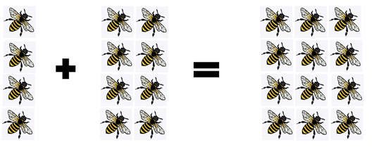
Adapted from ‘Bees’ by SisterJoBangles and used in accordance with the Pixabay License.
- Ask students to consider the different ways to tell this story. For example, 4 bees were in the hive and 8 bees joined them. There are now 12 bees sitting in the hive.
- Students share their story with a partner and the whole class.

Number story addition – 20 minutes
- Students sit in a circle. Divide counters into 2 easily quantifiable groups and cover (see Figure 8). Uncover both groups at the same time so students do not get a sense of which quantity comes first in the story.
Figure 8 – Groups of 6 and 9 counters
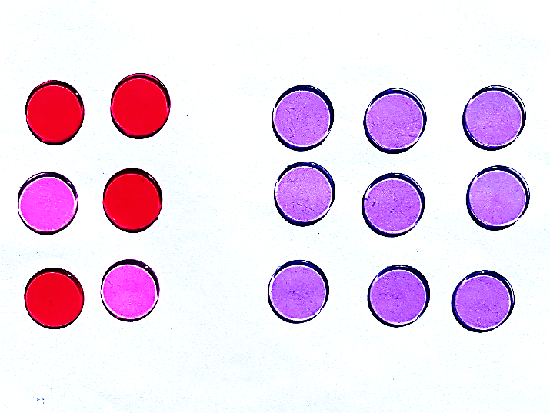
- Tell students, ‘I have a story here. In this story, the counters represent bees’.
The table below outlines stimulus prompts to generate conversation about the topic, along with anticipated responses from students.
Prompts | Anticipated student responses
- Can you write the story using words or symbols and include the result (the conclusion of the story)?  - What's happening?  - Why did some students have 9 bees as the starting amount, but others had 6? | - Depending on where they are sitting, students will write, ‘9 bees were on a flower and 6 joined them,’ or ‘6 bees were sitting on a flower and 9 joined them.’ Some students may use symbols to represent their story.  - Some students may notice that the viewpoint of the counters influenced which number came first in the story.
- Highlight the differences in order within the stories to launch an investigation into the commutative property.
- As a class, walk around to see the problem from the opposite side.
- Ask students, ‘What do you notice is different now? What do you notice about the result, does it change?’
- Ask students, ‘What happens if we don’t move, but the start and the change amounts do?’ Link the idea that when students moved their bodies to see the collection from different viewpoints, they were commuting. Explain that when the quantities in the mathematical story move, they are commuting as well.
- Rearrange the start and change amounts on the smartboard or using Resource 3: Dot cards 6 and 9. Ask students, ‘If we put 9 bees as the start amount and 6 as the change amount, how many bees are there?’ Students rearrange the 9 bees and the 6 bees. Ask students if they notice anything about the result.
- Ask, ‘If the quantities commute (change position), does it make a difference to the result when we use other numbers?’ Students investigate other numbers in commutative stories using Resource 4: Commutative stories.
- Look at the mathematical stories that students have investigated. Ask, ‘When we add 2 numbers together, does the order matter? Is this always the case? Why or why not? Do you need to test this out further with other numbers? Are you convinced that this always works when we are adding 2 numbers?’ Draw out the idea that, just as people can commute, amounts being combined can also commute. Explain that this is called a ‘commutative property.’

Subtraction story – 20 minutes
- Share the subtraction story with students: 11 bees were in the garden and 7 flew away. Ask, ‘How many bees stayed in the garden?’
- Students act out being the bees, starting with 11 and then taking away 7 to work out the result. Record what is happening using the equation ‘11 − 7 = 4’.
- Say, ‘I wonder if the commutative property will work for this number story when we use subtraction. What will that look like?’ Change the position of the 11 and the 7 in the equation.
- Start with 7 students and attempt to take away 11.
The table below outlines stimulus prompts to generate conversation about the topic, along with anticipated responses from students.
Prompts | Anticipated student responses
What do you notice? | - It does not work.  - It cannot be done.
- Explain that mathematicians can make a conjecture that the commutative property does not work for subtraction. However, seeing one example is not enough evidence to determine whether the conjecture is true. Explain that further investigation is needed.
- In pairs, students turn and talk to create subtraction mathematical stories and use concrete materials to represent them. Students investigate whether the order of the start and change amounts can be rearranged when solving a subtraction problem (can they commute?). Students can use mathematical tools and/or drawings to explore.

Discuss and connect the mathematics – 10 minutes
- Students share their mathematical stories and justify why or why not they believe the conjecture to be true.
- Discuss the initial conjecture, that the commutative property does not work for subtraction. Students decide whether they think they have enough evidence with all the examples they have investigated to say that their conjecture is a mathematical regularity. If students do not feel that they have enough evidence, provide time for further investigation.
- Guide students to understand that:
- In addition, the order of the start and change amount can be rearranged. This is called the commutative property.
- In subtraction, the position of the start and change amount cannot be rearranged. The commutative property does not work for subtraction.
This table details assessment opportunities and differentiation ideas.
Assessment opportunities | Too hard? | Too easy?
What to look for:  - Can students use mathematical tools to investigate their ideas? (MA1-CSQ-01, MAO-WM-01)  - Can students listen to and build onto the ideas of others? (MAO-WM-01)  - Can students use words and symbols to represent collections being combined and separated, for example +, −, = and words such as join, combine, add, is equal to, is equivalent in value to, part, whole, to describe their concrete and symbolic models? (MA1-CSQ-01) | Students find given numbers too difficult to compute mentally (bridging across the decade).  Use more familiar combination of numbers, for example, friends of 10 (6 and 4, 2 and 8).  Concept of commutation is too abstract:  - Provide concrete materials for students to use/manipulate.  - Encourage students to move materials around to view commutative property.  - Use other students to represent numbers instead of counters. Students can move around to view the quantities from different angles. | Students demonstrate quick understanding of commutation involving simple numbers. Ask students:  - Is the commutative property still true if they separate an amount into 3 or 4 parts instead of 2?  - Is the result the same when students combine the parts in a different order?  Students can try with one-digit and then two-digit numbers to explore their ideas.

Lesson 4: Part-part-whole
Core concept: A quantity is made up of smaller parts that, in turn, can form part of a larger quantity.
The table below contains suggested learning intentions and success criteria. These are best co-constructed with students.
Learning intentions | Success criteria
Students are learning that:  - visual methods can help to work out the number of objects in a group or to separate a collection of objects  - when 2 collections have the same total, they are described as ‘equivalent in value' and can be shown with an equal-arm balance. | Students can:  - identify the start and change amounts that combine to make a result  - use hefting and an equal-arm balance to show equivalence in mathematical stories  - use rhythmic and skip counting with knowledge of equal groups to effectively count a group or a collection of groups.

Daily number sense: Dot card talk – 10 minutes
- Build student understanding of subitising by quickly sharing a collection of dots and asking how many dots they see. Let students know that they will not have time to count the dots one at a time, so as mathematicians they will need to visualise what they saw to help them work it out.
- Show students Resource 5: Dot talk for 2-3 seconds and then hide it. Ask questions such as:
- How many dots did you see?
- How did you see them?
- Provide individual thinking time and then time to share their ideas. Monitor student conversations, preparing to ask some students to share how they saw the collection of dots.
- Reveal the dot card and invite selected students to share their thoughts with the class. Record student thinking (see Figure 9).
Figure 9 – Possible responses
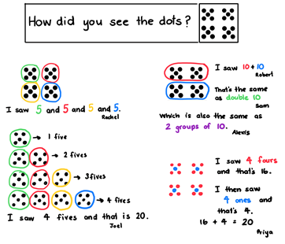
This table details assessment opportunities and differentiation ideas.
Assessment opportunities | Too hard? | Too easy?
What to look for:  - Can students use rhythmic or skip counting to identify the total? (MA1-FG-01)  - Can students use their knowledge of equal groups to identify the total? (For example, 4 lots of 5, or 4 lots of 4 added to 4 lots of 1) (MA1-FG-01, MAO-WM-01) | Four groups of 5 are too many for students beginning their use of this method to understand. Use 2 groups of 5 (or smaller numbers) to scaffold the visual thinking method. | Students already demonstrate quick and effective identification of one or more methods. Ask students to find all possible answers and prove that they are correct.

Consolidation and meaningful practice: Equivalence – 10 minutes
- Set out the complete equation using counters to make Figure 10. Students write what they see from their viewpoints using numerals and mathematical symbols.
Figure 10 – 12 = 8 + 4
- Discuss whether the equation still makes sense and whether it is still true:
- Does 12 = 8 + 4 make sense? Why or why not?
- Are 12 = 8 + 4 and 4 + 8 = 12 equivalent equations (number sentences)?
- Explain that, because the = sign refers to the 2 sides of the equation being equivalent in value, it does not matter if the total (end of the story) is on the left or on the right of = sign. Alternatively, display the above picture for the whole class and turn it upside down to show the different viewpoint as in Figure 11.
Figure 11 – 4 + 8 = 12

Frogs and turtles: How many of each? – 30 minutes
Note: Combining and separating quantities creates opportunities for students to use known related number facts to help solve problems in efficient ways. Mathematicians use knowledge of equivalence to work out the unknown quantity which can sometimes be the result amount, the change amount, or the start amount.
- Share the following story with students: One sunny day, there were some frogs and turtles sitting on a rock. Altogether, there were 14 of them. Ask students, ‘What does this mathematical story look like to you? Can you draw it using symbols and words?’
- Ask students to identify the result, start, and change amounts in their stories and others’ by sharing visual representations.
- Place student stories for all to see and ask students what they notice. Draw attention to the fact that there is more than one way to represent this story. For example, some students might draw 6 frogs and 8 turtles, others might draw 10 frogs and 4 turtles. Ask, ‘How many ways are there which are equivalent to 14?’
- Discuss what is the same about all the stories (the result amount) and discuss what is different (the start and the change amounts).
- Co-construct with students all the equations that they discovered are equivalent in value to 14. You could use symbols with numbers or concrete materials. Talk about the idea of equivalence.
- Model equivalence using an equal-arm balance using the example, 6 + 8 = 14. Place 14 weights (or counters or interlocking cubes) on one side of the equal-arm balance and 6 on the other. Students will notice that the 2 sides are not balanced. Add the 8 to the 6 and watch it balance. Discuss that the change is what makes the 2 arms balance.
- Students investigate using an equal-arm balance for other equations equivalent to 14. This could lead to further investigation and discussion about the equivalence of number equations (not just the 2 parts being equivalent in value to the whole). For example, 8 + 4 = 10 + 2.

Discuss and connect the mathematics – 10 minutes
- Students share their exploration of equivalent equations using the equal-arm balance. Ask, ‘What did you notice about all the ways to create 14?’ Discuss how students knew when collections were equivalent in value or mass. Guide students to the understanding that:
- when a starting collection is divided into 2 or more smaller collections, we are separating a collection
- when 2 collections have the same total, they are ‘equivalent in value’
- quantities can be ‘more than,’ ‘less than’, or ‘equivalent’ to other quantities
- we can see when the quantity or mass of collections are equivalent by using an equal-arm balance.
This table details assessment opportunities and differentiation ideas.
Assessment opportunities | Too hard? | Too easy?
What to look for:  - Can students identify and compare the size of quantities (part-part-whole) in number sentences? (MA1-CSQ-01)  - In their stories, are students able to identify the different parts (start and change amounts) that combine to make a whole (result amount)? (MA1-CSQ-01)  - Are students using their knowledge of equivalent number sentences to find unknown quantities? (MA1-CSQ-01, MAO-WM-01)  - Can students use hefting or an equal-arm balance to check if equations are equivalent? (MA1-NSM-01)  What to collect:  - work samples of student stories where students have used a variety of ways using words and symbols (MA1-CSQ-01) | Students find it difficult to represent problems with drawings or symbols. Have students represent 14 frogs and turtles using concrete materials (for example, 2 different coloured counters). | Student has achieved mastery of commutation with simple numbers. Build on the ‘Too easy’ activity from the previous lesson, which was to ask students if the commutative property still exists if they split an amount, for example, 8 into 3 or 4 groups instead of 2. Ask, ‘Does the final number remain the same?’  Students can then move into finding out how many possibilities there are to make 8 and prove that they have found all possibilities. Students can test their working hypothesis on another number. Ask, ‘Does this work for all numbers? How can you prove this?’  Students may explore these questions with numerals or concrete materials.

Lesson 5: Equivalence
Core concept: Compensation is a change that can return equivalence to the equation.
The table below contains suggested learning intentions and success criteria. These are best co-constructed with students.
Learning intentions | Success criteria
Students are learning that:  - the = sign shows equivalence  - when an equation is changed, it might stop being true (either side of the = sign is not equivalent)  - compensation is a change that can make an equation stay equivalent. | Students can:  - identify and compare the size of quantities  - explain one change that could be made to keep a problem equivalent  - check if equations are equivalent using concrete materials.

Daily number sense: Balancing numbers – 10 minutes
- Build student understanding of equivalence by watching Balancing numbers 3: part 1-3 (3:25).
- During and after viewing, discuss what shapes were needed to balance or to maintain equivalence in each of the examples.

Modifying the problem – 20 minutes
This activity has been adapted from Matthews et al. (2007).
- Share with students the following problem: There were 3 dogs running in the park and 4 more dogs joined them.
- Ask students to use counters and A5 sheets of paper with the + and = symbols to represent the 3 dogs joining 4 dogs to make 7 dogs playing in the park (see Figure 12).
Figure 12 – 3 + 4 = 7
Note: Intentionally choose numbers that students find easy to compute. Doing so allows students to focus on equivalence and compensation.
- Students remove one of the counters from the 3 in the equation.
- Ask students, ‘Is this still correct?’ Discuss why it is not. Ask, ‘What can we do to make the equation equivalent?’
- Provide time for students to think individually and discuss their ideas with a peer. Invite students to model how to make the equation equivalent and record their thinking.
- Ask students, ‘How can we check to see if the equation is equivalent?’ Use different mathematical tools to check for equivalence, for example, number balances or interlocking cubes. See anticipated student responses in Figure 13 below.
Figure 13 – Student anticipated responses
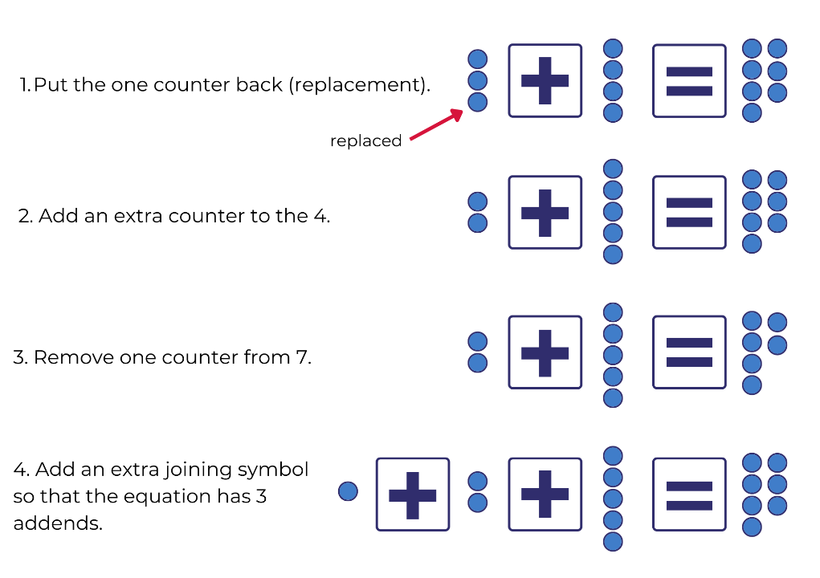
- Ask students to turn and talk about what they notice has happened in each version of the story. Share with students that all these options are ‘equivalent’ to the original story. Continue to ask questions, prompting until all 4 possibilities are given.

Further our understanding with other problems and look for patterns – 20 minutes
- Repeat the above steps for a new story: Jess had 3 fish in her tank and then she bought 5 more fish to join them, so now she has 8 fish.
- This time, ask students to remove 2 counters from the 3.
- Discuss how this makes the story wrong and propose ways to make the story true again. Try to draw out as many ways as possible (see Figure 13).
- Return counters to represent the original story of Jess and her fish, but this time, remove 2 counters from the 5. Ask, ‘What is the same and what is different?’
- Return counters to represent the original fish story, but this time, add 2 counters to the 5. Ask, ‘What is the same and what is different?’ Discuss how adding counters is different to removing them.
- In pairs, students work together using concrete materials to complete modified problems in Resource 4: Commutative stories. Students can use symbols, pictures, and words to record the different ways to maintain equivalence.
- Ask students, ‘Can you see a pattern or a rule to follow?’ (The 4 ways identified in Figure 13). You may need to do further examples if students cannot identify the pattern/rule yet.

Discuss and connect the mathematics – 10 minutes
- Discuss with students and guide them to understand that:
- the = sign shows equivalence
- when an equation or equal-arm balance is not equal, something needs to be changed to make it equivalent.
- when a change is made to an equation, it might stop being true (either side of the = sign is not equivalent)
- compensation is a change that we can make so that our equation stays equivalent
This table details assessment opportunities and differentiation ideas.
Assessment opportunities | Too hard? | Too easy?
What to look for:  - Are students able to identify and compare the size of quantities? (MA1-CSQ-01)  - Can students explain any change that could be made to make the modified problem equivalent? (MA1-CSQ-01, MAO-WM-01)  - Are students checking if equations are equivalent using concrete materials with the equal-arm balance? (MA1-NSM-01)  What to collect:  - work samples of students recording different ways to maintain equivalence (MA1-CSQ-01, MAO-WM-01) | Students find it difficult to use specific vocabulary around equivalence. Introduce specific language (equivalent, equation) by creating a definition using pictures, numbers, and words | Students have demonstrated deep understanding using simple numbers with addition and need to extend their thinking about equivalence.  Have students complete the Equivalent Pairs interactive online activity from NRICH which explores equivalence using different operations.  Students use The Interactive Balance from NRICH to explore equivalence on a balance scale and make links between maths and science concepts. This resource can be accessed at several levels of complexity for students as needed.

Lesson 6: Finding the missing part of the mathematical story
Core concept: Commutative property and equivalence can help find the missing parts of a mathematical story.
The table below contains suggested learning intentions and success criteria. These are best co-constructed with students.
Learning intentions | Success criteria
Students are learning that:  - equations (number sentences) tell mathematical stories and information can be used to work out a missing part  - the commutative property can be used to solve ‘start unknown’ and ‘change unknown’ problems. | Students can:  - tell mathematical stories where the result is known but other parts are missing  - use concrete materials to identify and check the missing number in a mathematical story.

Daily number sense: Splat! – 10 minutes
- Build student understanding of subitising by watching Splat! (conceptual subitising to 10) (7:13).
- Throughout the video, pause to discuss and answer question prompts.

Consolidation and meaningful practice: Sarah’s blocks – 10 minutes
Elements of this activity have been adapted from Van de Walle et al. (2019).
- Share with students a concrete or visual representation of Figure 14 using counters or symbols. Explain that it is a story about Sarah having some blocks and then getting some more from George. Ask students to turn and talk to tell this story using words to a partner.
Figure 14 – Tell the story of Sarah's blocks
- Ask several students to share their mathematical stories with the class. For example, ‘Sarah had 8 blocks and George gave her 4 more, so now she has 12 blocks.’

How can we work out the changes? – 40 minutes
- Explain to the students that you will cover a part of the story. Cover part of the concrete representation so that it now looks like Figure 15. The challenge will be to use words to tell the story that has some missing information.
Note: ‘Change unknown’ is the missing number in an equation.
Figure 15 – Story with missing information = change unknown
- Students turn and talk to discuss how they would tell the story now. For example, ‘Sarah had 8 blocks and George gave her some more and now she has 12.’ Make explicit that these kinds of problems refer to ‘change unknown’ because we know there is a change, but we do not know what the change is yet.
- Share with students a concrete or visual representation of Figure 16. Use counters or symbols. Explain that it is about Oscar buying bananas and apples.
Figure 16 – Oscar bought bananas and apples
Note: The numbers are intentionally chosen to be numbers that students find easy to compute. This is so students can focus on discovering patterns rather than computation.
The table below outlines stimulus prompts to generate conversation about the topic, along with anticipated responses from students.
Prompts | Anticipated student responses
- What do you know about this story?  - What do you want to know?  - How could you find out how many bananas Oscar bought?  - Can you think of more than one way to work this out? | - Oscar bought 3 bananas.  - Oscar bought some apples, but we don't know how many yet.  - Oscar bought 8 pieces of fruit.  - Redrawing 3 of the 8 circles as 3 bananas and the rest as apples.  - Using equal-arm balances with 3 counters on one side and 8 on the other, counting as they add to the 3 until the arms are balanced. Share back how they found how many apples Oscar bought.  - Crossing out or removing 3 of the blue circles or counters, since 3 of them must be apples.  - Using one row of 8 interlocking cubes to represent the total and then 2 colours to represent apples and bananas.
- Give students time to use materials such as equal-arm balances, interlocking cubes, counters, drawings, and other methods to prove their thinking.
- Select responses that highlight the above strategies, as well as other ways of thinking that you think would contribute to the class’s understanding.
- Students modify their own stories from previous lessons to become 'change unknown' stories. In small groups, students can use a variety of methods to find the missing addend of each other's stories.
- Revisit the story of Sarah, George, and their blocks, covering a different part. Challenge students to use words to tell the story with the missing information. Change concrete representation so that it now looks like Figure 17.
Figure 17 – How can we tell the story now?
- Students turn and talk to discuss how they would tell the story now. For example, ‘Sarah had some blocks and then George gave her 4 more. Now she has 12 blocks.’
- Explain that these kinds of problems are known as ‘start unknown’ problems. Say, ‘This is because we know there is a change and we know the result, but the start is unknown and that is what we need to work out.’
- Share with students a concrete or visual representation of Figure 18 using counters or symbols.
Figure 18 – Charlie saving money
- Encourage students to share what the story might be. For example:
- Charlie had some money and then his parents gave him $6. Now he has $11.
- Charlie had some money and then he received $6 for washing the car. Now he has $11.
Note: The more examples students create and share, the more exposure they will have to written word problems and learn to focus on the most critical information.
The table below outlines stimulus prompts to generate conversation about the topic, along with anticipated responses from students.
Prompts | Anticipated student responses
- How could you find out how much money Charlie had at the beginning of the story?  - Can you think of more than one way of finding out this information? | - Students might reference the commutative property from Lesson 3.  - Using equal-arm balances with 6 counters on one side and 11 on the other and counting as they add to the 6 until the arms are balanced (this will require students to apply the commutative property).  - Using equal-arm balances with 6 counters on one side and 11 on the other, students take away from the 11 and count to work out how many more than 6 had been there.  - Crossing out or removing 6 of the blue circles or counters, since 6 of them must be the dollars that Charlie already had.  - Using one row of 11 interlocking cubes to represent the total and then 2 colours, one to represent the dollars Charlie started with and one to represent the money that he later received.
- Give students time to use materials such as equal-arm balances, interlocking cubes, counters, drawings, and other methods.
Note: Students might not use these strategies with the example but may explore them when investigating their own stories. These strategies can be discussed during the next section, ‘Discuss and connect the mathematics.’
- Students modify their own stories from previous lessons to become ‘start unknown’ stories. In small groups, students use a variety of methods to find the missing addend of each other's stories. Select responses that highlight the above strategies, as well as other ways of thinking what you think would contribute to the class’s understanding.

Discuss and connect the mathematics – 10 minutes
- As a class, discuss what is similar about finding a ‘start unknown’ and finding a ‘change unknown’. Discuss what is different. Ask, ‘What do you notice about these problems? Is there anything you wonder?’
- Refer to Lesson 6 and ask, ‘How can we work out the changes?’ Suggest that to explore this idea further, students could go back to the Sarah and George story and change amounts. For example:
- What would the story be if Sarah started with 7 blocks?
- How could you work out how many blocks George gave her so that the story is still true?
- What about if Sarah had 13 blocks at the end of the story?
- Ask students to reflect on their exploration of mathematical stories. Invite students to notice that:
- equations (number sentences) tell mathematical stories
- sometimes we know the end of the story (the result), but part of the story is missing
- the commutative property can help solve ‘start unknown’ and ‘change unknown’ problems.
This table details assessment opportunities and differentiation ideas.
Assessment opportunities | Too hard? | Too easy?
What to look for:  - Can students create mathematical stories where the result is known but other parts of the story are missing? (MA1-CSQ-01)  - Can students use concrete materials with commutation to identify and check the missing part of their mathematical story? (MA1-CSQ-01, MA1-NSM-01, MAO-WM-01)  - Are students able to modify their own stories to become ‘change unknown’ and ‘start unknown’ stories? (MA1-CSQ-01, MAO-WM-01) | Students find the language demands or cognitive load difficult. Provide students with a model story when exploring change/start unknown problems. Underline numbers in both teacher and student examples.  Students find it difficult to generate ideas for their own stories. Provide students with characters and items to use in mathematical stories. | Students find it ‘too easy’ when identifying missing numbers.  Challenge students to identify as many patterns as possible using Sweetie Box from NRICH.  Challenge students to explore different possibilities for a number sentence with a missing number using What Could It Be? from NRICH.

Lesson 7: Uncovering related facts
Core concept: One number fact uncovers related number facts.
The table below contains suggested learning intentions and success criteria. These are best co-constructed with students.
Learning intentions | Success criteria
Students are learning that:  - combining and separating ‘undo’ each other  - mathematicians use what they know about one number fact to uncover related facts. | Students can:  - rearrange parts of an equation in a mathematical story to get the same answer  - select mathematical materials and tools to represent thinking  - apply strategies to solve combining and separating problems.

Daily number sense: What’s the same? What’s different? – 10 minutes
- Build student understanding of arrays by displaying Resource 6: Dots in array.
- Ask students to compare both pictures, looking for similarities. Students think individually, turn and talk with a peer, and then select several students to share their thinking with the class.
- Ask students to compare the pictures, looking for what is different. Students think individually, turn and talk with a peer, and then select several students to share their thinking with the class.
The table below outlines stimulus prompts to generate conversation about the topic, along with anticipated responses from students.
Prompts | Anticipated student responses
- What do you notice about the picture?  - What is the same?  - What is different? | - Picture A shows 3 and 3 and 3 and 3. Picture B shows 4 and 4 and 4.  - Picture A has 4 rows of 3 and Picture B shows 3 rows of 4.  - They are the same pictures, but one is just sideways.  - This could lead to a further investigation/discussion of the commutative property in multiplication.  - The story for this one might be …

Consolidation and meaningful practice: Array problems – 40 minutes
- Display Resource 7: Array problems and ask, ‘What symbols would I need to make this true?’ See Figure 19 for an example of a display layout. Anticipated student responses can be found in Figure 20.
Figure 19 – Array problems
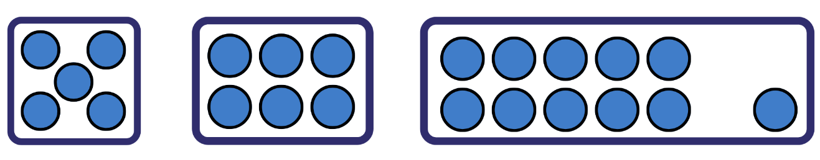
Figure 20 – Anticipated student responses
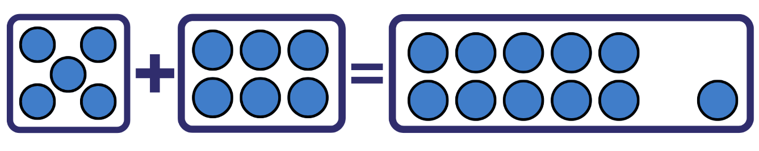
The table below outlines stimulus prompts to generate conversation about the topic, along with anticipated responses from students.
Prompts | Anticipated student responses
- Can we move the pieces around and have the equation still be true?  - Discuss what stories the equation could represent and how it changes when you move the addends around. | - Students may bring up the idea that they can move the 5 and 6 around and the equation will still be balanced.  - They might remember Lesson 3 on the commutative property.
- Say, ‘I wonder if we can use the − symbol rather than the + symbol. Is there a way to arrange the pieces to make the equation true?’
- Give students copies of Resource 2: +, − and = cards.
- In small groups, students move pieces around to create all the equations possible with Resource 7: Array problems and Resource 2: +, − and = cards. Students record these equations using pictures, symbols, and words. Provide concrete materials for students to verify that the equations are still balanced using equal-arm balances and other concrete materials.
- Students choose one of their mathematical stories and rewrite them to rearrange the parts into 3 related number sentences. Ask, ‘What might the stories be now?’
- Example of what the stories could be rearranged to from the original: 3 birds were sitting in a tree and 4 joined them, making them 7 birds in the tree (3 + 4 = 7).
- Related stories:
- 4 birds were sitting in a tree and 3 joined them, making them 7 birds in the tree (4 + 3 = 7)
- 7 birds were sitting in a tree and 3 flew away, so there were 4 birds left in the tree (7 − 3 = 4)
- 7 birds were sitting in a tree and 4 flew away, so there were 3 birds left in the tree (7 − 4 = 3).
- Students verify that the stories are still equivalent using mathematical tools and show their thinking in a variety of ways.

Discuss and connect the mathematics – 10 minutes
- Students select and share stories with representations that illustrate the relationship between addition and subtraction.
- Guide student discussion to focus on:
- understanding that combining quantities and separating quantities ‘undo’ each other
- mathematicians use what they know about one number fact to uncover related facts.
This table details assessment opportunities and differentiation ideas.
Assessment opportunities | Too hard? | Too easy?
What to look for:  - Can students rearrange parts of an equation to create equivalent related facts? For example, 2 plus 5 is equal to 3 plus 4 (MA1-CSQ-01)  - Can students use related facts in their mathematical stories? (MA1-CSQ-01)  - Are students able to select mathematical symbols, drawings and vocabulary to represent their thinking? (MA1-CSQ-01, MAO-WM-01)  - Can students apply appropriate strategies to solve combining, and separating problems? (MA1-CSQ-01, MAO-WM-01)  What to collect:  - work samples of student recordings of equivalent related facts using mathematical tools, symbols, drawings and vocabulary (on paper, photos, or film) (MA1-CSQ-01, MA1-NSM-01, MAO-WM-01) | Students find it difficult to make explicit links to prior learning. Recap mathematical symbols during lesson introduction and provide vocabulary support, for example, by defining 'equation'.  Students are having difficulty computing the problem. Adjust the model problem to a more familiar number relationship, for example, friends of 10 or friends of 20.  Provide students with scaffolds for mathematical stories. | Students demonstrate understanding of concepts and skills to a high degree. Use numbers that cross decades to write related number sentences. Explore related number facts and patterns using activities in Number Facts from NRICH.

Lesson 8: Related number facts can help us uncover missing information
Core concept: Commutative property, equivalence, and related number facts help find the missing parts of a mathematical story.
The table below contains suggested learning intentions and success criteria. These are best co-constructed with students.
Learning intentions | Success criteria
Students are learning that:  - mathematicians use their knowledge of related facts to help change and solve problems in efficient ways  - problems can be represented by selecting concrete materials, mathematical tools, and/or drawings. | Students can:  - use different strategies (counting back, concrete materials, diagram) to find the difference between 2 quantities  - select mathematical materials and tools to represent their thinking  - reflect on strategies used to solve a problem.

Daily number sense: Choose a Splat! – 10 minutes
- Build student understanding of subitising by choosing a Splat! from Steve Wyborney's blog:
- Splat! Set 1.1 [PPT 590KB]
- Splat! Set 1.2 [PPT 590KB].
- Display the shapes for 3-5 seconds and then cover with the Splat!. Follow the question prompts so that students consider the items in different arrangements.

Monkeys in the trees! – 40 minutes
- Explain that a Year 1 class was asked to solve the following problem mentally: 19 monkeys were swinging in the tree branches. It started to rain, so 17 of them left the trees to go into the nearby cave. Ask, ‘How many monkeys were now swinging in the rain?’
- Read the 2 speech bubbles in Resource 8: Thinking bubbles to share how 2 students, Daniel and Babsy, solved the problem. Explain that there was another student named Peter who was a bit confused by how Daniel and Babsy solved this problem. Ask, ‘Can you help Peter make sense of these 2 strategies?’
- Invite students to talk in pairs and devise how they would help Peter to make sense of Daniel and Babsy's strategies. Provide concrete materials, mathematical tools, and/or drawing materials to help students demonstrate the thinking behind the 2 strategies.
- Select some students to share how they would explain Daniel and Babsy's strategies.
The table below outlines stimulus prompts to generate conversation about the topic, along with anticipated responses from students.
Prompts | Anticipated student responses
How have you explained Daniel and Babsy’s strategies? | - Start with 19 counters and take 17 (1 ten and 7 ones) away to represent the 2 monkeys that are left.  - Start with 17 counters and add 2 more counters, so that there are 19 counters to represent the monkeys.
- Align both models and ask students what they notice is the same and what is different.
- Explain to students that these strategies can also be modelled using a number line. Draw a number line from 0-20. Students direct the teacher to show Daniel’s thinking on the number line by starting at 19 and jumping back by 1 ten, and then 7 ones as in Figure 21.
Figure 21 – Number line showing Daniel's strategy
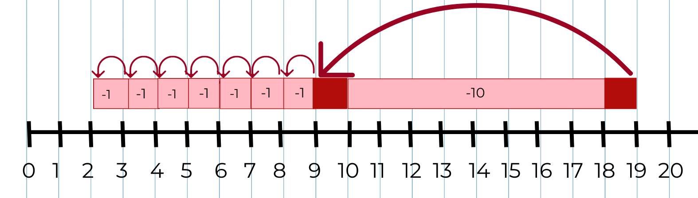
Images sourced from Canva and used in accordance with the Canva Content License Agreement.
- Ask students, ‘How many monkeys does Daniel think are still in the trees? Where can you see this on Daniel's number line?’
- Discuss with students that Daniel maintained this problem to be a result unknown (see Figure 22).
Figure 22 – As a result unknown problem
- Explain that Daniel started with the 19 and counted back 17, which meant that there were 2 left.
- Next to Daniel’s number line, draw another 0 to 20 number line to show Babsy's thinking. Students direct the teacher to show this by starting at 17, and count on 2 ones to get to 19 (see Figure 23).
Figure 23 – Number line showing Babsy's strategy
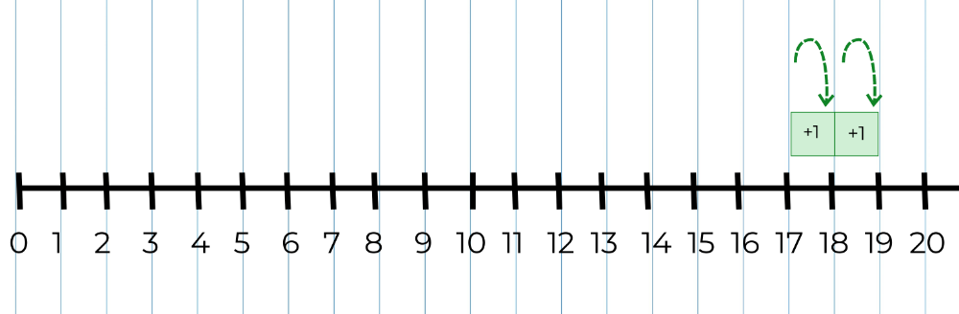
- Ask students, ‘How many monkeys does Babsy think are still in the trees? Where can you see this on her number line?’ Discuss that Babsy has changed the problem to a 'change unknown' problem (see Figure 24). The steps on the number line that represents the changes are now the result (+ 1 + 1) (see Figure 25). Discuss with students that Babsy used her knowledge of related facts to change the problem.
Figure 24 – The monkey’s problem as a ‘change unknown’ problem
Figure 25 – This is how the steps represent the answer in Babsy's number line
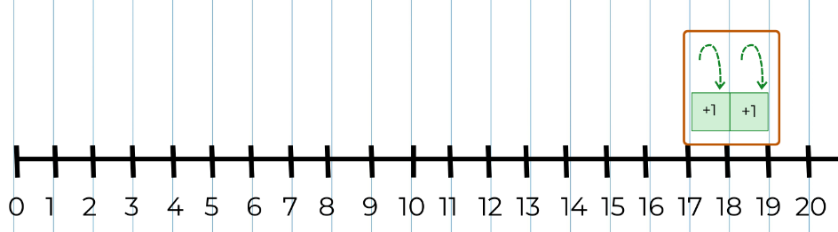
- Allow time for students to look at both number lines.
The table below outlines stimulus prompts to generate conversation about the topic, along with anticipated responses from students.
Prompts | Anticipated student responses
What do you notice? | - Daniel counted back by tens and ones, but Babsy counted on by ones.  - There are common amounts in both: 19, 17, and 2.  - It took Daniel 8 steps to solve the problem, but it only took Babsy 2 steps.  - When you count back to find the result, the jumps on the number line go to the left.  - When you count on, the jumps go to the right.
- Discuss the idea that mathematicians use what they know about related number facts to help them to solve problems. Share some mathematical stories that represent a variety of problem types from Resource 9: Mathematical stories for students to solve. In pairs, students select a problem and discuss what it is about and what the unknown information is. Students solve the problem mentally and share with each other how they worked out the unknown information.
- Students use concrete materials or a number line to model how they solved the problem. As students are representing their strategies, strategically select students to share their modelling strategies with the class.
- Ask students, ‘Can you use what you know about related facts to solve the problem in a different way?’

Discuss and connect the mathematics – 20 minutes
- Invite selected students to share their strategies for solving each problem.
- Discuss the following questions:
- How does the model or number line match the mathematical story?
- What questions do you have about what they did?
- Why does it make sense? Or not?
- Encourage students to make connections, and to compare and contrast their ways of thinking.
- Support students to reflect on their choice of strategies and reasons for using them. Ask students:
- When did you find it beneficial to change the problem?
- How did your knowledge of related facts help you solve the problem in a different way?
- Is it always beneficial to change the problem?
- Explain that:
- mathematicians use their knowledge of related facts to help solve problems in efficient ways
- mathematicians can choose to change the problem so that it is easier to work with. For example, ‘We can convert a 'change unknown' problem into a 'result unknown' problem if we think it will be easier to work with.’
- we can also convert a subtraction problem into an addition problem and this can sometimes reduce the number of steps
- ways of thinking about problems can be represented using concrete materials, mathematical tools, or drawings
- today we used number lines to represent Daniel and Babsy's thinking, and we identified where in the number line we could find the answer to our problem.
This table details assessment opportunities and differentiation ideas.
Assessment opportunities | Too hard? | Too easy?
What to look for:  - Can students use a number line to count back to find the difference between two quantities? (MA1-CSQ-01)  - Are students able to apply knowledge of related addition and subtraction facts to help solve problems? (MA1-CSQ-01)  - Can students represent the difference between 2 numbers using concrete materials, number lines and diagrams? (MA1-CSQ-01)  - Do students use taught mathematical vocabulary to reflect on chosen strategies when solving given problems? (MAO-WM-01)  What to collect:  - work samples of responses to Resource 9: Mathematical stories for students to solve. (MA1-CSQ-01, MAO-WM-01) | Students find it ‘too hard’ when working with a number line of 0-20. Use smaller numbers (for example, 9 and 7) on a 0-10 number line that is big enough to be used with concrete materials. | Students are confident in using numbers on a 0-20 number line. Use 0-50 or 0-100 number lines and explore numbers of choice; then explain their findings to another student. Encourage students to partition numbers and use most efficient counting strategy on the number line to solve problems.

Resource 1: Familiar and unfamiliar symbols
Pirate skull crossed bones by Clker-Free-Vector-Images used in accordance with the Pixabay License.
Traffic sign stop road by OpenClipart-Vectors used in accordance with the Pixabay License.
Emoji smilies by Pixaline used in accordance with the Pixabay License.
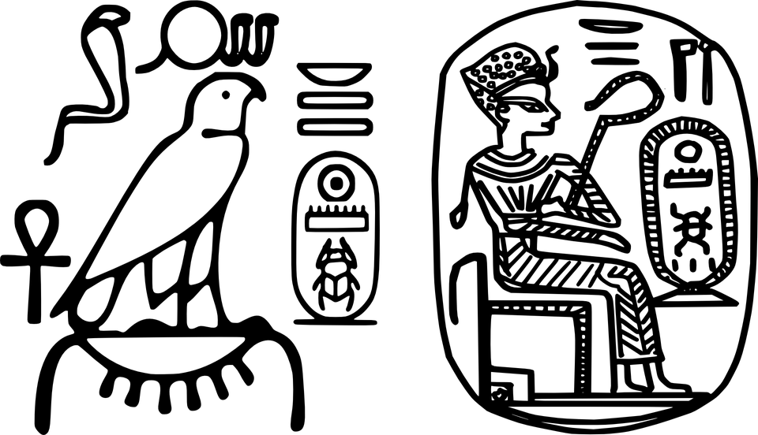
Egyptian hieroglyphics king plaque by OpenClipart-Vectors used in accordance with the Pixabay License.
Omega Greek Ohm letter symbols by Clker-Free-Vector-Images used in accordance with the Pixabay License.
Health Medicine Serpent Wings by Clker-Free-Vector-Images used in accordance with the Pixabay License.

Resource 2: +, − and = cards
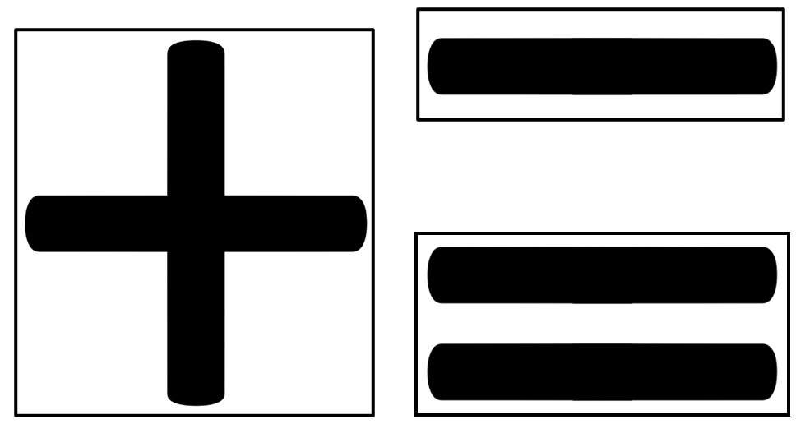

Resource 3: Dot cards 6 and 9

Resource 4: Commutative stories
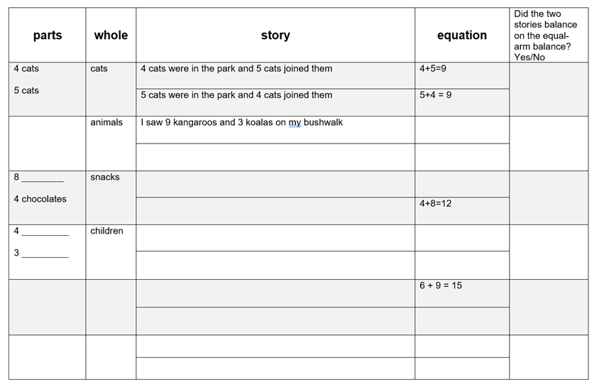

Resource 5: Dot talk
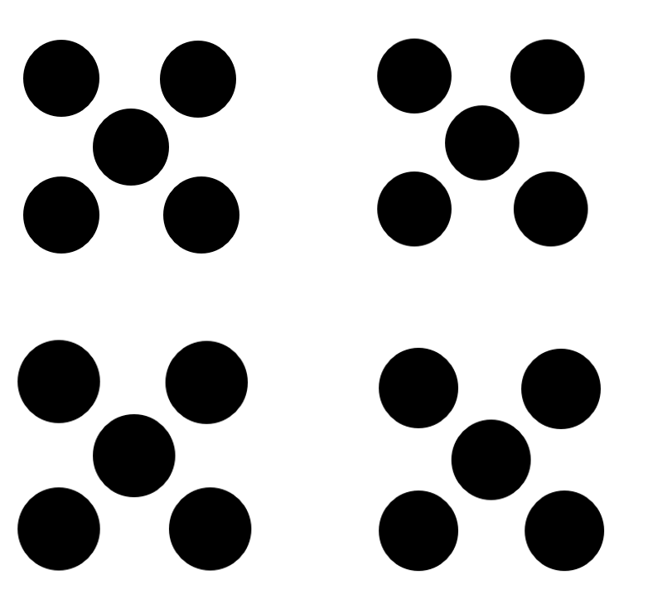

Resource 6: Dots in array
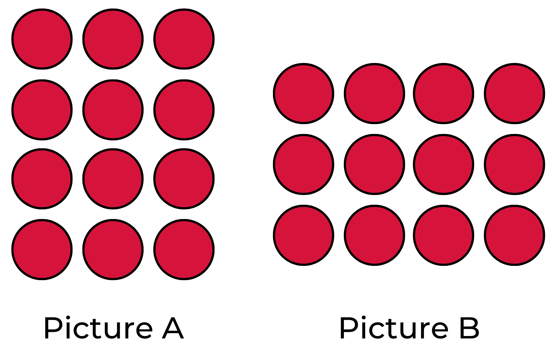

Resource 7: Array problems
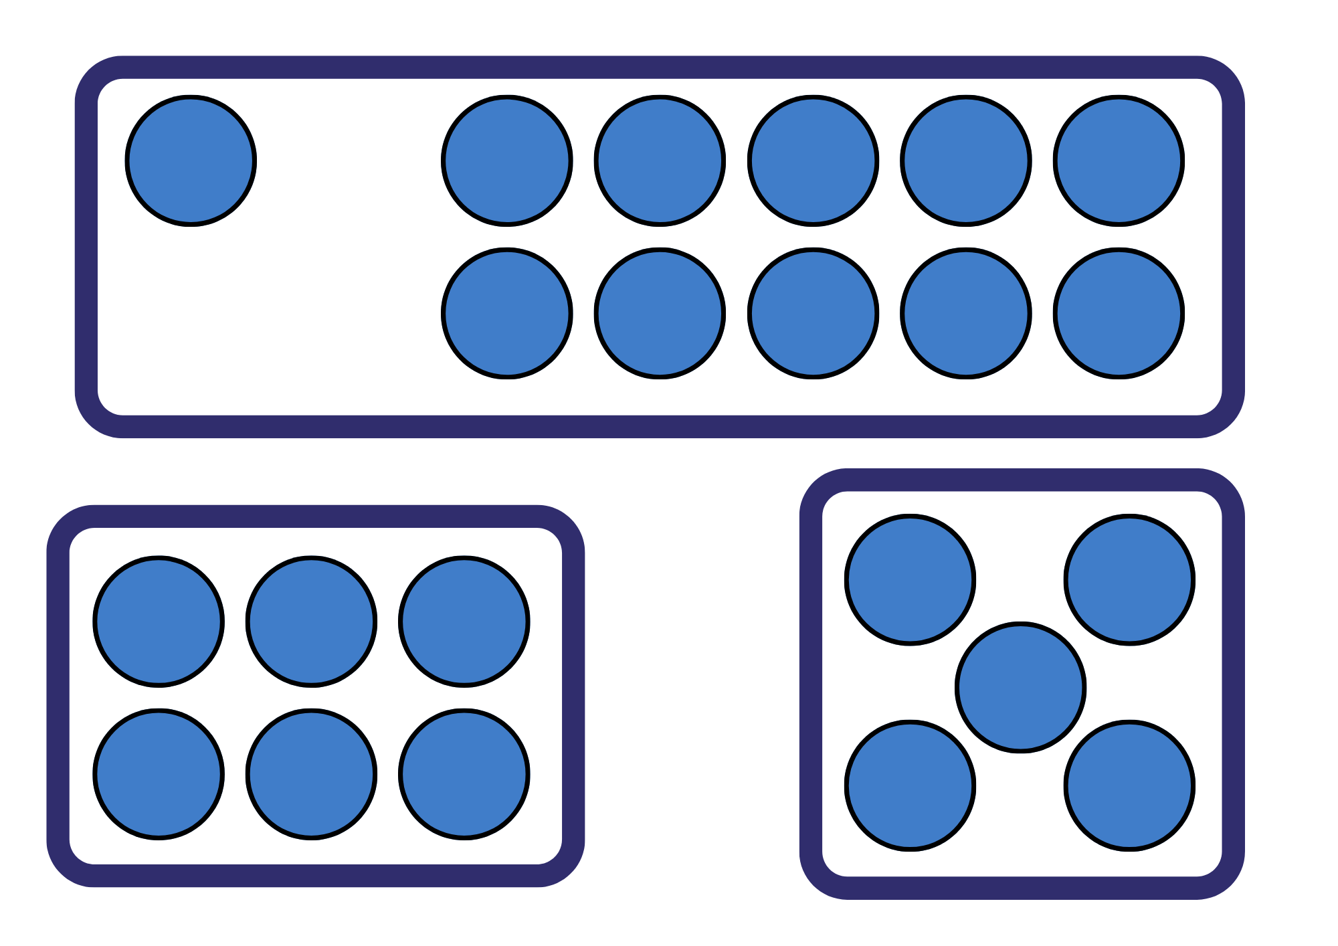

Resource 8: Thinking bubbles
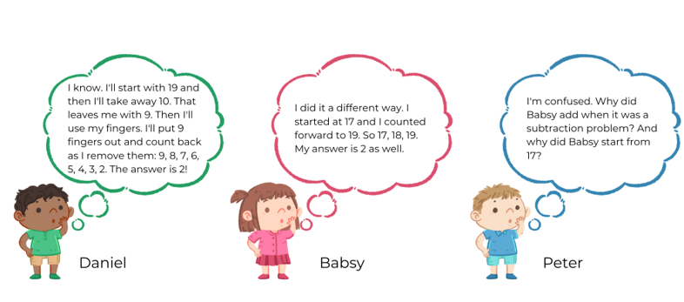
Images adapted from Biistudio21 and used in accordance with the Pixabay License.

Resource 9: Mathematical stories for students to solve
Result unknown | Result unknown | Change unknown
Sam has 12 pencils. His sister took 5 of these pencils to use. How many pencils does Sam have now? | There were 16 chocolates in the box. Rita ate 8 of them. How many chocolates are left? | 15 children were playing in the park. Then some children went home. Now there are 11 children in the park. How many children went home?
Helen borrowed 12 books from the school library. She took 10 of them home and left the others at school. How many books were left at school? | Amanda had 17 toy dinosaurs, but 14 of them went missing. How many dinosaurs does Amanda have left? | Ben had 15 counters in his hand, but then he dropped some on the floor. He now has 9 counters. How many counters did Ben drop?
Camilla picked 17 flowers but gave 4 of them to her friends. How many flowers does she have now? | Michael had 13 cars in his shed. He sold 4 of them over the weekend. How many cars does he have left? | There were 11 cats in the shed. Then some cats ran away. Now there are only 8 cats in the shed. How many cats ran away?

Syllabus outcomes and content
The table below outlines the syllabus outcomes and range of relevant syllabus content covered in this unit. Content is linked to National Numeracy Learning Progression versions (3).
Focus area and outcomes | Content groups and content points | Lessons
Representing whole numbers A  MAO-WM-01  MA1-RWN-01  MA1-RWN-02 | Use counting sequences of ones with two-digit numbers and beyond  - count forwards and backwards by ones from a given number to at least 120 (CPr6)  Continue and create number patterns  - count forwards and backwards by twos from any starting point (CPr6-CPr7, MuS2)  Represent numbers on a line  - sequence numbers and arrange them on a line by considering the order and size of those numbers (CPr5) | 1-2, 6, 8
Combining and separating quantities A  MAO-WM-01  MA1-CSQ-01 | Use advanced count-by-one strategies to solve addition and subtraction problems  - recognise and use the symbols for plus (+), minus (−) and equals (=)  - record number sentences in a variety of ways using drawings, words, numerals and symbols (AdS6)  - apply the terms add, plus equals to describe combining and separating quantities (AdS1, AdS6)  - fluently use advance count-by-one strategies including counting on and counting back to solve addition and subtraction problems involving one- and two- digit numbers (Reasons about relations) (AdS4, AdS5, AdS6)  Use flexible strategies to solve addition and subtraction problems  - select and apply strategies using number bonds to solve addition and subtraction problems with one- and two-digit numbers by partitioning numbers using quantity value and bridging to 10 (Reasons about relations) (AdS6, AdS7)  - represent addition and subtraction using structured materials such as a bead string or similar model (AdS6, AdS7)  Represent equality  - use the equals sign to record equivalent number sentences involving addition, and to mean 'is the same as', rather than as an indication to perform an operation (Reasons about relations) (NPA4)  - model the commutative property for addition and apply it to aid the recall of addition facts (Reasons about relations)  - recall related addition and subtraction facts for numbers to at least 10 (Reasons about relations) (AdS6) | 1-8
Combining and separating quantities B  MAO-WM-01  MA1-CSQ-01 | Represent and reason about additive relations  - create, record and recognise combinations of two numbers that add to numbers from 11 up to and including 20 (AdS7)  - create, model and solve word problems, using number sentences (AdS6)  - represent a constant difference between two numbers using concrete materials and diagrams (AdS6)  - model how addition and subtraction are inverse operations using concrete materials, drawings and diagrams (AdS7)  Use knowledge of equality to solve related problems  - use number knowledge to solve related problems (AdS6, AdS7)  - use number bonds to determine a missing number  - use a variety of ways of writing number sentences  - Use number bonds to solve equality problems | 3-8
Forming groups A  MAO-WM-01  MA1-FG-01 | Count in multiples using rhythmic and skip counting  - count by twos, threes, fives and tens using rhythmic counting and skip counting (MuS2, CPr6)  Model and use equal groups of objects to represent multiplication  - determine and distinguish between the number of groups and the number in each group when describing collections of objects (Reasons about relations)  - model and describe collections of objects as groups of (MuS2)  - Find the total number of objects using skip counting of equal groups of a known size (MuS2) | 1, 2, 4, 7
Forming groups B  MAO-WM-01  MA1-FG-01 | Represent and explain multiplication as the combining of equal groups  - model the commutative property of multiplication, using an array (Reasons about relations) (MuS6) | 7
Non-spatial measure A  MAO-WM-01  MA1-NSM-01 | Mass: Investigate mass using an equal-arm balance  - place objects on either side of an equal-arm balance to obtain a level balance (UuM2)  - compare and order the masses of two or more objects by hefting, and check using an equal-arm balance  - use a balance to find two collections of objects that have the same mass (UuM3) | 2, 4-6
Non-spatial measure B  MAO-WM-01  MA1-NSM-01 | Mass: Compare the masses of objects using an equal-arm balance  - use uniform informal units to measure the mass of an object by counting the number of units needed to obtain a level balance on an equal-arm balance | 2, 5-6

References
Links to third-party material and websites
Please note that the provided (reading/viewing material/list/links/texts) are a suggestion only and implies no endorsement, by the New South Wales Department of Education, of any author, publisher, or book title. School principals and teachers are best placed to assess the suitability of resources that would complement the curriculum and reflect the needs and interests of their students.
If you use the links provided in this document to access a third-party's website, you acknowledge that the terms of use, including licence terms set out on the third-party's website apply to the use which may be made of the materials on that third-party website or where permitted by the Copyright Act 1968 (Cth). The department accepts no responsibility for content on third-party websites.
Except as otherwise noted, all material is © State of New South Wales (Department of Education), 2021 and licensed under the Creative Commons Attribution 4.0 International License. All other material (third-party material) is used with permission or under licence. Where the copyright owner of third-party material has not licensed their material under a Creative Commons or similar licence, you should contact them directly for permission to reuse their material.
Mathematics K–10 Syllabus © 2022 NSW Education Standards Authority (NESA) for and on behalf of the Crown in right of the State of New South Wales.
© 2022 NSW Education Standards Authority. This document contains NSW Curriculum and syllabus content. The NSW Curriculum is developed by the NSW Education Standards Authority. This content is prepared by NESA for and on behalf of the Crown in right of the State of New South Wales. The material is protected by Crown copyright.
Please refer to the NESA Copyright Disclaimer for more information.
NESA holds the only official and up-to-date versions of the NSW Curriculum and syllabus documents. Please visit the NSW Education Standards Authority (NESA) website and the NSW Curriculum website.
National Numeracy Learning Progression © Australian Curriculum, Assessment and Reporting Authority (ACARA) 2010 to present, unless otherwise indicated. This material was downloaded from the Australian Curriculum website (National Numeracy Learning Progression) (accessed 22 November 2022) and was not modified. The material is licensed under CC BY 4.0. Version updates are tracked in the ‘Curriculum version history’ section on the 'About the Australian Curriculum' page of the Australian Curriculum website.
ACARA does not endorse any product that uses the Australian Curriculum or make any representations as to the quality of such products. Any product that uses material published on this website should not be taken to be affiliated with ACARA or have the sponsorship or approval of ACARA. It is up to each person to make their own assessment of the product, taking into account matters including, but not limited to, the version number and the degree to which the materials align with the content descriptions and achievement standards (where relevant). Where there is a claim of alignment, it is important to check that the materials align with the content descriptions and achievement standards (endorsed by all education Ministers), not the elaborations (examples provided by ACARA).
Boaler J, Munson J and William C (2020) Mindset Mathematics: Visualizing and Investigating Big Ideas, Grade K, Jossey-Bass, New York.
Lemonidis C and Kaiafa I (2019) ‘The Effect of Using Storytelling Strategy on Students’ Performance in Fractions’, Journal of Education and Learning, 8(2):165–175, doi:10.5539/jel.v8n2p165, accessed 22 November 2022.
Lowrie T, Logan T and Patahuddin S (2018) ‘A learning design for developing mathematics understanding: The ELPSA framework’, Australian Mathematics Teacher, 74(4):26–31, accessed 22 November 2022.
Matthews C, Cooper T and Baturo A (2007) ‘Creating Your Own Symbols: Beginning Algebraic Thinking With Indigenous Students’, in Woo J, Lew H, Seo D and Park K (eds) Proceedings of the 31st Conference of the International Group for the Psychology of Mathematics Education, The Korea Society of Educational Studies in Mathematics, Korea.
Matthews C, Grenfell M, Surha A, Cooper T, Cassady T and Phillips T (2007) Minjerribah Maths Project Booklet for Grade 4 Trial: MAST Additives-Principles Lessons [PDF 932.15KB], Queensland University of Technology YuMi Deadly Centre, accessed 22 November 2022.
Matthews C (2019) 'Maths as Storytelling' in Price K and Rogers J (eds) Aboriginal and Torres Strait Islander Education: An Introduction for the Teaching Profession, 3rd edn, Cambridge University Press.
Piggott J (2011) A Story about Absolutely Nothing, University of Cambridge NRICH website, accessed 22 November 2022.
University of Cambridge (Faculty of Mathematics) (2022) Equivalent Pairs, NRICH website, accessed 22 November 2022.
University of Cambridge (Faculty of Mathematics) (2022) Interactive Balance, NRICH website, accessed 22 November 2022.
University of Cambridge (Faculty of Mathematics) (2022) NRICH [website], accessed 22 November 2022.
University of Cambridge (Faculty of Mathematics) (2022) Number Facts, NRICH website, accessed 22 November 2022.
University of Cambridge (Faculty of Mathematics) (2022) Sweetie Box, NRICH website, accessed 22 November 2022.
University of Cambridge (Faculty of Mathematics) (2022) What Could It Be?, NRICH website, accessed 22 November 2022.
Van de Walle J, Karp K, Bay-Williams JM, Brass A, Bentley B, Ferguson S, Goff W, Livy S, Marshman M, Martin D, Pearn C, Prodromou T, Symons D and Wilkie K (2019) Primary and Middle Years Mathematics: Teaching Developmentally, 1st Australian edn, Pearson Education Australia, Melbourne.
Wyborney S (n.d.) Splat! Set 1.1 [PPT 590KB], Steve Wyborney, accessed 22 November 2022.
Wyborney S (n.d.) Splat! Set 1.2 [PPT 590KB], Steve Wyborney, accessed 22 November 2022.

Further reading
AITSL (Australian Institute for Teaching and School Leadership) (2017) ‘The no-language method’, Tools & Resources, AITSL website, accessed 22 November 2022.

