Mathematics – Stage 1 – Unit 8
Contents
Unit description and duration 3
Student prior learning 3
Lesson overview and resources 4
Lesson 1: Measuring with units: Long, longer, or longest? 10
Daily number sense: Seeing double – 10 minutes 11
Measuring with units: Long, longer, longest – 50 minutes 12
Lesson 2: What’s the difference? 17
Daily number sense: Domino flip – 10 minutes 18
Consolidation and meaningful practice: How much am I worth? – 10 minutes 18
How long is this? – 50 minutes 19
Lesson 3: Messy lengths 25
Daily number sense: Number talk – 20 minutes 26
Messy lengths – 50 minutes 27
Lesson 4: Cut me a fair share 32
Daily number sense: Quarters not quarters – 10 minutes 33
Cut me a fair share – 40 minutes 33
Lesson 5: Eating toast 37
Daily number sense: A sharing story – 20 minutes 38
Eating toast – 50 minutes 39
Consolidation and meaningful practice: Handfuls – Thinking multiplicatively – 10 minutes 42
Lesson 6: Paper bugs 43
Daily number sense: Number talk – 20 minutes 43
Exploring paper bugs – 40 minutes 44
Consolidation and meaningful practice: Double or halve? – 20 minutes 47
Lesson 7: Noticing the clock 48
Daily number sense: Zap zero – 10 minutes 48
Wonky clocks – 50 minutes 49
Lesson 8: Walking the clock 52
Daily number sense: Choral counting – 20 minutes 53
A human clock – 40 minutes 54
Resource 1: Ten-frame 57
Resource 2: Coloured rods 58
Resource 3: Measuring lengths 59
Resource 4: Folded paper 60
Resource 5: Number talk 61
Resource 6: Paper bugs 62
Resource 7: Number cards 63
Syllabus outcomes and content 64
References 70

Unit description and duration
This two-week unit develops student knowledge, understanding and skills of the attributes of length as well as the concept of partial measures. Students are provided opportunities to:
- explore units that can be used to measure our world
- reason why the number of units changes depending on the size of the unit used
- describe the lengths of objects that include partial measures
- explore the relationships between parts and a whole when describing fractions.
Mathematics K–10 Syllabus © 2022 NSW Education Standards Authority (NESA) for and on behalf of the Crown in right of the State of New South Wales.

Student prior learning
Before engaging in these teaching and learning activities, students would benefit from prior experience with:
- estimating to determine how much longer or shorter a length of measure is when comparing 2 or more objects
- using direct comparison to compare lengths
- describing division as an equal number of shares
- representing fractions as equal parts of a whole or a group.

Lesson overview and resources
The table below outlines the sequence and approximate timing of lessons, syllabus focus areas and content groups, and resources.
Lesson | Syllabus focus area and content groups | Resources
Lesson 1: Measuring with units: Long, longer or longest?  60 minutes  Lengths can be compared and ordered with informal units. | Representing whole numbers A  - Use counting sequences of ones with two-digit numbers and beyond  - Represent the structure of groups of ten in whole numbers  Geometric measure A  - Measure the lengths of objects using uniform informal units  - Compare lengths using uniform informal units  Combining and separating quantities B  - Represent and reason about additive relations | - Resource 1: Ten-frame  - Blocks or interlocking cubes of equal size  - Strips of paper of various lengths  - Writing materials
Lesson 2: What’s the difference?  70 minutes  A range of informal units can be used to measure accurately. | Representing whole numbers A  - Use counting sequences of ones with two-digit numbers and beyond  - Represent the structure of groups of ten in whole numbers  Geometric measure A  - Measure the lengths of objects using uniform informal units  - Compare lengths using uniform informal units  Combining and separating quantities B  - Represent and reason about additive relations | - Resource 2: Coloured rods  - A3 paper  - Classroom objects to measure  - Coloured rods  - Counters  - Dominoes  - Writing materials
Lesson 3: Messy lengths  70 minutes  Mathematicians estimate lengths and account for leftovers. | Representing whole numbers A  - Use counting sequences of ones with two-digit numbers and beyond  - Represent the structure of groups of ten in whole numbers  Geometric measure A  - Measure the lengths of objects using uniform informal units  - Compare lengths using uniform informal units  - Subdivide lengths to find halves and quarters  Combining and separating quantities B  - Represent and reason about additive relations | - Resource 3: Measuring lengths  - 16 cm × 1.5 cm strips of paper (orange)  - 10.5 cm × 1.5 cm strips of paper (green)  - Various 2 × 8 sized building bricks  - Various 2 × 4 sized building bricks  - Writing materials
Lesson 4: Cut me a fair share  50 minutes  Lengths can be partitioned into fractions. | Geometric measure A  - Subdivide lengths to find halves and quarters | - Resource 4: Folded paper  - Strips of paper  - Writing materials
Lesson 5: Eating toast  80 minutes  2D shapes can be partitioned. | Geometric measure A  - Subdivide lengths to find halves and quarters | - Video: Handfuls – Thinking multiplicatively (11:04)  - A3 paper  - Collection of small items (bears, mini figurines, dinosaurs, farm animals)  - Different coloured paper squares  - Writing materials
Lesson 6: Paper bugs  80 minutes  Doubling and halving can be used to create fractions. | Geometric measure A  - Subdivide lengths to find halves and quarters  Forming groups B  - Model doubling and halving with fractions | - Resource 5: Number talk  - Resource 6: Paper bugs  - Video: Double or halve? (7:37)  - Blank number charts  - Dice  - Writing materials
Lesson 7: Noticing the clock  60 minutes  Connections can be made between the number line and clock. | Representing whole numbers A  - Use counting sequences of ones with two-digit numbers and beyond  Geometric measure A  - Subdivide lengths to find halves and quarters  Non-spatial measure A  - Tell time to the half-hour  Non-spatial measure B  - Tell time to the quarter-hour using the language of ‘past’ and ‘to’ | - Analog clock  - Strips of paper  - Writing materials
Lesson 8: Walking the clock  60 minutes  Connections can be made between fractions and the clock. | Representing whole numbers A  - Use counting sequences of ones with two-digit numbers and beyond  - Represent the structure of groups of ten in whole numbers  Non-spatial measure A  - Tell time to the half-hour  Non-spatial measure B  - Tell time to the quarter-hour using the language of ‘past’ and ‘to’  - Describe duration using units of time  Two-dimensional spatial structure B  - 2D shapes: Identify and describe the orientation of shapes using quarter turns | - Resource 7: Number cards  - 2 large ropes  - Large piece of paper  - Writing materials

Lesson 1: Measuring with units: Long, longer, or longest?
Core concept: Lengths can be compared and ordered with informal units.
The table below contains suggested learning intentions and success criteria. These are best co-constructed with students.
Learning intentions | Success criteria
Students are learning that:  - numbers and units help to accurately describe length  - when measuring, it is important to state the type and number of units  - measuring allows the comparison and ordering of lengths  - familiar benchmarks can be used to help estimate  - when measuring, it is important to be accurate and precise  - when recording ideas, use pictures, words, and symbols. | Students can:  - estimate ‘how long’ a strip of paper is by seeing, thinking, and checking reasoning against an informal unit  - compare lengths using the words long, short, longer than, shorter than, the same  - use what they know about numbers to describe how much longer or shorter one length is compared to another length, for example, ‘This book is one extra red strip of paper longer than that book.’  - order, compare, and match lengths by lining up the strips of paper next to each other  - explain the importance of making sure there are no gaps or overlaps when measuring and that units are in straight lines from end to end.

Daily number sense: Seeing double – 10 minutes
- Build student understanding of subitising through the game ‘Seeing double’. Remind students that subitising is a spatial pattern and structure that helps to build strong mental images and supports us to visualise quantities.
- Display Resource 1: Ten-frame on the board with the dots temporarily concealed.
- Reveal the dots for 3 seconds and ask, ‘How many dots are there? How do you know?’
- Students turn and talk with a partner about how they saw the dots. Monitor for anticipated strategies that can be shared with the class.
- Discuss the different ways that dots were seen and the strategies students used to determine how many dots were present. Use multiple copies of Resource 1: Ten-frame to help students discuss the different ways they counted the dots. Annotate the publicly displayed ten-frames. Create a representation to show how students created chunks of meaning to determine how many dots there were.
- Use ‘Talk moves’ to support meaningful discussion and to help students make sense of mathematical ideas that emerge.
The table below outlines stimulus prompts to generate conversation about the topic, along with anticipated responses from students.
Prompts | Anticipated student responses
- What did you see and how did you see the dots?  - Can you imagine the dots moving in different ways that might help you to find out how many there are?  - Can you think of another strategy to find out how many dots there are?  - Can you use what you know to find out how many dots there are?  - Sometimes it can be helpful to look at what is missing as well as the dots we can see to find the total. | - Imagining dots moving – ‘I imagined 2 dots moving from the bottom ten-frame to the top ten-frame to make a 10, then I know there are 10 and 5 more.’  - Noticing doubles – ‘I imagined that one dot is taken away from the 8 to show 7 dots. Double 7 is 14, and 1 more is 15.’  - Noticing near doubles – ‘I know that double 8 is 16 and 1 less is 15.’  - Noticing the missing dots – ‘I noticed 2 missing dots on one and 3 missing dots on the other. That means that 5 dots are missing altogether. I know that 20 − 5 is 15.’

Measuring with units: Long, longer, longest – 50 minutes
This activity has been adapted from ‘Early Math Resources for Teacher Educators’ (Stanford University, n.d).
Note: This activity connects with prior learning about exploring length as an attribute of measurement.
- Ask students to turn to a partner and discuss what they remember about measuring lengths. Ask selected pairs to share their thinking with the class.
- Explain that, when describing length, it is important to use direct comparison. Show students the various strips of paper (see Figure 1).
Figure 1 – Strips of paper with various lengths
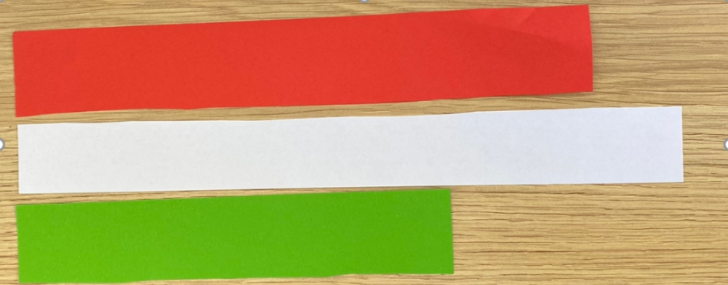
- Ask students to order the strips using direct comparison. Ask for their reasoning and justification.
The table below outlines stimulus prompts to generate conversation about the topic, along with anticipated responses from students.
Prompts | Anticipated student responses
- Which strip of paper is the longest? How do you know?  - I’m wondering how much longer the white strip is compared to the other strips of paper. How can we find out? | - White is the longest because it is longer at the end.  - ‘The white strip is about double the length of the green strip’ or ‘I noticed the white strip is about this much bigger’ (student indicates with fingers or lays the paper strips on top of each other for comparison).
- Ask students to estimate how many cubes they think will be needed to measure the length of each paper strip. Have students record their estimates.
- Students measure the length of one strip with cubes. If students are not demonstrating the intended learning, pause the lesson and explicitly demonstrate how to accurately measure the length of the paper strips. Explain, ‘When we measure lengths accurately, there are no gaps or overlaps and our units are in straight lines from end to end.’
- After measuring the length of one paper strip, ask students if they would like to revise their estimates for the others now that they have more information.
- As students measure the paper strips, ask them to record their findings beside their estimations.
- Students participate in a gallery walk to see how others have recorded their results. Briefly discuss the features of the images and diagrams to support students to understand that mathematicians record ideas so they can communicate them to an audience. Allow time for students to revise their recordings.
- Ask students, ‘How can we use this information about how many cubes longer the white strip of paper is compared to the other strips of paper to compare the lengths of paper?’
- Students explore strategies to find out how much longer or shorter the strips of paper are using the language of comparison. Students may use words, symbols, images, or concrete materials to determine and record the difference between the lengths. They may also use known facts to determine the difference. For example, ‘I know the white strip is 15 cubes long and the green strip is 10 cubes long. So, the white paper strip is 5 cubes longer than the green strip of paper’ (see Figure 2).
Figure 2 – Comparing lengths with cubes
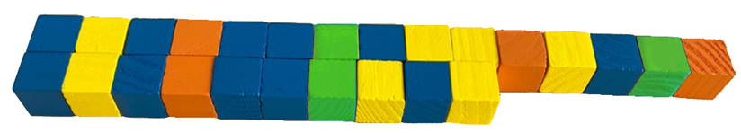
- Display the paper strips on a larger piece of paper. Share a range of student strategies for exploring the difference in lengths. Use these questions to support the conversation:
- Which object is the longest? How do you know?
- How much longer is the white strip compared to the red and the green? How can we be sure?
- What helped you find out how many more or less cubes there were in each length?
- How did you make sure you were measuring the paper strips accurately?
This table details assessment opportunities and differentiation ideas.
Assessment opportunities | Too hard? | Too easy?
What to look for:  - Are students using measuring techniques such as end to end, no gaps or overlaps, measuring in a straight line? (MAO-WM-01, MA1-GM-02)  - What are students describing as they listen to the ideas of others, and how do they communicate so others can understand? Do students reflect and adopt ideas and strategies? (MAO-WM-01)  - Do students estimate lengths and revise estimations when provided with more information? (MAO-WM-01, MA1-GM-02)  - Are students describing lengths by describing the number of units used? (MAO-WM-01, MA1-GM-02)  - Can students compare and order lengths by describing how many cubes longer or shorter, or quantify the difference? (MAO-WM-01, MA1-CSQ-02, MA1-GM-02)  - What strategies are students using when recording lengths? Are there a combination of symbols, words, and pictures or diagrams? (MAO-WM-01, MA1-GM-02)  What to collect:  - student estimations and recording of lengths. (MAO-WM-01, MA1-GM-02, MA1-CSQ-02) | Students may not understand that units need to be lined up end to end with no gaps or overlaps.  - Explain to students that it is difficult to compare lengths if we do not line the cubes end to end.  - Show students how to make sure the cubes are lined end to end. Ask, ‘Can we say a strip of paper is 5 cubes long if there are big gaps between the cubes?’ | Students can describe how they ordered lengths, discussing a variety of strategies that can be used to determine the difference in lengths.  - Ask students to create a new strip of paper that is 5 cubes longer than the longest strip of paper without using cubes.  - Students can estimate the length using visualisation, and then check using cubes.

Lesson 2: What’s the difference?
Core concept: A range of informal units can be used to measure accurately.
The table below contains suggested learning intentions and success criteria. These are best co-constructed with students.
Learning intentions | Success criteria
Students are learning that:  - to measure length accurately, there must be no gaps or overlaps, and units are to be placed in straight lines  - numbers and units help accurately describe how big, tall, or long something is  - the unit of measurement affects how many are needed  - mathematicians use a range of representations to communicate ideas. | Students can:  - position rods accurately to count the number of informal units needed to measure a chosen object  - recognise that the longer the unit of measurement, the fewer units will be needed  - use words, symbols, images, and drawings within a table to compare different lengths  - explain why some rods work better than others, for example, ‘These rods worked better because when they were repeated there were no leftovers.’

Daily number sense: Domino flip – 10 minutes
- Build student understanding of quantities through comparison.
- In pairs, flip over one domino each and compare the quantities. The highest (or lowest) quantity wins that round.
- Players take one counter each time they win a round.
- The player with the most counters at the end of 10 rounds, for example, wins.
- Variation 1: Record the difference. The student with the largest (or smallest) difference at the end of 5 (or another chosen number) rounds is the winner. Variation 2: Vary the domino number range or number of dominoes.

Consolidation and meaningful practice: How much am I worth? – 10 minutes
- Display Resource 2: Coloured rods. Ask students what they notice about the rods. Record their responses.
- Pose the question: ‘If the orange rod is equivalent in value to 10, what is the value of the other rods?’
- Use the ‘Talk moves’ strategies to facilitate a discussion. Provide students with time to organise their thinking.
- Ask students to share their solutions with a partner. Monitor for anticipated student responses to share with the class.
- Select students to share their findings with the class. Students must justify the value of each rod by describing the relationships they noticed that supported their reasoning.
The table below outlines stimulus prompts to generate conversation about the topic, along with anticipated responses from students.
Prompts | Anticipated student responses
- How can we use what we know, to find out what we don’t know?  - Can you use the size of the rods to help you find out their value?  - Is there a way you can check your thinking? | - We can use doubles to find the total. For example, ‘If the orange rod is 10, then I know that the total is 20, because double 10 is 20.’  - Student notices composite units. For example, ‘I see 6 green, which means I have 6 threes and 2 ones.’  - Comparing units. For example, ‘I notice 3 green rods are one bit longer than the black rod. If green is 3, then 3 of them are 9 Then the black would be 8, because it is one less.’  - We can use the total to check the value: ‘If 2 tens are 20 then 6 threes and 2 ones equal 20, too. 5 threes are 15, and 3 more is 18, plus 2 more equals 20.’

How long is this? – 50 minutes
This activity has been adapted from Boaler et al. (2021).
- Remind students that, in the previous lesson, they used units to measure strips of paper. Students reflect on strategies for measuring with units that were successful, and strategies that were not successful. Explain that they will be using coloured rods to measure lengths.
- Display a collection of objects to be measured and allow students to contribute additional objects. Tell students that they will be answering the question, ‘How long is this?’ by measuring the length of different objects using different coloured rods (see Figure 3).
Figure 3 – Example of a classroom item to measure
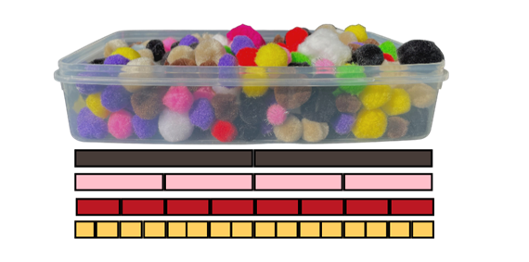
- In pairs, students choose 4 objects from the collection and use coloured rods to measure them. Ask students to estimate how many rods long the object is and record their estimations for each coloured rod. Observe if students are attending to the relationship between the length of the rods and the number of rods needed as they make their estimations. Students measure the length of the object by lining different coloured rods along the object’s length and record their findings beside the estimation. Students may use images, symbols, or words to record their estimations. Students can also use classroom technology to record their responses.
- Monitor for students measuring in a fair and accurate way, using the same-coloured rod for each measure, end on end without gaps or overlaps. If students are not measuring accurately, pause the lesson or work with small groups to explicitly address the intended learning for measuring lengths accurately.
- As students measure with the rods, ask questions such as:
- Which rod have you used to measure your object?
- Why did you choose to use that rod?
- How many red/brown rods long is your object?
- What happens when you choose a different coloured rod to measure your object?
- How can you record your findings so you can share them with others?
- Can you order the objects you have measured from shortest to longest and describe how you know?
- Bring students together to share their findings. Explicitly state that the size of the unit affects how many units are needed. Explain that mathematicians use diagrams and tables to help communicate their ideas. Ask students:
- Is there a way that we could publish our findings that would help us to compare the size of the units and the number of units we needed?
- What information would be important to record?
- How could we set up a table so we can see how many rods we need of each colour to measure our object?
Note: Paper folding can be used to create a table. Fold the left side of the paper over a third, then halve and halve again to create 5 sections. This creates one large column on the left to write the object measured, and 4 columns on the right to record how many rods are needed. Use the lines as a guide to rule the table. You could also have a large version of the table that includes all the different coloured rods to record different findings (see Figure 4).
- Using a piece of A3 paper, demonstrate how paper can be folded to create a table for displaying mathematical findings.
Figure 4 – Table to record data
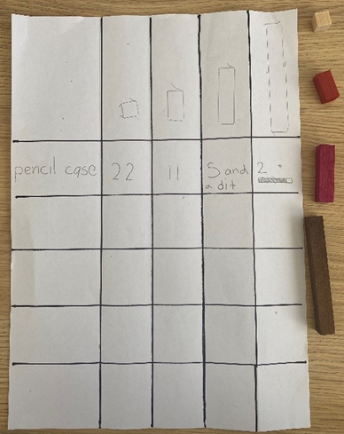
- In pairs, students record anything they notice about the size of the unit and the number of units needed. Ask students whether they thought some rods were more difficult to measure with than others.
- Select students to share their results and what they noticed about the relationship between the size of the unit and the number of units needed. As students share their findings, annotate their work samples to make the learning intentions explicit. Photos of objects measured with the rods lined up underneath supports student understanding. Ask the following questions to drive the conversation:
- What happened when we used different rods to measure the length of our objects?
- Were some rods easier to measure with than others?
- How can we say how long something is if the rods have a bit left over at the end?
- How did the table help you to compare the units used to measure the objects?
- When information is recorded in a table, did you notice any patterns? (Students may articulate that 2 of the pink rods are the same length as one brown rod.)
This table details assessment opportunities and differentiation ideas.
Assessment opportunities | Too hard? | Too easy?
What to look for:  - Are students using measuring techniques such as end to end, no gaps or overlaps, measuring in a straight line? (MA1-GM-02)  - What are students noticing, listening to, and commenting about when others share ideas and communicate for understanding? Do students reflect and adopt ideas and strategies? (MAO-WM-01)  - What strategies do students use when estimating lengths and revising estimates when provided with more information? (MAO-WM-01, MA1-GM-02)  - How do students describe the relationship between the size of the unit and the number of units needed? (MAO-WM-01, MA1-GM-02)  - Did students notice that some units are more accurate than others, some units have leftovers, and some line up neatly? How did they explain it? (MAO-WM-01, MA1-GM-02) | Students may not recognise the need to measure length with consistent informal units.  - Support students to ensure correct measurement techniques are being used, for example, lining up units end to end without gaps or overlaps.  - Explain that, when we use different units, it makes it difficult to describe how long our object is. For example, the length of the scissors can be described as one green, 2 blue and 3 red rods long. But, when we use all the same-coloured rods, it is much easier to describe because all the units are the same. | Students can already articulate the relationship between the size of the rods and the number of rods.  - Give students another item in the classroom and have them estimate length using specific-coloured rods. For example, how many white rods and how many red rods are needed to measure the same object? Students justify their answers. For example, ‘The red rods are double the length of the white rods, so we will need double the number of white rods for each red rod.’  - Have students identify things that they found tricky in this task. Ask them what they would do differently next time.

Lesson 3: Messy lengths
Core concept: Mathematicians estimate lengths and account for leftovers.
The table below contains suggested learning intentions and success criteria. These are best co-constructed with students.
Learning intentions | Success criteria
Students are learning that:  - to measure length accurately, there should be no gaps or overlaps, and the units should be in straight lines  - numbers and units help accurately describe how big, tall, or long something is  - the unit of measurement chosen affects how many units are needed  - ‘getting our eye in’ helps create reasonable estimations  - a length can be broken up into equally sized parts known as fractions  - mathematicians explain their thinking so it makes sense to others. | Students can:  - measure lengths accurately using one brick, and mark and move without leaving gaps or spaces  - describe that the smaller the unit, the more they will need, and the longer the unit, the less they will need  - change estimates when provided with more information  - describe the leftover lengths using the language of halves and quarters  - describe fractions as equal parts of a whole.

Daily number sense: Number talk – 20 minutes
- Build student understanding of additive relationships through a number talk.
- Display Resource 3: Measuring lengths. Explain that Phil and Silvia have been measuring the length of 2 pieces of string using building bricks and they found that, when they combined their building bricks, they had 17. Phil knew his string was 9 building bricks long. Ask the following questions:
- How many building bricks long was Silvia’s string?
- Can you share different ways to prove how many building bricks long Silvia’s string was?
- What do you notice about the numbers on the diagram?
- How can you use what you know to find out what you do not know?
The table below outlines stimulus prompts to generate conversation, along with anticipated responses from students.
Prompts | Anticipated student responses
- What do you notice about the numbers on the diagram?  - How can you use what you know to find out what you do not know?  - How many ways can we find out the total of missing building bricks? | - Take away by ones: students use fingers to keep track of the number taken away.  - Landmark numbers. For example, ‘I can partition 9 into 7 and 2 to help me get to the nearest landmark number. 17 − 7 = 10, 10 − 2 = 8, so 17 − 9 = 8.’  - Near doubles. For example, ‘Double 9 is 18 so it must be 9 and 8.’  - Think addition: ‘I can use what I know about how many more. 9 + something = 17.’  - Known facts. For example, ‘10 and 7 is 17, so 9 and 8 must also be 17.’

Messy lengths – 50 minutes
This activity has been adapted from Bruce et al. (2016).
- Show a 16 cm strip of orange paper and ask students to estimate how many 2 × 8 sized building bricks long is the orange strip of paper. Record students' estimations. Show the 2 × 8 sized building brick on top of the orange strip and ask if they would like to revise their estimation now that they see the building brick’s size in relation to the size of the orange strip.
- Provide students with one 16 cm × 1.5 cm orange strip of paper and one 2 × 8 building brick to measure the strip’s length. Students find how many 2 × 8 building bricks are needed to measure the length. Monitor for students describing how to measure the length using only one building brick, and using the building brick to measure end to end with no gaps or overlaps. Observe references to partial measures describing the equal sized parts of the last 2 × 8 building brick, describing 2 whole building bricks and some more, 2 whole building bricks and half, or 2 whole building bricks and 8 studs.
Note: If students do not measure carefully or find a different number of building bricks for the length, pause the lesson and explicitly address the intended learning for measuring. Show students the results that some groups were using and demonstrate the actions of a good measure. Reinforce the intended learning that measuring accurately means marking the ends with no gaps or overlaps.
- Annotate the orange strip of paper to record student ideas. Select students to share their findings and ask questions such as:
- How did you know how many building bricks to use when you only had one building brick?
- Did you find a strategy to make sure you were measuring accurately?
- How many building bricks do we need to measure the orange strip of paper?
- How much do you think is left over?
- What could we call the leftover bit?
- Show the 10.5 cm × 1.5 cm strip of green paper. Ask students to estimate the length of the paper using units of 2 × 4 sized building bricks. Students record their estimations. Hold the building brick up to the paper and invite students to revise their estimation with a partner using turn and talk. Monitor for the intended learning of ‘getting their eye in’ to make reasonable estimations and visualising the block moving along the length. Invite students to share their reasoning.
- Students determine the length of the green strip of paper with one 2 × 4 sized building brick. Observe students accurately using the building brick to measure the length, marking the length of the single building brick. Listen for students articulating the intended learning of partial measures. If the building bricks do not line up exactly, ask students, ‘How would you describe the part that hangs over the end?’ Students may describe the leftover bit as less than half, a little bit, 2 studs of the brick, or a quarter.
- Select students to discuss their findings. Ask the questions above to reinforce the intended learning while annotating the green strip of paper to record the class findings.
- Pose the question, ‘Could you use a different sized building brick to measure the lengths of paper so there are no leftover bits?’
- Allow students time to explore the different building bricks. Ask students, ‘Which building bricks will make a tidy measure with no leftovers?’ Students may articulate, ‘I can use the 2 × 4 sized building bricks for the orange strip’, ‘When I line the 2 × 4 building brick under the 2 × 8 sized building brick, I know I need 2 of them to make the same length’, ‘2 × 4 is half the length of 2 × 8. That means I need two 2 × 8 sized building bricks or four 2 × 4 sized building bricks to create the length of the orange paper strip’.
- Pose the next problem: ‘How could we use what we know about the length of the building bricks to make a new green strip of paper that is the same length as the orange strip of paper?’
- Students investigate how much longer the orange paper strip is compared to the green paper strip using a variety of building bricks.
- Ask questions to support students to notice the difference in length of the different strips of paper:
- How many 2 × 4, 2 × 2, or 2 × 1 sized building bricks would we need to make the strips the same length?
- Can we make the lengths the same using a 2 × 8 sized building brick?
- How could we describe how much longer the orange paper strip is?
- Select students to share their findings about which building bricks can be used to measure the length of the paper strips without leftovers. Have students describe the relationship between the building bricks and how that helps them to name the parts of the fractions. Ask questions to guide student thinking toward the intended learning:
- What happened when you measured the paper strips with different sized building bricks?
- Were some units better than others?
- What patterns did you notice when you lined up the building bricks?
- How can we name the part left over?
This table details assessment opportunities and differentiation ideas.
Assessment opportunities | Too hard? | Too easy?
What to look for:  - Are students using measuring techniques such as end to end, no gaps or overlaps, and measuring in a straight line? (MA1-GM-02)  - What are students wondering and commenting about as they listen to the ideas of others, and how do they communicate these so others can understand? Do students reflect and adopt ideas and strategies? (MAO-WM-01)  - Do students estimate lengths and revise estimates when provided with more information? (MAO-WM-01, MA1-GM-02)  - How do students describe the relationship between the size of the unit and the number of units needed? (MAO-WM-01, MA1-GM-02)  - Are students recognising and describing lengths as being divided into halves or quarters of a length? (MAO-WM-01, MA1-GM-03)  - Are students using words or diagrams to show the relationship between parts and the whole? (MAO-WM-01, MA1-GM-03) | Students do not recognise or know how to talk about the additional half length.  - Explain that it is ok to have parts of a measure, and that these parts can be named using what we know about parts of a whole.  - Create a strip of paper the length of the building brick. Have students fold the piece of paper and describe how we can name the parts. For example, 2 equal parts tells us we have halves.  - Discuss with students the number of studs on the building brick. Explain how this can help us to describe the leftover part. | Students already use the part of the unit to describe the length using the language of fractions.  - Draw students’ attention to the relationship between the 2 strips. Ask: ‘What do you notice about the length of the paper strips, and how many of each building brick do you need to measure their length?’  - Create a third strip of paper that is double the length of the first. Ask students to estimate how many building bricks they will need using what they know about the length of the current strip.

Lesson 4: Cut me a fair share
Core concept: Lengths can be partitioned into fractions.
The table below contains suggested learning intentions and success criteria. These are best co-constructed with students.
Learning intentions | Success criteria
Students are learning that:  - a length can be broken up into equally sized parts known as fractions  - the number of equal parts a length is broken into helps to name the fractions that have been created  - a fraction describes the relationship between the whole and the parts it has been broken into  - the same idea can be represented in different ways  - mathematicians compare their thinking with the thinking of others  - mathematicians use others’ ideas to refine and extend their ideas. | Students can:  - divide a whole into equal sized pieces to represent fractions  - use direct comparison to determine if an object has been divided into halves, quarters, or eighths  - use repeated halving to create quarters  - recognise that the more equal parts the whole is divided into, the smaller each part becomes.

Daily number sense: Quarters not quarters – 10 minutes
- Build student understanding of fractions by investigating examples and non-examples of quarters.
- Display Resource 4: Folded paper into 4 sections and ask:
- Are these shapes divided into equal parts?
- Which ones are showing quarters?
- Students turn and talk to a partner to justify which examples show quarters and which do not. Ask students to share their reasoning with their partner.
- While students are talking, listen for any of the anticipated responses to highlight during the class discussion.
- Strategically select students to share their thinking using ‘Talk moves’ to support rich meaningful conversation about the justifications.

Cut me a fair share – 40 minutes
This activity has been adapted from Van de Walle et al. (2019).
- Explain that students will plan a picnic lunch. The students will be sharing long salad rolls and need to make sure there will be a fair share of servings for everyone. Pose the problem: ‘4 friends want to share 6 long salad rolls so that each person gets the same amount. How much will each person get?’
- Provide students with paper strips to represent each of the long salad rolls. In groups, students explore the different ways they can partition the rolls to determine how much each person will receive.
- Observe students experimenting with paper folding and partitioning the paper strips. Monitor for students describing the intended learning (that lengths can be partitioned into equally sized parts). If students are not creating equal shares, pause the lesson and ask questions such as:
- I notice this roll has been partitioned into 2 parts but, when I hold them up, they don’t look like a fair share. Is it fair if I take this big bit and X gets the small bit? How can we create a fair share?
- How can we be sure that our shares are fair?
- How can we prove that our parts are equal?
- Does anyone have a strategy to make sure we are sharing the rolls equally between the students?
- If students arrive at a solution, provide them with more paper strips and challenge them to find another way to share the rolls fairly between the group members. Encourage students to record their findings using words, images, and symbols.
- Pose the next problem: ‘When the friends opened the bag of salad rolls, there was one extra. There were actually 7 salad rolls. How can we share the 7 rolls fairly with the 4 friends?’ Provide students with additional paper strips to represent the new amount of 7 rolls.
- Observe students describing the intended learning (that lengths can be partitioned into equally sized parts). Encourage students to name the fractions they have created and discuss how they know what fractions were created. If students are unsure how to name the fractions, pause the lesson and demonstrate how to notice and describe fractions by attending to the whole, the number of parts, and the relationship between the parts and the whole. Create an anchor chart for students to reference.
Note: Students do not need to identify the portion of salad rolls that each person will receive as ‘1 and 3 quarters’ to be successful. Instead, students may say that each person gets one whole roll, one half of a roll, and one quarter of a roll. If students do notice the relationship between halves and quarters, they may rename the halves as 2 quarters, then add on the other quarter to show the 3 quarters. This can be explored using the partitioned strips of paper.
- Select groups of students to share their evidence of partitioning. Students demonstrate the fair shares by aligning the parts on top of each other and naming them. Compare partitioning strategies to show different ways of solving the problem.
- Ask questions such as:
- What was the most efficient way of sharing the rolls?
- How do you know you have created halves/quarters?
- What do you notice about the parts you have made?
- How are they the same? How are they different?
Note: Students should notice the difference between the whole rolls, the rolls partitioned into halves, and the rolls partitioned into quarters. Use students’ observations about these differences to create an anchor chart for future lessons. For example, students may articulate that, when they see quarters, the parts are smaller than the halves or the whole.
This table details assessment opportunities and differentiation ideas.
Assessment opportunities | Too hard? | Too easy?
What to look for:  - What range of strategies are students exploring to share the rolls equally between the friends? (MAO-WM-01, MA1-GM-03)  - Are students describing the relationship of the parts to the whole length? (MAO-WM-01, MA1-GM-03)  - Do students recognise and explain how rolls have been partitioned into halves or quarters and then describe how they can prove they are equal parts? (MAO-WM-01, MA1-GM-03)  - How do students explain that as they created more parts, the parts became smaller? (MAO-WM-01, MA1-GM-03)  - Are students articulating that there is more than one way to partition the rolls, and making connections between their own partitioning strategies and those of others? (MAO-WM-01, MA1-GM-03) | Students have shared the rolls unevenly or the rolls are partitioned into unequal parts.  - Explain that, when we make fractions, it is important to make sure the parts of the roll are the same size. This will help us to make sure that everyone gets a fair and equal share.  - Demonstrate fair/unfair partitioning of paper strips. Ask students to attend to the features that help them notice if they have made halves or not halves, quarters or not quarters. | Students have found a way to partition the rolls to provide an equal share and are able to articulate how much each person will receive.  - Ask, ‘Are there other ways that the rolls can be shared equally between the friends?’ Provide more paper strips for the students to find other ways the rolls can be partitioned.  - Encourage students to create a diagram that shows the different ways that the rolls can be partitioned. Ask: ‘Can you tell me how this way is similar/different to your first way?’

Lesson 5: Eating toast
Core concept: 2D shapes can be partitioned.
The table below contains suggested learning intentions and success criteria. These are best co-constructed with students.
Learning intentions | Success criteria
Students are learning that:  - an object can be broken up into equally sized parts known as fractions  - the number of equal parts a length is broken into helps to name the fractions that have been created  - a fraction describes the relationship between the whole and the parts it has been broken into  - the same part can be described in different ways  - mathematicians use images and diagrams to communicate with others and prove their thinking. | Students can:  - divide a whole into equal sized pieces to represent fractions  - use direct comparison to determine if an object has been halved or quartered  - use repeated halving to create quarters  - recognise that the more equal parts the whole is divided into, the smaller each part becomes  - recognise halves and quarters  - rebuild a whole using 2 halves or 4 quarters  - create drawings to show how objects can be partitioned.

Daily number sense: A sharing story – 20 minutes
- Build student understanding of division by distributing a collection of objects equally into a given number of groups to determine how many in each group.
- Pose the problem: ‘4 children are planning to share 24 lollies. Everyone must get a fair share. How many lollies would each person get?’
- Provide students with wait time to solve the problem. Students may use hand signals to show how many ways they can think of to solve the problem.
- Ask students to turn and talk with a partner to discuss the ways they solved the problem. While students are talking, monitor for any of the anticipated responses to highlight during the class discussion.
- Strategically select students to share their thinking using ‘Talk moves’ to support rich meaningful conversation about the strategies discussed. Record student thinking on a public display so that others can understand the thinking.
The table below outlines stimulus prompts to generate conversation about the topic, along with anticipated responses from students.
Prompts | Anticipated student responses
- What is the problem asking us to do?  - How do you know?  - If you have thought of one way to solve the problem, can you think of another?  - Is sharing the only strategy that would work?  - What do you notice about the numbers in the problem? How could we use that to find how many each person gets? | - Sharing by ones: students may keep track of how many they have given out using their fingers.  - Trial and error. For example, ‘If I give them 3 each, that is 3, 6, 9, 12. That’s not enough, so it must be more than 3. I could try using fours.’  - Repeated halving. For example, ‘I know half of 24 is 12, but I need to share them with 4 people, not 2. If I halve again I will have 4 groups and half of 12 is 6, so they must get 6 each.’

Eating toast – 50 minutes
This activity has been adapted from Askew (2015).
- Pose the problem: ‘On Wednesday, I made a piece of toast and cut it into 2 equal pieces. I ate one piece. On Thursday I made another piece of toast, but this time I cut it into 4 equal sized pieces. I only ate 2 of the pieces. Did I eat more toast on Wednesday or Thursday?’
- Allow time for students to think and discuss their ideas with a partner. Provide students with 4 different coloured paper squares that represent the toast. Instruct the students to explore the problem with paper to build evidence to justify their thinking.
- Monitor students discussing and experimenting with the paper by folding and partitioning. If students are not creating equal parts, pause the lesson or speak with individual students by asking questions such as:
- How can we create equal parts with the paper?
- How can we prove that our parts are equal?
- Monitor students as they describe the parts. They should identify the Wednesday toast as halves and the Thursday toast as quarters. It may be beneficial to lay an extra square underneath students’ paper folding and partitioning so that they can see the half and quarters in relation to the whole.
- Identify students who were able to prove on which day the teacher ate more toast. Ask them to share their strategy for determining the answer. For example, laying the 2 pieces from Thursday on top of the one piece from Wednesday to show they were the same. If students have partitioned one piece of toast on the diagonal and the other straight down the middle, discuss how to compare the 2 different cuts.
- Once students have had enough time, provide them with an A3 piece of paper to create a poster to convince their audience of the solution. Students may want to draw a diagram or glue their partitioned shapes to the paper.
- Conduct a gallery walk and then allow time for students to revise their poster.
- Pair groups of students together to convince their audience (each other) of their argument using the evidence from their poster.
- Select students to share their proof with the class. Revise the question, ‘Did I eat more toast on Wednesday or Thursday? Does everyone agree?’ While students are sharing their evidence, ask questions to clarify or extend student thinking:
- What do you notice about the parts you have made?
- How are they the same? How are they different?
- What language can we use to describe the parts?
- How can it be that when you ate one piece on Wednesday, you ate the same amount as the day you ate 2 pieces? Isn’t 2 more than one?
This table details assessment opportunities and differentiation ideas.
Assessment opportunities | Too hard? | Too easy?
What to look for:  - What range of strategies did students explore to partition the toast into equal parts? (MAO-WM-01, MA1-GM-03)  - How did students describe and communicate the relationship of the parts to the whole? (MAO-WM-01, MA1-GM-03)  - Are students recognising and explaining how squares have been partitioned into halves or quarters and describing how they can prove they are equal parts? (MAO-WM-01, MA1-GM-03)  - How do students explain what they noticed? (As we created more parts, the smaller the parts became) (MAO-WM-01, MA1-GM-03)  - Are students creating quarters by repeated halving? (MA1-GM-03)  - How are students justifying that 2 quarters of the toast is the same amount as one half of the toast? (MAO-WM-01, MA1-GM-03)  What to collect:  - A3 posters. (MAO-WM-01, MA1-GM-03) | Students may think that the teacher will eat more on Thursday because they ate 2 pieces.  - Ask the student to show you how each of the pieces of toast are partitioned using paper folding. Cut paper into halves and layer them on a whole square so you can see the 2 parts sitting on top. Do the same with the quarters. Ask the student to get the part that you ate on Wednesday and move it below, doing the same for the Thursday toast. Ask students what they notice about the parts that had been eaten.  - If students are still unsure, lay the 2 quarters on top of the half and say: ‘I ate 2 pieces on Thursday but when I lay my 2 quarters on top of the half, they are the same amount. Can you see there are no gaps or overlaps? The pieces are the same size.’ | Students have solved the problem and are able to use their evidence to articulate the intended learning. Extend this thinking into halves and quarters of a collection. For example, ‘I had a bag of 12 treats and ate half one day, and the next day I had 24 treats and ate 2 quarters of them. Which day did I eat the most?’

Consolidation and meaningful practice: Handfuls – Thinking multiplicatively – 10 minutes
- View Handfuls – Thinking multiplicatively (11:04)
- Gather a collection of items for students, for example, animals or mini figurines. Items need 2 or 4 legs to enable multiplicative thinking.
- Player 1 takes a handful of items.
- Player 2 estimates how many the first player has.
- Player 1 arranges the items into a known pattern. For example, dominoes, dice, ten-frame.
- Player 2 identifies the number of items.
- Player 2 then calculates the number of legs/paws by counting by twos or fours.
- Students can rearrange items into different known patterns to support multiplicative thinking.

Lesson 6: Paper bugs
Core concept: Doubling and halving can be used to create fractions.
The table below contains suggested learning intentions and success criteria. These are best co-constructed with students.
Learning intentions | Success criteria
Students are learning that:  - a length can be broken up into equally sized parts known as fractions  - the number of equal parts the length is broken into helps name the fractions created  - a fraction describes the relationship between the whole and the parts it has been broken into  - the same part can be described in different ways. | Students can:  - divide a whole into equal sized parts to represent fractions  - use direct comparison to determine the relationship between the whole and the parts  - use repeated halving to create quarters and eighths  - recognise that the more equal parts the whole is divided into, the smaller each part becomes.

Daily number sense: Number talk – 20 minutes
- Build student understanding of additive relations and comparison of quantities.
- Display Resource 5: Number talk. Pose to students, ‘I am trying to find the length of this rod but can only find a broken ruler. Can you figure out the length of the rod?’
The table below outlines stimulus prompts to generate conversation about the topic, along with anticipated responses from students.
Prompts | Anticipated student responses
- What do you notice about the position of the rod and the numbers on the ruler?  - How can you use what you know to find out what you do not know? | - The rod begins at 4 and ends at 11.  - Think addition: ‘I can use what I know about how many more. Four + something = 11.’  - I can think about the difference between 11 and 4  - I can use my mathematical imagination and move the rod to sit above 3 and 10 because I know combinations to 10.

Exploring paper bugs – 40 minutes
This activity has been adapted from Bruce et al. (2016).
- Provide pairs or small groups of students with multiple copies of Resource 6: Paper bugs. Explain to students that paper bugs are special mathematical creatures that can grow and shrink.
- Ask the following questions:
- What do you notice about each of the different bugs?
- How could we describe their lengths?
- Is there a way that we can show how their lengths are related?
- Observe students as they describe the different lengths of the paper bugs. Monitor for students using direct comparison and language such as double and half to describe the lengths. If students do not attend to the doubling and halving relationship, ask:
- I am thinking that the blue bug is double the length of the red bug. Do you agree?
- What do you notice if we halve the green, blue, and red bugs?
- Is there a way we can make the green bug the same length as a red bug?
- Discuss and share findings as a group.
Note: Students should notice that the paper bugs can be doubled or halved to become equal in length. It may be beneficial to create a chart that shows how each bug can be doubled or halved to create the same length as another bug.
- Explain that, just as smaller paper bugs were hiding inside bigger paper bugs, smaller numbers also hide and nest inside bigger numbers. Use think-alouds to model language to students. For example, ‘We noticed before that if we double the length of a red bug, it becomes the same length as a blue bug. This means that we can see 2 red bugs hiding inside a blue bug.’
- Ask students:
- Can you find other ways smaller bugs are hiding inside bigger bugs?
- Can we find all the bugs hiding inside the green bug?
- Can we find out how many times bigger the green bug is in relation to the other bugs?
- Students investigate the different ways to see and describe paper bugs hiding inside of each other. Students record their findings by drawing or using the paper bugs to show the parts of the whole.
- Gather students to share findings. Draw students’ attention to the relationship between the number of parts and the size of the whole. For example, ‘By using repeated halving we can create halves, then quarters, then eighths. We know that there are 8 white bugs hiding inside a green bug. We can also say that the white bug is one eighth the length of the green bug. This means that the green bug is 8 times larger than the white bug.’
This table details assessment opportunities and differentiation ideas.
Assessment opportunities | Too hard? | Too easy?
What to look for:  - What are students wondering and commenting about as they listen to the ideas of others and how do they communicate these so others can understand? Do students reflect and adopt ideas and strategies? (MAO-WM-01)  - Can students recognise and explain how lengths can be doubled or halved to create new lengths? (MAO-WM-01, MA1-FG-01, MA1-GM-03)  - What strategies are students using when exploring relational reasoning to consider 2 measures in relation to each other? (MAO-WM-01, MA1-GM-02)  - Are students using language to describe the size of the part in relation to the whole? For example, one quarter is 4 times smaller than the whole. (MAO-WM-01, MA1-FG-01, MA1-GM-03) | Students do not recognise or know how to describe the relationship between bugs.  - Prompt students to notice that, if they double or halve certain bugs, the bugs become the same length. For example, ‘If we double the white bug or place 2 white bugs next to each other, is there another bug that is the same length?’  - Prompt students to use paperfolding and direct comparison to notice the relationship between the bugs. | Students recognise that the name of the fraction tells us its relationship to the whole.  - Have students use what they already know about the relationship between the bugs to create a new bug.  - Ask students if more than one type of bug is hiding inside a green bug. For example, ‘Inside a green bug is one blue bug and 2 red bugs. We can say that one half plus 2 quarters is equal to one whole.’

Consolidation and meaningful practice: Double or halve? – 20 minutes
- View Double or halve (7.37)
- Choose a target number between 10 and 99.
- Write your target number on your blank hundreds chart.
- The first player rolls the dice and chooses whether to double or halve the number.
- Record the roll on the game board, by shading the number of squares.
- Players record the running total to the side of their hundreds chart game board.
- Players take turns to roll the dice. If they can’t go, they miss a turn.
- The winner is the player who reaches the target number exactly.

Lesson 7: Noticing the clock
Core concept: Connections can be made between the number line and clock.
The table below contains suggested learning intentions and success criteria. These are best co-constructed with students.
Learning intentions | Success criteria
Students are learning that:  - an analog clock is made by curving a number line from 1 to 12 around the outside of a circle  - a fraction describes the relationship between the whole and the parts it has been broken into. | Students can:  - use a number line and paper folding to construct an accurate analog clock  - explain why we use the words ‘half past’, ‘quarter to’, and ‘quarter past’ to describe time.

Daily number sense: Zap zero – 10 minutes
This lesson was adapted from Zap by DENS (2021).
- Build student understanding of forward and backwards counting sequences by playing Zap zero
- Students form a large circle. Select one student to count backwards from a given number between zero to 120.
- Students take turns stating the next number in the sequence. When the number sequence reaches zero, the student who says ‘zero’ is zapped. The student calls out ‘zero!’ and sits down.
- Continue the activity with the students commencing the backward count from a given number again.
- Variations:
- Students count in a forward number word sequence to 120. When the number sequence reaches 120 the student who said ‘twenty’ is zapped.
- Students who are out remain in the circle and continue to say ‘zapped’ whenever it is their turn. The following student continues the count from the number after the number that would have been said instead of ‘zapped’.
- Select different numbers to be the ‘zapped’ number such as a number that lands on a decade, for example, 20, 30, 40.
- Start at a different number.

Wonky clocks – 50 minutes
This activity has been adapted from Boaler et al. (2021).
- In pairs, have students draw a clock. Bring students back together and have them compare their clocks to a real-life clock or an image of an accurate, round analog clock. Ask students, ‘What is the same and what is different between the clock you drew and this clock?’
- Explain to students that we can use a strip of paper to check how accurate our clocks are by wrapping the strip around the edge of the clock and marking where the numbers are. Model this process to students, marking each number on the strip of paper. Provide students with strips of paper and have them create their own strip to check the accuracy of their clock.
- Once students have marked their clocks on the strip of paper, have them discuss and compare their strip to the one modelled, asking questions such as:
- Where have we seen numbers arranged like this before?
- What do you notice about the numbers on your strip compared to the accurate one we made?
- What do you notice about the spaces between each number?
Note: As students draw their clock number line, they may have the numbers bunched up in sections. An opportunity to refine this will come in the next part of the lesson as we use paperfolding to notice the position of the number on a clock. Draw students’ attention to the relationship between the strip of paper and a number line, and the clock being a curved number line.
- Provide students with new strips of paper of the same length. Explain that we can use what we know about number lines and numbers to help us create an accurate clock. For example, ‘We know that 6 is half of 12 and if we fold our number line in half that is where 6 should be positioned.’ Have students fold their number line and mark where the 6 should be located. Ask, ‘Is there a way that we can keep folding our paper to find where any other numbers may sit on the clock number line?’ Students explore and discuss in pairs.
- Bring students together to discuss their thinking. Draw students’ attention to creating quarters and the relationship between 3 and 9 as being positioned at ‘quarter past’ and ‘quarter to’ on the clock.
This table details assessment opportunities and differentiation ideas.
Assessment opportunities | Too hard? | Too easy?
What to look for:  - How are students explaining their findings as they make connections between a number line and the position of the numbers on a clock? (MAO-WM-01, MA1-NSM-02)  - What strategies are students using to describe the position of the numbers on a clock number line and relating them to being quarter to, half past or quarter past? (MAO-WM-01, MA1-FG-01, MA1-NSM-02)  - Are students revising their thinking and making connections between the number line and the clock to create accurate representations? (MAO-WM-01, MA1-NSM-02). | Students do not recognise or know how to use paper folding to find where other numbers should be positioned on the number line.  - Ask students to show you how they folded their strip of paper to create half. Explain to students that we can use what we know about halves to find half of our half.  - Prompt students to think about how they could find out where 3 and 9 should be on the number line.  - If students are still unsure, cut the strip of paper in half and have them halve the halves. Lay the 4 quarters on top of the strip of paper and say, ‘We know that this section represents 6 (gesturing to the first 2 quarters). How can we use what we know about halves and the number 6 to help us find another number for our clock?’ | Students make connections to quarters and the relationship between 3 and 9 as being positioned at quarter past and quarter to on the clock. Ask:  - How can we find out if all our numbers on our number line clock are evenly spaced?  - How does knowing where ‘quarter past’ and ‘quarter to’ are positioned on a clock help us to describe time?  Students describe different aspects of the day using the language quarter to, half past, and quarter past, as well as the position of the minute hand. For example, ‘We eat lunch at half past 12, which means that the minute hand will be pointing to the 6.’

Lesson 8: Walking the clock
Core concept: Connections can be made between fractions and the clock.
The table below contains suggested learning intentions and success criteria. These are best co-constructed with students.
Learning intentions | Success criteria
Students are learning that:  - an analog clock is made by curving a number line from 1 to 12 around the outside of a circle  - the minute hand shows how many minutes past or how many minutes to the hour it is  - the hour and the minute hand are always moving  - the minute hand helps to be more precise when telling the time. | Students can:  - create an analog clock and describe the position of the numbers as being like a number line  - coordinate and describe the movement of the hour and minute hands on a clock  - describe the relationship between the position of the hands on a clock  - describe the movement of the minute hand on a clock using the language of quarter and half turn.

Daily number sense: Choral counting – 20 minutes
- Build student understanding of counting forwards from different numbers by creating a counting pattern. Select the number range based on the needs of the class.
- Students say each number in the sequence collectively as the teacher records the number on a large piece of paper (see Figure 5). Write the numbers counted aloud, such as counting by fives, starting at any number.
Figure 5 – Choral counting anchor chart
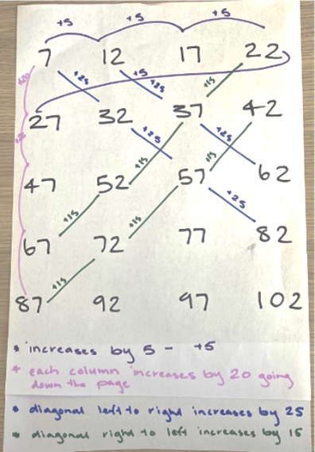
- Pose the question: ‘What patterns have we created in our choral count?’ Circle and annotate the patterns that students have identified after counting. Wait time gives students the opportunity to notice patterns, as well as identify the next numbers in the sequence using their knowledge of addition, subtraction and counting in multiples.

A human clock – 40 minutes
This activity has been adapted from Yumi Deadly Maths: Measurement Prep to Year 9 (Yumi Deadly Centre, QUT 2016).
- In a large open space students form a human clock by making a circle and using a post with 2 ropes. Begin by placing one student at the 12 position and have students discuss where the other numbers on the clock should be positioned. Encourage students to make connections to the previous lesson where they used a number line to determine where 3, 6 and 9 are positioned on a clock, then fill in the remaining numbers. For example:
- We know 6 is halfway around the clock face and is opposite number 12.
- We know that 3 is a quarter of the clock's number line, which means it is halfway between 12 and 6, because half of a half is a quarter.
- We know 9 is 3 quarters of the length of the clock's number line, which means it is positioned halfway between the 6 and the 12.
- The numbers 1 and 2, for example, need to be evenly spaced between the 12 and 3.
- Have students represent the numbers on a clock by holding cards showing the numbers 1 to 12 (Resource 7), while 2 students hold the ropes becoming the minute and hour hands. Beginning with both hands positioned at the 12, have students discuss and help their peers to make the minute and hour hand move in coordination with each other. Encourage generalisations such as:
- Every time the minute hand moves one full rotation, the hour hand moves toward the next number.
- When the minute hand is pointing toward 6, it has made a half turn around the clock.
- When the minute hand is pointing toward 3, it has made a quarter turn around the clock.
- When the minute hand is pointing toward 9 there is one quarter turn needed to complete the hour.
- When the minute hand is showing half past, or pointing toward the 6, the hour hand moves halfway between the numbers on a clock to show half past.
- In small groups, students create their own walkable clock. Call out times using the language of quarter past, half past and quarter to the hour. Provide students with the opportunity to embody both the minute and hour hands on the clock.
- Once students can move the minute and hour hand in coordination with each other, ask students to position themselves at a specific time and move forward in quarter-hour or half-hour increments. For example, ‘Begin at half past 3 and move forward half an hour.’ Repeat using a variety of times. Have students discuss the position of the hands in relation to turns, connecting the movement of the minute hand in half or quarter turns to the passing of a half or quarter of an hour, and the position of the hands on a clock at those times.
- Discuss the experience of walking around the clock with students. Have students describe the relationship between the hour and minute hand, and what their role is when each hand moves. Ask questions to prompt student thinking such as:
- What did you notice about the movements of the hands?
- What did you have to think about when moving the hour/minute hand?
- Was there anything hard about moving like the hands of a clock?
- How does the turning of the hands on a clock help us describe the position of the hands?
This table details assessment opportunities and differentiation ideas.
Assessment opportunities | Too hard? | Too easy?
What to look for:  - How are students communicating and describing the position of the hands on a clock for the half-hour and relating this to half turns? (MAO-WM-01, MA1-NSM-02)  - What are students wondering and commenting about as they listen to the ideas of others and how do they communicate these so others can understand? Do students reflect and adopt ideas and strategies? (MAO-WM-01)  - Are students making connections between the number line and the clock? (MA1-NSM-02)  - Are students using the language quarter past, half past and quarter to when describing time? (MA1-NSM-02, MA1-2DS-02, MA1-FG-01) | Students are not able to coordinate the movement of the minute and hour hands.  - Explain that each full turn the minute hand makes is equal to one hour in time. Remind students that the minute hand shows how many minutes have passed in the hour.  - Discuss why the hour hand on a clock is halfway between hour markers when the minute hand shows the half-hour. | Students make connections between the position of the hands in relation to half and quarter turns.  Have students position themselves at, for example, half past 3 and then move to 5 o’clock. Ask students questions such as:  - How did you know where to stand at the beginning?  - How did you know when to stop?  - How can you describe the turns you took when moving both the minute and hour hands?

Resource 1: Ten-frame
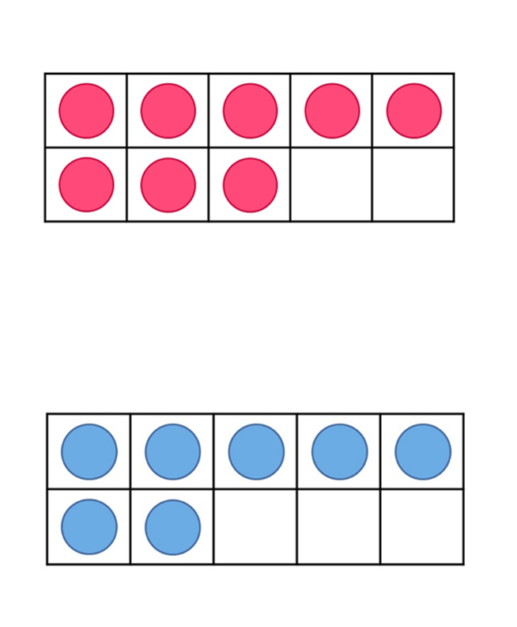

Resource 2: Coloured rods
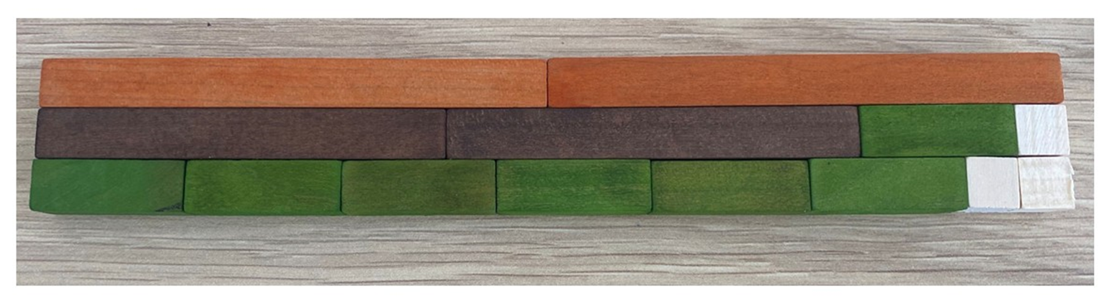

Resource 3: Measuring lengths
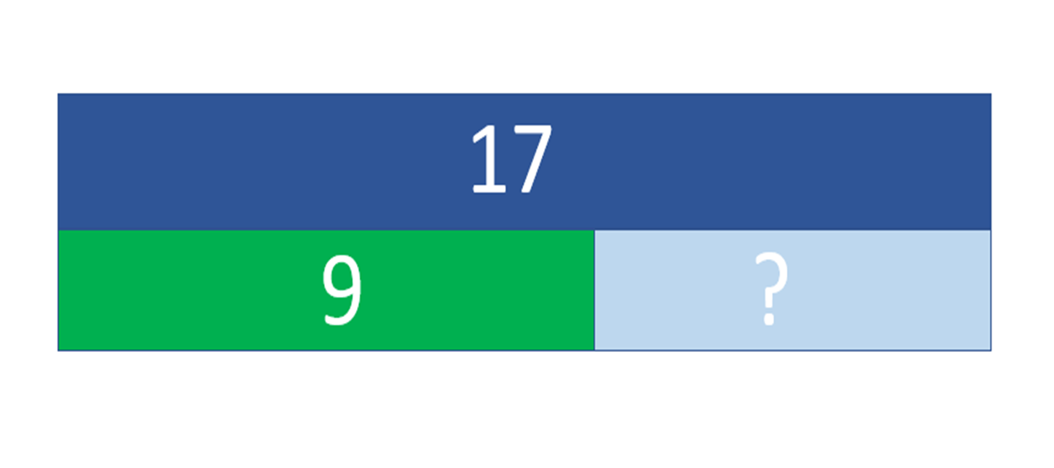

Resource 4: Folded paper
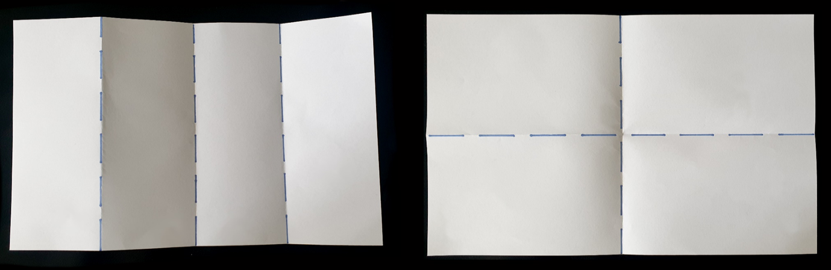
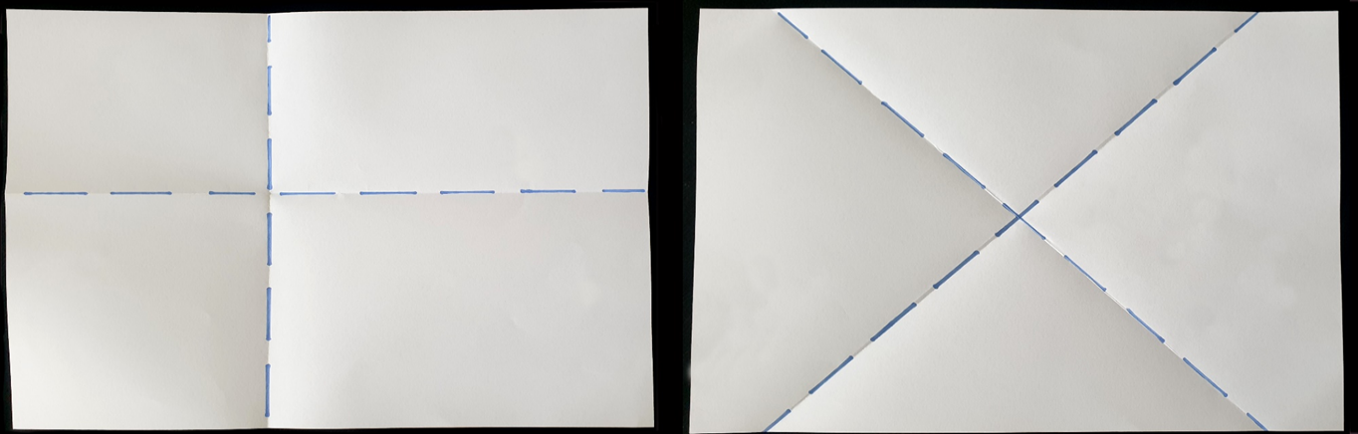

Resource 5: Number talk
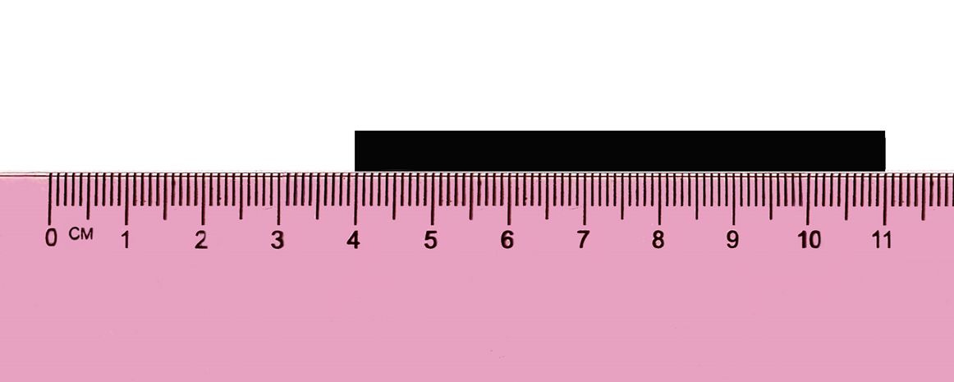

Resource 6: Paper bugs
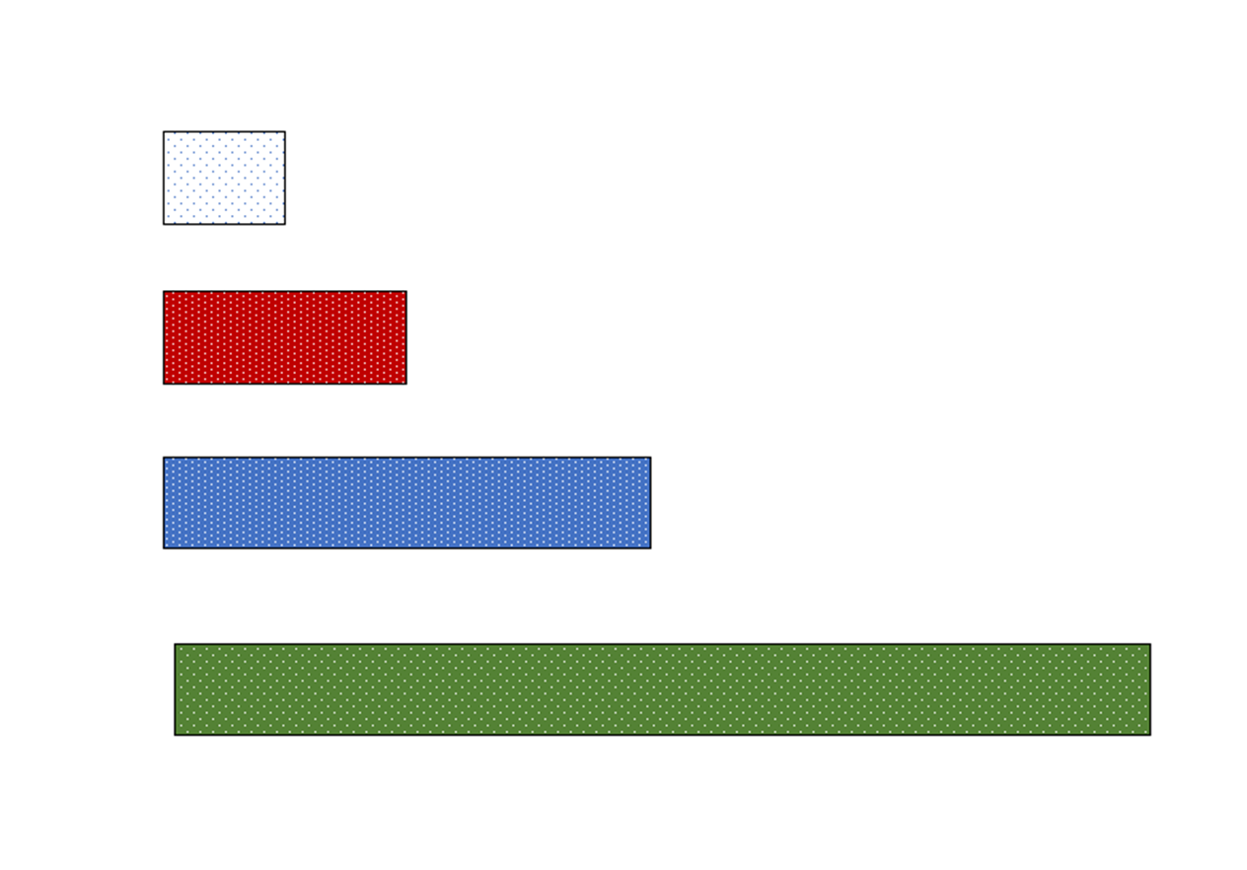

Resource 7: Number cards
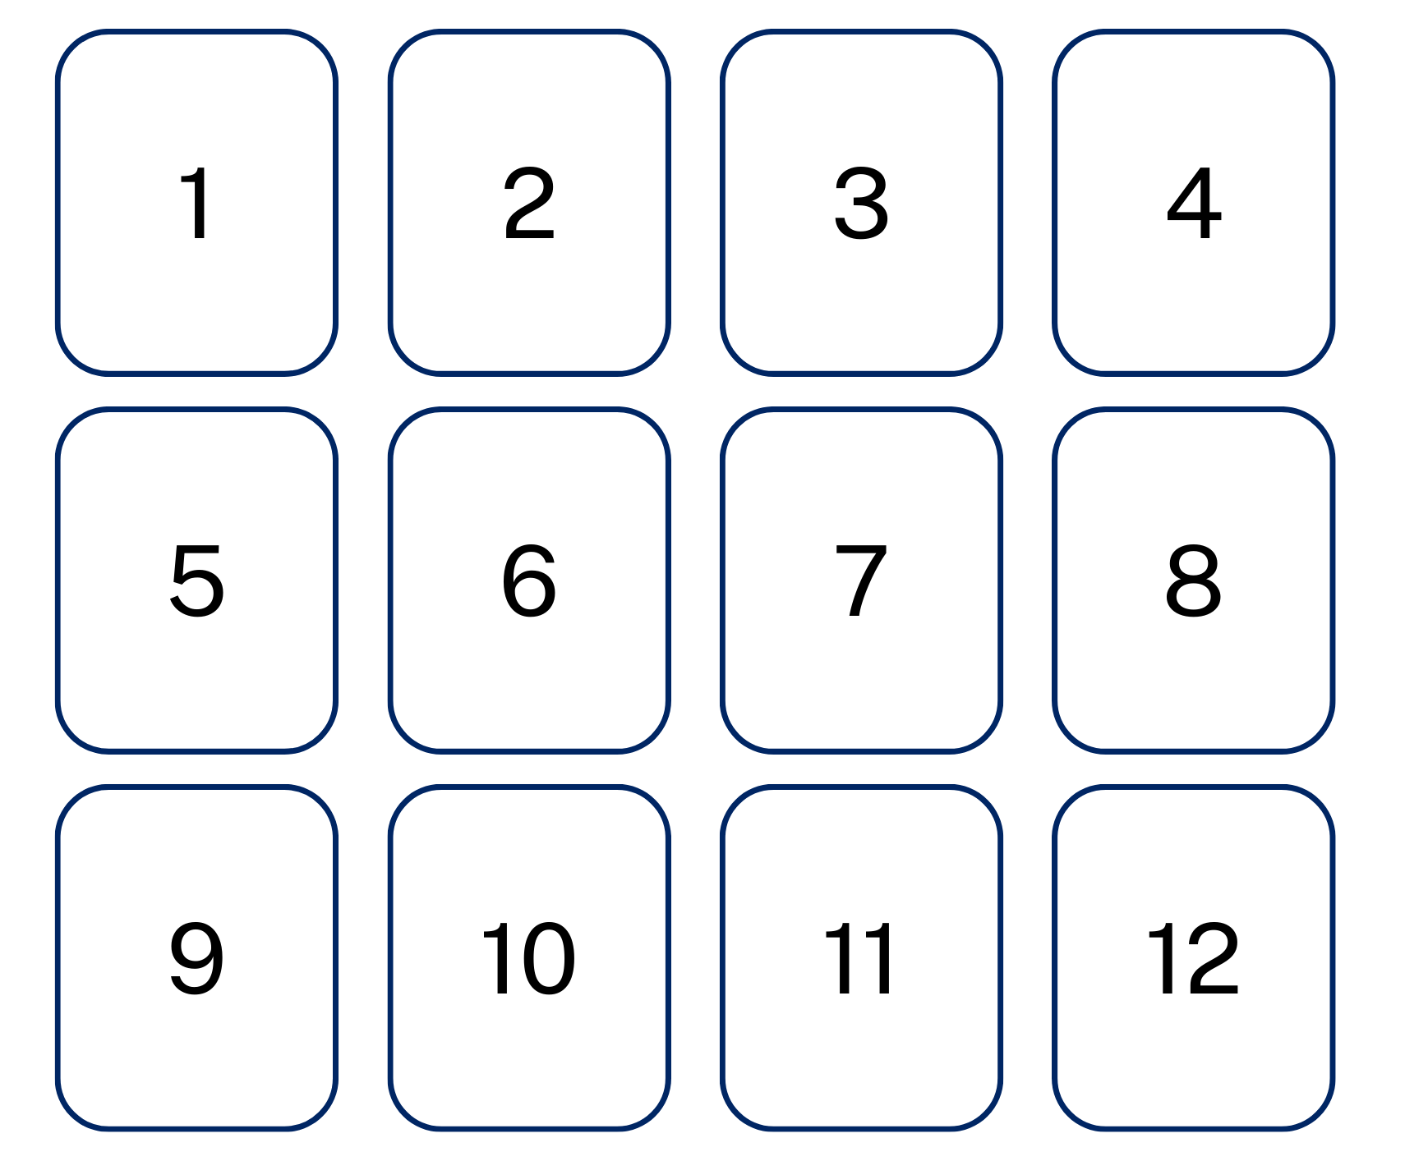

Syllabus outcomes and content
The table below outlines the syllabus outcomes and range of relevant syllabus content covered in this unit. Content is linked to National Numeracy Learning Progression version (3).
Focus area and outcomes | Content groups and content points | Lessons
Representing whole numbers A  MAO-WM-01  MA1-RWN-01  MA1-RWN-02 | Use counting sequences of ones with two-digit numbers and beyond  - identify the number before and after a given two-digit number (CPr5)  - count forwards and backwards by ones from a given two-digit number (CPr6)  Represent numbers on a line  - sequence numbers and arrange them on a line by considering the order and size of those numbers (CPr5)  Represent the structure of groups of ten in whole numbers  - recognise that ten ones is the same as one ten  - use 10 as a reference in forming numbers from 11 to 20  - use number lines and number charts to assist with locating the nearest ten to a number | 1-3, 7, 8
Combining and separating quantities A  MAO-WM-01  MA1-CSQ-01 | Use advanced count-by-ones strategies to solve addition and subtraction problems  - apply the terms ‘add’, ‘plus’, ‘equals’, ‘is equal to’, ‘is the same as’, ‘take away’, ‘minus’ and ‘the difference between’ to describe combining and separating quantities (AdS1, AdS6)  - recognise and use the symbols for plus (+), minus (−) and equals (=)  - record number sentences in a variety of ways using drawings, words, numerals and symbols (AdS6)  Recognise and recall number bonds up to ten  - describe combinations for numbers using words such as more than, less than and double (Reasons about relations) [AdS6] (AdS6) | 1-8
Forming groups A  MAO-WM-01  MA1-FG-01 | Recognise and represent division  - use concrete materials to model a half of a collection and show the relation between the half and the whole (InF1)  - model sharing division by distributing a collection of objects equally into a given number of groups to determine how many in each group (InF2, MuS5)  - model grouping division by determining the number of groups of a given size that can be formed (MuS5)  - describe the part left over when a collection cannot be distributed equally using the given group size (MuS6) | 4-8
Forming groups B  MAO-WM-01  MA1-FG-01 | Model doubling and halving with fractions  - model doubling and halving groups and the relation between the processes (MuS6, InF2)  - re-create the whole given half (InF3)  - use concrete materials to model a half, a quarter or an eighth of a collection, and explain their thinking (InF2, InF3) | 4-8
Geometric measure A  MAO-WM-01  MA1-GM-01  MA1-GM-02  MA1-GM-03 | Length: Measure the lengths of objects using uniform informal units  - use uniform informal units to measure lengths and distances by placing the units end to end without gaps or overlaps [UuM3] (UuM2)  - select appropriate uniform informal units to measure lengths and distances (UuM3)  - recognise and explain the relationship between the size of a unit and the number of units needed (Reasons about relations)  - count informal units to measure lengths or distances and describe the part left over (UuM4)  - record lengths and distances by referring to the number and type of unit used (UuM4)  Length: Compare length using uniform informal units  - estimate lengths, indicating the number and type of unit used and check by measuring (UuM4)  Length: Subdivide lengths to find halves and quarters  - use concrete materials to model both half and quarters of a whole length, highlighting the length (InF2)  - identify two equal lengths and the relationship of the parts to the whole length, linking words and images (InF2)  - recognise when lengths have or have not been divided into halves and quarters (InF2) | 1-7
Geometric measure B  MAO-WM-01  MA1-GM-01  MA1-GM-02  MA1-GM-03 | Length: Compare and order lengths, using appropriate uniform informal units  - record length comparisons using drawings, numerals and words, and by referring to the uniform informal unit used (UuM4) | 1, 2
Two-dimensional spatial structure B  MAO-WM-01  MA1-2DS-02 | 2D shapes: Identify and describe the orientation of shapes using quarter turns  - identify and describe directions of turns as ‘left turn’, ‘right turn’, ‘clockwise’ or ‘anti-clockwise’ (UuM4)  - connect the use of quarter and half turns to the turn of the minute hand on a clock for the passing of quarter and half-hours (Reasons about relations) | 8
Non-spatial measure A  MAO-WM-01  MA1-NSM-01  MA1-NSM-02 | Time: Tell time to the half-hour  - read analog clocks to the half-hour using the terms ‘o'clock’ and ‘half past’ (MeT2)  - describe the position of the hands on a clock for the half-hour (MeT2)  - connect the use of half turns to the turn of the minute hand for the passing of the half-hour (MeT2) | 7, 8
Non-spatial measure B  MAO-WM-01  MA1-NSM-01  MA1-NSM-02 | Time: Describe duration using units of time  - use the terms ‘hour’, ‘minute’ and ‘second (MeT2, MeT3)  Time: Tell time to the quarter-hour using the language of ‘past’ and ‘to’  - read analog clocks to the quarter-hour using the terms ‘past’ and ‘to’ (MeT2)  - describe the position of the hands on a clock for quarter past and quarter to and relate this to quarter turns (MeT2) | 7, 8

References
Links to third-party material and websites
Please note that the provided (reading/viewing material/list/links/texts) are a suggestion only and implies no endorsement, by the New South Wales Department of Education, of any author, publisher, or book title. School principals and teachers are best placed to assess the suitability of resources that would complement the curriculum and reflect the needs and interests of their students.
If you use the links provided in this document to access a third-party's website, you acknowledge that the terms of use, including licence terms set out on the third-party's website apply to the use which may be made of the materials on that third-party website or where permitted by the Copyright Act 1968 (Cth). The department accepts no responsibility for content on third-party websites.
All material © State of New South Wales (Department of Education), 2021 unless otherwise indicated. All other material used by permission or under licence.
Mathematics K–10 Syllabus © 2022 NSW Education Standards Authority (NESA) for and on behalf of the Crown in right of the State of New South Wales.
© 2022 NSW Education Standards Authority. This document contains NSW Curriculum and syllabus content. The NSW Curriculum is developed by the NSW Education Standards Authority. This content is prepared by NESA for and on behalf of the Crown in right of the State of New South Wales. The material is protected by Crown copyright.
Please refer to the NESA Copyright Disclaimer for more information.
NESA holds the only official and up-to-date versions of the NSW Curriculum and syllabus documents. Please visit the NSW Education Standards Authority (NESA) website and the NSW Curriculum website.
National Numeracy Learning Progression © Australian Curriculum, Assessment and Reporting Authority (ACARA) 2010 to present, unless otherwise indicated. This material was downloaded from the Australian Curriculum website (National Literacy Learning Progression) (accessed 25 November 2022) and was not modified. The material is licensed under CC BY 4.0. Version updates are tracked in the ‘Curriculum version history’ section on the 'About the Australian Curriculum' page of the Australian Curriculum website.
ACARA does not endorse any product that uses the Australian Curriculum or make any representations as to the quality of such products. Any product that uses material published on this website should not be taken to be affiliated with ACARA or have the sponsorship or approval of ACARA. It is up to each person to make their own assessment of the product, taking into account matters including, but not limited to, the version number and the degree to which the materials align with the content descriptions and achievement standards (where relevant). Where there is a claim of alignment, it is important to check that the materials align with the content descriptions and achievement standards (endorsed by all education Ministers), not the elaborations (examples provided by ACARA).
Askew M (2015) A Practical Guide to Transforming Primary Mathematics: Activities and tasks that really work, 1st edn, Routledge, New York.
Boaler J, Munson J. and William C (2021) Mindset Mathematics: Visualizing and Investigating Big Ideas, Grade 1, Jossey-Bass, New Jersey.
Bruce C, Flynn T and Bennett S (2016) ‘A Focus on Exploratory Tasks in Lesson Study: The Canadian "Math for Young Children" Project’, ZDM: The International Journal on Mathematics Education, 48(4):541–554, doi:10.1007/s11858-015-0747-7.
Queensland University of Technology (2016) Yumi Deadly Maths: Measurement Prep to Year 9, prepared by the Yumi Deadly Centre, Queensland, accessed 28 November 2022.
Stanford University (n.d.) 'Early Math Resources for Teacher Educators', Projects, DREME (Development and Research in Early Math Education) website, accessed 25 November 2022.
State of New South Wales, Department of Education (n.d.) ‘Activities to support forward and backward word sequences’, Counting-on-and-back Strategies, Developing Efficient Numeracy Strategies One website, accessed 25 November 2022.
Van de Walle J, Karp K, Bay-Williams JM, Brass A, Bentley B (2019) Primary and Middle Years Mathematics: Teaching Developmentally, 1st Australian edn, Pearson Education Australia.

