Mathematics – Stage 1 – Unit 7

Contents
Unit description and duration 4
Student prior learning 4
Lesson overview and resources 5
Lesson 1: Introducing ‘Clear the board’ 11
Daily number sense: Tally marks – 10 minutes 11
Clear the board – 40 minutes 13
Discuss and connect the mathematics – 10 minutes 16
Lesson 2: ‘Clear the board’ 18
Daily number sense – 10 minutes 18
Reviewing results – 10 minutes 19
Exploring combinations – 20 minutes 19
Discuss and connect the mathematics – 20 minutes 21
Lesson 3: Revisiting ‘Clear the board’ 23
Daily number sense: Would you rather? – 15 minutes 23
Describing the combinations – 10 minutes 24
‘Clear the board’ – 25 minutes 26
Discuss and connect the mathematics – 10 minutes 28
Lesson 4: Biography glyphs – Part 1 29
Daily number sense: What number am I? – 10 minutes 29
Creating biography glyphs – 30 minutes 30
Discuss and connect the mathematics – 20 minutes 34
Lesson 5: Biography glyphs – Part 2 36
Daily number sense: Number line – 10 minutes 36
Sorting and categorising data to answer a question – 30 minutes 38
Discuss and connect the mathematics – 20 minutes 41
Lesson 6: Biography glyphs – Part 3 42
Daily number sense: Number chart puzzle – 10 minutes 43
Using sorted information to create picture graphs – 30 minutes 44
Relaunch and re-summarise – 20 minutes 44
Lesson 7: Biography glyphs – Part 4 47
Daily number sense: Number busting – 20 minutes 48
True or false? How do you know? – 10 minutes 48
Picture graph interpreting – 20 minutes 49
Discuss and connect the mathematics – 10 minutes 50
Lesson 8: The data in our day 51
Daily number sense: Data talk – 15 minutes 51
Collecting the data from our day – 20 minutes 53
Displaying the data from our day – 25 minutes 55
Discuss and connect the mathematics – 10 minutes 56
Resource 1: Clear the board 58
Resource 2: Recording sheet 59
Resource 3: Assessing game play 60
Resource 4: Would you rather? 61
Resource 5: Dice display 62
Resource 6: Biography glyph key 63
Resource 7: Biography glyph face 64
Resource 8: Data table 65
Resource 9: Clock number talk 71
Resource 10: Our day template 72
Syllabus outcomes and content 73
References 78

Unit description and duration
This two-week unit provides opportunities for students to develop their understanding of communicating data through visual displays. Students are provided with opportunities to:
- collect and organise categorical data
- interpret data to make informed decisions
- identify and describe trends in data to predict the likelihood of outcomes
- use data as a powerful way to describe events in the world around us.
Mathematics K–10 Syllabus © 2022 NSW Education Standards Authority (NESA) for and on behalf of the Crown in right of the State of New South Wales.

Student prior learning
Before engaging in these teaching and learning activities, students would benefit from prior experience with:
- sorting and classifying objects according to their attributes and properties
- sorting, classifying, representing, and interpreting data
- gathering, organising, and displaying data in picture graphs.

Lesson overview and resources
The table below outlines the sequence and approximate timing of lessons, syllabus focus areas and content groups, and resources.
Lesson | Syllabus focus area and content groups | Resources
Lesson 1: Introducing ‘Clear the board’  60 minutes  Data can be used to help understand the world. | Representing whole numbers A  - Use counting sequences of ones with two-digit numbers and beyond  Combining and separating quantities A  - Recognise and recall number bonds up to ten  - Represent equality  Data A  - Ask questions and gather data  Chance A  - Identify and describe possible outcomes  Chance B  - Identify and describe activities that involve chance | - Resource 1: Clear the board  - Resource 2: Recording sheet  - Resource 3: Assessing game play  - Two 6-sided dot dice (per team)  - 20 double-sided counters (or 10 of one colour and 10 of another colour) per pair  - Sticky notes  - Writing materials
Lesson 2: ‘Clear the board’  60 minutes  Data can be used to answer questions and describe the world. | Combining and separating quantities A  - Use advanced count-by-one strategies to solve addition and subtraction problems  - Recognise and recall number bonds up to ten  - Use flexible strategies to solve addition and subtraction problems  - Represent equality  Data A  - Ask questions and gather data  - Represent data with objects and draw and describe displays  Data B  - Create displays of data and interpret them | - Resource 2: Recording sheet (from previous lesson)  - Large poster paper (per group)  - Two 6-sided dot dice (per group)  - Sticky notes  - Glue  - Writing materials
Lesson 3: Revisiting ‘Clear the board’  60 minutes  Data can be used to look for patterns and to help predict the likelihood of events. | Representing whole numbers A  - Continue and create patterns  Combining and separating quantities A  - Recognise and recall number bonds up to ten  - Represent equality  Data A  - Represent data with objects and drawings and describe displays  Data B  - Identify a question of interest and gather relevant data  - Create displays of data and interpret them  Chance A  - Identify and describe possible outcomes  Chance B  - Identify and describe activities that involve chance | - Resource 1: Clear the board  - Resource 2: Recording sheet  - Resource 4: Would you rather?  - Resource 5: Dice display  - Two 6-sided dot dice (per group)  - 20 double-sided counters (or 10 of one colour and 10 of another colour) per pair of students  - Writing materials
Lesson 4: Biography glyphs – Part 1  60 minutes  Data can be collected to answer questions. Data can be visually displayed and read. | Representing whole numbers A  - Represent the structure of groups of ten in whole numbers  Data A  - Ask questions and gather data  - Represent data with objects and drawings and describes the displays  Data B  - Identify a question of interest and gather relevant data | - Resource 6: Biography glyph key  - Resource 7: Biography glyph face  - Writing materials
Lesson 5: Biography glyphs – Part 2  60 minutes  Data can be sorted, categorised and displayed in different ways to communicate and highlight information. | Representing whole numbers A  - Represent numbers on a line  Data A  - Ask questions and gather data  - Represent data with objects and drawings and describes the displays  Data B  - Identify a question of interest and gather relevant data  - Create displays of data and interpret them | - Resource 6: Biography glyph key  - Resource 8: Data table  - Writing materials
Lesson 6: Biography glyphs – Part 3  60 minutes  Data can be communicated through visual representations. These representations need to be created with precision for information to be accurately conveyed. | Representing whole numbers A  - Use counting sequences on ones with two-digit numbers and beyond  Data A  - Represent data with objects and drawings and describe the displays  Data B  - Create displays of data and interpret them | - Resource 8: Data table  - Writing materials
Lesson 7: Biography glyphs – Part 4  60 minutes  Information can be interpreted from data displays. | Representing whole numbers A  - Represent the structure of groups of ten in whole numbers  Data B  - Create displays of data and interpret them | - Craft sticks  - Sticky notes  - Writing materials
Lesson 8: The data in our day  70 minutes  Data can be a powerful way to tell stories. | Data A  - Ask questions and gather data  - Represent data with objects and drawings and describe displays  Data B  - Identify a question of interest and gather relevant data  - Create displays of data and interpret them | - Resource 9: Clock number talk  - Resource 10: Our day template  - Writing materials

Lesson 1: Introducing ‘Clear the board’
Core concept: Data can be used to help understand the world.
The table below contains suggested learning intentions and success criteria. These are best co-constructed with students.
Learning intentions | Success criteria
Students are learning that:  - gathering and organising data helps to answer questions  - different combinations of numbers can add up or bond to form a given number. | Students can:  - track the total number of rolls using tally marks  - develop questions from data gathered. For example, ‘I wonder why 1 and 13 are always left over?’  - combine 2 number representations that add up to 12 or less.

Daily number sense: Tally marks – 10 minutes
- Draw 7 tally marks and ask students what they think the representation might mean, for example, see Figure 1.
Figure 1 – Tally marks
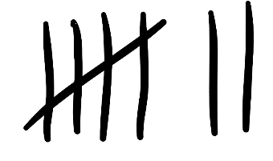
- Provide opportunity for students to turn and talk and then share their thinking.
- Explain that the representation is of the number 7 and each of the tally marks represents one observation. Ask students why they think the fifth mark has been drawn diagonally through the first 4 marks. Have students share their responses.
Tally marks: A single mark in a tally represents one observation. Tally marks are usually drawn in groups of 5. The first 4 marks are often drawn vertically, with the fifth mark drawn diagonally through the first 4. This makes counting in groups more efficient.
- Using their individual whiteboards, students write the numbers 1 to 6. Display a 6-sided dice and tell students that it will be rolled 20 times. Each time it is rolled, students need to record a tally mark next to the number. For example, if a 6 is rolled, a mark is recorded next to 6 (see Figure 2).
Figure 2 – Recording with tally marks
Images sourced from Canva and used in accordance with the Canva Content License Agreement.

Clear the board – 40 minutes
Note: Consider printing Resource 1: Clear the board on A3 paper.
- Explain that students are going to play a game in small teams. Each team rolls two 6-sided dice and combines the numbers rolled. The team then removes the corresponding counter from the gameboard and records the number of rolls using tally marks. Model playing the game against the class.
- Display Resource 1: Clear the board and each team decides which numbers to place their 10 counters on (see Figure 3).
Figure 3 – Clear the board set up
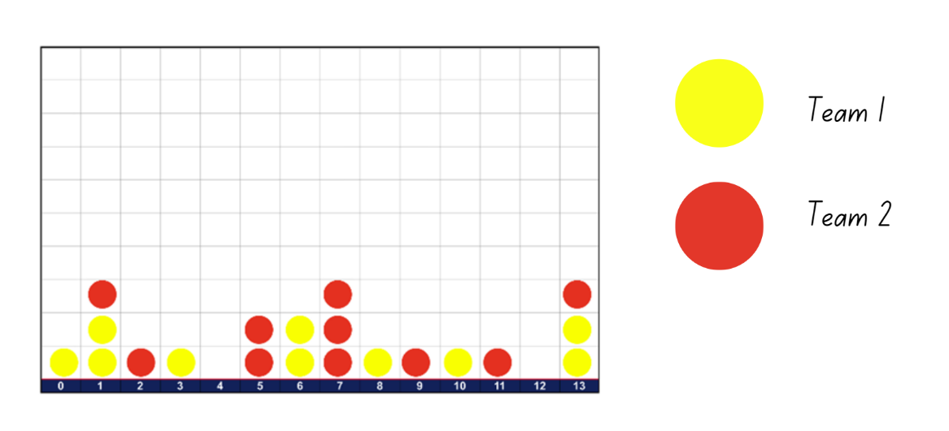
- Teams take turns rolling two 6-sided dice and combining the dots together. If the team has a counter on the corresponding number for the total combinations of dots, they remove their counter. For example, if Team 1 rolls a 6 and 4 and have a yellow counter on 10, they can remove the yellow counter. Only one counter can be removed each turn. The team must also record a tally mark for the total next to the number on Resource 2: Recording sheet.
- The first team to remove all 10 counters from the gameboard is the winner.
- When students are confident with the game, split them into groups of 4 with 2 players in each team. Each group needs two 6-sided dice, one copy of Resource 1: Clear the board and each team needs 10 of the same-coloured counters and Resource 2: Recording sheet.
- Teams play each other twice. During this time, observe the various strategies that students use to combine the dots and record rolls.
Note: Teams keep Resource 2: Recording sheet as it will be used in future lessons.
This table details assessment opportunities and differentiation ideas.
Assessment opportunities | Too hard? | Too easy?
What to look for:  - Are students able to combine 2 number representations that add up to 12 or less? (MAO-WM-01, MA1-CSQ-01)  - What are students noticing and wondering while they are playing and gathering data about the game? For example, it is hard to roll a 2 or it is impossible to roll zero. (MAO-WM-01, MA1-DATA-01, MA1-DATA-02, MA1-CHAN-01)  - Are students able to track the total number of rolls in each game using tally marks? (MAO-WM-01, MA1-RWN-01, MA1-DATA-01)  What to collect:  - observational data (MAO-WM-01, MA1-CSQ-01, MA1-DATA-01, MA1-DATA-02, MA1-CHAN-01)  - Resource 3: Assessing game play. (MAO-WM-01, MA1-CSQ-01, MA1-DATA-01, MA1-DATA-02, MA1-CHAN-01) | Students are unable to make use of part-whole relations in determining the total number of dots. Provide students with double-sided counters. Ask:  - Can you recreate the dot patterns using these counters?  - Now that you can move the dots, which ones would you move to make a friendly number? For example, moving 4 dots from the 5, then combining them with 6 to make 10.  Students have difficulty developing, noticing, and wondering questions from the game. Ask:  - What were some of the first numbers you cleared from the game board?  - Are there any numbers that you found difficult to clear from the board? What were they? | Students are confident in using count-by-one strategies to determine total number of dots. Ask:  - Is there another way to find the total of the 2 dice without having to count?  - What do you know about the relationship between numbers that might help you find the total?  - What do you know about 5 that might be useful when combining it with 6? For example, ‘5 is 4 and 1’. Now you can combine 6 and 4 and 1.

Discuss and connect the mathematics – 10 minutes
- Regroup as a class and ask:
- What did you notice when playing the game?
- Did some numbers come up more often than others?
- Were some numbers impossible to roll?
- What strategies did you use to combine the totals?
- Tell the class that many teams put a lot of their counters on 11 and 12. Have students turn and talk about the different dice combinations that they could make for 11 and 12.
- Select students to share their thinking and model recording combinations using sticky notes (see Figure 4).
Figure 4 – Recording combinations to 11 and 12
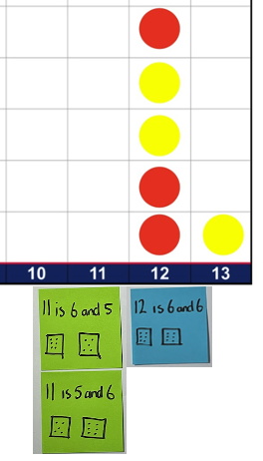
Note: Keep sticky notes for Lesson 2.
- Ask students if this information changes how they might place their counters in future games. Explain that this is something the class is going to continue to think about and explore in future lessons.

Lesson 2: ‘Clear the board’
Core concept: Data can be used to answer questions and describe the world.
The table below contains suggested learning intentions and success criteria. These are best co-constructed with students.
Learning intentions | Success criteria
Students are learning that:  - gathering and organising data helps to answer questions  - different combinations of numbers can add up or bond to form a given number. | Students can:  - create data displays using a combination of pictures, symbols, and words  - use data displays to develop questions  - recognise and recall different combinations of 2 numbers that add up to a given number.

Daily number sense – 10 minutes
- As part of the daily number sense session, consider including short, focused, and frequent teaching activities that target a concept or skill (for example, number sense) that you have identified as a class need through formative assessment. Examples of resources for this include:
- Thinking Mathematically Stage 1
- Universal Resources Hub.

Reviewing results – 10 minutes
- Have teams look at the data gathered on Resource 2: Recording sheet from Lesson 1 and reflect on the most and least common numbers rolled. Students share with the class.
- Display the sticky notes of the possible combinations for 11 and 12 from Lesson 1. Ask students to record all the possible combinations for 10 using two 6-sided dice.
- Provide students with independent thinking time, dice and an individual whiteboard to record their combinations.
- Select students to share their responses and model recording their thinking using sticky notes. Add the sticky notes to a class display.

Exploring combinations – 20 minutes
- Provide pairs with two 6-sided dice and a collection of sticky notes. Students work together to find all combinations for numbers 0-13.
- When pairs are confident that they have identified all the combinations, provide them with a large sheet of paper. Students stick their sticky notes to the paper to display all their combinations (see Figure 5).
Figure 5 – Displays of combinations
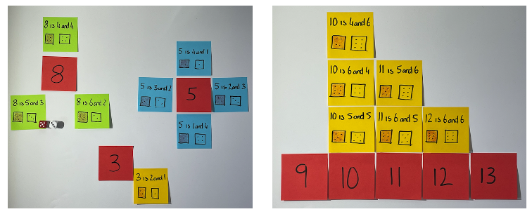
This table details assessment opportunities and differentiation ideas.
Assessment opportunities | Too hard? | Too easy?
What to look for:  - Are students able to create and organise their data? (MAO-WM-01, MA1-DATA-02)  - Are students able to use their data display to develop questions? (MAO-WM-01, MA1-DATA-01, MA1-DATA-02)  - Are students working systematically when exploring combinations? (MAO-WM-01, MA1-CSQ-01)  - Can students recognise and recall different combinations of 2 numbers that add up to a given number? (MAO-WM-01, MA1-CSQ-01)  What to collect:  - observational data (MAO-WM-01, MA1-CSQ-01, MA1-DATA-01, MA1-DATA-02)  - student work samples. (MAO-WM-01, MA1-CSQ-01, MA1-DATA-01, MA1-DATA-02) | Students have difficulty working systematically through the range of numbers and combinations. Ask:  - Is there a way you could organise the numbers to make sure we have them all?  - If we decrease 6 (in 6 and 4 is 10) by one to make 5, what would we need to do to the 4 so that the total is still 10? | Students confidently and accurately interpret information by describing the shape and distribution of the data. For example, the numbers in the middle of the range have more combinations. Ask:  - What would the data look like if we played the game with three 6-sided dot dice? How would it change?  - Which numbers would have the greatest number of combinations if we played the game with two 9-sided dot dice?

Discuss and connect the mathematics – 20 minutes
- Students display their work and go on a gallery walk to look at the other groups’ combinations and how they have displayed their data.
- Regroup as a class and ask:
- What do you notice about the different ways students have organised their data?
- How do you know you have all the combinations?
- Which way makes it easier to keep track of the combinations?
- Which number had the greatest number of combinations?
- Which way of displaying the combinations made it easier to answer these questions without having to count?
- Looking at the combinations of numbers for 10, I notice that there are 2 notes with 6 and 4. Are they the same? Why or why not?
- Provide additional time for students to revise their thinking, find missing combinations of numbers through being more systematic in their approach, and reorganise their data displays. If needed, students can glue their sticky notes to their display.

Lesson 3: Revisiting ‘Clear the board’
Core concept: Data can be used to look for patterns and to help predict the likelihood of events.
The table below contains suggested learning intentions and success criteria. These are best co-constructed with students.
Learning intentions | Success criteria
Students are learning that:  - the likelihood of possible outcomes can be identified and described  - data displays help mathematicians to share what they have noticed about the world around them  - mathematicians use data to help them make predictions. | Students can:  - describe events as likely, unlikely, more likely, less likely and impossible  - interpret data to choose the most likely combinations of numbers on the dice to increase chances of winning the game.

Daily number sense: Would you rather? – 15 minutes
- Display Resource 4: Would you rather? and ask students the 2 questions on the number talk.
- Allow individual thinking time and then students turn and talk to discuss the options. Ask:
- What did the options require you to think about?
- How did you reach your decision?
- Did you draw on any strategies when solving the problem?
- Are you confident with your decision? Why?
- Provide students with two 6-sided dice to roll 10 times. Students record if they roll 2 even numbers or doubles.
- After playing, ask:
- Are you still confident with your decision? Why or why not?
- Do you think the results will change if you play again?
- What are you still wondering?

Describing the combinations – 10 minutes
This activity has been adapted from Dice Sums from youcubed.
- Pairs of students have their data display from Lesson 2. Display Resource 5: Dice display and allow time for students to compare it to their data display.
- After looking at their display and Resource 5: Dice display, facilitate student discussion about labelling and the likelihood of rolling certain numbers. Ask students to identify numbers that are likely, unlikely and impossible and label them on their data display (see Figure 6).
Figure 6 – Labelling and comparing the likelihood of rolling different combinations
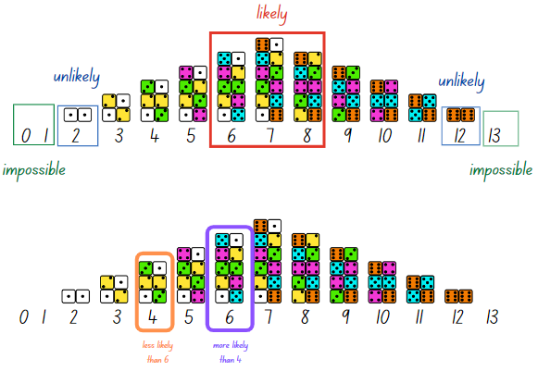
Adapted from ‘Dice Sums’ by youcubed and is licensed under CC-BY-NC 4.0.
- Looking at the data displays, ask:
- Which combinations of numbers are most likely to be rolled? Why?
- Which combinations of numbers are least likely to be rolled? Why?
- Are some numbers impossible to roll? How do you know?
- Looking at the combinations for 6 and 4, which one is more likely to be rolled during a game?
- Are there any other numbers that are just as likely to occur as 6? What are they?
- If you were to play ‘Clear the board’ again, which numbers would you pick to give you the best chance of winning? Are there any numbers you would not choose? Why?
- As mathematicians, we use data to help us develop a hunch or what we call a conjecture. Our conjecture is that if we choose numbers that have the greatest number of possible combinations, we have a better chance of winning the game.

‘Clear the board’ – 25 minutes
- Revise the rules from Lesson 1 and students replay ‘Clear the board’ against another team. Provide groups with Resource 1: Clear the board and each team with Resource 2: Recording sheet and 10 counters of the same colour.
- Explain that this is an opportunity to test the conjecture that certain combinations of numbers are more likely than others. Remind students that they are free to choose any numbers they like, but that they should think about which numbers will give their team the best chance of winning.
- This time students are asked to record both the total number of dice rolls using tally marks, and the number combinations that are rolled during the game. For example, if a 5 is rolled, a tally mark would be placed in the first column next to 5 and the combination rolled, 4 and 1, would be placed in the next column.
Note: Take photos of students’ game boards as they play to support the discussion in the next section.
This table below details assessment opportunities and differentiation ideas.
Assessment opportunities | Too hard? | Too easy?
What to look for:  - Can students interpret the data and use knowledge of the possible combinations to inform the choice of numbers (predict the outcomes of events)? (MAO-WM-01, MA1-DATA-01, MA1-DATA-02)  - Are students able to describe events as likely, unlikely, more likely, less likely and impossible? (MAO-WM-01, MA1-CHAN-01)  - Can students recognise and recall different combinations of 2 numbers that add up to a given number? (MAO-WM-01, MA1-CSQ-01)  What to collect:  - observational data. (MAO-WM-01, MA1-CSQ-01, MA1-DATA-01, MA1-DATA-02, MA1-CHAN-01) | Students are not yet able to use data display to help predict outcomes. Ask:  - Looking at the picture from our number talk today, which numbers have the greatest number of combinations?  - Which numbers are more likely to be rolled? Which numbers are least likely? | Students can confidently and accurately use the data to predict the outcomes of events to increase their chances of winning the game. Ask:  - What numbers would you choose if we were to use two 9-sided dot dice?  - What would the game board and data look like?

Discuss and connect the mathematics – 10 minutes
- Regrouping as a class, pairs compare their current recording sheet with the one from Lesson 1. Pairs turn and talk to discuss anything interesting they noticed from playing the game this time.
- Strategically select and sequence examples of students’ game boards and recording strategies to help facilitate a discussion about the key mathematical ideas. Ask:
- Did the numbers you predicted give your team the best chance of winning?
- Were there any numbers that surprised you when they came up? Why?
- Is there anything else you are still wondering?

Lesson 4: Biography glyphs – Part 1
Core concept: Data can be collected to answer questions. Data can be visually displayed and read.
The table below contains suggested learning intentions and success criteria. These are best co-constructed with students.
Learning intentions | Success criteria
Students are learning that:  - groups of 10 can be represented in different structures  - asking questions and collecting information helps to learn more about a topic  - the same information can be displayed in different ways. | Students can:  - recognise that 10 ones are the same as one 10  - ask and find answers to questions by collecting data  - use symbols to create and interpret data displays.

Daily number sense: What number am I? – 10 minutes
- Build student understanding of 10 ones are one 10 by making statements to guess the number. For example, I am thinking of a number that has:
- 3 tens and 4 ones
- one 10 and 12 ones
- 45 ones.
- Students record the numbers on their individual whiteboard.
- Students can create their own questions to ask the class or a partner.
The table below details assessment opportunities and differentiation ideas.
Assessment opportunities | Too hard? | Too easy?
What to look for:  - Can students recognise that 10 ones are the same as one 10? (MA1-RWN-01)  What to collect:  - observational data. (MAO-WM-01, MA1-RWN-01) | Students are unable to recognise that 10 ones are the same as one 10.  - Provide students with a ten-frame and counters to represent the number when thinking of and guessing partners’ numbers.  - Students use concrete materials, such as interlocking cubes, MAB blocks or craft sticks, to represent 10 ones as one 10. | Students can recognise that 10 ones are the same as one 10.  - Challenge students to think of and make statements about three-digit numbers.  - Students need to come up with at least 3 different statements for the same number.

Creating biography glyphs – 30 minutes
This lesson has been adapted from Marks Krpan (2013).
- Revise that, in the last few lessons, the focus was on making a data display. Remind the class that they explored possible dice sum combinations and how the data could help increase the chance of winning. Explain that students can be curious about anything and collect data to find answers. This is one of the reasons mathematicians make data displays; they get curious and want to share what they have learned.
- Explain that mathematicians can also be curious about each other. Ask students what they wonder about each other. Students may need some prompts, for example, what language do students in the class speak, or what superpower students might want. Students turn and talk and then share their ideas. Record student suggestions of what they wonder about each other.
- Explain to students that data can be represented as a symbol, like a glyph. Since the class is representing data about themselves, the data will be displayed by using glyphs to make a face.
Glyph: A ‘glyph’ is a symbol, icon or character that represents information.
- As a class, choose 6 suggestions of what students wonder about each other and make them a category heading on Resource 6: Biography glyph key. Then co-construct suggested responses (see Figure 7). Ensure categories and glyphs are colour-coded for easy interpretation later.
Figure 7 – Biography glyphs key (the categories and symbols can be adapted to suit the student’s interests and needs)
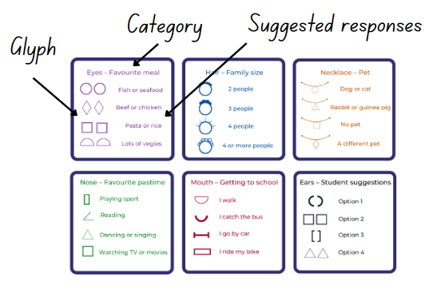
Image adapted from Marks Krpan C (2013).
- Demonstrate the creation of your teacher biography glyph by selecting the matching glyph and colour from each category to create your biography data face. For example, if pasta is your favourite food, draw 2 purple square eyes.
- Provide each student with Resource 7: Biography glyph face to create their own biography glyphs. As a class, systematically select a category and read and display each glyph option to support students to draw the matching glyph to their paper face (see Figure 8).
Figure 8 – Students' biography glyphs
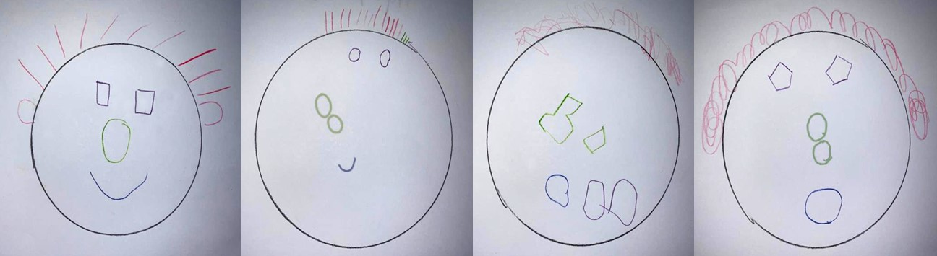
Note: Figure 8 shows a range of possible student responses. Some responses will be easier to interpret than others. First, focus on the details of the glyphs, then the composition of the ‘face’, and then the image as a whole.
This table details assessment opportunities and differentiation ideas.
Assessment opportunities | Too hard? | Too easy?
What to look for:  - Are students able to ask and find answers to questions by collecting data? (MAO-WM-01, MA1-DATA-01)  - Can students use symbols to create a data display? (MAO-WM-01, MA1-DATA-01)  What to collect:  - Resource 7: Biography glyph face. (MAO-WM-01, MA1-DATA-01) | Students find it difficult to draw glyph shapes with accuracy.  - Have students rehearse drawing the glyph by carefully tracing to ‘feel’ the glyph shape with a finger prior to drawing it on their paper face.  - Provide students with objects that are the shapes needed so students can trace around the shapes. | Students complete their biography glyph independently and quickly. Have students add more categories of interest for the glyph key and create their own glyphs within these categories to use for their biography glyph.

Discuss and connect the mathematics – 20 minutes
- Have students display their biography glyphs and go on a gallery walk. As students are walking around, encourage them to stop and read the data of different student biography glyphs. For example, ‘I can see this student has a dog because there is a circle on their necklace.’ Students may need to refer to Resource 6: Biography glyph key.
- Regroup as a class and have students bring their biography glyphs for a discussion. Display some student biography glyphs and choose different students to interpret the data or ask questions about it.
- Discuss how students were able to communicate information about themselves and their classmates through the chosen symbols used. Ask:
- How did we communicate information about ourselves?
- How did we learn information about each other?
- What are you wondering?
This table below details assessment opportunities and differentiation ideas.
Assessment opportunities | Too hard? | Too easy?
What to look for  - Can students use symbols to interpret a data display? (MAO-WM-01, MA1-DATA-01, MA1-DATA-02)  What to collect:  - observational data. (MAO-WM-01, MA1-DATA-01, MA1-DATA-02) | Students find it difficult to interpret a peer’s biography glyph.  - Support students by providing a colour copy of the glyph key to students.  - Show students how to systematically identify each glyph on their peer’s paper face, and then find it on the key through colour and shape to get the corresponding information. | Students can easily interpret biography glyphs of their peers using the glyph key.  - Students interpret the biography glyphs and match them to as many class members as possible.  - Challenge students to create their own glyph key.

Lesson 5: Biography glyphs – Part 2
Core concept: Data can be sorted, categorised and displayed in different ways to communicate and highlight information.
The table below contains suggested learning intentions and success criteria. These are best co-constructed with students.
Learning intentions | Success criteria
Students are learning that:  - numbers have a sequence based on their value  - data can be represented with objects and drawings  - data can be described and interpreted  - the same information can be displayed in different ways. | Students can:  - sequence given numbers and identify missing numbers on a number line  - organise collected data using concrete materials, tables or symbols  - investigate a topic by creating suitable questions  - sort data into relevant categories.

Daily number sense: Number line – 10 minutes
- Build student understanding of numeral identification and order by correctly sequencing numbers.
- Write the numbers 6, 12, 14, 18 and 23 on the board in a random order. Using their individual whiteboards, ask students to order these numbers from smallest to largest on a blank number line.
- Choose students to share where they placed their numbers and justify the position of their placement.
Note: It is important to look at the placement of numbers on the number line. Check if students have considered the missing numbers or placed all the numbers together.
- Ask students to identify and add the missing numbers.
- Repeat the above steps for different collections of numbers.
The table below details assessment opportunities and differentiation ideas.
Assessment opportunities | Too hard? | Too easy?
What to look for:  - Can students sequence given numbers and arrange them on a number line? (MA1-RWN-01)  What to collect:  - observational data. (MAO-WM-01, MA1-RWN-01) | Students are unable to order numbers on a number line.  - Provide students with 0-10 number cards to sequence in ascending and descending order.  - Provide students with 0-10 number cards with 2 or 3 cards missing. Students order the cards in ascending and descending order and identify the missing cards.  - Provide benchmark numbers to assist students in ordering the placement of numbers on a number line. | Students can order a collection of numbers on a number line.  - Provide students with a blank number line with 47 and 67 at either end. Have students determine the placement of 52.  - Challenge students with different three-digit number ranges.

Sorting and categorising data to answer a question – 30 minutes
- Students display their biography glyphs from the previous lesson on their desk. Provide time for students to examine them and reflect on the data collected. Ask:
- What do you notice about our class biography glyphs? Students turn and talk.
- What do you wonder about our class? While students turn and talk, monitor for students who wonder something that can be answered by sorting the data within the biography glyphs. For example, how many people have dogs or which superpower is the most popular?
- Explain that the class data about different categories has been represented in each individual biography glyph. The glyphs can be used to find out the answers to investigation questions. Display Resource 6: Biography glyph key from the previous lesson and ask students to think and share what investigation questions they have about the different categories. Record student suggestions with each category. For example:
- What is the class’ favourite meal?
- What is the class’ least favourite meal?
- How many more people like beef over fish?
- Ask students to think about how we could use and organise the data to answer these questions. Students turn and talk and then share their ideas with the class.
- Provide pairs with a category, their workbook and access to a range of materials like counters or interlocking cubes. Ask students to use the data presented in the biography glyphs to collect, sort and categorise the information to answer the investigation questions. Students walk around the room, looking at everyone’s biography glyphs to collect relevant information.
Note: This task has been left open to allow students to use their own strategies to collect and organise data. When collecting information to investigate a question, students can develop simple ways of recording. Some methods include placing blocks or counters in a line, colouring squares on grid paper, or using tally marks.
- Regroup as a class and strategically select students to present their different strategies for sorting and categorising data on their topic. Ask:
- How did you go about sorting and collating the information from the biography glyphs?
- What information did you pay attention to?
- Which information did you ignore and why?
- How is the way your group sorted your biography glyphs similar or different to another group?
- If needed, discuss possible ways to sort and categorise data that students have not yet mentioned.
- Provide time for pairs to reflect on the way they sorted and collated the data in the biography glyphs and if they think they have accurately collected the data to answer some of the investigation questions.
- Display and introduce Resource 8: Data table. Ask students to think how this table may assist them when collecting data.
- Provide pairs with the relevant table for their category from Resource 8: Data table and together they fill in the relevant sections (see Figure 9).
Figure 9 – Additional information
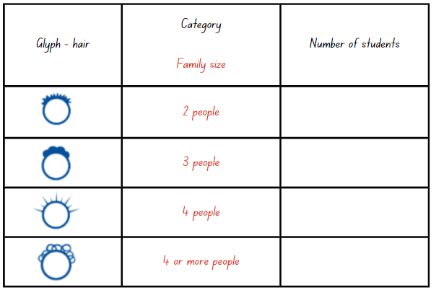
- Students then use Resource 8: Data table to organise and collect data on their category. Circulate and observe students during this process.
This table below details assessment opportunities and differentiation ideas.
Assessment opportunities | Too hard? | Too easy?
What to look for  - Are students able to organise collected data using concrete materials, tables or symbols? (MAO-WM-01, MA1-DATA-01)  - Can students investigate a topic by creating suitable questions? (MAO-WM-01, MA1-DATA-01)  - Are students able to sort data into relevant categories? (MAO-WM-01, MA1-DATA-01, MA1-DATA-02)  What to collect:  - observational data (MAO-WM-01, MA1-DATA-01, MA1-DATA-02)  - student work samples. (MAO-WM-01, MA1-DATA-01, MA1-DATA-02) | Students examine the wrong glyphs for the category they are investigating or find it difficult to sort and collate biography glyphs into appropriate subcategories. Ask:  - What are you finding out about our class?  - Which glyphs give you that information?  Students might count a glyph more than once or miss it. Ask:  - How do you know you have counted that information just once?  - Have you counted all the glyphs? How can you be sure? | Students can easily interpret and collate the biography glyph data for one category.  - Students interpret and collate the biography glyphs for another question/category.  - Challenge students to collate the collected data into a data display.

Discuss and connect the mathematics – 20 minutes
- Regroup as a class and have pairs reflect on both data collection methods they used to collect and organise data to answer the investigation questions. Ask:
- What is similar about your collection methods?
- What is different about your collection methods?
- Do they show the same information?
- Is one collection method easier to understand than the other?
- Have pairs ask each other the investigation questions and then use the data they have collected to answer the questions.
- Ask students to share the responses to the investigation questions with the class and record.
Note: Keep class biography glyphs and co-constructed strategies for sorting information for the next lesson.

Lesson 6: Biography glyphs – Part 3
Core concept: Data can be communicated through visual representations. These representations need to be created with precision for information to be accurately conveyed.
The table below contains suggested learning intentions and success criteria. These are best co-constructed with students.
Learning intentions | Success criteria
Students are learning that:  - data displays are an efficient way of communicating information  - the same information can be displayed in different ways. | Students can:  - represent data in a picture graph using a baseline, equal spacing and same-sized symbols  - interpret information presented in tables and picture graphs.

Daily number sense: Number chart puzzle – 10 minutes
This activity has been adapted from Open-Ended Maths Activities by Sullivan and Lilburn (2017).
- Build student understanding of number patterns by connecting a number to its neighbours on a number chart.
- Draw a number chart puzzle piece (see Figure 10) and tell students that the shape covers the number 57 on a number chart. Ask students what other numbers it might be covering.
Figure 10 – Puzzle piece
- Students use individual whiteboards to draw different possibilities and share them with the class.
- Using the same puzzle piece, students complete the activity with a different two-digit number.
Note: Initially some students may need to refer to a number chart.

Using sorted information to create picture graphs – 30 minutes
- Compare and contrast examples of strategies created and discussed in the previous lesson to sort and categorise data. Ask students to look at all the examples and think of which way helps to know about a category of interest at a glance.
- Have students think if there is a way to combine the pretty nature of the glyph and the tally table information. Students may suggest a picture graph (or pictograph); if not, make this suggestion.
Picture graph: Display of data using images, symbols or pictures to represent data in categories.
- Explain to students that a picture or symbol can be used to represent data. Discuss appropriate selection of a symbol and tell students that they ideally want a symbol that can be easily reproduced multiple times, so not to use a detailed drawing.
- Co-construct a picture graph from one of the glyph categories from Resource 8: Data table from the previous lesson. Demonstrate just enough to have students get started on a picture graph.
- Have students remain in the same pairs or groups as the previous lesson. Ask students to create a picture graph for the category they collected the data on, using their data from Resource 8: Data table.
- Do not show or tell students how to create a good data display yet. Instead, where appropriate, take photos of student work and pause to allow discussion of key aspects of data displays.

Relaunch and re-summarise – 20 minutes
- Compare and contrast the picture graphs students made for different categories.
- Strategically select and display students’ picture graphs to compare, contrast and highlight key features of data displays. Have students identify if they included any of the key features needed to create a clear picture graph. Ask:
- Does one picture represent one data value?
- Are symbols the same size, equally spaced and not overlapping?
- Is there a baseline?
- Co-construct a picture graph with students (see Figure 11).
Figure 11 – Simple picture graph
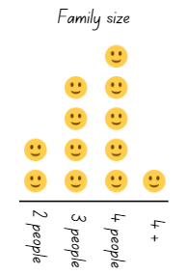
Images used in accordance with the Canva Pro Content License Agreement.
- Relaunch students to complete or revise their picture graph.
- Gather students together to re-summarise. Discuss how they have revised or modified their data representation to make it clearer to someone else. Ask:
- How have you changed/revised your picture graph? Why?
- How does this make the information clear to someone else?
This table below details assessment opportunities and differentiation ideas.
Assessment opportunities | Too hard? | Too easy?
What to look for:  - Are students able to represent data in a picture graph using a baseline, equal spacing and same-sized symbols? (MAO-WM-01, MA1-DATA-01)  - Can students interpret information presented in tables and picture graphs? (MAO-WM-01, MA1-DATA-01, MA1-DATA-02)  What to collect:  - observational data (MAO-WM-01, MA1-DATA-01, MA1-DATA-02)  - student work samples. (MAO-WM-01, MA1-DATA-01, MA1-DATA-02) | Students may find it difficult to display data so information conveyed is understood by others.  - Support students to create labels (such as title or categories).  - Ask how someone else could know what the picture graph is about.  Students may experience difficulty when representing the data value with the accurate number of picture symbols.  - Ask how students know __ people have __?  - Help students to create units/pictures that are uniform in size and are equally spaced with no overlapping.  - Help students work from a common baseline. Ask how they can tell how many more/less/most/least, without counting. | Students create a data display enabling efficient communication of class information.  - Challenge students to modify the unit/picture from representing one-to-one value to a unit/picture representing more than the value of one. Students adjust the data display accordingly.  - Students create another data display using the same collected data.

Lesson 7: Biography glyphs – Part 4
Core concept: Information can be interpreted from data displays.
The table below contains suggested learning intentions and success criteria. These are best co-constructed with students.
Learning intentions | Success criteria
Students are learning that:  - mathematicians can read data displays to learn about the world (people) around them  - data displays can be used to make inferences, make predictions and draw conclusions  - variation to data changes the visual data display. | Students can:  - use picture graphs to interpret information  - ask and answer questions about data represented on a picture graph  - draw conclusions from picture graphs to help make meaning from them.

Daily number sense: Number busting – 20 minutes
This lesson has been adapted from Number busting – number talk (renaming 26) (2:00) from Thinking Mathematically.
- Sit in a circle and display 4 groups of 10 and 7 ones using craft sticks or other materials. Tell students you have 47 craft sticks. Students turn and talk to share ideas on how they can prove there are 47 sticks.
Note: Bundles of 10 can be made with craft sticks, interlocking cubes or straws or something similar that can be separated. Teacher to watch Number busting – number talk (renaming 26) (2:00).
- Invite students to number bust 47 with you. Model how to use the collection to partition 47 in different ways. Record some of the different ways to rename 47. Invite other students to share their ideas. Demonstrate ideas students may not think of, such as unbundling the collections to show 47 is 3 tens and 17 ones.
- Repeat and model the above steps with different two-digit numbers to support student understanding.

True or false? How do you know? – 10 minutes
- Display picture graphs created in the previous lesson and pose some statements that students can indicate are true or false from the graph. For example, most people do not have a pet.
- Students can answer by indicating true or false via gestures or moving to a particular side of the classroom. Ensure students justify their thinking in reference to the picture graph. For example, I know more people have dogs than cats because…

Picture graph interpreting – 20 minutes
- Students display their picture graph on their desk and, in pairs, students walk around and analyse other picture graphs. Have students consider:
- What information can you get from this picture graph?
- What information can you not get from this picture graph? Why?
- Students write this information on sticky notes to attach around the appropriate picture graph.
- Students continue to examine other picture graphs and write all the information they can and cannot get from them.
This table details assessment opportunities and differentiation ideas.
Assessment opportunities | Too hard? | Too easy?
What to look for:  - Are students able to use picture graphs to interpret information? (MAO-WM-01, MA1-DATA-02)  - Can students ask and answer questions about data represented on a picture graph? (MAO-WM-01, MA1-DATA-02)  - Are students able to draw conclusions from picture graphs to help make meaning from them? (MAO-WM-01, MA1-DATA-02)  What to collect:  - observational data. (MAO-WM-01, MA1-DATA-02) | Students find it difficult to infer information from the picture graphs. Pose appropriate prompts to help students infer information through comparisons such as:  - Which ___ is the most popular?  - Which ___ is the least popular?  - Which ___ is more than ___?  - Which ___ is less than ___? | Students infer a lot of information about the class from the picture graphs. Students pose questions that can be answered using information in the graphs.

Discuss and connect the mathematics – 10 minutes
- Regroup as a class and display the picture graphs with all the information students have inferred. Ask the students to share what they notice.
- Co-construct a conclusion about information that can be inferred from picture graphs. For example, students can read the data displays to get information from them.
- Variation: Show one picture graph. Pose some questions to help students think about how variation can impact on the data in the picture graph. For example:
- What if 10 more people were included?
- What if 7 people changed their mind about …?
- How might the picture graph change?
- Ask students what they think would happen if data was collected on this topic from another class. Students turn and talk and then share with the class.

Lesson 8: The data in our day
Core concept: Data can be a powerful way to tell stories.
The table below contains suggested learning intentions and success criteria. These are best co-constructed with students.
Learning intentions | Success criteria
Students are learning that:  - mathematicians use data to describe their lives and the world around them  - the same data can be represented in different ways  - different data can be displayed in the same way. | Students can:  - identify and collect data telling a story about their day, using tools like a table  - create a data display telling a story about their day  - make simple inferences about their day from their data displays.

Daily number sense: Data talk – 15 minutes
This data talk has been adapted from ‘Water Usage’ from youcubed.
- Build student understanding of interpreting data in displays by engaging in a data talk.
- Display Resource 9: Clock number talk and ask some questions to generate rich talk.
- Provide students with independent thinking time, as well as the opportunity to turn and talk to a partner to share their thinking.
The table outlines stimulus prompts to generate conversation about the topic, along with anticipated responses from students.
Prompts | Anticipated student responses
- What do you notice?  - What do you wonder?  - What is going on in this data display? | - I notice that it looks like a clock. There are pictures around the outside of the clock and around the inside.  - The pictures all have a different meaning, but I wonder why they are around the clock.  - Maybe the pictures on the clock tell us when something is happening.
- Strategically select students to share their thinking. Record student thinking for the class to see. See Figure 12 for an example of a co-constructed anchor chart.
Figure 12 – Co-constructed noticing and wonderings
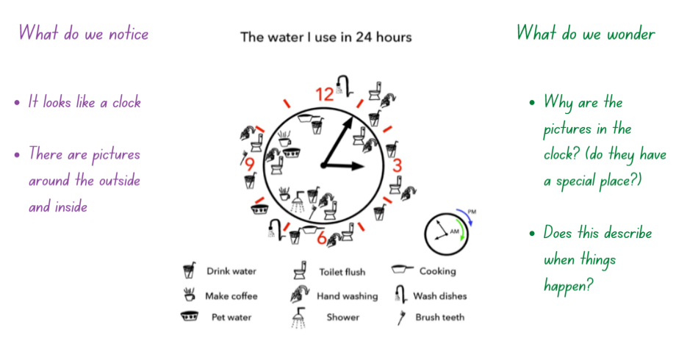
Image adapted from Water Usage by youcubed and is licensed under CC BY 4.0.

Collecting the data from our day – 20 minutes
This activity has been adapted from ‘Dear Data’ from youcubed.
Note: This lesson can be split into 2 smaller lessons to allow students time to collect the data from their day.
- Explain that, just like the person who created a data display of how they use water in their day, students are going to create a data display that tells a story about our day. Ask students to share things they do or experience in their day that they could collect data on. Provide students with independent thinking time, as well as an opportunity to turn and talk to share their thinking.
- Record students’ ideas and scaffold them to reflect which ones would be useful to represent with data. For example, charting how a student’s height changes through the day would not be appropriate as the change would not be measurable. Example topics for data collection could include:
- Where are we during our day? For example, home, the bus, in the playground, in the classroom.
- What do we eat during our day?
- How do we feel during our day?
- Explain to students that they will now plan for their data collection. Students will need to decide:
- What topic will they choose to collect data on?
- How will they collect their data? What tools might they need?
- How will they display their data? What tools might they need?
- Once students have a plan, they start to collect the necessary data.
This table details assessment opportunities and differentiation ideas.
Assessment opportunities | Too hard? | Too easy?
What to look for:  - Can students identify and collect data telling a story about their day, using tools like a table? (MAO-WM-01, MA1-DATA-01)  - Can students create a data display telling a story about their day? (MAO-WM-01, MA1-DATA-01)  - Are students able to make simple inferences about their day from their data displays? (MAO-WM-01, MA1-DATA-01, MA1-DATA-02)  What to collect:  - observational data. (MAO-WM-01, MA1-DATA-01) | Students are having difficulty in selecting a topic and collection method. Ask:  - What aspect of your day do you want to represent? For example, where am I during the day?  - What data will you need to collect? For example, what are the places you usually visit during the day? What time are you there?  - How will you keep track of the places you visit and the times you are there? For example, you may scaffold developing a table for students to use when collecting their data.  Students are having difficulty selecting a way to represent their data.  - Ask if there are any ways of representing data from other lessons that students may be able to use.  - Support students to revisit the ways data has been represented in this unit. | Students are already fluent in selecting an appropriate way to represent their data. Ask:  - What tools can you use to make your data display clearer to those people who will look at it? For example, using colour, spacing, images, and labels.  - Can you make more than one representation of the data?

Displaying the data from our day – 25 minutes
- Students revise the data they have collected from their day. Prompt students to consider how they will represent their data.
- Provide students with Resource 10: Our day template and time to create their data display. See Figure 13 for an example of student data display.
Figure 13 – Student data display
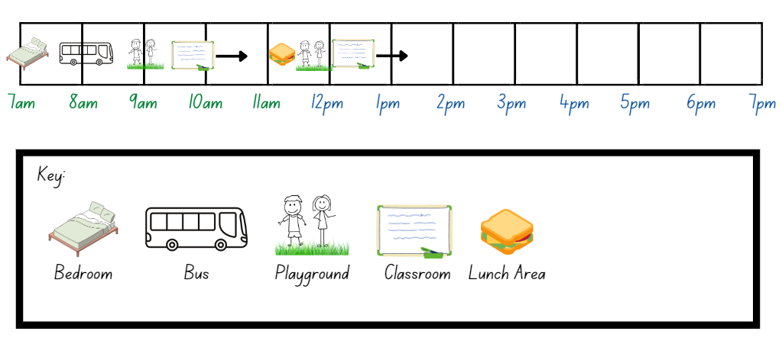
Images sourced from Canva and used in accordance with the Canva Content License Agreement.

Discuss and connect the mathematics – 10 minutes
- Students post their data displays around the classroom and go on a gallery walk. As students walk around and observe their peers’ work, ask:
- What is the story of this person's day?
- What is interesting about the way this person displayed their data?
- What are you wondering and what questions would you ask this person about their day?
- After the gallery walk, facilitate a whole class discussion. Ask questions such as:
- What did you learn about yourself that was interesting or surprised you?
- What did you learn about others?
- What ways of displaying the data did you find most interesting? Why?
- What other questions could you ask about yourself that you could answer by collecting data?

Resource 1: Clear the board

Resource 2: Recording sheet
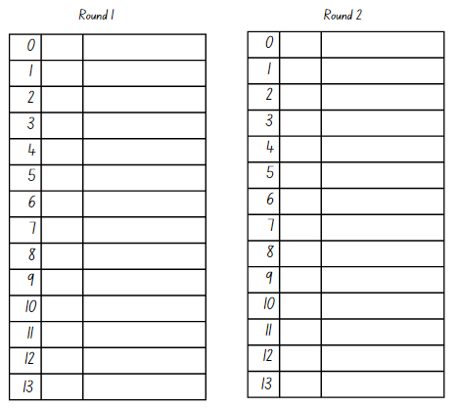

Resource 3: Assessing game play
Focus | Listen, watch, and think | Ask
Accuracy | Are they getting correct answers? | What answer did you get?
Efficiency and strategy selection | Silently count as students play to assess time taken to answer. | How did you solve it?  Was it an efficient strategy?
Flexibility and strategy selection | Are they applying the strategy in a reasonable timeframe? | Why did you pick that strategy?  Is there another strategy that you could use for that problem?  When do you like to use __ strategy instead of __strategy?
Adapted from Bay-Williams J and Kling G (2019).

Resource 4: Would you rather?
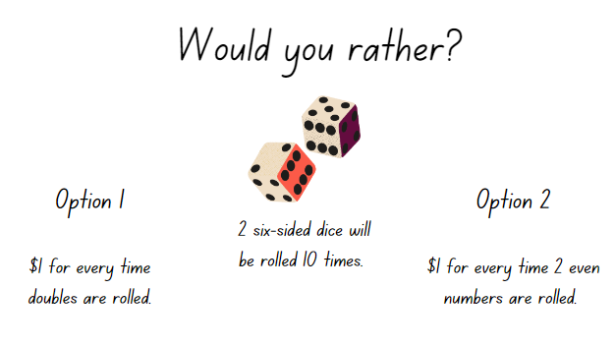
Images sourced from Canva and used in accordance with the Canva Content License Agreement.

Resource 5: Dice display
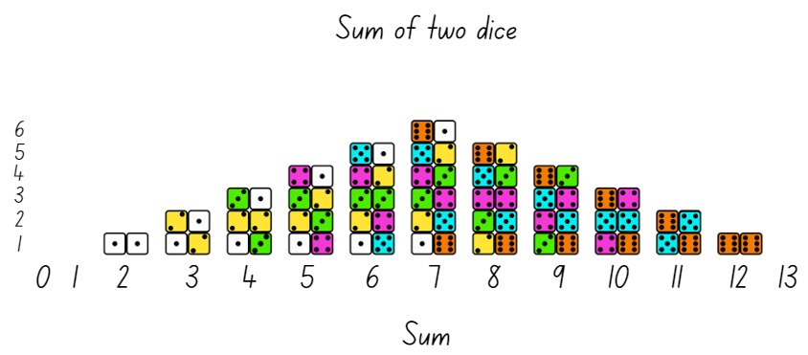
Adapted from "Dice Sums" by youcubed is licensed under CC BY 4.0.

Resource 6: Biography glyph key
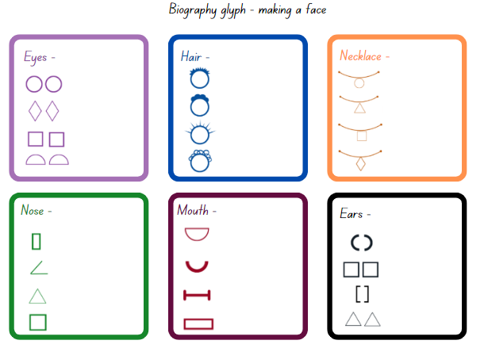

Resource 7: Biography glyph face

Resource 8: Data table
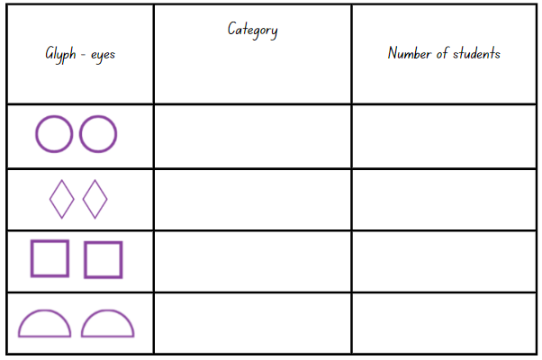
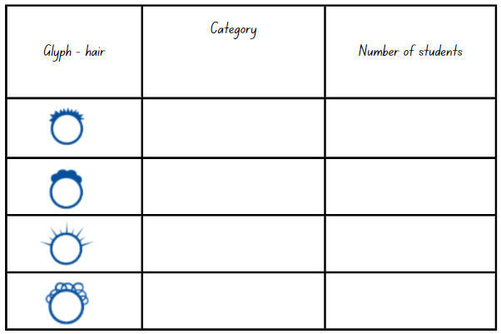

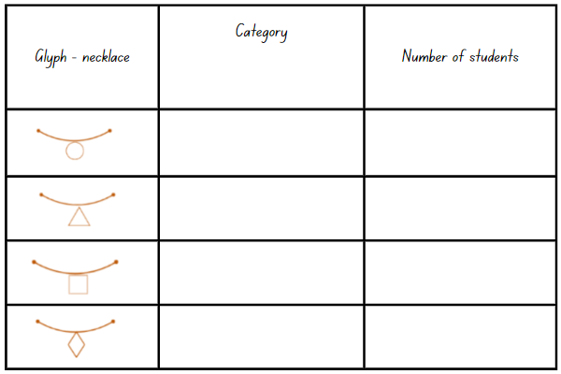
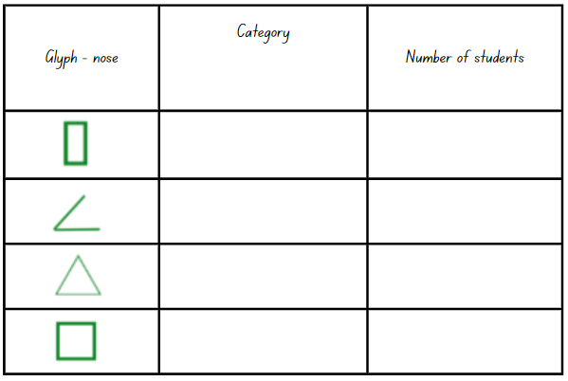
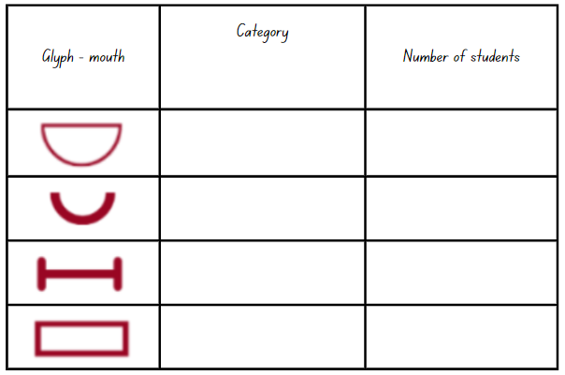
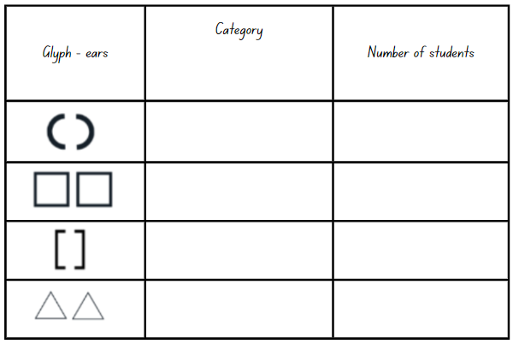

Resource 9: Clock number talk
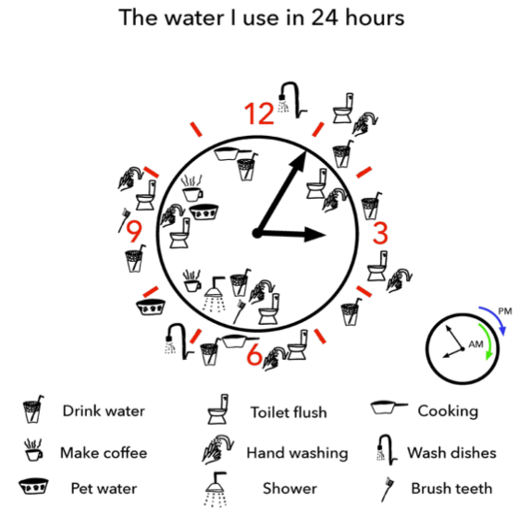
‘Water Usage’ by youcubed is licensed under CC BY 4.0.

Resource 10: Our day template

Syllabus outcomes and content
The table below outlines the syllabus outcomes and range of relevant syllabus content covered in this unit. Content is linked to National Numeracy Learning Progression versions (3).
Focus area and outcomes | Content groups and content points | Lessons
Representing whole numbers A  MAO-WM-01  MA1-RWN-01  MA1-RWN-02 | Use the counting sequences of ones with two-digit numbers and beyond  - count forwards and backwards by ones from a given number to at least 120 (CPr6)  Continue and create number patterns  - model and describe ‘odd’ and ‘even’ numbers using items paired in two rows  Represent numbers on a line  - sequence numbers and arrange them on a line by considering the order and size of those numbers (CPr5)  Represent the structure of groups of ten in whole numbers  - recognise that ten ones is the same as one ten (NPV2, NPV4)  - partition two-digit numbers to show quantity values (NPV4) | 1, 3–7
Combining and separating quantities A  MAO-WM-01  MA1-CSQ-01 | Use advanced count-by-one strategies to solve addition and subtraction problems  - record number sentences in a variety of ways using drawings, words, numerals and symbols (AdS6)  Recognise and recall number bonds up to ten  - recognise, recall and record combinations of two numbers that add up or bond to form 10 (AdS2, AdS6)  - model and record patterns for individual numbers up to ten by making all possible whole-number combinations (Reasons about patterns)  Use flexible strategies to solve addition and subtraction problems  - use non-count-by-one strategies such as using doubles for near doubles and combining numbers that add to ten (AdS6)  Represent equality  - use the equals sign to record equivalent number sentences involving addition, and to mean 'is the same as', rather than as an indication to perform an operation (Reasons about relations) (NPA3)  - model the commutative property for addition and apply it to aid the recall of addition facts (Reasons about relations) (AdS7) | 1–3
Data A  MAO-WM-01  MA1-DATA-01  MA1-DATA-02 | Ask questions and gather data  - investigate a topic of interest by choosing suitable questions to obtain appropriate data (IRD2)  - gather data and track what has been counted by using concrete materials, tally marks, lists or symbols (IRD3)  Represent data with objects and drawings and describe the displays  - use concrete materials or pictures of objects as symbols to create data displays where one object or picture represents one data value (IRD2)  - describe information presented in one-to-one data displays (Reasons about relations) (IRD2)  - use comparative language to describe information presented in a display, such as ‘more than’ and ‘less than’  - interpret a data display and identify the biggest or smallest values (IRD2) | 1–6, 8
Data B  MAO-WM-01  MA1-DATA-01  MA1-DATA-02 | Identify a question of interest and gather relevant data  - pose suitable questions where the answers form categories, and predict the likely responses (IRD2)  - collect data on familiar topics (IRD2)  - sort data into relevant categories (IRD2)  Create displays of data and interpret them  - organise collected data into lists and tables to display information (IRD2)  - represent data in a picture graph using a baseline, equal spacing and same-sized symbols (IRD2)  - interpret information presented in tables and picture graphs (IRD2) | 2–8
Chance A  MAO-WM-01  MA1-CHAN-01 | Identify and describe possible outcomes  - identify possible outcomes of familiar activities and events  - describe the chance of possible outcomes for familiar activities and events (UnC1) | 1, 3
Chance B  MAO-WM-01  MA1-CHAN-01 | Identify and describe activities that involve chance  - describe possible outcomes in everyday activities and events as being likely or unlikely to happen (UnC2)  - compare familiar activities and events and describe them as being more or less likely to happen (Reasoning about relations) (UnC2)  - describe familiar events as being possible (UnC2) | 1, 3

References
Links to third-party material and websites
Please note that the provided (reading/viewing material/list/links/texts) are a suggestion only and implies no endorsement, by the New South Wales Department of Education, of any author, publisher, or book title. School principals and teachers are best placed to assess the suitability of resources that would complement the curriculum and reflect the needs and interests of their students.
If you use the links provided in this document to access a third-party's website, you acknowledge that the terms of use, including licence terms set out on the third-party's website apply to the use which may be made of the materials on that third-party website or where permitted by the Copyright Act 1968 (Cth). The department accepts no responsibility for content on third-party websites.
Except as otherwise noted, all material is © State of New South Wales (Department of Education), 2021 and licensed under the Creative Commons Attribution 4.0 International License. All other material (third-party material) is used with permission or under licence. Where the copyright owner of third-party material has not licensed their material under a Creative Commons or similar licence, you should contact them directly for permission to reuse their material.
Mathematics K–10 Syllabus © 2022 NSW Education Standards Authority (NESA) for and on behalf of the Crown in right of the State of New South Wales.
© 2022 NSW Education Standards Authority. This document contains NSW Curriculum and syllabus content. The NSW Curriculum is developed by the NSW Education Standards Authority. This content is prepared by NESA for and on behalf of the Crown in right of the State of New South Wales. The material is protected by Crown copyright.
Please refer to the NESA Copyright Disclaimer for more information.
NESA holds the only official and up-to-date versions of the NSW Curriculum and syllabus documents. Please visit the NSW Education Standards Authority (NESA) website and the NSW Curriculum website.
National Numeracy Learning Progression © Australian Curriculum, Assessment and Reporting Authority (ACARA) 2010 to present, unless otherwise indicated. This material was downloaded from the Australian Curriculum website (National Numeracy Learning Progression) (accessed 5 December 2022) and was not modified. The material is licensed under CC BY 4.0. Version updates are tracked in the ‘Curriculum version history’ section on the 'About the Australian Curriculum' page of the Australian Curriculum website.
ACARA does not endorse any product that uses the Australian Curriculum or make any representations as to the quality of such products. Any product that uses material published on this website should not be taken to be affiliated with ACARA or have the sponsorship or approval of ACARA. It is up to each person to make their own assessment of the product, taking into account matters including, but not limited to, the version number and the degree to which the materials align with the content descriptions and achievement standards (where relevant). Where there is a claim of alignment, it is important to check that the materials align with the content descriptions and achievement standards (endorsed by all education Ministers), not the elaborations (examples provided by ACARA).
This resource contains images and content obtained from Canva, and their use outside of this resource is subject to Canva’s Content License Agreement. If you wish to use them separately from the resource, please go to Canva.
Bay-Williams J and Kling G (2019) ‘Interview Prompts for Assessing During Game Play’, Chapter 7. Assessing Derived Fact Strategies and All Facts, Math Fact Fluency Companion, accessed 5 December 2022.
Marks Krpan C (2013) Math Expressions: Developing Student Thinking and Problem Solving Through Communication, 1st edn, Pearson, Toronto, Canada.
Stanford University (n.d.) ‘Dice Sums’, Data Talks, youcubed, accessed 5 December 2022.
Stanford University (n.d.) ‘Water Usage’, Data Talks, youcubed, accessed 5 December 2022.
Stanford University (n.d.) ‘Dear Data’, Tasks, youcubed, accessed 5 December 2022.
Sullivan P and Lilburn P (2017) Open-Ended Maths Activities: Using ‘Good’ Questions to Enhance Learning in Mathematics, Revised edn, Oxford University Press ANZ, Great Britain.

