Mathematics – Stage 1 – Unit 6
Contents
Unit description and duration 4
Student prior learning 4
Lesson overview and resources 5
Lesson 1: Language of equivalence 11
Daily number sense: Celebrity head – 15 minutes 11
Language of equivalence – 35 minutes 12
Consolidation and meaningful practice: Equal or not? – 20 minutes 16
Lesson 2: Equivalent stories 17
Daily number sense: Before and after – 15 minutes 17
Equivalent stories – 40 minutes 18
Consolidation and meaningful practice: Sharing mathematical stories – 15 minutes 22
Lesson 3: Number bonds to 20 23
Daily number sense: Maths tipping – 15 minutes 23
Addition table patterns – 40 minutes 25
Lesson 4: Same but different 28
Daily number sense: Celebrity head – 15 minutes 29
Constant difference – 30 minutes 30
Consolidation and meaningful practice: Think board– 20 minutes 33
Lesson 5: Creating balance 35
Daily number sense: 3 tens in a line / 3 hundreds in a line? – 15 minutes 35
Creating balance – 40 minutes 36
Consolidation and meaningful practice: Noticing and wondering – 15 minutes 38
Lesson 6: Hungry, hungry monsters! 39
Daily number sense: Number balance talk – 15 minutes 40
Hungry, hungry monsters! – 30 minutes 40
Consolidation and meaningful practice: Summarising the learning – 15 minutes 42
Lesson 7: Pigs versus wolf! 44
Daily number sense: Piggy bank problem – 15 minutes 45
Pigs versus wolf! – 30 minutes 46
Consolidation and meaningful practice: Summarising the learning – 10 minutes 48
Lesson 8: Who balanced the boat? 49
Daily number sense: Teacher identified activity – 10 minutes 49
Who balanced the boat? – 40 minutes 50
Consolidation and meaningful practice: Summarising the learning – 10 minutes 53
Resource 1: Empty number chart 54
Resource 2: Number balance 55
Resource 3: Addition table 56
Resource 4: Extended addition table 57
Resource 5: Tower talk 58
Resource 6: Constant difference concentration 59
Resource 7: Think board 62
Resource 8: Number balance talk 63
Resource 9: Number balance questions 64
Resource 10: Number balance puzzles 65
Resource 11: Number balance scaffold 68
Resource 12: Piggy bank problem 69
Resource 13: Pigs vs. Wolf rules 70
Resource 14: Pigs vs. Wolf gameboard 71
Resource 15: Who balanced the boat? 72
Syllabus outcomes and content 73
References 77

Unit description and duration
This two-week unit develops student knowledge, understanding and skills of equality. Students are provided opportunities to:
- use balance to explore, prove, and check equivalence using the language of equality to record equivalence in different ways
- identify different combinations of numbers that bond to form up to 20 and identify the constant difference between numbers
- identify the equals sign and its purpose ad use equivalence to solve problems.
Mathematics K–10 Syllabus © 2022 NSW Education Standards Authority (NESA) for and on behalf of the Crown in right of the State of New South Wales.

Student prior learning
Before engaging in these teaching and learning activities, students would benefit from prior experience with:
- comparing 2 masses directly by hefting
- creating, modelling, and recognising combinations for numbers up to 10 counting by ones to find the total or difference
- using drawings, words, and numerals to record addition and subtraction.

Lesson overview and resources
The table below outlines the sequence and approximate timing of lessons; syllabus focus areas and content groups; and resources.
Lesson | Syllabus focus area and content groups | Resources
Lesson 1: Language of equivalence  70 minutes  Language assists in describing equivalent and non-equivalent situations. | Representing whole numbers A  - Use counting sequences of ones with two-digit numbers and beyond  - Represent numbers on a line.  Combining and separating quantities A  - Use advanced count-by-one strategies to solve addition and subtraction problems.  Non-spatial measure A  - Mass: Investigate mass using an equal-arm balance. | - 1-100 numeral cards  - Concrete materials  - Equal-arm balances  - Headpiece for displaying numeral cards  - Individual whiteboards  - Sticky notes  - Writing materials
Lesson 2: Equivalent stories  70 minutes  Mathematicians can record equivalence using mathematical stories. | Representing whole numbers A  - Use counting sequences of ones with two-digit numbers and beyond.  Combining and separating quantities A  - Use advanced count-by-one strategies to solve addition and subtraction problems.  Non-spatial measure A  - Mass: Investigate mass using an equal-arm balance. | - Resource 1: Empty number chart  - Resource 2: Number balance  - 0-9 dice (class set)  - Images  - Paint  - Paper  - Modelling clay  - Writing materials
Lesson 3: Number bonds to 20  55 minutes  Different combinations of numbers can add to form a given number. | Representing whole numbers A  - Use counting sequences of ones with two-digit numbers and beyond.  Combining and separating quantities A  - Use advanced count-by-one strategies to solve addition and subtraction problems  - Recognise and recall number bonds up to ten  - Use flexible strategies to solve addition and subtraction problems.  Combining and separating quantities B  - Represent and reason about additive relations  - Use knowledge of equality to solve related problems. | - Resource 3: Addition table  - Resource 4: Extended addition table  - Coloured highlighters  - Concrete materials  - Writing materials
Lesson 4: Same but different  65 minutes  A constant difference can be identified between pairs of numbers. | Representing whole numbers A  - Use counting sequences of ones with two-digit numbers and beyond  - Represent numbers on a line.  Combining and separating quantities A  - Use advanced count-by-one strategies to solve addition and subtraction problems  - Use flexible strategies to solve addition and subtraction problems.  Combining and separating quantities B  - Represent and reason about additive relations  - Use knowledge of equality to solve related problems. | - Resource 5: Tower talk  - Resource 6: Constant difference concentration  - Resource 7: Think board  - 1-100 numeral cards  - Concrete materials  - Headpiece for displaying numeral cards  - Sticky notes  - Writing materials
Lesson 5: Creating balance  70 minutes  Mathematicians think of equivalence as balance. | Representing whole numbers A  - Represent the structure of groups of ten in whole numbers.  Combining and separating quantities A  - Recognise and recall number bonds up to ten.  Combining and separating quantities B  - Represent and reason about additive relations.  Non-spatial measure A  - Mass: Investigate mass using an equal-arm balance. | - Video: 3 tens in a line (2:29)  - Video: Creating balance – part 1 (5:08)  - Video: Creating balance – part 2 (5:41)  - 10-sided dice  - Number arm balances or digital arm balances  - Writing materials
Lesson 6: Hungry, hungry monsters!  60 minutes  The equals symbol represents a relationship, not an action. | Representing whole numbers A  - Represent the structure of groups of ten in whole numbers.  Combining and separating quantities A  - Represent equality. | - Resource 8: Number balance talk  - Resource 9: Number balance questions  - Resource 10: number balance puzzles (a class set)  - Counters  - Number arm balance  - Writing materials
Lesson 7: Pigs versus wolf!  55 minutes  Mathematicians use the equals sign to explain if two quantities are equal or different. | Representing whole numbers A  - Represent the structure of groups of ten in whole numbers.  Combining and separating quantities A  - Use advanced count-by-one strategies to solve addition and subtraction problems  - Recognise and recall number bonds up to ten  - Represent equality.  Combining and separating quantities B  - Use knowledge of equality to solve related problems. | - Resource 12: Piggy bank problem  - Resource 13: Pigs vs. Wolf rules  - Resource 14: Pigs vs. Wolf gameboard (class set)  - 5 bean bags  - Equal-arm balance  - 6-sided and 10-sided dice  - Small bag  - Writing materials
Lesson 8: Who balanced the boat?  60 minutes  Mathematicians use equivalence to solve different problems in our world. | Representing whole numbers A  - Use counting sequences of ones with two-digit numbers and beyond.  Non-spatial measure A  - Mass: Investigate mass using an equal-arm balance. | - Resource 15: Who balanced the boat?  - Allen P (1988) Who Sank the Boat?, Puffin, Great Britain. ISBN: 9780140509403  - Adhesive tape  - Modelling clay  - Paper, cardboard, or paper plates  - Writing materials

Lesson 1: Language of equivalence
Core concept: Language assists in describing equivalent and non-equivalent situations.
The table below contains suggested learning intentions and success criteria. These are best co-constructed with students.
Learning intentions | Success criteria
Students are learning that:  - two things are equivalent if they have the same value  - language assists in describing equivalent and non-equivalent situations  - an equal-arm balance can be used to explore, prove, and check equivalence. | Students can:  - use words such as not equal, non-equivalent, different from, and not balanced when describing unequal sets  - use words such as equal, equivalent, same as, and balanced when describing equal sets  - use an equal-arm balance to create a level balance  - reason and explain why a set is equal or not equal.

Daily number sense: Celebrity head – 15 minutes
This activity has been adapted from Activities to support Numeral identification by Developing Efficient Numeracy Strategies (DENS) (2022).
- Build student understanding of number sequences by playing celebrity head.
- Display a number line marking numbers 1, 50, and 100 and place sticky notes at either end of the strip.
- Have one student wear a headpiece to which a numeral card between 1-100 is attached. Ensure that the student does not see the number on the numeral card.
- The student asks questions of the class to determine the number. For example, is the number larger than 50? Does the number begin with a 7?
- The class helps to identify the ‘secret number’ by responding only with a yes or no reply to each question. In response to the answers, the selected student then moves the sticky note along the number line to indicate the range within which the ‘secret number’ lies.
- Continue the process until the student can identify the number. Variation: Ask a student to think of a number on the number line. The student chooses a volunteer who makes a guess about the chosen number. The student then states if their number is higher or lower than the number the student guessed. Have the volunteer move the sticky note. Continue until the number has been identified.

Language of equivalence – 35 minutes
This activity has been adapted from Warren et al. (2009).
- Using an equal-arm balance, model placing objects on either side of the balance until they are balanced or equal. Discuss what happens to the equal-arm balance when it is equal. Have students demonstrate this with their arms outstretched.
- Ask students to turn and talk and discuss what it means if something is equal and what words can be used to describe something as equal.
- Students share their thinking. Create a class list of ideas and words that students identify as meaning equal. Add additional words if students do not provide them such as same as, equal, balanced, and equivalent. Discuss the meaning of the word equivalent.
Note: When exploring equivalence in the early years, there are 4 key areas that students should explore. These include developing the comparative language that assists in describing equivalent and non-equivalent situations, developing an understanding that equals means the 2 expressions are equivalent, representing equations in a variety of different formats, and using the ‘balance principle’ to find unknowns (Warren et al. 2009).
Equivalent: Two things are equivalent if they have the same value.
- Explain that the mass of the objects in the equal-arm balance are equal.
- Using the equal-arm balance, model placing objects on either side of the balance until they are not balanced. Discuss what happens to the equal-arm balance when it is not equal. Have students demonstrate this with their arms outstretched.
- Ask students to turn and talk and discuss what it means if something is not equal and what words can be used to describe something is not equal.
- Have students share their thinking and create a class list of ideas and words that students identify as meaning not equal. Add additional words if students do not provide them such as different from, more than, less than, not equal, unbalanced, and non-equivalent.
- Display class list for students to refer to during the investigation.
- Provide pairs of students with an equal-arm balance, a variety of concrete materials or classroom items, and pieces of paper.
- Ask students to investigate if they can make their equal-arm balance using concrete materials.
- Ask students to experiment with concrete materials to balance the scales. For example, students may place 5 blocks on one side and 20 pencils on the other side to see if the balance equals.
- Have students choose a word from the vocabulary list that represents their equal-arm balance. Students write the word on an individual whiteboard and display next to the scale.
- Ask students to explain why their sets were the same or balanced and have students conduct a gallery walk for students to view equal-arm balances.
- As a class, discuss the differences between the students sets. Ask questions such as:
- What did you notice about your set that was different from other groups’ sets? What was the same?
- Did all equal-arm balances have the same number of items on both sides? Why or why not?
- What did you notice about the different number of items used?
- What problems did you have trying to get the scales to balance? How did you solve this problem?
- Is there another word you could use to describe your set?
- Ask students to investigate if they can make their equal-arm balance unequal.
- Students experiment with concrete materials to unbalance the scale.
- Students choose a word from the vocabulary list that represents their equal-arm balance. Students write the word on an individual whiteboard and display next to the scale. Ask students to explain why their sets were not equal.
- Conduct a gallery walk for students to view equal-arm balances.
- As a class, discuss the differences between the different scales. Ask questions such as:
- Did all equal-arm balances have the same number of items on both sides? Why or why not?
- What did you notice about the different number of items used?
- What challenges did you have trying to get the scales to not balance? How did you solve this challenge?
- As a class discuss the language used and highlight the importance of being able to explain why the sets were the same or not the same.
This table details assessment opportunities and differentiation ideas.
Assessment opportunities | Too hard? | Too easy?
What to look for:  - Do students use appropriate language to describe the sets? (MAO-WM-01, MA1-CSQ-01)  - Can students identify equivalent sets? (MAO-WM-01, MA1-CSQ-01, MA1-NSM-01)  - Are students able to use an equal-arm balance to create a level balance? (MAO-WM-01, MA1-NSM-01)  What to collect:  - photographs of equivalent and non-equivalent sets and language choices (MAO-WM-01, MA1-CSQ-01, MA1-NSM-01) | Students do not use appropriate language to describe equal and not equal sets.  - Revise class list of vocabulary and match the words with images of equal and not equal sets.  - Select 2 vocabulary choices for students to use. For example, equal and not equal. | Students use appropriate language and identify equivalent sets.  - Ask students to draw a mathematical story to represent their set using images, words, and symbols.  - Students brainstorm other words that can be used to describe equal and not equal.  - Students write a reflection to explain what it means if 2 things are equivalent.

Consolidation and meaningful practice: Equal or not? – 20 minutes
- Ask students to choose a selection of items that are equivalent and non-equivalent from the classroom. Students display the items for a gallery walk. For example, 2 even stacks of blocks, 2 uneven containers of water, or 2 stacks of books.
- At each display have a large piece of paper for students to annotate as they complete the gallery walk.
- Place students into small groups and assign a display to each group. Have students discuss whether the display is equal or not equal. Students record their thinking and reasoning on the piece of paper. Encourage students to use the language of equivalence when annotating.
- Rotate groups to a different display and repeat the discussion and recording on the pieces of paper. Continue rotating students until they have seen all of the displays.
- As a class, discuss each groups different ideas and reasonings. Connect the language used to explain equal and not equal sets and add any additional vocabulary to the class lists.

Lesson 2: Equivalent stories
Core concept: Mathematicians can record equivalence using mathematical stories.
The table below contains suggested learning intentions and success criteria. These are best co-constructed with students.
Learning intentions | Success criteria
Students are learning that:  - mathematicians record their thinking in different ways  - two things are equivalent if they have the same value  - language assists in describing equivalent situations. | Students can:  - create a mathematical story to show equivalence  - explain their mathematical story to a partner  - combine 2 numbers together to determine a total  - identify equivalence on an equal-arm balance  - use words such as equal, equivalent, same as, and balanced when describing equal sets.

Daily number sense: Before and after – 15 minutes
This activity has been adapted from Activities to support Forward and backward number word sequences by DENS (2022).
- Build student understanding of counting sequences by playing a before and after number game.
- Give pairs of students a copy of Resource 1: Empty number chart, 4 × 0-9 dice and a marker.
- Student 1 rolls 4 dice, choosing 2 dice to form a two-digit number, then writes their number in a square on the chart.
- Student 2 rolls 4 dice, using them to form a two-digit number that fits within the chart, writing it in the appropriate space. If a student cannot form a number that fits the chart, they miss a turn (see Figure 1).
Figure 1 – A gameboard
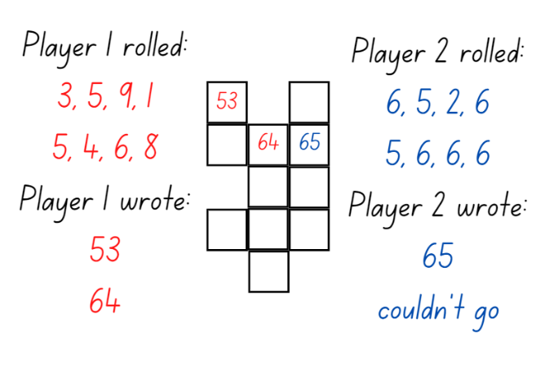
- Students continue to take turns and the student who fills in the most spaces in the chart is declared the winner.

Equivalent stories – 40 minutes
This activity has been adapted from Warren et al. (2009).
- Revise the term equivalence from previous lesson and the class list of words that mean equal.
- Display Resource 2: Number balance. Have students turn and talk about what they notice and wonder about the image.
- As a class discuss the image. Stimulate discussion by asking:
- Are the 2 sides equal? How do you know?
- How could we represent this using numbers and words?
- What is the value of each side? How can we represent this?
- Model equivalence with different combinations of smaller numbers using a bar model. Explain that the 2 sides of the balance are equivalent as they both have the value of 6 (see Figure 2).
Figure 2 – Bar model equivalence
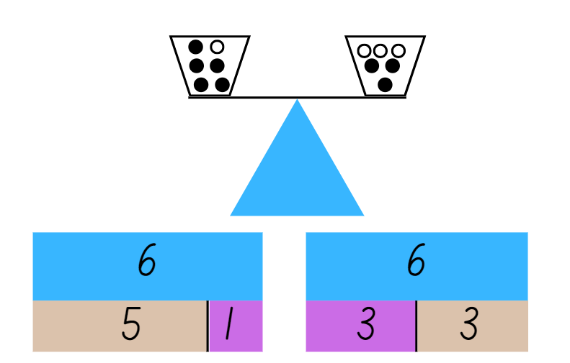
- Explain that mathematicians record their thinking about equivalence in different ways. One way to demonstrate an understanding of equivalence is by using a mathematical story.
- Give students a choice of materials to create an equivalent story. For example, paint, paper, modelling clay, pencils, and images.
- Encourage students to use a real-world example to show their understanding of equivalence. For example, they may use birds in a nest, spots on dalmatians, or lollies in a lolly jar. For an example, see Figure 3.
Figure 3 – Bird nests
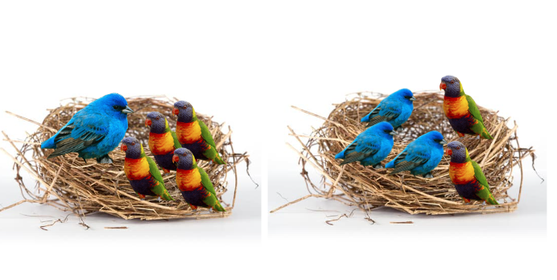
Images sourced from Canva and used in accordance with the Canva Content License Agreement.
- In pairs, students are encouraged to verbalise their mathematical stories to a partner.
Note: The more experience students have at expressing their ideas, the more competent they may become in using the language of mathematics to describe different story contexts (Warren et al. 2009).
- Have students write their mathematical story using words to support their picture (see Figure 4). Students may also be able to verbally explain their story and record it using a digital device.
Figure 4– A sample mathematical story
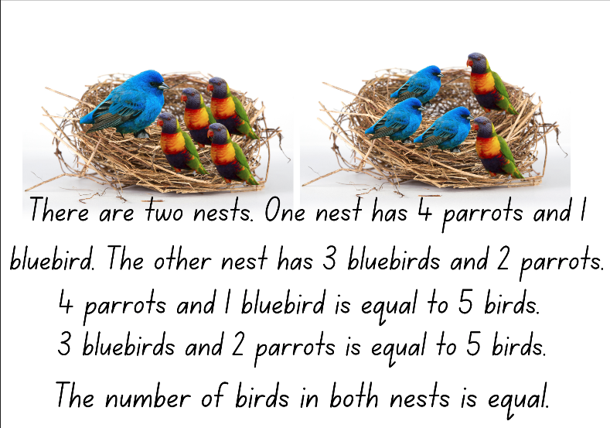
Images sourced from Canva and used in accordance with the Canva Content License Agreement.
This table details assessment opportunities and differentiation ideas.
Assessment opportunities | Too hard? | Too easy?
What to look for:  - Can students create a mathematical story to demonstrate equivalence? (MAO-WM-01, MA1-CSQ-01)  - Do students use appropriate language to explain their story? (MAO-WM-01, MA1-CSQ-01)  - Can students combine quantities to determine a total? (MA1-CSQ-01)  - Are students able to a level balance? (MAO-WM-01, MA1-NSM-01)  What to collect:  - mathematical equivalent stories (MAO-WM-01, MA1-CSQ-01). | Students are unable to create a mathematical story to demonstrate equivalence.  - Provide students with up to 10 concrete materials, for example, counters. Have students arrange the counters to show 2 equal sets. Students can count the sets using one-to-one correspondence to determine equivalence.  - Support students use of language by referring to class list of equivalent vocabulary and providing an additional word bank to support writing. | Students can create a mathematical story to demonstrate equivalence.  - Provide students with the following statement and have them create a drawing to support their understanding of the statement: ‘In one lolly jar there are 2 different types of lollies: red frogs and jellybeans. In the second lolly jar there are 4 types of lollies: red frogs, jellybeans, chocolate beans and pineapples. Both lolly jars have the same number of lollies inside’.  - Have students write a number sentence to demonstrate their understanding.

Consolidation and meaningful practice: Sharing mathematical stories – 15 minutes
- Invite another class to visit the classroom to share the mathematical stories.
- In partners or small groups, have students verbalise their stories to other students and discuss and connect the mathematics of equivalence.
- Display mathematical stories in classroom.

Lesson 3: Number bonds to 20
Core concept: Different combinations of numbers can add to form a given number.
The table below contains suggested learning intentions and success criteria. These are best co-constructed with students.
Learning intentions | Success criteria
Students are learning that:  - mathematicians use counting sequences  - different combinations of numbers can add up or bond to form a given number  - there are ways to model and record patterns when identifying number combinations for a given number  - different strategies can be used to combine quantities. | Students can:  - identify a number before and after a two-digit number  - recognise, recall, and record number bonds 20  - identify patterns within an addition table  - record number sentences in a variety of ways  - select and apply strategies such as counting on and back, doubles and near doubles or using concrete materials to solve addition problems.

Daily number sense: Maths tipping – 15 minutes
This activity has been adapted from Activities to support forward and backward number word sequences by DENS (2022).
- Build student understanding of numbers before and after by playing the game ‘maths tipping’.
- Students stand dispersed around the room. Ask individual students to say the number before or after a given number.
- Students must answer within a designated time, for example, 5 seconds. A correct response allows the student to take one step in any direction to attempt to tip another student on the shoulder.
- If tipped, the student must sit down. If a student states an incorrect answer to the question, they must also sit down.
- Continue the process until one student remains standing. Variations: When asking students to say the number before or after a given amount, show the students the starting number using large number word cards that have the numeral, word, and a visual representation on each card so students can hear and see various representations.
This table details assessment opportunities and differentiation ideas.
Assessment opportunities | Too hard? | Too easy?
What to look for:  - Can students identify a number before and after a given two-digit number? (MA1-RWN-01)  What to collect:  - observational data (MA1-RWN-01) | Students are unable to identify a number before or after a given two-digit number.  - Display a number chart or number line to support identification of numbers before and after.  - Students identify the number before and after for numbers less than 30. | Students can identify a number before or after a given two-digit number.  - Students identify the number before or after a three-digit number.  - Students identify 10 more or 10 less than a given number.

Addition table patterns – 40 minutes
This activity has been adapted from Boaler et al. (2021).
- As a class revise the language of addition including the terms ‘add’ and ‘plus’. Create a vocabulary list for students to support the language of addition.
Note: This unit focuses on equality and the use of the ‘equals’ sign. The other symbols such as the ‘plus’ and ‘minus’ sign do not have to be introduced within this unit. Students can build their vocabulary of the language of addition and subtraction, before being introduced to the mathematical symbols.
- Display Resource 3: Addition table.
- Ask students to turn and talk and discuss what they notice and what the table shows.
- Invite students to share their thinking with the class and develop a shared understanding that the table displays the combination of numbers that add to 10.
Note: Interpreting this table may be challenging. Spend time ensuring students understand the purpose and parts of the table. Particularly drawing attention to what the rows, columns, and intersection points mean. (Boaler et al., 2021).
- In pairs, provide partners with Resource 3: Addition Table, coloured highlighters, and concrete materials such as square tiles, interlocking cubes, or coloured bricks.
- Have students explore the following questions:
- What patterns can you see?
- What makes these patterns?
- How can you show these patterns using the concrete materials?
- Students explore, highlight, and annotate the table with the different patterns they find.
Note: Students may need more than one sheet to record the various patterns so their annotations do not become mixed up.
- Provide students copies of Resource 4: Extended addition table and ask students if the patterns would continue if you extended the table.
- Invite students to make predictions about their patterns by exploring the empty cells. Ask students to make predictions and test their ideas by combining the quantities and entering numbers into the empty cells. Encourage students to use count-by-one strategies including counting on and also strategies such as doubles and near doubles where appropriate.
- As a class, share students’ predictions and solutions. During the discussion, encourage students to use increasingly precise language for what they notice. Stimulate the discussion with the following questions:
- Will these patterns continue forever? Why or why not?
- How did you test your ideas? What did you find?
- What questions do you have now about the addition table?
- As a class, highlight number bond patterns for numbers up to 20.
This table details assessment opportunities and differentiation ideas.
Assessment opportunities | Too hard? | Too easy?
What to look for:  - Can students identify patterns within an addition table? (MAO-WM-01, MA1-CSQ-01)  - Are students able to recognise, recall and record number bonds to 20? (MAO-WM-01, MA1-CSQ-01)  - Can students record number sentences in a variety of ways? (MAO-WM-01, MA1-CSQ-01)  - Can students select and apply strategies such as counting on and back, doubles and near doubles or using concrete materials to solve addition problems? (MAO-WM-01, MA1-CSQ-01)  What to collect:  - work sample of Resource 3: Addition table (MAO-WM-01, MA1-CSQ-01) | Students are unable to recognise, recall, and record number bonds to 20.  - Provide students with concrete materials such as counters, to identify number bonds up to 5 or 10.  - Support students using a visual chart, such as a completed addition table to identify number bonds to 20. | Students can recognise, recall, and record number bonds to 20.  - Ask students what would happen if the table extended to 20 plus 20. What tools would you need to continue this investigation?  - Provide students grid paper to extend the table and identify the patterns.

Lesson 4: Same but different
Core concept: A constant difference can be identified between pairs of numbers.
The table below contains suggested learning intentions and success criteria. These are best co-constructed with students.
Learning intentions | Success criteria
Students are learning that:  - numbers can be represented on a line  - the difference between 2 numbers can be represented using concrete materials and diagrams  - a same constant difference can be identified between different pairs of numbers  - different strategies can be used to separate quantities  - mathematicians record their thinking in different ways. | Students can:  - identify the position of numbers on a number line  - identify the difference between 2 numbers for numbers up to 20  - Identify and represent the constant difference between 2 pairs of numbers  - use count-by-one strategies to solve subtraction problems including counting on and counting back  - represent the constant difference using a think board.

Daily number sense: Celebrity head – 15 minutes
This lesson has been adapted from Activities to support numeral identification by DENS (2022).
- Build student understanding of number sequences by playing ‘Celebrity head’.
- Display a number line marking numbers one, 50, and 100 and place sticky notes at either end of the strip.
- Have one student wear a headpiece to which a numeral card between 1-100 is attached. Ensure that the student does not see the number on the numeral card.
- The student asks questions of the class to determine the number, for example, they could ask if the number is larger than 50.
- The class helps to identify the ‘secret number’ by responding only with a yes or no reply to each question. In response to the answers, the selected student then moves the sticky note along the number line to indicate the range within which the ‘secret number’ lies.
- Continue the process until the student can identify the number. Variation: Ask a student to think of a number on the number line. The student chooses a volunteer who makes a guess about the chosen number. The student then states if their number is higher or lower than the number the student guessed. Have the volunteer move the sticky note. Continue until the number has been identified
This table details assessment opportunities and differentiation ideas.
Assessment opportunities | Too hard? | Too easy?
What to look for:  - Can students represent numbers on a number line? (MAO-WM-01, MA1-RWN-01)  What to collect:  - observational data (MAO-WM-01, MA1-RWN-01) | Students are unable to represent numbers on a line.  - Provide students with a visual scaffold such as a number chart.  - Identify additional numbers on the number line to scaffold students thinking. | Students are unable to represent numbers on a line.  - Provide students with a blank number line to identify numbers.  - Increase the range on the number line to include up to four-digit numbers.

Constant difference – 30 minutes
- Display Resource 5: Tower talk. Ask student what they wonder and notice about the 2 towers.
- Have students turn and talk and share their thinking.
- As a class, discuss and record what students’ notice about the towers.
- If students have not identified that there is a difference between the tower's pairs, highlight this using counting strategies.
- Tell students that by identifying a difference between 2 sets of numbers we can separate quantities.
- Create a vocabulary chart with words such as take away, difference between, and minus to support the language of subtraction.
- Provide pairs of students with up to 20 interlocking cubes and have them create 2 towers of difference. During the activity, identify different strategies to determine the difference including the count-by-one strategy.
- Invite students to share their tower differences using the language of subtraction. Identify 2 pairs that had the same difference. For example, 8 and 4 and 9 and 5.
- Discuss with students that we can identify pairs of numbers that have the same constant difference using our knowledge of numbers ‘one more and one less’ and using a number line.
- Model to students on a number line ‘one more, one less’ constant difference (see Figure 5).
Figure 5 – A constant difference of 4
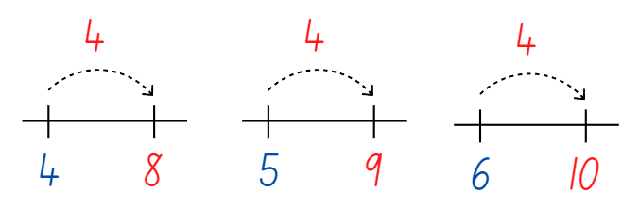
- Provide pairs of students with a number line and interlocking cubes. Give students a copy of Resource 6: Constant difference concentration.
- As students play concentration, they can use the number line and interlocking cubes to test their thinking. Ask students the following questions to guide their thinking:
- What strategy are you using to determine the difference between the numbers? Is there a more efficient strategy?
- What patterns or connections can be made between the numbers? Explain your thinking.
- Which questions do you find challenging? Why?
This table details assessment opportunities and differentiation ideas.
Assessment opportunities | Too hard? | Too easy?
What to look for:  - Can students identify the difference between 2 numbers for numbers up to 20? (MAO-WM-01, MA1-CSQ-01)  - Are students able to identify the constant difference between 2 pairs of numbers? (MAO-WM-01, MA1-CSQ-01)  - Can students represent the constant difference using interlocking cubes and number lines? (MAO-WM-01, MA1-CSQ-01)  - Do students use count-by-one strategies to solve subtraction problems including counting on and counting back? (MAO-WM-01, MA1-CSQ-01)  What to collect:  - observational data (MAO-WM-01, MA1-CSQ-01) | Students are unable to identify the difference between 2 numbers for numbers up to 20.  - Students use one-to-one correspondence to find the difference between the 2 towers.  - Provide a scaffold such as a bar model to support students thinking.  - Students find the difference between numbers up to 5 or 10. | Students can identify the constant difference between 2 numbers for numbers up to 20.  - Give students blank cards to create their own constant difference concentration cards.  - Ask how students could represent the difference between 299 and 123. Give students the opportunity to record their thinking.

Consolidation and meaningful practice: Think board– 20 minutes
- Display Resource 7: Think board. Explain to students that they are going to use the think board to represent their understanding of constant difference between numbers.
- Identify and explain each quadrant of the think board. See a completed example in Figure 6.
Figure 6 – A think board
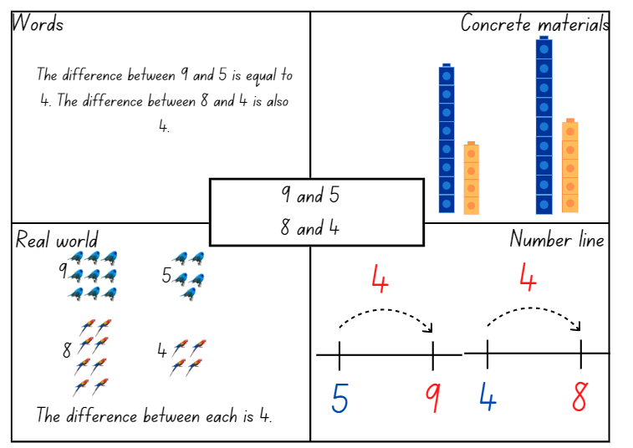
Images sourced from Canva and used in accordance with the Canva Content License Agreement.
- Have students choose 2 pairs of numbers that have a constant difference and record them in the centre of the think board.
- Students complete the think board and share their ideas with a partner.
This table details assessment opportunities and differentiation ideas.
Assessment opportunities | Too hard? | Too easy?
What to look for:  - Can students identify a constant difference between different pairs of numbers? (MAO-WM-01, MA1-CSQ-01)  - Are students able to represent their thinking using a think board? (MAO-WM-01, MA1-CSQ-01)  What to collect:  - think board. (MAO-WM-01, MA1-CSQ-01) | Students are unable to represent their thinking using a think board.  - Students use interlocking cubes and verbally explain their thinking to a partner.  - Students create a think board using numbers up to 10. | Students can represent their thinking using a think board.  - Ask students if there is another way to represent the constant difference for their numbers and to record their thinking.  - Ask students can they identify some generalisations or patterns when identifying constant differences in numbers up to 20.

Lesson 5: Creating balance
Core concept: Mathematicians think of equivalence as balance.
The table below contains suggested learning intentions and success criteria. These are best co-constructed with students.
Learning intentions | Success criteria
Students are learning that:  - recognising number combinations is helpful for solving problems efficiently  - a level balance of objects on either side of an equal-arm balance creates equivalence  - if one part of the total number increases while the other part decreases by the same amount, the total remains the same. | Students can:  - create, record, and recognise combinations of 2 numbers that add up to 20  - place objects on either side of an equal-arm balance to obtain a level balance and show equivalence  - use the ‘one more, one less’ strategy with numbers on either side of an equal-arm balance to maintain equivalence.

Daily number sense: 3 tens in a line / 3 hundreds in a line? – 15 minutes
- Build student understanding of number bonds to 10 by identifying different combinations in the game 3 tens in a line (2:29).
- As a class, view the 3 tens in a line (2:29) video that explains how to play the game.
- Students draw a 3 × 3 grid as a game board (like noughts and crosses game board).
- Players take turns to roll a 10-sided dice with numbers 0-9 and write the number in one of their boxes. The goal is to be able to write 2 numbers in each box that combine to make 10. Players continue taking turns until a player has been the first to make 3 tens in a line.
- As an extra challenge, students can play 3 hundreds in a line, by rolling a dice using multiples of 10. The goal is to be able to write 2 numbers in each box that combine to make 100. Players continue taking turns until a player has been the first to make 3 hundreds in a line.

Creating balance – 40 minutes
Note: The video could be viewed before the lesson or use the video as a resource during the lesson.
- Explain that equivalence can be thought of as balance.
- Watch Creating balance – part 1 (5:08). Pause at 0:42 and ask what students notice about the right side of the balance.
- Continue watching the video and compare the students’ noticings to those in the video.
- Pause again at 3:27 and ask students what would need to happen on the left of the balance, to make both sides equal.
- Continue watching the video and compare the students’ noticings to the findings in the video.
- Explain to students that their task is to find some different ways to make the arms balance. First, they must choose one of the numbers from the right side of the balance (10, 5 or 7) to stay the same on the left side. Students must use that number with 2 different numbers to make the left arm balance with the right arm.
- In pairs, students use number arm balances or a digital arm balance to find as many possible number combinations on the left side that will balance with the 10, 5 and 7 on the right side. Students draw pictures to record their thinking.
- Watch Creating balance – part 2 (5:41). Pause at 1:34 and discuss the ‘one more, one less’ strategy. Ask students to predict some other combinations of 3 numbers on the left arm that would balance the 10, 5, and 7 on the right arm using the ‘one more, one less’ strategy. For example, the 8 could gain one more to make 9, while the 4 have one less and become 3.
- Continue the video to see the number combinations made by the animals, comparing them to the combinations made by the students. Pause the video again at 4:39.
- Ask students to think of how they could make the arms balance using 4 tags. In their pairs, students use balance arms to find combinations of 4 tags on the left that balance the 10, 5, and 7 on the right side. Students draw pictures of each new combination to record their thinking.
This table details assessment opportunities and differentiation ideas.
Assessment opportunities | Too hard? | Too easy?
What to look for:  - Do students find other combinations that balance the 10, 5, and 7 on the right arm? (MAO-WM-01, MA1-RWN-01, MA1-CSQ-01, MA1-NSM-01)  - Can students explain how the ‘one more, one less’ strategy to find equivalent number combinations? (MAO-WM-01, MA1-CSQ-01)  What to collect:  - observations and student work samples of balanced number combinations (MAO-WM-01, MA1-RWN-01, MA1-CSQ-01, MA1-NSM-01) | Students are unable to use balance arms to find combinations that balance the 10, 5, and 7 on the right side. Support students to experiment with combinations of tags that achieve balance between the arms. Record this combination and encourage students to change the combination on one side using the ‘one more, one less’ strategy.  Students have difficulty recording their number combinations. Support students to record their combinations accurately. | Students confidently use balance arms to find combinations that balance the 10, 5, and 7 on the right side.  - Ask students to see how many combinations they can balance using 5 tags. Suggest they use the ‘one more, one less’ strategy and record their thinking.  - Students draw a number balance combination for another student to solve.

Consolidation and meaningful practice: Noticing and wondering – 15 minutes
- Select several student pictures to display that show their thinking of different number combinations.
- Ask students:
- What did you notice during the activity?
- How could you be sure you have all the possible combinations?
- What other ways could you make the arms balance if you could use any numbers?
- Is there anything that you are still wondering?
- Watch the rest of Creating balance – part 2 (5:41) from 4:39 to summarise some of the mathematics explored.
- Summarise the lesson by highlighting that equivalence can be thought of as balance.

Lesson 6: Hungry, hungry monsters!
Core concept: The equals sign represents a relationship, not an action.
Note: Students often interpret the equals sign as ‘makes’, or ‘find the answer’. This often leads students to think that ‘equal’ means to execute an operation, like hitting the ‘Enter’ key on an internet search. Instead, equal indicates a relationship. The 2 quantities on either side of the equals sign, regardless of their differences in appearance, have the same value. (Boaler, 2021).
The table below contains suggested learning intentions and success criteria. These are best co-constructed with students.
Learning intentions | Success criteria
Students are learning that:  - the equals sign means 'is the same as', rather than an indication to perform an operation  - the quantities on either side of the equals sign have the same value  - the equals sign can be used to identify an unknown quantity in a number sentence. | Students can:  - explain their thinking about balancing both sides of the number sentence  - identify that the amounts on both sides of an equals sign are equivalent, or the same  - identify the number of missing dots to balance both sides of the number sentence.

Daily number sense: Number balance talk – 15 minutes
This lesson has been adapted from ‘Visualize: Hungry, hungry monsters!’ in Mindset Mathematics: Visualizing and Investigating Big Ideas, Grade 1 (Boaler et. al, 2021).
- Build student understanding that the equals sign represents a relationship, not an action, by solving a balance puzzle.
- Show Resource 8: Number balance talk and tell students that the equals sign in the centre means that the value of the 2 sides is the same, even when they do not look the same. Use a number balance from Lesson 5 as an example, that the equals sign is like a balance and the 2 sides need the same value to balance. Explain that it does not mean ‘find the answer’.
- Explain that some of the dots have been eaten by the monster in the image. Ask how many dots students think have been eaten and why they think this. Draw attention to the equals sign and how many dots are needed on each side so they have the same value.
- Ask where students would add the dots. Model that there is not one correct answer for placing the dots if the total is correct. Students may see the numbers differently and imagine the dots in specific places. Encourage multiple ways of seeing the dots.
- Record student thinking. For example, after drawing the new dots where students wanted to place them, label that group as 6 or choose to label it 3 and 3, because there were 3 dots and students added 3 more. Once the dots are labelled, explain to students how it makes sense.

Hungry, hungry monsters! – 30 minutes
- Explain that now students will work with a partner to solve some balance puzzles of their own.
- Display Resource 9: Number balance questions. Provide students copies of Resource 10: Number balance puzzles, writing materials, and counters. For each puzzle, partners work together to answer the questions:
- How do you see the dots in the puzzle?
- What is the value of each side of the number sentence?
- How many dots are hidden by the monsters? How do you know?
- How can you balance the 2 sides so that they are equal?
- Where do you think the dots could be added?
- How can you record your thinking so that others can see what you see?
- In pairs, students work on the puzzles recording their thinking as they go. Support students to focus their conversation on the quantities and the value of each side of the number sentence.
This table details assessment opportunities and differentiation ideas.
Assessment opportunities | Too hard? | Too easy?
What to look for:  - Do students recognise that the amounts on both sides of an equals sign are equivalent, or the same? (MAO-WM-01, MA1-RWN-01, MA1-CSQ-01)  - Can students identify the number of missing dots to balance both sides of the number sentence? (MAO-WM-01, MA1-RWN-01, MA1-CSQ-01)  - Are students able to explain their thinking about balancing both sides of the number sentence? (MAO-WM-01, MA1-RWN-01, MA1-CSQ-01)  What to collect:  - observations and student work samples. (MAO-WM-01, MA1-RWN-01, MA1-CSQ-01) | Students cannot recognise that the amounts on both sides of an equals sign are equivalent, or the same.  - View Resource 8: Number balance talk, revising how the number of dots were the same on both sides of the equals sign.  - Use a number arm balance to explain that the equals sign is like the balance and the amounts on both sides need to have the same total.  Students are unable to identify the number of missing dots to balance both sides of the equation. Use counters to model the dots shown in each number balance puzzle. Support students to use the counters to find the missing amount ‘eaten’ by the monster to achieve a balance of counters on both sides. | Students confidently identify the number of missing dots to balance both sides of the equation.  - Students use Resource 11: Number balance scaffold to create their own number balance puzzles.  - Students share their number puzzles with other students.

Consolidation and meaningful practice: Summarising the learning – 15 minutes
- Invite students to share how they solved the puzzles by discussing the following questions:
- How did you know how many dots were eaten? How did you see it?
- How did the equals sign help you?
- Where did you add the dots? Why?
- Did you and your partner think differently about any of the puzzles? How were you each thinking?
- Were any of the puzzles challenging? What questions do you have, or how did you work through the challenge?
- As you discuss the different puzzles that partners solved, return to the big idea that the 2 sides of the equation must have the same value.
- Conclude the lesson by asking what the equals sign means. Ask students to explain, using an example if necessary.

Lesson 7: Pigs versus wolf!
Core concept: Mathematicians use the equals sign to explain if 2 quantities are equal or different.
Note: A critical aspect of students’ mathematical thinking is developing a relational understanding of the equals sign. This involves students interpreting this symbol as meaning ‘the same as’, rather than simply ‘the answer’. This discovery can be promoted through contrasting the concept of equivalence with the concept of inequality (for example, 'more than’ or ‘less than’) early in a student’s mathematical development. (Russo 2016).
The table below contains suggested learning intentions and success criteria. These are best co-constructed with students.
Learning intentions | Success criteria
Students are learning that:  - mathematicians describe combinations for numbers using words such as ‘more than’, ‘less than’ and ‘equal’  - mathematicians use their number knowledge to balance number sentences  - mathematicians use the equals sign to explain if 2 quantities are equal or different. | Students can:  - describe combinations for numbers using words such as ‘more than’, ‘less than’ and ‘equal’  - use their number knowledge to balance number sentences  - recognise and use the equals sign to show that 2 amounts are the same.

Daily number sense: Piggy bank problem – 15 minutes
This activity has been adapted from Warren et al. (2009).
- Build student understanding of equivalence by using balance to solve a problem. Display Resource 12: Piggy bank problem and introduce the story: ‘I have some money in my piggy bank. If I had another $3, I would have $5. How much do I have in my piggy bank?’
- This problem can also be modelled on an arm balance with an unknown bag. Secretly place 2 bean bags (representing coins) in the unknown bag and use bean bags to represent the other coins. Ask how students could find out what is in the bag.
Note: The balance strategy is one of the most powerful strategies for solving unknowns. It consists of 2 different thinking processes including how to isolate the unknown and how to balance the equation. The following problem illustrates this thinking.
- Some students may automatically know it is 2, however, the aim is not to know solutions but to develop mathematical reasoning. Ask them to work out ways of finding solutions and explain their solutions as they find them.
- There are 2 different ways of working out the unknown:
- One way is to take the unknown bag from the scales and then keep taking bean bags from the other side until the scales are again balanced. The number of bags that are taken off the left-hand side is the number of the unknown (isolating the unknown).
- Another way is to continually take one bag from each side of the scales until only the unknown bag is left on one side and bean bags are left on the other side (balancing the equation). The unknown would be the number of bean bags left on the other side, which is 2.
- Work through the problem to test students’ thinking. Highlight that keeping the equation balanced involves understanding that doing the same thing to each side of an equation means it will remain balanced. Explain that this is described as ‘equal’.

Pigs versus wolf! – 30 minutes
This activity has been adapted from Russo (2016).
- Build student understanding of the equals sign by exploring inequalities in this dice game, built around the familiar fairy-tale The Three Little Pigs and The Big Bad Wolf.
Note: You may wish to read a version of the fairy-tale prior to the activity, to engage students before introducing them to the game.
- Introduce the game by displaying Resource 13: Pigs vs. Wolf rules. Model how to play the game, using dice and Resource 14: Pigs vs. Wolf gameboard. The rules of the game are:
- Rule 1: In pairs, one student plays the pigs and the other student the wolf.
- Rule 2: Students roll the dice and students calculate their score for that roll. For example, using the 3 × 6-sided dice, the player representing the pigs would add the 3 × 6-sided dice together for their total, while the wolf uses the number they rolled on their 10-sided dice for their total. The player with the higher score records the number sentence and earns a ‘house’. For example, if the pigs rolled a 3, 2, and 6 it would be greater than an 8 rolled by the wolf. The winning student can record their house as a drawing on their paper or using an interlocking cube.
- Rule 3: The first to 5 houses wins.
- Students play the game in pairs, using the gameboard. Before long, students will encounter the problem of what to do if they get the same score. When this first happens, pause the lesson and discuss possible solutions with the class. Then, introduce Rule 4.
- Rule 4: This rule is a secret. If both players get the same score, they both earn a house!
- Students continue playing the game using the new rule.
This table details assessment opportunities and differentiation ideas.
Assessment opportunities | Too hard? | Too easy?
What to look for:  - Do students describe amounts using words such as ‘more than’, ‘less than’ and ‘equal’? (MAO-WM-01, MA1-RWN-01, MA1-CSQ-01)  - Do students recognise or use the equals sign to show that two amounts are the same? (MAO-WM-01, MA1-RWN-01, MA1-CSQ-01)  What to collect:  - observational data (MAO-WM-01, MA1-RWN-01, MA1-CSQ-01)  - student work samples. (MAO-WM-01, MA1-RWN-01, MA1-CSQ-01) | Students are unable to describe amounts using words such as more than, less than, and equal.  - Use counters to compare and describe collections that are more than, less than, and equal.  - Write the words more than, less than, and equal on sticky notes for students to refer to.  Students cannot recognise or use the equals sign to show that 2 amounts are the same. Support students to use counters to model the quantities they roll on their turn. Compare the pigs’ counters to the wolf’s counters to determine. | Students confidently use words and the equals sign to describe and compare amounts.  - Students try playing with 6 little pigs (6 × 6-sided dice) vs 3 big bad wolves (3 × 10-sided dice).  - Ask students to return to their gameboard and ask them to try and share the scores rolled into 2 even groups, recording their thinking. If there is a remainder, ask them what they could do to share this equally.

Consolidation and meaningful practice: Summarising the learning – 10 minutes
- Summarise the learning by using these discussion points with the class:
- What did you notice when you were playing the game?
- Why was rule 4 important?
- Why is the equals sign important for mathematicians?
- Is there anything else that you are still wondering about?
- Conclude by highlighting that the equals sign is used to show when 2 quantities are equal.

Lesson 8: Who balanced the boat?
Core concept: Mathematicians use equivalence to solve different problems in our world.
The table below contains suggested learning intentions and success criteria. These are best co-constructed with students.
Learning intentions | Success criteria
Students are learning that:  - objects with equivalent masses can be balanced  - mathematical reasoning is used to solve problems, for example, by experimenting with ways to balance equivalent masses  - mathematicians communicate their reasoning clearly to help others share their thinking. | Students can:  - identify objects with equivalent masses  - experiment with rearranging different objects to form equivalent masses  - communicate their mathematical reasoning clearly to help others share their thinking.

Daily number sense: Teacher identified activity – 10 minutes
- From a class need surfaced through formative assessment data, identify a short, focused activity that targets students’ knowledge, understanding and skills. Example activities may be drawn from the following resources:
- Thinking Mathematically Stage 1
- Universal Resources Hub.

Who balanced the boat? – 40 minutes
This lesson has been adapted from Russo (2016).
- Build student understanding of equivalence by investigating how different masses can achieve balance.
Note: You may wish to read Who Sank the Boat? by Pamela Allen to engage students prior to the activity.
- Revise the learning in previous lesson that the equals sign is used to explain if 2 quantities are equal or different.
- Identify that, in the story Who Sank the Boat? one of the reasons the boat stayed afloat for so long is because the animals worked out how to balance their weights across the boat. Just as numbers can be shared equally, weight can be shared equally, too.
- Explain that students will work in pairs to make a boat out of cardboard and animals from modelling clay. They will then see if they can balance their boat with their animals on it.
- Display Resource 15: Who balanced the boat? and introduce the problem.
- In pairs, students create a boat using paper, cardboard or paper plates and adhesive tape.
- Students represent the animals using modelling clay. They use the information on Resource 15: Who balanced the boat? as a guide. They need to ensure that the cow and sheep are the same size as each other, while the pig and sheep also need to be the same size. The mouse alone has a unique size and mass.
- In pairs, students discuss and make predictions about ways of arranging the animals on their boat so that it will successfully stay afloat.
Note: Mathematical reasoning and critical thinking can be supported by declaring that a solution may only be recorded when all group members agree that a particular configuration of animals would balance the boat. If an agreement cannot be reached by the group on a particular configuration, consider photographing it and exploring it further during the whole class discussion. It may provide an opportunity to address a misconception or provide an example where there is genuine confusion about whether the boat would be balanced.
- Students use their animal models and boat to explore possible solutions to the problem. They balance them on water in a sink or container (see Figure 7). Students record their successful solutions by drawing them on paper as they discover them.
Figure 7 – 4 ways to balance the boat
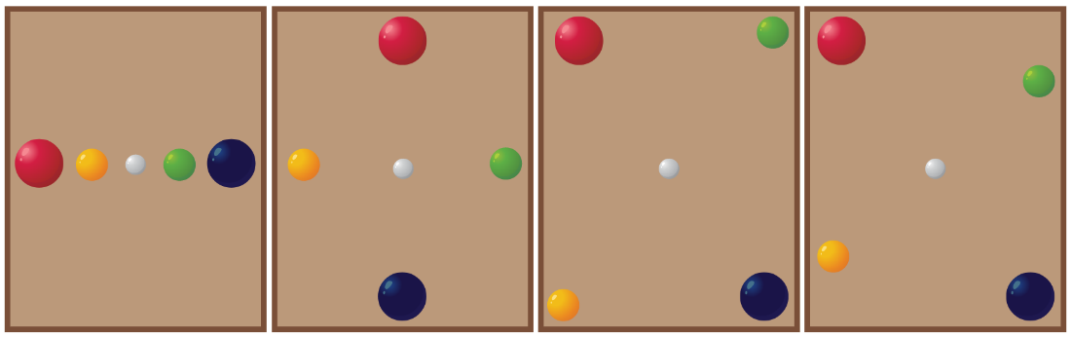
Images sourced from Canva and used in accordance with the Canva Content License Agreement.
Note: There are many solutions to this challenge, some of which are displayed in Figure 7. However, the key insight into the problem is realising that the mouse needs to be exactly in the middle of the boat.
This table details assessment opportunities and differentiation ideas.
Assessment opportunities | Too hard? | Too easy?
What to look for:  - Do students experiment with arranging their modelling clay animals in their boat in ways that balance the weight equally on water? (MAO-WM-01, MA1-NSM-01)  - Are students able to explain how their arrangement of animals in their boat balances the weight equally? (MAO-WM-01, MA1-NSM-01)  - Do students develop more than one solution to the problem? (MAO-WM-01, MA1-NSM-01)  What to collect:  - observations and students’ work samples of solutions to the problem (MAO-WM-01, MA1-NSM-01) | Students are unable to organise their animals to balance on the water.  - Support students in a small group and model one way to arrange the animals on the boat. Test if the boat balances, then ask students to reflect on whether the arrangement worked.  - Ask students to think of another arrangement to test. | Students find several ways to balance the weight of their animals on the water.  - Provide students with another piece of modelling clay to represent a second mouse. Students try to find a way to balance the boat with this extra mouse.  - Challenge students to think about how they could balance the animals in 2 boats. Ask them to consider if they would need the second mouse to help.

Consolidation and meaningful practice: Summarising the learning – 10 minutes
- Bring the class together and ask:
- Did you notice some things that were equal, or had equivalence, during this activity?
- Did you notice some things that were not equal, or didn’t have equivalence, during this activity?
- What challenges were there in this task? How did you solve them?
- What were some solutions to the problem that you discovered?
- If the mouse got onto the boat on his own, where would he need to stand to balance the boat?
- What if the mouse was in the middle of the boat? Would this help you solve the problem?
- Is there anything that you are still wondering?
- Summarise the learning by highlighting that, just like the animals on the boat, students use equivalence to solve problems in their world.

Resource 1: Empty number chart
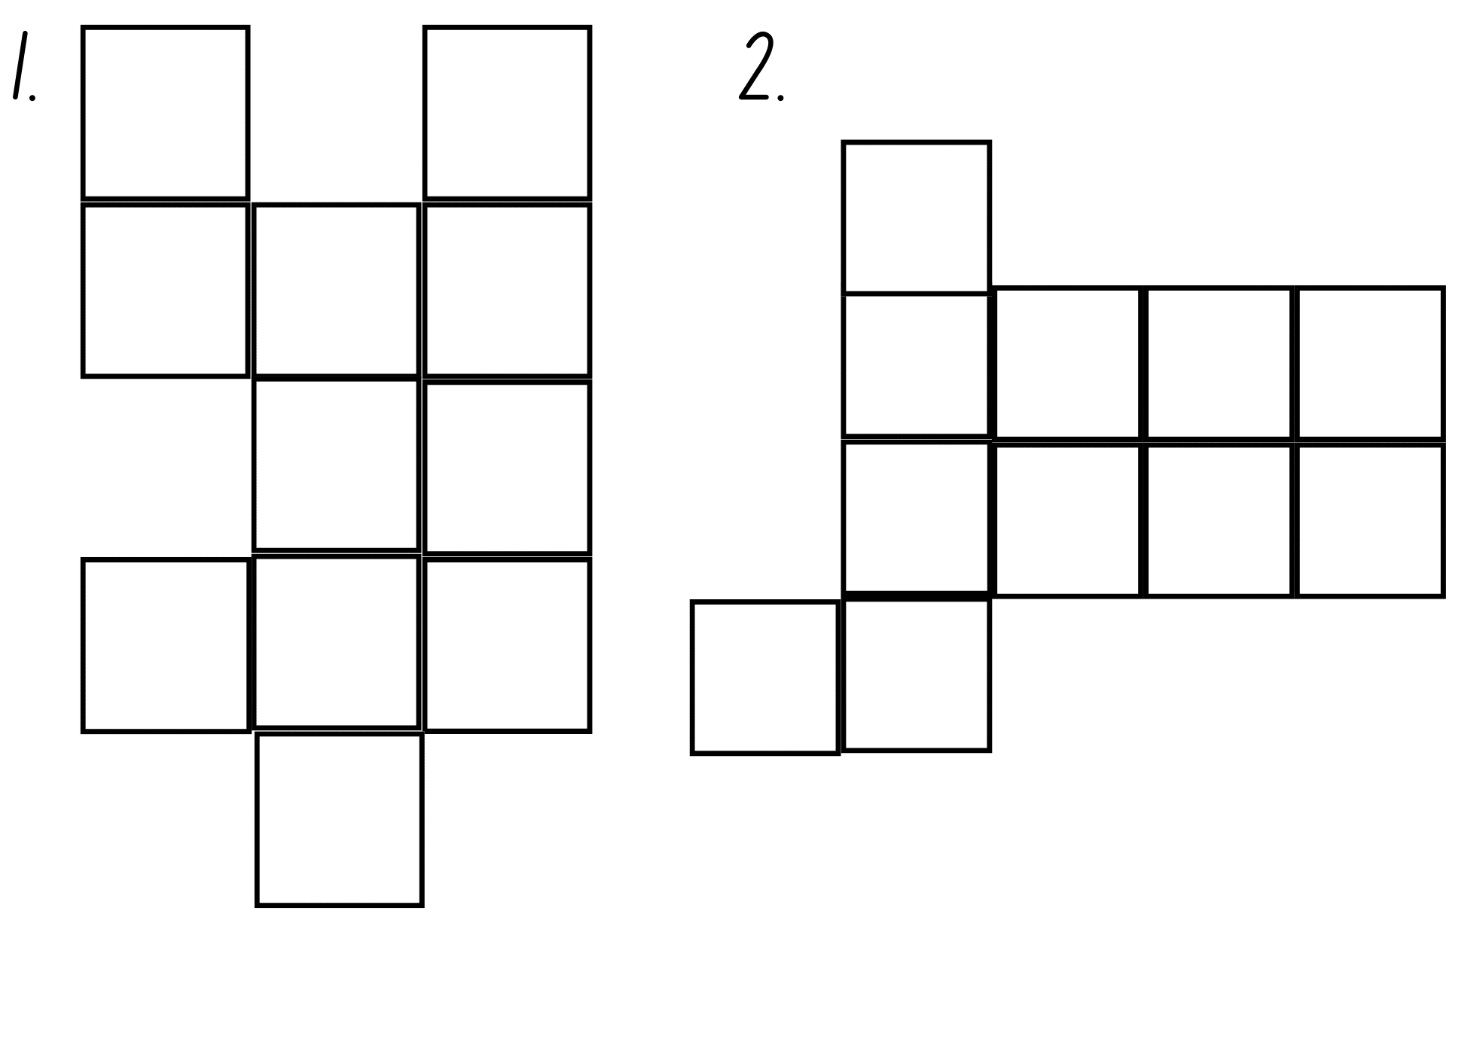

Resource 2: Number balance
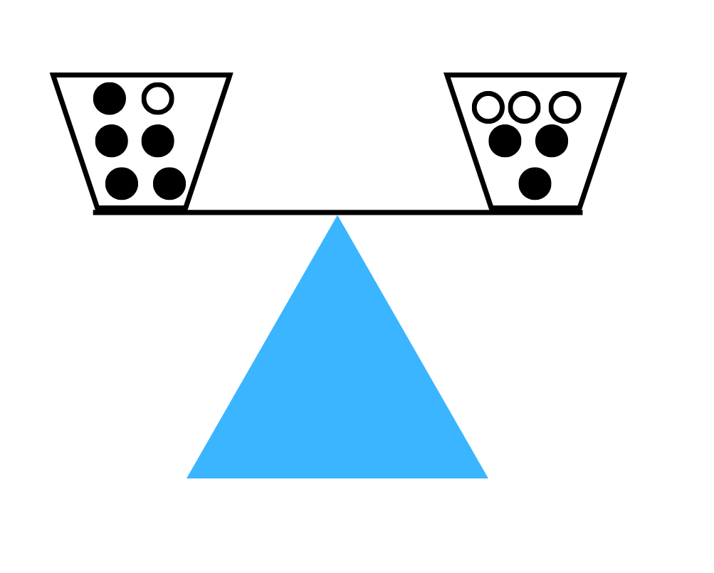

Resource 3: Addition table
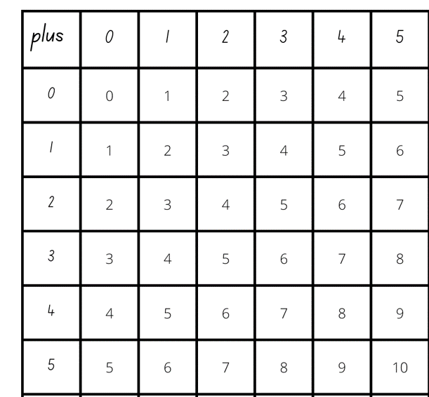

Resource 4: Extended addition table
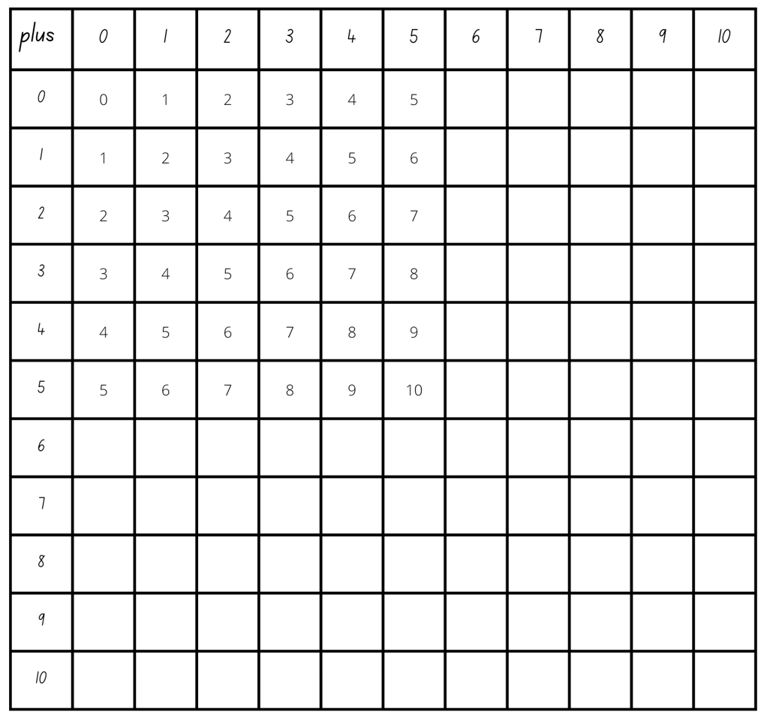

Resource 5: Tower talk
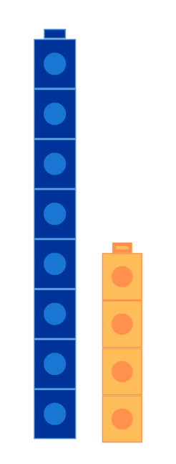

Resource 6: Constant difference concentration
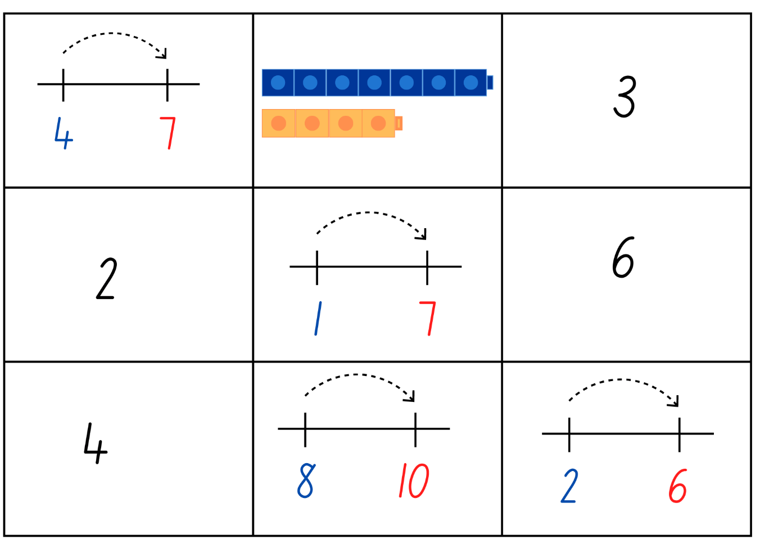
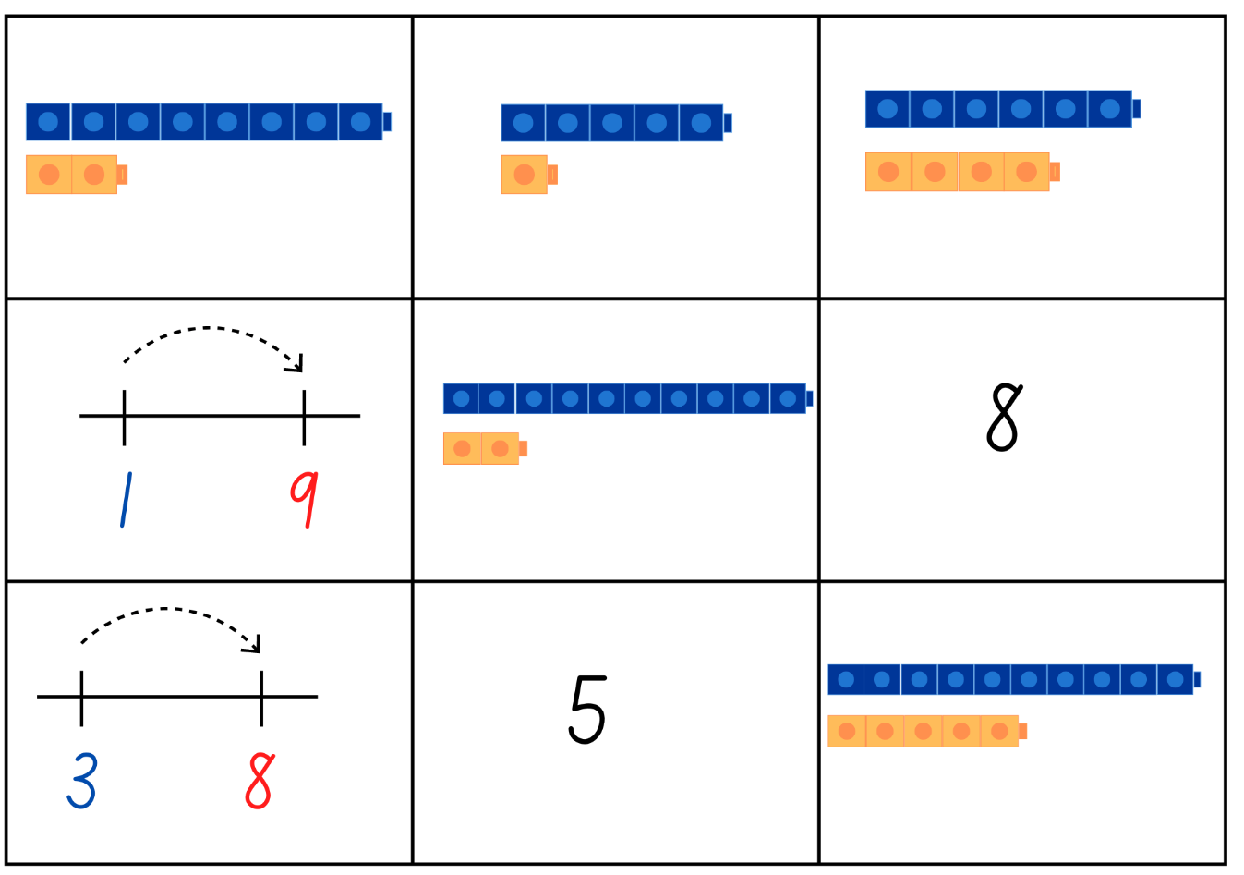
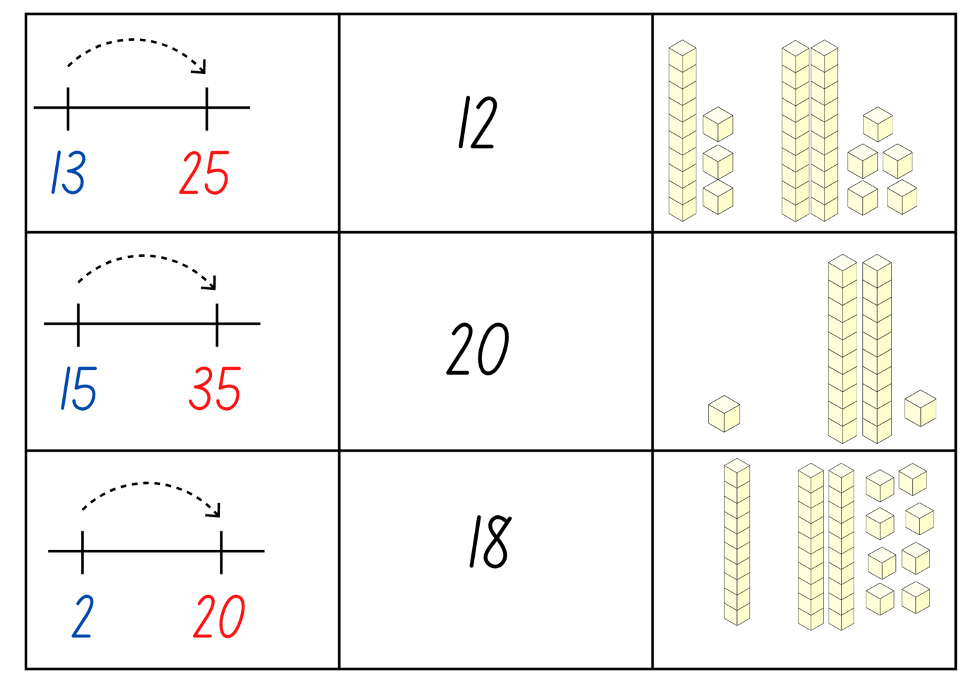

Resource 7: Think board
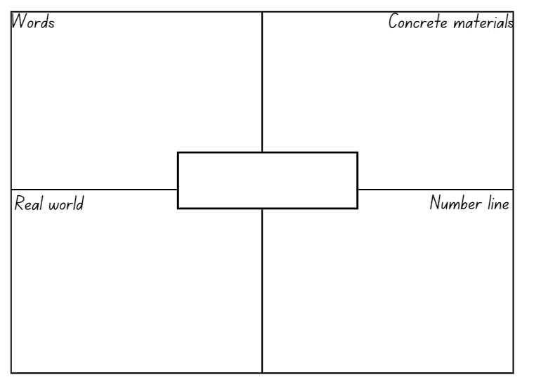

Resource 8: Number balance talk
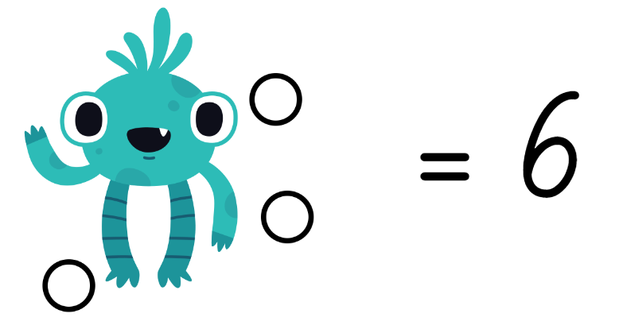
Images sourced from Canva and used in accordance with the Canva Content License Agreement.

Resource 9: Number balance questions
- How do you see the dots in the puzzle?
- What is the value of each side of the number sentence?
- How many dots are hidden by the monsters? How do you know?
- How can you balance the 2 sides so that they are equal?
- Where do you think the dots could be added?
- How can you record your thinking so that others can see what you see? (For example, using a bar model from Lesson 2).

Resource 10: Number balance puzzles
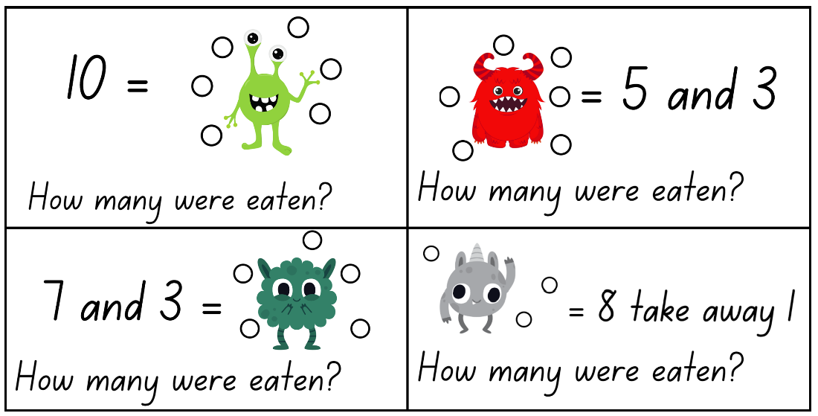
Images sourced from Canva and used in accordance with the Canva Content License Agreement.
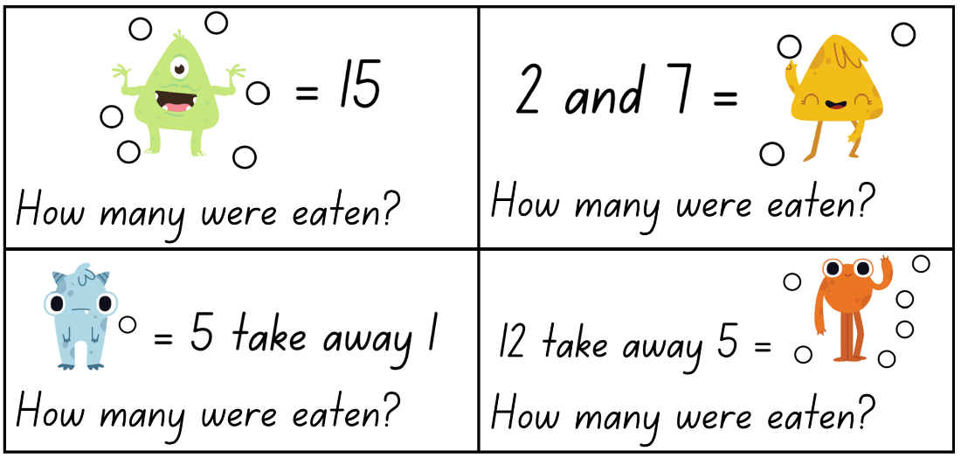
Images sourced from Canva and used in accordance with the Canva Content License Agreement.
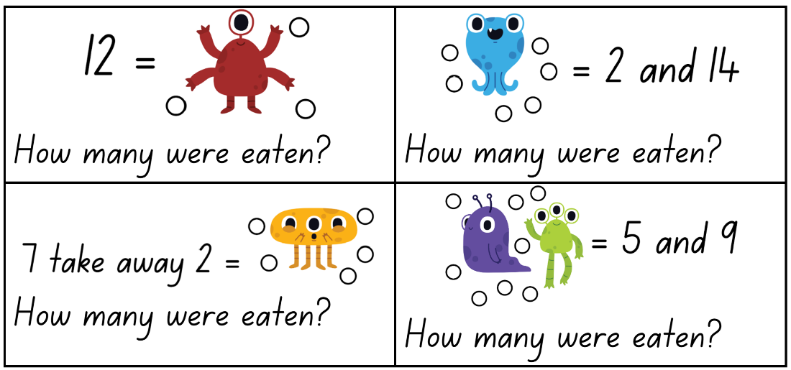
Images sourced from Canva and used in accordance with the Canva Content License Agreement.

Resource 11: Number balance scaffold
Images sourced from Canva and used in accordance with the Canva Content License Agreement.

Resource 12: Piggy bank problem
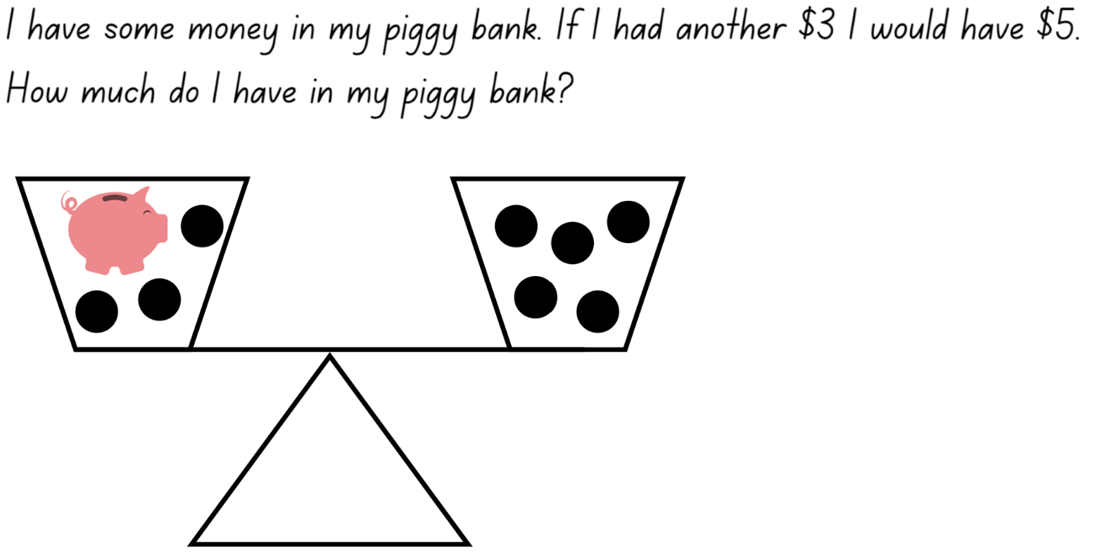
Images sourced from Canva and used in accordance with the Canva Content License Agreement.

Resource 13: Pigs vs. Wolf rules
Images sourced from Canva and used in accordance with the Canva Content License Agreement.

Resource 14: Pigs vs. Wolf gameboard
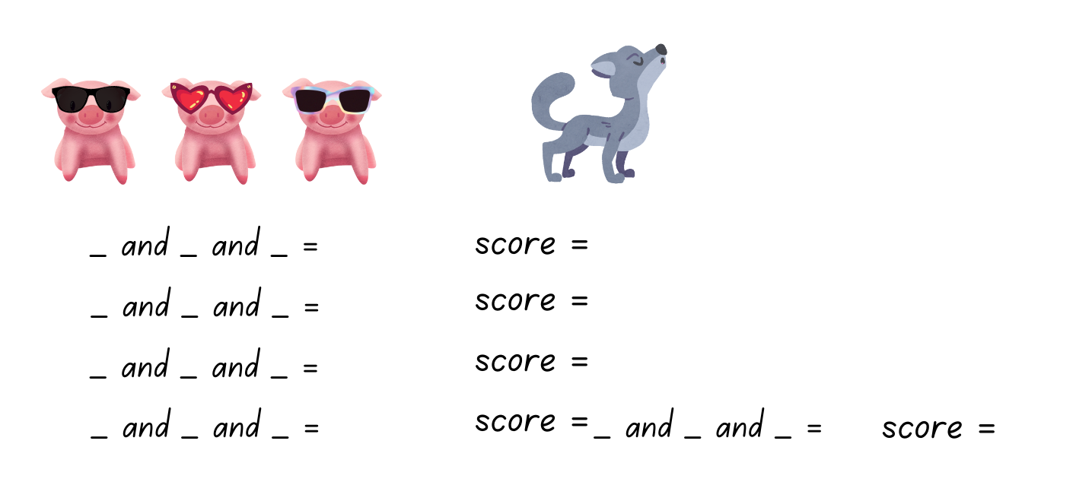
Images sourced from Canva and used in accordance with the Canva Content License Agreement.

Resource 15: Who balanced the boat?
Can you find a way to get all 5 animals, including the mouse, to distribute their weight across the boat so that the boat is balanced and stays afloat? Here is some important information about the weight of the animals to help solve the problem:
- The cow weighs the same as the donkey. They are equal (cow = donkey).
- The pig weighs the same as the sheep. They are equal (pig = sheep).
- The cow and the donkey are both heavier than the pig and the sheep. They are not equal to the pig and the sheep.
- The pig and the sheep are both heavier than the mouse. They are not equal to the mouse.
See how many ways the problem can be solved.
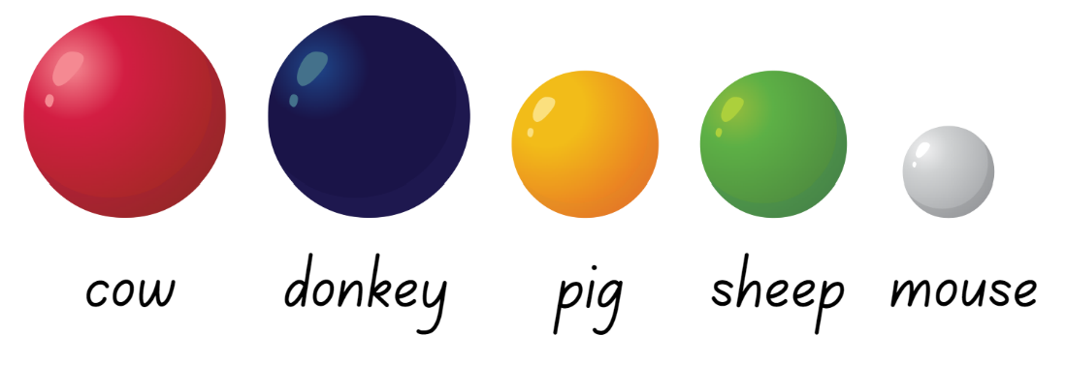
Images sourced from Canva and used in accordance with the Canva Content License Agreement.

Syllabus outcomes and content
The table below outlines the syllabus outcomes and range of relevant syllabus content covered in this unit. Content is linked to National Numeracy Learning Progression version (3).
Focus area and outcomes | Content groups and content points | Lessons
Representing whole numbers A  MAO-WM-01  MA1-RWN-01  MA1-RWN-02 | Use counting sequences of ones with two-digit numbers and beyond  - identify the number before and after a given two-digit number (CPr5)  - count forwards and backwards by ones from a given number to at least 120 (CPr6)  Represent numbers on a line  - sequence numbers and arrange them on a line by considering the order and size of those numbers (CPr5)  Represent the structure of groups of ten in whole numbers  - recognise that ten ones is the same as one ten (NPV2, NPV4) | 1–6, 8
Combining and separating quantities A  MAO-WM-01  MA1-CSQ-01 | Use advanced count-by-one strategies to solve addition and subtraction problems  - apply the terms ‘add’, ‘plus’, ‘equals’, ‘is equal to’, ‘is the same as’, ‘take away’, ‘minus’ and ‘the difference between’ to describe combining and separating quantities (AdS1, AdS6)  - recognise and use the symbols for plus (+), minus (–) and equals (=)  - record number sentences in a variety of ways using drawings, words, numerals and symbols (AdS6)  - fluently use advanced count-by-one strategies including counting on and counting back to solve addition and subtraction problems involving one- and two-digit numbers (AdS3-AdS5)  Recognise and recall number bonds up to ten  - recognise, recall and record combinations of two numbers that add up or bond to form 10 (AdS2, AdS6)  - model and record patterns for individual numbers up to ten by making all possible whole-number combinations  - create, recall and recognise combinations of two numbers that add up to numbers less than 10 (AdS2, AdS6)  - describe combinations for numbers using words such as more than, less than and double (AdS6)  Use flexible strategies to solve addition and subtraction problems  - use non-count-by-one strategies such as using doubles for near doubles and combining numbers that add to ten (AdS6)  - represent addition and subtraction using structured materials such as a bead string or similar model (AdS6-AdS7)  Represent equality  - use the equals sign to record equivalent number sentences involving addition, and to mean 'is the same as', rather than as an indication to perform an operation (NPA3)  - recall related addition and subtraction facts for numbers to at least 10 (AdS6) | 1–7
Combining and separating quantities B  MAO-WM-01  MA1-CSQ-01 | Represent and reason about additive relations  - create, record and recognise combinations of two numbers that add to numbers from 11 up to and including 20 (AdS7)  - create, model and solve word problems, using number sentences  - represent the difference between two numbers using concrete materials and diagrams (AdS6)  - represent a constant difference between pairs of numbers  Use knowledge of equality to solve related problems  - use number bonds to determine a missing number (AdS6, NPA3-NPA4)  - use number knowledge to solve related problems (AdS7, NPA4)  - use a variety of ways of writing number sentences (NPA3-NPA4)  - use number bonds to solve equality problems (NPA3-NPA4) | 3–5
Non-spatial measure A  MAO-WM-01  MA1-NSM-01 | Mass: Investigate mass using an equal-arm balance  - place objects on either side of an equal-arm balance to obtain a level balance  - use an equal-arm balance to compare the masses of two objects and record, which is heavier or lighter (UuM2)  - predict the action of an equal-arm balance before placing particular objects in each pan  - use a balance to find two collections of objects that have the same mass (UuM2)  - compare and order the masses of two or more objects by hefting, and check using an equal-arm balance (UuM2) | 1–2, 5, 8

References
Links to third-party material and websites
Please note that the provided (reading/viewing material/list/links/texts) are a suggestion only and implies no endorsement, by the New South Wales Department of Education, of any author, publisher, or book title. School principals and teachers are best placed to assess the suitability of resources that would complement the curriculum and reflect the needs and interests of their students.
If you use the links provided in this document to access a third-party's website, you acknowledge that the terms of use, including licence terms set out on the third-party's website apply to the use which may be made of the materials on that third-party website or where permitted by the Copyright Act 1968 (Cth). The department accepts no responsibility for content on third-party websites.
Except as otherwise noted, all material is © State of New South Wales (Department of Education), 2021 and licensed under the Creative Commons Attribution 4.0 International License. All other material (third-party material) is used with permission or under licence. Where the copyright owner of third-party material has not licensed their material under a Creative Commons or similar licence, you should contact them directly for permission to reuse their material.
Mathematics K–10 Syllabus © 2022 NSW Education Standards Authority (NESA) for and on behalf of the Crown in right of the State of New South Wales.
© 2022 NSW Education Standards Authority. This document contains NSW Curriculum and syllabus content. The NSW Curriculum is developed by the NSW Education Standards Authority. This content is prepared by NESA for and on behalf of the Crown in right of the State of New South Wales. The material is protected by Crown copyright.
Please refer to the NESA Copyright Disclaimer for more information.
NESA holds the only official and up-to-date versions of the NSW Curriculum and syllabus documents. Please visit the NSW Education Standards Authority (NESA) website and the NSW Curriculum website.
National Numeracy Learning Progression © Australian Curriculum, Assessment and Reporting Authority (ACARA) 2010 to present, unless otherwise indicated. This material was downloaded from the Australian Curriculum website (National Numeracy Learning Progression) (accessed 10 November 2022) and was not modified. The material is licensed under CC BY 4.0. Version updates are tracked in the ‘Curriculum version history’ section on the 'About the Australian Curriculum' page of the Australian Curriculum website.
ACARA does not endorse any product that uses the Australian Curriculum or make any representations as to the quality of such products. Any product that uses material published on this website should not be taken to be affiliated with ACARA or have the sponsorship or approval of ACARA. It is up to each person to make their own assessment of the product, taking into account matters including, but not limited to, the version number and the degree to which the materials align with the content descriptions and achievement standards (where relevant). Where there is a claim of alignment, it is important to check that the materials align with the content descriptions and achievement standards (endorsed by all education Ministers), not the elaborations (examples provided by ACARA).
This resource contains images and content obtained from Canva, and their use outside of this resource is subject to Canva’s Content License Agreement. If you wish to use them separately from the resource, please go to Canva.
Allen P (1988) Who Sank the Boat?, Puffin, Great Britain.
Boaler J, Munson J and William C (2021) Mindset Mathematics: Visualising and Investigating Big Ideas, Grade 1, Jossey-Bass, US.
Russo J (2016) ‘Using picture story books to discover and explore the concept of equivalence’, Australian Primary Mathematics Classroom, 21(2):26-31.
State of New South Wales, Department of Education (n.d.) ‘Activities to support Forward and backward word sequences’, Counting-on-and-back Strategies, Developing Efficient Numeracy Strategies One website, accessed 8 November 2022.
State of New South Wales, Department of Education (n.d.) ‘Activities to support Numeral identification’, Counting-on-and-back Strategies, Developing Efficient Numeracy Strategies One website, accessed 8 November 2022.
Warren E, Mollinson A and Oestrich K (2009) ‘Equivalence and Equations in Early Years Classrooms’, Australian Primary Mathematics Classroom, 14(1):10-15.

