Mathematics – Stage 1 – Unit 4
Contents
Unit description and duration 4
Student prior learning 5
Lesson overview and resources 6
Lesson 1: Counting on 12
Daily number sense: Benchmark numbers – 10 minutes 12
Forwards and backwards counting – 15 minutes 14
Counting on – 15 minutes 15
Consolidation and meaningful practice: Real counting on – 20 minutes 16
Lesson 2: Rekenrek numbers 19
Daily number sense: Number line – 20 minutes 19
Rekenreks – 30 minutes 21
Discuss and connect the mathematics – 10 minutes 24
Lesson 3: Domino numbers 26
Daily number sense: Rekenrek doubles – 15 minutes 26
Part whole dominoes – 30 minutes 27
Consolidation and meaningful practice: Real counting on – 15 minutes 30
Lesson 4: Bar model 31
Daily number sense: Odd and even numbers – 10 minutes 31
Building towers – 30 minutes 32
Consolidation and meaningful practice: Bar model – 20 minutes 35
Lesson 5: Domino triangles 36
Daily number sense: Dot Talk 1 – 15 minutes 36
Domino triangles – 35 minutes 38
Discuss and connect the mathematics – 10 minutes 40
Lesson 6: Doubles 41
Daily number sense: Dot Talk 2 – 10 minutes 41
Doubles – 40 minutes 42
Discuss and connect the mathematics – 10 minutes 44
Lesson 7: Near doubles 46
Daily number sense: Rekenrek number talk – 10 minutes 46
Near doubles – 40 minutes 47
Discuss and connect the mathematics: Anchor chart – 10 minutes 50
Lesson 8: Power dot pro 52
Daily number sense: Counting strategies – 15 minutes 52
Power dot pro – 30 minutes 54
Consolidation and meaningful practice – 15 minutes 56
Resource 1: Numbers cards 1 57
Resource 2: Numbers cards 2 58
Resource 3: Recording sheet 59
Resource 4: Rekenrek problems 60
Resource 5: Bar model 62
Resource 6: Dot talk 1 64
Resource 7: Domino triangles 1 65
Resource 8: Domino triangles 2 66
Resource 9: Dot talk 2 67
Resource 10: Doubles memory 68
Resource 11: Rekenrek number talk 70
Resource 12: Near doubles 71
Resource 13: Recording table 72
Resource 14: Numbers cards 3 73
Resource 15: Graphic organiser 74
Syllabus outcomes and content 75
References 78

Unit description and duration
This two-week unit provides opportunities to further develop student knowledge, understanding, and skills of combinations of numbers that add up to a given number. Students are provided opportunities to:
- count on from the largest number to find the total of 2 numbers
- recognise and recall different combinations of 2 numbers that add up to a given number
- identify patterns to find all combinations for a given number
- use the bar model to represent parts of a number
- identify and combine numbers which make doubles facts
- describe combinations for numbers using words such as ‘more than’ and ‘less than’, and ‘double’
- find smaller numbers inside larger numbers
- identify near doubles by doubling the smaller number and adding one more or doubling the larger number and subtracting one less
- recognise and record numbers in different representations including words, numerals, and known structures such as dice, rekenreks, and ten-frames.
Mathematics K–10 Syllabus © 2022 NSW Education Standards Authority (NESA) for and on behalf of the Crown in right of the State of New South Wales.

Student prior learning
Before engaging in these teaching and learning activities, students would benefit from prior experience with:
- identifying combinations of 2 numbers that add up to numbers less than 10
- representing numbers 0-20 with drawings, numerals, symbols, and words
- counting with one-to-one correspondence, recognising that the last number name represents the total number in the collection
- using a ten-frame to represent smaller parts of a number
- exposure to representing numbers on a rekenrek.

Lesson overview and resources
The table below outlines the sequence and approximate timing of lessons; syllabus focus areas and content groups; and resources.
Lesson | Syllabus focus area and content groups | Resources
Lesson 1: Counting on  60 minutes  Count-by-one strategies help to solve addition problems. | Representing whole numbers A  - Use counting sequences of ones with two-digit numbers and beyond  - Represent numbers on a line  Combining and separating quantities A  - Use advanced count-by-one strategies to solve addition and subtraction problems  - Recognise and recall number bonds up to ten | - Resource 1: Number cards 1  - Resource 2: Number cards 2  - Resource 3: Recording sheet  - Counters  - Playing or number cards 0-9  - Writing materials
Lesson 2: Rekenrek numbers  60 minutes  Patterns help to identify number combinations. | Representing whole numbers A  - Represent numbers on a line  Combining and separating quantities A  - Use advanced count-by-one strategies to solve addition and subtraction problems  - Recognise and recall number bonds up to ten  - Use flexible strategies to solve addition and subtraction problems | - Resource 4: Rekenrek problems  - 20-Bead rekenrek  - Class set of 20-bead rekenreks  - Writing materials
Lesson 3: Domino numbers  60 minutes  Patterns help to identify number combinations. | Combining and separating quantities A  - Use advanced count-by-one strategies to solve addition and subtraction problems  - Recognise and recall number bonds up to ten  - Use flexible strategies to solve addition and subtraction problems | - Resource 3: Recording sheet  - Class set of rekenreks  - Counters  - Large collection of dominoes  - Playing cards or number cards 0-9 and 10-20  - Writing materials
Lesson 4: Bar model  60 minutes  Concrete materials help to represent the smaller numbers which make up larger numbers. | Representing whole numbers A  - Continue and create patterns  Combining and separating quantities A  - Use advanced count-by-one strategies to solve addition and subtraction problems  - Recognise and recall number bonds up to ten  - Use flexible strategies to solve addition and subtraction problems | - Resource 5: Bar model  - Dice  - Interlocking cubes  - Sticky notes  - Writing materials
Lesson 5: Domino triangles  60 minutes  A quantity can be described by talking about its smaller parts. | Representing whole numbers A  - Use counting sequences of ones with two-digit numbers and beyond  - Represent the structure of groups of ten in whole numbers  Combining and separating quantities A  - Use advanced count-by-one strategies to solve addition and subtraction problems  - Recognise and recall number bonds up to ten  - Use flexible strategies to solve addition and subtraction problems | - Resource 6: Dot talk 1  - Resource 7: Domino triangles 1  - Resource 8: Domino triangles 2  - Digital ten-frame  - Dominoes  - Writing materials
Lesson 6: Doubles  60 minutes  Doubles facts are an efficient way to combine quantities. | Representing whole numbers A  - Use counting sequences of ones with two-digit numbers and beyond  - Represent the structure of groups of ten in whole numbers  Combining and separating quantities A  - Use advanced count-by-one strategies to solve addition and subtraction problems  - Recognise and recall number bonds up to ten  - Use flexible strategies to solve addition and subtraction problems | - Resource 9: Dot talk 2  - Resource 10: Doubles memory  - Digital ten-frame  - Writing materials
Lesson 7: Near doubles  60 minutes  Near doubles are an efficient way to combine quantities. | Representing whole numbers A  - Use counting sequences of ones with two-digit numbers and beyond  Combining and separating quantities A  - Use advanced count-by-one strategies to solve addition and subtraction problems  - Recognise and recall number bonds up to ten  - Use flexible strategies to solve addition and subtraction problems | - Resource 11: Rekenrek number talk  - Resource 12: Near doubles  - Resource 13: Recording table  - Counters  - Playing cards  - Writing materials
Lesson 8: Power dot pro  60 minutes  There are many ways to combine quantities to find a total. | Representing whole numbers A  - Use counting sequences of ones with two-digit numbers and beyond  Combining and separating quantities A  - Use advanced count-by-one strategies to solve addition and subtraction problems  - Recognise and recall number bonds up to ten  - Use flexible strategies to solve addition and subtraction problems | - Resource 14: Number cards 3  - Resource 15: Graphic organiser  - Video: Power dot pro (6:47)  - Tiny Dot Starter Kit or dominoes

Lesson 1: Counting on
Core concept: Count-by-one strategies help to solve addition problems.
The table below contains suggested learning intentions and success criteria. These are best co-constructed with students.
Learning intentions | Success criteria
Students are learning that:  - numbers have a sequence from any given number  - count-by-one strategies like counting on helps to solve addition problems. | Students can:  - count forwards and backwards by ones from any given number to at least 120  - count on from the largest number to find the total of 2 numbers.

Daily number sense: Benchmark numbers – 10 minutes
- Build student understanding of the relationship between numbers by locating the position of them on a number line.
- Students draw a blank number line with the benchmark numbers 5 and 10 at either end. Ask students to plot the number 7.
- Students share where they plotted the number 7 and justify its placement.
- Students then work out how many more from 5 to 7 and how many less from 10 to 7. Choose students to share their responses and how they worked it out.
- Students draw another blank number line with the benchmark numbers, 15 and 20 at either end. Ask students to plot the number 17.
- Students share where they plotted the number 17 and justify its placement.
- Students then work out how many more from 15 to 17 and how many less from 20 to 17. Choose students to share their responses and if they can draw any links between the 2 number lines (see Figure 1).
Figure 1 – Benchmark numbers
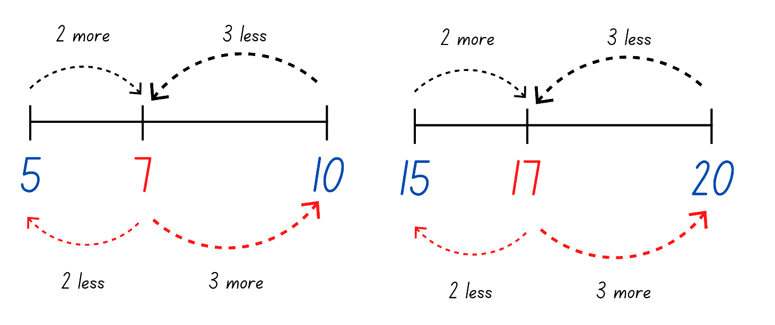
Note: Highlight to students that if it is 2 more from 5 to 7, it is also 2 less from 7 to 5. Students should start to see the pattern between numbers which end in 7.
- Challenge students to complete the same activity and plot the number 37.

Forwards and backwards counting – 15 minutes
This activity has been adapted from Forwards and Backwards Counting by Van de Walle et al. (2019).
- Stand students in a circle. Choose a target number between 5-10.
- Students take turns to count forwards to the target number, sitting down as they say a number. Once the target has been reached, the student who said the target number then stands back up and the count goes back down. Each student stands up again as they say a number.
- Continue to choose different target numbers and different students to start from within the circle.
Note: Have students start their count at numbers other than zero.
The table below details assessment opportunities and differentiation ideas.
Assessment opportunities | Too hard? | Too easy?
What to look for:  - Are students able to count forwards and backwards by ones from a given number? (MA1-RWN-01)  What to collect:  - observational data (MA1-RWN-01) | Students are not confident counting forwards or backwards from a given number.  - Have students focus on counting forwards between 0-10 and identifying numbers before and after.  - Display a number chart for students to reference whilst counting.  - Provide students with number cards to correctly order. | Students are confident counting forwards and backwards by ones from a given number.  - Challenge students to count by twos from a given number.  - Provide opportunity for students to count forwards and backwards by ones from a given three-digit number.  - Students count forwards and backwards by tens on and off the decade.

Counting on – 15 minutes
- Display Resource 1: Number cards 1. Ask students how they would work out the total. Provide thinking time and then have students turn and talk to discuss their strategy.
- Select students to share and model their strategy.
- If a student models counting on from the largest number, focus on this strategy and the explicit steps they undertook. If a student does not model this, explicitly demonstrate counting on.
Counting on: Counts on from the larger number to find the total of 2 numbers.
Note: The first advanced count-by-one strategies students use for addition and subtraction are counting on and counting back.
- Display Resource 2: Number cards 2. Ask students to use counting on to solve the problem. Students may use fingers, counters, or an individual whiteboard to keep track when counting on.
- Choose a student to model how they solved the problem, highlighting the counting on strategies.

Consolidation and meaningful practice: Real counting on – 20 minutes
This activity has been adapted from ‘Real Counting On’ by Van de Walle et al. (2019)
- Have a deck of cards (0-9), Resource 3: Recording sheet, and counters. Sitting in a circle, choose different students to play against.
- Turn over a card and place the indicated number of counters in the red circle and place the card above the circle. The student turns over a card and places the indicated number of counters in the blue circle and place the card above.
- Together, determine which number is the largest number. Students then count on from the larger number and record the total (see Figure 2).
Figure 2 – Game play
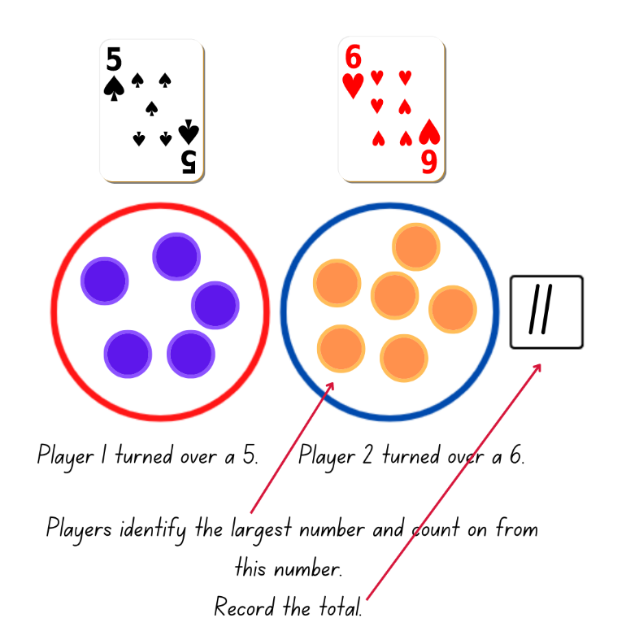
Images sourced from Canva and used in accordance with the Canva Content License Agreement.
- Once total has been determined, clear the board, and turn over new cards. Play again with a different student.
- Once students are confident with the activity, provide pairs of students with a deck of cards (0-9), Resource 3: Recording sheet, and counters. Students play with their partner.
Note: Using a reusable sleeve with Resource 3: Recording sheet will allow for continual use. An ace can represent zero.
- While students are playing, ask:
- How are you finding the total?
- How do you know your total is correct?
- Which number are you counting on from?
The table below details assessment opportunities and differentiation ideas.
Assessment opportunities | Too hard? | Too easy?
What to look for:  - Can students identify the largest number between 2 given numbers? (MA1-RWN-01)  - Are students able to count on from the largest number to find the total? (MA1-CSQ-01)  What to collect:  - observational data (MAO-WM-01, MA1-RWN-01, MA1-CSQ-01) | Students are not confident counting on from the largest number.  - Work with students to arrange Resource 3: Recording sheet so that the largest number is first. Model putting the largest number in your head and then touching each counter in the second circle as you count on.  - Students continue to develop their confidence by counting from one to find the total. | Students are confident counting on from the largest number.  - Provide opportunities for students to count on with a one-digit number from a two-digit number.  - Students use strategies to bridge to 10 to solve problems. Students use their counters to demonstrate the partitioning of numbers.

Lesson 2: Rekenrek numbers
Core concept: Patterns help to identify number combinations.
The table below contains suggested learning intentions and success criteria. These are best co-constructed with students.
Learning intentions | Success criteria
Students are learning that:  - numbers have a sequence based on their value  - different combinations of numbers can add up or bond to form a given number  - there are ways to model and record patterns when identifying number combinations for a given number. | Students can:  - sequence given numbers and identify missing numbers on a number line  - model and record number sentences using words and drawings  - create and recall combinations of 2 numbers that add up to numbers less than 10  - identify patterns for numbers up to 10 by making all possible combinations.

Daily number sense: Number line – 20 minutes
- Build student understanding of numeral identification and order by correctly sequencing numbers.
- Write 9, 11, 15, 17, and 20 on the board in random order. Using their individual whiteboards, ask students to order these numbers from smallest to largest on a blank number line.
- Choose students to share where they placed their numbers and justify the position of their placement.
Note: It is important to look at the placement of numbers on the number line. Check if students have considered the missing numbers or placed all the numbers together.
- Ask students to identify and add the missing numbers.
- Repeat the above steps for different collections of numbers.
The table below details assessment opportunities and differentiation ideas.
Assessment opportunities | Too hard? | Too easy?
What to look for:  - Can students sequence given numbers and arrange them on a number line? (MA1-RWN-01)  What to collect:  - observational data (MAO-WM-01, MA1-RWN-01) | Students are not confident ordering numbers on a number line.  - Provide students with 0-10 number cards to sequence in ascending and descending order.  - Provide students with 0-10 number cards with 2 or 3 cards missing. Students order the cards in ascending and descending order and identify the missing cards.  - Provide benchmark numbers to assist students in ordering the placement of numbers on a number line. | Students are confident ordering a collection of numbers on a number line.  - Provide students with a blank number line with 47 and 67 at either end. Have students determine the placement of 52.  - Challenge students with different three-digit number ranges.

Rekenreks – 30 minutes
This activity has been adapted from Introducing rekenreks (11:53) from Thinking Mathematically.
Watch Introducing rekenreks (11:53) prior to teaching this lesson.
- Display a 20-bead rekenrek and ask students what they notice.
The table below outlines prompts to generate conversation about the topic, along with anticipated responses from students.
Prompt | Anticipated student responses
What do you notice about the rekenrek? | - Different coloured beads.  - Each colour represents a collection of 5.  - 2 fives on the top row and 2 fives on the bottom row.  - 10 on the top row and 10 on the bottom row.  - 20 beads in total.
- Provide pairs with a 20-bead rekenrek. Explain that beads are moved across to represent quantities.
Note: Find out How to make a rekenrek (5:29) or access a digital rekenrek.
- Challenge students to represent 4 on their rekenrek. Look for different representations from students and choose them to explain how they represented 4. Record the different representations and draw attention to the pattern of the numbers (see Figure 3).
Figure 3 – Rekenrek pattern
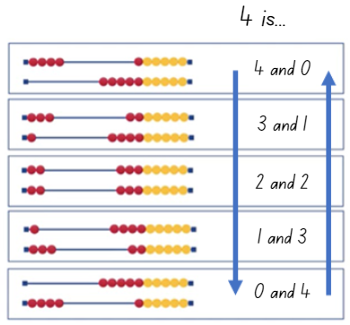
Images sourced from Canva and used in accordance with the Canva Content License Agreement.
- Choose different numbers for students to represent and share with the class. Continue to record and look for patterns.
- Display and read Resource 4: Rekenrek problems. Students work in pairs to find as many solutions as possible using their rekenrek for both problems. Students record their thinking (see Figure 4).
Figure 4 – Rekenrek student working
Images sourced from Canva and used in accordance with the Canva Content License Agreement.

Discuss and connect the mathematics – 10 minutes
- Summarise the lesson together, drawing out some key mathematical ideas. Ask students:
- How did the rekenrek help to solve the problem?
- How do you know you have all the solutions?
- How do patterns help to solve problems?
- How did you work like a mathematician today?
Note: When discussing the question about whether students have represented all the solutions, focus on the structure of the pattern. The pattern and order of combinations might not come naturally. Support students to understand where to start and end.
The table below details assessment opportunities and differentiation ideas.
Assessment opportunities | Too hard? | Too easy?
What to look for:  - Can students create and recall combinations of 2 numbers that add up to numbers less than 10? (MA1-CSQ-01)  - Are students able to model and record number sentences using words and drawings? (MAO-WM-01, MA1-CSQ-01)  - Can students identify patterns for numbers up to 10 by making all possible whole-number combinations? (MA1-CSQ-01)  What to collect:  - student work samples. (MAO-WM-01, MA1-CSQ-01) | Students are not confident identifying patterns for numbers up to 10 or creating combinations of 2 numbers.  - Provide students with interlocking cubes to model the pattern using different coloured cubes for the 2 parts of the whole number.  - Provide opportunities for students to count small collections of objects and break them into different groups and count them again. This leads to students understanding the conservation principle that a set of objects remains the same no matter if they are spread out or close together. | Students are confident identifying patterns and combining 2 numbers that add up to a number less than 10.  - Provide students with a target number to make on the rekenrek. Students need to create that number within a set amount of moves. For example, the target number is 17 and students have 3 moves. Students might move 10, 5, and 2 beads to represent 17. Students record their working.  - Provide students with a target number and they must use at least one combination to 10. For example, the target number is 17 and students have 3 moves. Students might move 6, 4, and 7 beads to represent 17. Students record their working.

Lesson 3: Domino numbers
Core concept: Patterns help to identify number combinations.
The table below contains suggested learning intentions and success criteria. These are best co-constructed with students.
Learning intentions | Success criteria
Students are learning that:  - different combinations of numbers can add up or bond to form a given number  - there are ways to model and record patterns when identifying number combinations for a given number. | Students can:  - record number sentences using words and drawings  - recognise and recall different combinations of 2 numbers that add up to a given number  - identify patterns to find all combinations for a given number.

Daily number sense: Rekenrek doubles – 15 minutes
This activity has been adapted from ‘Doubling’ from Beadstring Mathematics by Swan (2020).
- Build student understanding of doubles by representing numbers on a rekenrek.
- Provide each student with a rekenrek or a digital rekenrek and ask them to represent double 4.
- Students share their representation and explain how they see it. Record student responses (see Figure 5).
Figure 5 – Student working
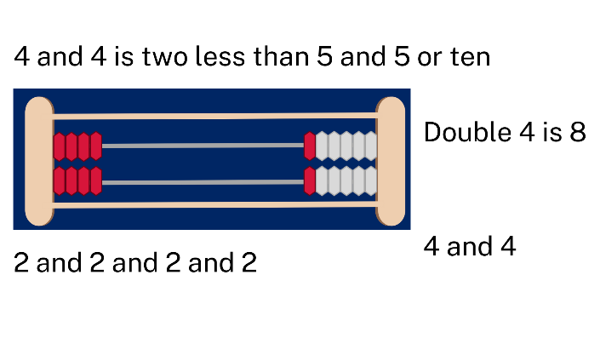
Images sourced from Canva and used in accordance with the Canva Content License Agreement.
- Provide other numbers under 10 for students to represent as doubles.

Part whole dominoes – 30 minutes
This activity has been adapted from Representing part whole with dominoes (2022).
- Provide pairs with a large collection of dominoes, more than 20. Students work together to organise their collection to find dominoes that form combinations for a given number.
- When dominoes have been organised, students select one number and write all the combinations (see Figure 6).
Figure 6 – Domino patterns
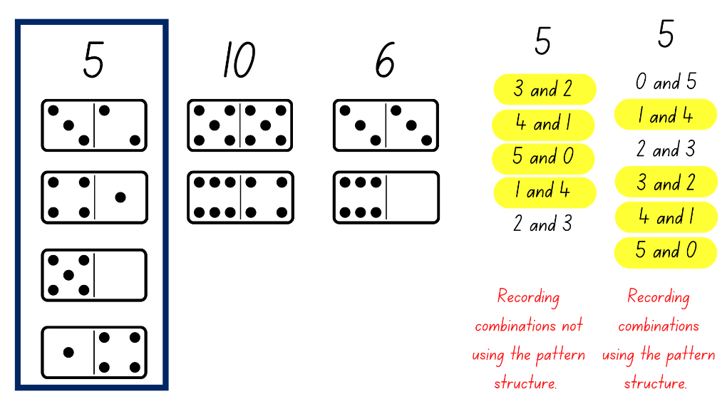
Note: In Lesson 2, students were exposed to the concept of a pattern to represent all combinations. Students may naturally organise their thinking using a systematic pattern, however, do not prompt students to do this at this stage of the lesson.
- Students display their work and go on a gallery walk to look at how others have structured their combinations. Ask students how they can be confident that they have all the combinations.
Note: Through class discussion, students consider the idea of the pattern and reflect on their work to see if they have applied this. Being able to flexibly partition numbers is critical for building number sense. Combining numbers in set patterns helps with the recall of mental calculations.
- Students reflect on their working and make changes to reflect the pattern. Students share their working with the class.
The table below details assessment opportunities and differentiation ideas.
Assessment opportunities | Too hard? | Too easy?
What to look for:  - Are students able to recognise and recall different combinations of 2 numbers that add up to a given number? (MA1-CSQ-01)  - Can students identify and use a systematic pattern to find all combinations for a given number? (MAO-WM-01, MA1-CSQ-01)  What to collect:  - student work samples (MAO-WM-01, MA1-CSQ-01) | Students are not confident identifying and using a systematic pattern to combine numbers to represent a given number.  - Provide students with a collection of dominoes that have all the combinations for a given number under 5. Students order these to reflect the systematic pattern.  - Provide students with interlocking cubes to model the pattern using different coloured cubes for the 2 parts of the given number. | Students are confident identifying and using a systematic pattern and combining 2 numbers to create a given number.  - Challenge students to combine 3 numbers to make the total of the given number.  - In pairs, the first student calls out a number between 1 and 12 and the second student identifies 3 numbers that combine to make that number.

Consolidation and meaningful practice: Real counting on – 15 minutes
This activity has been adapted from Real Counting On by Van de Walle et al. (2019)
- Provide students with number cards (0-9), Resource 3: Recording sheet, and counters and revise the rules from Lesson 1.
- Students play with their partner, counting on from the largest number. Challenge students to draw on their knowledge of doubles and combinations of numbers to also assist them when solving problems.
Note: Provide students with 2 decks of number cards, 0-9 and 10-20. This will provide opportunities for students to count on and solve addition problems involving one- and two-digit numbers.

Lesson 4: Bar model
Core concept: Concrete materials help to represent the smaller numbers which make up larger numbers.
The table below contains suggested learning intentions and success criteria. These are best co-constructed with students.
Learning intentions | Success criteria
Students are learning that:  - different combinations of numbers can add up or bond to form a given number.  - structured materials help to represent and solve number problems. | Students can:  - recognise and recall different combinations of numbers to identify how many more to build a given number.  - use the bar model to represent parts of a number.

Daily number sense: Odd and even numbers – 10 minutes
This activity has been adapted from Open-Ended Maths Activities by Sullivan et al. (2017).
- Build student understanding of numbers by identifying if a number is odd or even.
- Tell students you are thinking of a number between 20 and 30. It is even. Students record any possible responses on their individual whiteboards.
- Students share their responses.
Note: Look at how students record numbers, haphazardly or using a systematic pattern.
- Repeat for other number ranges on and off the decade and for odd numbers.

Building towers – 30 minutes
This activity has been adapted from Building towers (7:22) from Thinking Mathematically.
- On 4 sticky notes, have the numbers 5, 3, 11, and 7 written on a set for the class and on another set to model playing against the class.
Note: Watch Building towers (7:22) for an example of how to play the game.
- Take turns with students rolling the die and taking the corresponding number of interlocking cubes. Consider where to place the interlocking cubes to build a tower. The aim is for every number on the sticky note to have a tower made up of the same number of interlocking cubes. Model thinking aloud with students about how to separate numbers to create the given number and how many more are needed to get to the target number.
- When towers have been completed, reflect on the combinations of interlocking cubes used to build the tower and record.
- Once students are confident with the understanding of the game, put students with a partner. Students divide their individual whiteboard into quarters and write the same 4 numbers as their partner. Guide students to choose 4 numbers under 15.
- Provide students with a collection of interlocking cubes and a die. Students take turns to play the game.
- Students reflect and record the combination of numbers in each tower (see Figure 7).
Figure 7 – Student towers and recording
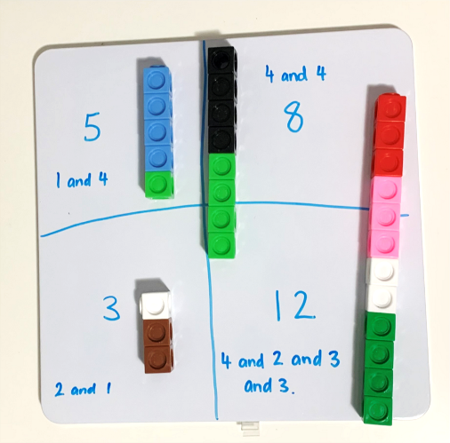
- Regroup as a class. Students should keep their whiteboard and one of their towers. Ask students to turn their tower on the side and create a bar model representation (see Figure 8).
Figure 8 – Student bar model
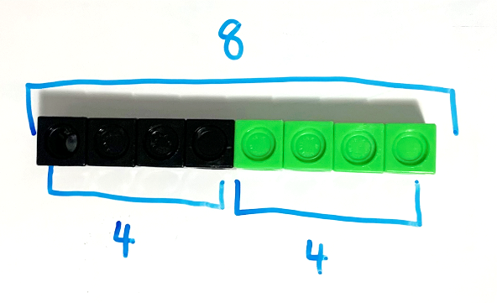
Note: Part-whole bar model involves one whole divided into 2 or more parts using bars to represent part or whole numbers.
- Students share examples of their bar model. Ask students what the bar model might remind them of. Students Think-Pair-Share.
Note: Through discussion, draw the link between the bar model and a number line.
The table below details assessment opportunities and differentiation ideas.
Assessment opportunities | Too hard? | Too easy?
What to look for:  - Are students able to identify parts of a number and identify how many more to form a given number? (MAO-WM-01, MA1-CSQ-01)  - Can students use the bar model to identify and represent parts of a number? (MA1-CSQ-01)  What to collect:  - observational data (MAO-WM-01, MA1-CSQ-01) | Students are not confident identifying how many more to form a given number.  - Provide students with a number range of 5 and under.  - Build towers of the identified numbers so that students can use the concrete representation of the number to assist them with identifying how many more. | Students are confident identifying how many more to form a given number.  - When playing Building towers (7:22), challenge students to build towers with only 2 or 3 number combinations.  - Provide students with two-digit numbers, for example, 23, 17, 34, 39. Challenge students to use bridging to 10 when making combinations.

Consolidation and meaningful practice: Bar model – 20 minutes
- Display the first task card from Resource 5: Bar model and ask students to represent 9 using interlocking cubes and their whiteboard (see Figure 8). Students share their representation of 9 and discuss how they have represented it using the bar model.
- Display other tasks cards from Resource 5: Bar model and create other examples. Students complete these using interlocking cubes to represent the bar model and then draw their working.

Lesson 5: Domino triangles
Core concept: A quantity can be described by talking about its smaller parts.
The table below contains suggested learning intentions and success criteria. These are best co-constructed with students.
Learning intention | Success criteria
Students are learning that they can recognise, recall, and record combinations of numbers that add up or bond to form a given number. | Students can:  - find smaller numbers inside larger numbers  - create number combinations on dominoes that make a given number  - describe combinations for numbers using words such as ‘more than’ and ‘less than’.

Daily number sense: Dot Talk 1 – 15 minutes
This activity has been adapted from ‘Seeing spots’ by Boaler et al. (2021).
- Build student understanding of subitising, composing and decomposing numbers by engaging in a dot talk.
- Display Resource 6: Dot talk 1 for a few seconds. Ask students how many dots they saw. Students turn and talk to a partner about how they saw the dots.
- Students share their thinking by showing or describing the different clusters they saw. Colour code the different groups they saw to help others see their thinking (see Figure 9).
Figure 9 – Recording dot talk
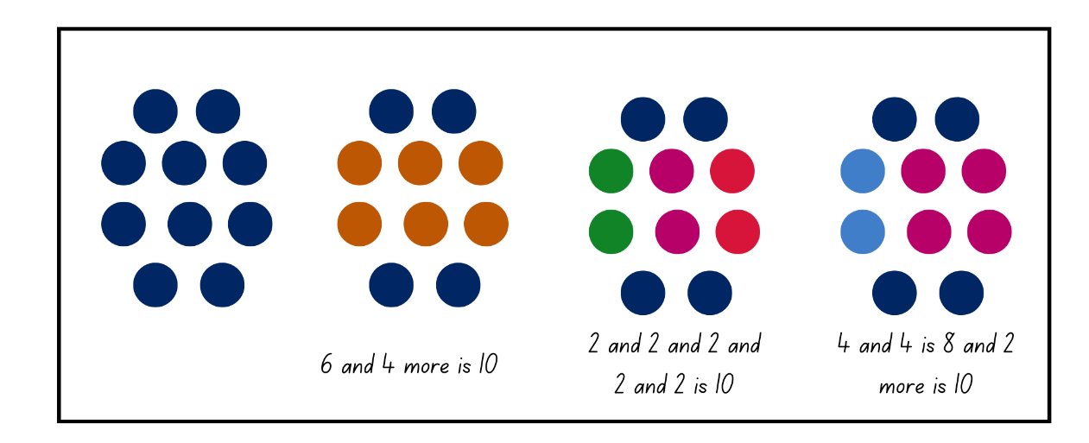
Note: Students may use the symmetry of the dots, use their knowledge of dice patterns, decompose in rows, or other strategies. These connections support students thinking visually about number and making the connection between the physical objects and the number used to represent them.

Domino triangles – 35 minutes
This activity has been adapted from ‘Domino Squares’ by Swan (2001).
- Display Resource 7: Domino triangles 1. Explain to students that the 3 dominoes must add up to the number in the middle, for example, 8.
- Allow students thinking time to work out possible solutions using their individual whiteboards. Students share how they have represented the number 8. If needed, model some additional solutions (see Figure 10).
Figure 10 – Representing 8
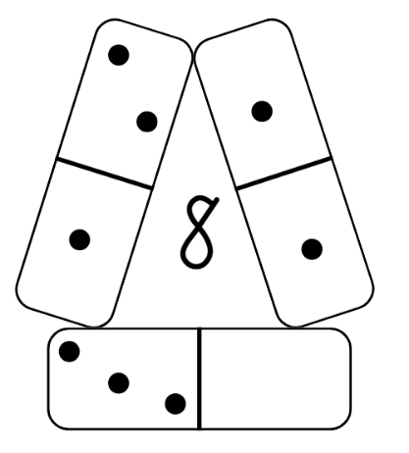
- Remind students that all numbers are composed of smaller numbers and smaller numbers make up larger numbers. Encourage students to use the language of ‘more than’ or ‘less than’. For example, 10 is 2 more than 8 or 9 is one less than 10.
- Discuss that, when a ten-frame is full, the total is always 10. Fill the digital ten-frame with red counters and change one of the counters to yellow. Ask the students what the total is, how many red and how many yellow. Continue this a few times, discussing and recording the total number of counters, the number of red counters and the number of yellow counters (see Figure 11).
Figure 11 – Digital ten frame
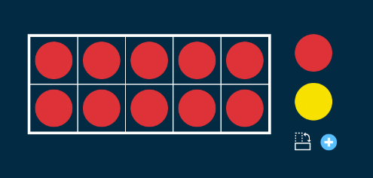
- Provide students with dominoes and Resource 8: Domino triangles 2. These may be cut into 3 separate strips of single dominoes, double dominoes, and triple dominoes.
- Students use their understanding of combinations of numbers that add up to 10 and record different solutions (see Figure 12).
Figure 12 – Dominoes
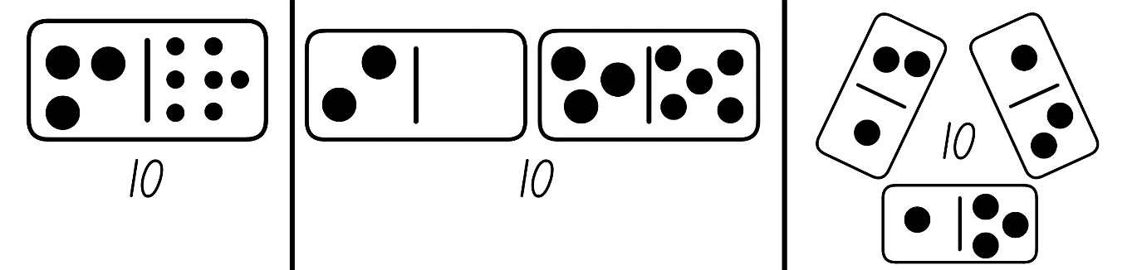
The table below details assessment opportunities and differentiation ideas.
Assessment opportunities | Too hard? | Too easy?
What to look for:  - Are students able to find smaller numbers inside larger numbers? (MAO-WM-01, MA1-RWN-01, MA1-CSQ-01)  - Can students create number combinations on dominoes that make the given number? (MA1-RWN-01, MA1-CSQ-01)  - Do students describe combinations for numbers using words such as more than or less than? (MA1-CSQ-01)  What to collect:  - Resource 8: Domino triangles 2 (MAO-WM-01, MA1-RWN-01, MA1-CSQ-01) | Students are not confident with recalling and recording number combinations to 10.  - Support students by providing a ten-frame and a collection of double-sided counters to create combinations to 10.  - Provide students with a small collection of dominoes. Students use count-by-one strategies to find a small collection of dominoes which adds up to 10. | Students are confident with recalling and recording number combinations to 10.  - Ask students to identify number combinations up to 20 and have them explain the pattern in relation to combinations to 10.  - Challenge students to represent 20 on 4 dominoes.

Discuss and connect the mathematics – 10 minutes
- Students share and explain their working. Ask students:
- What did you notice?
- Did you check your solution? How?
- How many possible solutions did you find?
- Could there be any other solutions? How do you know?

Lesson 6: Doubles
Core concept: Doubles facts are an efficient way to combine quantities.
The table below contains suggested learning intentions and success criteria. These are best co-constructed with students.
Learning intentions | Success criteria
Students are learning that:  - doubles facts are an efficient way to combine quantities  - communication is important when explaining mathematical thinking. | Students can:  - find smaller numbers inside larger numbers  - identify and combine numbers which make doubles facts  - describe combinations of numbers using the word ‘double’.

Daily number sense: Dot Talk 2 – 10 minutes
This activity has been adapted from ‘Dot talks’ from Boaler et al. (2021).
- Build student understanding of subitising, composing, and decomposing numbers by engaging in a dot talk.
- Display Resource 9: Dot talk 2 for a few seconds. Ask students how many dots they saw. Students turn and talk to a partner about how they saw the dots.
- Students share their thinking by showing or describing the different clusters they saw. Colour code the different groups they saw to help others see their thinking.
Note: Students may use the symmetry of the dots, use their knowledge of dice patterns, decompose in rows, or other strategies. These connections support students in thinking visually about number and making that connection between the physical objects and the number that we use to represent them.

Doubles – 40 minutes
This activity has been adapted from Concentration (doubles facts) (2002).
- Using 2 digital ten-frames, demonstrate doubles facts from 0-9 (see Figure 13).
Figure 13 – Doubles ten frames
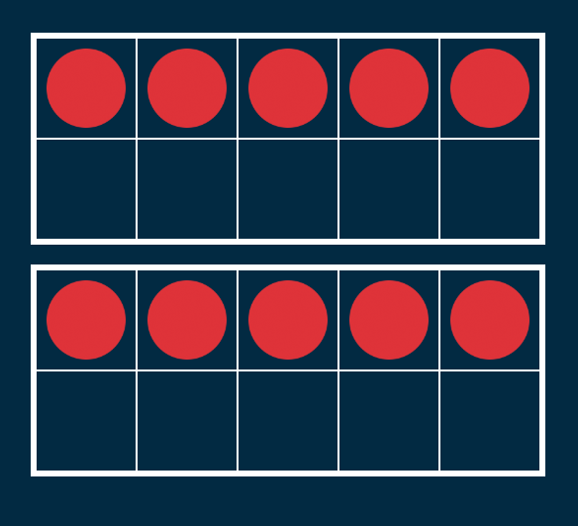
- For each of the doubles facts, ask students:
- What do you see?
- How can you use what you know about the ten-frame structure to help you determine the total?
- Can you explain your strategy?
- Is there another way to find the total?
- Encourage students to visualise moving the counters between the 2 ten-frames to firstly make 10 before adding any additional counters in the second ten-frame (see Figure 14). Demonstrate this to students using different coloured counters to show how the different amounts have been partitioned and joined.
Figure 14 – Counting on
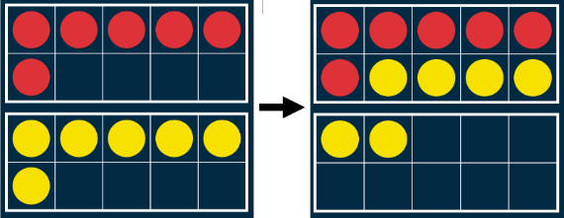
- In small groups, students are provided with Resource 10: Doubles memory. Students shuffle the cards and lay them out in an array, face down.
Note: Printing Resource 10: Doubles memory on coloured cardboard will allow the game to be played again and reduce the student's ability to see through the card.
- Students turn over 2 cards, looking for a pair. If they are correct, they collect the cards. If the cards do not match, students turn them back over. Play continues until all possible matches are found.
- On their individual whiteboards, students record the doubles facts they found and the strategy they used to find the total (see Figure 15).
Figure 15 – Students’ doubles facts

Discuss and connect the mathematics – 10 minutes
- As a class, students show and explain their working for doubles facts. Ask students:
- What strategy did you use to find the total?
- How did bridging to 10 help you find the total?
- Are there other strategies you could use to find the total?
- How did you work like a mathematician today?
The table below details assessment opportunities and differentiation ideas.
Assessment opportunities | Too hard? | Too easy?
What to look for:  - Can students identify doubles facts? (MA1-CSQ-01)  - Can students use doubles for combining numbers? (MA1-RWN-01, MA1-CSQ-01)  - Can students describe combinations for numbers using the term doubles? (MAO-WM-01, MA1-CSQ-01)  What to collect:  - observational data (MAO-WM-01, MA1-RWN-01, MA1-CSQ-01) | Students are not confident identifying and using doubles for combining numbers.  - Students roll a die, for example, 4. Then they put 4 red counters and 4 yellow counters in a ten-frame and count the total.  - Support students with using the correct vocabulary by having the students say double 4 is 8 when they put the counters in ten-frames. | Students can identify and use doubles for combining numbers.  - Students investigate why 2 odd numbers always equal an even number.  - Provide students with larger two-digit numbers, for example, 36. Students draw their working to explain how they got to this number using doubles.

Lesson 7: Near doubles
Core concept: Near doubles are an efficient way to combine quantities.
The table below contains suggested learning intentions and success criteria. These are best co-constructed with students.
Learning intentions | Success criteria
Students are learning that:  - doubles and near doubles facts are an efficient way to combine quantities  - near doubles are one more or one less than the doubles fact. | Students can:  - identify doubles and near doubles  - double the smaller number and add one more  - double the larger number and subtract one less  - choose efficient strategies to combine 2 numbers.

Daily number sense: Rekenrek number talk – 10 minutes
- Build student understanding of number combinations by looking at how the beads are represented on a rekenrek.
- Display Resource 11: Rekenrek number talk and students use individual whiteboards to record their thinking.
- As students share their thinking, ask:
- What do you notice in the image?
- What strategy did you use to work out the total?
- Can you see a pattern?
- Is your solution different to others? Why/why not?

Near doubles – 40 minutes
Adapted from Finding known facts (2002).
- Revise doubles facts from Lesson 6 by displaying a digital rekenrek with different doubles facts, for example, 7 beads on the top line and 7 beads on the bottom line.
- Display Resource 12: Near doubles. Students turn and talk to determine the total using their knowledge of doubles. Choose students to share their strategy with the class. Highlight the use of near doubles as a strategy with the class.
Note: Near doubles facts can be built upon the idea of one more or one less. For example, 5 and 4, think double 5 is 10 and one less is 9 or for 7 and 8, think double 7 is 14 and one more is 15 (Siemon et al. 2021).
- Explain that the strategy is to double the smaller number and add one, or to double the larger number and take away one. Model using the example 6 and 7 (see Figure 16).
Figure 16 – Near double cards
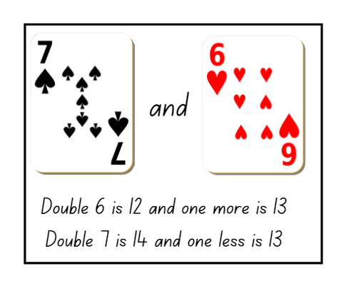
Images sourced from Canva and used in accordance with the Canva Content License Agreement.
Note: When displaying Resource 12: Near doubles, draw students’ attention to the number 6 playing card and how it can also look like a 9. Remind students to read the number in the top left corner, count the number of hearts, and demonstrate rotating the card to show how the 9 turns into a 6.
- Using playing cards, select examples of near doubles and model the strategy for different combinations.
- In pairs, provide students with a packet of playing cards, removing the picture cards, and Resource 13: Recording table.
- Students take turns to deal 4 cards to each other. Students turn over their cards and look for any known facts they can see. For example, combinations to 10, doubles and near doubles.
- For every known fact a student finds, they explain their thinking to their partner who records the information on Resource 13: Recording table. The partner checks and confirms their working on Resource 13: Recording table and gives a counter for each correct fact they found (see Figure 17).
Figure 17 – Recording table
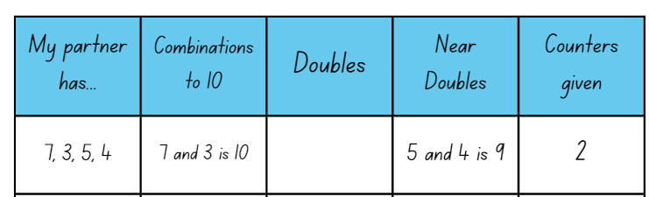
- Students take turns and complete 5 rounds each. The student with the largest number of counters at the end is the winner.
The table below details assessment opportunities and differentiation ideas.
Assessment opportunities | Too hard? | Too easy?
What to look for:  - Can students identify doubles and near doubles? (MAO-WM-01, MA1-CSQ-01)  - Are students able to double the smaller number and add 1 more? (MA1-RWN-01, MA1-CSQ-01)  - Are students able to double the larger number and subtract 1? (MA1-RWN-01, MA1-CSQ-01)  - Can students choose efficient strategies to combine 2 numbers? (MA1-CSQ-01)  - Can students record number combinations in a table? (MAO-WM-01, MA1-CSQ-01)  What to collect:  - Resource 13: Recording table (MAO-WM-01, MA1-CSQ-01) | Students are not confident identifying doubles and near doubles.  - Provide students with a visual representation of doubles and near doubles, for example, a doubles chart or a rekenrek.  - Have students create doubles facts using counters and ten-frame structures. Encourage the count-by-one strategy to determine the total. | Students can identify doubles and near doubles.  - Have students identify a doubles fact greater than 20. For example, 15 and 15 is 30.  - Students write as many number sentences as they can using larger facts and the idea of one more and one less.

Discuss and connect the mathematics: Anchor chart – 10 minutes
- Revise doubles and near doubles. As a class create an anchor chart to be displayed with known doubles and near doubles facts (see Figure 18).
Figure 18 – Anchor chart
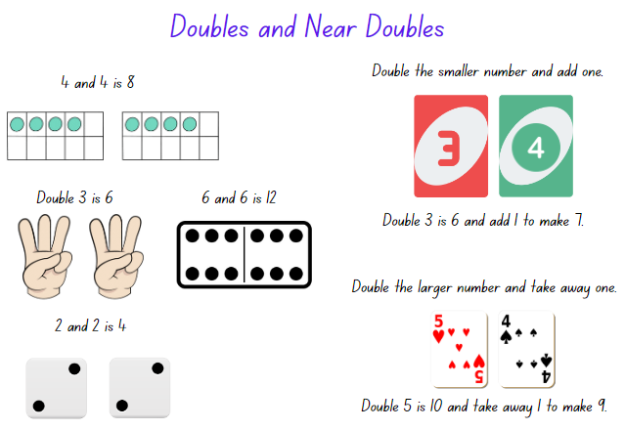
Images sourced from Canva and used in accordance with the Canva Content License Agreement.

Lesson 8: Power dot pro
Core concept: There are many ways to combine quantities to find a total.
The table below contains suggested learning intentions and success criteria. These are best co-constructed with students.
Learning intentions | Success criteria
Students are learning that:  - different strategies can be used to combine quantities  - numbers can be represented in different ways. | Students can:  - use a variety of strategies including counting on, number bonds to 10, doubles, and near doubles to solve problems  - record their thinking using drawings, words, numerals, or symbols  - recognise numbers in different representations including words, numerals, and known structures such as dice and ten-frames.

Daily number sense: Counting strategies – 15 minutes
- Build student understanding of smaller numbers make up larger numbers by providing opportunities for students to consolidate and explain their thinking through Resource 15: Graphic organiser.
- Revise with students the strategies they have learned over the previous lessons including:
- counting on
- number bonds to 10
- doubles and near doubles.
- Display Resource 14: Numbers cards 3 and provide students with Resource 15: Graphic organiser. Students use drawings, numerals, or words to show how they have solved the problem using known strategies.
- As a class discuss solutions and share working.
The table below details assessment opportunities and differentiation ideas.
Assessment opportunities | Too hard? | Too easy?
What to look for:  - Can students use a variety of strategies including counting on, number bonds to ten, doubles and near doubles to solve a given problem? (MAO-WM-01, MA1-RWN-01, MA1-CSQ-01)  - Can students record their thinking using drawings, words, numerals, or symbols? (MAO-WM-01, MA1-CSQ-01)  What to collect:  - Resource 15: Graphic organiser (MAO-WM-01, MA1-RWN-01, MA1-CSQ-01) | Students are not confident using a variety of strategies to solve a given problem.  - Students use concrete materials to model and solve the given problem and focus on counting on by ones from the larger number.  - Provide students with a visual representation of doubles and near doubles, for example, a doubles chart or a rekenrek. | Students can use a variety of strategies to solve a given problem.  - Provide students with a two-digit number sentence to apply the different strategies to.  - Ask students if they can demonstrate any other strategy to combine the quantities. Draw a representation of the strategy.

Power dot pro – 30 minutes
Adapted from Power dot pro by Thinking Mathematically. This game can be played with Tiny Dot Starter Kit or dominoes. Watch the Power dot pro (6:47) video to learn how to play.
- Model Power dot pro to the whole class by playing against a small group. Share the tiny dot cards evenly amongst players.
- To start with, turn over 2 cards. As students become more confident with the game, they can increase the number of cards they turn over.
- All players turn over the assigned number of cards from their deck. Each player combines the total of their cards and the player with the largest total wins the round. The winner of the round places their used cards at the bottom of their pile. The other players put their cards in a discard pile. If there is a tie, each player turns over another card and adds it to their previous total.
- The game is over when a player runs out of cards.
- When students are confident with the understanding of the rules, divide them into small groups with a collection of tiny dot cards.
Note: Print cards on cardboard so that they can be reused in future maths activities.
- During the game, ask students:
- How did you know what number was represented?
- How did you see the representation?
- Which colour of cards/structures are the easiest to combine for you? Why?
- What do you think is the highest total you could get in this round? Why?
The table below details assessment opportunities and differentiation ideas.
Assessment opportunities | Too hard? | Too easy?
What to look for:  - Can students use a variety of strategies including counting on, number bonds to 10, doubles and near doubles to combine numbers? (MAO-WM-01, MA1-RWN-01, MA1-CSQ-01)  What to collect:  - observational data (MAO-WM-01, MA1-RWN-01, MA1-CSQ-01) | Students are not confident using combining cards to find the total.  - Reduce the number of cards dealt so that students are only combining 2 numbers.  - Students use concrete materials to model and solve the given problem. Focus on counting on by ones from the larger number. | Students are confident combining multiple playing cards to find the total.  - Increase the number of cards students are dealt to allow greater opportunity to use a variety of strategies.  - Challenge students to complete a pyramid puzzle by using 10 cards. Students use 10 cards to make a pyramid so that each number is the sum of the 2 below it. For example, the 9 ten-frame card is on top and below it are the ten-frame cards, 4 and 5.

Consolidation and meaningful practice – 15 minutes
- As a whole class select 3 cards from the deck, do not show students the cards.
- Ask students, ‘If we were to combine the quantities represented on these 3 cards’:
- What is the smallest possible total?
- What is the largest possible total?
- What do you think the total might be?
- Reveal one card and ask students:
- Has your prediction changed?
- What might the total be now?
- Would you revise your thinking? Why/why not?
- Reveal another card and ask the same questions before revealing the total. Students reflect on their prediction and the final total.

Resource 1: Numbers cards 1
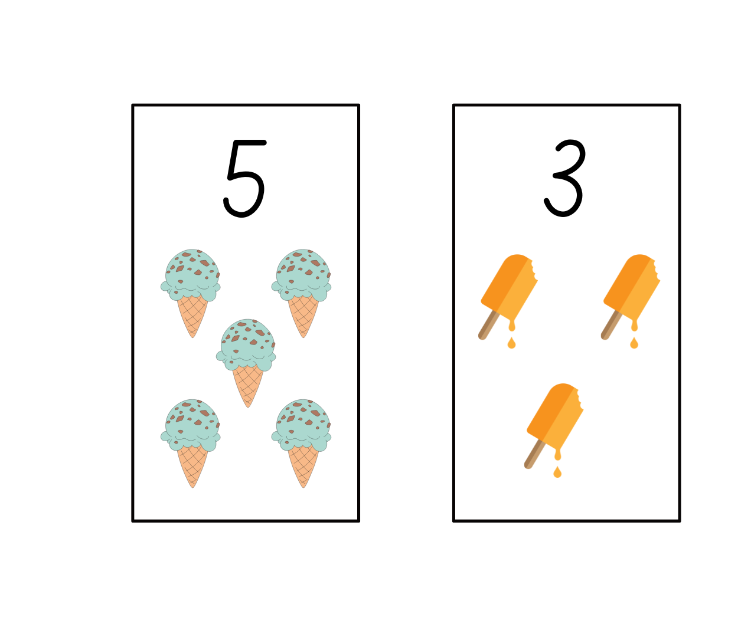
Images sourced from Canva and used in accordance with the Canva Content License Agreement.

Resource 2: Numbers cards 2
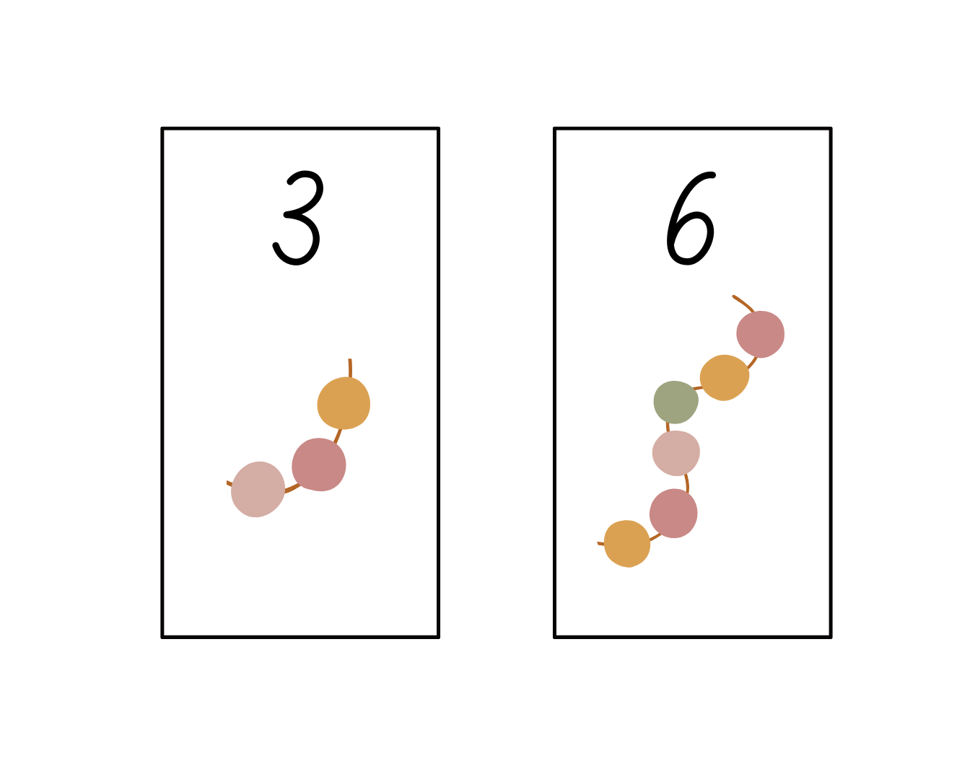
Images sourced from Canva and used in accordance with the Canva Content License Agreement.

Resource 3: Recording sheet
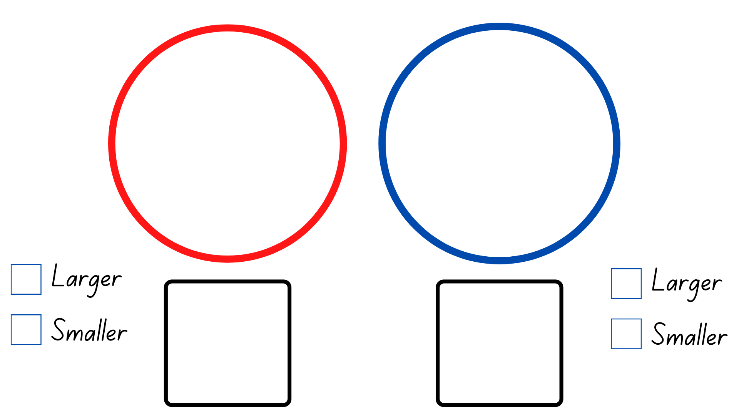

Resource 4: Rekenrek problems
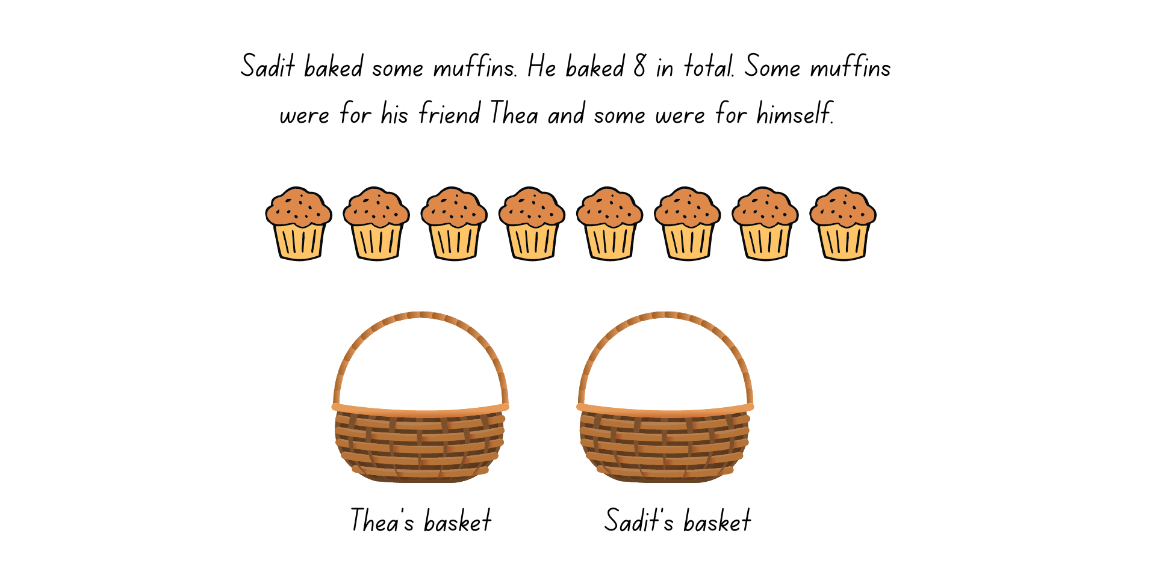
Images sourced from Canva and used in accordance with the Canva Content License Agreement.
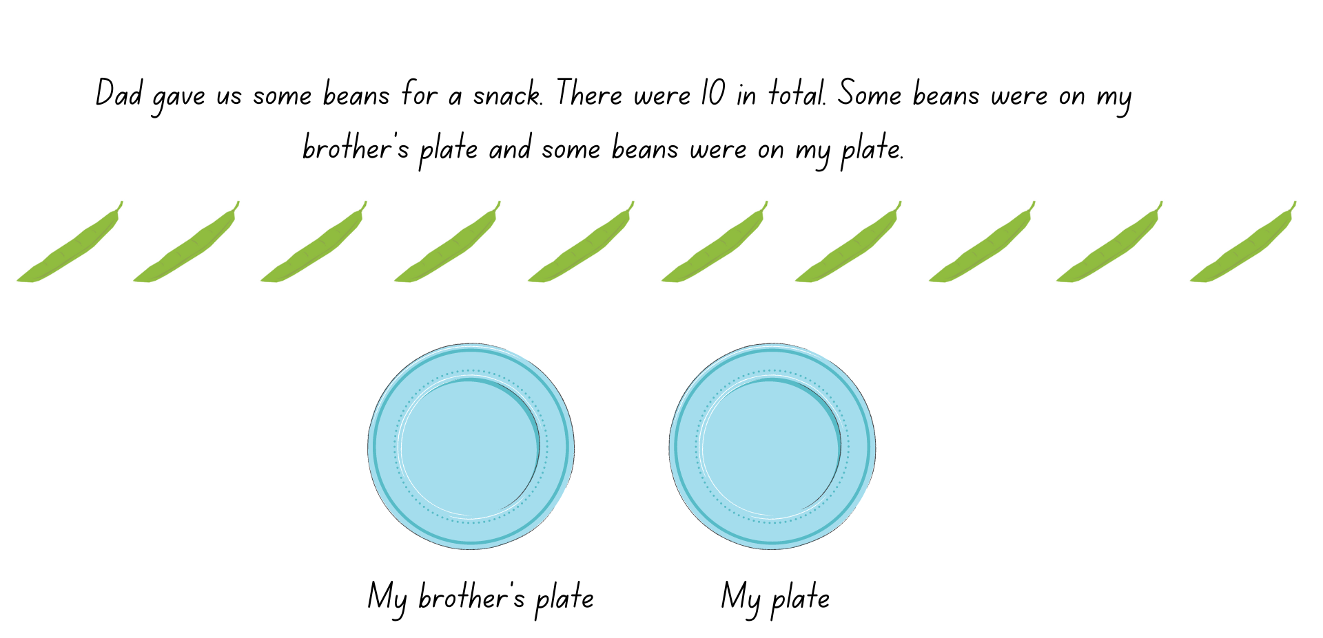
Images sourced from Canva and used in accordance with the Canva Content License Agreement.

Resource 5: Bar model
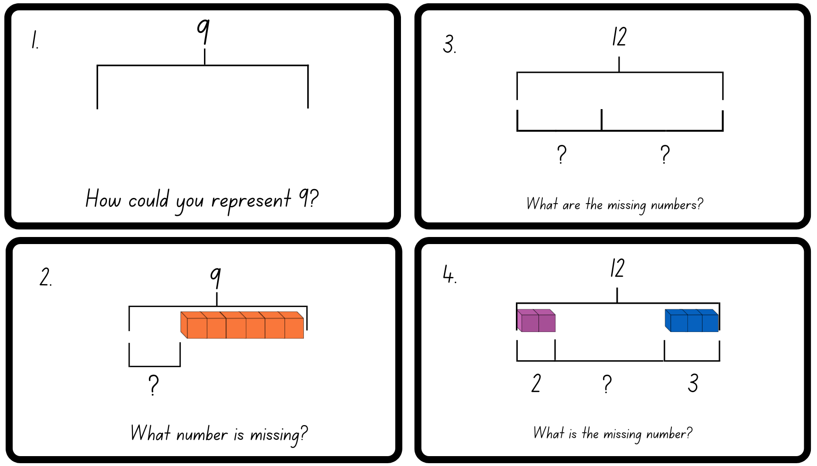
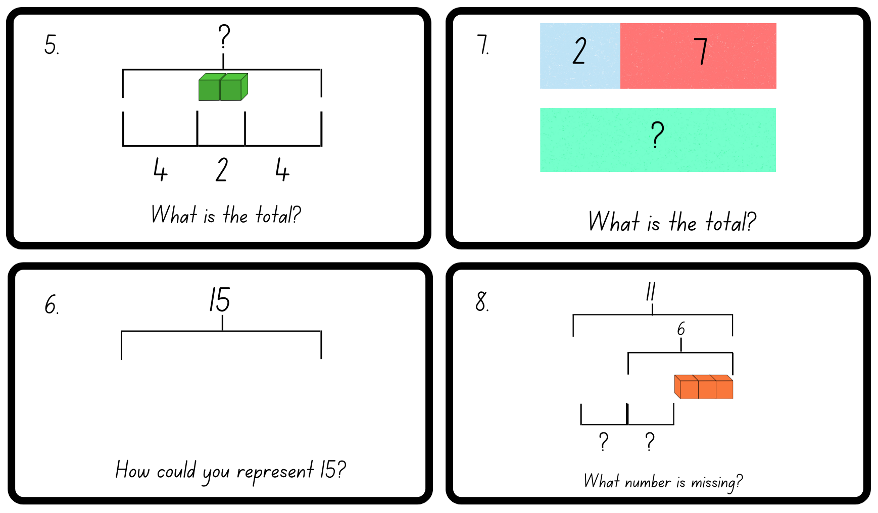

Resource 6: Dot talk 1

Resource 7: Domino triangles 1
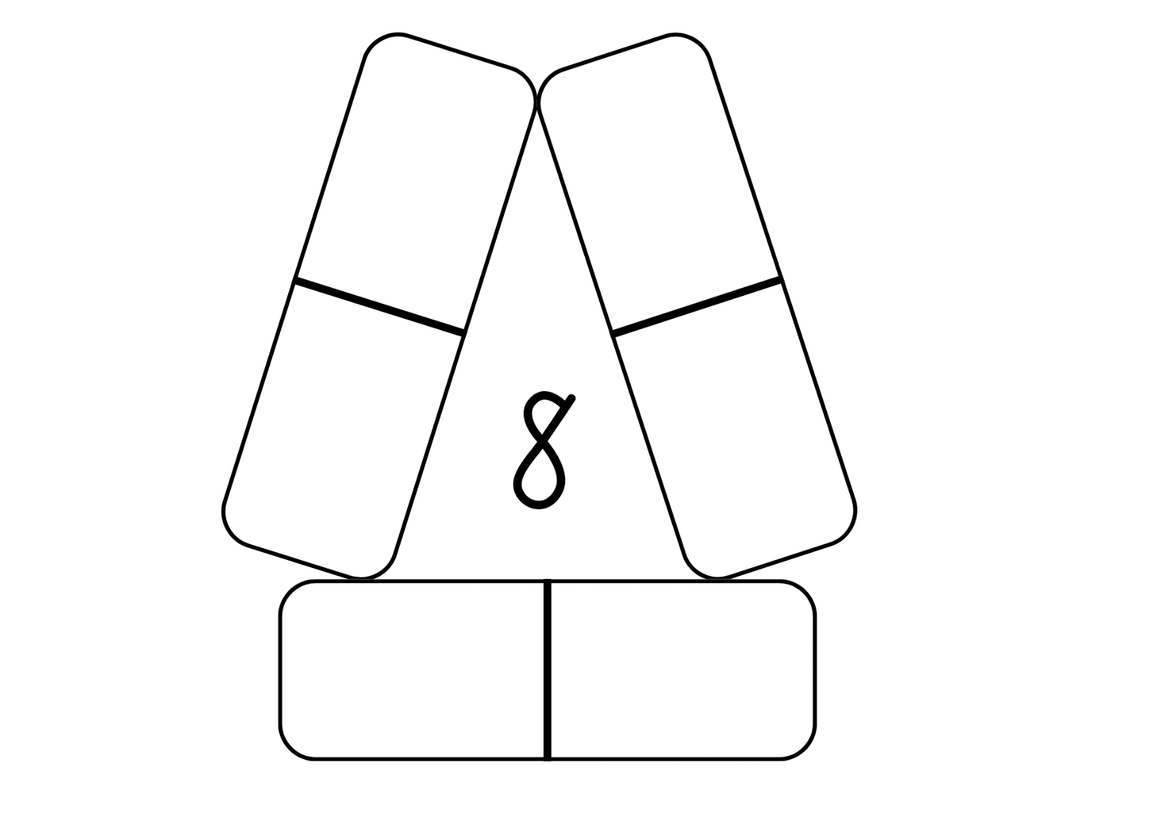

Resource 8: Domino triangles 2
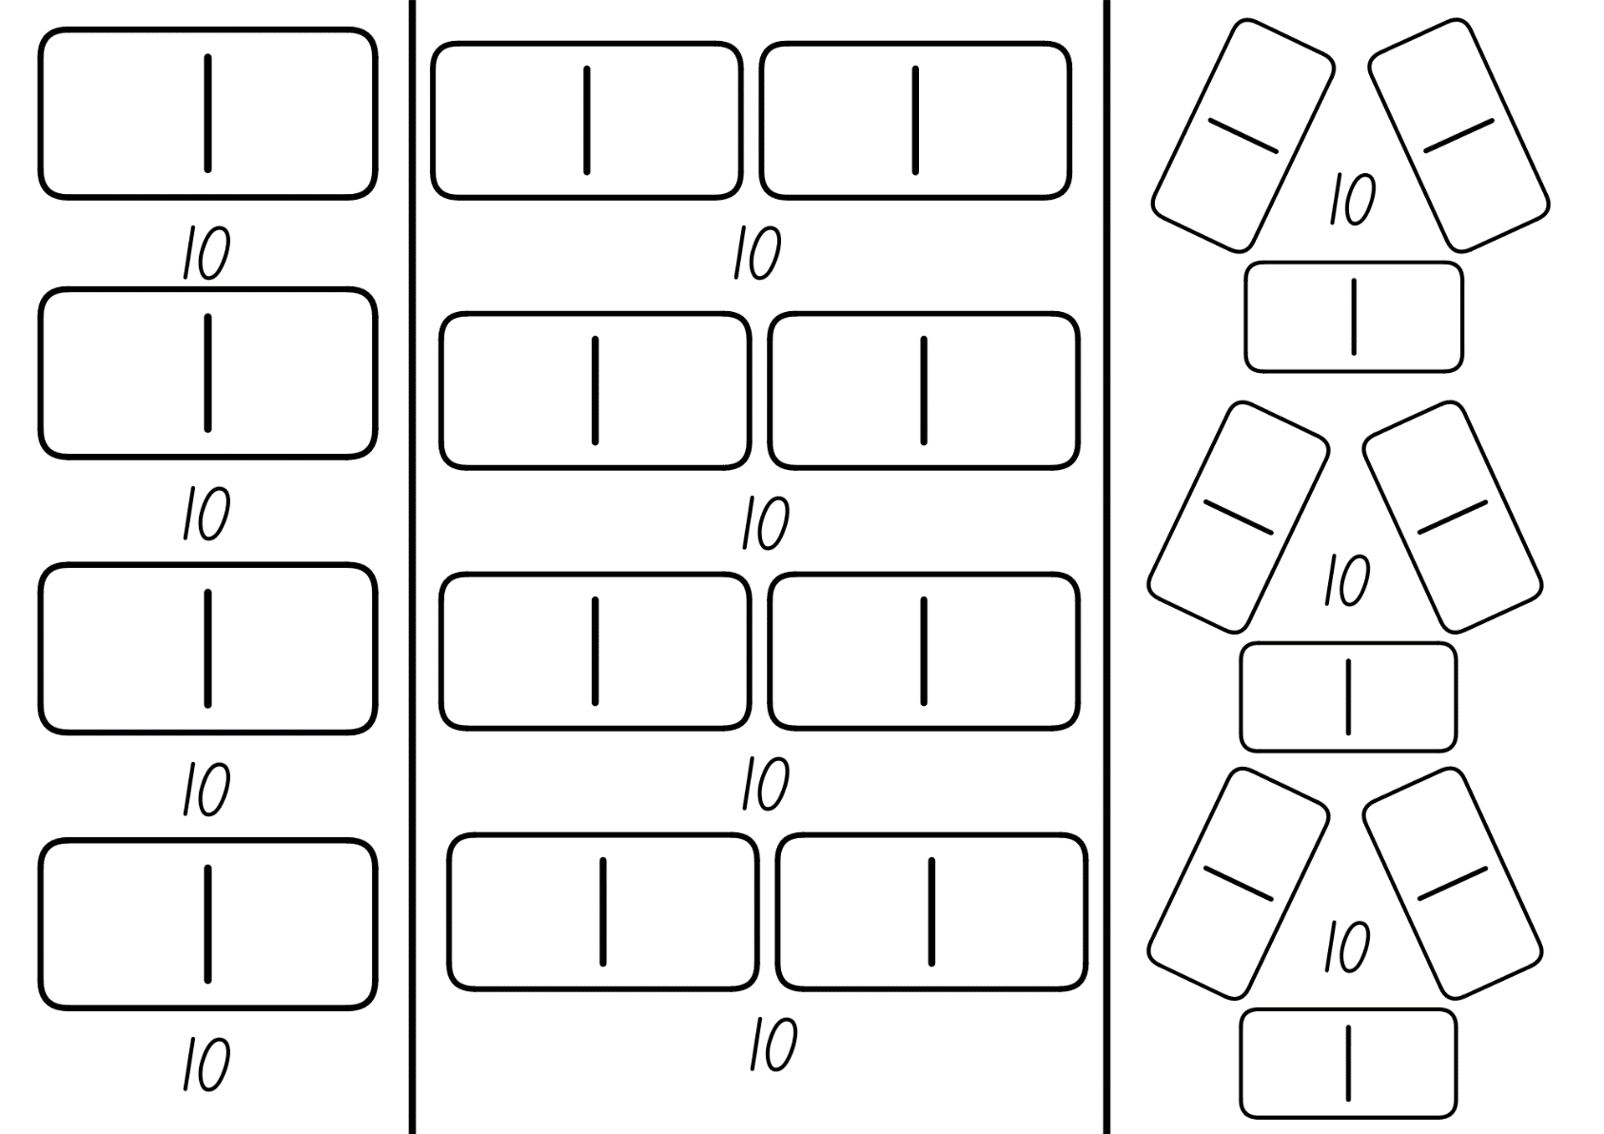

Resource 9: Dot talk 2

Resource 10: Doubles memory
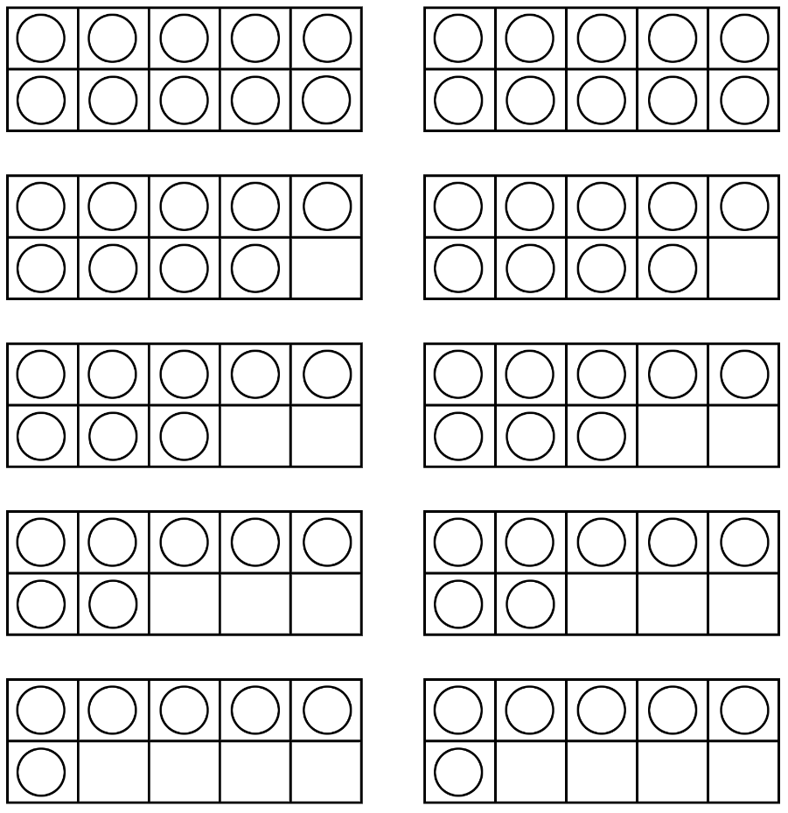
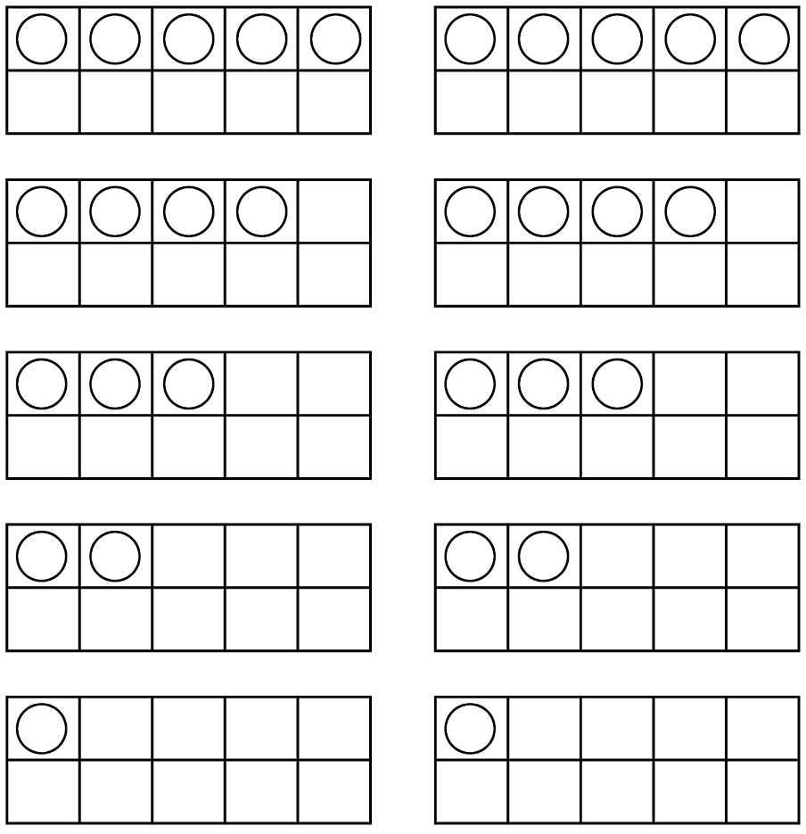

Resource 11: Rekenrek number talk

Resource 12: Near doubles
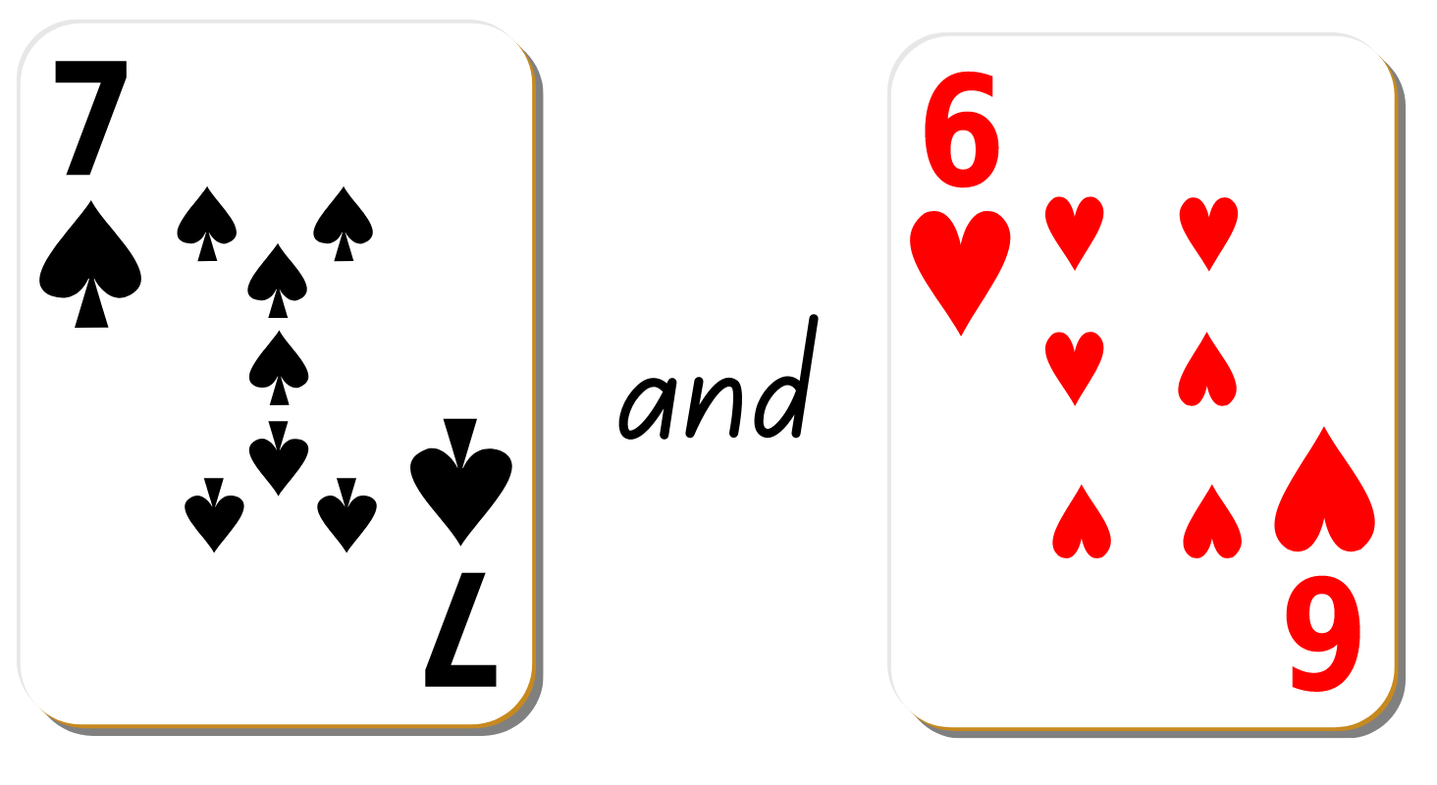
Images sourced from Canva and used in accordance with the Canva Content License Agreement.

Resource 13: Recording table
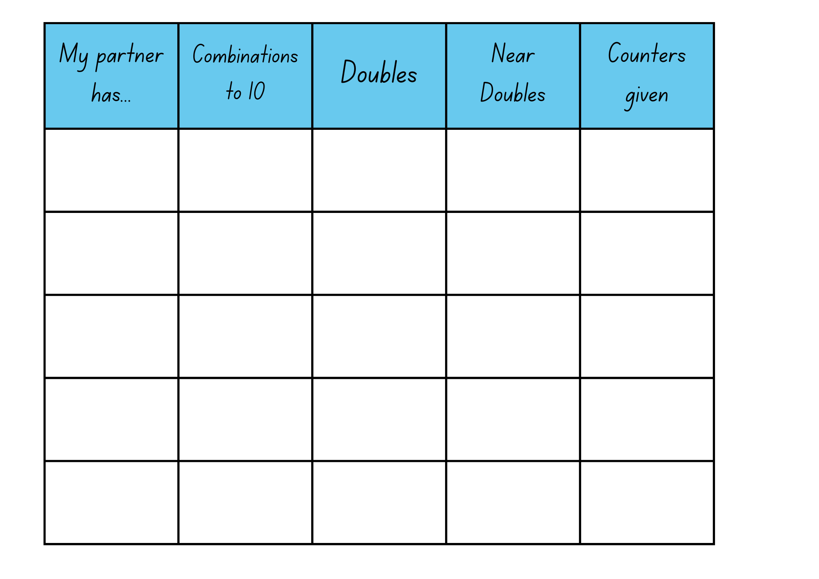

Resource 14: Numbers cards 3
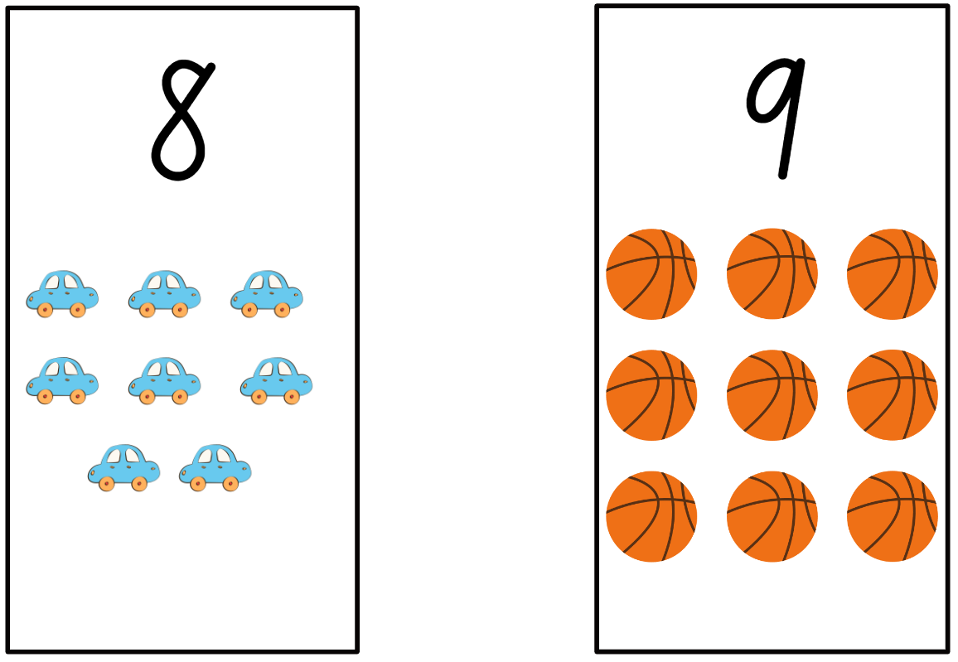
Images sourced from Canva and used in accordance with the Canva Content License Agreement.

Resource 15: Graphic organiser
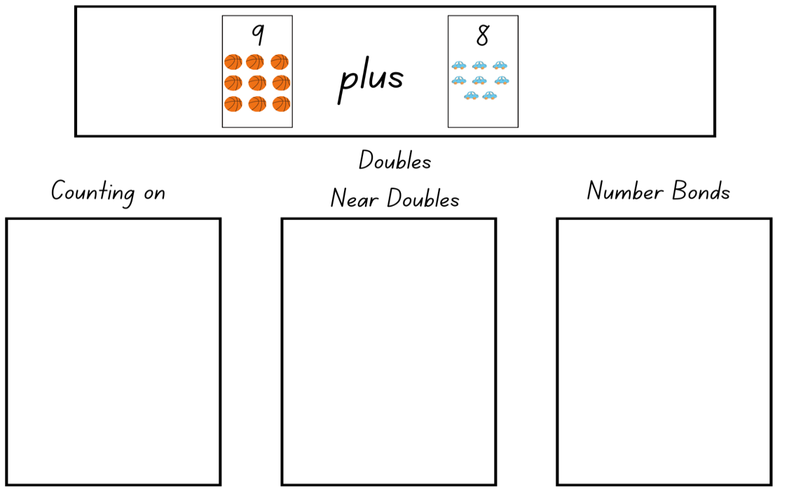
Images sourced from Canva and used in accordance with the Canva Content License Agreement.

Syllabus outcomes and content
The table below outlines the syllabus outcomes and range of relevant syllabus content covered in this unit. Content is linked to National Numeracy Learning Progression version (3).
Focus area and outcomes | Content groups and content points | Lessons
Representing whole numbers A  MAO-WM-01  MA1-RWN-01  MA1-RWN-02 | Use counting sequences of ones with two-digit numbers and beyond  - count forwards and backwards by ones from a given number to at least 120 (CPr6)  Continue and create patterns  - model and describe ‘odd’ and ‘even’ numbers using items paired in two rows  Represent numbers on a line  - sequence numbers and arrange them on a line by considering the order and size of those numbers (CPr5)  Represent the structure of groups of ten in whole numbers  - recognise that ten ones is the same as one ten (NPV2, NPV4)  - use 10 as a reference in forming numbers from 11 to 20 (CPr7) | 1–2, 4–8
Combining and separating quantities A  MAO-WM-01  MA1-CSQ-01 | Use advanced count-by-one strategies to solve addition and subtraction problems  - record number sentences in a variety of ways using drawings, words, numerals and symbols (AdS6)  - fluently use advanced count-by-one strategies including counting on and counting back to solve addition and subtraction problems involving one- and two-digit numbers (Reasons about relations) (AdS3-AdS5)  Recognise and recall number bonds up to ten  - recognise, recall and record combinations of two numbers that add up or bond to form 10 (AdS2, AdS6)  - model and record patterns for individual numbers up to ten by making all possible whole-number combinations (Reasons about patterns)  - create, recall and recognise combinations of two numbers that add up to numbers less than 10 (AdS2, AdS6)  - describe combinations for numbers using words such as more than, less than and double (Reasons about relations) (AdS6)  Use flexible strategies to solve addition and subtraction problems  - use non-count-by-one strategies such as using doubles for near doubles and combining number that add to ten (AdS6)  - represent addition and subtraction using structured materials such as a bead string or similar model (AdS6-AdS7) | 1–8

References
Links to third-party material and websites
Please note that the provided (reading/viewing material/list/links/texts) are a suggestion only and implies no endorsement, by the New South Wales Department of Education, of any author, publisher, or book title. School principals and teachers are best placed to assess the suitability of resources that would complement the curriculum and reflect the needs and interests of their students.
If you use the links provided in this document to access a third-party's website, you acknowledge that the terms of use, including licence terms set out on the third-party's website apply to the use which may be made of the materials on that third-party website or where permitted by the Copyright Act 1968 (Cth). The department accepts no responsibility for content on third-party websites.
Except as otherwise noted, all material is © State of New South Wales (Department of Education), 2021 and licensed under the Creative Commons Attribution 4.0 International License. All other material (third-party material) is used with permission or under licence. Where the copyright owner of third-party material has not licensed their material under a Creative Commons or similar licence, you should contact them directly for permission to reuse their material.
Mathematics K–10 Syllabus © 2022 NSW Education Standards Authority (NESA) for and on behalf of the Crown in right of the State of New South Wales.
© 2022 NSW Education Standards Authority. This document contains NSW Curriculum and syllabus content. The NSW Curriculum is developed by the NSW Education Standards Authority. This content is prepared by NESA for and on behalf of the Crown in right of the State of New South Wales. The material is protected by Crown copyright.
Please refer to the NESA Copyright Disclaimer for more information.
NESA holds the only official and up-to-date versions of the NSW Curriculum and syllabus documents. Please visit the NSW Education Standards Authority (NESA) website and the NSW Curriculum website.
National Numeracy Learning Progression © Australian Curriculum, Assessment and Reporting Authority (ACARA) 2010 to present, unless otherwise indicated. This material was downloaded from the Australian Curriculum website (National Numeracy Learning Progression) (accessed 7 October 2022) and was not modified. The material is licensed under CC BY 4.0. Version updates are tracked in the ‘Curriculum version history’ section on the 'About the Australian Curriculum' page of the Australian Curriculum website.
ACARA does not endorse any product that uses the Australian Curriculum or make any representations as to the quality of such products. Any product that uses material published on this website should not be taken to be affiliated with ACARA or have the sponsorship or approval of ACARA. It is up to each person to make their own assessment of the product, taking into account matters including, but not limited to, the version number and the degree to which the materials align with the content descriptions and achievement standards (where relevant). Where there is a claim of alignment, it is important to check that the materials align with the content descriptions and achievement standards (endorsed by all education Ministers), not the elaborations (examples provided by ACARA).
This resource contains images and content obtained from Canva, and their use outside of this resource is subject to Canva’s Content License Agreement. If you wish to use them separately from the resource, please go to Canva.
Boaler J, Munson J & Williams C. (2020). Mindset Mathematics: Visualising and Investigating Big Ideas, Grade K, Jossey-Bass, US.
Sullivan P & Lilburn P (2017) Open-Ended Maths Activities, Oxford University Press, UK.
Swan P (2020) Beadstring Mathematics, Self-published, Australia.
Swan P (2001) Developing Mathematics, Self-published, Australia.
Van de Walle J, Karp K, Bay-Williams J, Brass A, Bentley (2019) Primary and Middle Years Mathematics: Teaching Developmentally, 1st edn, Pearson Education, Australia.

