Mathematics – Stage 1 – Unit 2
Contents
Unit description and duration 4
Student prior learning 4
Lesson overview and resources 6
Lesson 1: Repeating patterns 1 13
Daily number sense: Quick counting! – 10 minutes 13
Finding different repeating patterns – 50 minutes 14
Consolidation and meaningful practice: What’s this pattern about? – 5 minutes 20
Lesson 2: Repeating patterns 2 20
Daily number sense: Dinner time! – 15 minutes 21
A pattern core is very helpful – 40 minutes 21
Discuss and connect the mathematics – 5 minutes 25
Lesson 3: Dice dots everywhere! 26
Daily number sense: Spot the Spots! – 20 minutes 26
Going dotty! How can dots help us to see numbers? – 40 minutes 27
Consolidation and meaningful practice: Matching Numbers – 10 minutes 31
Lesson 4: Smaller numbers inside bigger numbers 32
Daily number sense: Counting patterns – 10 minutes 33
What’s hiding inside? – 50 minutes 33
Consolidation and meaningful practice: What have we learned about growing and shrinking patterns? – 5 minutes 38
Lesson 5: Number facts have patterns too 39
Daily number sense 40
Thinking and reasoning – 10 minutes 40
Mathematical regularity – 45 minutes 40
Discuss and connect the mathematics – 5 minutes 42
Lesson 6: Place value patterns 43
Daily number sense: Counting on counting – 20 minutes 44
Quantifying collections – 45 minutes 45
Consolidation and meaningful practice: What patterns did we find? – 5 minutes 49
Lesson 7: Growing and shrinking patterns 50
Daily number sense: 3 tens in a line – 10 minutes 50
How can patterns grow and shrink? 45 minutes 52
Consolidation and meaningful practice: How do patterns grow and shrink? – 15 minutes 58
Lesson 8: Skipping across a number chart! 60
Daily number sense: What number comes next? Choral counting by twos – 15 minutes 61
Counting in multiples – 50 minutes 62
Consolidation and meaningful practice: Let’s problem solve! – 10 minutes 65
Resource 1: Shape train 66
Resource 2: AB Patterns 67
Resource 3: What’s this pattern? 68
Resource 4: Dot card 69
Resource 5: Assessing game play 70
Resource 6: Number chart 71
Resource 7: Empty number chart 72
Syllabus outcomes and content 73
References 79
Further reading 81

Unit description and duration
This two-week unit provides opportunity to further develop students’ knowledge, skills, and understanding of patterns. Students are provided opportunities to:
- understand that patterns have an element of repetition, meaning something repeats over and over and over again
- recognise that the repeating element in a pattern can be called the repeating core
- use the pattern core to create patterns, extend the patterns of others, and identify the missing elements within patterns
- develop an understanding that number bonds and dice structures are forms of mathematical patterns we trust
- understand that some patterns grow (the pattern increases by the same amount in each subsequent term) and shrink (the pattern decreases by the same amount in each subsequent term)
- identify, describe, and create patterns when counting forwards or backwards in twos, fives, and tens
- use objects, pictures, words, and numbers to represent and prove ideas
- apply knowledge of counting sequences to solve problems involving equal groups.
Mathematics K–10 Syllabus © 2022 NSW Education Standards Authority (NESA) for and on behalf of the Crown in right of the State of New South Wales.

Student prior learning
Before engaging in these teaching and learning activities, students would benefit from prior experience with:
- identifying repeating patterns and how they repeat over and over and over again
- recognising that a group of objects and shapes can be sorted and classified in different ways
- using everyday language to describe and compare the features of shapes and objects
- continuing a repeating pattern made from shapes by referring to distinguishing features such as colour or size.

Lesson overview and resources
The table below outlines the sequence and approximate timing of lessons; syllabus focus areas and content groups; and resources.
Lesson | Syllabus focus area and content groups | Resources
Lesson 1: Repeating patterns 1  65 minutes  Patterns have a core that repeats over and over and over again. | Representing whole numbers A  - Use counting sequences of ones with two-digit numbers and beyond  - Continue and create number patterns  Two-dimensional spatial structure A  - 2D shapes: Recognise and classify shapes using obvious features | - Resource 1: Shape train  - Resource 2: AB patterns  - Resource 3: What’s this pattern?  - A variety of counters or objects  - Concrete materials, such as 2D geometric shapes  - Writing materials
Lesson 2: Repeating patterns 2  60 minutes  Identifying the repeating core of a pattern is a strategy which assists with determining a missing element. | Representing whole numbers A  - Continue and create number patterns  - Represent the structure of groups of ten in whole numbers  Two-dimensional spatial structure A  - 2D shapes: Recognise and classify shapes using obvious features  Two-dimensional spatial structure B  - Represent, combine and separate two-dimensional shapes | - Counters  - Concrete materials, such as 2D geometric shapes, interlocking cubes  - Mini whiteboards  - Paper  - Sticky notes  - Writing materials
Lesson 3: Dice dots everywhere!  70 minutes  Arrangements of dots can be used to quantify small and large collections. | Representing whole numbers A  - Continue and create number patterns  - Represent numbers on a line  - Represent the structure of groups of ten in whole numbers  Combining and separating quantities A  - Recognise and recall number bonds up to ten  Combining and separating quantities B  - Represent and reason about additive strategies  Forming groups A  - Count in multiples using rhythmic and skip counting  - Use skip counting patterns | - Resource 4: Dot card  - Video: Subitising 6 (one less than) (6:06)  - Numerals and expressions: Dots 1-6 [PDF 28KB] (NZ maths)  - Matching Numbers (NRICH)  - Counters  - Dotted dice  - Mini whiteboards  - Number line for each student  - Poster paper and markers  - Writing materials
Lesson 4: Smaller numbers inside bigger numbers  65 minutes  Using smaller ‘chunks’ and familiar dice patterns help to work out a total. | Representing whole numbers A  - Use counting sequences of ones with two-digit numbers and beyond  Representing whole numbers B  - Use counting sequences of ones and tens flexibly  Combining and separating quantities A  - Use advanced count-by-one strategies to solve addition and subtraction problems  - Recognise and recall number bonds up to ten  Combining and separating quantities B  - Represent and reason about additive strategies | - Camera or tablet (teacher only)  - Concrete materials, such as 2D geometric shapes, counters  - Interlocking cubes  - Picture book related to counting  - Writing materials
Lesson 5: Number facts have patterns too  60 minutes  When number sequences are related, they can be arranged and repeated to create a number pattern. | Representing whole numbers A  - Continue and create number patterns  Combining and separating quantities A  - Use advanced count-by-one strategies to solve addition and subtraction problems  - Recognise and recall number bonds up to ten  Combining and separating quantities B  - Use knowledge of equality to solve related problems | - A4 paper  - A variety of concrete materials  - Dot cards  - Models or photographs from activity 11 in Lesson 4  - Writing materials
Lesson 6: Place value patterns  70 minutes  Place value can be used to explore and create number patterns. | Representing whole numbers A  - Represent numbers on a line  - Represent the structure of groups of ten in whole numbers  Representing whole numbers B  - Form, regroup, and rename three-digit numbers  Combining and separating quantities A  - Recognise and recall number bonds up to ten  Forming groups A  - Model and use equal groups of objects to represent multiplication  Forming groups B  - Represent and explain multiplication as the combining of equal groups | - Resource 5: Assessing game play  - Resource 6: Number chart  - Video: Quantifying collections – Ice cream sticks 1 – number talk (7:50)  - Digital number chart (Toy Theater)  - Frog animation (1:42) (NZ Maths)  - Odd one out cards (NZ Maths)  - Concrete materials  - Craft sticks  - Mini whiteboards  - Number line  - Writing materials
Lesson 7: Growing and shrinking patterns  70 minutes  A repeating core can make a pattern grow or shrink. | Representing whole numbers A  - Continue and create number patterns  Combining and separating quantities B  - Represent and reason about additive strategies  Forming groups B  - Represent and explain multiplication as the combining of equal groups  Data A  - Ask questions and gather data  - Represent data with objects and drawings and describe the displays  Data B  - Create displays of data and interpret them | - 2D geometric shapes  - Counters  - Interlocking cubes  - Mini whiteboards  - Multiple nine-sided dice  - Writing materials
Lesson 8: Skipping across a number chart!  75 minutes  There are a variety of number patterns on a number chart when you count in various sequences. | Representing whole numbers A  - Continue and create number patterns  Combining and separating quantities B  - Represent and reason about additive strategies  - Use knowledge of equality to solve related problems  Forming groups A  - Count in multiples using rhythmic and skip counting  - Use skip counting patterns  Forming groups B  - Represent and explain multiplication as the combining of equal group | - Resource 6: Number chart  - Resource 7: Empty number chart  - Video: Empty number chart (6:47)  - Digital number chart (Toy Theater)  - Beads and string  - Photograph of number chart with counters from activity 16 in Lesson 7  - Transparent counters

Lesson 1: Repeating patterns 1
Core concept: Patterns have a core that repeats over and over and over again.
The table below contains suggested learning intentions and success criteria. These are best co-constructed with students.
Learning intentions | Success criteria
Students are learning that:  - patterns have a core that repeats over and over and over again  - a pattern core can be described as a two-part pattern or a three-part pattern, and can be described using letters or symbols such as AB, ABC, ABB or ABA  - the repeating core helps to extend a pattern. | Students can:  - identify the core of a repeating pattern  - describe the repeating core as AB, ABC, ABB, and so on  - create patterns with a core that repeats over and over and over again, and extend a pattern  - use what they know about a repeating core to create a vertical pattern.

Daily number sense: Quick counting! – 10 minutes
- Build student understanding of grouping a collection and skip counting by displaying Resource 1: Shape train.
- Ask students to discuss an accurate way to count the total number of the same shape, such as counting the total number of circles or the total number of triangles.
- Select some students to draw the quantity of one chosen shape seen on the shape train. For example, one student may draw 4 triangles and another 24 circles. Allow time for all students to view the drawings and ask if drawing a collection of the same shape helps to count the total number of shapes.
- Continue the discussion with the following questions:
- What are some counting strategies we can use?
- Is it easier to count smaller collections and why?
- Is it easier to count larger collections when they are arranged in a certain way and why?
- How can we make sure we are accurate?
- Present a variety of counters or objects in large groups to encourage skip counting by twos, fives, and tens. Ask students to rearrange the displays to improve counting efficiency and accuracy.
- Revisit the shape train and ask students to discuss an accurate way to count and record the total number of all the different shapes on the shape train. Suggest strategies such as skip counting or grouping by twos, fives, or tens, and strategies for recording such as using tally marks, a collection of counters, or creating a table. Clarify with students how to check that the final total is accurate.

Finding different repeating patterns – 50 minutes
- Tell students that patterns are everywhere and invite them to think and share what they know about patterns by describing known examples. Create patterns like those in Figure 1. Ask students if the images are patterns and prompt students to share how they know.
Figure 1 – Are these patterns?
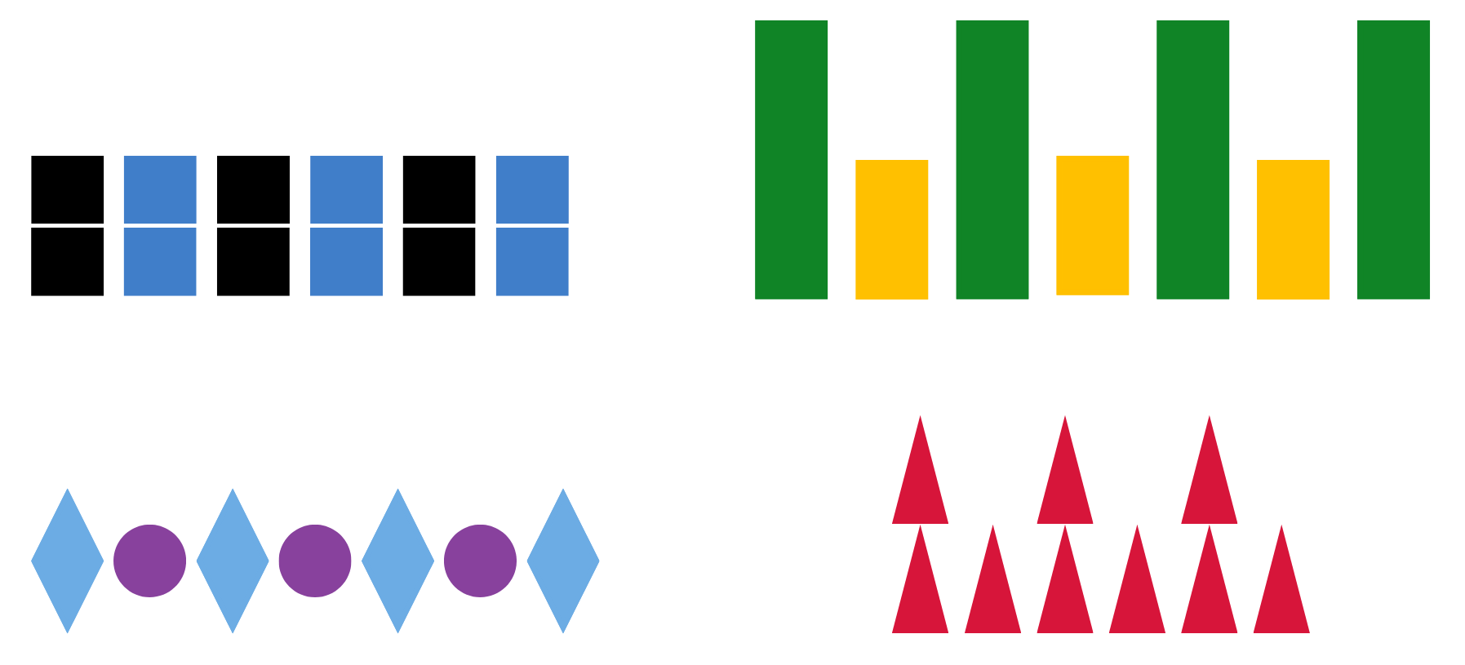
- Explain that when mathematicians describe repeating patterns, they look at different features, such as colour, size, number, and shape. Note that sometimes words can also be used to describe patterns, such as black, blue, black, blue, black, blue; or tall, short, tall, short, tall, short, and so on.
- Referring to Figure 1, ask students to think of more than one way to describe each pattern. Prompt students by asking them to think about colour, shape, size, and number to describe the parts of the patterns.
- Select students to share their thinking. This will provide an insight into what students know about patterns and the language they are using to explain their thinking. Encourage students to make comparisons between the patterns by asking them what is different and what is the same. Students turn and talk, sharing their comparisons.
- Explain that a pattern needs to have a core that is repeated over and over and over again (about 3 times) to trust that there is a regularity. Mathematicians describe the repeating core of a pattern using letters. For example, the patterns in Figure 2 can be described as having an AB core that has 2 parts. The first pattern has 2 parts that can be described as A (green) and B (orange). The second pattern also has an AB core that can be described as A (tall) and B (short).
Figure 2 – AB patterns
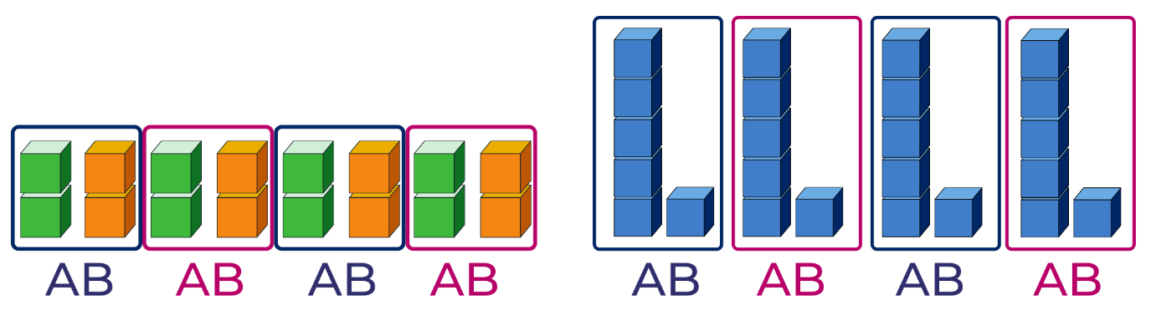
- Tell students that AB patterns can also be represented in different ways if there are 2 parts to the core. For example, using a body percussion pattern such as clap and click, a movement pattern such as jump and hop; or a position pattern such as up and down.
- With a partner, students explore an AB pattern involving body percussion. Select students to share their pattern with the class and to clearly identify the A and B parts.
- Display Resource 2: AB Patterns. Discuss the pattern core that is repeated in Example 2.
- Display Example 1 and ask students to identify what features are repeated in the pattern core, what features would be repeated next in the pattern, and how to label the repeated AB pattern.
- In small groups, students use concrete materials, 2D geometric shapes, body percussion, sounds and/or movement to create a repeating AB pattern. Explain that they need to record and clearly label the AB repeating core of their pattern by drawing, using a tablet to video/photograph, or representing using concrete materials.
- Have students do a gallery walk to view other students’ ideas, recordings, and representations of patterns. Discuss what was interesting, similar, and different.
- To further advance student thinking, reveal that there are different kinds of repeating patterns, such as AAB, ABC, ABAB, and so on. Create the AAB pattern seen in Figure 3 and ask students to identify and describe the core of the pattern. Discuss that sometimes when the core has more than 2 parts, the core may be difficult to find.
Figure 3 – AAB pattern shown horizontally
- Explicitly model how to identify the repeating three-part core of a pattern by manipulating and vertically aligning its parts.
- Ask students to describe the pattern using words, colour, shape name, features, or letters. The pattern would be described as having an AAB core. Break the pattern apart to identify the repeating core, as in Figure 4.
Figure 4 – Separated core of an AAB pattern
- Explain that the repeating core of this AAB pattern can be seen more clearly if we organise the pattern core vertically. This alignment will also highlight that the pattern does repeat over and over and over again as in Figure 5. Ask students to describe what they notice.
Figure 5 – AAB pattern aligned vertically
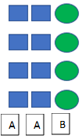
- Co-create various core pattern structures, such as AAB, AABBB, ABBA by using different concrete materials to represent A and B. Manipulate and use vertical alignment to identify the repeating core. Use the think aloud strategy to model the process of trial and error when aligning the core, noting when something has been moved incorrectly. Discuss and label the core using letters.
- Provide students with concrete materials and 2D geometric shapes to create a range of AB patterns. Encourage students to record their patterns using pictures and labelling the core with letters. Invite students to share their pattern ideas, describing the repeating core.
The table below details assessment opportunities and differentiation ideas.
Assessment opportunities | Too hard? | Too easy?
What to look for:  - Can students identify, describe and name features that are repeated in the core of a pattern? (MAO-WM-01, MA1-2DS-01)  - Can students create a repeated pattern and label the core? (MAO-WM-01, MA1-2DS-01)  - What strategies are students using to record their pattern? (MAO-WM-01, MA1-2DS-01)  - Can students identify and describe an incorrect element that does not belong in a repeated pattern? (MAO-WM-01, MA1-2DS-01)  What to collect:  - observations and recordings of vocabulary used by students (MA1-2DS-01, MA1-2DS-01)  - photos, drawings or videos of vertical and horizontal patterns (MAO-WM-01, MA1-2DS-01) | Students understand the concept of the core but find it hard to create a repeating pattern using the core. Limit the variety of available concrete materials to have only one attribute such as red squares and red circles.  Students find it hard to use or form letters to label their patterns.  - Use drawings to represent patterns.  - Give students paper copies of letters ABC to place under their drawings. | Students can easily identify and create two- and three-part patterns and represent these horizontally and vertically.  - Create four- and five-part patterns incorporating a variety of features using concrete materials, movement, and body percussion.  - Create patterns that include a variety of more complex features such as animals that can be pets, have fur, 4 legs, and need a special shelter.

Consolidation and meaningful practice: What’s this pattern about? – 5 minutes
- Display Resource 3: What’s this pattern? Ask student to identify the repeating features and core pattern.
- To further challenge thinking, ask students what would happen to the pattern if you added a picture of a dog after the bird. Ask students to explain how a dog would be suitable to add to this pattern.

Lesson 2: Repeating patterns 2
Core concept: Identifying the repeating core of a pattern is a strategy which assists with determining a missing element.
The table below contains suggested learning intentions and success criteria. These are best co-constructed with students.
Learning intentions | Success criteria
Students are learning that:  - symbols, such as letters, can be used to describe repeating patterns  - identifying the repeating core helps to extend and fix missing elements in a pattern  - there are different strategies to solve problems. | Students can:  - use symbols or letters such as AB, ABC, ABB, or ABA to describe a repeating pattern  - identify a missing part in a pattern  - use knowledge of 2D shapes and properties to solve problems when making repeating patterns.

Daily number sense: Dinner time! – 15 minutes
- Build student understanding of how to effectively solve a problem by applying a variety of strategies to find the best solution.
- Explain to students that there are 6 guests coming for dinner and they will be seated around a rectangular table. In pairs, students use a mini whiteboard to draw a rectangle and use 6 counters as the guests. Ask students the following questions:
- How many different ways can the 6 guests sit around the table?
- If another guest arrives, how can 7 guests sit around the table?
- If we joined 2 rectangular tables together and there are 10 guests, how many different ways can the 10 guests sit around the 2 tables?
- Provide time for students to share their problem-solving strategies. Discuss if one strategy was more effective than another. Ask students to explain how they knew that their solution was accurate.

A pattern core is very helpful – 40 minutes
- Make a pattern with a three-part core using concrete materials; one that repeats over and over and over again (see Figure 6). Ask students to identify the core and explain how they know. Explain that identifying the repeating core of a pattern is helpful to extend the pattern. Ask students to identify what comes next in the pattern and explain how they know this is correct. Invite students to continue the pattern. Model how to check, using vertical alignment of the core and parts.
Figure 6 – Three-part core aligned vertically
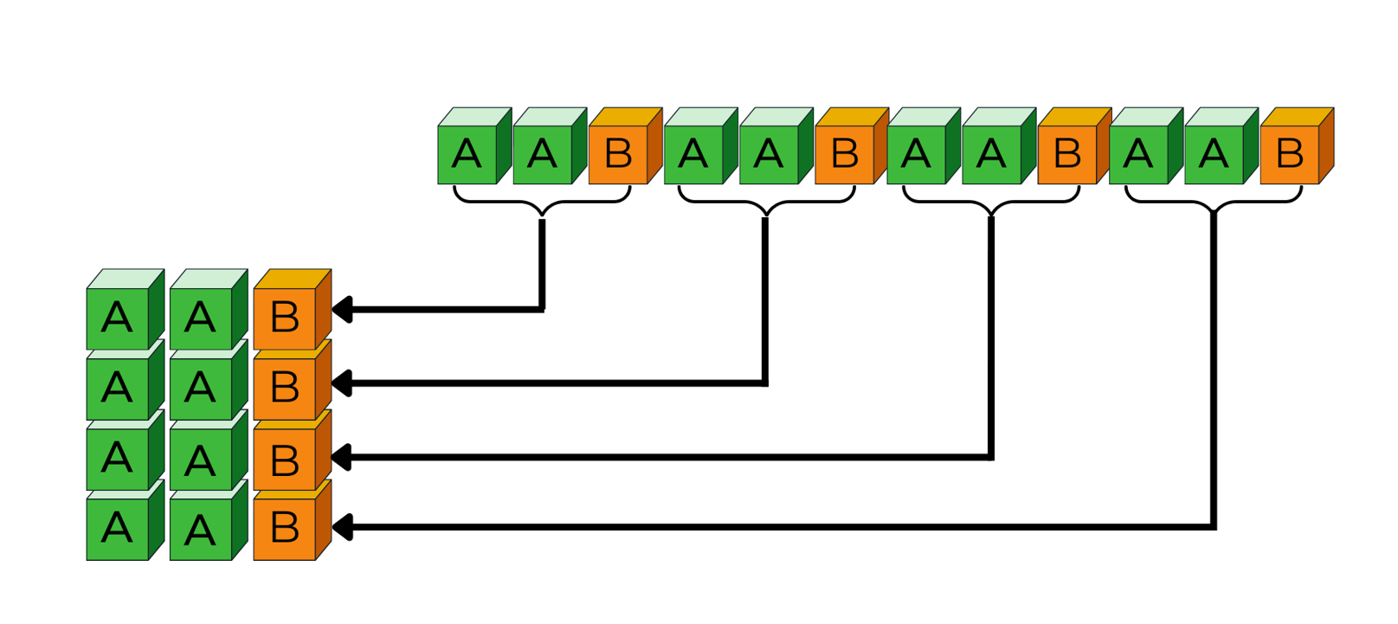
- Students create repeating patterns with a three-part core using a range of concrete materials. Have a partner identify the core and extend the pattern. Students check using vertical alignment. Encourage students to refine their thinking if their initial attempts are not accurate. Students draw and label each of their patterns, identifying the core structure as an AAB pattern.
- Inform students that identifying the repeating core of a pattern is also helpful to work out any missing parts. Create a linear three-part repeating core pattern using 2D geometric shapes (see Figure 7).
Figure 7 – Example of a repeating three-part core shape pattern
- Students view the pattern. Then ask students to close their eyes and visualise the pattern. While their eyes are closed, cover part of the pattern (see Figure 8). Ask students to look and work out which part of the pattern is missing. Encourage students to justify their thinking and check that suggestions do correspond with the hidden part. Discuss how to extend the pattern now that they can see the whole pattern. Repeat the process several times using a variety of 2D geometric shape patterns and ask students to focus specifically on identifying and naming the shape features being concealed and repeated.
Figure 8 – Example of a repeating three-part core shape pattern that has a missing part
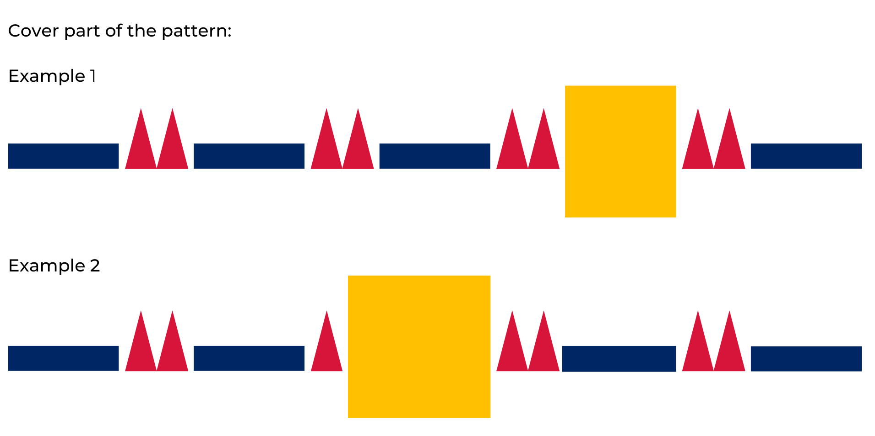
- Provide small groups with a variety of 2D geometric shapes to sort using the features of sides, vertices, and size. Ask students to get into pairs within their group. Each pair creates a linear pattern using 2 or 3 shapes. Encourage students to prove their pattern design by discussing with their partner the repeating core features.
- Re-joining their group, each pair of students covers one part of their pattern with a piece of paper. Students allow time for other group members to identify the missing part of the pattern before asking them to extend the pattern. Students need to vertically align the core to check that it repeats over and over and over again.
- Students go on a gallery walk to view other groups’ patterns. Students discuss the core of each pattern with their partner and identify the pattern structure, for example ABB.
- Encourage students to provide feedback about the pattern verbally or on a sticky note. This feedback can be a positive comment and/or provide a question for the creators to think about. When students return to their own patterns, they can make adjustments if needed based on the feedback.
The table below details assessment opportunities and differentiation ideas.
Assessment opportunities | Too hard? | Too easy?
What to look for:  - Can students describe the core of a three-part repeating pattern? (MAO-WM-01, MA1-2DS-01)  - Can students describe a pattern using letters or symbols such as AB, ABC, ABB? (MA1-2DS-01)  - Can students create and record repeating patterns using shapes in different orientations? (MAO-WM-01, MA1-2DS-01)  - Can students identify a missing part of a pattern? (MAO-WM-01, MA1-2DS-01)  What to collect:  - annotated work samples and photographs of student created patterns (MA1-2DS-01)  - observations and recordings of group discussions (MAO-WM-01, MA1-2DS-01) | Students need further support to apply thinking about features or properties and naming 2D shapes.  - Limit the 2D shapes to squares and rectangles.  - Model thinking about features or properties to a maximum of 2, for example, colour and number of sides. | Students can confidently sort and categorise shapes and explain their thinking as they create repeating patterns.  - Introduce polygons such as octagons, trapeziums, and rhombuses to be used in their patterns.  - Students create own ‘problematise’ shape pattern challenge with a missing element for another student to solve.

Discuss and connect the mathematics – 5 minutes
- Summarise the lesson together, drawing out the key mathematical ideas by asking questions such as:
- Which features did you think about when creating your shape pattern?
- How did you arrange the shapes in your repeating core so that it was more challenging to work out the missing element?
- During the gallery walk, which pattern did you see that had an interesting repeating core? How would you describe this pattern to a mathematician?

Lesson 3: Dice dots everywhere!
Core concept: Arrangements of dots can be used to quantify small and large collections.
The table below contains suggested learning intentions and success criteria. These are best co-constructed with students.
Learning intentions | Success criteria
Students are learning that:  - dice have a mathematical regularity, a pattern, which means we can trust how many dots there are every time we see them  - dice patterns help to see smaller numbers inside of bigger numbers  - subitising helps to answer the question ‘How many?’ | Students can:  - subitise dice patterns 1-6  - subitise a collection of dots by looking for dice patterns within the collection  - create and represent whole numbers using objects, drawings, words, and symbols.

Daily number sense: Spot the Spots! – 20 minutes
This activity has been adapted from Numerals and expressions by NZ Maths.
Note: Subitising is the ability to recognise collections without counting. If you want to learn more about the role of subitising and quantifying collections, you can search for ‘Becoming mathematicians: Quantifying collections’ in the ‘Browse Learning’ section on MyPL.
- Build student understanding of subitising a collection of spots by watching the video Subitising 6 (one less than) (6:06).
- As students are watching the video, pause at selected reveals. Allow time for students to share their answers about what one less would be, as well as the strategy they used to work it out. Ask students to share their ideas of how the number line was helpful with problem solving the answer.
- Explain to students that they are going to play a game called Spot the Spots! Print and prepare the spot cards (see numerals and expressions 1a [PDF 28KB] from Numerals and expressions on NZ Maths), ensuring there are enough cards to be used in small groups. Decide the complexity of the spot collection based on students’ needs and subitising abilities.
- In small groups, each student will have a turn briefly revealing a spot card before turning it back over. Using a mini whiteboard and the number line, all other players will record the number (numeral or a drawing), as well as one less than the quantity of spots they saw.
- After playing several games, have students work out what one more than the quantity of spots would be.
- After playing several games, ask students:
- What strategy did you use to remember the hidden quantity of spots?
- Was it easier to remember ‘one less than’ when the collection of spots was small?
- Was it easier to remember ‘one more than’ or ‘one less than’? Explain your ideas.
- How did you use the number line to assist you with your answers?

Going dotty! How can dots help us to see numbers? – 40 minutes
- Display the same-coloured counters (dots) arranged as in Figure 9, for 2-3 seconds and then hide it. Ask students to identify how many dots they could see and describe how they saw the collection of dots.
Figure 9 – Dot card 1
- Reveal the dots and invite selected students to share their thinking with the class. Record student thinking.
- Repeat this process using examples such as those in Figure 10, encouraging students to recognise that others may notice different parts of the collection of dots. Emphasise that there can be many solutions. As students are sharing, highlight solutions which include standard dice dot patterns.
Figure 10 – Dot card 2, 3 and 4
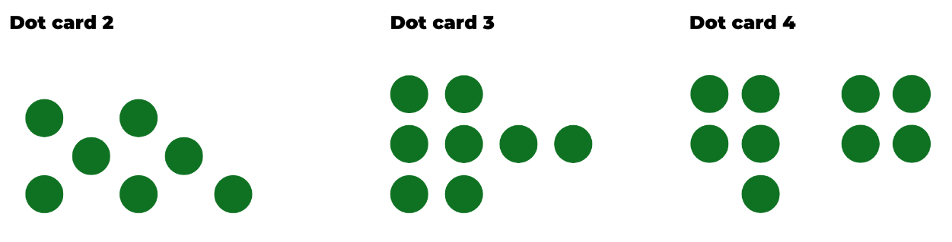
- Discuss whether everyone saw the collection of dots in the same way and share some of the recorded thinking with the class. Explain that some students use what they know about dice patterns to help them work out the total number of dots. This is an effective strategy when there is a large collection. Looking for a pattern helps to see chunks or parts within that collection.
- Discuss how dots on dice are a pattern because they are a mathematical regularity. For example, 4 is always representing a collection of 4 no matter what other features change. Show students a variety of dice, including different colours, shapes, and sizes. Discuss how, although other features may change, the quantity of 4 remains the same, as well as the way 4 is shown in a pattern of dots. Display a 1 to 6 dice to show that all quantities are a type of pattern.
- Show students Resource 4: Dot card and ask if they can see a dice pattern hiding that might help them to work out how many dots there are altogether. Reveal for 2 to 3 seconds and then hide, asking the students how many dots they saw and how did they see them.
- Display the card again and invite students to share responses, while co-constructing an anchor chart to record thinking and reasoning. Model how to represent the different ways that students see the dots using pictures, words, and symbols. Record the groups of dots that students see using poster paper and a coloured marker. This helps to make visible the smaller numbers that combine and are equivalent to the larger number (see Figure 11).
Anchor chart: A display that facilitates sharing concepts and information to ‘anchor’ future thinking.
Figure 11 – Example of an anchor chart: How did you see the dots?
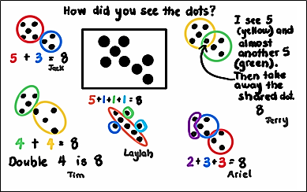
This table details assessment opportunities and differentiation ideas.
Assessment opportunities | Too hard? | Too easy?
What to look for:  - Can students communicate how the dice dot pattern assisted them with determining how many dots there were altogether? (MA1-CSQ-01)  - Can students recognise and create combinations of numbers to 10? (MA1-CSQ-01)  - What strategies are students using to count the dots? For example, by ones, twos or recognising dice dot patterns and counting on? (MA1-RWN-01, MA1-FG-01)  What to collect:  - student work samples (MAO-WM-01, MA1-RWN-01)  - observations of discussions and problem-solving strategies applied to identify the dice dot patterns (MAO-WM-01, MA1-CSQ-01) | Students are not able to recall the displayed and concealed pattern of dots.  - Provide students with a dice and cards that display the dot patterns 1 to 6. Students roll the dice and find the matching card, counting the dots and then calling out how many dots they see.  - Provide students with counters so they can reproduce the dot pattern they see on the dice or displayed card, and then point and count the total of dots. | Students confidently subitise the dice dot patterns and count efficiently.  - Ask students to record different patterns of dots to represent the same number quantity.  - Students use 2 dice, roll, and add the quantity. They then need to use dots to represent the quantity in the easiest way to subitise. Students need to prove that their representation is the easiest way to subitise.

Consolidation and meaningful practice: Matching Numbers – 10 minutes
This activity has been adapted from Matching Numbers by NRICH (2022).
- This game provides an opportunity for students to further develop their ability to count using various strategies, subitising skills, and to think flexibly about numbers and the part-part-whole combinations to 10.
- Introduce students to the game (optional to play on the screen or use the printable version).

Lesson 4: Smaller numbers inside bigger numbers
Core concept: Using smaller ‘chunks’ and familiar dice patterns help work out a total.
The table below contains suggested learning intentions and success criteria. These are best co-constructed with students.
Learning intentions | Success criteria
Students are learning that:  - parts of numbers can be combined to make a new number  - growing patterns are given that name because there is something (an element) that gets bigger by the same amount each time  - shrinking patterns are given that name because there is something (an element) that gets smaller by the same amount each time  - patterns of quantities can be hidden and are not always obvious. | Students can:  - create models to show the different ways that a quantity can be partitioned into 2 parts  - record ideas in a range of different ways  - problem solve and find all combinations to make a certain quantity  - identify a growing pattern and explain the element of repetition  - identify a shrinking pattern and explain the element of repetition.

Daily number sense: Counting patterns – 10 minutes
- Build student understanding of patterns by skip counting forwards and backwards.
- Students start counting by tens to 100. Interrupt the count suddenly and ask students to count backwards from that number to zero.
- Ask 2 students to stand up and share a count to 20 by twos. Students take turns saying the next number until they reach 20. Invite additional students into the count and increase the count to 50, then 100. Ask students to also count backwards using various skip counting strategies. Other variations may include increasing or decreasing the speed used to count, adding a movement or action, and/or starting the count off the decade.
- Ask students to count by ones to 20 but on even numbers, they clap instead of saying the number.
- Students count by fives to 50 and then from 50 they count by tens to 100.

What’s hiding inside? – 50 minutes
- Describe the following narrative: My sister has a fish tank with caves and 10 goldfish. Some fish like to hide in the blue cave and other fish hide in the orange cave, so sometimes she can’t see the fish at all. She isn’t sure how many fish are in each cave, so she took a photo for us to help her (see Figure 12).
Figure 12 – Some combinations created for 10
- Explain that there are 10 interlocking cubes representing the 10 goldfish with orange cubes representing fish in the orange cave and blue cubes representing fish in the blue cave. Make one tower of 10, for example 5 blue and 5 orange cubes, illustrating that there could be 5 fish hiding in the orange cave and 5 fish hiding in the blue cave.
- State that now the sister wants to know if there are other possibilities.
- Discuss how to find all the possible ways the 10 hidden fish could be hiding. Ask for suggestions, adjusting the model to reflect their thinking. You are looking for suggestions that some kind of order is needed to help determine the possibilities. Prompt student thinking if required. Give students interlocking cubes to experiment making different combinations of 10 using 2 colours.
- Discuss that it might help to label the numbers and record a number sentence. Explain that there may be a pattern and ask students if they can see a mathematical regularity that repeats over and over and over again.
- Students think about what they are seeing and then turn and talk. Use this time to listen in to conversations and invite students to share their thinking with the class. Draw students’ attention to the growing and shrinking patterns that can be seen in the cubes and in the recorded number sentences. Ask students to identify where they can see things getting bigger (growing) by one each time and where can they see things getting smaller (or shrinking) by one each time (see Figure 13). Students record their number sentences; take photos of student models.
Note: Photographs of partition models made by students in this lesson will be required in Lesson 5.
Figure 13 – Organised partitions of 10
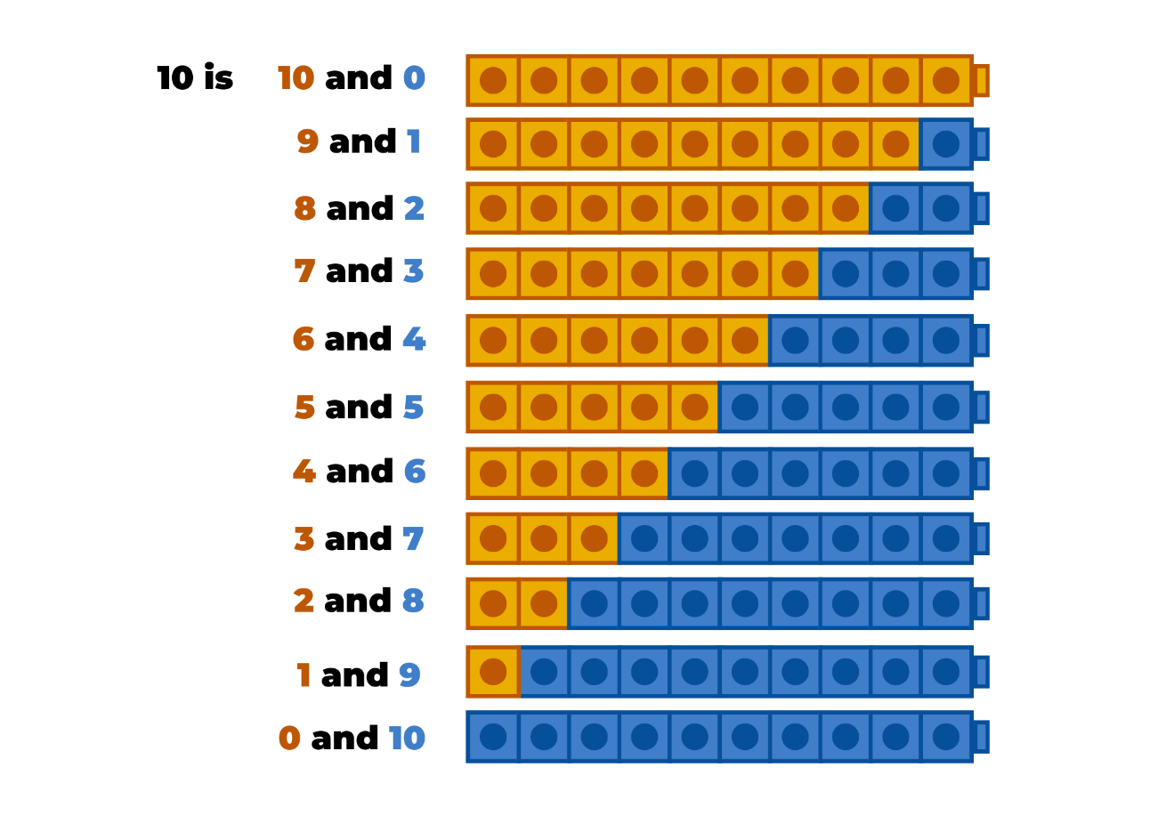
- Use Figure 13 to draw students’ attention to the growing pattern in the cubes. State that you have made a mathematical connection and are thinking about the counting sequence by ones. Allow time for thinking. Explain that the number word goes up by one each time and so does the number of cubes, so they both must be growing patterns. Identify that the same, but opposite, is happening when students count backwards, so they both must be shrinking patterns too.
- Use your favourite picture book related to counting.
Note: Examples of picture books related to counting include None the number by Oliver Jeffers, Count the Monkeys by Mac Barnett, Sixteen Runaway Pumpkins by Dianne Ochiltree, or Ten Sly Piranhas by William Wise.
- Read the book and discuss if there was a growing and shrinking pattern in the counting sequence. Read the book again to confirm and prove students’ thinking.
- Explain to students that they will use interlocking cubes to make each collection as the book is read to see if it increases or decreases by the same amount each time. Explain to students that the book will now be read backwards to check if the pattern grows or shrinks as it is read backwards.
The table below details assessment opportunities and differentiation ideas.
Assessment opportunities | Too hard? | Too easy?
What to look for:  - Can students communicate that smaller numbers can be combined (added together) to make a new larger number (a total)? (MAO-WM-01, MA1-CSQ-01)  - Are students using addition and subtraction strategies to identify and create growing and shrinking patterns? (MAO-WM-01, MA1-CSQ-01)  What to collect:  - observations and recordings of verbal addition and subtraction strategies used to create patterns (MAO-WM-01, MA1-CSQ-01) | Students are not confident when combining or partitioning numbers to 10.  - Modify the fish story to have only 5 hiding fish and work on combinations to 5.  - When reading the picture book, use a display of counters to model how the number pattern is growing and then shrinking.  - When reading the book a second time, provide students with counters so they can create the number pattern as the quantity increases by one and then decreases by one. | Students are confident when combining or partitioning numbers to 10.  - Modify the story to now having 3 caves, an orange, green, and blue cave where the 10 fish are hiding. What are the various combinations that can be made?  - Increase the number of fish to 20 and have 3 caves, an orange, blue, and green cave.

Consolidation and meaningful practice: What have we learned about growing and shrinking patterns? – 5 minutes
- Students share and discuss what happened each time one was added or taken away from the collection in the picture book. Encourage students to describe the growing and shrinking patterns they noticed in the picture book and in the fish tank problem. Add the appropriate explanations and vocabulary to the class patterns anchor chart.

Lesson 5: Number facts have patterns too
Core concept: When number sequences are related, they can be arranged and repeated to create a number pattern.
The table below contains suggested learning intentions and success criteria. These are best co-constructed with students.
Learning intentions | Success criteria
Students are learning that:  - number facts, like 8 + 2 = 10, are a special kind of pattern because when 8 of something is combined with 2 of something, there will be 10 of something. This kind of pattern is sometimes called a combinatorial pattern  - thinking systematically can help to find the different ways of partitioning (decomposing) a number into 2 parts. For example, 10 is 7 and 3, 6 and 4, 5 and 5, and so on  - concrete materials are useful to justify thinking and support explanations. | Students can:  - create models to show the different ways that a quantity can be split into 2 parts  - share thinking in different ways  - organise concrete models to find all part-part-whole combinations for a given quantity.

Daily number sense
- From a class need determined through formative assessment data, identify a short, focused activity that targets students’ knowledge, understanding, and skills. Example activities may be drawn from the following resources:
  - Thinking Mathematically Stage 1
  - Universal Resources Hub

Thinking and reasoning – 10 minutes
- Show a dot card for 3 seconds and ask students how many dots they could see and how they saw them.
- Provide students with thinking time and then Think-Pair-Share to share ideas. Use ‘Talk moves’ to support discussion and make sense of emerging mathematical ideas.
- Select students to share their thinking and record reasoning using pictures, numbers, and words to co-construct a ‘number facts’ anchor chart. Use colour to make visible smaller numbers inside larger number and include numbers and words to represent student thinking.

Mathematical regularity – 45 minutes
Note: Combinatorial patterns are the focus for this lesson as students explore the patterns in number facts. For example, when 8 is combined with 2, it is always equivalent in value to 10. This is a pattern worth knowing as it builds trust in number facts.
- Display 3 or 4 different models or photos from the previous lesson to show growing and shrinking patterns when partitioning 10 into 2 parts. Explain how each pair of students partitioned their models, for example, Ebony and Jacob created a combination of 10 with 6 fish in the orange cave and 4 fish in the blue cave. Marcus and Isra also had a combination of 4 and 6 that was equal to 10 fish in total. No one combined 6 and 7, or 6 and 2, or 6 and 6. In these examples, only 6 and 4 were combined to make 10.
- Students Think-Pair-Share as they view the models.
- Revise that you have seen repeating patterns where the repeating part (the core) might be AB, for example, left, right, left, right, left, right, or tall, short, tall, short, tall, short. Revise that you have also seen growing and shrinking patterns where one more is added or taken away each time. Explain that using 2 numbers to create 10 also creates a pattern. For example, if the goal is to create 10 with either a 6 or a 4, you can only join 6 with 4 or 4 with 6, otherwise the total will be different. This is called a mathematical regularity or a pattern.
- Students choose a number combination, such as 8 and 2, and explore if it always totals 10. Using concrete materials, discuss if this is true.
- Students investigate another combination equivalent to 10, for example, 7 and 3, or 6 and 4. Have students explore using different concrete materials to see if it is always equivalent to 10. For example, what does it look like on their fingers, on a ten-frame, on dice, on dominoes, on a bead string, and/or with real life objects, such oranges and pencils, and so on.
- Students create a poster showing their different investigations proving that their chosen number combination is equivalent to 10. Encourage students to draw, use words, and numbers to record their number sentences including the symbols +, −, and =.
- Provide time for students to go on a gallery walk to observe and discuss the posters. Ask students the following questions:
- Was there any time that you could not prove that your chosen number combination was equivalent to 10?
- Can you convince me that, for example, 8 and 2 is 10, and 2 and 8 is 10?
This table details assessment opportunities and differentiation ideas.
Assessment opportunities | Too hard? | Too easy?
What to look for:  - Are students recalling and recognising combinations of numbers to 10? (MA1-CSQ-01)  - Can they create representation using various materials to demonstrate their understanding? (MA1-CSQ-01)  - Are students using the strategy of counting on as they make 10? (MAO-WM-01, MA1-CSQ-01)  What to collect:  - annotated work samples of the posters (MAO-WM-01, MA1-CSQ-01) | Students have difficulty combining 2 numbers to 10.  - Students combine 2 numbers to make 5.  - Provide a set of dominoes and ask students to sort the pieces that have 10 dots altogether.  - Students can try (Domino Patterns) from NRICH. | Students use several strategies and create a variety of representations of combinatorial numbers to 10.  - Ask students to explore combinatorial numbers to 15 and 18.  - Ask students to determine if there are more combinatorial numbers when the number is odd, such as 15, or even, such as 18.

Discuss and connect the mathematics – 5 minutes
- Review the posters and display these on a gallery wall. Co-construct a statement to add to each wall display and explain that combinatorial patterns are a mathematical regularity that students can trust. For example, 8 of something and 2 of something is always 10 of something, and so on.

Lesson 6: Place value patterns
Core concept: Place value can be used to explore and create number patterns.
The table below contains suggested learning intentions and success criteria. These are best co-constructed with students.
Learning intentions | Success criteria
Students are learning that:  - in a collection of 10, the 10 ones can be regrouped and renamed as 1 ten  - there is a growing pattern every time they rename and regroup beyond a collection of 10 – 20 ones as 2 tens, 30 ones as 3 tens, 40 ones as 4 tens, and so on  - on a number chart, the numbers in each square will increase or decrease by 1 ten each time they move up or down. The digit in the ones column will increase or decrease by one when they move left or right. | Students can:  - regroup and rename 10 ones as 1 ten  - model what happens to a quantity when they add one more  - model what happens to a quantity when they take away one  - model what happens to a quantity when they add 10 more  - model what happens to a quantity when they take away 10.

Daily number sense: Counting on counting – 20 minutes
This activity has been adapted from Learning to count: Counting one-to-one by NZ Maths (2022).
- Build student understanding of subitising and counting forwards and backwards by exploring various visual representations of quantities and numbers.
- View the frog animation (1:42) clip from Learning to count on the nzmaths website and encourage students to predict the new quantity when one more frog is added to the various quantities in the bucket. Pause the clip and ask what the quantity would be if 2 more frogs jumped in, or if 2 frogs jumped out.
- Revise that students have previously used dot patterns and subitising to recognise and count a quantity of dots. Display the Odd one out cards from Learning to count on the NZ Maths website and ask students to apply subitising or skip counting strategies to count the collections and work out the odd one out.
This table details assessment opportunities and differentiation ideas.
Assessment opportunities | Too hard? | Too easy?
What to look for:  - How are students counting objects? For example, by ones, twos or tens? (MA1-RWN-01, MA1-FG-01)  - Do students understand that 10 ones are the same as 1 ten? (MA1-RWN-01, MA1-RWN-02)  - What strategies are students using to calculate their total? (MAO-WM-01, MA1-FG-01)  What to collect:  - Resource 5: Assessing game play (MAO-WM-01) | Students are not confident when mentally grouping the number of objects seen on the cards.  - Students use a mini whiteboard to track how many frogs jump in or out during the count to determine one more or one less.  - Students use a number line to track how many frogs there are during the count.  - Students use counters to track the number of objects displayed on the cards. | Students apply efficient counting methods and can subitise.  - Students are challenged to add a further 10 frogs to each count.  - Students use dominoes to record how many different ways they can make numbers, such as 29, 34, 55, and 60.

Quantifying collections – 45 minutes
- Prior to viewing the clip, Quantifying collections – Ice cream sticks 1 – number talk (7:50), ask students to look for the patterns they notice as the collection of craft sticks is quantified.
- After viewing the clip, provide time for students to Think-Pair-Share. Use ‘Talk moves’ to support meaningful discussion and to help make sense of emerging mathematical ideas. Select some students to share thinking with the class and record ideas on a whiteboard.
The table below outlines stimulus prompts to generate conversation about the topic, along with anticipated responses from students.
Prompts | Anticipated student responses
- Was this a growing or shrinking pattern? Explain.  - How did the pattern grow as the craft sticks were placed in the cups?  - How did the pattern shrink? Explain.  - Why were the craft sticks bundled together as 10 ones? Why were they regrouped and renamed?  - Did you see another pattern? | - The pattern grew each time a craft stick was put into the cup. We started at 1, 2, 3, 4, and went all the way to 24. The number got bigger.  - I knew it was a growing pattern because one more craft stick was added over and over and over again.  - When the craft sticks were taken away and she counted backwards, the numbers were shrinking so the pattern was shrinking too.  - Every time there were 10 craft sticks, she bundled them together. They went into another cup because altogether there were now 10 craft sticks so you could just say 10.  - I saw a pattern when there was one bundle of 10 and 3 more to make 13.
- Using Resource 6: Number chart or a digital number chart, locate the numbers 1 to 24. Illustrate on the chart what happened each time one craft stick was added to the collection – the quantity of the collection grew by one. Discuss what happened each time one craft stick was removed from the collection – it shrunk by one.
- Pose the following scenario for a number chart pattern: Rebecca noticed a pattern on the number chart. She noticed that if you choose any number, the number to the right of it is always one more and if you move to the left, it is always one less. Ask students the following questions:
- Is this always true?
- Can you find an example when this does not happen?
- In pairs, provide students with a mini whiteboard. Ask students to choose their own numbers from the number chart to investigate Rebecca’s idea. Explain that they need to use a model or drawing to share their evidence and thinking.
- Invite selected students to share their thinking, using a number chart and drawings to justify their findings. Record student thinking with visual examples.
- Ask students to look at the decade numbers column on the number chart, paying particular attention to how these numbers are growing and shrinking when you go up or down from a particular decade number. Ask students to share what they see happening to the digits in the tens place and the ones place as they move up and down the same column. Look at other columns on the number chart and ask students if they can see a pattern there too.
- Pose the following scenario for a number chart pattern: Kiaan thinks he noticed something. No matter what number he chose on the number chart, when he moved down, each number was 10 more. When he moved up, each number was 10 less. Is this always true?
- In pairs, students use a mini whiteboard to investigate what Kiaan noticed. Students record a number from the number chart and model adding and taking away 10 using concrete materials. Ask students the following questions:
- What happens to the number when you add 10 more?
- What happens when you take 10 away from their original number?
Note: If students are counting their concrete materials individually to make a quantity, ask them to think about how the craft sticks were bundled in the video to make counting more efficient. Pose, ‘Would it help to regroup and rename the 10 ones to make 1 ten in your model?’
- Students check to see if their models match what they see above and below their original number on the number chart. Compare this pattern to a number line. Ask what students notice. Continue to explore using different numbers to see if this is always true.
This table details assessment opportunities and differentiation ideas.
Assessment opportunities | Too hard? | Too easy?
What to look for:  - Can students identify the number before and after a two-digit number? (MA1-RWN-01)  - Can students state the value of digits in two- and three-digit numbers? (MA1-RWN-01, MA1-RWN-02)  - Can students count forwards and backwards by ones and tens, on and off the decade? (MA1-RWN-01, MA1-RWN-02)  What to collect:  - observations and recordings of investigations into their own number pattern (MAO-WM-01, MA1-RWN-01, MA1-CSQ-01, MA1-CSQ-02) | Students have difficulty working with two-digit numbers.  - Work with the smaller numbers on the number chart.  - Investigate one column only in the smaller numbers. | Students have completed an investigation of one column in depth.  - Students investigate if there are any diagonal number patterns on the number chart.  - Students discuss and justify their findings.  - Students try the Hundred Square problem from NRICH.

Consolidation and meaningful practice: What patterns did we find? – 5 minutes
- Select students to share what they think about the pattern that Kiaan noticed on the number chart. Discuss what happens to the quantity of the number when you go to the number above it and the number below it. Count up and down selected columns together so that students hear the pattern that is emerging. For example, 24, 34, 44, 54, and so on, or 2 tens and 4 ones, 3 tens and 4 ones, 4 tens and 4 ones, 5 tens and 4 ones, and so on. Note the pattern that repeats over and over and over again.
- Ask students what happens when they go 2 above and below the number, or 3 above and below the number. Ask if this is this a pattern that repeats over and over and over again with every number on the chart. Ask students how they think the number patterns will continue beyond 100.
Note: Support students to use place value language and model the use of this language throughout the lesson. When students refer to the tens and ones as the first and second number, clarify this by asking, ‘When you say the first number, are you talking about this digit in the tens place?’

Lesson 7: Growing and shrinking patterns
Core concept: A repeating core can make a pattern grow or shrink.
The table below contains suggested learning intentions and success criteria. These are best co-constructed with students.
Learning intentions | Success criteria
Students are learning that:  - when counting by twos, the next number word in the counting sequence is 2 more than the number before, creating a growing pattern  - when taking away 2 items at a time or counting backwards by 2, this creates a shrinking pattern (when the quantity decreases). | Students can:  - create a growing pattern with the constant difference of 2  - count a collection of objects by twos  - explain how a pattern grows when something is added every time the sequence repeats  - explain how a pattern shrinks when something is taken away every time the sequence repeats.

Daily number sense: 3 tens in a line – 10 minutes
- Build student understanding of subitising and the part-part-whole combinations to 10 by using 3 tens in a line (2:29).
- After watching the video, re-watch and pause at (1:52) and discuss with students why rolling a one would result in someone winning the game.
- Explain to students how to play the game and that they will need to think about numbers strategically and problem-solve using part-part-whole combinations to 10. Discuss and share ideas of strategies that can be used to count on and check that the combined total is 10 (counters can be used here to assist students if needed).
- Students will draw a 3 by 3 game board (like noughts and crosses) on a mini whiteboard or paper. Students take turns to roll a nine-sided dice and write the number in one of the game board’s squares. The goal of this game is to write 2 numbers in each box that combine to make 10. Players take turns and write the number they roll either in a blank section or in a section with an existing number if the total is 10 and continue until one player makes 3 tens in a row, vertically, horizontally, or diagonally (see Figure 14).
Figure 14 – Gameboard for 3 tens in a row
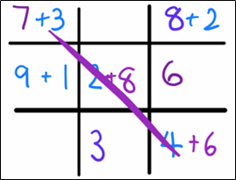
The table below outlines stimulus prompts to generate conversation about the topic, along with anticipated responses from students.
Prompts | Anticipated student responses
- What combination of numbers make 10? How did you work it out?  - When you have a 6 and a 4 is that the same or equivalent to having a 4 and a 6?  - Is there another number you can put with 6 to make 10? Why or why not?  - Do the numbers that you add together to make 10 always have to be smaller than 10? Explain. | - Look at the biggest number and then count on from the smallest number to get to 10.  - If both numbers are bigger than 5 then I knew I had more than 10.  - It is the same because you are just swapping them around when adding them together.  - You would need 2 more numbers with 6 to make 10, for example a 3, 1 and 6, not just one more number.  - Yes, because you need to get to 10 not more than 10.

How can patterns grow and shrink? 45 minutes
- Using interlocking cubes, create the pattern seen in Figure 15. Ask students what they notice.
Figure 15 – Odd and even patterns
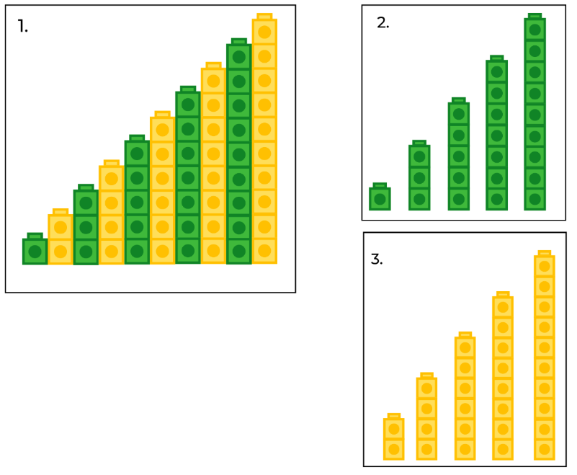
- Students Think-Pair-Share. Use ‘Talk moves’ to support meaningful discussion and help make sense of emerging mathematical ideas. If students notice just the colour pattern, direct their attention to the quantity (how many) in each tower and how this changes each time one more tower is added to the sequence.
- Select some students to share their thinking with the class and record observations on a whiteboard.
The table below outlines stimulus prompts to generate conversation about the topic, along with anticipated responses from students.
Prompts | Anticipated student responses
- Is this a pattern? How can you convince me?  - Is this a growing or shrinking pattern? How do you know?  - What is different in the pattern in picture 2 and 3? | - Picture 1 has a colour pattern, the yellow and the green repeat over and over and over again like an AB pattern.  - The tower in picture 1 is getting bigger. It’s growing by one each time.  - I can see each tower grows from 1, 2, 3, 4...10.  - In picture 2 the tower quantities are 1, 3, 5, 7, and 9. This pattern is getting bigger by 2 each time.  - In picture 3 the tower quantities are 2, 4, 6, 8, and 10. This pattern is also getting bigger by 2 each time.  - Both these towers are a growing pattern because they are growing by 2 each time but they start at a different number.
- Using counters, model what is happening each time a pattern grows by 2. Start with 2 and build up an array of counters by repeatedly adding 2 over and over and over again. Use different colours for each pair, continuing to 5 pairs. Start with 2 blue counters, add 2 red, 2 yellow, and so on (see Figure 16). Ask students to count aloud as each pair is added to the array ending at 10.
Figure 16 – Add 2 at a time to make an array
- Record the sequence of arrays, showing the number of counters below each one (see Figure 17). Count together the quantity in the sequence.
Figure 17 – Representation of a growing pattern
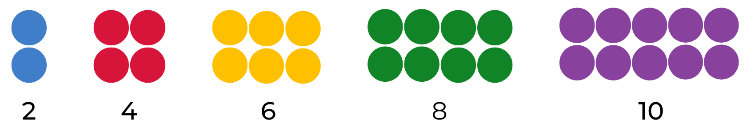
- Refer to the model and ask students what they know about the numbers 2, 4, 6, 8, and 10. Ask students what is happening to each part of the sequence and encourage them to recognise that a growing pattern must have a rule (a description of how the sequence grows each time a new element of the pattern is added). In this example, the rule is to add 2 every time the sequence repeats.
- Students use 2D geometric shapes to create their own models to explore patterns that grow by 2. Students start by making a model of 2, and then continuing to grow their pattern by 2 after that, until they get to 10.
- Provide students with writing materials and in pairs ask students to draw and record their findings (see Figure 18).
Figure 18 – Examples of ways students may record their findings
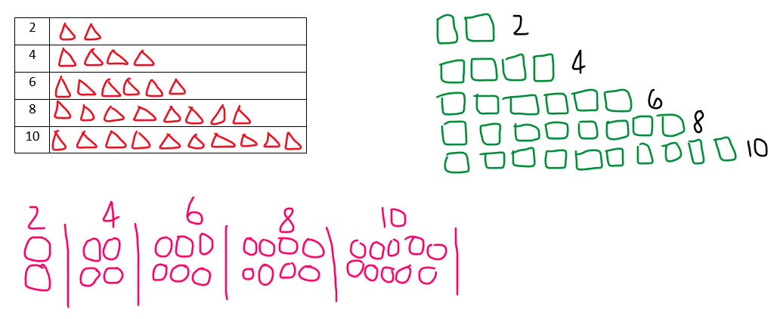
- Ask students what happens when 2 counters are taken away every time. They may notice that the pattern shrinks. Discuss that growing and shrinking patterns are a pattern if the rule repeats over and over again. In pairs, students draw and record their findings of a shrinking pattern (see Figure 19).
Figure 19 – Examples of ways students may record their findings
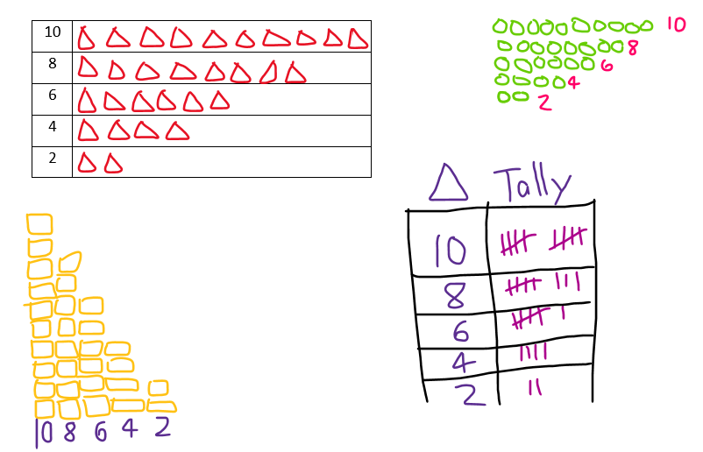
- Explain that mathematicians make predictions. Write a range of numbers on the board such as 1, 2, 3, 4, 5, 10, and 11, and ask students to select one to be a starting number to count by twos (explain that counting by twos doesn’t always have to start from zero). Provide mini whiteboards for students to use and ask them to Think-Pair-Share about what would come next in their sequence and explain how they know this. Prompt students to predict the tenth number in their sequence. Students extend the sequence each time to check if their predictions are correct. Discuss that, as mathematicians, students are using what they know about growing patterns to work out what comes next.
This table details assessment opportunities and differentiation ideas.
Assessment opportunities | Too hard? | Too easy?
What to look for:  - Can students count forwards and backwards by twos? (MA1-RWN-01, MA1-CSQ-01, MA1-FG-01)  - Are students demonstrating an understanding that when counting by twos, forwards and backwards, the next number in the sequence increases or decreases by 2 every time? (MAO-WM-01, MA1-RWN-01)  - Can students collect data to describe how a pattern grows and shrinks? (MAO-WM-01, MA1-DATA-01)  What to collect:  - observations of discussions and problem-solving strategies applied to identify the growing and shrinking patterns (MAO-WM-01, MA1-CSQ-01)  - work samples and photos of data collection (MA1-FG-01) | Students are unable to count forwards and backwards by twos to 10.  - In pairs, students create a growing shape pattern that grows by one over and over and over again.  - In pairs, students start at 10 and create a shrinking shape pattern that shrinks by one over and over and over again.  - Provide students with counters and a number line from 0 to 10. Ask students to skip count and place a counter on the correct number. | Students confidently identify the growing and shrinking pattern when counting by 2.  - Students create their own growing or shrinking number pattern, identifying the rule and proving it is growing and shrinking. Students draw a representation and prove their reasoning.  - Students create a growing or shrinking number pattern with a missing element and a partner needs to solve the rule and continue the pattern.

Consolidation and meaningful practice: How do patterns grow and shrink? – 15 minutes
- To connect the concrete representation of a growing pattern to your numerical system, use a student's recording of a growing pattern that starts with an even number and place transparent counters on the corresponding numbers on a number chart (see Figure 20). Continue to place counters on each number of the growing pattern.
Figure 20 – Skip counting by twos
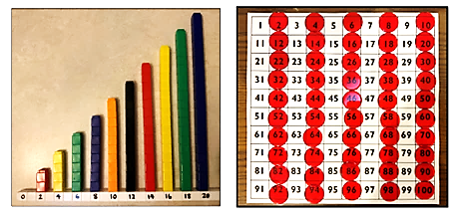
- Ask students what they notice when comparing the model and the number chart. Prompt them to explain why the pattern would look the same or different with a different starting number. Invite students to represent their growing models on the number chart and discuss findings. Photograph the number chart with counters for use in Lesson 8.
- Ask students to model a shrinking pattern. Discuss what happens to the quantity in each part and the order of the numbers.

Lesson 8: Skipping across a number chart!
Core concept: There are a variety of number patterns on a number chart when you count in various sequences.
The table below contains suggested learning intentions and success criteria. These are best co-constructed with students.
Learning intentions | Success criteria
Students are learning that:  - skip counting is counting forwards or backwards by a number other than one, skipping numbers in between  - when counting forwards by twos (or fives or tens), each number in the sequence increases in quantity by 2 (or 5 or 10), making it a growing pattern  - when skip counting backwards, each number in the sequence decreases in quantity by 2, making it a shrinking pattern  - skip counting can be a more efficient way of counting a collection. | Students can:  - skip count forwards by twos, fives, and tens  - skip count backwards by twos, fives, and tens  - create a model showing a skip counting pattern by twos, fives, and tens  - identify 10 before and 10 after a number using a model to explain their thinking.

Daily number sense: What number comes next? Choral counting by twos – 15 minutes
- Build student understanding of skip counting by choral counting adapted from Choral Counting at Teacher Education by Design.
- Students choral count forwards by twos up to 50. As they count, use colour to record in horizontal rows with 5 numbers in each row. Ask students to look at the numbers and discuss any patterns they notice. Record student ideas (see Figure 21).
Figure 21 – Record of choral counting by twos
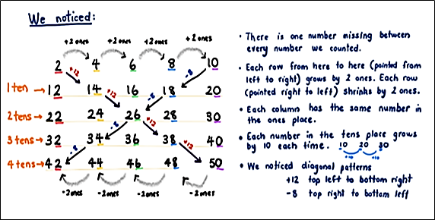
- An optional challenge is to combine choral counts to look for patterns, for example, 2 and 4.

Counting in multiples – 50 minutes
- Display the number chart from the previous lesson where students placed counters on the number chart as they counted by twos. Discuss some of the patterns seen by counting in twos, comparing it to the choral counting chart above.
- Discuss things that are the same:
- in any column, the digit in the ones place is the same on both charts
- as you travel across each row, the number increases or decreases by 2 each time
- the + 12 and − 8 pattern in the diagonals is also the same and so on.
- Discuss things that are different: in the number chart, the tens increase by 10 in each column you move down but in the choral counting chart, the tens are the same in each column, and so on.
- Display the number chart and ask students to visualise what counting by fives would look like on a bead string. Ask students to imagine seeing 5 beads move to the left as you say the number 5. Then 5 more moves across to make 10. Then 5 more to make 15, and so on. Ask students to share what they visualised and model this on a bead string and show the corresponding numbers on the number chart.
- Ask students if they can see a pattern of number words being said as we count by fives. Ask students to predict what the next 5 number words would be if we kept counting out aloud.
- Provide Resource 6: Number chart and transparent counters for pairs of students to colour-code the pattern made when skip counting by fives. Students can also use a digital number chart for this activity. Students can share their pattern with other students and discuss their findings before clearing the number chart to make another pattern.
- Challenge students by asking them to identify more patterns made by skip counting. They may count by twos, threes, tens, fours, or another unit to explore the patterns that emerge as they skip across the hundred (see Figure 22).
Figure 22 – Skip counting patterns
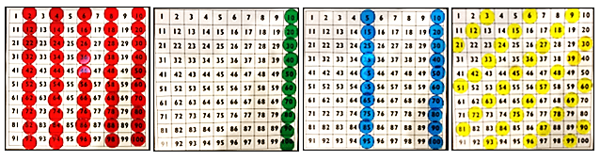
- Students go on a gallery walk to view and compare the counting patterns. Ask students to share their thinking and describe interesting aspects of the patterns, for example, counting by tens compared to counting by twos. Update the class number patterns anchor chart.
This table details assessment opportunities and differentiation ideas.
Assessment opportunities | Too hard? | Too easy?
What to look for:  - Do students confidently count forwards and backwards by twos, fives and tens? (MA1-FG-01)  - Can students identify and describe patterns when skip counting forwards and backwards by twos, fives and tens? (MAO-WM-01, MA1-FG-01)  - Can students use efficient strategies to organise and group quantities when skip counting and identify number patterns? (MAO-WM-01, MA1-FG-01)  - Are students able to identify the constant difference in a number pattern when skip counting? (MA1-RWN-01, MA1-FG-01)  What to collect:  - photos of students work from the gallery walk (MAO-WM-01, MA1-FG-01) | Students are unable to identify number patterns using a number chart.  - Provide students with a 20 or 30 chart.  - Support students to represent their patterns using counters and drawings. | Students apply many strategies to explore various number patterns.  - Students explore how number patterns extend and continue in a larger number chart.  - Students design a number pattern challenge for a partner to solve.

Consolidation and meaningful practice: Let’s problem solve! – 10 minutes
- View Empty number chart (6:47) to model the mathematical language to use and encourage students to use it while completing this task. Using Resource 7: Empty number chart, select a starting number based on the needs of your class and record it in the last square of your empty number chart.
- Display the empty number chart and scaffold students’ thinking by asking if they can use what they know to work out what the missing number might be. Provide students with thinking time.
- Ask students to share what number they think goes in what square and how they know this.
- Model how mathematicians use place value language to explain thinking. Use ‘Talk moves’ to support rich meaningful discussion and to assist with emerging mathematical ideas.

Resource 1: Shape train
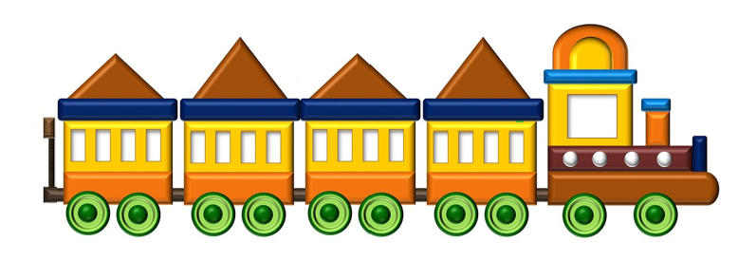
‘Cartoon Train’ by gyathanarts and used in accordance with the Pixabay Licence.

Resource 2: AB Patterns
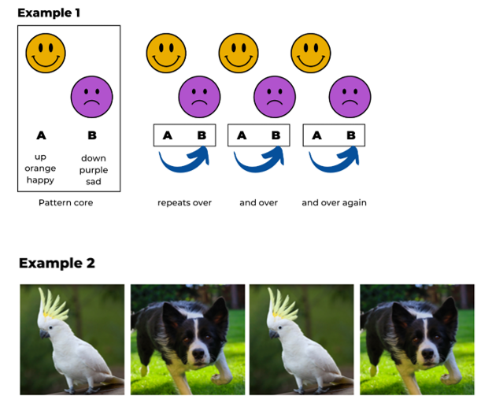
Images sourced from Canva and used in accordance with the Canva Content License Agreement.

Resource 3: What’s this pattern?
Images sourced from Canva and used in accordance with the Canva Content License Agreement.

Resource 4: Dot card

Resource 5: Assessing game play
Focus | Listen, watch, and think | Ask
Accuracy | Are they getting correct answers? | ‘What answer did you get?’
Efficiency and strategy selection | Are they applying the strategy in a reasonable timeframe?  Do they seem to be labouring or a little stuck? | ‘How did you solve it?’  ‘Was there a more efficient strategy you could have used or was this strategy the most efficient?’
Flexibility and strategy selection | Are they using different strategies?  Can they apply them with the same confidence? | ‘Why did you pick that strategy?’  ‘Is there another strategy that you could use for that problem?’  ‘When do you like to use __ strategy instead of __ strategy?’
Adapted from Bay-Williams J and Kling G (2019).

Resource 6: Number chart
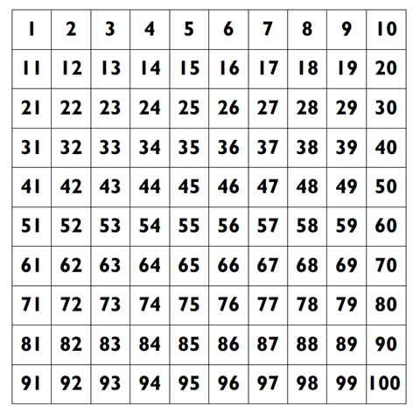

Resource 7: Empty number chart
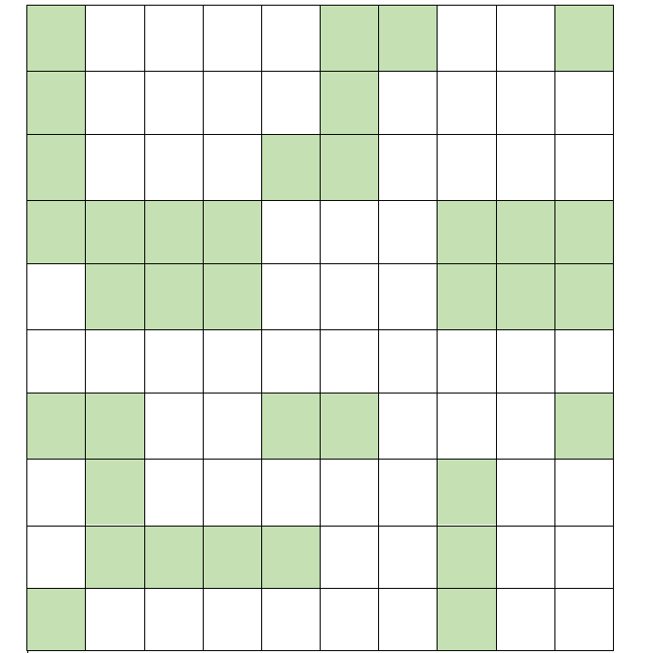

Syllabus outcomes and content
The table below outlines the syllabus outcomes and range of relevant syllabus content covered in this unit. Content is linked to National Numeracy Learning Progression (3).
Focus area and outcomes | Content groups and content points | Lessons
Representing whole numbers A  MAO-WM-01  MA1-RWN-01  MA1-RWN-02 | Use counting sequences of ones with two-digit numbers and beyond  - identify the number before and after a given two-digit number (CPr5)  - count forwards and backwards by ones from a given number to at least 120 (CPr6)  Continue and create number patterns  - model and describe 'odd' and 'even' numbers using items paired in two rows  - count forwards and backwards by twos from any starting point (CPr6-CPr7, MuS2)  Represent numbers on a line  - sequence numbers and arrange them on a line by considering the order and size of those numbers (CPr5)  Represent the structure of groups of ten in whole numbers  - recognise that ten ones is the same as one ten (NPV2, NPV4)  - count large sets of objects by systematically grouping in tens (CPr7)  - partition two-digit numbers to show quantity values (NPV4) | 1–8
Representing whole numbers B  MAO-WM-01  MA1-RWN-01  MA1-RWN-02 | Use counting sequences of ones and tens flexibly  - count forwards and backwards by tens, on and off the decade, with two- and three-digit numbers (CPr7)  Form, regroup, and rename three-digit numbers  - use models such as base 10 material and interlocking cubes to represent and explain grouping (CPr7)  - estimate, to the nearest hundred, the number of objects in a collection and check by grouping and counting (NPV6) | 4 and 6
Combining and separating quantities A  MAO-WM-01  MA1-CSQ-01 | Use advanced count-by-one strategies to solve addition and subtraction problems  - recognise and use the symbols for plus (+), minus (−) and equals (=)  - record number sentences in a variety of ways using drawings, words, numerals and symbols (AdS6)  - fluently use advanced count-by-one strategies including counting on and counting back to solve addition and subtraction problems involving one- and two-digit numbers (Reasons about relations) (AdS3-AdS5)  Recognise and recall number bonds up to ten  - recognise, recall and record combinations of two numbers that add up or bond to form 10 (AdS2, AdS6)  - model and record patterns for individual numbers up to ten by making all possible whole-number combinations  - create, recall and recognise combinations of two numbers that add up to numbers less than 10 (AdS2, AdS6)  - describe combinations for numbers using words such as more than, less than and double (AdS6) | 3–6
Combining and separating quantities B  MAO-WM-01  MA1-CSQ-01 | Represent and reason about additive strategies  - create, model and solve word problems, using number sentences  - represent the difference between two numbers using concrete materials and diagrams (AdS6)  - represent a constant difference between pairs of numbers  Use knowledge of equality to solve related problems  - use number bonds to determine a missing number (AdS6, NPA3-NPA4)  - use number knowledge to solve related problems (AdS7, NPA4)  - use a variety of ways of writing number sentences (NPA3-NPA4)  - use number bonds to solve equality problems (NPA3-NPA4) | 3, 5, 7 and 8
Forming groups A  MAO-WM-01  MA1-FG-01 | Count in multiples using rhythmic and skip counting  - count by twos, threes, fives and tens using rhythmic counting and skip counting (MuS2, CPr6)  Use skip counting patterns  - identify and describe patterns when skip counting forwards or backwards by twos, fives and tens (NPA3-NPA4)  - determine a missing number in a number pattern with a constant difference  - describe how the missing number in a number pattern was determined  Model and use equal groups of objects to represent multiplication  - model and describe collections of objects as groups of (MuS2)  - determine and distinguish between the number of groups and the number in each group when describing collections of objects  - find the total number of objects using skip counting of equal groups of a known size (MuS2-MuS3) | 3, 6 and 8
Two-dimensional spatial structure A  MAO-WM-01  MA1-2DS-01 | 2D shapes: Recognise and classify shapes using obvious features  - explore, manipulate and describe features of polygons (UGP3)  - use the terms ‘side’, ‘vertex’ and ‘two-dimensional’ to describe plane (flat) shapes (UGP1-UGP2)  - create repeating linear patterns with shapes, including two-shape and three-shape patterns  - compare, sort and classify polygons according to the number of sides or vertices (UGP3-UGP4) | 1–2
Two-dimensional spatial structure B  MAO-WM-01  MA1-2DS-01 | Represent, combine and separate two-dimensional shapes  - make representations of two-dimensional shapes and combinations of shapes in different orientations | 2
Data A  MAO-WM-01  MA1-DATA-01  MA1-DATA-02 | Ask questions and gather data  - investigate a topic of interest by choosing suitable questions to obtain appropriate data (IRD2)  - gather data and track what has been counted by using concrete materials, tally marks, lists or symbols (IRD3)  Represent data with objects and drawings and describe the displays  - use concrete materials or pictures of objects as symbols to create data displays where one object or picture represents one data value (IRD2)  - describe information presented in one-to-one data displays (IRD2) | 7
Data B  MAO-WM-01  MA1-DATA-01  MA1-DATA-02 | Create displays of data and interpret them  - organise collected data into lists and tables to display information (IRD2)  - represent data in a picture graph using a baseline, equal spacing and same-sized symbols (IRD2) | 7

References
Links to third-party material and websites
Please note that the provided (reading/viewing material/list/links/texts) are a suggestion only and implies no endorsement, by the New South Wales Department of Education, of any author, publisher, or book title. School principals and teachers are best placed to assess the suitability of resources that would complement the curriculum and reflect the needs and interests of their students.
If you use the links provided in this document to access a third-party's website, you acknowledge that the terms of use, including licence terms set out on the third-party's website apply to the use which may be made of the materials on that third-party website or where permitted by the Copyright Act 1968 (Cth). The department accepts no responsibility for content on third-party websites.
Except as otherwise noted, all material is © State of New South Wales (Department of Education), 2021 and licensed under the Creative Commons Attribution 4.0 International License. All other material (third-party material) is used with permission or under licence. Where the copyright owner of third-party material has not licensed their material under a Creative Commons or similar licence, you should contact them directly for permission to reuse their material.
Mathematics K–10 Syllabus © 2022 NSW Education Standards Authority (NESA) for and on behalf of the Crown in right of the State of New South Wales.
© 2022 NSW Education Standards Authority. This document contains NSW Curriculum and syllabus content. The NSW Curriculum is developed by the NSW Education Standards Authority. This content is prepared by NESA for and on behalf of the Crown in right of the State of New South Wales. The material is protected by Crown copyright.
Please refer to the NESA Copyright Disclaimer for more information.
NESA holds the only official and up-to-date versions of the NSW Curriculum and syllabus documents. Please visit the NSW Education Standards Authority (NESA) website and the NSW Curriculum website.
National Numeracy Learning Progression © Australian Curriculum, Assessment and Reporting Authority (ACARA) 2010 to present, unless otherwise indicated. This material was downloaded from the Australian Curriculum website (National Numeracy Learning Progression) (accessed 8 September 2022) and was not modified. The material is licensed under CC BY 4.0. Version updates are tracked in the ‘Curriculum version history’ section on the 'About the Australian Curriculum' page of the Australian Curriculum website.
ACARA does not endorse any product that uses the Australian Curriculum or make any representations as to the quality of such products. Any product that uses material published on this website should not be taken to be affiliated with ACARA or have the sponsorship or approval of ACARA. It is up to each person to make their own assessment of the product, taking into account matters including, but not limited to, the version number and the degree to which the materials align with the content descriptions and achievement standards (where relevant). Where there is a claim of alignment, it is important to check that the materials align with the content descriptions and achievement standards (endorsed by all education Ministers), not the elaborations (examples provided by ACARA).
This resource contains images and content obtained from Canva, and their use outside of this resource is subject to Canva’s Content License Agreement. If you wish to use them separately from the resource, please go to Canva.
Bay-Williams J and Kling G (2019) ‘Interview Prompts for Assessing During Game Play’, Chapter 7. Assessing Derived Fact Strategies and All Facts, Math Fact Fluency, Association for Supervision and Curriculum Development, United States.
New Zealand Ministry of Education (n.d.) ‘Learning to count: Counting one-to-one’, nzmaths, New Zealand Ministry of Education, accessed 8 September 2022.
New Zealand Ministry of Education (n.d.) ‘Numerals and expressions’, Resource, nzmaths website, accessed 8 September 2022.
State of Victoria (Department of Education and Training) (2017) ‘Modelling through think alouds’, Literacy Teaching Toolkit, Department of Education and Training website, accessed 8 September 2022.
Toy Theater (2022) ‘Interactive Hundreds Chart’, Number Chart Manipulatives, Toy Theater website, accessed 8 September 2022.
University of Cambridge (Faculty of Mathematics) (2022) Domino Patterns, NRICH website, accessed 8 September 2022.
University of Cambridge (Faculty of Mathematics) (2022) Hundred Square, NRICH website, accessed 8 September 2022.
University of Cambridge (Faculty of Mathematics) (2022) Matching numbers, NRICH website, accessed 8 September 2022.
University of Cambridge (Faculty of Mathematics) (2022) NRICH [website], accessed 8 September 2022.
University of Washington (2014) Choral Counting, Teacher Education by Design website, accessed 8 September 2022.
University of Washington (2014) Teacher Education by Design [website], accessed 8 September 2022.

Further reading
Boaler J, Munson J and William C (2021) Mindset Mathematics: Visualising and Investigating Big Ideas, Grade 1, Jossey-Bass, New Jersey.
Education Development Center, Inc (2021) ‘Same Rule, Different Stuff’, Pattern Games, Young Mathematicians website, accessed 8 September 2022.
Franke ML, Kazemi E and Chan Turrou A (2018) Choral Counting & Counting Collections: Transforming the PreK-5 Math Classroom, Stenhouse Publishers, United States.
Mulligan J and Mitchelmore M (2016) Pattern and Structure Mathematics Awareness Program (PASMAP): Book one – Foundation and Year 1, Australian Council for Educational Research, Victoria.
Siemon D, Warren E, Beswick K, Faragher R, Miller J, Horne M, Jazby D, Breed M, Clark J and Brady K (2020) Teaching Mathematics: Foundations to Middle Years, 3rd edn, Oxford University Press Australia and New Zealand.
State of New South Wales, Department of Education (n.d.) ‘Activities to Support Pattern and Number Structure’, Perceptual Strategies, Developing Efficient Numeracy Strategies One website, accessed 8 September 2022.
University of Cambridge (Faculty of Mathematics) (2022) Skip Counting, NRICH website, accessed 8 September 2022.

