Mathematics – Stage 1 – Unit 1
Contents
Unit description and duration 4
Student prior learning 4
Lesson overview and resources 5
Lesson 1: Mathematicians have superpowers! 12
Daily number sense: Investigating ten-frames – 15 minutes 12
Mathematicians have superpowers! – 30 minutes 13
Consolidation and meaningful practice: Attribute Anna – 15 minutes 16
Lesson 2: How many do you see? 18
Daily number sense: 3 tens in a row – 15 minutes 19
How many do you see? Part 1 – 30 minutes 20
Consolidation and meaningful practice: How many do you see? Part 2 – 15 minutes 23
Lesson 3: Attributes of polygons 25
Daily number sense: Shape talk – 10 minutes 25
Polygon hunt – 30 minutes 26
Consolidation and meaningful practice: Scavenger hunt – 20 minutes 30
Lesson 4: Attribute shape patterns 32
Daily number sense: 15 minutes 32
Attributes of shapes – 40 minutes 33
Lesson 5: Numbers have attributes too 35
Daily number sense: Sorting dominoes – 20 minutes 36
Numbers have attributes too – 20 minutes 36
Consolidation and meaningful practice: Connecting and discussing some of the mathematics – 20 minutes 40
Lesson 6: Organising and counting a collection 41
Daily number sense: Ten-frame filler – 20 minutes 41
Organising and counting a collection – 20 minutes 42
Consolidation and meaningful practice: How can we organise and count? – 15 minutes 44
Lesson 7: How many dots? 46
Daily number sense: Part-whole combinations – 10 minutes 46
How many dots? – 20 minutes 47
Count the dots – 20 minutes 48
Discuss and connect the mathematics – 10 minutes 49
Lesson 8: Boxes of pencils 51
Daily number sense: 15 minutes 51
Boxes of pencils – 20 minutes 52
Consolidation and meaningful practice – 20 minutes 54
Resource 1: Example anchor chart 55
Resource 2: Attribute Anna’s animals 56
Resource 3: How many do you see? (Part 1) 57
Resource 4: How many do you see? (Part 2) 58
Resource 5: Shape talk 59
Resource 6: Scavenger hunt 60
Resource 7: Shapes to sort 61
Resource 8: What do you notice? 62
Resource 9: Numbers to sort 63
Resource 10: Number cards (0 to 50) 64
Resource 11: Ten-frame filler gameboard 67
Resource 12: Box of pencils 68
Resource 13: A class needs... 69
Syllabus outcomes and content 70
References 78

Unit description and duration
This two-week unit develops student knowledge, understanding, and skills of place value, and how attributes can be used to sort objects. Students are provided opportunities to:
- recognise, classify, and sort shapes using obvious features
- visualise, play, and investigate the base 10 numerical system
- ask questions, gather data, and represent data with objects and drawings.
Mathematics K–10 Syllabus © 2022 NSW Education Standards Authority (NESA) for and on behalf of the Crown in right of the State of New South Wales.

Student prior learning
Before engaging in these teaching and learning activities, students would benefit from prior experience with:
- noticing, wondering, and asking questions about objects and collections
- collecting and playing informally with objects, such as pattern blocks and counters. Students could try stacking, rolling, building, deconstructing, filling, emptying, and so on
- counting collections of objects.

Lesson overview and resources
The table below outlines the sequence and approximate timing of lessons; syllabus focus areas and content groups; and resources.
Lesson | Syllabus focus area and content groups | Resources
Lesson 1: Mathematicians have superpowers!  60 minutes  Mathematicians solve problems and communicate their thinking. | Representing whole numbers A  - Use counting sequences of ones with two-digit numbers and beyond  Combining and separating A  - Use advanced count-by-one strategies to solve addition and subtraction problems  - Recognise and recall number bonds up to ten  - Represent equality | - Resource 1: Example anchor chart  - Resource 2: Attribute Anna’s animals  - Video: Investigating ten-frames (14:49)  - Video: Your brain is like a muscle (2:37)  - A4 paper for poster  - Blocks, counters, connecting cubes  - Writing materials
Lesson 2: How many do you see?  60 minutes  Mathematicians reason, convince others, and ask questions. | Representing whole numbers A  - Use counting sequences of ones with two-digit numbers and beyond  Combining and separating quantities A  - Use advanced count-by-one strategies to solve addition and subtraction problems  - Recognise and recall number bonds up to ten  - Represent equality  Combining and separating quantities B  - Represent and reason about additive relations | - Resource 3: How many do you see? (Part 1)  - Resource 4: How many do you see? (Part 2)  - Video: 3 tens in a line (2:29)  - Writing materials
Lesson 3: Attributes of polygons  60 minutes  Shapes can be recognised and classified by their features. | Two-dimensional spatial structure A  - 2D shapes: Recognise and classify shapes using obvious features  Two-dimensional spatial structure B  - 2D shapes: Represent, combine and separate two-dimensional shapes  Data A  - Represent data with objects and drawings and describe the displays | - Resource 5: Shape talk  - Resource 6: Scavenger hunt  - Pattern blocks  - Camera or iPad  - Writing materials
Lesson 4: Attribute shape patterns  55 minutes  Shapes can be categorised by using different attributes. | Two-dimensional spatial structure A  - 2D shapes: Recognise and classify shapes using obvious features  Data A  - Ask questions and gather data  - Represent data with objects and drawings and describe the displays  Data B  - Identify a question of interest and gather relevant data | - Resource 7: Shapes to sort (print and cut out)  - Writing materials
Lesson 5: Numbers have attributes too  60 minutes  Numbers can be sorted according to their attributes. | Representing whole numbers A  - Use counting sequences of ones with two-digit numbers and beyond  Combining and separating quantities A  - Use advanced count-by-one strategies to solve addition and subtraction problems  Combining and separating quantities B  - Represent and reason about additive relations  Data A  - Ask questions and gather data  - Represent data with objects and drawings and describe the displays  Data B  - Identify a question of interest and gather relevant data | - Resource 8: What do you notice?  - Resource 9: Numbers to sort  - Resource 10: Number cards (0 to 50)  - Video: Sorting dominoes (13:27)  - Writing materials
Lesson 6: Organising and counting a collection  55 minutes  Organising objects into groups is a useful way to count larger numbers. | Representing whole numbers A  - Use counting sequences of ones with two-digit numbers and beyond  - Represent the structure of groups of ten in whole numbers  Combining and separating quantities A  - Use advanced count-by-one strategies to solve addition and subtraction problems  - Recognise and recall number bonds up to ten  - Represent equality  Combining and separating quantities B  - Represent and reason about additive relations  - Form multiples of ten when adding and subtracting two-digit numbers | - Resource 11: Ten-frame filler gameboard  - Video: Ten-frame filler (4:40)  - 6-sided dice  - Collections of 20 to 100 objects that students can hold, group, and count such as buttons, counters, or cubes  - Small containers to hold a group of objects, such as cupcake liners, paper cups, or bowls  - Writing materials
Lesson 7: How many dots?  60 minutes  Tens and ones are a useful way to organise groups. | Representing whole numbers A  - Represent the structure of groups of ten in whole numbers  - Representing whole numbers B  - Use counting sequences of ones and tens flexibly  Combining and separating quantities A  - Recognise and recall number bonds up to ten | - Digital spinner  - Dice, at least 10 to 20 per group, or interactive dice  - Writing materials (whiteboard)
Lesson 8: Boxes of pencils  55 minutes  Large collections can be quantified, organised, and represented in different ways. | Representing whole numbers A  - Represent the structure of groups of ten in whole numbers  - Use counting sequences of ones with two-digit numbers and beyond  Representing whole numbers B  - Use counting sequences of ones and tens flexibly  Combining and separating quantities A  - Use advanced count-by-one strategies to solve addition and subtraction problems  - Recognise and recall number bonds up to ten  - Represent equality  Combining and separating quantities B  - Represent and reason about additive relations  - Form multiples of ten when adding and subtracting two-digit numbers | - Resource 12: Box of pencils  - Resource 13: A class needs...  - Writing materials

Lesson 1: Mathematicians have superpowers!
Core concept: Mathematicians solve problems and communicate their thinking.
The table below contains suggested learning intentions and success criteria. These are best co-constructed with students.
Learning intentions | Success criteria
Students are learning that:  - mathematicians communicate their thinking with words, symbols, or pictures  - mathematicians solve problems using concrete materials  - addition problems can be solved using advanced count-by-one strategies. | Students can:  - discuss the superpowers of mathematicians  - identify how to work with other students during maths activities  - record their ideas on a poster using words, symbols, or pictures  - work with others to solve Attribute Anna's animals using concrete materials  - count on and back to solve addition  - count by twos.

Daily number sense: Investigating ten-frames – 15 minutes
- Build student understanding of quantities and numbers using a mathematical representation: the ten-frame.
- Watch the video Investigating ten-frames (14:49).
- Pause the video at 4:12 and have students draw their own ten-frame.
- Play the video again and pause at 6:15. Students draw their representation of 4.
- Play the video again and pause at 9:11. Students draw their representation of 6.
- Play the video again and pause at 13:22. Students draw 6 in as many different representations as possible.

Mathematicians have superpowers! – 30 minutes
This task has been adapted from Boaler et al. (2021).
- Watch the video Your brain is like a muscle (2:37).
Note: An anchor chart is a display that ‘holds onto’ students’ ideas and is referred to across lessons. It has a title with images and text to support students’ understanding of the concept taught. An anchor chart summarises concepts, makes connections, and identifies mathematical language. It is added to over the sequence of learning as students learn more about the concept.
- Discuss with students what they like about mathematics and how they feel about mathematical investigations. Encourage students to think about the superpowers mathematicians have and record answers on a class anchor chart. For example, strength, resilience, problem solving skills (see Figure 1 and Resource 1: Example anchor chart).
Figure 1 – Example of anchor chart
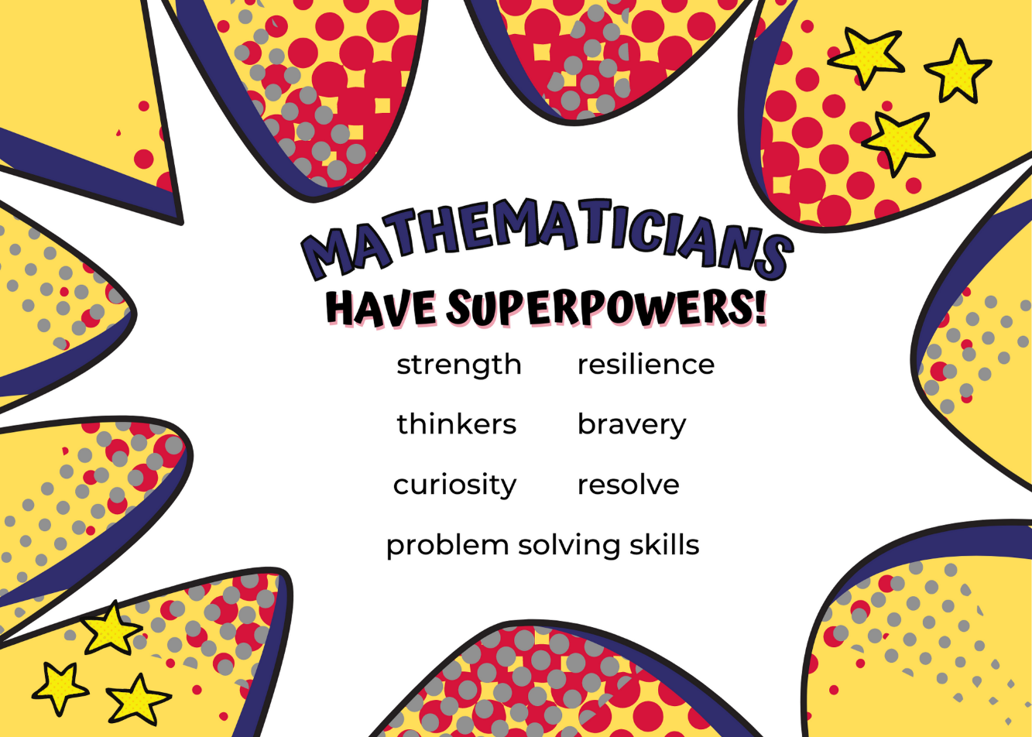
Images sourced from Canva and used in accordance with the Canva Content License Agreement.
- In groups of 3 or 4, students reflect on the things they don’t like people to say or do when working on maths problems together. For example, people telling them the answer or ignoring other people’s ideas. Students record their ideas using pictures, symbols, or words on a poster.
- Students brainstorm things they like people to say or do when working together. For example, listening to each other or working as a team to solve the problem. Students record their ideas using pictures, symbols, or words on a poster.
- As a class, groups share their posters and display these in the classroom. They can be referred to and built upon throughout the year.
The table below details assessment opportunities and differentiation ideas.
Assessment opportunities | Too hard? | Too easy?
What to look for:  - Can students discuss the qualities of a mathematician? (MAO-WM-01)  - Are students able to identify the skills required to participate in mathematical group tasks? (MAO-WM-01)  - Can students communicate their thinking through drawings, words and symbols? (MAO-WM-01)  What to collect:  - students’ posters. (MAO-WM-01). | Students are unable to identify the skills required to participate in mathematical group tasks.  - Students work together to solve a riddle. Pause the class to highlight the skills being modelled.  - Model through role-playing the skills required and pause the role-play to discuss at key points. | Students are able to identify the skills required to participate in mathematical group tasks. Pose the problem: ‘You are working in a group and one of the group members is not saying or doing anything’. Ask students to identify ways to make sure all group members are involved in the task.

Consolidation and meaningful practice: Attribute Anna – 15 minutes
This task has been adapted from Noah (University of Cambridge 2022).
- Display Resource 2: Attribute Anna's animals.
- Explain that our maths superhero Attribute Anna has a problem she needs help to solve. She is creating a mathematical zoo and she has invited all the animals to come and stay. Unfortunately, her superhero mask fell when the animals were entering the zoo and she could only count the animals’ legs. She counted 12 legs but does not know how many animals entered the zoo. Ask how many animals Attribute Anna could have seen. Challenge students to find as many different possible answers.
- Students work in groups to find a solution to Attribute Anna’s problem. They use a variety of materials including blocks, counters, or connecting cubes.
- Students record their thinking using numbers, words, symbols, or pictures.
- Draw attention to the posters about working effectively in mathematical groups. Highlight groups who are modelling effective group work strategies.
- Students conduct a gallery walk to see other solutions to the problem.
- As a class, create a mathematical vocabulary anchor chart from terms used in the lesson. Students contribute to a definition of each term using words, symbols, or pictures. For example, mathematics, investigate, and attribute. Refer to the anchor chart in later lessons. Add new words to the chart and display the anchor chart in the classroom.
The table below details assessment opportunities and differentiation ideas.
Assessment opportunities | Too hard? | Too easy?
What to look for:  - Can students communicate their thinking through drawings, words, and symbols? (MAO-WM-01)  - Are students working effectively together in the group? (MAO-WM-01)  - Can students use concrete materials to help solve the problem? (MAO-WM-01)  - Are students able to use flexible strategies to solve addition problems? (MA1-CSQ-01)  What to collect:  - observations of group discussions (MAO-WM-01)  - records of group solutions to the task. (MAO-WM-01). | Students are not listening to others or working effectively in their group.  - Pause the lesson and review the posters made in the previous lesson.  - Model asking questions that involve all students' ideas. | Students are working effectively together in the group task.  - Explain that Anna recounted and there were actually 20 legs. Ask students to solve the new problem.  - Ask students what would happen if there were an odd number of legs. Prompt students to explain whether it would work and record their answers.

Lesson 2: How many do you see?
Core concept: Mathematicians reason, convince others and ask questions.
The table below contains suggested learning intentions and success criteria. These are best co-constructed with students.
Learning intentions | Success criteria
Students are learning that:  - mathematicians work with others to solve problems  - combinations of 2 numbers (between 0 and 10) when added together, form 10  - the commutative property helps to recall addition facts  - the symbol + means ‘add’ and the symbol = means ‘is equal to’  - addition problems can be solved using advanced count-by-one strategies. | Students can:  - give reasons about how many vegetables they counted  - make groups of two numbers that add up to 10  - recognise and use the + and = sign  - recognise that 6 + 4 is the same as 4 + 6  - convince other students of their thinking about how many  - ask questions of others to understand their thinking.

Daily number sense: 3 tens in a row – 15 minutes
- Build student understanding of number bonds up to 10 by playing 3 tens in a row.
- Watch the video 3 tens in a line (2:29).
- Students play several rounds of the game in pairs.
The table below details assessment opportunities and differentiation ideas.
Assessment opportunities | Too hard? | Too easy?
What to look for:  - Can students recognise, recall, and record two numbers that add up or bond to form 10? (MA1-CSQ-01)  - Are students able to recognise and use the symbols for plus (+) and equals (=)? (MA1-CSQ-01)  - Do students apply the commutative property to addition facts? (MA1-CSQ-01)  - Can students record number sentences in a variety of ways using drawings, words, numerals, and symbols? (MA1-CSQ-01)  What to collect:  - observations of students as they participate in the game. (MA1-CSQ-01). | Students cannot recognise, recall, and record 2 numbers that add up to 10.  - Use visual representations of numbers to assist with combining and separating quantities. For example, ten-frames and counters.  - Model, using counters or blocks, the action of combining and separating quantities.  - Model using 5 as a reference in forming numbers from 6 to 10. | Students recognise, recall, and record numbers that add up to 10. Students play the game with a larger dice (0 to 20) and make 3 twenties in a row.

How many do you see? Part 1 – 30 minutes
This task has been adapted from Boaler et al. (2021).
- Revise the anchor charts about the superpowers of mathematicians and mathematical vocabulary. Remind students that if they hear a new mathematical word, it can be added to the anchor chart.
- Tell students that as mathematicians you have some important jobs to do. Explain to students, mathematicians have 3 very important jobs:
- Mathematicians reason and share their thinking with others.
- Mathematicians explain, show, or give evidence to convince others.
- Mathematicians listen and ask questions to make sense of the thinking of others’ ideas.
- Add these jobs to the mathematical vocabulary class anchor chart from the previous lesson.
- Tell students they are going to see an image that has lots of different things on it. They are going to be mathematician superheroes and figure out how many they see.
- Display Resource 3: How many do you see? (Part 1). Ask students how many they see. Give students time to think and wonder.
- Select students to share their thinking about what they saw. Explain that if students don’t understand someone else’s thinking, it is their job to ask a question. This helps people to explain their ideas and convince others of their thinking.
- Students share the quantities they saw, being specific about what they counted and the total amount.
- Ask questions to support students in explaining what they saw and how they saw it. For example, where did you see the 5 or 5 what?
- Record students’ thinking on the image, labelling the number, the unit (the vegetable), and how they saw the quantity. Encourage students to ask questions and provide reasoning for their thinking.
- Revise the 3 important jobs mathematicians have: reasoning, convincing, and posing questions. Have students share examples from the lesson, providing evidence of thinking, offering ideas, asking questions. Explain this is what a mathematician superhero does.
The table below details assessment opportunities and differentiation ideas.
Assessment opportunities | Too hard? | Too easy?
What to look for:  - Are students able to give reasons for their mathematical thinking about how many they saw? (MAO-WM-01)  - Can students convince others with evidence of their mathematical thinking? (MAO-WM-01)  - Are students able to ask questions to clarify their understanding of others' ideas? (MAO-WM-01)  - Can students use advanced count-by-one strategies including counting on to solve addition and subtraction problems? (MA1-CSQ-01)  What to collect:  - observations of student discussions. (MAO-WM-01, MA1-CSQ-01) | Students are unable to explain or reason about how many they saw.  - Encourage students to circle groups of vegetables with recognisable patterns. For example, group the carrots, then group the capsicums. Model using one to one counting patterns to determine how many.  - Create a model of the image using concrete materials. Students use one to one correspondence to determine how many they see. | Students are able to explain or reason about how many they saw.  - Students create their own image using resources in the classroom and ask a partner how many they see.  - Ask students to manipulate the objects to explain their thinking.

Consolidation and meaningful practice: How many do you see? Part 2 – 15 minutes
- Place students in groups of 3 or 4 and provide them with a copy of Resource 4: How many do you see? (Part 2).
- Students identify how many they see, explaining their thinking to the group.
- Students ask questions to understand others’ thinking. Students respond, providing reasoning and convincing evidence to support their ideas.
- Add new mathematical language to the mathematical vocabulary anchor chart. For example, reasoning, convincing, quantities and numbers.
The table below details assessment opportunities and differentiation ideas.
Assessment opportunities | Too hard? | Too easy?
What to look for:  - Are students able to give reasons for their mathematical thinking about how many they saw? (MAO-WM-01)  - Can students convince others with evidence of their mathematical thinking? (MAO-WM-01)  - Are students able to ask questions to clarify their understanding of others' ideas? (MAO-WM-01)  - Can students use advanced count-by-one strategies including counting on to solve addition and subtraction problems? (MA1-CSQ-01)  What to collect:  - student annotated images. (MAO-WM-01, MA1-CSQ-01). | Students are unable to explain or reason about how many they saw.  - Support students to circle groups of vegetables with recognisable patterns. For example, group the potatoes, then group the chillies. Model using one to one counting patterns to determine how many.  - Create a model of the image using concrete materials and have students use one to one correspondence to determine how many. | Students are able to explain or reason about how many they saw. Students create their own image using resources in the classroom and ask a partner how many they see.

Lesson 3: Attributes of polygons
Core concept: Shapes can be recognised and classified by their features.
The table below contains suggested learning intentions and success criteria. These are best co-constructed with students.
Learning intentions | Success criteria
Students are learning that:  - attributes are the features of a shape  - polygons are closed 2D shapes with more than 3 sides  - polygons can be sorted and classified according to the number of sides or vertices  - shapes can be identified in different orientations. | Students can:  - identify the attributes of shapes  - recognise, find, and name 2D shapes (circle, triangle, square, rectangle, pentagon, hexagon, and octagon)  - use the words side, vertex, and two-dimensional to describe shapes  - sort shapes into polygons and non-polygons  - sort shapes by the number of sides and vertices  - make a table to show how they sorted their shapes.

Daily number sense: Shape talk – 10 minutes
- Build student understanding of the attributes of 2D shapes by exploring and reasoning in a shape talk activity.
- Display Resource 5: Shape talk. Students turn and talk to a partner to discuss which one does not belong.
- Encourage students to reason with or convince a partner of their thinking. For example, the circle does not belong as it is the only one with curved lines.
- As a class, discuss student responses and highlight that there is more than one solution.

Polygon hunt – 30 minutes
- Revise the anchor charts about the superpowers of mathematicians and mathematical vocabulary. Remind students to add new mathematical words to the anchor chart.
- Refer to the shape talk and explain how attributes are used to sort and classify shapes.
Attributes are the traits or the properties of a shape or an object. Attributes help define the characteristics of the shape both visually, for example, its colour, and mathematically, for example, the length of the sides.
- Give students a selection of pattern blocks including squares, triangles, rectangles, pentagons, hexagons, and octagons. Explain to students what a polygon is and that they are going on a polygon hunt with the pattern blocks.
A polygon is a flat two-dimensional shape with 3 or more straight sides that are fully closed. The sides must be straight, not curved.
- Ask students to sort their collection of pattern blocks into polygons and non-polygons. Students name the shapes as they sort and explain their thinking. For example, a square is a polygon; it has 4 straight sides and is fully closed.
- As a class revise the sort, identifying the key features of polygons.
- Discuss that we can further sort our polygons using visual attributes. These include number of sides, vertices, size, and colour. Using a pattern block, identify the sides and vertices of a rectangle.
A vertex is where 2 straight sides of a two-dimensional shape meet. A side is the line segment joining two vertices of a two-dimensional shape.
- In pairs or groups, students explore how to further sort the polygons. Students then discuss and reason about their sort.
- Have students record their thinking in a table (see Figure 2).
Figure 2 – Example of table structure
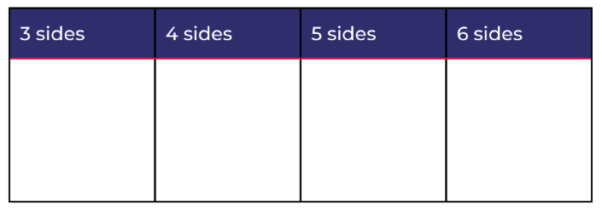
- Ask students:
- How did you sort your polygons? Explain your reasoning.
- Do some polygons fit in more than one sort? Why or why not?
- Can you identify any other features of your shapes?
- Can you think of another way to sort your polygons?
- How did you record your thinking?
- Invite students to share with the class how they sorted the polygons. Encourage students to reason and convince others of their mathematical thinking. Provide opportunity for students to ask questions to further their understanding of others’ classification choices.
- Add new words to the mathematical vocabulary anchor chart. For example, polygon, side, vertex, attributes, and non-polygons, and shape names such as, square, rectangle, circle, hexagon, and pentagon.
The table below details assessment opportunities and differentiation ideas.
Assessment opportunities | Too hard? | Too easy?
What to look for:  - Do students recognise and name 2D shapes? (MA1-2DS-01)  - Can students identify the attributes of shapes? (MA1-2DS-01)  - Are students using the words side, vertex, and two-dimensional, to describe shapes? (MA1-2DS-01)  - Can students sort shapes into polygons and non-polygons and by the number of sides and vertices? (MA1-2DS-01)  - Can students reason and explain their thinking about their sort? (MAO-WM-01, MA1-2DS-01)  - Can students record data in a table? (MAO-WM-01, MA1-DATA-01, MA1-DATA-02)  What to collect:  - observations during students’ discussions (MAO-WM-01, MA1-2DS-01)  - photographs of attribute sort (MA1-2DS-01)  - students’ work samples; table of data. (MAO-WM-01, MA1-2DS-01, MA1-DATA-01, MA1-DATA-02). | Students are unable to recognise and name 2D shapes:  - Revise names and features of common 2D shapes.  - Use images of shapes to support students’ understanding.  Students cannot sort shapes by attributes. Revise attributes including size, sides, and vertices. Guide students to use one to one correspondence to count the sides and vertices of a range of 2D shapes. | Students are able to name 2D shapes. Give students a square coloured paper to cut into 2 triangles. Cut one triangle into 2 triangles. Students use the 3 shapes to create many different 2D shapes (see Figure 3).  Students can sort shapes by attributes. Explain that rectangles and squares can be further classified as quadrilaterals; a quadrilateral is a polygon that has 4 sides, 4 angles, and 4 vertices. Have students sort their pattern blocks into quadrilaterals and non-quadrilaterals.
Figure 3 – Paper triangles

Consolidation and meaningful practice: Scavenger hunt – 20 minutes
- Discuss that shapes can be found in the environment. Make a class list of shapes in the classroom, for example, a book has a rectangle on the front cover.
- In pairs, students complete an outdoor scavenger hunt for polygons and non-polygons. Print Resource 6: Scavenger hunt for students. If devices are available students can use these instead of the printed resource, with students taking a photo and annotating the image (see Figure 4).
Figure 4 – Example of an outdoor polygon
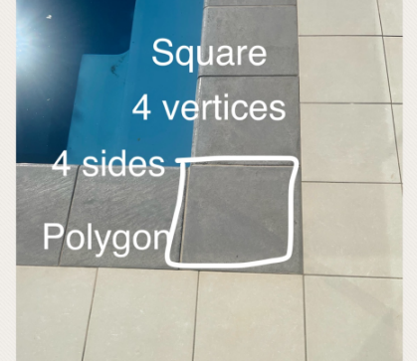
- As a class, students share their findings of the scavenger hunt. This information could be recorded on a whole class table.
The table below details assessment opportunities and differentiation ideas.
Assessment opportunities | Too hard? | Too easy?
What to look for:  - Can students identify 2D shapes in the playground? (MA1-2DS-01)  - Can students sort shapes into polygons and non-polygons and by number of sides and vertices? (MA1-2DS-01)  - Are students using the words ‘side’, ‘vertex’ and ‘two-dimensional’ to describe shapes? (MA1-2DS-01)  What to collect:  - a completed work sample such as Resource 6: Scavenger hunt or an annotated digital image. (MA1-2DS-01) | Students are unable to identify shapes in different orientations. Use a resource, such as a pattern block or printed shape, to take into the playground as a scaffold. Have the students refer to the shape and compare it to objects in the playground. Show the students similar features, for example, the number of sides. | Students can identify shapes in different orientations. Students identify 3D objects in the playground and identify the 2D shapes hiding inside these objects.

Lesson 4: Attribute shape patterns
Core concept: Shapes can be categorised by using different attributes.
The table below contains suggested learning intentions and success criteria. These are best co-constructed with students.
Learning intentions | Success criteria
Students are learning that:  - shapes can be different but share attributes  - some attributes are mathematical and some are not  - the same shapes can be sorted in different ways  - information (data) can be presented in different ways. | Students can:  - name and describe shapes  - identify attributes across shapes  - sort shapes based on more than one attribute  - re-sort shapes based on a different attribute  - create a table showing how they sorted shapes.

Daily number sense: 15 minutes
- From a class need surfaced through formative assessment data, identify a short, focused activity that targets students’ knowledge, understanding, and skills. Example activities may be drawn from the following resources:
- Thinking Mathematically Stage 1
- Universal Resources Hub

Attributes of shapes – 40 minutes
- Revise the anchor chart about the superpowers of mathematicians and mathematical vocabulary. Remind students to add new mathematical words to the anchor chart.
- Print, cut out, and display Resource 7: Shapes to sort. Ask students how they would categorise or sort the shapes and prompt them to explain their thinking. Provide independent thinking time, then time to talk with another student. Strategically select groups of students to share their thinking with the class.
- Ask if there are other shapes that share attributes. Prompt students to organise the shapes to show the relationships, as they did in the previous lesson (see Figure 2). In small groups, students explore other ways they can sort the shapes and go on a gallery walk to see how other students have sorted their shapes.
- Provide students with a copy of Resource 7: Shapes to sort and they sort the collection in different ways. Encourage students to sort the collections using 2 or more attributes.
- In small groups, students organise the shapes into two-way sorts. Ask:
- What attributes are shared?
- Is it possible to organise your collection into another two-way sort using different attributes?
- How can we represent this information visually using pictures and symbols?
- Display a selection of student two-way sorts to highlight a range of attributes, for example, number of sides, colour, size, orientation. Add additional words to the mathematics vocabulary anchor chart.
The table below details assessment opportunities and differentiation ideas.
Assessment opportunities | Too hard? | Too easy?
What to look for:  - Are students able to identify the attributes of shapes? (MAO-WM-01, MA1-2DS-01)  - Are students able to sort the shapes based on different attributes?  - Are students able to complete a two-way sort? (MAO-WM-01, MA1-2DS-01)  - Can students create a table to represent the sort? (MAO-WM-01, MA1-DATA-01, MA1-DATA-02)  What to collect:  - observations and photographs during the sort activity (MA1-2DS-01)  - work sample – the table representing the sort. (MA1-2DS-01, MA1-DATA-01, MA1-DATA-02) | Students cannot identify the attributes of shapes and/or the categories.  - Support students to identify attributes by selecting several shapes. Ask what is similar about the 2 shapes and what is different.  - Provide labels for the sections of the table according to their response. Ask students where the other shapes belong. Assist them to complete the attribute sort. | Students fluently sort shapes into a table and can explain the relationships between categories and objects.  - Ask students to find another way to organise the shapes in their table, showing which shapes belong to more than one category.  - Students investigate how many ways there are to sort their chosen shapes based on the attributes.

Lesson 5: Numbers have attributes too
Core concept: Numbers can be sorted according to their attributes.
Note: Number sense refers to ‘a well organised conceptual framework of number information that enables a person to understand numbers and number relationships’ (Bobis 1996). These are the attributes of numbers. In this lesson, students will explore some of the attributes of numbers and how numbers might be sorted according to their attributes.
The table below contains suggested learning intentions and success criteria. These are best co-constructed with students.
Learning intentions | Success criteria
Students are learning that:  - some attributes are mathematical, and some are not  - numbers have attributes which can be used to describe and sort them  - numbers can be different but share attributes  - the same numbers can be sorted or categorised in different ways. | Students can:  - recognise that numbers have mathematical attributes  - describe numbers by their parts and their relationship with other numbers. For example, 10 is used in the numbers 10 to 19  - organise numeral cards in a way that shows their shared attributes  - explain why numbers can be sorted (or categorised) into more than one category.

Daily number sense: Sorting dominoes – 20 minutes
- Build student understanding of identifying the attributes of numbers, including doubles, by using Sorting dominoes (13:27).
- Watch the start of the video and pause at 0:31 or use Resource 8: What do you notice? Students use paper or individual whiteboards to record what they noticed about the way the dominoes were sorted.
- Students share their pictures to show the attributes they identified from the dominoes, explaining why they think the dominoes were sorted this way.

Numbers have attributes too – 20 minutes
- Revise the anchor chart from the previous lesson and remind students to add new mathematical words to the anchor chart.
- Print, cut out, and display Resource 9: Numbers to sort. Ask students how they would sort the numbers, prompting them to explain why. Students think independently, then share their ideas with a partner. Strategically select groups of students to share their thinking with the class (see Figure 5 and Figure 6).
Figure 5 – Examples of sorting and labelling numbers
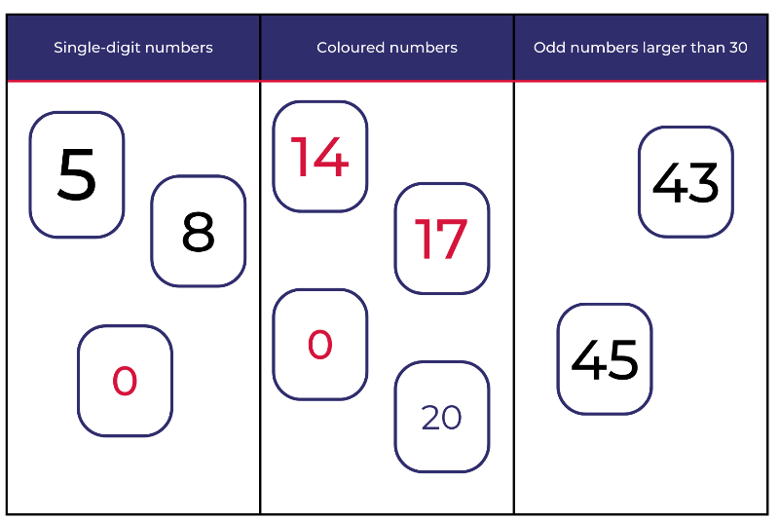
- In small groups students create their own number categories using Resource 10: Number cards (0 to 50).
Note: A gallery walk will allow students to explore other sorting strategies. Photos can be taken of the categories created by students to use in the ‘consolidation and meaningful practice’ part of the lesson.
Figure 6 – Examples of sorting numbers into categories
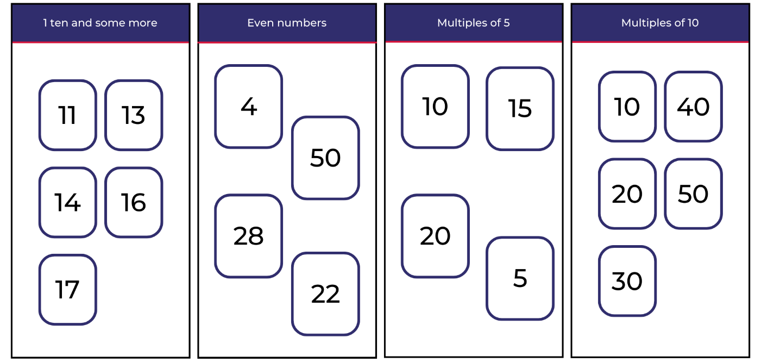
The table below details assessment opportunities and differentiation ideas.
Assessment opportunities | Too hard? | Too easy?
What to look for:  - Are students able to describe numbers by their parts? (MA1-RWN-01, MA1-RWN-02)  - Can students recognise number patterns? (MA1-RWN-01, MA1-RWN-02)  - Are students able to use their knowledge of number bonds to create sort categories? (MA1-CSQ-01)  - Do students organise their data into displays and tables? (MA1-DATA-01, MA1-DATA-02)  What to collect:  - work sample – the number tables (MA1-RWN-01, MA1-RWN-02, MA1-CSQ-01, MA1-DATA-01, MA1-DATA-02)  - observations of students' discussions. (MAO-WM-01, MA1-CSQ-01). | Students are unable to identify a suitable category in which to place a number. Select a number and ask students what they know about the number. For example, 8 is 2 fours, is also 2 less than 10, and it is even. Ask, ‘Are there any other numbers that are also even and if so, what are they?’ | Students can sort numbers and describe categories according to their mathematical properties. Prompt students to use a two-way sort structure from previous lessons. Ask students if there are any numbers that could belong to more than one category. Identify these numbers and have students explain the relationship to a partner.

Consolidation and meaningful practice: Connecting and discussing some of the mathematics – 20 minutes
- Strategically select examples of how students have categorised numbers to share with the class.
- Add additional words to the mathematics vocabulary anchor chart.
The table below outlines stimulus prompts to generate conversation about the topic, along with anticipated responses from students.
Prompts | Anticipated student responses
- What do you notice about the way these numbers have been sorted or categorised?  - Is there anything that is the same?  - Is there anything that is different?  - Are there any other numbers that could be in 2 or more categories?  - What categories do they belong to? | - I noticed that some numbers have been used more than once. For example, 10 is included as a multiple of 5 and as a multiple of 10.  - Even though the numbers are different and represent different amounts, they share attributes. For example, 10, 15, 20, and 5 are all multiples of 5.
- Explain to students that, just like shapes, numbers can be different and still share attributes.

Lesson 6: Organising and counting a collection
Core concept: Organising objects into groups is a useful way to count larger numbers.
The table below contains suggested learning intentions and success criteria. These are best co-constructed with students.
Learning intentions | Success criteria
Students are learning that:  - a large collection of objects can be organised into groups to support the count  - organising objects into groups of 10 is an efficient way to count larger quantities  - groups of objects can be used to form a visual representation of an amount. | Students can:  - organise objects into smaller groups to see how many objects there are  - use groups of 10 to organise and count large amounts  - groups of objects can display an amount.

Daily number sense: Ten-frame filler – 20 minutes
- Build student understanding of 10 as a unit by playing Ten-frame filler (4:40), based on the work of Siemon et. al., (2020).
- In pairs, students take turns to roll a 6-sided dice. On Resource 11: Ten-frame filler gameboard, students record their total using one of the ten-frames in a single, sweeping movement, as viewed in the video.
- Students fill in part of the ten-frames on each turn. The player who completes a ten-frame, for example, rolling a 3 and there is a ten-frame with 7 already filled, claims it by writing their initials on top of it.
- If there is not enough space in any of the ten-frames, the player misses a turn. The player with the most ten-frames at the end is the winner.
- After the game has ended, ask students:
- Was there a strategy that helped you to win the game?
- What numbers do you think were the best to roll? Why?
- Have we found all the combinations to 10?
- What might happen if we had a third player? Would it make it easier or harder to win?

Organising and counting a collection – 20 minutes
- Revise the anchor chart and remind students that during the lesson we can add any new mathematical language.
- Show students a collection of between 20 to 100 objects, such as buttons, counters, or cubes. Explain that you want to organise the objects to find out how many there are.
- Students turn and talk to a partner about strategies they could use to organise the objects and find the total.
- Students share their thinking to the class. Highlight that there are many ways to organise the objects. Explain that some ways of organising objects are more efficient than others.
- Tell students that they will be creating ways of organising objects in collections to make it easier to count and see how many there are.
- In pairs, provide students with between 20 to 100 objects each. Provide students small containers for organising the groups. For example, cupcake liners, paper cups, or bowls.
- After experimenting to find the total by organising objects in collections, discuss as a class:
- How many objects are in your collection?
- How can you organise the objects to see and count how many there are?
- How does your organisation help you count?
- How can you record the way you organised and counted the collection?
- Provide opportunities for partners to work with multiple collections as they develop systems for organising and counting. Students use drawings and labels to record their work and then share with others.
- During the activity, asks pairs to explain their systems of counting. Ask students how their system supports accuracy in counting. Take photographs of the collections before and after sorting to show how organising objects into groups is a useful way to count larger numbers.
The table below details assessment opportunities and differentiation ideas.
Assessment opportunities | Too hard? | Too easy?
What to look for:  - Can students organise a large collection of objects into groups to support the count? (MA1-RWN-01, MA1-RWN-02, MA1-CSQ-01)  - Are students organising large collections of objects into groups of ten as an efficient way to count larger quantities? (MA1-RWN-01, MA1-RWN-02, MA1-CSQ-0)  - Do students use groups of objects to form visual representations of amounts? (MA1-DATA-01, MA1-DATA-02)  What to collect:  - photographs of collections and student work samples. (MA1-RWN-01, MA1-RWN-02, MA1-CSQ-01, MA1-DATA-01, MA1-DATA-02). | Students do not organise a large collection of objects into groups to support the count.  - Use a smaller collection of objects and model forming groups.  - Support students to use containers to form groups of objects.  Students do not organise a large collection into groups of 10.  - Model how to form groups of 10 objects.  - Support students to count the groups using rhythmic and skip counting.  Students do not use groups of objects to form a visual representation of an amount. After forming groups, model how they can be arranged to represent the amount, such as by putting the groups in a row. | Students are able to organise a large collection of objects into groups to support the count.  - Encourage students to organise their collections using tens and ones, explaining that this can be the most useful way to organise collections.  - After using tens and ones, ask students to explain how organising in groups of 10 helps with the count. How did students know that there were 10 in each group and how were the leftover objects counted?

Consolidation and meaningful practice: How can we organise and count? – 15 minutes
- As a class, discuss:
- How did you organise your objects for counting?
- How did you use containers, such as cupcake liners, paper cups, or bowls, to help you organise?
- Once you had organised your objects, how did you count?
- Which ways of organising helped your count? Why?
- How did you and your partner agree on how many objects were in each collection?
- Invite students to share the ways they organised the objects. Take photographs of the collections before and after sorting to show how organising objects into groups is a useful way to count larger numbers.
- Draw attention to the ways objects were grouped and how these groups connect to counting, such as counting by twos, fives, or tens. Ask:
- How does grouping objects make it easier to count them?
- How did you decide what size your objects would be?

Lesson 7: How many dots?
Core concept: Tens and ones are a useful way to organise combinations of numbers.
The table below contains suggested learning intentions and success criteria. These are best co-constructed with students.
Learning intention | Success criteria
Students are learning that combinations of numbers (number bonds) help quantify collections. | Students can:  - recognise combinations of numbers to 10  - group the dice collections to make groups of 10  - describe why counting in tens and ones is efficient.

Daily number sense: Part-whole combinations – 10 minutes
Number bonds are combinations of numbers that add to a specific number. For example, 7 + 3 = 10 and 6 + 4 = 10.
- Build student understanding of part-whole combinations to 10 by providing them with a target number and having them recall and record combinations.
- Spin the digital spinner to provide the target number. Students record combinations for that number on their individual whiteboards. For example, if 5 is spun, a student may write 3 and 2 or 3 + 1 + 1.
- Select students to provide combinations for the target number and record these on the board.
Note: If the same number is spun, challenge students to come up with different combinations.

How many dots? – 20 minutes
This task has been adapted from Boaler et al. (2021).
- Roll at least 10 dice. Looking at the dice, ask students how many dots there are and how they can be organised.
- Students turn and talk about efficient and effective strategies for organising the dice to count the collection.
- Students present their ideas of organising the dice to the class.
Note: Choose students who have grouped similar numbers in different ways and have them justify their strategy. If a pair has grouped by 10, use their combination to lead into the next part of the lesson.
- Students reflect on the efficient and effective strategies to count large collections of objects in Lesson 1 and Lesson 2.
- Roll the 10 dice again. Students turn and talk to determine the most efficient and effective way to organise and count the number of dots (see Figure 7).
Figure 7 – Organising dots
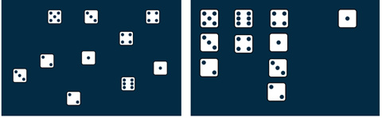
- Students share how they structured the dice to count the total number of dots effectively and efficiently. Draw attention to organising the dice in groups that add up to 10 and revise the concept that 10 ones is the same as 1 ten.

Count the dots – 20 minutes
- Provide small groups a collection of 10 to 20 dice and an individual whiteboard to record the total count. Students roll the dice, working together to organise the dice efficiently and effectively to count the dots.
- As students play, ask:
- How can you organise these dice to help you count?
- How might groups of 10 help you count the dots?
- What is the largest number of dots you rolled? How do you know?
Note: Take photographs of the ways students have organised their dice for the ‘discuss and connect’ part of the lesson.
The table below details assessment opportunities and differentiation ideas.
Assessment opportunities | Too hard? | Too easy?
What to look for:  - Can students create, recall, and recognise combinations of numbers to 10? (MA1-CSQ-01)  - Do students understand that 10 ones are the same as 1 ten? (MA1-RWN-01, MA1-RWN-02)  - Can students count large collections of objects by systematically grouping in tens? (MA1-CSQ-01)  What to collect:  - photos of how students have organised their dice (MA1-RWN-01). | Students cannot recognise combinations of numbers up to 10.  - Model combinations of 10 using coloured interlocking cubes.  - Support students to track the dots from the dice by providing them with counters and a ten-frame. | Students are able to organise the dice using an efficient counting method. Ask students how they can be sure that they have made all the combinations to 10. Students record all combinations and record a method to check their working.

Discuss and connect the mathematics – 10 minutes
- Summarise the lesson together. Draw out the key mathematical ideas with students by asking questions such as:
- How did you organise your dice to see how many dots there were?
- How did your strategies change as you played?
- What patterns did you notice that helped you to organise the dice?
- How did you count the dots without counting each dot individually?
- Are there any new words to add to our mathematical vocabulary chart?
- Display the pictures and ask:
- How did you organise your dice?
- How many dots are there?
- How did the organisation help you to count?
- What other ways could the dice be organised?

Lesson 8: Boxes of pencils
Core concept: Large collections can be quantified, organised, and represented in different ways.
The table below contains suggested learning intentions and success criteria. These are best co-constructed with students.
Learning intentions | Success criteria
Students are learning that:  - the same collection of objects can be represented in different ways  - mathematicians communicate their thinking using words, symbols, pictures, and numbers. | Students can:  - use the structure of a box of 10 pencils to organise a large collection of objects  - describe why counting in tens and ones is a good strategy  - communicate their thinking about counting strategies.

Daily number sense: 15 minutes
- From a class need surfaced through formative assessment data identify a short, focused activity that targets students’ knowledge, understanding, and skills. Example activities may be drawn from the following resources:
- Thinking Mathematically Stage 1
- Universal Resources Hub

Boxes of pencils – 20 minutes
This task has been adapted from Boaler et al. (2021).
- Display Resource 12: Box of pencils. Explain to students that pencils often come in packs of 10. Challenge students to figure out how many boxes of pencils they have to buy based on the number of individual pencils their class needs.
- Students turn and talk to a partner to discuss possible strategies.
Note: Monitor for students’ use of strategies, as well as understanding the idea of a pack of 10 and loose pencils.
- Students share their strategies for working out the number of boxes needed and loose pencils left over.
- Show class Resource 13: A class needs... Students answer the following questions with their partner:
- How many boxes can you make?
- How many loose pencils are left over?
- How can you check that you have the same number of pencils as the number needed by the class?
- Partners draw how they packed the pencils in their workbooks.
- Students complete a gallery walk. Collect photographs of the different structures students have created.
- Display the photographs and have students explain their strategies. Focus on groups that structured the pencils in groups of 10. Highlight efficient strategies and patterns between the images. For example, students may have drawn 10 pencils or they may have drawn a box with 10 on it.
The table below details assessment opportunities and differentiation ideas.
Assessment opportunities | Too hard? | Too easy?
What to look for.  - Do students recognise that 10 ones are the same as 1 ten by linking boxes of pencils to individual pencils? (MA1-RWN-01, MA1-RWN-02)  - Can students group in hundreds, tens and ones? (MA1-RWN-02)  - Are students communicating their reasoning behind their counting strategies? (MAO-WM-01)  What to collect:  - photos of students work presented in the gallery walk (MA1-RWN-01)  - student work samples (MA1-RWN-01) | Students do not recognise that 10 ones are the same as 1 ten. Students use concrete materials, like interlocking cubes, to represent 10 ones as 1 ten. Support students to translate this concrete representation into a drawing. | Students recognise that 10 ones are the same as 1 ten.  - Ask students what this would look like as a mathematical drawing and how they would structure their drawing so they do not rely on one-to-one counting.  - Ask students what they could do if they had 1000 pencils. Students draw a picture to show their thinking.

Consolidation and meaningful practice – 20 minutes
- Edit Resource 13: A class needs... with the new number of pencils required. Students consolidate their knowledge by repeating steps 7 and 8.
- Summarise the lesson together, drawing out some key mathematical ideas. Ask questions such as:
- How did you figure out how many boxes of 10 and how many loose pencils you had?
- Did you notice any patterns as you worked?
- Are there any words that can be added to the mathematical vocabulary chart?

Resource 1: Example anchor chart
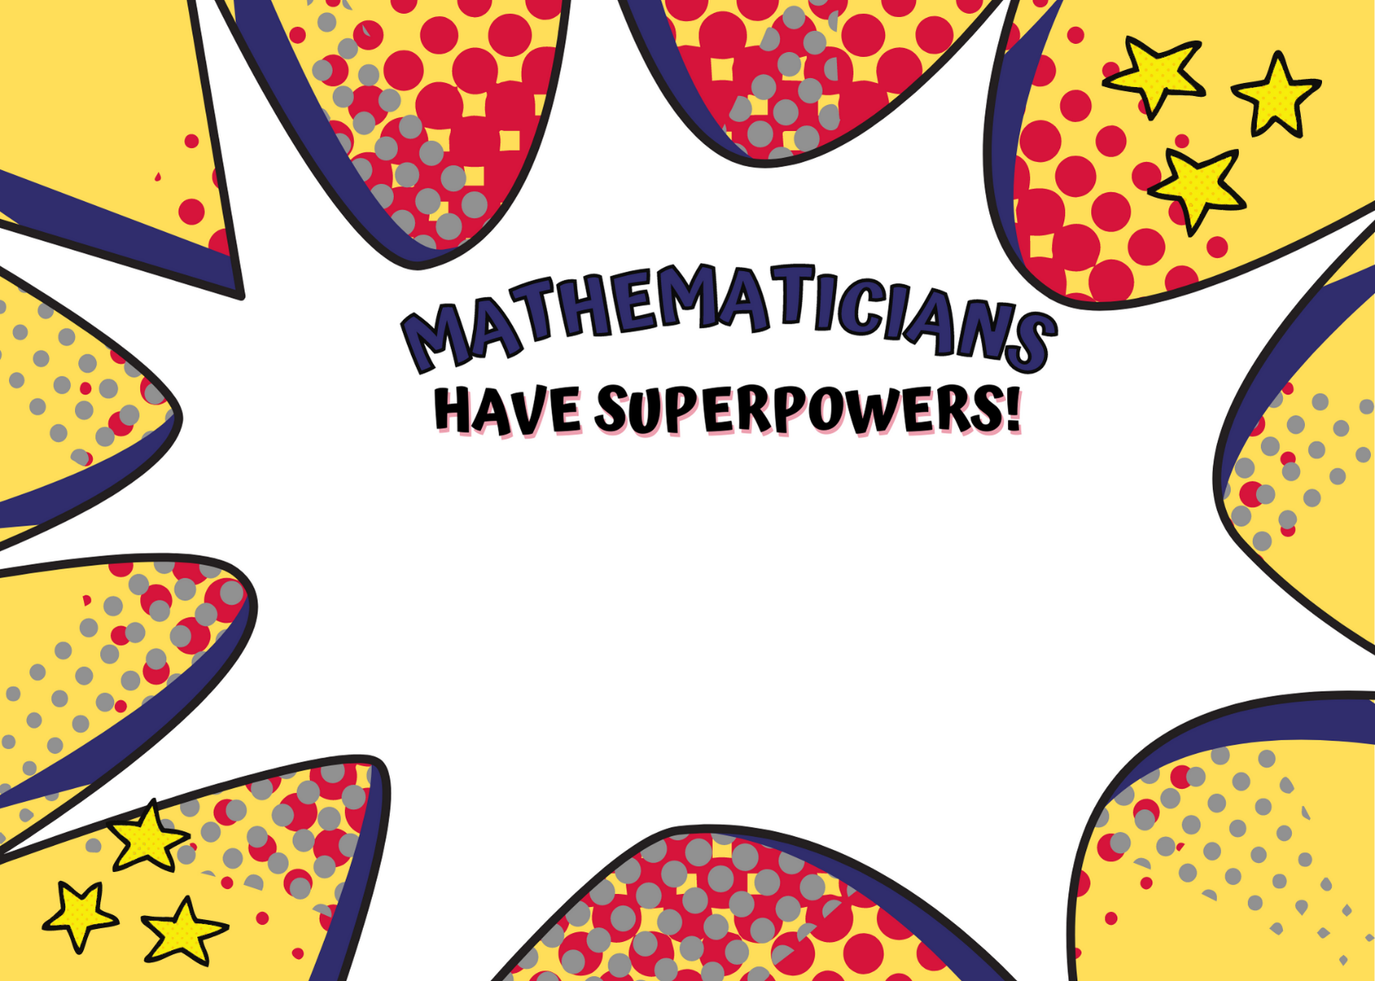
Images sourced from Canva and used in accordance with the Canva Content License Agreement.

Resource 2: Attribute Anna’s animals
Attribute Anna saw 12 legs walk past at the zoo. How many creatures could she have seen?
How many different answers can you find? Can you explain how you found out these answers?
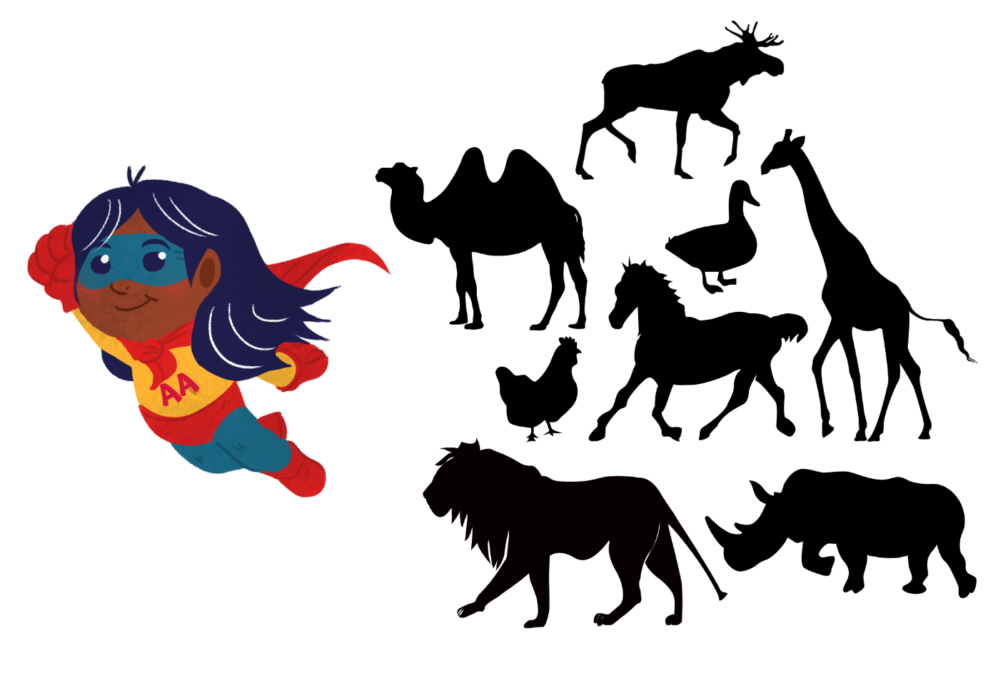
Images sourced from Canva and used in accordance with the Canva Content License Agreement.

Resource 3: How many do you see? (Part 1)
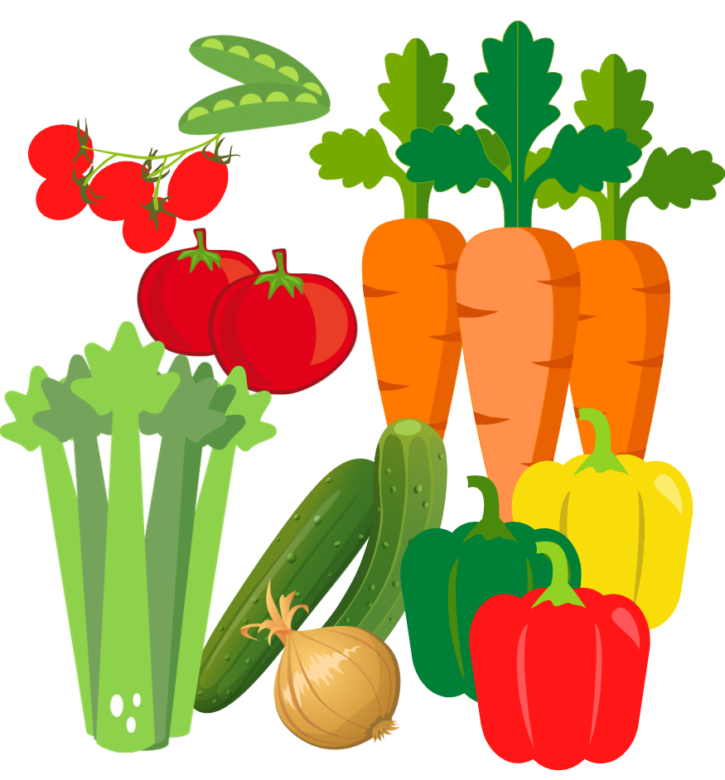
Images sourced from Canva and used in accordance with the Canva Content License Agreement.

Resource 4: How many do you see? (Part 2)
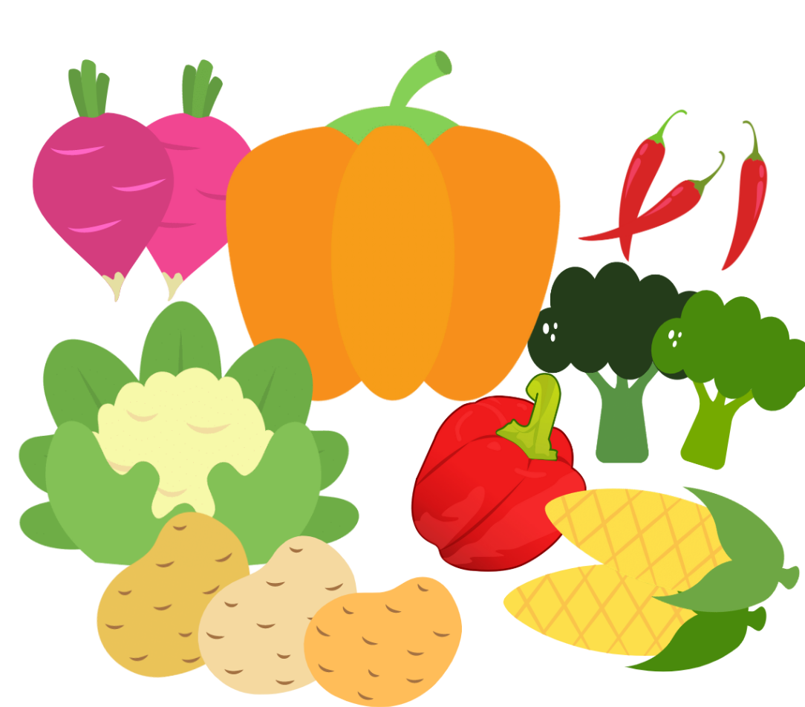
Images sourced from Canva and used in accordance with the Canva Content License Agreement.

Resource 5: Shape talk

Resource 6: Scavenger hunt
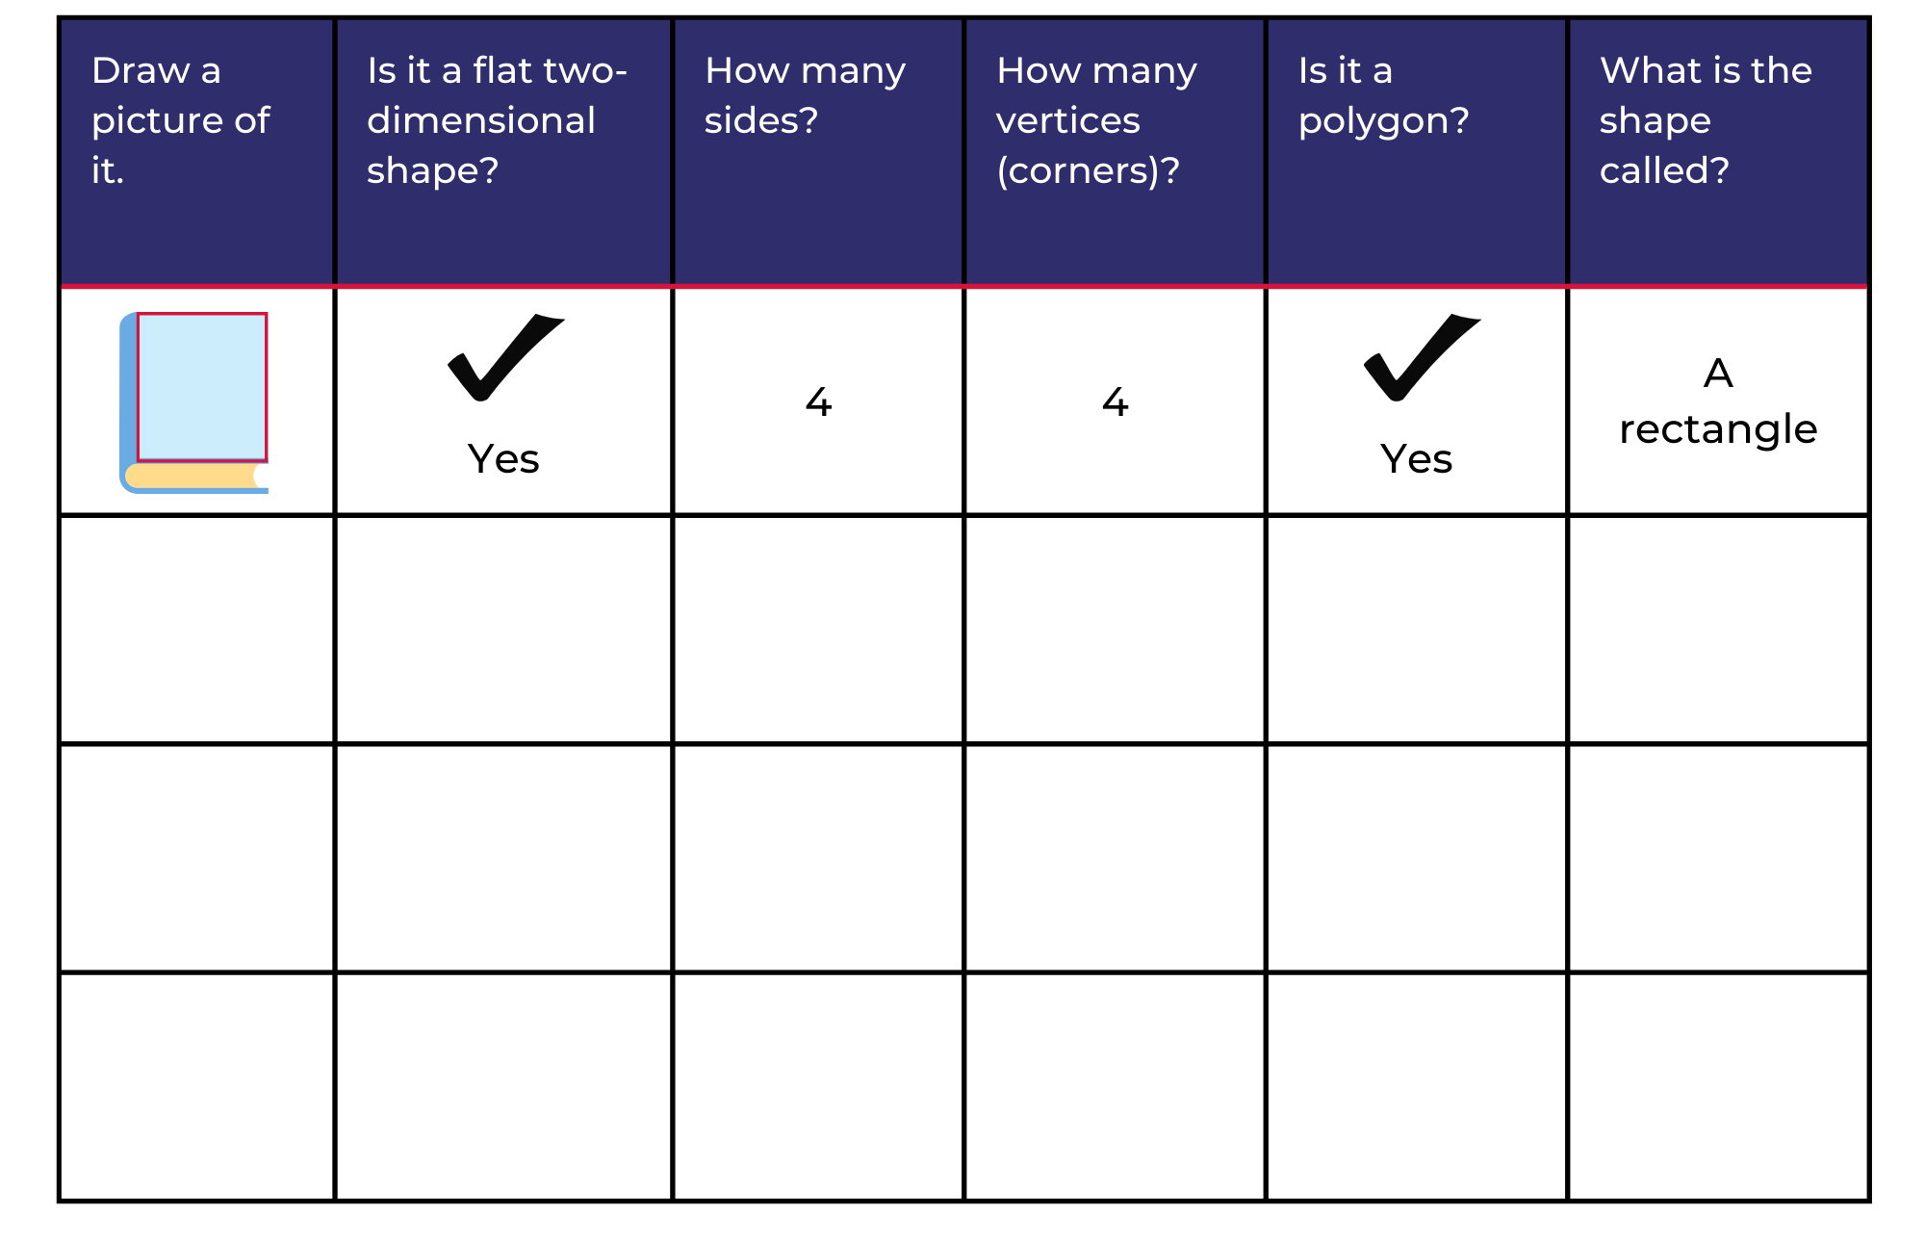

Resource 7: Shapes to sort
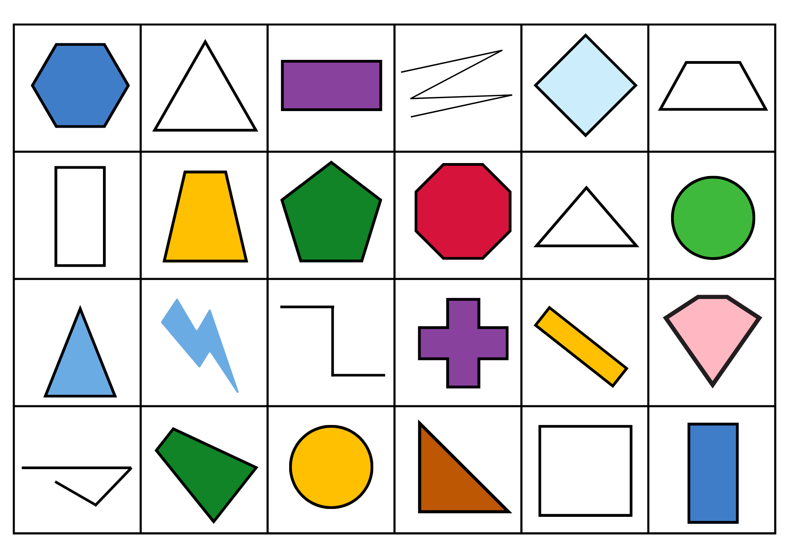

Resource 8: What do you notice?
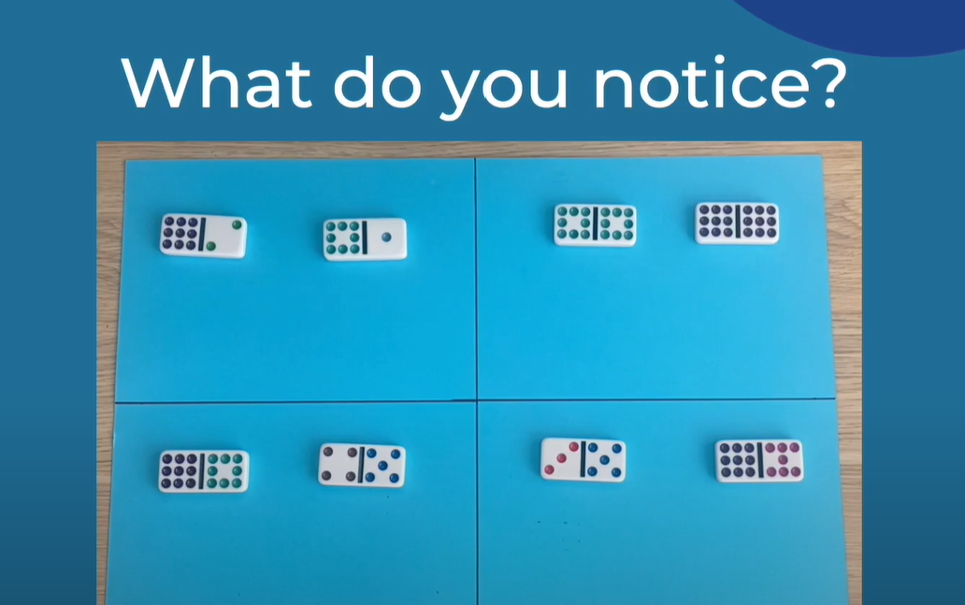

Resource 9: Numbers to sort
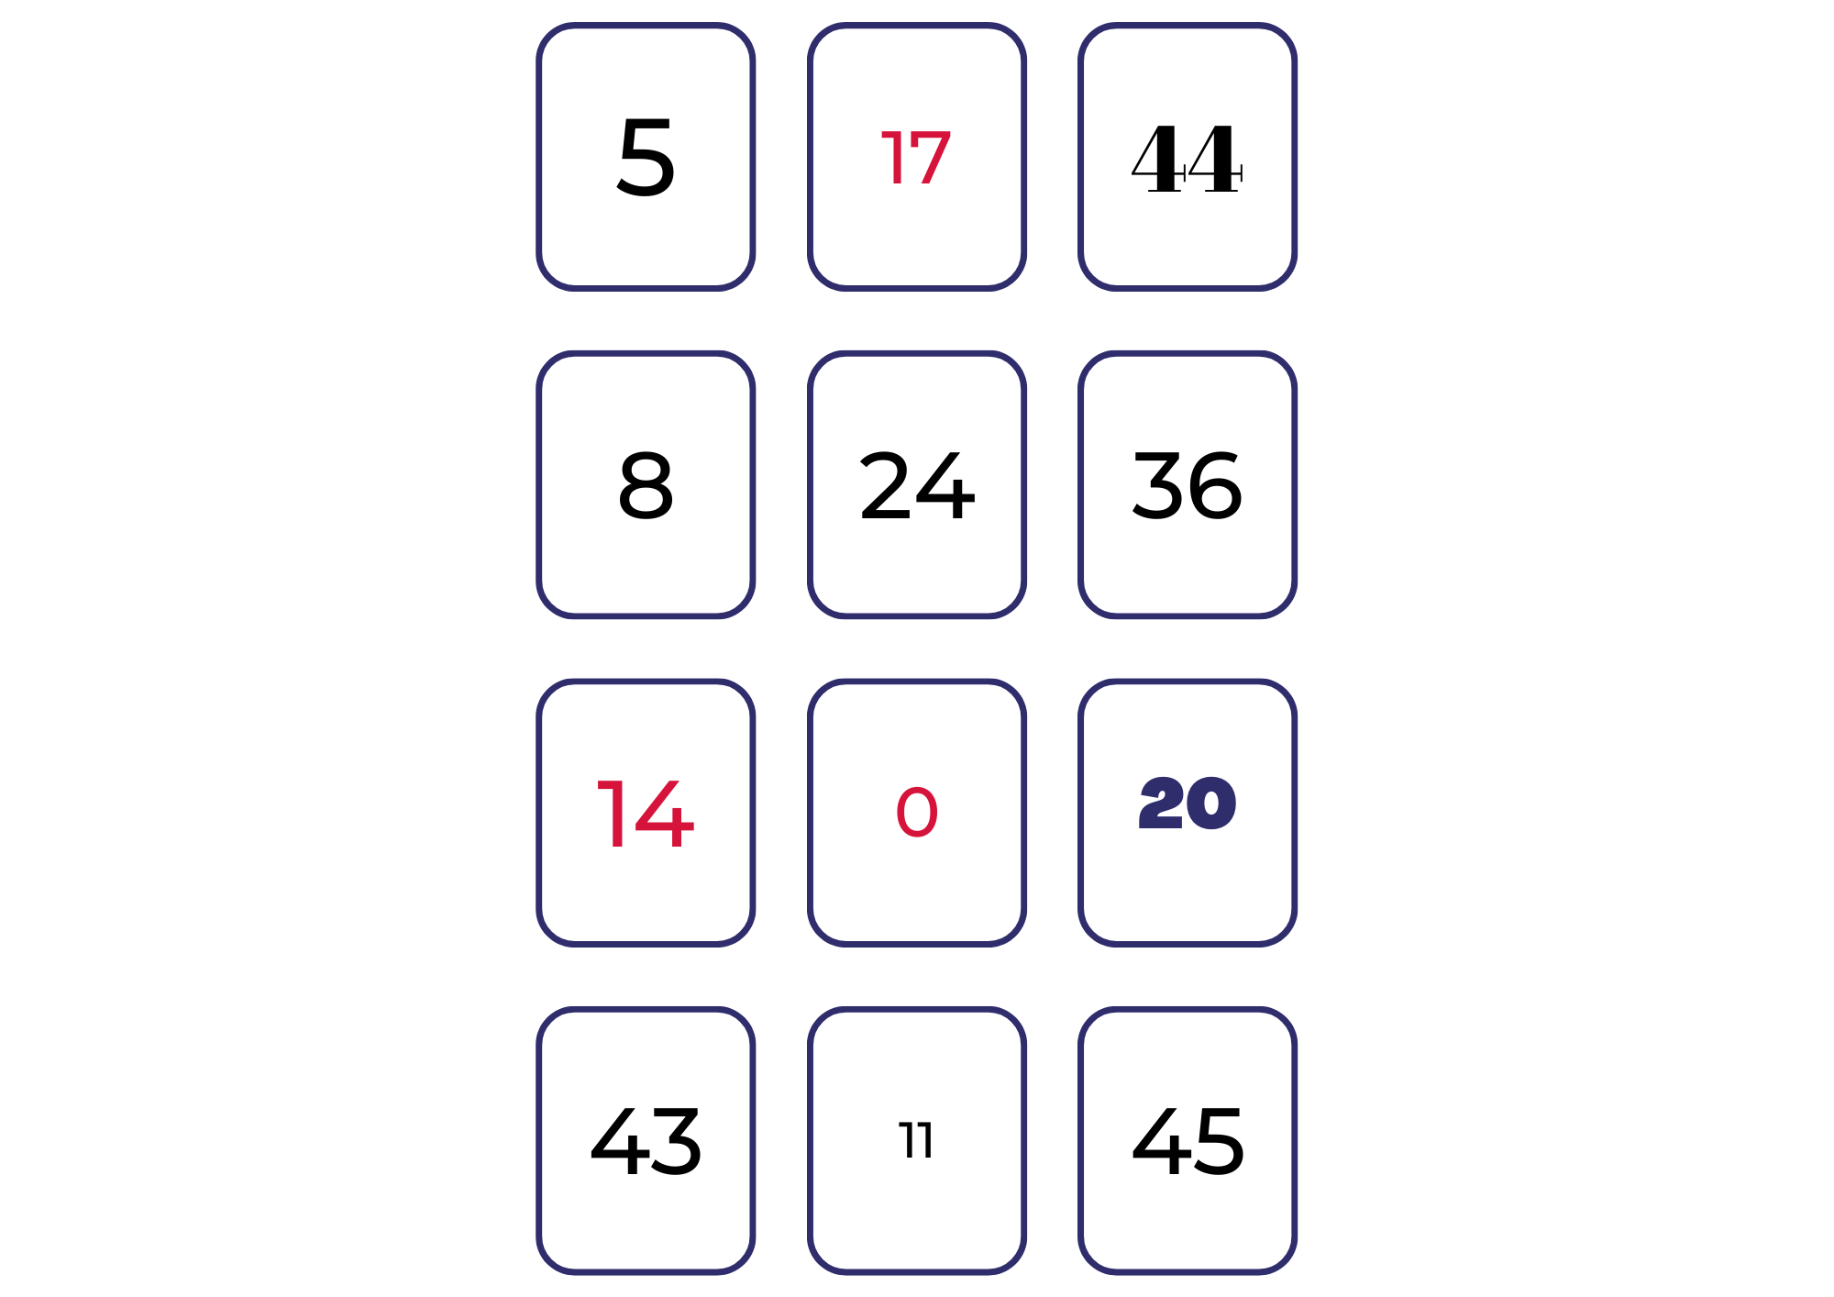

Resource 10: Number cards (0 to 50)
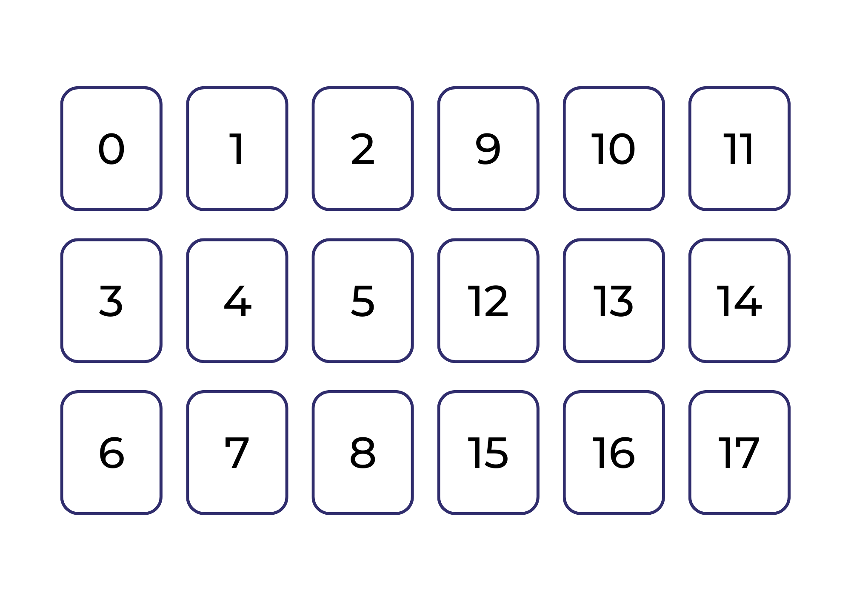
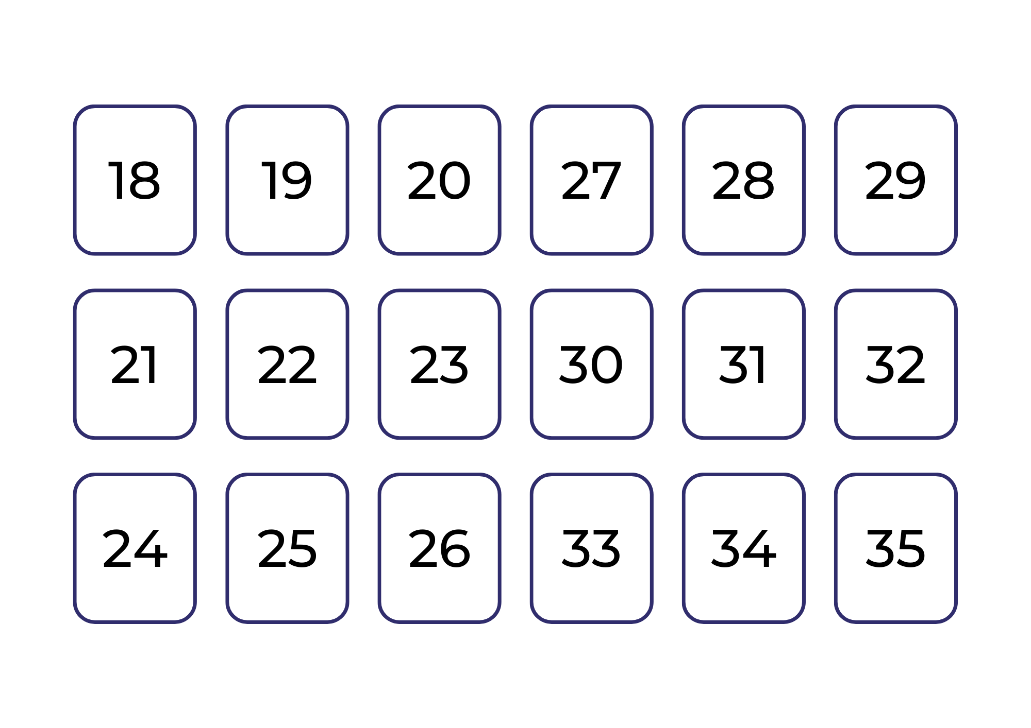
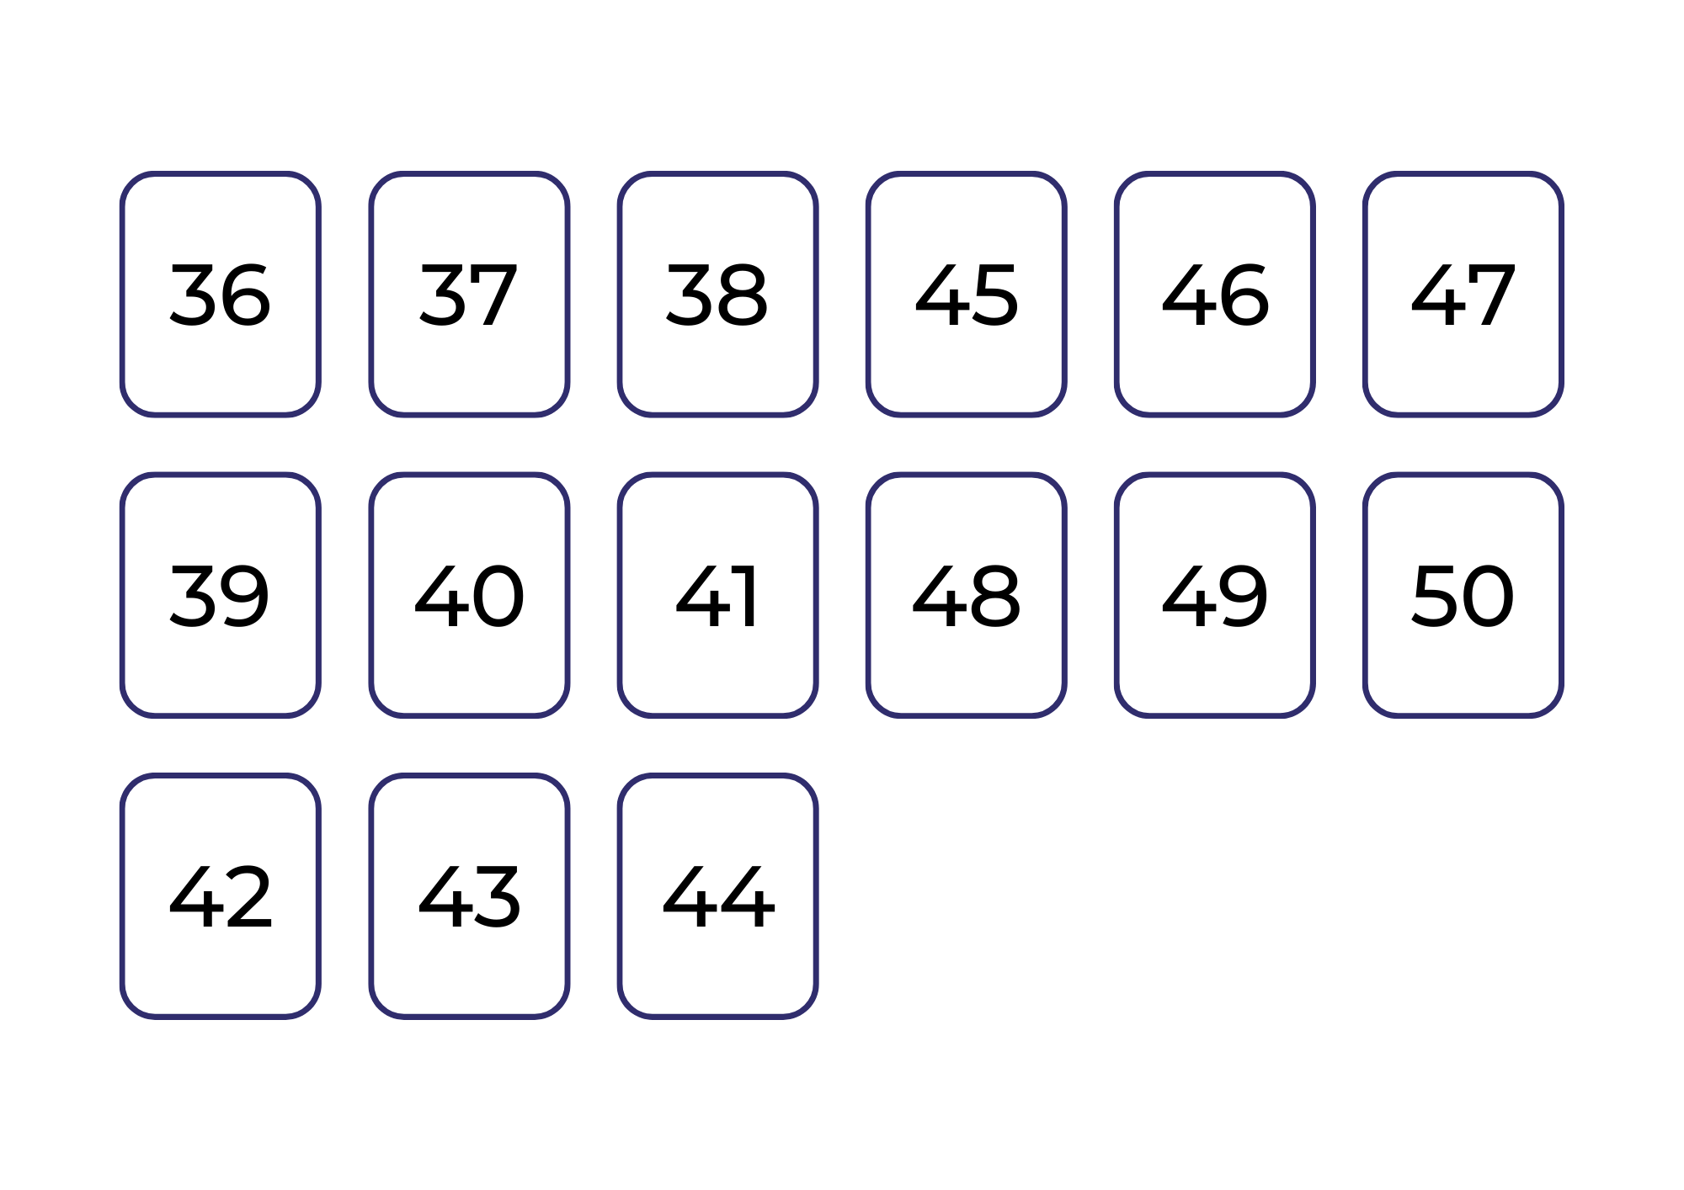

Resource 11: Ten-frame filler gameboard
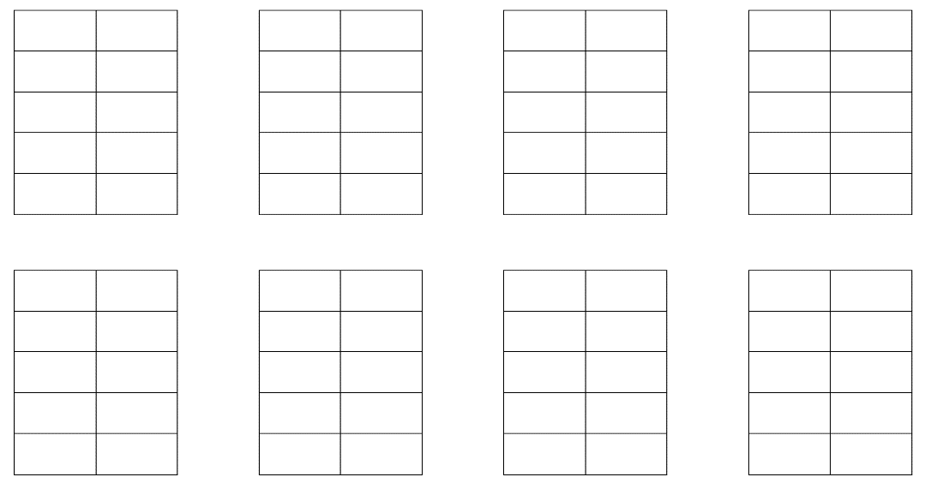

Resource 12: Box of pencils
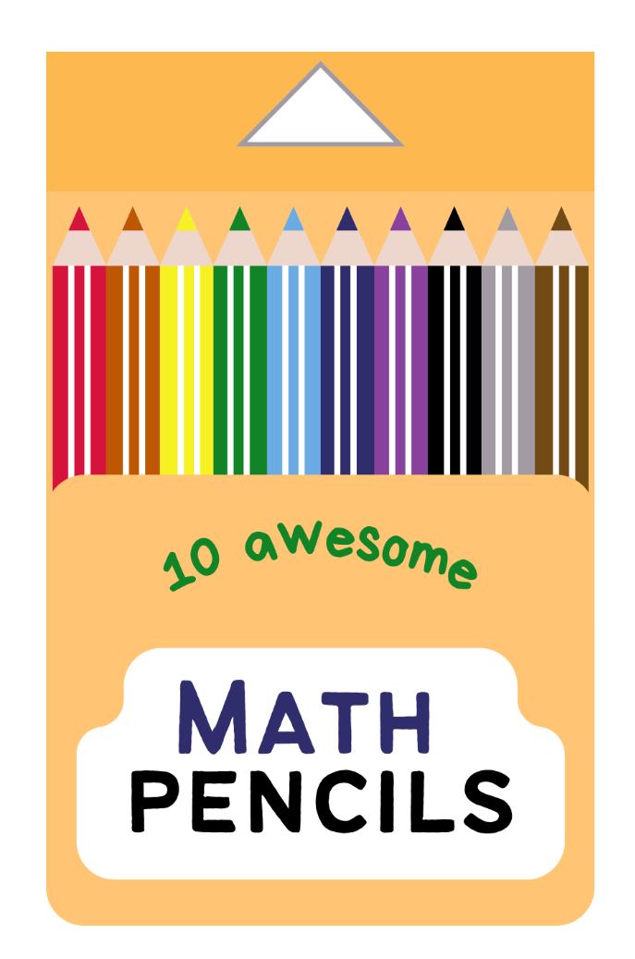
Images sourced from Canva and used in accordance with the Canva Content License Agreement.

Resource 13: A class needs...
A class needs... | How many full boxes can you make? | How many loose pencils are left over?
26 pencils
46 pencils
55 pencils
60 pencils
73 pencils
81 pencils
93 pencils
63 pencils
67 pencils
18 pencils
Adapted from Boaler et al. (2021).

Syllabus outcomes and content
The table below outlines the syllabus outcomes and range of relevant syllabus content covered in this unit. Content is linked to National Numeracy Learning Progression version (3).
Focus area and outcomes | Content groups and content points | Lessons
Representing whole numbers A  MA1-WM-01  MA1-RWN-01  MA1-RWN-02 | Use counting sequences of ones with two-digit numbers and beyond  - identify the number before and after a given two-digit number (CPr5)  - count forwards and backwards by ones from a given number to at least 120 (CPr6)  Represent the structure of groups of ten in whole numbers  - recognise that ten ones is the same as one ten (NPV2, NPV4)  - use 10 as a reference in forming numbers from 11 to 20 (CPr7)  - count large sets of objects by systematically grouping in tens (CPr7)  - estimate, to the nearest ten, the number of objects in a collection and check by counting in groups of ten (CPr7, NPV6) | 1 and 2, 5–8
Combining and separating quantities A  MA1-WM-01  MA1-CSQ-01 | Use advanced count-by-one strategies to solve addition and subtraction problems  - apply the terms ‘add’, ‘plus’, ‘equals’, ‘is equal to’, ‘is the same as’, ‘take away’, ‘minus’ and ‘the difference between’ to describe combining and separating quantities (AdS1, AdS6)  - recognise and use the symbols for plus (+), minus (-) and equals (=)  - record number sentences in a variety of ways using drawings, words, numerals and symbols (AdS6)  - fluently use advanced count-by-one strategies including counting on and counting back to solve addition and subtraction problems involving one- and two-digit numbers (AdS3- AdS5)  Recognise and recall number bonds up to ten  - recognise, recall and record combinations of two numbers that add up or bond to form 10 (AdS2, AdS6)  - model and record patterns for individual numbers up to ten by making all possible whole-number combinations  - create, recall and recognise combinations of two numbers that add up to numbers less than 10 (AdS2, AdS6)  - describe combinations for numbers using words such as more than, less than and double (AdS6)  Use flexible strategies to solve addition and subtraction problems  - use non-count-by-one strategies such as using doubles for near doubles and combining numbers that add to ten (AdS6)  - represent addition and subtraction using structured materials such as a bead string or similar model (AdS6-AdS7)  - select and apply strategies using number bonds to solve addition and subtraction problems with one- and two-digit numbers by partitioning numbers using quantity value and bridging to 10 (AdS6-AdS7)  Represent equality  - model the commutative property for addition and apply it to aid the recall of addition facts  - recall related addition and subtraction facts for numbers to at least 10 (AdS6) | 1 and 2, 5–8
Combining and separating quantities B  MA1-WM-01  MA1-CSQ-01 | Represent and reason about additive relations  - create, record and recognise combinations of two numbers that add to numbers from 11 up to and including 20 (AdS7)  - create, model and solve word problems, using number sentences  - represent the difference between two numbers using concrete materials and diagrams (AdS6)  - represent a constant difference between pairs of numbers  - recall and use related addition and subtraction number facts to at least 20 (AdS7)  Form multiples of ten when adding and subtracting two-digit numbers  - use quantity values to separate tens and ones for addition (only) (AdS7-AdS8)  Use knowledge of equality to solve related problems  - use number bonds to determine a missing number (AdS6, NPA3-NPA4)  - use number knowledge to solve related problems (AdS7, NPA4)  - use a variety of ways of writing number sentences (NPA3-NPA4)  - use number bonds to solve equality problems (NPA3-NPA4) | 2, 5, 6, and 8
Two-dimensional spatial structure A  MA1-WM-01  MA1-2DS-01  MA1-2DS-02 | 2D shapes: Recognise and classify shapes using obvious features  - explore, manipulate and describe features of polygons (UGP3)  - use the terms ‘side’, ‘vertex’ and ‘two-dimensional’ to describe plane (flat) shapes (UGP1-UGP2)  - compare, sort and classify polygons according to the number of sides or vertices (UGP3-UGP4)  - select and name a shape from a description of its features, identifying triangles, quadrilaterals, pentagons, hexagons and octagons  - recognise that shapes with the same name may have sides of equal or different lengths  - identify shapes presented in different orientations (UGP2) | 3 and 4
Two-dimensional spatial structure B  MA1-WM-01  MA1-2DS-01  MA1-2DS-02 | 2D shapes: Represent, combine and separate two-dimensional shapes  - make representations of two-dimensional shapes and combinations of shapes in different orientations  - combine and split single shapes and arrangements of shapes to form new shapes | 3
Data A  MA1-WM-01  MA1-DATA-01  MA1-DATA-02 | Ask questions and gather data  - investigate a topic of interest by choosing suitable questions to obtain appropriate data (IRD2)  - gather data and track what has been counted by using concrete materials, tally marks, lists or symbols (IRD3)  Represent data with objects and drawings and describe the displays  - use concrete materials or pictures of objects as symbols to create data displays where one object or picture represents one data value (IRD2)  - describe information presented in one-to-one data displays (IRD2)  - use comparative language to describe information presented in a display, such as ‘more than' and ‘less than’  - interpret a data display and identify the biggest or smallest values (IRD2) | 3–5
Data B  MA1-WM-01  MA1-DATA-01  MA1-DATA-02 | Identify a question of interest and gather relevant data  - pose suitable questions where the answers form categories, and predict the likely responses (IRD2)  - collect data on familiar topics (IRD2)  - sort data into relevant categories (IRD2)  Create displays of data and interpret them  - organise collected data into lists and tables to display information (IRD2)  - represent data in a picture graph using a baseline, equal spacing and same-sized symbols (IRD2)  - interpret information presented in tables and picture graphs (IRD2)  - record answers to questions using the information in tables and picture graphs (IRD2) | 4 and 5

References
Links to third-party material and websites
Please note that the provided (reading/viewing material/list/links/texts) are a suggestion only and implies no endorsement, by the New South Wales Department of Education, of any author, publisher, or book title. School principals and teachers are best placed to assess the suitability of resources that would complement the curriculum and reflect the needs and interests of their students.
If you use the links provided in this document to access a third-party's website, you acknowledge that the terms of use, including licence terms set out on the third-party's website apply to the use which may be made of the materials on that third-party website or where permitted by the Copyright Act 1968 (Cth). The department accepts no responsibility for content on third-party websites.
Except as otherwise noted, all material is © State of New South Wales (Department of Education), 2021 and licensed under the Creative Commons Attribution 4.0 International License. All other material (third-party material) is used with permission or under licence. Where the copyright owner of third-party material has not licensed their material under a Creative Commons or similar licence, you should contact them directly for permission to reuse their material.
Mathematics K–10 Syllabus © 2022 NSW Education Standards Authority (NESA) for and on behalf of the Crown in right of the State of New South Wales.
© 2022 NSW Education Standards Authority. This document contains NSW Curriculum and syllabus content. The NSW Curriculum is developed by the NSW Education Standards Authority. This content is prepared by NESA for and on behalf of the Crown in right of the State of New South Wales. The material is protected by Crown copyright.
Please refer to the NESA Copyright Disclaimer for more information.
NESA holds the only official and up-to-date versions of the NSW Curriculum and syllabus documents. Please visit the NSW Education Standards Authority (NESA) website and the NSW Curriculum website.
National Numeracy Learning Progression © Australian Curriculum, Assessment and Reporting Authority (ACARA) 2010 to present, unless otherwise indicated. This material was downloaded from the Australian Curriculum website (National Numeracy Learning Progression) (accessed 17 August 2022) and was not modified. The material is licensed under CC BY 4.0. Version updates are tracked in the ‘Curriculum version history’ section on the 'About the Australian Curriculum' page of the Australian Curriculum website.
ACARA does not endorse any product that uses the Australian Curriculum or make any representations as to the quality of such products. Any product that uses material published on this website should not be taken to be affiliated with ACARA or have the sponsorship or approval of ACARA. It is up to each person to make their own assessment of the product, taking into account matters including, but not limited to, the version number and the degree to which the materials align with the content descriptions and achievement standards (where relevant). Where there is a claim of alignment, it is important to check that the materials align with the content descriptions and achievement standards (endorsed by all education Ministers), not the elaborations (examples provided by ACARA).
Boaler J, Munson J and William C (2021) Mindset Mathematics: Visualizing and Investigating Big Ideas, Grade 1, Jossey-Bass, New Jersey.
Bobis J (1996) ‘Visualisation and the development of number sense with kindergarten children’, in Mulligan J and Mitchelmore M (eds.) Children's Number Learning: A Research Monograph of the Mathematics Education Group of Australasia and the Australian Association of Mathematics Teachers, Australian Association of Mathematics Teachers, Adelaide.
ClassDojo Inc (n.d.) 'Your brain is like a muscle' [video], Growth Mindset, ClassDojo website, accessed 17 August 2022.
Siemon D, Warren E, Beswick K, Faragher R, Miller J, Horne M, Jazby D, Breed M, Clark J and Brady K (2020) Teaching Mathematics: Foundations to Middle Years, 3rd edn, Oxford University Press Australia and New Zealand.
University of Cambridge (Faculty of Mathematics) (2022) Noah, NRICH website, accessed 17 August 2022.

