Mathematics – Stage 1 – Unit 35
Contents
Unit description and duration 4
Student prior learning 4
Lesson overview and resources 5
Lesson 1: Halfway points 10
Daily number sense: Which does not belong? – 10 minutes 10
Halving lengths – 40 minutes 11
Discuss and connect the mathematics – 10 minutes 16
Lesson 2: Equal and unequal parts 17
Daily number sense: Units of 100 – 10 minutes 17
Equal and unequal – 25 minutes 18
Introducing eighths – 15 minutes 18
Discuss and connect the mathematics – 10 minutes 20
Lesson 3: Part to whole 21
Daily number sense: Which does not belong? – 10 minutes 22
What is the hidden fraction? – 30 minutes 22
Discuss and connect the mathematics – 15 minutes 25
Lesson 4: Objects in a line 26
Daily number sense – 10 minutes 26
Sharing objects in a line – 40 minutes 27
Consolidation and meaningful practice: Blank strip – 10 minutes 32
Lesson 5: Sharing chocolate 33
Daily number sense: Double or halve? – 15 minutes 33
Meaningful problems – 35 minutes 35
Discuss and connect the mathematics – 10 minutes 37
Lesson 6: Sharing objects 38
Daily number sense: 10 minutes 38
Bar model – 20 minutes 39
Consolidation and meaningful practice: Solving problems – 20 minutes 42
Lesson 7: Leftovers 44
Daily number sense: Hidden numbers – 10 minutes 44
Bunches of balloons – 30 minutes 45
Discuss and connect the mathematics – 20 minutes 48
Lesson 8: Double trouble 49
Daily number sense: Next multiple of 10 – 10 minutes 50
Double or halve – 20 minutes 51
Double Trouble – 20 minutes 52
Discuss and connect the mathematics – 10 minutes 54
Resource 1: Nearest 10 55
Resource 2: Units of 100 57
Resource 3: Equal and unequal 59
Resource 4: Art project 61
Resource 5: Place value 63
Resource 6: Hidden fractions 65
Resource 7: Stars 67
Resource 8: Smiley faces 68
Resource 9: Circles 69
Resource 10: Blank strip 70
Resource 11: 30 grid 71
Resource 12: Problems 73
Resource 13: Sharing chocolate 76
Resource 14: Chocolate bars 77
Resource 15: Sharing toy cars 78
Resource 16: Sharing blocks 79
Resource 17: Sharing and grouping 80
Resource 18: Hidden numbers 82
Resource 19: Balloons 83
Resource 20: Maths Marvel 84
Resource 21: Always true? 85
Resource 22: Mindmap 86
Syllabus outcomes and content 87
References 90

Unit description and duration
This two-week unit develops student knowledge and skills in understanding that a fraction can mean half a collection or half a measure. Students are provided opportunities to:
- engage in meaningful activities using repeated halving to explore halves, quarters and eighths
- create and explore collections of objects that have or have not been divided into halves, quarters and eighths
- investigate division through sharing and grouping a collection, including leftovers.
Mathematics K–10 Syllabus © 2022 NSW Education Standards Authority (NESA) for and on behalf of the Crown in right of the State of New South Wales.

Student prior learning
Before engaging in these teaching and learning activities, students would benefit from prior experience with:
- folding paper to find the midpoint and represent fractions
- play-based experiences in recognising and dividing a whole into 2 parts and identifying equal or unequal parts
- using drawings and objects to represent authentic situations involving equal sharing and equal grouping.

Lesson overview and resources
The table below outlines the sequence and approximate timing of lessons; syllabus focus areas and content groups; and resources.
Lesson | Syllabus focus area and content groups | Resources
Lesson 1: Halfway points  60 minutes  Halfway points assist in determining equal parts of a whole. | Representing whole numbers A  - Represent the structure of groups of ten in whole numbers  Representing whole numbers B  - Use counting sequences of ones and tens flexibly  Geometric measure A  - Length: Subdivide lengths to find halves and quarters | - Resource 1: Nearest 10  - 2 yellow pegs  - A large collection of beads  - A large collection of different length pipe cleaners  - One long skipping rope  - One red peg  - Writing materials
Lesson 2: Equal and unequal parts  60 minutes  A fraction is made up of equal parts. | Representing whole numbers B  - Form, regroup and rename three-digit numbers  Geometric measure A  - Length: Subdivide lengths to find halves and quarters  Geometric measure B  - Length: Repeatedly halve lengths to form eighths | - Resource 2: Units of 100  - Resource 3: Equal and unequal  - Resource 4: Art project  - Thin strips of A4 paper  - Writing materials
Lesson 3: Part to whole  55 minutes  There is a relationship between the equal parts and the whole. | Representing whole numbers B  - Use counting sequences of ones and tens flexibly  - Form, regroup, and rename three-digit numbers  Geometric measure A  - Length: Subdivide lengths to find halves and quarters  Geometric measure B  - Length: Repeatedly halve lengths to form eighths | - Resource 5: Place value  - Resource 6: Hidden fractions  - Glue and scissors  - Narrow paper strips  - Paper squares
Lesson 4: Objects in a line  60 minutes  Repeatedly halving lengths to form fractions. | Forming groups A  - Recognise and represent division  Forming groups B  - Model doubling and halving with fractions  Geometric measure A  - Length: Subdivide lengths to find halves and quarters  Geometric measure B  - Length: Repeatedly halve lengths to form eighths | - Resource 7: Stars (printed on A3 paper)  - Resource 8: Smiley faces (printed on A3 paper)  - Resource 9: Circles (printed on A3 paper)  - Resource 10: Blank strip (printed on A3 paper)  - Scissors and glue  - Writing materials
Lesson 5: Sharing chocolate  60 minutes  Collections can be shared into different fractions. | Forming groups A  - Recognise and represent division  Forming groups B  - Model doubling and halving with fractions  Geometric measure A  - Length: Subdivide lengths to find halves and quarters  Geometric measure B  - Length: Repeatedly halve lengths to form eighths | - Resource 11: 30 grid  - Resource 12: Problems  - Resource 13: Sharing chocolate  - Resource 14: Chocolate bars  - 6-sided dice  - Writing materials
Lesson 6: Sharing objects  50 minutes  Division can be represented by either sharing or grouping objects. | Forming groups A  - Recognise and represent division  Forming groups B  - Model doubling and halving with fractions | - Resource 15: Sharing toy cars  - Resource 16: Sharing blocks  - Resource 17: Sharing and grouping  - Concrete materials, for example, counters or interlocking cubes  - Writing materials
Lesson 7: Leftovers  60 minutes  When shared equally, collections can have leftovers. | Representing whole numbers A  - Represent numbers on a line  - Represent the structure of groups of ten in whole numbers  Representing whole numbers B  - Use counting sequences of ones and tens flexibly  Forming groups A  - Recognise and represent division | - Resource 18: Hidden numbers  - Resource 19: Balloons  - Large collection of counters  - Writing materials
Lesson 8: Double trouble  60 minutes  Doubling and halving is an efficient method for solving number problems. | Representing whole numbers A  - Represent numbers on a line  - Represent the structure of groups of ten in whole numbers  Representing whole numbers B  - Use counting sequences of ones and tens flexibly  Forming groups A  - Recognise and represent division  Forming groups B  - Model doubling and halving with fractions | - Resource 11: 30 grid  - Resource 20: Maths Marvel  - Resource 21: Always true?  - Resource 22: Mindmap  - 6-sided dice  - Writing materials

Lesson 1: Halfway points
Core concept: Halfway points assist in determining equal parts of a whole.
The table below contains suggested learning intentions and success criteria. These are best co-constructed with students.
Learning intentions | Success criteria
Students are learning that:  - whole lengths can be divided into 2 equal parts at a halfway point  - the length of the equal parts depends on the length of the whole. | Students can:  - estimate the halfway point of a length and check by folding  - repeatedly halve a length to make quarters  - recognise when a length has been divided into halves and quarters.

Daily number sense: Which does not belong? – 10 minutes
- Build student understanding of representing the structures of groups of 10 by locating the nearest 10 to a given number.
- Display the first image from Resource 1: Nearest 10. Ask students to identify what is similar and different and justify which number they think does not belong. Have students focus their attention on the distance to the nearest 10. Provide individual thinking time and then have students turn and talk. Ask:
- What do you notice?
- What makes the numbers similar?
- What makes them different?
- Which one do you think does not belong? Explain.
- How far from the nearest 10 is each number?
- Explain to students that no number is ever more than 5 away from a benchmark of 10 and they may need to count forwards or backwards to find the nearest 10.
Note: Students can make a case for each number not belonging, for example, distance to the nearest 10, representation of the number, odd or even numbers, ordinal numbers, one-, two- or three-digit numbers.
- Display the second image from Resource 1: Nearest 10 and repeat the above steps.

Halving lengths – 40 minutes
- Stretch a long skipping rope into a straight line. Select a student to place a red peg on the rope where they estimate the halfway point to be. Ask students if they agree and add or move pegs based on student responses.
Note: The continuous model (linear) should be introduced first. Students use folds that compare fractional parts based on length rather than the shape. The continuous model (area), which focuses on the area of a shape, should be introduced once students understand the concept of area developed in Stage 2.
- Ask students how they could check they have found the halfway point. Students turn and talk and then share their responses with the class. If not identified during discussion, ensure students understand how to fold the rope into 2 equal lengths to identify the halfway point. As a class, locate the closest estimate and remove pegs except for one at the halfway point (see Figure 1). Ask:
- What is the name of 2 equal parts of a whole?
- How could we use the halfway point to help us find 4 equal parts of the whole length?
Figure 1 – Placement of pegs
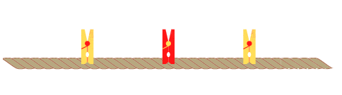
Images sourced from Canva and licensed under the Canva Content License Agreement.
- Students fold the halves in half again and place yellow pegs at these points on the rope. Stretch the rope back out to show the placement of the pegs (see Figure 1). Ask questions about the parts and the whole.
The table below outlines stimulus prompts to generate conversation about the topic, along with anticipated responses from students.
Prompts | Anticipated student responses
- How many equal parts can you see?  - What name is given to the 4 equal parts of a whole?  - How could we make smaller equal parts of the whole? | - The rope is divided into 4 equal parts, the rope is divided into 2 equal parts.  - 4 equal parts of a whole are called quarters.  - Fold the quarters again at the halfway point to make 8 equal lengths.
- Arrange the skipping rope into a wavy line. Ask students to explain whether the red peg is still at the halfway point, and if the yellow pegs are still a quarter of the whole length. Demonstrate to students that the halfway point remains the same by folding the rope back on itself. Identify the 2 equal lengths on either side of the halfway point as halves.
- With the pegs still on the skipping rope, make a shape. For example, arrange the rope as a square. Ask:
- Does the halfway point change if the line changes shape?
- How many equal parts can you see and how do you know?
- What happens to the length of the equal parts as we continue to divide the whole?
- Provide students with pipe cleaners, a small collection of beads and their workbook. Ask students to trace the length of their pipe cleaner into their workbook. They estimate and draw the halfway point. Students check their working by folding the pipe cleaner into 2 equal lengths and sliding a bead to the halfway point. Students unfold their pipe cleaner and compare it against their estimate. If their estimate is not exact, students draw the halfway point on the line in a different colour and label it as half (see Figure 2).
Figure 2 – Finding the halfway point
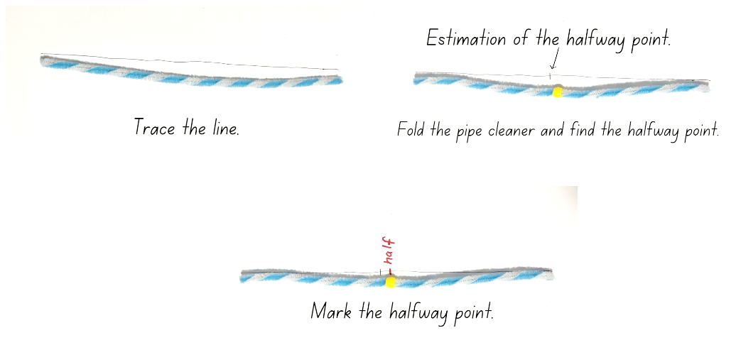
- Students look at the 2 equal parts of the line drawn and mark an estimation of the halfway point within each of the halves. Students fold their pipe cleaner back in half and then fold each half again. Students place a bead onto the halfway points of each half and check against their estimation. Ask students how many equal lengths the pipe cleaner has been divided into and identify quarter lengths. In their workbook, students draw these halfway points on the line in a different colour and label each length as a quarter (see Figure 3).
Figure 3 – Finding the halfway point within each half
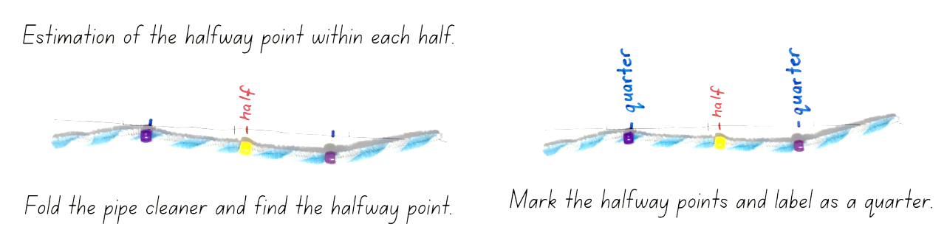
- Provide students with a collection of pipe cleaners of different lengths. Have students create different shapes and lines using the pipe cleaners. Students then estimate the halfway points and check by folding the pipe cleaner into equal lengths.
This table details assessment opportunities and differentiation ideas.
Assessment opportunities | Too hard? | Too easy?
What to look for:  - Can students estimate and identify 2 equal parts, and the relationship of the parts to the whole length? (MAO-WM-01, MA1-GM-03)  - Are students able to recognise when a length has been divided into halves and quarters? (MAO-WM-01, MA1-GM-03)  - Can students repeatedly halve a length to make quarters? (MAO-WM-01, MA1-GM-03)  What to collect:  - observational data (MAO-WM-01, MA1-GM-03)  - student work samples. (MAO-WM-01, MA1-GM-03) | Students are unable to recognise when lengths have been divided into 2 equal parts.  - Focus on halves as 2 equal lengths. When students are confident, have them halve the half by folding to make 4 equal parts.  - Have beads already threaded onto a collection of pipe cleaners at the halfway point. Students fold the pipe cleaner at the halfway point to demonstrate and discuss the equal lengths. | Students can recognise when a length has been folded into halves and quarters.  - Students join 2 pipe cleaners together to create a longer line. They estimate and place beads to show 8 equal lengths and fold to check.  - Give students one pipe cleaner and explain that the length is a half, quarter or eighth of the whole length. Students use additional pipe cleaners to build the whole length.

Discuss and connect the mathematics – 10 minutes
- Students display their pipe cleaners and do a gallery walk to identify the different halfway points and how these points help to identify halves and quarters.
- Regroup as a class and ask questions about the relationship between the whole and halves. Select different students to show and compare their pipe cleaners, focussing on how different sized halves have been created from different sized pipe cleaners.
The table below outlines stimulus prompts to generate conversation about the topic, along with anticipated responses from students.
Prompts | Anticipated student responses
- How many halves and quarters can be used to make up the length of a pipe cleaner? Is there more than one way?  - Can you replace your half with other equal lengths?  - Is the half of every pipe cleaner the same length? Explain. | - To make the length of one pipe cleaner, I used 2 halves, or one half and 2 quarters, or 4 quarters.  - I used one half and 2 quarters because 2 quarters are the same as one half, and 2 halves make one whole length.  - I can swap one half with 2 quarters, and I can put the quarters at the beginning and the end.  - Not all pipe cleaner halves are the same length because some pipe cleaners are longer and some are shorter. Longer whole lengths will divide into longer half lengths.

Lesson 2: Equal and unequal parts
Core concept: A fraction is made up of equal parts.
The table below contains suggested learning intentions and success criteria. These are best co-constructed with students.
Learning intentions | Success criteria
Students are learning that whole lengths can be divided into equal parts. | Students can:  - communicate their thinking and reasoning clearly  - recognise and explain when lengths have or have not been divided into halves, quarters and eighths  - use concrete materials to repeatedly halve lengths to find quarters and eighths.

Daily number sense: Units of 100 – 10 minutes
- Build student understanding of forming three-digit numbers by recognising units of 100.
- Display the first image from Resource 2: Units of 100. Ask students to identify what is similar and different and justify which one they think does not belong. Provide individual thinking time and then have students turn and talk. Ask:
- What do you notice?
- What makes all the items similar?
- What makes an item different?
- Which one does not belong? Explain.
Note: Students can make a case for each item not belonging, for example, units of measurement, representations and place value.
- Display the second image from Resource 2: Units of 100 and repeat the above steps.

Equal and unequal – 25 minutes
- Ask students what words they use when discussing fraction parts of a whole, for example, equal, estimate, halfway point, half, quarter or about a half. Record these for the class and encourage students to refer to this word bank throughout the lesson.
- Continue with the activity ‘which one does not belong’ by displaying the first image from Resource 3: Equal and unequal.
- Students identify what is similar and different and justify which object they think does not belong.
- Repeat the steps with the second image from Resource 3: Equal and unequal.
- Students use their workbook to create their own ‘which one does not belong’ with a focus on length and fractions.
- Select students to present their work to the rest of the class or a small group and students identify which one does not belong.

Introducing eighths – 15 minutes
This lesson has been adapted from Australia’s next top fraction model by Peter Gould (2013).
- Display and read the first part of Resource 4: Art project. Explain that students are working on their art project and 4 students need to share one length of ribbon. Ask students how they could each get an equal part. Select students to explain what an equal part is and how they might find it.
- Provide each student with a thin strip of paper to use as a ribbon to model the equal shares. Students record their working out using diagrams and words in their workbooks (see Figure 4).
- Display and explain the second part of Resource 4: Art project. Four more students have seen the ribbon and want some for their project. Now 8 students need an equal share of the ribbon. Ask how to name the 8 equal parts of one whole. If not provided, prompt students for the term ‘eighth’ and add to the word bank. Students use their thin strip of paper to explore how the ribbon could be divided into 8 equal parts and record their thinking using diagrams and words in their workbook (see Figure 4).
Figure 4 – Student work sample
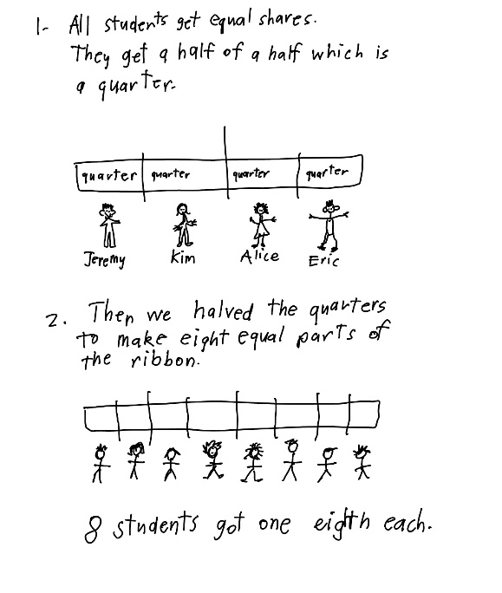

Discuss and connect the mathematics – 10 minutes
- Regroup and summarise the lesson together, drawing out some key mathematical ideas. Ask:
- How did you share the ribbon into eighths?
- What fraction did you get when you halved the half? How many equal pieces were there when you halved the quarters?
- Are the parts equal? How do you know?
- If your ribbon was a quarter, how long would the whole ribbon be?
- If the students had a longer ribbon, how would that change the length of ribbon each student received?
- How many ways can you make a half using quarters and eighths?
This table details assessment opportunities and differentiation ideas.
Assessment opportunities | Too hard? | Too easy?
What to look for:  - Can students use concrete materials to repeatedly halve lengths to find quarters and eighths? (MAO-WM-01, MA1-GM-03)  - Are students able to recognise and explain when a length is divided into 4 and 8 equal parts? (MAO-WM-01, MA1-GM-03)  What to collect:  - student work samples. (MAO-WM-01, MA1-GM-03) | Students are unable to recognise and model 8 equal parts.  - Students halve quarters with a focus on aligning the edges of the strip. Then they unfold and count the 8 equal parts to make the whole.  - Students join 8 interlocking cubes to form a whole length and identify the pieces as equal parts of the whole length. | Students can repeatedly halve lengths to make a whole.  - Students use diagrams and words to show and explain how many ways they can make a half using quarters and eighths.  - Provide students opportunities to find a third and fifth of the ribbon.

Lesson 3: Part to whole
Core concept: There is a relationship between the equal parts and the whole.
The table below contains suggested learning intentions and success criteria. These are best co-constructed with students.
Learning intentions | Success criteria
Students are learning that there is a relationship between the equal parts and the whole. | Students can:  - identify equal parts of the whole  - recreate the whole by repeating the equal part  - reason about the relationship between the equal parts and the whole.

Daily number sense: Which does not belong? – 10 minutes
- Build student understanding of the counting sequence by reasoning about patterns within the place value system of two- and three-digit numbers.
- Display the first image from Resource 5: Place value. Ask students to identify what is similar and different and justify which one they think does not belong. Provide individual thinking time and then students turn and talk. Ask:
- What do you notice?
- What makes all the items similar?
- What makes an item different?
- Which one do you think does not belong? Explain.
- How many more to the next multiple of 10 for each number?
- Display the second image from Resource 5: Place value and repeat the above steps.
Note: Students can make a case for each item not belonging, for example, consecutive numbers, odd and even numbers, 6 as a repeating digit, two- and three-digit numbers and numbers to next multiple of 10.

What is the hidden fraction? – 30 minutes
This lesson has been adapted from Teaching Mathematics Foundation to Middle Years from Siemon et al. (2021).
- Ask students to draw on their knowledge from previous lessons to find a half, a quarter or an eighth of a whole length. Ensure students understand that repeated halving results in equal lengths.
- Display the first image from Resource 6: Hidden fractions and explain that the blue line is a fraction of the whole line, and the rest of the line is covered by a piece of paper. Students visualise what the whole may look like and turn and talk to describe the whole.
- Choose students to come and draw what they think the whole might look like by drawing the missing equal parts. Students justify how they determined the size of the whole. For example, a student may suggest that half the whole is showing and draw an equal half, or suggest a quarter is showing and draw 3 more equal parts. However, an eighth showing may not work as the size of the paper covering the line would not be long enough to hide the rest of the whole (see Figure 5).
Figure 5 – Anticipated response
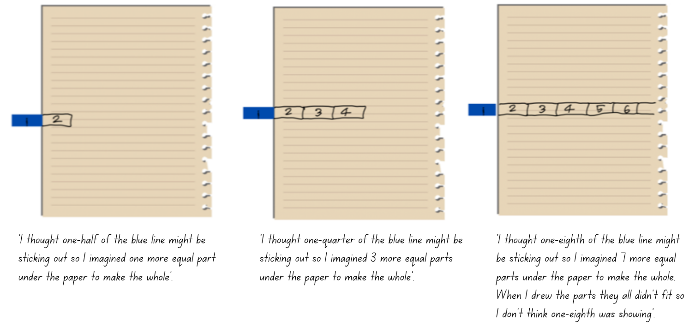
- Display the second image from Resource 6: Hidden fractions and repeat the previous steps.
- Provide students with a collection of paper, some of the paper should be cut into narrow strips and the other paper to be used as a rectangular cover. Students cut a paper strip of their own length and hide a part of it under the rectangular paper. Students glue the paper strip and covering paper into their workbook, then ask their partner to visualise the whole and draw the missing parts onto the covering paper. Students discuss if their visualisation of the whole was correct and reflect on the fractional parts of the whole.
- Students continue to take turns making different hidden fractions, asking their partner to visualise the whole and draw their thinking.
This table details assessment opportunities and differentiation ideas.
Assessment opportunities | Too hard? | Too easy?
What to look for:  - Can students identify equal parts of the whole? (MAO-WM-01, MA1-GM-03)  - Are students able to recreate the whole by repeating the equal part? (MAO-WM-01, MA1-GM-03)  - Can students reason about the relationship between the equal parts and the whole? (MAO-WM-01, MA1-GM-03)  What to collect:  - student work samples. (MAO-WM-01, MA1-GM-03) | Students are unable to recreate the whole when given the half.  - Students visualise and draw the missing strip on top of the piece of paper. They fold the paper to check the halfway point, then check and adjust their estimate.  - Provide students with paper strips and pipe cleaners to allow students to find the halfway point. Students then cover half of the object to assist with visualising the hidden half. | Students can recreate the whole when given the half.  - Students recreate other fractional amounts such as eighths, thirds or fifths.  - Students create a poster to demonstrate their knowledge and understanding of the relationship between fractions and length.

Discuss and connect the mathematics – 15 minutes
- Students display their work and do a gallery walk to identify the different hidden fractions.
- Regroup as a class and summarise the lesson together, drawing out some key mathematical ideas. Ask:
- Could you visualise the fraction? How did visualising the missing part help you find the whole? Explain your responses to both questions.
- How did understanding equal parts help you recreate the whole?
- What were some challenges today? How did you overcome them?

Lesson 4: Objects in a line
Core concept: Repeatedly halving lengths to form fractions.
The table below contains suggested learning intentions and success criteria. These are best co-constructed with students.
Learning intentions | Success criteria
Students are learning that fractions can be determined by repeatedly halving lengths and collections. | Students can:  - use concrete materials to model a half, a quarter and an eighth of a collection  - re-create the whole  - identify the equal parts and the relationship between the parts and the whole.

Daily number sense – 10 minutes
- From a class need surfaced through formative assessment data, identify a short, focused activity that targets students’ knowledge, understanding and skills. Example activities may be drawn from the following resources:
- Thinking Mathematically Stage 1
- Universal Resources Hub.

Sharing objects in a line – 40 minutes
This lesson has been adapted from Australia’s next top fraction model from Peter Gould (2013).
- Line up 8 students at the front of the class. Ask the class to split the line of students into 2 equal parts and explain what happened to the line of students. Then ask the class to halve the line of students again into equal parts. Provide time for students to explain what happened and discuss what fraction the line of students has been split into. Ask students to equally halve the line of students one last time and discuss what happened (see Figure 6).
Figure 6 – Repeatedly halving
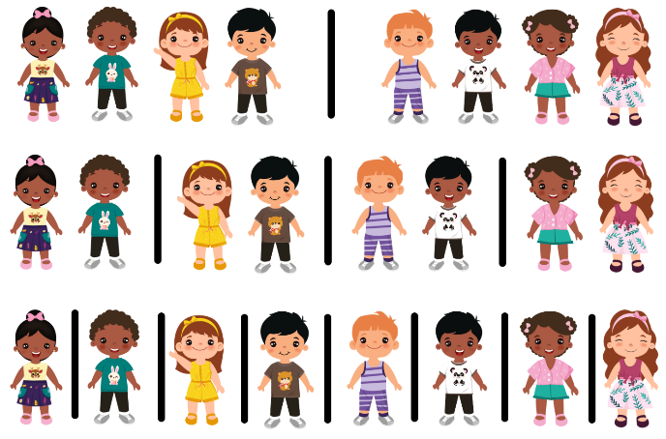
Images sourced from Canva and licensed under the Canva Content Licence Agreement.
The table below outlines stimulus prompts to generate conversation about the topic, along with anticipated responses from students.
Prompts | Anticipated student responses
- What happened when you equally split the line of 8 students?  - What happened when you equally halved the line of students again?  - What happened when you equally halved the line of students for the last time? | - There are 4 students in each half.  - I halved each half so now there are 2 students in each group. The line of students has been divided into quarters.  - The line of students has been divided into 4 groups.  - I halved each half and now there are 8 groups with one student in each group.  - I halved each quarter so now there is one student in each group. The line of students has been divided into eighths.
- Provide students with one strip from Resource 7: Stars and ask students to fold the strip to share the stars equally between 2. Ask how many stars each person would get and what fraction the strip has been folded into.
Note: Ensure the strips have been cut along the outlines to allow students to align the ends when folding.
- Ask students to fold the strip in half again to share the strip equally between 4. Ask how many stars each person would get and what fraction has the strip been folded into.
- Finally, ask students to fold the strip again to share the stars equally between 8 people. Ask how many stars each person would get and what fraction has the strip been folded into. Students can write the name of the fraction on the folds (see Figure 7).
Figure 7 – Folded stars
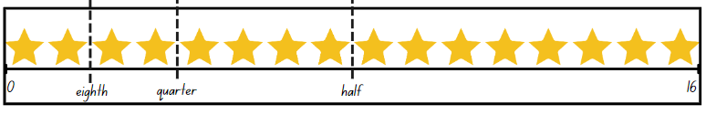
- Looking at the strip, ask:
- How many halves make a whole?
- How many quarters make a whole?
- How many eighths make a whole?
- What if 16 was the half, how many stars would make the whole?
Note: Linear models of fractions are important as they provide a direct link to the number line. Students make the link by working with linear arrangements of quantity. This activity supports the link to the linear arrangement by repeatedly halving a line of stars. Having the collections of the pictures on the strip helps students make the link between fraction units and quantities. Moving the focus from the length to a line of stars helps students to see how repeated halving could be used with both continuous and discrete quantities (Gould 2013).
Discrete model: This model uses separate items in collections to represent parts of the whole group.
- Provide students with one strip from Resource 8: Smiley faces and their workbooks. Ask students to fold the strip to demonstrate how many smiley faces would be in each group if they were equally shared in halves, quarters and eighths.
- Students complete the activity by folding their strip to show the equal shares. They mark the folds with lines and glue into their workbook. Students record their working using words and numbers to explain how many faces there are in each half, quarter and eighth (see Figure 8).
Note: It is not necessary for students in Stage 1 to use the symbol ½ to mean one-half or use ¼ for one-quarter. Students continue to use words.
Figure 8 – Student work sample
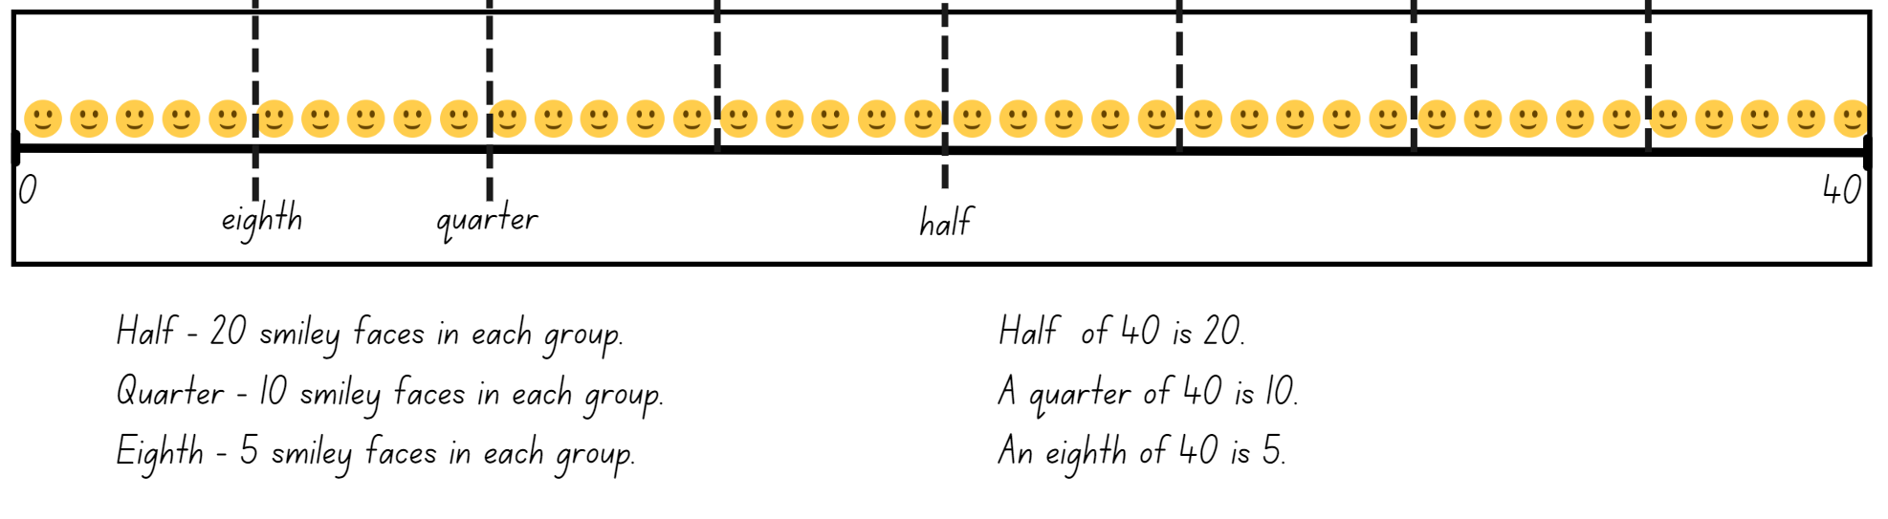
- Regroup as a class and ask:
- How many smiley faces in a half?
- How many smiley faces in a quarter?
- How many smiley faces in an eighth?
- What if 40 was the half, how many smiley faces would make the whole?
- Provide students with Resource 9: Circles and tell students that only an eighth of the circles have been drawn. Students need to identify and draw how many circles are missing. Students work independently or with a partner to identify the total number of circles required. Students can record their working in their workbook and use concrete materials.
- Regroup as a class and ask:
- What strategy did you use to find the whole collection?
- How many circles made up a half of the whole?
- How many circles made up a quarter of the whole?
- How many eighths make a whole?
- What further questions do you have?
- This table details assessment opportunities and differentiation ideas.
Assessment opportunities | Too hard? | Too easy?
What to look for:  - Can students use concrete materials to model a half, a quarter and an eighth of a collection? (MAO-WM-01, MA1-FG-01, MA1-GM-03)  - Are students able to re-create the whole? (MAO-WM-01, MA1-FG-01, MA1-GM-03)  - Can students identify the equal parts and the relationship between the parts and the whole? (MAO-WM-01, MA1-FG-01, MA1-GM-03)  What to collect:  - student work samples. (MAO-WM-01, MA1-FG-01, MA1-GM-03) | Students are unable to model a half, a quarter and an eighth of a collection.  - Provide students with concrete materials to physically share objects equally.  - Focus on students modelling half and, when confident, with creating equal halves. Model how to halve equal halves again to represent a quarter. | Students can use concrete materials to model a half, a quarter and an eighth of a collection.  - Provide students with only part of the collection on the line and have students re-create the collection to show the whole. For example, only an eighth of the smiley faces are drawn. Students draw the missing smiley faces to show the whole number.  - Provide students with opportunities to find a third and fifth of a collection or line.

Consolidation and meaningful practice: Blank strip – 10 minutes
- Provide students with Resource 10: Blank strip. Ask students to create their own picture strip that represents either halves, quarters or eighths.
- Students can choose to draw all the symbols on their strip and then fold the strip to demonstrate halves, quarters or eighths or draw the first part of the fraction for a friend to solve. For example, a student draws 4 smiley faces and explains to their partner that the 4 smiley faces represent a quarter of the whole.
- Students share their work with the class.

Lesson 5: Sharing chocolate
Core concept: Collections can be shared into different fractions.
The table below contains suggested learning intentions and success criteria. These are best co-constructed with students.
Learning intentions | Success criteria
Students are learning that collections can be divided into halves, quarters and eighths. | Students can:  - use concrete materials to model a half, a quarter and an eighth of a collection  - reason about the relationship between the part and the whole  - re-create the whole.

Daily number sense: Double or halve? – 15 minutes
This lesson has been adapted from Double or halve? – Stage 1 (7:37) from Thinking Mathematically.
- Build student understanding of flexible addition strategies by doubling and halving a given number.
- Provide pairs of students with one copy of Resource 11: 30 grid, 2 different coloured pencils and a 6-sided die.
- Together, students choose a target number between 10 and 30 and write it on the side of their grid and on the corresponding grid square.
- The first player rolls the die and chooses to either double or halve the number. The player records their choice on the grid by shading the correct number of squares. Players record a running total on the side of their grid.
- Players take turns to roll the die and record their chosen number. If a player cannot go, they miss a turn. The winner is the player who reaches the target number exactly (see Figure 9).
Figure 9 – Double or halve gameplay
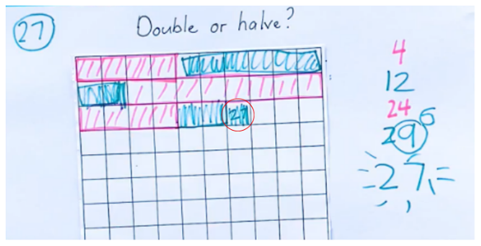
- While students are playing, move around to pairs and ask:
- If you play the game again, are there any moves you will change?
- Is there a number you should have halved instead of doubled? Why?
- If you play the game again and the rules changed where you could double, halve or keep your roll, do you think this might make it easier to reach the target number?
Note: Students can use their grid workbooks to play the game with a larger target number or use page 2 of Resource 11: 30 grid to support students to combine numbers and keep a running total.

Meaningful problems – 35 minutes
This activity has been adapted from Open-Ended Maths Activities by Sullivan et al. (2017) and Fractions of shapes and collections from State of Victoria (Department of Education and Training).
- Display the first problem from Resource 12: Problems and explain that you met up with your family on the weekend. Half the people in your family are males. Ask students to use their individual whiteboard or workbook to draw what your family might look like.
Note: Remind students that in mathematics simple drawings or symbols communicate ideas best, and that complicated features are not necessary.
- Choose students to share their drawing and explain or justify their response.
- Display the second problem from Resource 12: Problems and explain that you went to a party on the weekend and got a lolly bag. A quarter of the lollies in the bag were jelly snakes. Ask students to use their individual whiteboard or workbook to draw what your lolly bag might look like.
- Choose students to share their drawing and explain or justify their response.
- Display the third problem from Resource 12: Problems and explain to students that you received a bunch of flowers. An eighth of the flowers were daffodils. Ask students to use their individual whiteboard or workbook to draw what your bunch of flowers might look like.
- Choose students to share their drawing and explain or justify their response.
- Display, read and discuss Resource 13: Sharing chocolate. Ask students which chocolate bar they would choose and to justify their choice. Provide students with their workbook and 2 different coloured strips of paper or Resource 14: Chocolate bars to solve the problem. Students show their working in their workbook. Encourage students to use paper folding to help visualise and justify their thinking.
This table details assessment opportunities and differentiation ideas.
Assessment opportunities | Too hard? | Too easy?
What to look for:  - Can students use concrete materials to model a half, a quarter and an eighth of a collection? (MAO-WM-01, MA1-FG-01, MA1-GM-03)  - Are students able to reason about the relationship between the part and the whole? (MAO-WM-01, MA1-FG-01, MA1-GM-03)  - Can students re-create the whole? (MAO-WM-01, MA1-FG-01, MA1-GM-03)  What to collect:  - observational data (MAO-WM-01, MA1-FG-01, MA1-GM-03)  - student work samples. (MAO-WM-01, MA1-FG-01, MA1-GM-03) | Students are unable to model a half, a quarter and an eighth of a collection.  - Provide students with concrete materials to physically share objects equally.  - Students focus on modelling a half and then drawing it to represent the problem. When confident with creating equal halves, model the same with quarters. | Students can use concrete materials to model a half, a quarter and an eighth of a collection and reason about the relationship between the part and the whole.  - Students draw chocolate bars to represent how an eighth of a bar would be larger than a quarter of a bar.  - Provide opportunities for students to find a third and fifth of a collection and/or line.

Discuss and connect the mathematics – 10 minutes
- Regroup and summarise the lesson, drawing out key mathematical ideas. Ask students to share their work and how they solved the problem. Ask:
- What strategies did you use to solve the problem?
- Was your prediction correct?
- Would you always choose a quarter of a chocolate bar over an eighth of a chocolate bar? Explain.

Lesson 6: Sharing objects
Core concept: Division can be represented by either sharing or grouping objects.
The table below contains suggested learning intentions and success criteria. These are best co-constructed with students.
Learning intentions | Success criteria
Students are learning that:  - collections can be divided into halves, quarters and eighths  - division can be represented by sharing objects into equal groups  - division can be represented by finding out how many groups can be formed. | Students can:  - use objects and diagrams to model a half, a quarter and an eighth of a collection  - identify between the number of groups and the number in each group when solving division problems.

Daily number sense: 10 minutes
- From a class need surfaced through formative assessment data, identify a short, focused activity that targets students’ knowledge, understanding and skills. Example activities may be drawn from the following resources:
- Thinking Mathematically Stage 1
- Universal Resources Hub.

Bar model – 20 minutes
- Ask students to find half of 16. Students use their individual whiteboard to show their working using the bar model (see Figure 10).
- Ask students if they can halve the number again to show a quarter of 16 using the bar model. Students use their diagram from the previous question and add another row to it (see Figure 10). Then ask students if it is possible to halve the numbers again to show eighths using the bar model (see Figure 10). Have students share their working and model thinking aloud to record the bar model on the board.
Figure 10 – Repeatedly halving using the bar model
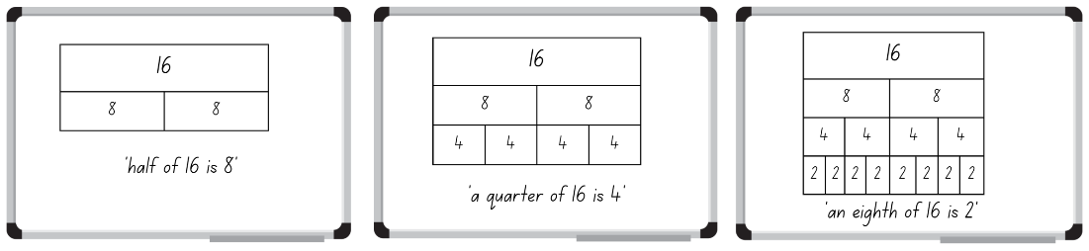
- Display and read Resource 15: Sharing toy cars. Provide students with a collection of concrete materials and their workbook to solve and represent this problem using the bar model (see Figure 11).
Note: Students may need guidance to draw a large bar divided into 4 equal parts and then collect the given number in counters. Demonstrate to students how to share the counters equally between the 4 parts. Once the counters have been shared equally, explain that the number of counters in each part is a quarter of the given number. By systematically sharing the concrete materials in an organised layout, students will be assisted in checking their count, ensuring that it is equal and that the fraction is visible (NCETM 2019).
Figure 11 – Different bar models to represent quarters
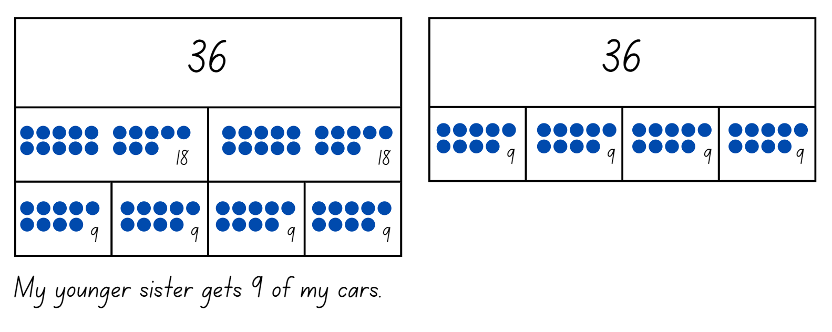
- Regroup as a class and ask:
- Which strategy did you use to solve this problem? Do you think it was the most efficient and why?
- How does the bar model help you to solve problems?
- Was this an equal sharing or equal grouping problem?
Partitive: Equal sharing (partitive) division requires finding how many are in each group, for example, calculating 12 marbles shared between 3 students, to work out how many marbles each student would get.
- Display and read Resource 16: Sharing blocks. Provide students with a collection of concrete materials and their workbook to solve and represent this problem using the bar model (see Figure 12).
Figure 12 – Bar model
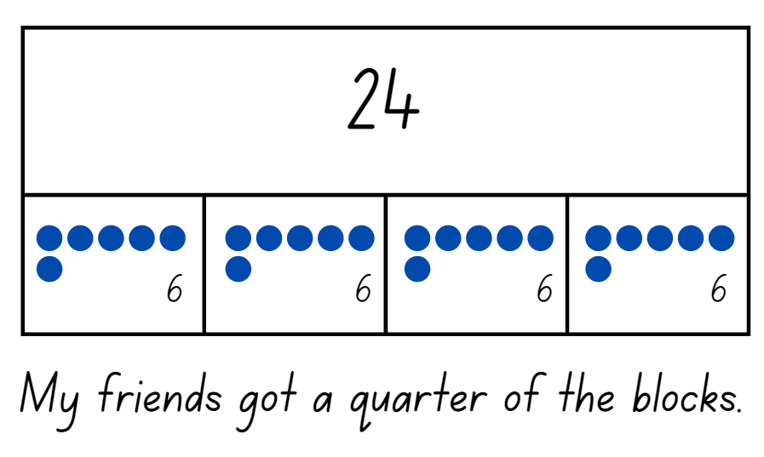
- Regroup as a class and ask:
- Which strategy did you use to solve this problem?
- How does the bar model help you to solve problems?
- Was this an equal sharing or equal grouping problem?
Quotitive: Equal grouping (quotitive) division requires finding how many groups are formed, for example, calculating how many children will get marbles if you start with 12 and give each child 4. When grouping, the quotient represents the number of groups within the shared quantity.
- Draw students’ attention to the different division problems, noting how one problem requires students to equally share the objects and the other requires students to work out how many groups. Focus on the different language within the problem and the different ways students go about solving the problem using the terms equal grouping and equal sharing.

Consolidation and meaningful practice: Solving problems – 20 minutes
- Provide students with some of the problems from Resource 17: Sharing and grouping. Students read each problem individually or with a partner to determine if it is an equal grouping or equal sharing problem.
Note: Resource 17: Sharing and grouping has a range of problems that increase in complexity.
- Students work through their given problems using concrete materials and use the bar model to record their working in their workbook.
- Regroup as a class and have students share their work and demonstrate how they solved different problems.
This table details assessment opportunities and differentiation ideas.
Assessment opportunities | Too hard? | Too easy?
What to look for:  - Can students use objects and diagrams to model a half, a quarter and an eighth of a collection? (MAO-WM-01, MA1-FG-01)  - Are students able to identify between the number of groups and the number in each group when solving division problems? (MAO-WM-01, MA1-FG-01)  What to collect:  - student work samples (MAO-WM-01, MA1-FG-01)  - observational data. (MAO-WM-01, MA1-FG-01) | Students are unable to solve division problems using objects and/or cannot identify between the number of groups and the number in each group when solving division problems.  - Support students to use the bar model with a focus on halving the given number. Students share counters into the partitioned sections of the bar model.  - Support students to read the problems and provide them with counters. Students count out the given number for each group until there are no counters left. Circle each group of counters to identify the number of groups.  - Support students to read the problem and draw circles to identify how many groups the items are being shared into. Then provide students with concrete materials to physically share objects between the identified groups. | Students can identify between the number of groups and the number in each group when solving division problems and use diagrams and materials to demonstrate their understanding.  - Provide students with page 3 of Resource 17: Sharing and grouping.  - Students solve the problems from Resource 17: Sharing and grouping and then rewrite the problems using multiplication.  - Students look at the problems from Resource 17: Sharing and grouping and see if it is possible to divide any of the collections in the problems equally by thirds or fifths.

Lesson 7: Leftovers
Core concept: When shared equally, collections can have leftovers.
The table below contains suggested learning intentions and success criteria. These are best co-constructed with students.
Learning intentions | Success criteria
Students are learning that:  - not all collections can be shared equally  - the part that cannot be shared equally has a name. | Students can:  - model division by sharing objects  - describe the part as ‘left over’ when a collection cannot be distributed equally.

Daily number sense: Hidden numbers – 10 minutes
The lesson has been adapted from Number Lines in Disguise from NRICH.
- Build student understanding of the structure of tens by working out the position of numbers on a number line.
- Display the first number line from Resource 18: Hidden numbers. Provide independent thinking time, then have students turn and talk about what they notice and wonder. Ask:
- What number would be where the red dot is? How do you know?
- Where would zero be on the number line?
- Can you work out where any other numbers would be?
- What were your strategies?
- Display the second number line from Resource 18: Hidden numbers. Students draw the number line on their individual whiteboard and record their answers to the previous number line questions.
- After solving the initial questions, follow up by asking:
- On the number line, where would the nearest 10 to the red dot be?
- Which challenge was harder and why?

Bunches of balloons – 30 minutes
This lesson has been adapted from Bunches of Balloons from reSolve: Maths by Inquiry (2018).
- Display Resource 19: Balloons and tell students that they need to decorate the room with a packet of balloons and make sure each bunch is equal. Students turn and talk to discuss how they could organise the balloons to make sure the bunches are equal.
- Choose students to share their responses and ideas.
- Tell the students that in the packet there are 29 balloons. Provide partners with their workbooks and ask students to draw the room, including how the balloons would be arranged.
- After 5–10 minutes, regroup as a class and ask students to share their ideas on how the room can be decorated. Record student responses, focussing on responses that use the correct vocabulary. For example, ‘I made 7 groups of 4 but there was one balloon left over.’
Note: In Stage 1, it is appropriate for student language to develop from using ‘leftovers’ to ‘remainders’ when describing the result of unequal shares.
- Ask students to continue investigating whether the room can be decorated with equal bunches of balloons. Students work with a partner and 29 counters to see if they can make equal groups. Have students record their different groupings using diagrams and words. Students could draw the counters or take a photo and record using words, including the number of counters in each group, the number of groups and how many are left over (see Figure 13).
Figure 13 – Grouping examples
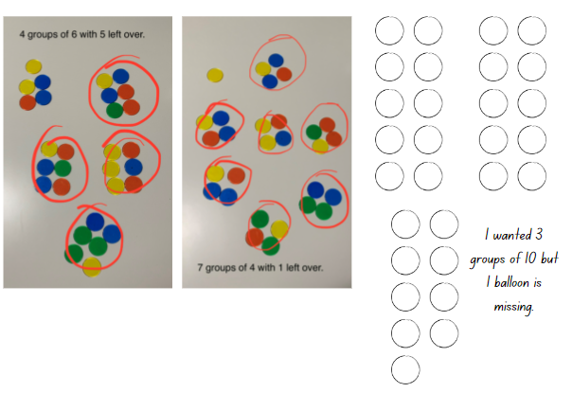
- While students are working, circulate and ask:
- Can you make equal groups of 2 from 29 balloons? Are you sure? Have you tested it?
- Have you tried another group size?
- How many ways are there to group the balloons?

Discuss and connect the mathematics – 20 minutes
- Students display their work and go on a gallery walk to identify the similar and different ways the balloons were grouped and if any partners were able to equally share the balloons.
- Regroup as a class and ask:
- Was anyone able to equally share the balloons? Why or why not?
- Is it always possible to make equal groups?
- What do we call the counters that are not equally shared into a collection?
- What further questions do you have?
This table details assessment opportunities and differentiation ideas.
Assessment opportunities | Too hard? | Too easy?
What to look for:  - Can students model division by sharing objects? (MA1-FG-01)  - Are students able to describe the part as ‘left over’ when a collection cannot be distributed equally? (MAO-WM-01, MA1-FG-01)  What to collect:  - student work samples. (MAO-WM-01, MA1-FG-01) | Students are unable to model division by sharing objects and describe the part as ‘left over’ when a collection cannot be distributed equally.  - Support students to share objects into equal groups by using a smaller collection of counters and a number of counters that is divisible by 2, 4 or 6.  - Support students to share counters into 3 small groups with one or 2 counters remaining, and name these as leftovers. | Students can model division by sharing objects and describe the part as ‘left over’ when a collection cannot be distributed equally.  - Challenge students to find other numbers that cannot be shared into equal groups.  - Ask students to find numbers that can be shared equally by 2 different numbers, for example, 2 and 5.

Lesson 8: Double trouble
Core concept: Doubling and halving is an efficient method for solving number problems.
The table below contains suggested learning intentions and success criteria. These are best co-constructed with students.
Learning intentions | Success criteria
Students are learning that:  - numbers have a sequence  - there is a relationship between doubling and halving. | Students can:  - identify how many more to the next multiple of 10 within two- and three-digit numbers  - use concrete materials to model a half of a collection and show the relationship between the half and the whole  - connect the concepts of doubling and halving and clearly communicate their thinking.

Daily number sense: Next multiple of 10 – 10 minutes
- Build student understanding of the counting sequence by identifying how many more to the next multiple of 10.
- Ask students to draw a blank number line and mark the numbers 64 and 72. Ask students how many more to the next multiple of 10. Students draw the jump to identify how many more and mark the next multiple of 10 (see Figure 14).
Figure 14 – Next multiple of 10
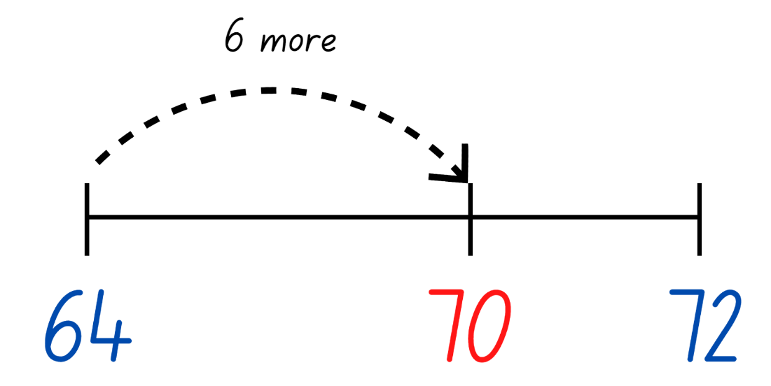
- Choose students to share and justify how they know it is the next multiple of 10.
Note: This activity focusses on identifying the next multiple of 10, not the closest multiple of 10.
- Continue this activity for different two- and three-digit number ranges.
This table details assessment opportunities and differentiation ideas.
Assessment opportunities | Too hard? | Too easy?
What to look for:  - Are students able to identify and justify how many more to the next multiple of 10 within two- and three-digit numbers? (MAO-WM-01, MA1-RWN-01)  What to collect:  - student work samples. (MAO-WM-01, MA1-RWN-01) | Students are unable to identify and justify how many more to the next multiple of 10 within two- and three-digit numbers.  - Provide students with a number chart to refer to when identifying how many more to the next multiple of 10.  - Support students to identify how many more to the next multiple of 10 with numbers up to 20. | Students can identify and justify how many more to the next multiple of 10 within two- and three-digit numbers.  - Provide opportunities for students to identify how many more to the next multiple of 50.  - Provide opportunities for students to identify how many more to the next multiple of 100.

Double or halve – 20 minutes
This lesson has been adapted from Double or halve? – Stage 1 (7:37) from Thinking mathematically.
- Revisit the ‘Double or halve?’ activity from Lesson 5: Sharing chocolate. Provide pairs with one copy of Resource 11: 30 grid, 2 different coloured pencils and a 6-sided die.
- Explain that students will be playing the game again but with slightly different rules. This time, students can double, halve or keep their roll. Revise that last time the game was played, students discussed whether they thought this might make it easier to reach their target number.
- After playing, ask:
- Was it easier or harder to reach the target number with the rule change? Explain.
- Do you have any other suggestions on how to change the rules to make the game harder or easier?
Note: Students can use their grid workbooks to play the game with a larger target number. Alternatively, use page 2 of Resource 11: 30 grid to support students to combine numbers and keep a running total.

Double Trouble – 20 minutes
The lesson has been adapted from Teaching for Mastery [PDF 6 MB] from NCTEM.
- Provide students with a range of numbers to double and halve, for example, double 8, half of 24. Provide access to concrete materials if needed. Ask:
- What do you have to do when you double?
- How do you know a number is a double?
- Display and read Resource 20: Maths Marvel. Ask students whether they agree with the Maths Marvel’s idea. Provide some independent thinking time for students to engage with the problem before sharing their response.
- Display and read the Resource 21: Always true? Students work in pairs to complete the investigation using Resource 22: Mindmap and concrete materials, for example, counters and interlocking cubes. Students also demonstrate their understanding using words and diagrams.
- Regroup as a class and have students share their findings.
This table details assessment opportunities and differentiation ideas.
Assessment opportunities | Too hard? | Too easy?
What to look for:  - Are students able to use concrete materials to model a half of a collection and show the relationship between the half and the whole? (MAO-WM-01, MA1-FG-01)  - Can students connect the concepts of doubling and halving and clearly communicate their thinking? (MAO-WM-01)  What to collect:  - student work samples (MAO-WM-01, MA1-FG-01)  - observational data. (MAO-WM-01, MA1-FG-01) | Students are unable to connect the concepts of doubling and halving.  - Explain to students that doubling means adding the same number again. Have students’ model this with interlocking cubes. Students then halve the row of cubes into equal parts and show that the half is their original number.  - Students use a 20-bead rekenrek to place a number on the top line and the same number on the next line to show how the number can be doubled. Students then remove the beads on the second line to show how it can be halved. | Students can connect the concepts of doubling and halving.  - Encourage students to communicate their thinking as clearly as they can using words from the word bank, diagrams and symbols.  - Students identify problems for which the strategy is useful and not useful, for example, halving odd numbers of collections.

Discuss and connect the mathematics – 10 minutes
- Reflect on the unit together, revising the key mathematical ideas.
- Allow students time to individually reflect. Have each student write a note describing something they learned from a peer during classroom or small group discussions in this unit.
- Select students to read out their notes and use the opportunity to correct, clarify, and celebrate the learning.
Note: This activity can also be done with students verbalising what they have learnt from their peers.

Resource 1: Nearest 10
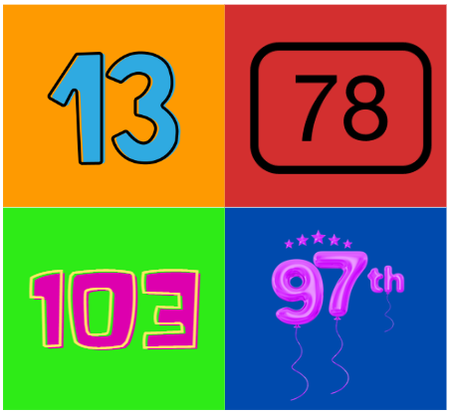
Images sourced from Canva and licensed under the Canva Content License Agreement.
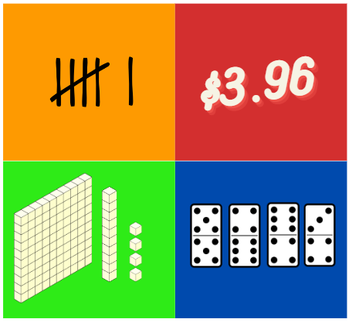
Images sourced from Canva and licensed under the Canva Content License Agreement.

Resource 2: Units of 100
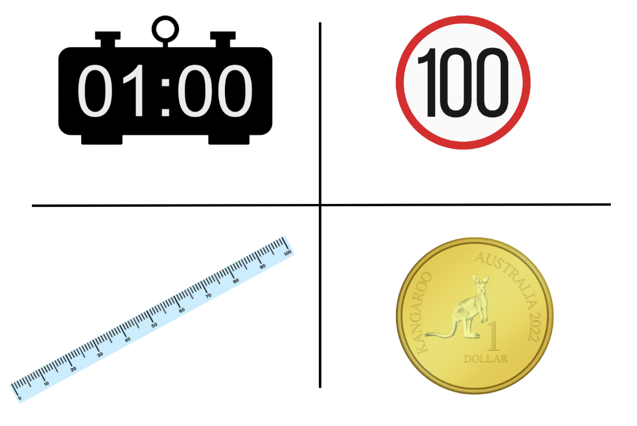
Images sourced from Canva and licensed under the Canva Content License Agreement.
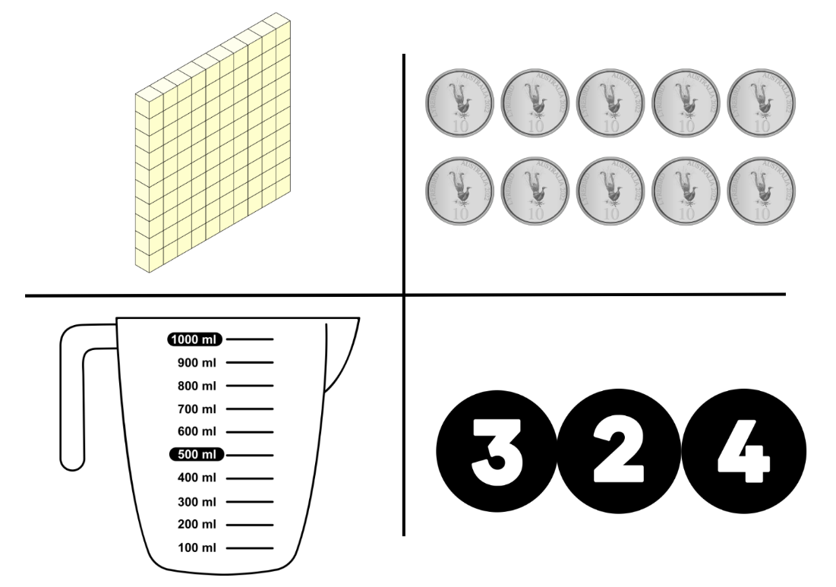
Images sourced from Canva and licensed under the Canva Content License Agreement.

Resource 3: Equal and unequal
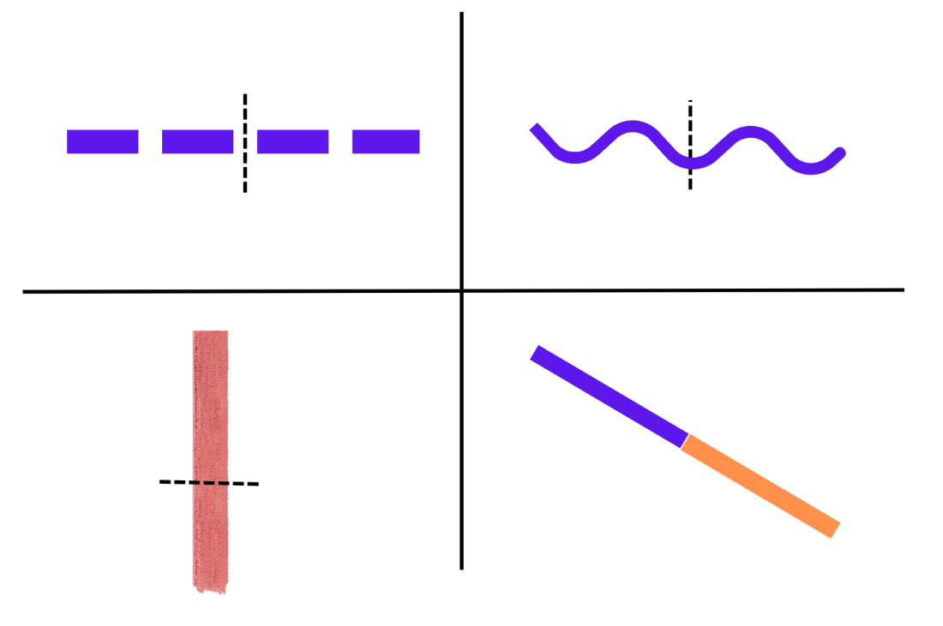
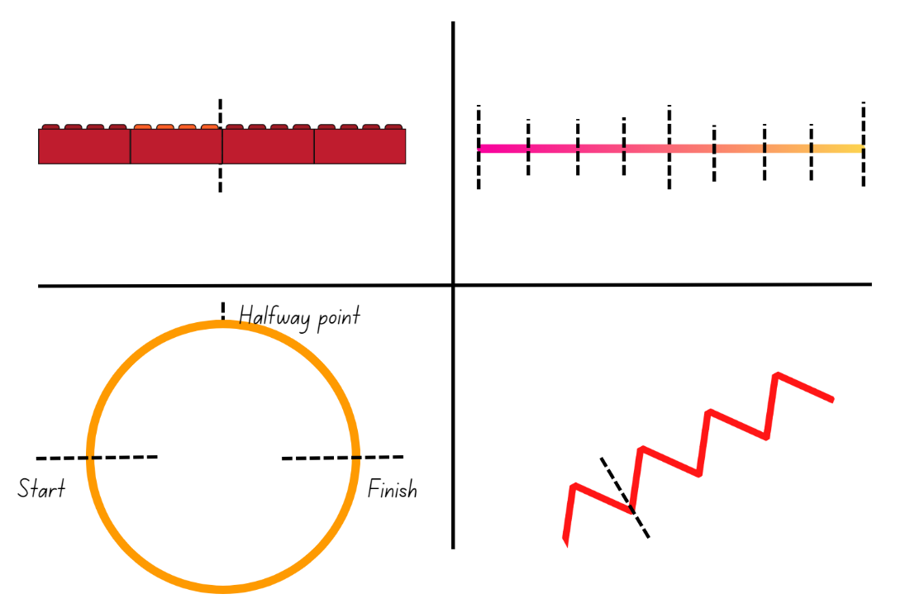
Images sourced from Canva and licensed under the Canva Content License Agreement.

Resource 4: Art project
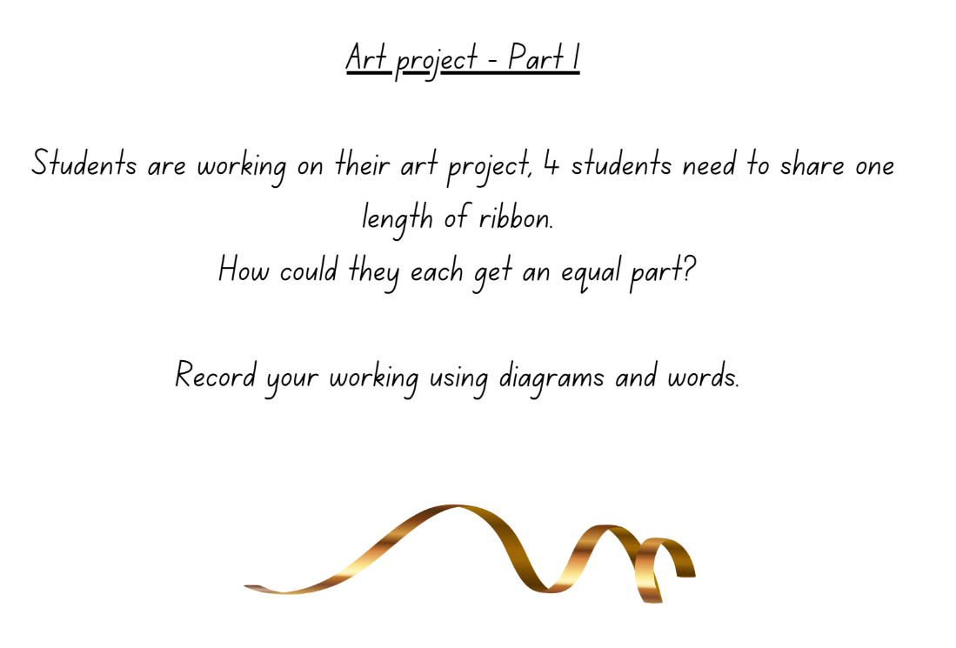
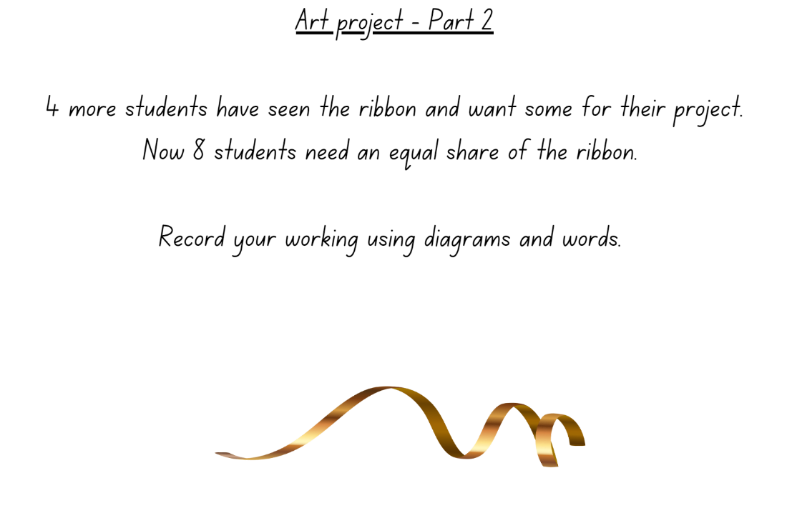
‘Gold Ribbon Illustration’ by ‘Libking’ is licensed under the Canva Content Licence Agreement.

Resource 5: Place value
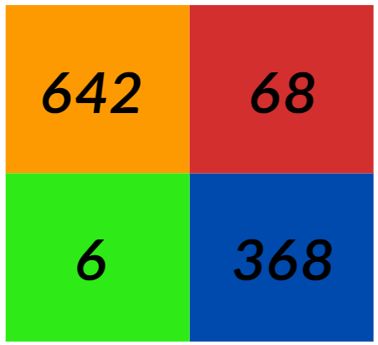
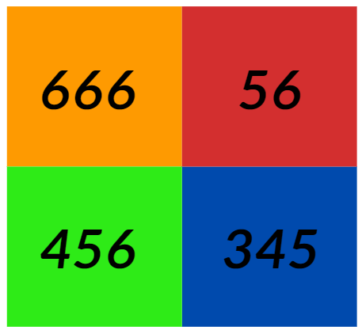

Resource 6: Hidden fractions

Resource 7: Stars
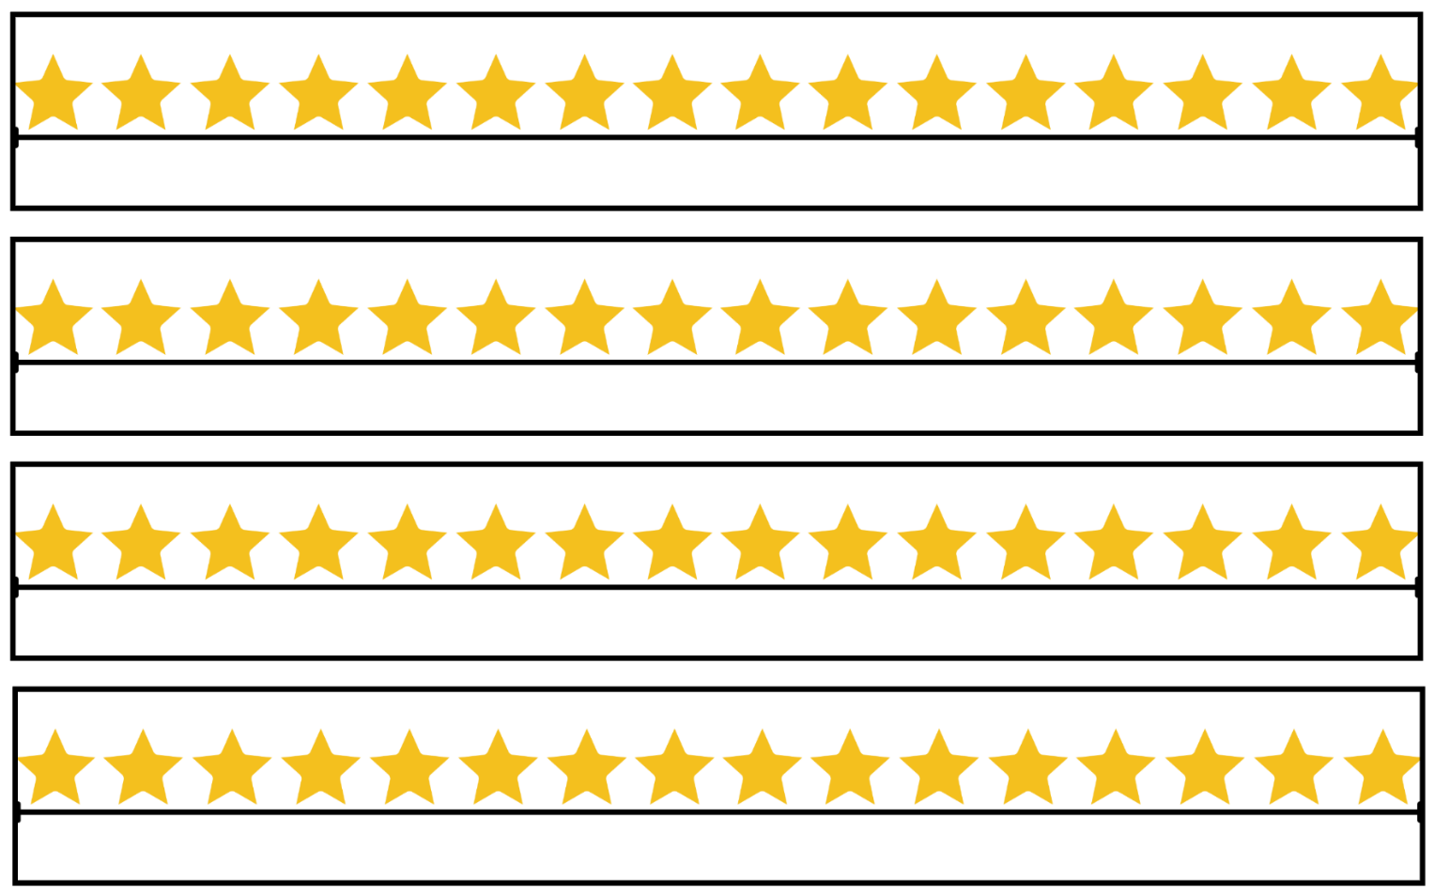

Resource 8: Smiley faces
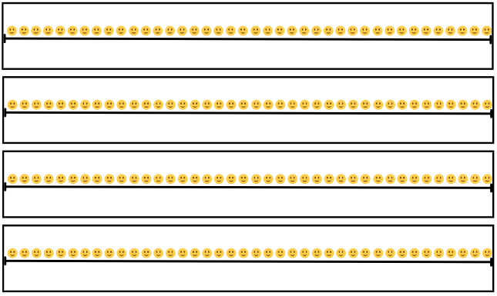
‘Smiley Emoji’ by ‘Architia’ is licensed under the Canva Content Licence Agreement.

Resource 9: Circles

Resource 10: Blank strip

Resource 11: 30 grid
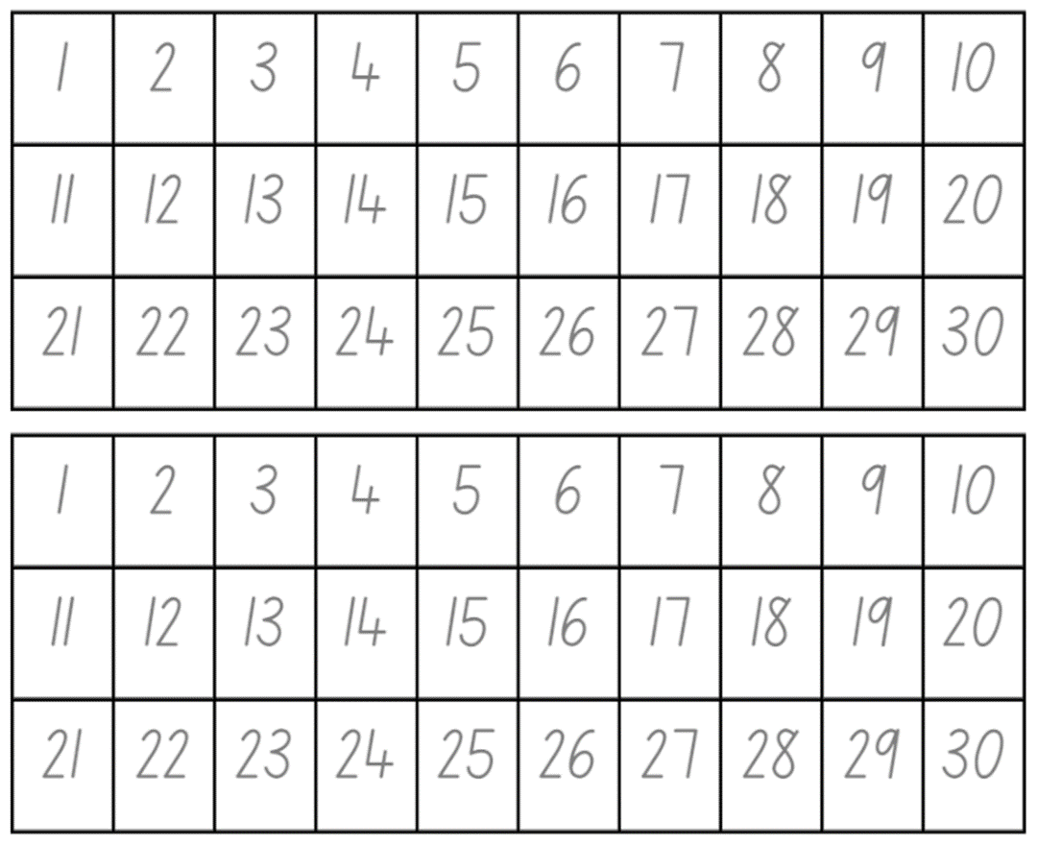

Resource 12: Problems
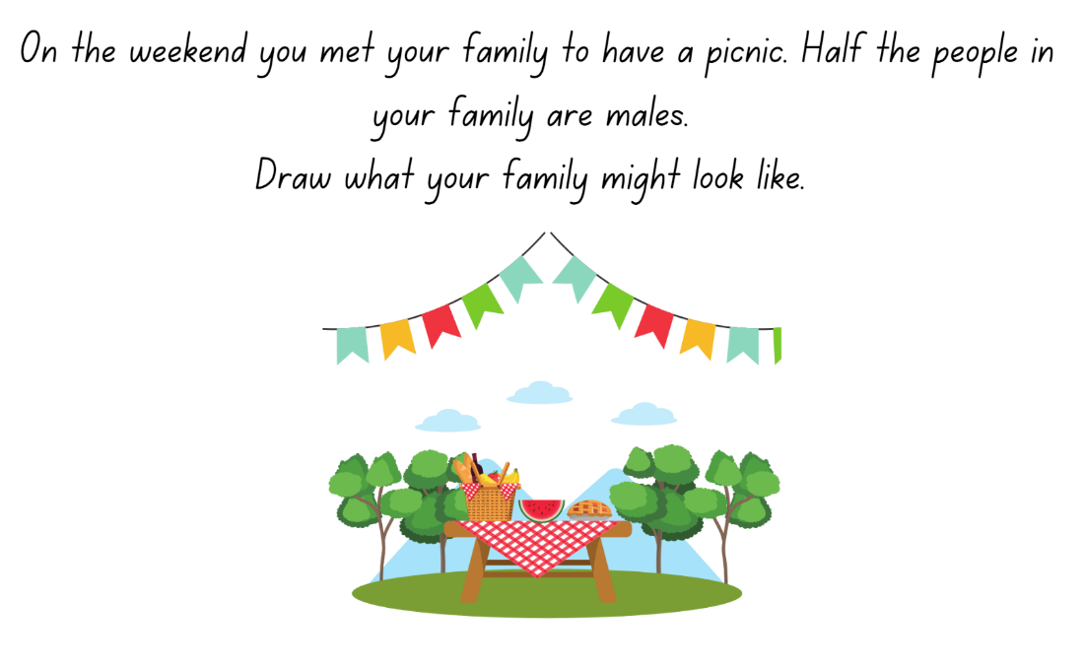
Images sourced from Canva and licensed under the Canva Content License Agreement.
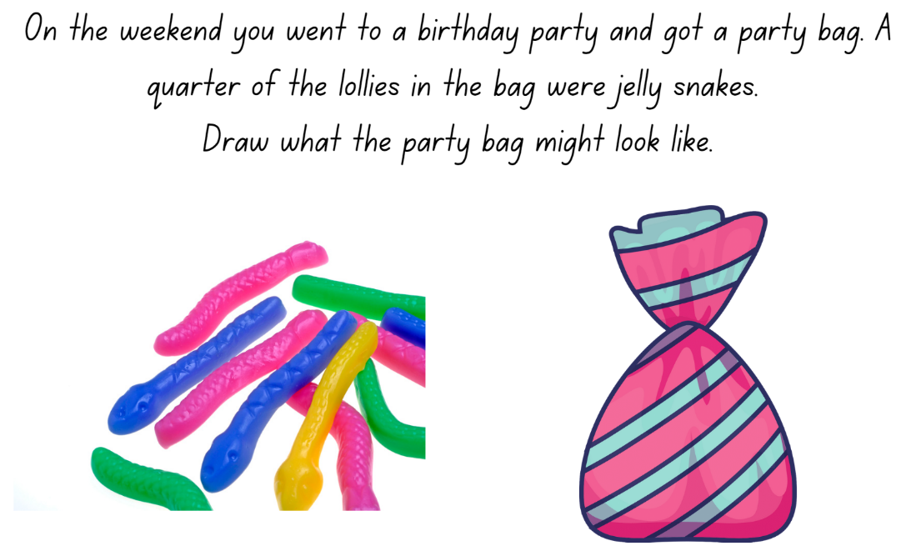
Images sourced from Canva and licensed under the Canva Content License Agreement.
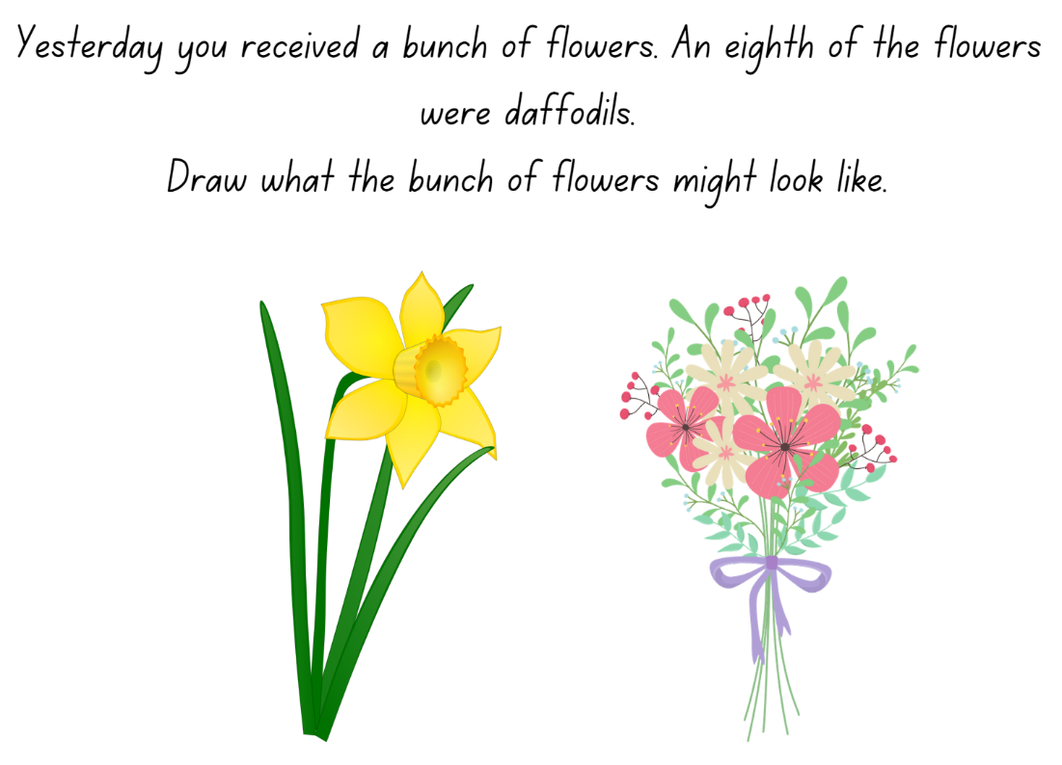
Images sourced from Canva and licensed under the Canva Content License Agreement.

Resource 13: Sharing chocolate
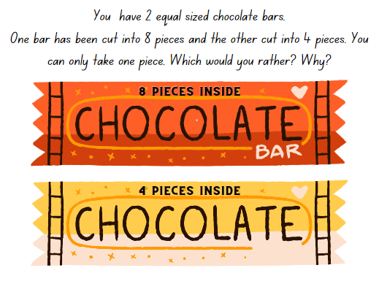
‘Chocolate Bar Illustration’ by ‘Sketchify’ is licensed under the Canva Content Licence Agreement.

Resource 14: Chocolate bars
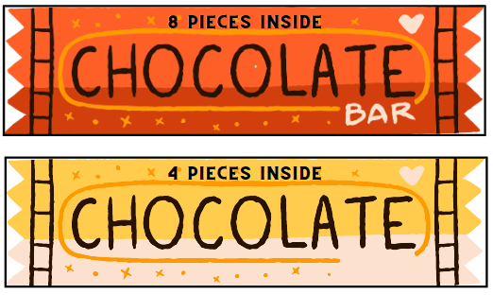
‘Chocolate Bar Illustration’ by ‘Sketchify’ is licensed under the Canva Content Licence Agreement.

Resource 15: Sharing toy cars
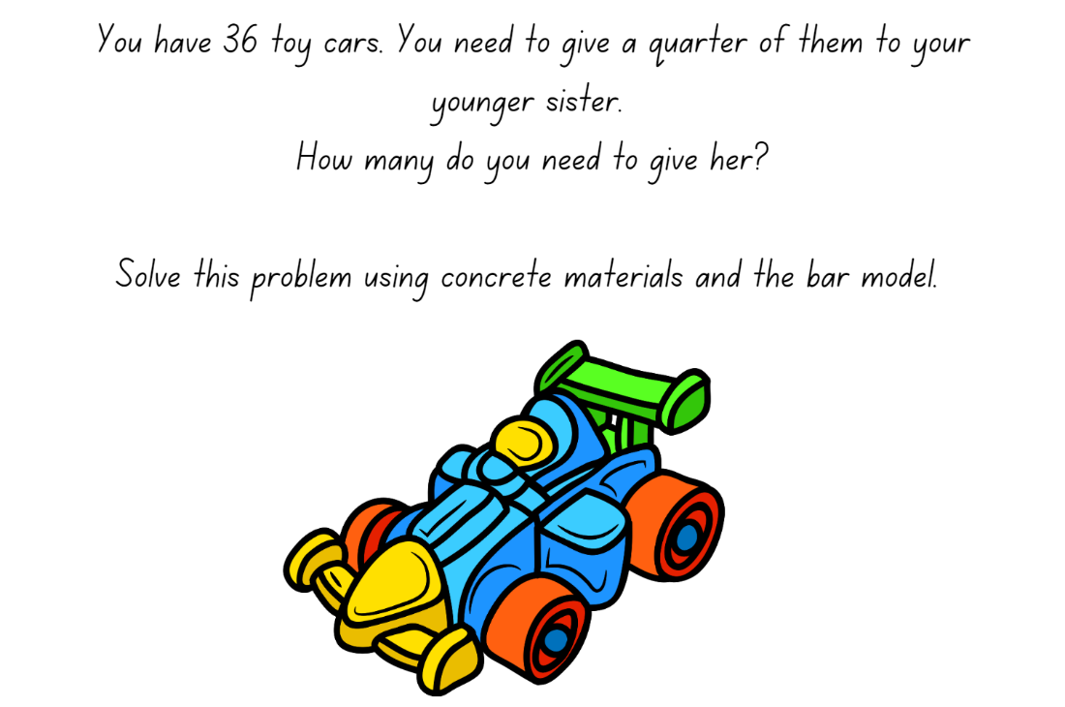
‘Toy Car’ by ‘heyrabbiticons’ is licensed under the Canva Content Licence Agreement.

Resource 16: Sharing blocks
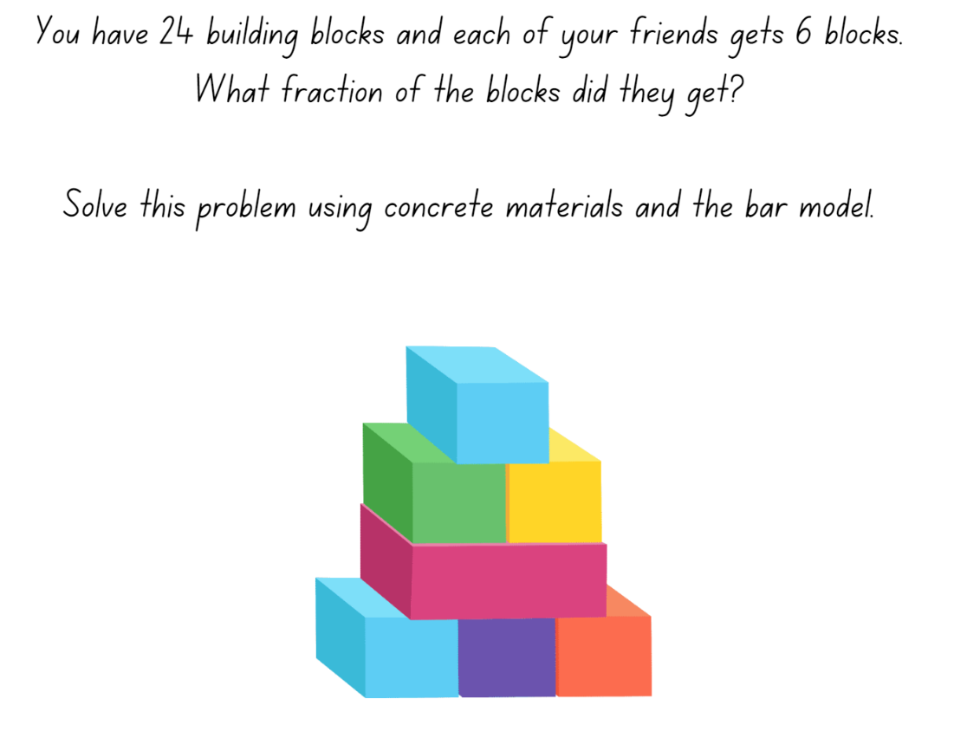
‘Toy Building Blocks’ by ‘zhaowhat’ is licensed under the Canva Content Licence Agreement.

Resource 17: Sharing and grouping
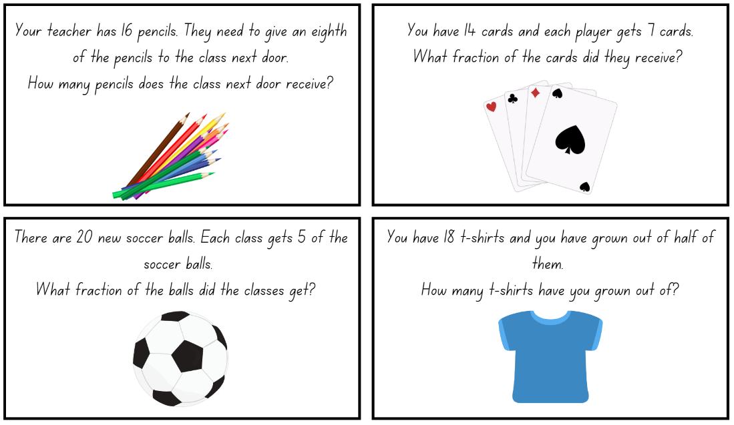
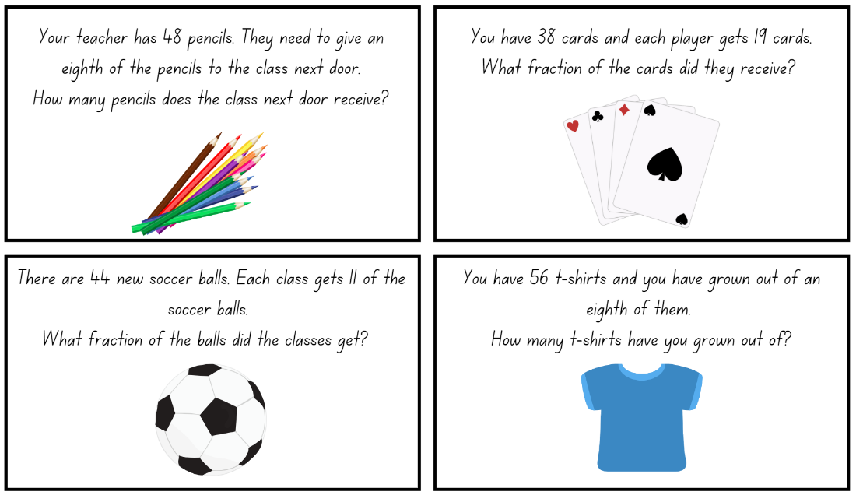
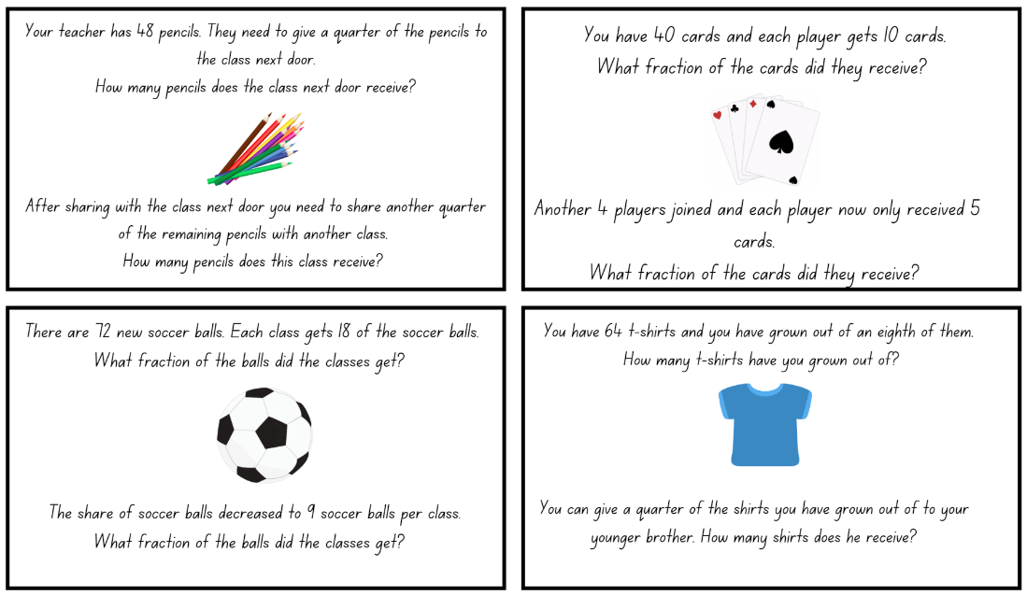
Images sourced from Canva and licensed under the Canva Content License Agreement.

Resource 18: Hidden numbers
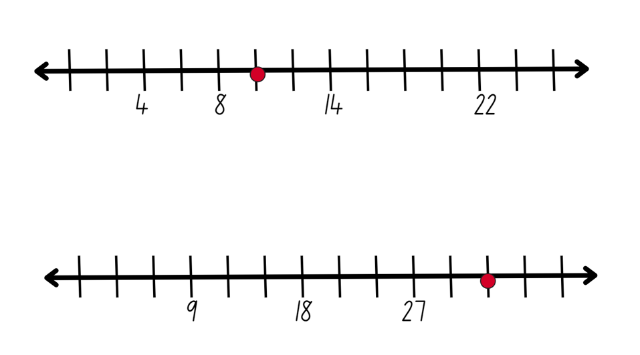

Resource 19: Balloons
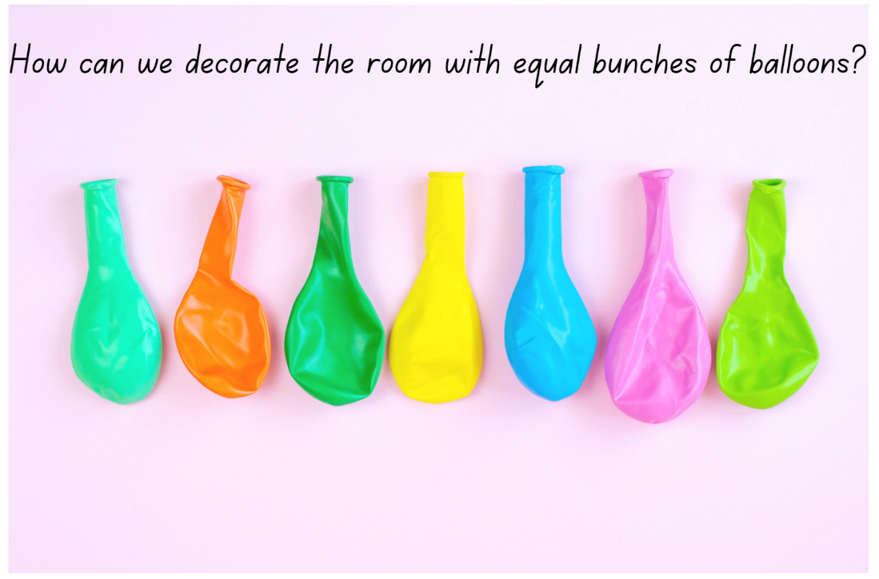
‘Many multicoloured deflated balloons’ by Maryna Terletska is licensed under the Canva Content Licence Agreement.

Resource 20: Maths Marvel
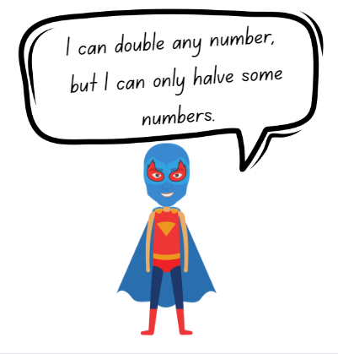
‘Boy Superhero’ by ‘grmarc2’ is licensed under the Canva Content Licence Agreement.

Resource 21: Always true?
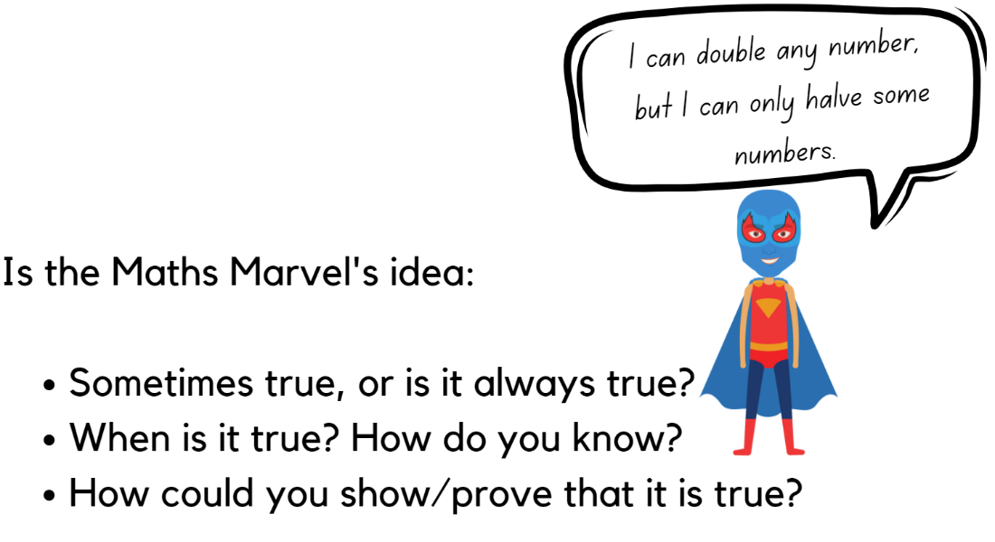
‘Boy Superhero’ by ‘grmarc2’ is licensed under the Canva Content Licence Agreement.

Resource 22: Mindmap
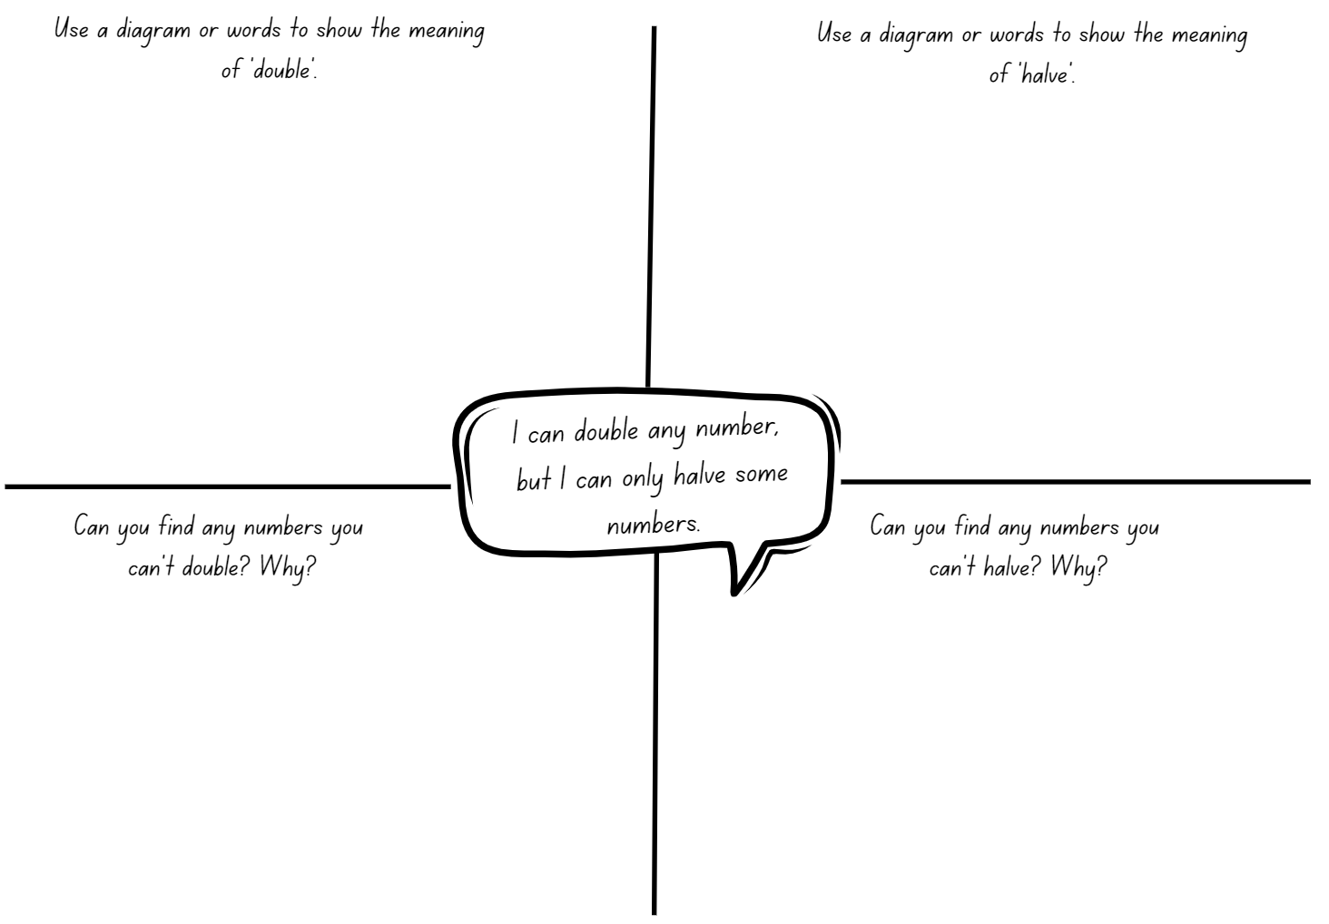

Syllabus outcomes and content
The table below outlines the syllabus outcomes and range of relevant syllabus content covered in this unit. Content is linked to National Numeracy Learning Progression version (3).
Focus area and outcomes | Content groups and content points | Lessons
Representing whole numbers A  MAO-WM-01  MA1-RWN-01  MA1-RWN-02 | Represent numbers on a line  - Sequence numbers and arrange them on a line by considering the order and size of those numbers (CPr5)  - Locate the approximate position of multiples of 10 on a model of a number line from 0 to 100 (CPr5)  Represent the structure of groups of ten in whole numbers  - Use number lines and number charts to assist with locating the nearest ten to a number  - Estimate, to the nearest ten, the number of objects in a collection and check by counting in groups of ten (CPr7, NPV6) | 1–2, 7–8
Representing whole numbers B  MAO-WM-01  MA1-RWN-01  MA1-RWN-02 | Use counting sequences of ones and tens flexibly  - Identify how many more to the next multiple of ten within two- and three-digit numbers  Form, regroup, and rename three-digit numbers  - State the quantity value of digits in numbers of up to three digits (NPV5)  - Recognise units of 100 (UnM5, NPV5) | 1, 3, 7–8
Forming groups A  MAO-WM-01  MA1-FG-01 | Recognise and represent division  - Use concrete materials to model a half of a collection and show the relation between the half and the whole (InF1)  - Model sharing division by distributing a collection of objects equally into a given number of groups to determine how many in each group (InF2, MuS5)  - Model grouping division by determining the number of groups of a given size that can be formed (MuS5)  - Describe the part left over when a collection cannot be distributed equally using the given group size (MuS6) | 4–8
Forming groups B  MAO-WM-01  MA1-FG-01 | Model doubling and halving with fractions  - Model doubling and halving groups and the relation between the processes (MuS6, InF2)  - Re-create the whole given half (InF3)  - Use concrete materials to model a half, a quarter or an eighth of a collection, and explain their thinking (InF2-InF3) | 4–6, 8
Geometric measure A  MAO-WM-01  MA1-GM-03 | Length: Subdivide lengths to find halves and quarters  - Use concrete materials to model both half and quarters of a whole length, highlighting the length (InF2)  - Identify two equal parts and the relationship of the parts to the whole length, linking words and images (InF2)  - Recognise when lengths have or have not been divided into halves and quarters (InF2) | 1–5
Geometric measure B  MAO-WM-01  MA1-GM-03 | Length: Repeatedly halve lengths to form eighths  - Use materials to model an eighth of a whole length, highlighting the length (InF2)  - Recognise when a length is divided into eight equal parts | 2–5

References
Links to third-party material and websites
Please note that the provided (reading/viewing material/list/links/texts) are a suggestion only and implies no endorsement, by the New South Wales Department of Education, of any author, publisher, or book title. School principals and teachers are best placed to assess the suitability of resources that would complement the curriculum and reflect the needs and interests of their students.
If you use the links provided in this document to access a third-party's website, you acknowledge that the terms of use, including licence terms set out on the third-party's website apply to the use which may be made of the materials on that third-party website or where permitted by the Copyright Act 1968 (Cth). The department accepts no responsibility for content on third-party websites.
Except as otherwise noted, all material is © State of New South Wales (Department of Education), 2023 and licensed under the Creative Commons Attribution 4.0 International License. All other material (third-party material) is used with permission or under licence. Where the copyright owner of third-party material has not licensed their material under a Creative Commons or similar licence, you should contact them directly for permission to reuse their material.
Mathematics K–10 Syllabus © 2022 NSW Education Standards Authority (NESA) for and on behalf of the Crown in right of the State of New South Wales.
© 2022 NSW Education Standards Authority. This document contains NSW Curriculum and syllabus content. The NSW Curriculum is developed by the NSW Education Standards Authority. This content is prepared by NESA for and on behalf of the Crown in right of the State of New South Wales. The material is protected by Crown copyright.
Please refer to the NESA Copyright Disclaimer for more information.
NESA holds the only official and up-to-date versions of the NSW Curriculum and syllabus documents. Please visit the NSW Education Standards Authority (NESA) website and the NSW Curriculum website.
National Numeracy Learning Progression © Australian Curriculum, Assessment and Reporting Authority (ACARA) 2010 to present, unless otherwise indicated. This material was downloaded from the Australian Curriculum website (National Numeracy Learning Progression) (accessed 27 February 2023) and was not modified. The material is licensed under CC BY 4.0. Version updates are tracked in the ‘Curriculum version history’ section on the 'About the Australian Curriculum' page of the Australian Curriculum website.
ACARA does not endorse any product that uses the Australian Curriculum or make any representations as to the quality of such products. Any product that uses material published on this website should not be taken to be affiliated with ACARA or have the sponsorship or approval of ACARA. It is up to each person to make their own assessment of the product, taking into account matters including, but not limited to, the version number and the degree to which the materials align with the content descriptions and achievement standards (where relevant). Where there is a claim of alignment, it is important to check that the materials align with the content descriptions and achievement standards (endorsed by all education Ministers), not the elaborations (examples provided by ACARA).
This resource contains images and content obtained from Canva, and their use outside of this resource is subject to Canva’s Content License Agreement. If you wish to use them separately from the resource, please go to Canva.
Askew M, Bishop S, Christie C, Eaton S, Griffin P, Morgan D and Oxford University Press (2015) Teaching for Mastery: Questions, tasks and activities to support assessment [PDF 6 MB], National Centre for Excellence in the Teaching of Mathematics, accessed 27 February 2023.
Australian Government Department of Education (2018) ‘Authentic Problems: Bunches of Balloons’, Teaching resources, reSolve: Maths by Inquiry website, accessed 27 February 2023.
Gould P (2013) ‘Australia’s next top fraction model’, Australian Primary Mathematics Classroom, 18(3):5–12, accessed 27 February 2023.
NCTEM (National Centre for Excellence in the Teaching of Mathematics) (2019) Mastery Professional Development: Fractions. Guidance on the teaching of fractions in Key Stage 1, Year 2 [PDF 3.17 MB], NCETM, accessed 27 February 2023.
Siemon D, Warren E, Beswick K, Faragher R, Miller J, Horne M, Jazby D & Breed M (2020) Teaching Mathematics Foundations to Middle Years, 3rd edn, Oxford University Press, Victoria.
State of Victoria (Department of Education and Training) (n.d.) ‘Fractions of shapes and collections’, Number and Algebra, Maths Curriculum Companion website, accessed 27 February 2023.
Sullivan P and Lilburn P (2017) Open-ended Maths Activities: Using ‘Good’ Questions to Enhance Learning in Mathematics, Revised edn, Oxford University Press ANZ, Great Britain.
University of Cambridge (Faculty of Mathematics) (1997-2023) Number Lines in Disguise, NRICH website, accessed 27 February 2023.

