Mathematics – Stage 1 – Unit 33
Contents
Unit description and duration 4
Student prior learning 4
Lesson overview and resources 5
Lesson 1: Bales of wool 10
Daily number sense: Nearest ten – 10 minutes 10
Number of groups and number in each group: Part 1 – 30 minutes 11
Consolidation and meaningful practice: Rolling groups – 20 minutes 14
Lesson 2: How many? 17
Daily number sense: Nearest hundred – 15 minutes 18
How many rectangles – 25 minutes 19
Number of groups and number in each group: Part 2 – 20 minutes 21
Lesson 3: Working with arrays 23
Daily number sense: The nearest hundred – 10 minutes 24
Fruit shop – 40 minutes 25
Discuss and connect the mathematics – 10 minutes 28
Lesson 4: Exploring arrays 29
Daily number sense: Counting patterns – 10 minutes 29
Fruit shop: Part 2 – 40 minutes 30
Discuss and connect the mathematics – 10 minutes 34
Lesson 5: Multiplicative strategies 36
Daily number sense: Missing numbers – 10 minutes 36
Multiplication toss – 25 minutes 37
Different representations – 25 minutes 40
Lesson 6: Equal sharing 43
Daily number sense: Double or halve – 15 minutes 43
How many in each group? – 35 minutes 45
Discuss and connect the mathematics – 10 minutes 47
Lesson 7: Equal grouping 49
Daily number sense: Number visuals – 15 minutes 50
How many groups? – 35 minutes 51
Discuss and connect the mathematics – 10 minutes 53
Lesson 8: Sharing 55
Daily number sense: More than one share – 15 minutes 55
Equal grouping and sharing – 35 minutes 56
Discuss and connect the mathematics – 10 minutes 59
Resource 1: Number talk 1 60
Resource 2: Number talk 2 61
Resource 3: Bales of wool 62
Resource 4: Different bales 63
Resource 5: Eggs 64
Resource 6: Student copy 1 65
Resource 7: Rectangles 66
Resource 8: Berries 67
Resource 9: Student copy 2 68
Resource 10: Number talk 3 69
Resource 11: Number talk 4 70
Resource 12: Fruit 71
Resource 13: Fruit shop 72
Resource 14: Lemons 73
Resource 15: Number talk 5 74
Resource 16: Number talk 6 75
Resource 17: Multiplication toss gameboard 76
Resource 18: Think board 77
Resource 19: Story representations 78
Resource 20: 30 grid 80
Resource 21: Equal sharing 1 82
Resource 22: Equal sharing 2 83
Resource 23: Pedro’s picnic 84
Resource 24: Number visuals 85
Resource 25: Equal grouping 1 86
Resource 26: Equal grouping 2 87
Resource 27: Poppy’s party 88
Resource 28: Sharing problems 89
Syllabus outcomes and content 95
References 99

Unit description and duration
This two-week unit develops student knowledge, understanding and skills of making and using equal groups. Students are provided opportunities to:
- identify between the number of groups and the number in each group when describing a collection of objects
- distribute a collection of objects equally into a given number of groups to determine how many in each group
- identify, form, rotate and name arrays using equal rows and equal columns to solve multiplication and division problems
- use counting strategies to find the total, for example, skip counting, counting on or double facts
- use various representation of diagrams, images or objects to model and solve multiplication and division problems.
Mathematics K–10 Syllabus © 2022 NSW Education Standards Authority (NESA) for and on behalf of the Crown in right of the State of New South Wales.

Student prior learning
Before engaging in these teaching and learning activities, students would benefit from prior experience with:
- forming equal groups by sharing and counting collections of objects
- counting in multiples using rhythmic and skip counting
- understanding that the equals sign is used to record equivalence.

Lesson overview and resources
The table below outlines the sequence and approximate timing of lessons; syllabus focus areas and content groups; and resources.
Lesson | Syllabus focus area and content groups | Resources
Lesson 1: Bales of wool  60 minutes  There is a difference between the number of groups and the number in each group. | Representing whole numbers A  - Use counting sequences of ones with two-digit numbers and beyond  - Represent the structure of groups of ten in whole numbers  Forming groups A  - Count in multiples using rhythmic and skip counting  - Model and use equal groups of objects to represent multiplication  Forming groups B  - Represent and explain multiplication as the combining of equal groups  - Represent multiplication and division problems | - Resource 1: Number talk 1  - Resource 2: Number talk 2  - Resource 3: Bales of wool  - Resource 4: Different bales  - Resource 5: Eggs  - Resource 6: Student copy 1  - 6-sided dice  - Counters  - Numbers 2, 3, 5 and 10 from decks of playing cards  - Writing materials
Lesson 2: How many?  60 minutes  The same numbers can be represented in many different ways. | Representing whole numbers A  - Use counting sequences of ones with two-digit numbers and beyond  - Represent the structure of groups of ten in whole numbers  Representing whole numbers B  - Form, regroup and rename three-digit numbers  Forming groups A  - Model and use equal groups of objects to represent multiplication  Forming groups B  - Represent and explain multiplication as the combining of equal groups  - Represent multiplication and division problems | - Resource 7: Rectangles  - Resource 8: Berries  - Resource 9: Student copy 2  - 12 tiles, pieces of paper or sticky notes (per student)  - Grid paper  - Large collection of objects, for example, counters, craft sticks, beads, ones or paperclips
Lesson 3: Working with arrays  60 minutes  Arrays are an efficient way to structure multiplication and find the total. | Representing whole numbers B  - Use counting sequences of ones and tens flexibly  - Form, regroup and rename three-digit numbers  Forming groups A  - Model and use equal groups of objects to represent multiplication  Forming groups B  - Represent and explain multiplication as the combining of equal groups  - Represent multiplication and division problems | - Resource 10: Number talk 3  - Resource 11: Number talk 4  - Resource 12: Fruit  - Resource 13: Fruit shop  - Writing materials
Lesson 4: Exploring arrays  60 minutes  The same number can be represented in arrays of different formations. | Representing whole numbers A  - Continue and create number patterns  Forming groups A  - Use skip counting patterns  Forming groups B  - Represent and explain multiplication as the combining of equal groups  - Represent multiplication and division problems | - Resource 14: Lemons  - Concrete materials, for example, counters or interlocking cubes  - Writing materials
Lesson 5: Multiplicative strategies  60 minutes  The same numbers can be represented in many different ways. | Representing whole numbers A  - Continue and create number patterns  Forming groups A  - Use skip counting patterns  - Model and use equal groups of objects to represent multiplication  Forming groups B  - Represent and explain multiplication as the combining of equal groups  - Represent multiplication and division problems | - Resource 15: Number talk 5  - Resource 16: Number talk 6  - Resource 17: Multiplication toss gameboard  - Resource 18: Think board (2 per student)  - Resource 19: Story representations  - 9-sided dice (2 per pair)  - Writing materials
Lesson 6: Equal sharing  60 minutes  Division can be represented by sharing objects into groups. | Representing whole numbers A  - Use counting sequences of ones with two-digit numbers and beyond  Forming groups A  - Recognise and represent division  Forming groups B  - Represent multiplication and division problems | - Resource 20: 30 grid  - Resource 21: Equal sharing 1  - Resource 22: Equal sharing 2  - Resource 23: Pedro’s picnic  - 6-sided dice  - Writing materials
Lesson 7: Equal grouping  60 minutes  Division requires finding how many groups are formed. | Representing whole numbers A  - Use counting sequences of ones with two-digit numbers and beyond  Forming groups A  - Recognise and represent division  Forming groups B  - Represent multiplication and division problems | - Resource 24: Number visuals  - Resource 25: Equal grouping 1  - Resource 26: Equal grouping 2  - Resource 27: Poppy’s party  - Concrete materials, for example, counters or interlocking cubes  - Writing materials
Lesson 8: Sharing  60 minutes  Division can be represented by sharing objects into groups or finding out how many groups are formed. | Forming groups A  - Recognise and represent division  Forming groups B  - Represent multiplication and division problems | - Resource 28: Sharing problems  - Collection of objects, for example, counters, interlocking cubes or pompoms  - Writing materials

Lesson 1: Bales of wool
Core concept: There is a difference between the number of groups and the number in each group.
The table below contains suggested learning intentions and success criteria. These are best co-constructed with students.
Learning intention | Success criteria
Students are learning that multiplication can be represented by making and using equal groups. | Students can:  - identify between the number of groups and the number in each group  - form arrays using equal rows and equal columns  - use counting strategies to find the total, for example, skip counting, counting on or double facts.

Daily number sense: Nearest ten – 10 minutes
- Build student understanding of the structure of groups of tens by estimating the number of objects in a collection to the nearest 10.
- Display Resource 1: Number talk 1 for about 5 seconds. Students look at the image and estimate the total to the nearest 10.
- Encourage students to visualise the image and use their knowledge of small collections to make an informed estimation. Give students time to think independently and show a silent thumbs-up when they are ready.
- Display Resource 1: Number talk 1 again. Ask students to share and justify the strategy they used to estimate the total. As students explain, record their thinking.
- If not already identified through questioning and discussion, explain to students that the total to the nearest 10 is 20, because 17 is 3 away from the benchmark of 20 and 7 away from the benchmark of 10.
Note: Place the emphasis on developing the quantity value of numbers and identifying the nearest 10 or 100 to a number. These can be referred to as benchmark or landmark numbers.
- Complete the process again with Resource 2: Number talk 2.

Number of groups and number in each group: Part 1 – 30 minutes
This lesson has been adapted from How many bales? from Thinking mathematically (2022).
- Display and read Resource 3: Bales of wool. Ask students to use their individual whiteboard to draw a diagram to solve the problem. Ask:
- What is the problem asking us to do?
- What part of the problem tells us the number of groups?
- What part of the problem tells us about the number in each group?
- What strategy did you use to work out the total?
- How did your diagram help you structure your solution?
- Choose different students to demonstrate how they solved the problem.
- Demonstrate to students how to determine the number of groups and the number in each group within the problem and the different ways to draw a diagram to solve the problem and find the total (see Figure 1).
Figure 1 – Solving the problem
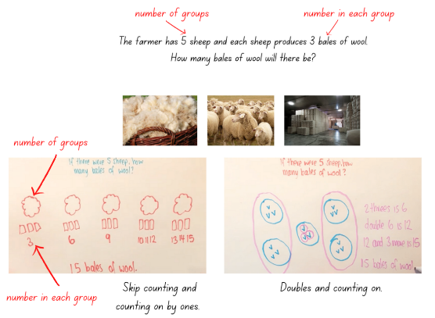
Images sourced from Canva and used in accordance with the Canva Content License Agreement.
- Read and display Resource 4: Different bales and ask students what they notice is similar and different to the last problem. Ask students to identify the number of groups and the number in each group. Ask students to consider and justify if they think the total will be the same or different.
- Students use their individual whiteboard to draw a diagram to solve the problem. Students share their solutions with the class. Through class discussion and comparison of both problems, highlight the difference between the number of groups and the number in each group. For example, 5 sheep with 3 bales is different from 3 sheep with 5 bales; not in terms of the total but in terms of the number of sheep and bales and the structure of their diagram.
- Read and display Resource 5: Eggs. Provide students with one copy of Resource 6: Student copy 1 for their workbook. Have students underline the number of groups and circle the number in each group for each of the problems. Students can use concrete materials to solve the problem and record in their workbook by drawing 2 diagrams to represent both problems.
- Regroup as a class and choose different students to demonstrate how they solved the problems. Ask:
- How did you work out the number of groups and the number in each group? How did knowing this help you draw your diagram?
- What counting strategy did you use to get the total?
- Why is the solution the same?
The table below details assessment opportunities and differentiation ideas.
Assessment opportunities | Too hard? | Too easy?
What to look for:  - Are students able to identify between the number of groups and the number in each group? (MAO-WM-01, MA1-FG-01)  - Can students use counting strategies to find the total? (MAO-WM-01, MA1-FG-01)  What to collect:  - student work samples. (MAO-WM-01, MA1-FG-01) | Students are unable to identify between the number of groups and the number in each group.  - Students label the number of objects in each group.  - Focus on students drawing circles to represent how many groups and use concrete materials to put items in each group. Assist students to verbally explain the process, for example, I have drawn 3 groups and put 4 items in each group. The total is 12. | Students can identify between the number of groups and the number in each group.  - Have students represent the problems using an array and correctly name the array.  - Challenge students to determine the total or number of equal groups where the individual items cannot be seen.

Consolidation and meaningful practice: Rolling groups – 20 minutes
The lesson is adapted from Rolling groups from Developing Efficient Numeracy Strategies (n.d).
- Have students look at their work from Resource 5: Eggs. Model to students how to make and label an array for both problems (see Figure 2).
Figure 2 – Building arrays
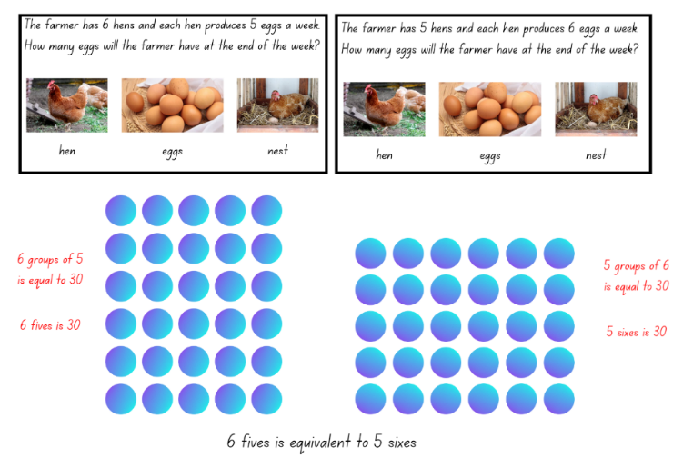
Images sourced from Canva and used in accordance with the Canva Content License Agreement.
- Provide students with one 6-sided die, the 2, 3, 5 and 10 playing cards and counters. Students roll the die to represent the number of rows or columns and turn over a card to represent the number in each row or column. Students use these numbers to build and name an array.
Note: Focus on using groups of, before progressing to rows of and columns of. A composite unit is a unit-whole composed of other units. Recognising and working with composite units introduces the distinction between the number of groups (how many) and the number in each group (how much). These problems identify the distinction between the count (how many) and the unit (how much). When recording distinctions, how many is recorded using the numeral and how much is recorded using the word, for example, 3 sevens. (Siemon et al. 2021)
- Students use rhythmic or skip counting to find the total. Students work together to create many different arrays.
The table below details assessment opportunities and differentiation ideas.
Assessment opportunities | Too hard? | Too easy?
What to look for:  - Are students able to form arrays using equal rows and equal columns? (MAO-WM-01, MA1-FG-01)  - Can students use counting strategies to find the total? (MAO-WM-01, MA1-FG-01)  What to collect:  - observational data. (MAO-WM-01, MA1-FG-01) | Students are unable to form an array using equal rows and equal columns.  - Students continue to focus on modelling and describing collections as groups of.  - Students make equal groups and count by ones or skip count to find the total. | Students can form an array using equal rows and equal columns.  - Have students verbally name the array correctly, focusing on using the numeral to represent the number rows or columns and the number words to represent the number in each row or column.  - Challenge students to determine the total in the array where the individual items cannot be seen.

Lesson 2: How many?
Core concept: The same numbers can be represented in many different ways.
The table below contains suggested learning intentions and success criteria. These are best co-constructed with students.
Learning intention | Success criteria
Students are learning that multiplication can be represented by making and using equal groups. | Students can:  - identify between the number of groups and the number in each group  - form arrays of equal rows and equal columns to create rectangles  - use counting strategies to find the total, for example, skip counting, counting on or double facts.

Daily number sense: Nearest hundred – 15 minutes
This lesson has been adapted from Mindset Mathematics: Scoop and Count from Boaler et al. (2022).
- Build student understanding of the structure of 100 by estimating the collection of 100 objects.
- Show students a large collection of the same object, for example, counters, craft sticks, beads, ones or paperclips. Ask students how they would scoop out 100 of these objects. For example, 2 big handfuls, a small collection in a cup or a large container.
- Students turn and talk about their estimation and then share their ideas and reasoning.
- Provide small groups with more than 100 of the same objects. Groups look at their objects and make an estimation of what their scoop of 100 objects would look like.
- Students then scoop out their estimation and count their collection using an efficient strategy. Ask:
- How close was your estimation to 100?
- What did you notice when you counted your collection?
- How did you count your collection? How can you be sure the total is correct?
- Is there a more efficient way to count your collection?
- How many more or less objects do you need to make 100?
Note: Encourage students to use efficient grouping strategies when counting large collections. For example, students can count out groups of 5 or 10 and then find the total using the groups. Grouping makes it easier to check the total and trust the count.
- Students adjust their collections to represent 100. Allow students to reflect on what 100 of their objects looks like.
Note: Take photographs to make a display representing different collections of 100.

How many rectangles – 25 minutes
This lesson has been adapted from How many rectangles? – Stage 1 from Thinking Mathematically. Watch How many rectangles? Parts 1-3 (7:15) prior to teaching the lesson.
- Display Resource 7: Rectangles and students turn and talk to share what they know, and what they notice is similar and different about the images.
- Select students to share their thinking and record their responses demonstrating how to name each of the rectangles as an array. For example, 3 fours and 2 sixes.
The table below outlines stimulus prompts to generate conversation about the topic, along with anticipated responses from students.
Prompts | Anticipated student responses
- What do you notice about the images?  - What is similar?  - What is different?  - What do you wonder? | - They are both rectangles.  - Both rectangles are made using 12 squares.  - They look different. One is long and thin and the other looks like a square.
- Ask students to consider if there are more rectangles that can be made using 12 squares. Provide students or pairs of students with 12 tiles, pieces of paper or sticky notes and grid paper or their grid workbook. Ask them to make a different rectangle using all their materials and then record on the grid paper, naming their new rectangle according to the number of rows and how many in each row using numerals and words (see Figure 3).
Figure 3 – Recording rectangles
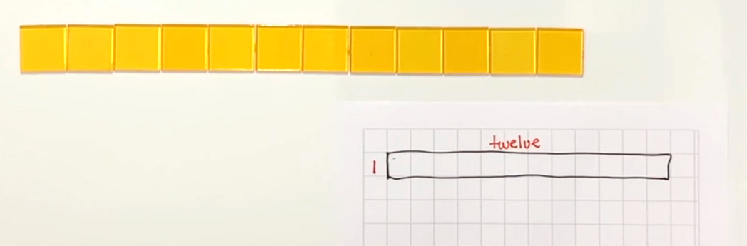
- Select students to share their new rectangles with the class and record.
- Provide students with a different number of materials under 20 that can be used to form a rectangular array and ask students to make as many different rectangles as they can using all their materials and record on their grid paper. Students need to name their rectangles, according to how many rows and how many in each row using numerals and words.
- While students are making rectangles, walk around and ask:
- What happens when you rotate your rectangles?
- Did you use a strategy to find all the different rectangles?
- How will you know when you have found all the rectangles you can make?
- What challenges did you face? How did you overcome them?
The table below details assessment opportunities and differentiation ideas.
Assessment opportunities | Too hard? | Too easy?
What to look for:  - Are students able to identify between the number of groups and the number in each group? (MAO-WM-01, MA1-FG-01)  - Are students able to form arrays of equal rows and equal columns when creating rectangles? (MAO-WM-01, MA1-FG-01)  What to collect:  - student work samples. (MAO-WM-01, MA1-FG-01) | Students are unable to make and name different rectangles using materials.  - Provide students with 8 tiles to make as many rectangles as possible.  - Support students to recognise basic arrays in rectangles, for example, 1 three or 2 threes and have students recognise the rows and how many tiles in each row, building their understanding of the structure of rows. | Students can make and name different rectangles using materials.  - Provide students with 24 tiles. Students create as many different rectangles as possible using all tiles and record on grid paper.  - Challenge students to create and record all the possible rectangles using 24 tiles without concrete materials to manipulate.

Number of groups and number in each group: Part 2 – 20 minutes
This part of the lesson has been adapted from How many bales? from NSW Department of Education (2022).
- Read and display Resource 8: Berries. Provide students with one copy of Resource 9: Student copy 2 for their workbook. Have students underline the number of groups and circle the number in each group for each of the problems. Students can use concrete materials to solve the problem and record in their workbook by drawing 2 diagrams to represent both problems. Encourage students to move from using groups of when representing their working out to using an array.
- Regroup as a class and choose different students to demonstrate how they solved the problems. Ask:
- How did you work out the number of groups and the number in each group? How did knowing this help you draw your diagram?
- What counting strategy did you use to get the total?
- Why is the solution the same?
The table below details assessment opportunities and differentiation ideas.
Assessment opportunities | Too hard? | Too easy?
What to look for:  - Are students able to identify between the number of groups and the number in each group? (MAO-WM-01, MA1-FG-01)  - Can students use counting strategies to find the total? (MAO-WM-01, MA1-FG-01)  What to collect:  - student work samples. (MAO-WM-01, MA1-FG-01) | Students are unable to identify between the number of groups and the number in each group.  - Students label the number of objects in each group.  - Focus on students drawing circles to represent how many groups and use concrete materials to put items in each group. Assist students to verbally explain the process, for example, ‘I have drawn 3 groups and put 4 items in each group. The total is 12.’ | Students can identify between the number of groups and the number in each group.  - Have students represent the problems using an array and correctly name the array.  - Challenge students to determine the total or number of equal groups where the individual items cannot be seen.

Lesson 3: Working with arrays
Core concept: Arrays are an efficient way to structure multiplication and find the total.
The table below contains suggested learning intentions and success criteria. These are best co-constructed with students.
Learning intention | Success criteria
Students are learning that multiplication can be represented by making and using arrays. | Students can:  - estimate, check and count a collection of objects to the nearest hundred  - identify and use arrays to solve addition and multiplication problems  - use counting strategies to find the total, for example, skip counting, counting on or double facts  - represent equality with the equals sign.

Daily number sense: The nearest hundred – 10 minutes
- Build student understanding of three-digit numbers to the nearest 100 by estimating a collection of objects.
- Display Resource 10: Number talk 3 for about 5 seconds. Students look at the image and estimate the total, to the nearest 100.
- Encourage students to visualise the image and use their knowledge of hundreds and tens to make an informed estimation. Give students time to independently think and show a silent thumbs-up when they are ready.
- Display Resource 10: Number talk 3 again and ask students to share and justify the strategy they used to estimate the total. As students explain, record their thinking. Ask students what information about the numbers did they use to determine the total as 400 or 500.
- If not identified through questioning and discussion, explain that the total to the nearest 100 is 500, because 470 is 30 away from the benchmark of 500 and 70 away from the benchmark of 400.
- Complete the process again with Resource 11: Number talk 4.
The table below details assessment opportunities and differentiation ideas.
Assessment opportunities | Too hard? | Too easy?
What to look for:  - Are students able to estimate, check and count a collection of objects to the nearest hundred? (MAO-WM-01, MA1-RWN-01, MA1-RWN-02)  What to collect:  - observational data. (MAO-WM-01, MA1-RWN-01, MA1-RWN-02) | Students are unable to estimate, check and count a collection of objects to the nearest hundred.  - Provide students with images or small collections of objects, like Lesson 1: Daily Number Sense. Students practise estimating to the nearest 10 using two-digit numbers.  - Students use a number line or number chart to identify a given number and then the closest benchmark number to that given number. | Students can estimate, check and count a collection of objects to the nearest hundred.  - Challenge students with problems that require estimation, for example, pencils come in a pack of 10. Students estimate the number of packs required for 127 Stage 1 students.  - Provide students with several collections of objects. Have students estimate each collection to the nearest 10 or 100 and then order them from smallest to largest. Students then check the total of each collection.

Fruit shop – 40 minutes
This lesson has been adapted from Multiplication: reSolve Fruit Shop from reSolve: Maths by Inquiry.
- Display Resource 12: Fruit and ask students what they notice about the fruit display. Provide individual thinking time and then students turn and talk.
- Select students to share and explain what they noticed about the image. Model to students how to record the total using numerals, words and the equals sign (see Figure 4).
Figure 4 – Recording an array
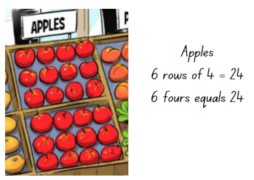
Image adapted from ‘Multiplication: reSolve Fruit Shop – 1a reSolve Fruit Shop’ by Australian Government Department of Education is licensed under CC BY-SA 4.0
- Provide students with their workbook or individual whiteboard and ask them to find and record the total of each collection of different fruit using diagrams, numerals and/or words. Ask:
- Which counting strategy did you use to find the total of each type of fruit?
- Does the way the fruit is organised help count them?
- Is there a different way you solve this problem?
- Regroup and choose students to share and explain how they found the total of each type of fruit with a focus on correctly naming the arrays. If not identified through questioning and discussion, explain that the fruit is organised into arrays, and students can quickly and efficiently work out how many pieces of fruit are in each array by skip counting.
- Display Resource 13: Fruit shop and ask students to find the total number of oranges, watermelons and punnets of berries.
- Students use their workbook to record diagrams, numerals and/or words to represent the number of each fruit, for example, punnets of berries can be represented as 3 threes = 9 punnets.
- Select students to share and explain how they solved the problems. While students are sharing, highlight efficient counting strategies, for example, skip counting.
- Challenge students to find the cost of the different fruits, for example, the 4 bags of lemons, all the watermelons weighing 2kg each, the punnets strawberries and the punnets of blueberries. Focus students’ attention to the number of groups and the cost of each group to reach the total, for example, 4 bags of lemons at $5 a bag is equal to $20. Students record their working in their workbook.
- Students display their work and go on a gallery walk to look at the various ways the problem has been solved.
The table below details assessment opportunities and differentiation ideas.
Assessment opportunities | Too hard? | Too easy?
What to look for:  - Can students identify and use arrays to solve addition and multiplication problems? (MAO-WM-01, MA1-FG-01)  - Can students use efficient counting strategies to find the total? (MAO-WM-01, MA1-FG-01)  - Are students able to use the equals sign to represent equality? (MAO-WM-01, MA1-CSQ-01)  What to collect:  - student work samples. (MAO-WM-01, MA1-CSQ-01, MA1-FG-01) | Students are unable to identify and use arrays to solve multiplication problems.  - Provide students with printed copies of Resource 12: Fruit and Resource 13: Fruit shop. Support students to identify arrays by drawing circles around rows of fruit and counting how many in each row.  - Students make equal groups and count by ones or skip count to find the total. | Students can identify and use arrays to solve multiplication problems.  - Challenge students to find the total number of the strawberries in the shop if there are 7 strawberries in each punnet.  - Students create their own fruit shop with different arrays and the price of the fruit. Students work out the totals for their fruit shop or share with a peer to solve.

Discuss and connect the mathematics – 10 minutes
- Summarise the lesson together, drawing out some key mathematical ideas. Ask students:
- What strategies did you use to work out the total number of each type of fruit?
- Are there other strategies you could use to find the total of each type of fruit?
- How did knowing how many and how much help with the total of fruit and the total cost?
- What challenges did you face? How did you overcome them?
- What questions do you still have?

Lesson 4: Exploring arrays
Core concept: The same number can be represented in arrays of different formations.
The table below contains suggested learning intentions and success criteria. These are best co-constructed with students.
Learning intentions | Success criteria
Students are learning that:  - multiplication can be represented by making and using arrays  - when an array is rotated the value remains the same. | Students can:  - form multiple arrays of equal rows and equal columns for the same number  - rotate arrays to model the commutative property  - use arrays to solve multiplication and division problems.

Daily number sense: Counting patterns – 10 minutes
- Build student understanding of skip counting by twos, threes and fives by creating and describing number patterns.
- Challenge students to create 3 different forwards or backwards number patterns that increase or decrease by twos, threes and fives. Students use their individual whiteboard to record their patterns (see Figure 5).
Figure 5 – Number patterns
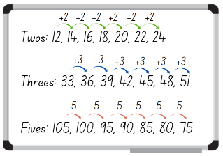
Images sourced from Canva and used in accordance with the Canva Content License Agreement.
- Choose different students to share their number patterns. When recording the pattern, demonstrate how to show the increasing or decreasing pattern, Figure 5. Select a student to identify the next 3 numbers in the pattern and record.

Fruit shop: Part 2 – 40 minutes
This lesson has been adapted from Multiplication: reSolve Fruit Shop from reSolve.
- Display and read one of the images from Resource 14: Lemons. Ask students to use their workbook to record all the different ways that all the lemons can be arranged in an array. Ask:
- Is there more than one way to arrange the lemons?
- How do you know you have found all the possible solutions?
- Did you rotate the arrays to help find all the possible solutions?
- Select students to share and explain how the owner could arrange the lemons until all possible solutions are recorded. Ensure students understand that arrays can be rotated to show a different arrangement and naming however the total remains the same.
Note: There are 6 possible solutions: 2 rows of 12 and 12 rows of 2, 3 rows of 8 and 8 rows of 3, 4 rows of 6 and 6 rows of 4.
Commutative property: Two numbers can be added or multiplied in any order and the solution will be the same.
- Display one of the images from Resource 14: Lemons again and explain that the owner wants to split the lemons into 2 equal-sized groups and arrange them in 2 arrays. Students use their workbook to record as many diagrams and solutions as possible to the problem (see Figure 6). Ask students:
- How did you split the lemons into 2 equal groups?
- What did you notice about the arrays?
- Is there more than one solution?
- How do you know you have found all the possible ways to arrange the lemons?
- Did you rotate the arrays to help find all the possible solutions?
Figure 6 – Student recording equal groups
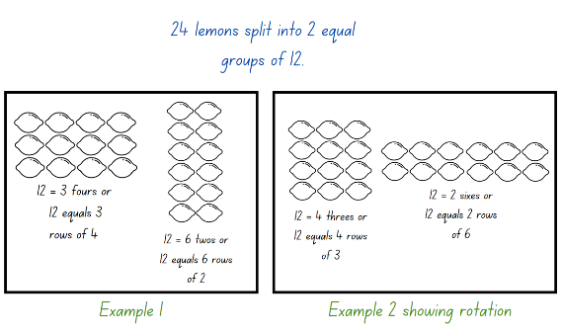
Images sourced from Canva and used in accordance with the Canva Content License Agreement.
- Regroup as a class and choose different students to demonstrate their solutions to the problem until all 4 possible solutions have been explained: 2 rows of 6 and 6 rows of 2, 3 rows of 4 and 4 rows of 3.
- Explain that the owner of the fruit shop now wants to use all the lemons to make 2 unequal arrays, where the array does not need to be the same size. For example, arrays of 4 and 20 or 10 and 14 (see Figure 7). Students solve the problem and record in their workbook using diagrams. Ask:
- What might the arrays look like?
- Is there more than one solution?
- How will you know when you have all the solutions?
Figure 7 – Student recording unequal groups
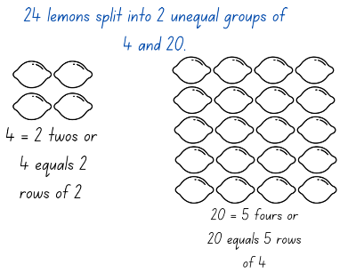
Images sourced from Canva and used in accordance with the Canva Content License Agreement.
Note: Students may need counters or interlocking cubes to manipulate in order to solve the problem.

Discuss and connect the mathematics – 10 minutes
- Students display their work and go a gallery walk to look at all the different ways students modelled their unequal arrays to solve the problem.
- Regroups as a class and choose students to show and explain their arrays. Ask:
- Did you face any challenges when creating the unequal arrays?
- Did you find a solution that was different to everyone else?
- What strategies did you use to find the solutions?
- Which solution would work best in the fruit shop? Why?
- Are you confident with rotating arrays?
- What questions do you still have?
The table below details assessment opportunities and differentiation ideas.
Assessment opportunities | Too hard? | Too easy?
What to look for:  - Can students form multiple arrays of equal rows and equal columns for the same number? (MAO-WM-01, MA1-FG-01)  - Are students able to rotate arrays to model the commutative property? (MAO-WM-01, MA1-FG-01)  - Can students use arrays to solve multiplication and division problems? (MAO-WM-01, MA1-FG-01)  What to collect:  - student work samples. (MAO-WM-01, MA1-FG-01) | Students are unable to form multiple arrays for 24 lemons.  - Provide concrete materials for students to move and explore different arrangements.  - Support students to form simple, fewer arrays by asking them to arrange 12 lemons. | Students can form multiple arrays for the same number.  - Challenge students to explain why there are only 5 ways to split the lemons into 2 unequal groups with at least 2 lemons in each row and column.  - Challenge students to find the 2 numbers that form square arrays and record how they form both a square array and a non-square array.

Lesson 5: Multiplicative strategies
Core concept: The same numbers can be represented in many different ways.
The table below contains suggested learning intentions and success criteria. These are best co-constructed with students.
Learning intention | Success criteria
Students are learning that multiplication can be represented in different ways. | Students can:  - form, rotate and name arrays when solving multiplication problems  - use various representation of diagrams, images or objects to model multiplication.

Daily number sense: Missing numbers – 10 minutes
- Build student understanding of skip counting patterns by determining a missing number in a number pattern.
- Display Resource 15: Number talk 5 and ask students to determine the missing numbers in the pattern. Students use their individual whiteboard to record the number pattern showing the rule and the missing numbers (see Figure 8).
Figure 8 – Student work sample
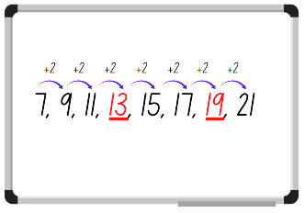
Images sourced from Canva and used in accordance with the Canva Content License Agreement.
- Choose students to demonstrate their working, explaining how they determined the missing number. Select a student to identify the next 3 numbers in the pattern and record.
- Display Resource 16: Number talk 6 and follow the above steps.

Multiplication toss – 25 minutes
This lesson has been adapted from Activity 15.4: Multiplication Toss from Siemon et al. (2021).
- Demonstrate how to play multiplication toss by playing against the class. Use and display one gameboard from Resource 17: Multiplication toss gameboard, two 9-sided dice and 2 different coloured makers.
- Player 1 rolls the dice and uses the numbers rolled to create an array. For example, if they roll 3 and 5, they can make either 3 fives or 5 threes. The player decides which array they will use, draws an outline of the array around the correct number of rows and columns and writes the name of the array in the middle (see Figure 9).
Figure 9 – Multiplication toss gameplay
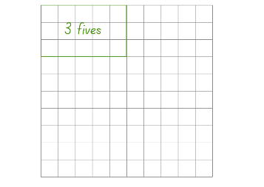
- Player 2 then rolls the dice and uses the numbers rolled to create an array that will fit without overlapping. For example, if player 2 rolls a 4 and 7 and chooses 7 fours. Player 2 draws an outline of the array around the correct number of rows and columns and writes the name of the array in the middle (see Figure 10).
Figure 10 – Gameplay
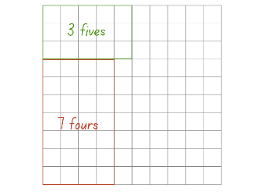
- If a player rolls an array that does not fit without overlapping, it is the other players turn. Players continue to take turns until there is no more room for either player. The player with the most squares covered is the winner.
- Once students are confident with the game, provide pairs with one gameboard from Resource 17: Multiplication toss gameboard, two 9-sided dice and 2 different coloured markers. Students take turns playing multiple rounds.
Note: Place Resource 17: Multiplication toss gameboard in a reusable sleeve to play multiple rounds or students can use their grid workbook. Students can also record the total in the middle of their array, for example, 7 fours = 28.

The table below details assessment opportunities and differentiation ideas.
Assessment opportunities | Too hard? | Too easy?
What to look for:  - Can students form, rotate and name arrays when solving multiplication problems? (MAO-WM-01, MA1-FG-01)  What to collect:  - students work samples. (MAO-WM-01, MA1-FG-01) | Students are unable to create and name arrays.  - Provide students with two 6-sided dice and support them to use concrete materials to create and correctly name arrays according to the number of rows and how many in each row.  - Print Resource 17: Multiplication toss gameboard on A3 paper and provide students with counters to place on the grid and then draw an outline around the counters. | Students can create and name simple arrays  - Challenge students to create arrays using 12-sided dice.  - Students can partition the number of groups to form 2 separate outlines. For example, 6 eights could be split into 4 eights and 2 eights.

Different representations – 25 minutes
- Write on the board that there are 8 chairs with 4 legs each and ask how many legs there are altogether. Provide students with an individual whiteboard and ask them to record all the different representations they can think of to solve the problem.
- Select students to share and explain their different representations.
- From the responses choose and record some of the efficient strategies, such as equal groups, using arrays and skip counting on a displayed Resource 18: Think board.
- Display, read and provide students with Resource 19: Story representations. Have students solve the problems and record 4 efficient representations for each story (see Figure 11). Students should use drawing, words and numerals in their representations.
Figure 11 – Different representations
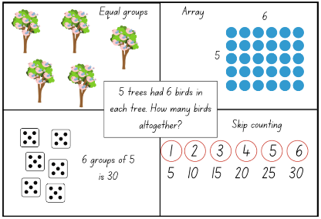
Images sourced from Canva and used in accordance with the Canva Content License Agreement.
- Students display their work and go a gallery walk to see and compare the different representations that students have used. As students are walking around, ask:
- Was creating 4 different representations challenging? Why or why not?
- Is there a strategy that you are more confident using? Why?
- Did you have strategies that were different or similar to others?
- Are there other representations for the stories that you did not write down?
- What other questions do you still have?
The table below details assessment opportunities and differentiation ideas.
Assessment opportunities | Too hard? | Too easy?
What to look for:  - Can students use various representation of diagrams, images or objects to model multiplication? (MAO-WM-01, MA1-FG-01)  What to collect:  - students work samples. (MAO-WM-01, MA1-FG-01) | Students are unable to create different representations using known strategies.  - Support students to create 2 different representations of the story. Highlight previously taught strategies in this unit, for example, skip counting and groups of.  - Provide students with concrete materials, such as, counters or interlocking cubes to manipulate when solving Resource 19: Story representations. | Students can create different representations using known strategies.  - Challenge students to use at least 6 different representations of the story and explain them to a peer.  - Have students create stories for a peer to solve using at least 4 different representations.  - Students identify and represent Resource 19: Story representations using the multiplication and equals symbols.

Lesson 6: Equal sharing
Core concept: Division can be represented by sharing objects into groups.
The table below contains suggested learning intentions and success criteria. These are best co-constructed with students.
Learning intention | Success criteria
Students are learning that division can be represented by sharing objects into equal groups. | Students can:  - identify between the number of groups and the number in each group when describing a collection of objects  - use concrete materials to model half of a collection  - distribute a collection of objects equally into a given number of groups to determine how many in each group.

Daily number sense: Double or halve – 15 minutes
This lesson has been adapted from Double or halve? – Stage 1 from Thinking Mathematically.
- Build student understanding of flexible addition strategies by doubling and halving a given number.
- Provide pairs with one copy of Resource 20: 30 grid, 2 different coloured pencils and a 6-sided die.
- Students choose a target number between 10 and 30 and write it on the side of their grid and on the correct grid square.
- The first player rolls the die and chooses to either double or halve the number. The player records their choice on the grid by shading the correct number of squares. Players record a running total on the side of their grid.
- Players take turns to roll the die and record their chosen number. If a player cannot go, they miss a turn. The winner is the player who reaches the target number exactly (see Figure 12).
Figure 12 – Double or halve gameplay
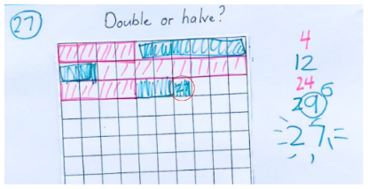
- While students are playing, move around to pairs and ask:
- If you play the game again, are there any moves you will change?
- Is there a number you should have halved instead of doubled? Why?
- If you play the game again and the rules changed where you could double, halve or keep your roll, do you think this might make it easier to reach the target number?
Note: Students can use their grid workbooks to play the game with a larger target number or use page 2 of Resource 20: 30 grid to support students to combine numbers and keep a running total.

How many in each group? – 35 minutes
This lesson has been adapted from Fair Feast from NRICH (2022).
- Display and read Resource 21: Equal sharing 1 and ask students to use their individual whiteboard or counters to solve the problem.
- After students have had a chance to solve the problem, ask them to explain how they solved the problem.
The table below outlines stimulus prompts to generate conversation about the topic, along with anticipated responses from students.
Prompts | Anticipated student responses
- What is this problem asking you to do?  - Is this problem asking how many in each group or how many groups?  - What is the solution? | - The problem is a division problem and is asking to share 12 marbles.  - This problem is asking how many in each group. There are 3 students, and each student represents one group.  - The 3 students will receive 4 marbles each.
Partitive: Sharing (partitive) division requires finding how many are in each group, for example, calculating how marbles 3 students would get if 12 marbles were shared equally between them.
- Draw students’ attention to the wording of the problem and how students represented different groups; note that the marbles need to be shared between the 3 students (groups). Demonstrate how to solve the problem with concrete materials and record the process using a diagram.
- Ask students what they notice about the answer and how it links to other mathematical things they know. Help students make the link to multiplication and ask students to recombine the groups to model multiplication by pointing out that 3 groups of 4 marbles, makes 12 marbles altogether. Students may also build an array and name it as 3 fours or 4 threes.
Note: After students have divided a quantity into equal groups, for example, 12 objects divided into 3 groups, students should recombine the groups. This reversal of the process links multiplication and division. Formal writing of number sentences for multiplication and division, including the use of the symbols × and ÷ is not introduced until Stage 2.
- Display and read Resource 22: Equal sharing 2 and ask students if this problem is asking how many in each group or how many groups. Students consider the questions and then use their individual whiteboard or counters to solve the problem.
- Choose students to demonstrate how they solved the problem and draw students’ attention to how each team represents a group and the objects needed to be shared into the 2 groups.
Note: When sharing a collection of objects into 2 groups, students may describe the number of objects in each group as being one half of the whole collection.
- Ask students what they notice about the answer and how it links to other mathematical things they know. Help students make the link to multiplication and ask students to recombine the groups to model multiplication.
- Display Resource 23: Pedro’s picnic and explain to students that Pedro and Michael are having a picnic and need to share the food equally between them.
- In pairs, provide students with a large piece of paper or their workbooks to solve the problem. Have students draw 2 plates and share the food equally between the plates (see Figure 13).
Figure 13 – Student example
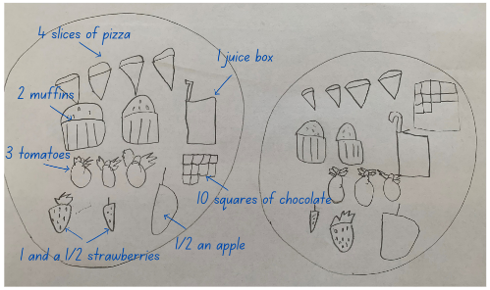

Discuss and connect the mathematics – 10 minutes
- Regroup as a class and have students share their solution to the problem. Ask:
- What strategy did you use when sharing the food?
- What was this problem asking, how many in each group or how many groups?
- How did you share the chocolate bar?
- Was it possible to share the fruit equally? Why or why not?
- What challenges did you face? How did you overcome them?
The table below details assessment opportunities and differentiation ideas.
Assessment opportunities | Too hard? | Too easy?
What to look for:  - Are students able to identify between the number of groups and the number in each group when describing a collection of objects? (MAO-WM-01, MA1-FG-01)  - Can students use concrete materials to model a half of a collection? (MAO-WM-01, MA1-FG-01)  - Are students able to distribute a collection of objects equally into a given number of groups to determine how many in each group? (MAO-WM-01, MA1-FG-01)  What to collect:  - student work samples. (MAO-WM-01, MA1-FG-01) | Students are unable to share a collection of items into groups.  - Support students to read the problem and draw circles to identify how many groups the items are being shared into. Then provide students with concrete materials to physically share objects between the identified groups.  - When solving Resource 23: Pedro’s picnic, cover the fruit so that students are only sharing whole items or support students with objects that represent the fruit and can be physically halved. | Students can share a collection of items into groups.  - When solving Pedro’s picnic, challenge students to share the food equally among a larger group of people.  - Students complete the problem, Sharing lollies from NZ Maths.

Lesson 7: Equal grouping
Core concept: Division requires finding how many groups are formed.
The table below contains suggested learning intentions and success criteria. These are best co-constructed with students.
Learning intention | Success criteria
Students are learning that division can be represented by finding out how many groups can be formed. | Students can:  - identify between the number of groups and the number in each group when describing a collection of objects  - work out the number of groups, of a given size, that can be made.

Daily number sense: Number visuals – 15 minutes
This lesson has been adapted from Number visuals – Stage 2 and 3 from Thinking Mathematically and Mindset Mathematics: The Groups Inside from Boaler et al. (2022).
- Build student understanding of patterns and smaller numbers inside a larger number by exploring equal groups within a collection.
- Display and provide students with one number visual from Resource 24: Number visuals. Allow students to make observations about what they notice.
- Explain to students that they need to explore the equal groups they can find inside the number visual. Students use colour-coding to represent the equal groups (see Figure 14).
- Students glue the number visual in their workbook and record next to it:
- smallest quantity
- largest quantity
- the different representations they have found, for example, 9 threes.
Figure 14 – Work example
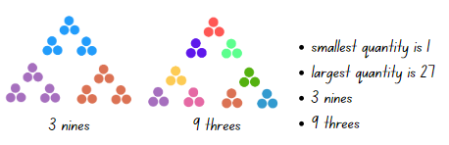
Note: Students may need more than one number visual to show different examples of equal groups.
- Have students share how they looked for and colour-coded equal groups. Record student thinking and ask:
- How did you look for equal groups? What helped you see equal groups inside the numbers?
- How did you colour-code your groups?
- What did you notice once you had colour-coded your groups?
- What numbers had equal groups inside them? What numbers did not? Why do you think that is?
- What patterns did you notice in equal groups?

How many groups? – 35 minutes
- Display and read Resource 25: Equal grouping 1 and ask students to use their individual whiteboard or counters to solve the problem.
- After students have had a chance to solve the problem ask them to explain and demonstrate how they solved the problem.
The table below outlines stimulus prompts to generate conversation about the topic, along with anticipated responses from students.
Prompts | Anticipated student responses
- What is this problem asking you to do?  - Is this problem asking how many in each group or how many groups?  - What is the solution? | - The problem is a division problem and is asking to share 15 flowers.  - This problem is asking how many groups. There are 15 items and each student gets 5 items.  - When 15 is shared into groups of 5, there are 3 groups in total.
Quotitive: Grouping (quotitive) division requires finding how many groups are formed, for example, calculating how many children will get marbles if you start with 12 and give each child 4. When grouping, the quotient represents the number of groups within the shared quantity.
- Draw students’ attention to the wording of the problem and how the number of groups is not stated but the amount in each group is given. If a student has not demonstrated an efficient way to solve the problem, use concrete materials to show students how to share the items and record the process using a diagram.
- Ask students to recombine the groups to model multiplication to strengthen the link between multiplication and division.
- Display and read Resource 26: Equal grouping 2 and ask students if this problem is asking how many in each group or how many groups. Students consider the questions and then use their individual whiteboard or counters to solve the problem.
- Choose students to demonstrate how they solved the problem and draw their attention to how the total number in each group was stated in the problem but not the number of groups.
- Display Resource 27: Poppy’s party and read through each of the problems. Students solve the problems in their workbooks, using concrete materials and drawing the solution.
Note: Resource 27: Poppy’s party can be displayed or printed, cut and glued into students’ workbooks.

Discuss and connect the mathematics – 10 minutes
- Regroup as a class and choose different students to share how they solved the problems. Ask:
- What strategy did you use when solving the problems?
- What was this problem asking – how many in each group or how many groups?
- Was it possible to share all the problems equally? Why or why not?
- What challenges did you face? How did you overcome them?
The table below details assessment opportunities and differentiation ideas.
Assessment opportunities | Too hard? | Too easy?
What to look for:  - Can students identify between the number of groups and the number in each group when describing a collection of objects? (MAO-WM-01, MA1-FG-01)  - Are students able to work out the number of groups, of a given size, that can be made? (MAO-WM-01, MA1-FG-01)  What to collect:  - student work samples. (MAO-WM-01, MA1-FG-01) | Students are unable to work out the number of groups that can be formed.  - Support students to read the problems and provide them with counters. Students count out the given number for each group until there are no counters left. Circle each group of counters to identify the number of groups.  - Provide students with a number line and support them to jump back the number in each group and then count the jumps to work out the number of groups. | Students can work out the number of groups that can be formed.  - Challenge students to create sharing and grouping division word problems for a peer to solve.  - Identify and represent multiplication and division using the symbols × and ÷ for Resource 27: Poppy’s party.

Lesson 8: Sharing
Core concept: Division can be represented by sharing objects into groups or finding out how many groups are formed.
The table below contains suggested learning intentions and success criteria. These are best co-constructed with students.
Learning intentions | Success criteria
Students are learning that:  - division can be represented by sharing objects into equal groups  - division can be represented by finding out how many groups can be formed. | Students can:  - solve division problems using objects and diagrams  - identify between the number of groups and the number in each group when describing a collection of objects.

Daily number sense: More than one share – 15 minutes
- Provide pairs of students with 24 objects and ask them to share them into equal groups. Students record their findings using diagrams, numerals and words. Ask:
- Is there more than one way to share the objects equally?
- How many ways did you find?
- How do you know you have found all the ways?
- Students share their work with the class (see Figure 15).
Figure 15 – Student work sample
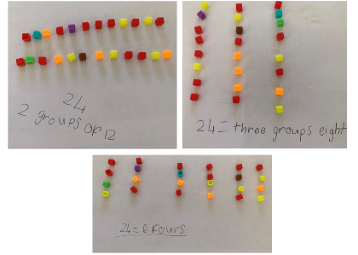

Equal grouping and sharing – 35 minutes
- Display one of the pictures from Resource 28: Sharing problems and discuss what can be seen. Choose one of the associated problems and, as a class, have students solve the problem and identify if it is an equal grouping problem or an equal sharing problem. Discuss what strategies students used to identify if it was an equal grouping problem or an equal sharing problem.
- Complete the above step again with another picture and associated problem from Resource 28: Sharing problems.
- Provide small groups with one of the images and the associated problems from Resource 28: Sharing problems. Students look at the image and discuss what can be seen. As a group, students then look at the given problems and identify which problems are equal grouping and which problems are equal sharing. Students choose one equal sharing and one equal grouping problem to solve and represent independently in their workbook (see Figure 16).
Figure 16 – Student work sample
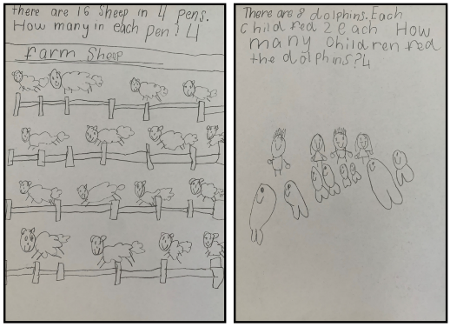
Note: This activity can be completed using technology like Book Creator where students can type, illustrate and verbally record the story.
The table below details assessment opportunities and differentiation ideas.
Assessment opportunities | Too hard? | Too easy?
What to look for:  - Are students able to solve division problems using objects and diagrams? (MAO-WM-01, MA1-FG-01)  - Can students identify between the number of groups and the number in each group when describing a collection of objects? (MAO-WM-01, MA1-FG-01)  What to collect:  - student work samples. (MAO-WM-01, MA1-FG-01) | Students are unable to solve division problems using objects and/or cannot identify between the number of groups and the number in each group when solving division problems.  - Support students to read the problems and provide them with counters. Students count out the given number for each group until there are no counters left. Circle each group of counters to identify the number of groups.  - Support students to read the problem and draw circles to identify how many groups the items are being shared into. Then provide students with concrete materials to physically share objects between the identified groups. | Students can identify between the number of groups and the number in each group when solving division problems.  - Provide students with the pictures from Resource 28: Sharing problems. Students use the pictures to create their own equal grouping story and equal sharing story.  - Students solve the problems from Resource 28: Sharing problems and then rewrite the problems using multiplication.

Discuss and connect the mathematics – 10 minutes
- Regroup as a class and have students share the problems they solved. Ask:
- How do you know it was an equal sharing problem?
- How do you know it was an equal grouping problem?
- What strategies did you use to solve the problem?
- What challenges did you face? How did you overcome them?

Resource 1: Number talk 1
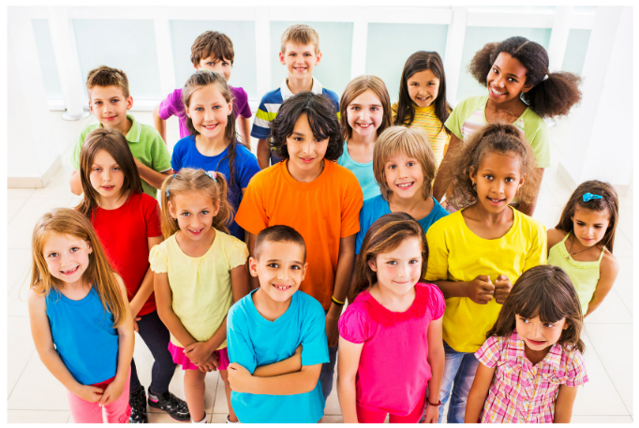
‘Large group of smiling children’ by skynesher is used in accordance with the Canva Content License Agreement.

Resource 2: Number talk 2
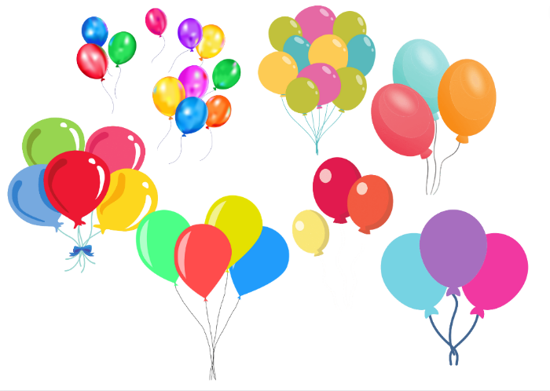
Images sourced from Canva and used in accordance with the Canva Content License Agreement.

Resource 3: Bales of wool
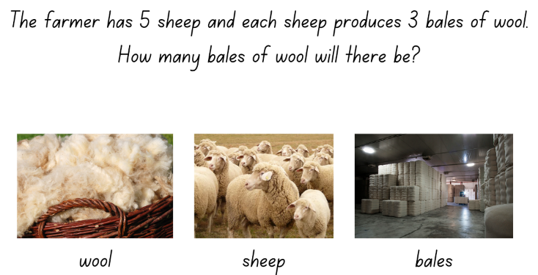
Images sourced from Canva and used in accordance with the Canva Content License Agreement.

Resource 4: Different bales
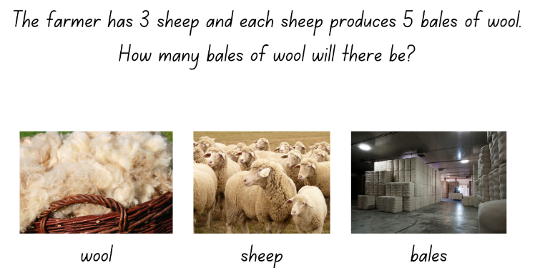
Images sourced from Canva and used in accordance with the Canva Content License Agreement.

Resource 5: Eggs
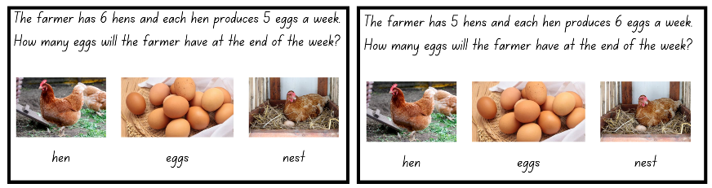
Images sourced from Canva and used in accordance with the Canva Content License Agreement.

Resource 6: Student copy 1
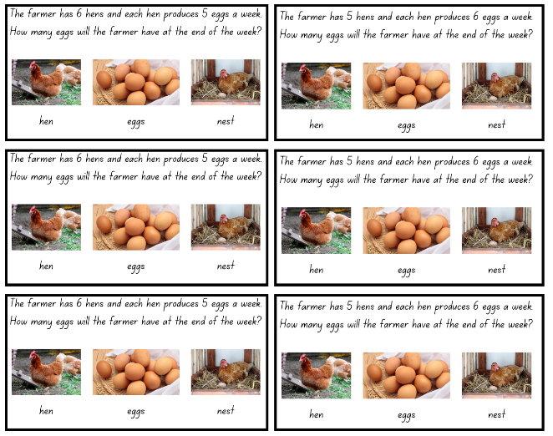
Images sourced from Canva and used in accordance with the Canva Content License Agreement.

Resource 7: Rectangles

Resource 8: Berries
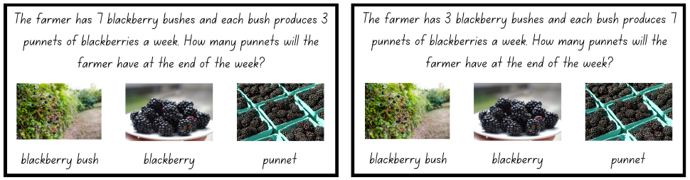
Images sourced from Canva and used in accordance with the Canva Content License Agreement.

Resource 9: Student copy 2
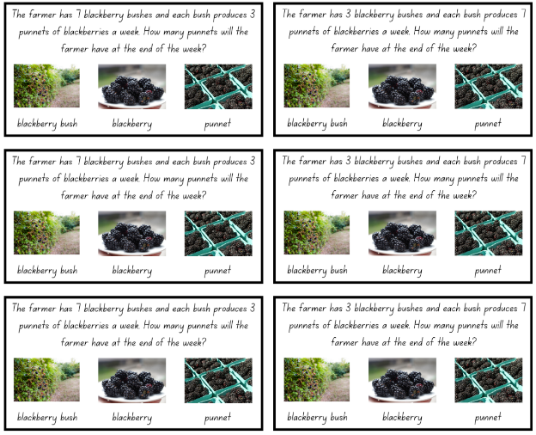
Images sourced from Canva and used in accordance with the Canva Content License Agreement.

Resource 10: Number talk 3
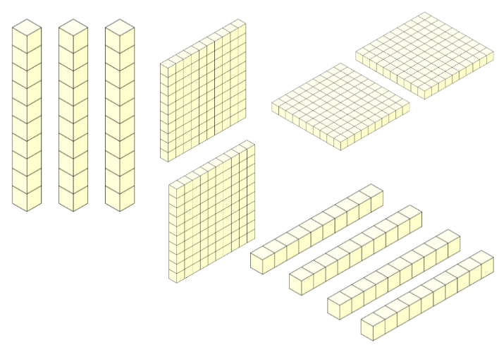
Images sourced from Canva and used in accordance with the Canva Content License Agreement.

Resource 11: Number talk 4
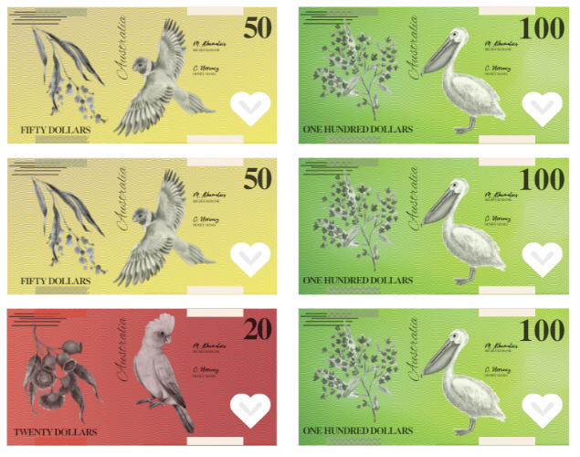
This image contains content obtained from Canva, and its use outside of this resource is subject to Canva’s Content License Agreement. If you wish to use it separately from the resource, please go to Canva.

Resource 12: Fruit
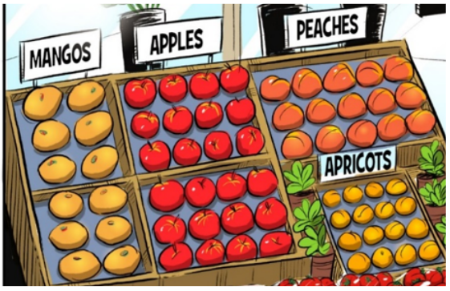
Image adapted from Multiplication: reSolve Fruit Shop – 1a resolve Fruit Shop by Australian Government Department of Education is licensed under CC BY-NC-SA 4.0.

Resource 13: Fruit shop
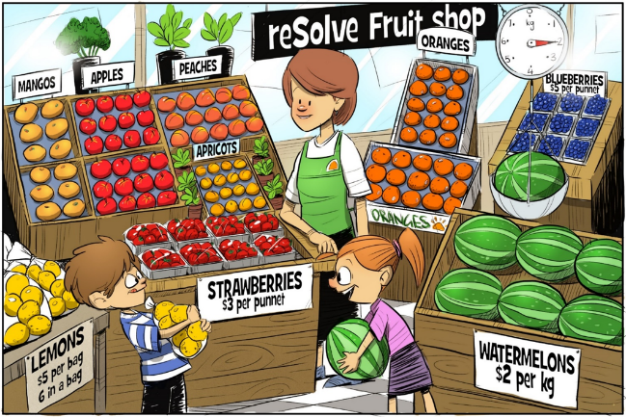
‘Multiplication: reSolve Fruit Shop – 1a reSolve Fruit Shop’ by Australian Government Department of Education is licensed under CC BY-SA 4.0

Resource 14: Lemons
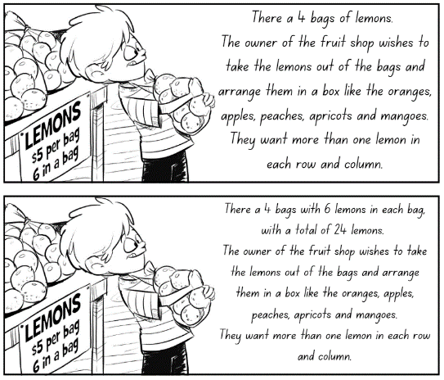
Image adapted from Multiplication: reSolve Fruit Shop – 1b resolve Fruit Shop by Australian Government Department of Education is licensed under CC BY-NC-SA 4.0.

Resource 15: Number talk 5
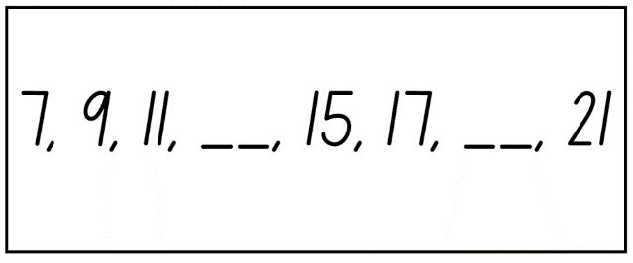

Resource 16: Number talk 6
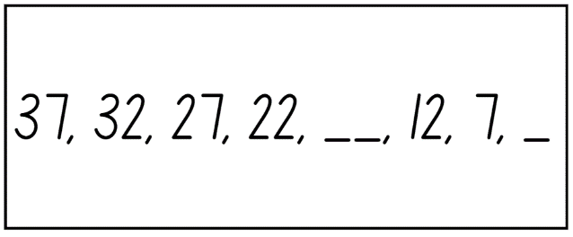

Resource 17: Multiplication toss gameboard
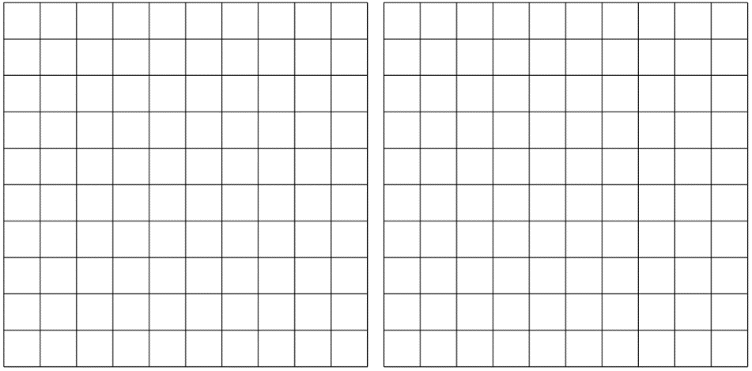

Resource 18: Think board
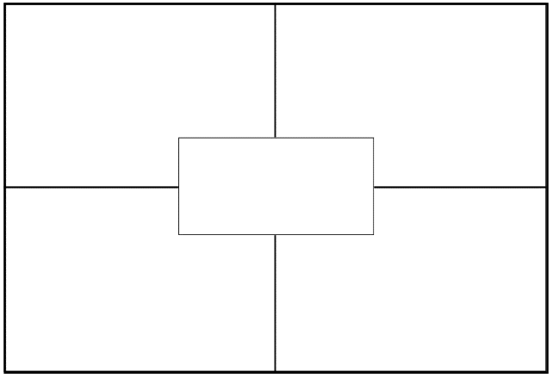

Resource 19: Story representations
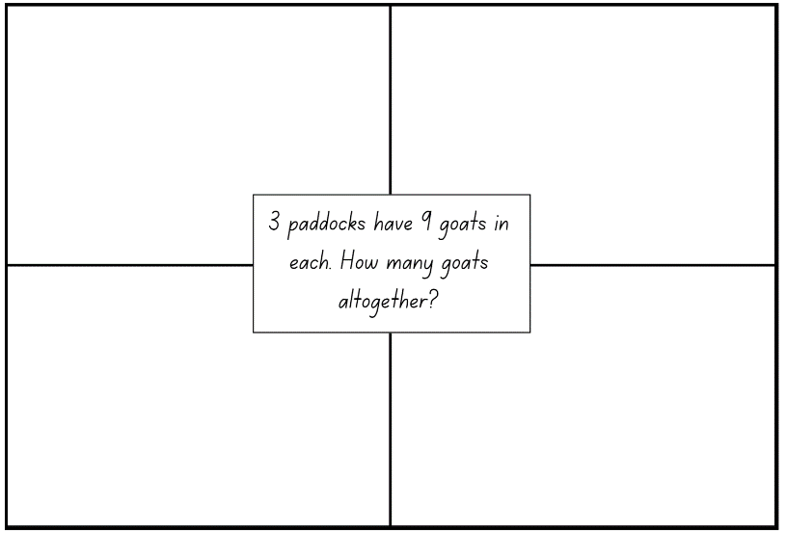
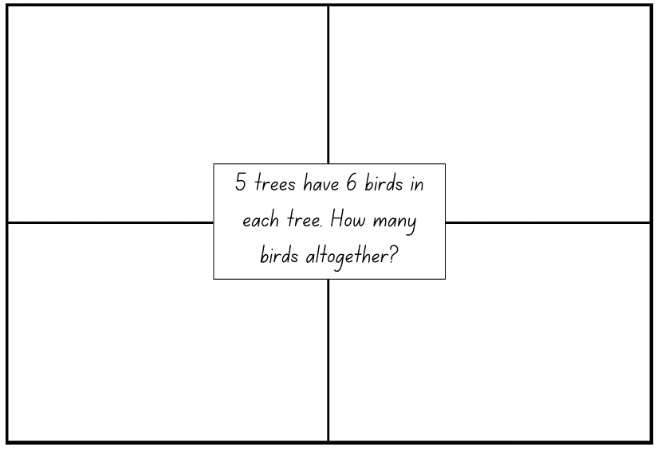

Resource 20: 30 grid
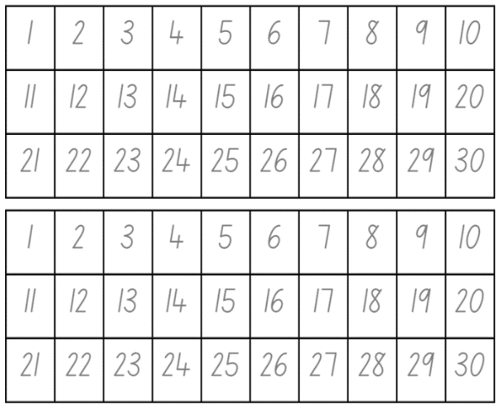

Resource 21: Equal sharing 1
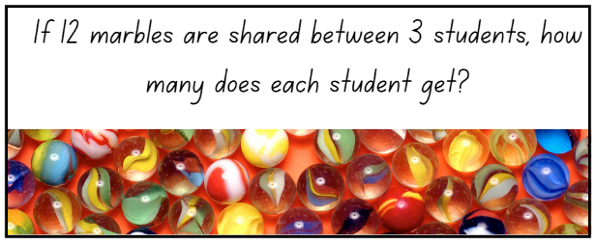
Images sourced from Canva and used in accordance with the Canva Content License Agreement.

Resource 22: Equal sharing 2
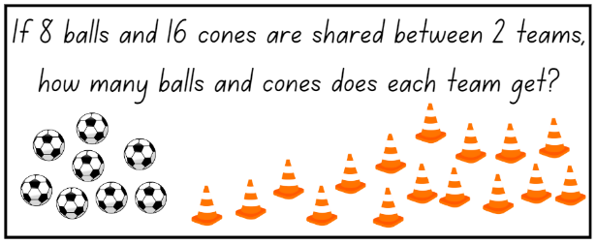
Images sourced from Canva and used in accordance with the Canva Content License Agreement.

Resource 23: Pedro’s picnic
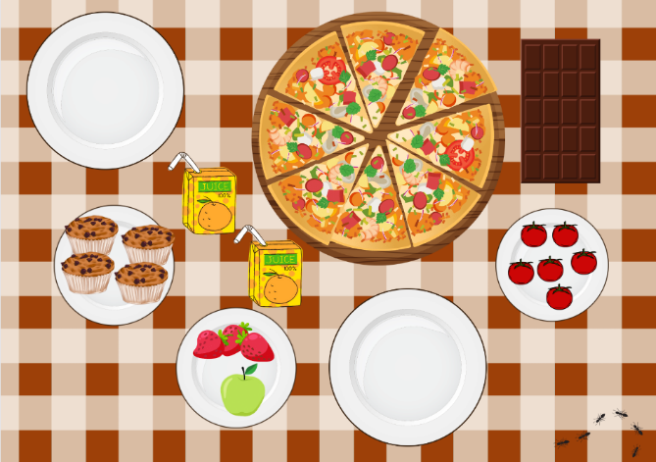
This image contains content obtained from Canva, and its use outside of this resource is subject to Canva’s Content License Agreement. If you wish to use it separately from the resource, please go to Canva.

Resource 24: Number visuals
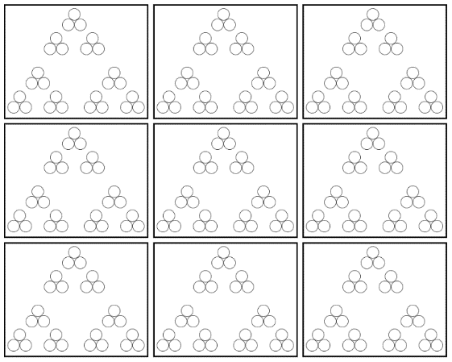

Resource 25: Equal grouping 1
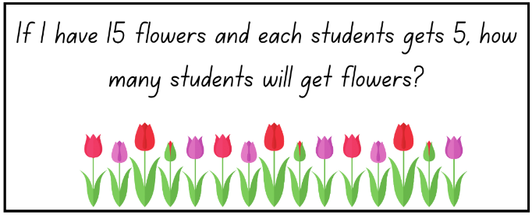
Images sourced from Canva and used in accordance with the Canva Content License Agreement.

Resource 26: Equal grouping 2
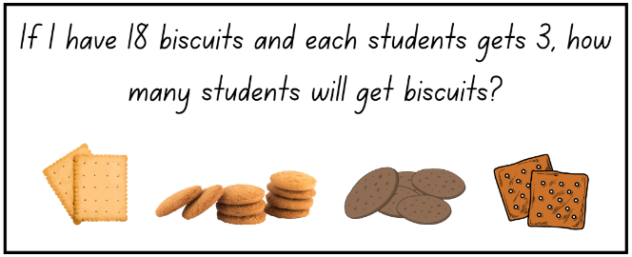
Images sourced from Canva and used in accordance with the Canva Content License Agreement.

Resource 27: Poppy’s party
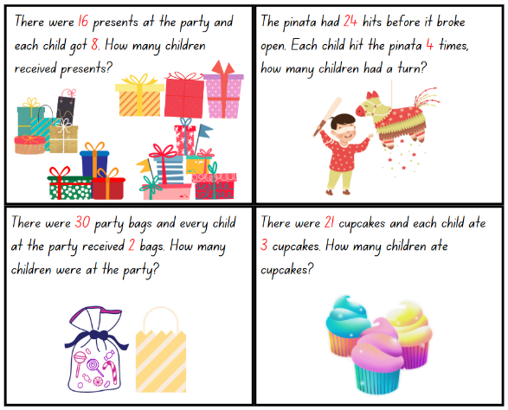
Images sourced from Canva and used in accordance with the Canva Content License Agreement.

Resource 28: Sharing problems
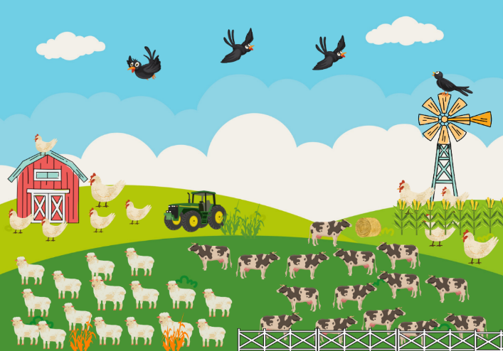
This image contains content obtained from Canva, and its use outside of this resource is subject to Canva’s Content License Agreement. If you wish to use it separately from the resource, please go to Canva.
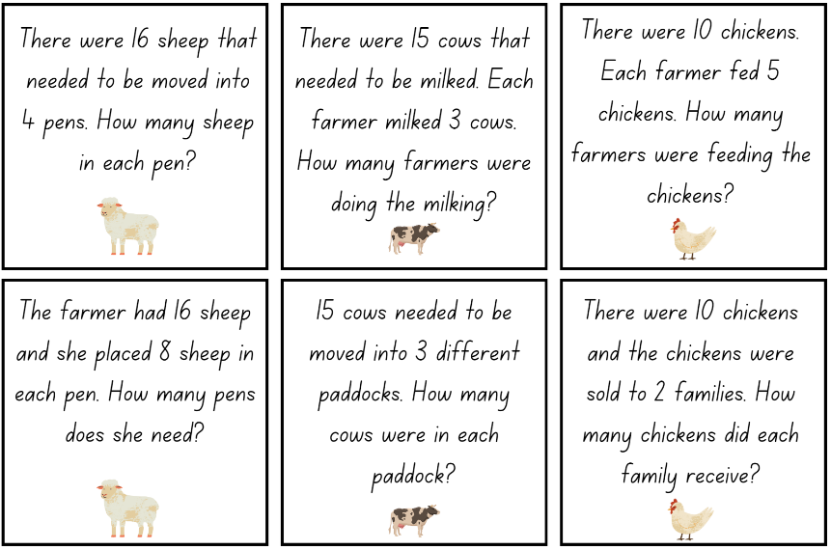
Images sourced from Canva and used in accordance with the Canva Content License Agreement.
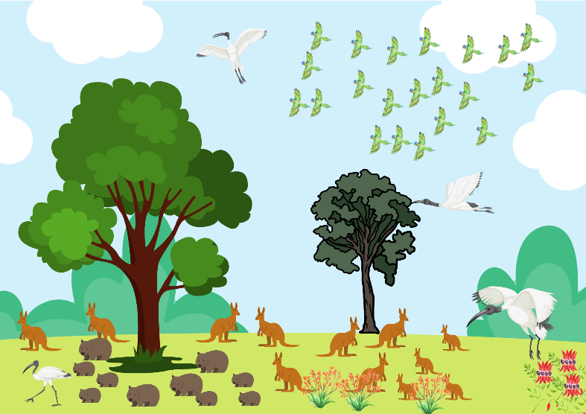
This image contains content obtained from Canva, and its use outside of this resource is subject to Canva’s Content License Agreement. If you wish to use it separately from the resource, please go to Canva.
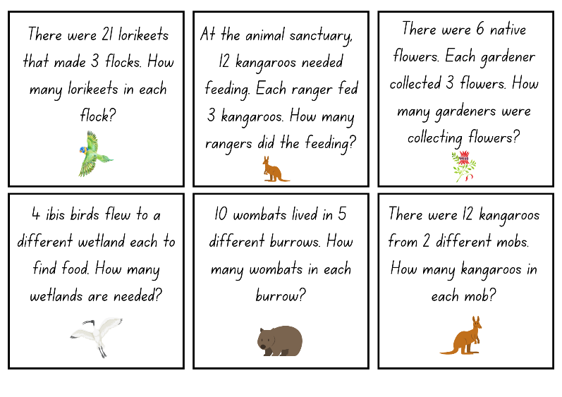
Images sourced from Canva and used in accordance with the Canva Content License Agreement.
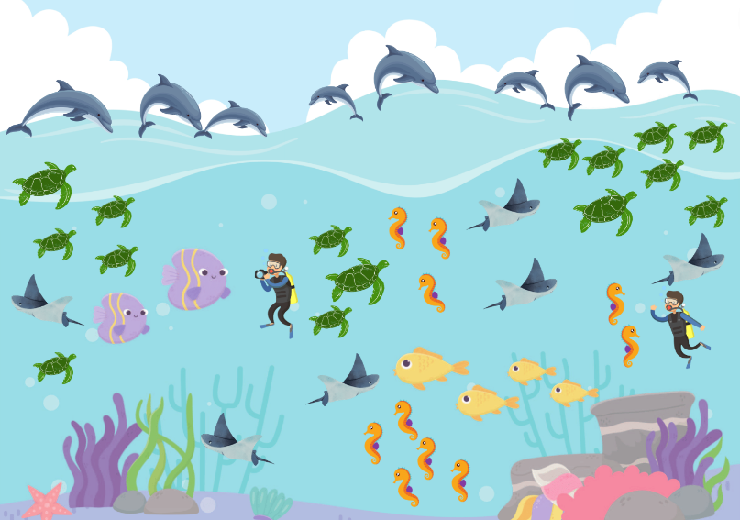
This image contains content obtained from Canva, and its use outside of this resource is subject to Canva’s Content License Agreement. If you wish to use it separately from the resource, please go to Canva.
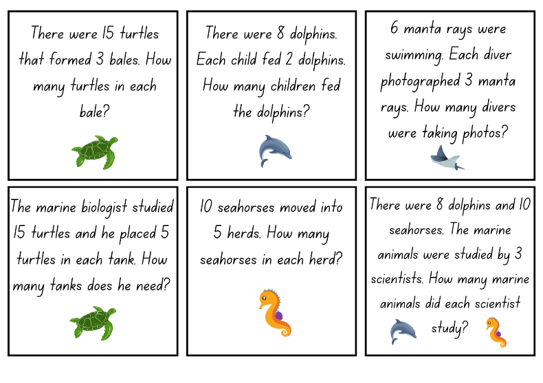
Images sourced from Canva and used in accordance with the Canva Content License Agreement.

Syllabus outcomes and content
The table below outlines the syllabus outcomes and range of relevant syllabus content covered in this unit. Content is linked to National Numeracy Learning Progression version (3).
Focus area and outcomes | Content groups and content points | Lessons
Representing whole numbers A  MAO-WM-01  MA1-RWN-01  MA1-RWN-02 | Use counting sequences of ones with two-digit numbers and beyond  - Count forwards and backwards by ones from a given number to at least 120 (CPr6)  Continue and create number patterns  - Count forwards and backwards by twos from any starting point (CPr6-CPr7, MuS2)  Represent the structure of groups of ten in whole numbers  - Count large sets of objects by systematically grouping in tens (CPr7)  - Estimate, to the nearest ten, the number of objects in a collection and check by counting in groups of ten (Reasons about quantity) (CPr7, NPV6) | 1–2, 4–7
Representing whole numbers B  MAO-WM-01  MA1-RWN-01  MA1-RWN-02 | Use counting sequences of ones and tens flexibly  - Count forwards and backwards by tens, on and off the decade, with two- and three-digit numbers (CPr7)  Form, regroup and rename three-digit numbers  - Count and represent large sets of objects by systematically grouping in tens and hundreds (CPr7, NPV5)  - Identify the nearest hundred to a number  - Recognise units of 100 (UnM5, NPV5)  - Estimate, to the nearest hundred, the number of objects in a collection and check by grouping and counting (NPV6) | 2–3
Combining and separating quantities A  MAO-WM-01  MA1-CSQ-01 | Represents equality  - Use the equals sign to record equivalent number sentences involving addition, and to mean 'is the same as', rather than as an indication to perform an operation (Reasons about relations) (NPA3) | 3
Forming groups A  MAO-WM-01  MA1-FG-01 | Count in multiples using rhythmic and skip counting  - Count by twos, threes, fives and tens using rhythmic counting and skip counting (MuS2, CPr6)  Use skip counting patterns  - Identify and describe patterns when skip counting forwards or backwards by twos, fives and tens (NPA3-NPA4)  - Determine a missing number in a number pattern with a constant difference  - Describe how the missing number in a number pattern was determined (Reasons about relations)  Model and use equal groups of objects to represent multiplication  - Model and describe collections of objects as groups of (MuS2)  - Determine and distinguish between the number of groups and the number in each group when describing collections of objects (Reasons about relations)  - Find the total number of objects using skip counting of equal groups of a known size (MuS2-MuS3)  Recognise and represent division  - Use concrete materials to model a half of a collection and show the relation between the half and the whole (InF2)  - Model sharing division by distributing a collection of objects equally into a given number of groups to determine how many in each group (InF2, MuS5)  - Model grouping division by determining the number of groups of a given size that can be formed (MuS5) | 1–8
Forming groups B  MAO-WM-01  MA1-FG-01 | Represent and explain multiplication as the combining of equal groups  - Use objects, diagrams, images or actions to model multiplication as accumulating equal groups (MuS4)  - Solve multiplication problems using repeated addition (MuS4)  - Form arrays of equal rows and equal columns (MuS5)  - Determine and distinguish between the number of rows/columns and the number in each row/column when describing collections of objects (MuS5)  - Model the commutative property of multiplication, using an array (Reasons about relations)  Represent multiplication and division problems  - Solve multiplication and division problems using objects, diagrams, images and actions (MuS6-MuS7)  - Record answers to multiplication and division problems (including those with remainders) using drawings, words and numerals (MuS6) | 1–8

References
Links to third-party material and websites
Please note that the provided (reading/viewing material/list/links/texts) are a suggestion only and implies no endorsement, by the New South Wales Department of Education, of any author, publisher, or book title. School principals and teachers are best placed to assess the suitability of resources that would complement the curriculum and reflect the needs and interests of their students.
If you use the links provided in this document to access a third-party's website, you acknowledge that the terms of use, including licence terms set out on the third-party's website apply to the use which may be made of the materials on that third-party website or where permitted by the Copyright Act 1968 (Cth). The department accepts no responsibility for content on third-party websites.
Except as otherwise noted, all material is © State of New South Wales (Department of Education), 2023 and licensed under the Creative Commons Attribution 4.0 International License. All other material (third-party material) is used with permission or under licence. Where the copyright owner of third-party material has not licensed their material under a Creative Commons or similar licence, you should contact them directly for permission to reuse their material.
Mathematics K–10 Syllabus © 2022 NSW Education Standards Authority (NESA) for and on behalf of the Crown in right of the State of New South Wales.
© 2022 NSW Education Standards Authority. This document contains NSW Curriculum and syllabus content. The NSW Curriculum is developed by the NSW Education Standards Authority. This content is prepared by NESA for and on behalf of the Crown in right of the State of New South Wales. The material is protected by Crown copyright.
Please refer to the NESA Copyright Disclaimer for more information.
NESA holds the only official and up-to-date versions of the NSW Curriculum and syllabus documents. Please visit the NSW Education Standards Authority (NESA) website and the NSW Curriculum website.
National Numeracy Learning Progression © Australian Curriculum, Assessment and Reporting Authority (ACARA) 2010 to present, unless otherwise indicated. This material was downloaded from the Australian Curriculum website (National Numeracy Learning Progression) (accessed 1 February 2023) and was not modified. The material is licensed under CC BY 4.0. Version updates are tracked in the ‘Curriculum version history’ section on the 'About the Australian Curriculum' page of the Australian Curriculum website.
ACARA does not endorse any product that uses the Australian Curriculum or make any representations as to the quality of such products. Any product that uses material published on this website should not be taken to be affiliated with ACARA or have the sponsorship or approval of ACARA. It is up to each person to make their own assessment of the product, taking into account matters including, but not limited to, the version number and the degree to which the materials align with the content descriptions and achievement standards (where relevant). Where there is a claim of alignment, it is important to check that the materials align with the content descriptions and achievement standards (endorsed by all education Ministers), not the elaborations (examples provided by ACARA).
This resource contains images and content obtained from Canva, and their use outside of this resource is subject to Canva’s Content License Agreement. If you wish to use them separately from the resource, please go to Canva.
Australian Government Department of Education (2020) ‘Multiplication: reSolve Fruit Shop’, Teaching resources, reSolve: Maths by Inquiry website, accessed 1 February 2023.
Boaler J, Munson J, and Williams C (2022) Mindset Mathematics: Visualising and Investigating Big Ideas, Grade 2, Jossey-Bass, US
New Zealand Ministry of Education (n.d) Sharing lollies, NZ Maths website, accessed 1 February 2023.
University of Cambridge (Faculty of Mathematics) (2022) Fair Feast, NRICH website, accessed 1 February 2023.
Siemon D, Warren E, Beswick K, Faragher R, Miller J, Horne M, Jazby D, Breed M, Clark J and Brady K (2021) Teaching Mathematics: Foundations to Middle Years, 3rd edition, Oxford University Press Australia and New Zealand.

