Mathematics – Stage 1 – Unit 31
Contents
Unit description and duration 4
Student prior learning 4
Lesson overview and resources 6
Lesson 1: Let’s add it up! 13
Daily number sense: Searching for number facts – 20 minutes 13
Twenty-frame filler – 40 minutes 16
Consolidation and meaningful practice: Gameboard strategies – 5 minutes 21
Lesson 2: Representing numbers 22
Daily number sense: Let’s make counting fun! – 15 minutes 22
Investigating 10s and 100s: Part 1 – 10 minutes 25
Investigating 10s and 100s: Part 2 – 45 minutes 26
Consolidation and meaningful practice: Splat that name! – 5 minutes 29
Lesson 3: Number tug of war 30
Daily number sense: – 10 minutes 30
Tug of war – 40 minutes 33
Consolidation and meaningful practice: MAB block representations of numbers – 20 minutes 35
Lesson 4: Inspecting 10s and 100s 37
Daily number sense: Tally marks – 25 minutes 37
Five steps to 100: Part 1 – 20 minutes 38
Five steps to 500: Part 2 – 20 minutes 40
Consolidation and meaningful practice: Problem-solving with bundles – 10 minutes 42
Lesson 5: Tracking tallies 43
Daily number sense: Show me 25! – 15 minutes 43
Collecting data: Part 1 – 40 minutes 44
Collecting data: Part 2 – 15 minutes 47
Consolidation and meaningful practice: Gallery walk – 5 minutes 49
Lesson 6: Getting to 999 50
Daily number sense: My eye can spy a number – 10 minutes 50
Following instructions – 45 minutes 51
Consolidation and meaningful practice: Let’s play! – 15 minutes 55
Lesson 7: Build it up! 56
Daily number sense: Odd or even – 10 minutes 56
Up for grabs! – 30 minutes 57
A variety of ways to make a number – 25 minutes 58
Consolidation and meaningful practice: Up for grabs! – 5 minutes 59
Lesson 8: Arranging large collections 60
Daily number sense: Estimating quantities – 20 minutes 60
We’re going on a number hunt! – 35 minutes 63
Consolidation and meaningful practice: Addition on ten-frames – 15 minutes 65
Resource 1: Twenty-frame filler gameboard 67
Resource 2: Sample game of twenty-frame filler 68
Resource 3: This is 57! 69
Resource 4: Tug of War number line 0–100 70
Resource 5: Five steps to 100 – number line 0–100 71
Resource 6: Five steps to 500 – number line 0–500 72
Resource 7: Five steps to 500 – number cards 73
Resource 8: How many craft sticks? 74
Resource 9: Show me 25 75
Resource 10: My data investigation 76
Resource 11: Number line 0–1000 77
Resource 12: Game Instructions template 78
Resource 13: Game plan template 79
Resource 14: Estimating quantities of circles 80
Resource 15: Number hunt grid paper 81
Resource 16: Addition on a ten-frame 82
Syllabus outcomes and content 83
References 89

Unit description and duration
This two-week unit develops student knowledge, understanding and skills of place value, number representation and data. Students are provided opportunities to:
- investigate the base 10 numerical system
- quantify, organise and represent a variety of collections
- order and compare numbers through different representations
- collect and organise categorical data
- interpret data to ask questions and make informed decisions
- identify simple objects on a map and describe their position in relation to another object
- create and follow instructions along a path from the beginning to the end.
Mathematics K–10 Syllabus © 2022 NSW Education Standards Authority (NESA) for and on behalf of the Crown in right of the State of New South Wales.

Student prior learning
Before engaging in these teaching and learning activities, students would benefit from prior experience with:
- modelling, reading and writing combinations of numbers to at least 10 using materials, representations, words and symbols
- subitising small collections
- reading and recalling numbers to at least 100
- estimating how many in a large collection
- organising a large collection of objects into groups of equal number.

Lesson overview and resources
The table below outlines the sequence and approximate timing of lessons; syllabus focus areas and content groups; and resources.
Lesson | Syllabus focus area and content groups | Resources
Lesson 1: Let’s add it up!  65 minutes  Counting on is an efficient mental strategy. | Representing whole numbers A  - Represent the structure of groups of ten in whole numbers  Combining and separating quantities A  - Recognise and recall number bonds up to ten  Combining and separating quantities B  - Represent and reason about additive relations | - Resource 1: Twenty-frame filler gameboard  - Resource 2: Sample game of twenty-frame filler  - Video: Investigating teen numbers with 10 frames (9:56)  - Counters  - Writing materials
Lesson 2: Representing numbers  75 minutes  Concrete materials are useful when representing two and three-digit numbers. | Representing whole numbers A  - Represent the structure of groups of ten in whole numbers  Representing whole numbers B  - Use counting sequences of ones and tens flexibly  - Form, regroup, and rename three-digit numbers  Forming groups A  - Model and use equal groups of objects to represent multiplication | - Mathigon – number tiles and cubes interactive board  - 200 interlocking cubes or coloured bricks  - Digital devices  - MAB blocks  - Writing materials
Lesson 3: Number tug of war  70 minutes  Mathematicians use number lines to explore and problem-solve with complex counting sequences. | Representing whole numbers A  - Use counting sequences of ones with two-digit numbers and beyond  - Represent numbers on a line  - Represent the structure of groups of ten in whole numbers  Combining and separating quantities A  - Use advanced count-by-one strategies to solve addition and subtraction problems  - Use flexible strategies to solve addition and subtraction problems  Combining and separating quantities B  - Represent and reason about additive relations  - Form multiples of ten when adding and subtracting two-digit numbers | - Resource 3: This is 57!  - Resource 4: Tug of war number line 0–100  - Counters  - MAB blocks  - Writing materials
Lesson 4: Inspecting 10s and 100s  75 minutes  Our understanding of numbers to 10 helps us understand numbers beyond 100. | Representing whole numbers B  - Form, regroup, and rename three-digit numbers  Combining and separating quantities A  - Use advanced count-by-one strategies to solve addition and subtraction problems  - Use flexible strategies to solve addition and subtraction problems  Combining and separating quantities B  - Represent and reason about additive relations  - Form multiples of ten when adding and subtracting two-digit numbers  - Use knowledge of equality to solve related problems | - Resource 5: Five steps to 100 – number line 0–100  - Resource 6: Five steps to 500 – number line 0–500  - Resource 7: Five steps to 500 – number cards  - Resource 8: How many craft sticks?  - Craft sticks  - Multiple 9-sided dice  - Writing materials
Lesson 5: Tracking tallies  75 minutes  Collecting, displaying and interpreting data helps us communicate about and understand information. | Representing whole numbers A  - Represent the structure of groups of ten in whole numbers  Combining and separating quantities A  - Recognise and recall number bonds up to ten  Forming Groups A  - Count in multiples using rhythmic and skip counting  - Use skip counting patterns  Data B  - Identify a question of interest and gather relevant data  - Create displays of data and interpret them | - Resource 9: Show me 25  - Resource 10: My data investigation  - Writing materials
Lesson 6: Getting to 999  70 minutes  Representing numbers in a variety of ways helps us understand larger numbers. | Representing whole numbers B  - Use counting sequences of ones and tens flexibly  - Form, regroup, and rename three-digit numbers  Geometric Measure A  - Position: Follow directions to familiar locations | - Resource 11: Number line 0–1000  - Resource 12: Game instructions template  - Resource 13: Game plan template  - Counters  - Multiple sets of Ace to 9 playing cards  - Writing materials
Lesson 7: Build it up!  70 minutes  A three-digit number can be represented in a variety of ways. | Representing whole numbers A  - Represent the structure of groups of ten in whole numbers  Representing whole numbers B  - Use counting sequences of ones and tens flexibly  - Form, regroup, and rename three-digit numbers  Combining and separating quantities B  - Use knowledge of equality to solve related problems  Forming groups A  - Model and use equal groups of objects to represent multiplication | - 6 hoops  - Large tub of interlocking cubes or coloured bricks  - MAB blocks  - Writing materials
Lesson 8: Arranging large collections  70 minutes  A large quantity can be arranged and quantified in a variety of ways. | Representing whole numbers A  - Represent the structure of groups of ten in whole numbers  Representing whole numbers B  - Use counting sequences of ones and tens flexibly  - Form, regroup, and rename three-digit numbers  Combining and separating quantities A  - Recognise and recall number bonds up to ten  Combining and separating quantities B  - Use knowledge of equality to solve related problems  Forming groups A  - Model and use equal groups of objects to represent multiplication  Geometric Measure A  - Position: Follow directions to familiar locations  Geometric Measure B  - Position: Explore simple maps of familiar locations | - Resource 14: Estimating quantities of circles  - Resource 15: Number hunt grid paper  - Resource 16: Addition on a ten-frame  - Large quantities of a variety of concrete materials, such as craft sticks, paper clips, pompoms and counters  - Multiple copies of a ten-frame  - Writing materials

Lesson 1: Let’s add it up!
Core concept: Counting on is an efficient mental strategy.
The table below contains suggested learning intentions and success criteria. These are best co-constructed with students.
Learning intentions | Success criteria
Students are learning that:  - different combinations of numbers can bond to form a new given number  - number sentences provide information which helps to solve problems  - a whole can be represented in 2 or more parts but the quantity of the whole remains the same. | Students can:  - combine 2 or 3 numbers to make a larger number  - record number sentences using numbers, symbols or words  - recognise that no matter how 2 quantities are arranged, the total of the whole is the same.

Daily number sense: Searching for number facts – 20 minutes
- Build student understanding of number bonds by investigating part-whole relationships.
- Display the numeral 10 and provide time for students to share what they know about the number 10. Ask students:
- Where can we see combinations of objects that make 10?
- What are some facts about 10?
- Explain to students that they will be identifying and recording number bonds for a ‘teen’ number of their choice (see Figure 1).
Figure 1 – Examples of number bonds for 18
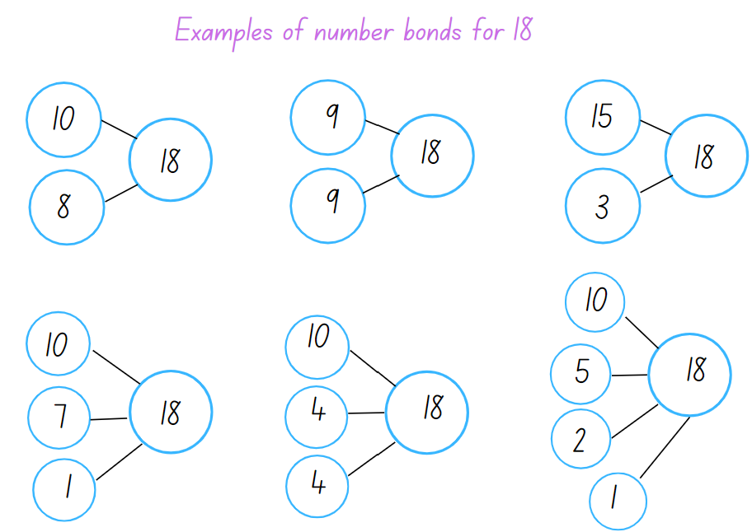
- Ask students to share 2 numbers that combine to make 18 and then 3 numbers that combine to make 18. Write student responses on the board.
- Ask students:
- What do you notice?
- Do number bonds to 10 help you to find numbers that combine to make a teen number?
- What strategies did you use and how did you check the accuracy of your work?
- Provide each pair of students with writing materials and explain that they need to select a ‘teen’ number and record 6 number sentences demonstrating number bonds for their chosen number.
- Students need to use symbols such as 10 + 4 + 4 = 18 and record a statement for each, such as 10 and double 4 makes 18 or 10 and 8 more makes 18.
Note: It is optional to provide counters and a number line to further support student understanding as they process combining quantities to make a specific ‘teen’ number.
The table below details assessment opportunities and differentiation ideas.
Assessment opportunities | Too hard? | Too easy?
What to look for:  - Can students count on from the larger number when adding 2 numbers? (MAO-WM-01, MA1-RWN-01, MA1-CSQ-01)  - Can students record number sentences using symbols, numerals or words? (MA1-CSQ-01)  - Can students recognise and use the symbols for plus (+), minus (−) and equals (=)? (MA1-CSQ-01)  - Do students model and record patterns for individual numbers by making all possible whole number combinations (Reasons about patterns)? (MA1-CSQ-01)  What to collect:  - samples of number sentences and/or drawn representations (MAO-WM-01, MA1-CSQ-01) | Students need to use concrete materials to count on from 10.  - Model an arrangement of 10 counters and explain that the teen numbers are a combination of 10 and then some more, for example, 13 is 10 and 3 more and so on.  - Watch Investigating teen numbers with 10 frames (9:56) for explicit instructional ideas and vocabulary that support students learning about teen numbers. | Students recall number bonds to 20 with accuracy. Students explore if any ‘teen’ numbers can be represented by using a combination of doubles, for example, 11 is double 5 and one more, and 16 is double 5 and double 3.

Twenty-frame filler – 40 minutes
This activity has been adapted from Siemon et al. (2021).
- Ask students to share what they know about a ten-frame and to describe ways they have used a ten-frame.
- Ask students if they can explain why a ten-frame is arranged the way it is.
- Ask if knowing everything about one ten-frame helps with knowing about 2 ten-frames or even 6 ten-frames. Discuss.
- Display 2 groups of 10 ten-frames in a horizontal and vertical arrangement (see Figure 2). Ask students to think about what they see. Allow time for students to share their thinking.
Figure 2 – 2 groups of 10 ten-frames
Note: Focus the discussion on the amount of ten-frames, how they are grouped and how this arrangement can make counting to 100 efficient.
The table below outlines stimulus prompts to generate conversation about the topic, along with anticipated responses from students.
Prompts | Anticipated student responses
- What do you notice is the same about these frames?  - How are they different from other ten-frames?  - Can you estimate how many squares there are all together?  - If I needed to count how many squares there are altogether, what counting strategy would I use?  - What are you wondering about all these ten-frames? | - Every ten-frame has 10 squares, and they are all the same size.  - There are some ten-frames that have 2 rows of 5 and the others have 5 rows of 2, which is still 10.  - Usually, we use one or 2 ten-frames and now there are 10 on the same page.  - There are 5 ten-frames in each column and 2 ten-frames in each row.  - I think there are 100 squares because if I count by 10 there are 10 lots of 10.  - I would count by fives to 100.  - I wonder if we are making groups of 10.  - I wonder if we are learning about 100.
- Explain to students that they will be playing a game called twenty-frame filler. The objective of the game is to be the player who fills the frame to exactly 20.
- To play the game students take turns rolling the dice and marking off that many squares in one of the twenty-frames. Players can choose to mark their number in any of the twenty-frames, so they do not need to follow on from their partner's previous roll. However, the aim of the game is to fill the twenty-frame. Students need to think strategically about where they mark their number so they can win that frame.
- Players continue to roll the dice, filling the frames strategically until a player rolls a number which allows them to fill a twenty-frame completely, claiming it and placing their initial next to that frame. The player with the most twenty-frames at the end is the winner (see Figure 3).
Figure 3 – Example of a game
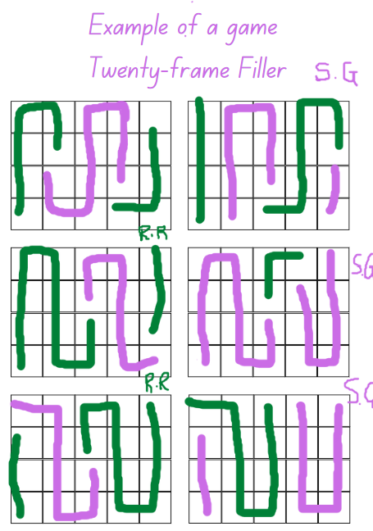
- Provide each pair of students with the gameboard Resource 1: Twenty-frame filler gameboard, 2 different coloured markers and a 10-sided dice.
Note: You can watch Ten-frame filler (4:40) on Thinking mathematically for an example of how to play the game using ten-frames.
- After several rounds, ask students:
- Was there a strategy that helped you win the game?
- What was challenging about the game?
- What numbers do you think were the best to roll? Why?
- After playing the game, did you find all the combinations to 20? Why or why not?
- What might happen if there was a third player? Would it make it easier or harder to win?
The table below details assessment opportunities and differentiation ideas.
Assessment opportunities | Too hard? | Too easy?
What to look for:  - Can students recognise combinations to 20? (MA1-CSQ-01)  - Can students apply a variety of strategies while problem-solving and adding quantities? (MA1-CSQ-01)  - Do students use 10 to assist with recognising, counting and recording ‘teen’ numbers? (MA1-RWN-01, MA1-CSQ-01)  What to collect:  - photos and anecdotal recordings of students’ reasoning and applied strategies (MAO-WM-01, MA1-CSQ-01) | Students need support identifying number bonds to 20.  - Play Ten-frame filler (4:40) as shown on Thinking mathematically.  - Once the student has rolled their number, support them to count the remaining squares in each of the twenty-frames to determine if their number would fill a frame. | Students apply various strategies and play Twenty-frame filler with confidence.  - Students play 100-frame filler. Provide students with 10 ten-frames and 2 × 10-sided dice.  - Provide students with an additional challenge, for example, if they roll an even number, they can double the number; if they roll an odd number, they miss a turn.

Consolidation and meaningful practice: Gameboard strategies – 5 minutes
- Display Resource 2: Sample game of twenty-frame filler. Ask students:
- What number or combination of numbers does each player need to roll to complete the last frame?
- Which player, green or purple, do you think will be the overall winner? How can you tell?
- Which twenty-frame do you think the green player had the best numbers rolled on the dice?
- Which player had the most luck rolling the dice? How do you know?

Lesson 2: Representing numbers
Core concept: Concrete materials are useful when representing two-digit and three-digit numbers.
The table below contains suggested learning intentions and success criteria. These are best co-constructed with students.
Learning intentions | Success criteria
Students are learning that:  - a large collection of objects can be organised into groups to support efficient counting  - using multiples of 10 is a useful strategy when counting large quantities  - numbers can be represented in a variety of ways and grouped based on place value. | Students can:  - organise a large collection into groups of 10  - use skip counting to count a large collection  - use MAB blocks to represent hundreds, tens and ones in two-digit and three-digit numbers  - name the place value of a digit in a large number based on the position of that digit.

Daily number sense: Let’s make counting fun! – 15 minutes
- Build student understanding of using groups of 10 to efficiently count a large collection.
Students require a range of opportunities to develop the skills required to accurately estimate. Opportunities to practise estimating meets both mathematical and practical needs. Students need to refer to their knowledge of numbers, make comparisons and draw on what is familiar to understand what is unfamiliar, and the ability to judge the reasonableness of their estimation.
Note: This is a collaborative, whole-class task. It is important to provide a large quantity of interlocking cubes or coloured bricks, at least 200, so that students can trial various ways to group and count accurately.
- Pose the problem that the tub of interlocking cubes was dropped, scattering all the cubes on the floor. Explain that you are wondering how many interlocking cubes there are on the floor. Ask students:
- How many interlocking cubes do you estimate are scattered on the floor?
- How did you reach that estimate? What strategy did you use?
- Can you suggest a way to work together and group the interlocking cubes so they can be counted efficiently without losing track of the count?
- Students may initially suggest counting by ones, twos or fives. As the count progresses, remind students that the interlocking cubes need to be organised in a way that is efficient and accurate. Observe strategies being used and discussions. Use opportunities to highlight successful strategies used by students.
- Once the interlocking cubes have been arranged in groups, ask students to view the collection and ask if they would like to adjust their estimates. Provide time for students to turn and talk with a partner.
- Ask students if they think there is a better way to arrange the groups, making it even easier to count the total. Provide time for students to share suggestions. Once adjustments have been made, proceed to count.
- Record the final number and ask students if their estimates were close or far off. Allow time for students to comment and share their estimating strategies. Ask students:
- Was your estimate more or less than the total?
- Did you estimate by predicting how many groups of a certain number you could make?
- Did you estimate by problem-solving how many interlocking cubes can fit in one handful?
- Does estimating help you know if the result of the count is correct? Explain how.
The table below details assessment opportunities and differentiation ideas.
Assessment opportunities | Too hard? | Too easy?
What to look for:  - Can students identify and use a systematic pattern to arrange and count a large collection? (MAO-WM-01, MA1-RWN-01)  - Can students use concrete materials to form equal groups? (MA1-FG-01)  - Do students apply their number knowledge when estimating? (MA1-RWN-01)  What to collect:  - photos of the grouped collections (MA1-RWN-01)  - anecdotal records of student reasoning when estimating (MAO-WM-01, MA1-RWN-01) | Students cannot arrange the collection into groups so that counting is more efficient. Provide time for students to explore 2 handfuls of interlocking cubes and to create a pattern which will enable counting.  Students are unable to estimate. Using a handful of interlocking cubes, ask students if they can tell how many interlocking cubes there are without counting by ones. Ask students to count and check their estimate. Repeat a few times and then add an additional handful. | Students can identify and use a systematic pattern to group and count the interlocking cubes. Ask students if they can create an arrangement of the groups of interlocking cubes so that the final count is even more efficient. For example, towers of 50 or 100 interlocking cubes or an array representing 100.

Investigating 10s and 100s: Part 1 – 10 minutes
- Display a MAB block one and a base 10 long.
- Explain that when students counted the interlocking cubes in the previous activity, they organised them into groups of 10.
- Ask students what they notice about the base 10 long and if they think it is like a tower of 10 interlocking cubes. Allow time for students to share their ideas.
- Explain that mathematicians use resources like MAB blocks and strategies such as counting in multiples to count and add large quantities.
- Briefly model the difference between counting to 100 by ones using MAB block ones as well as counting by base 10 longs to demonstrate the difference in efficiency.
- Ask students if counting by ones or tens was more efficient. Remind students that efficient counting allows the counter to keep track of their count easily. Discuss how counting by tens orally allows you to count at a good pace. Grouping the count in tens allow them to track the count more easily and recount to check they are correct.
- Ask students if they know how many MAB block longs make a MAB block flat.
- Using MAB block hundreds, tens and ones, model various numbers and ask students to identify what numbers have been made.

Investigating 10s and 100s: Part 2 – 45 minutes
- Display the Mathigon interactive board. Select the ‘Numbers’ option from the left menu and then select the ‘Number tiles and Cubes’ displaying the MAB block options. Explain that the interactive board supports the understanding of place value by using MAB blocks to represent numbers and visually see the ones, tens, hundreds and so on.
- Model clicking or dragging blocks from the left menu onto the blank board. Create a base 10 long by selecting the single orange cube from the left menu. Encourage students to count with students counting as the orange ones are lined up to create a tower (see Figure 4).
Figure 4 – Orange ones
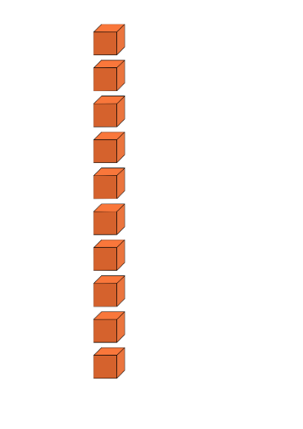
- Click on the blue base 10 long from the left menu and place it beside the ones tower. Explain to students that 10 ones make one base 10 long. If needed, slightly separate each of the orange ones so that students can clearly see the composition that 10 ones make one 10. Use the ‘pen’ function located at the bottom centre of the board to clearly label the ones and the ten long (see Figure 5).
Figure 5 – Representation of 10
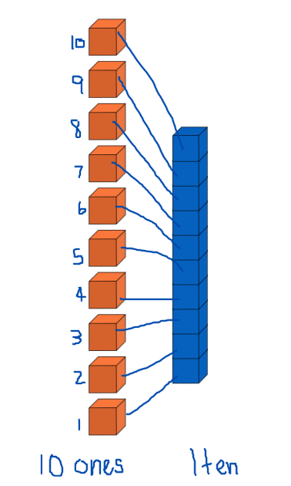
- Clear the board.
Note: You can quickly clear the board by dragging your curser over all blocks and pressing delete on the keyboard or using the ‘bin’ symbol.
- Ask a student to name a two-digit number and model how to create that number. Repeat.
- Provide each pair of students with a digital device and ask students to explore Mathigon.
- With their partner, students select and represent a two-digit number of their choice.
- Bring students back to the floor and select several students to share their representations.
- Model how to create a three-digit number and select several students to create a three-digit number for the class. Ensure students are using combinations of hundreds, tens and the ones to represent the place value for each digit of their selected three-digit number.
The table below details assessment opportunities and differentiation ideas.
Assessment opportunities | Too hard? | Too easy?
What to look for:  - Do students understand that 10 ones are the same as one 10? (MA1-RWN-01, MA1-RWN-02)  - Can students arrange various MAB blocks to represent a two-digit and/or three-digit number? (MAO-WM-01, MA1-RWN-02)  - Are students able to name two-digit and three-digit numbers? (MA1-RWN-02)  - What strategies are students using to arrange the blocks to represent 100 and 999? (MA1-WM-01, MA1-RWN-02)  What to collect:  - photos and annotations of representations created on Mathigon (MA1-WM-01, MA1-RWN-02) | Students require concrete materials to understand tens and hundreds.  - Provide students with MAB blocks and model how to make a base 10 long using 10 ones. Support students while they explore simple two-digit numbers using longs and ones.  Students require assistance manipulating the blocks on the interactive board.  - Model and support students as they make simple two-digit numbers.  - Students work in small groups to observe their peers and take turns to make simple two-digit numbers. | Students can create representations of numbers.  - Ask students to represent a number such as 538 and then represent the number that is 50 less or 50 more.  - Ask students to create a representation of a number for a partner to solve.

Consolidation and meaningful practice: Splat that name! – 5 minutes
- Display a variety of three-digit numbers, the numerals and the written name for each number. Ensure there are incorrect examples as well.
- As a class, students identify and name correct examples of three-digit numbers. If an example is incorrect, they say ‘Splat!’
- Students offer suggestions to make the correction, such as identify that the written name does not represent the numeral, or the digits are not spelt correctly in the written form, or their place value is incorrect.

Lesson 3: Number tug of war
Core concept: Mathematicians use number lines to explore and problem-solve with complex counting sequences.
The table below contains suggested learning intentions and success criteria. These are best co-constructed with students.
Learning intentions | Success criteria
Students are learning that:  - numbers lines are a useful tool to solve addition and subtraction problems  - mathematicians use numbers lines to assist with counting forwards and backwards  - each digit in a number has a name and the position of that digit is its place value. | Students can:  - recognise arrangements of quantities without needing to count from one  - understand the sequence and arrangement of numbers on a number line  - name a three-digit number and identify each digit’s place value.

Daily number sense: – 10 minutes
- Build student understanding of place value by making, naming and recording three-digit numbers.
Note: Exposing students to a variety of ways to make or represent two-digit and three-digit numbers builds their understanding of place value. As students explore numbers, they assign a value to each digit and recognise the importance of the position and the value of each digit in the whole number.
- Display Resource 3: This is 57! And ask students to explain what they are wondering.
- Explain to students that the arrangement of craft sticks represents the whole number 57. One part, the bundles of 10 craft sticks, represents the 5 tens and the other part, the 7 crafts sticks, represent the 7 ones.
- Using bundles of craft sticks model for students how to represent another two-digit number and label the parts as tens and ones.
- Provide small groups of students with bundles of craft sticks, as well as loose craft sticks, and display a variety of two-digit numbers for them to represent. Provide time for students to share their representations with another group of students and observe if they are correctly naming each digit as tens and ones.
- As a class, ask students how they would represent and label a three-digit number, knowing that there are now 3 digits, and each one has a place value, hundreds, tens and ones.
- Select a student to demonstrate making 342 using the craft sticks.
- Model representing 405 using the craft sticks. Ask students how they would label each of the three-digits. Ensure students notice the zero. Ask students to turn and talk with a partner and select students to share their ideas, recording suggestions and representations for the class to view.
- Provide time for pairs of students to use the craft sticks to make some suggested three-digit numbers and to name and label their representations.
Assessment opportunities | Too hard? | Too easy?
What to look for:  - Do students understand that 10 ones are the same as one 10? (MA1-RWN-01, MA1-RWN-02)  - Do students understand that 10 tens are the same as 1 hundred? (MA1-RWN-01, MA1-RWN-02)  - Can students arrange the crafts sticks to represent a three-digit number and clearly label the place value for each digit? (MAO-WM-01, MA1-RWN-02)  - Can students name three-digit numbers? (MA1-WM-01, MA1-RWN-02)  What to collect:  - photos of student representations MA1-WM-01, MA1-RWN-02) | Students cannot represent numbers using ones and tens.  - Support students to use loose craft sticks and bundle these to make representations of simple two-digit numbers, for example, numbers less than 30.  - As students gain confidence, in pairs they can make representations of other two-digit numbers.  Students require support to understand place value when exploring three-digit numbers.  - Support students to name some simple three-digit numbers. As they say the numbers, identify the digit being called hundred. For example, 3 hundred and 21.  - Provide students with bundles of crafts sticks and loose craft sticks and support students to represent some simple three-digit numbers using labelled columns hundreds, tens and ones. | Students can create representations of numbers using craft sticks.  - Ask students to represent a number such as 695 and ask a partner to represent the number that is one hundred more.  - In pairs, students select a number for their partner to represent. Their partner needs to represent the number that is 10 more and 10 less.

Tug of war – 40 minutes
This activity has been adapted from Tug of War by NRICH.
Note: Prior to the lesson copy Resource 4: Tug of war number line 0–100 onto A3 paper so there is one copy per pair of students.
- Display Resource 4: Tug of war number line 0–100 and explain to students they are going to play a game in pairs using a number line.
- In pairs, provide students with a number line, one counter each in a different colour and one 10-sided dice.
- Students identify where 50 is on the number line and explain that this is the target number.
- Students start the game by deciding which player will begin on zero and which player will begin on 100. Students then place their counter on their starting number.
- The player starting on zero will add the quantity rolled to zero and begin to move up towards 50 and the player starting on 100 will subtract the quantity rolled from 100 and start moving towards 50.
- Play continues until one player reaches the target number, 50. If a player is near 50 and rolls a quantity that does not allow them to land on 50, for example, falls short or goes beyond 50, they do not move from their previous number but continue rolling until they get the quantity needed. Students swap starting positions and repeat the game.
Note: It is optional to play the game where the objective is to reach the other end of the number line first and students use 2 ten-sided dice.
The table below details assessment opportunities and differentiation ideas.
Assessment opportunities | Too hard? | Too easy?
What to look for:  - Are students using effective counting strategies to add or subtract quantities? (MA1-CSQ-01)  - Can students recall and use number facts or number bonds to 10 as a strategy? (MA1-RWN-01, MA1-CSQ-01)  What to collect:  - anecdotal records of student conversations and strategies (MAO-WM-01) | Students cannot subtract a quantity from 100.  - Provide students with a 6-sided dice and another coloured counter to move along the number line.  - Provide students with a number line from 0–50. | Students can add and subtract along the number line to 100.  - Provide students with 2 × 10-sided dice and explain that the winner is the player who gets closest to the target number 50 in less than 4 rolls.  - Both players start at 100 and, using 2 × 10-sided dice and 2 counters, they race to get to zero.

Consolidation and meaningful practice: MAB block representations of numbers – 20 minutes
- Provide pairs of students with MAB and ask students to explore and record representations for the following:
- Can you make 17? What is one more? What is one less? What is 10 more? What is 10 less?
- Can you use 17 to make double 25? Or do you need to start again?
- Can you use what you have and make 125? What is 100 more?
- Can you use what you have and make 862? What is one more? What is one less? What is 10 more? What is 10 less?
The table below details assessment opportunities and differentiation ideas.
Assessment opportunities | Too hard? | Too easy?
What to look for:  - Can students identify the number 10 more or 10 less than a given number? (MA1-RWN-01)  - Can students read three-digit numbers correctly? (MA1-RWN-01)  - Are students able to identify how many tens and ones are in a two-digit number and how many hundreds, tens and ones are in a three-digit number? (MA1-RWN-01)  What to collect:  - anecdotal records of student conversations and strategies (MAO-WM-01) | Students cannot count forwards and backwards on and off the decade. Provide students with a 50 or 100 number chart and support their understanding by identifying counting patterns.  Students are not able to name or partition three-digit numbers. Support students with using concrete materials to partition two-digit numbers. Model naming the parts of the whole and create various representations for students to observe. | Students can read and partition three-digit numbers and can identify numbers 10 more than or 10 less than a given number.  - Provide students with various ‘what number am I’? challenges.  - Students create number representations for another student to solve.

Lesson 4: Inspecting 10s and 100s
Core concept: Our understanding of numbers to 10 helps us understand numbers beyond 100.
The table below contains suggested learning intentions and success criteria. These are best co-constructed with students.
Learning intentions | Success criteria
Students are learning that:  - tally marks are useful tools for counting and recording collections  - skip counting forwards and backwards is useful when counting to and from three-digit numbers  - using place value helps to partition and rename three-digit numbers  - mathematicians use tools, such as number lines to solve problems. | Students can:  - use tally marks to record two-digit numbers  - count forwards and backwards by fives, tens and hundreds from any three-digit number  - use effective counting strategies and a number line to find solutions.

Daily number sense: Tally marks – 25 minutes
- Build student understanding of tally marks by representing various two-digit numbers using tally marks.
- Explain to students that mathematicians use symbols or representations, such as tally marks, to record counting.
- Explain that tally marks allow mathematicians to record counting in groups of 5. By recording a count in multiples of 5, students can skip count by fives to find the total count.
- Model how to make a tally mark for 1, 2, 3, 4 and how the diagonal line ends that group of tally marks as it represents the total number of 5. Ask students:
- If this tally mark represents 5, how do they think 7 would be represented?
- How would 10 be represented?
- Provide students with writing materials and ask students to make representations for a variety of one-digit and two-digit numbers. Provide time for students to turn and talk with a partner, sharing their representations.

Five steps to 100: Part 1 – 20 minutes
This activity has been adapted from Five Steps to 50 by NRICH.
Note: Prior to the lesson, prepare the number lines and the number cards for Part 2. Laminating or putting the number lines in a plastic sleeve will allow the resource to be used with a non-permanent marker multiple times.
- Provide pairs of students with the number line Resource 5: Five steps to 100 – number line 0–100, 2 × 9-sided dice, an eraser, 2 non-permanent markers of different colours and writing materials to record strategies.
- Explain that students will be playing with a partner and the objective of the game is to be the player who gets on or closest to 100 in 5 moves by counting on or counting back from the number rolled.
- Player 1 rolls the 2 dice and identifies the smallest two-digit number that can be made and circles the number on the number line. Player 1 must decide how to jump to 100 in 5 jumps by using a combination of adding and/or subtracting fives, tens and ones (see Figure 6).
Figure 6 – Examples of 5 steps to 100
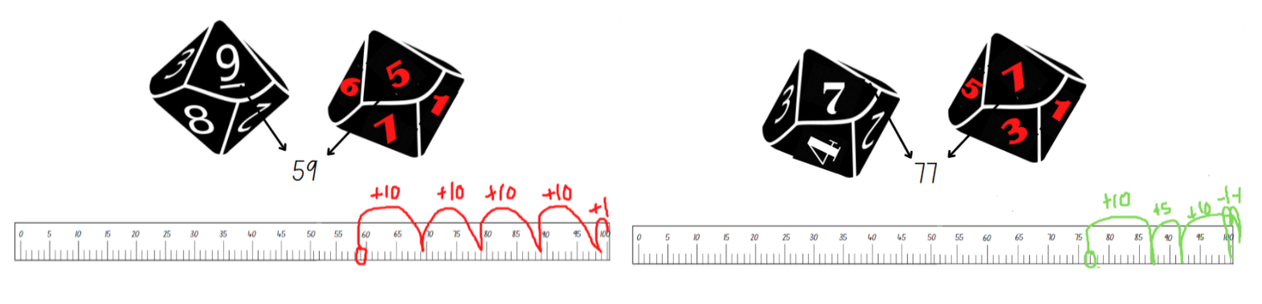
Images sourced from Canva and used in accordance with the Canva Content License Agreement.
- Ensure that students are recording their strategies for each round. For example, 59 + 10 + 10 + 10 + 10 + 1 = 100.
- As a class ask students:
- What two-digit number did you roll that needed you to jump forwards and backwards?
- How many times did you land on 100?
- How many times did you not land on 100 and how far off were you?
- How many ways did you try to make it to 100 on that round?
- Which numbers can get you to 100 and which numbers can’t?

Five steps to 500: Part 2 – 20 minutes
- Provide each pair of students with Resource 6: Five steps to 500 – number line 0–500 and Resource 7: Five steps to 500 – number cards. Explain that this time they need to reach 500 using 5 steps by counting on or back using combinations of fives, tens and hundreds.
- Each player turns over a number card from the pile. They read the three-digit number and identify where that number is on the number line. They then take 5 steps forwards or backwards in an attempt to land on 500.
- Ensure that students record their strategies for later discussions.
- Provide time for students to play multiple rounds. Observe strategies and listen to discussions as students reason and problem-solve.
- As a class ask:
- Was it more challenging to jump to 100 or jump to 500 in 5 steps? Why?
- How many times did you land on 500?
- Describe your best round. What strategies did you use?
- Which three-digit number card was the hardest to jump to 500?
- If you played again, was there one round that you would choose a different combination of fives, tens and hundreds?
The table below details assessment opportunities and differentiation ideas.
Assessment opportunities | Too hard? | Too easy?
What to look for:  - Are students using flexible additive and subtraction strategies to problem-solve? (MAO-WM-01, MA1-CSQ-01)  - Can students explain how they got a solution and explain the strategies they used? (MAO-WM-01)  - Can students count forwards and backwards by tens and fives, on and off the decade? (MA1-RWN-01)  What to collect:  - observational data and anecdotal recordings (MAO-WM-01)  - students’ work samples (MA1-RWN-01, MA1-CSQ-01) | Students require support to complete the 5 jumps. Support students to jump in tens and ones using another number line 0–100 and then complete the jump on the game number line.  Students are unable to count backwards from 100 off the decade. Provide students with counters and a hundreds chart to use as a reference. | Students can count forwards and backwards and use a variety of strategies to play the game.  - Each round students must include both addition and subtraction strategies to jump to 500.  - Students play using combinations of threes, sixes, and nines to jump in 5 steps to 500.

Consolidation and meaningful practice: Problem-solving with bundles – 10 minutes
- Provide each pair of students with one bundle of 10 craft sticks. Students Think-Pair-Share how they know there are 10 craft sticks without needing to count by ones.
- Display Resource 8: How many craft sticks? and ask students to problem-solve with their partner how many craft sticks there are all together in the image. Students represent their reasoning in drawings or a number sentence, using words or symbols on a mini whiteboard.
- As a class, students discuss and share their thinking. Ask students:
- What strategy did you use to count the loose craft sticks?
- How many bundles of 10 did you identify?
- How did you keep track of their count?
- How did you check if your result was accurate?

Lesson 5: Tracking tallies
Core concept: Collecting, displaying and interpreting data helps us communicate about and understand information.
The table below contains suggested learning intentions and success criteria. These are best co-constructed with students.
Learning intentions | Success criteria
Students are learning that:  - a quantity can be represented in various ways  - the way a quantity is represented supports accurate counting  - data can be collected and displayed to answer questions. | Students can:  - recognise how a quantity is represented, for example, 25 is represented as 5 groups of 5  - organise data using tally marks  - interpret a data display to answer questions  - describe and justify interpretations of data.

Daily number sense: Show me 25! – 15 minutes
- Build student understanding of accurate and inaccurate representations by playing Show me 25.
- Display Resource 9: Show me 25.
- Allow time for students to Think-Pair-Share. Ask students:
- How do we know that all these representations make 25? How can we check?
- Are there any representations that don’t make 25?
- Provide pairs of students with a variety of concrete materials and explain that they will create one accurate and one inaccurate representation of a selected two-digit number.
- As a class discuss that visual representations, including data displays, must provide accurate information. Explain that the reader relies on the representation to gather information and to find solutions to interpret the content so that they can understand what is presented.

Collecting data: Part 1 – 40 minutes
- Explain that collecting data about people's opinions is important as it can let students know what people like, don’t like, need, don’t need, want or don’t want.
- Discuss that some things can be more or less important to different people and what they think or feel about something is their opinion.
- Explain that students will be answering questions and their answers will be collected as data. The data will be used to make a graph for further discussion.
- Provide each student with a mini whiteboard to record their answers. Display a tally collection table and the opinion number line as in Figure 7. Explain to students that when they are asked a question, they will write 0, 1 or 2 on their board. Once you have recorded students’ answers, they wipe their board clean, ready for the next question.
Figure 7 – Opinion number line
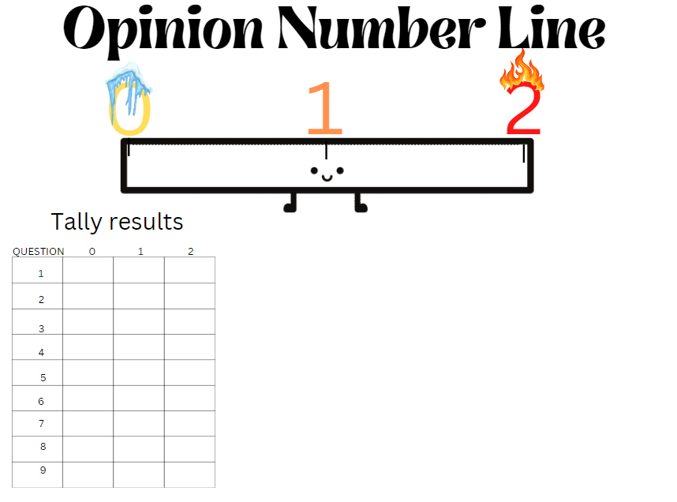
- As students hear a question, they need to think about how important the concept is to them. If their answer is very important, they will write a 2. If the answer is somewhat important, they will write a 1. If the answer is not important, they will write a 0.
- Explain that after each question, students’ responses will be collected and displayed in the tally chart so that the whole class can count the total for each question.
- Ask students:
- How important is having a good healthy breakfast every morning?
- How important is talking and laughing with your friends at lunchtime?
- How important is trying your best when playing a sport or hobby?
- How important is being on time to lines after the bell?
- How important is brushing your teeth?
- How important is helping your family with jobs at home?
- How important is keeping the playground free of rubbish?
- How important is having good manners?
Very important = 2
A little important = 1
Not important = 0
- As a class, jointly count the tally marks for each question and discuss the results. Ask students:
- Which questions have a high result for 2? (Very important)
- Which question has the highest result for 0? (Not important)
- Do any questions have a similar result?
- Explain that students will work in small groups and use the results from the tally marks to design a graph to represent the class results. If necessary, model how to create a graph using the data.
- Provide students with writing materials and explain that a data display needs to be organised and include specific features and labels so that the information is accurate and explains the results to others. Share examples such as in a bar graph or picture graph if necessary.
- As a class, brainstorm the specific features and annotate these for students to refer to. For example:
- a graph needs a title
- a graph needs a baseline
- consider how the results will be displayed, such as using symbols, coloured columns or rows.

Collecting data: Part 2 – 15 minutes
- Provide students with a copy of Resource 10: My data investigation and explain to students that they need to think about and record 3 different opinion questions they would like to explore. For example:
- How important is it to try your best during maths lessons?
- How important is it to ask questions when learning something new?
- How important is it to borrow library books each week?
Note: Students may choose their own questions to investigate.
- Students record their 3 questions and interview classmates to collect tally results. Students will then represent their results in a graph.
Note: It is optional to share the results with other classes to generate rich discussions as students analyse the results, comparing similarities and differences. Students may combine collected data and create a grade representation graph or students may use their selected opinion questions to interview their peers from another class and design a graph which compares the overall results.
The table below details assessment opportunities and differentiation ideas.
Assessment opportunities | Too hard? | Too easy?
What to look for:  - Can students skip count by fives and track the count using tally marks? (MA1-FG-01, MA1-DATA-01)  - Can students sort and create a data display where symbols, pictures or words represent the collected data accurately? (MA1-DATA-02)  - Are students asking suitable questions to collect data about their peers’ opinions? (MA1-DATA-01)  What to collect:  - work samples of data displays (MAO-WM-01, MA1-DATA-01, MA1-DATA-02) | Students are unable to count tally marks. Provide students with a visual display of the 5 times tables to support their count.  Students are unable to create data displays. Provide students with a simple example of a data display to copy. Highlight essential features such as the heading and baseline. Work collaboratively to talk aloud the process of deciding on a title as well as determining how to display the data. | Students have created a data display that is well organised and provides clear information. Ask students to add comments for the results such as:  - Which question had the highest or lowest response rate? Can you suggest why?  - Which question had a high result of ones and why was this topic in the question not considered too important?  - Are there any other questions that could have been asked?  - Which question might have different results if it was asked on another day or at a different time of the day?

Consolidation and meaningful practice: Gallery walk – 5 minutes
- Students go on a gallery walk to view other students’ data displays.
- Ask students to identify a data display that is creative and shares the information clearly.
- After students have viewed the work samples, ask if they would change something on their display. What would it be and why?

Lesson 6: Getting to 999
Core concept: Representing numbers in a variety of ways can assist with understanding larger numbers.
The table below contains suggested learning intentions and success criteria. These are best co-constructed with students.
Learning intentions | Success criteria
Students are learning that:  - each digit in a three-digit number has a place value and this gives the number its name  - understanding base 10 helps identify the place value of digits in numbers  - clear instructions accurately tell people what to do or where to go. | Students can:  - identify a three-digit number based on a visual representation  - read three-digit numbers represented by numerals  - discuss how many hundreds, tens and ones are in a given three-digit number  - write clear step-by-step instructions for a game.

Daily number sense: My eye can spy a number – 10 minutes
- Build student understanding of place value by investigating a representation of three-digit numbers.
- Display various correct and incorrect representations of three-digit numbers, as shown in Figure 8.
Figure 8 – Eye spy a number
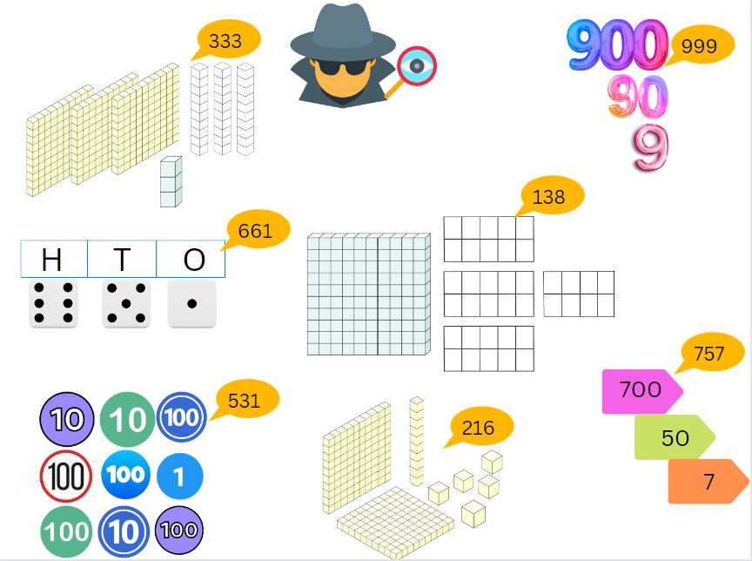
Images sourced from Canva and used in accordance with the Canva Content License Agreement.
- Ask students to identify the correct representations and explain their thinking.
- Provide time for students to view the incorrect representations. Select students to explain and prove their thinking and write the correct number value for the representation on the display.

Following instructions – 45 minutes
This activity has been adapted from Over the rainbow by NZ Maths.
- In small groups, provide students with Resource 11: A number line 0–1000, printed on card and Resource 12: Game instructions template.
- Explain that students will be given counters, a deck of cards and a number line to 1000. They need to use the resources to create a game. There are no instructions and that means there are many ways you can use these resources to create a game (see Figure 9).
Figure 9 – Game resources
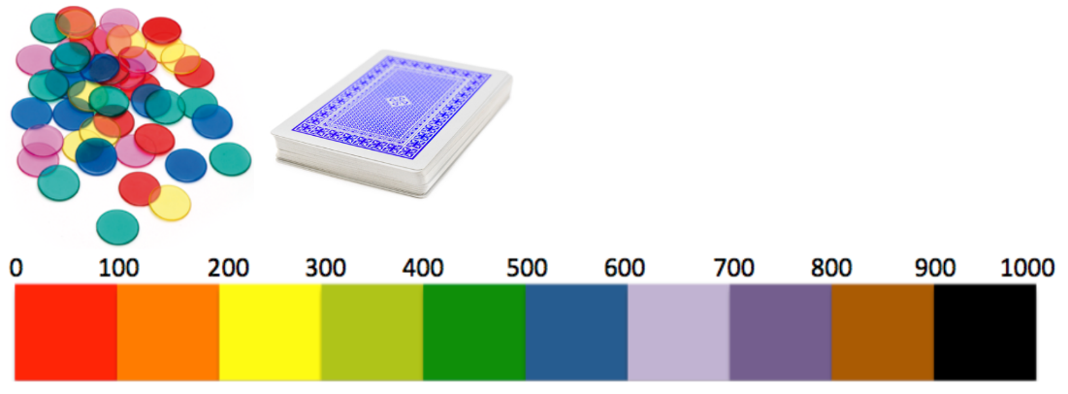
Images sourced from Canva and used in accordance with the Canva Content License Agreement.
- Provide pairs of students with the following resources:
- one number line 0–1000 for each pair
- 30 counters (15 of each colour) to share between pairs
- ace to 9 playing cards – 2 sets of 0–9 cards for each pair of students randomly shuffled.
- Explain one way to use the resources and play a game. Display the instructions for students to view and follow:
- Each player collects 15 counters of the same colour.
- Player 1 turns over 3 cards and places these on the table side-by-side making a three-digit number.
- Player 1 places one of their counters on the number line in the correct hundreds place. For example, if their number was 256, they would place their counter between 200 and 300 on the number line.
- Player 1 returns the 3 cards to the bottom of the pile and the game continues with each player having a turn.
- The objective of the game is for one player to have 3 of their counters on the same hundreds place value on the number line.
- Provide time for students to follow these instructions and play the game with a partner.
- Ask students if the instructions were clear and easy to follow, if they were able to play the game successfully and if they found it fun and challenging.
- Explain to students that they are going to work in small groups to create their own game. They will record 4 to 5 simple instructions using Resource 11: A number line 0–1000 and share them with the class.
- Provide time for students to brainstorm game ideas and to share examples with the class as needed.
- Prompt students to consider how to write instructions and identify essential words and features that need to be explained so that students can play the game correctly. Record suggestions on the board for students to refer to as needed.
The table below details assessment opportunities and differentiation ideas.
Assessment opportunities | Too hard? | Too easy?
What to look for:  - Do students understand the vocabulary needed to write a set of simple instructions that can be followed? (MA1-GM-01)  - Can students reason and explain their mathematical ideas for a game? (MAO-WM-01)  - Can students give clear instructions that can be followed to work through each step of the game? (MA1-GM-01)  - Are students connecting ideas and their knowledge of three-digit numbers when creating a game? (MAO-WM-01)  What to collect:  - samples of student work displaying the instructions for a game (MA1-GM-01)  - anecdotal recordings of discussions and the mathematical vocabulary and thinking being used (MAO-WM-01) | Students are unable to think of a game and create a set of instructions.  - Provide students with the instructions for the sample game used earlier in the lesson and ask students to modify the game instructions to use dice instead of playing cards.  - Provide students with Resource 13: Game plan template and support students to write one additional instruction. Provide time for students to test the instructions by playing the game a few times. | Students can design a game and a clear set of instructions.  - Students share their game with another small group to test if their instructions are clear and easy to follow. Students also provide feedback to each other about their game ideas and instructions.  - Provide students with an additional resource, such as a 10-sided dice and ask how they could include this as an additional challenge in their game.

Consolidation and meaningful practice: Let’s play! – 15 minutes
- Provide time for each group of students to share their game with another group and to play a few rounds. Ask students:
- Are the instructions clear and easy to follow? Why?
- Was it easy or difficult to win? What strategies did you need to use?
- Describe what made the game fun to play.
- Explain a challenge that this game included.

Lesson 7: Build it up!
Core concept: A three-digit number can be represented in a variety of ways.
The table below contains suggested learning intentions and success criteria. These are best co-constructed with students.
Learning intentions | Success criteria
Students are learning that:  - three-digit numbers can be partitioned in various ways  - there are various ways to represent three-digit numbers where the value of the number remains the same. | Students can:  - use MAB blocks to represent a three-digit number  - describe the representation of the three-digit number using hundreds, tens and ones  - identify 2 smaller numbers that when combined make a given three-digit number.

Daily number sense: Odd or even – 10 minutes
- Build student understanding of odd and even numbers by creating representations of numbers and recognising if the total quantity is odd or even.
- Explain that students will be playing a game in teams of 4. Two students will represent even numbers and 2 students will represent odd numbers.
- Provide groups of students with writing materials to record results using tally marks. Explain that this game is played like rock, paper, scissors. Students will:
- stand beside their even or odd partner and make fists
- as they shake their fists, they say, ‘odd or even’ and then display a number of fingers on both hands
- if the total count is an even number, the even team earns one point and if the total number is odd, the odd team earns one point. Students record using tally marks.
- After a few rounds ask students if they have been able to identify a strategy to help them win more rounds. Discuss.

Up for grabs! – 30 minutes
- In the playground, place 6 hoops randomly around an open space, ensuring there is enough space for students to run to and from the hoops. In the centre of all the hoops place a large tub of interlocking cubes or coloured bricks.
- In teams, students stand behind their designated hoop.
- Blow the whistle and the first player from each team runs to the tub and collects one handful of items. They return to the hoop and place their handful in the hoop. Player 2 then runs to collect another handful and so on.
- When all players have returned, teams arrange the interlocking cubes or coloured bricks into towers of tens and count how many they have in their collection. When they are done the team sits down to show they have completed their count. The team with the most items keeps their collection and continues to build on it during the next round. All other teams must return their items back to the tub.
- For round 2, explain that if the final count results in an even number, teams get to keep all their items. However, if the count results in an odd number, teams must return their items to the tub.
- For round 3, explain that if the count results in a 7 in the tens place value, teams get to keep their items. All other teams must return their items to the tub.

A variety of ways to make a number – 25 minutes
- In pairs, ask students to select a number between 299 and 999 and explain that all 3 digits need to be different. For example, the number 426.
- Students write their number on a mini whiteboard and, using MAB blocks, create 3 different representations that show their number.
- Display all the representations and provide time for students to go on a gallery walk. Ask students:
- Are there any representations of the exact same number?
- Are there any representations that are the same?
- Is there an interesting representation that you think is creative?
- Do you think it is easier to make a representation of a smaller three-digit number or a larger three-digit number?
The table below details assessment opportunities and differentiation ideas.
Assessment opportunities | Too hard? | Too easy?
What to look for:  - Students can explain that the number quantity stays the same even when arranged differently. (MA1-CSQ-01)  - Are students able to name each place value of a three-digit number? (MA1-RWN-02)  What to collect:  - discussions and photos of samples from the activity (MAO-WM-01, MA1-RWN-02, MA1-CSQ-01) | Students are not able to use a variety of MAB blocks to represent the same three-digit number in different ways.  - Support students to use the MAB blocks and explore ways to represent two-digit numbers.  - Reduce the number of MAB blocks being used by selecting three-digit numbers that have a zero in the ones place value. For example, 270, 450. | Students can organise the MAB blocks in different ways to represent three-digit numbers.  - Students partition a three-digit number and using MAB blocks, create a representation of the 2 smaller numbers that when combined make the initial three-digit number.  - Students create a problem using the MAB blocks for a partner to solve.

Consolidation and meaningful practice: Up for grabs! – 5 minutes
- Explain that, when students played the game Up for grabs!, there were 3 number challenges. Assist students to describe the challenges.
- Ask students to use ‘Talk moves’ in small groups and record 3 other number challenges that could be used the next time they play.
- Annotate ideas on a poster to be used when students play the game again.

Lesson 8: Arranging large collections
Core concept: A large quantity can be arranged and quantified in a variety of ways.
The table below contains suggested learning intentions and success criteria. These are best co-constructed with students.
Learning intentions | Success criteria
Students are learning that:  - collections of objects can be arranged and quantified in many ways  - mathematicians estimate by using what they know to decide how many they can see  - some arrangements make quantifying a large collection more efficient. | Students can:  - use groups of 10 to count a large collection  - understand the equivalent relationship between 10 ones and 1 ten  - compare 2 collections of similar sized objects by estimating how many there are by knowing which one has more or less.

Daily number sense: Estimating quantities – 20 minutes
- Build student understanding of how to estimate to the nearest tens and hundreds by investigating collections of concrete materials.
- Display Resource 14: Estimating quantities of circles for a few seconds and ask students to estimate how many dots they could see.
- Ask students to share their strategies and record these using a sample of Resource 13: Game plan template.
The table below details assessment opportunities and differentiation ideas.
Prompts | Anticipated student responses
- What do you notice about the way the circles were arranged?  - What are some ways you could group them to estimate how many there are all together?  - What are some strategies you used to estimate how many circles there are?  - What are you wondering? | - Some of the circles were closer to other circles and some were more spread out.  - I noticed that there were a few circles that I could group together and count by twos so I thought there would be about 30 circles.  - I saw that there were 2 lots of 6 circles on one side, so I thought maybe there are another 2 groups of 6 on the other side. I doubled the 12 so there were 24 altogether.  - I wonder if it would be harder to estimate how many circles there are, if they were smaller.  - I wonder if it would be harder to estimate how many circles there are, if they were more spread out.
- Display some large quantities of concrete materials in piles on the floor, for example, paper clips, match sticks, counters, pompoms, buttons, coloured bricks and craft sticks. Prior to the lesson count how many there are of each item and record this to be used later. Ensure there are a variety of quantities so that students can estimate to the nearest hundreds and tens.
- Provide students with writing materials and explain that they need to view each collection and write down an estimate for that collection. Prompt students by asking if they think there is more or less than 100 in each collection and how they know.
- Allow time for students to view and reason about their estimates.
- As a class ask students to share their estimates for each of the collections and record samples of their estimates.
- Display the correct total for each of the collections and discuss by asking students:
- How close was your estimate? By how much was your estimate incorrect?
- Who estimated more than there was in a collection?
- Who estimated less than there was in a collection?
- What was a collection that was tricky to estimate? Explain why it was tricky.
- Is it easier to estimate when the item is big or small? Or when the items are flat or in a pile?
The table below details assessment opportunities and differentiation ideas.
Assessment opportunities | Too hard? | Too easy?
What to look for:  - Students use their knowledge of what they know about an item and how many there would be in a small collection to then make an informed estimate of a larger collection. (MAO-WM-01, MA1-RWN-02)  - Are students able to adjust their estimate? (MA1-RWN-02)  What to collect:  - anecdotal recordings of discussions and the strategies being used to estimate (MAO-WM-01, MA1-RWN-02) | Students are not able to estimate with a large collection.  - Place small quantities of concrete materials, such as coloured bricks, in 2 piles. Ask which pile has more. Repeat this by making 3 piles and so on.  - Support students to estimate the number of paper clips. Each student takes a handful of paper clips. Place 5 paper clips on the table and ask students to view and after viewing what 5 paper clips look like, estimate how many would be in their hand. | Students can estimate to the nearest hundred and tens.  - Ask students to estimate a mixed collection of concrete materials that have various sizes.  - Ask students to draw a representation of the strategy they used and how they arranged the materials to determine their estimate.

We’re going on a number hunt! – 35 minutes
Note: Students may also design a number path that can be programmed into a robotic device.
- Provide students with Resource 15: Number hunt grid paper and explain that, in pairs, students will design a number path using a variety of two-digit and three-digit numbers, which their partner will use to go on a number hunt. Students include a variety of clues, such as number sentences, patterns and various number representations which need to be solved so that their partner can move right and left along a path from beginning to end, reaching a mystery number (see Figure 10).
- Students may write instructions such as:
- start (at a particular square)
- move left 3 squares and write the answer to what is 100 more than 199
- move up 2 squares and then move right 2 squares and write the answer to what is double 200
- move up 1 square and then left 7 squares and write the answer to how many hundreds in the number 876
- move up 3 squares and write the answer to what are 3 numbers that add together to make 173
- move 2 squares left to the target number and say what is 300 more than 555.
Figure 10 – Example of a number hunt
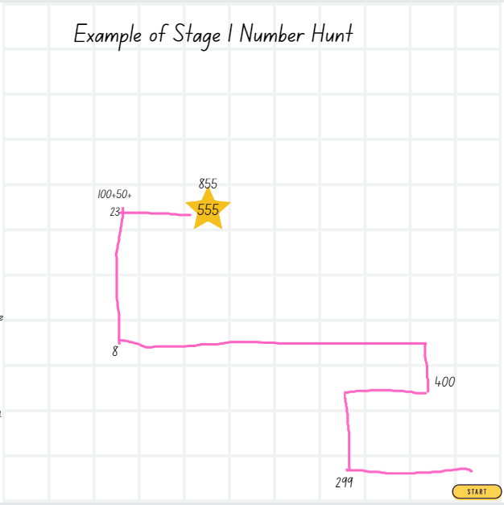
The table below details assessment opportunities and differentiation ideas.
Assessment opportunities | Too hard? | Too easy?
What to look for:  - Can students give and record clear instructions using directional language? (MA1-GM-01)  - Are students following directions correctly from one location to another? For example, left, right, up 2 squares. (MA1-GM-01)  - Can students solve problems applying various strategies, including number knowledge and explain their reasoning? (MAO-WM-01, MA1-CSQ-01)  What to collect:  - samples of students’ work and recordings of instructions (MAO-WM-01, MA1-GM-01) | Students are not able to give instructions involving multiple steps.  - Provide students with a blank grid paper displaying the word ‘start’ in one of the squares. Place a star in another square and support students to design a simple path from the start square to the star square. Model for students how to record the steps, using simple positional language.  - Provide students with a 10 × 10 grid and support students to count up and down, left and right to locate a specific square to draw a shape or symbol. | Students can follow and give clear instructions.  - Students challenge a partner by providing additional instructions to create a more complex path.  - Provide students with a blank grid and ask them to make a ‘bird’s eye view’ map of the classroom. Students will record instructions for a partner to navigate a pathway to find a hidden treasure.

Consolidation and meaningful practice: Addition on ten-frames – 15 minutes
- Display Resource 16: Addition on a ten frame and ask students to turn and talk with a partner, sharing ideas and strategies. Prompt students:
- What are you thinking?
- Can you explain a way to add the 2 quantities that doesn’t need you to count by ones?
- Can you use what you know about groups of tens to find a solution?
- Using blank ten-frames select students to share their thinking and their strategies. Encourage students to apply strategies such as number bonds and multiples of 10 (see Figure 11).
Figure 11 – Making groups of 10 when adding
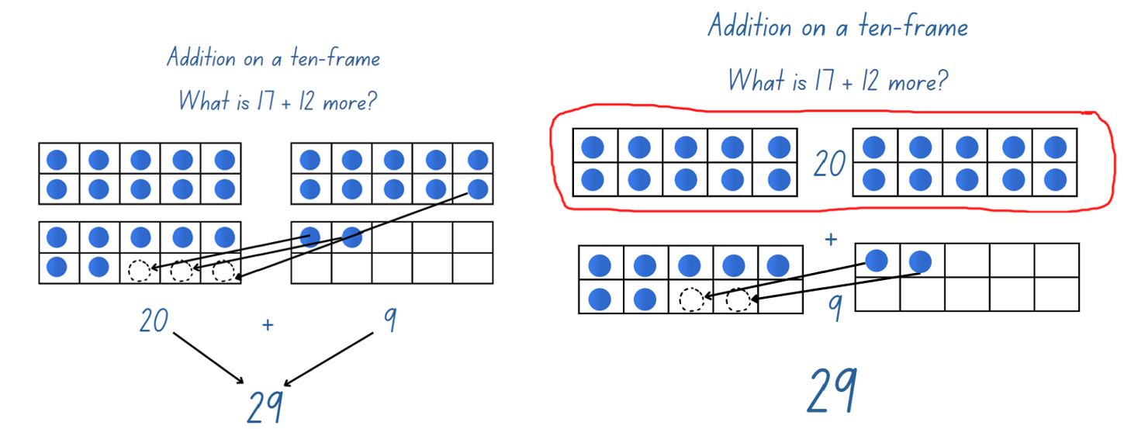
- As a class, provide time for students to explore adding 18 + 5 using a display of ten-frames. Select a variety of students to model groups of 10 and other strategies such as number bonds.

Resource 1: Twenty-frame filler gameboard
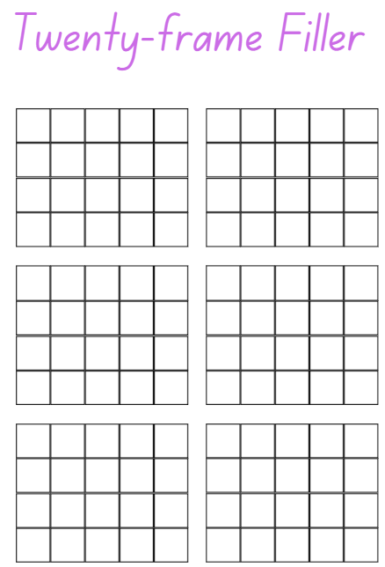

Resource 2: Sample game of twenty-frame filler
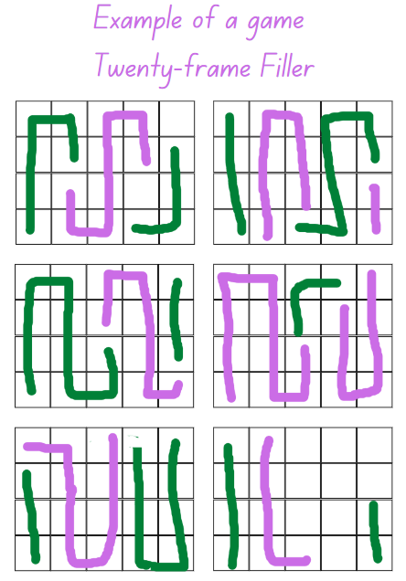

Resource 3: This is 57!
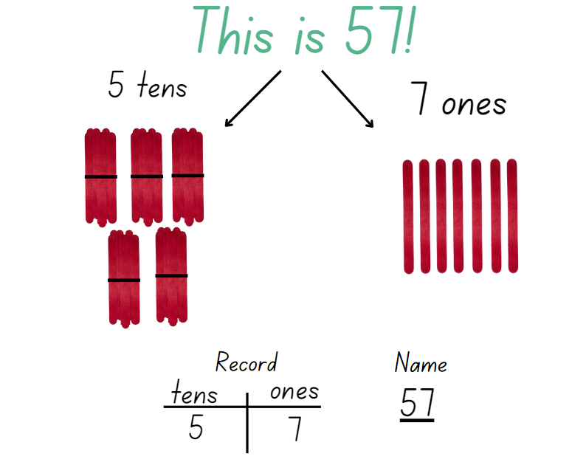
Images sourced from Canva and used in accordance with the Canva Content License Agreement.

Resource 4: Tug of War number line 0–100
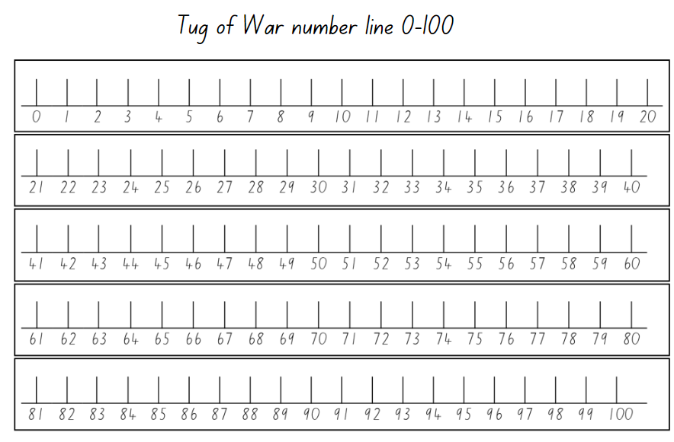

Resource 5: Five steps to 100 – number line 0–100
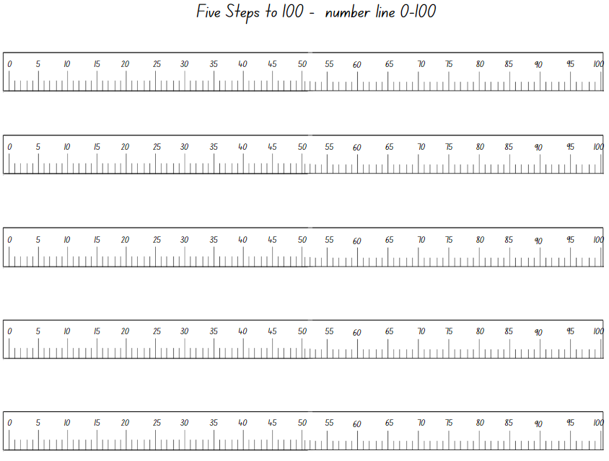
Images sourced from Canva and used in accordance with the Canva Content License Agreement.

Resource 6: Five steps to 500 – number line 0–500
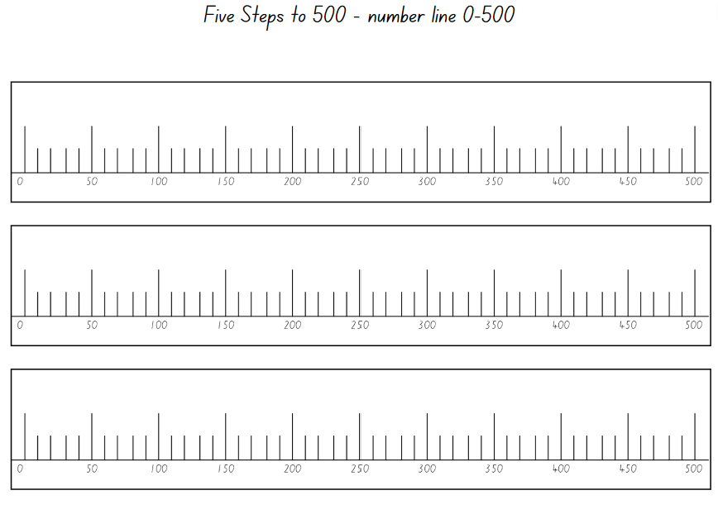
Images sourced from Canva and used in accordance with the Canva Content License Agreement.

Resource 7: Five steps to 500 – number cards
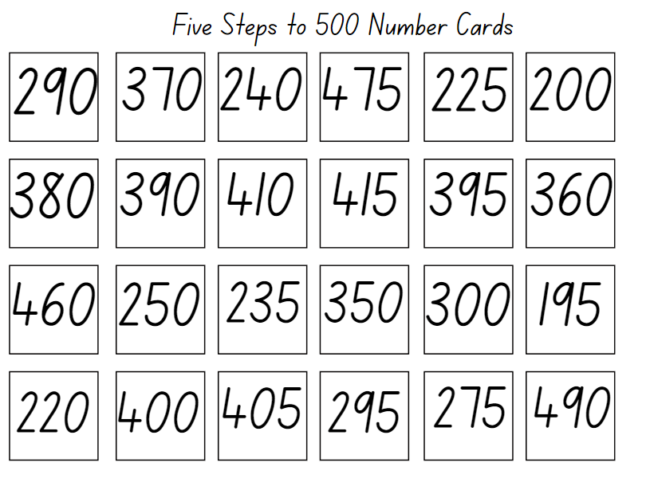

Resource 8: How many craft sticks?
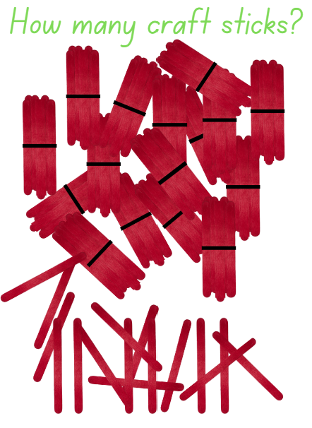
Images sourced from Canva and used in accordance with the Canva Content License Agreement.

Resource 9: Show me 25
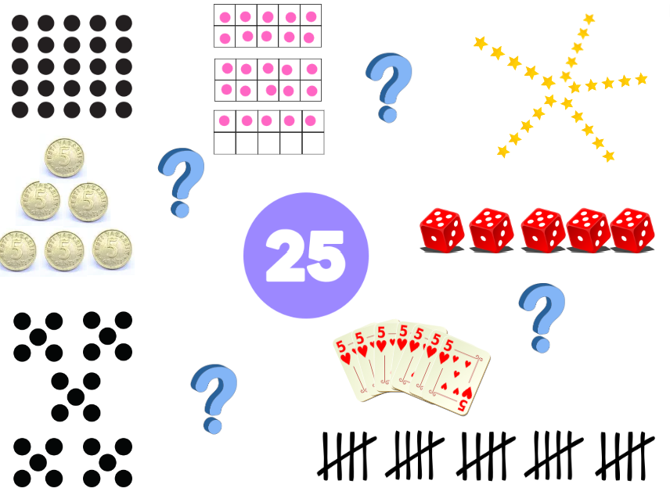
Images sourced from Canva and used in accordance with the Canva Content License Agreement.

Resource 10: My data investigation
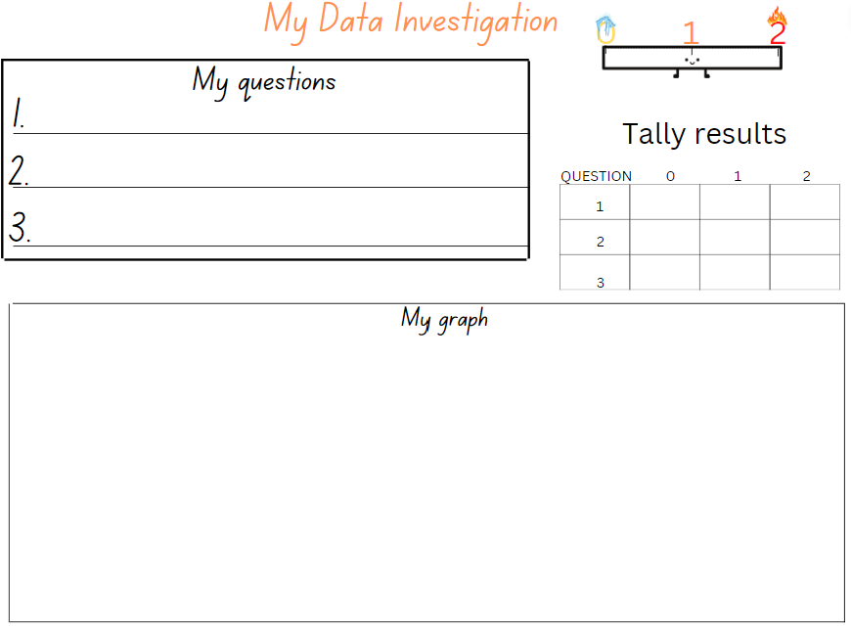

Resource 11: Number line 0–1000
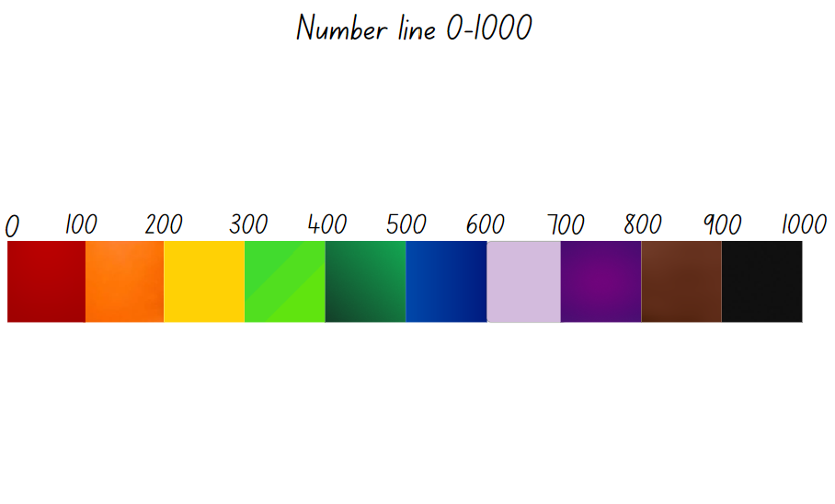

Resource 12: Game Instructions template
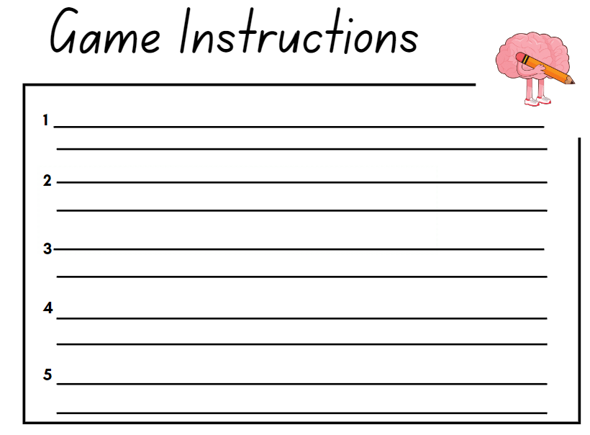
Images sourced from Canva and used in accordance with the Canva Content License Agreement.

Resource 13: Game plan template
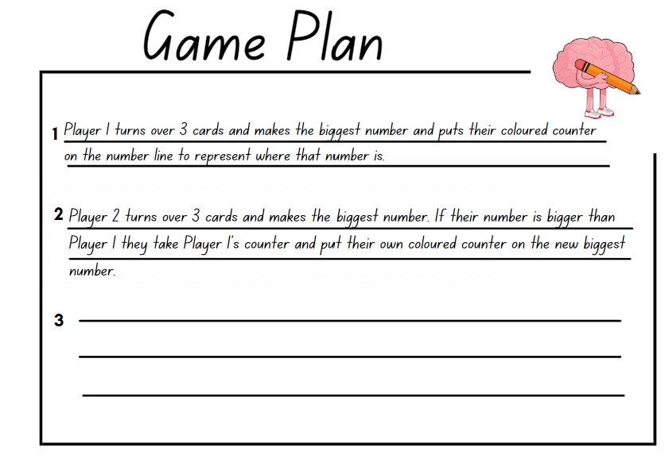
Images sourced from Canva and used in accordance with the Canva Content License Agreement.

Resource 14: Estimating quantities of circles

Resource 15: Number hunt grid paper
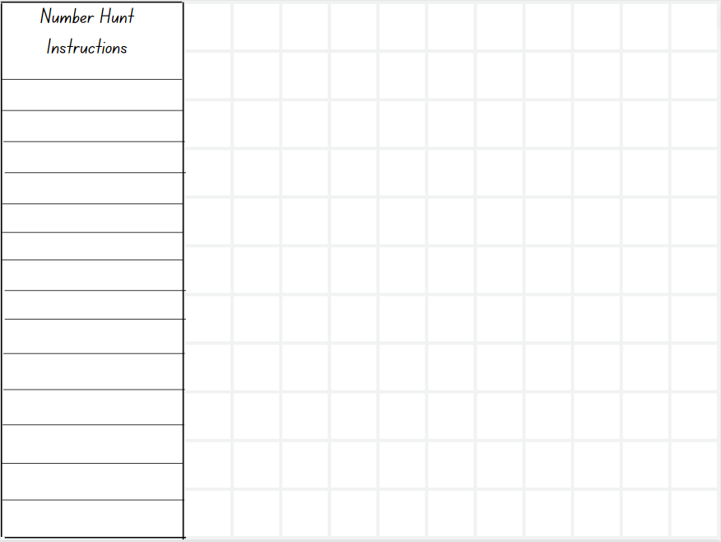

Resource 16: Addition on a ten-frame
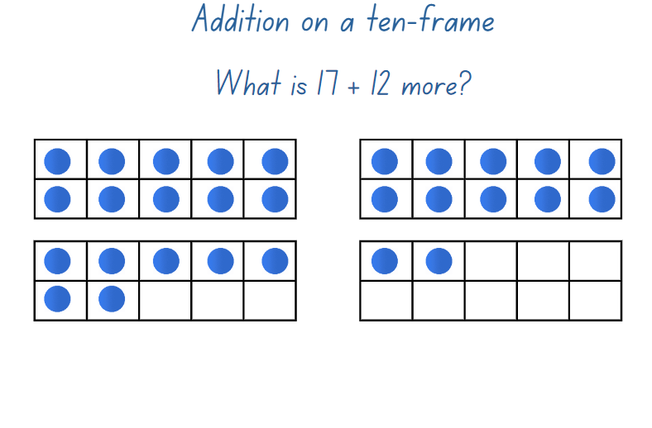

Syllabus outcomes and content
The table below outlines the syllabus outcomes and range of relevant syllabus content covered in this unit. Content is linked to National Numeracy Learning Progression version (3).
Focus area and outcomes | Content groups and content points | Lessons
Representing whole numbers A  MAO-WM-01  MA1-RWN-01  MA1-RWN-02 | Use counting sequences of ones with two-digit numbers and beyond  - identify the number before and after a given two-digit number (CPr5)  - count forwards and backwards by ones from a given number to at least 120 (CPr6)  Represent numbers on a line  - sequence numbers and arrange them on a line by considering the order and size of those numbers (CPr5)  - locate the approximate position of multiples of 10 on a model of a number line from 0 to 100 (QuN7)  Represent the structure of groups of ten in whole numbers  - recognise that ten ones is the same as one ten (NPV2, NPV4)  - count large sets of objects by systematically grouping in tens (CPr7)  - partition two-digit numbers to show quantity values (NPV4)  - use number lines and number charts to assist with locating the nearest ten to a number  - estimate, to the nearest ten, the number of objects in a collection and check by counting in groups of ten (CPr7, NPV6) | 1–5
Representing whole numbers B  MAO-WM-01  MA1-RWN-01  MA1-RWN-02 | Use counting sequences of ones and tens flexibly  - identify the number before and after a given three-digit number (AdS8)  - count forwards and backwards by tens, on and off the decade, with two- and three-digit numbers (CPr7)  - identify how many more to the next multiple of ten within two- and three-digit numbers  Form, regroup, and rename three-digit numbers  - count and represent large sets of objects by systematically grouping in tens and hundreds (CPr7, NPV5)  - use models such as base 10 material and interlocking cubes to represent and explain grouping  - state the quantity value of digits in numbers of up to three digits (Reasons about quantity) (NPV5)  - identify the nearest hundred to a number (QuN8)  - recognise units of 100 (QuN8)  - use place value to partition and rename three-digit numbers in different ways (Reasons about relations)  - estimate, to the nearest hundred, the number of objects in a collection and check by grouping and counting | 1–8
Combining and separating quantities A  MAO-WM-01  MA1-CSQ-01  NOTE – There is only one combining and separating quantities outcome for Stage 1. | Use advanced count-by-one strategies to solve addition and subtraction problems  - apply the terms ‘add’, ‘plus’, ‘equals’, ‘is equal to’, ‘is the same as’, ‘take away’, ‘minus’ and ‘the difference between’ to describe combining and separating quantities (AdS1, AdS6)  - recognise and use the symbols for plus (+), minus (-) and equals (=)  - record number sentences in a variety of ways using drawings, words, numerals and symbols (AdS6) | 4–8
Combining and separating quantities B  MAO-WM-01  MA1-CSQ-01  NOTE – There is only one combining and separating quantities outcome for Stage 1. | Represent and reason about additive relations  - create, record and recognise combinations of two numbers that add to numbers from 11 up to and including 20 (AdS7)  - create, model and solve word problems, using number sentences  - recall and use related addition and subtraction number facts to at least 20 (AdS7)  Form multiples of ten when adding and subtracting two-digit numbers  - add two-digit numbers by building to multiples of ten  - add and subtract from a two-digit number and record on an empty number line  - use quantity values to separate tens and ones for addition (only)  Use knowledge of equality to solve related problems  - use number knowledge to solve related problems (Reasons about relations) (AdS7, NPA4)  - use a variety of ways of writing number sentences (NPA3-NPA4) | 3–5, 7, 8
Forming groups A  MAO-WM-01  MA1-FG-01 | Model and use equal groups of objects to represent multiplication  - model and describe collections of objects as groups of (MuS3)  - determine and distinguish between the number of groups and the number in each group when describing collections of objects (Reasons about relations) (MuS3, MuS4)  - find the total number of objects using skip counting of equal groups of a known size (MuS2, MuS3) | 7, 8
Geometric measure A  MAO-WM-01  MA1-GM-01 | Position: Follow directions to familiar locations  - give and follow directions, including directions involving turns to the left and right, to move between familiar locations (PoL3)  - give and follow instructions to position objects in models and drawings (PoL4)  - describe the path from one location to another on drawings and diagrams (PoL4) | 6, 8
Geometric measure B  MAO-WM-01  MA1-GM-01 | Position: Explore simple maps of familiar locations  - make simple models from memory, photographs, drawings or descriptions (PoL3)  - interpret simple maps by identifying objects in different locations (PoL4)  - create a path from one location to another(PoL3) | 8
Data B  MAO-WM-01  MA1-DATA-02 | Identify a question of interest and gather relevant data  - pose suitable questions where the answers form categories, and predict the likely responses (IRD2)  - collect data on familiar topics (IRD2)  - sort data into relevant categories (IRD2)  Create displays of data and interpret them  - organise collected data into lists and tables to display information (IRD2)  - represent data in a picture graph using a baseline, equal spacing and same-sized symbols (IRD2)  - interpret information presented in tables and picture graphs (Reasons about relations) (IRD2)  - record answers to questions using the information in tables and picture graphs (IRD2) | 5

References
Links to third-party material and websites
Please note that the provided (reading/viewing material/list/links/texts) are a suggestion only and implies no endorsement, by the New South Wales Department of Education, of any author, publisher, or book title. School principals and teachers are best placed to assess the suitability of resources that would complement the curriculum and reflect the needs and interests of their students.
If you use the links provided in this document to access a third-party's website, you acknowledge that the terms of use, including licence terms set out on the third-party's website apply to the use which may be made of the materials on that third-party website or where permitted by the Copyright Act 1968 (Cth). The department accepts no responsibility for content on third-party websites.
Except as otherwise noted, all material is © State of New South Wales (Department of Education), 2023 and licensed under the Creative Commons Attribution 4.0 International License. All other material (third-party material) is used with permission or under licence. Where the copyright owner of third-party material has not licensed their material under a Creative Commons or similar licence, you should contact them directly for permission to reuse their material.
Mathematics K–10 Syllabus © 2022 NSW Education Standards Authority (NESA) for and on behalf of the Crown in right of the State of New South Wales.
© 2022 NSW Education Standards Authority. This document contains NSW Curriculum and syllabus content. The NSW Curriculum is developed by the NSW Education Standards Authority. This content is prepared by NESA for and on behalf of the Crown in right of the State of New South Wales. The material is protected by Crown copyright.
Please refer to the NESA Copyright Disclaimer for more information.
NESA holds the only official and up-to-date versions of the NSW Curriculum and syllabus documents. Please visit the NSW Education Standards Authority (NESA) website and the NSW Curriculum website.
National Numeracy Learning Progression © Australian Curriculum, Assessment and Reporting Authority (ACARA) 2010 to present, unless otherwise indicated. This material was downloaded from the Australian Curriculum website (National Literacy Learning Progression) (accessed 13 December 2022) and was not modified. The material is licensed under CC BY 4.0. Version updates are tracked in the ‘Curriculum version history’ section on the 'About the Australian Curriculum' page of the Australian Curriculum website.
ACARA does not endorse any product that uses the Australian Curriculum or make any representations as to the quality of such products. Any product that uses material published on this website should not be taken to be affiliated with ACARA or have the sponsorship or approval of ACARA. It is up to each person to make their own assessment of the product, taking into account matters including, but not limited to, the version number and the degree to which the materials align with the content descriptions and achievement standards (where relevant). Where there is a claim of alignment, it is important to check that the materials align with the content descriptions and achievement standards (endorsed by all education Ministers), not the elaborations (examples provided by ACARA).
Mathigon (2022) Mathigon [website], accessed 2 March 2023.
Mathigon (2022) ‘Number Tiles and Cubes’ Polypad, Mathigon website, accessed 13 December 2022.
New Zealand Ministry of Education (n.d.) ‘Over the rainbow’, Resource, NZ Maths website, accessed 13 December 2022.
New Zealand Ministry of Education (n.d.) NZ Maths [website], accessed 2 March 2023.
Siemon D, Warren E, Beswick K, Faragher R, Miller J, Horne M, Jazby D, Breed M, Clark J and Brady K (2020) Teaching Mathematics: Foundations to Middle Years, 3rd edn, Oxford University Press Australia and New Zealand.
University of Cambridge (Faculty of Mathematics) (2022) Five Steps to 50, NRICH website, accessed 13 December 2022.
University of Cambridge (Faculty of Mathematics) (2022) NRICH [website], accessed 13 December 2022.
University of Cambridge (Faculty of Mathematics) (2022) Tug of War, NRICH website, accessed 13 December 2022.

