Mathematics – Stage 1 – Unit 29
Contents
Unit description and duration 4
Student prior learning 4
Lesson overview and resources 5
Lesson 1: How do we see numbers? 12
Daily number sense: Tens detectives – 15 minutes 12
How do you see 100? – 40 minutes 14
Lesson 2: Array city! 17
Daily number sense: What do large numbers look like? – 15 minutes 17
Array City! – 40 minutes 19
Consolidation and meaningful practice: Arrays are all around us! – 5 minutes 22
Lesson 3: Numbers tell a story 22
Daily number sense: Blocks on the bowl – 10 minutes 23
Number stories – 45 minutes 24
Consolidation and meaningful practice: Blocks on the bowl – 5 minutes 29
Lesson 4: The human number line! 29
Daily number sense: How many cents in $1? – 15 minutes 30
The human number line! – 40 minutes 31
Consolidation and meaningful practice: Arrays are all around us! – 5 minutes 33
Lesson 5: Let’s party! 34
Daily number sense: Using a number line – 15 minutes 34
Party planning – 40 minutes 35
Discuss and connect the mathematics – 10 minutes 38
Lesson 6: Inverse operations 38
Daily number sense: Make 100! – 15 minutes 39
Inverse operations robots! – 40 minutes 41
Consolidation and meaningful practice: Human number line detectives! – 10 minutes 43
Lesson 7: Let’s party on! 44
Daily number sense: What’s the missing number? – 15 minutes 44
Let’s party on! – 45 minutes 45
Consolidation and meaningful practice: Inverse operations – 5 minutes 48
Lesson 8: Use the clues! 48
Daily number sense: Related number facts – 15 minutes 49
Esti-Mysteries! – 25 minutes 51
Consolidation and meaningful practice: Create your own – 30 minutes 54
Resource 1: Finding tens 55
Resource 2: Finding tens challenge 61
Resource 3: What is this? 63
Resource 4: Show with colour 64
Resource 5: Arrays around us! 65
Resource 6: Think board 66
Resource 7: What’s it worth? 67
Resource 8: Plus, minus, equals 68
Resource 9: Coins 69
Resource 10: Input robot 70
Resource 11: Inverse robot 71
Resource 12: Robots show how! 72
Resource 13: Input and inverse 73
Resource 14: How many beads? 74
Resource 15: Number chart 75
Resource 16: Bead clues 76
Resource 17: Fruit glass 77
Resource 18: Fruit clues 78
Resource 19: How many cherries? 79
Resource 20: Cherry clues 80
Resource 21: So many bananas 81
Resource 22: Banana clues 82
Syllabus outcomes and content 83
References 90

Unit description and duration
This two-week unit develops student knowledge, understanding and skills in forming groups and combining and separating. Students are provided opportunities to:
- choose and evaluate strategies to combine, separate and form groups
- use concrete materials, drawings, words, numerals and symbols to describe and explain mathematical operations
- understand that the order in which 2 quantities are combined does not change the result
- explore the inverse relation between addition and subtraction
- apply knowledge of related facts (number combinations to 10 and 20)
- use repeated addition to solve multiplication problems.
Mathematics K-2 Syllabus © 2021 NSW Education Standards Authority (NESA) for and on behalf of the Crown in right of the State of New South Wales.

Student prior learning
Before engaging in these teaching and learning activities, students would benefit from prior experience with:
- counting and subitising small collections to find a total
- describing the actions of combining, separating, and comparing
- sharing concrete materials into equal groups
- modelling and recognising combinations for numbers up to 10
- using drawings, words, and numbers to record thinking.

Lesson overview and resources
The table below outlines the sequence and approximate timing of lessons; syllabus focus areas and content groups; and resources.
Lesson | Syllabus focus area and content groups | Resources
Lesson 1: How do we see numbers?  55 minutes  Large numbers can be represented in many ways. | Representing whole numbers A  - Represent the structure of groups of ten in whole numbers  Representing whole numbers B  - Use counting sequences of ones and tens flexibly  - Form, regroup, and rename three-digit numbers  Forming groups A  - Count in multiples using rhythms and skip counting  Forming groups B  - Represent and explain multiplication as the combining of equal groups | - Resource 1: Finding tens  - Resource 2: Finding tens challenge  - Resource 3: What is this?  - Resource 4: Show with colour  - Coloured pencils  - Writing materials
Lesson 2: Array city!  60 minutes  Arrays can be found everywhere. | Representing whole number A  - Represent the structure of groups of ten in whole numbers  Forming groups B  - Represent and explain multiplication as the combining of equal groups  Statistics and Probability – Data A  - Ask questions and gather data  - Represent data with objects and drawings and describe the displays | - Resource 5: Arrays around us!  - 6-sided dice  - Coloured building blocks  - Beads  - Multi-attribute blocks (MAB)  - Photos or pictures of arrays  - Ten-frames  - Writing materials
Lesson 3: Numbers tell a story  60 minutes  Problems can be solved in different ways. | Combining and separating quantities A  - Use advanced count by one strategies to solve addition and subtraction problems  - Represent equality  Combining and separating quantities B  - Represent and reason about additive relations  - Form multiples of ten when adding and subtracting two-digit numbers  - Use knowledge of equality to solve related problems | - Resource 6: Think board  - Bowls  - Blocks or counters  - Writing materials
Lesson 4: The human number line!  60 minutes  Addition and subtraction number bonds can be used to solve problems. | Representing whole numbers A  - Use counting sequences of ones with two-digit numbers and beyond  - Represent numbers on a line  - Represent the structure of groups of ten in whole numbers  Representing whole numbers B  - Form, regroup, and rename three-digit numbers  Combining and separating quantities A  - Use advanced count by one strategies to solve addition and subtraction problems  - Use flexible strategies to solve addition and subtraction problems  - Represent equality  Forming groups A  - Count in multiples using rhythms and skip counting | - Resource 7: What’s it worth?  - Resource 8: Plus, minus, equals  - Australian coins  - MAB  - Number cards from one to the total number of students in the class
Lesson 5: Let’s party!  65 minutes  Number sentences can be used to solve word problems. | Representing whole numbers A  - Represent numbers on a line  Combining and separating quantities A  - Use advanced count by one strategies to solve addition and subtraction problems  Combining and separating quantities B  - Represent and reason about additive relations  - Form multiples of ten when adding and subtracting two-digit numbers  - Use knowledge of equality to solve related problems  Forming groups A  - Model and use equal groups of objects to represent multiplication  Forming groups B  - Represent and explain multiplication as the combining of equal groups  - Represent multiplication and division problems | - Concrete materials  - Number lines  - Writing materials
Lesson 6: Inverse operations  65 minutes  Addition and subtraction are inverse operations. | Representing whole numbers B  - Use counting sequences of ones and tens flexibly  - Form, regroup, and rename three-digit numbers  Combining and separating quantities A  - Use advanced count by one strategies to solve addition and subtraction problems  Combining and separating quantities B  - Form multiples of ten when adding and subtracting two-digit numbers | - Resource 9: Coins  - Resource 10: Input robot  - Resource 11: Inverse robot  - Resource 12: Robots show how!  - Resource 13: Input and inverse  - Counters  - Writing materials
Lesson 7: Let’s party on!  65 minutes  Addition strategies can be chosen to efficiently solve problems. | Combining and separating quantities A  - Use advanced count by one strategies to solve addition and subtraction problems  - Represent equality  Combining and separating quantities B  - Represent and reason about additive relations  Forming groups B  - Represent and explain multiplication as the combining of equal groups  - Represent multiplication and division problems | - Sticky notes  - Writing materials
Lesson 8: Use the clues!  70 minutes  Mathematical language can be used to recognise, identify and interpret numbers. | Representing whole numbers A  - Continue and create number patterns  Combining and separating quantities A  - Use flexible strategies to solve addition and subtraction problems  Combining and separating quantities B  - Represent and reason about additive relations  - Form multiples of ten when adding and subtracting two-digit numbers  - Use knowledge of equality to solve related problems | - Resource 14: How many beads?  - Resource 15: Number chart  - Resource 16: Bead clues  - Resource 17: Fruit glass  - Resource 18: Fruit clues  - Resource 19: How many cherries?  - Resource 20: Cherry clues  - 6-sided dice  - Concrete materials  - Writing materials

Lesson 1: How do we see numbers?
Core concept: Numbers can be represented in many ways.
The table below contains suggested learning intentions and success criteria. These are best co-constructed with students.
Learning intentions | Success criteria
Students are learning that:  - they can use 10 as a reference to find quantities  - one hundred can be represented in many ways  - arrays can be described in rows and columns. | Students can:  - identify groups of 10 to count larger numbers  - use colour coding to prove that there are 100 squares in a grid  - find more than one solution to a problem  - describe arrays in rows and columns.

Daily number sense: Tens detectives – 15 minutes
- Build student understanding of using 10 as a reference by counting quantities.
- Using Resource 1: Finding tens, model using 10 as a reference. With the first 2 images, say:
- There are 2 lots of 5 dots which make 10. I can see 4 dots and 6 dots, so that is another 10. I can see 2 dots left over so the total number of dots is 22.
- I can take 6 white flowers and add 4 pink flowers to them and make 10. Then I see 3 and 3 and 3 more blue flowers which make 9 and I will add the last pink flower to them to make 10. Now I have 20 flowers altogether.
- Students repeat the process independently or in small groups, using further images from Resource 1: Finding tens. These can be printed for students to record strategies used.
The table below details assessment opportunities and differentiation ideas.
Assessment opportunities | Too hard? | Too easy?
What to look for:  - Can students find combinations of 10 to efficiently count a number of objects? (MAO-WM-01, MA1-RWN-01)  - Can students communicate the strategies they used and compare these to strategies used by others? (MAO-WM-01, MA1-RWN-01)  What to collect:  - observational records (MAO-WM-01, MA1-RWN-01)  - photographs or work samples of grouping strategies. (MAO-WM-01, MA1-RWN-01) | Students cannot find tens or use groups of 10 as a reference.  - Model the concept using images printed from Resource 1: Finding tens.  - In pairs, students use coloured counters or blocks as they discuss images. | Students use 10 as a reference with all images.  - Students repeat the process with Resource 2: Finding tens challenge.  - Students investigate whether there is more than one solution for images from Resource 1: Finding tens.  - Students use concrete materials to make Finding 10 problems for other students to solve.

How do you see 100? – 40 minutes
This lesson is adapted from ‘Many ways to see one hundred’ in Mindset Mathematics: Visualizing and Investigating Big Ideas, Grade 2 by Boaler et. al (2022).
- Display Resource 3: What is this? Ask students what they can see and how they could count the squares. For example, counting in groups of 10, counting halfway and doubling, estimating and so on.
- When there is agreement that there are 100 squares in the grid, provide students with Resource 4: Show with colour and coloured pencils. Ask students:
- How could you use colour to prove that are 100 squares?
- Are there different ways to do this?
- How could you label each of your colour codes?
- How can you describe your grid? For example, I have 10 rows of 10, I have coloured in a 5 by 2 array 10 times.
Array: An ordered collection of objects or numbers arranged in rows and columns.
- Move around the room, encouraging students to think about different ways of grouping. Some possibilities are:
- rows or columns of 10
- groups of 2, 5 or 20
- finding rectangular or square array patterns
- using fractions such as halves or quarters.
Note: Correct labelling is important as it demonstrates understanding of the grouping chosen. For example, the label 10 lots of 10 should relate to a grid where 10 was represented 10 times, 25 + 25 + 25 +25 = 100 should describe a grid where 4 groups of 25 are colour coded.
- As a class, discuss different solutions found and any challenges. Ask students:
- Which solutions make the most sense to you? Why?
- Which solutions make it easier to see 100? Why?
- Which are harder? Why?
- Now you have looked at all the solutions, can you think of anymore?
The table below details assessment opportunities and differentiation ideas.
Assessment opportunities | Too hard? | Too easy?
What to look for:  - Can students explain why a method of counting is more efficient? (MAO-WM-01)  - Can students use colour to show different ways to prove that there are one hundred squares? (MAO-WM-01, MA1-RWN-01, MA1-FG-01)  - Do labels match how squares are coloured? (MAO-WM-01, MA1-RWN-01, MA1-FG-01)  - Can students use mathematical terms to describe their grid? (MAO-WM-01)  What to collect:  - observational records (MAO-WM-01, MA1-RWN-01, MA1-FG-01)  - work samples of different solutions with relevant labels. (MAO-WM-01, MA1-RWN-01, MA1-FG-01) | Students cannot show colour coding with a grid and pencils.  - Students use coloured blocks or tiles to make 100. Model the first few rows or columns of ten if necessary.  - Students draw the block pattern or transfer their pattern into Resource 4: Show with colour. | Students find different solutions to colour code, label and describe grids.  - Students use 50 coloured blocks to make a pattern on one side of a line.  - Students replicate the pattern on the other side of the line to show symmetry with 100 blocks.

Lesson 2: Array city!
Core concept: Arrays can be found everywhere.
The table below contains suggested learning intentions and success criteria. These are best co-constructed with students.
Learning intentions | Success criteria
Students are learning that:  - 10 can be used as a reference to count numbers between 11 and 20  - arrays in natural and built environments can be described using rows and columns  - data can be used to describe and compare. | Students can:  - identify units, tens and hundreds in a total  - identify and describe real-life arrays  - use rows and columns to make and describe arrays  - use tally charts to describe and compare arrays.

Daily number sense: What do large numbers look like? – 15 minutes
- Build student understanding of finding tens and hundreds by using place value resources with large numbers.
- Display the number 23. Ask students how many groups of 10 there are in the number. Check with concrete materials such as blocks, beads, MAB or ten-frames to organise groups of 10 and then left-over units or ones.
- Repeat the process for the number 67.
- Display the number 223. Ask students how this number is different to previous numbers. It has hundreds, tens, and units. Model with MAB. Ask students how many coloured blocks or beads they would need to make the 100 MAB. Show students 100 beads or blocks to help them visualise the quantity 100.
- In small groups, students roll a 6-sided die 3 times to make a three-digit number and represent it with MAB. For each three-digit number, students record the number and state the:
- three-digit number
- number before and after
- next 10
- next hundred.
The table below details assessment opportunities and differentiation ideas.
Assessment opportunities | Too hard? | Too easy?
What to look for:  - Do students understand that three-digit numbers contain hundreds, tens and units/ones? (MA1-RWN-01)  - Do students understand that each hundred contains one hundred ones or units? (MA1-RWN-01)  - Can students use MAB to explain their understanding of place value in three-digit numbers? (MAO-WM-01, MA1-RWN-01)  What to collect:  - observational records (MAO-WM-01, MA1-RWN-01)  - photographs of three-digit numbers represented with MAB or other concrete materials. (MAO-WM-01, MA1-RWN-01) | Students do not understand place value with three-digit numbers.  - Check that students understand place value of tens and units by rolling a 6-sided die twice and making the two-digit number with concrete materials.  - Model making one hundred with blocks in 10 groups of 10. Students repeat this process with other concrete materials.  - Students use blocks or beads to represent three-digit numbers and then use MAB. | Students represent three-digit numbers with MAB.  - Students state the hundred before and the hundred after each three-digit number rolled.  - Students state the closest hundred to each three-digit number rolled and explain why.  - Students count back to zero in tens from each number.

Array City! – 40 minutes
- Revise how in Lesson 1, students used arrays to see one hundred in different ways. Ask students if they can see any arrays in the classroom. For example, windows or a bookshelf. Display Resource 5: Arrays around us! and ask students to describe what they can see. Encourage use of the terms ‘rows’ and ‘columns'.
- Tell students they are going to create an Array City with coloured building blocks. Each student or pair of students will build a part of Array City that includes 3 or more arrays in its structure.
- Students may build a house, a garden or park, a shop, a train or bus, a train or bus station, a car park or an office block.
- Students make their model and present it to the class, pointing out and describing the arrays with rows and columns. Place each model into the city.
- In pairs, students make a tally chart to record different types of arrays and how many there are of each. Compare and discuss their tally chart with another pair.
- As a class, use the tally chart data to discuss the following questions:
- Which array was used most? Why?
- Which was used least? Why?
- Which array has most columns?
- Which array has least rows?
The table below details assessment opportunities and differentiation ideas.
Assessment opportunities | Too hard? | Too easy?
What to look for:  - Can students identify and describe real-life arrays? (MAO-WM-01, MA1-FG-01)  - Can students make a structure that includes arrays and describe them in rows and columns? (MAO-WM-01, MA1-FG-01)  - Can students create a tally chart to collect data and use it to describe Array City! (MAO-WM-01, MA1-FG-01, MA1-DATA-01, MA1-DATA-02)  What to collect:  - observational records (MAO-WM-01, MA1-FG-01)  - photographs of structures and work samples of tally charts. (MAO-WM-01, MA1-FG-01, MAO-WM-01, MA1-DATA-01, MA1-DATA-02) | Students cannot identify or describe arrays.  - Model an array from Resource 5: Arrays around us! with coloured tiles.  - Model describing an array from this resource using the words rows and columns.  - Ask students to build a flat house that has a door, windows and a chimney and then help them to identify these as arrays and describe them (see Figure 1).  - Students then build a structure for Array City. | Students create and describe a structure using 3 or more arrays.  - Identify 3 types of arrays not found in Array City.  - Add a structure that includes those arrays.
Figure 1 – Array house
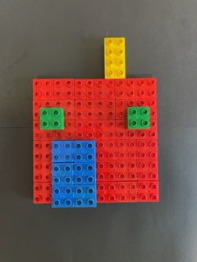

Consolidation and meaningful practice: Arrays are all around us! – 5 minutes
- Invite students to be array detectives! Ask students to think of arrays from the surroundings They can describe an array they can think of now or bring in drawings or photographs of arrays they find over the next few days. Use the images to create a classroom array display.

Lesson 3: Numbers tell a story
Core concept: Problems can be solved in different ways.
The table below contains suggested learning intentions and success criteria. These are best co-constructed with students.
Learning intentions | Success criteria
Students are learning that:  - number bonds can be used to find missing numbers and equivalence  - number sentences can be used to create, model and answer addition and subtraction problems  - the order in which 2 quantities are combined does not change the result. | Students can:  - use number bonds to find a missing number  - explain a maths story using a number sentence with addition, subtraction, and symbols  - use and explain the commutative property  - select and explain a strategy to find equivalence.

Daily number sense: Blocks on the bowl – 10 minutes
- Build student understanding of number bonds using 5 or 10 as a reference by finding a missing quantity.
- Give pairs of students a quantity of blocks between 5 and 20 and a bowl turned upside down. Student A places the blocks on top of the bowl and Student B counts them. While Student B looks away, student A places some of the blocks under the bowl and asks Student B how many blocks they can see now. Student B records their answer and explains a strategy to prove how many blocks have been placed under the bowl.
- Students swap roles and repeat the activity using a different number of blocks between 5 and 20. Some students may need the challenge of working with larger numbers of blocks.
The table below outlines stimulus prompts to generate conversation about the topic, along with anticipated responses from students.
Prompts | Anticipated student responses
- How many blocks are on top of the upside-down bowl?  - How many blocks are hidden by the bowl?  - What strategy can you use? | - I can see 5 blocks on top and I know there were 10 to start with. 5 and 5 make 10 so there must be 5 blocks under the bowl.  - I have 11 on top and there were 20 blocks altogether. I know that 11 and 9 make 20 so that means there are 9 blocks underneath.  - There are 14 blocks on top and 18 altogether. If I count by ones I count 15, 16, 17 and then I reach 18 so I know there are 4 blocks underneath.

Number stories – 45 minutes
This activity is drawn from Activity 1 – language of mathematics and Newmans Error Analysis (2022).
- Show students Resource 6: Think board. Explain that a think board is a useful tool for organising and solving problems. Introduce the problem: Nikiel went to the shops with his mum. They walked past 6 ducks on the way and 4 more ducks on the way back. Ask students how many ducks Nikiel and his mum saw on their walk. Check student understanding of the problem by asking questions such as:
- What is the number story asking you to find out?
- How can you solve this number problem?
- What is it called when the numbers are combined?
- How can you show your thinking?
- How can you prove your answer is correct?
- Demonstrate using Resource 6: Think board to record different ways of representing and solving the problem (see Figure 2).
Figure 2 – Think board example
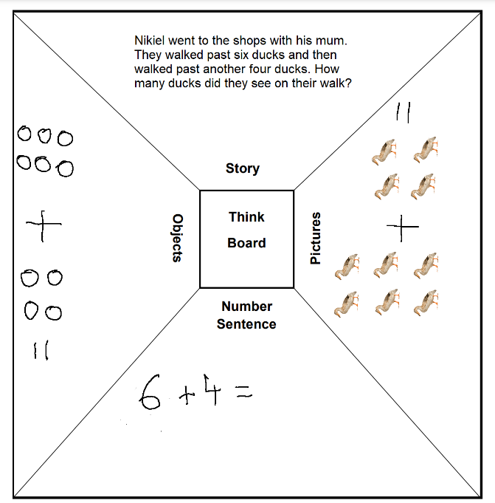
- Ask students what the answer would be if Nikiel saw 4 ducks on the way to the shops and 6 more on the way back. Discuss why the answer is still 10 and explain that mathematicians call this the commutative property.
Commutative property: Changing the order of addends does not change the result.
- Provide students with Resource 6: Think board and concrete materials, such as counters. Explain that students will use the think board to record their thinking and solve the problem. Introduce the problem: Nikita and Shahla were the best of friends. They always picked flowers from their own gardens for each other. Nikita picked 12 yellow roses from her garden and Shahla picked 12 pink roses from her garden. Ask students how many roses Nikita and Shahla have altogether. Check student understanding of the problem by asking questions such as:
- What is the number story asking you to find out?
- How can you solve this number problem?
- What is it called when 2 of the same numbers are combined?
- How can you show your thinking?
- How can you prove the answer?
- Allow time for students to solve the problem. As a class, share responses and select students to demonstrate how they recorded their thinking on the think board. Discuss different methods of representing the same number story. Ask students to evaluate strategies used, choose the most efficient one and explain why.
- Repeat the process using the following problem: one day Shahla walked to Nikita’s house. She decided to count her steps. She took 144 steps on the way there and 132 steps on the way back. Ask students how many steps Shahla took altogether.
- Introduce the following problem: Nikita and Shahla were excited to go to the zoo. They really wanted to see the monkeys. The sign at the monkey enclosure said that 36 monkeys were in the enclosure. Nikita counted 29 monkeys. Ask how many more monkeys there were to find. Ask students:
- How does this problem differ from the previous ones?
- What is the number story asking you to find out?
- How can you solve this number problem?
- Can you think of another way to solve this number problem?
- How can you prove your answer?
- Allow time for students to solve the problem. As a class, share responses and select students to demonstrate how they recorded their thinking on their think board. Discuss different methods of representing the same number story. Ask students to evaluate strategies used, choose the most efficient and explain why.
The table below details assessment opportunities and differentiation ideas.
Assessment opportunities | Too hard? | Too easy?
What to look for:  - Can students model and solve word problems using number sentences? (MAO-WM-01, MA1-CSQ-01)  - Can students use number bonds to solve equality problems? (MAO-WM-01, MA1-CSQ-01)  What to collect:  - student think board samples (MAO-WM-01, MA1-CSQ-01)  - recordings of student responses. (MAO-WM-01, MA1-CSQ-01). | Students cannot solve the problems.  - Rephrase the problems, using smaller numbers.  - Ask the questions in a different way. For example, ask students if the problem could be solved by adding tens and then ones.  - Model how to solve problems using MAB. | Students can solve the problems.  - Students create their own word problems for a partner to solve.  - Rephrase the problems, using larger numbers.  - Students write number problems that include more than one step. For example, there are 3 or more quantities to combine.

Consolidation and meaningful practice: Blocks on the bowl – 5 minutes
- Ask students questions to revise counting strategies to find a missing number:
- If there are 6 blocks on the bowl and 13 blocks altogether, how many blocks are under the bowl?
- There are 9 blocks under the bowl and there are 20 blocks altogether. How many blocks should be on top of the bowl?
- There are 15 blocks altogether and 3 of them are on top of the bowl. How can you work out how many blocks are under the bowl?

Lesson 4: The human number line!
Core concept: Addition and subtraction number bonds can be used to solve problems.
The table below contains suggested learning intentions and success criteria. These are best co-constructed with students.
Learning intentions | Success criteria
Students are learning that:  - large quantities can contain hundreds, tens and units  - subtraction and addition number bonds can be used to solve problems  - the equals sign can be used to show equivalence with addition and subtraction. | Students can:  - use concrete materials to show groups of hundreds, tens and units in three-digit numbers  - use a number line to skip count  - find multiple solutions for addition and subtraction problems  - show equivalence with the = symbol.

Daily number sense: How many cents in $1? – 15 minutes
- Build student understanding of place value by looking at Australian coinage.
Note: Where possible, show students real coins during this activity.
- Explain that students are going to learn all about money. Display Resource 7: What’s it worth? and use to discuss how people used precious things as money before coins were invented. Explain that it got a bit confusing trying to work out how much salt was worth 2 shells, so money was invented.
- Show students examples of Australian decimal coinage, including one and two cent coins. Look at the coins together and discuss things they can see, for example, value, date, animals, faces. Explain that the one and two cent coins are not used anymore because hardly anything costs one or two cents anymore.
- Show a $1 coin. Ask students how many one cent coins they would need to make one dollar. Show students a one hundred MAB and 100 beads or other small objects to emphasise that they would need 100 cents.
- Add a $1 coin and ask students how many one cent coins they would need now. Represent 200 with MAB ones, longs and flats in different combinations.
Note: You could ask students to bring in coins from other countries or pre-decimal Australian coins to discuss.

The human number line! – 40 minutes
- Prepare cards that begin at one and finish with the total number of students in the class. Give students a number card each and ask them to place themselves in order from smallest to largest to make a human number line!
- As a class, skip count by twos, fives, and tens. Students with those numbers put their hand up or take one step forward and then return to the line.
- Repeat the process for the following questions:
- Who is the smallest number?
- Who is the largest number?
- Who is the number before 14? Repeat with other randomly chosen numbers.
- Who is the number 10 before 14?
- Who is the number after 3? Repeat with other randomly chosen numbers.
- Who is the number 10 after 3?
- For the following questions, students take turns to suggest possible solutions. They communicate solutions using their number cards with Resource 8: Plus, minus, equals to make number sentences:
- Which 2 numbers can make 8 using addition? There are several possibilities.
- Which 2 numbers can make 23 using subtraction? For example, 24 minus one, 25 take away 2.
- Which 3 numbers can make 11 using addition? There are several possibilities.
- Split the class into 3 groups and give each group consecutive numbers and Resource 8: Plus, minus, equals. Give smaller numbers, for example, 1-8, to a group of students who found the previous questions challenging. Give larger consecutive numbers to the other groups. Students place themselves in a human number line and take it in turns to ask the line a question. Discuss:
- each suggested solution and decide whether it is correct or incorrect
- whether there is more than one solution.
The table below details assessment opportunities and differentiation ideas.
Assessment opportunities | Too hard? | Too easy?
What to look for:  - Can students use a number line to skip count and solve addition and subtraction problems? (MAO-WM-01, MA1-CSQ-01, MA1-FG-01)  - Can students show equivalence with the = symbol for addition and subtraction problems. (MAO-WM-01, MA1-CSQ-01)  - Do students understand that there can be more than one solution to an equivalence problem? (MAO-WM-01, MA1-CSQ-01)  What to collect:  - observational records (MAO-WM-01, MA1-CSQ-01, MA1-FG-01)  - photographs of solutions using the human number line and +, − and = symbols. (MAO-WM-01, MA1-CSQ-01) | Students cannot mentally find solutions to addition and subtraction problems.  - Model moving along the number line one-by-one to reach a solution.  - Use concrete materials to solve addition and subtraction problems. | Students solve addition and subtraction problems with numbers up to 20.  - Give students numbers and have them solve questions involving doubling and halving. For example, call out the number 4 and ask for double and half from the human number line.  - Students make a human number line with larger consecutive numbers. For example, 50-60 or 95-105. Then take turns to ask addition, subtraction and equivalence questions.

Consolidation and meaningful practice: Arrays are all around us! – 5 minutes
- Revise Lesson 2 by discussing any arrays that the array detectives have seen at home and out and about.

Lesson 5: Let’s party!
Core concept: Number sentences can be used to solve word problems.
The table below contains suggested learning intentions and success criteria. These are best co-constructed with students.
Learning intentions | Success criteria
Students are learning that:  - number sentences can be used to solve word problems  - collections of objects can be displayed in arrays with rows and columns  - arrays can be used to solve division problems. | Students can:  - record thinking using pictures, diagrams, words, numbers or objects  - identify columns and rows in an array  - use an array to solve a division problem.

Daily number sense: Using a number line – 15 minutes
- Build student understanding of addition and subtraction by using number lines to solve problems.
- Display numbers 23, 45 and 67 and ask students to place them on a number line. Alternatively, use an interactive number line.
- Ask the following questions:
- Which 2 numbers are closest on the number line?
- Which number is closest to 33?
- Which number is closest to 57?
- How far apart are 67 and 23?
- How far apart are 43 and 67?
- Can you think of any other questions to ask about the numbers?
- In pairs, students choose 3 two-digit numbers, place them on a number line and ask each other questions about them.

Party planning – 40 minutes
This activity is adapted from Birthday Sharing at NRICH.
- It’s Akisi’s birthday and she’s having a party with 5 friends. Akisi baked 24 cupcakes to share with her guests. Ask students if the cupcakes can be shared equally between Akisi and her friends. Students record their thinking using pictures, diagrams, words, numbers or objects. Support thinking and promote discussion by providing concrete materials and asking:
- How many cupcakes will each person receive?
- Can you show how the cupcakes can be arranged in an array?
- How many columns are there?
- How many rows are there?
- How many different arrays can you make with the 24 cupcakes?
- Akisi’s friend Mia can no longer come to the party. How many cupcakes will each person receive now?
- Can the cupcakes still be shared equally?
- How many cupcakes will be left over?
- Explain that Akisi wants to put the cupcakes on 4 plates. Ask students to draw a picture or use concrete materials to show how the plates might look if each plate has at least one cupcake. Ask students to show a solution where each plate has an equal number of cupcakes.
- Akisi made a party bag for herself and each of her 5 guests. She had:
- 12 balloons
- 6 packs of coloured pencils
- 8 jars of glow in the dark slime
- 24 lollipops.
- Ask students:
- How many of each item will be included in each party bag?
- How many items are in each party bag?
- How many items are there altogether?
- Are there any items left over?
- Students draw a picture of what a party bag would look like.
- One friend left with their party bag. Ask students how many of each item there are still at Akisi’s place.
- Ask students how many items would be left in the remaining party bags after 3 of Akisi’s friends have gone home.
The table below details assessment opportunities and differentiation ideas.
Assessment opportunities | Too hard? | Too easy?
What to look for:  - Can students record their thinking about cupcakes and party bags using pictures, diagrams, words, numbers or objects? (MAO-WM-01, MA1-CSQ-01)  - Can students identify and record columns and rows in an array? (MAO-WM-01, MA1-FG-01)  - Can students use an array to solve the cupcake problem? (MAO-WM-01, MA1-FG-01).  What to collect:  - student work samples (MAO-WM-01, MA1-CSQ-01, MA1-FG-01)  - photographs and recordings of student responses. (MAO-WM-01, MA1-CSQ-01, MA1-FG-01) | Students cannot share cupcakes and party bag items into equal groups.  - Model using an array to solve the cupcake problem, identifying columns and rows.  - Students share the cupcakes between 2 people and then 3 people.  - For the party bags, use balloons and pencils to begin with. | Students solve the problems and use arrays correctly.  - Students identify and record other amounts of cupcakes that could be shared equally between Akisi and her 5 friends.  - Akisi also wants to include stickers in the party bags. She has 100 stickers. Ask students how she can share them and if there will be any left over.

Discuss and connect the mathematics – 10 minutes
- Reflect on the activity by asking:
- What strategy did you use to share the cupcakes?
- Was it helpful to make arrays? Why or why not?
- How did you record your thinking and why did you choose that method?
- What do mathematicians call the leftover cupcakes?
- Is there any way that leftover cupcakes could be shared too?

Lesson 6: Inverse operations
Core concept: Addition and subtraction are inverse operations.
The table below contains suggested learning intentions and success criteria. These are best co-constructed with students.
Learning intentions | Success criteria
Students are learning that:  - addition and subtraction are inverse operations  - operations can be recorded using numerals with symbols  - there are 100 cents or units in $1. | Students can:  - explain inverse operations with addition and subtraction using concrete materials, drawings, and diagrams  - record inverse operations using +, − and = symbols  - use coins in different combinations to make $1.

Daily number sense: Make 100! – 15 minutes
- Build student understanding of place value by using coins in different combinations to show there are 100 cents in $1.
Note: Where possible, use real coins for activities.
- Revise Lesson 4 where students talked about Australian money and counted in ones and twos to make 100 cents or $1. Using coins or Resource 9: Coins (5, 10, 20 and 50 cents), students make 100 by:
- counting in tens with 10c coins
- counting in fives with 5c coins
- Show students a 50c coin and ask how many groups of 50 they would need to make 100.
- In small groups, using Resource 9: Coins, students explore current coinage and record different ways to make:
- 10 cents
- 20 cents
- 100 cents or $1.
- Move between groups, encouraging students to choose how they will organise and record solutions, for example with drawings, numbers or symbols.
- As a class, discuss solutions and methods of recording.
The table below details assessment opportunities and differentiation ideas.
Assessment opportunities | Too hard? | Too easy?
What to look for:  - Do students recognise that there are 100 units or cents in $1? (MA1-RWN-01)  - Can students use coins in different combinations to make $1? (MAO-WM-01, MA1-RWN-01)  What to collect:  - observational records (MAO-WM-01, MA1-RWN-01)  - work samples or photographs of coin combinations to make $1. (MAO-WM-01, MA1-RWN-01) | Students cannot find combinations or logically check they have found all solutions.  - Use counters to represent one cent coins and count out 10 together to make 10 cents.  - Model how 10 cents can be made with one 10c coin or two 5c coins. Check with counters.  - Students look for ways to make 20 cents with 5c and 10c coins, checking ideas with counters. | Students find many ways to make 10 cents, 20 cents and $1.  - Students begin with a 50c coin and find all solutions to make 70c.  - Students logically record answers to check that they have found all solutions to make $1.

Inverse operations robots! – 40 minutes
- Show students 2 counters. Add a third counter and ask how many counters there are now. There are 3. Ask students how they could reverse this operation and make the group of counters into 2 counters again. Model taking away one counter as an inverse operation to return to a total of 2. Explain that this is an inverse or reverse operation because a number is changed into a new number and then reversed back into the original number.
- Display Resource 10: Input robot. Tell students that the input robot has taken the number 5 and used an operation that has turned 5 into 6. Ask what the operation might be.
- Students may describe this operation as:
- add one
- plus one
- one more.
- Explain that these are all correct and mathematicians call this operation addition. Brainstorm all words that mean addition.
- Display Resource 11: Inverse robot. The inverse robot has taken the number 6 and changed it back into a 5. Ask what operation the robot used. Again, students may use a variety of mathematical terms such as take away one, one less, minus one. Explain that mathematicians call this inverse operation subtraction. Brainstorm all words that mean subtraction.
- Display Resource 12: Robots show how! to demonstrate the process from start to finish.
- Students use Resource 13: Input and inverse to create additions with the related inverse subtraction operations.
- Choose student ideas and display as a number sentence followed by the inverse operation number sentence. For example, 2 + 2 = 4 so 4 − 2 = 2. Revise with students that the = symbol means ‘the same as’ or ‘equals to’.
- Display the operation 5 − 2 = 3. Ask what is different about this operation. It begins with a subtraction. Ask students how they can reverse this to return to the original number of 5. When students have identified that they need to add 3, explain that this inverse operation is called addition. Display this as a number sentence followed by the inverse operation number sentence: 5 − 2 = 3 so 3 + 2 = 5.
- Students repeat and record the process, choosing their own single digit numbers.
The table below details assessment opportunities and differentiation ideas.
Assessment opportunities | Too hard? | Too easy?
What to look for:  - Can students describe and explain inverse operations using concrete materials, drawings and diagrams? (MAO-WM-01, MA1-CSQ-01)  - Can students record number sentences with +, − and = symbols? (MA1-CSQ-01)  - Do students recognise that the inverse operation for addition is subtraction and vice-versa? (MAO-WM-01, MA1-CSQ-01)  What to collect:  - observational records (MAO-WM-01, MA1-CSQ-01)  - work samples of Resource 13: Input and inverse (MAO-WM-01, MA1-CSQ-01)  - work samples of number sentences recorded with numerals and symbols followed by the inverse operation. (MAO-WM-01, MA1-CSQ-01) | Students do not demonstrate understanding of inverse operations or record number sentences.  - Model simple inverse operations for example, 3 + 1 = 4 so 4 − 1 = 3, using a variety of concrete materials.  - Students demonstrate understanding verbally using counters.  - Students use counters with sticky notes showing the symbols +, − and =. | Students demonstrate understanding of inverse operations of addition and subtraction and fluently apply this to single digit numbers.  - Students apply inverse operations of addition and subtraction to two-digit numbers.  - Students explore doubling and halving as inverse operations.

Consolidation and meaningful practice: Human number line detectives! – 10 minutes
- Students create a ‘human number’ line beginning at one. Tell students that one of them is a secret number and that they will use their maths detective powers to listen to clues and work out who the secret number is. Read out clues. If a clue means a number cannot be the secret number, that student sits down.
- For example, in a class of 25, the secret number is 9, and the clues are:
- The secret number is not a multiple of 2. Students with 2, 4, 6, 8, 10, 12, 14, 16, 18, 20, 22 and 24 sit down.
- The secret number does not contain the digit 3. Students with 3, 13 and 23 sit down.
- The secret number is less than 10. Only numbers 1, 5, 7 and 9 should still be standing.
- If the secret number was lollies, they could be divided equally between 3 people. The secret number is 9!

Lesson 7: Let’s party on!
Core concept: Addition strategies can be chosen to efficiently solve problems.
The table below contains suggested learning intentions and success criteria. These are best co-constructed with students.
Learning intentions | Success criteria
Students are learning that:  - repeated addition can be used to solve multiplication problems  - adding tens and then ones is an efficient way to solve addition problems  - some addition strategies are more efficient. | Students can:  - use repeated addition to solve multiplication problems  - add tens and then ones to solve addition problems  - make decisions about how to efficiently solve addition problems and explain their thinking.

Daily number sense: What’s the missing number? – 15 minutes
- Build student understanding of counting strategies by finding missing parts of number sentences.
- Tell students the answer is 9 and ask what the number story could be. Allow students to turn and talk and then display several student solutions. For example, there were 6 students playing handball and 3 more students joined in or 8 birds were sitting in the tree and then another bird flew over and landed next to them. Ask students to change the order of the 2 numbers they added and whether this makes a difference to the answer. For example, if they added 6 and 3 to make 9, does 3 + 6 still add up to 9?
- Ask students if they can also find a subtraction number sentence that gives the answer 9. Again, after some thinking time, select some students to explain their strategy and number sentence.
- Give small groups of students a sticky note with a number between 10 and 30. For their given number, students:
- Create an addition number story and record the number sentence. Check whether the answer changes if the order of the addition is changed.
- Create a subtraction number story and record the number sentence. Check whether the answer changes if the order of the subtraction is changed.
- Choose addition or subtraction and find different solutions.
- Prove that they have found all possible solutions.
- If students are challenged by this activity, provide them with Resource 6: Think board.

Let’s party on! – 45 minutes
- Explain that Akisi and her 5 friends decide to play some party games. They play duck, duck, goose and have 3 turns each. Then they have 5 turns each throwing the ball at targets. Lastly, they have 2 turns each at pinning the tail on the donkey. Ask students how many turns were had altogether for each game. There were 18, 30 and 12 turns.
- Ask students how they could work out the total number of turns. Students turn and talk and then share answers with the class. For example, they could:
- add the tens and then the units, for example, 10 + 30 + 10 + 8 + 2 = 60
- 18 + 12 = 30 and then 30 + 30 = 60
- 30 + 20 + 10 = 60
- counting on from 30 to get to 60.
- Discuss strategies used and which one students find most efficient.
- Akisi remembers that one of her friends had to leave early for sport so they didn't play the games. Ask students if this changes the number of turns taken and how they could work this out. Students turn and talk and then share answers with the class and discuss the most efficient strategies.
- Akisi’s dad calls the 5 girls over for birthday food. Akisi’s little sister is allowed to join in and she is very excited to eat with the big girls! They each eat:
- 2 pieces of fairy bread
- 3 lollies
- one piece of apple, 2 strawberries and 3 blueberries.
- Model how students could use repeated addition to find out how many pieces of food were eaten. Each child eats:
- 2 + 2 + 2 + 2 + 2 + 2 which equals 12 pieces of fairy bread
- 3 + 3 + 3 + 3 + 3 + 3 so that is 18 lollies altogether
- 6 + 6 + 6 + 6 + 6 + 6 = 36 pieces of fruit in total.
- Ask students to use the adding tens and then adding ones strategy to find the total number of pieces of food eaten.
- Tell students there were 45 pieces of fruit on the table at the start and ask what strategies they could use to work out how many pieces would be left over.
- In groups of 3-6, students create party problems that can be solved using repeated addition, adding with tens and units, and subtraction. Swap party problems with another group and discuss the most efficient strategies.
The table below details assessment opportunities and differentiation ideas.
Assessment opportunities | Too hard? | Too easy?
What to look for:  - Can students use repeated addition to solve multiplication problems? (MAO-WM-01, MA1-CSQ-01, MA1-FG-01)  - Can students add tens and then ones to solve addition problems? (MAO-WM-01, MA1-CSQ-01)  - Can students make decisions about how to efficiently solve addition problems and explain their thinking? (MAO-WM-01, MA1-CSQ-01, MA1-FG-01)  What to collect:  - observational records (MAO-WM-01, MA1-CSQ-01, MA1-FG-01)  - work samples of party problems with solutions. (MAO-WM-01, MA1-CSQ-01, MA1-FG-01) | Students cannot use mental strategies to find solutions.  - Students use MAB to find solutions using all the strategies.  - Model the repeated addition strategy by counting aloud.  - Students act out the problem with concrete materials as necessary. | Students can create and solve party problems.  - Students include doubling and halving in their party problems.  - Students select one party problem and find all possible strategies.  - Students evaluate and rank strategies from most to least efficient and explain reasoning.

Consolidation and meaningful practice: Inverse operations – 5 minutes
- Display the following operations and ask students to identify the inverse operations:
- 2 + 3 = 5 so the inverse operation is 5 − 3 = 2
- 3 + 7 = 10 so the inverse operation is?
- 10 − 6 = 4 so the inverse operation is?
- 20 − 11 = 9 so the inverse operation is?
- Ask students if they can think of any operations and their inverse operation.

Lesson 8: Use the clues!
Core concept: Mathematical language can be used to clarify clues when solving problems.
The table below contains suggested learning intentions and success criteria. These are best co-constructed with students.
Learning intentions | Success criteria
Students are learning that:  - number knowledge can be used to solve problems  - some problems can be solved by logical use of clues. | Students can:  - solve problems using clues  - find doubles or near doubles for single-digit numbers.

Daily number sense: Related number facts – 15 minutes
- Build student understanding of doubles and number facts to 20 by doubling and counting forwards and backwards.
- Model the game ‘Double it’ by:
- rolling a 6-sided die
- doubling the number
- using flexible counting strategies to get from the double to zero, 10 and 20.
- Students play the game in small groups. They record and compare strategies used for each roll of the die. Move between groups, supporting students to:
- apply knowledge of number bonds for 10 and 20
- explore the relationship between number bonds for 10 and 20, for example, if 6 + 4 = 10, then 6 + 14 = 20
- recognise the constant difference between any 2 numbers, for example, 8 taken away from 8 is always zero, double 2 is always 4.
- As a class, discuss some rolls and corresponding answers and ask:
- Which dice rolls were easier to find answers for? For example, a die roll of 5 doubled makes 10 and then minus 10 gets you to zero and adding 10 = 20.
- Which dice roll doubles got you closest to zero, 10 and 20?
The table below details assessment opportunities and differentiation ideas.
Assessment opportunities | Too hard? | Too easy?
What to look for:  - Can students identify doubles for single-digit numbers? (MAO-WM-01, MA1-CSQ-01)  - Can they explain how they use number bonds and other strategies to reach zero, 10 and 20 from their double? (MAO-WM-01, MA1-CSQ-01)  - Do they understand the constant difference between any number and zero? (MAO-WM-01, MA1-CSQ-01)  What to collect:  - observational records (MAO-WM-01, MA1-CSQ-01)  - written recordings of strategies used. (MAO-WM-01, MA1-CSQ-01) | Students do not understand the concept of doubling.  - Students roll one 6-sided die and then find the same face on another 6-sided die and count the total number of dots.  - Record the first throw and the double each time to absorb that a double of a number is always constant. For example, double 2 is always 4.  Students cannot visualise how to get from a given number to zero, 10 and 20.  - Model with a number line or number chart.  - Students use a 4-sided dice with sides of zero, 1, 2 and 3 so that the doubles are always single digit numbers.  - Students work with concrete materials to count backwards to zero and forwards to 10 from the double. | Students can find doubles and how to get to zero, 10 and 20.  - Students play the game with an 8- or 10-sided dice and consider whether this makes finding zero, 10 and 20 easier or harder.  - Students play the game with a 20-sided dice.

Esti-Mysteries! – 25 minutes
This activity has been adapted from Esti-Mysteries by Steve Wyborney.
- Explain that students will be shown a picture and then provided with a series of clues to solve a mystery. Students should consider each clue, using the information to narrow the possibilities to a smaller set, and then make a guess. Subsequent clues will provide opportunities to determine whether guesses are still reasonable. If the previous guess is no longer possible, students write down a new guess.
- Show students Resource 14: How many beads? and ask how many beads are in the cup. Ask students to make their first guess. Select students to share guesses and explain thinking.
- Provide each student with Resource 15: Number chart and explain that this will help to record thinking and eliminate incorrect answers. Reveal the first clue from Resource 16: Bead clues. Provide explanation if required. Model how to use the number chart to eliminate numbers. See Figure 3. Remind students to consider if their first guess is still reasonable and if not, record a new guess based on the clue. Select students to share estimates and explain thinking. Repeat the process for the remaining clues. Prior to revealing the last clue, students record their final guess and turn and talk to explain their thinking.
Figure 3 – Beads number chart after the first clue
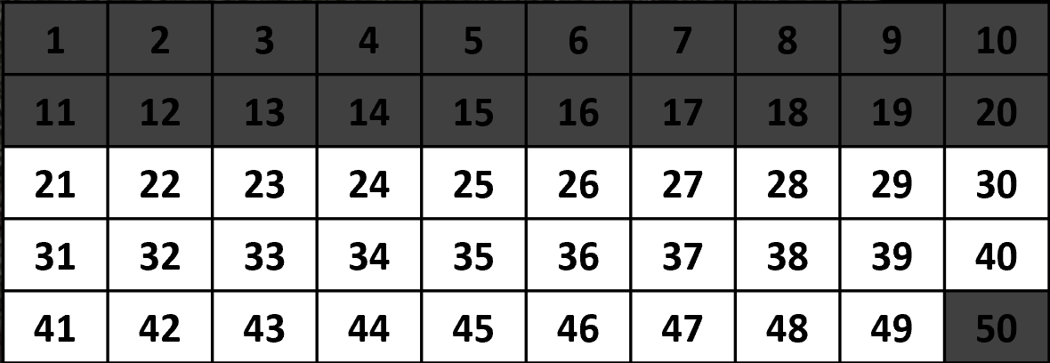
Image adapted from “Cup of Beads” from Esti-Mysteries by Steve Wyborney and is reproduced with permission.
- Reveal the correct answers. There are 2 possible answers, 22 and 38. Discuss and compare to students’ original guesses.
- Show students Resource 17: Fruit glass and ask how many objects are in the glass. Ask students to make their first guess. Select students to share guesses and explain thinking.
- Reveal the first clue from Resource 18: Fruit clues. Provide explanation if required. Instruct students to use their number chart to eliminate numbers. Remind students to consider if their first guess is still possible and if not, to record a new guess based on the clue. Select students to share guesses and explain thinking. Repeat the process for remaining clues. Prior to revealing the last clue, students record their final guess and turn and talk to explain thinking.
- Reveal the correct answers. There are 2 possible answers, 48 and 78. Revisit each clue and model how to reach a correct answer using a number chart to eliminate possible answers. For an example, see Figure 4.
Figure 4 – Fruit number chart after the first clue
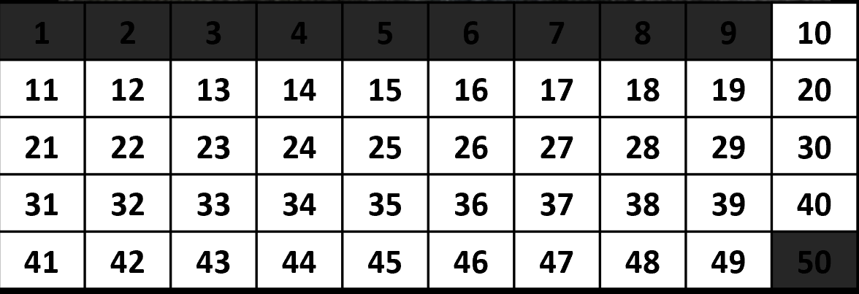
Image adapted from “Fruit Cup” from Esti-Mysteries by Steve Wyborney and is reproduced with permission.
The table below details assessment opportunities and differentiation ideas.
Assessment opportunities | Too hard? | Too easy?
What to look for:  - Can students use the clues to find a correct answer? (MAO-WM-01, MA1-RWN-01)  - Can students explain their thinking? (MAO-WM-01, MA1-RWN-01)  What to collect:  - student number chart and guess samples (MAO-WM-01, MA1-RWN-01)  - observational records. (MAO-WM-01, MA1-RWN-01) | Students cannot use the clues to find the correct answer.  - Provide further modelling on how to use the number chart in conjunction with the first 3 clues. Students then complete clues 4 and 5 independently.  - Students work with an easier esti-mystery with Resource 19: How many cherries? and Resource 20: Cherry clues. Ask how many cherries are in the bowl. | Students can use the clues to solve the esti-mystery.  - Choose several numbers and ask students to explain why they cannot be the correct answer.  - Students write 5 different clues for ‘Bead clues’ where the 2 possible answers are 22 and 38.  - Students work with a more challenging esti-mystery with Resource 21: So many bananas and Resource 22: Banana clues. Ask how many objects are in the vase.

Consolidation and meaningful practice: Create your own – 30 minutes
- In pairs, students create their own esti-mystery by using classroom objects and writing a series of clues for another pair to solve.
- Select students to present their esti-mystery to the class and demonstrate how to reach the correct answer.

Resource 1: Finding tens
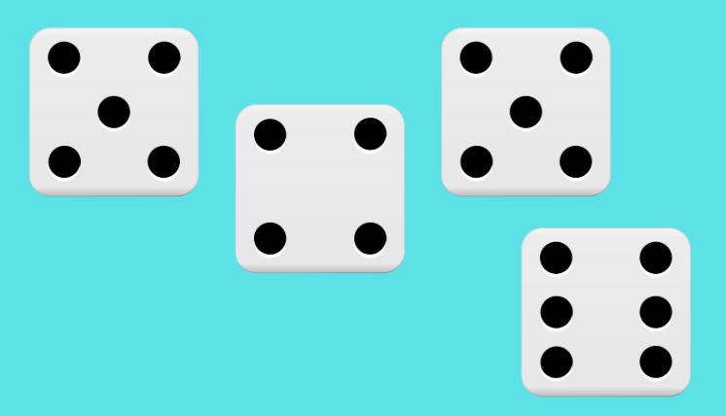
Images sourced from Canva and used in accordance with the Canva Pro Content License.
Images sourced from Canva and used in accordance with the Canva Pro Content License.
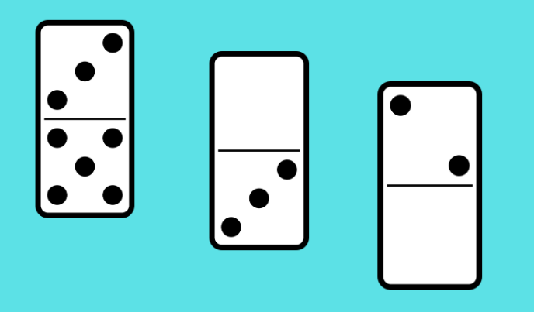
Images sourced from Canva and used in accordance with the Canva Pro Content License.
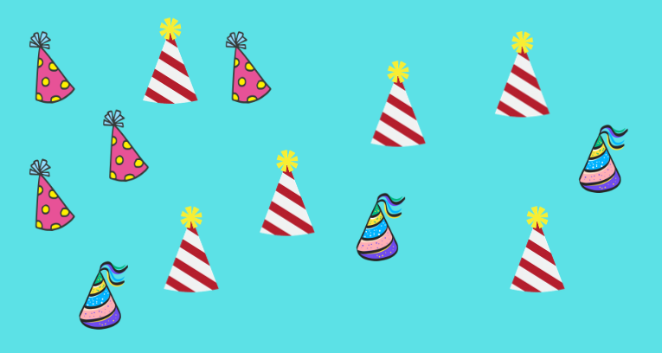
Images sourced from Canva and used in accordance with the Canva Pro Content License.
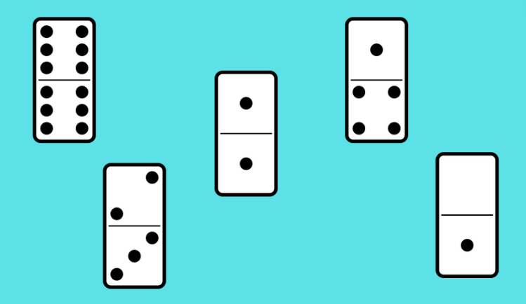
Images sourced from Canva and used in accordance with the Canva Pro Content License.
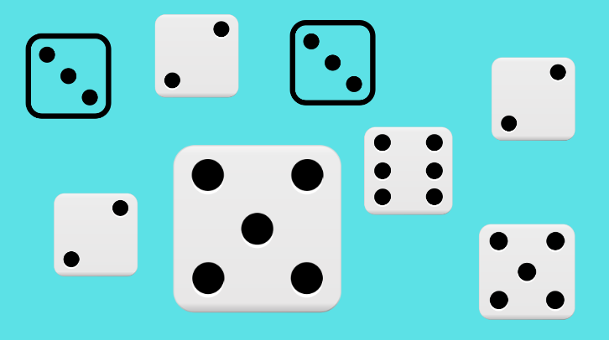
Images sourced from Canva and used in accordance with the Canva Pro Content License.

Resource 2: Finding tens challenge
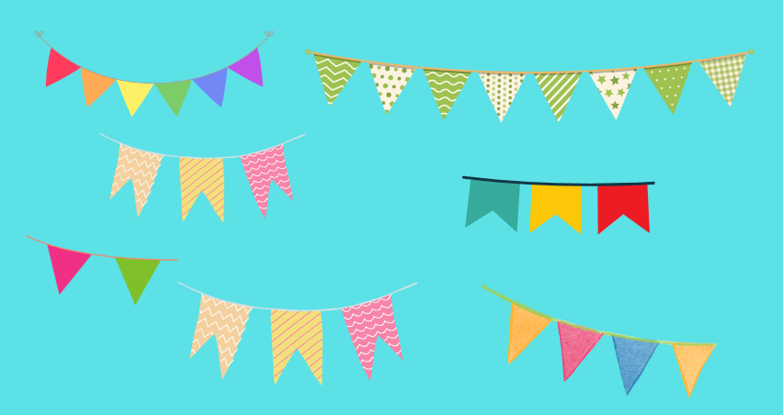
Images sourced from Canva and used in accordance with the Canva Pro Content License.
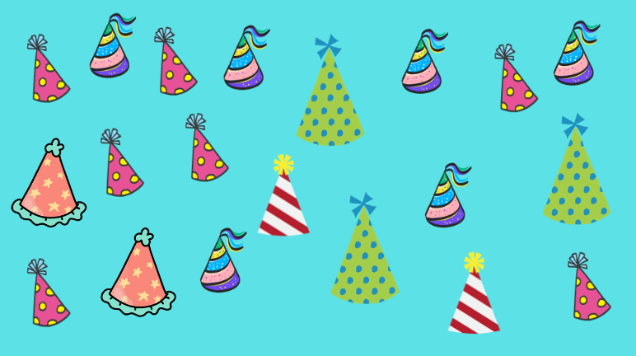
Images sourced from Canva and used in accordance with the Canva Pro Content License.

Resource 3: What is this?
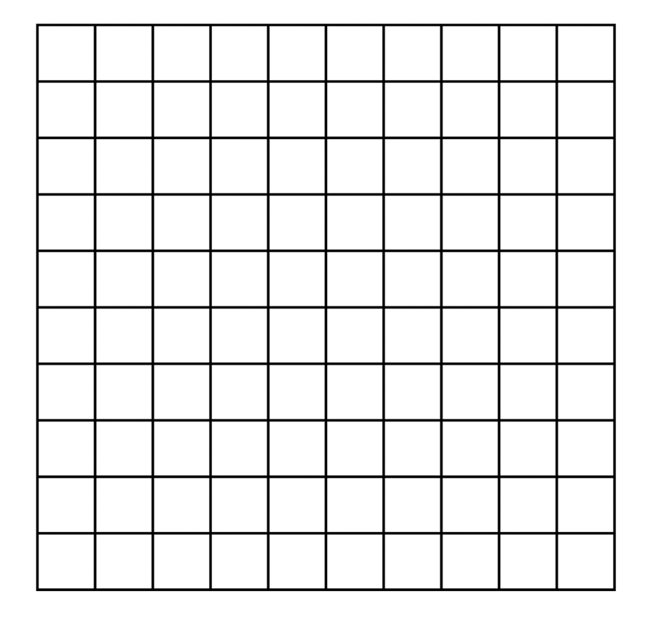

Resource 4: Show with colour
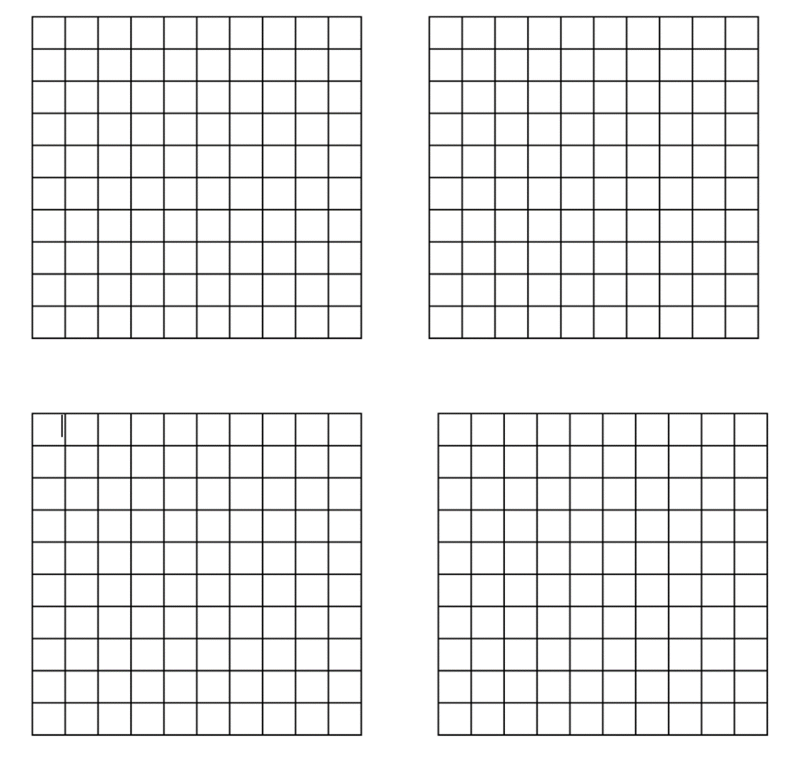

Resource 5: Arrays around us!
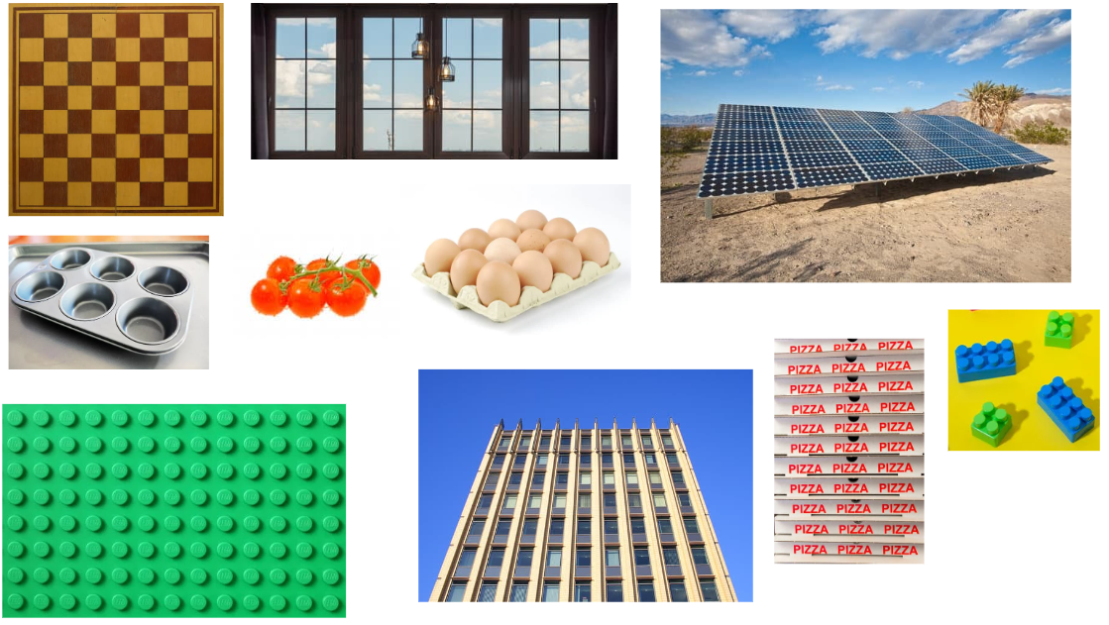
Images sourced from Canva and used in accordance with the Canva Pro Content License.

Resource 6: Think board
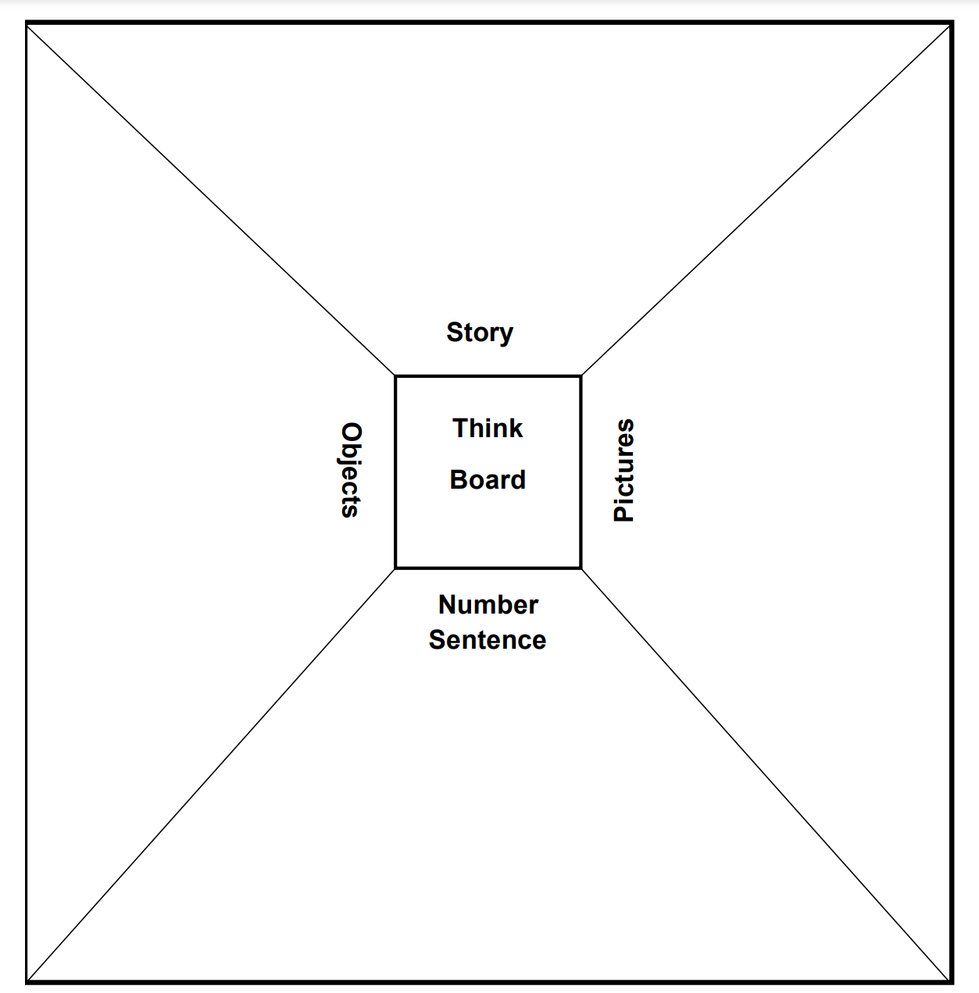

Resource 7: What’s it worth?
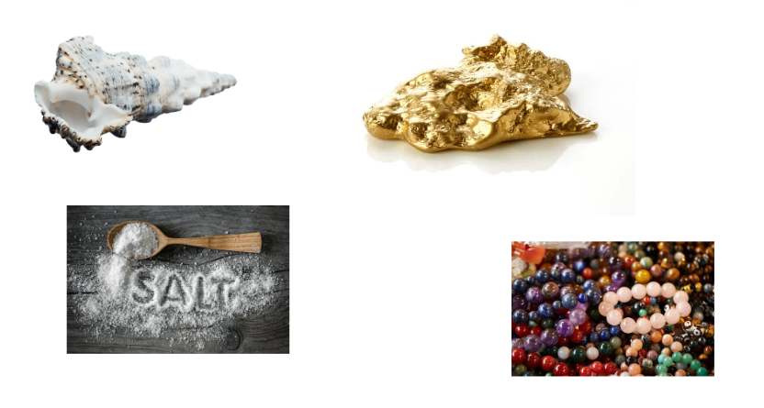
Images sourced from Canva and used in accordance with the Canva Pro Content License.

Resource 8: Plus, minus, equals
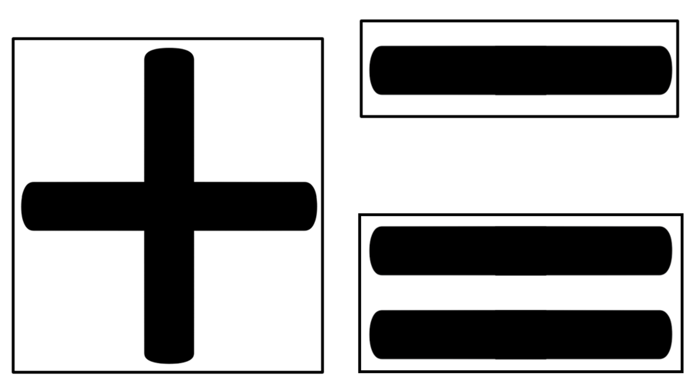

Resource 9: Coins
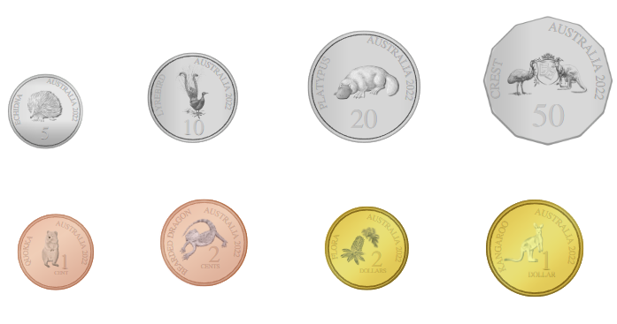
Images sourced from Canva and used in accordance with the Canva Pro Content License.

Resource 10: Input robot
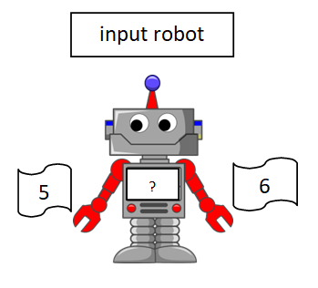
"Robot Machine Technology Science" by Clker-Free-Vector-Images is used in accordance with the Pixabay License.

Resource 11: Inverse robot
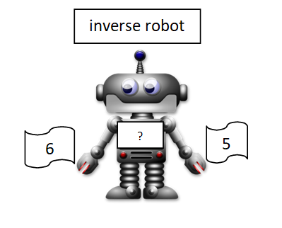
"Adorable Android Artificial" by Merlin2525 is used in accordance with the Pixabay License.

Resource 12: Robots show how!
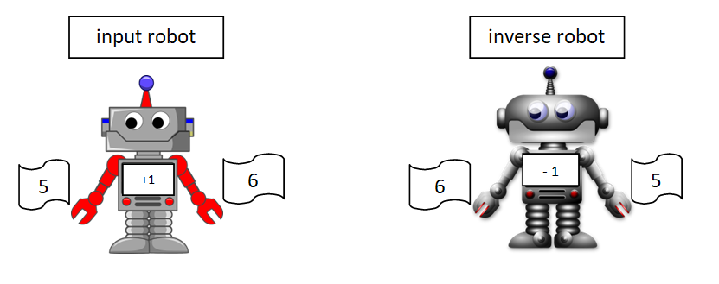
"Robot Machine Technology Science" by Clker-Free-Vector-Images and "Adorable Android Artificial" by Merlin2525 are used in accordance with the Pixabay License.

Resource 13: Input and inverse
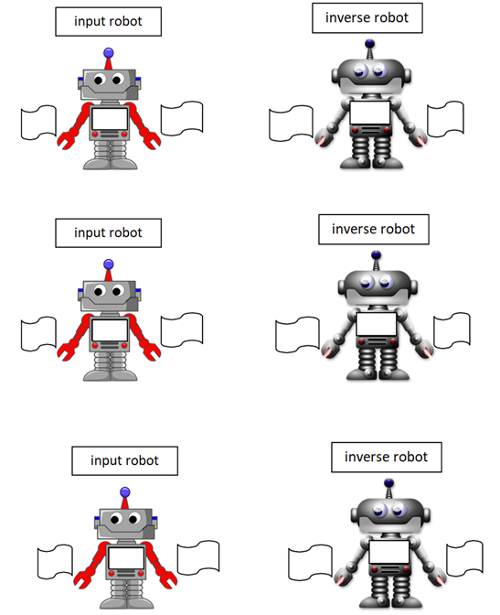
"Robot Machine Technology Science" by Clker-Free-Vector-Images and "Adorable Android Artificial" by Merlin2525 are used in accordance with the Pixabay License.

Resource 14: How many beads?
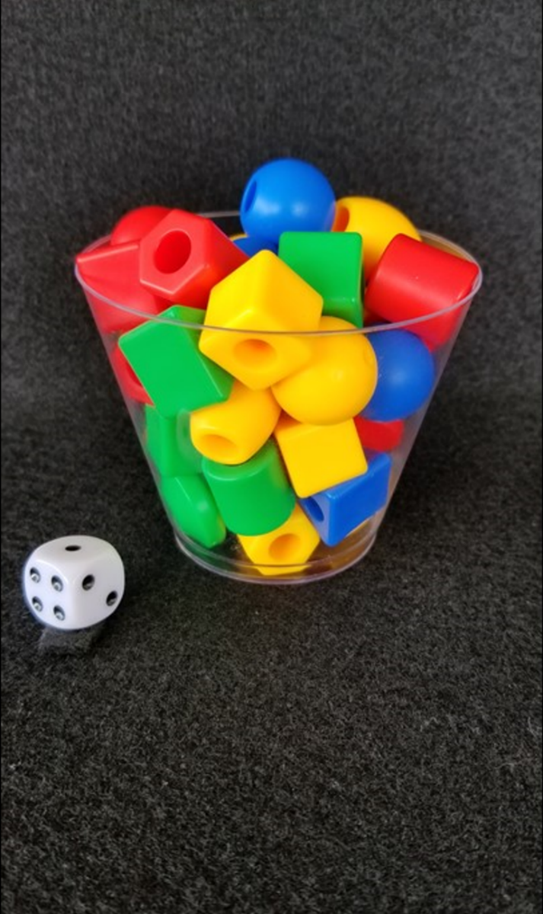
Image from “Cup of Beads” from Esti-Mysteries by Steve Wyborney is reproduced with permission.

Resource 15: Number chart
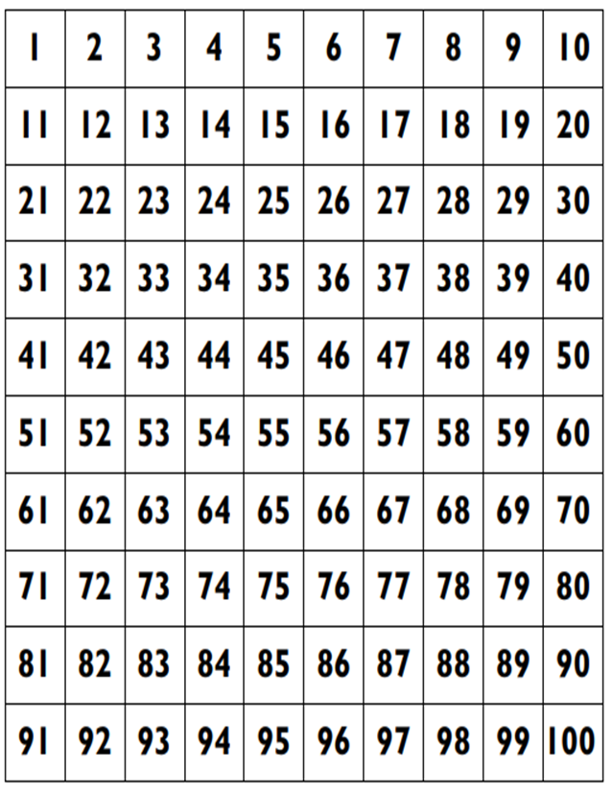

Resource 16: Bead clues
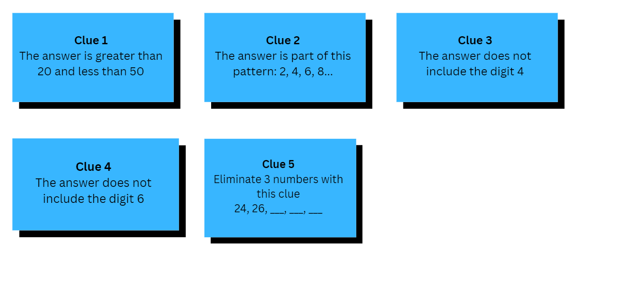
Adapted from "Cup of Beads" from Esti-Mysteries by Steve Wyborney.

Resource 17: Fruit glass
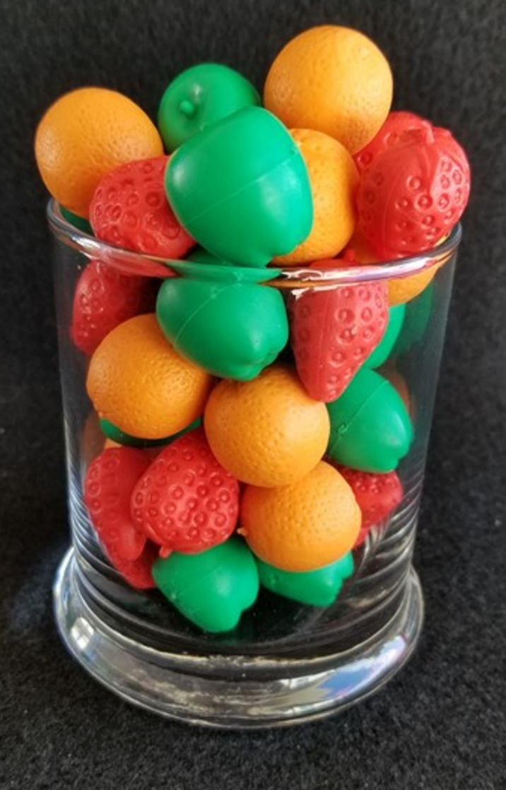
Image from "Fruit Glass" from Esti-Mysteries by Steve Wyborney is reproduced with permission.

Resource 18: Fruit clues
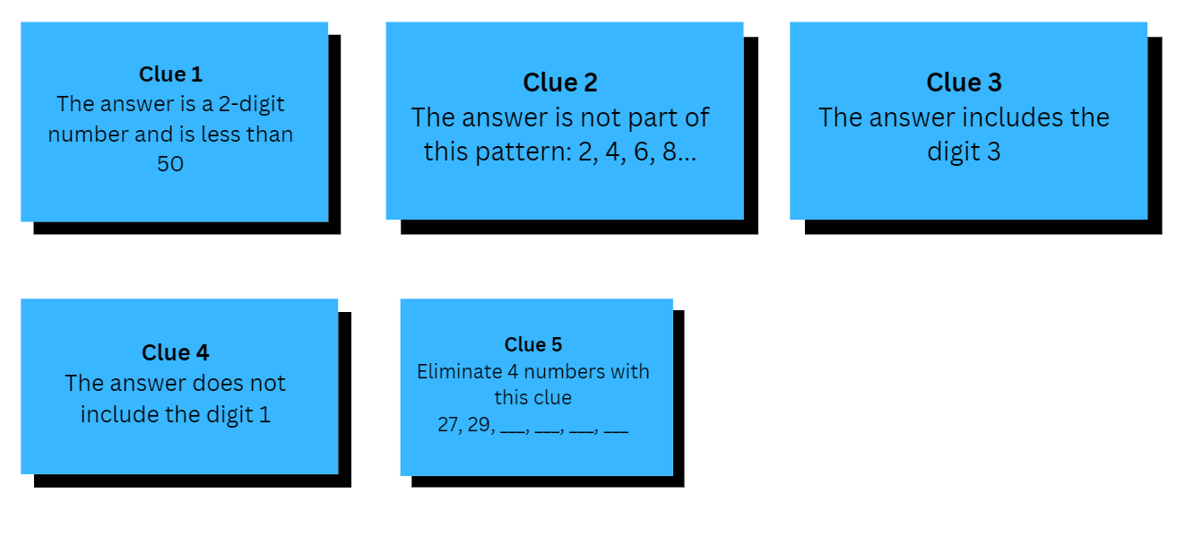
Adapted from "Fruit Cup" from Esti-Mysteries by Steve Wyborney.

Resource 19: How many cherries?
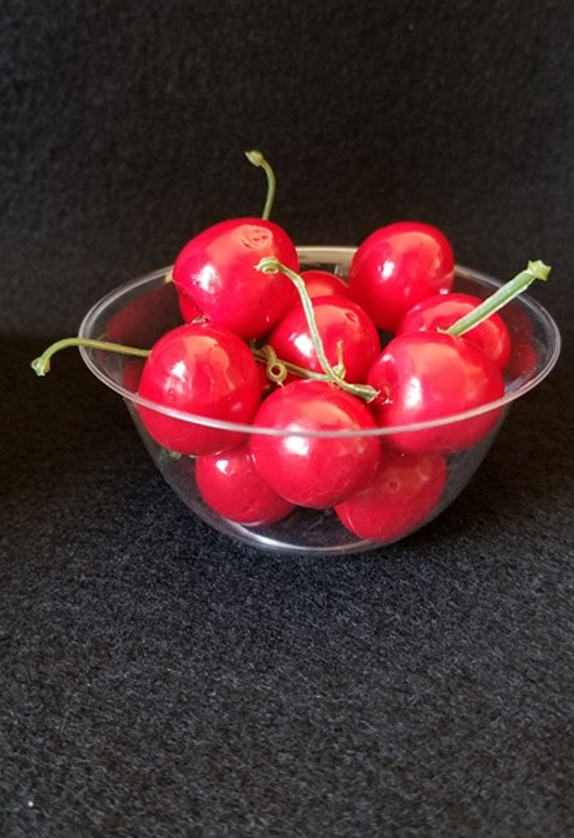
Image from "You Can’t See All the Cherries" from Esti-Mysteries by Steve Wyborney is reproduced with permission.

Resource 20: Cherry clues
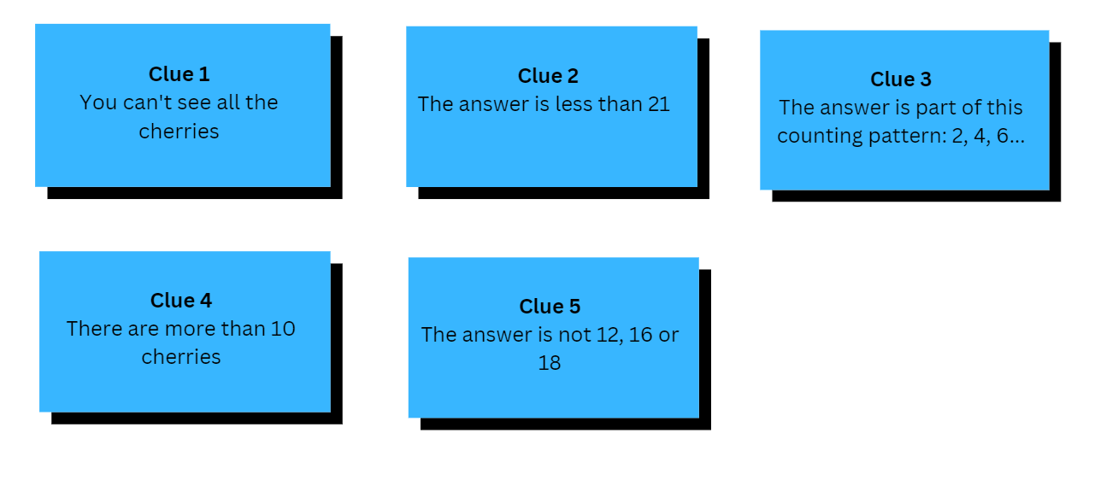
Adapted from "You Can’t See All the Cherries" from Esti-Mysteries by Steve Wyborney.

Resource 21: So many bananas
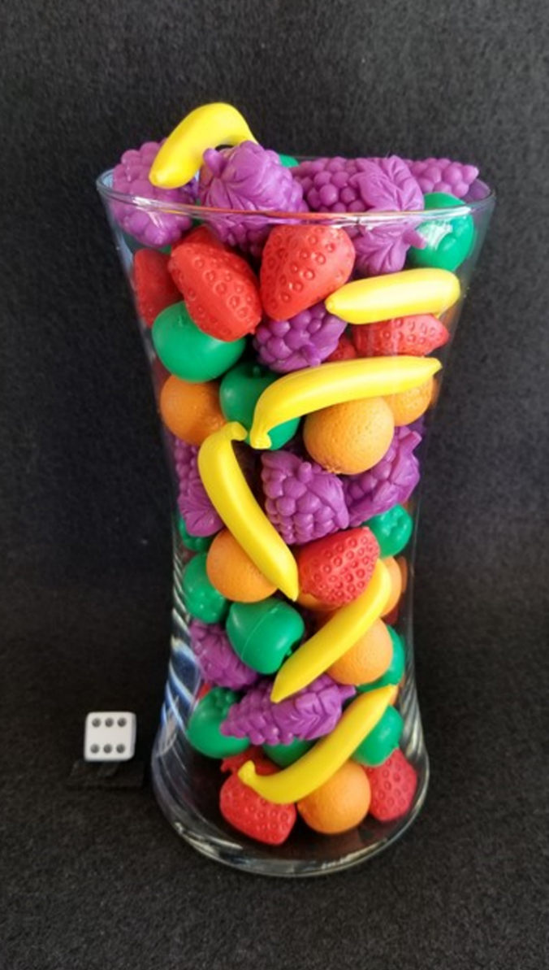
Image from "So Many Bananas" from Esti-Mysteries by Steve Wyborney is reproduced with permission.

Resource 22: Banana clues
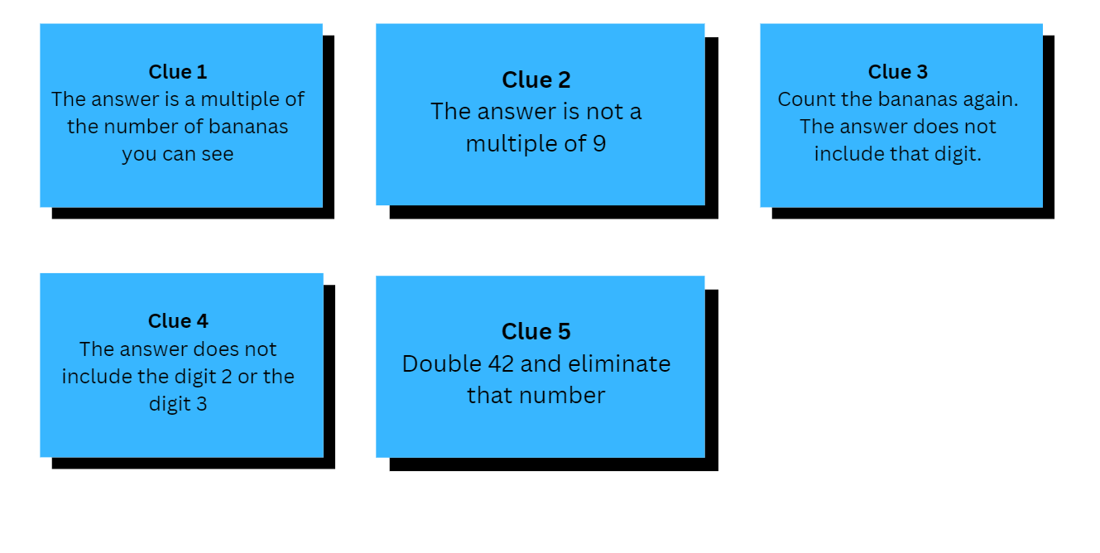
Adapted from "So Many Bananas" from Esti-Mysteries by Steve Wyborney.

Syllabus outcomes and content
The table below outlines the syllabus outcomes and range of relevant syllabus content covered in this unit. Content is linked to National Numeracy Learning Progression version (3).
Focus area and outcomes | Content groups and content points | Lessons
Representing whole numbers A  MAO-WM-01  MA1-RWN-01  MA1-RWN-02 | Use counting sequences of ones with two-digit numbers and beyond  - identify the number before and after a given two-digit number (CPr5)  Continue and create number patterns  - count forwards and backwards by twos from any starting point  Represent numbers on a line  - sequence numbers and arrange them on a line by considering the order and size of those numbers (CPr5)  Represent the structure of groups of ten in whole numbers  - recognise that ten ones is the same as one ten (NPV2, NPV4)  - use 10 as a reference in forming numbers from 11 to 20 (CPr7)  - count large sets of objects by systematically grouping in tens (CPr7)  - use number lines and number charts to assist with locating the nearest ten to a number | 1, 2, 4, 5, 8
Representing whole numbers B  MAO-WM-01  MA1-RWN-01  MA1-RWN-02 | Use counting sequences of ones and tens flexibly  - identify the number before and after a given three-digit number  - count forwards and backwards by tens, on and off the decade, with two- and three-digit numbers (CPr7)  - identify how many more to the next multiple of ten within two- and three-digit numbers  Form, regroup, and rename three-digit numbers  - count and represent large sets of objects by systematically grouping in tens and hundreds (CPr7, NPV5)  - use models such as base 10 material and interlocking cubes to represent and explain grouping (CPr7)  - identify the nearest hundred to a number  - recognise units of 100 (UnM5, NPV5)  - use place value to partition and rename three-digit numbers in different ways (NPV5) | 1, 4, 6
Combining and separating quantities A  MAO-WM-01  MA1-CSQ-01 | Use advanced count by one strategies to solve addition and subtraction problems  - apply the terms ‘add’, ‘plus’, ‘equals’, ‘is equal to’, ‘is the same as’, ‘take away’, ‘minus’ and ‘the difference between’ to describe combining and separating quantities (AdS1, AdS6)  - recognise and use the symbols for plus (+), minus (–) and equals (=)  - record number sentences in a variety of ways using drawings, words, numerals and symbols (AdS6)  - fluently use advanced count-by-one strategies including counting on and counting back to solve addition and subtraction problems involving one- and two-digit numbers (AdS3-AdS5)  Use flexible strategies to solve addition and subtraction problems  - use non-count-by-one strategies such as using doubles for near doubles and combining numbers that add to ten (AdS6)  - represent addition and subtraction using structured materials such as a bead string or similar model (AdS6-AdS7)  - select and apply strategies using number bonds to solve addition and subtraction problems with one- and two-digit numbers by partitioning numbers using quantity value and bridging to 10 (AdS6-AdS7)  Represent equality  - use the equals sign to record equivalent number sentences involving addition, and to mean 'is the same as', rather than as an indication to perform an operation (NPA3)  - model the commutative property for addition and apply it to aid the recall of addition facts (AdS7)  - recall related addition and subtraction facts for numbers to at least 10 (AdS6) | 3-8
Combining and separating quantities B  MAO-WM-01  MA1-CSQ-01 | Represent and reason about additive relations  - create, record and recognise combinations of two numbers that add to numbers from 11 up to and including 20 (AdS7)  - create, model and solve word problems, using number sentences  - represent the difference between two numbers using concrete materials and diagrams (AdS6)  - represent a constant difference between pairs of numbers  - model how addition and subtraction are inverse operations using concrete materials, drawings and diagrams (AdS7)  - recall and use related addition and subtraction number facts to at least 20 (AdS7)  Form multiples of ten when adding and subtracting two-digit numbers  - add two-digit numbers by building to multiples of ten (AdS7)  - add and subtract from a two-digit number and record on an empty number line (AdS6-AdS8)  - use quantity values to separate tens and ones for addition (only) (AdS7-AdS8)  - use an inverse strategy to turn a subtraction into an addition (AdS7)  Use knowledge of equality to solve related problem  - use number bonds to determine a missing number (AdS6, NPA3-NPA4)  - use number knowledge to solve related problems (AdS7, NPA4)  - use a variety of ways of writing number sentences (NPA3-NPA4)  - use number bonds to solve equality problems (NPA3-NPA4) | 3, 5-8
Forming groups A  MAO-WM-01  MA1-FG-01 | Count in multiples using rhythms and skip counting  - identify and describe patterns when skip counting forwards or backwards by twos, fives and tens (NPA3-NPA4)  Model and use equal groups of objects to represent multiplication  model and describe collections of objects as groups of (MuS2)  - determine and distinguish between the number of groups and the number in each group when describing collections of objects  - find the total number of objects using skip counting of equal groups of a known size (MuS2-MuS3) | 1, 2, 4, 5
Forming groups B  MAO-WM-01  MA1-FG-01 | Represent and explain multiplication as the combining of equal groups  - solve multiplication problems using repeated addition (MuS4)  - form arrays of equal rows and equal columns (MuS5)  - determine and distinguish between the number of rows/columns and the number in each row/column when describing collections of objects (MuS5)  - model the commutative property of multiplication, using an array (MuS6)  - model division by deconstructing an array equally into a given number of rows or columns  Represent multiplication and division problems  - solve multiplication and division problems using objects, diagrams, images and actions (MuS6-MuS7)  - record answers to multiplication and division problems (including those with remainders) using drawings, words and numerals (MuS6) | 1, 5, 7
Data  MAO-WM-01  MA1-DATA-01  MA1-DATA-02 | Ask questions and gather data  - gather data and track what has been counted by using concrete materials, tally marks, lists or symbols (IRD3)  Represent data with objects and drawings and describe the displays  - use comparative language to describe information presented in a display such as ‘more than’ and ‘less than’  - interpret a data display and identify the biggest or smallest values (IRD2) | 2

References
Links to third-party material and websites
Please note that the provided (reading/viewing material/list/links/texts) are a suggestion only and implies no endorsement, by the New South Wales Department of Education, of any author, publisher, or book title. School principals and teachers are best placed to assess the suitability of resources that would complement the curriculum and reflect the needs and interests of their students.
If you use the links provided in this document to access a third-party's website, you acknowledge that the terms of use, including licence terms set out on the third-party's website apply to the use which may be made of the materials on that third-party website or where permitted by the Copyright Act 1968 (Cth). The department accepts no responsibility for content on third-party websites.
Except as otherwise noted, all material is © State of New South Wales (Department of Education), 2021 and licensed under the Creative Commons Attribution 4.0 International License. All other material (third-party material) is used with permission or under licence. Where the copyright owner of third-party material has not licensed their material under a Creative Commons or similar licence, you should contact them directly for permission to reuse their material.
Mathematics K-2 Syllabus © 2021 NSW Education Standards Authority (NESA) for and on behalf of the Crown in right of the State of New South Wales.
© 2021 NSW Education Standards Authority. This document contains NSW Curriculum and syllabus content. The NSW Curriculum is developed by the NSW Education Standards Authority. This content is prepared by NESA for and on behalf of the Crown in right of the State of New South Wales. The material is protected by Crown copyright.
Please refer to the NESA Copyright Disclaimer for more information.
NESA holds the only official and up-to-date versions of the NSW Curriculum and syllabus documents. Please visit the NSW Education Standards Authority (NESA) website and the NSW Curriculum website.
National Numeracy Learning Progression © Australian Curriculum, Assessment and Reporting Authority (ACARA) 2010 to present, unless otherwise indicated. This material was downloaded from the Australian Curriculum website (National Numeracy Learning Progression) (accessed 12 December 2022) and was not modified. The material is licensed under CC BY 4.0. Version updates are tracked in the ‘Curriculum version history’ section on the 'About the Australian Curriculum' page of the Australian Curriculum website.
ACARA does not endorse any product that uses the Australian Curriculum or make any representations as to the quality of such products. Any product that uses material published on this website should not be taken to be affiliated with ACARA or have the sponsorship or approval of ACARA. It is up to each person to make their own assessment of the product, taking into account matters including, but not limited to, the version number and the degree to which the materials align with the content descriptions and achievement standards (where relevant). Where there is a claim of alignment, it is important to check that the materials align with the content descriptions and achievement standards (endorsed by all education Ministers), not the elaborations (examples provided by ACARA).
Boaler J, Munson J and Williams C (2022) Mindset Mathematics: Visualizing and Investigating Big Ideas, Grade 2, Jossey-Bass, New Jersey.
University of Cambridge (Faculty of Mathematics) (2022) Birthday Sharing, NRICH website, accessed 9 December 2022.
Wyborney S (2 November 2021) ‘150 New Esti-Mysteries’, Steve Wyborney’s Blog: I’m on a Learning Mission, accessed 8 December 2022.

