Mathematics – Stage 1 – Unit 28
Contents
Unit description and duration 4
Student prior learning 4
Lesson overview and resources 5
Lesson 1: Sponge transformation 12
Daily number sense: Choral counting – 15 minutes 12
It’s a wrap! – 30 minutes 13
Consolidation and meaningful practice: Connect the mathematics – 15 minutes 16
Lesson 2: Clock turns 16
Daily number sense: What’s my place value? – 15 minutes 17
Divide a circle – 30 minutes 19
Consolidation and meaningful practice: Discuss and connect the mathematics – 15 minutes 22
Lesson 3: Sense of time 23
Daily number sense – 10 minutes 24
Record the duration of events – 15 minutes 24
Compare the length of time – 25 minutes 26
Consolidation and meaningful practice: Discuss the mathematics – 10 minutes 28
Lesson 4: How long? 28
Daily number sense: How many cubes? – 15 minutes 29
Making shorter, making longer? – 30 minutes 29
Consolidation and meaningful practice: Discuss and connect the mathematics – 15 minutes 34
Lesson 5: Let’s cover the area 34
Daily number sense: Arrays – 15 minutes 35
Create the rules – 10 minutes 37
Consolidation and meaningful practice: Measure the square with an array – 35 minutes 39
Lesson 6: How many floors? 41
Daily number sense: Sixty second challenge – 20 minutes 41
How many floors – 30 minutes 43
Consolidation and meaningful practice: How many prisms? – 15 minutes 47
Lesson 7: Filling it up – Part 1 48
Daily number sense: Three-digit place value – 15 minutes 48
Filling up bottles: Part 1 – 40 minutes 50
Consolidation and meaningful practice: Estimation challenges – 10 minutes 53
Lesson 8: Filling it up – Part 2 54
Daily number sense: Place value castle – 15 minutes 54
Filling up bottles: Part 2 – 25 minutes 55
Changing the measure – 25 minutes 55
Consolidation and meaningful practice: Efficient measuring – 10 minutes 59
Resource 1: Number chart 1-120 60
Resource 2: Three-digit numbers 61
Resource 3: Three-digit number cards 62
Resource 4: Circle template 63
Resource 5: Duration of activities 64
Resource 6: Arrays 65
Resource 7: Rectangle template 66
Resource 8: Floors in a building 67
Resource 9: My castle 68
Resource 10: My castle template 69
Syllabus outcomes and content 71
References 81

Unit description and duration
This two-week unit develops student knowledge, understanding and skills of measurement and choosing the correct unit to measure. Students are provided opportunities to:
- explore spatial concepts of transformation
- explore attributes of measurement through meaningful experiences
- create a fair measurement
- use uniform units to count and measure.
Mathematics K-2 Syllabus © 2021 NSW Education Standards Authority (NESA) for and on behalf of the Crown in right of the State of New South Wales.

Student prior learning
Before engaging in these teaching and learning activities, students would benefit from prior experience with:
- play-based experiences and routines to recognise and compare attributes of length, area, volume and time
- describing daily routines and feeling of time passing to develop a sense of what different times feel like
- puzzles and construction which allow manipulation of shapes to fill gaps.

Lesson overview and resources
The table below outlines the sequence and approximate timing of lessons; syllabus focus areas and content groups; and resources.
Lesson | Syllabus focus area and content groups | Resources
Lesson 1: Sponge transformation  60 minutes  Mathematicians can represent ideas using pictures or mathematical diagrams. | Representing whole numbers A  - Continue and create number patterns  Representing whole numbers B  - Form, regroup and rename three-digit numbers  Forming groups B  - Model doubling and halving with fractions  Two-dimensional spatial structure B  - 2D shapes: Identify and describe the orientation of shapes using quarter turns | - Resource 1: Number chart 1-120  - 3 sponges of different shapes  - 3 different colours of paint  - A4 paper  - Bowls  - Mini whiteboards  - Writing materials
Lesson 2: Clock turns  60 minutes  The representation of a half-hour or 30 minutes is halfway round the clockface. | - Representing whole numbers B  - Form, regroup and rename three-digit numbers  Non- spatial measure A  - Time: Tell time to the half-hour  Non- spatial measure B  - Time: Describe duration using units of time  - Time: Tell time to the quarter hour using the language of ‘past’ and ‘to’ | - Resource 2: Three-digit numbers  - Resource 3: Three-digit number cards  - Resource 4: Circle template – 3 per student in different colours  - Base 10 materials – hundreds, tens and ones  - Analog clock  - Analog clock – 1 per pair  - Writing materials
Lesson 3: Sense of time  60 minutes  Minutes and seconds help us to compare time. | Non-spatial measure B  - Time: Describe duration using units of time | - Resource 5: Duration of activities  - Linking blocks – class set  - Bell  - Stopwatch  - Mini whiteboards  - Paper for anchor chart  - Writing materials
Lesson 4: How long?  60 minutes  Direct comparison helps to decide which one is longer. | Representing whole numbers A  - Represent numbers on a line  - Represent the structure of groups of ten in whole numbers  Combining and separating quantities A  - Use advanced count-by-one strategies to solve addition and subtraction problems  - Recognise and recall number bonds up to 10  Forming groups A  - Recognise and represent division  Forming groups B  - Model doubling and halving with fractions  Geometric measure A  - Length: Measure the lengths of objects using appropriate uniform informal units  - Length: Subdivide lengths to find halves and quarters  Geometric measure B  - Length: Compare and order lengths, using appropriate uniform informal units | - 4 boxes of linking cubes or sticks with different quantities  - Linking blocks  - Writing materials
Lesson 5: Let’s cover the area  60 minutes  Area is measured by selecting and using appropriate uniform informal units. | Forming groups A  - Count in multiples using rhythmic and skip counting  Forming groups B  - Represent and explain multiplication as the combining of equal groups  Two-dimensional spatial A structure  - Area: Measure areas using uniform informal units  Two-dimensional spatial structure B  - Area: Compare rectangular areas using uniform square units of an appropriate size in rows and columns | - Resource 6: Arrays  - Resource 7: Rectangle template  - Number spinner or dice  - How to make a square  - Square counters  - Paper to make into a square  - Scissors  - Square and round counters
Lesson 6: How many floors?  60 minutes  Collections of objects can look different but have the same quantity. | Representing whole numbers A  - Represent numbers on a line  - Represent the structure of groups of ten in whole numbers  Representing whole numbers B  - Use counting sequences of ones and tens flexibly  - Form, regroup and rename three-digit numbers  Forming groups A  - Count in multiples using rhythmic and skip counting  Two-dimensional spatial B structure  - Area: Compare rectangular areas using uniform square units of an appropriate size in rows and columns  Three-dimensional spatial structure A  - Volume: Construct volume using cubes | - Resource 8: Floors in a building  - 10-sided dice – per pair  - Counters or other concrete materials  - Skipping rope or masking tape to make a number line  - Sticky notes  - One-minute timer  - Blocks  - Writing materials
Lesson 7: Filling it up – Part 1  65 minutes  Objects can look different but still have the same internal volume. | Representing whole numbers B  - Form, regroup and rename three-digit numbers  Three-dimensional spatial structure A  - Volume: Measure and compare the internal volumes (capacities) of containers by filling  Three-dimensional spatial structure B  - Volume: Compare containers based on internal volume (capacity) by filling and packing | - Resource 2: Three-digit numbers  - Resource 3: Three-digit number cards – 1 set per pair  - Base 10 materials – hundreds, tens and ones  - Variety of containers of different sizes  - Water  - Marker to label containers  - Writing materials
Lesson 8: Filling it up – Part 2  75 minutes  We measure to compare, describe and understand the world around us. | Representing whole numbers B  - Form, regroup and rename three-digit numbers  Three-dimensional spatial structure A  - Volume: Measure and compare the internal volumes (capacities) of containers by filling  - Volume: Measure the internal volume (capacity) of containers by packing  Three-dimensional spatial structure B  - Volume: Compare containers based on internal volume (capacity) by filling and packing | - Resource 9: My castle  - Resource 10: My castle template  - Variety of containers of different sizes  - Variety of materials to fill up containers (liquids, rice, salt, sugar)  - Writing materials  - A cup or smaller container – one per pair  - A mug – per pair

Lesson 1: Sponge transformation
Core concept: Mathematicians can represent ideas using pictures or mathematical diagrams.
The table below contains suggested learning intentions and success criteria. These are best co-constructed with students.
Learning intentions | Success criteria
Students are learning that:  - number patterns can be continued by noticing the structure, rhythm and repetition  - translating, rotating and reflecting shapes does not change the shape but changes its position. | Students can:  - use a number chart to count forwards and backwards by twos  - create the different patterns by translating, rotating and reflecting with their sponges.

Daily number sense: Choral counting – 15 minutes
- Build student understanding of number patterns by choral counting.
- Display Resource 1: Number chart 1-120
- Ask students to choral count by twos starting at 6 and stopping at 28.
- Ask students to look at the number chart to prepare in their heads before they start the count.
- Ask students to continue to count and record the count on a mini whiteboard.
- Ask students to look at the number pattern and ask:
- What do you notice?
- What is a number that might come later in the sequence? How do you know? Can you prove it?
- Can you articulate a rule for counting by twos?
- Repeat activity by beginning at a different number.

It’s a wrap! – 30 minutes
This activity has been adapted from Sponge art transformations from Thinking Mathematically.
- Explain to students that they will be making wrapping paper.
- Provide students with 3 different colours of paint, 3 sponges that are 4 × 4 cm in size, and a piece of A4 paper.
- Ask students to lay their piece of paper in front of them in a landscape position and fold into thirds (see Figure 1).
Figure 1 – Wrapping paper
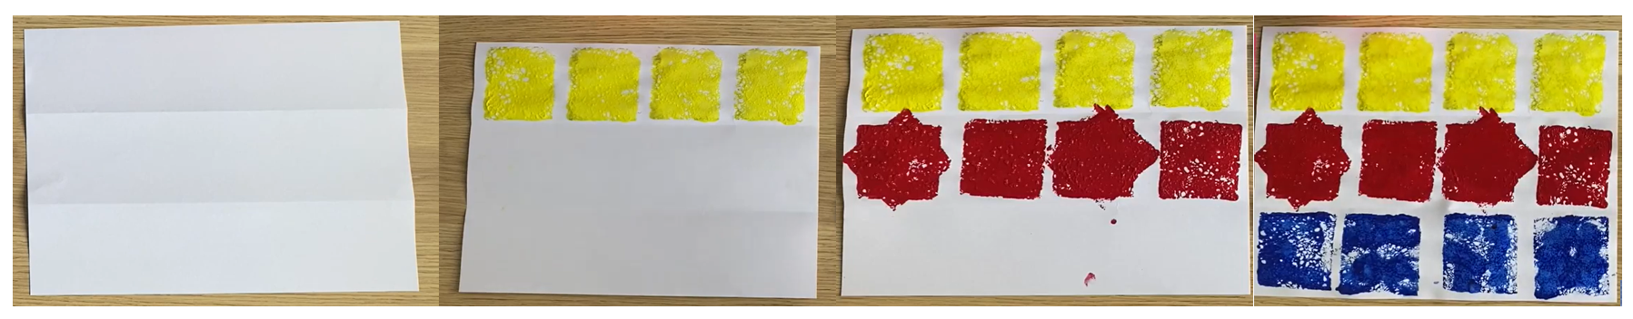
Note: It may help to have these pages pre-folded into thirds as this might be difficult for some students to do.
- Ask students to dip their first sponge into the paint, making sure the paint is spread evenly on the sponge.
- Students then place the sponge on the top left-hand side of the page and create a pattern by pressing the sponge across the page several times. This is called translating (see Figure 1).
Translation: A translation moves a shape up, down or side to side, but it does not change the appearance of the shape.
- Ask students to take a clean sponge and dip into another colour. On the second row they must press their sponge down to create a square just like in the first row. Students then turn their sponge clockwise just a little and press it down again on top of the square to create a star (see Figure 1).
- For the next shape along the same line, ask students to press the sponge down to create a square. They then turn their sponge in an anticlockwise direction a quarter of a turn and press down on top of the same square. This will produce a square again. Alternate the shape on the middle line between the star and the square.
Note: Bring students’ attention to the fact that rotating clockwise or anticlockwise does not make a difference to the shapes in this activity.
- Explain to students that turning the sponge clockwise and anticlockwise is called rotating.
Rotation: A rotation moves the shape around a fixed point in a clockwise or anticlockwise direction, so the shape is the same but its position changes.
- Ask students to take their last clean sponge and dip it into the remaining colour of paint, but this time they are putting paint on both sides of the sponge.
- On the last row of the page, students press the sponge down to create a square again. This time they must flip the sponge over and create another shape next to the first. This will be a square again. Explain that this flipping movement is called reflecting.
Reflection: A reflection flips the shape around so that you get a mirror image while the size of the shape remains the same.
- After creating their wrapping paper, give students another piece and allow them to experiment with translating, rotating and reflecting to create another piece of wrapping paper with shapes of their choice.
This table details assessment opportunities and differentiation ideas.
Assessment opportunities | Too hard? | Too easy?
What to look for:  - Can the students create the different patterns by translating, rotating and reflecting their sponges? (MA1-2DS-01)  What to collect:  - photos of the wrapping paper students have created (MA1-WM-01, MA1-2DS-01). | Students are unable to create patterns by translating, rotating and reflecting.  - Provide further opportunities to match shapes in puzzles.  - Allow students the opportunity to manipulate squares by flipping, sliding and turning. | Students are able to create patterns by translating, rotating and reflecting.  - Have students describe the features of polygons and explain why some shapes tessellate better than others.  - Have students create a picture of an animal using the flip, slide and turn movements.

Consolidation and meaningful practice: Connect the mathematics – 15 minutes
- Reflect on the activity by discussing the following with the students:
- How did moving your sponge in different directions using quarter, half and full turns change the print on the paper?
- Which movement (slide, turn or flip) made the greatest number of shapes?
- Did turning your sponge clockwise or anti-clockwise make a difference to your print?

Lesson 2: Clock turns
Core concept: The representation of a half-hour or 30 minutes is halfway round the clockface.
The table below contains suggested learning intentions and success criteria. These are best co-constructed with students.
Learning intentions | Success criteria
Students are learning that:  - quantities can be represented by numerals  - the representation of a half-hour or 30 minutes is halfway round the clockface  - the representation of a quarter-hour or 15 minutes is a quarter round the clockface. | Students can:  - accurately state the quantity value of digits in three-digit numbers  - describe and represent the position of clock hands to describe half past and quarter past the hour.

Daily number sense: What’s my place value? – 15 minutes
- Display Resource 2: Three-digit numbers.
- Ask students to make the number displayed using base 10 materials.
The table below outlines stimulus prompts to generate conversation about the topic, along with anticipated responses from students.
Prompts | Anticipated student responses
- How many hundreds have you used to make 324?  - What is the value of the 3 in 324?  - How many tens have you used to make 324?  - What is the value of the 2 in 324?  - How many ones have you used to make 324?  - What is the value of the 4 in 324? | - I have used 3 hundreds.  - The value of 3 is 300/3 hundreds.  - I have used 2 tens.  - The value of 2 is 20 or 2 tens.  - I have used 4 ones.  - The value of 4 is 4 or 4 ones.
- In pairs, students flip over a card from Resource 3: Three-digit number cards and make the number using base 10 materials.
- Students draw the base 10 model and record the expanded form (see Figure 2).
Figure 2 – Example of recording
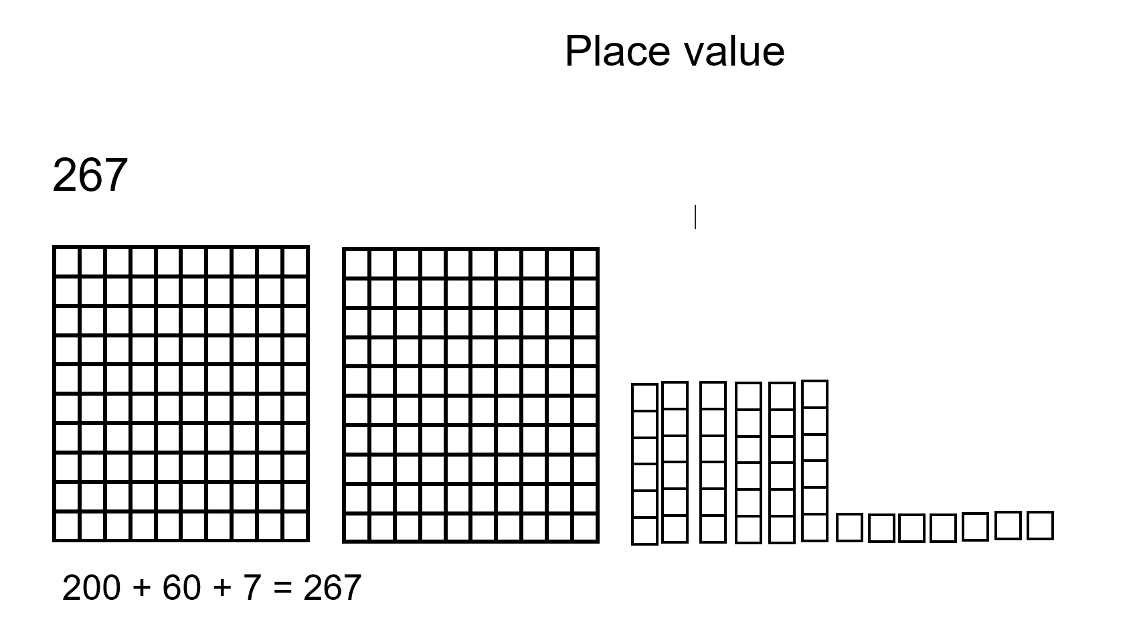
This table details assessment opportunities and differentiation ideas.
Assessment opportunities | Too hard? | Too easy?
What to look for:  - Can students state the quantity value of digits in three-digit numbers? (MA1-WM-01, MA1-RWN-02)  What to collect:  - students’ workbooks with recordings of numbers in expanded form (MA1-WM-01, MA1-RWN-02). | Students are unable to state the quantity value of digits in three-digit numbers.  - In pairs, students flip over two-digit number cards. Students read and make two-digit numbers using base 10 materials.  - Give students further experiences using concrete materials to represent numbers. | Students are able to state the quantity value of digits in three-digit numbers.  - Students flip over three-digit number cards and identify the nearest hundred to the number.  - Rename three-digit numbers in different ways. For example, 326 as 3 groups of one hundred, 2 groups of 10 and 6 ones, or 32 groups of 10 and 6 ones.

Divide a circle – 30 minutes
- Play a game of Simon Says, with Simon asking students to physically move their bodies to represent:
- a full turn
- a half-turn
- a quarter-turn.
- Display an analog clock. Explain that, when telling the time, the minute hand also makes a full turn, half turn and quarter turn around the clock face.
- Ask students to use their arm to represent the minute hand just like on the clock:
- as a full turn
- as a half-turn
- as a quarter-turn.
Note: When describing time, use the terms ‘hour hand’ and ‘minute hand’, rather than ‘little hand’ and ‘big hand’, to promote understanding of their respective functions.
- Ask students to cut out 3 of the circle templates from Resource 4: Circle template in different colours (see Figure 3). One of the circles will be used as a base. Ask students to lay this circle flat.
- Take the second circle and fold it in half and ask students to cut on the fold to create 2 halves.
- On the clock, demonstrate moving the minute hand halfway on a clock face. Ask students to describe the position of the minute hand on the clock for the half hour.
- Place the half circle on top of the clock. Explain this is halfway on a clockface. Ask students to place the half circle on top of the full circle.
- Have students fold their last coloured circle into quarters, cut on folds to create 4 quarters (see Figure 3).
- Demonstrate moving the minute hand to quarter past on the clock face. Ask students to describe the position of the hands on the clock.
- Place the quarter circle on top of the clock. Explain this is a quarter of a clockface. Explain this represents 15 minutes or one quarter of the clock face.
- Move the quarter circle to the quarter to position on the clock face. Ask students to describe the position of the hands on the clock.
- Layer the circles as shown and glue them down. Have students glue this in their books.
Figure 3 – Circle template
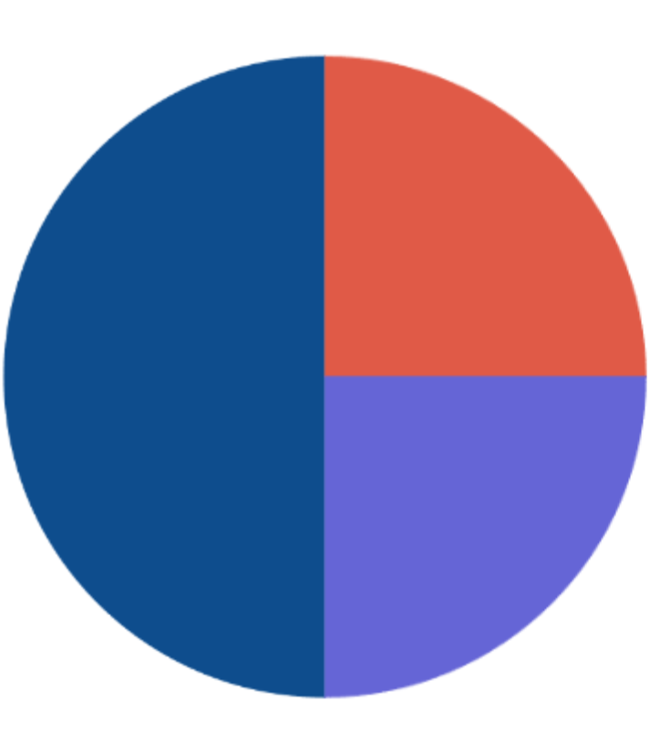
- Have students work in pairs and give each pair an analog clock. Ask students to place the minute hand to represent half past. Ask students to notice the minute hand and the purple section of their divided circle. Explain that, if half of the shapes are covered, this represents half-hour or 30 minutes because it is halfway around the clockface.
- Ask students to notice the red section (see Figure 3) and place the minute hand to represent quarter past the hour. Explain it is one quarter around the clockface.
Note: The concept of quarter past is much more difficult than half-hour for many students. It will require extensive modelling and repeated practice.

Consolidation and meaningful practice: Discuss and connect the mathematics – 15 minutes
The table below outlines stimulus prompts to generate conversation about the topic, along with anticipated responses from students.
Prompts | Anticipated student responses
- How many halves did we make from the whole circle?  - How many quarters did we make from the whole circle?  - How much of the circle does the red section take?  - How much does the blue section of the circle take? | - There were 2 halves.  - We made 4 quarters from the whole circle.  - The red section takes up one quarter.  - The blue section takes up half of the circle.
The table below details assessment opportunities and differentiation ideas.
Assessment opportunities | Too hard? | Too easy?
What to look for:  - Can the student describe and represent the position of clock hands to describe half past and quarter past the hour? (WA1-NSM-02, MA1-WM-01)  What to collect:  - anecdotal observation records while students are making and using clocks. (WA1-NSM-02, MA1-WM-01). | Students are unable to describe and represent the position of clock hands to describe half past and quarter past the hour.  - Provide students with further opportunities to manipulate clocks to tell the time to o’clock and half past.  - Provide students with further experiences moving their bodies and hands to represent time. | Students are able to describe and represent the position of clock hands to describe half past and quarter past the hour.  - Provide students with further opportunities to express time in analog and digital forms.  - Provide students with further experiences to explore clock hands positions when representing quarter to the hour as 45 minutes or three-quarters around the clockface.

Lesson 3: Sense of time
Core concept: Minutes and seconds help us to compare time.
The table below contains suggested learning intentions and success criteria. These are best co-constructed with students.
Learning intentions | Success criteria
Students are learning that:  - large collections of objects can be counted and represented by grouping them into tens and hundreds  - the length of time can be measured and compared. | Students can:  - identify and justify how objects can be grouped into tens and hundreds to make counting easier  - observe that some events take longer to complete than others.

Daily number sense – 10 minutes
- From a class need surfaced through formative assessment data, identify a short, focused activity that targets students’ knowledge, understanding and skills. Example activities may be drawn from the following resources:
- Thinking Mathematically Stage 1
- Universal Resources Hub.

Record the duration of events – 15 minutes
- Ask students the following:
- What do you know about time?
- How do we tell time?
- Why do we need to know about time?
- Complete a timed brain break, such as running on the spot or jumping jacks for 30 seconds.
- Discuss with students that people develop a sense of time so that they can estimate the amount of time something takes (duration).
- Introduce the words, second, minute and hour.
- Ask students the following:
- How long does it take to blink?
- How many blinks do you think you can you do in one minute?
Note: Remind students that one minute is 60 seconds.
- In partners, Think-Pair-Share to brainstorm different activities that take less than 5 minutes. For example, tying up shoelaces or writing your name.
- As a class determine 5 activities that will be measured.
- Ask students to estimate the duration of events in minutes.
- Ask students:
- Which of these will be the longest amount of time?
- Which of these will be the shortest amount of time?
- How will we compare the length of time taken to complete these activities?
- Use a stopwatch to time events.
- Provide each student with Resource 5: Duration of activities, where each square represents one minute. Students record the length of time. See Figure 4 for an example of how to record times.
Note: You will need to round activities to the nearest minute for recording purposes
Figure 4 – Recorded times
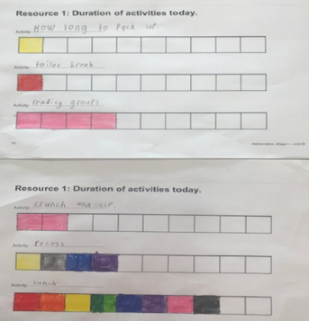

Compare the length of time – 25 minutes
- Cut the strips of paper used to record the duration of events from Resource 5: Duration of activities.
- Compare and discuss the length of time taken for each event. These strips can be pasted on cardboard to form a graph for display in the classroom.
The table below outlines stimulus prompts to generate conversation about the topic, along with anticipated responses from students.
Prompts | Anticipated student responses
- Which activity took the shortest time?  - How can you tell?  - Which activity took the longest?  - How can you tell? | - Packing up and going to the toilet took the shortest time.  - Because there is only one block coloured in for each.  - Lunch took the longest time.  - Because it has the most blocks coloured in.
The table below details assessment opportunities and differentiation ideas.
Assessment opportunities | Too hard? | Too easy?
What to look for:  - Can the student observe that some events take longer to complete than others? (MA1-WM-01, MA1-NSM-02)  What to collect:  - strategic questioning to determine individual understanding of time and Resource 4: Duration of activities work sample (MA1-WM-01, MA1-NSM-02). | Students are unable to observe that some events take longer to complete than others.  - Count the number of squares on each strip. Compare the numbers on a number line. Ask students which is greater.  - Use linking cubes to represent the strips, and students determine which is longer/has more. | Students are able to observe that some events take longer to complete than others.  - Describe everyday events in terms of how long they take in hours, minutes or seconds.  - Have students make predictions about the time remaining until a particular event starts or finishes.

Consolidation and meaningful practice: Discuss the mathematics – 10 minutes
- Discuss that, when measuring events, it is important to be accurate. Explain that students need to use a standard time unit to measure, for example, hours and minutes.
- Ask students to turn and talk to discuss what would happen if they didn’t have equal units of measure.

Lesson 4: How long?
Core concept: Direct comparison helps to decide which is longer.
The table below contains suggested learning intentions and success criteria. These are best co-constructed with students.
Learning intentions | Success criteria
Students are learning that:  - grouping collections of objects by tens and hundreds builds place value understanding  - uniform units can be used to measure lengths by placing units end to end without gaps  - concrete materials can be used to double, triple, half and quarter lengths. | Students can:  - count a large collection of blocks by grouping them into tens and hundreds  - compare the lengths of objects by using the same unit when measuring  - use linking blocks to represent double, triple, half and quarter of a length.

Daily number sense: How many cubes? – 15 minutes
This activity has been adapted from the lesson Counting large collections from reSolve.
- Build student understanding of place value by counting and representing large collections of objects by grouping into tens and hundreds.
- In groups of 2-4 students, provide a box of linking cubes (or other concrete materials), making sure that each box has a different number of concrete materials in it.
- Ask students to count their collections. While counting, prompt students to think about how to arrange the cubes to make it easier to count.
- Select some groups to share their answers and explain their counting strategies. Ask students the following questions:
- Is it more efficient to arrange objects into groups of 10 and skip count by tens to work out the total?
- Can we make a group of 100 and count by hundreds?
- Repeat activity by swapping boxes between groups.

Making shorter, making longer? – 30 minutes
This activity has been adapted from Making longer, making shorter from NRICH.
- Make a tower using 11-20 linking blocks. Display tower to students for 2 seconds, then cover (see Figure 5).
Figure 5 – Tower of linking blocks
Images sourced from Canva and used in accordance with the Canva Pro Content License.
- Ask students how many blocks they saw.
- Students take turns to estimate the number of linking blocks used to make the tower. Respond with shorter or longer, until students guess the correct length.
- Record the number of linking blocks used to make the tower on the whiteboard.
- Make a different length tower and repeat the process.
- Ask students how they calculated the length. Discuss the importance of using the same unit when measuring length to make it easier to compare lengths.
- Ask students:
- Which tower is longer?
- Can you prove it?
- Compare the lengths by counting the units and then placing the towers side by side and aligning the ends to check.
- In pairs, each student builds a tower. Students display and cover and then compare lengths.
- As a class, ask students to find the total of the length of the 2 towers together. When students have the answer, they should place a silent thumb by their chest.
- Select students to share their answers and explain their thinking. Demonstrate and record their method to the group.
- Ask students to subtract the shorter length tower from the longer length tower.
- Explain that the uniform unit of measure helps to measure lengths. Students sit in a circle with access to a supply of linking blocks.
- Display a tower of 4 linking cubes long.
- Ask students to create a length that is:
- double the modelled length
- triple the modelled length
- 4 times the modelled length
- half of the modelled length
- quarter the modelled length.
- Place each of the lengths side by side and align the ends. See Figure 6.
Figure 6 – Tower length comparison
Images sourced from Canva and used in accordance with the Canva Pro Content License.
- Ask students to point to the tower that is:
- twice the length of my original tower of 4 cubes?
- 3 times the length?
- 4 times the length?
- half the length of the first tower?
- a quarter of the length of the first tower?
- the same length as my original tower?
The table below details assessment opportunities and differentiation ideas.
Assessment opportunities | Too hard? | Too easy?
What to look for:  - Are students able to model a half and a quarter with their tower of blocks? (MA1-FG-01)  - Are students able to double, triple and quadruple their tower of blocks? (MA1-FG-01)  - Are students using the strategies of counting on to solve addition of their blocks? (MA1-CSQ-01)  What to collect:  - recordings of their block towers either through drawings or photos. (MA1-FG-01, MA1-CSQ-01, MA1-WM-01). | Students are unable to model a half or a quarter with their cubes.  - Model sharing materials equally between 2 groups, using the word half.  - Model sharing materials equally between 4 groups, using the word quarter.  Students cannot double, triple and quadruple their tower of blocks.  - Using counters, model doubling and halving groups, including the processes between them.  - Model recreating the whole given a half. For example, if half is 3 counters, ask how many there are altogether. | Students are able to model a half and a quarter with their cubes.  - Encourage students to build their own tower with a greater number of blocks, then ask them to halve and quarter this tower.  - With the same tower, ask students to model an eighth and have them explain their thinking.  Students can double, triple and quadruple their tower of blocks.  - Encourage students to build their own tower with a greater number of blocks, then ask them to double, triple and quadruple this tower.  - Once students have done this, they must explain their thinking to another student.

Consolidation and meaningful practice: Discuss and connect the mathematics – 15 minutes
- Use talk moves to support students to demonstrate and explain their reasoning about relations. Ask questions such as:
- What strategy did you use to double the length?
- How did you use this strategy to triple the length?
- What did you notice?
- Can you show me?
- Can you prove it?

Lesson 5: Let’s cover the area
Core concept: Area is measured by selecting and using appropriate uniform informal units.
The table below contains suggested learning intentions and success criteria. These are best co-constructed with students.
Learning intentions | Success criteria
Students are learning that:  - arrays have an equal number in each row and each column  - area relates to the measure of two-dimensional space  - rows and columns help us to calculate the area so that no units are missed or counted twice. | Students can:  - create arrays with counters and measure the area of a shape  - measure the surface of a shape using uniform informal units  - describe the spatial structure (grid) in a shape area.

Daily number sense: Arrays – 15 minutes
- As a class, view Resource 6: Arrays. Explain that an array is made by arranging a set of objects such as counters in columns and rows. Columns and rows must have the same number or equal number of items in them.
- Ask students if they can see any arrays in the classroom. Model by counting the equal rows and columns. Ask students where they can find more arrays.
- Model using groups to discuss the array and find the total. For example, in the egg carton there is one group of 6 in the first row and the second row makes 2 groups of 6. Two groups of 6 makes 12 eggs altogether.
- Repeat with other examples of arrays found in the classroom.
- Ask students to Think-Pair-Share to brainstorm everything they know about arrays.
Note: An array is one of several different arrangements that can be used to model multiplicative situations involving whole numbers.
- Model rolling 2 dice or use the number spinner.
- Write the number sentence on the board.
- Ask students to use square counters to create the array (see Figure 7).
- Students look at their array and answer the following questions:
- How could you describe the array?
- How many tiles are altogether?
- How could you work it out?
Note: Students should be encouraged to describe the spatial structure (grid) of the rectangular shapes. Assist students to notice the grid structure of the square tiles and use this for repeated addition.
Figure 7 – Example of array
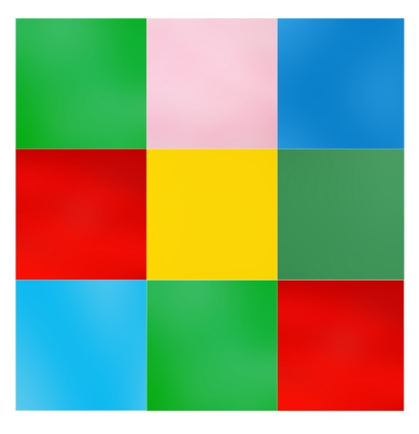

Create the rules – 10 minutes
This activity has been adapted from How to make a square (2:04) from Mathematics curriculum resources K-12.
- Discuss a square. Ask students to Think-Pair-Share some of the features of squares.
The table below outlines stimulus prompts to generate conversation about the topic, along with anticipated responses from students.
Prompts | Anticipated student responses
- What do you notice about the sides?  - How many vertices are there? What do you notice about them?  - Can this square be folded to create a smaller square?  - If I move the square to a different orientation, is it still a square? Why/why not? | - There are 4 sides of equal length.  - There are 4 vertices.  - There are 4 equal angles.  - Students can fold the paper into quarters.  - Yes, there are 4 smaller squares inside this one large square.  - Yes, you can flip, slide and turn and it is still a square.
Vertex: The term ‘vertex’ (plural: ‘vertices’) refers to the point where two straight sides of a two-dimensional shape meet.
- Ask students to turn and talk to discuss how could you make a square out of paper. Remind students that mathematicians are precise.
- Watch How to make a square (2:04).
- Ask students:
- What do you notice?
- What do you wonder?
- How did the person ensure the square had equal sides?
- Ask students to use paper and a pair of scissors to make their own square. Ask students to refer to the anchor chart to ensure:
- there are 4 vertices
- 4 equal angles
- 4 sides of equal length.
- When students have completed their squares explain that they are going to measure the area of their square.
- Provide students with both square and circular counters. Students choose the one they think will be best to measure the area of the square paper using an array.
The table below outlines stimulus prompts to generate conversation about the topic, along with anticipated responses from students.
Prompts | Anticipated student responses
- What did you notice?  - What do you need to remember when measuring area?  - What method will you use to ensure no gaps or overlaps?  - What do you estimate will be the most accurate unit to measure?  - How will you count your area? | - We need to cover the surface so there are no gaps or overlaps.  - I can make an array using rows and columns.  - The square counters will ensure no gaps.  - I can use repeated groups. When I know how many are in one row, I can count how many groups and add them together.
- As a class, determine some rules around measuring a shape’s area with counters. Record responses on an anchor chart. Discuss when we measure a shape, we must repeatedly place units so that there are no gaps or overlaps. All units must be equal in size. To be accurate mathematicians, our objects must tessellate and are therefore more suitable for measuring area.
- As a class, determine how to problem-solve the fact that the counters will most likely not exactly fit along the edge of the paper.
Tesselate is to fit together without gaps or overlaps.

Consolidation and meaningful practice: Measure the square with an array – 35 minutes
- Students cut out Resource 7: Rectangle template.
- Ask students to follow the rules established to measure the area of the rectangle by covering with square counters.
- Ask students to look at the covered rectangle and answer:
- How many rows?
- How many arrays?
- How many squares altogether?
- Ask students if they can record the area of their rectangle using a grid structure such as grid paper.
- Assist students to notice how many rows and how many columns to help draw the rectangle.
- Ask students to count how many units make the area of the rectangle. Remind students that they need to count so that no units are missed or counted twice.
- Ask students to share their counting strategy.
- Discuss using repeated addition or skip counting is an efficient way of counting the units to find the total area.
The table below details assessment opportunities and differentiation ideas.
Assessment opportunities | Too hard? | Too easy?
What to look for:  - Are students using uniform informal units in rows and columns? (MA1-WM-01, W1-2DS-02)  What to collect:  - workbooks, with polygon and area recorded (MA1-WM-01, MA1-2DS-02). | Students are unable to measure and compare areas using uniform informal units in rows and columns.  - Students complete filling in the array and count the number of tiles used to cover the area.  - Students count the number of tiles in a prefilled array. | Students are able to measure and compare areas using uniform informal units in rows and columns.  - Students draw an area on 1 cm grid paper and work out the area using formal units.  - Students work out the area of partially covered arrays.

Lesson 6: How many floors?
Core concept: Collections of objects can look different but have the same quantity.
The table below contains suggested learning intentions and success criteria. These are best co-constructed with students.
Learning intentions | Success criteria
Students are learning that:  - arrays are made up of a certain number of rows and each row contains a fixed number  - prisms can have the same volume but look different. | Students can:  - create arrays with blocks consisting of 5 blocks in each row  - create a range of rectangular prisms from a fixed number of blocks in different arrangements.

Daily number sense: Sixty second challenge – 20 minutes
This lesson has been adapted from the Place value with two-digit numbers: Session One from nzmaths.
- Build student understanding of place value by counting and representing large collections of objects by grouping into tens and hundreds.
- Ask students to form a pair and set a timer for one minute.
- Partner 1 rolls a 10-sided dice, and the other partner takes that many objects and adds them to their collection. Repeat until the timer goes off.
- Ask students to estimate and then count how many objects they have collected in total. Prompt students to arrange their objects into groups of tens and hundreds (where possible) to make counting more efficient. Students record their total on a sticky note.
- Create a number line by placing a skipping rope, chalk or line of masking tape more than 1 metre long on the floor and label the ends 0 and 100 (200 if needed).
- Ask students, one pair at a time, to place their sticky note on the rope where they think it belongs. Discuss the placement in terms of proximity to benchmarks like 50, 75, 25 and so on. After 5 numbers are placed, ask the remaining groups to put their score where they think it belongs (see Figure 8).
Figure 8 – Scores placed on a number line
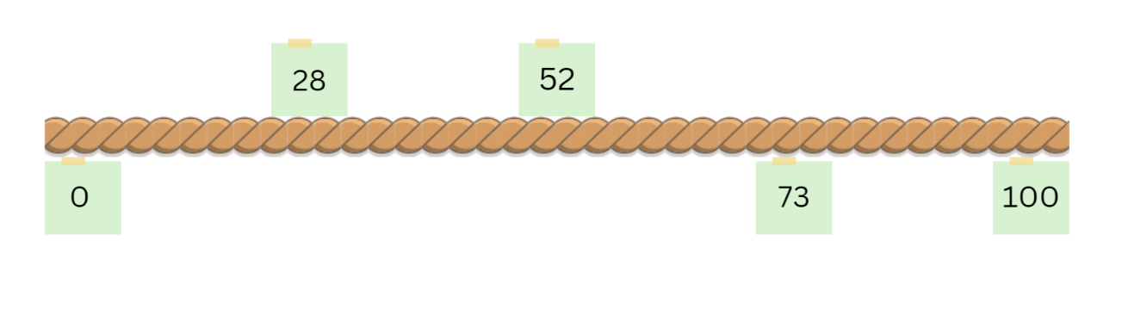
Images sourced from Canva and used in accordance with the Canva Pro Content License.
This table details assessment opportunities and differentiation ideas.
Assessment opportunities | Too hard? | Too easy?
What to look for:  - Are students arranging collection of objects into groups of tens and hundreds? (MA1-WM-01, MA1-RWN-01)  - Are students able to place their scores on the correct spot on the skipping rope? (MA1-WM-01, MA1-WM-02)  What to collect:  - anecdotal observation records while students are playing Sixty second challenge (MA1-WM-01, MA1-RWN-01). | Students are unable to arrange a large collection of objects into groups of tens and hundreds.  - Students roll a 6-sided dice to reduce the number of objects collected each time.  - Reduce time to collect objects to 30 seconds. | Students are able to arrange a large collection of objects into groups of tens and hundreds.  - Bundle craft sticks into groups of tens or use 10 MAB blocks.  - Students roll a 20-sided or 30-sided dice to increase the number of objects collected each time.  - Extend time to collect objects to 2 minutes.

How many floors – 30 minutes
This activity has been adapted from Hidden objects from Maths Curriculum Companion.
- Building on the previous lesson about arrays, show students Resource 8: Floors in a building and tell them that a building has 5 rooms on each floor. Explain to them that each row in the array represents a floor in the building. Ask the following questions:
- How many rooms does the building have if there are 5 floors?
- How many rooms does the building have if there are 10 floors?
- How many floors are in the building if there are 30 rooms? How would you work this out?
Note: Resource 8: Floors in a building only has 3 floors so the students can see the 3 ‘floors’ and the 5 ‘rooms’, but not the remaining floors. This task is designed to encourage students to count by fives rather than by ones since many students find this achievable.
- Explain that students are going to build each floor with blocks. Build an array from blocks made up of 3 rows, with each row containing 5 blocks and show students (see Figure 9). Prompt discussion about the difference between using tiles and blocks to build the floors and work out the answer.
Figure 9 – Floors in a building
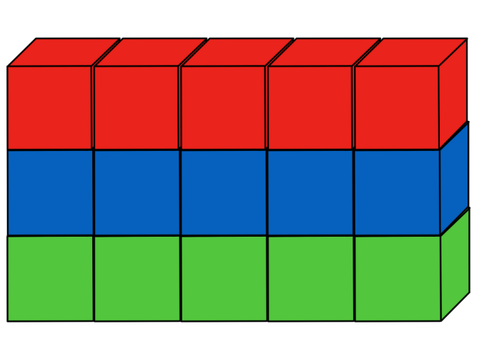
The table below outlines stimulus prompts to generate conversation about the topic, along with anticipated responses from students.
Prompts | Anticipated student responses
- What is the difference between the model in the picture and the model that I just built from the blocks?  - What is the difference between tiles and blocks?  - What do we call objects that are flat and objects that are not?  - What other differences are there between 2D shapes and 3D objects?  - How can you count the number of blocks used if you’re not counting every block one by one? | - The model in the picture is made from square counters and the model you built is made from blocks.  - Tiles are flat and blocks are not.  - The objects that are flat are called 2D shapes and the objects that are not flat are called 3D objects.  - 2D shapes have sides and vertices, 3D shapes have faces, edges and vertices.  - We measure 2D shapes using area and 3D shapes using volume.  - Because each floor has 5 rooms in it you can count by fives.
- Give pairs of students a set of blocks to make a building with 5 floors and 10 floors. Students work out how many blocks they used for each. They must also work out how many floors they would require for a building of 30 rooms.
- Before students begin, they must estimate how many blocks they will need to make both buildings and record this in their workbooks.
- After making their buildings and working out how many blocks are needed for each building, students record this next to their estimations. They also need to draw a picture of each of their buildings along with their working out.
The table below details assessment opportunities and differentiation ideas.
Assessment opportunities | Too hard? | Too easy?
What to look for:  - Are students able to estimate how many blocks they need to make their buildings? (MA1-WM-01, MA1-RWN-02)  - • Are students able to build the structure of rows and columns with the correct number of rooms and floors? (MA1-WM-01, MA1-FG-01 MA1-2DS-02)  What to collect:  - workbooks and photos of their buildings (MA1-WM-01, MA1-FG-01 MA1-2DS-02, MA1-RWN-02). | Students are unable to make their buildings with the correct number of rows and columns.  - Use fewer floors and rooms to begin with and increase the number once students become more confident.  - Draw the structure of rows and arrays for the students and ask what they notice.  Students cannot count by fives and are still using count-by-one strategy.  - Provide students with a ten-frame and remind them that each row in a ten-frame holds a total of 5.  - Give students counters and get them to bundle them into groups of 5 to making counting easier. | Students are able to make their buildings with the correct number of rows and columns:  - Ask how many floors you would have if you made a building with 37 rooms. Students need to explain their thinking and notice that there will be a remainder.  - Students make their own problems using a different number of rooms per floor and a different number of floors.

Consolidation and meaningful practice: How many prisms? – 15 minutes
- With the blocks that students used to make their buildings, they now make as many different rectangular prisms as they can.
- Give each student a fixed number of blocks, for example, 24.
- For every rectangular prism that students make, they must also find the volume. Remind students that by counting the number of blocks used they are finding the volume of that prism. Ask students:
- How many different rectangular prisms can you make?
- What is the volume of each prism that you make?
- Students make as many prisms as they can using their blocks. They will notice that all prisms have the same number of blocks, therefore the same volume.
- Discuss and connect the mathematics by bringing attention to the fact that objects can look different but still have the same internal volume.

Lesson 7: Filling it up – Part 1
Core concept: Objects can look different but still have the same internal volume.
The table below contains suggested learning intentions and success criteria. These are best co-constructed with students.
Learning intentions | Success criteria
Students are learning that:  - numbers can be represented using models and grouped together based on place value  - uniform informal units can be used to measure how much a container will hold  - when there are gaps when filling a container, it will affect the accuracy of the internal volume. | Students can:  - represent three-digit numbers using base 10 materials  - measure how much a container will hold by counting the number of times a smaller container can be filled and emptied into the larger container being measured  - pick the correct material to be measured so there are no gaps.

Daily number sense: Three-digit place value – 15 minutes
- Build student understanding of place value by reading and forming three-digit numbers.
- Display Resource 2: Three-digit numbers.
- Give students time to view the image. Students turn and talk to a partner about what they can see. Prompt students to count by hundreds, tens and ones to work out the number. Ask students:
- What do you notice?
- Does the model match the number?
- How did you work out the number?
- In pairs, students flip over a card from Resource 3: Three-digit number cards. Students both make the number using base 10 materials and compare their models.
- Students record one of the numbers from the cards in their workbooks and draw their base 10 model.
The table below details assessment opportunities and differentiation ideas.
Assessment opportunities | Too hard? | Too easy?
What to look for:  - Are students able to form 3-digit numbers using base 10 materials? (MA1-WM-01, MA1-RWN-02)  What to collect:  - workbooks, with number and model recorded (MA1-WM-01, MA1-RWN-02). | Students are unable to read and form three-digit numbers.  - In pairs, students flip over two-digit number cards and make using base 10 materials.  - Students work with teacher, or higher-ability student in small groups or pairs, to read and form three-digit numbers. | Students are able to read and model three-digit numbers accurately.  - Students flip over three-digit number card, add 100 to the number and make this number using base 10 materials.  - Ask students to explain their reasoning for their answer.

Filling up bottles: Part 1 – 40 minutes
This activity has been adapted from Bottles (1) from NRICH.
- Explain to students that they are going to investigate how much a large container holds by pouring liquid from a smaller container. They will be counting the number of times they pour the smaller container into the larger one to fill it.
- Remind students that they need to know what is being measured.
- Remind students that volume is the amount of space occupied by an object. Internal volume refers to the amount a container can hold and is only used in relation to containers.
- Show students a row of containers of varying sizes and shapes (see Figure 10). Ask students what they think these containers are used for and what informal units they could use to fill them up without leaving any spaces. Students use talk moves with a partner, sharing ideas and recording possible solutions on a whiteboard.
Figure 10 – An arrangement of bottles
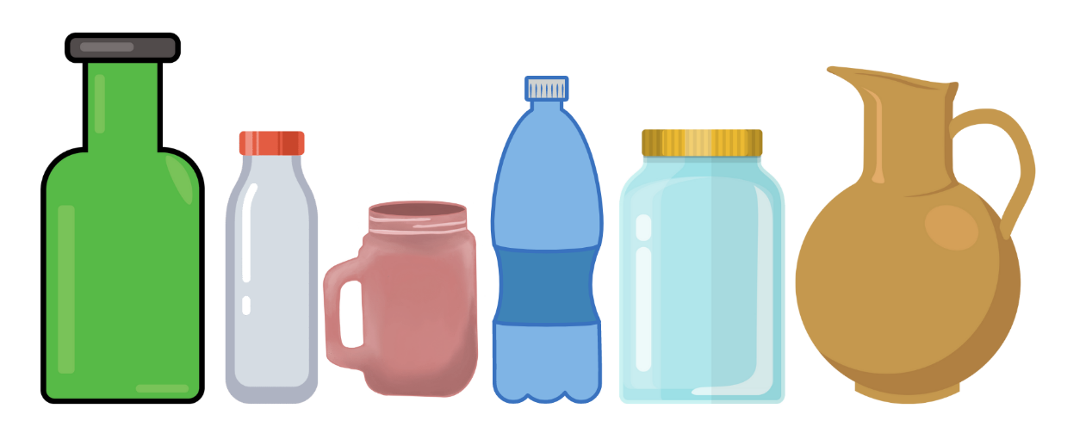
Images sourced from Canva and used in accordance with the Canva Pro Content License.
- Once all the possible informal units are discussed with the class, decide on the best one to use. Examples of informal units include liquids, rice, salt, sugar or anything else that can fill the jars without leaving any gaps.
- Explain that students will be using water as their informal unit; however, in the following lesson, Lesson 8, their suggestion will be used.
- Label the jars from left to right using the letters A through to F. Ask students the following questions to initiate a discussion.
The table below outlines stimulus prompts to generate conversation about the topic, along with anticipated responses from students.
Prompts | Anticipated student responses
- Which container do you think will hold the most water? How do you know?  - Which container do you think will hold the least amount of water? How do you know?  - How many Bs do you think it would take to fill up A?  - How many Cs do you think it would take to fill up D? | - I think A will hold the most water because it is the biggest container.  - I think B will hold the least amount of water because it is the smallest container.  - I think it would take 3 Bs to fill up A because A looks like it is around 3 times bigger than B.  - I think it would take 2 Cs to fill up D because D looks like it is around 2 times bigger than C.
- Ask students to estimate how many Bs it would take to fill up A and how many Cs it would take to fill up D. Students record estimations in their workbooks.
- Remind students about the importance of estimation when investigating measurement. Tell students that estimation helps to focus on the attribute being measured (volume), the measurement process, and will develop familiarity with the units.
- For this activity students work in pairs. Provide each pair with 4 different sized containers labelled A, B, C and D, making sure that containers B and C are smaller than A and D.
- Students then count the number of times they poured B into A until it is filled. They repeat the activity by counting how many times C is poured into D until it is filled.
- Once students have completed the activity have them record their answers in their workbooks and check against their estimations. Have students draw a picture in their workbooks of the activity.
The table below details assessment opportunities and differentiation ideas.
Assessment opportunities | Too hard? | Too easy?
What to look for:  - Can students measure how much a container will hold by counting the number of times a smaller container can be filled and emptied into the container being measured? (MA1-WM-01)  - Can students pick the correct material to be measured so there are no gaps? (MA1-WM-01, MA1-3DS-01, MA1-3DS-02)  What to collect:  - workbooks containing estimations, answers and pictures of the activity (MA1-WM-01, MA1-3DS-01, MA1-3DS-02). | Students are unable to measure how much a container will hold.  - Model filling up different sized containers with one informal unit of measurement like a cup.  - Have students count out loud the number of cups needed to fill large containers while doing this.  Students are unable to pick the correct material to be measured so there are no gaps.  - Model filling up a bottle with marbles and point out the gaps. Explain that this would not be an accurate way to measure volume because of the gaps.  - Model filling up the same container with salt/water and point out that there aren’t any gaps in the bottle. Explain that this would be a better choice because it provides a more accurate measurement of volume. | Students can measure how much a container will hold.  - Students create their own problems and get their peers to solve. For example, how many Hs would it take to fill up G?  - Ask students how many containers it would take to fill up half or a quarter of another container.  Students can pick correct material to be measured so there are no gaps.  - Compare, order and record the internal volumes (capacities) of 2 or more containers by measuring each container in uniform informal units.  - Ask students to explain their reasoning for ordering the containers in this way.

Consolidation and meaningful practice: Estimation challenges – 10 minutes
- Summarise the lesson together, drawing out some key mathematical ideas about estimation and volume with students. Ask students:
- How did you visualise your estimation?
- Did your estimation come close to your measurement? Why or why not?
- Would you choose a different unit of measure if you were to do this again? Explain your reasons.
- Did you have any challenges measuring with your chosen unit? How did you solve these challenges?

Lesson 8: Filling it up – Part 2
Core concept: We measure to compare, describe and understand the world around us.
The table below contains suggested learning intentions and success criteria. These are best co-constructed with students.
Learning intentions | Success criteria
Students are learning that:  - an estimate of how much a container will hold can be made before it is measured  - units help to describe the capacity of a container. | Students can:  - estimate how many cups and then how many mugs are needed to fill a container  - measure how much a container will hold by pouring or packing and stacking.

Daily number sense: Place value castle – 15 minutes
- Build student understanding of place value by playing the game Place value castle.
- Display Resource 9: My castle. Ask students to calculate the value of the castle by counting how many hundreds, tens and ones have been used. Select some students to share their answers and explain their thinking.
- Students create their own castle using Resource 10: My castle template. Students work out the value of their castle by counting how many hundreds, tens and ones have been used. Students paste castle into workbook and record value.

Filling up bottles: Part 2 – 25 minutes
This activity has been adapted from Bottles (2) from NRICH.
- Remind students that volume is the amount of space occupied by an object. Internal volume refers to the amount a container can hold and is only used in relation to containers. Therefore, to get an accurate result we need to make sure that the material we are using today does not allow for any gaps in the containers we are filling up.
- Display the containers that were used in Lesson 7. Explain that today the students will be repeating the activity of predicting and finding out how many small containers of water it would take to fill the larger containers. However, instead of using water they will be using the material of their choice.
Note: As discussed in Lesson 7, students were able to choose an appropriate material to fill up their containers. Examples of materials to be used include liquids, rice, salt, sugar or anything else that can fill the jars without leaving any gaps.
- For this activity students work in pairs. Provide each pair with 2 different sized containers, one small and one large, and have students estimate how many small containers of their material would be needed to fill up the large container. Have students record their estimations once again in their workbooks before they complete the activity.
- Once students have completed the activity have them record their answers in their workbooks and check against their estimations. Have students draw a picture in their workbooks of the activity.

Changing the measure – 25 minutes
- In this activity students will be filling up a container using different measuring devices.
- Students will work in pairs. Give each pair a large container, a drinking cup, a mug and the material of choice (see Figure 11).
Figure 11 – A cup, mug and a jug
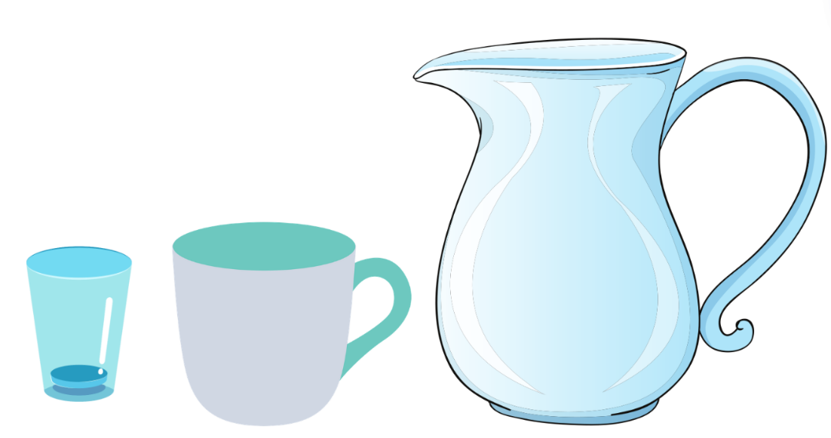
Images sourced from Canva and used in accordance with the Canva Pro Content License.
- The first student will use the drinking cup to fill the container and the second student will use the mug to refill the same container.
Note: It is very important to remind students that when filling up their cup or mug they must fill it right to the top and level it out with their hand for accurate measuring.
- Initiate a class conversation by asking the following questions.
The table below outlines stimulus prompts to generate conversation about the topic, along with anticipated responses from students.
Prompts | Anticipated student responses
- Why are we using different objects to measure how much the container holds?  - Do you think there will be a difference in the number of times you fill up the drinking cup compared to the mug?  - Why do you think this is the case? | - Because they are different sizes, and they will give us different answers.  - Yes, I think we will need to fill up the drinking cup many more times compared to the mug.  - The mug is much bigger than the drinking cup and will fill the container up much faster than the drinking cup.
- Before beginning the activity, students need to estimate how many drinking cups will be needed to fill the container and how many mugs are needed to fill the same container. Have students record these estimations into their workbooks.
- Once students have completed the activity, they record their answers in their workbooks and check against their estimations.
This table details assessment opportunities and differentiation ideas.
Assessment opportunities | Too hard? | Too easy?
What to look for:  - Can students estimate how many drinking cups and then how many mugs are needed to fill a container? (MA1-WM-01 MA1-3D-02)  - Can students recognise and explain the relationship between the size of a unit and the number of units needed? (MA1-WM-01, MA1-3D-02)  What to collect:  - workbooks containing estimations, answers and pictures of the activity (MA1-WM-01, MA1-3DS-02). | Students are unable to estimate how many drinking cups and then how many mugs are needed to fill a container.  - Model filling up the container using both objects while students count out loud.  - Compare the number of times you filled the container using both objects.  Students are unable to recognise and explain the relationship between the size of a unit and the number of units needed.  - Provide students with further experiences using continuous materials (water) and counting discrete objects (marbles) to fill the internal volume of containers.  - Construct prisms with the same number of units, but different sizes and make visual comparisons. | Students can estimate how many drinking cups and then how many mugs are needed to fill a container.  - Ask student to determine the number of informal units in a prism by referring to the number and type of unit used. For example, what is the volume of a prism 2 cubes high, 2 cubes wide and 4 cubes long?  - Explore communicating and reasoning about containers in which the internal volume of a closed container is slightly less than its volume.  Students can recognise and explain the relationship between the size of a unit and the number of units needed.  - Students record results by drawing and recording the comparison using the number and type of uniform unit used.  - Compare models with different appearance and reasons about spatial structures.

Consolidation and meaningful practice: Efficient measuring – 10 minutes
- Summarise the lesson together, drawing out some key mathematical ideas about volume with students. Ask students:
- What did you have to fill up the most times?
- Were your predictions correct?
- When filling up your container, would you rather use the drinking cup or the mug?
- Guide students to notice that the drinking cup had to be filled more times than the mug because it has a smaller volume and that when filling up containers it is much more efficient to use a larger measuring instrument.

Resource 1: Number chart 1-120
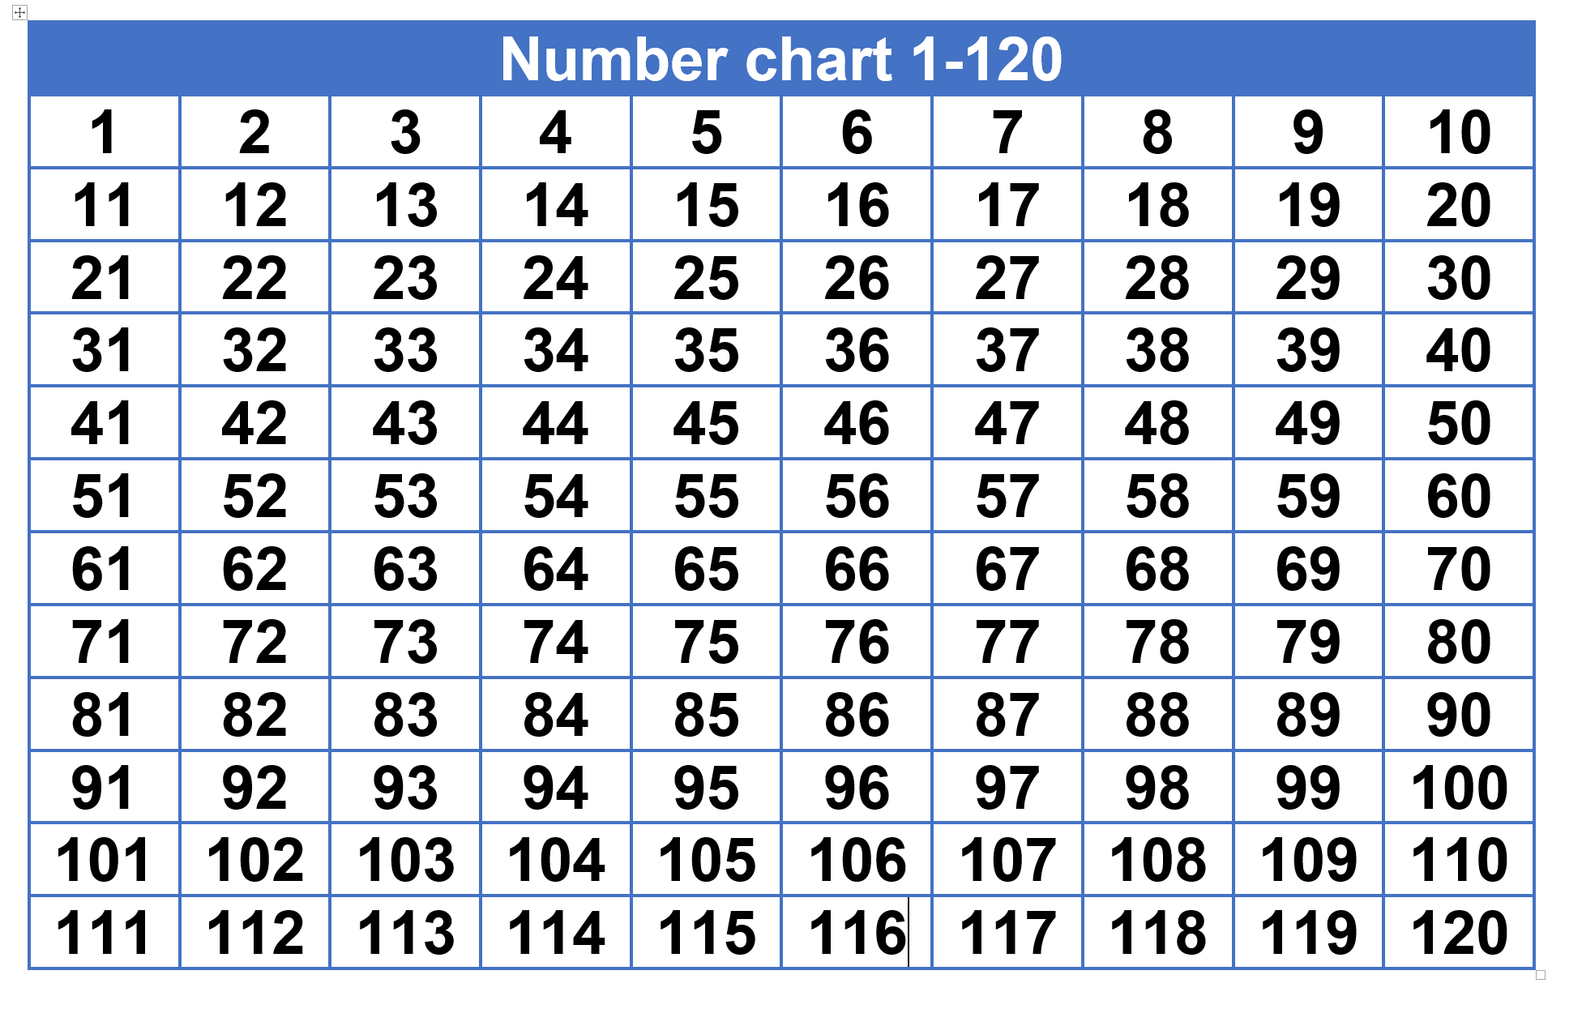

Resource 2: Three-digit numbers
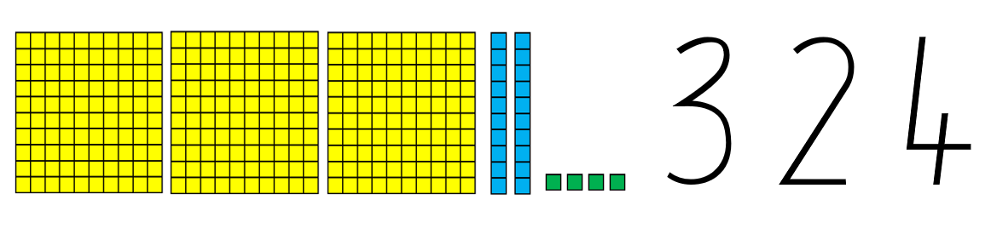

Resource 3: Three-digit number cards
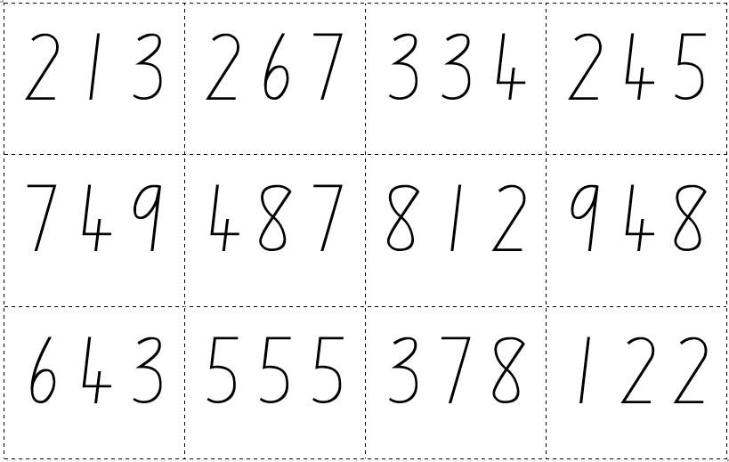

Resource 4: Circle template

Resource 5: Duration of activities

Resource 6: Arrays
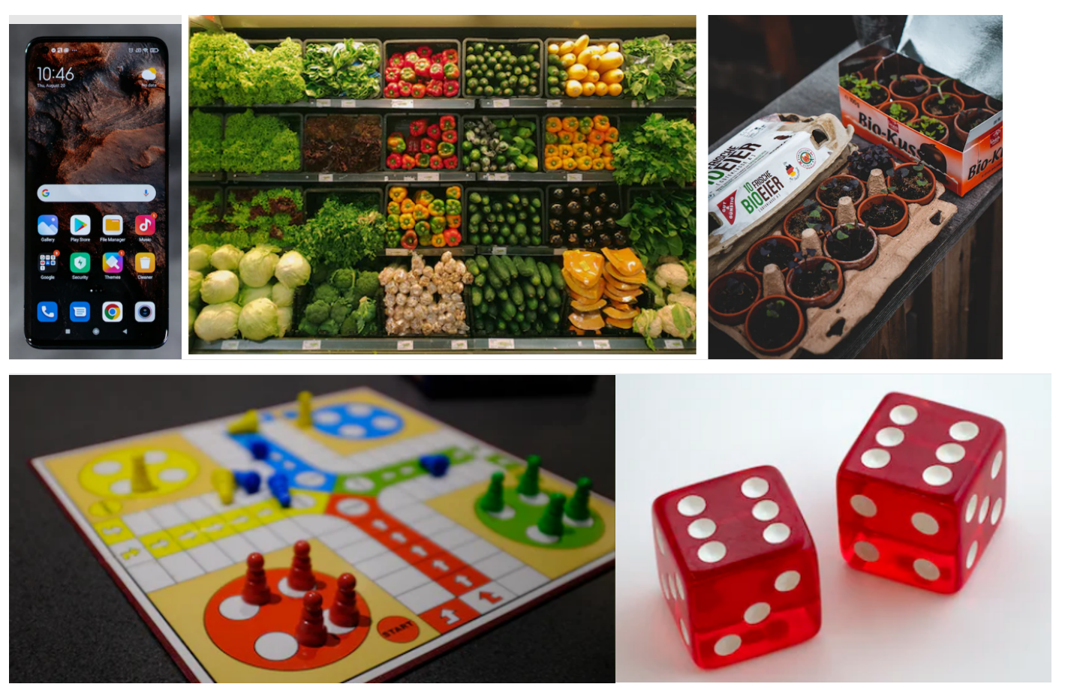
Images sourced from Unsplash and used in accordance with the Unsplash License.

Resource 7: Rectangle template

Resource 8: Floors in a building
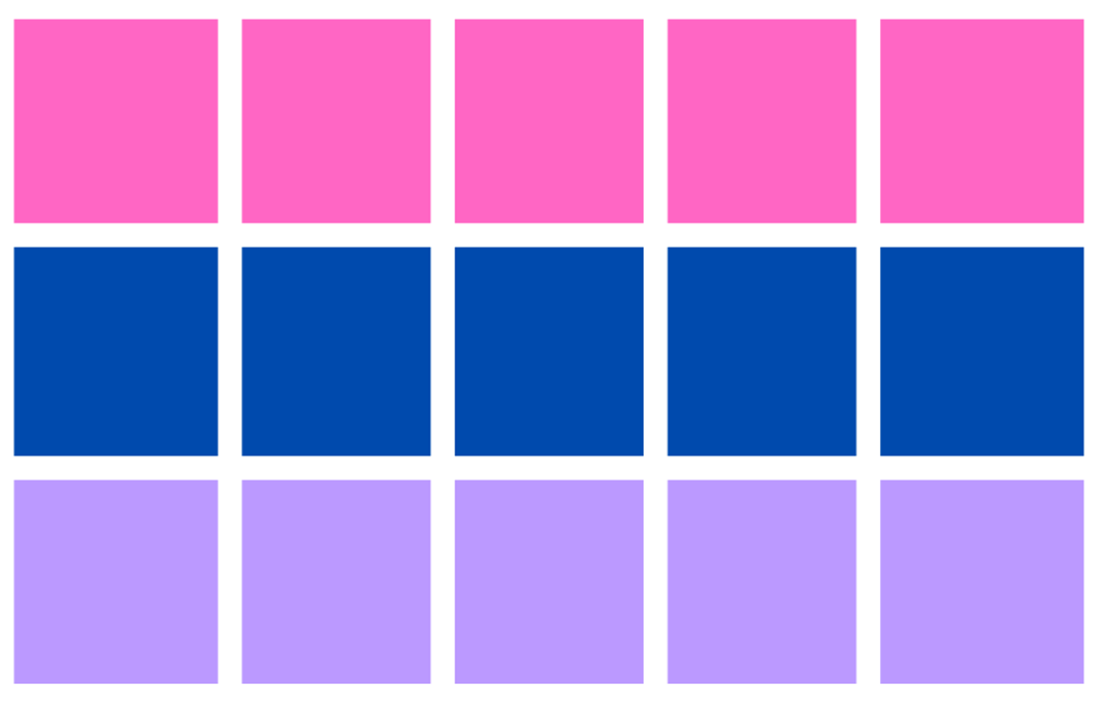

Resource 9: My castle
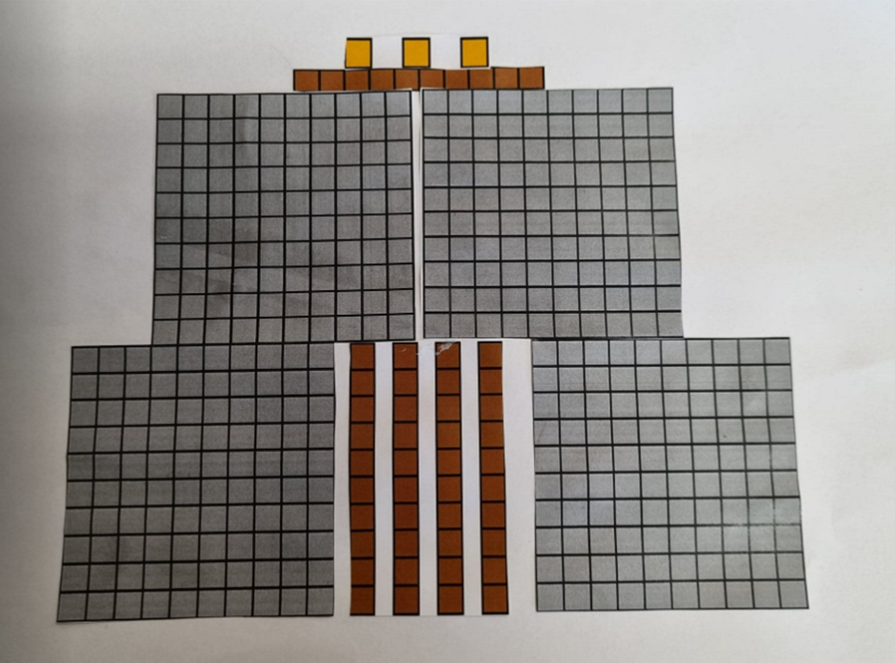

Resource 10: My castle template
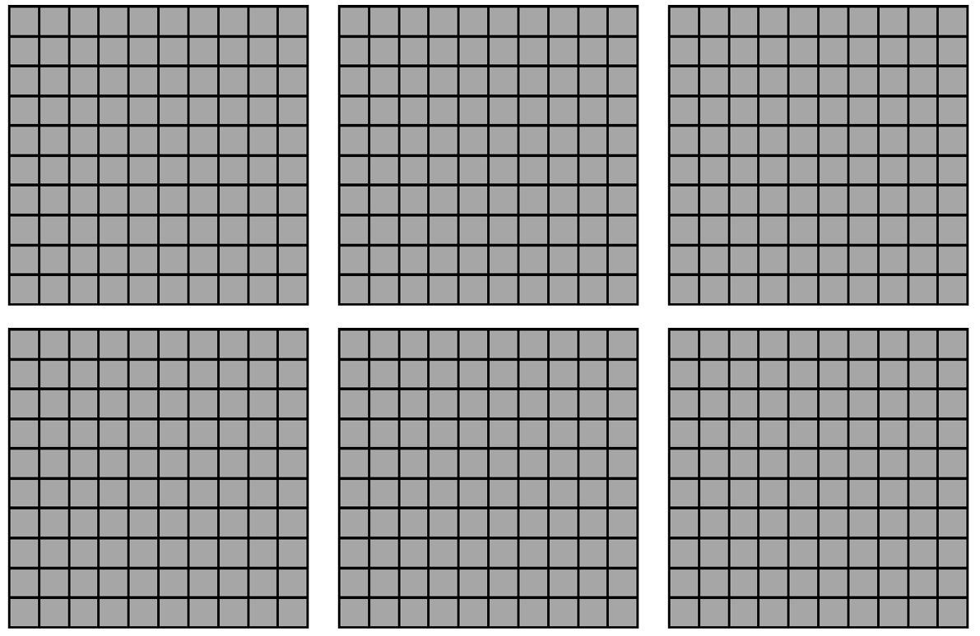
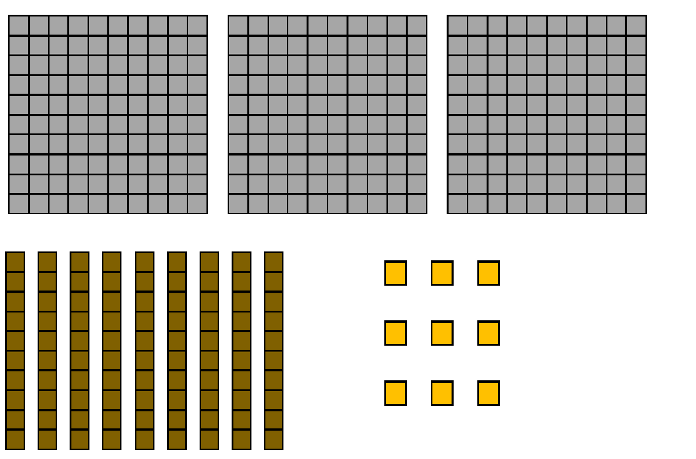

Syllabus outcomes and content
The table below outlines the syllabus outcomes and range of relevant syllabus content covered in this unit. Content is linked to National Numeracy Learning Progression version (3).
Focus area and outcomes | Content groups and content points | Lessons
Representing whole numbers A  MA1-WM-01  MA1-RWN-01  MA1-RWN-02 | Continue and create number patterns  - count forwards and backwards by twos from any starting point (CPr6-CPr7, MuS2)  Represent numbers on a line  - sequence numbers and arrange them on a line by considering the order and size of those numbers (CPr5)  Represent the structure of groups of ten in whole numbers  - count large sets of objects by systematically grouping in tens (CPr7)  - estimate, to the nearest ten, the number of objects in a collection and check by counting in groups of ten (CPr7, NPV6) | 1, 4, 6
Representing whole numbers B  MA1-WM-01  MA1-RWN-01  MA1-RWN-02 | Use counting sequences of ones and tens flexibly  - count forwards and backwards by tens, on and off the decade, with two-and three-digit numbers (CPr7)  Form, regroup and rename three-digit numbers  - count and represent large sets of objects by systematically grouping in tens and hundreds (CPr7, NPV5)  - use models such as base 10 material and interlocking cubes to represent and explain grouping (CPr7)  - state the quantity value of digits in numbers of up to three digits (NPV5) | 1-2, 6-8
Combining and separating quantities A  MA1-WM-01  MA1-CSQ-01 | Use advanced count-by-one strategies to solve addition and subtraction problems  - fluently use advanced count-by-one strategies including counting on and counting back to solve addition and subtraction problems involving one- and two-digit numbers (AdS3-AdS5)  Recognise and recall number bonds up to 10  - recognise, recall and record combinations of two numbers that add up or bond to form 10 (AdS2, AdS6) | 4
Forming groups A  MA1-WM-01  MA1-FG-01 | Count in multiples using rhythmic and skip counting  - count by twos, threes, fives and tens using rhythmic counting and skip counting (MuS2, CPr6)  Recognise and represent division  - use concrete materials to model a half of a collection and show the relation between the half and the whole (InF1) | 4-6
Forming groups B  MA1-WM-01  MA1-FG-01 | Represent and explain multiplication as the combining of equal groups  - form arrays of equal rows and equal columns (MuS5)  - determine and distinguish between the number of rows/columns and the number in each row/column when describing collections of objects (MuS5)  Model doubling and halving with fractions  - model doubling and halving groups and the relation between the processes (MuS6, InF2)  - re-create the whole given half (InF3)  - use concrete materials to model a half, a quarter or an eighth of a collection, and explain their thinking (InF2-InF3) | 1, 4-5
Geometric measure A  MA1-WM-01  MA1-GM-01  MA1-GM-02  MA1-GM-03 | Length: Measure the lengths of objects using appropriate uniform informal units  - use uniform informal units to measure lengths and distances by placing the units end to end without gaps or overlaps (UuM2)  - count informal units to measure lengths or distances and describe the part left over (UuM4)  - record lengths and distances by referring to the number and type of unit used (UuM4)  - use a single informal unit repeatedly (iteratively) to measure length (UuM4)  Length: Subdivides the lengths to find halves and quarters  - use concrete materials to model both half and quarters of a whole length, highlighting the length (InF2)  - recognise when lengths have or have not been divided into halves or quarters (InF2) | 4
Geometric measure B  MA1-WM-01  MA1-GM-01  MA1-GM-02  MA1-GM-03 | Length: Compare and order lengths using uniform informal units  - compare and order two or more shapes according to their lengths using an appropriate uniform informal unit | 4
Two-dimensional spatial A structure  MA1-WM-01  MA1-2DS-01  MA1-2DS-02 | Area: Measure areas using uniform informal units  - explore area using uniform informal units to cover the surface in rows or columns without gaps or overlaps (UuM5)  - measure area by selecting and using appropriate uniform informal units  - explain the relationship between the size of a unit and the number of units needed to measure an area  - estimate areas by referring to the number and type of uniform informal unit used and check by measuring (UuM3) | 5
Two-dimensional spatial B structure  MA1-WM-01  MA1-2DS-01  MA1-2DS-02 | 2D shapes: Identify and describe the orientation of shapes using quarter turns  - identify full, half and quarter turns of a single shape and describe the movement of the shape (UuM4)  - identify and describe directions of turns as ‘left turn’ , ‘right turn’, ‘clockwise’ or ‘anti-clockwise’ (UuM4)  - connect the use of quarter and half turns to the turn of the minute hand on a clock for the passing of quarter and half-hours  - perform full, half and quarter turns with a single shape  - describe the result of a turn of a shape  - determine the repeating pattern formed by quarter turns  Area: Compare rectangular areas using uniform square units of an appropriate size in rows and columns  - cover rectangular surfaces by creating repeated rows of square tiles (UuM5)  - use a single square to create the array structure of area in rows and columns (UuM5)  - use the structure of repeated units to find the area of a rectangle (UuM5) | 1, 5-6
Three-dimensional spatial structure A  MA1-WM-01  MA1-3DS-01  MA1-3DS-02 | Volume: Measure and compare the internal volumes (capacities) of containers by filling  - use uniform informal units to measure how much a container will hold by counting the number of times a smaller container can be filled and emptied into the container being measured (UuM3)  - select appropriate informal units to measure the capacities of containers  - recognise and explain the relationship between the size of a unit and the number of units needed  - compare the internal volumes of two or more containers using appropriate uniform informal units (UuM3)  - recognise and explain why containers of different shapes may have the same internal volume  - estimate how much a container holds by referring to the number and type of uniform informal unit used and check by measuring (UuM3-UuM4)  Volume: Measure the internal volume (capacity) of containers by packing  - estimate and measure the internal volume of a container by filling the container with uniform informal units and counting the number of units used  Volume: Construct volume using cubes  - explore different rectangular prisms that can be made from a given number of cubes  - devise and explain strategies for stacking and counting units to form a rectangular prism  - record volumes, referring to the number and type of uniform informal unit used | 6-8
Three-dimensional spatial structure B  MA1-WM-01  MA1-3DS-01  MA1-3DS-02 | Volume: Compare containers based on internal volume (capacity) by filling and packing  - make and use a device for measuring internal volume (capacity) calibrated in uniform informal units (UuM3-UuM4)  - compare, order and record the internal volumes (capacities) of two or more containers by measuring each container in uniform informal units (UuM3-UuM4)  - estimate internal volume (capacity) by referring to the number and type of uniform informal unit used (UuM3)  Volume: Compare volumes by using uniform informal units  - estimate the volumes of two or more models and check by counting the number of blocks used in each model  - compare models with different appearances, recognising when they have the same volume | 7-8
Non-spatial measure A  MA1-WM-01  MA1-NSM-01  MA1-NSM-02 | Time: Tell time to the half-hour  - read analog clocks to the half-hour using the terms ‘o'clock’ and ‘half past’ (MeT2)  - describe the position of the hands on a clock for the half-hour (MeT2)  - connect the use of half turns to the turn of the minute hand for the passing of the half-hour | 2
Non-spatial measure B  MA1-WM-01  MA1-NSM-01  MA1-NSM-02 | Time: Describe duration using units of time  - estimate and measure the duration of an event using a repeated informal unit (MeT1)  - compare and order the duration of events measured using a repeated informal unit (MeT1)  - make predictions about the time remaining until a particular event starts or finishes  Time: Tell time to the quarter hour using the language of ‘past’ and ‘to’  - describe the position of the hands on a clock for quarter past and quarter to and relate this to quarter turns | 2-3

References
Links to third-party material and websites
Please note that the provided (reading/viewing material/list/links/texts) are a suggestion only and implies no endorsement, by the New South Wales Department of Education, of any author, publisher, or book title. School principals and teachers are best placed to assess the suitability of resources that would complement the curriculum and reflect the needs and interests of their students.
If you use the links provided in this document to access a third-party's website, you acknowledge that the terms of use, including licence terms set out on the third-party's website apply to the use which may be made of the materials on that third-party website or where permitted by the Copyright Act 1968 (Cth). The department accepts no responsibility for content on third-party websites.
All material © State of New South Wales (Department of Education), 2021 unless otherwise indicated. All other material used by permission or under licence.
Mathematics K-2 Syllabus © 2021 NSW Education Standards Authority (NESA) for and on behalf of the Crown in right of the State of New South Wales.
© 2021 NSW Education Standards Authority. This document contains NSW Curriculum and syllabus content. The NSW Curriculum is developed by the NSW Education Standards Authority. This content is prepared by NESA for and on behalf of the Crown in right of the State of New South Wales. The material is protected by Crown copyright.
Please refer to the NESA Copyright Disclaimer for more information.
NESA holds the only official and up-to-date versions of the NSW Curriculum and syllabus documents. Please visit the NSW Education Standards Authority (NESA) website and the NSW Curriculum website.
National Numeracy Learning Progression © Australian Curriculum, Assessment and Reporting Authority (ACARA) 2010 to present, unless otherwise indicated. This material was downloaded from the Australian Curriculum website (National Literacy Learning Progression) (accessed 6 December 2022) and was not modified. The material is licensed under CC BY 4.0. Version updates are tracked in the ‘Curriculum version history’ section on the 'About the Australian Curriculum' page of the Australian Curriculum website.
ACARA does not endorse any product that uses the Australian Curriculum or make any representations as to the quality of such products. Any product that uses material published on this website should not be taken to be affiliated with ACARA or have the sponsorship or approval of ACARA. It is up to each person to make their own assessment of the product, taking into account matters including, but not limited to, the version number and the degree to which the materials align with the content descriptions and achievement standards (where relevant). Where there is a claim of alignment, it is important to check that the materials align with the content descriptions and achievement standards (endorsed by all education Ministers), not the elaborations (examples provided by ACARA).
Australian Government Department of Education, Skills and Employment (2022) 'Counting Large Collections', Teaching resources, re(Solve) website, accessed 6 December 2022.
New Zealand Ministry of Education (n.d.) Place value with two-digit numbers: Session One, Resource, NZ Maths website, accessed 6 December 2022.
State of Victoria (Department of Education and Training), Hidden Objects, Maths Curriculum Companion, Department of Education and Training website, accessed 6 December 2022.
University of Cambridge (Faculty of Mathematics) (2022) Bottles (1), NRICH website, accessed 6 December 2022.
University of Cambridge (Faculty of Mathematics) (2022) Bottles (2), NRICH website, accessed 6 December 2022.
University of Cambridge (Faculty of Mathematics) (2022) Making Longer, Making Shorter, NRICH website, accessed 6 December 2022.

