Mathematics – Stage 1 – Unit 26
Contents
Unit description and duration 4
Student prior learning 4
Lesson overview and resources 5
Lesson 1: Balancing numbers 12
Daily number sense: One less, one more – 10 minutes 12
Balancing numbers – 10 minutes 13
Representing balancing numbers – 30 minutes 15
Discuss and connect the mathematics – 10 minutes 17
Lesson 2: Hidden numbers 18
Daily number sense: Numbers before and after – 10 minutes 18
Practising balancing numbers – 10 minutes 19
Mystery Number – 30 minutes 20
Discuss and connect the mathematics – 10 minutes 22
Lesson 3: Exploring equivalence 23
Daily number sense: Equivalence – 20 minutes 24
Balance without numbers – 30 minutes 26
Discuss and connect the mathematics – 10 minutes 26
Lesson 4: Is it equal? 28
Daily number sense: Three-digit numbers – 10 minutes 29
Number talks – 20 minutes 30
True or false cards – 20 minutes 31
Discuss and connect the mathematics – 10 minutes 33
Lesson 5: Related facts 35
Daily number sense: From here to there – 15 minutes 35
Number facts – 35 minutes 38
Discuss and connect the mathematics – 10 minutes 40
Lesson 6: Number bonds 42
Daily number sense: Maths tipping – 15 minutes 43
Number stories – 35 minutes 43
Discuss and connect the mathematics – 10 minutes 47
Lesson 7: Exploring relations 48
Daily number sense: Number chart puzzle – 15 minutes 49
Missing numbers – 35 minutes 49
Discuss and connect the mathematics – 10 minutes 51
Lesson 8: Solving equality problems 53
Daily number sense: Number line – 10 minutes 54
Putting it altogether – 30 minutes 55
Discuss and connect the mathematics – 20 minutes 56
Resource 1: Balancing objects 59
Resource 2: Balancing objects 2 60
Resource 3: Student recording table 61
Resource 4: Number talk 1 62
Resource 5: Number talk 2 63
Resource 6: Number talk 3 64
Resource 7: True or false 65
Resource 8: Related dots 67
Resource 9: Hands 68
Resource 10: Number story 69
Resource 11: Number sentence 1 70
Resource 12: Number sentence 2 71
Resource 13: Missing numbers 72
Resource 14: Number chart puzzles 74
Resource 15: Missing number cards 75
Resource 16: Different problems 1 77
Resource 17: Different problems 2 78
Resource 18: Different problems 3 79
Syllabus outcomes and content 80
References 85

Unit description and duration
This two-week unit develops student knowledge, understanding and skills of equality. Students are provided opportunities to:
- place objects on either side of an equal-arm balance to obtain a level balance and check equivalence
- record equivalence using concrete materials, correct vocabulary, drawings, and diagrams
- choose efficient addition and subtraction strategies to determine if a number sentence is equal.
Mathematics K-2 Syllabus © 2021 NSW Education Standards Authority (NESA) for and on behalf of the Crown in right of the State of New South Wales.

Student prior learning
Before engaging in these teaching and learning activities, students would benefit from prior experience with:
- hefting and measuring objects using an equal-arm balance
- creating, recording, and recognising combinations of 2 numbers that add up to 20
- identifying the difference between 2 numbers up to 20.

Lesson overview and resources
The table below outlines the sequence and approximate timing of lessons; syllabus focus areas and content groups; and resources.
Lesson | Syllabus focus area and content groups | Resources
Lesson 1: Balancing numbers  60 minutes  The equals sign shows equivalence and means 'the same as'. | Representing whole numbers A  - Use counting sequences of ones with two-digit numbers and beyond  Combining and separating quantities A  - Represent equality  Non-spatial measure A  - Mass: Investigate mass using an equal-arm balance | - 20-sided dice (per pair)  - Counters or interlocking cubes  - Equal-arm balance (per pair)  - Individual whiteboards  - Writing materials
Lesson 2: Hidden numbers  60 minutes  Equivalence is when 2 things have the same value. | Representing whole numbers B  - Use counting sequences of ones and tens flexibly  Combining and separating quantities A  - Use advance count-by-one strategies to solve addition and subtraction problems  - Represent equality  Non-spatial measure A  - Mass: Investigate mass using an equal-arm balance | - Brown paper bags or envelopes (class set)  - Counters  - Equal-arm balance (per pair)  - Individual whiteboards  - Interlocking cubes  - Writing materials
Lesson 3: Exploring equivalence  60 minutes  Representations may look different, but they are still equivalent. | Combining and separating quantities A  - Use advance count-by-one strategies to solve addition and subtraction problems  - Represent equality  Combining and separating quantities B  - Represent and reason about additive relations  Non-spatial measure B  - Mass: Compare the masses of objects using an equal-arm balance | - Resource 1: Balancing objects  - Resource 2: Balancing objects 2  - 9-sided dice (class set)  - Individual whiteboards  - Playing cards (class set)  - Sticky notes  - Writing materials
Lesson 4: Is it equal?  60 minutes  Equivalence can be checked using addition and subtraction. | Representing whole numbers B  - Use counting sequences of ones and tens flexibly  Combining and separating quantities A  - Use advance count-by-one strategies to solve addition and subtraction problems  - Use flexible strategies to solve addition and subtraction problems  - Represent equality  Combining and separating quantities B  - Represent and reason about additive relations | - Resource 3: Student recording table (class set)  - Resource 4: Number talk 1  - Resource 5: Number talk 2  - Resource 6: Number talk 3  - Resource 7: True or false  - Glue  - Individual whiteboards  - Range of materials like counters, ten-frames, rekenreks, interlocking cubes and equal-arm balances  - Scissors  - Writing materials
Lesson 5: Related facts  60 minutes  Related facts help to solve addition and subtraction problems. | Representing whole numbers A  - Use counting sequences of ones with two-digit numbers and beyond  Combining and separating quantities A  - Use advance count-by-one strategies to solve addition and subtraction problems  - Recognise and recall number bonds to ten  - Use flexible strategies to solve addition and subtraction problems  - Represent equality  Combining and separating quantities B  - Represent and reason about additive relations | - Resource 8: Related dots  - Resource 9: Hands  - 9-sided dice (class set)  - 12-sided dice (class set)  - Individual whiteboards  - Writing materials
Lesson 6: Number bonds  60 minutes  Number bonds are an efficient way to solve some addition and subtraction problems. | Representing whole numbers B  - Use counting sequences of ones and tens flexibly  Combining and separating quantities A  - Use advance count-by-one strategies to solve addition and subtraction problems  - Recognise and recall number bonds to ten  - Use flexible strategies to solve addition and subtraction problems  - Represent equality  Combining and separating quantities B  - Represent and reason about additive relations  - Use knowledge of equality to solve related problems | - Resource 10: Number story  - Resource 11: Number sentence 1  - Resource 12: Number sentence 2  - Resource 13: Missing numbers  - Individual whiteboards  - Writing materials
Lesson 7: Exploring relations  60 minutes  Relational thinking involves the relationship between both sides of the problem. | Representing whole numbers A  - Use counting sequences of ones with two-digit numbers and beyond  Combining and separating quantities A  - Use advance count-by-one strategies to solve addition and subtraction problems  - Represent equality  Combining and separating quantities B  - Represent and reason about additive relations  - Use knowledge of equality to solve related problems | - Resource 14: Number chart puzzles  - Resource 15: Missing number cards  - Glue  - Individual whiteboards  - Scissors  - Writing materials
Lesson 8: Solving equality problems  60 minutes  Different strategies help to efficiently solve addition and subtraction equality problems. | Representing whole numbers A  - Represent numbers on a line  Representing whole numbers B  - Use counting sequences of ones and tens flexibly  Combining and separating quantities A  - Use advance count-by-one strategies to solve addition and subtraction problems  - Recognise and recall number bonds to ten  - Use flexible strategies to solve addition and subtraction problems  - Represent equality  Combining and separating quantities B  - Represent and reason about additive relations  - Use knowledge of equality to solve related problems | - Resource 16: Different problems 1  - Resource 17: Different problems 2  - Resource 18: Different problems 3  - Individual whiteboards  - Writing materials

Lesson 1: Balancing numbers
Core concept: The equals sign shows equivalence and means 'the same as'.
The table below contains suggested learning intentions and success criteria. These are best co-constructed with students.
Learning intentions | Success criteria
Students are learning that:  - the equals sign is used to indicate equivalence and to show that 2 or more amounts have the same value  - equivalence can be checked using an equal-arm balance. | Students can:  - correctly use the equals sign to show equivalence  - place objects on either side of an equal-arm balance to obtain a level balance and check equivalence  - record equivalence using concrete materials, correct vocabulary, drawings and diagrams.

Daily number sense: One less, one more – 10 minutes
- Build student understanding of number relationships by identifying the numbers before and after a two-digit number.
- Using their individual whiteboards, ask students to write the number 24 in the middle and then the number that is one less on the left and one more on the right (see Figure 1).
Figure 1 – Number sequence
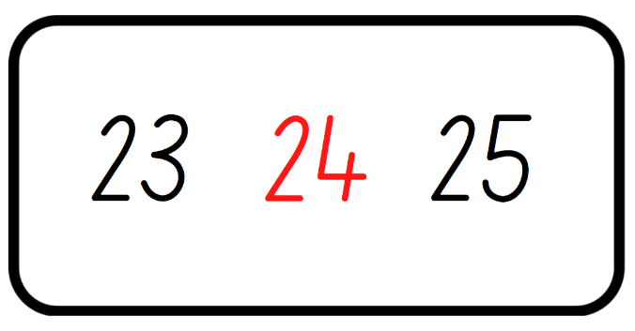
Images sourced from Canva and used in accordance with the Canva Pro Content License.
- Choose students to share their working and justify how they know the number is more or less then the given number.
- Repeat the above steps several times with other two-digit numbers.

Balancing numbers – 10 minutes
This lesson has been adapted from Lesson 1: Balancing Numbers in Algebra: Equivalence by reSolve (2020).
- Display a digital arm balance and place the equals sign in the middle. Explain that the equals sign indicates that the equal-arm balance is level and both sides have the same value.
Equals sign is used to indicate equivalence, for example, 5 + 1 = 2 + 4 and to show that 2 or more amounts have the same value.
- Place a weight on the number 7 on one arm of the equal-arm balance and see what students notice about how the equal-arm balance changes. Ask students how they could make the equal-arm balance equal. Provide thinking time and then students turn and talk to discuss their strategy.
- Have selected students share and model their thinking on the equal-arm balance. Record the matching number sentence on the board. For example, 7 = 4 + 3.
Note: Ensure selected students have different solutions to make the equal-arm balance equal, showing the part-whole relationships.
- Continue placing weights on different numbers including combinations of numbers, for example, 2 and 6 on one arm and 1, 3 and 4 on the other arm.
- Ask students:
- 6 and 4 are on one arm of the equal-arm balance. What numbers do you need to place on the other arm to show equivalence?
- 2 weights are on one arm of the equal-arm balance and 3 weights are on the other arm. What numbers will make the equal-arm balance the same?
- Have students explain strategies on how to make the equal-arm balance show equivalence. Record student working as a number sentence.
Equivalence: 2 things are equivalent if they have the same value.

Representing balancing numbers – 30 minutes
- Roll a 20-sided die and select students to use counters or interlocking cubes to show 2 different representations of the number rolled.
- Draw a simple equal-arm balance to show the equivalent representations of the number rolled. Demonstrate how to also show this using the bar model and the appropriate language (see Figure 2).
Figure 2 – Equal-arm balance representation
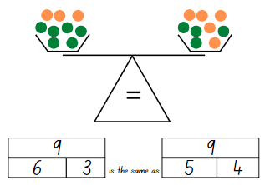
Images sourced from Canva and used in accordance with the Canva Pro Content License.
Note: Ensure a variety of language is used when discussing the equivalence, including ‘equals’, ‘is equal to’, ‘is the same as’ and ‘is the same amount as’.
- Demonstrate recording a number sentence of the representations. For example, 6 + 3 = 5 + 4.
- Model checking if the number sentence is equivalent by using both an equal-arm balance and the digital arm balance.
- Once students are confident with the understanding of the activity, provide pairs of students with a 20-sided die, workbook and an equal-arm balance or digital arm balance.
- Students roll the die to get their target number, draw the simple equal-arm balance, the bar model using the appropriate language and record the number sentence in their workbook. Pairs continue to do this for various numbers.
- While students are completing the activity, ask:
- Are there more representations of the number you rolled?
- How do you know your number sentence is equivalent?
- Did the equal-arm balance confirm your working?
This table details assessment opportunities and differentiation ideas.
Assessment opportunities | Too hard? | Too easy?
What to look for:  - Can students correctly use the equals sign to show equivalence? (MA1-CSQ-01)  - Can students place objects on either side of an equal-arm balance to check equivalence? (MA1-WM-01, MA1-CSQ-01, MA1-NSM-01)  - Are students able to record equivalence using concrete materials, correct vocabulary, drawings and diagrams? (MA1-WM-01, MA1-CSQ-01, MA1-NSM-01)  What to collect:  - student work samples (MA1-WM-01, MA1-CSQ-01, MA1-NSM-01) | Students are unable to create and record representations with numbers up to 20.  - Provide students with a 9-sided die to reinforce part-whole relationships with numbers under 10.  - Provide students with concrete materials to manipulate the representations of the number rolled. For example, 3 red counters and 8 blue counters is the same as 6 red counters and 5 blue counters. | Students can create and record representations with numbers up to 20.  - Challenge students to write the number sentence before drawing the representation of the equal-arm balance.  - Students need to include 3 numbers in their representation on the arm balance and reflect this in the number sentence. For example, 12 + 16 + 5 = 13 + 18 + 2.

Discuss and connect the mathematics – 10 minutes
- Summarise the lesson together and have students show some examples of their work.
- Ask students:
- What did you notice during this activity?
- How can we show equivalence?
- Were your equivalent number sentences, correct? How do you know?
- What language do you use to describe equivalence?
- What other questions do you still have?

Lesson 2: Hidden numbers
Core concept: Equivalence is when 2 things have the same value.
The table below contains suggested learning intentions and success criteria. These are best co-constructed with students.
Learning intentions | Success criteria
Students are learning that:  - the amount which is taken away from a collection can change the equivalence  - equivalence can be checked using an equal-arm balance. | Students can:  - subtract and record number sentences to 20  - place objects on either side of an equal-arm balance to obtain a level balance and check equivalence.

Daily number sense: Numbers before and after – 10 minutes
- Build student understanding of the counting sequence by identifying the numbers before and after given three-digit numbers.
- Roll 3 × 9-sided dice and have students identify the largest number possible.
Note: Use dice that have a zero as it is important to understand that the zero is a placeholder and does not hold a value.
- Write the number created and students record that number on their individual whiteboard. Ask students to write the number that is one less on the left and one more on the right (see Figure 3).
Figure 3 – Number sequence
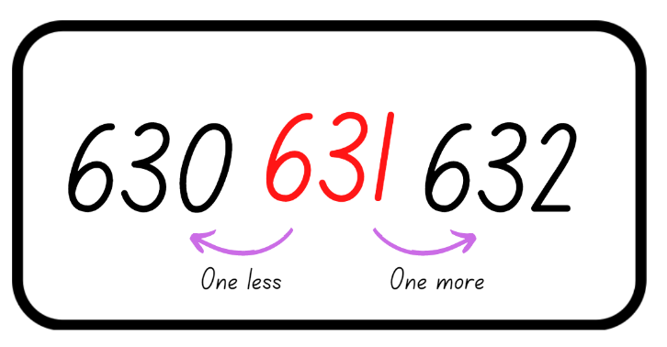
Images sourced from Canva and used in accordance with the Canva Pro Content License.
- Choose students to share their working and justify how they know the number is more or less than the given number.
- Repeat the above steps several times providing discussion time around identifying the largest number as well as the number before and after.

Practising balancing numbers – 10 minutes
- Tell students that you have an equal-arm balance with 2 weights on one arm and 3 weights on the other arm. What two-digit number representation could it be so the total is the same on each arm?
- Students use their individual whiteboard to record different representations using words, number sentences and diagrams.
- Students share their working with the class and justify how they know that the equal-arm balance is equivalent. Model students working on an equal-arm balance to assist in supporting their justification.

Mystery Number – 30 minutes
This lesson has been adapted from Equality and Equations from NZ Maths.
- Display and ask if this number sentence is correct, 5 + 5 = 10 − 4. Choose a student to model this using an equal-arm balance and counters or interlocking cubes. Students turn and talk to discuss what happened to the equal-arm balance.
The table below outlines stimulus prompts to generate conversation about the topic, along with anticipated responses from students.
Prompts | Anticipated student responses
- What happened to the equal-arm balance?  - Why is the arm lower/higher? | - It is no longer the same/equal.  - 5 + 5 is the not the same as/equal to 10 − 4.  - 10 is not equal to 6.
- Record suggestions of what can be done to restore the equality with a focus on taking away 4 from the other arm. As number sentences are suggested and recorded, have students demonstrate using an equal-arm balance. Together reach the conclusion that the same amount must be taken away from each side so that the equal-arm balance and the number representation remains equivalent.
The table below outlines stimulus prompts to generate conversation about the topic, along with anticipated responses from students.
Prompts | Anticipated student responses
- What can be done to restore the equality?  - How can we record this? | - To make the scales equal we can add 4 back.  - To make the scales equal we can take 4 away from the other arm (work to elicit this response from students).  - 5 + 5 − 4 is equal to 10 − 4.  - 10 − 4 is the same as 10 − 4.  - 10 − 4 = 10 − 4.  - 6 = 6.
- Provide pairs of students with an equal-arm balance and each partner a brown paper bag, 20 interlocking cubes and an individual whiteboard. Students place the 20 interlocking cubes in each brown paper bag and check that the equal-arm balance is equivalent.
Note: Use counters, interlocking cubes, MAB units or something similar which are the same weight and fit inside the brown paper bag.
- The first player removes some interlocking cubes from inside their brown paper bag, unseen by the other player, and returns the bag to the equal-arm balance. This player secretly records the number sentence, for example, 20 − 4 = 16.
- The second player looks at the equal-arm balance and estimates how many were removed and removes this number of interlocking cubes from their bag. They secretly record the number sentence, for example, 20 − 7 = 13, and return their bag to the equal-arm balance.
- Both players look carefully to see if the equal-arm balance is equally balanced making it equivalent. If the equal-arm balance is not equivalent, the second player repeats their turn with another amount. When the equal-arm balance finally balances, both students share their final number sentences and check the amount in each bag. Both students record the equivalence, for example, 16 = 16.
- Students continue to play, taking turns to be the first player to remove the interlocking cubes.
This table details assessment opportunities and differentiation ideas.
Assessment opportunities | Too hard? | Too easy?
What to look for:  - Are students able to subtract and record number sentences to 20? (MA1-CSQ-01)  - Can students place objects on either side of an equal-arm balance to obtain a level balance and check equivalence? (MA1-WM-01, MA1-CSQ-01, MA1-NSM-01)  What to collect:  - student work samples (MA1-WM-01, MA1-CSQ-01, MA1-NSM-01) | Students are unable to subtract from 20 and record the matching number sentence.  - Provide students with items bundled in tens or 2 ten-frames to assist students with maintaining their count as they remove items.  - Support students to subtract from 10 and record the matching number sentence. | Students can subtract from 20 and record the matching number sentence.  - Challenge students to develop their own subtraction story to reflect the number sentence.  - Students use different colours to show the numbers represented in the brown paper bag. For example, 10 + 5 + 3 + 2 = 20. Then they subtract at least 2 different numbers from the whole amount.

Discuss and connect the mathematics – 10 minutes
- Summarise the lesson together, drawing out some key mathematical ideas.
- Ask students:
- How can equivalence be maintained?
- Does the number sentence remain equivalent when something is taken away? Why or why not?
- How did you know that the number representation was no longer equal?
- What helped when making an informed guess about the number of interlocking cubes that were removed?
- What questions do you still have?

Lesson 3: Exploring equivalence
Core concept: Representations may look different, but they are still equivalent.
The table below contains suggested learning intentions and success criteria. These are best co-constructed with students.
Learning intentions | Success criteria
Students are learning that:  - combinations of numerals and objects may look different but are still equivalent  - whatever is added or taken away from one set must be added or taken away from the other set. | Students can:  - use number bonds and combinations of objects to solve equality problems  - record equivalence using concrete materials, correct vocabulary, drawings, and diagrams.

Daily number sense: Equivalence – 20 minutes
This lesson has been adapted from Lesson 1: Balancing Numbers in Algebra: Equivalence by reSolve (2020).
- Sitting in a circle, choose 2 or 3 different students to demonstrate how to play the game ‘Equivalence’.
Note: Picture cards are zero and an ace is one.
- Deal 12 cards to each player. Players need to divide their cards into 4 piles with 3 cards in each pile. Students leave a gap in the middle of their piles and have the top cards face up, see Figure 4. Any leftover cards are placed in a discard pile with 4 cards being turned over as free choice cards.
Figure 4 – Game play set up
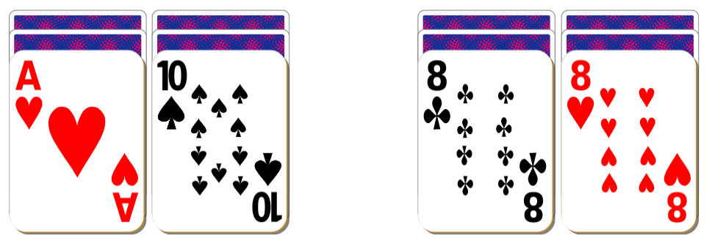
Images sourced from Canva and used in accordance with the Canva Pro Content License.
- Show students the equals sign and ask them to record any words they know which describes the symbol on their sticky note. Students keep the note and add it between their piles when they make them equivalent.
- During each turn, a player can choose to discard one of their display cards and turn over the card below or choose to discard a display card and take one from the free choice cards. The aim is to have both sides equivalent. Discarded cards are added to the discard pile and 4 free choice cards are always on display.
- Play continues until the cards on each side are equivalent or there are no more cards left (see Figure 5). Players record a number sentence which reflects the cards they finished with on their individual whiteboard. For example, 1 + 8 = 5 + 4 for an equivalent representation or 4 + 3 = 7, 2 + 8 = 10 for a non-equivalent representation.
Figure 5 – Game play
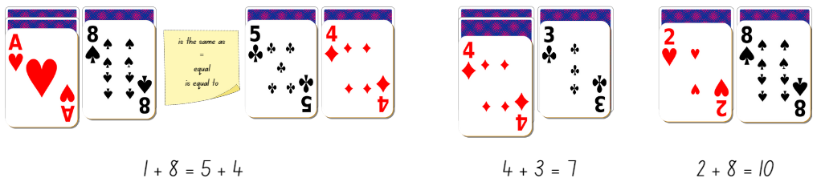
Images sourced from Canva and used in accordance with the Canva Pro Content License.
- Once students are confident with the activity, provide small groups of students with a deck of cards, a sticky note each and an individual whiteboard. Students take turns playing multiple rounds.

Balance without numbers – 30 minutes
- Display Resource 1: Balancing objects. Explain to students that the equal-arm balance is level and therefore equivalent, even though different combinations of objects with varied weights have been placed on either side.
Note: Avoid using numbers and assigning values to any of the objects.
- Students turn and talk about what they notice and how the objects are maintaining equivalence.
- Select students to share and justify their thinking and record ideas.
- Display Resource 2: Balancing objects 2. Tell students one image is equivalent and one is not. Students work with a partner to prove which image is equivalent. Students may need to view Resource 1: Balancing objects to look at the equivalence of the objects and use this knowledge when solving Resource 2: Balancing objects 2.
- When students are confident that they know which one is equivalent, they use their individual whiteboard to draw how they would make the other image equivalent.

Discuss and connect the mathematics – 10 minutes
- Select students to share and explain how they decided which equal-arm balance was equivalent and how they would make the other image equivalent.
- Ask students:
- What objects did you add to make the equal-arm balance equivalent?
- Can it be made equivalent using different objects?
- Does it make a difference which side the objects are on?
- What problem solving strategies did you use to work out how to make it equivalent?
This table details assessment opportunities and differentiation ideas.
Assessment opportunities | Too hard? | Too easy?
What to look for:  - Can students use number bonds to solve equality problems? (MA1-WM-01, MA1-CSQ-01)  - Are students able to combine objects to solve and justify equality problems? (MA1-WM-01, MA1-CSQ-01, MA1-NSM-01)  - Are students able to record equivalence using concrete materials, correct vocabulary, drawings and diagrams? (MA1-WM-01, MA1-CSQ-01, MA1-NSM-01)  What to collect:  - observational data (MA1-WM-01, MA1-CSQ-01, MA1-NSM-01) | Students are unable to use number bonds to solve equality problems.  - Provide students with concrete materials to represent the value of the playing cards. Students count with one-to-one correspondence to find the total of each side.  - Provide playing cards with a value up to 5 so students can reinforce their knowledge of number bonds to 10.  Students are unable to identify equivalent and non-equivalent representations.  - Create a key for each object, so students can see what each object represents.  - Provide students with a collection of objects and allow them to become familiar with equivalent representations. | Students can use number bonds to solve equality problems.  - Challenge students by dividing cards into 6 piles and use the 3 cards on each side to form an equivalent total.  - Remove the free choice cards so students do not have the option of additional numbers.  Students can identify equivalent and non-equivalent representations.  - Students create and draw their own non-equivalent equal-arm balance and have a partner solve the problem.  - Challenge students to make the equal-arm balance equivalent by drawing different solutions to the problem using a variety of objects.

Lesson 4: Is it equal?
Core concept: Equivalence can be checked using addition and subtraction.
The table below contains suggested learning intentions and success criteria. These are best co-constructed with students.
Learning intentions | Success criteria
Students are learning that:  - the counting sequence continues with three-digit numbers  - addition and subtraction can be used to check equivalence  - using different structured materials and strategies helps to solve addition and subtraction problems. | Students can:  - identify and record three-digit numbers in a sequence  - apply addition and subtraction to number sentences to check if they are equal  - represent, record, and solve addition and subtraction problems using structured materials and strategies like number bonds or counting on and back.

Daily number sense: Three-digit numbers – 10 minutes
- Build student understanding of the counting sequence by identifying the number before and after given three-digit numbers.
- Provide students with Resource 3: Student recording table and 3 × 9-sided dice or playing cards, removing the tens and picture cards.
- Students turn over 3 cards or roll the dice and record a three-digit number on Resource 3: Students recording table (see Figure 6). Students then need to identify the number that is one less and one more than the given number and record these in the table.
Figure 6 – Recording table
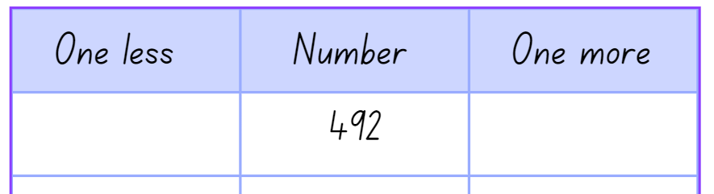
Images sourced from Canva and used in accordance with the Canva Pro Content License.
- Students continue to form numbers and complete the table for 7 rounds.
This table details assessment opportunities and differentiation ideas.
Assessment opportunities | Too hard? | Too easy?
What to look for:  - Can students identify the number before and after a given three-digit number? (MA1-WM-01, MA1-RWN-01)  - Can students record three-digit numbers in a table? (MA1-WM-01, MA1-RWN-01)  What to collect:  - Resource 3: Student recording table (MA1-WM-01, MA1-RWN-01) | Students are unable to identify the number before and after a three-digit number.  - Provide students with 2 dice. Students work and become confident identifying the number before and after two-digit numbers.  - Display a number chart for students to reference whilst identifying the number before and after. | Students can identify the number before and after a three-digit number.  - Provide students with 4 dice and challenge students to identify the number before and after a four-digit number.  - Challenge students to identify and record the number 10 more and 10 less than the given number.

Number talks – 20 minutes
This lesson has been adapted from Play: True or False, Mindset Mathematics: Visualizing and Investigating Big Ideas, Grade 1 from Boaler et al (2021).
- Display Resource 4: Number talk 1 and ask if this number sentence is true or false. Give students time to independently think and show a silent thumbs-up when they are ready.
Note: Students may need an individual whiteboard to record their working.
- Survey the class for who thinks it is true and who thinks it is false. Invite students to share their reasoning and evidence.
- Through discussion, come to the agreement and label the number sentence as false because 12 + 3 is not equal to 15 + 1.
Note: Some students might read this problem like a number sentence, checking each step remains true. 12 + 3 is equal to 15, true, then add one. Treating the number sentence like a series of steps undermines the idea of equivalence because students ignore the value of each side of the problem as a whole. Boaler et al (2021).
- Display Resource 5: Number talk 2 and ask if students notice anything different between this number talk and the previous one. Invite students to share what they notice.
- Ask students if Resource 5: Number talk 2 is true or false. Give students time to independently think and show a silent thumbs-up when they are ready.
- Invite students to share their reasoning and evidence.
- Display Resource 6: Number talk 3 and follow the previous steps.

True or false cards – 20 minutes
- Provide pairs of students with one page of Resource 7: True or false, scissors, glue, and workbooks.
Note: Have available a range of structured materials, for example counters, ten-frames, rekenreks, interlocking cubes and equal-arm balances.
- Students glue the number sentences in their workbook and then work together to model, reason and identify true or false number sentences. Students can choose different materials to model the number sentence (see Figure 7).
- Students record their working in their workbook, demonstrating if the number sentence is true or false (see Figure 7).
Figure 7 – Student examples of working
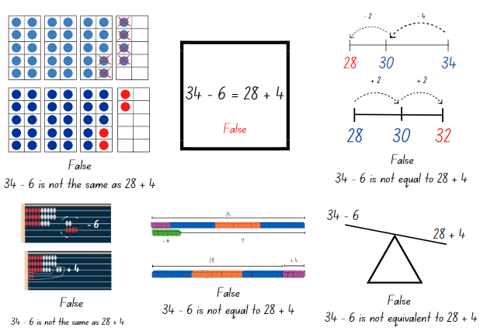
Images sourced from Canva and used in accordance with the Canva Pro Content License.
- As students are solving problems move around to partners and ask:
- What is the value of each side of the number sentence?
- Explain how you have modelled both sides of the number sentence to see whether they are equal?
- Is the number sentence true or false? Why? How do you know?
- Students continue to work through Resource 7: True or false.

Discuss and connect the mathematics – 10 minutes
- Students display their work and go on a gallery walk to look at all the different ways students modelled their working to prove if the number sentence was true or false.
- Discuss the strategies the students used and ask:
- What did you notice when you were solving each problem?
- What strategies did you and your partner use to decide whether a number sentence is true or false?
- What models did you make that were helpful?
- What challenges did you face? How did you solve the problem?

This table details assessment opportunities and differentiation ideas.
Assessment opportunities | Too hard? | Too easy?
What to look for:  - Are students able to apply addition and subtraction to number sentences to check if they are equal? (MA1-WM-01, MA1-CSQ-01)  - Can students represent, record and solve addition and subtraction problems using structured materials and strategies like number bonds or counting on and back? (MA1-CSQ-01)  What to collect:  - observational data (MA1-WM-01, MA1-CSQ-01)  - student work samples (MA1-WM-01, MA1-CSQ-01) | Students are unable to apply addition and subtraction strategies or use structured materials to check equivalence.  - Provide opportunities for students to recognise and recall number bonds to form 10.  - Support students in solving addition and subtraction problems up to 10 with structured materials and an equal-arm balance. | Students can apply addition and subtraction strategies.  - Students create their own true or false number sentences using addition and subtraction.  - Students create their own true or false number sentences using different number representations like dots, dominoes, or money.

Lesson 5: Related facts
Core concept: Related facts help to solve addition and subtraction problems.
The table below contains suggested learning intentions and success criteria. These are best co-constructed with students.
Learning intentions | Success criteria
Students are learning that:  - addition and subtraction are inverse operations  - number combinations can have related addition and subtraction number facts. | Students can:  - model how addition and subtraction are inverse operations using number sentences  - recall and use related addition and subtraction number facts to at least 20  - understand that the equals sign represents equivalence.

Daily number sense: From here to there – 15 minutes
This lesson has been adapted from Dice Dazzlers from Swan (2003).
- Build student understanding of the sequence of numbers by making and ordering numbers.
- Provide each pair with an individual whiteboard and 2 × 9-sided dice.
- One student draws a game board on their whiteboard. Together they set the starting and finishing numbers and write them on the game board.
- The first player rolls both dice and uses the 2 dice to form a number. The player must decide where to place the number on the game board so that the sequence of numbers remains in order (see Figure 8). The next player rolls and places their number on the same game board. If a number cannot be placed, the player misses their turn.
Figure 8 – Example of play
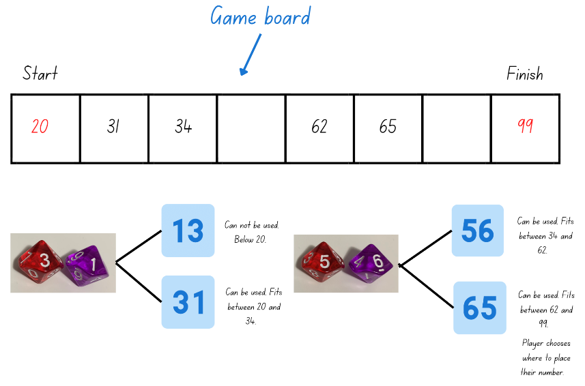
Images sourced from Canva and used in accordance with the Canva Pro Content License.
- The winner is the person who completes the sequence of numbers from the starting to the finishing number.
Note: Different dice can be used, however guide the students in understanding the finishing number. For example, if 2 × 6-sided dice are used the maximum finishing number will be 66.

Number facts – 35 minutes
This lesson has been adapted from Inverse operations: addition and subtraction from State of Victoria (Department of Education and Training).
- Display Resource 8: Related dots and provide students with an individual whiteboard. Ask students to only use the dot pictures to write a matching number sentence.
- Select students to share their number sentence and record. Group the addition sentences together and the subtraction sentences together. Ask students what they notice about the number sentences.
Note: Students should start to see the inverse relationship between the numbers and how the related numbers have created both addition and subtraction number sentences.
Inverse operation: The operation that reverses the effect of another operation. For example, add 3 to 7 to get 10. Then subtract 3 from 10 to get back to 7 (see Figure 9).
- Tell students there are 8 ways to represent these numbers in a number sentence. Remind students that the equals sign does not always have to end a number sentence as it symbolises ‘the same as or equal to’. Challenge students to identify all 8 related number sentences (see Figure 9).
Figure 9 – Related facts
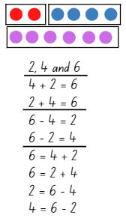
Images sourced from Canva and used in accordance with the Canva Pro Content License.
- Display Resource 9: Hands and ask students to use the number representations to write 8 related number sentences. If needed, identify that a total has not been provided this time.
- Select students to share related number sentences and as a class identify if all have been collected (see Figure 10).
Figure 10 – Related facts
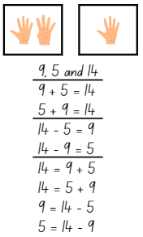
Images sourced from Canva and used in accordance with the Canva Pro Content License.
- Demonstrate rolling 2 × 9- or 12-sided dice and use those numbers to create and record 8 related number sentences.
- Provide students with 2 × 9- or 12-sided dice and their workbook to create and record related addition and subtraction number sentences.
- Students continue to roll the dice and record related number sentences for the numbers rolled. Students explain and check their work with their peers.

Discuss and connect the mathematics – 10 minutes
- Summarise the lesson together, drawing out some key mathematical ideas. Select students to share their work.
- Ask students:
- Did you notice any patterns? Did this help you?
- How do you know you have all the related number sentences?
- Do you think related facts apply to larger numbers?
- How do related facts help us to solve problems?
- What challenges did you face? How did you solve them?
This table details assessment opportunities and differentiation ideas.
Assessment opportunities | Too hard? | Too easy?
What to look for:  - Are students able to recall and use related addition and subtraction number facts to at least 20? (MA1-WM-01, MA1-CSQ-01)  - Can students correctly use and understand that the equals sign represents equivalence? (MA1-CSQ-01)  What to collect:  - student work samples (MA1-WM-01, MA1-CSQ-01) | Students are unable to recall and use related addition and subtraction number facts to 20.  - Provide students with counters so that they can model combining and separating the given numbers. Support students to record these number sentences as they create the representations.  - Students work with numbers either below 5 or 10 to model related addition and subtraction facts. Model talking aloud, for example 4 counters plus one counter is equal to 5 counters, so this means that 5 counters minus one counter is equal to 4 counters. | Students can recall and use related addition and subtraction number facts to 20.  - Provide students with a different range of dice to create larger numbers. For example, 2 × 20-sided dice or roll 2 dice to create different two-digit numbers.  - Challenge students to represent their number sentence using drawings with real world connections.

Lesson 6: Number bonds
Core concept: Number bonds are an efficient way to solve some addition and subtraction problems.
The table below contains suggested learning intentions and success criteria. These are best co-constructed with students.
Learning intentions | Success criteria
Students are learning that:  - number bonds can help to find a missing number in a number sentence  - an empty number line can be used to represent and solve addition and subtraction problems. | Students can:  - use known number bonds and knowledge of equality to solve missing number problems  - use an empty number line to solve addition and subtraction problems.

Daily number sense: Maths tipping – 15 minutes
This lesson has been adapted from Maths Tipping from NSW Department of Education.
- Build student understanding of the sequence of numbers by counting forwards and backwards by tens on and off the decade with two- and three-digit numbers.
- Stand students in a circle and have them count forwards or backwards by tens on or off the decade from a given two- or three-digit number until they reach a target number. For example, counting forwards by tens from 26 up to 156. Continue for a few rounds with different numbers.
- Then have students stand in different spaces around the room. Say a number to a student and they say the number that is 10 more and 10 less than the given number. The student must answer within a designated amount of time, for example, 5 seconds.
- If the student is correct, they can take one step in any direction to attempt to tip another student on the shoulder. If tipped, the student must sit down. If a student states the incorrect answer, they also must sit down.
- Continue until one student remains standing.

Number stories – 35 minutes
- Display Resource 10: Number story and provide students with an individual whiteboard. Ask students to write a number sentence to represent the story.
- Select students to share and explain their number sentence and record.
Note: If students write the missing number in their number sentence, discuss how this does not reflect the information in the story.
- Have selected students explain and demonstrate how they would solve the number story to find the missing number.
- Highlight how to solve this problem efficiently using number bonds to find the missing number. For example, $8 + $2 equals $10 and $10 more equals $20, $2 + $10 equals $12 so the missing number is 12, see Figure 11.
Figure 11 – Student working
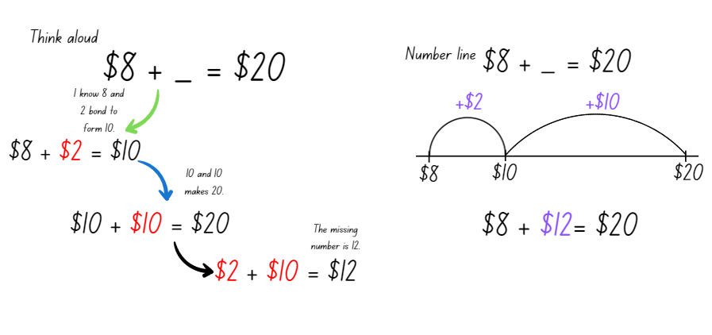
Images sourced from Canva and used in accordance with the Canva Pro Content License.
- Display Resource 11: Number sentence 1 and students use their individual whiteboard to solve the number sentence using known number bonds and a blank number line.
- Select students to share and demonstrate their working and explain how they found the missing number.
- Display Resource 12: Number sentence 2.
- Ask students:
- What do you notice is similar?
- What do you notice is different?
- Can you use number bonds to find the missing number?
- Students use their individual whiteboard to solve Resource 12: Number sentence 2 and show their working.
- Select students to share and demonstrate their working, explaining how they found the missing number. Highlight the use of number bonds in conjunction with a blank number line to solve the problem (see Figure 12).
Figure 12 – Student working
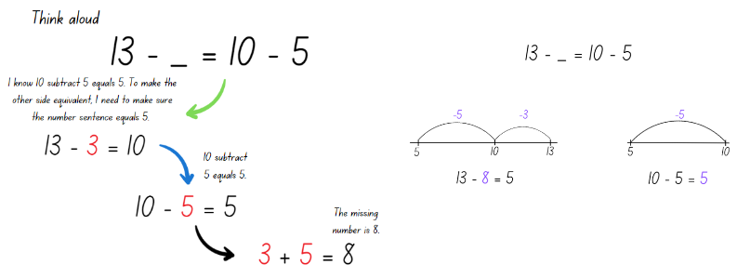
Images sourced from Canva and used in accordance with the Canva Pro Content License.
- Discuss how all 3 problems looked different, yet the same strategy and working was applied to find the missing number.
Note: If a student uses a different strategy like relational thinking, doubles or near doubles, briefly highlight and compare the different strategies.
- Provide students with one page of Resource 13: Missing numbers and their workbook. Students solve the problems and show their working using known number bonds and a blank number line.

Discuss and connect the mathematics – 10 minutes
- Choose students to share their work and demonstrate and explain their working.
- Ask students:
- What did you notice when you were solving the problems?
- Which number bonds did you use to find the missing number?
- Did your knowledge of equality help you to solve the problems? Explain your thinking.
- Did using a blank number line help you to solve the problems? How?
- Were any of the problems challenging? What questions do you still have, or did you work through the challenge?
This table details assessment opportunities and differentiation ideas.
Assessment opportunities | Too hard? | Too easy?
What to look for:  - Can students use known number bonds to solve missing number equality problems? (MA1-WM-01, MA1-CSQ-01)  - Are students able to use an empty number line to solve addition and subtraction problems? (MA1-WM-01, MA1-CSQ-01)  What to collect:  - student work samples (MA1-WM-01, MA1-CSQ-01) | Students are unable to use number bonds to find the missing number.  - Support students with solving the missing number problems using structured materials like an equal-arm balance and interlocking cubes.  - Provide concrete materials like counters so students can model the missing number problems and count with one-to-one correspondence. Support students to record these number sentences. | Students can use number bonds to find the missing number.  - Challenge students to use the inverse relationship to change the number sentences from either addition to subtraction or vice versa.  - Students write their own missing number equality word problems for a peer to solve.

Lesson 7: Exploring relations
Core concept: Relational thinking involves the relationship between both sides of the problem.
The table below contains suggested learning intentions and success criteria. These are best co-constructed with students.
Learning intention | Success criteria
Students are learning that relational thinking is an efficient strategy to solve addition and subtraction problems. | Students can:  - record and solve missing equality number problems using relational thinking  - use the forwards and backwards counting sequence to solve related problems.

Daily number sense: Number chart puzzle – 15 minutes
This activity has been adapted from Visualize: Patterns in the Hundred Chart from Mindset Mathematics: Visualizing and Investigating Big Ideas, Grade 1 from Boaler et al (2021).
- Build student understanding of the position of numbers by locating them on a number chart.
- Display Resource 14: Number chart puzzles. Using their individual whiteboard, students draw and fill in the missing numbers.
Note: Students may need a number chart displayed or Resource14: Number chart puzzles printed for support.
- As students are solving each puzzle, ask:
- How did you figure out the missing numbers? How do you know they are correct?
- Did you need to use the number chart to help?
- What patterns did you find and/or use?
- Select students to share and justify their working to the class.

Missing numbers – 35 minutes
This activity has been adapted from Investigate: Exploring Relations from Mindset Mathematics: Visualizing and Investigating Big Ideas, Grade 1 from Boaler et al (2021).
- Write 12 + 4 = __ + 5 on the board and explain to students that the number sentence is missing a number to make it equivalent. Challenge students to use a different strategy other than number bonds to solve it. Provide thinking time, then have students turn and talk to discuss how they will solve the problem. Students solve the problem using their individual whiteboard to record their working.
- Select students to share and justify their answers and record solutions. When students are sharing, discuss various strategies used including relational thinking. For example, the relationship between the 5 and the 4, 5 is one more than 4, so the missing number will need to be one less than 12. Demonstrate how using relational thinking is the most efficient way to solve this number sentence.
Note: Students may have solved the problem by adding 12 and 4 to get 16 and then taking 5 away from 16 to find the missing number of 11. This is correct; however, this is not relational thinking and not the most efficient way of solving this number sentence.
Relational thinking is the relationship between the numbers on both sides of the equals sign and the knowledge of the properties to solve problems. For example, 19 + 6 = 18 + __, 18 is one less than 19 so the missing value must be one greater than 6.
- Present additional relational thinking number sentences for students to solve, for example, 11 − __ = 10 − 3, 29 − 6 = __ − 7 and 14 + 22 = __ + 32. After each number sentence is displayed, provide thinking and working out time as well as opportunities for students to turn and talk to discuss possibilities.
- Once students are confident with applying relational thinking to a number sentence to make it equivalent, provide pairs with Resource 15: Missing number cards, scissors, glue, and workbooks.
- Students glue Resource 15: Missing number cards into their workbook and investigate and solve the missing number problems.
- Students complete the number sentence with their peers and demonstrate their understanding of relational thinking by showing their working (see Figure 13).
Figure 13 – Example of student working
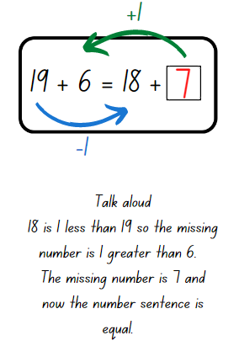
Images sourced from Canva and used in accordance with the Canva Pro Content License.

Discuss and connect the mathematics – 10 minutes
- Summarise the lesson together, drawing out some key mathematical ideas.
- Ask students:
- How did you find the missing number?
- How does the relationship between each side of the problem help you to find the missing number?
- How did you use the equals sign to help find the missing number?
- Did you find the missing number without finding the total of each side? How?
- Is there anything else you noticed?
This table details assessment opportunities and differentiation ideas.
Assessment opportunities | Too hard? | Too easy?
What to look for:  - Can students record and solve missing equality number problems using relational thinking? (MA1-WM-01, MA1-CSQ-01)  - Are students able to use the forwards and backwards counting sequence to solve related problems? (MA1-WM-01, MA1-CSQ-01)  What to collect:  - student work samples (MA1-WM-01, MA1-CSQ-01) | Students are unable to identify the missing number.  - Provide students with concrete materials, for example, interlocking cubes to represent the number sentence. Students count with one-to-one correspondence to find the total of one side and determine how many more are needed on the other side to make it equivalent.  - Students recall numbers before and after a given number to develop their confidence with the counting sequence to assist with relational thinking. | Students can identify the missing number.  - Challenge students to use a 20-sided die to create their own missing number sentence. Students have a partner solve their problems using relational thinking.  - Students compare the strategies of relational thinking and number bonds and create problems which reflect either strategy.

Lesson 8: Solving equality problems
Core concept: Different strategies help to efficiently solve addition and subtraction equality problems.
The table below contains suggested learning intentions and success criteria. These are best co-constructed with students.
Learning intentions | Success criteria
Students are learning that:  - different strategies can be applied to efficiently solve addition and subtraction problems  - a variety of number sentences can reflect equality. | Students can:  - model how addition and subtraction are inverse operations using concrete materials, drawings, and diagrams  - use known number bonds and knowledge of equality to solve missing number problems  - record and solve missing equality number problems using relational thinking.

Daily number sense: Number line – 10 minutes
This lesson has been adapted from Open-ended Maths Activities Revised Edition: Using ‘good’ questions to enhance learning in Mathematics from Sullivan and Lilburn (2017).
- Build student understanding of the sequence of numbers by counting forwards and backwards by tens on and off the decade with two- and three-digit numbers.
- Students draw a blank number line on their individual whiteboard.
- Show students 2 numbers and ask them to place them on the number line, as well as 5 other numbers of their choice which are multiples of 10. For example, show the students the numbers 60 and 120 and then they choose 5 other multiples of 10 to include, see Figure 14.
Figure 14 – Number line
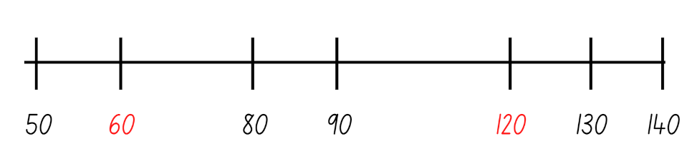
Images sourced from Canva and used in accordance with the Canva Pro Content License.
- Choose students to share their number line and justify the placement of the numbers.
- Continue to provide different two- and three-digit number ranges on and off the decade.
Note: Monitor where the students place the numbers. Ensure students understand that the largest number does not need to go at the very end of the line. The placement of each number is dependent on the other number/s.

Putting it altogether – 30 minutes
- Display Resource 16: Different problems 1, 6 and 7 (related number sentences), 30 − __ = 14 (number bonds) and 13 + 6 = 12 + __ (relational thinking). Ask students to look at the problems and work out which strategy they should apply to efficiently solve these equality problems. Students turn and talk and then use their individual whiteboard to solve the problems.
- Choose students to share, demonstrate and justify why they chose a particular strategy over another when solving these problems.
- Display Resource 17: Different problems 2 and provide students with independent thinking time as they look at the different problems and choose which strategy to apply. Students use their individual whiteboard to solve the problems.
- Choose students to share, demonstrate and justify why they chose a particular strategy over another when solving these problems.
- Discuss how the addition and subtraction problems require equality, yet different strategies can be applied to solve the problems in an efficient way.
- Provide students with Resource 18: Different problems 3 and students carefully analyse each problem to decide which strategy to use to solve the problem. Students glue the problem in their workbook, write the name of the strategy they are going to use and record their working and the answer.
- Students continue to work through each problem.
Note: Resource 18: Different problems 3 can be cut into 3 horizonal strips to provide students with 3 problems at a time. Each strip has the opportunity for students to demonstrate related number sentences, number bonds and relational thinking.

Discuss and connect the mathematics – 20 minutes
- Students display their work and go on a gallery walk looking at how their peers solved each problem.
- Regrouping as a class, choose students to demonstrate solving each problem and justify why they chose to solve the problem using that strategy.
- Summarise the unit together, drawing out the key mathematical ideas.
- Ask students:
- What does the equals sign represent?
- How can we check if something is equal?
- What are some different strategies we can use to solve addition and subtraction problems?
- What questions do you still have?
- Is there an area you would like more practise with?
- In what area are you feeling more confident in?
This table details assessment opportunities and differentiation ideas.
Assessment opportunities | Too hard? | Too easy?
What to look for:  - Are students able to choose the correct strategy and apply it to addition and subtraction problems? (MA1-WM-01, MA1-CSQ-01)  - Are students able to recall and use related addition and subtraction number facts to at least 20? (MA1-WM-01, MA1-CSQ-01)  - Can students use known number bonds and knowledge of equality to solve missing number problems? (MA1-WM-01, MA1-CSQ-01)  - Can students record and solve missing equality number problems using relational thinking? (MA1-WM-01, MA1-CSQ-01)  What to collect:  - student work samples (MA1-WM-01, MA1-CSQ-01) | Students are unable to apply different strategies to solve addition and subtraction problems.  - Provide students with concrete materials and an equal-arm balance to model and check different problems.  - Have students look at individual number sentences and tell you everything they know and understand about the number sentence. Ask guiding questions to help them identify which strategy they could use to solve the problem. | Students can apply different strategies to solve addition and subtraction problems.  - Challenge students to create different problems which use the various strategies.  - Students create a video explaining and demonstrating the different strategies.

Resource 1: Balancing objects
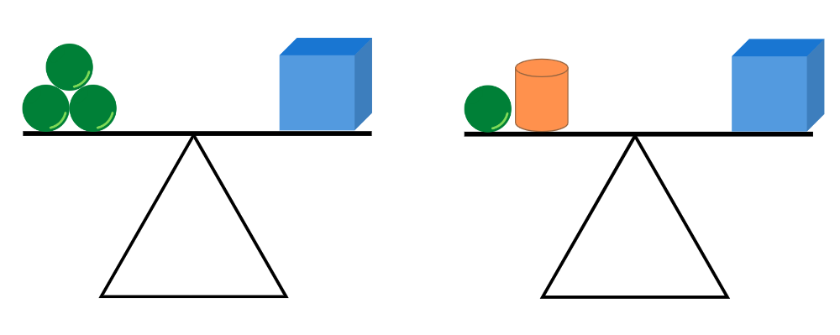
Image adapted from “Algebra: Equivalence” by © Australian Government Department of Education 2022 and is licensed under CC-BY-NC-SA 4.0.

Resource 2: Balancing objects 2
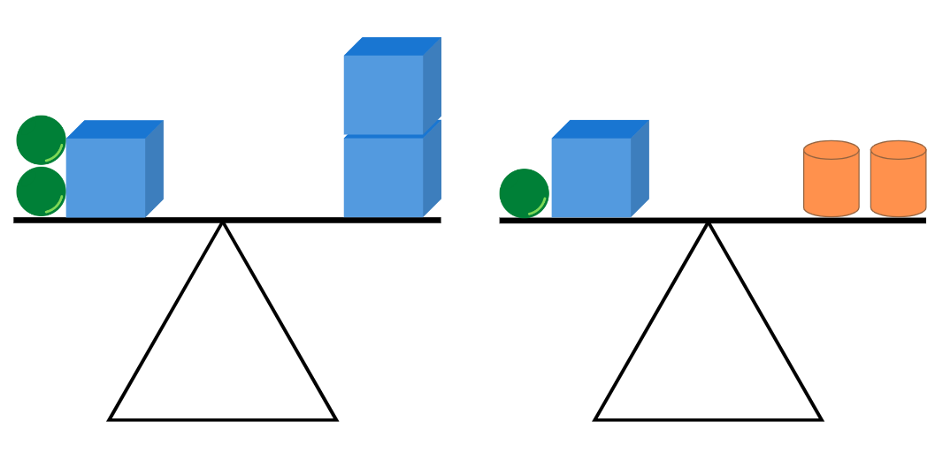
Image adapted from “Algebra: Equivalence” by © Australian Government Department of Education 2022 and is licensed under CC-BY-NC-SA 4.0.

Resource 3: Student recording table
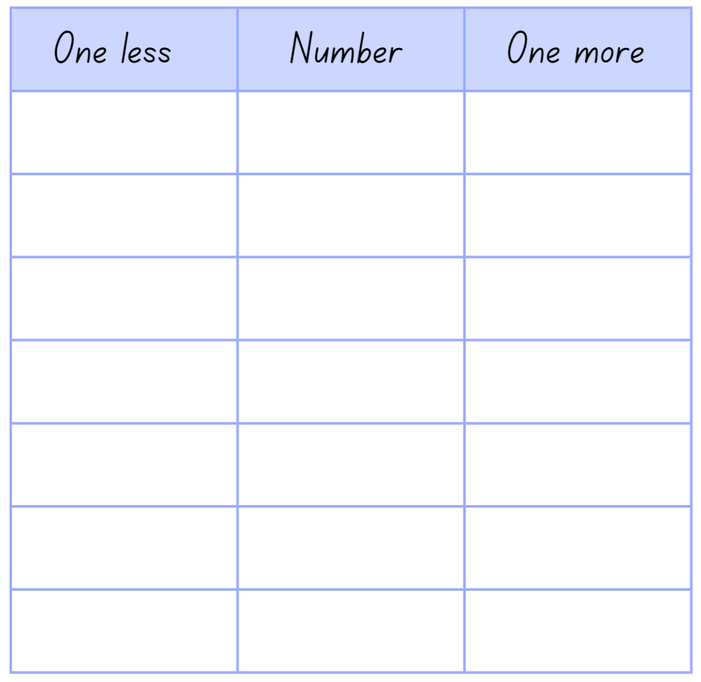
Images sourced from Canva and used in accordance with the Canva Pro Content License.

Resource 4: Number talk 1
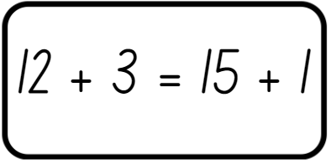
Images sourced from Canva and used in accordance with the Canva Pro Content License.

Resource 5: Number talk 2
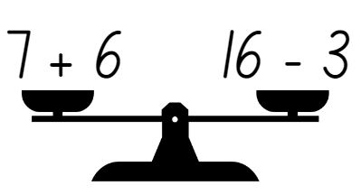
Images sourced from Canva and used in accordance with the Canva Pro Content License.

Resource 6: Number talk 3
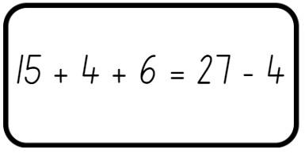
Images sourced from Canva and used in accordance with the Canva Pro Content License.

Resource 7: True or false
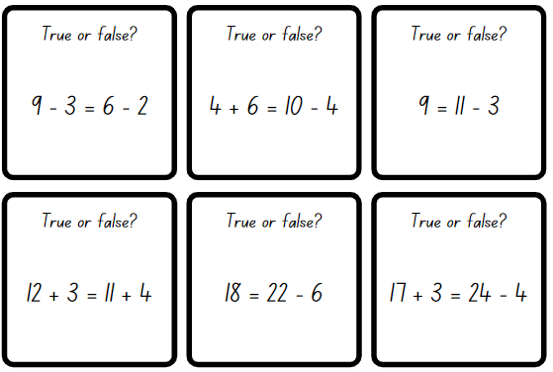
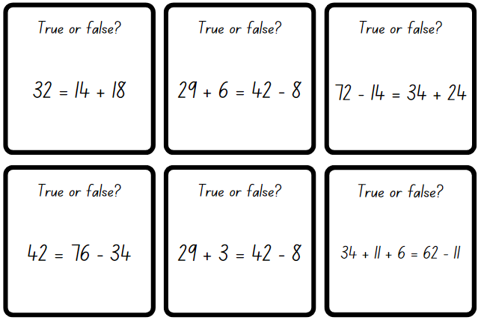
Images sourced from Canva and used in accordance with the Canva Pro Content License.

Resource 8: Related dots
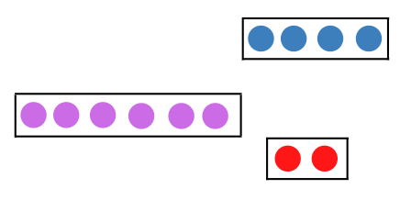
Images sourced from Canva and used in accordance with the Canva Pro Content License.

Resource 9: Hands
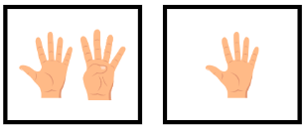
“Five Fingers Hand Gesture” and “Four Fingers Illustration” by Art Alex is used in accordance with the Canva Pro Content License.

Resource 10: Number story
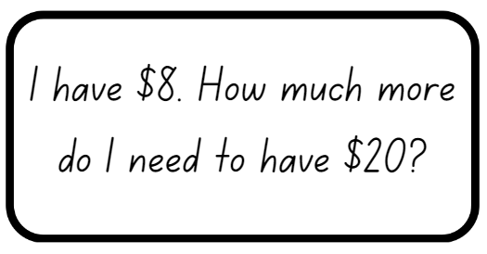
Images sourced from Canva and used in accordance with the Canva Pro Content License.

Resource 11: Number sentence 1
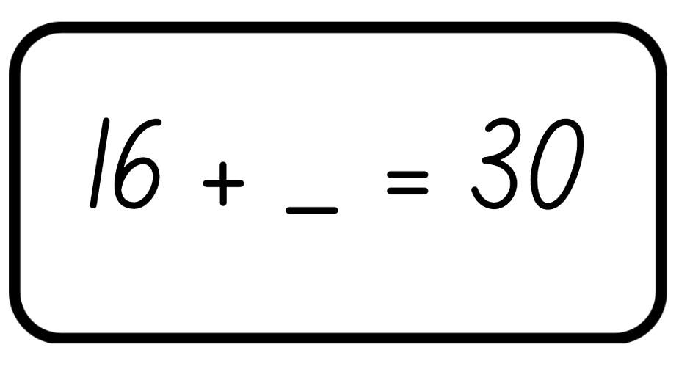
Images sourced from Canva and used in accordance with the Canva Pro Content License.

Resource 12: Number sentence 2
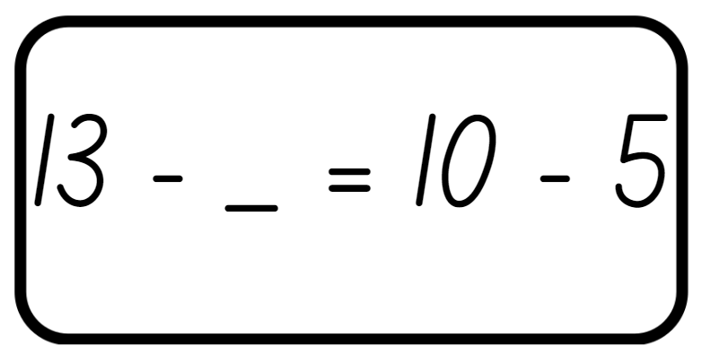
Images sourced from Canva and used in accordance with the Canva Pro Content License.

Resource 13: Missing numbers
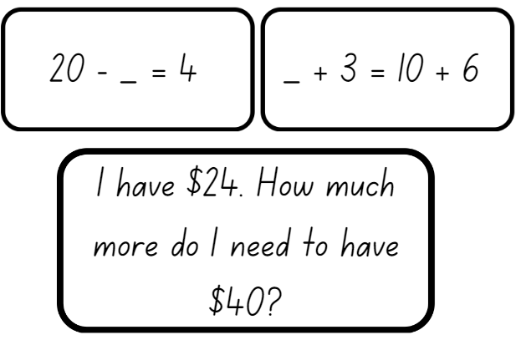
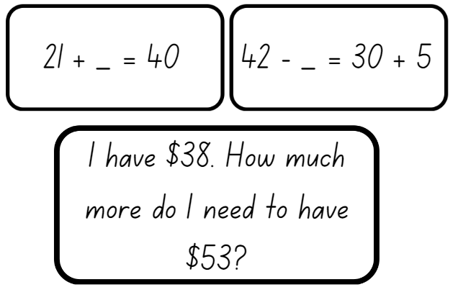
Images sourced from Canva and used in accordance with the Canva Pro Content License.

Resource 14: Number chart puzzles
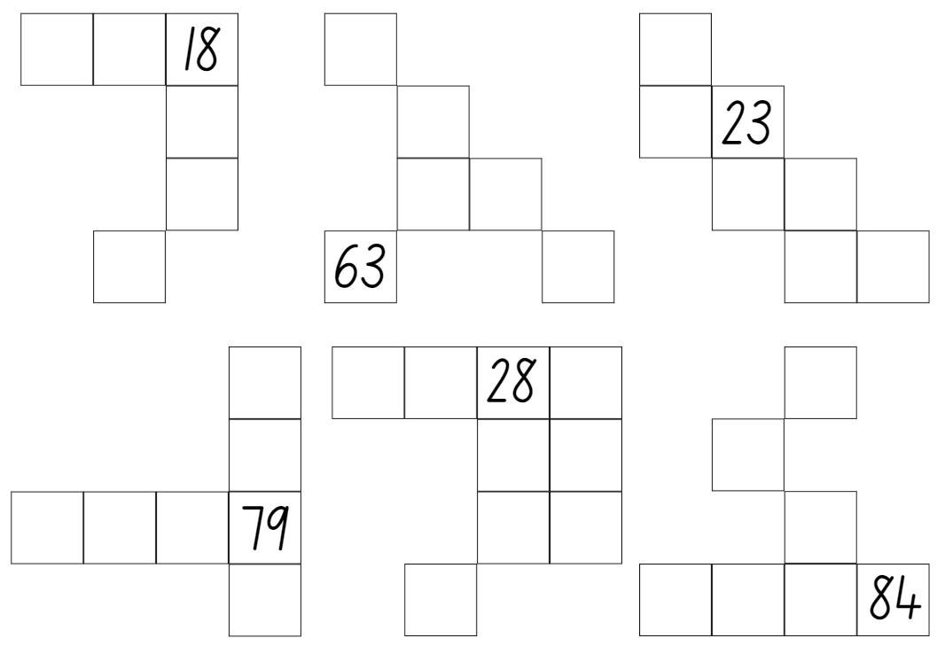
Images sourced from Canva and used in accordance with the Canva Pro Content License.

Resource 15: Missing number cards
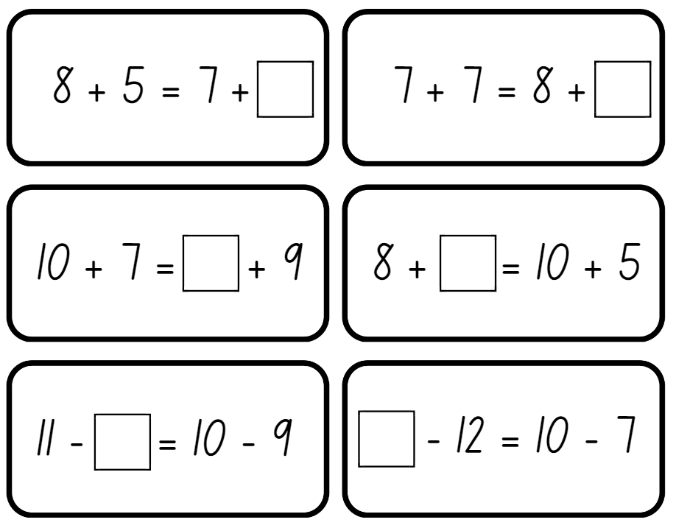
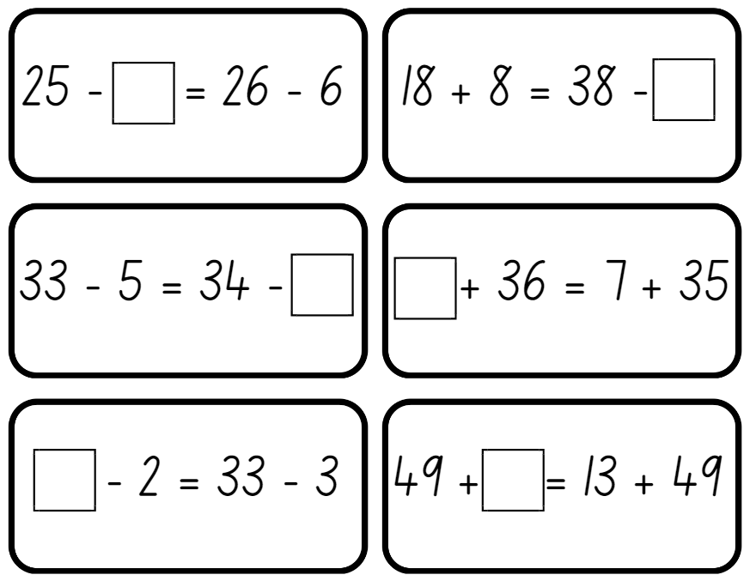
Adapted from Boaler et. al (2021).

Resource 16: Different problems 1
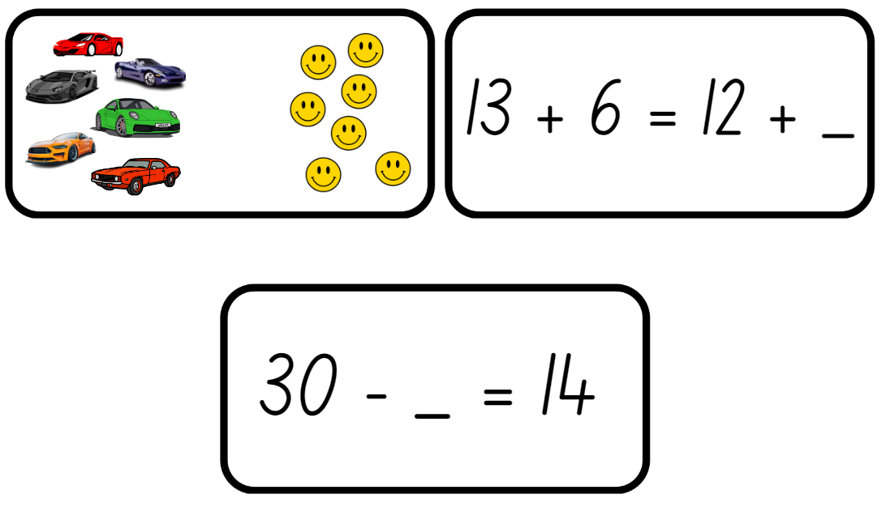
Images sourced from Canva and used in accordance with the Canva Pro Content License.

Resource 17: Different problems 2
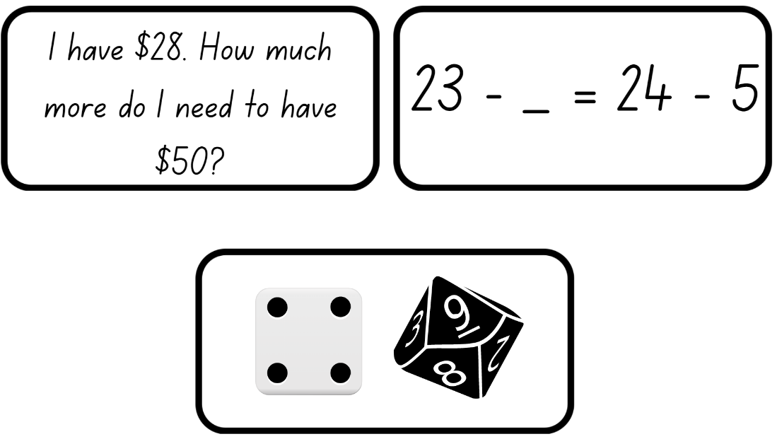
Images sourced from Canva and used in accordance with the Canva Pro Content License.

Resource 18: Different problems 3
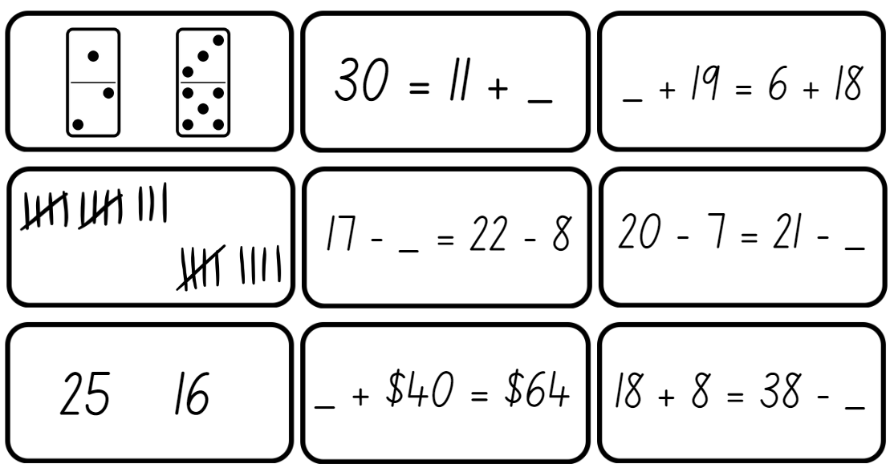
Images sourced from Canva and used in accordance with the Canva Pro Content License.

Syllabus outcomes and content
The table below outlines the syllabus outcomes and range of relevant syllabus content covered in this unit. Content is linked to National Numeracy Learning Progression version (3).
Focus area and outcomes | Content groups and content points | Lessons
Representing whole numbers A  MA1-WM-01  MA1-RWN-01  MA1-RWN-02 | Use counting sequences of ones with two-digit numbers and beyond  - identify the number before and after a given two-digit number (CPr5)  - count forwards and backwards by ones from a given number to at least 120 (CPr6)  Represent numbers on a line  - sequence numbers and arrange them on a line by considering the order and size of those numbers (CPr5)  - locate the approximate position of multiples of 10 on a model of a number line from 0 to 100 (CPr5) | 1, 5, 7, 8
Representing whole numbers B  MA1-WM-01  MA1-RWN-01  MA1-RWN-02 | Use counting sequence of ones and tens flexibly  - identify the number before and after a given three-digit number  - count forwards and backwards by tens, on and off the decade, with two- and three-digit numbers (CPr7) | 2, 4, 6, 8
Combining and separating quantities A  MA1-WM-01  MA1-CSQ-01 | Use advanced count-by-one strategies to solve addition and subtraction problems  - apply the terms ‘add’, ‘plus’, ‘equals’, is equal to’, ‘is the same as’, ‘take away’, ‘minus’ and ‘the difference between’ to describe combining and separating quantities (AdS1, AdS6)  - recognise and use the symbols for plus (+), minus (−) and equals (=)  - record number sentences in a variety of ways using drawings, words, numerals and symbols (AdS6)  - fluently use advanced count-by-one strategies including counting on and counting back to solve addition and subtraction problems involving one- and two-digit numbers (AdS3-AdS5)  Recognise and recall number bonds up to ten  - recognise, recall and record combinations of two numbers that add up or bond to form 10 (AdS2, AdS6)  - create, recall and recognise combinations of two numbers that add up to numbers less than 10 (AdS2, AdS6)  Use flexible strategies to solve addition and subtraction problems  - represent addition and subtraction using structured materials such as a bead string or similar model (AdS6-AdS7)  - select and apply strategies using number bonds to solve addition and subtraction problems with one- and two-digit numbers by partitioning numbers using quantity value and bridging (AdS6-AdS7)  Represent equality  - use the equals sign to record equivalent number sentences involving addition, and to mean 'is the same as', rather than as an indication to perform an operation (NPA3)  - recall related addition and subtraction facts for numbers to at least 10 (AdS6) | 1-8
Combining and separating quantities B  MA1-WM-01  MA1-CSQ-01 | Represent and reason about additive relations  - create, record and recognise combinations of two numbers that add to numbers from 11 up to and including 20 (AdS7)  - model how addition and subtraction are inverse operations using concrete materials, drawings and diagrams (AdS7)  - recall and use related addition and subtraction number facts to at least 20 (AdS7)  Use knowledge of equality to solve related problems  - use number bonds to determine a missing number (AdS6, NPA3-NPA4)  - use number knowledge to solve related problems (AdS7, NPA4)  - use a variety of ways of writing number sentences (NPA3-NPA4)  - use number bonds to solve equality problems (NPA3-NPA4) | 3-8
Non-spatial measure A  MA1-WM-01  MA1-NSM-01  MA1-NSM-02 | Mass: Investigate mass using an equal-arm balance  - place objects on either side of an equal-arm balance to obtain a level balance  - use an equal-arm balance to compare the masses of two objects and record, which is heavier or lighter (UuM2)  - use a balance to find two collections of objects that have the same mass (UuM2) | 1, 2
Non-spatial measure B  MA1-WM-01  MA1-NSM-01  MA1-NSM-02 | Mass: Compare the masses of objects using an equal-arm balance  - explain the relationship between the mass of a unit and the number of units needed | 3

References
Links to third-party material and websites
Please note that the provided (reading/viewing material/list/links/texts) are a suggestion only and implies no endorsement, by the New South Wales Department of Education, of any author, publisher, or book title. School principals and teachers are best placed to assess the suitability of resources that would complement the curriculum and reflect the needs and interests of their students.
If you use the links provided in this document to access a third-party's website, you acknowledge that the terms of use, including licence terms set out on the third-party's website apply to the use which may be made of the materials on that third-party website or where permitted by the Copyright Act 1968 (Cth). The department accepts no responsibility for content on third-party websites.
All material © State of New South Wales (Department of Education), 2021 unless otherwise indicated. All other material used by permission or under licence.
Mathematics K-2 Syllabus © 2021 NSW Education Standards Authority (NESA) for and on behalf of the Crown in right of the State of New South Wales.
© 2021 NSW Education Standards Authority. This document contains NSW Curriculum and syllabus content. The NSW Curriculum is developed by the NSW Education Standards Authority. This content is prepared by NESA for and on behalf of the Crown in right of the State of New South Wales. The material is protected by Crown copyright.
Please refer to the NESA Copyright Disclaimer for more information.
NESA holds the only official and up-to-date versions of the NSW Curriculum and syllabus documents. Please visit the NSW Education Standards Authority (NESA) website and the NSW Curriculum website.
National Numeracy Learning Progression © Australian Curriculum, Assessment and Reporting Authority (ACARA) 2010 to present, unless otherwise indicated. This material was downloaded from the Australian Curriculum website (National Numeracy Learning Progression) (accessed 4 November 2022) and was not modified. The material is licensed under CC BY 4.0. Version updates are tracked in the ‘Curriculum version history’ section on the 'About the Australian Curriculum' page of the Australian Curriculum website.
ACARA does not endorse any product that uses the Australian Curriculum or make any representations as to the quality of such products. Any product that uses material published on this website should not be taken to be affiliated with ACARA or have the sponsorship or approval of ACARA. It is up to each person to make their own assessment of the product, taking into account matters including, but not limited to, the version number and the degree to which the materials align with the content descriptions and achievement standards (where relevant). Where there is a claim of alignment, it is important to check that the materials align with the content descriptions and achievement standards (endorsed by all education Ministers), not the elaborations (examples provided by ACARA).
Australian Government Department of Education (2020) ‘Algebra: Equivalence’, Teaching resources, reSolve: Maths by Inquiry website, accessed 4 November 2022.
Boaler J, Munson J and Williams C (2021) Mindset Mathematics: Visualizing and Investigating Big Ideas, Grade 1, Jossey-Bass, San Francisco.
New Zealand Ministry of Education (n.d) Equality and equations, NZ Maths website, accessed 4 November 2022.
State of Victoria (Department of Education and Training) (n.d.) ‘Inverse operations: addition and subtraction’, Number and place value, Maths Curriculum Companion website, accessed 4 November 2022.
State of Victoria (Department of Education and Training) (2019) The Department of Education and Training (DET) [website], accessed 7 November 2022.
Sullivan P and Lilburn P (2017) Open-ended Maths Activities: Using ‘good’ questions to enhance learning in Mathematics, revised edn, OUP (Oxford University Press) Australia and New Zealand, Melbourne.
Swan P (2003) Dice Dazzlers, Self-published, Australia.
Toy Theater (2022) Dice, Toy Theater website, accessed 10 October 2022.

