Mathematics – Stage 1 – Unit 15
Contents
Unit description and duration 4
Student prior learning 4
Lesson overview and resources 5
Lesson 1: Halves, not halves 10
Daily number sense: Double or halve? – 35 minutes 10
Trains – 25 minutes 13
Consolidation and meaningful practice: Repeated halving – 15 minutes 15
Lesson 2: Number lines are more than a line 18
Daily number sense: Let’s skip count! – 10 minutes 18
Can you partition a line? – 30 minutes 19
0-12 Number line – 20 minutes 21
Consolidation and meaningful practice: Charlotte’s problem! – 5 minutes 23
Lesson 3: A whole length is made up of equal parts 25
Daily number sense: Counting by 10s – 10 minutes 25
Representing fractions of a length – 30 minutes 26
Consolidation and meaningful practice: Creating a whole – 10 minutes 28
Lesson 4: Partitioning lengths 30
Daily number sense: Making lunch – 15 minutes 30
Who am I? – 25 minutes 31
Consolidation and meaningful practice: Stick the tail on the donkey – 10 minutes 31
Lesson 5: Sharing toys 34
Daily number sense: Mr Equalson – 15 minutes 34
Let’s share toys! – 40 minutes 35
Consolidation and meaningful practice: Examples and non-examples – 10 minutes 37
Lesson 6: Sharing biscuits 38
Daily number sense: Domino patterns: Double and half – 10 minutes 38
Sharing biscuits – 35 minutes 39
Consolidation and meaningful practice: Reflection and consolidation – 15 minutes 42
Lesson 7: Is there a remainder? 43
Daily number sense: Dot collections, double and half – 10 minutes 43
Is there a remainder? – 40 minutes 44
Consolidation and meaningful practice: Poster creation – 15 minutes 46
Lesson 8: Halves and quarters 48
Daily number sense: Number lines – 10 minutes 48
Dot decider – 40 minutes 49
Consolidation and meaningful practice: Double or halve? – 10 minutes 51
Resource 1: Blank number chart 53
Resource 2: Trains 54
Resource 3: Number line 0–12 55
Resource 4: 120 number chart 56
Resource 5: Fraction bars 57
Resource 6: Fraction bars blank 58
Resource 7: Fraction bar puzzle 59
Resource 8: Breadstick 60
Resource 9: Animal line 61
Resource 10: Animal line 2 62
Resource 11: Stick the tail on the donkey 63
Resource 12: Toy box 64
Resource 13: Toys 65
Resource 14: Dominoes 66
Resource 15: Two rectangles 70
Resource 16: Four rectangles 71
Resource 17: Number lines 0-20 72
Resource 18: Dot decider 73
Resource 19: Dot cards 74
Syllabus outcomes and content 76
References 80

Unit description and duration
This two-week unit develops students’ knowledge, understanding and skills of division and fractions as part measures of a whole length. Students are provided opportunities to:
- explore that a fraction, such as one-half, can mean half of a collection, half of a length or half of a measure
- investigate that when a whole is cut or partitioned into equal parts, the number of parts increases but the size of each part is smaller
- understand that a fraction which describes two equal parts of a whole, and four equal parts of a whole, have the names half and quarter
- recognise that division can result in leftovers or a remainder.
Mathematics K–10 Syllabus © 2022 NSW Education Standards Authority (NESA) for and on behalf of the Crown in right of the State of New South Wales.

Student prior learning
Before engaging in these teaching and learning activities, students would benefit from prior experience with:
- drawing or using concrete materials to represent how to share a collection of objects equally amongst a group of people
- folding or drawing a whole length and showing the 2 equal halves
- skip counting by twos
- using concrete materials to model doubles.

Lesson overview and resources
The table below outlines the sequence and approximate timing of lessons; syllabus focus areas and content groups; and resources.
Lesson | Syllabus focus area and content groups | Resources
Lesson 1: Halves, not halves  75 minutes  A length can be subdivided into halves and quarters. | Representing whole numbers A  - Use counting sequences of ones with two-digit numbers and beyond  Forming groups A  - Recognise and represent division  Forming groups B  - Model doubling and halving with fractions  Geometric measure A  - Length: Subdivide lengths to find halves and quarters | - Resource 1: Blank number chart  - Resource 2: Trains  - Video: Double or halve? – Stage 1 (7:37)  - Art paper  - Colour tiles  - Dice  - Interlocking cubes  - Scissors and glue  - Writing materials
Lesson 2: Number lines are more than a line  65 minutes  Number lines have equally spaced partitions which can be used to represent fractions. | Representing whole numbers A  - Continue and create number patterns  - Represent numbers on a line  Forming groups B  - Model doubling and halving with fractions  Geometric measure A  - Length: subdivide lengths to find halves and quarters  Geometric measure B  - Length: Repeatedly halve lengths to form eighths | - Resource 3: Number line 0–12  - Cuisenaire Environment  - Coloured rods  - Interlocking cubes  - Writing materials
Lesson 3: A whole length is made up of equal parts  50 minutes  Understanding that equal partitions help determine halves and quarters. | Representing whole numbers B  - Use counting sequences of ones and tens flexibly  Geometric measure A  - Length: compare lengths using uniform informal lengths  - Length: subdivide lengths to find halves and quarters  Geometric measure B  - Length: Repeatedly halve lengths to form eighths | - Resource 4: 1–120 number chart or Interactive 120 board  - Resource 5: Fraction bars  - Resource 6: Fraction bars blank  - Resource 7: Fraction bar puzzle (printed on A3 paper)  - Two 0–9 dice per pair  - Scissors and glue  - Writing materials
Lesson 4: Partitioning lengths  50 minutes  The more parts a whole length is partitioned into, the smaller the parts become. | Forming groups A  - Recognise and represent division  Forming groups B  - Model doubling and halving with fractions  Geometric measure A  - Length: compare lengths using uniform informal lengths  - Length: subdivide lengths to find halves and quarters | - Resource 8: Breadstick  - Resource 9: Animal line  - Resource 10: Animal line 2  - Resource 11: Stick the tail on the donkey  - Pieces of string of the same length (3 per group)  - Scissors  - Writing materials
Lesson 5: Sharing toys  65 minutes  Collections can be divided equally into halves, quarters and eighths. | Forming groups A  - Recognise and represent division  Forming groups B  - Model doubling and halving with fractions | - Resource 12: Toy box  - Resource 13: Toys  - Dice or Interactive dice  - Interlocking cubes  - Scissors  - Writing materials
Lesson 6: Sharing biscuits  60 minutes  As the number of equal shares increases, the size of each share gets smaller. | Forming groups A  - Recognise and represent division  Forming groups B  - Model doubling and halving with fractions | - Resource 14: Dominoes  - 20 modelling clay biscuits (or a substitute)  - Counters, paper plates, or similar manipulatives  - Writing materials
Lesson 7: Is there a remainder?  65 minutes  Remainders occur when a collection cannot be shared equally. | Forming groups A  - Recognise and represent division  Forming groups B  - Model doubling and halving with fractions | - Resource 15: Two rectangles  - Resource 16: Four rectangles  - A3 paper or large poster  - Counters, paper plates, or similar manipulatives  - Selection of dot cards from Numerals and expressions: Number words [PDF 386KB]  - Writing materials  - Writing materials
Lesson 8: Halves and quarters  60 minutes  Half of a half is called a quarter. | Forming groups A  - Recognise and represent division  Forming groups B  - Model doubling and halving with fractions | - Resource 1: Blank number chart  - Resource 17: Number lines 0-20  - Resource 18: Dot decider  - Resource 19: Dot cards  - Art paper  - Dice  - Writing materials

Lesson 1: Halves, not halves
Core concept: A length can be subdivided into halves and quarters.
The table below contains suggested learning intentions and success criteria. These are best co-constructed with students.
Learning intentions | Success criteria
Students are learning that:  - doubles and near doubles can be used as a flexible strategy  - a whole length can be broken into equally sized parts known as halves and quarters. | Students can:  - double and halve numbers using a range of strategies  - divide a whole length into 2 and 4 equal sized pieces to represent halves and quarters  - use direct comparison to check if a length has been split in half or quarters.

Daily number sense: Double or halve? – 35 minutes
This task has been adapted from Double or Halve? from NRICH and Double or halve? – Stage 1 (7:37) from Mathematics K-6 resources by NSW Department of Education.
- Build student understanding of doubling and halving by playing the game ‘Double or halve?’
- Watch the video, Double or halve? – Stage 1 (7:37). Pause the video at specific sections and ask students the following questions:
- How do we know if the number chart in the video had one hundred squares?
- What are some quick ways we could count and check that there are one hundred squares in a number chart?
- How can you work out whether to double or halve the number you roll on the dice?
- What strategies can be used to check that they have doubled or halved a number correctly?
- In pairs, provide students with a 6-sided dice and a copy of Resource 1: Blank number chart. Revise the rules of the game.
- After a few rounds ask:
- Did you use a specific strategy to help you win a round?
- Are there any moves you would change?
- Would you halve the number instead of doubling the number next time so you could win? Why?
- How did you choose the target number each round?
- If you also had the option to keep your roll without doubling or halving the number, do you think this would make it easier to reach the target number? Why?
The table below details assessment opportunities and differentiation ideas.
Assessment opportunities | Too hard? | Too easy?
What to look for:  - What strategies are being used to work out the double? (MAO-WM-01, MA1-RWN-01)  - What strategies are being used to work out half? (MAO-WM-01, MA1-RWN-01)  - Are students strategising when choosing to either double or halve so they can win the game? (MAO-WM-01, MA1-RWN-01)  What to collect:  - completed game number charts (MAO-WM-01, MA1-RWN-01)  - anecdotal records of conversations. (MAO-WM-01, MA1-RWN-01) | Students have difficulty using numbers greater than 30.  - Provide students with a 20- or 30-frame for the game, counters, and a dotted dice.  - Students play the game by adding quantities only.  Students cannot calculate double and halve.  - Provide a number chart to 30 and play a few rounds using only the doubling strategy, use counters to assist.  - Play using only the halving strategy and use counters to assist.  - Play a round with the students and use counters to model how to find double and half of a quantity. | Students confidently double and halve numbers up to 6 and can use the number chart with ease.  - Provide a range of more complex numbered dice.  - Provide a number chart to 200.  - Add an additional challenge, such as only doubling odd numbers rolled and halving the even numbers rolled.

Trains – 25 minutes
Note: Linear models of fractions are important as they provide a direct link to the number line. Students make the link by working with linear arrangements of quantity. This activity links to the linear arrangement by repeatedly halving a line of train carriages. Having the pictures on the strip helps students make the link between fraction units and quantities. Moving the focus from the length to a line of carriages helps students to see how halving could be used with both continuous and discrete quantities (Gould 2013).
Discrete model: This model uses separate items in collections to represent parts of the whole group.
- Discuss what students know about halves and ask selected students to share their thinking.
- Explain that a ‘fraction’ is the name that mathematicians give to each equal part of a whole, and the name of a fraction with 2 equal parts is a half.
- Provide each student with scissors, glue and Resource 2: Trains.
- Explain that the station master needs 6 trains to transport the passengers around the city. There needs to be 2 ‘whole’ trains and 4 ‘half’ trains. Have students discuss with a partner how they could achieve this using their 4 train strips (Resource 2).
- Students discuss with a partner which trains will stay ‘whole’ and which trains will be halved.
- Demonstrate how to fold the strips in half by lining up the edges and corners. Use ‘Talk moves’ to discuss the accuracy of folding to make halves.
- Students cut out the train strips. Students fold, then cut along the fold line to create half trains (see Figure 1).
- Students paste the ‘whole’ and half trains on a piece of art paper, ensuring the ends of the trains are aligned. Draw students’ attention to the fact that they now have two halves of a whole.
Figure 1 – Two whole trains and 4 half trains
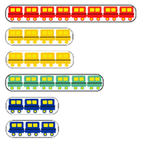
Images sourced from Canva and licensed under the Canva Content License Agreement.
- Provide students with time to Think-Pair-Share with a partner about their train picture. Invite students to share their ideas with the class. Prompting questions could include:
- Which coloured trains are equal?
- Which coloured trains are half the length of the red train?
- Is the yellow train ‘more than half’, ‘about half’ or ‘less than half’ of the green train?
- Which trains are not equal in length?
- Prompt students to write 1–2 sentences about their train picture. Invite students to share their sentences with their peers.

Consolidation and meaningful practice: Repeated halving – 15 minutes
- Use the Coloured Tiles Interactive Manipulator (Figure 2), to recreate the trains.
Figure 2 – Coloured tiles interactive manipulator
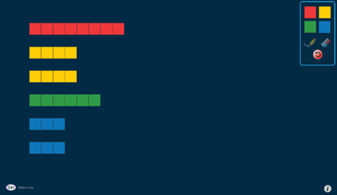
- In small groups, ask students to create the trains with interlocking cubes.
- Invite students to investigate whether they can halve the yellow and blue half trains to create 4 trains of equal length. Prompt students to reason as to why they cannot halve the blue trains with 3 blocks.
- Explain to students that when a whole length has been partitioned into 4 equal parts, these parts are known as quarters.
- Model the repeated halving of a whole to create halves and quarters.
- In pairs, students work together to create trains with their interlocking cubes that can be broken into halves and quarters.
- Whilst students are working, lead discussions to promote mathematical thinking.
Prompts | Anticipated student responses
- When there are 2 equal parts, what are the parts called?  - Can you make a train with 12 cubes? Can you make a train half the size or a quarter of the size?  - When there are 4 equal parts, what are the parts called?  - Can you make any other trains that can be broken into halves and quarters?  - How can we check they are equal parts? | - Halves.  - Yes, the whole train is 12 so half is 6 cubes and a quarter is 3 cubes.  - Quarters.  - Yes, a train of 10 can be broken into halves (5 in each) but not quarters.  - I lined the 2 trains on top of each other.  - I counted the blocks in each train and they were the same.
The table below details assessment opportunities and differentiation ideas.
Assessment opportunities | Too hard? | Too easy?
What to look for:  - Can students describe the relationship between the parts and the whole? (MAO-WM-01, MA1-GM-03)  - Can students use concrete materials to model halves and quarters of a whole length? (MAO-WM-01, MA1-GM-03)  What to collect:  - student recordings of findings. (MAO-WM-01, MA1-FG-01, MA1-GM-03) | Students cannot create equal halves and quarters.  - Use the student’s unequal train strip to model how it is unequal by overlapping to show that one portion is smaller than the other. Count the carriages with the student.  - Provide a new train strip from Resource 2: Trains. Model how to fold corner to corner, with edges aligned.  - Use interlocking cubes to create a model of the trains. | Students can articulate how the trains have been partitioned into halves and quarters.  - Ask students if there are other ways they can partition the trains equally. Provide additional paper strips for them to create trains that are a quarter or eighth of the whole.  - Ask students to show a number representation of the fractions they have that make a whole.  - Students reflect on their learning by recording their observations.

Lesson 2: Number lines are more than a line
Core concept: Number lines have equally spaced partitions which can be used to represent fractions.
The table below contains suggested learning intentions and success criteria. These are best co-constructed with students.
Learning intentions | Success criteria
Students are learning that:  - a line can be partitioned showing part-whole relationships  - equal partitions can be marked on a number line to represent fractions  - number lines are useful tools for mathematical problems. | Students can:  - use concrete materials to model part-whole on a number line  - partition a number line from 0–12 to show halves and quarters  - use direct comparison to determine if a length has been halved or quartered.

Daily number sense: Let’s skip count! – 10 minutes
- Students form a long line representing a number line and are given a number. The first student is number one, the second student is number 2 and so on.
- Draw students’ attention to the fact that they are representing a number line.
- Explain that students will be skip counting along the line. For example, if counting by twos, the student who has been given the number 2 will start the count, the fourth student will call out 4, the sixth student will call out 6 and so on.
- Repeat the activity several times, using a different starting number, counting forwards and backwards and using different patterns, such as counting by fives and tens.
Note: If students are having difficulty visualising the connection between themselves and the number line they represent, draw a chalk number line and the corresponding numbers on the floor in front of the students. When skip counting you could also show how the count jumps from number to number.

Can you partition a line? – 30 minutes
This task has been adapted from Cuisenaire Environment by NRICH.
- Explain that students are going to investigate how to partition a line into equal parts. Highlight that the lines represent various lengths.
Note: The number line can be a powerful model for thinking about quantities. To be most effective, the number line needs to be introduced when students can make use of its defining feature – length. Refer to the teaching advice in the Mathematics K–10 Syllabus for information about using number lines as a mathematical tool.
- Using the interactive Cuisenaire Environment (Figure 3), turn on the grid lines and use the zoom button to increase the size of the page as this allows students to count the length of rods more easily. Show students how each of the coloured rods are incrementally longer starting at white. Draw each rod onto the page so students can see their length.
Figure 3 – Cuisenaire Environment interactive board
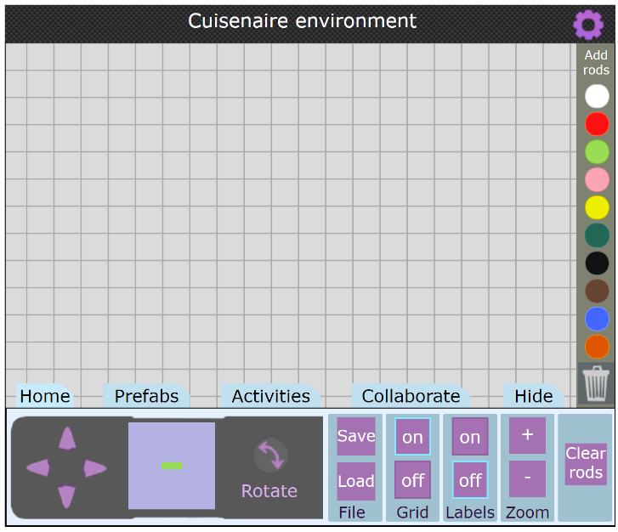
‘Cuisenaire Environment’ by © University of Cambridge is licensed under CC-BY-NC 4.0.
- Clear the board then drag a brown rod into the centre of the page. Count the length of the rod by showing the connection between the grid lines and the length of the rod as a total of 8.
- Explain that the brown rod represents the whole. Show how the pink rod, which is equivalent to 4 can be placed directly above the brown rod to show half. Remind students that they may need to select and drag several rods before finding the rod that is equivalent to half. Place another pink rod above the brown rod to show the 2 halves that make the whole (see Figure 4).
Figure 4 – Partitioning into halves and quarters using coloured rods
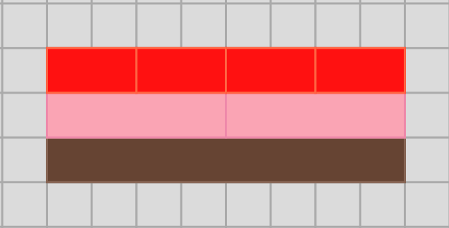
Image from ‘Cuisenaire Environment’ by © University of Cambridge is licensed under CC-BY-NC 4.0.
- Ask students to notice that the pink coloured rods are placed end-to-end and with no gaps to accurately measure half, and the equal parts of the whole are also visible. Clear the board.
- Select students to repeat the task, using various lengths. Discuss as they trial different rods.
- In small groups, students explore equal partitioning by using a range of different coloured rods. Provide time for students to record their investigations using drawings, symbols, or words.
- Students go on a gallery walk to see how other students have recorded their thinking. Discuss the features of students work.

0-12 Number line – 20 minutes
- Prompt students to share what they know about number lines and to share examples of known number lines, for example a ruler, tape measure or a height or growth chart.
- Display a number line from 0–12 on the board. Ask student to suggest ways to discover where the halfway point is on the number line. Prompt students by asking:
- If we estimate, how will we know its accurate?
- If this is the full length of the line and it is labelled 0–12 in sequential order, will this information help us determine a half of the number line or where the halfway point is on the line?
- How do we know that the spaces in between each number are equal? Refer to the coloured rods used in the previous activity and how they used shorter coloured rods to partition a long-coloured rod from end to end with no overlaps or spaces.
- Allow a few students to demonstrate their thinking to the class, drawing attention to the numbers and spaces in between as they problem solve to find the halfway point.
- Provide each student with a 0–12 number line using Resource 3: Number line 0-12 and ask students to mark where they think half would be. Observe strategies and listen for vocabulary or ideas that can be shared with the class.
- Ask students to also explore other ways to partition their number line into equal parts, for example, quarters.
Note: This investigation is for students to understand that on either side of the halfway mark there are equal parts of the whole line.
This table details assessment opportunities and differentiation ideas.
Assessment opportunities | Too hard? | Too easy?
What to look for?  - What strategies are students using to divide a number line into equal parts? (MAO-WM-01, MA1-GM-03)  - Are students describing the relationship between the parts and the whole? (MAO-WM-01, MA1-GM-03)  - Do students recognise and explain how the number line has been partitioned into halves and quarters and then describe how they can prove they are equal parts? (MAO-WM-01, MA1-GM-03)  What to collect:  - student samples and recordings of findings. (MAO-WM-01, MA1-GM-03) | Students have divided the number line unevenly.  - Explain how to make the parts of the whole the same size, otherwise they are not true halves. Show multiple examples of a half. Show students examples that are not a half. Ensure students see half in a variety of ways, for example half a length and half a collection. Model how to verify that the 2 partitions are equivalent.  - Demonstrate how to partition a number line. Ask students to attend to the partition and ask them to check if it is half by measuring each segment. Allow multiple opportunities for students to partition the number line, while scaffolding their understanding. | Students can create equal parts and can articulate how many parts they have.  - Provide students number lines of varying lengths longer than 0–12. Ask if there are other ways they can partition the larger number lines.  - Support students to display quarters and eighths when partitioning different number lines.  - Support students in understanding that the more equal parts they partition the line into the smaller the fraction.  - Ask students to show a number representation of the fractions they have that created on the number line.

Consolidation and meaningful practice: Charlotte’s problem! – 5 minutes
- Using interlocking cubes, make a model as seen in Figure 5.
Figure 5 – Four joined interlocking cubes
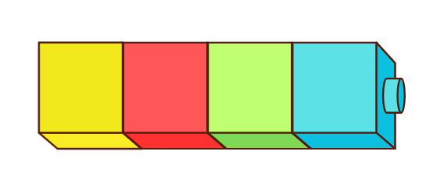
Images sourced from Canva and licensed under the Canva Content License Agreement.
- Ask students to help Charlotte find the answers to some questions.
- How many more interlocking cubes does Charlotte need to add if she wants to double the quantity?
- How many interlocking cubes does Charlotte need to remove if she wants to halve the quantity she currently has?
- If Charlotte wanted 12 interlocking cubes in total, how many more does she need to add?

Lesson 3: A whole length is made up of equal parts
Core concept: Understanding that equal partitions help determine halves and quarters.
The table below contains suggested learning intentions and success criteria. These are best co-constructed with students.
Learning intentions | Success criteria
Students are learning that:  - a length can be divided into equally sized parts known as fractions and the halfway point is half of the length  - halving a whole length once makes halves  - halving and halving again makes quarters. | Students can:  - identify halves and quarters by folding and layering  - recognise unequal partitions when dividing a length  - use direct comparison to determine the relationship between the whole and the parts.

Daily number sense: Counting by 10s – 10 minutes
- Provide pairs with two 0–9-sided dice and a copy of Resource 4: 1–120 number chart (or display Interactive 120 board).
- Have one student roll the dice and form a 2-digit number. Their partner finds the number on the number chart and identifies the number 10 before and 10 after. Repeat with students swapping roles.

Representing fractions of a length – 30 minutes
Eighths are introduced in Geometric measure B by repeatedly halving lengths. This lesson exposes students to the concept of eighths.
- Display Resource 5: Fraction bars. Ask students to turn and talk to share what they notice.
Prompts | Anticipated student responses
- What do you notice? | - They are like the Cuisenaire rods.  - Four quarters are the same length as a whole.  - Two quarters are the same length as a half.  - The more parts a length is divided into, the smaller the parts are.  - Four quarters are the same as 2 halves.  - When the equal sized parts are together, they are the same length as a whole.
- Model creating the fraction bars. Cut out the bars and draw attention to their equal length by layering them for direct comparison.
- Write the word ‘whole’ on the first bar.
- Fold the second bar in half by aligning the ends and then reopen. Mark a line on the fold and write ‘half’ on the 2 equal parts.
- Fold the third bar in half and half again. Open the bar and highlight the 4 equal parts that have been created. Mark a line on the folds and write ‘quarter’ on the 4 equal parts.
- Fold the fourth bar in half and half again to recreate the quarter model. Ask students to predict how many equal parts there would be if it was folded in half one more time. Fold the bar in half and then reopen to demonstrate 8 equal parts. Explain that these sections are called eighths and write ‘eighth’ on each of the 8 parts.
- Provide students with a copy of Resource 6: Fraction bars blank and have them create their own whole, half and quarter fraction bars by folding and drawing lines on the folds and writing the word to describe the equal parts.
- Paste all fraction bars on a piece of paper, aligning the ends of the bars to show equivalence.
This table details assessment opportunities and differentiation ideas.
Assessment opportunities | Too hard? | Too easy?
What to look for:  - Can students identify halves and quarters by folding and layering? (MAO-WM-01, MA1-GM-02)  - Can students identify unequal parts when folding and refold to ensure equality? (MAO-WM-01, MA1-GM-02)  - Can students use direct comparison to determine the relationship between the whole and the parts? (MAO-WM-01, MA1-GM-03)  What to collect:  - student fraction bar models (MAO-WM-01, MA1-GM-02, MA1-GM-03)  - annotated work samples. (MAO-WM-01, MA1-GM-02, MA1-GM-03) | Students are unable to identify halves and quarters.  - Fold the bar strips for the students and ask them to identify how many parts the strip has been folded into.  - Use an additional copy of Resource 6: Fraction bars blank and cut 2 strips into halves and quarters. Lay the parts on top of the student’s whole strip to illustrate the relationship between the whole and the parts. | Students can create halves and quarters of the length.  - Ask students to create a fraction bar showing eighths.  - Provide students with another strip of paper and ask them to estimate and mark where the quarters and eighths marks would be without folding. Check their estimates by repeatedly halving and folding the lengths.

Consolidation and meaningful practice: Creating a whole – 10 minutes
- Provide each student with a piece of the puzzle from Resource 7: Fraction bar puzzle.
Note: Pre-cut the puzzle pieces prior to the lesson. Select the puzzle pieces depending on the number of students present to ensure that wholes can be created.
- Ask selected students to predict how many parts they will need to create their whole.
- Have students try to create a whole by finding other students that have an equal length puzzle piece. When students think they have a whole, they sit down and place the puzzle pieces together in a line to make a whole.
- Ask the following questions to students:
- Can you have 5 people with quarters make a whole?
- How many people did you need to make the whole out of eighths, quarters and/or halves?
- Have students swap puzzle pieces with a peer and repeat the activity.

Lesson 4: Partitioning lengths
Core concept: The more parts a whole length is partitioned into, the smaller the parts become.
The table below contains suggested learning intentions and success criteria. These are best co-constructed with students.
Learning intentions | Success criteria
Students are learning that:  - a fraction describes the relationship between the whole and the parts it has been partitioned into  - when dividing a whole length, sometimes there are unequal parts. | Students can:  - use partitioning to create halves and quarters of a whole  - use strategies such as folding and layering to find equal parts  - recognise unequal examples of partitioning and dividing  - recognise that the more equal parts the whole is divided into, the smaller each part becomes.

Daily number sense: Making lunch – 15 minutes
- Build student understanding of division by looking at how a whole can be divided into equal parts.
- Display Resource 8: Breadstick and pose the problem: Mrs Singh had one breadstick to share between her 4 children. Everyone needed an equal share. How much of the breadstick would each child get and what do we call these parts?
- Explain that students can use hand signals or drawings to show how many ways they can solve the problem.
- Students turn and talk with a partner to share strategies. Monitor responses to highlight during follow-up discussions.
- Select students to share their thinking and record responses on the displayed image of the breadstick.

Who am I? – 25 minutes
- Display Resource 9: Animal line and ask students what they notice about where the images have been positioned on the line.
- Model drawing lines on the rope with a marker to partition the rope into halves and quarters. Pose the following prompts:
- I am halfway along the line. Who am I?
- I am a less than halfway along the line. Who am I?
- I am more than halfway along the line. Who could I be?
- I am a quarter of the way along the line. Who am I?
- Provide pairs with a copy of Resource 9: Animal line or Resource 10: Animal line 2 and have students make marks to partition the rope into halves and quarters. Encourage students to fold the picture to determine the positions if needed.
- In pairs, students choose an image and give their partner clues using the language of ‘more than’, ‘less than’ or ‘about’ half or a quarter of the way along the line. Partners use the clues to guess which image their partner is referring to.

Consolidation and meaningful practice: Stick the tail on the donkey – 10 minutes
- Display Resource 11: Stick the tail on the donkey. Explain that Aunty Melanie made the game for Neha's birthday party and only had one strip of ribbon for the tail. She wanted to know:
- How could the tail strip be cut into equal parts so that all the friends had an equal length?
- Will the tail pieces become smaller or larger the more friends they are shared between?
- Provide each small group with 3 pieces of string of the same length and scissors. Explain that students need to use each piece of string to create tails for 1, 2, or 4 people to play.
- Regroup as a class and summarise the lesson together, drawing out some key mathematical ideas. Ask:
- What did you notice about the length of the tails for each group of friends?
- Do the parts get smaller or larger as more people play?
- What do we call the equal parts that you have created?
- If the parts weren’t equal, would they still be halves or quarters?
This table details assessment opportunities and differentiation ideas.
Assessment opportunities | Too hard? | Too easy?
What to look for:  - Can students use partitioning to create halves and quarters? (MAO-WM-01, MA1-GM-03)  - Can students identify when the fraction parts are equal or not? (MAO-WM-01, MA1-GM-03)  - Do students recognise that the more equal parts the whole is divided into, the smaller each part becomes? (MAO-WM-01, MA1-GM-03)  What to collect:  - recordings of student discussions (MAO-WM-01, MA1-GM-03)  - annotated work samples. (MAO-WM-01, MA1-GM-03) | Students have difficulty finding half and a quarter of the line and dividing the tail strip into equal parts.  - Discuss with students the meaning of equal parts by sharing the tail strip between 2 people.  - Give students a printout of the animal line and support students by folding it in half and explaining (after opening the fold) that this represents the halfway point. Fold it again to show the line separated into quarters. | Students can divide the animal line into halves and quarters and tail strip into equal parts.  - Students play Who am I? using the Resource 10: Animal line 2.  - Ask students to investigate how many tail pieces would be required for 8 players. Have students cut their tail piece into eighths.

Lesson 5: Sharing toys
Core concept: Collections can be divided equally into halves, quarters, and eighths.
The table below contains suggested learning intentions and success criteria. These are best co-constructed with students.
Learning intentions | Success criteria
Students are learning that:  - there are multiple ways to solve a problem  - collections can’t always be divided equally. | Students can:  - recognise that the more equal parts the collection is divided into, the smaller each equal share becomes  - use representations to show how collections can be divided equally into halves, quarters, and eighths  - use representations to demonstrate when a collection cannot be shared equally.

Daily number sense: Mr Equalson – 15 minutes
- Build student understanding of equality by investigating what students know about number patterns and place value.
- Prompt students to share what they know about equal groups. Annotate responses as words and drawings.
- Discuss by asking:
- Luke said 4 can be shared equally. How does he know?
- Molly said you can share 10 lollies and there are none left over.
- Are there leftovers when we share 12 between 2 people? Why are there leftovers when we share 11 between 2 people?
- Explain that Mohamad and his friend Nick like having an equal number of blocks when they play together. They dislike when they have an unequal number of blocks, and they always put one back in the toybox when the share is not equal. Ask students to work out a good number of blocks for Mohamad and Nick to play with.
- Provide students with whiteboards to brainstorm solutions. Students use diagrams to show how many ways they can solve the problem. Provided time for students to share their ideas with a partner.
- Select students to share their thinking and record students thinking on a poster.

Let’s share toys! – 40 minutes
- Display Resource 12: Toy box and provide pairs of students with a copy of Resource 13: Toys. Ask students to cut the toys out to allow them to be manipulated.
- Explain that a toy box has 24 toys: 6 balls, 8 robots, 4 planes, 2 cars and 4 teddies inside. Ask how we could share the toys between 2 friends, 4 friends or 8 friends.
- Focus on one toy collection at a time, for example the 8 robots. Ask how 8 robots could be shared between 2 or 4 friends. Ask if anyone can show how 8 robots could be shared equally among 8 friends.
- Ask students if 2 cars could be shared between 2 or 4 friends. Ensure students understand that sharing with 4 friends would be an unfair share, so the cars are limited in their ability to be shared with more than 2 friends.
- Explain to students that the total collection of toys needs to be shared amongst the friends. Ask students to predict whether they think the number of toys each friend receives will become larger or smaller the more friends they share the collection between.
- In pairs, students share the total collection of 24 toys between 2 friends, 4 friends and 8 friends and record their thinking on individual whiteboards.
Figure 6 – Toys shared between friends
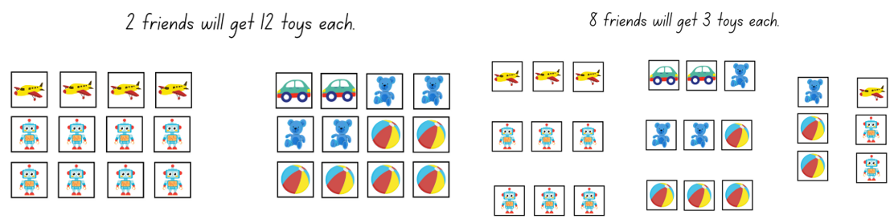
Images sourced from Canva and licensed under the Canva Content License Agreement.
- Highlight that when sharing the toy collection between 2 friends, they are halving the collection and when sharing the toy collection between 4 friends, the collection has been separated into quarters.
This table details assessment opportunities and differentiation ideas.
Assessment opportunities | Too hard? | Too easy?
What to look for:  - Can students divide a collection into halves and quarters? (MAO-WM-01, MA1-FG-01)  - Can students recognise that the more equal parts the collection is divided into, the smaller each share is? (MAO-WM-01, MA1-FG-01)  - Can students identify an equal share and unequal share? (MAO-WM-01, MA1-FG-01)  What to collect:  - recording of student discussions (MAO-WM-01, MA1-FG-01)  - annotated work sample. (MAO-WM-01, MA1-FG-01) | Students have difficulty finding equal shares.  - Model sharing a small collection of counters between 2 friends (include both a fair and unfair share). Repeat with multiple examples.  - Model sharing the toys between 2 teddies or 2 children and discuss sharing using the strategy of alternating, one at a time.  - Give students a printout of the toys to cut out and share the toys between various groups of children or teddies. | Students can share the toys equally among groups of friends and explain their thinking.  - Students investigate how many equal shares they can make with each toy and if this is at all possible.  - Show students half a collection and ask them to identify how many were in the whole collection. Repeat with quarters and eighths if appropriate.

Consolidation and meaningful practice: Examples and non-examples – 10 minutes
- Model playing a game to practise halving a collection. Player 1 rolls a 20-sided dice (or Interactive dice) and uses interlocking cubes to determine if the number rolled can be halved. If the number can be halved, without any cubes left over, the player gets a point. Repeat for Player 2. Continue playing until one player reaches 10 points.

Lesson 6: Sharing biscuits
Core concept: As the number of equal shares increases, the size of each share gets smaller.
The table below contains suggested learning intentions and success criteria. These are best co-constructed with students.
Learning intentions | Success criteria
Students are learning that:  - sharing a collection involves distributing objects equally  - as the number of equal shares increases, the size of each share gets smaller  - there is a difference between the number of groups and the number in each group. | Students can:  - recognise when a share is not equal  - notice that when the number shared with gets bigger, the quantity of the share gets smaller  - count the number of groups and the number in each group, for example, 5 groups with 4 inside each group.

Daily number sense: Domino patterns: Double and half – 10 minutes
- Build student understanding of doubling and halving groups by exploring dot patterns on dominoes.
- Display domino doubles from Resource 14: Dominoes and for each domino, cover half.
- Ask students:
- What do you see?
- If this is a double domino, how many dots are on the hidden side?
- How many dots altogether?
Note: Model the use of mathematical language, for example, double 3 is 6.
- Repeat with the remaining dominoes.
- Display the whole first domino shared again. Ask how students can work out what half of the quantity of the dot pattern is on each domino. Display each of the domino doubles again, showing the whole domino.
- Ask students:
- What do you see?
- How many dots altogether?
- How many dots are on each half of the domino?
Note: Model the use of mathematical statements, for example, half of 6 is 3.

Sharing biscuits – 35 minutes
- Show students a plate of 12 modelling clay biscuits or similar. Introduce the following scenario: Mum has baked a plate of biscuits for Georgia and Hugo.
- Ask students:
- Can you estimate how many biscuits mum has baked?
- If Mum baked 12 biscuits, how many biscuits would Georgia and Hugo get if they shared equally?
- Model sharing 12 biscuits on 2 plates and record using the ‘shared between’ sentence, ‘12 shared between 2 is 6 each’.
- Model sharing the biscuits equally between 4, 6 and 12 people.
- Explain that sometimes a collection cannot be shared equally. Model sharing 20 biscuits between 6 people and demonstrate that there are some left over.
Figure 7 – Unequal share
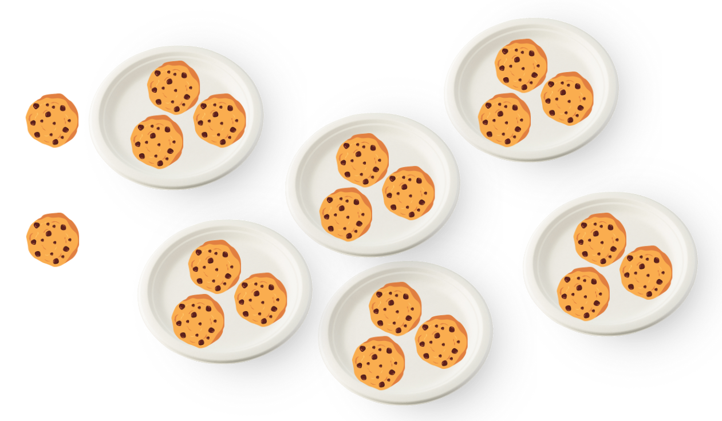
Images sourced from Canva and licensed under the Canva Content License Agreement.
- Provide pairs with counters and 6 paper plates to find different ways to share 20 cookies.
- Ask students to draw representations or write about the possibilities they discovered, noting whether the share was equal or unequal.
Figure 8 – Student work sample
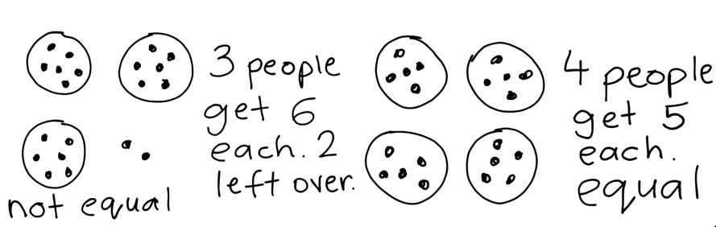
This table details assessment opportunities and differentiation ideas.
Assessment opportunities | Too hard? | Too easy?
What to look for:  - Can students use objects, arrays and diagrams to solve sharing problems? (MAO-WM-01, MA1-FG-01)  - Can students recognise when a share is equal and not equal? (MAO-WM-01, MA1-FG-01)  - Can students notice that when the number of people to share with gets bigger, the share gets smaller? (MAO-WM-01, MA1-FG-01)  - Can students count the number of groups and the number in each group? (MAO-WM-01, MA1-FG-01)  What to collect:  - work samples or drawings (MAO-WM-01, MA1-FG-01)  - evidence including photographs of student manipulation of materials (MAO-WM-01, MA1-FG-01)  - recordings of students’ discussions. (MAO-WM-01, MA1-FG-01) | Students cannot share collections equally.  - Support students to create groups and identify the amount within each group.  - Model the use of manipulatives and perceptual markers to share collections into equal groups.  - Decrease the size of the collection to be shared for example, share 8 biscuits instead of 20. | Students do not need manipulatives or perceptual markers to share collections equally.  - Students model sharing their collection without perceptual markers, for example, by using an array.  - Extend the range to further challenge students. For example, grandma made 36 biscuits. Using counters and mini whiteboards, ask students to find as many ways as possible to share the 36 biscuits. Students record their thinking to explain their findings.

Consolidation and meaningful practice: Reflection and consolidation – 15 minutes
- Students participate in a gallery walk to observe the ways 20 cookies were shared. Prompt students to share their thinking and explain how they distributed the cookies into equal and unequal groups.

Lesson 7: Is there a remainder?
Core concept: Remainders occur when a collection cannot be shared equally.
The table below contains suggested learning intentions and success criteria. These are best co-constructed with students.
Learning intentions | Success criteria
Students are learning that:  - the part leftover when a collection cannot be distributed equally is called the remainder  - collections can be shared equally in multiple ways  - collections can be distributed into halves and quarters. | Students can:  - describe the part left over or remainder when the collection cannot be shared equally  - use the term half to name one part of a collection that has been equally shared between 2 groups  - use the term quarter to name one part of a collection that has been shared equally between 4 groups.

Daily number sense: Dot collections, double and half – 10 minutes
This task has been adapted from Numerals and expressions from NZ Maths.
- Build student understanding of doubling and halving a group by using various collections of dot patterns.
- Display a selection of dot cards from Numerals and expressions: Number words [PDF 386KB].
- Ask students:
- How many dots do you see?
- If I had twice as many dots how many altogether?
- Have I doubled the collection of dots? How can we prove that happened?
Note: Model the use of mathematical language, for example, double 3 is 6.
- Display the dot cards again and ask students the following questions:
- How many dots do you see?
- If I had half as many dots, how many altogether?
- Have I halved the collection of dots? How can we prove that happened?
- Discuss if there were any collections that could not be halved.
Note: Model the use of mathematical statements. for example, half of 8 is 4.

Is there a remainder? – 40 minutes
- Refer to the previous lesson and ask students if we can share 20 biscuits equally between 3 people. Provide time for students to model the problem using counters and 3 paper plates or circles.
- Draw student attention to the 2 biscuits left over and discuss that these are referred to as remainders.
- Model taking a handful of small manipulatives, estimating how many you have and then record your response.
- Ask students if you can share your handful equally between 2.
- Model using Resource 15: Two rectangles to show how to organise and divide the handful collection into 2 equal groups. Ask students if the estimate was accurate and to notice that this time the handful was not able to be divided equally. Students record how many leftovers or remainders on the paper.
- Provide a copy of Resource 15: Two rectangles for each student and small manipulatives for them to share with a partner. Explain to students that they will take a handful of manipulatives, record an estimate of how many altogether and then divide the manipulatives into 2 equal groups. Ask students to record any adjustments made to their initial estimates and to also record if their handful was able to be divided equally or not.
- Using the same handful, ask students to attempt to organise their collection into 4 equal groups using a copy of Resource 16: Four rectangles. Ask students to record if their handful was able to be divided equally or not.
This table details assessment opportunities and differentiation ideas.
Assessment opportunities | Too hard? | Too easy?
What to look for:  - Can students describe the remainder when the collection cannot be shared equally? (MAO-WM-01, MA1-FG-01)  - Can students use the term ‘half’? (MAO-WM-01, MA1-FG-01)  - Can students use the term ‘quarter’? (MAO-WM-01, MA1-FG-01)  What to collect:  - work samples or drawings (MAO-WM-01, MA1-FG-01)  - evidence including photographs of student manipulation of materials (MAO-WM-01, MA1-FG-01)  - recordings of student discussions. (MAO-WM-01, MA1-FG-01) | Students cannot share a collection.  - Decrease the quantity of the handful using bigger manipulatives.  - Support students to create groups and identify the amount within each group.  - Model the use of manipulatives and perceptual markers as they share collections into equal groups. | Students identify and represent division in multiple ways.  - Students model sharing their collection without perceptual markers for example, by using an array.  - Extend the range to further challenge students. For example, students share their handful into 8 groups noticing if there are any left over or remainders. Ask students to name each part of a collection that has been shared into 8 equal groups with no leftovers (each part is one-eighth).

Consolidation and meaningful practice: Poster creation – 15 minutes
- Jointly construct a poster on the terms ‘half’ and ‘quarter’ (including discrete, linear and continuous models). Refer to Figure 9.
Figure 9 – Poster
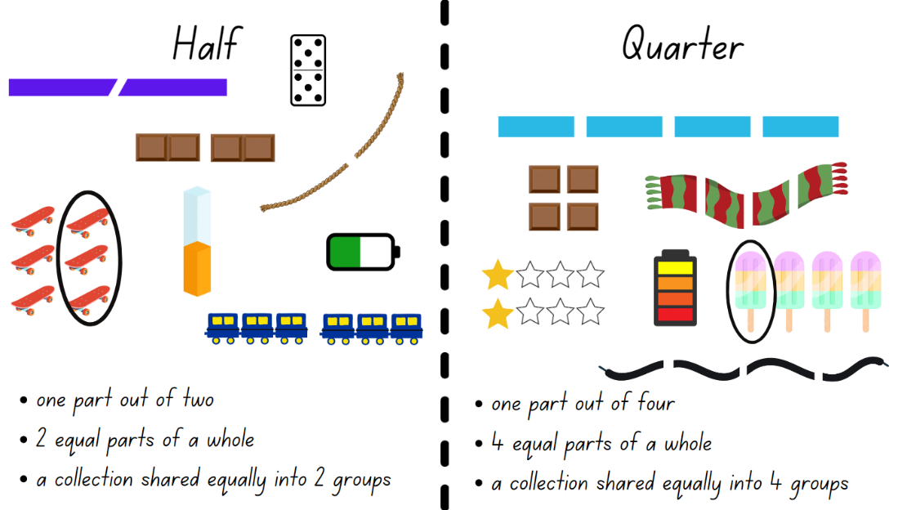
Images sourced from Canva and licensed under the Canva Content License Agreement.

Lesson 8: Halves and quarters
Core concept: Half of a half is called a quarter
The table below contains suggested learning intentions and success criteria. These are best co-constructed with students.
Learning intentions | Success criteria
Students are learning that:  - a collection of objects can be shared equally into a given number of groups  - collections can be divided into halves and quarters. | Students can:  - identify half or a quarter of a collection  - find a quarter of a collection, by halving and halving again.

Daily number sense: Number lines – 10 minutes
- Build student understanding of number lines and skip counting.
- Have students stand in a circle. The first student calls out zero and students continue around the circle counting forwards by tens. Once the number 120 is reached, the count reverses and students count backward by tens to zero.
- Draw an empty number line bounded by zero and 120 (see Figure 10).
- Ask students:
- How could we use our knowledge of skip counting by 10s to complete the number line?
- What do the blank lines represent?
- Which number would be halfway between zero and 120?
Figure 10 – Empty number line
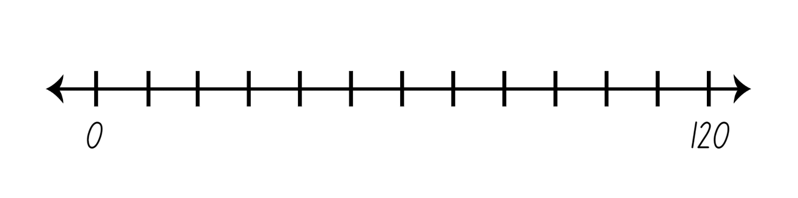

Dot decider – 40 minutes
- Display Resource 18: Dot decider. Explain to students that they are going to use their knowledge of halving or quartering a collection to create a ‘dot decider face’ (see Figure 11).
- Use ‘Talk moves’ to brainstorm a range of strategies that could be used to find a quarter of a collection, including halving and halving again.
- Demonstrate how to play the game with the red dot cards (halves).
- Place the dot cards face down on the table.
- Choose a card at random and count the total collection of dots.
- Find half the collection. Use counters or interlocking cubes to model halving the collection if needed.
- Refer to Resource 18: Dot decider and find the number that is half of your collection.
- Draw the corresponding face shape on your art paper.
- Return the card face down on the table. Repeat 4 times to create a completed dot decider face.
Note: This game can be played with the red dot cards to find half or the blue dot cards to find a quarter depending on student need.
Figure 11 – Dot decider face examples
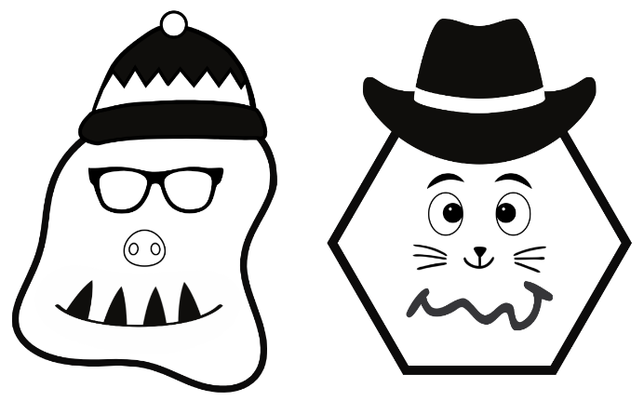
- Provide students with a copy of Resource 18: Dot decider, Resource 19: Dot cards, art paper and drawing materials.
- Students create their own dot decider artwork.
- Students go on a gallery walk to see the varying artworks that have been created.
This table details assessment opportunities and differentiation ideas.
Assessment opportunities | Too hard? | Too easy?
What to look for:  - identify half or a quarter of a collection (MAO-WM-01, MA1-FG-01)  - find a quarter of a collection, by halving and halving again (MAO-WM-01, MA1-FG-01)  What to collect:  - student drawings (MAO-WM-01, MA1-FG-01)  - recordings of student discussions. (MAO-WM-01, MA1-FG-01) | Students cannot partition a collection into halves.  - Support students to create groups and identify the amount within each group.  - Encourage students to check the 2 parts are equal by superimposing one part on top of the other.  - Provide students with scaffolds for recording their thinking. For example, give students a picture of 2 people to mark the groups. | Students can partition a collection into halves.  - Provide students with the blue dot cards to find a quarter of a collection.

Consolidation and meaningful practice: Double or halve? – 10 minutes
This task has been adapted from Double or Halve? from NRICH and Double or halve? – Stage 1 (7:37) from Mathematics K-6 resources by NSW Department of Education.
- Consolidate student understanding of doubling and halving by playing the game ‘Double or halve?’ from Lesson 1.
- In pairs, provide students with a 6-sided dice and a copy of Resource 1: Blank number chart and revise the rules of the game.
- After a few rounds ask:
- Did you use a specific strategy to help you win a round?
- Are there any moves you would change?
- Would you halve the number instead of doubling the number next time so you could win? Why?
- How did you choose the target number each round?
- If you also had the option to keep your roll without doubling or halving the number, do you think this would make it easier to reach the target number? Why?

Resource 1: Blank number chart
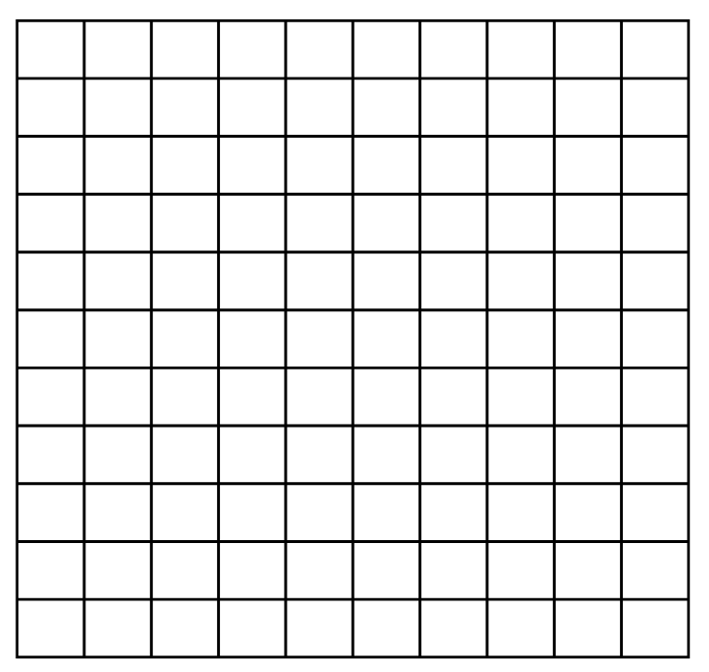

Resource 2: Trains
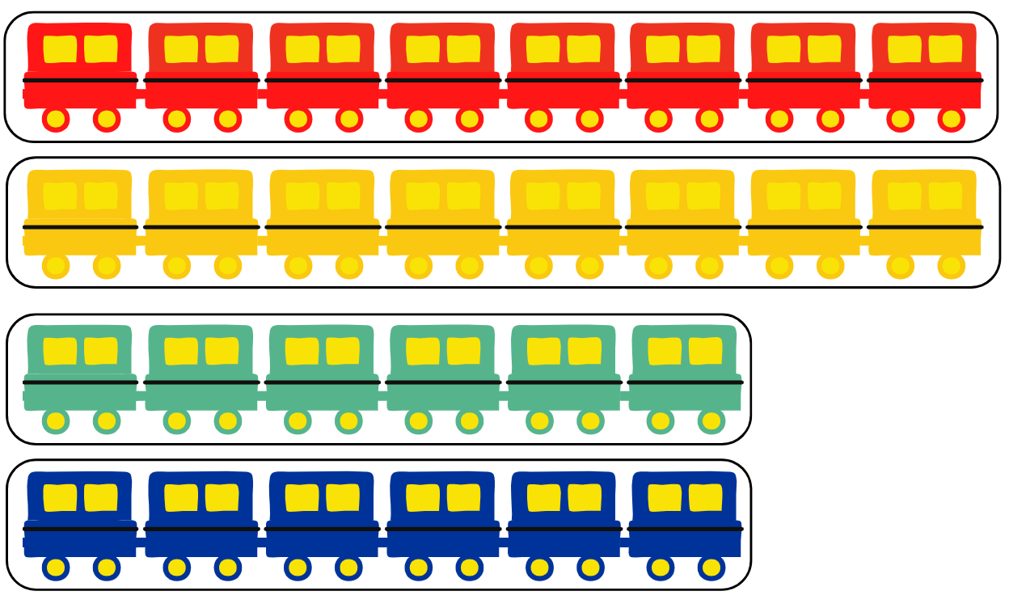
Images sourced from Canva and licensed under the Canva Content License Agreement.

Resource 3: Number line 0–12
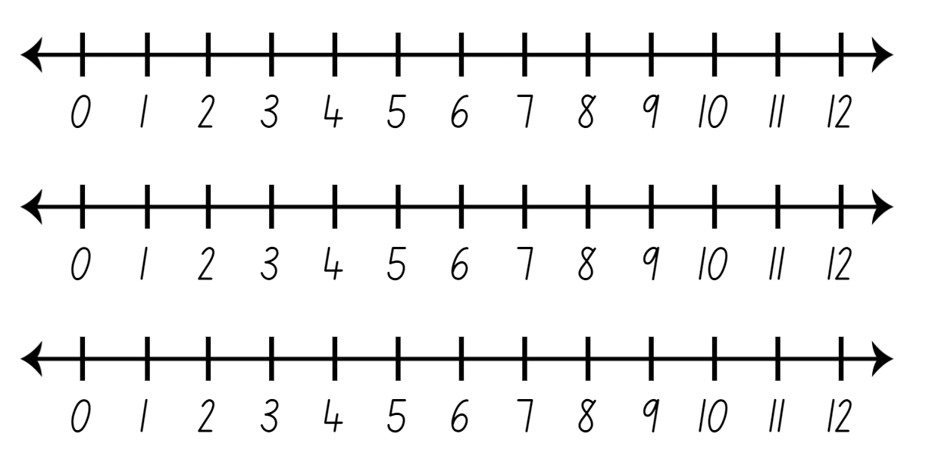

Resource 4: 120 number chart
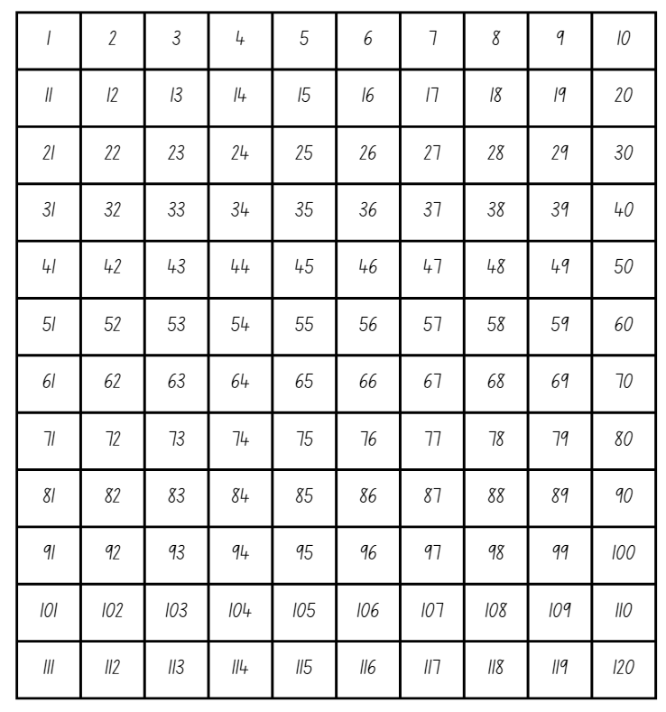

Resource 5: Fraction bars
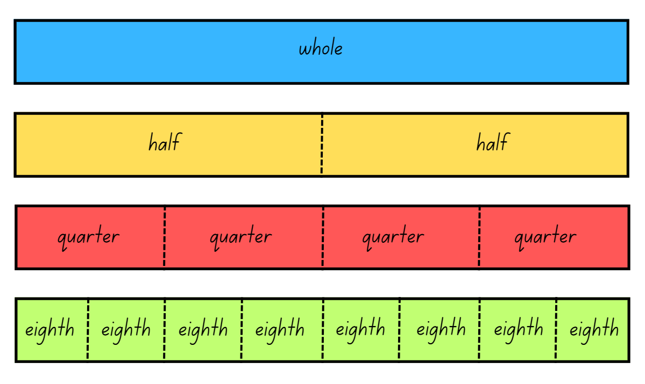

Resource 6: Fraction bars blank

Resource 7: Fraction bar puzzle
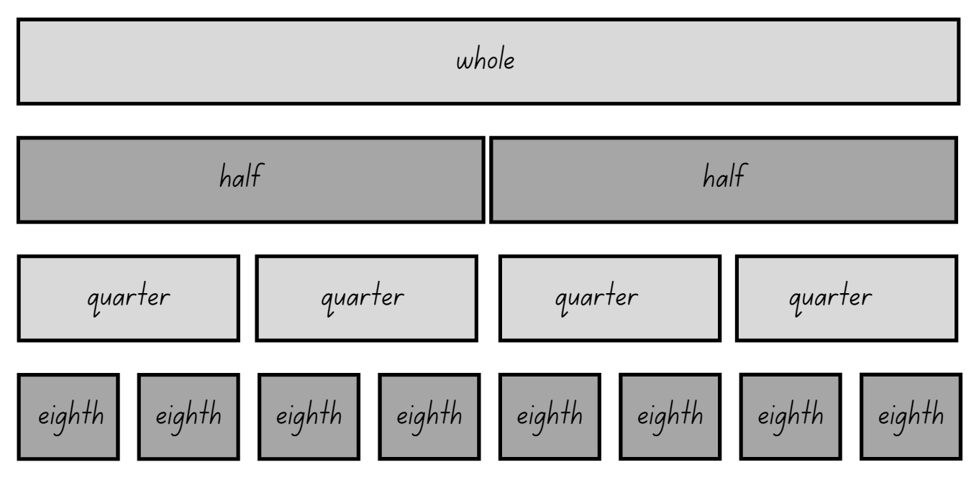

Resource 8: Breadstick
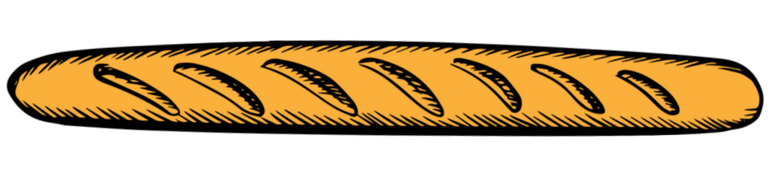
‘Bread Stick Icon’ by Vectortradition is licensed under the Canva Content License Agreement.

Resource 9: Animal line
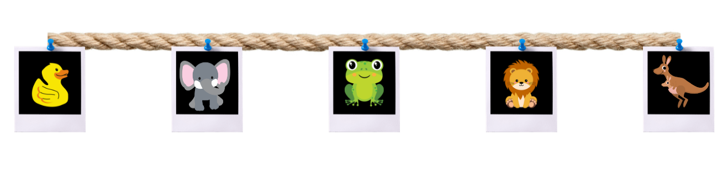
Images sourced from Canva and licensed under the Canva Content License Agreement.

Resource 10: Animal line 2
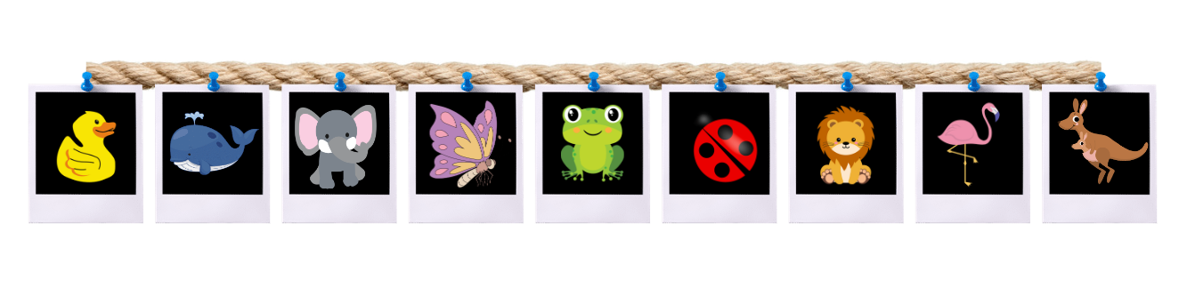
Images sourced from Canva and licensed under the Canva Content License Agreement.

Resource 11: Stick the tail on the donkey
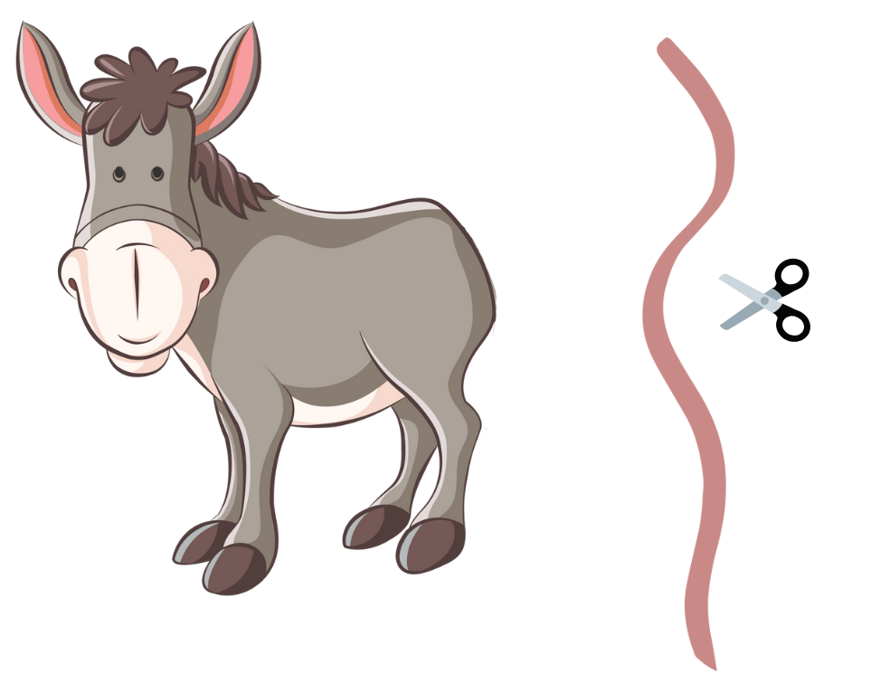
‘Illustration of a Donkey’ by Petergiese under the Canva Content License Agreement.

Resource 12: Toy box
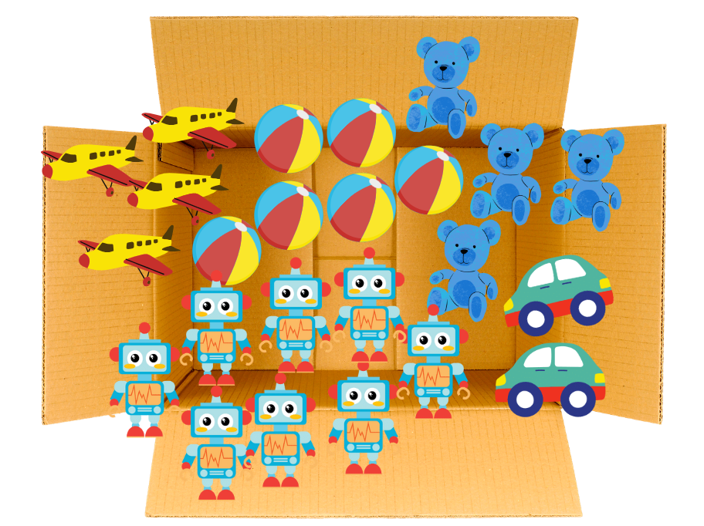
Images sourced from Canva and licensed under the Canva Content License Agreement.

Resource 13: Toys
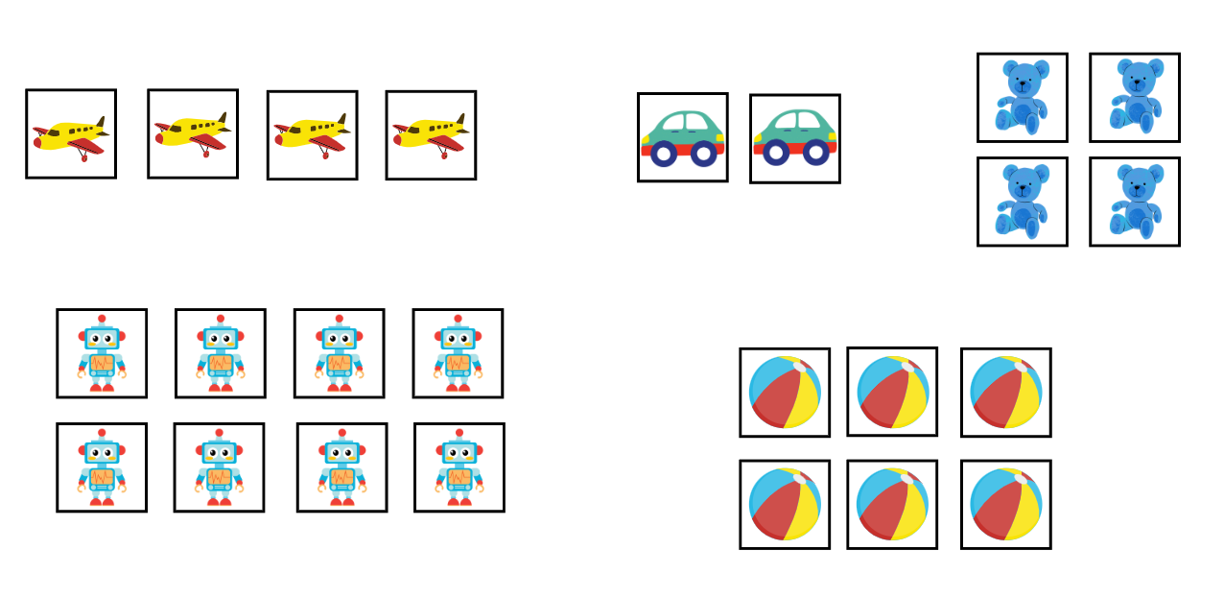
Images sourced from Canva and licensed under the Canva Content License Agreement.

Resource 14: Dominoes
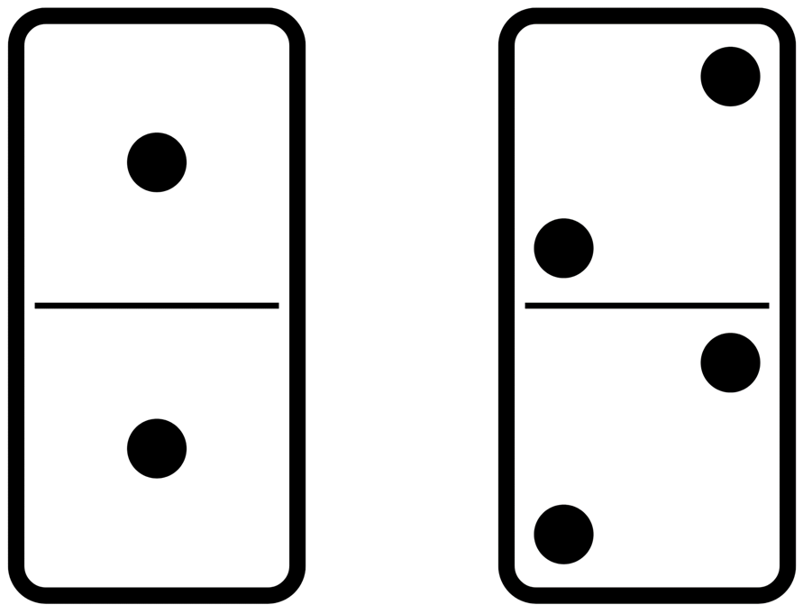
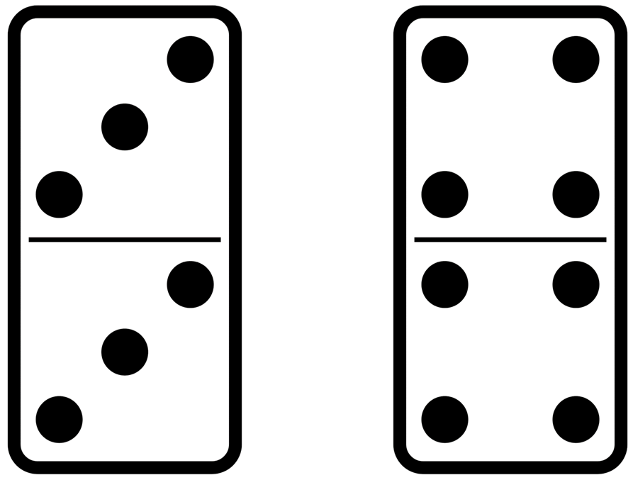
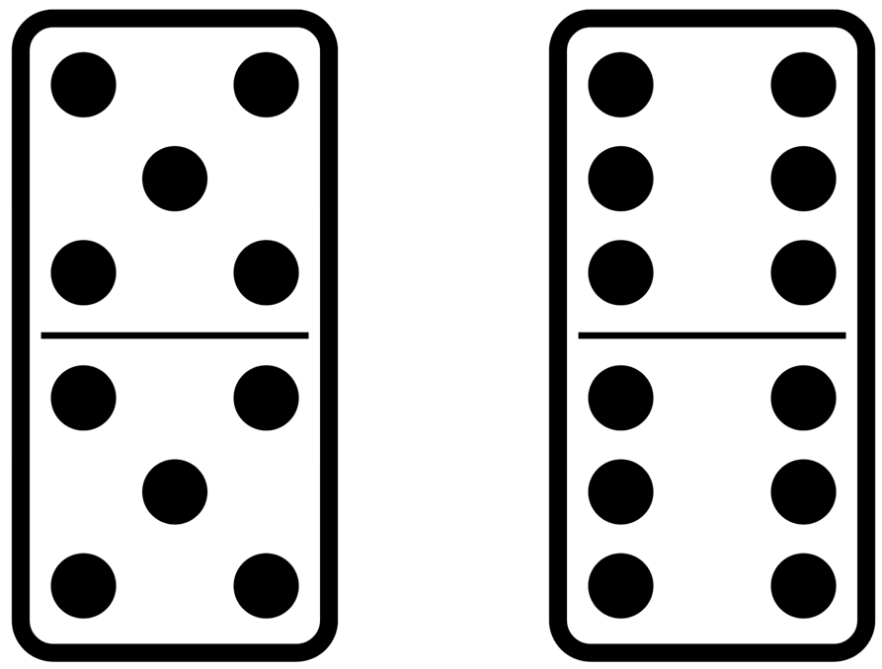
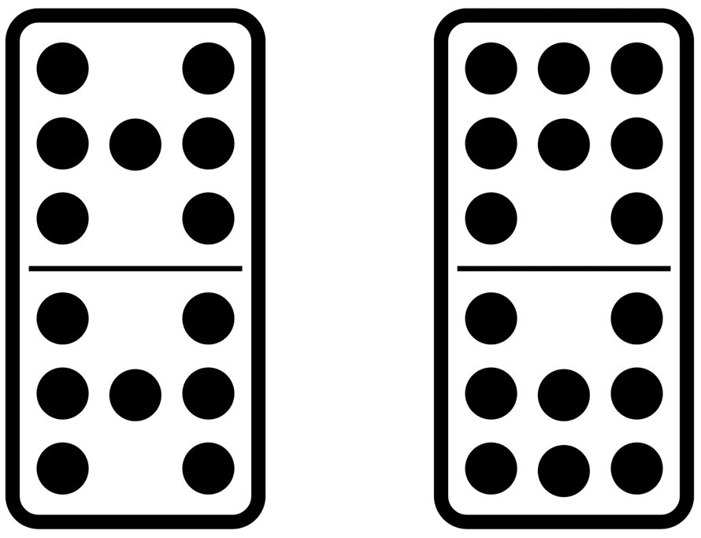

Resource 15: Two rectangles

Resource 16: Four rectangles

Resource 17: Number lines 0-20
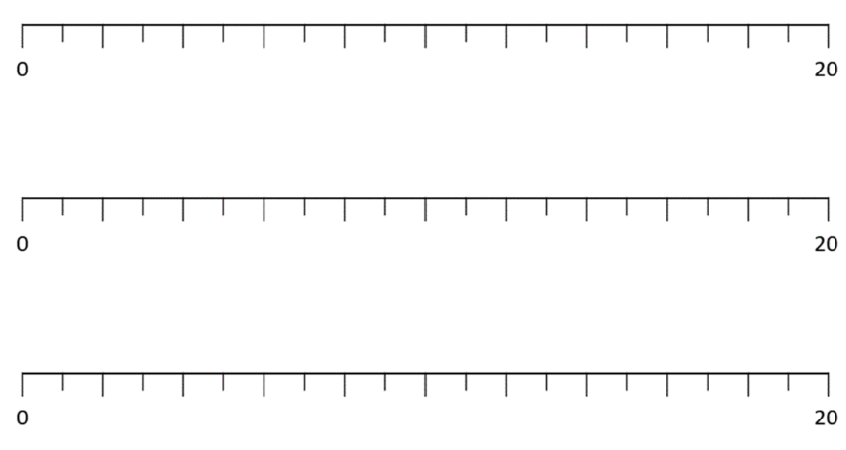

Resource 18: Dot decider
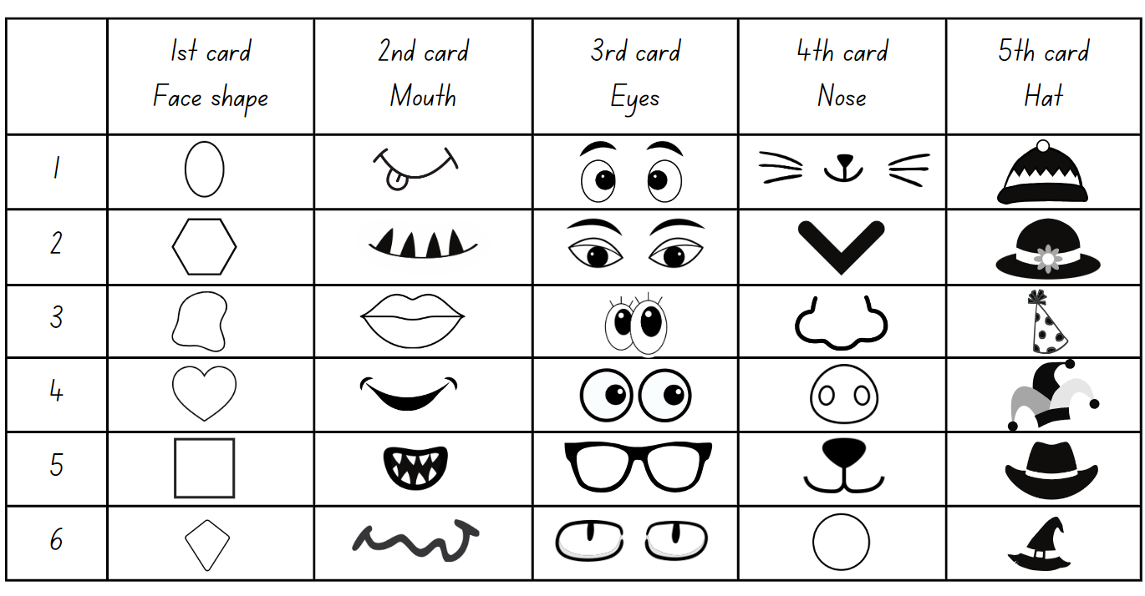
Images sourced from Canva and licensed under the Canva Content License Agreement.

Resource 19: Dot cards
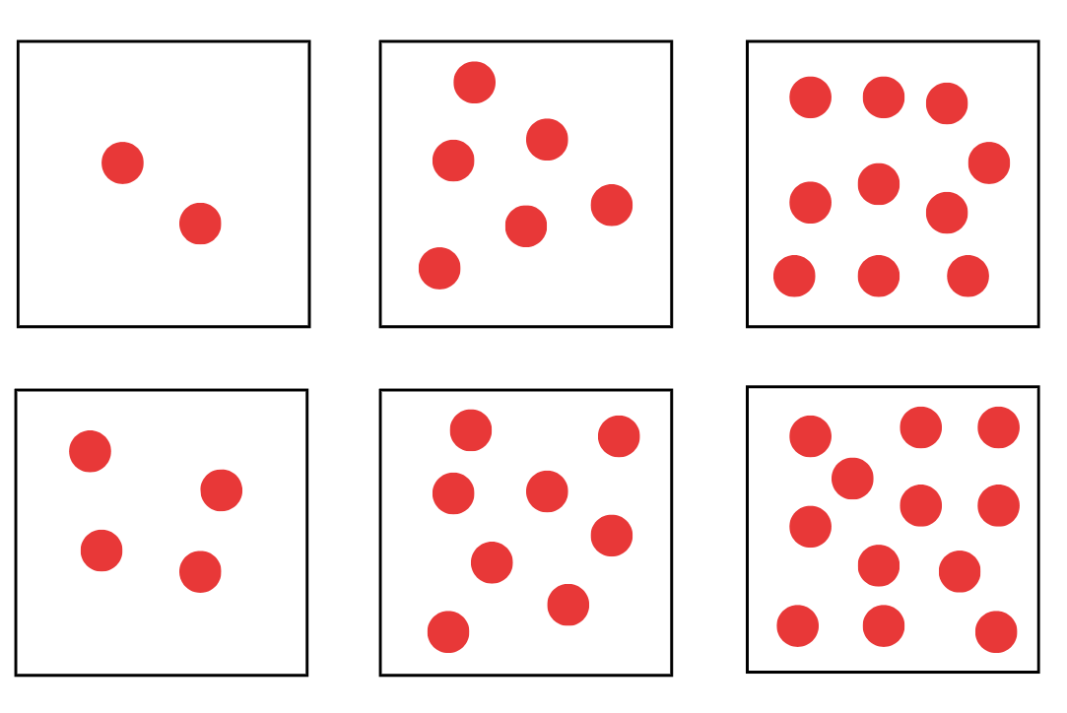
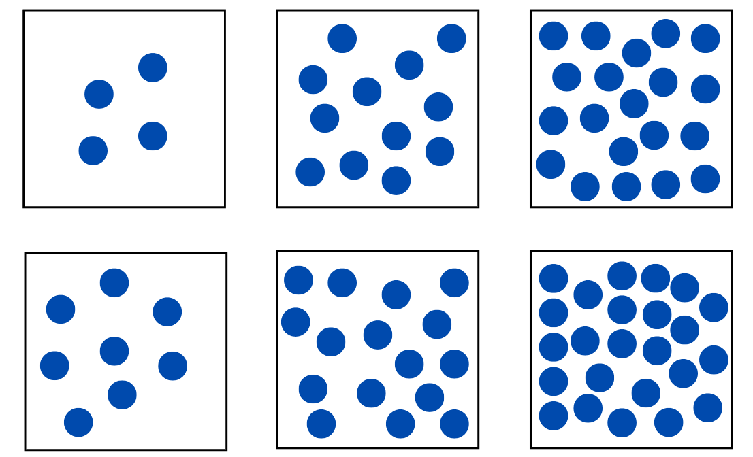

Syllabus outcomes and content
The table below outlines the syllabus outcomes and range of relevant syllabus content covered in this unit. Content is linked to National Numeracy Learning Progression version (3).
Focus area and outcomes | Content groups and content points | Lessons
Representing whole numbers A  MAO-WM-01  MA1-RWN-01  MA1-RWN-02 | Use counting sequences of ones with two-digit numbers and beyond  - identify the number before and after a given two-digit number (CPr5)  - count forwards and backwards by ones from a given number to at least 120 (CPr6)  Continue and create number patterns  - model and describe 'odd' and 'even' numbers using items paired in two rows  - count forwards and backwards by twos from any starting point (CPr6-CPr7, MuS2)  Represent numbers on a line  - sequence numbers and arrange them on a line by considering the order and size of those numbers  Represent the structure of groups of ten in whole numbers  - recognise that ten ones is the same as one ten (QuN7)  - partition two-digit numbers to show quantity values (NPV4) | 1–3, 5, 8
Representing whole numbers B  MAO-WM-01  MA1-RWN-01  MA1-RWN-02 | Use counting sequences of ones and tens flexibly  - count forwards and backwards by tens, on and off the decade, with two- and three-digit numbers (CPr7) | 3
Forming groups A  MAO-WM-01  MA1-FG-01 | Recognise and represent division  - use concrete materials to model a half of a collection and show the relation between the half and the whole (CoU1, InF1)  - model sharing division by distributing a collection of objects equally into a given number of groups to determine how many in each group (MuS5)  - model grouping division by determining the number of groups of a given size that can be formed (MuS5)  - describe the part left over when a collection cannot be distributed equally using the given group size | 1–8
Forming groups B  MAO-WM-01  MA1-FG-01 | Model doubling and halving with fractions  - model doubling and halving groups and the relation between the processes (InF1)  - re-create the whole given half (InF1)  - use concrete materials to model a half, a quarter or an eighth of a collection, and explain their thinking (InF1) | 1–2, 4–8
Geometric measure A  MAO-WM-01  MA1-GM-01  MA1-GM-02  MA1-GM-03 | Length: Compare lengths using uniform informal units  - explain why the length of an object remains constant when rearranged (Reasons about relations)  Lengths: Subdivide lengths to find halves and quarters  - use concrete materials to model both half and quarters of a whole length, highlighting the length (InF1, InF2)  - identify two equal lengths and the relationship of the parts to the whole length, linking words and images (InF1, InF2)  - recognise when lengths have or have not been divided into halves and quarters (InF1, InF2) | 1–4
Geometric measure B  MAO-WM-01  MA1-GM-01  MA1-GM-02  MA1-GM-03 | Length: Recognise and use formal units to measure the lengths of objects  - recognise that there are 100 centimetres in one metre  Lengths: Repeatedly halve lengths to form eighths  - use materials to model an eighth of a whole length, highlighting the length (InF2)  - recognise when a length is divided into eight equal parts (InF2) | 2–3

References
Links to third-party material and websites
Please note that the provided (reading/viewing material/list/links/texts) are a suggestion only and implies no endorsement, by the New South Wales Department of Education, of any author, publisher, or book title. School principals and teachers are best placed to assess the suitability of resources that would complement the curriculum and reflect the needs and interests of their students.
If you use the links provided in this document to access a third-party's website, you acknowledge that the terms of use, including licence terms set out on the third-party's website apply to the use which may be made of the materials on that third-party website or where permitted by the Copyright Act 1968 (Cth). The department accepts no responsibility for content on third-party websites.
Except as otherwise noted, all material is © State of New South Wales (Department of Education), 2023 and licensed under the Creative Commons Attribution 4.0 International License. All other material (third-party material) is used with permission or under licence. Where the copyright owner of third-party material has not licensed their material under a Creative Commons or similar licence, you should contact them directly for permission to reuse their material.
Mathematics K–10 Syllabus © 2022 NSW Education Standards Authority (NESA) for and on behalf of the Crown in right of the State of New South Wales.
© 2022 NSW Education Standards Authority. This document contains NSW Curriculum and syllabus content. The NSW Curriculum is developed by the NSW Education Standards Authority. This content is prepared by NESA for and on behalf of the Crown in right of the State of New South Wales. The material is protected by Crown copyright.
Please refer to the NESA Copyright Disclaimer for more information.
NESA holds the only official and up-to-date versions of the NSW Curriculum and syllabus documents. Please visit the NSW Education Standards Authority (NESA) website and the NSW Curriculum website.
National Numeracy Learning Progression © Australian Curriculum, Assessment and Reporting Authority (ACARA) 2010 to present, unless otherwise indicated. This material was downloaded from the Australian Curriculum website (National Numeracy Learning Progression) (accessed 24 October 2022) and was not modified. The material is licensed under CC BY 4.0. Version updates are tracked in the ‘Curriculum version history’ section on the 'About the Australian Curriculum' page of the Australian Curriculum website.
ACARA does not endorse any product that uses the Australian Curriculum or make any representations as to the quality of such products. Any product that uses material published on this website should not be taken to be affiliated with ACARA or have the sponsorship or approval of ACARA. It is up to each person to make their own assessment of the product, taking into account matters including, but not limited to, the version number and the degree to which the materials align with the content descriptions and achievement standards (where relevant). Where there is a claim of alignment, it is important to check that the materials align with the content descriptions and achievement standards (endorsed by all education Ministers), not the elaborations (examples provided by ACARA).
Gould P (2013) ‘Australia’s next top fraction model’, Australian Primary Mathematics Classroom, 18(3):5–12, accessed 17 August 2023.
McDonough A and Sullivan P (2011) ‘Learning to Measure Length in the First Three Years of School’, Australasian Journal of Early Childhood, 36(3):27–35, doi:https://doi.org/10.1177/183693911103600305, accessed 21 August 2023.
New Zealand Ministry of Education (n.d) ‘Numerals and expressions’, Resource Finder, NZ Maths website, accessed 24 October 2022.
New Zealand Ministry of Education (n.d) Numerals and expressions: Number words [PDF 386KB], NZ Maths website, accessed 25 October 2022.
State of Victoria (Department of Education and Training) (2018) ‘Modelling through think alouds’, Literacy Teaching Toolkit, Department of Education and Training website, accessed 24 October 2022.
Toy Theater (2023) Dice, Toy Theater website, accessed 17 August 2023.
University of Cambridge (Faculty of Mathematics) (2022) Cuisenaire Environment, NRICH website, accessed 24 October 2022.
University of Cambridge (Faculty of Mathematics) (2022) Double or Halve?, NRICH website, accessed 24 October 2022.
University of Cambridge (Faculty of Mathematics) (2022) Halving, NRICH website, accessed 24 October 2022.
University of Cambridge (Faculty of Mathematics) (2022) Paper Halving, NRICH website, accessed 24 October 2022.
University of Cambridge (Faculty of Mathematics) (2022) What Do You See Here?, NRICH website, accessed 24 October 2022.

