Mathematics – Stage 1 – Unit 14
Contents
Unit description and duration 4
Student prior learning 4
Lesson overview and resources 5
Lesson 1: Jump, jump, jump! 11
Daily number sense: Secret jumps! – 15 minutes 11
Jump, jump, jump! – 60 minutes 12
Consolidation and meaningful practice: More secret jumps! – 5 minutes 16
Lesson 2: Comparing lengths 17
Daily number sense: How far does my car roll? – 20 minutes 17
Brush loads – 40 minutes 19
Consolidation and meaningful practice: How tall? – 10 minutes 26
Lesson 3: Wrapping presents 27
Daily number sense: Dicey arrays – 20 minutes 27
Wrapping boxes – 45 minutes 29
Consolidation and meaningful practice: How many arrays? – 5 minutes 32
Lesson 4: Cover it! 33
Daily number sense: Away with arrays! – 15 minutes 33
Cover it! – 40 minutes 36
Consolidation and meaningful practice: Forwards and backwards – 5 minutes 38
Lesson 5: Building and packing! 39
Daily number sense: Beads – 15 minutes 39
Fun with blocks – 20 minutes 41
Pack it! – 25 minutes 44
Consolidation and meaningful practice: Big and small cubes – 10 minutes 45
Lesson 6: Thirsty! 46
Daily number sense: Lots of beads! – 15 minutes 46
Thirsty! – 40 minutes 48
Consolidation and meaningful practice: Away with arrays! – 10 minutes 51
Lesson 7: Mass – Looks can be deceiving 51
Daily number sense: Pick 2, pick 3! – 10 minutes 52
Tricky party bags – 45 minutes 53
Discuss and connect the mathematics – 5 minutes 56
Lesson 8: Heavier, lighter or the same? 57
Daily number sense: Teacher identified activity – 15 minutes 57
Weighing balls and worms – 30 minutes 58
Consolidation and meaningful practice: Comparing and ordering – 15 minutes 60
Resource 1: Number line 63
Resource 2: Brush loads data 64
Resource 3: Mug and monkey 65
Resource 4: Array cards 66
Resource 5: Pencil case 67
Resource 6: Number chart 68
Resource 7: Thirsty picture cards 69
Resource 8: Thirsty clue cards 71
Resource 9: Thirsty easy clues 72
Resource 10: Place markers 73
Resource 11: Thirsty hard clues 74
Resource 12: Zero to nine 75
Resource 13: Mass discussion cards 76
Syllabus outcomes and content 77
References 86
Further reading 88

Unit description and duration
This two-week unit introduces students to measurement using uniform informal units. Students are provided opportunities to:
- compare, order and match using informal units of measurement
- estimate whether a measurement is reasonable
- consider how selection of measuring unit affects accuracy
- explore conservation of length, area, volume and mass.
Mathematics K–10 Syllabus © 2022 NSW Education Standards Authority (NESA) for and on behalf of the Crown in right of the State of New South Wales.

Student prior learning
Before engaging in these teaching and learning activities, students would benefit from prior experience with:
- making direct comparisons with measurement, for example, hefting and superimposing
- using everyday language to compare, such as lighter-heavier, longer-shorter, wider-thinner, bigger-smaller, farther-nearer
- using mathematical language of length, area, mass and volume through play with informal units such as craft sticks, blocks, clay, water, sand
- recognising and sorting objects by length, area, mass and volume
- exploring properties of common shapes such as squares and rectangles through play.

Lesson overview and resources
The table below outlines the sequence and approximate timing of lessons; syllabus focus areas and content groups; and resources.
Lesson | Syllabus focus area and content groups | Resources
Lesson 1: Jump, jump, jump!  80 minutes  Jumps can be used to solve number and length problems. | Representing whole numbers A  - Represent numbers on a line  Combining and separating quantities A  - Use advanced count-by-one strategies to solve addition and subtraction problems  Geometric measure A  - Length: Measure the lengths of objects using uniform informal units  - Length: Compare lengths using uniform informal units  Geometric measure B  - Length: Compare and order lengths, using appropriate uniform informal units | - Resource 1: Number line  - Counters  - Large number of beads or other uniform informal unit (such as blocks)  - String  - Writing materials
Lesson 2: Comparing lengths  70 minutes  Units of measurement can be used to measure length and area. | Representing whole numbers A  - Represent numbers on a line  Geometric measure A  - Length: Measure the lengths of objects using uniform informal units  - Length: Compare lengths using uniform informal units  Geometric measure B  - Length: Compare and order lengths, using appropriate uniform informal units | - Resource 2: Brush loads table  - Resource 3: Mug and monkey  - A few small toy cars or other toys on wheels  - Blocks  - Interlocking cubes  - Metre ruler  - Thick pieces of cardboard  - Writing materials
Lesson 3: Wrapping presents  70 minutes  Using consistent units of measurement enables comparison. | Forming groups B  - Represent and explain multiplication as the combining of equal groups  Two-dimensional spatial structure A  - Area: Measure areas using uniform informal units  Two-dimensional spatial structure B  - Area: Compare rectangular areas using uniform square units of an appropriate size in rows and columns | - 9-sided dice  - Counters  - Different sized boxes  - Timer  - Wrapping paper  - Writing materials
Lesson 4: Cover it!  60 minutes  Different surfaces can have the same area. | Forming groups B  - Represent and explain multiplication as the combining of equal groups  Two-dimensional spatial structure A  - Area: Measure areas using uniform informal units  Two-dimensional spatial structure B  - Area: Compare rectangular areas using uniform square units of an appropriate size in rows and columns | - Resource 4: Array cards  - Resource 5: Pencil case  - Resource 6: Number chart  - 6-sided dice  - Counters  - Sticky notes  - Pattern blocks  - Writing materials
Lesson 5: Building and packing  70 minutes  Capacities can be measured, compared and ordered by packing with uniform informal units. | Representing whole numbers A  - Represent the structure of groups of ten in whole numbers  Three-dimensional spatial structure A  - Volume: Measure the internal volume (capacity) of containers by packing  Three-dimensional spatial structure B  - Volume: Compare containers based on internal volume (capacity) by filling and packing  - Volume: Compare volumes using uniform informal units | - Classroom objects  - Beads  - Interlocking cubes  - Boxes and cylinders of various sizes  - Writing materials
Lesson 6: Thirsty!  65 minutes  Different shaped containers can have the same volume. | Representing whole numbers A  - Represent numbers on a line  Representing whole numbers B  - Use counting sequences of ones and tens flexibly  Three-dimensional spatial structure A  - Volume: Measure and compare the internal volumes (capacities) of containers by filling | - Resource 6: Number chart  - Resource 7: Thirsty picture cards  - Resource 8: Thirsty clue cards  - Resource 9: Thirsty easy clues  - Resource 10: Place markers  - Resource 11: Thirsty hard clues  - 6-sided dice  - Large number of beads (between 20 and 50)  - Pieces of string  - Short wide glass  - Tall thin glass
Lesson 7: Mass – Looks can be deceiving  60 minutes  Objects can look different but have the same mass. | Representing whole numbers A  - use counting sequences of ones with two-digit numbers and beyond  Representing whole numbers B  - use counting sequences of ones and tens flexibly  Non-spatial measure  - measures, records, compares and estimates the masses of objects using uniform informal units | - Resource 12: Zero to nine  - Resource 13: Mass discussion cards  - Classroom objects  - Equal-arm balance  - Paper bags
Lesson 8: Heavier, lighter or the same?  60 minutes  Different objects can have the same mass | Non-spatial measure  - Mass: Compare the masses of objects using an equal-arm balance | - Beads or blocks  - Cylindrical object such as cans  - Modelling clay  - Shoebox or lunchbox lids  - Tape

Lesson 1: Jump, jump, jump!
Core concept: Jumps can be used to solve number and length problems.
The table below contains suggested learning intentions and success criteria. These are best co-constructed with students.
Learning intentions | Success criteria
Students are learning that:  - estimating and measuring allows them to compare, match and order lengths  - choice of measuring unit affects accuracy when measuring length. | Students can:  - estimate a length and check by measuring  - think about choice of uniform informal units of measurement to compare lengths of objects  - reason whether they have measured a length accurately by avoiding spaces and overlaps and measuring in a straight line.

Daily number sense: Secret jumps! – 15 minutes
This activity is adapted from Number Lines from NRICH (2022).
- Build student understanding of number by taking jumps on a number line.
- Introduce the scenario: Kyra and Finn both have number lines and a counter. They always start with their counters at zero. Kyra's number line goes from left to right. First, Kyra made a jump of 3 and then she made a jump of 4. Ask students where they think Kyra landed and how they know. Check using Resource 1: Number line and a counter to show the jumps and the finishing position of 7.
- Explain that Kyra then went back to zero and made a jump of 6 and another secret jump. She landed on 10. Ask students to explain how they could find out what the secret jump was. Check students’ thinking using the number line and a counter.
- Explain that next, Kyra went back to zero and made a secret jump along her number line. Then she made a jump of 5 and landed on 9. Ask how long Kyra’s secret jump was. Ask students how they could work out what the secret jump was. Use the number line to check that the missing number is 4.
- Explain that Finn wanted a go too! He made a secret jump and then a jump of 11 and then another secret jump to land on 16. Ask students what Finn's secret jumps could be and what strategies they used to work it out. Check students’ thinking using the number line and counters.
- In pairs, students use Resource 1: Number line and counters to play the game. Partner A tells Partner B their known jump and their final destination. Partner B works out the secret jump or jumps, describes the strategy used to Partner A and proves their thinking using the number line and a counter.

Jump, jump, jump! – 60 minutes
These activities have been adapted from Boaler et al. (2021) and Measurement: Jump! from reSolve (2022).
Note: Students should be instructed to wear suitable clothing, including appropriate footwear. All physical activity should be preceded by a warm-up and stretching.
- Show students a string of 3 beads or 3 blocks. Ask what items in the classroom might be 3 beads or blocks long. Allow time for thinking and discussion. Have students retrieve one item that they think is 3 beads or blocks long and discuss how they might prove that it is 3 beads or blocks long. Compare each item to 3 beads or blocks. Discuss estimates and any challenges faced.
- Ask students the following questions:
- How far can you jump?
- Is it easier to jump with 2 feet together or from one foot?
- Does it help to have a running start?
- In what ways have you seen athletes jump?
- Explain that students are going to estimate and then measure how far they can jump. Jumps will be measured using uniform informal units such as beads or blocks of the same length.
- Show students a length of around one metre made from uniform informal units of measure such as beads or blocks. Ask students to estimate how far they can jump using:
- both feet from standing
- one foot from standing
- one foot with a run up.
- Students turn and talk to discuss estimates. Allow students to revise estimates if necessary. Discuss as a class and allow students to revise again if necessary.
- Using a suitable outdoor space, allow students 3 attempts for each type of jump. Indicate a clear starting line for jumps. Place a line of uniform informal units adjacent to the jumping area for measuring jumps. Ask students how the units could be organised to make counting easier. For example, beads may be placed in groups of 10, either by colour or threaded on string. Measurements are taken from the starting point to the back of the foot. Students record their measurements for each jump.
- Discuss results. Ask questions such as:
- Which method of jumping allowed you to jump the furthest? Why do you think this was so?
- How long was your longest jump?
- How long was your shortest jump?
- What was the difference between your longest and shortest jumps in each category?
- What was the difference between your longest and shortest jumps across all categories?
- How did your jumps compare to your estimates?
- Do you think your measurements were accurate? Why or why not?
- Were beads/blocks appropriate uniform informal units of measurement for this activity? Why or why not?
- Show students pre-cut lengths of string showing current men’s and women’s long jump world records. Have students estimate how many units of blocks or beads would be required to measure those jumps. In groups, create lengths of units to replicate both world records. Mark a common starting point and use repeated lengths of beads or blocks as necessary. Remind students that the units must be placed in a straight line, with no gaps or overlaps. Compare the lengths showing the men’s and women’s records. Ask which is longer and by how much.
This table details assessment opportunities and differentiation ideas.
Assessment opportunities | Too hard? | Too easy?
What to look for:  - Can students find an object that is around 3 beads or 3 blocks long and check the length? (MAO-WM-01, MA1-GM-02)  - Can students estimate and accurately measure length of jumps? (MAO-WM-01, MA1-GM-02)  - Can students find differences in lengths? (MAO-WM-01, MA1-CSQ-01)  - Did students make reasoned statements about suitability of units of measurement? (MAO-WM-01, MA1-GM-02)  What to collect:  - student recordings of lengths jumped and differences between longest and shortest jumps (MAO-WM-01, MA1-CSQ-01, MA1-GM-02).  - teacher photographs and observational records (MAO-WM-01, MA1-CSQ-01, MA1-GM-02) | Students cannot work out the differences between their shortest and longest jumps.  - Student makes a length of beads or blocks to match the longest jump and then the shortest jump.  - Place bead or block lengths next to each other and count on from the shortest length to find the difference.  - Model strings of 10 beads or blocks in one colour and then another colour and so on and then single beads or blocks at the end. This should help students visualise 10 as a reference when finding a length. | Students accurately measure all jumps and answer questions.  - Students compare answers to questions with a partner or in a small group.  - Students work out the difference between their jump lengths and current long jump world records.  - Students find lengths around school that are about the same length as current long jump world records.

Consolidation and meaningful practice: More secret jumps! – 5 minutes
- Ask students:
- I make a secret jump and then a jump of 7 and I land on the number 13. What was my secret jump?
- I jump 7 and then make 2 secret jumps and land on 13. What could my secret jumps have been?
- I make a secret jump, then a jump of 5 and then another secret jump and I land on 17. What could my secret jumps have been?

Lesson 2: Comparing lengths
Core concept: Units of measurement can be used to measure length and area.
The table below contains suggested learning intentions and success criteria. These are best co-constructed with students.
Learning intentions | Success criteria
Students are learning that:  - measuring allows them to compare and order lengths and areas  - estimating can be used to decide if a measurement of length is reasonable  - a number line can be used to find multiples of 10 before and after a given number. | Students can:  - visually estimate if a measurement is reasonable  - compare and order measurements by using the same informal unit  - use a number line to find the multiples of 10 before and after a given number.

Daily number sense: How far does my car roll? – 20 minutes
- Build student understanding of multiples of 10 by measuring and comparing lengths.
- Make a ramp with a piece of thick cardboard. From the bottom of the ramp, place blocks in a line to the side to measure roll lengths using uniform informal units.
- Put a car or other toy with wheels at the top of the ramp. Estimate how far the car will travel in blocks and let it go. Count the number of blocks the car goes past. As a class, decide where each car roll will be measured from to maintain consistency of finish points. Take the total number of blocks and find it on a metre ruler used as a number line. Mark the spot with a counter. Then state the multiples of 10 before and after the finish point. For example, a roll of 47 would give 40 and 50.
- In groups, students repeat the process with a few different cars. Observe students finding the length travelled by the car in blocks and stating the multiples of 10 before and after.
- At the end, ask students:
- Which car rolled the furthest? How far was this?
- Which car went the shortest length? How far was this?
- Can anyone work out the jump size between the shortest and furthest lengths?
- What was the biggest multiple of 10 found?
- What was the smallest multiple of 10 found?
- Can anyone think of a way to organise the blocks so the distance travelled can be measured more quickly?
This table details assessment opportunities and differentiation ideas.
Assessment opportunities | Too hard? | Too easy?
What to look for:  - Can students work out the lengths travelled in blocks? (MAO-WM-01, MA1-GM-02)  - Do students accurately state the multiples of 10 before and after each distance? (MA1-RWN-01)  What to collect:  - observational records of students stating multiples of 10 (MA1-RWN-01)  - photographs of metre rulers with counters marking distances (MA1-GM-02) | Students cannot count large numbers of blocks or find multiples of 10.  - Roll some objects that move a shorter distance such as a pencil or paper roll so there are less blocks to count.  - Place blocks in groups of 10 in different colours so that students can count in tens and then add the ones at the end.  - Model moving a counter forward and then back from the finish point to find the multiples of 10. | Students accurately measure lengths rolled and state multiples of 10.  - Students state the next 3 multiples of 10 before and after each roll.  - Students experiment with the angle of the ramp and observe how it affects distances travelled by cars.

Brush loads – 40 minutes
This activity is adapted from Brush Loads from NRICH (2022).
- Give each student an interlocking cube and explain that they will work out how to paint it in their favourite colour. Ask how many faces they can see to paint if they hold it in the air. They can paint 6 faces. Ask how many faces they could paint if they put the cube on a surface. Now they can paint 5 faces. This is called 5 brush loads. Highlight that one brush load will paint one square face.
- Turn the cube over and count how many brush loads are needed now. Students will still need 5 brush loads.
- Give students another interlocking cube so they can join them together to make a tower. Show students 2 cubes joined together in a tower as in Figure 1.
Figure 1 – 2 cube tower
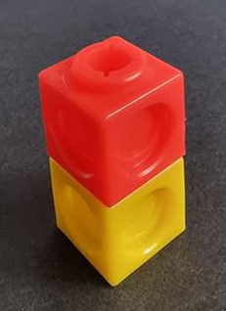
- Ask students to place their tower in this vertical orientation on a surface and estimate how many brush loads they would need if they paint the faces that can be seen. Revise that one brush load will paint one square face. Check estimates by finding all surfaces that require a brush load. Students can rotate their tower to count faces on all sides but must not count the bottom of the tower, that is, the face touching the surface. Students need 9 brush loads for this tower. Record the brush loads in Resource 2: Brush loads data.
- Tip the tower over so it is horizontal (see Figure 2).
Figure 2 – Tower in horizontal orientation
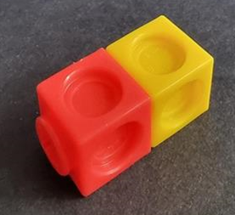
- Ask students how many brush loads of paint they would need now. They will need 8 brush loads. Discuss why fewer brush loads are needed. Record in Resource 2: Brush loads data.
- In pairs, students build vertical and horizontal towers using 3 interlocking cubes and record brush load data in Resource 2: Brush loads data. Students use data from the table to identify and discuss patterns (see Figure 3).
Figure 3 – Data for 2 and 3 interlocking cubes
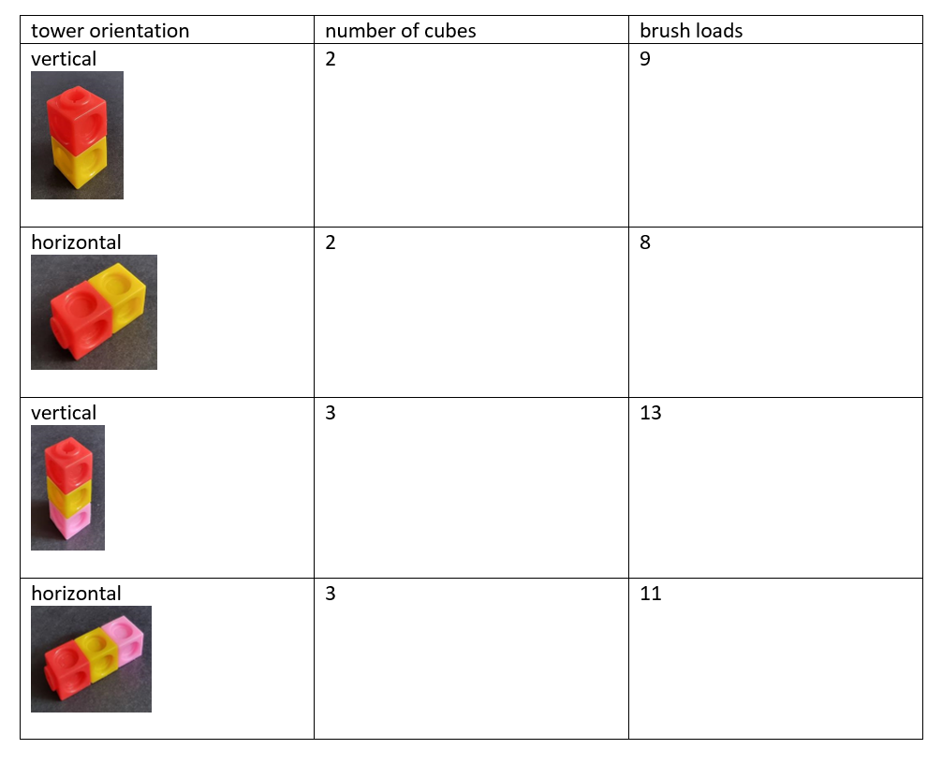
- Ask students:
- Which tower needed the most brush loads?
- Which tower needed the fewest brush loads?
- Can you see any patterns? Notice if students can predict that 4 extra brush loads are needed for each new vertical tower and 3 brush loads are needed for each new horizontal tower.
- Using the patterns you have found, how many brush loads would you need for towers of 4 and 5 cubes? Check predictions by making the towers and counting brush loads. See Figure 4 for solutions.
Figure 4 – Brush loads data for all towers
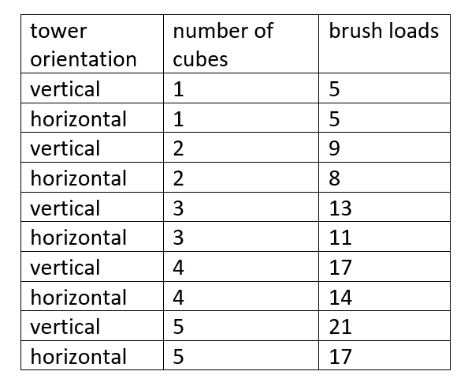
- Ask students if there are any other ways to join 3 interlocking cubes if the solution does not have to be a simple tower. See Figure 5 for the other possible solution.
Figure 5 – L arrangement
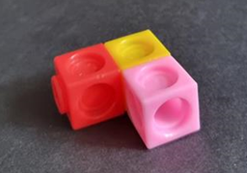
- Investigate how many brush loads would be needed for this model in different orientations and discuss why the answer is different to brush loads for the towers.
This table details assessment opportunities and differentiation ideas.
Assessment opportunities | Too hard? | Too easy?
What to look for:  - Can students find and record brush load data for different lengths of interlocking cubes? (MAO-WM-01, MA1-GM-02)  - Can students identify patterns in data and use these to predict brush loads for longer lengths? (MAO-WM-01, MA1-GM-02)  What to collect:  - brush load student data tables (MAO-WM-01, MA1-GM-02)  - observational records of patterns and predictions (MAO-WM-01, MA1-GM-02) | Students cannot identify brush loads.  - Take one cube and model how many brush loads would be needed if the cube is held in the air and all surfaces could be painted. Then place the cube on a surface and think about how many brush loads are needed now.  - Student places a numbered sticky dot on each face that needs a brush load to aid visualisation of solutions. | Students find all solutions working with 2, 3 4 and 5 cubes, using data to describe patterns and predict answers for longer towers.  - Students find all solutions using 4 interlocking cubes on one level (see Figure 6). Students investigate brush load data.  - Students investigate brush load data for 4 interlocking cubes but this time, solutions can be more than one cube high.
Figure 6 – 4-cube models
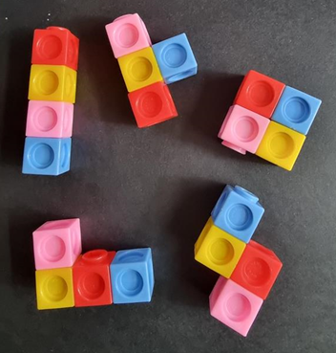

Consolidation and meaningful practice: How tall? – 10 minutes
This activity is adapted from Little Man from NRICH (2022). You may choose to read the whole text, The Man by Raymond Briggs, with students to further their understanding of length and estimation.
- Show students Resource 3: Mug and monkey. Ask students if this monkey is taller or shorter than them and how they can tell. Students show you with their fingers how tall the monkey is. Show students a mug if necessary to help them visualise this.
- Ask students to think of an object:
- at school that is about the same height as the monkey
- at home that is about the same height as the monkey
- at school that is approximately twice as tall as the monkey
- at home that is approximately twice as tall as the monkey
- that is about half as tall as the monkey
- that is about a quarter of the height of the monkey.

Lesson 3: Wrapping presents
Core concept: Using consistent units of measurement enables comparison.
The table below contains suggested learning intentions and success criteria. These are best co-constructed with students.
Learning intentions | Success criteria
Students are learning that:  - estimating and measuring allows them to compare, order and match areas  - choice of measuring unit affects accuracy when measuring area  - arrays can be built and described using rows and columns. | Students can:  - compare areas of 2 surfaces that cannot be moved  - estimate which of 2 similar shapes has the larger area and check using a chosen informal unit of measure  - organise area measurements on a number line to make comparisons  - build and describe arrays using rows and columns.

Daily number sense: Dicey arrays – 20 minutes
This activity is developed from Dicey Array from NRICH (2022). If further information is required, there is an explanatory video on the site.
- Build student understanding of forming groups by making all possible arrays with a given quantity.
- Provide students with 2 × 9-sided dice, a timer, counters and writing materials to record scores.
- Start the timer. Player 1 rolls 2 dice and adds to find the total of the 2 numbers. They count out that number of counters and create as many rectangular arrays as they can using exactly that number of counters. Students score a point for each correct array. For example, rolls of 3 and 5 give a total of 8 counters. Player 1 can make arrays of 8 × 1, 1 × 8, 2 × 4 and 4 × 2 so their score is 4.
- Player 2 rolls the dice in the same way and repeats the process. Again, they score a point for each correct array. Player 2 rolls a 6 and a 3 giving a total of 9 counters. Player 2 can make arrays of 9 × 1, 1 × 9 and 3 × 3 so their score is 3.
- Play continues with players taking turns. Points scored in each player's second turn are added to the number of points they scored in their first turn to make a running total and so on.
- The game ends when 20 points have been scored altogether. Stop the timer and record the time.
- Repeat the process and try to beat the time from the first game.
- After playing the game as many times as possible in the available time, ask students:
- Which dice totals are good to get? Why?
- Which dice totals are not so good to get? Why?
- Does it matter if you go first or second?
- What happens if you can choose to add or subtract the 2 dice numbers? How does this change the game?
This table details assessment opportunities and differentiation ideas.
Assessment opportunities | Too hard? | Too easy?
What to look for:  - Can students build all possible arrays from a given quantity? (MAO-WM-01, MA1-FG-01)  - Do students describe arrays using the terms rows and columns? (MAO-WM-01, MA1-FG-01)  What to collect:  - observational records (MAO-WM-01, MA1-FG-01)  - photographs of arrays (MAO-WM-01, MA1-FG-01) | Students cannot work with larger numbers.  - Use 4-sided dice to work with quantities between 2 and 8 to form arrays.  - Then use 6-sided dice to work with quantities between 2 and 12. | Students accurately form all possible arrays with 9-sided dice.  - Use 12-sided dice to work with quantities between 2 and 24 to form arrays.  - Use 20-sided dice to work with quantities between 2 and 40.

Wrapping boxes – 45 minutes
This activity has been adapted from Wrapping Presents from NRICH (2022).
- Provide students with paper and different sized boxes as in Figure 7. Explain that the boxes need to be wrapped with the least amount of paper possible. Only one piece of paper can be used to wrap a box.
Figure 7 – Boxes
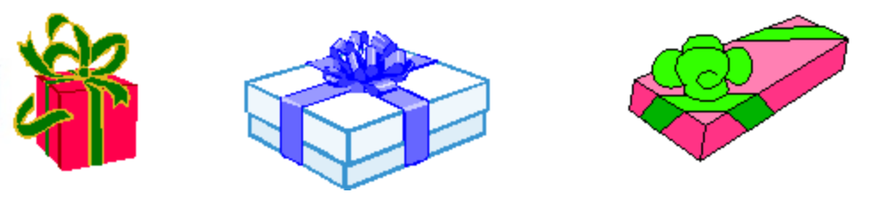
‘Wrapping Presents’ (adapted) by © University of Cambridge is licensed under CC-BY-NC 4.0.
- Students can experiment with different shapes of wrapping paper such as rectangles, squares and circles. They need to make at least 2 attempts to wrap a box, but they may make many. They should find that rectangular shapes of paper are the most efficient.
- Tell students that they need to prove which is the smallest piece of wrapping paper they used to wrap a box without using direct comparison. Students will need to choose a uniform informal unit of measurement such as sticky notes or square tiles so they can estimate, measure, and compare areas of paper used. Support students to use units end-to-end with no spaces. Record areas on a class number line.
- Ask students:
- Which shape of wrapping paper worked best?
- What were the challenges?
- Which box used the smallest area of wrapping paper? Use the number line to find this.
- Which box used the largest area of wrapping paper? Use the number line to find this.
- How could you use jumps on the number line to find the difference between the smallest and largest area?
- What unit of measurement did you choose to find areas of wrapping paper?
- How well did this work?
- How did you measure parts left over from your measurement?
- Would you use the same unit of measurement again? Why? Why not?
This table details assessment opportunities and differentiation ideas.
Assessment opportunities | Too hard? | Too easy?
What to look for:  - Can students choose an informal unit to accurately measure and compare areas? (MAO-WM-01, MA1-2DS-02)  - Can students estimate which of 2 or more similar shapes has the larger area and check? (MAO-WM-01, MA1-2DS-02)  - Do students organise area measurements on a number line to make comparisons? (MA1-RWN-02)  What to collect:  - observational records (MAO-WM-01, MA1-RWN-02, MA1-2DS-02)  - photographs of comparisons and measurements using uniform informal units (MAO-WM-01, MA1-2DS-02) | Students cannot select or use a uniform informal unit.  - Model using a unit such as sticky notes and discuss how to describe left over parts.  - Student revises this skill with a small area of paper before measuring their wrapping paper. | Students accurately measure and compare surface areas of rectangular prisms.  - Students repeat the process with a variety of cylinders and compare findings to rectangular prisms.  - Students repeat the process with a variety of pyramids.

Consolidation and meaningful practice: How many arrays? – 5 minutes
- Ask students what different arrays could be made with:
- 6 counters
- 12 counters
- 5 counters
- 9 counters.

Lesson 4: Cover it!
Core concept: Different surfaces can have the same area.
The table below contains suggested learning intentions and success criteria. These are best co-constructed with students.
Learning intentions | Success criteria
Students are learning that:  - estimating and measuring allows them to compare, order and match areas  - choice of measuring unit affects accuracy when measuring area  - area can be the same even if shapes look different. | Students can:  - estimate, measure and record area using uniform informal units  - explain why different shapes can have the same area  - understand that the size of the measuring unit used makes a difference to the number of units needed.

Daily number sense: Away with arrays! – 15 minutes
- Build student understanding of arrays by deconstructing an array using rows and columns.
- Provide groups of students with Resource 4: Array cards, 6-sided dice, counters and writing materials to record number of moves.
- Demonstrate the game using the 4 × 3 array card and use counters to show 4 rows of 3, and 3 columns of 4 as in Figure 8.
Figure 8 – 4 × 3 array
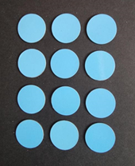
- The first die roll is a 4 so players can remove one column of 4 counters. Describe the new array arrangement as 2 columns of 4, or 4 rows of 2 (see Figure 9). Keep a tally of the number of rolls.
Figure 9 – After the first roll
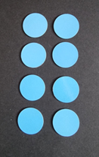
- The second die roll is a 3. Only one complete row or column can be removed in a turn so this roll cannot be used. The roll is still added to the tally chart.
- The third die roll is a 2. The players can remove one row of 2 counters. They add a tally mark and describe the new array as 2 columns of 3 or 3 rows of 2 (see Figure 10).
Figure 10 – After the third roll
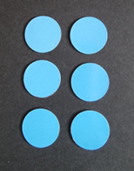
- Roll the die. The fourth roll is a 3. The players remove one column of 3, add a tally mark and describe the new array as one column of 3 or 3 rows of one (see Figure 11).
Figure 11 – After the fourth roll
- Ask students what possible ways there are to finish the game. They could roll:
- a 3 to finish with 5 throws
- a one and then a 2 to finish with 6 throws
- a one, another one and then another one to finish with 7 throws.
- Write the final number of throws next to the tally.
- In pairs or small groups, students play the game once or twice in the time available and compare the number of throws for each game.

Cover it! – 40 minutes
Parts of this activity have been adapted from Sullivan and Lilburn (2017).
- Ask students to predict which flat surfaces in the classroom could be covered with exactly 6 sticky notes. For example, a book cover or pencil case. Check by placing sticky notes with no spaces. Discuss how the surfaces have different shapes but the same area.
- Students identify flat surfaces in the classroom that would have larger or smaller areas. Estimate how many sticky notes would be required to cover them.
- Repeat the process with 12 sticky notes or a different size of sticky notes.
- Students trace around pattern blocks to create a design using Resource 5: Pencil case. Count and record how many of each shape have been used. Observe students discussing the following questions in small groups:
- What shapes did you use?
- How many of each shape did you use?
- How many shapes did you use in total?
- Why did some people use more shapes than others?
- How are all the pencil case designs the same? They cover the same area.
- How are they different? They all have different designs.
This table details assessment opportunities and differentiation ideas.
Assessment opportunities | Too hard? | Too easy?
What to look for:  - Can students estimate, measure and record area using uniform informal units? (MAO-WM-01, MA1-2DS-02)  - Can students explain why different shapes can have the same area? (MAO-WM-01, MA1-2DS-02)  - Do students understand that the size of the unit used makes a difference to the number of units needed? (MAO-WM-01, MA1-2DS-02)  What to collect:  - samples of designs and photographs of sticky note surfaces (MAO-WM-01, MA1-2DS-02)  - observations of student reasoning about designs and conservation of area (MAO-WM-01, MA1-2DS-02) | Students cannot find area or explain conservation.  - Model placing sticky notes with no spaces on surfaces.  - Students make different rectangles with 6 sticky notes to revise the concept of conservation.  - Students make designs with a limited number of shapes. For example, squares and triangles. | Students understand conservation of area.  - Students find 2 surfaces that have a combined area of 12 sticky notes.  - Students use hexagons and/or octagons in designs.

Consolidation and meaningful practice: Forwards and backwards – 5 minutes
- Choose a number from Resource 6: Number chart and count forwards in ones, twos, and tens.
- Repeat the process, counting backwards in ones, twos and tens.

Lesson 5: Building and packing!
Core concept: Capacities can be measured, compared and ordered by packing with uniform informal units.
The table below contains suggested learning intentions and success criteria. These are best co-constructed with students.
Learning intentions | Success criteria
Students are learning that:  - estimating and measuring can be used to compare, order and match volume and capacity  - choice of measuring unit affects accuracy when measuring volume and capacity  - using 10 as a reference makes estimating and counting more accurate. | Students can:  - use estimation to decide if an answer is reasonable  - measure, compare and order the capacity of different containers by packing with uniform informal units  - use 10 as a reference when estimating and counting quantities.

Daily number sense: Beads – 15 minutes
- Build student understanding of using 10 as a reference by organising coloured beads to measure objects.
- Pre-select classroom objects to measure that will be between 11 and 20 beads in length. Prior to each measurement, ask students to estimate how many beads long the object will be. Measure using one colour for the first 10 beads and another colour for the remainder. This will demonstrate using 10 as a reference to make counting larger numbers easier. See example in Figure 12.
Figure 12 – Count 14 using 10 as a reference
- Repeat this process with an object between 20 and 30 beads long. Use one colour for the first 10 beads, a second colour for the next 10, and another for remaining units.
- Align groups of 10 beads and then units in a vertical alignment to demonstrate partitioning of numbers into tens and units. See example in Figure 13.
Figure 13 – Partitioning 24 using vertical alignment
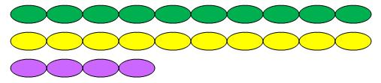
- In pairs, have students choose objects that will be over 11 beads long and estimate how many beads long they think the objects will be. Measure, using beads in groups of 10 and then ones. Partition using 10 as modelled. Compare final measurements to estimates each time.
The table below details assessment opportunities and differentiation ideas.
Assessment opportunities | Too hard? | Too easy?
What to look for:  - Can students make reasonable predictions? (MAO-WM-01)  - Can students use 10 as a reference number when counting quantities between 11 and 20? (MAO-WM-01, MA1-RWN-02)  - Can students partition two-digit numbers to show tens and units? (MAO-WM-01, MA1-RWN-02)  What to collect:  - observations of students predicting and measuring objects with beads, using 10 as a reference (MAO-WM-01, MA1-RWN-02)  - photographs of bead groupings (MA1-RWN-02) | Students cannot work with lengths between 11 and 20 units.  - Students measure objects between 5 and 9 beads long and use 5 as a reference.  - Model using 10 as a reference. | Students can find large numbers of beads using 10 as a reference.  - Students think about how they will organise counting when they have 10 lots of 10 beads, and some left over.  - Students measure vertical as well as horizontal lengths, choosing an appropriate uniform informal unit and method.

Fun with blocks – 20 minutes
This lesson has been adapted from Triple Cubes from NRICH (2022).
- Show students 8 models of 3 interlocking cubes as in Figure 14.
- Ask students:
- How would you describe the models? They are three-dimensional and each is made from 3 interlocking cubes. They are different colours.
- What is the same about the models? Volume.
- What is different about the models? Orientation and colour.
- What do you wonder?
Figure 14 – Triple cubes
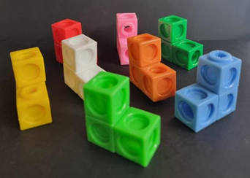
- In pairs, students make 8 triple cubes and use them to make a model. Triple cubes need to be connected by a face or an edge. See examples in Figure 15.
Figure 15 – Triple cube model examples
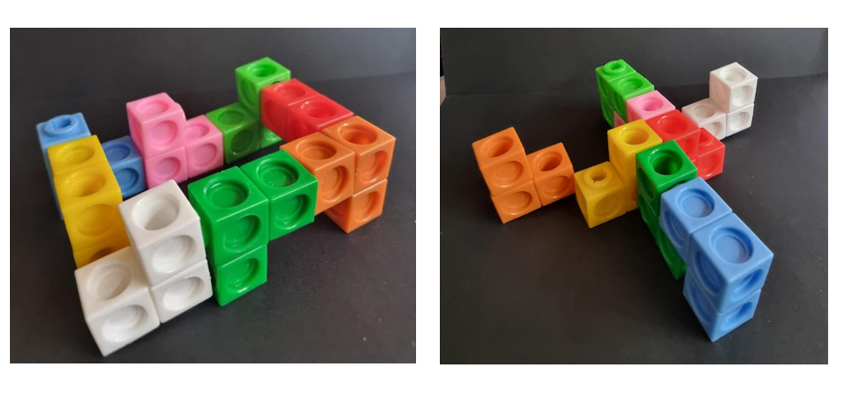
- As a class, compare and discuss the models by asking:
- How are they the same? They all have 24 cubes, so they all have the same volume.
- How are they different? For example, heights, lengths, faces or edges touching.
- Do any have a name or a purpose?
- Each pair removes a triple cube from their design. Ask students how many cubes everyone has now (21 cubes).
- Each pair now removes 2 more triple cubes from their design. Ask students how many cubes everyone has now (15 cubes).
- Keep the triple cubes for the next activity.

Pack it! – 25 minutes
- In groups of 4, students estimate how many triple cubes could be packed into different sized boxes and cylinders, aiming for no spaces. The triple cubes cannot be taken apart. More triple cubes can be made as necessary. Pack the containers. Record the number of triple cubes needed. Check measurements with original estimates.
- As a class, discuss which containers:
- took the most cubes to fill
- took the least cubes to fill
- were easiest to pack and why
- were a challenge to pack and why.
This table details assessment opportunities and differentiation ideas.
Assessment opportunities | Too hard? | Too easy?
What to look for:  - Can students estimate to decide if an answer is reasonable? (MAO-WM-01, MA1-3DS-02)  - Can students measure, compare and order the capacity of containers by packing with uniform informal units? (MAO-WM-01, MA1-3DS-02)  What to collect:  - observational records (MAO-WM-01, MA1-3DS-02)  - photographs of models and packed containers (MAO-WM-01, MA1-3DS-02) | Students do not understand conservation or have problems packing efficiently.  - Show students 2 equal volumes of modelling clay in 2 identical containers. Agree that they take up the same amount of space. Make one into a ball and one into a worm. Then make the worm into a ball to show that they have the same volume.  - Show students conservation with different units of measurement. For example, 2 pieces of string the same length with one straight and one curled up.  - Model packing some of the triple cubes into a container with no spaces. Students pack the last few triple cubes. | Students understand conservation of volume and pack efficiently with no spaces.  - In pairs, make a cube or a rectangle with all 8 triple cubes.  - Join another pair and make a cube or a rectangle with 16 triple cubes.

Consolidation and meaningful practice: Big and small cubes – 10 minutes
- Take a container that was used for packing triple cubes. Pack with MAB units and count the number of cubes needed. Compare the answer with the number of triple cubes needed for the same container. Discuss why the answers are different.

Lesson 6: Thirsty!
Core concept: Different shaped containers can have the same volume.
The table below contains suggested learning intentions and success criteria. These are best co-constructed with students.
Learning intentions | Success criteria
Students are learning that:  - estimating and measuring allows them to compare, order and match volumes  - volume can be the same even if containers are different shapes  - counting in tens develops understanding of place value. | Students can:  - use clues to order glasses containing different volumes of liquid  - explain why different shaped containers can have the same internal volume  - estimate and check by counting in groups of 10 and adding leftover parts  - count forwards and backwards in tens from a given number.

Daily number sense: Lots of beads! – 15 minutes
- Build student understanding of place value by counting in groups of 10.
- Show students a pile of between 20 and 50 beads. Students estimate how many beads there are and check by counting into groups of 10 and adding on leftover beads. Groups of 10 beads may be threaded onto pieces of string if desired. Ensure the answer is off the decade.
- From the answer, students count forwards by tens into three-digit numbers and then backwards by tens.
- Ask students which is the next multiple of 10. Count forwards and backwards on the decade from the answer.
- Repeat in small groups with a different number of beads between 20 and 50.
This table details assessment opportunities and differentiation ideas.
Assessment opportunities | Too hard? | Too easy?
What to look for:  - Can students find a quantity by counting beads in groups of 10 and adding on leftover beads? (MAO-WM-01, MA1-RWN-01)  - Do students refer to estimates to decide if their answer is reasonable? (MAO-WM-01, MA1-RWN-01)  - Can students count forwards and backwards by tens on and off the decade? (MAO-WM-01, MA1-RWN-01)  What to collect:  - observations of students demonstrating use of groups of 10 to find answers (MAO-WM-01, MA1-RWN-01)  - recordings of students counting forwards and backwards off the decade (MAO-WM-01, MA1-RWN-01) | Students cannot work with beads independently or count forwards or backwards by ten off the decade.  - Model estimating and counting another pile of beads between 20 and 50.  - Students work with 10 to 20 beads.  - Students use a number chart to find the next number. See Resource 6: Number chart. | Students can count by tens on and off the decade.  - Students use the answer to count forwards by twos, threes and fives and then by numbers of their choice.  - Students use the answer to count backwards by twos, threes and fives and then by numbers of their choice.  - Students use beads to demonstrate partitioning of two-digit numbers.

Thirsty! – 40 minutes
This lesson is adapted from Thirsty? from NRICH (2022). If desired, students can be given group roles. Please see Further reading section for more information.
- Show students a tall, thin glass and a short, wide glass, both with the same amount of water. Ask which glass they would choose to get the biggest drink. Pour the contents of the tall glass into another glass and mark the level. Pour away water and repeat for the short, wide glass to show students that both glasses contained the same amount. Discuss why one glass appeared to have more water.
- Revise using uniform informal units to compare internal volume with the two-minute marble challenge:
- Students choose 2 containers from a variety of small, different shaped containers.
- Estimate which of the containers has the largest internal volume.
- Compare the internal volumes by filling with marbles.
- Tell students that they will apply their skills as length and volume experts! Give Resource 7: Thirsty picture cards to small groups. Students turn and talk about what they notice. Move around groups asking:
- What is the same and different about the pictures?
- Can you sort the cards in different ways?
- What words can you use to describe the glasses? For example, full, half full, empty, short, shorter, shortest, tall, taller, tallest.
- Give each group Resource 8: Thirsty clue cards. Students share cards between them. The cards with a dot should be read first. Take turns to read each card aloud and use clues to organise the picture cards. Move around and support groups by asking:
- How are the cards alike?
- How are the cards different?
- What do your clues say?
- What do you have to do with the pictures of the glasses?
- Who has a good clue with a dot to start with?
- Can you explain that clue in your own words?
- Do you need to read any cards again if you were not sure the first time?
- Do you think you have arranged the glasses in the right order? How do you know?
This table details assessment opportunities and differentiation ideas.
Assessment opportunities | Too hard? | Too easy?
What to look for:  - Can students explain why different shaped containers can have the same volume? (MAO-WM-01, MA1-3DS-02)  - Can students use clues to logically order glasses containing different volumes of liquid? (MAO-WM-01, MA1-3DS-02)  What to collect:  - observational records of verbal reasoning (MAO-WM-01, MA1-3DS-02)  - photographs of cards in order (MAO-WM-01, MA1-3DS-02) | Students are challenged by the level of logical reasoning so they cannot show their understanding of volume conservation.  - Students use Resource 9: Thirsty easy clues with the picture cards.  - Then students use Resource 8: Thirsty clue cards with the support of Resource 10: Place markers. | Students accurately order the picture cards using all clue cards.  - Students use Resource 11: Thirsty hard clues with the picture cards.  - Students make their own Thirsty game.

Consolidation and meaningful practice: Away with arrays! – 10 minutes
- Show students an array of 3 by 2 counters. Ask students what different throws of a 6-sided dice could be made to remove all rows and columns.

Lesson 7: Mass – Looks can be deceiving
Core concept: Objects can look different but have the same mass.
The table below contains suggested learning intentions and success criteria. These are best co-constructed with students.
Learning intentions | Success criteria
Students are learning that:  - estimating and measuring allows them to compare, order and match mass  - choice of measuring unit affects accuracy when measuring mass  - place value can be used to identify the numbers before and after two-digit and three-digit numbers. | Students can:  - compare mass using comparative language such as heavy, heavier, heaviest, light, lighter, lightest or the same as  - use comparison to order masses by estimating, hefting and checking using an equal-arm balance  - identify the numbers before and after two-digit and three-digit numbers.

Daily number sense: Pick 2, pick 3! – 10 minutes
- Build student understanding of place value by identifying the numbers before and after a given number.
- Using Resource 12: Zero to nine, draw 2 playing cards. Students arrange the digits on the 2 cards to make the largest number possible. For example, the biggest number a student could make with cards 2 and 9 is 92 and the smallest number that can be made with 0 and 7 is 7. Select students to share strategies. For example, placing the biggest digit in the tens place and the smallest digit in the units place. Ask students to identify and record the numbers before and after the number they made. Students share responses and discuss.
- Repeat the process, but this time make the smallest number possible with the 2 cards drawn.
- Repeat the previous step, using 3 cards instead of 2. Students play the game in pairs while teacher observes.
This table details assessment opportunities and differentiation ideas.
Assessment opportunities | Too hard? | Too easy?
What to look for:  - Can students use place value to make the largest or smallest possible numbers? (MAO-WM-01, MA1-RWN-01)  - Can students identify the number before or after two-digit and three-digit numbers? (MAO-WM-01, MA1-RWN-01)  What to collect:  - teacher observations (MAO-WM-01, MA1-RWN-01)  - recordings or photographs of student responses (MAO-WM-01, MA1-RWN-01) | Students cannot make the largest or smallest possible numbers or identify numbers before and after.  - Provide students with their own digit cards and model how to make the largest possible number by placing the largest digit first, followed by the other digit.  - Students use a number chart to locate the number they made and then the numbers before and after.  - Model the process again but for how to make the smallest number possible each time. | Students accurately make the largest or smallest possible numbers and identify the numbers before and after.  - Use 4 cards instead of 2 or 3.  - Students make the largest and smallest numbers, then find the difference.

Tricky party bags – 45 minutes
This lesson has been adapted from 'Tricky' party bags by McDonough et al. (2013).
- In small groups, students order Resource 13: Mass discussion cards from heaviest to lightest.
- Discuss ideas as a class and develop a working definition for mass using comparative language.
- In pairs, students select 3 objects from the classroom. Place the objects in paper bags to create 3 sealed bags of different masses to be ordered by hefting. Challenge the students to make their bags ‘tricky’, by deliberately making them different in size but similar in mass. Label the bags A, B and C.
Hefting: Testing the weight of an object by lifting and/or balancing it.
- Once each pair has filled and sealed their bags, another pair is challenged to estimate the order of the bags from heaviest to lightest by looking only. Record estimations with reasons. For example, this bag is really small so it will be the lightest or this bag is really tall so I think it will be the heaviest.
- In their pairs, students order the bags by hefting. Students still cannot look inside. After testing estimations using only hefting, students can revise or confirm their thinking based on new evidence.
- As a class, discuss what students have observed so far in relation to mass. Students should be able to explain that mass cannot be measured just by looking; the objects needed to be picked up. Mathematicians call this hefting. Ask questions, such as:
- What do you notice about your estimations?
- Was it possible to accurately order your party bags just by looking and thinking?
- Why do you think it is difficult to estimate the mass of an object without picking it up?
- Ask students if they could compare mass with their eyes closed. Students turn and talk to discuss.
- Add new ideas to the working definition of mass. Students should justify reasoning. Ask students to explain how mass is different to other measurable attributes such as length and area.
- Ask if students found it hard to order the bags by hefting. Discuss why hefting is not always an accurate measure. Ask students if they can think of a tool that might be more accurate when checking the mass of the bags.
- Students check the order of the tricky party bags using an equal-arm balance. Represent findings by drawing mathematical diagrams of the equal-arm balance to prove their comparisons.
- Students identify relationships between the masses of the bags by reasoning about comparisons. For example, A is heavier than B and C is lighter than B so C must also be lighter than A. Use questioning to support reasoning about relationships between objects and discuss how the equal-arm balance helped them to compare and order the objects. Ask each group to communicate the strategy they used to prove their bags were ordered correctly.
Note: You may prepare 3 party bags equivalent in mass that look different to provide an explicit example if masses of student party bags are too easy to heft and order. Party bags that are equivalent or similar in mass will create a need for using the equal-arm balances.
This table details assessment opportunities and differentiation ideas.
Assessment opportunities | Too hard? | Too easy?
What to look for:  - Can students use comparative language when comparing the mass of objects? (MAO-WM-01, MA1-NSM-01)  - Can students estimate, order and check the mass of objects by hefting and using an equal-arm balance? (MAO-WM-01, MA1-NSM-01)  What to collect:  - student work samples (MAO-WM-01, MA1-NSM-01)  - teacher observations (MAO-WM-01, MA1-NSM-01) | Students think that the bigger an object is, the heavier it is.  - Model hefting, making sure that some objects are bigger and lighter and some are smaller but heavier.  - Students find an object that is lighter and an object that is heavier than a party bag.  - Students compare 2 party bags. | Students accurately estimate, measure and order objects according to their mass.  - Ask students to find objects in the room that are about the same mass as their party bags.  - Students brainstorm a list of objects that are small but heavy.  - Students brainstorm a list of objects that are large but not heavy.

Discuss and connect the mathematics – 5 minutes
- Revise that mathematicians create diagrams that include the most important mathematical information. Select pairs to share their diagrams and ask questions such as:
- Does the size of the bag help you predict the heaviest or lightest bag?
- How do we know when our party bags have the same mass or are equivalent?
- Were your estimations accurate?
- How does the equal-arm balance help you to be more precise?
- Did your results remain the same or did they change when you used the equal-arm balance?
- Did your diagrams help you to compare and order the mass of your bags? Why or why not?
- Revise the working definition of mass to include new ideas and reasoning.

Lesson 8: Heavier, lighter or the same?
Core concept: Different objects can have the same mass.
The table below contains suggested learning intentions and success criteria. These are best co-constructed with students.
Learning intentions | Success criteria
Students are learning that:  - estimating and measuring allows them to compare, order and match mass  - choice of measuring unit affects accuracy when measuring mass  - mass remains the same even if the object changes shape. | Students can:  - describe objects using vocabulary of mass, for example, heavier, lighter, the same as  - use a consistent unit of measure with an equal-arm balance to compare and order mass  - explain that a ball of modelling clay can be made into 2 different shapes but still have the same mass.

Daily number sense: Teacher identified activity – 15 minutes
- From a class need surfaced through formative assessment data, identify a short, focused activity that targets students’ knowledge, understanding and skills. Example activities may be drawn from the following resources:
- Thinking mathematically Stage 1
- Universal Resources Hub.

Weighing balls and worms – 30 minutes
This activity is adapted from Seesaws from NZ Maths.
- Revise Tricky party bags (Lesson 7) and ask how the mass of 2 objects can be compared. Explain that a seesaw can be used as an equal-arm balance and that students will make their own to compare mass.
- Students work in small groups. Provide each group with an aluminium can, water bottle or other cylindrical object. Fix it to a flat surface using tape or balls of modelling clay. Use a shoebox lid, lunchbox lid or similar, ensuring the lid has sides so objects being weighed will not fall off (see Figure 16). See if students can balance the lid on top of the can. Attach the lid to the can with tape.
Figure 16 – Handmade seesaw
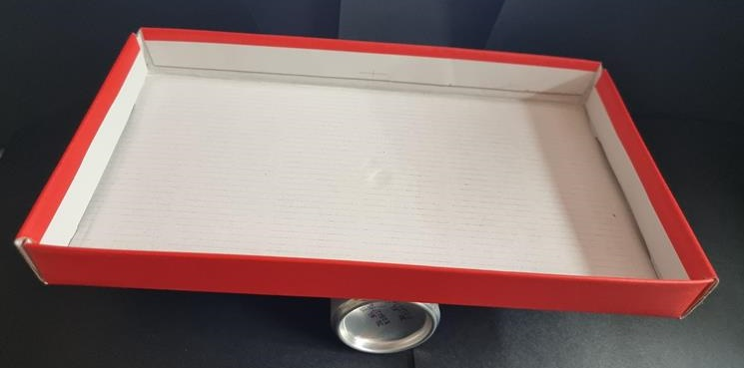
- Give each student some modelling clay to roll into 2 balls. In the groups, each student attempts to balance the seesaw using their 2 balls. Demonstrate if necessary. Students may need to remove some modelling clay from one of the balls in order to balance the seesaw.
- Students use their modelling clay to make an object of choice. Ask groups if their objects will have the same mass and why or why not. Check predictions using the seesaw.
- Ask students to use their modelling clay to make the longest worm that they can. Predict which worm will be the heaviest and check using the seesaw. Ask questions such as:
- Which worm is the longest?
- Which worm is the heaviest?
- How can you check?
- Why do the worms have the same mass?
- Ask some students to make their worm into a few different sized balls. Work with 2 students at a time and ask:
- Who has made the most balls?
- Which ball is the heaviest? Check your prediction.
- If each student puts their balls together on either side of the seesaw, what do you think will happen? Check predictions.
- What do you notice?
- Why is the seesaw balanced?
This table details assessment opportunities and differentiation ideas.
Assessment opportunities | Too hard? | Too easy?
What to look for:  - Can students use an equal-arm balance to compare the mass of 2 objects? (MAO-WM-01, MA1-NSM-01)  - Can students explain why a ball of modelling clay can be made into 2 different shapes but still have the same mass? (MAO-WM-01, MA1-NSM-01)  What to collect:  - teacher observations and recordings of student responses (MAO-WM-01, MA1-NSM-01)  - photographs of student work (MAO-WM-01, MA1-NSM-01) | Students do not understand equivalence or conservation of mass.  - Students use hefting to estimate mass and equivalence of their clay in a ball and then in a worm.  - Show students conservation with different units of measurement. For example, 2 pieces of string the same length with one straight and one curled up. | Students understand conservation and equivalence of mass.  - Students explore equivalence with an interactive equal-arm balance using Are You Well Balanced? from NRICH.  - Each group puts all their modelling clay together in one ball and finds an object in the classroom with equivalent mass.

Consolidation and meaningful practice: Comparing and ordering – 15 minutes
- Revise how beads or blocks were used to measure length of jumps in Jump, jump, jump! (Lesson 1). Ask how beads/blocks could be used to compare and order modelling clay balls. Revise that they can be used as a uniform informal unit. Ask students to estimate how many beads/blocks would be required to balance their modelling clay. In small groups, use the seesaw or an equal-arm balance to check estimates. Order the balls in order from lightest to heaviest.
- Ask students:
- How close was your estimate?
- How many beads/blocks did it take to balance the seesaw?
- How many beads/blocks did it take your partner to balance the seesaw?
- Find someone who needed more beads/blocks than you. Explain why.
- Find someone who needed less beads/blocks than you. Explain why.
- Were beads/blocks an appropriate unit of measurement? Why or why not?
- Can you think of another unit of measurement that could be used?
This table details assessment opportunities and differentiation ideas.
Assessment opportunities | Too hard? | Too easy?
What to look for:  - Can students describe objects using vocabulary of mass, for example, heavier, lighter, the same as? (MAO-WM-01, MA1-NSM-01)  - Can students use a consistent unit to measure mass so that objects can be compared and ordered? (MAO-WM-01, MA1-NSM-01)  What to collect:  - teacher observations and recordings of student responses (MAO-WM-01, MA1-NSM-01)  - photographs of student work (MAO-WM-01, MA1-NSM-01) | Students cannot find equivalence using the equal-arm balance or seesaw.  - Model placing the clay ball on one side and adding one bead or block at a time to the other side until equivalence is found.  - Students then work with a small clay ball to begin with and then a bigger ball.  - Students play with placing beads or blocks on each side to explore equivalence. | Students accurately compare and order masses.  - Students repeat process with classroom objects.  - Students use Seesaw Shenanigans from NRICH to explore equivalence.

Resource 1: Number line
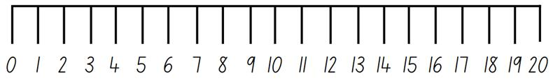
Images sourced from Canva and used in accordance with the Canva Pro Content License.

Resource 2: Brush loads data
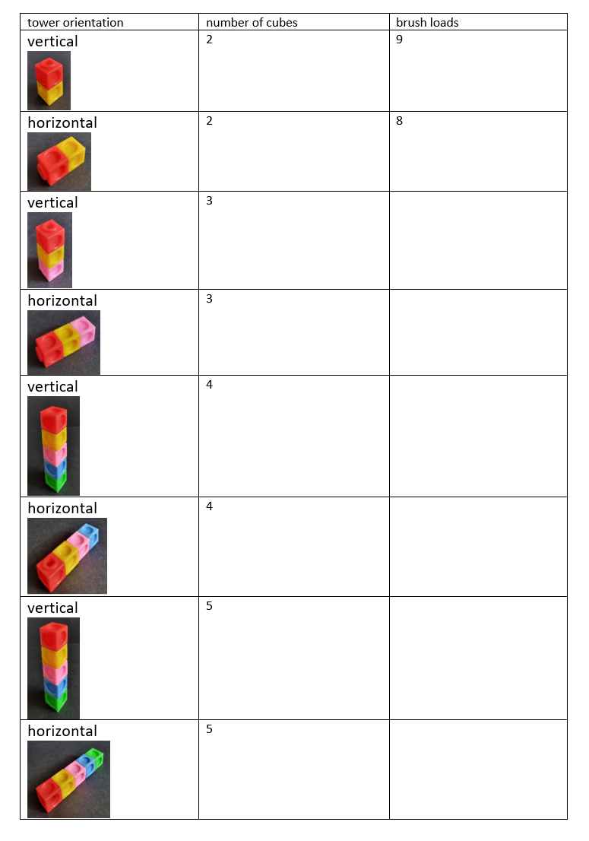

Resource 3: Mug and monkey
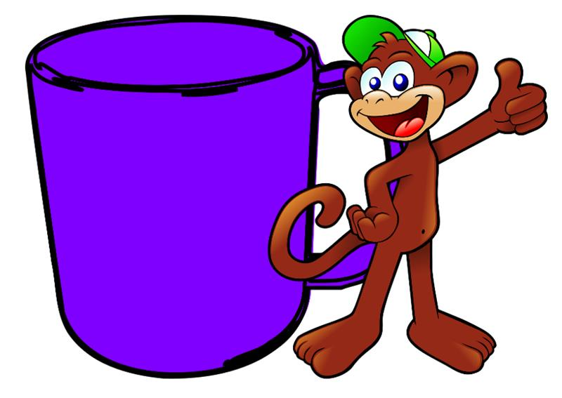
Images sourced from Pixabay and used in accordance with the Pixabay License.

Resource 4: Array cards
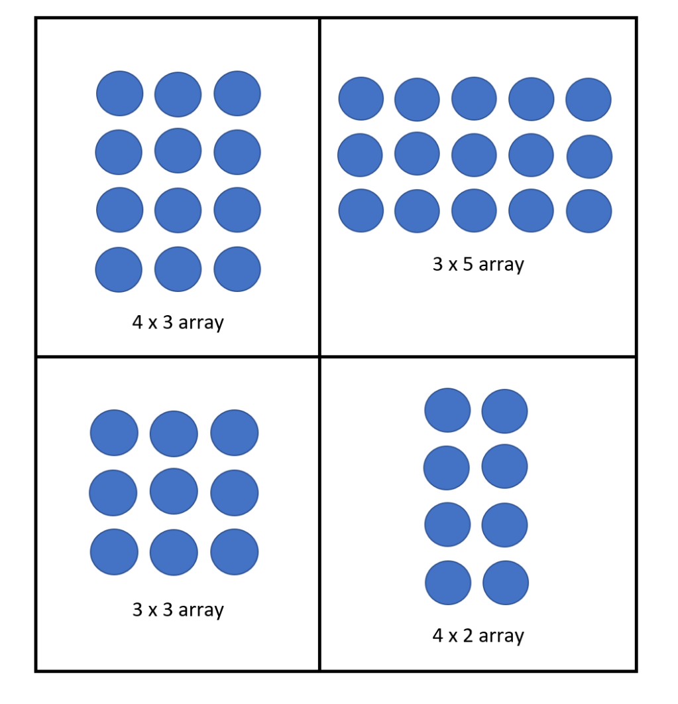

Resource 5: Pencil case
Images sourced from Canva and used in accordance with the Canva Pro Content License.

Resource 6: Number chart
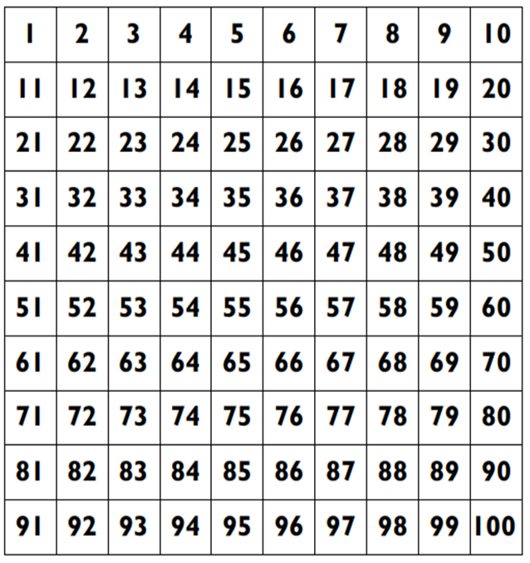

Resource 7: Thirsty picture cards
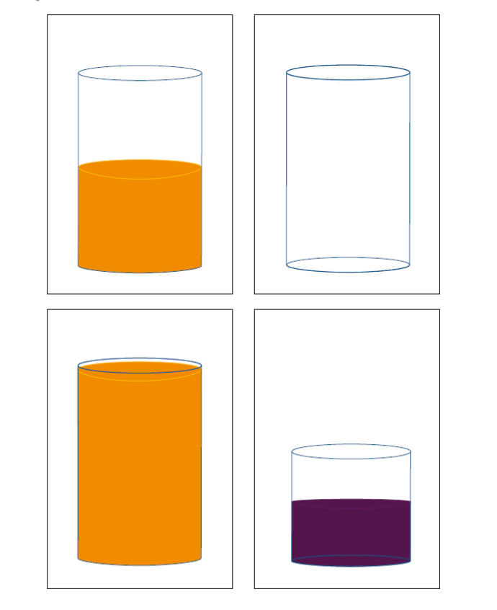
‘Thirsty’ by © University of Cambridge is licensed under CC-BY-NC 4.0.
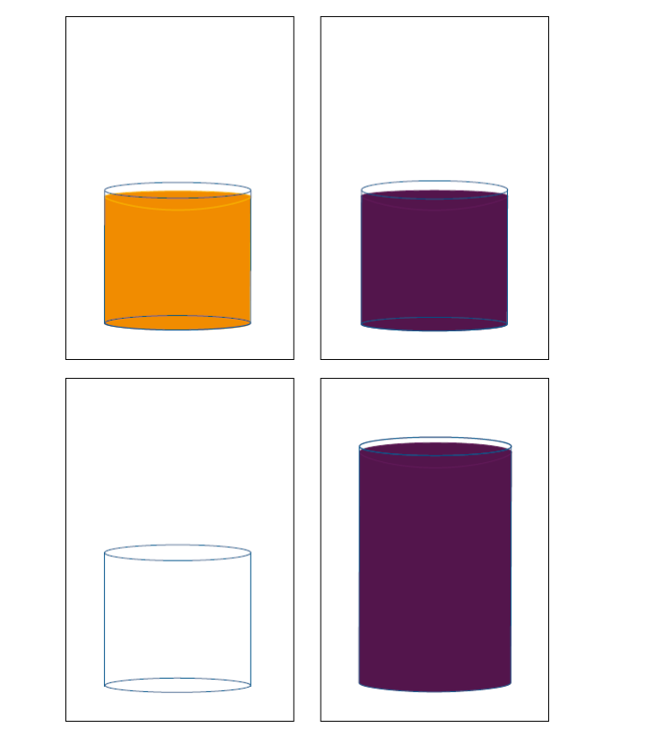
‘Thirsty’ by © University of Cambridge is licensed under CC-BY-NC 4.0.

Resource 8: Thirsty clue cards
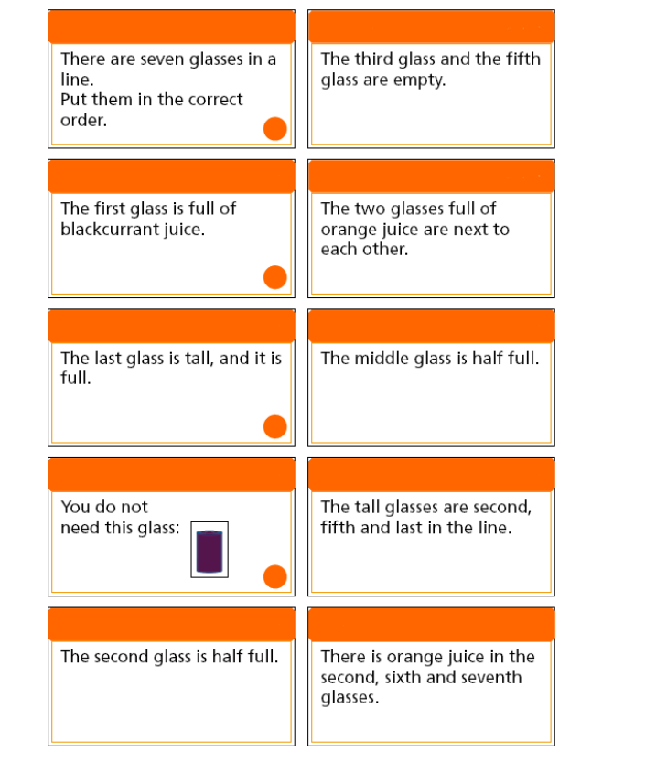
‘Thirsty’ by © University of Cambridge is licensed under CC-BY-NC 4.0.

Resource 9: Thirsty easy clues
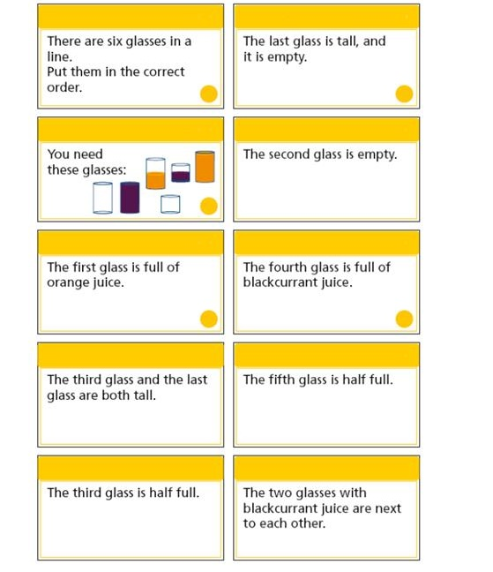
‘Thirsty’ - Teachers' Resources by © University of Cambridge is licensed under CC-BY-NC 4.0.

Resource 10: Place markers
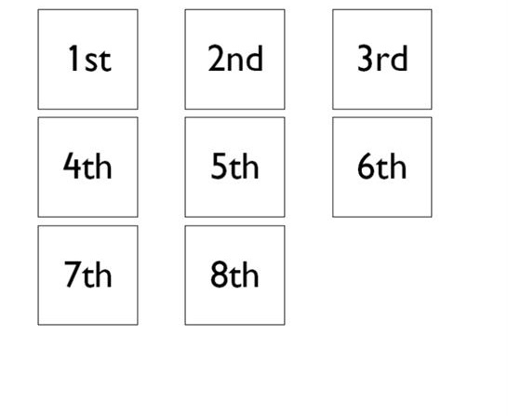
‘Thirsty’ - Teachers' Resources by © University of Cambridge is licensed under CC-BY-NC 4.0.

Resource 11: Thirsty hard clues
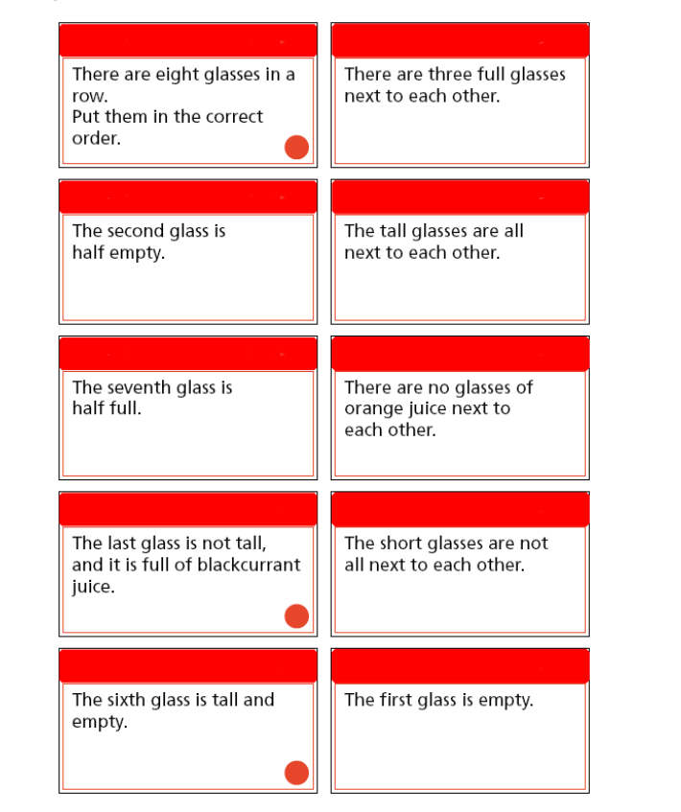
‘Thirsty’ - Teachers' Resources by © University of Cambridge is licensed under CC-BY-NC 4.0.

Resource 12: Zero to nine
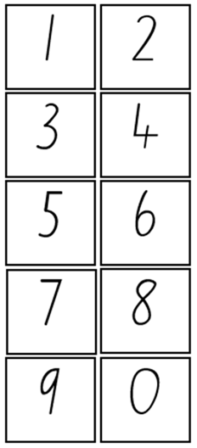

Resource 13: Mass discussion cards
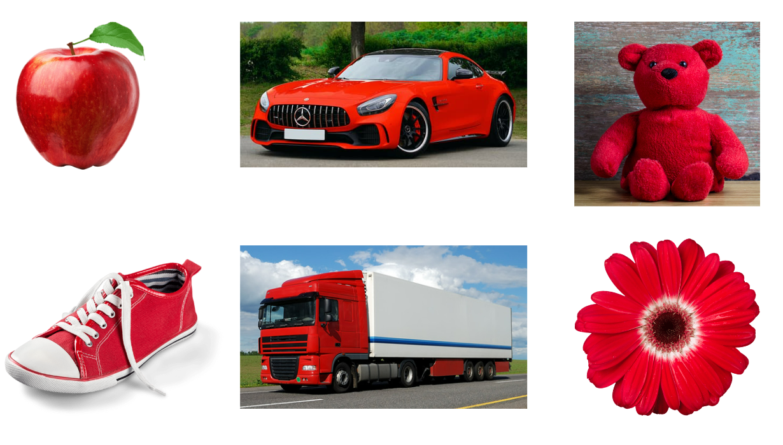
Images sourced from Canva and used in accordance with the Canva Pro Content License.

Syllabus outcomes and content
The table below outlines the syllabus outcomes and range of relevant syllabus content covered in this unit. Content is linked to National Numeracy Learning Progression version (3).
Focus area and outcomes | Content groups and content points | Lessons
Representing whole numbers A  MAO-WM-01  MA1-RWN-01  MA1-RWN-02 | Use counting sequences of ones with two-digit numbers and beyond  - identify the number before and after a given two-digit number (CPr5)  - count forwards and backwards by ones from a given number to at least 120 (CPr6)  Represent numbers on a line  - sequence numbers and arrange them on a line by considering the order and size of those numbers (CPr5)  - locate the approximate position of multiples of 10 on a model of a number line from 0 to 100 (CPr5)  Represent the structure of groups of ten in whole numbers  - recognise that ten ones is the same as one ten (NPV2, NPV4)  - use 10 as a reference in forming numbers from 11 to 20 (CPr7)  - count large sets of objects by systematically grouping in tens (CPr7)  - partition two-digit numbers to show quantity values (NPV4)  - estimate, to the nearest ten, the number of objects in a collection and check by counting in groups of ten (CPr7, NPV6) | 1, 2, 5–7
Representing whole numbers B  MAO-WM-01  MA1-RWN-01  MA1-RWN-02 | Use counting sequences of ones and tens flexibly  - identify the number before and after a given three-digit number  - count forwards and backwards by tens, on and off the decade, with two- and three-digit numbers (CPr7)  - identify how many more to the next multiple of ten within two- and three-digit numbers  Form, regroup, and rename three-digit numbers  - use models such as base 10 material and interlocking cubes to represent and explain grouping (CPr7) | 6–7
Combining and separating quantities A  MAO-WM-01  MA1-CSQ-01 | Use advanced count-by-one strategies to solve addition and subtraction problems  - apply the terms ‘add’, ‘plus’, ‘equals’, ‘is equal to’, ‘is the same as’, ‘take away’, ‘minus’ and ‘the difference between’ to describe combining and separating quantities (AdS1, AdS6)  - fluently use advanced count-by-one strategies including counting on and counting back to solve addition and subtraction problems involving one- and two-digit numbers (Reasons about relations) (AdS3-AdS5) | 1
Forming groups B  MAO-WM-01  MA1-FG-01 | Represent and explain multiplication as the combining of equal groups  - use objects, diagrams, images or actions to model multiplication as accumulating equal groups (MuS4)  - solve multiplication problems using repeated addition (MuS4)  - form arrays of equal rows and equal columns (MuS5)  - determine and distinguish between the number of rows/columns and the number in each row/column when describing collections of objects (MuS5)  - model the commutative property of multiplication, using an array (MuS6)  - model division by deconstructing an array equally into a given number of rows or columns | 3–4
Geometric measure A  MAO-WM-01  MA1-GM-02 | Length: Measure the lengths of objects using uniform informal units  - use uniform informal units to measure lengths and distances by placing the units end to end without gaps or overlaps (UuM2)  - select appropriate uniform informal units to measure lengths and distances (UuM3)  - recognise and explain the relationship between the size of a unit and the number of units needed  - record lengths and distances by referring to the number and type of unit used (UuM4)  - use a single informal unit repeatedly (iteratively) to measure length (UuM4)  Length: Compare lengths using uniform informal units  - compare the lengths of two or more objects using appropriate uniform informal units and check by placing the objects side by side and aligning the ends (UuM2-UuM3)  - explain why the length of an object remains constant when rearranged  - estimate lengths, indicating the number and type of unit used and check by measuring (UuM3) | 1–2
Geometric measure B  MAO-WM-01  MA1-GM-02 | Length: Compare and order lengths, using appropriate uniform informal units  - record length comparisons using drawings, numerals and words, and by referring to the uniform informal unit used | 1–2
Two-dimensional spatial structure A  MAO-WM-01  MA1-2DS-02 | Area: Measure areas using uniform informal units  - explore area using uniform informal units to cover the surface in rows or columns without gaps or overlaps (UuM5)  - measure area by selecting and using appropriate uniform informal units  - explain the relationship between the size of a unit and the number of units needed to measure an area  - explain why the area remains constant when units are rearranged  - record areas by referring to the number and type of uniform informal unit used  - identify any parts of units left over when counting uniform informal units to measure area  - estimate areas by referring to the number and type of uniform informal unit used and check by measuring (UuM3) | 3–4
Two-dimensional spatial structure B  MAO-WM-01  MA1-2DS-02 | Area: Compare rectangular areas using uniform square units of an appropriate size in rows and columns  - cover rectangular surfaces by creating repeated rows of square tiles (UuM5)  - use the structure of repeated units to find the area of a rectangle (UuM5)  - record comparisons of area using drawings, numerals and words, and by referring to the uniform informal unit used | 3–4
Three-dimensional spatial structure A  MAO-WM-01  MA1-3DS-01  MA1-3DS-02 | 3D objects: Recognise familiar three-dimensional objects  - use the term ‘three-dimensional’ to describe a range of objects (UGP2-UGP3)  - distinguish between objects, which are three-dimensional (3D) and shapes which are two-dimensional (2D)  - identify and name familiar three-dimensional objects, including cubes, cylinders, spheres and rectangular prisms  Volume: Measure and compare the internal volumes (capacities) of containers by filling  - recognise and explain the relationship between the size of a unit and the number of units needed  - compare the internal volumes of two or more containers using appropriate uniform informal units (UuM3)  - recognise and explain why containers of different shapes may have the same internal volume  - estimate how much a container holds by referring to the number and type of uniform informal unit used and check by measuring (UuM3-UuM4)  Volume: Measure the internal volume (capacity) of containers by packing  - pack cubic units (eg blocks) into rectangular containers so that there are no gaps  - recognise that cubes pack better than other objects in rectangular containers  - estimate and measure the internal volume of a container by filling the container with uniform informal units and counting the number of units used  - explain that if there are gaps when packing and stacking, this will affect the accuracy of measuring the internal volume | 5–6
Three-dimensional spatial structure B  MAO-WM-01  MA1-3DS-01  MA1-3DS-02 | Volume: Compare containers based on internal volume (capacity) by filling and packing  - compare, order and record the internal volumes (capacities) of two or more containers by measuring each container in uniform informal units (UuM3-UuM4)  - estimate internal volume (capacity) by referring to the number and type of uniform informal unit used (UuM3)  Volume: Compare volumes using uniform informal units  - compare models with different appearances, recognising when they have the same volume  - record the results of volume comparisons using drawings, numerals and words, referring to the units used | 5
Non-spatial measure B  MAO-WM-01  MA1-NSM-01 | Mass: Compare the masses of objects using an equal-arm balance  - use uniform informal units to measure the mass of an object by counting the number of units needed to obtain a level balance on an equal-arm balance (UuM3)  - select an appropriate uniform informal unit to measure the mass of an object and justify the choice (UuM3)  - explain the relationship between the mass of a unit and the number of units needed  - compare the masses of two or more objects using the same informal units (UuM3)  - estimate mass by referring to the number and type of uniform informal unit used and check by measuring (UuM3-UuM4)  - recognise that mass is conserved | 7–8

References
Links to third-party material and websites
Please note that the provided (reading/viewing material/list/links/texts) are a suggestion only and implies no endorsement, by the New South Wales Department of Education, of any author, publisher, or book title. School principals and teachers are best placed to assess the suitability of resources that would complement the curriculum and reflect the needs and interests of their students.
If you use the links provided in this document to access a third-party's website, you acknowledge that the terms of use, including licence terms set out on the third-party's website apply to the use which may be made of the materials on that third-party website or where permitted by the Copyright Act 1968 (Cth). The department accepts no responsibility for content on third-party websites.
Except as otherwise noted, all material is © State of New South Wales (Department of Education), 2023 and licensed under the Creative Commons Attribution 4.0 International License. All other material (third-party material) is used with permission or under licence. Where the copyright owner of third-party material has not licensed their material under a Creative Commons or similar licence, you should contact them directly for permission to reuse their material.
Mathematics K–10 Syllabus © 2022 NSW Education Standards Authority (NESA) for and on behalf of the Crown in right of the State of New South Wales.
© 2022 NSW Education Standards Authority. This document contains NSW Curriculum and syllabus content. The NSW Curriculum is developed by the NSW Education Standards Authority. This content is prepared by NESA for and on behalf of the Crown in right of the State of New South Wales. The material is protected by Crown copyright.
Please refer to the NESA Copyright Disclaimer for more information.
NESA holds the only official and up-to-date versions of the NSW Curriculum and syllabus documents. Please visit the NSW Education Standards Authority (NESA) website and the NSW Curriculum website.
National Numeracy Learning Progression © Australian Curriculum, Assessment and Reporting Authority (ACARA) 2010 to present, unless otherwise indicated. This material was downloaded from the Australian Curriculum website (National Literacy Learning Progression) (accessed 8 November) and was not modified. The material is licensed under CC BY 4.0. Version updates are tracked in the ‘Curriculum version history’ section on the 'About the Australian Curriculum' page of the Australian Curriculum website.
ACARA does not endorse any product that uses the Australian Curriculum or make any representations as to the quality of such products. Any product that uses material published on this website should not be taken to be affiliated with ACARA or have the sponsorship or approval of ACARA. It is up to each person to make their own assessment of the product, taking into account matters including, but not limited to, the version number and the degree to which the materials align with the content descriptions and achievement standards (where relevant). Where there is a claim of alignment, it is important to check that the materials align with the content descriptions and achievement standards (endorsed by all education Ministers), not the elaborations (examples provided by ACARA).
Australian Government Department of Education (2020) Measurement: Jump!, Teaching resources, reSolve website, accessed 7 November 2022.
Australian Government Department of Education, Skills and Employment (2022) ReSolve [website], accessed 7 November 2022.
Boaler J, Munson J and William C (2021) Mindset Mathematics: Visualising and Investigating Big Ideas, Grade 1, Jossey-Bass, New Jersey.
McDonough A, Cheeseman J and Ferguson S (2013) ‘Young children's emerging understandings of the measurement of mass’. Australasian Journal of Early Childhood, 38(4):13–20, doi:10.1177/183693911303800403, accessed 7 November 2022.
New Zealand Ministry of Education (n.d.) Seesaws, NZ Maths website, accessed 7 November 2022.
Sullivan P and Lilburn P (2017) Open-ended Maths Activities: Using ‘Good’ Questions to Enhance Learning in Mathematics, Revised edn, Oxford University Press ANZ, Great Britain.
University of Cambridge (Faculty of Mathematics) (2022) Are You Well Balanced?, NRICH website, accessed 8 November 2022.
University of Cambridge (Faculty of Mathematics) (2022) Brush Loads, NRICH website, accessed 7 November 2022.
University of Cambridge (Faculty of Mathematics) (2022) Dicey Array, NRICH website, accessed 7 November 2022.
University of Cambridge (Faculty of Mathematics) (2022) Little Man, NRICH website, accessed 7 November 2022.
University of Cambridge (Faculty of Mathematics) (2022) Number Lines, NRICH website, accessed 7 November 2022.
University of Cambridge (Faculty of Mathematics) (2022) Seesaw Shenanigans, NRICH website, accessed 9 November 2022.
University of Cambridge (Faculty of Mathematics) (2022) Thirsty?, NRICH website, accessed 7 November 2022.
University of Cambridge (Faculty of Mathematics) (2022) Triple Cubes, NRICH website, accessed 7 November 2022.
University of Cambridge (Faculty of Mathematics) (2022) Wrapping Presents, NRICH website, accessed 7 November 2022.

Further reading
University of Cambridge (Faculty of Mathematics) (n.d.) Thirsty: Roles [PDF 106KB], NRICH website, accessed 7 November 2022.

