Mathematics – Stage 1 – Unit 13
Contents
Unit description and duration 4
Student prior learning 4
Lesson overview and resources 5
Lesson 1: Number visuals 13
Daily number sense: The counting game 1 – 20 minutes 13
Number visuals – 40 minutes 14
Lesson 2: A group of friends 17
Daily number sense: Number talk – 15 minutes 17
A group of friends – 35 minutes 18
Consolidation and meaningful practice: Thinking multiplicatively – 15 minutes 21
Lesson 3: Thinking multiplicatively 21
Daily number sense: Spatial structuring of 2D arrays – 15 minutes 22
Array talks – 30 minutes 22
Lesson 4: True or false? 25
Daily number sense: Balancing numbers – 20 minutes 26
True or false – 30 minutes 26
Consolidation and meaningful practice: Number talk – 10 minutes 30
Lesson 5: Chanel’s garden 31
Daily number sense: Sharing collections (Part 1) – 10 minutes 31
Chanel’s garden – 40 minutes 32
Lesson 6: Multiplication toss – Part 1 35
Daily number sense: Multiples of 10 – 10 minutes 35
Multiplication toss – 40 minutes 36
Consolidation and meaningful practice: Multiplication toss – 10 minutes 39
Lesson 7: Multiplication toss – Part 2 40
Daily number sense: 3 tens in a row – 15 minutes 41
Multiplication toss revisited – 40 minutes 41
Consolidation and meaningful practice: Reflection – 10 minutes 43
Lesson 8: 30 cubes 44
Daily number sense: Rectangular prism ‘notice’ and ‘wonder’ – 10 minutes 44
30 cubes – 40 minutes 45
Consolidation and meaningful practice: Reflection – 10 minutes 47
Resource 1: Number visuals 48
Resource 2: Basketball array 49
Resource 3: A group of friends 50
Resource 4: An array of friends 51
Resource 5: Partially covered array 52
Resource 6: Array talk 53
Resource 7: Array puzzle 54
Resource 8: Equal-arm balance 55
Resource 9: True or false arrays 56
Resource 10: Basketball array 2 58
Resource 11: Rectangular prism ‘notice’ and ‘wonder’ 59
Syllabus outcomes and content 60
References 67

Unit description and duration
This two-week unit introduces students to making and using equal groups. Students are provided opportunities to:
- model and use equal groups of objects to represent multiplication
- use arrays to distinguish between the number of groups and the number in each group when describing collections of objects
- solve multiplication and division problems using objects, diagrams, images, and actions.
Mathematics K–10 Syllabus © 2022 NSW Education Standards Authority (NESA) for and on behalf of the Crown in right of the State of New South Wales.

Student prior learning
Before engaging in these teaching and learning activities, students would benefit from prior experience with:
- recognising, describing, and continuing repeating patterns
- forming equal groups by sharing and counting collections of objects
- describing and comparing areas of similar shapes.

Lesson overview and resources
The table below outlines the sequence and approximate timing of lessons; syllabus focus areas and content groups; and resources.
Lesson | Syllabus focus area and content groups | Resources
Lesson 1: Number visuals  60 minutes  There are smaller quantities inside of larger quantities. | Representing whole numbers A  - Use counting sequences of ones with two-digit numbers and beyond  - Represent the structure of groups of ten in whole numbers  Combining and separating quantities A  - Use flexible strategies to solve addition and subtraction problems  Forming groups A  - Count in multiples using rhythmic and skip counting  - Use skip counting patterns | - Resource 1: Number visuals  - Video: Counting game (by ones) (3:39)  - Counters  - Writing materials
Lesson 2: A group of friends  65 minutes  Numbers can be represented in different ways. | Representing whole numbers A  - Use counting sequences of ones with two-digit numbers and beyond  - Represent the structure of groups of ten in whole numbers  Forming groups A  - Count in multiples using rhythmic and skip counting  - Use skip counting patterns  - Model and use equal groups of objects to represent multiplication  Forming groups B  - Represent and explain multiplication as the combining of equal groups  - Represent multiplication and division problems | - Resource 2: Basketball array  - Resource 3: A group of friends  - Resource 4: An array of friends  - Video: Handfuls (thinking multiplicatively) (11:04)  - Counters, mini whiteboards, and markers  - Writing materials
Lesson 3: Thinking multiplicatively  45 minutes  Numbers can be composed and decomposed using the structure of an array. | Representing whole numbers A  - Use counting sequences of ones with two-digit numbers and beyond  - Represent the structure of groups of ten in whole numbers  Combining and separating quantities A  - Use flexible strategies to solve addition and subtraction problems  Forming groups A  - Count in multiples using rhythmic and skip counting  - Model and use equal groups of objects to represent multiplication  Forming groups B  - Represent and explain multiplication as the combining of equal groups  - Represent multiplication and division problems | - Resource 5: Partially covered array  - Resource 6: Array talk  - Resource 7: Array puzzle  - Coloured pencils  - Tiles  - Writing materials
Lesson 4: True or false?  60 minutes  Equal means the same. | Representing whole numbers A  - Use counting sequences of ones with two-digit numbers and beyond  - Represent the structure of groups of ten in whole numbers  Combining and separating quantities A  - Use flexible strategies to solve addition and subtraction problems  - Represent equality  Forming groups A  - Count in multiples using rhythmic and skip counting  - Model and use equal groups of objects to represent multiplication  Forming groups B  - Represent and explain multiplication as the combining of equal groups  Non-spatial measure A  - Mass: Investigate mass using an equal-arm balance | - Resource 8: Equal-arm balance  - Resource 9: True or false arrays  - Video: Balancing numbers 1: Part 1 (0:41)  - A variety of manipulatives, including connecting cubes, 1 cm grid paper, and counters  - Writing materials
Lesson 5: Chanel’s garden  50 minutes  Division is the equal distribution of objects. | Representing whole numbers A  - Use counting sequences of ones with two-digit numbers and beyond  - Represent the structure of groups of ten in whole numbers  Forming groups A  - Recognise and represent division  Forming groups B  - Represent multiplication and division problems | - Video: Sharing collections: Part 1 (4:02)  - A variety of manipulatives, including modelling clay, connecting cubes, blocks, and counters  - Writing materials
Lesson 6: Multiplication toss – Part 1  60 minutes  Arrays are a uniform informal measure of area. | Representing whole numbers A  - Use counting sequences of ones with two-digit numbers and beyond  Forming groups A  - Count in multiples using rhythmic and skip counting  Forming groups B  - Represent and explain multiplication as the combining of equal groups  Two-dimensional spatial structure A  - 2D shapes: Transform shapes with slides and reflections  - Area: Measure areas using uniform informal units  Two-dimensional spatial structure B  - 2D shapes: Represent, combine and separate two-dimensional shapes  - Area: Compare rectangular areas using uniform square units of an appropriate size in rows and columns | - Resource 10: Basketball array 2  - Video: Multiplication Toss (5:38)  - 1 cm grid paper and dice  - A variety of manipulatives, including connecting cubes, blocks, and counters  - Coloured markers  - Writing materials
Lesson 7: Multiplication toss – Part 2  65 minutes  When a shape is rotated the area remains constant. | Representing whole numbers A  - Use counting sequences of ones with two-digit numbers and beyond  Forming groups A  - Count in multiples using rhythmic and skip counting  Forming groups B  - Represent and explain multiplication as the combining of equal groups  Two-dimensional spatial structure A  - 2D shapes: Recognise and classify shapes using obvious features  - Area: Measure areas using uniform informal units  Two-dimensional spatial structure B  - 2D shapes: Represent, combine and separate two-dimensional shapes  - Area: Compare rectangular areas using uniform square units of an appropriate size in rows and columns | - Video: 3 tens in a line (2:29)  - 1 cm grid paper and dice  - A variety of manipulatives, including connecting cubes, blocks, and counters  - Coloured tiles  - Writing materials
Lesson 8: 30 cubes  60 minutes  Volume can be represented with a 3D spatial structure. | Representing whole numbers A  - Use counting sequences of ones with two-digit numbers and beyond  - Represent the structure of groups of ten in whole numbers  Three-dimensional spatial structure A  - 3D objects: Recognise familiar three-dimensional objects  - 3D objects: Sort and describe three-dimensional objects  - Volume: Construct volumes using cubes  Three-dimensional spatial structure B  - Volume: Compare volumes using uniform informal units | - Resource 11: Rectangular prism ‘notice’ and ‘wonder’  - 30 cubes for each group  - 4 × 3 × 3 rectangular prism  - Writing materials

Lesson 1: Number visuals
Core concept: There are smaller quantities inside of larger quantities.
The table below contains suggested learning intentions and success criteria. These are best co-constructed with students.
Learning intentions | Success criteria
Students are learning that:  - smaller groups of numbers (units) can be found hiding inside larger numbers  - there is a difference between the number of groups and the number (units) in each group. | Students can:  - find smaller groups of numbers inside of larger numbers  - identify spatial patterns by colour coding the visual  - count the number of groups and the number in each group, for example, 3 groups with 4 inside each group.

Daily number sense: The counting game 1 – 20 minutes
- Build student understanding of multiplicative thinking using a game. Watch the video Counting game (by ones) (3:39) and ask students to play the game.
- Show students how to play the game counting by fives. In pairs, students take it in turns to count in multiples and place a counter in a row each time they say a number. For example, they could start at zero and aim for 85, counting by fives.
- Students draw ten-frames to accommodate the numbers in their game.
- Students then play counting by fives. Players collect a point if they say the target number, then a new target number is chosen, and players play again. As a variation, include a backward multiple count.
- After playing several games ask students:
- What did you notice about playing the game by counting backwards? Did it make your brain work harder or was it less difficult?
- Did you work out a way to play this game so that you didn’t lose? What was your strategy? Did it work?

Number visuals – 40 minutes
This activity has been adapted from Boaler et al. (2021).
- Watch the video Number visuals (5:21).
- Display Resource 1: Number visuals on the board.
- Give students time to review the image. Students turn and talk to a partner about what they can see. Ask students what they notice and what patterns they see to stimulate further discussion.
- After students have looked at the patterns on their own, organise students into groups. Give each student a copy of Resource 1: Number visuals. Ask students to share what they notice within their group. Ask each group to share something that they see. Ask students to write the number that each pattern represents on their copy of Resource 1: Number visuals, near the number visual. Tell students that there are different ways to express number and that some ways are very visual, like this sheet. Explain that visual representations of numbers can help us see what a number is made up of. For example, the visual for 4 shows 4 individual circles.
- Ask students:
- Can you also see the number 2 inside of 4?
- How many different ways can you see numbers inside of 4?
- Ask students to explore the number visuals and record different ways that each one could be made up of other numbers. Students share discoveries with the class.
This table details assessment opportunities and differentiation ideas.
Assessment opportunities | Too hard? | Too easy?
What to look for:  - Are students able to recognise and explain patterns? (MAO-WM-01, MA1-FG-01)  - Can students describe collections of objects as groups of an identified quantity? (MAO-WM-01, MA1-FG-01)  - Are students able to identify and explain the difference between the number of groups and the number in each group? (MAO-WM-01, MA1-FG-01)  - Can students find the total number of objects using skip counting strategies? (MA1-FG-01)  What to collect:  - annotated work sample – Number visuals (MAO-WM-01, MA1-FG-01)  - recordings of classroom discussions (MAO-WM-01, MA1-FG-01) | Students are unable to identify patterns across the visual.  - Fold the number visual paper to only show first 2 rows of images. Give students a collection of coloured tiles to help recreate the pattern so they can see the connections.  - Explicitly identify one pattern in the image and ask students to identify a pattern that matches. For example, highlight 4 and 8 and have them search for another image that is similar, for example, 12. Students then identify the next one in the pattern. | Students are able to identify patterns across the visual.  - Ask students to explore the following questions: What do you think 29 might look like? What could 30 look like?  - Give students objects to arrange, such as coloured tiles, while they create each image or have students draw the image.  - Have students create their own visuals to represent numbers 1–28.

Lesson 2: A group of friends
Core concept: Numbers can be represented in different ways.
The table below contains suggested learning intentions and success criteria. These are best co-constructed with students.
Learning intentions | Success criteria
Students are learning that:  - numbers can be represented in many different ways  - collections of objects can be quantified using a range of strategies  - arrays can be used to share a collection into equal sized groups  - objects, arrays, diagrams or actions can be used to solve problems involving equal groups. | Students can:  - find (determine) the total of a collection of objects  - explain strategies used  - form arrays of equal rows and equal columns  - tell and show (describe) collections of objects using the number of rows/columns and the number in each row/column  - use objects, arrays, diagrams, or actions to solve problems involving equal groups.

Daily number sense: Number talk – 15 minutes
- Build student understanding of numbers by displaying Resource 2: Basketball array and asking students what they notice.
- Share a range of strategies for determining how many dots there are in total. Explain that an array is an arrangement of objects, organised into an equal number of rows and columns.
Array: One of several different arrangements that can be used to model multiplicative situations involving whole numbers. An array is made by arranging a set of objects – such as counters or pictures – into columns and rows:
- each column must contain the same number of items as the other columns
- each row much contain the same number of items as the other rows.
Note: Students should focus on using ‘groups of’ before progressing to the array model. Although the array is a powerful mathematical model, it requires students to identify groups in 2 directions. Coordinating between columns and rows is more difficult than using groups of with repeated addition.
- Ask students how many ways they think the number 12 could be represented. Highlight that the number 12 can be shown in many ways, including 6 twos, 2 sixes, 3 fours, 4 threes, or by cutting and re-arranging them into an array. Students may share other ways 12 can be represented including numbers, base 10 blocks, 1 ‘ten’ and 2 ‘ones’.

A group of friends – 35 minutes
Note: The use of arrays and manipulatives, such as counters, are important learning tools for all students, not only those requiring additional support. All learners benefit from a range of experiences using arrays and manipulatives to support multiplicative thinking.
- Display Resource 3: A group of friends. Introduce the story, Chanel and some friends are at the park for a birthday party. Ask how many there are in total at the party. Prompt students to explain how they know.
- Show Resource 4: An array of friends and ask which group is more efficient to count between Resource 3: A group of friends and Resource 4: An array of friends. Prompt students to explain their thinking.
- Students work with a partner and a copy of Resource 4: An array of friends, counters, a mini whiteboard and marker. Explain that sharing an amount into equal groups is a way of dividing. Use examples from earlier in the lesson to record combinations as division equations.
- Explain that Chanel’s friends from Resource 3: A group of friends will be playing some games. They need to work out all the ways they could be divided into equally sized teams. Ask students what sized groups might look like and how many different ways these teams could be grouped.
Note: If students have not structured Chanel’s friends as an array, model this using Resource 4: An array of friends.
- Invite selected students to share their thinking with the class. Make connections to the concept that numbers can be represented in different ways.
Note: For leading more powerful classroom discussions, see The Five Practices in Practice: Successfully Orchestrating Mathematics Discussions in Your Elementary Classroom (Smith et al. 2019).
- In pairs, students determine how many friends would be in 4 equal teams. Explain that Chanel and her friends will be playing other games that need more than 4 equal groups or teams. Student pairs find other ways to divide the 24 friends into groups and record their thinking.
This table details assessment opportunities and differentiation ideas.
Assessment opportunities | Too hard | Too easy?
What to look for:  - Are students able to create and describe different arrays using a specified number of counters? (MAO-WM-01, MA1-FG-01)  - Can students use rhythmic and skip counting to find the total of a collection? (MA1-FG-01)  What to collect:  - work samples or drawings (MAO-WM-01, MA1-FG-01, MA1-2DS-01)  - evidence including photographs of student manipulation of materials (MA1-FG-01, MA1-2DS-01)  - recordings of students counting and discussing the tasks (MAO-WM-01, MA1-FG-01, MA1-2DS-01) | Students are not able to use skip counting, repeated addition, or an array to determine the total of an amount.  - Support students to create groups and identify the amount within each group and model skip counting.  - Ask what they could do to make the groups equal. For example, if there were 4 in each group, what would that look like?  - Model the use of manipulatives to support students as they coordinate the identification of groups in an array. | Students skip count and use repeated addition fluently to determine the total of an amount of an array.  Explain to students that at another party there were 36 guests (or a larger number). Using counters and mini whiteboards, ask them to find how many ways the 36 guests could be grouped in equal teams. Students record their thinking to explain their findings.

Consolidation and meaningful practice: Thinking multiplicatively – 15 minutes
- Play the game from the video Handfuls (thinking multiplicatively) (11:04).
- Prompt students to think about groups of twos, such as pairs of socks; or groups of fours, such as the bears where each bear has 4 paws.

Lesson 3: Thinking multiplicatively
Core concept: Numbers can be composed and decomposed using the structure of an array.
The table below contains suggested learning intentions and success criteria. These are best co-constructed with students.
Learning intentions | Success criteria
Students are learning that:  - numbers can be composed and decomposed in different ways using partially covered arrays  - the same number can be represented in different arrays  - skip counting patterns help count larger collections  - mathematicians use a range of different representations to communicate ideas. | Students can:  - recognise that arrays have rows and columns  - display numbers using arrays  - count the number of shaded squares in a rectangle without counting them one by one  - find the total of an array by separating the units into groups  - recognise there is more than one way to count the total of an array.

Daily number sense: Spatial structuring of 2D arrays – 15 minutes
This activity has been adapted from Battista et al. (1998).
- Build student understanding of forming arrays by using a row-by-column structure.
- Display Resource 5: Partially covered array on the board. Give students time to review the image and make suggestions about how many squares in the rectangle might be hidden. Record this prediction for later reference.
- Provide Resource 5: Partially covered array to each student and ask them to draw where they think the squares would be located behind the covering rectangle, then count how many squares were needed.
- Discuss predictions and ask students to explain their thinking.

Array talks – 30 minutes
This activity has been adapted from Boaler et al. (2022).
- Display Resource 6: Array talk on the board. Give students time to review the image.
- Without counting one-by-one, have students count the shaded squares.
- Students then turn and talk with a partner. Responses may include:
- I can see 3 vertical groups of 4 plus an extra group of 3, (4 + 4 + 4 + 3), which equals 15.
- There’s one horizontal row of 6 and 3 rows of 3, (6 + 3 + 3 + 3), which equals 15.
- I can see 2 groups of 6 arranged like dice one on top of the other, plus an additional group of 3, (6 + 6 + 3), which equals 15.
- I can see that the whole array contains 24 squares and if I take away the 9 unshaded squares, it equals 15 (24 − 9 = 15).
- As students share solutions, make connections to strategies involving equivalence. For example, 24 − 9 = 12 + 3 means seeing the array as 24 with 9 squares unshaded and recognising that it is equal to seeing the shaded portion as 12 plus another 3 squares.
- Give each student a copy of Resource 7: Array puzzle. Students turn and talk to a partner using the following questions:
- How many squares are coloured, without counting one-by-one?
- What different strategies can you use to find out how many squares are shaded?
- How can you represent your thinking using numbers and symbols on the puzzle?
Note: Resource 7: Array puzzle has multiple copies of the same puzzle. This allows students to show use of different strategies. Tiles or coloured pencils can be used to record and share their ‘working out’.
This table details assessment opportunities and differentiation ideas.
Assessment opportunities | Too hard? | Too easy?
What to look for:  - What strategies are students using to find the number of coloured squares? (MAO-WM-01, MA1-FG-01)  - Are students using the strategy of focusing on the shaded squares and decomposing these to count the total? (MAO-WM-01, MA1-FG-01)  - Are students using the strategy to determine the number of the whole array and subtracting the unshaded squares to find the total? (MA1-FG-01, MA1-CSQ-01)  What to collect:  - annotated work samples of the array puzzle sheets (MA1-FG-01) | Students have difficulty counting the number of shaded squares. Support students to draw the gridlines to reveal and count the squares.  Students have difficulty finding equivalence connections, particularly where they involve addition and subtraction. Discuss with students the meaning of the equals sign and the value of each side. For example, 24 − 9 has the same value as 12 + 3. | Students successfully use several strategies to count the coloured squares, including finding equivalence connections.  Students use grid paper to design their own array puzzle. They then share this with a partner, who finds as many ways as possible to determine the number of coloured squares.

Lesson 4: True or false?
Core concept: Equal means the same.
The table below contains suggested learning intentions and success criteria. These are best co-constructed with students.
Learning intentions | Success criteria
Students are learning that:  - when something is balanced it means it is equivalent  - the equals sign means ‘is the same as’  - skip counting patterns help count large collections  - multiplication can be represented using equal groups  - to recognise the commutative property of multiplication using arrays  - when an array is rotated the value (product) remains the same. | Students can:  - identify array equations that are equal using repeated addition and skip counting  - describe the equals sign as meaning ‘is the same as’  - use cubes or counters to show the 2 sides of the array equation  - make arrays of equal rows and equal columns, for example, see that 5 rows of 4 is the same as 4 rows of 5 (when rotated).

Daily number sense: Balancing numbers – 20 minutes
This activity is based on the work of Dan Meyer.
- Build student understanding of equivalence by engaging with Balancing numbers 1: Part 1 (0:41).
- Watch Balancing numbers 1 – Part 1 (0:41), Part 2 (1:19) and Part 3 (4:42).
- Students create a drawing to answer the question: How many bears are equivalent in mass to the Hulk?

True or false – 30 minutes
This activity has been adapted from Boaler et al. (2021).
- Display Resource 8: Equal-arm balance and use ‘Talk moves’ to facilitate student discussion in response to the following questions:
- What does the equals sign mean?
- How many are on each side of the equal-arm balance?
- Are the 2 sides equal? How do you know?
- Can you show your understanding with manipulatives?
- Is the statement 3 + 2 = 1 + 5 true or false? Can you create a drawing to show your reasoning?
Note: Correct any misconceptions about the equals sign as a series of steps. For example, 3 + 2 is equal to 5 then we add 1 more. This activity provides an opportunity to consolidate understanding that the equals sign means the same as.
- Provide students with Resource 9: True or false arrays and tools for modelling (cubes, grid paper and/or other manipulatives).
- In pairs, students model, reason about, and sort the array equations into true or false categories.
Note: Arrays are an effective tool for modelling the commutative property of multiplication. For example, 4 × 5 has the same product as 5 × 4. Figure 1 (below) shows 4 rows of 5 dots rotated to demonstrate it is the same amount as 5 rows of 4 dots.
Figure 1 – Commutative arrays
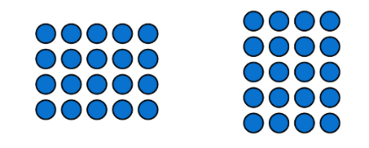
Commutative property: (of addition or multiplication) means that 2 numbers can be added or multiplied in any order and the solution will be the same. Commutative law, commutativity, and turn-around facts are interchangeable terms.
- Ask students the following questions to guide their thinking:
- What is the total value of each side of the equation? What strategy are you using to count them? Is there a more efficient way to count than by ones?
- How can you show if the 2 sides are equal?
- Is the equation true or false? Why? How do you know?
- What evidence can you share with your partner to explain your thinking?
- Combine pairs of students with another pair and have them discuss the strategies they used to sort the equations. Ask students:
- What strategies did you and your partner use to decide whether an equation was true or false?
- What models did you make that were helpful?
- What evidence did you find convincing?
- What challenges did you face?
- Was there an equation you changed your mind about? What made you change your mind?
- Discuss the equations that the class found challenging. Display these equations on the board and ask:
- Why might this be true?
- Why might this be false?
- How can we prove whether it is true or false?
Note: Highlight the evidence that students present, with a particular focus on the models they create. An equal-arm balance will help students prove their reasonings.
This table details assessment opportunities and differentiation ideas.
Assessment opportunities | Too hard? | Too easy?
What to look for:  - Are students able to explain the meaning of the equals sign? (MAO-WM-01, MA1-CSQ-01)  - Can students identify and use skip counting patterns to find the value of the arrays? (MA1-FG-01)  - Are students creating models to show multiplication can be represented using equal groups? (MAO-WM-01, MA1-FG-01)  - Are students able to identify and explain the commutative property of multiplication? For example, 3 fours is the same value as 4 threes. (MAO-WM-01, MA1-FG-01)  What to collect:  - students' work samples – drawings (MAO-WM-01, MA1-FG-01)  - evidence including photographs of students manipulating materials to demonstrate conceptual understanding of arrays (MAO-WM-01, MA1-FG-01)  - record observations of students during game-based play (MAO-WM-01, MA1-FG-01) | Students are not able to create models showing multiplication as equal groups and cannot identify the commutative property.  - Support students to use manipulatives to recreate the arrays and use count- by-one strategies to find the value. Use colour coded connecting cubes to assist with direct comparison.  - Model and use an equal-arm balance to assist students to visualise equivalence. | Students can create models showing multiplication as equal groups and can identify the commutative property of multiplication.  - In pairs students design their own true or false cards for others to use. Students can use arrays to design their equations.  - Encourage students to create a variety of true or false cards, before swapping and testing them with a partner.

Consolidation and meaningful practice: Number talk – 10 minutes
- Select and display one of the true or false arrays from Resource 9: True or false arrays, or one that a student has created.
- Ask students why the equation is true or false and how we can prove our thinking.

Lesson 5: Chanel’s garden
Core concept: Division is the equal distribution of objects.
The table below contains suggested learning intentions and success criteria. These are best co-constructed with students.
Learning intentions | Success criteria
Students are learning that:  - division is distributing a collection of objects equally into a given number of groups to determine how many are in each group  - arrays are a structure used to model multiplicative situations involving whole numbers  - there can be parts left over when a collection cannot be distributed equally using a given group size. | Students can:  - recognise that dividing the flowers means to share them equally  - make arrays of equal rows and equal columns  - share the flowers from the array into equal groups  - identify the part left over when sharing flowers into groups.

Daily number sense: Sharing collections (Part 1) – 10 minutes
- Build student understanding of multiplicative thinking by viewing Sharing collections – Part 1 (4:02) and pause at 1:07. Students identify what is different between the 2 images in the video and record their responses using images, words, and symbols.
- Continue playing the video and pause at 3:03. Students identify what is the same between the 2 images in the video and record their responses using images, words, and symbols. Discuss students’ responses as a class and continue watching the video to build on students’ thinking.

Chanel’s garden – 40 minutes
- Explain that Chanel has 20 flowers to plant in her garden. Ask students to use what they know about arrays to work out how Chanel could plant her flowers in equal groups.
- Give students a variety of manipulatives, including modelling clay, connecting cubes, and blocks and encourage students to draw, create models, and visualise the garden.
- Guide the learning through discussion and the following questions:
- How can you share the flowers equally into groups?
- Can you use the structure of an array to help you?
- Is there another way you can check the count to make sure you have planted all the flowers?
- How many different ways could Chanel plant the flowers? How do you know if you have found all the solutions?
- Are there any solutions that do not form equal groups? Why?
- Students create posters using drawings, symbols, and words with annotations to display what Chanel’s garden might look like. Students annotate their posters and justify their solutions. For example, ‘I made 4 rows of flowers with 5 in each row.’
- As a class discuss some of the posters, noticing the commutative property of multiplication. Discuss the different ways students made equal groups for the number 20.
- Pose the problem: Chanel’s friends have given her an extra 2 flowers for her garden. Can she make 5 equal rows in her garden? Allow time for students to investigate and record their thinking using images, words, and symbols.
- Ask students:
- How many flowers does Chanel have altogether?
- How can we use manipulatives to show a solution?
- Are there any other solutions we can try?
- How can we explain how to represent the parts that were left over?
- Share some students’ ideas and ask them to prove their thinking using manipulatives. Using students’ work samples, explicitly identify that Chanel cannot have 5 equal rows as there will be 2 left over. Therefore, it is not possible to form 5 equal groups with the number 22.
- Ask students whether Chanel could redesign her garden so that the 22 flowers can be shared equally into groups. Prompt students to consider what this might look like. Select some students to share their evidence of sharing 22 equally.
This table details assessment opportunities and differentiation ideas.
Assessment opportunities | Too hard? | Too easy?
What to look for:  - Are students able to distribute objects into equal groups? (MA1-FG-01)  - Can students form an array to create the garden? (MA1-FG-01)  - Can students identify and explain the difference between the number of rows/columns and the number in each row/column? (MAO-WM-01, MA1-FG-01)  - Can students model division with a given size group? (MA1-FG-01)  - Can students identify a part left over and explain why the collection cannot be divided equally? (MAO-WM-01, MA1-FG-01)  What to collect:  - students’ posters (MAO-WM-01, MA1-FG-01)  - recordings of students’ discussions (MAO-WM-01, MA1-FG-01) | Students are unable to form arrays or model division with a given group size.  - Support students to divide the flowers into equal groups, then arrange flowers into arrays.  - Revise the structure of arrays using a graphic organiser such as a blank hundreds chart. | Students can form arrays and model division with a given group size.  - Students work out a new array, limiting Chanel’s garden to a maximum of 6 rows.  - Students work out all the combinations of array structures that Chanel can have with 32 flowers.

Lesson 6: Multiplication toss – Part 1
Core concept: Arrays are a uniform informal measure of area.
The table below contains suggested learning intentions and success criteria. These are best co-constructed with students.
Learning intentions | Success criteria
Students are learning that:  - area is the measure of the units inside a shape  - arrays are a uniform informal measure of area  - the same area can be presented in different orientations. | Students can:  - count the total area of a rectangle using skip counting or repeated addition  - explain why units of measurement need to be the same size  - measure area using arrays of equal rows and columns  - recognise that a shape can be rotated but the area remains the same.

Daily number sense: Multiples of 10 – 10 minutes
- Build student understanding of the properties of groups within a larger collection using an array.
- Display Resource 10: Basketball array 2 and ask students how many basketballs they can see. Prompt students to explain how they knew and how they saw the array. Ask if there is there another way to find the product.
- Students record their responses and share their thinking.

Multiplication toss – 40 minutes
Note: This task has been adapted from Siemon et al. (2020) for Stage 1 students. It can be used to emphasise the difference between ‘how many’ and ‘how much’, for example, 6 fours.
- Watch Multiplication toss (5:38). When playing this game, discuss with students that we are able to use the structure of an array to measure the area of a rectangle. The area of the rectangle is the inside of the shape.
- Explain that the squares are uniform in size and this ensures a more accurate measure of area.
- In pairs, players take turns to roll 2 dice.
- A player uses the 2 numbers they roll to make a rectangle on 1 cm grid paper. For example, if a 3 and 6 are rolled, the player can draw either a rectangle of 3 rows of 6 (3 sixes) or 6 rows of 3 (6 threes). Rectangles must be drawn and labelled accurately before the next player’s turn.
- As the game continues, students monitor their rectangles to ensure no areas overlap.
- Eventually the unused space on the grid paper becomes limited (see Figure 2).
Figure 2: Multiplication toss example
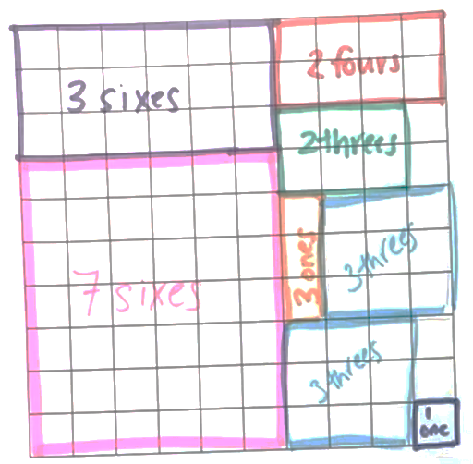
- The game ends when either player cannot complete their turn because the 1 cm grid is full. The winner is the player with the most squares covered.
- Students play several rounds of ‘Multiplication toss’ with their partner.
- Discuss with students their strategies while playing the game. For example, placing the larger rectangles in the corner position allows more space on the grid, or rotating the rectangle (using knowledge of the commutative property) means it may fit the available space.
This table details assessment opportunities and differentiation ideas.
Assessment opportunities | Too hard? | Too easy?
What to look for:  - Can students form arrays of equal rows and equal columns? (MA1-FG-01)  - Can students find the area of the rectangle using skip counting or repeated addition? (MA1-FG-01)  - Can students identify and explain that the area remains constant when the units are rearranged? (MAO-WM-01, MA1-2DS-02)  What to collect:  - students' work samples – rectangles on 1 cm grid (MAO-WM-01, MA1-FG-01, MA1-2DS-01)  - photographs of students manipulating materials to demonstrate conceptual understanding of arrays (MAO-WM-01, MA1-FG-01, MA1-2DS-01)  - recordings of students during discussions and game-based play (MAO-WM-01, MA1-FG-01, MA1-2DS-01) | Students are not able to create an array using manipulatives or recognise the connection between multiplication and area.  - Support students to create simple arrays, for example, 2 threes, using skip counting.  - Support students to play ‘Multiplication toss’ to model the use of skip counting, by building arrays and recording them on 1 cm grid paper. | Students are able to create an array using manipulatives and recognise the connection between multiplication and area.  - Students play ‘Multiplication toss’ with dice of greater values, and on a larger 1 cm grid to provide a bigger gameboard.  - When there is limited space on the ‘Multiplication toss’ gameboard, challenge students to try and fill unused spaces by reconstructing their arrays. For example, students could reconstruct a 4 cm × 6 cm array to create a 12 cm × 2 cm rectangle.

Consolidation and meaningful practice: Multiplication toss – 10 minutes
- Students play the game again with a different partner. Variations include using different numbered dice, a larger grid or limit the number of rolls per game.
- Discuss strategies that students have developed or experimented with to calculate the areas. These could include:
- using skip counting
- using repeated addition
- making a model of the array with counters to visualise the area.
- Ask, ‘What would happen if the squares were not the same size? How are area and multiplication connected?’

Lesson 7: Multiplication toss – Part 2
Core concept: When a shape is rotated the area remains constant.
This activity has been adapted from Siemon et al (2020).
The table below contains suggested learning intentions and success criteria. These are best co-constructed with students.
Learning intentions | Success criteria
Students are learning that:  - area is the measure of the units inside a shape  - arrays are a uniform informal measure of area  - when a shape is rotated the area remains constant  - 2 shapes can have the same area but look different. | Students can:  - count the number of units within the area of a shape using skip counting or repeated addition  - explain why units of measurement need to be the same size  - form different arrays using the same number of coloured tiles  - form arrays with equal rows and equal columns  - recognise that a rotated rectangle has the same area  - rotate a rectangle and identify the new width and length.

Daily number sense: 3 tens in a row – 15 minutes
- Build student understanding of number bonds to 10 by playing 3 tens in a line (2:29).
- Students play the game in pairs.

Multiplication toss revisited – 40 minutes
- Students should be familiar with the game ‘Multiplication toss’ from the previous lesson. Revisit the instructions for students who may require additional support. Revise that the squares are uniform in size and this ensures a more accurate measure of area.
- In pairs, students play one round of the game.
- Model for students how a rectangle can be rotated to create a new rectangle, pointing out that the number of internal squares (the area) is the same, but the length and width are now different.
- Have students cut out the rectangles they created on the 1 cm grid paper (there should be a range of different sizes).
- Students choose one rectangle and overlay each square with one coloured tile in to ensure the total number of tiles matches the array.
- Students make as many different arrays as they can using the same number of coloured tiles. For example, if the cut-out rectangle is 3 rows of 6 (3 sixes), students can make a rectangle out of tiles that is 2 rows of 9 (2 nines), 9 rows of 2 (9 twos), 6 rows of 3 (6 threes), one row of 18 (1 eighteen) or 18 rows of one (18 ones).
- Students repeat this process with each of their rectangle cut-outs.
- Students arrange their arrays in order – first by total number of tiles, then by length of each array. Finally, ask students if any arrays had the same total but looked different.
- The winner is the student (from each pair) who has made the most arrays from their cut-outs.
This table details assessment opportunities and differentiation ideas.
Assessment opportunities | Too hard? | Too easy?
What to look for:  - Can students find the total number of objects using skip counting of equal groups? (MA1-FG-01)  - Can students solve multiplication problems using repeated addition? (MA1-FG-01)  - Do students use objects, diagrams, images or actions to compare, order and match attributes? (MAO-WM-01, MA1-FG-01)  - Are students able to form arrays of equal rows and equal columns? (MA1-FG-01)  - Do students identify shapes presented in different orientations? (MA1-2DS-01)  What to collect:  - work samples (MAO-WM-01, MA1-FG-01, MA1-2DS-01)  - evidence including photographs of student manipulation of coloured tiles demonstrating arrays and area (MAO-WM-01, MA1-FG-01, MA1-2DS-01)  - observations during discussions and game-based play (MAO-WM-01, MA1-FG-01, MA1-2DS-01) | Students are not able to identify the total number of objects by comparing, ordering and matching attributes.  - Support students to create simple arrays, for example, 3 fours, using skip counting.  - Support students to play ‘Multiplication toss’ to model the use of skip counting, by building arrays and recording them on 1 cm grid paper. | Students are able to identify the total number of objects by comparing, ordering and matching attributes.  - Students play ‘Multiplication toss’ with dice of greater values, and on a larger 1 cm grid to provide a bigger gameboard.  - Students use the cut-out rectangles to estimate, measure and compare the area of surfaces in the classroom. For example, a desk or book.

Consolidation and meaningful practice: Reflection – 10 minutes
- Lead a guided discussion with the class. Ask the following questions:
- Is there anything else that you noticed while playing the game?
- Do you have any other wonderings?
- How can 2 rectangles have the same number of squares but look different?
- What strategies and ways of organising your work did you find most helpful?

Lesson 8: 30 cubes
Core concept: Volume can be represented with a 3D spatial structure.
The table below contains suggested learning intentions and success criteria. These are best co-constructed with students.
Learning intentions | Success criteria
Students are learning that:  - different rectangular prisms can be made from a given number of cubes  - strategies can be devised for stacking and counting units to form a rectangular prism  - volumes can be recorded by referring to the number and type of uniform informal unit used. | Students can:  - construct different rectangular prisms from a given number of cubes  - explain how to create a rectangular prism by stacking and counting cubes  - record volumes by counting the number of cubes used.

Daily number sense: Rectangular prism ‘notice’ and ‘wonder’ – 10 minutes
- Build student understanding of the array structure in the volume of shapes by pondering the properties of a 4 × 3 × 3 rectangular prism.
- Show Resource 11: Rectangular prism ‘notice’ and ‘wonder’. Ask students what they notice or wonder and record their thinking on an anchor chart.
Note: This activity can provide insights into students’ understanding of arrays and their length, width, height, volume and surface area, and their visualisation of a 3D object.

30 cubes – 40 minutes
This activity has been adapted from Stanford University (2021).
- Divide the class into groups of 3 or 4 and provide each group with 30 cubes.
- Revise the properties of a rectangular prism with the class.
Rectangular prism: A three-dimensional object with 6 rectangular faces, 8 vertices (corners – the point where 3 or more faces meet) and 12 straight edges (the line segment where 2 or more faces meet). It has length, width, and height.
- Groups of students construct new rectangular prisms by adding one cube at a time. For each cube added, the group must construct a rectangular prism.
- Continue creating rectangular prisms until groups have used the 30 cubes.
- Guide the investigation by asking:
- How many different prisms can you build with 2 cubes? What about with 3 cubes?
- How many different rectangular prisms can you build using 30 cubes?
- What makes rectangular prisms different from each other?
- Can you find any patterns or connections?
- While investigating, groups must:
- record findings (by drawing, colour coding, and describing their work) so others can understand their discoveries
- identify any connections or patterns in their findings.
- Provide groups with adequate time to complete the task.
- Ask groups to share their results, focusing on the process they used. Draw out any connections that students have made with previous learning, particularly the use of repeated addition of arrays to construct the layers of blocks in a prism.
This table details assessment opportunities and differentiation ideas.
Assessment opportunities | Too hard? | Too easy?
What to look for:  - Can students create different rectangular prisms from a given number of cubes? (MAO-WM-01, MA1-3DS-01, MA1-3DS-02)  - Are students able to devise and explain strategies for stacking and counting units to form a rectangular prism? (MAO-WM-01, MA1-3DS-01, MA1-3DS-02)  - Are students recording volumes by referring to uniform informal units? (MA1-3DS-02)  What to collect:  - record student discussions (MAO-WM-01, MA1-3DS-01, MA1-3DS-02)  - students’ work samples – drawings (MAO-WM-01, MA1-3DS-01, MA1-3DS-02)  - evidence including photographs of students using the cubes to create different prisms (MAO-WM-01, MA1-3DS-01, MA1-3DS-02) | Students are not able to create a rectangular prism using cubes.  - Support students to create a rectangular prism using a smaller number of cubes. For example, use 2-4 cubes and record how they are used to make the object.  - Model how to describe the number of cubes in each layer or array to find the total number of cubes. | Students create and describe a range of rectangular prisms using cubes.  Encourage students to analyse and explain their findings. For example:  - Which number of cubes can make the greatest number of rectangular prisms?  - If you double this number of cubes, how many rectangular prisms could you make?  - Can you find a way to prove this?

Consolidation and meaningful practice: Reflection – 10 minutes
- Facilitate reflection on learning in this lesson by asking:
- Is there anything else that you noticed while working with 30 cubes?
- What makes a rectangular prism different from another one that is built from the same number of cubes?
- What tools and ways of organising your work did you find most helpful?

Resource 1: Number visuals
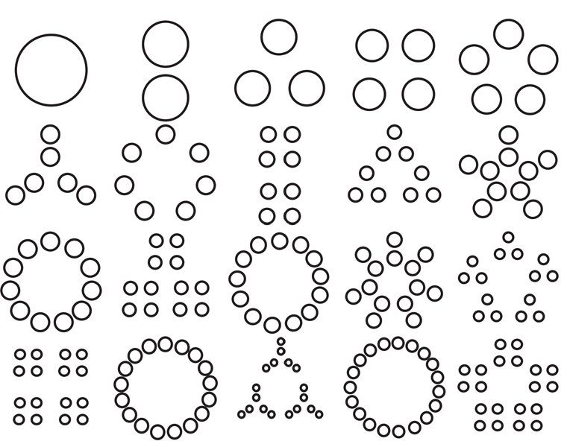
‘Number visuals (1-2)’ by youcubed is licensed under CC BY 4.0.

Resource 2: Basketball array
‘Basketball 3D’ by rafiico-creative is licensed in accordance with the Canva Content License Agreement.

Resource 3: A group of friends
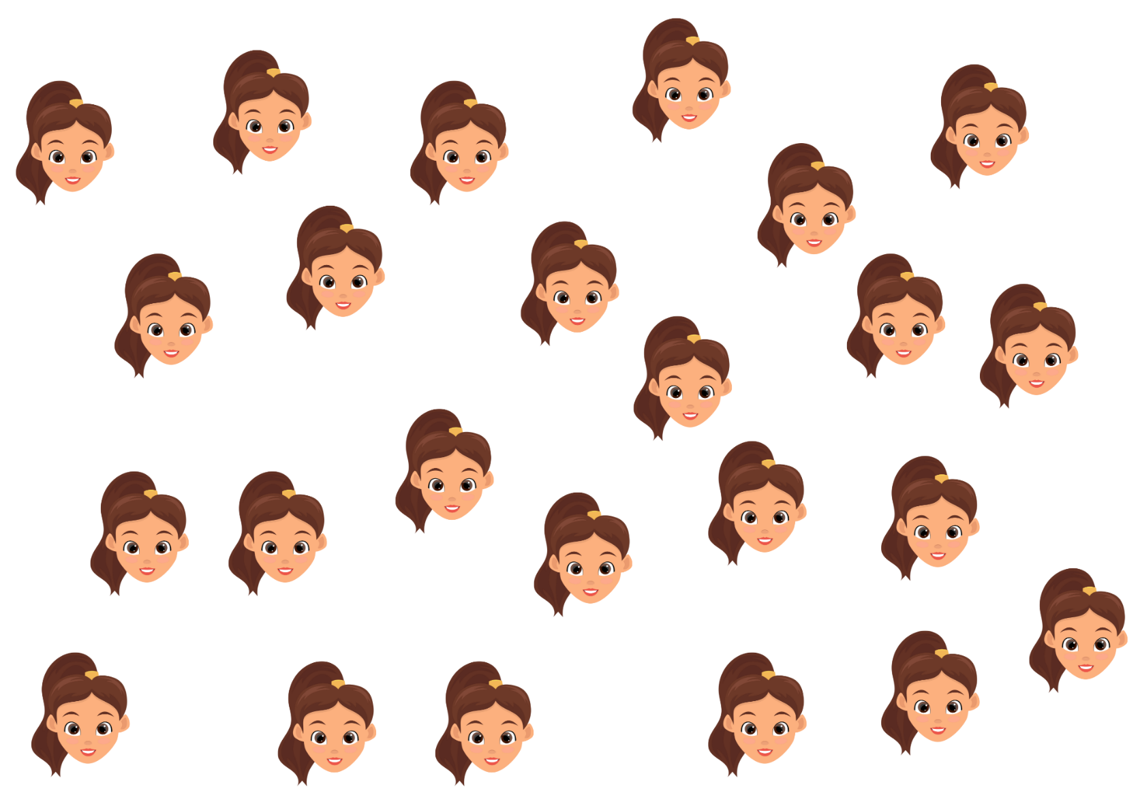
‘Happy Girl Face’ by EmilTimplaru is licensed in accordance with the Canva Content License Agreement.

Resource 4: An array of friends
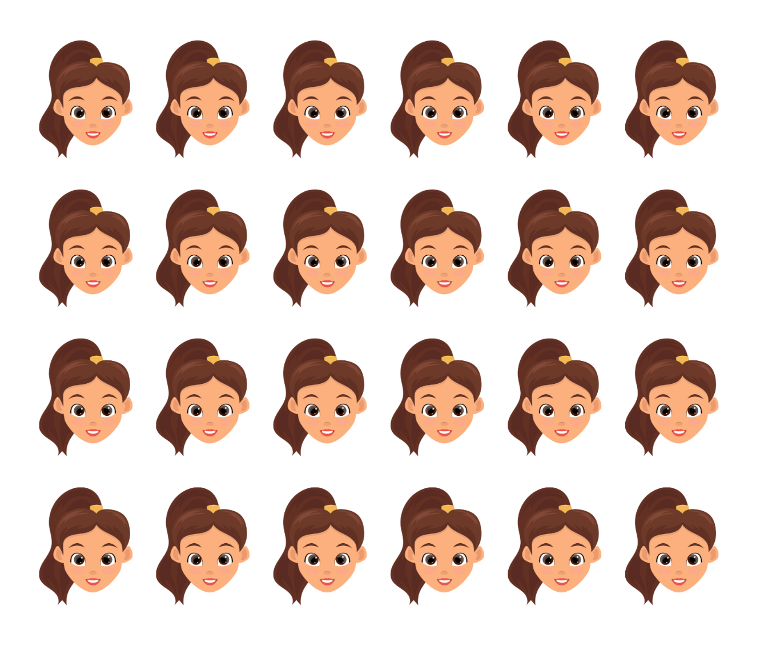
‘Happy Girl Face’ by EmilTimplaru is licensed in accordance with the Canva Content License Agreement.

Resource 5: Partially covered array
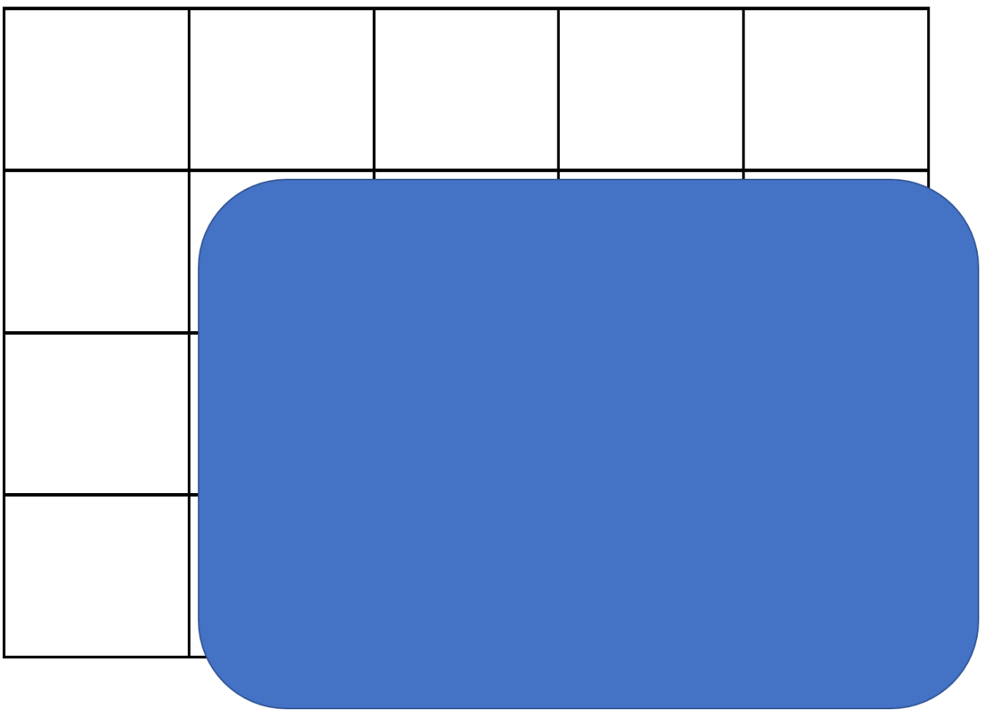
Adapted from Battista et al. (1998).

Resource 6: Array talk
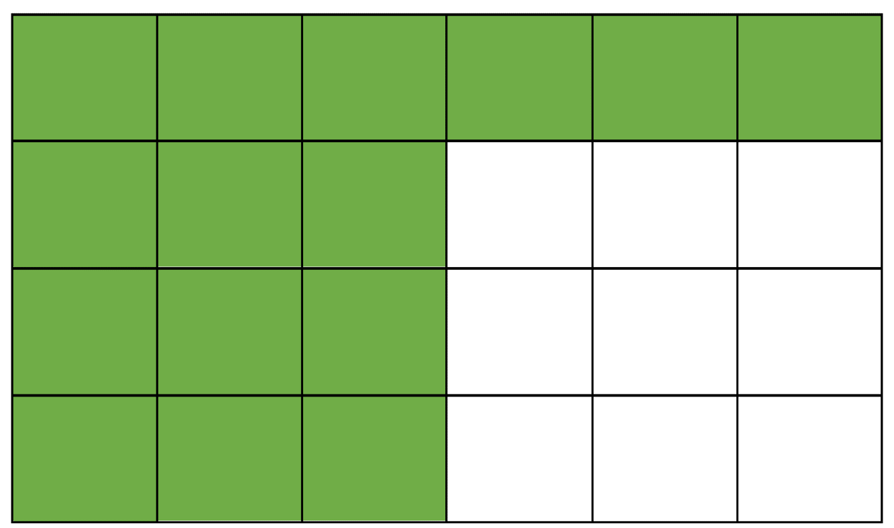

Resource 7: Array puzzle
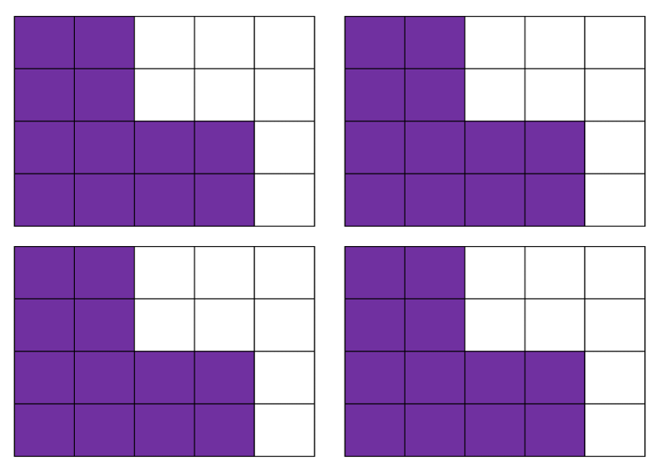

Resource 8: Equal-arm balance
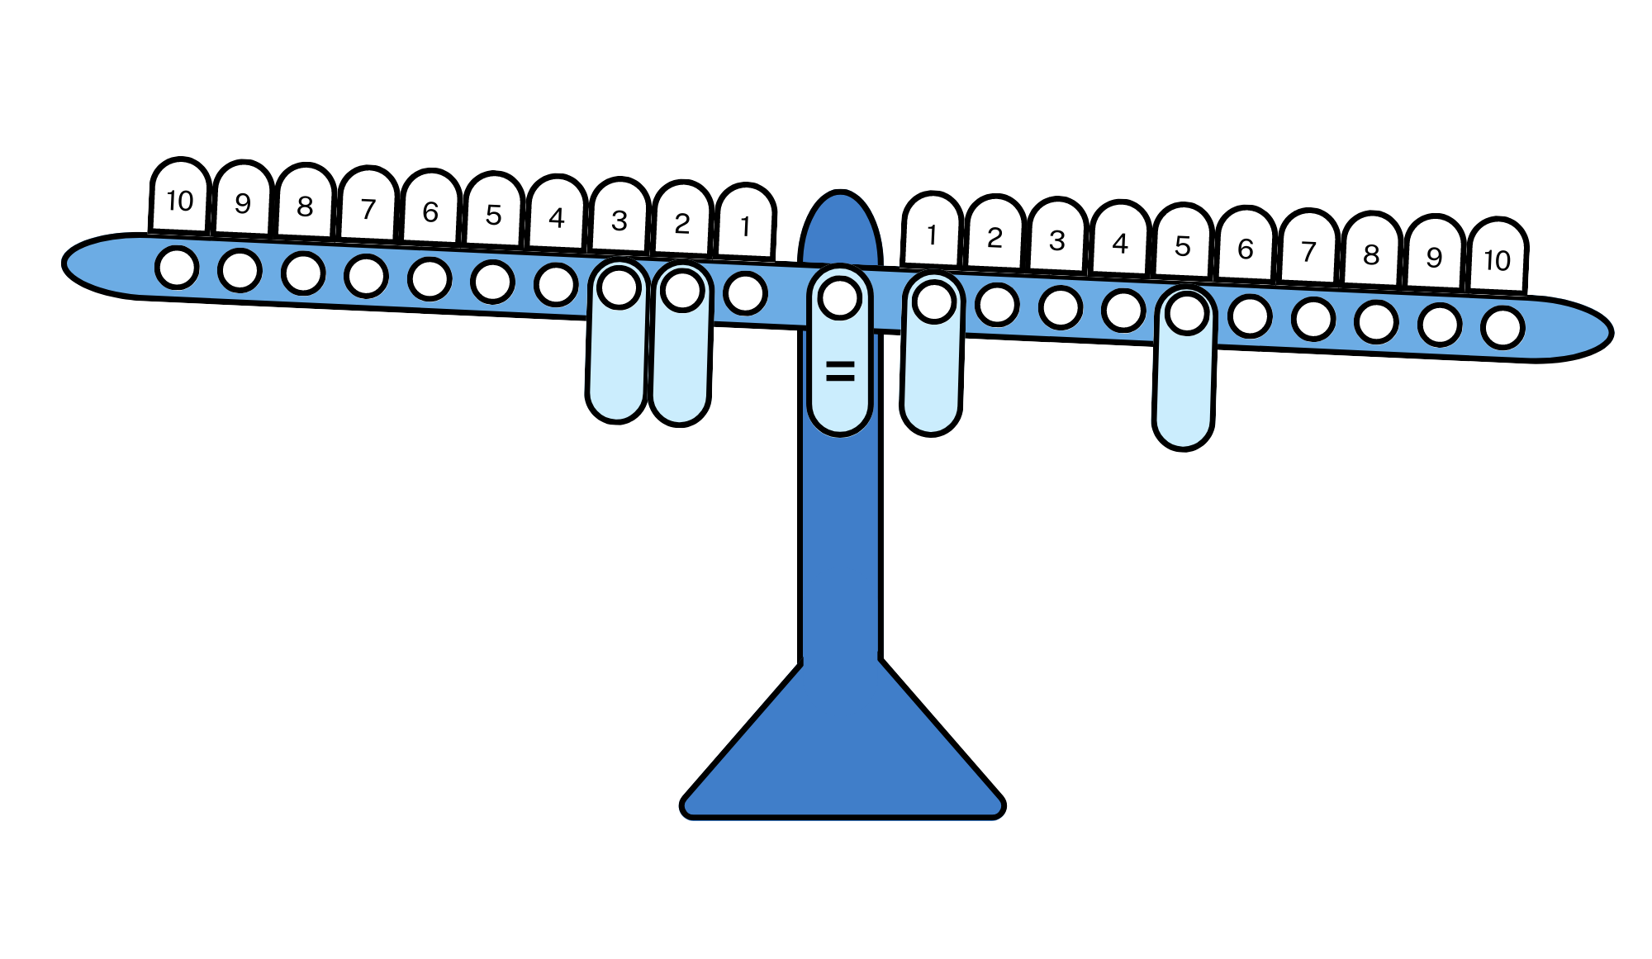

Resource 9: True or false arrays
These arrays have an equal number of squares shaded – True or false?
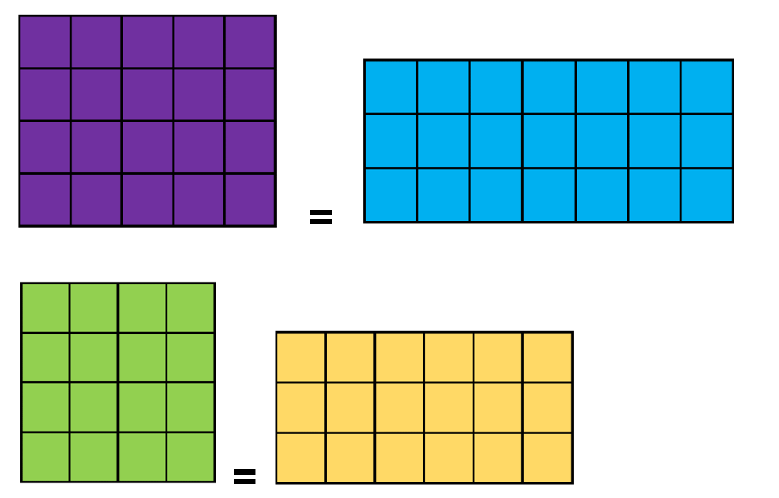
These arrays have an equal number of squares shaded – True or false?
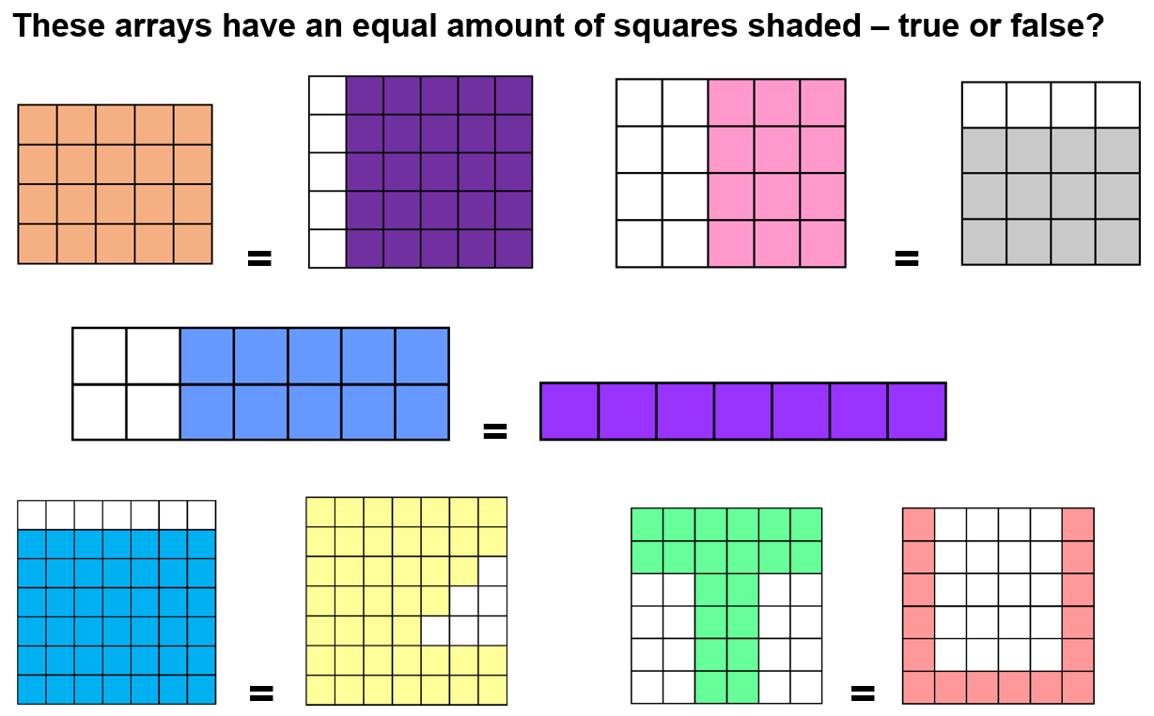

Resource 10: Basketball array 2
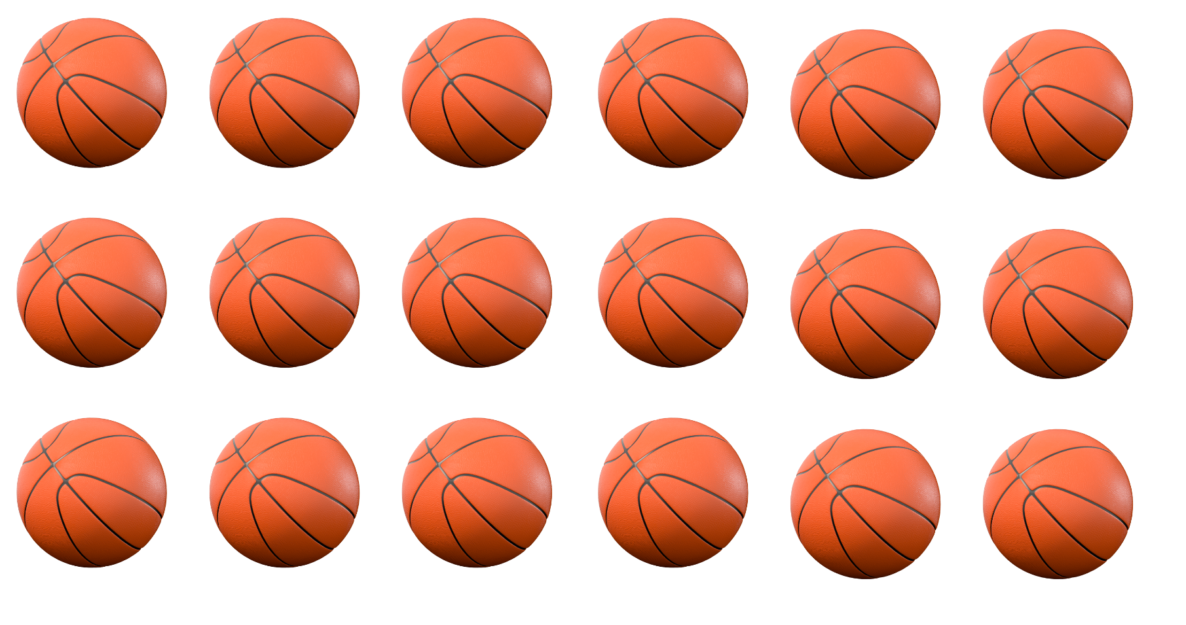
‘Basketball 3D’ by rafiico-creative is licensed in accordance with the Canva Content License Agreement.

Resource 11: Rectangular prism ‘notice’ and ‘wonder’
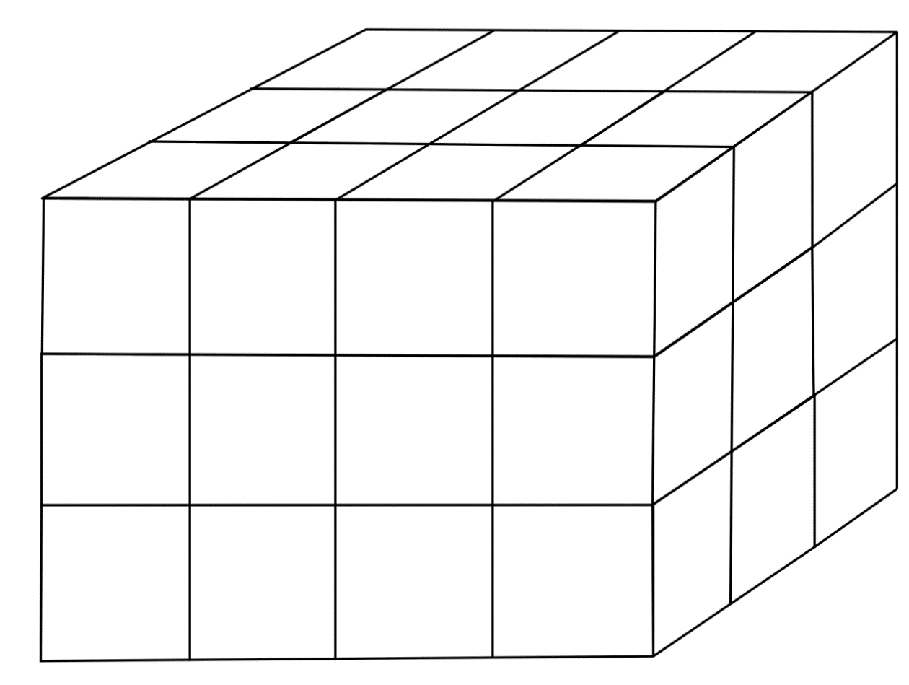
This resource is from the task ‘30 cubes’ by youcubed.

Syllabus outcomes and content
The table below outlines the syllabus outcomes and range of relevant syllabus content covered in this unit. Content is linked to National Numeracy Learning Progression versions (3).
Focus area and outcomes | Content groups and content points | Lessons
Representing whole numbers A  MAO-WM-01  MA1-RWN-01  MA1-RWN-02 | Use counting sequences of ones with two-digit numbers and beyond  - identify the number before and after a given two-digit number (CPr5)  - count forwards and backwards by ones from a given number to at least 120 (CPr6)  Represent the structure of groups of ten in whole numbers  - recognise that ten ones is the same as one ten (NPV2, NPV4)  - count large sets of objects by systematically grouping in tens (CPr7)  - partition two-digit numbers to show quantity values (NPV4) | 1–8
Combining and separating quantities A  MAO-WM-01  MA1-CSQ-01 | Use advanced count-by-one strategies to solve addition and subtraction problems  - apply the terms ‘add’, ‘plus’, ‘equals’, ‘is equal to’, ‘is the same as’, ‘take away’, ‘minus’ and ‘the difference between’ to describe combining and separating quantities (AdS1, AdS6)  - recognise and use the symbols for plus (+), minus (−) and equals (=)  - record number sentences in a variety of ways using drawings, words, numerals and symbols (AdS6)  - fluently use advanced count-by-one strategies including counting on and counting back to solve addition and subtraction problems involving one- and two-digit numbers (Reasons about relations) (AdS3-AdS5)  Represent equality  - use the equals sign to record equivalent number sentences involving addition, and to mean 'is the same as', rather than as an indication to perform an operation (Reasons about relations) (NPA3) | 1, 3–4
Forming groups A  MAO-WM-01  MA1-FG-01 | Count in multiples using rhythmic and skip counting  - count by twos, threes, fives and tens using rhythmic counting and skip counting (MuS2, CPr6)  Use skip counting patterns  - identify and describe patterns when skip counting forwards or backwards by twos, fives and tens (NPA3, NPA4)  Model and use equal groups of objects to represent multiplication  - model and describe collections of objects as groups of (MuS2)  - determine and distinguish between the number of groups and the number in each group when describing collections of objects (Reasons about relations)  - find the total number of objects using skip counting of equal groups of a known size (MuS2-MuS3)  Recognise and represent division  - model sharing division by distributing a collection of objects equally into a given number of groups to determine how many in each group (InF2, MuS5)  - model grouping division by determining the number of groups of a given size that can be formed (MuS5)  - describe the part left over when a collection cannot be distributed equally using the given group size (MuS6) | 1–8
Forming groups B  MAO-WM-01  MA1-FG-01 | Represent and explain multiplication as the combining of equal groups  - use objects, diagrams, images or actions to model multiplication as accumulating equal groups (MuS4)  - solve multiplication problems using repeated addition (MuS4)  - form arrays of equal rows and equal columns (MuS5)  - determine and distinguish between the number of rows/columns and the number in each row/column when describing collections of objects (MuS5)  - model the commutative property of multiplication, using an array (MuS6)  - model division by deconstructing an array equally into a given number of rows or columns  Represent multiplication and division problems  - solve multiplication and division problems using objects, diagrams, images and actions (MuS6-MuS7)  - record answers to multiplication and division problems (including those with remainders) using drawings, words and numerals (MuS6) | 2–7
Non-spatial measure A  MAO-WM-01  MA1-NSM-01  MA1-NSM-02 | Mass: Investigate mass using an equal-arm balance  - place objects on either side of an equal-arm balance to obtain a level balance  - use a balance to find two collections of objects that have the same mass (UuM2) | 4
Two-dimensional spatial structure A  MAO-WM-01  MA1-2DS-01  MA1-2DS-02 | Area: Measure areas using uniform informal units  - explore area using uniform informal units to cover the surface in rows or columns without gaps or overlaps (UuM5)  - explain why the area remains constant when units are rearranged (Reasons about relations)  - estimate areas by referring to the number and type of uniform informal unit used and check by measuring (UuM3)  2D shapes: Recognise and classify shapes using obvious features  - identify shapes presented in different orientations (UGP2) | 6–7
Two-dimensional spatial structure B  MAO-WM-01  MA1-2DS-01  MA1-2DS-02 | 2D shapes: Represent, combine and separate two-dimensional shapes  - make representations of two-dimensional shapes and combinations of shapes in different orientations  Area: Compare rectangular areas using uniform square units of an appropriate size in rows and columns  - cover rectangular surfaces by creating repeated rows of square tiles  - use a single square to create the array structure of area in rows and columns  - use the structure of repeated units to find the area of a rectangle  - explain how the grid structure of rows and columns helps to find the area (Reasons about spatial structure)  - record comparisons of area using drawings, numerals and words, and by referring to the uniform informal unit used | 6–7
Three-dimensional spatial structure A  MAO-WM-01  MA1-3DS-01 | 3D objects: Recognise familiar three-dimensional objects  - identify and name familiar three-dimensional objects, including cubes, cylinders, spheres and rectangular prisms  3D objects: Sort and describe three-dimensional objects  - manipulate and describe familiar three-dimensional objects (UGP2)  Volume: Construct volumes using cubes  - explore different rectangular prisms that can be made from a given number of cubes  - devise and explain strategies for stacking and counting units to form a rectangular prism (Reasons about spatial structure)  - record volumes, referring to the number and type of uniform informal unit used | 8
Three-dimensional spatial structure B  MAO-WM-01  MA1-3DS-01 | Volume: Compare volumes using uniform informal units  - compare models with different appearances, recognising when they have the same volume (Reasons about spatial structure)  - record the results of volume comparisons using drawings, numerals and words, referring to the units used | 8

References
Links to third-party material and websites
Please note that the provided (reading/viewing material/list/links/texts) are a suggestion only and implies no endorsement, by the New South Wales Department of Education, of any author, publisher, or book title. School principals and teachers are best placed to assess the suitability of resources that would complement the curriculum and reflect the needs and interests of their students.
If you use the links provided in this document to access a third-party's website, you acknowledge that the terms of use, including licence terms set out on the third-party's website apply to the use which may be made of the materials on that third-party website or where permitted by the Copyright Act 1968 (Cth). The department accepts no responsibility for content on third-party websites.
Except as otherwise noted, all material is © State of New South Wales (Department of Education), 2023 and licensed under the Creative Commons Attribution 4.0 International License. All other material (third-party material) is used with permission or under licence. Where the copyright owner of third-party material has not licensed their material under a Creative Commons or similar licence, you should contact them directly for permission to reuse their material.
Mathematics K–10 Syllabus © 2022 NSW Education Standards Authority (NESA) for and on behalf of the Crown in right of the State of New South Wales.
© 2022 NSW Education Standards Authority. This document contains NSW Curriculum and syllabus content. The NSW Curriculum is developed by the NSW Education Standards Authority. This content is prepared by NESA for and on behalf of the Crown in right of the State of New South Wales. The material is protected by Crown copyright.
Please refer to the NESA Copyright Disclaimer for more information.
NESA holds the only official and up-to-date versions of the NSW Curriculum and syllabus documents. Please visit the NSW Education Standards Authority (NESA) website and the NSW Curriculum website.
National Numeracy Learning Progression © Australian Curriculum, Assessment and Reporting Authority (ACARA) 2010 to present, unless otherwise indicated. This material was downloaded from the Australian Curriculum website (National Numeracy Learning Progression) (accessed 22 November 2022) and was not modified. The material is licensed under CC BY 4.0. Version updates are tracked in the ‘Curriculum version history’ section on the 'About the Australian Curriculum' page of the Australian Curriculum website.
ACARA does not endorse any product that uses the Australian Curriculum or make any representations as to the quality of such products. Any product that uses material published on this website should not be taken to be affiliated with ACARA or have the sponsorship or approval of ACARA. It is up to each person to make their own assessment of the product, taking into account matters including, but not limited to, the version number and the degree to which the materials align with the content descriptions and achievement standards (where relevant). Where there is a claim of alignment, it is important to check that the materials align with the content descriptions and achievement standards (endorsed by all education Ministers), not the elaborations (examples provided by ACARA).
This resource contains images and content obtained from Canva, and their use outside of this resource is subject to Canva’s Content License Agreement. If you wish to use them separately from the resource, please go to Canva.
Battista MT, Clements DH, Arnoff J, Battista K and Van Auken Borrow C (1998) ‘Students' Spatial Structuring of 2D Arrays of Squares’, Journal for Research in Mathematics Education, 29(5):503–532, doi:10.2307/749731, accessed 22 November 2022.
Boaler J, Munson J and Williams C (2021) Mindset Mathematics: Visualizing and Investigating Big Ideas, Grade 1, Jossey-Bass Inc, New York.
Boaler J, Munson J and Williams C (2022) Mindset Mathematics: Visualizing and Investigating Big Ideas, Grade 2, Jossey-Bass Inc, New York.
Didax, Inc (2023) Didax [website], accessed 2 March 2023.
Siemon D, Warren E, Beswick K, Faragher R, Miller J, Horne M, Jazby D, Breed M, Clark J and Brady K (2020) Teaching Mathematics: Foundations to Middle Years, 3rd edn, Oxford University Press Australia and New Zealand.
Smith MP, Bill VL and Gamoran Sherin M (2019) The Five Practices in Practice: Successfully Orchestrating Mathematics Discussions in Your Elementary Classroom, Corwin Press, Inc and NCTM (National Council of Teachers of Mathematics), United States.
Stanford University (n.d.) ‘Number Visuals (K-12)’, Resources, youcubed website, accessed 22 November 2022.
Stanford University (n.d.) youcubed [website], accessed 2 March 2023.
Stanford University (2021) ‘30 Cubes’, Tasks, youcubed website, accessed 22 November 2022.

