Mathematics – Stage 1 – Unit 12
Contents
Unit description and duration 4
Student prior learning 4
Lesson overview and resources 5
Lesson 1: Translating patterns 17
Daily number sense: Dot talk – 10 minutes 18
Translating patterns – 40 minutes 19
Consolidation and meaningful practice: Sharing our patterns – 10 minutes 21
Lesson 2: Shrinking patterns 1 22
Daily number sense: Choral counting – Counting forwards by ones – 20 minutes 22
Shrinking patterns – 40 minutes 24
Consolidation and meaningful practice: Representing patterns in different ways – 10 minutes 28
Lesson 3: Shrinking patterns 2 29
Daily number sense: Choral counting – Counting backwards by ones – 20 minutes 30
Identifying and representing shrinking patterns – 40 minutes 32
Lesson 4: Growing patterns 1 35
Daily number sense: Choral counting by twos – 20 minutes 35
Representing growing patterns – 50 minutes 37
Lesson 5: Growing patterns 2 41
Daily number sense – 15 minutes 42
Sticky Triangles – 45 minutes 42
Lesson 6: Patterns in the number chart 47
Daily number sense: Snail One Hundred – 20 minutes 47
Number pattern detectives – 30 minutes 48
Consolidation and meaningful practice: Discuss and connect the mathematics – 10 minutes 50
Lesson 7: Weaving patterns 51
Daily number sense: Guess my pattern – 15 minutes 51
Weaving patterns – 45 minutes 52
Consolidation and meaningful practice: Discuss and connect the mathematics – 10 minutes 56
Lesson 8: Diagonal sums 57
Daily number sense: Buzzy Bee – 20 minutes 57
Diagonal sums – 40 minutes 59
Resource 1: Dot talk 62
Resource 2: AB pattern 63
Resource 3: ABC pattern 64
Resource 4: ABB pattern 65
Resource 5: Graphic organiser 66
Resource 6: Triangle growing pattern 67
Resource 7: Cube growing pattern 68
Resource 8: Snail one hundred 69
Resource 9: Bottom-up number chart 70
Resource 10: Number chart puzzles 71
Resource 11: Woven basket 72
Resource 12: Centimetre number chart 73
Resource 13: Buzzy Bee’s honeycomb 74
Syllabus outcomes and content 75
References 80
Further reading 82

Unit description and duration
This two-week unit develops student knowledge, understanding, and skills in patterning. Students are provided opportunities to:
- understand that patterns repeat, and this repetition is referred to as the repeating core
- understand that some patterns can increase (grow) or decrease (shrink) by the same amount in each subsequent term
- develop an understanding of patterns in the place value system.
Mathematics K–10 Syllabus © 2022 NSW Education Standards Authority (NESA) for and on behalf of the Crown in right of the State of New South Wales.

Student prior learning
Before engaging in these teaching and learning activities, students would benefit from prior experience with:
- recognising a pattern
- copying and continuing simple repeating patterns using sounds, shapes, objects, images, or actions
- number charts and counting.

Lesson overview and resources
The table below outlines the sequence and approximate timing of lessons; syllabus focus areas and content groups; and resources.
Lesson | Syllabus focus area and content groups | Resources
Lesson 1: Translating patterns  60 minutes  A pattern core can be created in different forms. | Representing whole numbers A  - Use counting sequences of ones with two-digit numbers and beyond  - Continue and create number patterns  - Represent the structure of groups of ten in whole numbers  Forming groups A  - Count in multiples using rhythmic and skip counting | - Resource 1: Dot talk  - Resource 2: AB pattern  - Resource 3: ABC pattern  - Resource 4: ABB pattern  - Resource 5: Graphic organiser  - Video: Pattern matching (4:24)  - Concrete materials  - Writing materials
Lesson 2: Shrinking patterns 1  70 minutes  Shrinking patterns get smaller by the same quantity each time. | Representing whole numbers A  - Use counting sequences of ones with two-digit numbers and beyond  - Continue and create number patterns  - Represent the structure of groups of ten in whole numbers  Representing whole numbers B  - Use counting sequences of ones and tens flexibly  Combining and separating quantities A  - Use advanced count-by-one strategies to solve addition and subtraction problems  - Recognise and recall number bonds up to ten  - Use flexible strategies to solve addition and subtraction problems  Forming groups A  - Count in multiples using rhythmic and skip counting  - Use skip counting patterns  Forming groups B  - Model and use equal groups of objects to represent multiplication  Data A  - Ask questions and gather data  - Represent data with objects and drawings and describe the displays  Data B  - Identify a question of interest and gather relevant data  - Create displays of data and interpret them | - Video: 5 Little Monkeys (2:23)  - Concrete materials  - Writing materials
Lesson 3: Shrinking patterns 2  60 minutes  Shrinking patterns can be represented in different ways. | Representing whole numbers A  - Use counting sequences of ones with two-digit numbers and beyond  - Continue and create number patterns  - Represent the structure of groups of ten in whole numbers  Representing whole numbers B  - Use counting sequences of ones and tens flexibly  Combining and separating quantities A  - Use advanced count-by-one strategies to solve addition and subtraction problems  - Recognise and recall number bonds up to ten  - Use flexible strategies to solve addition and subtraction problems  Forming groups A  - Count in multiples using rhythmic and skip counting  - Use skip counting patterns  Forming groups B  - Model and use equal groups of objects to represent multiplication  Data A  - Ask questions and gather data  - Represent data with objects and drawings and describe the displays  Data B  - Identify a question of interest and gather relevant data  - Create displays of data and interpret them | - Counters  - Writing materials
Lesson 4: Growing patterns 1  70 minutes  Growing patterns get bigger by the same quantity each time. | Representing whole numbers A  - Use counting sequences of ones with two-digit numbers and beyond  - Continue and create number patterns  Combining and separating quantities A  - Use advanced count-by-one strategies to solve addition and subtraction problems  - Recognise and recall number bonds up to ten  - Use flexible strategies to solve addition and subtraction problems  Forming groups A  - Count in multiples using rhythmic and skip counting  - Use skip counting patterns  Forming groups B  - Model and use equal groups of objects to represent multiplication  Data A  - Ask questions and gather data  - Represent data with objects and drawings and describe the displays  Data B  - Identify a question of interest and gather relevant data  - Create displays of data and interpret them | - Resource 6: Triangle growing pattern  - Resource 7: Cube growing pattern  - Concrete materials  - Writing materials
Lesson 5: Growing patterns 2  60 minutes  Growing patterns can be represented in different ways. | Representing whole numbers A  - Use counting sequences of ones with two-digit numbers and beyond  - Continue and create number patterns  Combining and separating quantities A  - Use advanced count-by-one strategies to solve addition and subtraction problems  - Recognise and recall number bonds up to ten  - Use flexible strategies to solve addition and subtraction problems  Forming groups A  - Count in multiples using rhythmic and skip counting  - Use skip counting patterns  Data A  - Ask questions and gather data  - Represent data with objects and drawings and describe the displays  Data B  - Identify a question of interest and gather relevant data  - Create displays of data and interpret them | - Craft sticks  - Writing materials
Lesson 6: Patterns in the number chart  60 minutes  Number patterns can be identified within number charts. | Representing whole numbers A  - Use counting sequences of ones with two-digit numbers and beyond  - Continue and create number patterns  - Represent the structure of groups of ten in whole numbers  Representing whole numbers B  - Use counting sequences of ones and tens flexibly  - Form, regroup and rename three-digit numbers  Combining and separating quantities A  - Use advanced count-by-one strategies to solve addition and subtraction problems  - Recognise and recall number bonds up to ten  - Use flexible strategies to solve addition and subtraction problems  Forming groups A  - Count in multiples using rhythmic and skip counting  - Use skip counting patterns | - Resource 8: Snail one hundred  - Resource 9: Bottom-up number chart  - Resource 10: Number chart puzzles  - 6-sided dice  - Counters  - Writing materials
Lesson 7: Weaving patterns  70 minutes  A number pattern can be represented in different ways. | Representing whole numbers A  - Use counting sequences of ones with two-digit numbers and beyond  - Continue and create number patterns  - Represent the structure of groups of ten in whole numbers  Representing whole numbers B  - Use counting sequences of ones and tens flexibly  Combining and separating quantities A  - Use advanced count-by-one strategies to solve addition and subtraction problems  - Recognise and recall number bonds up to ten  - Use flexible strategies to solve addition and subtraction problems  Forming groups A  - Count in multiples using rhythmic and skip counting  - Use skip counting patterns | - Resource 9: Bottom-up number chart  - Resource 11: Woven basket  - Resource 12: Centimetre number chart  - Coloured rods  - Writing materials
Lesson 8: Diagonal sums  60 minutes  Number charts can be used to explore patterning. | Representing whole numbers A  - Use counting sequences of ones with two-digit numbers and beyond  - Continue and create number patterns  - Represent the structure of groups of ten in whole numbers  Representing whole numbers B  - Use counting sequences of ones and tens flexibly  Combining and separating quantities A  - Use advanced count-by-one strategies to solve addition and subtraction problems  - Recognise and recall number bonds up to ten  - Use flexible strategies to solve addition and subtraction problems | - Resource 9: Bottom-up number chart  - Resource 13: Buzzy Bee’s honeycomb  - Calculators  - Writing materials

Lesson 1: Translating patterns
Core concept: A pattern core can be created in different forms.
The table below contains suggested learning intentions and success criteria. These are best co-constructed with students.
Learning intentions | Success criteria
Students are learning that:  - patterns have something that repeats over and over and over again  - in repeating patterns, the part that repeats is called the repeating core  - a pattern core can be created in different forms. | Students can:  - create repeating patterns  - find the core of a repeating pattern  - create the same repeating core in different ways  - describe the pattern core by the number of parts. For example, ‘This is a three-part pattern’  - describe the pattern core using letters such as AB, ABC, ABB, AABBCC.

Daily number sense: Dot talk – 10 minutes
This activity has been adapted from ‘Dot talks’ from Mindset Mathematics: Visualising and Investigating Big Ideas, Grade 1 by Boaler et al. (2021).
- Build student understanding of subitising, composing and decomposing numbers by engaging in a dot talk.
- Display Resource 1: Dot talk for a few seconds. Ask students how many dots they saw. Students turn and talk to a partner about how they saw the dots.
- Students share their thinking by showing or describing the different clusters they saw. Colour code the different groups they saw to help others see their thinking (see Figure 1).
Figure 1 – Example of dot talk responses
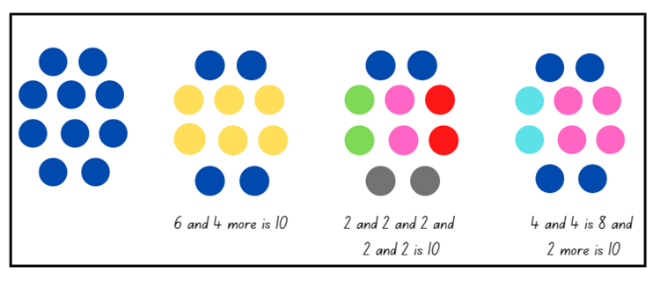

Translating patterns – 40 minutes
- Revise prior learning on patterning. Highlight that patterns need to have a core that is repeated over and over and over again. Explain that mathematicians often describe the repeating core of a pattern using letters.
- Display Resource 2: AB pattern. Identify the repeating core and explain that it is an AB pattern. Demonstrate how to follow the pattern using body percussion and have students continue the pattern.
- Explain to students that a pattern can be represented in more than one form. For example, this pattern was translated into body percussion by assigning a movement to each colour.
- Display Resource 3: ABC pattern. Identify the repeating core and explain that it is an ABC pattern. Demonstrate how to follow the pattern using body percussion and have students continue the pattern.
- Display Resource 4: ABB pattern. Identify the repeating core and explain that it is an ABB pattern. Demonstrate how to follow the pattern using body percussion and have students continue the pattern.
- Watch the video Pattern matching (4:24). Ask students to turn and talk to a partner and identify the pattern core. Record the pattern core on a whiteboard and label the pattern using letters.
- The structure of Eddie Woo’s first pattern is AABBC. Ask students how many different ways they can find to translate the same pattern.
- Using ‘Talk moves’, have students identify a variety of forms that could be used to represent a pattern. For example, physical movements, instruments, numbers, drawings, symbols, or by using concrete materials.
- Students create their own repeating patterns using coloured counters and choose different forms to translate their pattern.
- Students record translations using Resource 5: Graphic organiser.
The table below details assessment opportunities and differentiation ideas.
Assessment opportunities | Too hard? | Too easy?
What to look for:  - Can students create repeating patterns? (MAO-WM-01, MA1-RWN-01, MA1-RWN-02)  - Are students able to find the core of a repeating pattern? (MAO-WM-01)  - Can students describe the pattern core by the number of parts? For example, ‘This is a three-part pattern’ (MAO-WM-01)  - Do students describe the pattern core using letters such as AB, ABC, ABB, AABBCC? (MAO-WM-01)  - Can students translate the same repeating core in different ways? (MAO-WM-01)  What to collect:  - observations of students creating patterns and translating patterns (MAO-WM-01)  - work sample Resource 5: Graphic organiser (MAO-WM-01, MA1-RWN-01, MA1-RWN-02) | Students are unable to translate the same repeating core in different ways.  - Provide visuals to assist in translating, for example, use colours, pictures, or signals.  - Support students with a simple AB pattern and model translating with simple body percussion. | Students can translate the same repeating core in different ways.  - Increase the complexity of the core.  - Extend the length of the pattern core.

Consolidation and meaningful practice: Sharing our patterns – 10 minutes
- Invite students to share their patterns with the class. Ask the following questions to stimulate rich discussion:
- Can you identify the pattern core?
- How could you describe your pattern?
- How many ways were you able to translate the pattern?
- What did you find challenging?
- Can you demonstrate your pattern using body percussion?

Lesson 2: Shrinking patterns 1
Core concept: Shrinking patterns get smaller by the same quantity each time.
The table below contains suggested learning intentions and success criteria. These are best co-constructed with students.
Learning intentions | Success criteria
Students are learning that:  - counting sequences have patterns  - a shrinking pattern gets smaller by the same quantity each time  - an array is one way to model multiplicative thinking involving whole numbers  - mathematicians represent data with tables. | Students can:  - identify patterns in numbers when choral counting  - identify a shrinking pattern and explain the repeating core  - represent a shrinking pattern in different ways  - use an array model to skip count  - draw a table showing a shrinking pattern.

Daily number sense: Choral counting – Counting forwards by ones – 20 minutes
This activity has been adapted from Franke et al. (2018).
- Build student understanding of counting patterns and fluency in counting sequences through choral counting.
- Have students count aloud by ones, starting from 5 up to 42. Record counting sequence on the board (see Figure 2).
Figure 2 – Choral counting chart
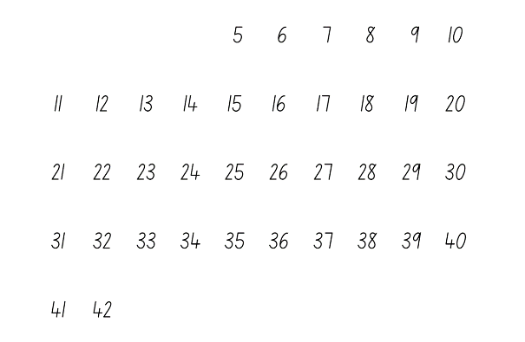
- Ask students what they notice and wonder about the numbers using the following prompts.
The table below outlines stimulus prompts to generate conversation about the topic, along with anticipated responses from students.
Prompts | Anticipated student responses
- What do you notice about the numbers?  - Which numbers are the two-digit numbers?  - What do you notice about the numbers in this column? (point) For example, 6, 16, 26, 36.  - Who can tell us what number will come next? How do you know?  - Does someone have another way to know the next number? | - There is a pattern of ones in each column. For example, for the numbers 11, 21, 31, 41, all have a ones digit that says ‘one’  - Student points to each column and says: ‘These have one, these have 2, these have 3, and these have 4, and so on. All of the tens numbers have the same in each column.’
- Record observations and patterns on the board (see Figure 3).
Figure 3 – Annotated choral counting chart
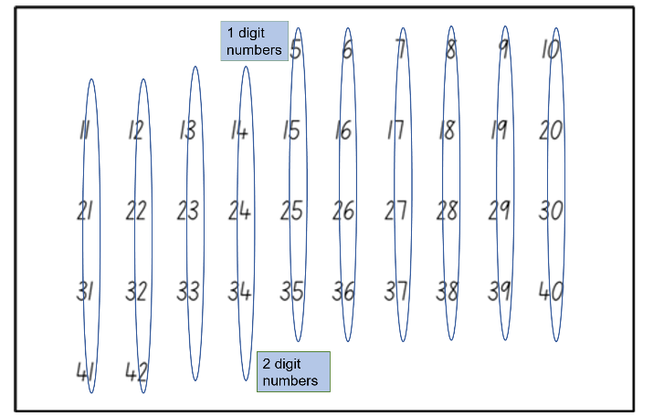
- During the discussion, explicitly highlight the patterns in the numbers. Select one pattern to count, for example, 10, 20, 30, 40. Students continue counting by tens up to 120. Variation: Select a pattern that increases by tens off the decade, for example, 7, 17, 27, 37, and continue counting on.

Shrinking patterns – 40 minutes
This activity has been adapted from Gecko feet by NZ Maths.
- Watch the video 5 Little Monkeys (2:23). Revise that there were 5 monkeys at the beginning of the song and each monkey has 4 limbs. Ask students how many limbs there were all together.
- Give students the opportunity to turn and talk with a partner and to record their thinking using drawing, words, or numbers.
- Using the structure of an array, model a solution to the problem to students (see Figure 4).
Figure 4 – Array structure
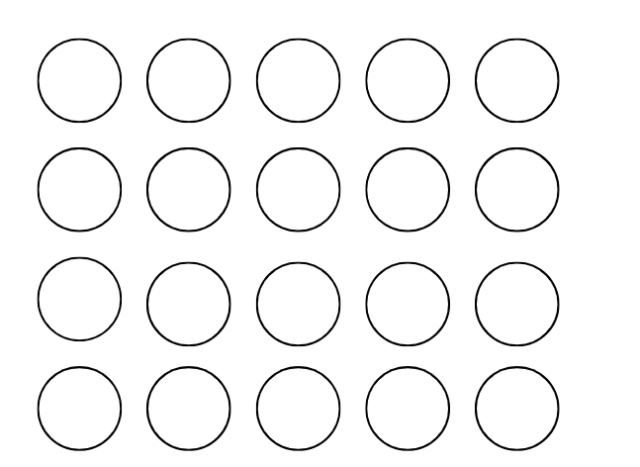
Array: one of several different arrangements that can be used to model multiplicative situations involving whole numbers. An array is made by arranging a set of objects, such as counters or pictures, into columns and rows. Each column must contain the same number of items as the other columns and each row much contain the same number of items as the other rows.
- Ask students what they notice about the array. Draw attention to the number in each column, the number of columns, and how this represents 20. Model skip counting by fives to find the total.
- Watch the video 5 Little Monkeys (2:23) again. Pause the video when one monkey jumps off the bed and ask students how they could represent this using the structure of an array.
- Give students the opportunity to create a model using counters. Press play and continue creating arrays each time a monkey jumps off the bed (see Figure 5).
Figure 5 – Decreasing array structure
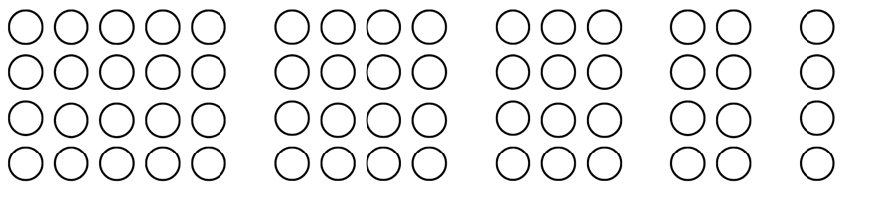
- Ask students to explain the pattern core using words. Highlight that it is a shrinking pattern, as it subtracts 4 each time. The quantity of limbs shrinks or gets smaller as each monkey falls off the bed – the pattern shrinks by 4 limbs each time.
- Discuss with students that mathematicians record data or information using tables. Tables help organise mathematical information.
Note: Representing an object with a different object, picture, or drawing is an abstraction. It is important that each object in a (one-to-one) data display represents one object. Aligning the rows or columns of tables can make comparisons easier.
- Model drawing and reading a table to represent the shrinking pattern (see Figure 6). Draw students’ attention to the table structure and information recorded.
Figure 6 – Example of table
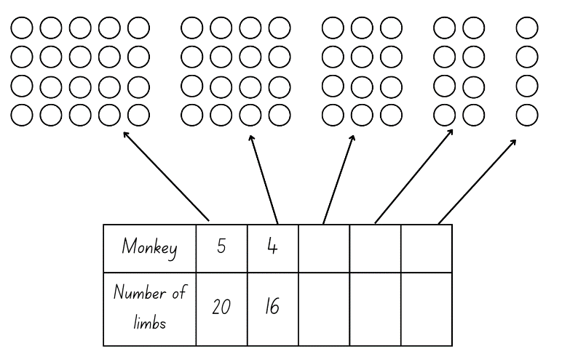
- Students copy the table into workbooks and complete the missing elements of the table.
The table below details assessment opportunities and differentiation ideas.
Assessment opportunities | Too hard? | Too easy?
What to look for:  - Are students able to skip count by fives to find the total number in an array? (MA1-FG-01)  - Can students identify the core element of repeat in the shrinking pattern? (MA1-RWN-01, MA1-RWN-02, MA1-CSQ-01)  - Can students use the structure of an array to model a shrinking pattern? (MAO-WM-01, MA1-FG-02)  - Can students draw a table to show the shrinking pattern? (MA1-CSQ-01, MA1-DATA-01, MA1-DATA-02)  What to collect:  - student observations (MA1-FG-01, MA1-RWN-01, MA1-RWN-02, MA1-DATA-01, MA1-DATA-02)  - work sample – table in workbooks (MA1-CSQ-01, MA1-DATA-01, MA1-DATA-02) | Students are unable to skip count by fives to find the total of the array.  - Provide concrete materials such as counters to represent the monkey limbs. Have students use the counters to form groups and count by ones.  - Support skip counting with a visual, for example, a number chart. | Students can identify the missing elements in the table.  - Ask students to create a table to represent the data if there were 20 monkeys.  - Have students create their own shrinking pattern. Students ask a partner to continue the pattern in a table format.

Consolidation and meaningful practice: Representing patterns in different ways – 10 minutes
- Ask students if they could represent the monkey’s limbs using letters. Students may use AAAA to describe the repeating core.
- In pairs, ask students to represent this pattern in a different form. Students can record their representation using Resource 5: Graphic organiser from Lesson 1.
- Students present their representations to the class.

Lesson 3: Shrinking patterns 2
Core concept: Shrinking patterns can be represented in different ways.
The table below contains suggested learning intentions and success criteria. These are best co-constructed with students.
Learning intentions | Success criteria
Students are learning that:  - counting sequences have patterns  - a shrinking pattern gets smaller by the same quantity each time  - an array is one way to model multiplicative thinking involving whole numbers  - mathematicians represent data with tables. | Students can:  - identify patterns in numbers when choral counting  - identify a shrinking pattern and explain the repeating core  - create a model of a shrinking pattern using counters  - use an array model to skip count  - draw a table showing a shrinking pattern.

Daily number sense: Choral counting – Counting backwards by ones – 20 minutes
This activity has been adapted from Franke et al..
- Build student understanding of counting patterns and build fluency of counting sequences through choral counting.
- Have students count aloud backwards by ones, starting from 42. Record counting sequence on the board (see Figure 7).
Figure 7 – Choral counting chart
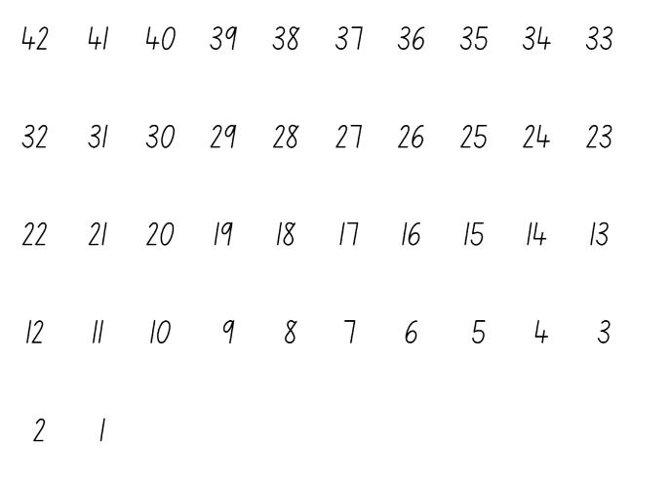
- Ask students what they notice about the numbers using the following prompts:
The table below outlines stimulus prompts to generate conversation about the topic, along with anticipated responses from students.
Prompts | Anticipated student responses
- What do you notice about the numbers?  - Which numbers are the two-digit numbers?  - What do you notice about the numbers in this column? (point) For example, 6, 16, 26, 36.  - Who can tell us what number will come next? How do you know?  - Does someone have another way to know the next number? | - There is a pattern of ones in each column. For example, the numbers 11, 21, 31, 41 all have a ones digit that says ‘1’.  - Student points to each column and says: ‘These have 1, these have 2, these have 3 and these have 4, and so on. All of the tens numbers have the same in each column.’
- Using ‘Talk moves’, invite students to share their thinking. Record observations and patterns on the board, as shown in Figure 8.
Figure 8 – Annotated choral counting chart
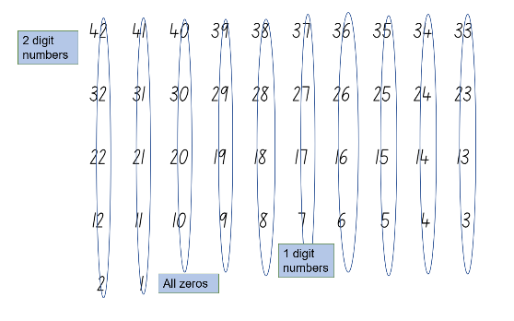
- During the discussion, explicitly highlight the patterns in the numbers. Select one pattern to count, for example, 40, 30, 20, 10. Students continue counting backwards by tens from 120. Variation: Select a pattern that decreases by tens off the decade, for example, 87, 77, 67, 57, and continue counting back.

Identifying and representing shrinking patterns – 40 minutes
- Revise shrinking patterns from Lesson 2.
- Tell students that they will be investigating shrinking patterns through a story.
- Select one of the following stories below based on student’s individual needs and interests:
- Twos – There were 6 emus in the outback. Each emu had 2 legs. One by one they walked away.
- Fours – There were 5 frogs sat on a lily pad. Each frog had 4 legs. One by one they jumped off.
- Fives – There were 4 flowers in a garden. Each flower had 5 petals. One by one the flowers were picked.
- Sixes – There were 4 ants on a log. Each ant had 6 legs. One by one they walked away.
- Eights – There were 3 spiders in a web. Each spider had 8 legs. One by one they walked away.
- Give students a selection of counters to create a model of the shrinking pattern. Remind students to use the structure of the array. Ask students the following questions to guide their thinking:
- How could you organise your counters to represent the total?
- How does the structure of an array help support the count?
- Can you identify the repeating core?
- Students share their model with a partner and explain their thinking.
- Revise with students that mathematicians record data, or information using tables. Tables help organise mathematical information.
- Students create a table to represent their shrinking pattern using the table structure from Lesson 2.
- Select students to present their models and tables to the class. Identify the key features and revise the concept that a shrinking pattern gets smaller.
The table below details assessment opportunities and differentiation ideas.
Assessment opportunities | Too hard? | Too easy?
What to look for:  - Are students able to skip count to find the total number in an array? (MA1-FG-01)  - Are students able to represent shrinking patterns using counters or arrays? (MAO-WM-01, MA1-CSQ-01, MA1-FG-02)  - Can students identify the core/element of repeat in the shrinking pattern? (MA1-RWN-01, MA1-RWN-02, MA1-CSQ-01)  - Can students draw a table to show the shrinking pattern? (MA1-CSQ-01, MA1-DATA-01, MA1-DATA-02)  What to collect:  - observational data (MA1-RWN-01, MA1-RWN-02, MA1-CSQ-01, MA1-FG-01, MA1-DATA-01, MA1-DATA-02)  - work sample – table in workbooks (MA1-CSQ-01, MA1-DATA-01, MA1-DATA-02) | Students are unable to represent shrinking patterns using counters and arrays.  - Scaffold students’ thinking by having them organise their counters in groups.  - Model creating an array structure, revise equal rows and columns.  - Provide a visual template to support the array structure. | Students can represent shrinking patterns using counters and arrays.  - Ask students what would happen if 2 went away each time. Have students record their thinking using the structure of an array.  - Ask students what would happen if 3 went away each time. Have students record their thinking using the structure of an array.

Lesson 4: Growing patterns 1
Core concept: Growing patterns get bigger by the same quantity each time.
The table below contains suggested learning intentions and success criteria. These are best co-constructed with students.
Learning intentions | Success criteria
Students are learning that:  - counting sequences have patterns  - a growing pattern gets bigger by the same quantity each time  - identifying the rule or generalisation in a pattern can determine what comes next  - mathematicians represent data with tables. | Students can:  - identify patterns in numbers when choral counting  - identify a growing pattern and explain the repeating core  - create a growing pattern  - identify the next number in a pattern  - draw a table showing a growing pattern.

Daily number sense: Choral counting by twos – 20 minutes
This activity has been adapted from Franke et al. (2018).
- Build student understanding of counting patterns and build fluency of counting sequences through choral counting.
- Have students count aloud by twos, starting from 2 up to 30. Record counting sequence on the board (see Figure 9).
Figure 9 – Choral counting chart
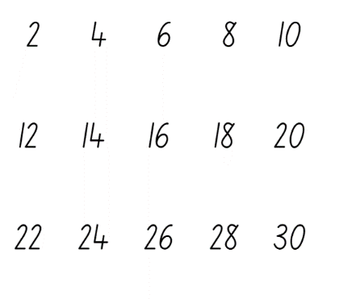
- Ask students what they notice about the numbers using the following prompts.
The table below outlines stimulus prompts to generate conversation about the topic, along with anticipated responses from students.
Prompts | Anticipated student responses
- What do you notice about the numbers?  - Which numbers are the two-digit numbers?  - Who can tell us what number will come next? How do you know? Does someone have another way to know the next number?  - Can you see any patterns? | - There is a pattern of ones in each column. For example, the numbers 2, 12, 22 all have a ones digit that says ‘2’.  - All the numbers are even in every column.  - Yes, there is a repeat of numbers 0, 2, 4, 6, 8.
- Use ‘Talk moves’ to invite students to share their thinking. Record observations and patterns on the board (see Figure 10).
Figure 10 – Annotated choral chart
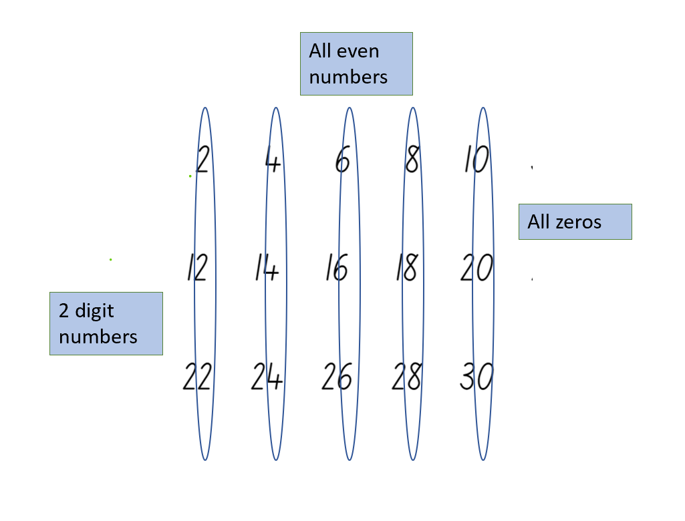
- During the discussion, explicitly highlight the patterns in the numbers. Continue counting by twos up to 120.

Representing growing patterns – 50 minutes
This activity has been adapted from Van de Walle et al. (2019).
- Display Resource 6: Triangle growing pattern. Ask students:
- What do you notice about the images?
- Can you identify a pattern? Explain how you see the images changing?
- Can you identify the pattern core?
- Are the patterns increasing or decreasing in size? How do you know?
- How are numbers related to the visual images? Explain your thinking.
- Discuss with students that this is a growing pattern. The quantity is growing or getting bigger by 3 triangles each time. Make a class anchor chart about growing patterns.
- Ask students to turn and talk to a partner to discuss what would be the next sequence in the pattern. Invite students to share their thinking to the class.
- Model creating a table to reflect this pattern (see Figure 11).
Figure 11 – Example table for recording data
- Explain to students that growing patterns can be represented in different forms and look very different.
- Display Resource 7: Cube growing pattern. Have students identify the pattern core. Compare this pattern to Resource 6: Triangle growing pattern and discuss similarities and differences.
- Provide students with a variety of concrete materials for example, counters, craft sticks, paper clips, markers, building blocks, pattern blocks, or natural materials and ask students to create their own growing pattern.
- Provide students with time to explore and create their growing patterns with their chosen material. Observe students and ask the following questions to guide their thinking:
- What is your repeating core?
- How are you representing the pattern growing?
- Are there any structures you could use to help you organise your thinking?
- Students then represent their pattern using a table structure similar to the ones created in previous lessons. Remind students as this is a growing pattern, the numbers will increase.
- Students participate in a gallery walk to see how others have represented their growing pattern.
- In pairs, have students recreate the next 3 or 4 sequences in their partner’s sequence, justifying their reasoning.
The table below details assessment opportunities and differentiation ideas.
Assessment opportunities | Too hard? | Too easy?
What to look for:  - Are students able to skip count to find the totals in a pattern sequence? (MA1-FG-01)  - Can students identify a growing pattern and explain the repeating core? (MAO-WM-01, MA1-RWN-01, MA1-RWN-02, MA1-CSQ-01, MA1-FG-01)  - Can students create a growing pattern using concrete materials? (MAO-WM-01, MA1-RWN-01, MA1-CSQ-01, MA1-FG-01)  - Are students able to identify the next number in a growing pattern? (MAO-WM-01, MA1-RWN-01, MA1-RWN-02, MA1-CSQ-01)  - Can students explain and justify their growing pattern? (MAO-WM-01)  - Are students able to draw a table showing a growing pattern? (MA1-CSQ-01, MA1-DATA-01, MA1-DATA-02)  What to collect:  - observation of students creating a growing pattern (MAO-WM-01, MA1-RWN-01, MA1-CSQ-01, MA1-FG-01)  - work sample – table in workbooks (MA1-CSQ-01, MA1-DATA-01, MA1-DATA-02) | Students are unable to create a growing pattern.  - Revise with students the choral counting chart and relate how the numbers are increasing.  - Model a simple growing pattern, increasing by ones. Ask students to complete next sequence in the pattern. | Students can create a growing pattern and identify repeating core.  - Ask students to represent a pattern that doubles each sequence. Students create this using concrete materials.  - Ask students to create a table to show a pattern that doubles each sequence.

Lesson 5: Growing patterns 2
Core concept: Growing patterns can be represented in different ways.
The table below contains suggested learning intentions and success criteria. These are best co-constructed with students.
Learning intentions | Success criteria
Students are learning that:  - counting sequences have patterns  - a growing pattern gets bigger by the same quantity each time  - identifying the rule or generalisation in a pattern can determine what comes next  - mathematicians represent data with tables. | Students can:  - identify patterns in numbers when choral counting  - identify a growing pattern and explain the repeating core  - create a growing pattern using craft sticks  - draw a table showing a growing pattern  - use information from a table to recognise, continue, and record a pattern.

Daily number sense – 15 minutes
- From a class need surfaced through formative assessment data, identify a short, focused activity that targets students’ knowledge, understanding, and skills. Example activities may be drawn from the following resources:
- Thinking Mathematically Stage 1
- Universal Resources Hub

Sticky Triangles – 45 minutes
This activity has been adapted from Sticky Triangles by NRICH.
- Revise growing patterns from previous lesson.
- Create a triangle using 3 craft sticks or drawn lines and display for students (see Figure 12).
Figure 12 – Triangle
- Model how to add more craft sticks to create 4 small triangles in 2 rows (see Figure 13).
Figure 13 – Triangle pattern
- Ask students how many more craft sticks were added and how many have now been used altogether.
- Invite students to predict how many more craft sticks will be needed for another row in the pattern. As a class, select some students to share how they visualised the pattern and identify the repeating core.
- Discuss with students how this information could be recorded in a table like the previous lessons. Draw an example of how the data could be recorded on the board (see Figure 14).
Figure 14 – Example of a triangle pattern
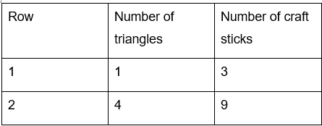
- Give students craft sticks and ask them to create the next few rows in the pattern and record their data in the table.
- Ask students:
- Can you see why the number of craft sticks increased by that amount when you added that row?
- Can you predict how many craft sticks the tenth row will need? How do you know?
- Can you see a link between the number of rows and the total number of craft sticks?
- Can you see a link between the number of small triangles and the total number of craft sticks?
- How would you describe the pattern?
This table details assessment opportunities and differentiation ideas.
Assessment opportunities | Too hard? | Too easy?
What to look for:  - Can students identify a growing pattern and explain the repeating core? (MAO-WM-01, MA1-RWN-01, MA1-RWN-02, MA1-CSQ-01, MA1-FG-01)  - Are students able to create a growing pattern using craft sticks? (MAO-WM-01, MA1-RWN-01, MA1-CSQ-01, MA1-FG-01)  - Can students draw a table showing a growing pattern? (MA1-CSQ-01, MA1-DATA-01, MA1-DATA-02)  - Can students use information from a table to recognise, continue and record a pattern? (MAO-WM-01, MA1-RWN-01, MA1-RWN-02, MA1-CSQ-01)  What to collect:  - observational data of students creating a growing pattern (MAO-WM-01, MA1-RWN-01, MA1-RWN-02, MA1-CSQ-01, MA1-FG-01)  - work sample – table in workbook (MA1-CSQ-01, MA1-FG-01, MA1-DATA-01, MA1-DATA-02) | Students are unable to create a growing pattern.  - Revise the feature of growing patterns and provide additional visual examples of growing patterns  - Support students to create one row at a time and count craft sticks individually for each row. | Students can create a growing pattern.  - Have students look more carefully at the number patterns involved, rather than simply counting craft sticks each time.  - Ask students to work out the total number of craft sticks for 27 rows of triangles.

Lesson 6: Patterns in the number chart
Core concept: Number patterns can be identified within number charts.
The table below contains suggested learning intentions and success criteria. These are best co-constructed with students.
Learning intention | Success criteria
Students are learning that number patterns can be identified within a number chart. | Students can:  - describe and identify patterns in a bottom-up number chart  - identify numbers one more, one less, 10 more, and 10 less than a given number  - identify the missing numbers in a number pattern  - determine the location of missing numbers in a number chart puzzle.

Daily number sense: Snail One Hundred – 20 minutes
This activity has been adapted from Snail One Hundred by NRICH.
- Build student understanding of counting to 100 by playing Snail One Hundred.
- In pairs, give each group a copy of Resource 8: Snail one hundred, a 6-sided dice and 3 matching counters for each player.
- Both players place one of their counters on the zero, one of their counters on the 0 tens and one of their counters on the 0 hundreds.
- Player 1 rolls the dice and moves their counter that number of places along the snail's body. Player 2 rolls the dice.
- When a player reaches 9 on the snail’s body, they return their counter to zero and move their second counter up to 1 ten.
- Players continue to move their first counter along the snail’s body and moving the second counter to the next 10 every time.
- When a player’s counter is on 9 tens, it can’t move any further around the spiral. Instead, it goes back to 0 tens and their third counter moves from 0 hundreds to 1 hundred. The first player to move their counter onto the 1 hundred space is the winner.

Number pattern detectives – 30 minutes
- Display Resource 9: Bottom-up number chart. Ask students:
- What do you notice about this number chart?
- How is it different to other number charts?
- How is it like other number charts?
- Can you identify any patterns?
- How do number charts help us count?
Note: A bottom-up number chart allows students to use language to accurately capture what is happening to the size of the numbers. For example, going up on the chart correlates to the number also going up. By inverting the chart and starting with zero at the bottom, students can explain that when the number increases by 10, it gets larger/taller/bigger/greater which are all modelled when they move up.
- Students share their observations with the class. Using coloured markers, annotate student responses. Highlight relationships of one more, one less, 10 more, and 10 less, as well as directionality.
- Display the number chart in the classroom for students to access.
- Provide students with a copy of Resource 10: Number puzzles. Students identify missing numbers using their knowledge of patterning and the bottom-up hundreds chart.
- Students share their solutions with a partner and discuss their reasoning.
The table below details assessment opportunities and differentiation ideas.
Assessment opportunities | Too hard? | Too easy?
What to look for:  - Can students describe and identify patterns in a bottom-up number chart? (MAO-WM-01, MA1-RWN-01, MA1-RWN-02, MA1-FG-01)  - Are students able to identify numbers one more, one less, ten more and ten less than a given number? (MA1-RWN-01, MA1-RWN-02, MA1-CSQ-01)  - Can students identify the missing numbers in a number pattern? (MAO-WM-01, MA1-RWN-01, MA1-RWN-02, MA1-CSQ-01, MA1-FG-01)  What to collect:  - work sample – Resource 10 Number chart puzzles (MAO-WM-01, MA1-RWN-01, MA1-RWN-02, MA1-CSQ-01, MA1-FG-01) | Students are unable to identify the missing numbers in a number chart puzzle.  - Provide students their own bottom-up number chart to support locating the missing numbers.  - Provide only one before and one less puzzles for students to gain confidence before moving to 10 before and 10 less. | Students can identify the missing numbers in a number chart puzzle.  - Provide students their own copy of a bottom-up number chart. Students highlight skip counting patterns including twos, fives, and tens.  - Provide students with a blank number chart and have them create their own number pattern puzzles.

Consolidation and meaningful practice: Discuss and connect the mathematics – 10 minutes
- As a class, summarise the lesson together drawing out key mathematical ideas. Ask students:
- How did you work out what numbers were missing?
- Could you work out the numbers without the use of the number chart? How?
- What patterns helped you determine the missing numbers?
- Were you able to explain your reasoning?

Lesson 7: Weaving patterns
Core concept: A number pattern can be represented in different ways.
The table below contains suggested learning intentions and success criteria. These are best co-constructed with students.
Learning intentions | Success criteria
Students are learning that:  - a pattern core can be described using letters  - patterns can be identified in number charts  - patterns can be represented by numbers. | Students can:  - describe the pattern core using letters such as AB, ABC, ABB, AABBCC  - create a pattern using coloured rods  - identify numerical patterns in a number chart  - replicate a pattern into a number chart.

Daily number sense: Guess my pattern – 15 minutes
This activity has been adapted from Boaler et al. (2021).
- Build student understanding of number patterns by playing ‘Guess my pattern’.
- In pairs, provide students with a copy of laminated Resource 9: Bottom-up number chart and coloured markers.
- Partners sit across from each other with a barrier between them such as a book or file to ensure they cannot see the other player’s chart.
- Player 1 creates a number pattern on their number chart and reads aloud the first few numbers in their pattern to their partner.
- Player 2 marks the numbers on their own chart to keep track of the pattern. Player 2 then guesses the next number in the pattern and describes the pattern. For example, the next number is 12 and it is skip counting by threes. Player 2 can ask for additional numbers in the pattern to be read before taking a guess.
- Player 1 shows their partner their chart to confirm or check solutions.
- After students have had the chance to play a few rounds, discuss the following questions:
- What information was needed to determine the pattern?
- What clues were useful?
- Explain your reasoning for identifying the next number in the pattern.

Weaving patterns – 45 minutes
This activity has been adapted from Boaler et al. (2021).
- Display Resource 11: Woven basket on the board. Discuss with students that basket weaving involves lots of mathematical ideas.
- Have students turn and talk to a partner about what they notice and what patterns they can see.
- Invite students to come up and point to the patterns they notice. Encourage students to use precise language to describe the pattern such as vertical, horizontal, diagonal, and repeating. Highlight to students that the basket is woven in a wrapped spiral using different coloured material.
- Explain to students that they will explore how to make a weaving pattern on a number chart using coloured rods. The coloured rods will be the bands of colours like those in the basket.
- Provide students the coloured rods and have them make observations about them. Students should notice that they come in different lengths and colours, and that they can be associated with numerical values.
- In pairs, students can make repeating patterns such as AB or AAB (see Figure 15).
Figure 15 – Example of coloured rod patterns
- Display Resource 12: Centimetre number chart. Select one of the students’ patterns and ask the class how this pattern could be represented on the number chart. Students turn and talk to a partner to discuss possible solutions.
- Invite some students to share their ideas and demonstrate how they could use colours to mark the pattern (see Figure 16).
Figure 16 – Bottom-up chart example
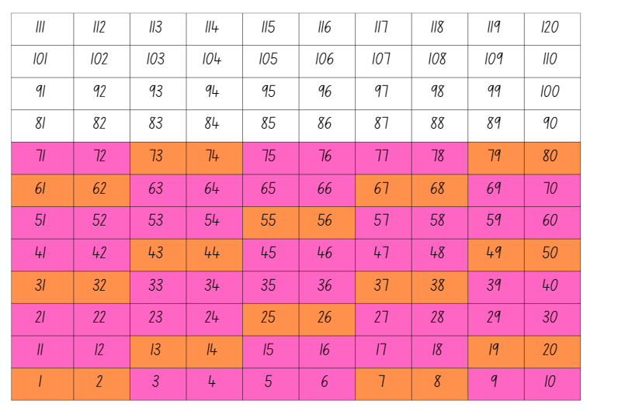
- In pairs, provide students with Resource 12: Centimetre number chart, coloured markers, and a selection of coloured rods. Students create a new pattern with their coloured rods. Guide students’ thinking by asking the following questions:
- How can this pattern be transferred to the number chart?
- What can you do when you come to the end of a row? How can you continue the pattern?
- Once you have coloured your pattern on the hundreds chart, what do you notice?
- Do you notice any patterns with the numbers? Explain your thinking.
- What are you wondering about weaving patterns?
- Have students make different patterns with different coloured rods. Discuss with their partner the most interesting patterns.
The table below details assessment opportunities and differentiation ideas.
Assessment opportunities | Too hard? | Too easy?
What to look for:  - Can students describe the pattern core using letters such as AB, ABC, ABB, AABBCC? (MAO-WM-01)  - Can students create a pattern using coloured rods? (MAO-WM-01, MA1-RWN-01, MA1-RWN-02)  - Are students able to identify numerical patterns in a number chart? (MA1-RWN-01, MA1-RWN-02, MA1-CSQ-01, MA1-FG-02)  - Can students replicate a coloured rod pattern into a number chart? (MA1-RWN-01, MA1-RWN-02, MA1-CSQ-01, MA1-FG-02)  What to collect:  - work sample – Resource 12: Centimetre number chart (MA1-RWN-01, MA1-RWN-02, MA1-CSQ-01, MA1-FG-02) | Students are unable to identify numerical patterns in a number chart.  - Use a simplified AB pattern to support students’ understanding of patterning.  - Ask students to focus on what they see and highlight the connections between the rods and the number patterns. | Students can identify numerical patterns in a number chart.  - Ask students if they have seen woven patterns before. Discuss what mathematical ideas are important when creating woven baskets.  - Record and share your thinking with a partner.

Consolidation and meaningful practice: Discuss and connect the mathematics – 10 minutes
- Ask students to conduct a gallery walk to review other students’ patterns. Ask the following questions:
- How is each pattern constructed? What is the pattern?
- What kinds of patterns with rods and numbers make diagonal patterns?
- What kinds of patterns with rods and numbers make vertical patterns?
- Which patterns did you find most interesting and why?
- Were there any patterns that did not look like patterns? Why or why not?

Lesson 8: Diagonal sums
Core concept: Number charts can be used to explore patterning.
The table below contains suggested learning intentions and success criteria. These are best co-constructed with students.
Learning intentions | Success criteria
Students are learning that:  - the structure of a number chart can be used to explore relationships between numbers  - numerical patterns can be identified within number charts  - mathematicians test conjectures to establish a rule  - mathematicians use a range of representations to prove their ideas and convince others. | Students can:  - identify the missing numbers in a number pattern  - identify numerical patterns in a number chart  - describe and identify patterns in a bottom-up number chart  - identify numbers one more, one less, 10 more, and 10 less than a given number  - communicate their thinking giving reasons and evidence.

Daily number sense: Buzzy Bee – 20 minutes
This activity has been adapted from Buzzy Bee by NRICH.
- Build student understanding of number sequences and patterns by engaging in a mathematical investigation.
- Tell students that Buzzy Bee was building a honeycomb. She decided to decorate the honeycomb with a pattern using numbers. Display Resource 13: Buzzy Bee’s honeycomb.
- Give students time to look closely at the honeycomb. Ask students to turn and talk to a partner and discuss where another number could be placed on the honeycomb.
- Invite one pair to write a suggestion on the honeycomb. Have students explain their reasoning. Ask the following questions to guide their thinking:
- What number could follow on from this?
- What number could come before this?
- What number could come between these 2 numbers?
- Does that number fit with the pattern in this part of the honeycomb too?
Note: In this instance, students may not give the correct number to go in that position and the students will only realise this when there are more numbers on the honeycomb. It is important for students to use a system of trial and error on this investigation.
- In pairs, give students a copy of Resource 13: Buzzy Bee’s honeycomb to annotate their full solutions.
- As a class, share some solutions and reasonings.

Diagonal sums – 40 minutes
This activity has been adapted from ‘Diagonal sums’ from Primary and Middle Years Mathematics: Teaching Developmentally by Van de Walle et al. (2019).
- Remind students of the previous lessons where patterns were identified within a bottom-up number chart.
- Explain that there are some other different number patterns that can be found in a bottom-up number chart.
- Display Resource 9: Bottom-up number chart on the board. Highlight 4 numbers that form a square (see Figure 17).
Figure 17 – Example of a square from number chart
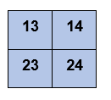
- Explain that, when looking at a square number chart, the sum of the diagonals will always be equal. Model to students that 13 plus 24 is equal to 37, which is the same quantity as 14 plus 23.
- Explain that the statement is true for the square on the number chart, but you would like to know if it is true for every square. Ask students how they can test this.
Note: This problem demonstrates the power of the number chart in helping students to recognise number properties and in beginning to reason carefully. Students can use a calculator or alternate digital device to calculate quantities. The focus of the lesson is on the identification of patterns rather than addition strategies.
- In pairs, provide students with a copy of Resource 9: Bottom-up number chart, highlighters, and calculators.
- Provide time for students to investigate several squares across the number chart.
- As a class, discuss the statements validity that the diagonals of a square on a number chart always have the same combined quantity. Have students share their thinking and explain why the pattern works.
The table below details assessment opportunities and differentiation ideas.
Assessment opportunities | Too hard? | Too easy?
What to look for:  - Can students identify numerical patterns in a number chart (MA1-RWN-01, MA1-RWN-02, MA1-CSQ-01)  - Can students describe and identify patterns in a bottom-up number chart (MAO-WM-01, MA1-RWN-01, MA1-RWN-02, MA1-CSQ-01)  - Are students able to communicate their thinking giving reasons and evidence? (MAO-WM-01)  What to collect:  - observational data (MAO-WM-01, MA1-RWN-01, MA1-RWN-02, MA1-CSQ-01) | Students are unable to identify diagonal number patterns in a number chart.  - Students identify simpler number patterns, such as skip counting by twos from any starting point.  - Have students identify the number before and after a variety of two-digit numbers on the number chart. | Students can identify diagonal number patterns in a number chart.  - Students test the statement in a larger square, for example, a 3 × 3 square. Ask if the statement continues to be true.  - Students investigate the statement with a rectangle on the number chart. Ask if the statement is still true. Prompt students to explain their thinking.

Resource 1: Dot talk

Resource 2: AB pattern
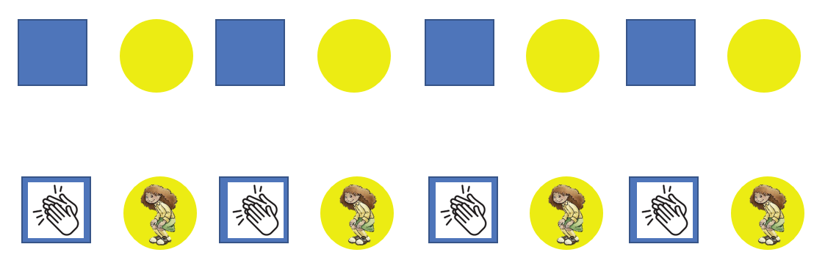

Resource 3: ABC pattern
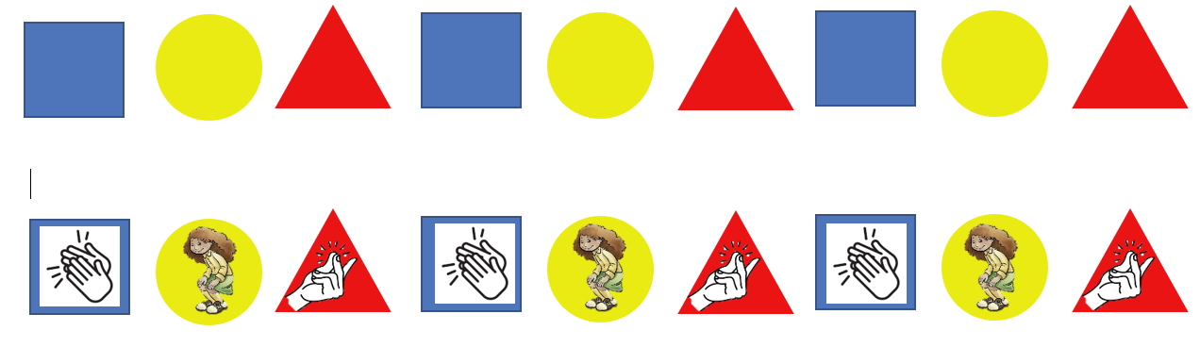

Resource 4: ABB pattern
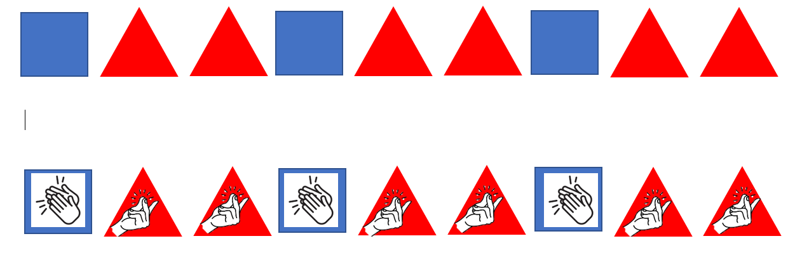

Resource 5: Graphic organiser
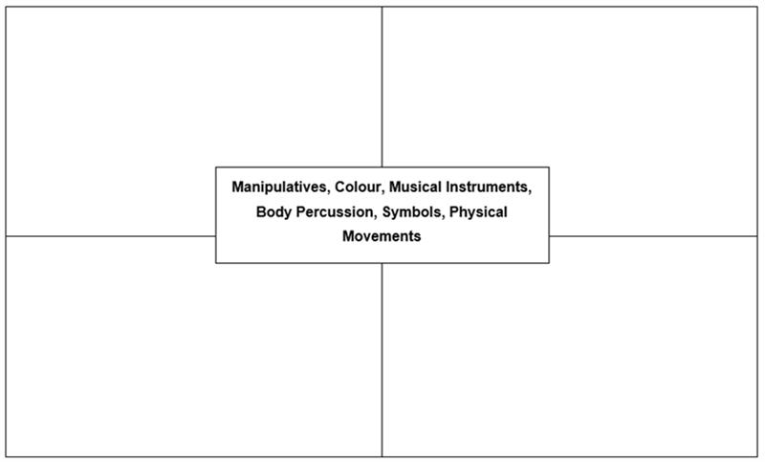

Resource 6: Triangle growing pattern
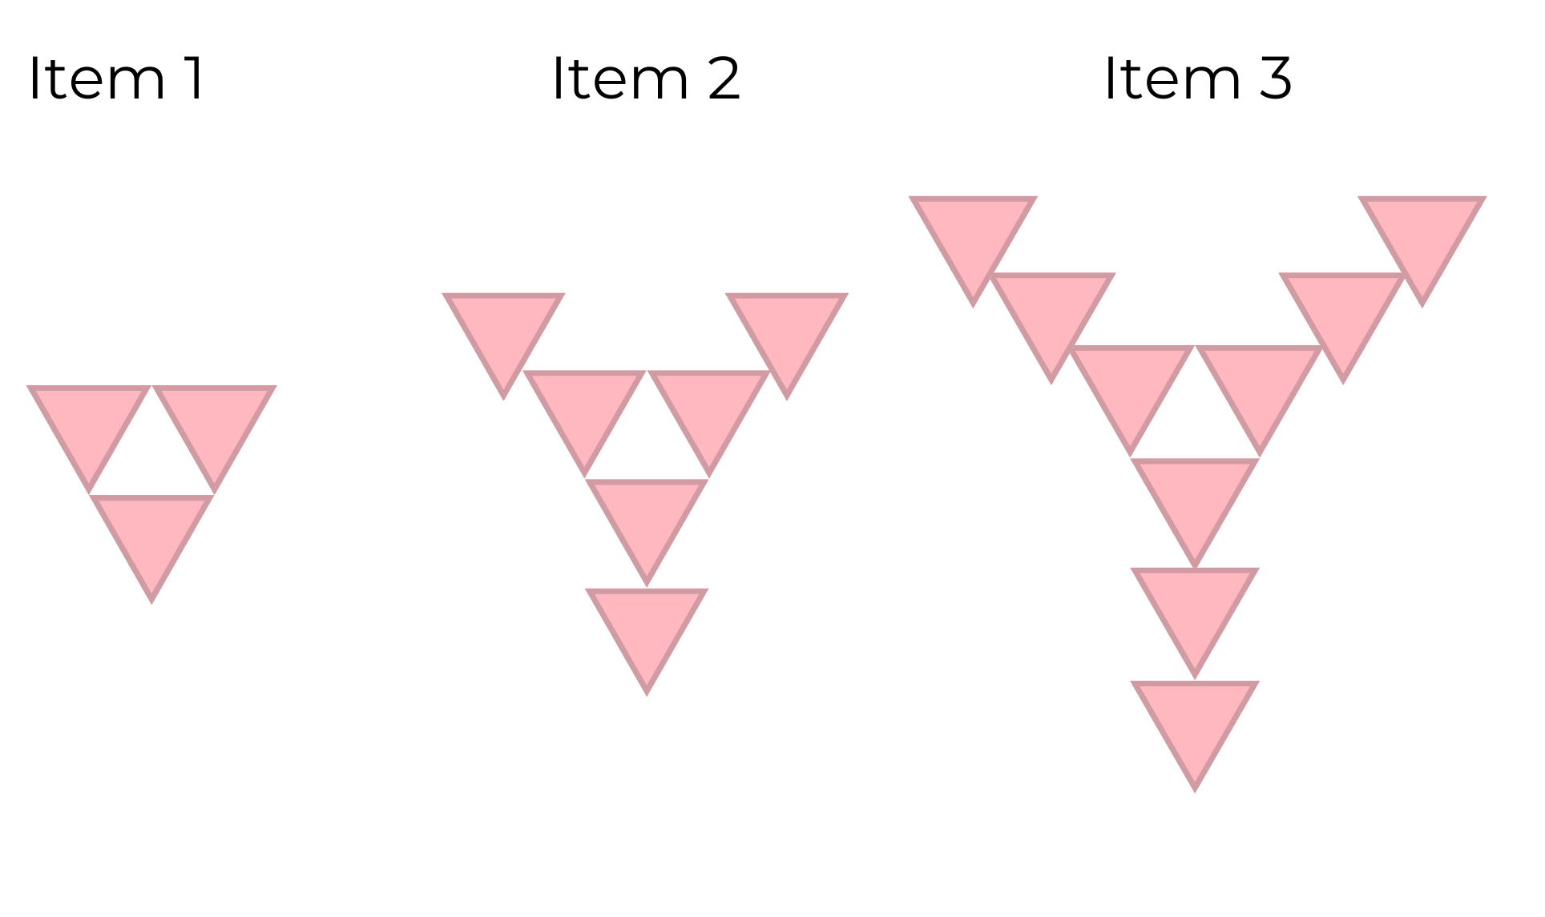

Resource 7: Cube growing pattern
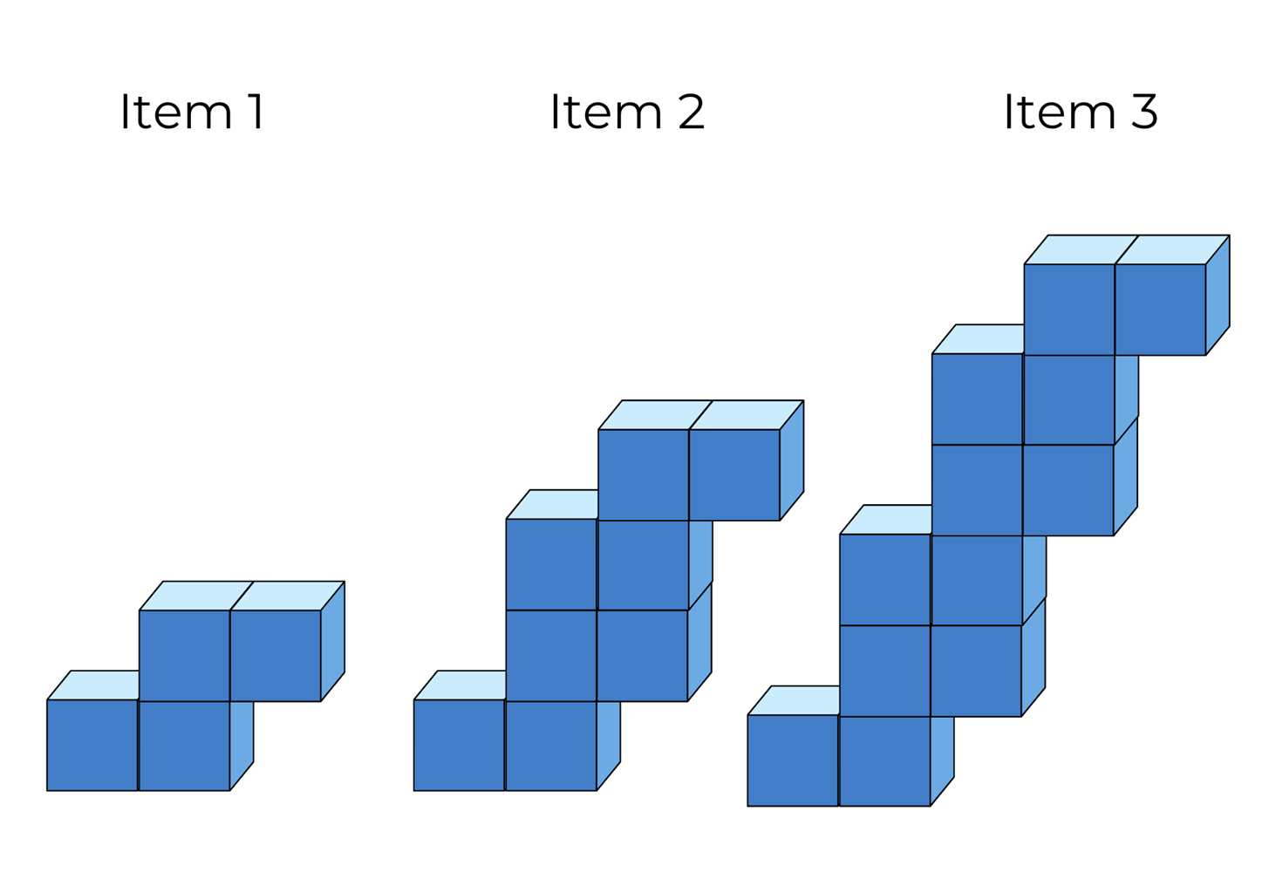

Resource 8: Snail one hundred
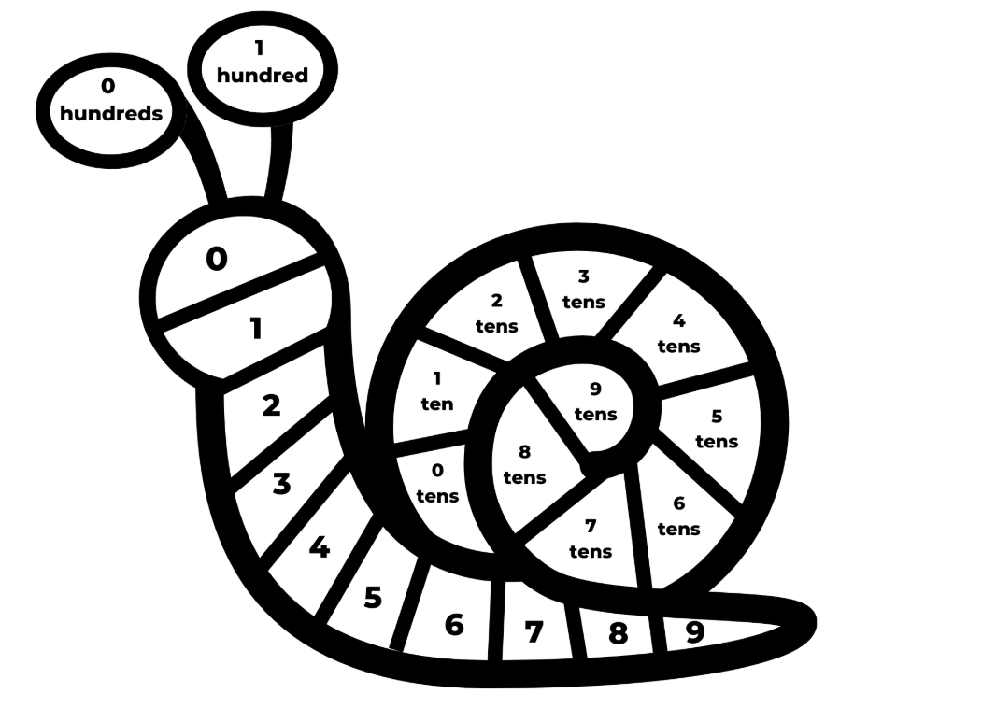
Images sourced from Canva and used in accordance with the Canva Content License Agreement.

Resource 9: Bottom-up number chart
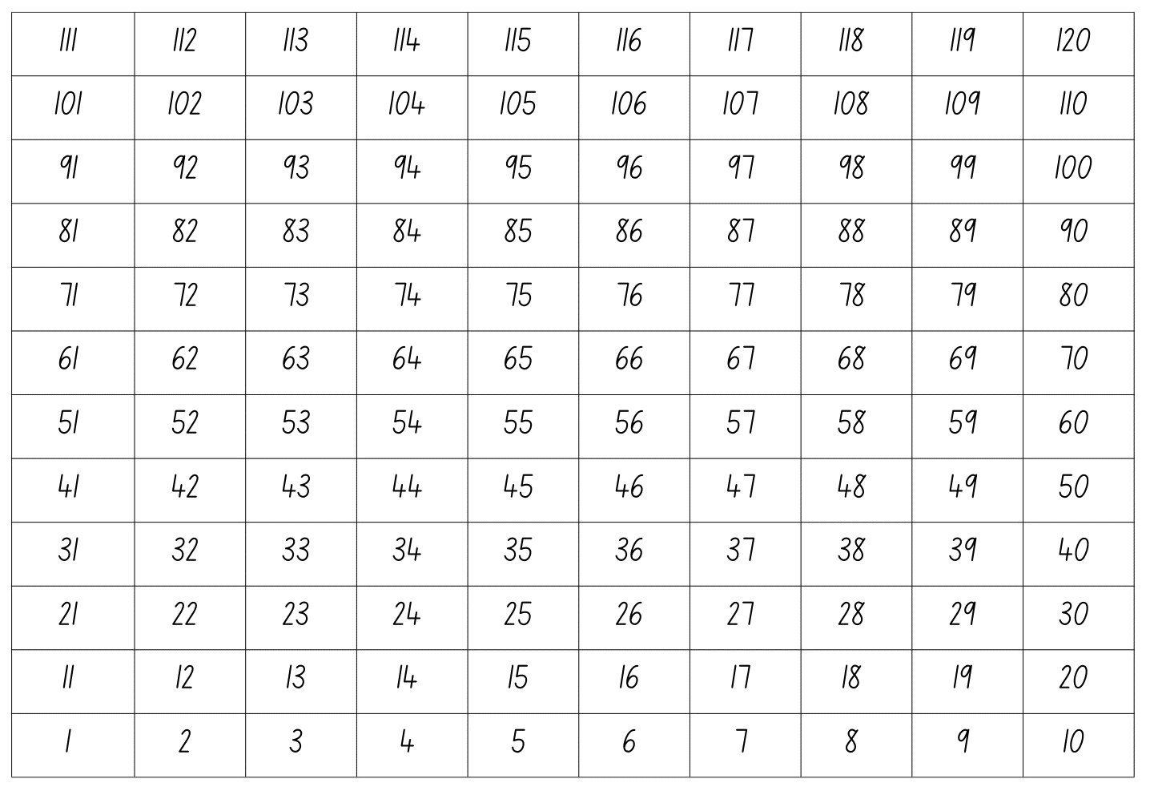

Resource 10: Number chart puzzles
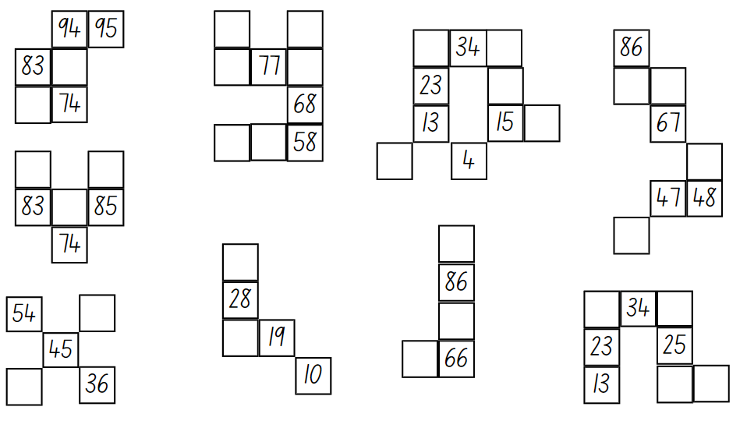

Resource 11: Woven basket
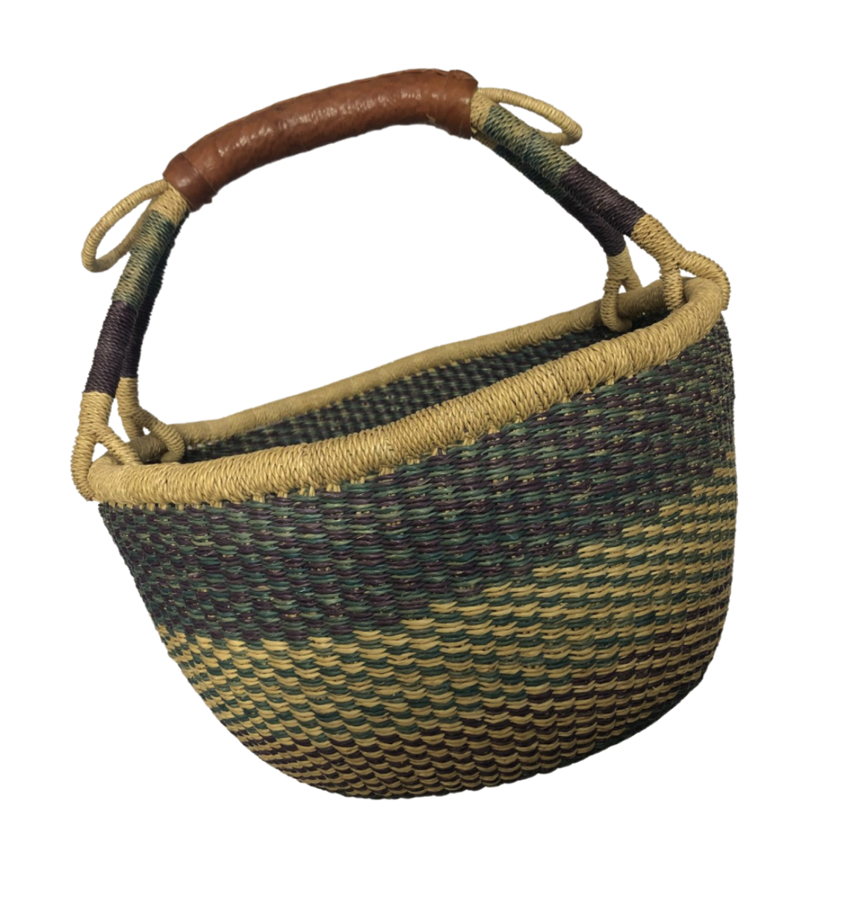

Resource 12: Centimetre number chart
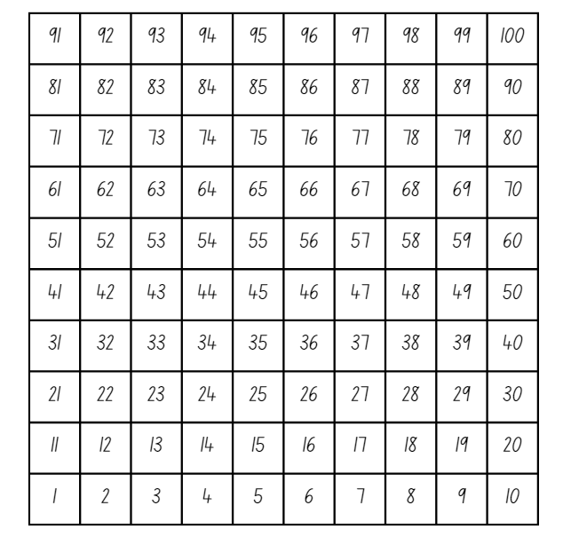

Resource 13: Buzzy Bee’s honeycomb
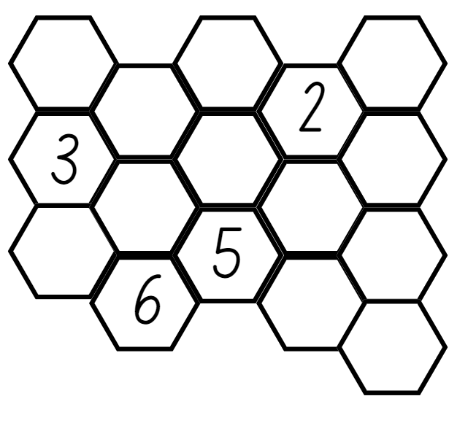

Syllabus outcomes and content
The table below outlines the syllabus outcomes and range of relevant syllabus content covered in this unit. Content is linked to National Numeracy Learning Progression version (3).
Focus area and outcomes | Content groups and content points | Lessons
Representing whole numbers A  MAO-WM-01  MA1-RWN-01  MA1-RWN-02 | Using counting sequence of ones with two-digit numbers and beyond  - identify the number before and after a given two-digit number (CPr5)  - count forwards and backwards by ones from a given number to at least 120 (CPr6)  Continue and create number patterns  - model and describe ‘odd’ and ‘even’ numbers using items paired in two rows  - count forwards and backwards by twos from any starting point (CPr6-CPr7, MuS2)  Represent the structure of groups of ten in whole numbers  - partition two-digit numbers to show quantity values (NPV4) | 1–8
Representing whole numbers B  MAO-WM-01  MA1-RWN-01  MA1-RWN-02 | Use counting sequences of ones and tens flexibly  - identify the number before and after a given three-digit number  - count forwards and backwards by tens, on and off the decade, with two- and three-digit numbers (CPr7)  Form, regroup and rename three-digit numbers  - recognise units of 100 (UnM5, NPV5) | 2, 3, 6–8
Combining and separating quantities A  MAO-WM-01  MA1-CSQ-01 | Use advanced count-by-one strategies to solve addition and subtraction problems  - apply the terms ‘add’, ‘plus’, ‘equals’, ‘is equal to’, ‘is the same as’, ‘take away’, ‘minus’ and ‘the difference between’ to describe combining and separating quantities (AdS1, AdS6)  - record number sentences in a variety of ways using drawings, words, numerals and symbols (AdS6)  - fluently use advanced count-by-one strategies including counting on and counting back to solve addition and subtraction problems involving one- and two-digit numbers (Reasons about relations) (AdS3-AdS5)  Recognise and recall number bonds up to ten  - recognise, recall and record combinations of two numbers that add up or bond to form 10 (AdS2, AdS6)  - model and record patterns for individual numbers up to ten by making all possible whole-number combinations (Reasons about patterns)  - describe combinations for numbers using words such as more than, less than and double (Reasons about relations) (AdS6)  Use flexible strategies to solve addition and subtraction problems  - select and apply strategies using number bonds to solve addition and subtraction problems with one- and two-digit numbers by partitioning numbers using quantity value and bridging to 10 (Reasons about relations) (AdS6-AdS7) | 2–8
Forming groups A  MAO-WM-01  MA1-FG-01 | Count in multiples using rhythmic and skip counting  - count by twos, threes, fives and tens using rhythmic counting and skip counting (MuS2, CPr6)  Use skip counting patterns  - identify and describe patterns when skip counting forwards or backwards by twos, fives and tens (NPA3- NPA4)  - determine a missing number in a number pattern with a constant difference  - describe how the missing number in a number pattern was determined (Reasons about relations)  Model and use equal groups of objects to represent multiplication  - model and describe collections of objects as groups of (MuS2)  - find the total number of objects using skip counting of equal groups of a known size (MuS2-MuS3) | 1–7
Forming groups B  MAO-WM-01  MA1-FG-01 | Represent and explain multiplication as the combining of equal groups  - use objects, diagrams, images or actions to model multiplication as accumulating equal groups (MuS4)  - form arrays of equal rows and equal columns (MuS5)  - determine and distinguish between the number of rows/columns and the number in each row/column when describing collections of objects (MuS5) | 2–4
Data A  MAO-WM-01  MA1-DATA-01  MA1-DATA-02 | Ask questions and gather data  - gather data and track what has been counted by using concrete materials, tally marks, lists or symbols (IRD3)  Represent data with objects and drawings and describe the displays  - use concrete materials or pictures of objects as symbols to create data displays where one object or picture represents one data value (IRD2)  - use comparative language to describe information presented in a display, such as ‘more than' and ‘less than’ | 2–5
Data B  MAO-WM-01  MA1-DATA-01  MA1-DATA-02 | Identify a question of interest and gather relevant data  - collect data on familiar topics (IRD2)  Create displays of data and interpret them  - organise collected data into lists and tables to display information (IRD2)  - interpret information presented in tables and picture graphs (Reasons about relations) (IRD2) | 2–5

References
Links to third-party material and websites
Please note that the provided (reading/viewing material/list/links/texts) are a suggestion only and implies no endorsement, by the New South Wales Department of Education, of any author, publisher or book title. School principals and teachers are best placed to assess the suitability of resources that would complement the curriculum and reflect the needs and interests of their students.
If you use the links provided in this document to access a third party's website, you acknowledge that the terms of use, including licence terms set out on the third party's website apply to the use which may be made of the materials on that third-party website or where permitted by the Copyright Act 1968 (Cth). The department accepts no responsibility for content on third-party websites.
Except as otherwise noted, all material is © State of New South Wales (Department of Education), 2023 and licensed under the Creative Commons Attribution 4.0 International License. All other material (third-party material) is used with permission or under licence. Where the copyright owner of third-party material has not licensed their material under a Creative Commons or similar licence, you should contact them directly for permission to reuse their material.
Mathematics K–10 Syllabus © 2022 NSW Education Standards Authority (NESA) for and on behalf of the Crown in right of the State of New South Wales.
© 2022 NSW Education Standards Authority. This document contains NSW Curriculum and syllabus content. The NSW Curriculum is developed by the NSW Education Standards Authority. This content is prepared by NESA for and on behalf of the Crown in right of the State of New South Wales. The material is protected by Crown copyright.
Please refer to the NESA Copyright Disclaimer for more information.
NESA holds the only official and up-to-date versions of the NSW Curriculum and syllabus documents. Please visit the NSW Education Standards Authority (NESA) website and the NSW Curriculum website.
National Numeracy Learning Progression © Australian Curriculum, Assessment and Reporting Authority (ACARA) 2010 to present, unless otherwise indicated. This material was downloaded from the Australian Curriculum website (National Numeracy Learning Progression) (accessed 18 October 2022) and was not modified. The material is licensed under CC BY 4.0. Version updates are tracked in the ‘Curriculum version history’ section on the 'About the Australian Curriculum' page of the Australian Curriculum website.
ACARA does not endorse any product that uses the Australian Curriculum or make any representations as to the quality of such products. Any product that uses material published on this website should not be taken to be affiliated with ACARA or have the sponsorship or approval of ACARA. It is up to each person to make their own assessment of the product, taking into account matters including, but not limited to, the version number and the degree to which the materials align with the content descriptions and achievement standards (where relevant). Where there is a claim of alignment, it is important to check that the materials align with the content descriptions and achievement standards (endorsed by all education Ministers), not the elaborations (examples provided by ACARA).
ABC (Australian Broadcasting Corporation) (5 January 2022) 'Eddie Woo on Play School (4 of 4: Pattern matching)' [video], Eddie Woo, YouTube, accessed 18 October 2022.
Boaler J, Munson J and William C (2021) Mindset Mathematics: Visualising and Investigating Big Ideas, Grade 1, Jossey-Bass, New Jersey.
Franke ML, Kazemi E and Chan Turrou A (2018) Choral Counting and Counting Collections: Transforming the PreK-5 Math Classroom, Stenhouse Publishers, United States.
Little BoBo Nursery Rhymes – FlickBox Studios (24 October 2013) ‘Five Little Monkeys Jumping On The Bed’ [video], Little BoBo Nursery Rhymes – FlickBox Studios, YouTube, accessed 18 October 2022.
New Zealand Ministry of Education (2020) ‘Gecko feet’, Resource Finder, NZ Maths website, accessed 10 October 2022.
New Zealand Ministry of Education (2020) NZ Maths [website], accessed 2 March 2023.
University of Cambridge (Faculty of Mathematics) (1997–2022) Buzzy Bee, NRICH website, accessed 18 October 2022.
University of Cambridge (Faculty of Mathematics) (1997–2023) NRICH [website], accessed 2 March 2023.
University of Cambridge (Faculty of Mathematics) (1997–2022) Snail One Hundred, NRICH website, accessed 18 October 2022.
University of Cambridge (Faculty of Mathematics) (1997–2022) Sticky Triangles, NRICH website, accessed 18 October 2022.
Van de Walle J, Karp K, Bay-Williams JM, Brass A, Bentley B, Ferguson S, Goff W, Livy S, Marshman M, Martin D, Pearn C, Prodromou T, Symons D and Wilkie K (2019) Primary and Middle Years Mathematics: Teaching Developmentally, 1st Australian edn, Pearson Australia, Melbourne.

Further reading
Randolph W and Jeffers V (1974) ‘A new look for the hundreds chart’, The Arithmetic Teacher, 21(3): 203-208, accessed 18 October 2022.

