Mathematics – Stage 1 – Unit 11
Contents
Unit description and duration 4
Student prior learning 4
Lesson overview and resources 6
Lesson 1: Large collections 12
Daily number sense: Guess the mystery number – 10 minutes 13
Counting large collections – 20 minutes 13
Discuss and connect the mathematics – 10 minutes 15
Consolidation and meaningful practice – 20 minutes 16
Lesson 2: Counting with handfuls 19
Daily number sense: Nearest 10 – 10 minutes 19
Discuss and connect the mathematics – 10 minutes 21
Consolidation and meaningful practice: Minute to win it – 20 minutes 24
Lesson 3: Place value 25
Daily number sense: Make a number? – 10 minutes 25
Beat the teacher – 20 minutes 26
Build a number – 20 minutes 27
Discuss and connect the mathematics – 10 minutes 27
Lesson 4: Busting numbers 29
Daily number sense – 10 minutes 29
Number busting – 20 minutes 30
Different ways to see a number – 20 minutes 31
Discuss and connect the mathematics – 10 minutes 32
Lesson 5: Compare 2 number lines 33
Daily number sense: Number placement – 15 minutes 33
Hour and minute lines – 20 minutes 34
Building time – 25 minutes 36
Lesson 6: How many seeds? 38
Daily number sense: Part-whole combinations – 10 minutes 38
How many seeds? – 20 minutes 39
Consolidation and meaningful practice – 20 minutes 41
Discuss and connect the mathematics – 10 minutes 43
Lesson 7: Sorting seeds 44
Consolidation and meaningful practice: The clock – 10 minutes 44
Sorting seeds: Part 1 – 15 minutes 45
Sorting seeds: Part 2 – 15 minutes 46
Discuss and connect the mathematics – 20 minutes 47
Lesson 8: Position on a grid 49
Daily number sense: Number chart rounding – 10 minutes 49
Difference between numbers – 15 minutes 50
Snakes and ladders – 25 minutes 51
Discuss and connect the mathematics – 10 minutes 52
Resource 1: Ten-frame 54
Resource 2: Make a number 55
Resource 3: Build a number 56
Resource 4: Build a two-digit number 57
Resource 5: Build a number assessing game play 58
Resource 6: Hour and minute numbers 59
Resource 7: How many seeds? 60
Resource 8: Pumpkin patch problem 61
Resource 9: Packets of seeds 62
Resource 10: Need for seeds 63
Resource 11: Number chart 64
Resource 12: Stage 1 snakes and ladders 65
Resource 13: 0–30 snakes and ladders 66
Syllabus outcomes and content 67
References 71
Further reading 73

Unit description and duration
This two-week unit further develops students' knowledge, understanding and skills of place value and number representation. Students are provided opportunities to:
- use representations of groups of 10
- quantify, organise and represent large collections
- explore place value through partitioning
- demonstrate equivalence
- compare numbers through different representations
- find patterns when representing large numbers
- see and explore that an analog clock is made by curving a number line
- use a grid structure to describe the paths between numbers.
Mathematics K–10 Syllabus © 2022 NSW Education Standards Authority (NESA) for and on behalf of the Crown in right of the State of New South Wales.

Student prior learning
Before participating in these teaching and learning activities, students would benefit from prior experience with:
- making the connection between a curved number line and an analog clock
- modelling, reading and writing combinations of numbers to 10 using materials, representations, words and symbols
- subitising small collections
- counting to at least 100 and matching objects one-to-one
- counting by tens.

Lesson overview and resources
The table below outlines the sequence and approximate timing of lessons; syllabus focus areas and content groups; and resources.
Lesson | Syllabus focus area and content groups | Resources
Lesson 1: Large collections  60 minutes  Large collections can be quantified, organised and represented in different ways. | Representing whole numbers  Stage 1 – Part A  - Use counting sequences of ones with two-digit numbers and beyond  - Represent the structure of groups of ten in whole numbers  Stage 1 – Part B  - Use counting sequences of ones and tens flexibly  - Forming groups  Forming groups  Stage 1 – Part A  - Count in multiples using rhythmic and skip counting | - Resource 1: Ten-frame  - Digital number chart  - Large collection of objects. For example, blocks, cubes, counters, craft sticks
Lesson 2: Counting with handfuls  60 minutes  Large collections can be quantified, organised and represented in different ways. | Representing whole numbers  Stage 1 – Part A  - Represent the structure of groups of ten in whole numbers  Stage 1 – Part B  - Form, regroup and rename three-digit numbers  Combining and separating quantities  Stage 1 – Part A  - Use flexible strategies to solve addition and subtraction problems  Forming groups  Stage 1 – Part A  - Count in multiples using rhythmic and skip counting | - Resource 1: Ten-frame  - Large collection of counters  - Large number line (masking tape or chalk)  - Large collection of objects. For example, blocks, cubes, counters, craft sticks  - Sticky notes  - Writing materials
Lesson 3: Place value  60 minutes  Numbers can be partitioned in different but equivalent ways. | Representing whole numbers  Stage 1 – Part A  - Represent the structure of groups of ten in whole numbers  Stage1 – Part B  - Form, regroup and rename three-digit numbers  Combining and separating quantities  Stage 1 – Part A  - Use flexible strategies to solve addition and subtraction problems | - Resource 1: Ten-frame  - Resource 2: Make a number  - Resource 3: Build a number  - Resource 4: Build a two-digit number  - Resource 5: Build a number assessing game play  - 0–3 dice  - 0–6 dice  - 0–9 dice  - Interlocking cubes  - MAB blocks  - Writing materials
Lesson 4: Busting numbers  60 minutes  Numbers can be partitioned in many different ways. | Representing whole numbers  Stage 1 – Part A  - Represent the structure of groups of ten in whole numbers  Stage 1 – Part B  - Form, regroup and rename three-digit numbers  Combining and separating quantities  Stage 1 – Part A  - Use flexible strategies to solve addition and subtraction problems  - Represent equality  Non-spatial measure  Stage 1 – Part A  - Mass: Investigate mass using an equal-arm balance | - Resource 1: Ten-frame  - 0–10 number cards or playing cards  - Craft sticks or elastic bands  - MAB blocks  - Interlocking cubes  - Equal-arm balance  - Writing materials
Lesson 5: Compare 2 number lines  60 minutes  Numbers can be compared through different representations. | Representing whole numbers  Stage 1 – Part A  - Represent numbers on a line  Non-spatial measure  Stage 1 – Part A  - Tell time to the half-hour  Stage 1 – Part B  - Tell time to the quarter-hour using the language of ‘past’ and ‘to’ | - Resource 6: Hour and minute numbers (printed on A3 paper)  - 24 pegs or pieces of tape  - 3 long ropes  - Class set of student clocks  - Numbers 0–12 written on A4 paper in blue  - Numbers 0–60 (counting by 5) written on A4 paper in red  - Writing materials
Lesson 6: How many seeds?  60 minutes  Patterns are helpful when quantifying large collections. | Representing whole numbers  Stage 1 – Part A  - Represent the structure of groups of ten in whole numbers  Stage 1 – Part B  - Use counting sequences of ones and tens flexibly  Combining and separating quantities  Stage 1 – Part A  Recognise and recall number bonds up to ten | - Resource 1: Ten-frame  - Resource 7: How many seeds?  - Digital spinner  - Large collection of dice (10–20 per small group)  - Writing materials
Lesson 7: Sorting seeds  60 minutes  Large collections can be quantified, organised and represented in different ways. | Representing whole numbers  Stage 1 – Part A  - Use counting sequences of ones with two-digit numbers and beyond  - Represent the structure of groups of ten in whole numbers  Stage 1 – Part B  - Use counting sequences of ones and tens flexibly  Forming groups  Stage 1 – Part A  - Count in multiples using rhythmic and skip counting | - Resource 1: Ten-frame  - Resource 8: Pumpkin patch problem  - Resource 9: Packets of seeds  - Resource 10: Need for seeds  - Writing materials
Lesson 8: Position on a grid  60 minutes  There are patterns to the way numbers are formed. | Representing whole numbers  Stage 1 – Part A  - Use counting sequences of ones with two-digit numbers and beyond  - Represent the structure of groups of ten in whole numbers  Geometric Measure  Stage 1 – Part A  - Follow direction to familiar locations | - Resource 11: Number chart  - Resource 12: Stage 1 snakes and ladders  - Resource 13: Early Stage 1 snakes and ladders  - Counters  - Dice  - Writing materials

Lesson 1: Large collections
Core concept: Large collections can be quantified, organised and represented in different ways.
The table below contains suggested learning intentions and success criteria. These are best co-constructed with students.
Learning intentions | Success criteria
All students are learning that:  - collections of objects can be organised and quantified in many ways  - some ways of quantifying collections are more efficient than others. | Students can:  - use counting strategies, for example, twos, fives and tens to count large collections  - understand the equivalent relationship between 10 ones and 1 ten  - arrange objects to represent collections of 10  - use counting and ordinal names (for example, the third box)  - give and follow instructions, including turns (for example, go forward 2 places, turn left, then move forward one box)  - use spatial and positional language to describe position, direction and movement in different ways (for example, next to the chair, behind the table, on the carpet, below the fan)  - draw or recreate more complex images.

Daily number sense: Guess the mystery number – 10 minutes
- Build student understanding of how to describe and locate numbers by asking mathematical questions to find numbers on a number chart from 0–120.
- Using a digital number chart, colour all the squares and select a mystery number. Students ask questions to find the answer. Set a goal of uncovering the mystery number in 10 questions or less.
- Students may ask questions such as:
- Is the number more than...?
- Is the number less than...?
- Is the number between...?
- Is it an odd number?
- Is it an even number?
- Does the number end in zero?
- Record questions to encourage reflection on which questions eliminated the highest number of possibilities.
- After each question, clear the board of the relevant numbers until the mystery number remains.

Counting large collections – 20 minutes
This activity has been adapted from Counting Large Collections by reSolve: Maths by Inquiry (2020).
- Provide pairs or small groups with a large collection of objects, for example, over 50 objects. Ask students to estimate and record how many objects are in the collection. Students then count the total.
Note: Purposely disrupt the count so that students need to start again. This will lead to future discussions about keeping track of what has and has not been counted.
- After students have found their totals, discuss the counting strategies used by asking questions such as:
- What counting strategy did you use?
- How are you sure that the total is correct?
- Did you successfully maintain the count?
- What happened when you were disrupted?
- Early Stage 1 students add the 27 objects back into the larger collection of objects. Stage 1 students check their total and Early Stage 1 students count out 27 objects from the larger collection. This time, as they count, encourage students to think about how they could organise the objects more efficiently.
Note: Students should consider the way they order the count. This should lead to efficient and effective counting strategies and allow students to see the place value properties. For example, using groups of 10. During this count, take photographs of the different strategies that students use so that you can compare them. Look for examples of structured and unstructured groups.

Discuss and connect the mathematics – 10 minutes
- After students have checked the total, compare their findings by asking how the different strategies used are reflected in the way students have organised the count. Display the photographs and have students explain why they structured their count this way (see Figure 1).
Figure 1 – Structured and unstructured groups
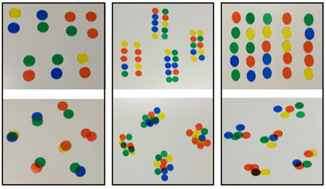
- Focus the discussion on the difference between a structured and unstructured group. Ask:
- Which way of organising the objects made it easier to tell how many there were without having to count?
- Which way of organising the objects made it easier for you to ‘trust’ that there were 10 there without having to count?
- What do you notice about the way we organise the objects and the way we record the number?
- Which structure did you prefer?
- Which way of quantifying your collection was the most efficient?
Note: At this point of the discussion students need to visualise the structure of 10 and identify how that structure can help to efficiently organise the count. The focus for Stage 1 is to identify that 10 ones are the same as 1 ten. These discussion questions can be revisited after ‘consolidation and meaningful practice’.

Consolidation and meaningful practice – 20 minutes
- Have students count their collection again with a focus on structuring their count and seeing 10 ones as 1 ten.
Note: Disrupt the count again to create an opportunity for students to reflect on the benefits of using an effective method to maintain their count.
- Students continue to count other large collections of items to consolidate their understanding of efficient counting methods and the understanding that 10 ones are 1 ten.
Forming groups: This helps students progress from ‘counting by ones’ to ‘skip counting’ and ‘using repeated addition’. These are important steps towards understanding the idea of coordinating units and multiplication.
This table details assessment opportunities and differentiation ideas.
Assessment opportunities | Too hard? | Too easy?
What to look for:  - Are students able to count out a given number of objects from a larger collection? (MA1-RWN-01, MA1-RWN-02)  - Do students understand that 10 ones are the same as 1 ten? (MA1-RWN-01, MA1-RWN-02)  - What strategies are students using to calculate their total? (MAO-WM-01, MA1-FG-01)  - How are students counting objects? By ones? Twos? Tens? (MAO-WM-01, MA1-RWN-01, MA1-FG-01)  - How are students organising their objects? For example, small equal groups, ones, in a line, making towers or by forming structures like ten-frames or dice patterns. (MAO-WM-01, MA1-RWN-01, MA1-FG-01)  What to collect:  - photos of students’ work (MAO-WM-01, MA1-RWN-01, MA1-FG-01) | Students are not confident counting out a given number of objects from a larger collection or are unable to keep track of the count.  - Support students to count objects one-to-one by physically moving the objects into different piles as students count. Ask students how many objects they have and highlight that the last number word said indicates how many objects have been counted.  - Have students arrange the objects in a line and recount (noting where they have said the incorrect number). Ask students what number comes before or after the incorrect number.  - Explain to students that they should keep spaces between collections to show which ones have been counted and which ones have not. Demonstrate the benefits of using spaces between collections.  Students are not confident using place value knowledge to rename collections of 10 ones as 1 ten to help determine how many there are.  - Provide students with Resource 1: Ten-frame.  - Help students visualise collections of 10 by physically grouping objects in a clear cup. | Students count a large collection of objects.  - Ask students if there are different ways that they can organise their collection.  - Ask students to record different strategies for working out how many counters there are. For example, making collections of 10 and then renaming to make collections of fives, so students can use known facts.  Students describe a range of strategies for quantifying the same collection. Ask students to make an argument for which strategy they believe is most efficient. Students will need to provide evidence to support their argument.

Lesson 2: Counting with handfuls
Core concept: Large collections can be quantified, organised and represented in different ways.
The table below contains suggested learning intentions and success criteria. These are best co-constructed with students.
Learning intentions | Success criteria
All students are learning that:  - collections of objects can be organised and quantified in many ways  - some ways of quantifying collections are more efficient than others. | Students can:  - count large collections using counting strategies, for example, twos, fives and tens  - understand that 10 ones can be renamed as 1 ten  - organise objects to represent collections of 10.

Daily number sense: Nearest 10 – 10 minutes
- Build student understanding of the relationship between numbers by locating their positions.
- Display a digital number line and choose a number for students to locate the nearest 10. For example, if you choose 13, students write 10 on their individual whiteboard.
- Continue selecting numbers and ask questions such as:
- What are you noticing?
- What strategies are you using to locate the numbers?
Note: No number is ever more than 3 away from a landmark (or benchmark) of 5 or 10 (see Figure 2).
Figure 2 – Landmark numbers
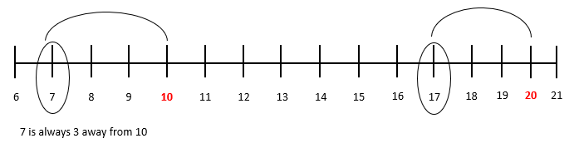
Helping the principal – 20 minutes
- Tell students the principal asked to borrow a handful of counters, so you gave the principal a handful. The handful contained 43 counters. Now the principal has asked for another handful. Ask students to get another handful for the principal.
- Each child grabs a handful of counters and records how many they grabbed on a sticky note.
- On a large 0-50 number line, with increments of 10 marked, plot your handful and have students place their sticky note on the number line.
Note: Use masking tape or chalk to draw a number line large enough for all students to plot their handful of counters.
- Looking at the number line, ask:
- Will the principal get the same number of counters from each handful? Why or why not?
- Who has the smallest handful?
- Who has the largest handful?
- Do you think you will need to grab more handfuls to get a similar amount to me?
- Ask students to think about how they could organise their collections so that it is easier to see how many counters they have and how to keep track of the counters they have counted. Students collect handfuls of counters, trying to get as close to 43 as possible.
- Revise the structured ways to organise a large collection of objects by displaying photos from Lesson 1.
- Students grab more handfuls and structure their count. Students record each time they grab a handful, so they know how many handfuls are needed.

Discuss and connect the mathematics – 10 minutes
- Students share how many handfuls they grabbed, how many lots of 10, and the total amount they collected. Figure 3 shows how the handfuls could be recorded.
Figure 3 – Organised count
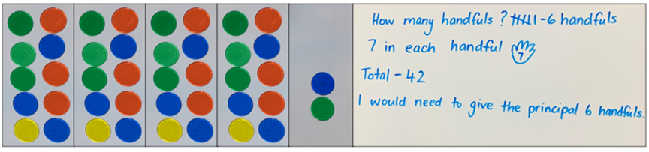
- Go on a gallery walk and prompt students to demonstrate their counting strategies with a focus on the success criteria.
- Ask students:
- How did you keep track of the count?
- Did you use a counting strategy (like counting by twos) to count out the number of objects?
- How can you be sure of your total?
- How many handfuls did you need to get as close to 43 as possible?
- Which was the most efficient way to count your total? Why?
This table details assessment opportunities and differentiation ideas.
Assessment opportunities | Too hard? | Too easy?
What to look for:  - Do students understand that 10 ones are the same as 1 ten? (MA1-RWN-01, MA1-RWN-02)  - What strategies are students using to calculate their total? (MAO-WM-01, MA1-FG-01)  - How are students counting objects? By ones? Twos? Tens? (MA1-RWN-01, MA1-FG-01)  - How are students organising their objects? For example, small equal groups, ones, in a line, making towers or by forming structures like ten-frames or dice patterns. (MAO-WM-01, MA1-RWN-01, MA1-FG-01)  What to collect:  - photos of students work presented in the gallery walk (MAO-WM-01, MA1-RWN-01, MA1-RWN-02) | Students do not count out a given number of objects from a larger collection.  - Support students to count objects one-to-one by physically moving the objects into different piles as they count. Ask students how many objects they have and highlight that the last number word said indicates how many objects have been counted.  - Have students arrange the objects in a line and recount (noting where they have said the incorrect number). Ask students what number comes before or after the incorrect number.  - Explain to students that they should keep spaces between collections to show which ones have been counted and which ones have not. Demonstrate the benefits of using spaces between collections.  Students do not use place value knowledge to rename collections of 10 ones as 1 ten to help determine how many there are.  - Provide students with Resource 1: Ten-frame.  - Help students visualise collections of 10 by physically grouping objects in a clear cup. | Students count a large collection of objects.  - Estimate and check how many handfuls students needed to grab to reach 43 by using a number line or skip counting.  - Students create their own mathematical story and solve it using their handful as the unit of measurement.

Consolidation and meaningful practice: Minute to win it – 20 minutes
- Organise students into small groups with a large collection of objects in the middle. Students have one minute to collect as many objects as possible, collecting only one object at a time.
- When the minute is up, students count their objects using a structured strategy to maintain the count and strengthen their understanding that 10 ones are the same as 1 ten.
- Students share their total and the player with the largest number wins.

Lesson 3: Place value
Core concept: Numbers can be partitioned in different but equivalent ways
The table below contains suggested learning intentions and success criteria. These are best co-constructed with students.
Learning intentions | Success criteria
Students are learning that:  - the position of a digit in a number determines the value it represents  - zero is used as a ‘place holder’. | Students can:  - rename a one-, two- or three-digit number to understand the value of each number’s place. For example, in the number 965, 9 is 9 hundreds, 6 is 6 tens and 5 is 5 ones  - understand the role of zero as a ‘place holder’.

Daily number sense: Make a number? – 10 minutes
- Build student understanding of how numbers are represented by joining different representations of numbers together.
- Display Resource 2: Make a number. Students choose a number representation from inside the box and one from outside the box and combine them.
- Students use their individual whiteboard to record their combinations (see Figure 4).
Figure 4 – Number representations
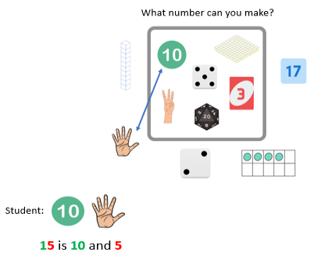
Images sourced from Canva and used in accordance with the Canva Content License Agreement.
- Choose students to share how they used different representations to create numbers.

Beat the teacher – 20 minutes
- On the board, draw 3 columns titled hundreds, tens and ones. Inform students that they need to make the largest possible three-digit number with just 3 rolls of a die. Roll a 0–9 die and have students suggest where to place the digit. Continue until you have a three-digit number.
- Repeat the process. Explain that the goal is to be the player that can represent the largest three-digit number. Challenge a student to represent the largest two-digit number.
- Give students a die and have them roll 2 or 3 times and create their largest number, working independently on whiteboards.
Note: Students working towards Stage 1 outcomes can complete this activity with numbers between 0–30. Provide a range of dice to support the creation of smaller and larger numbers, for example, 0–3, 0–6 or 0–9 dice. Use dice that have a zero as it is important for students to understand that the zero is a placeholder and does not hold a value.
- Select students to demonstrate the number they created and the reasoning behind the placement of each digit.
Note: If students are unable to articulate the reason for the strategic placement of the digit, model your thinking out loud. For example, ‘I rolled a 9, this is the largest number on this die. I will place it in the hundreds column because the 9 represents 9 hundreds.’
Build a number – 20 minutes
- Provide pairs of students with Resource 3: Build a number and dice. Have partners play each other to build the largest number.
- After students have played 4 rounds, change the aim to the smallest number and then closest to a target number.
- Use Resource 5: Build a number assessing game play to prompt students whilst playing the game.
Note: Use a reusable plastic sleeve for the gameboard to allow students to play multiple games.

Discuss and connect the mathematics – 10 minutes
- Summarise the lesson together, drawing out some key mathematical ideas with students by asking:
- What strategy did you use when you were trying to build the largest/smallest/target number?
- What strategy did you use to help you represent your number using interlocking cubes or MAB blocks?
- How did you know your number was larger/smaller than your partner’s?
- What does each column represent?
- When you rolled a zero, what did you do with it? Why?
This table details assessment opportunities and differentiation ideas.
Assessment opportunities | Too hard? | Too easy?
What to look for:  - Can students rename one-, two- and three-digit numbers to show the value? (MA1-RWN-01, MA1-RWN-02)  - Can students state the value of digits in two- and three-digit numbers? (MAO-WM-01, MA1-RWN-01, MA1-RWN-02)  What to collect:  - student samples of Resource 5: Build a number assessing game play (MAO-WM-01, MA1-RWN-01, MA1-RWN-02) | Students do not build numbers to 20 with manipulatives. Use 2 of Resource 1: Ten-frame for students to record the number rolled using counters.  Students cannot partition numbers or state the place value of three-digit numbers.  - Use interlocking cubes to build and rename the given number.  - Use Resource 4: Build a two-digit number to allow students to focus on using manipulatives to build two- and three-digit numbers. Ask questions, such as which digit is in the tens place or what is the value of the 4 in the tens column. | Students state the place value of two- and three-digit numbers.  - Students use 4 dice to explore all the different four-digit combinations that can be created and round them to the nearest multiple of 1000 by playing Round the Four Dice from NRICH.  - Students play Mastermind (7:43) or Hit it! (9:11) which provides an opportunity to ask mathematical questions around place value.

Lesson 4: Busting numbers
Core concept: Numbers can be partitioned in many different ways.
The table below contains suggested learning intentions and success criteria. These are best co-constructed with students.
Learning intentions | Success criteria
Students are learning that:  - a collection can be partitioned (renamed) in different ways but keep the same value  - equal-arm balances show equivalence. | All students can:  - rename and record one-, two- or three-digit numbers in different ways  - use an equal-arm balance to check equivalence.

Daily number sense – 10 minutes
- Identify a class need through formative assessment data and complete a short, focused activity that targets students’ knowledge, understanding and skills. Example activities may be drawn from the following resources:
- Thinking Mathematically Stage 1
- Universal Resources Hub

Number busting – 20 minutes
This activity has been adapted from Number busting – number talk (renaming 26) (2:00) by Thinking Mathematically Stage 1.
- Have students sit in a circle and display 3 bundles of 10 and 6 ones. Explain that you have 36 objects. Students turn and talk to share ideas on how they can prove there are 36 objects.
Note: Bundles of 10 can be made with craft sticks, interlocking cubes, straws or similar items that can be separated. Watch Number busting – number talk (renaming 26) (2:00) prior to the lesson.
- Invite students to number bust 36. Record some of the different ways they have renamed the collections. Demonstrate ideas students may not think of, such as unbundling the collections to show that 36 is 2 tens and 16 ones.
- Heft the collections of craft sticks and then use an equal-arm balance to prove equivalence. Place 3 bundles of 10 and 6 ones on one side, and 2 bundles of 10 and 16 ones on the other side. Emphasise that no more craft sticks have been added and none have been removed. This means the total size of the collection remains the same even though it looks different. Invite students to share 2 or 3 other ways of renaming 36 and check equivalence.
- Repeat and model the above steps with students using a different number.
Note: Provide opportunities for students to bust larger two- or three-digit numbers.

Different ways to see a number – 20 minutes
- Provide pairs of students with an equal-arm balance and a large collection of MAB blocks.
- Display a variety of one-, two- and three-digit numbers to rename. Students choose numbers to rename and build different representations. They check equivalence using either hefting or an equal-arm balance.
- Students record their working using symbols and words (see Figure 5).
Figure 5 – Student working
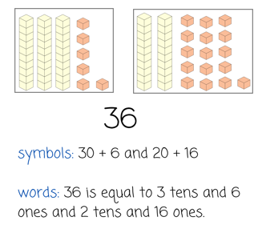
Images sourced from Canva and used in accordance with the Canva Content License Agreement.
- Students continue to rename given numbers and check that they remain the same.
This table details assessment opportunities and differentiation ideas.
Assessment opportunities | Too hard? | Too easy?
What to look for  - Do students understand that 10 ones are the same as 1 ten? (MA1-RWN-01, MA1-RWN-02)  - Can students use an equal-arm balance to check the equivalence of a number? (MA1-NSM-01)  - Can students partition (rename) one-, two- and three-digit numbers to show the value? (MAO-WM-01, MA1-RWN-01, MA1-RWN-02)  What to collect:  - student work samples (MAO-WM-01, MA1-RWN-01, MA1-RWN-02). | Students are not confident with renaming numbers.  - Use craft sticks bundled together or interlocking cubes so students can manipulate the numbers, breaking them apart and re-forming them. Explain that no more sticks are being added to the collection and none are being removed.  - Students rename numbers to 10 or 20, using interlocking cubes to represent the way they have renamed the whole number. | Students are confident in two- and three-digit partitioning strategies.  - Revise that students can partition the number in 2 ways, then ask if they can also partition it in 3 or 4 ways.  - Students explore different ways to balance an equation using Multiply Multiples 3 by NRICH.  - Students partition four-digit numbers and check equivalence.

Discuss and connect the mathematics – 10 minutes
- Strategically select students to share their thinking and model different ways of renaming their collection to prove that nothing has changed.
- As a class, record students’ thinking using symbols and words and focus on the idea that a collection can have the same value but look different. Revise that equivalence can be proved using hefting or an equal-arm balance.

Lesson 5: Compare 2 number lines
Core concept: Numbers can be compared through different representations.
The table below contains suggested learning intentions and success criteria. These are best co-constructed with students.
Learning intentions | Success criteria
Students are learning that:  - number lines of the same length can represent different ranges of numbers  - the position of the hour hand and minute hand represent time. | Students can:  - understand that an analog clock is made by curving a number line  - locate, sequence and compare numbers on a range of number lines  - read and communicate o’clock, half- and quarter-hour time using the position of the hour and minute hands.

Daily number sense: Number placement – 15 minutes
- Build student understanding of number placement by ordering given numbers.
- On their individual whiteboards, students draw a blank number line within a given range.
- Students mark multiples of 10 within that range (see Figure 6) and justify the placement of their numbers.
Figure 6 – Number placement
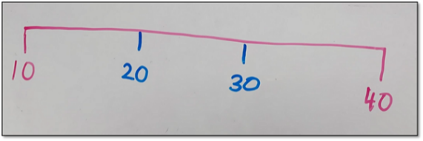
- Provide students with a selection of numbers, for example, 19, 15, 12, 17, 6 and 21. Students order the numbers in ascending or descending order on their individual whiteboards.
- Continue with different ranges and provide time for discussion.

Hour and minute lines – 20 minutes
- Students sit facing 2 long ropes, placed parallel to each other. Students place numbers 1–12 on the top number line, attaching the numbers to the number line with tape or pegs.
- Students then repeat this activity for the bottom number line using numbers 0–60 (see Figure 7).
Figure 7 – Rope number lines
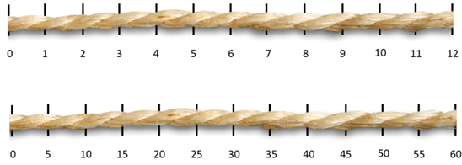
Images sourced from Canva and used in accordance with the Canva Content License Agreement.
Note: If students do not align the numbers with the parallel number line, discuss the importance of lining up the numbers. For example, if 2 on the top number line does not align with 10 on the bottom number line.
- Have students stand and look at the 2 number lines. Discuss the connection between both lines.
The table below outlines stimulus prompts to generate conversation about the topic, along with anticipated responses from students.
Prompts | Anticipated student responses
- Do you see any patterns between the lines?  - What are some similarities?  - What are some differences?  - How are the lines related? | - Both lines have the same number of numbers.  - One line goes up by ones.  - One line goes up by fives.  - The numbers are plotted with the same distance.
- Place the words ‘hour’ and ‘minute’ next to the corresponding number lines. Ask:
- Is there a relationship between the hour number line and the minute number line?
- Why does one number line count by fives and the other number line count by ones?
- On a third number line, students peg Resource 6: Hour and minute numbers onto the rope to represent the combination of the hour and minute number lines. Turn the rope into a circle so the numbers represent the face of a clock.
- Discuss the connections that students make between the number lines and the representation of a clock face.

Building time – 25 minutes
- Choose one student to stand on the hour number line and another on the minute number line (see Figure 8) and give them a time to represent. Students represent o’clock, half past and quarter-to and quarter-past, using a variety of language to name the time, for example, four-thirty and half past 5.
Figure 8 – Time on the line
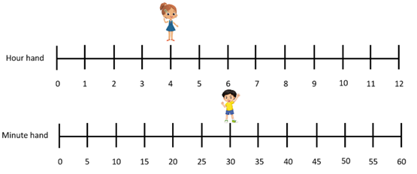
Images sourced from Canva and used in accordance with the Canva Content License Agreement.
- Have the rest of the class build the time given using their clock.
- Continue to do this for various times and choose different students to stand on the number lines. Pause to discuss the relationship between the number lines and the hour and minute hands.
This table details assessment opportunities and differentiation ideas.
Assessment opportunities | Too hard? | Too easy?
What to look for:  - Can students sequence numbers and arrange them on a number line? (MA1-RWN-01)  - Can students read o’clock, half-hour and quarter-hour and describe the position of the hands? (MA1-NSM-02)  - Can students connect and communicate that an analog clock is made by curving a number line? (MAO-WM-01)  What to collect:  - student work samples (MAO-WM-01, MA1-RWN-01, MA1-NSM-02) | Students have difficulty sequencing numbers. Provide students with a number chart so they can see the order of numbers and use this as a reference.  Students have difficulty making the connection between the number line representation and the clock face representation.  - Students describe where the number is on the line and where the number is on the clock face, for example, 6 is halfway on the number line and halfway around the clock face.  - Demonstrate how the 12 on the number line represents o’clock on the clock face.  Students are not able to count by fives. Include markings of ones on the number line and on the clock face. | Students make the connection between the number line and the clock face. Students move between the hour numbers to represent the movement of the minute hand, for example, by standing halfway between the 4 and 5 to represent 4:30.

Lesson 6: How many seeds?
Core concept: Patterns are helpful when quantifying large collections.
The table below contains suggested learning intentions and success criteria. These are best co-constructed with students.
Learning intentions | Success criteria
Students are learning that:  - familiar structures can be used to represent a large collection of objects  - patterns inside of numbers help to count (quantify) collections, for example, number bonds  - renaming collections as tens and ones is an efficient way to quantify total amounts  - familiar combinations (patterns) of numbers up to and including 10 is an efficient way to quantify total amounts. | Students can:  - confidently use familiar structures to represent a large collection of objects  - use patterns inside of numbers to help count (quantify) collections  - describe why renaming tens and ones is more efficient  - create, recall and recognise combinations (patterns) of numbers up to and including 10.

Daily number sense: Part-whole combinations – 10 minutes
- Build student understanding of part-whole combinations to 10 by providing them with a target number and having students recall and record combinations.
- Spin the digital spinner to provide the target number. Students record combinations for that number on their individual whiteboard. For example, if 5 is spun, a student may write 3 and 2 or 3 + 1 + 1.
- Select students to provide combinations for the target number and record these on the board.
Note: If the same number is spun, challenge students to come up with different combinations.

How many seeds? – 20 minutes
This activity has been adapted from Boaler et al. (2021)
- Display Resource 7: How many seeds? and explain that Farmer Dave works at the seed warehouse. Each packet of seeds must have 10 seeds inside before they can be sold. He needs to sort his piles of seeds into groups of 10, but he has a lot of seed piles. He needs some help!
- Explain that for this activity, individual counters or dots on the dice will represent the seeds.
- Scatter a handful of 20 counters and explain that student need to find how many seeds there are in total. Ask students to discuss different ways they could organise the counters so that they can efficiently count the collection of seeds.
- With a partner, students turn and talk about ways to organise the counters for an efficient count.
- Students share ways of structuring the counters and the total number of seeds they counted.
- Roll at least 10 dice and explain that students need to find how many seeds there are in total now. Ask students to discuss ways they could organise the dice so that they can efficiently count the collection of seeds. Looking at the dice, ask students how many dots there are in total.
- Students turn and talk about ways to organise the dice so that they can efficiently count the collection.
- Students share ways of structuring the dice and the total number of seeds they counted.
- Have students reflect on the efficient and effective strategies they used to count large collections of objects in Lesson 1 and Lesson 2. Ask if there was a strategy that students used to maintain the count of a large collection.
- Roll the dice again. Students turn and talk to determine the most efficient and effective way to organise and count the number of seeds (see Figure 9).
Figure 9 – Organising seeds
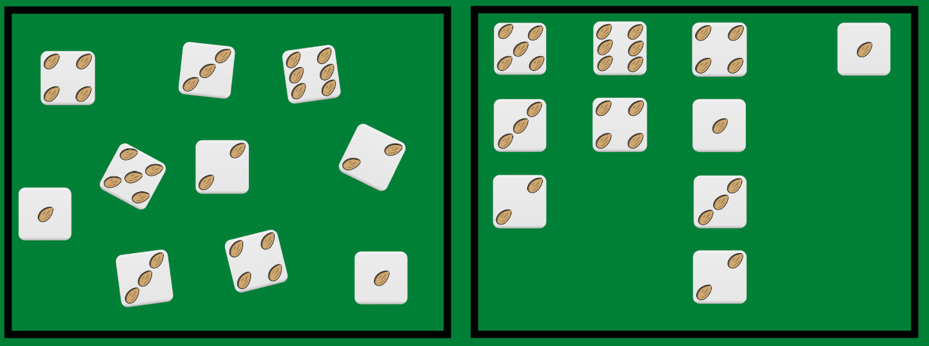
Images sourced from Canva and used in accordance with the Canva Content License Agreement.
- Students share the ways they structured the counters or dice to count the total number of seeds. Choose students who have grouped the dice in different ways, for example, using similar numbers, and have them justify their strategy. If a pair has grouped by 10, use their combination to lead into the next part of the lesson.

Consolidation and meaningful practice – 20 minutes
- Provide small groups of students with a collection of 10-20 dice and an individual whiteboard to record the total count.
- Students take it in turns to roll the dice. They work together to organise the dice to count the seeds efficiently.
- As students play, ask:
- How can you organise the counters or dice to help you count?
- How many groups of 10 did you make?
- Did you use more than 2 dice to create a group of 10?
- How might groups of 10 help you count the seeds?
- What is the largest number of seeds you counted? How do you know?
Note: Take photographs of the ways that students organise their dice for assessment and the ‘discuss and connect’ part of the lesson.
This table details assessment opportunities and differentiation ideas.
Assessment opportunities | Too hard? | Too easy?
What to look for:  - Can students create, recall and recognise combinations of numbers to 10? (MAO-WM-01, MA1-CSQ-01)  - Do students understand that 10 ones are the same as 1 ten? (MA1-RWN-01, MA1-RWN-02)  - Can students count large sets of objects by systematically grouping in tens? (MAO-WM-01, MA1-CSQ-01)  What to collect:  - photos of how students have organised their dice (MAO-WM-01, MA1-RWN-01, MA1-RWN-02, MA1-CSQ-01). | Students are unable to count their collection using known patterns or structures.  - Students use an individual whiteboard to draw and keep track of counters or dice.  - Students organise their counters or dice into groups of the same number. For example, all the fours.  - Provide students with Resource 1: Ten-frame and different coloured counters to demonstrate the dots from the different dice.  Students do not use groups of 10 dots to quantify and rename collections.  - Ask students to look at the collection of dice and think about many seeds there are. Ask how students could group the seeds to make them easier to count.  - Ask students to tell you everything they know about 10. Encourage students to use this knowledge to help them make groups. | Students organise their dice using an efficient counting method.  - Using the combinations they have made, challenge students to only use 2 dice to partition to 10 or use the greatest or least number of dice to partition to 10.  - Ask students how they can be sure that they have made all the combinations to 10. Have students record all combinations and a method to check their working.  - Tell students that Farmer Dave is having a special sale and is making packets with 12 seeds. Students repeat the activity, using their counters or dice to make combinations of 12.

Discuss and connect the mathematics – 10 minutes
- Display the pictures and summarise the lesson together by asking questions, such as:
- How did you organise your dice to see how many seeds there were?
- How did your strategies change as you played?
- What patterns did you notice that helped you organise the dice?
- How did organising the dice help you count? Explain your thinking
- What other ways could the dice be organised?
- Is there anything that you are still wondering?

Lesson 7: Sorting seeds
Core concept: Large collections can be quantified, organised and represented in different ways.
The table below contains suggested learning intentions and success criteria. These are best co-constructed with students.
Learning intentions | Success criteria
All students are learning that:  - the same collection of objects can be represented in different ways  - counting in tens and ones is more efficient. | All students can:  - use familiar structures to represent a large collection of objects  - describe why counting in tens and ones is more efficient  - communicate their reasoning behind counting strategies.

Consolidation and meaningful practice: The clock – 10 minutes
- Build student understanding of the relationship between a number line and the face of a clock by representing the time.
- Draw the minute and the hour number line on the board and display an interactive clock.
- Choose a number from the minute number line and the hour number line and have students build the time on the interactive clock.
- Discuss the relationship between the number lines and the hour and minute hands.
Note: Stage 1 students represent o’clock, half past and quarter-to and quarter-past.

Sorting seeds: Part 1 – 15 minutes
This activity has been adapted from Boaler et al. (2021).
- Show Resource 8: Pumpkin patch problem. Explain that farmer Phil needs to plant pumpkin seeds in his vegetable garden. Unfortunately, his pumpkin seeds have been jumbled up into 4 different piles. He needs to know how many seeds are in each pile.
- Show students a handful of seeds (or counters) and explain that counting seeds by ones would take a long time. Ask students to suggest some more efficient ways of counting the seeds. These could include using familiar groupings such as fives or tens to coordinate the count.
- Provide each pair of students with a handful of counters. For each round of the activity, they will need a different number of counters.
- Ask students to consider how many packets of 10 vegetable seeds they can make and how many loose ones might be left over. Students turn and talk with a partner. They can use containers, ten-frames or drawings to support their count.
Note: Monitor for students’ use of strategies and the idea of a packet of 10 and loose seeds.
- Students share their strategies for working out the number of seed packets they need, and loose seeds left over.

Sorting seeds: Part 2 – 15 minutes
- Show students Resource 9: Packets of seeds and say that farmer Phil’s manager, farmer Fay, needs to purchase enough seeds for the next planting, but she is unsure of how many packets to order.
- Display Resource 10: Need for seeds and assign pairs of students to a type of vegetable. Provide each group with the corresponding number of counters for their vegetable.
Note: The values in Resource 10: Need for seeds can be edited to meet the needs of the students.
- With their partner, students use the counters and a copy of Resource 10: Need for seeds to answer the following questions:
- How many full packets of seeds can you make? How many will be left over?
- Were all the packets full?
- What happens to the seeds that are left over?
- How can you check that you have the same number of seeds as the number needed by farmer Fay?
- Students share their strategies for working out the number of packets they will need.
Note: Monitor students for the use of strategies and the concept of a pack of 10 and loose seeds.
- Partners draw how they have packed the seeds and share with the class.

Discuss and connect the mathematics – 20 minutes
- Go on a gallery walk and collect photographs of the different ways that students grouped their seeds.
- Display the photographs and have students explain their strategies. Draw attention to the grouping of tens and hundreds, efficient strategies and patterns between the images. For example, students may have drawn 10 seeds or a packet with 10 on it.
- Ask:
- How did you figure out how many packets of 10 and how many loose seeds you had?
- What did you do when you did not have a full packet? Why?
- Did you notice any patterns as you worked? Explain your thinking.
- How are 3 groups of 10 and 8 ones the same as 38?
- How are 12 groups of 10 and 2 ones the same as 122?
This table details assessment opportunities and differentiation ideas.
Assessment opportunities | Too hard? | Too easy?
What to look for:  - Can students use familiar structures to represent large collections? (MAO-WM-01, MA1-RWN-01)  - Do students understand that 10 ones are the same as 1 ten? (MA1-RWN-01, MA1-RWN-02)  - Are students communicating the reasoning behind their counting strategies? (MAO-WM-01)  What to collect:  - Photos of students’ work from the gallery walk and student work samples (MAO-WM-01, MA1-RWN-01, MA1-RWN-02) | Students are not able to use familiar structures to represent large collections.  - Students use concrete materials, for example, interlocking cubes or counters and ten-frames to represent 10 ones as 1 ten.  - Support students to use a structure to represent the numbers of seed packets needed for each type of vegetable.  - Help students to translate their concrete representation into a drawing. | Students are able to use familiar structures to represent large collections.  - Ask students what this would look like as a mathematical drawing and how they would structure their drawing, so they do not rely on counting.  - Edit Resource 10: Need for seeds with a new number of seeds and have students consolidate their knowledge by repeating steps 12 and 13.  - Explain that the seed company is changing their packaging and are now only selling packets of 8 seeds. Ask how many packets of seeds Farmer Fay would need for each type of vegetable now.

Lesson 8: Position on a grid
Core concept: There are patterns to the way numbers are formed.
The table below contains suggested learning intentions and success criteria. These are best co-constructed with students.
Learning intentions | Success criteria
Students are learning that:  - each decade has a repeating pattern of 0–9  - grid structures help to describe locations and the paths between them. | Students can:  - identify the repeating pattern of 0–9, for example, (10, 11, 12...19, 20, 21, 22...29, 30, 31, 32...39)  - describe the movement of an object using the words up and down  - describe a path and give directions from one location to another  - count forwards and backwards by ones and tens, on and off the decade.

Daily number sense: Number chart rounding – 10 minutes
- Build student understanding of locating the nearest 10 to a number by using a number chart.
- Display a number chart. Say a number and have students locate the nearest 10. For example, if you choose 57 the students would say 60.
- Continue selecting numbers and ask questions such as:
- How do we know it is closer to 60?
- Do you see any patterns?
- What happens when you land on 5?

Difference between numbers – 15 minutes
- Display Resource 11: Number chart and colour 2 different numbers. Students turn and talk about how they could describe the difference between the position of the numbers (see Figure 10).
Figure 10 – Position of numbers
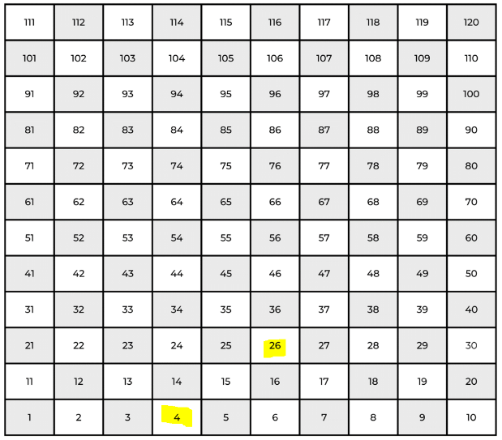
- After the discussion, select students to share how they described the difference between the position of the numbers.
- Based on the responses, model your thinking about how to explain the position of the numbers using the grid structure. For example, ‘Starting at 4, every time I move up one square, I add 10. Because I moved up 2 squares, this means I moved up 2 tens. I then moved right 2 squares and added 2 ones.’ This describes the difference in the position between the numbers 14 and 46 as being 3 tens and 2 ones. Repeat this to model subtraction of tens and ones by starting at 46.
- Continue selecting different numbers, providing opportunities to demonstrate adding and subtracting tens and ones. Choose students to model how to describe the difference in the position of the 2 numbers.

Snakes and ladders – 25 minutes
- Provide Stage 1 students with Resource 12: Stage 1 snakes and ladders to practise describing the difference in position between 2 numbers.
- Students roll a 6-sided die and move the number of places shown on the die, going up any ladders and down any snakes that they land on.
Note: Draw attention to the numbers on the gameboards as each row goes from left to right to show the repeating pattern.
- When students go up a ladder, they need to record the difference in the position between the 2 numbers on their whiteboard, for example, add 3 tens and 4 ones.
- When students go down a snake, they need to record the difference in the position between 2 numbers, for example, subtract 4 tens and 2 ones.
This table details assessment opportunities and differentiation ideas.
Assessment opportunities | Too hard? | Too easy?
What to look for  - Can students count forwards and backwards by ones and tens, on and off the decade? (MA1-RWN-01, MA1-RWN-02)  - Can students use a grid system to describe a path from one location to another? (MA1-GM-01)  - Can students give directions involving left and right turns to move between numbers? (MA1-GM-01)  What to collect:  - observations of students counting accurately and their discussions during the lesson (MAO-WM-01, MA1-RWN-01, MA1-RWN-02) | Students do not find the difference between numbers.  - Support students to identify vertical and horizontal number patterns on the game board.  - Model going up the 75–105 ladder and demonstrate the increasing count.  - Model going down the 37–15 snake and demonstrate the decreasing count.  Students are developing knowledge of numbers above 30. Provide students with Resource 13: 0–30 snakes and ladders and finish game play at 30. | Students can explain the difference between numbers. Students explore a hundreds chart and use a code to put it back together using Coded Hundred Square from NRICH.

Discuss and connect the mathematics – 10 minutes
- Summarise the lesson together, drawing out some key mathematical ideas with students by asking questions, such as:
- How does the grid structure help when describing the path between numbers?
- How did you know when your number increased or decreased?
- What strategies did you use when describing your path?

Resource 1: Ten-frame

Resource 2: Make a number
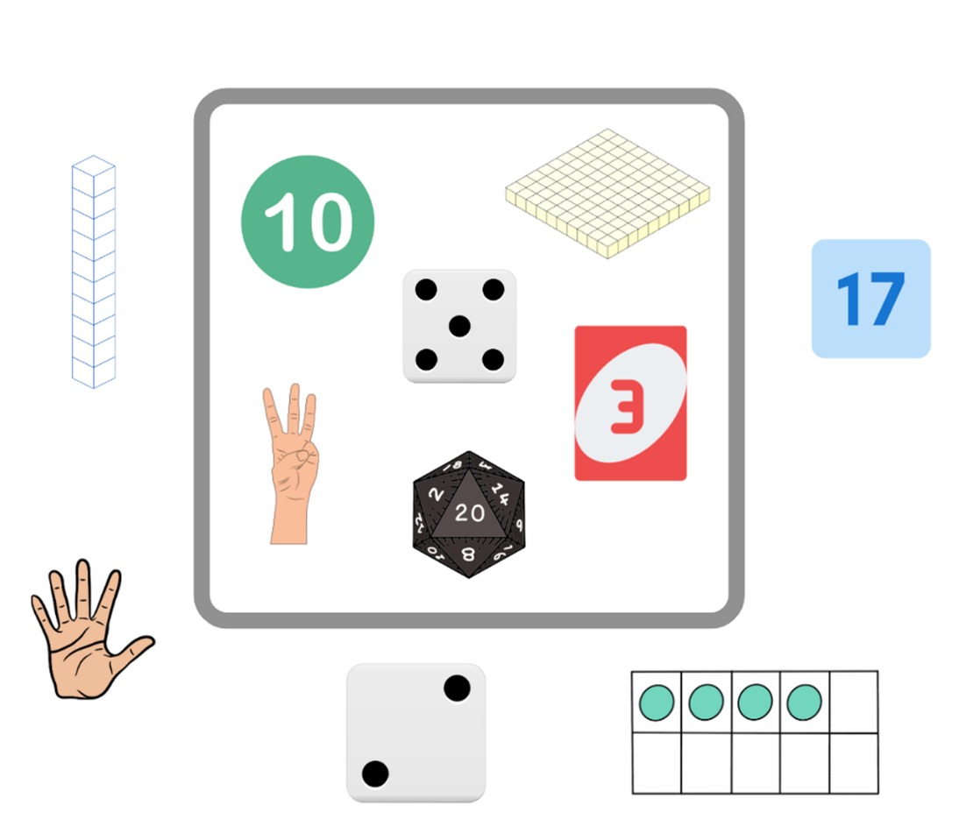
Images sourced from Canva and used in accordance with the Canva Content License Agreement.

Resource 3: Build a number
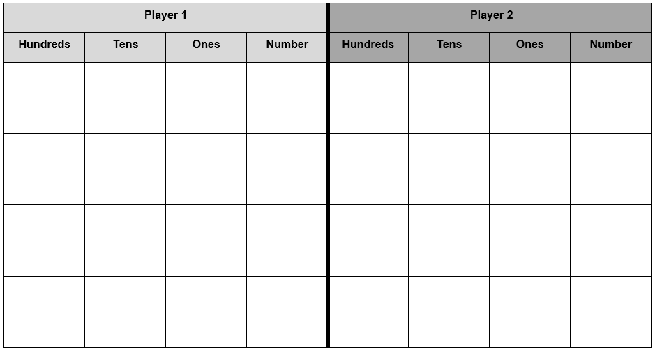

Resource 4: Build a two-digit number
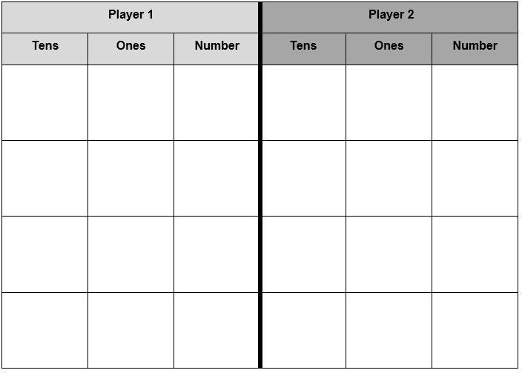

Resource 5: Build a number assessing game play
Focus | Listen, watch, and think | Ask
Accuracy | Are they getting correct answers? | What answer did you get?
Efficiency and strategy selection | Are they applying the strategy in a reasonable timeframe?  Do they seem to be labouring or a little stuck? | - How did you solve it?  - Was there a more efficient strategy you could have used or was this strategy most efficient?
Flexibility and strategy selection | Are they using different strategies?  Can they apply them with the same confidence? | - Why did you pick that strategy?  - Is there another strategy that you could use for that problem?  - When do you like to use __ strategy instead of __ strategy?
Adapted from Bay-Williams and Kling G (2019).

Resource 6: Hour and minute numbers
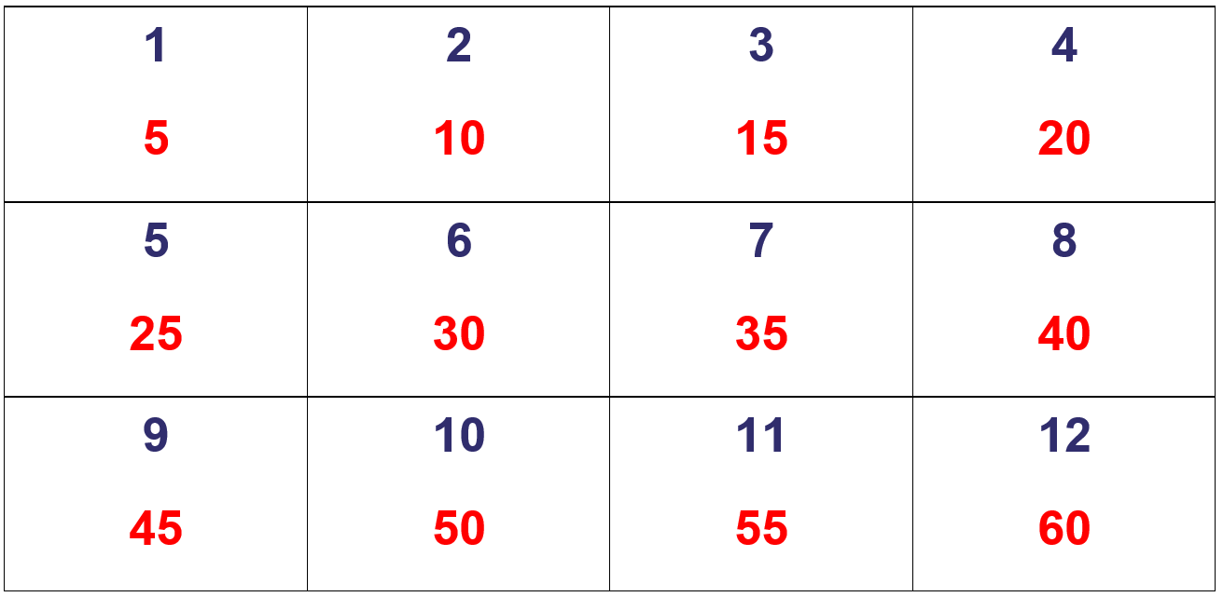

Resource 7: How many seeds?
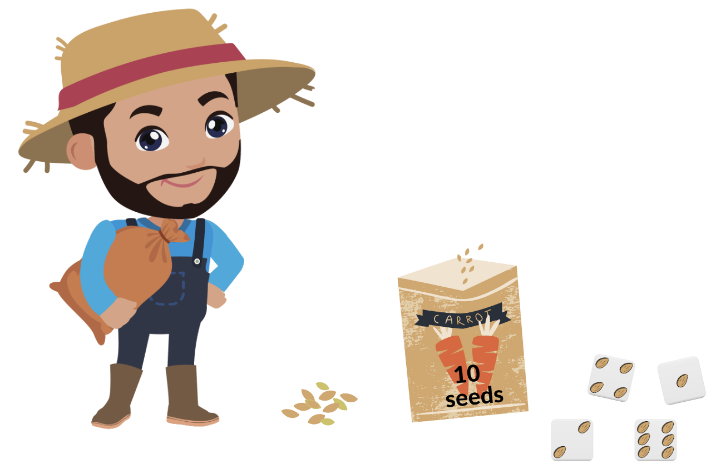
Images sourced from Canva and used in accordance with the Canva Content License Agreement.

Resource 8: Pumpkin patch problem
Pile | How many packets of 10? | How many loose seeds? | Total number of seeds?
Pile 1
Pile 2
Pile 3
Pile 4
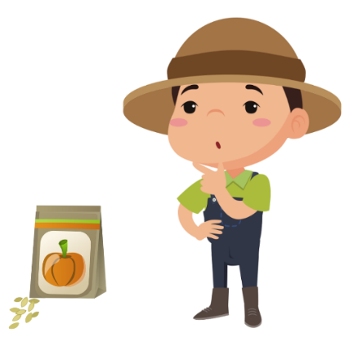
“Farmer” by rafyfane sourced from Canva and used in accordance with the Canva Content License Agreement.

Resource 9: Packets of seeds
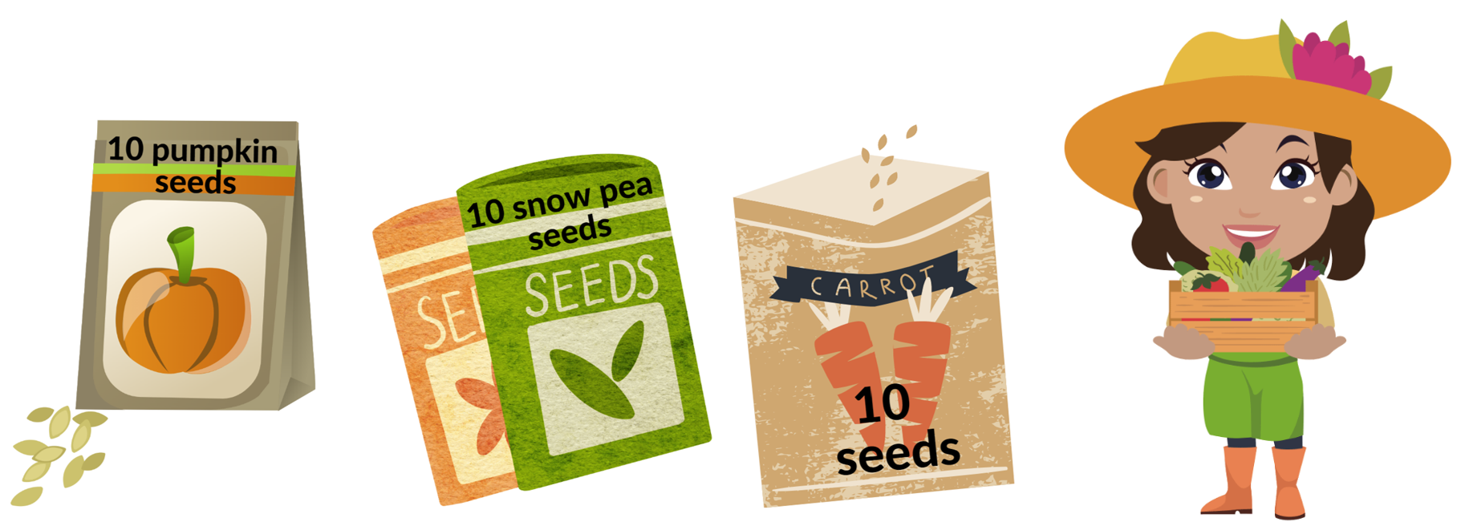
Images sourced from Canva and used in accordance with the Canva Content License Agreement.

Resource 10: Need for seeds
Garden bed | Number of seeds
pumpkins | 15
corn | 23
broccoli | 26
tomatoes | 38
carrots | 64
beans | 167
capsicum | 122
snow peas | 189

Resource 11: Number chart
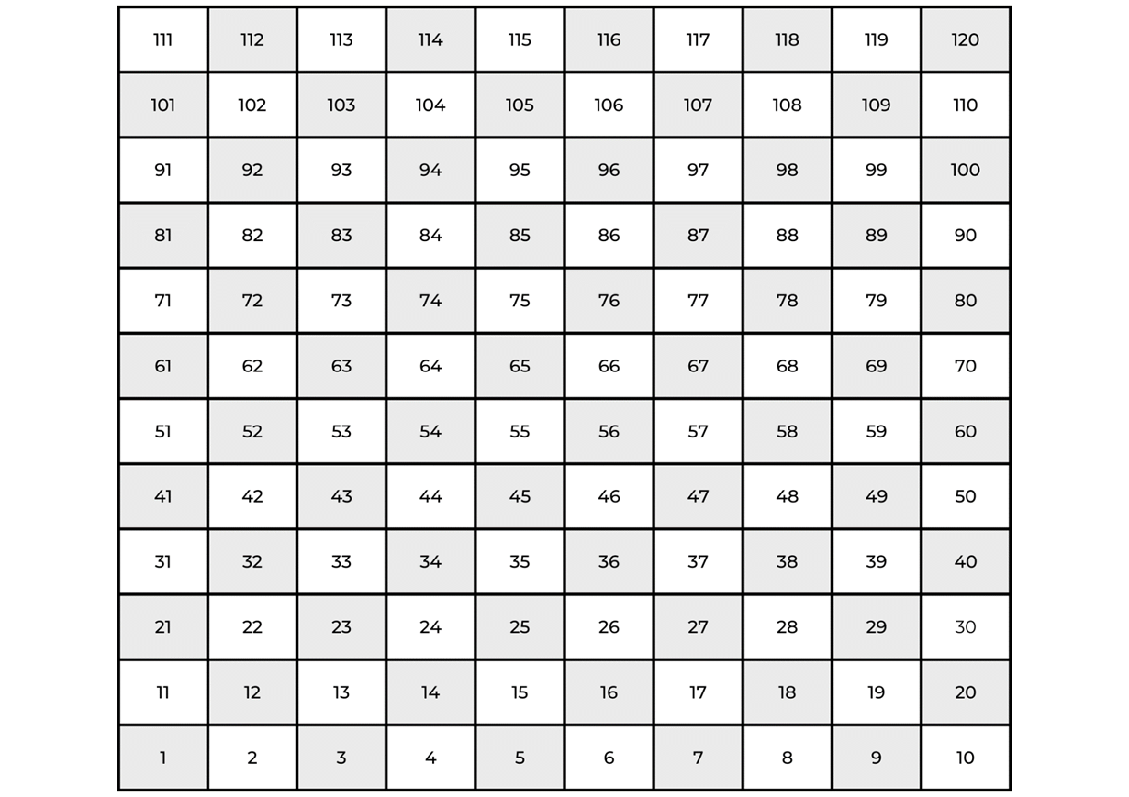

Resource 12: Stage 1 snakes and ladders
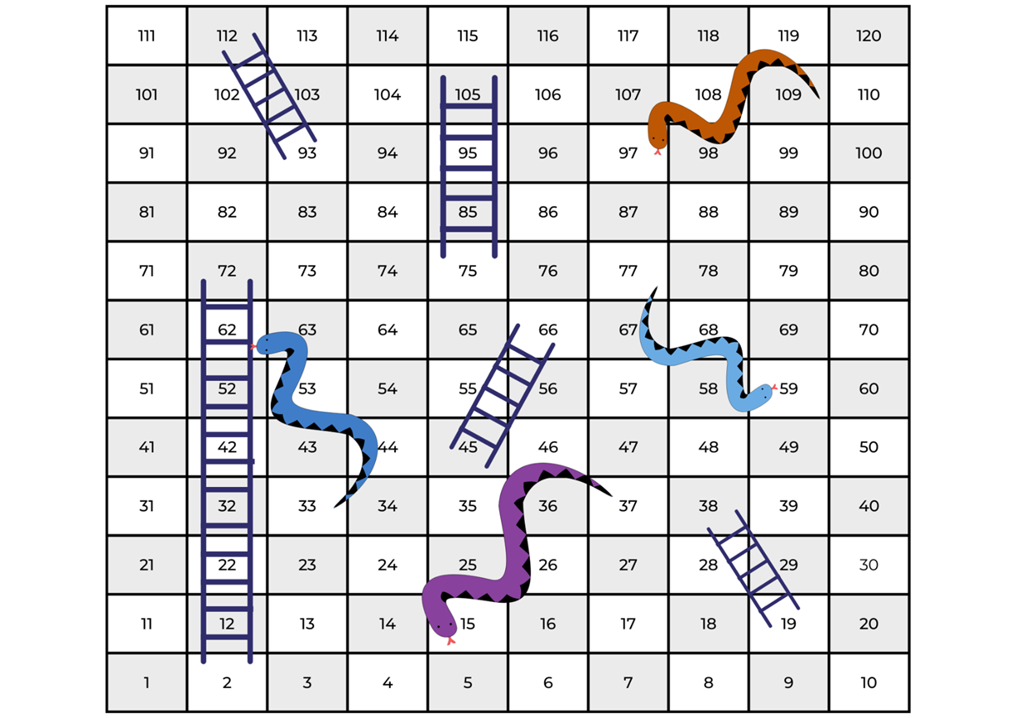
Images sourced from Canva and used in accordance with the Canva Content License Agreement.

Resource 13: 0–30 snakes and ladders
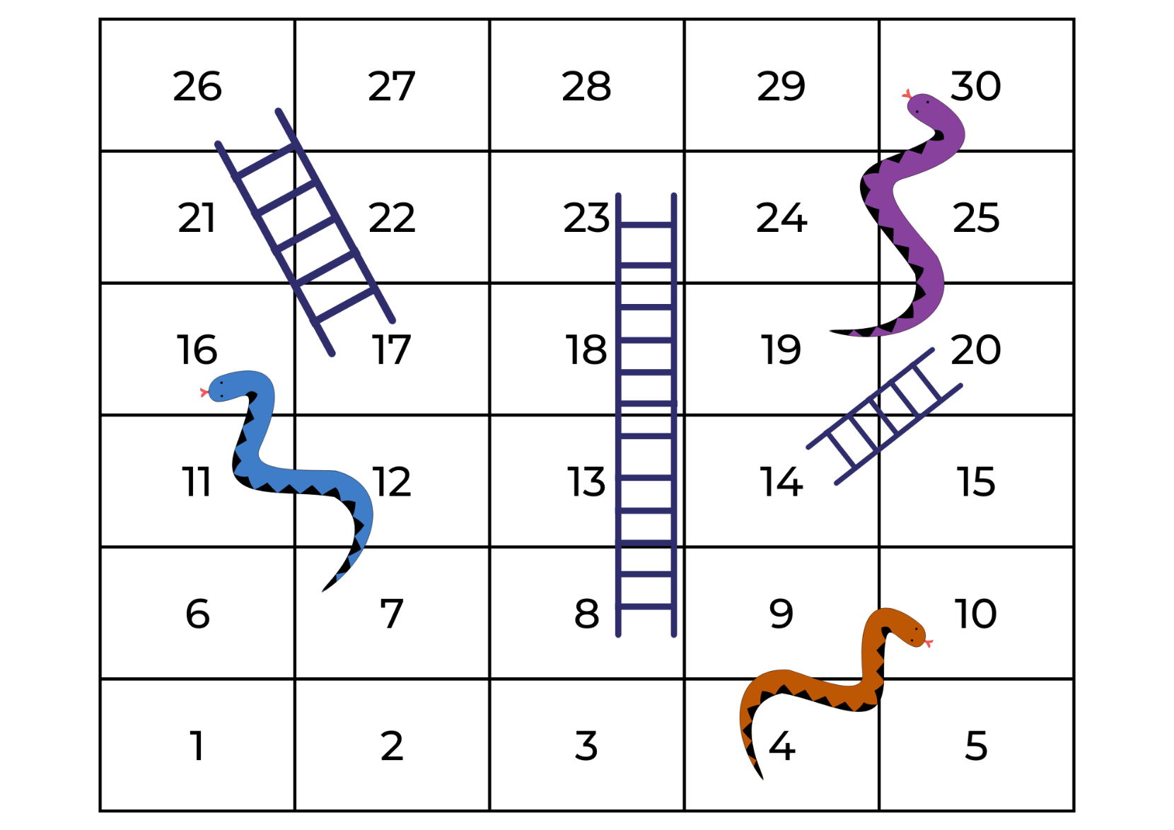
Images sourced from Canva and used in accordance with the Canva Content License Agreement.

Syllabus outcomes and content
The table below outlines the syllabus outcomes and range of relevant syllabus content covered in this unit. Content is linked to National Numeracy Learning Progression version (3).
Focus area and outcomes | Content groups and content points | Lessons
Representing whole numbers A  MAO-WM-01  MA1-RWN-01  MA1-RWN-02 | Use counting sequences of ones with two-digit numbers and beyond  - identify the number before and after a given two-digit number (CPr5)  - count forwards and backwards by ones from a given number to at least 120 (CPr6) | 1, 6–8
Representing whole numbers A (cont) | Represent numbers on a line  - sequence numbers and arrange them on a line by considering the order and size of those numbers (CPr5) | 5
Representing whole numbers A (cont) | Represent the structure of groups of ten in whole numbers  - recognise that ten ones is the same as one ten (NPV2, NPV4)  - count large sets of objects by systematically grouping in tens (CPr7)  - partition two-digit numbers to show quantity values (NPV4)  - use number lines and number charts to assist with locating the nearest ten to a number | 1–8
Representing whole numbers B  MAO-WM-01  MA1-RWN-01  MA1-RWN-02 | Use counting sequences of ones and tens flexibly  - count forwards and backwards by tens, on and off the decade, with two- and three-digit numbers (CPr7) | 1, 6–7
Representing whole numbers B (cont) | Form, regroup and rename three-digit numbers  - state the quantity value of digits in numbers of up to three digits (NPV5)  - use place value to partition and rename three-digit numbers in different ways (NPV5) | 2, 3, 4, 6–7
Combining and separating quantities A  MAO-WM-01  MA1-CSQ-01  NOTE – there is only one combining and separating quantities outcome for Stage 1. | Recognise and recall number bonds up to ten  - recognise, recall and record combinations of two numbers that add up or bond to form 10 (AdS2, AdS6)  - create, recall and recognise combinations of two numbers that add up to numbers less than 10 (AdS2, AdS6) | 6–7
Combining and separating quantities A (cont) | Use flexible strategies to solve addition and subtraction problems  - represent addition and subtraction using structured materials such as a bead string or similar model (AdS6-AdS7) | 2, 3, 4–7
Combining and separating quantities A (cont) | Represent equality  - model the commutative property for addition and apply it to aid the recall of addition facts (AdS7) | 4
Forming groups A  MAO-WM-01  MA1-FG-01  NOTE – there is only one forming groups outcome for Stage 1. | Count in multiples using rhythmic and skip counting  - count by twos, threes, fives and tens using rhythmic counting and skip counting (MuS2, CPr6) | 1, 2, 7
Geometric measure A  MAO-WM-01  MA1-GM-01  MA1-GM-02  MA1-GM-03 | Position: Follow directions to familiar locations  - give and follow directions, including direction involving turns to the left and right, to move between familiar locations (PoL2)  - give and follow instructions to position objects in model drawings (PoL2)  - describe the path from one location to another on drawings and diagrams | 8
Non-spatial measure A  MAO-WM-01  MA1-NSM-01  MA1-NSM-02 | Mass: Investigate mass using an equal-arm balance  - place objects on either side of an equal-arm balance to obtain a level balance  - use a balance to find two collections of objects that have the same mass (UuM2) | 4
Non-spatial measure A (cont) | Time: Tell time to the half-hour  - read analog clocks to the half-hour using the terms ‘o’clock’ and ‘half past’ (MeT2)  - describe the position of the hands on a clock for the half-hour (MeT2) | 5, 7
Non-spatial measure B MAO-WM-01  MA1-NSM-01  MA1-NSM-02 | Time: Tell time to the quarter-hour using the language of ‘past’ and ‘to’  - read analog clocks to the quarter-hour using the terms ‘past’ and ‘to’ (MeT2)  - describe the position of the hands on a clock for quarter past and quarter to and relate this to quarter turns | 5, 7

References
Links to third-party material and websites
Please note that the provided (reading/viewing material/list/links/texts) are a suggestion only and implies no endorsement, by the New South Wales Department of Education, of any author, publisher, or book title. School principals and teachers are best placed to assess the suitability of resources that would complement the curriculum and reflect the needs and interests of their students.
If you use the links provided in this document to access a third-party's website, you acknowledge that the terms of use, including licence terms set out on the third-party's website apply to the use which may be made of the materials on that third-party website or where permitted by the Copyright Act 1968 (Cth). The department accepts no responsibility for content on third-party websites.
Except as otherwise noted, all material is © State of New South Wales (Department of Education), 2023 and licensed under the Creative Commons Attribution 4.0 International License. All other material (third-party material) is used with permission or under licence. Where the copyright owner of third-party material has not licensed their material under a Creative Commons or similar licence, you should contact them directly for permission to reuse their material.
Mathematics K–10 Syllabus © 2022 NSW Education Standards Authority (NESA) for and on behalf of the Crown in right of the State of New South Wales.
© 2022 NSW Education Standards Authority. This document contains NSW Curriculum and syllabus content. The NSW Curriculum is developed by the NSW Education Standards Authority. This content is prepared by NESA for and on behalf of the Crown in right of the State of New South Wales. The material is protected by Crown copyright.
Please refer to the NESA Copyright Disclaimer for more information.
NESA holds the only official and up-to-date versions of the NSW Curriculum and syllabus documents. Please visit the NSW Education Standards Authority (NESA) website and the NSW Curriculum website.
National Numeracy Learning Progression © Australian Curriculum, Assessment and Reporting Authority (ACARA) 2010 to present, unless otherwise indicated. This material was downloaded from the Australian Curriculum website (National Numeracy Learning Progression) (accessed 6 February 2022) and was not modified. The material is licensed under CC BY 4.0. Version updates are tracked in the ‘Curriculum version history’ section on the 'About the Australian Curriculum' page of the Australian Curriculum website.
ACARA does not endorse any product that uses the Australian Curriculum or make any representations as to the quality of such products. Any product that uses material published on this website should not be taken to be affiliated with ACARA or have the sponsorship or approval of ACARA. It is up to each person to make their own assessment of the product, taking into account matters including, but not limited to, the version number and the degree to which the materials align with the content descriptions and achievement standards (where relevant). Where there is a claim of alignment, it is important to check that the materials align with the content descriptions and achievement standards (endorsed by all education Ministers), not the elaborations (examples provided by ACARA).
This resource contains images and content obtained from Canva, and their use outside of this resource is subject to Canva’s Content License Agreement. If you wish to use them separately from the resource, please go to Canva.
Australian Government Department of Education (2020) ‘Counting Large Collections’, Teaching resources, reSolve: Maths by Inquiry website, accessed 6 February 2023.
Australian Government Department of Education (2020) reSolve: Maths by Inquiry [website], accessed 2 March 2023.
Bay-Williams J and Kling G (2019) ‘Interview Prompts for Assessing During Game Play’, Chapter 7. Assessing Derived Fact Strategies and All Facts, Math Fact Fluency Companion, accessed 6 February 2023.
Boaler J, Munson J, and Williams C (2021) Mindset Mathematics: Visualising and Investigating Big Ideas, Jossey-Bass, US
Didax, Inc (2023) ‘120 Number Board’, Virtual Manipulatives, Didax website, accessed 2 March 2023.
Didax, Inc (2023) ‘Dice’, Virtual Manipulatives, Didax website, accessed 2 March 2023.
Didax, Inc (2023) ‘Number Lines’, Virtual Manipulatives, Didax website, accessed 2 March 2023.
Didax, Inc (2023) ‘Spinners’, Virtual Manipulatives, Didax website, accessed 2 March 2023.
Toy Theater (2001-2023) Interactive Clock, Toy Theater website, accessed 6 February 2023.
Toy Theater (2001-2023) Number chart 1-30, Toy Theater website, accessed 6 February 2023.
University of Cambridge (Faculty of Mathematics) (1997-2003) Coded Hundred Square, NRICH website, accessed 6 February 2023.
University of Cambridge (Faculty of Mathematics) (1997-2003) Equivalent Pairs, NRICH website, accessed 6 February 2023.
University of Cambridge (Faculty of Mathematics) (1997-2003) Multiply Multiples 3, NRICH website, accessed 6 February 2023.
University of Cambridge (Faculty of Mathematics) (1997-2003) NRICH [website], accessed 2 March 2023.
University of Cambridge (Faculty of Mathematics) (1997-2003) Round the Four Dice, NRICH website, accessed 6 February 2023.
Van De Walle J, Karp K, Bay-Williams J.M, Brass A and Bentley B (2019) Primary and Middle Years Mathematics: Teaching Developmentally, 1st edn, Pearson, Melbourne.

Further reading
Australian Government Department of Education (2020) ‘Authentic Problems: Grandma's Soup’, Teaching resources, reSolve: Maths by Inquiry website, accessed 6 February 2023.
Australian Government Department of Education (2020) ‘Place Value: Number Sorting’, Teaching resources, reSolve: Maths by Inquiry website, accessed 6 February 2023.

