Mathematics – Stage 1 – Unit 5
Contents
Unit description and duration 4
Student prior learning 4
Lesson overview and resources 5
Lesson 1: Exploring 2D shapes 11
Daily number sense: Guess the mystery number – 10 minutes 11
Creating shapes with a rope – 50 minutes 12
Discuss and connect the mathematics – 10 minutes 14
Lesson 2: Constructing squares 15
Daily number sense: Number bonds to 10 – 10 minutes 15
Making squares from rectangles – is it possible? – 40 minutes 17
Discuss and connect the mathematics – 10 minutes 19
Lesson 3: Making shapes 21
Daily number sense: Which one does not belong? – 10 minutes 21
Paper folding shapes – 40 minutes 22
Discuss and connect the mathematics – 10 minutes 24
Lesson 4: Hexagon filler 25
Daily number sense: Sequence numbers -10 minutes 26
Building a hexagon – 40 minutes 27
Discuss and connect the mathematics – 10 minutes 29
Lesson 5: What shapes are hiding inside a square? 30
Daily number sense: Can you remember? – 10 minutes 30
Hexagons – 15 minutes 31
Shapes in a square – 25 minutes 32
Discuss and connect the mathematics – 10 minutes 33
Lesson 6: Paper halving 35
Daily number sense: Doubles – 10 minutes 35
Exploring halves – 20 minutes 36
Discuss and connect the mathematics – 10 minutes 38
Proving halves – 20 minutes 38
Lesson 7: Making patterns 40
Daily number sense: 10 minutes 41
Translations and reflections – 25 minutes 41
Patterns – 15 minutes 43
Discuss and connect the mathematics – 10 minutes 44
Lesson 8: Symmetry 45
Daily number sense: Number bonds to 10 – 10 minutes 46
Finding the line of symmetry – 30 minutes 47
Discuss and connect the mathematics – 20 minutes 49
Resource 1: Recording table 51
Resource 2: Dot talk 53
Resource 3: Odd one out 54
Resource 4: Folding rhombus 55
Resource 5: Folding shapes instructions 56
Resource 6: Hexagon filler gameboard 57
Resource 7: Hexagon filler game cards 58
Resource 8: Assessing gameplay 62
Resource 9: Can you remember? 63
Resource 10: Shapes in a hexagon 64
Resource 11: Examples of halves 65
Resource 12: Translation pattern 66
Resource 13: Reflection image 67
Resource 14: Representations of numbers 68
Resource 15: Shapes 69
Resource 16: Images 70
Syllabus outcomes and content 72
References 76
Further reading 78

Unit description and duration
This two-week unit develops student knowledge, understanding, and skills in the attributes and features of two-dimensional shapes. Students are provided opportunities to:
- explore how shapes can be made by joining (combining) and breaking apart (partitioning) existing shapes
- classify shapes based on their attributes as that shape (features of triangles, circles, squares, rectangles, quadrilaterals, hexagons, octagons, polygons)
- manipulate shapes and objects to halve them in different ways. Sometimes, halves are made up of more than one part
- create new shapes by adding or removing sides and vertices (corners)
- explore how two-dimensional (2D) shapes can be classified into different categories according to their features
- create linear patterns with shapes that transform (slide and reflections)
- make designs which have a line of symmetry.
Mathematics K-2 Syllabus © 2021 NSW Education Standards Authority (NESA) for and on behalf of the Crown in right of the State of New South Wales.

Student prior learning
Before engaging in these teaching and learning activities, students would benefit from prior experience with:
- opportunities to investigate 2D shapes through playing with pattern blocks, geoboards, paper folding, and cutting
- noticing and using attributes to sort and classify shapes
- distinguishing shapes by their features
- using mathematical language in relation to shapes such as sides, equal, vertices, and straight
- measure objects using informal units.

Lesson overview and resources
The table below outlines the sequence and approximate timing of lessons; syllabus focus areas and content groups; and resources.
Lesson | Syllabus focus area and content groups | Resources
Lesson 1: Exploring 2D shapes  70 minutes  Shapes have features which can be used to name them. | Represent whole numbers A  Use counting sequences of ones with two-digit number  Two-dimensional spatial structure A  2D shapes: Recognise and classify shapes using obvious features  Two-dimensional spatial structure B  2D shapes: Represent, combine and separate two-dimensional shapes | - Resource 1: Recording table, (printed double sided)  - Digital number chart  - Burns M (2008) The Greedy Triangle (Silveria G, illus.), Scholastic US. ISBN13: 9780545042208  - Chalk  - Class set of skipping ropes  - Writing materials
Lesson 2: Constructing squares  60 minutes  Shapes have features which can be used to name them. | Combining and separating quantities A  Recognise and recall number bonds up to ten  Geometric measure A  Length: Measure the lengths of objects using informal units  Two-dimensional spatial structure A  2D shapes: Recognise and classify shapes using obvious features  Two-dimensional spatial structure B  2D shapes: Represent, combine and separate two-dimensional shapes | - Resource 2: Dot talk  - Think-Pair-Share  - Frayer diagram  - Paperclips, interlocking cubes, or similar informal units  - Range of different sized and coloured paper (A4, A3, A2, A5, A6)  - Scissors  - Writing materials
Lesson 3: Making shapes  60 minutes  Shapes can be classified into different categories. | Two-dimensional spatial structure A  2D shapes: Recognise and classify shapes using obvious features  Two-dimensional spatial structure B  2D shapes: Represent, combine and separate two-dimensional shapes | - Resource 3: Odd one out  - Resource 4: Folding rhombus (print one per student)  - Resource 5: Folding shapes instructions  - Geoboards/pegboards, rubber bands, straws, or toothpicks  - Camera  - Writing materials
Lesson 4: Hexagon filler  60 minutes  Smaller shapes are hiding in larger shapes. | Representing whole numbers A  Representing numbers on a line  Two-dimensional spatial structure A  2D shapes: Recognise and classify shapes using obvious features  Two-dimensional spatial structure B  2D shapes: Represent, combine and separate two-dimensional shapes | - Resource 6: Hexagon filler gameboard (print enough for whole class)  - Resource 7: Hexagon filler game cards (cut up, one set per pair)  - Resource 8: Assessing gameplay  - Gallery walk  - Pattern blocks
Lesson 5: What shapes are hiding inside a square?  60 minutes  Smaller shapes are hiding in larger shapes. | Two-dimensional spatial structure A  2D shapes: Recognise and classify shapes using obvious features  Two-dimensional spatial structure B  2D shapes: Represent, combine and separate two-dimensional shapes | - Resource 9: Can you remember?  - Resource 10: Shapes in a hexagon (print 3 copies)  - Think-Pair-Share  - Coloured paper squares  - Glue  - Individual whiteboards  - Scissors  - Camera  - Writing materials
Lesson 6: Paper halving  60 minutes  Not all halves look the same but are always equal. | Combining and separating quantities A  Recognise and recall number bonds up to ten  Geometric measure A  Length: Subdivide lengths to find halves and quarters  Two-dimensional spatial structure A  - 2D shapes: Recognise and classify shapes using obvious features  - Area: Measure areas using uniform informal units | - Resource 11: Examples of halves  - Gallery walk  - Pattern blocks  - A4 paper  - Individual whiteboards  - Scissors  - Writing materials
Lesson 7: Making patterns  60 minutes  Objects can be transformed using movement. | Two-dimensional spatial structure A  - 2D shapes: Recognise and classify shapes using obvious features  - 2D shapes: Transform shapes with slides and reflections | - Resource 12: Translation pattern  - Resource 13: Reflection image (print one copy)  - Gallery walk  - Pattern blocks  - Pattern blocks
Lesson 8: Symmetry  60 minutes  A symmetrical object is reflected with the same image. | Combining and separating quantities A  Recognise and recall number bonds up to ten  Two-dimensional spatial structure A  Transform shapes with slides and reflections | - Resource 14: Representations of numbers  - Resource 15: Shapes (print one per small group)  - Resource 16: Images  - Collection of objects (some symmetrical items)  - Individual whiteboards  - Mirrors (class set)  - Pattern blocks  - Scissors  - Straws, wooden skewers, or pipe cleaners (class set)  - Writing materials

Lesson 1: Exploring 2D shapes
Core concept: Shapes have features which can be used to name them.
The table below contains suggested learning intentions and success criteria. These are best co-constructed with students.
Learning intention | Success criteria
Students are learning that 2D shapes have features which determine their name (vertices and straight sides). | Students can:  - create new shapes from existing shapes by adding one more side  - understand that when a side is added to a shape, a vertex is also added  - identify and describe the features of given 2D shapes using appropriate mathematical language.

Daily number sense: Guess the mystery number – 10 minutes
- Build student understanding of how to describe and locate numbers by asking mathematical questions to find numbers on a number chart.
- Choose a digital number chart and colour all the number squares. Select a mystery number. Students ask questions to find the answer. Set a goal of uncovering the mystery number in 10 questions or less.
- Students may ask questions such as:
- Is it an odd number?
- Is the number even?
- Is the number more than...?
- Is the number less than...?
- Is the number between...?
- Does the number end in zero?
- After each question, clear the number chart of the relevant numbers until the mystery number remains. Record questions and reflect on which questions generated the highest number of possibilities.

Creating shapes with a rope – 50 minutes
- Read The Greedy Triangle by Marilyn Burns. Students identify 2D shapes throughout the story and make a list sharing what they know about each shape.
- Take students, along with Resource 1: Recording table, a pencil, chalk, and a class set of skipping ropes to a large space where they can build 2D shapes and use chalk on the ground.
- Explain to students that they are going to make 2D shapes with skipping ropes, trace them with chalk, and identify and record their features.
- Introduce students to Resource 1: Recording table (See Figure 1).
Figure 1 – Example of recording table
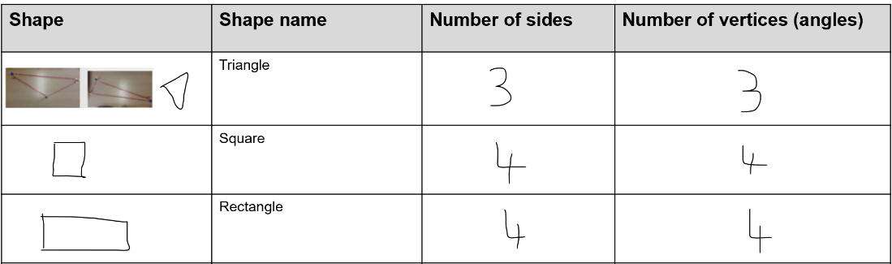
- As a class, model building a triangle with at least one skipping rope. Build the triangle with the rope and then trace around it with chalk. Have students circle and count the vertices, and tick and count the straight sides. Ask students if they know some of the features of a triangle. Draw attention to the correct use of vocabulary, for example, it has 3 straight sides and 3 vertices (corners), and it is a triangle. As a class, draw and record the triangle on Resource 1: Recording table.
- Have students manipulate the skipping rope to show triangles in various orientations and with sides of different lengths. Draw various triangles made, record their features, and name the shape.
Note: Tying the ends of the skipping rope together will allow students to create a closed shape. If this is not possible, ensure that students understand that the rope must be connected, as 2D shapes are a closed shape.
- Students work in small groups and build the various 2D shapes from Resource 1: Recording table. Follow step 9 so that students can build, identify, and record the features of the shape.
This table details assessment opportunities and differentiation ideas.
Assessment opportunities | Too hard? | Too easy?
What to look for:  - Are students able to identify that when a side is added to a shape, it creates a new shape and that a vertex is also added? (MA1-2DS-01)  - Can students identify and describe the features of given 2D shapes using appropriate mathematical language? (MA1-2DS-01)  What to collect:  - Resource 1: Recording table (MA1-2DS-01, MA1-WM-01) (MA1-2DS-01, MA1-WM-01) | Students find it difficult to describe the features of shapes with appropriate vocabulary. For example, a rectangle has 4 flat (straight) lines and 4 points (vertices). Support students to walk around their tracing using the correct vocabulary. For example, ask them to stand on a vertex or straight side; or ask them to find a 2D object with 3 vertices and 3 straight sides. | Students are confident making and describing a range of shapes and their features with appropriate vocabulary. Challenge students to create as many different shapes as possible for each number of sides. This leads to the identification of regular and irregular 2D shapes.

Discuss and connect the mathematics – 10 minutes
- Students look at Resource 1: Recording table and discuss the following questions:
- How did the shapes change as we added sides?
- What do you notice about the number of sides and number of vertices for a shape?
- What questions do you still have about the shapes?
- Did changing the look of the shape change the features?
- How did working with others help you as a mathematician?

Lesson 2: Constructing squares
Core concept: Shapes have features which can be used to name them.
The table below contains suggested learning intentions and success criteria. These are best co-constructed with students.
Learning intention | Success criteria
Students are learning that quadrilaterals and polygons have necessary features that determine their name. | Students can:  - describe and represent the features of a square (necessary attributes)  - recognise and use a range of strategies to confirm the features of a square, for example, measuring the equal sides and checking the angle of the vertices.

Daily number sense: Number bonds to 10 – 10 minutes
- Build student understanding of number bonds to 10 by looking for whole-number combinations.
- Flash Resource 2: Dot talk for 3 seconds and ask students how many dots they see and how do they see them. Students Think-Pair-Share.
- Choose different students to share and demonstrate their thinking.
Note: Listen for students who may have seen familiar or known chunks of dots within the collection of dots. For example, students may see the shape of a square and use that to see a chunk of 4 (see Figure 2). Emphasise seeing squares inside the rectangle of dots.
Figure 2 – Possible student responses
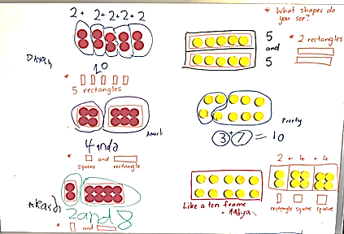

Making squares from rectangles – is it possible? – 40 minutes
This activity has been adapted from Burnett et al (2007).
- Revisit the responses from Daily number sense and how students found squares within the rectangle. Ask students if they think they can make a square out of a piece of A4 paper.
- Working in pairs, with multiple pieces of A4 paper and scissors, ask students to fold and cut the paper to make a square.
- Students share their square and how they created it.
- Ask students:
- How do you know you have made a square?
- What features must be included to make it a square?
- What tools could you use to prove your shape is a square?
Note: Not all students will have made a true square. It is important that, through this discussion, students understand the features of a square. Students may suggest paperclips or similar informal units to measure and compare the length of the sides to ensure they are equal.
Square: A four-sided shape (quadrilateral and a parallelogram) with all sides of equal length and all 4 interior angles equal (right angles).
- Students check their square using informal units to measure if all sides are equal. They record the measurement of each side, for example, 6 paperclips.
- Students share with the class if their sides are equal and if they have created a square.
- Students then check if all 4 vertices (corners) are the same size. Demonstrate how to use a book to overlay on the vertex to see if they align. Students tick all the vertices which align.
- With a partner, students reflect on their square and if they have created a true representation of one.
Note: If needed, demonstrate to students how to make a square. Watch How to make a square (2:04) to see the 2 methods.
- Provide students with a variety of different sized paper. Ask if it is possible to make squares with this paper using the same method.
- Students create squares using the different sized paper, then check if it is a true representation of a square by measuring the sides and vertices. Students record their work on the squares they create.
This table details assessment opportunities and differentiation ideas.
Assessment opportunities | Too hard? | Too easy?
What to look for:  - Can students describe the features of a square as being 4 equal sides and 4 vertices of the same size? (MA1-2DS-01)  - Can students represent the features of a square by creating a true representation? (MA1-WM-01, MA1-2DS-01)  - Can students use informal units to measure the length of the sides and the vertices? (MA1-GM-02)  What to collect:  - work samples of squares (MA1-WM-01, MA1-2DS-01) | Students confuse a rectangle for a square or attend to non-necessary attributes (size, orientation, colour, texture, material) when thinking about what makes a square a square. Help students to check their thinking against the other examples of squares or known shapes. Ask if this shape (square on its point and identified by student as a diamond) could be moved or rotated to look like this square.  Students attend to only some necessary features. For example, it is a square because it has 4 sides. Help students to check their thinking against the other examples of squares or known shapes. For example, explain that a rectangle has 4 sides too and ask what other features make a square a square. | Students record their findings, referencing all features of a square. Ask students if a square is a rectangle. Prompt students to explain their thinking and write an argument to prove their response.

Discuss and connect the mathematics – 10 minutes
- Display a variety of work samples and co-construct a Frayer diagram (see Figure 3). Draw attention to the different sized squares, as well as the different colours and non-examples. Ask students:
- What do all these shapes have in common?
- Does size and colour change what makes a square a square?
- How do you know when something is not a square?
- How did you decide if your shape was a square? What were you looking for?
- Did you find anything challenging when proving your square was a square?
- What are some non-examples of squares and why are they not a square?
Figure 3 – Student work samples
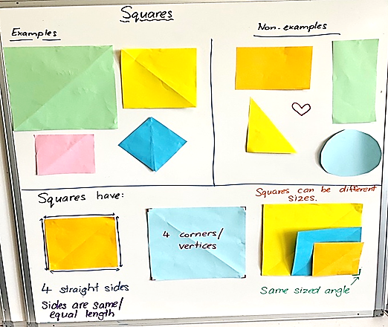

Lesson 3: Making shapes
Core concept: Shapes can be classified into different categories.
The table below contains suggested learning intentions and success criteria. These are best co-constructed with students.
Learning intentions | Success criteria
Students are learning that:  - shapes can be classified into more than one category  - quadrilaterals and polygons have necessary features that determine their name. | Students can:  - sort and classify quadrilaterals and polygons  - name and describe the features of quadrilaterals and polygons with appropriate mathematical language.

Daily number sense: Which one does not belong? – 10 minutes
- Build student understanding of the attributes of 2D shapes by justifying their reasons when solving a problem.
- Display Resource 3: Odd one out and ask students to provide reasons why one shape is the odd one out. Allow individual thinking time.
- Students turn and talk to share their thinking with a partner.
- Invite students to share their reasons with the class and record their ideas.
Note: There could be a case made for each shape not belonging. Students may refer to the square as a diamond and/or refer to the triangle as upside down. This is a good talking point, as orientation is a mathematical attribute and does not change the property of the shape.

Paper folding shapes – 40 minutes
This activity has been adapted from Burnett et al (2007).
- Students cut out Resource 4: Folding rhombus.
- Display Resource 5: Folding shapes instructions and direct students to build:
- equilateral triangle – fold the rhombus in half along the dotted line
- hexagon – fold the outer corners of the rhombus inwards so that the corners meet in the middle
- trapezium – take the hexagon and fold it in half
- pentagon – start with your original shape, the rhombus, and fold only one corner in so that it meets the point in the middle.
Note: After building each shape, pause to allow students to share what they notice and the features of each of the shapes. For example, a triangle is a polygon with 3 straight sides and 3 interior angles (vertices).
Polygon: Plane shape bounded by 3 or more-line segments.
Quadrilateral: Plane shape bounded by four-line segments.
- Place students in groups of 4. One person from each group builds one of the 4 shapes so that each group has an equilateral triangle, hexagon, trapezium, and pentagon. Students label the shape they build. Provide all groups with an original rhombus.
- Ask students to sort and classify their shapes.
- Display the example shapes you have just made by folding the paper, including the rhombus, and ask groups to share how they grouped their shapes and provide justifications as to why they have grouped them in certain ways.
Note: Highlight sorts where quadrilaterals have been grouped together.
- Display and introduce the terms, quadrilateral and polygon. Discuss the features relevant for classifying quadrilaterals and polygons. Students work with their group to group their shapes using these headings.
Note: A 2D shape can be classified in more than one category and have different names. For example, a rectangle is a polygon and a quadrilateral, but a pentagon is only a polygon.
- Provide students with a wide range of materials, for example, geoboards/pegboards, rubber bands, straws, or toothpicks. Challenge students to create as many quadrilaterals and polygons as possible. Prompt students to build shapes of 7, 8, 9, 10, 11 and 12 sides.
- As students build their shapes, they identify which categories they belong to and if they belong to more than one.
Note: Take photos of how students build and sort their shapes to use in Discuss and connect the mathematics.

Discuss and connect the mathematics – 10 minutes
- Display student work samples and examine how they have sorted their shapes. Ask students:
- Which shapes have you built?
- Have you built a shape which you do not know the name of?
- Can you name the features of the shapes?
- How do you know if it is a quadrilateral and/or a polygon?
Note: Looking at work samples, draw attention to any irregular polygons. A regular polygon is where all sides are the same length, and all angles are the same size. If all the sides are not the same length and all the angles are not the same size, it is called an irregular polygon. All closed shapes with straight sides are polygons, so triangles, quadrilaterals, pentagons, hexagons, heptagons, and octagons can all be classified as polygons.
This table details assessment opportunities and differentiation ideas.
Assessment opportunities | Too hard? | Too easy?
What to look for:  - Are students able to sort and classify quadrilaterals and polygons? (MA1-WM-01, MA1-2DS-01)  - Can students name and describe the features of quadrilaterals and polygons with appropriate mathematical language? (MA1-2DS-01)  What to collect:  - photographs of student work samples (MA1-WM-01, MA1-2DS-01) | Students are not confident with creating 2D shapes from the materials provided. Have students identify any of the shapes they know. Find these shapes in the classroom and have students use them as a model to create shapes from the materials provided.  Students are not confident with identifying the features of 2D shapes. Have students identify the shapes they know and name the features of those shapes. Can they see any similarities between the shapes they know and the new shapes? | Students are confident with creating and naming a range of shapes, and listing their features. Have students manipulate their shapes to see if they can find other/smaller 2D shapes within their shape.

Lesson 4: Hexagon filler
Core concept: Smaller shapes are hiding in larger shapes.
The table below contains suggested learning intentions and success criteria. These are best co-constructed with students.
Learning intention | Success criteria
Students are learning that there are many ways to combine 2D shapes to make new 2D shapes. | Students can:  - move, flip, or rotate shapes, physically or mentally, to fit in a space  - create shapes by combining other shapes  - find smaller shapes in larger shapes.

Daily number sense: Sequence numbers -10 minutes
- Build student understanding of sequencing numbers on a number line by considering the order of given numbers.
- Draw a number line with missing values and have students complete the number line with the missing numbers.
- Students share and justify the placement of numbers on the number line (see Figure 4).
Figure 4 – Number line
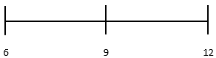
- Continue with different number ranges.

Building a hexagon – 40 minutes
This activity has been adapted from Moss et al (2016).
- Show students Resource 6: Hexagon filler gameboard. Ask students to identify the shapes on the gameboard.
- Cut up Resource 7: Hexagon filler game cards and display a couple of the cards. Ask students what they notice about the shapes on the cards.
- Choose a student to play against; to model the activity. Explain that the aim of the game is to be the first player to fill all their hexagons.
- Select a game card from the deck. Show the card to the students and ask them to identify the shapes on the card. Then find the corresponding pattern blocks for each shape on the card. Place these pattern blocks onto Resource 6: Hexagon filler gameboard.
Note: You can choose to place all the blocks on one hexagon or spread them across several hexagons. Once the blocks have been placed on the gameboard they cannot be moved. Not all the shapes pictured on your selected card need to be used. You can choose to only use some of them.
- The student then selects a game card from the deck, shows the class, names all the shapes, and finds the corresponding pattern blocks. They place the pattern blocks onto their Resource 6: Hexagon filler gameboard.
- For your next turn, choose a game card, name the shapes, and select incorrect pattern blocks and/or deliberately place the blocks incorrectly on the gameboard. Provide time for students to notice the error. If they do not notice the error, ask if they think all the blocks on the gameboard fit.
- Continue playing against the student, ensuring all students understand the rules and how to manipulate the 2D pattern blocks into the hexagons on the gameboard.
- Provide partners with Resource 6: Hexagon filler gameboard and Resource 7: Hexagon filler game cards to play against each other. Use Resource 8: Assessing gameplay as you move around the room and observe students playing the game.
Note: Printing the gameboard and game cards on cardboard will allow you to use this in future activities.
The table below details assessment opportunities and differentiation ideas.
Assessment opportunities | Too hard? | Too easy?
What to look for:  - Are students able to move, flip, or rotate shapes, physically or mentally, to fit them into a hexagon outline? (MA1-WM-01, MA1-2DS-01)  - Can students use pattern blocks to create new shapes by combining them? (MA1-WM-01, MA1-2DS-01)  - Are students able to identify smaller shapes in larger shapes? (MA1-WM-01, MA1-2DS-01)  What to collect:  - Resource 8: Assessing gameplay (MA1-WM-01, MA1-2DS-01, MA1-WM-01, MA1-2DS-01) | Students are not confident building a hexagon using other 2D shapes. Model that shapes can be flipped or turned from the orientation of the shapes presented on the game card to fit a space on the hexagon. Encourage students to flip and turn different blocks to fit within the hexagon.  Students are not confident picking the corresponding pattern block to the game card. Support students by placing the chosen pattern block on top of the corresponding shape on the game card. | Students can confidently create a hexagon using a variety of pattern blocks. Challenge students to build other 2D shapes using a variety of pattern blocks or materials.

Discuss and connect the mathematics – 10 minutes
- Students go on a gallery walk and look at the various gameboards. Discuss what they notice about the hexagons on each gameboard and how they have been made. Encourage students to notice what is the same, what is different, and if there is anything they now wonder.
Note: Take photographs of different gameboards and the way hexagons have been created to use in Lesson 5.
- Select students to share their ideas with the class, connecting back to the learning goal of smaller shapes hiding within larger shapes.
The table below outlines stimulus prompts to generate conversation about the topic, along with anticipated responses from students.
Prompts | Anticipated student responses
What do you notice about the way the hexagon has been made? | - I noticed that these hexagons are made with the same shape of 6 triangles or 2 trapeziums or 3 rhombuses.  - I noticed that a rhombus and a triangle make a trapezium, so there are shapes hiding inside trapeziums too.

Lesson 5: What shapes are hiding inside a square?
Core concept: Smaller shapes are hiding in larger shapes.
The table below contains suggested learning intentions and success criteria. These are best co-constructed with students.
Learning intention | Success criteria
Students are learning that there are many ways to combine 2D shapes to make new 2D shapes. | Students can:  - demonstrate and record how to find smaller shapes inside larger shapes  - create shapes by combining other shapes.

Daily number sense: Can you remember? – 10 minutes
- Build student understanding of visualising 2D shapes by identifying different 2D shapes within an image.
- Display one of the images from Resource 9: Can you remember? for 5 seconds. Students look carefully at the image, then teacher removes the image.
- Using individual whiteboards, students draw the image from memory.
- Show the same image again for a few more seconds and allow students to refine their drawing.
- Discuss how students visualised the image to help them draw it. Have the students recall any 2D shapes they can see in the image.
- Continue with the other images from Resource 9: Can you remember?

Hexagons – 15 minutes
This activity has been adapted from Moss et al (2016).
- Display photographs from Lesson 4 for students to identify and discuss the different shapes which were used to create a hexagon.
- Display Resource 10: Shapes in a hexagon and ask students if there is another way to build a hexagon without using pattern blocks. Student Think-Pair-Share and then provide examples of how this can be done.
- Cut Resource 10: Shapes in a hexagon to demonstrate some of the suggestions on how to partition the hexagon (see Figure 5). Model recording the shapes that were found in the hexagon.
Figure 5 – Shapes in a hexagon
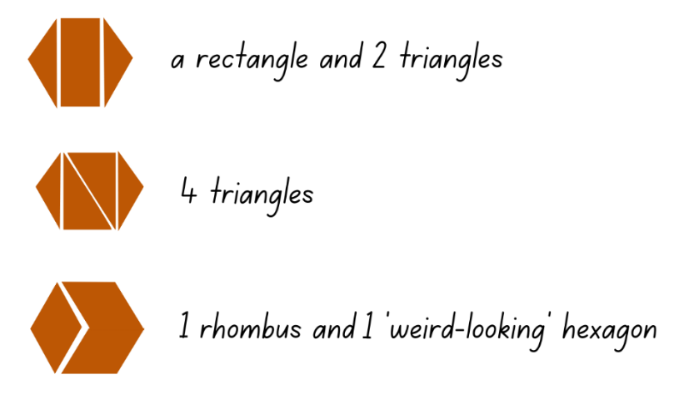
Images sourced from Canva and used in accordance with the Canva Pro Content Licence.

Shapes in a square – 25 minutes
- Discuss how it is possible to find different shapes within other shapes and how so many were found in a hexagon. Display a square piece of coloured paper and ask if there might be shapes inside the square.
- Students investigate the paper squares to find different 2D shapes within it. They can fold, cut and/or draw to investigate the range of shapes. Students glue squares into their book and record the shapes they found (see Figure 6).
Figure 6 – Shapes in a square
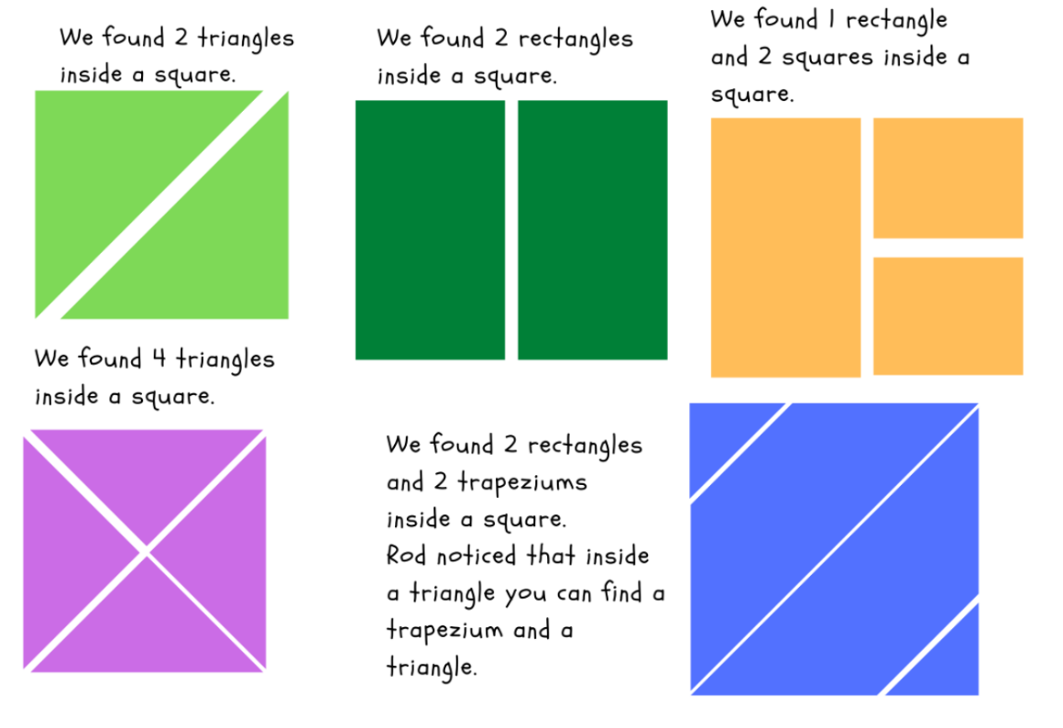
Images sourced from Canva and used in accordance with the Canva Pro Content Licence.

Discuss and connect the mathematics – 10 minutes
- Have students provide examples of the different ways they partitioned their square and what 2D shapes they found inside it.
- Discuss the following questions:
- What have we discovered about 2D shapes?
- How did you record your findings/show your thinking?
- Was there anything you found challenging?
- How did you work like a mathematician today?
The table below details assessment opportunities and differentiation ideas.
Assessment opportunities | Too hard? | Too easy?
What to look for:  - Are students able to identify and cut a shape to find smaller shapes inside? (MA1-WM-01, MA1-2DS-01)  - Can students create a shape by combining other shapes? (MA1-WM-01, MA1-2DS-01)  What to collect:  - student work samples (MA1-WM-01, MA1-2DS-01) | Students cut squares into many pieces but are unable to reconstruct it back into a square. Encourage students to fold the square to partition it into shapes with straight sides. Students then unfold the square to see the smaller shapes and cut along the folds.  Students find it challenging to identify the shapes they have found within the square. Have students use Resource 1: Recording table to recall and identify the features of different 2D shapes. Help students make the connection between the shapes in the table and the ones they have found. | Students are confident partitioning squares into smaller shapes and identifying the shapes inside. Investigate how other shapes like triangles, pentagons, or quadrilaterals might have smaller shapes hiding in them.

Lesson 6: Paper halving
Core concept: Not all halves look the same but are always equal.
The table below contains suggested learning intentions and success criteria. These are best co-constructed with students.
Learning intention | Success criteria
Students are learning that when a whole has been partitioned (shared) equally in 2, the parts created are called halves. | Students can:  - accurately halve shapes  - halve the same shape in different ways  - check their work to see if they have created equal halves.

Daily number sense: Doubles – 10 minutes
- Build student understanding of doubles by investigating the number of sides a 2D shape has and doubling that number.
- Display a pattern block and have students name the 2D shape and recall the number of sides.
- Double the pattern block so that 2 are displayed. Students record the number doubled on their individual whiteboard (see Figure 7).
Figure 7 – Shape doubles
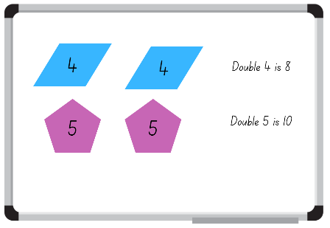
Images sourced from Canva and used in accordance with the Canva Pro Content Licence.
- Choose different students to share their responses and the strategy they used to get the total.

Exploring halves – 20 minutes
This activity has been adapted from Paper halving parts 1 (11:58) and 2 (13:46) from Thinking mathematically.
- Display Resource 11: Examples of halves. Ask students what they notice, what is the same, and what is different about the images.
- Provide individual thinking time before students turn and talk.
- Strategically select students to share their thinking with the class. Ask:
- What do you notice about the images?
- Is there something in common between the images?
- What are some things you already know about halves?
- Do all the halves look the same?
Note: Highlight that halves can look different, but still be a half because the whole was divided (shared) into 2 equal parts.
- Provide each student with a piece of A4 paper. Ask students what 2D shape the paper is and then try to halve their piece of paper.
- Students share how they halved their paper. Highlight how there are many ways that a piece of paper can be halved: horizontally, vertically, diagonally, and so on (see Figure 8). Challenge students to identify the different 2D shapes they created when halving their piece of paper.
Figure 8 – Paper halves
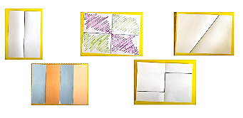
- Provide pairs of students with A4 paper and pencils to demonstrate different ways to halve a piece of paper. Students can fold or use pencils to indicate different halves.
- Challenge students to identify and record the different 2D shapes they created whilst halving the pieces of paper.

Discuss and connect the mathematics – 10 minutes
- Students display their work and go on a gallery walk. Students compare the ways their peers halved the paper with how they halved their own, taking note of which methods are the same and which are different.
Note: Look for examples of the way pieces of paper have not been halved equally. Use this example as a prompt for further thinking or alternatively, have an example prepared to use Paper halving – part 2 (13:46) (from 5:32).
- Display an example where a piece of paper has not been halved equally. Ask:
- What makes something half?
- Has this piece of paper been halved?
- How can we prove that it has been halved?
Note: Students might suggest strategies to prove a half by using direct comparison, further folding, informal units like interlocking cubes, pattern shapes, or sticky notes. If they do not, guide discussion to come up with a collection of ideas.

Proving halves – 20 minutes
- Provide pairs of students with a range of materials. Students use informal units to cover the surface of each half to prove they have created equal halves.
- Students sort their pieces of paper into equal halves and not equal halves.
- As a class, students demonstrate and share the way they proved their paper was divided into 2 equal halves.
Note: Take photographs of how students have sorted their halves.
The table below details assessment opportunities and differentiation ideas.
Assessment opportunities | Too hard? | Too easy?
What to look for:  - Can students accurately halve a piece of paper? (MA1-WM-01, MA1-2DS-01, MA1-2DS-02)  - Are students able to identify different ways to halve a piece of paper? (MA1-WM-01, MA1-2DS-01, MA1-2DS-02)  - Can students use materials to check they have created equal halves? (MA1-WM-01, MA1-2DS-02)  What to collect:  - photographs of student work (MA1-WM-01, MA1-2DS-01, MA1-2DS-02) | Students are not confident halving a piece of paper.  - Have students tell you anything they know about halves. Encourage links between their knowledge and halving a piece of paper. Model one way to halve the paper and ask them if they have another way to halve it.  - Provide students with a circular piece of paper, as half always looks the same. | Students confidently halve A4 paper in a range of ways.  - Prompt students to think of other ways to halve an object using more than one fold line (see Figure 8).  - Provide a piece of paper that has been halved in a complex way and ask the student to prove or disprove whether the paper has been halved.

Lesson 7: Making patterns
Core concept: Objects can be transformed using movement.
The table below contains suggested learning intentions and success criteria. These are best co-constructed with students.
Learning intention | Success criteria
Students are learning that objects can be transformed using slides (translations) and reflections. | Students can:  - identify slides (translations) and reflections in images and patterns  - make repeating patterns which involve slides (translations) and reflections.

Daily number sense: 10 minutes
- From a class need surfaced through formative assessment data, identify a short, focused activity that targets students’ knowledge, understanding and skills. Example activities may be drawn from the following resources:
- Thinking Mathematically Stage 1
- Universal Resources Hub

Translations and reflections – 25 minutes
This activity has been adapted from Making Patterns from NZ Maths.
- Display Resource 12: Translation pattern. Students turn and talk to discuss what they see in the image. Ask:
- What 2D shape is represented in the image?
- Are the 2D shapes the same each time?
- How are the 2D shapes the same (shape, size, orientation, colour)?
- Ask students to make a similar pattern using the pattern blocks. Whilst students are making their pattern, ask how they are transforming the shape. Guide students to see how the movement of the shape within the pattern is a slide (translation).
- Allow time for students to use various shapes to practise sliding (translating) vertically, horizontally, and diagonally (see Figure 9).
Figure 9 – Slide (translation)
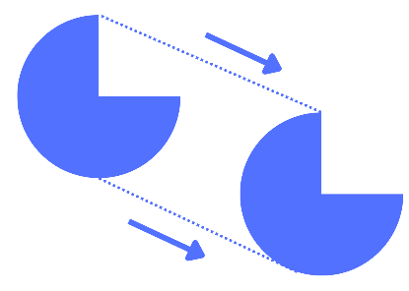
Slide (translation): Sliding a shape without turning it.
- Display and print Resource 13: Reflection image. Students turn and talk to discuss what they see in the image.
- Students share their ideas. Guide students to express that the image has been reflected and could be folded in half.
- Fold the image and use a mirror on the fold to show the reflection is the same as the other side.
- Provide students with a collection of pattern blocks and a mirror to look at how the shapes reflect. Students model reflection with the pattern blocks. Draw attention to how some 2D shapes appear to look the same but have been reflected (see Figure 10).
Figure 10 – Reflection
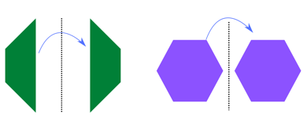
Reflection: A transformation of a shape formed by creating a mirror image on the other side of a given line.

Patterns – 15 minutes
- Create and display a repeating linear pattern with pattern blocks that includes reflection and translation (see Figure 11). Ask:
- Why is this a pattern?
- Do any of the shapes show reflection?
- Do any shapes slide (translate)?
- What would come next?
Figure 11 – Linear pattern
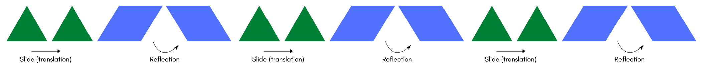
- Provide students with a collection of pattern blocks and challenge them to create a repeating linear pattern which includes:
- 2 or 3 different 2D shapes
- reflection
- slide (translation).
- Students create a variety of patterns.
Linear pattern: A pattern created by the regular repetition of units with the same difference between terms.

Discuss and connect the mathematics – 10 minutes
- Students display their patterns and go on a gallery walk to determine the rule in their classmates' patterns.
- As students are observing patterns, ask:
- Does this pattern have a reflection and if so, where?
- Does the shape slide (translate) and if so, where?
- What would come next?
- As a class, reflect if they feel confident with their understanding of the success criteria.
The table below details assessment opportunities and differentiation ideas.
Assessment opportunities | Too hard? | Too easy?
What to look for:  - Can students identify slides (translations) in images and patterns? (MA1-2DS-01)  - Can students identify reflections in images and patterns? (MA1-2DS-01)  - Can students make repeating patterns which involve slides (translations) and reflections? (MA1-WM-01, MA1-2DS-01) | Students are not confident reflecting and sliding (translating) single shapes. Show students how to make the first slide (translation) or reflection of the shape, focusing on how it moves. Students model your movement and discuss what happened to the shape when it was slid or reflected.  Students are not confident in creating a pattern with 2 or 3 different 2D shapes that slide (translate) and reflect. Students create a pattern using one 2D shape (trapezium) with a focus on either sliding (translating) or reflecting. | Students are confident with identifying and creating patterns that use slide (translation) and reflection. Students find natural materials like flowers and leaves to identify patterns within these objects. They look at the shapes within the patterns and determine if they are reflecting or sliding. Students consider if there is a different transformation happening within the object.

Lesson 8: Symmetry
Core concept: A symmetrical object is reflected with the same image.
The table below contains suggested learning intentions and success criteria. These are best co-constructed with students.
Learning intention | Success criteria
Students are learning that objects may have a line of symmetry. | Students can:  - identify lines of symmetry in objects and pictures  - make patterns/designs which have a line of symmetry.

Daily number sense: Number bonds to 10 – 10 minutes
- Build student understanding of number bonds to 10 by providing a range of number representations to recall and record combinations.
- Display Resource 14: Representations of numbers. Students choose one number representation from inside the box and one or 2 number representations from outside the box and combine them to make 10.
- Students use their individual whiteboard to record their combinations (see Figure 12).
Figure 12 – Number bonds to 10
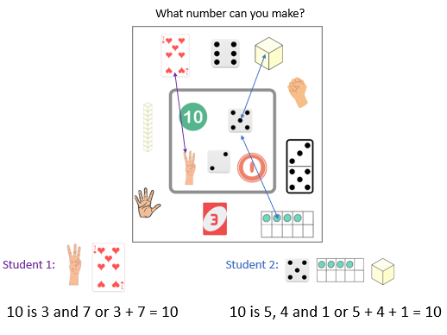
Images sourced from Canva and used in accordance with the Canva Pro Content Licence.
- Choose different students to share how they used different representations to build 10.

Finding the line of symmetry – 30 minutes
This activity has been adapted from Pattern Matching from NZ Maths.
- In small groups, students cut out Resource 15: Shapes, talk about the shapes, and share what they know about them.
- Ask students if they can fold their shapes in half so both halves are the same. Students work with their group to fold their shapes.
- As a class, groups share which shapes they could easily fold and which ones were more difficult.
- Choose a shape with a line of symmetry and show how to draw a line on the fold. Use a mirror on the fold line to create (reflect) an image of the whole shape. Choose another shape which does not have a line of symmetry and draw a line on the fold. Use the mirror to show (reflect) how it does not create the whole shape.
- Explain that the fold line that creates the same halves side by side is called the line of symmetry.
Symmetry: A shape has line symmetry if matching parts are produced when it is folded along a line of symmetry. Each part represents the mirror image of the other.
- Provide the class with a collection of objects and Resource 16: Images, as well as mirrors and straws (used for a folding line). Students explore the various objects and use the mirrors and straws to sort the objects into 2 groups: objects with a line of symmetry and objects without a line of symmetry. As students are sorting objects, ask:
- Why have you chosen this object?
- Did you use the mirror to see if the halves are the same?
- Can you put a straw down the line of symmetry?
- Why does this object not have a line of symmetry?
- How can we be sure?
Note: Some shapes and pictures have more than one line of symmetry. Allow students to discover this. Straws or a similar item, like pencils or wooden skewers, are used to assist students in identifying and marking the line of symmetry.

Discuss and connect the mathematics – 20 minutes
- Provide students with a collection of pattern blocks, a mirror, and a straw to create a symmetrical pattern/design (see Figure 13).
Figure 13 – Symmetrical designs
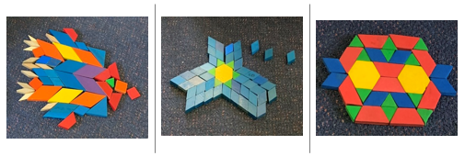
- As students are creating their pattern/design, take photographs and ask:
- Where is the line of symmetry? Can you show me with a mirror and straw?
- How can you be sure?
- Does your pattern/design have more than one line of symmetry?
The table below details assessment opportunities and differentiation ideas.
Assessment opportunities | Too hard? | Too easy?
What to look for:  - Can students identify lines of symmetry in objects and pictures? (MA1-2DS-01)  - Are students able to make patterns/designs which have a line of symmetry? (MA1-WM-01, MA1-2DS-01)  What to collect:  - photographs of student work (MA1-WM-01, MA1-2DS-01) | Students are not confident finding the line of symmetry in objects and pictures. Students look at an image and tell you what is the same in the image. Circle the similarities and work together to fold the image so that the students can see that it is the same on both sides.  Students are not confident with creating a patten/design with objects. Put one block down at a time and have the students mirror your action so that you are building a symmetrical pattern/design together. Have the students check by using a mirror. | Students can confidently identify lines of symmetry and build a symmetrical pattern/design.  - Students look for lines of symmetry in natural items like leaves, butterflies, and flowers.  - Students create half a symmetrical pattern for someone else to complete.  - Challenge students to create a pattern/design which has more than one line of symmetry.

Resource 1: Recording table
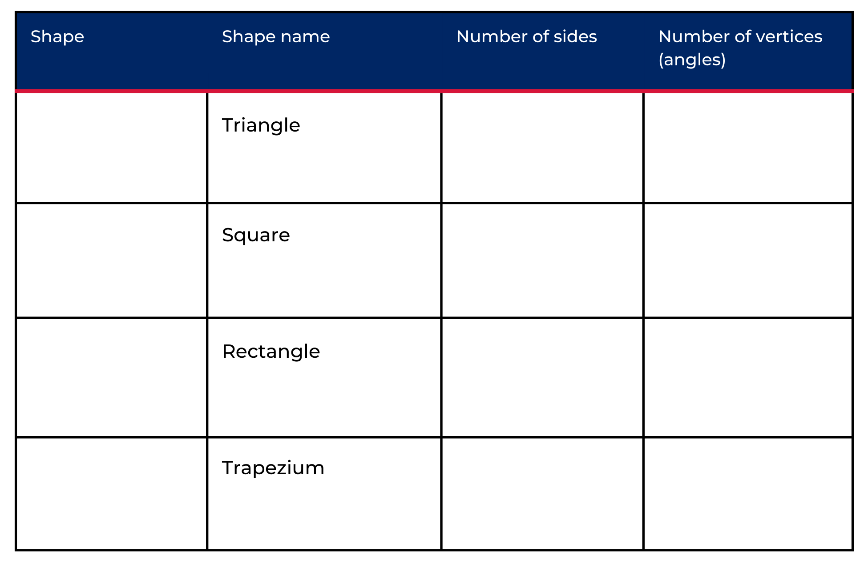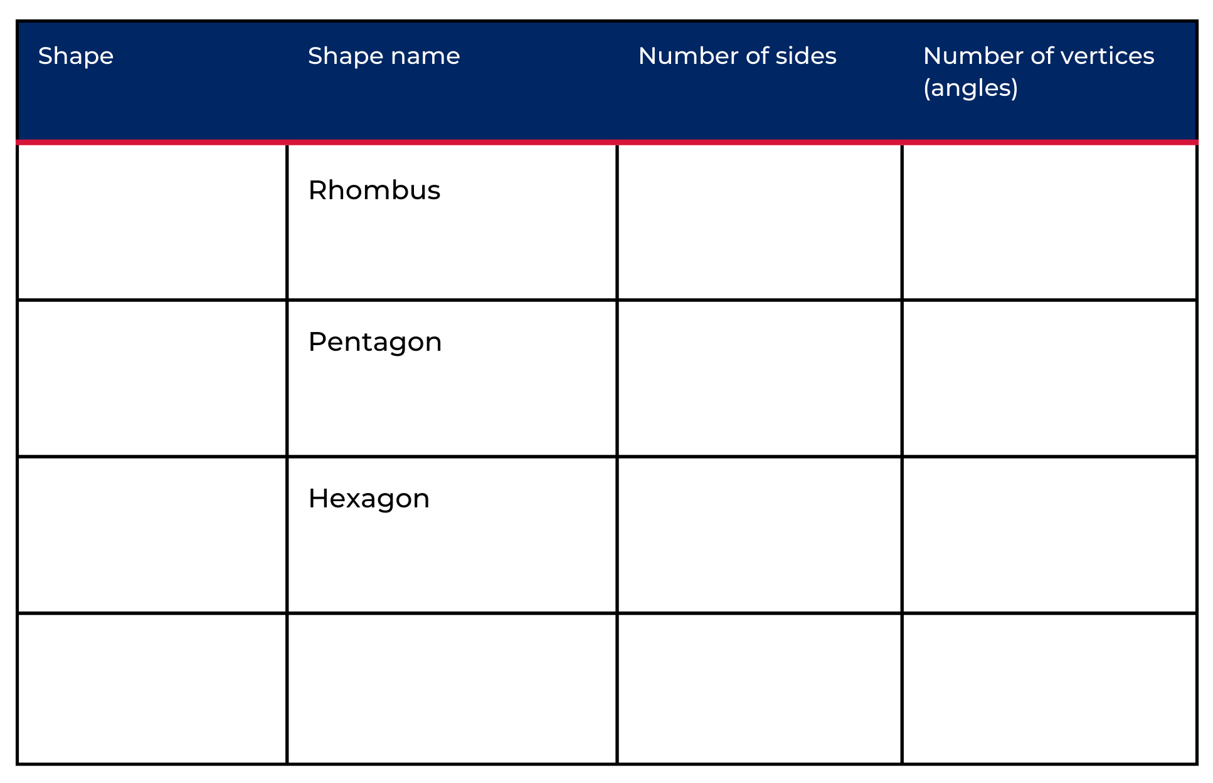

Resource 2: Dot talk
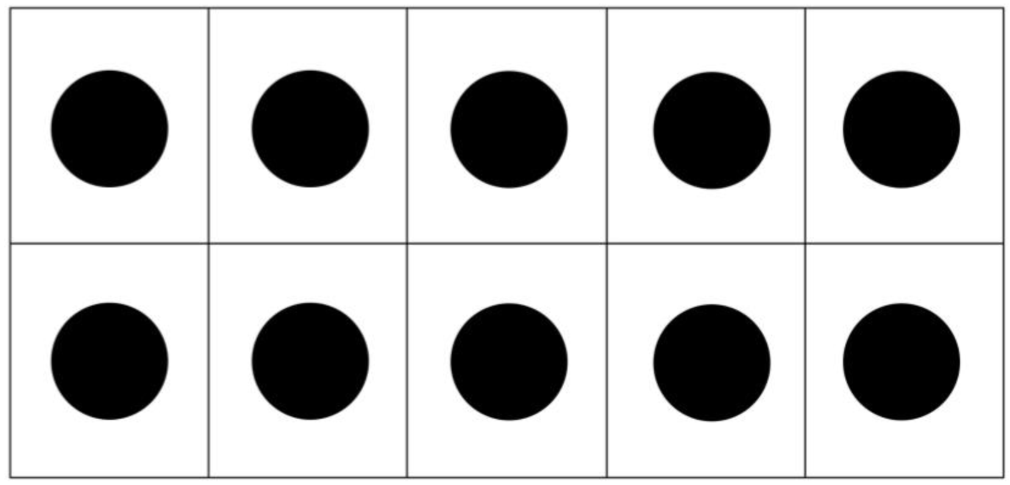

Resource 3: Odd one out
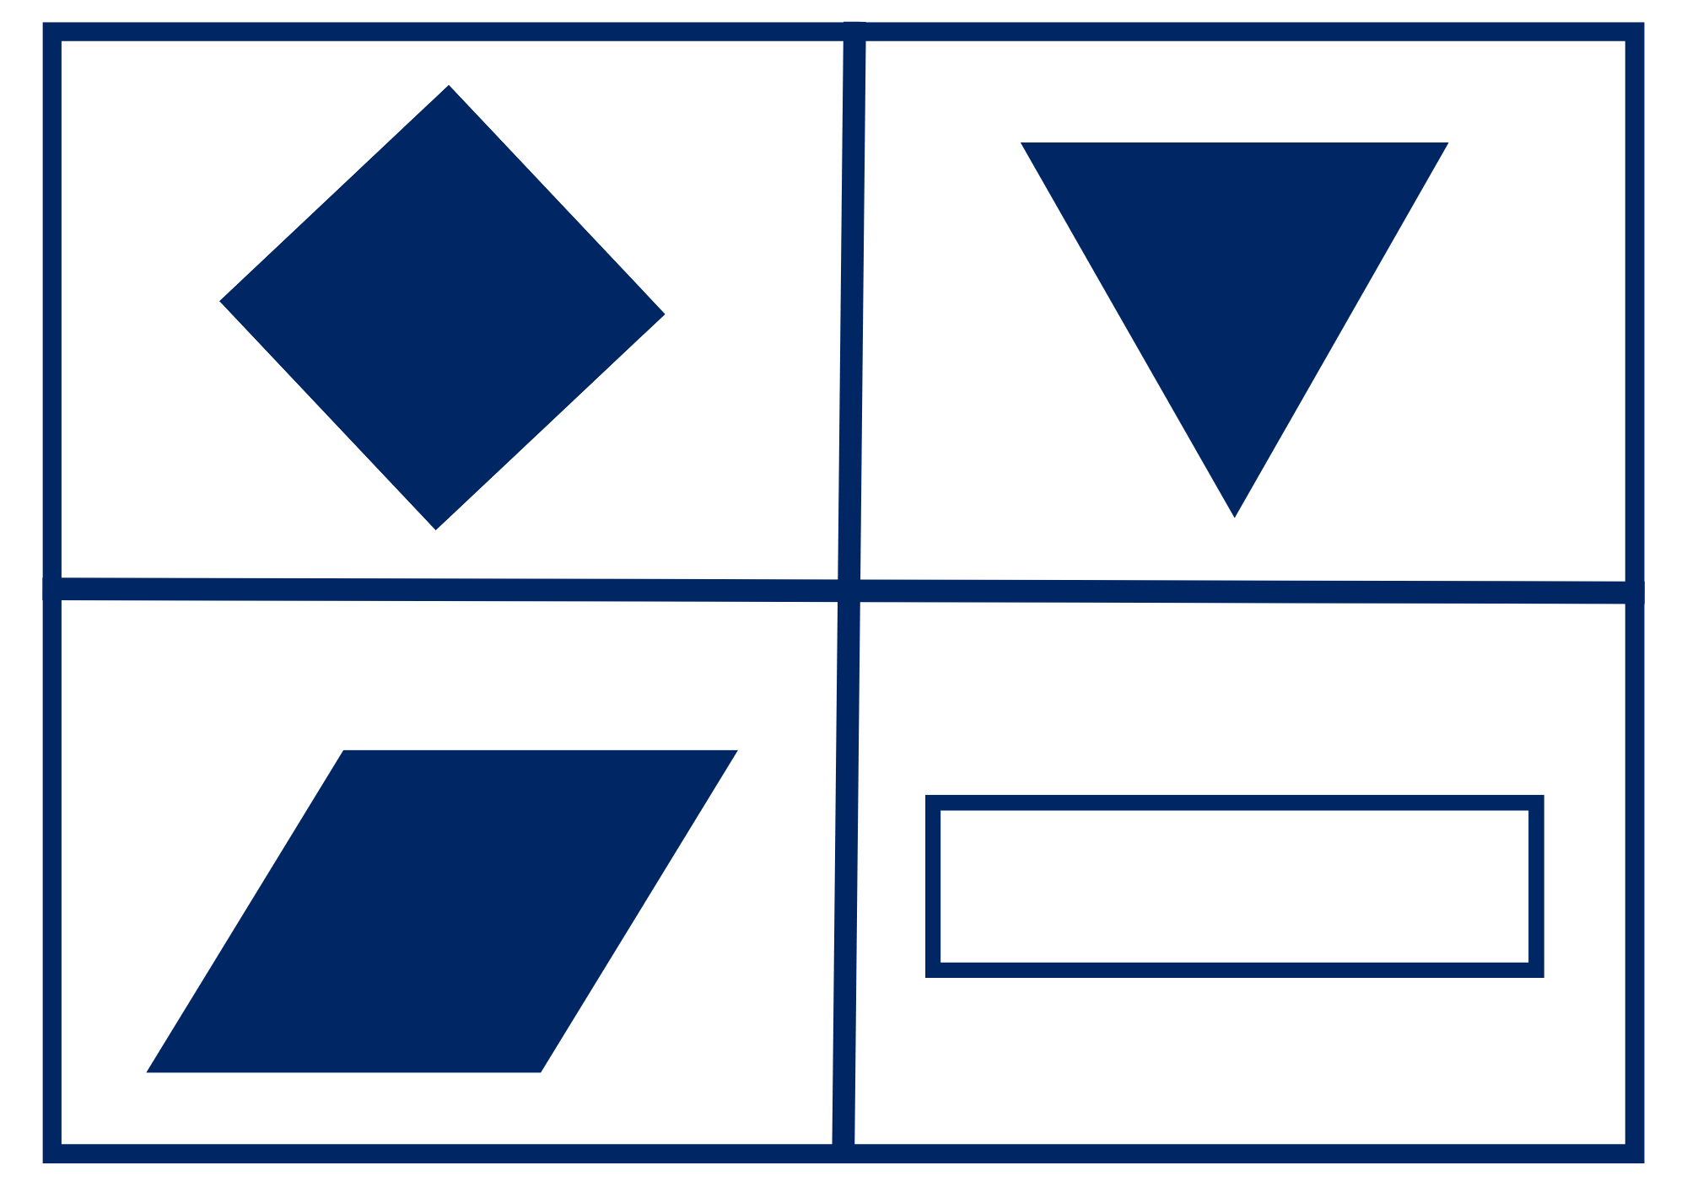

Resource 4: Folding rhombus
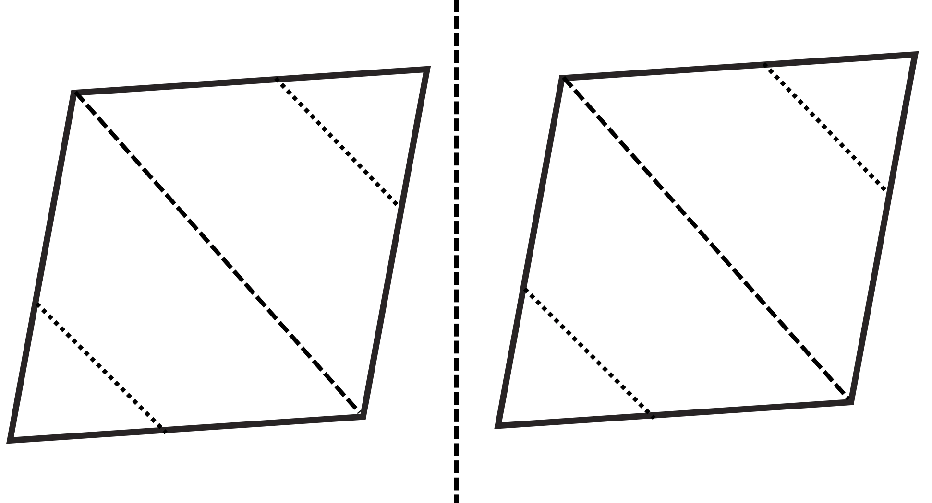

Resource 5: Folding shapes instructions
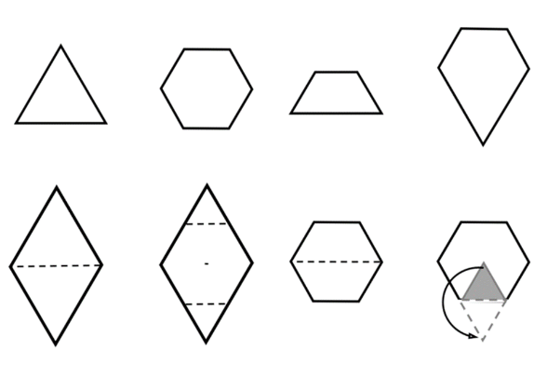

Resource 6: Hexagon filler gameboard
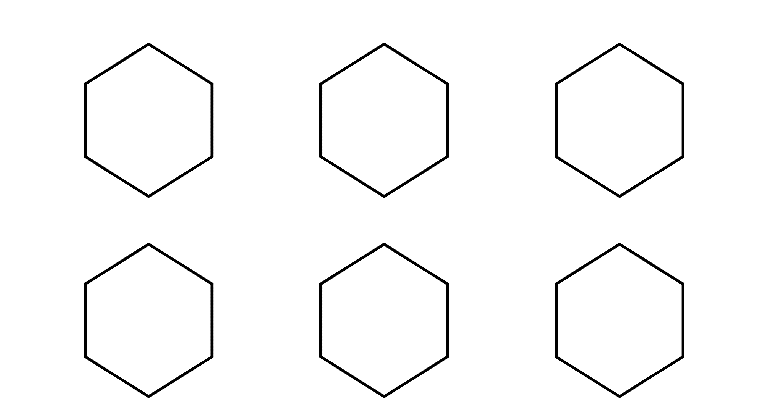
Image adapted from Moss et al (2016).

Resource 7: Hexagon filler game cards
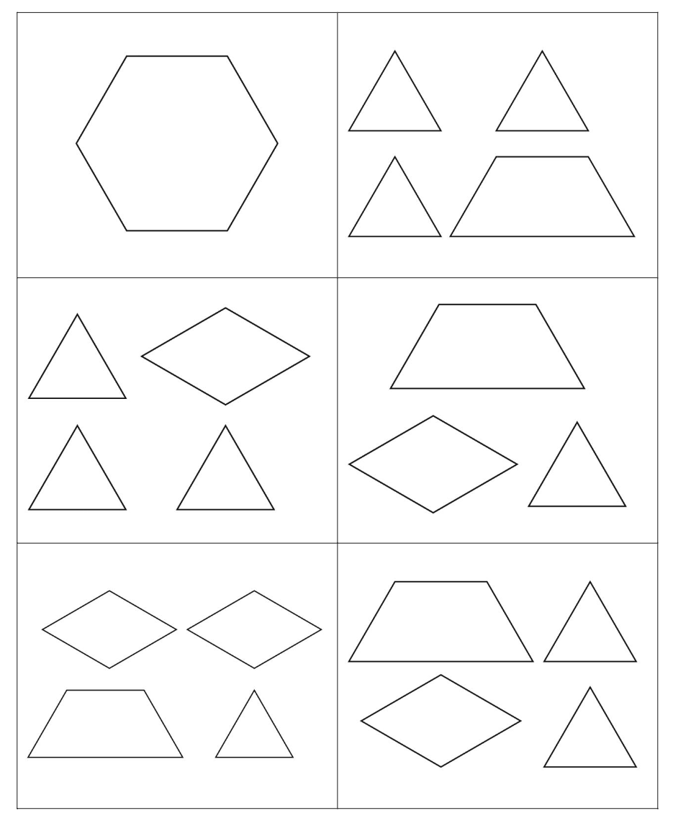
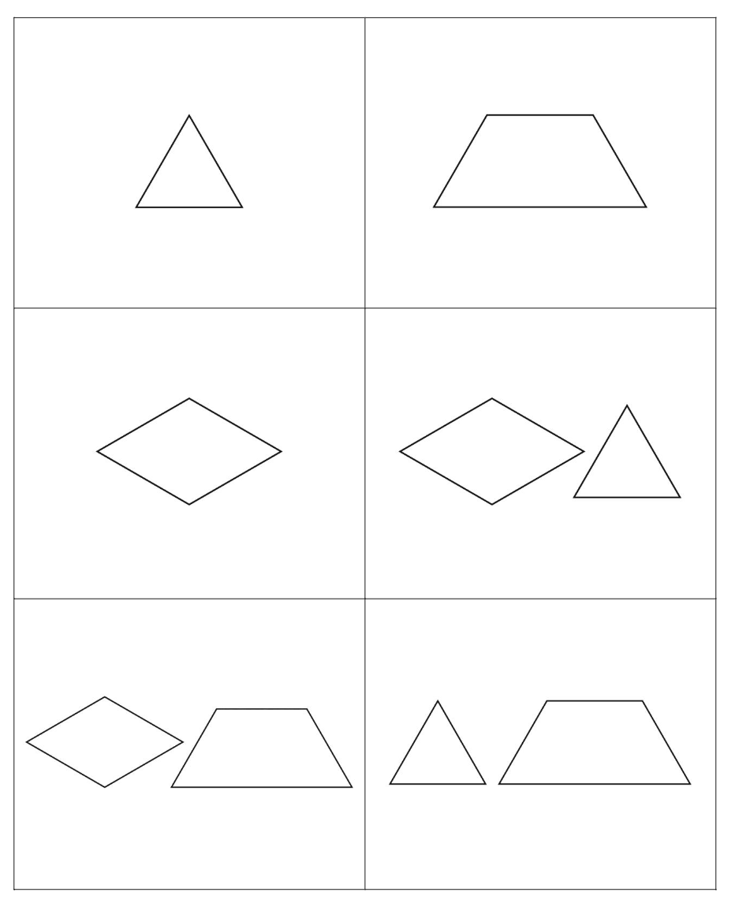
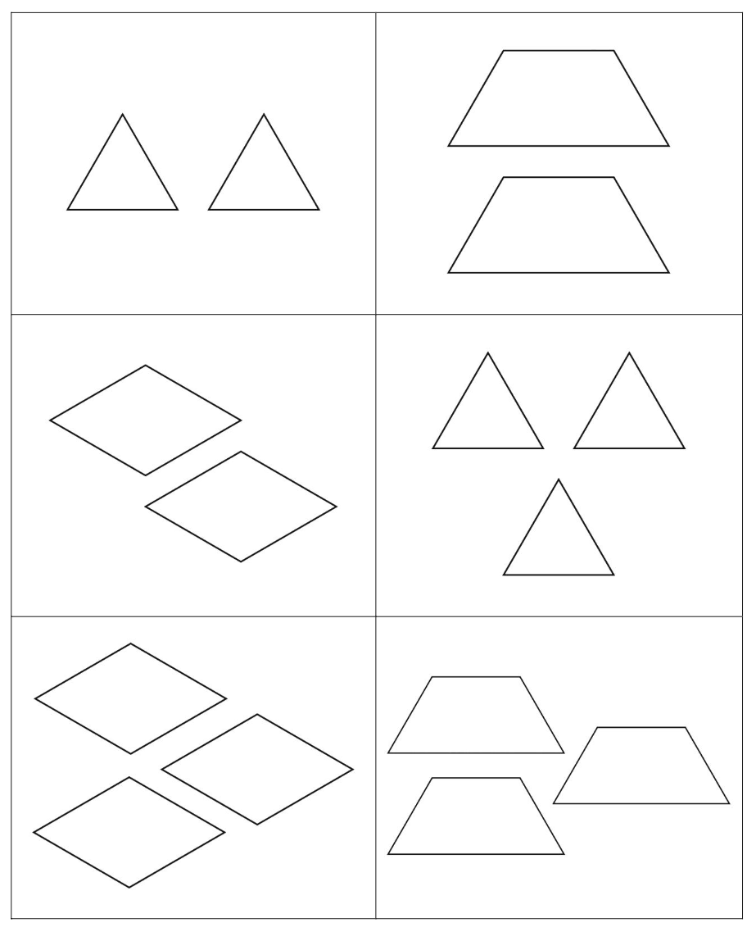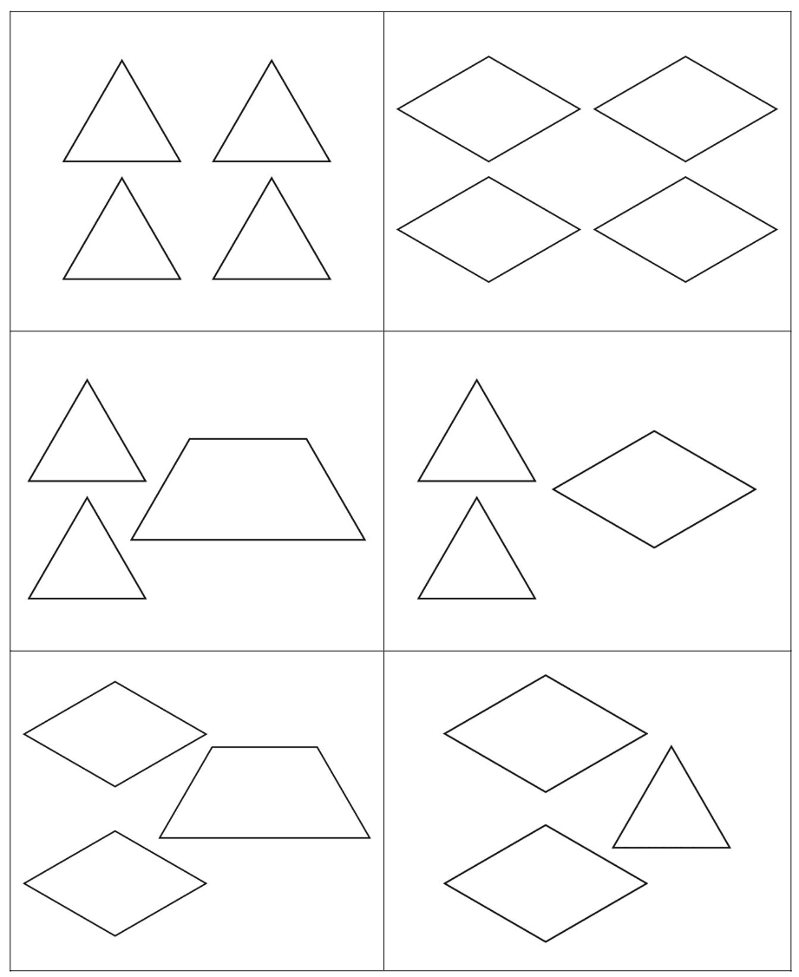
Image adapted from Moss et al (2016).

Resource 8: Assessing gameplay
Focus | Listen, watch, and think | Ask
Accuracy | Are they getting correct answers?  Are they able to name the 2D shapes? | What answer did you get?  What 2D shapes are you using?
Efficiency and strategy selection | Are they manipulating the 2D shape blocks to fit into the gameboard?  Do they seem to be labouring or a little stuck? | How did you solve it?  How did you work out how to fit the shapes into the hexagon?  Was there a more efficient strategy you could have used or was this strategy most efficient?
Flexibility and strategy selection | Are they using different strategies?  Can they apply them with the same confidence?  Are they thinking about which 2D shapes are needed to complete the hexagon? | Why did you pick that strategy?  Is there another strategy that you could use for that problem?  What shapes are you hoping to turn over?  What shapes do you not want to turn over?
Adapted from Bay-Williams J and Kling G (2019).

Resource 9: Can you remember?
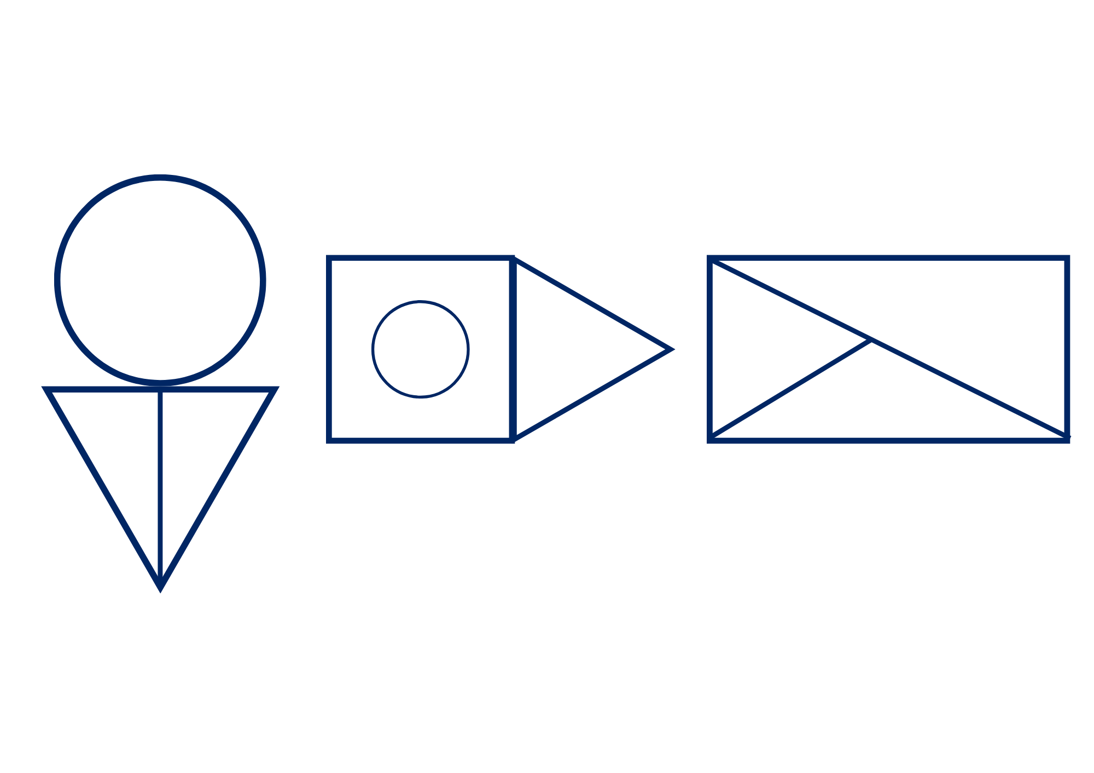

Resource 10: Shapes in a hexagon
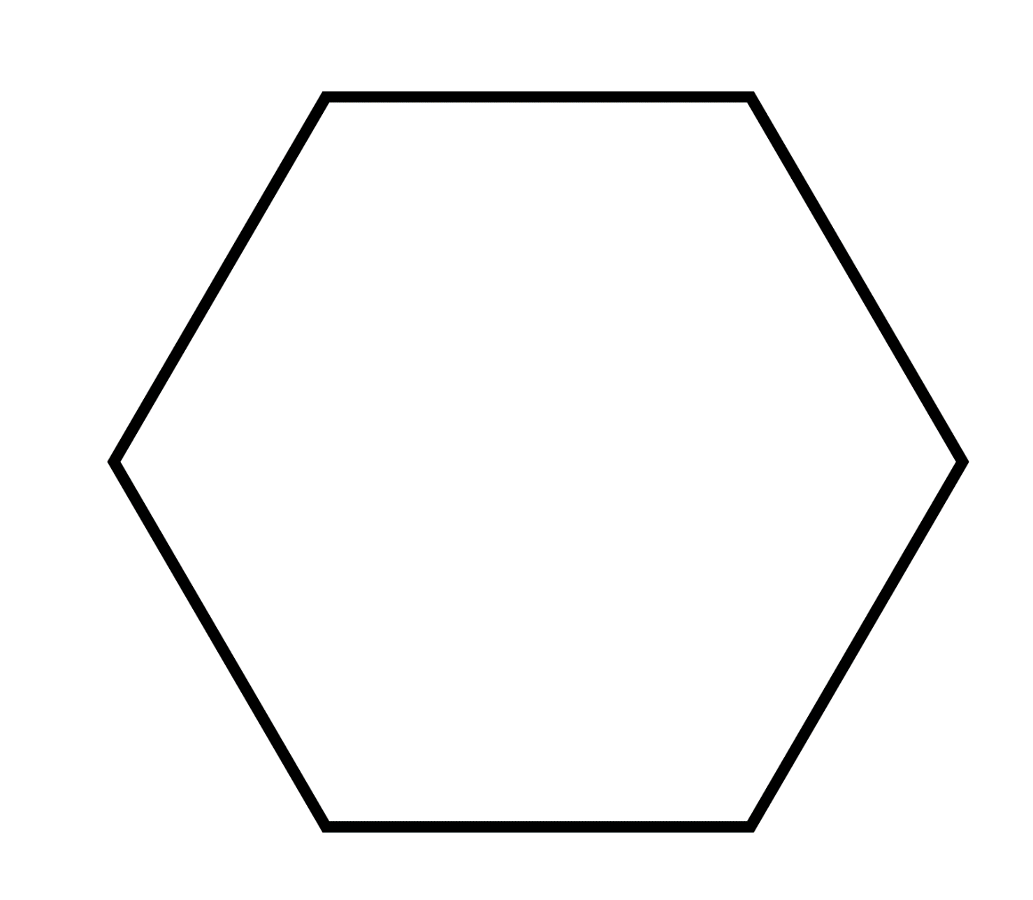

Resource 11: Examples of halves
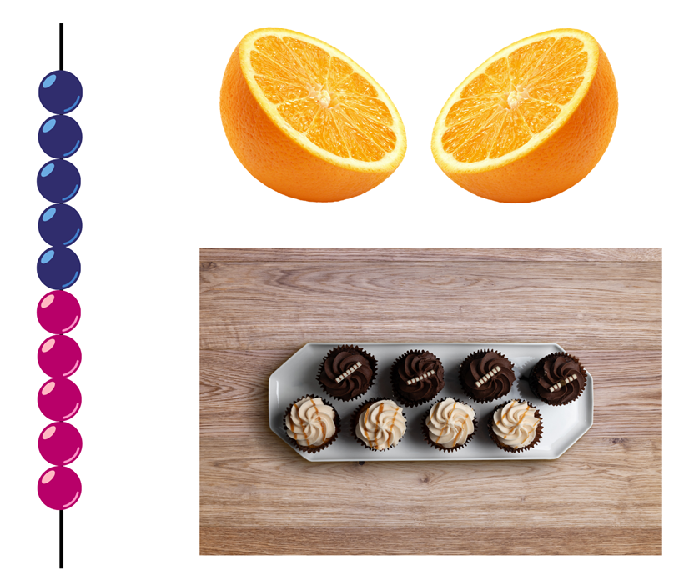
"Fresh orange half" by Danny Smythe and "Top down - plate with 8 cupcakes" by Thomas Faull are licensed in accordance with the Canva Pro Content License Agreement.

Resource 12: Translation pattern

Resource 13: Reflection image
"Church, Lake, Sunset, Panorama" by 12019 and used in accordance with the Pixabay Licence.

Resource 14: Representations of numbers
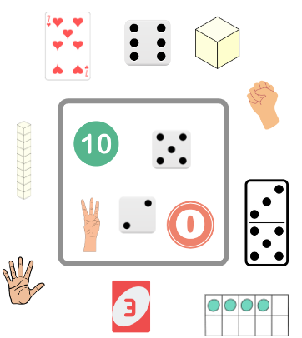
Images sourced from Canva and used in accordance with the Canva Pro Content Licence.

Resource 15: Shapes
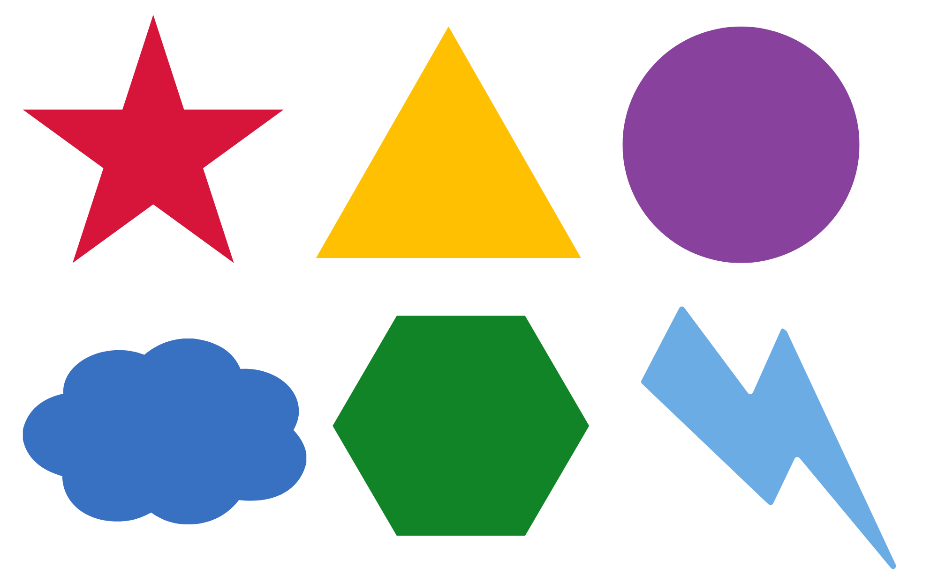
Images sourced from Canva and used in accordance with the Canva Pro Content Licence.

Resource 16: Images
Images sourced from Pixabay and used in accordance with the Pixabay Licence.
Images sourced from Pixabay and used in accordance with the Pixabay Licence.

Syllabus outcomes and content
The table below outlines the syllabus outcomes and range of relevant syllabus content covered in this unit. Content is linked to National Numeracy Learning Progression version (3).
Focus area and outcomes | Content groups and content points | Lessons
Representing whole numbers A  MA1-WM-01  MA1-RWN-01  MA1-RWN-02 | Use counting sequences of ones with two-digit numbers and beyond  - identify the number before and after a given two-digit number (CPr5)  - count forwards and backwards by ones from a given number to at least 120 (CPr6)  Represent numbers on a line  - sequence numbers and arrange them on a line by considering the order and size of those numbers (CPr5) | 1 and 4
Combining and separating quantities A  MA1-WM-01  MA1-CSQ-01 | Recognise and recall number bonds up to ten  - recognise, recall and record combinations of two numbers that add up or bond to form 10 (AdS2, AdS6)  - describe combinations for numbers using words such as more than, less than and double (AdS6) | 2, 6, and 8
Geometric measure A  MA1-WM-01  MA1-GM-01  MA1-GM-02  MA1-GM-03 | Length: Measure the lengths of objects using uniform informal units  - use uniform informal units to measure lengths and distances by placing the units end to end without gaps or overlaps (UuM2)  - select appropriate uniform informal units to measure lengths and distances (UuM3)  Length: Subdivide lengths to find halves and quarters  - use concrete materials to model both half and quarters of a whole length, highlighting the length (InF2)  - identify two equal parts and the relationship of the parts to the whole length, linking words and images (InF2)  - recognise when lengths have or have not been divided into halves and quarters (InF2) | 2 and 6
Two-dimensional spatial structure A  MA1-WM-01  MA1-2DS-01  MA1-2DS-02 | 2D shapes: Recognise and classify shapes using obvious features  - explore, manipulate and describe features of polygons (UGP3)  - use the terms ‘side’, ‘vertex’ and ‘two-dimensional’ to describe plane (flat) shapes (UGP1-UGP2)  - create repeating linear patterns with shapes, including two-shape and three-shape patterns  - compare, sort and classify polygons according to the number of sides or vertices (UGP3-UGP4)  - recognise that shapes with the same name may have sides of equal or different lengths  - identify shapes presented in different orientations (UGP2)  2D shapes: Transform shapes with slides and reflections  - recognise that sliding or reflecting a shape does not change its size or features (UGP2)  - identify and create a slide (translation) or reflection of a single shape and use the terms ‘slide’ (translation) and ‘reflection’ to describe the movement of the shape (UGP2)  - make designs with symmetry from reflection using paper-folding, mirrors, drawing or paintings (UGP3)  Area: Measure areas using uniform informal units  - explore area using uniform informal units to cover the surface in rows or columns without gaps or overlaps (UuM5) | 1 to 8
Two-dimensional spatial structure B  MA1-WM-01  MA1-2DS-01  MA1-2DS-02 | 2D shapes: Represent, combine and separate two-dimensional shapes  - make representations of two-dimensional shapes and combinations of shapes in different orientations  - combine and split single shapes and arrangements of shapes to form new shapes | 1 to 5

References
Links to third-party material and websites
Please note that the provided (reading/viewing material/list/links/texts) are a suggestion only and implies no endorsement, by the New South Wales Department of Education, of any author, publisher, or book title. School principals and teachers are best placed to assess the suitability of resources that would complement the curriculum and reflect the needs and interests of their students.
If you use the links provided in this document to access a third-party's website, you acknowledge that the terms of use, including licence terms set out on the third-party's website apply to the use which may be made of the materials on that third-party website or where permitted by the Copyright Act 1968 (Cth). The department accepts no responsibility for content on third-party websites.
All material © State of New South Wales (Department of Education), 2021 unless otherwise indicated. All other material used by permission or under licence.
Mathematics K-2 Syllabus © 2021 NSW Education Standards Authority (NESA) for and on behalf of the Crown in right of the State of New South Wales.
© 2021 NSW Education Standards Authority. This document contains NSW Curriculum and syllabus content. The NSW Curriculum is developed by the NSW Education Standards Authority. This content is prepared by NESA for and on behalf of the Crown in right of the State of New South Wales. The material is protected by Crown copyright.
Please refer to the NESA Copyright Disclaimer for more information.
NESA holds the only official and up-to-date versions of the NSW Curriculum and syllabus documents. Please visit the NSW Education Standards Authority (NESA) website and the NSW Curriculum website.
National Numeracy Learning Progression © Australian Curriculum, Assessment and Reporting Authority (ACARA) 2010 to present, unless otherwise indicated. This material was downloaded from the Australian Curriculum website (National Numeracy Learning Progression) (accessed 24 August 2022) and was not modified. The material is licensed under CC BY 4.0. Version updates are tracked in the ‘Curriculum version history’ section on the 'About the Australian Curriculum' page of the Australian Curriculum website.
ACARA does not endorse any product that uses the Australian Curriculum or make any representations as to the quality of such products. Any product that uses material published on this website should not be taken to be affiliated with ACARA or have the sponsorship or approval of ACARA. It is up to each person to make their own assessment of the product, taking into account matters including, but not limited to, the version number and the degree to which the materials align with the content descriptions and achievement standards (where relevant). Where there is a claim of alignment, it is important to check that the materials align with the content descriptions and achievement standards (endorsed by all education Ministers), not the elaborations (examples provided by ACARA).
Burnett J, Irons CJ and Turton A (2007) Geo Paper Polygons: Exploring 2D Shapes Through Paper Folding, Origo Education, Narangba.
Burns M (2008) The Greedy Triangle (Silveria G, illus.), Scholastic, Unites States.
Moss J, Bruce CD, Caswell B, Flynn T and Hawes Z (2016) Taking Shape: Activities to Develop Geometric and Spatial Thinking, Grades K-2, Pearson, Canada.
New Zealand Ministry of Education (n.d.) nzmaths. [website], accessed 24 August 2022.
New Zealand Ministry of Education (n.d) ‘Making Patterns’, Resource Finder, NZ Maths website, accessed 24 August 2022.
New Zealand Ministry of Education (n.d) ‘Pattern Matching’, Resource Finder, NZ Maths website, accessed 24 August 2022.
Toy Theatre (2022) ‘Number Chart Manipulatives’, Virtual Manipulatives, Toy Theatre website, accessed 24 August 2022.

Further reading
Askew M (2016) A Practical Guide to Transforming Primary Mathematics: Activities and tasks that really work, 1st edn, Routledge, New York.
Boaler J, Munson J and Williams C (2021) Mindset Mathematics: Visualising and Investigating Big Ideas, Grade 1, Jossey-Bass, New Jersey.
Bobis J, Mulligan J and Lowrie T (2012) Mathematics for Children: Challenging children to think mathematically, 4th edn, Pearson Education, Australia.
Clarke D and Roche A (2014) Engaging Maths: 25 favourite lessons, 2nd edn, The Mathematics Teaching and Learning Centre, Fitzroy.
Hattie J, Fisher D, Frey N, Gojak LM, Delano Moore S and Mellman W (2016) Visible Learning for Mathematics, Grades K-12: What Works Best to Optimize Student Learning, Corwin Press Inc, United States.
Hiebert J, Morris AK, Berk D and Jansen A (2007) ‘Preparing Teachers to Learn from Teaching’, Journal of Teacher Education, 58(1):47–61, doi:10.1177/0022487106295726.
Jodoin R (1966) ‘Notes on a Triangle’ [video], NFB, YouTube, accessed 24 August 2022.
NCTM (National Council of Teachers of Mathematics) (2014) Principles to Actions: Ensuring Mathematical Success for All, National Council of Teachers of Mathematics, United States.
Siemon D, Warren E, Beswick K, Faragher R, Miller J, Horne M, Jazby D and Breed M (2020) Teaching Mathematics: Foundations to Middle Years, 3rd edn, Oxford University Press Australia and New Zealand.
Van de Walle JA, Karp KS, Bay-Williams JM (2019) Elementary and Middle School Mathematics: Teaching Developmentally, Global edn, Pearson Education, United States.

