Mathematics – K-2 multi-age – Year B – Unit 15
Contents
Unit description and duration 4
Student prior learning 4
Lesson overview and resources 5
Lesson 1: Halfway points 13
Daily number sense: What is similar and different? – 10 minutes 14
Halving lengths – 40 minutes 14
Discuss and connect the mathematics – 10 minutes 20
Lesson 2: Equal and unequal parts 21
Daily number sense: What is similar and different? – 10 minutes 22
Equal and unequal – 20 minutes 22
Introducing eighths and using language – 20 minutes 23
Discuss and connect the mathematics – 10 minutes 25
Lesson 3: Part to whole 27
Daily number sense: Which does not belong? – 10 minutes 27
Fractions and halfway points – 35 minutes 28
Discuss and connect the mathematics – 15 minutes 33
Lesson 4: Objects in a line 34
Daily number sense – 10 minutes 35
Sharing objects in a line – 40 minutes 35
Consolidation and meaningful practice: Blank strip – 10 minutes 43
Lesson 5: Sharing 44
Daily number sense: Double or halve – 15 minutes 45
Meaningful problems – 35 minutes 47
Discuss and connect the mathematics – 10 minutes 50
Lesson 6: Sharing objects 51
Daily number sense: 10 minutes 52
Bar model – 30 minutes 52
Consolidation and meaningful practice: Solving problems – 20 minutes 56
Lesson 7: Leftovers 59
Daily number sense: Counting – 10 minutes 60
Bunches of balloons – 35 minutes 62
Discuss and connect the mathematics – 15 minutes 65
Lesson 8: Problem solving 67
Daily number sense: Double or halve – 20 minutes 68
Different combinations – 30 minutes 69
Discuss and connect the mathematics – 10 minutes 71
Resource 1: Numbers 72
Resource 2: 10 or 100 74
Resource 3: Equal and unequal 76
Resource 4: Art project 78
Resource 5: Place value 80
Resource 6: Hidden fractions 81
Resource 7: Stars (Early Stage 1) 83
Resource 8: Stars (Stage 1) 84
Resource 9: Smiley faces (Early Stage 1) 85
Resource 10: Smiley faces (Stage 1) 86
Resource 11: Circles (Early Stage 1) 87
Resource 12: Circles (Stage 1) 88
Resource 13: Blank strip 89
Resource 14: 30 grid 90
Resource 15: Problems 92
Resource 16: Sharing chocolate 95
Resource 17: Chocolate bars 96
Resource 18: Sharing toy cars 97
Resource 19: Sharing blocks 98
Resource 20: Sharing and grouping 99
Resource 21: Balloons 102
Resource 22: Balloon sharing 103
Resource 23: Maths Marvel 105
Resource 24: Always true? 106
Resource 25: Mindmap 107
Syllabus outcomes and content 108
References 115

Unit description and duration
This two-week unit develops student knowledge and skills in understanding that a fraction can mean half a collection or half a measure. Students are provided opportunities to:
- engage in meaningful activities using repeated halving to explore halves, quarters or eighths
- create and explore collections of objects that have or have not been divided into halves, quarters or eighths
- share objects into smaller groups and recognise if the number in each group is equal or not
- investigate division through sharing and grouping a collection, including leftovers.
Mathematics K–10 Syllabus © 2022 NSW Education Standards Authority (NESA) for and on behalf of the Crown in right of the State of New South Wales.

Student prior learning
Before engaging in these teaching and learning activities, students would benefit from prior experience with:
- folding paper to represent fractions and finding the midpoint
- play-based opportunities to divide a whole into 2 parts
- identifying equal or unequal parts, as well as groups which are equal and unequal
- sharing objects into groups based on features or number of items
- using drawings and objects to represent authentic situations involving equal sharing and equal grouping.

Lesson overview and resources
The table below outlines the sequence and approximate timing of lessons; syllabus focus areas and content groups; and resources.
Lesson | Syllabus focus area and content groups | Resources
Lesson 1: Halfway points  60 minutes  Halfway points assist in determining equal parts of a whole. | Representing whole numbers  Early Stage 1  - Recognise number patterns  - Connect counting and numerals to quantities  Stage 1 – Part A  - Represent the structure of groups of ten in whole numbers  Stage 1 – Part B  - Use counting sequences of ones and tens flexibly  Geometric measure  Early Stage 1  - Length: Create half a length  Stage 1 – Part A  - Length: Subdivide lengths to find halves and quarters | - Resource 1: Numbers  - 2 yellow pegs  - A large collection of beads  - A large collection of different length pipe cleaners  - One long skipping rope  - One red peg  - Writing materials
Lesson 2: Equal and unequal parts  60 minutes  A fraction represents equal parts of a whole. | Representing whole numbers  Early Stage 1  - Recognise number patterns  - Connect counting and numerals to quantities  Stage 1 – Part B  - Form, regroup and rename three-digit numbers  Geometric measure  Early Stage 1  - Length: Create half a length  Stage 1 – Part A  - Length: Subdivide lengths to find halves and quarters  Stage 1 – Part B  - Length: Repeatedly halve lengths to form eighths | - Resource 2: 10 or 100  - Resource 3: Equal and unequal  - Resource 4: Art project  - Glue  - Thin strips of A4 paper of different lengths  - Writing materials
Lesson 3: Part to whole  60 minutes  There is a relationship between the equal parts, the whole and the halfway point. | Representing whole numbers  Early Stage 1  - Connect counting and numerals to quantities  Stage 1 – Part B  - Use counting sequences of ones and tens flexibly  - Form, regroup, and rename three-digit numbers  Geometric measure  Early Stage 1  - Length: Create half a length  Stage 1 – Part A  - Length: Subdivide lengths to find halves and quarters  Stage 1 – Part B  - Length: Repeatedly halve lengths to form eighths | - Resource 5: Place value  - Resource 6: Hidden fractions  - A3 strips of paper  - Glue and scissors  - Narrow paper strips of different sizes  - Paper squares
Lesson 4: Objects in a line  60 minutes  Fractions can be formed by repeatedly halving lengths. | Forming groups  Early Stage 1  - Investigate equal groups by sharing  - Record grouping and sharing  Stage 1 – Part A  - Recognise and represent division  Stage 1 – Part B  - Model doubling and halving with fractions  Geometric measure  Early Stage 1  - Length: Create half a length  Stage 1 – Part A  - Length: Subdivide lengths to find halves and quarters  Stage 1 – Part B  - Length: Repeatedly halve lengths to form eighths | - Resource 7: Stars (Early Stage 1) (A3)  - Resource 8: Stars (Stage 1) (A3)  - Resource 9: Smiley faces (Early Stage 1) (A3)  - Resource 10: Smiley faces (Stage 1) (A3)  - Resource 11: Circles (Early Stage 1) (A3)  - Resource 12: Circles (Stage 1) (A3)  - Resource 13: Blank strip (A3)  - Scissors and glue  - Writing materials
Lesson 5: Sharing  60 minutes  Collections can be shared into different fractions. | Combining and separating quantities  Early Stage 1  - Model additive relations and compare quantities  - Identify part–whole relationships in numbers up to 10  Forming groups  Early Stage 1  - Investigate equal groups by sharing  - Record grouping and sharing  Stage 1 – Part A  - Recognise and represent division  Stage 1 – Part B  - Model doubling and halving with fractions  Geometric measure  Stage 1 – Part A  - Length: Subdivide lengths to find halves and quarters  Stage 1 – Part B  - Length: Repeatedly halve lengths to form eighths | - Resource 14: 30 grid  - Resource 15: Problems  - Resource 16: Sharing chocolate  - Resource 17: Chocolate bars  - 6-sided dice  - Interlocking cubes  - Writing materials
Lesson 6: Sharing objects  60 minutes  Division can be represented by either sharing or grouping objects. | Forming groups  Early Stage 1  - Investigate equal groups by sharing  - Record grouping and sharing  Stage 1 – Part A  - Recognise and represent division  Stage 1 – Part B  - Model doubling and halving with fractions | - Resource 18: Sharing toy cars  - Resource 19: Sharing blocks  - Resource 20: Sharing and grouping  - 6-sided dice  - Concrete materials, for example, counters or interlocking cubes  - Writing materials
Lesson 7: Leftovers  60 minutes  Not all collections can be shared equally. | Representing whole numbers  Early Stage 1  - Use the counting sequence of ones flexibly  Stage 1 – Part A  - Represent numbers on a line  - Represent the structure of groups of ten in whole numbers  Stage 1 – Part B  - Use counting sequences of ones and tens flexibly  Forming groups  Early Stage 1  - Investigate equal groups by sharing  - Record grouping and sharing  Stage 1 – Part A  - Recognise and represent division | - Resource 21: Balloons  - Resource 22: Balloon sharing  - Large collection of counters or interlocking cubes  - Writing materials
Lesson 8: Problem solving  60 minutes  Collections can be shared into different groups. | Combining and separating quantities  Early Stage 1  - Model additive relations and compare quantities  - Identify part–whole relationships in numbers up to 10  Forming groups  Early Stage 1  - Investigate equal groups by sharing  - Record grouping and sharing  Stage 1 – Part A  - Recognise and represent division  Stage 1 – Part B  - Model doubling and halving with fractions | - Resource 14: 30 grid  - Resource 23: Maths Marvel  - Resource 24: Always true?  - Resource 25: Mindmap  - 6-sided dice  - Collection of objects including figurines and building blocks  - Writing materials

Lesson 1: Halfway points
Core concept: Halfway points assist in determining equal parts of a whole.
The table below contains suggested learning intentions and success criteria. These are best co-constructed with students.
Learning intentions | Success criteria
All students are learning that:  - whole lengths can be divided into 2 equal parts at a halfway point  - the length of the equal parts depends on the length of the whole. | All students can estimate the halfway point of a length and check by folding.  In addition, students working towards Early Stage 1 outcomes can:  - divide a length into 2 equal parts  - explain the difference between the halfway point and half a length.  In addition, students working towards Stage 1 outcomes can:  - repeatedly halve a length to make quarters  - recognise when a length has been divided into halves and quarters.

Daily number sense: What is similar and different? – 10 minutes
- Build students understanding of the structures of numbers by having students justify the relationships between different numbers.
- Display the first image from Resource 1: Numbers. Ask students to identify what is similar and different and justify why. Have Stage 1 students focus their attention on each number and the distance to the nearest 10. Provide individual thinking time and then have students turn and talk. Ask:
- What do you notice?
- What makes the numbers similar?
- What makes them different?
- How far from the nearest 10 is each number? (Stage 1)
- Explain to Stage 1 students that no number is ever more than 5 away from a benchmark of 10 and they may need to count forwards or backwards to find the nearest 10.
Note: Students can make a case for similarities and differences for each number, for example, distance to the nearest 10, representation of the number, odd or even numbers, ordinal numbers, one-, two- or three-digit numbers.
- Display the second image from Resource 1: Numbers and repeat the above steps.

Halving lengths – 40 minutes
- Stretch a long skipping rope into a straight line. Select a student to place a red peg on the rope where they estimate the halfway point to be. Ask students if they agree and add or move pegs based on student responses.
Note: The continuous model (linear) should be introduced first. Students use folds that compare fractional parts based on length rather than the shape. The continuous model (area), which focuses on the area of a shape, should be introduced once students understand the concept of area developed in Stage 2.
- Ask students how they could check they have found the halfway point. Students turn and talk and then share their responses with the class. If not identified during discussion, ensure students understand how to fold the rope into 2 equal lengths to identify the halfway point. As a class, locate the closest estimate and remove pegs except for one at the halfway point. Ask:
- What is the name of 2 equal parts of a whole?
- How could we use the halfway point to help us find 4 equal lengths? (Stage 1)
Note: The idea of a halfway point builds on the equality of 2 lengths. It also introduces the notion of subdividing a length, which in turn underpins measuring. It is important to model and reinforce the language of 2 equal lengths when describing ‘halfway’; this helps distinguish between the halfway point and half a length.
- Stage 1 students fold the halves in half again and place yellow pegs at these points on the rope. Stretch the rope back out to show the placement of the pegs (see Figure 1).
Figure 1 – Placement of pegs
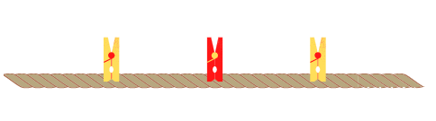
Images licensed under the Canva Content License Agreement.
- Ask Stage 1 students questions about the parts and the whole.
The table below outlines stimulus prompts to generate conversation about the topic, along with anticipated responses from students.
Prompts | Anticipated student responses
- How many equal parts can you see?  - What name is given to the 4 equal parts of a whole?  - How could we make smaller equal parts of the whole? | - The rope is divided into 4 equal parts, the rope is divided into 2 equal parts.  - 4 equal parts of a whole are called quarters.  - Fold the quarters again at the halfway point to make 8 equal lengths. Those parts are called eighths.
- Arrange the skipping rope into a wavy line. Ask Early Stage 1 students to explain whether the red peg is still at the halfway point, and Stage 1 students if the yellow pegs are still a quarter of the whole length. Demonstrate to students that the halfway point remains the same by folding the rope back on itself. Identify the 2 equal lengths on either side of the halfway point as halves.
- With the pegs still on the skipping rope, make a shape. For example, arrange the rope as a square. Ask:
- Does the halfway point change if the line changes shape?
- How many equal parts can you see and how do you know?
- What happens to the length of the equal parts as we continue to divide the whole?
- Provide students with pipe cleaners, a small collection of beads and their workbook. Ask students to trace the length of their pipe cleaner into their workbook. They estimate and draw the halfway point. Students check their working by folding the pipe cleaner into 2 equal lengths and sliding a bead to the halfway point. Students unfold their pipe cleaner and compare it against their estimate. If their estimate is not exact, students draw the halfway point on the line in a different colour and label it as half (see Figure 2).
Figure 2 – Finding the halfway point
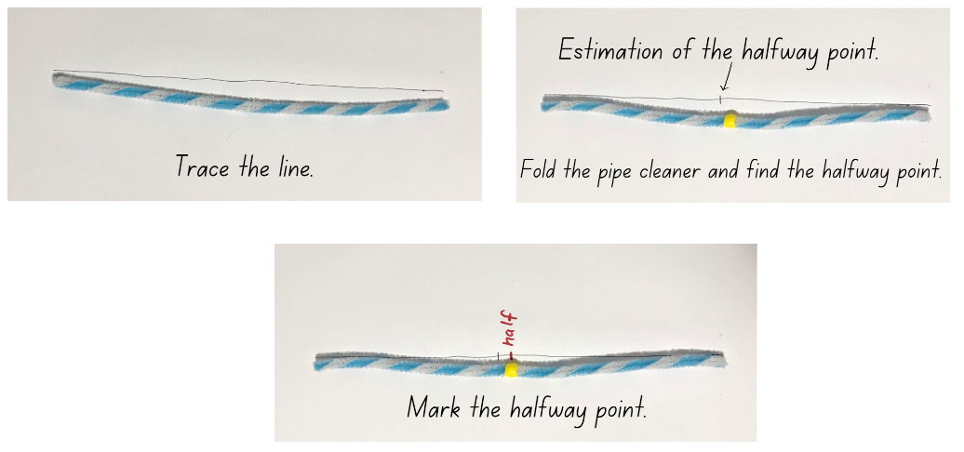
- Provide Early Stage 1 students with a collection of pipe cleaners of different lengths. Have students create different shapes and lines using the pipe cleaners. Students then estimate the halfway point and check by folding the pipe cleaner into equal lengths.
- Stage 1 students look at the 2 equal parts of the drawn line and mark an estimation of the halfway point within each of the halves. Students fold their pipe cleaner back in half and then fold each half again. Students place a bead onto the halfway points of each half and check against their estimation. Ask Stage 1 students how many equal lengths the pipe cleaner has been divided into and identify quarter lengths. In their workbook, Stage 1 students draw these halfway points on the line in a different colour and label each length as a quarter (see Figure 3).
Figure 3 – Finding the halfway point within each half
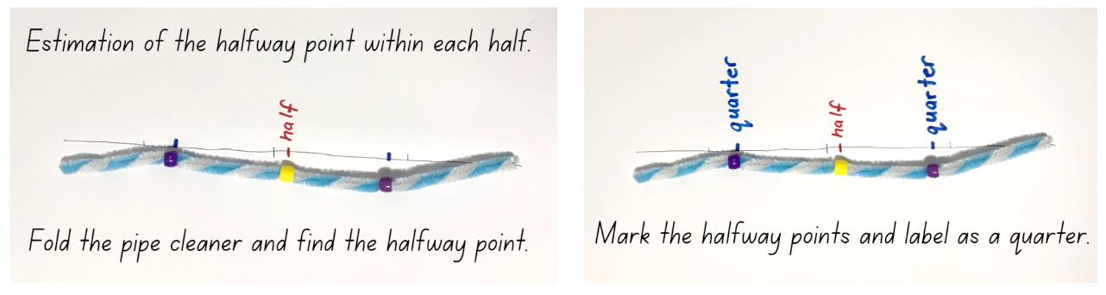
- Provide Stage 1 students with a collection of pipe cleaners of different lengths. Have students create different shapes and lines using the pipe cleaners. Students then estimate the halfway points and check by folding the pipe cleaner into equal lengths.
This table details assessment opportunities and differentiation ideas.
Assessment opportunities | Too hard? | Too easy?
What to look for:  - Can Early Stage 1 students divide a length into 2 equal parts? (MAO-WM-01, MAE-GM-03)  - Are Early Stage 1 students able to explain the difference between the halfway point and half a length? (MAO-WM-01, MAE-GM-03)  - Are all students able to estimate and identify 2 equal parts, and the relationship of the parts to the whole length? (MAO-WM-01, MAE-GM-03, MA1-GM-03)  - Can Stage 1 students recognise when a length has been divided into halves and quarters? (MAO-WM-01, MA1-GM-03)  - Are Stage 1 students able to repeatedly halve a length to make quarters? (MAO-WM-01, MA1-GM-03)  What to collect:  - observational data (MAO-WM-01, MAE-GM-03, MA1-GM-03)  - student work samples. (MAO-WM-01, MAE-GM-03, MA1-GM-03) | Students are unable to recognise when lengths have been divided into equal parts.  - Have beads already threaded onto a collection of pipe cleaners at the halfway point. Students fold the pipe cleaner at the halfway point to demonstrate and discuss the equal lengths.  - Focus on halves as 2 equal lengths. When students are confident, have them halve the half by folding to make 4 equal parts. | Students can recognise when a length has been folded into halves and quarters.  - Students join 2 pipe cleaners together to create a longer line. They estimate and place beads to show 8 equal lengths and fold to check.  - Give students one pipe cleaner and explain that the length is a half, quarter or eighth of the whole length. Students use additional pipe cleaners to build the whole length.

Discuss and connect the mathematics – 10 minutes
- Students display their pipe cleaners and go on a gallery walk to identify the different halfway points and how these points help to identify halves and quarters.
- Regroup as a class and ask questions about the relationship between the whole and halves. Select different students to show and compare their pipe cleaners, focussing on how different sized halves have been created from different sized pipe cleaners.
The table below outlines stimulus prompts to generate conversation about the topic, along with anticipated responses from students.
Prompts | Anticipated student responses
- How many halves and quarters can be used to make up the whole length of a pipe cleaner? Is there more than one way?  - Can you replace your half with other equal lengths?  - Is the half of every pipe cleaner the same length? Explain. | - To make the length of one pipe cleaner, I used 2 halves, or one half and 2 quarters or 4 quarters.  - I used one half and 2 quarters because 2 quarters are the same as one half, and 2 halves make one whole length.  - I can swap one half with 2 quarters, and I can put the quarters at the beginning and the end.  - Not all pipe cleaner halves are the same length because some pipe cleaners are longer and some are shorter. Longer length wholes will divide into longer half lengths.

Lesson 2: Equal and unequal parts
Core concept: A fraction represents equal parts of a whole.
The table below contains suggested learning intentions and success criteria. These are best co-constructed with students.
Learning intentions | Success criteria
All students are learning that whole lengths can be divided into equal parts.  In addition, students working towards Early Stage 1 outcomes are learning that the position of a point on a line can be described. | All students can:  - communicate their thinking and reasoning clearly  - recognise and explain when lengths have or have not been divided into halves, quarters or eighths.  In addition, students working towards Early Stage 1 outcomes can describe positions as ‘about halfway’, ‘more than halfway’ or ‘less than halfway’.  In addition, students working towards Stage 1 outcomes can use concrete materials to repeatedly halve lengths to find quarters and eighths.

Daily number sense: What is similar and different? – 10 minutes
- Build student understanding of forming numbers by recognising units of 10 or 100.
- Display the first image from Resource 2: 10 or 100. Ask students to identify what is similar and different and justify why. Provide individual thinking time, then have students turn and talk. Ask:
- What do you notice?
- What makes all the items similar?
- What makes an item different?
Note: Students can make a case for similarities and differences for each item, for example, units of measurement, representations and place value.
- Display the second image from Resource 2: 10 or 100 and repeat the above steps.

Equal and unequal – 20 minutes
- Ask students what words they use when discussing fraction parts of a whole, for example, equal, estimate, halfway point, about halfway, half, more than halfway, quarter, less than halfway or about a half. Record these for the class and encourage students to refer to this word bank throughout the lesson.
- Continue with the activity ‘Which does not belong’ by displaying the first image from Resource 3: Equal and unequal.
- Students identify what is similar and different and justify which object they think does not belong. Encourage Early Stage 1 to use the words ‘more than halfway’, ‘less than halfway’ and ‘about halfway’ when describing which object does not belong.
- Repeat the steps with the second image from Resource 3: Equal and unequal.
Note: If time permits, have students use their workbook to create their own ‘which does not belong’ question, with a focus on length and fractions. Early Stage 1 students focus on halfway and Stage 1 students focus on half and quarter ways.

Introducing eighths and using language – 20 minutes
This lesson has been adapted from Australia’s next top fraction model from Peter Gould (2013).
- Provide Early Stage 1 partners with a collection of paper strips of varying lengths. Students draw a line on the strip for their partner and their partner identifies if it is about halfway, more than halfway or less than halfway and explains how they know. Early Stage 1 students glue the strip into their book and label with the matching words (see Figure 4). Students take turns to repeat the steps using the other paper strips.
Figure 4 – Early Stage 1 describing positions
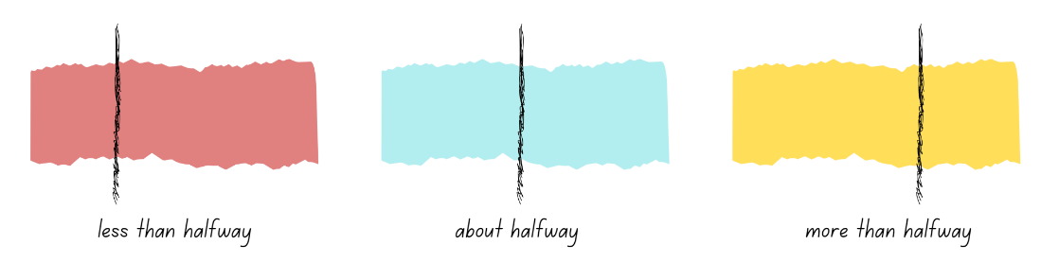
- For Stage 1 students, display and read the first part of Resource 4: Art project. Explain that students are working on their art project and 4 students need to share one length of ribbon. Ask how each student could get an equal part. Select students to explain what an equal part is and how they might find it.
- Provide each Stage 1 student with a thin strip of paper to use as a ribbon to model the equal shares. Students record their working out using diagrams and words in their workbooks (see Figure 5).
- Display and explain to Stage 1 students the second part of Resource 4: Art project. Four more students have seen the ribbon and want some for their project. Now 8 students need an equal share of the ribbon. Ask how to name the 8 equal parts of one whole. If not provided, prompt students for the term ‘eighth’ and add to the word bank. Students use their thin strip of paper to explore how the ribbon could be divided into 8 equal parts and record their thinking using diagrams and words in their workbook (see Figure 5).
Figure 5 – Stage 1 student work sample
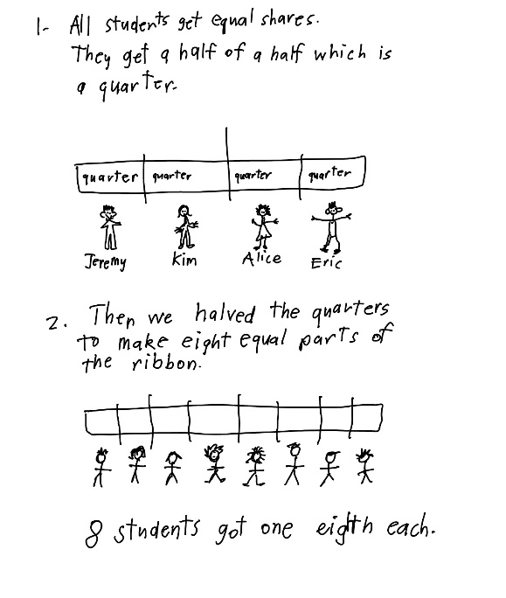

Discuss and connect the mathematics – 10 minutes
- Regroup and summarise the lesson together, drawing out some key mathematical ideas. Ask:
- How did you know the strip was about halfway, more or less than halfway? (Early Stage 1)
- Were there any challenges identifying halfway on the strip? (Early Stage 1)
- Did you use any strategies to identify halfway? (Early Stage 1)
- How did you share the ribbon into eighths? (Stage 1)
- What fraction did you get when you halved the half? How many equal pieces were there when you halved the quarters? (Stage 1)
- Are the parts equal? How do you know? (Stage 1)
- If your ribbon part was a quarter, how long would the whole ribbon be? (Stage 1)
- If the students had a longer ribbon, how would that change the length of ribbon each student received? (Stage 1)
- How many ways can you make a half using quarters and eighths? (Stage 1)
This table details assessment opportunities and differentiation ideas.
Assessment opportunities | Too hard? | Too easy?
What to look for:  - Are Early Stage 1 students able to describe and justify the positions as ‘about halfway’, ‘more than halfway’ or ‘less than halfway’? (MAO-WM-01, MAE-GM-03)  - Can Stage 1 students use concrete materials to repeatedly halve lengths to find quarters and eighths? (MAO-WM-01, MA1-GM-03)  - Can Stage 1 students recognise and explain when a length is divided into 4 and 8 equal parts? (MAO-WM-01, MA1-GM-03)  What to collect:  - student work samples. (MAO-WM-01, MAE-GM-03, MA1-GM-03) | Students are unable to describe and justify the positions as ‘about halfway’, ‘more than halfway’ or ‘less than halfway’.  - Provide students with a paper strip that has been divided into 2 equal parts. Students use this to help them identify more or less than halfway.  - Students fold paper to identify about halfway or more or less than halfway.  Students are unable to recognise and model 8 equal parts.  - Students halve quarters with a focus on aligning the edges of the strip. Then they unfold and count the 8 equal parts in the whole.  - Students join 8 interlocking cubes to form a whole length and identify the pieces as equal parts of the whole length. | Students can describe and justify the positions as ‘about halfway’, ‘more than halfway’ or ‘less than halfway’.  - Have students divide the length into 2 or 4 equal parts.  - Students use the words ‘half’ and ‘quarter’ to name the parts.  Students can repeatedly halve lengths to make a whole.  - Students use diagrams and words to show and explain how many ways they can make a half using quarters and eighths.  - Provide students opportunities to find a third and fifth of the ribbon.

Lesson 3: Part to whole
Core concept: There is a relationship between the equal parts, the whole and the halfway point.
The table below contains suggested learning intentions and success criteria. These are best co-constructed with students.
Learning intentions | Success criteria
Students working towards Early Stage 1 outcomes are learning that whole lengths can be divided into 2 equal parts at a halfway point.  Students working towards Stage 1 outcomes are learning that there is a relationship between the equal parts and the whole. | Students working towards Early Stage 1 outcomes can:  - divide a length into 2 equal parts  - distinguish between the halfway point and half a length.  Students working towards Stage 1 outcomes can:  - identify equal parts of the whole  - recreate the whole by repeating the equal part  - reason about the relationship between the equal parts and the whole.

Daily number sense: Which does not belong? – 10 minutes
- Build students understanding of the counting sequence by reasoning about patterns within the place value system of one-, two- and three-digit numbers.
- Display the first image from Resource 5: Place value. Ask students to identify what is similar and different and justify why. Provide individual thinking time and then have students turn and talk. Ask:
- What do you notice?
- What makes all the items similar?
- What makes an item different?
- Display the second image from Resource 5: Place value and repeat the above steps.
Note: Students can make a case for similarities and differences for each item, for example, consecutive numbers, odd and even numbers, 6 as a repeating digit, one-, two- and three-digit numbers and numbers to next multiple of 10.

Fractions and halfway points – 35 minutes
This lesson has been adapted from Teaching Mathematics Foundation to Middle Years from Siemon et al. (2021).
- Ask Stage 1 students to draw on their knowledge from previous lessons to find a half, a quarter or an eighth of a whole length. Ensure students understand that repeated halving results in equal lengths.
- Display, for Stage 1 students, the first image from Resource 6: Hidden fractions and explain that the blue line is a fraction of the whole line, and the rest of the line is covered by a piece of paper. Stage 1 students visualise what the whole may look like and turn and talk to describe the whole.
- While Stage 1 students are talking, show Early Stage 1 students a long strip of A3 paper and think aloud about where the halfway point would be. Provide Early Stage 1 students with one strip and ask students to draw a line where they think the halfway point might be and then think about how they could check if their line is halfway.
- While Early Stage 1 students are finding the halfway point, choose Stage 1 students to come and draw what they think the whole might look like by drawing the missing equal parts. Students justify how they determined the size of the whole. For example, a student may suggest that half the whole is showing and draw an equal half, or suggest a quarter is showing and draw 3 more equal parts. An eighth showing may not work as the size of the paper covering the line would not be long enough to hide the rest of the whole (see Figure 6). Question student understanding of why an eighth may not work in relation to the size of the paper.
Figure 6 – Stage 1 anticipated response
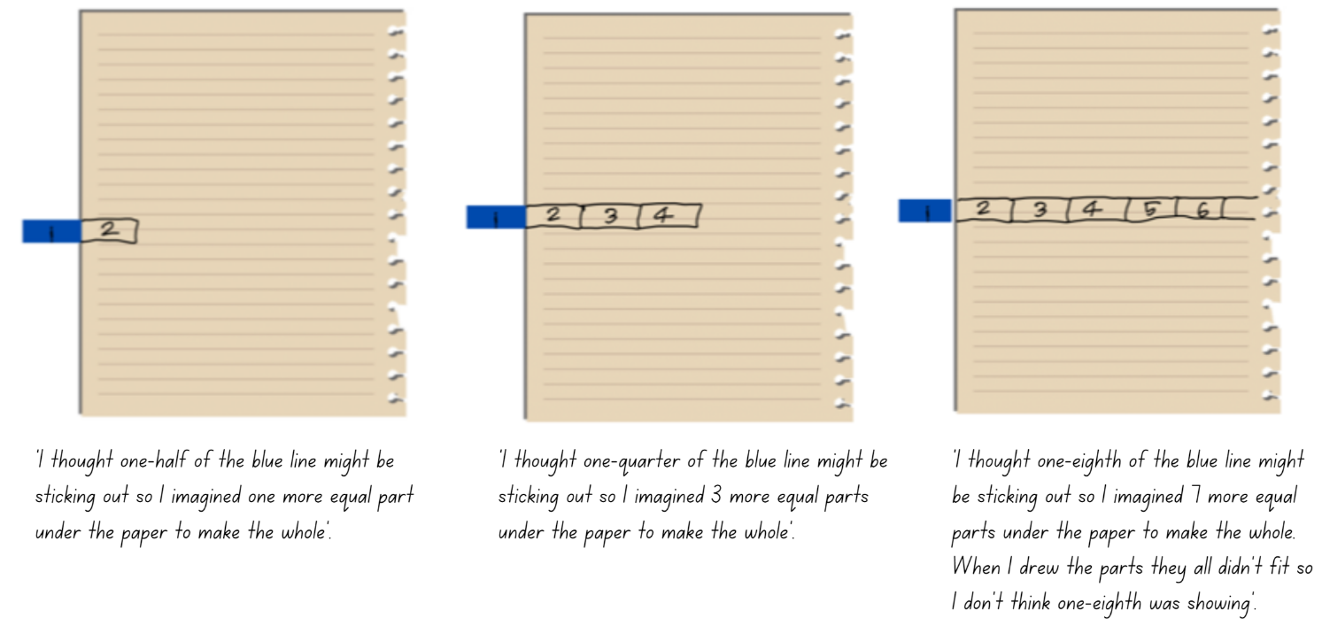
Images licensed under the Canva Content License Agreement.
- For Stage 1 students, display the second image from Resource 6: Hidden fractions and repeat the previous steps.
- While Stage 1 students are completing the hidden fraction task, ask Early Stage 1 students to share where they marked the halfway point on their strip and what ideas they came up with to check if the line was halfway. Demonstrate how to fold the strip into 2 equal halves and compare the estimated halfway point to the fold mark. Discuss the difference between the line as the halfway point and the half of the length.
- Provide Early Stage 1 students with 6 different length strips of paper. Students estimate the halfway point on their strips and draw a line. Students check their halfway point by folding the paper strip and making any corrections to show the correct halfway point. Students continue to do this for each of their 6 strips. Early Stage 1 students use their paper strips to make a starburst artwork by arranging the paper strips on top of each other in a circular shape, using the halfway point of the strips to centre them (see Figure 7).
Figure 7 – Early Stage 1 starburst example
- Provide Stage 1 students with a collection of paper, some of the paper to be cut into narrow strips and the other paper to be used as a rectangular cover. Students cut a paper strip of their own length and hide a part of it under the rectangular paper. Students glue the paper strip and covering paper into their workbook, then ask their partner to visualise the whole and draw the missing parts onto the covering paper. Students discuss if their visualisation of the whole was correct and reflect on the fractional parts of the whole.
- Stage 1 students continue to take turns making different hidden fractions, asking their partner to visualise the whole and draw their thinking.
This table details assessment opportunities and differentiation ideas.
Assessment opportunities | Too hard? | Too easy?
What to look for:  - Are Early Stage 1 students able to accurately fold to find halfway? (MAO-WM-01, MAE-GM-03)  - Are Early Stage 1 students able to visually identify the halfway point of a length and mark it? (MAO-WM-01, MAE-GM-03)  - Can all students identify equal parts of the whole? (MAO-WM-01, MAE-GM-03, MA1-GM-03)  - Are Stage 1 students able to recreate the whole by repeating the equal part? (MAO-WM-01, MA1-GM-03)  - Can Stage 1 students reason about the relationship between the equal parts and the whole? (MAO-WM-01, MA1-GM-03)  What to collect:  - student work samples. (MAO-WM-01, MAE-GM-03, MA1-GM-03) | Students are unable to visually identify halfway and find halfway by folding.  - Model how to use 2 hands to align the ends of a strip and fold it accurately, then ask students to copy.  - After students have aligned the ends, hold the paper in place while they fold it.  - Use interlocking cubes as a guide to help students see the halfway point along the length of paper.  Students are unable to recreate the whole when given the half.  - Students visualise and draw the missing strip on top of the piece of paper. Students fold the paper to check the halfway point, then check and adjust their estimate.  - Provide students with paper strips and pipe cleaners to allow students to find the halfway point. Students then cover half of the object to assist with visualising the hidden half. | Students can visually identify halfway and find halfway by folding.  - Ask students to explain how finding halfway has supported the process of making a starburst.  - Provide students with long strips of paper to estimate and check the halfway point and quarter points.  Students can recreate the whole when given the half.  - Students recreate other fractional amounts such as eighths, thirds or fifths.  - Students create a poster to demonstrate their knowledge and understanding of the relationship between fractions and length.

Discuss and connect the mathematics – 15 minutes
- Students display their work and go on a gallery walk to identify the halfway point or the different hidden fractions.
- Regroup as a class and summarise the lesson together, drawing out some key mathematical ideas. Ask:
- What is the difference between the halfway point and half a length? (Early Stage 1)
- How did folding the length help confirm the halfway point? (Early Stage 1)
- Could you visualise the fraction? How did visualising the missing part help you find the whole? Explain your responses to both questions. (Stage 1)
- How did understanding equal parts help you recreate the whole? (Stage 1)
- What were some challenges today? How did you overcome them?

Lesson 4: Objects in a line
Core concept: Fractions can be formed by repeatedly halving lengths.
The table below contains suggested learning intentions and success criteria. These are best co-constructed with students.
Learning intentions | Success criteria
All students are learning that:  - objects can be shared into smaller groups  - fractions can be determined by repeatedly halving lengths and collections. | Students working towards Early Stage 1 outcomes can:  - divide a length into 2 equal parts  - use concrete materials to model a half of a collection  - label the number of objects in a group.  Students working towards Stage 1 outcomes can:  - use concrete materials to model a half, a quarter and an eighth of a collection  - re-create the whole  - identify the equal parts and the relationship between the parts and the whole.

Daily number sense – 10 minutes
- From a class need surfaced through formative assessment data, identify a short, focused activity that targets students’ knowledge, understanding and skills. Example activities may be drawn from the following resources:
- Thinking Mathematically Stage 1
- Universal Resources Hub.

Sharing objects in a line – 40 minutes
This lesson has been adapted from Australia’s next top fraction model from Peter Gould (2013).
- Line up 8 students out the front of the class. Ask Early Stage 1 students to split the line of students into 2 equal parts and explain what happened to the line of students. Then ask Stage 1 students to halve the line of students again into equal parts. Provide time for Stage 1 students to explain what happened and discuss what fraction the line of students has been split into. Ask Stage 1 students to equally halve the line of students one last time and discuss what happened (see Figure 8).
Figure 8 – Repeatedly halving
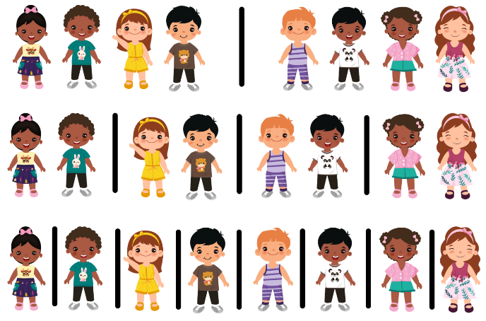
Images licensed under the Canva Content License Agreement.
The table below outlines stimulus prompts to generate conversation about the topic, along with anticipated responses from students.
Prompts | Anticipated student responses
- What happened when you equally split the line of 8 students?  - What happened when you equally halved the line of students again?  - What happened when you equally halved the line of students for the last time? | - There are 4 students in each half.  - I halved each half so now there are 2 students in each group. The line of students has been divided into quarters.  - The line of students has been divided into 4 groups.  - I halved each half and now there are 8 groups with one student in each group.  - I halved each quarter so now there is one student in each group. The line of students has been divided into eighths.
- Provide students with one strip from Resource 7: Stars (Early Stage 1) or Resource 8: Stars (Stage 1) and ask them to fold the strip to share the stars equally between 2. Ask:
- How many stars would each person get?
- How many groups have been created?
- What fraction has the strip been folded into?
Note: Ensure the strips have been cut along the outlines to allow students to align the ends when folding.
- Early Stage 1 students record how many stars are in each group and draw a circle around the groups (see Figure 9).
Figure 9 – Early Stage 1 folded stars
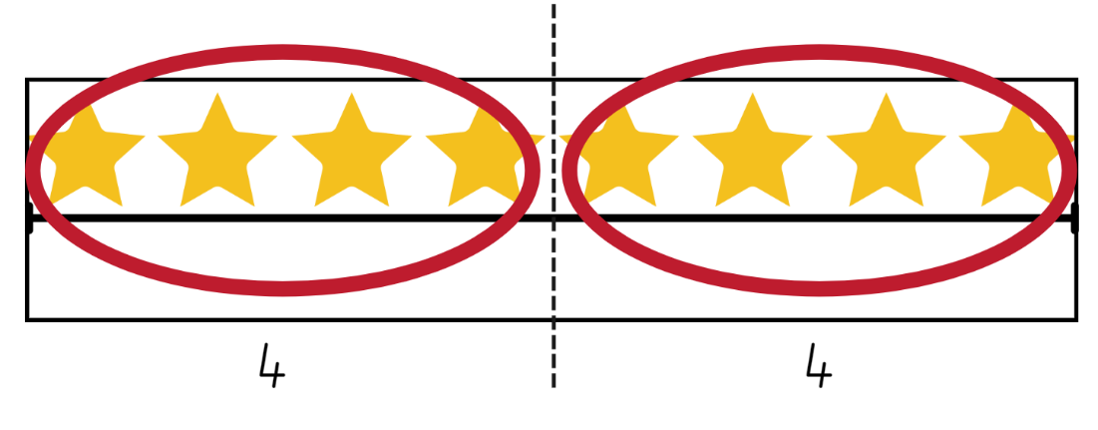
Images licensed under the Canva Content License Agreement.
- Ask Stage 1 students to fold the strip in half again to share the strip equally between 4. Ask how many stars each person would get and what fraction has the strip been folded into.
- Finally, ask Stage 1 students to fold the strip again to share the stars equally between 8 people. Ask how many stars each person would get and what fraction has the strip been folded into. Students write the name of the fraction on the folds (see Figure 10).
Figure 10 – Stage 1 folded stars
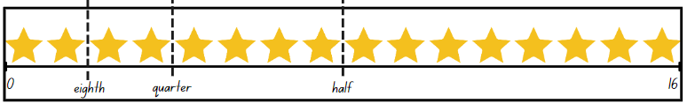
Images licensed under the Canva Content License Agreement.
- Looking at the strips, ask:
- How many groups did you make? How many stars were in each group? (Early Stage 1)
- How many halves make a whole? (Early Stage 1)
- How many quarters make a whole? (Stage 1)
- How many eighths make a whole? (Stage 1)
- What if 16 was the half, how many stars would make the whole? (Stage 1)

Note: Linear models of fractions are important as they provide a direct link to the number line. Students make the link by working with linear arrangements of quantity. This activity supports the link to the linear arrangement by repeatedly halving a line of stars. Having the collections of pictures on the strip helps students make the link between fraction units and quantities. Moving the focus from the length to a line of stars helps students to see how repeated halving could be used with both continuous and discrete quantities (Gould 2013).
Discrete model: This model uses separate items in collections to represent parts of the whole group.
- Provide students with one strip from Resource 9: Smiley faces (Early Stage 1) or Resource 10: Smiley faces (Stage 1) and their workbooks. Ask students to fold the strip to demonstrate how many smiley faces would be in each group if they were equally shared in halves (Early Stage 1), quarters and eighths (Stage 1).
- Students complete the activity by folding their strip to show the equal shares. Early Stage 1 students mark the fold with a line and draw circles around the groups and record how many in each group (see Figure 9). Stage 1 students mark the folds with lines and glue into their workbook. Stage 1 students record their working using words and numbers to explain how many smiley faces there are in each half, quarter and eighth (see Figure 11).
Note: It is not necessary for students in Stage 1 to use the symbol ½ to mean one half or use ¼ for one quarter. Students continue to use words.
Figure 11 – Stage 1 student work sample
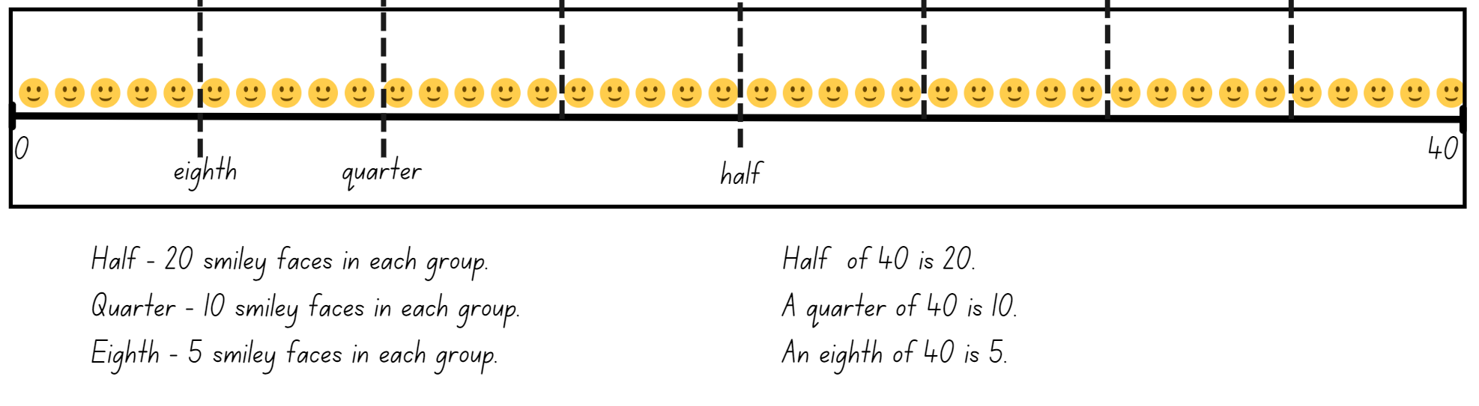
Images licensed under the Canva Content License Agreement.
- Regroup as a class and ask:
- How many smiley faces are in a half? (Early Stage 1)
- How many groups did you make? How many were in each group? (Early Stage 1)
- How many smiley faces are in a quarter? (Stage 1)
- How many smiley faces are in an eighth? (Stage 1)
- What if 40 was the half, how many smiley faces would make the whole? (Stage 1)
- Provide Early Stage 1 students with one strip from Resource 11: Circles (Early Stage 1). Ask students to fold the strip to demonstrate how many circles would be in each group if they were equally shared in halves. Early Stage 1 students complete the activity by folding their strip to show the equal shares. Students mark the fold with a line, draw circles around the groups and record how many there are in each group (see Figure 9).
- Provide Stage 1 students with Resource 12: Circles (Stage 1) and tell students that only an eighth of the circles have been drawn. Students need to identify and draw how many circles are missing. Students work independently or with a partner to identify the total number of circles required. Students can record their working in their workbook and use concrete materials.
- Regroup as a class and ask:
- How many circles are in a half? (Early Stage 1)
- How many groups did you make? How many were in each group? (Early Stage 1)
- What strategy did you use to find the whole collection? (Stage 1)
- How many circles made up a half of the whole? (Stage 1)
- How many circles made up a quarter of the whole? (Stage 1)
- How many eighths make a whole? (Stage 1)
- What further questions do you have? (Stage 1)
This table details assessment opportunities and differentiation ideas.
Assessment opportunities | Too hard? | Too easy?
What to look for:  - Can Early Stage 1 students divide a length into 2 equal parts? (MAO-WM-01, MAE-GM-03)  - Are Early Stage 1 students able to group items into equal groups? (MAO-WM-01, MAE-FG-02)  - Are Early Stage 1 students able to label the number of objects in a group? (MAO-WM-01, MAE-FG-02)  - Can Stage 1 students use concrete materials to model a half, a quarter and an eighth of a collection? (MAO-WM-01, MA1-FG-01, MA1-GM-03)  - Are Stage 1 students able to re-create the whole? (MAO-WM-01, MA1-FG-01, MA1-GM-03)  - Can Stage 1 students identify the equal parts and the relationship between the parts and the whole? (MAO-WM-01, MA1-FG-01, MA1-GM-03)  What to collect:  - student work samples. (MAO-WM-01, MAE-FG-02, MA1-FG-01, MAE-GM-03, MA1-GM-03) | Students are unable to model a half, a quarter and an eighth of a collection.  - Provide students with concrete materials to physically share objects equally.  - Support students to model half. Model for students how to halve equal halves to represent a quarter. Students repeat the process to halve equal halves to represent a quarter. | Students can use concrete materials to model a half, a quarter and an eighth of a collection.  - Provide students with only part of the collection on the line and have them recreate the collection to show the whole. For example, only an eighth of the smiley faces are drawn. Students draw the missing smiley faces to show the whole number.  - Provide students with opportunities to find a third and fifth of a collection and/or line.

Consolidation and meaningful practice: Blank strip – 10 minutes
- Provide students with Resource 13: Blank strip. Ask students to create their own picture strip that represents either halves, quarters and/or eighths.
- Students can choose to draw all the symbols on their strip and then fold the strip to demonstrate halves, quarters or eighths or draw a fraction of the total amount for a friend to solve. For example, a student draws 4 smiley faces and explains to their partner that the 4 smiley faces represent a quarter of the whole.
- Students share their work with the class.

Lesson 5: Sharing
Core concept: Collections can be shared into different fractions.
The table below contains suggested learning intentions and success criteria. These are best co-constructed with students.
Learning intentions | Success criteria
All students are learning that collections can be divided into halves, quarters or eighths. | Students working towards Early Stage 1 outcomes can:  - use concrete materials to halve objects into 2 groups  - share objects into groups and recognise whether the number in each group is equal or not.  Students working towards Stage 1 outcomes can:  - use concrete materials to model a half, a quarter and an eighth of a collection  - reason about the relationship between the part and the whole  - re-create the whole.

Daily number sense: Double or halve – 15 minutes
This lesson has been adapted from Double or Halve – Stage 1 from Thinking Mathematically.
- Build students understanding of flexible addition strategies by combining 2 or more groups or doubling and halving a given number.
- Provide pairs of Early Stage 1 students with one copy of page 2 of Resource 14: 30 grid and pairs of Stage 1 students with one copy of page 1 from Resource 14: 30 grid, 2 different coloured pencils and a 6-sided die.
- Together, students choose a target number between 10 and 30 and write it on the side of their grid and on the corresponding grid square.
- The first Early Stage 1 player rolls the die and colours the corresponding number of squares. Players take turns rolling and colouring the number of squares until they reach the target number exactly. If a player cannot go, they miss a turn.
- The first Stage 1 player rolls the die and chooses to either double or halve the number rolled on the die. The player records their choice on the grid by shading the corresponding number of squares. Stage 1 players record a running total on the side of their grid.
- Stage 1 players take turns to roll the die and record their chosen number. If a player cannot go, they miss a turn. The winner is the player who reaches the target number exactly (see Figure 12).
Figure 12 – Double or halve gameplay
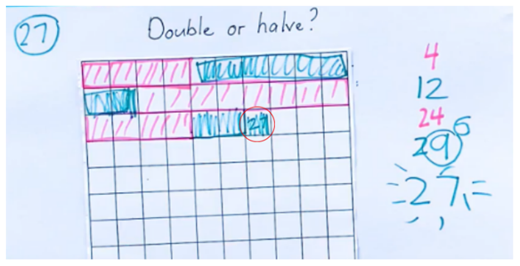
- While students are playing, move around to pairs and ask:
- If you were to play the game again, are there any moves you would change?
- If you were to play the game again, how would you change the rules? Explain. (Early Stage 1)
- Is there a number you should have halved instead of doubled? Why? (Stage 1)
- If you were to play the game again and the rules changed so you could double, halve or keep your roll, do you think this might make it easier to reach the target number? (Stage 1)
Note: Students can use their grid workbooks to play the game with a larger target number or use page 2 of Resource 14: 30 grid. This will support students to combine numbers and keep a running total. Using Resource 14: 30 grid in a reusable sleeve will allow students to play multiple times.

Meaningful problems – 35 minutes
This activity has been adapted from Open-Ended Maths Activities by Sullivan et al. (2017) and Fractions of shapes and collections from State of Victoria (Department of Education and Training).
- Display the first problem from Resource 15: Problems and explain that you met up with your family on the weekend. Half the people in your family are males. Ask students to use their individual whiteboard or workbook to draw what your family might look like. Provide Early Stage 1 students with concrete materials to explore the problem before drawing.
- With Early Stage 1 students, reinforce that, when halving a collection of objects, 2 equal groups are being created.
Note: Remind students that in mathematics simple drawings or symbols communicate ideas best and that complicated features are not necessary.
- Choose students to share their drawing and explain their response.
- Display the second problem from Resource 15: Problems and explain that you went to a party on the weekend and got a lolly bag. Tell Early Stage 1 students that half the lollies in the bag were jelly snakes and tell Stage 1 that a quarter of the lollies in the bag were jelly snakes. Ask students to use their individual whiteboard or workbook to draw what the lolly bag might look like. Provide Early Stage 1 students with concrete materials to explore the problem before drawing.
- Choose students to share their drawing and explain their response.
- Display the third problem from Resource 15: Problems and explain that you received a bunch of flowers. Tell Early Stage 1 students that half the flowers were daffodils and tell Stage 1 students that an eighth of the flowers were daffodils. Ask students to use their individual whiteboard or workbook to draw what your bunch of flowers might look like. Provide Early Stage 1 students with concrete materials to explore the problem before drawing.
- Choose students to share their drawing and explain their response.
- With Stage 1 students, display, read and discuss Resource 16: Sharing chocolate. Ask Stage 1 students which chocolate bar they would choose and to justify their choice. Provide Stage 1 students with their workbook and 2 different coloured strips of paper or Resource 17: Chocolate bars to solve the problem. Students show their working in their workbook. Encourage students to use paper folding to help visualise and justify their thinking.
- Provide Early Stage 1 students with 20 interlocking cubes and ask them to find out which quantities between 2 and 20 can be halved. Reinforce that, when halving a collection of objects, 2 equal groups are being created. Students record in their workbook or on their individual whiteboard which quantities can be halved and which ones cannot (see Figure 13).
Figure 13 – Early Stage 1 halving groups
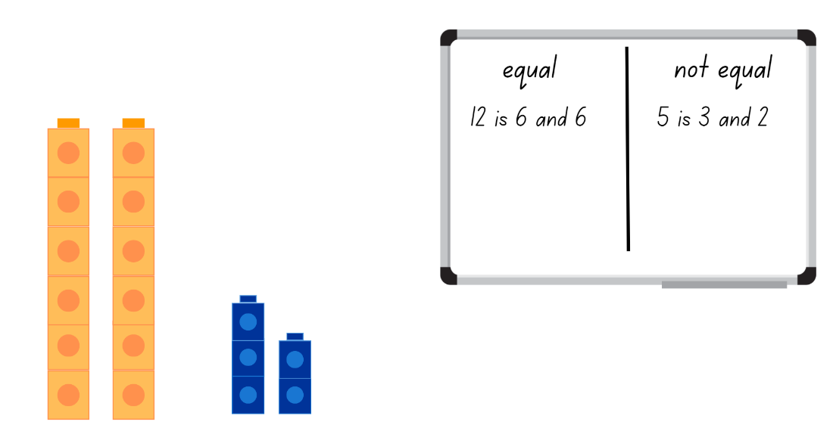
Images licensed under the Canva Content License Agreement.
This table details assessment opportunities and differentiation ideas.
Assessment opportunities | Too hard? | Too easy?
What to look for:  - Can Early Stage 1 students use concrete materials to halve objects into 2 groups? (MAO-WM-01, MAE-FG-01)  - Can Early Stage 1 students share objects into groups and recognise whether the quantity in each group is equal or not? (MAO-WM-01, MAE-FG-01)  - Can Stage 1 students use concrete materials to model a half, a quarter and an eighth of a collection? (MAO-WM-01, MA1-FG-01, MA1-GM-03)  - Are students able to reason about the relationship between the part and the whole? (MAO-WM-01, MA1-FG-01, MA1-GM-03)  - Can students re-create the whole? (MAO-WM-01, MA1-FG-01, MA1-GM-03)  What to collect:  - observational data (MAO-WM-01, MAE-FG-01, MA1-FG-01, MA1-GM-03)  - student work samples. (MAO-WM-01, MAE-FG-01, MA1-FG-01, MA1-GM-03) | Students are unable to solve open ended sharing problems.  - Provide students with a starting number to halve. For example, ‘I have 6 family members and half of them are males.’  - Support students by having them share objects into smaller groups. For example, sharing 6 counters into 2 equal groups.  Students are unable to model a half, a quarter and an eighth of a collection.  - Provide students with concrete materials to physically share objects equally.  - Students focus on modelling a half, then drawing it to represent the problem. When students are confident with creating equal halves, model the same with quarters. | Students can use concrete materials to model a half, a quarter and an eighth of a collection and reason about the relationship between the part and the whole.  - Students draw chocolate bars to represent how an eighth of a bar would be larger than a quarter of a bar.  - Provide opportunities for students to find a third and fifth of a collection and/or line.

Discuss and connect the mathematics – 10 minutes
- Regroup and summarise the lesson, drawing out key mathematical ideas. Ask students to share their work. Ask:
- Did you use a method to find equal and unequal groups? Explain. (Early Stage 1)
- Did you notice a pattern? Explain. (Early Stage 1)
- What strategies did you use to solve the problem? (Stage 1)
- Was your prediction correct? (Stage 1)
- Would you always choose a quarter of a chocolate bar over an eighth of a chocolate bar? Explain. (Stage 1)

Lesson 6: Sharing objects
Core concept: Division can be represented by either sharing or grouping objects.
The table below contains suggested learning intentions and success criteria. These are best co-constructed with students.
Learning intentions | Success criteria
Students working towards Early Stage 1 outcomes are learning that collections can be shared into equal groups.  Students working towards Stage 1 outcomes are learning that:  - collections can be divided into halves, quarters and eighths  - division can be represented by sharing objects into equal groups  - division can be represented by finding out how many groups can be formed. | Students working towards Early Stage 1 outcomes can:  - identify the number of groups and the number in each group  - prove and explain if the number in each group is equal.  Students working towards Stage 1 outcomes can:  - use objects or diagrams to model a half, a quarter or an eighth of a collection  - identify the number of groups and the number in each group when solving division problems.

Daily number sense: 10 minutes
- From a class need surfaced through formative assessment data, identify a short, focused activity that targets students’ knowledge, understanding and skills. Example activities may be drawn from the following resources:
- Thinking Mathematically Stage 1
- Universal Resources Hub.

Bar model – 30 minutes
- Ask students to find half of 16. Provide Early Stage 1 students with interlocking cubes to share into 2 groups and make towers with their cubes. Ask Stage 1 students to show their working using the bar model and record on their individual whiteboard (see Figure 14). Stage 1 students share with the class.
- Ask Early Stage 1 students:
- How do you know you have halved the collection?
- How many groups do you have?
- How many in each group?
- How many altogether?
- Are the groups equal? How can you prove it?
- Ask Stage 1 students if they can halve the number again to show a quarter of 16 using the bar model. Stage 1 students use their diagram from the previous question and add another row to it (see Figure 14). Stage 1 students share with the class. Ask Early Stage 1 students to share their interlocking cubes equally into 4 groups. Ask Early Stage 1 students the previous questions around how many groups and how many in each group.
- Ask Stage 1 students if it is possible to halve the numbers again to show eighths using the bar model (see Figure 14). Have Stage 1 students share their working and model thinking aloud to record the bar model on the board. Ask Early Stage 1 students to share their interlocking cubes equally into 8 groups. Ask Early Stage 1 students the previous questions around how many groups and how many in each group.
Figure 14 – Stage 1 repeatedly halving using the bar model
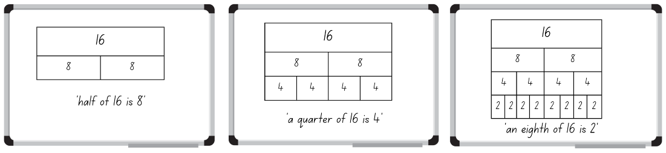
Images licensed under the Canva Content License Agreement.\
- Place Early Stage 1 students into small groups of 3 or 4, with a collection of interlocking cubes. Students sit in a circle. Each player represents a group and the collected interlocking cubes represents how many in each group. The first player rolls a 6-sided die, and all players take that number of interlocking cubes from the pile. The player who rolled the die states the total number of groups and the number of interlocking cubes in each group, as well as counting the total number of interlocking cubes. The other players say if they agree and why. Another student rolls the die and play continues.
- For Stage 1 students, display and read Resource 18: Sharing toy cars. Provide students with a collection of concrete materials and their workbook to solve and represent the problem using the bar model (see Figure 15).
Note: Students may need guidance to draw a large bar divided into 4 equal parts and then collect the given number in counters. Demonstrate how to share the counters equally between the 4 parts. Once the counters have been shared equally, explain that the number of counters in each part is a quarter of the given number. Systematically sharing the concrete materials in an organised layout will assist students to check their count, ensure that it is equal and see the fraction (NCETM 2019).
Figure 15 – Stage 1 different bar models to represent quarters
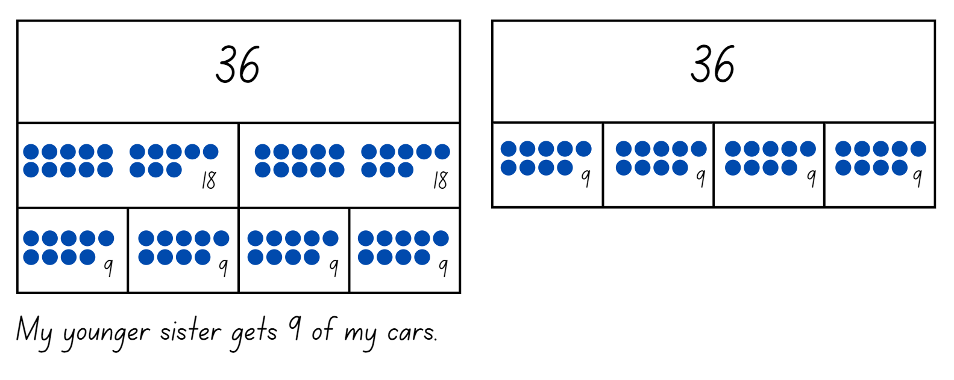
- Regroup with Stage 1 students and ask:
- Which strategy did you use to solve this problem? Do you think it was the most efficient and why?
- How does the bar model help you to solve problems?
- Was this an equal sharing or equal grouping problem?
Partitive: Equal sharing (partitive) division requires finding how many are in each group, for example, calculating 12 marbles shared between 3 students, to work out how many marbles each student would get.
- For Stage 1 students, display and read Resource 19: Sharing blocks. Provide students with a collection of concrete materials and their workbook to solve and represent this problem using the bar model (see Figure 16).
Figure 16 – Stage 1 bar model
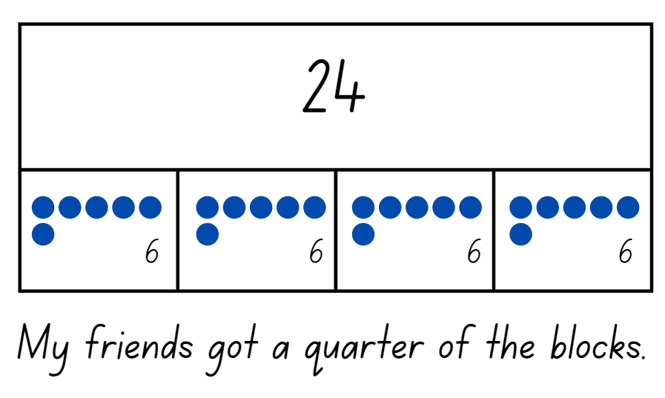
- Regroup with Stage 1 students and ask:
- Which strategy did you use to solve this problem?
- How does the bar model help you to solve problems?
- Was this an equal sharing or equal grouping problem?
Quotitive: Equal grouping (quotitive) division requires finding how many groups are formed, for example, calculating how many children will get marbles if you start with 12 and give each child 4. When grouping, the quotient represents the number of groups within the shared quantity.
- Draw Stage 1 students’ attention to the different division problems, noting how one problem requires students to equally share the objects and the other requires students to work out how many groups. Focus on the different language within the problem and the different ways students go about solving the problem using the terms equal grouping and equal sharing.

Consolidation and meaningful practice: Solving problems – 20 minutes
The Early Stage 1 component of this activity was adapted from Making Groups from Developing Efficient Numeracy Strategies (n.d).
- Provide Stage 1 students with some of the problems from Resource 20: Sharing and grouping. Students read each problem individually or with a partner to determine if it is an equal grouping or equal sharing problem.
Note: Resource 20: Sharing and grouping has a range of problems that increase in complexity.
- Stage 1 students work through their given problems using concrete materials and the bar model to record their working in their workbook.
- Early Stage 1 students can continue with the previous activity or change their activity to Making Groups. Provide Early Stage 1 students with a large collection of interlocking cubes or counters, an individual whiteboard or cups and two 6-sided dice. Explain that one die is for identifying how many groups and the other die indicates how many are in each group. Students roll the first die to identify how many groups. Students draw the corresponding number of groups by drawing circles on their whiteboard or using cups to represent each group. Students then roll the second die to identify and place the corresponding number of items in each group. Students verbalise the number of groups, the number in each group, the total and how they can prove the total.
- Regroup as a class and have students share their work. Stage 1 students demonstrate how they solved different problems.
This table details assessment opportunities and differentiation ideas.
Assessment opportunities | Too hard? | Too easy?
What to look for:  - Can Early Stage 1 students identify the number of groups and the number in each group when sharing objects? (MAO-WM-01, MAE-FG-01)  - Are students able to prove and explain if the number in each group is equal? (MAO-WM-01, MAE-FG-01)  - Can Stage 1 students use objects and diagrams to model a half, a quarter and an eighth of a collection? (MAO-WM-01, MA1-FG-01)  - Are Stage 1 students able to identify between the number of groups and the number in each group when solving division problems? (MAO-WM-01, MA1-FG-01)  What to collect:  - student work samples (MAO-WM-01, MAE-FG-01, MA1-FG-01)  - observational data. (MAO-WM-01, MAE-FG-01, MA1-FG-01) | Students are unable to share object or solve division problems.  - Provide students with an item like a bowl to represent the groups. Students share objects into the bowls one at a time until there are none left.  - Support students to read the problems and provide them with counters. Students count out the given number for each group until there are no counters left. Circle each group of counters to identify the number of groups.  - Support students to read the problem and draw circles to identify how many groups the items are being shared into. Then provide students with concrete materials to physically share objects between the identified groups. | Students can identify between the number of groups and the number in each group when solving division problems and use diagrams and materials to demonstrate their understanding.  - Provide students with page 3 of Resource 20: Sharing and grouping.  - Students solve the problems from Resource 20: Sharing and grouping and then rewrite the problems using multiplication.  - Students look at the problems from Resource 20: Sharing and grouping and see if it is possible to divide any of the collections in the problems equally by thirds or fifths.

Lesson 7: Leftovers
Core concept: Not all collections can be shared equally.
The table below contains suggested learning intentions and success criteria. These are best co-constructed with students.
Learning intentions | Success criteria
All students are learning that:  - numbers have a sequence  - groups are made by sharing objects  - not all collections can be shared equally  In addition, students working towards Stage 1 outcomes are learning that the part that cannot be shared equally has a name. | All students can model division by sharing objects.  In addition, students working towards Early Stage 1 outcomes can:  - identify the number before as ‘one less’ and the number after as ‘one more’ than a given number  - share objects into smaller groups and recognise whether the quantities in each group are equal or not  - record grouping and sharing using drawings, words and numerals and explain their thinking.  In addition, students working towards Stage 1 outcomes can:  - identify how many more to the next multiple of 10 within two- and three-digit numbers  - describe the part as ‘left over’ when a collection cannot be distributed equally.

Daily number sense: Counting – 10 minutes
- Build Early Stage 1 students understanding of the counting sequence by identifying the number before as ‘one less’ and the number after as ‘one more’.
- Build Stage 1 students understanding of the counting sequence by identifying how many more to the next multiple of 10.
- Ask Stage 1 students to draw a blank number line and mark the numbers 64 and 72. Ask Stage 1 students how many more are needed to get to the next multiple of 10. Students draw the jump to identify how many more and mark the next multiple of 10 (see Figure 17).
Figure 17 – Stage 1 next multiple of 10
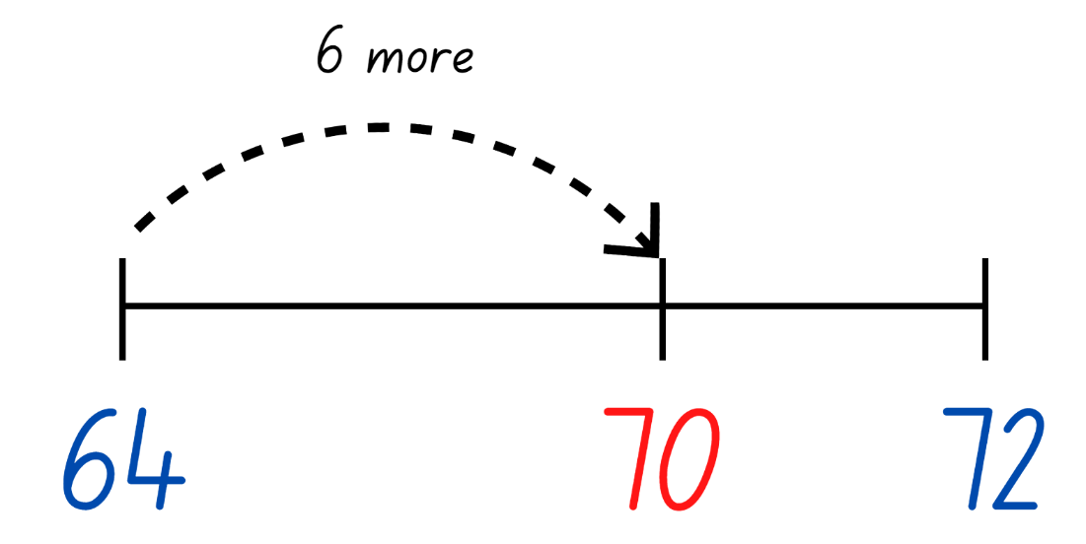
- While Stage 1 are drawing their number line, ask Early Stage 1 students to record numbers that are ‘one less’ or ‘one more’ than the given number. Choose different numbers between 0 to 30 and say, for example:
- I am thinking of the number that is ‘one less’ than 12.
- I am thinking of the number that is ‘one more’ than 21.
- Choose Stage 1 students to share and justify how they know it is the next multiple of 10.
Note: This activity focuses on the next multiple of 10, not the closest multiple of 10.
- Continue asking Early Stage 1 students ‘one less’ and ‘one more’ questions and choose different two- and three-digit number ranges for Stage 1 to complete.
This table details assessment opportunities and differentiation ideas.
Assessment opportunities | Too hard? | Too easy?
What to look for:  - Are Early Stage 1 students able to identify the number before as ‘one less’ and the number after as ‘one more’ than a given number? (MAE-RWN-01)  - Are Stage 1 students able to identify and justify how many more to the next multiple of 10 within two- and three-digit numbers? (MAO-WM-01, MA1-RWN-01)  What to collect:  - student work samples. (MAO-WM-01, MAE-RWN-01, MA1-RWN-01) | Students are unable to identify numbers as ‘one less’ or ‘one more’ than the given number or identify how many more to the next multiple of 10 within two- and three-digit numbers.  - Provide students with a number chart to refer to when identifying numbers.  - Provide students with number cards to sequence.  - Support Stage 1 students to identify how many more to the next multiple of 10 with numbers up to 20. | Students can identify numbers as ‘one less’ or ‘one more’ than the given number or identify how many more to the next multiple of 10 within two- and three-digit numbers.  - Choose larger two- and three-digit numbers for students to identify ‘one less’ or ‘one more’ than the given number.  - Provide opportunities for students to identify how many more to the next multiple of 50.  - Provide opportunities for students to identify how many more to the next multiple of 100.

Bunches of balloons – 35 minutes
This lesson has been adapted from Bunches of Balloons from reSolve: Maths by Inquiry (2018).
- Display Resource 21: Balloons and tell students that they need to decorate the room with a packet of balloons and make sure each bunch is equal. Students turn and talk to discuss how they could organise balloons to make sure the bunches are equal.
- Choose students to share their responses and ideas.
- Tell Stage 1 students that there are 29 balloons in a packet. Provide partners with their workbooks and ask students to draw the room, including how the balloons would be arranged.
- While Stage 1 students are drawing the room, tell Early Stage 1 students that they have 12 balloons and need to share them into 2, 3, 4, 5 and 6 groups, then determine if the share is equal or not. Students can record their working on Resource 22: Balloon sharing by moving counters into the ovals or drawing balloons in the ovals and recording with words and numerals (see Figure 18). Students can also use bowls or cups to represent groups instead of Resource 22: Balloon sharing.
Figure 18 – Early Stage 1 sharing balloons
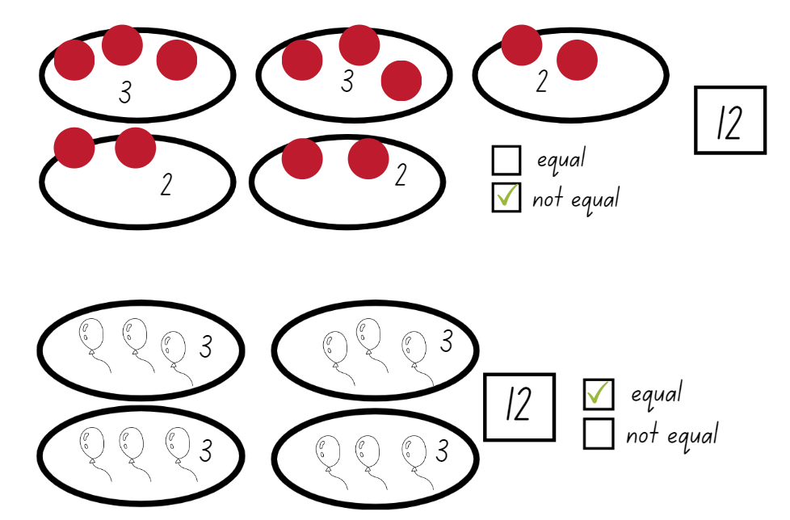
Images licensed under the Canva Content License Agreement.
- After 5-10 minutes, regroup with Stage 1 students and ask them to share their ideas on how the room can be decorated. Record student responses, focussing on responses that use the correct vocabulary. For example, ‘I made 7 groups of 4 but there was one balloon left over.’
Note: In Stage 1, it is appropriate for student language to develop from using ‘leftovers’ to ‘remainders’ when describing the result of unequal shares.
- Ask Stage 1 students to continue investigating whether the room can be decorated with equal bunches of balloons. Students work with a partner and 29 counters to see if they can make equal groups. Have students record their different groupings using diagrams and words. Students could draw the counters or take a photo and record using words, including the number of counters in each group, the number of groups and how many are left over (see Figure 19).
Figure 19 – Grouping examples
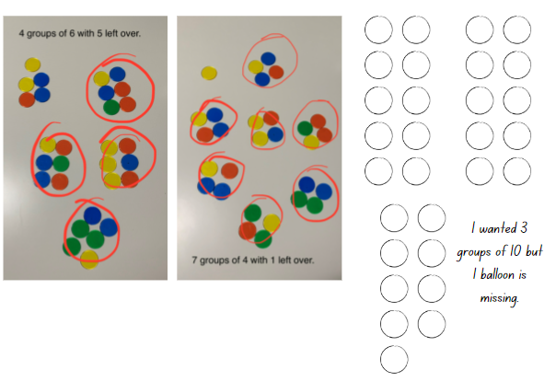
- Early Stage 1 students can continue to share their balloons on Resource 22: Balloon sharing. While students complete the activity, Early Stage 1 students can be challenged by asking them to find as many ways as possible to share 20 into equal groups. Students record their working with concrete materials, drawings, words or numbers.
- While students are working, circulate and ask:
- Have you noticed any patterns? (Early Stage 1)
- How do you know a share is not equal? (Early Stage 1)
- Can you make equal groups of 2 from 29 balloons? Are you sure? Have you tested it? (Stage 1)
- Have you tried another group size? (Stage 1)
- How many ways are there to group the balloons? (Stage 1)

Discuss and connect the mathematics – 15 minutes
- Students display their work and go on a gallery walk to identify the similar and different ways balloons were grouped and if any Stage 1 students were able to equally share the balloons.
- Regroup as a class and ask:
- Were any Stage 1 students able to equally share the balloons? Why or why not?
- Is it always possible to make equal groups?
- What do we call the objects that are not equally shared into a collection? (Stage 1)
- What further questions do you have?
This table details assessment opportunities and differentiation ideas.
Assessment opportunities | Too hard? | Too easy?
What to look for:  - Can all students model division by sharing objects? (MAE-FG-01, MA1-FG-01)  - Are Early Stage 1 students able to share objects into smaller groups and recognise whether the quantities in each group are equal or not? (MAO-WM-01, MAE-FG-01)  - Can Early Stage 1 students record grouping and sharing using drawings, words and numerals and explain their thinking? (MAO-WM-01, MAE-FG-01)  - Are Stage 1 students able to describe the part as ‘left over’ or as a ‘remainder’ when a collection cannot be distributed equally? (MAO-WM-01, MA1-FG-01)  What to collect:  - student work samples. (MAO-WM-01, MAE-FG-01, MA1-FG-01) | Students are unable to model division by sharing objects and recognise if objects have been distributed equally.  - Support students to share objects into equal groups by using a smaller collection of counters and a number of counters that is divisible by 2, 4 or 6.  - Support Early Stage 1 students by using interlocking cubes so they can build towers with their shared objects and line them up to see if they are equal or not.  - Support Stage 1 students to share counters into 3 small groups with one or 2 counters remaining, and naming these as leftovers. | Students can model division by sharing objects and describe the part as ‘left over’ or as a ‘remainder’ when a collection cannot be distributed equally.  - Challenge students to find other numbers that cannot be shared into equal groups.  - Ask students to find numbers that can be shared equally by 2 different numbers, for example, 2 and 5.

Lesson 8: Problem solving
Core concept: Collections can be shared into different sized groups.
The table below contains suggested learning intentions and success criteria. These are best co-constructed with students.
Learning intentions | Success criteria
Students working towards Stage 1 outcomes are learning that:  - groups are made by sharing objects  - not all collections can be shared equally.  Students working towards Stage 1 outcomes are learning that there is a relationship between doubling and halving. | Students working towards Early Stage 1 outcomes can:  - share objects into smaller groups and recognise whether the number in each group is equal or not  - record grouping and sharing using drawings, words and numerals and explain their thinking.  Students working towards Stage 1 outcomes can:  - use concrete materials to model a half of a collection and show the relationship between the half and the whole  - connect the concepts of doubling and halving and clearly communicate their thinking.

Daily number sense: Double or halve – 20 minutes
This lesson has been adapted from Double or Halve – Stage 1 from Thinking Mathematically.
- Revisit the Double or Halve activity from Lesson 5: Sharing. Provide pairs with the appropriate grid from Resource 14: 30 grid, 2 different coloured pencils and a 6-sided die.
- Explain to Stage 1 students that they will be playing the game again but with slightly different rules. This time, students can double, halve or keep their roll. Revise that last time the game was played, students discussed whether they thought this might make it easier to reach their target number.
- Early Stage 1 students play the game again from Lesson 5: Sharing, either maintaining the same rules or adding some of the student rule suggestions.
- After playing, ask:
- Was it easier or harder to reach the target number with the rule change? Explain. (Stage 1)
- Do you have any other suggestions on how to change the rules to make the game harder or easier?
Note: Students can use their grid workbooks to play the game with a larger target number. Alternatively, use page 2 of Resource 14: 30 grid to support students to combine numbers and keep a running total.

Different combinations – 30 minutes
The lesson has been adapted from Teaching for Mastery [PDF 6 MB] from NCTEM.
- Tell Early Stage 1 students that there is a train with 4 carriages and 18 passengers wanting to travel from Sydney to Broken Hill. Early Stage 1 students can draw, act, build or model different combinations for the train journey showing combinations that are equal and those that are not equal. Provide different challenges, for example, explain that a family of 5 wants to travel together and ask if the carriages will be equal or not. Early Stage 1 students continue to work through their combinations.
- Provide Stage 1 students with a range of numbers to double and halve, for example, double 8, half of 24. Provide access to concrete materials if needed. Ask:
- What do you have to do when you double?
- How do you know a number is a double?
- For Stage 1 students, display and read Resource 23: Maths Marvel. Ask students whether they agree with the Maths Marvel’s idea. Provide some independent thinking time for students to engage with the problem before sharing their response.
- Display and read for Stage 1 students, Resource 24: Always true? Students work in pairs to complete the investigation using Resource 25: Mindmap and concrete materials, for example, counters and interlocking cubes. Stage 1 students also demonstrate their understanding using words and diagrams.
- Regroup as a class and have students share their findings.
This table details assessment opportunities and differentiation ideas.
Assessment opportunities | Too hard? | Too easy?
What to look for:  - Are Early Stage 1 students able to share objects into smaller groups and recognise whether the groups are equal or not? (MAO-WM-01, MAE-FG-01)  - Can Early Stage 1 students record grouping and sharing using drawings, words and numerals and explain their thinking? (MAO-WM-01, MAE-FG-01)  - Are Stage 1 students able to use concrete materials to model a half of a collection and show the relationship between the half and the whole? (MAO-WM-01, MA1-FG-01)  - Can Stage 1 students connect the concepts of doubling and halving and clearly communicate their thinking? (MAO-WM-01, MA1-FG-01)  What to collect:  - student work samples (MAO-WM-01, MAE-FG-01, MA1-FG-01)  - observational data. (MAO-WM-01, MAE-FG-01, MA1-FG-01) | Students are unable to share objects and recognise if objects have been distributed equally or not.  - Support students to share objects into equal groups by using a smaller collection of counters and a number of counters that is divisible by 2, 4 or 6.  - Support students by using interlocking cubes so students can build towers with their shared objects and line them up to see if they are equal or not.  Students are unable to connect the concepts of doubling and halving.  - Explain to students that doubling means adding the same number again. Have students model this with interlocking cubes. Students then halve the row of cubes into equal parts and show that the half is their original number.  - Students use a 20-bead rekenrek to place a number on the top line and the same number on the next line to show how the number can be doubled. Students then remove the beads on the second line to show how it can be halved. | Students can share objects and recognise if objects have been distributed equally or not.  - Provide different challenges for students as they distribute the passengers between the carriages.  - Provide students with a number and ask them to find as many equal sharing combinations as possible for that number.  Students can connect the concepts of doubling and halving.  - Encourage students to communicate their thinking as clearly as they can using words from the word bank, diagrams and symbols.  - Students identify problems for which the strategy is useful and not useful, for example, halving odd numbers of collections.

Discuss and connect the mathematics – 10 minutes
- Reflect on the unit together, revising the key mathematical ideas.
- Allow students time to individually reflect. Have each student write a note describing something they learned from a peer during classroom or small group discussions in this unit.
- Select students to read out their notes and use the opportunity to correct, clarify and celebrate the learning.
Note: This activity can also be done with students verbalising what they have learnt from their peers.

Resource 1: Numbers
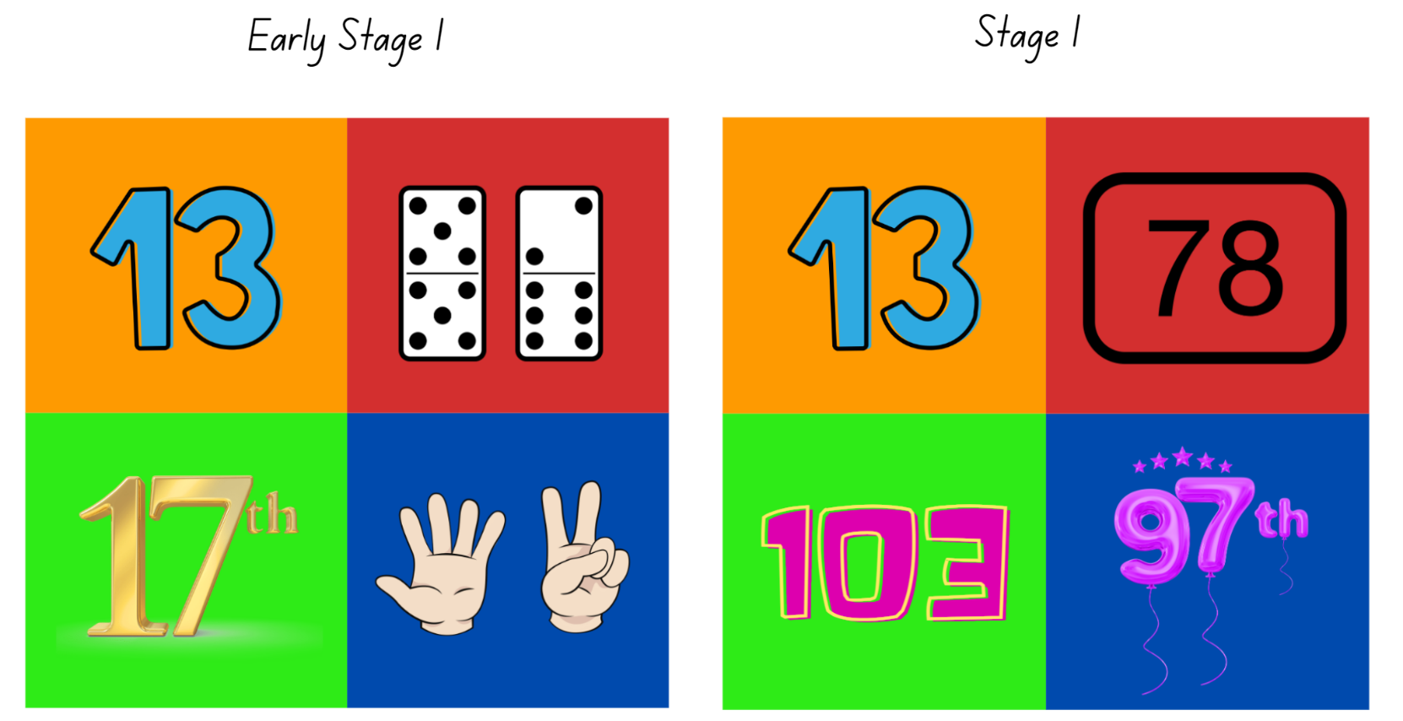
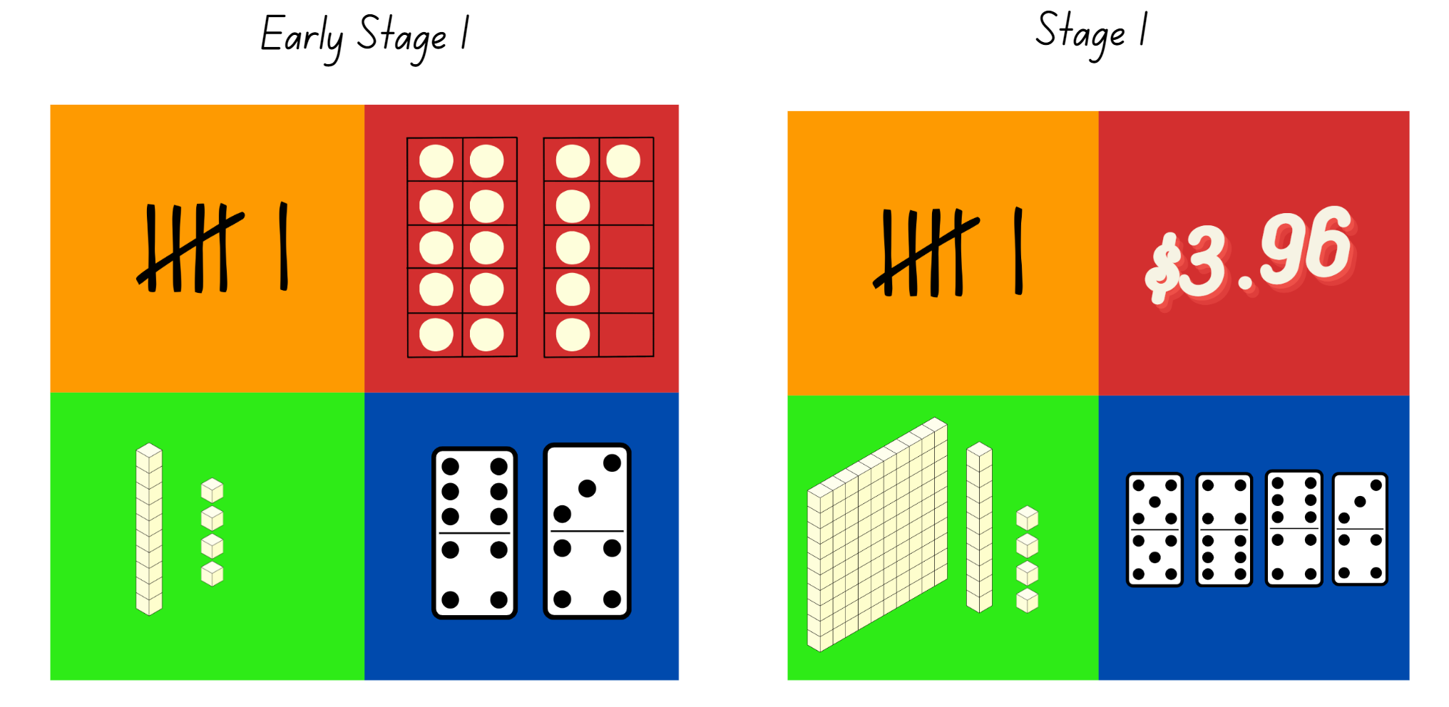
Images licensed under the Canva Content License Agreement.

Resource 2: 10 or 100
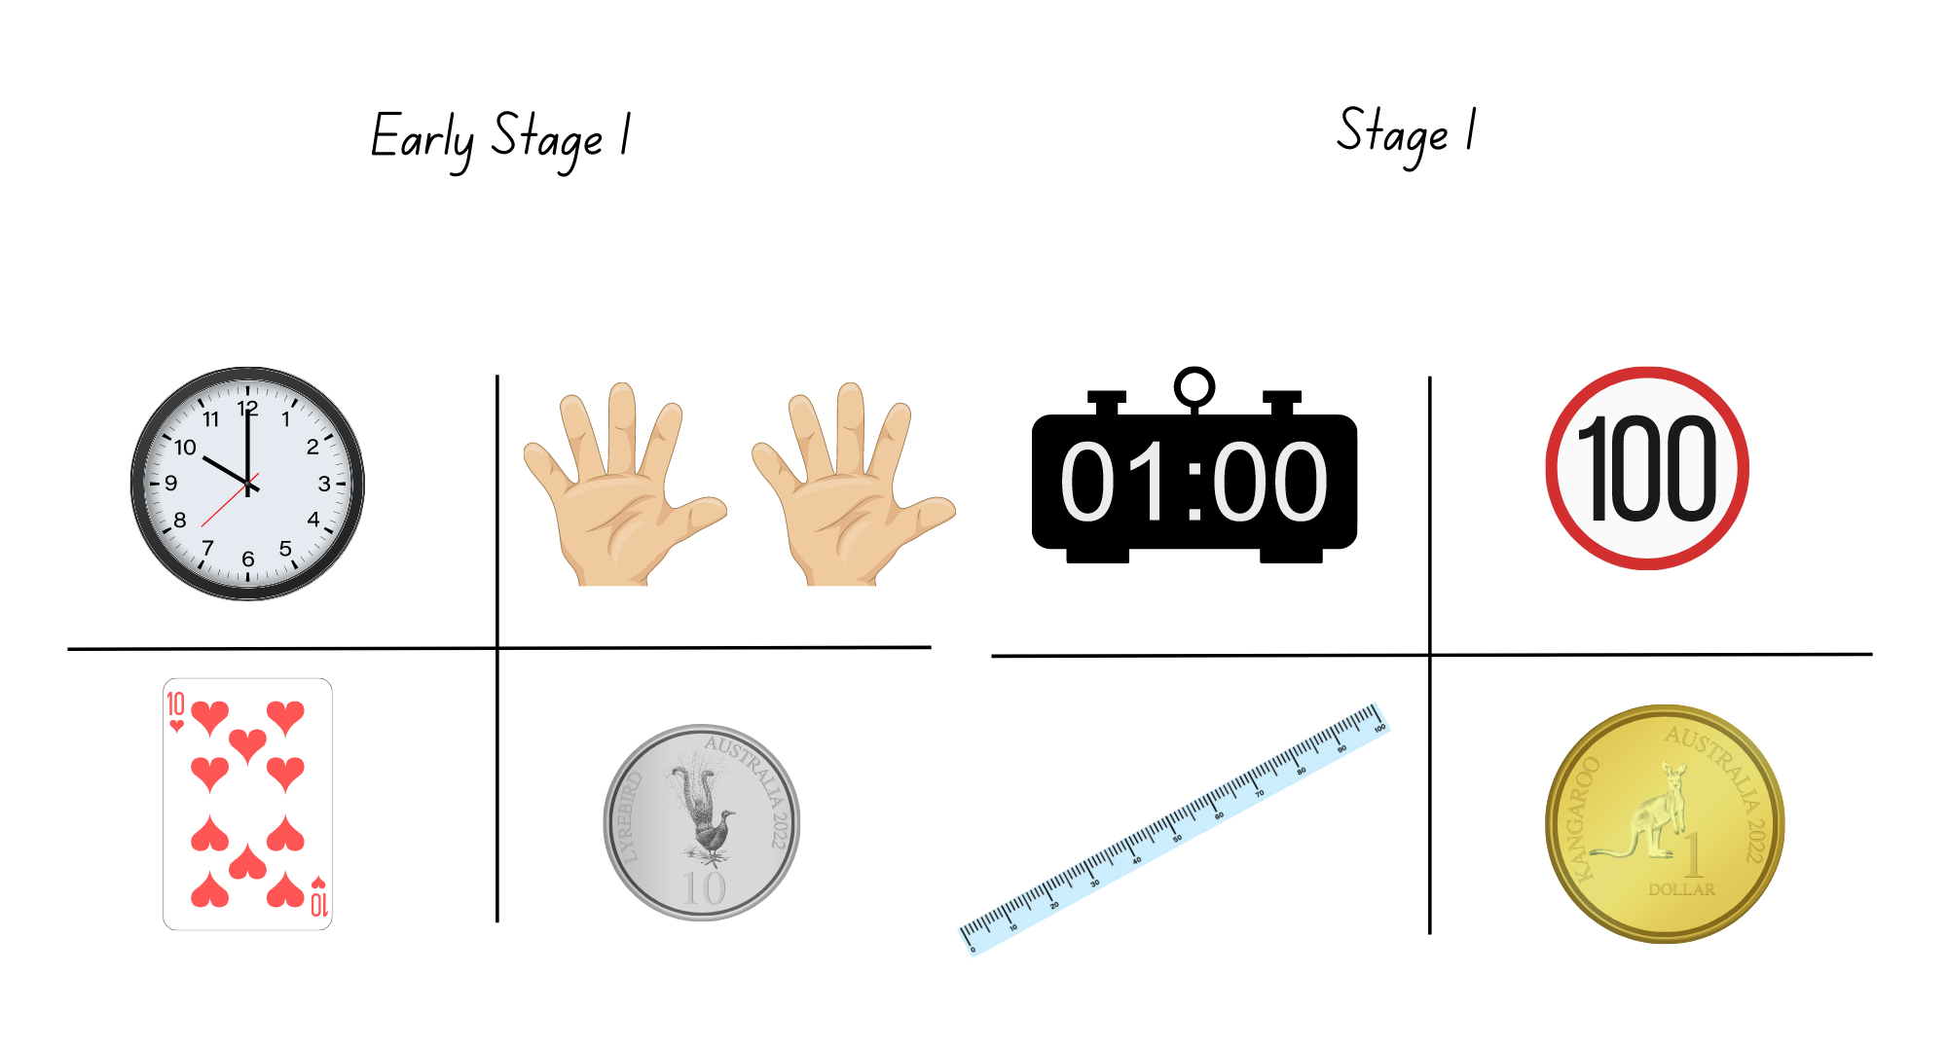
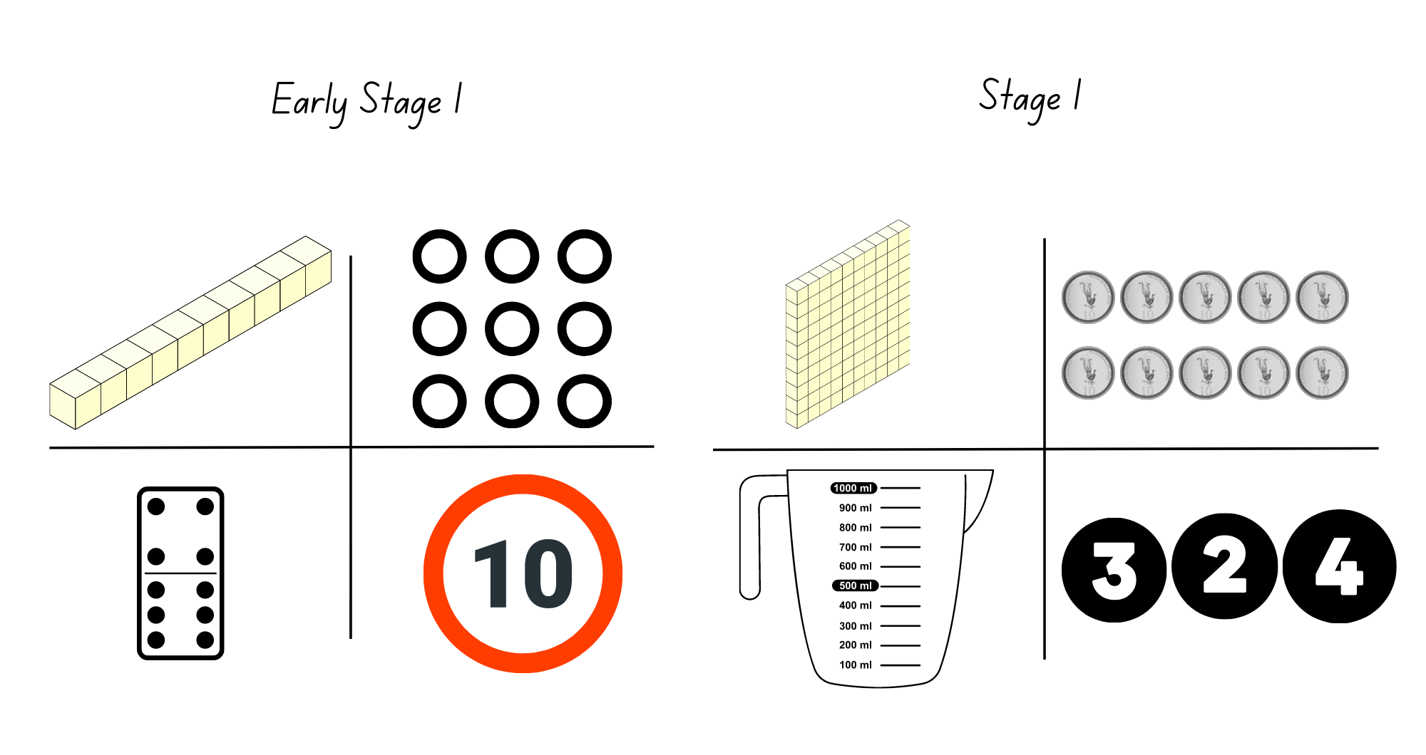
Images licensed under the Canva Content License Agreement.

Resource 3: Equal and unequal
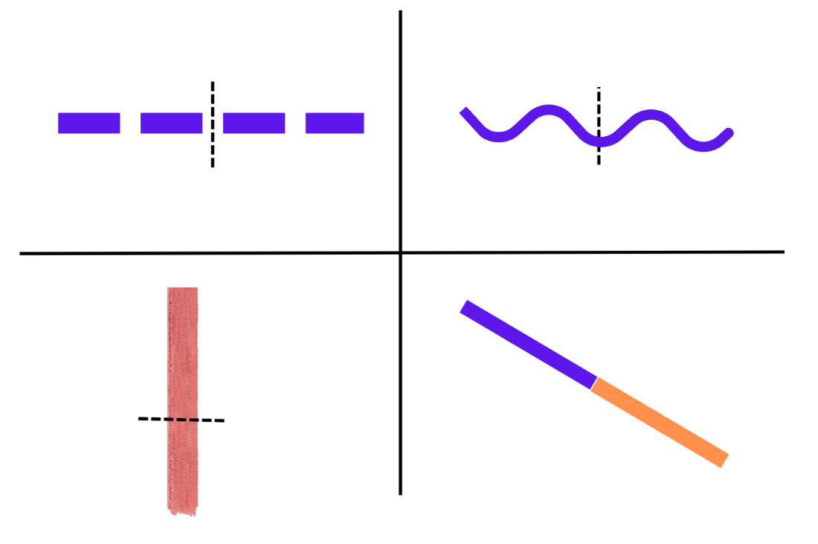
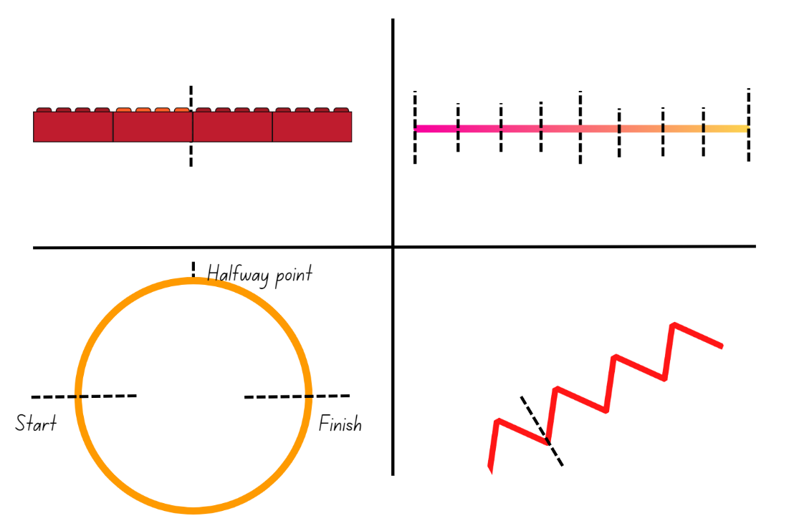
Images licensed under the Canva Content License Agreement.

Resource 4: Art project
.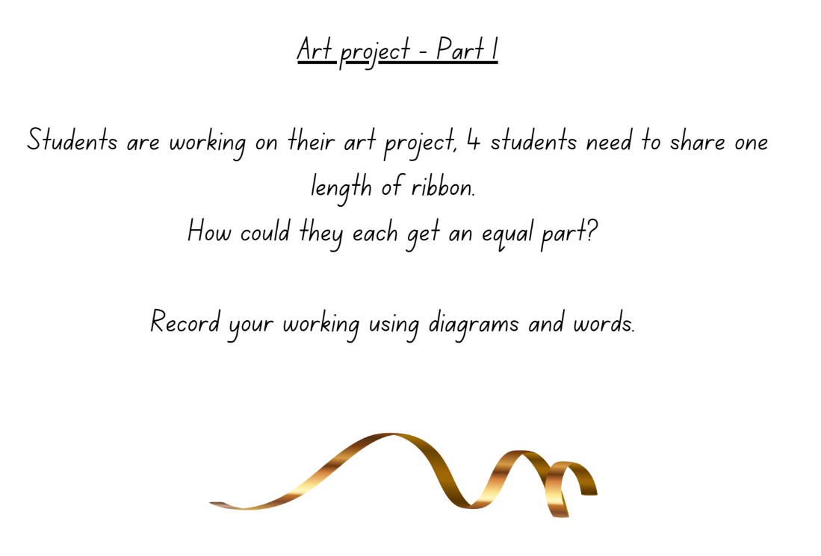
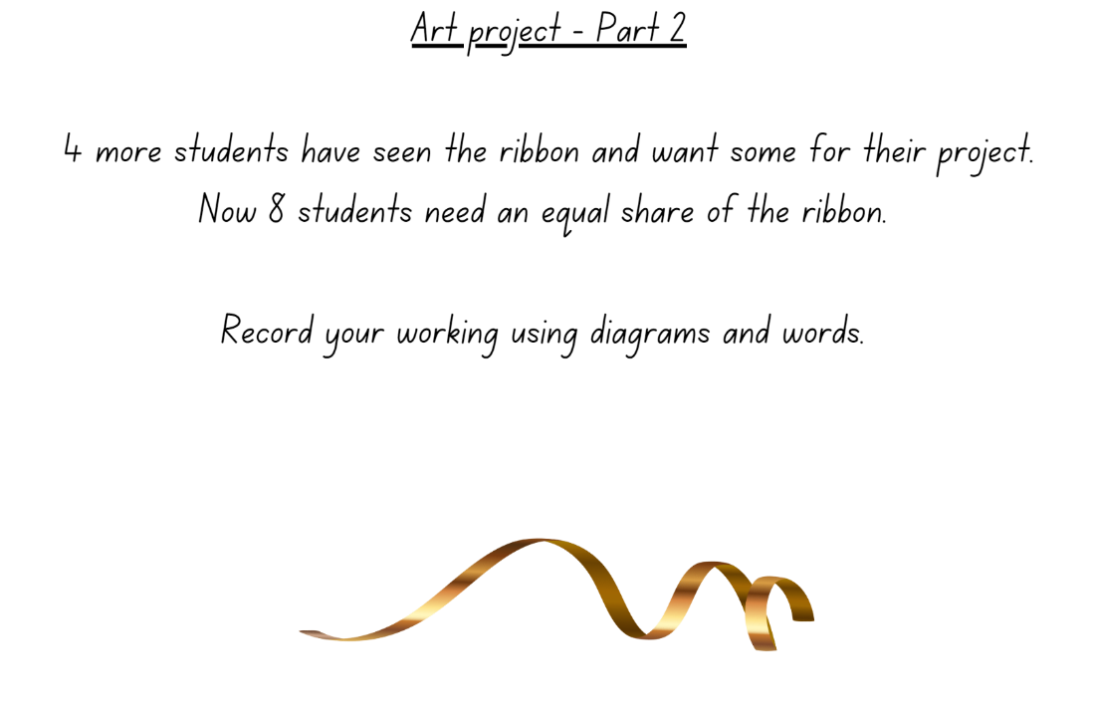
‘Gold Ribbon Illustration’ by ‘Libking’ licensed under the Canva Content Licence Agreement.

Resource 5: Place value
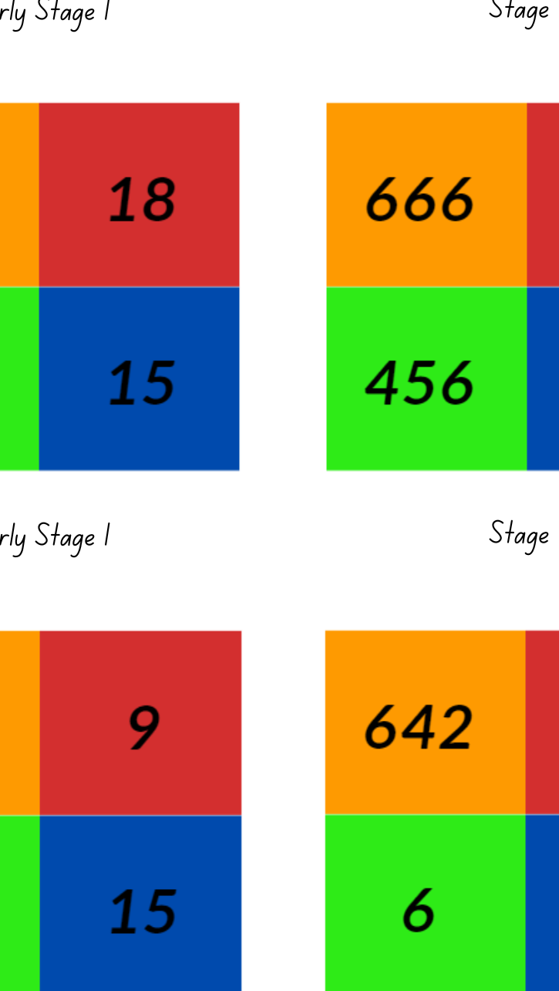

Resource 6: Hidden fractions

Resource 7: Stars (Early Stage 1)
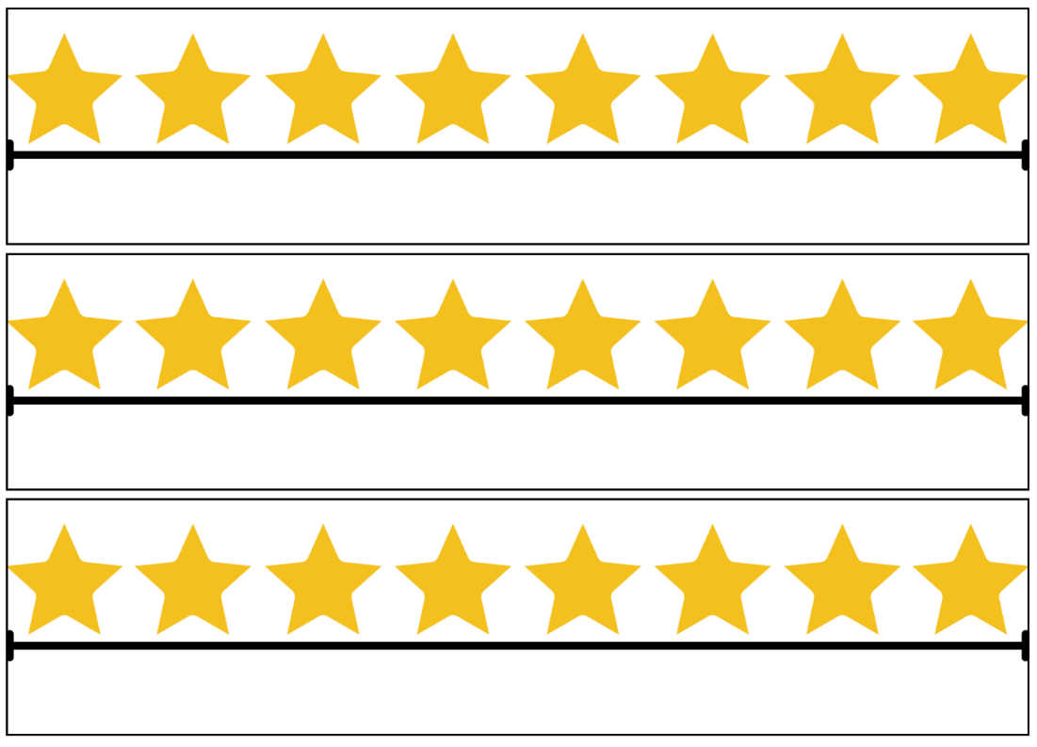

Resource 8: Stars (Stage 1)
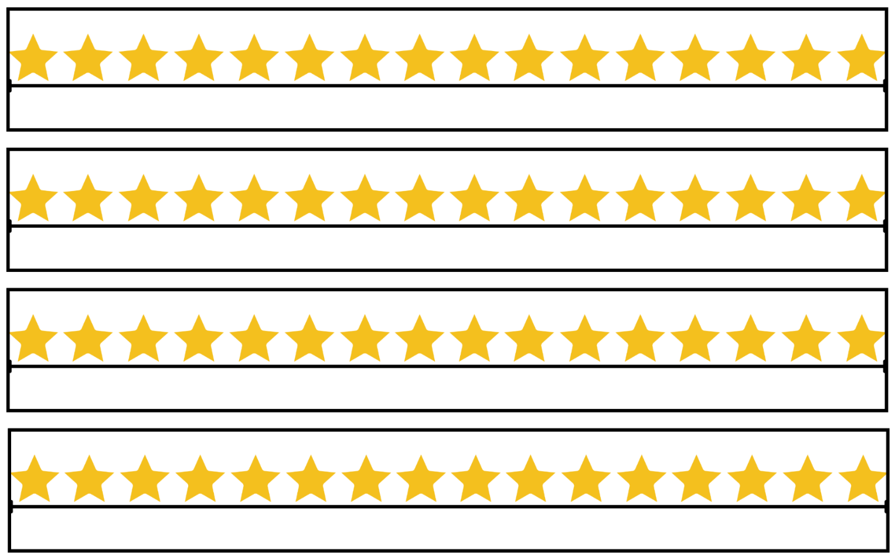

Resource 9: Smiley faces (Early Stage 1)
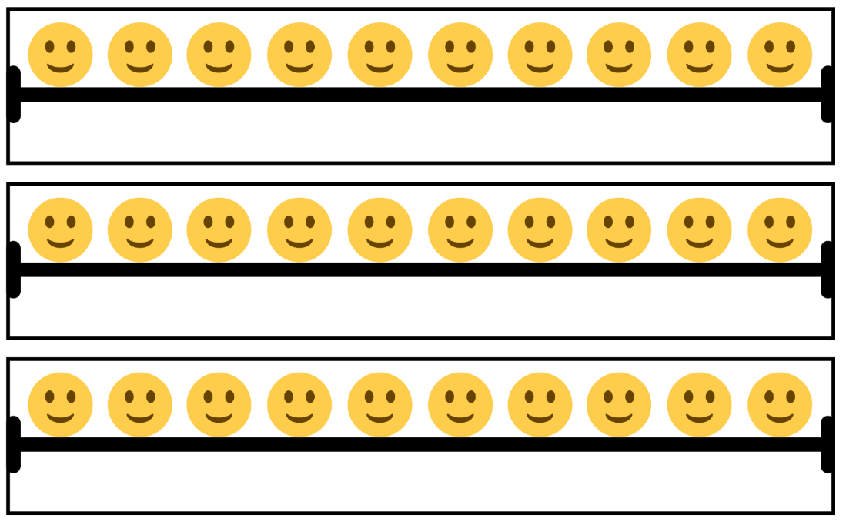
‘Smiley Emoji’ by ‘Architia’ licensed under the Canva Content Licence Agreement.

Resource 10: Smiley faces (Stage 1)
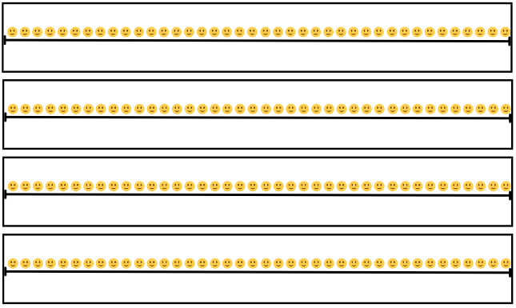
‘Smiley Emoji’ by ‘Architia’ is licensed under the Canva Content Licence Agreement.

Resource 11: Circles (Early Stage 1)
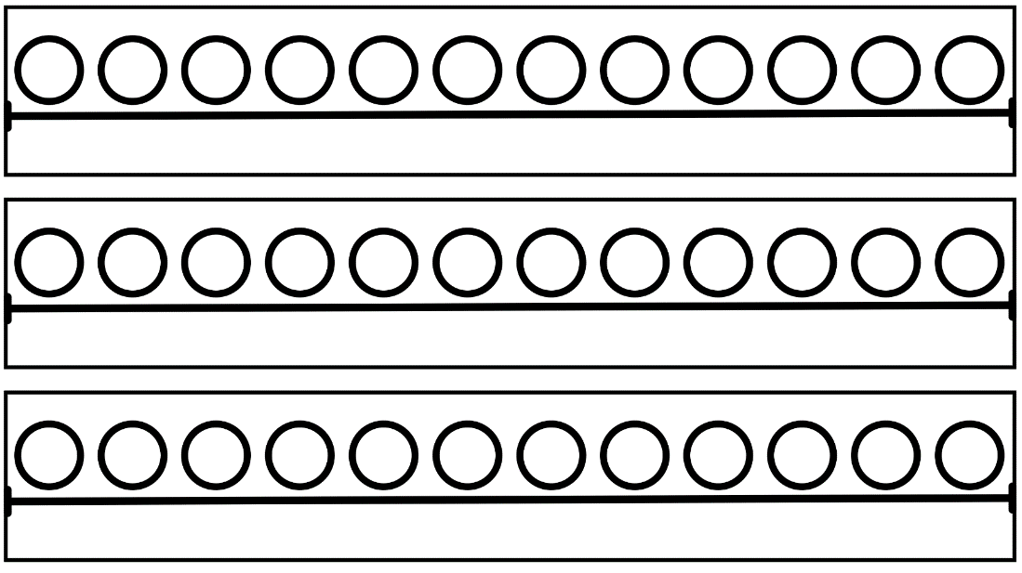

Resource 12: Circles (Stage 1)

Resource 13: Blank strip

Resource 14: 30 grid
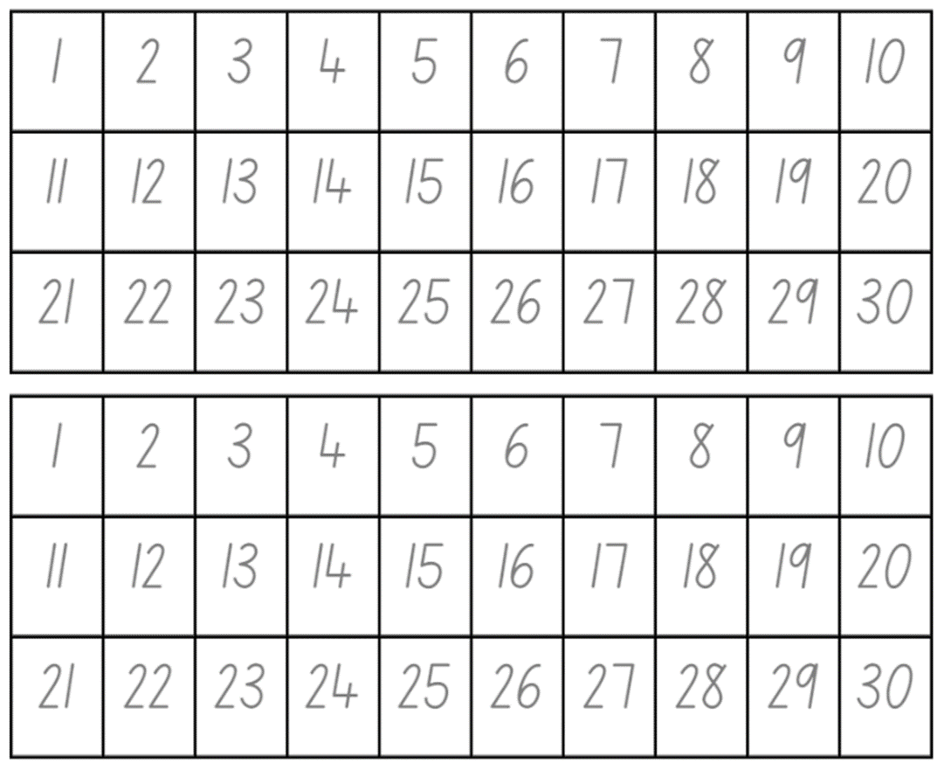

Resource 15: Problems
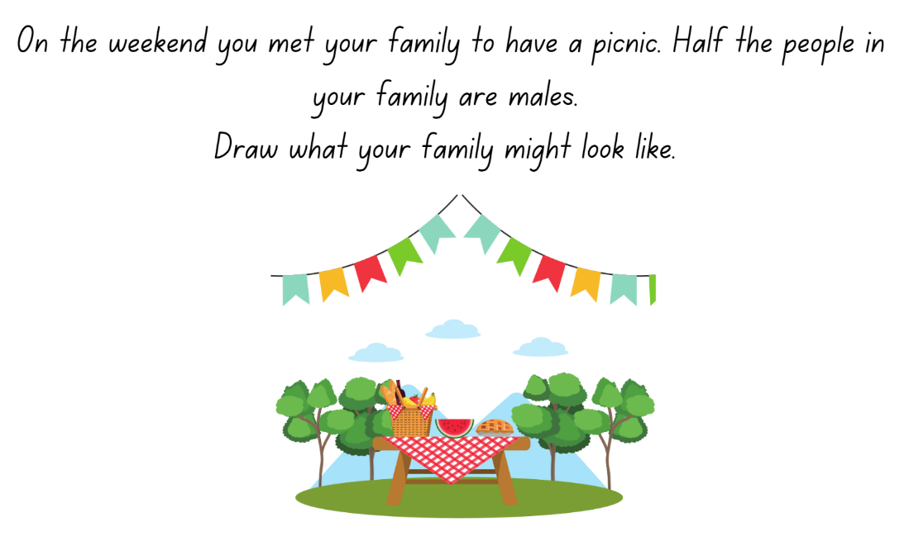
Images licensed under the Canva Content License Agreement.
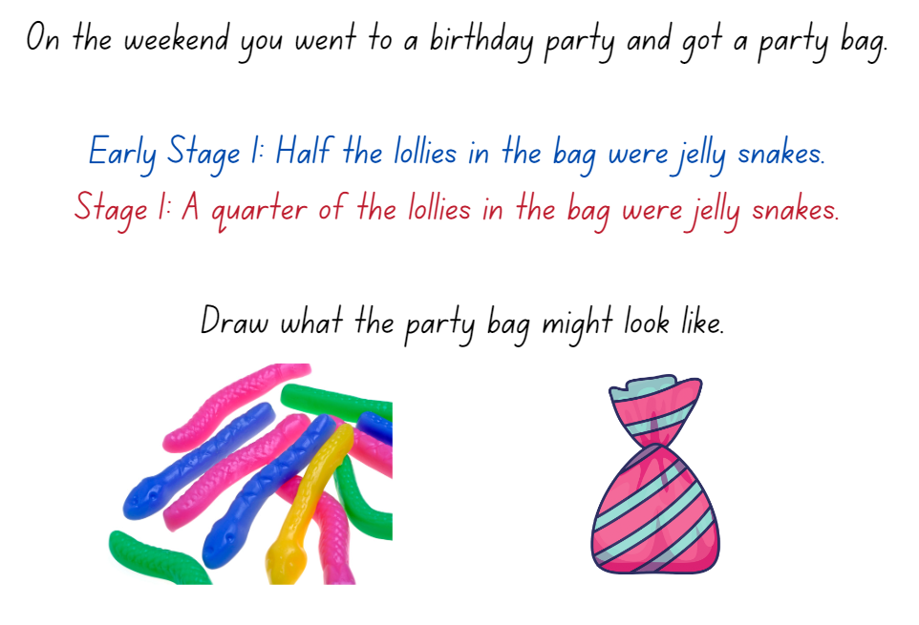
Images licensed under the Canva Content License Agreement.
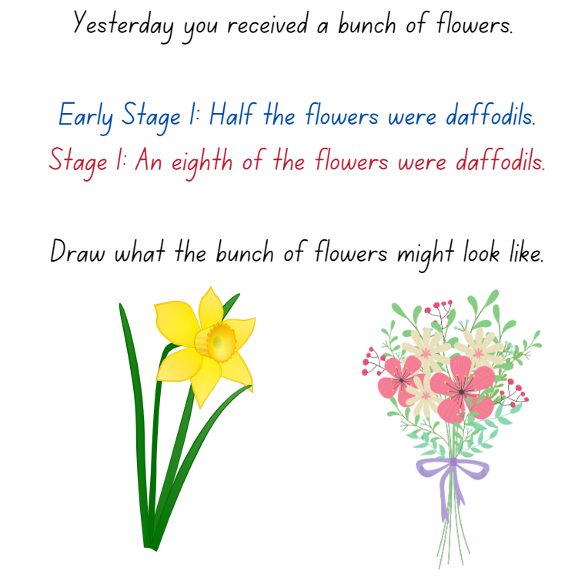
Images licensed under the Canva Content License Agreement.

Resource 16: Sharing chocolate
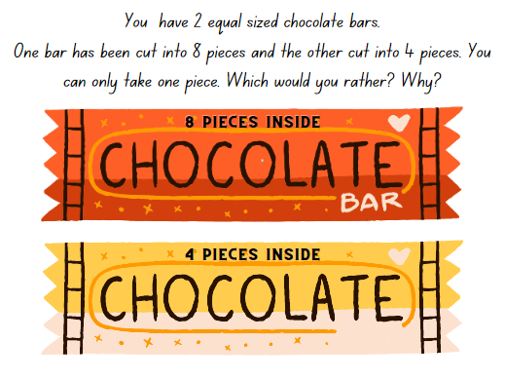
‘Chocolate Bar Illustration’ by ‘Sketchify’ licensed under the Canva Content Licence Agreement.

Resource 17: Chocolate bars
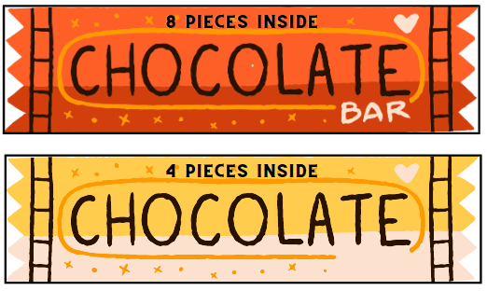
‘Chocolate Bar Illustration’ by ‘Sketchify’ licensed under the Canva Content Licence Agreement.

Resource 18: Sharing toy cars
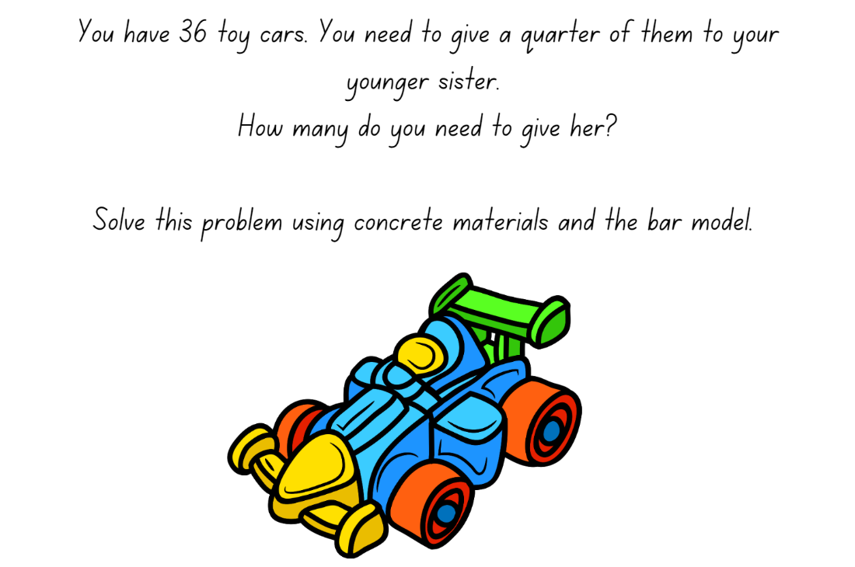
‘Toy Car’ by ‘heyrabbiticons’ licensed under the Canva Content Licence Agreement.

Resource 19: Sharing blocks
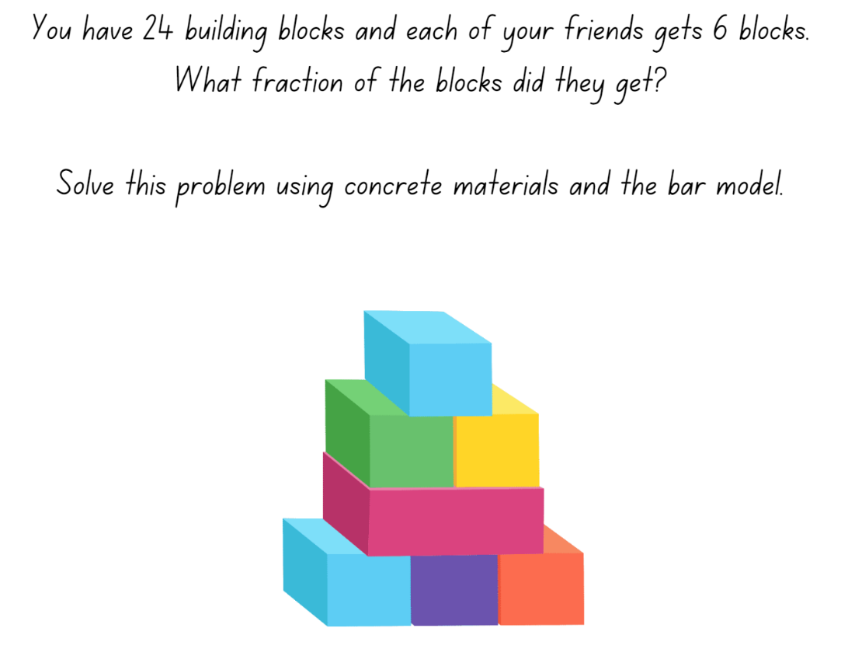
‘Toy Building Blocks’ by ‘zhaowhat’ licensed under the Canva Content Licence Agreement.

Resource 20: Sharing and grouping
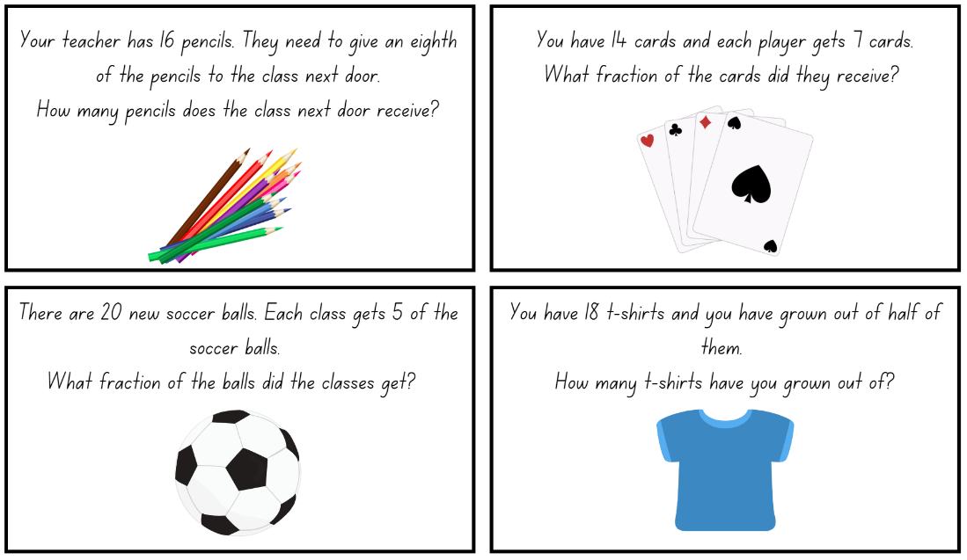
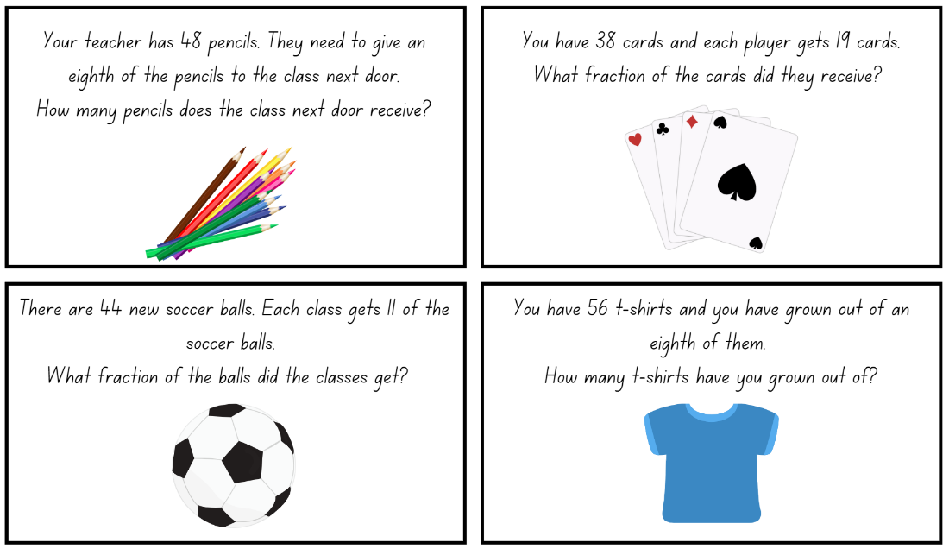
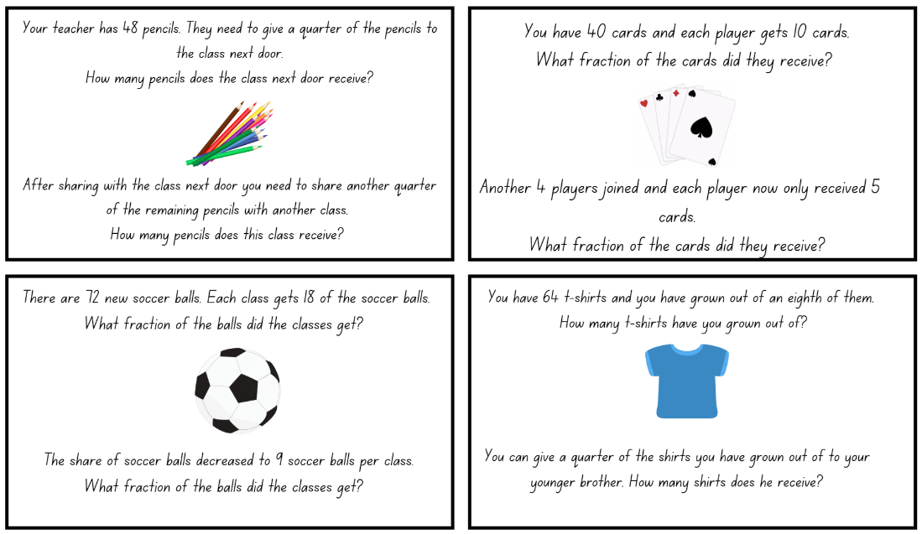
Images licensed under the Canva Content License Agreement.

Resource 21: Balloons
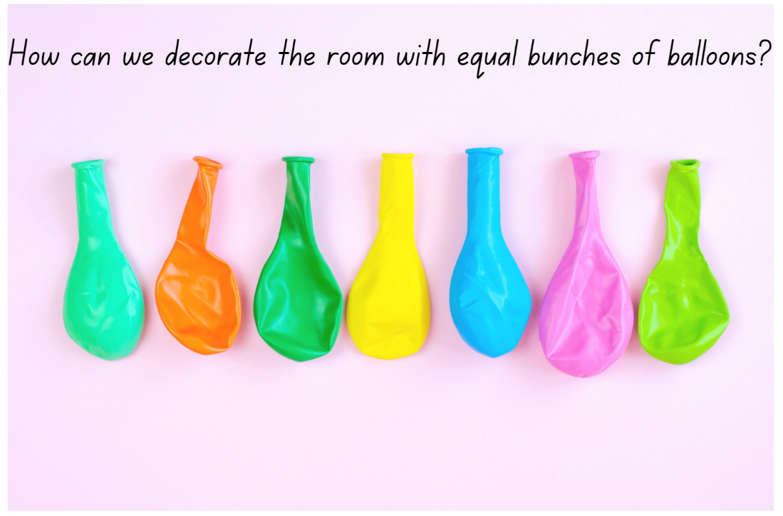
‘Many multicoloured deflated balloons’ by Maryna Terletska licensed under the Canva Content Licence Agreement.

Resource 22: Balloon sharing
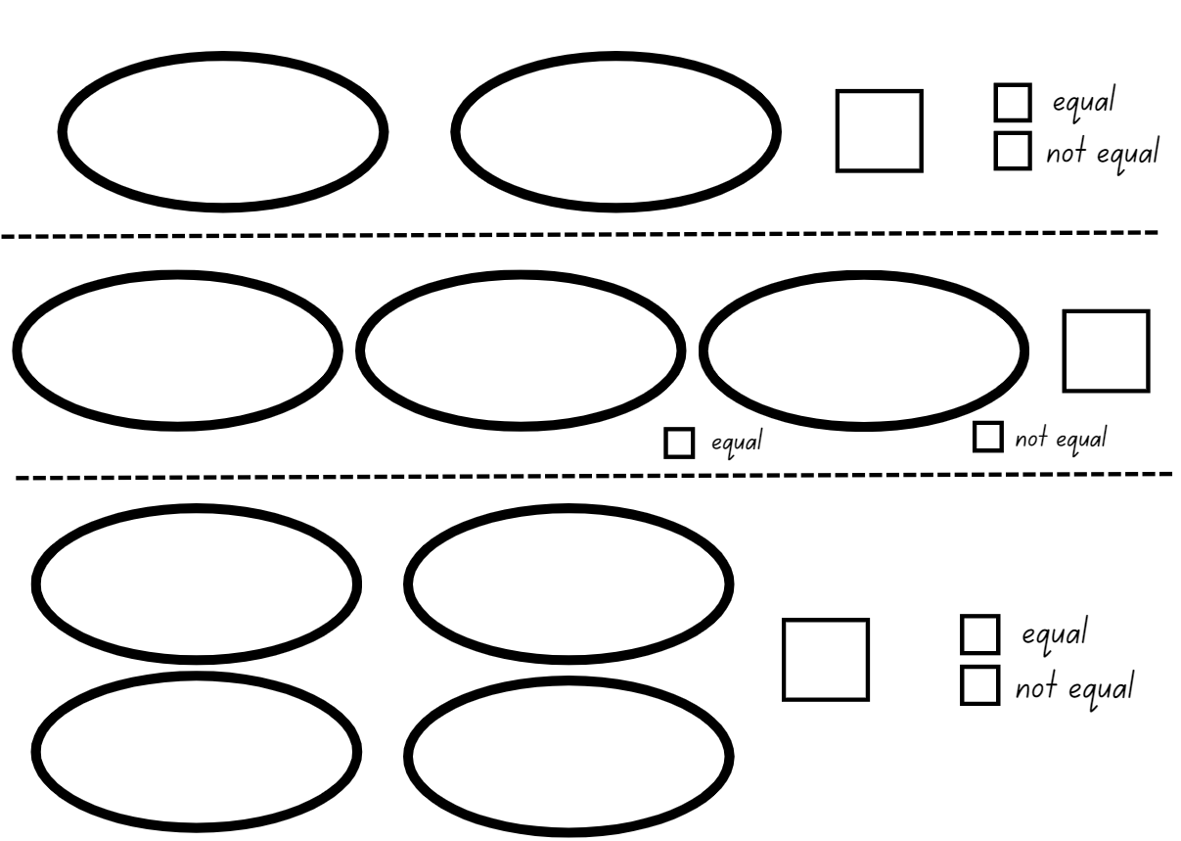
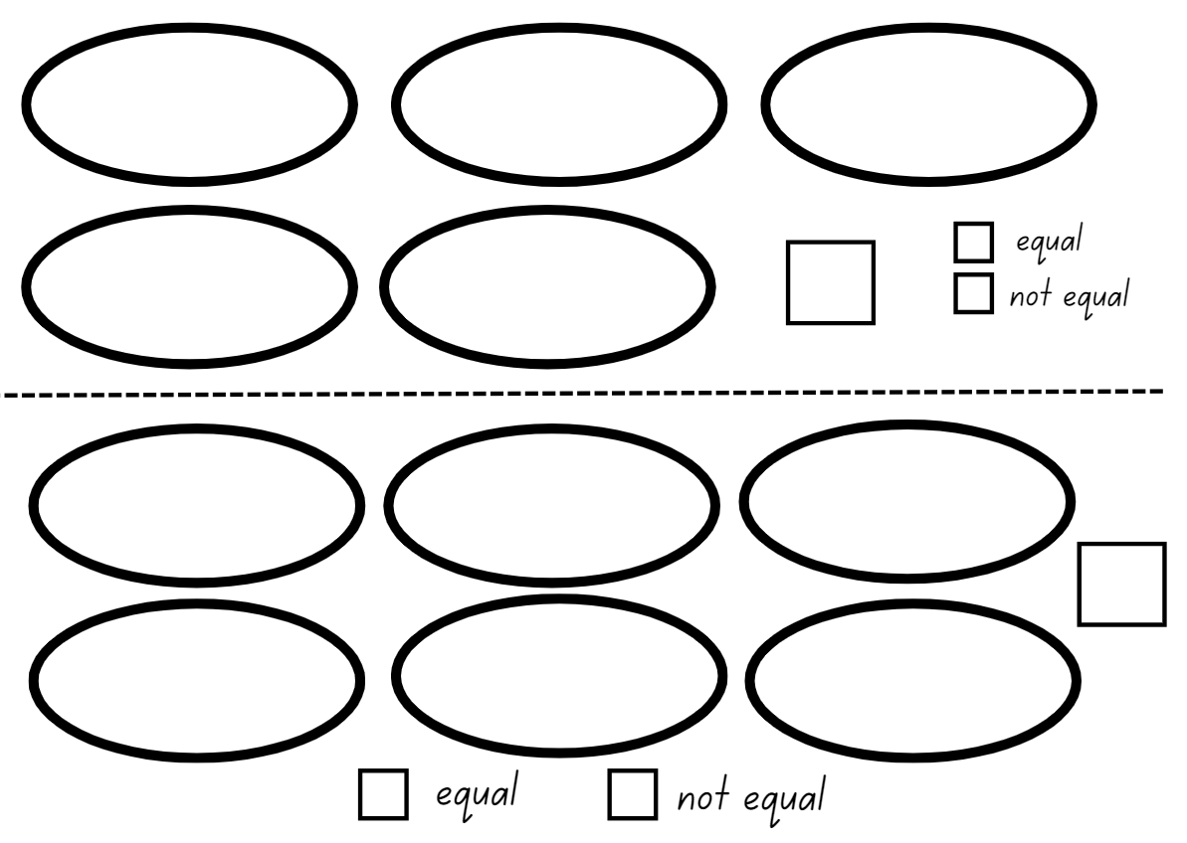

Resource 23: Maths Marvel
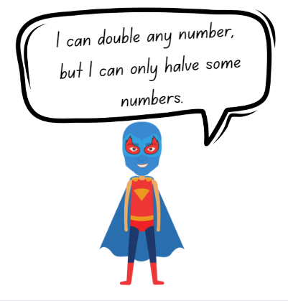
‘Boy Superhero’ by ‘grmarc2’ licensed under the Canva Content Licence Agreement.

Resource 24: Always true?
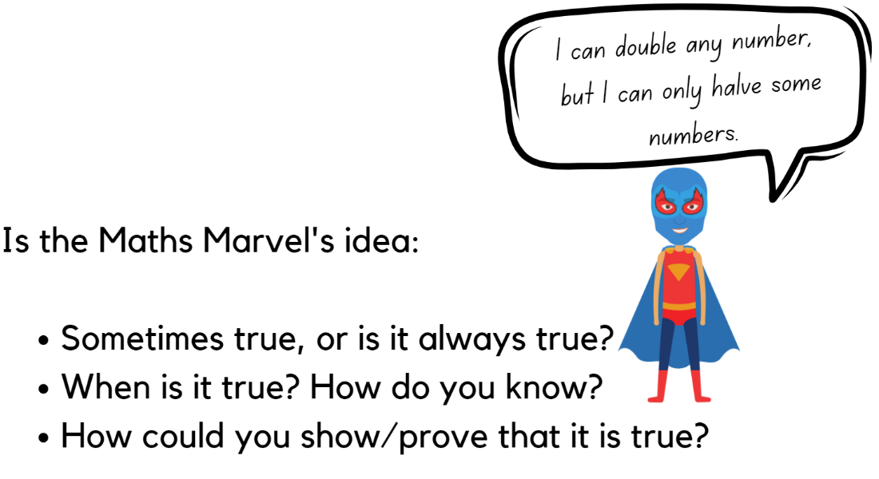
‘Boy Superhero’ by ‘grmarc2’ licensed under the Canva Content Licence Agreement.

Resource 25: Mindmap
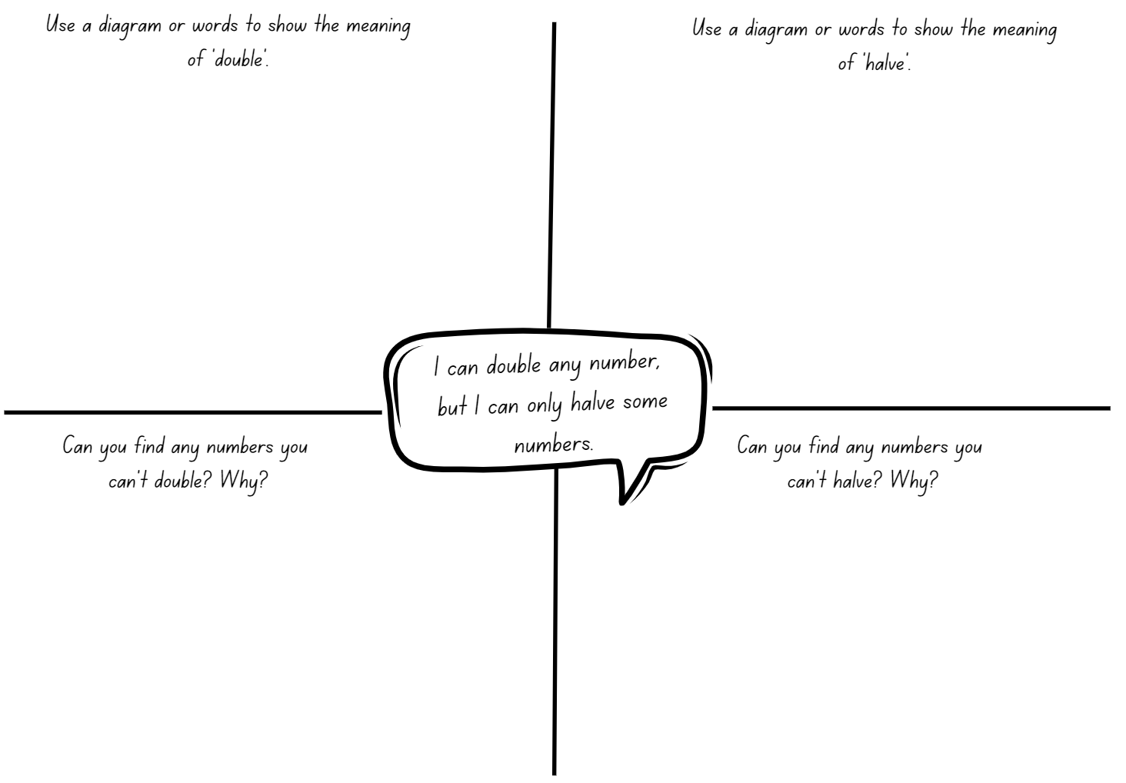

Syllabus outcomes and content
The table below outlines the syllabus outcomes and range of relevant syllabus content covered in this unit. Content is linked to National Numeracy Learning Progression version (3).
Focus area and outcomes | Content groups and content points | Lessons
Representing whole numbers  MAO-WM-01  MAE-RWN-01, MA1-RWN-01  MAE-RWN-02, MA1-RWN-02 | Early Stage 1  Use the counting sequence of ones flexibly  - Count forwards to at least 30 and state the number after or before a given number, without needing to count from one (CPr4)  - Identify the number before as 'one less' and the number after as 'one more’ than a given number | 7
Representing whole numbers (cont) | Early Stage 1  Recognise number patterns  - Recognise dice and domino dot patterns (NPA1, NPV2, CPr2)  - Recognise different finger patterns for the same number (NPA2) | 1–2
Representing whole numbers (cont) | Early Stage 1  Connect counting and numerals to quantities  - Read numerals to at least 20, including zero (NPV3)  - Compare and order numbers to 20 (NPV2-NPV3) | 1–3
Representing whole numbers A (cont) | Stage 1  Represent numbers on a line  - Sequence numbers and arrange them on a line by considering the order and size of those numbers (CPr5)  - Locate the approximate position of multiples of 10 on a model of a number line from 0 to 100 (CPr5) | 7
Representing whole numbers A (cont) | Stage 1  Represent the structure of groups of ten in whole numbers  - Use number lines and number charts to assist with locating the nearest ten to a number  - Estimate, to the nearest ten, the number of objects in a collection and check by counting in groups of ten (CPr7, NPV6) | 1, 7
Representing whole numbers B (cont) | Stage 1  Use counting sequences of ones and tens flexibly  - Identify how many more to the next multiple of ten within two- and three-digit numbers | 1,3, 7
Representing whole numbers B (cont) | Stage 1  Form, regroup, and rename three-digit numbers  - State the quantity value of digits in numbers of up to three digits (NPV5)  - Recognise units of 100 (UnM5, NPV5) | 2–3
Combining and separating quantities  MAO-WM-01  MAE-CSQ-01, MAE-CSQ-02 | Early Stage 1  Model additive relations and compare quantities  - Combine two or more groups of objects to model addition, identifying the relationship between the parts and the whole (AdS1-AdS2)  - Use concrete materials or fingers to model and solve addition and subtraction questions, counting forwards or backwards by ones as necessary (AdS1-AdS2, NPV3) | 5, 8
Combining and separating quantities (cont) | Early Stage 1  Identify part–whole relationships in numbers up to 10  - Use visual representations of numbers to assist with combining and separating quantities, identifying the relationship between the quantities (NPV2, NPA2, AdS2-AdS3)  - Count by ones to find the total or difference (AdS2-AdS3)  - Use drawings, words and numerals to record addition and subtraction, and explain their thinking (AdS2) | 5, 8
Forming groups  MAO-WM-01  MAE-FG-01, MAE-FG-02  MA1-FG-01 | Early Stage 1  Investigate equal groups by sharing  - Distribute a group of familiar objects into smaller groups and recognise whether the number in each group is equal or not (MuS1-MuS2)  - Group and share concrete materials by distributing objects one by one or using another method (MuS1-MuS2) | 4–8
Forming groups (cont) | Early Stage 1  Record grouping and sharing  - Label the number of objects in a group  - Record grouping and sharing using drawings, words and numerals, and explain their thinking (MuS2) | 4–8
Forming groups A (cont) | Stage 1  Recognise and represent division  - Use concrete materials to model a half of a collection and show the relation between the half and the whole (InF1)  - Model sharing division by distributing a collection of objects equally into a given number of groups to determine how many in each group (InF2, MuS5)  - Model grouping division by determining the number of groups of a given size that can be formed (MuS5)  - Describe the part left over when a collection cannot be distributed equally using the given group size (MuS6) | 4–8
Forming groups B (cont) | Stage 1  Model doubling and halving with fractions  - Model doubling and halving groups and the relation between the processes (MuS6, InF2)  - Re-create the whole given half (InF3)  - Use concrete materials to model a half, a quarter or an eighth of a collection, and explain their thinking (InF2-InF3) | 4–6, 8
Geometric measure  MAO-WM-01  MAE-GM-03  MA1-GM-03 | Early Stage 1  Length: Create half a length  - Divide a length into two equal parts (InF1)  - Distinguish between the halfway point and half a length  - Describe positions as 'about halfway', 'more than halfway' or 'less than halfway' (InF2) | 1–4
Geometric measure A (cont) | Stage 1  Length: Subdivide lengths to find halves and quarters  - Use concrete materials to model both half and quarters of a whole length, highlighting the length (InF2)  - Identify two equal parts and the relationship of the parts to the whole length, linking words and images (InF2)  - Recognise when lengths have or have not been divided into halves and quarters (InF2) | 1–5
Geometric measure B (cont) | Stage 1  Length: Repeatedly halve lengths to form eighths  - Use materials to model an eighth of a whole length, highlighting the length (InF2)  - Recognise when a length is divided into eight equal parts | 2–5

References
Links to third-party material and websites
Please note that the provided (reading/viewing material/list/links/texts) are a suggestion only and implies no endorsement, by the New South Wales Department of Education, of any author, publisher, or book title. School principals and teachers are best placed to assess the suitability of resources that would complement the curriculum and reflect the needs and interests of their students.
If you use the links provided in this document to access a third-party's website, you acknowledge that the terms of use, including licence terms set out on the third-party's website apply to the use which may be made of the materials on that third-party website or where permitted by the Copyright Act 1968 (Cth). The department accepts no responsibility for content on third-party websites.
Except as otherwise noted, all material is © State of New South Wales (Department of Education), 2023 and licensed under the Creative Commons Attribution 4.0 International License. All other material (third-party material) is used with permission or under licence. Where the copyright owner of third-party material has not licensed their material under a Creative Commons or similar licence, you should contact them directly for permission to reuse their material.
Mathematics K–10 Syllabus © 2022 NSW Education Standards Authority (NESA) for and on behalf of the Crown in right of the State of New South Wales.
© 2022 NSW Education Standards Authority. This document contains NSW Curriculum and syllabus content. The NSW Curriculum is developed by the NSW Education Standards Authority. This content is prepared by NESA for and on behalf of the Crown in right of the State of New South Wales. The material is protected by Crown copyright.
Please refer to the NESA Copyright Disclaimer for more information.
NESA holds the only official and up-to-date versions of the NSW Curriculum and syllabus documents. Please visit the NSW Education Standards Authority (NESA) website and the NSW Curriculum website.
National Numeracy Learning Progression © Australian Curriculum, Assessment and Reporting Authority (ACARA) 2010 to present, unless otherwise indicated. This material was downloaded from the Australian Curriculum website (National Numeracy Learning Progression) (accessed 21 March 2023) and was not modified. The material is licensed under CC BY 4.0. Version updates are tracked in the ‘Curriculum version history’ section on the 'About the Australian Curriculum' page of the Australian Curriculum website.
ACARA does not endorse any product that uses the Australian Curriculum or make any representations as to the quality of such products. Any product that uses material published on this website should not be taken to be affiliated with ACARA or have the sponsorship or approval of ACARA. It is up to each person to make their own assessment of the product, taking into account matters including, but not limited to, the version number and the degree to which the materials align with the content descriptions and achievement standards (where relevant). Where there is a claim of alignment, it is important to check that the materials align with the content descriptions and achievement standards (endorsed by all education Ministers), not the elaborations (examples provided by ACARA).
This resource contains images and content obtained from Canva, and their use outside of this resource is subject to Canva’s Content License Agreement. If you wish to use them separately from the resource, please go to Canva.
Askew M, Bishop S, Christie C, Eaton S, Griffin P, Morgan D and Oxford University Press (2015) Teaching for Mastery: Questions, tasks and activities to support assessment [PDF 6 MB], National Centre for Excellence in the Teaching of Mathematics, accessed 17 February 2023.
Australian Government Department of Education (2018) ‘Authentic Problems: Bunches of Balloons’, Teaching resources, reSolve: Maths by Inquiry website, accessed 17 February 2023.
Gould P (2013) ‘Australia’s next top fraction model’, Australian Primary Mathematics Classroom, 18(3):5–12, accessed 17 February 2023.
NCTEM (National Centre for Excellence in the Teaching of Mathematics) (2019) Mastery Professional Development: Fractions. Guidance on the teaching of fractions in Key Stage 1, Year 2 [PDF 3.17 MB], NCETM, accessed 17 February 2023.
Siemon D, Warren E, Beswick K, Faragher R, Miller J, Horne M, Jazby D & Breed M (2020) Teaching Mathematics Foundations to Middle Years, 3rd den, Oxford University Press, Victoria.
State of Victoria (Department of Education and Training) (n.d.) ‘Fractions of shapes and collections’, Number and Algebra, Maths Curriculum Companion website, accessed 13 February 2023.
Sullivan P and Lilburn P (2017) Open-ended Maths Activities: Using ‘Good’ Questions to Enhance Learning in Mathematics, Revised edn, Oxford University Press ANZ, Great Britain.

