Mathematics – K-2 multi-age – Year B – Unit 14

Contents
Unit description and duration 4
Student prior learning 4
Lesson overview and resources 5
Lesson 1: Exploring length 17
Daily number sense: Guess my number – 15 minutes 18
How long is that? – 50 minutes 20
Part 1 – Making a measuring device 21
Part 2 – Measuring length 23
Consolidation and meaningful practice: Gallery Walk – 10 minutes 25
Lesson 2: Longer or shorter 26
Daily number sense: Track Your Number – 10 minutes 27
Slithering Snakes – 45 minutes 30
Consolidation and meaningful practice: Drawings – 15 minutes 32
Lesson 3: Exploring flat spaces 33
Daily number sense: Poison Number– 15 minutes 34
Sleeping snakes– 40 minutes 38
Discuss and connect the mathematics – 10 minutes 42
Lesson 4: Comparing and ordering 43
Daily number sense: Which doesn’t belong? – 10 minutes 44
How do we compare? – 50 minutes 45
Consolidation and meaningful practice: A problem with area – 10 minutes 49
Lesson 5: Investigating capacity 50
Daily number sense: Before and after – 10 minutes 51
What can I fit inside? – 45 minutes 52
Consolidation and meaningful practice: Curious about containers – 10 minutes 55
Lesson 6: Where does this fit? 56
Daily number sense: Number chart puzzle – 10 minutes 57
Where does this fit? – 15 minutes 59
What does it look like? – 35 minutes 62
Consolidation and meaningful practice: Fill that space! – 10 minutes 64
Lesson 7: Multiple masses 65
Daily number sense: An up and down story – 10 minutes 66
Problem solving with mass – 50 minutes 69
Discussing and connecting the mathematics – 5 minutes 72
Lesson 8: Measurement investigators 73
Daily number sense: 10 minutes 74
Measurement investigators – 50 minutes 74
Discussing and connecting the mathematics – 5 minutes 79
Resource 1: Animals everywhere 80
Resource 2: Species of snakes 81
Resource 3: Early Stage 1-Investigating length 82
Resource 4: Stage 1 – Investigating length 83
Resource 5: Sleeping snakes 84
Resource 6: What doesn’t belong? 85
Resource 7: Comparing area 86
Resource 8: Number chart puzzle 89
Resource 9: An empty space 90
Resource 10: An up and down story 91
Resource 11: Measurement Investigators 92
Syllabus outcomes and content 93
References 104

Unit description and duration
This two-week unit develops student knowledge, skills and understanding of measurement. Students are provided opportunities to:
- compare, order and match measurement attributes by using direct comparison and informal units
- consider how the choice of measuring unit affects accuracy
- explore conservation of length, area, internal volume (capacity) and volume and mass
- explore, connect and communicate their thinking about mathematical measurement techniques.
Mathematics K–10 Syllabus © 2022 NSW Education Standards Authority (NESA) for and on behalf of the Crown in right of the State of New South Wales.

Student prior learning
Before engaging in these teaching and learning activities, students would benefit from prior experience with:
- using everyday language to compare length, area, internal volume (capacity), volume and mass such as lighter, heavier, wider, thinner, bigger, smaller, taller, shorter, longer
- making direct comparisons with measurement, for example, hefting and superimposing
- recognising and sorting everyday objects by length, area, mass, and volume
- using an equal-arm balance to predict and compare the mass of 2 different objects.

Lesson overview and resources
The table below outlines the sequence and approximate timing of lessons; syllabus focus areas and content groups; and resources.
Lesson | Syllabus focus area and content groups | Resources
Lesson 1: Exploring length  75 minutes  Consistent units of measurement are needed for comparison of length. | Representing whole numbers  Early Stage 1  - Connect counting and numerals to quantities  Stage 1 – Part A  - Represent the structure of groups of ten in whole numbers  Stage 1 – Part B  - Form, regroup, and rename three-digit numbers  Geometric Measure  Early Stage 1  - Length: Use direct and indirect comparisons to decide which is longer  Stage 1 – Part A  - Length: Measure the lengths of objects using uniform informal units  - Length: Compare lengths using uniform informal units  Stage 1 – Part B  - Length: Compare and order lengths, using appropriate uniform informal units | - Resource 1: Animals everywhere  - Chalk  - Informal units of measurement such as matchsticks, paperclips, blocks, counters  - Playing cards or cards with the digits 1–8  - String or wool  - Wide strips of paper, card, pipe cleaners or string  - Writing materials
Lesson 2: Longer or shorter  70 minutes  Informal units can be used to measure and compare lengths. | Representing whole numbers  Early Stage 1  - Use the counting sequence of ones flexibly  - Connect counting and numerals to quantities  Stage 1 – Part A  - Represent the structure of groups of ten in whole numbers  Stage 1 – Part B  - Use counting sequences of ones and tens flexibly  Geometric Measure  Early Stage 1  - Length: Use direct and indirect comparisons to decide which is longer  Stage 1 – Part A  - Length: Measure the lengths of objects using uniform informal units  - Length: Compare lengths using uniform informal units  Stage 1 – Part B  - Length: Compare and order lengths, using appropriate uniform informal units | - Resource 2: Species of snakes (enlarged and printed as A3 size)  - Resource 3: Early Stage 1 – Investigating length  - Resource 4: Stage 1 – Investigating length  - 10-sided dice  - 20-sided dice  - Informal units of measurement such as matchsticks, paperclips, blocks, counters  - Number chart 1–120  - Number track 1–20  - String or wool  - Writing materials
Lesson 3: Exploring flat spaces  65 minutes  Informal units can be used to measure and compare length and area. | Representing whole numbers  Early Stage 1  - Connect counting and numerals to quantities  Stage 1 – Part A  - Represent the structure of groups of ten in whole numbers  Stage 1 – Part B  - Form, regroup, and rename three-digit numbers  Forming groups  Stage 1 – Part B  - Represent and explain multiplication as the combining of equal groups  Two-dimensional spatial structure  Early Stage 1  - Area: Identify and compare area  Stage 1 – Part A  - Area: Measure areas using uniform informal units  Stage 1 – Part  - Area: Compare rectangular areas using uniform square units of an appropriate size in rows and columns | - Resource 5: Sleeping snakes  - 4 or 5 different sized paper squares and rectangles  - 10-sided dice  - 20-sided dice  - Counters  - Digital device  - Informal units of measurement such as matchsticks, paperclips, blocks, counters  - Modelling clay  - Number chart 1–120  - Number track 1–20  - Square tiles or cubes  - Writing materials
Lesson 4: Comparing and ordering  70 minutes  Using a consistent unit of measurement enables comparing and ordering. | Representing whole numbers  Early Stage 1  - Instantly name the number of objects within small collections  - Recognise number patterns  Stage 1 – Part A  - Continue and create number patterns  Forming groups  Stage 1 – Part B  - Represent and explain multiplication as the combining of equal groups  Two-dimensional spatial structure  Early Stage 1  - Area: Identify and compare area  Stage 1 – Part A  - Area: Indirectly compare area  - Area: Measure areas using uniform informal units  Stage 1 – Part B  - Area: Compare rectangular areas using uniform square units of an appropriate size in rows and columns | - Resource 6: What doesn’t belong?  - Resource 7: Comparing area  - Square tiles or cubes  - Two-dimensional shape tiles  - Writing materials
Lesson 5: Investigating capacity  65 minutes  Internal volume (capacity) is a measure of how much a container or object can hold. | Representing whole numbers  Early Stage 1  - Use the counting sequence of ones flexibly  - Connect counting and numerals to quantities  Stage 1 – Part A  - Use counting sequences of ones with two-digit numbers and beyond  Stage 1 – Part B  - Use counting sequences of ones and tens flexibly  - Form, regroup, and rename three-digit numbers  Three-dimensional spatial structure  Early Stage 1  - Volume: Compare internal volume by filling and packing  Stage 1 – Part A  - Volume: Measure the internal volume (capacity) of containers by packing  Stage 1 – Part B  - Volume: Compare containers based on internal volume (capacity) by filling and packing | - Coloured bricks  - Concrete materials such as paper clips, counters, marbles, tiles, buttons and cubes  - Containers and objects  - Digital device  - Interactive spinner  - Writing materials
Lesson 6: Where does this fit?  60 minutes  Volume is the space occupied by a container or object. | Representing whole numbers  Early Stage 1  - Use the counting sequence of ones flexibly  - Connect counting and numerals to quantities  Stage 1 – Part A  - Use counting sequences of ones with two-digit numbers and beyond  - Represent the structure of groups of ten in whole numbers  Three-dimensional spatial structure  Early Stage 1  - Volume: Compare volume by building  Stage 1 – Part A  - Volume: Construct volumes using cubes  Stage 1 – Part B  - Volume: Compare volumes using uniform informal units | - Resource 8: Number chart puzzle  - Resource 9: An empty space  - 2 different sized lunchboxes (with lids and no reference to the internal boundaries of the lunchbox)  - Concrete materials such as blocks, cubes, coloured bricks, counters, square tiles, two-dimensional shape tiles  - Digital number chart  - Various containers and boxes  - Writing materials
Lesson 7: Multiple masses  65 minutes  We can compare and order objects by their mass. | Representing whole numbers  Early Stage 1  - Use the counting sequence of ones flexibly  Stage 1 – Part A  - Use counting sequences of ones with two-digit numbers and beyond  Non-spatial measure  Early Stage 1  - Mass: Identify and compare mass using weight  Stage 1 – Part A  - Mass: Investigate mass using an equal-arm balance  Stage 1 – Part B  - Mass: Compare the masses of objects using an equal-arm balance | - Resource 10: An up and down story  - Concrete materials such as cubes, blocks, counters, square tiles  - Multiple equal-arm balances  - Uniform informal units of measurement and everyday classroom objects  - Various suitable objects for measuring mass  - Writing materials
Lesson 8: Measurement investigators  65 minutes  The unit of measure to use is determined by what needs to be measured. | Representing whole numbers  Early Stage 1  - Use the counting sequence of ones flexibly  Stage 1 – Part A  - Use counting sequences of ones with two-digit numbers and beyond  Geometric Measure  Early Stage 1  - Length: Use direct and indirect comparisons to decide which is longer  Stage 1 – Part A  - Length: Measure the lengths of objects using uniform informal units  - Length: Compare lengths using uniform informal units  Forming groups  Stage 1 – Part B  - Represent and explain multiplication as the combining of equal groups  Two-dimensional spatial structure  Early Stage 1  - Area: Identify and compare area  Stage 1 – Part A  - Area: Measure areas using uniform informal units  Stage 1 – Part B  - Area: Compare rectangular areas using uniform square units of an appropriate size in rows and columns  Three-dimensional spatial structure  Early Stage 1  - Volume: Compare internal volume by filling and packing  Stage 1 – Part A  - Volume: Measure the internal volume (capacity) of containers by packing  Three-dimensional spatial structure  Early Stage 1  - Volume: Compare volume by building  Stage 1 – Part A  - Volume: Construct volumes using cubes  Non-spatial measure  Early Stage 1  - Mass: Identify and compare mass using weight  Stage 1 – Part A  - Mass: Investigate mass using an equal-arm balance | - Resource 11: Measurement investigators  - Digital devices  - Informal units of measurement such as matchsticks, paperclips, blocks, counters  - Modelling clay  - Multiple equal-arm balances  - Placemats

Lesson 1: Exploring length
Core concept: Consistent units of measurement are needed for comparison of length.
The table below contains suggested learning intentions and success criteria. These are best co-constructed with students.
Learning intentions | Success criteria
All students are learning that:  - units of measurement can be selected to estimate, measure, record and compare lengths  - the length of an object remains constant when rearranged.  Students working towards Early Stage 1 outcomes are learning that:  - when counting a sequence of numbers, each numeral has a name  - numbers can be represented as numerals or quantities.  Students working towards Stage 1 outcomes are learning that:  - numbers can be partitioned in different ways  - each digit in a two- and three-digit number has a place value. | All students can:  - recognise a piece of string is still the same length even when rearranged  - record and compare lengths using numerals and words.  In addition, students working towards Early Stage 1 outcomes can explore comparative relationships between numbers to 10.  In addition, students working towards Stage 1 outcomes can partition a three-digit number in different ways to explore place value.

Daily number sense: Guess my number – 15 minutes
This activity has been adapted from Guess my number from Thinking Mathematically.
- Build student understanding of whole number by reasoning about quantities.
- In pairs, students use playing cards or cards with the digits 1 to 8, set out as in Figure 1.
Figure 1 – Number cards
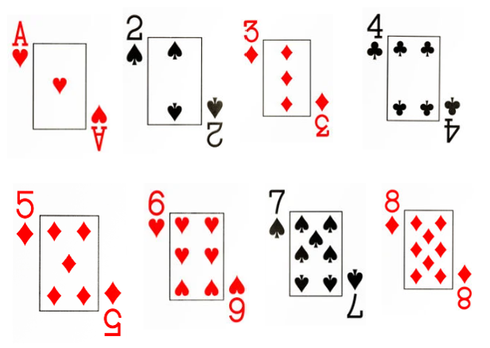
Images sourced from Canva and used in accordance with the Canva Content License Agreement.
Note: Early Stage 1 students select one of the displayed numbers as their secret number. Stage 1 students combine the displayed numbers to select a two- or three-digit number as their secret number.
- Player 1 selects a secret number.
- Player 2 uses questioning strategies to guess the secret number. For example, students could ask if the number is less than 5, more than 4 or an odd number. Player 1 will respond with yes and no answers.
- Explain to students that the objective of the game is to guess the secret number with the fewest questions possible.
- Ask students:
- What was the most useful strategy to guess the number?
- What did you notice when your questions were answered with a yes or a no?
- What would you do differently to guess the number in fewer guesses?
The table below details assessment opportunities and differentiation ideas.
Assessment opportunities | Too hard? | Too easy?
What to look for:  - Can students explore comparative relationships between numbers 1 to 10? (MAO-WM-01, MAE-RWN-01, MAE-RWN-02)  - Can students explore comparative relationships between two- and three-digit numbers? (MAO-WM-01, MAE1-RWN-01, MA1-RWN-02)  What to collect:  - observations of students playing the game and recordings of discussions and strategies used (MAO-WM-01, MAE-RWN-01, MAE-RWN-02, MA1-RWN-01, MA1-RWN-02) | Students cannot explore comparative relationships between numbers 1 to 10.  - Represent the numbers using concrete materials to visually support students compare quantity.  - Use a number track to visually support students and to help them name and identify numbers.  Students cannot explore comparative relationships between two- or three-digit numbers.  - Decrease the numbers to 20.  - Use a number line. | Students can explore comparative relationships between numbers 1 to 10. Increase numbers to 20 by adding a 9 and 10 card and allowing students to combine digits.  Students can explore comparative relationships between two- or three-digit numbers. Students try to guess the number with 3 guesses only.

How long is that? – 50 minutes
Note: Students may have prior knowledge of measuring length and the challenges that may arise if they have completed previous units, such as use of formal units with a metre ruler in K-2 multi-age Year B Unit 3, or fractional parts of lengths in K-2 multi-age Year B Unit 8. The animals shown in Resource 1: Animals everywhere are paintings and carvings from around the world. Consider using representations of animals from your local community or Aboriginal and Torres Strait Islander cultures if appropriate and available.

Part 1 – Making a measuring device
Note: For this activity, Stage 1 students will make a measuring device comprised of 10 uniform informal units. Early Stage 1 students will indirectly compare lengths using longer uniform informal units, such as pre-cut string or wool of uniform lengths of 30 cm.
- Display Resource 1: Animals everywhere. Allow time for students to turn and talk to make observations and connections.
- Explain that, in the past, many groups of people drew or carved animals because animals were very important to them. Ask students if they can think of any reasons why. Explain people needed animals to survive by using them for food, clothing and making tools. Some animals also had spiritual importance. Animals were so precious that people painted and carved them in many places. Often, the paintings and carvings were bigger than life size to show how important animals were. The paintings do not include much detail and are usually flat or two-dimensional, but it is still easy to identify exactly what animals they are.
- Ask students:
- What could be used to measure such large animals?
- Have you seen or used any tools as a measuring device?
- What tool could you make to measure a representation of an animal, such as the ones in Resource 1: Animals everywhere? How would you make your tool?
- Explain that a long time ago, feet were often used to measure and sometimes hands were used too. Model how to place your feet heel to toe to measure the length of the classroom, asking students to keep count as you step. Select a student to use their hand span to measure the length of a table.
- Discuss some situations where using a foot or hand to measure would not be appropriate or very accurate, for example, measuring the height of a tree.
- Explain to Early Stage 1 students that they will work with a partner and use lengths of string or wool to compare specific attributes of a drawn animal, such as the length of a leg or the body from head to tail. Model using a piece of string or wool to directly compare the length of various parts of your body using explicit comparative language.
- Make a joint list of items that Early Stage 1 students can compare with string or wool. Instruct Early Stage 1 students to compare those items while Stage 1 students make measuring devices.
Make, mark and move: Using the phrase ‘make, mark and move’ assists students in understanding the concept of repeated units. By placing a unit on a flat surface, marking where it ends, moving it along and continuing the process, students identify that the unit of measurement is the space between the marks on a measuring device and not the marks themselves.
- Explain to Stage 1 students that, with a partner, they will make a measuring device like the one shown in Figure 2.
Figure 2 – Example of a student’s measuring device showing uniform units used
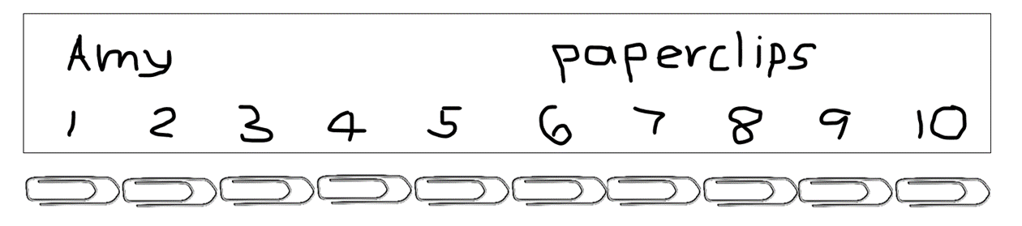
- Provide Stage 1 students with a wide strip of paper, card, pipe cleaners or string. Students investigate the material and discuss how it may be adapted to be used as a measuring tool. Students brainstorm ideas. Select students to share their ideas, using examples for students to view and refer to as they make decisions about the appropriateness of ideas.
- Explain to students that they need to lay 10 uniform informal units and make marks to show measuring intervals (like a ruler). Remind all students that a unit of measurement, like a paper clip, needs to be placed side by side with no gaps or overlaps for the measuring device to be accurate and useful.
- Students compare devices with partner. If using the same uniform informal unit, the devices should be close in length to each other. Discuss the importance of consistency.

Part 2 – Measuring length
- Take students outside with their measuring devices, string, chalk and writing materials. Draw a simple outline of an animal, like the cave drawings. Discuss different features of the drawing that can be used to measure length, for example, length of leg, tail, head to tail, foot to shoulder. Discuss measuring the curves and odd shapes.
- Model how to mark a starting and end point of a feature to measure. Explain that this is necessary for accuracy.
- For Early Stage 1 students, model how to compare lengths directly and indirectly from the drawing using pre-cut string. Model how to use comparative language such as longer, shorter, the same length as.
- For Stage 1 students, discuss how to keep track of the measuring count and how to record the measurements. Ask a pair of students to measure one feature by placing their measuring devices end to end, without gaps or overlaps. Then ask how they are going to keep track of the count, for example, by using tally marks, dot marks or counting numbers in a line.
- Bring attention to a circumstance where the measuring device length does not match the total length being measured. Explain that when it is the students’ turn to measure, they need to come up with ways to measure the remaining length.
- Draw at least 4 additional animals. Divide the class into groups to measure and record the length of different features of each drawing. Move between groups to support students using their measuring devices. Observe students’ thinking and strategies about how to record their counting as it moves into larger numbers. Ask:
- How do you know you have measured length?
- How have you measured accurately?
- What problems are you encountering?
- What happens to the parts left over from the measure?
Note: Retain student measuring devices and lengths of string for use in Lesson 2.
This table details assessment opportunities and differentiation ideas.
Assessment opportunities | Too hard? | Too easy?
What to look for:  - Do students compare lengths directly by placing objects side by side and aligning the ends? (MAO-WM-01, MAE-GM-02, MA1-GM-02)  - Can students use comparative language to describe length? (MAO-WM-01, MAE-GM-02)  - Do students select appropriate units of measurement to estimate and measure lengths, and describe the part left over? (MAO-WM-01, MA1-GM-02)  - Can students record and compare lengths using drawings, numerals and words? (MAO-WM-01, MAE-GM-02, MA1-GM-01)  What to collect:  - observational records of students making devices or using string to measure (MAO-WM-01, MAE-GM-02, MA1-GM-02)  - work samples of recording using words, pictures and numbers (MAO-WM-01, MAE-GM-02, MA1-GM-02) | Students cannot measure the length of various features of the animal.  - Model using string to measure the length of one feature. Students use that length of string to compare the length of another feature.  - Model using the measuring device as an appropriate uniform informal unit to measure part of the animal, identifying left-over parts. Students continue measuring. | Students find the length of the animal.  - Students use a metre ruler to measure the identified parts of the animal using formal units.  - Students problem-solve where the halfway point is for each feature – each side must be equal.

Consolidation and meaningful practice: Gallery Walk – 10 minutes
- As a class, conduct a gallery walk around each of the 5 animals to observe the records of measurements made by each group.
- Bring students back together. Ask students:
- What went well when you measured?
- What were the challenges when you measured?
- How did you describe the parts left over?
- Would you change anything if you did this activity again?
- What are you wondering about?

Lesson 2: Longer or shorter
Core concept: Informal units can be used to measure and compare lengths.
The table below contains suggested learning intentions and success criteria. These are best co-constructed with students.
Learning intentions | Success criteria
All students are learning that:  - mathematical reasoning can be used to explore attributes of measurement  - uniform informal units can be selected to measure and compare length.  Students working towards Early Stage 1 outcomes are learning that objects, drawings and words are useful to represent numbers as quantities.  Students working towards Stage 1 outcomes are learning that:  - number lines are useful when arranging and sequencing two-digit numbers  - numbers can be partitioned in different ways. | All students can:  - explore and explain ideas about length  - estimate and measure length  - record and compare lengths using numerals and words.  In addition, students working towards Early Stage 1 outcomes can:  - read numerals to at least 20  - identify numbers ‘one more’ and ‘one less’ than a given number  - explain which is longer or shorter.  In addition, students working towards Stage 1 outcomes can:  - name, order and partition a two- or three-digit number  - use number charts to locate the nearest 10 to a number.

Daily number sense: Track your number – 10 minutes
- Build student understanding of whole number quantity by identifying and comparing numbers.
- Display a number track with numbers 0 to 20.
- Roll a 20-sided die. Ask Early Stage 1 students to identify the number rolled on the board, and the number that is ‘one more’ and ‘one less’. Ask Stage 1 students to locate the nearest 10.
- Repeat rolls until all Early Stage 1 students have had a turn.
- Provide Early Stage 1 students with dice and a 0 to 20 number track to continue playing independently, identifying numbers and the number that is ‘one more’ and ‘one less’.
Note: If you do not have a physical chart, this digital number chart can be set from 0 to 120 by adjusting the starting number to zero and expanding both the rows and columns to 11. It can be adjusted in a variety of ways to work with numbers to 1000.
- For Stage 1 students, display a number chart for 0 to 120.
- Roll 2 dice labelled 0 to 9, for example, 10-sided dice. For this digital 10-sided dice, select the light blue die and the number 2.
- Ask a Stage 1 student to form the largest number, state the quantity value of each digit and locate the number on the chart.
- Roll again. Ask a second Stage 1 student to form the largest number, state the quantity value of each digit and locate the number on the chart.
- Ask students to identify which of the 2 numbers is closest to 100. Stage 1 students can calculate the difference between numbers, or how far to 100 or 120 for each number.
- Extend the activity to 3 dice to explore numbers to 1000. Ask:
- What three-digit numbers can be formed with those digits?
- What is the quantity value of each digit in those numbers?
- What are the closest hundreds to those numbers?
- How can those numbers be partitioned and renamed?
The table below details assessment opportunities and differentiation ideas.
Assessment opportunities | Too hard? | Too easy?
What to look for:  - Can students read numerals to at least 20? (MAO-WM-01, MAE-RWN-02)  - Can students identify, name and state the number before and after a given number? (MAO-WM-01, MAE-RWN-01, MAE-RWN-02)  - Can students use a number chart to locate the nearest ten to a number up to 1000? (MAO-WM-01, MA1-RWN-01, MA1-RWN-02)  - Can students state the quantity value of digits in numbers of up to 3 digits? (MAO-WM-01, MA1-RWN-01)  What to collect:  - observational records (MAO-WM-01, MAE-RWN-01, MAE-RWN-02, MA1-RWN-01, MA1-RWN-02) | Students find it difficult to read numerals to 20.  - Focus on numbers 1 to 10 only.  - Use concrete materials and a number track to model ‘one less’ and ‘one more’.  Students find it difficult to form and order two-digit numbers.  - Model forming numbers with bundles of 10 or MAB blocks and compare them.  - Model ordering numbers on a number line. | Students are confident with forming and ordering two-digit numbers.  - Students count forwards off the decade by 10, for example, 27, 37, 47…  - Students count backwards off the decade by 10, for example, 76, 66, 56...  - Select a number chart with three-digit numbers, such as 400, and form numbers in that range.  - Select a mystery three-digit number and have others guess it.

Slithering snakes – 45 minutes
Note: Prior to lesson, prepare containers of uniform informal materials from which students may select, for example, interlocking blocks, paperclips, square tiles or counters. Resource 2: Species of snakes is best enlarged and printed as A3 size.
- Remind students about the measurements they made of the animal cave drawings in Lesson 1. Discuss any issues with accurate measurement. Guide discussion to measuring curved lines, parts left over and starting and ending at correct points.
- Remind students about using the phrase ‘make, mark and move’ from Lesson 1 to support their understanding of repeated units.
- Display Resource 2: Species of snakes. Explain that different snake species have different features that scientists use to identify and study them. Ask students if they know any snake species or how to identify them. Discuss features of the snakes’ appearance such as colour, patterns, thickness and length.
- Brainstorm student approaches for measuring length of each snake. Ask:
- How could you measure the length of a snake if it was straight, curved, or coiled?
- What tools do we have in the classroom to help us measure the length of a snake?
- Explain to students they will work with a partner and predict the order of each snake from shortest to longest. Students record their predictions on Resource 3: Early Stage 1 – Investigating length and Resource 4: Stage 1 – Investigating length.
- Early Stage 1 students use string to measure and compare the length of each snake and record their answers on Resource 3: Early Stage 1 – Investigating length. Students justify their results by using comparative language such as longer than, longest, shorter than, shortest, same length as.
- Stage 1 pairs select and use a uniform informal unit (paper clips, counters or interlocking cubes) to measure and order the snakes from the shortest length to the longest and record results. Students compare their estimates.
- Students share their findings with another pair who used a different unit of measure.
- Students swap the units of measure and remeasure their snakes with new units. Record on Resource 4: Stage 1 – Investigating length.
- Select pairs of students to report back their findings. Ask:
- Which unit of measure was most accurate? Why?
- What problems did you notice?
- How could you solve those problems?
The table below details assessment opportunities and differentiation ideas.
Assessment opportunities | Too hard? | Too easy?
What to look for:  - Do students use uniform, informal units to measure length end to end with no gaps or overlaps? (MAO-WM-01, MA1-GM-02)  - Can students explain and describe any part left over? (MAO-WM-01, MA1-GM-02)  - Can students identify and order lengths from shortest to longest, using comparative language? (MAO-WM-01, MAE-GM-02, MA1-GM-02)  - Do students understand that snake position and orientation does not affect the length? (MAO-WM-01, MAE-GM-02, MA1-GM-02)  - Do students recognise the relationship between the size of the chosen unit and the number of units needed? (MAO-WM-01, MA1-GM-02)  What to collect:  - annotated work samples (MAO-WM-01, MAE-GM-02, MA1-GM-02) | Students cannot use uniform informal units to measure and compare length.  - Model placing materials end to end with no gaps or overlaps.  - Measure straight lengths, instead of curved.  - Copy the length of one snake by using string, then compare the string to the other snakes.  - Construct 2 ‘snakes’ from concrete materials and count the bricks on each snake to compare lengths. | Students can use uniform informal units to measure and compare length.  - Represent the length of each snake using string. Measure each string in centimetres.  - Measure using a single repeated unit using the ‘make, mark, and move’ strategy.  - Students develop a way to calculate and check the combined length all the snakes on each Resource 2: Species of snakes. Ask students which resource has the highest total.

Consolidation and meaningful practice: Drawings – 15 minutes
- Early Stage 1 students compare the length (height) of 2 friends by standing them back-to-back or against a wall to mark their heights. Students then use comparative language to describe the 2 friends, recording which one was taller. For example, Matthew is taller than Jeremy.
- Early Stage 1 students then draw their 2 friends showing the length (height) comparison visually.
- Stage 1 students measure and compare the height of their 2 friends by standing them against a wall and using uniform informal units, marking each unit to record measurements. Students may also use centimetres.
- Stage 1 students write or record a statement comparing their 2 friends.

Lesson 3: Exploring flat spaces
Core concept: Informal units can be used to measure and compare length and area.
The table below contains suggested learning intentions and success criteria. These are best co-constructed with students.
Learning intentions | Success criteria
All students are learning that:  - mathematicians estimate, compare and order area to determine the largest surface  - mathematicians record comparisons of area using pictures, numbers, and words.  Students working towards Stage 1 outcomes are learning that:  - the quantities represented by individual digits in two- and three-digit numerals are determined by their position  - area can be measured by selecting and using square uniform informal units of an appropriate size  - the array structure of rows and columns can be used to find the area of an object. | All students can:  - compare area directly by drawing, tracing or cutting  - record length and area comparisons using drawing, numerals or words.  In addition, students working towards Stage 1 outcomes can:  - partition a three-digit number in different ways to explore place value  - use uniform informal units to measure length and area by placing units end to end repeatedly without gaps or overlaps, such as in an array  - describe how using different size units makes a difference to the answer when measuring length and area.

Daily number sense: Poison Number– 15 minutes
- Build student understanding of whole number quantity by identifying and comparing numbers.
Note: This learning activity is a variation of the daily number sense activity Track your number from Lesson 2. Early Stage 1 students will need a 20-sided dice, a 1 to 20 number track and a counter each. Stage 1 students will need 2 × 10-sided dice, a number chart labelled 1 to 120 and a counter each.
- Display a digital number track or physical track labelled 1 to 20.
- Roll a 20-sided die. Ask Early Stage 1 students to identify the number rolled. Describe and mark this as the ‘poison number’ on the digital number track. Explain that to win a point, students will need to roll the number that is furthest away from the poison number.
- Player 1 rolls the die and marks their roll on the track. Player 2 rolls the die and marks their number the track (see Figure 3).
Figure 3 – Poison Number 0-20
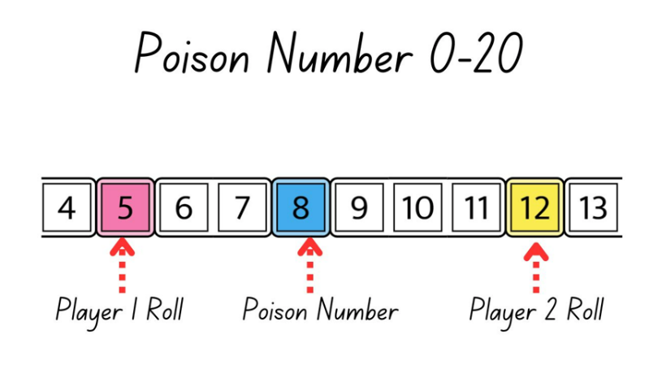
Image adapted and sourced from ‘Number Path’ by Toy Theater and used in accordance with the Toy Theater Terms of Service.
- Model counting forward or backwards to the poison number to determine who is the closest. The player furthest from the poison number gets a point.
- Model again. Discuss what students could do if the numbers rolled are the same, or if they are the same distance from the poison number, for example, rerolling or sharing a point.
- Provide Early Stage 1 students with materials to play independently.
- For Stage 1 students, display a number chart labelled 1 to 120.
- Roll 2 × 10-sided dice. Ask a Stage 1 student to form a number, stating the place value of each digit and locating the number on the chart. This is now the ‘poison number’.
- Select 2 students to be the players.
- Roll again. Ask Player 1 to form the number furthest from the poison number, stating the place value of each digit and locating the number on the chart.
- Roll again. Ask Player 2 to form the number furthest from the poison number, stating the place value of each digit and locating the number on the chart.
- Ask Stage 1 students to calculate who should get a point. Discuss and compare different strategies for calculating the difference for each number in reference to the poison number. Students share approaches (see Figure 4).
Figure 4 – Poison Number 1-120
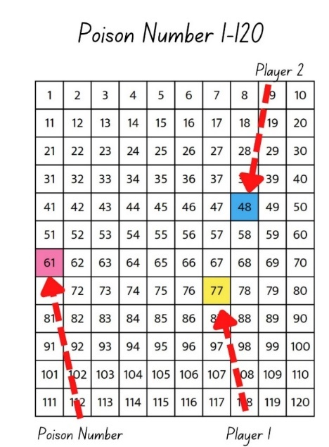
- Play again as a class or provide materials for students to play independently.
This table details assessment opportunities and differentiation ideas.
Assessment opportunities | Too hard? | Too easy?
What to look for:  - Can students count forwards and backwards using the number track? (MAO-WM-01, MAE-RWN-02)  - Do students count forwards and backwards by tens, on and off the decade, with two- and three-digit numbers? (MAO-WM-01, MA1-RWN-02)  What to collect:  - observational records of student strategies for explaining difference (MAO-WM-01, MAE-RWN-02, MA1-RWN-02) | Students find it difficult to read numerals to 20.  - Focus on numbers 1 to 10 only.  - Use concrete materials and a number track to model ‘one less’ and ‘one more’.  Students find it difficult to form and order two-digit numbers.  - Model forming numbers with bundles of 10 or base-ten materials and compare.  - Model ordering numbers on a number line. | Students are confident with forming and ordering two-digit numbers.  - Select a number chart with a range of three-digit numbers, for example, 1 to 400 and have students form numbers in that range.  - Select a mystery three-digit number and have other students guess it by asking relevant questions.

Sleeping snakes– 40 minutes
Note: Prior to the lesson, cut and prepare 4 or 5 different sized paper squares and rectangles. Stage 1 students will use the measuring devices made in Lesson 2. Stage 1 students will also need uniform informal materials, for example, interlocking blocks, square tiles, same-sized coloured bricks.
- Discuss what happens when people are tired and go to sleep. Share different sleeping positions, for example, flat on back, on stomach, curled up, and so on. Focus on lying down to sleep and the size of the bed. Discuss different size beds in student houses.
- Activate student background knowledge about snake behaviours, focusing on actions and sleep.
- Display Resource 5 – Sleeping snakes. Ask:
- I wonder, as a mathematician, how long that snake is and how much space that snake needs to sleep?
- I wonder what we have already learned about measurement and tools to help us work that out?
- Explain that mathematicians call the amount of surface inside a closed flat shape ‘area’. Share the definition with students.
Area: The amount of surface inside a closed flat two-dimensional shape.
- Draw students’ attention to various items in the classroom, emphasising that area refers to the whole surface from edge to edge in all directions.
- Display the pre-cut squares and rectangles to display as snake beds and draw students’ attention to the surface inside the shapes from edge to edge.
- Explain that students will use modelling clay to make snakes. Students will measure the length and the area their snake needs to sleep.
Note: Early Stage 1 students will make a few different snakes. They will cut out the area for direct comparison. Stage 1 students will use the measuring device from Lesson 2 to measure length. They will use uniform informal materials to measure area.
- Model how to:
- make snakes from modelling clay, giving guidance on a manageable length
- compare length using comparative language (Early Stage 1)
- measure length using the made measuring device (Stage 1)
- loosely coil the snake into what resembles a sleeping position (roughly rectangular).
- place on a piece of blank paper
- trace around the snake with a marker pen, creating a roughly drawn rectangular bed shape
- remove the snake to leave a roughly drawn rectangular shape.
- Explain to Early Stage 1 students that they will make at least 2 snakes, comparing their own snakes and the snakes that others make. Issue challenges, such as make the longest, shortest, thinnest, widest snake. Provide a digital device or writing materials for students to photograph and record comparisons.
- Early Stage 1 students then explore area. Support students to coil, place and trace their snakes onto a piece of paper. Students cut out their snake beds and directly compare the different areas by placing them on top of others. Early Stage 1 students explore who has the largest bed and the smallest bed by ordering all the beds on the floor.
- For Stage 1 students ask:
- How can I measure the area that my snake would need to sleep on?
- How can we compare which snake needs to have the largest area to sleep on?
- Explain to Stage 1 students that they are going to measure the area the snake needs to sleep in using square tiles (or another uniform informal unit). Explain that the units used must all be the same size and must be placed over the area being measured with no gaps or overlaps.
Array: A systematic arrangement of objects in rows and columns whereby each subsequent row has the exact same quantity and each subsequent column has the exact same quantity. Arrays support multiplicative thinking and the early development of knowledge and understanding of multiplication and division.
- Model how to cover the area of the snake bed with uniform informal units in rows and columns, like an array. Label each row and column and support students to count and record the area found (see Figure 5).
Figure 5 – Stage 1 – Snake fact sheet
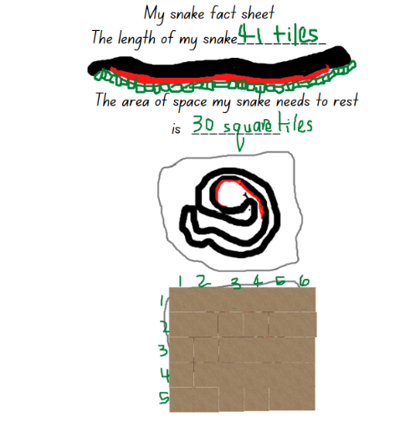
This table details assessment opportunities and differentiation ideas.
Assessment opportunities | Too hard? | Too easy?
What to look for:  - Do students identify area as the measure of the amount of surface? (MAO-WM-01, MAE-2DS-02)  - Can students compare and describe areas of 2 similar shapes directly by drawing, tracing or cutting and pasting? (MAO-WM-01, MAE-2DS-02)  - Can students record area by referring to the number and type of uniform informal unit used, and can they place units so that there are no gaps or overlaps? (MAO-WM-01, MA1-2DS-02)  - Do students use efficient strategies for counting such as repeated addition or skip counting so that units are not missed or counted twice? (MAO-WM-01, MA1-2DS-02, MA1-FG-01)  - Can students identify any parts of units left over when counting uniform informal units to measure area? (MAO-WM-01, MA1-2DS-02).  What to collect:  - photographs and samples of student work (MAO-WM-01, MAE-2DS-02, MA1-2DS-02) | Students cannot use uniform informal units to measure and compare area.  - Students cut out their snake bed and place it on top of other student samples to compare.  - Provide grid paper for students to place their snake on and trace around. Count the squares. | Students can use uniform informal units to measure and compare area.  - Students use only one unit (instead of multiple units) to visualise and record an array over the area.  - Students investigate and compare the area of 3 different sleeping positions.  - Students identify different ways of arranging the same snake that covers the same area.  - Students use grid paper and formal square centimetre to calculate the area.

Discuss and connect the mathematics – 10 minutes
- Students conduct a gallery walk of the records made by other students. Draw students’ attention to the different types of units used and to the relative sizes of the areas.
- Select examples that have very different areas. Ask:
- Which snake used the largest area?
- Which snake used the smallest area?
- What different units did you use?
- Which units are easy to measure area with and which were tricky? Why?
- What problems did you have when measuring area?
- What are some solutions to those problems?
- Did you notice a connection between area and length?
- Repeat the discussion with 2 examples that are similar in size.

Lesson 4: Comparing and ordering
Core concept: Using a consistent unit of measurement enables comparing and ordering.
The table below contains suggested learning intentions and success criteria. These are best co-constructed with students.
Learning intentions | Success criteria
All students are learning that:  - estimating and measuring allows them to compare, order and match areas  - choice of measuring unit affects accuracy when covering an area.  Students working towards Early Stage 1 outcomes are learning that area can be compared by placing one shape on top of another.  Students working towards Stage 1 outcomes are learning that:  - an array can be used to find area  - the units in a square or rectangle can be rearranged but the area will remain constant. | All students can:  - estimate and compare the area of squares and rectangles  - use equal-sized square tiles to explore area.  In addition, students working towards Early Stage 1 outcomes can:  - subitise numbers up to 6  - compare areas by superposing paper and surfaces  - use language to compare area, such as biggest, smallest and the same as.  In addition, students working towards Stage 1 outcomes can measure and explain how parts of a square or rectangle can be rearranged but the area remains the same.

Daily number sense: Which doesn’t belong? – 10 minutes
- Build student understanding of number and patterns by comparing dice.
- Display Resource 6: What doesn’t belong? and provide time for students to turn and talk, discussing why each of these dice doesn’t belong. Explain and justify ideas as a class.
- Ask students:
- What is the same and what is different about these dice?
- Which dice doesn’t belong? What attribute or feature did you consider making your choice?
- Are there more dice that share something that is the same or more dice that are different?

How do we compare? – 50 minutes
Note: Prior to the lesson, prepare Resource 7: Comparing area by reformatting, enlarging and printing 2 of the shapes (or similar shapes) per sheet of large paper. Make sure that there are multiple copies for students. Ensure that the shapes, when formatted, allow a variety of paper squares and rectangles to be superimposed and that the square tiles fit in rows and columns covering the space. Students need to identify areas that are the same, smaller and bigger. It is optional to use butcher’s paper and draw accurately sized shapes prior to the lesson. Prepare other different sized paper squares and rectangles for students to make direct comparisons and compare the ‘amount of surface’. Students can do this by layering and placing their shapes over the top or under as they superimpose and superpose to explore and measure area.
Superpose: To place a geometric shape on top of another so common parts such as corners and edges are aligned.
Superimpose: To place something over something else as a layer but both are still evident.
- Display Resource 7: Comparing area and ask students what they can see. Ask:
- Are these common shapes?
- Where have you seen these shapes and can you name them?
- Is there a shape that you can see that is repeating in other shapes?
- Explain that student pairs will compare and measure the area of squares, rectangles and composite shapes. Remind students that they explored area in Lesson 3. Ask students to share what they know about area as a measurement. Record responses for students to view and discuss.
- Early Stage 1 students will compare and order area by using a variety of paper squares and rectangles to layer and place over the shapes on Resource 7: Comparing area. Students identify and record which shapes have the same area, the largest area, the smallest area, the widest area or the narrowest area. Students record their findings with a digital device or writing materials (see Figure 6).
Figure 6 – Examples of area comparisons
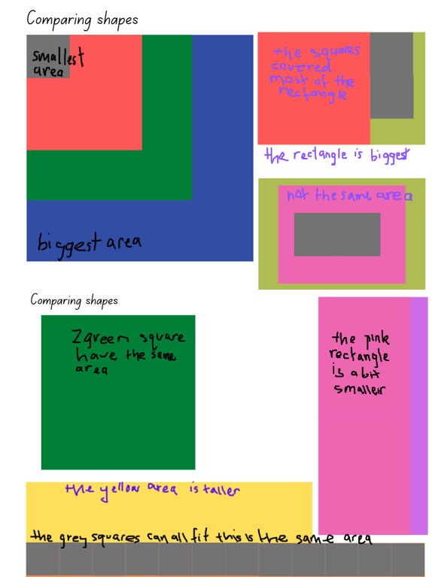
- Early Stage 1 now explore area using two-dimensional shape tiles. Explain that they will choose one shape from Resource 7: Comparing area. Students explore the area of that shape by using a variety of two-dimensional shapes to layer and determine which of the 2 shapes with have the largest area. Encourage students to explore which two-dimensional shapes can be used to superimpose and superpose. Students use a digital device to take photographs and record their findings or use writing materials to record their findings using words or drawings.
Composite shape: A shape that is formed by combining other two-dimensional shapes. Composite shapes can be described as ‘complex’ when they are made up of many and different shapes.
- For Stage 1 students, display Resource 7: Comparing area and revise how students measured area in Lesson 3. Ask if there are any skills or materials they could use again in order to achieve an accurate result when measuring the shapes in Resource 7.
- Ask students what might be different or the same from Lesson 3 when comparing and measuring the area of various shapes including composite shapes. Ask students to select which of the displayed uniform informal units of measurement would be most effective to find the area of the shapes in Resource 7 by using rows and columns, such as in an array. Discuss, recording student ideas.
- Examine a composite shape and discuss how arrays could be used to find the area. Possibilities include:
- splitting the shape into 2 parts, making an array on each part, and combining the count
- using individual squares and making one array.
- In pairs or small groups, students estimate, measure and order the shapes from the smallest area to the largest area and record their findings using a digital device or writing materials.
- Discuss results as a class. Ask:
- Were there any shapes that had the exact same area?
- Were there any surprises? For example, the longest shape did not have the biggest area.
- Were there any challenges?
This table details assessment opportunities and differentiation ideas.
Assessment opportunities | Too hard? | Too easy?
What to look for:  - Can students select methods such as superimposing or arrays to estimate, measure and compare areas of squares and rectangles? (MAO-WM-01, MAE-2DS-01, MA1-FG-01, MA1-2DS-01)  - Can students apply strategies and problem solve area of composite shapes using arrays? (MAO-WM-01, MA1-FG-01, MA1-2DS-01)  - Can students explain how parts of a square or rectangle can be turned or rearranged but the area remains the same? (MAO-WM-01, MA1-FG-01, MA1-2DS-01)  - Can students use comparative language to compare, order and describe area? (MAO-WM-01, MAE-2DS-01, MA1-2DS-01)  What to collect:  - observational records and photographs of strategies used to measure area (MAO-WM-01, MA1-FG-01, MAE-2DS-01, MA1-2DS-01)  - work samples of student’s findings and problem-solving strategies (MAO-WM-01, MA1-FG-01, MAE-2DS-01, MA1-2DS-01) | Students cannot find areas of shapes.  - Model ordering squares from smallest to largest, drawing attention to the ‘space’ or area being used to determine the order. Ask students to repeat using rectangles.  - Provide students with paper to cut out a large square and then cut out a smaller square, pasting it on top to prove the area is smaller.  - Stage 1 students make each shape with square tiles and count how many tiles were needed. | Students measure, compare and order the area.  - Students investigate the length of each shape and order the shapes from shortest to longest.  - Students create a composite shape of their own and investigate the area.

Consolidation and meaningful practice: A problem with area – 10 minutes
- Display 3 different sized sticky notes or pieces of paper. Explain that you want to write a note to the principal and you can’t decide which piece to choose because you have a lot to say. Ask students which one you should use and why.
- Discuss and record student justifications. Support students by drawing attention to comparisons, for example, 2 of the smaller notes fit on the larger note, this sticky note has less writing space (area) because the patterns make the writing space smaller in area compared to the plain sticky note.

Lesson 5: Investigating capacity
Core concept: Internal volume (capacity) is a measure of how much a container or object can hold.
The table below contains suggested learning intentions and success criteria. These are best co-constructed with students.
Learning intentions | Success criteria
All students are learning that:  - identifying a number helps with naming the number before and the number after  - units of measurement can be selected to efficiently estimate, measure and compare internal volume (capacity)  - containers of different shapes can have the same internal volume (capacity)  - internal volume (capacity) is a measure of how much a container can hold. | All students can understand that internal volume (capacity) measures how much can fit inside a container.  In addition, students working towards Early Stage 1 outcomes can:  - use comparative language to describe containers, such as holds more, holds less, full, empty, more than, less than, the same as  - directly compare capacity by pouring and packing the contents of one container into another.  In addition, students working towards Stage 1 outcomes can:  - use place value to identify the number before and after a given three-digit number  - select appropriate uniform informal units to estimate, measure and compare internal volume (capacity)  - identify containers of different shapes that have the same internal volume (capacity).

Daily number sense: Before and after – 10 minutes
- Build student understanding of number sequences by finding the number before and after a given number.
- Use a spinner to get 3 digits, for example, 7, 9 and 6. Ask students to name each digit.
- Ask students to record:
- the number that is one less and one more than each of the digits
- the numbers in order from the biggest value to the smallest value.
- Ask Early Stage 1 students to record:
- the numbers as a sequence, identifying which numbers are missing so that the number track is complete from 0 to 10
- 2 different numbers that, when combined, make each of the numbers displayed. For example, 3 and 6 make 9, 4 and 2 make 6 and 5 and 2 make 7.
- Early Stage 1 students use the spinner and repeat the task using a new combination of numbers.
- Ask Stage 1 students to record:
- the biggest number possible using the 3 digits and record the number before and the number after
- the smallest even or odd number possible
- the number closest to 500 and the number after.
- Select students to share their recordings.

What can I fit inside? – 45 minutes
Internal volume (capacity): A measure of how much a container can hold.
- Ask students to name some containers they use at home or at school. For example, compare 2 backpacks by identifying the storage or internal spaces that can be used to pack and fill.
- Revise that a container, such as a backpack, shopping bag, bucket or lunchbox can be used to hold or carry contents. Explain that the amount of space inside the container is called the internal volume (capacity).
- Give students a two-minute challenge to view the classroom and point out some examples of containers. Show examples of boxes, containers and crates, referring to these as open cubes and rectangular prisms. Explicitly distinguish those objects from cylinders and spheres.
- Explain that, with a partner, students will make a container such as a flat rectangular ‘tray’ shape, cube or a rectangular prism using coloured bricks. The container will be filled with concrete materials so that students can compare the internal volume (capacity) of the container by filling and packing. Draw attention to a variety of concrete materials such as paper clips, counters, marbles, tiles, buttons and cubes. Explain that before they build their containers, each pair will select a different concrete material to use to fill or pack their container. Students will then swap the concrete material to compare the internal volume, recording their results.
Note: It is optional to display models of cubes and rectangular prisms made of coloured bricks prior to the lesson for students to refer to before they make their own containers. Ensure students understand that when packing and filling, a container needs to be stable and have a base and sides to hold the contents.
- Ask:
- What are some things you need to think about before making your container if you selected, for example, marbles and buttons?
- How can you estimate the size and the shape that your container needs to be so it can hold your selected units of measurement?
- What strategy will you use to fill and empty your container? For example, if the top is narrow, you need to add one item at a time.
- How will you keep track of the count so you can work out how many units of measurement were able to fit inside each time?
- Provide students with writing materials or a digital device to record their findings.
- As a class, select students to share their results. Ask:
- Whose estimates were correct or close to the result? Whose estimates were quite different to the measurements?
- Who had a container with an internal volume that was greater than they initially estimated?
- Was there a unit of measurement that was not easy to pack or fill? Why?
- Would you change the units of measurement you selected? What would you pick instead? Why?
- Did a cube or a rectangular prism have a greater internal volume? Did this change with the unit of measurement used?
- Did each partner use the exact same quantity of coloured bricks to make their containers? Did you compare who had more or less coloured bricks? Would this change the internal volume?
- Ask the class to share their results. Identify if any of the containers had the same capacity when using the same units of measurement. Display these and compare, thinking about why containers might look different but have the same capacity. If no 2 containers are the same, select the closest in internal volume to compare.
This table details assessment opportunities and differentiation ideas.
Assessment opportunities | Too hard? | Too easy?
What to look for:  - Can students select appropriate uniform informal units to estimate, measure and compare the internal volume (capacity) of 2 containers? (MAO-WM-01, MA1-3DS-02)  - Can students identify containers of different shapes that have the same internal volume (capacity)? (MAO-WM-01, MAE-3DS-02, MA1-3DS-02)  - Do students understand that internal volume refers to the capacity of a container when it is filled or packed? (MAO-WM-01, MAE-3DS-02, MA1-3DS-02)  What to collect:  - anecdotal records of students using vocabulary and reflecting on their work (MAO-WM-01, MAE-3DS-02, MA1-3DS-02)  - photographs of containers and student recordings (MAO-WM-01, MAE-3DS-02, MA1-3DS-02) | Students do not understand internal volume (capacity).  - Early Stage 1 students fill 2 similar shaped containers with objects and determine which one had more or less objects or were they both the same (equal)?  - Stage 1 students use a variety of cups and sand or rice. Support students to fill a cup and to pour the contents into a smaller or larger cup, noticing the difference. Repeat a few times and discuss.  Students are not filling or packing their container correctly. Ask students to pack and fill their container and record results. Model packing and filling the container with no gaps and to the very top. | Students understand internal volume and reason about their results.  - Ask students to create another container that is a different shape and can hold the same units of measurement and have the same internal volume.  - Ask students to create a container that has double the internal volume (capacity).

Consolidation and meaningful practice: Curious about containers – 10 minutes
- Explain that you filled a container with 30 spoonfuls of sugar. Ask students to imagine what the container look might like.
- Provide students with writing materials and time to turn and talk. In small groups, students draw 2 or 3 possible containers and explain their reasoning.
- Ask:
- Why did you choose that container shape?
- How did you know that the spoonfuls would fit?
- Discuss and share ideas.

Lesson 6: Where does this fit?
Core concept: Volume is the space occupied by a container or object.
The table below contains suggested learning intentions and success criteria. These are best co-constructed with students.
Learning intentions | Success criteria
All students are learning that:  - units of measurement can be selected to efficiently estimate, measure and compare volume  - containers of different shapes can have the same volume  - volume is a measure of the space taken up by an object. | All students can understand that volume measures how much space does an object need to fit or sit.  In addition, students working towards Early Stage 1 outcomes can:  - uses language to compare the space needed for 2 objects such as needs more space, needs less space  - compare capacity directly by pouring and packing the contents of one container into another.  In addition, students working towards Stage 1 outcomes can:  - select appropriate uniform informal units to estimate, measure and compare volume  - identify containers of different shapes that have the same volume.

Daily number sense: Number chart puzzle – 10 minutes
- Display Resource 8: Number chart puzzle and a digital number chart displaying numbers 1 to 50. Provide students with writing materials.
- Explain that you cut out 2 capital letter puzzles, C and F, from the number chart, but you cannot remember from where in the chart. You also cannot remember which way up the chart was when you cut the letters out. You are now wondering what possible numbers could fit in each letter shape (see Figure 7).
Figure 7 – Number chart puzzle
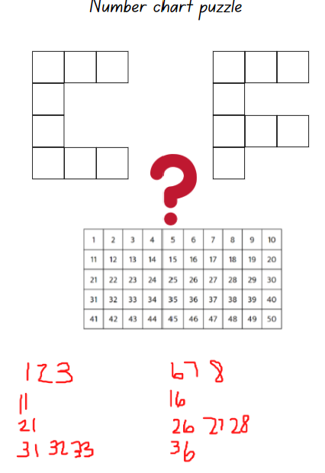
- Ask students to record at least one possibility for each letter.
- Encourage Stage 1 students to slide, turn or reflect the letter shapes.
- Select students to share their ideas and record these for students to view.

Where does this fit? – 15 minutes
- Remind students that in Lesson 5, they explored internal volume (capacity). Select students to share an explanation, examples and non-examples of what internal volume (capacity) means or looks like. Record ideas on an anchor chart, such as in Figure 8.
Figure 8 – Anchor chart: Internal volume (capacity)
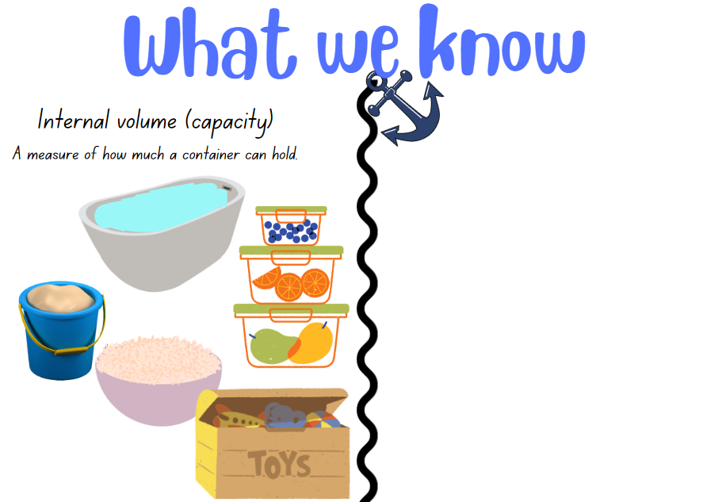
Images sourced from Canva and used in accordance with the Canva Content License Agreement.
- Explain that there is another type of volume that mathematicians use. Volume is the amount of space that is needed for an object.
- Display 2 different sized lunchboxes (ensure that they have lids and that there is no reference to the internal boundaries of the lunchbox). Ask students to point to the smallest lunchbox and then the largest lunchbox and to explain what features or attributes of the lunchbox students are using to make their judgement. For example, the length of the lunchbox is shorter or longer.
- Ask students which lunchbox would need a small space for it to sit or fit and which lunchbox would need a larger space.
Note: Ensure that students clearly understand that the focus is on the external features of the lunchbox and not the internal boundaries, as that is internal volume (capacity).
- Select some students to go on a volume hunt for 2 objects that have different volumes.
- Discuss and model how both the suggested objects need a different space to sit or fit as they are a different size, for example, taller, shorter or wider; or their shape is different, for example, cylindrical, spherical, a rectangular prism or an irregular shape.
- Select some students to go on a volume hunt for 2 objects that have the same volume. Discuss and ask students to justify how the 2 objects require the exact same space.
- Record examples of volume on the anchor chart, such as in Figure 9.
Figure 9 – Anchor chart: Internal volume (capacity) and volume
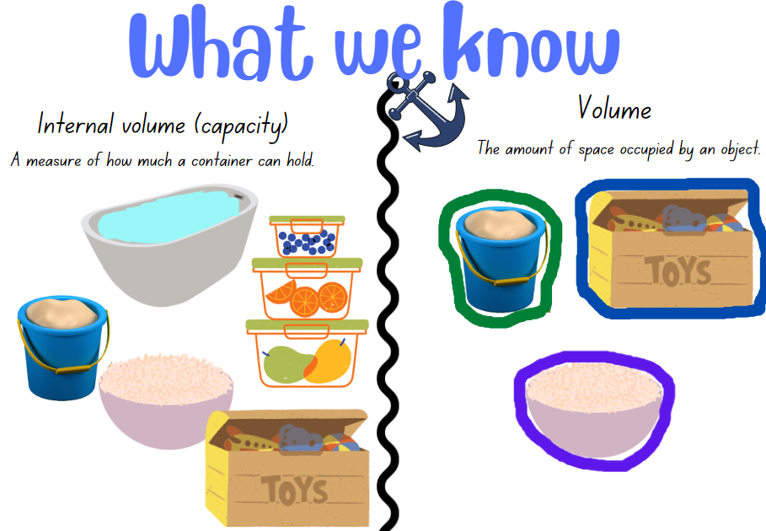
Images sourced from Canva and used in accordance with the Canva Content License Agreement.
- Display the anchor chart for future reference and discussion.

What does it look like? – 35 minutes
Note: Prior to the lesson, collect a large quantity and a variety of concrete materials that can be stacked and packed to create a three-dimensional object or objects. For example, blocks, cubes, coloured bricks and shape tiles.
- Display Resource 9: An empty space and explain that students will work with a partner to investigate a volume problem using concrete materials.
- Pose that, at the supermarket, there is a space on a shelf and you are wondering what objects look like they could fit in this space. Draw students’ attention to the shapes of products found on a supermarket shelf and ask them to share experiences of items and objects they have seen. Discuss the space needed and how items are stacked and packed on shelves. Ask:
- What are the names of the three-dimensional objects you can see on the shelves?
- Are all products stacked and packed in the same way?
- What determines how an item is displayed on the shelf?
- Can you describe the empty space in the picture using the measurement attributes we have explored and described in previous lessons, for example length, area and volume?
- Explain that student pairs will use concrete materials to explore a design for an object or objects that would best fit the space.
- Explain to students that, when exploring volume, you are looking at a three-dimensional object and must consider how long, wide and tall the object is and what size does it need to be to fit in the space.
- Students will use concrete materials that can be stacked, placed in columns and rows or in other creative designs for the space.
This table details assessment opportunities and differentiation ideas.
Assessment opportunities | Too hard? | Too easy?
What to look for:  - Can students identify different containers that have the same or different volume, and can they justify their reasoning using appropriate mathematical vocabulary? (MAO-WM-01, MAE-3DS-02, MA1-3DS-02)  - Can students use concrete materials to design and build an object that has a volume to fit in a specific space? (MAO-WM-01, MAE-3DS-02, MA1-3DS-02)  - Do students identify and explain what is internal volume (capacity) and what is volume, and can they share examples? (MAE-3DS-02, MA1-3DS-02)  What to collect:  - anecdotal records of students identifying, reasoning and sharing examples to explain internal volume (capacity) and volume (MA0-WM-01, MAE-3DS-02, MA1-3DS-02). | Students do not understand the difference between volume and internal volume (capacity).  - Support students to fill and empty containers and assist students to identify the internal capacity by comparing 2 containers.  - Support students to order various containers by identifying attributes of length and height. Connect thinking to volume by comparing the space needed to sit or fit each container by comparing attributes. | Students understand internal volume (capacity) and volume. Ask students to create 2 containers that are a different shape but share features and attributes, making their volume the same. Suggest that both containers also need to have the same internal volume (capacity).

Consolidation and meaningful practice: Fill that space! – 10 minutes
- Display student objects or arrangements and provide time for students conduct a gallery walk to view other models. Ask:
- Can you identify an object that would fit perfectly in the space on the shelf? How do you know?
- Is there an interesting shape and can you describe how it can be stacked or stored on the shelf?
- Can you see 2 other objects or arrangements that you estimate have the same volume as the one you made? How do you know?
- What do people who work at the supermarket have to think about regarding the measurement volume when they are packing the shelves?

Lesson 7: Multiple masses
Core concept: We can compare and order objects by their mass.
The table below contains suggested learning intentions and success criteria. These are best co-constructed with students.
Learning intentions | Success criteria
All students are learning that comparative language is used to describe mass, such as heavier than or lighter than.  Students working towards Early Stage 1 outcomes are learning that hefting is an informal way of measuring and comparing the mass of 2 objects by holding them to see which is heavier.  Students working towards Stage 1 outcomes are learning that:  - the number of units needed to measure the mass of an object will depend on the mass of the unit  - mass is conserved  - uniform informal units can be selected to estimate, measure and compare masses. | All students can describe and identify objects that are heavy or light.  In addition, students working towards Early Stage 1 outcomes can compare masses directly by hefting.  In addition, students working towards Stage 1 outcomes can:  - explain why different numbers of units can be used to measure the mass of an everyday object  - explain how what they know about the mass of one object can be used to measure the mass of another object  - select uniform informal units to estimate, measure and compare masses.

Daily number sense: An up and down story – 10 minutes
- Build student understanding of height as a length by solving number problems.
- Display Resource 10: An up and down story and provide students with writing materials.
- Tell a story about Ollie, the powerful owl who lives in an apartment tree with many levels. Ollie lives on level 3 and he loves baking cupcakes. One day, Ollie makes cupcakes and decides to share them with his friends. He flies up 2 levels and gives some to Madi the magpie. He then realises that he must go back down 3 levels as he missed Walter the wattlebird. He then flies back up 5 levels to take Frankie the finch a cupcake. Finally, he flies up one more level to the top floor to give Lulu the lorikeet a cupcake too.
- Ask students to problem solve how many levels there are in Ollie’s apartment tree.
- Students turn and talk and use numbers, words and diagrams to solve the problem and share solutions as a class (see Figure 10).
Figure 10– Examples of recordings: An up and down story
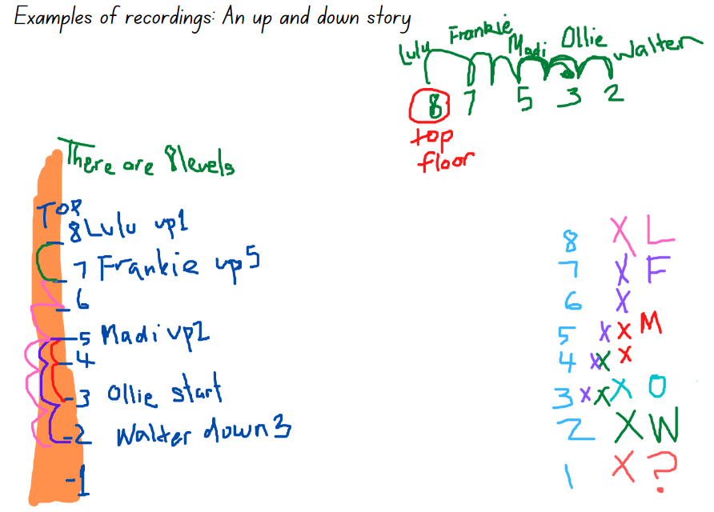
This table details assessment opportunities and differentiation ideas.
Assessment opportunities | Too hard? | Too easy?
What to look for:  - Can students count forwards and backwards as they problem solve without needing to start at one? (MAO-WM-01, MAE-RWN-01)  - Can students sequence numbers such as on a number line to problem solve as they count forwards and backwards? (MAO-WM-01, MA1-RWN-01)  - Do students understand what the problem is asking, and can they apply strategies to find the solution? (MAO-WM-01)  What to collect:  - anecdotal recording of vocabulary and strategies being used to problem solve (MAO-WM-01) | Students are unable to keep track of a count. Provide students with counters to use during each step of the problem.  Students are unable to count forwards and backwards beginning at any number other than one. Provide students with a number track to 10 and counters to use as they work through each step of the problem. | Students are able to solve the problem and explain recorded results.  - Provide students with an additional challenge – Ollie made 35 cupcakes and wasn’t sure how to equally distribute them between his friends and have an equal share for himself.  - Students create a similar problem for a friend to solve.

Problem solving with mass – 50 minutes
Note: Prior to the lesson, select 2 of the same objects and ensure that one is heavier than the other. For example, 2 balls, 2 books or 2 toy dinosaurs. Show students the 2 items and state that although they are the same object, one is heavier than other.
- Select a student and place an object in each hand. Ask the student to heft (lift) to identify which object feels heaviest.
- Ask the class to describe how the student is comparing by hefting (lifting) the mass of the 2 objects and if they agree or disagree with the student’s opinion just by looking at the objects.
- Place the 2 objects on the equal-arm balance. Students explain what happens when the 2 objects are placed in the trays.
- Explain that by hefting (lifting) and comparing the items, the student identified that one item was heavier or lighter than the other. The equal-arm balance also showed that one item was heavier or lighter than the other.
- Provide time for students to heft (lift) a few objects. Revise how to use the equal-arm balance to compare by describing objects as heavier or lighter.
- Early Stage 1 students work with a partner to explore the classroom and find 2 sets of objects that are equal in mass and 2 sets of objects that are different in their mass. Students need to compare objects that have the same mass (are equal) and objects that have a mass that is lighter than or heavier than another object and record their results using drawings, numbers or words.
- Stage 1 students explore a mass story. For example, ask:
- How many coloured bricks would you need for 2 balls if one ball has the same mass (is equal to) as 15 coloured bricks?
- How many books would you need for 2 lunchboxes if one lunch box has the same mass (is equal to) as 2 books?
- How many marbles would equal one book if a pencil case is equal in mass to 20 marbles and a book is equal in mass to 2 pencil cases?
- Ask Stage 1 students to share ideas and how they could check. Demonstrate with concrete materials and equal-arm-balance. Ask students what other units could have been used to solve these problems.
- Provide Stage 1 students with writing materials, equal-arm-balances, a choice of uniform informal units and everyday classroom objects. Explain that in small groups, they will create, record and solve a three-part mass problem such as the marbles, pencil case and book problem above. Students will test their own problem, recording results, then swap their problem with another group and record solutions for the new problem.
- As a class, ask students:
- What did you discover about mass that was interesting?
- What items did you compare that had a result that made you wonder? What did you wonder about?
- Were there any uniform informal units or everyday objects that did not work? Why was this? (Stage1)
- Did you estimate correctly each time which objects would be lighter or heavier? What helpful strategies did you use?
- As a class, discuss, create and record findings on an anchor chart to be displayed for future reference.
This table details assessment opportunities and differentiation ideas.
Assessment opportunities | Too hard? | Too easy?
What to look for:  - Can students predict by hefting the mass of 2 or more objects? (MAE-NSM-01, MA1-NSM-01)  - Are students comparing mass by using language such as heavier, lighter, heaviest and lightest? (MAE-NSM-01, MA1-NSW-01)  - Can students select uniform informal units to estimate, measure and compare masses? (MAO-WM-01, MA1-NSM-01)  - Can students explain why different numbers of units can be used to measure the mass of an everyday object? For example, a stapler has a mass the same as 5 marbles or 60 paperclips (MAO-WM-01, MA1-NSM-01)  What to collect:  - observational records and photographs of problems (MAO-WM-01, MAE-NSM-01, MA1-NSM-01) | Students cannot use what they know about the mass of one object to find the mass of a second object.  - Students use the same uniform informal unit to measure the mass of both items.  - Select 2 objects for comparison and ensure that one is much lighter than the other. Discuss and provide time for students to heft so they can increase their experience and familiarity with comparing mass and test using the equal-arm balance. | Students use hefting to estimate and can use an equal-arm-balance to create, compare and solve two- and three- part mass problems.  - Students compare 2 objects on an equal-arm balance and determine which informal unit of measure to use that requires the least quantity to make both objects equal in mass.  - Students estimate, create, record, and solve four-part mass problems.

Discussing and connecting the mathematics – 5 minutes
- Ask students:
- What are some wonderings you have about mass?
- Were there any objects that you compared on the equal-arm balance that were interesting and made you discuss their mass? For example, comparing a solid object (a block) with a soft object (teddy) or an irregular shape (a seashell) with a regular shape (ball).
- How will your knowledge about length, area, internal volume, volume and mass help you each day?

Lesson 8: Measurement investigators
Core concept: The unit of measure to use is determined by what needs to be measured.
The table below contains suggested learning intentions and success criteria. These are best co-constructed with students.
Learning intentions | Success criteria
All students are learning that:  - length, area, volume and mass can be investigated in isolation or through their connections  - mathematical thinking can be explored and communicated through numbers, words, drawings and diagrams.  Students working towards Early Stage 1 outcomes are learning that when comparing and measuring, predictions and solutions can be described by using measurement language, such as full, empty, heavier, lighter, bigger, smaller, shorter or longer.  Students working towards Stage 1 outcomes are learning that informal units of measurement can be selected to estimate, measure, record and compare shapes and objects. | All students can:  - compare and measure different attributes of an object  - explain and record the measurement attributes of common objects.  In addition, students working towards Early Stage 1 outcomes can compare and describe objects by using words such as full, empty, heavier, lighter, bigger, smaller, shorter or longer.  In addition, students working towards Stage 1 outcomes can justify the selection of a unit of measure to estimate, measure, record and compare attributes.

Daily number sense: 10 minutes
- From a class need surfaced through formative assessment data, identify a short, focused activity that targets students’ knowledge, understanding and skills. Example activities may be drawn from the following resources:
- Thinking Mathematically Early Stage 1
- Thinking Mathematically Stage 1
- Universal Resources Hub.

Measurement investigators – 50 minutes
Note: Prior to the lesson, prepare modelling clay for each student and placemats so that the modelling clay remains on a designated surface. Students can use a digital device to photograph and record their measurement investigations on Resource 11: Measurement investigators to draw representations and record results.
- Ask students what types of measurement they have used in this unit. Students turn and talk and then share ideas with the class.
- Explain that people use all or combinations of these types of measurement every day. Ask students to share examples of real-life measurement experiences they have had today. For example, filling their glass with milk, putting toothpaste on the length of their toothbrush, packing and lifting their school bag and arranging the length of their seatbelt.
- Explain that students are going to be measurement investigators by using modelling clay to design a container to investigate different measurement attributes.
- Ask, ‘What must you think about when shaping your container? For example, have you thought about the space inside your container? Does it resemble a three-dimensional object? Have you thought about the length, width and height? Have you thought about the capacity and internal volume (what do I want my container to hold)?’
- Provide students with modelling clay and a variety of informal units of measurement, such as counters, cubes, buttons or square tiles to select from.
Note: Ensure that Early Stage 1 students are comparing and describing each measurement attribute and recording findings by using descriptions in drawings or vocabulary such as, longer, shorter, taller, empty, full, bigger, smaller. Stage 1 students will make their container and explore each measurement attribute one at a time by using their selected informal units of measurement. As students make their container, provide support when measuring the length, area, volume, mass and when filling and packing for internal volume (capacity). Students will compare the mass of their container with a peer’s container.
- Early Stage 1 students consider how long, how wide and how tall their container needs to be to hold informal units of measurement. Students will have the opportunity to create 2 containers. They will explore the length, area, internal volume (capacity), volume and mass of their first container and record their findings. They will then remodel their first container and create a different container to predict and compare measurement attributes between their first and second containers (see Figure 11).
Figure 11 – Measurement investigator – Early Stage 1 example
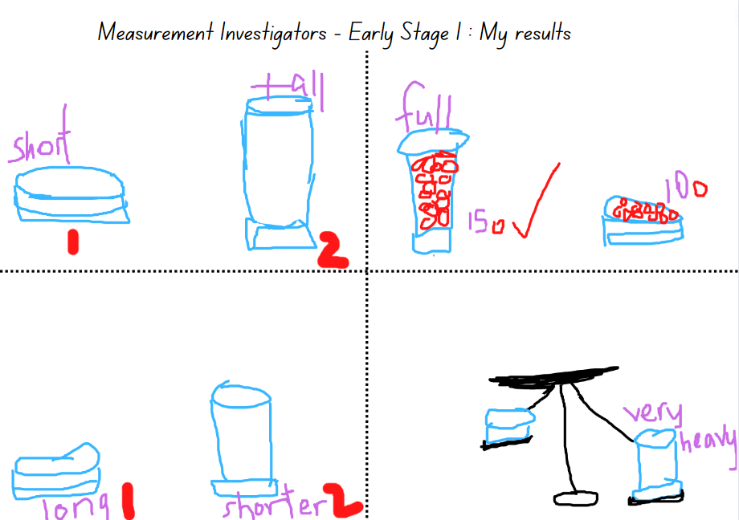
- Stage 1 students make their container, use their selected informal units of measurement to explore each measurement attribute and record their findings for each attribute using a digital device or Resource 11: Measurement investigators (see Figure 12).
Figure 12 – Measurement Investigator – Stage 1 example
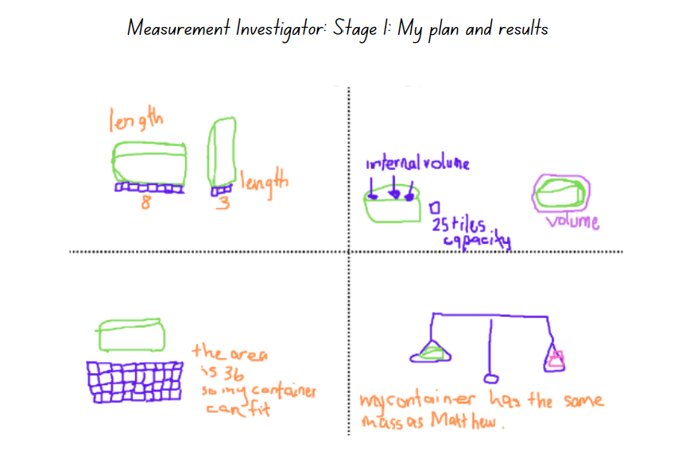
- As a class, review students’ findings and discuss.
- Explain that students have recorded a range of measurement results for their container and you are wondering if there are any containers in the class that might have the same or similar length, volume, internal volume and area.
- Provide time for students to view other containers on a gallery walk. Ask:
- Was there a container you viewed and estimated that could be the same or like yours?
- What strategies did you use to determine that connection?
- Do you think it is important to check that the same informal units of measurement were used to work out the length, area, volume and internal volume? Why? (Stage 1)
- Is there a container that is shorter than yours? Do you think that means the container would also be lighter (mass) than yours? (Early Stage 1)
- Ask students to estimate and select 2 containers that have the same mass. Select students to use the equal-arm balance and compare the mass of the 2 containers.
This table details assessment opportunities and differentiation ideas.
Assessment opportunities | Too hard? | Too easy?
What to look for:  - Can students justify the selection of a unit of measure to estimate, measure correctly end to end, record and compare attributes? (MAO-WM-01, MA1-GM-02, MA1-2DS-02, MA1-3DS-02, MA1-NSM-01)  - Can students explore and communicate measurement ideas and results through drawings, words, numbers, symbols and diagrams? (MAO-WM-01, MAE-GM-02, MA1-GM-02, MAE-2DS-02, MA1-2DS-02, MAE-3DS-02, MA1-3DS-02, MAE-NSM-01, MA1-NSM-01)  What to collect:  - photographs and annotated work samples (MAO-WM-01, MAE-GM-02, MA1-GM-02, MAE-2DS, 02, MA1-2DS-02, MAE-3DS-02, MA1-3DS-02, MAE-NSM-01, MA1-NSM-01) | Students cannot select and use appropriate uniform informal units of measurement.  - Support Stage 1 students to choose an appropriate uniform informal unit of measurement by testing examples and determining accuracy.  - Provide Stage 1 students with a small container and support students to choose an appropriate uniform informal unit to explore measurements and assist with recording results.  Students are unable to measure and record results for length, area, volume and mass. Support students to identify the length, internal volume and mass of a sample container. | Students complete and communicate a measurement investigation showing understanding and reasoning. Students create a measurement investigation poster to define each measurement attribute. Suggest modifications or new ideas for each group presentation.

Discussing and connecting the mathematics – 5 minutes
- Ask students:
- What was a challenge you experienced and how did you resolve it?
- Was there a measurement result that surprised you?

Resource 1: Animals everywhere
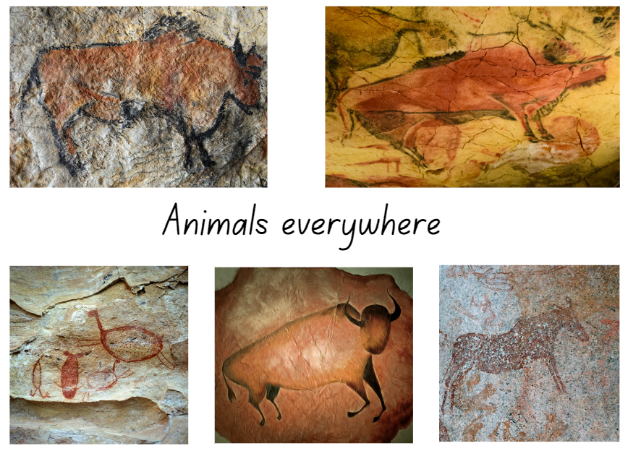
Images sourced from Canva and used in accordance with the Canva Content License Agreement.

Resource 2: Species of snakes
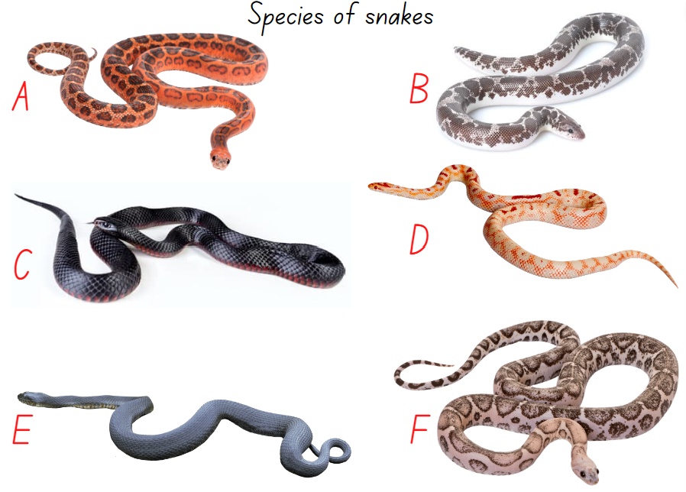
Images sourced from Canva and used in accordance with the Canva Content License Agreement.

Resource 3: Early Stage 1-Investigating length
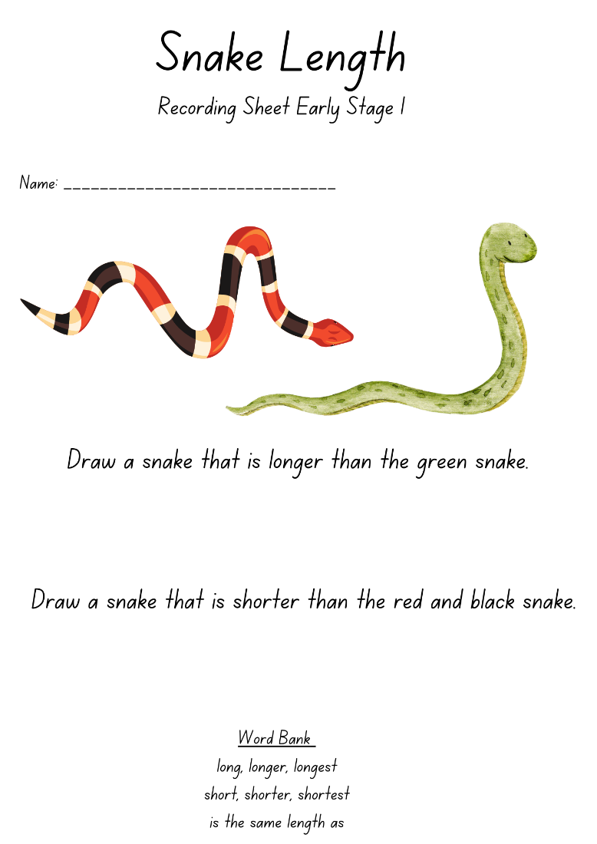
Images sourced from Canva and used in accordance with the Canva Content License Agreement.

Resource 4: Stage 1 – Investigating length
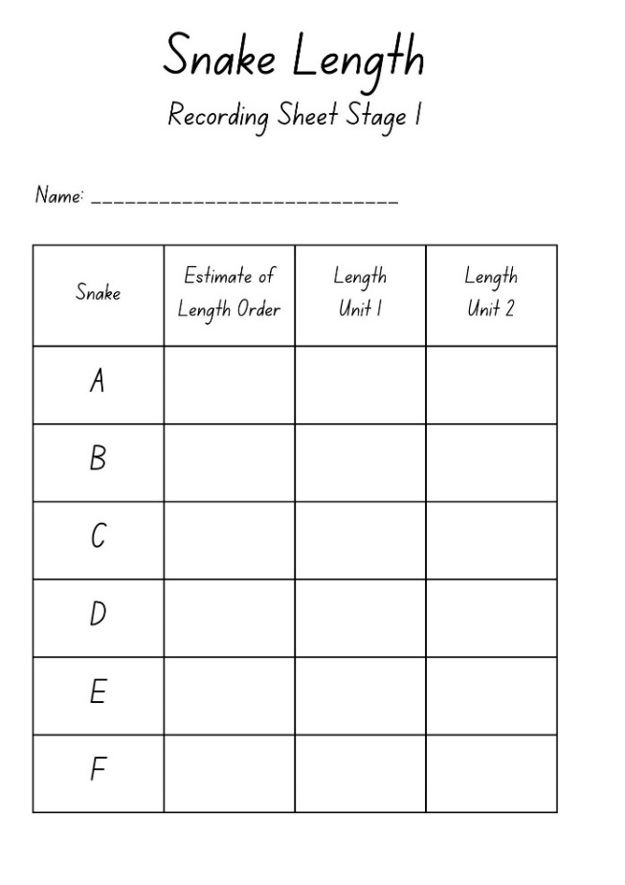

Resource 5: Sleeping snakes
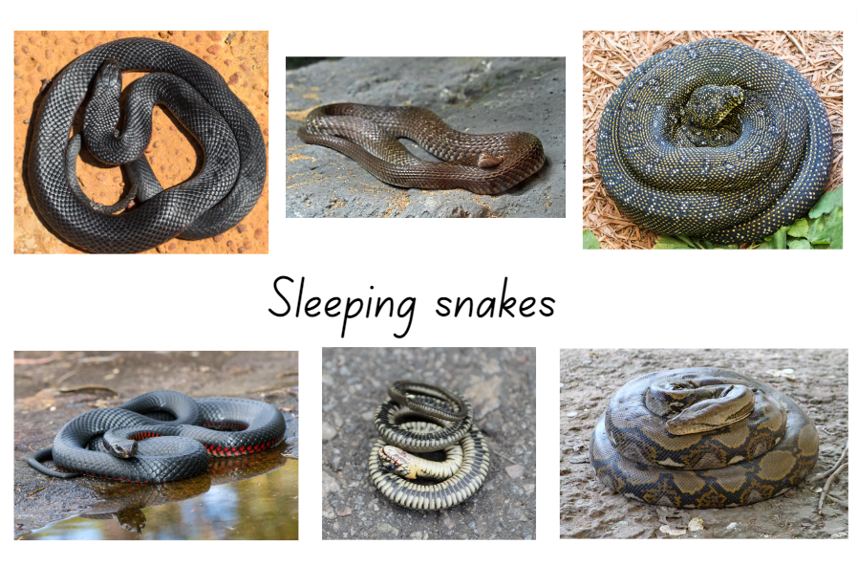
Images sourced from Canva and used in accordance with the Canva Content License Agreement.

Resource 6: What doesn’t belong?
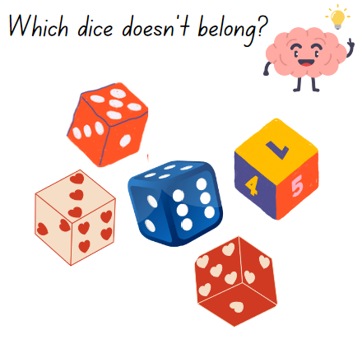
Images sourced from Canva and used in accordance with the Canva Content License Agreement.

Resource 7: Comparing area
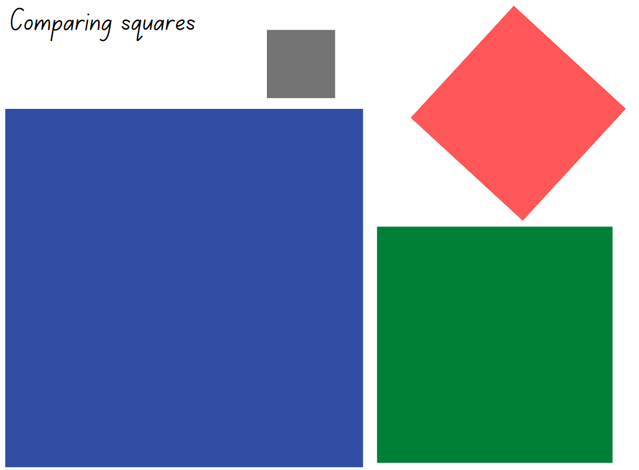
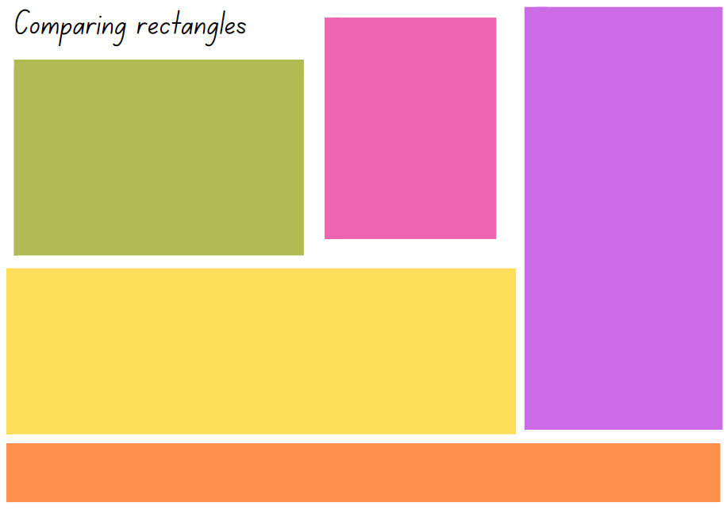
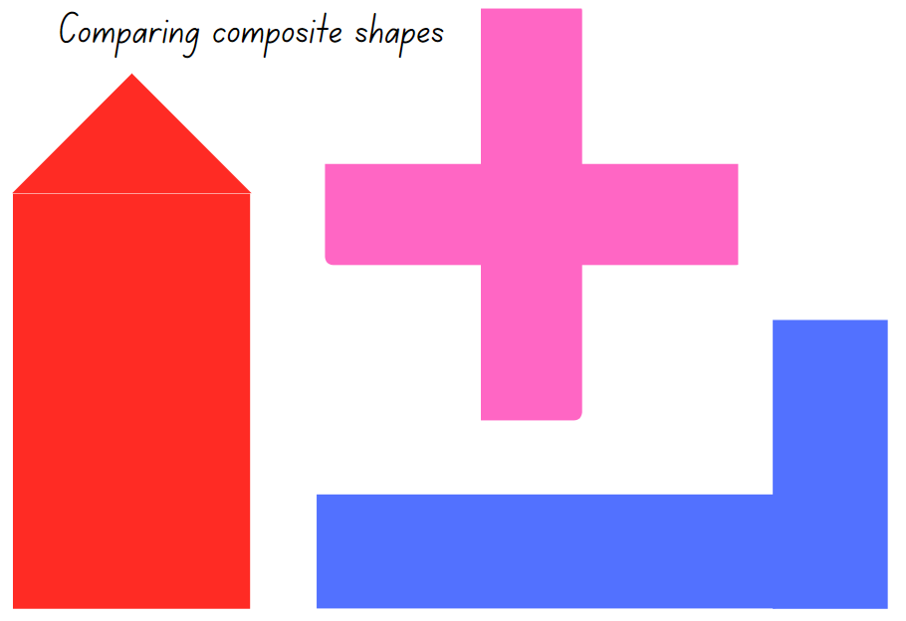

Resource 8: Number chart puzzle
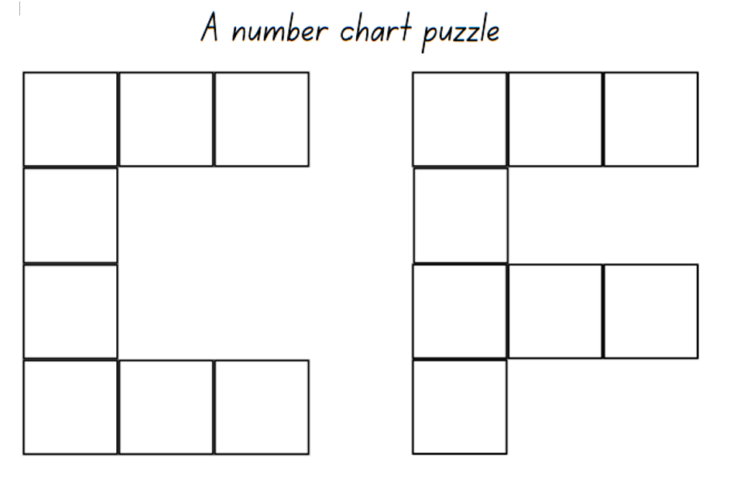

Resource 9: An empty space
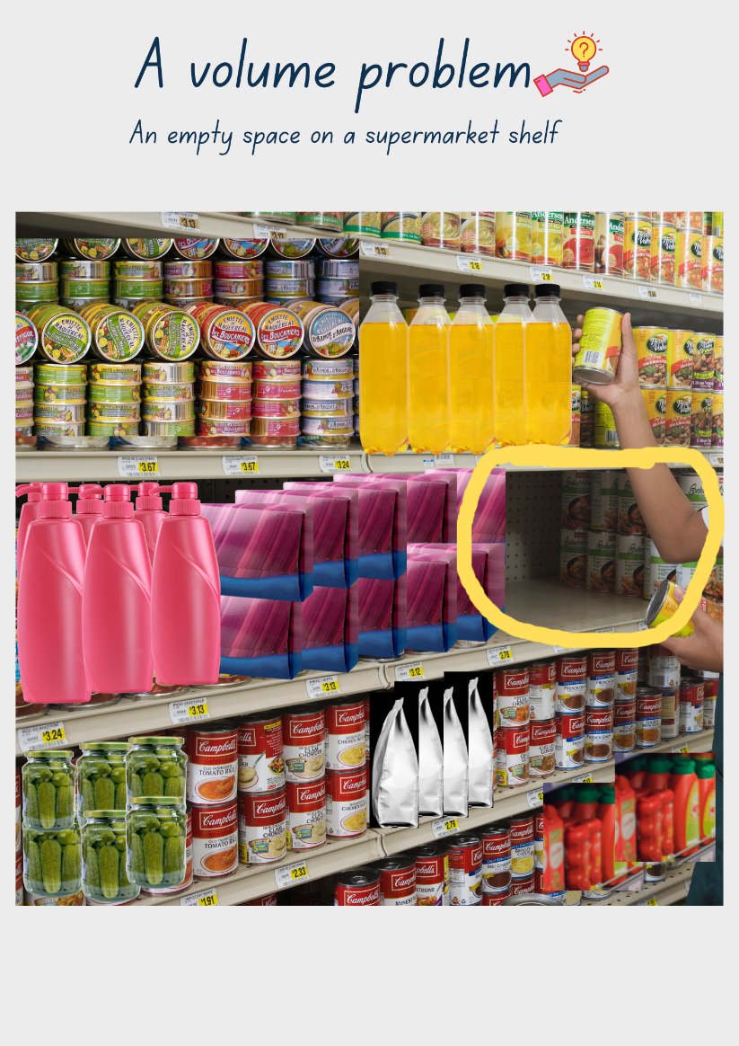
Images sourced from Canva and used in accordance with the Canva Content License Agreement.

Resource 10: An up and down story
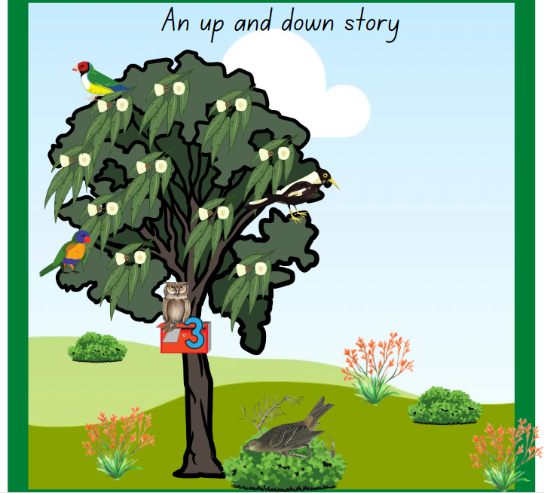
This image contains content obtained from Canva, and its use outside of this resource is subject to Canva’s Content License Agreement. If you wish to use it separately from the resource, please go to Canva.

Resource 11: Measurement investigators
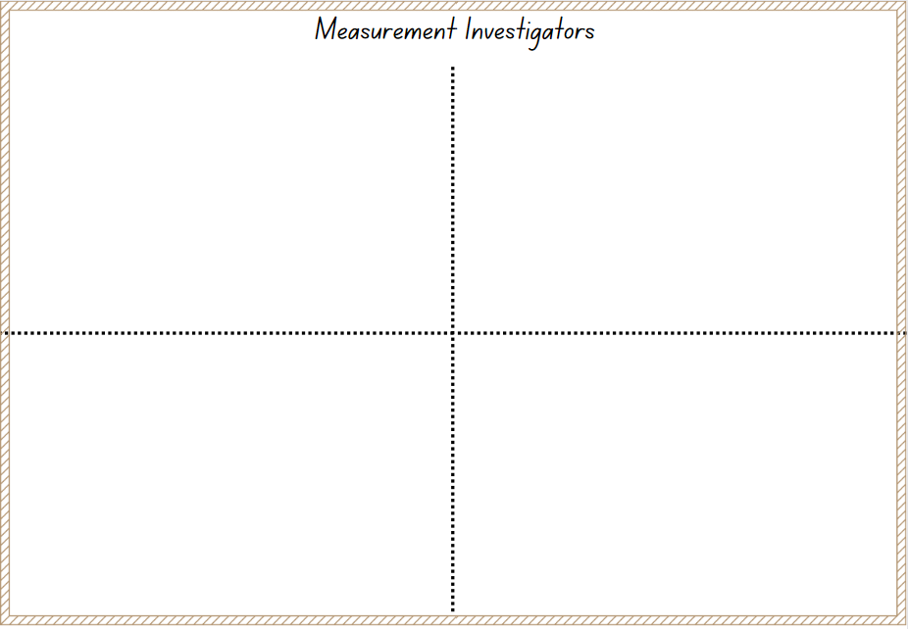

Syllabus outcomes and content
The table below outlines the syllabus outcomes and range of relevant syllabus content covered in this unit. Content is linked to National Numeracy Learning Progression version (3).
Focus area and outcomes | Content groups and content points | Lessons
Representing whole numbers  MAO-WM-01  MAE-RWN-01, MA1-RWN-01  MAE-RWN-02, MA1-RWN-02 | Early Stage 1  Instantly name the number of objects within small collections  - Identify the number of items in different arrangements (CPr2)  Use the counting sequence of ones flexibly  - Count forwards to at least 30 and state the number after or before a given number, without needing to count from one (CPr5) (QuN6) (NPV3)  - Identify the number before as 'one less' and the number after as 'one more’ than a given number  Recognise number patterns  - Recognise dice and domino dot patterns (NPA1, NPV2, CPr2)  Connect counting and numerals to quantities  - Count with one-to-one correspondence, recognising that the last number name represents the total number in the collection (CPr3, CPr5)  - Read numerals to at least 20, including zero (NPV3)  - Represent numbers as quantities to at least 20 using objects (such as fingers), number words and numerals (NPV2, NPV3, NPV4, CPr3)  - Compare and order numbers to 20 (NPV2, NPV3) | 1–7
Representing whole numbers A (cont) | Stage 1  Use counting sequences of ones with two-digit numbers and beyond  - Identify the number before and after a given two-digit number (CPr5)  - Count forwards and backwards by ones from a given number to at least 120 (CPr6)  Represent the structure of groups of ten in whole numbers  - Partition two-digit numbers to show quantity values (NPV4)  - Use number lines and number charts to assist with locating the nearest ten to a number | 1–4, 6, 7
Representing whole numbers B (cont) | Stage 1  Use counting sequences of ones and tens flexibly  - Identify the number before and after a given three-digit number (AdS8)  - Count forwards and backwards by tens, on and off the decade, with two- and three-digit numbers (CPr7)  - Identify how many more to the next multiple of ten within two- and three-digit numbers  Form, regroup, and rename three-digit numbers  - State the quantity value of digits in numbers of up to three digits (Reasons about quantity) (NPV5)  - Identify the nearest hundred to a number  - Recognise units of 100 (QuN8, UnM5, NPV5)  - Use place value to partition and rename three-digit numbers in different ways (Reasons about relations) | 1–3, 5
Forming groups B  MA1-FG-01  NOTE – There is only one Forming groups outcome for Stage 1. | Stage 1  Represent and explain multiplication as the combining of equal groups  - Form arrays of equal rows and equal columns (MuS5)  - Determine and distinguish between the number of rows/columns and the number in each row/column when describing collections of objects (MuS5) | 3, 4, 8
Geometric measure  MAO-WM-01, MAE-GM-02, MA1-GM-02 | Early Stage 1  Length: Use direct and indirect comparisons to decide which is longer  - Use comparative language to describe length (UuM2)  - Compare lengths directly by placing objects side by side and aligning the ends (UuM2) | 1, 2, 8
Geometric measure A (cont) | Stage 1  Length: Measure the lengths of objects using uniform informal units  - Use uniform informal units to measure lengths and distances by placing the units end to end without gaps or overlaps (UuM2)  - Recognise and explain the relationship between the size of a unit and the number of units needed (Reasons about relations)  - Count informal units to measure lengths or distances and describe the part left over (UuM4)  Length: Compare lengths using uniform informal units  - Explain why the length of an object remains constant when rearranged (Reasons about relations) | 1, 2, 8
Geometric measure B (cont) | Stage 1  Length: Compare and order lengths, using appropriate uniform informal units  - Make and use a tape measure calibrated in uniform informal units (UuM4)  - Record length comparisons using drawings, numerals and words, and by referring to the uniform informal unit used | 1, 2, 8
Two-dimensional spatial structure  MAO-WM-01  MAE-2DS-02, MA1-2DS-02 | Early Stage 1  Area: Identify and compare area  - Make closed shapes and identify the attribute of area as the measure of the amount of surface  - Use comparative language to describe areas (UuM2)  - Compare areas of two similar shapes directly by drawing, tracing, or cutting and pasting (UuM3, UuM4) | 3, 4, 8
Two-dimensional spatial structure A (cont) | Stage 1  Area: Measure areas using uniform informal units  - Explore area using uniform informal units to cover the surface in rows or columns without gaps or overlaps (UuM5)  - Measure area by selecting and using appropriate uniform informal units (Reasons about relations)  - Record areas by referring to the number and type of uniform informal unit used  - Identify any parts of units left over when counting uniform informal units to measure area | 3, 4, 8
Two-dimensional spatial structure B (cont) | Stage 1  Area: Compare rectangular areas using uniform square units of an appropriate size in rows and columns  - Cover rectangular surfaces by creating repeated rows of square tiles (UuM5)  - Use the structure of repeated units to find the area of a rectangle (UuM5)  - Explain how the grid structure of rows and columns helps to find the area (Reasons about spatial structure) | 3, 4, 8
Three-dimensional spatial structure  MAO-WM-01, MAE-3DS-02  MA1-3DS-01, MA1-3DS-02 | Early Stage 1  Volume: Compare internal volume by filling and packing  - Use the terms ‘full’, ‘empty’ and ‘about half full’  - Establish that containers of different shapes may hold the same amount  - Stack and pack blocks into defined spaces (UuM5)  Volume: Compare volume by building  - Identify the attribute of volume as the amount of space an object or substance occupies  - Use comparative language to describe volume (UuM2) | 5, 6, 8
Three-dimensional spatial structure A (cont) | Stage 1  3D objects: Recognise familiar three-dimensional objects  - Use the term ‘three-dimensional’ to describe a range of objects (UGP2) (UGP3)  - Distinguish between objects, which are three-dimensional (3D) and shapes which are two-dimensional (2D)  - Identify and name familiar three-dimensional objects, including cubes, cylinders, spheres and rectangular prisms  Volume: Measure and compare the internal volumes (capacities) of containers by filling  - Select appropriate informal units to measure the capacities of containers  - Compare the internal volumes of two or more containers using appropriate uniform informal units (UuM3)  - Recognise and explain why containers of different shapes may have the same internal volume (Reasons about relations)  Volume: Measure the internal volume (capacity) of containers by packing  - Pack cubic units (eg blocks) into rectangular containers so that there are no gaps  - Recognise that cubes pack better than other objects in rectangular containers (Reasons about spatial structure)  - Estimate and measure the internal volume of a container by filling the container with uniform informal units and counting the number of units used  - Explain that if there are gaps when packing and stacking, this will affect the accuracy of measuring the internal volume | 5, 6, 8
Three-dimensional spatial structure B (cont) | Stage 1  Volume: Compare containers based on internal volume (capacity) by filling and packing  - Compare, order and record the internal volumes (capacities) of two or more containers by measuring each container in uniform informal units (UuM3, UuM4)  - Estimate internal volume (capacity) by referring to the number and type of uniform informal unit used (UuM3)  Volume: Compare volumes using uniform informal units  - Compare models with different appearances, recognising when they have the same volume (Reasons about spatial structure)  - Record the results of volume comparisons using drawings, numerals and words, referring to the units used | 5, 6, 8
Non-spatial measure  MAO-WM-01  MAE-NSM-01, MA1-NSM-01  MAE-NSM-02, MA1-NSM-02 | Early Stage 1  Mass: Identify and compare mass using weight  - Identify that objects can be heavy or light (UuM2)  - Compare two masses directly by hefting (UuM2) [UuM3]  - Predict which object would be heavier than, lighter than, or have about the same weight as another object and explain reasons for this prediction (Reasons about relations) | 7, 8
Non-spatial measure B (cont) | Stage 1  Mass: Compare the masses of objects using an equal-arm balance  - Use uniform informal units to measure the mass of an object by counting the number of units needed to obtain a level balance on an equal-arm balance  - Select an appropriate uniform informal unit to measure the mass of an object and justify the choice (Reasons about relations)  - Explain the relationship between the mass of a unit and the number of units needed (Reasons about relations)  - Compare the masses of two or more objects using the same informal units (UuM3)  - Estimate mass by referring to the number and type of uniform informal unit used and check by measuring (UuM3, UuM4)  - Recognise that mass is conserved | 7, 8

References
Links to third-party material and websites
Please note that the provided (reading/viewing material/list/links/texts) are a suggestion only and implies no endorsement, by the New South Wales Department of Education, of any author, publisher, or book title. School principals and teachers are best placed to assess the suitability of resources that would complement the curriculum and reflect the needs and interests of their students.
If you use the links provided in this document to access a third-party's website, you acknowledge that the terms of use, including licence terms set out on the third-party's website apply to the use which may be made of the materials on that third-party website or where permitted by the Copyright Act 1968 (Cth). The department accepts no responsibility for content on third-party websites.
Except as otherwise noted, all material is © State of New South Wales (Department of Education), 2023 and licensed under the Creative Commons Attribution 4.0 International License. All other material (third-party material) is used with permission or under licence. Where the copyright owner of third-party material has not licensed their material under a Creative Commons or similar licence, you should contact them directly for permission to reuse their material.
Mathematics K–10 Syllabus © 2022 NSW Education Standards Authority (NESA) for and on behalf of the Crown in right of the State of New South Wales.
© 2022 NSW Education Standards Authority. This document contains NSW Curriculum and syllabus content. The NSW Curriculum is developed by the NSW Education Standards Authority. This content is prepared by NESA for and on behalf of the Crown in right of the State of New South Wales. The material is protected by Crown copyright.
Please refer to the NESA Copyright Disclaimer for more information.
NESA holds the only official and up-to-date versions of the NSW Curriculum and syllabus documents. Please visit the NSW Education Standards Authority (NESA) website and the NSW Curriculum website.
National Numeracy Learning Progression © Australian Curriculum, Assessment and Reporting Authority (ACARA) 2010 to present, unless otherwise indicated. This material was downloaded from the Australian Curriculum website (National Numeracy Learning Progression) (accessed 1 March 2023) and was not modified. The material is licensed under CC BY 4.0. Version updates are tracked in the ‘Curriculum version history’ section on the 'About the Australian Curriculum' page of the Australian Curriculum website.
ACARA does not endorse any product that uses the Australian Curriculum or make any representations as to the quality of such products. Any product that uses material published on this website should not be taken to be affiliated with ACARA or have the sponsorship or approval of ACARA. It is up to each person to make their own assessment of the product, taking into account matters including, but not limited to, the version number and the degree to which the materials align with the content descriptions and achievement standards (where relevant). Where there is a claim of alignment, it is important to check that the materials align with the content descriptions and achievement standards (endorsed by all education Ministers), not the elaborations (examples provided by ACARA).
This resource contains images and content obtained from Canva, and their use outside of this resource is subject to Canva’s Content License Agreement. If you wish to use them separately from the resource, please go to Canva.
Didax, Inc (2023) ‘Number Line’, Virtual Manipulatives, Didax website, accessed 1 March 2023.
Mathigon (2022) ‘Polyhedral Dice’, Probability and Data, Mathigon website, accessed 17 February 2023.
MathsBot.com (n.d.) ‘Hundred Square’, Manipulatives: A Collection of Virtual Manipulatives, MathsBot.com, accessed 1 March 2023.
Toy Theater (2001–2023) ‘Dice’, Probability Manipulatives, Toy Theater website, accessed 16 February 2023.
Toy Theater (2001–2023) ‘120 Chart’, Number Chart Manipulatives, Toy Theater website, accessed 1 March 2023.
Toy Theater (2001–2023) ‘Number Chart 1 to 50’, Number Chart Manipulatives, Toy Theater website, accessed 1 March 2023.
Toy Theater (2001–2023) ‘Number path’, Number Line Manipulatives, Toy Theater website, accessed 16 February 2023.

