Mathematics – K-2 multi-age – Year B – Unit 13
Contents
Unit description and duration 4
Student prior learning 4
Lesson overview and resources 5
Lesson 1: Bales of wool 16
Daily number sense: Building towers – 20 minutes 16
Number of groups and number in each group: Part 1 – 30 minutes 18
Consolidation and meaningful practice: Rolling groups – 10 minutes 22
Lesson 2: Berries 24
Daily number sense: Building towers and Roll 3 – 15 minutes 24
Number of groups and number in each group: Part 2 – 25 minutes 25
Consolidation and meaningful practice: Thinking multiplicatively – 20 minutes 27
Lesson 3: Fruit shop 28
Daily number sense: Number visuals – 10 minutes 29
Fruit shop – 40 minutes 30
Discuss and connect the mathematics – 10 minutes 33
Lesson 4: Fruit shop 2 34
Daily number sense: Patterns – 20 minutes 35
Fruit shop: Part 2 – 40 minutes 37
Discuss and connect the mathematics – 10 minutes 41
Lesson 5: Birthday party 43
Daily number sense: Estimating GOAT – 20 minutes 44
Birthday party – 35 minutes 45
Consolidation and meaningful practice: Musical groups – 5 minutes 48
Lesson 6: The doorbell rang 49
Daily number sense: Domino carpark and 3 tens in a line – 15 minutes 50
The doorbell rang – 40 minutes 51
Lesson 7: Outdoor grouping 54
Daily number sense: Estimating GOAT – 15 minutes 55
Outdoor grouping – 40 minutes 56
Discuss and connect the mathematics – 10 minutes 60
Lesson 8: Equal sharing and grouping 60
Daily number sense: The counting game – 20 minutes 61
Equal sharing and grouping – 35 minutes 62
Discuss and connect the mathematics – 10 minutes 65
Resource 1: Bales of wool 66
Resource 2: Different bales 67
Resource 3: Eggs 68
Resource 4: Student copy 69
Resource 5: Berries 70
Resource 6: Student copy 2 71
Resource 7: Number visuals (Early Stage 1) 72
Resource 8: Number visuals (Stage 1) 73
Resource 9: Fruit 74
Resource 10: Fruit shop 75
Resource 11: Lemons 76
Resource 12: Parking template 77
Resource 13: The doorbell rang 78
Resource 14: Ten-frame 79
Resource 15: Sharing and grouping problems (Early Stage 1) 80
Resource 16: Sharing and grouping problems (Stage 1) 86
Syllabus outcomes and content 92
References 101
Further reading 103

Unit description and duration
This two-week unit develops student knowledge, understanding and skills of making and using equal groups. Students are provided opportunities to:
- recognise, model and use equal and unequal groups
- share collections by forming equal groups
- use arrangements to distinguish between the number of groups and the number in each group when describing collections of objects
- solve multiplication and division problems using objects, diagrams, images, and actions.
Mathematics K–10 Syllabus © 2022 NSW Education Standards Authority (NESA) for and on behalf of the Crown in right of the State of New South Wales.

Student prior learning
Before engaging in these teaching and learning activities, students would benefit from prior experience with:
- recognising, describing and continuing repeating patterns
- everyday situations that require sharing and distribution of materials
- forming equal groups by sharing and counting collections of objects.

Lesson overview and resources
The table below outlines the sequence and approximate timing of lessons; syllabus focus areas and content groups; and resources.
Lesson | Syllabus focus area and content groups | Resources
Lesson 1: Bales of wool  60 minutes  There is a difference between the number of groups and the number in each group. | Representing whole numbers  Early Stage 1  - Instantly name the number of objects within small collections  - Use the counting sequence of ones flexibly  - Recognise number patterns  - Connect counting and numerals to quantities  Stage 1 – Part A  - Use counting sequences of ones with two-digit numbers and beyond  - Continue and create number patterns  Forming groups  Early Stage 1  - Copy, continue and create patterns  - Investigate and form equal groups by sharing  - Record grouping and sharing  Stage 1 – Part A  - Count in multiples using rhythmic and skip counting  - Model and use equal groups of objects to represent multiplication  Stage 1 – Part B  - Represent and explain multiplication as the combining of equal groups  - Represent multiplication and division problems | - Resource 1: Bales of wool  - Resource 2: Different bales  - Resource 3: Eggs  - Resource 4: Student copy  - Video: Building towers (7:22)  - 10-sided dice  - 6-sided dice  - Blocks  - Concrete materials  - Counters  - Mini whiteboards  - Playing cards  - Sticky notes  - Whiteboard markers  - Writing materials
Lesson 2: Berries  60 minutes  Equal groups can be used to solve problems. | Representing whole numbers  Early Stage 1  - Instantly name the number of objects within small collections  - Use the counting sequence of ones flexibly  - Recognise number patterns  - Connect counting and numerals to quantities  Stage 1 – Part A  - Represent the structure of groups of ten in whole numbers  Stage 1 – Part B  - Use counting sequences of ones and tens flexibly  - Form, regroup, and rename three-digit numbers  Forming groups  Early Stage 1  - Investigate and form equal groups by sharing  - Record grouping and sharing  Stage 1 – Part A  - Count in multiples using rhythmic and skip counting  - Model and use equal groups of objects to represent multiplication  - Recognise and represent division  Stage 1 – Part B  - Represent and explain multiplication as the combining of equal groups  - Represent multiplication and division problems | - Resource 5: Berries  - Resource 6: Student copy 2  - Video: Handfuls (thinking multiplicatively) (11:04)  - 10-sided dice  - A collection of items like coloured blocks, toy cars or animal figurines  - Blocks  - Concrete materials  - Mini whiteboards  - Sticky notes  - Whiteboard markers  - Writing materials
Lesson 3: Fruit shop  60 minutes  Collections can be arranged to make counting easier. | Representing whole numbers  Early Stage 1  - Instantly name the number of objects within small collections  - Connect counting and numerals to quantities  Stage 1 – Part A  - Represent the structure of groups of ten in whole numbers  Combining and separating quantities  Stage 1 – Part A  - Represent equality  Forming groups  Early Stage 1  - Investigate and form equal groups by sharing  - Record grouping and sharing  Stage 1 – Part A  - Count multiples using rhythmic and skip counting  - Model and use equal groups of objects to represent multiplication  - Recognise and represent division  Stage 1 – Part B  - Represent and explain multiplication as the combining of equal groups  - Represent multiplication and division problems | - Resource 7: Number visuals (Early Stage 1)  - Resource 8: Number visuals (Stage 1)  - Resource 9: Fruit  - Resource 10: Fruit shop  - Coloured pencils  - Counters  - Writing materials
Lesson 4: Fruit shop 2  70 minutes  The same number can be represented in different forms. | Representing whole numbers  Early Stage 1  - Use the counting sequence of ones flexibly  - Connect counting and numerals to quantities  - Recognise number patterns  - Connect counting and numerals to quantities  Combining and separating quantities  Stage 1 – Part A  - Represent equality  Forming groups  Early Stage 1  - Copy, continue and create patterns  - Investigate and form equal groups by sharing  - Record grouping and sharing  Stage 1 – Part A  - Count in multiples using rhythmic and skip counting  - Use skip counting patterns  - Recognise and represent division  Stage 1 – Part B  - Represent and explain multiplication as the combining of equal groups  - Represent multiplication and division problems | - Resource 11: Lemons  - 10-sided dice  - Concrete materials  - Interlocking cubes  - Mini whiteboards  - Whiteboard markers  - Writing materials
Lesson 5: Birthday party  60 minutes  An equal share is when all groups have the same number of items. | Representing whole numbers  Early Stage 1  - Instantly name the number of objects within small collections  Stage 1 – Part A  - Represent the structure of groups of ten in whole numbers  Forming groups  Early Stage 1  - Investigate and form equal groups by sharing  - Record grouping and sharing  Stage 1 – Part A  - Model and use equal groups of objects to represent multiplication  - Recognise and represent division  Stage 1 – Part B  - Represent multiplication and division problems | - Game: Greatest of all thieves  - Counters  - Digital device to display to the class  - Mini whiteboards  - Modelling clay  - Music  - Paper plates  - Whiteboard markers  - Writing materials
Lesson 6: The doorbell rang  55 minutes  Division is the equal distribution of objects. | Representing whole numbers  Early Stage 1  - Instantly name the number of objects within small collections  - Use the counting sequence of ones flexibly  - Recognise number patterns  - Connect counting and numerals to quantities  Combining and separating quantities  Stage 1 – Part A  - Represent equality  Forming groups  Early Stage 1  - Investigate and form equal groups by sharing  - Record grouping and sharing  Stage 1 – Part A  - Model and use equal groups of objects to represent multiplication  - Recognise and represent division  Stage 1 – Part B  - Represent and explain multiplication as the combining of equal groups  - Represent multiplication and division problems | - Resource 12: Parking template  - Resource 13: The doorbell rang  - Text: The Doorbell Rang by Pat Hutchins (1989)  - 10-sided dice  - Counters  - Dominoes  - Writing materials
Lesson 7: Outdoor grouping  65 minutes  Collections can be quantified in many ways. | Representing whole numbers  Early Stage 1  - Instantly name the number of objects within small collections  - Connect counting and numerals to quantities  Stage 1 – Part A  - Represent the structure of groups of ten in whole numbers  Stage 1 – Part B  - Form, regroup, and rename three-digit numbers  Forming groups  Early Stage 1  - Investigate and form equal groups by sharing  - Record grouping and sharing  Stage 1 – Part A  - Model and use equal groups of objects to represent multiplication  - Recognise and represent division  Stage 1 – Part B  - Represent and explain multiplication as the combining of equal groups  - Represent multiplication and division problems | - Game: Greatest of all thieves  - Digital devices  - Natural materials such as stones, sticks, flowers, shells, leaves, seed pods  - Small hoops  - Writing materials
Lesson 8: Equal sharing and grouping  65 minutes  Division can be represented by sharing objects into groups or finding out how many groups are formed. | Representing whole numbers  Early Stage 1  - Use the counting sequence of ones flexibly  - Connect counting and numerals to quantities  Forming groups  Early Stage 1  - Investigate and form equal groups by sharing  - Record grouping and sharing  Stage 1 – Part A  - Count in multiples using rhythmic and skip counting  - Use skip counting patterns  - Model and use equal groups of objects to represent multiplication  - Recognise and represent division  Stage 1 – Part B  - Represent multiplication and division problems | - Resource 14: Ten-frame  - Resource 15: Sharing and grouping problems (Early Stage 1)  - Resource 16: Sharing and grouping problem (Stage 1)  - Video: Counting game (by ones) (3:39)  - Counters  - Writing materials

Lesson 1: Bales of wool
Core concept: There is a difference between the number of groups and the number in each group.
The table below contains suggested learning intentions and success criteria. These are best co-constructed with students.
Learning intentions | Success criteria
Early Stage 1 students are learning that collections can be arranged to make counting easier.  Stage 1 students are learning that multiplication can be represented by making and using equal groups. | All students can use counting strategies to find the total, for example, counting by ones, skip counting, counting on or double facts.  In addition, students working towards Stage 1 outcomes can:  - identify the number of groups and the number in each group  - form arrays using equal rows and equal columns.

Daily number sense: Building towers – 20 minutes
This lesson has been adapted from Building towers from Mathematics K–6 resources.
- Build student understanding of representing whole numbers by combining and separating blocks in towers.
- Show students the video Building towers (7:22).
- Early Stage 1 students use one 10-sided die. Stage 1 students use two 10-sided dice.
- In pairs, students choose 4 numbers to build as their towers. Early Stage 1 students choose numbers up to 15. Stage 1 students choose two-digit numbers between 10 and 25.
- Students make their own playing board by recording the 4 numbers on sticky notes or on a mini whiteboard (See Figure 1).
Figure 1 – Building towers game
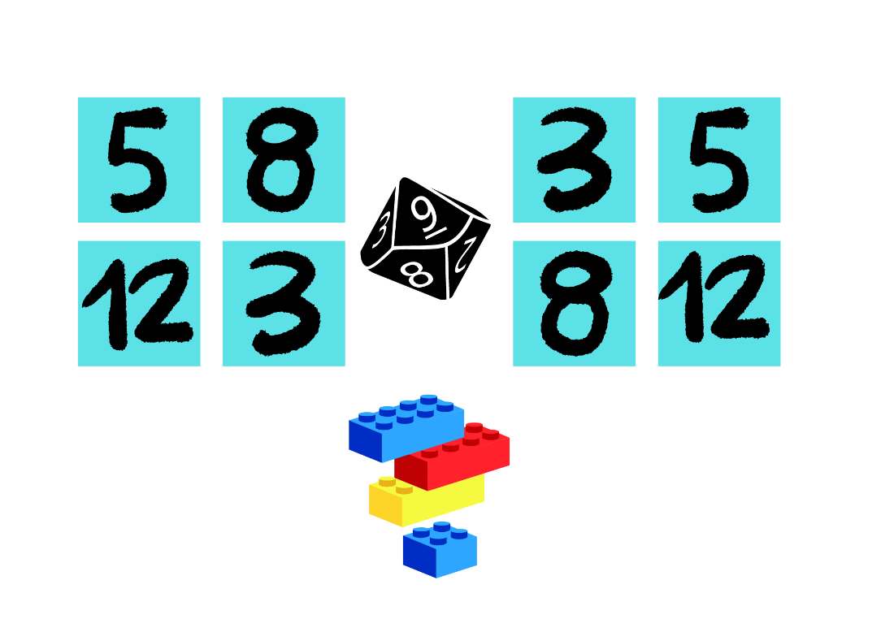
Images from Canva are licensed under Canva Content License Agreement.
- Students take turns to roll the dice and use that number of bricks to build a tower. For example, if a student rolls 4, they must build a tower of 4 and place it on one of the numbered sticky notes. If the student places this tower on the number 5, they will need to add one more brick to complete the tower on their next roll. Towers can be built in any order.
- Students take turns to roll the dice and build up towers until one player completes all their towers.
- As students are playing, ask:
- How many blocks do you have so far?
- How many more do you need to get to your target number?
- What strategy are you using to build your tower and work out how many more you need to complete the tower?
- At the end of their game, students arrange the towers in order from smallest to largest.
- Early Stage 1 students choose one of their tower numbers and count backwards to zero. Stage 1 students choose one of their tower numbers and count forward by twos to 40 and backwards by twos to zero.
- Students describe one thing they would do differently if they were to play the game again. Prompt students to explain their thinking.

Number of groups and number in each group: Part 1 – 30 minutes
This lesson has been adapted from How many bales? from Thinking mathematically.
- Display and read Resource 1: Bales of wool.
- Provide concrete materials to Early Stage 1 students and model how to distribute them one by one into 5 groups of 3 to represent 5 sheep with 3 bales each. Ask students if the groups are equal and to explain how they know. Students count to determine the total and record their answer in drawings, words or numerals.
- Ask Stage 1 students to use a mini whiteboard to draw a diagram to solve the problem. Ask:
- What is the problem asking us to do?
- What part of the problem tells the number of groups?
- What part of the problem tells the number in each group?
- What strategy did you use to work out the total?
- How did your diagram help you structure your solution?
- Choose students to demonstrate how they solved the problem.
- Demonstrate to students how to determine the number of groups and the number in each group within the problem. Model the different ways to draw a diagram to solve the problem and find the total (See Figure 2).
Figure 2 – Bales of wool solutions
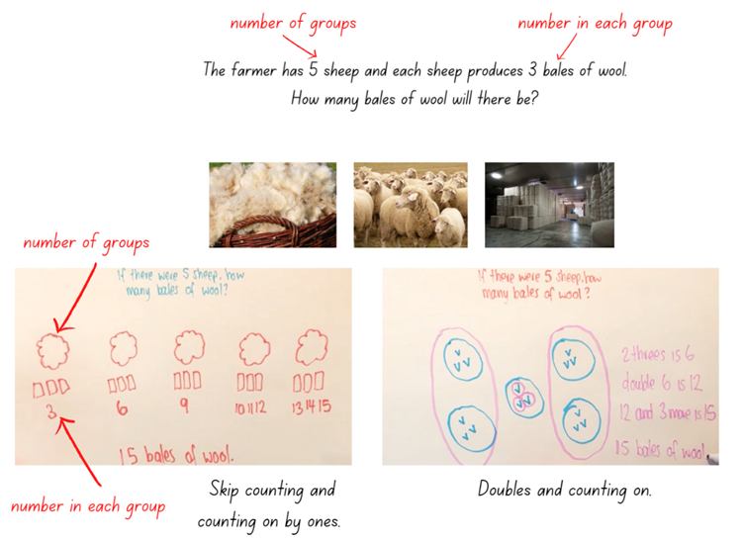
Images from Canva are licensed under Canva Content License Agreement.
- Display and read Resource 2: Different bales and ask students what they notice is similar and different to the last problem. Ask Stage 1 students to identify the number of groups and the number in each group. Ask students to consider and justify if they think the total will be the same or different.
- Provide Early Stage 1 students with concrete materials. Stage 1 students use their mini whiteboard to draw a diagram to solve the problem. Students share their solutions with the class. Through class discussion and comparison of problems, highlight the difference between the number of groups and the number in each group. For example, 5 sheep with 3 bales is different from 3 sheep with 5 bales; not in terms of the total but in terms of the number of sheep and bales and the structure of their diagram.
- Display and read Resource 3: Eggs. Provide students with one copy of Resource 4: Student copy. Stage 1 students underline the number of groups and circle the number in each group for each of the problems. Students use concrete materials to solve the problem and record using drawings, words or numerals.
- Regroup as a class and choose students to demonstrate how they solved the problems. Ask:
- How did you work out the number of groups and the number in each group? How did knowing this help you to record your solution?
- What counting strategy did you use to get the total?
- Why is the solution the same?
The table below details assessment opportunities and differentiation ideas.
Assessment opportunities | Too hard? | Too easy?
What to look for:  - Can students recognise equal and unequal groups? (MAO-WM-01, MAE-FG-02, MA1-FG-01)  - Can Early Stage 1 students share items equally by distributing items one by one until the collection is exhausted? (MAO-WM-01, MAE-FG-02)  - Can Stage 1 students identify the number of groups and the number in each group? (MAO-WM-01, MA1-FG-01)  - Can students use counting strategies to find the total? (MAO-WM-01, MAE-RWN-02, MA1-FG-01)  What to collect:  - student work samples. (MAO-WM-01, MAE-RWN-02, MAE-FG-02, MA1-FG-01) | Early Stage 1 students are unable to form and recognise equal groups.  - Form 2 groups by arranging items in each group side-by-side and use direct comparison.  - Provide multiple opportunities for students to complete guided and independent practise comparing ‘same as’ quantities.  Stage 1 students are unable to identify the number of groups and the number in each group.  - Students label the number of objects in each group.  - Students draw circles to represent how many groups and use concrete materials to put items in each group. Assist students to explain the process, for example, ‘I have drawn 3 groups and put 4 items in each group. The total is 12.’ | Early Stage 1 students can form and recognise equal groups.  - Ask students how the total would differ if there were more sheep.  - Students record their thinking.  Stage 1 students can identify the number of groups and the number in each group.  - Students represent the problems using an array and correctly name the array.  - Students determine the total or number of equal groups where the individual items cannot be seen.

Consolidation and meaningful practice: Rolling groups – 10 minutes
This lesson has been adapted from Rolling groups from Developing Efficient Numeracy Strategies (n.d).
- Provide students with one 6-sided die, playing cards 2, 3, 5 and 10, and counters. Students roll the dice to represent the number of rows or columns and turn over a card to represent the number in each row or column. Stage 1 students use these numbers to build and name an array. Early Stage 1 students only use the 2 and 3 playing cards and use the numbers to form equal groups.
Note: Focus on using groups of, before progressing to rows of and columns of. A composite unit is a unit-whole composed of other units. Recognising and working with composite units introduces the distinction between the number of groups (how many) and the number in each group (how much). These problems identify the distinction between the count (how many) and the unit (how much). When recording, how many is represented using the numeral and how much is recorded using the word, for example, 3 sevens. (Siemon et al. 2021)
- Students use an appropriate counting strategy to find the total. Stage 1 students should use rhythmic or skip counting. Students work together to create many different groups and arrays.
The table below details assessment opportunities and differentiation ideas.
Assessment opportunities | Too hard? | Too easy?
What to look for:  - Can students recognise equal and unequal groups? (MAO-WM-01, MAE-FG-02, MA1-FG-01)  - Can Early Stage 1 students share items equally by distributing items one by one until the collection is exhausted? (MAO-WM-01, MAE-FG-02)  - Can Stage 1 students form arrays using equal rows and equal columns? (MAO-WM-01, MA1-FG-01)  - Can students use counting strategies to find the total? (MAO-WM-01, MAE-RWN-02, MA1-FG-01)  What to collect:  - observational data. (MAO-WM-01, MAE-RWN-02, MAE-FG-02, MA1-FG-01) | Early Stage 1 students are unable to count to find the total.  - Use one 6-sided die and the 2 playing cards.  - Use a number chart and place counters on the numbers.  Stage 1 students are unable to form an array using equal rows and equal columns.  - Students continue to focus on modelling and describing collections as groups of.  - Students make equal groups and count by ones or skip count to find the total. | Early Stage 1 students can count to find the total.  - Use one 6-sided die and the 2, 3 and 5 playing cards.  - Students arrange their counters to allow efficient counting.  Stage 1 students can form an array using equal rows and equal columns.  - Have students name the array correctly, focussing on using the numeral to represent the number rows or columns and the number words to represent the number in each row or column, for example, 3 fives.  - Students determine the total in the array where the individual items cannot be seen.

Lesson 2: Berries
Core concept: Equal groups can be used to solve problems.
The table below contains suggested learning intentions and success criteria. These are best co-constructed with students.
Learning intentions | Success criteria
All students are learning that:  - numbers can be represented in different ways  - collections of objects can be quantified using a range of strategies.  In addition, Stage 1 students are learning that:  - objects, arrays, diagrams or actions can be used to solve problems involving equal groups  - multiplication can be represented by making and using equal groups. | All students can:  - describe collections of objects using words and numerals  - explain the strategies used to count a collection of objects.  In addition, students working towards Stage 1 outcomes can:  - form arrays to solve problems  - identify the number of groups and the number in each group.

Daily number sense: Building towers and Roll 3 – 15 minutes
- Build Early Stage 1 students’ understanding of representing whole numbers by revisiting Building towers from Lesson 1.
- Build Stage 1 students’ understanding of place value and the role of zero to read, write and order two- and three-digit numbers by playing ‘Roll 3’.
- Provide pairs of Stage 1 students three 10-sided dice and a mini whiteboard.
- Students take turns to roll the dice and use the numbers to create the largest three-digit number possible. Students record this on the mini whiteboard, then write the number immediately before and after the three-digit number they made.
- Students identify the nearest hundred to the number, then rearrange the digits to create the smallest three-digit number possible.
- Students partition and record the smallest three-digit number into place value parts, for example, 3 hundreds, 7 tens and 8 ones. Students repeat activity.

Number of groups and number in each group: Part 2 – 25 minutes
This lesson has been adapted from How many bales? from Thinking mathematically.
- Display and read Resource 5: Berries. Provide students with one copy of Resource 6: Student copy 2. Have students underline the number of groups and circle the number in each group for each of the problems. Support Early Stage 1 students to do this.
- Students use concrete materials to solve the problem and record their thinking using drawings, words or numerals. Stage 1 students should draw 2 diagrams to represent both problems. Encourage Stage 1 students to move from using groups of when representing their working out to using an array.
- Regroup as a class and choose students to demonstrate how they solved the problems. Ask:
- Are the groups equal? How do you know? (Early Stage 1)
- How did you work out the number of groups and the number in each group? How did knowing this help you draw your diagram? (Stage 1)
- What counting strategy did you use to get the total?
- Why is the solution the same?
- Ask students to work in small groups and create their own grouping problems like those posed in Lessons 1 and 2. Conduct a gallery walk and allow selected groups to share their problems and explain the solutions.
This table details assessment opportunities and differentiation ideas.
Assessment opportunities | Too hard? | Too easy?
What to look for:  - Can students recognise equal and unequal groups? (MAO-WM-01, MAE-FG-02, MA1-FG-01)  - Can Early Stage 1 students share items equally by distributing items one by one until the collection is exhausted? (MAO-WM-01, MAE-FG-02)  - Can Stage 1 students identify the number of groups and the number in each group? (MAO-WM-01, MA1-FG-01)  - Can students use counting strategies to find the total? (MAO-WM-01, MAE-RWN-02, MA1-FG-01)  What to collect:  - student work samples. (MAO-WM-01, MAE-RWN-02, MAE-FG-02, MA1-FG-01) | Early Stage 1 students are unable to form and recognise equal groups.  - Form 2 groups and arrange items in each group side-by-side and use direct comparison.  - Provide multiple opportunities for students to complete guided and independent practise comparing ‘same as’ quantities.  Stage 1 students are unable to identify between the number of groups and the number in each group.  - Students label the number of objects in each group.  - Have students focus on drawing circles to represent how many groups and use concrete materials to put items in each group. Assist students to explain the process, for example, ‘I have drawn 3 groups and put 4 items in each group. The total is 12.’ | Early Stage 1 students can form and recognise equal groups.  - Ask students to arrange their materials to promote efficient counting strategies.  - Ask students to count by twos.  Stage 1 students can identify between the number of groups and the number in each group.  - Have students represent the problems using an array.  - Students determine the total or number of equal groups where the individual items cannot be seen.

Consolidation and meaningful practice: Thinking multiplicatively – 20 minutes
- Show students the video Handfuls (thinking multiplicatively) (11:04) from Thinking mathematically.
- Provide pairs of students a collection of items to play the game. Early Stage 1 students play with items that encourage counting by ones, for example, the pasta in the video. Stage 1 students play with items that require counting groups of 2 or 4, for example, the figurines or bear toys in the video.

Lesson 3: Fruit shop
Core concept: Collections can be arranged to make counting easier.
The table below contains suggested learning intentions and success criteria. These are best co-constructed with students.
Learning intentions | Success criteria
All students are learning that:  - mathematicians use different ways to communicate ideas including drawings, words, numerals and arrays  - the same collection can be represented in different arrangements.  In addition, Stage 1 students are learning that:  - skip counting patterns help count larger collections  - multiplication can be represented by making and using arrays. | All students can:  - use counting strategies to find the total of different collections, for example, counting by ones, skip counting, counting on or double facts  - explain their reasoning using drawings, words, numerals or arrays.  In addition, students working towards Stage 1 outcomes can:  - identify and use arrays to solve addition and multiplication problems  - represent equality with the equals sign.

Daily number sense: Number visuals – 10 minutes
This lesson has been adapted from Number visuals from Thinking mathematically and Mindset Mathematics: The Groups Inside by J Boaler et al. (2022).
- Build students’ understanding of patterns and smaller numbers inside a larger number by exploring equal groups within a collection.
- Display Resource 7: Number visuals (Early Stage 1) and give students time to review the image independently.
- Provide Early Stage 1 students with Resource 7: Number visuals (Early Stage 1) and Stage 1 students with one number visual from Resource 8: Number visuals (Stage 1).
- Explain that students will explore the equal groups they can find inside the number visual. Students use colour-coding to represent the equal groups (see Figure 3.)
- Early Stage 1 students write the number that each pattern represents on their resource.
- Stage 1 students record the:
- smallest quantity
- largest quantity
- different representations they have found, for example, 9 threes.
Figure 3 – Number visuals student work example
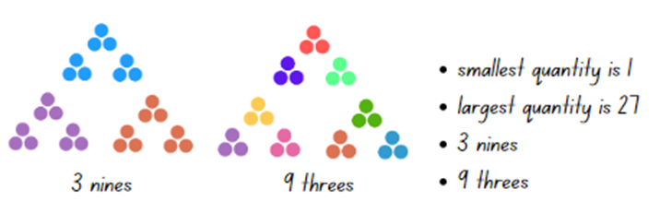
Note: Students may need more than one copy of the number visual to show different examples of equal groups.
- Students share how they looked for and colour-coded equal groups. Record student thinking and ask:
- How did you look for equal groups? What helped you see equal groups inside the numbers?
- How did you colour-code your groups?
- What did you notice once you had colour-coded your groups?
- What numbers had equal groups inside them? What numbers did not? Why do you think that is?
- What patterns did you notice in equal groups?

Fruit shop – 40 minutes
This lesson has been adapted from Multiplication: reSolve Fruit Shop from reSolve: Maths by Inquiry.
- Display Resource 9: Fruit and ask students what they notice about the fruit display. Provide individual thinking time and then have students turn and talk.
- Students share and explain what they noticed about the image.
- Model to Stage 1 students how to record the total of each fruit using numerals, words and the equals sign (see Figure 4).
Figure 4 – Recording an array
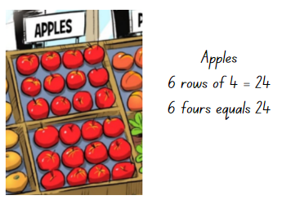
Image adapted from Multiplication: reSolve Fruit Shop – 1a resolve Fruit Shop by Australian Government Department of Education is licensed under CC BY-NC-SA 4.0.
- Ask students to find and record the total of each collection of fruit using diagrams, words and numerals. Early Stage 1 students may count by ones. Stage 1 students use other counting strategies, such as skip counting by twos or using arrays. Ask:
- Which counting strategy did you use to find the total of each type of fruit?
- How does the way the fruit is organised help you count them?
- Is there a different way you can solve this problem?
- Regroup and choose students to share and explain how they found the total. If not identified through questioning and discussion, explain to Stage 1 students that the fruit is organised into arrays and students can quickly and efficiently workout how many pieces of fruit are in each array by skip counting.
- Display Resource 10: Fruit shop and ask students to find the total number of oranges, watermelons and punnets of berries. Students record diagrams, words and numerals to represent the number of each fruit, for example, punnets of berries can be represented as 3 threes = 9 punnets (Stage 1).
Note: For Stage 1 students, arrays are an effective tool for modelling the commutative property of multiplication. For example, 3 × 5 has the same product as 5 × 3. Refer to the oranges in the resource as an example.
- Provide counters and ask students to find the cost of various fruits in the fruit shop, for example, punnets of strawberries. Focus students’ attention on the number of groups (for example, punnets) and the cost of each group. Encourage Early Stage 1 students to form equal groups of counters. For example, 8 groups of 3 to represent the cost of the strawberries. Stage 1 students should form arrays. Draw students’ attention to the scales in the image when working out the cost of the watermelons. Students record their working using drawings, words and numerals.
- Students display their work and go on a gallery walk to look at the various ways the problem has been solved.
The table below details assessment opportunities and differentiation ideas.
Assessment opportunities | Too hard? | Too easy?
What to look for:  - Can students use efficient counting strategies to find the total? (MAO-WM-01, MAE-RWN-01, MAE-RWN-02, MA1-FG-01)  - Can Stage 1 students identify and use arrays to solve addition and multiplication problems? (MAO-WM-01, MA1-FG-01)  - Can Stage 1 students use the equals sign to represent equality? (MAO-WM-01, MA1-CSQ-01)  What to collect:  - student work samples. (MAO-WM-01, MAE-RWN-01, MAE-RWN-02, MAE-FG-02, MA1-CSQ-01, MA1-FG-01) | Early Stage 1 students are unable to find the total of a collection. Provide students with printed copies of the resource. Students place counters on the resource as they count the items in each collection.  Stage 1 students are unable to identify and use arrays to solve multiplication problems.  - Provide students with printed copies of the resource. Support students to identify arrays by drawing circles around rows of fruit and counting how many there are in each row.  - Students make equal groups and count by ones or skip count to find the total. | Early Stage 1 students are able to find the total in each collection. Students use counting strategies other than counting by ones, for example, skip counting by twos.  Students can identify and use arrays to solve multiplication problems.  - Students find the total number of the strawberries in the shop if there are 7 strawberries in each punnet.  - Students create their own fruit shop with different arrays and the price of the fruit. Students work out the totals for their fruit shop or share with a peer to solve.

Discuss and connect the mathematics – 10 minutes
- Summarise the lesson together, drawing out some key mathematical ideas related to equal groups and arrays. Ask students:
- What strategies did you use to work out the total number of each type of fruit?
- Are there other strategies you could use?
- What strategy did you use to work out the total cost of each fruit?
- What challenges did you face? How did you overcome them?

Lesson 4: Fruit shop 2
Core concept: The same number can be represented in different forms.
The table below contains suggested learning intentions and success criteria. These are best co-constructed with students.
Learning intentions | Success criteria
Early Stage 1 students are learning that:  - different finger patterns can represent the same number  - an equal share is when all groups have the same amount.  Stage 1 students are learning that:  - multiplication can be represented by making and using arrays  - when an array is rotated, the value remains the same. | Students working towards Early Stage 1 outcomes can:  - make and recognise different finger patterns for the same number  - distribute items equally between groups.  Students working towards Stage 1 outcomes can:  - form multiple arrays of equal rows and equal columns for the same number  - rotate arrays to model the commutative property  - use arrays to solve multiplication and division problems.

Daily number sense: Patterns – 20 minutes
This activity has been adapted from Talking about patterns and algebra [PDF 3.28 MB].
- Create an AB pattern using a sequence of different sounds or actions, such as clap, stamp, clap, stamp, clap, stamp.
Pattern: A pattern in mathematics is made up of a number of elements that repeat or follow a rule.
- Students continue the pattern and describe it in words.
- Students use interlocking cubes to represent the actions and continue the pattern (see Figure 5).
Figure 5 – AB pattern with interlocking cubes
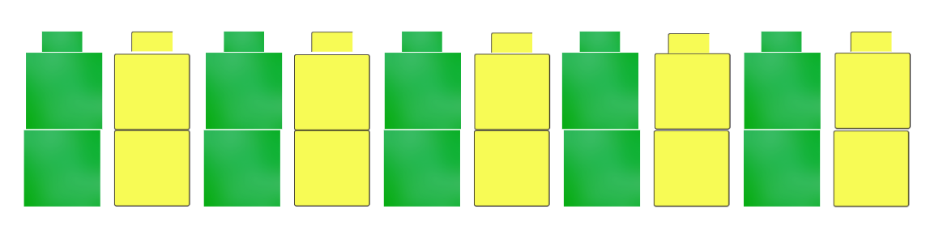
Images sourced from Canva and used in accordance with the Canva Content Licence Agreement.
- Repeat the activity using different sounds or actions, such as tap, click, tap, click, tap, click.
- Provide students time to think independently, then turn and talk to a partner. Ask students:
- How do you know this is a pattern?
- What part of the pattern is repeated?
- Stage 1 students to record the pattern on mini whiteboards using words, letters or numbers. For example, green, yellow, green, yellow...; G, Y, G, Y... or 5, 1, 5, 1, 5, 1...
- Explain that a two-part pattern can be described as an AB pattern. Demonstrate that A is the first element and B is the second element; the core is the 2 parts combined, which repeat.
- Repeat the activity. Ask students what an ABB pattern might look like in actions or sounds. Model an ABB pattern and then ask students to create an ABB pattern with interlocking cubes. Ask the students to describe the part of the pattern that is repeated.
- Cover each student’s interlocking cubes pattern with a piece of paper and ask students to draw their ABB pattern from memory. Ask students to explain how they remembered the pattern.
Note: It is important to model the words repeat, repeated and repeating. Early Stage 1 students develop strategies for forming groups based on the structure and pattern of numbers as countable units.
- Stage 1 students record their ABB pattern on mini whiteboards using words, letters or numbers.
- Early Stage 1 students use interlocking cubes to make their own pattern. Students turn and talk and describe their pattern.
- Explain to Stage 1 students that patterns can be made by skip counting, for example, 2, 4, 6, 8, 10... Ask Stage 1 students to create an appropriate skip counting pattern with a missing number, for example, 5, 10, 15, __, 20, 25, 30. Have students work with a partner to identify the missing number and to explain their thinking.

Fruit shop: Part 2 – 40 minutes
This lesson has been adapted from Multiplication: reSolve Fruit Shop from reSolve: Maths by Inquiry.
- Provide small groups of Early Stage 1 students with a 10-sided die. Students roll the dice and take turns using their fingers to represent the number rolled.
- Ask Early Stage 1 students:
- What number did you roll?
- How can you represent that number using your fingers?
- Can you think of a different finger pattern to represent that number?
- How can you check that you are using the correct number of fingers?
- Display and read one of the images from Resource 11: Lemons to Stage 1 students. Ask them to record all the different ways that all the lemons can be arranged in an array.
- Ask Stage 1 students:
- Is there more than one way to arrange the lemons?
- How do you know you have found all the possible solutions?
- Did you rotate the arrays to help find all the possible solutions? This question will emphasise the commutative property.
Commutative property: Two numbers can be added or multiplied in any order and the solution will be the same.
- Select students to share and explain how the fruit shop owner could arrange the lemons until all possible solutions are recorded. Ensure students understand that arrays can be rotated to show a different arrangement, however the total remains the same.
Note: There are 6 possible solutions: 2 rows of 12 and 12 rows of 2, 3 rows of 8 and 8 rows of 3, 4 rows of 6 and 6 rows of 4.
- Display one of the images from Resource 11: Lemons again and explain that the owner wants to split the lemons into 2 equal-sized groups. Early Stage 1 students use concrete materials and distribute them one by one until the collection is exhausted. Stage 1 students arrange the lemons in 2 arrays. Students record as many diagrams and solutions as possible to the problem (see Figure 6).
- Ask students:
- How did you split the lemons into 2 equal groups?
- How do you know that your groups are equal?
- How many lemons do you have in each group?
- What did you notice about the arrays? (Stage 1)
- Is there more than one solution? (Stage 1)
- How do you know you have found all the possible ways to arrange the lemons? (Stage 1)
- Did you rotate the arrays to help find all the possible solutions? (Stage 1)
Figure 6 – Student recording equal groups
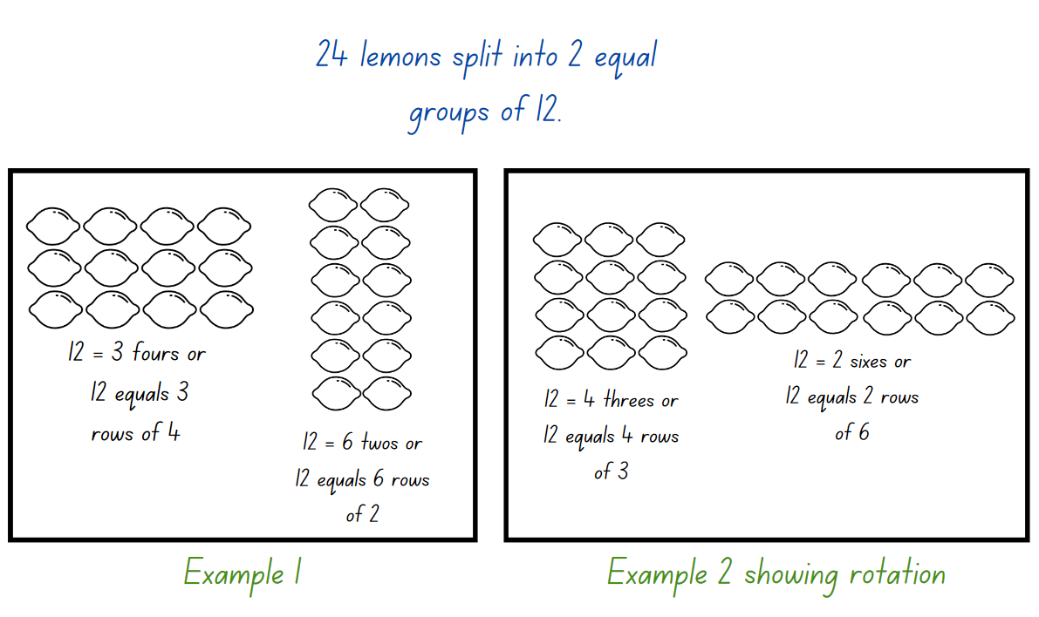
Images sourced from Canva and used in accordance with the Canva Pro Content Licence.
- Regroup as a class and choose students to demonstrate their solutions to the problem until all 4 possible solutions have been explained (2 rows of 6 and 6 rows of 2, 3 rows of 4 and 4 rows of 3).
- Explain that the owner of the fruit shop now wants to use all the lemons in a display where the different groups or arrays do not need to be the same size. For example, groups or arrays of 4 and 20 or 10 and 14 (See Figure 7). Students solve the problem and record using diagrams of unequal groups (Early Stage 1) or arrays (Stage 1), numerals or words.
- Ask students:
- What might the groups or arrays look like?
- Is there more than one solution?
- How will you know when you have all the solutions?
Figure 7 – Student recording unequal groups
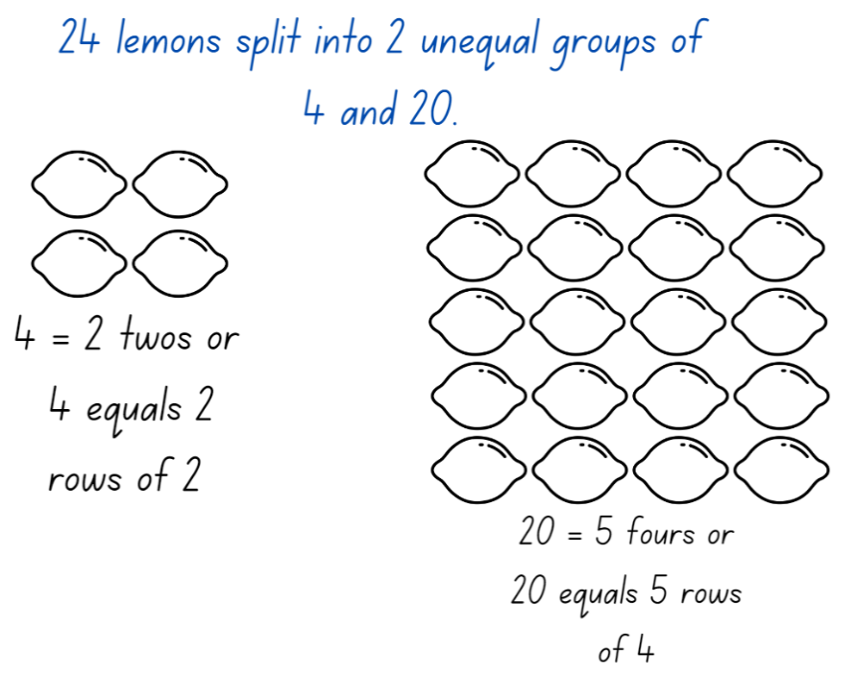
Images sourced from Canva and used in accordance with the Canva Pro Content Licence.
Note: Students may need counters or interlocking cubes to manipulate in order to solve the problem.

Discuss and connect the mathematics – 10 minutes
- Students display their work and do a gallery walk to look at all the different ways students modelled their unequal groups and arrays to solve the problem.
- Regroup as a class and choose students to show and explain their groups and arrays. Ask:
- Did you face any challenges when creating the unequal groups or arrays?
- Did you find a solution that was different to everyone else?
- Which solution would work best in the fruit shop? Why?
- Are you confident with rotating arrays? (Stage 1)
The table below details assessment opportunities and differentiation ideas.
Assessment opportunities | Too hard? | Too easy?
What to look for:  - Can Early Stage 1 students make and recognise different finger patterns to represent numbers to 10? (MAO-WM-01, MAE-RWN-02)  - Can Early Stage 1 students recognise equal and unequal groups? (MAO-WM-01, MAE-FG-02)  - Can Early Stage 1 students share items equally by distributing items one by one until the collection is exhausted? (MAO-WM-01, MAE-FG-02)  - Can Stage 1 students form multiple arrays of equal rows and equal columns for the same number? (MAO-WM-01, MA1-FG-01)  - Can Stage 1 students rotate arrays to model the commutative property? (MAO-WM-01, MA1-FG-01)  - Can Stage 1 students use arrays to solve multiplication and division problems? (MAO-WM-01, MA1-FG-01)  What to collect:  - student work samples (MAO-WM-01, MAE-RWN-02, MAE-FG-02, MA1-FG-01)  - recordings of student discussion answers. (MAO-WM-01, MAE-RWN-02, MAE-FG-02, MA1-FG-01) | Early Stage 1 students are unable to make and recognise different patterns to 10.  - Provide concrete materials for students to show different combinations to 10.  - Students use their fingers to represent smaller numbers, such as 5.  Stage 1 students are unable to form multiple arrays for 24 lemons.  - Provide concrete materials for students to move and explore different arrangements.  - Support students to form fewer arrays by asking them to arrange 12 lemons. | Early Stage 1 students make and recognise different finger patterns to 10.  - Challenge students to find as many finger patterns as they can for each number to 10.  - Students state the number before and after the number they rolled and count backwards to zero.  Stage 1 students can form multiple arrays for the same number.  - Students explain why there are only 5 ways to spit the lemons into 2 unequal groups with at least 2 lemons in each row and column.  - Students find numbers that form square arrays.

Lesson 5: Birthday party
Core concept: An equal share is when all groups have the same number of items.
The table below contains suggested learning intentions and success criteria. These are best co-constructed with students.
Learning intentions | Success criteria
All students are learning that:  - an equal share is when all groups have the same amount  - after sharing objects, it is important to recognise whether the number in each group is equal or not.  In addition, Early Stage 1 students are learning that a collection of objects can be shared by giving out items one at a time.  In addition, Stage 1 students are learning that:  - there are multiple ways to share objects into equal groups  - leftover parts when sharing into equal groups are called a remainder. | All students can:  - recognise groups of objects that are equal  - explain how to create equal groups.  In addition, students working towards Early Stage 1 outcomes can share items one by one to create equal groups.  In addition, students working towards Stage 1 outcomes can:  - share objects equally into a given number of groups  - describe the part left over when sharing into equal groups.

Daily number sense: Estimating GOAT – 20 minutes
- Build students’ understanding of estimating and checking the number of objects in a collection by playing Greatest of all thieves.
- Display the home page for the game and click on ‘Level 1: small change’.
- Explain that students must look at a collection of coins and estimate the total number. Students will only have a few seconds to estimate the total.
- After making an estimate, ask students:
- How do the 3 goats provide different ways of organising the coins?
- How do the different ways make it easier to count?
- Which way do you find the most helpful? Why?
- Play several rounds of the game as a class, asking students to record estimates on mini whiteboards.
- Compare student estimates, methods used and accuracy of estimates after each round.

Birthday party – 35 minutes
This lesson has been adapted from Birthday Sharing at NRICH.
- In small groups, provide each student with a paper plate and a ball of modelling clay. Ask students to make a plate of lollies from the modelling clay, then share them with each other. Observe the students’ abilities to share equally.
- Ask students:
- Does everyone in your group have the same amount? How do you know?
- Is it fair or equal? Why or why not?
- Explain that it is Chanel’s birthday, and she is having a party. Display 6 lollies and 2 plates.
- Model sharing unequal groups onto each of the plates.
- Ask students:
- Does everyone have the same amount? How do you know?
- Is it fair or equal? Why or why not?
- How should the lollies be handed out equally between Chanel and her friend?
- Can you draw a picture to show an equal share?
- Model the equal sharing of the lollies and putting the lollies back into one group. Explain there are 6 lollies altogether.
Note: The process of sharing objects equally and putting shared objects back together to form one collection develops students’ later understanding of the link between multiplication and division. It also provides the foundation for a conceptual understanding of their inverse relationship.
- Share students’ pictures and ask them to explain their thinking. Ask students:
- Can you find another way to share the 6 lollies into equal groups?
- Can you show me how they are equal or the same as each other?
- Ask Early Stage 1 students how they could share 12 lollies between Chanel and her friend. Ask Stage 1 students how they could share 24 lollies between Chanel and 3 of her friends. Students record their thinking using pictures, words and numerals.
- Explain that Chanel also has 18 cupcakes to share equally. Explain that Early Stage 1 students will be sharing the cupcakes between Chanel and one friend, but Stage 1 students will be sharing between Chanel and 3 friends. In small groups, students use 18 counters and paper plates to divide the cupcakes equally.
- Use ‘Talk moves’ to support student reasoning. Ask students:
- How do you know you have 18? Can you prove it?
- How many cupcakes are on each plate?
- Do all plates have the same number of cupcakes? Why or why not?
- What strategy did you use to make sure that the cupcakes were shared equally?
- Were there any cupcakes left over? How many? Is there a way to share the leftover cupcakes equally?
- Explain that Chanel has invited 11 friends to her party and they will play a game in groups. Each group will need a balloon. Early Stage 1 students work out a solution if the game is played in pairs, while Stage 1 students work out a solution if the game is played in groups of 4. Ask students to work out how many balloons Chanel will need, using counters, drawings, words and numerals.
- Use ‘Talk moves’ to support student reasoning. Ask students:
- How are you working this out?
- How did you know what to do first?
- What do we need to remember when sharing?
- Can you see a relationship between the number of balloons needed for 2 people and the number of balloons needed for 4 people? Explain your thinking. (Stage 1)
This table details assessment opportunities and differentiation ideas.
Assessment opportunities | Too hard? | Too easy?
What to look for:  - Can students recognise equal and unequal groups? (MAO-WM-01, MAE-FG-02, MA1-FG-01)  - Can Early Stage 1 students share items equally by distributing items one by one until the collection is exhausted? (MAO-WM-01, MAE-FG-02)  - Can Stage 1 students share objects equally into a given number of groups to determine how many are in each group? (MAO-WM-01, MA1-FG-01)  What to collect:  - student drawings (MAO-WM-01, MAE-FG-02, MA1-FG-01)  - photographs of student work (MAO-WM-01, MAE-FG-02, MA1-FG-01)  - recording of student discussion. (MAO-WM-01, MAE-FG-02, MA1-FG-01) | Students cannot recognise equal and unequal groups.  - Arrange items in each group side-by-side and use direct comparison.  - Provide multiple opportunities for students to complete guided and independent practise comparing ‘same as’ quantities. | Students can recognise equal and unequal groups.  - Change the problem to ask what would happen if another child joined the party.  - Repeat with different numbers of children and objects at the party.  Students can distribute items one by one until the collection is exhausted.  - Distribute items by twos to make equal groups.  - Ask students to find another way of distributing items equally such as equal grouping.

Consolidation and meaningful practice: Musical groups – 5 minutes
- Students spread out around the room.
Note: You may like to use background music and pause the music.
- Ring a bell or pause the music, then call out a number.
- Ask the students to make groups of that size.
- Ask students:
- Are all the groups equal?
- How many are in each group?
- How many groups are there?

Lesson 6: The doorbell rang
Core concept: Division is the equal distribution of objects.
The table below contains suggested learning intentions and success criteria. These are best co-constructed with students.
Learning intentions | Success criteria
All students are learning that an equal share is when all groups have the same amount.  Early Stage 1 students are learning that a collection of objects can be shared by distributing items one by one.  Stage 1 students are learning that:  - division is the equal distribution of objects  - leftover objects in division problems are called remainders. | All students can:  - distribute items equally between groups  - recognise groups of objects that are equal and unequal.  In addition, students working towards Early Stage 1 outcomes can distribute items one by one until the collection is exhausted.  In addition, students working towards Stage 1 outcomes can:  - determine the number of groups and the number in each group when given a collection of objects  - solve division problems by sharing and grouping objects.

Daily number sense: Domino carpark and 3 tens in a line – 15 minutes
- Build Early Stage 1 students’ understanding of representing whole number by subitising dominoes in different arrangements. This has been adapted from Dominoes parking lot game at The Robertson Program.
- Display Resource 12: Parking template and a domino from a collection. Demonstrate that each domino will be placed into a parking spot based on its total number of dots. For example, a domino with one dot on the top and 2 dots on the bottom will go into the number 3 spot. Explain that this is a race against the clock.
- Organise students into groups. Provide a copy of the parking template resource for each player and dominoes, all facing down.
- Students take turns to flip over a domino and place it in the correct parking spot on the resource. If the parking spot is full, the player places the domino back into the pile and the player’s turn is over.
- Students continue taking turns until one player has filled all their parking spots and wins the game.
- Ask students to share their counting strategies. Ask how students ‘see’ (subitise) the total.
- Build Stage 1 students’ understanding of number bonds to 10 by playing 3 tens in a line (2:25) from Thinking mathematically.
- Stage 1 students play the game in pairs. This game was introduced in Unit 2, Lesson 7.

The doorbell rang – 40 minutes
This lesson has been adapted from Sharing Cookies – A Division Lesson Plan based on ‘The Doorbell Rang’ from Australian Curriculum Lessons.
- Build student understanding of sharing and grouping by solving problems.
- Show students the book, The Doorbell Rang by Pat Hutchins. Students predict what might happen in the story before reading the book.
- After reading the book, give each student 12 counters to represent cookies and Resource 13: The doorbell rang.
- Students use counters to model the first 3 scenarios in the story and draw their findings. Stage 1 students may represent each scenario with a number sentence.
- Use ‘Talk moves’ to discuss the following questions:
- How can you make sure each person has the same share of cookies?
- How do you know everyone has the same share?
- How do you know how many cookies there are altogether?
- Stage 1 students share cookies between 5 children and discuss the impact of leftovers.
- Discuss that students can share items equally by distributing the items one by one (equally sharing) or by forming groups (equal grouping).
- Pose the problem, ‘Grandma arrived with 4 plates of treats, but she does not know how many treats there are on each plate. There are 6 children altogether’. Ask how many of each treat Grandma will need if each child is allowed:
- 2 cookies
- 5 marshmallows
- 3 pieces of chocolate
- 4 lollies.
- Students use counters to determine how many of each treat Grandma will need and record their working using drawings, words and numerals on Resource 13: The doorbell rang.
Note: Stage 1 students can find the total number using skip counting.
- Choose students to share their work and how they solved the problem. Ask:
- What strategy did you use to solve the problem?
- Do you think it was the most efficient method and why?
- Are there other ways to solve the problem?
- Was this an equal sharing or equal grouping problem? (Stage 1)
This table details assessment opportunities and differentiation ideas.
Assessment opportunities | Too hard? | Too easy?
What to look for:  - Can Early Stage 1 students share the cookies equally by distributing them one by one until the collection is exhausted? (MAO-WM-01, MAE-FG-02)  - Can students create equal groups from a collection? (MAO-WM-01, MAE-FG-02, MA1-FG-01)  - Can Stage 1 students distinguish between the number of groups and the number in each group? (MAO-WM-01, MA1-FG-01)  What to collect:  - completed Resource 13: The doorbell rang (MAO-WM-01, MAE-FG-02, MA1-FG-01)  - recording of student discussion. (MAO-WM-01, MAE-FG-02, MA1-FG-01) | Students cannot create equal groups.  - Use a smaller number of items to be shared and a smaller number to share the items amongst.  - Students count aloud whilst sharing objects one by one.  - Use a cup or container for each group, to emphasise the number of groups selected. | Students can share a collection of objects into equal groups.  - Repeat task with a larger number of items.  - Students distribute the items by twos.  - Students find all possible combinations of equal groups using 12 cookies.  - Stage 1 students form arrays and model division in each scenario.  - Stage 1 students to work out all the array structures that Grandma can have with 16 cookies.

Lesson 7: Outdoor grouping
Core concept: Collections can be quantified in many ways.
The table below contains suggested learning intentions and success criteria. These are best co-constructed with students.
Learning intentions | Success criteria
All students are learning that:  - an equal share is when all groups have the same amount  - forming a different number of equal groups from the same collection of objects helps represent numbers in different ways.  Stage 1 students are learning that:  - the number of objects in a collection can be estimated and checked by grouping to the nearest 10 and 100  - there is a difference between the number of groups and the number in each group  - division problems can be solved by forming equal groups. | All students can:  - distribute items equally between groups  - distribute the same number of items into an unknown number of groups.  In addition, students working towards Stage 1 outcomes can:  - estimate, to the nearest 10 and 100, the number of objects in a collection and check by grouping and counting  - determine the number of groups and the number in each group for a collection of objects  - model division by sharing and grouping objects.

Daily number sense: Estimating GOAT – 15 minutes
- Assess Stage 1 students’ understanding of estimating and checking the number of objects in a collection by playing Greatest of all thieves.
- Early Stage 1 students play ‘Level 1: small change’ on a device with a partner, estimating amounts up to 30.
- Display the home page for the game to Stage 1 students and click on ‘Level 2: big money’. Explain that in this level, students must look at a collection of notes and coins and estimate the total amount. Students will only have a few seconds to estimate the total.
- After making an estimate, ask students:
- How do the 3 goats provide different ways of organising the money?
- How do the different ways make it easier to count?
- Which way do you find the most helpful? Why?
- Play several rounds of the game together, asking students to record estimates on mini whiteboards.
- Compare student estimates, methods used and accuracy of estimates after each round.
This table details assessment opportunities and differentiation ideas.
Assessment opportunities | Too hard? | Too easy?
What to look for:  - Can Stage 1 students estimate, to the nearest ten, the number of objects in a collection and check by counting and grouping? (MAO-WM-01, MA1-RWN-01, MA1-RWN-02)  - Can Stage 1 students estimate, to the nearest hundred, the number of objects in a collection and check by counting and grouping? (MAO-WM-01, MA1-RWN-01, MA1-RWN-02)  What to collect:  - photographs of students’ whiteboards. (MAO-WM-01, MA1-RWN-01, MA1-RWN-02) | Stage 1 students cannot estimate the number of objects in a collection to the nearest hundred.  - Support students to play ‘Level 1: small change’, showing how to estimate the collection.  - Use MAB blocks to model grouping of money shown in the game. | Stage 1 students can estimate the number of objects in a collection to the nearest hundred.  - Students draw another way to represent each amount of money.  - After recording the answer, students write the nearest 10 and the nearest 100.

Outdoor grouping – 40 minutes
This lesson has been adapted from Robertson (2017).
- Explain that examples of equal and unequal groups can be found all around, including in nature.
- Take students outside and allow them a few minutes to collect a variety of natural materials such as stones, sticks, flowers, shells and seed pods.
Note: A collection of natural materials readily available in the classroom can also be used.
- Students share their objects with a friend by drawing 2 circles on the ground or using small hula hoops (see Figure 8).
Figure 8 – Hula hoop sharing
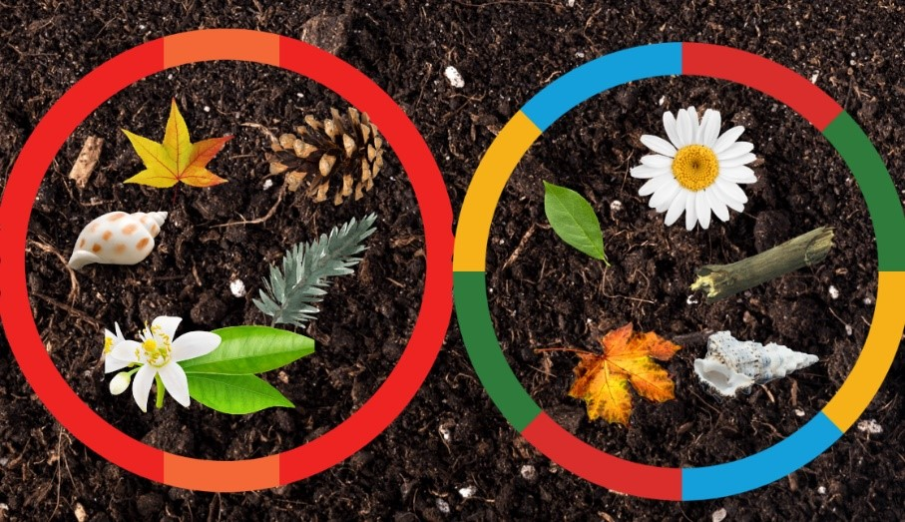
Images from Canva are licensed under Canva Content License Agreement.
- When sharing the objects into 2 groups, Stage 1 students may describe the number of objects in each group as being one half of the whole collection.
Note: Early Stage 1 students do not need to discuss leftover items. If groups are uneven, Early Stage 1 students should collect one more item to ensure the groups are equal or discard the leftovers.
- While students are sharing, ask:
- Is each group equal?
- How did you distribute the objects equally into the groups?
- How many objects are in each group?
- How many objects are there altogether?
- What happens when you divide an odd number of objects into 2 equal groups? (Stage 1)
- In pairs, students go on a treasure hunt to find as many leaves as possible in 30 seconds.
- Early Stage 1 students share the collection equally into 2 groups and find the total. Stage 1 students distribute the collection into 4 groups and discuss the method used to make the groups equal.
- In pairs, Early Stage 1 students collect 16 small natural items, while Stage 1 students collect 24.
Note: You may choose to reallocate items that have already been collected so that each pair has the required quantity.
- Students find different ways to share the items so the groups are equal. Students record their findings using drawings, words and numerals.
- While students are recording their findings, ask:
- How many ways could you share the items?
- How do you know if you have found all the solutions?
- This activity may be repeated using different materials and quantities if desired.
This table details assessment opportunities and differentiation ideas.
Assessment opportunities | Too hard? | Too easy?
What to look for:  - Can students share objects equally into a given number of groups to determine how many are in each group? (MAO-WM-01, MAE-FG-02, MA1-FG-01)  - Can students recognise equal and unequal groups? (MAO-WM-01, MAE-FG-02, MA1-FG-01)  - Can students distribute the same number of items into an unknown number of groups? (MAO-WM-01, MAE-FG-02, MA1-FG-01)  What to collect:  - photos of the shared materials in groups. (MAO-WM-01, MAE-FG-02, MA1-FG-01) | Students cannot distribute the same number of items into an unknown number of groups.  - Form amounts that create 2 equal groups and distribute items one by one until the collection is exhausted.  - Model distributing the same number of items into an unknown number of groups.  - Use a smaller collection of items. | Students can distribute the same number of items into an unknown number of groups.  - Students distribute the items by twos instead of counting out one by one.  - Stage 1 students form arrays and model division in each scenario.  - Students pose a new problem that can be solved by forming groups.

Discuss and connect the mathematics – 10 minutes
- Summarise the lesson, drawing out some key mathematical ideas about equal grouping. Ask students:
- What strategy did you use to group the items equally?
- How is your strategy the same or different?
- Has anyone revised their thinking or strategy for grouping? Why or why not?

Lesson 8: Equal sharing and grouping
Core concept: Division can be represented by sharing objects into groups or finding out how many groups are formed.
The table below contains suggested learning intentions and success criteria. These are best co-constructed with students.
Learning intentions | Success criteria
All students are learning that:  - division can be represented by sharing objects into equal groups  - division can be represented by finding out how many groups can be formed. | All students can:  - solve division problems using equal sharing and grouping  - identify between the number of groups and the number in each group when describing a collection of objects.

Daily number sense: The counting game – 20 minutes
- Build students’ understanding of multiplicative thinking using Counting game (by ones) (3:39) from Thinking mathematically.
- Show students the video Counting game (by ones) (3:39).
- Explain that Early Stage 1 students will play the game by counting by ones and can choose a target number between 12 and 20. Explain that Stage 1 students will play the game counting by fives and can choose a target number between 50 and 100. Students will use one counter to represent each count of 5.
- Students use Resource 14: Ten-frame to organise the counters in their game.
- In pairs, students take turns to count and place a counter in a row each time they say a number. Each student uses a different coloured counter.
- Students gain a point if they say the target number, then a new target number is chosen and students play again. After each game, students count and record the number of counters that they each played during the game.
- After playing several games, ask students:
- How could we change the game to make it more challenging?
- Did you work out a way to play this game so that you didn’t lose?
- What was your strategy? Did it work?
This table details assessment opportunities and differentiation ideas.
Assessment opportunities | Too hard? | Too easy?
What to look for:  - Can students count by ones to 20? (MAO-WM-01, MAE1-RWN-01)  - Can students count and record the number of counters that they played in each game? (MAO-WM-01, MAE-RWN-01)  - Can students count by fives? (MAO-WM-01, MA1-RWN-01)  What to collect:  - student responses to discussion questions (MAO-WM-01, MAE-RWN-01, MA1-RWN-01)  - video of students playing the game. (MAO-WM-01, MAE-RWN-01, MA1-RWN-01) | Early Stage 1 students cannot count to 20.  - Model counting using a number line or hundreds chart.  - Students use a lower target number.  Stage 1 students cannot count by fives.  - Model counting by fives using a number line or hundreds chart.  - Students play, counting by twos. | Students count to reach the target number.  - Students play, counting backwards from the target number.  - Students choose higher target numbers.

Equal sharing and grouping – 35 minutes
- Display one of the pictures from Resource 15: Sharing and grouping problems (Early Stage 1) and discuss what can be seen.
- Choose one of the associated problems and, as a class, have students solve the problem. Discuss what strategies students used.
- Complete the steps again with another picture and associated problem from Resource 15: Sharing and grouping problems (Early Stage 1).
- Provide small groups of Early Stage 1 one of the images, the associated problems from the resource and counters. Students look at the image and discuss what can be seen. Students solve the problems and represent their thinking using drawings, words and numerals.
- Provide groups of Early Stage 1 students with one of the images, associated problems from Resource 16: Sharing and grouping problems (Stage 1) and counters. Students look at the image and discuss what can be seen. As a group, students look at the given problems and identify which problems are equal grouping and which problems are equal sharing. Students choose one equal sharing and one equal grouping problem to solve and represent using drawings, words or numerals (see Figure 9).
Figure 9 – Student work sample
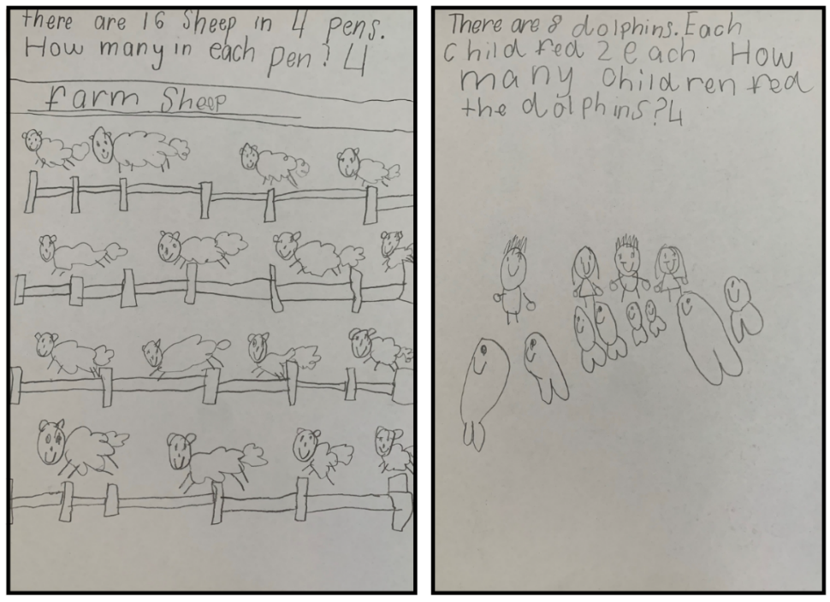
Note: This activity can be completed using technology like Book Creator where students type, illustrate and verbally record the story.
The table below details assessment opportunities and differentiation ideas.
Assessment opportunities | Too hard? | Too easy?
What to look for:  - Can students solve division problems using objects and diagrams? (MAO-WM-01, MAE-FG-02, MA1-FG-01)  - Can students identify between the number of groups and the number in each group when describing a collection of objects? (MAO-WM-01, MA1-FG-01)  What to collect:  - student work samples. (MAO-WM-01, MAE-FG-02, MA1-FG-01) | Students are unable to solve division problems using objects and/or cannot identify between the number of groups and the number in each group when solving division problems.  - Support students to read the problems and count out the given number for each group until there are no counters left. Circle each group of counters to identify the number of groups.  - Support students to read the problem and draw circles to identify how many groups the items are being shared into. Then provide students with concrete materials to physically share objects between the identified groups. | Students can identify between the number of groups and the number in each group when solving division problems.  - Students use the pictures from the resource to create their own equal sharing or grouping story.  - Students solve the problems from the resource and then rewrite the problems using multiplication (Stage 1).

Discuss and connect the mathematics – 10 minutes
- Regroup as a class and have students share the problems they solved. Ask:
- What strategies did you use to solve the problem?
- What challenges did you face? How did you overcome them?
- How did you know it was an equal sharing or equal grouping problem? (Stage 1)

Resource 1: Bales of wool
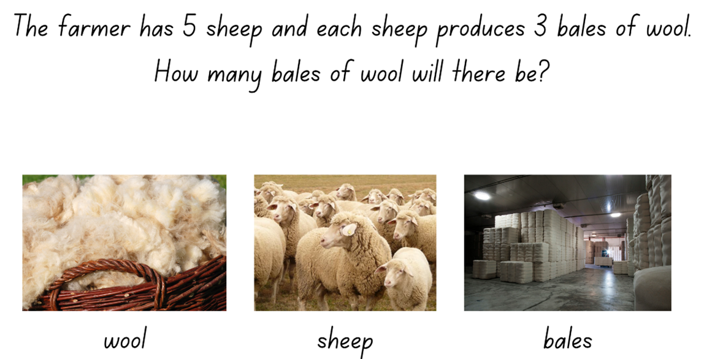
Images from Canva are licensed under Canva Content License Agreement.

Resource 2: Different bales
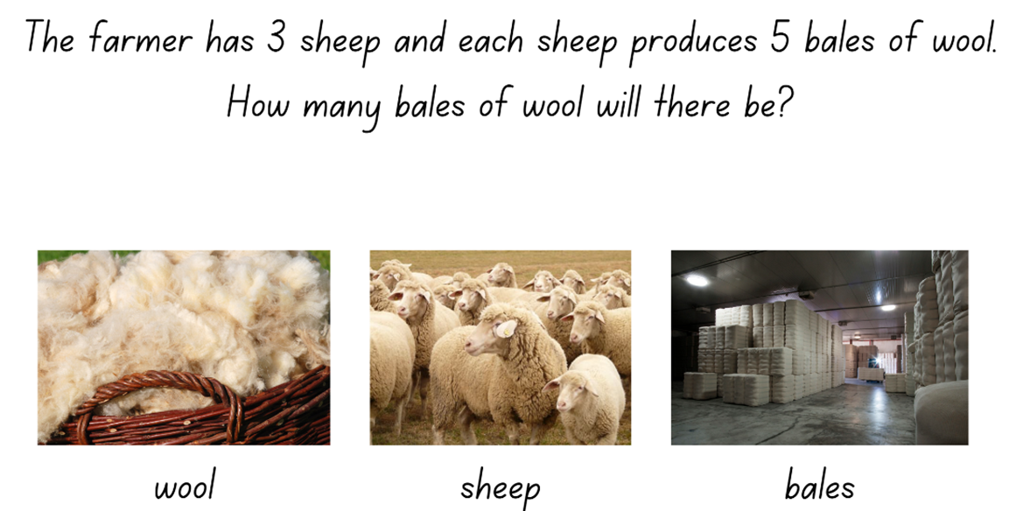
Images from Canva are licensed under Canva Content License Agreement.

Resource 3: Eggs
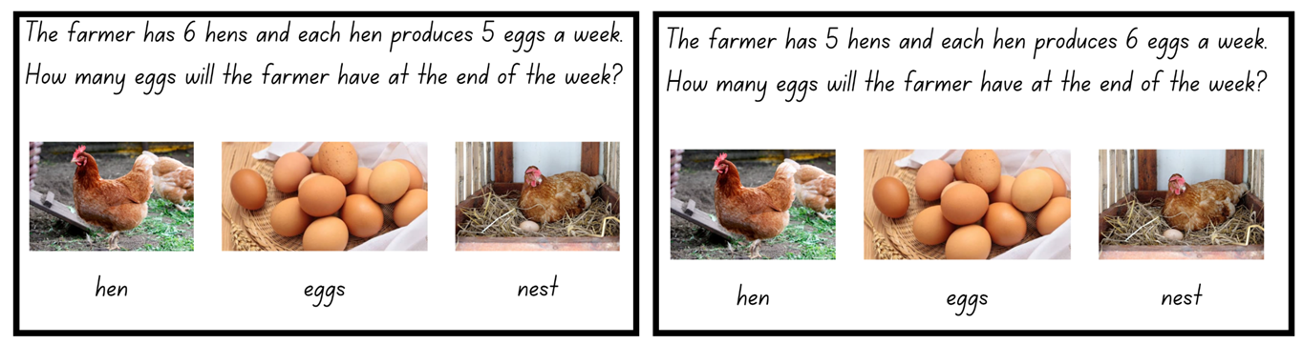
Images from Canva are licensed under Canva Content License Agreement.

Resource 4: Student copy
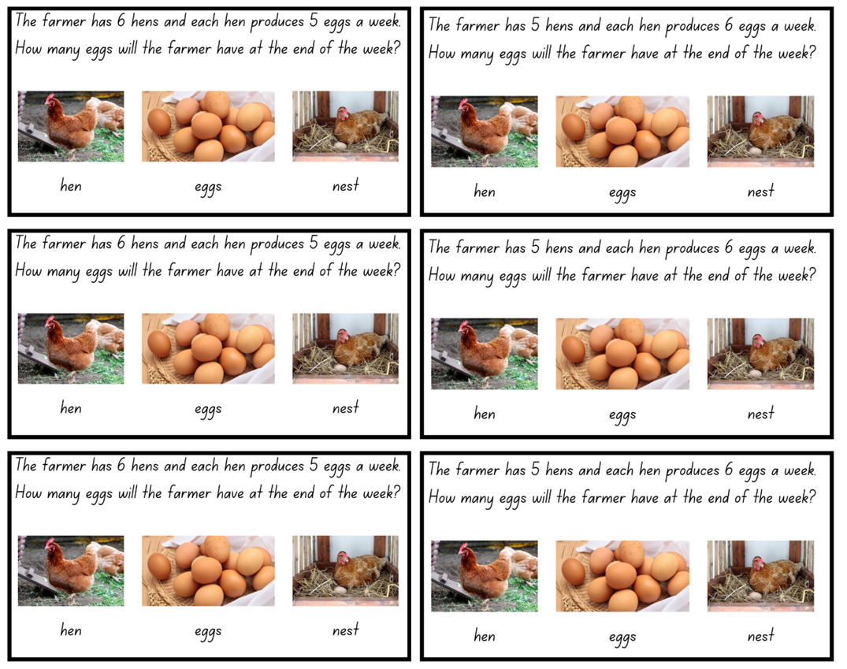
Images from Canva are licensed under Canva Content License Agreement.

Resource 5: Berries
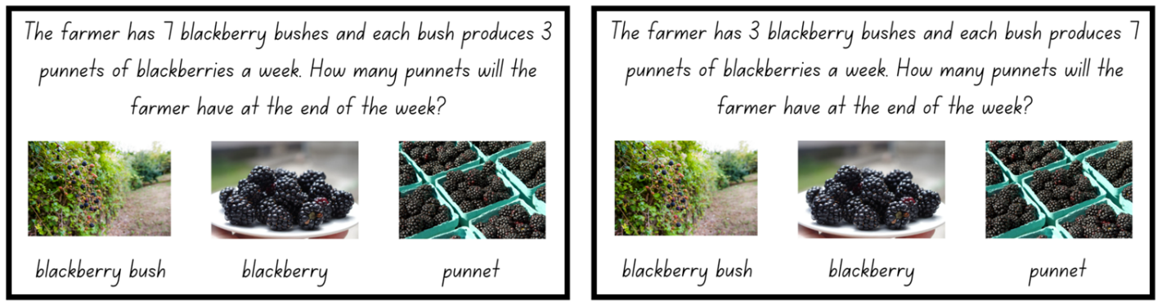
Images from Canva are licensed under Canva Content License Agreement.

Resource 6: Student copy 2
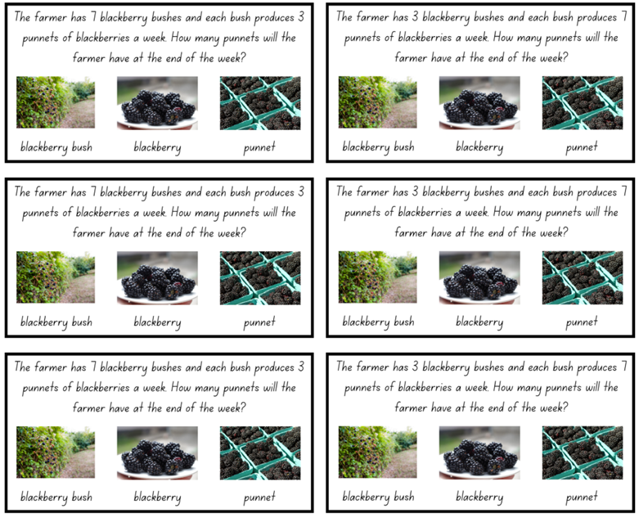
Images from Canva are licensed under Canva Content License Agreement.

Resource 7: Number visuals (Early Stage 1)
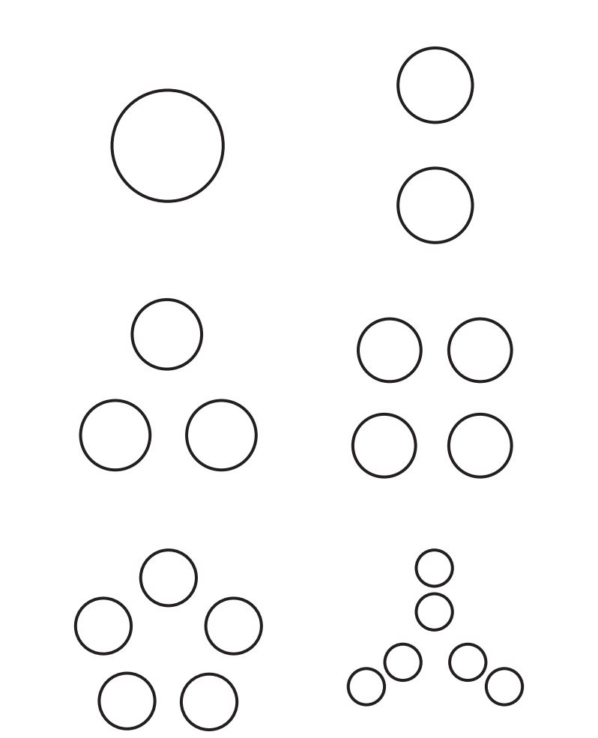
"Number visuals (Kindergarten)" by youcubed is licensed under CC BY 4.0.

Resource 8: Number visuals (Stage 1)
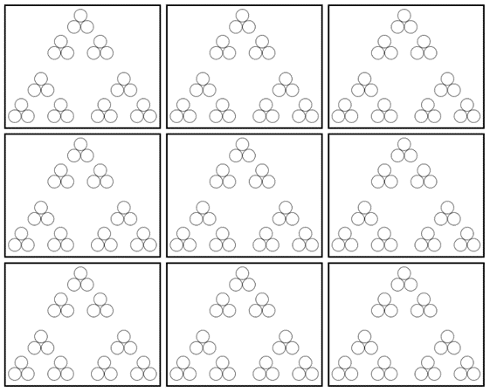
"Number visuals (1-2)" by youcubed is licensed under CC BY 4.0.

Resource 9: Fruit
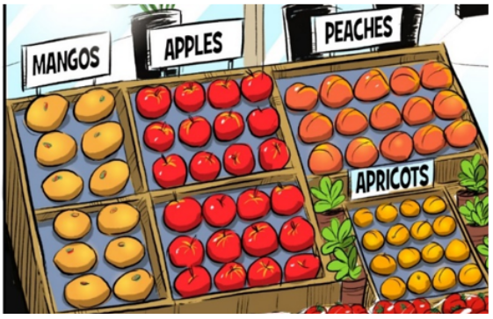
Image adapted from Multiplication: reSolve Fruit Shop – 1a resolve Fruit Shop by Australian Government Department of Education is licensed under CC BY-NC-SA 4.0.

Resource 10: Fruit shop
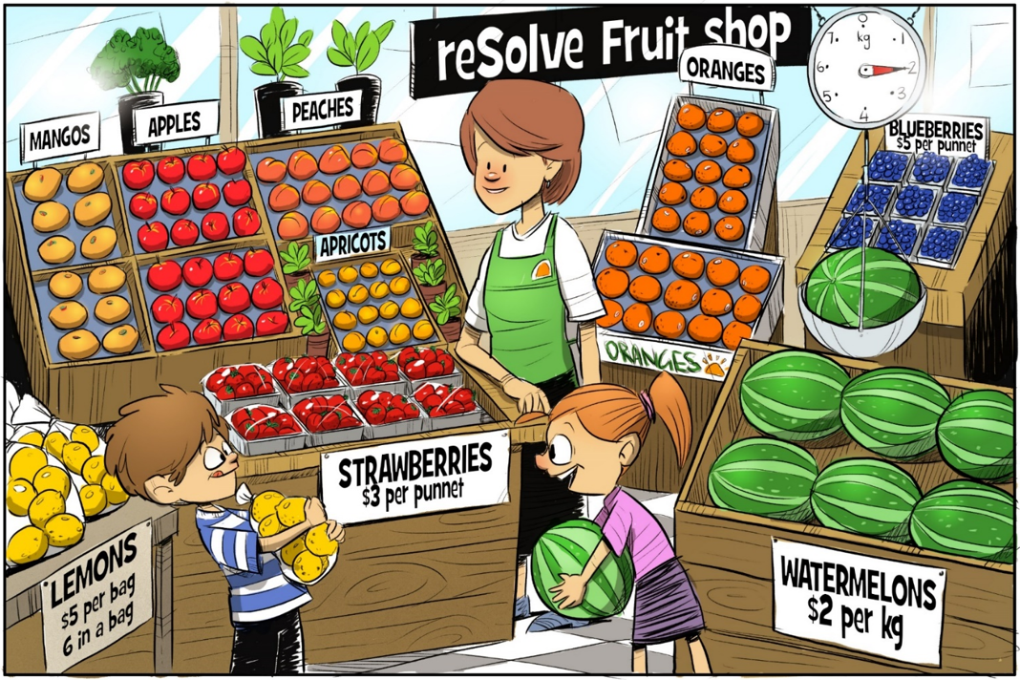
"Multiplication: reSolve Fruit Shop – 1a reSolve Fruit Shop" by Australian Government Department of Education is licensed under CC-BY-SA 4.0

Resource 11: Lemons
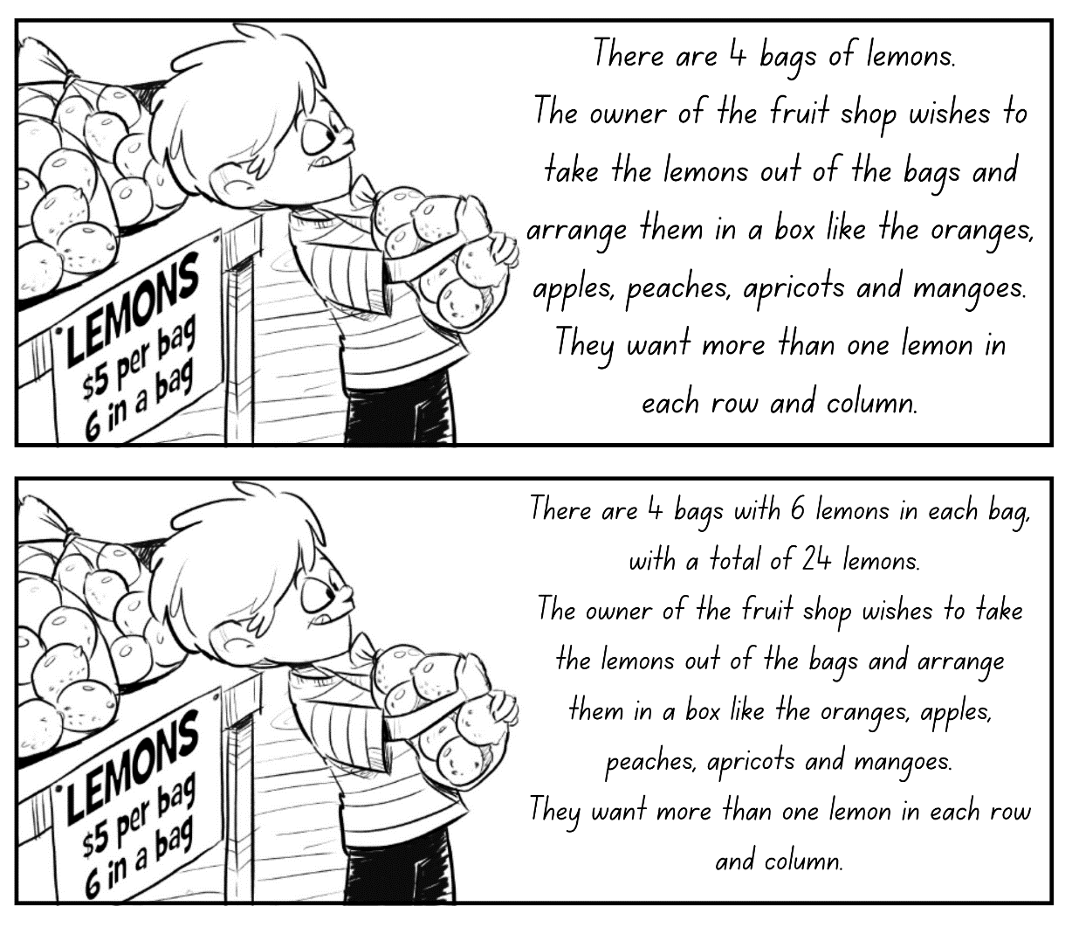
Image adapted from Multiplication: reSolve Fruit Shop – 1b resolve Fruit Shop by Australian Government Department of Education is licensed under CC BY-NC-SA 4.0.

Resource 12: Parking template
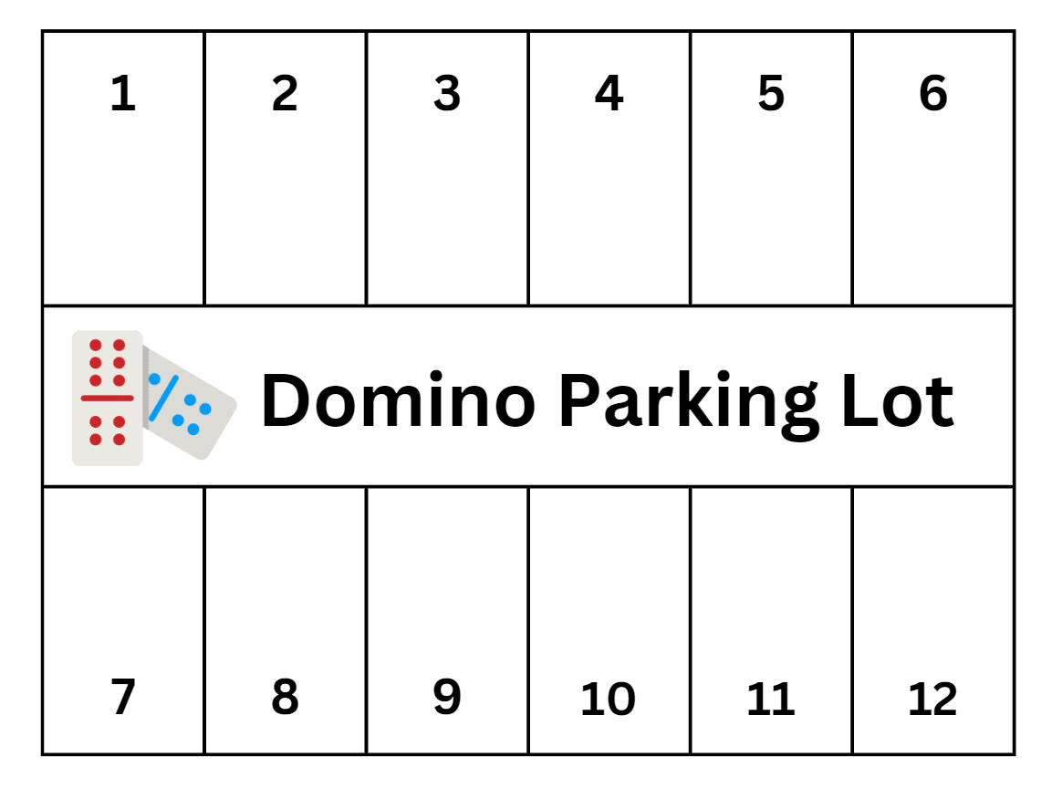
‘Domino’ by photo3idea is licensed in accordance with the Canva Content Pro License Agreement.

Resource 13: The doorbell rang
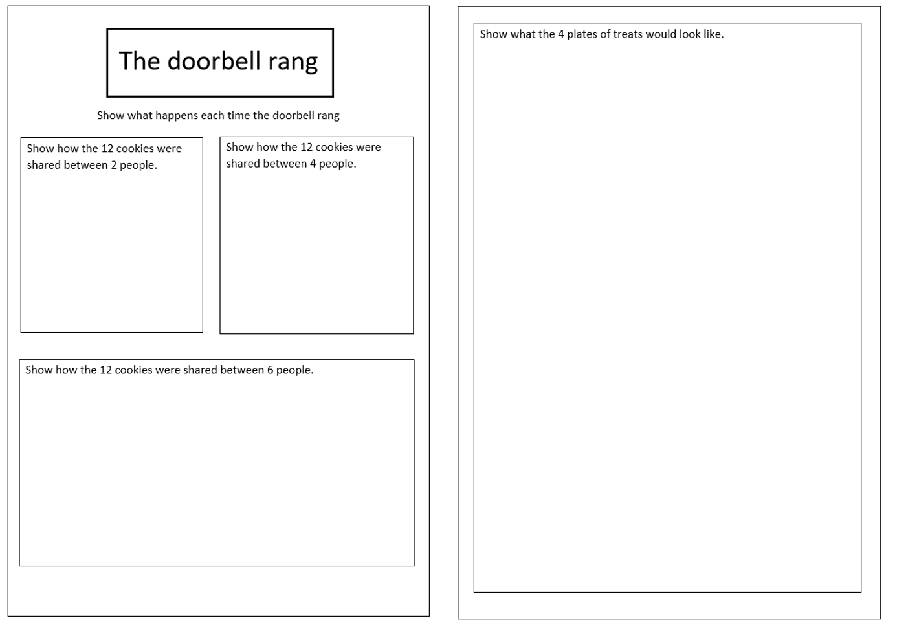

Resource 14: Ten-frame

Resource 15: Sharing and grouping problems (Early Stage 1)
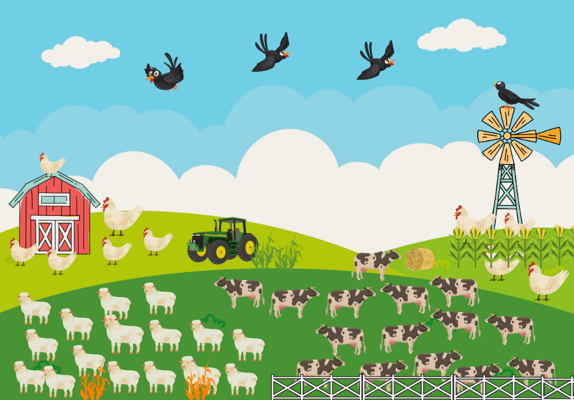
This image contains content obtained from Canva, and its use outside of this resource is subject to Canva’s Content License Agreement. If you wish to use it separately from the resource, please go to Canva.
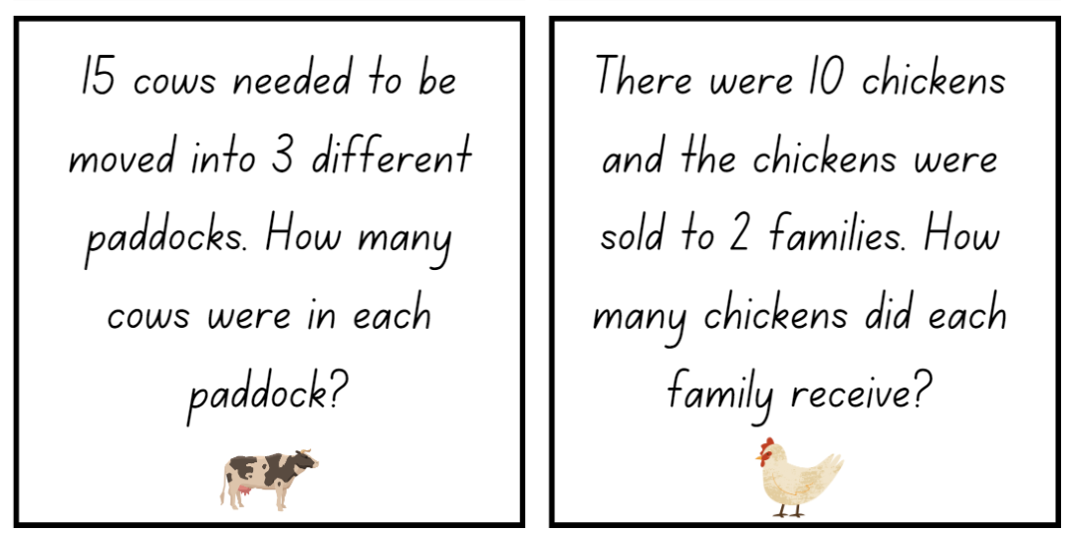
Images sourced from Canva and used in accordance with the Canva Pro Content Licence.
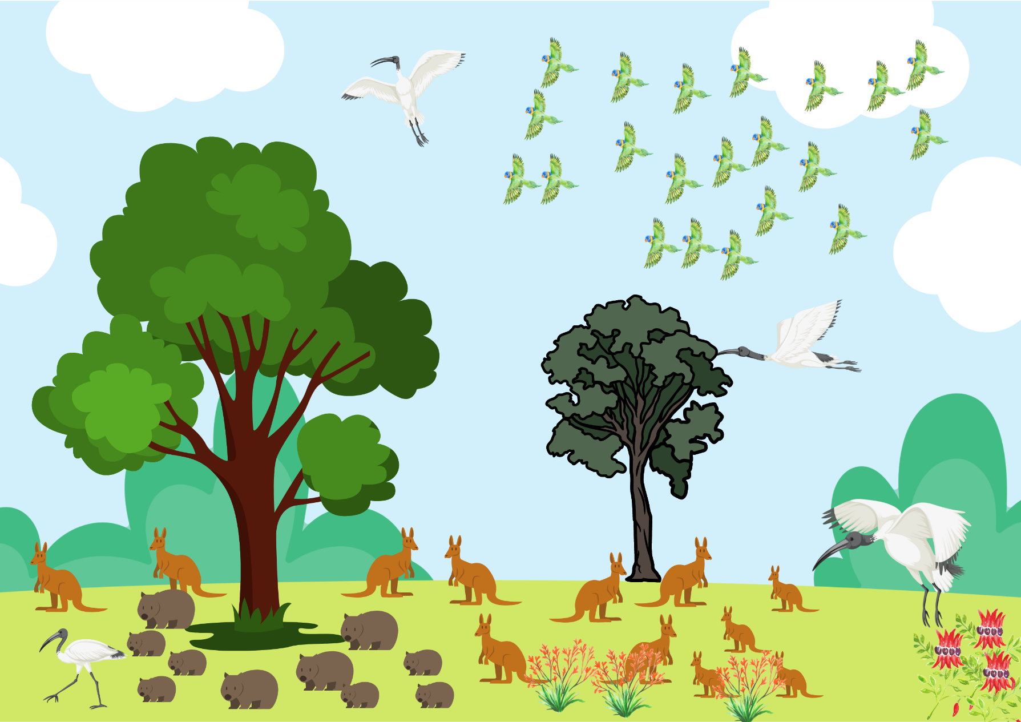
This image contains content obtained from Canva, and its use outside of this resource is subject to Canva’s Content License Agreement. If you wish to use it separately from the resource, please go to Canva.
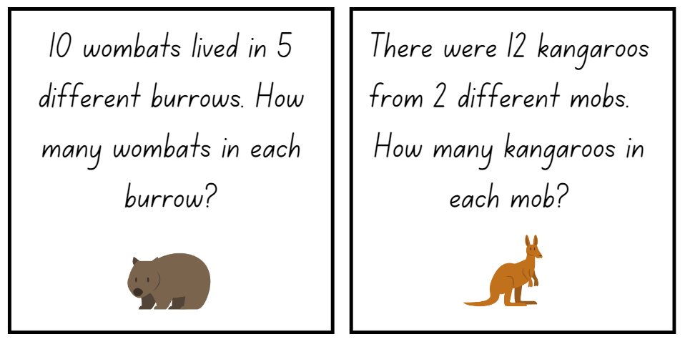
Images sourced from Canva and used in accordance with the Canva Pro Content Licence.
This image contains content obtained from Canva, and its use outside of this resource is subject to Canva’s Content License Agreement. If you wish to use it separately from the resource, please go to Canva.
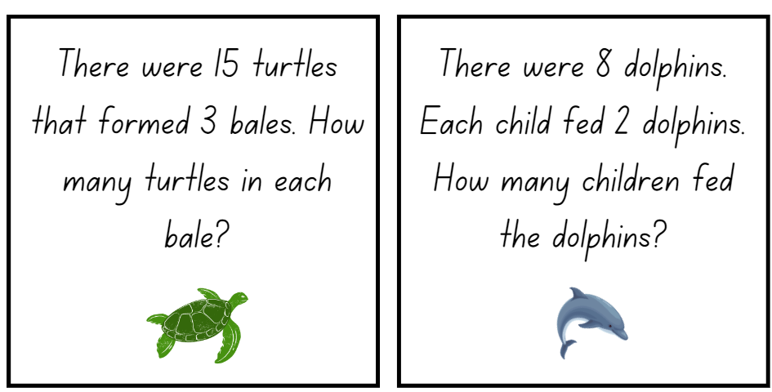
Images from Canva are licensed under Canva Content License Agreement.

Resource 16: Sharing and grouping problems (Stage 1)
This image contains content obtained from Canva, and its use outside of this resource is subject to Canva’s Content License Agreement. If you wish to use it separately from the resource, please go to Canva.
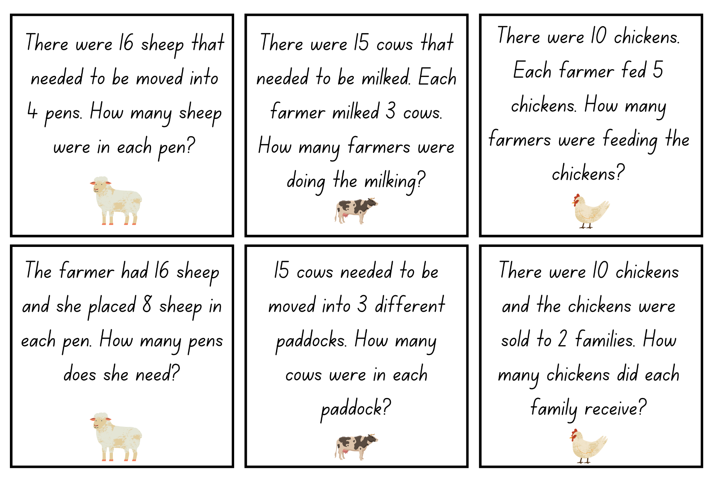
Images from Canva are licensed under Canva Content License Agreement.
This image contains content obtained from Canva, and its use outside of this resource is subject to Canva’s Content License Agreement. If you wish to use it separately from the resource, please go to Canva.
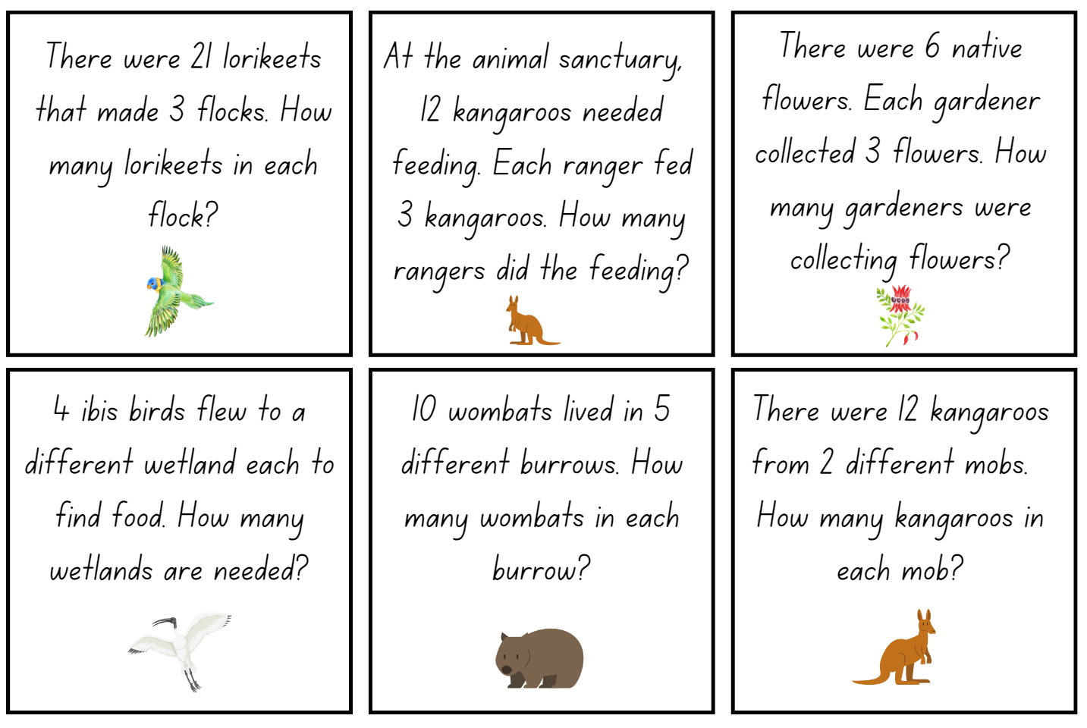
Images from Canva are licensed under Canva Content License Agreement.
This image contains content obtained from Canva, and its use outside of this resource is subject to Canva’s Content License Agreement. If you wish to use it separately from the resource, please go to Canva.
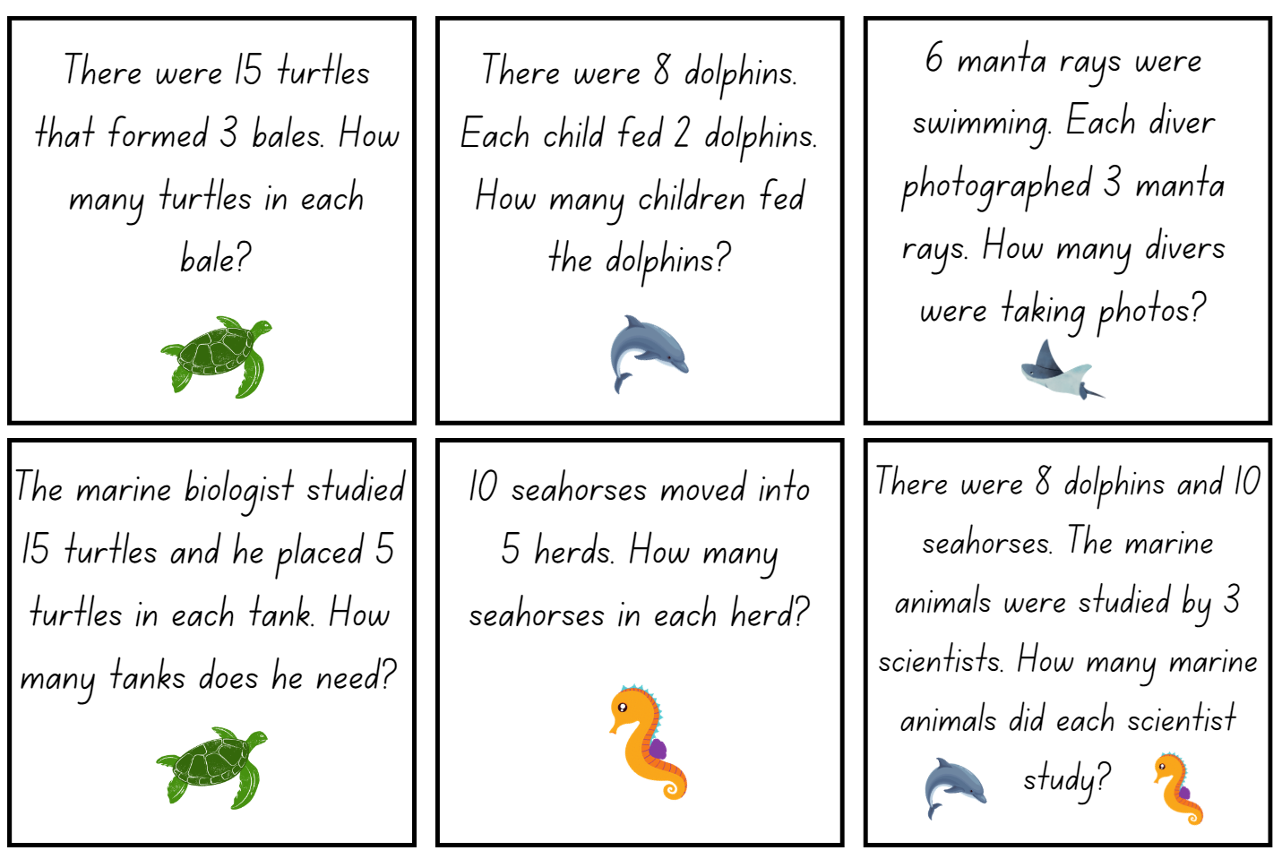
Images from Canva are licensed under Canva Content License Agreement.

Syllabus outcomes and content
The table below outlines the syllabus outcomes and range of relevant syllabus content covered in this unit. Content is linked to National Numeracy Learning Progression version (3).
Focus area and outcomes | Content groups and content points | Lessons
Representing whole numbers  MAO-WM-01, MAE-RWN-01, MA1-RWN-01, MAE-RWN-02, MA1-RWN-02 | Early Stage 1  Instantly name the number of objects within small collections  - Instantly recognise (subitise) the number of items in small groups of up to four items without counting (NPV1, CPr1)  - Identify the number of items in different arrangements (CPr2) | 1–3, 5–7
Representing whole numbers (cont) | Early Stage 1  Use the counting sequence of ones flexibly  - Count forwards to at least 30 and state the number after or before a given number, without needing to count from one (CPr4)  - Count backwards from a given number 20 or less (CPr5)  - Identify the number before as 'one less' and the number after as 'one more’ than a given number | 1–2, 4, 6, 8
Representing whole numbers (cont) | Early Stage 1  Recognise number patterns  - Recognise dice and domino dot patterns (NPA1, NPV2, CPr2)  - Recognise different finger patterns for the same number (NPA2) | 1–2, 4, 6
Representing whole numbers (cont) | Early Stage 1  Connect counting and numerals to quantities  - Count with one-to-one correspondence, recognising that the last number name represents the total number in the collection (CPr3, CPr5)  - Count out a specified number of objects (from 5 to 20) from a larger collection, keeping track of the count (CPr4-CPr5)  - Make correspondences between collections  - Read numerals to at least 20, including zero (NPV3)  - Represent numbers as quantities to at least 20 using objects (such as fingers), number words and numerals (NPV2-NPV4, CPr3)  - Compare and order numbers to 20 (NPV2-NPV3)  - Use the term ‘is the same as’ to express equality of groups (CPr4-CPr5, MuS1) | 1–4, 6–8
Representing whole numbers A | Stage 1  Use counting sequences of ones with two-digit numbers and beyond  - Identify the number before and after a given two-digit number (CPr5)  - Count forwards and backwards by ones from a given number to at least 120 (CPr6)  Continue and create number patterns  - Count forwards and backwards by twos from any starting point (CPr6-CPr7, MuS2) | 1
Representing whole numbers A (cont) | Stage 1  Represent the structure of groups of ten in whole numbers  - Recognise that ten ones ‘is the same as’ one ten (NPV2, NPV4)  - Use 10 as a reference in forming numbers from 11 to 20 (CPr7)  - Count large sets of objects by systematically grouping in tens (CPr7)  - Partition two-digit numbers to show quantity values (NPV4)  - Estimate, to the nearest ten, the number of objects in a collection and check by counting in groups of ten (CPr7, NPV6) | 2–3, 5, 7
Representing whole numbers B | Stage 1  Use counting sequences of ones and tens flexibly  - Identify the number before and after a given three-digit number  - Identify how many more to the next multiple of ten within two- and three-digit numbers | 2
Representing whole numbers B (cont) | Stage 1  Form, regroup, and rename three-digit numbers  - Count and represent large sets of objects by systematically grouping in tens and hundreds (CPr7, NPV5)  - State the quantity value of digits in numbers of up to three digits (NPV5)  - Identify the nearest hundred to a number  - Recognise units of 100 (UnM5, NPV5)  - Use place value to partition and rename three-digit numbers in different ways (NPV5)  - Estimate, to the nearest hundred, the number of objects in a collection and check by grouping and counting (NPV6) | 2, 7
Combining and separating quantities A  MAO-WM-01, MA1-CSQ-01  NOTE – There is only one combining and separating quantities outcome for Stage 1. | Stage 1  Represent equality  - Use the equals sign to record equivalent number sentences involving addition, and to mean 'is the same as', rather than as an indication to perform an operation (NPA3)  - Model the commutative property for addition and apply it to aid the recall of addition facts (AdS7)  - Recall related addition and subtraction facts for numbers to at least 10 (AdS6) | 3–4, 6
Forming groups  MAO-WM-01,  MAE-FG-01, MA1-FG-01  MAE-FG-02 | Early Stage 1  Copy, continue and create patterns  - Copy and continue repeating patterns using sounds and/or actions (NPA1-NPA2)  - Copy, continue and create repeating patterns using shapes, objects, images or pictures (NPA1-NPA2) | 1, 4
Forming groups (cont) | Early Stage 1  Investigate and form equal groups by sharing  - Distribute a group of familiar objects into smaller groups and recognise whether the number in each group is equal or not (MuS1-MuS2)  - Group and share concrete materials by distributing objects one by one or using another method (MuS1-MuS2) | 2–8
Forming groups (cont) | Early Stage 1  Record grouping and sharing  - Label the number of objects in a group  - Record grouping and sharing using drawings, words and numerals, and explain their thinking (MuS2) | 1–8
Forming groups A  NOTE – There is only one forming groups outcome for Stage 1. | Stage 1  Count in multiples using rhythmic and skip counting  - Count by twos, threes, fives and tens using rhythmic counting and skip counting (MuS2, CPr6) | 1–4, 8
Forming groups A (cont) | Stage 1  Use skip counting patterns  - Identify and describe patterns when skip counting forwards or backwards by twos, fives and tens (NPA3-NPA4)  - Determine a missing number in a number pattern with a constant difference  - Describe how the missing number in a number pattern was determined | 4, 8
Forming groups A | Stage 1  Model and use equal groups of objects to represent multiplication  - Model and describe collections of objects as groups of (MuS2)  - Determine and distinguish between the number of groups and the number in each group when describing collections of objects  - Find the total number of objects using skip counting of equal groups of a known size (MuS2-MuS3) | 1–3, 5–8
Forming groups A (cont) | Stage 1  Recognise and represent division  - Use concrete materials to model a half of a collection and show the relation between the half and the whole (InF1)  - Model sharing division by distributing a collection of objects equally into a given number of groups to determine how many in each group (InF2, MuS5)  - Model grouping division by determining the number of groups of a given size that can be formed (MuS5)  - Describe the part left over when a collection cannot be distributed equally using the given group size (MuS6) | 2–8
Forming groups B | Stage 1  Represent and explain multiplication as the combining of equal groups  - Use objects, diagrams, images or actions to model multiplication as accumulating equal groups (MuS4)  - Solve multiplication problems using repeated addition (MuS4)  - Form arrays of equal rows and equal columns (MuS5)  - Determine and distinguish between the number of rows/columns and the number in each row/column when describing collections of objects (MuS5)  - Model the commutative property of multiplication, using an array (MuS6)  - Model division by deconstructing an array equally into a given number of rows or columns | 1–4, 6–7
Forming groups B (cont) | Stage 1  Represent multiplication and division problems  - Solve multiplication and division problems using objects, diagrams, images and actions (MuS6-MuS7)  - Record answers to multiplication and division problems (including those with remainders) using drawings, words and numerals (MuS6) | 1–8

References
Links to third-party material and websites
Please note that the provided (reading/viewing material/list/links/texts) are a suggestion only and implies no endorsement, by the New South Wales Department of Education, of any author, publisher, or book title. School principals and teachers are best placed to assess the suitability of resources that would complement the curriculum and reflect the needs and interests of their students.
If you use the links provided in this document to access a third-party's website, you acknowledge that the terms of use, including licence terms set out on the third-party's website apply to the use which may be made of the materials on that third-party website or where permitted by the Copyright Act 1968 (Cth). The department accepts no responsibility for content on third-party websites.
Except as otherwise noted, all material is © State of New South Wales (Department of Education), 2023 and licensed under the Creative Commons Attribution 4.0 International License. All other material (third-party material) is used with permission or under licence. Where the copyright owner of third-party material has not licensed their material under a Creative Commons or similar licence, you should contact them directly for permission to reuse their material.
Mathematics K–10 Syllabus © 2022 NSW Education Standards Authority (NESA) for and on behalf of the Crown in right of the State of New South Wales.
© 2022 NSW Education Standards Authority. This document contains NSW Curriculum and syllabus content. The NSW Curriculum is developed by the NSW Education Standards Authority. This content is prepared by NESA for and on behalf of the Crown in right of the State of New South Wales. The material is protected by Crown copyright.
Please refer to the NESA Copyright Disclaimer for more information.
NESA holds the only official and up-to-date versions of the NSW Curriculum and syllabus documents. Please visit the NSW Education Standards Authority (NESA) website and the NSW Curriculum website.
National Numeracy Learning Progression © Australian Curriculum, Assessment and Reporting Authority (ACARA) 2010 to present, unless otherwise indicated. This material was downloaded from the Australian Curriculum website (National Literacy Learning Progression) (accessed 1 March 2023) and was not modified. The material is licensed under CC BY 4.0. Version updates are tracked in the ‘Curriculum version history’ section on the 'About the Australian Curriculum' page of the Australian Curriculum website.
ACARA does not endorse any product that uses the Australian Curriculum or make any representations as to the quality of such products. Any product that uses material published on this website should not be taken to be affiliated with ACARA or have the sponsorship or approval of ACARA. It is up to each person to make their own assessment of the product, taking into account matters including, but not limited to, the version number and the degree to which the materials align with the content descriptions and achievement standards (where relevant). Where there is a claim of alignment, it is important to check that the materials align with the content descriptions and achievement standards (endorsed by all education Ministers), not the elaborations (examples provided by ACARA).
Australian Curriculum Lessons (2013-2019) Sharing Cookies – A Division Lesson Plan based on ‘The Doorbell Rang’, Australian Curriculum Lessons website, accessed 14 February 2023.
Australian Government Department of Education (2020) ‘Multiplication: reSolve Fruit Shop’, Teaching resources, reSolve: Maths by Inquiry website, accessed 20 January 2023.
Boaler J, Munson J and Williams C (2022) Mindset Mathematics: Visualizing and Investigating Big Ideas, Grade 2, Jossey-Bass Inc, New York.
Hutchins P (1989) When the doorbell rang, HarperCollins, US.
Robertson J (2017) Messy Maths: A Playful, Outdoor Approach to Early Years, Independent Thinking Press, UK.
Siemon D, Warren E, Beswick K, Faragher R, Miller J, Horne M, Jazby D, Breed M, Clark J and Brady K (2020) Teaching Mathematics: Foundations to Middle Years, 3rd edn, Oxford University Press Australia and New Zealand.
State of New South Wales, Department of Education (n.d.) ‘Activities to support Multiplication and division’, Counting-on-and-back Strategies, Developing Efficient Numeracy Strategies One website, accessed 1 March 2023.
University of Cambridge (Faculty of Mathematics) (1997-2023) Birthday Sharing, NRICH website, accessed 14 February 2023.
University of Toronto OISE (Ontario Institute for Studies in Education) (n.d.) Dominoes Parking Lot Game, The Robertson Program website, accessed 14 February 2023.

Further reading
Smith MP, Bill VL and Gamoran Sherin M (2019) The Five Practices in Practice: Successfully Orchestrating Mathematics Discussions in Your Elementary Classroom, Corwin Press Inc and NCTM (National Council of Teachers of Mathematics), United States.

