Mathematics – K-2 multi-age – Year B – Unit 12
Contents
Unit description and duration 4
Student prior learning 4
Lesson overview and resources 6
Lesson 1: Repeating patterns are everywhere 16
Daily number sense: Number before and after – 15 minutes 17
Repeating patterns in our world – 40 minutes 19
Discussing and connecting the mathematics – 10 minutes 24
Lesson 2: We’re going on a repeating pattern hunt 25
Daily number sense: Number possibilities – 10 minutes 26
Repeating Pattern hunt – 45 minutes 27
Consolidation and meaningful practice – 10 minutes 30
Lesson 3: Reproducing patterns 31
Daily number sense: Estimating quantities – 15 minutes 32
Reproducing patterns: Part 1 – 5 minutes 35
Reproducing patterns: Part 2 – 40 minutes 35
Consolidation and meaningful practice: Gallery walk – 10 minutes 38
Lesson 4: Generating number patterns 39
Daily number sense: What other numbers belong? – 10 minutes 40
Generating number sequences: Part 1 – 35 minutes 41
Generating number sequences: Part 2 – 20 minutes 48
Discussing the mathematics: Features of a growing pattern – 5 minutes 50
Lesson 5: Generating counting sequences 51
Daily number sense: Generating counting sequences – 15 minutes 52
How many legs? – 45 minutes 55
Consolidation and meaningful practice: Generating Patterns – 10 minutes 60
Lesson 6: Investigating counting sequences 61
Daily number sense: 10 minutes 62
Representations of numbers – 45 minutes 63
Consolidation and meaningful practice: Investigating number patterns – 10 minutes 68
Lesson 7: Problem-solving detectives 69
Daily number sense: Ways to represent a number – 10 minutes 70
Pattern detectives – 45 minutes 71
Discussing the mathematics: What do equal groups and arrays tell us? – 5 minutes 75
Lesson 8: Arranging and displaying information 76
Daily number sense: An arrangement of cupcakes – 15 minutes 77
Sort the street: Part 1 – 15 minutes 79
Sort the street: Part 2 – 35 minutes 82
Discussing the mathematics: What does the information tell us? – 5 minutes 86
Resource 1: Number before and after 87
Resource 2: Patterns in architecture 88
Resource 3: Cards 1 and 2 97
Resource 4: A growing pattern 98
Resource 5: How many Legs? Early Stage 1 99
Resource 6: How many Legs? Stage 1 100
Resource 7: Number patterns 101
Resource 8: 12 and 30 square tiles 102
Resource 9: Repeating patterns and arrays 103
Resource 10: Sort the street 104
Syllabus outcomes and content 106
References 114

Unit description and duration
This two-week unit develops student knowledge, skills and understanding about repeating patterns, arrays and different ways to present and communicate about data. Students are provided opportunities to:
- recognise, name, create and extend various patterns
- identify that repeating patterns have a core that repeats over and over and over again
- identify, describe, organise and compare a variety of repeating patterns and arrays
- communicate their understanding and thinking as they create and explore various patterns and arrays
- select appropriate methods to display and interpret data.
Mathematics K–10 Syllabus © 2022 NSW Education Standards Authority (NESA) for and on behalf of the Crown in right of the State of New South Wales.

Student prior learning
Before engaging in these teaching and learning activities, students would benefit from prior experience with:
- creating repeating patterns using various concrete materials and identifying the core to extend the pattern to repeat over and over and over again
- using letters, such as AB and AABB to label and describe the core of a pattern
- creating representations, such as an array and describing how many groups (rows and columns) and how many in each group
- arranging objects according to a characteristic to form a data display and using it to ask and answer questions
- subitise dot patterns 1 to 5.

Lesson overview and resources
The table below outlines the sequence and approximate timing of lessons; syllabus focus areas and content groups; and resources.
Lesson | Syllabus focus area and content groups | Resources
Lesson 1: Repeating patterns are everywhere  65 minutes  A repeating pattern must have a repeating core or a mathematical regularity. | Representing whole numbers  Early Stage 1  - Instantly name the number of objects within small collections  - Recognise number patterns  Stage 1 – Part A  - Continue and create number patterns  Stage 1 – Part B  - Use counting sequences of ones and tens flexibly  - Form, regroup, and rename three-digit numbers  Forming Groups  Early Stage 1  - Copy, continue and create patterns | - Resource 1: Number before and after  - Resource 2: Patterns in architecture  - Digital device  - Sticky notes  - Various concrete materials  - Writing materials
Lesson 2: We’re going on a repeating pattern hunt  65 minutes  Repeating patterns have a core that repeats over and over and over again. | Representing whole numbers  Early Stage 1  - Instantly name the number of objects within small collections  - Recognise number patterns  Stage 1 – Part A  - Continue and create number patterns  Stage 1 – Part B  - Form, regroup, and rename three-digit numbers  Forming Groups  Early Stage 1  - Copy, continue and create patterns | - Digital devices  - Writing materials
Lesson 3: Reproducing patterns  70 minutes  Identifying the repeating core helps to extend and translate the pattern using a variety of materials. | Representing whole numbers  Early Stage 1  - Use the counting sequence of ones flexibly  - Recognise number patterns  Stage 1 – Part A  - Represent the structure of groups of ten in whole numbers  Stage 1 – Part B  - Form, regroup, and rename three-digit numbers  Forming groups  Early Stage 1  - Copy, continue and create patterns  Stage 1 – Part A  - Use skip counting patterns | - Collection of various small concrete materials  - Digital devices  - Writing materials
Lesson 4: Generating number patterns  70 minutes  Number sequences can be arranged and repeated to create a variety of number patterns. | Representing whole numbers  Early Stage 1  - Instantly name the number of objects within small collections  - Use the counting sequence of ones flexibly  - Recognise number patterns  - Connect counting and numerals to quantities  Stage 1 – Part A  - Use counting sequences of ones with two-digit numbers and beyond  Combining and separating quantities  Early Stage 1  - Identify part-whole relationships in numbers up to 10  Forming groups  Early Stage 1  - Copy, continue and create patterns  Stage 1 – Part A  - Use skip counting patterns  - Model and use equal groups of objects to represent multiplication  Stage 1 – Part B  - Represent and explain multiplication as the combining of equal groups | - Resource 3: Cards 1 and 2  - Resource 4: A growing pattern  - Digital devices  - Paper squares or sticky notes  - Square tiles or similar concrete materials  - Writing materials
Lesson 5: Generating counting sequences  70 minutes  Problems can be solved using a number pattern or sequence that you can trust. | Representing whole numbers  Early Stage 1  - Instantly name the number of objects within small collections  - Use the counting sequence of ones flexibly  - Recognise number patterns  - Connect counting and numerals to quantities  Stage 1 – Part A  - Use counting sequences of ones with two-digit numbers and beyond  Representing whole numbers B  - Form, regroup, and rename three-digit numbers  Combining and separating quantities  Early Stage 1  - Model additive relations and compare quantities  Forming groups  Early Stage 1  - Copy, continue and create patterns  Stage 1 – Part A  - Use skip counting patterns  - Model and use equal groups of objects to represent multiplication  Stage 1 – Part B  - Represent and explain multiplication as the combining of equal groups  - Represent multiplication and division problems  Data  Stage 1 – Part A  - Ask questions and gather data  Stage 1 – Part B  - Create displays of data and interpret them | - Resource 5: How many legs? Early Stage 1  - Resource 6: How many legs? Stage 1  - Resource 7: Number patterns  - Craft sticks  - Sticky notes  - Ten-frames  - Writing materials
Lesson 6: Investigating counting sequences  65 minutes  The quantity stays the same even when an arrangement of materials changes. | Representing whole numbers  Early Stage 1  - Instantly name the number of objects within small collections  - Use the counting sequence of ones flexibly  - Recognise number patterns  - Connect counting and numerals to quantities  Stage 1 – Part A  - Continue and create number patterns  Combining and separating quantities  Early Stage 1  - Identify part-whole relationships in numbers up to 10  Forming groups  Early Stage 1  - Copy, continue and create patterns  Stage 1 – Part A  - Use skip counting patterns  - Model and use equal groups of objects to represent multiplication  Stage 1 – Part B  - Represent and explain multiplication as the combining of equal groups  - Represent multiplication and division problem  Data  Stage 1 – Part B  - Create displays of data and interpret them | - Resource 8: 12 and 30 square tiles  - Square tiles or similar concrete materials  - Writing materials
Lesson 7: Problem-solving detectives  60 minutes  Collecting and recording information is a useful strategy when problem solving. | Representing whole numbers  Early Stage 1  - Instantly name the number of objects within small collections  - Use the counting sequence of ones flexibly  - Recognise number patterns  Stage 1 – Part A  - Continue and create number patterns  Stage 1 – Part B  - Use counting sequences of ones and tens flexibly  Forming groups  Early Stage 1  - Copy, continue and create patterns  Stage 1 – Part A  - Use skip counting patterns  - Model and use equal groups of objects to represent multiplication  Stage 1 – Part B  - Represent and explain multiplication as the combining of equal groups  - Represent multiplication and division problem | - Resource 9: Repeating patterns and arrays  - Digital devices  - Number lines  - Number tracks  - Ten-frames  - Writing materials
Lesson 8: Arranging and displaying information  70 minutes  Recorded information can be displayed in many ways and the results will provide meaningful information. | Representing whole numbers  Early Stage 1  - Instantly name the number of objects within small collections  - Recognise number patterns  - Connect counting and numerals to quantities  Stage 1 – Part A  - Use counting sequences of ones with two-digit numbers and beyond  Combining and separating quantities  Early Stage 1  - Model additive relations and compare quantities  Data  Stage 1 – Part A  - Ask questions and gather data  Stage 1 – Part B  - Create displays of data and interpret them | - Resource 10: Sort the street  - Counters  - Digital devices  - Writing materials

Lesson 1: Repeating patterns are everywhere
Core concept: A repeating pattern must have a repeating core or a mathematical regularity.
The table below contains suggested learning intentions and success criteria. These are best co-constructed with students.
Learning intentions | Success criteria
All students are learning that a simple repeating pattern core can be labelled and described using concrete materials, symbols or letters.  Students working towards Early Stage 1 outcomes are learning that:  - counting can begin from any number, without needing to count from one  - the value of a number before another number is ‘one less’ and the value of the number after is ‘one more’.  Students working towards Stage 1 outcomes are learning that:  - there is a repeating pattern when skip counting by tens on and off the decade beyond 100  - a repeating pattern can have multiple repeating attributes such as colour, size, shape and texture. | All students can:  - identify and describe the repeating core of a pattern  - use concrete materials, symbols or letters such as AB to label and describe a simple repeating pattern core.  In addition, students working towards Early Stage 1 outcomes can:  - count forwards to at least 30 and state the number after or before a given number, without needing to count from one  - identify the number before as ‘one less’ and the number after as ‘one more’ than a given number.  In addition, students working towards Stage 1 outcomes can:  - skip count by tens on and off the decade beyond 100  - use letters such as AB, ABC and AABB to label and describe a repeating pattern core.

Daily number sense: Number before and after – 15 minutes
- Build student understanding of counting sequences and numbers before and after a given number, by playing ‘Before and after’.
- Ask Early Stage 1 students to count to 20, starting from zero. Record the numbers on the board and ask students if they notice anything interesting about the number sequence.
- Ask Stage 1 students to skip count by tens to 200, starting from zero. Record the numbers on the board and ask students what they notice about the number pattern.
- Using a digital number board, ask Stage 1 students to skip count by tens to 120 starting off the decade, for example, starting from 7. Record the numbers on the board and ask students what they notice about the number pattern.
- Ask students to talk with a partner about what numbers they think would come next in the pattern, up to 200.
- Using a digital number board ask Early Stage 1 students to count backwards from 20 to zero.
- Display Resource 1: Number before and after, explaining that you need their help to find what comes before and what comes after.
- Ask Early Stage 1 students if they can identify the number that is one less and one more than the given numbers.
- Ask Stage 1 students if they can identify the number that is 10 less and 10 more than the given numbers.
- Provide students with writing materials and display a variety of one- and two-digit numbers to 30 and more complex two- and three-digit numbers for Stage 1 students.
- Early Stage 1 students record the number one less and one more than each number.
- Stage 1 students record the number 10 less and 10 more than each number.
- Select students to share their results and record these for students to view.
The table below details assessment opportunities and differentiation ideas.
Assessment opportunities | Too hard? | Too easy?
What to look for:  - Do students identify the number before as 'one less' and the number after as 'one more’ than a given number? (MAO-WM-01, MAE-RWN-01)  - Are students able to name the number before and after a given two- and/or three-digit number? (MAE-RWN-01, MA1-RWN-01)  - Can students name the number 10 more and 10 less than a given two- or three-digit number? (MA1-RWN-01)  What to collect:  - anecdotal records of discussions. (MAO-WM-01, MAE-RWN-01, MA1-RWN-01) | Students are unable to identify the number before as ‘one less’ and the number after as ‘one more’ than a given number. Provide students with a number track and model how to count with one-to-one correspondence. Pause and ask students to identify a number that is one less or one more than a given number.  Students are unable to skip count by tens off the decade or name the number that is 10 more or 10 less than a given number. Provide students with counters, a number track and/or a hundred chart. Model how to count backwards and forwards by 10. | Students can create and continue various skip counting pattern sequences up to 999.  - Provide students with a 200 chart. Ask students to identify interesting skip counting sequences.  - Challenge students to create a backwards skip counting pattern from 999 that has missing numbers. Ask them to share it with a partner to find the missing numbers to complete the pattern.

Repeating patterns in our world – 40 minutes
Note: Resource 2: Patterns in architecture will be used in multiple lessons. It is suggested to use 2 to 3 images per small group in this lesson and in future lessons, groups can swap images so students experience all of the patterns.
- Display one image from Resource 2: Patterns in architecture. Discuss the features, repeating shapes, colours, textures and sizes of objects. Ask students to identify and describe what they can see, and to name the repeating core pattern.
- Draw students’ attention to how patterns appear both vertically and horizontally and that patterns may have several elements that repeat over and over and over again, such as a shape, colour and texture. Ask students:
- Are there other elements that are repeating over and over and over again? For example, colour or texture?
- Is there more than one repeating core for the pattern?
- Can you describe another repeating core of the pattern?
- Is the pattern a two-part, three-part or four-part pattern?
- Are the patterns repeating in one direction only or do some patterns repeat both vertically and horizontally?
- Select students to label the repeating core of the patterns identified in the images using letters written on sticky notes, such as AB, ABB or ABC. Students may identify examples of repeating core patterns such as those in Figure 1 to Figure 3.
Figure 1 – Repeating core pattern
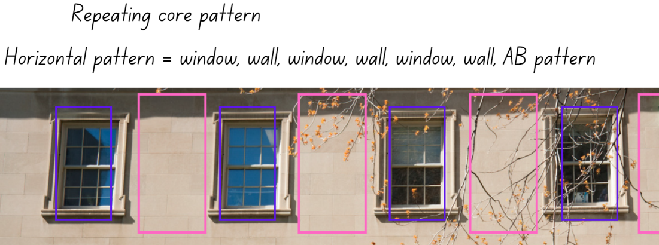
"Rows of Windows” by DebraLee Wiseberg has been adapted and is and used in accordance with the Canva Content License Agreement.
Figure 2 – Multiple repeating core patterns
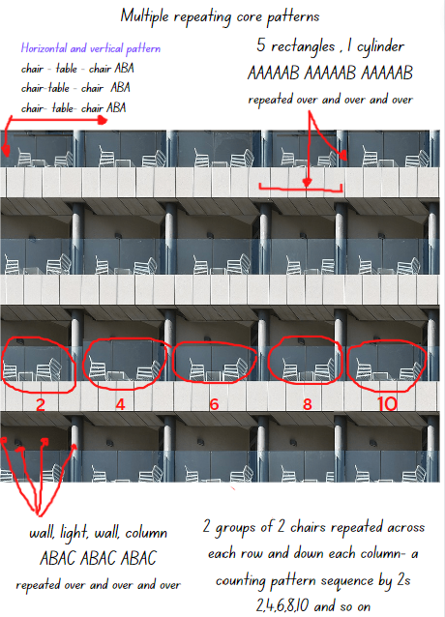
“Modern Industry Steel Technology Expression City” by moshehar has been adapted and used in accordance with the Pixabay License.
Figure 3 – Multiple repeating core patterns
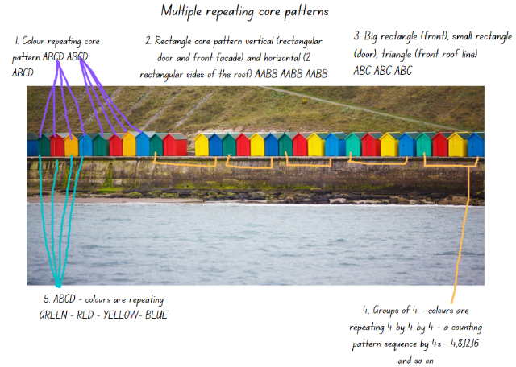
“Architecture Beach Bright Cabin” by PublicDomainPictures has been adapted and used in accordance with the Pixabay License.
- Provide each small group of students with a copy of selected images for Early Stage 1 and Stage 1 students from Resource 2: Patterns in architecture.
- Allow time for each group to view their images and to discuss and label the repeating core patterns they identify.
Note: Draw attention to various attributes that may be repeated in a pattern, such as texture, the quantity or number of objects. The size and position of objects may also be repeated in a pattern, for example, a column on the left and a column on the right and so on.
- Provide each group with writing materials and concrete resources such as coloured shape tiles, blocks and/or coloured bricks.
- Explain that students will select one image and replicate the repeating core pattern using concrete materials. Students need to record the core pattern, identify the elements that are repeated over and over and over again, and label the core pattern with letters or symbols.
- Students photograph and annotate their design so that it can be displayed and shared with the class during a gallery walk.
The table below details assessment opportunities and differentiation ideas.
Assessment opportunities | Too hard? | Too easy?
What to look for:  - Can students identify and describe the repeating core of a pattern using concrete materials, symbols or letters? (MAO-WM-01, MAE-RWN-01, MA1-RWN-01, MAE-FG-01)  - Do students identify if a repeating pattern has a variety of attributes which also repeat over and over and over again? (MAO-WM-01, MA1-RWN-01, MAE-FG-01)  - Can students describe the pattern core using letters such as AB, ABC, ABB, AABBCC? (MAO-WM-01, MA1-RWN-01, MAE-FG-01)  What to collect:  - observations of students creating, labelling and representing patterns. (MAO-WM-01, MAE-RWN-01, MA1-RWN-01, MAE-FG-01)  - photographs of students reproducing patterns from images. (MAO-WM-01, MAE-RWN-01, MA1-RWN-01, MAE-FG-01) | Students are not able to identify the repeating core of a pattern displayed in the images.  - Model how to identify and circle the repeating core of a pattern. Support students to describe the parts of the core that repeat.  - Provide students with an image of a simple architectural pattern and support them to identify and reproduce the identified core that repeats.  - Support students to record this pattern using concrete materials, symbols or letters. | Students can identify and describe various repeating core patterns and can create representations of these using concrete materials.  - In pairs, each student creates a representation of a core pattern from an image. The partner guesses which image the pattern represents and continues the pattern by labelling the core using letters.  - In pairs, each student creates a representation of a core pattern from an image and leaves a missing part of the pattern for their partner to guess and continue the pattern including the missing part.

Discussing and connecting the mathematics – 10 minutes
- Select one of the pattern representations made by a student and cover one part of the repeating core with a piece of paper. Ask students:
- What is the missing part of the repeating core? How do you know?
- What parts of the pattern do you think are repeating over and over and over again?
- What would come next if this pattern was to continue?

Lesson 2: We’re going on a repeating pattern hunt
Core concept: Repeating patterns have a core that repeats over and over and over again.
The table below contains suggested learning intentions and success criteria. These are best co-constructed with students.
Learning intentions | Success criteria
All students are learning that:  - patterns can be made from numbers, symbols and objects  - the part that repeats in repeating patterns is called the core.  Students working towards Early Stage 1 outcomes are learning that the ordered sequence of ‘teen’ numbers makes a pattern that repeats over and over and over again.  Students working towards Stage 1 outcomes are learning that:  - each digit in a two- and three-digit number has a place value  - all digits must be considered when ordering numbers. | All students can:  - identify patterns made from numbers, symbols or objects  - recognise and label the core of a repeating pattern.  In addition, students working towards Early Stage 1 outcomes can sequence numerals to 30 and name the number before and after.  In addition, students working towards Stage 1 outcomes can name the place value of each digit in a two- and three-digit number

Daily number sense: Number possibilities – 10 minutes
- Build student understanding of numbers by investigating how to combine and order given numerals to make all possible numbers.
- Display numerals 1 and 5.
- Ask students to name all the possible numbers that can be made using 1 and 5. Record suggested numbers on the board. Ask:
- What is the smallest number you can make?
- What is the largest number you can make?
- Can you order all the recorded numbers from the smallest to the largest?
- How do you know you have recorded all the possible combinations of numbers?
- Explain to Early Stage 1 students that they need to record all the possible one- and two-digit numbers using the numerals 1, 2, 3.
- Explain to Stage 1 students that they need to record all the possible numbers that can be made using only the 4 numerals 8, 4, 9, 1; all one-digit, two-digit and three-digit numbers.
- Provide each student with writing materials to problem solve and record all the possible numbers they can. Ask the above prompt questions again.
- Ask Stage 1 students:
- What is an example of an odd number and an even number? Can you circle an example of each and share it with a partner.
- What is the largest odd number you can make?
- What does the number look like that has one hundred, 4 tens and 8 ones?

Repeating Pattern hunt – 45 minutes
- Provide groups of students with a digital device and writing materials to take photographs and record pattern representations.
- Explain that students will explore the school playground on a ‘repeating pattern hunt’.
- Each group needs to find 4 different repeating patterns to photograph.
- Ask students to suggest patterns that they have already around the school, such as in Figure 4.
Figure 4 – Repeating patterns at school
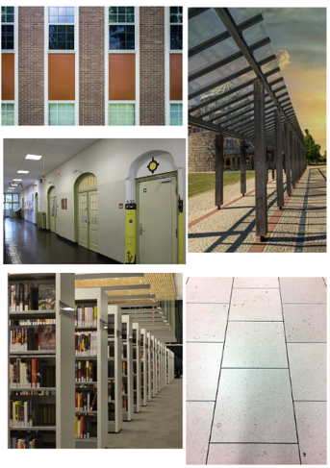
Images sourced from Pixabay and used in accordance with the Pixabay License.
- Explain that the repeating patterns need to have a core that repeats over and over and over again. Challenge students to identify patterns that have more than one repeating core, such as shape and colour, tall and short or plastic and metal.
- Support students as they conduct the ‘repeating pattern hunt’. Observe students as they discover patterns and prompt them to identify the repeating pattern core.
- Students label the pattern core in their photograph using symbols, letters or numbers. See Figure 5.
Figure 5 – Annotated repeating patterns
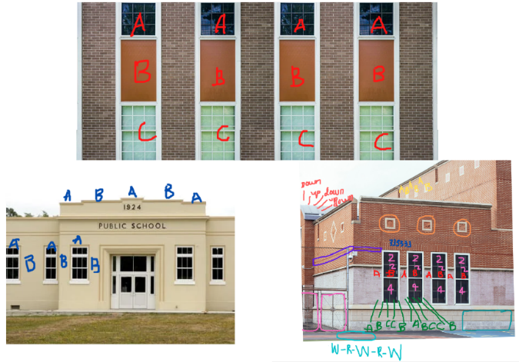
Images sourced from Canva and used in accordance with the Canva Content License Agreement.
The table below details assessment opportunities and differentiation ideas.
Assessment opportunities | Too hard? | Too easy?
What to look for:  - Can students identify patterns made from numbers, symbols or objects? (MAO-WM-01, MAE-RWN-01, MA1-RWN-01, MAE-FG-01)  - Are students able to identify the repeating core of a pattern within a range of contexts? (MAO-WM-01, MA1-RWN-01, MAE-FG-01)  - Can students name and describe the attributes of a repeating pattern within a range of contexts, such as shapes, colour and materials? (MAO-WM-01, MA1-RWN-01, MAE-FG-01)  What to collect:  - observations and recordings of conversations and vocabulary (MAO-WM-01, MAE-RWN-01, MA1-RWN-01, MAE-FG-01)  - photos and work samples of identified patterns. (MAO-WM-01, MAE-RWN-01, MA1-RWN-01, MAE-FG-01) | Students cannot identify patterns made from numbers, symbols or objects. Show students a simple pattern, for example, a paved pathway or a wall. Support them to identify and describe the pattern using numbers, symbols or objects.  Students are not able to find the repeating core of a pattern. Students create a representation of a pattern core that repeats over and over and over again. Support students to label the repeating core of a simple AB pattern. | Students can identify and label a variety of more complex repeating patterns within a range of contexts.  - Challenge students to identify a repeating core pattern that occurs horizontally and vertically in a pattern. For example, the glass and metal parts of a window and the rectangular shape.  - Ask students to find how many different pattern cores they can find in one image of an area in the school.

Consolidation and meaningful practice – 10 minutes
- Strategically select students to display their photographs and describe the identified patterns. Aim to include a range of examples from simple AB pattern cores to more complex, such as ABBBC. Ask:
- What did you notice as you were looking for patterns?
- What would be the next part of this pattern if we continued to extend it?
- Did you find any examples of a four- or five-part pattern? Such as an ABCD pattern or ABBBC pattern?
- Is there anything else that you noticed?

Lesson 3: Reproducing patterns
Core concept: Identifying the repeating core helps to extend a pattern.
The table below contains suggested learning intentions and success criteria. These are best co-constructed with students.
Learning intentions | Success criteria
All students are learning that:  - identifying the repeating core helps to extend a pattern  - a variety of materials can be used to translate the core of a repeating pattern  - there are different strategies to solve problems  - mathematicians estimate a large quantity by viewing and comparing to what they already know. | All students can:  - describe a repeating pattern as having a two-part (AB) repeating core pattern, a three-part (for example, ABC, ABB) repeating core pattern, and so on  - create and extend a variety of representations of repeating core patterns  - look, think and compare quantities to make an accurate estimation.  In addition, students working towards Early Stage 1 outcomes can:  - count a collection of objects and keep track of the count  - identify and compare if 2 collections of objects have a quantity that is the same, more or less.  In addition, students working towards Stage 1 outcomes can accurately use various skip counting strategies to count a large collection of objects.

Daily number sense: Estimating quantities – 15 minutes
- Build student understanding of estimating by viewing a variety of large quantities of concrete materials and using strategies and experience to estimate.
Students require a range of opportunities to develop the ability and the skills involved to estimate accurately. Experiences with estimating meets both mathematical and practical needs. Students need to refer to their knowledge of numbers, make comparisons and draw on what is familiar to understand what is unfamiliar, and the ability to judge the reasonableness of their estimation.
Note: Prepare a variety of familiar small concrete materials such as, small pom poms, paper clips, coloured bricks, counters and beads. Display these in containers or on paper plates. Label each container with the exact number of items but do not disclose this until the task is complete. Ensure there are containers with an exact quantity of items and some which have more or less than the quantity specified. During the lesson, ensure that students view, hold, move and heft the containers. For Early Stage 1 use a maximum of 30 items per container and for Stage 1 use up to 100 items per container.
- Ask students to suggest strategies to determine what 30 coloured bricks would look like without counting. Have students test their ideas and estimate what 30 would look like. For example, students may suggest a pile made of 3 handfuls or pouring out a large pile of the coloured bricks from a container.
- Ask students to view the pile of coloured bricks and either agree or disagree with the estimated result, recording the results.
- Select students to count the coloured bricks and observe strategies being used. Ask students to share specific strategies to count a collection so that it will be more efficient and accurate, such as counting on or making groups of 2, 5 or 10.
- Discuss with students the accuracy of their estimates and focus on strategies that were used to judge the reasonableness of their ideas and how they were able to determine what a quantity of 30 coloured bricks would look like.
- Provide time for students to explore, discuss and record their estimates in workbooks for all containers. Ask students:
- Is it harder or easier to estimate with smaller or larger objects? Why?
- Which item was the most difficult to estimate and why?
- Does holding the container and moving the items help to make a more accurate estimate?
- Ask Stage 1 students:
- Do you think 100 beads is 2 handfuls? How can we test that estimate?
- Which item were you certain had 100 and which item were you certain did not have 100? Why? Were you correct with your estimate?
- Use a table to record students’ responses. Display the label stating how many items are in each container to show students which containers had 30 or 100 and which had more or less than 30 or 100 (see Figure 6).
Figure 6 – Student responses and estimates
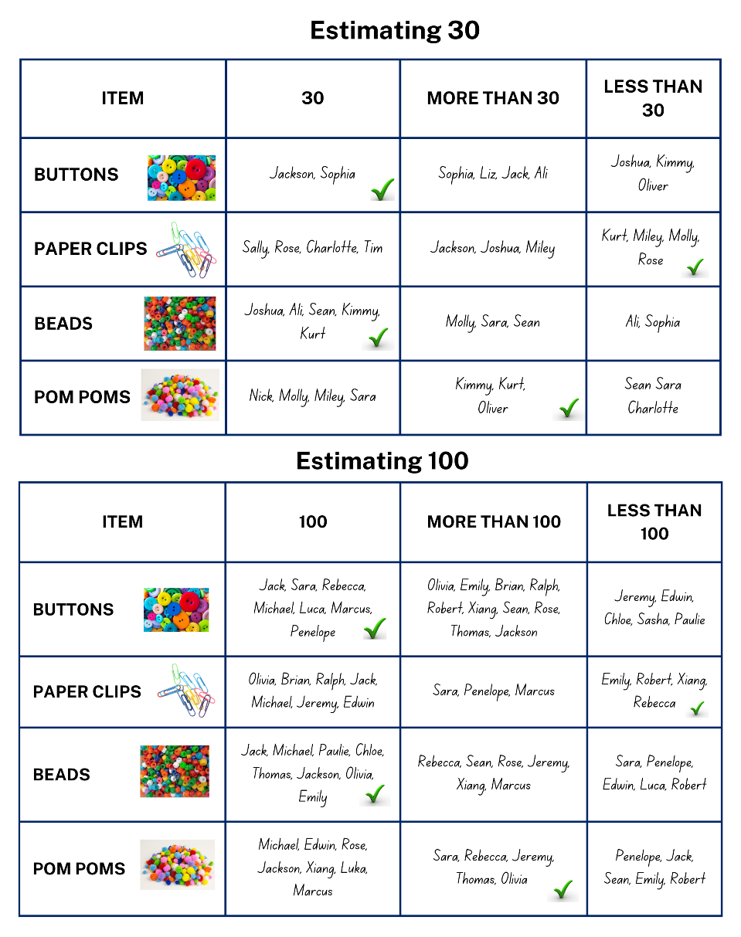
Images sourced from Canva and used in accordance with the Canva Content License Agreement.
- Discuss the accuracy of estimates and ensure that students discuss how they arrived at their estimates. Once the correct amounts have been disclosed, do students understand what may have gone wrong or right with their estimating strategies.
- Use the collected data table to prompt a discussion by asking students:
- Which collection did most people estimate correctly? How many people?
- Which collection did most people find difficult to estimate correctly? How do you know this?

Reproducing patterns: Part 1 – 5 minutes
- In this part of the lesson students will work with the same small group as they did in the Lesson 2.
- Provide each pair of students a digital device. Explain that each pair will select a different image of a repeating pattern from the previous ‘repeating pattern hunt’ lesson.
- The group will identify, discuss and label each part of the repeating core for each image. For example, students may annotate the shapes, the number of sides, colours and/or the number and size of objects.
- Explain that each pair will use the annotated information that they identified as the core for their selected photograph to create a representation using Mathigon.

Reproducing patterns: Part 2 – 40 minutes
- Display the Mathigon interactive board. Use the left menu to select the ‘Geometry’ option and then the ‘Polygons and Shapes’ option. Explain that the interactive board supports the understanding of and the creative exploration of repeating patterns.
Note: To cater for the diverse abilities and learning styles of students, consider small collaborative groups which include a range of learning abilities and pairs of students who may require more directed support, modelling and instruction. It is essential that students refer to the photographs of the patterns they selected from the pattern hunt in the previous lesson.
- Model clicking or dragging shapes from the left menu onto the blank board. Show students how to rotate the individual shapes by clicking on the small black circle located above the shape and model how to change shape colours by using the colour wheel option located on the ‘options ribbon’ on the bottom centre of the board.
- Display a sample image of any school building and model how to create a repeating pattern that represents windows and a brick wall. It is essential to model how to change the colour of the shapes and manipulate the size and orientation (see Figure 7).
Figure 7 – Representation of a repeating pattern on a school building
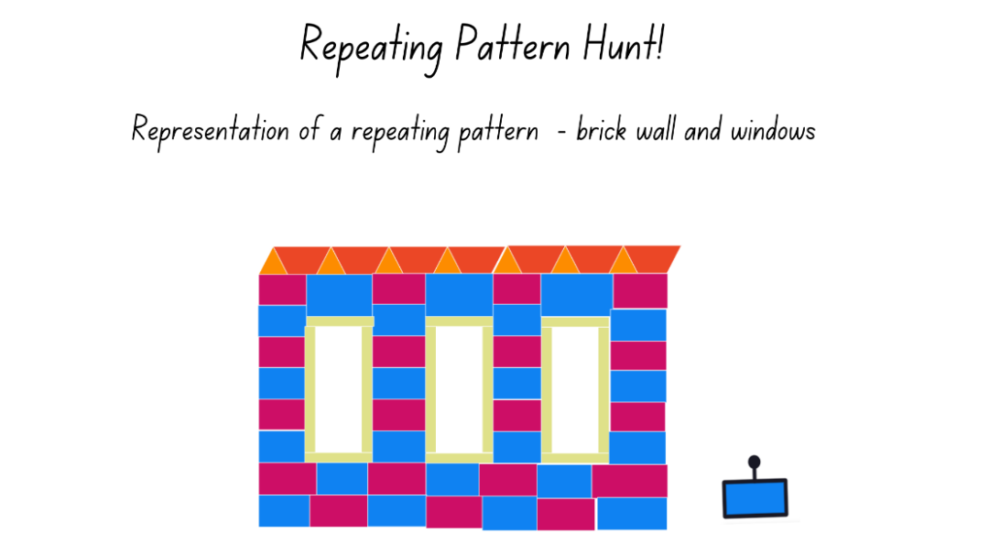
Images sourced from Canva and used in accordance with the Canva Content License Agreement.
- In pairs, students use a selected annotated image to create a representation of the repeating pattern using Mathigon.
- Provide time and support for students to explore and use Mathigon. Bring students back to the floor and select several students to share how they have been manipulating the shapes. Provide time for pairs of students to complete their representations.
Note: Students may use coloured paper shapes instead of Mathigon and a digital device to create their pattern representations.
The table below details assessment opportunities and differentiation ideas.
Assessment opportunities | Too hard? | Too easy?
What to look for:  - What strategies are students using to arrange the various parts of the repeating core so that it accurately represents their selected photograph? (MAO-WM-01, MAE-RWN-01, MA1-RWN-01, MAE-FG-01, MA1-FG-01)  - Is the repeating core of the pattern being represented accurately and does it repeat over and over and over again? (MAO-WM-01, MAE-RWN-01, MA1-RWN-01, MAE-FG-01)  What to collect:  - observations and recordings of conversations and vocabulary used by students (MAO-WM-01, MAE-RWN-01, MA1-RWN-01, MAE-FG-01, MA1-FG-01)  - photos and work samples of repeating patterns. (MAO-WM-01, MAE-RWN-01, MA1-RWN-01, MAE-FG-01) | Students cannot manipulate shapes to create representations of repeated patterns.  - Model how to create a repeated pattern and support students to make simple repeating patterns, such as tiles or a fence.  - Provide students with coloured tiles and shape blocks to make the repeating pattern they identified in the photograph. | Students can create representations of the photographed repeating patterns.  - Students swap their representations with another small group. They need to identify the pattern core represented and then create the next part of the pattern.  - Ask students to use letters, such as A and B to label the repeating core pattern.

Consolidation and meaningful practice: Gallery walk – 10 minutes
- Students display their images and pattern representations on their digital device and go on a gallery walk. Allow time for students to view and discuss other groups’ work. Ask:
- Can you identify where in the school the repeating pattern occurs?
- Is there a repeating pattern that has a very interesting repeating core? Can you describe what makes it interesting?
- Can you identify a repeating pattern that has a two-part (AB) repeating core pattern, a three-part (for example ABC ABB) repeating core pattern, and a four-part (for example ABCD or ABCC) repeating core?

Lesson 4: Generating number patterns
Core concept: Number sequences can be arranged and repeated to create a variety of number patterns.
The table below contains suggested learning intentions and success criteria. These are best co-constructed with students.
Learning intentions | Success criteria
All students are learning that:  - growing patterns have something (an element) that gets bigger by the same amount each time  - shrinking patterns have something (an element) that gets smaller by the same amount each time.  Students working towards Early Stage 1 outcomes are learning that the core of a repeating pattern can be repeated over and over and over again to create a growing pattern.  Students working towards Stage 1 outcomes are learning that:  - mathematicians use arrays to represent a quantity  - arrays are useful when reasoning about the commutative property of multiplication. | All students can:  - identify other numbers that belong to a number pattern  - explain how a pattern grows or shrinks.  In addition, students working towards Early Stage 1 outcomes can create a growing number pattern by repeating the created core over and over and over again.  In addition, students working towards Stage 1 outcomes can create and explain an array, for example, 2 rows of 5 objects are the same as 5 rows of 2 objects, there are still 10 objects altogether.

Daily number sense: What other numbers belong? – 10 minutes
This lesson has been adapted from Talking about Patterns and Algebra (2010), NSW Department of Education.
- Build student understanding of identifying and describing number patterns by playing ‘What other numbers belong?’
- Display Resource 3: Cards 1 and 2, conceal card 2 and explain that the number sequence in card 1 has been jumbled (see Figure 8).
Figure 8 – What other numbers belong?
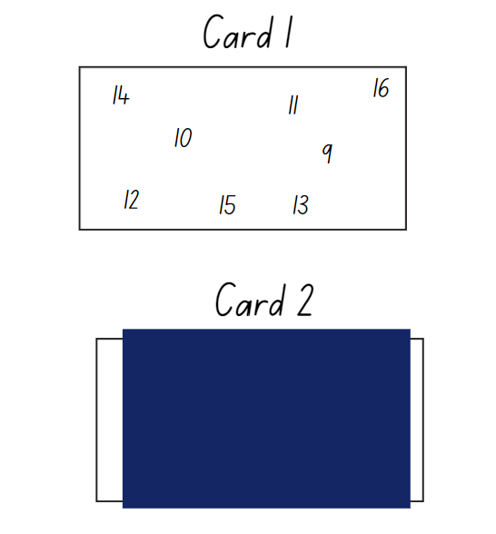

- Ask students:
- What other numbers could be added onto this card?
- How do you know?
- Record student responses and reveal card 2 and repeat the activity.

Generating number sequences: Part 1 – 35 minutes
- Display various arrangements of concrete materials to create representations of 12, such as 6 groups of 2 tiles or 4 groups of 3 tiles (see Figure 9).
Figure 9 – Representations of 12
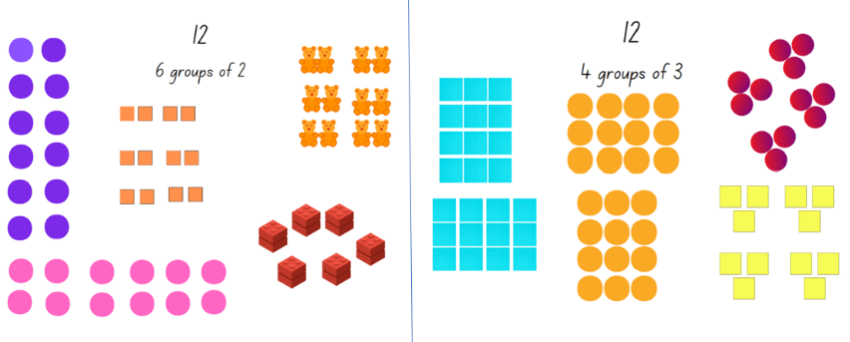
- Use ‘Talk moves’ to discuss what students see and what they wonder.
- Ask students:
- What do these arrangements tell us about the number 12?
- Can you see a quantity of 12 without needing to count by one? Explain.
- Why do you think mathematicians choose to make such organised arrangements to represent a number quantity?
- Using a piece of paper, select an example and cover or label one of the groups. For example, using 4 groups of 3 is 12, identify and model for students how each group represents 3 ones and each group is a part of the whole 12. That is, one representation of 12 is 4 equal groups, with 3 ones in each group (see Figure 10).
Figure 10 – 12 is 4 equal groups of 3 ones
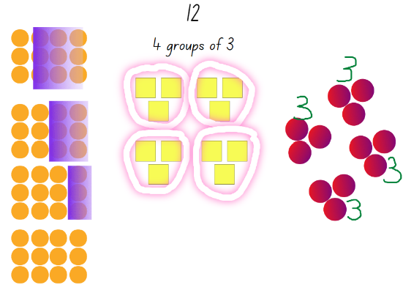
- Ask students to view the example of 12 counters arranged in 4 groups of 3 and ask:
- What is the repeating core of this number pattern? Can you explain.
- How do you know that there are 12 counters altogether?
- Explain that students will be using virtual tiles or concrete materials to create a variety of representations of 12.
- Early Stage 1 students will focus on equal groups which represent 12 and Stage 1 students will create arrays that represent 12.
- Model for Stage 1 students an array of 12 by arranging 4 threes in both orientations (see Figure 11).
Figure 11 – 4 threes
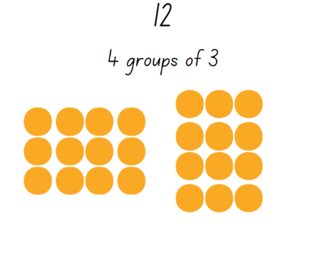
- Using a piece of paper, cover part of the array and model for Stage 1 students how each column represents 4 ones, then 4 twos and lastly 4 threes (see Figure 12).
Figure 12 – Covering part of the array
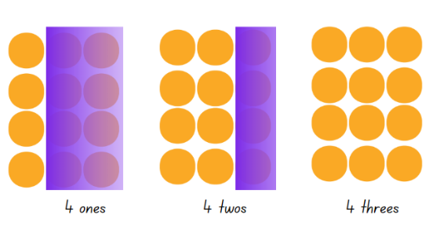
Note: To support the development of multiplicative thinking it is essential to explicitly distinguish between the number of groups (rows and columns) and the number in each group (row and column). For example, that there are 4 ones, 4 twos, 4 threes and so on, as this develops mental strategies for multiplication and moves beyond additive strategies. It is also important to explain that changing the presentation of an array does not change the quantity of objects. Understanding the commutative property of multiplication supports reasoning, the development of metalanguage and understanding of multiplication facts. For more information and research-based evidence see Handfuls (thinking multiplicatively) (11:04), Stage 1 multiplication and division, Multiplication and division – cats on a mat, Multiplicative strategies, and Teaching Mathematics Foundations to Middle Years, 3rd ed (2021) by Siemon et al.
- Students return to the mat and view an arrangement of 12 objects as equal groups and an arrangement of 12 objects as an array (see Figure 13).
Figure 13 – 12 as equal groups and as an array
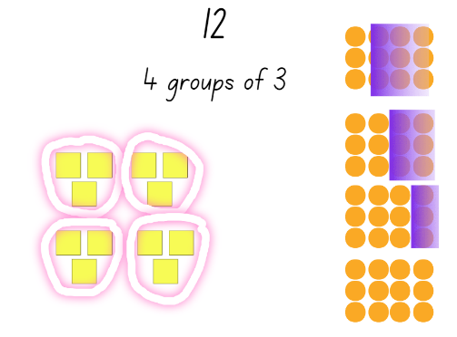
- Explain that both arrangements represent 12 and they are a repeating pattern and a growing pattern.
- Ask students to count as you label each group and each row of the array with a sticky note to show how each group and each row of the pattern grows by 3 (see Figure 14).
Figure 14 – Labelling the array as a counting sequence
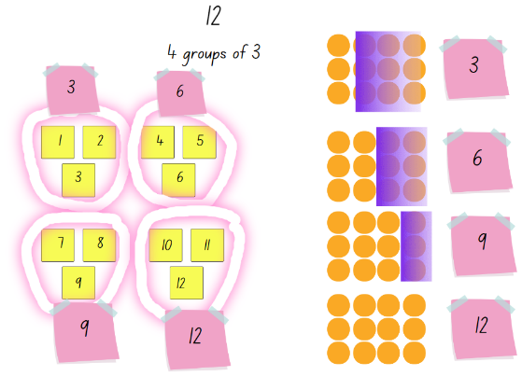
- Explain that these arrangements also represent a counting sequence.
- Ask students:
- What number would come next in the number sequence? How do you know?
- How can you describe this number patterns?
- If the number sequence is getting bigger, is it a growing pattern? Explain how.
- Display Resource 4: A growing pattern.
- Explain that all the growing patterns have been made using 12 blocks. Ask:
- What is the same and what is different?
- How did you check that there are 12 blocks in each growing pattern?
- Explain that you are wondering what the next part of the sequence would look like for each pattern. Ask students ‘How do you know these are growing patterns and how can you make the pattern grow one more time?’
- Provide pairs of students with writing materials and concrete materials, such as interlocking cubes or coloured bricks.
- Students select one of the growing patterns from Resource 5, determine what comes next in the pattern and record their findings. Stage 1 students need to also create an array to represent their growing pattern (see Figure 15).
Figure 15 – Annotated growing number pattern
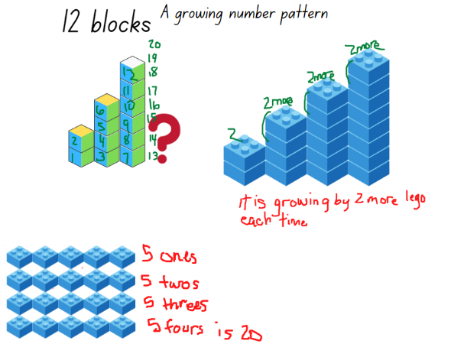
Images sourced from Canva and used in accordance with the Canva Content License Agreement.
- Ask students:
- What number would come next in the number sequence? How do you know?
- How can you describe this number pattern?
Note: Draw Stage 1 students’ attention to the number pattern and the structure of the array to provide opportunities to make generalisations, to view the structure of a given number as an array and to build knowledge of other number sequences.
- Bring students back to the mat to discuss their findings. Ask students:
- What is something interesting you noticed?
- What is something you are still wondering about?
The table below details assessment opportunities and differentiation ideas.
Assessment opportunities | Too hard? | Too easy?
What to look for:  - Can students identify the number before and after in a sequence? (MAO-WM-01, MAE-RWN-01, MA1-RWN-01)  - Are students able to identify the skip counting pattern for their number sequence? (MA1-FG-01)  - Are students able to count forwards to at least 30 and sequence numbers correctly in order? (MAE-RWN-01)  - Can students continue and describe the repeating core of a pattern? (MAO-WM-01, MAE-FG-01, MAE-FG-02)  - Are students able to communicate their understanding of the commutative property of multiplication when reasoning about their array? (MAO-WM-01, MA1-FG-01)  What to collect:  - samples of work displaying students number patterns and their recorded findings. (MAO-WM-01, MAE-FG-01, MA1-FG-01) | Students are not able to use a core to continue a pattern and to identify how it is growing.  - When predicting what comes next, allow students to point to the image or the concrete materials to indicate what comes next. Orally count and discuss to support language.  - Make a model using concrete materials and identify the core. Students create another matching core and count each element to identify how the pattern is growing.  Students are unable to communicate their understanding of the commutative property. Use concrete materials to create various arrays. Support students to identify what is a row and what is a column and then construct the same array, rearranging the rows and columns. | Students can clearly explain the key features of their growing pattern. Ask students to compare 2 growing patterns and to explain what they notice is the same and what is different about the patterns.  Students can record, describe and create various number sequences.  - Provide students with a 100 or 200 chart and challenge students to find a variety of interesting number sequences.  - Ask students to select one of their number sequences and create a representation.

Generating number sequences: Part 2 – 20 minutes
- Explain that you have been thinking about 6 and the different ways you can represent 6. Using square tiles, display representations of 6 as number sequences, groups and growing patterns, such as in Figure 16.
Figure 16 – This is 6
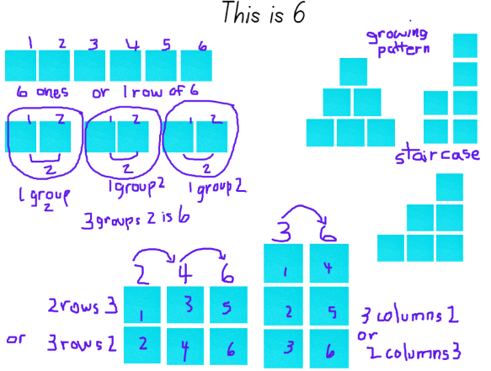
- Explain that the number 6 can be represented as groups, arrays and as various growing staircase patterns. Ask students if all numbers up to 14 can be represented in such ways as 6.
- Provide pairs of students with square tiles or other suitable concrete materials, writing materials or a digital device to record their findings. Students will investigate a number of their choice up to and including 14 and record their findings.
- Provide time to explore some numbers. Ask students:
- Is there anything you are wondering?
- Are there any numbers that you cannot create as a counting sequence pattern or as a growing pattern or an array?
- Bring students back together and select students to share their findings and explain their recordings.
The table below details assessment opportunities and differentiation ideas.
Assessment opportunities | Too hard? | Too easy?
What to look for:  - Are students able to identify and record a number pattern or sequence in a variety of ways? (MAO-WM-01, MAE-FG-01, MA1-RWN-01)  - Can students describe growing patterns as having equal groups or equal rows and equal columns which combine to make a total? (MAE-CSQ-01, MA1-FG-01)  What to collect:  - annotated samples of groups, arrays and counting patterns. (MAO-WM-01, MAE-CSQ-01, MAE-FG-01, MA1-FG-01) | Students are unable to investigate their chosen number and create representations.  - Students copy and recreate the number 6 using visuals, images and concrete material.  - Model and label each part of the growing pattern.  - Students work in small groups and collaboratively explore the number 8. | Students can create various representations for all numbers up to 14.  - Students compare 2 numbers, for example, 9 and 14 and all the representations. Ask students to record what was similar and/or different for both numbers.  - Students record number sentences to explain their findings.  - Challenge students to select one of the ‘teen’ numbers and record a shrinking pattern with missing elements for a partner to solve.

Discussing the mathematics: Features of a growing pattern – 5 minutes
- Display examples of Early Stage 1 and Stage 1 growing patterns and provide time for students to view.
- Ask students to view the examples and each consecutive growing core. Ask:
- Are these number patterns or just patterns or are they both? How can you convince me?
- What is happening in each consecutive growing core?

Lesson 5: Generating counting sequences
Core concept: Problems can be solved using a number pattern or sequence that you can trust.
The table below contains suggested learning intentions and success criteria. These are best co-constructed with students.
Learning intentions | Success criteria
All students are learning that:  - identifying and describing a number pattern is helpful when solving a problem  - to accurately group and count a collection, the number of objects needs to be the same in every group  - number patterns have a rule that repeats over and over and over again. | All students can:  - identify how many objects there are in each group and how many groups there are altogether  - describe the pattern rule when investigating a number sequence.  In addition, students working towards Early Stage 1 outcomes can:  - count a collection of objects by recognising 5 and then counting on to know how many more there are altogether  - share a collection making equal groups.  In addition, students working towards Stage 1 outcomes can use a variety of skip counting patterns when solving a problem.

Daily number sense: Generating counting sequences – 15 minutes
This lesson has been adapted from Talking about Patterns and Algebra (2010), NSW Department of Education.
- Build student understanding of number patterns by investigating and generating visual and numerical counting sequences.
- Provide counters and ask students to make 5 groups that have 2 counters in each group side by side in a line or a row. Ask:
- What do you notice about the arrangement of counters?
- Is it just a dot pattern or is it also a number pattern?
- Can you see a number pattern when you count the counters?
- Can you explain how it is a pattern? What is the repeating core?
- Repeat the tasks making 3 groups using 3 counters in each group. Discuss using the same prompt questions.
- Provide craft sticks and ask students to make a row of triangles. Begin with 2 triangles and ask:
- What do you notice about this arrangement of triangles?
- Is it the same number pattern as the one you made with the 3 counters in 3 groups? What would come next in the sequence?
- Explain that this sequence of repeating the number of craft sticks is a number pattern or a counting sequence.
- Ask students to turn and talk and use sticky notes to label each triangle in the sequence, creating a counting sequence. For example, 3 craft sticks were used to make the first triangle, then 3 more to make the next, so that is 6 altogether. Then add another 3, so there are 9 craft sticks altogether and so on (see Figure 17).
Figure 17 – A row of triangles representing a counting sequence
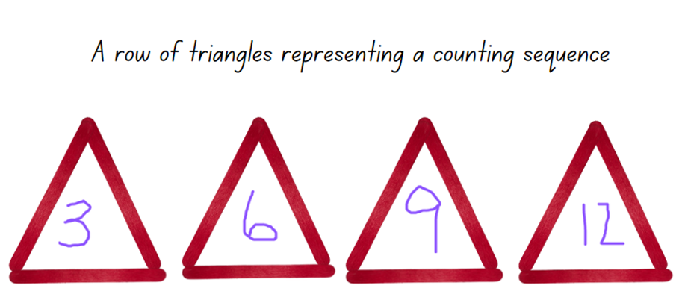
- Explicitly talk aloud about the connection between the visual representation of the triangles and the numerical pattern. Explain that the pattern is a growing pattern because the rule (or the core that repeats over and over and over again) is an increase of 3 craft sticks each time.
- Explain that using manipulatives and illustrations helps when figuring out the rule for more complex number patterns.
- Provide time for students to continue the number pattern beyond 12.
- Discuss the counting sequence created and record the numbers, explicitly showing the rule for this pattern.
The table below details assessment opportunities and differentiation ideas.
Assessment opportunities | Too hard? | Too easy?
What to look for:  - Can students count forwards to at least 30? (MAE-RWN-01)  - Can students count forwards to at least 120? (MA1-RWN-01)  - Are students combining the groups to work out how many altogether? (MAE-CSQ-01, MA1-FG-01)  - Can students identify how many more is needed to make the next equal group? (MAE-CSQ-02, MA1-FG-01)  - Are students counting by threes as they count the triangles? (MA1-FG-01)  - Can students describe the number pattern and suggest the next number in the sequence? (MAE-FG-01, MA1-FG-01)  What to collect:  - recordings of vocabulary used to describe the number pattern. (MAO-WM-01, MAE-CSQ-01, MAE-CSQ-02, MA1-FG-01) | Students are not able to identify the number pattern in the counting sequence using triangles.  - Provide students with interlocking cubes and support students to add 3 more interlocking cubes as each triangle is being made.  - Use 2 ten-frames and, as students are making each triangle, place 3 counters in the frame so that students can visualise how the groups of 3 are the repeating core and are added to the previous 3 counters. | Students can label and continue the triangle counting sequence.  - Ask students to create a number pattern using pentagons and/or squares.  - Provide students with writing materials and crafts sticks to create a counting sequence that has a missing element for a partner to solve.

How many legs? – 45 minutes
- Pose the following narrative: You were in a restaurant the other day and, while you were waiting for your meal to arrive, you started to wonder how many legs were in the restaurant all together.
- Display Resource 5: How many legs? for Early Stage 1 and Resource 6: How many legs? for Stage 1.
- Explain to Early Stage 1 students that you observed one table with 2 chairs and one person eating, one empty table with 2 chairs, one table with 3 chairs and 3 people eating, 2 people and one dog arriving, 2 people serving the food and 2 chefs cooking in the kitchen. Ask how many legs were there altogether.
- Explain to Stage 1 students that you observed 3 tables with 6 chairs and 6 people eating, 5 tables with 4 chairs and 4 people eating, and 7 tables with 2 chairs and 2 people eating. There were also 7 people serving the food and 3 chefs cooking in the kitchen. Ask how many legs there were altogether.
- Ask students:
- What is the problem asking you to do?
- What types of legs exist in the restaurant and which ones will you count?
- What are some efficient strategies you could use to solve this problem?
- How will you count all the legs and keep track of the legs you have already counted?
- How will you record the solution?
- What type of drawings, diagram or words would be useful?
- Record suggestions on the board and discuss.
- Provide pairs of students with writing materials and explain that one strategy to problem-solve is to draw a diagram of the restaurant, but that it might take a long time to draw all the tables, chairs and people.
- Explain that mathematicians solve problems like this one all the time. When mathematicians count lots of things, they are collecting information about a quantity or data. The collected information or data will give them the solution to the problem.
- Explain to Early Stage 1 students that mathematicians like to use counters or marks to help them keep track of their counting.
- Explain to Stage 1 students that mathematicians like to use tally marks to help them track their counting.
Note: Explain to Stage 1 students that tally marks are used to represent groups of 5 and this allows efficiency when counting a large collection as students can skip count by fives to find the total count. If students have not had the opportunity to work with tally marks, model how to make 4 tally marks and how the diagonal line ends the group of tally marks as it represents the total number of 5. Provide time for students to explore tally marks for various two-digit numbers.
- Ask pairs of students to brainstorm ideas for collecting the information or data (count all the different legs) and representing the information or data in a diagram to show the solution to the problem. Select students to share brainstorming ideas.
Note: Students may be able to collect the information but need support to organise and represent the information or data to show their solution to the problem. It is optional to share an example of a diagram or data table as in Figure 18 and Figure 19.
Figure 18 – How many legs? Early Stage 1 diagrams
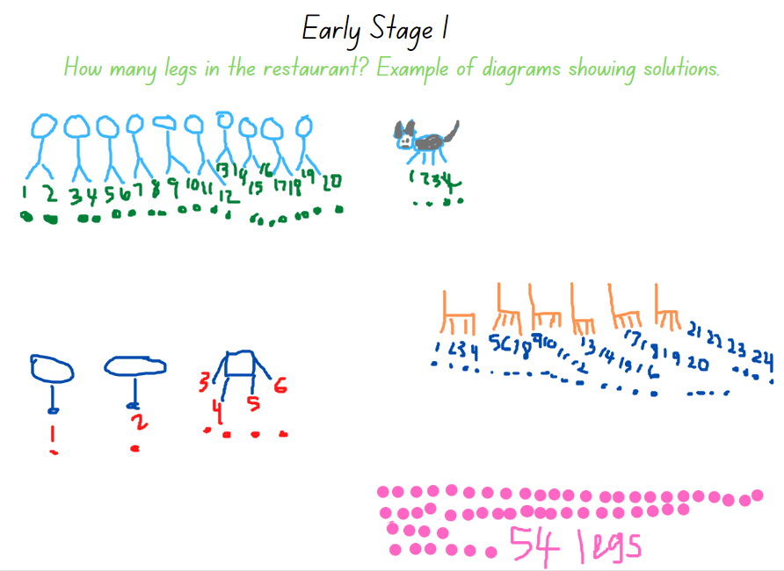
Figure 19 – How many legs? Stage 1 data table and a diagram
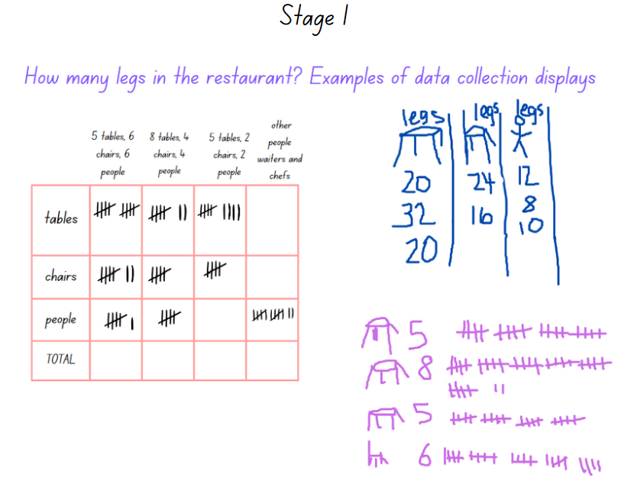

The table below details assessment opportunities and differentiation ideas.
Assessment opportunities | Too hard? | Too easy?
What to look for:  - Can students skip count by fives and track the count using tally marks? (MA1-FG-01, MA1-DATA-01)  - Can students count forwards to at least 30 and keep track of the count? (MAE-RWN-01)  - Can students group the legs into groups to assist with counting? (MAE-CSQ-01, MAE-FG-01, MA1-RWN-01)  - Can students distinguish how many legs are in each group and then how many legs there are altogether? (MAE-CSQ-01, MAE-CSQ-02, MAE-FG-01, MA1-FG-01)  - Do students understand what the problem is asking them to do, and can they apply appropriate strategies to find the solution? (MAO-WM-01)  - Can students organise the collected information into categories and display the information accurately? (MAO-WM-01, MAE-CSQ-01, MAE-CSQ-02, MA1-DATA-01, MA1-DATA-02)  What to collect:  - work samples of student's recordings or data table displaying solutions (MAO-WM-01, MAE-CSQ-01, MA1-DATA-01)  - recordings of students' conversations and trial solutions to the problem. (MAO-WM-01) | Students are unable to track a count using marks or tally marks as they problem solve a multi-step problem.  - Provide students with concrete materials to illustrate the problem and find the solution.  - Provide Early Stage 1 students with a number track and counters.  - Provide Stage 1 students with counters and a visual display that shows the 5 times table to support skip counting by fives as students use tally marks.  - Reduce the number of tables, chairs and people. | Students have created a diagram or a data table that clearly displays the results and is well organised.  - Ask students to identify patterns that they can see from the results in the diagrams or data table. For example, counting by twos or fours.  - Pose the scenario that a family of 6 arrive but one of the families of 2 leave. Ask how this changes the initial solution.

Consolidation and meaningful practice: Generating Patterns – 10 minutes
- Provide students with writing materials and display Resource 7: Number patterns.
- Ask students to record what would be the next drawing or number for each of the displayed patterns. Ensure that students are identifying the pattern rule.
- Select students to share their solutions and discuss how do they know that they have continued the patterns correctly.

Lesson 6: Investigating counting sequences
Core concept: The quantity stays the same even when an arrangement of materials changes.
The table below contains suggested learning intentions and success criteria. These are best co-constructed with students.
Learning intentions | Success criteria
All students are learning that:  - an arrangement of a given number of counters can be repositioned, but the quantity of counters stays the same  - investigating equal groups is helpful when exploring counting sequences.  Students working towards Early Stage 1 outcomes are learning that to accurately group and count a collection the number of objects needs to be the same in every group.  Students working towards Stage 1 outcomes are learning that:  - arrays are made of equal columns and equal rows  - data tables are a useful way to explain number sequences. | All students can:  - identify how many objects are in each group and when groups are combined, can identify how many altogether  - arrange concrete materials in various ways and know that the quantity of materials always stays the same.  In addition, students working towards Early Stage 1 outcomes can:  - arrange and count a collection by distributing objects so that each group has the same number of objects  - subitise a pattern of dots up to and including 6 dots.  In addition, students working towards Stage 1 outcomes can:  - describe an array by stating, for example, that there are 3 ones, then 6 ones, then 9 ones, then 12 ones, which is an array representing 12  - create a data table or diagram to represent a counting pattern or sequence.

Daily number sense: 10 minutes
- From a class need surfaced through formative assessment data, identify a short, focused activity that targets students’ knowledge, understanding and skills. Example activities may be drawn from the following resources.
- Thinking Mathematically Early Stage 1
- Thinking Mathematically Stage 1
- Universal Resources Hub.

Representations of numbers – 45 minutes
Note: It is optional to use small squares of paper or plastic or wooden square tiles or shapes. Stage 1 students can also use grid paper and colour in all the different options.
- Display 5 dice each showing two dots as shown in Figure 20.
Figure 20 – Dice dot pattern
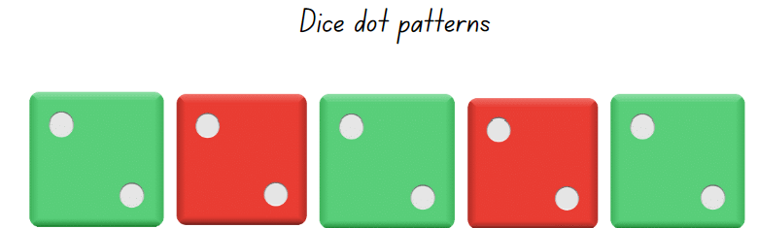
- Ask students to identify the repeating core of the dice pattern, as well as how many dots there are in each group and how many dots there are altogether.
- In pairs, provide 10 counters and ask students to create groups or various arrangements that represent 10 (see Figure 21).
Figure 21 – Examples of groups that represent 10
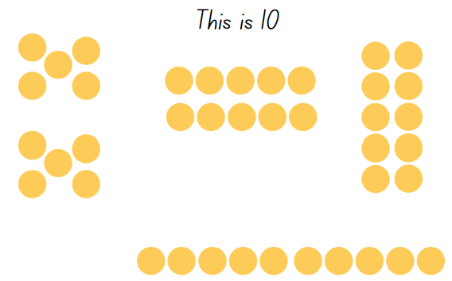
- Display Resource 8: 12 and 30 square tiles. Ask Early Stage 1 students to view the 12 square tiles and Stage 1 students to view the 30 square tiles. Ask students what they notice and wonder about the arrangement of tiles or the array.
The table below outlines stimulus prompts to generate conversation about the topic, along with anticipated responses from students.
Prompts | Anticipated student responses
- Does this arrangement of square tiles remind you of a shape?  - How many square tiles have been used to create the rectangle?  - Can you label the rows and columns? How many square tiles are there in each row and in each column?  - If it was flipped on its end, what would the shape be? How many rows and how many columns?  - Can you describe this arrangement or array of squares as a pattern?  - How can you record your findings? Can you use a diagram or a table to show how many tiles are needed? | - A rectangle because it has 2 long sides and 2 short sides.  - Early Stage 1 – there are 12.  - Stage 1 – there are 30.  - If you flipped it, it would still be a rectangle and the long sides would be vertical and the short sides horizontal.  - Early Stage 1 – Yes. One, 2 and then there is another 2 and another 2 and so on. It is repeating by 2 over and over and over again.  - Stage 1 – Yes. 3, 6, 9, 12, 15, 18, 21, 24, 27, 30.  - We could list each quantity used in each row and column to show the different rectangles or we can draw a diagram and record how many there are.
Array: An array is a systematic arrangement of objects in rows and columns where each subsequent row has the same quantity and each subsequent column has the same quantity. Arrays support multiplicative thinking and the early development of knowledge and understanding of multiplication and division.
- Provide pairs of students with concrete materials, a digital device or writing materials and explain that there may be other ways to arrange the 12 or 30 square tiles to make a different rectangle.
- Explain that they need to investigate all the possibilities and record their findings (see Figure 22).
Figure 22 – Labelled rectangles
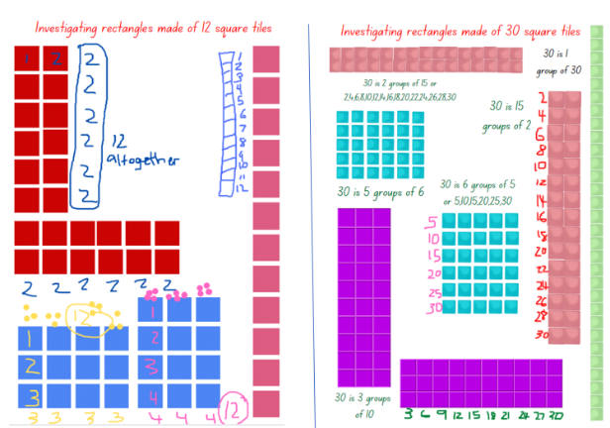
- Select students to share their representations. Ask students:
- How can you prove that these arrangements or arrays are really 12 or 30?
- Does it matter if the rectangle is turned and repositioned? Are there the same number of tiles altogether? How can you prove it?
The table below details assessment opportunities and differentiation ideas.
Assessment opportunities | Too hard? | Too easy?
What to look for:  - Can students arrange the tiles to show repeating equal groups? (MAE-CSQ-01, MAE-CSQ-02, MA1-FG-01)  - Can students skip count by twos, threes and fives? (MA1-RWN-01, MA1-FG-01)  - Are students creating arrangements or arrays that have equal rows and equal columns as a rectangle to show 12 or 30? (MAO-WM-01, MAE-CSQ-01, MAE-CSQ-02, MA1-FG-01)  - Do students understand the commutative property by creating an array of 30 as 5 rows of 6 or 6 rows of 5? (MAO-WM-01, MA1-FG-01)  What to collect:  - annotated work samples displaying student's findings. (MAO-WM-01, MAE-CSQ-01, MAE-CSQ-02, MA1-FG-01) | Students are unable to create multiple arrays using either the 12 or 30 tiles.  - Provide students with 10 square tiles and support students to create arrays.  - Support students to explore other arrays using the 12 or 30 tiles by asking students to create equal groups using all the 12 or all the 30 tiles.  - Model and support students to use the equal groups to create rectangles or arrays. | Students create and label a variety of rectangles or arrays that had equal groups in each row and column.  - Provide Stage 1 students with 36 or 42 square tiles to create rectangles and arrays.  - Provide early Stage 1 students with 20 square tiles to create rectangles and arrays.  - Challenge Stage 1 students to prove that arrays can be created for both odd and even numbers.

Consolidation and meaningful practice: Investigating number patterns – 10 minutes
- Display a variety of shape and colour patterns, such as in Figure 23.
Figure 23 – Are these number patterns too?
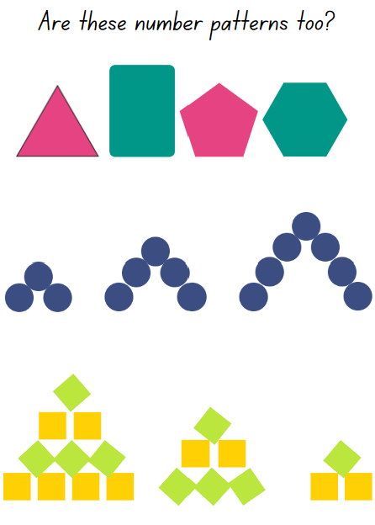
- Provide pairs of students with writing materials and concrete materials.
- Ask students to prove that these shape and colour repeating patterns are also number patterns.
- Ensure students are copying the patterns and correctly labelling or annotating the number sequence.
- Select students to share their explanations and to demonstrate how the patterns are also a number pattern. Discuss.

Lesson 7: Problem-solving detectives
Core concept: Collecting and recording information is a useful strategy when problem-solving.
The table below contains suggested learning intentions and success criteria. These are best co-constructed with students.
Learning intentions | Success criteria
All students are learning that:  - there are a variety of ways to solve a problem and find an accurate solution  - information or data can be used to investigate, record and solve problems.  Students working towards Early Stage 1 outcomes are learning that:  - mathematicians use groups to count, compare and arrange a quantity of objects  - when counting a large collection to 20, it is useful to use 5 as a subitised reference and then count on.  Students working towards Stage 1 outcomes are learning that:  - tally marks are a useful tool for recording a count  - mathematicians use arrays to represent a quantity of objects as groups in rows and columns. | All students can:  - use collected information to record solutions and solve everyday problems  - arrange a quantity of objects into equal groups to work out the total.  In addition, students working towards Early Stage 1 outcomes can subitise quantities up to 6.  In addition, students working towards Stage 1 outcomes can:  - use tally marks to record quantities and then count the total by skip counting by fives  - arrange a quantity of objects into an array and explain that for example 2 rows of 5 objects is the same as 5 rows of 2 objects.

Daily number sense: Ways to represent a number – 10 minutes
- Build student understanding of number representations and number patterns by exploring a given number.
- Provide pairs of students with concrete materials and writing materials.
- Provide Early Stage 1 students with a number track to 18 and Stage 1 students with a number line to 24.
- Explain that students need to investigate how many different ways they can represent the allocated number.
- Explain that students can use concrete materials to make groups and patterns or they can use drawings or numbers to create representations.
- Stage 1 students use a number line to identify and record how many different skip counting sequences can be used to count to 24.
- Ask students:
- Which pattern, group or representation do you think is the easiest to subitise and see your given number?
- How can you convince me that your pattern or representation is exactly 18 or 24.
- Ask Stage 1 students:
- Were there any skip counting sequences that did not work?
- Describe a skip counting sequence that was interesting.

Pattern detectives – 45 minutes
This lesson has been adapted from Mindset Mathematics: Array Museum from Boaler et al. (2022).
Note: To successfully create a display of students’ work as a ‘pattern museum’ or an ‘array museum’ it is important to designate a space in the classroom prior to the lesson so that students’ creative samples can be displayed and added to over the following weeks. Early Stage 1 students will explore repeating patterns and Stage 1 students will explore arrays.
- Display Resource 9: Repeating patterns and arrays.
- Ask students to share what they can see and describe how the objects are arranged and organised systematically. Ensure Early Stage 1 students identify the repeating patterns and Stage 1 students identify the arrangements, such as an array.
- Ask Early Stage 1 students to share what they know about repeating patterns and how they know if a repeating pattern is also a growing pattern. Ask students to provide examples, such as dots on a domino showing 6, or bricks along a wall. Display shared examples.
- Ask Stage 1 students to share what they know about arrays and to provide examples, such as ten-frames, chess boards or dots on dominoes. Display examples of arrays and ensure that students understand that an array has columns and rows that are systematically arranged to look like a grid, that every row has the same quantity of objects, and every column has the same quantity of objects (such as on a ten-frame).
- Ask students to turn and talk with a partner and look around the classroom to identify examples of repeating patterns or arrays.
- Explain to Early Stage 1 students that they will be working with a partner and using a digital device to take a photograph of a repeating pattern they can see in the classroom. Students will reproduce the pattern using concrete materials or Mathigon to determine if it is a growing pattern. Students record their findings then problem solve and count how many objects they used to reproduce the repeating pattern Ask students to annotate the elements they would need to continue the pattern (see Figure 24).
Figure 24 – A growing repeating pattern in the classroom
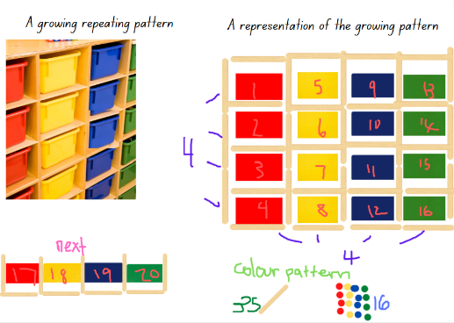
Images sourced from Canva and used in accordance with the Canva Content License Agreement.
- Explain to Stage 1 students that mathematicians find arrays very useful to group, organise or ‘chunk’ a collection of items so that they can calculate or count how many items there are altogether, without needing to count by ones.
- Display 2 ten-frames in an arrangement that looks like an array. Ask students if they can suggest how to use the columns and rows to count how many squares there are altogether. Provide pairs of students with counters and ask them to make an array that models the 2 ten-frames. Select students to share their findings and results.
- Ask students to think about the ‘repeating pattern hunt’ lesson and recall if they photographed any repeating patterns that may look like an array. Ensure that students are identifying repeating patterns that have rows and columns like an array. Allow students to use digital devices to share photographs and discuss how the repeating pattern is an array. Ask students:
- How can you prove that the repeating pattern is an array? How do you know?
- If you were going to count how many objects were in that repeating pattern or array, how might you do that?
- Explain they will use a digital device to photograph and/or draw illustrations of arrays that they identify around the school context. Students can also use previously recorded photographs from the pattern hunt lesson. Students work in small groups.
- Explain that students will need to label their arrays, recording the total units or number of units in each column and each row.
The table below details assessment opportunities and differentiation ideas.
Assessment opportunities | Too hard? | Too easy?
What to look for:  - Are students identifying and creating arrays that have equal rows and equal columns? (MAO-WM-01, MA1-FG-01)  - Can students arrange quantities of objects, grouping these to make counting quantities more efficient? (MAE-RWN-01, MAE-CSQ-01, MAE-CSQ-02, MA1-RWN-01)  - Do students create, explain and use the repeating patterns or arrays to model how many items in each group or row/column and how many groups or rows/columns there are altogether? (MAO-WM-01, MAE-RWN-01, MAE-CSQ-02, MA1-RWN-01, MAE-FG-01 MA1-FG-01)  What to collect:  - samples of work and labelled photographs or drawings of arrays (MAO-WM-01, MAE-CSQ-01, MAE-FG-01, MA1-FG-01) | Students are unable to count with one-to-one correspondence. Use concrete materials and model moving each object from one group to another as they count.  Students are unable to identify a repeating pattern or array within the school context.  - Provide students with an image of an example of a repeating pattern such as windows, bricks, concrete paths or tiles found at school.  - Support students to use concrete materials and create a model of the repeating pattern or array.  Students are unable to identify how many items in each row and column of an array.  - Provide students with counters and a ten-frame or an empty egg carton.  - Model and support students to identify a row and a column by using counters to represent numbers in rows and columns. | Students can calculate how many items in a collection of groups or in an array by using the columns and rows.  - Challenge students to calculate how many bricks there are in one section of a school wall and use this information to calculate how many bricks would be in the whole wall.  - Challenge students to calculate if there are 2 rows of 4 windows in each classroom how many windows are there in 4 classrooms.  - Ask Stage 1 students to problem-solve and create an array that has columns and rows to represent the total quantity 150.

Discussing the mathematics: What do equal groups and arrays tell us? – 5 minutes
- Provide time for students to view the repeating patterns and array museum. Ask students:
- Are there any designs that are similar or different?
- Are there any examples that you can recognise and connect to a place in the school context?
- Is there one type of repeating pattern or array that is more common at our school than any other? Why do you think this is so?

Lesson 8: Arranging and displaying information
Core concept: Recorded information can be displayed and represented in many ways and the results will provide meaningful information.
The table below contains suggested learning intentions and success criteria. These are best co-constructed with students.
Learning intentions | Success criteria
All students are learning that exploring and sorting objects helps when looking for things that are the same and different.  Students working towards Early Stage 1 outcomes are learning that:  - when sorting a collection, the groups can be compared to provide information about the quantity  - by combining groups, the parts can be added to find the total altogether.  Students working towards Stage 1 outcomes are learning that data can be recorded using symbols, pictures or numbers and the information can then be interpreted to solve problems. | All students can sort and organise collected information to find solutions to a problem.  In addition, students working towards Early Stage 1 outcomes can:  - sort a collection into groups and identify which has the most, the least or are equal in quantity  - count a collection to find the total.  In addition, students working towards Stage 1 outcomes can ask questions and provide answers about data displayed in in a graph or table.

Daily number sense: An arrangement of cupcakes – 15 minutes
- Build student understanding of how to arrange collections into equal groups (or arrays) by exploring how to arrange a given quantity of objects into equal groups, such as rows and columns.
Note: Early Stage 1 students will investigate different ways that a collection of 20 cupcakes can be arranged into equal groups to represent the whole. Stage 1 students will investigate all the different arrays that can be made to represent 36 cupcakes.
- Explain that a baker made some cupcakes and wants to display these as a pattern in the shop window.
- Provide pairs of students with counters and writing materials or a digital device to record their findings.
- Early Stage 1 students will arrange 20 cupcakes in a creative arrangement of equal groups. Explain that they need to explore as many different solutions as possible to arrange the 20 cupcakes.
- Explain to Stage 1 students that they need to arrange and display 36 cupcakes as an array in the shop window. Explain that the baker knows that there are different arrays to choose from to represent 36 but wants to know all the options.
- Ask Stage 1 students to investigate how many different arrays, rows and columns can be made to arrange the 36 cupcakes.
- Provide time for students to share their different arrangements and ask:
- How do you know you have found all possible representations for 20 or arrays for 36?
- How do you know that each of your arrangements represents the whole 20 or 36 cupcakes? Explain.
- Which pattern of groups to represent 20 do you think is the most suitable for the baker to use? Why?
- Which array of 36 cupcakes do you think is the most suitable for the baker to use? Why?
The table below details assessment opportunities and differentiation ideas.
Assessment opportunities | Too hard? | Too easy?
What to look for:  - Can Early Stage 1 students identify how many in each group and when groups are combined how many altogether? (MAE-CSQ-01)  - Are Early Stage 1 students counting on and keeping track of the count? (MAE-RWN-01)  - Are Stage 1 students arranging the counters in equal rows and columns creating various arrays? (MA1-FG-01)  What to collect:  - work samples and photographs of students work. (MAE-CSQ- MAE-RWN-01, MA1-FG-01) | Early Stage 1 students are unable to arrange objects into equal groups and to identify that each group is a part of a whole. Adjust the number of cupcakes to 12 and support students to share the counters with teddies, modelling how each group has an equal share and that all shares together total 12 cupcakes.  Stage 1 students are unable to create multiple arrays to represent 36 cupcakes. Adjust the number of cupcakes to 16 and model sharing the 16 counters into various equal groups. Repeat and increase the number of cupcakes as needed. | Students are able to arrange the quantity of cupcakes into various equal groups and a variety of arrays.  - Ask students to create 2 examples of groups or arrays that accurately represent 20 and 36 cupcakes.  - Ask students to create groups or an array if there were 2 extra cupcakes.

Sort the street: Part 1 – 15 minutes
This lesson has been adapted from NRICH, Sort the Street.
- Display Resource 10: Sort the street and ask students to identify what is the same and/or different between all the houses.
- Provide each pair of students in Early Stage 1 and Stage 1 with a copy of the appropriate Resource 10 and a digital device.
- Explain that students will cut out each house and arrange them to represent 2 different ways to sort based on combinations of attributes. For example, Early Stage 1 students might sort by the colour of the house and how many windows or sort by the colour of the roof and a patterned or unpatterned door. Stage 1 students might sort by identifying houses with/without curtains and a verandah, houses with/without curtains and a chimney, or houses that are two storey or one storey (see Figure 25 and Figure 26).
Figure 25 – Sorting into groups Early Stage 1 – sort 1 and sort 2
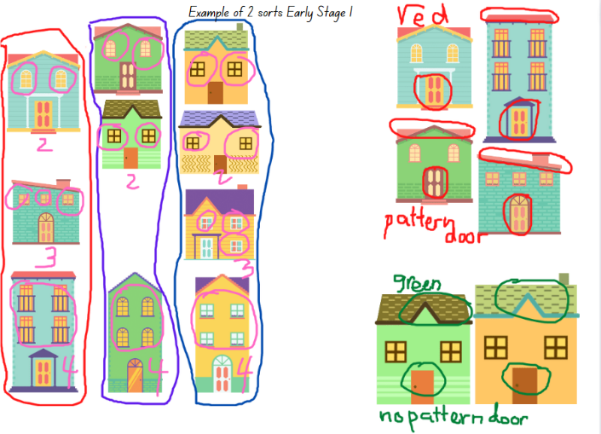
Images sourced from Canva and used in accordance with the Canva Content License Agreement.
Figure 26 – Sorting Stage 1 – sort 1 and sort 2
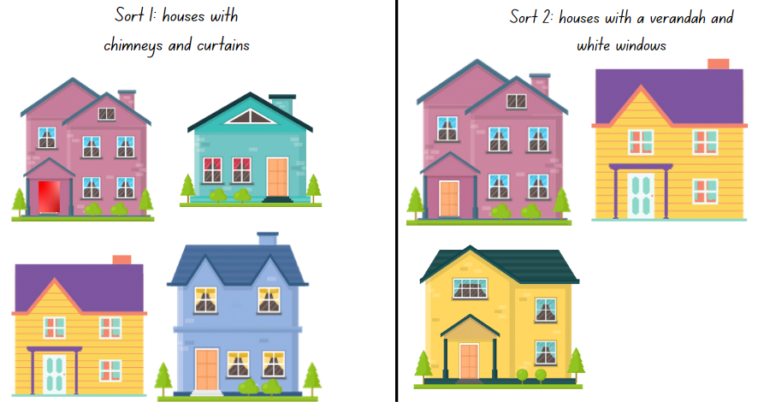
Images sourced from Canva and used in accordance with the Canva Content License Agreement.
- Explain that each sorting arrangement needs to be photographed using a digital device and then annotated to explain the selected attributes used in the sort.
- Ask student pairs to share one sort that they think is the most creative with another pair of students. Select students that have an interesting sort to share and display the photograph digitally for the class to view and discuss.

Sort the street: Part 2 – 35 minutes
Note: Early Stage 1 students will create a pictorial annotated display to show how many altogether of a specific feature and comparisons between features that occur the most and the least. Stage 1 students will create a data display to share the information.
- Explain that there were many different attributes identified and used to sort the houses. State that, during the class discussion, the shared examples showed that the houses in Resource 10 had a lot of detail or information that was similar and some that were different.
- Explain that, when there is a lot of information that is the same or different, one way to collect and represent the information in order to share it, is to create a display.
- Display Resource 10 and ask students to share ideas or examples of ways that information can be collected, grouped and compared. For example, ways to show and explain which attribute or feature has the most or the least in all the houses. Ask:
- What are some attributes that are included in all the houses? Which attributes are not included in all the houses?
- What is one strategy to keep track of counting each of the parts? For example, how will you track and record how many windows there are altogether? How will you know which houses you have already counted?
- How will you know if the information is accurate and easy to understand?
- Select students to share their ideas and record examples so that other students can refer to them if needed.
- Explain that Early Stage 1 students will work with a partner and use paper or a digital device to create a display to share the information about the houses. For example, students will explore and record how many windows, doors, chimneys and verandahs there are altogether. Students will also annotate which attributes had the most or least, comparing the quantities.
- Explain that students need to group the houses and annotate the information using words, numbers or drawings (see Figure 27).
Figure 27 – Early Stage 1 annotated display
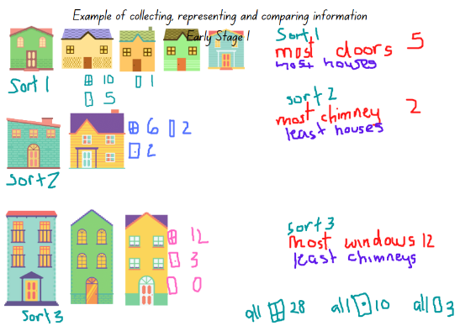
Images sourced from Canva and used in accordance with the Canva Content License Agreement.
- Explain that Stage 1 students will work with a partner to create a data display to show how many different attributes there are on all the houses in the street, altogether. For example, how many windows, doorknobs, shrubs, curtains and front doors.
- Discuss ways that the data could be collected, counted and then represented in a data display, such as a graph, so that the information could be shared with others. Ask:
- How will you structure your graph so that the information can be shared? Will you have rows and columns? Will you use symbols, pictures or words to name each of the attributes/parts?
- How will you know if the information is accurate and that others will understand your data display and the content you are sharing?
- What title will you give your graph? What data are you collecting and what information is your graph representing or sharing?
- Select some Stage 1 students to share their ideas and record these on the board. Students may refer to these ideas while creating their data displays. For example, suggestions may include tally marks to track the count, a labelled picture graph of the parts of the house with symbols to represent each individual part, or a data table with rows and columns to represent how many of each part there are (see Figure 28).
Figure 28 – Stage 1 data display
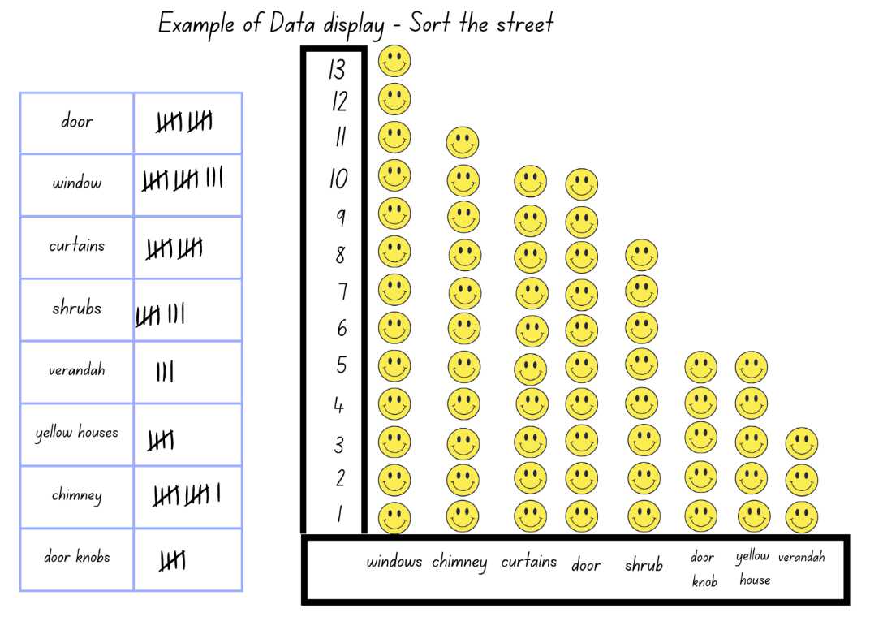
Images sourced from Canva and used in accordance with the Canva Content License Agreement.
The table below details assessment opportunities and differentiation ideas.
Assessment opportunities | Too hard? | Too easy?
What to look for:  - Are students comparing and sorting the information into appropriate categories and representing the collected information into pictorial representations, diagrams or a graph? (MAE-CSQ-01, MAE-CSQ-02, MA1-DATA-01)  - Are Stage 1 students using tally marks and efficient counting strategies to keep track of the count? (MA1-DATA-01)  - Can students combine groups and add the parts to determine how many altogether? (MAO-WM-01, MAE-CSQ-02)  - Can students select appropriate symbols, pictures and/or words to represent a data value? (MA1-DATA-01)  What to collect:  - work samples and photographs of students work. (MAO-WM-01, MAE-CSQ-01, MAE-CSQ-02, MA1-DATA-01) | Students are unable to sort objects using more than 2 categories and do not use tally marks to track the count.  - Support students to list all the features of one image of a house and then ask students to compare with another house to identify what is the same, what is different.  - List the features and compare to one more house.  - Provide students with craft sticks to use as tally marks.  Students are unable to organise the collected information and create a display.  - Model for Early Stage 1 students how to arrange the images of the houses by comparing 2 attributes. Support students to count and record the results.  - Provide Stage 1 students with examples of picture graphs and a template of a simple table. Support students to collect data from 2 houses and to create a simple data display. | Early Stage 1 students can annotate and display information accurately showing comparisons and totals. Ask students to record a simple sentence which explains their results.  Stage 1 students use tally marks accurately and are able to sort and design an informative data display.  - Ask students to record 3 questions that could be asked about their collected data.  - Ask students to identify which house was the most different to all the others and explain why.

Discussing the mathematics: What does the information tell us? – 5 minutes
- Provide time for each pair of students to Think-Pair-Share with another pair of students, sharing their results. Ensure students are identifying attributes that have been used and are comparing which attributes had the most and the least results. Ask students:
- Which attribute occurred the most or had the highest result on your graph? How do you know?
- Which attribute occurred the least or had the lowest result on your graph? How do you know?
- Is there an attribute that you and your partner did not include, but the other pair of students did include?

Resource 1: Number before and after
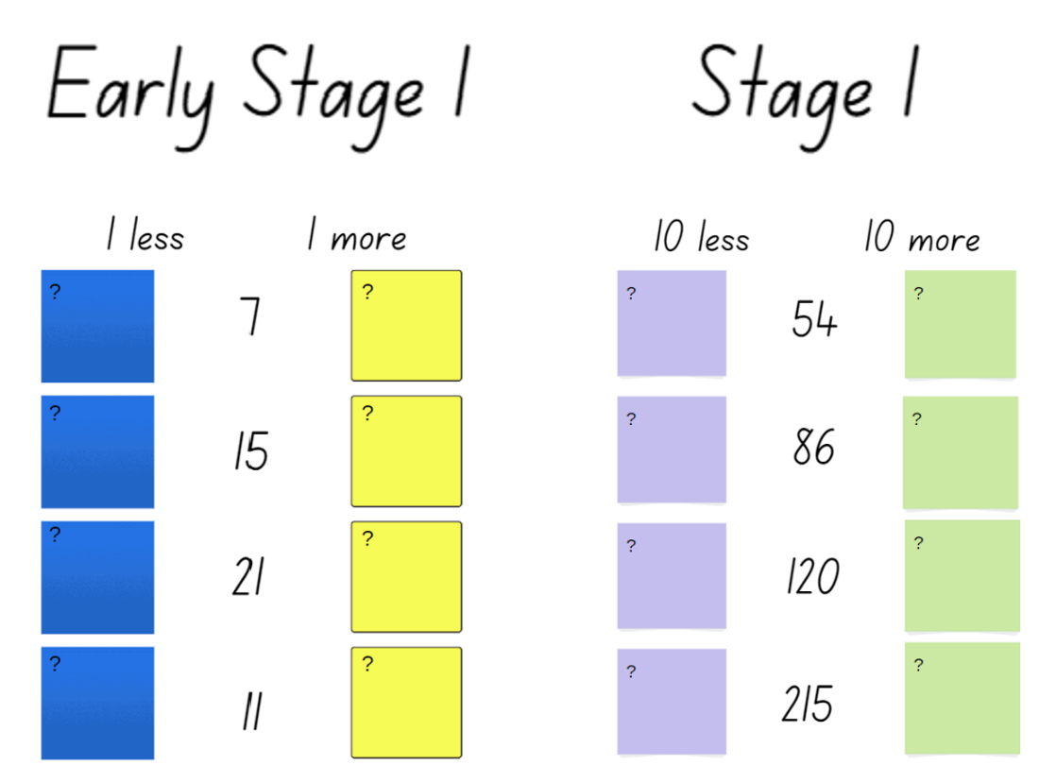

Resource 2: Patterns in architecture
"Rows of Windows” by DebraLee Wiseberg is used in accordance with the Canva Content License Agreement.
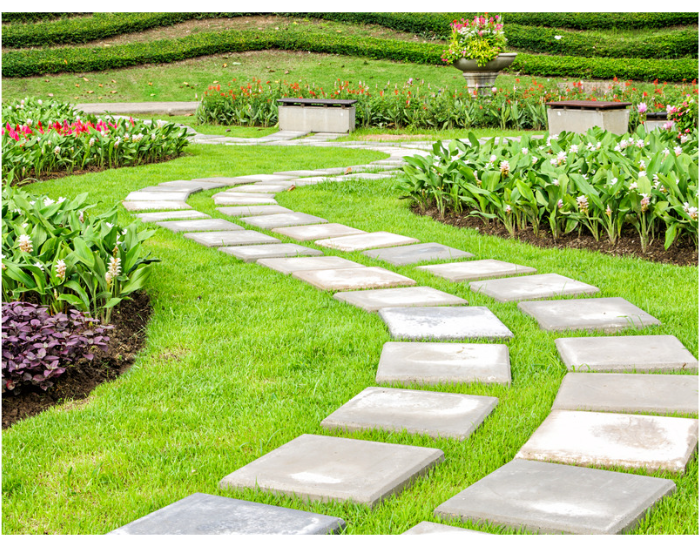
"Landscaping in the garden” by nuwatphoto is used in accordance with the Canva Content License Agreement.

“Buildings Pedestrian Crossing City” by Pexels is licensed under the Pixabay License.
“Architecture Beach Bright Cabin” by PublicDomainPictures is licensed under the Pixabay License.
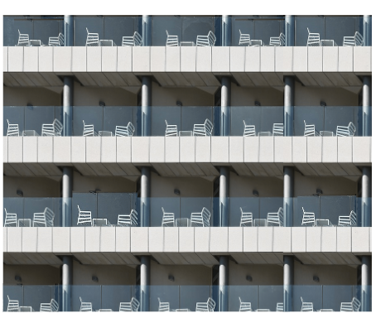
“Modern Industry Steel Technology Expression City” by moshehar is used in accordance with the Pixabay License.
“Opera House Australia Sydney City Travel Break” by HeungSoon is used in accordance with the Pixabay License
"Colourful Building” by JohnnyGreig is used in accordance with the Canva Content License Agreement.
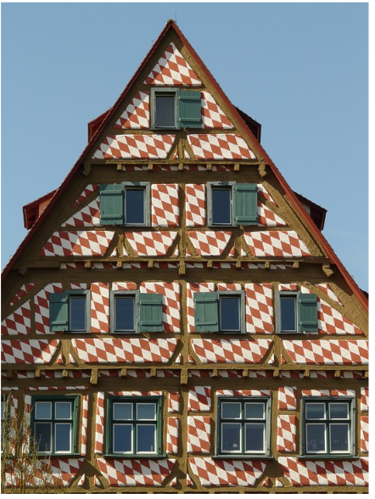
“Truss Half-Timbered House Bar Entablature House” by Hans is used in accordance with the Pixabay License.
“Beach Cottage Cottages Beach Huts” by baluda is used in accordance with the Pixabay License.

Resource 3: Cards 1 and 2
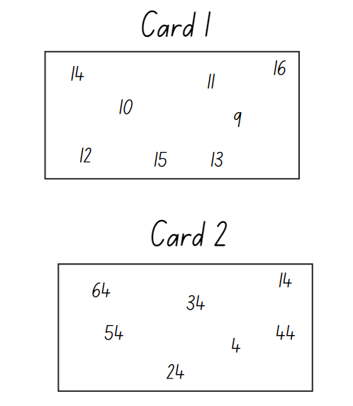

Resource 4: A growing pattern
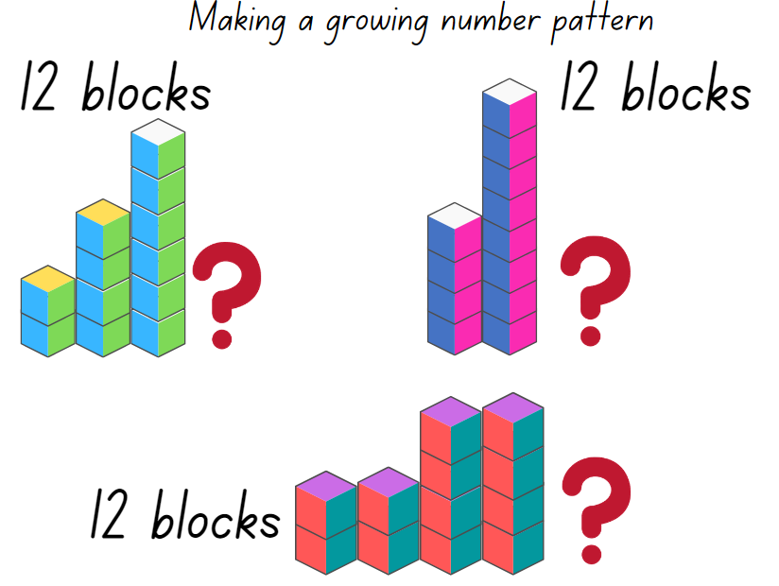
Images sourced from Canva and used in accordance with the Canva Content License Agreement.

Resource 5: How many Legs? Early Stage 1
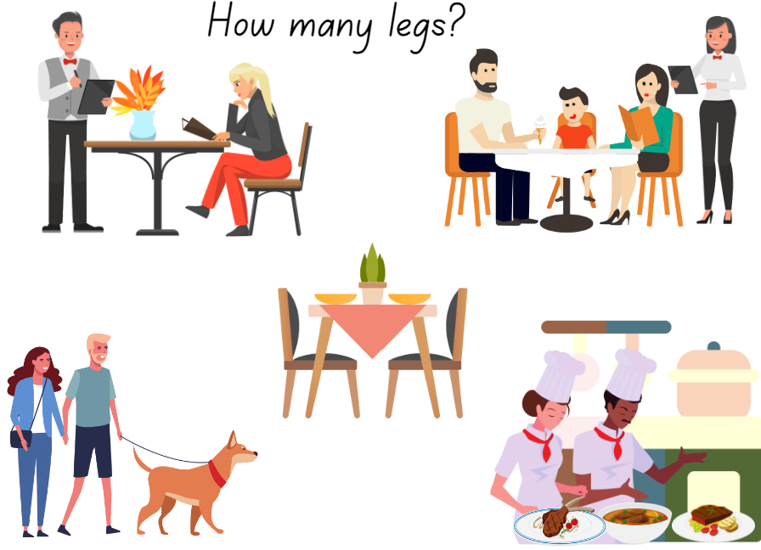
Images sourced from Canva and used in accordance with the Canva Content License Agreement.

Resource 6: How many Legs? Stage 1
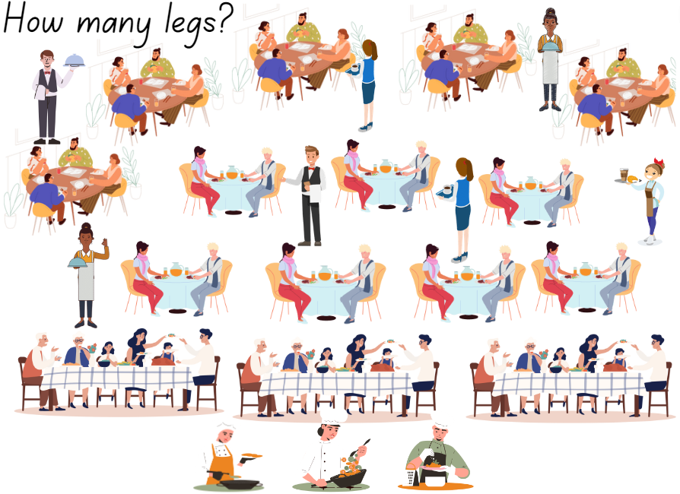
Images sourced from Canva and used in accordance with the Canva Content License Agreement.

Resource 7: Number patterns
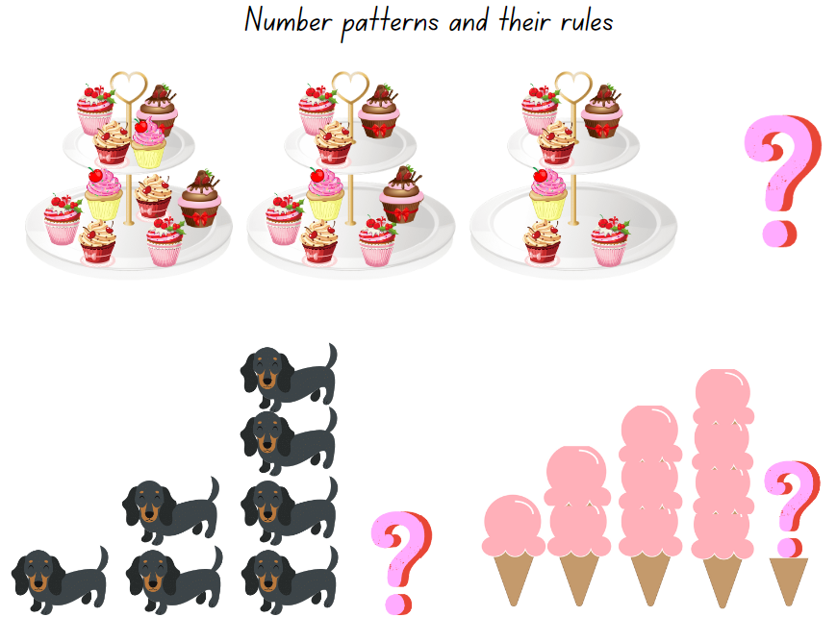
Images sourced from Canva and used in accordance with the Canva Content License Agreement.

Resource 8: 12 and 30 square tiles
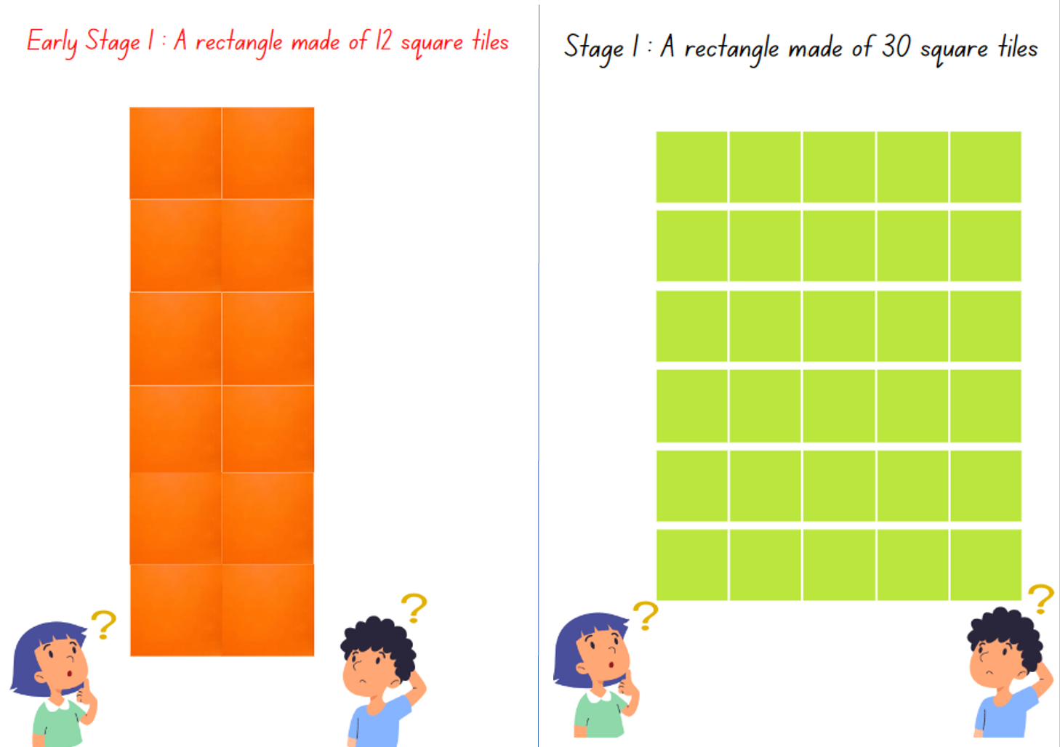
Images sourced from Canva and used in accordance with the Canva Content License Agreement.

Resource 9: Repeating patterns and arrays
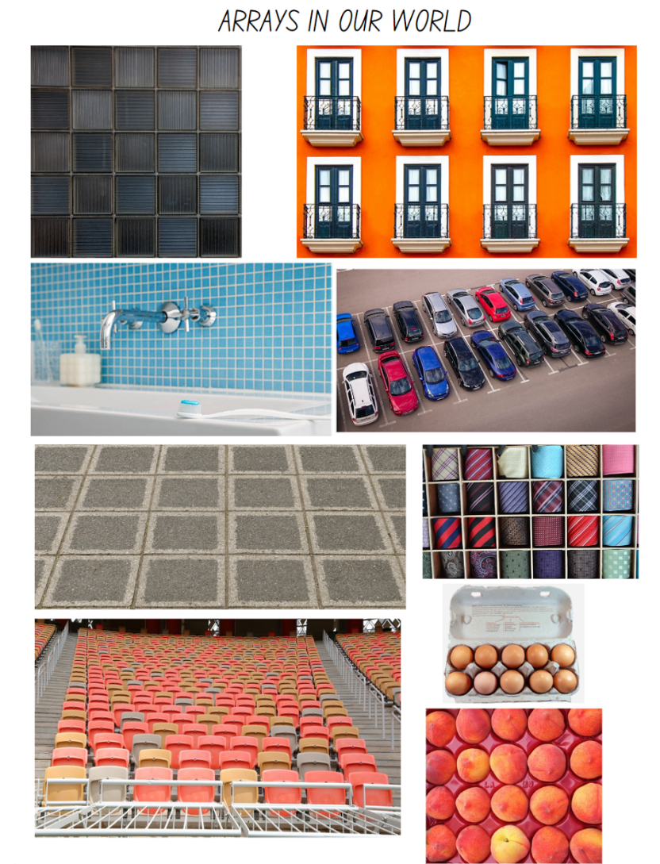
Images sourced from Pixabay and used in accordance with the Pixabay License.

Resource 10: Sort the street
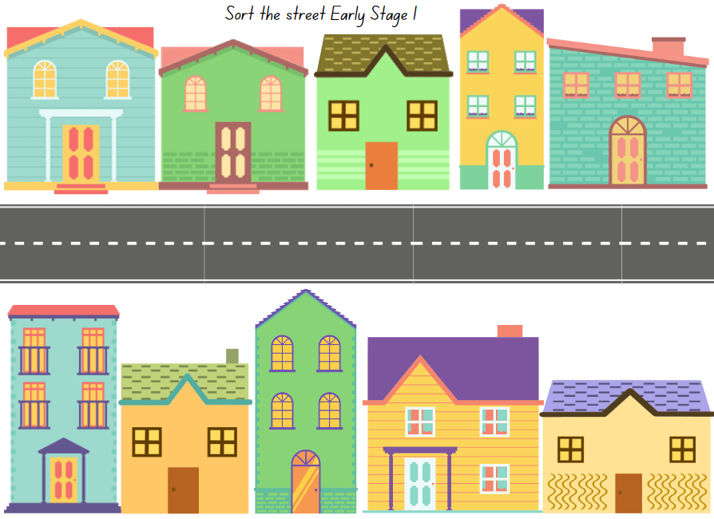
Images sourced from Canva and used in accordance with the Canva Content License Agreement.
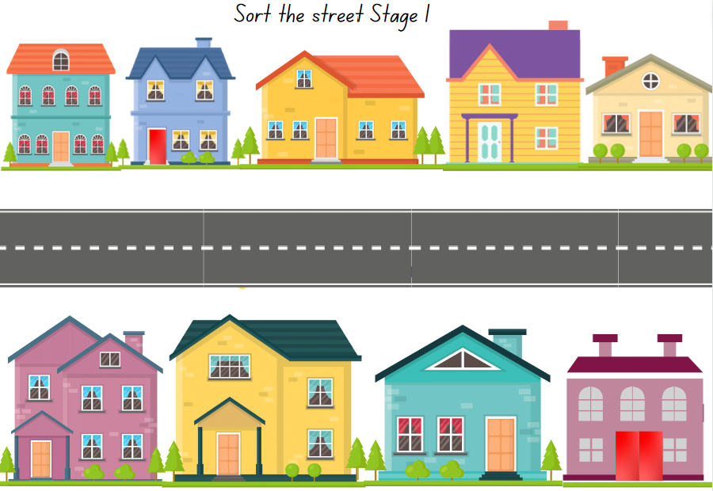
Images sourced from Canva and used in accordance with the Canva Content License Agreement.

Syllabus outcomes and content
The table below outlines the syllabus outcomes and range of relevant syllabus content covered in this unit. Content is linked to National Numeracy Learning Progression version (3).
Focus area and outcomes | Content groups and content points | Lessons
Representing whole numbers  MAO-WM-01  MAE-RWN-01, MA1-RWN-01  MAE-RWN-02, MA1-RWN-02 | Early Stage 1  Instantly name the number of objects within small collections  - Instantly recognise (subitise) the number of items in small groups of up to four items without counting (NPV1, CPr1)  - Identify the number of items in different arrangements (CPr2)  Use the counting sequence of ones flexibly  - Count forwards to at least 30 and state the number after or before a given number, without needing to count from one (CPr4)  - Identify and distinguish the ‘teen’ numbers from multiples of ten with the same initial sounds (NPV3)  - Identify the number before as 'one less' and the number after as 'one more’ than a given number  Recognise number patterns  - Recognise dice and domino dot patterns (NPA1, NPV2, CPr2)  Connect counting and numerals to quantities  - Count with one-to-one correspondence, recognising that the last number name represents the total number in the collection (CPr3, CPr5)  - Count out a specified number of objects (from 5 to 20) from a larger collection, keeping track of the count (CPr4-CPr5)  - Make correspondences between collections  - Read numerals to at least 20, including zero (NPV3)  - Use the term ‘is the same as’ to express equality of groups (CPr4-CPr5, MuS1) | 1–8
Representing whole numbers A | Stage 1  Use counting sequences of ones with two-digit numbers and beyond  - identify the number before and after a given two-digit number (CPr5)  Continue and create number patterns  - Model and describe 'odd' and 'even' numbers using items paired in two rows  - count forwards and backwards by twos from any starting point (CPr6-CPr7, MuS2)  Represent the structure of groups of ten in whole numbers  - recognise that ten ones is the same as one ten (NPV2, NPV4)  - use 10 as a reference in forming numbers from 11 to 20 (CPr7)  - count large sets of objects by systematically grouping in tens (CPr7)  - estimate, to the nearest ten, the number of objects in a collection and check by counting in groups of ten (CPr7, NPV6) | 1–8
Representing whole numbers B | Stage 1  Use counting sequences of ones and tens flexibly  - identify the number before and after a given three-digit number  - count forwards and backwards by tens, on and off the decade, with two- and three-digit numbers (CPr7)  Form, regroup, and rename three-digit numbers  - count and represent large sets of objects by systematically grouping in tens and hundreds (CPr7, NPV5)  - recognise units of 100 (UnM5, NPV5)  - estimate, to the nearest hundred, the number of objects in a collection and check by grouping and counting (NPV6) | 1–7
Combining and separating quantities  MAO-WM-01  MAE-CSQ-01, MAE-CSQ-02 | Early Stage 1  Model additive relations and compare quantities  - Combine two or more groups of objects to model addition, identifying the relationship between the parts and the whole (AdS1-AdS2)  - Use concrete materials or fingers to model and solve addition and subtraction questions, counting forwards or backwards by ones as necessary (AdS1-AdS2, NPV3)  - Compare two groups of objects to determine how many more (NPV1, AdS2)  Identify part–whole relationships in numbers up to 10  - Describe the action of combining, separating and comparing (AdS1)  - Use five as a reference in forming numbers from six to ten  - Count by ones to find the total or difference (AdS2-AdS3)  - Use drawings, words and numerals to record addition and subtraction, and explain their thinking (AdS2) | 4, 6, 8
Forming groups  MAO-WM-01  MAE-FG-01, MA1-FG-01  MAE-FG-02  NOTE – There is only one forming groups outcome for Stage 1. | Early Stage 1  Copy, continue and create patterns  - Copy, continue and create repeating patterns using shapes, objects, images or pictures (NPA1-NPA2) | 1–7
Forming groups A | Stage 1  Count in multiples using rhythmic and skip counting  - count by twos, threes, fives and tens using rhythmic counting and skip counting (MuS2, CPr6)  Use skip counting patterns  - identify and describe patterns when skip counting forwards or backwards by twos, fives and tens (NPA3-NPA4)  - determine a missing number in a number pattern with a constant difference  - describe how the missing number in a number pattern was determined  Model and use equal groups of objects to represent multiplication  - model and describe collections of objects as groups of (MuS2)  - determine and distinguish between the number of groups and the number in each group when describing collections of objects  - find the total number of objects using skip counting of equal groups of a known size (MuS2-MuS3) | 3–7
Forming groups B | Stage 1  Represent and explain multiplication as the combining of equal groups  - use objects, diagrams, images or actions to model multiplication as accumulating equal groups (MuS4)  - solve multiplication problems using repeated addition (MuS4)  - form arrays of equal rows and equal columns (MuS5)  - determine and distinguish between the number of rows/columns and the number in each row/column when describing collections of objects (MuS5)  - model the commutative property of multiplication, using an array (MuS6) | 4–7
Data A  MAO-WM-01  MA1-DATA-01, MA1-DATA-02 | Stage 1  Ask questions and gather data  - gather data and track what has been counted by using concrete materials, tally marks, lists or symbols (IRD3)  Represent data with objects and drawings and describe the displays  - Use concrete materials or pictures of objects as symbols to create data displays where one object or picture represents one data value (IRD2)  - Describe information presented in one-to-one data displays (IRD2)  - Use comparative language to describe information presented in a display, such as ‘more than' and ‘less than’  - Interpret a data display and identify the biggest or smallest values (IRD2) | 5, 8
Data B | Stage 1  Create displays of data and interpret them  - organise collected data into lists and tables to display information (IRD2)  - represent data in a picture graph using a baseline, equal spacing and same-sized symbols (IRD2)  - interpret information presented in tables and picture graphs (IRD2)  - record answers to questions using the information in tables and picture graphs (IRD2) | 5, 6, 8

References
Links to third-party material and websites
Please note that the provided (reading/viewing material/list/links/texts) are a suggestion only and implies no endorsement, by the New South Wales Department of Education, of any author, publisher, or book title. School principals and teachers are best placed to assess the suitability of resources that would complement the curriculum and reflect the needs and interests of their students.
If you use the links provided in this document to access a third-party's website, you acknowledge that the terms of use, including licence terms set out on the third-party's website apply to the use which may be made of the materials on that third-party website or where permitted by the Copyright Act 1968 (Cth). The department accepts no responsibility for content on third-party websites.
Except as otherwise noted, all material is © State of New South Wales (Department of Education), 2023 and licensed under the Creative Commons Attribution 4.0 International License. All other material (third-party material) is used with permission or under licence. Where the copyright owner of third-party material has not licensed their material under a Creative Commons or similar licence, you should contact them directly for permission to reuse their material.
Mathematics K–10 Syllabus © 2022 NSW Education Standards Authority (NESA) for and on behalf of the Crown in right of the State of New South Wales.
© 2022 NSW Education Standards Authority. This document contains NSW Curriculum and syllabus content. The NSW Curriculum is developed by the NSW Education Standards Authority. This content is prepared by NESA for and on behalf of the Crown in right of the State of New South Wales. The material is protected by Crown copyright.
Please refer to the NESA Copyright Disclaimer for more information.
NESA holds the only official and up-to-date versions of the NSW Curriculum and syllabus documents. Please visit the NSW Education Standards Authority (NESA) website and the NSW Curriculum website.
National Numeracy Learning Progression © Australian Curriculum, Assessment and Reporting Authority (ACARA) 2010 to present, unless otherwise indicated. This material was downloaded from the Australian Curriculum website (National Numeracy Learning Progression) (accessed 10 February 2023) and was not modified. The material is licensed under CC BY 4.0. Version updates are tracked in the ‘Curriculum version history’ section on the 'About the Australian Curriculum' page of the Australian Curriculum website.
ACARA does not endorse any product that uses the Australian Curriculum or make any representations as to the quality of such products. Any product that uses material published on this website should not be taken to be affiliated with ACARA or have the sponsorship or approval of ACARA. It is up to each person to make their own assessment of the product, taking into account matters including, but not limited to, the version number and the degree to which the materials align with the content descriptions and achievement standards (where relevant). Where there is a claim of alignment, it is important to check that the materials align with the content descriptions and achievement standards (endorsed by all education Ministers), not the elaborations (examples provided by ACARA).
This resource contains images and content obtained from Canva, and their use outside of this resource is subject to Canva’s Content License Agreement. If you wish to use them separately from the resource, please go to Canva.
Boaler J, Munson J and Williams C (2022) Mindset mathematics: Visualizing and Investigating Big Ideas: Grade 2, Jossey-Bass, United States.
Siemon D, Warren E, Beswick K, Faragher R, Miller J, Horne M, Jazby D, Breed M, Clark, J and Brady K (2020) Teaching Mathematics: Foundations to Middle Years, 3rd edn, Oxford University Press.
University of Cambridge (Faculty of Mathematics) (2022) Sort the Street, NRICH website, accessed 10 February 2023.

