Mathematics – K-2 multi-age – Year B – Unit 11
Contents
Unit description and duration 4
Student prior learning 4
Lesson overview and resources 6
Lesson 1: Let’s add it up! 18
Daily number sense: Searching for number facts – 20 minutes 19
Twenty frame filler – 40 minutes lesson 23
Consolidation and meaningful practice: Bus stop! – 5 minutes 29
Lesson 2: Representing numbers 30
Daily number sense: Let’s make counting fun! – 20 minutes 31
Investigating 10s and 100s – Part 1 – 10 minutes 34
Investigating 10s and 100s – Part 2 – 35 minutes 36
Discuss and connect the mathematics – 5 minutes 40
Lesson 3: Number tug of war 41
Daily number sense – 15 minutes 42
Tug of war – 35 minutes 48
Consolidation and meaningful practice: MAB representations of numbers – 20 minutes 52
Lesson 4: Inspecting 10s and 100s 54
Daily number sense: Counting with Patterns – 20 minutes 55
Five steps to 100 – Part 1 – 20 minutes 57
Five steps to 500 – Part 2 – 20 minutes 59
Discuss the mathematics – 10 minutes 61
Lesson 5: Data detectives 63
Daily number sense: Show me 25! – 15 minutes 64
Collecting data – Part 1 – 20 minutes 65
Representing data – Part 2 – 30 minutes 70
Discuss and connect the mathematics – 5 minutes 72
Lesson 6: Communicating instructions 73
Daily number sense: My eye can spy a number – 10 minutes 74
Following instructions – 45 minutes 76
Discuss and connect the mathematics: Let’s play! – 15 minutes 82
Lesson 7: Build it up! 83
Daily number sense: Recognising number quantities – 10 minutes 84
Up for grabs! – 30 minutes 85
A variety of ways to make a number – 30 minutes 86
Consolidation and meaningful practice: Left or right, up, or down! – 10 minutes 88
Lesson 8: Arrangements of numbers 90
Daily number sense: Estimating quantities – 20 minutes 91
We’re going on a number hunt! – 35 minutes 94
Discussing the mathematics – 5 minutes 97
Resource 1: Car park 99
Resource 2: Twenty-frame filler blank gameboard 100
Resource 3: Place value chart 101
Resource 4: MAB number cards 102
Resource 5: Investigating ‘teen’ numbers 105
Resource 6: This is 57! 106
Resource 7: Tug of war number line 0-100 107
Resource 8: ‘Teen’ towers 108
Resource 9: ‘Teen’ number cards 109
Resource 10: Three steps to 12 110
Resource 11: 5 Steps to 100 111
Resource 12: 5 Steps to 500 112
Resource 13: Number cards 113
Resource 14: Show me 10! 114
Resource 15: Show me 25! 115
Resource 16: Our data investigation 116
Resource 17: Number track and number lines 117
Resource 18: How to play Zap! 118
Resource 19: Estimating quantities of circles 119
Resource 20: Number hunt grid 120
Syllabus outcomes and content 121
References 132

Unit description and duration
This two-week unit develops student knowledge, understanding, and skills of place value, number representation, and data. Students are provided opportunities to:
- investigate the base 10 numerical system
- quantify, organise, and represent a variety of collections
- compare numbers through different representations
- collect and organise categorical data
- interpret data to ask questions and make informed decisions
- identify simple objects on a map and describe their position in relation to another object
- create and follow instructions along a path from the beginning to the end.
Mathematics K–10 Syllabus © 2022 NSW Education Standards Authority (NESA) for and on behalf of the Crown in right of the State of New South Wales.

Student prior learning
Before engaging in these teaching and learning activities, students would benefit from prior experience with:
- modelling, reading, and writing numbers to at least 10 using materials, representations, words, and symbols
- subitising small collections
- estimating how many in a collection of objects
- following and communicating simple instructions to complete a task or play a game
- collecting and arranging data in a display to provide information.
Note: Learn more about how young children learn mathematics Math play: How young children approach math (Clements and Sarama 2005).

Lesson overview and resources
The table below outlines the sequence and approximate timing of lessons; syllabus focus areas and content groups; and resources.
Lesson | Syllabus focus area and content groups | Resources
Lesson 1: Let’s add it up!  65 minutes  Counting on is an efficient mental strategy. | Representing whole numbers  Early Stage 1  - Connect counting and numerals to quantities  Stage 1 – Part A  - Represent the structure of groups of ten in whole numbers  Combining and separating quantities A  Early Stage 1  - Identify part–whole relationships in numbers up to 10  Stage 1 – Part A  - Recognise and recall number bonds up to ten  Combining and separating quantities  Stage 1 – Part B  - Represent and reason about additive relations | - Resource 1: Car park  - Resource 2: Twenty-frame filler blank gameboard  - Video: Investigating teen numbers with ten-frames (9:56)  - Video: Ten-frame filler (4:40)  - Concrete materials  - Counters  - Dice  - Writing materials
Lesson 2: Representing numbers  70 minutes  Concrete materials are useful when representing a variety of numbers. | Representing whole numbers  Early Stage 1  - Use the counting sequence of ones flexibly  - Connect counting and numerals to quantities  Stage 1 – Part A  - Represent the structure of groups of ten in whole numbers  Stage 1 – Part B  - Use counting sequences of ones and tens flexibly  - Form, regroup, and rename three-digit numbers  Forming groups  Stage 1 – Part A  - Model and use equal groups of objects to represent multiplication | - Resource 3: Place value chart  - Resource 4: MAB number cards  - Mathigon – number tiles and cubes interactive board  - 200 interlocking cubes or coloured bricks  - Digital devices  - MAB blocks  - Writing materials
Lesson 3: Number tug of war  70 minutes  Mathematicians use number tracks and number lines to problem solve and explore a range of counting sequences. | Representing whole numbers  Early Stage 1  - Use the counting sequence of ones flexibly  - Connect counting and numerals to quantities  Stage 1 – Part A  - Use counting sequences of ones with two-digit numbers and beyond  - Represent numbers on a line  - Represent the structure of groups of ten in whole numbers  Combining and separating quantities  Early Stage 1  - Model additive relations and compare quantities  - Identify part–whole relationships in numbers up to 10  Stage 1 – Part A  - Use advanced count-by-one strategies to solve addition and subtraction problems  - Use flexible strategies to solve addition and subtraction problems  Stage 1 – Part B  - Represent and reason about additive relations  - Form multiples of ten when adding and subtracting two-digit numbers | - Resource 5: Investigating ‘teen’ numbers  - Resource 6: This is 57!  - Resource 7: Tug of war number line 0-100  - Resource 8: ‘Teen’ towers  - Resource 9: ‘Teen’ number cards  - Video: Quantifying collections – Ice cream sticks 1 – number talk (7:50)  - 10-sided dice  - Counters  - Craft sticks  - MAB blocks  - Number track 0-20  - Writing materials
Lesson 4: Inspecting 10s and 100s  70 minutes  Our understanding of numbers to 10 helps us to understand numbers beyond 100. | Representing whole numbers  Early Stage 1  - Use the counting sequence of ones flexibly  - Connect counting and numerals to quantities  Stage 1 – Part B  - Form, regroup, and rename three-digit numbers  Combining and separating quantities  Early Stage 1  - Model additive relations and compare quantities  - Identify part–whole relationships in numbers up to 10  Stage 1 – Part A  - Use advanced count-by-one strategies to solve addition and subtraction problems  - Use flexible strategies to solve addition and subtraction problems  Stage 1 – Part B  - Represent and reason about additive relations  - Form multiples of ten when adding and subtracting two-digit numbers  - Use knowledge of equality to solve related problems | - Resource 10: Three steps to 12  - Resource 11: Five steps to 100  - Resource 12: Five steps to 500  - Resource 13: Number cards  - 6-sided dotted dice  - 9-sided dice  - Counters  - Digital device  - Dominoes  - Writing materials
Lesson 5: Data detectives  70 minutes  Collecting, displaying, and interpreting data helps us communicate and understand information. | Representing whole numbers  Early Stage 1  - Instantly name the number of objects within small collections  - Use the counting sequence of ones flexibly  - Recognise number patterns  - Connect counting and numerals to quantities  Stage 1 – Part A  - Represent the structure of groups of ten in whole numbers  Combining and separating quantities  Early Stage 1  - Model additive relations and compare quantities  - Identify part–whole relationships in numbers up to 10  Stage 1 – Part A  - Recognise and recall number bonds up to ten  Forming Groups  Stage 1 – Part A  - Count in multiples using rhythmic and skip counting  - Use skip counting patterns  Data  Early Stage 1  - Respond to questions, collect information and discuss possible outcomes of activities  - Organise objects into simple data displays and interpret the displays  Stage 1 – Part B  - Identify a question of interest and gather relevant data  - Create displays of data and interpret them | - Resource 14: Show me 10!  - Resource 15: Show me 25!  - Resource 16: Our data investigation  - Concrete materials  - Writing materials
Lesson 6: Communicating instructions  70 minutes  Sharing and following instructions requires using language that is clear, appropriate, and describes what? where? and when? | Representing whole numbers  Early Stage 1  - Use the counting sequence of ones flexibly  - Connect counting and numerals to quantities  Stage 1 – Part B  - Use counting sequences of ones and tens flexibly  - Form, regroup, and rename three-digit numbers  Geometric measure  Early Stage 1  - Position: Describe position and movement of oneself  Stage 1 – Part A  - Position: Follow directions to familiar locations | - Resource 17: Number track and number lines  - Resource 18: How to play Zap!  - Counters  - Multiple sets of ace to 9 playing cards  - Writing materials
Lesson 7: Build it up!  80 minutes  Some arrangements of objects are instantly recognisable, and this is useful when counting a collection. | Representing whole numbers  Early Stage 1  - Instantly name the number of objects within small collections  - Connect counting and numerals to quantities  Stage 1 – Part A  - Represent the structure of groups of ten in whole numbers  Stage 1 – Part B  - Use counting sequences of ones and tens flexibly  - Form, regroup, and rename three-digit numbers  Combining and separating quantities  Early Stage 1  - Model additive relations and compare quantities  - Identify part–whole relationships in numbers up to 10  Stage 1 – Part B  - Use knowledge of equality to solve related problems  Forming groups  Stage 1 – Part A  - Model and use equal groups of objects to represent multiplication | - 6 hoops  - Buckets and bean bags  - Digital device  - Large tub of interlocking cubes or coloured bricks  - Modelling clay  - MAB blocks  - Paper circles  - Writing materials
Lesson 8: Arrangements of numbers  60 minutes  A large quantity can be arranged and quantified in a variety of ways. | Representing whole numbers  Early Stage 1  - Instantly name the number of objects within small collections  - Use the counting sequence of ones flexibly  - Connect counting and numerals to quantities  Stage 1 – Part A  - Represent the structure of groups of ten in whole numbers  Stage 1 – Part B  - Use counting sequences of ones and tens flexibly  - Form, regroup, and rename three-digit numbers  Combining and separating quantities  Early Stage 1  - Model additive relations and compare quantities  - Identify part–whole relationships in numbers up to 10  Stage 1 – Part A  - Recognise and recall number bonds up to ten  Stage 1 – Part B  - Use knowledge of equality to solve related problems  Forming groups  Stage 1 – part A  - Model and use equal groups of objects to represent multiplication  Geometric Measure  Early Stage 1  - Position: Describe position and movement of oneself  Stage 1 – Part A  - Position: Follow directions to familiar locations  Stage 1 – Part B  - Position: Explore simple maps of familiar locations | - Resource 19: Estimating quantities of circles  - Resource 20: Number hunt grid  - Large quantities of a variety of concrete materials, such as craft sticks, paper clips, pompoms, and counters  - Writing materials

Lesson 1: Let’s add it up!
Core concept: Counting on is an efficient mental strategy.
The table below contains suggested learning intentions and success criteria. These are best co-constructed with students.
Learning intentions | Success criteria
All students are learning that:  - different combinations of numbers can bond to form a new given number  - representations of numbers provide information which helps solve problems  - a whole can be represented in 2 or more parts and the quantity of the whole remains the same. | All students can:  - recognise that no matter how 2 quantities are arranged, the total of the whole is the same  - understand that a quantity has a number name  - combine 2 quantities and keep track of the count.  In addition, students working towards Early Stage 1 outcomes can use drawings or symbols to explain solutions to simple problems.  In addition, students working towards Stage 1 outcomes can:  - combine 3 numbers to make a larger number  - record number sentences using numbers, symbols, or words.

Daily number sense: Searching for number facts – 20 minutes
- Build student understanding of number bonds by investigating part-whole relationships.
- Display the numeral 10 and provide time for students to share what they know about the number 10. Ask:
- Where can we see combinations to 10?
- What are some facts about 10?
- Explain to students that they will identify and record number bonds for a variety of numbers.
- Early Stage 1 students will explore combinations up to 10 and Stage 1 students will explore a ‘teen’ number of their choice (see Figure 1).
Figure 1 – Examples of number bonds for 18
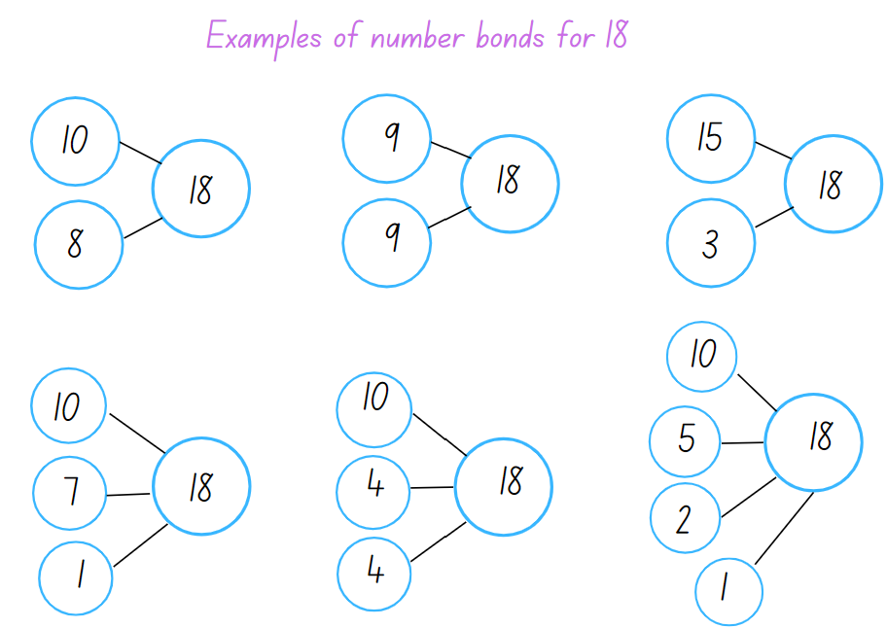
- Ask Stage 1 students to share 2 numbers that combine to make 18 and then share 3 numbers. Record responses on the board.
- Early Stage 1 students will use concrete materials to create representations of 10 and use drawings or symbols to record their thinking. Ask students:
- What do you notice?
- Did you use known dice patterns to create part-whole combinations to 10?
- What strategies did you use and how did you check the accuracy of your work?
- With a partner, students use writing materials and select a number, displaying the parts using symbols, numbers, or pictures to represent the combinations of the whole.
- Ask Stage 1 students to select a ‘teen’ number. Students need to record up to 6 number sentences demonstrating number bonds for their chosen number.
- Students need to use symbols such as, 10 + 4 + 4 = 18 or record a statement for each, such as ‘10 and double 4 makes 18’ or ‘10 and 8 more makes 18’.
- Ask students:
- Do number bonds to 10 help with finding numbers that combine to make a teen number?
- What strategies did you use? Which was the most efficient and why?
- How did you check the accuracy? Can you think of another way?
Note: Optional to record representations using a digital device. Photographs can be collected to create a class poster (see Figure 2).
Figure 2 – Examples of number bonds to 10
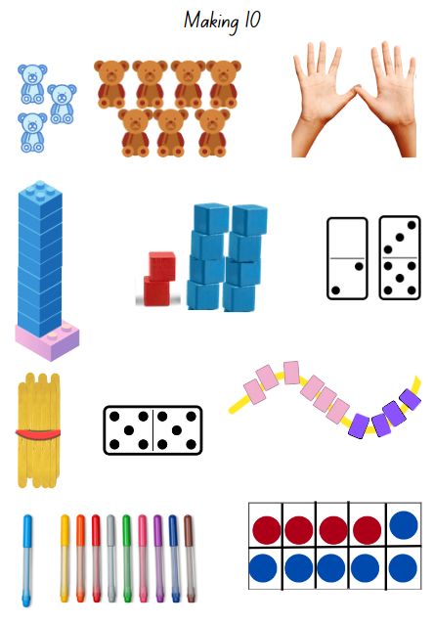
Images sourced from Canva and used in accordance with the Canva Content License Agreement.
The table below details assessment opportunities and differentiation ideas.
Assessment opportunities | Too hard? | Too easy?
What to look for:  - Can students create representations to model combinations to 10? (MAO-WM-01, MAE-CSQ-01)  - Can students count on from the larger number when adding 2 numbers? (MAO-WM-01, MA1-RWN-01, MA1-CSQ-01)  - Can students record number sentences using symbols, numerals or words? (MAO-WM-01, MAE-CSQ-01, MA1-CSQ-01)  - Can Stage 1 students recognise and use the symbols for plus (+), minus (−) and equals (=)? (MAO-WM-01, MA1-CSQ-01)  - Can students describe the action of combining? (MAO-WM-01, MAE-CSQ-01)  - Can students model and explain part-whole combinations using language such as join, add more, take away or subtract? (MAO-WM-01, MA1-CSQ-01)  What to collect:  - samples of student's number sentences or drawn representations. (MAO-WM-01, MAE-CSQ-01, MA1-CSQ-01)  - photographs of student representations to be used for a class poster (MAO-WM-01, MAE-CSQ-01, MA1-CSQ-01) | Students need support with counting strategies.  For Early Stage 1:  - Provide students with a ten-frame and counters in 2 different colours.  - Support students to identify part-whole combinations.  For Stage 1:  - Model an arrangement of 10 counters and explain that the teen numbers are a combination of 10 and then some more, for example, 13 is 10 and 3 more and so on.  - Watch the video Investigating teen numbers with ten-frames (9:56) for explicit instructional ideas and vocabulary that support students learning about teen numbers. | Students recall number bonds to 20 with accuracy.  - Students explore if any ‘teen’ numbers can be represented by using a combination of doubles.  - For example, 11 is double 5 and one more; 16 is double 5 and double 3.

Twenty frame filler – 40 minutes lesson
This activity has been adapted from Teaching Mathematics Foundation to Middle Years, 3rd edn by Siemon et al. (2020).
- Ask students:
- What do you know about a ten-frame?
- How can a ten-frame be used?
- How is the structure of a ten-frame useful? Explain your thinking.
- Explain to students that ten-frames are a useful tool to assist in combining quantities. Early Stage 1 students will explore combinations of numbers to 10, using one ten-frame and playing ‘Car park’. Stage 1 students will explore combinations of numbers to 20, using multiple twenty-frames, playing ‘twenty-frame filler’.
Note: Subitising is the ability to recognise collections without counting. Further information on subitising can be found in the professional learning resource Becoming mathematicians: Quantifying collections.
- Place Early Stage 1 students in pairs and provide Resource 1: Car park, at least 30 counters of 2 differing colours and two 6-sided dot dice.
- Players take turns rolling 2 dice and combining the quantities. Players place their coloured counter onto a car with the matching quantity. For example, Player 1 rolls a 4 and a 6 and places a counter on a car with the quantity 10. If a player rolls a combination of 11 or 12, they place their counter near the boom gate. If a player rolls a quantity that is not available, the player skips a turn. Play continues until the car park is full and the winner is the player with the most counters on the cars (see Figure 3).
Figure 3 – Example of car park gameboard
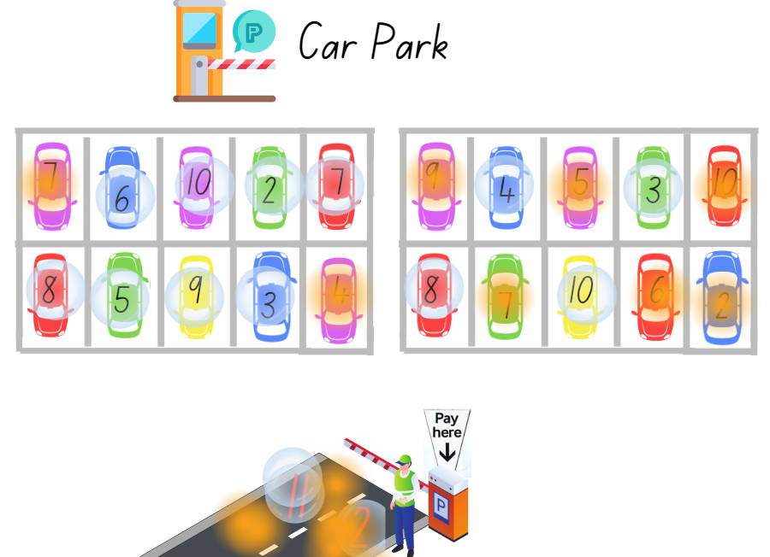
Images sourced from Canva and used in accordance with the Canva Content License Agreement.
- After a few rounds, ask Early Stage 1 students to share their strategies for combining the quantities.
- For Stage 1 students, display 10 ten-frames in an arrangement as seen in Figure 4 and ask students to think about what they see. Allow time for students to share their thinking and discuss how the structure of ten-frames supports efficiency in counting large quantities by tens.
Figure 4 – 10 ten-frames
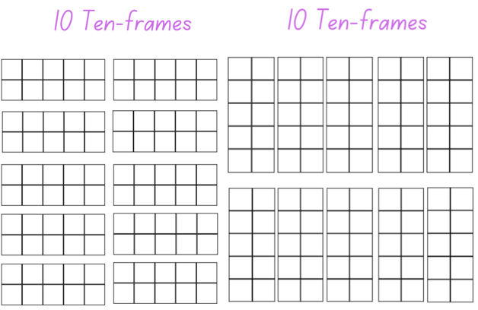
Note: Focus the discussion on the number of ten-frames, how they are grouped, and how this arrangement can make counting to 100 efficient.
- Explain that students will be playing a game called ‘Twenty-frame filler’. The objective of the game is to be the player who fills a frame to exactly 20.
Note: Watch Ten-frame filler (4:40) on Thinking Mathematically for more instructions on how to play the game using ten-frames.
- Students take turns rolling the dice and marking off that many squares in one of the twenty-frames. Players can choose to mark the quantity rolled in any of the twenty-frames. They do not need to follow on from their partner's previous roll. The aim of the game is to fill the twenty-frames. Ensure that students think strategically about where they mark their number so they can win that frame.
- Players continue to roll the dice filling the frames until a player rolls a number which allows them to fill a twenty-frame completely, claiming it and placing their initials next to that frame. The player with the most twenty-frames at the end is the winner (see Figure 5).
Figure 5 – Example of a game
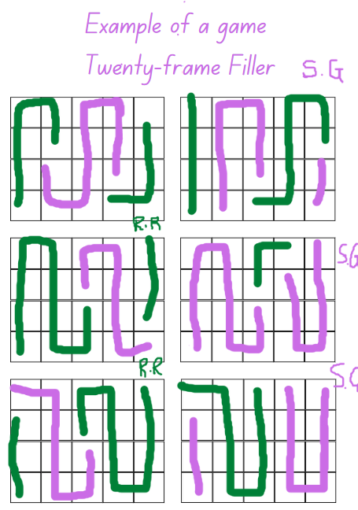
- Provide each pair of students with the gameboard, Resource 2: Twenty-frame filler blank gameboard, 2 different coloured markers and a 10-sided dice.
- After several rounds, ask students:
- Was there a strategy that helped win the game?
- What was challenging?
- What numbers were the best to roll? Why?
- After playing a few rounds, have all the combinations to 20 be found? Why or why not?
- What might happen if there was a third player? Would it make it easier or harder to win?
The table below details assessment opportunities and differentiation ideas.
Assessment opportunities | Too hard? | Too easy?
What to look for:  - Are students able to recognise combinations to 20? (MA1-CSQ-01)  - Are students able to name the number and recognise the numeral? (MAE-RWN-01)  - Are students able to subitise the number of dots on the dice? (MAE-RWN-01)  - Can students apply a variety of strategies while problem solving and combining quantities? (MAE-CSQ-01, MA1-CSQ-01)  - Do students use 10 to assist with recognising, counting and recording ‘teen’ numbers? (MA1-RWN-01, MA1-CSQ-01)  What to collect:  - photos and anecdotal recordings of students’ reasoning and applied strategies (MAO-WM-01, MA1-CSQ-01) | Students need support counting the number of dots and identifying the numeral.  - Provide students with concrete materials and number cards that also display a corresponding dot pattern so that students can use these as a reference.  - Provide each student with a blank ten-frame and support students to identify numbers that combine to make 10.  Students need support to count on from 10.  - Model an arrangement of 10 counters and explain that the teen numbers are a combination of 10 and then some more, for example, 13 is 10 and 3 more and so on.  - Watch the video Investigating teen numbers with ten-frames (9:56) for explicit instructional ideas and vocabulary that support students learning about teen numbers. | Students identify and name all numbers to 10 and combine number bonds to 10 with confidence.  - Provide a challenge in the way they play the game. For example, instructions are the same except players use both car park ten-frames and they need to make 3 in a row.  - Provide students with numbered dice instead.  Students apply various strategies and play twenty-frame filler with confidence.  - Students play Hundred-frame – filler. Provide students with 10 ten-frames and two 10-sided dice.  - Provide students with an additional challenge, for example, if you roll an even number, double the number and if you roll an odd number, miss a turn.

Consolidation and meaningful practice: Bus stop! – 5 minutes
- Pose to students that on a school bus, there are 9 children. At the first stop, one child gets off and 2 children get on the bus. Ask students how many children are on the bus now.
- Provide students with writing materials and ask students to use drawings or symbols to represent their answer.
- Pose to Early Stage 1 students that at the next stop, 2 children get off the bus and no one gets on the bus. Ask how many children are on the bus now. Ask students to use drawings to represent their answer.
- Pose to Stage 1 students that at the next stop, 4 children get off the bus and 6 children and 2 parents get on the bus. Ask how many people there are altogether on the bus now. Ask students to use drawing or symbols to represent their answer.

Lesson 2: Representing numbers
Core concept: Concrete materials are useful when representing a variety of numbers.
The table below contains suggested learning intentions and success criteria. These are best co-constructed with students.
Learning intentions | Success criteria
Students working towards Early Stage 1 outcomes are learning that:  - numbers have a sequence based on their value  - parts of a number can be combined to make a whole.  Students working towards Stage 1 outcomes are learning that:  - using multiples of 10 is a useful strategy when counting large quantities  - numbers can be represented in a variety of ways and grouped based on place value. | All students can:  - accurately count a collection  - represent numbers in a variety of ways.  In addition, students working towards Early Stage 1 outcomes can:  - use MAB to make numbers up to 20  - recognise collections that are the same using dice patterns, ten-frames, MAB blocks, and numerals.  In addition, students working towards Stage 1 outcomes can:  - organise and count a large collection using groups of 10  - use MAB blocks to represent hundreds, tens, and ones in two- and three-digit numbers  - name the place value of a digit in a large number based on the position of that digit.

Daily number sense: Let’s make counting fun! – 20 minutes
- Build student understanding of efficient strategies to count a large collection by using groups of 10.
Note: This is a collaborative, whole class task. It is important to provide a large quantity of interlocking cubes or coloured bricks, at least 200 so, that students can trial various ways to group and count accurately.
Students require a range of opportunities to develop the ability and the skills involved to estimate accurately. Experiences with estimating meets both mathematical and practical needs. Students need to refer to their knowledge of numbers, make comparisons and draw on what is familiar to understand what is unfamiliar, and the ability to judge the reasonableness of their estimation.
- Pose the problem that the tub of interlocking cubes was dropped, scattering all the cubes on the floor. Explain to students that you are wondering how many interlocking cubes there are on the floor. Ask students:
- Are there more than 2 handfuls of interlocking cubes?
- Are there more than 2 cups? What about 2 lunch boxes?
- Ask Stage 1 students:
- How many interlocking cubes do you estimate are scattered on the floor?
- How did you reach that estimate? What strategy did you use?
- Ask Early Stage 1 students to view all the interlocking cubes and ask:
- How many interlocking cubes would fit in 1 handful? What about 2 handfuls?
- Do you think there are more or less than 10 handfuls?
- Ask all students to suggest a way to work together and group the interlocking cubes so that they can be counted efficiently without losing track of the count.
- Students may initially suggest counting by ones, twos, or fives. As the count progresses, remind students that the interlocking cubes need to be organised or grouped in a way that is efficient and accurate. Observe strategies being used and the ongoing discussions. Use opportunities to highlight successful strategies being used by students.
- Once the interlocking cubes have been arranged in groups, ask Stage 1 students to view the collection and ask if they would like to adjust their estimates. Provide time for students to turn and talk with a partner.
- Ask students if they think there is a better way to arrange the groups, making it even easier to count the total. Provide time for students to share suggestions. Once adjustments have been made, proceed to count.
- Record the final number and ask Stage 1 students if their estimates were close or far off. Allow time for students to comment and share their estimating strategies. Ask students:
- Was your estimate more or less than the total number of interlocking cubes?
- Did you estimate by predicting how many groups of a certain number they could make?
- Does estimating help you know if the result of the count is correct? Explain how?
- Ask Early Stage 1 students to collect 2 handfuls of interlocking cubes and discuss if they had more or less than their initial ideas.
The table below details assessment opportunities and differentiation ideas.
Assessment opportunities | Too hard? | Too easy?
What to look for:  - Can students identify and use a systematic pattern to arrange and count a collection? (MAO-WM-01, MAE-RWN-01, MA1-RWN-01)  - Can students use concrete materials to form equal groups? (MA1-RWN-01)  - Are students able to combine 2 or more groups and explain that they are parts of the whole quantity of cubes? (MAE-CSQ-01)  - Do students apply their number knowledge when estimating? (MA1-RWN-01)  - Can students reason about a quantity by explaining that it is ‘more than’, ‘less than’ or ‘the same as’? (MAE-RWN-01)  What to collect:  - photos of the grouped collections (MAE-RWN-01, MA1-RWN-01)  - anecdotal records of student reasoning when estimating using handfuls (MAO-WM-01, MAE-RWN-01)  - anecdotal records of student reasoning when estimating the whole collections of cubes (MAO-WM-01, MA1-RWN-01) | Students cannot arrange the collection into groups so that counting is more efficient.  - Provide time for students to explore 2 handfuls of interlocking cubes and to create a pattern which will enable counting.  Students are unable to estimate.  - Using a handful of interlocking cubes, ask students if they can tell how many interlocking cubes there are without counting by ones. Ask students to count and check their estimate.  - Repeat several times and then add an additional handful. | Students are confident identifying and using a systematic pattern to group and count the interlocking cubes.  - Ask students if they can create an arrangement of the groups of interlocking cubes so that the final count is even more efficient.  - For example, towers of 50 or 100 interlocking cubes or an array representing 100.

Investigating 10s and 100s – Part 1 – 10 minutes
- Display an MAB one and a base 10 long.
- Explain that when students counted the interlocking cubes in the previous activity, they organised the cubes into groups of 10.
- Display a tower of 10 interlocking cubes and a base 10 long. Ask students what they notice about the base 10 long and if they think it is like a tower of 10 interlocking cubes. Allow time for students to share their ideas.
- Explain that mathematicians use various strategies to count a large quantity of objects, such as counting on.
- Model by placing 5 MAB ones, one at a time, on the table and state to students that there are 5, without counting. Continue to count aloud as you place each ones block down until you have 10. Repeat the task a few times and ask students what they notice. Select students to model counting on, starting from various numbers to 10.
- In pairs, provide Early Stage 1 students with writing materials and a collection of MAB ones.
- Explain that the first student will collect a handful of ones and place these on the floor. The second student then collects a handful and holds these in their hand. Jointly, they count the first handful and then count on using the second handful. Once they have completed their count, students record a representation of the total count of 2 handfuls using drawings, symbols, or numbers.
- Early Stage 1 students will continue to explore collections of MAB with a partner, while Stage 1 students are provided with the instructions for their task.
- Explain to Stage 1 students that this is an example of an inefficient way to count large numbers by ones. Count slowly to 100 whilst you use MAB ones to match the count. Each time you say a number, place a one in front of the class to represent the quantity. After some time, stop and explain that you will now use the base 10 long to complete a count to 100.
- Ask students to skip count by tens to 100. As students count, match their count with a base 10 long until you reach 100. Discuss how counting by tens orally, as well as grouping objects in tens, is an efficient strategy.
- Ask students to suggest how to make a hundreds flat and select students to model.
- Using MAB hundreds, tens, and ones, model various numbers and ask students to identify what numbers have been made.

Investigating 10s and 100s – Part 2 – 35 minutes
Note: MAB or multibase arithmetic blocks are used to assist students with understanding the base 10 structure of our number system. Students can use these materials to create, model, and explain the place value of a digit in a number. These materials resemble bundles of 10 as we move from ones to tens to hundreds and then to thousands, showing the relationship of our number system, for example, 100 is 10 times bigger than 10 and 1000 is 10 times bigger than 100. To assist student understanding, it is optional to use Resource 3: Place value chart.
- Display the Mathigon interactive board. Explain that the interactive board supports the understanding of place value by using MAB to represent numbers and visually see the ones, tens, hundreds, and so on.
- Model selecting or dragging MAB from the left menu onto the blank board. Create a base 10 long with students, counting as the orange ones are lined up to create a tower (see Figure 6.)
Figure 6 – Orange ones
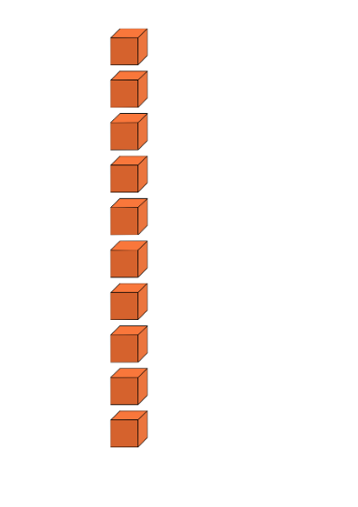
- Select the blue base 10 long from the left menu and place it beside the ones tower. Explain that 10 units make one 10, which is one base 10 long. If needed, slightly separate each of the orange ones so that students can clearly see the composition that 10 ones make one 10 (see Figure 7).
Figure 7 – Representation of 10
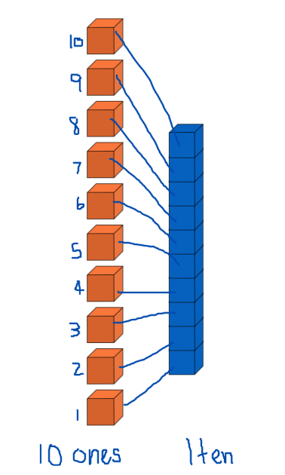
- Clear the board.
Note: You can quickly clear the board by dragging your curser over all blocks and pressing delete on the keyboard or using the ‘bin’ symbol.
- Ask a student to suggest a number that is less than 10 and model how to create that number. Ask a student for a two-digit number that is less than 30 and model how to create that number. Repeat.
- In pairs, provide students with a digital device and ask students to explore Mathigon.
Note: To cater for the diverse abilities and learning styles of students, consider small collaborative groups which include a range of learning abilities and pairs of students which may require more directed support, modelling, and instructions. It is optional to use Resource 4: MAB number cards to assist students with visual representations that they can recreate.
- With their partner, students select and represent one- and two-digit numbers of their choice.
- Bring students back to the floor and select several students to share their representations.
- For Stage 1 students, model how to create a three-digit number. Select several students to create a three-digit number and ensure students are using combinations of hundreds (flats), tens (longs), and ones to represent the place value for each digit of their selected three-digit number.
The table below details assessment opportunities and differentiation ideas.
Assessment opportunities | Too hard? | Too easy?
What to look for:  - Do students understand that 10 ones are the same as one 10? (MAE-RWN-01, MA1-RWN-01, MA1-RWN-02)  - What strategies are students using to arrange various MAB to represent a one- and two-digit number? (MAO-WM-01, MAE-RWN-01, MA1-RWN-02)  - What strategies are students using to arrange various MAB to represent a three-digit number? (MAO-WM-01, MAE-RWN-01, MA1-RWN-02)  - Are students able to name two-digit numbers up to 20? (MAE-RWN-01)  - Are students able to name two- and three-digit numbers? (MA1-RWN-02)  What to collect:  - photographs and anecdotal records of discussions and strategies used (MAO-WM-01, MAE-RWN-01, MA1-RWN-02) | Students require support to understand tens and hundreds.  - Provide students with MAB and model how to make a base 10 long using 10 ones.  - Support students while they explore simple two-digit numbers up to 20 using MAB longs and ones.  Students require assistance using Mathigon and manipulating the MAB on the interactive board.  - Model how to use Mathigon and support students as they make simple one- and two-digit numbers.  - Students work in small groups to observe their peers and take turns to make simple one- and two-digit numbers. | Students are confident creating representations of numbers using MAB.  - Ask students to represent a number such as 538 and then represent the number that is 50 less or 50 more.  - Ask students to create a representation of a number for a partner to solve.

Discuss and connect the mathematics – 5 minutes
- Select students to display their Mathigon representation to the class. Ask students:
- to identify the number that matches the MAB representation
- to explain how they knew the representation was for that number.

Lesson 3: Number tug of war
Core concept: Mathematicians use number tracks and lines to problem solve and explore a range of counting sequences.
The table below contains suggested learning intentions and success criteria. These are best co-constructed with students.
Learning intentions | Success criteria
Students working towards Early Stage 1 outcomes are learning that:  - number tracks are a useful tool to track a count sequence when combining or separating quantities  - recognising patterns of numbers is helpful when counting a collection.  Students working towards Stage 1 outcomes are learning that:  - number lines are a useful tool to track a count sequence when solving addition and subtraction problems  - each digit in a number has a name and the position of that digit is its place value. | All students can:  - name the total number of objects in a small collection to 10  - recognise and sequence numbers on a number track to 20.  In addition, students working towards Early Stage 1 outcomes can accurately match a numeral with a quantity of objects.  In addition, students working towards Stage 1 outcomes can:  - understand the sequence and arrangement of numbers on a number line to 100  - name a three-digit number and identify each digit's place value.

Daily number sense – 15 minutes
- Build student understanding of place value by making, naming, and recording three-digit numbers.
Notes: Exposing students to a variety of ways to make or represent numbers builds their understanding of place value. As students explore numbers, they assign a value to each digit and recognise the importance of the position and the value of each digit in the whole number. Watch the video Quantifying collections – Ice cream sticks 1 – number talk (7:50) for explicit instructional ideas and vocabulary that supports Early Stage 1 students learning about tens and ones.
- For Early Stage 1 students, explain that they are going to explore the ‘teen’ numbers, the numbers from 10 to 20.
- Display a number track from zero to 20 and explain:
- these numbers are always sequenced in this order
- as students count, they add one more to the previous number to make the next number in the sequence
- when counting aloud, the name of the number (what is said) matches the numeral (what is seen) in the sequence. Ask students to count.
- Ask students if they can name the number that comes after 10 and the number after that, and so on. Identify these numbers as the ‘teen’ numbers and ask students:
- Can you see something interesting about these numbers?
- When you say the numbers can you hear something interesting?
- Is there a pattern?
- Provide each pair of students with Resource 5: Investigating ‘teen’ numbers, a zero to 20 number track, 20 counters, and 20 craft sticks.
- Explain that students will be working with a partner to investigate the ‘teen’ numbers to 20.
- Display 10 craft sticks and jointly count these. Ask students what number would come next and as they say 11, place the craft stick down as in Figure 8.
Figure 8 – Investigating ‘teen’ numbers
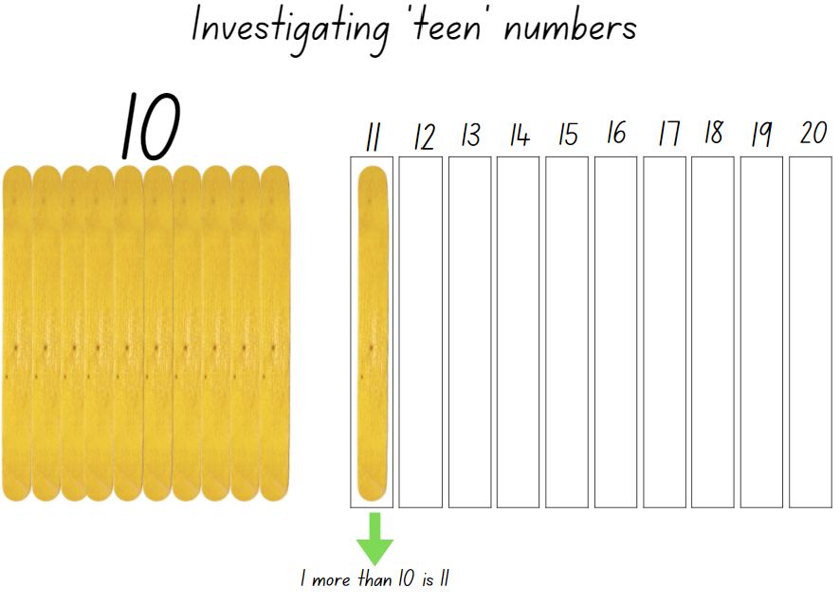
Images sourced from Canva and used in accordance with the Canva Content License Agreement.
- State that 11 is one more than 10. Continue adding a craft stick as students count through the ‘teen’ numbers and state, for example, that ‘12 is 2 more than 10’.
Note: To consolidate student understanding, refer to the 10 craft sticks, ensuring that students visualise and understand that the 10 craft sticks are a part of the whole teen number being explored.
- Explain to students that they will work with a partner to make the ‘teen’ numbers. The first student collects a handful of craft sticks and places these down.
- With their partner, students count out 10 craft sticks and place these on Resource 5: Investigating 'teen' numbers, making a group of 10. Students count the remaining craft sticks, laying these down to make a ‘teen’ number.
- Students identify the teen number and using the counters, they count and place the counters along the number track to represent the teen number they made with the craft sticks (see Figure 9).
Figure 9 – Example of investigating 13
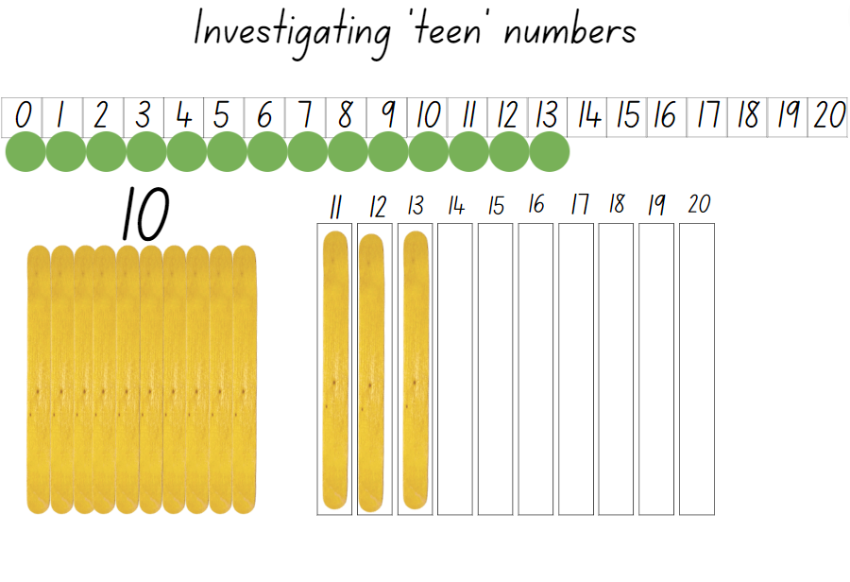
Images sourced from Canva and used in accordance with the Canva Content License Agreement.
- For Stage 1 students, display Resource 6: This is 57! and ask students to explain what they are wondering.
- Explain to students that the arrangement of craft sticks represents the whole number 57. One part, the bundles of 10 craft sticks represents the 5 tens and the other part, the 7 crafts sticks represent the 7 ones.
- Using bundles of craft sticks, model for students how to represent another two-digit number and label the parts as tens and ones.
- Provide small groups of students with bundles of craft sticks, as well as loose craft sticks and display a variety of two-digit numbers for them to make a representation. Provide time for students to share their representations with another group of students and observe if they are correctly naming each digit tens and ones.
- As a class, ask students how they would represent and label a three-digit number, knowing that there are now 3 digits, and each one has a place value, hundreds, tens, and ones.
- Select a student to demonstrate making 342 using the bundles and loose craft sticks. Ensure that students are noticing that they are using a lot of bundles of 10 to make the three-digit number. Provide time for students to make connections with having used MAB previously and discuss the structure of the MAB hundreds flat in comparison to using multiple bundles of 10 craft sticks.
- Model representing 405 using the craft sticks. Ask students how they would label each of the three-digits. Ensure students notice the zero. Ask students to turn and talk with a partner and select students to share their ideas, recording suggestions and representations for the class to view.
- Provide time for pairs of students to use the craft sticks to make some suggested three-digit numbers and to name and label their representations.
The table below details assessment opportunities and differentiation ideas.
Assessment opportunities | Too hard? | Too easy?
What to look for:  - Do students understand that 10 ones are the same as 1 ten? (MA1-RWN-01, MA1-RWN-02)  - Do students understand that 10 tens are the same as 1 hundred? (MA1-RWN-01, MA1-RWN-02)  - Can students count a collection of craft sticks and recognise that the last number name represents the total number of craft sticks? (MAE-RWN-01)  - Do students order the numbers 0-20 correctly on the number track? (MAE-RWN-01)  - Can students identify and sequence the ‘teen’ numbers? (MAE-RWN-01)  - Can students arrange the crafts sticks to represent a three-digit number and clearly label the place value for each digit? (MAO-WM-01, MA1-RWN-02)  - Can students name 3-digit numbers? (MAO-WM-01, MA1-RWN-02)  What to collect:  - work samples and photos of student representations (MAO-WM-01, MAE-RWN-01, MA1-RWN-02) | Students require additional support to understand ones and tens. Support students to use 2 ten-frames and counters. Initially, introduce numbers to 10, encouraging students to count on and use one-to-one correspondence. As students gain confidence, continue to 20.  Stage 1 students require support to understand place value when exploring three-digit numbers.  - Support students to name some simple three-digit numbers and identify the digit being called hundred. For example, 3 hundred and 21.  - Provide students with bundles of crafts sticks and loose craft sticks and support students to represent these three-digit numbers using labelled columns hundreds, tens, and ones. | Students are confident creating representations of numbers using craft sticks.  - Ask students to represent a number such as 695 and ask a partner to represent the number that is one hundred more.  - In pairs, students select a number for their partner to represent. Their partner needs to represent the number that is 10 more and 10 less.

Tug of war – 35 minutes
This activity has been adapted from Tug of War by NRICH.
Note: Prior to the lesson, copy Resource 7: Tug of war number line 0-100 onto A3 paper so there is one copy per pair of Stage 1 students.
- Display Resource 7: Tug of war number line 0-100 for Stage 1 students and explain that they will play a game in pairs using a number line.
- Provide students with a number line, one counter each of a different colour, and one 10-sided dice.
- Students identify where 50 is on the number line as this is the target number.
- Students start the game by deciding which player will begin on zero and which player will begin on 100 with students placing their counter on their starting number.
- The player starting on zero will add the quantity rolled to zero and begin to move up towards 50 and the player starting on 100 will subtract the quantity rolled from 100 and start moving towards 50.
- Play continues until one player reaches the target number, 50. If a player is near 50 and rolls a quantity that does not allow them to land on 50, for example, falls short or goes beyond 50, they do not move from their previous number but continue rolling until they get the quantity needed. Students swap starting positions and repeat the game.
Note: It is optional to play the game where the objective is to reach the other end of the number line first and students use 2 ten-sided dice.
- Explain to Early Stage 1 students that they will be exploring ‘teen’ numbers. Students will identify a ‘teen’ number and then use MAB ones to represent the number on a ‘Teen’ Tower.
- Provide each pair of students with a copy of the game board Resource 8: ‘Teen’ towers, two sets of Resource 9: ‘Teen’ number cards and 60 MAB ones.
- Player 1 draws a card from the pile and turns it over. The number displayed is identified by the player, who then uses MAB ones to construct a tower on any of the towers on the game board. The player places the number card on the tower to match their representation (see Figure 10).
Figure 10 – Example of ‘Teen’ Towers game
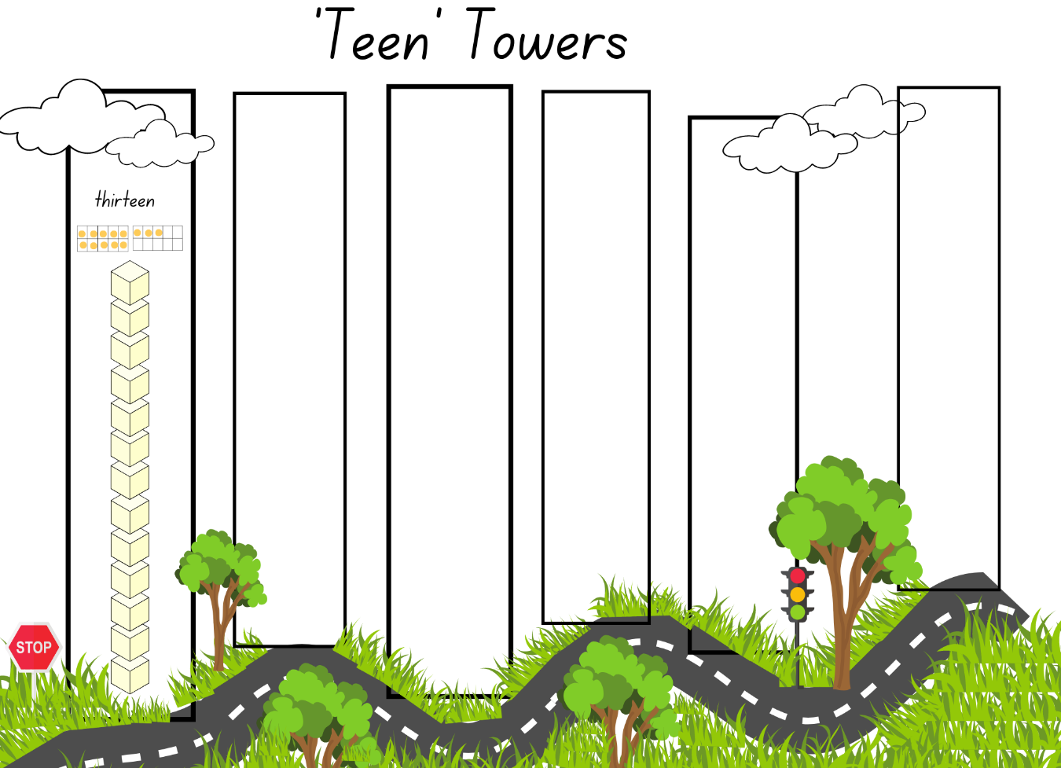
Images sourced from Canva and used in accordance with the Canva Content License Agreeement.
- Player 2 draws a card and proceeds to make a tower using the MAB ones.
- Players continue to take turns to draw a card and construct a tower. After the 6 towers are constructed, the player with the tallest tower is the winner.
The table below details assessment opportunities and differentiation ideas.
Assessment opportunities | Too hard? | Too easy?
What to look for:  - Are students using effective counting on strategies to combine quantities? (MAE-CSQ-01)  - Are students using effective counting strategies to combine and separate quantities? (MA1-CSQ-01)  - Are students able to represent the ‘teen’ numbers using concrete materials? (MAO-WM-01, MAE-RWN-01)  - Can students recall and use number facts or number bonds to ten as a strategy? (MA1-RWN-01, MA1-CSQ-01)  What to collect:  - anecdotal records of student conversations and strategies (MAO-WM-01) | Students need support to represent ‘teen’ numbers.  - Provide students with number cards from 1 to 20, displaying the numerals and representations. Support students to use various concrete materials and make the representations, counting items by using one-to-one correspondence.  - Repeat multiple times using various numbers.  Stage 1 students cannot subtract a quantity from 100. Provide students with a 6-sided dice and another coloured counter to move along the number line.  Students are not confident with numbers to 100. Provide students with a number line from 0 to 50. | Students can confidently add and subtract along the number line to 100.  - Provide students with 2 ten-sided dice and explain that the winner is who gets closest to the target number 50 in less than 4 rolls.  - Both players start at 100 and using 2 ten-sided dice and 2 counters, they race to get to zero.

Consolidation and meaningful practice: MAB representations of numbers – 20 minutes
- Ask Early Stage 1 students to look at their towers and with their partner, order the ‘teen’ numbers in the correct sequence from the smallest ‘teen’ tower to the largest ‘teen’ tower. Students identify the missing ‘teen’ numbers that they did not construct a tower for and use MAB ones to construct the additional towers.
- Stage 1 students explore ones, tens, and hundreds by partitioning two- and three-digit numbers.
- Provide pairs of students with a variety of MAB ones and ask students to explore and record representations for the following:
- Can you make 11? What is one more? What is one less? What is 10 more? What is 10 less?
- Can you use 11 to make double 25, or do you need to start again?
- Can you make 125 using the 50? What is 10 more?
- Can you make 862? What is one more? What is one less? What is 10 more? What is 10 less?
The table below details assessment opportunities and differentiation ideas.
Assessment opportunities | Too hard? | Too easy?
What to look for:  - Can students identify the number 10 more or ten less than a given number? (MA1-RWN-01)  - Can students read three-digit numbers correctly? (MA1-RWN-01)  - Are students able to identify how many tens and ones are in a two-digit number or how many hundreds, tens and ones are in a three-digit number? (MA1-RWN-01)  What to collect:  - anecdotal records of student conversations and strategies (MAO-WM-01). | Students cannot count forwards and backwards on and off the decade.  - Provide students with a 50 or 100 number chart  - Support their understanding by identifying counting patterns.  Students are unable to name or partition three-digit numbers  - Support students with using concrete materials to partition two-digit numbers.  - Model naming the parts of the whole and create various representations for students to observe. | Students confidently read and partition three-digit numbers and can identify numbers 10 more than or 10 less than a given number.  - Provide students with various ‘What number am I?’ challenges.  - Students create number representations for another student to solve.

Lesson 4: Inspecting 10s and 100s
Core concept: Our understanding of numbers to 10 helps us understand numbers beyond 100.
The table below contains suggested learning intentions and success criteria. These are best co-constructed with students.
Learning intentions | Success criteria
Students working towards Early Stage 1 outcomes are learning that:  - mathematicians use tools, such as number tracks to sequence numbers based on their value  - different combinations of numbers can be added or bond to represent a given number.  Students working towards Stage 1 outcomes are learning that:  - tally marks are useful tools for counting and recording collections  - using place value helps to partition and rename three-digit numbers  - mathematicians use tools, such as number lines, to solve problems. | All students can count forward and backwards from at least 20.  In addition, students working towards Early Stage 1 outcomes can:  - order numbers to 30 on a number track  - combine small collections to create a given number.  In addition, students working towards Stage 1 outcomes can:  - use tally marks to record two-digit numbers  - count forwards and backwards by fives, tens, and hundreds from any three-digit number  - use effective counting strategies and a number line to find solutions when playing a game.

Daily number sense: Counting with Patterns – 20 minutes
- Build student understanding of counting patterns, such as domino patterns and tally marks by representing various one- and two-digit numbers.
- Explain to students that mathematicians use symbols or representations, such as domino patterns and tally marks to record counting.
- Explain to Stage 1 students that tally marks allow people to record their count in groups of 5, which is useful when counting a large quantity as they can then skip count by fives to find the total count.
- Model how to make a tally mark for 1, 2, 3, 4, and how the diagonal line ends that group of tally marks as it represents the total number of 5.
- Ask students:
- If this tally mark represents 5, how do you think 7 would be represented?
- How would 10 be represented?
- Provide students with writing materials and ask students to make representations for a variety of one- and two-digit numbers. Provide times for students to turn and talk with a partner, sharing their representations.
- Explain to Early Stage 1 students that dot patterns on dice and dominoes are useful as the arrangement and quantity of dots always stays the same and represents a number quantity.
- Explain to students that in pairs, they will be exploring domino patterns and using the dot patterns to make 12.
- Provide students with a variety of dominoes, writing materials, or a digital device to take photographs of representations.
- Explain to students that they will create a variety of representations of 12 using combinations of different dot patterns they see on dominoes (see Figure 11).
Figure 11 – This is 12!
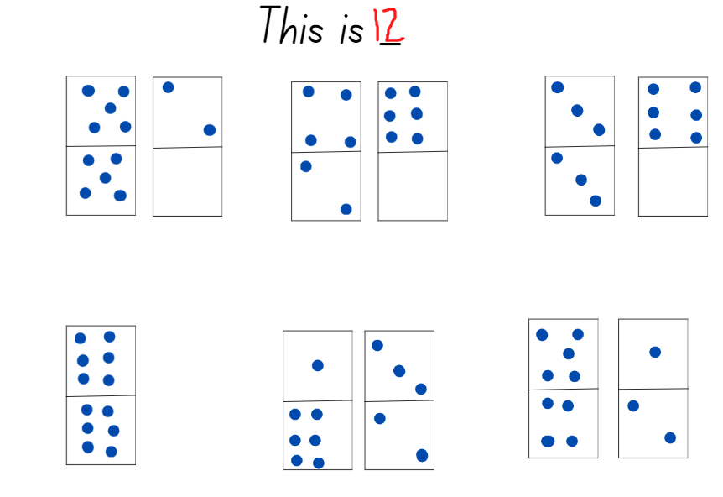

Five steps to 100 – Part 1 – 20 minutes
This activity has been adapted from Five Steps to 50 by NRICH.
Note: Prior to the lesson, prepare the number tracks, number lines, and the number cards. Laminating or putting the number lines in a plastic sleeve will allow the resource to be used with a non-permanent marker multiple times.
- Provide each pair of Early Stage 1 students with Resource 10: Three steps to 12, a dotted dice, 2 counters of different colours, and writing materials to record the score.
- Explain to students that each player will roll the dice 3 times in an attempt to get to 12. After each roll, Player 1 counts and moves their counter along the steppingstones to reach 12. Player 2 then rolls the dice 3 times and, after each roll, counts and moves their counter towards 12. After each round, the student who was the closest to 12 gets one point. If a student manages to land on 12, they get 2 points. However, if a student rolls a combination that is more than 12, they get no points. If it is a draw, each player gets 3 points. Students record their scores (see Figure 12).
Figure 12 – Example of 3 steps to 12
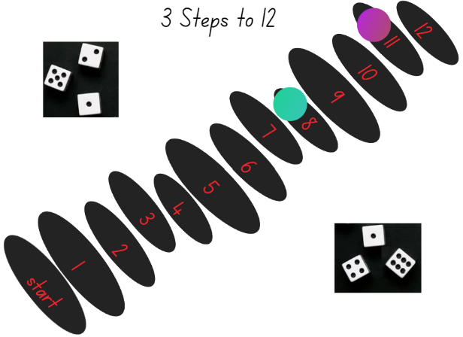
- Provide pairs of Stage 1 students with Resource 11: Five steps to 100 number line, two 9-sided dice, an eraser, 2 non-permanent markers of different colours, and writing materials to record strategies.
- Explain that students will be playing with a partner. The objective of the game is to be the player who gets on or closest to 100 in 5 moves by counting on or counting back from the number rolled.
- Player 1 rolls the 2 dice and identifies the smallest two-digit number that can be made, then circles the number on the number line. Player 1 must think about how to jump to 100 in 5 jumps by using a combination of adding and/or subtracting fives, tens, and ones. see Figure 13.
Figure 13 -– Examples of 5 Steps to 100
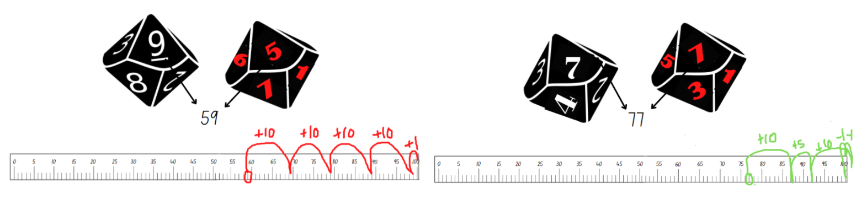
Images sourced from Canva and used in accordance with the Canva Content License Agreement.
- Ensure that students are recording their strategies for each round. For example, 59 + 10 + 10 + 10 + 10 + 1 = 100.
- As a class, ask students:
- What two-digit number did you roll that needed you to jump forwards and backwards?
- How many rounds did you land on 100?
- How many rounds did you not land on 100 and how far off were you?
- Which numbers can get you to 100 and which numbers can’t?

Five steps to 500 – Part 2 – 20 minutes
- Early Stage 1 students continue to explore Resource 10: Three steps to 12. Provide each pair of Stage 1 students with Resource 12: Five steps to 500 number line 0–500 and Resource 13: Number cards. Explain that this time, they need to reach 500 using 5 steps by counting on or back using combinations of fives, tens, and hundreds.
- Each player turns over a number card from the pile, reads the three-digit number, and takes 5 steps forwards or backwards. The aim is to land on 500.
- Ensure that students record their strategies for later discussions.
- Provide time for students to play multiple rounds. Observe strategies and listen to discussions as students reason and problem solve. Ask students:
- Was it more challenging to jump to 100 or jump to 500 in 5 steps? Why?
- How many times did you land on 500?
- Describe your best round. What strategies did you use?
- Which three-digit number card was the hardest to jump to 500?
- If you played again, was there one round that you would have chosen a different combination of fives, tens, and hundreds?
The table below details assessment opportunities and differentiation ideas.
Assessment opportunities | Too hard? | Too easy?
What to look for:  - Are students using flexible additive and subtraction strategies to problem solve? (MAO-WM-01, MA1-CSQ-01)  - Are students able to subitise the dot quantities on a 6-sided dice? (MAE-RWN-01)  - Can students combine the dot quantities and then move their counter to represent the total? (MAO-WM-01, MAE-CSQ-01)  - Can students explain how they got a solution and explain the strategies they used? (MAO-WM-01)  - Can students count forwards and backwards by tens and fives, on and off the decade? (MA1-RWN-01)  What to collect:  - observational data and anecdotal recordings (MAO-WM-01)  - students work samples (MAE-RWN-01, MAE-CSQ-01, MA1-RWN-01, MA1-CSQ-01) | Students are unable to subitise dot patterns that are 4 or more.  - Provide students with counters to model and count the dot pattern.  - After identifying how many, match the total with a numeral card.  Stage 1 students require support to complete the 5 jumps. Support students to jump in tens and ones using another number line 0–100 and then complete the jump on the game number line.  Stage 1 students are unable to count backwards from 100 off the decade. Provide students with counters and a hundred chart to use as a reference. | Students confidently count forwards and backwards and use a variety of strategies to play the game.  - Each round, students must include both addition and subtraction strategies to jump to 500.  - Students play using combinations of threes, sixes, and nines to jump in 5 steps to 500.

Discuss the mathematics – 10 minutes
- Explain that the patterns which represent numbers are very useful and the more students use them, the quicker they start to recognise the patterns. This is because students can trust that the patterns will always stay the same and represent that number quantity.
- Display 6 dotted dice as in Figure 14.
Figure 14 – Dice patterns
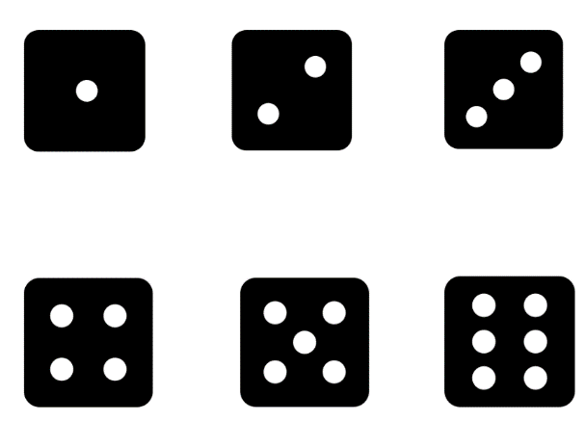
- Provide time for students to view the dice patterns and encourage them to notice how the structure of each dot pattern is purposeful and is a combination of the dots in the previous number pattern (see Figure 15).
Figure 15 – One explanation for dice patterns
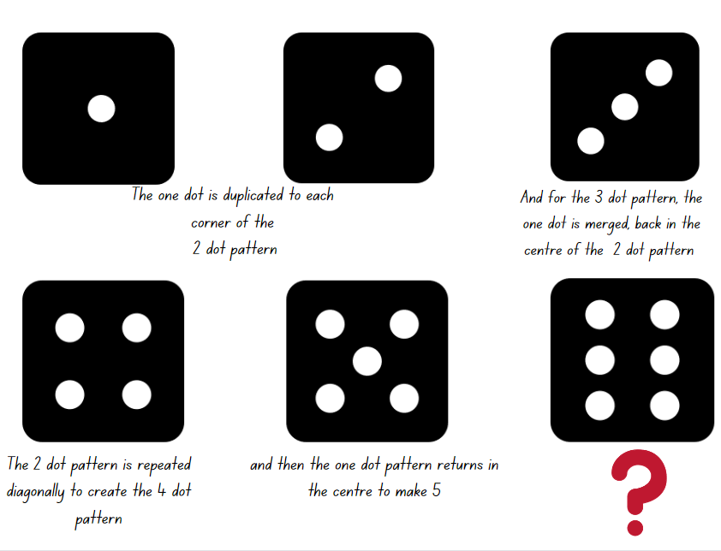
- Ask students to share ideas and suggestions for how the 6-dot pattern has been made using the previous dot patterns.

Lesson 5: Data detectives
Core concept: Collecting, displaying and interpreting data helps us communicate and understand information.
The table below contains suggested learning intentions and success criteria. These are best co-constructed with students.
Learning intentions | Success criteria
All students are learning that:  - a quantity can be represented in various ways  - the way a quantity is represented supports accurate counting  - responses to questions can be recorded in tables and displayed in graphs  - data displays can be interpreted to make simple inferences. | All students can:  - recognise if a collection for a given number is represented accurately  - collect, record, and create a graph to represent data.  In addition, students working towards Early Stage 1 outcomes can share ideas and make comments about the data results displayed in a graph.  In addition, students working towards Stage 1 outcomes can:  - count a quantity by grouping in fives or tens  - use tally marks to record data and represent this information on a graph and explain results.

Daily number sense: Show me 25! – 15 minutes
- Build student understanding of accurate and inaccurate representations of a given number by viewing a variety of visual representations.
- For Early Stage 1 students, display Resource 14: Show me 10! and for Stage 1 students display Resource 15: Show me 25!
- Allow time for students to Think-Pair-Share in their stage groups. Ask students:
- How do we know that all these representations make 10 or 25? How can we check?
- Are there any representations that don’t make 10 or 25?
- Can we use subitising with any of these representations?
- Provide pairs of students with a variety of concrete materials and explain that they will create one accurate and one inaccurate representation of a selected ‘teen’ number of their choice.
The table below details assessment opportunities and differentiation ideas.
Assessment opportunities | Too hard? | Too easy?
What to look for:  - Are students able to subitise quantities to identify collections of 10? (MAE-RWN-01)  - Can students identify smaller numbers within a quantity and combine these to make multiples of 10? (MAE-CSQ-01, MA1-CSQ-01)  - Can students identify incorrect representations for a given number and suggest how many more or less is needed to make the representation accurate? (MAO-WM-01)  What to collect:  - anecdotal records of student conversations and strategies. (MAO-WM-01) | Students need support to identify and make representations of quantities to 10.  - Provide students with concrete materials to create representations of numbers to 6.  - Support students by modelling known dot patterns on dice and dominoes.  Students are not able to subitise numbers greater than 5 and are unable to count on.  - Provide students with counters and model counting on strategies from 1 to 6. Increase the range to 10 once students are confident.  - Using a 6-sided dice and numeral cards, ask students to match the dice patterns with the numeral card. | Students can identify accurate and inaccurate representations of 25.  - Explain to students that dot patterns on dice and dominoes only go up to 6.  - Ask students to design a logical but creative pattern for 7, 8, and 9 that would be easily identifiable or subitised.

Collecting data – Part 1 – 20 minutes
- Explain to students that collecting data about peoples’ opinions is important as it can let you know what people like, don’t like, need, don’t need, and want or don’t want. Discuss that while something can be important to one person, it can be less important to another and what someone thinks or feels about it is their opinion.
- Explain that in students’ day-to-day life, people ask questions to find out information about what others like, want, or need. The answers to these questions might be different on a different day, depending on what the person is thinking or feeling and that is an opinion. For example:
- Your parents might ask you what you would like for your lunch order today.
- Your friend might ask you if you’d like to play soccer or tag at lunchtime.
- A family member might ask you what you would like for your birthday this year.
- At school, you might need to vote for a movie to watch at the end of year celebrations.
- Explain that gathering this information is called data and that students will be asked questions. They need to think about how important that question is to them. Students will record their responses and the data will be used to make a graph for further discussion.
- Provide Stage 1 students with a mini whiteboard to record their answers. When asked a question, students write down zero, one, or 2 in response. After responses have been tallied, students can wipe their board clear to be ready for the next question.
- Early Stage 1 students will respond by showing a thumbs up to agree that it is an important concept or showing a thumb down to disagree that it is important.
- Display a tally collection table for Stage 1 and a data collection table for Early stage 1, such as the examples in Figure 16.
Figure 16 – Opinion number line
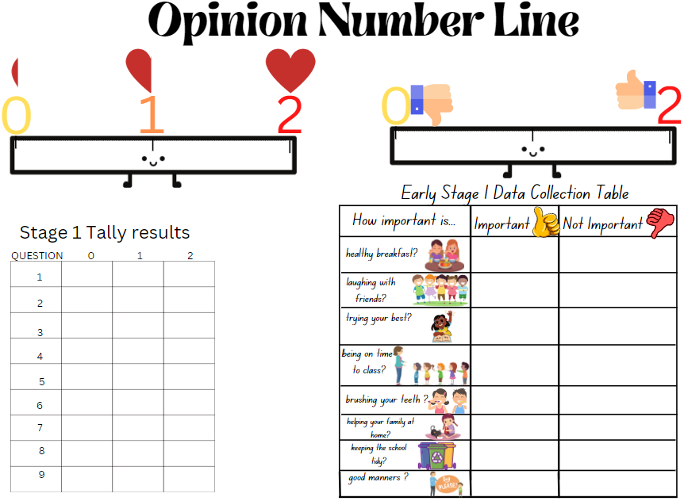
Images sourced from Canva and used in accordance with the Canva Content License Agreement.
- As students hear a question, they need to think about how important the concept is to them. Stage 1 students need to decide if the statement is very important (which will score 2), somewhat important (which will score one), or not important (which will score zero).
- Early Stage 1 students show their agreement or disagreement for the importance of the question by holding a thumbs up or thumbs done.
- Explain to students that after each question, their responses will be collected and displayed in the chart so that they can count a total for each question.
- Ask students:
- How important is having a good healthy breakfast every morning?
- How important is talking and laughing with your friends at lunchtime?
- How important is trying your best when playing a sport or hobby?
- How important is being on time to lines after the bell?
- How important is brushing your teeth?
- How important is helping your family with jobs at home?
- How important is keeping the playground free of rubbish?
- How important is having good manners?
- Model for Stage 1 students how to count the total number of tally marks recorded for options zero, one, and 2 for each question. Ask students:
- Which questions have the highest amount of tally marks for 2 – very important?
- Which questions have the highest amount of tally marks for zero – not important?
- Do any questions have a similar amount?
- Were there any similarities between the 2 charts.
- For Early Stage 1 students, briefly discuss the total for each of the responses (see Figure 17). Ask students:
- Which question has the highest result, showing that a lot of students agree that it’s important?
- Which questions do students think is not important and have the lowest result?
Figure 17 – Early Stage 1 data collection table
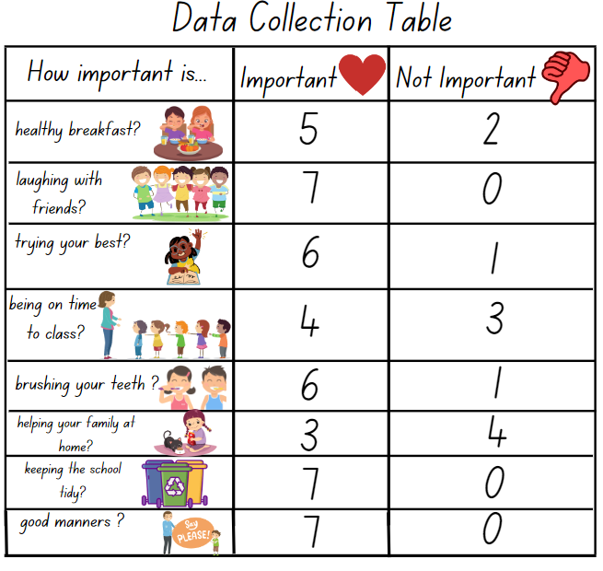
Images sourced from Canva and used in accordance with the Canva Content License Agreement.

Representing data – Part 2 – 30 minutes
- Stage 1 students work in small groups to design a graph to represent the collected data.
- Explain that each group has to brainstorm and select 3 additional opinion questions to ask the class and then record the data using tally marks. Once all the data has been collected and combined with the previous results, each group will design a suitable graph.
- Explain that, as a group, students will use Resource 16: Our data investigation to record their 3 questions and then interview up to 10 classmates to collect responses. Students collaboratively select their questions and they may include topics such as:
- How important is it to try your best during maths lessons?
- How important is it to ask questions when you're learning something new?
- How important is it to borrow library books each week?
- Provide students with writing materials and explain that a data display needs to be organised and include specific features and labels so that the information is accurate and explains the results to others.
- As a class, brainstorm the principles needed to construct a graph and annotate these for students to refer to. For example:
- A graph needs a title.
- The structure of the graph needs a common base line.
- The collected data needs to be displayed in rows to explain the results.
- The display needs to provide accurate information that can be easily understood.
- As a result of the discussion, if necessary, share examples of various bar graphs or a picture graph to support student understanding.
- For Early Stage 1 students, model how to arrange the data, creating a display which includes a title, symbols or pictures, and numbers to explain the results.
- Ensure that students understand that the visual representation of a graph needs to provide accurate information so that the results can be explained and shared with others.
- Provide students with writing materials and support students as they create a data display.
The table below details assessment opportunities and differentiation ideas.
Assessment opportunities | Too hard? | Too easy?
What to look for:  - Can students skip count by tens and track the count using tally marks? (MA1-FG-01, MA1-DATA-01)  - Can students create a data display that has a base line to show data accurately? (MAE-DATA-01, MA1-DATA-02)  - Are students contributing to discussions by making comments or asking questions in response to the data results? (MAE-DATA-01, MA1-DATA-01)  - Are students asking suitable questions to collect data about their peers' opinions? (MA1-DATA-01)  - Can students arrange the collected data in an organised data display? (MAE-DATA-01, MA1-DATA-02)  What to collect:  - work samples of data displays (MAO-WM-01, MAE-DATA-01, MA1-DATA-01, MA1-DATA-02) | Students in Stage 1 are unable to count tally marks. Provide students with a visual display such as a number line or a chart highlighting the 5 times table to support skip counting by fives.  Students are unable to create data displays. Provide students with a simple example of a data display to copy. Highlight essential features such as the heading and the base line. Work collaboratively to talk aloud the process of deciding on a title and how to show the data effectively. | Students have created a data display that is well organised and provides clear information. Ask students to add comments for the results such as:  - Which question had the highest or lowest response rate? Can you suggest why?  - Which question had a high result of ones and why was this topic in the question not considered too important?  - Are there any other questions that could have been asked?  - Which question might have different results if it was asked on another day or at a different time of the day?

Discuss and connect the mathematics – 5 minutes
- Students go on a gallery walk to view other students' data displays and to look at all the different ways the results have been represented using symbols, drawings or words.
- Ask students to identify a data display that is creative and shares the information clearly. Encourage students to ask questions and to share comments.
- After students have viewed the work samples, ask if they would change something on their own display. What would it be and why?

Lesson 6: Communicating instructions
Core concept: Sharing and following instructions requires using language that is clear, appropriate, and describes what, where, and when?
The table below contains suggested learning intentions and success criteria. These are best co-constructed with students.
Learning intentions | Success criteria
All students are learning that:  - when reading and writing a number, each digit has a place value and this gives the number its name  - clear instructions tell us accurately what to do or where to go.  Students working towards Early Stage 1 outcomes are learning that a quantity can be represented in various ways.  Students working towards Stage 1 outcomes are learning that understanding base 10 helps identify the place value of digits in numbers. | All students can:  - recognise, read, and write a number identifying where it belongs in a number sequence from 0-20  - understand and follow simple instructions to complete a given task.  In addition, students working towards Early Stage 1 outcomes can recognise that a collection of 10 will always have 10 no matter how it is represented.  In addition, students working towards Stage 1 outcomes can:  - recognise and name a three-digit number based on a visual representation  - explain the place value of the three-digit number  - write clear step-by-step instructions for a game.

Daily number sense: My eye can spy a number – 10 minutes
- Build student understanding of place value by investigating representations of various one, two and three-digit numbers.
Note: Providing students with a variety of representations invites students to communicate their ideas and their understanding about numbers. For Early Stage 1 students, focus on representations up to 20 and for Stage 1 students, focus on representations up to 999.
- Display various correct and incorrect representations of one-, two- and three-digit numbers, as shown in Figure 18.
Figure 18 – Eye spy a number
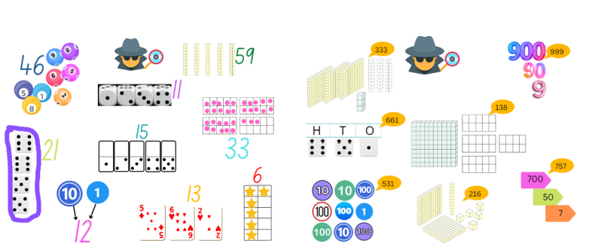
Images sourced from Canva and used in accordance with the Canva Content License Agreement.
- Ask students to identify the correct representations and explain their thinking.
- Provide time for students to view the incorrect representations. Select students to explain and prove their thinking and write the correct number value for the representation on the display.

Following instructions – 45 minutes
This activity has been adapted from Over the rainbow by NZ Maths.
- Explain that students will be given counters, a deck of cards, and either a number track or a number line. They need to use the resources to create a game. There are no instructions, which means there are many ways students can use the resources to create a game (see Figure 19).
Figure 19 – Game resources
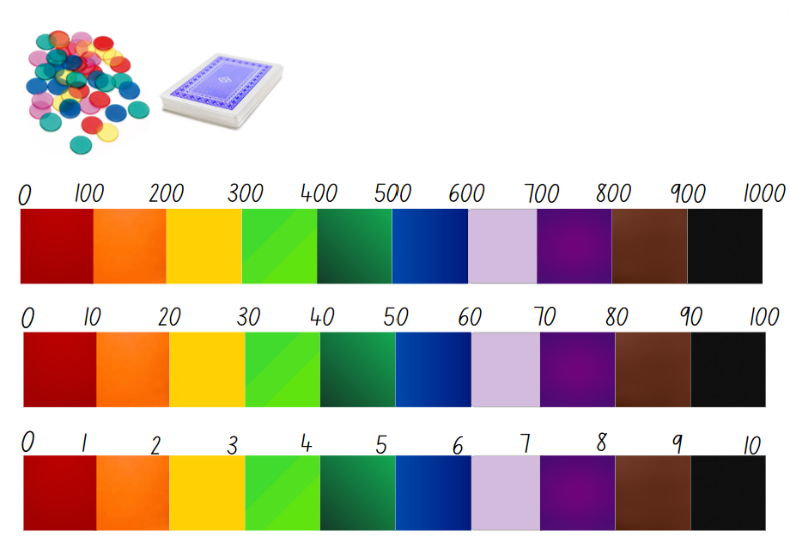
Images sourced from Canva and used in accordance with the Canva Content License Agreement.
- Provide students with Resource 17: Number track and number lines. Select either a 0–10 number track, or a 0–100 or 0–1000 number line depending on student ability.
- In pairs, provide students with the following resources:
- one number track or line for each pair of students.
- 30 counters (15 of each colour) to share between pairs.
- ace to 9 playing cards – 2 of each card for each pair of students, randomly shuffled.
- Explain to Early Stage 1 students that they will be using the resources to play a game.
Note: Ensure that the instructions for the game are modelled explicitly for Early Stage 1 students by repeating each step and using the resources in the correct way.
- Model how to play ‘Zap!’ – an elimination game:
- Each player puts one counter of their colour, side by side on each coloured space on the number track, from zero to 10.
- The cards are shuffled and placed in a pile.
- The first player draws a card, for example a 6, and removes the opponent’s counter from that space. The drawn card is returned to the bottom of the pile. The second player now has a turn.
- If a card is drawn and there is no counter to ‘zap’ off the number track, the player returns the card to the bottom of the pile and the next player has a turn.
- Players continue drawing cards and zapping counters, trying to clear as many of their opponent’s counters as possible.
- The winner of the game is the player with the most counters left on the number track.
- Explain to Early Stage 1 students that they will play the game with a partner. Discuss the instructions for the game and ensure that students have a clear understanding of the steps involved. Explicitly describe how to play and the objective of the game.
Note: It is important to verify how much experience students have with playing board games. Determine if students have seen and followed visual instructions including symbols, pictures, and words. Ensure that students understand instructions are a way of communicating and explaining how to do something from beginning to end. To assist students, you may provide examples of simple instructions that include features, such as numbered step-by-step content, a combination of pictures and arrows to show the order of instructions, or simple ordinal numbers combined with a simple sentence.
- Provide each pair of students with the resources to play ‘Zap!’ Observe whether students are following the instructions and using the resources correctly as they play.
- Once students have played a few rounds, explain that, with their partner, students will use a set of images to sequence the instructions for how to play ‘Zap!’ in the correct order.
- Provide each pair of students with writing materials and Resource 18: How to play Zap! and explain that students will cut and paste the images, sequencing these in the correct order to show the steps involved for how to play ‘Zap’!
The table below outlines stimulus prompts to generate conversation about the topic, along with anticipated responses from students.
Prompts | Anticipated student responses
- What must you include in the instructions?  - How can you display the information so that others can follow and play the game successfully?  - How much information must you include?  - What are some examples of pictures you can draw to explain an instruction?  - What are some things you can write to explain an instruction? | - You have to say what each player has to do and how to use the cards and counters.  - If you write number one and say the first thing, and then number 2 and say what comes next, people can follow the instructions by following the numbers.  - I think drawing a picture of a hand taking a card and then a hand moving the counter on the number track is a good way to explain instructions.  - You can draw pictures in a box to show what to do and then a picture to show how to win the game.  - Words like ‘start here’, ‘pick a card’, ‘move your counter’, ‘count the number’, and ‘you need to do this to win the game’.
- Explain to Stage 1 students that this is one way to use the resources and play a game. Display the instructions for students to view and follow:
- Each player collects 15 counters of the same colour.
- Player 1 turns over 3 cards and places these on the table side by side making a three-digit number of their choice.
- Player 1 places one of their counters on the number line in the correct hundreds place value. For example, if their number was 256, they would place their counter between 200 and 300 on the number line.
- Player 1 returns the 3 cards to the bottom of the pile and the game continues with each player having a turn.
- The objective of the game is for one player to have 3 counters on the same hundreds place value on the number line.
- Provide time for students to follow these instructions and play the game with a partner.
- After a few rounds, ask students:
- Were the instructions clear and easy to follow?
- Were you able to play the game successfully? Did you find it fun and challenging?
- Explain that students are going to work in small groups to create their own game using the same resources, a number line, numbered cards from zero to 9, and counters.
- Explain that students will record 4 to 5 simple instructions that will be shared with the class.
Note: Students may create a poster that includes drawings, symbols, and sentences or students can use a digital device to design and record their instructions and include photographs to support their explanations.
- As needed, provide time for students to brainstorm game ideas and to share examples with the class.
- Prompt students to consider how to write instructions and identify essential words and features that need to be explained so that students can play the game correctly. Record suggestions on the board for student to refer to as needed.
The table below details assessment opportunities and differentiation ideas.
Assessment opportunities | Too hard? | Too easy?
What to look for:  - Do students understand the vocabulary needed to write a set of simple instructions that can be followed? (MA1-GM-01)  - Can students combine drawings, symbols and simple sentences to give instructions that can be followed? (MAE-GM-01)  - Can student's reason and explain their mathematical ideas for a game? (MAO-WM-01)  - Are students connecting ideas and their knowledge of three-digit numbers when creating a game? (MAO-WM-01)  What to collect:  - samples of student's work displaying the instructions for a game (MAE-GM-01, MA1-GM-01)  - anecdotal recordings of discussions and the mathematical vocabulary and thinking being used (MAO-WM-01) | Students are unable to design a poster to provide simple instructions. Provide students with a structured template that includes a word bank, a place to write the title of the game, sequenced numbers next to boxes so that students can draw or write simple sentences for each instruction in the correct order.  Students are unable to think of a game and create a set of instructions. Provide students with the instructions for the sample game used in the introduction of the lesson and ask students to modify the game instructions to use dice instead of number cards. | Students confidently designed a game and a clear set of instructions.  - Students share their game with another small group to test if their instructions are clear and easy to follow. Students also provide feedback to each other about their game ideas and instructions.  - Provide students with an additional resource, such as a 10-sided dice, and ask how they could include this as an additional challenge in their game.

Discuss and connect the mathematics: Let’s play! – 15 minutes
- Provide time for each group of students to share their game, poster instructions or sequenced instructions with another group. After playing a few rounds, ask students:
- Are the instructions clear and easy to follow? Why?
- Was it easy or difficult to win? What strategies did you need to use?
- Describe what made the game fun to play.
- Explain a challenge that this game included.

Lesson 7: Build it up!
Core concept: Some arrangements of objects are instantly recognisable, and this is useful when counting a collection.
The table below contains suggested learning intentions and success criteria. These are best co-constructed with students.
Learning intentions | Success criteria
All students are learning that:  - some arrangements of objects make it easier to connect a number name to the quantity without needing to count from one  - when providing instructions to move positions, students need to use language such as turn right, turn left, or move forward, back, or down.  Students working towards Early Stage 1 outcomes are learning that an arrangement of 10 objects can look different, but it will always have a quantity of 10.  Students working towards Stage 1 outcomes are learning that there are various ways to represent three-digit numbers and the value of the number remains the same. | All students can:  - instantly recognise a small arrangement of objects and state the number quantity  - give and follow simple directions to move from one place to the next.  In addition, students working towards Stage 1 outcomes can:  - use MAB to represent a three-digit number  - describe the representation of the three-digit number using hundreds, tens, and ones  - identify 2 smaller numbers that when combined make a given three-digit number.

Daily number sense: Recognising number quantities – 10 minutes
Note: The following tasks are best suited for outdoors as they require a large open space and a variety of resources for students to explore mathematical concepts while being active.
- Build student understanding of recognising and counting a collection by problem solving and using a variety of grouping strategies.
- Stage 1 students play a game in teams of 4. Explain that 2 students represent even numbers and 2 students represent odd numbers.
- Provide each group with writing materials to record results using tally marks. Explain to students that this game is played like rock, paper, scissors. Students will:
- stand beside their even or odd partner and make fists
- as students shake their fists, they say ‘odd or even’ and then display a number of fingers on both hands.
- if the total count is an even number, that team earns one point. If the total number is odd, the odd team earns one point. Students record using tally marks.
- After a few rounds, ask students if they have been able to identify a strategy that helps them win more rounds. Discuss responses.
- Early Stage 1 students play a game with a partner. Provide students with a bucket and 10 bean bags.
- Player 1 hides several bean bags inside the bucket, leaving some on the floor. Player 2 needs to identify how many are in the bucket based on how many bean bags they can still see.
- If the student is correct, they are challenged to take 5 steps away from the bucket and throw the remaining number of bean bags inside the bucket to make 10.

Up for grabs! – 30 minutes
- In the playground, place 6 hoops randomly around an open space, ensuring there is enough space for students to run to and from the hoops. In the centre of all the hoops, place a large tub of interlocking cubes or coloured bricks (see Figure 20).
Figure 20 – Up for grabs!
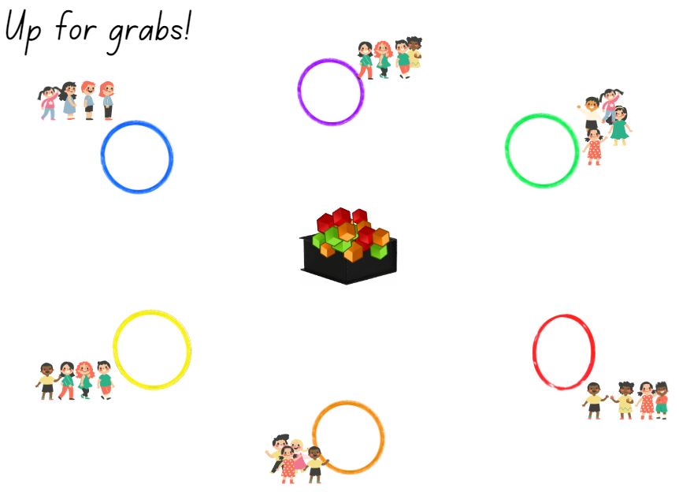
Images sourced from Canva and used in accordance with the Canva Content License Agreement.
- In teams, students stand behind their designated hoop.
- Blow the whistle and the Player 1 from each team runs to the tub and collects one handful of items. Player 1 then returns to the hoop and places their handful in the hoop. Player 2 then runs to collect another handful, and so on.
- When all players have returned, the team needs to arrange the interlocking cubes or coloured bricks into towers of tens to count how many they have in their collection. When they are done, the team sits down to show they have completed their count.
- The team with the most interlocking cubes keeps their items collection and continues to build on it during the next round by adding the next number of cubes or bricks. All other teams must return their interlocking cubes or coloured bricks back into the tub.
- For round 2, explain that if the final count results in a number that is greater than 50, teams get to keep all their items. However, if the count resulted in less than 50, teams must return their items to the tub.
- Other options for subsequent rounds may include: odd and even numbers, colour grouping all the collected interlocking cubes, a place value of 7 in the tens place value, or the team with the lowest number of items gets to keep their items.

A variety of ways to make a number – 30 minutes
- In pairs, ask Stage 1 students to select a number between 299 and 999 and explain that all 3 digits need to be different. For example, the number 426.
- Students write their number on a mini whiteboard and using MAB, students create 3 different representations that shows their number.
- Display all the representations and provide time for students to go on a gallery walk. Ask students:
- Are there any representations of the exact same number?
- Are there any representations that are the same?
- Is there an interesting representation that you think is creative?
- Do you think it is easier to make a representation of a smaller three-digit number or a larger three-digit number?
- In pairs, ask Early Stage 1 students to select a number up to and including 12. Provide students with 3 paper circles and modelling clay.
- Explain that students will use the modelling clay to create 3 different and creative representations for their selected number.
- Provide students with a digital device to take photographs of their representations. These can be used to create a classroom poster as a reference for further discussions.
The table below details assessment opportunities and differentiation ideas.
Assessment opportunities | Too hard? | Too easy?
What to look for:  - Students can explain that the total number quantity stays the same even when arranged differently. (MAE-CSQ-01, MA1-CSQ-01)  - Are students instantly recognising simple arrangements of numbers and state the number quantity? (MAE-RWN-01)  - Are students able to name each place value of a three-digit number? (MA1-RWN-02)  What to collect:  - records of discussions and photos of samples from the activity. (MAO-WM-01, MAE-RWN-01, MAE-CSQ-01, MA1-RWN-02, MA1-CSQ-01) | Students require support to make different representations of the same number. Provide students with examples for their reference, such as dice, dominoes, MAB, and ten-frames.  Students are not able to use a variety of MAB to represent the same three-digit number in different ways.  - Support students to use MAB and explore ways to represent two-digit numbers.  - Reduce the number of MAB being used by selecting three-digit numbers that have a zero in the ones place value. For example, 270, 450. | Students can confidently organise MAB in different ways to represent three-digit numbers.  - Students partition a three-digit number and using MAB, create a representation of the 2 smaller numbers that when combined make the initial three-digit number.  - Students create a problem using MAB for a partner to solve.

Consolidation and meaningful practice: Left or right, up, or down! – 10 minutes
- Position 6 coloured hoops to make a circle large enough for all students to walk around the outside as in Figure 21.
Figure 21 – Left or right, up, or down, 10!
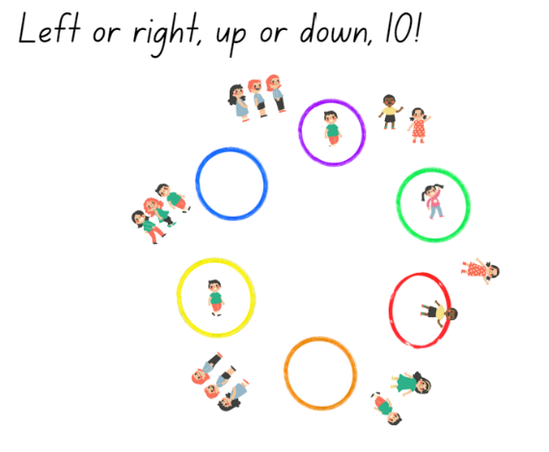
Images sourced from Canva and used in accordance with the Canva Content License Agreement.
- Explain to students that they will begin to walk at a normal pace around the outside of the hoops, in a circle moving around to the right. Demonstrate this for students. Students need to follow the instructions that are called out. For example:
- When the instruction is left – students turn and walk towards the left direction of the circles
- When the instruction is right – students turn and walk towards the right
- When the instruction is up – students stop and stand still
- When the instruction is down – students must squat
- When the instruction is 10, the student closest to a hoop must jump inside the hoop.

Lesson 8: Arrangements of numbers
Core concept: A large quantity can be arranged and quantified in a variety of ways.
The table below contains suggested learning intentions and success criteria. These are best co-constructed with students.
Learning intentions | Success criteria
All students are learning that:  - collections of objects can be arranged and quantified in many ways  - mathematicians estimate by using what they know to decide how many they can see  - some arrangements make quantifying a large collection more efficient. | All students can:  - use concrete materials to combine 2 or more groups of objects to problem solve and count a total  - use what they see and what they know about numbers to make an appropriate estimate for a quantity of objects.  In addition, students working towards Early Stage 1 outcomes can count a large collection of objects and keep track of the count.  In addition, students working towards Stage 1 outcomes can:  - use groups of 10 to count a large collection  - compare 2 collections of similar sized objects by estimating how many there are.

Daily number sense: Estimating quantities – 20 minutes
- Build student understanding of how to estimate to the nearest tens and hundreds by investigating collections of concrete materials.
- Display Resource 19: Estimating quantities of circles for a few seconds and ask students to estimate how many dots they could see.
- Ask students to share their strategies, describe how they subitised the quantities of circles, and record these on a sample of Resource 19: Estimating quantities of circles.
Prompts | Anticipated student responses
- What do you notice about the way the circles were arranged?  - What are some ways you could group them to then estimate how many there are all together?  - What are some strategies you used to estimate how many circles there are?  - What are you wondering? | - Some of the circles were closer to other circles and some were more spread out.  - I saw 2 groups of 3 red circles and I know that’s 6. Then there were 2 more and that is 8.  - I noticed that there were a few circles that I could group together and count by twos, so I thought there would be about 30 circles.  - I saw that there were 2 lots of 6 circles on one side, so I thought maybe there are another 2 groups of 6 on the other side. Then I doubled the 12 to get 24 altogether.  - I wonder if the circles were smaller if it would be harder to estimate.  - I wonder if the circles were more spread out if it would be harder to estimate.
- Display a variety of quantities of concrete materials in piles on the floor. For example, paper clips, match sticks, counters, pompoms, buttons, coloured bricks, and craft sticks. Prior to the lesson, count how many of each item there are and record this to be used later.
Note: Ensure there are a variety of quantities so that students can estimate to the nearest tens and provide some large quantities for Stage 1 students to estimate to the nearest hundreds.
- Provide students with writing materials and explain that they need to view each collection and write down an estimate for that collection. Prompt students by asking if they think there are more or less than 10, 20, or 100 in each of the collections and how do they know.
- Allow time for students to view and reason about their estimates.
- As a class, ask students to share their estimates for each of the items and record samples of their estimates.
- Display the correct total for each of the collections and discuss by asking students:
- How close was your estimate? By how much was your estimate incorrect?
- Who estimated more than there was in a collection?
- Who estimated less than there was in a collection?
- What was a collection that was tricky to estimate? Explain why it was tricky?
- Is it easier to estimate when the item is big or small? Or when the items are flat or in a pile?
Assessment opportunities | Too hard? | Too easy?
What to look for:  - Students use their knowledge of what they know about an item and how many there would be in a small collection to then make an informed estimate of a larger collection. (MAO-WM-01, MAE-RWN-01, MA1-RWN-02)  - Are students able to adjust their estimate? (MAE-RWN-01, MA1-RWN-02)  What to collect:  - anecdotal records of discussions and of strategies being used to estimate (MAO-WM-01, MAE-RWN-01, MA1-RWN-02) | Students are not able to estimate with a large collection.  - Place small quantities of concrete materials, such as coloured bricks in 2 piles. Ask which pile has more than the other. Repeat this by making 3 piles, and so on.  - Support students to estimate by using the paper clips. Each student takes a handful of paper clips. Place 5 paper clips on the table and ask students to view and to now estimate, after viewing what 5 looks like, how many would be in their hand. | Students can estimate to the nearest hundred and tens.  - Ask students to estimate a mixed collection of concrete materials that have various sizes.  - Ask students to draw a representation of the strategy they used and how they arranged the materials to determine their estimate.

We’re going on a number hunt! – 35 minutes
Note: Students may design a number path to be programmed for use with various digital devices, such as Bee-Bots, Blue-Bots or Sphero.
- Provide students with Resource 20: Number hunt grid and explain that in pairs, students will design a number path using a variety of one-, two- and three-digit numbers for their partner to go on a number hunt. Students will include a starting position, a variety of clues such as number sentences, patterns, and various number representations which need to be solved so that their partner can move right and left along a path from beginning to end, reaching a mystery square or number (see Figure 22 and Figure 23).
- Early Stage 1 students may write instructions such as:
- start (at a particular square)
- go left 5 squares and write the number 8
- go up 7 squares and write the number after 12
- go right 3 squares then up 2 squares and draw 3 dots.
Figure 22 – Example of Early Stage 1 number hunt
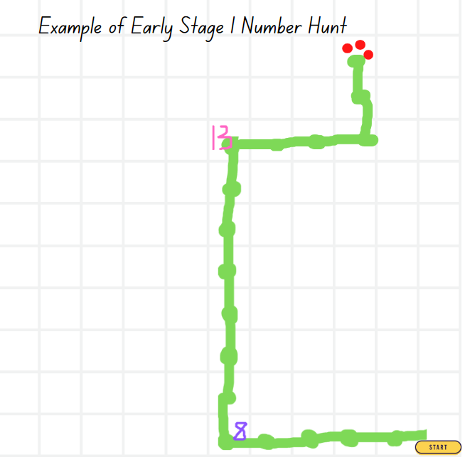
- Stage 1 students may write instructions such as:
- start (at a particular square)
- move left 3 squares and write the answer to what is 100 more than 199?
- move up 2 squares and then move right two squares and write the answer to what is double 200?
- move up 1 square and then left 7 squares and write the answer to how many hundreds in the number 876?
- move up 3 squares and write the answer to what are 3 numbers that add together to make 173?
- move 2 squares left to the target number and say what is 300 more than 555?
Figure 23 – Example of Stage 1 number hunt
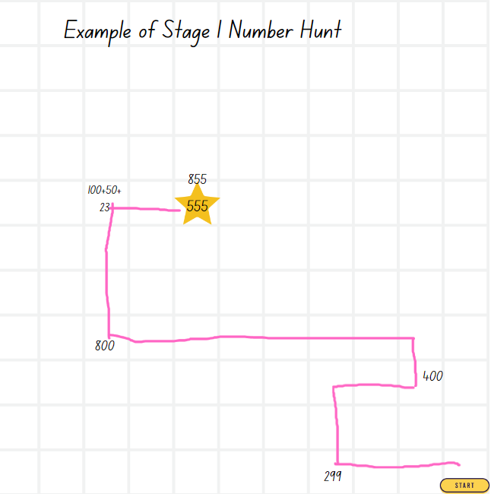
The table below details assessment opportunities and differentiation ideas.
Assessment opportunities | Too hard? | Too easy?
What to look for:  - Can students give and record simple clear instructions using some directional language? (MAE-GM-01, MA1-GM-01)  - Are students following directions correctly from one location to another? (MAE-GM-01, MA1-GM-01)  - Can students solve problems applying various strategies, including number knowledge and explain their reasoning? (MAO-WM-01, MA1-CSQ-01)  What to collect:  - samples of students’ work and recordings of instructions (MAO-WM-01, MA1-GM-01) | Students are not able to give instructions involving multiple steps.  - Provide students with a blank grid paper displaying the word ‘start’ in one of the squares. Place a star in another square and support students to design a simple path from the start square to the star square. Model how to record the steps using simple positional language.  - Provide students with a 10 by 10 grid and support students to count up and down, left and right to locate a specific square to draw a shape or symbol. | Students confidently follow and give clear instructions.  - Students challenge a partner by providing additional instructions to create a more complex path.  - Provide students with a blank grid and ask them to make a map of the classroom, including obstacles such as tables and chairs. Students will record instructions for a partner to navigate a pathway to a find a hidden treasure.

Discussing the mathematics – 5 minutes
- Select and display various samples of student number hunt maps and provide time for students to view and discuss. Ask students:
- Which moves were the most challenging: left, right, or up and down?
- Which maps have a variety of moves, making the pathway very creative?
- Can you share an example of a challenging number question you had to solve?
- Do you have a new idea that you would include next time?

Resource 1: Car park
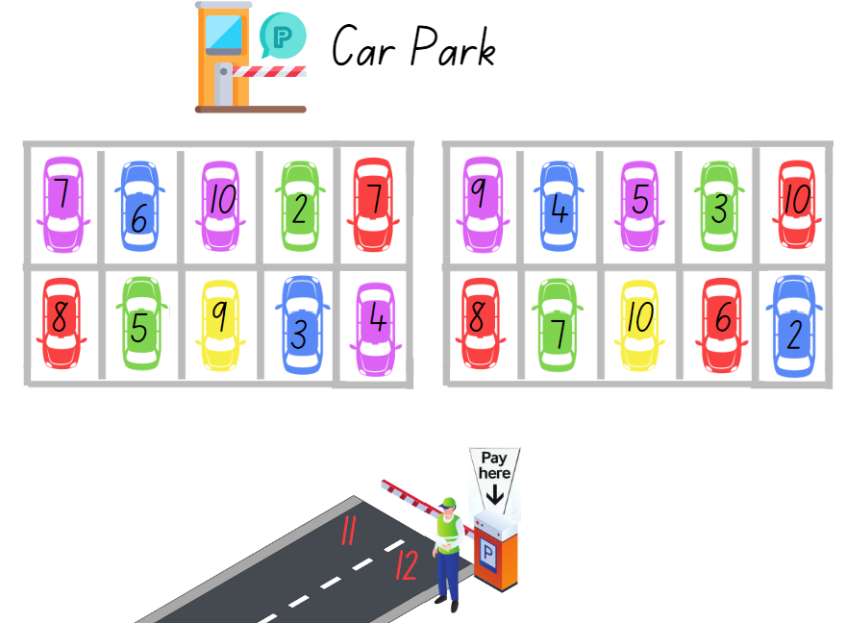
Images sourced from Canva and used in accordance with the Canva Content License Agreement.

Resource 2: Twenty-frame filler blank gameboard
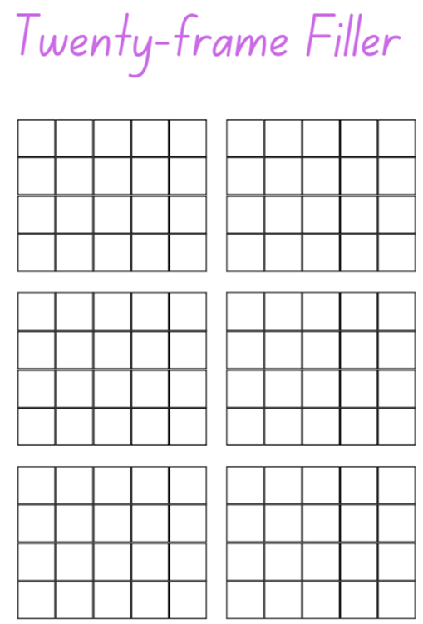

Resource 3: Place value chart
Hundreds | Tens | Ones

Resource 4: MAB number cards
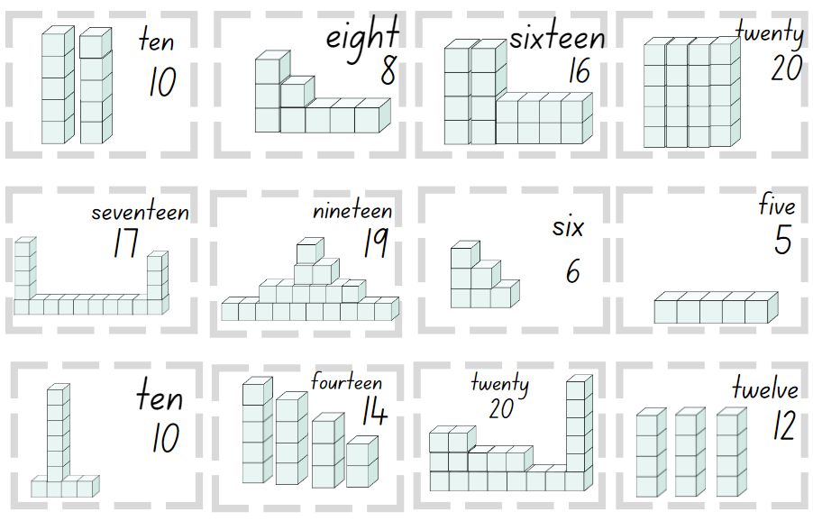
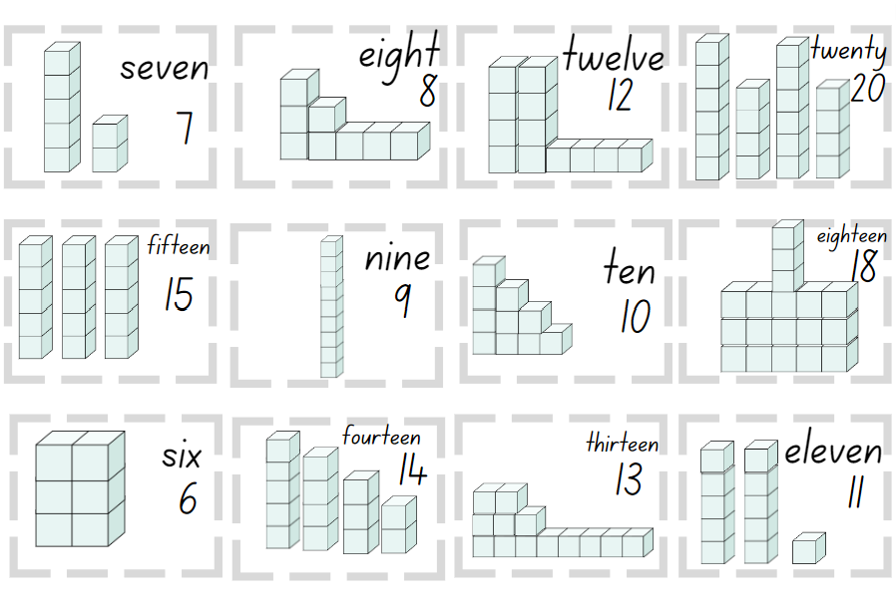
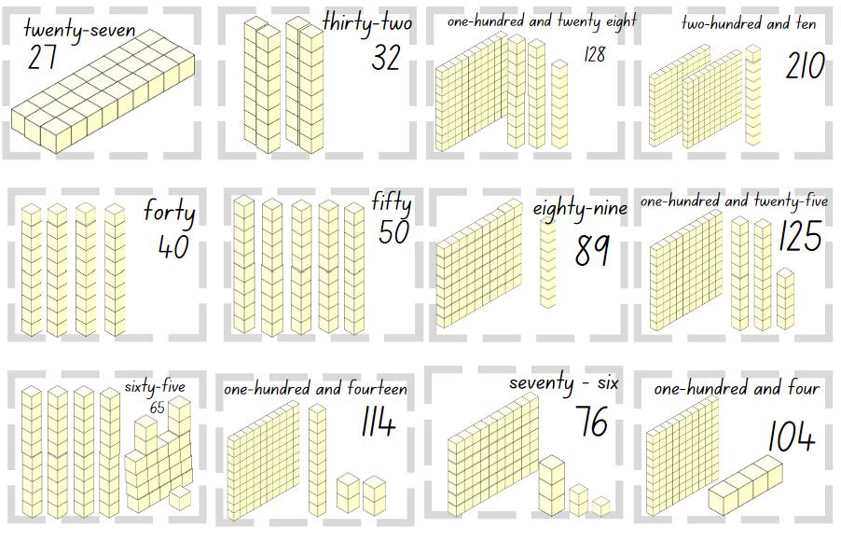
Images sourced from Canva and used in accordance with the Canva Content License Agreement.

Resource 5: Investigating ‘teen’ numbers
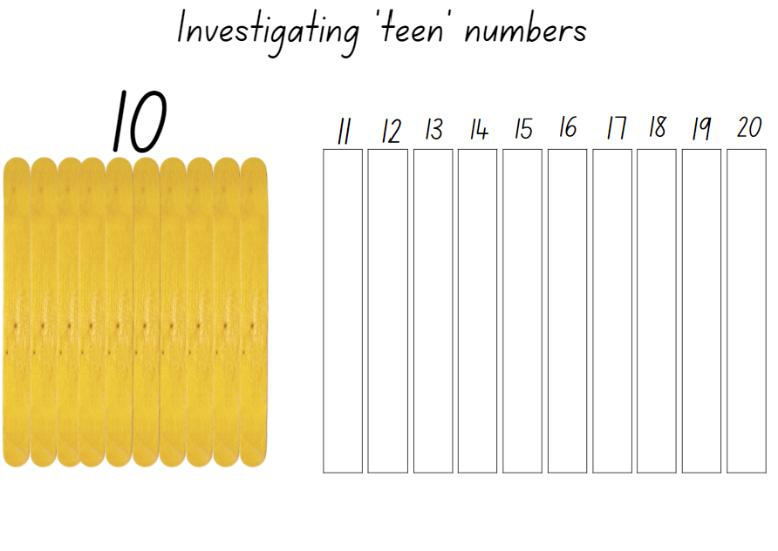
Images sourced from Canva and used in accordance with the Canva Content License Agreement.

Resource 6: This is 57!
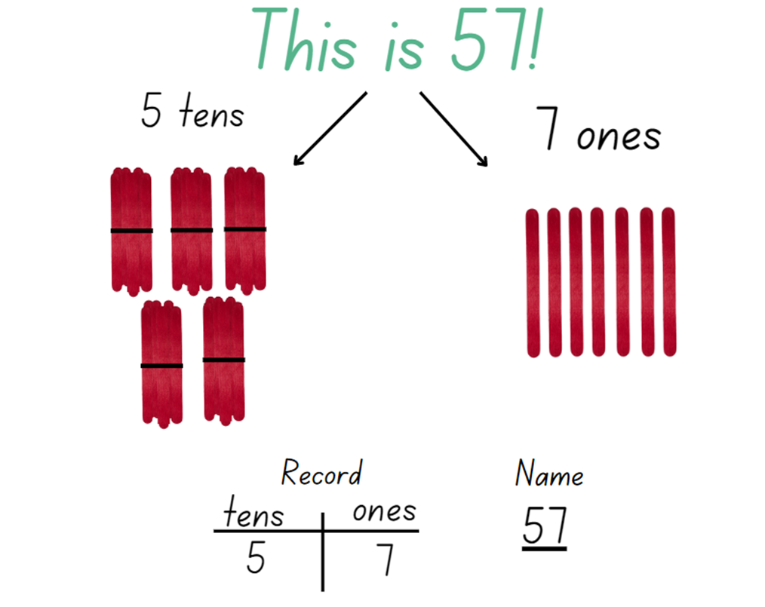
Images sourced from Canva and used in accordance with the Canva Content License Agreement.

Resource 7: Tug of war number line 0-100
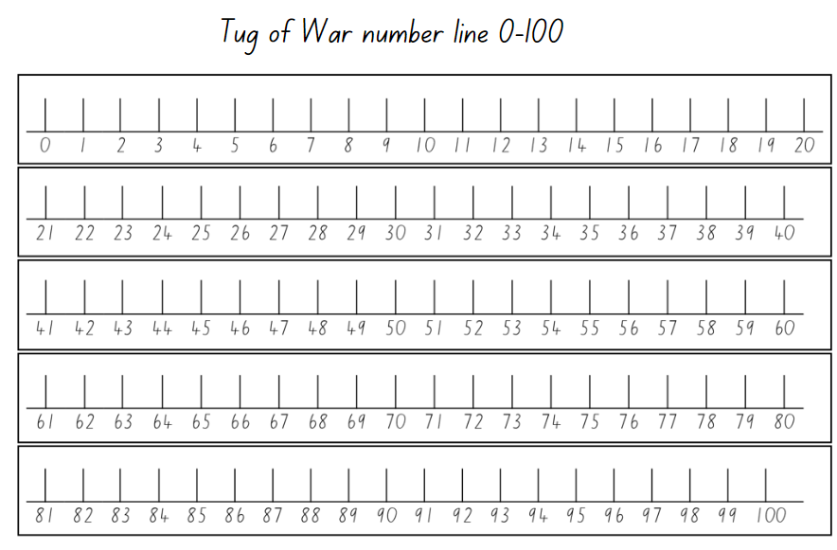

Resource 8: ‘Teen’ towers
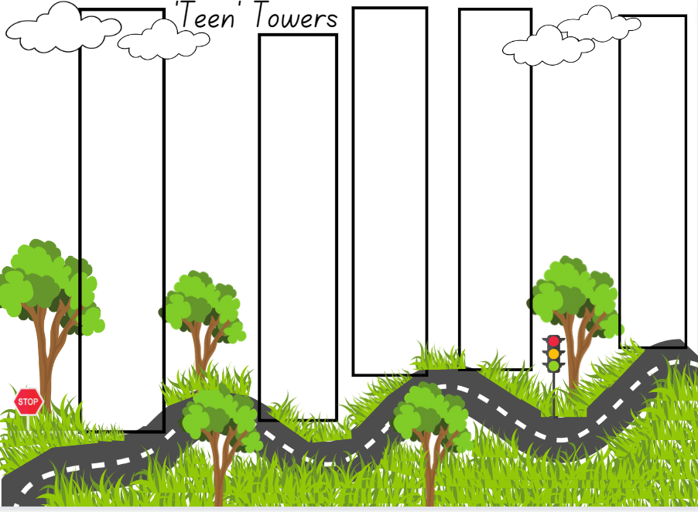
Images sourced from Canva and used in accordance with the Canva Content License Agreement.

Resource 9: ‘Teen’ number cards
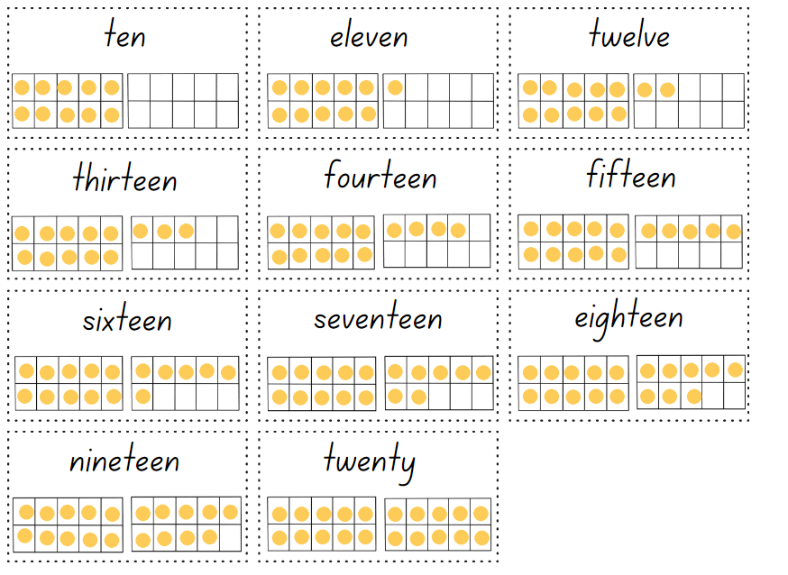

Resource 10: Three steps to 12
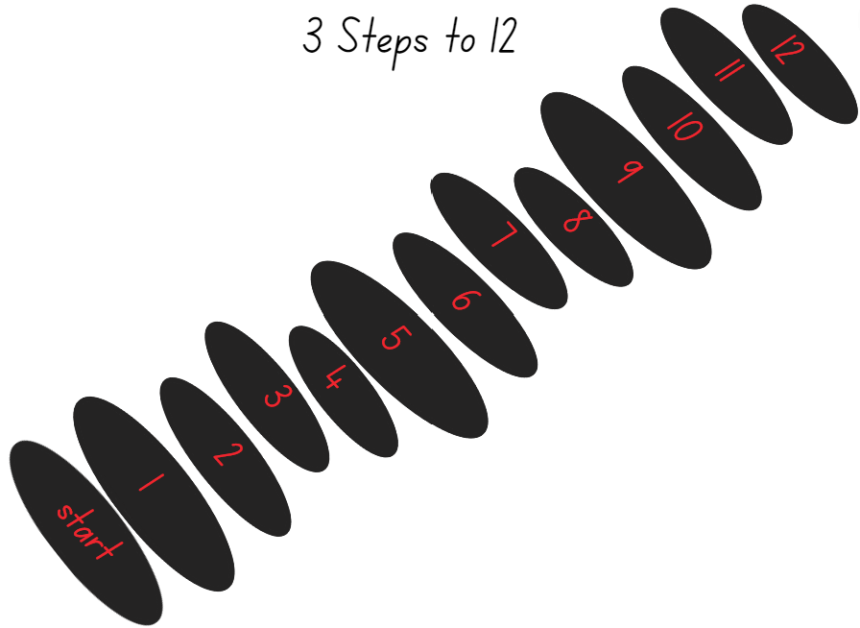

Resource 11: 5 Steps to 100
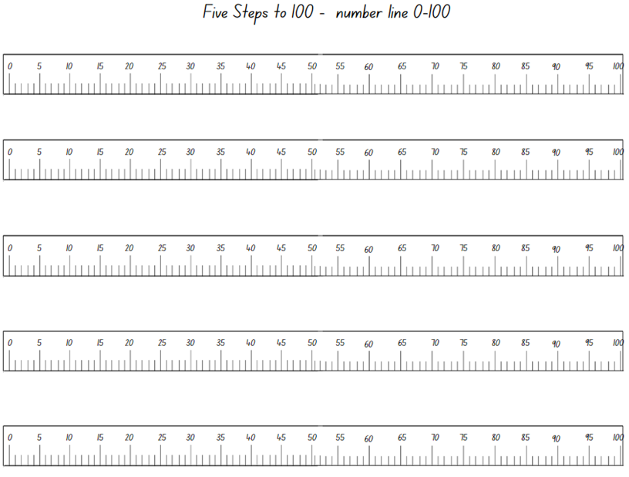
Images sourced from Canva and used in accordance with the Canva Content License Agreement.

Resource 12: 5 Steps to 500
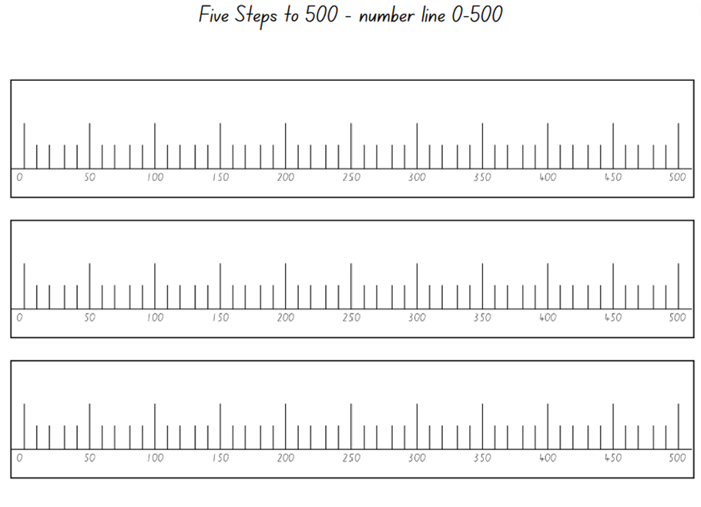
Images sourced from Canva and used in accordance with the Canva Content License Agreement.

Resource 13: Number cards
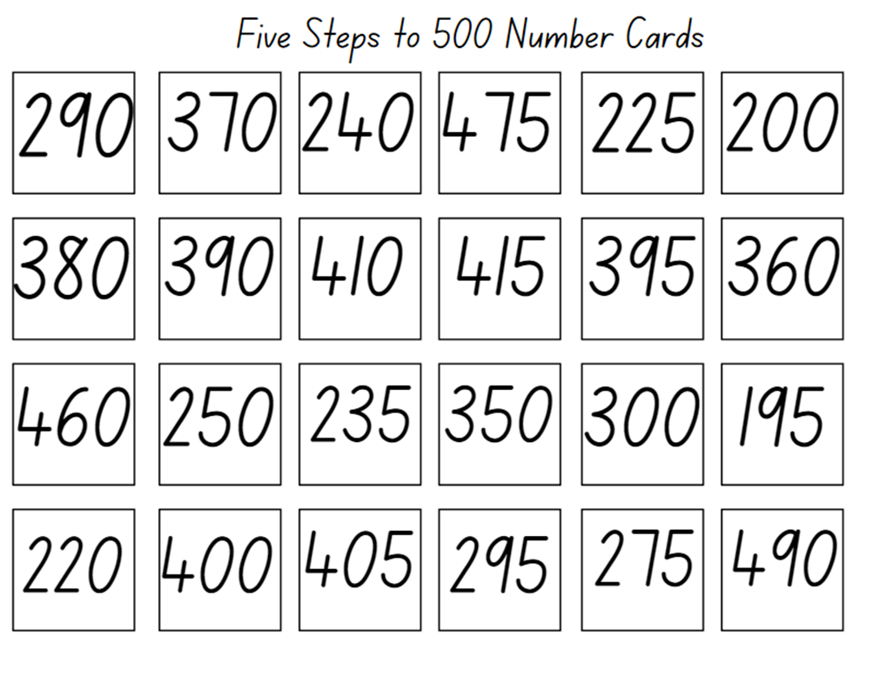

Resource 14: Show me 10!
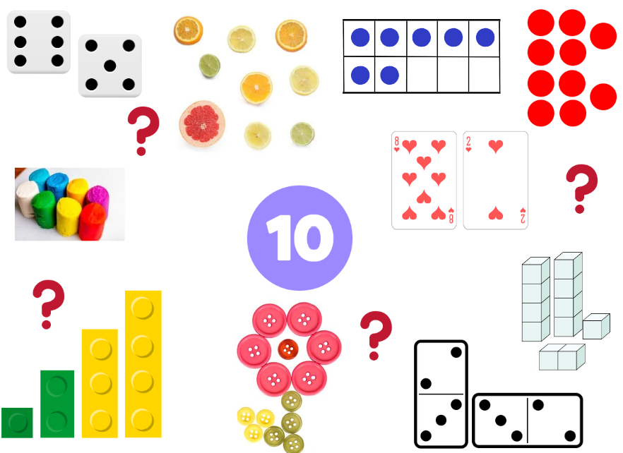
Images sourced from Canva and used in accordance with the Canva Content License Agreement.

Resource 15: Show me 25!
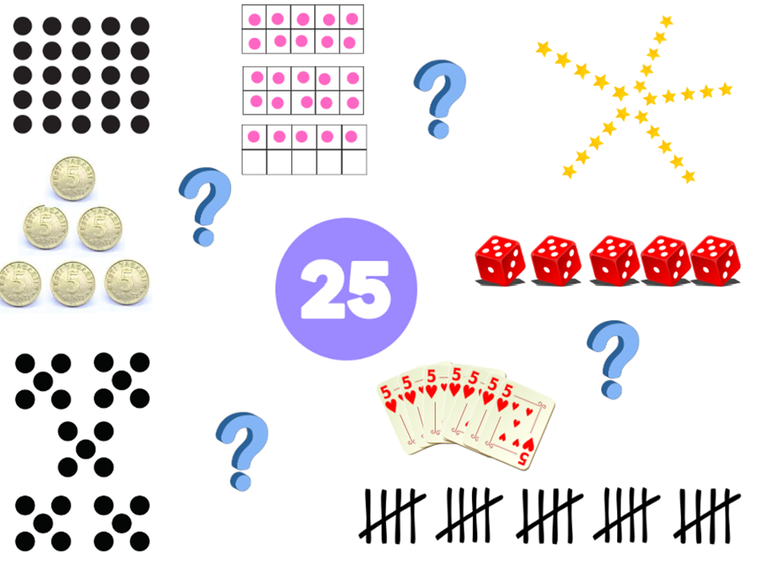
Images sourced from Canva and used in accordance with the Canva Content License Agreement.

Resource 16: Our data investigation
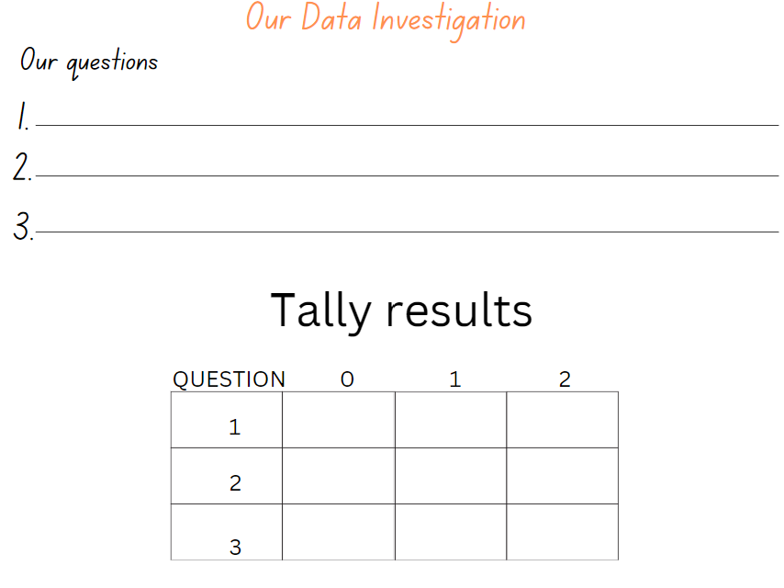

Resource 17: Number track and number lines
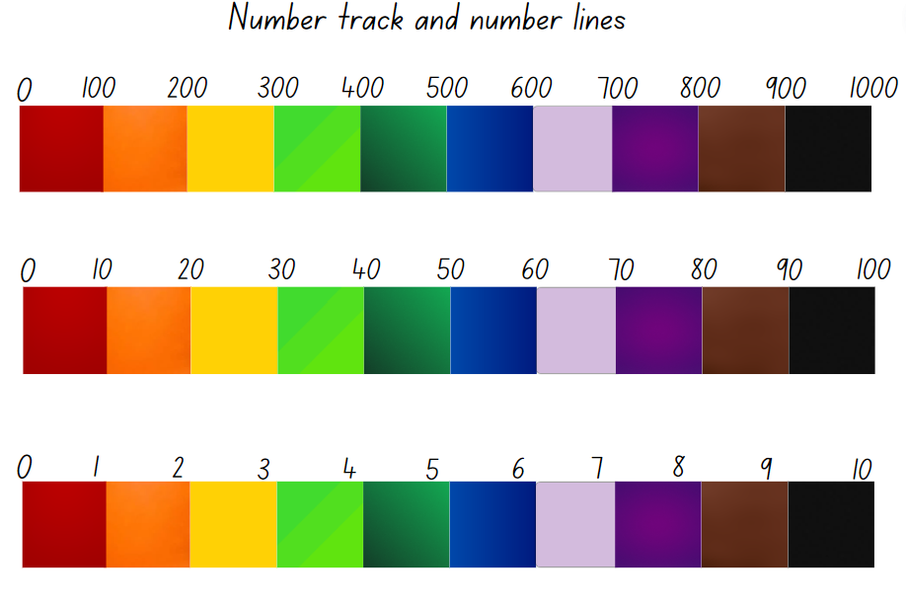

Resource 18: How to play Zap!
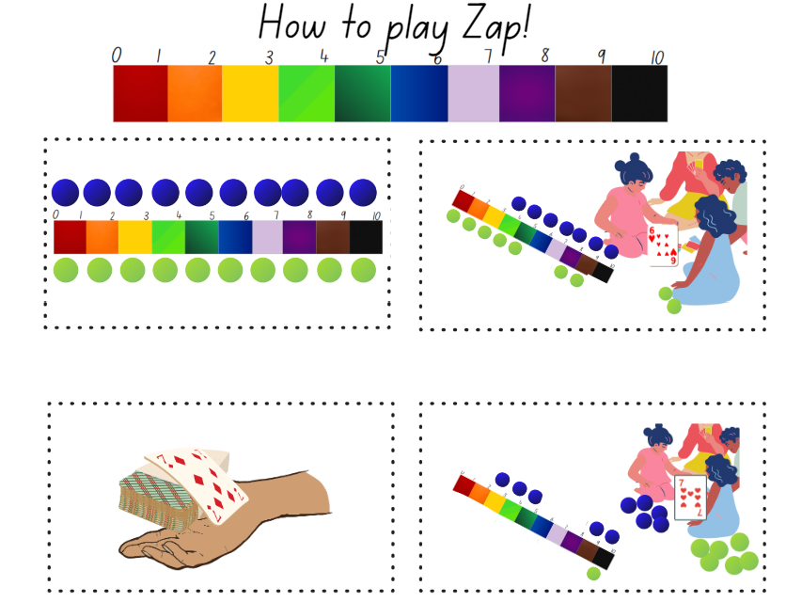
Images sourced from Canva and used in accordance with the Canva Content License Agreement.

Resource 19: Estimating quantities of circles

Resource 20: Number hunt grid

Syllabus outcomes and content
The table below outlines the syllabus outcomes and range of relevant syllabus content covered in this unit. Content is linked to National Numeracy Learning Progression version (3).
Focus area and outcomes | Content groups and content points | Lessons
Representing whole numbers  MAO-WM-01  MAE-RWN-01, MA1-RWN-01  MAE-RWN-02, MA1-RWN-02 | Early Stage 1  Instantly name the number of objects within small collections  - instantly recognise (subitise) the number of items in small groups of up to four items without counting (QuN3)  - identify the number of items in different arrangements (QuN3)  Use the counting sequence of ones flexibly  - count forwards to at least 30 and state the number after or before a given number, without needing to count from one (QuN6)  - identify and distinguish the ‘teen’ numbers from multiples of ten with the same initial sounds (QuN6)  - count backwards from a given number 20 or less (QuN6)  Recognise number patterns  - recognise dice and domino dot patterns (QuN3)  Connect counting and numerals to quantities  - count with one-to-one correspondence, recognising that the last number name represents the total number in the collection (QuN4)  - count out a specified number of objects (from 5 to 20) from a larger collection, keeping track of the count (QuN4)  - make correspondences between collections (Reasons about quantity) (QuN4)  - read numerals to at least 20, including zero (QuN5)  - represent numbers as quantities to at least 20 using objects (such as fingers), number words and numerals (QuN5) | 1–8
Representing whole numbers A | Stage 1  Use counting sequences of ones with two-digit numbers and beyond  - identify the number before and after a given two-digit number (CPr5)  - count forwards and backwards by ones from a given number to at least 120 (CPr6)  Represent numbers on a line  - sequence numbers and arrange them on a line by considering the order and size of those numbers (CPr5)  - locate the approximate position of multiples of 10 on a model of a number line from 0 to 100 (QuN7)  Represent the structure of groups of ten in whole numbers  - recognise that ten ones is the same as one ten (NPV2, NPV4)  - count large sets of objects by systematically grouping in tens (CPr7)  - partition two-digit numbers to show quantity values (NPV4)  - use number lines and number charts to assist with locating the nearest ten to a number  - estimate, to the nearest ten, the number of objects in a collection and check by counting in groups of ten (CPr7, NPV6) | 1–5
Representing whole numbers B | Stage 1  Use counting sequences of ones and tens flexibly  - identify the number before and after a given three-digit number (AdS8)  - count forwards and backwards by tens, on and off the decade, with two- and three-digit numbers (CPr7)  - identify how many more to the next multiple of ten within two- and three-digit numbers  Form, regroup, and rename three-digit numbers  - count and represent large sets of objects by systematically grouping in tens and hundreds (CPr7, NPV5)  - use models such as base 10 material and interlocking cubes to represent and explain grouping  - state the quantity value of digits in numbers of up to three digits (Reasons about quantity) (NPV5)  - identify the nearest hundred to a number (QuN8)  - recognise units of 100 (QuN8)  - use place value to partition and rename three-digit numbers in different ways (Reasons about relations)  - estimate, to the nearest hundred, the number of objects in a collection | 1–8
Combining and separating quantities  MAO-WM-01  MAE-CSQ-01, MA1-CSQ-01  MAE-CSQ-02 | Early Stage 1  Model additive relations and compare quantities  - combine two or more groups of objects to model addition, identifying the relationship between the parts and the whole (AdS2)  - use concrete materials or fingers to model and solve addition and subtraction questions, counting forwards or backwards by ones as necessary (AdS2)  - compare two groups of objects to determine how many more (Reasons about quantity) (AdS2)  Identify part–whole relationships in numbers up to 10  - use visual representations of numbers to assist with combining and separating quantities, identifying the relationship between the quantities (AdS2)  - describe the action of combining, separating and comparing  - use five as a reference in forming numbers from six to ten  - create, model and recognise combinations for numbers up to ten (Reasons about relations) (AdS2)  - count by ones to find the total or difference  - use drawings, words and numerals to record addition and subtraction, and explain their thinking (Reasons about relations) | 1, 3–5, 7, 8
Combining and separating quantities A  NOTE – There is only one combining and separating quantities outcome for Stage 1. | Stage 1  Use advanced count-by-one strategies to solve addition and subtraction problems  - apply the terms ‘add’, ‘plus’, ‘equals’, ‘is equal to’, ‘is the same as’, ‘take away’, ‘minus’ and ‘the difference between’ to describe combining and separating quantities (AdS1, AdS6)  - recognise and use the symbols for plus (+), minus (−) and equals (=)  - record number sentences in a variety of ways using drawings, words, numerals and symbols (AdS6)  Recognise and recall number bonds up to ten  - recognise, recall and record combinations of two numbers that add up or bond to form 10 (AdS1)  - model and record patterns for individual numbers up to ten by making all possible whole-number combinations (Reasons about patterns) (AdS2)  - create, recall and recognise combinations of two numbers that add up to numbers less than 10 (AdS2)  Use flexible strategies to solve addition and subtraction problems  - use non-count-by-one strategies such as using doubles for near doubles and combining numbers that add to ten (AdS2)  - represent addition and subtraction using structured materials such as a bead string or similar model  - select and apply strategies using number bonds to solve addition and subtraction problems with one- and two-digit numbers by partitioning numbers using quantity value and bridging to 10 (Reasons about relations) (AdS2)  Represent equality  - recall related addition and subtraction facts for numbers to at least 10 (Reasons about relations) | 1, 3, 4–8
Combining and separating quantities B  NOTE – There is only one combining and separating quantities outcome for Stage 1. | Stage 1  Represent and reason about additive relations  - create, record and recognise combinations of two numbers that add to numbers from 11 up to and including 20 (AdS7)  - model how addition and subtraction are inverse operations using concrete materials, drawings and diagrams (AdS7)  - recall and use related addition and subtraction number facts to at least 20 (AdS7)  Form multiples of ten when adding and subtracting two-digit numbers  - add two-digit numbers by building to multiples of ten  - add and subtract from a two-digit number and record on an empty number line  - use quantity values to separate tens and ones for addition (only)  Use knowledge of equality to solve related problems  - use number bonds to determine a missing number (AdS6, NPA3-NPA4)  - use number knowledge to solve related problems (AdS7, NPA4)  - use a variety of ways of writing number sentences (NPA3-NPA4)  - use number bonds to solve equality problems (NPA3-NPA4) | 3–5, 7, 8
Forming groups A  MAO-WM-01  MA1-FG-01 | Stage 1  Model and use equal groups of objects to represent multiplication  - model and describe collections of objects as groups of (MuS3)  - determine and distinguish between the number of groups and the number in each group when describing collections of objects (Reasons about relations) (MuS3, MuS4)  - find the total number of objects using skip counting of equal groups of a known size (MuS2, MuS3) | 7, 8
Geometric measure  MAO-WM-01  MAE-GM-01, MA1-GM-01 | Early Stage 1  Position: Describe position and movement of oneself  - give and follow simple directions to position themselves or objects (PoL1)  - describe the position of an object using proximity terms and referring to frames of reference (PoL1)  - use the ordinal names to at least third to describe order of position  - begin to describe the positions of objects in relation to themselves using the terms ‘left’ and ‘right’ (PoL2) | 8
Geometric measure A | Stage 1  Position: Follow directions to familiar locations  - give and follow directions, including directions involving turns to the left and right, to move between familiar locations (PoL3)  - give and follow instructions to position objects in models and drawings (PoL4)  - describe the path from one location to another on drawings and diagrams (PoL4) | 6, 8
Geometric measure B | Stage 1  Position: Explore simple maps of familiar locations  - make simple models from memory, photographs, drawings or descriptions (PoL3)  - interpret simple maps by identifying objects in different locations (PoL4)  - create a path from one location to another (PoL3) | 8
Data  MAO-WM-01  MAE-DATA-01, MA1-DATA-01  MA1-DATA-02  NOTE – There is only one data outcome for Early Stage 1. | Early Stage 1  Respond to questions, collect information and discuss possible outcomes of activities  - predict possible responses to a question (IRD1)  - collect information from their peers and about their environment  - pose and respond to questions about the information collected (IRD1)  Organise objects into simple data displays and interpret the displays  - group objects according to characteristics (IRD1)  - compare the sizes of groups of objects by counting (Reasons about relations)  - arrange objects according to a characteristic to form a data display  - interpret information presented in a data display to answer questions (Reasons about quantity) (IRD1) | 5
Data B | Stage 1  Identify a question of interest and gather relevant data  - pose suitable questions where the answers form categories, and predict the likely responses (IRD2)  - collect data on familiar topics (IRD2)  - sort data into relevant categories (IRD2)  Create displays of data and interpret them  - organise collected data into lists and tables to display information (IRD2)  - represent data in a picture graph using a baseline, equal spacing and same-sized symbols (IRD2)  - interpret information presented in tables and picture graphs (Reasons about relations) (IRD2)  - record answers to questions using the information in tables and picture graphs (IRD2) | 5

References
Links to third-party material and websites
Please note that the provided (reading/viewing material/list/links/texts) are a suggestion only and implies no endorsement, by the New South Wales Department of Education, of any author, publisher, or book title. School principals and teachers are best placed to assess the suitability of resources that would complement the curriculum and reflect the needs and interests of their students.
If you use the links provided in this document to access a third-party's website, you acknowledge that the terms of use, including licence terms set out on the third-party's website apply to the use which may be made of the materials on that third-party website or where permitted by the Copyright Act 1968 (Cth). The department accepts no responsibility for content on third-party websites.
Except as otherwise noted, all material is © State of New South Wales (Department of Education), 2023 and licensed under the Creative Commons Attribution 4.0 International License. All other material (third-party material) is used with permission or under licence. Where the copyright owner of third-party material has not licensed their material under a Creative Commons or similar licence, you should contact them directly for permission to reuse their material.
Mathematics K–10 Syllabus © 2022 NSW Education Standards Authority (NESA) for and on behalf of the Crown in right of the State of New South Wales.
© 2022 NSW Education Standards Authority. This document contains NSW Curriculum and syllabus content. The NSW Curriculum is developed by the NSW Education Standards Authority. This content is prepared by NESA for and on behalf of the Crown in right of the State of New South Wales. The material is protected by Crown copyright.
Please refer to the NESA Copyright Disclaimer for more information.
NESA holds the only official and up-to-date versions of the NSW Curriculum and syllabus documents. Please visit the NSW Education Standards Authority (NESA) website and the NSW Curriculum website.
National Numeracy Learning Progression © Australian Curriculum, Assessment and Reporting Authority (ACARA) 2010 to present, unless otherwise indicated. This material was downloaded from the Australian Curriculum website (National Numeracy Learning Progression) (accessed 2 December 2022) and was not modified. The material is licensed under CC BY 4.0. Version updates are tracked in the ‘Curriculum version history’ section on the 'About the Australian Curriculum' page of the Australian Curriculum website.
ACARA does not endorse any product that uses the Australian Curriculum or make any representations as to the quality of such products. Any product that uses material published on this website should not be taken to be affiliated with ACARA or have the sponsorship or approval of ACARA. It is up to each person to make their own assessment of the product, taking into account matters including, but not limited to, the version number and the degree to which the materials align with the content descriptions and achievement standards (where relevant). Where there is a claim of alignment, it is important to check that the materials align with the content descriptions and achievement standards (endorsed by all education Ministers), not the elaborations (examples provided by ACARA).
Clements D and Sarama J (2005) ‘Math play: How young children approach math’, Scholastic Early Childhood Today, 19:50–57, accessed 2 December 2022.
Mathigon Ltd (2022) ‘Number Tiles and Cubes’, Polypad, Mathigon website, accessed 2 December 2022.
New Zealand Ministry of Education (n.d.) NZ Maths [website], accessed 2 December 2022.
New Zealand Ministry of Education (n.d.) ‘Over the rainbow’, Resource, NZ Maths website, accessed 2 December 2022.
Siemon D, Warren E, Beswick K, Faragher R, Miller J, Horne M, Jazby D, Breed M, Clark J and Brady K (2020) Teaching Mathematics: Foundations to Middle Years, 3rd edn, Oxford University Press Australia and New Zealand.
University of Cambridge (Faculty of Mathematics) (2022) Five Steps to 50, NRICH website, accessed 2 December 2022.
University of Cambridge (Faculty of Mathematics) (2022) NRICH [website], accessed 2 December 2022.
University of Cambridge (Faculty of Mathematics) (2022) Tug of War, NRICH website, accessed 2 December 2022.

