Mathematics – K-2 multi-age – Year B – Unit 10
Contents
Unit description and duration 4
Student prior learning 4
Lesson overview and resources 5
Lesson 1: Are we there yet? 22
Daily number sense: Garbage! – 15 minutes 23
Part 1: Mirror mates – 10 minutes 24
Part 2: Hidden positions – 25 minutes 24
Consolidation and meaningful practice: Positional language – 10 minutes 26
Lesson 2: ‘X’ marks the spot! 27
Daily number sense: More garbage! – 10 minutes 27
Treasure Hunt Part 1 – 20 minutes 28
Treasure Hunt Part 2 – 20 minutes 29
Connecting the mathematics – 10 minutes 30
Lesson 3: Which way Mr Wolf? 31
Daily number sense: Some steps forward, some steps back – 10 minutes 32
Pig pathway: Part 1 – 20 minutes 33
Pig pathway: Part 2 – 20 minutes 34
Noticing and wondering – 10 minutes 36
Lesson 4: Songlines 37
Daily number sense: Counting in fives – 10 minutes 38
Songlines and symbols – 40 minutes 39
Noticing and wondering – 10 minutes 42
Lesson 5: Perplexing perspectives 43
Daily number sense: Number line dance – 15 minutes 44
Building perspectives: Part 1 – 20 minutes 45
Building perspectives: Part 2 – 20 minutes 47
Consolidation and meaningful practice: Noticing and wondering – 10 minutes 49
Lesson 6: Welcome to our place 50
Daily number sense: Teacher choice – 15 minutes 51
Our place: Part 1 – 15 minutes 51
Our place: Part 2 – 30 minutes 52
Noticing and wondering – 10 minutes 54
Lesson 7: Tour guides 55
Daily number sense: Number assessment – 15 minutes 56
Part 1: Deliveries! – 20 minutes 58
Part 2: Tour guides – 25 minutes 59
Noticing and wondering – 10 minutes 61
Lesson 8: We’re here! 62
Daily number sense: Assessment follow-up – 20 minutes 63
Part 1: At the Opera House – 10 minutes 63
Part 2: Tour feedback – 20 minutes 64
Part 3: Tour improvements – 10 minutes 65
Noticing and wondering – 10 minutes 67
Resource 1: Hidden positions gameboard 1 68
Resource 2: Hidden positions gameboard 2 69
Resource 3: Blank anchor chart 70
Resource 4: Number tracks 71
Resource 5: Pig pathways 1 72
Resource 6: Pig pathways 2 73
Resource 7: Pig pathways 3 74
Resource 8: Aboriginal animal symbols 75
Resource 9: Meeting place symbols 76
Resource 10: Natural environment symbols 77
Resource 11: Symbols template 78
Resource 12: Number tracks 2 79
Resource 13: Building perspectives 1 80
Resource 14: Building perspectives 2 81
Resource 15: Number line assessment 82
Resource 16: Number track assessment 83
Resource 17: Tour feedback 84
Syllabus outcomes and content 85
References 96

Unit description and duration
This two-week unit develops student knowledge, understanding and skills of position. Students are provided opportunities to:
- describe their position and movement
- give and follow simple directions to position themselves or objects
- interpret simple maps by identifying objects in different locations
- create a path from one location to another.
Mathematics K–10 Syllabus © 2022 NSW Education Standards Authority (NESA) for and on behalf of the Crown in right of the State of New South Wales.

Student prior learning
Before engaging in these teaching and learning activities, students would benefit from prior experience with:
- playing games that involve locations and position, for example hide and seek
- giving and following simple directions to position themselves or objects
- beginning to describe the positions of objects in relation to themselves, using terms such as ‘in’, ‘on’, ‘under’, ‘left’, ‘right’, ‘up’ and ‘down’.

Lesson overview and resources
The table below outlines the sequence and approximate timing of lessons; syllabus focus areas and content groups; and resources.
Lesson | Syllabus focus area and content groups | Resources
Lesson 1: Are we there yet?  60 minutes  Positional language is useful to describe locations of objects and how they move. | Representing whole numbers  Early Stage 1  - Instantly name the number of objects within small collections  - Use the counting sequence of ones flexibly  - Connect counting and numerals to quantities  Stage 1 – Part A  - Use counting sequences of ones with two-digit numbers and beyond  - Continue and create number patterns  - Represent numbers on a line  Stage 1 – Part B  - Use counting sequences of ones and tens flexibly  Geometric measure  Early Stage 1  Position: Describe position and movement of oneself  Stage 1 – Part A  - Position: Follow directions to familiar locations  Stage 1 – Part B  - Position: Explore simple maps of familiar locations  Two-dimensional spatial structure  Stage 1 – Part A  - 2D shapes: Recognise and classify shapes using obvious features  - 2D shapes: Transform shapes with slides and reflections  Stage 1 – Part B  - 2D shapes: Identify and describe the orientation of shapes using quarter turns | - Resource 1: Hidden positions gameboard 1 – class set  - Resource 2: Hidden positions gameboard 2  - Resource 3: Blank anchor chart  - Garbage! (4:44)  - Counters or small toys  - Decks of playing cards  - Small objects such as pattern blocks, teddy counters, coloured counters  - Writing materials
Lesson 2: ‘X’ marks the spot!  60 minutes  We can describe when people, shapes or objects move but we stay still. | Representing whole numbers  Early Stage 1  - Instantly name the number of objects within small collections  - Use the counting sequence of ones flexibly  - Connect counting and numerals to quantities  Stage 1 – Part A  - Use counting sequences of ones with two-digit numbers and beyond  - Continue and create number patterns  - Represent numbers on a line  Stage 1 – Part B  - Use counting sequences of ones and tens flexibly  Geometric measure  Early Stage 1  - Position: Describe position and movement of oneself  Stage 1 – Part A  - Position: Follow directions to familiar locations  Stage 1 – Part B  - Position: Explore simple maps of familiar locations  Two-dimensional spatial structure  Stage 1 – Part B  - 2D shapes: Identify and describe the orientation of shapes using quarter turns | - Garbage! (4:44)  - Small objects for students to hide  - Anchor chart
Lesson 3: Which way Mr Wolf?  60 minutes  We can describe the same location in different ways. | Representing whole numbers  Early Stage 1  - Instantly name the number of objects within small collections  - Use the counting sequence of ones flexibly  - Recognise number patterns  - Connect counting and numerals to quantities  Stage 1 – Part A  - Use counting sequences of ones with two-digit numbers and beyond  - Continue and create number patterns  - Represent numbers on a line  - Represent the structure of groups of ten in whole numbers  Stage 1 – Part B  - Use counting sequences of ones and tens flexibly  Combining and separating quantities  Early Stage 1  - Model additive relations and compare quantities  - Identify part–whole relationships in numbers up to 10  Stage 1 – Part A  - Recognise and recall number bonds up to ten  - Use flexible strategies to solve addition and subtraction problems  Geometric measure  Early Stage 1  - Position: Describe position and movement of oneself  Stage 1 – Part A  - Position: Follow directions to familiar locations  Stage 1 – Part B  - Position: Explore simple maps of familiar locations  Two-dimensional spatial structure  Stage 1 – Part A  - 2D shapes: Recognise and classify shapes using obvious features  - 2D shapes: Transform shapes with slides and reflections  Stage 1 – Part B  - 2D shapes: Identify and describe the orientation of shapes using quarter turns | - Resource 4: Number tracks  - Resource 5: Pig pathways 1 – class set  - Resource 6: Pig pathways 2 – class set  - Resource 7: Pig pathways 3 – class set  - Some steps forward, some steps back – part 1 (2:58)  - Scieszka J (2004) The True Story of the Three Little Pigs (Smith L, illus.), Puffin, Great Britain (original work published 1989). ISBN: 9780140544510.  - Anchor chart
Lesson 4: Songlines  60 minutes  Aboriginal cultures have used mathematics for thousands of years. | Representing whole numbers  Early Stage 1  - Instantly name the number of objects within small collections  - Use the counting sequence of ones flexibly  - Connect counting and numerals to quantities  Stage 1 – Part A  - Use counting sequences of ones with two-digit numbers and beyond  - Continue and create number patterns  - Represent numbers on a line  - Represent the structure of groups of ten in whole numbers  Stage 1 – Part B  - Use counting sequences of ones and tens flexibly  - Form, regroup, and rename three-digit numbers  Combining and separating quantities  Early Stage 1  - Model additive relations and compare quantities  - Identify part–whole relationships in numbers up to 10  Stage 1 – Part A  - Recognise and recall number bonds up to ten  - Use flexible strategies to solve addition and subtraction problems  Forming groups  Early Stage 1  - Record grouping and sharing  Geometric measure  Early Stage 1  - Position: Describe position and movement of oneself  Stage 1 – Part A  - Position: Follow directions to familiar locations  Stage 1 – Part B  - Position: Explore simple maps of familiar locations  Two-dimensional spatial structure  Stage 1 – Part A  - 2D shapes: Recognise and classify shapes using obvious features  - 2D shapes: Transform shapes with slides and reflections  Stage 1 – Part B  - 2D shapes: Identify and describe the orientation of shapes using quarter turns | - Resource 8: Aboriginal animal symbols – class set  - Resource 9: Meeting place symbols – class set  - Resource 10: Natural environment symbols – class set  - Resource 11: Symbols template – class set  - Anchor chart  - Lengths of string  - Writing materials
Lesson 5: Perplexing perspectives  60 minutes  Sometimes objects look different depending on where we are viewing them from. We call this perspective. | Representing whole numbers  Early Stage 1  - Instantly name the number of objects within small collections  - Use the counting sequence of ones flexibly  - Recognise number patterns  - Connect counting and numerals to quantities  Stage 1 – Part A  - Use counting sequences of ones with two-digit numbers and beyond  - Continue and create number patterns  - Represent numbers on a line  - Represent the structure of groups of ten in whole numbers  Stage 1 – Part B  - Use counting sequences of ones and tens flexibly  - Form, regroup, and rename three-digit numbers  Two-dimensional spatial structure  Stage 1 – Part A  - 2D shapes: Recognise and classify shapes using obvious features  - 2D shapes: Transform shapes with slides and reflections  Stage 1 – Part B  - 2D shapes: Identify and describe the orientation of shapes using quarter turns | - Resource 12: Number tracks 2  - Resource 13: Building perspectives 1  - Resource 14: Building perspectives 2  - 3D shapes or objects  - Anchor chart  - Blocks or interlocking cubes  - Masking tape or chalk  - Writing materials
Lesson 6: Welcome to our place  70 minutes  Places can be represented using maps and models. | Representing whole numbers  Early Stage 1  - Instantly name the number of objects within small collections  - Use the counting sequence of ones flexibly  - Recognise number patterns  - Connect counting and numerals to quantities  Stage 1 – Part A  - Use counting sequences of ones with two-digit numbers and beyond  - Continue and create number patterns  - Represent numbers on a line  - Represent the structure of groups of ten in whole numbers  Stage 1 – Part B  - Use counting sequences of ones and tens flexibly  Geometric measure  Early Stage 1  - Position: Describe position and movement of oneself  Stage 1 – Part A  - Position: Follow directions to familiar locations  Stage 1 – Part B  - Position: Explore simple maps of familiar locations  Two-dimensional spatial structure  Stage 1 – Part A  - 2D shapes: Recognise and classify shapes using obvious features  - 2D shapes: Transform shapes with slides and reflections  Stage 1 – Part B  - 2D shapes: Identify and describe the orientation of shapes using quarter turns | - Digital map  - Anchor chart  - Interlocking cubes and blocks  - Map and model of a local street from the previous lesson  - Writing materials
Lesson 7: Tour guides  70 minutes  Maps and models can be used to plan efficient pathways. | Representing whole numbers  Early Stage 1  - Instantly name the number of objects within small collections  - Use the counting sequence of ones flexibly  - Recognise number patterns  - Connect counting and numerals to quantities  Stage 1 – Part A  - Use counting sequences of ones with two-digit numbers and beyond  - Continue and create number patterns  - Represent numbers on a line  - Represent the structure of groups of ten in whole numbers  Stage 1 – Part B  - Use counting sequences of ones and tens flexibly  - Form, regroup, and rename three-digit numbers  Combining and separating quantities  Early Stage 1  - Model additive relations and compare quantities  - Identify part–whole relationships in numbers up to 10  Stage 1 – Part A  - Recognise and recall number bonds up to ten  Geometric measure  Early Stage 1  - Position: Describe position and movement of oneself  - Length: Use direct and indirect comparisons to decide which is longer  Stage 1 – Part A  - Position: Follow directions to familiar locations  Stage 1 – Part B  - Position: Explore simple maps of familiar locations  Two-dimensional spatial structure  Stage 1 – Part A  - 2D shapes: Recognise and classify shapes using obvious features  - 2D shapes: Transform shapes with slides and reflections  Stage 1 – Part B  - 2D shapes: Identify and describe the orientation of shapes using quarter turns | - Resource 15: Number line assessment – Stage 1  - Resource 16: Number track assessment – Early Stage 1  - Anchor chart  - Map and model of a local street from the previous lesson  - Writing materials
Lesson 8: We’re here!  70 minutes  Maps and models can be used to plan efficient pathways. | Representing whole numbers  Early Stage 1  - Instantly name the number of objects within small collections  - Use the counting sequence of ones flexibly  - Recognise number patterns  - Connect counting and numerals to quantities  Stage 1 – Part A  - Use counting sequences of ones with two-digit numbers and beyond  - Continue and create number patterns  - Represent numbers on a line  - Represent the structure of groups of ten in whole numbers  Stage 1 – Part B  - Use counting sequences of ones and tens flexibly  - Form, regroup, and rename three-digit numbers  Combining and separating quantities  Early Stage 1  - Model additive relations and compare quantities  - Identify part–whole relationships in numbers up to 10  Stage 1 – Part A  - Recognise and recall number bonds up to ten  Geometric measure  Early Stage 1  - Position: Describe position and movement of oneself  Stage 1 – Part A  - Position: Follow directions to familiar locations  Stage 1 – Part B  - Position: Explore simple maps of familiar locations  Two-dimensional spatial structure  Stage 1 – Part A  - 2D shapes: Recognise and classify shapes using obvious features  - 2D shapes: Transform shapes with slides and reflections  Stage 1 – Part B  - 2D shapes: Identify and describe the orientation of shapes using quarter turns | - Resource 15: Number line assessment – students’ work samples  - Resource 16: Number track assessment – students’ work samples  - Resource 17: Tour feedback – class set  - Garbage! (4:44)  - Anchor chart  - Decks of playing cards  - Students’ tour maps and models  - Writing materials

Lesson 1: Are we there yet?
Core concept: Positional language is useful to describe locations of objects and how they move.
The table below contains suggested learning intentions and success criteria. These are best co-constructed with students.
Learning intentions | Success criteria
All students are learning that:  - simple directions can be given and followed to position themselves or objects  - positions of objects can be described in relation to another object, for example ‘in’, ‘on’, ‘under’ as well as the directions ‘up’ and ‘down’.  In addition, students working towards Stage 1 outcomes are learning that:  - movements of people, shapes and objects can be described, for example, ‘forwards’, ‘backwards’, ‘turn left’ and ‘turn right’  - clear instructions are helpful to find positions of objects. | All students can:  - give and follow simple directions to position themselves or objects  - describe the position of an object in relation to another object, for example ‘in’, ‘on’, ‘under’ as well as the directions ‘up’ and ‘down’.  In addition, students working towards Stage 1 outcomes can:  - describe the movements of people, shapes and objects, for example, ‘forwards’, ‘backwards’, ‘turn left’ and ‘turn right’  - give and follow clear instructions to find positions of objects.

Daily number sense: Garbage! – 15 minutes
- Build student understanding of number tracks by sequencing numbers in Garbage! (4:44).
- Model to students how to play the game:
- Shuffle the deck of playing cards and place the pile face down in the middle of both players. Each player draws 10 cards each. Players organise their 10 cards in a row in front of them, with the cards facing down.
- Player 1 draws a card from the middle pile. They place this card in the matching position in their row of 10.
- Player 1 then picks up the card in its place. For example, if a 4 is drawn, Player 1 places the card in the fourth position and picks up the card in that position.
- Player 1 looks at the card and decides whether it can also be placed in their row. Their turn is over when they can no longer place a card in their row. This card is thrown away as 'garbage'!
- Player 2 draws a card to begin their turn and follows the same steps as Player 1.
- The first player to complete their entire row of cards is the winner!
- Discuss the game with students by asking:
- Can you explain why a numeral is positioned in a certain place using terms such as ‘before’, ‘after’, ‘more’ and ‘less’?
- What numbers are you hoping to turn over? Why?
- What numbers don’t you want to turn over? Explain your thinking.

Part 1: Mirror mates – 10 minutes
This activity has been adapted from the task ‘Hidden positions’ by Van de Walle et al. (2019).
- Choose a student to place out of sight of the other students, just outside the classroom. They choose a position to hold, for example, placing their left hand on left hip or their right hand on their head.
- A second student stands where they can see the student outside, but still see the rest of the class. They look at the position held by the student outside, then describe the position using words such as ‘in’, ‘on’ ‘up’ and ‘down’. The aim is for them to direct the class into the same position as the person outside. To support Early Stage 1 students, the positions can begin as simply before becoming more complex. Model ‘left’ and ‘right’ language.
- After several rounds, the students swap places with other members of the class. The positions can become more complex to increase level of challenge. Students can be supported to use language including ‘top’, ‘middle’, ‘above’, ‘below’, ‘next to’ and ‘beside’.

Part 2: Hidden positions – 25 minutes
- Model this activity to the whole class first, being sure to use words such as ‘top row’, ‘middle row’, ‘left’, ‘right’, ‘above’, ‘under’, ‘next’ and ‘beside’.
- Give students a copy of Resource 1: Hidden positions gameboard 1. Place a screen, such as a book, between the grids, so that students are not able to see each other’s gameboard.
- Early Stage 1 students have 2 different objects such as pattern blocks, teddy counters, different coloured counters and so on. Stage 1 students begin with 4 different objects.
- Player 1 places the objects onto different sections of the grid.
- Player 1 then gives instructions on where Player 2 should place the objects on the grid to match.
- Player 1 should use words such as top row, middle row, left, right, above, below, next and beside.
- Players then check to see if their boards match.
This table details assessment opportunities and differentiation ideas.
Assessment opportunities | Too hard? | Too easy?
What to look for:  - Do students describe the position of an object in relation to another object, for example ‘in’, ‘on’, ‘under’ as well as the directions ‘up’ and ‘down’? (MAO-WM-01, MAE-GM-01)  - Do students give and follow clear instructions to find positions of objects? (MAO-WM-01, MA1-GM-01)  What to collect:  - observations of students describing locations (MAO-WM-01, MAE-GM-01, MA1-GM-01)  - photographs of students’ gameboards (MAO-WM-01, MAE-GM-01, MA1-GM-01). | Students cannot describe movements or give and follow clear instructions to find positions of objects.  - Support students by using just one object to begin.  - Model the use of positional language to describe the location of an object.  - Support students to describe the position of one of their objects, for example, ‘up’, ‘down’, ‘left’ and ‘right’. | Students can describe movements of people and objects, for example, ‘forwards’, ‘backwards’, ‘left’ and ‘right’.  - Provide students with more objects and a larger grid to use, for example, Resource 2: Hidden positions gameboard 2.  - Ask students to consider other ways to identify the locations of the objects. For example, they may name, label or colour code the columns and rows.  - Students develop their own grid coordinate system.

Consolidation and meaningful practice: Positional language – 10 minutes
- As a class, ask students:
- What did you notice while you were playing the game?
- Did you find any ways that were helpful to describe the locations of objects? Explain why they were helpful.
- What words did you use to describe the locations of the objects?
- Is there anything that you are still wondering?
- Use Resource 3: Blank anchor chart to summarise the positional language used. This can be used to add to it in future lessons and summarise the learning.

Lesson 2: ‘X’ marks the spot!
Core concept: Mathematicians describe when people, shapes or objects move but they stay still.
The table below contains suggested learning intentions and success criteria. These are best co-constructed with students.
Learning intentions | Success criteria
All students are learning that:  - the positions of objects can be described in relation to themselves using the terms ‘left’ and ‘right’  - positions of objects can be described using proximity terms and referring to frames of reference.  In addition, students working towards Stage 1 outcomes are learning that:  - movements of people, shapes and objects can be described, for example, ‘forwards’, ‘backwards’, ‘turn left’ and ‘turn right’  - clear instructions are helpful to find positions of objects. | All students can:  - begin to describe the positions of objects using ‘left’ and ‘right’  - describe how close an object or location is to someone.  In addition, students working towards Stage 1 outcomes can:  - describe the movements of people, shapes and objects, for example, ‘forwards’, ‘backwards’, ‘turn left’ and ‘turn right’  - give and follow clear instructions to find positions of objects.

Daily number sense: More garbage! – 10 minutes
- Build student understanding of number lines by sequencing numbers in Garbage! (4:44).
- Revise how to play the game from Lesson 1.
- Students play the game with a partner.
- Other ways to play include:
- Use a picture card that a player can use to represent any number.
- If a player puts their unwanted card in the garbage and the other player needs it, it can be picked up to use.
- A king can be played to turn back over another player's card.
- Discuss the game with students by asking:
- Can you explain why a numeral is positioned in a certain place using terms such as ‘before’, ‘after’, ‘more’ and ‘less’?
- What numbers are you hoping to turn over? Why?
- What numbers don’t you want to turn over? Explain your thinking.

Treasure Hunt Part 1 – 20 minutes
Note: Depending on the context, this lesson could be facilitated in an outdoor space.
- Hide an object somewhere in the learning space.
- Select a student to be the treasure hunter and make sure they do not know where the object representing the treasure is hidden.
- As the ‘navigator’, give the treasure hunter instructions to guide them to the object. For example, ‘move forward 3 steps’, ‘turn right’, ‘move forward 2 steps’, ‘go back one step’.
- Simpler hiding places and instructions can be used to build understanding for Early Stage 1 students.
- Once the student finds the object another student is selected to be the treasure hunter.
- The new treasure hunter closes their eyes while the object representing the treasure is hidden again. They open their eyes, then listen carefully to the navigator’s instructions to guide them to the treasure.

Treasure Hunt Part 2 – 20 minutes
- Students’ work in pairs to play the treasure hunt themselves. Initially, Early Stage 1 students could work with a Stage 1 partner to support their use of positional language to find the treasure.
- Students take it in turns to be the treasure hunter and the navigator, making sure that they think carefully about the words used to guide the treasure hunters to the treasure.
This table details assessment opportunities and differentiation ideas.
Assessment opportunities | Too hard? | Too easy?
What to look for:  - Can students describe movements of people and objects, for example, ‘forwards’, ‘backwards’, ‘left’ and ‘right’? (MAO-WM-01, MAE-GM-01, MA1-GM-01)  - Do students give and follow clear instructions to find positions of objects? (MAO-WM-01, MA1-GM-01)  What to collect:  - observations of students describing locations, students’ gameboards. (MAO-WM-01, MAE-GM-01, MA1-GM-01) | Students cannot give and follow clear instructions to find positions of objects.  - In a small group, model to students how to complete one direction at a time to arrive at a simple destination.  - Model the use of directions, including ‘forwards’, ‘backwards’, ‘left’ and ‘right’.  - Support a small group of students to complete one direction at a time to arrive at a destination. Students take it in turns to be the person giving the directions to their chosen destination. | Students give and follow clear instructions to find positions of objects.  - Students draw a representation of the area and provide written instructions using words and arrows.  - In pairs, students develop hand signals to give non-verbal directions.

Connecting the mathematics – 10 minutes
- Regroup as a class and ask students:
- What problems did you and your partner face?
- How did you solve those problems?
- How important are the instructions you give to your partner?
- What words did you use to guide your partner to the treasure?
- Add new vocabulary to the anchor chart, for example, ‘forward’, ‘back’, ‘turn left’ and ‘turn right’. Summarise the lesson by explaining that students can use these words to describe when people, shapes or objects move, but they stay still.

Lesson 3: Which way Mr Wolf?
Core concept: We can describe the same location in different ways.
The table below contains suggested learning intentions and success criteria. These are best co-constructed with students.
Learning intentions | Success criteria
All students are learning that:  - simple directions can be given and followed to position themselves or objects  - positions of objects can be described in relation to another object, for example ‘in’, ‘on’, ‘under’ as well as the directions ‘up’ and ‘down’.  In addition, students working towards Stage 1 outcomes are learning that:  - giving and following directions can involve turning to the left and right  - the same location can be described in different ways  - paths can be created from one location to another. | All students can:  - give and follow simple directions to position themselves or objects  - describe the position of an object in relation to another object, for example ‘in’, ‘on’, ‘under’ as well as the directions ‘up’ and ‘down’.  In addition, students working towards Stage 1 outcomes can:  - give and follow directions, including directions involving turns to the left and right  - describe the same location in different ways  - create a path from one location to another.

Daily number sense: Some steps forward, some steps back – 10 minutes
- Build student understanding of number sequences by using ordinal numbers and number tracks in Some steps forward, some steps back.
- Explain that students can describe the order of people or things using words, for example, ‘first’, ‘second’ and ‘third’. These are called ordinal numbers.
- Ask 5 students to stand in a line. Have the class identify the ordinal positions of the students from the left side, using the words ‘first’, ‘second’, ‘third’, ‘fourth’ and ‘fifth’.
Note: Depending on the needs of the class, the video Some steps forward, some steps back - part 1 (2:58) could be shown to students to support their learning. Alternatively, the video can be viewed earlier as a guide for this activity.
- Display Resource 4: Number tracks. Explain that in each turn of this investigation the toy needs to take some steps forward and some steps back. The aim is to start on the number with the dot, take some steps forward, take some steps back and finish on the underlined number.
- The class views either the video Some steps forward, some steps back - part 1 (2:58) or an explanation of the investigation using Resource 4: Number tracks. Record the number of steps forward and back by using an arrow for each direction, with a number indicating the steps taken for each.
- If modelling the investigation to the class, provide a non-example such as ‘5 steps forward, 3 steps back’. Ask for students to suggest solutions that will land on the number 9.
- After finding a solution to the problem, ask:
- Are there other solutions to this problem? (Test several student’s solutions on the number track).
- Can you see any patterns in the solutions that work?

Pig pathway: Part 1 – 20 minutes
Note: Teachers may wish to read The True Story of the Three Little Pigs by Jon Scieszka (2004) to engage students before introducing them to the activity.
- Explain that the wolf is going to make a cake for his granny’s birthday, but he has run out of sugar. Students are going to help the wolf find a path to each of the pig’s houses, so he can ask for a cup of sugar.
- Use masking tape or chalk to create a grid of 5 by 5 squares on the classroom floor or outside. Other options include using an outdoor chess board, classroom sit spots or an interactive whiteboard.
- Choose students to play the 3 pigs and the wolf or use markers to represent them. Identify which pig has either straw, sticks or bricks as building materials. The wolf needs to visit the pigs in order of straw, sticks and then bricks.
- The 3 pigs choose a spot anywhere on the grid.
- As a class, discuss one pathway for the wolf to visit each house. Record the pathway, including the directional language and record many steps were taken. For example, go forward 3 steps then turn right.
- Re-read the instructions and ask the students if the language used has been clear enough for the wolf.
- Ask students to think if there is another pathway to complete the wolf’s journey.

Pig pathway: Part 2 – 20 minutes
- Explain that students will work in pairs to find other pathways that the wolf could use.
- Give Early Stage 1 students a copy of Resource 5: Pig pathways 1.
- Give Stage 1 Students a copy of either Resource 5: Pig pathways 1, Resource 6: Pig pathways 2 or Resource 7: Pig pathways 3, depending on their learning needs.
- All students cut and paste or draw the pigs’ houses in 3 different squares on the grid.
- Early Stage 1 students work together to guide the wolf through to the 3 houses in order, using directional language. They record their pathway on the map using lines, arrows and words. Then they work together to find a different path.
- For Stage 1, one student guides the wolf through to the 3 houses in order, using directional language. They record the pathway on the map using lines, arrows and words.
- The second Stage 1 student then looks for a different pathway to guide the wolf through the map. They also use lines, arrows and words to record the pathway on the map.
- The 2 students then compare the 2 pathways by counting how many steps each path took.
- Ask students to discuss in pairs:
- Which pathway do you think the wolf would take?
- Why might the wolf choose one pathway over another?
This table details assessment opportunities and differentiation ideas.
Assessment opportunities | Too hard? | Too easy?
What to look for:  - Can students create a path from one location to another, giving and following directions with left and right turns? (MAO-WM-01, MAE-GM-01, MA1-GM-01)  - Can students describe the same location in different ways? (MAO-WM-01, MA1-GM-01)  What to collect:  - observations of students describing locations, students’ annotated work samples (MAO-WM-01, MAO-GM-01, MA1-GM-01). | Students cannot create a path from one location to another, giving and following directions with left and right turns.  - Support students by positioning the map in the direction they are moving.  - Provide a ‘left’ and ‘right’ scaffold to assist students.  Students cannot describe the same location in different ways.  - Model how to start a different pathway for the wolf. Support students to complete this different pathway.  - Show students that it is a different pathway by asking them to trace over both paths with their fingers.  - Ask students to identify what is different about the 2 pathways. | Students can create a path from one location to another, giving and following directions with left and right turns.  - Provide a more complex map, for example Resource 7: Pig pathways 3.  - The police are coming! Starting at a map corner, students give directions for the police to catch the wolf. Students write their directions to send as a text message to the police.  Students can describe the same location in different ways.  - The pigs have seen the wolf coming! They need to block the bridge with bricks. Students plot pathways for the pigs to get to the bridge first.  - Ask how many ways the wolf could sneak up on the pigs’ houses. Students work out sneaky alternatives!

Noticing and wondering – 10 minutes
- Regroup as a class and ask students:
- What did you notice during the activity?
- What words did you find were the most helpful for giving directions?
- Was there only path the wolf could have chosen? How do you know?
- Were there any pathways that you thought were better than the others? Why did you think they were better?
- Add new vocabulary to the anchor chart, summarising the learning that students can describe the same location in different ways.

Lesson 4: Songlines
Core concept: Aboriginal cultures have used maps to identify places of interest for thousands of years.
Note: Many of the symbols used by Aboriginal artists are a variation of lines or dots. While symbols differ extensively between language groups, family clans and artists, there are a number of useful starting points that may help identify potential meaning. (Pol, 2020).
The symbols provided in this unit are common across many Aboriginal Nations, however templates are provided in the resource section to adapt for your local Country if required. Teachers are encouraged to work with their school’s Aboriginal Education team and local AECG (Aboriginal Education Consultative Group) to develop learning resources with local Aboriginal knowledge wherever possible. This lesson has been developed in consultation with the Aboriginal Outcomes and Partnerships Directorate.
The table below contains suggested learning intentions and success criteria. These are best co-constructed with students.
Learning intentions | Success criteria
All students are learning that:  - simple directions can be given and followed to position themselves or objects  - positions of objects can be described in relation to another object, for example, ‘in’, ‘on’, ‘under’ as well as the directions ‘up’ and ‘down’.  In addition, students working towards Stage 1 outcomes are learning that:  - positional language is used to give directions to a location  - efficient pathways are well organised and well planned  - maps are used to locate areas of interest. | All students can:  - give and follow simple directions to position themselves or objects  - describe the position of an object in relation to another object, for example ‘in’, ‘on’, ‘under’ as well as the directions ‘up’ and ‘down’.  In addition, students working towards Stage 1 outcomes can:  - use positional language such as ‘forward’, ‘back’, ‘turn to the left’ or ‘turn to the right’  - identify an efficient pathway to a place of interest on a map.

Daily number sense: Counting in fives – 10 minutes
- Build student understanding of how maths is used in Aboriginal cultures by counting in fives.
- Explain that some Aboriginal cultures use a counting by 5 system to keep track of their count. It’s sometimes known as ‘body tallying’. This physical method of counting has been used for thousands and thousands of years.
- Students form a circle and take it in turns counting aloud by ones. Every time a student gets to a 5 or 10 the student high fives you or another student.
- The count can start at zero, from a larger number or go down from a given number depending on the class needs.
- Early Stage 1 students use white boards to draw dots and write the numbers going up or down by ones, while Stage 1 students write the numbers going up or down fives. Students can work with a partner, as well as start on or off the decade.

Songlines and symbols – 40 minutes
Songlines: Songlines are known as navigational tracks, in that the elders or the trained Indigenous people will sing the landscape and therefore be able to move from location to location through it and teach each other. At every location, each sacred site within that sung track, they perform rituals. Those rituals are repeated songs, and those songs encode the information. Research has shown that up to 70 per cent of Indigenous songs are knowledge about animals, plants and seasonality. They are singing the information in songs that tell stories because song, story, mythology, is so much more memorable than a list of facts. (Lynne Kelly on ABC Radio National, 2016).
- Explain that songlines are songs that have been used by Aboriginal people for thousands of years. The songs include information about plants, animals, the weather and locations. Aboriginal cultures have used these like maps to identify places of interest.
- Explain that Aboriginal people didn't have a written language. Instead, they used symbols as a means of storytelling. Many of the symbols used by Aboriginal artists are a variation of lines or dots. While symbols differ extensively between language groups, family clans and artists, there are a number of useful starting points that may help identify potential meaning.
- Display Resource 8: Aboriginal animal symbols and discuss how animals are usually represented by the tracks they leave in the dirt or sand. Kangaroos leave a set of mirror-image tick shapes from its hind paws and long tail. An emu leaves an arrow-shaped footprint, while goannas, possums and other small marsupials leave E-shaped tracks due to their claws.
- Show Resource 9: Meeting place symbols, identifying that meeting places are usually marked as a circle or set of circles. These markings can represent a bonfire, campsite, or waterhole. Lines connecting circles usually show a journey of some kind, where travellers stop at a series of locations. Explain that this is an example of how Aboriginal people used maps to tell stories, identify locations and give directions.
- Present Resource 10: Natural environment symbols, explaining that Aboriginal people have a strong connection to the land. They celebrate the sun, rain and the stars by performing song and dance cycles during ceremonies.
Note: Resource 11: Symbols template can be used to incorporate traditional Aboriginal symbols from the school’s local Country.
- In pairs, students glue some of the animal, meeting place and natural environment symbols on a sheet of paper.
- Explain that each pair of students will be given a length of string, for example, 30 cm, which will represent a day’s journey on the map.
- Starting at one of the meeting places on their map, students will use the piece of string to mark out a journey on their map. In their journey they will be going hunting. They will need to visit at least one place with water and 2 places with animals.
- Alternatively, Early Stage 1 students can draw their journey as a line to make it easier to record the directions taken.
- Students work in pairs to plan their journey using the length of string. They use words to describe the journey that they take. For example, walk from the meeting place to the river. At the river, turn left to go to the kangaroo trail.
- The directions can be recorded by the students using arrows or other symbols.
Note: The students’ maps could be used as a stimulus for creative writing about a traditional journey of Aboriginal people. This could provide an additional opportunity to use language that describes positions.
This table details assessment opportunities and differentiation ideas.
Assessment opportunities | Too hard? | Too easy?
What to look for:  - Can students use simple positional language such as ‘left’ or ‘right’? (MAO-WM-01, MAE-GM-01)  - Do students use positional language such as ‘forward’, ‘back’, ‘turn to the left’ or ‘turn to the right’? (MAO-WM-01, MA1-GM-01)  - Can students identify an efficient pathway to a place of interest on a map? (MAO-WM-01, MA1-GM-01)  What to collect:  - observations and students’ maps (MAO-WM-01, MAE-GM-01, MA1-GM-01). | Students cannot use positional language such as ‘forward’, ‘back’, ‘left’ or ‘right’.  - Support students to turn their map so that they view the direction that the person would be travelling in.  - Use the map and demonstrate giving directions, for example, at the river, turn to the right.  Students are not able to identify an efficient pathway to a place of interest on a map.  - Show 2 pathways that lead to the same location. Make one less efficient, asking students which was the most efficient and why.  - Support students to choose a destination, then use the string to plan an efficient pathway. Students attempt to do it again independently. | Students can use positional language such as ‘forward’, ‘back’, ‘turn to the left’ or ‘turn to the right’.  - Students record the directions on their journey, using symbols to show directions and distances.  - Students create their own symbols to communicate directions and distances that another person could use to follow.  Students are able to identify an efficient pathway to a place of interest on a map.  - Students swap their map with another map and use their string to identify an efficient pathway.  - Students check with the peer who created the map to compare the pathways that were chosen. They decide which was the most efficient.
Note: This lesson also provides an opportunity to assess students’ learning of Aboriginal and Torres Strait Islander histories and cultures.

Noticing and wondering – 10 minutes
- Bring students together after they have explored their pathways. Ask:
- What are some things that you noticed about the pathway of your journey?
- Did you find a way to make your journey more efficient? What did you do?
- Is there anything that you are still wondering?
- Draw attention to examples that demonstrated the benefits of an efficient pathway.
- Update the class anchor chart. Summarise the learning that Aboriginal cultures have used maps to identify places of interest for thousands of years.

Lesson 5: Perplexing perspectives
Core concept: The position of an object can be described by its order or the perspective it is viewed from.
The table below contains suggested learning intentions and success criteria. These are best co-constructed with students.
Learning intentions | Success criteria
All students are learning that the positions of objects can be described in relation to themselves using the terms ‘left’ and ‘right’.  In addition, students working towards Stage 1 outcomes are learning that:  - objects can be viewed and drawn from different perspectives  - an object’s size and appearance look different depending on the perspective. | All students can begin to describe the positions of objects using ‘left’ and ‘right’.  In addition, students working towards Stage 1 outcomes can:  - view and draw objects from different perspectives  - identify that the appearance of an object looks different from different perspectives.

Daily number sense: Number line dance – 15 minutes
This activity has been adapted from Sidewalk Line Dance (K-8) [video] (5:55) by youcubed. Early Stage 1 students are still developing their understanding of comparing and ordering numbers to 20. At this point in their learning, the use of number tracks is more appropriate than the formal use of number lines.
- While you work with Stage 1 students on the Number line dance, Early Stage 1 students revisit number tracks in Some steps forward, some steps back.
- Revise that ordinal numbers are words that describe the order of people or things, for example ‘first’, ‘second’ and ‘third’.
- Ask 10 students to stand in a line. Have the class identify the ordinal positions of the students from the left side, using the words ‘first’ through to ‘tenth’.
- Provide Early Stage 1 students with a copy of Resource 12: Number tracks 2. In pairs, Early Stage 1 students use a counter or small toy to act out the steps along each number track and record their steps using numbers and arrows.
- Build Stage 1 students’ understanding of representing numbers on a line by considering the order and size of those numbers.
- Draw a number line outside with even spacing, up to 20. Select 4 students to choose a number to start on.
- Tell students to add 3, Students all hop 3 numbers along the line. Ask students:
- What number they are you on now?
- Has the distance between each of you changed or stayed the same?
- When students notice they are moving the same distance, ask them what distance this is.
Note: This can be challenging as students often count the dashes on the number line rather than the spaces between the numbers. If students are confused, have them walk the distance to see how many jumps they take to get from one number to the next.
- Provide other directions, for example, take away 2, add 5, subtract 6 or double your number. After each direction, ask students what number they are on and if the distance between students changed or stayed the same.
- After several directions, students swap with students who haven’t ‘danced the line’ yet. This activity can be modified in many ways to meet the needs of the students, including having the number line go by twos or fives.

Building perspectives: Part 1 – 20 minutes
This activity is adapted from the task ‘Building perspectives’ by Siemon et al. (2020). In Early Stage 1, the emphasis is on students manipulating, describing, sorting and representing familiar geometric objects. Teachers are encouraged to use a range of objects of different sizes. Some students may require larger objects to manipulate. Early Stage 1 students will be creating and arranging towers in order of height. The focus for Stage 1 students will be to view objects from different perspectives.
- Early Stage 1 students form pairs and are given 20 blocks or inter-connecting cubes each. They take it in turns and use all 20 blocks to build 3 towers, using different combinations each turn. For example, the 3 towers could have 3, 5 and 12 blocks each.
- Once one partner has constructed the towers, the other partner arranges them in order from smallest to largest. This student identifies which is first, second and third, then draw the 3 towers in order of height.
- Students swap roles and repeat the process, using different combinations of the 20 blocks.
- Explain to Stage 1 students that sometimes objects look different depending on where they are viewed from. This is called ‘perspective’.
- Display Resource 13: Building perspectives 1, explaining that it is a view of 3D objects from above. Ask students to turn and talk with a partner about which 3D shapes or objects they think these might be.
- Provide some models of 3D objects, including the ones in the image.
- Choose some students to try and recreate the image displayed. They select, then position some of the 3D objects on a copy of Resource 14: Building perspectives 2 to test their thinking.
- After students have attempted to reconstruct the image, ask:
- Do you think that this model represents the shapes in the image?
- How do you know? What clues can you use to be sure?
- How can different perspectives help us to confirm our thinking?
- When the class have agreed on the correct arrangement, students view the shapes from different perspectives. Use language to describe these perspectives, including ‘top’, ‘back’, ‘front’ and ‘side’.
- Ask students to identify what they can see on the sides of the 3D shapes from the different perspectives. Demonstrate how to record the shapes seen from the different perspectives on the whiteboard.
Note: This is an opportunity to remind students that the faces of the 3D shapes are 2D shapes. This connection can help support their learning about the perspectives of 3D shapes.

Building perspectives: Part 2 – 20 minutes
- Early Stage 1 students continue making towers and arranging them in order. They can also try using the 20 blocks to make 5 towers, each with different numbers of blocks.
- In pairs, Stage 1 students are each given 5-10 blocks or interlocking cubes and their own copy of Resource 14: Building perspectives 2.
- Out of their partner’s view, one student uses the blocks to create a 3D model, for example, several towers of 2-3 blocks each. They position these on Resource 14: Building perspectives 2.
- These students then draw their own creation from 3 different perspectives; the ‘top’, ‘front’ and ‘side’.
- Students give their 3 perspectives drawing to their partner who tries to recreate their 3D construction on. They are to use their own copy of Resource 14: Building perspectives 2 to build it.
- Once the second student has built their model, they compare it to the original model. Both students compare the models to see how accurate the recreation was.
- The students swap roles and repeat the activity.
This table details assessment opportunities and differentiation ideas.
Assessment opportunities | Too hard? | Too easy?
What to look for:  - Are Early Stage 1 students able to manipulate, describe, sort and represent familiar geometric objects? (MAO-WM-01, MAE-GM-01)  - Are students able to view and draw objects from different perspectives? (MAO-WM-01, MA1-GM-01)  - Can students identify that the appearance of an object looks different from different perspectives? (MAO-WM-01, MA1-GM-01)  What to collect:  - observations and student work samples (MAO-WM-01, MAE-GM-01, MA1-GM-01). | Early Stage 1 students are not able to manipulate, describe, sort and represent familiar geometric objects.  - Model how to use the 20 blocks to create 3 towers. Arrange them in order of smallest to largest, identifying which is first, second and third.  - Support students to draw the towers in order or smallest to largest.  Students are not able to view and draw objects from different perspectives.  - As a small group, support students to participate in the Resource 14: Building perspectives 2 activity.  - Support students to draw the arrangement of towers they can see from each perspective.  Students cannot identify that the appearance of an object looks different from different perspectives.  - Revise the activity in Resource 13: Building perspectives 1.  - Support students to describe the shapes they can see on each 3D object from different perspectives. | Early Stage 1 students are able to manipulate, describe, sort and represent familiar geometric objects.  - Students make 5 towers, each with different numbers of blocks.  - Provide additional blocks for students to use, while also increase the number of towers for them to build and arrange in order.  Students are able to view and draw objects from different perspectives.  - Students draw models made of 3D shapes and interlocking cubes.  - The number of blocks used in the models can be increased.  Students can identify that the appearance of an object looks different from different perspectives.  - Students use a combination of 3D shapes and interlocking cubes to include more detail in their models.  - Ask students to use words to accurately describe what they see. For example, ‘I can see that the tower has 3 square blocks on the bottom, with a triangle on the top.

Consolidation and meaningful practice: Noticing and wondering – 10 minutes
- Bring the class together and ask:
- What did you notice during the activity?
- Was there something that you and your partner found challenging? What did you do?
- What words did Stage 1 students find helpful for describing the different perspectives?
- What did you learn about seeing objects from different perspectives?
- Is there anything that you are still wondering?
- Add any new vocabulary identified to the anchor chart. Summarise the learning that sometimes objects look different depending on the perspective they are viewed from.

Lesson 6: Welcome to our place
Core concept: Places can be represented using maps and models.
The table below contains suggested learning intentions and success criteria. These are best co-constructed with students.
Learning intentions | Success criteria
All students are learning that:  - simple directions can be given and followed to position themselves or objects  - the positions of objects can be described in relation to themselves using the terms ‘left’ and ‘right’.  In addition, students working towards Stage 1 outcomes are learning that:  - places can be represented using maps and models  - giving directions can include turning to the left and right  - maps can be interpreted by identifying objects in different locations. | All students can:  - give and follow simple directions to position themselves or objects  - begin to describe the positions of objects using ‘left’ and ‘right’.  In addition, students working towards Stage 1 outcomes can:  - compare and explain their pathways  - make simple models of a familiar place  - give directions including ‘turn to the left’ or ‘turn to the right’  - interpret simple maps by identifying objects in different locations.

Daily number sense: Teacher choice – 15 minutes
- From a class need surfaced through formative assessment data, identify a short, focused activity that targets students’ knowledge, understanding and skills. Example activities may be drawn from the following resources:
- Thinking Mathematically Stage 1
- Universal Resources Hub.

Our place: Part 1 – 15 minutes
Note: Although the text’s language is generally for older students, teachers may wish view some pages from My place by Nadia Wheatley to introduce the concept of describing a familiar location.
- Use a digital map to show students a map of a familiar location, for example, their school. Demonstrate how the ‘layers’ function can be used to show specific information, such as an aerial photograph, traffic conditions or public transport.
- Explain how the street view (the small yellow person) on digital maps can be used to show images of a position within the map.
- Drag and drop the yellow person onto a street near the school and ask students if they recognise the location. Ask students to direct you to the front gate of the school, using language including ‘go forwards,’ ‘turn around,’ ‘turn left’ or ‘turn right’.
- Ask the students to help you make a model of a local street. For example, interlocking cubes can be used to represent buildings and pencils can mark the outline of the road.
- Students consider if the features are positioned in a way that is an accurate representation of the location. The model’s features can be checked on digital maps for accuracy.
- Discuss how your position around the model changes the features that you can see. Students view the model from several different perspectives, discussing how the features they see changes depending on their position.
- Once the students are satisfied with the model, record this on paper as a map. Mark the features included in the model, explaining that this is showing an overhead point of view, or perspective.

Our place: Part 2 – 30 minutes
- Explain that Early Stage 1 students will be working in pairs to create a model of the classroom. Stage 1 students will be working in pairs to create a model of the school. Show them the materials and answer any questions they might have.
- Students work with their partner to decide on the features to include in their model. A sheet of paper can be used by each group to represent the area of the familiar place they are modelling.
- They create the model using materials, for example, interlocking cubes, blocks, and pencils.
- When students are satisfied with their model, they test it for accuracy by viewing it from different perspectives and comparing it to the actual place.
- Students use the model to create a map of their design on paper. Early Stage 1 students may require support to view and draw their model from an overhead perspective, similar to a digital map. Alternatively, they can draw a representation from any perspective.
- After completing their map, show students how to test it with their partner. Students use a counter or small toy to represent a person and ‘walk’ it on the map, while following the same steps in person.
- Early Stage 1 students try to match the movements of the counter or small toy on the map with their movements through the room.
- They use it to try and navigate through their chosen space, thinking about features they identified accurately. Students can adjust their map based on their findings when testing it.
This table details assessment opportunities and differentiation ideas.
Assessment opportunities | Too hard? | Too easy?
What to look for:  - Can students give directions including ‘turn to the left’ or ‘turn to the right’? (MAO-WM-01, MAE-GM-01, MA1-GM-01).  - Do students make simple models of a familiar place? (MAO-WM-01, MAE-GM-01, MA1-GM-01).  - Are students able to interpret simple maps by identifying objects in different locations? (MAO-WM-01, MA1-GM-01).  What to collect:  - observations and the students’ maps (MAO-WM-01, MAE-GM-01, MA1-GM-01). | Students cannot interpret simple maps or give directions.  - Support students to record their model’s features on paper as a map.  - Use the map and the model to demonstrate giving directions, for example, ‘at the group of desks, turn right’.  Students cannot make a simple model of a familiar place.  - Support students to create a model of the classroom. Identify 3-4 main features and model how to represent these using interlocking cubes and blocks.  - Show how to view the model from several perspectives, including from directly above. | Students are able to interpret simple maps or give directions.  - Ask students to consider using colours or a key to support another person to easily identify the features on the map.  - Students design a code to guide someone through their map. They take it in turns to write directions in code for their partner to test.  Students are able to make a simple model of a familiar place.  - Encourage students to look for additional features that could be included in their model.  - Students reflect on the accuracy of the size and spacing of the features in their model.

Noticing and wondering – 10 minutes
- Students display their map next to their model, then go on a gallery walk to observe other students’ models and maps. Prompt students to think about what they notice on their gallery walk and if there is anything there is still wondering.
- Ask:
- What did you notice on the gallery walk?
- What did you and your partner find challenging about these activities?
- What did you and your partner do to work through these challenges?
- Is there anything that you are still wondering?
- Draw attention to one or examples where students’ map of a familiar place reflected their model accurately. Identify the features that made this an accurate representation. Add these to the anchor chart.
- Summarise the learning that places can be represented using maps and models. Collect the students’ maps for use in future lessons.

Lesson 7: Tour guides
Core concept: Maps and models can be used to plan efficient pathways.
The table below contains suggested learning intentions and success criteria. These are best co-constructed with students.
Learning intentions | Success criteria
All students are learning that:  - numbers can be compared and ordered  - simple directions can be given and followed to position themselves or objects  - the positions of objects can be described in relation to themselves using the terms ‘left’ and ‘right’.  In addition, students working towards Stage 1 outcomes are learning that:  - numbers can be sequenced and arranged on a line by thinking of the order and size of those numbers  - maps can be interpreted by identifying objects in different locations  - pathways take us from one location to another. | All students can:  - compare and order numbers to 20  - give and follow simple directions to position themselves or objects  - begin to describe the positions of objects using ‘left’ and ‘right’.  In addition, students working towards Stage 1 outcomes can:  - use forward and backward count to identify missing numbers in a sequence  - interpret simple maps by identifying objects in different locations  - plan an efficient path from one location to another.

Daily number sense: Number assessment – 15 minutes
- Build student understanding of sequencing numbers by completing a number sequence assessment.
- Provide Stage 1 students with a copy of Resource 15: Number line assessment and read the tasks aloud to them.
- Ask them to find as many of the missing numbers as they can. Explain that they can take their time and ask you for help if they are unsure what to do. Stage 1 students begin the task.
- Show Early Stage 1 students Resource 16: Number track assessment and explain what the tasks are asking them to do. Explain that they can take their time and ask you for help if they are unsure what to do. Early Stage 1 students begin the task.
- These tasks can be used to determine if students are working below, at or beyond the Stage expectations. The Daily number sense: Assessment follow-up activity in the next lesson provides an opportunity for the teacher to provide additional support for students working below Stage expectations.
This table details assessment opportunities and differentiation ideas.
Assessment opportunities | Too hard? | Too easy?
What to look for:  - Can students compare and order numbers to 20? (MAO-WM-01, MAE-RWN-01, MAE-RWN-02)  - Can students sequence and arrange numbers on a line by thinking of the order and size of those numbers? (MAO-WM-01, MA1-RWN-01, MA1-RWN-02)  What to collect:  - students’ copies of Resource 15: Number line assessment, Resource 16: Number track assessment and observations (MAO-WM-01, MAE-RWN-01, MAE-RWN-02, MA1-RWN-01, MA1-RWN-02). | Students cannot compare and order numbers to 20.  - Support students by identifying a number on the number track and count along each number track.  - Coordinate the count while pointing to each space on each number track.  Students cannot sequence and arrange numbers on a line by thinking of the order and size of those numbers.  - Support students by drawing a blank number line with marks for the numbers 0-10. Provide several numbers as clues, then work with students to count aloud to ten, completing the line.  - Use counters to represent the value of each number on the line, arranged in a line for each corresponding number. | Students can sequence and arrange numbers on a line by thinking of the order and size of those numbers.  - Early Stage 1 students create their own number track on the reverse of their Resource 16: Number track assessment.  - Stage 1 students create their own number line on the reverse of their Resource 15: Number line assessment.  - Ask students to create a number line or number track between a specific number range. For example, for Stage 1 students could create a number line increasing by fives between 120 and 150.

Part 1: Deliveries! – 20 minutes
Note: For Early Stage 1 students, the focus in this activity is on the use of directional language, for example ‘turn left’ and ‘’turn right’. For Stage 1 students the focus is on finding efficient pathways.
- Revisit one of the Early Stage 1 students’ map and model of the classroom from the previous lesson. Ask students to pretend that they have been asked to hand out notes to all the students in the classroom just before lunchtime.
- Say that maps and models can be used to plan the shortest, or most efficient, pathways. Explain that they don’t want to spend all lunchtime handing out the notes, so they need to find the most efficient pathway.
- Students turn and talk with a partner to share their thinking about the most efficient pathway to hand out the notes.
- Ask several pairs of students to share their thinking, then evaluate the different pathways as a class.
- Use 2 lengths of string to trace the pathways on the model of the class. Demonstrate that the length is the measure of an object from end to end. Show how to mark the end of the measure on the string by using tape or a peg as a marker.
- After measuring 2 pathways using lengths of string, compare the lengths directly by placing them side by side and aligning the ends. Discuss why the length of a piece of string remains unchanged whether it is placed in a straight line or a curve.
- Provide a non-example of an inefficient pathway, showing how it covers a longer distance and takes more time to complete.

Part 2: Tour guides – 25 minutes
- Ask students to imagine that the school’s open day is coming up. They have been asked to design a tour of the familiar space that they mapped in the previous lesson. Early Stage 1 students will design a tour of the classroom, while Stage 1 students will design a tour of the school.
- As a class, discuss some of the main places within the classroom and the school that students could include on their tour. Explain that there will be lot of visitors, so there needs to be an efficient pathway for people to move through the location without making them walk too far or taking too much time.
- The pairs of students use 2 lengths of string and measure the lengths of 2 pathways on their map they could use. They compare the lengths directly by placing them side by side and aligning the ends. They identify which pathway is the shortest but discuss if this would be the most interesting pathway for their visitors.
- In their pairs, students use their map to decide on an efficient pathway for the visitors to move through their location. They mark this on their map in pencil so it can be changed or added to.
- Students ‘walk their map’ by following the pathway around their location. They can make changes if they identify improvements that could be made to it.
This table details assessment opportunities and differentiation ideas.
Assessment opportunities | Too hard? | Too easy?
What to look for:  - Are students able to interpret simple maps by identifying objects in different locations? (MAO-WM-01, MAE-GM-01, MA1-GM-01).  - Can students plan an efficient path from one location to another? (MAO-WM-01, MA1-GM-01).  What to collect:  - observations and the students’ maps (MAO-WM-01, MAE-GM-01, MA1-GM-01). | Students are unable to interpret simple maps by identifying objects in different locations.  - Support students to orientate themselves at the starting point of their identified pathway.  - Ask students to identify the next point of their map, then prompt them to identify this in the actual location. Students walk to the location, then repeat the process to follow the pathway on their map.  Students are unable to plan an efficient path from one location to another.  - Ask students to identify a starting point, as well as the other places they want visitors to go to.  - Support students to plot a pathway that visits these locations efficiently. | Students are able to interpret simple maps by identifying objects in different locations.  - Students look for additional features that could be included in their model.  - Students consider using colours or a key to support another person to identify the features on the map.  Students are able to plan an efficient path from one location to another.  - Ask students to consider variations they could make to the tour. For example, how they could make it shorter for elderly people who get tired, or how they could do a tour of the most important locations (if people only had a short amount of time).  - Students consider the accessibility of their pathway. For example, if their pathway would be accessible for people in wheelchairs, or if it would need to change if there was heavy rain.

Noticing and wondering – 10 minutes
- Bring students together after they have had an opportunity to test their open day tour pathway. Ask:
- What are some things that you noticed while you were testing your tour pathway?
- Was there anything that you and your partner changed on your map? Why?
- Is there anything that you are still wondering about your pathway?
- For Stage 1 students, draw attention to examples that demonstrated the benefits of an efficient pathway.
- Summarise the learning that maps and models can be used to represent different locations and plan efficient pathways. Update the anchor chart and collect the students’ maps for use in future lessons.

Lesson 8: We’re here!
Core concept: Maps and models can be used to evaluate efficient pathways.
The table below contains suggested learning intentions and success criteria. These are best co-constructed with students.
Learning intentions | Success criteria
All students are learning that:  - numbers can be compared and ordered  - simple directions can be given and followed to position themselves or objects  - the positions of objects can be described in relation to themselves using the terms ‘left’ and ‘right’.  In addition, students working towards Stage 1 outcomes are learning that:  - numbers can be sequenced and arranged on a line by thinking of the order and size of those numbers  - maps can be interpreted by following specific pathways  - pathways can be evaluated on their efficiency. | All students can:  - compare and order numbers to 20  - give and follow simple directions to position themselves or objects  - begin to describe positions of objects using ‘left’ and ‘right’.  In addition, students working towards Stage 1 outcomes can:  - explain why a numeral is positioned in a certain place  - use forward and backward count to identify missing numbers in a sequence  - interpret simple maps by following a specific pathway  - evaluate the efficiency of a pathway from one location to another.

Daily number sense: Assessment follow-up – 20 minutes
- Build student understanding of number lines with students who are requiring assessment follow-up support, by sequencing numbers on a number line.
- Students who do not require assessment follow-up support consolidate their understanding of number lines by sequencing numbers in the game Garbage! (4:44) from Lesson 2. Revise how to play the game, then have these students play the game with a partner.
Note: After analysing the students’ work samples from Lesson 7, identify students who could benefit from additional support with sequencing numbers on a number line.
- For students requiring assessment follow-up support, start by drawing a blank number line with marks for the numbers 0-10. Provide several numbers as clues, then work with students to complete the number line. This could be done by counting aloud to 10 or using the provided numbers as clues to identify the missing numbers before and after.
- Use counters to represent the value of each number on the line, arranged in a line for each corresponding number. These can be arranged to show a staircase pattern.
- Using whiteboards, students draw a number line for a partner and provide 2 number clues. Students swap whiteboards with their partner and try to identify the missing numbers.

Part 1: At the Opera House – 10 minutes
- Introduce the story that Jordan and Sahara are visiting Sydney with their mum. They are going to the Opera House and are wondering if they will also be able to see the Harbour Bridge.
- Use a digital map to help Jordan and Sahara plan their trip. Show students the Sydney Opera House. Demonstrate how the ‘layers’ function can be used to show specific information, such as an aerial photograph, traffic conditions or public transport.
- Show how the street view (the small yellow person) on Google maps can be used to show images of a position within the map.
- Drag and drop the yellow person next to the Sydney Opera House and compare this perspective from the overhead view. Ask students to direct you to view the Harbour Bridge, for example, ‘go forwards,’ ‘turn to the left’ or ‘turn to the right’.
- Discuss what students see when viewing the Sydney Opera House from different perspectives and draw these on the whiteboard.

Part 2: Tour feedback – 20 minutes
- Explain that that maps and models can be used to evaluate if the directions can be followed or if a pathway is efficient. Tell students that they will test another groups’ open day tour. They will follow the pathway on one of the open day maps and give feedback.
Note: Explain to students that ‘evaluate’ means to think about the features of something and if they are helpful or not. ‘Feedback’ means to tell someone what has worked well and what could be improved. Evaluations and feedback are best when they are honest but respectful. This helps a person feel confident about what is working and what they could refine.
- The pairs of Early Stage 1 students from the previous lesson will be matched with a pair of Stage 1 students. Within this group of 4, students make 2 new pairs, each with an Early Stage 1 and Stage 1 student.
- Display Resource 17: Tour feedback and provide students with a copy. They will also need something to lean on and something to write with. Discuss the criteria that students will be considering as they follow the tour pathway on a map by asking:
- Did you know where to start?
- Could you follow the pathway, or did you get lost?
- Did it take you to the finish?
- Was it efficient? How do you know?
- What did you like about the map?
- What could have made it even better?
- The new pairs will take it in turns to use one of the maps and test either the class tour or the school tour created yesterday. The pairs will then swap maps and test the other tour.
- Explain that while one partner is testing a tour, the other partner can help them if they have difficulty following the directions.
- In pairs, students take the tours. Stage 1 students can support their Early Stage 1 partner to use Resource 17: Tour feedback to record their thinking about the tour.
- After taking the tours, the students re-join their groups of 4 people. Revise Resource 17: Tour feedback and the criteria that students considered as they followed the tour map.
- Early Stage 1 students provide feedback for the Stage 1 students on their school tour, who then provide them with feedback on their class tour.

Part 3: Tour improvements – 10 minutes
- After using another groups’ map to follow the tour pathway, students re-join a class.
- Students return the other students’ map. They share their feedback using Resource 17: Tour feedback.
- Prompt students to consider any changes they may need to make to the pathway on their map. From the feedback, they may think of ways to make it more efficient or improve the tour for visitors.
This table details assessment opportunities and differentiation ideas.
Assessment opportunities | Too hard? | Too easy?
What to look for:  - Can students interpret simple maps by following a specific pathway? (MAO-WM-01, MAE-GM-01)  - Do students evaluate the efficiency of a pathway from one location to another? (MAO-WM-01, MA1-GM-01)  What to collect:  - observations, students’ maps and Resource 17: Tour feedback (MAO-WM-01, MAE-GM-01, MA1-GM-01). | Students are unable to interpret simple maps by following a specific pathway.  - Support students to orientate themselves at the starting point of their identified pathway.  - Ask students to identify the next point of their map, then prompt them to identify this in the actual location. Students walk to this location, then repeat the process.  Students are unable to evaluate an efficient path from one location to another.  - Support students to go through each of the questions on Resource 17: Tour feedback comparing this to their experience.  - Provide support for students to record their feedback clearly. | Students are able to interpret simple maps by following a specific pathway.  - Students consider additional features that could be included on the tour to enhance the visitor’s experience.  - Prompt students to reflect on the similarities and differences between this tour and their own.  Students are able to evaluate an efficient path from one location to another.  - Ask students to evaluate variations they could suggest for the tour. For example, if people only had a short amount of time and could only do a tour of the most important locations.  - Students evaluate the accessibility of the tour pathway. For example, students can check if their pathway would be accessible for people in wheelchairs, or if it would need to change if there was heavy rain.

Noticing and wondering – 10 minutes
- Bring students together after they have had an opportunity to give and receive feedback on the tour pathways. Ask:
- What are some things that you noticed while you were testing the tour pathways?
- Did you find a way to make a pathway more efficient? How?
- Was there anything that you and your partner changed about your tour? Why?
- Is there anything that you are still wondering about your pathway?
- Draw attention to examples that demonstrated the benefits of an efficient pathway. Display the anchor chart and students’ tour maps and models to celebrate the students’ learning across the unit.

Resource 1: Hidden positions gameboard 1

Resource 2: Hidden positions gameboard 2

Resource 3: Blank anchor chart
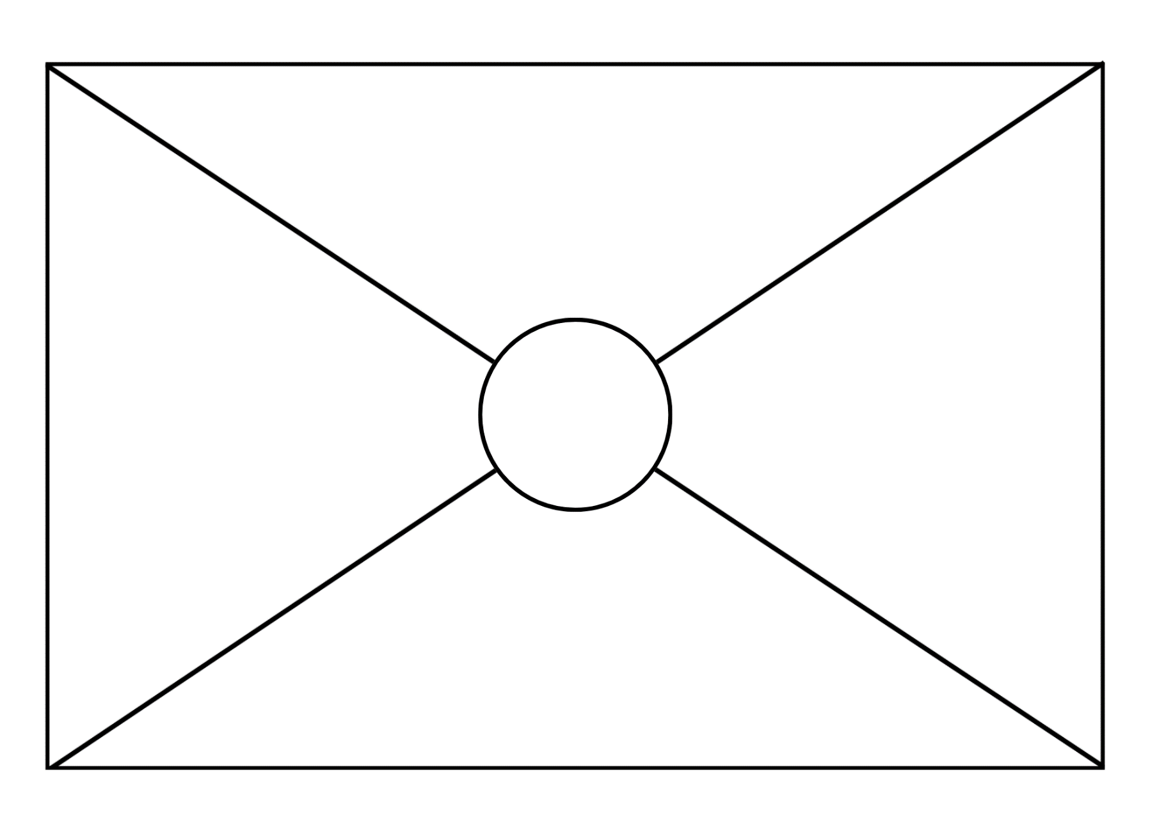

Resource 4: Number tracks

Resource 5: Pig pathways 1
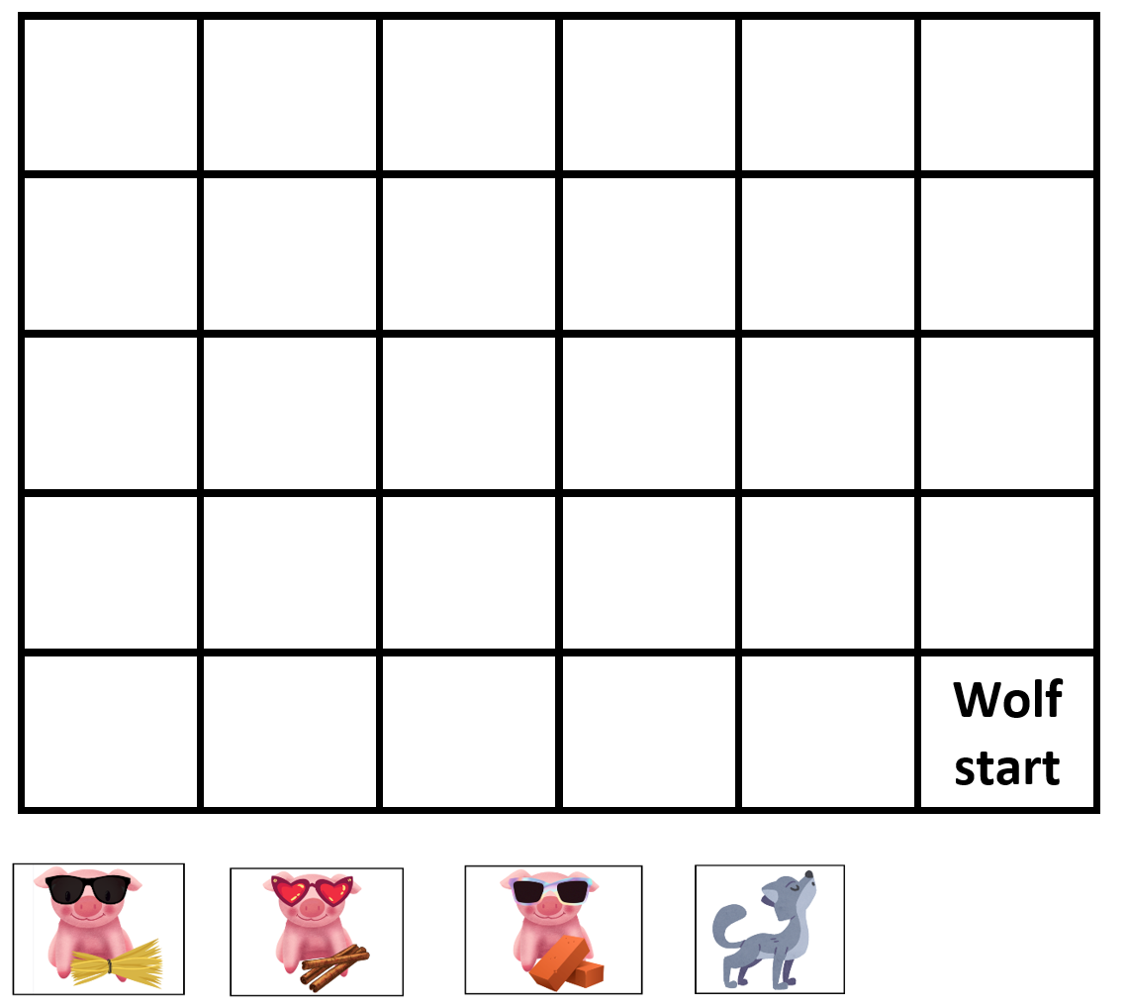
Images sourced from Canva and used in accordance with the Canva Content License Agreement.

Resource 6: Pig pathways 2
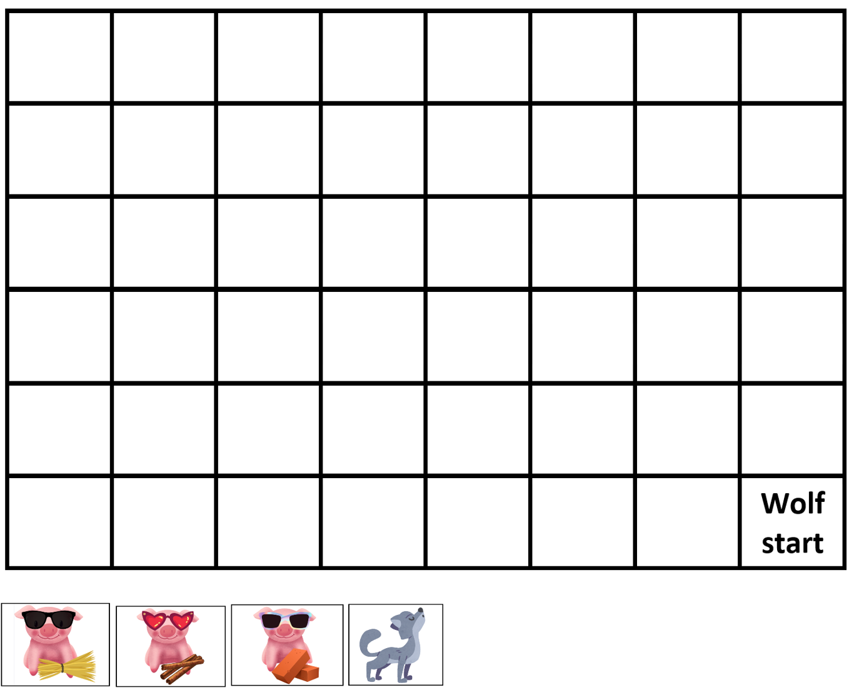
Images sourced from Canva and used in accordance with the Canva Content License Agreement.

Resource 7: Pig pathways 3
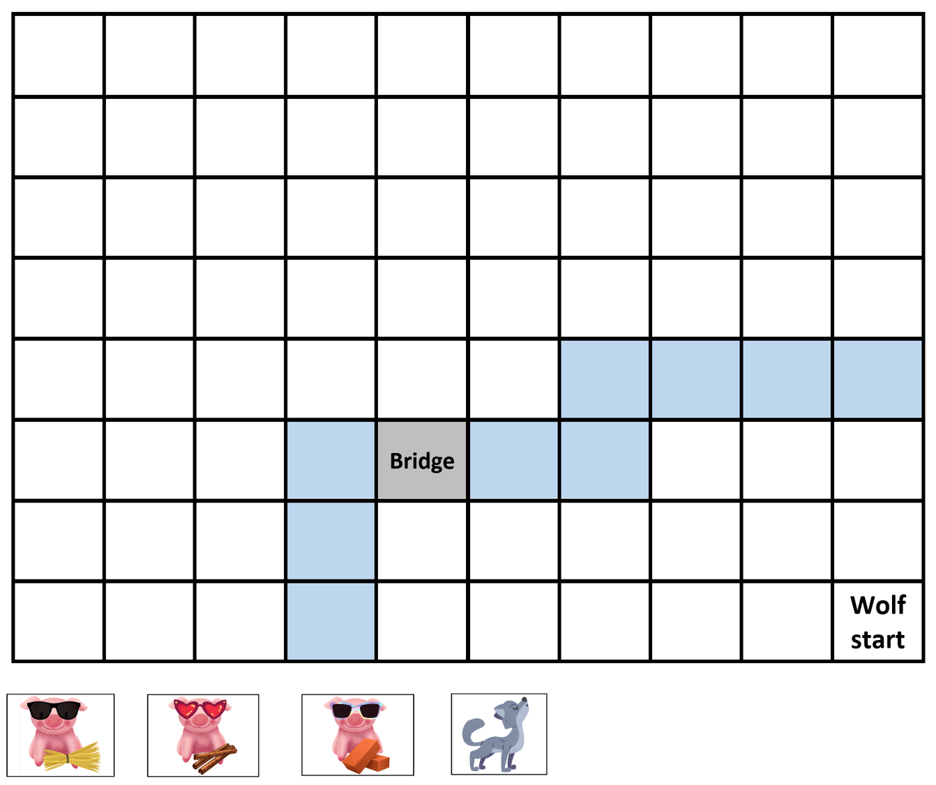
Images sourced from Canva and used in accordance with the Canva Content License Agreement.

Resource 8: Aboriginal animal symbols
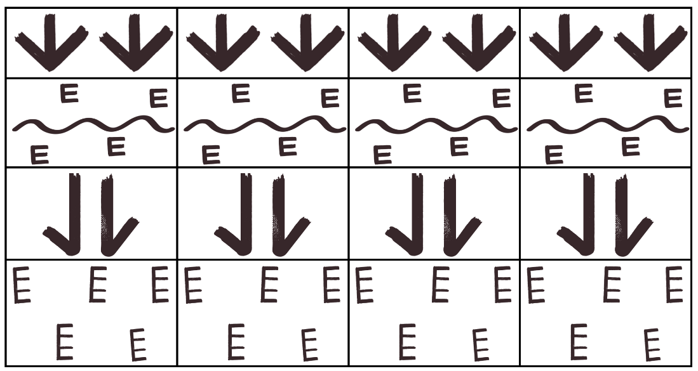
This image was created in Canva and its elements have been used in accordance with the Canva Content License Agreement.

Resource 9: Meeting place symbols
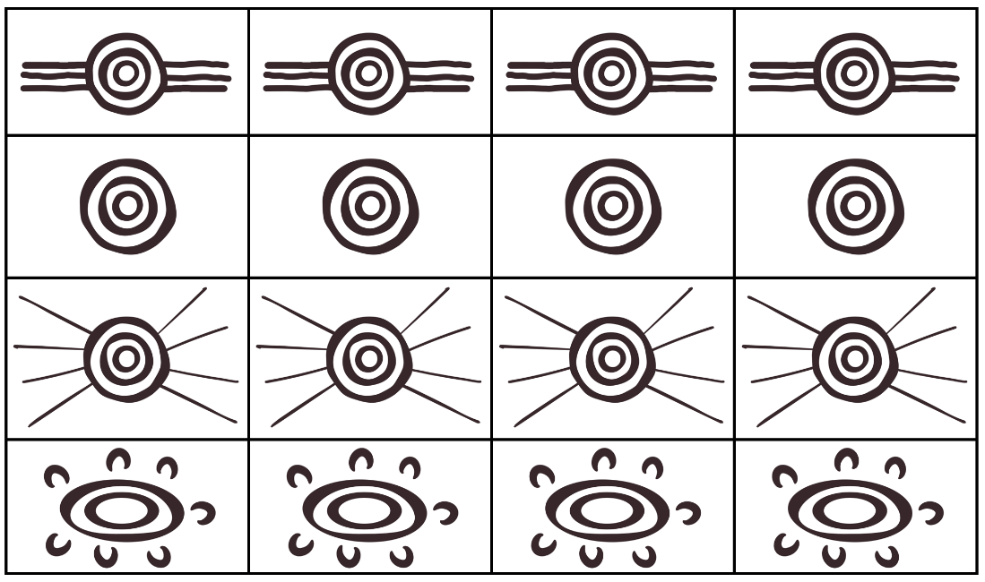
This image was created in Canva and its elements have been used in accordance with the Canva Content License Agreement.

Resource 10: Natural environment symbols
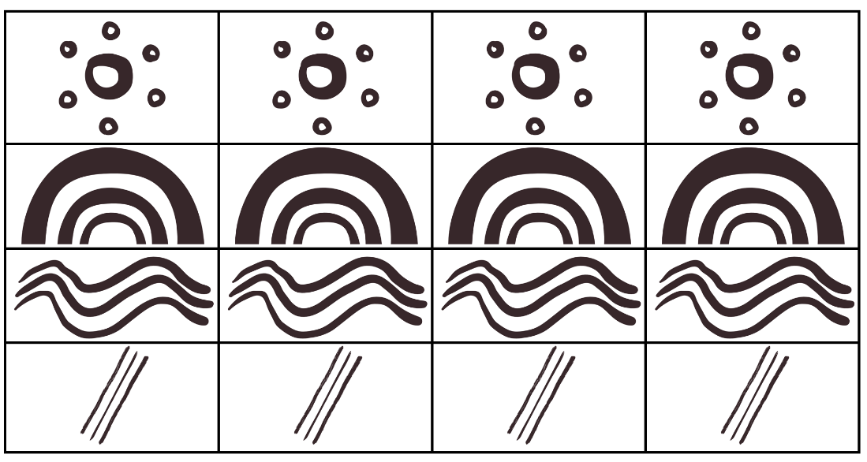
This image was created in Canva and its elements have been used in accordance with the Canva Content License Agreement.

Resource 11: Symbols template

Resource 12: Number tracks 2
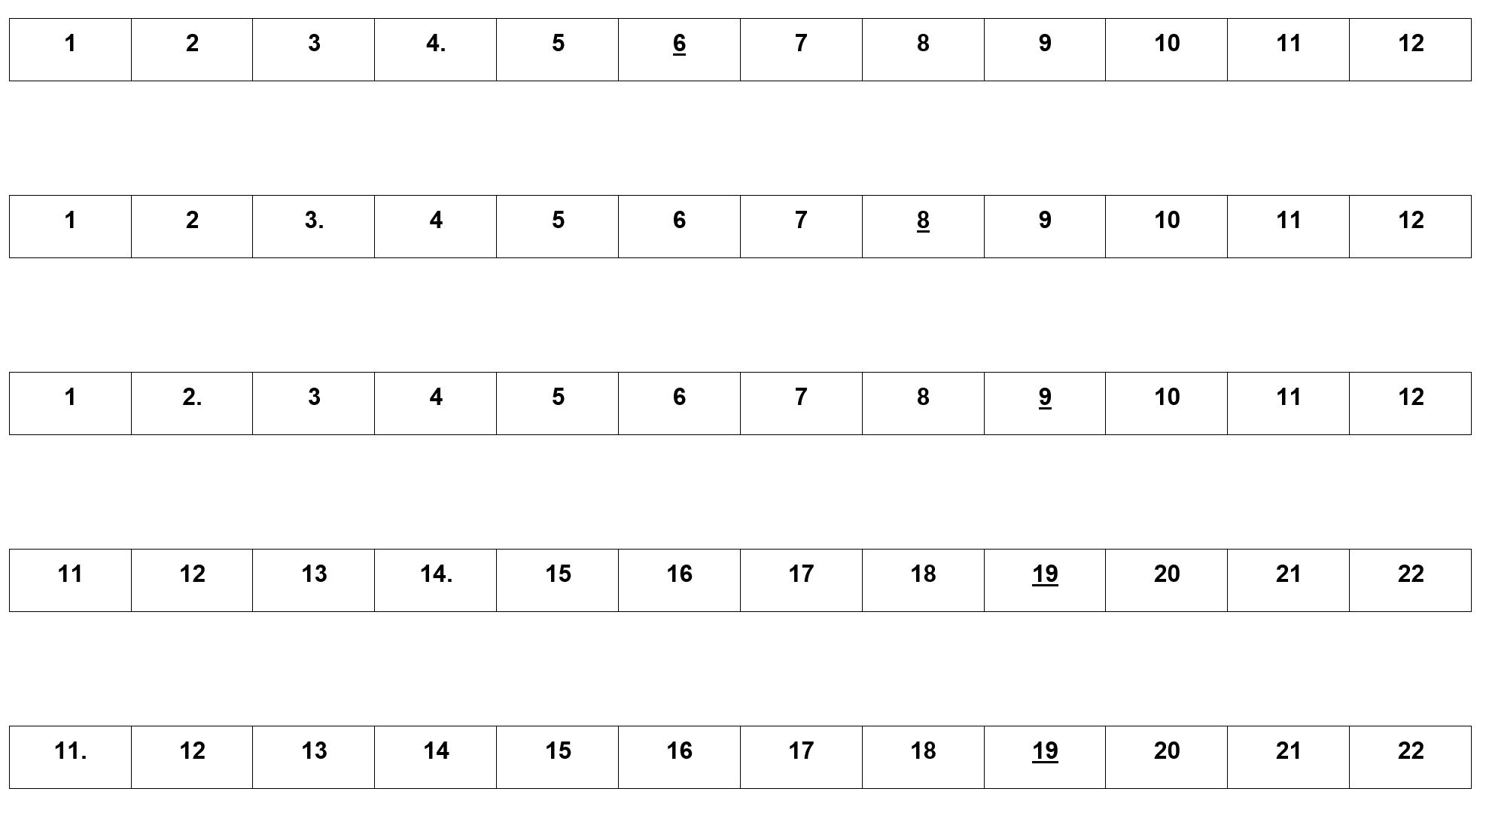

Resource 13: Building perspectives 1
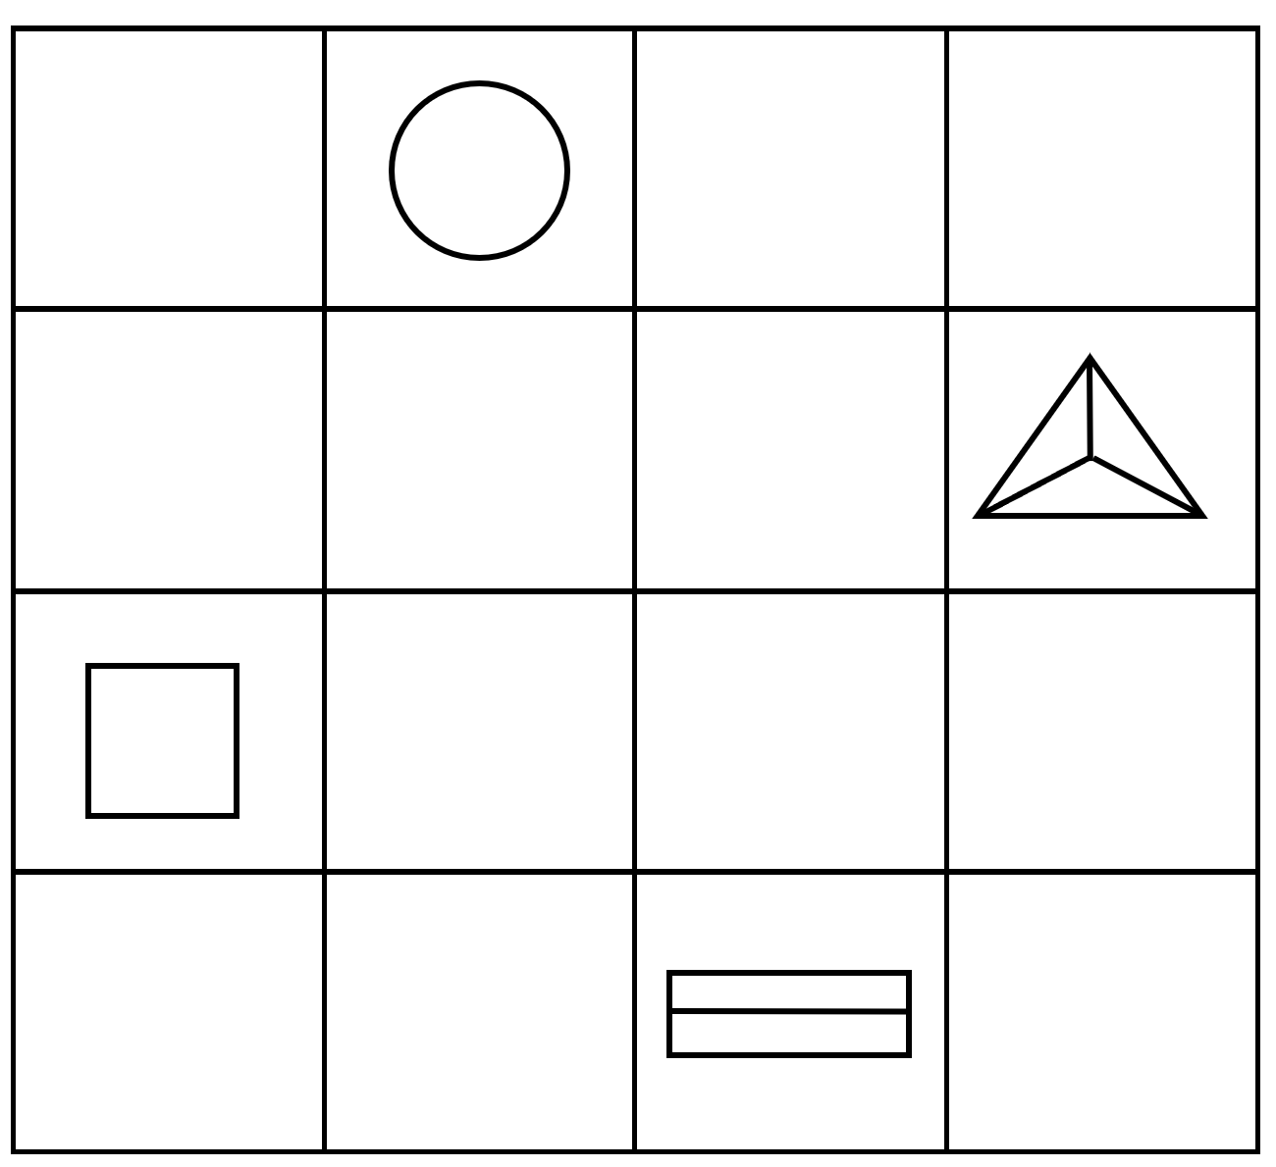

Resource 14: Building perspectives 2

Resource 15: Number line assessment
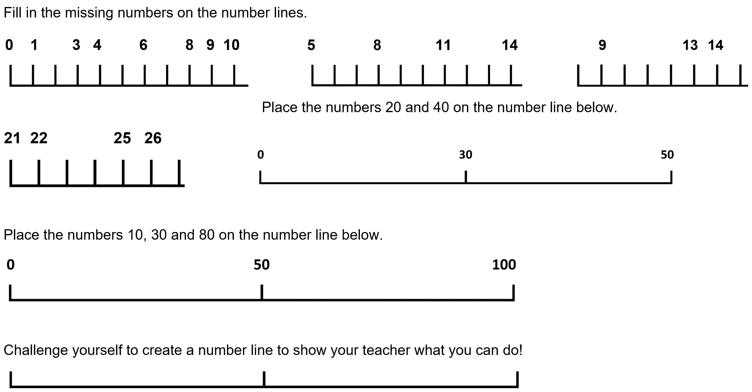

Resource 16: Number track assessment
Find the missing numbers in each number track.
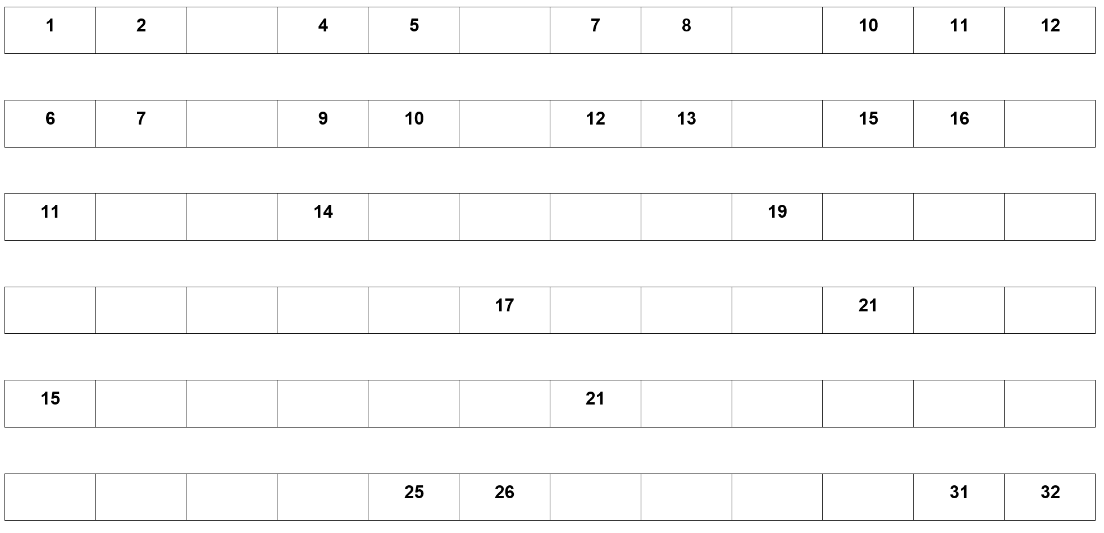

Resource 17: Tour feedback
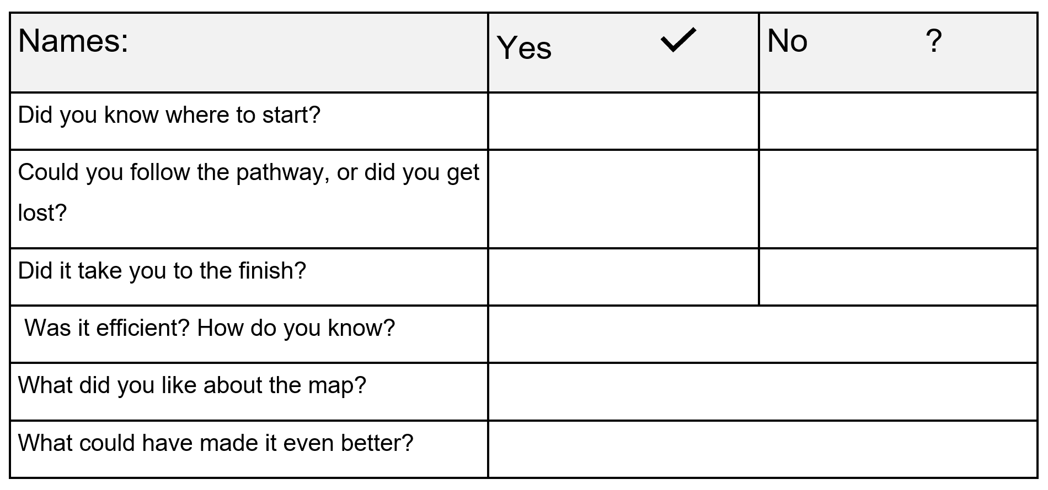

Syllabus outcomes and content
The table below outlines the syllabus outcomes and range of relevant syllabus content covered in this unit. Content is linked to National Numeracy Learning Progression version (3).
Focus area and outcomes | Content groups and content points | Lessons
Representing whole numbers  MAO-WM-01  MAE-RWN-01, MA1-RWN-01  MAE-RWN-02, MA1-RWN-02 | Early Stage 1  Instantly name the number of objects within small collections  - instantly recognise (subitise) the number of items in small groups of up to four items without counting (NPV1, CPr1)  - identify the number of items in different arrangements (CPr2) | 1-8
Representing whole numbers (cont) | Early Stage 1  Use the counting sequence of ones flexibly  - count forwards to at least 30 and state the number after or before a given number, without needing to count from one (CPr4)  - identify and distinguish the ‘teen’ numbers from multiples of ten with the same initial sounds (NPV3)  - count backwards from a given number 20 or less (CPr5)  - identify the number before as 'one less' and the number after as 'one more’ than a given number | 1-8
Representing whole numbers (cont) | Early Stage 1  Recognise number patterns  - recognise dice and domino dot patterns (NPA1, NPV2, CPr2)  - recognise different finger patterns for the same number (NPA2) | 3, 5-8
Representing whole numbers (cont) | Early Stage 1  Connect counting and numerals to quantities  - count with one-to-one correspondence, recognising that the last number name represents the total number in the collection (CPr3, CPr5)  - count out a specified number of objects (from 5 to 20) from a larger collection, keeping track of the count (CPr4-CPr5)  - make correspondences between collections  - read numerals to at least 20, including zero (NPV3)  - represent numbers as quantities to at least 20 using objects (such as fingers), number words and numerals (NPV2-NPV4, CPr3)  - compare and order numbers to 20 (NPV2-NPV3)  - use the term ‘is the same as’ to express equality of groups (CPr4-CPr5, MuS1) | 1-8
Representing whole numbers A (cont) | Stage 1  Use counting sequences of ones with two-digit numbers and beyond  - identify the number before and after a given two-digit number (CPr5)  - count forwards and backwards by ones from a given number to at least 120 (CPr6) | 1-8
Representing whole numbers A (cont) | Stage 1  Continue and create number patterns  - count forwards and backwards by twos from any starting point (CPr6-CPr7, MuS2) | 1-8
Representing whole numbers A (cont) | Stage 1  Represent numbers on a line  - sequence numbers and arrange them on a line by considering the order and size of those numbers (CPr5)  - locate the approximate position of multiples of 10 on a model of a number line from 0 to 100 (CPr5) | 1-8
Representing whole numbers A (cont) | Stage 1  Represent the structure of groups of ten in whole numbers  - recognise that ten ones is the same as one ten (NPV2, NPV4)  - use 10 as a reference in forming numbers from 11 to 20 (CPr7)  - count large sets of objects by systematically grouping in tens (CPr7)  - use number lines and number charts to assist with locating the nearest ten to a number | 3-8
Representing whole numbers B (cont) | Stage 1  Use counting sequences of ones and tens flexibly  - count forwards and backwards by tens, on and off the decade, with two- and three-digit numbers (CPr7) | 1-8
Representing whole numbers B (cont) | Stage 1  Form, regroup, and rename three-digit numbers  - state the quantity value of digits in numbers of up to three digits (NPV5)  - identify the nearest hundred to a number  - recognise units of 100 (UnM5, NPV5) | 4-5, 7-8
Combining and separating quantities  MAO-WM-01  MAE-CSQ-01, MA1-CSQ-01  MAE-CSQ-02 | Early Stage 1  Model additive relations and compare quantities  - identify situations in which addition and subtraction may be applied (AdS1-AdS2)  - combine two or more groups of objects to model addition, identifying the relationship between the parts and the whole (AdS1-AdS2)  - separate and take away part of a group of objects to model subtraction (AdS1-AdS2)  - use concrete materials or fingers to model and solve addition and subtraction questions, counting forwards or backwards by ones as necessary (AdS1-AdS2, NPV3)  - compare two groups of objects to determine how many more (NPV1, AdS2) | 3
Combining and separating quantities (cont) | Early Stage 1  Identify part–whole relationships in numbers up to 10  - use visual representations of numbers to assist with combining and separating quantities, identifying the relationship between the quantities (NPV2, AdS2-AdS3, NPA2)  - describe the action of combining, separating and comparing (AdS1)  - use five as a reference in forming numbers from six to ten  - create, model and recognise combinations for numbers up to ten (AdS2)  - count by ones to find the total or difference (AdS2-AdS3)  - use drawings, words and numerals to record addition and subtraction, and explain their thinking (AdS2) | 3
Combining and separating quantities A (cont)  NOTE – There is only one combining and separating quantities outcome for Stage 1. | Stage 1  Recognise and recall number bonds up to ten  - recognise, recall and record combinations of two numbers that add up or bond to form 10 (AdS2, AdS6)  - create, recall and recognise combinations of two numbers that add up to numbers less than 10 (AdS2, AdS6)  - describe combinations for numbers using words such as more than, less than and double (AdS6) | 3-4, 7-8
Forming groups  MAO-WM-01  MAE-FG-01, MAE-FG-02 | Early Stage 1  Record grouping and sharing  - Label the number of objects in a group  - Record grouping and sharing using drawings, words and numerals, and explain their thinking | 4
Geometric measure  MAO-WM-01  MAE-GM-01, MA1-GM-01  MAE-GM-02, MA1-GM-02  MAE-GM-03, MA1-GM-03 | Early Stage 1  Position: Describe position and movement of oneself  - give and follow simple directions to position themselves or objects (PoL1)  - describe the position of an object in relation to another object, such as in, on, under as well as the directions up and down (PoL1)  - describe the position of an object using proximity terms and referring to frames of reference (PoL2)  - use the ordinal names to at least third to describe order of position  - begin to describe the positions of objects in relation to themselves using the terms ‘left’ and ‘right’ (PoL2) | 1-4, 6-8
Geometric measure (cont) | Early Stage 1  Length: Use direct and indirect comparisons to decide which is longer  - identify the attribute of 'length' as the measure of an object from end to end  - use comparative language to describe length (UuM2)  - compare lengths directly by placing objects side by side and aligning the ends (UuM2)  - explain why the length of a piece of string remains unchanged whether placed in a straight line or a curve  - compare lengths indirectly by copying a length (UuM3) | 7
Geometric measure A (cont) | Stage 1  Position: Follow directions to familiar locations  - give and follow directions, including directions involving turns to the left and right, to move between familiar locations (PoL2)  - give and follow instructions to position objects in models and drawings (PoL2)  - describe the path from one location to another on drawings and diagrams | 1-4, 6-8
Geometric measure B (cont) | Stage 1  Position: Explore simple maps of familiar locations  - make simple models from memory, photographs, drawings or descriptions  - interpret simple maps by identifying objects in different locations (PoL3)  - create a path from one location to another (PoL3) | 1-4, 6-8
Two-dimensional spatial structure  MAO-WM-01  MAE-2DS-01, MA1-2DS-01  MAE-2DS-02, MA1-2DS-02 | Early Stage 1  2D shapes: Sort, describe and name familiar shapes  - identify familiar shapes in a range of contexts  - sort shapes according to features such as size and shape (UGP1-UGP2)  - recognise and explain how a group of shapes has been sorted  - describe shapes, including circles, squares, triangles and rectangles (UGP1-UGP2)  - ask and respond to questions that help identify and name a particular shape  - distinguish examples of triangles from non-examples | 3-8
Two-dimensional spatial structure A (cont) | Stage 1  2D shapes: Recognise and classify shapes using obvious features  - explore, manipulate and describe features of polygons (UGP3)  - select and name a shape from a description of its features, identifying triangles, quadrilaterals, pentagons, hexagons and octagons  - identify shapes presented in different orientations (UGP2) | 1-8
Two-dimensional spatial structure A (cont) | Stage 1  2D shapes: Transform shapes with slides and reflections  - recognise that sliding or reflecting a shape does not change its size or features (UGP2)  - identify and create a slide (translation) or reflection of a single shape and use the terms ‘slide’ (translation) and ‘reflection’ to describe the movement of the shape (UGP2)  - make designs with symmetry from reflection using paper-folding, mirrors, drawings or paintings (UGP3) | 1-8
Two-dimensional spatial structure B (cont) | Stage 1  2D shapes: Identify and describe the orientation of shapes using quarter turns  - identify full, half and quarter turns of a single shape and describe the movement of the shape (UuM4)  - identify and describe directions of turns as ‘left turn’, ‘right turn’, ‘clockwise’ or ‘anti-clockwise’ (UuM4) | 1-8

References
Links to third-party material and websites
Please note that the provided (reading/viewing material/list/links/texts) are a suggestion only and implies no endorsement, by the New South Wales Department of Education, of any author, publisher, or book title. School principals and teachers are best placed to assess the suitability of resources that would complement the curriculum and reflect the needs and interests of their students.
If you use the links provided in this document to access a third-party's website, you acknowledge that the terms of use, including licence terms set out on the third-party's website apply to the use which may be made of the materials on that third-party website or where permitted by the Copyright Act 1968 (Cth). The department accepts no responsibility for content on third-party websites.
Except as otherwise noted, all material is © State of New South Wales (Department of Education), 2021 and licensed under the Creative Commons Attribution 4.0 International License. All other material (third-party material) is used with permission or under licence. Where the copyright owner of third-party material has not licensed their material under a Creative Commons or similar licence, you should contact them directly for permission to reuse their material.
Mathematics K–10 Syllabus © 2022 NSW Education Standards Authority (NESA) for and on behalf of the Crown in right of the State of New South Wales.
© 2022 NSW Education Standards Authority. This document contains NSW Curriculum and syllabus content. The NSW Curriculum is developed by the NSW Education Standards Authority. This content is prepared by NESA for and on behalf of the Crown in right of the State of New South Wales. The material is protected by Crown copyright.
Please refer to the NESA Copyright Disclaimer for more information.
NESA holds the only official and up-to-date versions of the NSW Curriculum and syllabus documents. Please visit the NSW Education Standards Authority (NESA) website and the NSW Curriculum website.
National Numeracy Learning Progression © Australian Curriculum, Assessment and Reporting Authority (ACARA) 2010 to present, unless otherwise indicated. This material was downloaded from the Australian Curriculum website (National Numeracy Learning Progression) (accessed 09/11/2022) and was not modified. The material is licensed under CC BY 4.0. Version updates are tracked in the ‘Curriculum version history’ section on the 'About the Australian Curriculum' page of the Australian Curriculum website.
ACARA does not endorse any product that uses the Australian Curriculum or make any representations as to the quality of such products. Any product that uses material published on this website should not be taken to be affiliated with ACARA or have the sponsorship or approval of ACARA. It is up to each person to make their own assessment of the product, taking into account matters including, but not limited to, the version number and the degree to which the materials align with the content descriptions and achievement standards (where relevant). Where there is a claim of alignment, it is important to check that the materials align with the content descriptions and achievement standards (endorsed by all education Ministers), not the elaborations (examples provided by ACARA).
This resource contains images and content obtained from Canva, and their use outside of this resource is subject to Canva’s Content License Agreement. If you wish to use them separately from the resource, please go to Canva.
Glynn-McDonald R (20 August 2019) ‘Songlines’, Common Ground First Nations: Articles, accessed 22 December 2022.
Google Maps (2022) Sydney Opera House [Google Map], accessed 22 December 2022.
Malcolm L and Willis O (8 July 2016) ‘Songlines: the Indigenous memory code’, ABC Radio National, accessed 6 December 2022.
NSW AECG (NSW Aboriginal Education Consultative Group Incorporated) (2022) NSW AECG [website], accessed 22 December 2022.
Pol G (20 July 2020) ‘First Nations Symbols’, Common Ground First Nations: Articles, accessed 6 December 2022.
Scieszka J (2004) The True Story of the Three Little Pigs (Smith L, illus.), Puffin, Great Britain (original work published 1989).
Siemon D, Warren E, Beswick K, Faragher R, Miller J, Horne M, Jazby D, Breed M, Clark J and Brady K (2020) Teaching Mathematics: Foundations to Middle Years, 3rd edn, Oxford University Press Australia and New Zealand.
Stanford University (n.d.) ‘Sidewalk line dance’, Resources, youcubed website, accessed 22 December 2022.
Stanford University (n.d.) youcubed [website], accessed 22 December 2022.
Van de Walle J, Karp K, Bay-Williams JM, Brass A, Bentley B, Ferguson S, Goff W, Livy S, Marshman M, Martin D, Pearn C, Prodromou T, Symons D and Wilkie K (2019) Primary and Middle Years Mathematics: Teaching Developmentally, 1st Australian edn, Pearson Australia.
Wheatley N (2008) My place (Rawlins D, illus.), 20th anniversary edn, Walker Books Australia (original work published 1987).

