Mathematics – K-2 multi-age – Year B – Unit 8
Contents
Unit description and duration 4
Student prior learning 4
Lesson overview and resources 5
Lesson 1: Sponge transformation 16
Daily number sense: Choral counting – 10 minutes 16
It’s a wrap! – 40 minutes 18
Consolidation and meaningful practice: Connect the mathematics – 10 minutes 20
Lesson 2: Clock turns 22
Daily number sense: Up and down – 10 minutes 22
Making clocks – 30 minutes 24
Consolidation and meaningful practice: Body clocks – 15 minutes 27
Lesson 3: Sense of time 30
Daily number sense: Number memory – 15 minutes 31
Duration of time – 25 minutes 32
Consolidation and meaningful practice: Connect the mathematics – 15 minutes 35
Lesson 4: How long 36
Daily number sense: How many cubes? – 15 minutes 36
Packing for a picnic – 15 minutes 37
Consolidation and meaningful practice: Making shorter, making longer – 30 minutes 38
Lesson 5: Let’s cover the area 42
Daily number sense: Feed the frog – 15 minutes 42
A square – 30 minutes 44
Consolidation and meaningful practice: Order area – 15 minutes 48
Lesson 6: How many floors? 49
Daily number sense: Sixty second challenge – 20 minutes 50
How many floors – 30 minutes 52
Consolidation and meaningful practice: How many prisms? – 15 minutes 56
Lesson 7: Filling it up – Part 1 58
Daily number sense – 10 minutes 58
Filling up bottles: Part 1 – 40 minutes 59
Consolidation and meaningful practice: Estimation challenges – 10 minutes 63
Lesson 8: Filling it up – Part 2 64
Daily number sense – 10 minutes 65
Filling up bottles: Part 2 – 25 minutes 65
Changing the measure – 25 minutes 66
Consolidation and meaningful practice: Efficient measuring – 10 minutes 69
Resource 1: Number chart 1-120 70
Resource 2: Circle template 71
Resource 3: About halfway 72
Resource 4: More than halfway 73
Resource 5: Less than halfway 74
Resource 6: Think board 75
Resource 7: Think board 2 76
Resource 8: Arrays 77
Resource 9: Floors in the building 78
Syllabus outcomes and content 79
References 100

Unit description and duration
This two-week unit develops student knowledge, understanding and skills of measurement and choosing the correct unit to measure. Students are provided opportunities to:
- explore spatial concepts of transformation
- compare, describe and explore attributes of measurement through meaningful experiences
- create a fair measurement
- use uniform units to count and measure (Stage 1).
Mathematics K–10 Syllabus © 2022 NSW Education Standards Authority (NESA) for and on behalf of the Crown in right of the State of New South Wales.

Student prior learning
Before engaging in these teaching and learning activities, students would benefit from prior experience with:
- play-based experiences and routines to recognise and compare attributes of length, area, volume and time
- describing daily routines and the feeling of time passing to develop a sense of what different times feel like
- puzzles and construction which allow manipulation of shapes to fill gaps.

Lesson overview and resources
The table below outlines the sequence and approximate timing of lessons; syllabus focus areas and content groups; and resources.
Lesson | Syllabus focus area and content groups | Resources
Lesson 1: Sponge transformation  60 minutes  Mathematicians can represent ideas using pictures or mathematical diagrams. | Representing whole numbers  Early Stage 1  - Use the counting sequence of ones flexibly  Stage 1 – Part A  - Use counting sequences of ones with two-digit numbers and beyond  - Continue and create number patterns  Stage 1 – Part B  - Use the counting sequences of ones and tens flexibly  Forming groups  Early Stage 1  - Forming groups  Stage 1 – Part A  - Count in multiples using rhythmic and skip counting  Two-dimensional spatial structure  Early Stage 1  - 2D shapes: Represent shapes  Stage One – Part A  - 2D shapes: Transform shapes with slides and reflections  Stage One – Part B  - 2D shapes: Identify and describe the orientation of shapes using quarter turns | - Resource 1: Number chart 1-120  - A tapping stick  - A4 paper  - 3 sponges of different shapes  - 3 different colours of paint  - Bowls  - Writing materials
Lesson 2: Clock turns  55 minutes  Mathematicians use analog clocks to tell the time. | Representing whole numbers  Early Stage 1  - Connect counting and numerals to quantities  Stage 1 – Part A  - Represent the structure of groups of ten in whole numbers  Stage 1 – Part B  - Form, regroup, and rename three-digit numbers  Geometric measure  Early Stage 1  - Length: Create half a length  Stage 1 – Part A  - Length: Subdivide lengths to find halves and quarters  Non-spatial measure  Early Stage 1  - Time: Tell time on the hour on analog and digital clocks  Stage 1 – Part A  - Time: Tell time to the half-hour  Stage 1 – Part B  - Time: Tell time to the quarter-hour using the language of ‘past’ and ‘to’ | - Resource 2: Circle template or pre-cut circles in different colours  - Video: The Stickie Gang: Episode 7 Telling the Time (1:03)  - Clock demonstrator  - Deck of cards – one per pair  - MAB blocks  - Scissors  - Glue  - Writing materials  - 2D shapes which can be folded in half (Early Stage 1 students)
Lesson 3: Sense of time  55 minutes  Duration of time can be compared. | Combining and separating quantities  Early Stage 1  - Model additive relations and compare quantities  - Identify part–whole relationships in numbers up to 10  Combining and separating quantities A  Stage 1  - Recognise and recall number bonds up to ten  Non- spatial measure  Early Stage 1  - Time: Compare and order the duration of events using the language of time  Stage 1 – Part B  - Time: Describe duration using units of time | - Deck of cards – one per pair  - Timer – whole class or stopwatches  - Writing materials
Lesson 4: How long  60 minutes  We can use direct comparison to decide which is longer. | Representing whole numbers  Early Stage 1  - Connect counting and numerals to quantities  Stage 1 – Part A  - Represent the structure of groups of ten in whole numbers  Geometric measure  Early Stage 1  - Length: Use direct and indirect comparisons to decide which is longer  - Length: Create half a length  Stage 1 Part A  - Length: Compare lengths using uniform informal units  - Length: Subdivide lengths to find halves and quarters | - Resource 3: About halfway  - Resource 4: More than halfway  - Resource 5: Less than halfway  - Class set of linking cubes
Lesson 5: Let’s cover the area  60 minutes  The area of a surface can be measured by comparing shapes. | Representing whole numbers  Early Stage 1  - Instantly name the number of objects within small collections  - Use the counting sequence of ones flexibly  - Recognise number patterns  - Connect counting and numerals to quantities  Stage 1 – Part A  - Use counting sequences of ones with two-digit numbers and beyond  - Represent the structure of groups of ten in whole numbers  Stage 1 – Part B  - Use counting sequences of ones and tens flexibly  - Form, regroup, and rename three-digit numbers  Forming groups  Stage 1 – Part A  - Count in multiples using rhythmic and skip counting  Stage 1- Part B  - Represent and explain multiplication as the combining of equal groups  Two-dimensional spatial structure  Early Stage 1  - 2D shapes: Represent shapes  - Area: Identify and compare area  Two-dimensional spatial structure  Stage 1 – Part A  - Area: Measure areas using uniform informal units  Stage 1 – Part B  - Area: Compare rectangular areas using uniform square units of an appropriate size in rows and columns | - Resource 6: Think board  - Resource 7: Think board 2  - Video: How to make a square  - 3 dice – per student  - Paper to make a square  - Square and circle counters  - Scissors  - Objects in the room to compare  - Writing materials
Lesson 6: How many floors?  65 minutes  Collections of objects can look different but have the same quantity. | Representing whole numbers  Early Stage 1  - Connect counting and numerals to quantities  Stage 1 – Part A  - Represent numbers on a line  - Represent the structure of groups of ten in whole numbers  Stage 1- Part B  - Form, regroup, and rename three-digit numbers  Combining and separating quantities  Early Stage 1  - Model additive relations and compare quantities  Stage 1 – Part A  - Use advanced count-by-one strategies to solve addition and subtraction problems  Forming groups  Stage 1 – Part B  - Represent and explain multiplication as the combining of equal groups  Three-dimensional spatial structure  Early Stage 1  - Volume: Compare volume by building  Stage 1 – Part B  - Volume: Compare volumes using uniform informal units | - Resource 8: Arrays  - Resource 9: Floors in the building  - 10-sided dice per student pair  - Counters or other concrete materials  - Skipping rope or masking tape to make a number line  - Sticky notes  - One-minute timer  - Blocks  - Writing materials
Lesson 7: Filling it up – Part 1  60 minutes  Objects can look different but still have the same internal volume. | Three-dimensional spatial structure  Early Stage 1  - Volume: Compare internal volume by filling and packing  - Volume: Compare volume by building  Three-dimensional spatial structure A  Stage 1  - Volume: Measure and compare the internal volumes (capacities) of containers by filling  - Volume: Measure the internal volume (capacity) of containers by packing  - Volume: Construct volumes using cubes  Three-dimensional spatial structure B  Stage 1  - Volume: Compare containers based on internal volume (capacity) by filling and backing  - Volume: Compare volumes using uniform informal units | - Marker to label containers  - Variety of containers of different size  - Water  - Writing materials
Lesson 8: Filling it up – Part 2  70 minutes  Mathematicians are precise and accurate when measuring internal volume. | Three-dimensional spatial structure  Early Stage 1  - Volume: Compare internal volume by filling and packing  - Volume: Compare volume by building  Three-dimensional spatial structure A  Stage 1  - Volume: Measure and compare the internal volumes (capacities) of containers by filling  - Volume: Measure the internal volume (capacity) of containers by packing  - Volume: Construct volumes using cubes  Three-dimensional spatial structure B  Stage 1  - Volume: Compare containers based on internal volume (capacity) by filling and backing  - Volume: Compare volumes using uniform informal units | - A cup or smaller container per pair of students  - A mug per pair of students  - Variety of containers of different sizes  - Variety of materials to fill up containers (liquids, rice, salt, sugar)  - Writing materials

Lesson 1: Sponge transformation
Core concept: Mathematicians can represent ideas using pictures or mathematical diagrams
The table below contains suggested learning intentions and success criteria. These are best co-constructed with students.
Learning intentions | Success criteria
All students are learning that:  - shapes come in different orientations and can be represented in different ways  - number patterns can be continued by noticing the structure, rhythm and repetition. | All students can make representations of shapes in different orientations with paint.  In addition, students working towards Early Stage 1 outcomes can count forwards and backwards from 0-30.  In addition, students working towards Stage 1 outcomes can:  - use a number chart to count forwards and backwards by twos  - create the different patterns by translating, rotating and reflecting with their sponges.

Daily number sense: Choral counting – 10 minutes
This lesson has been adapted from Robertson (2017).
- Build student understanding of number patterns by choral counting.
- Explain that students will play a counting game by slowly tapping a stick on the ground in time with each number said aloud. Encourage all students to chorally count aloud and work on developing a steady rhythm.
- For Early Stage 1 students, begin by counting forwards to 30 and then backwards from 20 to the rhythm of stick tapping. Vary the game by having students count forwards and backwards from different starting points.
- For Stage 1 students, begin counting forwards from two-digit numbers (for example, 28) or three-digit numbers (for example, 355). Vary the game by having students count forwards and backwards from different starting points, on and off the decade.
- Develop a ‘switch’ and challenge students to begin by counting forwards. Then, when you call out ‘switch’, students change direction and count backwards.
- Display Resource 1: Number chart 1-120.
- Ask Stage 1 students to choral count by twos starting at 6 and stopping at 28. Ask students to look at the number chart to prepare in their heads before they start the count. Early Stage 1 students can clap or hop to the rhythm of choral counting.
- Ask students to continue to count and colour the numerals on the class numeral chart to demonstrate the pattern.
- Ask students to look at the number pattern and ask:
- What do you notice?
- Can you describe the pattern?
- What is a number that might come later in the sequence? How do you know? Can you prove it?
- Can you articulate a rule for counting by twos?
- Repeat activity by beginning at a different number.

It’s a wrap! – 40 minutes
This activity has been adapted from Sponge art transformations from Thinking Mathematically.
- Explain to students that they will be making wrapping paper.
- Display a square sponge. Ask students to notice squares in the classroom and describe the features of the square, such as 4 sides, straight lines, and so on.
- Provide students with 3 different colours of paint, 3 sponges that are 4 × 4 cm in size, and a piece of A4 paper.
- Ask students to lay their piece of paper in front of them in a landscape position and fold into thirds (see Figure 1).
Figure 1 – Wrapping paper
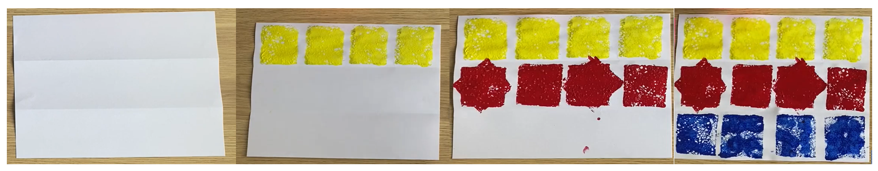
Note: It may help to have these pages pre-folded into thirds as this may be difficult for some students to do.
- Ask students to dip their first sponge into the paint, making sure the paint is spread evenly on the sponge.
- For Stage 1, students then place the sponge on the top left-hand side of the page and create a pattern by pressing the sponge across the page several times (see Figure 1). Explain that this is called translating.
- For Early Stage 1, ask students:
- What do you notice?
- Has the shape changed?
Translation: A translation moves a shape up, down or side to side but it does not change the appearance of the shape.
- Ask students to take a clean sponge and dip into another colour. On the second row they must press their sponge down to create a square just like in the first row. They then turn their sponge clockwise just a little, press it down again on top of the square to create a star (see Figure 1).
- For the next shape along the same line, ask Stage 1 students to press the sponge down to create a square. They then turn their sponge in an anticlockwise direction a quarter of a turn and press down on top of the same square. This will produce a square again. Alternate the shape on the middle line between the star and the square.
Note: Bring students’ attention to the fact that rotating clockwise or anticlockwise does not make a difference to the shape in this activity.
- Explain that turning the sponge clockwise and anticlockwise is called rotating.
Rotation: A rotation moves the shape around a fixed point in a clockwise or anticlockwise direction so the shape is the same but its position changes.
- For Early Stage 1, demonstrate and then ask students to turn their shape in different orientations and press down. Ask students:
- What do you notice?
- Has the shape changed even though it was turned?
- Ask students to take their last clean sponge and dip it into the remaining colour of paint, but this time they are putting paint on both sides of the sponge.
- On the last row of the page, ask students to predict what will happen if they press the sponge down to create a square again, but this time they must flip the sponge over and create another shape next to the first. Ask students, will it be a square again?
- For Stage 1, explain that this flipping movement is called reflecting.
Reflection: A reflection flips the shape around so that you get a mirror image while the size of the shape remains the same.
- After creating their wrapping paper give students another piece and allow them to experiment with shape orientations to create another piece of wrapping paper with shapes of their choice.

Consolidation and meaningful practice: Connect the mathematics – 10 minutes
- Reflect on the activity by discussing the following questions with students:
- Did moving the shape’s orientation change the shape in any way?
- How did moving your sponge in different directions change the print on the paper?
- Which movement (slide, turn or flip) made the greatest number of shapes?
- Did turning your sponge clockwise or anticlockwise make a difference to your print?
This table details assessment opportunities and differentiation ideas.
Assessment opportunities | Too hard? | Too easy?
What to look for:  - Can the students make different representations of shapes in different orientations? (MAO-WM-01, MAE-2DS-01, MA1-2DS-01)  What to collect:  - student manipulation of materials and wrapping paper. (MAO-WM-01, MAE-2DS-01, MA1-2DS-01) | Students are unable to create patterns by using different orientations of shapes.  - Provide further opportunities to match shapes in puzzles.  - Allow students the opportunity to manipulate squares by flipping, sliding and turning. | Students are able to create patterns by using different orientations of shapes.  - Students describe the features of polygons and explain why some shapes tessellate better than others.  - Students create a picture of an animal using the flip, slide and turn movements.

Lesson 2: Clock turns
Core concept: Mathematicians use analog clocks to tell the time.
The table below contains suggested learning intentions and success criteria. These are best co-constructed with students.
Learning intentions | Success criteria
All students are learning that time can be represented on a clock face.  In addition, students working towards Stage 1 outcomes are learning that half a clockface supports us to tell the time to the half-hour. | All students can describe the position of the hour and minute hands on a clock.  In addition, students working towards Early Stage 1 outcomes can find half of an object by folding objects to ensure each side is the same.  In addition, students working towards Stage 1 outcomes can describe and represent the position of clock hands to describe half past and quarter past the hour.

Daily number sense: Up and down – 10 minutes
This lesson has been adapted from Up and Down at The Mathematical Association of Victoria.
- Introduce ‘up and down’ by explaining that this game will be played in small groups. One student deals out 4 cards, face up, to each player with all picture cards removed from the deck. The remaining cards are placed in a pack in the middle of the table.
- Model how to play ‘up and down’. Explain that the aim of the game is to be the first player to arrange their cards in either ascending or descending order. The order does not need to be in consecutive order. For example, 1, 2, 3, 4. It could be 1, 3, 4, 7 (see Figure 2).
Figure 2 – Ascending and descending cards
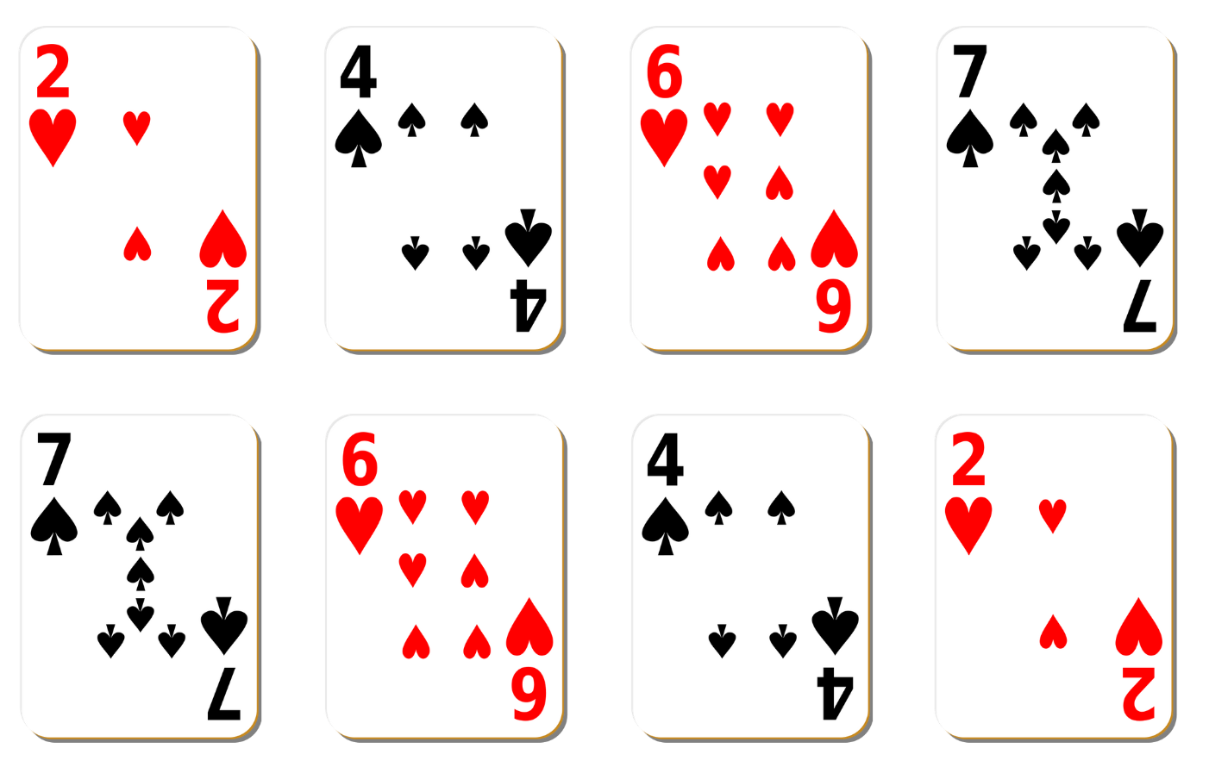
Images sourced from Canva and used in accordance with the Canva Content License Agreement.
- The first player to arrange their cards in order is the winner of that round.
- For Stage 1 students, this game can be adapted to make two-digit or three-digit numbers by removing the 10 from the pack and making two-digit numbers from the remaining cards. Each student makes a number from MAB blocks and then all the numbers are ordered from ascending or descending order.

Making clocks – 30 minutes
- Reinforce times of the day by viewing The Stickie Gang’s Episode 7 Telling the Time (1:03) from ABC iview.
- Ask students what they noticed or wondered about the different times of the day, such as breakfast before playtime, dinner after homework, playtime at 9 o’clock.
- Provide time for students to Think-Pair-Share about their favourite time of day.
- Encourage students to use their mathematical brains to think about the clocks they saw and to describe what they noticed. Ask the following questions:
The table below outlines stimulus prompts to generate conversation about the topic, along with anticipated responses from students.
Prompts | Anticipated student responses
- What did you notice about the clocks that you saw in the video?  - Where may you have seen clocks like this before? | - I saw the number 5.  - I saw 2 zeros on some of the clocks.  - The number 12 is at the top of the clock.  - I’ve seen these clocks in the classroom, school hall, microwave oven and bedside table.
- Explain that students saw 2 different types of clocks in the video and these are called analog and digital clocks. Draw students’ attention to the features of each.
- Use Clock demonstrator to introduce features of analog and digital clocks. These features include the clock face, counting and ordering numbers 1 to 12; that 9 o’clock is the same as 9:00, and 3 o’clock is the same as 3:00; identifying and noticing how the hour and minute hand move.
- Play a game of Simon Says, with Simon asking students to physically move their bodies to represent:
- a full turn
- a half-turn
- a quarter-turn.
- Explain that, when telling the time, the minute hand also makes a full turn, half turn and quarter turn around the clock face.
- Ask students to use their arms to represent the minute hand just like on the clock:
- as a full turn
- as a half-turn
- as a quarter-turn.
Note: When describing time, use the terms ‘hour hand’ and ‘minute hand’, rather than ‘little hand’ and ‘big hand’, to promote understanding of their respective functions.
- Ask students to cut out 3 of the circle templates from Resource 2: Circle template or provide pre-cut circles in different colours. One of the circles will be used as a base. Ask students to lay this circle flat. This will be the clock face. See the blue circle in Figure 3.
- Take the second circle and fold it in half and ask students to cut on the fold to create 2 halves.
Note: Support students in understanding the halfway point in the circle, ensuring both sides of the circle are equal in size.
- Place the half circle on top of the clock. Explain this is halfway on a clockface. Ask students to place the half circle on top of the full circle. See purple section in Figure 3.
- For Stage 1, demonstrate moving the minute hand halfway or a half turn on the clock face. Describe the position of the minute hand on the clock for the half-hour. Explain half of the circle represents half on the hour.
- Have students fold their last coloured circle into quarters and cut on folds to create 4 quarters. See the red section in Figure 3.
- Early Stage 1 students form pairs and find items in the classroom that they could fold in half, identifying the 2 equal parts. Support students to describe language, such as about halfway, more than halfway, or less than halfway.
- For Stage 1 students, demonstrate moving the minute hand to quarter past on the clock face. Ask students to describe the position of the hands on the clock. Explain that one quarter of the clockface represents a quarter of an hour, which is quarter past or 15 minutes past the hour.
- Move the quarter circle so that it represents quarter to on the clock face. Ask the students what the time would be if the minute hand looked like this. Explain that it is quarter to the hour.
Note: The concept of quarter past is much more difficult than half-hour for many students. It will require extensive modelling and repeated practice as well as a good understanding of hour and half-hour on clock faces.
- Layer the circles as shown and glue them down.
- Ask students to label their clocks with the numerals 3, 6, 9 and 12.
Figure 3 – Example of circle
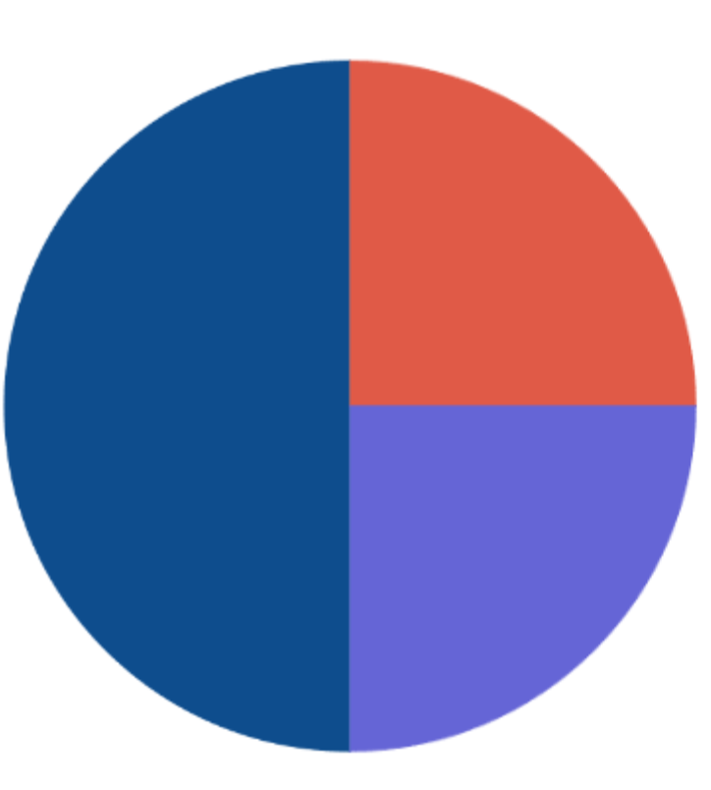

Consolidation and meaningful practice: Body clocks – 15 minutes
This lesson has been adapted from Robertson (2017).
- Explain that students will become human clocks, using their body to create different times on the hour.
- Demonstrate how to stretch your arms up and out to the side to feel the position of the hour and minute hands.
- Encourage students to rock from foot to foot while slowly chanting ‘Tick, tock, tick, tock. I’m a ticking human clock. What time is it?’
- Call out a time. Students make that time with their arms showing the position of the hour and minute hands (see Figure 4).
Figure 4 – Human clocks
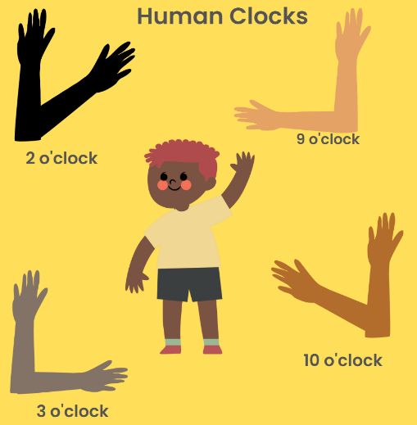
Images sourced from Canva and used in accordance with the Canva Content License Agreement.
Note: Remember it will look back to front if you are standing in front of students.
- Ensure you have a clock face on hand so students can check and correct their answers.
- As students become familiar with the game, they can be invited to call out a time for the class to make. For Stage 1 students, time can include half past, and quarter hours. Notice and ask students to explain why the hour hand on a clock is halfway between successive hour-markers when the minute hand shows the half-hour.
- Repeat chant before calling out each time.
Note: This also works as an activity undertaken in pairs with one student moving the arms of their partner to the correct position.
This table details assessment opportunities and differentiation ideas.
Assessment opportunities | Too hard? | Too easy?
What to look for:  - Can the students describe the position of the hour and minute hands on a clock? (MAE-NSM-02, MA1-NSM-02)  - Can the students find half of an object by folding objects to ensure each side is the same? (MAO-WM-01, MAE-GM-02, MA1-GM-02)  What to collect:  - anecdotal observation records while students are making clocks and folding circles. (MAO-WM-01, MAE-GM-02, MAE-NSM-02, MA1-NSM-02) | Students are unable to describe and represent the position of clock hands.  - Provide students with further opportunities to manipulate clocks to tell the time to o’clock.  - Provide further experiences for students to move their bodies and hands to represent time.  Students are unable to find half of an object by folding.  - Model dividing regular shapes into halves.  - Model and reinforce language of 2 equal sides or lengths when describing halfway. | Students are able to describe and represent the position of clock hands.  - Provide students with further opportunities to express time in analog and digital forms.  - Provide further experiences for students to explore clock hand positions when representing quarter to the hour as 45 minutes or three-quarters around the clockface.  Students are able to find half of an object by folding.  - Find other fractions of lengths such as repeatedly halving to find quarters or exploring folding to make thirds.  - Continue to estimate and then find half of a variety of lengths.

Lesson 3: Sense of time
Core concept: Duration of time can be compared.
The table below contains suggested learning intentions and success criteria. These are best co-constructed with students.
Learning intentions | Success criteria
All students are learning that:  - the length of time can be measured and compared.  - the duration of an event can be estimated from prior experience  - number bonds are pairs of numbers that form 10. | All students can:  - measure and order time taken to complete tasks  - estimate and describe the duration of daily events.  In addition, students working towards Early Stage 1 outcomes can:  - compare the duration of 2 events  - create and record numbers that add up to 10.  In addition, students working towards Stage 1 outcomes can create and record numbers that add up to and including 20.

Daily number sense: Number memory – 15 minutes
- Build student understanding of forming combinations to 10 by playing ‘number memory’.
- Students play ‘number memory’ in small groups. Students will lay out a deck of cards face down in rows and columns with all picture and number 10 cards removed from the deck (see Figure 5).
Figure 5 – Rows and columns
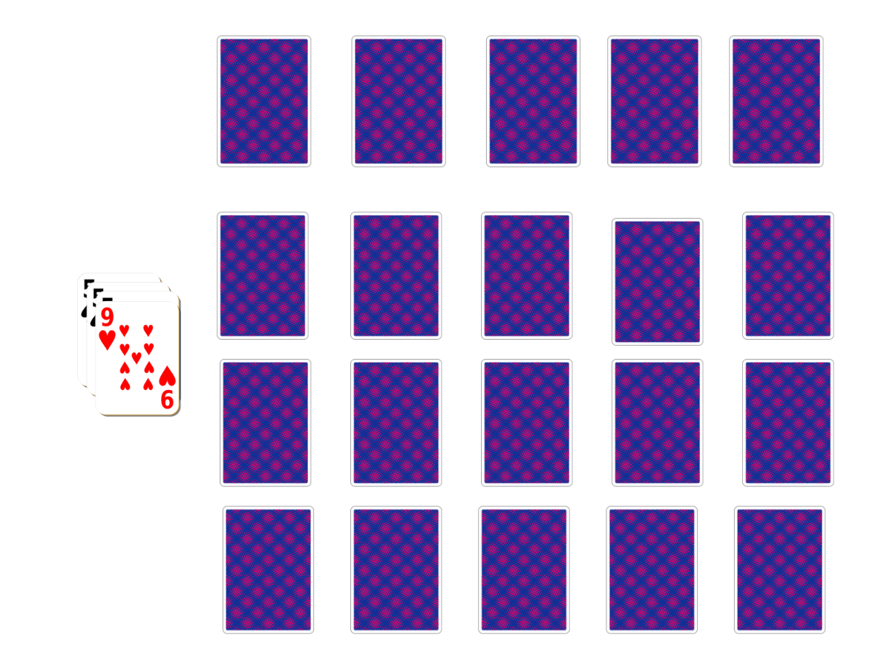
Images sourced from Canva and used in accordance with the Canva Content License Agreement.
- Provide time for students to play memory by turning over 2 cards at a time to see if they can make a match for the target number of 10.
- Focus on the reasoning students provide for the match and for students to build connections between concepts.
- Students can record their combinations that add up or bond to form 10 to find all the different combinations.
This table details assessment opportunities and differentiation ideas.
Assessment opportunities | Too hard? | Too easy?
What to look for:  - Can the students create and record numbers that add up to 10? (MAO-WM-01, MA-CSQ-02, MA1-CSQ-01)  What to collect:  - strategic questioning and observation during game playing and recording of number bonds. (MAO-WM-01, MA-CSQ-02, MA1-CSQ-01) | Students are unable to create and record number bonds to 10.  - Provide students with a ten-frame to fill with concrete materials to visually represent 10 while playing the game.  - Model counting with one-to-one correspondence to add the 2 cards. | Students are able to create and record number bonds to 10.  - Challenge students to combine 3 cards to make combinations to 10.  - Challenge students to look for combinations to 20.

Duration of time – 25 minutes
- Ask students to turn and talk about all the events that occurred yesterday afternoon.
- Revise events that occur during routines of night-time, morning, afternoon, today, tomorrow, yesterday, and so on. Record some of the events students are discussing on the board.
Note: Pay attention to vocabulary such as first, next and last when recalling events.
- Explain to students that mathematicians are precise when measuring. Ask how these events can be ordered from the shortest time to the longest time.
- Discuss with students that we develop a sense of time so that we can estimate the amount of time something takes (duration).
- Discuss that when we measure time, we use a second, minute, and an hour as our units of measure.
Note: Early Stage 1 students discuss duration through ideas such as before, after, how long, how soon and so on.
- Ask students:
- Can you think of something that takes a second?
- How long does it take to blink?
- How many blinks do you think you can you do in one minute?
- What other activities could you do in one minute?
- Can you think of an activity which would take 5 minutes?
- What is an activity that could take one hour?
Note: Remind Stage 1 students that one minute is 60 seconds. Sixty minutes is equal to one hour.
- As a class determine 5 activities that will be measured. These activities need to be varied in how long they take, for example, from seconds to hours.
- Ask students to estimate and record the duration of the events:
- Which of these will be the longest amount of time?
- Which of these will be the shortest amount of time?
- How can we compare the length of time taken to complete these activities?
- Introduce a timer or stopwatch.
- Complete activities and time events recording the length of time.
This table details assessment opportunities and differentiation ideas.
Assessment opportunities | Too hard? | Too easy?
What to look for:  - Can the students estimate and describe the duration of daily events? (MAO-WM-01, MAE-NSM-02, MA1-NSM-02)  What to collect:  - student reflections on duration and measuring of events. (MAO-WM-01, MAE-NSM-02, MA1-NSM-02) | The student is unable to estimate and describe the duration of daily events.  - Introduce time in everyday contexts, for example, schedule of familiar routines first, then board and visual schedules.  - Support students with everyday opportunities to experience wait time for activities. | The student is able to estimate and describe the duration of daily events.  - Tell a story or role-play to discuss the duration of events during the day.  - Encourage students to notice when the classroom clock shows time on the hour throughout the day.

Consolidation and meaningful practice: Connect the mathematics – 15 minutes
- Ask questions such as:
- Was your estimation too high or too low?
- What do we mean when we say something takes ‘about a minute’?
- Why is time important?
- What would happen if we didn’t have clocks?
- How would we know when to get up and go to sleep?
- How would we know if we had enough sleep?

Lesson 4: How long
Core concept: We can find fractional parts of lengths.
The table below contains suggested learning intentions and success criteria. These are best co-constructed with students.
Learning intentions | Success criteria
All students are learning that:  - a length is the measure of an object from end to end  - half is equal parts of a whole length. | All students can:  - use direct comparison to compare and order length  - recognise halves of a length.  In addition, students working towards Early Stage 1 outcomes can align the ends of towers to compare lengths.  In addition, students working towards Stage 1 outcomes can count informal units to measure and compare lengths of towers.

Daily number sense: How many cubes? – 15 minutes
This activity has been adapted from the lesson Counting large collections from reSolve.
- Build student understanding of place value by counting and representing large collections of objects by grouping into tens and hundreds.
- In groups of 2-4 students, provide a box of linking cubes (or other concrete materials), making sure that each box has a different number of concrete materials in it.
- Ask students to estimate and then count their collections. While counting, prompt students to think about how to arrange the cubes to make it easier to count. Students can bundle cubes into groups of 10 to support counting.
Note: In Early Stage 1, students should pay attention to one-to-one correspondence to count and bundle groups of 10.
- Select some groups to share their answers and explain their counting strategies. Ask students:
- Is it more efficient to arrange our objects into groups of 10 and skip count by tens to work out the total?
- Can we make a group of 100 and count by hundreds?
- Repeat activity by swapping boxes between groups. Ask students which box held the largest number of cubes and prompt them to explain how they know.

Packing for a picnic – 15 minutes
- Tell a story using frog figurines about 2 frog friends going on a picnic. Explain that the frogs, Flora and Forest, collected some fruits and vegetables that they harvested from their garden to eat. They harvested a cucumber, a carrot and a banana. When they arrived at the lake for their picnic, they realised that they had forgotten to cut the fruits and vegetables to share. Flora uses a knife from the picnic basket to cut the fruits and vegetables.
- Show students Resource 3: About halfway.
- Ask students what they notice about where the knife is going to cut the cucumber.
- Explain that when a length has been divided into 2 equal parts the parts are called halves.
- Encourage students to describe the positions of the length when Flora cuts the carrot and banana into parts.
- Show students Resource 4: More than halfway
- Ask students how they would describe the position of where the carrot has been cut.
- Explain that when a length has been divided like the carrot, it can be described as more than halfway.
- Show students Resource 5: Less than halfway.
- Ask students how they would describe the position of where the banana has been cut.
- Explain that when a length has been divided like the banana it can be described as less than halfway.

Consolidation and meaningful practice: Making shorter, making longer – 30 minutes
This activity has been adapted from Making longer, making shorter from NRICH.
- Display 2 towers made from linking cubes, one with 8 cubes and another with 12 cubes.
- Ask students:
- Which tower is longer?
- Can you prove it?
- Where do the ends need to be to ensure an accurate comparison?
Note: Observe students physically placing the towers side by side and aligning the ends to ensure a fair and accurate measurement. Some students may already have the ability to conserve length, in which the relative positions can be altered and still recognise which is longer.
- Ask students if they can think of another way we could compare the length of the towers.
- Notice the countable units.
- Make 2 new towers of different lengths using different amounts of linking cubes.
- Ask students to compare the lengths by counting the units and then placing the towers side by side and aligning the ends to check.
- Early Stage 1 students can continue to build towers with a partner, estimate and then compare the lengths by aligning the ends.
- Explain that the uniform unit of measure helps to measure lengths. Students sit in a circle with access to a supply of linking blocks.
- For Stage 1 students display a tower of 4 linking cubes long. Ask students to create a length that is:
- double the modelled length
- triple the modelled length
- 4 times the modelled length
- half of the modelled length
- quarter the modelled length.
- In pairs, Early Stage 1 students build a long tower, estimate, and then halve their tower. Students can check if their estimate was correct by aligning the ends and checking the length. Repeat several times until students develop a better sense of half.
- Place each of the lengths side by side and align the ends (see Figure 6).
Figure 6 – Tower length comparison
Images sourced from Canva and used in accordance with the Canva Content License Agreement.
- Ask students to point to the tower that is:
- twice the length of my original tower of 4 cubes?
- 3 times the length?
- 4 times the length?
- half the length of the first tower?
- a quarter of the length of the first tower?
- the same length as my original tower?
This table details assessment opportunities and differentiation ideas.
Assessment opportunities | Too hard? | Too easy?
What to look for:  - Can the students use direct comparison to compare and order length? (MAO-WM-01, MAE-GM-02, MA1-GM-02)  What to collect:  - student participation in finding fractions of length and making comparisons. (MAO-WM-01, MAE-GM-02, MA1-GM-02) | Students are unable to use direct comparison to compare and order length.  - Start by comparing objects where the difference in lengths is easy to notice, for example, the table is longer than the pencil.  - Support students to align the ends by creating a line as a starting point. | Students are able to use direct comparison to compare and order length.  - Ask students to visualise a known unit to estimate the length of tower before direct comparison.  - Find other fractions of lengths such as repeatedly halving to find quarters or exploring folding to make thirds.

Lesson 5: Let’s cover the area
Core concept: The area of a surface can be measured by comparing shapes.
The table below contains suggested learning intentions and success criteria. These are best co-constructed with students.
Learning intentions | Success criteria
All students are learning that:  - area relates to the measure of two-dimensional surface  - mathematicians predict which has the largest area and can find out by measuring. | All students can:  - describe the attributes of a square  - compare the area of a square.  In addition, students working towards Early Stage 1 outcomes can use direct comparison and superimpose to measure area.  In addition, students working towards Stage 1 outcomes can use arrays of uniform informal units to calculate area.

Daily number sense: Feed the frog – 15 minutes
- Build student understanding of subitising by representing numbers in a variety of ways.
- Tell a story about a very hungry frog named Frank. Explain that, unfortunately, Frank the frog is getting old and is no longer able to catch his favourite food, flies, as he is too slow and cannot catch them.
- Show students Resource 6: Think board.
- Explain that they will be representing the number rolled by the dice in a variety of ways to feed Frank the frog that number of flies.
- Model rolling 3 dice and combining to find the total. Write this numeral and number word in the centre of Resource 6: Think board. Next, write the numeral on the line in the centre of the before and after section and write the numerals that come before and after in the circles. Model completing the ten-frame section, drawing flies and using natural materials to represent the flies to feed Frank the frog (see Figure 7).
Figure 7 – Frog think board
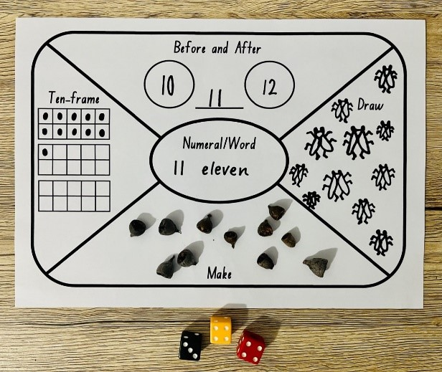
- For Stage 1 students, use Resource 7: Think board 2. Roll the 3 dice and create a three-digit number. Model making the number using MAB materials and draw the place value.
- Provide time to play ‘feed the frog’ independently.
This table details assessment opportunities and differentiation ideas.
Assessment opportunities | Too hard? | Too easy?
What to look for:  - Can students visually represent numbers in a variety of ways? (MAO-WM-01, MAE-RWN-01, MA1-RWN-02)  What to collect:  - observations of students composing visual representations of numbers. (MAO-WM-01, MAE-RWN-01, MA1-RWN-02) | Students are unable to visually represent numbers in a variety of ways.  - Model counting dice dot patterns using one-to-one correspondence.  - Use less dice to create small numbers. | Students are able to visually represent numbers in a variety of ways.  - Roll additional dice to represent larger numbers.  - Work in pairs and compare numbers to play ‘Highest number wins’.

A square – 30 minutes
- Ask students to identify squares in the classroom, school or playground. Discuss the features of a square including equal sides and 4 vertices.
Note: To develop a robust concept of shapes it is important that students encounter shapes in different orientations and sizes, represented in a variety of ways.
- Students turn and talk to discuss how they could make a square.
- Watch How to make a square (2:04).
- Ask students:
- What do you notice?
- What do you wonder?
- How did the person ensure the square had equal sides?
- Ask students to use paper and a pair of scissors to make their own square.
- When students have completed their squares, explain that we are going to measure the area of our squares.
- Encourage students to predict and then complete a ‘square hunt’ in the classroom and find:
- a square of different area where it fits inside the boundary of their paper square
- a different shape whose boundary fits inside their paper square
- a shape that has the same area as their paper square.
Note: Ask students to use comparative language to describe the area.
- Discuss that there are 2 different strategies that students can use to compare area by placing one area on top of another. These are superimposing and superposing (see Figure 8).
Superimpose: The comparison of areas by placing one area on top of another.
Superpose: The comparison of areas by aligning the edges (or corners) of 2 areas when one is placed on top of the other.
Figure 8 – Comparing areas
- Display a box of both square and circular counters. Students arrange the counters to cover the area of the square’s surface.
- Students explain their strategy to cover the area. Allow time for students to explore covering the area.
The table below outlines stimulus prompts to generate conversation about the topic, along with anticipated responses from students.
Prompts | Anticipated student responses
- What did you notice?  - What do you need to remember when measuring area?  - What method will you use to ensure there are no gaps or overlaps?  - What do you estimate will be the most accurate unit to measure?  - How will you count your array?  - What would happen if we changed the counter to a sticky note? | - We need to cover the surface so there are no gaps or overlaps  - I can make an array using rows and columns.  - The square counters will ensure no gaps.  - The most accurate unit will be the squares.  - I can use repeated groups. When I know how many are in one row, I can count how many groups and add them together.  - The sticky note is bigger so I won’t need as many.
- As a class, determine some rules around measuring a shape’s area with counters. Record responses on an anchor chart.
- Discuss when measuring a shape, students must repeatedly place units so that there are no gaps or overlaps. All units must be equal in size. To be accurate mathematicians, the objects used must tessellate to be suitable for measuring area.
Tessellate: to fit together without gaps or overlaps.
- Ask students to record the area of a rectangle using a grid structure. Ask:
- How many rows?
- How many columns
- How many squares are there altogether?
- Model and discuss how to form arrays of equal rows and equal columns. Count the number of rows and the number in each row to describe the arrays made on the rectangle.
- Ask students to describe how they could count the array efficiently by skip counting.
This table details assessment opportunities and differentiation ideas.
Assessment opportunities | Too hard? | Too easy?
What to look for:  - Can students use arrays of units to calculate the area? (MAO-WM-01, MA1-2DS-02)  What to collect:  - observation of student manipulation of counters and record of grid structure in workbooks (MAO-WM-01, MA1-2DS-02). | Students are unable to use arrays of units to calculate the area.  - Students complete filling in the array and count the number of counters used to cover the area.  - Students count the number of counters in a prefilled array. | Students are able to use arrays of units to calculate the area.  - Use only one square to calculate the number of counters needed in the array.  - Students draw the array structure.

Consolidation and meaningful practice: Order area – 15 minutes
- In groups of 4, students choose 5 shapes from the classroom and calculate their area. Ask students to look at the surfaces and order from largest to smallest.
- Early Stage 1 students can check their predictions by superimposing shapes.
- Stage 1 students can check their predictions by using units of measure in arrays.
Note: Early Stage 1 students should use regular shapes such as squares and rectangles of different size and orientation. Stage 1 students should be challenged to find shapes close in size.

Lesson 6: How many floors?
Core concept: Collections of objects can look different but have the same quantity.
The table below contains suggested learning intentions and success criteria. These are best co-constructed with students.
Learning intentions | Success criteria
All students are learning that:  - collections can be grouped and organised  - volume is the measurement of three-dimensional space. | All students can:  - group and share large collections  - use three-dimensional blocks to make a building.  In addition, students working towards Early Stage 1 outcomes can form equal groups distributing items one at a time into set number of groups.  In addition, students working towards Stage 1 outcomes can create arrays with blocks consisting of 5 blocks in each row.

Daily number sense: Sixty second challenge – 20 minutes
This lesson has been adapted from the Place value with two-digit numbers: Session One from nzmaths.
- Build student understanding of representing whole numbers by counting and representing large collections of objects by grouping.
- Ask students to form a pair. Provide each pair with a collection of objects and a 10-sided dice. Set a timer for one minute.
- Partner 1 rolls a 10-sided dice, and the other partner takes that many objects and adds them to their collection. Repeat until the timer goes off.
Note: Early Stage 1 students can adapt this task using a 6-sided die and counting to 30.
- Ask students to estimate and then count how many objects they have collected in total.
- Create a number line by placing a skipping rope, chalk or line of masking tape more than 1 metre long, on the floor and label the ends 0 and 100, or 200 if needed (see Figure 9).
- Prompt students to arrange their objects into groups of tens or hundreds (where possible) to make counting more efficient. Students record their total on a sticky note.
- Ask students, one pair at a time, to place their sticky note with their score on the line where they think it belongs. Discuss the placement in terms of proximity to benchmarks like 50, 75, 25, and so on. After 5 numbers are placed, ask the remaining groups to put their score where they think they belong.
Figure 9 – Numbers on a number line
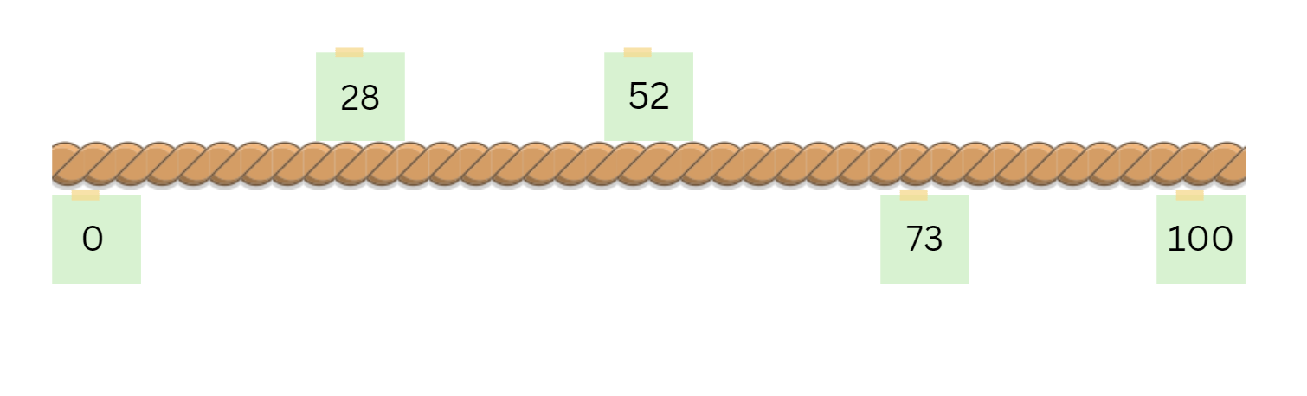
Images sourced from Canva and used in accordance with the Canva Content License Agreement.
This table details assessment opportunities and differentiation ideas.
Assessment opportunities | Too hard? | Too easy?
What to look for:  - Are students arranging collection of objects into groups of tens or hundreds? (MAO-WM-01, MAE-RWN-01, MA1-RWN-01)  - Are students able to place their scores on the correct spot on the skipping rope? (MAO-WM-01, MA1-WM-02)  What to collect:  - anecdotal observation records while students are playing Sixty second challenge. (MAO-WM-01, MAE-RWN-01, MA1-RWN-01, MA1-RWN-02) | Students are unable to arrange a large collection of objects into groups.  - Students roll a 6-sided dice to reduce the number of objects collected each time.  - Reduce time to collect objects to 30 seconds. | Students are able to arrange a large collection of objects into groups:  - Bundle craft sticks into groups of tens or use 10 MAB blocks.  - Students roll a 20-sided or 30-sided dice to increase the number of objects collected each time.  - Extend time to collect objects to 2 minutes.

How many floors – 30 minutes
This activity has been adapted from Hidden objects from Maths Curriculum Companion.
- As a class, view Resource 8: Arrays. Explain that an array is made by arranging a set of objects such as counters in columns and rows. Columns and rows must have the same number or equal number of items in them.
- Ask students if they can see any arrays in the classroom. Model by counting the equal rows and columns. Ask the students where they can find more arrays.
- For Early Stage 1 students, model using groups to discuss the array and find the total. For example, in the egg carton there is one group of 6 in the first row and the second row makes 2 equal groups of 6. Two groups of 6 makes 12 eggs altogether. Students use counters to create groups and find the total.
- Repeat with other examples of arrays found in the classroom.
Array: An array is an arrangement that can be used to model multiplicative situations involving whole numbers.
- Model rolling 2 dice or use the number spinner.
- Write the number sentence on the board.
- Ask students to use square counters to create the array. Encourage Early Stage 1 students to make equal groups of counters by dealing one counter at a time.
- Display Resource 9: Floors in the building and tell them that a building has 5 rooms on each floor. Tell them that each row in the array represents a floor in the building. Ask the following questions:
- How many rooms does the building have if there are 5 floors?
- How many rooms does the building have if there are 10 floors?
- How many floors are in the building if there are 30 rooms? How would you work this out?
Note: Resource 9: Floors in the building only has 3 floors so the students can see the 3 ‘floors’ and the 5 ‘rooms’ but not the remaining floors. This task is designed to encourage students to count by fives rather than by ones since many students find this achievable.
- Explain that students are going to build each floor with blocks. Build an array from blocks made up of 3 rows, with each row containing 5 blocks and show students (see Figure 10). Prompt discussion about the difference between using tiles and blocks to build the floors and work out the answer.
Note: Early Stage 1 can complete this task by forming equal groups of 5 blocks. Students can then record their grouping and sharing using drawings, words and numerals. Students only complete one problem.
Figure 10 – Floors in a building
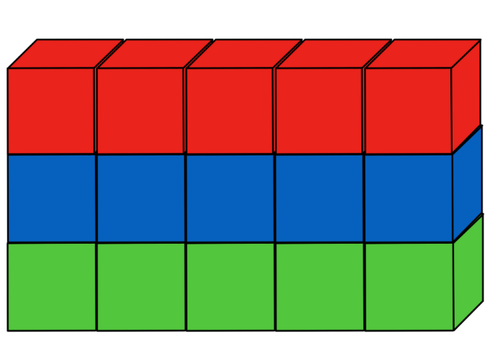
The table below outlines stimulus prompts to generate conversation about the topic, along with anticipated responses from students.
Prompts | Anticipated student responses
- What is the difference between the model in the picture (Resource 9) and the model that I just built from the blocks?  - What is the difference between tiles and blocks?  - What do we call objects that are flat and objects that are not?  - What other differences are there between 2D shapes and 3D objects?  - How can you count the number of blocks used if you’re not counting every block one by one? | - The model in the picture (Resource 9) is made from square counters and the model you built is made from blocks.  - Tiles are flat and blocks are not.  - The objects that are flat are called 2D shapes and the objects that are not flat are called 3D objects.  - 2D shapes have sides and vertices, 3D shapes have faces, edges and vertices.  - We measure 2D shapes using area and 3D shapes using volume.  - Because each floor has 5 rooms in it you can count by fives.
- Working in pairs, students are given a set of blocks to make a building with 5 floors and 10 floors and work out how many blocks they used for each. They must also work out how many floors they would require for a building of 30 rooms.
- Early Stage 1 students only make a building with 5 floors.
- Discuss that each row must have an equal number of blocks. Support Early Stage 1 students to recognise the equal rows.
- Before students begin, they must estimate how many blocks they will need to make both buildings and record this in their workbooks.
- After making their buildings and working out how many blocks are needed for each building, students record this next to their estimations. They also need to draw a picture of each of their buildings along with their working out.
The table below details assessment opportunities and differentiation ideas.
Assessment opportunities | Too hard? | Too easy?
What to look for:  - Are students able to estimate how many blocks they need to make their buildings? (MAO-WM-01, MAE-RWN-01, MA1-RWN-02)  - Are students able to build the structure of rows and columns with the correct number of rooms and floors? (MAO-WM-01, MAE-FG-02, MA1-FG-01, MA1-2DS-02)  What to collect:  - workbooks and photos of their buildings. (MAO-WM-01, MAE-FG-02, MA1-FG-01, MA1-2DS-02, MA1-RWN-02) | Students are unable to make their buildings with the correct number of rows and columns:  - Use fewer floors and rooms to begin with and increase the number once students become more confident.  - Draw the structure of rows and arrays for the students and ask what they notice.  Students cannot count by fives and are still using count-by-one strategy.  - Provide students with a ten-frame and remind them that each row in a ten-frame holds a total of 5.  - Give students counters and get them to bundle them into groups of 5 to making counting easier. | Students are able to make their buildings with the correct number of rows and columns:  - Ask how many floors you would have if you made a building with 37 rooms. Students need to explain their thinking and notice that there will be a remainder.  - Students make their own problems using a different number of rooms per floor and a different number of floors.

Consolidation and meaningful practice: How many prisms? – 15 minutes
- Using the blocks that the students have used to make their buildings, students will make as many different rectangular prisms as they can.
- Each student is given a fixed number of blocks. A workable number of blocks would be 24 for Stage 1, 12 for Early Stage 1.
- With every rectangular prism students make, they must also find the volume. Remind students that by counting the number of blocks used, they are finding the volume of that prism. Ask students:
- How many different rectangular prisms can you make?
- What is the volume of each prism that you make?
- Students make as many prisms as they can using their blocks. They will notice that all prisms have the same number of blocks, therefore the same volume.
- Discuss and connect the mathematics by bringing attention to the fact that objects can look different but still have the same internal volume.

Lesson 7: Filling it up – Part 1
Core concept: Objects can look different but have the same internal volume.
The table below contains suggested learning intentions and success criteria. These are best co-constructed with students.
Learning intentions | Success criteria
All students are learning that:  - internal volumes can be compared by filling and pouring  - mathematicians can accurately measure volume by filling to the brim and ensuring there are no gaps. | All students can measure how much a container will hold by counting the number of times a smaller container can be filled and emptied into the larger container being measured.  In addition, students working towards Early Stage 1 outcomes can use the terms, full, empty, and about half full when measuring.  In addition, students working towards Stage 1 outcomes can pick the correct units of measure so there are no gaps.

Daily number sense – 10 minutes
- From a class need surfaced through formative assessment data, identify a short, focused activity that targets students’ knowledge, understanding and skills. Example activities may be drawn from the following resources:
- Thinking Mathematically Stage 1
- Universal Resources Hub.

Filling up bottles: Part 1 – 40 minutes
This activity has been adapted from Bottles (1) from NRICH.
- Explain that students are going to investigate how much a large container holds by pouring liquid from a smaller container. They will be counting the number of times they pour the smaller container into the larger one to fill it.
- Remind students that they need to know what is being measured.
- Remind students that volume is the amount of space occupied by an object. Internal volume refers to the amount a container can hold and is only used in relation to containers.
- Show students a row of containers of varying sizes and shapes (see Figure 11). Ask students what they think these containers are used for and what informal units they could use to fill them up without leaving any spaces. Students use ‘Talk moves’ with a partner, sharing ideas and recording possible solutions on a mini whiteboard.
Figure 11 – Different sized bottles
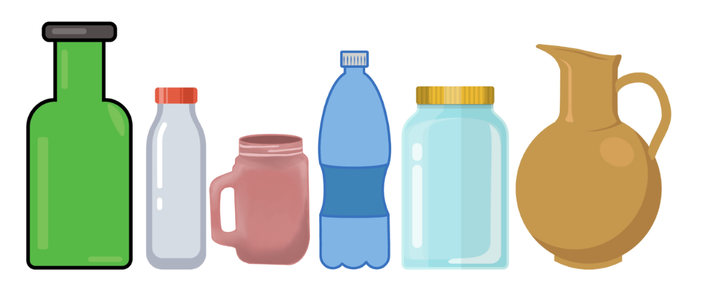
Images sourced from Canva and used in accordance with the Canva Content License Agreement.
- Once all the possible informal units have been discussed with the class, decide on the best one to use. Examples of informal units include liquids, rice, salt, sugar or anything else that can fill the containers without leaving any gaps.
- Remind students that, to be accurate, they must ensure containers are filled to the brim. Ask students what they can do to ensure an accurate measurement.
- Explain to students that they will be using water as their informal unit; however, in the following lesson, Lesson 8, their suggestion will be used.
- Label the containers from left to right using the letters A through to F. Ask students the following questions to initiate a discussion.
The table below outlines stimulus prompts to generate conversation about the topic, along with anticipated responses from students.
Prompts | Anticipated student responses
- Which container do you think will hold the most water? How do you know?  - Which container do you think will hold the least amount of water? How do you know?  - How many Bs do you think it would take to fill up A?  - How many Cs do you think it would take to fill up D? | - I think A will hold the most water because it is the biggest container.  - I think B will hold the least amount of water because it is the smallest container.  - I think it would take 3 Bs to fill up A because A looks like it is around 3 times bigger than B.  - I think it would take 2 Cs to fill up D because D looks like it is around 2 times bigger than C.
- Remind students about the importance of estimation when investigating measurement. Tell students that estimation helps to focus on the attribute being measured (volume). The measurement process develops familiarity with the units.
- For this activity students work in pairs. Provide each pair with 4 different sized containers labelled A, B, C and D, making sure that containers B and C are smaller than A and D.
- Ask students to estimate how many Bs it would take to fill up A and how many Cs it would take to fill up D. Students record their estimations in their workbooks.
- Students then count the number of times they poured B into A until it is filled. They repeat the activity by counting how many times C is poured into D until it is filled.
- Once students have completed the activity, have them record their answers in their workbooks and check against their estimations. Have students draw a picture in their workbooks of the activity.
The table below details assessment opportunities and differentiation ideas.
Assessment opportunities | Too hard? | Too easy?
What to look for:  - Can students measure how much a container will hold by counting the number of times a smaller container can be filled and emptied into the container being measured? (MAO-WM-01)  - Can students pick the correct material to be measured so there are no gaps? (MAO-WM-01, MAE-3DS-02, MA1-3DS-01, MA1-3DS-02)  What to collect:  - workbooks containing estimations, answers and pictures of the activity. (MAO-WM-01, MAE-3DS-02, MA1-3DS-01, MA1-3DS-02) | Students cannot measure how much a container will hold.  - Model filling up different sized containers with one informal unit of measurement like a cup.  - Have students count out loud the number of cups needed to fill large containers while doing this.  Students cannot pick the correct material to be measured so there are no gaps.  - Model filling up a bottle with marbles and point out the gaps. Explain that this would not be an accurate way to measure volume because of these gaps.  - Model filling up the same container with salt/water and point out that there aren’t any gaps in the bottle. Explain that this would be a better choice because it provides a more accurate measurement of volume. | Students can measure how much a container will hold.  - Students create their own problems and get their peers to solve. For example, how many Hs would it take to fill up G?  - Ask students how many containers it would take to fill up half or a quarter of another container.  Students can pick correct material to be measured so there are no gaps.  - Compare, order and record the internal volumes (capacities) of 2 or more containers by measuring each container in uniform informal units.  - Ask students to explain their reasoning for ordering the containers this way.

Consolidation and meaningful practice: Estimation challenges – 10 minutes
- Summarise the lesson together, drawing out some key mathematical ideas about estimation and volume with students. Ask students:
- How did you visualise your estimation?
- Did your estimation come close to your measurement? Why or why not?
- Would you choose a different unit of measure if you were to do this again? Explain your reasons.
- Did you have any challenges measuring with your chosen unit? How did you solve these challenges?

Lesson 8: Filling it up – Part 2
Core concept: Mathematicians are precise and accurate when measuring internal volume.
The table below contains suggested learning intentions and success criteria. These are best co-constructed with students.
Learning intentions | Success criteria
All students are learning that:  - an estimate of how much a container will hold can be made before it is measured  - units help to describe the capacity of a container  - when filling up a container, the smaller unit of measurement is filled many more times than the larger one. | All students can:  - estimate how many cups and then how many mugs are needed to fill a container  - measure how much a container will hold by pouring or packing and stacking.  In addition, students working towards Early Stage 1 outcomes can fill and empty containers accurately.  In addition, students working towards Stage 1 outcomes can recognise that the cup needs to be filled up more times than the mug when filling up a container.

Daily number sense – 10 minutes
- From a class need surfaced through formative assessment data, identify a short, focused activity that targets students’ knowledge, understanding and skills. Example activities may be drawn from the following resources:
- Thinking Mathematically Stage 1
- Universal Resources Hub.

Filling up bottles: Part 2 – 25 minutes
This activity has been adapted from Bottles (2) from NRICH.
- Remind students that volume is the amount of space occupied by an object. Internal volume refers to the amount a container can hold and is only used in relation to containers. Therefore, to get an accurate result, students need to make sure that the material they are using does not allow for any gaps in the containers we are filling up.
- Display the containers that were used in Lesson 7. Explain that students will be repeating the activity of predicting and finding out how many small containers of water it would take to fill the larger containers. However, instead of using water, students will use a material of their choice.
Note: As discussed in Lesson 7, students were able to choose an appropriate material to fill up their containers. Examples of materials to be used include liquids, rice, salt, sugar or anything else that can fill the containers without leaving any gaps.
- For this activity students work in pairs. Provide each pair with 2 different sized containers, one small and one large, and have them estimate how many small containers of their material would be needed to fill up the large container. Have students record their estimations once again in their workbooks before they complete the activity.
- Once students have completed the activity, have them record their answers in their workbooks and check against their estimations. Have students draw a picture in their workbooks of the activity.

Changing the measure – 25 minutes
- In this activity students will be filling up a container using different measuring devices.
- Students will work in pairs. Give each pair a large container, a drinking cup, a mug and the material of choice (see Figure 12).
Figure 12 – A cup, mug and a jug
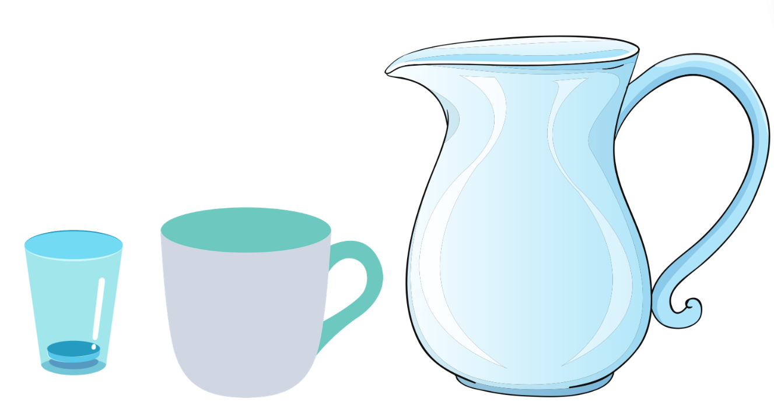
Images sourced from Canva and used in accordance with the Canva Content License Agreement.
- The first student will use the drinking cup to fill the container and the second student will use the mug to refill the same container.
Note: It is very important to remind students that when filling up their cup or mug they must fill it right to the top and level it out with their hand for accurate measuring.
- Initiate a class conversation by asking the following questions.
The table below outlines stimulus prompts to generate conversation about the topic, along with anticipated responses from students.
Prompts | Anticipated student responses
- Why are we using different objects to measure how much the container holds?  - Do you think there will be a difference in the number of times you fill up the drinking cup compared to the mug?  - Why do you think this is the case? | - Because they are different sizes, and they will give us different answers.  - Yes, I think we will need to fill up the drinking cup many more times compared to the mug.  - The mug is much bigger than the drinking cup and will fill the container up much faster than the drinking cup.
- Before beginning the activity, students need to estimate how many drinking cups will be needed to fill the container and how many mugs are needed to fill the same container. Have students record these estimations into their workbooks.
- Once students have completed the activity, they record their answers in their workbooks and check against their estimations.
This table details assessment opportunities and differentiation ideas.
Assessment opportunities | Too hard? | Too easy?
What to look for:  - Can students estimate how many drinking cups and then how many mugs are needed to fill a container? (MAO-WM-01, MAE-3DS-02, MA1-3DS-02)  - Can students recognise and explain the relationship between the size of a unit and the number of units needed? (MAO-WM-01, MAE-3DS-02, MA1-3DS-02)  What to collect:  - workbooks containing estimations, answers and pictures of the activity. (MAO-WM-01, MAE-3DS-02, MA1-3DS-02) | Students cannot estimate how many drinking cups and then how many mugs are needed to fill a container.  - Model filling up the container using both objects while students count out loud.  - Compare the number of times they filled the container using both objects.  Students cannot recognise and explain the relationship between the size of a unit and the number of units needed.  - Provide further experiences using continuous materials (water) and counting discrete objects (marbles) to fill the internal volume of containers.  - Construct prisms with the same number of units, but different sizes and make visual comparisons. | Students can estimate how many drinking cups and then how many mugs are needed to fill a container.  - Ask students to determine the number of informal units in a prism by referring to the number and type of unit used. For example, what is the volume of a prism 2 cubes high, 2 cubes wide and 4 cubes long?  - Explore communicating and reasoning about containers in which the internal volume of a closed container is slightly less than its volume.  Students can recognise and explain the relationship between the size of a unit and the number of units needed.  - Record the results by drawing and recording the comparison using the number and type of uniform unit used.  - Compare models with different appearance and reasons with spatial structures.

Consolidation and meaningful practice: Efficient measuring – 10 minutes
- Summarise the lesson together, drawing out some key mathematical ideas about volume with students. Ask students:
- What did you have to fill up the most times?
- Were your predictions correct?
- When filling up your container, would you rather use the drinking cup or the mug?

Resource 1: Number chart 1-120
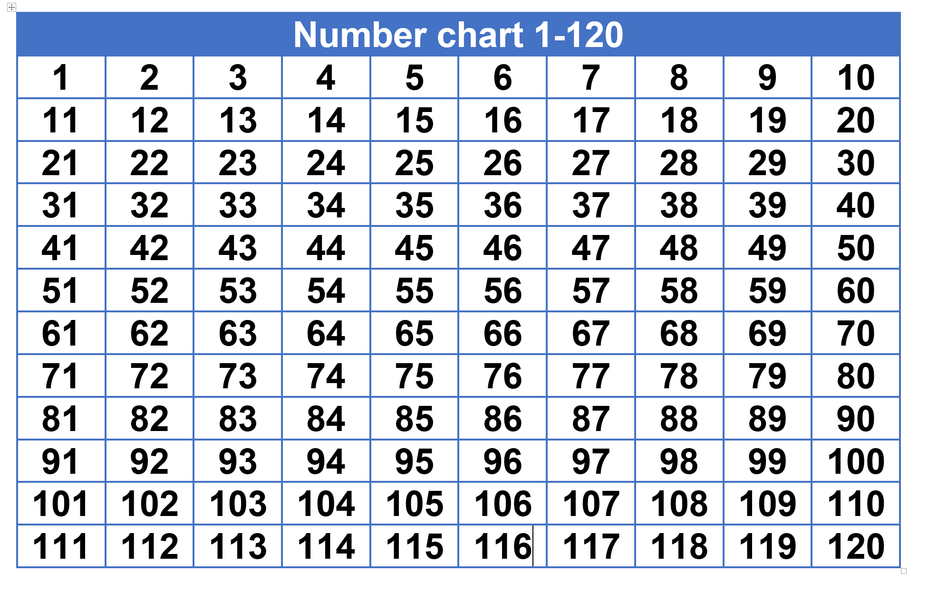

Resource 2: Circle template

Resource 3: About halfway
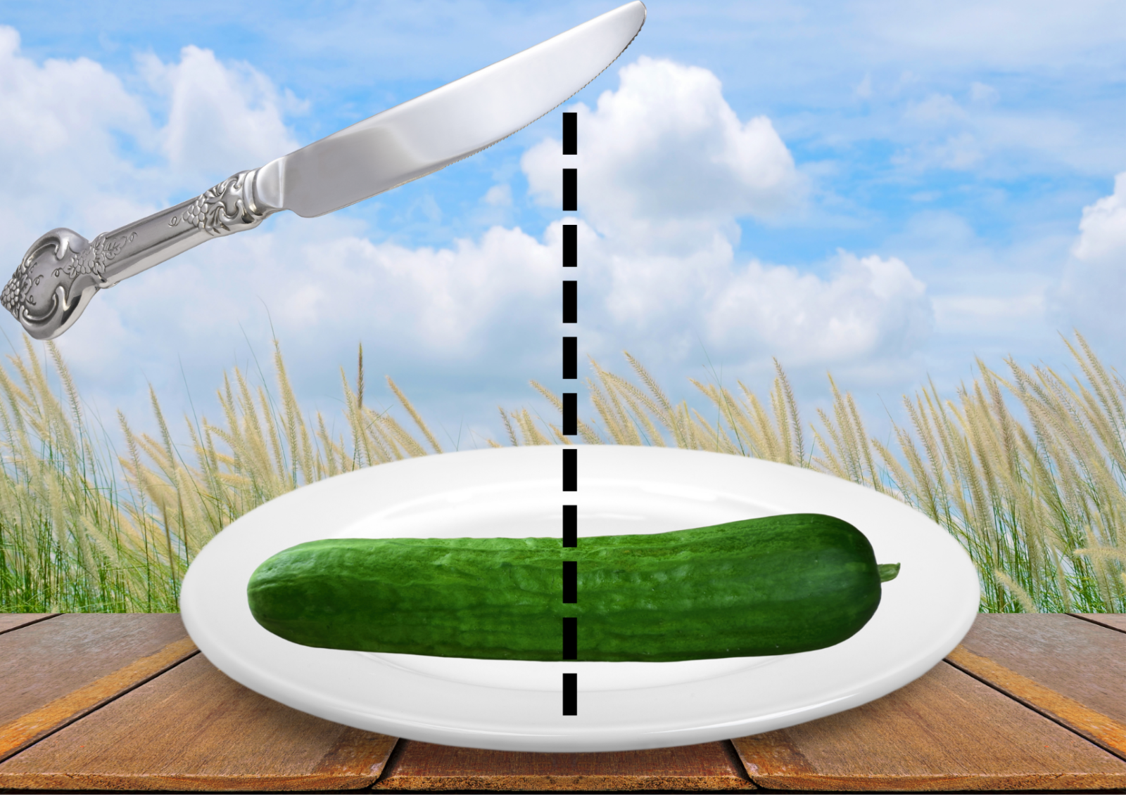
Images sourced from Canva and used in accordance with the Canva Content License Agreement.

Resource 4: More than halfway
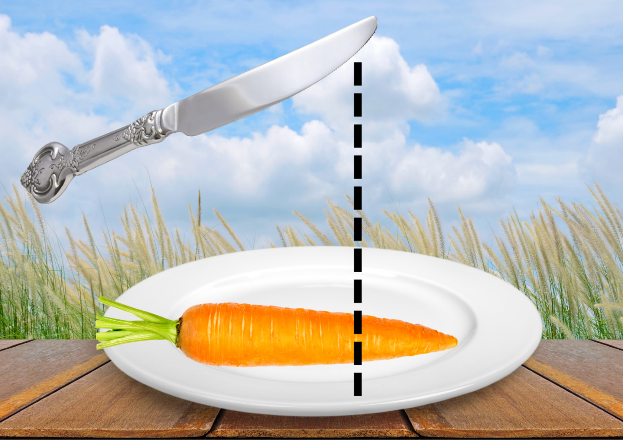
Images sourced from Canva and used in accordance with the Canva Content License Agreement.

Resource 5: Less than halfway
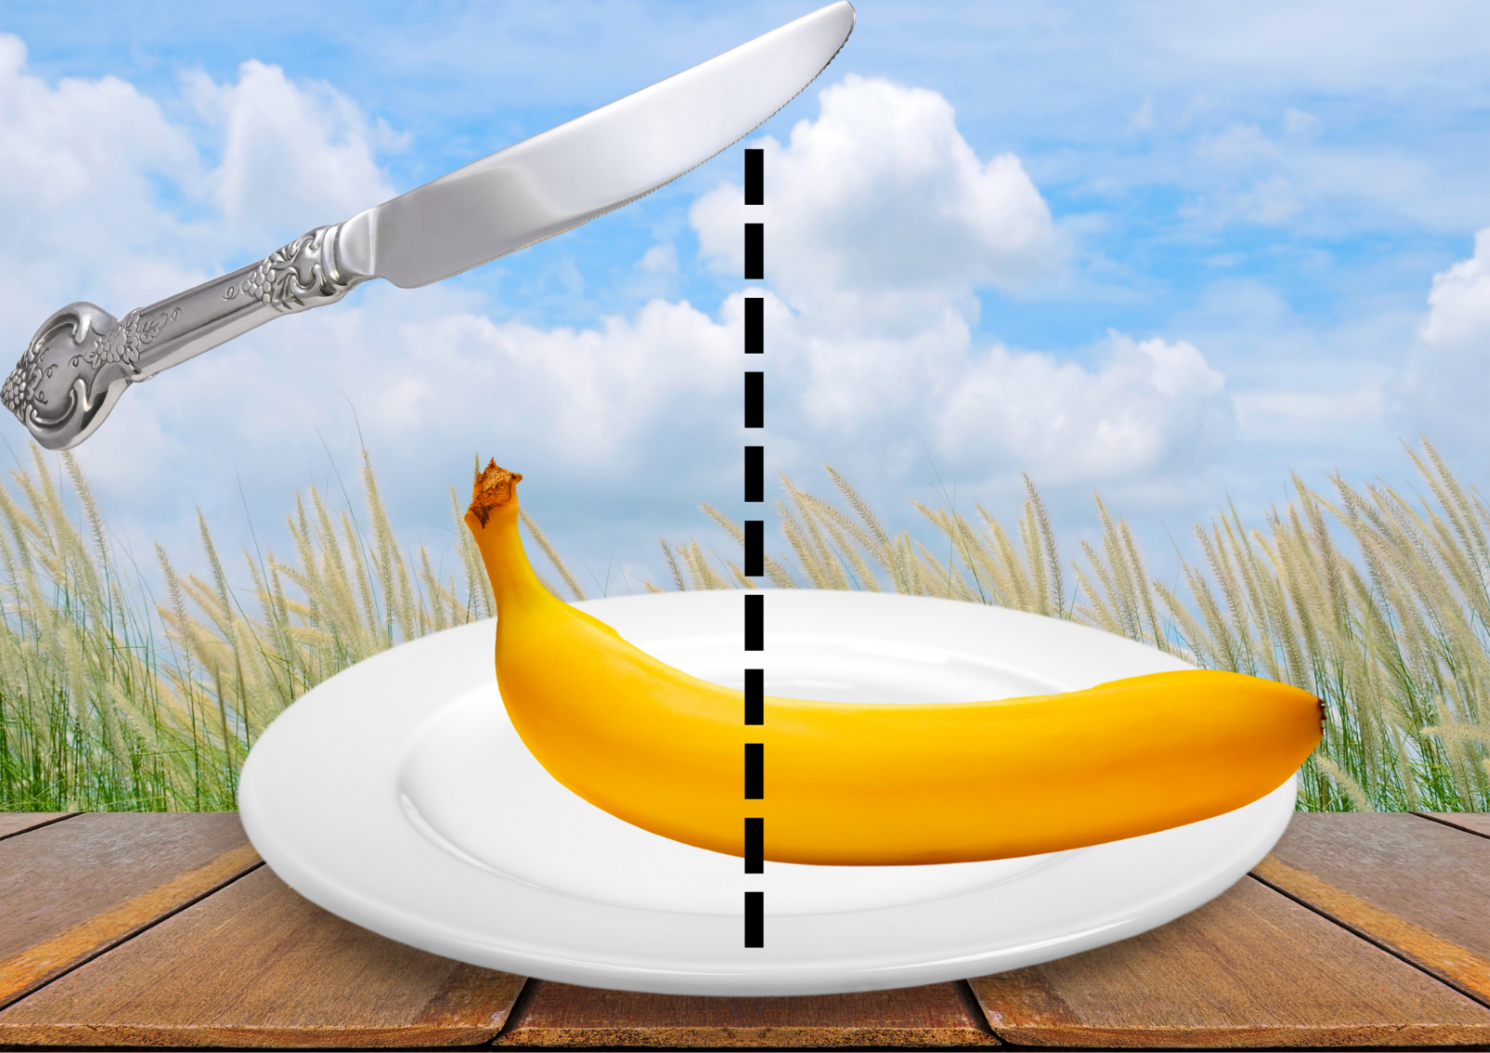
Images sourced from Canva and used in accordance with the Canva Content License Agreement.

Resource 6: Think board
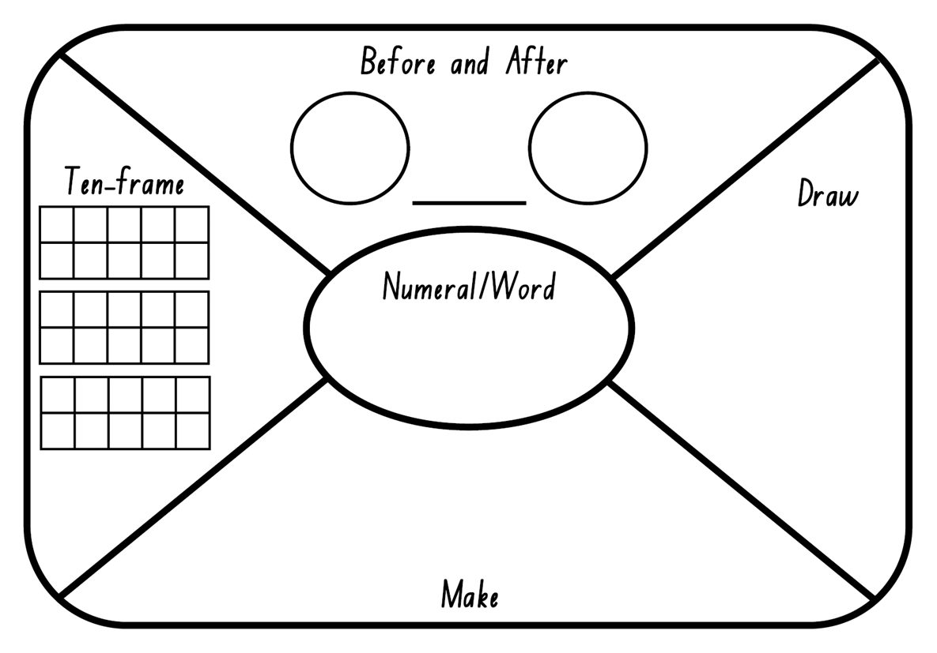

Resource 7: Think board 2
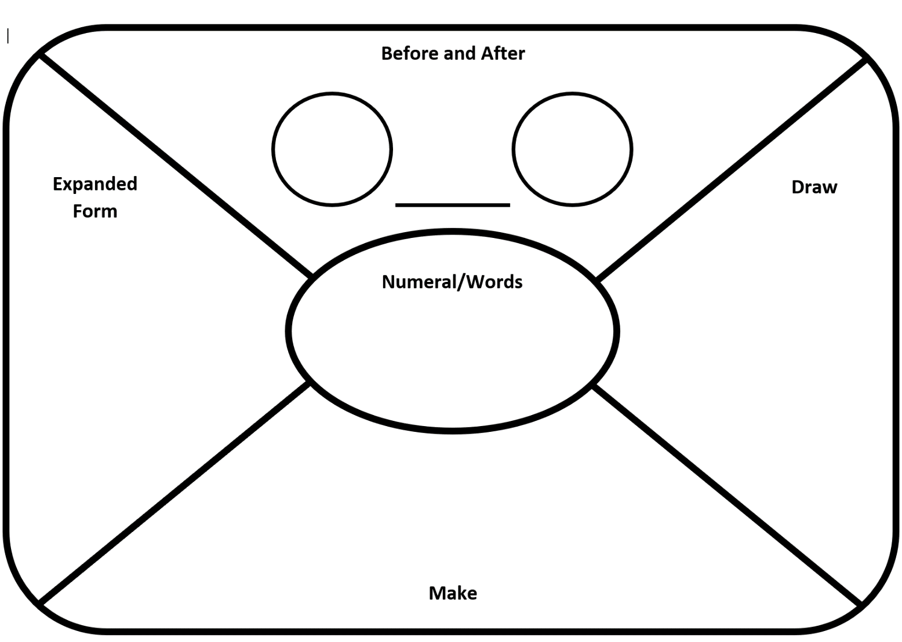

Resource 8: Arrays
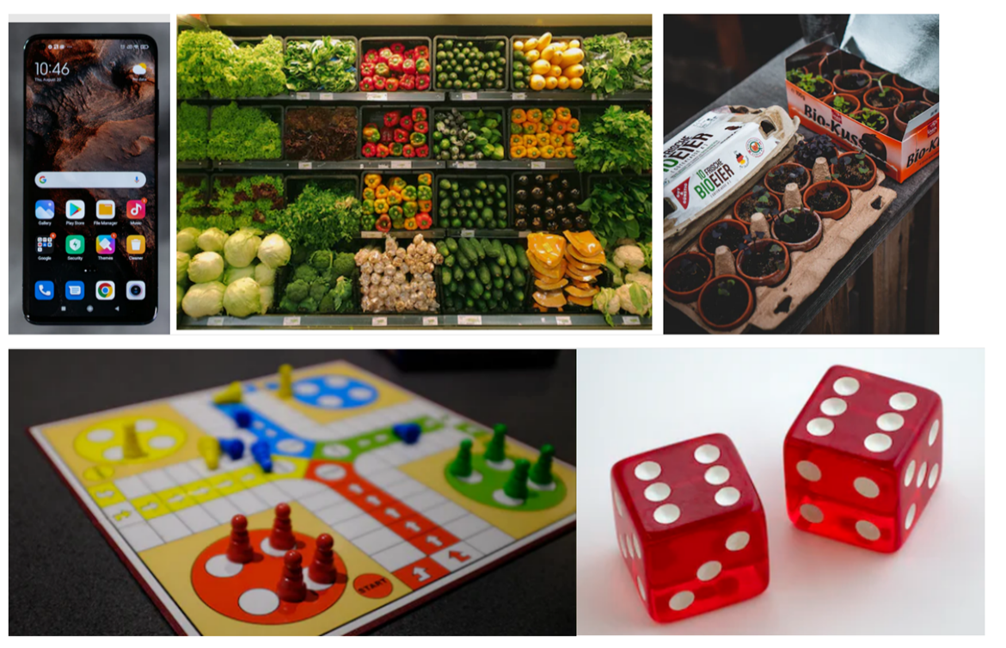
Images sourced from Unsplash and used in accordance with the Unsplash License.

Resource 9: Floors in the building
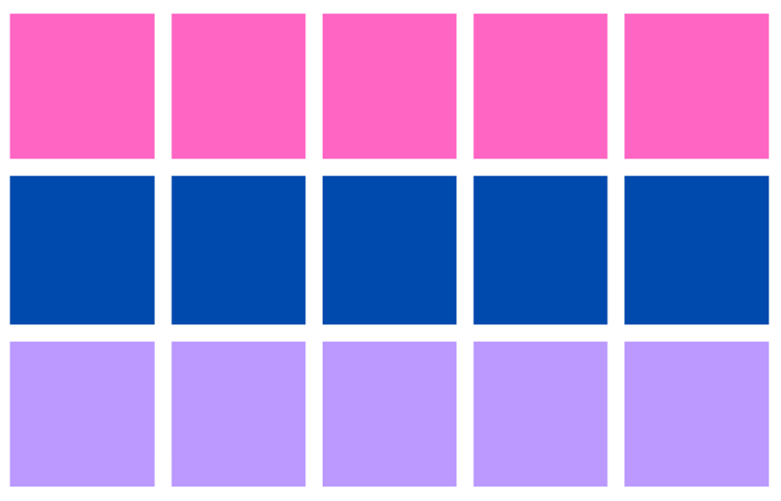

Syllabus outcomes and content
The table below outlines the syllabus outcomes and range of relevant syllabus content covered in this unit. Content is linked to National Numeracy Learning Progression version (3).
Focus area and outcomes | Content groups and content points | Lessons
Representing whole numbers  MAO-WM-01  MAE-RWN-01, MA1-RWN-01  MAE-RWN-02, MA1-RWN-02 | Early Stage 1  Instantly name the number of objects within small collections  - instantly recognise (subitise) the number of items in small groups of up to four items without counting (NPV1, CPr1)  - identify the number of items in different arrangements (CPr2)  Use the counting sequence of ones flexibly  - count forwards to at least 30 and state the number after or before a given number, without needing to count from one (CPr4)  - count backwards from a given number 20 or less (CPr5)  - identify the number before as 'one less' and the number after as 'one more’ than a given number  Recognise number patterns  - recognise dice and domino dot patterns (NPA1, NPV2, CPr2)  Connect counting and numerals to quantities  - count with one-to-one correspondence, recognising that the last number name represents the total number in the collection (CPr3, CPr5)  - count out a specified number of objects (from 5 to 20) from a larger collection, keeping track of the count (CPr4, CPr5)  - make correspondences between collections (Reasons about quantity)  - represent numbers as quantities to at least 20 using objects (such as fingers), number words and numerals (NPV2, NPV3, NPV4, CPr3) | 1, 2, 4–6
Representing whole numbers A (cont) | Stage 1  Use counting sequences of ones with two-digit numbers and beyond  - identify the number before and after a given two-digit number (CPr5)  - count forwards and backwards by ones from a given number to at least 120 (CPr6)  Continue and create number patterns  - count forwards and backwards by twos from any starting point (CPr6, CPr7, MuS2)  Represent numbers on a line  - sequence numbers and arrange them on a line by considering the order and size of those numbers (CPr5)  Represent the structure of groups of ten in whole numbers  - recognise that ten ones is the same as one ten (NPV2, NPV4)  - use 10 as a reference in forming numbers from 11 to 20 (CPr7)  - count large sets of objects by systematically grouping in tens (CPr7)  - partition two-digit numbers to show quantity values (NPV4)  - estimate, to the nearest ten, the number of objects in a collection and check by counting in groups of ten (Reasons about quantity) (CPr7, NPV6) | 1, 2, 4–6
Representing whole numbers B (cont) | Stage 1  Use counting sequences of ones and tens flexibly  - identify the number before and after a given three-digit number  - count forwards and backwards by tens, on and off the decade, with two- and three-digit numbers (CPr7)  Form, regroup, and rename three-digit numbers  - count and represent large sets of objects by systematically grouping in tens and hundreds (CPr7, NPV5)  - use models such as base 10 material and interlocking cubes to represent and explain grouping (CPr7)  - state the quantity value of digits in numbers of up to three digits (Reasons about quantity) (NPV5)  - use place value to partition and rename three-digit numbers in different ways (Reasons about relations) (NPV5)  - estimate, to the nearest hundred, the number of objects in a collection and check by grouping and counting (NPV6) | 1, 2, 4–6
Combining and separating quantities  MAO-WM-01  MAE-CSQ-01, MA1-CSQ-01  MAE-CSQ-02 | Early Stage 1  Model additive relations and compare quantities  - identify situations in which addition and subtraction may be applied (AdS1, AdS2)  - combine two or more groups of objects to model addition, identifying the relationship between the parts and the whole (AdS1, AdS2)  - use concrete materials or fingers to model and solve addition and subtraction questions, counting forwards or backwards by ones as necessary (AdS1, AdS2, NPV3)  Identify part–whole relationships in numbers up to 10  - create, model and recognise combinations for numbers up to ten (Reasons about relations) (AdS2)  - count by ones to find the total or difference (AdS2, AdS3) | 3, 6
Combining and separating quantities A (cont.)  NOTE – There is only one combining and separating quantities outcome for Stage 1. | Stage 1  Use advanced count-by-one strategies to solve addition and subtraction problems  - apply the terms ‘add’, ‘plus’, ‘equals’, ‘is equal to’, ‘is the same as’, ‘take away’, ‘minus’ and ‘the difference between’ to describe combining and separating quantities (AdS1, AdS6)  - fluently use advanced count-by-one strategies including counting on and counting back to solve addition and subtraction problems involving one- and two-digit numbers (Reasons about relations) (AdS3, AdS4, AdS5)  Recognise and recall number bonds up to 10  - recognise, recall and record combinations of two numbers that add up or bond to form 10 (AdS2, AdS6)  - model and record patterns for individual numbers up to ten by making all possible whole-number combinations (Reasons about patterns)  - create, recall and recognise combinations of two numbers that add up to numbers less than 10 (AdS2, AdS6) | 3, 6
Forming groups  MAO-WM-01  MAE-FG-01, MA1-FG-01  MAE-FG-02 | Early Stage 1  Copy, continue and create patterns  - copy and continue repeating patterns using sounds and/or actions (NPA1, NPA2)  - copy, continue and create repeating patterns using shapes, objects, images or pictures (Reasons about patterns) (NPA1, NPA2) | 1, 5
Forming groups A (cont)  NOTE – There is only one forming groups outcome for Stage 1. | Stage 1  Count in multiples using rhythmic and skip counting  - count by twos, threes, fives and tens using rhythmic counting and skip counting (MuS2, CPr6)  Recognise and represent division  - use concrete materials to model a half of a collection and show the relation between the half and the whole (InF1) | 1, 5, 6
Forming groups B (cont) | Stage 1  Represent and explain multiplication as the combining of equal groups  - use objects, diagrams, images or actions to model multiplication as accumulating equal groups (MuS4)  - solve multiplication problems using repeated addition (MuS4)  - form arrays of equal rows and equal columns (MuS5)  - determine and distinguish between the number of rows/columns and the number in each row/column when describing collections of objects (MuS5)  - model the commutative property of multiplication, using an array (Reasons about relations) (MuS6)  - model division by deconstructing an array equally into a given number of rows or columns  Model doubling and halving with fractions  - model doubling and halving groups and the relation between the processes  - re-create the whole given half  - use concrete materials to model a half, a quarter or an eighth of a collection, and explain their thinking | 1, 5, 6
Geometric measure  MAO-WM-01  MAE-GM-01, MA1-GM-01  MAE-GM-02, MA1-GM-02  MAE-GM-03, MA1-GM-03 | Early Stage 1  Length: Use direct and indirect comparisons to decide which is longer  - identify the attribute of 'length' as the measure of an object from end to end  - use comparative language to describe length (UuM2)  - compare lengths directly by placing objects side by side and aligning the ends (UuM2)  Length: Create half a length  - divide a length into two equal parts (Reasons about relations) (InF1)  - distinguish between the halfway point and half a length  - describe positions as 'about halfway', 'more than halfway' or 'less than halfway' (InF2) | 2, 4
Geometric measure A (cont) | Stage 1  Length: Measure the lengths of objects using uniform informal units  - use uniform informal units to measure lengths and distances by placing the units end to end without gaps or overlaps (UuM2)  - select appropriate uniform informal units to measure lengths and distances (UuM3)  - recognise and explain the relationship between the size of a unit and the number of units needed (Reasons about relations)  - count informal units to measure lengths or distances and describe the part left over (UuM4)  - record lengths and distances by referring to the number and type of unit used (UuM4)  - use a single informal unit repeatedly (iteratively) to measure length (UuM4)  Length: Compare lengths using uniform informal units  - compare the lengths of two or more objects using appropriate uniform informal units and check by placing the objects side by side and aligning the ends (UuM2, UuM3)  - estimate lengths, indicating the number and type of unit used and check by measuring (UuM3)  Length: Subdivide lengths to find halves and quarters  - use concrete materials to model both half and quarters of a whole length, highlighting the length (InF2)  - identify two equal parts and the relationship of the parts to the whole length, linking words and images (InF2)  - recognise when lengths have or have not been divided into halves and quarters (InF2) | 2, 4
Geometric measure B (cont) | Stage 1  Length: Compare and order lengths, using appropriate uniform informal units  - compare and order two or more shapes according to their lengths using an appropriate uniform informal unit  - compare the lengths of two or more objects that cannot be moved or aligned (Reasons about relations)  - record length comparisons using drawings, numerals and words, and by referring to the uniform informal unit used | 2, 4
Two-dimensional spatial structure  MAO-WM-01  MAE-2DS-01, MA1-2DS-01  MAE-2DS-02, MA1-2DS-02 | Early Stage 1  2D shapes: Represent shapes  - manipulate circles, squares, triangles and rectangles, and describe their features (UGP2, UGP3)  - make representations of shapes in a variety of ways, using paint, paper, movements or technology (UGP3)  - make pictures and designs using a selection of shapes  Area: Identify and compare area  - use comparative language to describe areas (UuM2)  - predict which of two surfaces will have the larger area and justify the answer (Reasons about spatial relations) | 1, 5
Two-dimensional spatial structure A (cont) | Stage 1  2D shapes: Transform shapes with slides and reflections  - recognise that sliding or reflecting a shape does not change its size or features (Reasons about spatial relations) (UGP2)  - identify and create a slide (translation) or reflection of a single shape and use the terms ‘slide’ (translation) and ‘reflection’ to describe the movement of the shape (UGP2)  Area: Measure areas using uniform informal units  - explore area using uniform informal units to cover the surface in rows or columns without gaps or overlaps (UuM5)  - measure area by selecting and using appropriate uniform informal units (Reasons about relations)  - explain the relationship between the size of a unit and the number of units needed to measure an area (Reasons about relations)  - identify any parts of units left over when counting uniform informal units to measure area  - estimate areas by referring to the number and type of uniform informal unit used and check by measuring (UuM3) | 1, 5
Two-dimensional spatial structure B (cont) | Stage 1  2D shapes: Identify and describe the orientation of shapes using quarter turns  - identify full, half and quarter turns of a single shape and describe the movement of the shape (UuM4)  - identify and describe directions of turns as ‘left turn’, ‘right turn’, ‘clockwise’ or ‘anti-clockwise’ (UuM4)  - connect the use of quarter and half turns to the turn of the minute hand on a clock for the passing of quarter and half-hours (Reasons about relations)  - perform full, half and quarter turns with a single shape  - describe the result of a turn of a shape  - determine the repeating pattern formed by quarter turns  Area: Compare rectangular areas using uniform square units of an appropriate size in rows and columns  - cover rectangular surfaces by creating repeated rows of square tiles (UuM5)  - use a single square to create the array structure of area in rows and columns (UuM5)  - use the structure of repeated units to find the area of a rectangle (UuM5)  - explain how the grid structure of rows and columns helps to find the area (Reasons about spatial structure)  - compare the areas of two or more surfaces that cannot be moved, or superimposed, by measuring in uniform informal units (UuM4)  - record comparisons of area using drawings, numerals and words, and by referring to the uniform informal unit used | 1, 5
Three-dimensional spatial structure  MAO-WM-01  MAE-3DS-01, MA1-3DS-01  MAE-3DS-02, MA1-3DS-02 | Early Stage 1  Volume: Compare internal volume by filling and packing  - fill and empty containers using materials such as water or sand  - use the terms ‘full’, ‘empty’ and ‘about half full’  - compare the internal volumes (capacities) of two containers directly by filling one and pouring into the other (UuM2)  - compare the internal volumes of two containers indirectly by pouring their contents into two other identical containers and observing the level reached in each (UuM3)  - establish that containers of different shapes may hold the same amount  - stack and pack blocks into defined spaces (UuM5)  Volume: Compare volume by building  - identify the attribute of volume as the amount of space an object or substance occupies  - compare the volumes of two objects made from blocks or connecting cubes directly by deconstructing one object and using its parts to construct a copy of the other object  - use comparative language to describe volume (UuM2) | 6–8
Three-dimensional spatial structure A (cont.) | Stage 1  Volume: Measure and compare the internal volumes (capacities) of containers by filling  - use uniform informal units to measure how much a container will hold by counting the number of times a smaller container can be filled and emptied into the container being measured (UuM3)  - select appropriate informal units to measure the capacities of containers  - recognise and explain the relationship between the size of a unit and the number of units needed (Reasons about relations)  - compare the internal volumes of two or more containers using appropriate uniform informal units (UuM3)  - recognise and explain why containers of different shapes may have the same internal volume (Reasons about relations)  - estimate how much a container holds by referring to the number and type of uniform informal unit used and check by measuring (UuM3, UuM4)  Volume: Measure the internal volume (capacity) of containers by packing  - pack cubic units (e.g. blocks) into rectangular containers so that there are no gaps  - recognise that cubes pack better than other objects in rectangular containers (Reasons about spatial structure)  - estimate and measure the internal volume of a container by filling the container with uniform informal units and counting the number of units used  - explain that if there are gaps when packing and stacking, this will affect the accuracy of measuring the internal volume  Volume: Construct volumes using cubes  - explore different rectangular prisms that can be made from a given number of cubes  - devise and explain strategies for stacking and counting units to form a rectangular prism (Reasons about spatial structure)  - record volumes, referring to the number and type of uniform informal unit used | 6–8
Three-dimensional spatial structure B (cont.) | Stage 1  Volume: Compare containers based on internal volume (capacity) by filling and packing  - make and use a device for measuring internal volume (capacity) calibrated in uniform informal units (UuM3, UuM4)  - compare, order and record the internal volumes (capacities) of two or more containers by measuring each container in uniform informal units (UuM3, UuM4)  - estimate internal volume (capacity) by referring to the number and type of uniform informal unit used (UuM3)  Volume: Compare volumes using uniform informal units  - estimate the volumes of two or more models and check by counting the number of blocks used in each model  - compare models with different appearances, recognising when they have the same volume (Reasons about spatial structure)  - record the results of volume comparisons using drawings, numerals and words, referring to the units used  - explain that models made of the same number of units may have different volumes depending on the size of the units used (Reasons about spatial relations) | 6–8
Non-spatial measure  MAO-WM-01  MAE-NSM-01, MA1-NSM-01  MAE-NSM-02, MA1-NSM-02 | Early Stage 1  Time: Compare and order the duration of events using the language of time  - use terms such as 'daytime', 'night-time', 'morning', 'afternoon', 'today', 'tomorrow', 'yesterday', 'before', 'after' and 'next' (MeT1)  - sequence events in time (MeT1)  - compare the duration of two events (MeT1)  Time: Tell time on the hour on analog and digital clocks  - create the layout of an analog clock (MeT2)  - read analog and digital clocks to the hour using the term ‘o'clock’ (MeT2, MeT3)  - describe the position of the hour and minute hands on an analog clock when reading hour time (MeT2) | 2, 3
Non-spatial measure A (cont.) | Stage 1  Time: Tell time to the half-hour  - read analog clocks to the half-hour using the terms ‘o'clock’ and ‘half past’ (MeT2)  - describe the position of the hands on a clock for the half-hour (MeT2)  - connect the use of half turns to the turn of the minute hand for the passing of the half-hour  - explain why the hour hand on a clock is halfway between successive hour-markers when the minute hand shows the half-hour (Reasons about relations)  - describe everyday events with particular hour and half-hour times  - record hour and half-hour time, making connections between analog and digital clock (MeT3) | 2, 3
Non-spatial measure B (cont.) | Stage 1  Time: Describe duration using units of time  - estimate and measure the duration of an event using a repeated informal unit (MeT1)  - compare and order the duration of events measured using a repeated informal unit (MeT1)  - use the terms ‘hour’, ‘minute’ and ‘second’ (MeT2, MeT3)  - compare the duration of standard time units (MeT2, MeT3)  - make predictions about the time remaining until a particular event starts or finishes (Reasons about relations)  Time: Tell time to the quarter-hour using the language of ‘past’ and ‘to’  - read analog clocks to the quarter-hour using the terms ‘past’ and ‘to’ (MeT2)  - describe the position of the hands on a clock for quarter past and quarter to and relate this to quarter turns  - identify which hour has just passed when the hour hand is not pointing to a numeral  - record quarter-past and quarter-to time on analog and digital clocks (MeT2)  - associate the numerals 3, 6 and 9 with 15, 30 and 45 minutes and with the terms ‘quarter past’, ‘half past’ and ‘quarter to', respectively | 2, 3

References
Links to third-party material and websites
Please note that the provided (reading/viewing material/list/links/texts) are a suggestion only and implies no endorsement, by the New South Wales Department of Education, of any author, publisher, or book title. School principals and teachers are best placed to assess the suitability of resources that would complement the curriculum and reflect the needs and interests of their students.
If you use the links provided in this document to access a third-party's website, you acknowledge that the terms of use, including licence terms set out on the third-party's website apply to the use which may be made of the materials on that third-party website or where permitted by the Copyright Act 1968 (Cth). The department accepts no responsibility for content on third-party websites.
Except as otherwise noted, all material is © State of New South Wales (Department of Education), 2021 and licensed under the Creative Commons Attribution 4.0 International License. All other material (third-party material) is used with permission or under licence. Where the copyright owner of third-party material has not licensed their material under a Creative Commons or similar licence, you should contact them directly for permission to reuse their material.
Mathematics K–10 Syllabus © 2022 NSW Education Standards Authority (NESA) for and on behalf of the Crown in right of the State of New South Wales.
© 2022 NSW Education Standards Authority. This document contains NSW Curriculum and syllabus content. The NSW Curriculum is developed by the NSW Education Standards Authority. This content is prepared by NESA for and on behalf of the Crown in right of the State of New South Wales. The material is protected by Crown copyright.
Please refer to the NESA Copyright Disclaimer for more information.
NESA holds the only official and up-to-date versions of the NSW Curriculum and syllabus documents. Please visit the NSW Education Standards Authority (NESA) website and the NSW Curriculum website.
National Numeracy Learning Progression © Australian Curriculum, Assessment and Reporting Authority (ACARA) 2010 to present, unless otherwise indicated. This material was downloaded from the Australian Curriculum website (National Literacy Learning Progression) (accessed 6 December 2022) and was not modified. The material is licensed under CC BY 4.0. Version updates are tracked in the ‘Curriculum version history’ section on the 'About the Australian Curriculum' page of the Australian Curriculum website.
ACARA does not endorse any product that uses the Australian Curriculum or make any representations as to the quality of such products. Any product that uses material published on this website should not be taken to be affiliated with ACARA or have the sponsorship or approval of ACARA. It is up to each person to make their own assessment of the product, taking into account matters including, but not limited to, the version number and the degree to which the materials align with the content descriptions and achievement standards (where relevant). Where there is a claim of alignment, it is important to check that the materials align with the content descriptions and achievement standards (endorsed by all education Ministers), not the elaborations (examples provided by ACARA).
ABC (Australian Broadcasting Corporation) (2022) Episode 7 Telling the Time [video], The Stickie Gang, ABC iview, accessed 5 December 2022.
Australian Government Department of Education, Skills and Employment (2022) 'Counting Large Collections', Teaching resources, re(Solve) website, accessed 6 December 2022
Barrett J (2022) Clock demonstrator, ICT Games website, accessed 5 December 2022.
Mathematical Association of Victoria (2020) F-2: Remote Maths (Edition 18) [PDF 528KB], Mathematical Association of Victoria, accessed 6 December 2022.
New Zealand Ministry of Education (n.d.) Place value with two-digit numbers: Session One, Resource, NZ Maths website, accessed 6 December 2022.
Robertson J (2017) Messy Maths: A Playful, Outdoor Approach to Early Years, Crown House Publishing, UK.
State of Victoria (Department of Education and Training), Hidden Objects, Maths Curriculum Companion, Department of Education and Training website, accessed 6 December 2022.
University of Cambridge (Faculty of Mathematics) (2022) Bottles (1), NRICH website, accessed 6 December 2022.
University of Cambridge (Faculty of Mathematics) (2022) Bottles (2), NRICH website, accessed 6 December 2022.
University of Cambridge (Faculty of Mathematics) (2022) Making Longer, Making Shorter, NRICH website, accessed 6 December 2022.

