Mathematics – K-2 multi-age – Year B – Unit 7
Contents
Unit description and duration 4
Student prior learning 4
Lesson overview and resources 6
Lesson 1: Superpowers! 18
Daily number sense: Odd or even? – 15 minutes 19
Superhero powers! – 30 minutes 22
Student superpowers! – 10 minutes 27
Consolidation and meaningful practice: Gallery walk – 15 minutes 29
Lesson 2: Vehicle superpowers! 30
Daily number sense: Number patterns – 10 minutes 30
Vehicle superpowers! – 50 minutes 33
Consolidation and meaningful practice: Thinking about categories – 5 minutes 36
Lesson 3: Environment superheroes! 36
Daily number sense: Teacher choice – 10 minutes 37
Tricky data: picture graphs – 10 minutes 38
What can rubbish tell us? – 50 minutes 38
Consolidation: How might the time of day affect data collection? – 5 minutes 42
Lesson 4: Australian animal superpowers! 43
Daily number sense: Find the next multiple of 10 – 10 minutes 44
Possum Magic Maths! – 25 minutes 46
Group investigations – 25 minutes 48
Consolidation and meaningful practice: Sequencing events for Hush the possum– 10 minutes 52
Lesson 5: Australian bird superpowers! 53
Daily number sense: Birds I saw at the zoo – 10 minutes 54
Birds around us – 40 minutes 55
Consolidation and meaningful practice: Tally charts – 15 minutes 58
Lesson 6: What’s the chance? Let’s investigate! 61
Daily number sense: Teacher choice – 10 minutes 62
Tricky data: animals on holiday – 10 minutes 62
What’s the chance? Birds around us (continued) – 10 minutes 63
What’s the chance? Investigate! – 35 minutes 64
Consolidation and meaningful practice: Connecting and discussing some of the mathematics – 5 minutes 67
Lesson 7: What's the chance? – Everyday events 68
Daily number sense: Highest and lowest – 25 minutes 69
Everyday events – 40 minutes 71
Consolidation and meaningful practice: Possible or impossible? – 5 minutes 76
Lesson 8: Data superpowers! 77
Daily number sense: The 10 tree – 15 minutes 78
Let’s investigate! – 45 minutes 79
Discuss and connect the mathematics – 5 minutes 82
Resource 1: Superpowers Venn diagram 83
Resource 2: Triple Venn diagram 84
Resource 3: Holiday bird graph 85
Resource 4: Number charts 86
Resource 5: Possum Magic animals 89
Resource 6: Possum Magic foods 90
Resource 7: Possum Magic places 91
Resource 8: An analog clock 92
Resource 9: A digital clock 93
Resource 10: Zoo birds tally 94
Resource 11: Zoo birds data display 95
Resource 12: Birds seen tally 96
Resource 13: Birds seen data collection 97
Resource 14: Favourite colours 98
Resource 15: Animals on holiday 99
Resource 16: Tally times 100
Resource 17: Digit cards 101
Syllabus outcomes and content 102
References 110

Unit description and duration
This two-week unit provides opportunities for students to develop their understanding of communicating data through visual displays. Students are provided with opportunities to:
- investigate topics of interest by choosing suitable questions and collecting relevant data
- select appropriate methods to display and interpret data
- use data to reason about possible outcomes in familiar activities
- explore the sequence of events
- read hour time on analog and digital clocks.
Mathematics K–10 Syllabus © 2022 NSW Education Standards Authority (NESA) for and on behalf of the Crown in right of the State of New South Wales.

Student prior learning
Before engaging in these teaching and learning activities, students would benefit from prior experience with:
- sorting and classifying concrete materials, including natural objects and two-dimensional and three-dimensional shapes
- arranging objects according to a characteristic to form a data display and using it to ask questions
- using comparative language in everyday discussions
- thinking about the chance of everyday events occurring
- sequencing steps to describe a simple, familiar event.

Lesson overview and resources
The table below outlines the sequence and approximate timing of lessons; syllabus focus areas and content groups; and resources.
Lesson | Syllabus focus area and content groups | Resources
Lesson 1: Superpowers!  70 minutes  Pictures and symbols can be used to classify and describe information. | Representing whole numbers  Early Stage 1  Recognise number patterns  Stage 1 – Part A  - Continue and create number patterns  Combining and separating quantities  Early Stage 1  - Model additive relations and compare quantities  Data  Early Stage 1  - Respond to questions, collect information and discuss possible outcomes of activities  - Organise objects into simple data displays and interpret the display  Stage 1 – Part A  - Ask questions and gather data  - Represent data with objects and drawings and describe the displays  Stage 1 – Part B  - Identify a question of interest and gather relevant data  - Create displays of data and interpret them | - Resource 1: Superpowers Venn diagram  - Resource 2: Triple Venn diagram  - 6-sided numeral and dotted dice  - Building blocks of different colours  - Chalk  - Coloured counters  - Hula hoops  - Writing materials
Lesson 2: Vehicle superpowers!  65 minutes  Data can be recorded in many ways. | Representing whole numbers  Early Stage 1  - Recognise number patterns  Stage 1 – Part A  - Continue and create number patterns  Data  Early Stage 1  - Respond to questions, collect information and discuss possible outcomes of activities  - Organise objects into simple data displays and interpret the display  Stage 1 – Part A  - Ask questions and gather data  - Represent data with objects and drawings and describe the displays  Stage 1 – Part B  - Identify a question of interest and gather relevant data  - Create displays of data and interpret them | - 40 mixed coloured building blocks per student  - Counters  - Digital device  - Writing materials
Lesson 3: Environment superheroes!  75 minutes  Data can be recorded in many ways. | Non-spatial measure  Early Stage 1  - Time: Compare and order the duration of events using the language of time  Data  Early Stage 1  - Respond to questions, collect information and discuss possible outcomes of activities  - Organise objects into simple data displays and interpret the display  Stage 1 – Part A  - Ask questions and gather data  - Represent data with objects and drawings and describe the displays  Stage 1 – Part B  - Identify a question of interest and gather relevant data | - Resource 3: Holiday bird graph  - Gloves and containers for rubbish  - Writing materials
Lesson 4: Australian animal superpowers!  70 minutes  Data can be recorded in different ways to organise and interpret information. | Representing whole numbers  Early Stage 1  - Connect counting and numerals to quantities  Stage 1 – Part B  - Use counting sequences of ones and tens flexibly  - Form, regroup and rename three-digit numbers  Non-spatial measure  Early Stage 1  - Time: Tell time on the hour on analog and digital clocks  Data  Early Stage 1  - Respond to questions, collect information and discuss possible outcomes of activities  - Organise objects into simple data displays and interpret the display  Stage 1 – Part A  - Ask questions and gather data  - Represent data with objects and drawings and describe the displays  Stage 1 – Part B  - Identify a question of interest and gather relevant data  - Create displays of data and interpret them | - Resource 4: Number charts  - Resource 5: Possum Magic animals  - Resource 6: Possum Magic foods  - Resource 7: Possum Magic places  - Resource 8: An analog clock  - Resource 9: A digital clock  - Fox M (2018) Possum Magic, (Vivas J, illus.), Omnibus Books, Australia, ISBN: 9781742763460  - 6-sided dice  - Craft sticks  - Interactive analog clock  - Model of a digital clock  - Number cards 1-12  - Number cards to 20  - Writing materials
Lesson 5: Australian bird superpowers!  65 minutes  Pictures and symbols can be used to classify and describe information. | Representing whole numbers  Early Stage 1  - Connect counting and numerals to quantities  Combining and separating quantities  Early Stage 1  - Model additive relations and compare quantities  Stage 1 – Part A  - Use advanced count-by-one strategies to solve addition and subtraction problems  Data  Early Stage 1  - Respond to questions, collect information and discuss possible outcomes of activities  - Organise objects into simple data displays and interpret the displays  Stage 1 – Part A  - Ask questions and gather data  - Represent data with objects and drawings and describe the displays  Stage 1 – Part B  - Identify a question of interest and gather relevant data  Chance  Stage 1 – Part A  - Identify and describe possible outcomes | - Resource 10: Zoo birds tally  - Resource 11: Zoo birds data display  - Resource 12: Birds seen tally  - Resource 13: Birds seen data collection  - Resource 14: Favourite colours  - Writing materials
Lesson 6: What’s the chance? Let’s investigate  70 minutes  Data can be used to predict the likelihood of events. | Non-spatial measure  Early Stage 1  - Time: Compare and order the duration of events using the language of time  Data  Early Stage 1  - Respond to questions, collect information and discuss possible outcomes of activities  - Organise objects into simple data displays and interpret the displays  Stage 1 – Part A  - Ask questions and gather data  - Represent data with objects and drawings and describe the displays  Stage 1 – Part B  - Identify a question of interest and gather relevant data  Chance  Stage 1 – Part A  - Identify and describe possible outcomes | - Resource 12: Birds seen tally  - Resource 13: Birds seen data collection  - Resource 15: Animals on holiday  - Resource 16: Tally times  - Writing materials
Lesson 7: What’s the chance? – Everyday events  70 minutes  Data can be used to predict the likelihood of events. | Representing whole numbers  Early Stage 1  - Connect counting and numerals to quantities  Stage 1 – Part B  - Use counting sequences of ones and tens flexibly  - Form, regroup, and rename three-digit numbers  Non-spatial measure  Early Stage 1  - Time: Compare and order the duration of events using the language of time  Chance  Stage 1 – Part A  - Identify and describe possible outcomes  Stage 1 – Part B  - Identify and describe activities that involve chance | - Resource 4: Number charts  - Resource 17: Digit cards  - Bag  - Writing materials
Lesson 8: Data superpowers!  65 minutes  The type of data determines the choice of display. | Representing whole numbers  Early Stage 1  - Connect counting and numerals to quantities  Stage 1 – Part B  - Use counting sequences of ones and tens flexibly  - Form, regroup, and rename three-digit numbers  Data  Early Stage 1  - Respond to questions, collect information and discuss possible outcomes of activities  - Organise objects into simple data displays and interpret the displays  Stage 1 – Part A  - Ask questions and gather data  - Represent data with objects and drawings and describe the displays  Stage 1 – Part B  - Identify a question of interest and gather relevant data | - Writing materials

Lesson 1: Superpowers!
Core concept: Pictures and symbols can be used to classify and describe information.
The table below contains suggested learning intentions and success criteria. These are best co-constructed with students.
Learning intentions | Success criteria
All students are learning that:  - there are different ways to classify and describe information  - pictures and symbols can represent data values  - recognisable arrangements of dots or objects assist with knowing how many without having to count. | All students can:  - use pictures and symbols to represent data  - recognise patterns of dots on dice.  In addition, students working towards Early Stage 1 outcomes can:  - create a pattern that repeats over and over and over again  - subitise dot patterns and identify the correct numeral to match  - combine 2 quantities of dot patterns and identify the total number of dots.  In addition, students working towards Stage 1 outcomes can:  - sort and describe information in a Venn diagram  - represent odd and even numbers with counters.

Daily number sense: Odd or even? – 15 minutes
- Model the following process to students:
- Roll 2 × 6-sided numeral dice and use them to represent a two-digit number. For example, a 2 and a 3 could make 32 or 23. Early Stage 1 students will use 2 × 6-sided dotted dice. Students are encouraged to subitise the dot patterns, combine the total and use counters to represent the quantity, such as in Figure 1.
Note: Exploring a collection of dots is important to develop students’ understanding that a quantity can be represented using simple symbols, numbers, drawings and words. Making meaning from seeing various representations provides the opportunity for students to recognise or subitise a quantity, identify which numeral is represented in the quantity and be able to combine the quantities to get a total.
Figure 1 – Stage 1 display 23 counters and Early Stage 1 display a combined total of 5 counters
- Ask Stage 1 students to state whether the number is odd or even.
- If it is even, add a counter and state what the number is now and whether it is odd or even.
- If it is odd, take a counter away and state what the number is now and whether it is odd or even.
- In pairs, students play the game.
- As a class, discuss what is the same about all the counter collections showing even numbers and then what is the same about all the counter collections showing odd numbers.
- Show Early Stage 1 students an arrangement of counters representing a quantity that is less than 5. Ask students to make another arrangement representing 5 using counters.
- Ask students to describe their arrangement and how they can easily see the quantity without counting from one. Use students' responses to annotate examples of arrangements for 5 on a poster. Provide time for students to explore other numbers such as 3 and 6. Ask students to explain how these arrangements are easily recognisable and add annotated responses and examples to the poster.
This table details assessment opportunities and differentiation ideas.
Assessment opportunities | Too hard? | Too easy?
What to look for:  - Can students subitise the number of dots on the dice and then represent the number using counters in an organised arrangement? (MAO-WM-01, MAE-RWN-01)  - Can students combine 2 quantities of dot patterns and identify the total? (MAE-CSQ-01)  - Can students recognise and state that some arrangements of numbers have one less in a row making the number odd? Can students then change it by adding a counter to make it an even number? (MAO-WM-01, MA1-RWN-01)  - Can students state the number is odd or even and then change it by adding or taking away a counter? (MA1-RWN-01)  What to collect:  - observations of pairing and describing odd and even numbers (MA1-RWN-01)  - observations of patterns and arrangements of counters which describe subitising (MAE-RWN-01) | Students are working towards representing the number because it is too big, or they do not understand how to pair counters.  - Repeat the process but with one 6-sided dotted or numbered dice.  - Use a ten-frame to assist with the arrangement of pairing.  - For Stage 1 students, repeat the process but students use the smallest throw for the tens value or throw a 4-sided dice.  - Model a number with paired counters, counting in twos together. | Students can work easily with numbers created by 6-sided dice.  - Repeat the process but students use 3 × 6-sided dice to make three-digit numbers. They can use MAB longs and flats to represent hundreds and tens. Then represent the odd or even number of ones with counters.  - Repeat the process but use 2 or 3 × 10-sided dice.

Superhero powers! – 30 minutes
This activity is adapted from Super Venn Hierarchical Classifier at Learning Trajectories.
- Explain that students are going to learn how to organise information. Ask students how they could organise their favourite superheroes into groups, for example, by main colour of clothes. Discuss student ideas. Explain to Stage 1 students that they are going to think about grouping superheroes by asking questions such as:
- Can the superhero fly?
- Does the superhero use special technology?
- Explain to Early Stage 1 students that they are going to think about grouping superheroes by asking questions such as:
- Can the superhero fly?
- Does the superhero wear a mask?
- Does the superhero have a cape?
- Is the superhero a ‘goodie’ or a ‘baddie?
Note: If you have any students in your class who do not know what a superhero is, show them some pictures of superheroes or read a book about them.
- Explain to Early Stage 1 students that they will be collecting information about superheroes from their classmates and will show this information in a picture graph.
- Explain that there is a process for collecting data and that some important decisions need to be made. Ask students to turn to a partner and Think-Pair-Share 3 qualities or characteristics that are interesting about superheroes. For example, they can fly, wear masks so they can’t be recognised, and some do bad things and others do good things. Students share their suggestions and as a class, they decide on 3 facts they would like to explore.
- Ask students to turn to another partner and Think-Pair-Share ideas for symbols or pictures that can be used in their picture graph to represent the information. For example, a symbol of superhero flying, a mask and a ‘goodie’ thumbs up (see Figure 2).
Figure 2 – Superhero picture graph
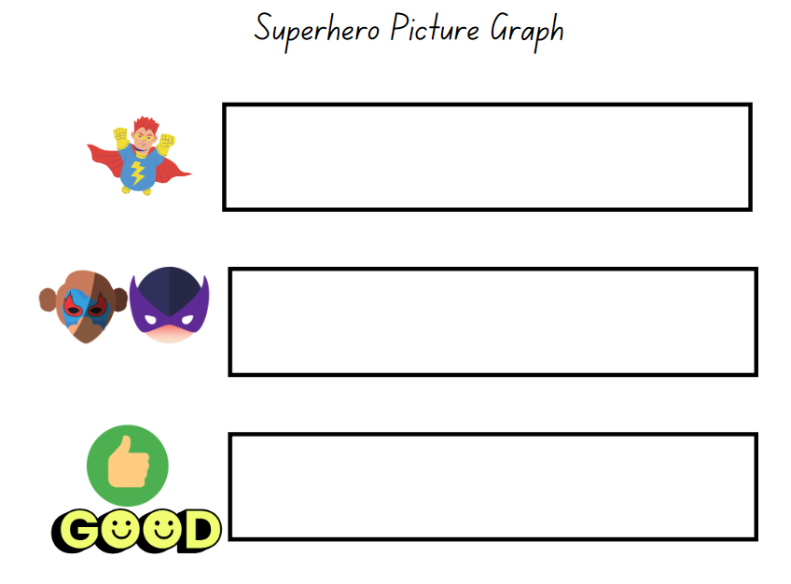
Images sourced from Canva and used in accordance with the Canva Content License Agreement.
- Using the 3 nominated qualities or characteristics that students have agreed on, ask students to suggest superheroes that belong to each, for example, can fly, wear a mask and are a ‘goodie’. On the board, write the names of the superheroes or use pictures or symbols to group them together.
- Ask students:
- Can you see how many superheroes can fly?
- Are there more superheroes that can fly or wear a mask?
- How many superheroes are ‘goodies’?
- Are there any qualities or characteristics that have the same amount?
- Provide pairs of students with writing materials to create a picture graph. Ask students to look at the results displayed on the board and, using symbols, pictures and/or words, complete the picture graph so that they can see how many superheroes were nominated by their classmates that can fly, wear masks and are ‘goodies’.
Note: Providing the opportunity for communication and sharing mathematical thinking builds mathematical confidence, problem-solving skills and encourages students to predict and take risks as they investigate to gain a deeper understanding.
- For Stage 1 students, have 5 different coloured counters ready to represent 5 superheroes.
- Explain to students that they will be grouping the selected superheroes into 2 circles. One circle is labelled ‘Can fly’ and the other circle is labelled ‘Uses special technology’.
- Ask students to think about a superhero with flying powers and in which circle would he/she go into. Place a counter in the correct circle. Next, ask students where a superhero with special technology powers would go and place a different coloured counter into the circle labelled ‘Uses special technology’. Next, ask student to think of a superhero that can fly and uses special technology.
- Explain that this superhero can do both so how can they show this by using the 2 circles. Ask students to turn and talk with a partner and discuss ideas for how they could combine the circles to display superheroes that have both superpowers.
- Show the students Resource 1: Superpowers Venn diagram. Explain that this diagram allows collected information to be organised in different ways showing that sometimes an object can be sorted in more than one way. Model moving the counter representing a superhero that can fly into the correct section on the Venn diagram. Then model moving the counter representing a superhero that uses special technology into the correct section on the Venn diagram.
- Explain that the centre section of the Venn diagram shows there is a superhero that belongs in both sections because they can fly and they use special technology (see Figure 3).
Figure 3 – Superpowers
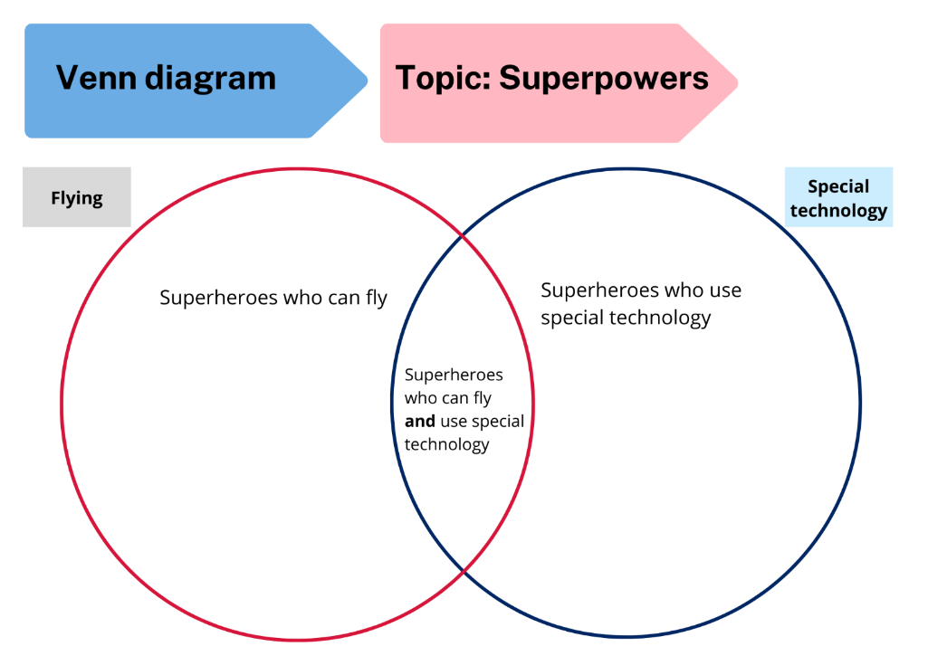
- Place counters for other student suggestions of superheroes that can fly, use special technology or have both superpowers on the Venn diagram.
Note: To teach this lesson in digital form, access Venn diagrams.
- Indicate sections of the Venn diagram and ask students questions to scaffold interpretation of data and use of comparative language:
- How many superheroes can fly?
- How many superheroes use special technology?
- How many superheroes have both superpowers?
- Which categories contain less than 3 superheroes?

Student superpowers! – 10 minutes
Note: Prior to this activity, draw a large two-circle Venn diagram outside with chalk. Label one circle ‘thinking’ and the other ‘talking’.
- Tell students that they are all maths superheroes and ask them to choose whether their biggest maths superpower is doing maths or talking about maths. Students choose a section of the diagram to stand in. If some students think their doing and talking superpowers are equal, explain that they can stand in the middle because that is the section for both superpowers.
- Ask students what other learning superpowers they have. This time, label the Venn diagram with ‘drawing’ and ‘writing’ and ask students where they would stand. Check if there is anyone who thinks they have superpowers in both drawing and writing and ask where they will stand. These students stand in the middle section.
This table details assessment opportunities and differentiation ideas.
Assessment opportunities | Too hard? | Too easy?
What to look for:  - Can students use symbols to represent data? (MAE-DATA-01, MA1-DATA-01)  - Can students use a picture graph to sort and describe information? (MAO-WM-01, MAE-DATA-01)  - Can students use a Venn diagram to sort and describe information, considering items that fit into more than one category? (MAO-WM-01, MA1-DATA-01, MA1-DATA-02)  - Are students able to justify their decisions and explain these using the correct mathematical vocabulary? (MAO-WM-01)  What to collect:  - work samples, including photographs of picture graphs and Venn diagrams from student investigations (MAO-WM-01, MAE-DATA-01, MA1-DATA-01, MA1-DATA-02) | Students are not confident with counting the collected results to make a picture graph.  - Using 3 pieces of paper label each with a superhero quality and lay the paper down. Ask students to identify each superhero and place a counter on the piece of paper which is most suitable.  - Calculate how many counters are on each paper and explain that this quantity will now be transferred onto the picture graph to show the results. For example, there are 4 superheroes that wear a mask, so draw 4 symbols of masks in the designated space.  Students do not understand how to use the part of the Venn diagram which includes all choices.  - Using a red and blue hula hoop ask students to choose whether they like a red or blue building block. Ask students to stand in the corresponding hula hoop.  - Now ask students who likes both red and blue building blocks. Explain that they need a section to show that they like both colours. Overlap the red and blue hoop so students can see that the colours overlap and ask the students to move into the middle section holding their red and blue building blocks. | Students understand how to use a two-circle Venn diagram.  - Students add a hula hoop and investigate a question with 3 possible answers. Use Resource 2: Triple Venn diagram to record answers.  - Repeat the process using 4 hula hoops and 4 possible answers.

Consolidation and meaningful practice: Gallery walk – 15 minutes
- Students do a gallery walk in pairs to look at the different investigations and make statements about the data collected.

Lesson 2: Vehicle superpowers!
Core concept: Data can be recorded in many ways.
The table below contains suggested learning intentions and success criteria. These are best co-constructed with students.
Learning intentions | Success criteria
All students are learning that:  - concrete materials can be used to create a data display  - data can be described and interpreted using comparative language  - a numeral track assists with the identification of a number that is one more than and/or one less than a given number. | All students can:  - use concrete materials to create a one-to-one data display  - create and answer questions about the data  - use comparative language to describe data  - name and identify a given number that is one more than or one less than.  In addition, students working towards Early Stage 1 outcomes can recognise and create different patterns for the same number.  In addition, students working towards Stage 1 outcomes can identify patterns in odd and even numeral tracks.

Daily number sense: Number patterns – 10 minutes
- Build student understanding of number patterns by identifying patterns in a numeral track.
- Write the numeral track 10, 12, 14, 16, 18, ?. For Early Stage 1 students write the numeral track 1, 2, ?.
- Ask Early Stage 1 students if they know what the next number in the sequence is after 2. Provide students with various opportunities to explore number patterns using a numeral track. Include both forward and backward number sequences and opportunities to investigate what would be one more than and one less than a given number. Students may work with a partner to identify a missing number in a simple number sequence on the numeral track.
- Ask Stage 1 students if they can see a pattern or any similarities between the numbers. Students share and justify ideas. Revise that they are all even numbers and model an example by using counters and pairing, as in the previous lesson.
- Fill in the gaps using a different colour and ask what comes next. Extend counting to match the ability of your Stage 1 students. Ask students if they know the special name for these numbers. Revise that they are odd numbers. Ask Stage 1 students why the numbers are odd and model an example by pairing counters, leaving one counter left unpaired at the end. In pairs, students use ‘Talk moves’ to identify and discuss patterns in the odd numbers. For example, odd numbers always end in 1, 3, 5, 7 or 9, or that odd numbers can never be made into 2 equal groups.
- As a further challenge for Stage 1 students, call out random two-digit and three-digit numbers. Students show a thumbs-up if the number is even and thumbs-down if it is odd.
This table details assessment opportunities and differentiation ideas.
Assessment opportunities | Too hard? | Too easy?
What to look for:  - Can students identify that there are missing numbers in the numeral track, and can they name the missing numbers and then count the sequence correctly? (MAO-WM-01, MAE-RWN-01)  - Can students identify the missing numbers as odd? (MA1-RWN-01)  - Can students describe patterns in a simple sequence and then continue the pattern stating what number would come next in the sequence? MAO-WM-01, MAE-RWN-01)  - Can students describe patterns in the odd numbers? (MAO-WM-01, MA1-RWN-01)  What to collect:  - observational data of students identifying and describing a variety of number patterns, including odd number patterns (MA1-RWN-01)  - observational data of students identifying and describing a number one more than and one less than on a numeral track (MAE-RWN-01) | Students are working towards identifying a pattern in a simple number sequence.  - Provide students with counters and samples of dot patterns that they can replicate. Discuss the repeated elements and ask students to identify what would come next in the pattern.  - Provide students with numbered cards and ask students to place the correct number card next to the corresponding dot pattern. Observe whether students are demonstrating an understanding that the dot patterns are also a number pattern.  Students are working towards finding odd and even larger numbers.  - Provide the numeral track 2, ? 4, ? 6, ? 8, ? 10, ? and have students find the missing odd numbers.  - Make each number with pairs of counters for the even number and add one more counter to each to represent the missing odd numbers. | Students work quickly with two-digit numbers.  - Students repeat the process with a three-digit numeral track.  - Students work with a partner and create a challenge of a numeral track that is counting backwards with either two-digit or three-digit numbers.  - Students roll 3 × 6-sided or 10-sided dice to find a three-digit number. Use this as the starting number for an odd or even numeral track.

Vehicle superpowers! – 50 minutes
- Explain to students that they are going to explore data by creating their own vehicle with superpowers from a pile of coloured building blocks. They can choose exactly 40 blocks from the pile to make it.
- Provide Early Stage 1 students with images or samples of simple cars made from coloured blocks for students to replicate or use as inspiration. Students complete their model and draw it or take a photograph.
- Ask students to predict which coloured blocks they have used the most and the least. Tell the students that they are going to check their predictions by taking their model apart to create a data display.
- Students categorise the coloured blocks (for example, by colour or number of dots) in a one-to-one data display and decide how they will record this, as in Figure 4.
Figure 4 – Superpower vehicle and data display
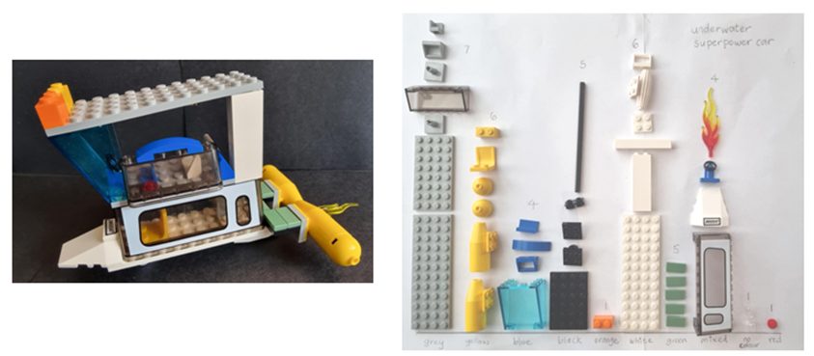
- Ask students:
- How did you organise your coloured block pieces? Did you choose colour or dots?
- Who can compare their data display with someone else? People who have used the same category to organise their data.
- Is there anyone you cannot compare your data with? For example, dot graphs cannot be compared with colour graphs.
- Students find a partner to compare their data with and ask:
- Which category has the most pieces?
- Which category has the least pieces?
- Were your predictions correct?
- Were there any coloured block pieces that did not fit into either category? How did you solve this problem?
This table details assessment opportunities and differentiation ideas.
Assessment opportunities | Too hard? | Too easy?
What to look for:  - Can students use concrete materials to create a simple one-to-one data display? (MAE-DATA-01, MA1-DATA-01)  - Can students create and answer questions about data? (MAE-DATA-01, MA1-DATA-02)  - Do students use comparative language to describe data? (MAE-DATA-01, MA1-DATA-02)  What to collect:  - work samples of data displays showing how students have chosen to categorise data (MAO-WM-01, MAE-DATA-01, MA1-DATA-01)  - observational data of students asking and answering questions using comparative language (MAO-WM-01, MA1-DATA-02) | Students are working towards building with 40 coloured blocks.  - Students use 20 coloured blocks to make the model individually.  - Students work in pairs to make a model using 40 pieces.  Students find it challenging to decide how to categorise their pieces.  - Provide students with ideas for how they could sort their coloured blocks, for example, by colour, or number of dots.  - Model one category as a column and then students complete. | Students organise all the coloured blocks quickly using colour or dots.  - Ask students what other categories could be used, for example, transparency.  - Students re-organise their data using 3 or more categories.  - Students consider which coloured blocks could now be placed in more than one category and how they will decide this.

Consolidation and meaningful practice: Thinking about categories – 5 minutes
- Discuss a data display that contains 3 or more categories, for example, colour, number of dots and transparency. Ask students if they would have chosen these categories or different categories and why.
- Ask students what other questions they have about the data.

Lesson 3: Environment superheroes!
Core concept: Data can be recorded in many ways.
The table below contains suggested learning intentions and success criteria. These are best co-constructed with students.
Learning intentions | Success criteria
All students are learning that:  - data can be used to investigate a topic of interest and solve problems  - consistent choice of categories enables interpretation. | All students can:  - select categories to organise and interpret data  - use data to identify and solve everyday problems.  In addition, students working towards Early Stage 1 outcomes can:  - collect and arrange objects in various groups of the same category  - ask and respond to questions about their data display  - describe when an event happens by using the words in the morning, after recess and after lunch  - explain if an event occurs before or after another event, such as recess happens before lunch time.  In addition, students working towards Stage 1 outcomes can:  - identify how many more to the next 10 from a given two-digit or three-digit number  - ask and respond to questions about their data display.

Daily number sense: Teacher choice – 10 minutes
- From a class need surfaced through formative assessment data, identify a short, focused activity that targets students’ knowledge, understanding and skills. Example activities may be drawn from the following resources:
- Thinking Mathematically Stage 1
- Universal Resources Hub.

Tricky data: picture graphs – 10 minutes
- Build student understanding of misleading data by exploring a picture graph where symbol size is not consistent.
- Display Resource 3: Holiday bird graph and tell students it is a picture graph of birds that Emily saw on holiday.
- Ask students:
- How many times did Emily see a stone curlew?
- How many times did she see a robin?
- How many times did she see a lorikeet?
- How is the graph misleading?
- What could you do to make the graph easier to read? (Make the pictures the same size so that they can be compared.)

What can rubbish tell us? – 50 minutes
- Explain that students are going to be environmental superheroes and are going to pick up rubbish from the playground at different times of the day, for example in the morning, after recess and after lunch. Ask students what they might find. Emphasise safety rules, such as not picking up unsafe objects, and telling the teacher where they are.
- On each occasion when visiting the playground, divide the playground into sections and allocate to small groups of students.
- Early Stage 1 students will focus on the rubbish collected at different times of the day. Facilitate students’ understanding of the passing of time by making connections and sharing examples of tasks and events that occur throughout the school day.
- Stage 1 students will focus on the type of rubbish collected, at what time of the day and the playground area the rubbish was found.
- Provide students with superhero protective gear such as gloves and an evidence bag. Superheroes have 5 minutes at each time of the day to collect rubbish from their allocated area and bring it back to headquarters as evidence.
- For Early Stage 1, label a large sheet of plastic with morning rubbish, after recess rubbish and after lunch rubbish. For Stage 1 add an additional section to reflect the playground allocations. Superheroes empty their evidence bags.
- Ask students:
- What do you notice?
- What do you wonder?
- What can the rubbish tell us?
- Where did the rubbish come from?
- What time of the day is there the least or most rubbish? Why do you think this happens?
- How can you categorise the rubbish?
- Can you estimate which section has the most rubbish and the least rubbish?
- Can you estimate at what time of the day there is the most rubbish?
- In small groups, environmental superheroes categorise their rubbish. Students need to consider the type of rubbish such as plastic and paper and at what time of the day there was the most or least rubbish.
- In small groups, Early Stage 1 students create a data display showing the categorised rubbish found at the different times of the day. Students take a photo to show how much rubbish was found in the morning, after recess and after lunch.
- Stage 1 students will record 3 statements about the data using comparative language. Students consider what kind of rubbish is the biggest problem, which area of the playground has the most rubbish and at what time of the day is littering mostly happening and why.
- Early Stage 1 students will think about 2 statements to share with their class explaining at what time of the day most litter is dropped and what type of rubbish, paper or plastic, is mostly seen.
- Prompt students to think about the time of the day and the duration of time being spent on the playground. For example, there may be less rubbish in the morning, as students have just arrived at school. In comparison, there was the most rubbish after lunch.
Note: Consider individual school contexts for this task as recess and lunch times may vary depending on the needs of the school.
- As a class, look at the displays and discuss whether they can identify from the results that there is a littering problem at school.
- Ask students:
- Which type of rubbish is the biggest problem?
- What area of the playground has the most rubbish?
- At what time of the school day is rubbish being dropped? Why do you think this is happening?
- If we checked the rubbish on another day of the week, do you think we would have the same results? Why or why not?
- How can each problem be solved? Consider classroom and whole school solutions.
Note: This activity could be extended into classroom kindness superpowers or helpful-at-home superpowers with data collected over a few days.
This table details assessment opportunities and differentiation ideas.
Assessment opportunities | Too hard? | Too easy?
What to look for:  - Can students choose categories to organise rubbish into and interpret findings? (MAO-WM-01, MAE-DATA-01, MA1-DATA-02)  - Are students able to compare the duration of time for an event, for example, recess versus lunch time? (MAE-NSM-02)  - Can students distinguish when an event happens and describe it using terms such as in the morning, after recess, in the afternoon, and during lunch time? (MAE-NSM-02)  - Are students able to share a question and can they answer a question with a sensible response or statement? (MAE-DATA-01, MA1-DATA-02)  - Do students use this data to identify and make suggestions for how to solve rubbish problems? (MAO-WM-01, MAE-DATA-01, MA1-DATA-02)  What to collect:  - work samples of data displays with student categories (MAO-WM-01, MAE-DATA-01, MA1-DATA-02)  - observational data of questions, statements and solutions (MAO-WM-01, MAE-DATA-01, MA1-DATA-02) | Students are working towards identifying categories.  - Provide visual categories for students to sort rubbish.  - Students sort and discuss rubbish in pairs.  Students require support to identify when an event occurs and the duration of the event.  - Provide students with visual images to categorise tasks they may do in the morning, during the day and at night. Ask students to explain how long it takes to do some of the tasks in comparison to another task. For example, sleeping takes a longer time than brushing teeth.  - Ask students to make connections with routines at school by identifying things they do at school in the morning, at recess and at lunch time. Ask why students think that there is a lot of rubbish at lunch time? | Students make a data display and record statements.  - Students consider each type of rubbish and brainstorm all possible categories.  - For example, paper could be re-used, recycled, shredded for the compost or used as mulch. Students debate which category best solves the problem of paper rubbish.

Consolidation: How might the time of day affect data collection? – 5 minutes
- Ask students to predict whether the data might be different if the collection took place at a different time of day or on a different day. Consider how and why this might be. Some examples include:
- more rubbish blows into school in the afternoon if it becomes windy
- there is less rubbish if one grade is on an excursion
- there is less rubbish on a Friday because the older students are away at sport during lunch time
- in the morning there is less rubbish because students can't play in that area as it is out of bounds.

Lesson 4: Australian animal superpowers!
Core concept: Data can be recorded in different ways to organise and interpret information.
The table below contains suggested learning intentions and success criteria. These are best co-constructed with students.
Learning intentions | Success criteria
All students are learning that:  - data can be recorded in picture graphs to organise and interpret information  - counting patterns can include counting forwards and backwards. | All students can organise data with a picture graph and use it to answer questions.  In addition, students working towards Early Stage 1 outcomes can:  - count forwards to at least 20 and backwards from at least 20 to zero  - name and sequence the ‘teen’ numbers correctly.  In addition, students working towards Stage 1 outcomes can:  - demonstrate that place value can be used to find numbers  - explain how to use place value to identify the next multiple of 10 for a given number  - find the next multiple of 10 for a given three-digit number.

Daily number sense: Find the next multiple of 10 – 10 minutes
- Build student understanding of place value by identifying a given number and finding the next multiple of 10.
Note: Early Stage 1 students will explore both forward and backward counting sequences to 20.
- Stage 1 students throw 3 × 6-sided dice to make a three-digit number, then state the number and the next multiple of 10. Students use the same digits to make a different three-digit number, state the new number and the next multiple of 10. Students repeat in small groups. Record each number and the next multiple of 10.
- Early Stage 1 students will use number cards to 20. In pairs, Player 1 chooses to count forwards or backwards and turns over a number card. They start counting from the number displayed, while their partner checks that they are counting correctly. Player 2 then has a turn. You may give students a number line from 0-20 or a mini whiteboard to write their number sequences or draw representations to assist with counting.
This table details assessment opportunities and differentiation ideas.
Assessment opportunities | Too hard? | Too easy?
What to look for:  - Can students use place value to make more than one quantity with the same 3 digits? (MA1-RWN-02)  - Can students count forwards and backwards from 0-20? (MAE-RWN-01)  - Can students recognise and name the ‘teen’ numbers correctly? (MAE-RWN-01)  - Can students state the next multiple of 10 for a given number? (MA1-RWN-01)  What to collect:  - work samples showing recognition of the next multiple of 10 (MA1-RWN-01)  - work samples showing recognition of ‘teen’ numbers and sequencing numbers correctly when counting forwards and backwards from 0-20 (MAO-WM-01, MAE-RWN-01) | Students are working towards identifying and naming ‘teen’ numbers.  - Provide students with number cards, counters and a ten-frame. Model how teen numbers are made up of 10 counters on a ten-frame consistently and additional counters on another ten-frame.  - For example, model 11 as 10 counters on a ten-frame and an additional one on another ten-frame, and so on.  Students are working towards manipulating three-digit numbers.  - Students throw 2 × 6-sided dice, make two-digit numbers and then find the next multiple of 10.  - Students use Resource 4: Number charts to find the next multiple of 10. | Students can confidently count forwards and backwards to 20 and correctly name each numeral.  - Provide students with number cards to 30 to use.  Students can make three-digit numbers and find the next multiple of 10.  - Students repeat the process with 3 × 10-sided dice.  - Students find the next multiple of 10 and then the next 100.

Possum Magic Maths! – 25 minutes
- Explain that students are going to find maths from Australian animal superheroes. Tell students that if animal superheroes had their own Olympics, the medal presentation might look like this:
- The winner of the high jump is the rock wallaby! Rock wallabies can jump 3 metres up rocks in one go, which is about 3 times their height!
- The red kangaroo wins the long jump! If they are hopping away from something in a hurry, kangaroos can jump 9 metres!
- Our number one Australian animal superhero today is the bandicoot with the gold medal for weightlifting! The bandicoot weighs less than 2 kilograms but it can move 13 kilograms of soil in a night while it is looking for food. The digging helps to put air into the soil and keeps it healthy so that more plants can grow. That’s why the bandicoot is a real superhero!
- Show students the cover of Possum Magic by Mem Fox and explain that possums have acrobatic superpowers.
- Tell them that they will be finding maths in the story. Discuss what the book might be about and ask students to predict how many times possums will appear in the story.
- Read the book and each time an animal appears, use Resource 5: Possum Magic animals, to add to a picture graph. Model using a baseline, equal spacing and same-sized symbols. Figure 5 shows how the picture graph appears after 3 pages.
Figure 5 – Possum Magic picture graph
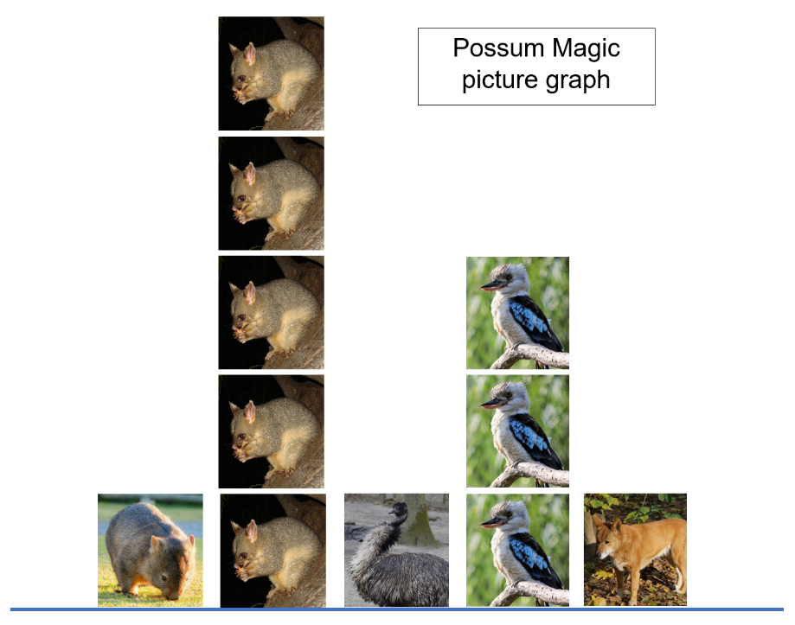
Images sourced from Pixabay and used in accordance with the Pixabay Licence.
- Ask students what questions and answers they can find in the picture graph. Some examples are:
- How many different animals are in the book?
- How many times did possums appear?
- Which animal appears the most?
- Which animal appears the least?
- How many times do animals with fur appear?
- Ask students what other questions they can find the answers to using information from the graph.

Group investigations – 25 minutes
Note: Early Stage 1 students will undertake an investigation of a clock and telling hour time. Stage 1 students will investigate a question of their own choosing from the book Possum Magic and create a picture graph.
- Ask Early Stage 1 students to share all they know about clocks. Display various analog clocks or images of analog clocks in various shapes and sizes.
Note: It is important to display simple analog clocks that only display hour time so that students can become familiar with and learn about hour time.
- Explain to students that an analog clock has different parts, that these parts have names and each part has an important job. Use an interactive model of a clock to support students’ understanding.
The table below outlines stimulus prompts to generate conversation about the topic, along with anticipated responses from students.
Prompts | Anticipated student responses
- What do you notice about the clock face and how the numbers are arranged around it, from 1-12?  - What do you notice as the big hand or the minute hand moves around the clock face? What’s happening to the small hand or hour hand at the same time?  - As the clock hands move around the face from one number to the next, what do you think it is telling us?  - What activities do you think you can do while the clock hand goes around one whole rotation? | - I can see that the numbers are in order around the face.  - The number 12 is up the top.  - When the big hand, the minute hand, moves around the clock, the small hand moves to the next number.  - As the clock hand moves and the small hand, the hour hand, goes to a number such as 1, you say 1 o’clock.  - I think I can eat my breakfast and get dressed.  - I think I can read my book.
- Modelling on the interactive analog clock, explain to students that when the small hand (hour hand) is pointing to a number, that tells us it is an o’clock time. For example, if the hour hand is pointing to the number 2, it is 2 o’clock.
- Display a digital clock and ask students where they may have seen a digital clock.
- Explain to students that a digital clock, just like an analog clock, helps with telling time. Show students that a digital clock also has a face and numbers.
- Display 2 o’clock on the digital clock. Explain that the number 2 followed by 2 zeroes after the colon means that it is an o’clock time (2 o’clock). For example, if a display read 9:00, it would be 9 o’clock.
- Place Resource 8: An analog clock and Resource 9: A digital clock, side by side. Use number cards labelled 1-12 and 2 different length craft sticks to represent the hour hand and minute hand for the analog clock.
Note: Laminate or place each clock in a plastic sleeve to allow students to write, erase and use the resources multiple times during the lesson.
- Select a student to use the craft sticks and show 7 o’clock on the analog clock. Ask another student to use the number cards and show 7 o’clock on the digital clock. Repeat this multiple times and provide students with the opportunity to represent o’clock times on both the analog and digital clock.
- Stage 1 students, in groups of 6, will investigate a question of their choosing from the book and create a picture graph, using images from Resource 5: Possum Magic animals, Resource 6: Possum Magic foods or Resource 7: Possum Magic places. Photocopy these resources as needed. If students choose another question to answer, they will need to draw their own symbols to create a picture graph. Prompt students with questions such as:
- Who has tasted foods from the book? Anzac biscuits, lollies, steak, salad, pumpkin, pavlova and lamingtons.
- Which 3 capital cities would you most like to visit from the book? Adelaide, Melbourne, Sydney, Brisbane, Darwin, Perth, Hobart.
- Who has seen the animals from the book at the zoo or around where they live? Possum, wombat, kangaroo, dingo, kookaburra, emu, koala, snake.
- Move between groups, revising accurate use of a baseline, equal spacing and same-sized symbols as necessary.
- Using the graph, identify and record the most frequent and least frequent outcomes. Choose another category and identify and record all other categories that contain more and less.
This table details assessment opportunities and differentiation ideas.
Assessment opportunities | Too hard? | Too easy?
What to look for:  - Can students use the term o’clock to read an analog and a digital clock? (MAE-NSM-02)  - Can students position the clock hands correctly on an analog clock to show various o’clock times? (MAE-NSM-02)  - Can students use a baseline, equal spacing and same-sized symbols to create a picture graph? (MAO-WM-01, MA1-DATA-01)  - Can students interpret and compare the collected data in a picture graph by counting a total and using the terms ‘more than’ or ‘less than’ to compare quantities? (MAO-WM-01, MAE-DATA-01)  - Can students ask questions and predict responses? (MAE-DATA-01, MA1-DATA-01)  - Do students interpret the information displayed and do they use comparative language to ask and answer questions about the picture graph? (MAO-WM-01, MAE-DATA-01, MA1-DATA-02)  What to collect:  - work samples of picture graphs created to answer a question with comparative statements (MAO-WM-01, MA1-DATA-01, MA1-DATA-02) | Students find organising data for the group investigation too challenging.  - Students investigate which animals they have seen using Resource 5: Possum Magic animals.  - Model how to record symbols for the first 3 students. Then the group records symbols for the next 3 students. | Students use data to ask and answer questions.  - Students use Resource 2: Triple Venn diagram to find out who has tasted a food, visited a city and seen an animal from the book.  - Use the Venn diagram to find out who has experienced 2 of the categories.  - Students research animal superpowers around the world to see what maths they can find. For example, longest, fastest, smallest.

Consolidation and meaningful practice: Sequencing events for Hush the possum– 10 minutes
- Revise and discuss the story Possum Magic. Refer to the illustrations for clues and ask students to think about and sequence the following events from the story:
- Did Hush slide down kangaroos before or after she was squashed by koalas?
- What did Grandma Poss do all night? What did she realise the very next morning?
- Did they eat steak and salad before they ate pumpkin scones?
- At what time of the day did Hush eat a Vegemite sandwich?
- What time was it when Poss ate a lamington? What did Grandma Poss do next?

Lesson 5: Australian bird superpowers!
Core concept: Pictures and symbols can be used to classify and describe information.
The table below contains suggested learning intentions and success criteria. These are best co-constructed with students.
Learning intentions | Success criteria
All students are learning that:  - data can be collected and displayed to answer questions  - data can be used to investigate the chance of everyday events occurring. | All students can:  - organise data into lists and tables  - describe the information displayed to answer questions  - use data to describe the chance of events being more or less likely to happen.  In addition, students working towards Early Stage 1 outcomes can:  - compare the size of groups by counting objects or images  - sort objects or responses according to what’s different and/or the same.  In addition, students working towards Stage 1 outcomes can:  - pose suitable questions that could be investigated or answered through a data set  - interpret tally marks to answer questions.

Daily number sense: Birds I saw at the zoo – 10 minutes
- Build student understanding of number by interpreting a tally chart.
- Introduce the following scenario: Neville went to the zoo. He was fascinated by the native Australian birds and decided to make a tally chart to record how many times he saw each kind of bird during the day. Stage 1 students use Resource 10: Zoo birds tally to revise how tally marks are recorded in groups of 5. Early Stage 1 students use Resource 11: Zoo birds data display to compare the size of groups.
- Ask students:
- How many different birds did Neville see? 6.
- How many birds did he see altogether? Count tally groups of fives and then add remaining tally marks.
- Which birds did Neville see an even number of times? Pelican, stone curlew, lorikeet, ibis.
- Which birds did Neville see an odd number of times? Cassowary and robin.
- Which bird did Neville see the least? Cassowary.
- Which bird did Neville see the most? Ibis.
- Which birds did Neville see less than 5 times but more than once? Pelican and robin.
- Which bird did Neville see twice as many times as the lorikeet? Ibis.
- How many times more did Neville see stone curlews compared to cassowaries? 5 more times.
- How many times less does Neville see robins compared to stone curlews? 3 less times.
Note: Early Stage 1 students create data displays using real objects, drawings or pictures. Stage 1 students gather and track data using tally marks.
Note: The Aussie Bird Count is held annually in October through birdlife Australia. It could be used as a resource to support students to connect to real-life maths and revise tally chart skills.

Birds around us – 40 minutes
Note: This activity is split into 3 short timeslots across the day. It requires identification of local bird species.
- Explain that birds have superpowers too! Examples are:
- The emu, which is the second tallest bird in the world at 2 metres high and it can run at speeds of up to 50 kilometres per hour!
- Australian gannets, which can dive through water at up to 100 kilometres per hour!
- The Green catbird, whose superpower is to imitate a cat meowing. This sound is so realistic that many people living on the east coast of Australia have searched the bush because they think a cat is lost in there.
- The Australian wagtail, which is called Chitty Chitty by the Noongar Aboriginal Peoples of Western Australia because its superpower is to talk without stopping!
- Ask students if they know any bird superpowers and if they have seen birds at school or in their local area.
- Explain that students are going to collect data about birds in and around school by colouring circles to represent the quantity of birds (Early Stage 1) or using tally marks (Stage 1). Then students will interpret the information to make predictions about how often they might see each kind of bird.
- Go outside as a class as early as possible in the morning for 5 minutes to identify and count birds. Repeat this process around noon. Stage 1 students use Resource 12: Birds seen tally and use tally marks to record how many birds they saw. Early Stage 1 students use Resource 13: Birds seen data collection and colour in a circle each time they see one of the identified birds.
Note: For Early Stage 1 students insert pictures and names of birds in Resource 13: Birds seen data collection that are commonly seen in the school context or local area. This will assist students to easily identify the birds as they create their data display.
- After returning to the classroom, support Early Stage 1 students to count how many birds were seen in each category. Ask Stage 1 students what this quantity looks like using tally marks in groups of 5.
- Use the class charts to ask:
- How many birds did you see altogether?
- Which kind of bird was seen most often?
- Which species was seen the least?
- What bird are you most likely to see in school?
- What bird are you least likely to see in school?
- Were there any differences between birds seen in the morning and around lunch time? Why might this be?
- What birds are you more likely to see when you get to school the next day?
- In groups, students choose one bird from the tally chart and identify other birds that were seen more often and less often.
- Encourage students to keep looking for birds and recording how many they see after school to add to the tally chart the following day.
This table details assessment opportunities and differentiation ideas.
Assessment opportunities | Too hard? | Too easy?
What to look for:  - Can students use the tally chart to identify biggest and smallest values? (MA1-DATA-02)  - Can students’ group and organise a collection to show how many of each object is included in each group? (MAE-DATA-01, MAE-CSQ-01)  - Can students use comparative language to describe data from different times of the day? (MAO-WM-01, MAE-DATA-01, MA1-DATA-02)  - Can students use data to decide which birds they are more or less likely to see the next morning? (MA1-CHAN-01)  What to collect:  - observational data of students using data values to communicate events as being more or less likely to happen (MAO-WM-01, MAE-DATA-01, MA1-DATA-02, MA1-CHAN-01) | Students require support to count and write numerals.  - Provide students with number cards to copy and model how to begin and end writing the numeral.  - Use counters to represent each of the coloured circles from the data collection table so that students have concrete materials to count.  Students find grouping in fives in a tally chart challenging.  - Model how to group tally marks with coloured craft sticks, using one colour for the first 5, another colour for the next 5 and so on.  - Students make tally marks with craft sticks first and then draw them.  - Students use counters in groups of 5. | Students accurately identify values and make connections between data and chance.  - Students identify other situations where data could be collected to make connections to chance. For example, when students are more likely or less likely to go to sick bay.  - Students research bird superpowers around the world to see what maths they can find. For example, longest wingspan, fastest, smallest.

Consolidation and meaningful practice: Tally charts – 15 minutes
- Give students Resource 14: Favourite colours. Explain that another class, 2 Rainbow, has collected data on their favourite colours but it is very disorganised. Ask students if they can help by organising the data. Early Stage 1 students arrange the tiles according to their colour and compare the size of the groups. Stage 1 students organise the data in a table using tally marks.
- In small groups, students use the tally marks to answer the questions:
- Which colour was the most popular?
- Which colour was the least popular?
- Which colours were liked by more than 5 students?
- Which colour was liked by 3 more students than the students who chose yellow?
- Are there any other questions you could use the tally chart to find the answers to?
This table details assessment opportunities and differentiation ideas.
Assessment opportunities | Too hard? | Too easy?
What to look for:  - Can students create a table and decide on categories? (MAO-WM-01, MA1-DATA-01)  - Did students correctly group tally marks in groups of 5? (MA1-DATA-01)  - Could students use the tally chart to answer questions and pose suitable questions? (MAO-WM-01, MA1-DATA-02)  - Can students arrange the coloured tiles to form a data display? (MAE-DATA-01)  - Can students count objects in each category to determine the size of the group? (MAE-RWN-01)  - Can students compare the size of the groups? (MAE-DATA-01)  What to collect:  - work samples of correctly organised tally charts (MA1-DATA-01)  - work samples of sorted coloured tiles (MAE-DATA-01)  - observational data of created and given questions and corresponding answers (MAO-WM-01, MAE-DATA-01, MA1-DATA-02) | Students find grouping in fives within a tally chart too challenging.  - Model how to group tally marks with coloured craft sticks, using one colour for the first 5, another colour for the next 5 and so on.  - Students make tally marks with craft sticks first and then draw them.  - Students use counters in groups of 5.  Students cannot arrange the coloured tiles into categories to create a data display.  - Support students to sort the tiles into colours. Model how to line up the colours to create a bar chart.  - Ask students which colours were chosen the least, which colour was chosen the most and if any colours were chosen equally. | Students quickly organise tally marks and answer questions.  - In groups, students use tally marks to collect data on favourite colours from their own class. Identify the most and least popular colour.  - Students compare class data to data from 2 Rainbow.  - Students think of other questions that could be answered using their class data.

Lesson 6: What’s the chance? Let’s investigate!
Core concept: Data can be used to predict the likelihood of events.
The table below contains suggested learning intentions and success criteria. These are best co-constructed with students.
Learning intentions | Success criteria
All students are learning that:  - data can be represented in misleading ways  - data can be used to predict the likelihood of events. | All students can:  - understand that data in a picture graph can be misleading if it is not numbered and arranged correctly, such as there are gaps, or pictures are different sizes  - use data to predict whether an event is more or less likely to happen.  In addition, students working towards Early Stage 1 outcomes can:  - interpret information in a data display to respond to questions  - make predictions about the likelihood of events using language such as might or might not happen  - describe everyday events that occur in a particular order.  In addition, students working towards Stage 1 outcomes can:  - use comparative language, such as certain, likely, unlikely, impossible, to compare data  - identify the most likely and least likely event  - order events in terms of their likelihood  - describe which events are or are not possible.

Daily number sense: Teacher choice – 10 minutes
- From a class need surfaced through formative assessment data, identify a short, focused activity that targets students’ knowledge, understanding and skills. Example activities may be drawn from the following resources:
- Thinking Mathematically Stage 1
- Universal Resources Hub.

Tricky data: animals on holiday – 10 minutes
- Display Resource 15: Animals on holiday and tell students that Emily made a picture graph of animals she saw on holiday.
- Ask students:
- How many times did Emily see a wombat?
- How many times did she see a koala?
- How many times did she see a kangaroo?
- How is the graph misleading?
- What could you do to make the graph easier to read? For example
- make the pictures the same size
- make sure there are no gaps
- make sure all the animals start at the bottom of the picture graph.

What’s the chance? Birds around us (continued) – 10 minutes
- Add data about birds that students saw after school to Resource 12: Birds seen tally and Resource 13: Birds seen data collection Ask students if there are any changes to the birds most frequently and least frequently seen.
Note: In Early Stage 1, some chance experiments may be included as part of an investigation that collects data. Students will need support in understanding the key vocabulary demands associated with probability.
- Use the tally chart to make connections between data and chance by asking:
- What bird are you most likely to see each day?
- What bird are you least likely to see?
- What birds are you more and less likely to see after school?

What’s the chance? Investigate! – 35 minutes
- Early Stage 1 students will sequence some simple daily events that are likely to occur at school every day using the language before, after and next.
- Provide each student with writing materials and ask students to draw 3 pictures which describe events that happen in a particular order. For example, before we come to class we line up, after that we unpack our bags, and next we sit on the mat.
- Provide time for Early Stage 1 students to participate in a gallery walk to observe and discuss other students' work samples.
- Ask students:
- Can you see any events that are certain to happen every day at school?
- Is there one event that is impossible to happen if it rains?
- Can you see an example of an event that will happen tomorrow?
- Can you see an example of an event that happened yesterday?
- Stage 1 students will identify other events where data could be collected over time with a tally chart to make connections to chance. Some examples are when:
- students are more likely or less likely to go to sick bay
- there is likely to be more or less rubbish in the playground
- students have a higher or lower pulse rate
- ants are more or less likely to be seen at chosen locations.
- In groups, students choose a question to investigate and follow the steps listed below:
- create a tally chart template that includes sections to record data in the morning and at noon
- ensure there is time in the afternoon to use the data to make connections to chance
- collect data for 5 minutes at the chosen times
- use the data to make predictions about whether the chosen event is more or less likely at the 2 times during the day.
This table details assessment opportunities and differentiation ideas.
Assessment opportunities | Too hard? | Too easy?
What to look for:  - Can students give reasons why data is misleading? (MAE-DATA-01, MA1-DATA-02)  - Can students organise and sequence events to show what happens before, after and next? (MAE-NSM-01)  - Are students able to use vocabulary to describe at what time of the day an event occurs, for example, afternoon or daytime? (MAE-NSM-01)  - Do students choose a question which can be investigated over time? (MAO-WM-01, MA1-DATA-01)  - Can students organise data over time into a tally chart to display information clearly? (MAO-WM-01, MA1-DATA-02)  - Can students organise information and display the content clearly? (MAO-WM-01, MAE-DATA-01)  - Can students interpret data to describe an event as more or less likely to happen at chosen times of the day? (MAE-DATA-01, MA1-CHAN-01)  What to collect:  - work samples of student data (MAO-WM-01, MAE-DATA-01, MA1-DATA-01)  - observational data of how students use data to predict the likelihood of an event (MAO-WM-01, MAE-DATA-01, MA1-DATA-01, MA1-CHAN-01) | Students required support to generate a question and develop a template.  - Students choose one of the 4 example questions.  - Students choose a template to copy or use.  - Provide students with Resource 16: Tally times to enter tally marks. | Students record and use data over time to make connections to chance.  - Students use Now and Then from NRICH to investigate patterns in data over time for Olympic events.  - Students consider factors and predict what results athletes will be achieving in the future.

Consolidation and meaningful practice: Connecting and discussing some of the mathematics – 5 minutes
- Display Resource 15: Animals on holiday and ask students if there is another way Emily could have presented her picture graph?
- Ask students:
- Instead of pictures what symbols could she have used?
- Could the picture graph be organised in a different way?
- What could be a better name for Emily’s graph?

Lesson 7: What's the chance? – Everyday events
Core concept: Data can be used to predict the likelihood of events.
The table below contains suggested learning intentions and success criteria. These are best co-constructed with students.
Learning intentions | Success criteria
All students are learning that:  - language can be used to describe chance  - data can be used to predict the likelihood of events. | All students can use data to predict the likelihood of an event.  In addition, students working towards Early Stage 1 outcomes can:  - identify events that are impossible and certain  - create a two-digit number using numerals 0-3  - identify the number before a given number  - identify the number after a given number.  In addition, students working towards Stage 1 outcomes can:  - correctly use the terms impossible, certain, likely, highly likely, unlikely  - place value can be used to manipulate two-digit and three-digit numbers  - use place value to find highest and lowest values  - find the next multiple of 10 from a given number.

Daily number sense: Highest and lowest – 25 minutes
This activity is adapted from The Thousands Game from NRICH.
- Build Stage 1 student understanding of partitioning and multiples of 10 by using place value to make different quantities from the same digits.
- Build Early Stage 1 understanding of a number that is one more than or one less than a given number. Display a numeral track from 1-9, or optional to provide pairs of students with a numeral track.
- Explain how to play the number game.
- Stage 1 students will use a set of number cards from 0-9 and take turns to select 3 number cards and make a three-digit number out of them. Every time the cards are used, they are placed back in the bag. Explain that Miranda made the highest number she could when she took out 3, 8 and 2. Ask Stage 1 students what number did she make? (832). Ask students how many hundreds, tens and ones there are in 832 and what the next multiple of 10 is.
- Early Stage 1 students follow the same steps and use the number cards from 1-9 in the bag. Students will draw one card from the bag and need to say or record the number that is one less than and one more than the drawn number on the card. As students gain confidence try 2 less than and 2 more than a drawn number. Pose to Early Stage 1 students that Raphael took out 8 and said that 7 was one less and 9 was one more. Ask if Raphael is correct.
- Provide each pair of students in Early Stage 1 with Resource 17: Digit cards and a bag. Allow students to play multiple rounds.
- Provide each small group of Stage 1 students with Resource 17: Digit cards and a bag. Allow students to play multiple rounds.
- Pause Stage 1 students and explain that Miranda selected another 3 cards from the bag to make the lowest number. She took out 5, 0 and 4 and made 045. Her friends said that you can’t put zero at the beginning of a number. Ask students if they agree. Miranda also agreed and made 405. Ask students how many hundreds, tens and ones and what the next multiple of 10 is. Allow Stage 1 students to play multiple rounds.
- Pause Stage 1 students and explain that Miranda drew cards to make the highest odd number. She took out 0, 6 and 9. Her friend Ali took out 5, 2 and 7. Ask students who they think found the highest odd number. Miranda made 609 and Ali made 527, so Miranda was happy that she had made the highest odd number. But then Alan said Ali could make a bigger number with his digits. Ask students what that number could be. Allow Stage 1 students to play multiple rounds.
This table details assessment opportunities and differentiation ideas.
Assessment opportunities | Too hard? | Too easy?
What to look for:  - Can students make highest and lowest three-digit numbers with randomly chosen digits from 0-9? (MAO-WM-01, MA1-RWN-01, MA1-RWN-02)  - Can students name the number one less than and one more than a given number? (MAO-WM-01, MAE-RWN-01)  - Can students identify the next multiple of 10 from a given number? (MAO-WM-01, MA1-RWN-02)  - Can students read the numerals from 1-9? (MAO-WM-01, MAE-RWN-01)  What to collect:  - observational data of students playing the game (MAO-WM-01, MAE-RWN-01, MAE-RWN-02, MA1-RWN-01, MA1-RWN-02) | Students are not able to name the numeral one less than or one more than a given number.  - Provide students with a numeral track from 1-9 and a counter to place on the number before and the number after.  Students are working towards manipulation of three-digit numbers.  - Students draw 2 cards each time and follow the process, working out which number is closest to 100.  - Students play with digit cards from 0-5.  - Students are working towards understanding place value of the zero card and the next multiple of 10.  - Students play the game without the zero card.  - Students use Resource 4: Number charts to find the next multiple of 10. | Students understand all place value skills.  - Students brainstorm how many different strategies they could use to get from a given number to 1000.  - Students repeat the process drawing 4 cards each time.

Everyday events – 40 minutes
Note: In Early Stage 1, some chance experiments may be included as part of an investigation that collects data. Students will need support in understanding the key vocabulary demands associated with probability.
Note: Prior to this lesson, draw a long line in the playground and mark it as shown in Figure 6.
Figure 6 – Possibilities
- Outside, students stand next to the line. Explain that you will ask questions. For each question, students will consider whether the outcome is impossible, unlikely, likely and certain. Students move to that section of the line as you ask:
- Will the sun set tonight?
- Will you be going to the shops this afternoon?
- Will you pet a dog today?
- Will you go to the moon this week?
- If I throw a ball, will you catch it?
- At recess or lunch time today, will I play with my best friend?
- For each question, choose one student to justify why they have chosen that section of the line.
- Back in the classroom, explain to students that they are going to explore everyday events in school. Brainstorm events that take place at school.
- Early Stage 1 students can use a visual timetable to assist with sequencing events that happen during a school day.
- Stage 1 students could use Brainstorming from the Digital Learning Selector to record ideas or students could record the ideas in a weekly timetable on a large sheet of paper.
- For Stage 1 students, model statements to predict certain, more likely and less likely events. For each statement, ask for 2 volunteers to share their reasoning. Some examples include:
- It is certain that students will learn about maths or English in the morning.
- It is impossible that students will have sport today.
- Students are more likely to play a ball game on Wednesday.
- For Early Stage 1 students, model statements to predict certain, possible and impossible. For each statement, ask students to share their reasoning. Some examples include:
- It is impossible that I will come to school in a submarine.
- It is possible that we will play a game after lunch.
- It is certain that we will do maths in the morning.
- In pairs, Stage 1 and Early Stage 1 students will use the visual timetable to make statements, then predict and justify possibilities about the likelihood of an event.
- Stage 1 students will record things that happen before and after school. Students write 3 statements about the likelihood of events in their week using the language of chance. They justify their thinking to a partner.
- Explain to Early Stage 1 students that they will draw a representation of 3 of their favourite events that happen at school. Provide each student with 3 pieces of A6 sized paper. When students have completed their drawings, display a line on a wall or on the floor clearly labelled morning, lunch time and afternoon (see Figure 7).
Figure 7 – Events at school
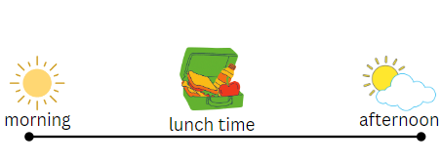
Images sourced from Canva and used in accordance with the Canva Content License Agreement.
- Using adhesive putty, ask Early Stage 1 students to adhere each of their drawings under the correct time of the day their event happens. Discuss the results by asking students:
- Which part of the day has the most favourite events?
- Which part of the day has the least favourite events?
- Is there one event that has the most drawings?
- Why do you think this event is so popular?
- Can you think of one event that happens at school that nobody drew a picture of?
This table details assessment opportunities and differentiation ideas.
Assessment opportunities | Too hard? | Too easy?
What to look for:  - Can students sequence events and use terms to show when an event occurs, such as morning, lunch time and afternoon? (MAE-NSM-01)  - Do students correctly use the language of chance? (MA1-CHAN-01)  - Do students respond to questions about the popularity of an event by recognising the least or the greatest number of data collected? (MAE-DATA-01)  - Can students interpret data to describe the likelihood of a familiar event? (MAO-WM-01, MA1-CHAN-01)  What to collect:  - work samples of student statements using the language of chance (MAO-WM-01, MA1-CHAN-01)  - drawings of representations of events (MAE-DATA-01)  - observational data of justifying thinking (MAO-WM-01, MA1-CHAN-01) | Students are working towards using the language of chance.  - Give students examples of certain and impossible events to sort.  - Begin by using one term at a time, then introduce more terms as the students become proficient. For example, discuss events that are impossible first, then, events that are certain. | Students accurately use language to describe the likelihood of events.  - Students include weekend events in their timetables.  - Students write 3 statements about likelihood and justify their thinking.

Consolidation and meaningful practice: Possible or impossible? – 5 minutes
- Ask students what is needed for them to be able to guess a secret number.
- Pose to students that guessing the number will be impossible if they only get one clue. Why or why not?
- Will guessing the number be possible if they get 5 clues? Why or why not?
- Ask how many clues students think is necessary for them to get to make it certain that they can guess the secret number.

Lesson 8: Data superpowers!
Core concept: The type of data determines the choice of display.
The table below contains suggested learning intentions and success criteria. These are best co-constructed with students.
Learning intentions | Success criteria
All students are learning that:  - data can be collected and displayed in a variety of ways  - questions can be investigated through data interpretation. | All students can:  - choose a question to investigate a chosen topic  - select ways to collect and display data  - describe and justify interpretations of data.  In addition, students working towards Early Stage 1 outcomes can:  - collect information relating to a data display  - arrange data according to a characteristic to form a data display.  In addition, students working towards Stage 1 outcomes can:  - organise data into a suitable data display  - give reasons why some data representations might be misleading  - record answers to questions.

Daily number sense: The 10 tree – 15 minutes
This activity is adapted from The Deca Tree from NRICH.
- Build Stage 1 student understanding of place value by using repeated addition.
- Build Early Stage 1 student understanding that when combining 2 small numbers a new larger number is made.
- For Stage 1 students, explain that in the bush there is a deca tree. In winter, the deca tree has 10 branches growing from its trunk. Draw a simple tree with 10 branches to support students.
- Continue to explain that on each branch there are 10 twigs and draw 10 twigs from each branch. Ask students how many branches and twigs are on the deca tree in total. The answer is 110.
- Explain that, in spring, the leaves come back. Each twig has 10 leaves on one branch. Draw the 10 leaves on each of the 10 twigs to show how there are 100 leaves on each branch.
- Ask Stage 1 students how many branches, twigs and leaves are on the deca tree now.
- Use ‘Talk moves’ and in pairs use drawings and concrete materials to discuss the solution.
- Stage 1 students find the answer 1110. Observe and ask selected groups to share their strategies.
- Early Stage 1 students use concrete materials and drawings to show their solutions. For assessment purposes take photographs or keep student work samples.
- Explain that one day, a farmer cut down one branch from the tree. Ask students how many branches, twigs and leaves are on the deca tree now.
- Stage 1 students find the answer which is 999. Discuss solutions and ask selected groups to share their strategies.
- Early Stage 1 students adjust their initial tree with the new problem. Ensure that you keep photos or work samples showing their understanding and problem-solving strategies.

Let’s investigate! – 45 minutes
- Explain to students that they are going to work in groups and use their data superpowers to investigate a topic they are interested in. In small groups students answer questions to scaffold the process:
- What question do you want to know the answer to?
- What data do you need to collect?
- Do you need to collect data over time? When will you do this?
- How will you collect your data? Tally chart, picture graph or Venn diagram?
- Examples of simple questions to investigate are:
- Which month has the most birthdays?
- What’s the favourite? For example, food, celebration or sport.
- When I grow up, I want to be…?
- Examples of more complex questions for Stage 1 students to investigate are:
- When is it most likely to see an animal during the school day?
- Do more people have brothers or sisters?
- Which hobby is the most popular?
- Students collect and display data. Provide a variety of concrete materials to support Early Stage 1 students as they design representations and create their display. Students record 3 interpretations about the data. Stage 1 students record the connections to chance. For example:
- September is the month with most birthdays. I predict that this will be the same in all the other classes.
- Learning piano is the most popular hobby. But not everybody is learning it now. Some people want to learn in the future.
- In a data talk each Stage 1 group presents their data and 3 interpretations, communicating their thinking and reasoning clearly. Each time, allow time for peer feedback. This could be to:
- ask questions about the process
- ask new questions about the data
- identify any misleading data and how this could be clarified.
- Early Stage 1 students share their picture graph with another Early Stage 1 class and compare the results. Ask the following questions:
- Does the other class have the most birthdays in September?
- Are there also no birthdays in February?
This table details assessment opportunities and differentiation ideas.
Assessment opportunities | Too hard? | Too easy?
What to look for:  - Can students pose a suitable question to investigate? (MAO-WM-01, MAE-DATA-01, MA1-DATA-01)  - Can students decide how to collect and display data? (MAO-WM-01, MAE-DATA-01, MA1-DATA-02)  - Do students describe and justify interpretations of data? (MAO-WM-01, MAE-DATA-01, MA1-DATA-02)  - Are students able to make connections to chance outcomes? (MAO-WM-01, MA1-CHAN-01)  What to collect:  - work samples of data displays and interpretations (MAO-WM-01, MAE-DATA-01, MA1-DATA-01, MA1-DATA-02)  - observational data of justifications in data talks (MAO-WM-01, MAE-DATA-01, MA1-DATA-02, MA1-CHAN-01) | Students find it challenging to create a question or method of data collection.  - Give students examples of investigations to choose from.  - Provide a method of collection. | Students choose a suitable question, collect data and communicate interpretations including connections to chance.  - Students investigate the same question with another class.  - Students then compare the 2 sets of data and think of reasons why data may differ.

Discuss and connect the mathematics – 5 minutes
- Summarise the lesson together. Draw out key mathematical ideas with students by asking questions, such as:
- What strategies did you use to represent your deca tree?
- How did you keep track of the changes each time?
- How did you combine all the numbers to find the total? How did you know it was accurate?

Resource 1: Superpowers Venn diagram
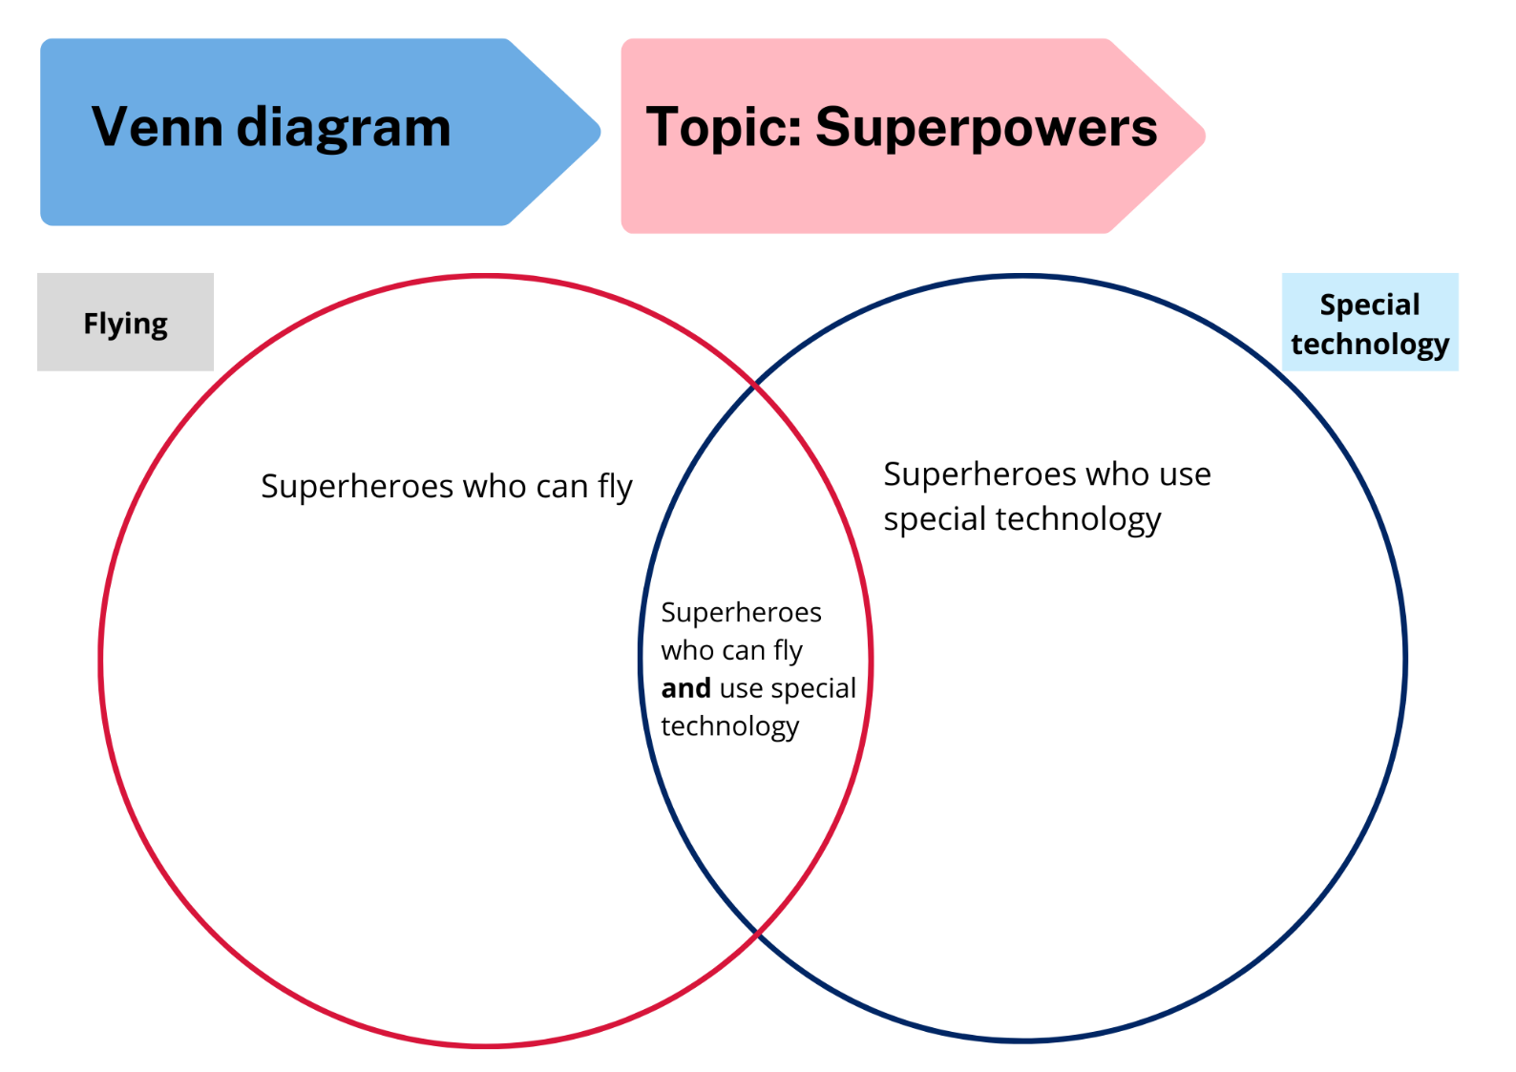

Resource 2: Triple Venn diagram
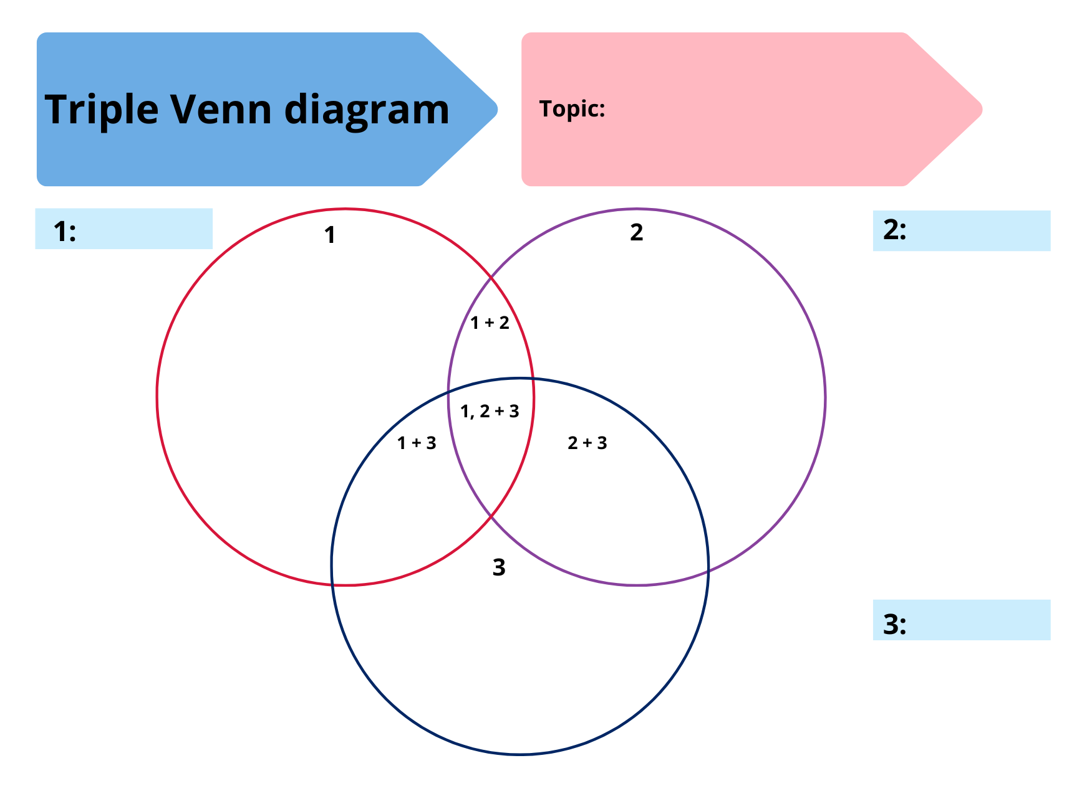

Resource 3: Holiday bird graph
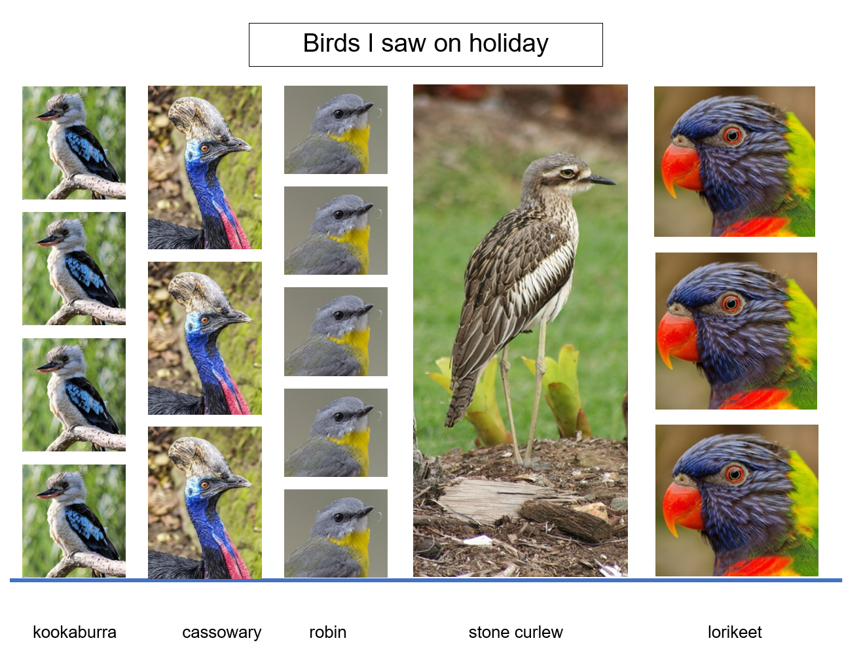
Images sourced from Pixabay and used in accordance with the Pixabay License.

Resource 4: Number charts
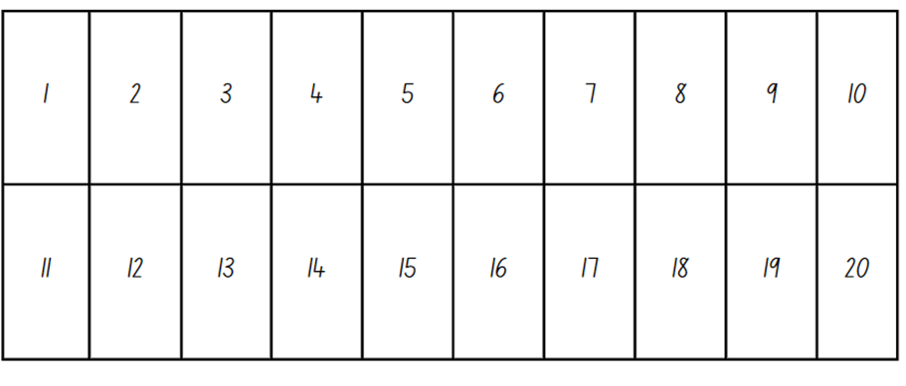

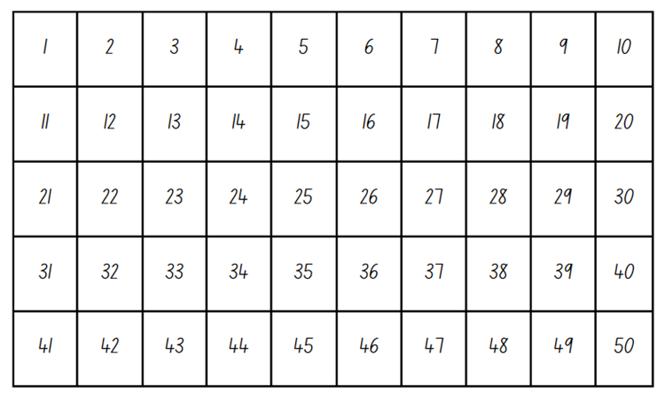

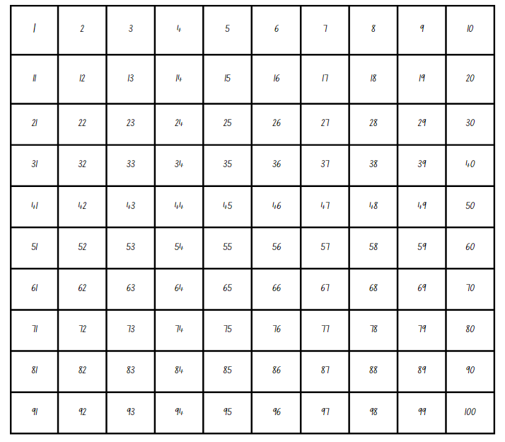

Resource 5: Possum Magic animals
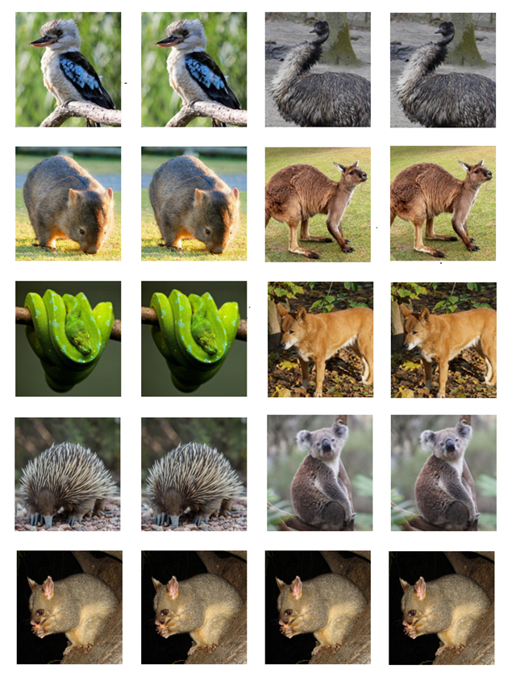
Images sourced from Pixabay and used in accordance with the Pixabay License.

Resource 6: Possum Magic foods
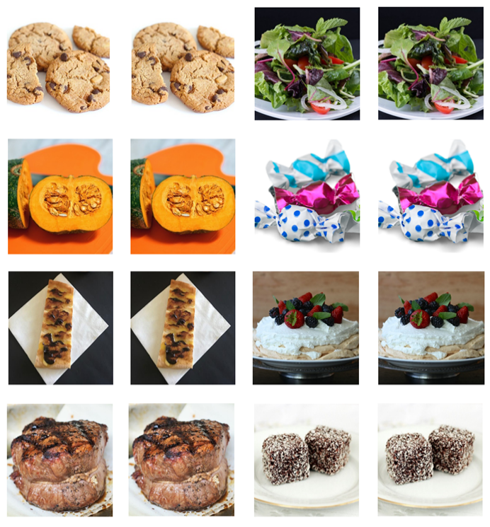
Images sourced from Pixabay and used in accordance with the Pixabay License.

Resource 7: Possum Magic places
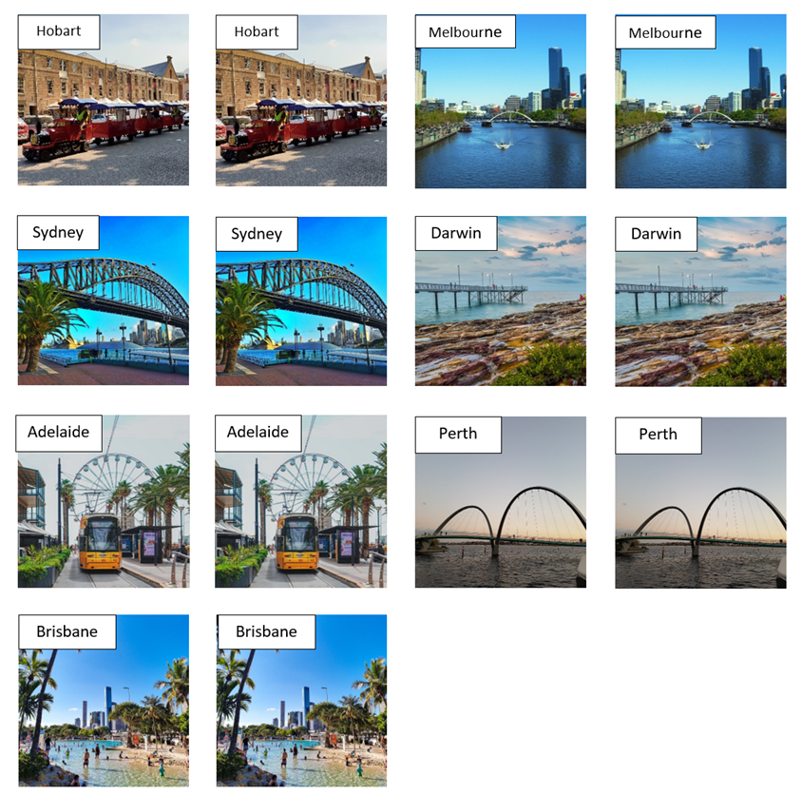
“Hobart” by Nico Smit and “Brisbane” by Romain Terpreau are licensed under the Unsplash License.
“Melbourne” by DADAs, “Sydney” by GoodGuyPaul, “Darwin” by Patjosse, “Adelaide” by weizhang and “Perth” by juhiking are licensed in accordance with the Pixabay License.

Resource 8: An analog clock
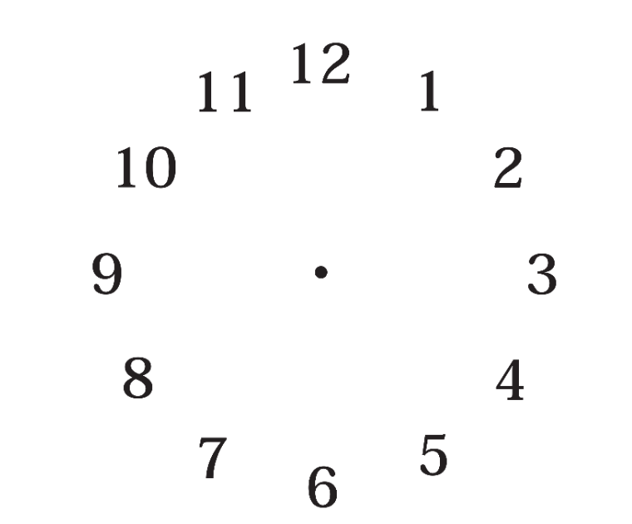

Resource 9: A digital clock
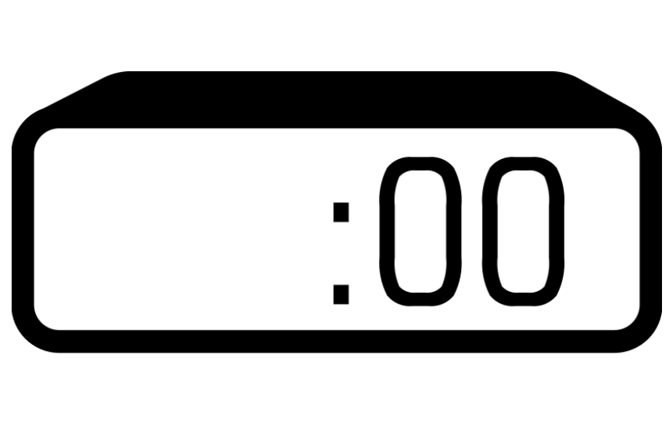
Images sourced from Canva and used in accordance with the Canva Content License Agreement.

Resource 10: Zoo birds tally
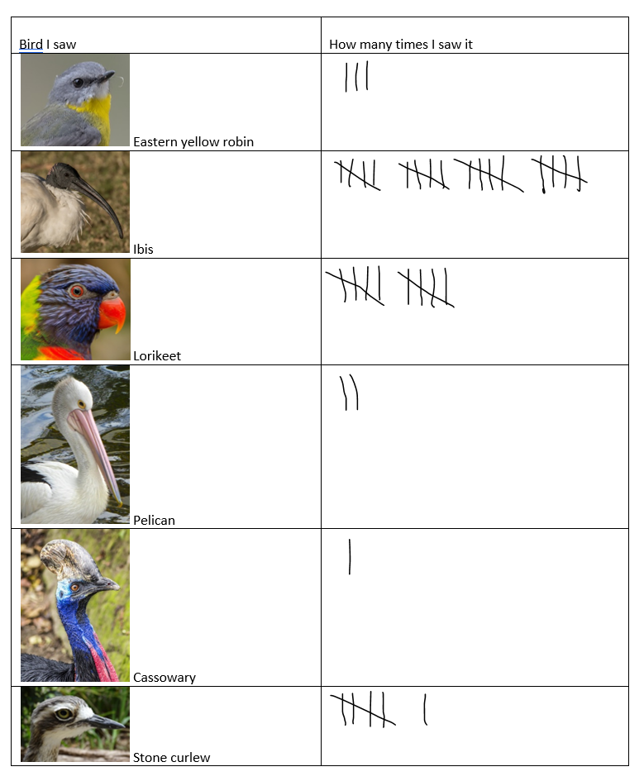
Images sourced from Pixabay and used in accordance with the Pixabay License.

Resource 11: Zoo birds data display
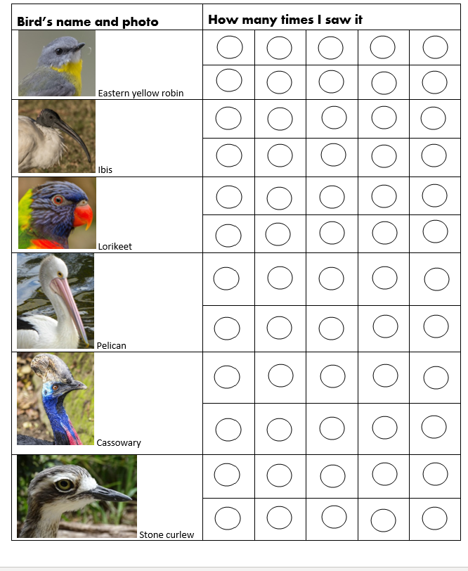
Images sourced from Pixabay and used in accordance with the Pixabay License.

Resource 12: Birds seen tally
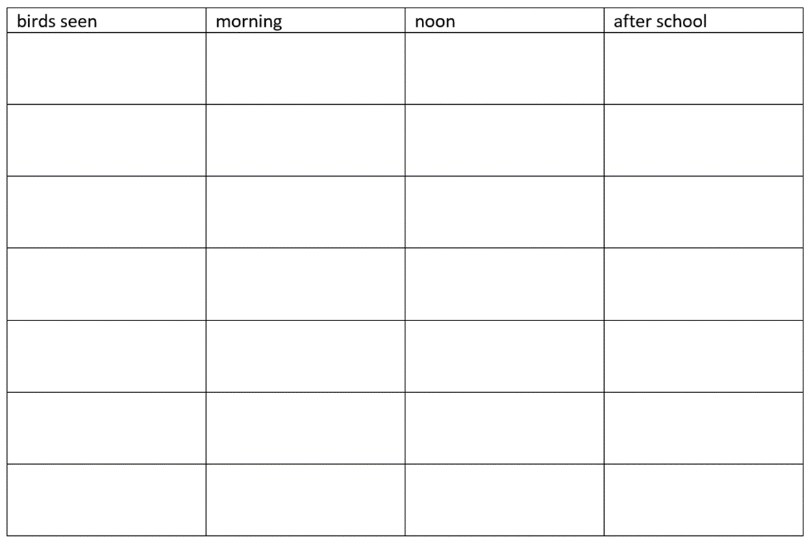

Resource 13: Birds seen data collection
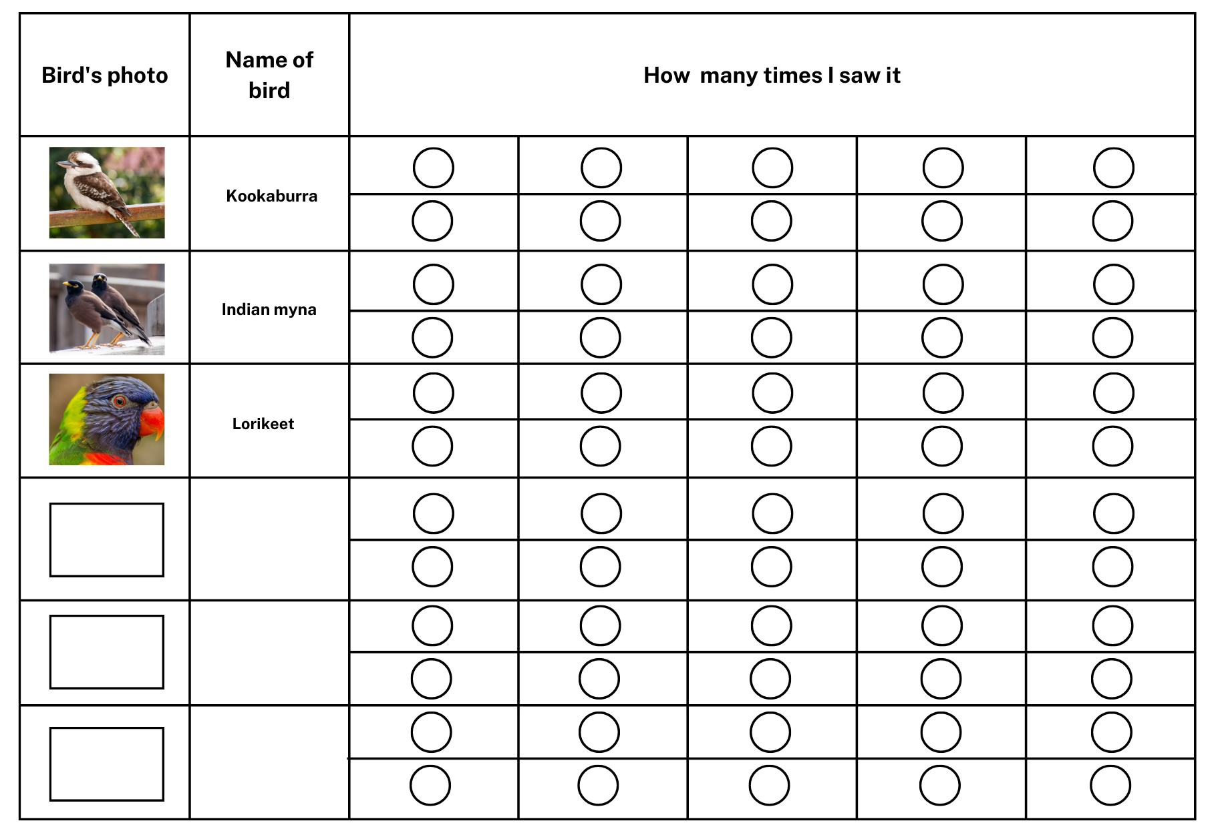
Images sourced from Canva and used in accordance with the Canva Content License Agreement.

Resource 14: Favourite colours
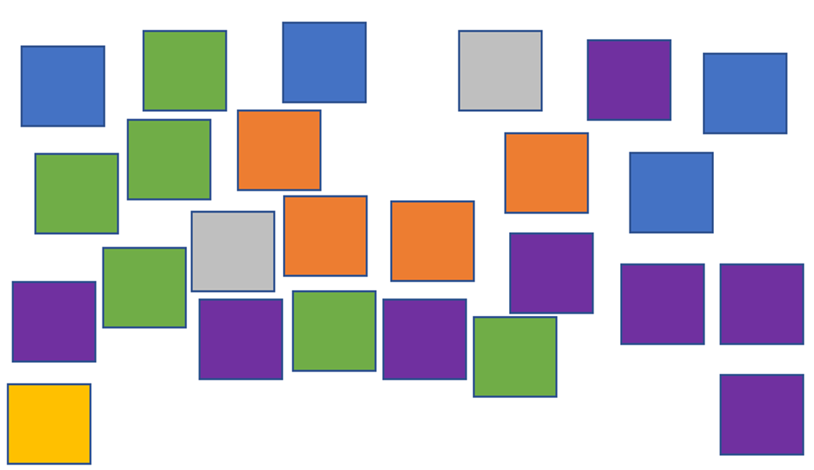

Resource 15: Animals on holiday
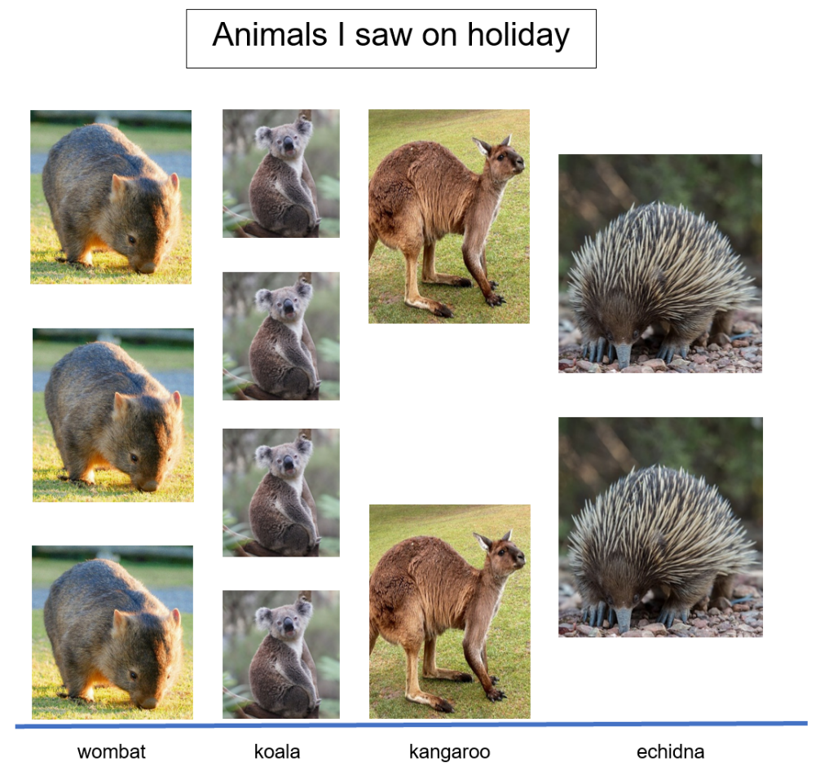
Images sourced from Pixabay and used in accordance with the Pixabay License.

Resource 16: Tally times
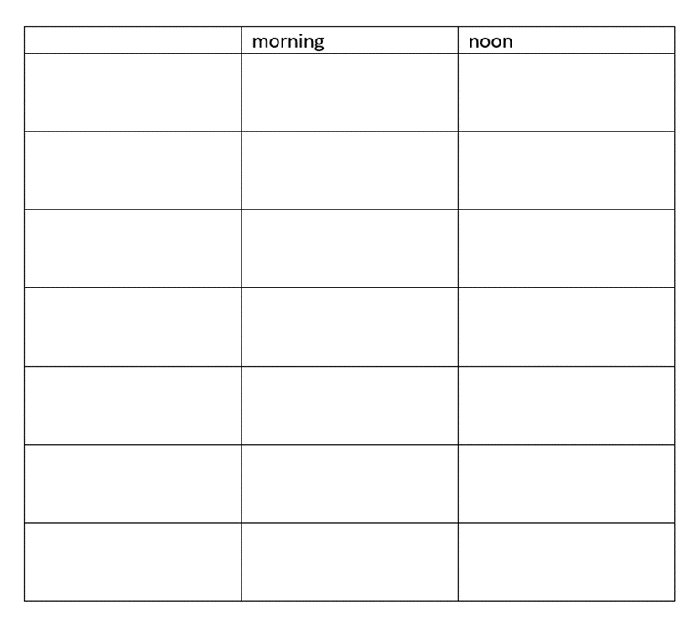

Resource 17: Digit cards
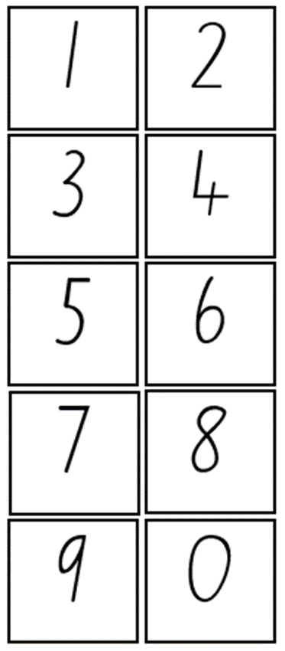

Syllabus outcomes and content
The table below outlines the syllabus outcomes and range of relevant syllabus content covered in this unit. Content is linked to National Numeracy Learning Progression version (3).
Focus area and outcomes | Content groups and content points | Lessons
Representing whole numbers  MAO-WM-01  MAE-RWN-01, MA1-RWN-01  MA1-RWN-02 | Early Stage 1  Recognise number patterns  - recognise dice and domino dot patterns (NPA1, NPV2, CPr2)  - recognise different finger patterns for the same number (NPA2)  Connect counting and numerals to quantities  - count with one-to-one correspondence, recognising that the last number name represents the total number in the collection (CPr3, CPr5)  - count out a specified number of objects (from 5 to 20) from a larger collection, keeping track of the count (CPr4-CPr5)  - make correspondences between collections  - read numerals to at least 20, including zero (NPV3)  - represent numbers as quantities to at least 20 using objects (such as fingers), number words and numerals (NPV2-NPV4, CPr3)  - compare and order numbers to 20 (NPV2-NPV3)  - use the term ‘is the same as’ to express equality of groups (CPr4-CPr5, MuS1) | 1, 2, 4, 7, 8
Representing whole numbers A (cont) | Stage 1  Continue and create number patterns  - model and describe ‘odd’ and ‘even’ numbers using items paired in two rows  Represent the structure of groups of ten in whole numbers  - partition two-digit numbers to show quantity values (NPV4) | 1, 2, 4, 7, 8
Representing whole numbers B (cont) | Stage 1  Use counting sequences of ones and tens flexibly  - identify how many more to the next multiple of ten within two- and three-digit numbers (AdS7)  Form, regroup and rename three-digit numbers  - use place value to partition and rename three-digit numbers in different ways (Reasons about relations) (NPV5) | 1, 2, 4, 7, 8
Combining and separating quantities  MAO-WM-01  MAE-CSQ-01, MA1-CSQ-01  MAE-CSQ-02 | Early Stage 1  Model additive relations and compare quantities  - use concrete materials or fingers to model and solve addition and subtraction questions, counting forwards or backwards by ones as necessary (AdS1-AdS2, NPV3)  - compare 2 groups of objects to determine how many more (Reasons about quantity) (NPV1, AdS2)  Identify part-whole relationships in numbers up to 10  - describe the action of combining, separating and comparing (AdS1)  - use five as a reference in forming numbers from six to ten  - create, model and recognise combinations for numbers up to ten (Reasons about relations) (AdS2)  - count by ones to find the total or difference (AdS2-AdS3) | 1, 5
Combining and separating quantities A (cont) | Stage 1  Use advanced count-by-one strategies to solve addition and subtraction problems  - fluently use advanced count-by-one strategies including counting on and counting back to solve addition and subtraction problems involving one- and two-digit numbers (Reasons about relations) (AdS3, AdS4, AdS5) | 5
Non-spatial measure  MAO-WM-01  MAE-NSM-02 | Early Stage 1  Time: Compare and order the duration of events using the language of time  - use terms such as 'daytime', 'night-time', 'morning', 'afternoon', 'today', 'tomorrow', 'yesterday', 'before', 'after' and 'next'  - sequence events in time  Time: Tell time on the hour on analog and digital clocks  - create the layout of an analog clock  - read analog and digital clocks to the hour using the term ‘o'clock’  - describe the position of the hour and minute hands on an analog clock when reading hour time | 3, 4, 6, 7
Data  MAO-WM-01  MAE-DATA-01, MA1-DATA-01  MA1-DATA-02 | Early Stage 1  Respond to questions, collect information and discuss possible outcomes of activities  - predict possible responses to a question (IRD1-IRD2)  - collect information from their peers and about their environment (IRD1-IRD2)  - pose and respond to questions about the information collected (IRD1-IRD2)  Organise objects into simple data displays and interpret the displays  - group objects according to characteristics (IRD1-IRD2)  - compare the sizes of groups of objects by counting (Reasons about relations) (IRD1-IRD2)  - arrange objects according to a characteristic to form a data display (IRD1-IRD2)  - interpret information presented in a data display to answer questions (Reasons about quantity) (IRD1-IRD2) | 1-6, 8
Data A (cont) | Stage 1  Ask questions and gather data  - investigate a topic of interest by choosing suitable questions to obtain appropriate data (IRD2)  - gather data and track what has been counted by using concrete materials, tally marks, lists or symbols (IRD3)  Represent data with objects and drawings and describe the displays  - use concrete materials or pictures of objects as symbols to create data displays where one object or picture represents one data value (IRD2)  - describe information presented in one-to-one data displays (Reasons about relations) (IRD2)  - use comparative language to describe information presented in a display, such as ‘more than’ and ‘less than’  - interpret a data display and identify the biggest or smallest values (IRD2) | 1-6, 8
Data B (cont) | Stage 1  Identify a question of interest and gather relevant data  - pose suitable questions where the answers form categories, and predict the likely responses (IRD2)  - collect data on familiar topics IRD2)  - sort data into relevant categories (IRD2)  Create displays of data and interpret them  - organise collected data into lists and tables to display information (IRD2)  - represent data in a picture graph using a baseline, equal spacing and same-sized symbols (IRD2)  - give reasons why some representations of data are misleading (Reasons about relations) (IRD2)  - interpret information presented in tables and picture graphs (Reasons about relations) (IRD2)  - record answers to questions using the information in tables and picture graphs (IRD2) | 1-6, 8
Chance A (cont)  MAO-WM-01  MA1-CHAN-01 | Stage 1  Identify and describe possible outcomes  - identify possible outcomes of familiar activities and events  - describe the chance of possible outcomes for familiar activities and events (UnC1) | 5-8
Chance B (cont) | Stage 1  Identify and describe activities that involve chance  - describe possible outcomes in everyday activities and events as being likely or unlikely to happen (UnC2)  - compare familiar activities and events and describe them as being more or less likely to happen (Reasons about relations) (UnC2)  - describe familiar events as being possible (UnC2) | 5-8

References
Links to third-party material and websites
Please note that the provided (reading/viewing material/list/links/texts) are a suggestion only and implies no endorsement, by the New South Wales Department of Education, of any author, publisher, or book title. School principals and teachers are best placed to assess the suitability of resources that would complement the curriculum and reflect the needs and interests of their students.
If you use the links provided in this document to access a third-party's website, you acknowledge that the terms of use, including licence terms set out on the third-party's website apply to the use which may be made of the materials on that third-party website or where permitted by the Copyright Act 1968 (Cth). The department accepts no responsibility for content on third-party websites.
Except as otherwise noted, all material is © State of New South Wales (Department of Education), 2021 and licensed under the Creative Commons Attribution 4.0 International License. All other material (third-party material) is used with permission or under licence. Where the copyright owner of third-party material has not licensed their material under a Creative Commons or similar licence, you should contact them directly for permission to reuse their material.
Mathematics K–10 Syllabus © 2022 NSW Education Standards Authority (NESA) for and on behalf of the Crown in right of the State of New South Wales.
© 2022 NSW Education Standards Authority. This document contains NSW Curriculum and syllabus content. The NSW Curriculum is developed by the NSW Education Standards Authority. This content is prepared by NESA for and on behalf of the Crown in right of the State of New South Wales. The material is protected by Crown copyright.
Please refer to the NESA Copyright Disclaimer for more information.
NESA holds the only official and up-to-date versions of the NSW Curriculum and syllabus documents. Please visit the NSW Education Standards Authority (NESA) website and the NSW Curriculum website.
National Numeracy Learning Progression © Australian Curriculum, Assessment and Reporting Authority (ACARA) 2010 to present, unless otherwise indicated. This material was downloaded from the Australian Curriculum website (National Literacy Learning Progression) (accessed 4 November 2022) and was not modified. The material is licensed under CC BY 4.0. Version updates are tracked in the ‘Curriculum version history’ section on the 'About the Australian Curriculum' page of the Australian Curriculum website.
ACARA does not endorse any product that uses the Australian Curriculum or make any representations as to the quality of such products. Any product that uses material published on this website should not be taken to be affiliated with ACARA or have the sponsorship or approval of ACARA. It is up to each person to make their own assessment of the product, taking into account matters including, but not limited to, the version number and the degree to which the materials align with the content descriptions and achievement standards (where relevant). Where there is a claim of alignment, it is important to check that the materials align with the content descriptions and achievement standards (endorsed by all education Ministers), not the elaborations (examples provided by ACARA).
BirdLife Australia (2022) birdlife Australia [website], accessed 4 November 2022.
Clements DH and Sarama J (2019) ‘Super Venn (Hierarchical Classifier)’, Math Activities, Learning and teaching with trajectories website, accessed 4 November 2022.
Fox M (2018) Possum Magic (Vivas J, illus.), Omnibus Books.
Stanford University (n.d.) Data Talks, youcubed website, accessed 4 November 2022.
University of Cambridge (Faculty of Mathematics) (2022) Now and Then, NRICH website, accessed 3 November 2022.
University of Cambridge (Faculty of Mathematics) (2022) The Deca Tree, NRICH website, accessed 3 November 2022.
University of Cambridge (Faculty of Mathematics) (2022) The Thousands Game, NRICH website, accessed 3 November 2022.

