Mathematics – K-2 multi-age – Year B – Unit 6
Contents
Unit description and duration 4
Student prior learning 4
Lesson overview and resources 5
Lesson 1: Balancing numbers 16
Daily number sense: Balancing numbers – 20 minutes 17
Representing balancing numbers – 30 minutes 19
Discuss and connect the mathematics – 10 minutes 24
Lesson 2: Hidden numbers 25
Daily number sense: Numbers before and after – 10 minutes 25
Practising balancing numbers – 10 minutes 26
Mystery Number – 30 minutes 28
Discuss and connect the mathematics – 10 minutes 33
Lesson 3: Exploring the same as 34
Daily number sense: Equivalence – 20 minutes 35
Balance without numbers – 30 minutes 38
Discuss and connect the mathematics – 10 minutes 40
Lesson 4: Is it the same? 43
Daily number sense: One less, one more – 10 minutes 44
Number talks – 20 minutes 46
True or false cards – 20 minutes 47
Discuss and connect the mathematics – 10 minutes 49
Lesson 5: Related facts 52
Daily number sense: From here to there – 15 minutes 53
Number facts – 35 minutes 55
Discuss and connect the mathematics – 10 minutes 61
Lesson 6: Number bonds 64
Daily number sense: Maths tipping – 15 minutes 64
Number stories – 35 minutes 65
Discuss and connect the mathematics – 10 minutes 71
Lesson 7: Exploring relations 73
Daily number sense: Number chart puzzle – 15 minutes 74
Missing numbers – 35 minutes 75
Discuss and connect the mathematics – 10 minutes 79
Lesson 8: Solving equality problems 82
Daily number sense: Number line – 10 minutes 83
Problem solving – 30 minutes 84
Discuss and connect the mathematics – 20 minutes 87
Resource 1: Balancing objects 91
Resource 2: Balancing objects 2 92
Resource 3: Balancing objects 3 93
Resource 4: Student recording table 94
Resource 5: Number talk 1 95
Resource 6: Number talk 2 96
Resource 7: Number talk 3 97
Resource 8: True or false 1 98
Resource 9: True or false 2 99
Resource 10: Related dots 101
Resource 11: Hands 102
Resource 12: Domino 103
Resource 13: Number story 104
Resource 14: Number sentence 1 105
Resource 15: Number sentence 2 106
Resource 16: Missing numbers 107
Resource 17: Early Stage 1 Number puzzles 109
Resource 18: Stage 1 Number puzzles 110
Resource 19: Missing number cards 111
Resource 20: Zoo animals 113
Resource 21: Different problems 1 114
Resource 22: Different problems 2 115
Resource 23: Different problems 3 116
Syllabus outcomes and content 117
References 125

Unit description and duration
This two-week unit develops student knowledge, understanding and skills of equality. Students are provided opportunities to:
- heft or place objects on either side of an equal-arm balance to obtain a level balance and check equivalence/about the same as
- record about the same as/equivalence using concrete materials, correct vocabulary, drawings, and diagrams
- choose efficient addition and subtraction strategies to determine if a number sentence is about the same as/equal
- represent a given number by using concrete materials to show the different parts of the same number.
Mathematics K–10 Syllabus © 2022 NSW Education Standards Authority (NESA) for and on behalf of the Crown in right of the State of New South Wales.

Student prior learning
Before engaging in these teaching and learning activities, students would benefit from prior experience with:
- hefting or measuring objects using an equal-arm balance
- opportunities to develop confidence in using mathematical terms to communicate learning, for example, ‘heavy’, ‘lightest’ and ‘about the same as’
- creating, recording, and recognising combinations of 2 numbers
- identifying the difference between 2 numbers.

Lesson overview and resources
The table below outlines the sequence and approximate timing of lessons; syllabus focus areas and content groups; and resources.
Lesson | Syllabus focus area and content groups | Resources
Lesson 1: Balancing numbers  60 minutes  Hefting helps to compare and order objects. The equals sign shows equivalence and means 'about the same as'. | Representing whole numbers  Early Stage 1  - Use the counting sequence of ones flexibly  - Connect counting and numerals to quantities  Combining and separating quantities  Early Stage 1  - Identify part–whole relationships in numbers up to 10  Stage 1 – Part A  - Recognise and recall number bonds to ten  - Represent equality  Stage 1 – Part B  - Represent and reason about additive relations  Non-spatial measure  Early Stage 1  - Mass: Identify and compare mass using weight  Stage 1 – Part A  - Mass: Investigate mass using an equal-arm balance | - 20-sided dice (per pair)  - 9-sided dice  - Counters or interlocking cubes  - Equal-arm balance (per pair)  - Shopping bags (2 per pair)  - Writing materials
Lesson 2: Hidden numbers  60 minutes  Equivalence or ‘about the same as’ is when 2 things have the same value. | Representing whole numbers  Early Stage 1  - Use the counting sequence of ones flexibly  - Connect counting and numerals to quantities  Stage 1 – Part B  - Use counting sequences of ones and tens flexibly  Combining and separating quantities  Early Stage 1  - Model additive relations and compare quantities  - Identify part–whole relationships in numbers up to 10  Stage 1 – Part A  - Use advance count-by-one strategies to solve addition and subtraction problems  - Represent equality  Non-spatial measure  Early Stage 1  - Mass: Identify and compare mass using weight  Stage 1 – Part A  - Mass: Investigate mass using an equal-arm balance | - Brown paper bags (class set)  - Equal-arm balance (per pair)  - Interlocking cubes  - Ten-frames  - Writing materials
Lesson 3: Exploring the same as  60 minutes  Representations may look different, but they are still ‘the same as’ or equivalent. | Representing whole numbers  Early Stage 1  - Connect counting and numerals to quantities  Combining and separating quantities  Early Stage 1  - Model additive relations and compare quantities  - Identify part–whole relationships in numbers up to 10  Stage 1 – Part A  - Use advance count-by-one strategies to solve addition and subtraction problems  - Represent equality  Stage 1 – Part B  - Represent and reason about additive relations  Non-spatial measure  Early Stage 1  - Mass: Identify and compare mass using weight  Stage 1 – Part B  - Mass: Compare the masses of objects using an equal-arm balance | - Resource 1: Balancing objects  - Resource 2: Balancing objects 2  - Resource 3: Balancing objects 3  - 9-sided dice (class set)  - Modelling clay  - Playing cards (class set)  - Writing materials
Lesson 4: Is it the same?  60 minutes  The same total can be checked by using addition and/or subtraction. | Representing whole numbers  Early Stage 1  - Use the counting sequence of ones flexibly  - Connect counting and numerals to quantities  Stage 1 – Part B  - Use counting sequences of ones and tens flexibly  Combining and separating quantities  Early Stage 1  - Model additive relations and compare quantities  - Identify part-whole relationships in numbers up to 10  Stage 1 – Part A  - Use advance count-by-one strategies to solve addition and subtraction problems  - Use flexible strategies to solve addition and subtraction problems  - Represent equality  Stage 1 – Part B  - Represent and reason about additive relations | - Resource 4: Student recoding table (class set)  - Resource 5: Number talk 1  - Resource 6: Number talk 2  - Resource 7: Number talk 3  - Resource 8: True or false 1  - Resource 9: True or false 2  - 9-sided dice (class set)  - Glue  - Range of materials, for example, counters, ten-frames, rekenreks, interlocking cubes and equal-arm balances  - Scissors  - Writing materials
Lesson 5: Related facts  60 minutes  Related facts help to solve addition and subtraction problems. | Representing whole numbers  Early Stage 1  - Use the counting sequence of ones flexibly  - Connect counting and numerals to quantities  Stage 1 – Part A  - Use counting sequences of ones with two-digit numbers and beyond  Combining and separating quantities  Early Stage 1  - Model additive relations and compare quantities  - Identify part-whole relationships in numbers up to 10  Stage 1 – Part A  - Use advance count-by-one strategies to solve addition and subtraction problems  - Recognise and recall number bonds to ten  - Use flexible strategies to solve addition and subtraction problems  - Represent equality  Stage 1 – Part B  - Represent and reason about additive relations | - Resource 10: Related dots  - Resource 11: Hands  - Resource 12: Domino  - 5- or 6-sided dice (class set)  - 9-sided dice (class set)  - 12-sided dice (class set)  - Counters  - Interlocking cubes  - Writing materials
Lesson 6: Number bonds  60 minutes  The relationship between numbers is an efficient way to solve some addition and/or subtraction problems. | Representing whole numbers  Early Stage 1  - Use the counting sequence of ones flexibility  - Connect counting and numerals to quantities  Stage 1 – Part B  - Use counting sequences of ones and tens flexibly  Combining and separating quantities  Early Stage 1  - Model additive relations and compare quantities  - Identify part-whole relationships in numbers up to 10  Stage 1 – Part A  - Use advance count-by-one strategies to solve addition and subtraction problems  - Recognise and recall number bonds to ten  - Use flexible strategies to solve addition and subtraction problems  - Represent equality  Stage 1 – Part B  - Represent and reason about additive relations  - Use knowledge of equality to solve related problems | - Resource 13: Number story  - Resource 14: Number sentence 1  - Resource 15: Number sentence 2  - Resource 16: Missing numbers  - Collection of various objects, for example, coloured teddies, shells, animals, figurines, and leaves  - Writing materials
Lesson 7: Exploring relations  60 minutes  The same number can be represented in different ways. Relational thinking involves the relationship between both sides of the problem. | Representing whole numbers  Early Stage 1  - Use the counting sequence of ones flexibility  - Connect counting and numerals to quantities  Stage 1 – Part A  - Use counting sequences of ones with two-digit numbers and beyond  Combining and separating quantities  Early Stage 1  - Model additive relations and compare quantities  - Identify part-whole relationships in numbers up to 10  Stage 1 – Part A  - Use advance count-by-one strategies to solve addition and subtraction problems  - Represent equality  Stage 1 – Part B  - Represent and reason about additive relations  - Use knowledge of equality to solve related problems | - Resource 17: Early Stage 1 Number puzzles  - Resource 18: Stage 1 Number puzzles  - Resource 19: Missing number cards  - Interlocking cubes  - Scissors  - Glue  - Writing materials
Lesson 8: Solving equality problems  60 minutes  Different strategies help to efficiently solve addition and/or subtraction equality problems. | Representing whole numbers  Early Stage 1  - Use the counting sequence of ones flexibility  - Connect counting and numerals to quantities  Stage 1 – Part A  - Represent numbers on a line  Stage 1 – Part B  - Use counting sequences of ones and tens flexibly  Combining and separating quantities  Early Stage 1  - Model additive relations and compare quantities  - Identify part-whole relationships in numbers up to 10  Stage 1 – Part A  - Use advance count-by-one strategies to solve addition and subtraction problems  - Recognise and recall number bonds to ten  - Use flexible strategies to solve addition and subtraction problems  - Represent equality  Stage 1 – Part B  - Represent and reason about additive relations  - Use knowledge of equality to solve related problems | - Resource 20: Zoo animals  - Resource 21: Different problems 1  - Resource 22: Different problems 2  - Resource 23: Different problems 3  - A4 paper  - Concrete materials, for example, interlocking cubes, counters and ten-frames  - Collection of objects, for example, sticks, toothpicks, leaves, modelling clay, paperclips or counters  - Writing materials

Lesson 1: Balancing numbers
Core concept: Hefting helps to compare and order objects. The equals sign shows equivalence and means 'about the same as'.
The table below contains suggested learning intentions and success criteria. These are best co-constructed with students.
Learning intentions | Success criteria
Students working towards Early Stage 1 outcomes are learning that hefting helps to compare, order, and describe the weight of objects.  Students working towards Stage 1 outcomes are learning that:  - the equals sign is used to indicate equivalence and to show that 2 or more amounts have the same value  - equivalence can be checked using an equal-arm balance. | Students working towards Early Stage 1 outcomes can:  - compare the weight of various objects by hefting  - use the correct language to compare the weight of objects that are ‘heavier’, ‘lighter’ or ‘about the same as’.  Students working towards Stage 1 outcomes can:  - correctly use the equals sign to show equivalence  - place objects on either side of an equal-arm balance to obtain a level balance and check equivalence  - record equivalence using concrete materials, correct vocabulary, drawings, and diagrams.

Daily number sense: Balancing numbers – 20 minutes
This lesson has been adapted from Lesson 2: Balancing Numbers from Algebra: Equivalence (reSolve, 2020).
- Provide Early Stage 1 students with a 9-sided die, an individual whiteboard, and a large collection of counters (more than 20). Students roll the die and collect the corresponding number of counters.
- Early Stage 1 students use the counters to create different representations of the number rolled. Students draw the combinations they create with the counters and describe them using the correct vocabulary (see Figure 1).
Figure 1 – Early Stage 1 representations
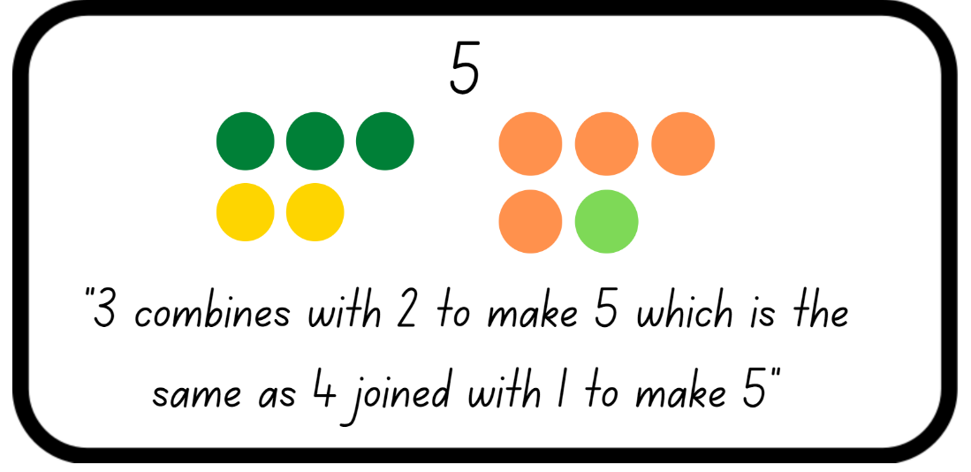
Images sourced from Canva and used in accordance with the Canva Content License Agreement.
Note: Early Stage 1 students are beginning to identify that the parts can be different when making up the same whole number. Early Stage 1 students use the vocabulary of ‘combines with’, ‘joins’, ‘take away’, altogether’ and ‘makes’ when combining and separating. The formal writing of number sentences, including the use of the symbols +, − and =, is introduced in Stage 1.
- Early Stage 1 students continue to roll and record different representations and use the correct vocabulary to explain their working and identify how the given number is the same, yet the parts are different.
- While Early Stage 1 students are working independently, display a digital equal-arm balance for Stage 1 students and place the equals sign in the middle. Explain that the equals sign indicates that the equal-arm balance is level and both sides have the same value.
Equals sign is used to indicate equivalence, for example, 5 + 1 = 2 + 4 and to show that 2 or more amounts have the same value.
- Place a weight on the number 7 on one arm of the equal-arm balance and see if Stage 1 students notice any changes. Ask students how they could make the equal-arm balance equal. Provide thinking time and then allow students to turn and talk to discuss their strategy.
- Have selected Stage 1 students share and model their thinking on the equal-arm balance. Record the matching number sentence on the board. For example, 7 = 4 + 3.
Note: Ensure selected students have different solutions to make the equal-arm balance equal, showing the part-whole relationships.
- Continue placing weights on different numbers including combinations of numbers, for example, 2 and 6 on one arm and one, 3 and 4 on the other arm. Ask:
- 6 and 4 are on one arm of the equal-arm balance. What numbers do you need to place on the other arm to show equivalence?
- 2 weights are on one arm of the equal-arm balance and 3 weights are on the other arm. What numbers will make the equal-arm balance the same?
- Have Stage 1 students explain strategies for how to make the equal-arm balance show equivalence. Record student working as a number sentence.
Equivalence: Two things are equivalent if they have the same value.
Note: In Early Stage 1, the terms ‘weigh’ and ‘weight’ are more common in everyday usage than ‘mass’. When working with Early Stage 1 students’, ‘weight’ is an acceptable description for mass. Early Stage 1 students become familiar and confident with hefting and using the vocabulary ‘about the same as’ to describe equivalence before they are introduced to ‘equals’ in Stage 1.

Representing balancing numbers – 30 minutes
- Explain that Early Stage 1 students will explore the weight of objects and will use the shopping bags and their arms as a balance scale. Ask students to suggest words that could be used to explain weight. Create a vocabulary word bank ensuring the words ‘light’, ‘heavy’, ‘heavier than’ or ‘lighter than’ are included.
- Demonstrate to Early Stage 1 students how to place various objects from around the room in the shopping bags and heft them to determine which is lighter or heavier.
Note: Stage 1 students can participate in this discussion as revision before undertaking their activity.
- Provide pairs of Early Stage 1 students with 2 shopping bags and their workbook. Students work with their partner to heft the objects and use the correct language to explain to their partner their reasoning. Students record their findings in their workbook, drawing themselves and the objects in each bag. If possible, students can label their image using the correct language (see Figure 2).
Figure 2 – Early Stage 1 comparison
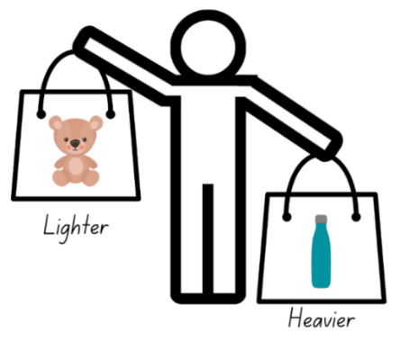
Images sourced from Canva and used in accordance with the Canva Content License Agreement.
- While Early Stage 1 students are working independently, roll a 20-sided die and select Stage 1 students to use counters or interlocking cubes to show 2 different representations of the number rolled.
- Draw a simple equal-arm balance to show the equivalent representations of the number rolled. Demonstrate how to also show this using the bar model and the appropriate language (see Figure 3).
Figure 3 – Equal-arm balance representation
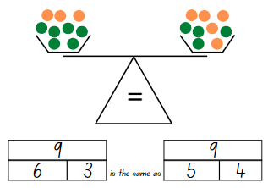
Images sourced from Canva and used in accordance with the Canva Content License Agreement.
Note: Ensure a variety of language is used when discussing the equivalence, including ‘equals’, ‘is equal to’, ‘is the same as’ and ‘is the same amount as’.
- Demonstrate recording a number sentence of the representations. For example, 6 + 3 = 5 + 4.
- Model checking if the number sentence is equivalent by using both an equal-arm balance and the digital equal-arm balance.
- When Stage 1 students are confident with the understanding of the activity, provide pairs of students with a 20-sided die, workbook and an equal-arm balance, or digital equal-arm balance.
- Stage 1 students roll the die to get their target number, draw the simple equal-arm balance and bar model using the appropriate language, and record the number sentence in their workbook. Pairs continue to do this for various numbers.
- While Stage 1 students are completing the activity, regroup with Early Stage 1 students and select students to share which objects they identified as lighter or heavier. Have students show how they hefted the items, using the correct vocabulary to show their reasoning.
- Provide an Early Stage 1 student with 2 objects which are about the same weight and ask them to heft the objects. Ask the student to explain what they notice about the weight of the objects. Guide the student to use the language ‘about the same as’ to describe the equal weight of the objects. Add ‘about the same as’ to the word bank.
- Challenge Early Stage 1 students to find objects in the room which are ‘about the same’. Students use their shopping bags to heft the objects until they are confident that they are ‘about the same’. Guide students to understand that they can use multiple objects in each bag to assist them with the weight being about the same. Students record their findings in their workbook, drawing themselves and the objects in each bag. If possible, students can label their image using the correct language (see Figure 4).
Figure 4 – Early Stage 1 about the same as
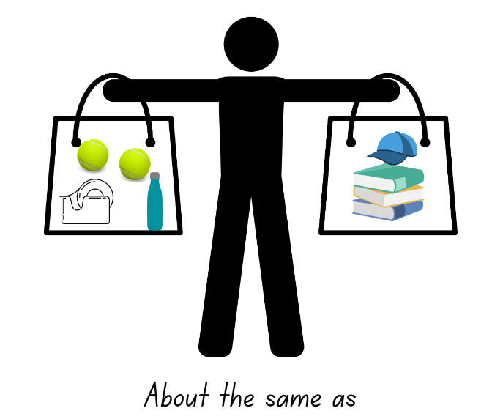
All images are used in accordance with the Canva Content License Agreement Agreement.
This table details assessment opportunities and differentiation ideas.
Assessment opportunities | Too hard? | Too easy?
What to look for:  - Can students compare the weight of various objects by hefting? (MAO-WM-01, MAE-NSM-01)  - Can students use the correct language to compare the weight of objects? (MAE-NSM-01)  - Can students correctly use the equals sign to show equivalence? (MA1-CSQ-01)  - Can students place objects on either side of an equal-arm balance to check equivalence? (MAO-WM-01, MA1-CSQ-01, MA1-NSM-01)  - Are students able to record equivalence using concrete materials, correct vocabulary, drawings and diagrams? (MAO-WM-01, MA1-CSQ-01, MA1-NSM-01)  What to collect:  - student work samples (MAO-WM-01, MAE-NSM-01, MA1-CSQ-01, MA1-NSM-01) | Students are unable to compare the weight of items by hefting and use the correct language.  - Students sit and place objects on their lap to feel the resistance against their body to determine if the object is light or heavy.  - Provide students with 2 objects that are very different in weight. Have students use a firm grip to heft and identify if it is lighter or heavier.  Students are unable to create and record representations with numbers up to 20.  - Provide students with a 9-sided die to reinforce part-whole relationships with numbers under 10.  - Provide students with concrete materials to manipulate the representations of the number rolled. For example, 3 red counters and 8 blue counters is the same as 6 red counter and 5 blue counters. | Students can compare the weight of items using hefting and use the correct language.  - Provide students with an equal-arm balance to use after they have hefted an item to confirm their thinking.  - Challenge students to use at least 4 objects in each bag when they are trying to make the bags about the same.  Students can create and record representations with numbers up to 20.  - Challenge students to write the number sentence before drawing the representation of the equal-arm balance.  - Students need to include 3 numbers in their representation on the arm balance and reflect this in the number sentence. For example, 12 + 16 + 5 = 13 + 18 + 2.

Discuss and connect the mathematics – 10 minutes
- Summarise the lesson together and have students show some examples of their work. Ask:
- What did you notice during this activity?
- Were there objects that you thought would be lighter/heavier? (Early Stage 1)
- Did you discover objects that have about the same weight? (Early Stage 1)
- What language do you use to compare weight?
- How can we show equivalence/the same as?
- Were your equivalent number sentences, correct? How do you know? (Stage 1)
- What language do you use to describe equivalence? (Stage 1)
- Did the equal-arm balance confirm your working? (Stage 1)
- What questions do you still have?

Lesson 2: Hidden numbers
Core concept: Equivalence or ‘about the same as’ is when 2 things have the same value.
The table below contains suggested learning intentions and success criteria. These are best co-constructed with students.
Learning intentions | Success criteria
Students working towards Early Stage 1 outcomes are learning that different combinations of numbers can add up or bond to represent a given number.  Students working towards Stage 1 outcomes are learning that:  - the amount which is taken away from a collection can change the equivalence  - equivalence can be checked using an equal-arm balance. | Students working towards Early Stage 1 outcomes can represent a given number by using concrete materials to show the different parts of the same number.  Students working towards Stage 1 outcomes can:  - subtract and record number sentences to 20  - place objects on either side of an equal-arm balance to obtain a level balance and check equivalence.

Daily number sense: Numbers before and after – 10 minutes
- Build student understanding of the counting sequence by identifying the numbers before and after a given number.
- Roll a 20-sided die for Early Stage 1 students. Students write the number rolled on their individual whiteboard and then record the number before and after (see Figure 5).
- Roll three 9-sided dice for Stage 1 students. Students identify the largest number possible and record it on their individual whiteboard and then record the number that is one less and one more (see Figure 5).
Figure 5 – Number sequence
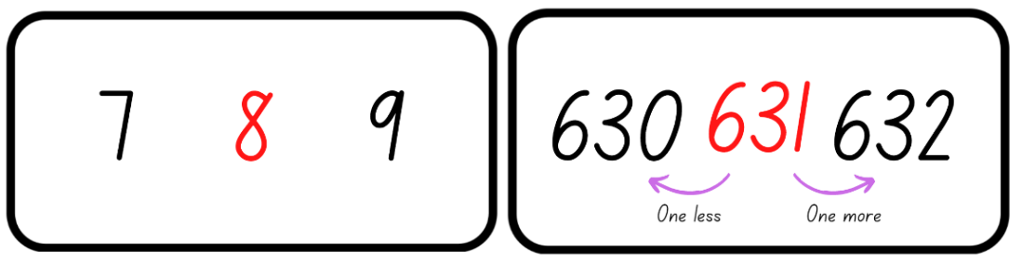
Images sourced from Canva and used in accordance with the Canva Content License Agreement.
Note: Use dice that have a zero as it is important to understand that the zero is a placeholder and does not hold a value.
- Choose students to share their working and justify how they know the number is more or less than the given number.
- Repeat the above steps several times providing discussion time around identifying the largest number with Stage 1 students as well as the number before and after with all students.

Practising balancing numbers – 10 minutes
- Tell Stage 1 students that an equal-arm balance has 2 weights on one arm and 3 weights on the other arm. Ask students what two-digit number representation they could use so the total is the same on each arm.
- Stage 1 students use their individual whiteboard to record different representations using words, numbers, and diagrams.
- While Stage 1 students are recording their representations, explain the scenario ‘Animal Snacks’ to Early Stage 1 students.
- Pose the scenario to Early Stage 1 students that animal snacks have arrived at the zoo. The snacks only come in 2 flavours and are 10 cubes long. The zookeepers are wondering what some of the combinations could look like.
- Explain and model to Early Stage 1 students that they need to make 5 snack bar combinations of 10 for the animals. Remind them that there are only 2 flavours that can be used. Provide Early Stage 1 students with a collection of interlocking cubes to create their snack bars. Students can have the option to also record their snack bar combinations in their workbook using simple symbols for the 2 different snacks used to make the bar of 10 (see Figure 6).
Figure 6 – Early Stage 1 recording combinations
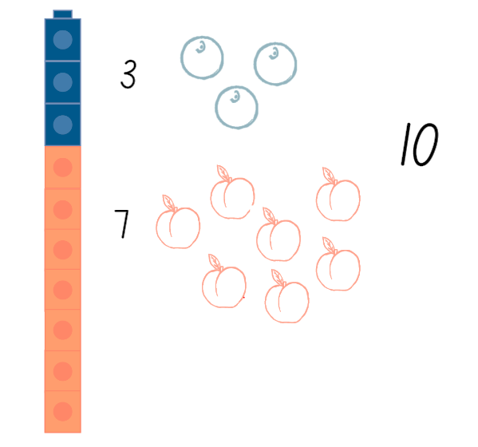
Images sourced from Canva and used in accordance with the Canva Content License Agreement.
- Stage 1 students share their working and justify how they know that the equal-arm balance is equivalent. Model students working on an equal-arm balance to assist in supporting their justification.

Mystery Number – 30 minutes
This lesson has been adapted from Equality and Equations from NZ Maths.
- Early Stage 1 students continue to make and record their animal snack bars.
- Display and ask Stage 1 students if this number sentence is correct, 5 + 5 = 10 − 4. Choose a student to model this using an equal-arm balance and counters or interlocking cubes. Stage 1 students turn and talk to discuss what happened to the equal-arm balance.
The table below outlines stimulus prompts to generate conversation about the topic, along with anticipated responses from students.
Prompts | Anticipated student responses
- What happened to the equal-arm balance?  - Why is the arm lower or higher? | - It is no longer the same/equal.  - 5 + 5 is the not the same as/equal to 10 − 4.  - 10 is not equal to 6.
- Record suggestions of what can be done to restore the equality with a focus on taking away 4 from the other arm. As number sentences are suggested and recorded, have students demonstrate using an equal-arm balance. Together, reach the conclusion that the same amount must be taken away from each side so that the equal-arm balance and the number representation remains equivalent.
The table below outlines stimulus prompts to generate conversation about the topic, along with anticipated responses from students.
Prompts | Anticipated student responses
- What can be done to restore the equality?  - How can we record this? | - To make the scales equal we can add 4 back.  - To make the scales equal we can take 4 away from the other arm (work to elicit this response from students).  - 5 + 5 − 4 is equal to 10 − 4.  - 10 − 4 is the same as 10 − 4.  - 10 − 4 = 10 − 4  - 6 = 6
- Provide pairs of Stage 1 students with an equal-arm balance and each partner a brown paper bag, 20 interlocking cubes, and an individual whiteboard. Students place the 20 interlocking cubes in each brown paper bag and check that the equal-arm balance is equivalent.
Note: Use counters, interlocking cubes, MAB units or something similar which are the same weight and fit inside the brown paper bag.
- The first player removes some interlocking cubes from inside their brown paper bag, unseen by the other player, and returns the bag to the equal-arm balance. This player secretly records the number sentence, for example, 20 − 4 = 16.
- The second player looks at the equal-arm balance and estimates how many were removed and removes this number of interlocking cubes from their bag. They secretly record the number sentence, for example, 20 − 7 = 13 and return their bag to the equal-arm balance.
- Both players look carefully to see if the equal-arm balance is equally balanced making it equivalent. If the equal-arm balance is not equivalent, the second player repeats their turn with another amount. When the equal-arm balance finally balances, both students share their final number sentences and check the amount in each bag. Both students record the equivalence, for example, 16 = 16.
- Stage 1 students continue to play, taking turns to be the first player to remove the interlocking cubes.
- While Stage 1 are playing, regroup with Early Stage 1 students. Place students in pairs and have them both show each other one of their snack bars. Model asking:
- Is your snack bar the same combination as your partner?
- What is different?
- What is the same?
- Have Early Stage 1 students heft both bars to confirm that they are the same number and weight but made up of different combinations.
Note: Ensure students are using the same materials as their partner when they are hefting to help connect the idea that the number representations are the same.
- Early Stage 1 students represent each of their snack bars by taking apart the interlocking cubes and placing them on a ten-frame (see Figure 7).
Figure 7 – Early Stage 1 animal snacks
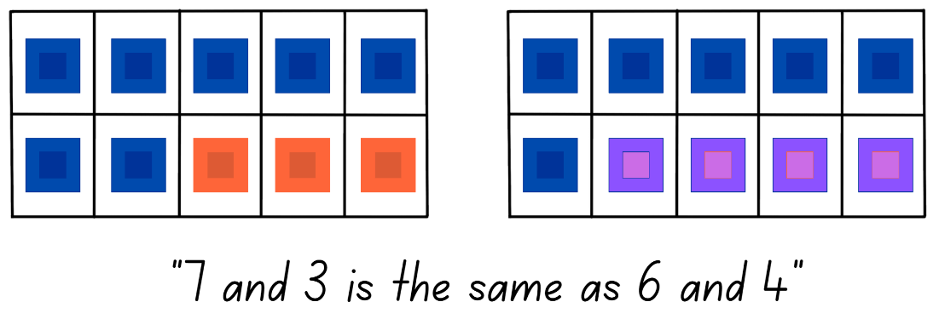
Images sourced from Canva and used in accordance with the Canva Content License Agreement.
- Early Stage 1 students continue to represent each of their snack bars on a ten-frame and compare, heft, and discuss what is similar and different about their combinations. Students may record their combinations by writing 7 and 3, 7 combines with 3 or 7 joins 3.
This table details assessment opportunities and differentiation ideas.
Assessment opportunities | Too hard? | Too easy?
What to look for:  - Can students create, model and recall combinations of 2 numbers that add up to 10? (MAO-WM-01, MAE-RWN-01, MAE-RWN-02, MAE-CSQ-01, MAE-CSQ-02)  - Are students able to subtract and record number sentences to 20? (MA1-CSQ-01)  - Can students place objects on either side of an equal-arm balance to obtain a level balance and check equivalence? (MAO-WM-01, MA1-CSQ-01, MA1-NSM-01)  What to collect:  - student work samples (MAO-WM-01, MAE-RWN-01, MAE-RWN-02, MAE-CSQ-01, MAE-CSQ-02, MA1-CSQ-01, MA1-NSM-01) | Students are unable to create and record combinations of 2 numbers that add up to 10.  - Provide students with a number range below 5. Students strengthen their understanding of combinations to 5 using counters to show and communicate the different representations.  - Support students to record number combinations by providing a device to photograph combinations and verbally explain.  Students are unable to subtract from 20 and record the matching number sentence.  - Provide students with items bundled in tens or 2 ten-frames to assist students with maintaining their count as they remove items.  - Support students to subtract from 10 and record the matching number sentence. | Students can create and record combinations of 2 numbers that add up to 10.  - Students use an equal-arm balance to check if their combinations of numbers are the same.  - Students use 3 or 4 different coloured interlocking cubes in their animal snacks to make combinations to 10 and record in their workbook.  - Challenge students to make animal snacks that are combinations to 20 using at least 3 flavours.  Students can subtract from 20 and record the matching number sentence.  - Challenge students to develop their own subtraction story to reflect the number sentence.  - Students use different colours to show the numbers represented in the brown paper bag. For example, 10 + 5 + 3 + 2 = 20. Then they subtract at least 2 different numbers from the whole amount.

Discuss and connect the mathematics – 10 minutes
- Summarise the lesson together, drawing out some key mathematical ideas. Ask:
- Did you have the same combination as your partner?
- What was different with your combinations?
- What was the same with your combinations?
- Would it matter which snack the animals received? Would they get the same amount of food? (Early Stage 1)
- How can equivalence be maintained? (Stage 1)
- Does the number sentence remain equivalent when something is taken away? Why or why not? (Stage 1)
- How did you know that the number representation was no longer equal? (Stage 1)
- What helped when making an informed guess about the number of interlocking cubes that were removed? (Stage 1)
- What questions do you still have?

Lesson 3: Exploring the same as
Core concept: Representations may look different, but they are still ‘the same as’ or equivalent.
The table below contains suggested learning intentions and success criteria. These are best co-constructed with students.
Learning intentions | Success criteria
All students are learning that different combinations of numbers can add up or bond to represent a given number.  In addition, students working towards Early Stage 1 outcomes are learning that objects can be hefted to identify and compare their weight.  In addition, students working towards Stage 1 outcomes are learning that  - combinations of numerals and objects may look different but are still equivalent  - whatever is added or taken away from one set must be added or taken away from the other set. | Students working towards Early Stage 1 outcomes can:  - create different combinations of numbers that add up to or bond to represent a given number  - heft objects to compare and order as ‘heavier’, ‘lighter’ or ‘about the same as’  - identify objects of different sizes that can be grouped together to represent the same weight.  Students working towards Stage 1 outcomes can:  - use number bonds and combinations of objects to solve equality problems  - record equivalence using concrete materials, correct vocabulary, drawings and diagrams.

Daily number sense: Equivalence – 20 minutes
This lesson has been adapted from Lesson 1: Balancing Numbers from Algebra: Equivalence (reSolve, 2020).
- Sitting in a circle, choose 2 or 3 different Early Stage 1 students and Stage 1 students to demonstrate how to play ‘Equivalence’.
- Deal 10 cards to each Early Stage 1 player. Students divide their cards in to 2 piles with 5 cards in each pile and have the top cards face up. Early Stage 1 students turn over a target card from the leftover cards and place it above their cards (see Figure 8).
- Deal 12 cards to each Stage 1 player. Students need to divide their cards into 4 piles with 3 cards in each pile. Stage 1 students leave a gap in the middle of their piles and have the top cards face up, Figure 8. Any leftover cards are placed in a discard pile with 4 cards being turned over as free choice cards.
Note: Picture cards are zero and an ace is one.
Figure 8 – Game play set up
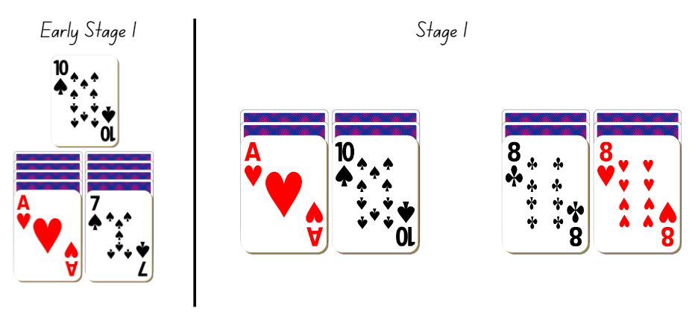
Images sourced from Canva and used in accordance with the Canva Content License Agreement.
- Early Stage 1 players take turns to discard one of their display cards and turn over the card underneath. The aim for each player is to have their display cards combine to make the target number. The first player to represent the target number is the winner.
- Stage 1 players take turns to discard one of their display cards and either turn over the card underneath or take one from the free choice cards. The aim is to have both sides equivalent. Discarded cards are added to the discard pile and 4 free choice cards are always on display. The first player to have each side equivalent is the winner or play ends when there are no cards left (see Figure 9). Players record a number sentence which reflects the cards they have finished with on their individual whiteboard. For example, 1 + 8 = 5 + 4 for an equivalent representation or 4 + 3 = 7, 2 + 8 = 10 for a non-equivalent representation.
Figure 9 – Game play
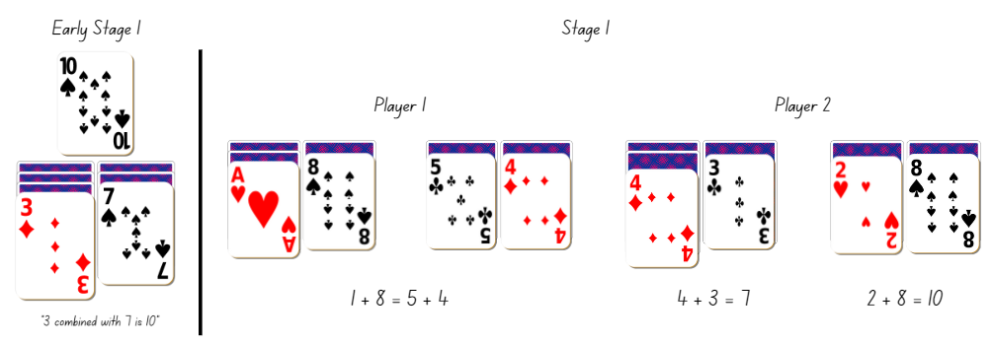
Images sourced from Canva and used in accordance with the Canva Content License Agreement.
- Once students are confident with the activity, provide small groups of students with a deck of cards and Stage 1 with an individual whiteboard. Students take turns, playing multiple rounds.
This table details assessment opportunities and differentiation ideas.
Assessment opportunities | Too hard? | Too easy?
What to look for:  - Are students able to create different combinations of numbers that add up to or bond to represent a given number? (MAO-WM-01, MAE-RWN-01, MAE-RWN-02, MAE-CSQ-01, MAE-CSQ-02)  - Can students use number bonds to solve equality problems? (MAO-WM-01, MA1-CSQ-01)  What to collect:  - observational data (MAO-WM-01, MAE-RWN-01, MAE-RWN-02, MAE-CSQ-01, MAE-CSQ-02, MA1-CSQ-01) | Students are unable to use number bonds to represent a number or make equivalent representations.  - Provide students with concrete materials to represent the value of the playing cards. Students count with one-to-one correspondence to find the total of each side.  - Provide playing cards with a value up to 5 so students can reinforce their knowledge of number bonds up to 10. | Students can use number bonds to represent a number.  - Students have 3 piles of cards to combine the 3 numbers together to represent the given number.  - Students increase the target number to a number which is below 20.  Students can use number bonds to solve equality problems.  - Challenge students by divide cards into 6 piles and use the 3 cards on each side to form an equivalent total.  - Remove the free choice cards so students do not have the option of additional numbers.

Balance without numbers – 30 minutes
- Display for Stage 1 students, Resource 1: Balancing objects. Explain to students that the equal-arm balance is level and therefore equivalent, even though different combinations of objects with varied weights have been placed on either side. Stage 1 students turn and talk about what they notice and how the objects are maintaining equivalence.
Note: Avoid using numbers and assigning values to any of the objects.
- While Stage 1 students are discussing, provide Early Stage 1 students with modelling clay. Students need to create different sized balls and heft them to compare and order the weight from lightest to heaviest.
- Select Stage 1 students to share and justify their thinking from Resource 1: Balancing objects and record ideas.
- Display Resource 2: Balancing objects 2 for Stage 1 students. Tell students one image is equivalent and one is not. Stage 1 students work with a partner to prove which equal-arm balance is equivalent. Students may need to view Resource 1: Balancing objects to look at the equivalence of the objects and use this knowledge when solving Resource 2: Balancing objects 2. Students then draw how they would make the other equal-arm balance equivalent.
- While Stage 1 students are solving the problem, regroup with Early Stage 1 students. Challenge students to heft many balls of different sizes in each hand with the aim to get the weight the same. Students may need to create some additional balls to help find the same weight in each hand. Early Stage 1 students then need to draw their working in their workbook (see Figure 10).
Figure 10 – Early Stage 1 recording
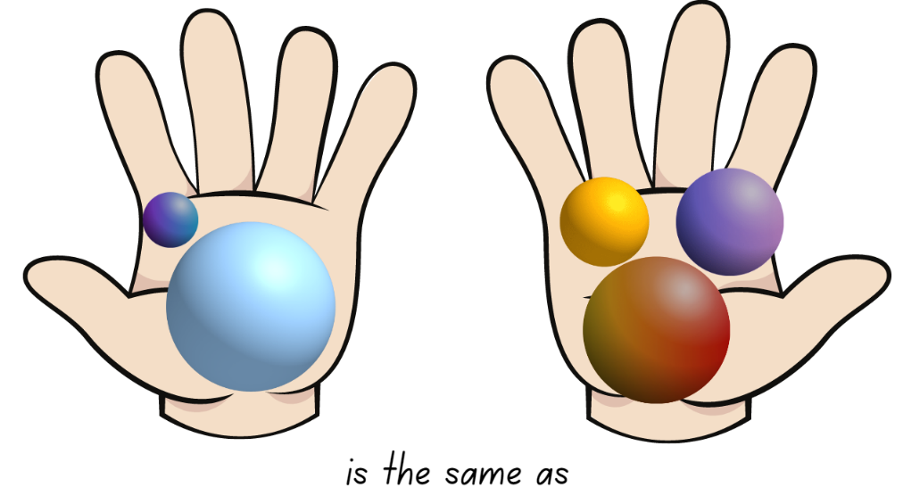
Images sourced from Canva and used in accordance with the Canva Content License Agreement.
- When Stage 1 students have drawn how they would make the equal-arm balances equivalent, provide or display Resource 3: Balancing objects 3 for students to identify which equal-arm balance is equivalent and then draw how they would make the other equal-arm balance equivalent.

Discuss and connect the mathematics – 10 minutes
- Select Stage 1 students to share and explain their how they decided which equal-arm balance was equivalent and how they would make the other equal-arm balance equivalent. Ask:
- What objects did you add to make the equal-arm balance equivalent?
- Can it be made equivalent using different objects?
- Does it make a difference which side the objects are on?
- What problem solving strategies did you use to work out how to make it equivalent?
- Choose Early Stage 1 students to share how they were able to heft many balls to be the same weight. Have Stage 1 students ask Early Stage 1 students questions about how they determined which balls to put on each side to make it the same.
This table details assessment opportunities and differentiation ideas.
Assessment opportunities | Too hard? | Too easy?
What to look for:  - Can students heft objects to compare and order as ‘heavier’, ‘lighter’ or ‘about the same as’? (MAO-WM-01, MAE-NSM-01)  - Are students able to identify objects of different sizes that can be grouped together to represent the same weight? (MAO-WM-01, MAE-NSM-01)  - Can students combine objects to solve and justify equality problems? (MAO-WM-01, MA1-CSQ-01, MA1-NSM-01)  - Are students able to record equivalence using concrete materials, correct vocabulary, drawings and diagrams? (MAO-WM-01, MA1-CSQ-01, MA1-NSM-01)  What to collect:  - observational data (MAO-WM-01, MAE-NSM-01, MA1-CSQ-01, MA1-NSM-01) | Students are unable to compare the weight of items by hefting.  - Students sit and place objects on their lap to feel the resistance against their body to determine if the object is light or heavy.  - Guide students to create 2 balls that are very different in weight and size. Have students use a firm grip to heft and identify if it is lighter or heavier.  Students are unable to identify equivalent and non-equivalent representations.  - Create a key for each object, so students can see what each object represents.  - Provide students with a collection of objects and allow them to become familiar with equivalent representations. | Students can compare the same weight of items using hefting and the correct language.  - Provide students with an equal-arm balance to use after they have hefted their items to confirm if the weight is the same.  - Challenge students to create a larger number of balls and heft at least 4 in each hand to have the same weight. Check using an equal-arm balance.  Students can identify equivalent and non-equivalent representations.  - Students create and draw their own non-equivalent equal-arm balance and have a partner solve the problem.  - Challenge students to make the equal-arm balance equivalent by drawing different solutions to the problem using a variety of objects.

Lesson 4: Is it the same?
Core concept: The same total can be checked by using addition and/or subtraction.
The table below contains suggested learning intentions and success criteria. These are best co-constructed with students.
Learning intentions | Success criteria
Students working towards Early Stage 1 outcomes are learning that:  - numbers have a sequence based on their value  - numbers can be combined to compare and confirm if the total quantity is the same.  Students working towards Stage 1 outcomes are learning that:  - the counting sequence continues with three-digit numbers  - using different structured materials and strategies helps to solve addition and subtraction problems  - addition and subtraction can be used to check equivalence. | Students working towards Early Stage 1 outcomes can:  - identify the number before and after a given one-digit number  - combine 2 or more groups to model addition  - use drawings, words and numerals to solve, record and check addition problems.  Students working towards Stage 1 outcomes can:  - identify and record three-digit numbers in a sequence  - apply addition and subtraction to number sentences to check if they are equal  - represent, record and solve addition and subtraction problems using structured materials and strategies like number bonds or counting on and back.

Daily number sense: One less, one more – 10 minutes
- Build student understanding of the counting sequence by identifying the number before and after given numbers.
- Provide Resource 4: Student recording table and one 9-sided die for Early Stage 1 students and 3 × 9-sided dice for Stage 1 students.
Note: Playing cards can be used instead of dice, remove the tens and picture cards.
- Early Stage 1 students roll the die to record a one-digit number on Resource 4: Students recording table (see Figure 11). Stage 1 students roll their 3 dice and record a three-digit number on Resource 4: Students recoding table (see Figure 11).
Figure 11 – Recording table
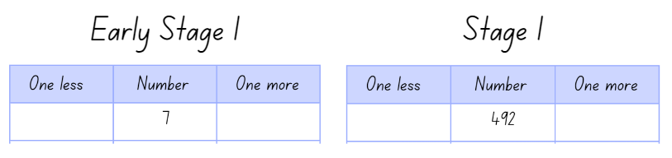
Images sourced from Canva and used in accordance with the Canva Content License Agreement.
- All students identify the number that is one less and one more than the recorded number and write the numbers in the table.
- Students continue to form numbers and complete for 7 rounds.
This table details assessment opportunities and differentiation ideas.
Assessment opportunities | Too hard? | Too easy?
What to look for:  - Can students identify the number before and after a given one-digit number? (MAO-WM-01, MAE-RWN-02)  - Can students identify the number before and after a given three-digit number? (MAO-WM-01, MA1-RWN-01)  - Can students record three-digit numbers in a table? (MAO-WM-01, MA1-RWN-01)  What to collect:  - Resource 4: Student recording table. (MAO-WM-01, MAE-RWN-02, MA1-RWN-01) | Students are unable to identify the number before and after a given one-digit number.  - Display a number chart for students to reference whilst identifying the number before and after.  - Provide students with a ten-frame and counters. Students roll the die and place the corresponding counters on the ten-frame. Students remove a counter to identify the number before and add a counter to identify the number after.  Students are unable to identify the number before and after a three-digit number.  - Provide students with 2 dice. Students work and become confident identifying the number before and after two-digit numbers.  - Display a number chart for students to reference whilst identifying the number before and after. | Students can identify the number before and after a given one-digit number.  - Provide students with a 20-sided die and challenge students to identify the number before and after.  - Challenge students to identify and record the number 2 less and 2 more than the given number.  Students can identify the number before and after a three-digit number.  - Provide students with 4 dice and challenge students to identify the number before and after a four-digit number.  - Challenge student to identify and record the number 10 more and 10 less than the given number.

Number talks – 20 minutes
This lesson has been adapted from Mindset Mathematics: True or False from Boaler et al. (2021).
- Display Resource 5: Number talk 1. Ask Early Stage 1 students if their problem is true or false and ask Stage 1 students if their problem is true or false. Give students time to independently think and show a silent thumbs-up when they are ready.
Note: Students may need an individual whiteboard or concrete materials to record their working.
- Survey the class for who thinks their problem is true and who thinks it is false. Invite students to share their reasoning and evidence.
- Through discussion, come to the agreement and label the number sentences as false because 6 and 2 is not the same as 4 and 3 and 12 + 3 is not equal to 15 + 1.
Note: Some Stage 1 students might read the problem like a number sentence, checking each step remains true. 12 + 3 is equal to 15, true, then add one. Treating the number sentence like a series of steps undermines the idea of equivalence because students ignore the value of each side of the problem as a whole. (Boaler et al., 2021).
- Display Resource 6: Number talk 2 and ask if students notice anything different between this number talk and the previous one. Invite students to share what they notice.
- Ask students if Resource 6: Number talk 2 is true or false. Give students time to independently think and show a silent thumbs-up when they are ready.
- Invite students to share their reasoning and evidence.
- Display Resource 7: Number talk 3 and follow the previous steps.

True or false cards – 20 minutes
- Provide everyone with scissors, glue, and their workbook. In addition, give Early Stage 1 students a copy of Resource 8: True or false 1 and Stage 1 students one page of Resource 9: True or false 2.
Note: Have available a range of structured materials, for example counters, ten-frames, rekenreks, interlocking cubes and equal-arm balances.
- Early Stage 1 students work with a partner to solve, reason and identify if the number sentence is true or false. Students glue in the true or false problems and record their working using drawings, words and/or numerals.
- Stage 1 students glue the number sentences in their workbook and then work with a partner to model, reason and identify if the number sentence is true or false. Students can choose different materials to model the number sentence (see Figure 12).
- Stage 1 students record their working in their workbook, demonstrating if the number sentence is true or false (see Figure 12).
Figure 12 – Stage 1 student examples of working
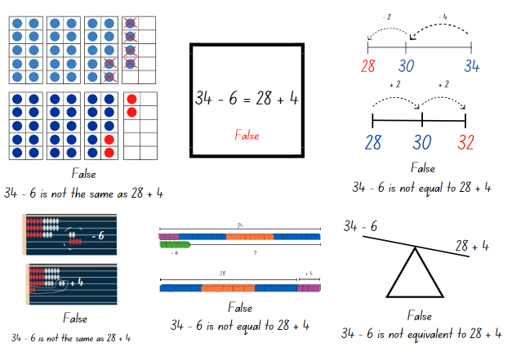
Images sourced from Canva and used in accordance with the Canva Content License Agreement.
- As students are solving problems move around to partners and ask:
- What is the total of each side of the number sentence?
- Explain how you have modelled both sides of the number sentence to see whether they are equal/same?
- Is the number sentence true or false? Why? How do you know?
- Students continue to work through Resource 8: True or false 1 and Resource 9: True or false 2.

Discuss and connect the mathematics – 10 minutes
- Students display their work and go on a gallery walk to look at all the different ways students modelled their working to prove if the number sentences are true or false.
- Discuss the strategies the students used and ask:
- What did you notice when you were solving each problem?
- What strategies did you and your partner use to decide whether a number sentence is true or false?
- What models did you make that were helpful?
- What challenges did you face? How did you solve the problem?
This table details assessment opportunities and differentiation ideas.
Assessment opportunities | Too hard? | Too easy?
What to look for:  - Are students able to combine 2 or more groups to model addition? (MAO-WM-01, MAE-RWN-01, MAE-RWN-02, MAE-CSQ-01, MAE-CSQ-02)  - Can students use drawings, words and numerals to solve, record and check addition problems? (MAO-WM-01, MAE-RWN-01, MAE-RWN-02, MAE-CSQ-01, MAE-CSQ-02)  - Are students able to apply addition and subtraction to number sentences to check if they are equal? (MAO-WM-01, MA1-CSQ-01)  - Can students represent, record and solve addition and subtraction problems using structured materials and strategies like number bonds or counting on and back? (MA1-CSQ-01)  What to collect:  - observational data (MAO-WM-01, MAE-RWN-01, MAE-RWN-02, MAE-CSQ-01, MAE-CSQ-02, MA1-CSQ-01)  - student work samples (MAO-WM-01, MAE-RWN-01, MAE-RWN-02, MAE-CSQ-01, MAE-CSQ-02, MA1-CSQ-01) | Students are unable to combine a group of objects to model addition.  - Provide students with a ten-frame to assist them in tracking their collection.  - Provide students with 0-5 number cards to become confident with combining number to 5.  Students are unable to apply addition and subtraction strategies or use structured materials to check equivalence.  - Provide opportunities for students to recognise and recall number bonds to form 10.  - Support students in solving addition and subtraction problems up to 10 with structured materials and an equal-arm balance. | Students can combine a group of objects to model addition with numbers to 10.  - Challenge students to create a true or false problem which has 3 or more parts.  - Students complete true or false problems with numbers up to 20.  Students can apply addition and subtraction strategies.  - Students create their own true or false number sentences using addition and subtraction.  - Students create their own true or false number sentences using different number representations like dots, dominoes, or money.

Lesson 5: Related facts
Core concept: Related facts help to solve addition and subtraction problems.
The table below contains suggested learning intentions and success criteria. These are best co-constructed with students.
Learning intentions | Success criteria
All students are learning that:  - numbers have a sequence and a connection to a quantity  - number combinations can have related addition and subtraction number facts.  In addition, students working towards Stage 1 outcomes are learning that addition and subtraction are inverse operations. | Students working towards Early Stage 1 outcomes can:  - represent, compare, and order numbers to 20  - model combining 2 groups in the reverse order to recognise ‘turn around facts’  - identify when subtraction can be applied.  Students working towards Stage 1 outcomes can:  - create and sequence two- and three-digit numbers  - model how addition and subtraction are inverse operations using number sentences  - recall and use related addition and subtraction number facts to at least 20  - understand that the equals sign represents equivalence.

Daily number sense: From here to there – 15 minutes
This lesson has been adapted from Dice Dazzlers (From Here to There) from Dr Paul Swan (2003).
- Build student understanding of the sequence of numbers by making and ordering numbers.
- Provide each pair with an individual whiteboard, Early Stage 1 students with a 9-sided die and interlocking cubes and Stage 1 students with two 9-sided dice.
- One student draws a game board on their whiteboard. Early Stage 1 students need to make sure they have 11 boxes.
- Early Stage 1 students write zero in the first box and 10 in the last box. Stage 1 pairs set their starting and finishing numbers and write them on the gameboard.
- The first Early Stage 1 player rolls the die and works out where to write the number on the gameboard. Once they have added the number, they construct the representation of the number using interlocking cubes (see Figure 13).
- The first Stage 1 player rolls both dice and uses the 2 dice to form a number. The player must decide where to place the number on the gameboard so that the sequence of numbers remains in order (see Figure 13). The next player rolls and places their number on the same gameboard. If a number cannot be placed, the player misses their turn.
Figure 13 – Example of play
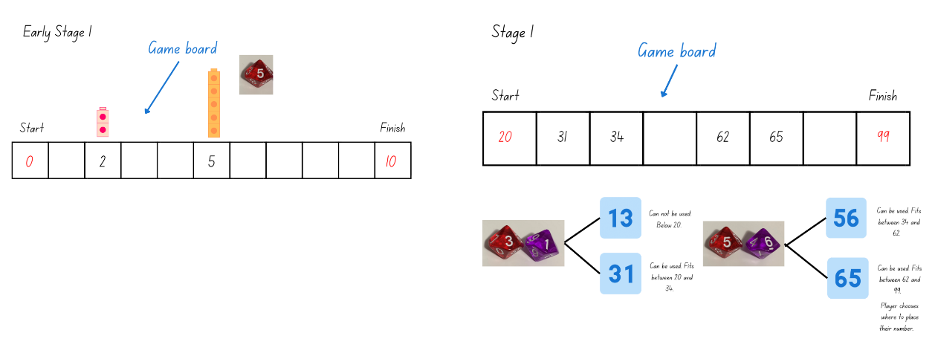
Images sourced from Canva and used in accordance with the Canva Content License Agreement.
- The winner is the person who completes the sequence of numbers from the starting to the finishing number.
Note: Early Stage 1 students can use a 20-sided die and choose a number range between zero and 20. Stage 1 can use different dice, however, guide the students in understanding the finishing number. For example, if two 6-sided dice are used the maximum finishing number will be 66.
This table details assessment opportunities and differentiation ideas.
Assessment opportunities | Too hard? | Too easy?
What to look for:  - Are students able to represent, compare and order numbers to 20? (MAO-WM-01, MAE-RWN-01, MAE-RWN-02)  - Can students create and sequence two- and three-digit numbers? (MAO-WM-01, MA1-RWN-01)  What to collect:  - observational data (MAO-WM-01, MAE-RWN-01, MAE-RWN-02, MA1-RWN-01) | Students are unable to create and sequence numbers.  - Provide students with a number range and have students fill in the missing numbers using a number chart for guidance.  - Support students to roll one or 2 dice to create numbers under 20 with concrete materials or use 2 dice to form a two-digit number. Students record the numbers they create. | Students can create and sequence numbers for their given range.  - Provide opportunities for students to complete the activity in descending order.  - Challenge students to complete the activity with different requirements. For example, odd or even numbers, multiples of 2 or 10.

Number facts – 35 minutes
This lesson has been adapted from Inverse operations: addition and subtraction from State of Victoria (Department of Education and Training).
- Provide Early Stage 1 students with 2 different coloured counters and ask them to use the counters to make a combination for the number 6. After they have made one combination, ask them to ‘turn around the facts’ to show the same combination in a different order (see Figure 14).
Figure 14 – Early Stage 1 number relationships
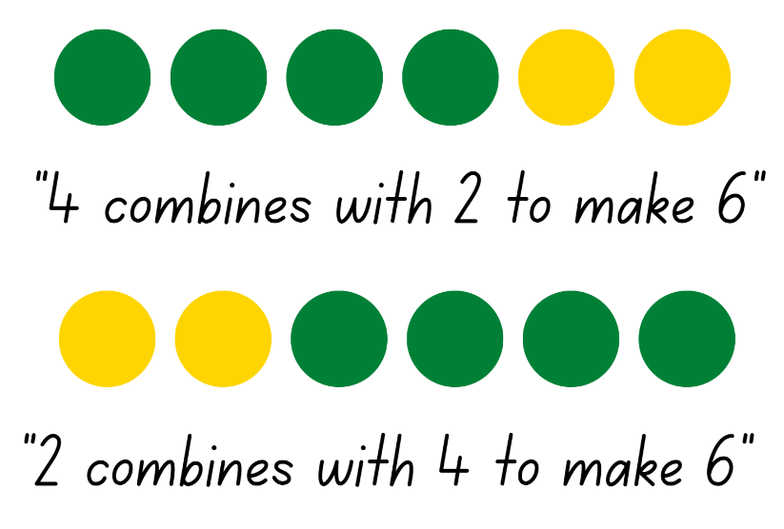
Images sourced from Canva and used in accordance with the Canva Content License Agreement.
- Display for Stage 1 students, Resource 10: Related dots and provide them with an individual whiteboard. Ask students to only use the dot pictures to write a matching number sentence.
- Select Early Stage 1 students to share the 2 representations and record their suggestions. Model and encourage students to use the correct vocabulary to describe their working (see Figure 14).
Note: Early Stage 1 students may know that 4 and 2 and 2 and 4 are ‘turn around facts’ but may not be able to give reasons why they result in the same total. Modelling what these number relations look like assists in building the generalisation that it does not matter which order you add the numbers, the total is still the same (the commutative property of addition).
- Select Stage 1 students to share their number sentence and record. Group the addition sentences together and the subtraction sentences together. Ask Stage 1 students what they notice about the number sentences.
Note: Stage 1 students should start to see the inverse relationship between the numbers and how the related numbers have created both addition and subtraction number sentences.
Inverse operation: The operation that reverses the effect of another operation. For example, add 3 to 7 to get 10. Then subtract 3 from 10 to get back to 7 (see Figure 15).
- Tell Stage 1 students there are 8 ways to represent these numbers in a number sentence. Remind students that the equals sign does not always have to end a number sentence as it symbolises ‘the same as or equal to’. Challenge Stage 1 students to identify all 8 related number sentences (see Figure 15).
Figure 15 – Stage 1 related facts
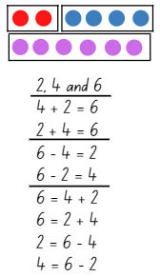
Images sourced from Canva and used in accordance with the Canva Content License Agreement.
- Display Resource 11: Hands for all students.
- Ask Early Stage 1 students to use their counters to combine the numbers represented by the hands to create ‘turn around facts’. Have students explain their combinations to a peer using the correct vocabulary (see Figure 14).
- Ask Stage 1 students to use the numbers represented by the hands to write 8 related number sentences. If needed, identify that a total has not been provided this time.
- Select students to share and explain their work. Ask Stage 1 students to identify if all related number sentences have been collected (see Figure 16).
Figure 16 – Stage 1 related facts
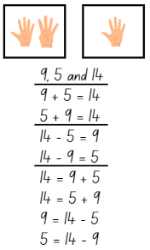
Images sourced from Canva and used in accordance with the Canva Content License Agreement.
- Display Resource 12: Domino for Early Stage 1 students and ask them to use their counters to combine the numbers represented on the domino to create ‘turn around facts’. Challenge students to also use their counters to create 2 ‘turn around facts’ that represents take away.
- While Early Stage 1 are working, demonstrate to Stage 1 students how to roll two 9- or 12-sided dice and use those numbers to create and record 8 related number sentences.
- Provide Stage 1 students with two 9- or 12-sided dice and their workbook to create and record related addition and subtraction number sentences. Students continue to roll the dice and record related number sentences for the numbers rolled. Stage 1 students explain and check their work with their peers.
- Ask Early Stage 1 students to share the 2 representations they created where they joined the number representations together and record their suggestions. Then ask students to share what happened when they tried to create 2 ‘turn around facts’ that represented take away. Allow students to share and guide them to understand the order of numbers when taking away.
Note: Early Stage 1 students need opportunities to build reasoning and to reflect on how ‘turn around facts’ and the number relationship is not true for subtraction. Understanding that the order of numbers cannot change for subtraction is an important concept.
- Provide Early Stage 1 students with two 5- or 6-sided dice to roll together. Students combine the numbers represented with 2 different coloured counters to create ‘turn around facts’. Model to students how to communicate their representations using the correct vocabulary, Figure 17. Challenge students to create one representation that shows how to take away the smallest number from the largest number and communicate their actions using the correct vocabulary (see Figure 17). Students continue to roll and represent with counters ‘turn around facts’, communicating their actions.
Figure 17 – Early Stage 1 talk aloud
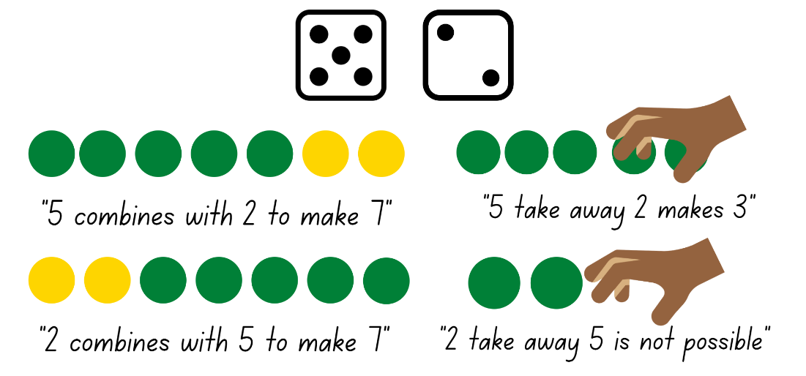
Images sourced from Canva and used in accordance with the Canva Content License Agreement.

Discuss and connect the mathematics – 10 minutes
- Summarise the lesson together, drawing out some key mathematical ideas. Select students to share their work and ask:
- Did you notice any patterns? Did this help you?
- Can you use ‘turn around facts’ when taking away? Why/why not? (Early Stage 1)
- Do you think related facts/’turn around facts’ apply to larger numbers?
- How do related facts/’turn around facts’ help us to solve problems?
- How do you know you have all the related number sentences? (Stage 1)
- What challenges did you face? How did you solve them?
This table details assessment opportunities and differentiation ideas.
Assessment opportunities | Too hard? | Too easy?
What to look for:  - Are students able to model combining 2 groups and then model the reverse order to recognise ‘turn around facts’? (MAO-WM-01, MAE-RWN-01, MAE-RWN-02, MAE-CSQ-01, MAE-CSQ-02)  - Can students identify when subtraction can be applied? (MAO-WM-01, MAE-RWN-01, MAE-CSQ-01)  - Are students able to recall and use related addition and subtraction number facts to at least 20? (MA1- WM-01, MA1-CSQ-01)  - Can students correctly use and understand that the equals sign represents equivalence? (MA1-CSQ-01)  What to collect:  - observational data (MAO-WM-01, MAE-RWN-01, MAE-RWN-02, MAE-CSQ-01, MAE-CSQ-02, MA1-CSQ-01)  - student work samples (MAO-WM-01, MAE-RWN-01, MAE-RWN-02, MAE-CSQ-01, MAE-CSQ-02, MA1-CSQ-01) | Students are unable to model combining 2 groups to show ‘turn around facts’ and identify the order of numbers for subtraction.  - Support students to use 2 number cards below 5 and coloured counters to model combining the 2 numbers. Then move the number cards to show the reverse order and model combining the 2 numbers with another set of counters. Students use one-to-one counting to check the total of each group and identify they are the same.  - Provide lots of hands-on opportunities for students to model subtraction using concrete materials. This may help students confirm the order of numbers to successfully complete a take-away problem.  Students are unable to recall and use related addition and subtraction number facts to 20.  - Provide students with counters so that they can model combining and separating the given numbers. Support students to record these number sentences as they create the representations.  - Students work with numbers either below 5 or 10 to model related addition and subtraction facts. Model talking aloud, for example 4 counters plus one counter is equal to 5 counters, so this means that 5 counters minus one counter is equal to 4 counters. | Students can model combining 2 groups to show ‘turn around facts’ and identify the order of numbers for subtraction.  - Allow students to show ‘turn around facts’ when they combine 3 numbers together.  - Provide students with two 9 or 20-sided dice to explore identifying the order of numbers for subtraction and modelling this with concrete materials.  Students can recall and use related addition and subtraction number facts to 20.  - Provide students with a different range of dice to create larger numbers. For example, two 20-sided dice or roll 2 dice to create different two-digit numbers.  - Challenge students to represent their number sentence using drawings with real world connections.

Lesson 6: Number bonds
Core concept: The relationship between numbers is an efficient way to solve some addition and/or subtraction problems.
The table below contains suggested learning intentions and success criteria. These are best co-constructed with students.
Learning intentions | Success criteria
Students working towards Early Stage 1 outcomes are learning that there is a relationship between the parts and the whole when combining quantities.  Students working towards Stage 1 outcomes are learning that:  - number bonds can help to find a missing number in a number sentence  - an empty number line can be used to represent and solve addition and subtraction problems. | Students working towards Early Stage 1 outcomes can combine 2 groups of objects to model addition and identify the relationship between the parts and the whole.  Students working towards Stage 1 outcomes can:  - use known number bonds and knowledge of equality to solve missing number problems  - use an empty number line to solve addition and subtraction problems.

Daily number sense: Maths tipping – 15 minutes
This lesson has been adapted from Maths Tipping from NSW Department of Education.
- Build student understanding of the sequence of numbers by counting forwards and backwards by ones or tens on and off the decade with one-, two-, and three-digit numbers.
- Have students stand in a circle with Early Stage 1 students on one side and Stage 1 students on the other side.
- Choose Early Stage 1 students to count forwards by ones within a range to 30 or backwards by ones within a range from 20. For example, counting forwards by ones from 11 up to 23. Continue for a few rounds with different numbers.
- Choose Stage 1 students to count forwards or backwards by tens on or off the decade from a given two- or three-digit number until they reach a target number. For example, counting forwards by tens from 26 up to 156. Continue for a few rounds with different numbers.
- Then have students stand in different spaces around the room.
- Say a number to a student and an Early Stage 1 student says the number that is ‘one less’ and ‘one more’ than the given number. Stage 1 students say the number that is 10 more and 10 less than the given number.
- Students must answer within a designated amount of time, for example, 5 seconds. If the student is correct, they can take one step in any direction to attempt to tip another student on the shoulder. If tipped, the student must sit down. If a student states the incorrect answer, they also must sit down.
- Continue until one student remains standing.

Number stories – 35 minutes
- Display for Stage 1 students, Resource 13: Number story and provide them with an individual whiteboard. Ask Stage 1 students to write a number sentence to represent the story and then share with a peer.
- While Stage 1 are representing the story provide Early Stage 1 students with various objects, 0-10 number cards and their workbook. Model to students how to turn over a card to get a target number. Then create a combination story using the objects as well as verbally explaining or acting out the story to combine the objects together to reach the target number. Model how to record this using simple drawings to represent the story. Challenge students to come up with 2 stories with different representations for the given number (see Figure 18).
Figure 18 – Early Stage 1 representations
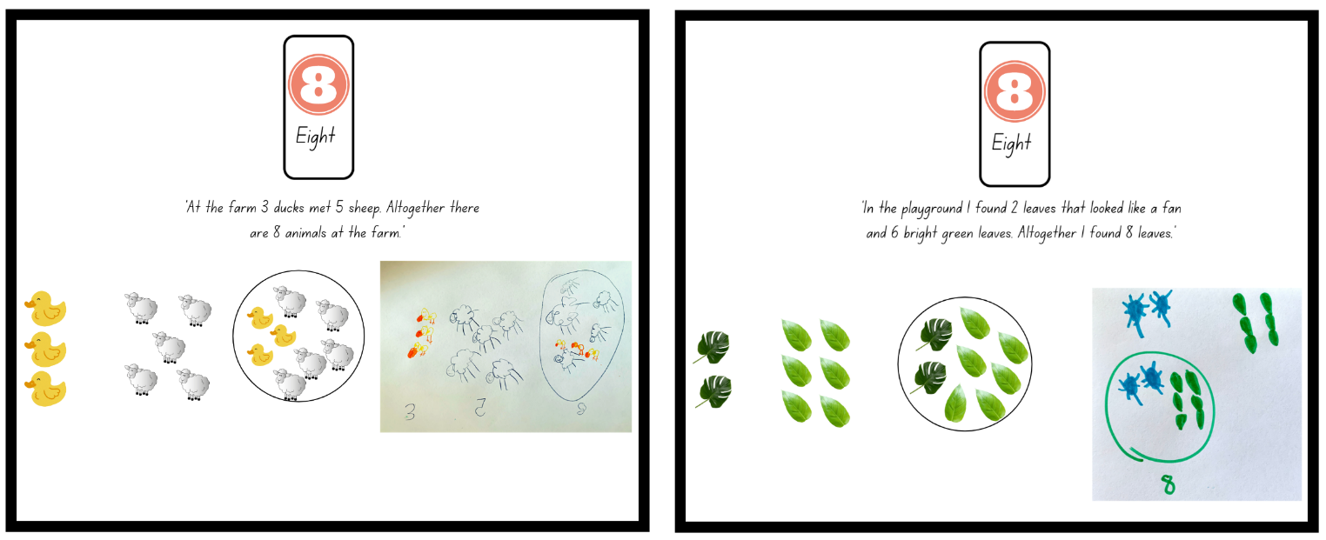
Images sourced from Canva and used in accordance with the Canva Content License Agreement.
Note: Storytelling is an effective way for students to conceptualise and communicate mathematical ideas, such as combining and separating quantities, and assists students to recognise the purposeful nature of mathematics in real-world contexts. When providing students with various objects choose items which students can use within their story. For example, coloured teddies, shells, animals, figurines, and leaves. Students illustrate and verbally tell the story.
- Early Stage 1 students work with a partner or small groups to create and illustrate stories to show 2 different representations of a given number (see Figure 18).
- While Early Stage 1 students are creating their stories, select Stage 1 students to share and explain their number sentence and record their thinking.
Note: If Stage 1 students write the missing number in their number sentence, discuss how this does not reflect the information in the story.
- Select Stage 1 students to explain and demonstrate how they would solve the number story to find the missing number.
- Highlight to Stage 1 students how to solve this problem efficiently using number bonds to find the missing number. For example, $8 + $2 equals $10 and $10 more equals $20, $2 + $10 equals $12 so the missing number is 12 (see Figure 19).
Figure 19 – Student working
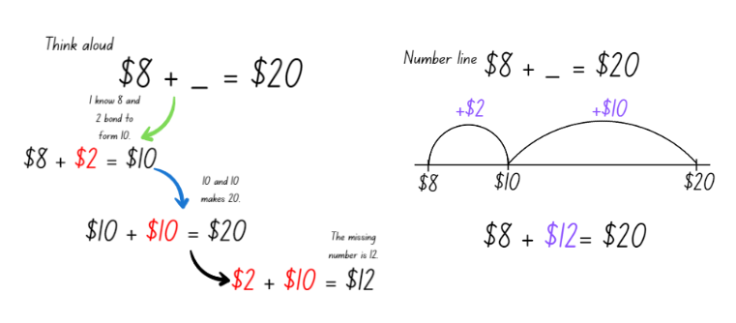
Images sourced from Canva and used in accordance with the Canva Content License Agreement.
- Display for Stage 1 students, Resource 14: Number sentence 1 and have them use their individual whiteboard to solve the number sentence using known number bonds and a blank number line.
- While Stage 1 are solving the problem, check in with Early Stage 1 students and ask them to share their stories and illustrations. Early Stage 1 students continue to work on creating and illustrating stories.
- Select Sage 1 students to share and demonstrated their working and explain how they found the missing number.
- Display Resource 15: Number sentence 2 to Stage 1 students and ask:
- What do you notice is similar?
- What do you notice is different?
- Can you use number bonds to find the missing number?
- Stage 1 students use their individual whiteboard to solve Resource 15: Number sentence 2 and show their working.
- Select Stage 1 students to share and demonstrated their working, explaining how they found the missing number. Highlight the use of number bonds in conjunction with a blank number line to solve the problem (see Figure 20).
Figure 20 – Student working
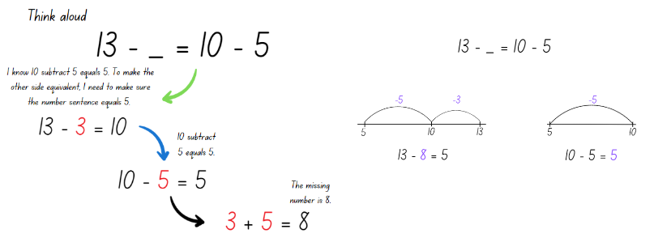
Images sourced from Canva and used in accordance with the Canva Content License Agreement.
- Discuss with Stage 1 how all 3 problems looked different, yet the same strategy and working was applied to find the missing number.
Note: If a student uses a different strategy like relational thinking, doubles or near doubles, briefly highlight and compare the different strategies.
- Provide Stage 1 students with one page of Resource 16: Missing numbers and their workbook. Students solve the problems and show their working using know number bonds and a blank number line.
- While Stage 1 students are working, regroup with Early Stage 1 students. Have Early Stage 1 students share their stories and illustrations. Focus the discussion on the relationship between the different parts and the whole number.
- Model to Early Stage 1 students how to record the number bonds for the given number in their stories. Draw students' attention to how the parts are different, but the given number is the same (see Figure 21).
Figure 21 – Early Stage 1 number bonds
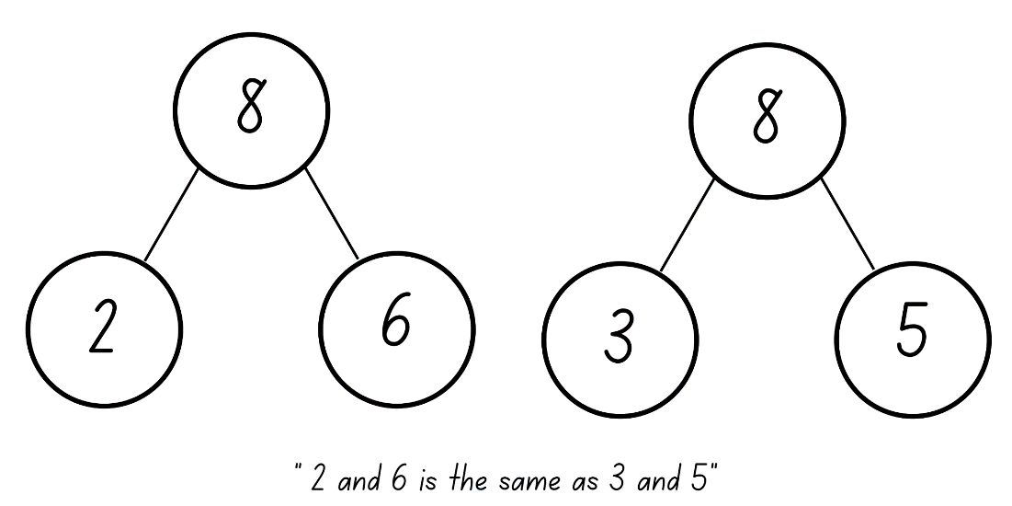
Images sourced from Canva and used in accordance with the Canva Content License Agreement.
- In their workbook, Early Stage 1 students create number bond representations for their number stories.

Discuss and connect the mathematics – 10 minutes
- Choose students to share their work and demonstrate and explain their working. Ask:
- What did you notice when you were solving the problems?
- Can you tell the class your story? (Early Stage 1)
- Did you notice any patterns with the combinations? (Early Stage 1)
- Are there different parts of a given number? (Early Stage 1)
- Which number bonds did you use to find the missing number? (Stage 1)
- Did your knowledge of equality help you to solve the problems? Explain your thinking. (Stage 1)
- Did using a blank number line help you to solve the problems? How? (Stage 1)
- Were any of the problems challenging? What questions do you still have, or did you work through the challenge?
This table details assessment opportunities and differentiation ideas.
Assessment opportunities | Too hard? | Too easy?
What to look for:  - Are students able to combine 2 groups of objects to model addition and identify the relationship between the parts and the whole? (MAO-WM-01, MAE-RWN-01, MAE-RWN-02, MAE-CSQ-01, MAE-CSQ-02)  - Can students use known number bonds to solve missing number equality problems? (MAO-WM-01, MA1-CSQ-01)  - Are students able to use an empty number line to solve addition and subtraction problems? (MAO-WM-01, MA1-CSQ-01)  What to collect:  - student work samples (MAO-WM-01, MAE-RWN-01, MAE-RWN-02, MAE-CSQ-01, MAE-CSQ-02, MA1-CSQ-01) | Students are unable to combine a group of objects to model addition.  - Provide students with a ten-frame to assist them in tracking their collection.  - Provide students with 0-5 number cards to become confident with combining number to 5.  Students are unable to use number bonds to find the missing number.  - Support students with solving the missing number problems using structured materials like an equal-arm balance and interlocking cubes.  - Provide concrete materials like counters so students can model the missing number problems and count with one-to-one correspondence. Support students to record these number sentences. | Students can combine a group of objects to model addition with numbers to 10.  - Challenge students to create and model a story which has 3 parts.  - Students use objects to create subtraction stories.  Students can use number bonds to find the missing number.  - Challenge students to use the inverse relationship to change the number sentences from either addition to subtraction or vice versa.  - Students write their own missing number equality word problems for a peer to solve.

Lesson 7: Exploring relations
Core concept: The same number can be represented in different ways. Relational thinking involves the relationship between both sides of the problem.
The table below contains suggested learning intentions and success criteria. These are best co-constructed with students.
Learning intentions | Success criteria
Students working towards Early Stage 1 outcomes are learning that different combinations of numbers can add up or bond to represent a given number.  Students working towards Stage 1 outcomes are learning that relational thinking is an efficient strategy to solve addition and subtraction problems. | Students working towards Early Stage 1 outcomes can:  - create, model, and recognise combinations for numbers up to 10  - use drawings, words, and numerals to record number combinations up to 10.  Students working towards Stage 1 outcomes can:  - record and solve missing equality number problems using relational thinking  - use the forwards and backwards counting sequence to solve related problems.

Daily number sense: Number chart puzzle – 15 minutes
This activity has been adapted from Mindset Mathematics: Patterns in the Hundreds chart from Boaler et al. (2021).
- Build student understanding of the position of numbers by locating them on different sections of a number chart.
- Provide Resource 17: Early Stage 1 Number puzzles for Early Stage 1 students and display Resource 18: Stage 1 Number puzzles for Stage 1 students.
- Early Stage 1 students add the missing numbers on the resource and Stage 1 can use their individual whiteboard to draw and fill in the missing numbers.
Note: Students may need a number chart displayed and Stage 1 students may need Resource 18: Stage 1 Number puzzles printed.
- As students are solving each puzzle, ask:
- How did you figure out the missing numbers? How do you know they are correct?
- Did you need to use the number chart?
- What patterns did you find and/or use?
- Select students to share and justify their working to the class.

Missing numbers – 35 minutes
This lesson has been adapted from Mindset Mathematics: Exploring relations and Snap It from Boaler et al. (2021 and 2020).
- Write 12 + 4 = __ + 5 and 15 − __ = 14 − 5 on the board and provide Stage 1 students with interlocking cubes. Explain to Stage 1 students that the number sentences are both missing a number to make it equivalent. Challenge Stage 1 students to use a different strategy other than number bonds to solve it. Provide thinking time, then have students turn and talk to discuss how they will solve the problem. Stage 1 students solve the problem using their individual whiteboard and interlocking cubes to record their working.
- While Stage 1 students are solving the problems, explain Snap It to Early Stage 1 students. Show students a stick of interlocking cubes 4-10 cubes long. Allow students time to look at the full stick and identify how many cubes make up the stick. Then snap the stick into 2 sections. Students observe the 2 sections and identify how many cubes are in each piece and how many cubes there were altogether. Record the information about the stick, drawing a line to show how it was snapped and label the parts and the whole (see Figure 22). Join the stick back together, identifying the total number again and then snap the stick into 2 different sections. Discuss and record the information about the sticks, drawing students' attention that 2 and 5 is the same as 4 and 3 and they both total 7.
Figure 22 – Teacher recording
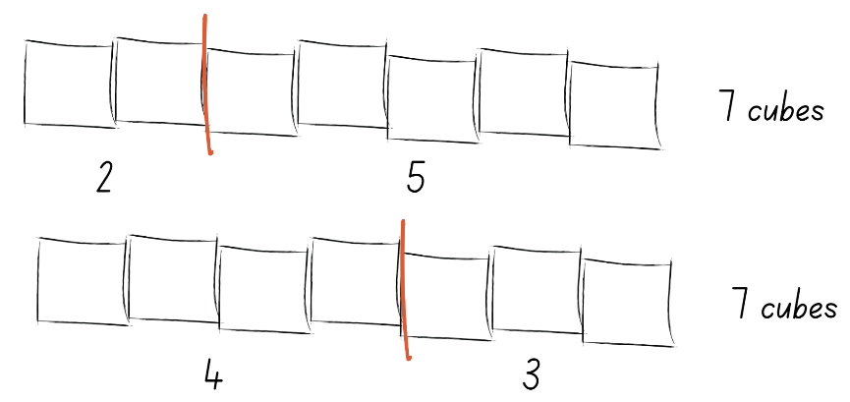
Images sourced from Canva and used in accordance with the Canva Content License Agreement.
- Provide pairs of Early Stage 1 students with a collection of interlocking cubes and their workbook. Students each create a stick of 4-10 interlocking cubes, partners must have the same size stick. At the same time, the pair of students snap their stick and compare what is similar and different about their snap. Students record their own snap in their workbook. Pairs do 3 snaps each time recording in their workbook and discussing their snap. Then they create another stick of a different value and complete the process again.
- Select Stage 1 students to share and justify their answers to the initial problems they were presented with and record their solutions. When students are sharing, discuss various strategies used including relational thinking. For example, the relationship between the 5 and the 4, 5 is one more than 4, so the missing number will need to be one less than 12. Demonstrate how using relational thinking is the most efficient way to solve these number sentences.
Note: Stage 1 students may have solved the problem by adding 12 and 4 to get 16 and then taking 5 away from 16 to find the missing number of 11. This is correct; however, this is not relational thinking and not the most efficient way of solving this number sentence.
Relational thinking: Is the relationships between the numbers on both sides of the equals sign and the knowledge of the properties to solve problems. For example, 19 + 6 = 18 + __, 18 is one less than 19 so the missing value must be one greater than 6.
- Present Stage 1 students with additional relational thinking number sentences to solve, for example, 11 − __ = 10 − 3, 29 − 6 = __ − 7 and 14 + 22 = __ + 32. After each number sentence is displayed, provide thinking and working out time as well as opportunities for students to turn and talk to discuss possibilities.
- Once Stage 1 students are confident with applying relational thinking to a number sentence to make it equivalent, provide pairs with Resource 19: Missing number cards, interlocking cubes, scissors, glue and workbooks.
- Stage 1 students' glue Resource 19: Missing number cards into their workbook and investigate and solve the missing number problems. They complete the number sentence with their peers and demonstrate their understanding of relational thinking by showing their working (see Figure 23).
Figure 23 – Example of student working
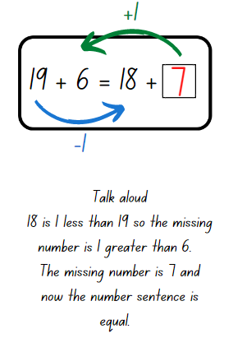
Images sourced from Canva and used in accordance with the Canva Content License Agreement.
- Regroup with Early Stage 1 students and have them share their snaps and what they notice is similar and different between their snap and their partners.
- Challenge Early Stage 1 students to choose one number between 5-10 and create a poster with all the combinations that use 2 numbers. Encourage students to use different illustrations and words to represent all the combinations (see Figure 24).
Figure 24 – Early Stage 1 student poster
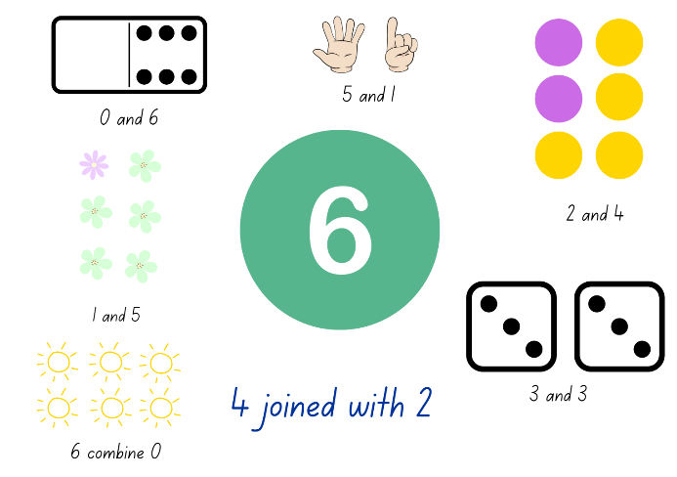
Images sourced from Canva and used in accordance with the Canva Content License Agreement.

Discuss and connect the mathematics – 10 minutes
- Summarise the lesson together, drawing out some key mathematical ideas, ask:
- When recording number combinations does the order matter? Explain. (Early Stage 1)
- How do you know you have found all the combinations? (Early Stage 1)
- How did you find the missing number? (Stage 1)
- How does the relationship between each side of the problem help you to find the missing number? (Stage 1)
- How did you use the equals sign to help find the missing number? (Stage 1)
- Did you find the missing number without finding the total of each side? How? (Stage 1)
- Is there anything else you noticed?
This table details assessment opportunities and differentiation ideas.
Assessment opportunities | Too hard? | Too easy?
What to look for:  - Are students able to create, model and recognise combinations for numbers up to 10? (MAO-WM-01, MAE-RWN-01, MAE-RWN-02, MAE-CSQ-01, MAE-CSQ-02)  - Can students use drawings, words and numerals to record number combinations up to 10? (MAO-WM-01, MAE-RWN-01, MAE-RWN-02, MAE-CSQ-01, MAE-CSQ-02)  - Can students record and solve missing equality number problems using relational thinking? (MAO-WM-01, MA1-CSQ-01)  - Are students able to use the forwards and backwards counting sequence to solve related problems? (MAO-WM-01, MA1-CSQ-01)  What to collect:  - student work samples (MAO-WM-01, MAE-RWN-01, MAE-RWN-02, MAE-CSQ-01, MAE-CSQ-02, MA1-CSQ-01) | Students are unable to create, model, recognise and record combinations for numbers up to 10.  - Provide students with concrete materials and a number range below 5. Students can use a ten-frame to assist them with maintaining the count.  - Students count with one-to-one correspondence with numbers to 10 and collect an interlocking cube each time they say a number out loud. Students then count the total.  Students are unable to identifying the missing number.  - Provide students with concrete materials, for example, interlocking cubes to represent the number sentence. Students count with one-to-one correspondence to find the total of one-side and determine how many more are needed on the other side to make it equivalent.  - Students recall numbers before and after a given number to develop their confidence with the counting sequence to assist with relational thinking. | Students can create, model, recognise and record combinations for numbers up to 10.  - Challenge students to snap their stick into 3 or 4 parts and record.  - Provide students with up to 20 interlocking cubes and students snap their sticks to make 2 or 3 combinations. Students record their working.  Students can identify the missing number.  - Challenge students to use a twenty-sided die to create their own missing number sentence. Students have a partner solve their problems using relational thinking.  - Students compare the strategies of relational thinking and number bonds and create problems which reflect either strategy.

Lesson 8: Solving equality problems
Core concept: Different strategies help to efficiently solve addition and/or subtraction equality problems.
The table below contains suggested learning intentions and success criteria. These are best co-constructed with students.
Learning intentions | Success criteria
Students working towards Early Stage 1 outcomes are learning that different combinations of numbers can add up or bond to represent a given number.  Students working towards Stage 1 outcomes are learning that:  - different strategies can be applied to efficiently solve addition and subtraction problems  - a variety of number sentences can reflect equality. | Students working towards Early Stage 1 outcomes can:  - represent a given number by using concrete materials to show the different parts of the same number  - communicate their thinking and reasoning using models, drawings, numbers, and words.  Students working towards Stage 1 outcomes can:  - model how addition and subtraction are inverse operations using concrete materials, drawings, and diagrams  - use known number bonds and knowledge of equality to solve missing number problems  - record and solve missing equality number problems using relational thinking.

Daily number sense: Number line – 10 minutes
This lesson has been adapted from Open-Ended Maths Activities from Sullivan and Lilburn (2017).
- Build student understanding of the sequence of numbers by counting forwards and backwards by ones or tens on and off the decade.
- Provide Early Stage 1 students with 2 numbers within the range of 0-20. Students use their individual whiteboard to record the missing numbers between the range (see Figure 25).
Figure 25 – Early Stage 1 recording
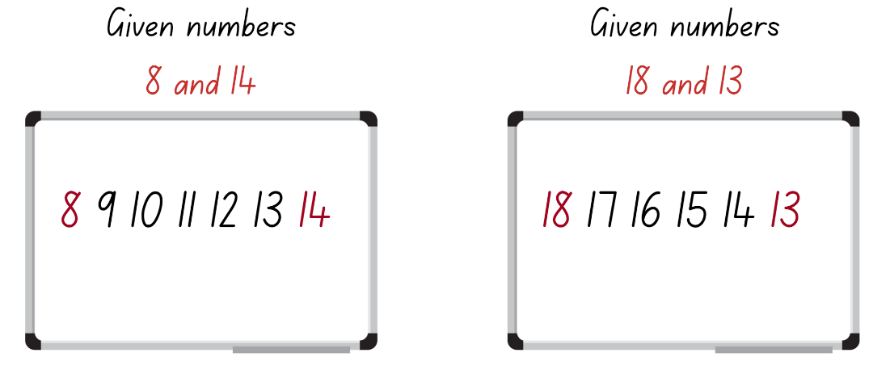
Images sourced from Canva and used in accordance with the Canva Content License Agreement.
- Stage 1 students draw a blank number line on their individual whiteboard. Show students 2 numbers and ask them to place them on the number line, as well as 5 other numbers of their choice which are multiples of 10. For example, provide the numbers 60 and 120 and then students choose 5 other multiple of 10 to include (see Figure 26).
Figure 26 – Number line
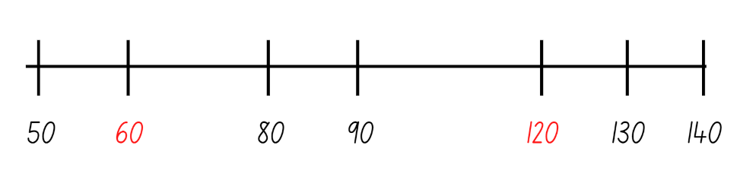
Images sourced from Canva and used in accordance with the Canva Content License Agreement.
- Choose students to share their missing numbers or number line and justify the placement of the numbers.
- Continue to provide Early Stage 1 students with different number ranges which are ascending and descending and Stage 1 students with different two- and three-digit number ranges on and off the decade.
Note: Monitor where Stage 1 students place the numbers. Ensure students understand that the largest number does not need to go at the very end of the line. The placement of each number is dependent on the other numbers.

Problem solving – 30 minutes
- Display for Early Stage 1 students Resource 20: Zoo animals and allow students time to look closely at the resource. Then students turn and talk and discuss the following questions. Ask:
- How many animals do you think there are with 2 legs?
- How many animals do you think there are with 4 legs?
- Are there any animals with a different number of legs?
- While Early Stage 1 are looking closely at Resource 20: Zoo animals, display for Stage 1 students Resource 21: Different problems 1, 6 and 7 (related number sentences), 30 − __ = 14 (number bonds) and 13 + 6 = 12 + __ (relational thinking). Ask Stage 1 students to look at the problems and work out which strategy they should apply to efficiently solve these equality problems. Students turn and talk and then use their individual whiteboard to solve the problems.
- While Stage 1 are solving the problems, choose Early Stage 1 students to share their responses to the previous questions. Then ask Early Stage 1 students how they could count and represent all the animal legs. Provide pairs of students with an individual whiteboard and access to concrete materials to represent their count of animal legs.
- Choose Stage 1 students to share, demonstrate and justify why they chose a particular strategy over another when solving Resource 21: Different problems 1.
- Choose different Early Stage 1 students to share their working and justify their representation.
- Display for Stage 1 students Resource 22: Different problems 2 and provide students with independent thinking time as they look at the different problems and choose which strategy to apply. Students use their individual whiteboard to solve the problems.
- While Stage 1 students are solving the problems, pose this scenario to Early Stage 1 students. The zookeepers are organising an animal party and need help. There are 2 animal enclosures for the party and each enclosure must have the same number of animal legs. Ask students what this might look like and record their thinking using drawings, numerals and words.
- Provide each Early Stage 1 student with 2 pieces of paper to represent the 2 enclosures, their workbook and access to a range of materials to create the animals and legs. Remind students that animals have a different number of legs and each enclosure needs the same number of animal legs (see Figure 27). Guide students by asking:
- What could the animals in the enclosure looks like?
- How will you make the animals with 2 or 4 legs?
- How will you keep track of the number of legs?
Figure 27 – Enclosure with animals
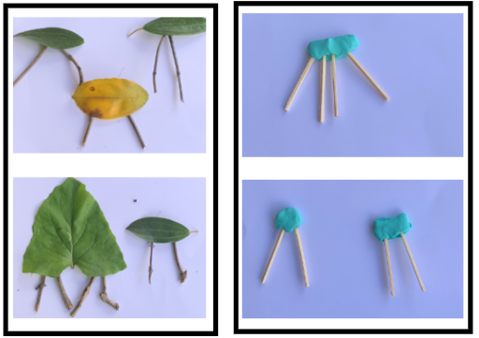
- Early Stage 1 students create different representations of animals within the zoo enclosures and record their working in their workbook. Encourage students to record the combinations using drawings, numerals and words. Take photographs of the different animal enclosures.
Note: Students can record their animals and legs using materials and drawing the representation. Provide students with a range of materials, for example, sticks, toothpicks, leaves, shells, counters, blocks, modelling clay, paperclips, or pencils. Students can use paper, their workbook or individual whiteboards to represent the enclosures.
- Choose Stage 1 students to share, demonstrate and justify why they chose a particular strategy over another when solving these problems.
- Discuss with Stage 1 students how the addition and subtraction problems require equality, yet different strategies can be applied to solve the problems in an efficient way.
- Provide Stage 1 students with Resource 23: Different problems 3 and students carefully analyse each problem to decide which strategy to use to solve the problem. Students glue the problem in their workbook, write the name of the strategy they are going to use and record their working and the answer.
Note: Resource 23: Different problems 3 can be cut into 3 horizonal strips to provide students with 3 problems at a time. Each strip has the opportunity for students to demonstrate related number sentences, number bonds and relational thinking.
- Early Stage 1 students continue to make different displays to represent the animals in the enclosures and Stage 1 students continue to work through each problem.

Discuss and connect the mathematics – 20 minutes
- Students display their work and go on a gallery walk.
- Regrouping as a class, choose students to either explain their animal enclosures or demonstrate solving a problem and justify why they chose to solve the problem using that strategy. Ask Early Stage 1 students:
- Did you face any challenges when creating your animals?
- What were some of the strategies you used to make sure each enclosure had the same number of legs?
- Did you need to change the animals in your enclosures?
- How did you know that your animal enclosures have the same number of legs?
- Summarise the unit together, drawing out the key mathematical ideas:
- What does the equals sign represent? (Stage 1)
- How can we check if something is equal/same?
- What are some different strategies we can use to solve addition and subtraction problems? (Stage 1)
- What questions do you still have?
- Is there an area you would like more practice with?
- In what area are you feeling more confident in?
This table details assessment opportunities and differentiation ideas.
Assessment opportunities | Too hard? | Too easy?
What to look for:  - Are students able to represent a given number by using concrete materials to show the different parts of the same number? (MAO-WM-01, MAE-RWN-01, MAE-RWN-02, MAE-CSQ-01, MAE-CSQ-02)  - Are students able to communicate their thinking and reasoning using models, drawings, numbers and words? (MAO-WM-01, MAE-RWN-01, MAE-RWN-02, MAE-CSQ-01, MAE-CSQ-02)  - Are students able to choose the correct strategy and apply it to addition and subtraction problems? (MAO-WM-01, MA1-CSQ-01)  - Are students able to recall and use related addition and subtraction number facts to at least 20? (MAO-WM-01, MA1-CSQ-01)  - Can students use known number bonds and knowledge of equality to solve missing number problems? (MAO-WM-01, MA1-CSQ-01)  - Can students record and solve missing equality number problems using relational thinking? (MAO-WM-01, MA1-CSQ-01)  What to collect:  - student work samples (MAO-WM-01, MAE-RWN-01, MAE-RWN-02, MAE-CSQ-01, MAE-CSQ-02, MA1-CSQ-01) | Students are unable to create 2 animal enclosures with the same number of legs and explain using correct mathematical language.  - Support students with making one animal for each enclosure with the same number of legs.  - Explicitly model the correct mathematical language by creating a scenario with a small number of animal legs in each animal enclosure.  Students are unable to apply different strategies to solve addition and subtraction problems.  - Provide students with concrete materials and an equal-arm balance to model and check different problems.  - Have students look at individual number sentences and tell you everything they know and understand about the number sentence. Ask guiding questions to help them identify which strategy they could use to solve the problem. | Students can create 2 animal enclosures with the same number of legs and explain using correct mathematical language.  - Challenge students by increasing the number of legs and enclosures as well as challenging them to represent animals that have more than 2 or 4 legs.  - Encourage students to create a story about their Zoo using mathematical language to share with the class.  Students can apply different strategies to solve addition and subtraction problems.  - Challenge students to create different problems which use the various strategies.  - Students create a video explaining and demonstrating the different strategies.

Resource 1: Balancing objects
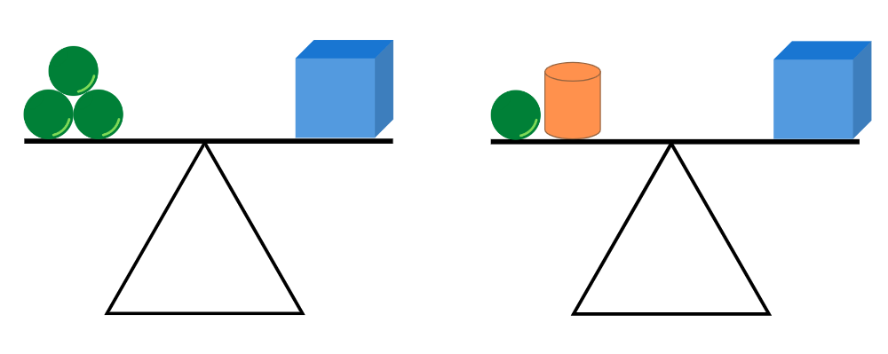
Image adapted from ‘Lesson 2: Balance without Numbers’ by © Australian Government Department of Education 2022 which is licensed under CC-BY-NC-SA 4.0.

Resource 2: Balancing objects 2
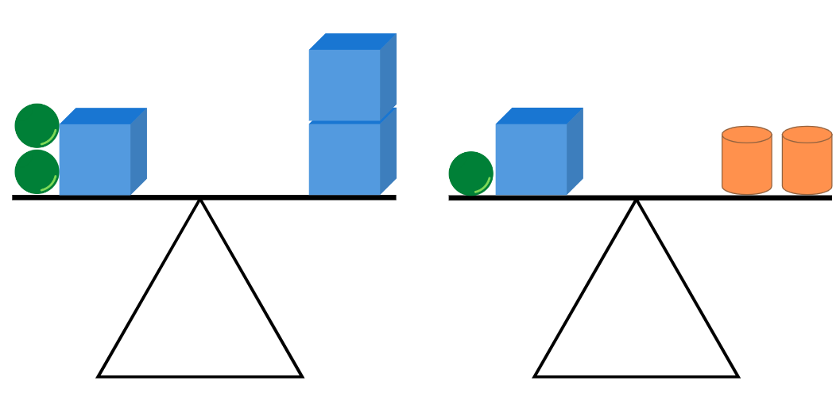
Image adapted from ‘Lesson 2: Balance without Numbers’ by © Australian Government Department of Education 2022 which is licensed under CC-BY-NC-SA 4.0.

Resource 3: Balancing objects 3
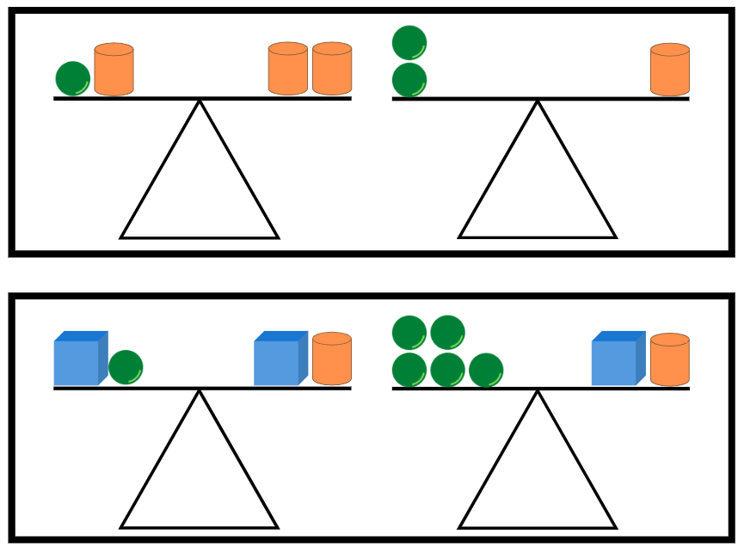
Image adapted from ‘Lesson 2: Balance without Numbers’ by © Australian Government Department of Education 2022 which is licensed under CC-BY-NC-SA 4.0.

Resource 4: Student recording table
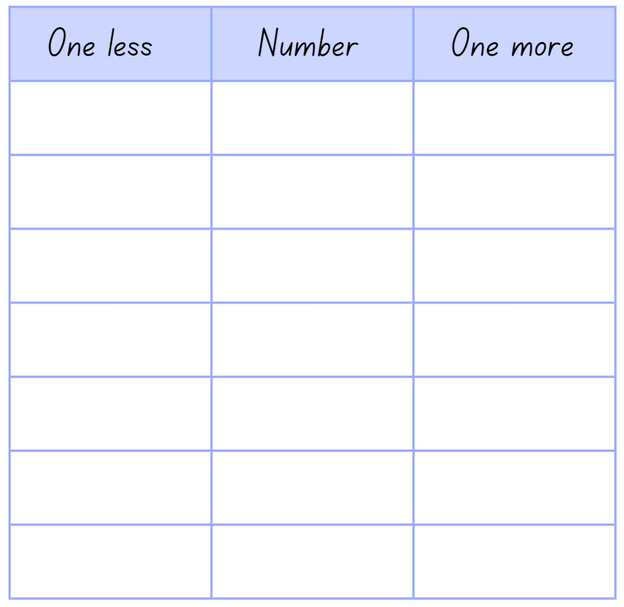

Resource 5: Number talk 1
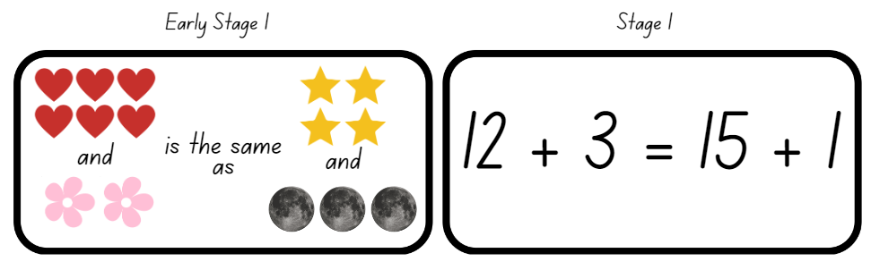Images sourced from Canva and used in accordance with the Canva Content License Agreement.

Resource 6: Number talk 2
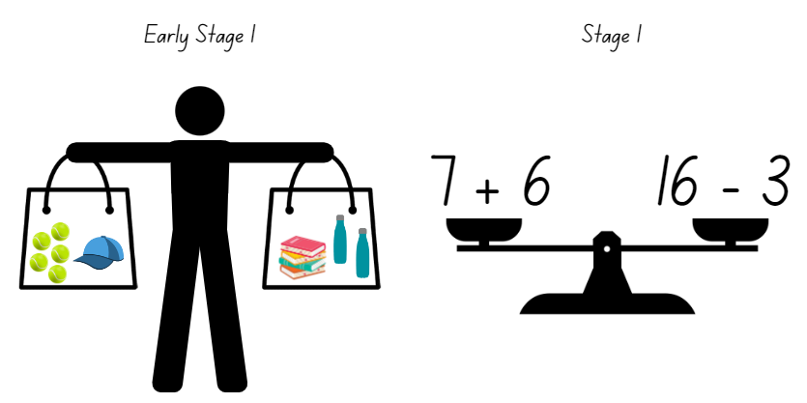
Images sourced from Canva and used in accordance with the Canva Content License Agreement.

Resource 7: Number talk 3
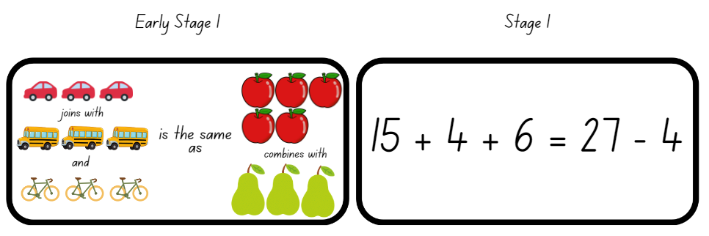 Images sourced from Canva and used in accordance with the Canva Content License Agreement.

Resource 8: True or false 1
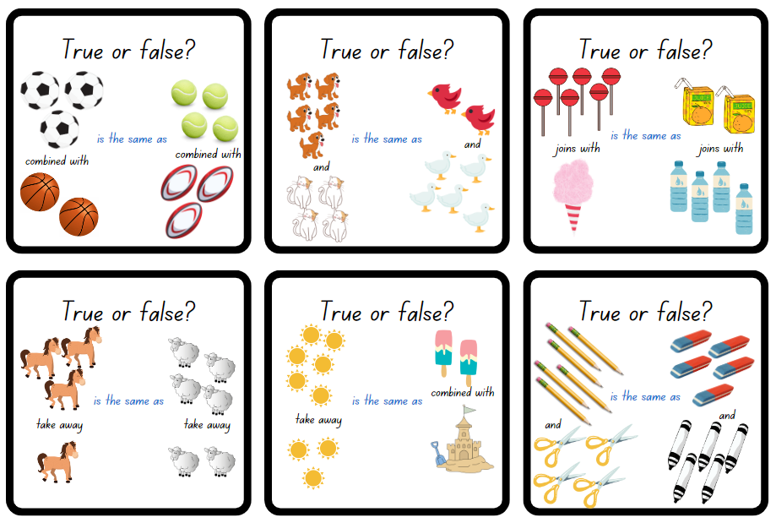
Images sourced from Canva and used in accordance with the Canva Content License Agreement.

Resource 9: True or false 2
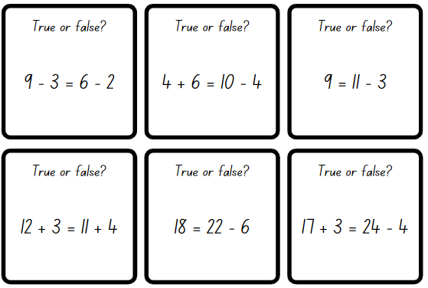

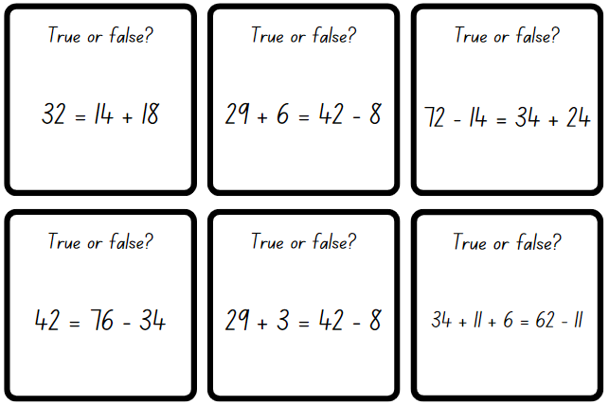

Resource 10: Related dots
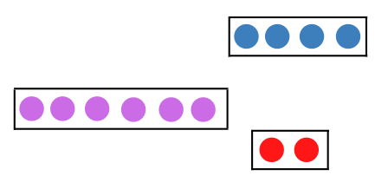

Resource 11: Hands
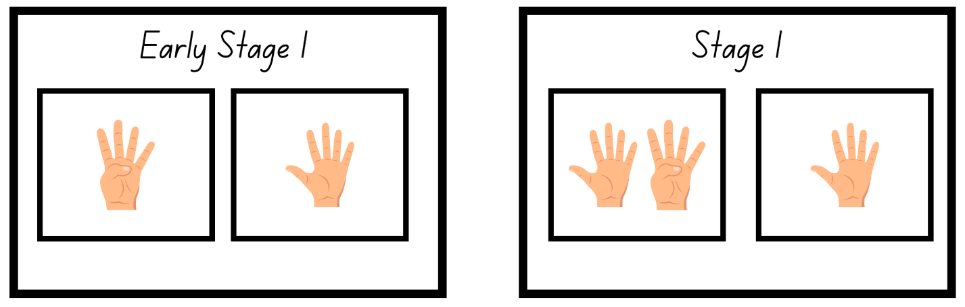
Images sourced from Canva and used in accordance with the Canva Content License Agreement.

Resource 12: Domino
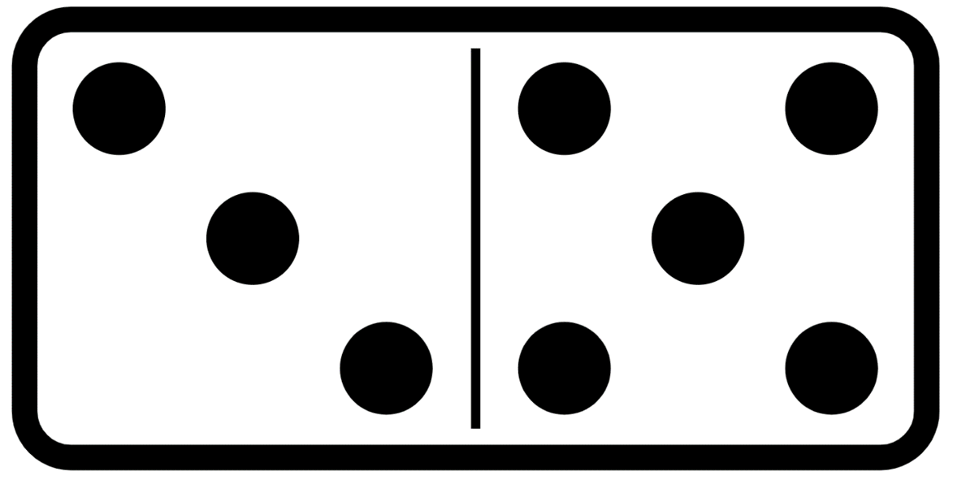
Images sourced from Canva and used in accordance with the Canva Content License Agreement.

Resource 13: Number story
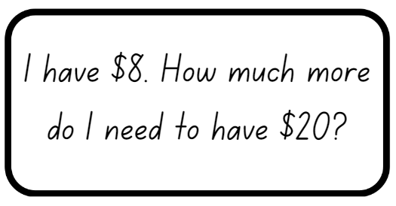

Resource 14: Number sentence 1
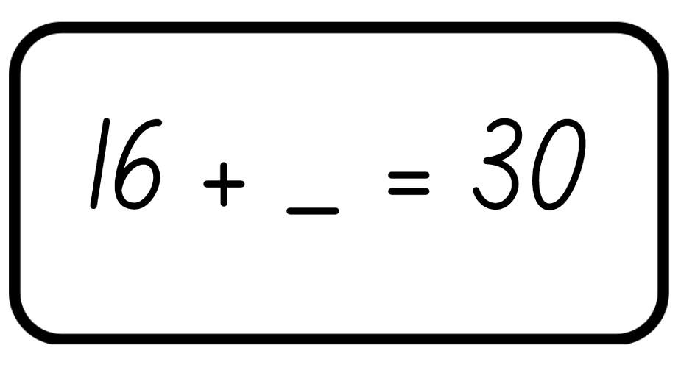

Resource 15: Number sentence 2
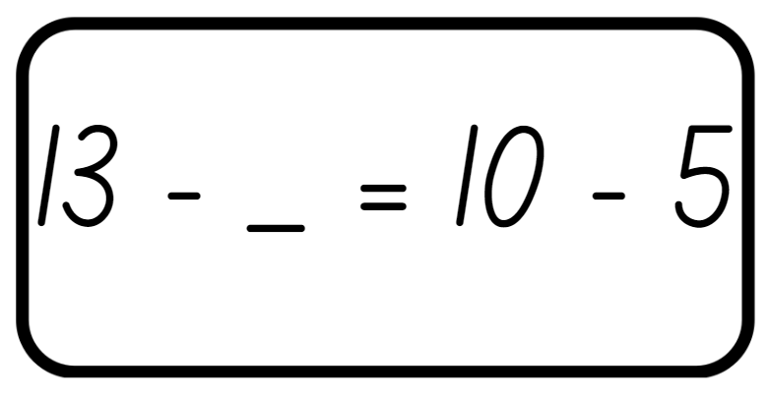

Resource 16: Missing numbers
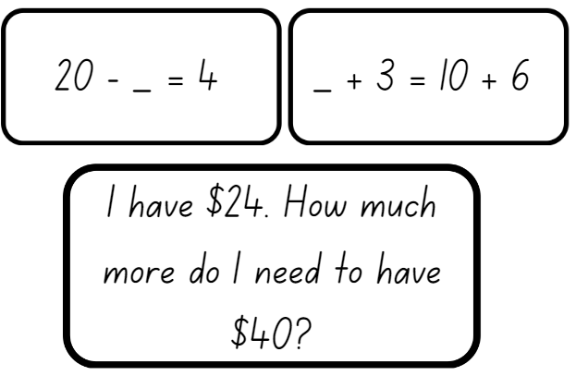
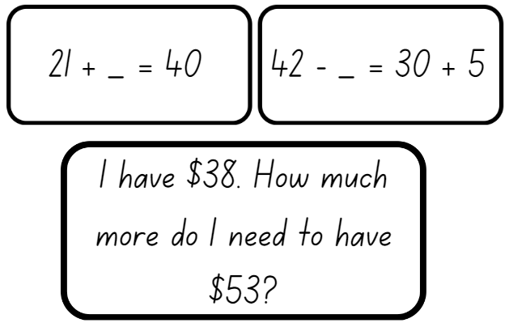

Resource 17: Early Stage 1 Number puzzles
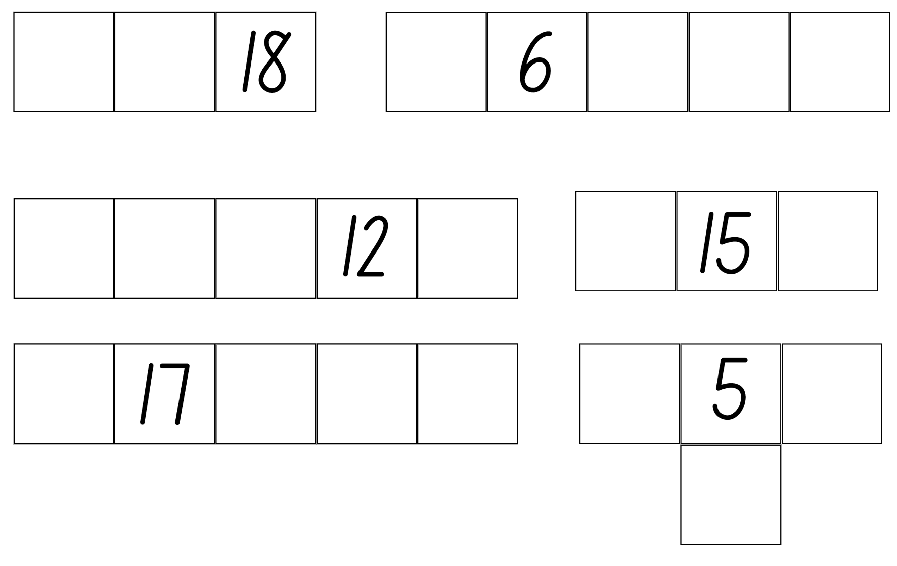

Resource 18: Stage 1 Number puzzles
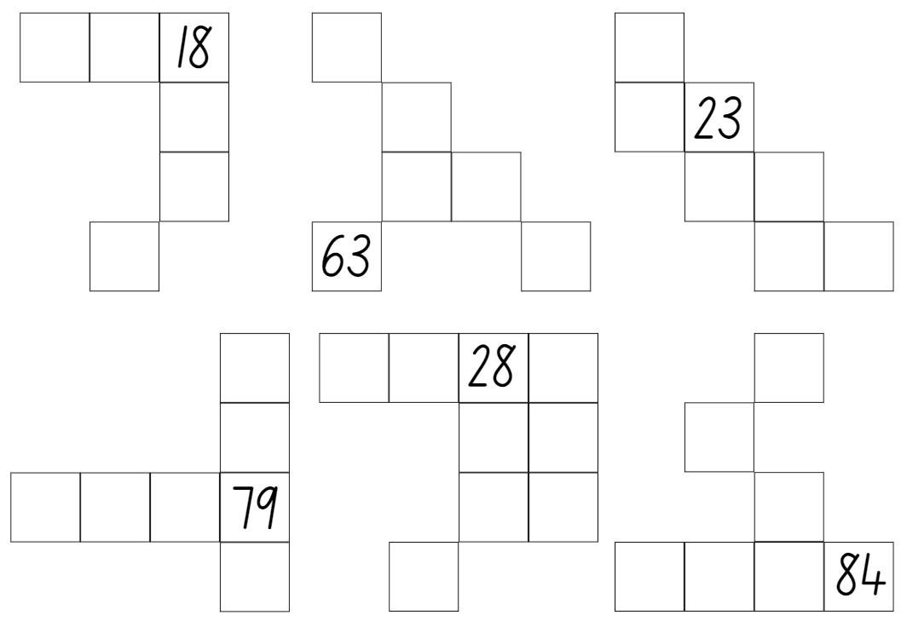

Resource 19: Missing number cards
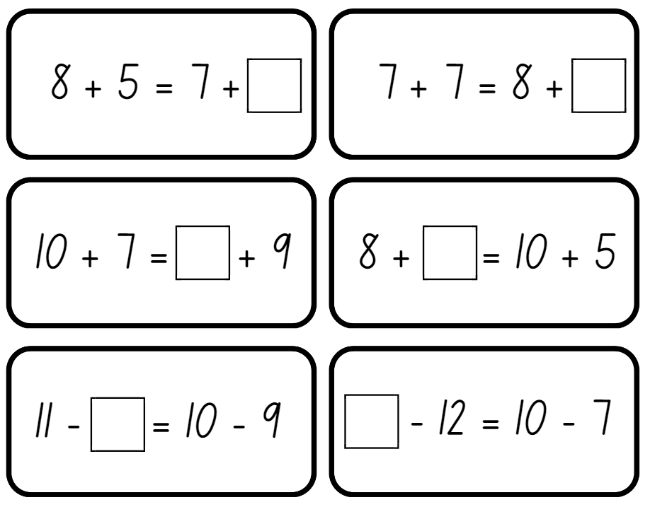
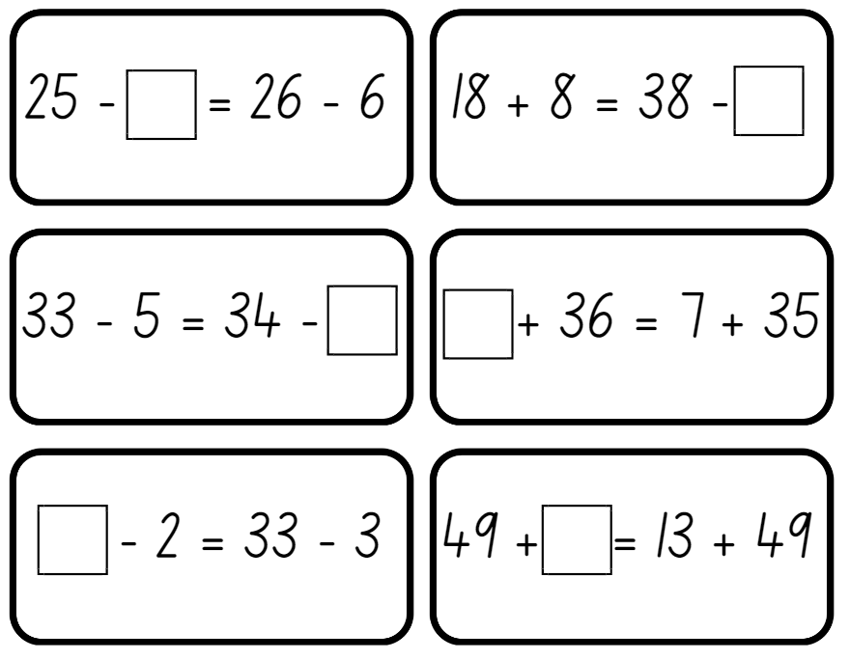
Adapted from Missing Number cards in Mindset Mathematics, Grade 1 by Boaler et. al (2021).

Resource 20: Zoo animals
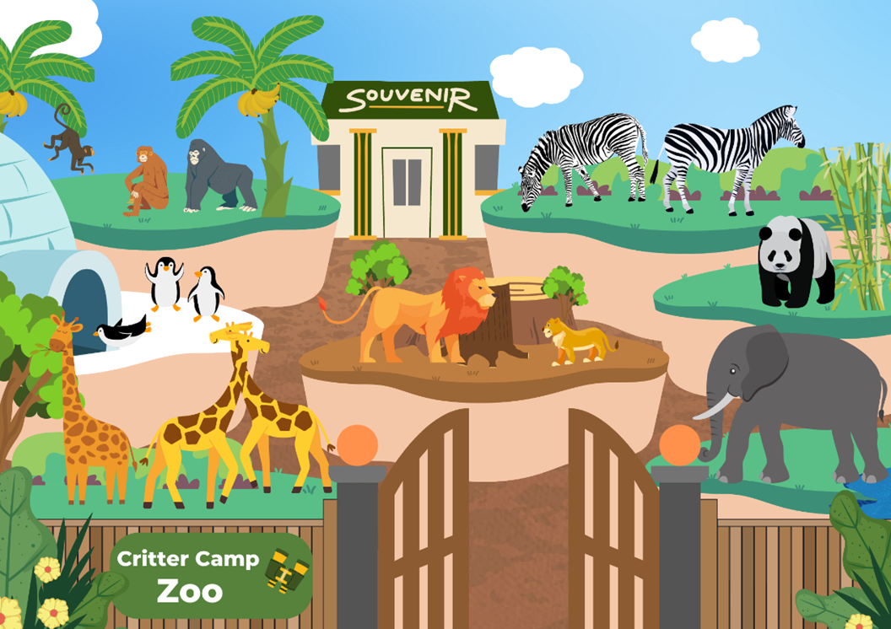
Images sourced from Canva and used in accordance with the Canva Content License Agreement.

Resource 21: Different problems 1
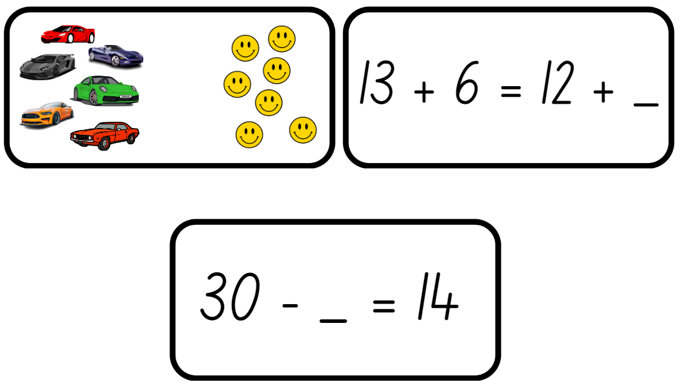
Images sourced from Canva and used in accordance with the Canva Content License Agreement.

Resource 22: Different problems 2
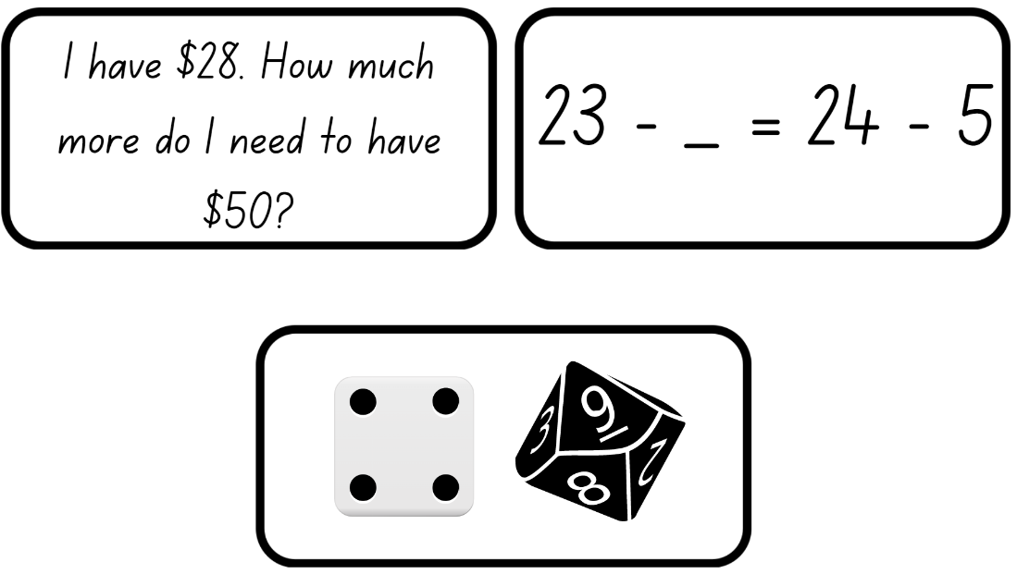
Images sourced from Canva and used in accordance with the Canva Content License Agreement.

Resource 23: Different problems 3
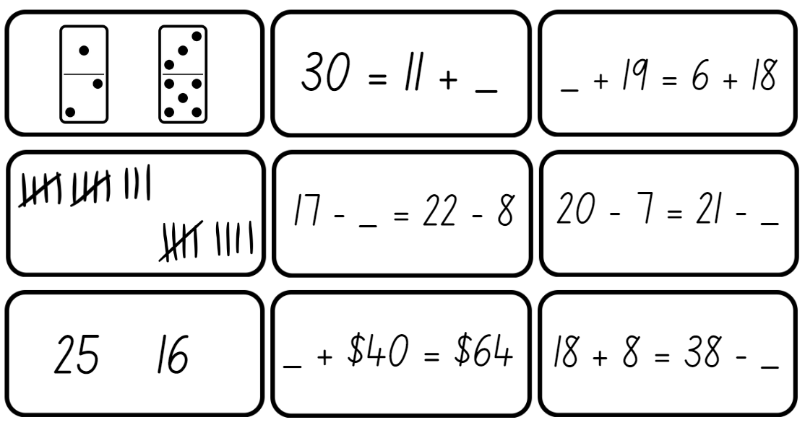
Images sourced from Canva and used in accordance with the Canva Content License Agreement.

Syllabus outcomes and content
The table below outlines the syllabus outcomes and range of relevant syllabus content covered in this unit. Content is linked to National Numeracy Learning Progression version (3).
Focus area and outcomes | Content groups and content points | Lessons
Representing whole numbers  MAO-WM-01  MAE-RWN-01, MA1-RWN-01  MAE-RWN-02, MA1-RWN-02 | Early Stage 1  Use the counting sequence of ones flexibly  - count forwards to at least 30 and state the number after or before a given number without needing to count from one (CPr4)  - count backwards from a given number 20 or less (CPr5)  - identify the number before as 'one less' and the number after as 'one more’ than a given number | 1–2, 4–8
Representing whole numbers  (cont) | Early Stage 1  Connect counting and numerals to quantities  - count with one-to-one correspondence, recognising that the last number name represents the total number in the collection (CPr3, CPr5)  - count out a specified number of objects (from 5 to 20) from a larger collection, keeping track of the count (CPr4-CPr5)  - read numerals to at least 20, including zero (NPV3)  - represent numbers as quantities to at least 20 using objects (such as fingers), number words and numerals (NPV2-NPV4, CPr3)  - compare and order numbers to 20 (NPV2-NPV3) | 1–8
Representing whole numbers A (cont) | Stage 1  Use counting sequences of ones with two-digit numbers and beyond  - identify the number before and after a given two-digit number (CPr5)  - count forwards and backwards by ones from a given number to at least 120 (CPr6) | 5, 7
Representing whole numbers A (cont) | Stage 1  Represent numbers on a line  - sequence numbers and arrange them on a line by considering the order and size of those numbers (CPr5)  - locate the approximate position of multiples of 10 on a model of a number line from 0 to 100 (CPr5) | 8
Representing whole numbers B (cont) | Stage 1  Use counting sequence of ones and tens flexibly  - identify the number before and after a given three-digit number  - count forwards and backwards by tens, on and off the decade, with two- and three-digit numbers (CPr7) | 2, 4, 6, 8
Combining and separating quantities  MAO-WM-01  MAE-CSQ-01, MA1-CSQ-01  MAE-CSQ-02 | Early Stage 1  Model additive relations and compare quantities  - identify situations in which addition and subtraction may be applied (AdS1-AdS2)  - combine two or more groups of objects to model addition, identifying the relationship between the parts and the whole (AdS1-AdS2)  - separate and take away part of a group of objects to model subtraction (AdS1-AdS2)  - use concrete materials or fingers to model and solve addition and subtraction questions, counting forwards or backwards by ones as necessary (AdS1-AdS2, NPV3) | 2–8
Combining and separating quantities (cont) | Early Stage 1  Identify part–whole relationships in numbers up to 10  - describe the action of combining, separating and comparing (AdS1)  - create, model and recognise combinations for numbers up to ten (AdS2)  - count by ones to find the total or difference (AdS2-AdS3)  - use drawings, words and numerals to record addition and subtraction, and explain their thinking (AdS2) | 1–8
Combining and separating quantities A (cont)  NOTE – There is only one combining and separating quantities outcome for Stage 1 | Stage 1  Use advanced count-by-one strategies to solve addition and subtraction problems  - apply the terms ‘add’, ‘plus’, ‘equals’, is equal to’, ‘is the same as’, ‘take away’, ‘minus’ and ‘the difference between’ to describe combining and separating quantities (AdS1, AdS6)  - recognise and use the symbols for plus (+), minus (−) and equals (=)  - record number sentences in a variety of ways using drawings, words, numerals and symbols (AdS6)  - fluently use advanced count-by-one strategies including counting on and counting back to solve addition and subtraction problems involving one- and two-digit numbers (AdS3-AdS5) | 2–5, 7–8
Combining and separating quantities A (cont) | Stage 1  Recognise and recall number bonds up to ten  - recognise, recall and record combinations of two numbers that add up or bond to form 10 (AdS2, AdS6)  - create, recall and recognise combinations of two numbers that add up to numbers less than 10 (AdS2, AdS6) | 1, 5–6, 8
Combining and separating quantities A (cont) | Stage 1  Use flexible strategies to solve addition and subtraction problems  - represent addition and subtraction using structured materials such as a bead string or similar model (AdS6-AdS7)  - select and apply strategies using number bonds to solve addition and subtraction problems with one- and two-digit numbers by partitioning numbers using quantity value and bridging (AdS6-AdS7) | 4–6, 8
Combining and separating quantities A (cont) | Stage 1  Represent equality  - use the equals sign to record equivalent number sentences involving addition, and to mean 'is the same as', rather than as an indication to perform an operation (NPA3)  - recall related addition and subtraction facts for numbers to at least 10 (AdS6) | 1–8
Combining and separating quantities B (cont) | Stage 1  Represent and reason about additive relations  - create, record and recognise combinations of two numbers that add to numbers from 11 up to and including 20 (AdS7)  - model how addition and subtraction are inverse operations using concrete materials, drawings and diagrams (AdS7)  - recall and use related addition and subtraction number facts to at least 20 (AdS7) | 1, 3–8
Combining and separating quantities B (cont) | Stage 1  Use knowledge of equality to solve related problems  - use number bonds to determine a missing number (AdS6, NPA3-NPA4)  - use number knowledge to solve related problems (AdS7, NPA4)  - use a variety of ways of writing number sentences (NPA3-NPA4)  - use number bonds to solve equality problems (NPA3-NPA4) | 6–8
Non-spatial measure  MAO-WM-01  MAE-NSM-01, MA1-NSM-01 | Early Stage 1  Identify and compare mass using weight  - identify that objects can be heavy or light (UuM2)  - compare two masses directly by hefting (UuM3) | 1–3
Non-spatial measure A (cont) | Stage 1  Mass: Investigate mass using an equal-arm balance  - place objects on either side of an equal-arm balance to obtain a level balance  - use an equal-arm balance to compare the masses of two objects and record, which is heavier or lighter (UuM2)  - use a balance to find two collections of objects that have the same mass (UuM2) | 1–2
Non-spatial measure B (cont) | Stage 1  Mass: Compare the masses of objects using an equal-arm balance  - explain the relationship between the mass of a unit and the number of units needed | 3

References
Links to third-party material and websites
Please note that the provided (reading/viewing material/list/links/texts) are a suggestion only and implies no endorsement, by the New South Wales Department of Education, of any author, publisher, or book title. School principals and teachers are best placed to assess the suitability of resources that would complement the curriculum and reflect the needs and interests of their students.
If you use the links provided in this document to access a third-party's website, you acknowledge that the terms of use, including licence terms set out on the third-party's website apply to the use which may be made of the materials on that third-party website or where permitted by the Copyright Act 1968 (Cth). The department accepts no responsibility for content on third-party websites.
Except as otherwise noted, all material is © State of New South Wales (Department of Education), 2021 and licensed under the Creative Commons Attribution 4.0 International License. All other material (third-party material) is used with permission or under licence. Where the copyright owner of third-party material has not licensed their material under a Creative Commons or similar licence, you should contact them directly for permission to reuse their material.
Mathematics K–10 Syllabus © 2022 NSW Education Standards Authority (NESA) for and on behalf of the Crown in right of the State of New South Wales.
© 2022 NSW Education Standards Authority. This document contains NSW Curriculum and syllabus content. The NSW Curriculum is developed by the NSW Education Standards Authority. This content is prepared by NESA for and on behalf of the Crown in right of the State of New South Wales. The material is protected by Crown copyright.
Please refer to the NESA Copyright Disclaimer for more information.
NESA holds the only official and up-to-date versions of the NSW Curriculum and syllabus documents. Please visit the NSW Education Standards Authority (NESA) website and the NSW Curriculum website.
National Numeracy Learning Progression © Australian Curriculum, Assessment and Reporting Authority (ACARA) 2010 to present, unless otherwise indicated. This material was downloaded from the Australian Curriculum website (National Literacy Learning Progression) (accessed 2 December 2022) and was not modified. The material is licensed under CC BY 4.0. Version updates are tracked in the ‘Curriculum version history’ section on the 'About the Australian Curriculum' page of the Australian Curriculum website.
ACARA does not endorse any product that uses the Australian Curriculum or make any representations as to the quality of such products. Any product that uses material published on this website should not be taken to be affiliated with ACARA or have the sponsorship or approval of ACARA. It is up to each person to make their own assessment of the product, taking into account matters including, but not limited to, the version number and the degree to which the materials align with the content descriptions and achievement standards (where relevant). Where there is a claim of alignment, it is important to check that the materials align with the content descriptions and achievement standards (endorsed by all education Ministers), not the elaborations (examples provided by ACARA).
Australian Government Department of Education (2020) ‘Algebra: Equivalence’, Teaching resources, reSolve: Maths by Inquiry website, accessed 2 December 2022.
Boaler J, Munson J, & Williams C (2020) Mindset Mathematics: Visualizing and Investigating Big Ideas, Grade K, Jossey-Bass, San Francisco.
Boaler J, Munson J, & Williams C (2021) Mindset Mathematics: Visualizing and Investigating Big Ideas, Grade 1, Jossey-Bass, San Francisco.
New Zealand Ministry of Education (n.d) ‘Equality and equations’, Resource Finder, NZ Maths website, accessed 2 December 2022.
State of Victoria (Department of Education and Training) (n.d.) ‘Inverse operations: addition and subtraction’, Number and Algebra, Maths Curriculum Companion website, accessed 2 December 2022.
Sullivan P and Lilburn P (2017) Open-Ended Maths Activities: Using ‘Good’ Questions to Enhance Learning in Mathematics, Revised edn, Oxford University Press ANZ, Great Britain.
Swan P (2003) Dice Dazzlers, Self-published, Australia.
Toy Theater (2022) ‘Dice’, Virtual Manipulatives, Toy Theater website, accessed 2 December 2022.

