Mathematics – K-2 multi-age – Year B – Unit 3
Contents
Unit description and duration 4
Student prior learning 4
Lesson overview and resources 5
Lesson 1: Measurement Matey 18
Daily number sense: Guess what – 10 minutes 19
Maths is everywhere – 40 minutes 20
Consolidation and meaningful practice: Reasoning – 10 minutes 25
Lesson 2: Captain Beard’s treasure chest 27
Daily number sense: Walk the plank counting – 10 minutes 28
Captain Beard’s Investigation – 50 minutes 29
Lesson 3: Cannon ball maths 34
Daily number sense: Go Fish – 15 minutes 35
Fire the cannon – 40 minutes 36
Lesson 4: Pirate Bonny’s flag 39
Daily number sense: Zap – 10 minutes 40
Which flag has a larger area? – 30 minutes 41
Consolidation and meaningful practice: More flags – 20 minutes 48
Lesson 5: Pirate Bonny’s new treasure chest 50
Daily number sense: Pirate Bonny’s fort – 15 minutes 51
Pirate Bonny’s treasure chest – 30 minutes 52
Consolidation and meaningful practice: smaller units – 15 minutes 56
Lesson 6: Heave the cargo 57
Daily number sense: Fingers and hands – 10 minutes 58
Heave the cargo – 50 minutes 59
Consolidation and meaningful practice: Mystery item – 10 minutes 62
Lesson 7: Pirate Bonny’s measurement challenge (Part 1) 63
Daily number sense: 10 minutes 64
Jump the plank and treasure chest mass – 50 minutes 64
Lesson 8: Pirate Bonny’s measurement challenge (Part 2) 69
Daily number sense – 10 minutes 70
Area Ahoy and Pirate Bonny’s lunch – 50 minutes 70
Consolidation and meaningful practice: Pirate ceremony – 10 minutes 75
Resource 1: Captain Beard’s Ship 76
Resource 2: Pirate Crew 77
Resource 3: Pirate Bonny’s bucket 78
Resource 4: Bucket recording sheet 79
Resource 5: Estimating and recording 80
Resource 6: Fire the cannon 81
Resource 7: Pirate flags 82
Resource 8: Sample flags 83
Resource 9: Cubes 84
Resource 10: Estimating volume 85
Resource 11: Recording volume 86
Resource 12: Counting hands 87
Resource 13: Counting fingers 88
Resource 14: Jump the plank 89
Resource 15: Crew certificate 90
Syllabus outcomes and content 91
References 103

Unit description and duration
This two-week unit develops student knowledge, understanding and skills of measurement. Students are provided opportunities to:
- measure, record, compare and estimate a variety of attributes including length, area, volume, and mass using informal and formal units
- explore and connect mathematical measurement concepts
- apply mathematical measurement techniques to solve problems and communicate their thinking.
Mathematics K–10 Syllabus © 2022 NSW Education Standards Authority (NESA) for and on behalf of the Crown in right of the State of New South Wales.

Student prior learning
Before engaging in these teaching and learning activities, students would benefit from prior experience with:
- measuring the length of objects around the house and backyard using informal units of measurement
- comparing the sizes of shapes or objects by direct comparison
- filling different size and shape containers with water, marbles, rice, or sand to compare which can hold the most
- hefting (holding 2 items in each hand and lifting to test the weight) to order a variety of household items from lightest to heaviest
- labelling attributes of measurement in daily routines. For example, my stick is longer than your stick.

Lesson overview and resources
The table below outlines the sequence and approximate timing of lessons; syllabus focus areas and content groups; and resources.
Lesson | Syllabus focus area and content groups | Resources
Lesson 1: Measurement Matey  60 minutes  Objects have common attributes that can be measured in different ways. | Representing whole numbers  Early Stage 1  - Instantly name the number of objects within small collections  - Use the counting sequence of ones flexibly  - Connect counting and numerals to quantities  Stage 1 – Part A  - Use counting sequences of ones with two-digit numbers and beyond  - Represent the structure of groups of 10 in whole numbers  Geometric measure  Early Stage 1  - Length: Use direct and indirect comparisons to decide which is longer  Stage 1 – Part A  - Length: Compare lengths using uniform informal units  Stage 1 – Part B  - Length: Compare and order lengths, using appropriate uniform informal units  Two-dimensional spatial structure  Early Stage1  - Area: Identify and compare area  Stage 1 – Part A  - Area: Indirectly compare area  - Area: Measure areas using uniform informal units  Stage 1 – Part B  - Area: Compare rectangular areas using uniform square units of an appropriate size in rows and columns  Three-dimensional spatial structure  Early Stage 1  - Volume: Compare internal volume by filling and packing  Stage 1 – Part A  - Volume: Measure and compare the internal volumes (capacities) of containers by filling  Stage 1 – Part B  - Volume: Compare containers based on internal volume (capacity) by filling and packing  Non-spatial measure  Early Stage 1  - Mass: Identify and compare mass using weight  Stage 1 – Part A  - Mass: Investigate mass using an equal-arm balance | - Resource 1: Captain Beard’s ship  - Resource 2: Pirate crew  - Resource 3: Pirate Bonny’s bucket  - Resource 4: Bucking recording sheet  - Container or bucket (one per group of students)  - Counters  - Ten-frame (one per student)  - Paper to cover ten-frame  - Treasure chest  - Variety of objects (a book, a coin, a hat)  - Selection of informal units such as blocks (volume), paperclips (length)  - Writing materials
Lesson 2: Captain Beard’s Treasure Chest  60 minutes  We can measure lengths using informal and formal units. | Representing whole numbers  Early Stage 1  - Use the counting sequence of ones flexibly  - Connect counting and numerals to quantities  Stage 1 – Part A  - Use counting sequences of ones with two-digit numbers and beyond  - Represent numbers on a line  Stage 1 – Part B  - Use counting sequences of ones and tens flexibly  Geometric measure  Early Stage 1  - Length: Use direct and indirect comparisons to decide which is longer  Stage 1 – Part A  - Length: Compare lengths using uniform informal units  Stage 1 – Part B  - Length: Compare and order lengths, using appropriate uniform informal units  - Length: Recognise and use formal units to measure lengths of objects | - Resource 1: Captain Beard’s ship  - Resource 5: Estimating and recording  - Beanbags  - Chalk  - Metre ruler  - Metre string (ribbon or cardboard) (Stage 1)  - Number chart  - Paper to create anchor chart  - String in various lengths (Early Stage 1)  - Variety of objects of different lengths  - Writing materials
Lesson 3: Cannon ball maths  60 minutes  Measuring and comparing the lengths and distances using formal units. | Representing whole numbers  Early Stage 1  - Use the counting sequence of ones flexibly  - Connect counting and numerals to quantities  Stage 1 – Part A  - Use counting sequences of ones with two-digit numbers and beyond  Stage 1 – Part B  - Use counting sequences of ones and tens flexibly  Geometric measure  Early Stage 1  - Length: Use direct and indirect comparisons to decide which is longer  Stage 1 – Part A  - Length: Compare lengths using uniform informal units  Stage 1 – Part B  - Length: Compare and order lengths, using appropriate uniform informal units  - Length: Recognise and use formal units to measure lengths of objects | - Resource 6: Fire the cannon  - Beanbag (one per group)  - Blocks (Early Stage 1)  - Chalk  - Deck of cards (one deck per group)  - Metre ruler (Stage 1 – one per group)  - Writing materials
Lesson 4: Pirate Bonny’s Flag  60 minutes  Area can be measured using uniform square units in rows and columns. | Representing whole numbers  Early Stage 1  - Instantly name the number of objects within small collections  - Use the counting sequence of ones flexibly  - Connect counting and numerals to quantities  Stage 1 – Part A  - Use counting sequences of ones with two-digit numbers and beyond  - Represent the structure of groups of ten in whole numbers  Forming Groups  Stage 1 – Part B  - Represent and explain multiplication as the combining of equal groups  Two-dimensional spatial structure  Early Stage 1  - 2D Shapes: Sort, describe and name familiar shapes  - 2D Shapes: Represent shapes  - Area: Identify and compare area  Stage 1 – Part A  - Area: Indirectly compare area  - Area: Measure areas using uniform informal units  Stage 1 – Part B  - Area: Compare rectangular areas using uniform square units of an appropriate size in rows and columns | - Resource 7: Pirate flags  - Resource 8: Sample flags  - 2D shape pattern blocks  - Paper to create anchor chart  - Selection of informal units (paper clips, connecting blocks, sticky notes)  - Square tiles  - Treasure box (container)  - Writing materials
Lesson 5: Pirate Bonny’s new treasure chest  60 minutes  Volume can be measured by filling and packing with informal unit. | Representing whole numbers  Early Stage 1  - Use the counting sequence of ones flexibly  - Connect counting and numerals to quantities  Three-dimensional spatial structure  Early Stage 1  - 3D objects: Explore familiar three-dimensional objects  - Volume: Compare internal volume by filling and packing  Stage 1 – Part A  - Volume: Measure and compare the internal volumes (capacities) of containers by filling  Stage 1 – Part B  - Volume: Compare containers based on internal volume (capacity) by filling and packing | - Resource 9: Cubes  - Resource 10: Estimating volume  - Resource 11: Recording volume  - 3 different sized containers  - Blocks  - Interlocking cubes  - Paper to create anchor chart  - Selection of informal units  - Treasure chest (container)  - Variety of 3D objects to describe
Lesson 6: Heave the cargo  70 minutes  Mass can be measured and compared using an equal-arm balance. | Representing whole numbers  Early Stage 1  - Use the counting sequence of ones flexibly  - Connect counting and numerals to quantities  Stage 1 – Part A  - Continue and create number patterns  Forming groups  Stage 1 – Part A  - Count in multiples using rhythmic and split counting  - Use skip counting patterns  - Model and use equal groups of objects to represent multiplication  Non-spatial measure  Early Stage 1  - Mass: Identify and compare mass using weight  Stage 1 – Part A  - Mass: Investigate mass using an equal-arm balance | - Resource 1: Captain Beard’s ship  - Resource 12: Counting hands  - Resource 13: Counting fingers  - 2 bags to support hefting (one set per pair)  - Equal-arm balance (one per pair)  - Paper to create an anchor chart  - Variety of objects with different mass (a pirate book, a ball, a toy, a box, a hat, or a map)  - Writing materials
Lesson 7: Pirate Bonny’s Measurement Challenge Part 1  60 minutes  Mathematicians use units of measure to solve mathematical problems. | Forming groups  Stage 1 – Part B  - Represent and explain multiplication as the combining of equal groups  Geometric measure  Early Stage 1  - Length: Use direct and indirect comparisons to decide which is longer  Stage 1 – Part A  - Length: Compare lengths using uniform informal units.  Stage 1 – Part B  - Length: Compare and order lengths, using appropriate uniform informal units  - Length: Recognise and use formal units to measure lengths of objects  Non-spatial measure  Early Stage 1  - Mass: Identify and compare mass using weight  Stage 1 – Part A  - Mass: Investigate mass using an equal-arm balance | - Resource 14: Jump the plank (Stage 1 – one per person)  - 4 treasure boxes with different mass  - Cardboard (rectangular shape)  - Chalk  - Equal-arm balance (one per pair)  - Length and area anchor chart from previous lessons  - Metre ruler (Stage 1 – one per pair)  - Writing materials
Lesson 8: Pirate Bonny’s Measurement Challenge Part 2  75 minutes  Mathematicians use units of measure to solve mathematical problems. | Forming groups  Stage 1 – Part B  - Represent and explain multiplication as the combining of equal groups  Two-dimensional spatial structure  Early Stage 1  - Area: Identify and compare area  Stage 1 – Part A  - Area: Indirectly compare area  - Area: Measure areas using uniform informal units  Stage 1 – Part B  - Area: Compare rectangular areas using uniform square units of an appropriate size in rows and columns  Three-dimensional spatial structure  Early Stage 1  - Volume: Compare internal volume by filling and packing  Stage 1 – Part A  - Volume: Measure and compare the internal volumes (capacities) of containers by filling  Three-dimensional spatial structure B  - Volume: Compare containers based on internal volume (capacity) by filling and packing | - Resource 15: Crew certificate  - 4 containers of different sizes  - Blocks  - Chalk  - Single square or tile as unit of measure  - Volume and area anchor chart from previous lessons  - Writing materials

Lesson 1: Measurement Matey
Core concept: Objects have common attributes that can be measured in different ways.
The table below contains suggested learning intentions and success criteria. These are best co-constructed with students.
Learning intentions | Success criteria
All students are learning that:  - objects have common attributes (length, volume, mass, and area) that can be measured  - the attribute being measured determines the unit used to measure  - mathematics-specific language helps convey meaning about measurement  - mathematicians estimate, compare and record using pictures, numbers, and words, and by referring to the uniform informal unit used. | All students can:  - identify attributes that can be measured, including length, area, internal volume, and mass  - record their thinking using pictures, numbers, and words.  In addition, students working towards Early Stage 1 outcomes can identify and describe Pirate Bonny’s bucket using the language of measurement, for example tall, short, big, small, heavy, light.  In addition, students working towards Stage 1 outcomes can:  - estimate the number of units to measure each attribute of Pirate Bonny’s bucket  - choose an informal unit to measure attributes of Pirate Bonny’s bucket.

Daily number sense: Guess what – 10 minutes
This activity has been adapted from A Sense of 'ten' and Place Value by the University of Cambridge (NRICH).
- Build student understanding of a ‘sense of 10’ as a foundation for place value, mental calculations, and visualising by playing the ten-frame game, ‘Guess What’.
- For Early Stage 1, Player one displays a collection on a ten-frame, ensuring there is only one item in each box. Player one then flashes the ten-frame and covers it with a piece of paper.
- Player 2 answers the questions:
- What did you see?
- How do you know?
- For Stage 1, Player one secretly arranges some counters on a ten-frame. Player 2 asks questions that can be answered yes or no, trying to gain enough clues to work out the arrangement of counters. For example:
- Is the top row full?
- Are there 8 counters?
- Is there an empty box in the bottom row?
Note: The ten-frame provides a visual link between collections and ten. Students can see number bonds to 10.
Variations: As players become more skilled, start counting the number of questions players ask. The player who asks the fewest questions, wins. More ten-frames can be used to provide additional challenge.

Maths is everywhere – 40 minutes
This activity has been adapted from Van de Walle et al. (2019).
- Display a treasure chest with a variety of objects inside, for example a book, a coin, a hat. Revise the term attribute.
Attribute: A quality, feature or characteristic of an object or shape.
- Display 2 objects from the chest and ask students:
- What do you notice?
- How could you describe the objects by its features?
- What is different?
- What is the same?
- Create a word wall to document students’ language when describing attributes.
Note: In Early Stage 1, focus on developing language of attributes including describing long, short, big, small etc.
- Display Resource 1: Captain Beard’s ship on the board. Give students time to review the image and then ask the following questions:
- What do you notice about the image?
- What items or objects could you count in this image?
- What could you measure in this image?
- As a class, make a list of the mathematics in the image. For example, the number of portholes, area of the ship’s deck, volume of the treasure chest, weight of the pirate or length of the masts.
- Draw students’ attention to the mathematics that exists all around, including the different measurements visible in Resource 1: Captain Beard’s ship. Explain that, during this unit, students will explore and investigate mathematics through a pirate adventure with Captain Beard and Pirate Bonny.
- Display Resource 2: Pirate Crew. As a class, connect prior learning regarding measurement, including what measurement is, why it is used and how to measure.
- Display Resource 3: Pirate Bonny’s bucket and explain that Pirate Bonny wants to measure her bucket.
The table below outlines stimulus prompts to generate conversation about the topic, along with anticipated responses from students.
Prompts | Anticipated student responses
- What could she measure? Is there more than one thing she can measure?  - What unit of measure could she use to measure her bucket?  - Could she use the same unit to measure everything? Why/Why not? | - She could measure how many cups of water it takes to fill the bucket.  - She could measure the mass using an equal-arm balance.  - She could measure how tall the bucket is using blocks.  - She could measure the area of the bucket using tiles.  - She can’t measure length with the same unit as volume because the water would go everywhere.  - She could measure the length and the mass with the same unit, blocks.
Note: Students need to understand that, to measure something, they must perform the following steps. First, decide on the attribute to be measured, for example length. Then, select a unit that has that attribute, for example a piece of string. Next, measure the attribute, for example the length of the bucket, with the chosen units by filling, covering, matching, or using another method. The number of units required to match the object is the measure (Van de Walle et al., 2019, p.458).
- Explain to students that they need to know what is being measured (the attribute). The measurement attributes of the bucket include length, area, internal volume, and mass.
- For Early Stage 1 students, explain that items can be compared by their measurable attributes, such as length, area, mass, and volume. Revisit the bucket and demonstrate how to identify the attributes. For example, the length is from one end to the other end of the bucket, the volume is everything the bucket can hold, the mass is how heavy the bucket is, and the area is the amount of surface the bucket has.
- Divide students into groups of 3 or 4. Give each group a container or bucket and Resource 4: Bucket recording sheet.
- Provide students with a selection of informal units to choose from to measure each attribute. Invite students to share their choice of informal unit and their reasoning for that selection.
- Discuss the importance of estimation when investigating measurement. Remind students that estimation helps them focus on the attribute being measured, the measurement process and helps develop familiarity with the units.
Estimation is the process of using mental and visual information to measure or make comparisons without using measuring instruments (Van de Walle et al. 2019 p 462). Estimating is often based on visualising a known unit or benchmark.
- Students measure all the attributes using their chosen informal units and record their measurements.
- Select some students to present their results to the class. Ask students:
- Why did you choose a particular unit of measure for a certain attribute?
- How did you visualise your estimation?
- Did your estimation come close to your measurement? Why or why not?
- Would you choose a different unit of measure if you were to do this again? Explain your reasons.
- Did you have any challenges measuring with your chosen unit?
- How did you solve these challenges?
The table below details assessment opportunities and differentiation ideas.
Assessment opportunities | Too hard? | Too easy?
What to look for:  - Can students identify the attributes of the bucket including length, area, volume/capacity, and mass? (MAO-WM-01, MAE-GM-02, MA1-2DS-02, MAE-3DS-02, MAE-NSM-02, MA1-GM-02, MA1-2DS-02, MA1-3DS-02, MA1-NSM-01)  - Are students able to estimate the number of informal units needed to measure different attributes? (MAO-WM-01, MA1-GM-02, MA1-2DS-02, MA1-3DS-02, MA1-NSM-01)  - Can students select an appropriate unit of measurement? (MAO-WM-01, MA1-GM-02, MA1-2DS-02, MA1-3DS-02, MA1-NSM-01)  - Do students use appropriate mathematical language to describe the attributes of the bucket? (MAO-WM-01)  - Can students record their thinking using drawings, numbers, and words? (MAO-WM-01, MAE-GM-02, MAE-2DS-02, MA1-3DS-02, MAE-NSM-01, MA1-GM-02, MA1-2DS-02, MA1-3DS-02, MA1-NSM-01)  What to collect:  - observations of students estimating and measuring (MAO-WM-01, MAE-GM-02, MAE-2DS-02, MAE-3DS-02, MAE-NSM-01, MA1-GM-02, MA1-2DS-02, MA1-3DS-02, MA1-NSM-01)  - student work sample – Resource 4: Bucket recording sheet (MAO-WM-01, MAE-GM-02, MAE-2DS-02, MAE-3DS-02, MAE-NSM-01, MA1-GM-02, MA1-2DS-02, MA1-3DS-02, MA1-NSM-01) | Students are unable to estimate the number of informal units needed.  - Support students to count units by marking off single units mentally or physically. For example, if measuring length, have students use their hands to mark their place or make a mark on the container to keep track of their place.  - In a small group, revise that estimation is visualising a known benchmark.  Students are unable to use appropriate mathematical language to describe the attributes of the bucket.  - Model the mathematical specific language during measurement activities or play experiences.  - Create a word wall with students to refer to using the mathematical language of measurement. | Students are able to estimate the number of informal units needed.  - Ask students to choose a different unit of measurement and how this might change their estimation.  - Students measure again using a different unit. Ask if this was a more accurate measurement. Prompt students to explain their thinking.

Consolidation and meaningful practice: Reasoning – 10 minutes
- Give students the opportunity to complete the activity again, using different informal units of measurement.
- Ask students:
- What were some of the challenges when measuring attributes?
- How did you ensure the measurement was fair and precise?
- What would happen if we used different units of measure?
- Discuss the importance of fair and precise measurement techniques. For example, when measuring the volume of the bucket it must be filled to the brim, length needs to be measured from endpoint to endpoint and so on.

Lesson 2: Captain Beard’s treasure chest
Core concept: We can measure lengths using informal and formal units.
The table below contains suggested learning intentions and success criteria. These are best co-constructed with students.
Learning intentions | Success criteria
All students are learning that:  - mathematicians can use informal and formal units to estimate and measure lengths  - metres can be abbreviated to ‘m’ (Stage 1)  - mathematicians communicate their thinking and reasoning coherently and clearly. | All students can reason and explain their thinking about Captain Beard’s problem.  In addition, students working towards Early Stage 1 outcomes can:  - identify where the measurement begins and ends  - use direct and indirect comparisons to decide which objects are longer or shorter than the piece of string  - compare lengths using words such as long, short, longer than, shorter than, the same.  In addition, students working towards Stage 1 outcomes can:  - estimate and measure items in the classroom using a metre ruler  - use a formal unit of measurement  - record metres using the abbreviation for metres (m).

Daily number sense: Walk the plank counting – 10 minutes
- Build student understanding of whole numbers by counting forwards and backwards by tens to at least 120.
- Draw a number line on the ground marking 0, 60 and 120. Call out a number and ask a student to stand on the number line where they think this number would be. Ask the class if they agree/disagree and select students to identify what information they used to work out where the number would be.
- Lead the students in oral counting by tens to walk the plank forward and backwards. Use a number chart to support students by pointing to the multiples of ten. Vary the activity by using other counting patterns such as twos and fives, forwards and backwards from any starting point.
- For Early Stage 1, adapt task to include forward and backward counting sequences. Lead the students in oral counting to 10, forwards and backwards. Coordinate body actions, such as clapping, clicking, or stamping with each number as it is counted. Ask students what the number would be if it were one less or one more.
Variation: Early Stage 1 students can play counting hopscotch. Students can throw a small beanbag to land on a number. Students can hop to the number, pick up the beanbag and count back down to the start.
The table below details assessment opportunities and differentiation ideas.
Assessment opportunities | Too hard? | Too easy?
What to look for:  - Can students count forward and backwards? (MAE-RWN-01, MAE-RWN-02)  - Can students count forwards and backwards by tens, twos and fives from any starting point? (MA1-FG-01)  - Are students able to locate the approximate position of multiples of 10, 2 and 5 on a model of a number line from 0-120? (MA1-FG-01) | Students are unable to count forward and backwards on the plank.  - Provide multiple experiences in rhymical games counting by ones.  - Support students to orally count in sequence to 5.  Students are unable to count forwards and backwards by tens, twos, and fives.  - Students look at a number chart to prompt skip counting.  - Scaffold counting with concrete materials such as connecting blocks. | Students are able to count forwards and backwards flexibly on the plank.  - Student identifies 2 numbers before or after numbers on the plank.  - Students may create their own number pattern on the plank.  Students can count forwards and backwards by tens, twos, and fives.  - Students count by tens, twos, fives off the decade.  - Students count by sixes, sevens, or eights.  - Increase the number range from 120 to 250.

Captain Beard’s Investigation – 50 minutes
This activity has been adapted from Can You Do it Too? by the University of Cambridge (NRICH).
- As a class, discuss what students already know about length. Create a class anchor chart focusing on a definition, vocabulary, units of measurement and how to measure (see Figure 1).
Figure 1 – Example measurement anchor chart
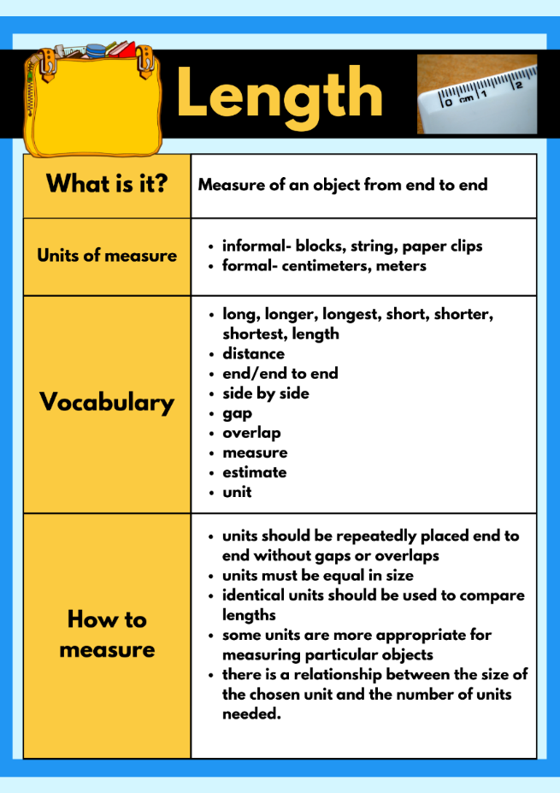
Images sourced from Canva and used in accordance with the Canva Content License Agreement.
- Display Resource 1: Captain Beard’s ship. Explain the problem that Captain Beard wants to bury his treasure chest on the island and record where it is on his treasure map. He draws the palm tree on his map then counts 14 steps from the palm tree to the treasure chest and writes this on his map. He asks Pirate Bonny to check if his counting is correct, but she counts 20 steps. Captain Beard wants the students to investigate.
- Take students outside and have them line up behind a marked line. Mark another line 3-4 metres away and have students silently count how many steps it takes from one line to the other. Discuss how many steps it took each student and why the number varies.
- Ask students:
- Why do you think Captain Beard counted 14 steps and Pirate Bonny counted 20 steps to the treasure chest?
- Why are the measurements different? Why is this a problem for Captain Beard?
- Is there a better way to measure the distance? Explain your reasoning.
- Discuss the importance of uniform units which provide accurate measurements, and the need for a formal unit of measure, such as a metre ruler, to ensure precise measurement.
- Show students a metre ruler. Ask students what they notice and wonder.
Note: Early Stage 1 students are not expected to use formal units of measurement including one metre. Students use direct and indirect comparison to compare lengths.
- Investigate the metre ruler. Discuss with students that the distances between marks on a ruler represent unit lengths and that the marks indicate the endpoints of each unit. Model estimating and measuring length using a metre ruler.
Note: Using the phrase ‘make, mark, and move’ assists students in understanding the concept of repeated units. By placing a unit on a flat surface, marking where it ends, moving it along and continuing the process, students identify that the unit of measurement is the space between the marks on a measuring device and not the marks themselves. When recording measurements, a space should be left between the number and the abbreviated unit of measurement, for example, 1 m.
- Return to the classroom and explain that Captain Beard has set students a challenge to find items in the classroom that are more than one metre long. Provide students with a one metre length strip cut from ribbon or cardboard and a copy of Resource 5: Estimating and recording.
- In pairs, students select items to estimate and measure using the metre length. Students record their estimates and measurements on the worksheet.
- In pairs, Early Stage 1 students use a variety of string lengths to estimate and compare items in the classroom that are longer and shorter. Have students begin measuring by lining up the ends to ensure direct comparison. Early Stage 1 students can record their measurement by drawing items in order from shortest to longest in workbooks.
- Invite students to share their findings with the class. Ask the students the following questions to guide a class discussion:
- Why did you choose a particular item to measure?
- What was the strategy you used to estimate? How accurate was your estimate?
- What did you notice? What surprised you?
- Were there any challenges when measuring? How did you solve them?
- What items in the classroom were about a metre long?
- What items were more than a metre long?
The table below details assessment opportunities and differentiation ideas.
Assessment opportunities | Too hard? | Too easy?
What to look for:  - Can the students give reasons and explanations about the problem and their thinking? (MAO-WM-01, MAE-GM-02, MA1-GM-02)  - Can students estimate length to the nearest metre? (MAO-WM-01, MA1-GM-02)  - Do students measure using a metre ruler/strip? (MA1-GM-02)  - Are students able to record lengths with the abbreviation (m)? (MA1-GM-02)  - Are students able to line up the ends to compare length? (MAE-GM-02)  What to collect:  - observations of students estimating, comparing, and measuring (MAO-WM-01, MAE-GM-02, MA1-GM-02)  - student work sample Resource 5: Estimating and recording (MAO-WM-01, MA1-GM-02) | Students are unable to estimate and measure a metre length.  - Students continue to use non-standard units, for example, hand spans to measure.  - Explicitly model the correct use of a metre ruler, making sure there are no gaps or overlaps.  - Work with small groups of students to measure accurately, reinforcing the correct use of the metre ruler and metre strip.  - Ask students to identify something in the room that is about 1 metre long and measure to check.  Students are unable to line up the ends to compare length.  - Use a ruler, pencil, chalk line to mark the beginning point.  - Model with several classroom items how to line up the ends to compare the length of the items. | Students are able to estimate and measure a metre length.  - Ask students if they need a smaller unit of measure than a metre. Prompt students to explain their thinking.  - Ask students if they would ever need a unit bigger than a metre. Students make a list of things they could measure with a unit bigger than a metre.

Lesson 3: Cannon ball maths
Core concept: We can measure and compare lengths using informal and formal units.
The table below contains suggested learning intentions and success criteria. These are best co-constructed with students.
Learning intentions | Success criteria
All students are learning that:  - mathematicians can use informal and formal units to estimate, compare and measure lengths  - metres can be abbreviated to (m) (Stage 1)  - mathematicians communicate their thinking and reasoning coherently and clearly. | All students can answer the question ‘How far can the cannon ball go?’  In addition, students working towards Early Stage 1 outcomes can:  - estimate and compare lengths using direct and indirect comparisons to decide which is longer  - identify where the measurement begins and ends.  In addition, students working towards Stage 1 outcomes can:  - recognise a metre length  - estimate, measure, and record to the nearest metre  - organise results (data) to answer the question ‘How far can the cannon ball go?’

Daily number sense: Go Fish – 15 minutes
- Build student understanding of whole numbers by identifying numbers before and after a given number.
- Each player gets 7 cards. The rest of the cards are placed in a pile in the middle. Players try to make pairs with matching card patterns.
- Once a player cannot make any more pairs, they can still take turns to ask their opponent for the number card they need to make a pair. The opponent must give the card to the asking player.
- If the opponent does not have the card, they say 'Go Fish'. The player then gets a card from the central pile of cards. Play continues until one player has no more cards left in their hand. They are the winner.
Variation: Players try to make pairs that are one more, one less, 2 more, or 2 less. For example, if the player has a 5 in their hands, they can ask for a 7 to make a pair, as it is 2 more.
- Ask students:
- How many pairs did you collect?
- Is this more than, less than or the same as your opponent?
- What is the difference between how many pairs you collected and how many your opponent collected?

Fire the cannon – 40 minutes
- Draw a variety of chalk lines, including straight, curved, and round lines. In pairs, ask students to measure the length of lines using their footprints. Explain that mathematicians are fair and precise and need to ensure there are no gaps when lining up units of measure.
- Have students report their findings. Select students to share what they found out. Ask students:
- What were some of the challenges you found when measuring the line?
- What were some of the strategies to make sure your measure was accurate and precise?
- What did you notice about the length if the line was curled, or straight?
Note: Conservation of length is an important concept. It develops over time when students are comparing lengths. If students consistently say that the objects are equal in length, though their relative positions have been altered, they are conserving length.
- Explain the problem that Captain Beard needs to protect his treasure. He wants the pirate crew to fire the cannon if anyone comes near the treasure chest. Captain Beard needs to work out how far the cannon ball can go. He wants the students to fire the cannon and record the distance the cannon ball can travel and report back to him.
- Give each student a copy of Resource 6: Fire the cannon and take them outside to an open space. Line the students up behind a marked line.
- Explain to students they will have 3 chances to fire the cannon. Show students the cannon ball (beanbag).
- Stage 1 students record an estimate in metres and then fire the cannon (throw the beanbag). After they have fired the cannon, students check how far the cannon ball travelled using a metre ruler. Remind students to use the phrase ‘make, mark, and move’ to assist them in understanding the concept of repeated units.
- Early Stage 1 students estimate and measure using informal units such as footprints or blocks lined up from end to end. After they have fired the cannon, draw a line on the ground to demonstrate the length. Remind students to measure end to end. Support student discussion about which throw is longer.
Note: Early Stage 1 students are not required to use formal measurement. Use this learning opportunity to support development on comparative language and identification of length.
- As a class, add any additional information about length to the anchor chart.
The table below details assessment opportunities and differentiation ideas.
Assessment opportunities | Too hard? | Too easy?
What to look for:  - Can students estimate length to the nearest metre? (MAO-WM-01, MA1-GM-02)  - Do students measure lengths using a metre unit? (MA1-GM-02)  - Are students able to use comparative language to describe length? (MAE-GM-02)  What to collect:  - student work sample Resource 6: Fire the cannon (MAO-WM-01, MA1-GM-02) | Students are unable to estimate and measure distances in metres.  - Support students to count units by marking off single units mentally or physically.  - Hold the metre ruler for students to use as a visual benchmark.  - Model the make, mark, and move process.  - Create a visual anchor chart co-constructed to refer to and support language development.  - Provide opportunities for exploration of many objects and explicitly model language of length comparison, for example, this object is tall and round, this object is short and thin. | Students are able to measure distances in metres.  - Provide opportunity for students to use centimetres (cm) to provide a more accurate measure.  - Ask students how they could measure a longer length, for example a swimming pool or football field. Ask if a metre would be an appropriate unit of measure and prompt students to explain their thinking.

Lesson 4: Pirate Bonny’s flag
Core concept: Area can be measured informally and by using uniform square units in rows and columns.
The table below contains suggested learning intentions and success criteria. These are best co-constructed with students.
Learning intentions | Success criteria
All students are learning that:  - mathematicians estimate, compare and order area to determine the largest surface  - area can be measured by selecting and using square uniform informal units of an appropriate size  - the array structure of rows and columns can be used to find the area of an object  - mathematicians record comparisons of area using pictures, numbers, and words. | All students can:  - estimate which pirate flag has the largest area  - compare and order the pirate flags by area size  - record their thinking using pictures, numbers, and words.  In addition, students working towards Early Stage 1 outcomes can:  - compare using language such as ‘bigger than’, ‘smaller than’ or ‘the same as’  - identify and describe attributes of 2D shapes  - measure the area of the pirate flags by directly comparing shapes.  In addition, students working towards Stage 1 outcomes can:  - measure the pirate flags area using uniform informal units  - use the structure of rows and columns (array) to find the total area.

Daily number sense: Zap – 10 minutes
- Build student understanding of counting sequences to 30 by playing ‘Zap’.
- Students stand in a circle. Instruct them to count from 0- 30. Each student calls out one number in the sequence around the circle.
- When the number sequence reaches 30, the student who says 30 is zapped and sits down.
- Continue the counting sequence with students commencing the count from zero. This process continues until one student remains standing.
Variation: Students can count backwards from 30.
The table below details assessment opportunities and differentiation ideas.
Assessment opportunities | Too hard? | Too easy?
What to look for:  - Counts forwards and backwards to at least 30. (MAO-WM-01, MAE-RWN-01, MAE-RWN-02, MA1-RWN-01, MA1-RWN-02) | Students are unable to count to 30.  - Support counting with use of a visual aid such as a number chart.  - Model counting sequences including stable order principle in rhymes, body percussion and songs. | Students are able to count forwards and backwards to 30.  - Represent the number with fingers and hands.  - Count forwards and backwards in number patterns such as twos.  - Extend counting sequence to 120.

Which flag has a larger area? – 30 minutes
- Display a treasure box with a variety of 2D shape pattern blocks.
- Ask students:
- What shape is this? How do you know?
- Can you describe the attributes of the shape? For example, how many sides does it have?
- Make a representation of shape by tracing around the face of a shape on the board, then slide, reflect, or rotate the shape and make another representation of the shape in a different orientation.
Note: To develop a robust concept of shapes it is important that students encounter shapes in different orientations and sizes, represented in a variety of ways.
- Ask students:
- What is the same about these shapes?
- What is different about these shapes?
- How could we measure the length of this shape?
- How could we compare the area of these shapes?
- As a class discuss, when measuring length, students only need to think from the beginning to the end of the object but with area, they need to think about the whole surface, end to end but also side to side. Explain that when measuring the area of an object, they are measuring the space inside a shape.
- As a class, discuss what else students already know about area. Create an anchor chart with a definition, vocabulary, units of measurement and how to measure area.
Area: The measure of the surface taken up by a two-dimensional shape.
- Explain to students that Pirate Bonny has a mathematical pirate problem to solve. She wants to get a new flag made for her pirate ship. Pirate Bonny has been sent 2 sample flags from the pirate shop. She wants to choose the flag with the largest area.
- Mark 2 rectangular shapes with differing lengths and widths on the classroom floor. Make sure it is not easy to determine by looking at the shapes which rectangle has the larger area (see Figure 2).
Figure 2 – Examples of rectangular shapes
- Ask students how the shapes are the same and how they are different.
- Ask the students to turn and talk to a partner and estimate which flag has the largest area.
- Share some of the student’s estimations and thinking. Remind students that mathematicians check their thinking and estimations by measuring.
Note: Early Stage 1 students are not expected to use formal units of measurement. Students use direct and indirect comparison to discuss which flag has a bigger area.
- For Early Stage 1, students cut out Resource 7: Pirate flags. Students estimate the order of shapes from smallest to largest. Students check their estimation by superimposing or superposing shapes.
Superimpose: Comparison of areas by placing one area on top of another.
Superpose: Comparison of areas by aligning the edges (or corners) of 2 areas when one is placed on top of the other.
- Provide Stage 1 students Resource 8: Sample flags and a selection of informal units that can be used to measure, for example paper clips, connecting blocks, square tiles, sticky notes, and string.
- In small groups, give students time to discuss which is the most appropriate unit to measure the area of the flags. Discuss why some uniform informal units are more appropriate to measure area than others. For example, paper clips leave gaps which will not give us an accurate measure.
Note: Covering surfaces with a range of informal units should assist students in understanding that some units tessellate (fit together without gaps or overlaps) and are therefore more suitable for measuring area.
- Students estimate the number of units needed to cover each flag. Students record their estimations in their workbook.
- Students measure the area of the flags using their chosen unit of measure. During the activity, observe students’ strategies for measuring. Remind students that they should have no gaps or overlaps of units and emphasise the use of the array structure of rows and columns.
Array: One of several different arrangements that can be used to model multiplicative situations involving whole numbers. An array is made by arranging a set of objects into columns and rows. Each column must contain the same number of items as the other columns. Each row must contain the same number of items as the other rows.
- Ask students the following questions:
- How does the structure of rows and columns help measure area?
- How can you count the total area? For example, use repeated addition or skip counting.
- Were there parts leftover when measuring the area? How did you count these? For example, folding a sticky note to fit.
- Which rectangle was larger? How do you know?
Note: In covering activities, rectangular shapes are used so that students develop an understanding of the structure of the unit covering (array) in area. Knowledge of array structure is important for an understanding of area measurement. It enables the area of a rectangle to be linked to the lengths of its sides.
- Students record their strategy for measuring area and the total area of each flag next to their estimates using pictures, numbers, and words. Ask students:
- What were some of the challenges you found when measuring the area of rectangles?
- What were some of the strategies to make sure your measure was accurate and precise?
- How did your answer compare to your estimate?
- Why do you think your estimate was close to or far away from the actual answer?
- What strategies could you use to help you estimate more accurately next time?
- Which flag would you tell Pirate Bonny to choose? Why?
Note: Drawing the array structure for the tessellation of area units helps students to understand the rows (and columns) as composite units. This enables them to connect side length and area. If students have drawn and talked about the structure of an array, they may grasp the structure of three-dimensional stacking more easily.
The table below details assessment opportunities and differentiation ideas.
Assessment opportunities | Too hard? | Too easy?
What to look for:  - Can students describe and name familiar shapes? (MAO-WM-01, MAE-2DS-01, MAW-2DS-01)  - Can students make a reasonable estimate about area? (MAO-WM-01, MAE-2DS-02, MA1-2DS-02)  - Are students able to use the structure of rows and columns with uniform informal units? (MA1-FG-01, MA1-2DS-02)  - Can students find the total area? (MA1-FG-01, MA1-2DS-02)  - Are students able to compare the area of 2 rectangles and determine which has the larger area? (MAO-WM-01, MAE-2DS-02, MA1-2DS-02)  - Can students record comparisons of area using drawing, words, and numbers? (MAO-WM-01, MA-2DS-02)  What to collect:  - records of student observations (MAO-WM-01, MAE-2DS-01, MAE-2DS-02, MA1-FG-01, MA1-2DS-02)  - student's recordings of area (MAO-WM-01, MA-2DS-01, MAE-2DS-02, MA1-FG-01, MA1-2DS-02) | Students are unable to describe and name familiar 2D shapes.  - Provide further experience identifying, representing, and manipulating shapes in the environment.  - Model new vocabulary by narrating and labelling shapes.  Students are unable to use the structure of rows and columns with uniform informal units to find the total area.  - Model creating one row and one column using the informal units. Students use this initial structure as a scaffold to complete.  - Support students to group informal units. Model skip counting on a number chart to find the total.  - Provide further opportunities to extend vocabulary in small groups.  Students are unable to compare the area of 2 rectangles and determine which is larger.  - Explicitly model and provide additional opportunities for students to compare the area of rectangles using direct comparison and overlaying, justifying why an object has a larger or smaller area.  - Meaningful practice in using comparative language to describe area. | Students are able to describe and name familiar 2D shapes.  - Have students discuss examples and non-examples of shapes and focus on critical attributes. For example, a triangle could be compared to a kite.  - Use digital technologies such as computer drawing tools to create, manipulate and describe 2D shapes.  Students can use the structure of rows and columns with uniform informal units to find the total area.  - Ask students what difference it would make if they used much smaller or bigger informal units for measuring. Students explain their thinking.  - Students measure the area of a non-rectangular surface within the classroom. Ask them what challenges this has. Encourage students to find a solution and record their findings.  Students can compare the area of 2 rectangles and determine which is larger.  - Predict which of 2 surfaces will have the larger area and justify the answer (reasons about spatial relations).  - Support conversations about reasoning with peers.

Consolidation and meaningful practice: More flags – 20 minutes
- Give each student a copy of Resource 8: Sample flags.
- Explain to students that Pirate Bonny has been given another 2 flags to choose from.
- For Early Stage 1 students, ask:
- Can you cover the surface area of the flags using tiles?
- How could we use this information to tell us which flag has a bigger area?
- What do you need to ensure you are a providing a precise measurement?
- For Stage 1 students, ask:
- Is it possible to measure and compare the areas using only one tile? How?
- What will you need to show in your recording?
- Students measure the area. Encourage Stage 1 students to make, mark and move to iterate units accurately. Encourage Early Stage 1 students to ensure measuring with no gaps or overlaps.
- Ask all students which flag they would tell Pirate Bonny to choose. Prompt students to explain their thinking.
Note: To help students develop an appreciation of the structure of repeated units in measuring area, progress teaching from providing multiple squares to cover an area, to providing only one square. Having only one square requires students to create the pattern or structure of the units by drawing or visualising.
- As a class, add any additional information they have learned about area to the anchor chart.
The table below details assessment opportunities and differentiation ideas.
Assessment opportunities | Too hard? | Too easy?
What to look for:  - Are students able to use the structure of rows and columns with a single square? (MA1-FG-01 MA1-2DS-02)  - Can students find the total area using a single square? (MA1-FG-01, MA1-2DS-02)  - Are students able to compare the area of two rectangles and determine which has the larger area? (MAO-WM-01, MAE-2DS-02, MA1-2DS-02)  - Can students record comparisons of area using drawing, words and numbers? (MAO-WM-01, MA-2DS-02)  What to collect:  - records of student observations (MAO-WM-01, MAE-2DS-02, MA1-FG-01, MA1-2DS-02)  - student's recordings of area (MAO-WM-01, MA1-FG-01, MA1-2DS-02) | Students are unable to use the structure of rows and columns with a single square.  - Support students by providing a grid structure to overlay onto the flags.  - Scaffold the rows and columns by creating pencil marks on images to demonstrate rows and columns.  Students are unable to measure the area with no gaps or overlaps.  - Explicitly model and provide additional opportunities for students to compare the area of the flags using direct comparison and overlaying, justifying why an object has a larger or smaller area.  - Pay attention to students' language in describing the comparison. | Students are able to use the structure of rows and columns with a single square.  - Ask students how measuring the length and width of the rectangle helps to determine the total area.  - Ask students if they can think of other informal units that would be appropriate to measure area. Students make a list.  Students are able to measure the area of the flag with no gaps or overlays.  - Measure the area of other items, for example, classroom desk.  - Demonstrate their reasoning in a journal.

Lesson 5: Pirate Bonny’s new treasure chest
Core concept: Volume can be measured by filling and packing with informal units.
The table below contains suggested learning intentions and success criteria. These are best co-constructed with students.
Learning intentions | Success criteria
All students are learning that:  - mathematicians estimate, compare and order internal volume by counting the number of blocks used in models  - mathematicians are precise when measuring internal volume, making sure they fill right to the top of the container  - objects can look different but still have the same internal volume  - mathematicians record comparisons of volume using pictures, numbers, and words. | All students can:  - estimate which container has the larger internal volume  - compare and order the internal volume of containers  - measure the internal volume of the containers using cubes filled to the brim  - record their thinking using pictures, words, and numbers.  In addition, students working towards Early Stage 1 outcomes can:  - use comparative language, such as will hold more, will hold less, takes up more space, takes up the same space, full, empty, about half full or the same  - compare and identify which 3D objects stack and pack easily when measuring volume.  In addition, students working towards Stage 1 outcomes can recognise models that look different may have the same volume.

Daily number sense: Pirate Bonny’s fort – 15 minutes
This lesson has been adapted from Sullivan and Lilburn (2004).
- Build student understanding of volume by comparing structures. Display Resource 9: Cubes on the board. Ask students to turn and talk to a partner and discuss the following questions:
- How many cubes are in the stack? Why do you think so?
- How many cubes cannot be seen in each stack? How do you know?
- Ask the students to count 12 blocks. Support Early Stage 1 students to count with one-to-one correspondence.
- Explain that Pirate Bonny used 12 blocks to make a fort on her island. Ask the students what her fort might look like.
- Invite students to use 12 interlocking cubes to build a model. Encourage students to build more than one object using 12 interlocking cubes.
Note: This is an opportunity to look at number bonds. For example, if a student uses 6 blocks, ask them how many more blocks they will need to use to use all 12. Record combinations.
- Students gallery walk to view other results. Ask students:
- What did you notice?
- What can you tell me about the different objects with the same volume?

Pirate Bonny’s treasure chest – 30 minutes
- Display a treasure chest, with a variety of 3D objects for students to describe attributes. Display 2 objects from the chest and ask students:
- What do you notice?
- How could you describe the objects?
- What is different?
- What is the same?
- Encourage Early Stage 1 students to describe the features of familiar objects using terms such as flat, round or curved. This prepares students to sort objects based on attributes, such as size, shape, or function.
- Explain that Pirate Bonny’s treasure chest has broken; she needs to find the perfect container that will hold as much treasure as possible.
- As a class, discuss what students already know about volume. Create an anchor chart with a definition, vocabulary, units of measurement and how to measure volume. Explain to students that using their knowledge of the array structure will help to determine internal volume.
- Display 3 different sized containers and one block. Ask students to estimate which container would hold the most blocks and make the best treasure chest. Prompt students to explain how they will know.
- Students complete Resource 10: Estimating volume to record their estimations.
Note: Early Stage 1 students may need support recording learning. Group students flexibly to provide peer models for support.
- Ask students:
- How could you work out how many blocks the containers can hold?
- How can we figure out how big the inside of this container is?
- What do you notice about the shape of the containers and how much they hold?
- How many blocks fit in each of the containers?
- Which container holds the most blocks? The fewest?
- How could we check that the container is full?
- How can we level the container to make sure it is filled to the brim?
- In pairs, students measure using blocks to fill and order 3 containers from the container that the holds the least to most.
- Students record measurement by completing Resource 11: Recording volume. Ask students:
- What did you notice about the shape of the block?
- Why did you put the containers in that order?
- What do we need to remember when we are fitting the blocks inside the containers? Why?
- What is same or different about the containers measured?
- What do you notice when you compare your estimation and actual results?
- What was the most accurate method for filling the containers? Why?
- How do we ensure accurate measuring of volume?
The table below details assessment opportunities and differentiation ideas.
Assessment opportunities | Too hard? | Too easy?
What to look for:  - Can students describe attributes of 3D objects? (MAO-WM-01, MAE-3DS-01)  - Can students estimate internal volume? (MAO-WM-01, MAE-3DS-02) (MAO-WM-01, MA1-3DS-02)  - Are students able to use informal units to measure volume? (MAO-WM-01, MA1-3DS-02)  - Are students able to compare, order and record the volume of 2 or more containers? (MAO-WM-01, MAE-3DS-02, MA1-3DS-02)  - Are students able to recognise and explain why containers of different shapes may have the same internal volume? (MAO-WM-01, MAE-3DS-01), MA1-3DS-02)  - Are students able to estimate how much a container holds by referring to the number and type of uniform informal unit used and check by measuring? (MAO-WM-01, MA1-3DS-02)  What to collect:  - Records of student observations (MAO-WM-01, MAE-3DS-01, MAE-3DS-02, MA1-3DS-02)  - student recordings (MAO-WM-01, MA1-3DS-02) | Students are unable to describe the attributes of 3D objects. Further opportunities for students to describe the features of familiar objects using the terms flat, round, or curved.  Students are unable to use informal units to measure volume.  - Provide further experiences in filling containers with continuous materials such as water, and discrete objects, such as marbles, to the brim.  - Model the use of informal units and the structure of rows and arrays, noticing the lack of gaps. | Students are able to describe the attributes of 3D objects.  - Use comparative language when describing the attributes of 3D objects.  - Record comparisons between the attributes of various 3D objects.  Students can use informal units to measure volume.  - Students fill the containers with 2 different materials, such as water and marbles, and compare differences.  - Students fill the container halfway and use mathematical reasoning to estimate the remaining blocks needed.  - Give students containers that look different but hold the same amount. Have students estimate which container has the greatest volume.

Consolidation and meaningful practice: smaller units – 15 minutes
- Students are given the opportunity to complete the activity again, using different informal units of measurement.
- As a class, discuss the differences between the units of measurement. For example, the smaller the units of measure, the more are needed to fill the container. Add any new information to the anchor chart on volume.

Lesson 6: Heave the cargo
Core concept: Mass can be measured and compared by hefting and using an equal-arm balance.
The table below contains suggested learning intentions and success criteria. These are best co-constructed with students.
Learning intentions | Success criteria
All students are learning that:  - mathematicians estimate, compare and order mass to determine which object is heaviest or lightest  - mathematicians record comparisons of mass using pictures, numbers, and words.  In addition, Stage 1 students are learning that mass can be measured using an equal-arm balance. | All students can:  - estimate, compare and order the mass of cargo (objects)  - compare and order the mass of cargo (objects)  - record thinking using pictures, words, and number.  In addition, students working towards Early Stage 1 outcomes can:  - compare mass using comparative language such as heavy, heavier, light, lighter or the same as  - compare the mass of 2 objects by hefting.  In addition, students working towards Stage 1 outcomes can measure the mass of objects by using an equal-arm balance.

Daily number sense: Fingers and hands – 10 minutes
This activity has been adapted from Fingers and Hands by the University of Cambridge (NRICH).
- Build student understanding of counting sequences and number patterns by counting large groups.
- Display Resource 12: Counting hands. Ask students the following questions:
- What do you notice?
- How many fingers (including thumbs) are there in the picture? How do you know?
- How many fingers (including thumbs) would there be if another person joined the group?
- As a group, students share how they came to their total and compare their way with other people’s ways.
- For Early Stage 1, discuss the stable order counting principle, in which words are always said in a particular order when counting. Then discuss the order irrelevance counting principle, in which the order numbers are counted, does not change the total.
- Display Resource 13: Counting fingers. Ask students the following questions:
- What do you notice?
- How many fingers are there in the picture? How do you know?
- Are there some ways that were more popular to count than others? Why do you think this is?
- For Early Stage 1 students, explicitly model one-to-one correspondence when counting, emphasise the last word counted and gesture to the corresponding objects.

Heave the cargo – 50 minutes
- Display Resource 1: Captain Beard’s ship on the board. Ask students to identify 2 objects that could have the same mass in the image. Students turn and talk to explain their thinking to a partner. Guide student discussions with the following questions:
- Is it possible to determine mass by looking? Why or why not?
- Does the size of an object determine the mass? Why or why not?
- How can we measure mass? Is there another way?
- If I needed to compare mass quickly, how could I do this?
- As a class, discuss what students already know about mass. Create an anchor chart with a definition, vocabulary, units of measurement and how to measure mass.
- Display 2 shopping bags, for example, one filled with a full drink bottle and the other bag with a small book. Ask students to estimate:
- Which object will be heavier?
- Why do you think this way?
- How can I work out which shopping bag is the heaviest?
- Ask students to close their eyes and heft each bag to check their estimation of which object is heavier.
Hefting: Testing the weight of an object by lifting and balancing it. Where possible, students can compare the weights of 2 objects by using their bodies to balance each object.
- Ask students to find objects in the classroom about the same size, first estimate and then check estimation by hefting.
- Ask students:
- Is hefting an accurate way to measure? Why or why not?
- What challenges did you have? How did you solve them?
- How could you measure mass accurately?
- Display an equal-arm balance and 5 objects that could be found as cargo on a pirate ship. For example, a pirate book, a ball, a toy, a box, a hat, or a map.
Note: The equal-arm balance can have 2 functions including comparing the masses of 2 objects and measuring the mass of an object by using multiple identical units.
- Display 2 of the objects. Ask students:
- What do you notice about these objects?
- Which item will be the heaviest? How could you find out?
- Can you predict what will happen if one object sits in one bucket, and the other object sits in the other bucket?
- When will you know the mass is the same?
- When is it hard to predict which items will be heavier?
- Place the objects on either side of an equal-arm balance. Ask students:
- What do you notice about these objects?
- Which item is the heaviest? How do you know?
- Can you see any objects that may have the same mass? What makes you think that?
- When will you know the mass is the same?
- Explain that Captain Beard must ensure that all the cargo on his ship is ordered from heaviest to lightest so the boat can sail safely across the seas. Students need to order the items from heaviest to lightest.
- In pairs, students compare and order objects by hefting. Stage 1 students then use an equal-arm balance to check comparison. Students predict the action of the equal-arm balance before placing objects in each bucket. Use ‘Talk moves’ to support student reasoning about relations.
- Ask students to create a drawing to record their thinking.
The table below details assessment opportunities and differentiation ideas.
Assessment opportunities | Too hard? | Too easy?
What to look for:  - Can students make a reasonable estimate about mass? (MAO-WM-01, MAE-NSM-01, MA1-NSM-01)  - Are students able to use an equal arm balance to measure, compare and record mass of 2 items? (MAO-WM-01, MA1-NSM-01)  - Are students able to describe, compare and order mass by hefting? (MAO-WM-01, MAE-NSM-01)  What to collect:  - records of student observations (MAO-WM-01, MAE-NSM-01, MA1-NSM-01)  - student recording (MAO-WM-01, MAE-NSM-01, MA1-NSM-01) | Students are unable to compare mass by hefting.  - Model ways to compare mass using comparative language while manipulating objects such as heavy, light, big, small, balance.  - Model how to use hefting to feel the difference between 2 different masses and provide further experiences in hefting.  - Provide more time and opportunities to manipulate objects that are quite different in mass.  Students are unable to use an equal-arm balance to measure and record mass.  - Reduce the number of objects to compare mass.  - Model how to use the equal-arm balance to support accuracy. | Students are able to compare mass by hefting.  - Extend responses through a turn and talk to compare reasoning and communicate about what they are learning. Give feedback to peers on their learning.  - Predict, justify, and prove their own examples to compare mass.  - Explore the placement of mass on an equal-arm balance (ES1).  Students can use an equal-arm balance to measure and record mass.  - Compare mass systematically and explain why mass fits in a particular order.  - Further explore spatial structure of items and relation to mass.

Consolidation and meaningful practice: Mystery item – 10 minutes
- Explain that Pirate Bonny has found a mystery item that has the same mass as a drink bottle. Ask students what it could it be.
- Students heft items around the room to compare. Stage 1 then use an equal-arm balance to check their estimation.
- As a class, discuss the differences between an object’s attributes, and the effect on its mass.
- As a class, add any additional information they have learned about mass to the anchor chart.

Lesson 7: Pirate Bonny’s measurement challenge (Part 1)
Core concept: Mathematicians use units of measure to solve mathematical problems.
The table below contains suggested learning intentions and success criteria. These are best co-constructed with students.
Learning intentions | Success criteria
All students are learning that:  - length can be measured using formal units of measure  - mass can be measured by hefting (Early Stage 1) and using an equal-arm balance (Stage 1)  - mathematicians use units of measure to solve mathematical problems  - mathematicians record estimations, comparisons and results using pictures, numbers, and words, and by referring to the unit used. | All students can estimate and measure pirate jumps  In addition, students working towards Early Stage 1 outcomes can:  - describe and compare lengths of jumps by measuring with footprints.  - compare and order the masses of treasure by hefting  In addition, students working towards Stage 1 outcomes can:  - compare and order the masses of treasure by hefting and checking using an equal-arm balance.  - estimate the length of jumps to the nearest metre and check by measuring  - record lengths of jumps using (m)  - recognise the need for a formal unit smaller than a metre.

Daily number sense: 10 minutes
- From a class need surfaced through formative assessment data, identify a short, focused activity that targets students’ knowledge, understanding and skills. Example activities may be drawn from the following resources.
- Thinking Mathematically Stage 1
- Universal Resources Hub.

Jump the plank and treasure chest mass – 50 minutes
Note: These activities can be completed as 2 separate rotations.
- Revise that students have been exploring measurement in different ways. Explain that Pirate Bonny is very impressed with their mathematical skills and would like to invite them to be part of her crew. However, to be part of Pirate Bonny’s crew, they will need to complete some final pirate measurement challenges.
- Explain that the first pirate challenge is called ‘jump the plank’. Pirate Bonny wants to know how far her pirates can jump from the plank on her ship.
- Ask students what measurement attribute is being measured in this challenge and how they know.
- Review the anchor chart on length and draw a pirate plank on the ground using chalk or a piece of rectangular cardboard.
- Revise the importance of estimating through visualising the unit of measurement.
- Students estimate how far they will jump. Stage 1 students can record their estimate of metres using the abbreviation (m). See Resource 14: Jump the plank for an example table to be drawn to record student data. Have Early Stage 1 students estimate by how many footprints their jump could be.
- In pairs, one student places both feet together on the plank and jumps as far as they can. Using chalk, the other student marks how far the first student jumped. Stage 1 students use a metre ruler to record the length of the jump using metres. For Early Stage 1 students, revise correct measurement technique from Lesson 3 and have them use footprints to measure the length of their jump. Each student records 3 estimates and 3 jumps.
- Ask students:
- How did you visualise or think about your estimate?
- Was your estimate close to the actual measurement? Why do you think that happened?
- How accurate was your measurement? How do you know?
- Is there a way you could check your measurements?
- Which jump was your furthest? How do you know?
- Did you use the ‘make, mark, move’ process? How did it help you measure more accurately?
- Do we need a unit of measure smaller than the metre? Explain why.
- Explain that the second pirate challenge is treasure chest mass. Pirate Bonny has 4 pieces of treasure. She wants to find out which treasure has the greatest mass. Students must find one object in the classroom with the same mass as the heaviest treasure.
- Review the anchor chart on mass.
- Divide students into groups of 3 or 4. Give students the opportunity to explore the 4 objects (treasure) using hefting. Students estimate the order of the treasure from lightest to heaviest. Students record their estimations in their workbook using a line model (see Figure 3).
Figure 3 – Example of treasure line model
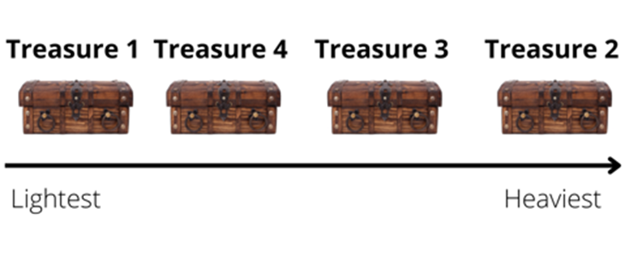
Images sourced from Canva and used in accordance with the Canva Content License Agreement.
- Give each group an equal-arm balance to measure and compare their treasure. Students measure and record their comparisons in their workbook using a line model.
- Students identify objects in the classroom that could be the same mass as the heaviest treasure. Students investigate by hefting objects to compare mass (Early Stage 1), then using the equal-arm balance to measure (Stage 1). In their workbooks, students record an object that has the same mass as the heaviest treasure.
- Select some groups to share their strategies for comparing the mass of the treasure and identifying an object with the same mass. Ask the following questions to stimulate a class discussion:
- What did you notice about the mass of the treasure when hefting?
- How did you compare the 4 treasures? Is there a different way you would do this next time?
- Did the size of the treasure affect the mass? Explain your thinking.
The table below details assessment opportunities and differentiation ideas.
Assessment opportunities | Too hard? | Too easy?
What to look for:  - Can students estimate length to the nearest metre? (MAO-WM-01, MA1-GM-02)  - Do students measure jumps using a metre unit? (MA1-GM-02)  - Are students able to record lengths with the abbreviation (m)? (MA1-GM-02)  - Are students able to use comparative language to describe lengths of jumps? (MAO-WM-01, MAE-GM-02)  - Can students compare and order the masses of the treasure by hefting? (MAO-WM-01, MAE-NSM-01)  - Can students compare and order the mass of the treasure by hefting and use an equal-arm balance to check and record which is heavier or lighter? (MAO-WM-01, MA1-NSM-01)  - Are students able to record their thinking using drawings, numbers, and words? (MAO-WM-01, MAE-NSM-02, MAE-NSW-01, MA1-GM-02, MA1-NSM-01)  What to collect:  - records of observations when students are estimating, comparing, and measuring (MAO-WM-01, MAE-GM-02, MAE-NSM-01, MA1-GM-02, MA1-NSM-01)  - workbook displaying recording (MAO-WM-01, MA1-GM-02, MAE-NSM-01, MA1-GM-02, MA1-NSM-01) | Students are unable to measure jumps using a metre unit.  - Support students to mark a starting point and to line up the unit correctly.  - Mark one unit to help the student understand where to begin the next measurement.  Students unable to use comparative language to describe lengths of jumps.  - Provide additional opportunities to explore and differentiate length to move past simple classifications like short and tall.  - Explicitly model language of length comparison, for example, this object is tall, this object is short.  Students are unable to compare the mass of the 4 treasures.  - Allow students to compare 2 treasures. Demonstrate hefting and provide an opportunity for the student to heft 2 items.  - Model how to use the equal-arm balance to support accuracy. | Students are able to measure jumps using a metre unit.  - Ask if the metre is the most accurate unit of measure. Prompt students to explain their thinking.  - Ask if the student can help you think of a smaller unit of measure that would be more accurate. Support students to use centimetres for a more accurate measurement.  Students can use comparative language to describe lengths of jumps.  - Additional opportunities to extend vocabulary and discuss reasoning by comparing lengths.  - Provide opportunities to develop confidence in using terms such as metre and centimetre to communicate about length.  Students can compare the mass of the 4 treasures.  - Ask students if the equal-arm balance is an accurate measure of mass. Prompt students to explain why or why not.  - Explain that the equal-arm balance helps to compare mass. Ask how students could measure mass using a formal unit of measure.

Lesson 8: Pirate Bonny’s measurement challenge (Part 2)
Core concept: Mathematicians use units of measure to solve mathematical problems.
The table below contains suggested learning intentions and success criteria. These are best co-constructed with students.
Learning intentions | Success criteria
All students are learning that:  - mathematicians estimate, compare and order area to determine the largest surface  - mathematicians estimate, compare and order volume to determine which container holds the most  - mathematicians use units of measure to solve mathematical problems  - mathematicians record estimations, comparisons and results using pictures, numbers, and words, and by referring to the unit used. | All students can:  - estimate which pirate ship has the larger area  - compare and order the pirate ships by area  - estimate which treasure chest holds the most  - compare the internal volume of the treasure chests  - record mathematical thinking using pictures, numbers, and words.  In addition, students working towards Early Stage 1 outcomes can:  - identify and describe attributes of 2D shapes  - measure the internal volume of the treasure chest accurately by making sure the container is packed to the top before comparing.  In addition, students working towards Stage 1 outcomes can:  - use the structure of rows and columns to find the total area  - measure the pirate ships area using uniform informal units  - measure the internal volume of the treasure chests by packing cubic units using an array model.

Daily number sense – 10 minutes
- From a class need surfaced through formative assessment data, identify a short, focused activity that targets students’ knowledge, understanding and skills. Example activities may be drawn from the following resources.
- Thinking Mathematically Stage 1
- Universal Resources Hub.

Area Ahoy and Pirate Bonny’s lunch – 50 minutes
- Revise that students have been exploring measurement in different ways. Explain that Pirate Bonny is very impressed with their mathematical skills and would like to invite them to be part of her crew. To be part of Pirate Bonny’s crew they will need to complete the final 2 pirate measurement challenges.
- Explain that the first pirate challenge is called ‘Area Ahoy’. Students need to find out how many new square planks would be needed to replace the deck on the pirate ships.
- Review the anchor chart on area and draw 3 large rectangle pirate ship decks on the ground using chalk. Ask students:
- What do you need to remember when measuring area?
- How would you measure the area? What could you use in the classroom?
- Could you use the same unit of measure that you used in Lesson 4 (sticky notes) to measure the area of the pirate ship? Why or why not?
- Display a single square. Ask Stage 1 students the following questions about finding the area of a ship:
- What pattern would the tiles make? How could you draw this?
- How can you count the total area? For example, how could you use repeated addition or skip counting?
- Is it possible to measure and compare area using only one square? How will you do this?
- Revise the importance of estimating by visualising the unit of measure. Ask students to estimate the area of the chalk pirate ship deck and record their estimations by drawing in their workbook.
- Students work in groups of 3 or 4 to measure the area of the pirate ships’ deck by covering the surface with a single square in rows and columns without gaps. Early Stage 1 students use multiple tiles to ensure covering with no gaps. Stage 1 students use the ‘make, mark, move’ process and record measurements.
Note: Early Stage 1 students are only expected to identify and compare area.
- Students order the decks from smallest to largest area using a line model.
- Select some groups to share their strategies for comparing the area. Ask the following questions to stimulate a class discussion:
- How did you visualise or think about your estimate?
- Can you explain your drawing? How did you work out the area?
- Was your estimate close to the actual measurement? Why do you think that happened?
- How accurate was your measurement? How do you know?
- How do the structure of rows and columns help measure area?
- Which pirate ship had the biggest area? How do you know?
- Explain that the second pirate challenge is called ‘Pirate Bonny’s lunch’. Show students 3 varying sized treasure chests (containers). Pirate Bonny wants to know which treasure chest is best for holding the most amount of gold.
- Review the anchor chart on volume. Ask students:
- What do you need to remember when measuring volume?
- Why is it important to fill to the brim with no gaps?
- What materials could you use to work out the volume? Why?
- If I want to measure the internal volume of this container with blocks, how should I put them in? Explain your reasoning.
- How might finding the area of a shape help you to find the volume of an object?
- With a partner, students pack containers with blocks to measure the internal volume, then count the units. Stage 1 students record the structure of their packing in their workbooks by drawing a picture.
- Bring students back together. Ask students:
- How did you count the blocks? Was there an easy way to draw the pattern of layers?
- How accurate was your measurement? How do you know?
- Which treasure box was the biggest? How do you know?
The table below details assessment opportunities and differentiation ideas.
Assessment opportunities | Too hard? | Too easy?
What to look for:  - Can students make a reasonable estimate about area? (MAO-WM-01, MAE-2DS-02, MA1-2DS-02)  - Are students able to use the structure of rows and columns with uniform informal units? (MA1-FG-01, MA1-2DS-02)  - Can students find the total area? (MA1-FG-01, MA1-2DS-02)  - Are students able to compare the area of 2 or more rectangles and determine which has the larger area? (MAO-WM-01, MAE-2DS-02, MA1-2DS-02)  - Can students record comparisons of area using drawing, words, and numbers? (MAO-WM-01, MA-2DS-02, MAE-2DS-02)  - Can students make a reasonable estimate about volume? (MAO-WM-01, MAE-3DS-02, MA1-3DS-02)  - Are students able to use informal units to measure volume? (MAO-WM-01, MA1-3DS-02)  - Are students able to compare, order and record the volume of two or more containers? (MAO-WM-01, MAE-3DS-02, MA1-3DS-02)  What to collect:  - records of observations when students are estimating, comparing, and measuring (MAO-WM-01, MAE-3DS-02, MAE-2DS-02, MA1-3DS-02, MA1-2DS-02)  - workbook displaying recording (MAO-WM-01, MA1-3DS-02, MA1-2DS-01) | Students are unable to use rows and column structure to measure area.  - Draw the structure of rows and arrays for the students and ask what they notice.  - Model creating one row and one column using the informal units. Students use initial structure as a scaffold to complete.  Students are unable to measure volume using units.  - Further experiences in filling containers with continuous materials such as water, and discrete objects such as marbles  - Model creating one layer for the students and supporting them to replicate the first layer on top. | Students are able to use rows and columns to measure area.  - Ask students to measure the area of a non-rectangular surface within the classroom. Ask what challenges this has and prompt students to find a solution.  - Students record their findings.  Students can measure volume using units.  - Ask students why they think blocks would not be the most accurate way of measuring volume. Encourage students to suggest alternatives.  - Ask students to draw a diagram of how they have organised your blocks and describe their thinking.
Consolidation and meaningful practice: Pirate ceremony – 10 minutes
- Congratulate students on their mathematical skills and explain that they have exceeded all of Pirate Bonny’s expectations.
- Hand out Resource 15: Crew Certificate to all students and explain that Pirate Bonny has invited them to be part of the crew.
- Explain that Captain Beard would like a record of students’ challenges and successes during their investigations. Students draw a picture of what they have learnt during this investigation. Ask students:
- What did you enjoy most about being measuring mathematicians? Why?
- How did the challenge make you feel?
- What group work skills did you use in this unit?

Resource 1: Captain Beard’s Ship
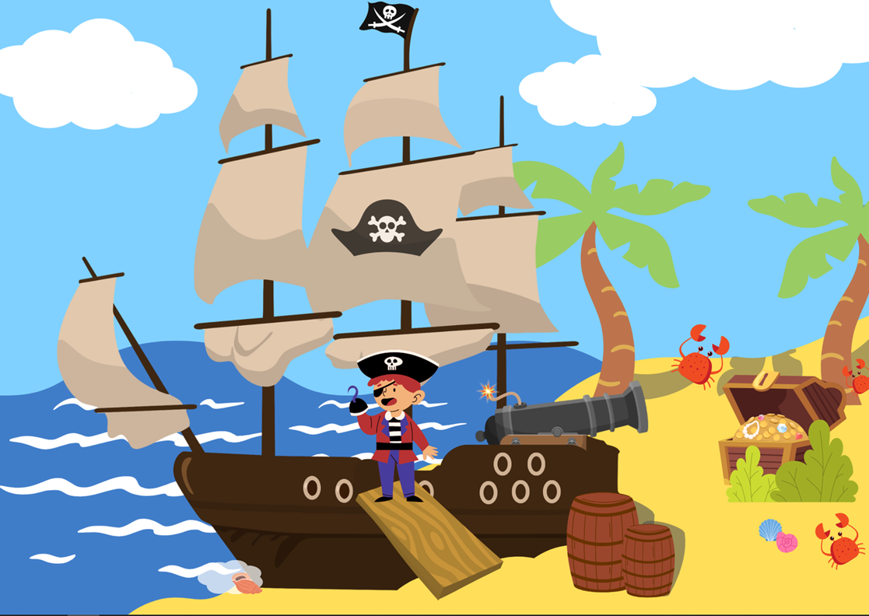
Images sourced from Canva and used in accordance with the Canva Content License Agreement.

Resource 2: Pirate Crew
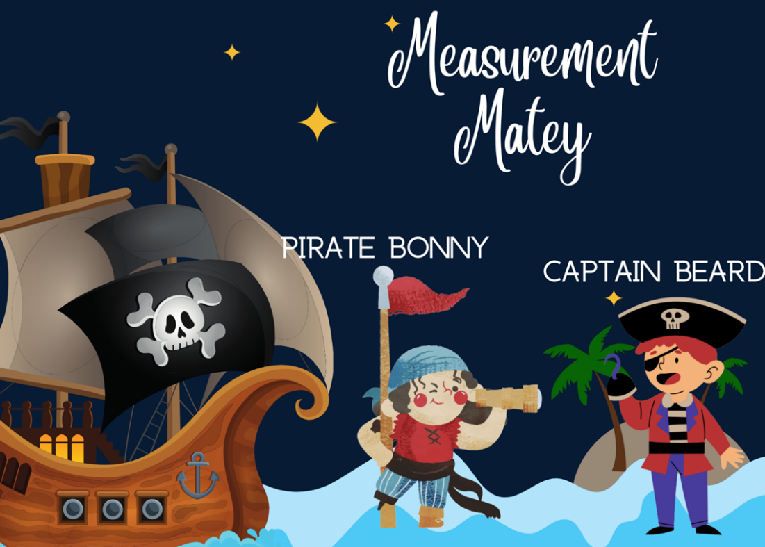
Images sourced from Canva and used in accordance with the Canva Content License Agreement.

Resource 3: Pirate Bonny’s bucket
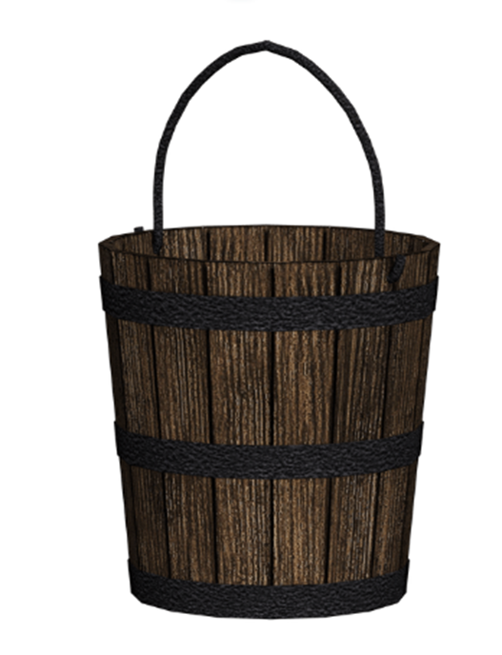
‘Wooden bucket’ by susannp4 is used in accordance with the Pixabay License.

Resource 4: Bucket recording sheet
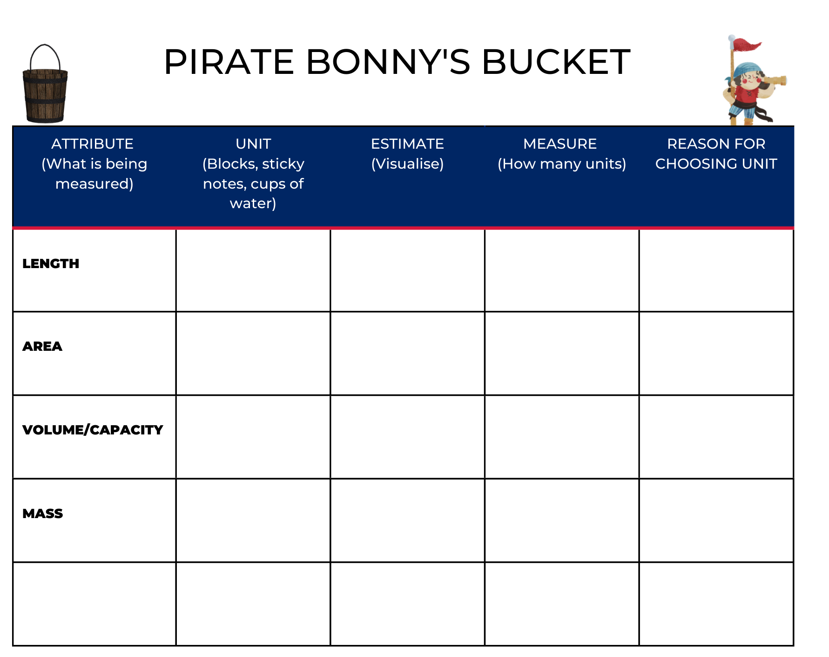
Images sourced from Canva and used in accordance with the Canva Content License Agreement.

Resource 5: Estimating and recording
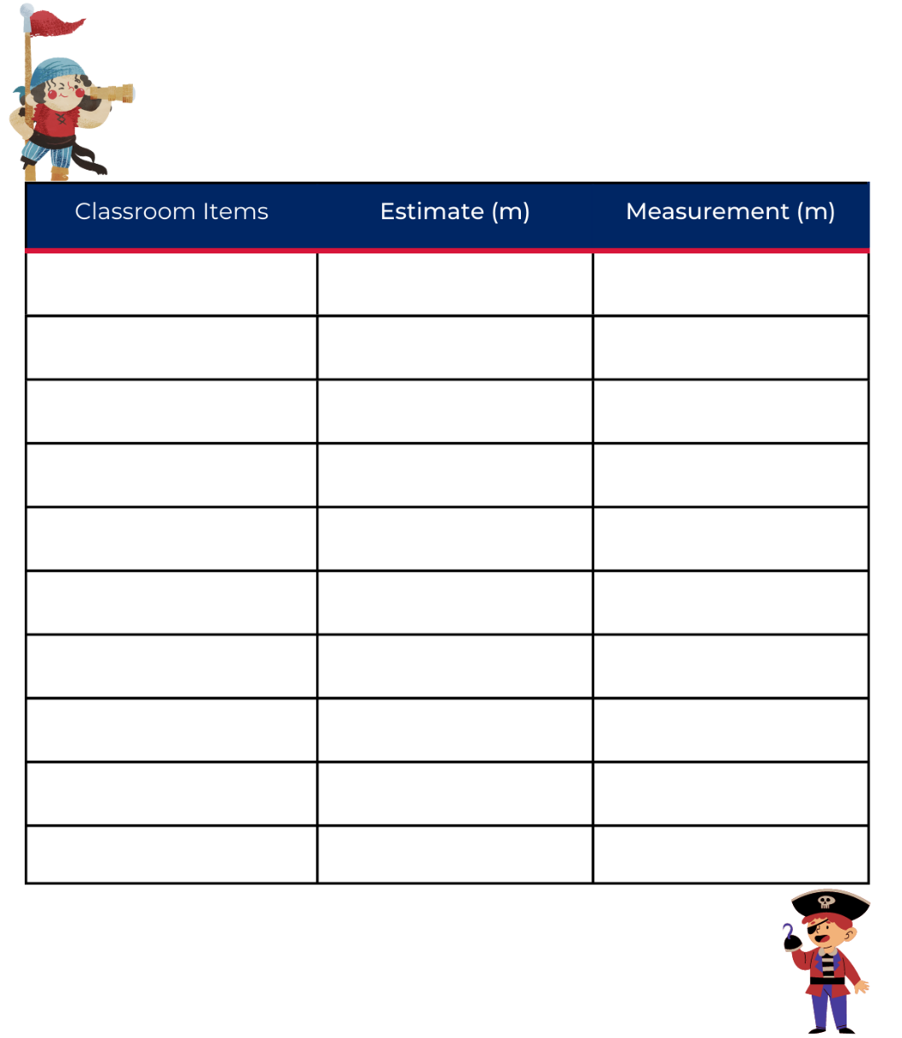
Images sourced from Canva and used in accordance with the Canva Content License Agreement.

Resource 6: Fire the cannon
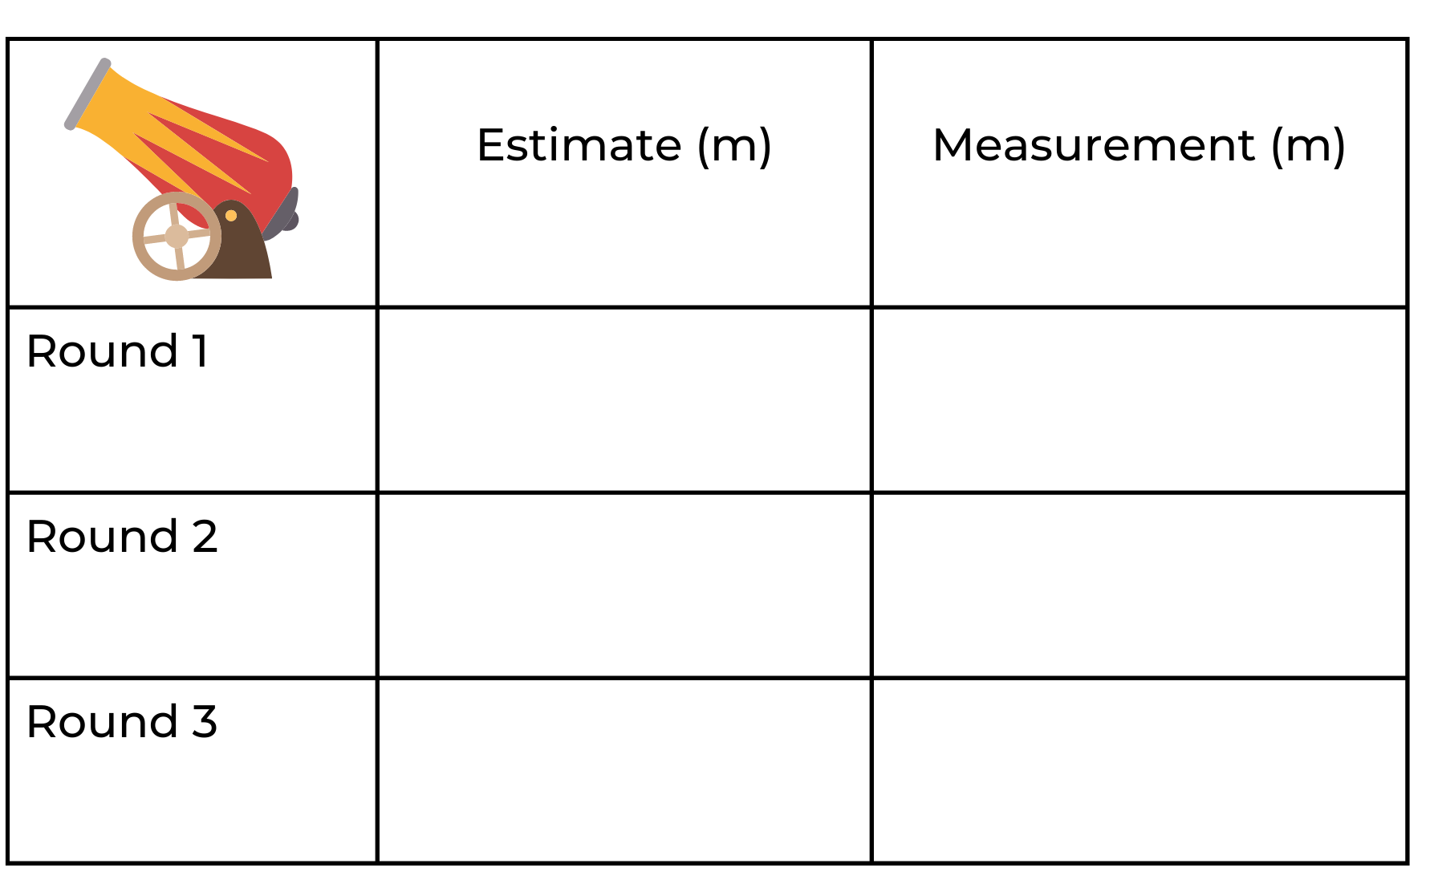
Images sourced from Canva and used in accordance with the Canva Content License Agreement.

Resource 7: Pirate flags
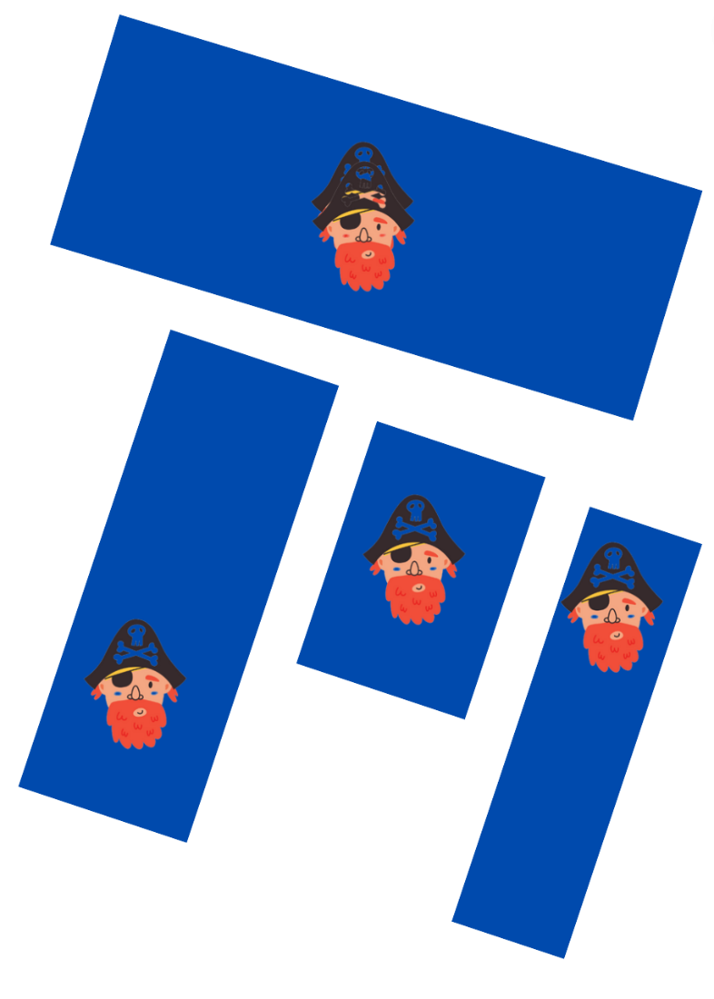
Images sourced from Canva and used in accordance with the Canva Content License Agreement.

Resource 8: Sample flags
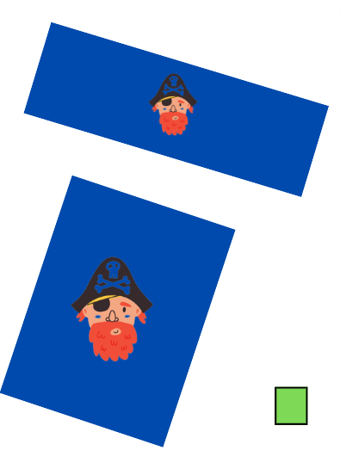
Images sourced from Canva and used in accordance with the Canva Content License Agreement.

Resource 9: Cubes
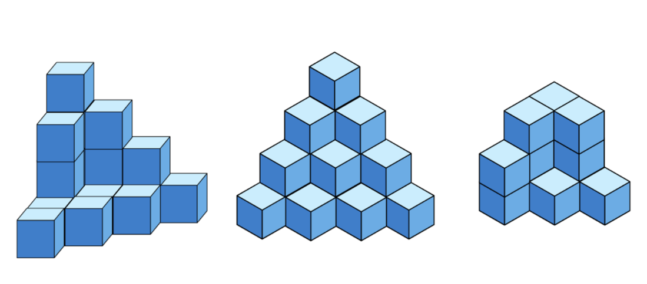
Images sourced from Canva and used in accordance with the Canva Content License Agreement.

Resource 10: Estimating volume
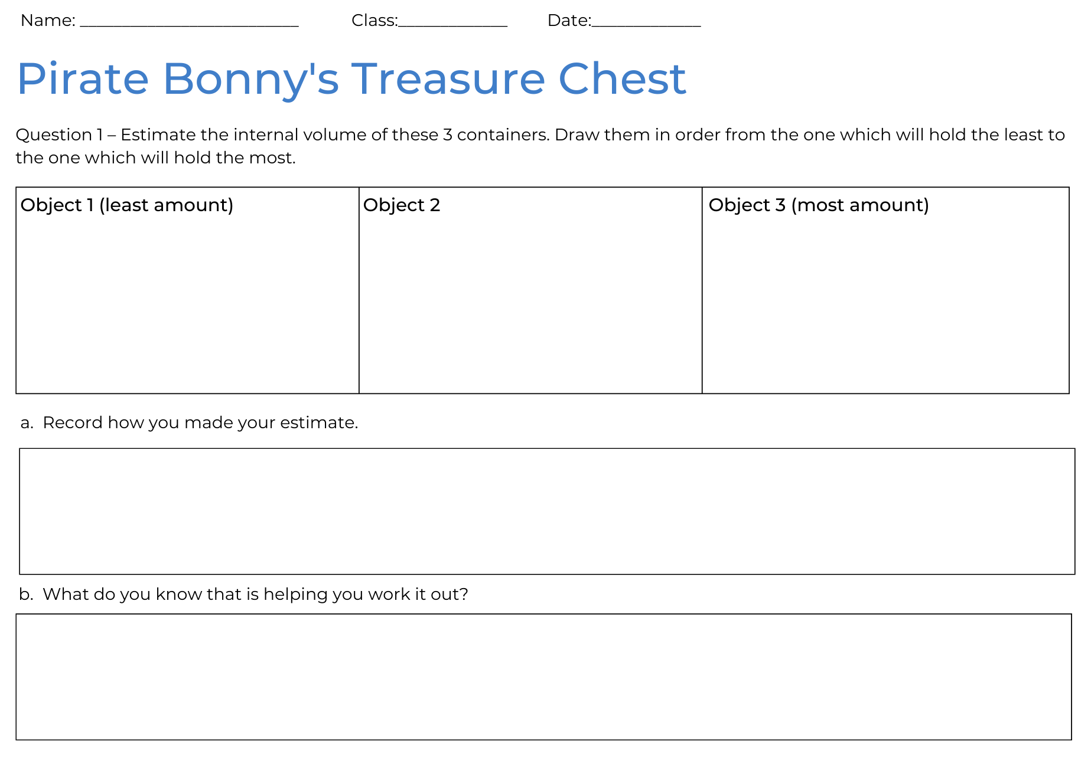

Resource 11: Recording volume
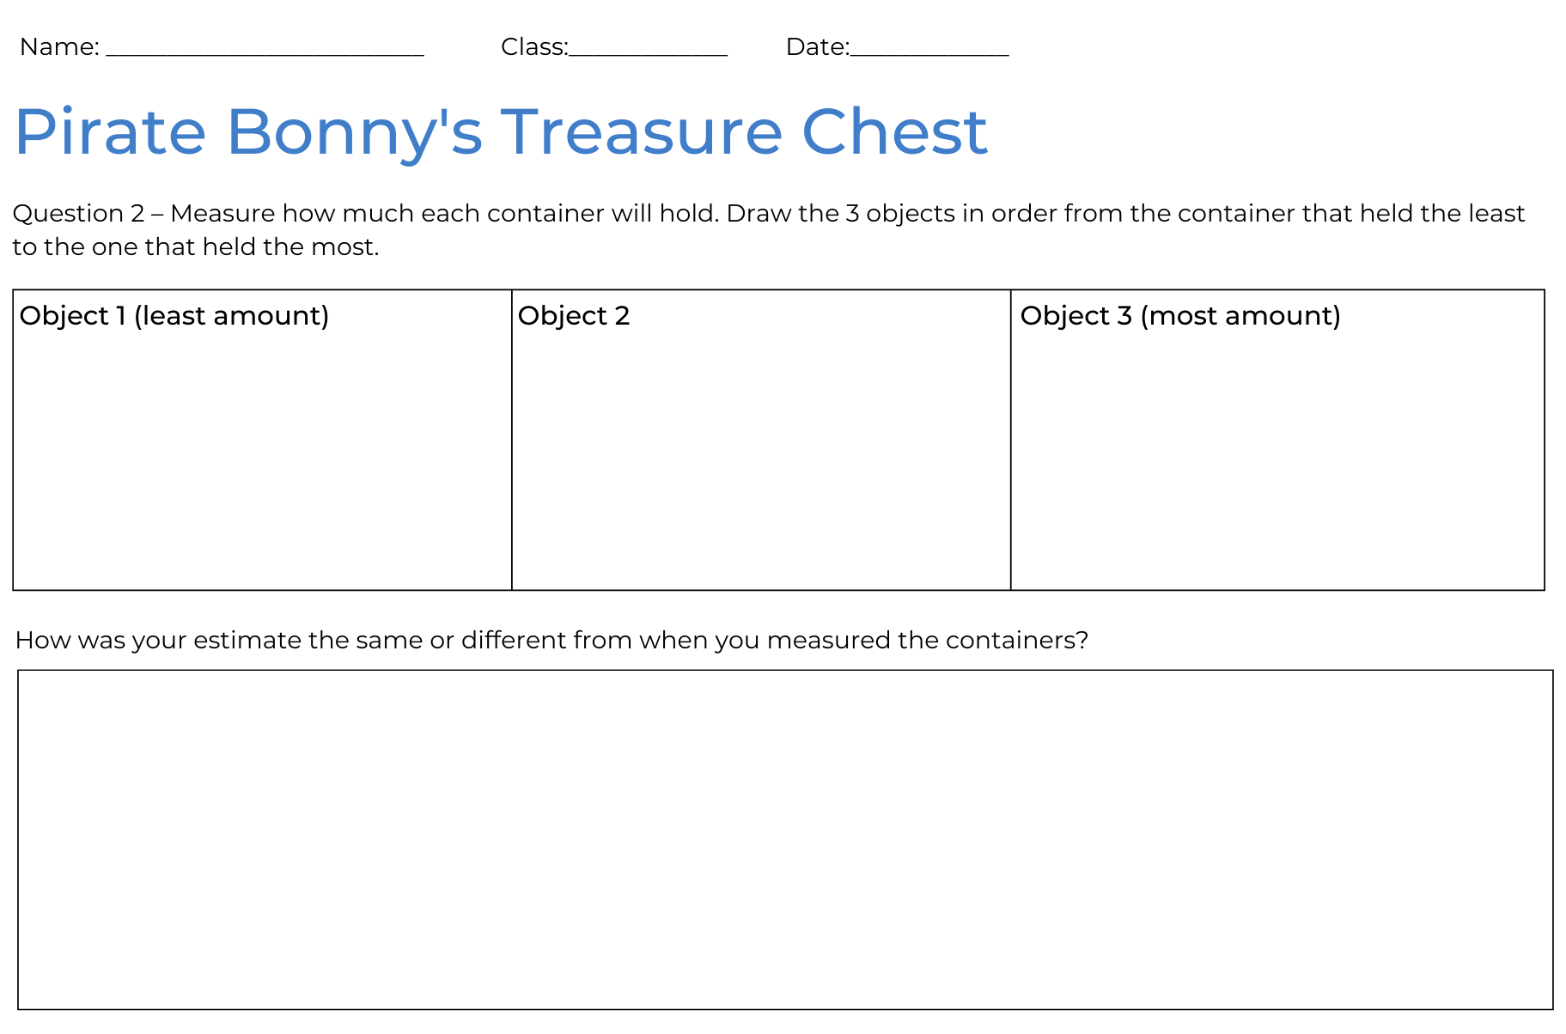

Resource 12: Counting hands
‘Human Hand’ by Billion Photos is used in accordance with the Canva Pro Content Licence.

Resource 13: Counting fingers
‘Group of People Forming Star Using Their Hands’ by Zun is used in accordance with the Canva Pro Content Licence.

Resource 14: Jump the plank
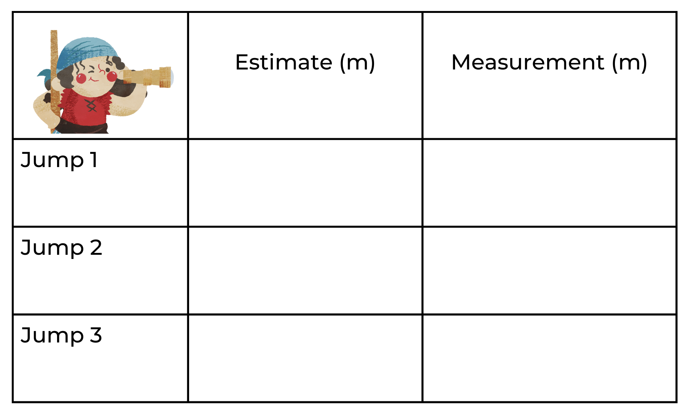
Image sourced from Canva and used in accordance with the Canva Content License Agreement.

Resource 15: Crew certificate
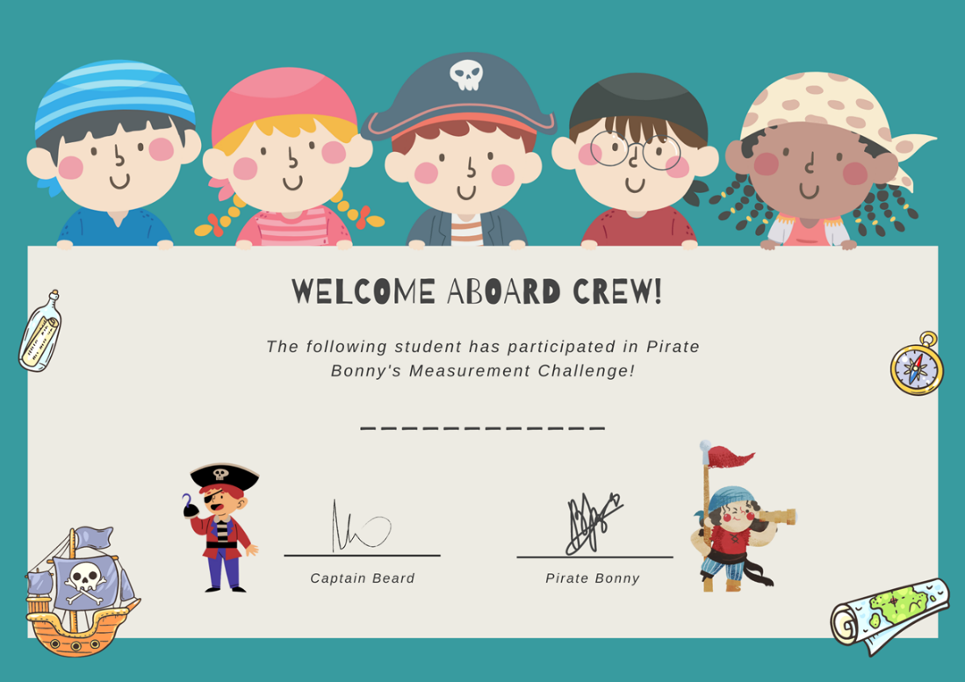
Images sourced from Canva and used in accordance with the Canva Content License Agreement.

Syllabus outcomes and content
The table below outlines the syllabus outcomes and range of relevant syllabus content covered in this unit. Content is linked to National Numeracy Learning Progression version (3).
Focus area and outcomes | Content groups and content points | Lessons
Representing whole numbers  MAO-WM-01  MAE-RWN-01, MA1-RWN-01  MAE-RWN-02, MA1-RWN-02 | Early Stage 1  Instantly name the number of objects within small collections  - instantly recognise (subitise) the number of items in small groups of up to four items without counting (NPV1, CPr1)  - identify the number of items in different arrangements (CPr2) | 1, 3, 4, 6
Representing whole numbers (cont) | Early Stage 1  Use the counting sequence of ones flexibly  - count forwards to at least 30 and state the number after or before a given number, without needing to count from one (CPr4)  - identify and distinguish the ‘teen’ numbers from multiples of ten with the same initial sounds (NPV3)  - count backwards from a given number 20 or less (CPr5) | 1-8
Representing whole numbers (cont) | Early Stage 1  Connect counting and numerals to quantities  - count with one-to-one correspondence, recognising that the last number name represents the total number in the collection (CPr3, CPr5)  - count out a specified number of objects (from 5 to 20) from a larger collection, keeping track of the count (CPr4-CPr5)  - read numerals to at least 20, including zero (NPV3)  - represent numbers as quantities to at least 20 using objects (such as fingers), number words and numerals (NPV2- NPV4, CPr3) | 1-8
Representing whole numbers A (cont) | Stage 1  Use counting sequences of ones with two-digit numbers and beyond  - identify the number before and after a given two-digit number (CPr5) | 2-3
Representing whole numbers A (cont) | Stage 1  Continue and create number patterns  - count forwards and backwards by twos from any starting point (CPr6-CPr7, MuS2) | 5
Representing whole numbers A (cont) | Stage 1  Represent numbers on a line  - sequence numbers and arrange them on a line by considering the order and size of those numbers (CPr5)  - locate the approximate position of multiples of 10 on a model of a number line from 0 to 100 (CPr5) | 1-4, 6
Representing whole numbers A (cont) | Stage 1  Represent the structure of groups of ten in whole numbers  - recognise that ten ones is the same as one ten (NPV2, NPV4)  - use 10 as a reference in forming numbers from 11 to 20 (CPr7)  - count large sets of objects by systematically grouping in tens (CPr7)  - estimate, to the nearest ten, the number of objects in a collection and check by counting in groups of ten (Reasons about quantity) (CPr7, NPV6) | 1-4, 6
Representing whole numbers B (cont) | Stage 1  Use counting sequences of ones and tens flexibly  - identify the number before and after a given three-digit number | 2-3
Forming groups B  MAO-WM-01  MAE-FG-01, MA1-FG-01  MAE-FG-02  NOTE – There is only one Forming groups outcome for Stage 1 | Stage 1  Represent and explain multiplication as the combining of equal groups  - use objects, diagrams, images or actions to model multiplication as accumulating equal groups (MuS4)  - solve multiplication problems using repeated addition (MuS4)  - form arrays of equal rows and equal columns (MuS5)  - determine and distinguish between the number of rows/columns and the number in each row/column when describing collections of objects (MuS5) | 4, 6-8
Geometric measure  MAO-WM-01  MAE-GM-01, MA1-GM-01  MAE-GM-02, MA1-GM-02  MAE-GM-03, MA1-GM-03 | Early Stage 1  Length: Use direct and indirect comparisons to decide which is longer  - identify the attribute of 'length' as the measure of an object from end to end  - use comparative language to describe length (UuM2)  - compare lengths directly by placing objects side by side and aligning the ends (UuM2)  - explain why the length of a piece of string remains unchanged whether placed in a straight line or a curve  - compare lengths indirectly by copying a length (Reasons about relations) (UuM3) | 1-3, 7
Geometric measure A (cont) | Stage 1  Length: Compare lengths, using uniform informal units  - estimate lengths, indicating the number and type of unit used and check by measuring (UuM3) | 1-3, 7
Geometric measure B (cont) | Stage 1  Length: Compare and order lengths, using appropriate uniform informal units  - compare the lengths of two or more objects that cannot be moved or aligned (Reasons about relations)  - record length comparisons using drawings, numerals and words, and by referring to the uniform informal unit used | 1-3, 7
Geometric measure B (cont) | Stage 1  Length: Recognise and use formal units to measure the lengths of objects  - recognise the need for formal units to measure lengths and distances (UuM6)  - use the metre as a unit to measure lengths and distances to the nearest metre or half-metre  - record lengths and distances using the abbreviation for metres (m)  - estimate lengths and distances to the nearest metre and check by measuring (UuM6) | 1-3, 7
Two-dimensional spatial structure  MAO-WM-01  MAE-2DS-01, MA1-2DS-01  MAE-2DS-02, MA1-2DS-02 | Early Stage 1  2D shapes: Sort, describe and name familiar shapes  - identify familiar shapes in a range of contexts  - describe shapes, including circles, squares, triangles and rectangles (UGP1-UGP2)  - ask and respond to questions that help identify and name a particular shape | 4
Two-dimensional spatial structure (cont) | Early Stage 1  2D shapes: Represent shapes  - manipulate circles, squares, triangles and rectangles, and describe their features (UGP2-UGP3) | 4
Two-dimensional spatial structure (cont) | Early Stage 1  Area: Identify and compare area  - make closed shapes and identify the attribute of area as the measure of the amount of surface  - use comparative language to describe areas (UuM2)  - predict which of two surfaces will have the larger area and justify the answer (Reasons about spatial relations)  - compare areas of two similar shapes directly by drawing, tracing, or cutting and pasting (UuM3-UuM4) | 1, 4, 8
Two-dimensional spatial structure A (cont) | Stage 1  Area: Indirectly compare area  - indirectly compare the areas of two surfaces that cannot be moved or superimposed (UuM4)  - predict which of two similar shapes has the larger area and check by covering (UuM4) | 1, 4, 8
Two-dimensional spatial structure B (cont) | Stage 1  Area: Compare rectangular areas using uniform square units of an appropriate size in rows and columns  - cover rectangular surfaces by creating repeated rows of square tiles (UuM5)  - use a single square to create the array structure of area in rows and columns (UuM5)  - use the structure of repeated units to find the area of a rectangle (UuM5)  - explain how the grid structure of rows and columns helps to find the area  - compare the areas of two or more surfaces that cannot be moved, or superimposed, by measuring in uniform informal units (UuM4)  - record comparisons of area using drawings, numerals and words, and by referring to the uniform informal unit used | 1, 4, 8
Three-dimensional spatial structure  MAO-WM-01  MAE-3DS-01, MA1-3DS-01  MAE-3DS-02, MA1-3DS-02 | Early Stage 1  3D objects: Explore familiar three-dimensional objects  - describe the features of familiar objects (UGP1)  - sort objects and identify the attribute used to sort them (UGP2)  - make and describe a variety of three-dimensional models (UGP3) | 5
Three-dimensional spatial structure (cont) | Early Stage 1  Volume: Compare internal volume by filling and packing  - fill and empty containers using materials such as water or sand  - use the terms ‘full’, ‘empty’ and ‘about half full’  - compare the internal volumes (capacities) of two containers directly by filling one and pouring into the other (UuM2)  - compare the internal volumes of two containers indirectly by pouring their contents into two other identical containers and observing the level reached in each (UuM3)  - establish that containers of different shapes may hold the same amount  - stack and pack blocks into defined spaces (UuM5) | 1, 5, 8
Three-dimensional spatial structure (cont) | Early Stage 1  Volume: Compare volume by building  - identify the attribute of volume as the amount of space an object or substance occupies  - compare the volumes of two objects made from blocks or connecting cubes directly by deconstructing one object and using its parts to construct a copy of the other object  - use comparative language to describe volume (UuM2) | 1, 5, 8
Three-dimensional spatial structure A (cont) | Stage 1  Volume: Measure and compare the internal volumes (capacities) of containers by filling  - use uniform informal units to measure how much a container will hold by counting the number of times a smaller container can be filled and emptied into the container being measured (UuM3)  - select appropriate informal units to measure the capacities of containers  - recognise and explain the relationship between the size of a unit and the number of units needed (Reasons about relations)  - compare the internal volumes of two or more containers using appropriate uniform informal units (UuM3)  - recognise and explain why containers of different shapes may have the same internal volume (Reasons about relations)  - estimate how much a container holds by referring to the number and type of uniform informal unit used and check by measuring (UuM3-UuM4) | 1, 5, 8
Three-dimensional spatial structure B (cont) | Stage 1  Volume: Compare containers based on internal volume (capacity) by filling and packing  - make and use a device for measuring internal volume (capacity) calibrated in uniform informal unit (UuM3-UuM4)  - compare, order and record the internal volumes (capacities) of two or more containers by measuring each container in uniform informal units (UuM3-UuM4)  - estimate internal volume (capacity) by referring to the number and type of uniform informal unit used (UuM3) | 1, 5, 8
Non-spatial measure  MAO-WM-01  MAE-NSM-01, MA1-NSM-01  MAE-NSM-02, MA1-NSM-02 | Early Stage 1  Mass: Identify and compare mass using weight  - identify that objects can be heavy or light (UuM2)  - compare two masses directly by hefting (UuM3)  - predict which object would be heavier than, lighter than, or have about the same weight as another object and explain reasons for this prediction (Reasons about relations) | 1, 6, 7
Non-spatial measure A (cont) | Stage 1  Mass: Investigate mass using an equal-arm balance  - place objects on either side of an equal-arm balance to obtain a level balance  - use an equal-arm balance to compare the masses of two objects and record, which is heavier or lighter (UuM2)  - predict the action of an equal-arm balance before placing particular objects in each pan (Reasons about relations)  - use a balance to find two collections of objects that have the same mass (UuM2)  - compare and order the masses of two or more objects by hefting, and check using an equal-arm balance (UuM2) | 1, 6, 7

References
Links to third-party material and websites
Please note that the provided (reading/viewing material/list/links/texts) are a suggestion only and implies no endorsement, by the New South Wales Department of Education, of any author, publisher, or book title. School principals and teachers are best placed to assess the suitability of resources that would complement the curriculum and reflect the needs and interests of their students.
If you use the links provided in this document to access a third-party's website, you acknowledge that the terms of use, including licence terms set out on the third-party's website apply to the use which may be made of the materials on that third-party website or where permitted by the Copyright Act 1968 (Cth). The department accepts no responsibility for content on third-party websites.
Except as otherwise noted, all material is © State of New South Wales (Department of Education), 2021 and licensed under the Creative Commons Attribution 4.0 International License. All other material (third-party material) is used with permission or under licence. Where the copyright owner of third-party material has not licensed their material under a Creative Commons or similar licence, you should contact them directly for permission to reuse their material.
Mathematics K–10 Syllabus © 2022 NSW Education Standards Authority (NESA) for and on behalf of the Crown in right of the State of New South Wales.
© 2022 NSW Education Standards Authority. This document contains NSW Curriculum and syllabus content. The NSW Curriculum is developed by the NSW Education Standards Authority. This content is prepared by NESA for and on behalf of the Crown in right of the State of New South Wales. The material is protected by Crown copyright.
Please refer to the NESA Copyright Disclaimer for more information.
NESA holds the only official and up-to-date versions of the NSW Curriculum and syllabus documents. Please visit the NSW Education Standards Authority (NESA) website and the NSW Curriculum website.
National Numeracy Learning Progression © Australian Curriculum, Assessment and Reporting Authority (ACARA) 2010 to present, unless otherwise indicated. This material was downloaded from the Australian Curriculum website (National Numeracy Learning Progression) (accessed 30 September 2022 and was not modified. The material is licensed under CC BY 4.0. Version updates are tracked in the ‘Curriculum version history’ section on the 'About the Australian Curriculum' page of the Australian Curriculum website.
ACARA does not endorse any product that uses the Australian Curriculum or make any representations as to the quality of such products. Any product that uses material published on this website should not be taken to be affiliated with ACARA or have the sponsorship or approval of ACARA. It is up to each person to make their own assessment of the product, taking into account matters including, but not limited to, the version number and the degree to which the materials align with the content descriptions and achievement standards (where relevant). Where there is a claim of alignment, it is important to check that the materials align with the content descriptions and achievement standards (endorsed by all education Ministers), not the elaborations (examples provided by ACARA).
Sullivan P and Lilburn P (2004) Open-Ended Maths activities: Using ‘good’ questions to enhance learning in Mathematics, Oxford University Press, Australia.
University of Cambridge (Faculty of Mathematics) (2022) Number Sense Series: A Sense of 'ten' and Place Value, NRICH website, accessed 30 September 2022.
University of Cambridge (Faculty of Mathematics) (2022) Can you do it too?, NRICH website, accessed 30 September 2022.
University of Cambridge (Faculty of Mathematics) (2022) Fingers and Hands, NRICH website, accessed 30 September 2022.
Van de Walle, J, Karp, K, Bay-Williams, J, Brass, A, & Bentley, B (2019). Primary and Middle Years Mathematics: Teaching Developmentally, 1st edn, Pearson Education, Australia.

