Mathematics – K-2 multi-age – Year B – Unit 2
Contents
Unit description and duration 4
Student prior learning 4
Lesson overview and resources 5
Lesson 1: Exploring attributes and properties of shapes 15
Daily number sense Early Stage 1: Attributes of shapes – 10 minutes 16
Daily number sense Stage 1: Attributes of numbers – 10 minutes 16
Warm-up: Let’s think about shapes! Which one does not belong? – 10 minutes 17
Let’s make a shape train to think about attributes and properties – 10 minutes 19
Shape train challenge! – 30 minutes 22
Discuss and connect the mathematics – 5 minutes 23
Lesson 2: What are patterns and how do we describe them? 25
Daily number sense: What can you see? – 10 minutes 25
Patterns repeat over and over and over again – 15 minutes 26
Different kinds of repeating patterns – 20 minutes 28
Shape patterns: What's the missing part? – 15 minutes 31
Discuss and connect the mathematics – 15 minutes 32
Lesson 3: Patterns are all around us 34
Daily number sense: Counting patterns – 10 minutes 34
Patterns found in nature and built environments – 50 minutes 35
Discuss and connect the mathematics – 5 minutes 39
Lesson 4: Symmetrical patterns – Mandalas 40
Daily number sense: Counting patterns – 5 minutes 40
Warm-up: Let’s look at symmetry! – 10 minutes 41
Making mandalas 1 – 20 minutes 41
Making mandalas 2 – 30 minutes 42
Consolidation and meaningful practice: Guess what? – 5 minutes 44
Lesson 5: Growing and shrinking – 2D geometric patterns 45
Daily number sense: What number comes next? Squares to stairs – 20 minutes 45
How does it grow or shrink? – 45 minutes 49
Discuss and connect the mathematics – 5 minutes 51
Lesson 6: Growing and shrinking number patterns 53
Daily number sense: What number comes next? Counting on in ones, twos, and fives – 15 minutes 54
Input–output robot – 30 minutes 56
Discuss and connect the mathematics – 20 minutes 59
Lesson 7: Place value in number patterns 61
Daily number sense: What comes next? – 10 minutes 62
Window mysteries – 40 minutes 64
Discuss and connect the mathematics – 10 minutes 65
Lesson 8: Let’s investigate patterns! 68
Daily number sense: Dice collection – 15 minutes 68
Let’s frame it! – 45 minutes 69
Discuss and connect the mathematics – 5 minutes 74
Resource 1: 2D paper shapes 75
Resource 2: Simple mandala template 76
Resource 3: Squares to stairs 77
Resource 4: Robot eats the number 5! 78
Resource 5: What comes next – dots? 79
Resource 6: What comes next - numbers? 80
Resource 7: Hundreds chart 81
Resource 8: Rectangular and hexagonal frames 82
Syllabus outcomes and content 83
References 92

Unit description and duration
This two-week unit provides opportunity for students to further develop knowledge, understanding, and skills of two-dimensional shapes and their attributes and properties. Students are provided opportunities to:
- sort collections using attributes and properties
- recognise, name, and explore properties of two-dimensional shapes
- investigate repeating shape patterns that grow, shrink, radiate, and are symmetrical
- investigate repeating number patterns that grow and shrink.
Mathematics K–10 Syllabus © 2022 NSW Education Standards Authority (NESA) for and on behalf of the Crown in right of the State of New South Wales.

Student prior learning
Before engaging in these teaching and learning activities, students would benefit from prior experience with:
- recognising, describing, and naming two-dimensional shapes
- identifying repeating patterns and how they repeat over and over again
- counting forwards and back
- skip counting by twos, fives, and tens (Stage 1 students).

Lesson overview and resources
The table below outlines the sequence and approximate timing of lessons; syllabus focus areas and content groups; and resources.
Lesson | Syllabus focus area and content groups | Resources
Lesson 1: Exploring attributes and properties of shapes  65 minutes  Attributes and properties can be used to describe similarities and differences between shapes. | Representing whole numbers  Early Stage 1  - Use the counting sequence of ones flexibly  Stage 1 – Part A  - Use counting sequences of ones with two-digit numbers and beyond  Two-dimensional spatial structure  Early Stage 1  - Sort, describe and name familiar shapes  Stage 1 – Part A  - Recognise and classify shapes using obvious features  Stage 1 – Part B  - Represent, combine and separate two-dimensional shapes | - Video: Play School's Marvellous Maths – Sort and classify with Eddie (4:48)  - reSolve 1a Class Set of Attribute Blocks  - reSolve 1b Student Sets of Attribute Blocks  - reSolve 2b Student Set of Three-Attributes Blocks  - reSolve 2c Train Challenge Reflection  - Class set of 2D geometric shapes  - Student sets of two-dimensional (2D) geometric shapes  - Writing materials
Lesson 2: What are patterns and how do we describe them?  75 minutes  Patterns have a core that repeats over and over again and can be represented using letters or symbols. | Two-dimensional spatial structure  Early Stage 1  - Sort, describe and name familiar shapes  - Represent shapes  Stage 1 – Part A  - Recognise and classify shapes using obvious features  Stage 1 – Part B  - Represent, combine and separate two-dimensional shapes. | - A variety of objects for pattern making, for example, geometric shapes, counters, interlocking cubes, craft sticks, beads, blocks, and so on  - Anchor chart paper  - Coloured beads and string  - Mini whiteboards and markers  - Writing materials
Lesson 3: Patterns are all around us  65 minutes  Mathematical patterns exist in natural and built environments. | Two-dimensional spatial structure  Early Stage 1  - Sort, describe and name familiar shapes  - Represent shapes  Stage 1 – Part A  - Recognise and classify shapes using obvious features  Stage 1 – Part B  - Represent, combine and separate two-dimensional shapes. | - 2D geometric shapes  - Anchor chart paper  - Camera or iPad  - Images and/or real-life objects  - Mini whiteboards and markers  - 0-5-sided dice  - Writing materials
Lesson 4: Symmetrical patterns – Mandalas  70 minutes  Repeated geometric shapes can be manipulated to represent patterns of symmetry and reflection. | Two-dimensional spatial structure  Early Stage 1  - Sort, describe and name familiar shapes  - Represent shapes  Stage 1 – Part A  - Recognise and classify shapes using obvious features  Stage 1 – Part B  - Represent, combine, and separate two-dimensional shapes  Data  Early Stage 1  - Organise objects into simple data displays and interpret the displays  Stage 1 – Part A  - Gathers and organises data, displays data in lists, tables and picture graphs. | - Resource 1: 2D paper shapes  - Resource 2: Simple mandala template  - Video: Making mandalas – Stage 1 (9:10)  - 2D geometric shape blocks  - Camera or iPad  - Coloured squares or blocks  - Concrete materials for making mandalas, for example, beads and pasta  - Objects for printing, for example, sponge shapes  - Playing cards numbered 1-5  - Paper shapes for folding  - Writing materials
Lesson 5: Growing and shrinking – 2D geometric patterns  70 minutes  Patterns grow and shrink as the repeated element is added or subtracted. | Combining and separating quantities  Early Stage 1  - Model additive relations and compare quantities  - Identify part-whole relationships in numbers up to 10  Stage 1 – Part A  - Use advanced count-by-one strategies to solve addition and subtraction problems  - Use flexible strategies to solve addition and subtraction problems  Stage 1 – Part B  - Represent and reason about additive relations  Two-dimensional spatial structure  2D shapes  Early Stage 1  - Sort, describe and name familiar shapes  - Represent shapes  Stage 1 – Part A  - Recognise and classify shapes using obvious features  Stage 1 – Part B  - Represent, combine and separate two-dimensional shapes  Data  Stage 1 – Part A  - Gathers and organises data, displays data in lists, tables and picture graphs. | - Resource 3: Squares to stairs  - Video: Staircase Patterns 1 (6:17)  - Youcubed: Squares to stairs  - 2D geometric shapes  - Blocks  - Images of patterns in nature  - Interlocking cubes  - Mini whiteboards and markers  - Writing materials
Lesson 6: Growing and shrinking number patterns  65 minutes  A repeating core can grow or shrink a number pattern. | Representing whole numbers  Early Stage 1  - Instantly name the number of objects within small collections  - Recognise number patterns  - Connect counting and numerals to quantities  Stage 1 – Part A  - Continue and create number patterns  - Represent the structure of groups of ten in whole numbers  Combining and separating quantities  Early Stage 1  - Model additive relations and compare quantities  - Identify part-whole relationships in numbers up to 10  Stage 1 – Part A  - Use advanced count-by-one strategies to solve addition and subtraction problems  - Use flexible strategies to solve addition and subtraction problems  Stage 1 – Part B  - Represent and reason about additive relations. | - Resource 4: Robot eats the number 5!  - Teacher Education by Design Choral Counting  - A variety of materials to create patterns, for example, 2D geometric shapes, counters, blocks  - Mini whiteboards and markers  - Sticky notes with numbers 1- 5  - Writing materials
Lesson 7: Place value in number patterns  60 minutes  Place value can be used to investigate number patterns. | Representing whole numbers  Early Stage 1  - Instantly name the number of objects within small collections  - Use the counting sequence of ones flexibly  - Recognise number patterns  - Connect counting and numerals to quantities  Stage 1 – Part A  - Continue and create number patterns  - Represent the structure of groups of ten in whole numbers  Stage 1 – Part B  - Use counting sequences of ones and tens flexibly  Combining and separating quantities  Early Stage 1  - Model additive relations and compare quantities  Stage 1 – Part A  - Use flexible strategies to solve addition and subtraction problems  Stage 1 – Part B  - Represent and reason about additive relations  - Form multiples of ten when adding and subtracting two-digit numbers  Data  Early Stage 1  - Organise objects into simple data displays and interpret the displays  Stage 1 – Part A  - Gathers and organises data, displays data in lists, tables and picture graphs. | - Resource 5: What comes next – dots?  - Resource 6: What comes next – numbers?  - Resource 7: Hundreds chart  - Mini whiteboards and markers  - 6-sided dice  - Small hundreds charts – several per group  - Sticky notes with numbers  - Writing materials
Lesson 8: Let’s investigate patterns!  65 minutes  Repeated and growing patterns can be used to solve problems. | Forming groups  Early Stage 1  - Copy, continue and create patterns  Combining and separating quantities  Early Stage 1  - Model additive relations and compare quantities  Stage 1 – Part A  - Use flexible strategies to solve addition and subtraction problems  Stage 1 – Part B  - Represent and reason about additive relations  Two-dimensional spatial structure  2D shapes  Stage 1 – Part A  - Recognise and classify shapes using obvious features  Data  Early Stage 1  - Organise objects into simple data displays and interpret the displays  Stage 1 – Part A  - Gathers and organises data, displays data in lists, tables and picture graphs  Stage 1 – Part B  - Create displays of data and interpret them. | - Resource 8: Rectangular and hexagonal frames  - 8 × 6-sided dice of one colour and 8 × 6-sided dice in a second colour  - Different coloured counters  - Hundreds chart  - Mini whiteboards and markers  - Squared paper  - Writing materials

Lesson 1: Exploring attributes and properties of shapes
Core concept: Attributes and properties can be used to describe similarities and differences between shapes.
The table below contains suggested learning intentions and success criteria. These are best co-constructed with students.
Learning intentions | Success criteria
All students are learning that:  - there are different strategies to solve problems  - attributes are all the ways we describe a shape or object, for example, size, colour, sides, corners  - shapes change when one or more attributes change  - a collection of shapes can be sorted in more than one way, depending on which attributes and properties are selected  - shapes change when one or more properties change. | All students can:  - build a shape train by changing one attribute or property at a time  - use knowledge of attributes or properties to solve problems in a game.  In addition, students working towards Early Stage 1 outcomes can use attributes in more than one way to sort a collection.  In addition, students working towards Stage 1 outcomes can predict how a shape may change by identifying properties that can change.

Daily number sense Early Stage 1: Attributes of shapes – 10 minutes
- Students build understanding of attributes of common geometric shapes through structured play adapted from Learning Trajectories (Clements and Sarama 2017/2019).
- Early Stage 1 students: Use 2D geometric shapes to make pictures. Talk about the shapes used. For example, name, colour, number of corners, number of sides.

Daily number sense Stage 1: Attributes of numbers – 10 minutes
- Students build understanding of properties of numbers through completing a Which one does not belong? adapted from Thinking Mathematically.
- Stage 1 students: Display the numbers 3, 27, 32, and 123. Discuss with the class why each number may or may not belong in the group.
The table below outlines stimulus prompts to generate conversation about the topic, along with anticipated responses from students.
Prompts | Anticipated student responses
- What is one reason why a number doesn't belong? Why?  - If you take out a number, can you see a pattern? | - 3 is the only one-digit number.  - 27 is the only number with 7 ones.  - 32 is the only even number.  - 123 is the only three-digit number.  - If you take away 3, the other numbers all have a 2 in them.

Warm-up: Let’s think about shapes! Which one does not belong? – 10 minutes
- Show students 4 shapes – see example in Figure 1. Discuss how attributes and properties of the shapes are alike and unalike. Remind students that, in this context, colour is an attribute, but sides and vertices are properties because these attributes are essential to the structure of the shapes.
Attributes: An attribute is a quality, feature, or characteristic of an object or shape. Anything that can be described has attributes. Some attributes are mathematical, and some are not.
Properties: Mathematical regularities are based on necessary attributes which are called properties. For example, having 3 angles and 3 sides are properties of a triangle because they are essential attributes.
- Provide independent thinking time and use 'Talk moves' to support students to share thinking.
Figure 1 – Which one does not belong?
The table below outlines stimulus prompts to generate conversation about the topic, along with anticipated responses from students.
Prompts | Anticipated student responses
- How can you describe attributes like colour and height?  - How can you describe properties like sides and vertices?  - How are some of these shapes the same?  - Is there a shape that you think doesn’t belong? Why? | - The square, triangle, and circle are the same because they are the same height.  - The circle doesn’t belong because it is the only shape without vertices.  - The circle is the only shape with less than 3 sides.
This table details assessment opportunities and differentiation ideas.
Assessment opportunities | Too hard? | Too easy?
What to look for:  - Can students use attributes or properties to describe a shape? (MAE-2DS-01, MA1-2DS-01)  - Can students identify and describe items that do not belong in a collection? (MAO-WM-01, MAE-2DS-01, MA1-2DS-01)  What to collect:  - evidence of student thinking during discussion (MAO-WM-01, MAE-2DS-01, MA1-2DS-01) | Students do not understand the term ‘attribute’.  - Watch the video Play School's Marvellous Maths – Sort and classify with Eddie (4:48). Ask students what they notice and wonder.  - Use everyday objects to discuss attributes. For example, a collection of toys could be classified using an attribute such as colour or purpose.  Students need further support to understand the meaning of vertices. Explain that mathematicians call corners ‘vertices’. Look for vertices together in the classroom. For example, on books, tables, shelves.  Students need support to understand the difference between a property and an attribute. Look at a blue triangle and discuss what makes it a triangle and not a blue circle or blue square. Explain that the 3 sides are a property of the triangle and triangles are the only polygons with 3 sides. Colour is an attribute because any of these shapes can be blue. | Students can sort and categorise shapes and explain their thinking.  - Prompt students to explore other ways they could organise the shapes to show that they belong to more than one category. Ask students how many shapes share attributes or properties with other shapes.  - Students compare the attributes and properties of 3 different shapes. Ask students to show how they organise and record the similarities and differences.

Let’s make a shape train to think about attributes and properties – 10 minutes
This activity has been adapted from Attribute trains at reSolve: Maths by Inquiry (2022).
- Sit in a circle. Using a collection of 2D geometric shapes on cards (approximately 30, including triangles, squares, circles, and hexagons), discuss how each shape has the attribute ‘colour’ and whether they have the properties ‘sides’ and ‘vertices’. Explain that these characteristics will help when deciding how shapes are similar or different. Early Stage 1 students can work with triangles, squares, and circles, and focus only on attributes.
- Select one shape and explain that it is the start of a shape train. Students take turns to continue the train by selecting a card that has one attribute or property that is different and one that is the same as the previous shape. Students state whether they are changing an attribute or property. See Figure 2 where one attribute or property changes each time.
Figure 2 – Example of a shape train where one attribute or property changes each time
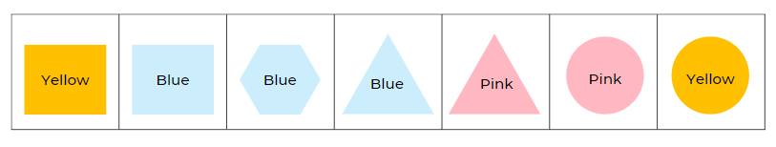
Image adapted from ‘Patterns: Attribute Trains’ by reSolve: Maths by Inquiry © Australian Government Department of Education 2022 and licensed under CC BY-NC-SA 4.0.
This table details assessment opportunities and differentiation ideas.
Assessment opportunities | Too hard? | Too easy?
What to look for:  - Can students communicate thinking and reasoning about attributes and properties as they add shapes? (MAO-WM-01, MAE-2DS-01, MA1-2DS-01)  - Can students predict how a shape can change by identifying the attribute or property that can change? (MAO-WM-01, MAE-2DS-01, MA1-2DS-01)  - Can students select and apply knowledge of attributes and properties to solve problems in a game? (MAO-WM-01, MAE-2DS-01, MA1-2DS-01)  What to collect:  - observations of student discussion about strategies (MAO-WM-01, MAE-2DS-01, MA1-2DS-01) | Students need support to understand the terms ‘attribute’ and ‘property’ as they apply to shapes.  - Use a set of 4 squares that are the same size but are different colours to model how the attribute of colour changes.  - Use a circle, triangle, square, (Early Stage 1 and Stage 1) and hexagon (Stage 1) of the same colour to discuss the properties sides and vertices.  - Play the shape train game with students and give them 2 choices to select from for the next card including one correct and one incorrect possibility. | Early Stage 1 students can sort and categorise shapes, explain their thinking, and apply this to the shape game.  - Introduce additional shapes such as hexagons and trapeziums.  - Play shape trains, changing 2 attributes with each card.  Stage 1 students can sort and categorise shapes, explain their thinking, and apply this to the shape game.  - Ask students if they think a shape train could be made that uses all 30 cards. Students work in small groups to investigate this. Use a gallery walk to discuss findings.  - Play shape trains, changing 2 attributes with each card.  - Play the shape train with the cards in a circle. The connecting card at the end of the train must connect back to the first card.  - Students choose 2 attribute cards at random. Changing only one attribute or property each time, challenge students to find the fewest number of moves needed to get from one card to another. Ask students if the number of moves is the same each time they choose 2 random cards to work with. Prompt students to give reasons why or why not.

Shape train challenge! – 30 minutes
This activity has been adapted from Attribute trains at reSolve: Maths by Inquiry (2022).
- In pairs, students are given one complete set of 24 three-attributes/properties cards (download 2b Student Set of Three-Attributes Blocks). Remove hexagons for Early Stage 1 students.
- The game is played as follows:
- Each player takes 5 cards and places them face up in front of them.
- Remaining cards are placed face down in a redraw pile. If necessary, model attributes or properties of some of the cards before starting.
- The first card in the redraw pile is flipped over. This is the start of the train. Ask a student to state 3 attributes or properties of the first card (choosing from sides, colour, vertices, size). With Early Stage 1 students, all descriptive words are attributes, such as size, shape, corners, sides.
- Players take turns placing a card on the end to continue the train. The card they place in the train must change one attribute or property of the previous card but keep 2 the same. Encourage players to state whether they are changing an attribute or property.
- If a player cannot place a card, they pick up a new card from the redraw pile and add it to theirs.
- Encourage students to identify cards that cannot be used next in the train and move them to one side, leaving suitable cards to select from. The winner is the first player to use all their cards. If there is no clear winner, whoever played the last card wins.
- As students are playing, differentiate the level of challenge. If students cannot predict and describe how a shape may appear when 2 attributes or properties have changed, model the discussion for placing the next card. If students identify and describe how shapes change when 2 attributes or properties have changed, promote strategic thinking. For example, ask students which card would give them the best chance of winning, or make their partner skip a turn. Students predict which card their partner might play next and prepare.

Discuss and connect the mathematics – 5 minutes
- Ask:
- Which attributes and properties did you think about when choosing the cards you placed?
- How did you organise your shapes when playing the game?
This table details assessment opportunities and differentiation ideas.
Assessment opportunities | Too hard? | Too easy?
What to look for:  - Can students name shapes using knowledge of attributes? (MAE-2DS-01)  - Can students use knowledge of attributes or properties to solve problems in a game? (MAO-WM-01, MAE-2DS-01, MA1-2DS-01)  What to collect:  - observations of student discussion around attributes and properties (MAO-WM-01, MAE-2DS-01, MA1-2DS-01)  - student recordings of strategy group discussions (MAO-WM-01, MAE-2DS-01, MA1-2DS-01) | Students need support to apply thinking about attributes or properties.  - Model thinking about fewer attributes or properties, for example, colour and number of sides. Use the mathematical definition on p 19 to reinforce the difference between an attribute and a property.  - Take some shapes from a pile and sort them into groups. Ask students to determine what attribute is being used to sort. For example, quadrilaterals and other polygons (this activity is adapted from Learning Trajectories). | Students can already sort and categorise shapes and explain their thinking.  - Students further develop strategies using questions from the resource: reSolve's 2c Train Challenge Reflection.  - Introduce polygons such as octagons, trapeziums, and rhombus into the game.

Lesson 2: What are patterns and how do we describe them?
Core concept: Patterns have a core that repeats over and over again and can be represented using letters or symbols.
The table below contains suggested learning intentions and success criteria. These are best co-constructed with students.
Learning intentions | Success criteria
All students are learning that:  - repeating patterns have a core that repeats over and over and over again  - the part that repeats is called the repeating core and is described as a two-part or three-part pattern  - repeating patterns can be described using sounds, symbols or letters such as AB, ABC, ABB, or ABA  - the repeating core helps to extend or identify missing elements in a pattern. | All students can:  - identify the core of a two-part or three-part repeating pattern  - create a repeating pattern using shapes  - use sounds, symbols or letters such as AB, ABC, ABB, or ABA to describe a repeating pattern  - identify a missing part in a pattern.

Daily number sense: What can you see? – 10 minutes
- Build student understanding of patterns by looking for regularities in a shape sequence.
Note: When displaying any pattern for students, the core of the pattern is repeated at least 3 times. This reinforces the idea that a pattern is something that has to be repeated over and over and over again to trust that there is a regularity.
- Display shape patterns and ask students what they notice. Throughout this lesson, there are references to simple shapes for Early Stage 1 students and more complex shapes for Stage 1 students. Examples of shape patterns include:
- circle, square, circle, square, circle, square...
- triangle, rectangle, triangle, rectangle, triangle, rectangle...
- square, octagon, square, octagon, square, octagon...
- trapezium, trapezium, circle, trapezium, trapezium, circle, trapezium, trapezium, circle...
- hexagon, isosceles triangle, hexagon, isosceles triangle, hexagon, isosceles triangle...
- Ask students to describe the patterns and encourage the use of vocabulary associated with properties and attributes.
- Display the hexagon, isosceles triangle pattern but with the isosceles triangles rotated in a different orientation each time (upwards, sideways, downwards, and so on). Ask students if this is the same pattern or if it has changed.

Patterns repeat over and over and over again – 15 minutes
- Show students ABABAB patterns with blocks, counters, and shapes as in Figure 3, and support students to make comparisons by asking what is different and what is the same.
Figure 3 – Four patterns
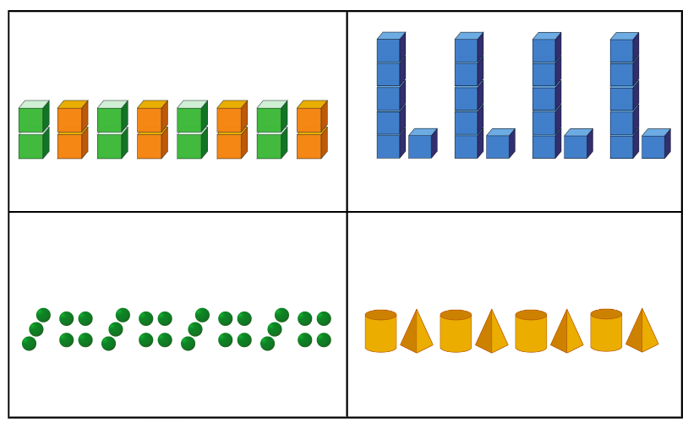
- Explain to students that a pattern has a core that is repeated over and over and over again, and that mathematicians describe this core using letters or symbols. For example, the patterns in Figure 4 can be described as having an AB core with 2 parts. The first pattern has 2 parts that can be described as A (green) and B (orange), the second pattern has an AB core that can be described as A (tall) and B (short).
Figure 4 – AB patterns
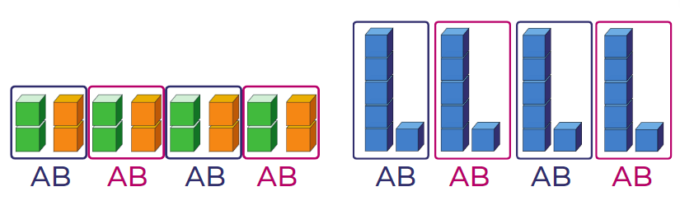
- Discuss how AB patterns can be represented in different ways. For example, clap, click or jump, hop. Students explore and share examples of AB patterns with body percussion, movement, or position.
- Explain that mathematicians use many symbols to communicate patterns. For example, *! * ! *! is a pattern using symbols to record an AB pattern. Students create their own symbol AB patterns on mini whiteboards and discuss.

Different kinds of repeating patterns – 20 minutes
- Discuss different kinds of repeating patterns, such as AB (see Figure 5), AAB (see Figure 6), ABC, ABAB and explain how to identify the repeating core of a pattern.
Figure 5 – AB pattern shown horizontally
Figure 6 – AAB pattern shown horizontally
- Ask how these patterns could be described using attributes, properties, names of shapes or letters. For example, 6 vertices, 6 vertices, 4 vertices, and so on.
- Explain how to separate the core to clearly show the pattern as in Figure 7 and Figure 8.
Figure 7 – Separated core of an AB pattern
Figure 8 – Separated core of an AAB pattern
- Explain that the pattern can be seen clearly when the core is arranged vertically, as in Figure 9 and Figure 10.
Figure 9 – AB pattern aligned vertically
Figure 10 – AAB pattern aligned vertically
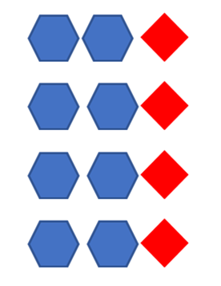
- Use familiar objects and movements to represent an AB or AAB pattern structure. Brainstorm other AB and AAB patterns together. For example, AAB patterns could include clap, clap, stomp; triangle, triangle, square; bag, bag, lunchbox; clap, clap, click; 5, 5, 2.
- Co-create patterns that have other core structures (ABA, ABC, ABB). Use manipulation and vertical alignment to identify the repeating core. Create and label visual representations of these patterns. Early Stage 1 students co-create AB patterns.

Shape patterns: What's the missing part? – 15 minutes
- Students use 3 kinds of shapes to create a linear three-part pattern. Students justify their pattern to a partner by discussing the attributes size and colour, and the properties of sides and vertices. Early Stage 1 students create a two-part pattern and can be encouraged to create three-part patterns as applicable.
- Instruct one student from each pair to cover one part of the pattern. The other student must identify the missing part and prove that the part fits with the rest of the pattern. Vertically align the pattern to check that the core repeats over and over and over again. Ask students to extend the pattern.
- Make a pattern and rotate the shapes and discuss whether the pattern is still the same or if it has changed and why.
This table details assessment opportunities and differentiation ideas.
Assessment opportunities | Too hard? | Too easy?
What to look for:  - Can students describe the core of a two-part or three-part repeating pattern? (MAO-WM-01, MAE-FG-01, MA1-2DS-01)  - Can students describe a pattern using sounds, letters or symbols such as AB, ABC, ABB? (MAE-FG-01, MA1-2DS-01)  - Can students create and record repeating patterns using shapes? (MAO-WM-01, MAE-FG-01, MA1-2DS-01)  - Can students identify a missing part of a pattern? (MAO-WM-01, MAE-FG-01, MA1-2DS-01)  What to collect:  - annotated work samples or photographs of student created patterns (MAE-FG-01, MA1-2DS-01)  - observations and recordings of group discussions (MAO-WM-01, MAE-FG-01, MA1-2DS-01) | Students cannot visualise patterns. Use bead threading to make two-part and three-part patterns.  Students understand the concept of the core but find it hard to use letters or have difficulty forming letters.  - Use drawings to represent patterns.  - Give students paper copies of letters A, B, and C to place under their drawings.  Students cannot find the missing part of a shape pattern. Show students coloured blocks in simple two-part AB patterns and then model harder patterns. | Students can already identify and create two-part and three-part patterns, and missing elements.  - Students create four-part and five-part patterns with missing elements.  - Students use complex shape patterns, for example, the different types of triangles, to create patterns and missing elements.

Discuss and connect the mathematics – 15 minutes
- Co-construct a class anchor chart about patterns. See example in Figure 11. Support students with the following prompts:
- Some patterns have a core that repeats over and over and over again.
- The parts of a pattern core can be described using letters or symbols. For example, AB, ABB, ABC, *!, *!!, *!#.
Figure 11 – Example of an anchor chart
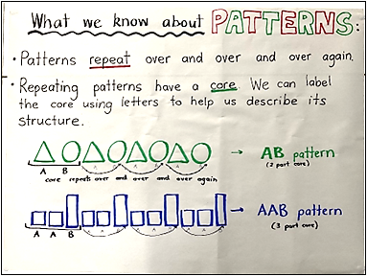

Lesson 3: Patterns are all around us
Core concept: Mathematical patterns exist in natural and built environments.
The table below contains suggested learning intentions and success criteria. These are best co-constructed with students.
Learning intentions | Success criteria
All students are learning that:  - natural and built objects can share similar mathematical properties and attributes  - patterns occur in different contexts and can repeat, grow, shrink, and combine  - there are different kinds of patterns, for example, orderly, complex, or symmetrical. | All students can:  - identify and describe repeated patterns in natural and built objects  - design and describe a repeating pattern.  In addition, students working towards Stage 1 outcomes can identify and describe different kinds of patterns.

Daily number sense: Counting patterns – 10 minutes
- Build student understanding of properties of number by counting forwards and backwards from different starting points.
- In pairs, Early Stage 1 students throw a zero to five-sided dice, count the dots, and then count forwards to 10 and backwards to zero from the dice throw.
- Stage 1 students start at 17 and count on in odd numbers. They then start at 26 and count on in even numbers.
- Build student understanding of number by discussing its properties.
- Show Stage 1 students the numbers 48, 44, 41, and 36. As a class, discuss which number does not belong and why.
The table below outlines stimulus prompts to generate conversation about the topic, along with anticipated responses from students.
Prompts | Anticipated student responses
- What is one reason a number doesn't belong? Why?  - What else belongs in a group?  - What other numbers are even? | - 41 is the only odd number.  - 3 numbers have 4 tens but 36 only has 3 tens.  - 44 is the only double-digit number.  - 48 is the only number where when you add both digits you get a number greater than 10.

Patterns found in nature and built environments – 50 minutes
- Display images of built environments and natural objects, for example Figure 12 and Figure 13. You can also refer to a natural object display. Ask students if they see similarities in shapes from the image and geometric 2D shapes, or if they notice a repeated pattern. In pairs, students select an image or object and using 'Talk moves', discuss the following:
- Can you notice and name a 2D shape or shapes?
- How is it (are they) being repeated?
- Are they in order or random?
- Can you predict what the next pattern sequence would include?
- What shape would be repeated next? How many more? What colour or size?
Figure 12 – Patterns in built environments
Images sourced from Pixabay and used in accordance with the Pixabay Licence.
Figure 13 – Natural objects with patterns
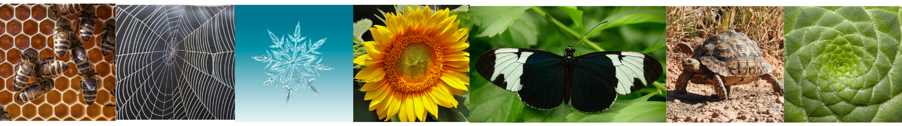
Images sourced from Pixabay and used in accordance with the Pixabay Licence.
- As a class, brainstorm the mathematics that appear in the images. For example, 2D shapes, comparing quantities, making groups, symmetry, comparing measurement, counting on, and comparing attributes and properties that are similar and different. Early Stage 1 students will focus on shape, size, and number in the built patterns.
- Use an anchor chart to record suggestions that connect what students see in nature and built environments to their mathematical knowledge. For example, the spider web has vertical lines and horizontal lines that cross; the beehive has no gaps in between hexagons, which are all the same size; the tortoiseshell looks like different-sized trapeziums; each part of the plant has 4 vertices; the brick wall is made up of rectangles; the tiles all have 4 sides.
- In pairs, students select 2 different images or 2 natural objects, identify patterns that are repeated, and compare what is similar and different.
The table below outlines stimulus prompts to generate conversation about the topic, along with anticipated responses from students.
Prompts | Anticipated student responses
- Can you see any attributes (colour, shape) that are the same or different in the 2 patterns you selected?  - Do the patterns combine more than one attribute? For example, colour and shape?  - Is the pattern symmetrical?  - Do the patterns repeat but also increase and grow?  - Are the patterns simple or complex?  - Is the pattern growing or shrinking?  - Can the pattern be interrupted, stopped or changed?  - Can it grow and go on for ever (infinite)? | - The brick wall is all rectangles, and the tiles are all squares.  - The snowflake is symmetrical, but the plant is not.  - As the spider web grows, it has more parts, like the plant.  - The beehive pattern is simple, but the snowflake is complex because there are more shapes, and it grows bigger and moves in more directions.  - The butterfly pattern will not grow or shrink. The beehive can grow because the bees can continue to build it. The snowflake can be interrupted if it shrinks and melts.
- In pairs, students use coloured 2D geometric shapes to create a brick wall or tiles (Early Stage 1) and a snowflake, a beehive, or spider web (Stage 1). Ask students to find a design made by other students that is similar or different to their own. Allow time for discussion.
- Walk around the school and ask students to record their observations of mathematical features of patterns, using drawings and photographs, to explain properties and attributes observed. Use these in a gallery walk to make connections and comparisons. Guide the walk past features such as brick patterns, the wire fence around the basketball court, shrubs in a garden bed.
- Optional investigation: Use nursery rhymes and songs, such as B-I-N-G-O, and ask students if these have a repeated pattern of sounds. Use body percussion to identify and reproduce these core patterns. In pairs, students create a repeated pattern using body percussion. Record the rhyme or rhythm scheme of a poem, for example, ABABAB or AABBAABBAABB. Students swap recordings, identify the core pattern, and extend it. Ask some students to perform their pattern.
This table details assessment opportunities and differentiation ideas.
Assessment opportunities | Too hard? | Too easy?
What to look for:  - Can students create and describe a pattern, for example, core, radiating or symmetrical? (MAO-WM-01, MA1-2DS-01)  - Can students record similarities and differences in found patterns? (MAO-WM-01, MA1-2DS-01)  What to collect:  - annotated samples of student pattern investigations, for example, drawings, diagrams or photographs (MAO-WM-01, MA1-2DS-01) | Patterns are too complex for students.  - Explain the repetition in simple patterns with only 2 attributes or 2 properties, such as a brick wall or a beehive.  - Model patterns in nursery rhymes or poems with very simple rhyme schemes. | Students already understand all patterns provided.  - Students investigate fractal patterns through the problem posed in Smaller and Smaller from NRICH.  - Students work in pairs using a personal interest, for example, music or architecture, to develop a creative pattern that grows in various directions, radiates, or is symmetrical. Students identify the initial repeating core and use diagrams, drawings, or concrete materials to demonstrate how it repeats, grows, or shrinks.

Discuss and connect the mathematics – 5 minutes
- Discuss the shapes that students notice in built and natural environments. Ask:
- Is there a particular 2D shape that is most repeated in patterns? For example, are there more triangles than squares?
- What do you think are the attributes or properties of that shape that make it the most used in patterns?

Lesson 4: Symmetrical patterns – Mandalas
Core concept: Repeated geometric shapes can be manipulated to represent patterns of symmetry and reflection.
The table below contains suggested learning intentions and success criteria. These are best co-constructed with students.
Learning intentions | Success criteria
All students are learning that:  - a shape can be identified from its properties, regardless of orientation  - in symmetrical patterns, the left side is the same as, or a reflection of, the right side  - shapes can be manipulated. | All students can:  - place shapes in each expanding circle of a mandala so the pattern continues  - use attributes or properties to name shapes used at each stage of a mandala.  In addition, students working towards Stage 1 outcomes can:  - identify shapes when they are shown in different orientations  - place shapes symmetrically in a mandala  - identify shapes that can be split to form new shapes.

Daily number sense: Counting patterns – 5 minutes
- Build student understanding of place value by counting forwards and backwards from different starting points.
- Early Stage 1 students draw a playing card from a pile of cards with numbers 1 to 5 and call out the numbers before and after the number on the card drawn.
- Stage 1 students start at 110 and count forwards by tens. They then start at 110 and count backwards by tens.
- Stage 1 students start at 42 and count forwards by twos. They then start at 42 and count backwards by twos.

Warm-up: Let’s look at symmetry! – 10 minutes
- As a class, use large sizes of paper shapes, including equilateral triangles, squares, rectangles, and hexagons, to fold and explore how many lines of symmetry each shape has. Early Stage 1 students could explore folding paper shapes with no overlaps during this activity.
- Ask students if they can see a pattern between the number of sides of a shape and how many lines of symmetry it has.
- Ask students how many lines of symmetry there are in a circle. Students fold their paper circles and discuss their findings.

Making mandalas 1 – 20 minutes
- Display images of mandalas and ask students what they notice. Discuss how mandalas can be created using everyday objects or mathematical shapes. Ask students to identify patterns of symmetry and radiating patterns. See Making mandalas – Stage 1 (9:10) for further information as necessary.
- Early Stage 1 students explore making circular patterns with concrete materials, for example, beads and pasta.
- Provide Stage 1 students with a variety of 2D geometric shape blocks. In small groups, students create their own mandala. Discuss the importance of rotating the shapes to create the circular pattern. Students use a device to record each expanding symmetrical stage of their mandala.
- Stage 1 students identify the shapes in their mandala, recording the increase in the number of shapes from stage to stage in a table or with tally marks. See Figure 14. Early Stage 1 students count aloud the number of beads in their pattern.
Figure 14 – Recording number of shapes in an expanding mandala
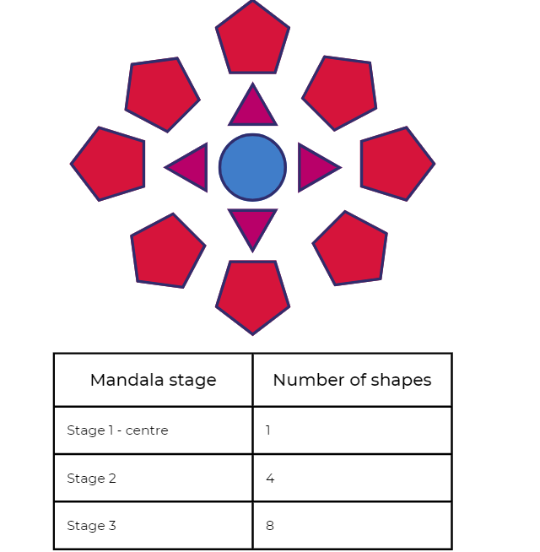

Making mandalas 2 – 30 minutes
- Early Stage 1 students print with sponge shapes or other objects to create a mandala pattern. Encourage students to rotate their objects as they make their prints.
- Stage 1 students use Resource 1: 2D paper shapes to discuss whether any shapes can be split by cutting into new shapes. For example, a circle can become 2 semi-circles, and a hexagon can become 6 triangles.
- Stage 1 students cut and paste new shapes to create a symmetrical mandala. They choose a property to record at each stage, such as how many vertices or sides there are.
- All students share ideas to add to or reinforce the pattern anchor chart.
This table details assessment opportunities and differentiation ideas.
Assessment opportunities | Too hard? | Too easy?
What to look for:  - Can students identify and manipulate common 2D shapes in different orientations? (MAO-WM-01, MAE-2DS-01, MA1-2DS-01)  - Can students create a symmetrical mandala? (MAO-WM-01, MA1-2DS-01)  - Can students select shapes which can be split to make new shapes, for example, a square into 2 or 4 triangles? (MAO-WM-01, MA1-2DS-02)  What to collect:  - photographs of mandala designs using 2D shapes and found objects (MAE-2DS-01)  - mandala designs demonstrating understanding of symmetry and splitting (MA1-2DS-02) | Students cannot create a circular pattern. Give students a template with outlined shapes in a mandala pattern to colour – see Resource 2: Simple mandala template.  Students do not understand the concept of symmetry. Students paint a pattern on one half of a circle. Close and open the circle to show symmetry. | Students quickly create mandala 2.  - In pairs, students design a quarter or half a mandala, then give their part to another pair to complete using symmetry.  - Students design a mandala using a restricted number of shapes, for example, only squares and rectangles, requiring them to explore shape orientation in depth.  - Students design a mandala that includes some combined shapes, for example, 2 trapeziums combined to form a hexagon.

Consolidation and meaningful practice: Guess what? – 5 minutes
- Students stand up and think of a secret 2D shape. Other students need to ask ‘yes’ and ‘no’ questions about attributes and properties of shapes to guess the shape.

Lesson 5: Growing and shrinking – 2D geometric patterns
Core concept: Patterns grow and shrink as the repeated element is added or subtracted.
The table below contains suggested learning intentions and success criteria. These are best co-constructed with students.
Learning intentions | Success criteria
All students are learning that:  - growing patterns have an element that gets bigger by the same amount each time  - shrinking patterns have an element that gets smaller by the same amount each time  - collections of objects can be organised and interpreted with data displays. | All students can:  - communicate the repeating core in a growing and shrinking pattern  - create patterns that show how the core is growing and shrinking.  In addition, students working towards Early Stage 1 outcomes can organise shapes used in an activity to count quantities.  In addition, students working towards Stage 1 outcomes can choose a method to collect data to show how a pattern grows.

Daily number sense: What number comes next? Squares to stairs – 20 minutes
- Build student understanding of how shapes can be used to find number patterns using youcubed ‘Squares to stairs’ and Thinking mathematically ‘Staircase patterns’.
- Model a simple growing geometric pattern for all students, for example, one square, 2 squares, 3 squares.
- Early Stage 1 students explore growing patterns with squares or blocks, for example, towers, stairs, and pyramids. Count as the pattern grows.
- Share Resource 3: Squares to stairs with Stage 1 students and explain that this is a repeating pattern but something else is happening too. See Figure 15.
- Explain the repetition and growing nature of the pattern.
Figure 15 – Squares to stairs
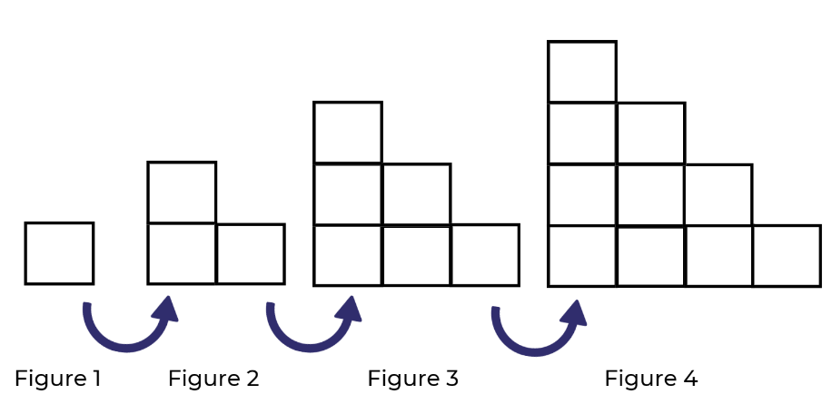
The table below outlines stimulus prompts to generate conversation about the topic, along with anticipated responses from students.
Prompts | Anticipated student responses
- How do we know this is a repeating pattern?  - What is the same? What changes?  - Is this a growing pattern? How can you prove it?  - Can you tell me how many squares there would be in Figure 6? How do you know?  - Is there an efficient way to count and work out how many squares are used altogether in the 4 figures? | - The square in the bottom corner is always there, and then more squares are added beside it and on top.  - The pattern is growing because it looks like stairs.  - The pattern is growing because each row has one extra square added from the previous pattern, so we added 2, then 3, then 4.  - The next pattern has 15 squares (Figure 5), so Figure 6 will have 15 plus 6 more, which is 21 squares.  - 1 plus 2 more plus 3 more plus 4 more equals 10.
- Ask students to record number patterns using a table and tally marks. See Figure 16. Use 'Talk moves' to discuss patterns in the table.
Figure 16 – A suggested idea for recording
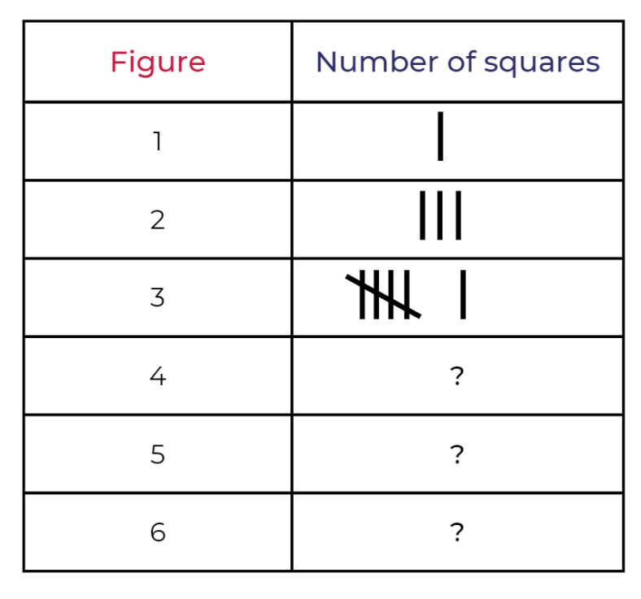
This table details assessment opportunities and differentiation ideas.
Assessment opportunities | Too hard? | Too easy?
What to look for:  - Can students build and describe towers, stairs and pyramids? (MAO-WM-01, MAE-FG-01)  - Can students communicate how the stair pattern is growing? (MAO-WM-01, MA1-2DS-01)  - Can students collect data to describe how a pattern grows? (MAO-WM-01, MA1-DATA-02)  What to collect:  - observations of discussions and problem-solving strategies applied to identify the growing pattern (MAO-WM-01, MA1-2DS-01)  - photographs of towers, stairs and pyramids (MAO-WM-01)  - work samples of data collection (MA1-DATA-02) | Students cannot identify the growing pattern presented in Figure 15.  - Watch the video Staircase Patterns 1 (6:17) with students.  - Use interlocking cubes and create an AB pattern, identifying the repeating core. Then add an extra part to create the three-part pattern ABB. Ask students to identify the change or the growing part of the pattern.  - In pairs, students create the pattern ABBCCC and identify the core. Ask students to vertically align parts in a tower. For example, A then BB, then CCC, then DDDD, using different colours for each section. Show how the pattern is growing one by one. | Students applied efficient strategies to find the pattern. Ask students to imagine a staircase that has 34 levels. Record data in a table with tally marks from step to step as the staircase grows. Explain how the staircase pattern grows and shrinks.

How does it grow or shrink? – 45 minutes
- Display images such as those suggested in Figure 17, such as beehives, spider webs, and snowflakes. Explain that the next part of our pattern journey is about investigating growing and shrinking patterns from nature with geometric shapes.
Figure 17 – Patterns in nature that grow and shrink
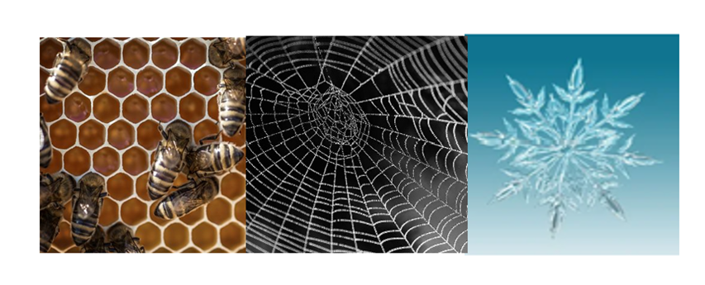
Images sourced from Pixabay and used in accordance with the Pixabay Licence.
- Ask students to identify the repeating core of the pattern, using attributes and properties to explain how it is growing. Ask students to think about:
- how a pattern grows when the pattern core repeats over and over and over again
- how a pattern shrinks when the pattern core parts are repeated less and less
- whether a growing or shrinking pattern needs only one part of the pattern to change
- what could cause a spider web, snowflake, and a beehive to grow and shrink? What core part or geometric shape or shapes is repeated more and more or less and less?
- In pairs, students use 2D geometric shapes to create a repeating, growing, or symmetrical pattern. For example, see Figure 18.
Figure 18 – Making patterns from nature

Discuss and connect the mathematics – 5 minutes
- Ask students:
- What attributes or properties did you use to make your pattern grow?
- How did your pattern grow from layer to layer? For example, by the number of vertices, sides, or shapes.
- What strategies did you use to work this out? For example, skip counting, partitioning.
- How did you record your findings?
- Add or clarify ideas on the Pattern anchor chart.
This table details assessment opportunities and differentiation ideas.
Assessment opportunities | Too hard? | Too easy?
What to look for:  - What attributes or properties of shapes are used to expand growing patterns? (MAO-WM-01, MAE-2DS-01, MA1-2DS-01)  - What strategies are students using to record their pattern? (MAO-WM-01, MAE-CSQ-01, MA1-CSQ-01)  - How are students proving that their growing pattern is symmetrical? (MAO-WM-01, MA1-2DS-01)  What to collect:  - observations and recordings of patterns and vocabulary used. (MAO-WM-01, MAE-CSQ-01, MAE-2DS-01, MA1-CSQ-01, MA1-2DS-01) | Students cannot expand their growing shape pattern past the first 2 layers:  - Support students to identify which 2D shape or colour to use in each layer of the shape pattern.  - Provide students with shape patterns to replicate and then continue. | Students created complex growing shape patterns that included more than 2 attributes and properties:  - Create a 2D shape pattern that contains less than 20 shapes but more than 60 vertices.  - Create an odd, even, odd, even pattern at each stage of a growing pattern.

Lesson 6: Growing and shrinking number patterns
Core concept: A repeating core can grow or shrink a number pattern.
The table below contains suggested learning intentions and success criteria. These are best co-constructed with students.
Learning intentions | Success criteria
All students are learning that:  - growing patterns have an element that gets bigger by the same amount each time  - shrinking patterns have an element that gets smaller by the same amount each time  - flexible addition and subtraction strategies can be used to find and create growing and shrinking patterns  - number patterns can represent a constant difference between numbers in a sequence. | All students can identify and use a repeating core to grow and shrink number patterns.  In addition, students working towards Early Stage 1 outcomes can:  - count objects in small groups  - write a numeral that shows a small quantity.  In addition, students working towards Stage 1 outcomes can:  - use addition and subtraction strategies to create growing and shrinking patterns  - identify halving and doubling patterns.

Daily number sense: What number comes next? Counting on in ones, twos, and fives – 15 minutes
- Build student understanding of the numerical sequence by counting on.
- Use counters to count on in ones, showing how the pattern increases by one each time. See Figure 19.
Figure 19 – Increasing by one
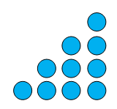
- Display growing by twos and growing by fives with a variety of concrete materials, for example, counters and dice. See Figure 20.
Figure 20 – Growing by twos and fives
- Ask:
- How many are there?
- What do you notice?
- Is there a pattern?
- How do you know?
- Stage 1 students move into Choral counting. This activity has been adapted from Teacher Education by Design. Give Early Stage 1 students further play-based experience counting by ones with a range of concrete materials.
- Students choral count, counting forwards by twos up to 50. As they count, use colour to record in horizontal rows with 5 numbers in each row. Ask students to look at the numbers and discuss any patterns they notice. Record student ideas. See Figure 21.
Figure 21 – Record of choral counting by twos
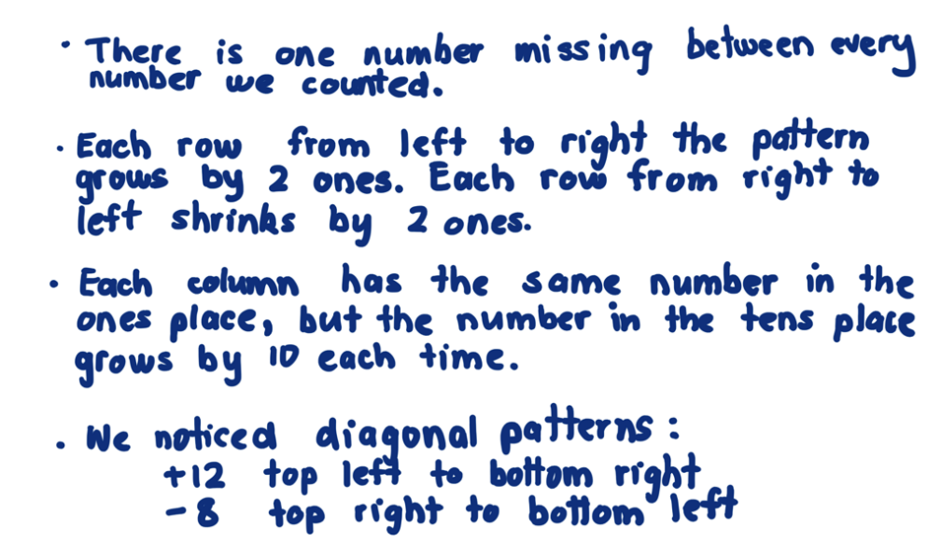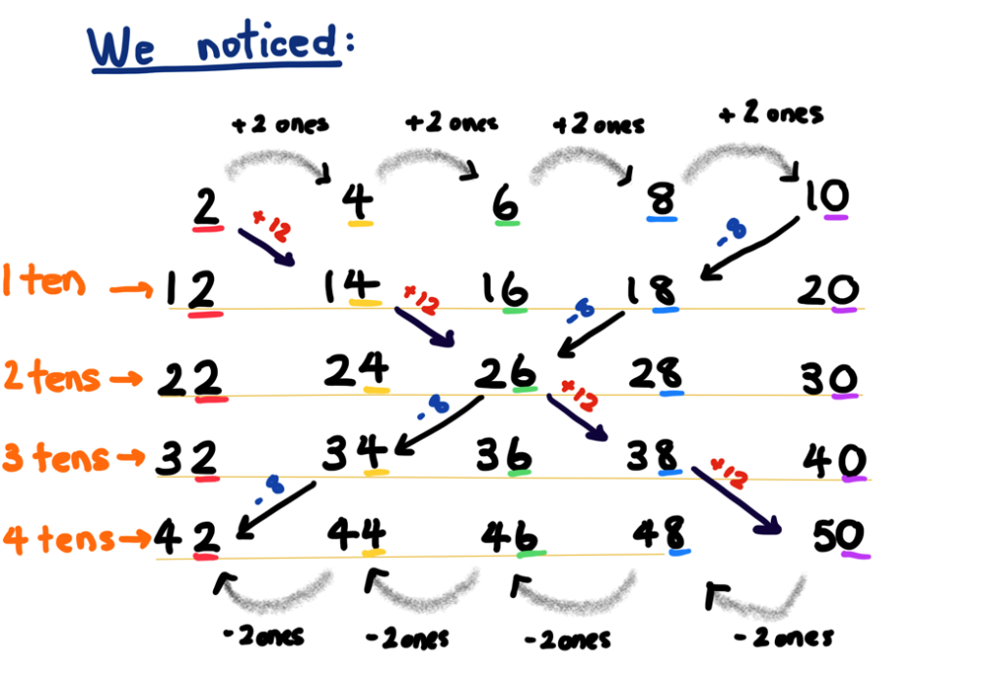
- An optional challenge is to combine choral counts to look for patterns, for example, 2 and 4; or 2, 4, and 8.

Input–output robot – 30 minutes
- Remind students of growing and shrinking patterns with geometric shapes and ask if there might be growing and shrinking patterns in the number world too. Ask if students have seen any.
- Introduce the lesson narrative: I know a robot who loves eating numbers and making number patterns from them. For example, in Figure 22, the robot eats one counter at a time and makes 2 counters, 3 counters, 4 counters, and so on. Ask what number the robot could make next. Prompt students to share what they can see. If there is a pattern, can they explain how they know?
Figure 22 – Robot eats one counter
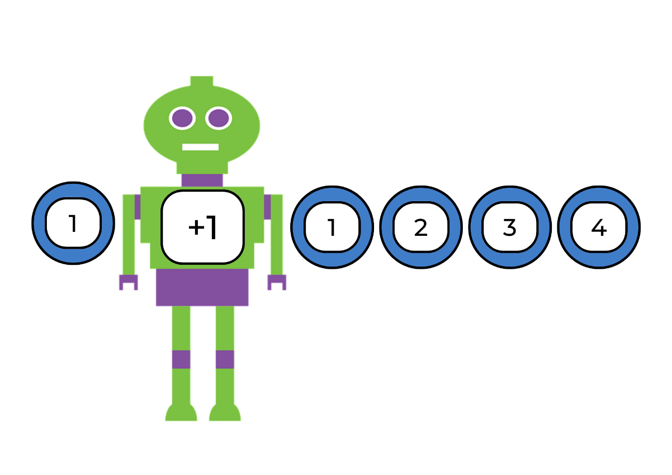
Images sourced from Pixabay and used in accordance with the Pixabay Licence.
- Early Stage 1 students input a range of concrete materials into the robot, for example, dice and counters, and create patterns that grow by one. Students write the numbers 1 to 5 on sticky notes and place with the pattern sequence. Students could also practise correct numeral formation at this point.
Note: For further resources on numeral formation, refer to Emergent strategies at Developing Efficient Number Strategies – DENS.
- Show Stage 1 students Resource 4: Robot eats the number 5! See Figure 23 with the input number 5, the robot eats it and outputs 15, 25, and 35. Ask students:
- What pattern did the robot find? That’s right, the robot added 10 each time!
- Is this pattern growing or shrinking? How do you know?
- What other numbers could the robot output using this pattern?
- Can you find a growing pattern and a shrinking pattern?
Figure 23 – Robot eats the number 5!
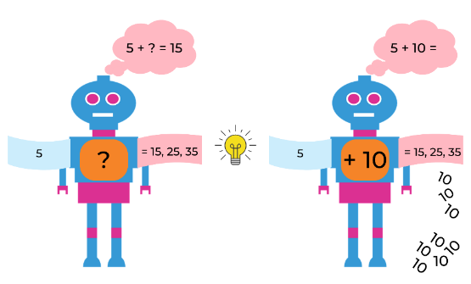
Images sourced from Pixabay and used in accordance with the Pixabay Licence.
- Input the number 4 and the robot outputs 8,12, and 16. Ask what pattern the robot found, prompting students to explain how they know. Explain that this is a growing pattern. Ask if the robot could have found any other growing patterns, for example, double 4 is 8 and then double again to 16. Ask students how the robot makes the patterns.
- Ask students if the robot could have made any shrinking patterns. For example, an output for the number 4 could take away one each time to get 3, 2, 1; or the robot could halve 4 each time to get 2, then 1.
- Ask students to work out what the 5th number would be if they started with 7 and the robot added 4 each time. Students then work out what the 10th number would be and give their reasoning. Ask if students need to use blocks to find the answer, or if there is another way. For example, writing out the number pattern.
- Ask students if the robot could have made any other patterns with the quantity 7, such as doubling or adding 10 each time.
- Ask students to offer ideas about how to record input-output numbers. For example, using counters, coloured blocks, or sticky notes with numbers.
- In pairs, students choose a number to input and explore the output patterns the robot might make with it. Ask:
- Is there more than one pattern the robot could output from your number?
- Could the robot output growing and shrinking patterns with your input number?
- What number knowledge did you use to find patterns? For example, addition, subtraction, halving, doubling, skip counting, and so on.
- Can you find all the possible patterns the robot could make?
- How can you tell you have found them all?
- Support students to work with input numbers and patterns that will challenge their mathematical ability. Students need to record patterns using numbers.

Discuss and connect the mathematics – 20 minutes
- Students present their input-output patterns and listen to comments and suggestions. Ask the following questions:
- What patterns did you find? What were the consistent differences?
- Did you find growing and shrinking patterns?
- What addition and subtraction strategies did you use to continue a pattern?
- Were there any strategies that didn’t work and why?
- Update the class Pattern anchor chart.
This table details assessment opportunities and differentiation ideas.
Assessment opportunities | Too hard? | Too easy?
What to look for:  - Can students communicate how they identify and continue growing and shrinking number patterns? (MAO-WM-01, MAE-RWN-01, MAE-RWN-02, MAE-CSQ-01, MA1-CSQ-01)  - Are students using addition and/or subtraction strategies to create growing and shrinking patterns? (MAO-WM-01, MAE-CSQ-01, MA1-CSQ-01)  - Can students identify halving and doubling patterns? (MAO-WM-01, MA1-CSQ-01)  What to collect:  - samples of written, drawn or made patterns. (MAO-WM-01, MAE-CSQ-01, MA1-CSQ-01)  - samples of written numerals (MAE-RWN-02)  - observations and recordings of verbal addition and/or subtraction strategies used to continue patterns. (MAO-WM-01, MAE-CSQ-01, MA1-CSQ-01) | Early Stage 1 students cannot form written numerals. Students are given sticky notes with numbers written on them to record thinking about patterns.  Students are unable to identify patterns that use the number 4. Use simpler input numbers, for example, 2, 5, and 10.  Students are unable to record robot patterns with numerals. Support students to represent patterns with drawings, counters or 2D geometric shapes. | Early Stage 1 students already recognise counting by one patterns. Students use concrete materials to count on by 2 and 5.  Students apply many strategies to explore input numbers and are no longer being challenged using their own ideas.  - Students use numbers which form patterns with three-digit numbers.  - Students explore a two-step output from the robot. For example, add 3, take away 1.  - Students use multiplication and division strategies to create patterns with the robot.  - Students find patterns that involve fractions or decimals.  - Students remove a number from one of their patterns and ask another student to identify and find the missing element.

Lesson 7: Place value in number patterns
Core concept: Place value can be used to investigate number patterns.
The table below contains suggested learning intentions and success criteria. These are best co-constructed with students.
Learning intentions | Success criteria
All students are learning that:  - place value can be used to identify the number before and after a given number  - using place value is an effective strategy when looking for patterns. | All students can:  - identify consecutive numbers  - use concrete materials and/or flexible strategies to solve addition and subtraction problems.  In addition, students working towards Early Stage 1 outcomes can:  - instantly name the number of objects in a small group and record with a numeral  - count forwards and backwards from 0 to 5  - recognise simple number patterns.  In addition, students working towards Stage 1 outcomes can:  - find the next number in a pattern with three-digit numbers  - use place value to add consecutive two-digit numbers in a hundreds chart  - identify how many more to the next multiple of 10 or 100 in two-digit and three-digit numbers.

Daily number sense: What comes next? – 10 minutes
- Build student understanding of place value by identifying missing numbers.
- Give cut up Resource 5: What comes next – dots? to Early Stage 1 students. Put dot cards 1, 2, 3, and 5 in order from smallest to largest and read out the numbers. Turn cards face down. Students choose a card at random and state the next consecutive number or numbers. Students choose another card and say consecutive numbers counting backwards to zero.
- Display the following sequences for Stage 1 students, asking which numbers are missing and what the numbers before and after each sequence are:
- ?, 135, 136, 137, ?
- ?, 298, 299, 300, ?
- ?, 398, 399, ?, 401
- ?, 551, 550, 549, ?
- ?, 102, 101, ?, 99
- ?, 776, 777, ?, 779
- ?, 412, 411, ?, 409
- Students use mini whiteboards to create a three-digit number sequence with a missing number and ask a partner to find the solution.
This table details assessment opportunities and differentiation ideas.
Assessment opportunities | Too hard? | Too easy?
What to look for:  - Can students count forwards and backwards with a counting by one number pattern? (MAE-RWN-01)  - Can students identify the number before and after a three-digit number? (MA1-RWN-02)  What to collect:  - observations of discussions between students (MAO-WM-01, MAE-RWN-01, MA1-RWN-02) | Students cannot identify the number after. Students make 1, then 2, then 3, and so on with counters.  Students cannot work quickly with three-digit numbers.  - Students count on from 100.  - In pairs, one student counts on from 1 to 100, while their partner interrupts the count to suggest new numbers they could start from. | Students can count forwards and backwards by ones. Start with a number and count forwards and backwards by twos, fives, or 10 off the decade.

Window mysteries – 40 minutes
This lesson has been adapted from Boaler et al. (2022).
- Early Stage 1 students play the game Resource 6: What comes next – numbers? Students order cards 0, 2, 3, and 5 from smallest to largest and read out the numbers. Turn cards face down. Choose a card at random to turn over and state the next few consecutive numbers. Students then choose a 2, 3, or 5 card at random, and count consecutive numbers backwards to zero.
- Show Stage 1 students Figure 24. Explain that a pattern journey can be all about finding special patterns within a hundreds chart.
Figure 24 – A window from a hundreds chart with 26, 27, 36 and 37 highlighted
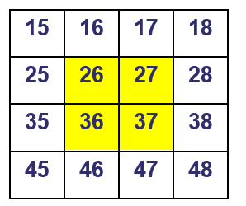
- Explain that a window in this lesson is any 2 × 2 square in a number chart. Students make observations and collaborate to find the sum of the numbers. Record different strategies used and support students to think about how to use patterns of tens and ones to find answers, for example:
- 26 + 27 + 36 + 37
- double 20 + double 30 + double 6 + double 7
- 26 + 27 = 53, and then 36 + 37 must be 20 more (73), and then add these numbers together
- using jumps to get to the next 10 to make the addition easier.
- Students work in groups using Resource 7: Hundreds chart, to find a 2 × 2 window with a sum of 158. Ask what place value strategies students are using. Ask if there is more than one window with that sum, or if there is only one answer, prompting students to explain why.
- Students select a chosen sum and try to find it through a 2 × 2 window. If the number is not present through a 2 x 2 window, prompt students to explain why not. Ask students to track and record numbers used to avoid repetition. Monitor for opportunities to support use of place value patterns. Encourage students to think about how they will apply strategies such as partitioning to larger numbers. Record students’ ideas.
- While Stage 1 students are working on activities 8 and 9, play the ‘Consecutive or not consecutive?’ game with Early Stage 1 students. Students take turns to roll 2 six-sided dice and say whether the 2 numbers rolled are consecutive. Other students agree or disagree. If the answer is no, choose one of the dice and state the next or consecutive number. Then, while Stage 1 students discuss and connect the mathematics, Early Stage 1 students roll a dice and write the corresponding numeral using correct formation.

Discuss and connect the mathematics – 10 minutes
- Ask Stage 1 students:
- What was the best strategy you used when you were adding using tens and ones patterns to find answers? Why?
- Is it possible to find a window for every possible sum between 1 and 100?
- If not, how many answers are there and how do you know this?
- What is the smallest sum possible? (Answer: 1 + 2 + 11 + 12 = 26) Why? Discuss place value.
- What is the biggest sum possible? (Answer: 89 + 90 + 99 + 100 = 378) Why? Discuss place value.
This table details assessment opportunities and differentiation ideas.
Assessment opportunities | Too hard? | Too easy?
What to look for:  - Can students identify consecutive numbers between zero and 6? (MAE-RWN-01, MAE-RWN-02)  - Can students use place value to add 2 consecutive numbers? For example, are they counting by ones or partitioning using tens and ones? (MAO-WM-01, MA1-RWN-01, MA1-CSQ-01)  - Can students apply the strategy of moving to the next multiple of 10 or 100 when they are finding the total of a 2 × 2 window? (MAO-WM-01, MA1-CSQ-01, MA1-CSQ-02)  What to collect:  - samples of written numerals (MAE-RWN-02)  - observations and recordings of investigations into their own choice of window (MAO-WM-01, MA1-RWN-01, MA1-CSQ-01, MA1-CSQ-02) | Students cannot identify the number after. Students make 1, then 2, then 3, and so on with dice.  Students cannot correctly write numerals. Students are given sticky notes with numbers so they can record patterns.  Students have difficulty working with 4 two-digit numbers.  - Work with the smaller numbers in the hundreds chart.  - Support students to use a 2 × 1 window with smaller numbers from the hundreds chart. | Students have completed an investigation of a 2 × 2 window in depth.  - Explore a different size or shape window, for example, 2 × 3, 3 × 3.  - Students identify sums and patterns that emerge from new windows and compare to the possibilities from a 2 × 2 window.  - Students discuss reasons why patterns are different.

Lesson 8: Let’s investigate patterns!
Core concept: Repeated and growing patterns can be used to solve problems.
The table below contains suggested learning intentions and success criteria. These are best co-constructed with students.
Learning intentions | Success criteria
All students are learning that:  - the core of repeating patterns can be used to solve real-life problems  - growing patterns have an element that increases by the same amount each time. | All students can:  - design and create a repeating pattern to solve a real-life problem  - collect data to organise thinking and explain how a pattern grows.

Daily number sense: Dice collection – 15 minutes
- Build student understanding of patterns and subitising using Dice Collection from Thinking Mathematically Stage 1.
- Display a collection of 16 × 6-sided dice in a square pattern. For example, see Figure 25.
Figure 25 – 16 dice
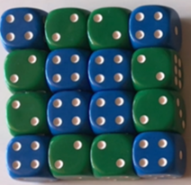
- Using mini whiteboards, students explain in words or drawings what they can see. As a whole class, discuss similarities and differences. Ask:
- Can you see what the core of the colour pattern around the outside might be?
- What part of the pattern is repeating over and over again? Green, green, blue, green, green, blue, and so on.
- Remove dice so an AAB pattern is shown. Describe the pattern using the letters A and B.
- Optional challenge: Using the same dice, students create a new pattern.

Let’s frame it! – 45 minutes
- Explain that students will investigate how to combine shapes and number patterns to solve a problem.
- In pairs, students use counters to create a growing pattern that increases by 3 each time. Students record findings on mini whiteboards and share strategies. As a class, place counters on a hundreds chart showing the number pattern they noticed, for example, 3, 6, 9, 12, 15. Predict how many counters there would be if students made a sixth column (18) or beyond.
- Explain that Xiang, Matthew, Tyler, and Rebecca are making picture frames to sell at the school fete. They have small purple, green, and blue squares. They want to create repeating patterns to make borders around the outside of each picture frame. They have decided that the three-part pattern will be the same around each frame – ABC. The frames are all square and there are 3 different sizes. They worked out that the pattern will need to be a growing pattern. As the frame gets bigger in size, the pattern needs to continue repeating but grow at the same time. See Figure 26. Ask students how they will collect and record data about the pattern, and how will they use this data to explain the pattern. Ask students how they could work out how many more squares they would need for the fourth and tenth frame. Provide squared paper for students to investigate and record their ideas.
- Early Stage 1 students begin with smaller photos and frames and two-part ABABAB tile patterns. Count the number of each coloured tile they use for each size of frame.
Note: 4 × 4, 6 × 6, and 8 × 8 photo sizes have been selected as they enable regular placement of coloured blocks for the frames, maintaining the pattern back to the start place. Smaller photo sizes could be modelled as necessary.
Figure 26 – Patterned photo frame
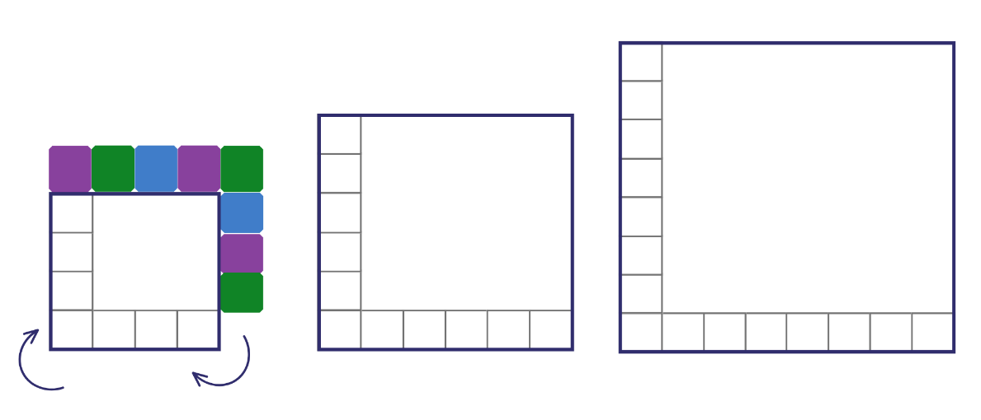
- Students record data in a table considering shapes, attributes, and properties. They can also use diagrams or drawings to explain problem-solving strategies. Ask:
- What patterns did you find?
- How did you record your ideas?
- Were there any problems and how did you solve them?
- Ask students what would happen if rectangular frames with small triangles are used to make the border. See Figure 27.
- Ask students what would happen if rectangular and hexagonal frames with small squares are used to make the border. See Figure 27. Use Resource 8: Rectangular and hexagonal frames.
Figure 27 – Different frames
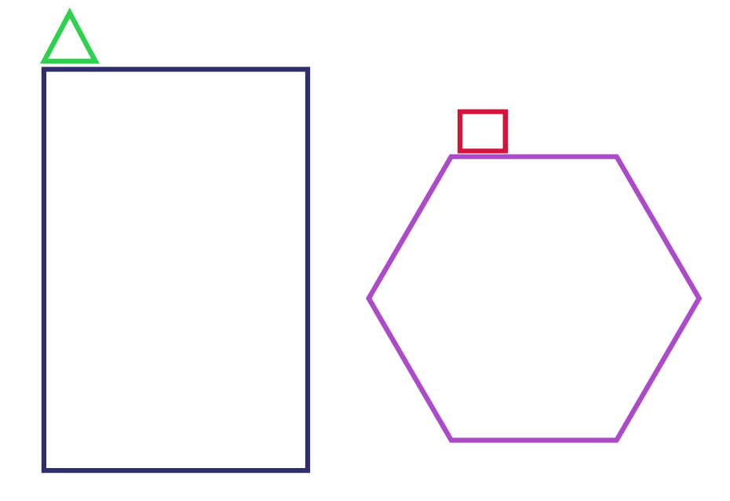
- Discuss patterns investigated by students.
This table details assessment opportunities and differentiation ideas.
Assessment opportunities | Too hard? | Too easy?
What to look for:  - Can students determine how many squares are needed to create the borders? (MAO-WM-01, MAE-FG-01, MA1-2DS-01)  - Can students apply skip counting strategies? (MAO-WM-01, MA1-CSQ-01)  - Are students using repeated addition strategies? (MAO-WM-01, MA1-CSQ-01)  - Can students collect data in a table and interpret results? (MAE-DATA-01, MA1-DATA-02)  What to collect:  - observations, photographs, and diagrams demonstrating understanding of repeating and growing patterns (MAO-WM-01, MAE-FG-01, MA1-CSQ-01 MA1-2DS-01)  - work samples of data collected during the investigation (MAE-DATA-01, MA1-DATA-01) | Students cannot find the frame pattern.  - Support students to create a simple border pattern using only one or 2 colours.  - Provide students with a template of a square and geometric shapes, allowing time for hands-on exploration. | Students have applied repeated addition and skip counting strategies to find answers to the frame investigation.  - Students use 4 colours in their border.  - Students create a 2 layered border.  - Students select another geometric shape and create a border pattern combining 2 new geometric shapes.

Discuss and connect the mathematics – 5 minutes
- As a class, add to and clarify the pattern anchor chart.

Resource 1: 2D paper shapes
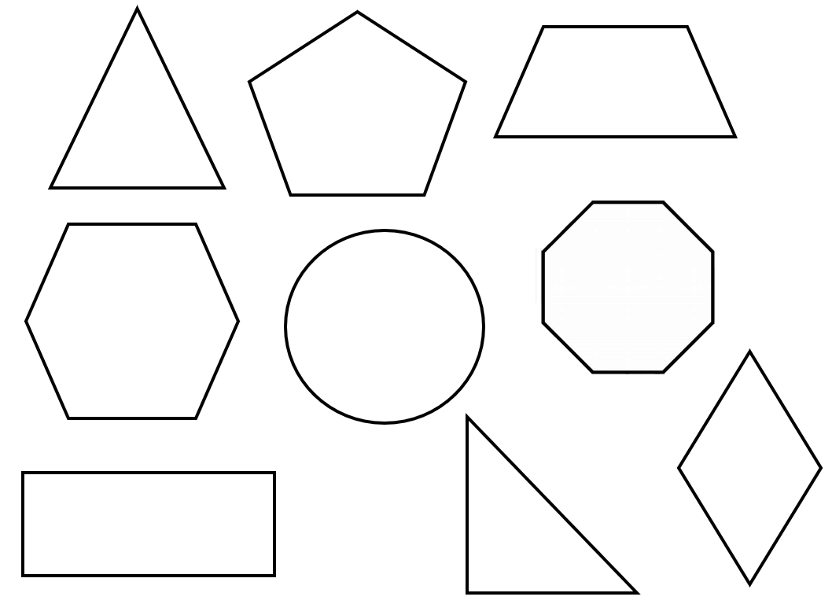

Resource 2: Simple mandala template
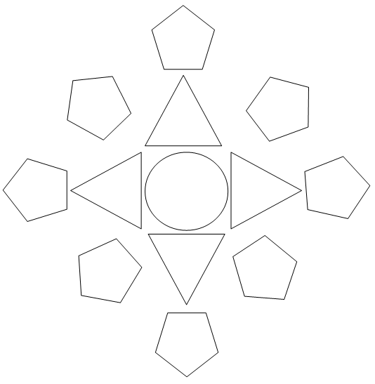

Resource 3: Squares to stairs

Resource 4: Robot eats the number 5!
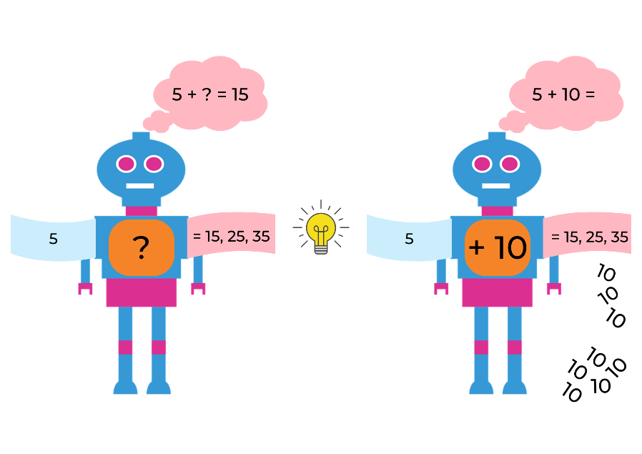
Images sourced from Pixabay and used in accordance with the Pixabay Licence.

Resource 5: What comes next – dots?
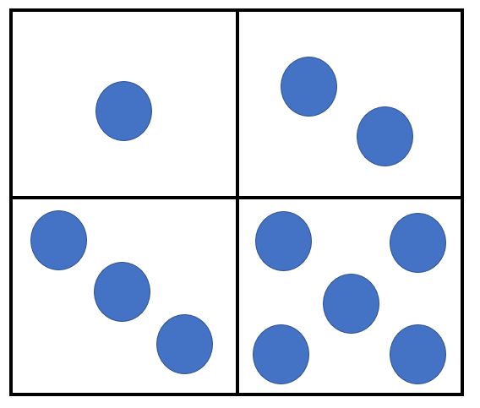

Resource 6: What comes next - numbers?
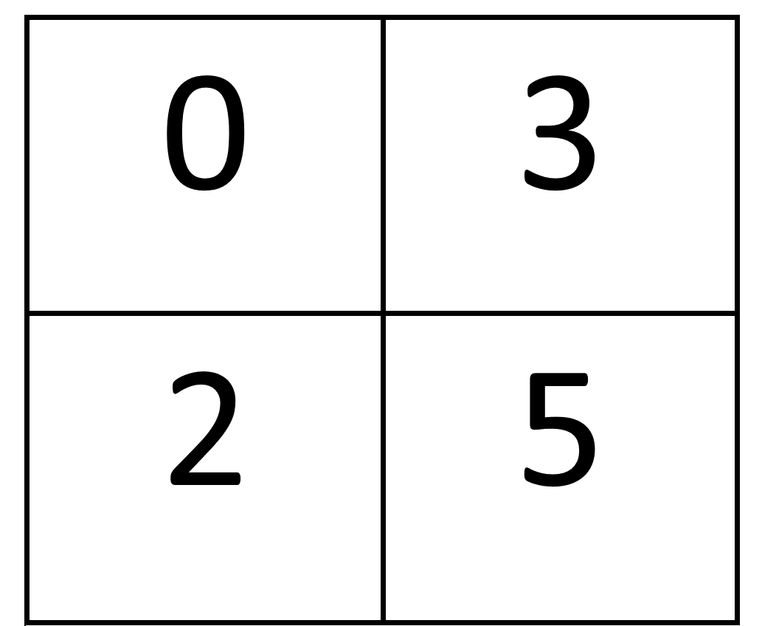

Resource 7: Hundreds chart
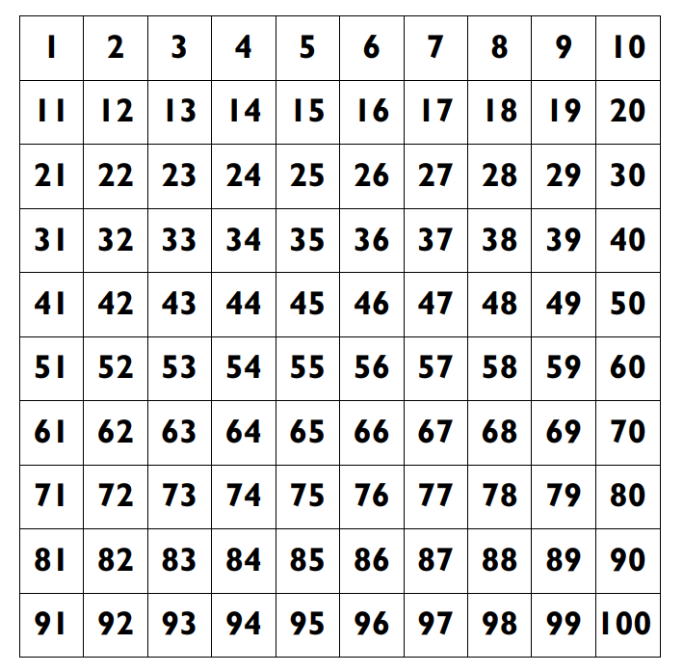

Resource 8: Rectangular and hexagonal frames
Resize to suit the available square geometric shapes or paper shapes.

Syllabus outcomes and content
The table below outlines the syllabus outcomes and range of relevant syllabus content covered in this unit. Content is linked to National Numeracy Learning Progression version (3).
Focus area and outcomes | Content groups and content points | Lessons
Representing whole numbers  MAO-WM-01  MAE-RWN-01, MA1-RWN-01  MAE-RWN-02, MA1-RWN-02 | Early Stage 1  Use the counting sequence of ones flexibly  - count forwards to at least 30 and state the number after or before a given number, without needing to count from one (CPr4)  - count backwards by ones from a given number 20 or less (CPr5)  - identify the number before as ‘one less’ and the number after as ‘one more’ than a given number | 1 and 7
Representing whole numbers (cont.) | Early Stage 1  Instantly name the number of objects within small collections  - instantly recognise (subitise) the number of items in small groups of up to 4 items without counting (NPV1, CPr1)  - identify the number of items in different arrangements (CPr2)  Recognise number patterns  - recognise dice and domino patterns (NPA1, NPV2, CPr2) | 6 and 7
Representing whole numbers (cont.) | Early Stage 1  Connect counting and numerals to quantities  - count with one-to-one correspondence, recognising that the last number name represents the total number in the collection (CPr3, CPr5) | 6 and 7
Representing whole numbers A | Stage 1  Use counting sequences of ones with two-digit numbers and beyond  - identify the number before and after a given two-digit number (CPr5)  - count forwards and backwards by ones from a given number to at least 120 (CPr6) | 1
Representing whole numbers A (cont) | Stage 1  Continue and create number patterns  - model and describe 'odd' and 'even' numbers using items paired in two rows  - count forwards and backwards by twos from any starting point (CPr6-CPr7, MuS2)  Represent the structure of groups of ten in whole numbers  - count large sets of objects by systematically grouping in tens (CPr7)  - partition two-digit numbers to show quantity values (NPV4) | 6 and 7
Representing whole numbers B | Stage 1  Use counting sequences of ones and tens flexibly  - identify the number before and after a given three-digit number  - count forwards and backwards by tens, on and off the decade, with two- and three-digit numbers (CPr7)  - identify how many more to the next multiple of ten within two- and three-digit numbers | 7
Combining and separating quantities  MAO-WM-01  MAE-CSQ-01, MA1-CSQ-01  MAE-CSQ-02 | Early Stage 1  Model additive relations and compare quantities  - identify situations in which addition and subtraction may be applied (AdS1-AdS2)  - use concrete materials or fingers to model and solve addition and subtraction questions, counting forwards or backwards by ones as necessary (AdS1-AdS2, NPV3) | 5–7
Combining and separating quantities (cont.) | Early Stage 1  Identify part-whole relationships in numbers up to 10  - count by ones to find the total or difference (AdS2-AdS3)  - use drawings, words and numerals to record addition and subtraction, and explain their thinking (AdS2) | 5–7
Combining and separating quantities A | Stage 1  Use advanced count-by-one strategies to solve addition and subtraction problems  - apply the terms ‘add’, ‘plus’, ‘equals’, ‘is equal to’, ‘is the same as’, ‘take away’, ‘minus’ and ‘the difference between’ to describe combining and separating quantities (AdS1, AdS6)  - record number sentences in a variety of ways using drawings, words, numerals and symbols (AdS6)  - fluently use advanced count-by-one strategies including counting on and counting back to solve addition and subtraction problems involving one- and two-digit numbers (AdS3- AdS5) | 5 and 6
Combining and separating quantities A  (cont.) | Stage 1  Use flexible strategies to solve addition and subtraction problems  - use non-count-by-one strategies such as using doubles for near doubles and combining numbers that add to ten (AdS6)  - represent addition and subtraction using structured materials such as a bead string or similar model (AdS6-AdS7) | 5–7
Combining and separating quantities B | Stage 1  Represent and reason about additive relations  - create, record and recognise combinations of two numbers that add to numbers from 11 up to and including 20 (AdS7)  - model how addition and subtraction are inverse operations using concrete materials, drawings and diagrams (AdS7)  - recall and use related addition and subtraction number facts to at least 20 (AdS7) | 5–7
Combining and separating quantities B (cont.) | Stage 1  Form multiples of ten when adding and subtracting two-digit numbers  - add two-digit numbers by building to multiples of ten (AdS7)  - use quantity values to separate tens and ones for addition (only) (AdS7-AdS8) | 7
Forming groups  MAO-WM-01  MAE-FG-01 | Early Stage 1  Copy, continue and create patterns  - copy and continue repeating patterns using sounds and/or actions (NPA1-NPA2)  - copy, continue and create repeating patterns using shapes, objects, images or pictures (NPA1-NPA2) | 8
Two-dimensional spatial structure  MAO-WM-01  MAE-2DS-01, MA1-2DS-01 MA1-2DS-02 | Early Stage 1  2D shapes: Sort, describe and name familiar shapes  - identify familiar shapes in a range of contexts  - sort shapes according to features such as size and shape (UPG1-UPG2)  - recognise and explain how a group of shapes has been sorted  - describe shapes, including circles, squares, triangles and rectangles (UPG1-UPG2)  - ask and respond to questions that help identify and name a particular shape | 1–5, 8
Two-dimensional spatial structure (cont.) | Early Stage 1  2D shapes: Represent shapes  - manipulate circles, squares, triangles and rectangles, and describe their features (UPG2-UPG3)  - turn shapes to fit into or match a given space (Reasons about spatial relations)  - make pictures and designs using a selection of shapes | 2–5, 8
Two-dimensional spatial structure A | Stage 1  2D shapes: Recognise and classify shapes using obvious features  - explore, manipulate and describe features of polygons (UGP3)  - use the terms ‘side’, ‘vertex’ and ‘two-dimensional’ to describe plane (flat) shapes (UGP1-UGP2)  - create repeating linear patterns with shapes, including two-shape and three-shape patterns  - compare, sort and classify polygons according to the number of sides or vertices (UGP3-UGP4)  - select and name a shape from a description of its features, identifying triangles, quadrilaterals, pentagons, hexagons and octagons  - recognise that shapes with the same name may have sides of equal or different lengths  - identify shapes presented in different orientations (UGP2) | 1–5, 8
Two-dimensional spatial structure B | Stage 1  2D shapes: Represent, combine and separate two-dimensional shapes  - make representations of two-dimensional shapes and combinations of shapes in different orientations  - combine and split single shapes and arrangements of shapes to form new shapes | 1–5, 8
Data  MAO-WM-01  MAE-DATA-01, MA1-DATA-01  MA1-DATA-02 | Early Stage 1  Organise objects into simple data displays and interpret the displays  - group objects according to characteristics (IRD1)  - compare the sizes of groups of objects by counting  - interpret information presented in a data display to answer questions (IRD2) | 4, 7, and 8
Data A | Stage 1  Ask questions and gather data  - investigate a topic of interest by choosing suitable questions to obtain appropriate data (IRD2)  - gather data and track what has been counted by using concrete materials, tally marks, lists or symbols (IRD3) | 4, 5, 7, and 8
Data B | Stage 1  Identify a question of interest and gather relevant data  - collect data on familiar topics (IRD2)  - sort data into relevant categories (IRD2)  Create displays of data and interpret them  - organise collected data into lists and tables to display information (IRD2)  - represent data in a picture graph using a baseline, equal spacing and same-sized symbols (IRD2)  - interpret information presented in tables and picture graphs (IRD2)  - record answers to questions using the information in tables and picture graphs (IRD2) | 7 and 8

References
Links to third-party material and websites
Please note that the provided (reading/viewing material/list/links/texts) are a suggestion only and implies no endorsement, by the New South Wales Department of Education, of any author, publisher or book title. School principals and teachers are best placed to assess the suitability of resources that would complement the curriculum and reflect the needs and interests of their students.
If you use the links provided in this document to access a third-party's website, you acknowledge that the terms of use, including licence terms set out on the third-party's website apply to the use which may be made of the materials on that third-party website or where permitted by the Copyright Act 1968 (Cth). The department accepts no responsibility for content on third-party websites.
Except as otherwise noted, all material is © State of New South Wales (Department of Education), 2021 and licensed under the Creative Commons Attribution 4.0 International License. All other material (third-party material) is used with permission or under licence. Where the copyright owner of third-party material has not licensed their material under a Creative Commons or similar licence, you should contact them directly for permission to reuse their material.
Mathematics K–10 Syllabus © 2022 NSW Education Standards Authority (NESA) for and on behalf of the Crown in right of the State of New South Wales.
© 2022 NSW Education Standards Authority. This document contains NSW Curriculum and syllabus content. The NSW Curriculum is developed by the NSW Education Standards Authority. This content is prepared by NESA for and on behalf of the Crown in right of the State of New South Wales. The material is protected by Crown copyright.
Please refer to the NESA Copyright Disclaimer for more information.
NESA holds the only official and up-to-date versions of the NSW Curriculum and syllabus documents. Please visit the NSW Education Standards Authority (NESA) website and the NSW Curriculum website.
National Numeracy Learning Progression © Australian Curriculum, Assessment and Reporting Authority (ACARA) 2010 to present, unless otherwise indicated. This material was downloaded from the Australian Curriculum website (National Numeracy Learning Progression) (accessed 15 August 2022) and was not modified. The material is licensed under CC BY 4.0. Version updates are tracked in the ‘Curriculum version history’ section on the 'About the Australian Curriculum' page of the Australian Curriculum website.
ACARA does not endorse any product that uses the Australian Curriculum or make any representations as to the quality of such products. Any product that uses material published on this website should not be taken to be affiliated with ACARA or have the sponsorship or approval of ACARA. It is up to each person to make their own assessment of the product, taking into account matters including, but not limited to, the version number and the degree to which the materials align with the content descriptions and achievement standards (where relevant). Where there is a claim of alignment, it is important to check that the materials align with the content descriptions and achievement standards (endorsed by all education Ministers), not the elaborations (examples provided by ACARA).
Australian Broadcasting Corporation (2021) ‘Sort and Classify with Eddie’ [video], ABC, ABC Kids website, accessed 15 August 2022.
Australian Government Department of Education (2022) ‘Patterns: Attribute Trains', Teaching resources, reSolve website, accessed 15 August 2022.
Boaler J, Munson J and Williams C (2022) Mindset Mathematics: Visualizing and Investigating Big Ideas, Grade 2, Jossey-Bass Inc, New York.
Clements DH and Sarama J (2017/2019) Learning and teaching with learning trajectories [LT]2 [website], accessed 15 August 2022.
Stanford University (n.d.) ‘Squares To Stairs’, Tasks, youcubed website, accessed 15 August 2022.
University of Cambridge (Faculty of Mathematics) (2022) NRICH [website], accessed 15 August 2022.
University of Cambridge (Faculty of Mathematics) (2022) Smaller and Smaller, NRICH website, accessed 15 August 2022.
University of Washington (2014) Choral Counting, Teacher Education by Design website, accessed 15 August 2022.
University of Washington (2014) Teacher Education by Design [website], accessed 15 August 2022.

