Mathematics – K-2 multi-age – Year B – Unit 1
Contents
Unit description and duration 4
Student prior learning 4
Lesson overview and resources 5
Lesson 1: Adventures in mathematics 17
Daily number sense: I spy with my little eye – 15 minutes 18
Mathematics explorers – 30 minutes 19
Consolidation and meaningful practice: What do mathematicians do? – 15 minutes 23
Lesson 2: Counting the dots 24
Daily number sense: It’s a dotty kind of day! – 15 minutes 25
Counting dots – 25 minutes 26
Consolidation and meaningful practice: Dot discussion – 10 minutes 30
Lesson 3: Exploring shapes 31
Daily number sense: 10 minutes 32
Shape jumping – 20 minutes 32
Changing shapes – 30 minutes 34
Consolidation and meaningful practice: Sharing shapes – 15 minutes 37
Lesson 4: Sorting shapes 38
Daily number sense: Order up – 15 minutes 39
Which one doesn’t belong? – 15 minutes 42
Sorting collections – 25 minutes 43
Consolidation and meaningful practice: Gallery walk – 15 minutes 45
Lesson 5: Attribute adventures 47
Daily number sense: Counting with monsters – 20 minutes 48
So many ways to sort: Part A – 15 minutes 53
So many ways to sort: Part B – 15 minutes 55
Consolidation and meaningful practice: Let’s sort! – 15 minutes 59
Lesson 6: Counting collections 60
Daily number sense: How many in your cup – 15 minutes 60
Organising and counting a collection – 25 minutes 62
Consolidation and meaningful practice: Discussing the count – 15 minutes 64
Lesson 7: Organising a collection for counting 66
Daily number sense: Counting with monsters – 15 minutes 67
Organising, counting, and recording a collection – 20 minutes 68
Consolidation and meaningful practice: Stairs and towers – 15 minutes 72
Lesson 8: Quantifying collections 76
Daily number sense: Cities and stairs – 20 minutes 77
Flip and match – 15 minutes 78
Nim – 15 minutes 81
Consolidation and meaningful practice: Roll to the goal – 15 minutes 83
Resource 1: Mathematics around us 86
Resource 2: Be a mathematician 87
Resource 3: Dice dot patterns 88
Resource 4: Triangle design shapes 89
Resource 5: Number cards 90
Resource 6: Which one doesn’t belong? 91
Resource 7: Shape attribute sort 92
Resource 8: Venn diagram 93
Resource 9: Monster making cards 94
Resource 10: Number attribute labels 95
Resource 11: Counting collections anchor chart 96
Resource 12: Place value chart 97
Resource 13: Fill the stairs 98
Resource 14: Ten-frame 99
Resource 15: 0-9 numeral cards 100
Syllabus outcomes and content 101
References 111

Unit description and duration
This two-week unit introduces students to the big idea that collections of 10 are useful. Students are provided opportunities to:
- notice, wonder, and ask questions about mathematical concepts around them
- count collections of objects by organising them and paying attention to the structure of groups
- combine and separate quantities
- recognise and explain how a collection of objects has been sorted
- describe two-dimensional spatial structures
- organise information into simple data displays and interpret these displays.
Mathematics K–10 Syllabus © 2022 NSW Education Standards Authority (NESA) for and on behalf of the Crown in right of the State of New South Wales.

Student prior learning
Before engaging in these teaching and learning activities, students would benefit from prior experience with:
- contributing constructively to mathematical discussions
- applying a wide variety of thinking strategies to engage with situations and solve problems
- sorting, categorising, ordering, and comparing collections and attributes of objects and materials.

Lesson overview and resources
The table below outlines the sequence and approximate timing of lessons; syllabus focus areas and content groups; and resources.
Lesson | Syllabus focus area and content groups | Resources
Lesson 1: Adventures in mathematics  60 minutes  Mathematicians notice, explore, and make connections to solve problems. | Representing whole numbers  Early Stage 1  - Connect counting and numerals to quantities  Stage 1 – Part A  - Use counting sequences of ones with two-digit numbers and beyond  Data  Early Stage 1  - Respond to questions, collect information and discuss possible outcomes of activities  Stage 1 – Part A  - Ask questions and gather data  Stage 1 – Part B  - Identify a question of interest and gather relevant data | - Resource 1: Mathematics around us – one enlarged copy  - Resource 2: Be a mathematician – one enlarged copy  - Video: Popping Balloons (Act – 1) (0:19)  - Video: Wacky Number Songs: Series 1 Episode 37 It’s Everywhere! (1:41)  - Device to play music  - Digital tablet – for teacher  - Writing materials
Lesson 2: Counting the dots  50 minutes  Dice dot patterns help us explore small quantities which can be combined to make larger quantities. | Representing whole numbers  Early Stage 1  - Instantly name the number of objects within small collections  - Recognise number patterns  - Connect counting and numerals to quantities  Stage 1 – Part A  - Use counting sequences of ones with two-digit numbers and beyond  Combining and separating quantities  Early Stage 1  - Identify part-whole relationships in numbers up to 10  Stage 1 – Part A  - Use advanced count-by-one strategies to solve addition and subtraction problems  - Recognise and recall number bonds up to ten  - Represent equality  Stage 1 – Part B  - Represent and reason about additive strategies | - Resource 3: Dice dot patterns – one copy printed on card and cut up for each Early Stage 1 student  - Clothes pegs – at least 15 per student  - Digital tablets – one per pair of students  - Large dice  - Loose parts such as shells, pebbles, craft materials, gumnuts, or similar.  - Paper plates – at least 5 per Early Stage 1 student  - 6-sided dot pattern dice – at least 20 per pair of Stage 1 students  - Small pieces of card – 5 per student  - Writing materials
Lesson 3: Exploring shapes  75 minutes  Two dimensional shapes can be described by their attributes. | Two-dimensional (2D) spatial structure  Early Stage 1  - Sort, describe and name familiar shapes  - Represent shapes  Stage 1 – Part A  - Recognise and classify shapes using obvious features  Stage 1 – Part B  - Represent, combine and separate two-dimensional shapes | - Resource 4: Triangle design shapes – at least one copy for every student and one copy for teacher, with triangles cut out and placed in envelopes.  - Chalk  - Device to play music  - Digital tablets  - Glue (optional)  - Large cardboard for display  - Music for movement  - Selection of 2D geometric shapes  - Writing materials
Lesson 4: Sorting shapes  70 minutes  Shapes can be sorted according to their attributes. | Representing whole numbers  Early Stage 1  - Use the counting sequence of ones flexibly  - Connect counting and numerals to quantities  Stage 1 – Part A  - Represent numbers on a line  Two-dimensional (2D) spatial structure  Early Stage 1  - Sort, describe and name familiar shapes  - Represent shapes  Stage 1 – Part A  - Recognise and classify shapes using obvious features  Data  Early Stage 1  - Respond to questions, collect information and discuss possible outcomes of activities  - Organise objects into simple data displays and interpret the displays  Stage 1 – Part A  - Ask questions and gather data  - Represent data with objects and drawings and describe the displays  Stage 1 – Part B  - Identify a question of interest and gather relevant data  - Create displays of data and interpret them | - Resource 2: Be a mathematician – anchor chart established in previous lessons  - Resource 5: Number cards – 2 sets  - Resource 6: Which one doesn’t belong?  - Resource 7: Shape attribute sort – one per Stage 1 student  - Resource 8: Venn diagram – one per student  - Video: Dr Knickerbocker Number 9 (2:18)  - Venn diagram  - Collections of items or loose parts – sets ranging in variety of about 20 per pair of Early Stage 1 students  - Digital tablet – for teacher  - Glue – one per Stage 1 student  - Hoops or plates – 2 per Early Stage 1 student  - Number flip chart  - Scissors – one pair per Stage 1 student  - Sets of 10 random coloured rods – one set per Early Stage 1 student  - Sticky notes
Lesson 5: Attribute adventures  65 minutes  Relationships between objects and numbers can be explored by comparing attributes. | Representing whole numbers  Early Stage 1  - Connect counting and numerals to quantities  Stage 1 – Part A  - Use counting sequence of ones with two-digit numbers and beyond  Stage 1 – Part B  - Form, regroup and rename three-digit numbers  Data  Early Stage 1  - Respond to questions, collect information and discuss possible outcomes of activities  - Organise objects into simple data displays and interpret the displays  Stage 1 – Part A  - Ask questions and gather data  - Represent data with objects and drawings and describe the displays  Stage 1 – Part B  - Identify a question of interest and gather relevant data  - Create displays of data and interpret them | - Resource 5: Number cards  - Resource 8: Venn diagram  - Resource 9: Monster making cards  - Resource 10: Number attribute labels  - Video: Play School's Marvellous Maths – Sort and classify with Eddie (4:48)  - Venn diagram  - Collections of around 20 different items – one collection per pair  - Digital tablet – one for teacher and one per Early Stage 1 student  - Glue  - Googly eyes  - Loose parts such as matchsticks and pipe cleaners  - Markers – at least 5 different colours  - Modelling clay  - Patterned socks – students to bring in at least one pair  - Scissors  - Writing materials
Lesson 6: Counting collections  55 minutes  Mathematicians use techniques and tools to support accurate counting. | Representing whole numbers  Early Stage 1  - Instantly name the number of objects within small collections  - Connect counting and numerals to quantities  Stage 1 – Part A  - Use counting sequences of ones with two-digit numbers and beyond  - Continue and create number patterns  - Represent the structure of groups of ten in whole numbers  Stage 1 – Part B  - Use counting sequences of ones and tens flexibly  - Form, regroup and rename three-digit numbers  Combining and separating quantities  Early Stage 1  - Identify part-whole relationships in numbers up to 10  Stage 1 – Part A  - Recognise and recall number bonds up to ten  - Use flexible strategies to solve addition and subtraction problems  Stage 1 – Part B  - Form multiples of ten when adding and subtracting two-digit number | - Resource 11: Counting collections anchor chart  - Resource 12: Place value chart  - Resource 14: Ten-frame – class set  - Dice – class set  - Digital tablet – one for teacher  - Paper cups  - Collection of loose parts of various sizes – enough to fill a cup per student  - Counting collections – natural materials, craft materials, recycled items, and stationary products (50-100 for Stage 1 students and 10-20 for Early Stage 1 students)  - Tools to support counting – patty pans, cups, bowls, rubber bands, number charts, number lines, grids, ten-frames, and place value charts  - Writing materials
Lesson 7: Organising a collection for counting  50 minutes  Organising items in a count helps us to count accurately. | Representing whole numbers  Early Stage 1  - Instantly name the number of objects within small collections  - Use the counting sequence of ones flexibly  - Recognise number patterns  - Connect counting and numerals to quantities  Stage 1 – Part A  - Use counting sequences of ones with two-digit numbers and beyond  - Represent numbers on a line  - Represent the structure of groups of ten in whole numbers  Stage 1 – Part B  - Use counting sequences of ones and tens flexibly  - Form, regroup and rename three-digit numbers  Combining and separating quantities  Early Stage 1  - Model additive relations and compare quantities  - Identify part-whole relationships in numbers up to 10  Stage 1 – Part A  - Recognise and recall number bonds up to ten  - Use flexible strategies to solve addition and subtraction problems  Stage 1 – Part B  - Form multiples of ten when adding and subtracting two-digit numbers | - Resource 9: Monster making cards  - Resource 11: Counting collections anchor chart  - Resource 12: Place value chart – class set  - Resource 13: Fill the stairs – class set  - Resource 14: Ten-frame – class set  - 0-9 dice – class set (or Dice and Spinners Interactive for 0-9 digital dice)  - Basket of soft balls  - Container or bag – one per pair of Early Stage 1 students  - Counting collections – natural materials, craft materials, recycled items, and stationary products (50-100 for Stage 1 students and 10-20 for Early Stage 1 students)  - Digital tablet – one for teacher  - Googly eyes  - Loose parts such as matchsticks and pipe cleaners  - MAB blocks  - Modelling clay  - Small cards with numerals 0-3 written or drawn on cards in dot form – one set per pair of Early Stage 1 students  - Stackable items such as tissue boxes, recycled boxes, or cardboard tubes – 10 per pair of Early Stage 1 students  - Tools to support counting – patty pans, rubber bands, number charts, grids, cups, bowls  - Writing materials
Lesson 8: Quantifying collections  65 minutes  Collections can be quantified, organised, and represented in different ways. | Representing whole numbers  Early Stage 1  - Instantly name the number of objects within small collections  - Recognise number patterns  - Connect counting and numerals to quantities  Stage 1 – Part A  - Use counting sequences of ones with two-digit numbers and beyond  - Continue and create number patterns  - Represent numbers on a line  - Represent the structure of groups of ten in whole numbers  Stage 1 – Part B  - Use counting sequences of ones and tens flexibly  - Form, regroup and rename three-digit numbers  Combining and separating quantities  Early Stage 1  - Model additive relationships in numbers up to 10  - Identify part-whole relationships in numbers up to 10  Stage 1 – Part A  - Use advanced count-by-one strategies to solve addition and subtraction problems  - Use flexible strategies to solve addition and subtraction problems  - Represent equality  Stage 1 – Part B  - Represent and reason about additive strategies  - Use knowledge of equality to solve related problems | - Resource 12: Place value chart – class set  - Resource 13: Fill the stairs  - Resource 14: Ten-frame  - Resource 15: 0-9 numeral cards  - 0-9 dice – class set  - 6-sided dice with zero covered by a sticker – one per Early Stage 1 student  - Counters – at least 10 per student  - Craft sticks or MAB blocks – class set  - Domino sets – one set per Early Stage 1 student  - Wooden blocks or coloured bricks  - Writing materials

Lesson 1: Adventures in mathematics
Core concept: Mathematicians notice, explore and make connections to solve problems.
The table below contains suggested learning intentions and success criteria. These are best co-constructed with students.
Learning intentions | Success criteria
All students are learning that:  - quantities can be noticed and counted everywhere  - mathematics can be noticed and explored all around  - there are ways of thinking and working that are specific to being a learner of mathematics, which are called ‘being a mathematician’. | All students can:  - notice and describe mathematical observations in everyday items and experiences  - share ideas about helpful ways to think and learn as a mathematician.  In addition, students working towards Early Stage 1 outcomes can count small collections of objects under 5.  In addition, students working towards Stage 1 outcomes can:  - count collections of objects over 10  - use mathematical language to explain mathematical connections.

Daily number sense: I spy with my little eye – 15 minutes
- Build student understanding of recognising and counting quantities by playing the ‘I spy’ game.
- Select a range of items visible in the learning space that feature mathematical quantities that can be observed.
- Use the game lead line ‘I spy with my little eye’, followed by a statement describing a visible item that has an observable mathematical quality. Some suggestions could be:
- I spy a group of 3 matching items in a row.
- I spy a word on the wall with 2 letters in it.
- I spy a shape that has 3 straight sides.
- Acknowledge possibilities that may meet the criteria in the clue and provide further clues using mathematical language to guide students to identify the intended item.
- Provide more challenging clues for Stage 1 students which allow them to identify larger quantities around the learning space. Some suggestions could be:
- I spy a group of 12.
- I spy 16 legs, all the same, touching the ground.
- I spy a two-digit number where the 2 digits add together to make 5.
- After each item is correctly identified, count the quantity together and ask students what they notice about each quantity.
This table details assessment opportunities and differentiation ideas.
Assessment opportunities | Too hard? | Too easy?
What to look for:  - Are students able to accurately identify and count quantities under 5 in the environment around them? (MAE-RWN-01, MAO-WM-01)  - Are students able to accurately identify and count quantities over 10 in the environment around them? (MA1-RWN-01, MAO-WM-01) | Students have difficulty accurately counting sets of items around the room.  - Pause after a set of objects is found and count the set together in unison, whilst pointing to each item.  - Invite students to find quantities under 3 around the room. | Students readily and accurately count sets of items to identify.  - Students find a set of items in the room to count and provide clues for other students.  - Provide clues that extend students’ counting understanding, such as ‘I spy with my little eye a group of objects that amounts to one less than 13’.

Mathematics explorers – 30 minutes
- Prior to this lesson, consider specific areas in and around the school that could be used as stimulus for conversations about mathematics in everyday items or experiences.
- Watch Wacky Number Songs: Series 1 Episode 37 It’s Everywhere! (1:41).
- Ask students to describe the mathematics they have noticed around the room. Record student responses on Resource 1: Mathematics around us anchor chart. Discuss students’ ideas to build a shared understanding of mathematical concepts in everyday items and experiences.
Note: When making the anchor chart, sort student responses into categories such as shapes, patterns, quantities, measurements. This will allow students to begin to explore sorting and categorising data.
Anchor chart: An anchor chart is a display that contains a summary of students’ ideas and can be revisited across lessons.
- Take students on a walk around different areas within the school grounds. At each location, ask students:
- What do you notice?
- What do you wonder?
- Pause regularly to observe and discuss mathematical ideas, such as shapes, repeating patterns, collections of items, or comparative sizes. Include places, items, and experiences, such as:
- features of leaves or flowers in gardens
- repeating patterns in the structure of a building
- items such as a soccer ball
- listening to a piece of music on a device or a musical instrument being played
- watching the video Popping balloons (Act – 1) (0:19)
- quantities of items in storage containers.
Note: Students will make mathematical and non-mathematical observations. Accept all responses and use mathematical ideas to build a shared understanding of how mathematical ideas can be noticed and explored around.
- Observe and record student discussions by taking notes or videoing students discussions, as this will provide useful assessment data.
- Gather students together and use the anchor chart to record further ideas and questions noticed during the walk. Possible student responses for the soccer ball are included in the table below.
Prompts | Anticipated student responses
- What do you notice?  - What do you notice about the size, shapes, patterns, or quantities?  - What do you wonder?  - Could you ask a question about how many or how much? | - The ball is a sphere.  - The ball is a 3D object.  - The ball is made up of lots of shapes that are the same.  - Each shape on the ball has 6 sides.  - The shapes are in a colour pattern of black and white.  - The shapes all fit together perfectly with no gaps, so the air can’t get out.  - The sides of each shape on the ball are all the same length.  - The ball is about as big as my head.  - I wonder how many shapes cover the surface of the ball altogether?  - I wonder how shapes with straight sides make a curved 3D object when they are all joined together?  - I wonder how much air the ball holds inside?  - I wonder what it would look like if we picked the ball apart to lay out all the shapes flat?
This table details assessment opportunities and differentiation ideas.
Assessment opportunities | Too hard? | Too easy?
What to look for:  - Are students able to notice and describe mathematical ideas in places, items and experiences around them? (MAO-WM-01)  - What language are students using to describe observed mathematical concepts? (MAO-WM-01)  What to collect:  - recording of student observations. (MAO-WM-01) | Students are not able to identify specific mathematical ideas in places, items, or experiences.  - Select one item and ask specific questions about quantities, patterns, shapes, groups, and size to guide student thinking.  - Use ideas shared by peers about one item to identify similar concepts in a different context. | Students articulately and readily describe some mathematical concepts.  - Choose 2 items to compare and ask students what mathematical features the 2 items have in common.  - Choose a ‘wonder’ question and ask what information students would need to further investigate that question.

Consolidation and meaningful practice: What do mathematicians do? – 15 minutes
- Ask students questions to reflect upon the ways that mathematicians work effectively, such as:
- What do you notice about exploring mathematics that might tell us what mathematicians do?
- What sort of questions do mathematicians ask and investigate?
- How do mathematicians find the answers to their questions?
- How do mathematicians work well together and alone?
- Use student responses to record ideas on the anchor chart Resource 2: Be a mathematician.

Lesson 2: Counting the dots
Core concept: Dice dot patterns help us explore small quantities which can be combined to make larger quantities.
The table below contains suggested learning intentions and success criteria. These are best co-constructed with students.
Learning intentions | Success criteria
All students are learning that:  - dice dot patterns are recognisable, and the quantities represented can be trusted  - recognising dice dot patterns helps to instantly recognise quantities 1-5  - the smaller parts within 10 make it easier to recognise groups of 10. | All students can name the total number of dots on a dice dot pattern 1-5.  In addition, students working towards Early Stage 1 outcomes can:  - accurately model dice dot patterns  - accurately match a quantity represented on a dice dot pattern with the same quantity of another item.  In addition, students working towards Stage 1 outcomes can:  - combine smaller quantities to create a total of 10  - count a large collection of dots using groupings of 10 to count efficiently.

Daily number sense: It’s a dotty kind of day! – 15 minutes
This activity has been adapted from DENS.
- Build student understanding of subitising by recognising dice dot patterns up to 6.
- Begin the lesson by adapting lyrics and introducing the song ‘It’s a dotty kind of day’ to the tune of ‘It’s a small world’:
Put a dot over here
And a dot over there,
Put (1, 2, 3, 4, 5) dots on the ground
And a dot in the air,
Put a lot of (little, tiny, big, large) dots in the air,
Everywhere!
It’s a dotty kind of day.
- Introduce Resource 3: Dice dot patterns 1-5. Show a large dice.
- Display the dice dot pattern cards and roll the dice. Ask Early Stage 1 students to find the card that matches the dice quantity rolled. Ask students what they notice about the dots and discuss the matching quantities. Count each quantity in unison to demonstrate that they are the same.
- Show all students a dice pattern card for 1-2 seconds. Ask students how many dots they saw.
- Observe student responses. Select a student who was unable to subitise to point at each dot as the class counts in unison. Ensure that the student points to each number as it is spoken to model one-to-one correspondence. Discuss the idea that the last number named represents the total number of dots in the collection on the dice.
- Repeat for several dice dot cards.
- Show the dice dot pattern card for 5.
- Explain the dice pattern 5 by covering the 2 dots at the bottom and one dot in the middle so that only the 2 dots at the top are visible. Reveal the 2 dots at the bottom and continue to cover the one dot in the middle. Finally, reveal the one dot in the middle.
- Ask Stage 1 students to share other ways they may see the dots for 5. Record various student responses on the board, circling combinations of dots within the dice dot pattern for 5.
- Use dice dot pattern cards. Hold up 2 random cards at a time for 2-3 seconds and ask how many there are altogether.
- Select students to share how they saw the cards and how they worked out the total amount.
- Show students images of individual dice pattern cards and ask how many more would be needed to make 10.
- Select students to share how they worked out how many more to 10.

Counting dots – 25 minutes
This activity has been adapted from Boaler et al. (2021).
- Provide each Early Stage 1 student with Resource 3: Dice dot patterns printed on card. Provide clothes pegs, small pieces of card, paper plates and loose parts such as pebbles, shells, or dried beans.
- Select the dice dot pattern card for 2. Model how to count out and attach 2 pegs to a piece of card. Follow this by modelling how to use loose parts to recreate the dot patterns for 2.
- Ask Early Stage 1 students to use dice dot pattern cards to create matching arrangements with loose parts and pegs, similar to Figure 1.
Figure 1 – Creating dice dot patterns using loose parts to represent numbers 1-5
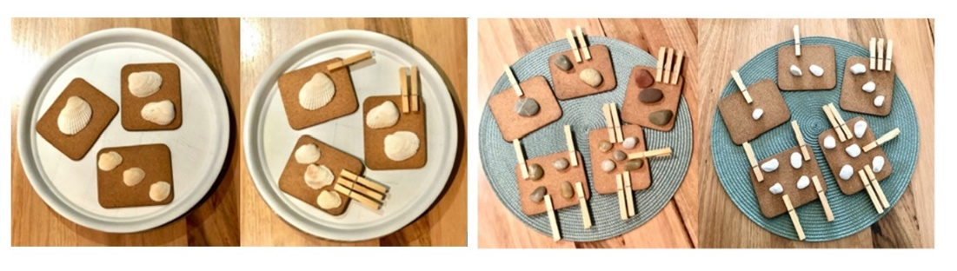
- Gather Stage 1 students and roll a collection of at least 10 6-sided dice so that all students can see. Ask students how many dots there are and how the dice could be organised to show how many.
- Give students a chance to turn and talk to a partner. Ask students questions from the table below.
Prompts | Anticipated student responses
- How can we organise these dice to help you count the dots on them?  - How might groups of 10 help you count the dots?  - What is the largest number of dots rolled? How do you know? | - We can organise the dice so that the dots are in groups of 5 or 10.  - Groups of 10 are easy to count because you don’t have to count each dot.  - Largest number of dots is 60 because the highest number on a die is 6 and there are 10 dice.
- Show students some possible ways of forming equal groups with the dice, especially groups of 5 and 10 to help count the dots, as shown in Figure 2.
Figure 2 – Combinations of 10 with dice
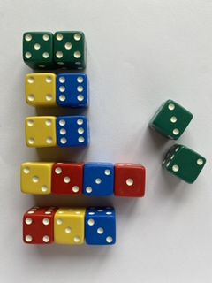
- Students work in pairs. Provide students with 10 dice and writing materials or digital tablets.
- Students roll their collection of dice. Students arrange dice in groupings that total 10. Students record the possibilities for combinations that total 10.
- Students calculate the total number of dots. Observe how students work out the total.
- Circulate amongst all students and observe the strategies they use to complete tasks. Photograph or video student work for assessment data.
This table details assessment opportunities and differentiation ideas.
Assessment opportunities | Too hard? | Too easy?
What to look for:  - Can Early Stage 1 students subitise and recreate dot patterns 1-5? (MAE-RWN-02, MAE-RWN-02, MAO-WM-01)  - How do Stage 1 students organise the dice? (MA1-CSQ-01, MA1-CSQ-01, MA1-RWN-02, MA1-RWN-02, MAO-WM-01)  - How do Stage 1 students count the total number of dots? (MA1-CSQ-01, MA1-CSQ-01, MA1-RWN-02, MA1-RWN-02, MAO-WM-01)  - Are students able to make groups of 5 or 10 to support the total count? (MA1-RWN-01, MA1-RWN-02, MAO-WM-01)  What to collect:  - records of student work (MAE-RWN-01, MAE-RWN-02, MA1-RWN-01, MA1-RWN-02, MA1-CSQ-01, MAO-WM-01) | Early Stage 1 students find it difficult to accurately match quantities on dice pattern cards 1-5.  - Model how to lay a peg or loose part on top of each dot before attaching pegs to cards or arranging loose parts.  - Limit dot cards to quantities 1-3.  Stage 1 students find it difficult to subitise, organise, and efficiently count dots on the dice.  - Reduce the number of dice.  - Ask students to model quantities using fingers and count how many fingers remain to make 10.  - Use counters in ten-frames to support part-whole recognition to 10.  - Provide a number chart to support counting in tens.  - Provide sticky notes to place each set of dice that totals 10 before counting the total number of dots. | Early Stage 1 students readily and accurately match and model the quantities on the dice dot pattern cards.  - Ask students to combine 2 cards and model the dots of 2 combined cards with loose parts before counting the total number of dots.  - Ask students to look at the card for 2-3 seconds and model the quantity they subitised.  Stage 1 students readily organise dice into groups of 10 and calculate the total by counting in tens.  - Provide a larger number of dice for students to group and calculate the totals of.  - Students arrange the same rolled set of dice in several different ways. Ask which method was the most efficient to support calculating the total and why.

Consolidation and meaningful practice: Dot discussion – 10 minutes
- Gather the students and share recordings of the way students matched dot pattern cards or organised their dice.
- Compare the same dot pattern card represented with pegs in different ways by 2 different students. Ask questions, such as:
- Have both students represented the same quantity with pegs?
- How can we check these 2 different arrangements both represent the same quantity?
- How do the different ways of arranging the pegs help us to see this quantity?
- Look at some examples of how Stage 1 students organised collections of dice. Ask questions, such as:
- How did you organise your dice to help you count?
- Why did organising your dice in that way support your counting?
- How did you go about counting your total?
- What are some of the combinations to ten that you discovered?
- Record student ideas for the possibilities of combinations to 10.

Lesson 3: Exploring shapes
Core concept: Two-dimensional shapes can be described by their attributes.
The table below contains suggested learning intentions and success criteria. These are best co-constructed with students.
Learning intentions | Success criteria
All students are learning that:  - shapes can be described by their attributes  - shapes can be combined to make new shapes  - mathematicians work within rules to solve problems. | All students can:  - describe shapes by their attributes using appropriate language  - manipulate and turn shapes to find solutions  - solve problems within a set of rules.  In addition, students working towards Early Stage 1 outcomes can:  - identify triangles, circles, squares, and rectangles  - describe the attributes of a shape no matter what the orientation.  In addition, students working towards Stage 1 outcomes can:  - identify shapes according to number of sides and vertices  - accurately label shapes with correct vocabulary  - combine 4 triangles to create new shapes.

Daily number sense: 10 minutes
- From a class need surfaced through formative assessment data, identify a short, focused activity that targets students’ knowledge, understanding, and skills. Example activities may be drawn from the following resources.
- Thinking Mathematically
- Universal Resources Hub.

Shape jumping – 20 minutes
- Using chalk, draw 10-15 large shapes on the ground. For example, squares, hexagons, circles, and various types of triangles and rectangles. Include at least 2 of each shape.
- Gather students and hold up examples of 2D geometric shapes. Ask questions to review the attributes of each shape, such as:
- What do you notice about this shape?
- How could you describe this shape by the number or length of sides?
- How could you describe this shape by its vertices?
- How is this shape similar to that shape?
- How is this shape different to that shape?
Note: Early Stage 1 students are expected to develop an understanding of triangles, circles, squares, and rectangles throughout the year. Stage 1 students are expected to extend their understanding of shapes to include quadrilaterals and other common polygons such as pentagons, hexagons, and octagons.
- Review the language used to describe 2D geometric shape attributes as students share their observations.
Attributes are the features of a shape. The attributes of shapes help define its characteristics both visually, for example, colour; and mathematically, for example, the length of the sides.
- Play music on a device as students move around the space. When the music stops, call out an attribute. Students stand on the shape that fits the description. Some suggestions are:
- Find a shape that has 4 sides.
- Find a shape that has 3 vertices.
- Find a shape that has all 4 sides the same length.
- Once all students have found the correct shape, ask if they can name the shape and describe one other attribute that is unique to that shape.
- Continue the game until all attributes and shapes have been named.

Changing shapes – 30 minutes
This activity has been adapted from Triangle Designs by youcubed.
- Use Resource 4: Triangle design shapes and cut out the 4 triangles.
- Show students the 4 triangles and ask them what they notice about the shapes. Select students to share observations about the shapes. Label the triangle as an isosceles triangle.
- Explain that an isosceles triangle has 2 sides of equal length.
- Demonstrate that triangles can be moved around and placed next to one another with no gaps to create new shapes. Create 1 or 2 examples and ask what students notice about this new shape you have made.
- Explain that students will use the 4 triangles to create as many shapes as they can. There are 4 constraints that they must work with:
- Shapes must use all 4 isosceles triangles.
- There cannot be any gaps or overlaps between triangles.
- Each triangle must be touching another triangle.
- Triangles must be touching along the sides of the same length.
- Show students some examples and non-examples, as in Figure 3.
Figure 3 – Shapes made from triangles
‘Triangle Designs’ by youcubed, Stanford University is licensed under CC BY 4.0
- Ask students to consider each example and describe why it does or does not meet the constraints.
- Students work in mixed stage pairs. Provide pairs of students with Resource 4: Triangle design shapes. Students compare each design against the 4 constraint criteria. If the design satisfies the criteria, they record the design using digital tablets with photographs, drawings, or by gluing sets of triangles onto a large cardboard poster for display.
This table details assessment opportunities and differentiation ideas.
Assessment opportunities | Too hard? | Too easy?
What to look for:  - What language do students use to describe attributes of shapes? (MA1-2DS-01, MAO-WM-01, MAE-2D2-02)  - Are students able to accurately label shapes with shape names? (MA1-2DS-01, MAO-WM-01, MAE-2D2-02)  - Are students able to manipulate and combine shapes to create new shapes within constraints provided? (MA1-2DS-01, MAO-WM-01, MAE-2D2-02)  What to collect:  - student work samples of triangle designs (MA1-2DS-01, MAO-WM-01, MAE-2D2-02) | Students lack the language to describe shapes by attribute or label the shapes with correct terminology.  - Model the language of attributes, using examples of shapes to demonstrate the language in context.  - Use comparisons of 2 shapes at a time to identify similarities and differences, focusing on specific vocabulary such as sides and vertices.  - Display labelled posters of shapes and regularly review the name of shapes and their attributes in daily routines.  Students find it difficult to manipulate triangles into new shapes within the constraints provided.  - Create shapes with 2 triangles to illustrate constraints then add a third one when students have been able to meet all constraints criteria.  - Identify the triangle that does not meet a constraint. Students play with other ideas with that triangle to solve the problem. | Students articulate observations of shapes and readily manipulate triangles to create new shapes within constraints.  - Ask students to describe how a design satisfies each constraint.  - Ask students how a non-example does not satisfy each constraint.

Consolidation and meaningful practice: Sharing shapes – 15 minutes
- Each pair selects one shape they have created to share with the class.
- Ask students questions, such as:
- Can you describe the new shape you have created?
- How can you be sure it meets all the constraints of the task?
- Are there other pairs who also created this shape?
- Display the triangle designs.

Lesson 4: Sorting shapes
Core concept: Shapes can be sorted and grouped according to their attributes.
The table below contains suggested learning intentions and success criteria. These are best co-constructed with students.
Learning intentions | Success criteria
All students are learning that:  - the attributes of a shape can be used to describe and sort it  - shapes can be different but still share attributes  - the same shape can be sorted in different ways  - information (data) can be presented in different ways. | All students can:  - describe differences and similarities of shapes based on attributes  - sort shapes based on attributes.  In addition, students working towards Early Stage 1 outcomes can:  - select shapes from a collection that have a particular attribute  - sort shapes into 2 groups based on a comparative attribute.  In addition, students working towards Stage 1 outcomes can use a Venn diagram to sort shapes.

Daily number sense: Order up – 15 minutes
This activity has been adapted from Dacey et al. (2016).
- Build student understanding of counting in sequence to 9 and ordering numbers from smallest to largest by playing ‘Order Up’.
- Begin by singing Dr Knickerbocker Number 9 (2:18) together.
- Use a number flip chart to count in unison. Begin with blank tiles and flip each numeral as the class counts to 10.
- Use the tens column to explore the rows of 10 ending in multiples of 10 on the number flip chart. Complete a count by tens with Stage 1 students, beginning with blank tiles and flipping each numeral as students count from 10 to 120.
- Provide Early Stage 1 students with sets of 10 coloured rods. Ask students to sort or order the rods according to attributes. Students count the total number of rods then select a new way to sort or order the rods before counting them again. Some examples are shown in Figure 4.
Figure 4 – Different size and coloured rods
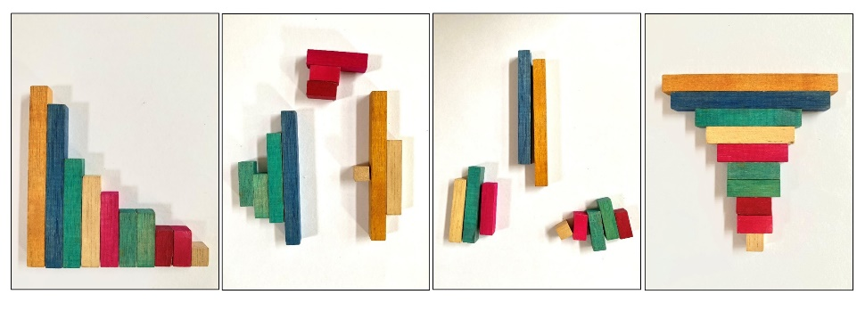
- Arrange the Stage 1 students into 2 teams. Use 2 sets of Resource 5: Number cards. Deal out 5 cards per team and select a student to stick them onto a board in front of their team from left to right in the order they were dealt. Place the undealt cards face down into a central pile.
- The aim of the game is to strategically swap one of the 5 cards on display with one picked up from the central pile, until the cards are in order from smallest to largest. The first team to have a series of 5 cards in correct ascending order wins.
- Select a student from each team to take turns selecting a card from the central pile. The student asks their team which card from the displayed set they should swap it with and why. The student chooses at least 2 people to suggest ideas and reasoning before deciding which card they will swap it with.
- The teams take it in turn to repeat this process until a team has all 5 cards in order from smallest to largest.
- Whilst Stage 1 students complete this game, gather Early Stage 1 students and ask them to share the different ways they have sorted the sets of coloured rods. Count sets of coloured rods in unison. Discuss the fact that, no matter how the rods are arranged, there are always 10 rods in a set.
- Invite Stage 1 students to reflect on the process of sharing and negotiating ideas to reach a goal in a mathematical game.
- Ask students if they have any further reflections to add to Resource 2: Be a mathematician.
This table details assessment opportunities and differentiation ideas.
Assessment opportunities | Too hard? | Too easy?
What to look for:  - Are Early Stage 1 students able to accurately count a collection of 10 items in a collection? (MAO-WM-01, MAE-RWN-01)  - Are Early Stage 1 students demonstrating an understanding of the number in a group remaining constant despite the arrangement of items? (MAO-WM-01, MAE-RWN-01)  - What language do students use to reason and connect ideas? (MAO-WM-01)  - What mathematical behaviours are evident in support of achieving a common mathematical goal? (MA1-RWN-01, MAO-WM-01)  - What strategies do students use to choose which numbers to swap to achieve the goal of ascending order? (MA1-RWN-01, MAO-WM-01) | Early Stage 1 students find it difficult to accurately count a collection of 10 with understanding.  - Provide students with a group of 5 coloured rods to sort and count.  - Provide students with a five-frame or ten-frame to arrange rods and support the count.  Stage 1 students find it difficult to make purposeful choices to order cards and find it challenging to negotiate with peers.  - Use a number line or number chart to support thinking.  - Omit three-digit numeral cards from the game.  - Use a limited set of numeral cards between 0-50.  - Pause the game and scaffold student reasoning with questions that promote explanations for students with differing views. | Early Stage 1 students sort rods in a range of ways and count with accuracy and understanding.  - Provide students with a larger group of coloured rods.  - Ask students to record the quantity of each separate group and mask the rods before working out the total using the recorded quantities.  Stage 1 students accurately make decisions about positions of cards on behalf of the group.  - Pause the game and ask for at least 2 other ideas and reasons and vote on each idea.  - Students explain to their team why they thought that was a useful swap.

Which one doesn’t belong? – 15 minutes
- Students work in pairs with a copy of Resource 6: Which one doesn't belong? Ask students:
- What do you notice?
- How are the shapes similar?
- How are the shapes different?
- Provide time for students to turn and talk. Invite students to share ideas with the whole class. Use student responses to record a list of attributes on the board. Review attributes of shapes and mathematical terms used to describe attributes, such as vertex and sides.
A vertex is where 2 straight sides of a two-dimensional shape meet. A side is the line segment joining 2 vertices of a two-dimensional shape.
- Ask students to look at the shapes and think about which one doesn’t belong.
- Provide thinking time and ask students:
- Why doesn’t the shape belong?
- Which attribute can you describe to explain why it doesn't belong with the other shapes?
- Provide students time to turn and talk to explain and share reasoning with their partner.
- Ask a few students to share the shape their partner chose and the reason it did not belong. Use student responses to highlight the different attributes and allow them to think about the information they notice about shapes, which may change how they sort the shapes.

Sorting collections – 25 minutes
The activity has been adapted from Data Shapes by NRICH.
- Introduce 2 hoops and present the Early Stage 1 students with a collection of items or loose parts. Students sort the collection based on the attributes big and small, placing one collection in each hoop. Use ‘Talk moves’ to facilitate the collaborative sort.
Note: Loose parts, such as pasta, gumnuts, pebbles, buttons, shells, craft materials, and twigs are objects that students can interact with, move, combine, and use in a variety of ways.
- Ask students to suggest some other ways to sort the collection into 2 groups. Write or draw ideas on the board to use as a reference.
- Overlap the 2 hoops to demonstrate a Venn diagram for Stage 1 students.
A Venn diagram is graphic organisation tool that uses overlapping circles to show the unique traits or relationships within a collection.
- Explain the use of the 4 regions within the rings, including the region outside of the rings to organise and sort shapes according to the attribute labels, as shown in Figure 5.
Figure 5 – Venn diagram
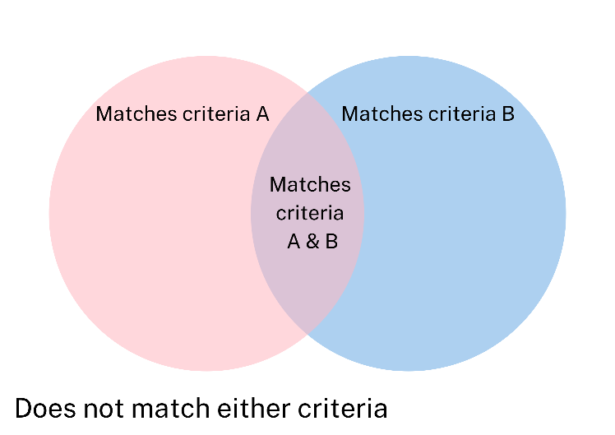
- Use Resource 7: Shape attribute sort to investigate the different attributes of shapes. Ask students to describe an attribute that might help to group some of the shapes together. Make a list of possible attributes for sorting on the board.
- Demonstrate the use of a Venn diagram. Select 2 attributes to label each ring. Record these on sticky notes and place each one in a ring.
- Present each shape to students and use ‘Talk moves’ to facilitate the class in sorting each shape into the Venn diagram.
- Students work in stage-based pairs. Provide Early Stage 1 pairs with 2 hoops or plates and a collection of items or loose parts.
- Provide Stage 1 students with Resource 7: Shape attribute sort and a copy of Resource 8: Venn diagram. Students write 2 attributes and record these on sticky notes in each ring. They cut out shapes and work together to sort shapes into the Venn diagram.
- Record students’ sorting processes using a digital tablet by taking notes, photographing, or videoing students’ work to use for assessment data.

Consolidation and meaningful practice: Gallery walk – 15 minutes
- Take students on a gallery walk to view other students’ work. Select a range of Early Stage 1 students to explain their work and explain how they used attributes to decide how to sort the shapes. Ask questions such as:
- What was it about the shapes that gave you the idea to use these attributes to sort the shapes?
- Are the attributes you chose mathematical or visual?
- Provide opportunities for Stage 1 students to explain the process of sorting in a Venn diagram, asking questions such as:
- Can you explain how a shape in the ‘both’ section of the Venn diagram shows both attributes?
- Can you prove why this shape belongs in this place in the Venn diagram?
- Does anyone have a different idea about where they might place one of the shapes in this Venn diagram? Why?
- Take photographs of students’ sorted shapes and Venn diagrams. Video the explanations that students make about the sorting process to refer to as assessment data.
- Allow students to glue shapes in place on Venn diagrams following the gallery walk discussion and display students’ work.
This table details assessment opportunities and differentiation ideas.
Assessment opportunities | Too hard? | Too easy?
What to look for:  - How do students use attributes to identify the differences between 2 sets of shapes? (MAO-WM-01, MAE-2DS-01, MA1-2DS-01)  - Are students able to complete a two-way sort? (MAO-WM-01, MAE-2DS-01)  - Are students able to sort the shapes using a Venn diagram based on attributes? (MAO-WM-01, MA1-2DS-01)  - How clearly and accurately are students able to explain their reasoning when describing the sorted shapes? (MAO-WM-01, MAE-2DS-01, MA1-2DS-01)  What to collect:  - records of students’ work (MAO-WM-01, MAE-2DS-01, MA1-2DS-01) | Students find it difficult to define categories based on attributes and sort shapes.  - Select 2 or 3 shapes and discuss what is similar and different between the shapes to identify comparative attributes.  - Provide labels for sorting, worded as closed questions, and ask the question for each shape.  Students are unable to use accurate attribute language to explain reasoning for sorting shapes.  - Model language to students using shapes to demonstrate accurate use of vocabulary.  - Select one attribute to focus on and ask questions to explore that attribute with a group of shapes. | Students quickly and accurately sort shapes.  - Provide an opportunity for Early Stage 1 students to sort their collection using a Venn diagram.  - Ask Stage 1 students to add a third circle and attribute to the Venn diagram to extend the sort.  - Ask students to justify why they have placed specific shapes within specific regions of the Venn diagram, for example, why does this shape meet both criteria?

Lesson 5: Attribute adventures
Core concept: Relationships between objects and numbers can be explored by comparing attributes.
The table below contains suggested learning intentions and success criteria. These are best co-constructed with students.
Learning intentions | Success criteria
All students are learning that:  - numbers and objects have attributes which can be used to describe and sort them  - collections of numbers and objects can be sorted and classified in different ways  - relationships between attributes of numbers are a type of pattern. | All students can describe similarities and differences using attribute language.  In addition, students working towards Early Stage 1 outcomes can:  - sort a collection of items and follow with a further sort to create several categories of items  - describe the attributes used to sort a collection  - describe the attributes that are different between 2 items.  In addition, students working towards Stage 1 outcomes can:  - identify and explain patterns and relationships between numbers in a recorded count  - identify and explain attributes of numbers  - analyse numbers 0-120 based on simple attributes.

Daily number sense: Counting with monsters – 20 minutes
This activity has been adapted from Franke et al. (2018) and Choral Counting by Teacher Education by Design (TEDD).
- Build Early Stage 1 students’ understanding of how to accurately count and represent quantities by creating matching sets of items.
- Provide Early Stage 1 students with modelling clay, googly eyes, and loose parts such as matchsticks or pipe cleaners. Provide students with Resource 9: Monster making cards.
- Allow students time to create monsters to match the challenges on each card, similar to Figure 6.
Figure 6 – Monster creations
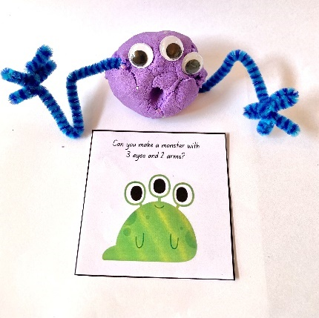
- Photograph samples of modelling clay monsters with the card using a digital tablet.
- Build Stage 1 students’ understanding of number patterns and relationships by choral counting.
Note: Choral counting activities involve the whole class counting with you as you record the count in a strategic way to support student discussion of emerging patterns in the count. To establish an effective choral counting routine, lead students to count in unison to match the pace of a visible, written record of the count.
- While Early Stage 1 students create modelling clay monsters, lead Stage 1 students in a choral count beginning at 87 and continuing to 122. Record each numeral in rows of 10, allowing a clear space between each numeral, as shown in Figure 7.
Figure 7 – Choral counting
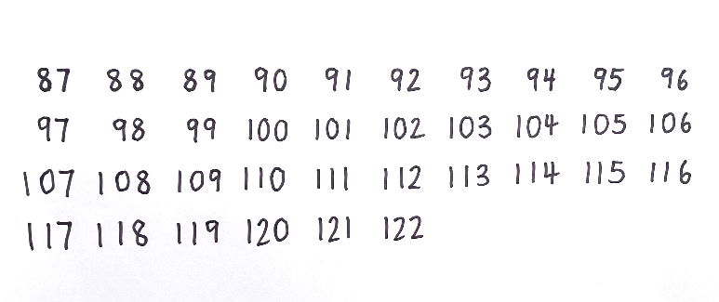
- Ask what students notice, using further questions to prompt discussion. Use coloured markers to record what students notice about patterns, similar to Figure 8.
Figure 8 – Patterns in choral counting
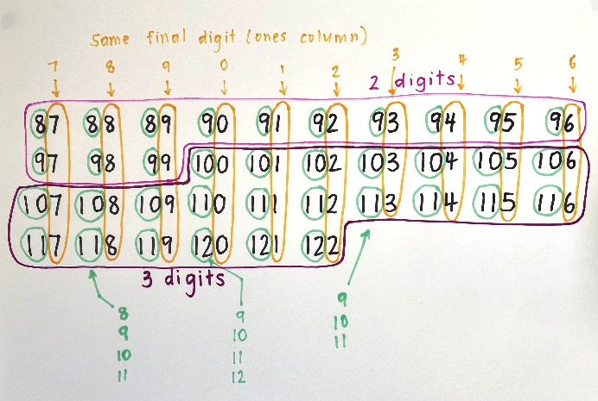
The table below outlines stimulus prompts to generate conversation about the topic, along with anticipated responses from students.
Prompts | Anticipated student responses
- What changes do you notice in the numbers?  - What stays the same?  - Where can you see some similarities?  - Can you describe any patterns that you see?  - Is that pattern happening anywhere else?  - What do you think would come next? | - Some of the numbers at the beginning of the count have 2 digits and after that all the numbers have 3 digits.  - Each row has 10 numbers.  - The numbers go up by one each count.  - The final digit in the ones column, going down each column, is the same. Seven in this column, then 8 in the next column and so on.  - Each column has a counting pattern at the beginning of each number going down – 8, 9, 10, 11, 12.  - It goes up by 10 each row that you go down.
- Draw an empty box below the number 116 and ask students which number they predict would go there. Students place a thumb up on their chest when they have worked it out.
- Select a student to share their answer and ask other students if they had the same answer. Ask the student to explain how they worked out their answer.
- Use ‘Talk moves’ to guide students in a discussion about their reasoning and allow students to revise their thinking.
- Ask if anyone had a different answer. Repeat this process of sharing until all students have shared their answers. Observations of students’ answers and explanations can be used for assessment data.
Note: Choral counting routines help students to develop number sense. Students build meaningful connections between spoken number word with the assigned symbolic notation recorded carefully by the teacher to support understanding.
- Invite Early Stage 1 students to share the monsters they have made. Discuss the quantities they have matched to the images.
This table details assessment opportunities and differentiation ideas.
Assessment opportunities | Too hard? | Too easy?
What to look for:  - Are Early Stage 1 students able to accurately match the quantities in the monster images in modelling clay creations? (MAO-WM-01, MAE-RWN-01)  - Are Stage 1 students able to participate in the count? (MAO-WM-01, MA1-RWN-01)  - What do Stage 1 students’ expectations of patterns in the recorded count indicate about their knowledge of number? (MAO-WM-01, MA1-RWN-01)  - Are Stage 1 students able to accurately predict a number in the count? (MAO-WM-01, MA1-RWN-01)  - What strategies do Stage 1 students use to predict a future number in the count? (MAO-WM-01, MA1-RWN-01)  What to collect:  - photographs of Early Stage 1 student work (MAO-WM-01, MAE-RWN-01)  - written record of choral count (MAO-WM-01, MA1-RWN-01) | Early Stage 1 students have difficulty accurately counting quantities to create matching monsters.  - Ask the student to place one loose part on top of each body part on the card to match the quantity, before attaching the pieces to the modelling clay model.  - Ask students to point to each body part and count in unison to support accurate counting to 5.  Stage 1 students have difficulty participating in the count or accurately predicting a future number in the count.  - Repeat the count in unison following the initial count.  - Select the section of the count in which students seem least confident and read through that section in unison several times for consolidation.  - Select a relevant column or row of numbers that would support prediction and read through it in unison. | Early Stage 1 students readily create accurately matching models of monsters.  - Students create a drawing of an original monster and label the number of body parts.  - Students work in pairs to suggest a quantity of body parts for a monster and create that monster.  Stage 1 students actively participate in the count and accurately predict a future number in the count.  - Ask students to explain how a predicted number continues a pattern in the recorded count.  - Create an empty box at a strategic place further along in the count or prior to the start of the count and ask students to use their understanding of patterns to predict the number.

So many ways to sort: Part A – 15 minutes
Note: Ask each student to bring in at least one pair of patterned socks prior to this lesson.
- Watch Play School's Marvellous Maths – Sort and classify with Eddie (4:48).
- Provide time for all students to Think-Pair-Share about what they have noticed or wondered.
The table below outlines stimulus prompts to generate conversation about the topic, along with anticipated responses from students.
Prompts | Anticipated student responses
- What did you notice?  - What did you wonder? | - There are socks that have 2 different lengths.  - The socks have different colours.  - The socks have different patterns.  - The piles of socks change as they are sorted.  - One attribute changes each time a new pile of socks is made.  - I wonder what would happen if they started sorting by pattern and finished sorting by length?  - I wonder how many different ways the socks could be sorted?
- Provide Early Stage 1 students with a collection of different types of socks or other items to sort and classify with a partner. After sorting items 2 ways, invite students to consider how to sort the small piles into smaller piles based on further attributes.
- Gather Stage 1 students. Write the number 52 on the board. Ask students to Think-Pair-Share to discuss what they know about this number. Allow students a couple of minutes to share their ideas with other students.
- Ask students to share ideas with the whole class. Record each new idea on the board. If necessary, prompt further thinking with targeted questioning. Explain that the features of a number are called its attributes. Write this as a title at the top of the board.
- Write the numbers 47, 7, and 117 on the board. Ask students to think about what attributes all 3 of these numbers have in common. Allow students time to Think-Pair-Share. Monitor students’ ideas and support discussion using the attributes already listed to prompt thinking.
- Ask Stage 1 students to share ideas with the group. Accept responses and use ‘Talk moves’ to explore the shared attributes of this group of numbers.

So many ways to sort: Part B – 15 minutes
This activity has been adapted from the game ‘Number Sort’ by Dacey et al. (2016).
- Review the Venn diagram structure and the 4 regions for classification.
- Select 2 of the attribute labels from Resource 10: Number attribute labels at the top of each ring and position a selection of 8 numbers from Resource 5: Number cards above the Venn diagram. Present each number to students and use ‘Talk moves’ to allow students to negotiate where the number should go in the Venn diagram, similar to Figure 9. Observations of students’ ideas and reasoning during this process will provide useful assessment data.
Figure 9 – Completed Venn diagram
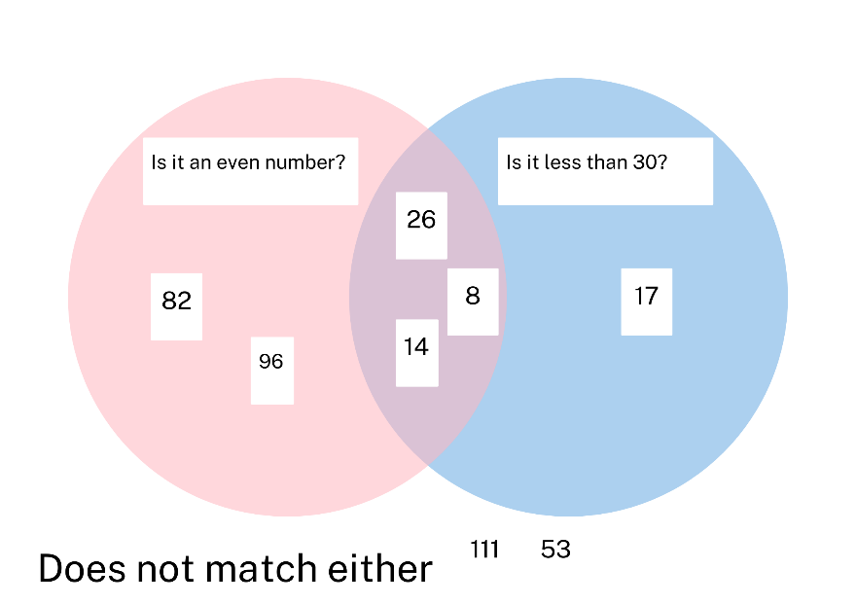
- Discuss the relationships between the numbers in each section of the Venn diagram, based on similar or different attributes.
- Place a new selection of numbers in the Venn diagram and turn attribute labels face down at the top of each circle, as shown in Figure 10.
Figure 10 – Attribute Venn diagram
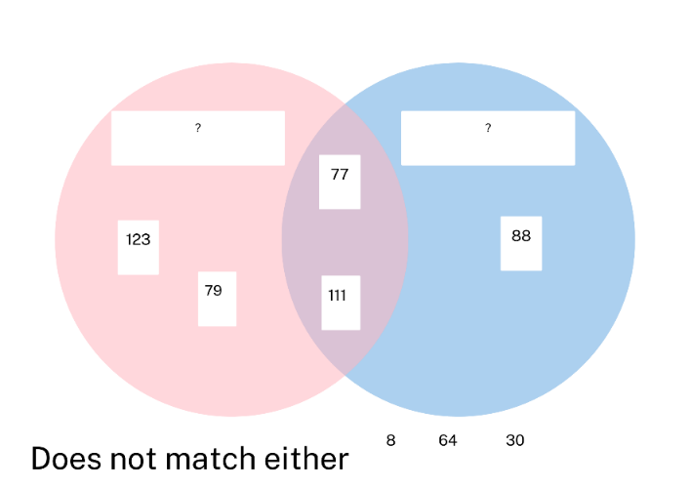
- Point out the ring on the left and ask students how the numbers in the ring are all alike. Students share ideas and use ‘Talk moves’ to share reasoning. Compare numbers in the other regions of the Venn diagram to confirm or challenge suggestions.
- Repeat this process for the ring on the right, using the numbers in the other regions to confirm or challenge suggestions.
- When students share a strong consensus for the label of the attributes, turn the attribute cards over. Discuss student ideas in comparison with the labels and use the displayed numbers to consolidate understanding of the labelled attributes.
This table details assessment opportunities and differentiation ideas.
Assessment opportunities | Too hard? | Too easy?
What to look for:  - Are Early Stage 1 students able to sort items into two groups and develop a further category to sort two groups into smaller groups? (MAO-WM-01, MAE-DATA-01)  - What attributes and strategies do Early Stage 1 students use to guide the sorting of items? (MAO-WM-01, MAE-DATA-01)  - Are Stage 1 students able to analyse a sorted collection of numbers to identify a common attribute? (MA1-RWN-01, MA1-DATA-01, MA1-DATA-02, MAO-WM-01)  - What strategies do Stage 1 students use to compare relationships between numbers based on attributes? (MA1-RWN-01, MA1-DATA-01, MA1-DATA-02, MAO-WM-01) | Early Stage 1 students find it difficult to manage sorting and re-sorting items in a collection.  - Ask students to focus on a two-way sort at any one point in the process of sorting.  - Brainstorm a list of possible attributes students could choose from to support the sorting process.  Stage 1 students find it difficult to identify attributes of numbers.  - Provide students with one number at a time to analyse against one attribute.  - Model and explain the attributes, using language that supports understanding. For example, the number 18 can be shared into 2 groups evenly, so it is an even number. | Early Stage 1 students can sort items in a variety of layered sorting processes.  - Add further items to the collection to sort.  - Ask students to explain the connections between several items in the collection and why this is evident in the way they have sorted the items.  Stage 1 students accurately sort all numbers into a Venn diagram.  - Students use more than one attribute to guide the sort in each ring.  - Students develop further attributes to guide the sort.  - Pairs of students turn over attribute labels and analyse their partner’s sort to establish the label for each ring.

Consolidation and meaningful practice: Let’s sort! – 15 minutes
- Provide each Stage 1 student with a copy of Resource 8: Venn diagram, Resource 10: Number attribute labels and Resource 5: Number cards.
- Students select 2 attribute labels and paste one in each ring. Students cut out a minimum of 8 numbers to sort into the 4 regions of the Venn diagram.
- Students work in pairs to peer review one another’s number sort before gluing numbers in place.
- Whilst Stage 1 students work on Venn diagram sort, gather Early Stage 1 students. Ask questions to provide opportunities for students to describe the ways they have sorted the collections of items, such as:
- What was one way you sorted your items?
- What was a different way you sorted your items?
- How many ways were you able to sort the items?
- Can you describe a way you were able to sort in 2 ways and then sort the 2 groups into further categories?
- Use ‘Talk moves’ to discuss the ways in which they have sorted the collections of items. Photograph or video students’ sorted collections as assessment data.

Lesson 6: Counting collections
Core concept: Mathematicians use techniques and tools to support accurate counting.
The table below contains suggested learning intentions and success criteria. These are best co-constructed with students.
Learning intentions | Success criteria
All students are learning that:  - to count a collection accurately by ones, one number name is allocated to each individual item (one-to-one correspondence)  - organising objects into groups of 10 can help count large collections  - smaller parts within 10 remain constant and can be used to create groups of 10. | All students can organise and count a collection accurately.  In addition, students working towards Early Stage 1 outcomes can count groups of at least 5 items using one-to-one correspondence.  In addition, students working towards Stage 1 outcomes can identify quantities that combine to make 10 to organise a count in groups of 10.

Daily number sense: How many in your cup – 15 minutes
- Build student understanding of counting quantities by filling a cup with a series of additive quantities.
- Provide pairs of students with a paper cup, a die, and a collection of loose parts. Students spend 10 minutes taking turns to roll the die and counting out the corresponding number of objects into the paper cup.
Note: Consider providing larger loose parts for Early Stage 1 students and smaller loose parts for Stage 1 students so they can fill cups at different rates. Early Stage 1 students should be able to fill a cup with fewer than 10 items.
- Once the students have filled the cup, each Stage 1 student estimates how many objects are in the cup then checks their estimation by counting. Students compare the counted total with the estimation to work out who was closest, using a number chart or number line to support the comparison.
Note: Early Stage 1 students should begin by establishing the ability to count to 5 with one-to-one correspondence. Some students may require support to meaningfully count to quantities larger than 5 with accuracy. Provide a ten-frame for students to place one item in each window as they count to support one-to-one correspondence.
- Circulate amongst students and make notes or video student work using a digital tablet to record the strategies used to estimate and count quantities for assessment data.
This table details assessment opportunities and differentiation ideas.
Assessment opportunities | Too hard? | Too easy?
What to look for:  - Are students counting their objects using one-to-one correspondence? (MAE-RWN-01)  - What strategies do students use to estimate the total quantity in the cup? (MAO-WM-01, MA1-RWN-02, MA1-CSQ-01)  - Are students able to accurately count the objects in the cup? (MAO-WM-01, MA1-RWN-02, MA1-CSQ-01)  What to collect:  - photographs of the students’ work. (MAO-WM-01, MAE-RWN-01, MA1-RWN-02, MA1-CSQ-01) | Early Stage 1 students are not able to count items using one-to-one correspondence.  - Provide a smaller quantity or larger items so that students are required to count under 5.  - Count larger quantities in unison, pointing to every object being counted and saying the next number with each new movement.  Stage 1 students are not able to accurately estimate and count collections.  - Pour contents of cup out and count out 10 items and compare with larger quantity, to support estimation strategies.  - Provide ten-frames or hundreds grid to support the count. | Early Stage 1 students can count items with accurate one-to-one correspondence.  - Ask students to estimate the quantity of similar items in another cup before counting.  - Ask students to count the contents of another cup with a larger quantity of items inside.  Stage 1 students estimate with relative accuracy and readily count the items in the cup.  - Ask students to calculate the difference between their own estimation and that of their partner.  - Ask students to calculate how many more or less they would need to the nearest 10 or 100.

Organising and counting a collection – 25 minutes
This activity has been adapted from Boaler et al. (2021) and Counting Collections by Teacher Education by Design (TEDD).
Counting collections is an instructional activity which provides a structured opportunity for students to explore methods of counting, organising, and recording a count for a collection of items. Students can apply counting to a context, explore and discuss the base-ten structure of the counting system, and develop efficient skills in counting.
- Provide Stage 1 students with counting collections of 50-150 and Early Stage 1 students with collections of 10-20.
- Provide students with a selection of tools that might support counting, such as sets of Resource 14: Ten-frame, patty pans, cups, bowls, rubber bands, Resource 12: Place value chart, grids, and number charts.
Note: Counting collections are sets of items which can be stored in snap-lock bags or boxes. The quantity of items varies in each collection to suit the counting range being explored by students. A selection of items such as natural materials, craft materials, recycled items, and stationary products stored for regular counting routines supports ongoing counting investigations.
- Students work in pairs and select a collection to count. Ask students to estimate how many may be in the count. Ask students:
- How many would be just a bit too high?
- How many would be just a bit too low?
- Demonstrate how to mark these 2 quantities on an empty number line as the range for estimation and discuss the quantities that come between these 2 numbers as possible estimations. Ask students to turn and talk with a partner about what a likely estimate may be in the range they have established.
Note: Selecting an estimation range supports students to develop strong number sense. Students will often select a wide range for ‘too high’ and ‘too low’ as an estimation range. Support students’ reasoning and encourage considered adjustments to the range to demonstrate that mathematicians adjust their ideas as they problem solve.
- Ask students to count their collection and organise it as they count to support keeping track of the count.
- Students record what they have counted to share with others after the count.
- Circulate amongst students to observe and record the strategies students use to count, organise, and record the collection as they count. Ask questions of pairs, such as:
- Why have you decided to count your collection that way?
- How are you keeping track of what you have already counted?

Consolidation and meaningful practice: Discussing the count – 15 minutes
- Bring students back together to discuss counting, organising, and recording strategies. Select students to share the methods used. Ask questions, such as:
- How many objects do you think are in your collection?
- Can you describe the way you arranged the items as you counted?
- How did you count your collection and why? For example, did you count by ones, groups of fives or tens, or some other way?
- Is there a way we could look at the way you have arranged your counted items to confirm your count?
- How did you record your count?
- How does your recording help us to see the way you counted?
- Record student thinking using Resource 11: Counting collections anchor chart.
- Ask students to Think-Pair-Share and describe ways to improve the count. Ask a selection of students to share one idea with the class and add ideas to the anchor chart.
This table details assessment opportunities and differentiation ideas.
Assessment opportunities | Too hard? | Too easy?
What to look for:  - How close are students’ estimations of the quantity prior to counting? (MAO-WM-01, MAE-RWN-01, MA1-RWN-01)  - Are students accurately counting the quantities in their collections? (MAE-RWN-01, MAE-RWM-02, MA1-RWN-02, MAO-WM-01)  - How are students organising their count? (MAE-RWN-01, MAE-RWM-02, MA1-RWN-02, MAO-WM-01)  - What strategies do students use to record the count? (MA1-RWN-02, MAO-WM-01)  What to collect:  - photos of student work. (MAE-RWN-01, MAE-RWM-02, MA1-RWN-02, MAO-WM-01) | Students find it difficult to organise the collection and count accurately.  - Demonstrate the tools available for supporting the count and discuss ways these tools could support the organisation of the count.  - Suggest students move items from one place to another when counting to support tracking the count. | Students can organise their objects into consistent groups and keep track of objects counted.  - Give Early Stage 1 students a larger collection and encourage them to group items in tens.  - Ask students to estimate the groups of tens before they count the items.  - Ask students to describe how they can prove the quantity they have counted is correct.

Lesson 7: Organising a collection for counting
Core concept: Organising items in a count helps us to count accurately.
The table below contains suggested learning intentions and success criteria. These are best co-constructed with students.
Learning intentions | Success criteria
All students are learning that:  - mathematicians use tools to support accuracy  - 10 ones can be grouped to make one 10  - the place a digit holds in a numeral indicates the quantity it represents  - numbers can be placed in ascending and descending order. | All students can use mathematical tools to support counting with accuracy.  In addition, students working towards Early Stage 1 outcomes can arrange counted items in a ten-frame.  In addition, students working towards Stage 1 outcomes can:  - organise items in groups of 10 to support accurate counting  - represent a counted collection on a place value chart  - order two-digit numbers in ascending order  - describe and compare the size of quantities under 100.

Daily number sense: Counting with monsters – 15 minutes
- Build student understanding of how to represent different quantities by creating monsters with modelling clay.
- Provide all students with modelling clay, googly eyes, and loose parts such as matchsticks or pipe cleaners.
- Provide Early Stage 1 students with Resource 9: Monster making cards.
- Allow students time to create monsters to match the challenges on each card, similar to Figure 11.
Figure 11 – Monster creations
- Photograph samples of modelling clay monsters with the card using a digital tablet.
- Provide Stage 1 students with the following monster-making challenge:
I see 20 eyes staring at me.
I see 30 legs marching towards me.
I see 10 tongues wiggling at me.
I see 40 arms waving at me.
It’s a herd of matching monsters!
- Ask students to use the clues to work out answers to the following questions:
- How many monsters could there be?
- What would one monster look like?
- Gather students together to share the monsters they created and ask questions to allow students opportunities to share strategies for how they problem-solved the monster-making challenges.

Organising, counting, and recording a collection – 20 minutes
This lesson has been adapted from Boaler et al. (2021) and Counting Collections by Teacher Education by Design (TEDD).
- Provide Stage 1 students with counting collections of 50-150 and Early Stage 1 students with collections of 10-20.
- Provide students with a selection of tools that might support counting, such as sets of Resource 14: Ten-frame, patty pans, cups, bowls, rubber bands, Resource 12: Place value chart, grids, and number charts.
- Review the Resource 11: Counting collections anchor chart established in the previous lesson.
- Students work in pairs matched to stage levels. Ask students to select a collection to count and tools that could support the organisation of their count. Provide students with writing materials to record their count.
- As students work, circulate, and observe the methods students use to count and record the count. Record observations of students’ counting and recording processes.
- Support students to cooperate to share the counting process and make decisions around the recording of the count.
Note: Allow Early Stage 1 students to use large pieces of paper to organise items and make marks or press stamps alongside each item to represent a record of the count.
- Use questions to develop students’ counting strategies and capacity to work together mathematically, such as:
- Is there a way you can count together?
- How can you record this count so somebody else can see how you counted it?
- How might someone else be able to check your count by looking at the way you organised the count?
- Once students have finished counting and recording, gather the class and ask questions, such as:
- How did you organise the objects in your collection for counting?
- Can you describe what tools you used to help you organise your objects?
- How did you count your objects after they were organised?
- Was there a strategy you used that made it quicker or easier to count your collection?
- Did your partner agree with the final count and how did you check?
- Could someone else look at how your collection is arranged after you counted it and quickly identify the size of the collection?
- Present students with Resource 12: Place value chart. Ask students if they know how you could arrange the items on this place value chart. Use student responses to arrange a set of items less than 10 on the place value chart in the ones column.
- Ask Stage 1 students to explain why more than 10 is not represented in the ones column of a place value chart.
- Select a larger collection where students have organised the items in groups of 10 and have remaining ones. Alternatively, count a collection as a class, grouping sets of 10 in cups or patty pans and arrange the collections on the place value chart to demonstrate the grouping of 10 ones as one group of 10.
- Ask a student to write a numeral above each column to indicate the relationship between digits and place value, as shown in Figure 12.
Figure 12 – Collections arranged on place value chart
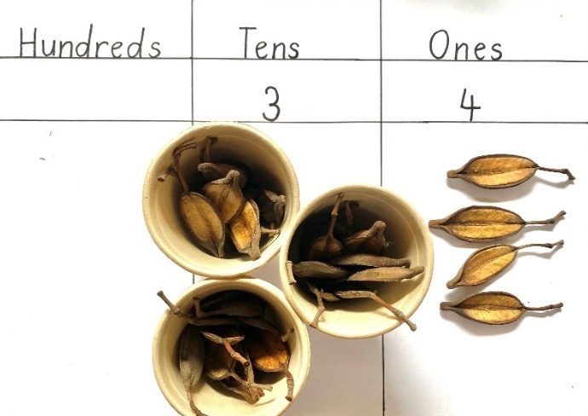
This table details assessment opportunities and differentiation ideas.
Assessment opportunities | Too hard? | Too easy?
What to look for:  - What strategies are students using to organise and count the collection? (MAE-RWN-01, MAE-RWN-02, MA1-RWN-02, MAO-WM-01)  - How are students recording the count? (MAE-RWN-01, MAE-RWN-02, MA1-RWN-02, MAO-WM-01)  - Are students able to share ideas and strategies to problem solve together? (MAO-WM-01)  What to collect:  - recordings of student observations. (MAE-RWN-01, MAE-RWN-02, MA1-RWN-02, MAO-WM-01) | Students find it challenging to accurately count and record items in the collection.  - Demonstrate the use of tools provided to support organising the count before counting. For example, place one item on each box of a number chart to keep track of the count.  - Use number charts to support numeral recording.  Students find it challenging to work together effectively on a count.  - Assist students to count in unison and move or touch items as they count.  - Suggest one person count and the second person record.  - Suggest one person count and the second person check the count. | Students accurately count the collection and record the count coherently.  - If the count is less than 100, ask students how many more there are to 100.  - If the count is more than 100, explain that another group has 65 in their count. Ask students how many more are in their count.  - Provide a larger collection for students to organise, count, and record.

Consolidation and meaningful practice: Stairs and towers – 15 minutes
This activity has been adapted from Fill the Stairs by Math for Love.
- Early Stage 1 students work in pairs. Provide each pair with at least 10 stackable items such as tissue boxes, recycled boxes, or cardboard tubes. Students work in an open space with a few spaces between each pair. Place a basket of balls next to students.
- Place small cards with numerals 0-3 written in a bag or images indicating these quantities in dot form. Each pair pulls a numeral out of the bag and uses the corresponding quantity of items to begin building a pyramid or tower. Students continue to take turns adding 0-3 items to their tower.
- When a pair reaches a total of 10 items in their built structure, they are allowed to use the following turn to take a ball, take 5 steps back from another team’s tower and roll the ball to knock another team’s tower down.
- The team with the last structure still standing is the winning team.
- Provide each student with writing materials and a blank copy of Resource 13: Fill the stairs. Choose a 0-9 die to be the tens die, and another 0-9 die to be the ones die. When both dice are rolled, students will get a one-digit or two-digit number, as shown in Figure 13.
Figure 13 – Two dice creating two-digit numeral
Note: Use a place value chart and MAB blocks to review the formation of a one-digit number when the tens die rolls a zero. Early Stage 1 students only require the MAB blocks for this activity, not the place value chart.
- The aim of the game is to write one number on each stair in ascending order.
Note: 0-9 digital dice can be located on the NRICH website in the Dice and Spinners Interactive.
- Roll the dice or die and read the number together.
- Students strategically choose a place on their staircase to write the number. Ask a few students to share where they placed this number and why.
- Repeat this process pausing every few turns to select a few students to share where they have chosen to write new numbers and why.
- As the game progresses, there may be some players who are unable to include a number in the remaining spaces on the staircase. This number is a discard number and is written under the stairs.
- The first student to fill the staircase with correctly ascending numbers is the winner.
This table details assessment opportunities and differentiation ideas.
Assessment opportunities | Too hard? | Too easy?
What to look for:  - Are Early Stage 1 students able to accurately count out matching quantities of items to match the amount on the card? (MAE-RWN-01)  - Are Early Stage 1 students able to keep track of items to 10? (MAE-RWN-01)  - Are Stage 1 students able to accurately read and write the two-digit numbers generated by the dice? (MA1-RWN-01)  - Are students able to order one-digit numbers in ascending order accurately? (MAE-RWN-01, MAO-WM-01)  - What strategies are students using to select a stair to place each numeral? (MAE-RWN-01, MAO-WM-01, MA1-RWN-01)  What to collect:  - student staircase worksheet samples. (MAE-RWN-01, MA1-RWN-01) | Early Stage 1 students are unable to match the quantities accurately.  - Pair students with a partner who is able to check the count and share roles.  - Provide number cards 1-3 for students to match items with a direct match for each number.  Stage 1 students do not accurately read and write two-digit numbers to achieve ascending order on the staircase.  - Use a place value chart or number chart to support two-digit numeral understanding.  - Use dice with fewer sides to generate numerals under 60.  - Reduce number of stairs on staircase worksheet. | Early Stage 1 students are able to match quantities accurately and build towers to 10 accurately.  - Set a higher quantity as a tower goal, such as 15 or 20.  - Students throw a ball at a tower and score a point for each item they knock down.  Stage 1 students can efficiently and accurately write numbers to achieve ascending order.  - Extend the number of stairs on the staircase worksheet.  - Students can use 3 dice and make the stairs numbers three-digit numbers.  - Ask students to explain how they know that number is bigger than this one.

Lesson 8: Quantifying collections
Core concept: Collections can be quantified, organised, and represented in different ways.
The table below contains suggested learning intentions and success criteria. These are best co-constructed with students.
Learning intentions | Success criteria
All students are learning that:  - quantities can be represented to help see, understand, and compare them  - quantities can be organised to clearly identify the smaller parts within the whole  - the digits in three-digit numerals represent groupings of hundreds, tens, and ones  - numbers can be ordered by ascending and descending quantities. | All students can use familiar structures to represent and name a collection of objects.  In addition, students working towards Early Stage 1 outcomes can order quantities under 5 in ascending or descending order.  In addition, students working towards Stage 1 outcomes can:  - order two-digit numbers in ascending or descending order  - make and record two-digit numbers using equipment, symbols, pictures, and words  - work with place value units and view numbers as counts of these units rather than collections of ones.

Daily number sense: Cities and stairs – 20 minutes
This activity has been adapted from Fill the Stairs by Math for Love.
- Build student understanding of how to order quantities in ascending order by building towers with Early Stage 1 and playing ‘Fill the Stairs’ with Stage 1.
- Provide Early Stage 1 students with wooden blocks or connecting bricks and a 6-sided dice with a sticker covering the 6 to represent zero. Ask students to roll the dice and build a tower with the number of bricks indicated on the dice.
- When students have spent 5 minutes rolling dice and building towers, ask students to order their towers from shortest to tallest to make a cityscape.
- Ask student to create taller towers by rolling the dice and building towers from the quantities indicated on 3 rolls of the dice in a row and add these towers to the cityscape.
- Stage 1 students work in pairs. Provide students with two 0-9 dice, writing materials, and a blank copy of Resource 13: Fill the stairs.
- Review the aim of the game and strategies required to successfully achieve the goal of the game, which is to write the numbers generated by the dice in ascending order on the staircase.
- Students play the game in pairs. As the students play, circulate amongst the students to observe the strategies students are using to choose the position of each new number. Ask questions to encourage students to explain their reasoning, such as:
- Tell me why you chose to write that number on that step?
- What number are you hoping might be rolled next? Why?
- Are there any choices you wish you made differently now? Why?

Flip and match – 15 minutes
- Provide Early Stage 1 students with a set of dominoes per pair.
- Students deal 5 dominoes to each player and place one domino in the middle.
- Players take turns placing a domino with a matching quantity with one of the domino portions on the end of the row of dominoes. If no match can be made, the player takes another domino from the stack of spare dominoes.
- The first player to use all their dominoes wins.
- Provide Stage 1 students with MAB blocks and/or craft sticks bundled in groups of 10, as well as loose single ones. Provide each Stage 1 student with a copy of Resource 12: Place value chart.
- Divide Stage 1 students into 2 teams. Students use MAB blocks or craft sticks to model a two-digit number on their individual place value chart. Select a few students and ask what number they have modelled on their chart. Observe students’ models and the quantity they name.
- Use 2 sets of Resource 15: 0-9 numeral cards and place them face down. Flip over one numeral for the tens column and one numeral for the ones column and place them on a place value chart on display.
- Read the numeral together. Ask students if anyone has a model on their chart which is the exact match of the numeral on the board. If anyone does have an exact match, they score 10 points for their team.
- Ask students if anyone has a match of one more or one less. These students score 5 points for their team.
- Ask students if anyone has a of match 2 more or 2 less. These students score 2 points for their team.
- Students model a new number and repeat the process of creating a numeral and scoring points several times.
- Introduce the third column for the final round and allow a team representative to model a three-digit number on the place value chart on behalf of their team.
- Use 3 sets of 0-9 numeral cards to flip over 3 numerals to create a three-digit numeral on the displayed place value chart.
- The team with the numeral closest to the three-digit numeral gains a bonus 10 points for their team. Ask Stage 1 students to work in pairs to work out how many more or less their team quantity is than the numeral on display.
- Ask students to share possible answers. Use ‘Talk moves’ to support explanations of thinking and reasoning until each team agrees on an accurate total.
- The team with the most points wins.
This table details assessment opportunities and differentiation ideas.
Assessment opportunities | Too hard? | Too easy?
What to look for:  - Are Early Stage 1 students able to accurately match domino dot patterns? (MAE-RWN-01, MAO-WM-01)  - Are Stage 1 students able to model two-digit quantities? (MA1-RWN-01, MAO-WM-01)  - Are students able to recognise and say the quantity modelled with MAB blocks on a place value chart? (MA1-RWN-01, MAO-WM-01)  - Are students able to identify a quantity one or 2 more or less than a two-digit number? (MA1-RWN-01, MAO-WM-01)  - What strategies do students use to work out how much more or less a quantity is than a given number? (MA1-RWN-01, MA1-CSQ-01, MAO-WM-01) | Early Stage 1 students find it difficult to accurately match quantities with one of the domino ends.  - Use a piece of card to cover over one end of each domino to isolate the number of dots to be counted.  - Remove dominoes with representations of 4, 5, or 6 and play the game with dominoes representing quantities of 3 or under.  Students find it difficult to read and/or model two-digit numerals.  - Create a sample model first and explain what each part of the model represents in a two-digit numeral, before allowing the student to create their own.  - Provide individual students with a set of numeral cards to directly label their own model with the digits that match the model for each column.  - Use a number chart to support reading and grouping of tens for two-digit numerals. | Early Stage 1 students readily and accurately match domino quantities.  - Ask students to play the game again and place a domino that is one more or one less than a domino on the end of the line.  - Ask students to turn dominoes over and play a memory match game, matching at least one domino dot pattern on the end of each domino for a pair.  Students readily create, read, and compare two-digit numerals.  - Select 2 random models and ask the students which of the 2 models is closest to the displayed numeral on the board.  - Use a third digit for the hundreds column after each round and ask students to read the numeral created.

Nim – 15 minutes
This activity has been adapted from 1-2 Nim by Math for Love. In preparation for this lesson watch Rich Task: 1-2 Nim | Lesson plan with Dan Finkel (7:53).
- Arrange 10 counters so that all students can clearly see. Explain that the game requires 2 players to take turns removing either one or 2 counters each turn. The aim of the game is to be the player who takes the last counter.
- Select a volunteer student to be your opponent and play a narrated round of the game.
- As the game progresses, pause and ask students questions such as:
- If my opponent has just taken 2, what advice would you give for my next move if I want to win?
- What would you suggest the best move is for my opponent at this stage? Why?
- Is there a strategy that you have noticed that you could use to beat me in another game?
- What can I learn from losing this game?
- What can I learn from winning this game?
- Play another 2 rounds of the game with alternative student volunteers.
- Allow students to play 1-2 Nim in pairs with 10 counters.
Note: Working through the strategies with students provides opportunities to notice patterns which contribute to a winning strategy. As students play further rounds of the game, ask them to share what they have noticed to develop a shared understanding for effective winning strategies.
This table details assessment opportunities and differentiation ideas.
Assessment opportunities | Too hard? | Too easy?
What to look for:  - Are students able to work out how many counters are taken and how many remain? (MAO-WM-01, MAE-CSQ-01, MA1-CSQ-01)  - What strategies do students suggest or apply to win the game? (MAO-WM-01, MAE-CSQ-01, MA1-CSQ-01)  - Are students able to make connections between strategies used and how to win the game? (MAO-WM-01, MA1-CSQ-01) | Students find it difficult to accurately count quantities within the range of 10.  - Provide 8 counters to play the game.  - Place the counters in a ten-frame to support recognition of quantities.  Students find it difficult to notice consistent patterns in the strategies they use to play the game.  - Play a round of the game several times, focusing on a specific strategy to allow students to notice the result the strategy has on the outcome of the game.  - Record the strategies in a table, working backwards and adding a counter each time. | Students readily notice and apply strategies to win the game.  - Ask students to record the strategies they have noticed in a table and describe the key decision-making points in a game.  - Pair students whose grasp of a winning strategy is strong and ask them to try and break their opponent’s strategy.

Consolidation and meaningful practice: Roll to the goal – 15 minutes
- All students work in stage-based pairs. Provide each pair of Stage 1 students a 0-9 die, MAB blocks, and Resource 12: Place value chart.
- Stage 1 players take turns rolling the die and creating the quantity rolled using MAB blocks on a place value chart. As subsequent quantities are added, students combine sets of 10 MAB shorts and replace them with one long to place the tens column. When 10 MAB longs are gathered in the tens column, students replace these with a flat in the hundreds column.
- Students continue to add new quantities. The first student to reach a total of 120 MAB blocks on the place value chart is the winner.
- Provide each Early Stage 1 pair with a 6-sided die with a sticker covering the 6 to represent zero. Provide each student with Resource 14: Ten-frame and set of counters or loose parts. Students roll the die and create the quantity with counters or loose parts in the ten-frame. The first student to reach 10 gets a point. Each time the frame is filled by one student, both in the pair, clear the ten-frame and begin a new round of the game.
- Circulate the room to observe students’ work and ask students questions, such as:
- How many do you have modelled on your chart or ten-frame?
- How many do you hope you will roll next? Why?
- How many does your partner need to win?
This table details assessment opportunities and differentiation ideas.
Assessment opportunities | Too hard? | Too easy?
What to look for:  - Are Stage 1 students able to recognise groups of ten and re-make groups of 10 ones with a long and a group of 10 longs with a flat? (MA1-RWN-02, MA1-CSQ-01)  - Are Stage 1 students able to recognise and name a quantity and the parts that comprise it, based on an MAB block representation? (MA1-RWN-02, MA1-CSQ-01)  - Are students able to subitise the numbers on their die? (MAE-RWN-01)  - Are Early Stage 1 students able to place the correct number of counters as their die on the ten-frame? (MAE-RWN-02)  - Are Early Stage 1 students able to combine the number of counters on their ten-frames? (MAE-CSQ-01) | Early Stage 1 students are having difficulty subitising the numbers on the die and combining the number of counters on their ten-frame.  - Ask students to point to each dot on the die and count in unison to support accurate counting to 6.  - Instead of combining the number on their ten-frame, have students roll the die and make the number on their ten-frame with their counters, then start again.  Stage 1 students are not able to explain and manipulate quantities of MAB blocks to represent quantities.  - Provide each student with a ten-frame to place inside the ones column and fill to support recognition of a group of 10.  - Use single-digit numeral cards to label quantities in each column to support understanding of two-digit numbers.  - Reduce the quantity the students are aiming for. | Early Stage 1 students can subitise numbers on a die and combine the number of counters on their ten-frame.  - Provide students with MAB blocks instead of counters and have them swap the shorts for a long every time they fill a ten-frame.  Stage 1 students accurately add and represent quantities with MAB blocks on place value chart.  - Provide students with 2 dice to roll for each turn and increase the amount they are aiming for.  - Ask students to begin with 120, modelled with a flat and 2 longs, and subtract the quantity rolled to model each new total, until they reach zero.

Resource 1: Mathematics around us
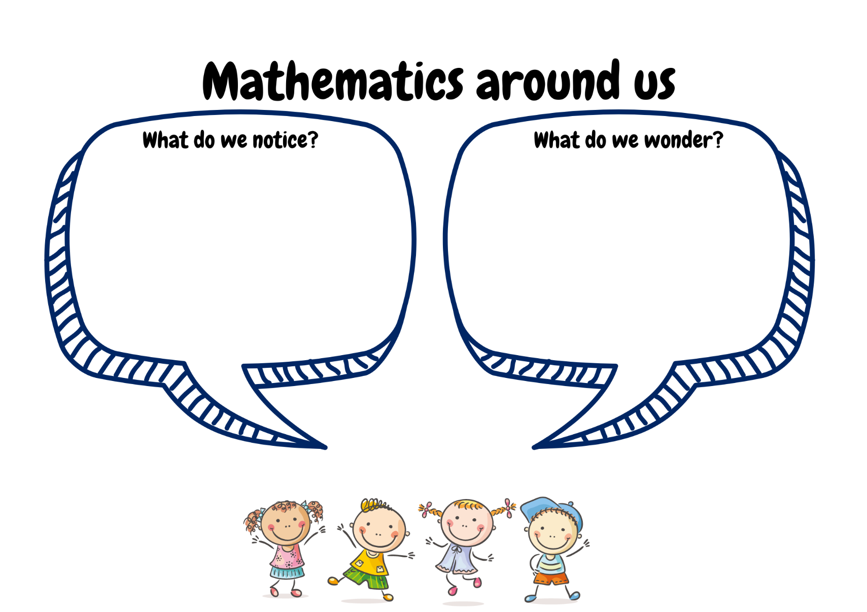
Images sourced from Canva and used in accordance with the Canva Content License Agreement.

Resource 2: Be a mathematician
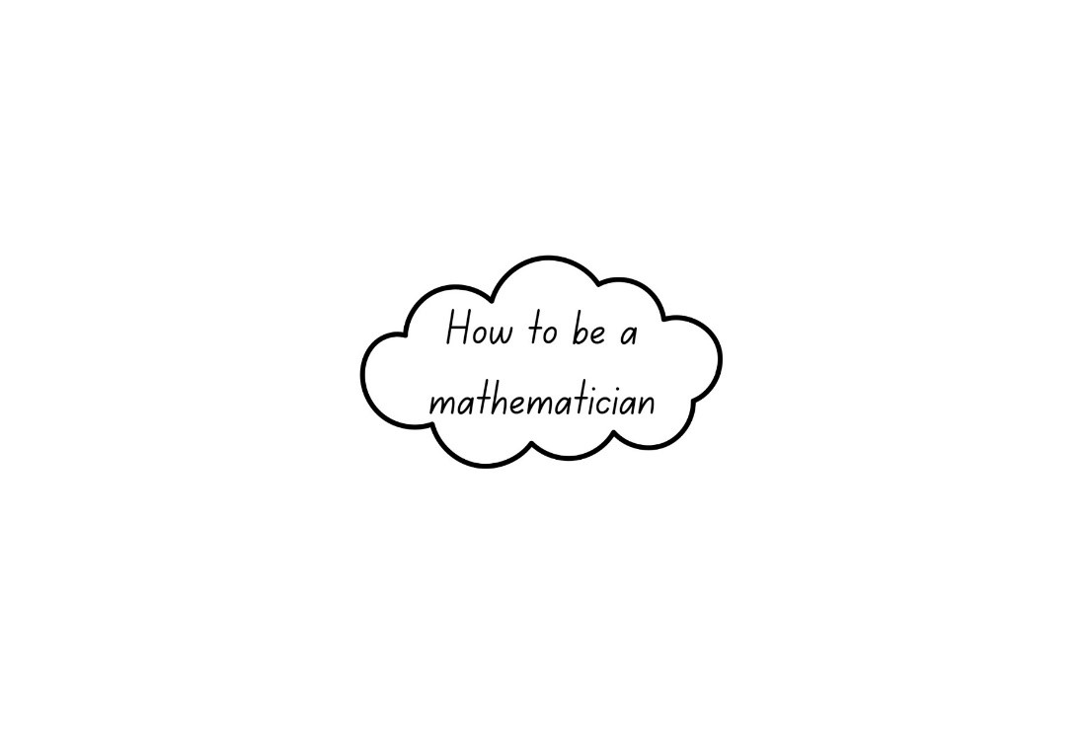

Resource 3: Dice dot patterns
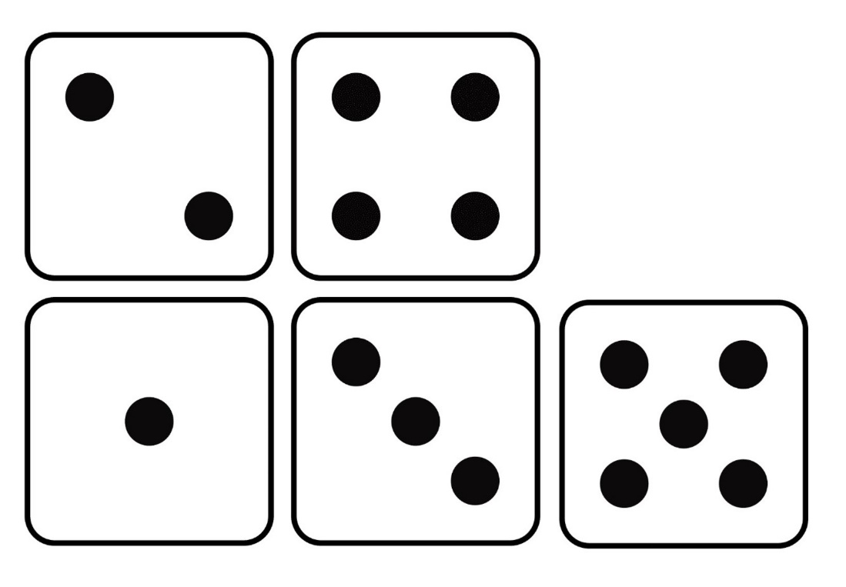

Resource 4: Triangle design shapes
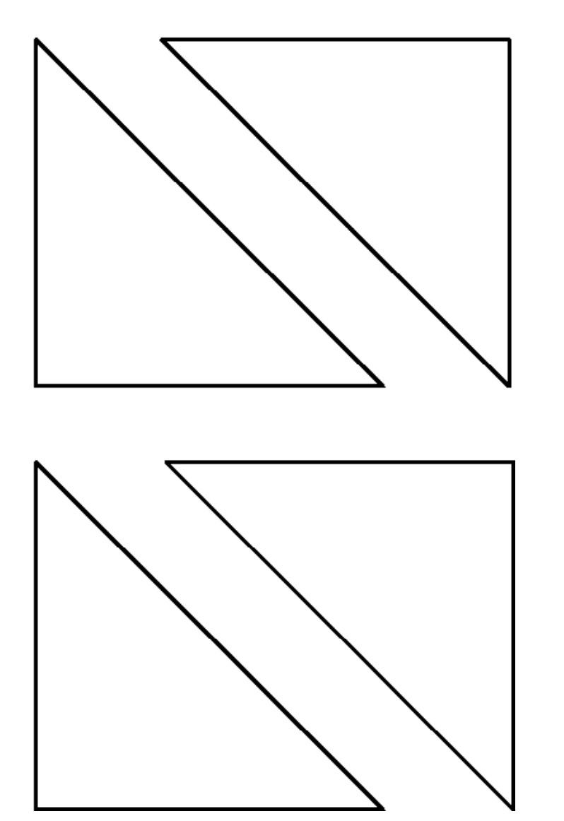
‘Triangle Designs (K-2)’ by youcubed, Stanford University is licensed under CC BY 4.0

Resource 5: Number cards
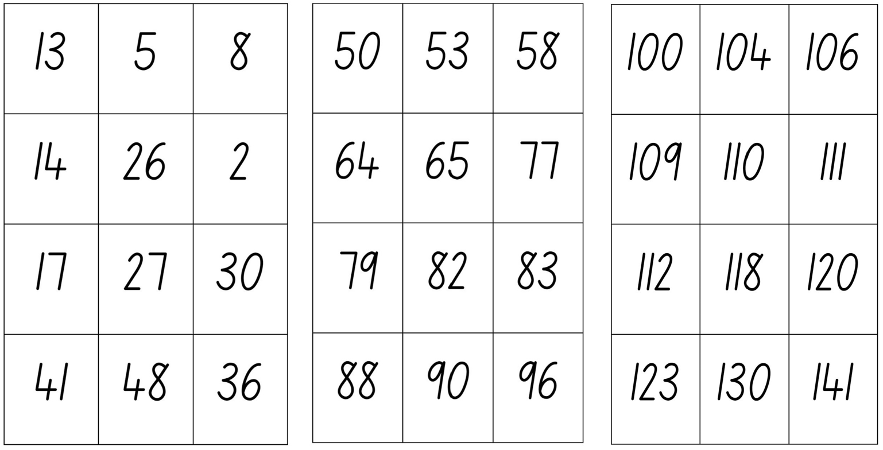

Resource 6: Which one doesn’t belong?
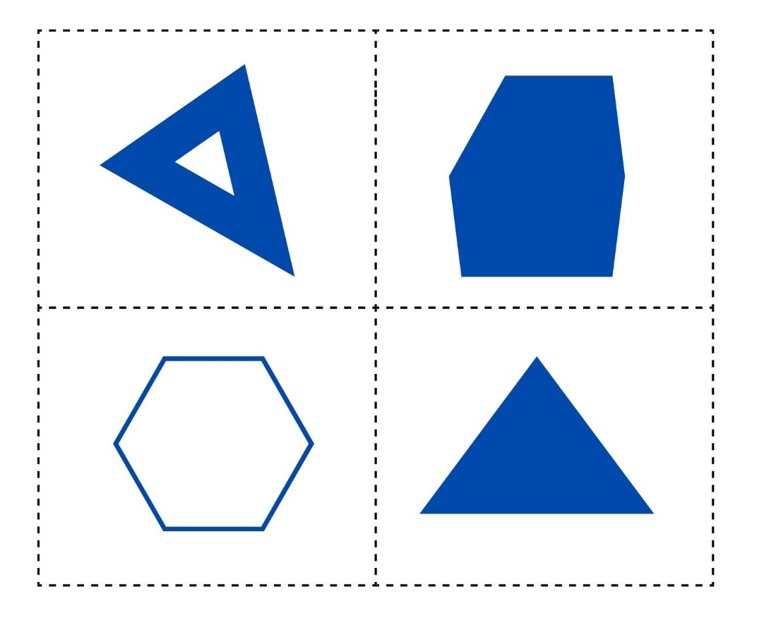

Resource 7: Shape attribute sort
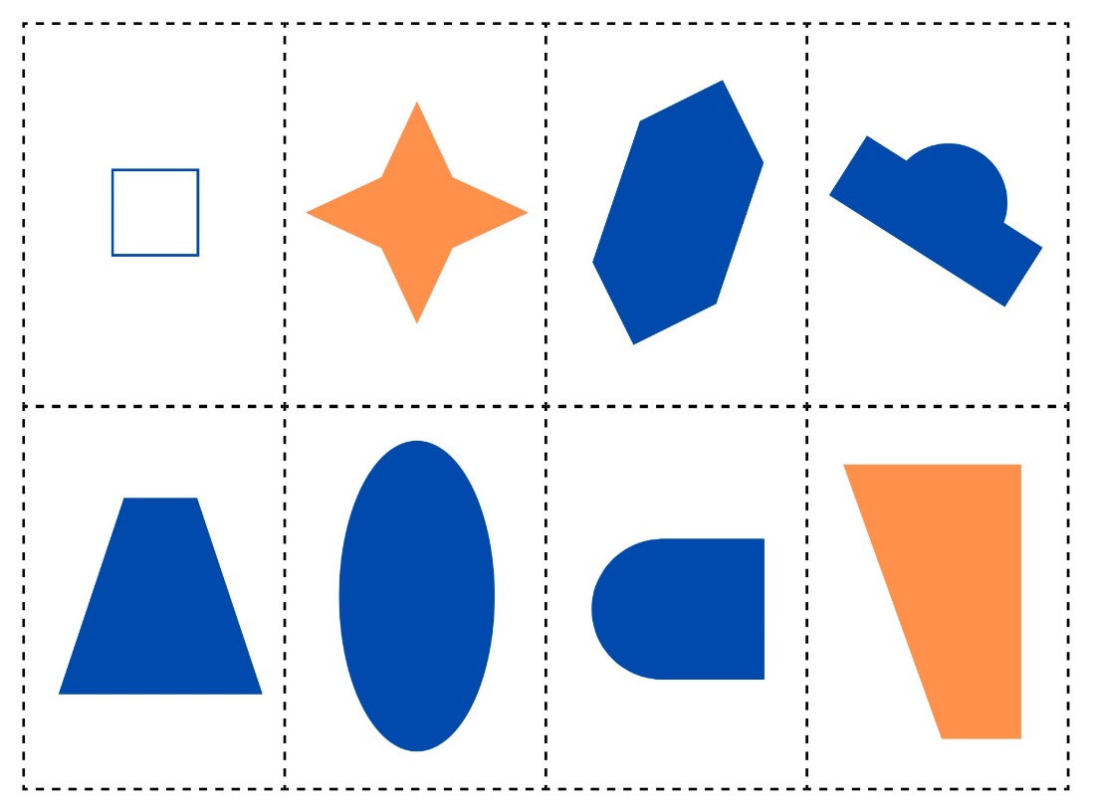

Resource 8: Venn diagram
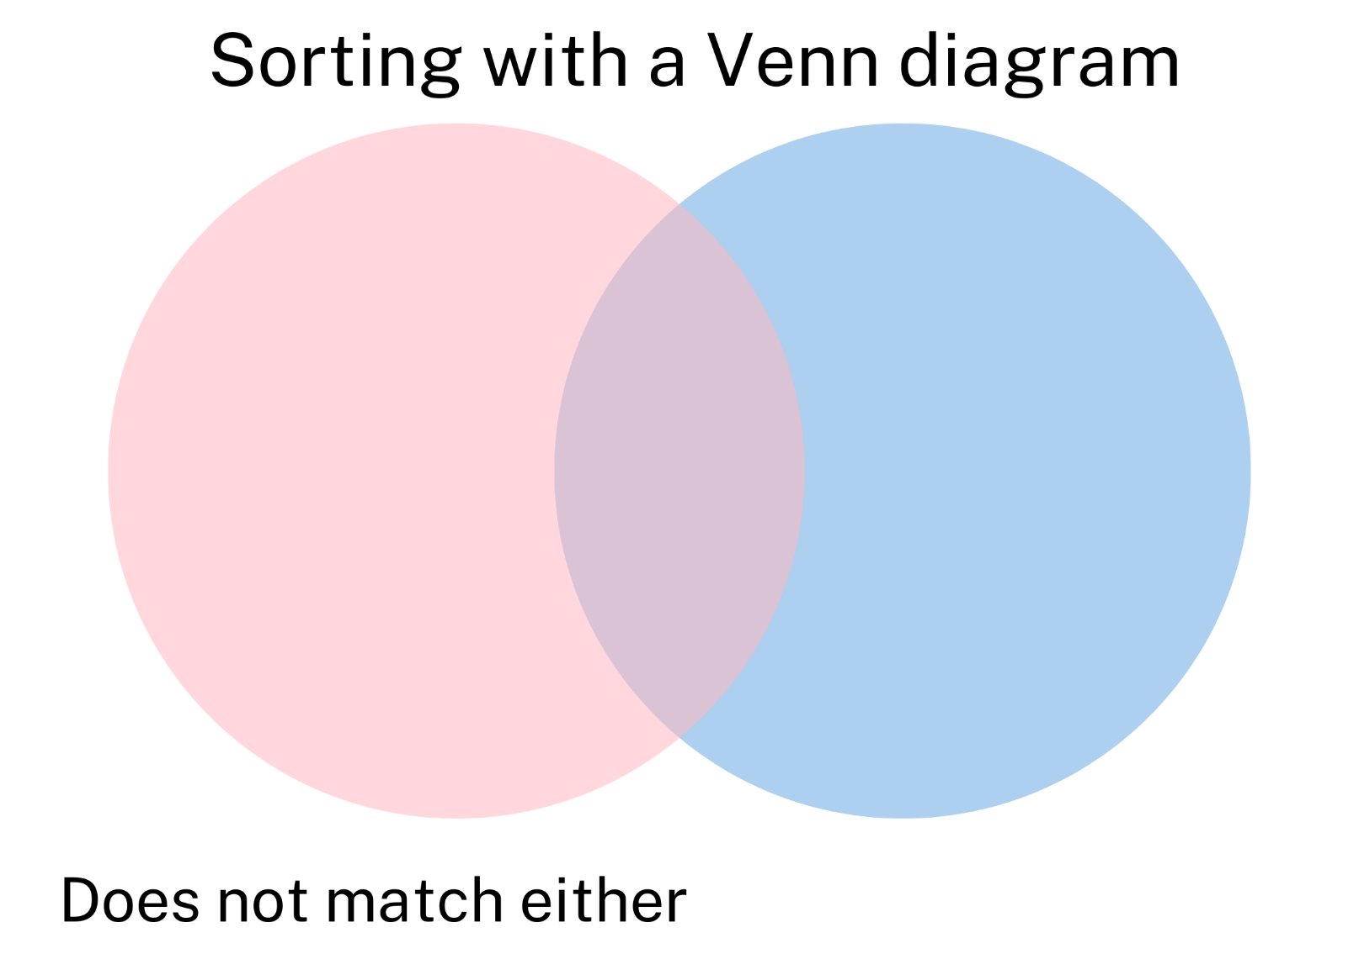

Resource 9: Monster making cards
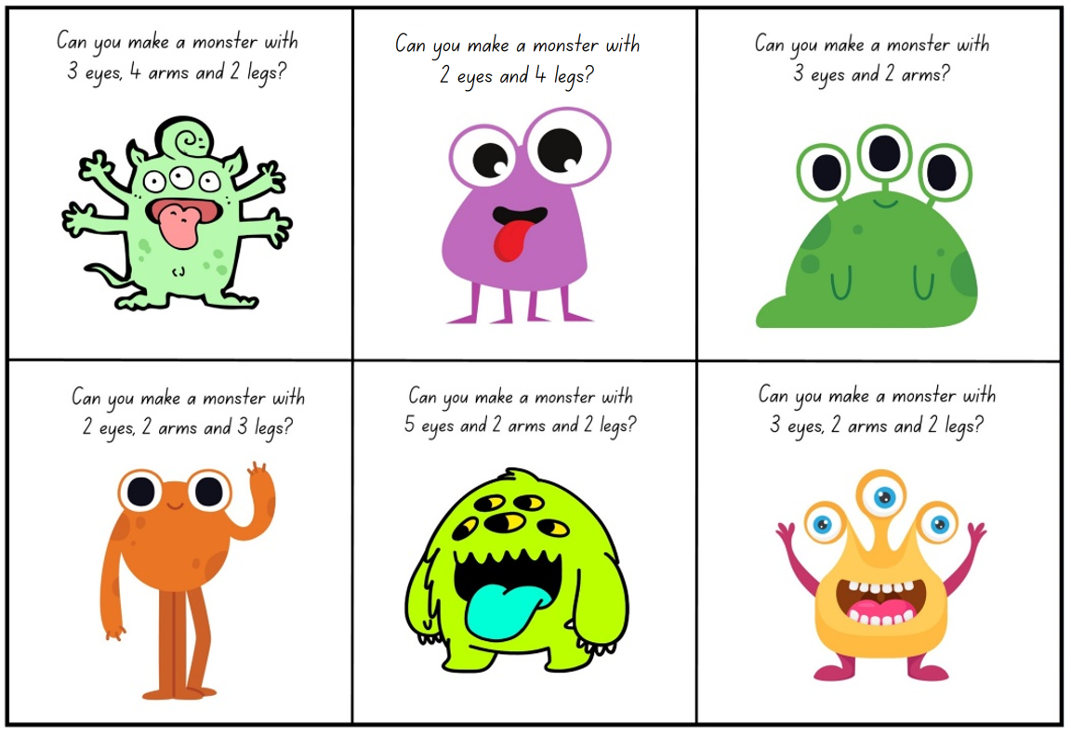
Images sourced from Canva and used in accordance with the Canva Content License Agreement.

Resource 10: Number attribute labels
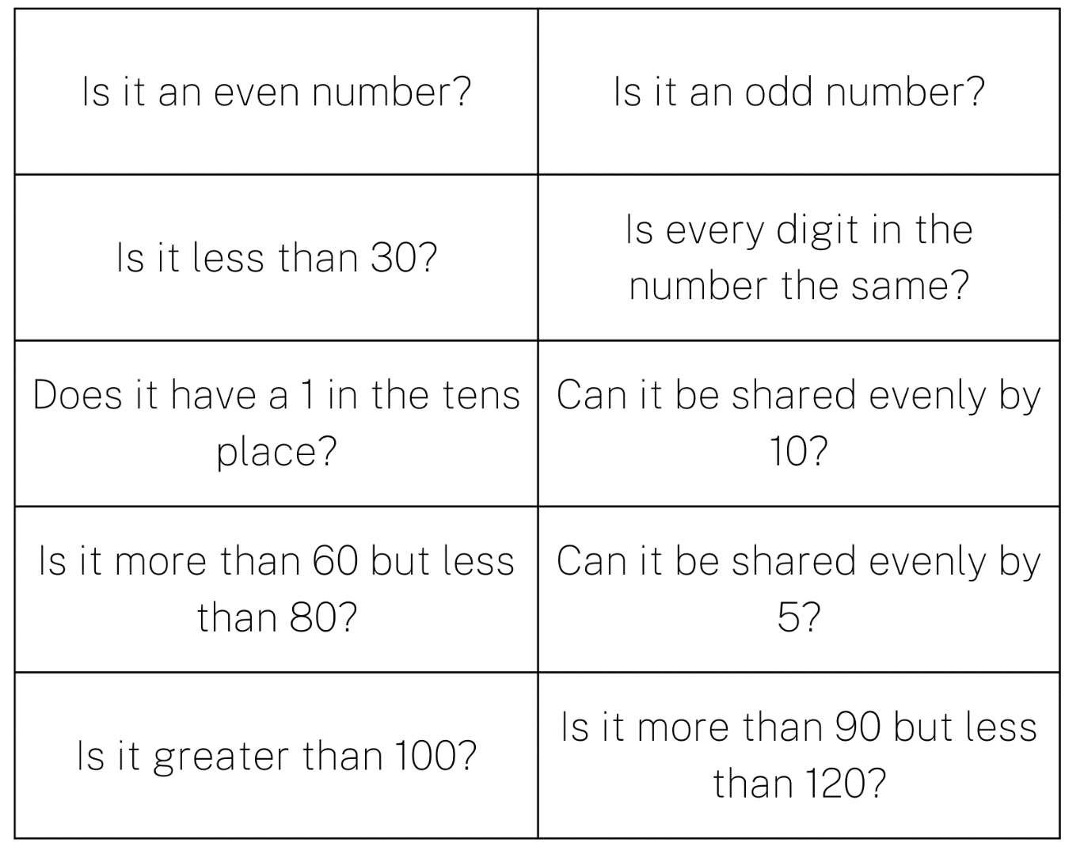

Resource 11: Counting collections anchor chart
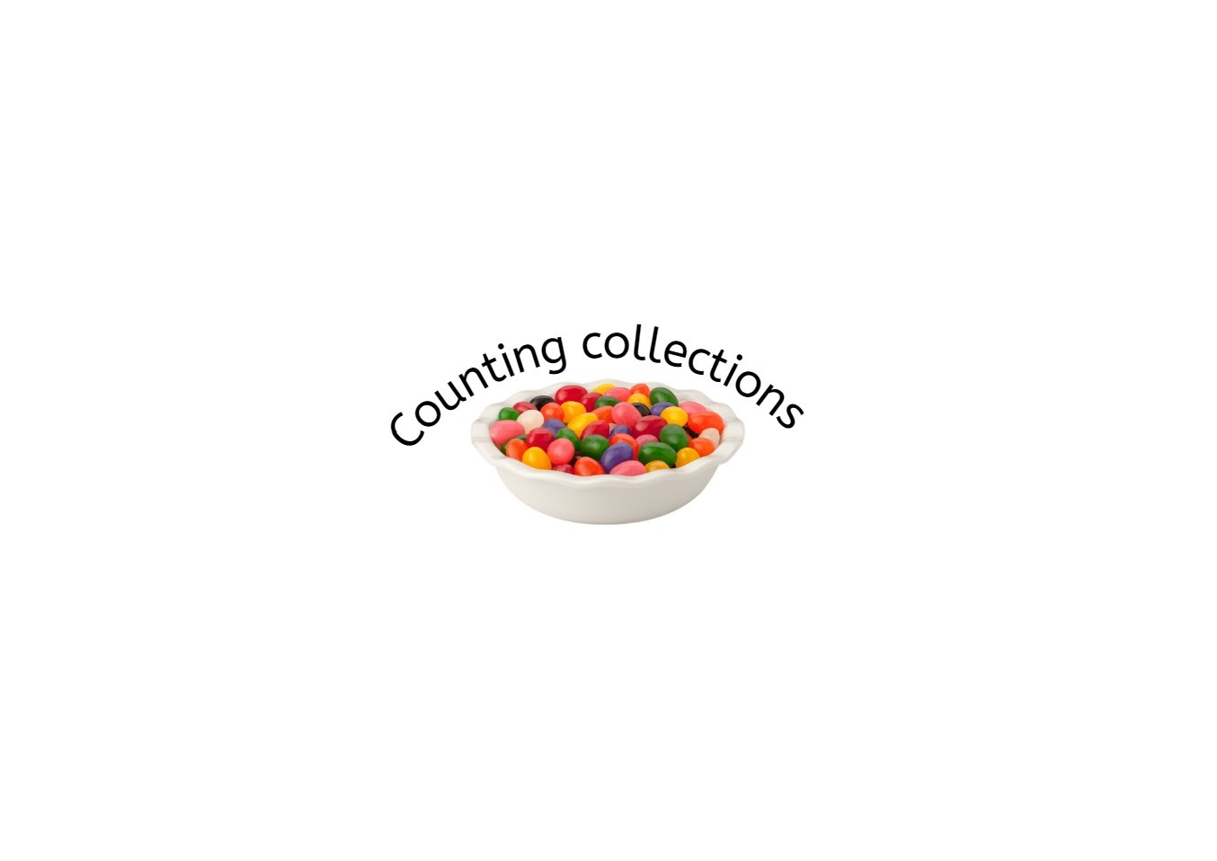
Image sourced from Canva and used in accordance with the Canva Content Licence Agreement.

Resource 12: Place value chart
Hundreds | Tens | Ones

Resource 13: Fill the stairs
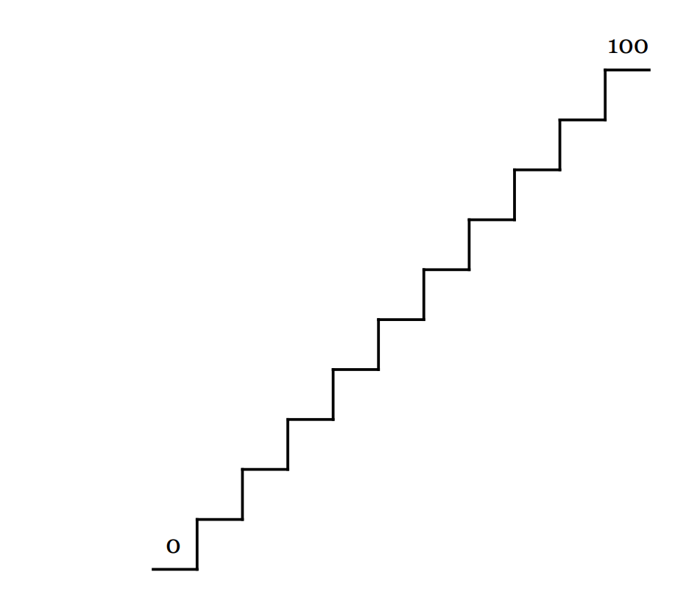

Resource 14: Ten-frame

Resource 15: 0-9 numeral cards
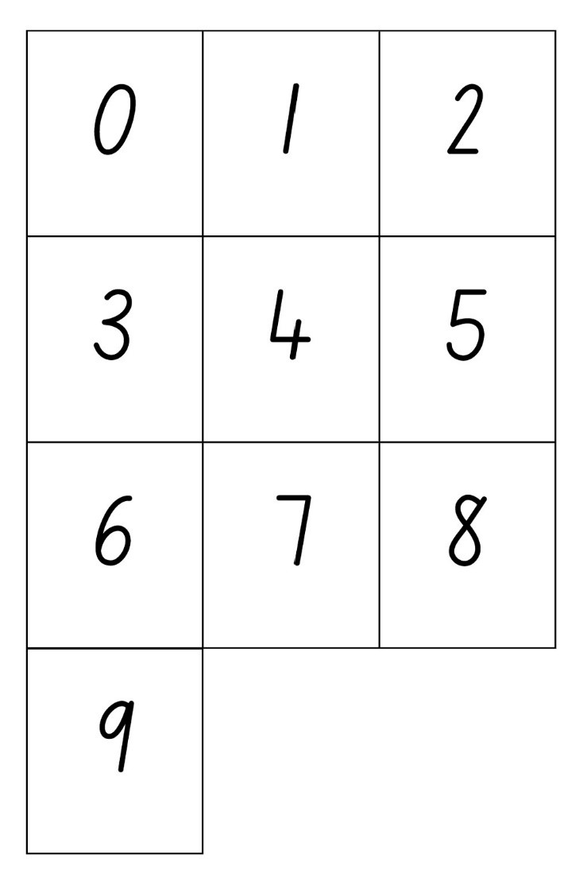

Syllabus outcomes and content
The table below outlines the syllabus outcomes and range of relevant syllabus content covered in this unit. Content is linked to National Numeracy Learning Progression version (3).
Focus area and outcomes | Content groups and content points | Lessons
Representing whole numbers  MAO-WM-01  MAE-RWN-01, MA1-RWN-01  MAE-RWN-02, MA1-RWN-02 | Early Stage 1  Instantly name the number of objects within small collections  - instantly recognise (subitise) the number of items in small groups of up to four items without counting (NPV1, CPr1)  - identify the number of items in different arrangements (CPr2) | 2, 6–8
Representing whole numbers  (cont) | Early Stage 1  Use the counting sequence of ones flexibly  - identify the number before as ‘one less’ and the number after as ‘one more’ than a given number | 4, 7
Representing whole numbers  (cont) | Early Stage 1  Recognise number patterns  - recognise dice and domino dot patterns (NPA1, NPV2, CPr2) | 2, 7–8
Representing whole numbers  (cont) | Early Stage 1  Connect counting and numerals to quantities  - count with one-to-one correspondence, recognising that the last number name represents the total number in the collection (CPr3, CPr5) | 1–2, 4-8
Representing whole numbers A  (cont) | Stage 1  Use counting sequence of ones with two-digit numbers and beyond  - count forwards and backwards by ones from a given number to at least 120 (CPr6) | 1–2, 5–8
Representing whole numbers A  (cont) | Stage 1  Continue and create number patterns  - model and describe ‘odd’ and ‘even’ numbers using items paired in two rows  - count forwards and backwards by twos from any starting point (CPr6, CPr7, MuS2) | 6, 8
Representing whole numbers A  (cont) | Stage 1  Represent numbers on a line  - sequence numbers and arrange them on a line by considering the order and size of those numbers (CPr5)  - locate the approximate position of multiples of 10 on a model of a number line from 0 to 100 (CPr5) | 4, 7–8
Representing whole numbers A  (cont) | Stage 1  Represent the structure of groups of ten in whole numbers  - recognise that ten ones is the same as one ten (NPV2, NPV4)  - count large sets of objects by systematically grouping in tens (CPr7)  - partition two-digit numbers to show quantity values (NPV4)  - estimate, to the nearest ten, the number of objects in a collection and check by counting in groups of ten (Reasons about quantity) (CPr7, NPV6) | 6–8
Representing whole numbers B  (cont) | Stage 1  Use counting sequences of one and tens flexibly  - identify the number before and after a given three-digit number  - count forwards and backwards by tens, on and off the decade, with two- and three-digit numbers (CPr7)  - identify how many more to the next multiple of ten within two- and three-digit numbers (AdS7) | 6–8
Representing whole numbers B  (cont) | Stage 1  Form, regroup and rename three-digit numbers  - count and represent large sets of objects by systematically grouping in tens and hundreds (CPr7, NPV5)  - use models such as base 10 material and interlocking cubes to represent and explain grouping (CPr7)  - state the quantity value of digits in numbers of up to three digits (NPV5)  - use place value to partition and rename three-digit numbers in different ways (Reasons about relations) (NPV5) | 5–8
Combining and separating quantities  MAO-WM-01  MAE-CSQ-01, MA1-CSQ-01  MAE-CSQ-02 | Early Stage 1  Model additive relations and compare quantities  - combine two or more groups of objects to model addition, identifying the relationship between the parts and the whole (AdS1, AdS2)  - use concrete materials or fingers to model or solve addition or subtraction questions, counting forwards or backwards by ones as necessary (AdS1, AdS2, NPV3)  - compare two groups of objects to determine how many more (Reasons about quantity) (NPV1, AdS2) | 7–8
Combining and separating quantities (cont) | Early Stage 1  Identify part-whole relationships in numbers up to 10  - use visual representations of numbers to assist with combining and separating quantities, identifying the relationship between the quantities (NPV2, AdS2, AdS3, NPA2)  - describe the action of combining, separating and comparing (AdS1) | 1–2, 6–8
Combining and separating quantities A (cont) | Stage 1  Use advance count by one strategies to solve addition and subtraction problems  - record number sentences in a variety of ways using drawings, words, numerals and symbols (AdS6) | 2, 8
Combining and separating quantities A (cont) | Stage 1  Recognise and recall number bonds up to ten  - recognise, recall and record combinations of two numbers that add up or bond to form 10 (AdS2, AdS6)  - model and record patterns for individual numbers up to ten by making all possible whole-number combinations (Reasons about patterns) | 2, 6–7
Combining and separating quantities A (cont) | Stage 1  Use flexible strategies to solve addition and subtraction problems  - use non-count-by-one strategies such as using doubles or near doubles and combining numbers that add to ten (AdS6) | 6-8
Combining and separating quantities A (cont) | Stage 1  Represent equality  - recall related addition and subtraction facts for numbers to at least 10 (Reasons about relations) (AdS6)  Represent and reason about additive relations  - create, record and recognise combinations of two numbers that add to numbers from 11 up to and including 20 (AdS7) | 2, 8
Combining and separating quantities B (cont) | Stage 1  Form multiples of ten when adding and subtracting two-digit numbers  - add two-digit numbers by building to multiples of ten (AdS7) | 6–7
Combining and separating quantities B (cont) | Stage 1  Use knowledge of equality to solve related problems  - use number knowledge to solve related problems (Reasons about relations) (AdS7, NPA4) | 8
Two-dimensional spatial structure  MAO-WM-01  MAE-2DS-01, MA1-2DS-01  MAE-2DS-02, MA1-2DS-02 | Early Stage 1  2D shapes: Sort, describe and name familiar shapes  - identify familiar shapes in a range of contexts  - sort shapes according to features such as size and shape (UGP1, UGP2)  - recognise and explain how a group of shapes has been sorted (Reasons about spatial relations)  - describe shapes, including circles, squares, triangles and rectangles (UGP1, UGP2)  2D shapes: Represent shapes  - make representations of shapes in a variety of ways, using paint, paper, movement or technology (UGP3)  - make pictures and designs using a selection of shapes | 3–4
Two-dimensional spatial structure A (cont) | Stage 1  Recognise and classify shapes using obvious features  - explore, manipulate and describe features of polygons (UGP3)  - use the terms ‘side’, ‘vertex’ and ‘two-dimensional’ to describe plane (flat) shapes (UGP1, UGP2)  - compare, sort and classify polygons according to the number of sides or vertices (UGP3, UGP4)  - recognise that shapes with the same name may have sides of equal or different lengths (Reasons about spatial relations)  - identify shapes presented in different orientations (UGP2) | 3–4
Two-dimensional spatial structure B (cont) | Stage 1  Represent, combine and separate two-dimensional shapes  - make representations of two-dimensional shapes and combinations of shapes in different orientations  - combine and split single shapes and arrangements of shapes to form new shapes (Reasons about spatial relations) | 3
Data  MAO-WM-01  MAE-DATA-01, MA1-DATA-01  MA1-DATA-02  Note: There is only one data outcome for Early Stage 1. | Early Stage 1  Respond to questions, collect information and discuss possible outcomes of activities  - predict possible responses to a question  - collect information from their peers and about their environment (IRD1)  - pose and respond to questions about the information collected (IRD1) | 1, 4 and 5
Data (cont) | Early Stage 1  Organise objects into simple data displays and interpret the displays  - group objects according to characteristics (IRD1)  - arrange objects according to a characteristic to form a data display (IRD1) | 4 and 5
Data A (cont) | Stage 1  Ask questions and gather data  - gather data and track what has been counted by using concrete materials, tally marks, lists or symbols (IRD3) | 1, 4 and 5
Data A (cont) | Stage 1  Represent data with objects and drawings and describe the displays  - use concrete materials or pictures of objects as symbols to create data displays where one object or picture represents one data value (IRD2) | 4 and 5
Data B (cont) | Stage 1  Identify a question of interest and gather relevant data  - sort data into relevant categories (IRD2) | 1, 4 and 5
Data B (cont) | Stage 1  Create displays of data and interpret them  - organise collected data into lists and tables to display information (IRD1)  - interpret information presented in tables and picture graphs (Reasons about relations) (IRD3) | 4–5

References
Links to third-party material and websites
Please note that the provided (reading/viewing material/list/links/texts) are a suggestion only and implies no endorsement, by the New South Wales Department of Education, of any author, publisher, or book title. School principals and teachers are best placed to assess the suitability of resources that would complement the curriculum and reflect the needs and interests of their students.
If you use the links provided in this document to access a third-party's website, you acknowledge that the terms of use, including licence terms set out on the third-party's website apply to the use which may be made of the materials on that third-party website or where permitted by the Copyright Act 1968 (Cth). The department accepts no responsibility for content on third-party websites.
Except as otherwise noted, all material is © State of New South Wales (Department of Education), 2021 and licensed under the Creative Commons Attribution 4.0 International License. All other material (third-party material) is used with permission or under licence. Where the copyright owner of third-party material has not licensed their material under a Creative Commons or similar licence, you should contact them directly for permission to reuse their material.
Mathematics K–10 Syllabus © 2022 NSW Education Standards Authority (NESA) for and on behalf of the Crown in right of the State of New South Wales.
© 2022 NSW Education Standards Authority. This document contains NSW Curriculum and syllabus content. The NSW Curriculum is developed by the NSW Education Standards Authority. This content is prepared by NESA for and on behalf of the Crown in right of the State of New South Wales. The material is protected by Crown copyright.
Please refer to the NESA Copyright Disclaimer for more information.
NESA holds the only official and up-to-date versions of the NSW Curriculum and syllabus documents. Please visit the NSW Education Standards Authority (NESA) website and the NSW Curriculum website.
National Numeracy Learning Progression © Australian Curriculum, Assessment and Reporting Authority (ACARA) 2010 to present, unless otherwise indicated. This material was downloaded from the Australian Curriculum website (National Numeracy Learning Progression) (accessed 29 September 2022) and was not modified. The material is licensed under CC BY 4.0. Version updates are tracked in the ‘Curriculum version history’ section on the 'About the Australian Curriculum' page of the Australian Curriculum website.
ACARA does not endorse any product that uses the Australian Curriculum or make any representations as to the quality of such products. Any product that uses material published on this website should not be taken to be affiliated with ACARA or have the sponsorship or approval of ACARA. It is up to each person to make their own assessment of the product, taking into account matters including, but not limited to, the version number and the degree to which the materials align with the content descriptions and achievement standards (where relevant). Where there is a claim of alignment, it is important to check that the materials align with the content descriptions and achievement standards (endorsed by all education Ministers), not the elaborations (examples provided by ACARA).
This resource contains images and content obtained from Canva, and their use outside of this resource is subject to Canva’s Content License Agreement. If you wish to use them separately from the resource, please go to Canva.
ABC (Australian Broadcasting Corporation) (2021) ‘Sort and classify with Eddie’ [video], Australian Broadcasting Corporation, ABC Kids Play School website, accessed 29 September 2022.
Apartment 11 Productions (2021) ‘It’s Everywhere!’ [television program], Wacky Number Songs (series 1, episode 37), TVOntario Kids, Canada, accessed 29 September 2022.
Boaler J, Munson J and William C (2021) Mindset Mathematics: Visualising and Investigating Big Ideas, Grade 1, Jossey-Bass, New Jersey.
Dacey L, Gartland K and Bamford Lynch J (2016) Well Played: Building Mathematical Thinking Through Number Games and Puzzles, Grades K-2, Stenhouse Publishers, United States.
Fletcher G (3 September 2017) 'Popping balloons (Act – 1)' [video], GFletchy, Vimeo, accessed 29 September 2022.
Franke ML, Kazemi E and Chan Turrou A (2018) Choral Counting and Counting Collections: Transforming the PreK-5 Math Classroom, Stenhouse Publishers, United States.
Finkel D (2015) ‘1-2 Nim’, Free Lessons, Math for Love website, accessed 29 September 2022.
Finkel D (2017) ‘Fill the Stairs’, Free Lessons, Math for Love website, accessed 29 September 2022.
Finkel D (14 March 2019) ‘Rich Task: 1-2 Nim | Lesson plan with Dan Finkel’ [video], MathsPathway, YouTube, accessed 29 September 2022.
Finkel D (2020) Math for Love [website], accessed 29 September 2022.
Stanford University (n.d) ‘Triangle Designs (K-2)’, Week of Inspirational Math(s) Resources, youcubed website, accessed 29 September 2022.
Stanford University (n.d) youcubed [website], accessed 29 September 2022.
State of New South Wales, Department of Education (n.d.) ‘Activities to Support Pattern and Number Structure’, Perceptual Strategies, Developing Efficient Numeracy Strategies One website, accessed 29 September 2022.
The Wiggles (11 April 2017) ‘Dr Knickerbocker Number 9 | Counting Songs for Kids | Nursery Rhymes | The Wiggles | 123456789’ [video], The Wiggles, YouTube, accessed 29 September 2022.
University of Cambridge (Faculty of Mathematics) (2022) Data Shapes, NRICH website, accessed 29 September 2022.
University of Cambridge (Faculty of Mathematics) (2022) Dice & Spinners Interactive, NRICH website, accessed 29 September 2022.
University of Cambridge (Faculty of Mathematics) (2022) NRICH [website], accessed 29 September 2022.
University of Washington (2014) ‘Choral Counting’, Math Activities, Teacher Education by Design website, accessed 29 September 2022.
University of Washington (2014) ‘Counting Collections’, Math Activities, Teacher Education by Design website, accessed 29 September 2022.
University of Washington (2014) Teacher Education by Design [website], accessed 29 September 2022.

