Mathematics – K-2 multi-age – Year A – Unit 15
Contents
Unit description and duration 4
Student prior learning 4
Lesson overview and resources 5
Lesson 1: Equal parts 12
Daily number sense: Double or halve? – 20 minutes 13
Equal parts – 30 minutes 16
Discuss and connect the mathematics: Two parts in a whole – 10 minutes 18
Lesson 2: Number lines are more than a line 20
Daily number sense: Let’s count! – 10 minutes 20
Can you partition a line? – 30 minutes 21
0–12 Number line – 20 minutes 24
Consolidation and meaningful practice: Charlotte’s problem! – 5 minutes 26
Lesson 3: A whole length is made up of equal parts 27
Daily number sense: Before and after – 10 minutes 28
Representing fractions of a length – 30 minutes 28
Consolidation and meaningful practice: Creating a whole – 10 minutes 31
Lesson 4: Partitioning lengths 33
Daily number sense: Making lunch – 10 minutes 34
Who am I? – 30 minutes 34
Consolidation and meaningful practice: Stick the tail on the donkey – 10 minutes 35
Lesson 5: Sharing toys 37
Daily number sense: Mr Equalson – 20 minutes 37
Let’s share toys! – 40 minutes 38
Consolidation and meaningful practice: Examples and non-examples – 10 minutes 41
Lesson 6: Sharing biscuits 43
Daily number sense: Dominoes – Double and half – 10 minutes 44
Sharing biscuits – 40 minutes 45
Consolidation and meaningful practice: Reflection – 10 minutes 49
Lesson 7: Is there a remainder? 50
Daily number sense: Teacher identified activity – 10 minutes 51
Is there a remainder? – 40 minutes 51
Consolidation and meaningful practice: Making an unequal collection equal – 15 minutes 55
Lesson 8: Dot division 57
Daily number sense: Dice dilemma– 10 minutes 57
Dot decider – 40 minutes 58
Consolidation and meaningful practice: Double or halve? – 10 minutes 61
Resource 1: Number chart 1–30 63
Resource 2: Number chart 1–100 64
Resource 3: 0–12 and 0–6 number line 65
Resource 4: Number chart 1–120 67
Resource 5: Number chart 1–30 68
Resource 6: Fraction bars 69
Resource 7: Fraction bars blank 70
Resource 8: Fraction bar puzzle 71
Resource 9: Breadstick 72
Resource 10: Animal line 73
Resource 11: Animal line 2 74
Resource 12: Stick the tail on the donkey 75
Resource 13: Fair and unfair collections 76
Resource 14: Toy box 77
Resource 15: Toys 78
Resource 16: Dominoes 79
Resource 17: Two rectangles 83
Resource 18: Four rectangles 84
Resource 19: Unfair shares 85
Resource 20: Dot decider 86
Resource 21: Dot cards 87
Syllabus outcomes and content 89
References 96

Unit description and duration
This two-week unit develops student knowledge, understanding and skills of rational numbers and fractions. Students are provided opportunities to:
- investigate that when a whole is cut or partitioned into equal parts, the number of parts increases but the size of each part is smaller
- develop an understanding that a fraction which describes 2 equal partitions of a whole, and 4 equal partitions of a whole, have the name, half and quarter
- recognise that not all partitions of a collection will result in equal shares, but instead have leftovers or a remainder which sometimes can be partitioned further
- apply knowledge of equal partitioning to solve problems with remainders.
Mathematics K–10 Syllabus © 2022 NSW Education Standards Authority (NESA) for and on behalf of the Crown in right of the State of New South Wales.

Student prior learning
Before engaging in these teaching and learning activities, students would benefit from prior experience with:
- drawing or using concrete materials to represent how to share a set of objects equally amongst a group of people
- skip counting by twos
- identifying objects and concrete materials that show doubles.

Lesson overview and resources
The table below outlines the sequence and approximate timing of lessons; syllabus focus areas and content groups; and resources.
Lesson | Syllabus focus area and content groups | Resources
Lesson 1: Equal parts  60 minutes  Lengths can be subdivided into equal parts to create halves and quarters. | Representing whole numbers  Early Stage 1  - Use the counting sequence of ones flexibly  Stage 1 – Part A  - Use counting sequences of ones with two-digit numbers and beyond  Combining and separating quantities  Early Stage 1  - Identify part–whole relationships in numbers up to 10  Stage 1 – Part A  - Recognise and recall number bonds up to 10  Geometric measure  Early Stage 1  - Length: Create half a length  Stage 1 – Part A  - Length: Subdivide lengths to find halves and quarters | - Resource 1: Number chart 1–30  - Resource 2: Number chart 1–100  - 6-sided dice  - Collection of items, such as rope, ribbon, paper strips, straws, twine, crepe paper, streamers and string  - Coloured pencils  - Dice  - Pegs  - Writing materials
Lesson 2: Number lines are more than a line  65 minutes  Number lines and number tracks have equally spaced partitions which can be used to represent fractions. | Representing whole numbers  Early Stage 1  - Recognise number patterns  - Connect counting and numerals to quantities  Stage 1 – Part A  - Continue and create number patterns  - Represent numbers on a line  Geometric measure  Early Stage 1  - Length: Create half a length  Stage 1 – Part A  - Length: Subdivide lengths to find halves and quarters  Stage 1 – Part B  - Length: Repeatedly halve lengths to form eighths | - Resource 3: 0-12 and 0-6 number line  - Cuisenaire environment interactive board  - Coloured rods  - Interlocking cubes  - Writing materials
Lesson 3: A whole length is made up of equal parts  50 minutes  Equal partitions help determine halves and quarters. | Representing whole numbers  Early Stage 1  - Use the counting sequence of ones flexibly  Stage 1 – Part B  - Use counting sequences of ones and tens flexibly  Geometric measure  Early Stage 1  - Length: Create half a length  Stage 1 – Part A  - Length: Compare lengths using uniform informal lengths  - Length: Subdivide lengths to find halves and quarters  Stage 1 – Part B  - Length: Recognise and use formal units to measure the lengths of objects | - Resource 4: 1–120 number chart  - Resource 5: Number chart 1–30  - Resource 6: Fraction bars  - Resource 7: Fraction bars blank  - Resource 8: Fraction bar puzzle  - 20-sided dice  - 0–9-sided dice  - A3 strips of paper  - Scissors  - Writing materials
Lesson 4: Partitioning lengths  50 minutes  Lengths can be portioned into halves and quarters. | Representing whole numbers  Early Stage 1  - Use the counting sequence of ones  Stage 1 – Part A  - Use counting sequences of ones with two-digit numbers and beyond  Geometric measure  Early Stage 1  - Length: Create half a length  Stage 1 – Part A  - Length: Compare lengths using uniform informal lengths  - Length: Subdivide lengths to find halves and quarters | - Resource 9: Breadstick  - Resource 10: Animal line  - Resource 11: Animal line 2  - Resource 12: Stick the tail on the donkey  - Scissors  - String or ribbon
Lesson 5: Sharing toys  70 minutes  Collections can be divided equally into equal groups known as halves, quarters, and eighths. | Representing whole numbers  Early Stage 1  - Use the counting sequence of ones flexibly  - Recognise number patterns  Stage 1 – Part A  - Use counting sequences of ones with two-digit numbers and beyond  - Continue and create number patterns  Forming groups  Early Stage 1  - Investigate and form equal groups by sharing  Stage 1 – Part A  - Recognise and represent division  Stage 1 – Part B  - Model doubling and halving with fractions | - Resource 13: Fair and unfair collections  - Resource 14: Toy Box  - Resource 15: Toys  - 20-sided dice  - Counters  - Interlocking cubes  - Scissors  - Writing materials
Lesson 6: Sharing biscuits  60 minutes  As the number of equal parts increases the size of each part gets smaller. | Forming Groups  Early Stage 1  - Investigate and form equal groups by sharing  - Record grouping and sharing  Stage 1 – Part A  - Recognise and represent division  Stage 1 – Part B  - Model doubling and halving with fractions | - Resource 16: Dominoes  - Counters, paper plates (or similar manipulatives)  - Individual whiteboards  - Modelling clay  - Writing materials
Lesson 7: Is there a remainder?  65 minutes  Sometimes shares are unequal. Remainders occur when a collection cannot be shared equally. | Representing whole numbers  Early Stage 1  - Recognise number patterns  - Connect counting and numerals to quantities  Stage 1 – Part A  Forming Groups  Early Stage 1  - Investigate and form equal groups by sharing  - Record grouping and sharing  Stage 1 – Part A  - Recognise and represent division  Stage 1 – Part B  - Mode doubling and halving with fractions | - Resource 17: Two rectangles  - Resource 18: Four rectangles  - Resource 19: Unfair shares  - Concrete materials  - Counters  - Paper plates  - Writing materials
Lesson 8: Dot division  60 minutes  A collection of objects can be distributed into smaller groups. | Forming Groups  Early Stage 1  - Investigate and form equal groups by sharing  - Record grouping and sharing  Stage 1 – Part A  - Recognise and represent division  Stage 1 – Part B  - Mode doubling and halving with fractions | - Resource 20: Dot Decider  - Resource 21: Dot cards  - 20-sided dice  - Counters or interlocking cubes  - Writing materials

Lesson 1: Equal parts
Core concept: Lengths can be subdivided into equal parts to create halves and quarters.
The table below contains suggested learning intentions and success criteria. These are best co-constructed with students.
Learning intentions | Success criteria
All students are learning that doubles and near doubles can be used as a flexible strategy  Students working towards Stage 1 outcomes are learning that a whole length can be broken into equally sized parts known as halves and quarters.  Students working towards Early Stage 1 outcomes are learning that lengths can be compared to check if they are equal. | All students can:  - organise items in a collection to support accurate counting  - use direct comparison to see equal parts.  In addition, students working towards Early Stage 1 outcomes can explain that a whole, when cut into 2 equal parts, can re-join to make a whole again.  In addition, students working towards Stage 1 outcomes can:  - can double and halve numbers using a range of strategies  - divide a whole length into 2 and 4 equal sized pieces to represent halves and quarters.

Daily number sense: Double or halve? – 20 minutes
This task has been adapted from Double or Halve? from NRICH and Double or halve? – Stage 1 (7:37) from Mathematics K-6 resources by NSW Department of Education.
- Build student understanding of flexible addition strategies by combining 2 or more groups or doubling and halving a given number.
- Provide pairs of Early Stage 1 students with one copy of Resource 1: Number chart 1–30 and pairs of Stage 1 students with one copy of Resource 2: Number chart 1–100, 2 different coloured pencils and a 6-sided die.
Note: Using Resource 1: Number chart 1–30 and Resource 2: Number chart 1–100 in a reusable sleeve will allow students to play multiple times.
- Together, students choose a target number between 10–30 (Early Stage 1) and 10–100 (Stage 1) and write it on the side of their grid and on the corresponding grid square.
- The first Early Stage 1 player rolls the die and colours the corresponding number of squares. Players take turns rolling and colouring the number of squares until they reach the target number exactly. If a player cannot go, they miss a turn.
- The first Stage 1 player rolls the die and chooses to either double or halve the number rolled on the die. The player records their choice on the grid by shading the corresponding number of squares. Stage 1 players record a running total on the side of their grid.
- Stage 1 players take turns to roll the die and record their chosen number. If a player cannot go, they miss a turn. The winner is the player who reaches the target number exactly (see Figure 1).
Figure 1 – Double or halve gameplay
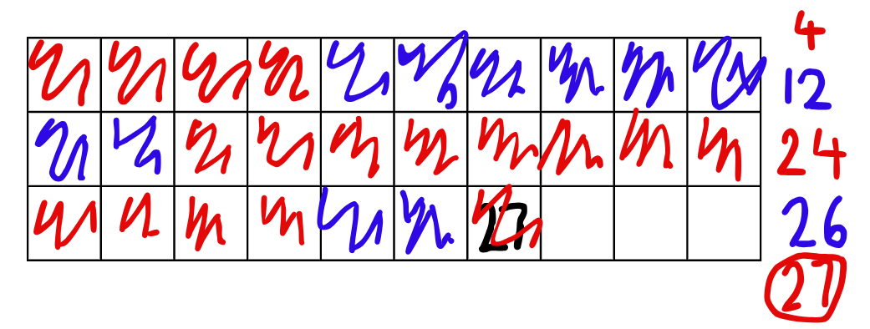
- While students are playing, ask:
- If you were to play the game again, are there any moves you would change?
- If you were to play the game again, how could you change the rules? Explain. (Early Stage 1)
- Is there a number you should have halved instead of doubled? Why? (Stage 1)
- If you were to play the game again and the rules changed so you could double, halve or keep your roll, do you think this might make it easier to reach the target number? (Stage 1)
Note: Early Stage 1 students can choose to use the number rolled or they can double the quantity rolled. Stage 1 students can choose to double or halve. Students must reach the target number exactly without passing it, so halving might be a good strategy for Stage 1.
- After a few rounds, ask students:
- What strategies did you use to work out double or half of a quantity rolled?
- What were the reasons for choosing to double or halve a number?
- When you doubled a number did you start counting from one or did you use a quick strategy to count how many altogether?
- Were you always accurate when you halved or doubled? How did you check if you made a mistake?
This table details assessment opportunities and differentiation ideas.
Assessment opportunities | Too hard? | Too easy?
What to look for:  - What strategies are being used to work out the double? (MAO-WM-01, MAE-RWN-01, MA1-RWN-01)  - What strategies are being used to work out half? (MAO-WM-01, MA1-RWN-01)  - Are students using number bonds up to 10 to assist with counting a total? (MAO-WM-01, MAE-CSQ-01, MA1-CSQ-01)  - Can students recognise or subitise the dice pattern? (MAO-WM-01, MAE-RWN-01, MA1-RWN-01)  - Are students strategising when choosing to either double or halve so they can win the game? (MAO-WM-01, MA1-RWN-01)  What to collect:  - anecdotal records of conversations during the game (MAO-WM-01, MAE-RWN-01, MA1-RWN-01) | Students have difficulty using numbers greater than 10.  - Provide students with a ten-frame, counters and dotted cards showing 1–4. Students play the game by turning over a card, counting the dots and placing counters on the ten-frame.  - The range of dotted cards can increase to 10 as students gain confidence and accuracy.  Students cannot calculate doubles and halves.  - Provide a number chart to 20 and play a few rounds using only the doubling strategy. Use counters to assist.  - Play a few rounds using only the halving strategy and use counters to assist.  - Play a round with students and use counters to model how to find double or half of a quantity. | Students confidently double and halve numbers up to 6 and can use the number chart with ease.  - Provide a range of more complex numbered dice.  - Provide a number chart to 200.  - Add an additional challenge, such as, you can only double odd numbers rolled and halve the even numbers rolled.

Equal parts – 30 minutes
Note: Linear models of fractions are important as they provide a direct link to the number line. Students make the link by working with linear arrangements of quantity. This activity links to the linear arrangement by repeatedly halving a line of train carriages. Having the pictures on the strip helps students make the link between fraction units and quantities. Moving the focus from the length to a line of carriages helps students to see how halving could be used with both continuous and discrete quantities (Gould 2013).
Discrete model: This model uses separate items in collections to represent parts of the whole group.
- Discuss what students know about equal parts (Early Stage 1) and halves (Stage 1) and ask students to share their thinking.
- Explain that a ‘fraction’ is the name that mathematicians give to each equal part of a whole, and the name of a fraction with 2 equal parts is a half.
- Show students several ‘whole’ linear items, for example, ribbons, streamers or straws.
- Place pegs at one quarter, halfway and 3 quarter points on one of the items and ask students what they notice about the equality of the parts on either side of the peg.
- Place pegs at ‘almost halfway’, ‘more than halfway’ or ‘less than halfway’ to create unequal partitions of the whole length.
- Use student responses to establish that each length can have parts, but not all lengths have equal parts. Model folding the item to compare the lengths of the parts and determine whether the parts are equal or unequal.
- Provide groups of students with a set of linear items and pegs. Have students place the peg on each item and then sort the collection of items under the headings ‘equal’ and ‘not equal’ (Early Stage 1 see Figure 2) and ‘halves’ and quarters’ (Stage 1 see Figure 3).
- Use ‘Talk moves’ to facilitate discussion.
Figure 2 – Equal and not equal display
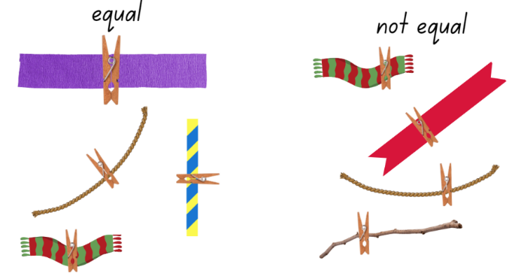
Images sourced from Canva and licensed under the Canva Content License Agreement.
Figure 3 – Halves and Quarters
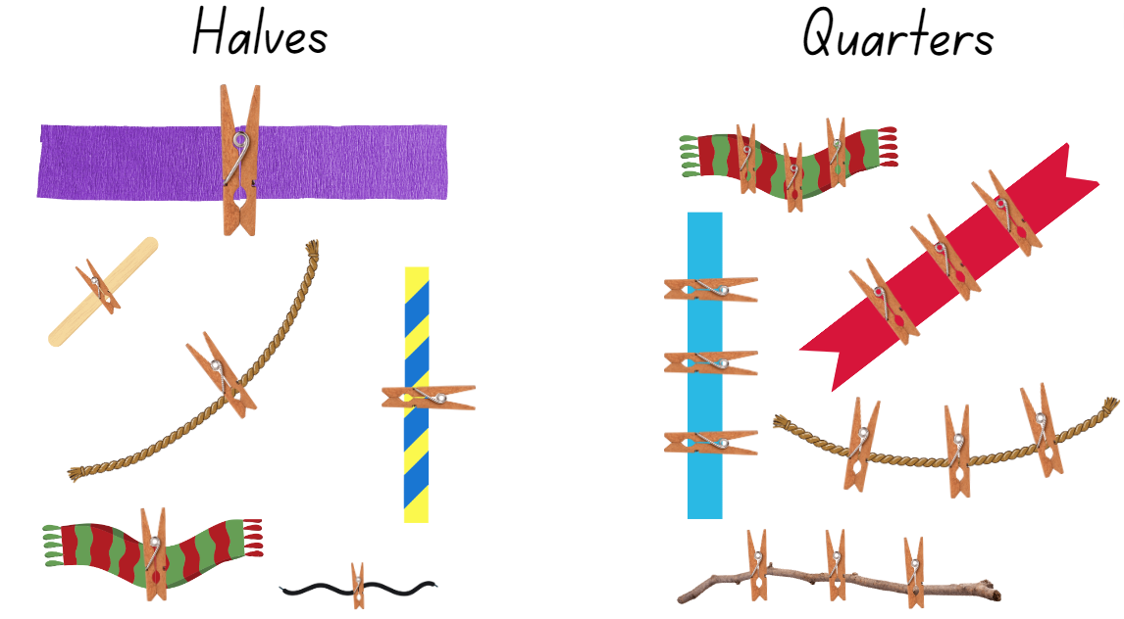
Images sourced from Canva and licensed under the Canva Content License Agreement.

Discuss and connect the mathematics: Two parts in a whole – 10 minutes
- Students go on a gallery walk. Ask each group to select one item from each category and explain why they placed it under that heading.
- Ask questions, such as:
- How did you find the halfway point?
- Why are the 2 parts of this item ‘not equal’? (Early Stage 1)
- How could you find the halfway point of an item you cannot fold, for example, a stick?
- How did you find 4 equal parts to make quarters? (Stage 1)
The table below details assessment opportunities and differentiation ideas.
Assessment opportunities | Too hard? | Too easy?
What to look for:  - Can students compare the size of 2 linear items to check if they are equal? (MAO-WM-01, MAE-GM-02)  - Can students divide a length into 2 equal parts? (MAO-WM-01, MAE-GM-03)  - Can students describe the relationship between the parts and the whole? (MAO-WM-01, MA1-GM-03)  - Can students use concrete materials to model halves and quarters of a whole length? (MAO-WM-01, MA1-GM-03)  What to collect:  - student recordings of findings (MAO-WM-01, MA1-FG-01, MA1-GM-03) | Students are unable to compare and describe the size and quantities of lengths to check if they are equal or not.  - Model how to superimpose an item on top of the other to compare and check.  - Model how to describe the comparison of 2 parts and ask students to repeat. | Students compare the size and quantities of items to check if they are equal or not.  - Provide paper strips for students to create a model that represents a quarter or eighth of the whole.  - Ask students to show a number representation of the fractions they have that make a whole.

Lesson 2: Number lines are more than a line
Core concept: Number lines have equally spaced partitions which can be used to represent fractions.
The table below contains suggested learning intentions and success criteria. These are best co-constructed with students.
Learning intentions | Success criteria
Students are learning that:  - a line can be partitioned showing part-whole relationships.  - equal partitions can be marked on a number line to represent fractions  - number lines are useful tools for mathematical problems.  Early Stage 1 students are learning that:  - a length can be divided into 2 equal parts  - the halfway point is equal distance from the beginning and end points of a length. | All students can:  - compare 2 parts and identify if they are equal or not  - find halfway on a length by modelling 2 equal parts, placing lengths side by sides and aligning the ends.  In addition, students working towards Stage 1 outcomes can:  - use concrete materials to model part-whole on a number line  - partition a number line from 0–12 to show halves and quarters

Daily number sense: Let’s count! – 10 minutes
- Build student understanding of number lines and number tracks by ordering numbers and investigating counting patterns.
Note: For Early Stage 1 students, number tracks assist students to arrange numbers sequentially and help to identify and name numbers in order, counting forwards and backwards, and naming what comes before and what comes after a particular number.
- Students form a long line representing a number line and are given a number. The first student is number 1, the second student is number 2 and so on.
- Draw students’ attention to the fact that they are representing a number line.
- Explain that students will be skip counting along the line. For example, if counting by twos, the student who has been given the number 2 will start the count, the fourth student will call out 4 and so on.
- Repeat the activity several times, using a different starting number, counting forwards and backwards and using different patterns.
Note: If students have difficulty visualising the connection between themselves and the number line or number track they represent, draw a chalk line and place the corresponding numbers on the floor in front of the students. When skip counting you could also show how the count jumps from number to number.

Can you partition a line? – 30 minutes
This task has been adapted from Cuisenaire Environment by NRICH.
- Explain that students are going to investigate how to partition a line into equal parts. Highlight that the lines represent various lengths.
Note: The number line can be a powerful model for thinking about quantities. To be most effective, the number line needs to be introduced when students can make use of its defining feature – length. Refer to the Teaching advice in the K–10 Mathematics Syllabus for information about using number lines as a mathematical tool.
- Using the interactive Cuisenaire Environment (Figure 4), turn on the grid lines and use the zoom button to increase the size of the page as this allows students to count the length of rods more easily. Show students how each of the coloured rods are incrementally longer starting at white. Place each rod onto the page so students can see their length.
Figure 4 – Cuisenaire Environment interactive board
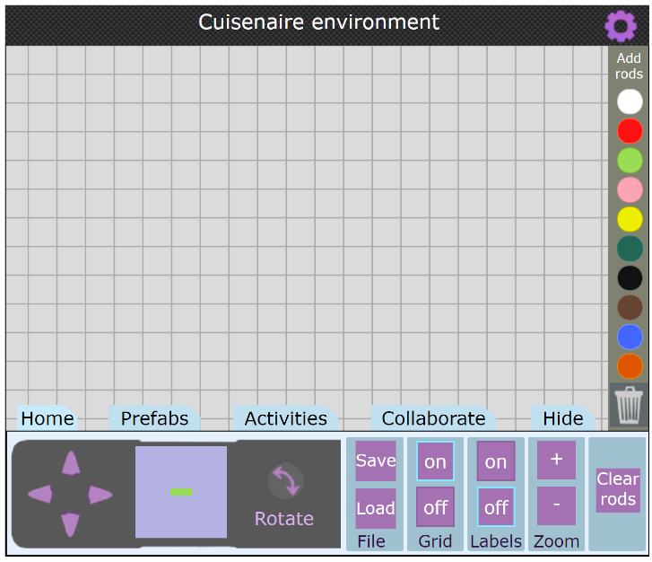
‘Cuisenaire Environment’ by © University of Cambridge is licensed under CC-BY-NC 4.0.
- Clear the board then drag a brown rod into the centre of the page. Count the length of the rod by showing the connection between the grid lines and the length of the rod as a total of 8.
- Explain that the brown rod represents the whole. Show how the pink rod, which is equivalent to 4 can be placed directly above the brown rod to show half (Stage 1 students) or one of 2 equal parts (Early Stage 1 students). Remind students that they may need to select and drag several rods before finding the rod that is equivalent to half. Place another pink rod above the brown rod to show the 2 halves or equal parts that make the whole (see Figure 5).
Figure 5 – Partitioning into halves and quarters using coloured rods
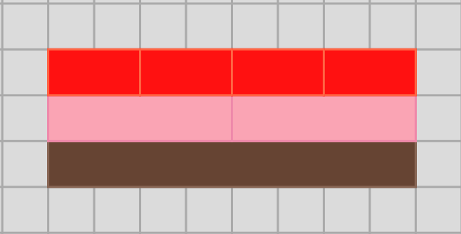
Image from ‘Cuisenaire Environment’ by © University of Cambridge is licensed under CC-BY-NC 4.0.
- Ask students to notice that the pink coloured rods are placed end-to-end and with no gaps to accurately measure half, and the equal parts of the whole are also visible. Clear the board.
- Select students to repeat the task, using various lengths. Discuss their thinking as they trial different rods.
- In small groups, students explore equal partitioning by using a range of different coloured rods. Provide time for students to record their investigations using drawings, symbols, or words.
- Students go on a gallery walk to see how other students have recorded their thinking. Discuss the features of students’ work.

0–12 Number line – 20 minutes
- Ask Early Stage 1 students to create a line using 12 interlocking cubes. Model breaking the line of interlocking cubes into 2 equal parts, comparing the lengths by placing them side by side and aligning the ends.
- Repeat the task with 11 interlocking cubes. Break the model into halves and identify that the 2 towers are unequal in length. Explain to students that the line of 11 cubes cannot be partitioned into 2 equal parts because one length is longer than the other.
- Provide students with a collection of interlocking cubes and ask pairs to investigate the different ways to make ‘whole’ and ‘2 equal parts’ lengths with the cubes.
- Prompt Stage 1 students to share what they know about number lines and to share examples of known number lines, for example a ruler, tape measure or a height or growth chart.
- Display a number line from 0–12 on the board. Ask student to suggest ways to discover where the halfway point is on the number line. Prompt students by asking:
- If we estimate, how will we know it is accurate?
- If this is the full length of the line and it is labelled 0–12 in sequential order, will this information help us determine a half of the number line or where the halfway point is on the line?
- How do we know that the spaces in between each number are equal? Refer to the coloured rods used in the previous activity and how they used shorter coloured rods to partition a long-coloured rod from end to end with no overlaps or spaces.
- Allow a few students to demonstrate their thinking to the class, drawing attention to the numbers and spaces in between as they problem solve to find the halfway point.
- Provide each Stage 1 student with a number line from Resource 3: Number line 0–12 and 0–6 and ask students to mark where they think half would be. Observe strategies and listen for vocabulary or ideas that can be shared with the class.
- Ask students to also explore other ways to partition their number line into equal parts, for example, quarters.
Note: This investigation is for Stage 1 students to see that on either side of the halfway mark there are equal parts of the whole line.
This table details assessment opportunities and differentiation ideas.
Assessment opportunities | Too hard? | Too easy?
What to look for?  - Can Early Stage 1 students compare 2 parts and identify if they are equal or not? (MAO-WM-01, MAE-GM-02, MAE-GM-03)  - Can Stage 1 use concrete materials to model part-whole on a number line (MAO-WM-01, MA1-RWN-01)  - Can Stage 1 partition a number line to show halves and quarters (MAO-WM-01, MA1-GM-03)  What to collect:  - student samples and recordings of findings (MAO-WM-01, MAE-GM-02, MAE-GM-03, MA1-GM-03) | Early Stage 1 students cannot create whole and equal lengths with cubes:  - model how to align the 2 parts to check for equality  - use a small number of blocks, for example 6 or 8 blocks as the whole.  Stage 1 students have divided the number line unevenly:  - Explain how to make the parts of the whole the same size, otherwise they are not true halves. Model how to verify that the 2 partitions are equivalent.  - Demonstrate how to partition a number line using the 0–6 number line. | Early Stage 1 students can model 2 equal parts and a whole using cubes:  - Ask students to find 4 equal parts of a whole.  Stage 1 students can create equal parts and can articulate how many parts they have.  - Provide students number lines of varying lengths longer than 0–12. Ask if there are other ways they can partition the larger number lines.  - Support students to display quarters and eighths on their number lines.  - Ask students to show a number representation of the fractions they have that created on the number line.

Consolidation and meaningful practice: Charlotte’s problem! – 5 minutes
- Using interlocking cubes, make a model as seen in Figure 6.
Figure 6 – Four joined interlocking cubes
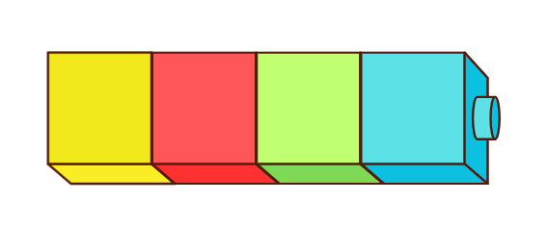
Images sourced from Canva and licensed under the Canva Content License Agreement.
- Ask students to help Charlotte find the answers to some questions.
- How many more interlocking cubes does Charlotte need to add if she wants to double the quantity?
- How many interlocking cubes does Charlotte need to remove if she wants to halve the quantity she currently has?
- If Charlotte wanted 12 interlocking cubes in total, how many more does she need to add?

Lesson 3: A whole length is made up of equal parts
Core concept: Equal partitions help determine halves and quarters.
The table below contains suggested learning intentions and success criteria. These are best co-constructed with students.
Learning intentions | Success criteria
All students are learning that:  - a length can be divided into equally sized parts known as fractions  - halving a whole length once makes halves  - halving and halving again makes quarters  Early Stage 1 students are learning that a halfway point needs to be an equal distance from the beginning and end point. | Stage 1 students can:  - identify halves and quarters by folding and layering  - recognise unequal partitions when dividing a length  - use direct comparison to determine the relationship between the whole and the parts.  Early Stage 1 students can:  - describe halves as 2 equal parts of a whole  - describe a length as ‘about half’, ‘less than half’ and ‘more than half’ of a whole length  - model 2 equal parts by folding paper  - identify 2 parts that are not equal are not halves.

Daily number sense: Before and after – 10 minutes
- Provide Stage 1 pairs with two 0–9-sided dice and a copy of Resource 4: 1–120 number chart (or display Interactive 1–120 chart).
- Have one student roll the dice and form a 2-digit number. Their partner finds the number on the number chart and identifies the number 10 before and 10 after. Repeat with students swapping roles.
- Provide Early Stage 1 pairs with a 20-sided dice and Resource 5: 1–30 number chart.
- Have one student roll the dice and find the numeral on the number chart. Their partner identifies the number before and after. Repeat with students swapping roles.

Representing fractions of a length – 30 minutes
Eighths are introduced in Stage 1 Geometric measure B by repeatedly halving lengths. This lesson exposes students to eighths.
- Display Resource 6: Fraction bars. Ask students to turn and talk to share what they notice.
Prompts | Anticipated student responses
- What do you notice? | - They are like the Cuisenaire rods.  - Four quarters are the same length as a whole.  - A quarter is less than halfway along the length of the whole.  - Two quarters are the same length as a half.  - The more parts a length is divided into, the smaller the parts are.  - Four quarters are the same as two halves.  - When the equal sized parts are together, they are the same length as a whole.
- Model creating half, quarter and eighths fraction bars.
- Cut out the fraction bars and draw student’s attention to their equal length by layering them for direct comparison.
- Write the word ‘whole’ on the first bar.
- Fold the second bar in half by aligning the ends and then reopen. Mark a line on the fold and write ‘half’ on the 2 equal parts.
- Fold the third bar in half and half again. Open the bar and highlight the 4 equal parts that have been created. Mark a line on the folds and write ‘quarter’ on the 4 equal parts.
- Fold the fourth bar in half and half again to recreate the quarter model. Ask students to predict how many equal parts there would be if it was folded in half one more time. Fold the bar in half and then reopen to demonstrate 8 equal parts. Explain that these sections are called eighths and write ‘eighth’ on each of the 8 parts.
- As a class, identify each part and count aloud using the language ‘one-eighth, two-eighths, three-eighths’ and so on.
- Provide Stage 1 students with a copy of Resource 7: Fraction bars blank and have them create their own whole, half and quarter fraction bars by folding and drawing lines on the folds and writing the word to describe the equal parts.
- Paste all fraction bars on a piece of paper, aligning the ends of the bars to show equivalence.
- Show Early Stage 1 students a strip of A3 paper and think aloud about where the halfway point would be. Estimate and describe positions as 'about halfway', 'more than halfway' or 'less than halfway'.
- Invite students to estimate the halfway point and, based on student feedback, mark an estimated halfway line on the strip.
- Ask students how they might check if the line is exactly halfway. For example, folding, cutting along the line and comparing if each section is equal in length, using interlocking cubes.
- Fold the strip into 2 equal halves and compare the estimated halfway mark to the fold mark using the language ‘less’, ‘more’ or ‘exactly halfway’. Discuss the difference between the line as the halfway point and the half of the length.
- Provide each student with a strip of A3 paper and coloured pencils. Ask students to fold their strip of paper and draw a line over the fold mark. Label this as ‘halfway’.
- Students choose a position on the strip that is ‘less than halfway’ and draw a line and label the line as ‘less than halfway’. Repeat with a position ‘more than halfway’.
- Early Stage 1 students repeat the activity with different lengths of paper.
This table details assessment opportunities and differentiation ideas.
Assessment opportunities | Too hard? | Too easy?
What to look for:  - Can students identify equal parts (halves and quarters) by folding and layering? (MAO-WM-01, MAE-GM-02, MAE-GM-03, MA1-GM-02)  - Can students identify 2 parts that are not equal halves by finding a position less than half and more than half on a length? (MAO-WM-01, MAE-GM-02, MAE-GM-03)  - Can students use direct comparison to determine the relationship between the whole and the parts? (MAO-WM-01, MAE-GM-02, MA1-GM-03)  What to collect:  - student fraction bar models (MAO-WM-01, MA1-GM-02, MA1-GM-03)  - annotated work samples (MAO-WM-01, MA1-GM-02, MA1-GM-03) | Early Stage 1 students are unable to find the halfway point on a length.  - Model folding the paper with the student, aligning the ends.  - Provide opportunities for students to explore lengths of everyday items and sort them into same or not the same lengths.  Stage 1 students are unable to identify halves and quarters.  - Fold the bar strips for the students and ask them to identify how many parts the strip has been folded into.  - Using an additional copy of Resource 6: Fraction bars blank and cut 2 strips into halves and quarters. Lay the parts on top of the student’s whole strip to illustrate the relationship between the whole and the parts. | Early Stage 1 students can identify and describe positions as ‘about halfway’, ‘less than halfway’ and ‘more than halfway’.  - Have students fold the paper in half and half again and label the 4 equal parts as quarters.  Stage 1 students can create halves and quarters of the length.  - Ask students to create a fraction bar showing eighths.  - Provide students with another strip of paper and ask them to estimate and mark where the quarters and eighths marks would be without folding. Check their estimates by repeatedly halving and folding the lengths.

Consolidation and meaningful practice: Creating a whole – 10 minutes
- Provide each student with a piece of the puzzle from Resource 8: Fraction bar puzzle.
Note: Pre-cut the puzzle pieces prior to the lesson. Select the puzzle pieces depending on the number of students present to ensure that wholes can be created.
- Ask selected students to predict how many parts they will need to create their whole.
- Have students try to create a whole by finding other students that have an equal length puzzle piece. When students think they have a whole, they sit down and place the puzzle pieces together in a line to make a whole.
- Ask the following questions to students:
- Can you have 5 people with quarters make a whole?
- How many people did you need to make the whole out of eighths, quarters and/or halves?
- Have students swap puzzle pieces with a peer and repeat the activity.

Lesson 4: Partitioning lengths
Core concept: Lengths can be portioned into halves and quarters.
The table below contains suggested learning intentions and success criteria. These are best co-constructed with students.
Learning intentions | Success criteria
Students are learning that:  - a fraction describes the relationship between the whole and the parts it has been partitioned into.  - when dividing a whole length, sometimes there are unequal parts. | Early Stage 1 students can:  - identify 2 equal lengths as halves  - divide a length into 2 equal parts  Stage 1 students can:  - use portioning to create halves and quarters of a whole  - use strategies such as folding and layering to find equal parts  - recognise unequal examples of partitioning and dividing  - recognise that the more equal parts the whole is divided into, the smaller each part becomes.

Daily number sense: Making lunch – 10 minutes
- Build student understanding of division by looking at how a whole can be divided into equal parts.
- Display Resource 9: Breadstick and pose the problem: Mrs Singh had one breadstick to share between her 4 children. Everyone needed an equal share. How much of the breadstick would each child get and what do we call these parts?
- Students turn and talk with a partner to share strategies. Monitor responses to highlight during follow-up discussions.
- Select students to share their thinking and record responses on the displayed image of the breadstick.

Who am I? – 30 minutes
- Display Resource 10: Animal line and ask students what they notice about where the images have been positioned on the line.
- Model drawing lines on the rope with a marker to partition the rope into halves and quarters. Pose the following prompts:
- I am halfway along the line. Who am I?
- I am a less than halfway along the line. Who am I?
- I am more than halfway along the line. Who could I be?
- I am a quarter of the way along the line. Who am I?
- Provide pairs with a copy of Resource 10: Animal line (Early Stage 1) or Resource 11: Animal line 2 (Stage 1) and have students make marks to partition the rope into 2 equal parts/halves and 4 equal parts/quarters. Encourage students to fold the picture to determine the positions if needed.
- In pairs, students choose an image and give their partner clues using the language of ‘more than’, ‘less than’ or ‘about’ half (Early Stage 1) or a quarter (Stage 1) of the way along the line. Partners use the clues to guess which image their partner is referring to.

Consolidation and meaningful practice: Stick the tail on the donkey – 10 minutes
- Display Resource 12: Stick the tail on the donkey. Explain that Aunty Melanie made the game for Neha's birthday party and only had one strip of ribbon for the tail. She wanted to know:
- How could the tail strip be cut into equal parts so that all the friends had an equal length?
- Will the tail pieces become smaller or larger the more friends they are shared between?
- Provide each small group with 3 pieces of string of the same length and scissors. Explain that students need to use each piece of string to create tails for 1, 2, or 4 people to play.
- Regroup as a class and summarise the lesson together, drawing out some key mathematical ideas. Ask:
- What did you notice about the length of the tails for each group of friends?
- Do the parts get smaller or larger as more people play?
- What do we call the equal parts that you have created?
- If the parts weren’t equal, would they still be halves or quarters?
This table details assessment opportunities and differentiation ideas.
Assessment opportunities | Too hard? | Too easy?
What to look for:  - Can students use partitioning to create halves and quarters? (MAO-WM-01, MAE-GM-02, MAE-GM-03, MA1-GM-03)  - Can students identify when the fraction parts are equal or not? (MAO-WM-01, MAE-GM-02, MAE-GM-03, MA1-GM-03)  - Do students recognise that the more equal parts the whole is divided into, the smaller each part becomes? (MAO-WM-01, MA1-GM-03)  What to collect:  - recordings of student discussions (MAO-WM-01, MA1-GM-03)  - annotated work samples (MAO-WM-01, MA1-GM-03) | Students have difficulty finding half and a quarter of the line and dividing the tail strip into equal parts.  - Discuss with students the meaning of equal parts by sharing the tail strip between 2 people.  - Give students a printout of the animal line and support students by folding it in half and explaining (after opening the fold) that this represents the halfway point. Fold it again to show the line separated into quarters. | Students can divide the animal line into halves and quarters and tail strip into equal parts.  - Students play Who am I? using the Resource 11: Animal line 2 and give clues using the position of eighths.  - Ask students to investigate how many tail pieces would be required for 8 players. Have students cut their tail piece into eighths.

Lesson 5: Sharing toys
Core concept: Collections can be divided into equal groups known as halves, quarters, and eighths.
The table below contains suggested learning intentions and success criteria. These are best co-constructed with students.
Learning intentions | Success criteria
Students are learning that:  - there are multiple ways to solve a problem  - collections can’t always be divided equally. | Students can:  - recognise that the more equal parts the collection is divided into, the smaller each equal share becomes  - use representations to show how collections can be divided equally into halves, quarters, and eighths  - use representations to demonstrate when a collection cannot be shared equally.

Daily number sense: Mr Equalson – 20 minutes
- Display Resource 13: Fair and unfair collections and provide students with a collection of counters. Ask students to recreate the groups with their counters. Have students sort each group of counters into 2 groups and identify whether the 2 groups are equal or a fair share. As students are distributing the counters, ensure that they notice that sometimes there is one left over. Pose to students what can be done to make it a fair share. Encourage students to verbalise that one counter can be taken away or one counter can be added to make both shares equal.
- Explain that Mohamad and his friend Nick like having an equal number of blocks when they play together. They dislike when they have an unequal number of blocks, and they always put one back in the toybox when the share is not equal. Ask students to work out a good number of blocks for Mohamad and Nick to play with.
- Provide students with whiteboards to brainstorm solutions. Students use diagrams to show how many ways they can solve the problem. Provided time for students to share their ideas with a partner.
- Select students to share their thinking and record students’ thinking on a poster.

Let’s share toys! – 40 minutes
- Display Resource 14: Toy box and provide pairs of students with a copy of Resource 15: Toys and ask students to cut the toys out to allow them to be manipulated.
- Explain that a toy box has 24 toys: 6 balls, 8 robots, 4 planes, 2 cars and 4 teddies inside. Ask how we could share the toys between 2 friends, 4 friends or 8 friends.
- Focus on one toy collection at a time, for example the 8 robots. Ask how 8 robots could be shared between 2 or 4 friends. Ask if anyone can show how 8 robots could be shared equally among 8 friends.
- Ask students if 2 cars could be shared between 2 or 4 friends. Ensure students understand that sharing with 4 friends would be an unfair share, so the cars are limited in their ability to be shared with more than 2 friends.
- Explain to Early Stage 1 students that each toy type needs to be shared amongst 2 friends. In pairs, students share each set of toys between 2 friends and record their thinking on individual whiteboards (see Figure 7).
Figure 7 – Early Stage 1 toys shared between friends
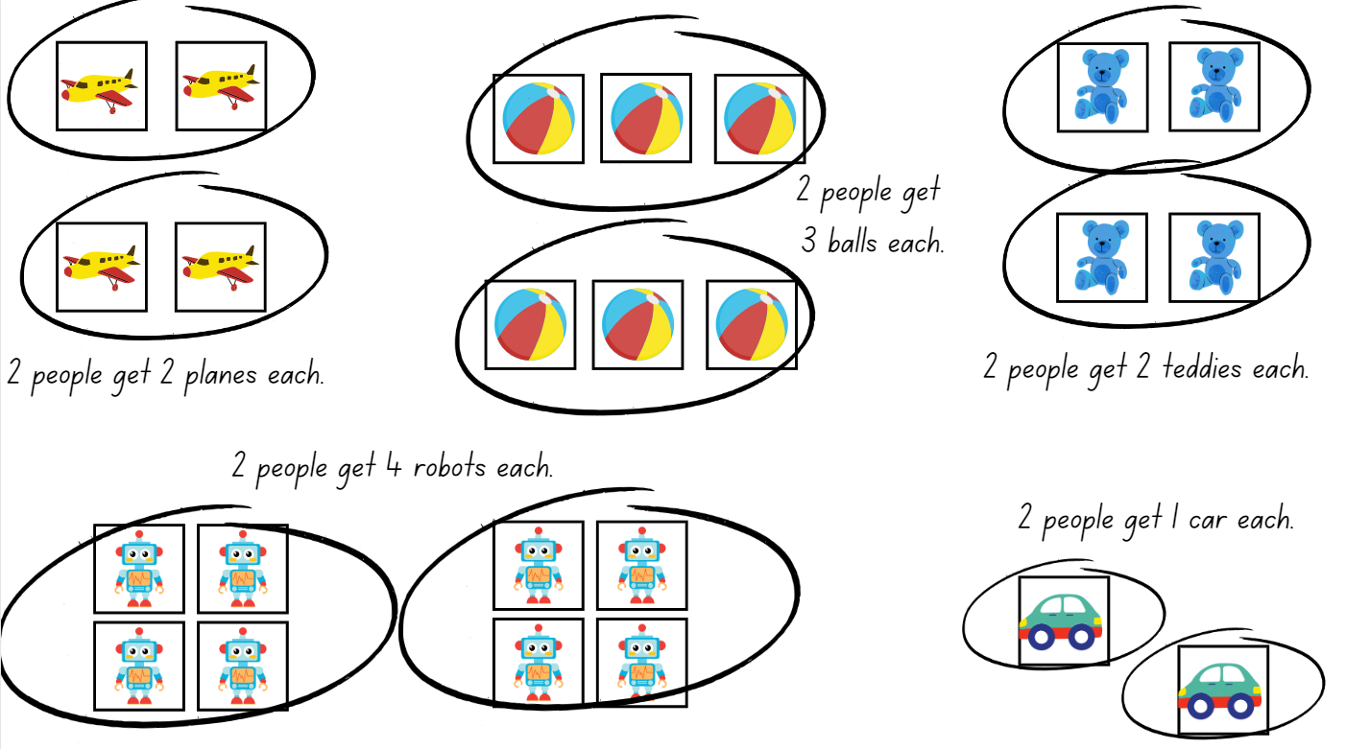
Images sourced from Canva and licensed under the Canva Content License Agreement
- Explain to Stage 1 students that the total collection of toys needs to be shared amongst the friends. Ask students to predict whether they think the number of toys each friend receives will become larger or smaller the more friends they share the collection between.
- In pairs, Stage 1 students share the total collection of 24 toys between 2 friends, 4 friends and 8 friends and record their thinking on individual whiteboards (see Figure 8).
Figure 8 – Stage 1 toys shared between friends
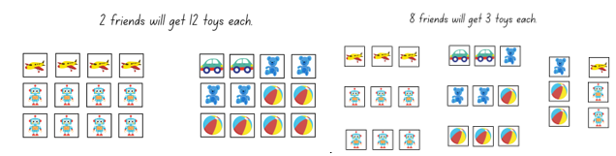
Images sourced from Canva and licensed under the Canva Content License Agreement
- Highlight that when sharing the toy collection between 2 friends, they are halving the collection and when sharing the toy collection between 4 friends, the collection has been separated into quarters.
This table details assessment opportunities and differentiation ideas.
Assessment opportunities | Too hard? | Too easy?
What to look for:  - Can students divide a collection into halves and quarters? (MAO-WM-01, MA1-FG-01)  - Can students recognise that the more equal parts the collection is divided into, the smaller each share is? (MAO-WM-01, MA1-FG-01)  - Can students identify an equal share and unequal share? (MAO-WM-01, MAE-FG-02, MA1-FG-01)  - Do students adopt successful ideas and strategies to inform their thinking? (MAO-WM-01)  What to collect:  - recording of classroom discussions (MAO-WM-01, MA1-FG-01)  - annotated work sample (MAO-WM-01, MAE-FG-02, MA1-FG-01) | Students have difficulty finding equal shares.  - Model sharing a small collection of counters between 2 friends (include both a fair and unfair share). Repeat with multiple examples.  - Model sharing the toys between 2 teddies or 2 children and discuss sharing using the strategy of alternating, one at a time.  - Give students a printout of the toys to cut out and share the toys between various groups of children or teddies. | Students can share the toys equally among groups of friends and explain their thinking.  - Students investigate how many equal shares they can make with each toy and if this is at all possible.  - Show the students half a collection and ask them to identify how many were in the whole collection. Repeat with quarters and eighths if appropriate.  - Reframe the question: If there were 8 toy cars and each person got 2 cars. How many people got cars?  Early Stage 1 students can share toys between 2 groups equally:  - Have students redistribute the parts into 4 equal quantities.  - Ask students to describe 2 different methods that could be used to make quantities equal.

Consolidation and meaningful practice: Examples and non-examples – 10 minutes
This activity has been adapted from Halving from NRICH.
- Model playing a game to practise halving a collection. Player 1 rolls a 20-sided dice (or Interactive dice) and uses interlocking cubes to determine if the number rolled can be divided into 2 equal groups/halved. If the number can be halved, without any cubes left over, the player gets a point. Repeat for Player 2. Continue playing until one player reaches 10 points.

Lesson 6: Sharing biscuits
Core concept: As the number of equal shares increases, the size of each share gets smaller.
The table below contains suggested learning intentions and success criteria. These are best co-constructed with students.
Learning intentions | Success criteria
All students are learning that:  - sharing a collection involves distributing objects equally  - collections of objects can be distributed into smaller groups where the number in each group is equal or not equal  - as the number of equal shares increases, the size of each share gets smaller  - there is a difference between the number of groups and the number in each group. | All students can:  - count the number of groups and the number in each group, for example, 5 groups with 4 inside each group.  - In addition, students working towards Early Stage 1 outcomes can:  - distribute a group of objects into smaller groups and recognise whether the number in each group is equal or not  - group and share objects by distributing them one by one or using another method  - label the number of objects in each group.  In addition, students working towards Stage 1 outcomes can:  - use objects, arrays, diagrams, or actions to solve problems involving sharing/or equal groups  - recognise when a share is not equal by having leftovers, or not enough.  - notice that when the number of groups a collection is shared between gets bigger, the quantity of the share gets smaller

Daily number sense: Dominoes – Double and half – 10 minutes
- Build student understanding of doubling and halving groups by exploring dot patterns on dominoes.
- Display Resource 16: Dominoes and for each domino, cover half. Provide Early Stage 1 students with an individual whiteboard and counters so students can model and problem solve using manipulatives.
- Ask students:
- What do you see?
- If this is a double domino and there is an equal number of dots on each side, how many dots are on the hidden side?
- How many dots altogether?
Note: Model the use of mathematical language for example, double 3 is 6.
- Repeat with remaining dominoes.
- Build student understanding of halves using domino patterns.
- Display domino doubles again. Showing the whole domino this time.
- Ask students:
- What do you see?
- How many dots altogether?
- How many dots are on each half of the domino?
Note: Model the use of mathematical statements for example, half of 6 is 3.

Sharing biscuits – 40 minutes
- Introduce the scenario: Mum has baked a plate of biscuits for Georgia and Hugo. Show students a plate of 12 modelling clay biscuits or similar.
- Ask students:
- Can you estimate how many biscuits mum has baked?
- If Mum baked 12 biscuits, how many biscuits would Georgia and Hugo get if they shared equally?
- Model sharing 12 biscuits on 2 plates and record using the ‘shared between’ sentence, 12 shared between 2 is 6 each.
- Model sharing the biscuits equally between 4, 6 and 12 people.
- Explain that sometimes a collection cannot be shared equally. Model sharing 20 biscuits between 6 people and demonstrate that there are some left over (see Figure 9).
Figure 9 – Unequal share
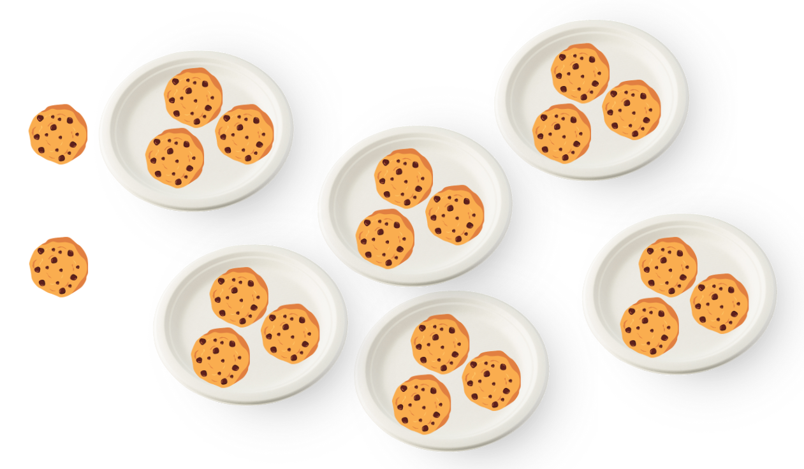
Images sourced from Canva and licensed under the Canva Content License Agreement
- Ask Early Stage 1 students how many people Mum can share 8 biscuits with, so that each person gets an equal share.
- In pairs, students investigate sharing the 8 biscuits equally. Students use manipulatives such as counters and plates. Encourage students to draw representations on individual whiteboards of the solutions they discover and to label the number of biscuits on each plate.
- Ask Stage 1 students how many people Mum can share 20 biscuits with, so that each person gets an equal share. Students use manipulatives, such as counters and plates, and draw representations on individual whiteboards of as many solutions to the problem as possible and noting whether the share was equal or unequal (see Figure 10).
Figure 10 – Student work sample
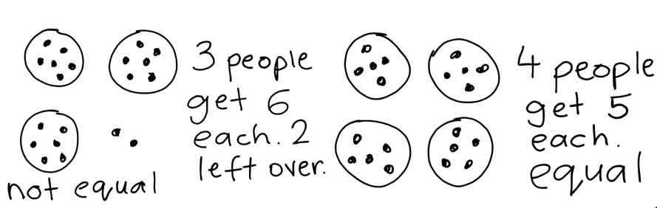
Images sourced from Canva and licensed under the Canva Content License Agreement
The table below outlines stimulus prompts to generate conversation about the topic, along with anticipated responses from students.
Prompts | Anticipated student responses
- How can you share the cookies equally?  - Have you found all the solutions? How do you know?  - Were there any numbers of people where the sharing was not equal?  - Who discovered an efficient/accurate way to record your findings? (drawing/diagram/tally marks?)  - What happens to the size of the share when the number of people you share with gets bigger/smaller? | - I shared the cookies one-by-one onto plates.  - You can use skip counting to share the cookies onto the plates.  - I used more or less plates to share the cookies and sometimes there were leftovers, so I changed the number of plates.  - 20 cookies could not be shared equally between 3 people, and I used an array to work that out.  - You can draw circles as plates and dots as cookies to show solutions.

This table details assessment opportunities and differentiation ideas.
Assessment opportunities | Too hard? | Too easy?
What to look for:  - Can students use objects, arrays and diagrams to solve sharing problems? (MAO-WM-01, MAE-RWN-01, MAE-RWN-02, MAE-FG-02, MA1-FG-01)  - Can students recognise when a share is equal and not equal? (MAO-WM-01, MAE-FG-02, MA1-FG-01)  - Can students notice that when the number of people to share with gets bigger, the share gets smaller? (MAO-WM-01, MA1-FG-01)  - Can students count the groups and the number in each group? (MAO-WM-01, MAE-RWN-01, MAE-RWN-02, MA1-FG-01)  What to collect:  - work samples and drawings (MAO-WM-01, MAE-FG-02, MA1-FG-01)  - photographs of students arranging concrete materials (MAO-WM-01, MAE-FG-02, MA1-FG-01) | Students have difficulty distributing concrete materials into equal groups and cannot distinguish if each share is equal or not.  - Support students to create groups and identify the amount within each group.  - Model the use of manipulatives and perceptual markers to share collections into 2 equal groups.  - Decrease the size of the collection to be shared for example, share 8 biscuits instead of 20. | Students confidently share collections equally.  - Students model sharing a collection by using an array. Challenge students to problem solve.  - Extend the range to further challenge students. For example, grandma made 36 cookies (or another number). Using counters and individual whiteboards, students explore how many ways the 36 cookies could be shared equally. Students record their thinking to explain their findings.

Consolidation and meaningful practice: Reflection – 10 minutes
- Students participate in a gallery walk to observe the ways the cookies were shared. Prompt students to share their thinking and explain how they distributed the cookies into equal and unequal groups.

Lesson 7: Is there a remainder?
Core concept: Sometimes shares are unequal. Remainders occur when a collection cannot be shared equally.
The table below contains suggested learning intentions and success criteria. These are best co-constructed with students.
Learning intentions | Success criteria
All students are learning that:  - the part left over when a collection cannot be distributed equally is called the remainder  - collections can be shared equally in multiple ways  - collections can be distributed into halves and quarters.  Early Stage 1 students are learning that:  - equal groups can be formed by distributing objects one-by-one or other methods  - two groups of objects can be combined to model addition. | Students working towards Early Stage 1 outcomes can:  - distribute a group of objects into smaller groups and recognise whether the number in each group is equal or not  - group and share objects by distributing them one-by-one or using another method.  - use drawings, words and numerals to record addition and explain their thinking  Students working towards Stage 1 outcomes can:  - use the term ‘quarter’ to name one part of a collection that has been shared equally between 4 groups  - describe the part left over/remainder when the collection cannot be shared equally.

Daily number sense: Teacher identified activity – 10 minutes
- From a class need surfaced through formative assessment data, identify a short, focused activity that targets students’ knowledge, understanding and skills. Example activities may be drawn from the following resources:
- Thinking Mathematically Early Stage 1
- Universal Resources Hub.

Is there a remainder? – 40 minutes
- Explain that Mum baked 7 cookies. Ask if she can she share these equally with 2 people. Model sharing the 7 cookies by using counters divided onto 2 plates. Point to the ‘cookie’ counter left over. Ask students if they know what the leftover part is called. Explain that this part is called the leftover or the remainder.
- Ask students if mum could share 15 cookies equally between 4 people. Students discuss. Choose 4 students to hold a plate each. Model sharing the 15 cookie counters. Point to the 3 cookie counters left over and ask what students would call this part.
- Model taking a handful of counters and estimate how many there are in the handful. Ask if you can share this handful equally between 2 friends. Model sharing the handful, drawing students’ attention to any leftovers and asking what that part is called.
- Provide pairs of students with a collection of counters and explain that they will take turns to grab a handful and estimate how many they have. Each student will then share their handful into 2 groups using Resource 17: Two rectangles to see if they have an equal or unequal share with remainders.
Note: Early Stage 1 students should collect approximately 12–15 in each handful. Use larger manipulatives such as teddy bear counters. Stage 1 students should collect approximately 15–25 in each handful. Use smaller manipulatives such as beans, buttons, or counters.
- Students use Resource 17: Two rectangles to record their thinking using drawings, words and numbers. Students participate in a gallery walk to observe students work samples and thinking.
The table below outlines stimulus prompts to generate conversation about the topic, along with anticipated responses from students.
Prompts | Anticipated student responses
- Can you see a collection that has been organised into 2 groups without a remainder?  - What do we call each part of a collection that has been shared into 2 equal groups with no remainder?  - Can you see a collection that has a remainder? How many are left over?  - Is there something interesting that you noticed when sharing into 2 equal groups? | - 20 items can be shared into 2 groups of 10 without any remainders.  - I can see that half of 16 is 8 because the 2 parts of the collection are equal.  - There are 21 counters and they have been shared into 2 groups of 10 with one remainder.  - I noticed that when sharing between 2 people there is only one remainder every time. So odd numbers give you one left over when you share in 2 equal groups.
- Ask students to select one of their handful samples and to attempt to partition their collection into 4 equal groups using Resource 18: Four rectangles. Discuss and select students to share their findings.
The table below outlines stimulus prompts to generate conversation about the topic, along with anticipated responses from students.
Prompts | Anticipated student responses
- Does anyone have a collection that was partitioned into 4 groups without a remainder?  - What do we call each part of a collection that has been shared into 4 equal groups with no remainder?  - Can you see a collection that has a remainder? How many are left over?  - Is there something interesting that you noticed when sharing into 4 equal groups? | - 20 items can be shared into 4 groups of 5 without any remainders.  - I shared 16 counters, and each plate has 4 counters with no remainders. I know that fraction is called a quarter.  - 25 items can be shared into 4 groups of 6 with one remainder.  - I noticed that when you have more plates there are less counters in each.
Note: Early Stage 1 students may share their handful into 4 groups but are not yet required to identify quarters.
This table details assessment opportunities and differentiation ideas.
Assessment opportunities | Too hard? | Too easy?
What to look for:  - Can students use the term ‘half’ to name one part of a collection that has been equally shared between 2? (MAO-WM-01, MAE-FG-02, MA1-FG-01)  - Can students use the term ‘quarter’ to name one part of a collection that has been shared equally between 4 groups? (MAO-WM-01, MA1-FG-01)  - Can students use drawings, words and numerals to record addition and explain their thinking? (MAO-WM-01, MAE-RWN-01, MAE-RWN-02)  - Can students distribute a group of objects into smaller groups and recognise if the number in each group is equal or not? (MAO-WM-01, MAE-FG-02, MA1-FG-01)  Students working towards Stage 1 outcomes can:  - Can students describe the part left over/remainder when the collection cannot be shared equally? (MAO-WM-01, MA1-FG-01)  What to collect:  - work samples/drawings (MAO-WM-01, MAE-FG-02, MA1-FG-01)  - photographs of students partitioning materials (MAO-WM-01, MAE-FG-02, MA1-FG-01)  - recordings of student discussions (MAO-WM-01, MAE-FG-02, MA1-FG-01) | Students cannot share a collection.  - Decrease the quantity of the handful (5–10) using bigger manipulatives.  - Support students to create groups and identify the amount within each group.  - Ask students what they could do to make the groups equal.  - Model the use of manipulatives and perceptual markers as they share collections into equal groups. | Students identify and represent division in multiple ways.  - Students model sharing their collection without perceptual markers, for example, by using an array.  - Extend the range to further challenge students. For example, student shares their handful into 8 groups noticing if there are any leftovers/ remainders. Ask students what they call each part of a collection that has been shared into 8 equal groups with no leftovers.

Consolidation and meaningful practice: Making an unequal collection equal – 15 minutes
- Display Resource 19: Unfair shares. Provide pairs of students with writing materials and concrete materials. Ask students to demonstrate how to make the unequal shares equal using words, symbols and numbers.
- Have selected students share their strategies and representations (see Figure 11).
Figure 11 – Making an unequal collection equal
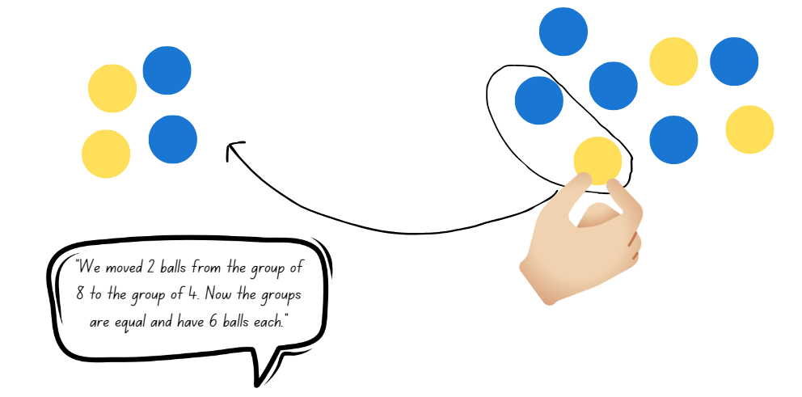
Images sourced from Canva and licensed under the Canva Content License Agreement

Lesson 8: Dot division
Core concept: A collection of objects can be distributed into smaller groups.
The table below contains suggested learning intentions and success criteria. These are best co-constructed with students.
Learning intentions | Success criteria
Students are learning that:  - a collection of objects can be shared equally into a given number of groups  - Stage 1 students are learning that:  - collections can be divided into halves and quarters. | Early Stage 1 students can:  - share concrete materials by distributing objects one-by-one  - identify when a collection is equal  Stage 1 students can:  - identify half or a quarter of a collection  - find a quarter of a collection, by halving and halving again

Daily number sense: Dice dilemma– 10 minutes
This activity has been adapted from Activities to Support Forward and Backward Number Word Sequences from Developing Efficient Numeracy Strategies by NSW Department of Education.
- Build Early Stage 1 students’ understanding of one more and one less by writing a numeral before or after a given number.
- Provide pairs with a 20-sided dice and writing materials. Player 1 rolls the dice and writes the numeral in the middle of the page. Player 2 writes the 2 numbers that come before and after their partner’s number. Players swap roles and repeat.
Figure 12 – Numbers before and after
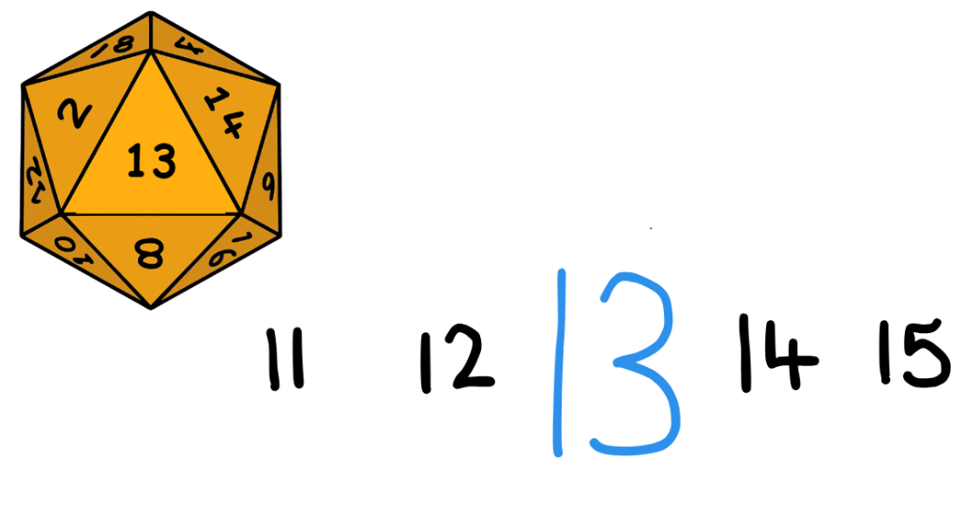
Images sourced from Canva and licensed under the Canva Content License Agreement
- Build Stage 1 students’ knowledge of half a collection.
- Provide pairs with a 20-sided dice, concrete materials and writing materials. Player 1 rolls the dice and determines whether the number can be halved into 2 equal groups. If the number can be halved, the player gets a point. Swap roles and repeat. The first player to 10 points wins.

Dot decider – 40 minutes
- Display Resource 20: Dot decider. Explain to students that they are going to use their knowledge of forming equal groups (Early Stage 1) and halving or quartering a collection (Stage 1) to create a ‘dot decider face.’
- Use ‘Talk moves’ to brainstorm a range of strategies that could be used to find 4 equal groups or a quarter of a collection, including halving and halving again.
- Demonstrate how to play the game with the red dot cards (halves/2 equal groups).
- Place the dot cards face down on the table.
- Choose a card at random and count the total collection of dots.
- Model distributing the collection into 2 equal groups. Early Stage 1 students use counters or interlocking cubes to model sharing the collection if needed.
- Refer to Resource 20: Dot decider and find the number in each group now the collection has been split into 2 equal groups.
- Draw the corresponding face shape on your art paper.
- Return the card face down on the table. Repeat 4 times to create a completed dot decider face.
Note: This game can be played with the red dot cards to find half/2 equal groups (Early Stage 1) or the blue dot cards to find a quarter/4 equal groups (Stage 1) depending on student need.
Figure 13 – Dot decider face examples
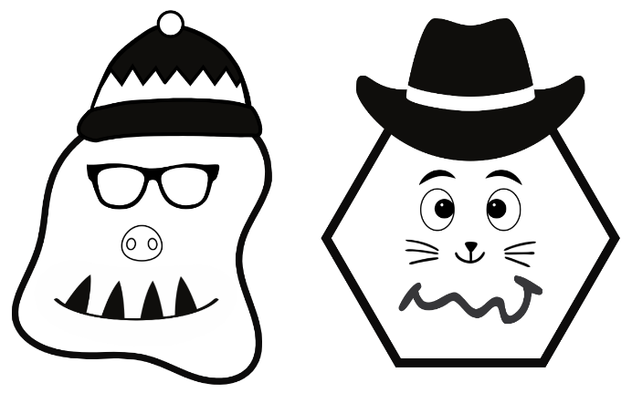
- Provide students with a copy of Resource 20: Dot decider, Resource 21: Dot cards, art paper and drawing materials.
- Students create their own dot decider artwork.
- Students go on a gallery walk to see the varying artworks that have been created.
This table details assessment opportunities and differentiation ideas.
Assessment opportunities | Too hard? | Too easy?
What to look for:  - identify half or a quarter of a collection (MAO-WM-01, MA1-FG-01)  - identify when a group is equal or unequal (MAO-WM-01, MAE-FG-02)  - find a quarter of a collection, by halving and halving again (MAO-WM-01, MA1-FG-01)  What to collect:  - student drawings (MAO-WM-01, MA1-FG-01)  - recordings of student discussions (MAO-WM-01, MA1-FG-01) | Students cannot partition a collection into halves.  - Support students to create groups and identify the amount within each group.  - Encourage students to check the 2 parts are equal by superimposing one part on top of the other.  - Provide students with scaffolds for recording their thinking. For example, give students a picture of 2 people to mark the groups. | Students can partition a collection into halves.  - Provide students with the blue dot cards to find a quarter of a collection.

Consolidation and meaningful practice: Double or halve? – 10 minutes
This task has been adapted from Double or Halve? from NRICH and Double or halve? – Stage 1 (7:37) from Mathematics K-6 resources by NSW Department of Education.
- Consolidate student understanding of doubling and halving by playing the game ‘Double or halve?’ from Lesson 1.
- In pairs, provide students with a 6-sided dice and a copy of Resource 1: Blank number chart and revise the rules of the game.
- After a few rounds ask:
- Did you use a specific strategy to help you win a round?
- Are there any moves you would change?
- Would you halve the number instead of doubling the number next time so you could win? Why?
- How did you choose the target number each round?
- If you also had the option to keep your roll without doubling or halving the number, do you think this would make it easier to reach the target number? Why?

Resource 1: Number chart 1–30
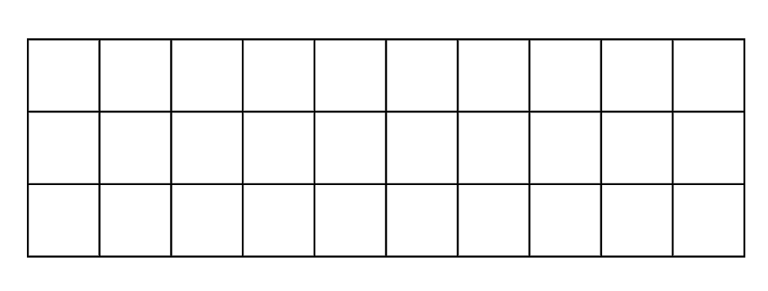

Resource 2: Number chart 1–100
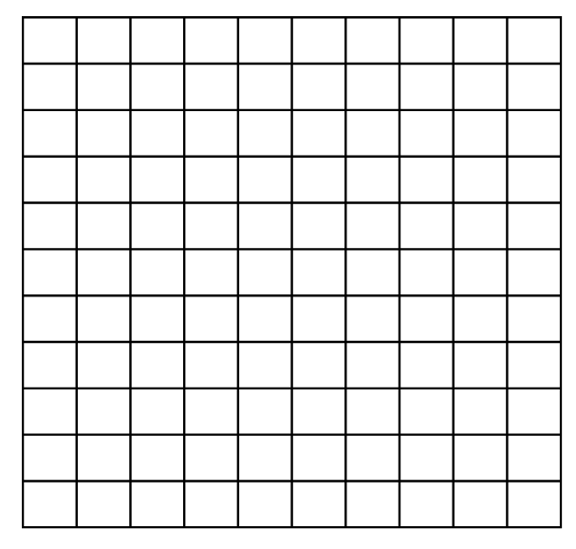

Resource 3: 0–12 and 0–6 number line
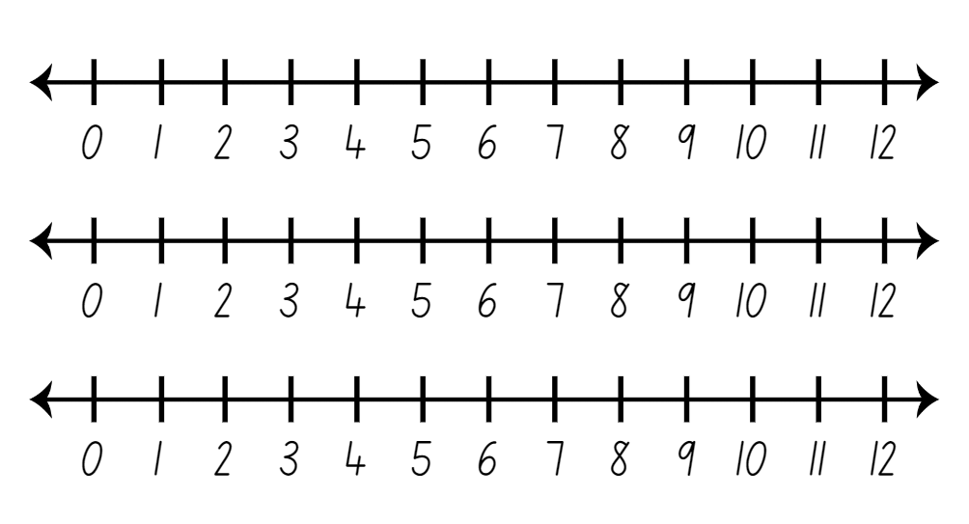

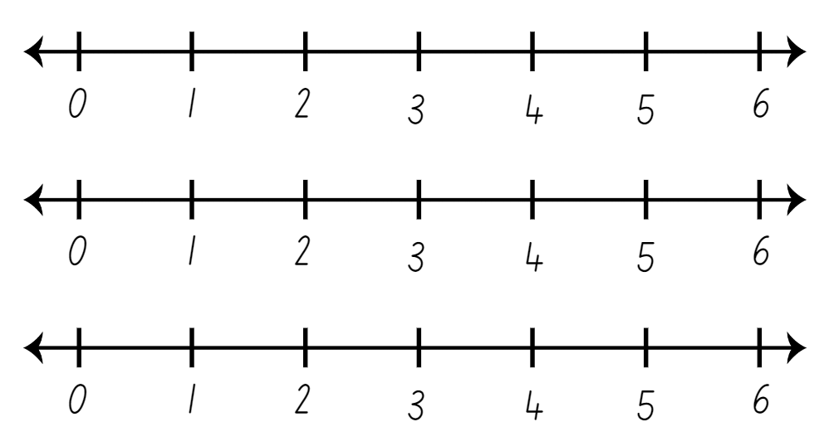

Resource 4: Number chart 1–120
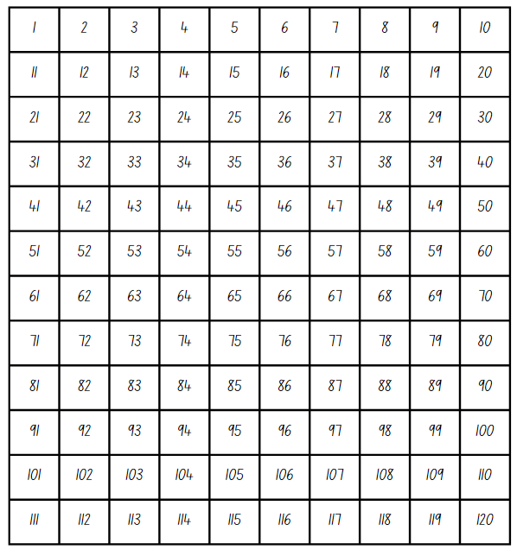

Resource 5: Number chart 1–30
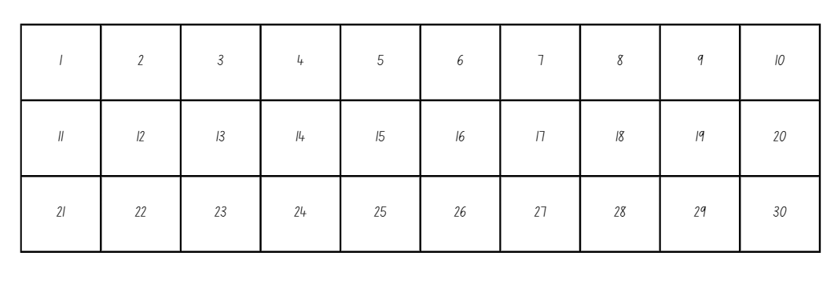

Resource 6: Fraction bars
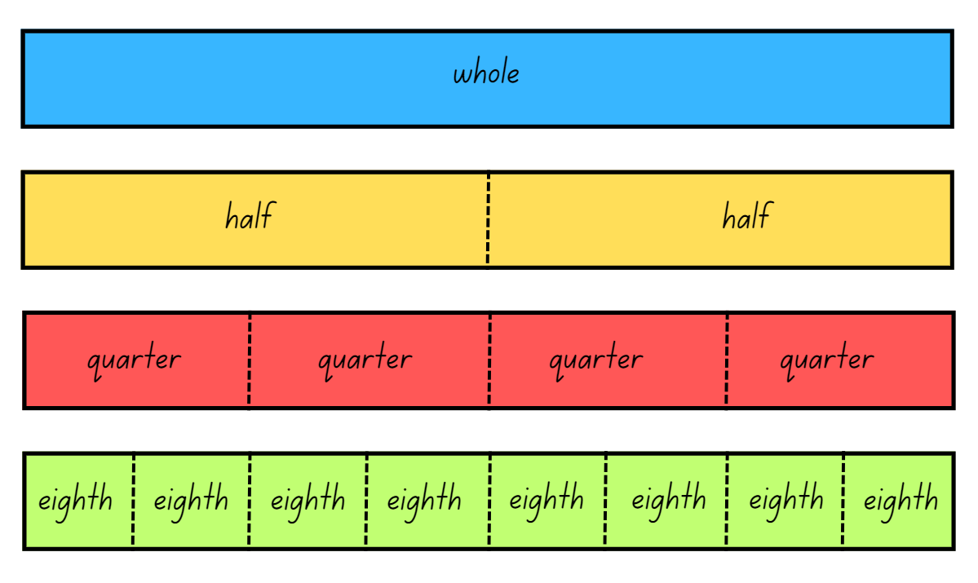

Resource 7: Fraction bars blank

Resource 8: Fraction bar puzzle
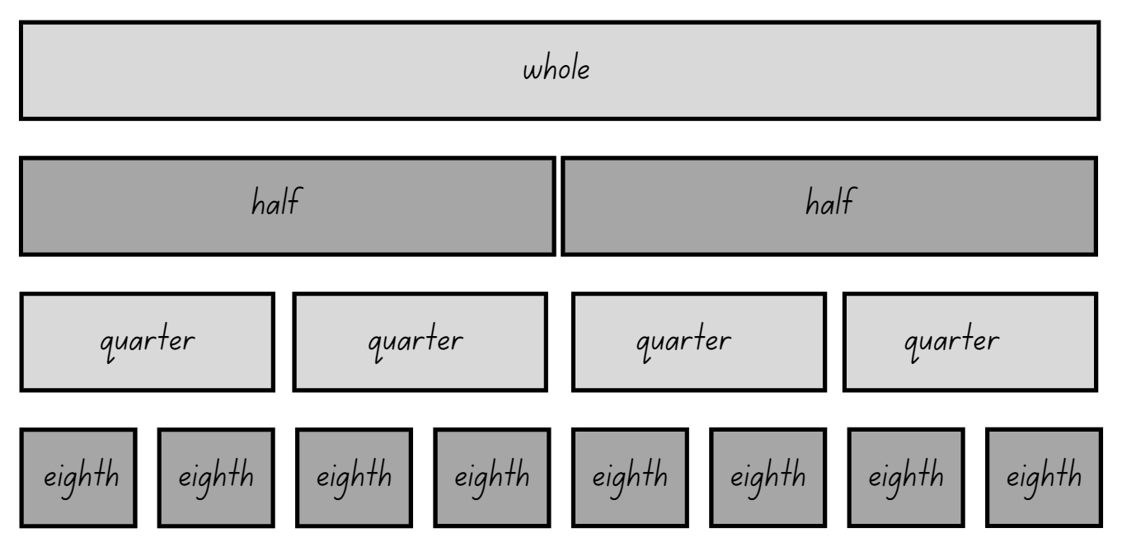

Resource 9: Breadstick
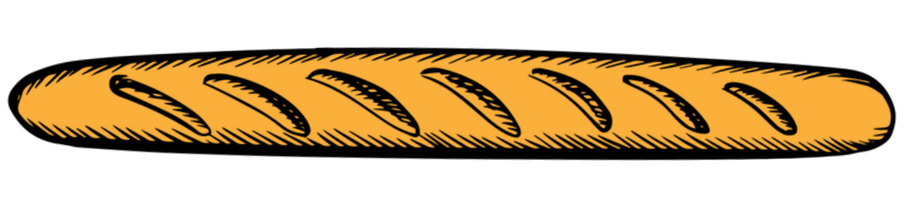
‘Bread Stick Icon’ by Vectortradition is licensed under the Canva Content License Agreement.

Resource 10: Animal line
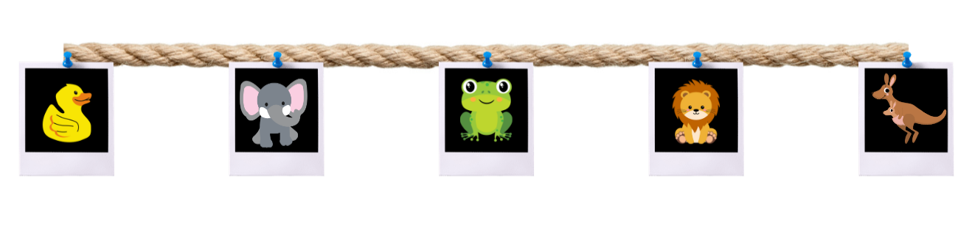
Images sourced from Canva and licensed under the Canva Content License Agreement.

Resource 11: Animal line 2
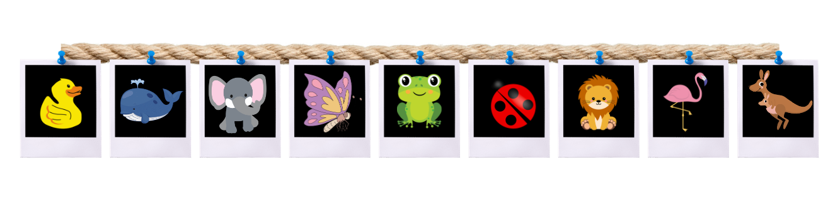
Images sourced from Canva and licensed under the Canva Content License Agreement.

Resource 12: Stick the tail on the donkey
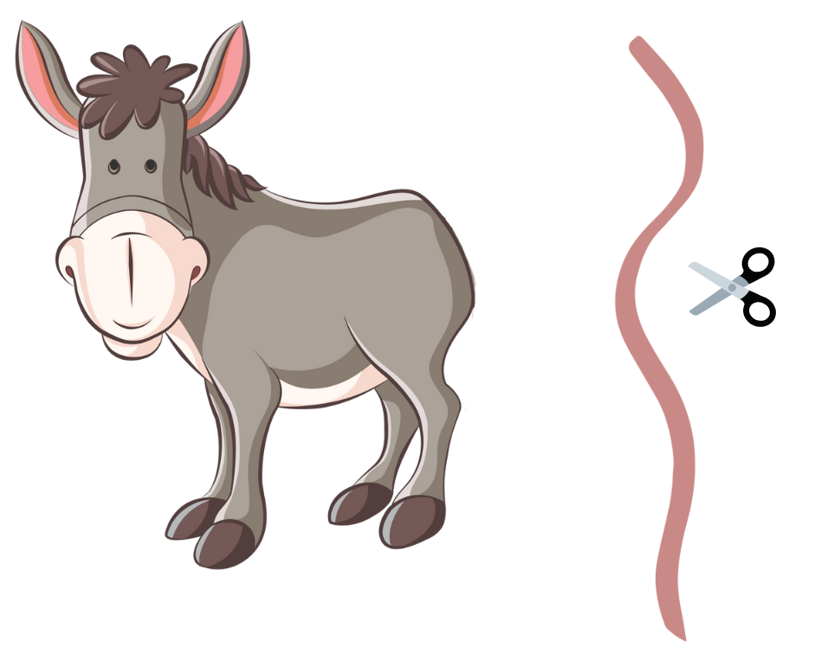
‘Illustration of a Donkey’ by Petergiese under the Canva Content License Agreement.

Resource 13: Fair and unfair collections
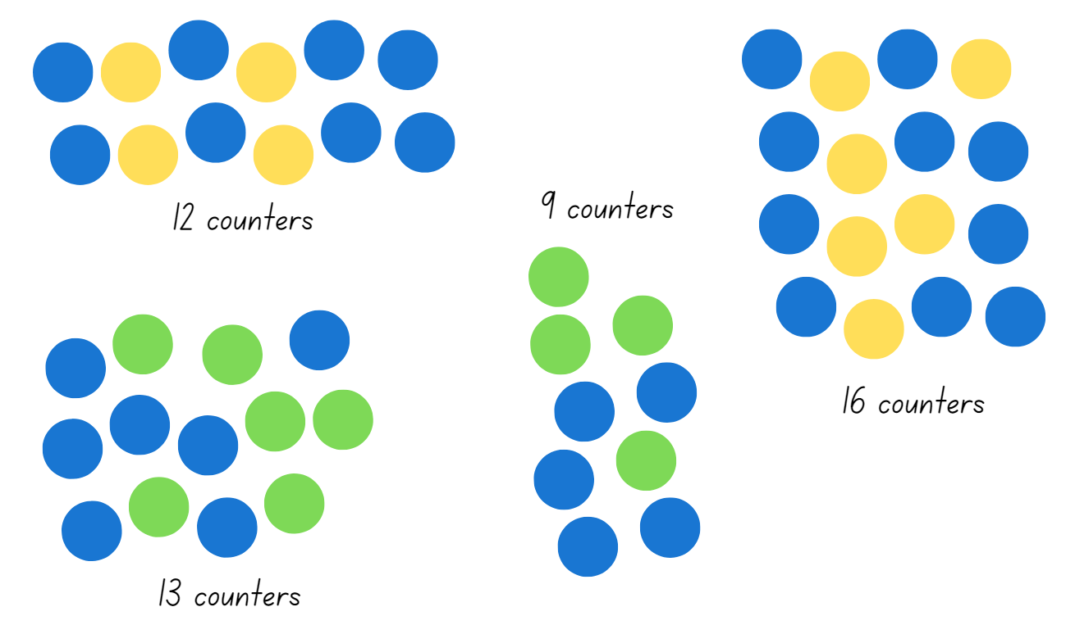

Resource 14: Toy box
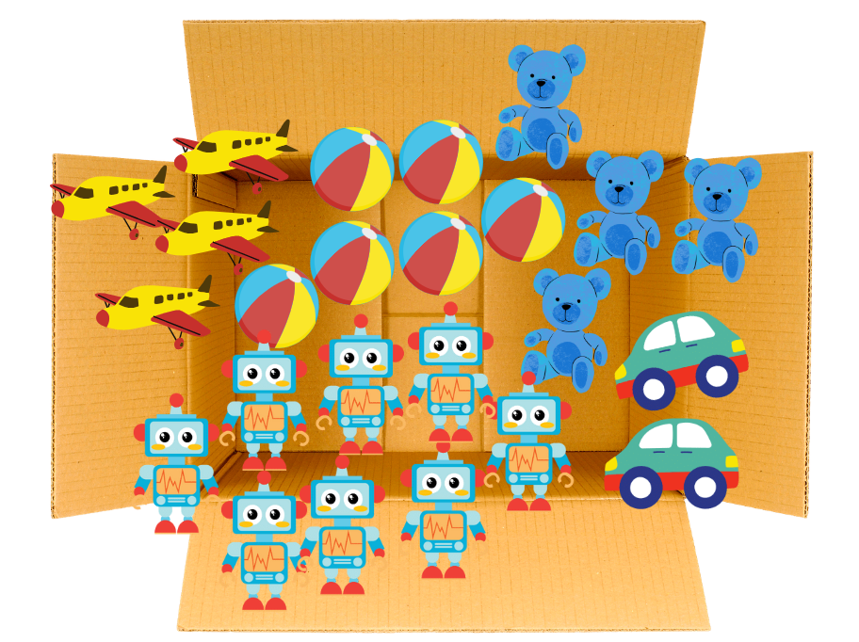
Images sourced from Canva and licensed under the Canva Content License Agreement.

Resource 15: Toys
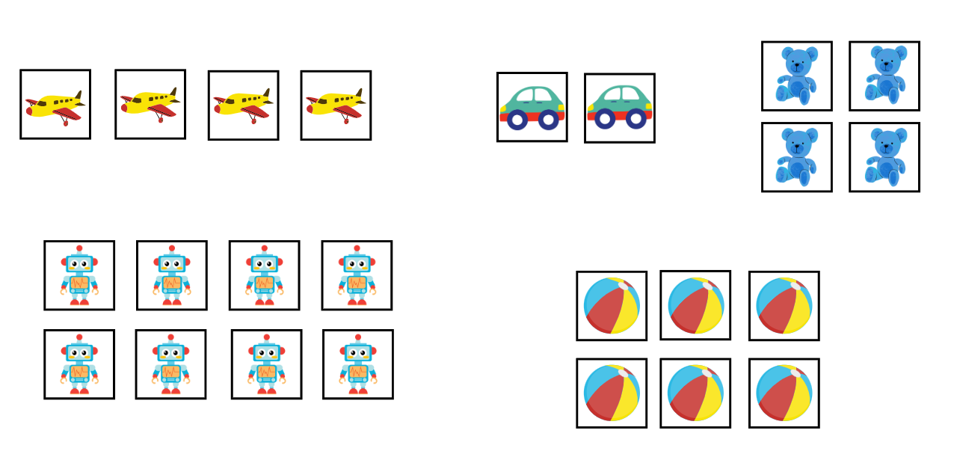
Images sourced from Canva and licensed under the Canva Content License Agreement.

Resource 16: Dominoes
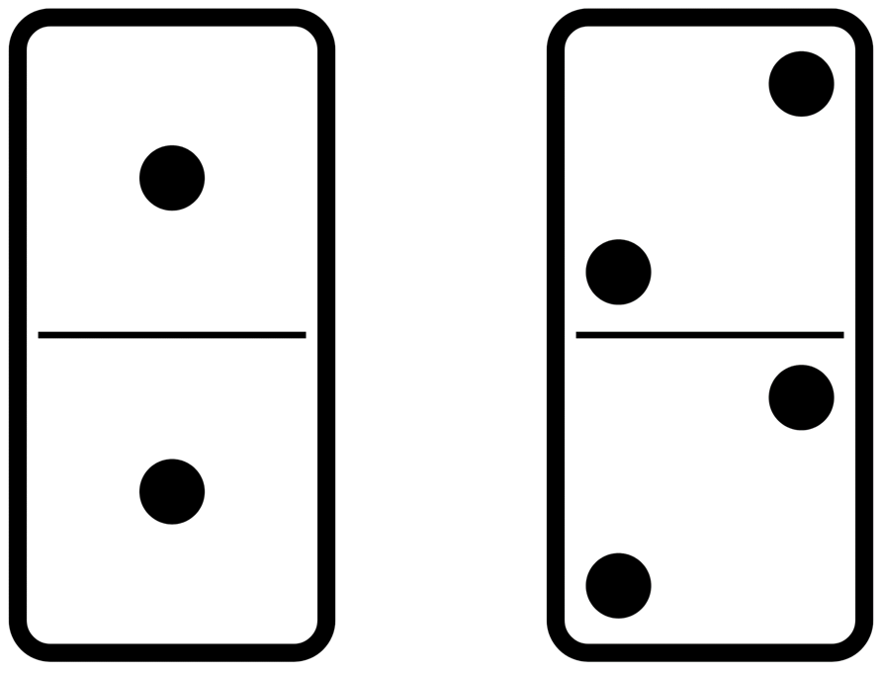
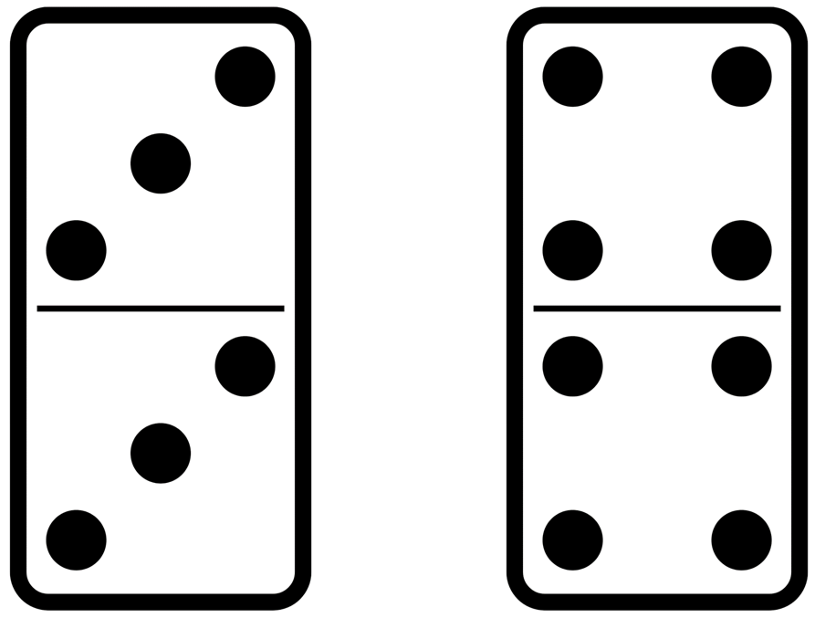
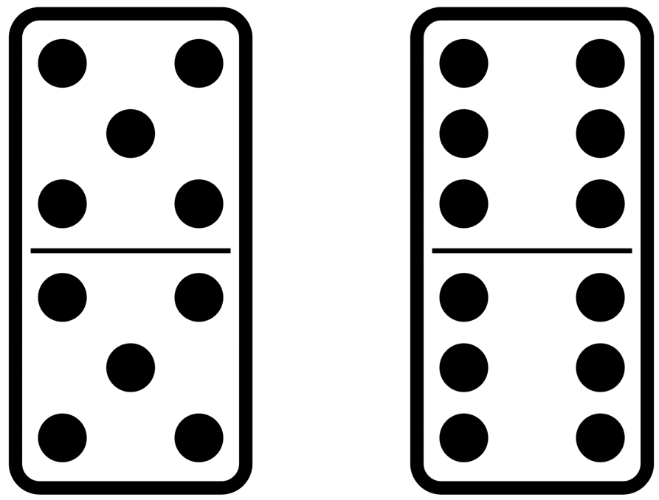
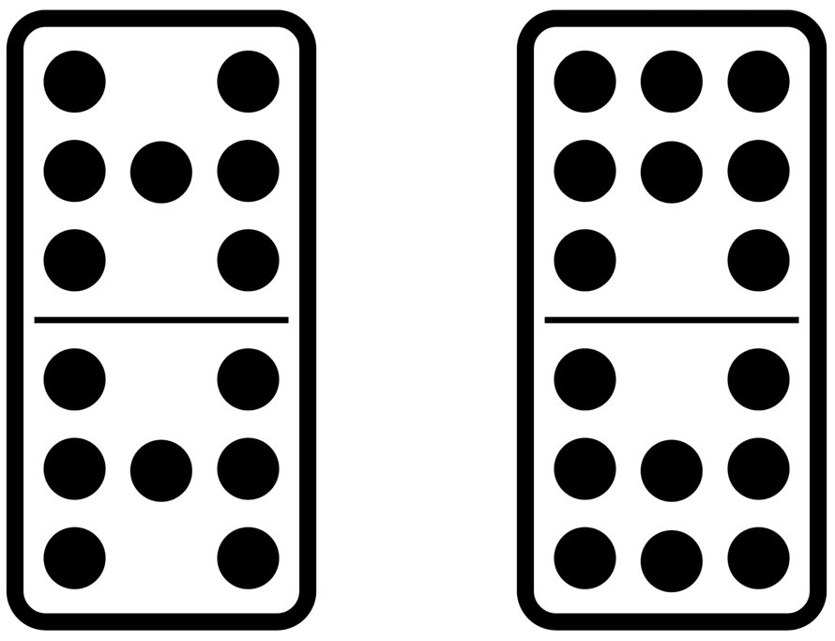
Images sourced from Canva and licensed under the Canva Content License Agreement.

Resource 17: Two rectangles

Resource 18: Four rectangles

Resource 19: Unfair shares
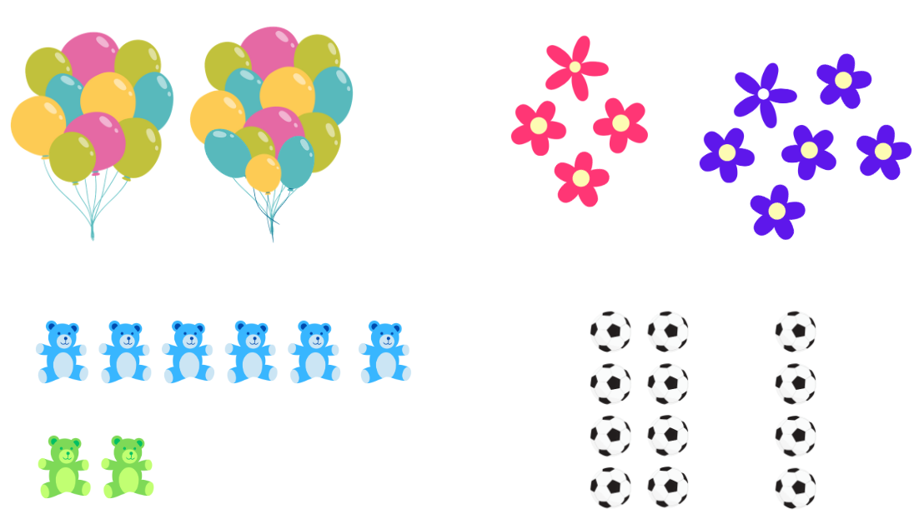
Images sourced from Canva and licensed under the Canva Content License Agreement.

Resource 20: Dot decider
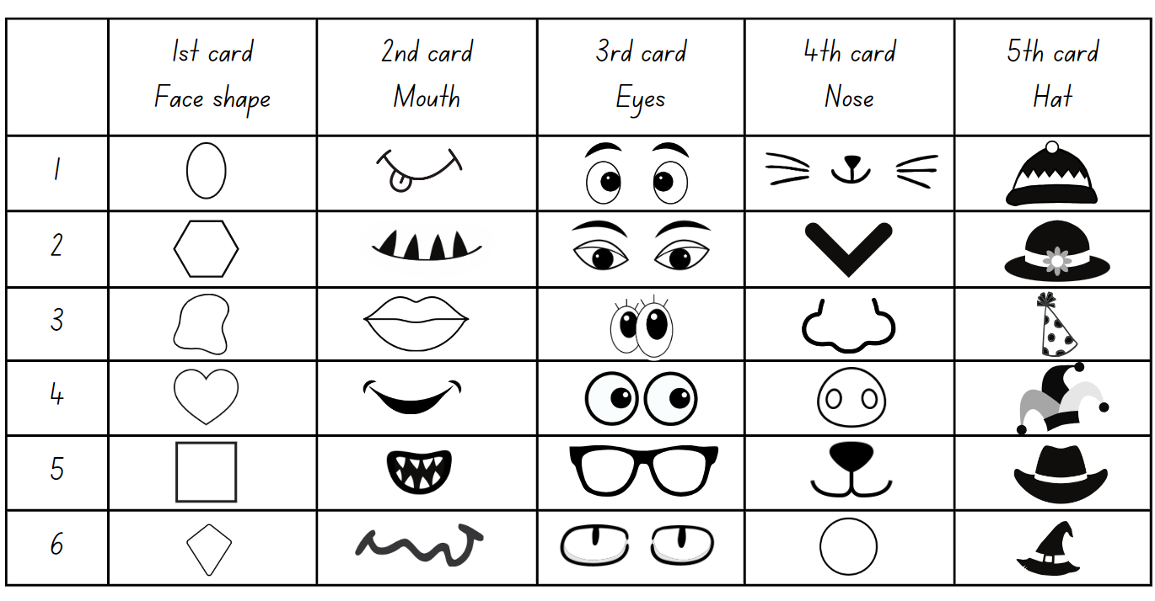
Images sourced from Canva and licensed under the Canva Content License Agreement.

Resource 21: Dot cards
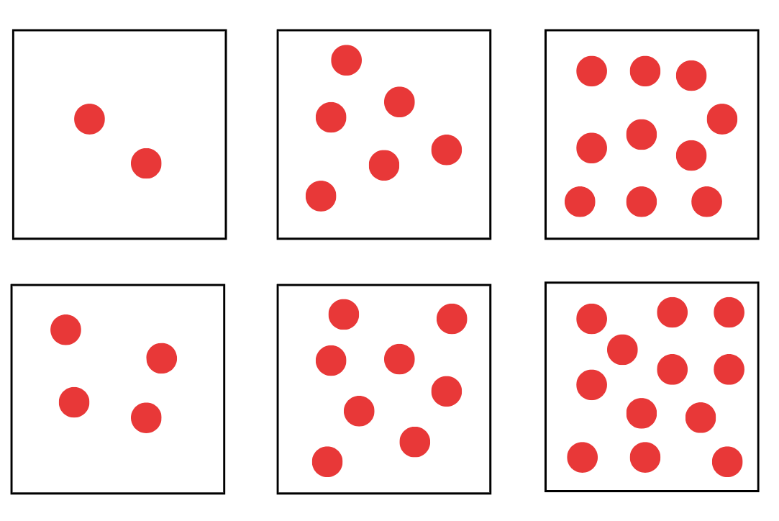

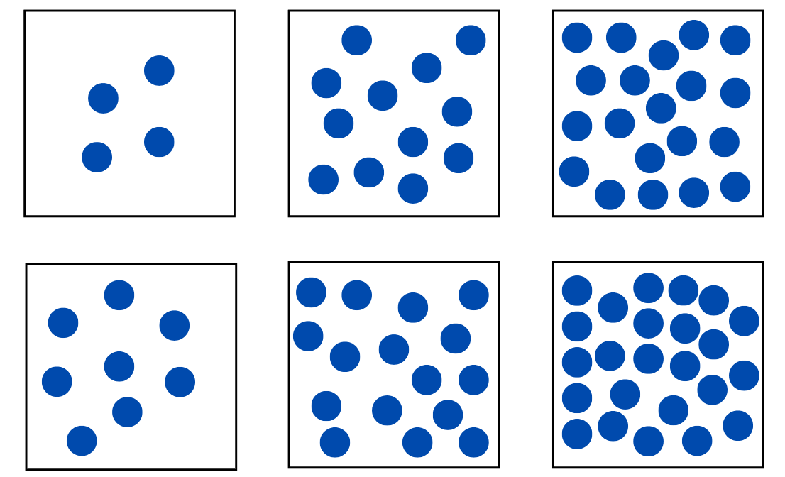

Syllabus outcomes and content
The table below outlines the syllabus outcomes and range of relevant syllabus content covered in this unit. Content is linked to National Numeracy Learning Progression version (3).
Focus area and outcomes | Content groups and content points | Lessons
Representing whole numbers  MAO-WM-01  MAE-RWN-01, MA1-RWN-01  MAE-RWN-02, MA1-RWN-02 | Early Stage 1  Use the counting sequence of ones flexibly  - count forwards to at least 30 and state the number after or before a given number, without needing to count from one | 1, 3–5
Representing whole numbers (cont) | Early Stage 1  Recognise number patterns  - recognise dice and domino dot patterns | 2, 5, 7
Representing whole numbers (cont) | Early Stage 1  Connect counting and numerals to quantities  - count with one-to-one correspondence, recognising that the last number name represents the total number in the collection  - count out a specified number of objects (from 5 to 20) from a larger collection, keeping track of the count  - make correspondences between collections (Reasons about quantity)  - read numerals to at least 20, including zero | 2, 7
Representing whole numbers A | Stage 1  Use counting sequences of ones with two-digit numbers and beyond  - identify the number before and after a given two-digit number (CPr5)  - count forwards and backwards by ones from a given number to at least 120 (CPr6) | 1, 4–5
Representing whole numbers A (cont) | Stage 1  Continue and create number patterns  - model and describe 'odd' and 'even' numbers using items paired in two rows  - count forwards and backwards by twos from any starting point (CPr6-CPr7, MuS2) | 2, 5
Representing whole numbers A (cont) | Stage 1  Represent numbers on a line  - sequence numbers and arrange them on a line by considering the order and size of those numbers | 2
Representing whole numbers B | Stage 1  Use counting sequences of ones and tens flexibly  - count forwards and backwards by tens, on and off the decade, with two- and three-digit numbers (CPr7) | 3
Combining and separating quantities  MAO-WM-01  MAE-CSQ-01, MA1-CSQ-01  MAE-CSQ-02  NOTE – there is only one combining and separating quantities outcome for Stage 1 | Early Stage 1  Identify part–whole relationships in numbers up to 10  - describe the action of combining, separating and comparing  - create, model and recognise combinations for numbers up to ten | 1
Combining and separating quantities A | Stage 1  Recognise and recall number bonds up to ten  - recognise, recall and record combinations of two numbers that add up or bond to form 10 (AdS2, AdS6) | 1
Forming groups  MAO-WM-01  MAE-FG-01, MA1-FG-01  MAE-FG-02  NOTE – there is only one forming groups outcome for Early Stage 1 | Early Stage 1  Investigate and form equal groups by sharing  - distribute a group of familiar objects into smaller groups and recognise whether the number in each group is equal or not  - group and share concrete materials by distributing objects one by one or using another method | 5–8
Forming groups (cont) | Early Stage 1  Record grouping and sharing  - label the number of objects in a group  - record grouping and sharing using drawings, words and numerals, and explain their thinking | 6–8
Forming groups A | Stage 1  Count in multiples using rhythmic and skip counting  - count by twos, threes, fives and tens using rhythmic counting and skip counting | 2–3
Forming groups A (cont) | Stage 1  Recognise and represent division  - use concrete materials to model a half of a collection and show the relation between the half and the whole  - model sharing division by distributing a collection of objects equally into a given number of groups to determine how many in each group  - model grouping division by determining the number of groups of a given size that can be formed  - describe the part left over when a collection cannot be distributed equally using the given group size | 5, 7–8
Forming groups B | Stage 1  Model doubling and halving with fractions  - model doubling and halving groups and the relation between the processes (InF1)  - re-create the whole given half (InF1)  - use concrete materials to model a half, a quarter or an eighth of a collection, and explain their thinking (InF1) | 5–8
Geometric measure  MAO-WM-01  MAE-GM-02, MA1-GM-02  MAE-GM-03, MA1-GM-03 | Early Stage 1  Create half a length  - divide a length into two equal parts (Reasons about relations)  - distinguish between the halfway point and half a length  - describe positions as about halfway, more than halfway or less than halfway | 1–3
Geometric measure A | Stage 1  Length: Compare lengths using uniform informal units  - explain why the length of an object remains constant when rearranged (Reasons about relations) | 3–4
Geometric measure A (cont) | Stage 1  Length: Subdivide lengths to find halves and quarters  - use concrete materials to model both half and quarters of a whole length, highlighting the length  - identify two equal lengths and the relationship of the parts to the whole length, linking words and images  - recognise when lengths have or have not been divided into halves and quarters | 1–4
Geometric measure B (cont) | Stage 1  Length: Repeatedly halve lengths to form eighths  - use materials to model an eighth of a whole length, highlighting the length (InF2)  - recognise when a length is divided into eight equal parts (InF2) | 2, 4

References
Links to third-party material and websites
Please note that the provided (reading/viewing material/list/links/texts) are a suggestion only and implies no endorsement, by the New South Wales Department of Education, of any author, publisher or book title. School principals and teachers are best placed to assess the suitability of resources that would complement the curriculum and reflect the needs and interests of their students.
If you use the links provided in this document to access a third party's website, you acknowledge that the terms of use, including licence terms set out on the third party's website apply to the use which may be made of the materials on that third-party website or where permitted by the Copyright Act 1968 (Cth). The department accepts no responsibility for content on third-party websites.
Except as otherwise noted, all material is © State of New South Wales (Department of Education), 2023 and licensed under the Creative Commons Attribution 4.0 International License. All other material (third-party material) is used with permission or under licence. Where the copyright owner of third-party material has not licensed their material under a Creative Commons or similar licence, you should contact them directly for permission to reuse their material.
Mathematics K–10 Syllabus © 2022 NSW Education Standards Authority (NESA) for and on behalf of the Crown in right of the State of New South Wales.
© 2022 NSW Education Standards Authority. This document contains NSW Curriculum and syllabus content. The NSW Curriculum is developed by the NSW Education Standards Authority. This content is prepared by NESA for and on behalf of the Crown in right of the State of New South Wales. The material is protected by Crown copyright.
Please refer to the NESA Copyright Disclaimer for more information.
NESA holds the only official and up-to-date versions of the NSW Curriculum and syllabus documents. Please visit the NSW Education Standards Authority (NESA) website and the NSW Curriculum website.
National Numeracy Learning Progression © Australian Curriculum, Assessment and Reporting Authority (ACARA) 2010 to present, unless otherwise indicated. This material was downloaded from the Australian Curriculum website (National Numeracy Learning Progression) (accessed 24 October 2022) and was not modified. The material is licensed under CC BY 4.0. Version updates are tracked in the ‘Curriculum version history’ section on the 'About the Australian Curriculum' page of the Australian Curriculum website.
ACARA does not endorse any product that uses the Australian Curriculum or make any representations as to the quality of such products. Any product that uses material published on this website should not be taken to be affiliated with ACARA or have the sponsorship or approval of ACARA. It is up to each person to make their own assessment of the product, taking into account matters including, but not limited to, the version number and the degree to which the materials align with the content descriptions and achievement standards (where relevant). Where there is a claim of alignment, it is important to check that the materials align with the content descriptions and achievement standards (endorsed by all education Ministers), not the elaborations (examples provided by ACARA).
Gould P (2013) ‘Australia’s next top fraction model’, Australian Primary Mathematics Classroom, 18(3):5–12, accessed 24 October 2022.
McDonough A and Sullivan P (2011) ‘Learning to Measure Length in the First Three Years of School’, Australasian Journal of Early Childhood, 36(3):27–35, doi:https://doi.org/10.1177/183693911103600305, accessed 24 October 2022.
New Zealand Ministry of Education (n.d) ‘Numerals and expressions’, Resource Finder, NZ Maths website, accessed 24 October 2022.
New Zealand Ministry of Education (n.d) Numerals and expressions: Number words [PDF 386KB], NZ Maths website, accessed 24 October 2022.
State of New South Wales, Department of Education (n.d) Activities to Support Forward and Backward Number Word Sequences, Resources for Mathematics, DENS website, accessed 24 October 2022.
State of Victoria (Department of Education and Training) (2018) ‘Modelling through think alouds’, Literacy Teaching Toolkit, Department of Education and Training website, accessed 24 October 2022.
University of Cambridge (Faculty of Mathematics) (2022) Cuisenaire Environment, NRICH website, accessed 24 October 2022.
University of Cambridge (Faculty of Mathematics) (2022) Double or Halve?, NRICH website, accessed 24 October 2022.
University of Cambridge (Faculty of Mathematics) (2022) Halving, NRICH website, accessed 24 October 2022
University of Cambridge (Faculty of Mathematics) (2022) What Do You See Here?, NRICH website, accessed 24 October 2022.

