Mathematics – K–2 multi-age – Year A – Unit 14
Contents
Unit description and duration 4
Student prior learning 4
Lesson overview and resources 5
Lesson 1: Jump, jump, jump! 15
Daily number sense: Jumping on a number line! – 15 minutes 16
Jump, jump, jump! – 50 minutes 17
Consolidation and meaningful practice: Jump discussion – 10 minutes 21
Lesson 2: How far does it roll? 22
Daily number sense: More or less – 10 minutes 23
How far does my car roll? – 40 minutes 23
Consolidation and meaningful practice: How tall? – 10 minutes 26
Lesson 3: Wrapping presents 27
Daily number sense: It’s a bit dicey! – 20 minutes 28
Wrapping presents – 40 minutes 30
Lesson 4: Cover it! 34
Daily number sense – 15 minutes 35
Cover it! – 40 minutes 39
Consolidation and meaningful practice: Forwards and backwards – 5 minutes 42
Lesson 5: Build it, pack it! 43
Daily number sense: How many beads? – 15 minutes 44
Build it! Pack it! – 40 minutes 47
Consolidation and meaningful practice: Big cubes, small cubes – 10 minutes 52
Lesson 6: Thirsty! 53
Daily number sense: Lots of beads! – 15 minutes 54
Thirsty! (Early Stage 1) – 40 minutes 56
Thirsty! (Stage 1) – 40 minutes 59
Consolidation and meaningful practice: Discuss and connect the mathematics – 10 minutes 61
Lesson 7: Mass – looks can be deceiving! 62
Daily number sense: Bigger, smaller! (Early Stage 1) – 15 minutes 63
Daily number sense: Bigger, smaller! (Stage 1) – 15 minutes 64
Tricky party bags – 40 minutes 65
Consolidation and meaningful practice: Tricky party bags discussion – 10 minutes 68
Lesson 8: Heavier, lighter or the same? 69
Daily number sense: Teacher choice – 10 minutes 70
Supermarket hefting (Early Stage 1) – 40 minutes 70
Weighing balls and worms (Stage 1) – 40 minutes 73
Consolidation and meaningful practice: Comparing and ordering – 15 minutes 75
Resource 1: Number line 1-30 78
Resource 2: Mug and Monkey! 79
Resource 3: Race to write 80
Resource 4: Array cards 81
Resource 5: Pencil case 82
Resource 6: Number chart A 83
Resource 7: Number chart B 84
Resource 8: Thirsty picture cards 85
Resource 9: Thirsty clue cards 87
Resource 10: Thirsty easy clues 88
Resource 11: Place markers 89
Resource 12: Thirsty hard clues 90
Resource 13: Zero to nine 91
Resource 14: Mass discussion cards 92
Resource 15: Recording weight 93
Syllabus outcomes and content 94
References 111

Unit description and duration
This two-week unit develops student knowledge, understanding and skills of measurement. Students are provided opportunities to:
- compare, order and match using direct comparison and informal units of measurement
- estimate whether a measurement is reasonable
- consider how selection of measuring unit affects accuracy (Stage 1 students)
- explore conservation of length, area, volume and mass.
Mathematics K–10 Syllabus © 2022 NSW Education Standards Authority (NESA) for and on behalf of the Crown in right of the State of New South Wales.

Student prior learning
Before engaging in these teaching and learning activities, students would benefit from prior experience with:
- making direct comparisons with measurement, for example, hefting and superimposing
- using everyday language to compare, such as lighter-heavier, longer-shorter, wider-thinner, bigger-smaller, farther-nearer
- using mathematical language of length, area, mass and volume through play with craft sticks, blocks, clay, water and sand
- recognising and sorting objects by length, area, mass and volume
- exploring properties of common shapes such as squares and rectangles through play.

Lesson overview and resources
The table below outlines the sequence and approximate timing of lessons; syllabus focus areas and content groups; and resources.
Lesson | Syllabus focus area and content groups | Resources
Lesson 1: Jump, jump, jump!  75 minutes  Jumps can be used to solve number and length problems. | Representing whole numbers  Early Stage 1  - Use the counting sequence of ones flexibly  Stage 1 – Part A  - Represent numbers on a line  Stage 1 – Part B  - Form, re-group and rename three-digit numbers  Combining and separating quantities  Early Stage 1  - Model additive relations and compare quantities  Stage 1 – Part A  - Use advanced count-by-one strategies to solve addition and subtraction problems  Geometric measure  Early Stage 1  - Length: Use direct and indirect comparisons to decide which is longer  Stage 1 – Part A  - Length: Measure the lengths of objects using uniform informal units  - Length: Compare lengths using uniform informal units  Stage 1 – Part B  - Length: Compare and order lengths, using appropriate uniform informal | - Resource 1: Number line  - Counters  - Large number of beads or another uniform informal unit (such as blocks)  - String  - Writing materials
Lesson 2: How far does it roll?  60 minutes  Different lengths can be ordered and compared. | Representing whole numbers  Early Stage 1  - Use the counting sequence of ones flexibly  Stage 1 – Part A  - Represent numbers on a line  Geometric measure  Early Stage 1  - Length: Use direct and indirect comparisons to decide which is longer  Stage 1 – Part A  - Length: Measure the lengths of objects using uniform informal units  - Length: Compare lengths using uniform informal units  Stage 1 – Part B  - Length: Compare and order lengths, using appropriate uniform informal units  Two-dimensional spatial structure  Early Stage 1  - 2D shapes: Represent shapes  Stage 1 – Part A  - 2D shapes: Recognise and classify shapes using obvious features | - Resource 2: Mug and monkey  - 6-sided dice  - A few small toy cars or other toys on wheels  - A large, foam 6-sided die  - Blocks  - Metre ruler  - String  - Thick pieces of cardboard  - Writing materials
Lesson 3: Wrapping presents  60 minutes  Areas can be compared in different ways. | Forming groups  Early Stage 1  - Copy, continue and create patterns  - Investigate and form equal groups by sharing  Stage 1 – Part B  - Represent and explain multiplication as the combining of equal groups  Two-dimensional spatial structure  Early Stage 1  - Area: Identify and compare area  Stage 1 – Part A  - Area: Measure areas using uniform unformal units  Stage 1 – Part B  - Area: Compare rectangular areas using uniform square units of an appropriate size in rows and columns | - 6-sided dice  - 9-sided dice  - Counters  - Different sized boxes  - Sticky notes or tiles  - Timer  - Wrapping paper  - Writing materials
Lesson 4: Cover it!  60 minutes  Area can be measured and compared. | Representing whole numbers  Early Stage 1  - Connect counting and numerals to quantities  Combining and separating quantities  Early Stage 1  - Model additive relations and compare quantities  Forming groups  Stage 1 – Part B  - Represent and explain multiplication as the combining of equal groups  Two-dimensional spatial structure  Early Stage 1  - 2D shapes: Represent shapes  - Area: Identify and compare area  Stage 1 – Part A  - 2D shapes: Recognise and classify shapes using obvious features  - Area: Measure areas using uniform informal units  Stage 1 – Part B  - Area: Compare rectangular areas using uniform square units of an appropriate size in rows and columns | - Resource 3: Race to Write  - Resource 4: Array cards  - Resource 5: Pencil case  - Resource 6: Number chart A  - Resource 7: Number chart B  - 6-sided dice  - Counters  - Paper  - Pattern blocks  - Sticky notes  - Writing materials
Lesson 5: Build it, pack it!  65 minutes  Volume can be compared by building and capacity can be compared by packing. | Early Stage 1  Combining and separating quantities  - Identify part-whole relationships in numbers up to 10  Representing whole numbers  Stage 1 – Part A  - Represent the structure of groups of ten in whole numbers  Three-dimensional spatial structure  Early Stage 1  - 3D objects: Explore familiar three-dimensional objects  - Volume: Compare internal volume by filling and packing  - Volume: Compare volume by building  Stage 1 – Part A  - 3D objects: Recognise familiar three-dimensional objects  - Volume: Measure the internal volumes (capacities) of containers by packing  Stage 1 – Part B  - Volume: Compare containers based on internal volume (capacity) by filling and packing  - Volume: Compare volumes using uniform informal units | - Beads  - Boxes and cylinders of various sizes  - Classroom objects  - Interlocking cubes  - Writing materials
Lesson 6: Thirsty!  65 minutes  Different shaped containers can have the same volume. | Representing whole numbers  Early Stage 1  - Use the counting sequence of ones flexibly  Stage 1 – Part A  - Represent numbers on a line  Stage 1 – Part B  - Use counting sequences of ones and tens flexibly  Three-dimensional spatial structure  Early Stage 1  - Volume: Compare internal volume by filling and packing  Stage 1 – Part A  - Volume: Measure and compare the internal volumes (capacities) of containers by filling | - Resource 6: Number chart A  - Resource 7: Number chart B  - Resource 8: Thirsty picture cards  - Resource 9: Thirsty clue cards  - Resource 10: Thirsty easy clues  - Resource 11: Place markers  - Resource 12: Thirsty hard clues  - 6-sided dice  - Funnels  - Large number of beads per group (between 20 and 50)  - Packaging examples for liquid including bottles, jars and pouches  - Pieces of string  - Short wide glass  - Tall thin glass  - Writing materials
Lesson 7: Mass – looks can be deceiving!  65 minutes  Objects can look different but have the same mass. | Representing whole numbers  Early Stage 1  - Instantly name the number of objects within small collections  - Connect counting and numerals to quantities  Stage 1 – Part A  - Use counting sequences of ones with two-digit numbers and beyond  Stage 1 – Part B  - Use counting sequences of ones and tens flexibly  Non-spatial measure  Early Stage 1  - Mass: Identify and compare mass using weight  Stage 1 – Part A  - Mass: Investigate mass using an equal-arm balance | - Resource 13: Zero to nine  - Resource 14: Mass discussion cards  - Classroom objects  - Equal-arm balances  - Paper bags  - Playing cards  - Writing materials
Lesson 8: Heavier, lighter or the same?  65 minutes  Mass can be compared and recorded using diagrams, pictures, and words. | Non-spatial measure  Early Stage 1  - Mass: Identify and compare mass using weight  Stage 1 – Part B  - Mass: Investigate mass using an equal-arm balance  - Mass: Compare the masses of objects using an equal-arm balance | - Resource 15: Recording weights  - Beads or blocks  - Cylindrical object such as cans  - Equal-arm balances  - Grocery items of different types, sizes and mass  - Modelling clay  - Shoebox or lunchbox lids  - Sticky tape  - Writing materials

Lesson 1: Jump, jump, jump!
Core concept: Jumps can be used to solve number and length problems.
The table below contains suggested learning intentions and success criteria. These are best co-constructed with students.
Learning intentions | Success criteria
All students are learning that:  - estimating and measuring is used to compare, match and order lengths  - the choice of measuring materials affects accuracy when directly comparing or measuring lengths. | All students can:  - describe and compare lengths using mathematical language, such as longer, shorter, longest, shortest  - use objects, diagrams and words to communicate thinking.  In addition, students working towards Early Stage 1 outcomes can:  - use direct comparison to compare lengths  - understand that a length of string remains the same however it is arranged.  In addition, students working towards Stage 1 outcomes can:  - choose appropriate uniform informal units of measurement to compare lengths of objects  - reason whether they have measured a length accurately by avoiding gaps and overlaps and measuring in a straight line.

Daily number sense: Jumping on a number line! – 15 minutes
Note: This lesson is best completed outside.
- Build student understanding of number by taking jumps on a number line.
- Show all students Resource 1: Number line. Students count forwards to 30 and backwards from 20 to zero using the number line as needed. Whilst counting, students create a movement sequence, for example, using hands on heads for even numbers and hands on shoulders for odd numbers.
- Explain that counting does not always begin with one. Call out a number between 5 and 10 and have students count forwards to 30. Then call out a number between 10 and 20 and have students count backwards to zero.
- Ask all students:
- What happened to the numbers when you were counting forwards?
- What happened to the numbers when you were counting backwards?
- Make a number track from one to 30 on the floor for Early Stage 1 students. Have students practise counting by:
- jumping forwards from one along the line together and counting. Students take turns to call stop and then count backwards to zero.
- taking turns to toss a counter onto the number track, then counting forwards to that number from one and backwards from that number to zero.
- tossing a counter on the track and thinking about how many more jumps they will need to reach 30. Students then talk about how they worked out the answer.
- Explain to Stage 1 students that they are going to play with secret jumps. Introduce the scenario: Kyra and Finn both have number lines and a counter. They always start with their counters at zero. First, Kyra makes a jump of 3 and then she makes a jump of 4. Ask students where they think Kyra lands and how they know. Check students’ answers using Resource 1: Number line and a counter to show the jumps and the finishing position of 7.
- Explain that Kyra then goes back to zero and makes a jump of 6 and another secret jump. She lands on 10. Ask students to explain how they could find out what the secret jump was. Use the number line to check that the missing number is 4.
- Explain that Finn also wants a go. He makes a secret jump, then a jump of 11 and then another secret jump to land on 16. Ask students what Finn’s secret jumps could be and what strategies they used to work it out.
- In pairs, students use Resource 1: Number line and counters to play Kyra and Finn’s game. Partner A tells Partner B their known jump and their destination. Partner B works out the secret jump or jumps, describes their strategy and proves their thinking using the number line and a counter.

Jump, jump, jump! – 50 minutes
These activities have been adapted from Boaler et al. (2021) and Measurement: Jump! from reSolve (2022).
- Ask students the following questions:
- How far can you jump?
- Is it easier to jump with 2 feet together or from one foot?
- Does it help to have a running start?
- In what ways have you seen athletes jump?
- Explain that students are going to estimate and then measure how far they can jump. Early Stage 1 students will measure jumps using lengths of string. Stage 1 students will measure using uniform informal units such as beads or blocks.
- Show students 2 lengths of around one metre; one using string and another using uniform informal units of measure, such as beads or blocks. Ask students to individually estimate how far they can jump using:
- both feet from standing
- one foot from standing
- one foot with a run up.
- Students turn and talk to discuss estimates using hand spans and mathematical language, for example, as long as, about as long and so on. Allow students to revise estimates if necessary. Discuss as a class and allow students to revise again if necessary.
- Using a suitable outdoor space, allow students 3 attempts for each type of jump. Indicate a clear starting line for jumps.
- Early Stage 1 students measure each jump by cutting pieces of string. Working in groups of 3, one student holds the beginning, another student marks the end of the jump, and the third student cuts the string. Students directly compare their strings to order the jumps using their choice of shortest to longest or longest to shortest.
- Ask students to stretch one of their strings out, then make it into a wiggly line. Discuss what is happening to the length of the string.
- For Stage 1 students, place a line of uniform informal units adjacent to the space used for measuring jumps. Ask students how the units could be organised to make counting easier. For example, beads may be placed in groups of 10, either by colour or threaded on string. Measurements are taken from the starting point to the back of the landing foot. Students record their measurements for each jump.
- As a class, ask which method of jumping allowed students to jump the furthest and why. Discuss results, asking questions such as:
- How long was your longest and shortest jump?
- What was the difference between your longest and shortest jumps in each category?
- What was the difference between your longest and shortest jumps across all categories?
- How did your jumps compare to your estimates?
- Was using beads, blocks and string providing accurate ways to measure? Why or why not?
- Show students pre-cut lengths of string showing current men’s and women’s long jump world records.
- Early Stage 1 students use big steps to predict how far they might be able to jump compared to the records. Take it in turns to jump next to the record string and compare jumps using mathematical language. Discuss how they could improve their own jump lengths and repeat the process. Discuss how close they are to half-way.
- Stage 1 students estimate how many units of blocks or beads would be required to measure those jumps. In groups, create lengths of units to replicate both world records. Mark a common starting point and use repeated lengths of beads or blocks as necessary. Students decide on a sensible number of beads or blocks to use. They might choose 10, 20 or 100 beads. Remind students that the units must be placed in a straight line, with no gaps or overlaps and to think about left-over parts. Compare the lengths showing the men’s and women’s records. Ask which is longer and by how much.
- As a class, have one more jump next to the strings for the world records and use stage appropriate mathematical language to discuss results. For example:
- ‘I jumped close to a quarter of the women’s record.’
- ‘4 of my jumps would make half of the men’s record.’
The table below details assessment opportunities and differentiation ideas.
Assessment opportunities | Too hard? | Too easy?
What to look for:  - Can students use direct comparison to describe and compare lengths? (MAE-GM-02)  - Can students estimate and accurately measure length of jumps? (MAO-WM-01, MA1-GM-02)  - Can students find differences in lengths? (MAO-WM-01, MAE-GM-02, MA1-CSQ-01)  - Did students make reasoned statements about suitability of units of measurement? (MAO-WM-01, MA1-GM-02)  What to collect:  - student recordings of lengths jumped and differences between longest and shortest jumps (MAO-WM-01, MA1-CSQ-01, MA1-GM-02)  - teacher photographs and observational records. (MAO-WM-01, MAE-GM-02, MA1-CSQ-01, MA1-GM-02) | Students cannot work out the difference between their shortest and longest jumps.  - Model comparing 2 lengths of string and putting the shortest one on the left, then compare these to another length of string and so on.  - Student makes a length of beads or blocks to match the longest jump and then the shortest jump.  - Place bead or block lengths next to each other and count on from the shortest length to find the difference  - Model strings of 10 beads or blocks in one colour, then another colour and so on. Place single beads or blocks at the end. This should help students visualise 10 as a reference when finding a length. | Students can compare all jumps with lengths of string.  - Students take the longest length of string and find another jump length half the size.  - Students take the shortest length of string and find another jump length twice as long.  Students accurately measure all jumps using uniform informal units and answer questions.  - Students compare answers to questions with a partner or in a small group.  - Students work out the difference between their jump lengths and current long jump world records.  - Students find lengths around school that are about the same length as current long jump world records.

Consolidation and meaningful practice: Jump discussion – 10 minutes
- Choose an Early Stage 1 student and a Stage 1 student to explain how they measured their jumps.

Lesson 2: How far does it roll?
Core concept: Lengths can be compared.
The table below contains suggested learning intentions and success criteria. These are best co-constructed with students.
Learning intentions | Success criteria
All students are learning that:  - measuring is used to compare and order lengths  - mathematical language is used to reason about length.  Students working towards Stage 1 outcomes are learning that:  - estimating can be used to decide if a measurement of length is reasonable  - a number line can be used to find multiples of 10 before and after a given number. | All students can:  - estimate how far an object will roll  - select effective materials or units to measure with.  In addition, students working towards Early Stage 1 outcomes can:  - order measurements using direct comparison  - identify the beginning and end of a length.  In addition, students working towards Stage 1 outcomes can:  - visually estimate if a measurement is reasonable  - compare and order measurements by using the same informal unit  - use a number line to find the multiples of 10 before and after a given number.

Daily number sense: More or less – 10 minutes
- Build student understanding of numbers before and after by exploring a numeral track.
- Draw a large number track from zero to 21 on a piece of paper or whiteboard or use numeral cards.
- Roll a large 20-sided dice or use a virtual dice. Ask students to state the number that is one more or one less than the number rolled. Stage 1 students can state the number 10 more or 10 less (where appropriate).
- Select a student to locate the number on the dice on the numeral track. Ask the student to point to and identify the number one more or one less, or 10 more or 10 less. Have the student state the number and then state the number one more or more or one less. For example, 17 is one more than 16 or 4 is 10 less than 14.
- Repeat the above steps to consolidate the skill of identifying the number one more, one less, 10 more or 10 less a given number, without needing to count from one.
Note: This task requires students to recall a mental image of the quantity rolled on the dice and add one more or take one away. Regular opportunities for subitising will assist in developing flexible mental images of quantities. In the same way that young children find counting backwards more challenging than counting forwards, it is more difficult to identify the number before a given number (Siemon et al., 2020).

How far does my car roll? – 40 minutes
Note: Prepare a ramp made from thick cardboard, with blocks used as uniform informal units to measure from the bottom of the ramp.
- Build student understanding of counting by ones or multiples of 10 to compare lengths.
- Show all students the ramp. From the bottom of the ramp, place uniform informal units, such as blocks, in a line to the side to measure roll lengths.
- Put a car or other toy with wheels at the top of the ramp. Students predict or estimate how far the car will travel in blocks and let it go. All students count the number of blocks the car passes and decide where each car roll will be measured from to maintain consistent start points.
- Early Stage 1 students cut a piece of string to measure the distance the car has travelled. Continue to roll cars, counting forwards to find out how far each car travels in blocks and then cut a distance string. Students then order the strings from the shortest to the longest after each car roll.
- Stage 1 students take the total number of blocks travelled and find it on a metre ruler, used as a number line. Mark the spot with a counter. Then state the multiples of 10 before and after the finish point. For example, a roll of 47 would give 40 and 50.
- In groups, students repeat the process with a few different cars. Observe students finding the distance travelled by the car in blocks and stating the multiples of 10 before and after.
- At the end, ask all students:
- Which car rolled the furthest? How can you describe this?
- Which car went the shortest length? How can you describe this?
- Can anyone work out the jump size between the shortest and furthest lengths?
- Ask Stage 1 students:
- What was the biggest multiple of 10 found?
- What was the smallest multiple of 10 found?
- Can anyone think of a way to organise the blocks so the distance travelled can be measured more quickly? For example, colour coding blocks in groups of 10.
- Ask students if they can think of other objects that would roll down the ramp.
The table below details assessment opportunities and differentiation ideas.
Assessment opportunities | Too hard? | Too easy?
What to look for:  - Can students measure the distances travelled in string and compare them? (MAE-GM-02)  - Can students work out the lengths travelled in blocks? (MAO-WM-01, MA1-GM-02)  - Do students accurately state the multiples of 10 before and after each distance? (MA1-RWN-01)  - Can students think about efficient ways to use blocks to measure lengths? (MAO-WM-01, MA1-GM-02)  What to collect:  - photographs of ordered pieces of string (MAE-GM-02)  - observational records of students stating multiples of 10 (MA1-RWN-01)  - photographs of metre rulers with counters marking distances (MA1-GM-02) | Students cannot use string for comparison.  - Model the start and finish point of the string used to measure a car roll.  - Identify the shortest piece of string in a group, then the next longest and so on.  Students cannot count large numbers of blocks or find multiples of 10.  - Roll some objects that move a shorter distance, such as a pencil or paper roll so there are less blocks to count.  - Place blocks in groups of 10 in different colours so that students can count in tens and then add the ones at the end.  - Model moving a counter forward and then back from the finish point to find the multiples of 10. | Students accurately measure lengths rolled and state multiples of 10.  - Students state the next 3 multiples of 10 before and after each roll.  - Students experiment with the angle of the ramp and observe how it affects the distance cars travel.

Consolidation and meaningful practice: How tall? – 10 minutes
This activity is adapted from Little Man from NRICH (2022). You may choose to read the whole text, The Man by Raymond Briggs, with students to further their understanding of length and estimation.
- Show students Resource 2: Mug and monkey. Ask students if the monkey is taller or shorter than them and how they can tell. Students show you with their fingers how tall the monkey is. Show students a mug if necessary to help them visualise. Ask students to think of an object that is:
- about the same height as the monkey in the classroom
- about the same height as the monkey at home
- approximately twice as tall as the monkey in the classroom
- approximately twice as tall as the monkey at home
- about half as tall as the monkey
- about a quarter of the height of the monkey.

Lesson 3: Wrapping presents
Core concept: Area can be compared in different ways.
The table below contains suggested learning intentions and success criteria. These are best co-constructed with students.
Learning intentions | Success criteria
All students are learning that:  - using consistent language to describe area increases effective communication  - estimating and measuring helps compare and order areas  - sometimes it is possible to share a quantity equally and sometimes it is not.  Stage 1 students are learning that:  - the measuring unit affects accuracy when measuring area  - arrays can be built and described using rows and columns. | All students can:  - use consistent language to describe area  - estimate which of 2 similar shapes has the larger area and check.  In addition, students working towards Early Stage 1 outcomes can:  - share objects in a group and recognise whether everyone gets an equal share  - use direct comparison to measure and compare similar areas.  In addition, students working towards Stage 1 outcomes can:  - use a chosen informal unit to measure area  - organise area measurements on a number line to make comparisons  - build and describe arrays using rows and columns.

Daily number sense: It’s a bit dicey! – 20 minutes
This activity is developed from Dicey Array from NRICH (2022). If further information is required, an explanatory video is on the site.
- Build student understanding of forming groups and making arrays or patterns by counting and sharing with a given quantity.
- Provide pairs or small groups of students with two 6-sided dice or two 10-sided dice. Students roll the dice and, in a group:
- collect that number in counters and share between the group
- discuss whether everyone gets the same number of counters. If not, compare how many counters everyone has and find how many counters are left over.
- Explore ways to organise the counters, for example, whether they make a circle, square, triangle or a coloured pattern. Draw the most interesting ways found to organise the counters.
- Continue the most interesting patterns with extra counters.
- Early Stage 1 students repeat this process.
- Stage 1 students roll 2 dice and add them to find the total of the 2 numbers. They count out that number of counters and create as many rectangular arrays as they can using exactly that number of counters.
The table below details assessment opportunities and differentiation ideas.
Assessment opportunities | Too hard? | Too easy?
What to look for:  - Do students use effective ways to arrange and share counters? (MAO-WM-01, MAE-FG-02)  - Can students recognise whether a quantity can be shared equally? (MAO-WM-01, MAE-FG-02)  - Can students build all possible arrays from a given quantity? (MAO-WM-01, MA1-FG-01)  - Do students describe arrays using the terms rows and columns? (MAO-WM-01, MA1-FG-01)  What to collect:  - observational records (MAO-WM-01, MAE-FG-02, MA1-FG-01)  - photos or student drawings of counter arrangements (MAO-WM-01, MAE-FG-02, MA1-FG-01) | Students cannot use effective ways to arrange and share counters.  - Model distributing the counters one by one or in groups of 2.  - Provide ten-frames to make it easier for students to count their counters and see if they have equal shares.  Students cannot work with large numbers.  - Students use 4-sided dice to work with quantities between 2 and 8 to form arrays.  - Students then use 6-sided dice to work with quantities between 2 and 12. | Students can arrange and share counters effectively.  - Have students group and share the counters using drawings, words and numerals and explain their thinking.  - Add a third die to the toss and have students organise counters into larger groups when sharing.  Students accurately identify all possible arrays with 6-sided dice.  - Students use 9-sided dice to work with quantities between 2 and 18 to form arrays.  - Students use 12-sided dice to work with quantities between 2 and 24.  - Have students play the Dicey Array game from NRICH.

Wrapping presents – 40 minutes
This activity has been adapted from Wrapping Presents by NRICH (2022).
- Provide students with paper and different sized boxes as in Figure 1. Have many sizes and shapes of wrapping paper available in the classroom to choose from. Explain that the boxes need to be wrapped with the least amount of paper possible. Only one piece of paper can be used to wrap a box.
Figure 1 – Wrapped boxes
Images sourced from Canva and used in accordance with the Canva Content License Agreement.
- Students estimate and experiment wrapping with different sizes and shapes of wrapping paper such as rectangles, squares and circles. They need to make at least 2 attempts to wrap a box, but they may make more. They should find that rectangular shapes of paper are the most efficient.
- Explain that students need to prove which is the smallest piece of wrapping paper they used to wrap a box.
- Early Stage 1 students will use direct comparison by superimposing their wrapping paper pieces to find the smallest piece. Students then use direct comparison to order all the wrapping pieces from smallest to largest.
- Early Stage 1 students find other objects in the classroom. Students then estimate whether they will need pieces of wrapping paper that are smaller or larger than those needed for the original boxes. They check by wrapping the objects and superimposing the papers. If students have chosen objects that are not cubes, they discuss how they can compare them to the original pieces of wrapping paper.
- Stage 1 students need to prove which is the smallest piece of wrapping paper without using direct comparison. Students need to choose a uniform informal unit of measurement such as sticky notes or square tiles so they can estimate, measure and compare areas of the paper used. Support students to use units end-to-end with no spaces. Record areas on a class number line.
- Ask all students:
- Which size of wrapping paper worked best? Why?
- Which shape of wrapping paper worked best? Why?
- Were there any challenges? What would you do differently if you did this again?
- Which boxes used the smallest and largest areas of wrapping paper? Use the number line to find this.
Ask Stage 1 students:
- How could you use jumps on the number line to find the difference between the smallest and largest area?
- What unit of measurement did you choose to find areas of wrapping paper? How well did this work?
- How did you measure parts left over from your measurement?
- Would you use the same unit of measurement again? Why? Why not?
The table below details assessment opportunities and differentiation ideas.
Assessment opportunities | Too hard? | Too easy?
What to look for:  - Can students estimate which of 2 or more similar shapes has the larger area and check? (MAO-WM-01, MAE-2DS-02, MA1-2DS-02)  - Can students choose an informal unit to accurately measure and compare areas? (MAO-WM-01, MA1-2DS-02)  - Do students organise area measurements on a number line to make comparisons? (MA1-RWN-02)  What to collect:  - observational records (MAO-WM-01, MA1-RWN-02, MAE-2DS-02, MA1-2DS-02)  - photographs of comparisons and measurements using direct comparison or uniform informal units. (MAO-WM-01, MAE-2DS-02, MA1-2DS-02) | Students cannot superimpose for direct comparison or order their sizes of wrapping paper.  - Model how to superimpose, beginning with a corner of each shape.  - Students use play-based activities with a range of concrete materials to discuss areas of shapes and how to order them.  Students cannot select or use a uniform informal unit.  - Model using a unit, such as sticky notes, and discuss how to describe left over parts.  - Students revise this skill with a small area of paper before measuring their wrapping paper. | Students accurately measure and compare surface areas of rectangular prisms.  - Students repeat the process with a variety of cylinders and compare findings to rectangular prisms.  - Students repeat the process with a variety of pyramids.  - Explore lengths of ribbons needed to add a bow to each present.

Lesson 4: Cover it!
Core concept: Area can be measured and compared.
The table below contains suggested learning intentions and success criteria. These are best co-constructed with students.
Learning intentions | Success criteria
All students are learning that:  - estimating and measuring allows them to compare, order and match areas  - the measuring material or unit affects accuracy when measuring area.  Stage 1 students are learning that:  - area can be the same even if shapes look different  - the size of measuring unit used makes a difference to the number of units needed. | All students can:  - explain how choice of measuring material or unit affects accuracy when measuring area  - use comparative language to describe area.  In addition, students working towards Early Stage 1 outcomes can:  - predict which of 2 areas will have the largest surface  - measure and record area using direct comparison.  In addition, students working towards Stage 1 outcomes can:  - estimate, measure and record area using uniform informal units  - explain why different shapes can have the same area  - explain why they might need a few big units or lots of small units to measure an area.

Daily number sense – 15 minutes
This lesson has been adapted from Race to write from Thinking mathematically and is designed for Early Stage 1 students.
- Build student understanding of connecting counting and numerals by playing Race to write.
- Give Early Stage 1 students laminated copies of Resource 3: Race to write.
- In pairs, students take turns to roll two 6-sided dice and combine quantities.
- Students trace over the matching total numeral on game board.
- If the number is already covered, students miss a turn.
- The first player to complete their gameboard wins the race. Students discuss which numbers were easiest and hardest to roll and why.
This lesson is designed for Stage 1 students.
- Build student understanding of arrays by deconstructing an array using rows and columns.
- Provide pairs or small groups of students with Resource 4: Array cards, 6-sided dice, counters and writing materials to record the number of moves.
- Demonstrate the game using the 4 × 3 array card and use counters to show 4 rows of 3 and 3 columns of 4, as in Figure 2.
Figure 2 – 4 × 3 array
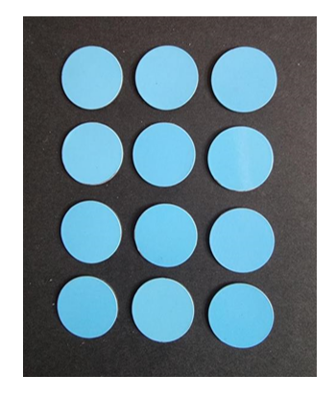
- The first die roll is a 4 so players can remove one column of 4 counters. Describe the new array arrangement as 2 columns of 4, or 4 rows of 2 (see Figure 3). Keep a tally of the number of rolls.
Figure 3 – After the first roll
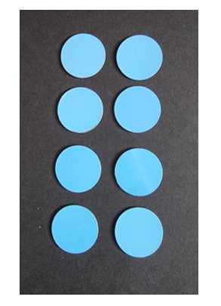
- The second die roll is a 3. Only one complete row or column can be removed in a turn so this roll cannot be used. The roll is still added to the tally chart.
- The third die roll is a 2. The players can remove one row of 2 counters. They add a tally mark and describe the new array as 2 columns of 3 or 3 rows of 2 (see Figure 4).
Figure 4 – After the third roll
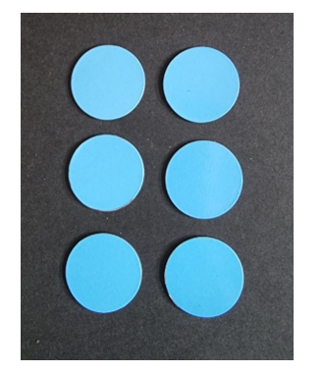
- Roll the die. The fourth roll is a 3. The players remove one column of 3, add a tally mark and describe the new array as one column of 3 or 3 rows of one (see Figure 5).
Figure 5 – After the fourth roll
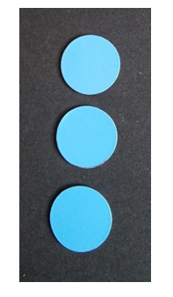
- Ask students what possible ways there are to finish the game. They could roll:
- a 3 to finish with 5 throws
- a one and then a 2 to finish with 6 throws
- a one, another one and then another one to finish with 7 throws.
- Write the final number of throws next to the tally.
- In pairs or small groups, students play the game once or twice and compare the number of throws for each game.

Cover it! – 40 minutes
- Ask Stage 1 students to predict which flat surfaces in the classroom could be covered with exactly 6 sticky notes, for example, a book cover or a pencil case. Early Stage 1 students will use a piece of paper the same area as 6 sticky notes. Early Stage 1 students use direct comparison to check their predictions by superimposing the piece of paper onto their chosen surface. Stage 1 students check by placing sticky notes with no gaps or overlaps. Discuss how surfaces can have different shapes but the same area.
- Students predict flat surfaces in the classroom that would have larger or smaller areas. Early Stage 1 students check through direct comparison with their piece of paper and make piles of objects that are smaller, bigger and the same. Stage 1 students estimate how many sticky notes would be required to cover object and check by measuring with no gaps or overlaps. They record this information in their workbooks.
- Repeat the process with 12 sticky notes or a different size of sticky notes.
- Students trace around pattern blocks to create a design inside Resource 5: Pencil case. They must try to leave no gaps or overlaps. Early Stage 1 students use simple shapes such as circles, squares, rectangles and triangles. They could also print with everyday objects with faces of common shapes. Count and record how many of each shape have been used. Observe students discussing the following questions in small groups:
- What shapes did you use?
- How many of each shape did you use?
- How many shapes did you use in total?
- Why did some people use more shapes than others?
- How are all the pencil case designs the same? They cover the same area.
- How are they different? They all have different designs.
- In the classroom, Early Stage 1 students find:
- 3 surfaces with the same area as their pencil case design
- 3 surfaces with smaller areas than their pencil case design
- 3 surfaces with larger areas than their pencil case design.
- Stage 1 students roll a 6-sided die in groups, predict and find an area that many times bigger than their pencil case.
The table below details assessment opportunities and differentiation ideas.
Assessment opportunities | Too hard? | Too easy?
What to look for:  - Can students use direct comparison to compare and order areas? (MAO-WM-01, MAE-2DS-02)  - Can students describe shapes used in their pencil-case design? (MAO-WM-01, MAE-2DS-01, MA1-2DS-01)  - Can students estimate, measure and record area using uniform informal units? (MAO-WM-01, MA1-2DS-02)  - Can students explain why different shapes can have the same area? (MAO-WM-01, MA1-2DS-02)  - Do students understand that the size of the unit used makes a difference to the number of units needed? (MAO-WM-01, MA1-2DS-02)  What to collect:  - samples of designs and photographs of sticky note surfaces and pencil case comparisons with classroom objects (MAO-WM-01, MAE-2DS-02, MA1-2DS-02)  - observations of student reasoning about designs and conservation of area (MAO-WM-01, MA1-2DS-02) | Students cannot find area or explain conservation.  - Model how to superimpose to compare areas.  - Provide play-based activities for students to explore area.  - Model placing sticky notes with no spaces or overlaps on surfaces.  - Students make different rectangles with 6 sticky notes to revise the concept of conservation.  - Students make designs with a limited number of shapes. For example, squares and triangles. | Students understand conservation of area.  - Students find 2 surfaces that have a combined area of 12 sticky notes.  - Students use hexagons and/or octagons in pencil case designs.

Consolidation and meaningful practice: Forwards and backwards – 5 minutes
- Early Stage 1 students drop a counter onto Resource 6: Number chart A and use that number to:
- count forwards to 30 and then backwards to zero in ones
- say the number before and after
- work out how many people they need to represent that number using fingers.
- Stage 1 students drop a counter to choose a number from Resource 7: Number chart B and count forwards in ones, twos, and tens.
- Repeat the process, counting backwards in ones, twos and tens.

Lesson 5: Build it, pack it!
Core concept: Volume can be compared by building and capacity can be compared by packing.
The table below contains suggested learning intentions and success criteria. These are best co-constructed with students.
Learning intentions | Success criteria
All students are learning that:  - three-dimensional objects can look different but have the same volume  - estimating and direct comparisons and/or measuring can be used to compare, order and match volume and/or capacity  - using 5 or 10 as a reference makes estimating and counting more accurate.  Stage 1 students are learning that choice of measuring unit affects accuracy when measuring volume and capacity. | All students can:  - use prediction or estimation to develop measuring skills  - identify objects that have the same volume but look different.  In addition, students working towards Early Stage 1 outcomes can:  - use 5 as a reference when predicting and counting quantities  - use volume to manipulate, describe and sort three-dimensional objects.  In addition, students working towards Stage 1 outcomes can:  - measure, compare and order the capacity of different containers by packing with uniform informal units  - use 10 as a reference when estimating and counting quantities.

Daily number sense: How many beads? – 15 minutes
- Build student understanding of using 10 as a reference by organising coloured beads to measure objects.
- Explain to students that they will be using bead groupings to measure objects. Pre-select a classroom object that is between 5 and 10 beads in length. Prior to each measurement, ask students to predict or estimate how many beads long the object will be.
- Measure using one colour for the first 5 beads and another colour for the remainder. This demonstrates using 5 as a reference to make counting larger numbers easier. See example in Figure 6.
Figure 6 – Count 8 using 5 as a reference
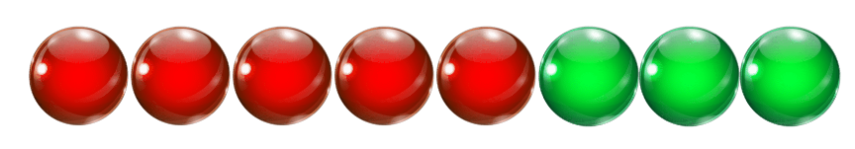
Images sourced from Canva and used in accordance with the Canva Content License Agreement.
- In small groups, Early Stage 1 students select classroom objects that they estimate will be between 5 and 10 beads long and check using 5 as a reference. Students discuss how to group their objects.
- Show Stage 1 students a pre-selected classroom object to measure that is between 11 and 20 beads in length. Ask students to estimate how many beads long the object will be. Ask whether there is a more effective way to group the beads for a longer object.
- Measure using one colour for the first 10 beads and another colour for the remainder. This will demonstrate using 10 as a reference to make counting larger numbers easier. See example in Figure 7.
Figure 7 – Count 14 using 10 as a reference
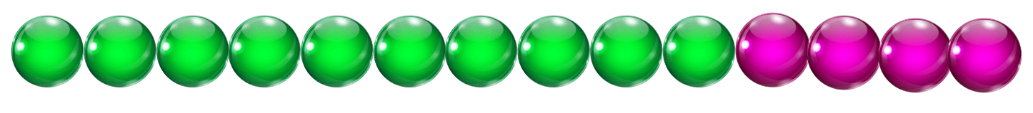
Images sourced from Canva and used in accordance with the Canva Content License Agreement.
- Repeat this process with an object between 20 and 30 beads long. Use one colour for the first 10 beads, a second colour for the next 10 and another for remaining units.
- Align groups of 10 beads horizontally in rows to demonstrate partitioning of numbers into tens and units. See example in Figure 8.
Figure 8 – Beads aligned
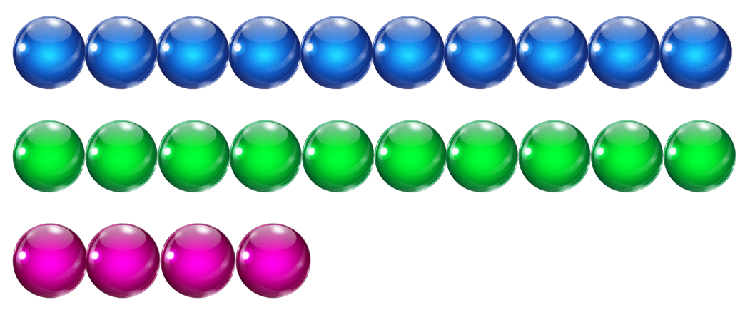
Images sourced from Canva and used in accordance with the Canva Content License Agreement.
- In small groups, students choose objects that will be over 11 beads long and estimate how many beads long they think the objects will be. Students then measure their objects using beads in groups of 10 and then ones. Partition using 10 as modelled. Compare final measurements to estimates each time.
The table below details assessment opportunities and differentiation ideas.
Assessment opportunities | Too hard? | Too easy?
What to look for:  - Can students make reasonable predictions? (MAO-WM-01)  - Can students use 5 or 10 as a reference number when counting quantities? (MAO-WM-01, MAE-CSQ-01, MA1-RWN-02)  - Can students partition two-digit numbers to show tens and units? (MAO-WM-01, MA1-RWN-02)  What to collect:  - observations of students predicting and measuring objects with beads, using 10 as a reference (MAO-WM-01, MAE-CSQ-01, MA1-RWN-02)  - photographs of bead groupings. (MAE-CSQ-01, MA1-RWN-02) | Students cannot work with lengths between 5 and 10 units.  - Provide students with a bead string of 5 in one colour so they must only find the remaining beads.  - Model counting by ones with the beads for an object.  Students cannot work with lengths between 11 and 20 units.  - Students measure objects between 5 and 9 beads long and use 5 as a reference.  - Model using 10 as a reference. | Students can find large numbers of beads using 10 as a reference.  - Students think about how they will organise counting when they have 10 lots of 10 beads, and some left over.  - Students measure vertical as well as horizontal lengths, choosing an appropriate uniform informal unit and method.

Build it! Pack it! – 40 minutes
- Ask Early Stage 1 students to make a robot out of 10 connecting cubes (see Figure 9).
Figure 9 – Example robot
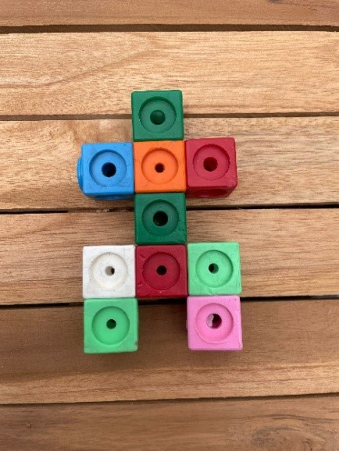
- Place all robots together and compare by asking:
- What do you notice?
- Which robot is the biggest? Why do you think that?
- Which robot is the smallest? Why do you think that?
- Remind students that arranging the cubes differently does not change the volume:
- The volume stays the same because everyone used 10 connecting cubes.
- The volume is the same because no cubes have been added or taken away.
- The volume is the same, but the robots look different.
- Ask how students could prove that all the robots have the same volume. In pairs, students use a method to convince the other that the volume is the same. Deconstruct one robot of a pair and use the cubes to make the other one of the pair. If they have the same volume, there should be no cubes left over.
- Ask students to find all the possibilities of what the robot could look like using 10 connecting cubes. Ask how they could sort them, for example, tall and short, big heads and small heads.
- Once Early Stage 1 students have finished their activity with the robots, they can find containers around the classroom and use them to investigate stacking and packing blocks.
- Show Stage 1 students 8 models of 3 interlocking cubes as in Figure 10.
Figure 10 – Triple cubes
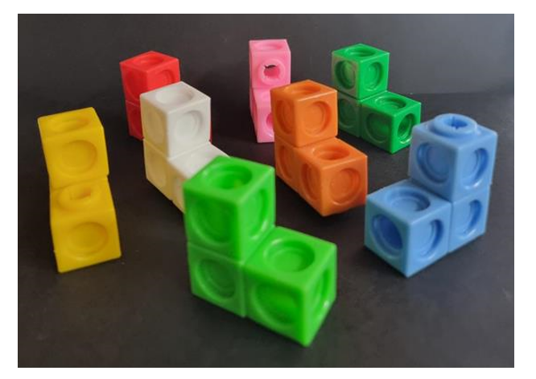
- Ask students:
- How would you describe the models? They are three-dimensional and each is made from 3 interlocking cubes. (They are different colours)
- What is the same about the models? (The volume)
- What is different about the models? (Orientation and colour)
- What do you wonder?
- In pairs, students make 8 triple cubes and use them to make a model. Triple cubes need to be connected by a face or an edge. See examples in Figure 11.
Figure 11 – Triple cube model examples
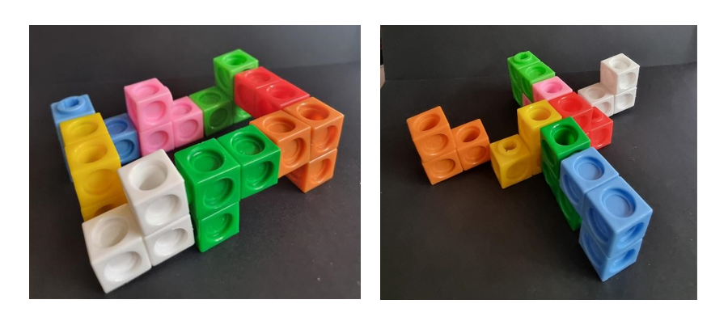
- As a class, compare and discuss the models by asking:
- How are they the same? They all have 24 cubes, so they all have the same volume.
- How are they different? For example, heights, lengths, faces or edges touching.
- Do any models have a name or a purpose?
- Each pair removes a triple cube from their design. Ask students how many cubes everyone has now (21 cubes).
- Each pair now removes 2 more triple cubes from their design. Ask students how many cubes everyone has now (15 cubes).
Note: Keep the triple cubes for the next activity.
- In groups of 4, students estimate how many triple cubes could be packed into different sized boxes and cylinders from around the classroom, aiming for no spaces. The triple cubes cannot be taken apart. More triple cubes can be made as necessary. Pack the containers. Record the number of triple cubes needed. Check measurements with original estimates.
- As a class, discuss which containers:
- took the most and least number of cubes to fill
- were easiest to pack and why
- were a challenge to pack and why.
The table below details assessment opportunities and differentiation ideas.
Assessment opportunities | Too hard? | Too easy?
What to look for:  - Can students estimate to decide if an answer is reasonable? (MAO-WM-01, MA1-3DS-02)  - Can students manipulate, describe and sort three-dimensional objects such as robots and block models? (MAE-3DS-01, MA1-3DS-01)  - Can students describe and compare volumes? (MAE-3DS-02)  - Can students measure, compare and order the capacity of containers by packing with uniform informal units? (MAO-WM-01, MA1-3DS-02)  What to collect:  - observational records (MAO-WM-01, MAE-3DS-02, MA1-3DS-02)  - photographs of robots, models and packed containers. (MAO-WM-01, MAE-3DS-02, MA1-3DS-02) | Students do not understand conservation or have problems packing efficiently.  - Show students 2 equal volumes of modelling clay in 2 identical containers. Agree that they take up the same amount of space. Make one into a ball and one into a worm. Then make the worm into a ball to show that they have the same volume.  - Show students conservation with different units of measurement. For example, 2 pieces of string of the same length, with one straight and one curled up.  - Model packing some of the triple cubes into a container with no spaces. Students pack the last few triple cubes. | Students understand conservation of volume and pack efficiently with no spaces.  - In pairs, make a cube or a rectangle with all 8 triple cubes.  - Join another pair and make a cube or a rectangle with 16 triple cubes.

Consolidation and meaningful practice: Big cubes, small cubes – 10 minutes
- Take one container that was used for packing triple cubes. Pack with MAB units and count the number of cubes needed. Compare the answer with the number of triple cubes needed for the same container. Discuss why the answers are different.

Lesson 6: Thirsty!
Core concept: Different shaped containers can have the same volume.
The table below contains suggested learning intentions and success criteria. These are best co-constructed with students.
Learning intentions | Success criteria
All students are learning that:  - estimating and measuring allows them to compare, order and match volumes  - volume can be the same even if containers are different shapes  - counting forwards and backwards develops understanding of place value. | All students can:  - compare the internal volumes (capacities) of 2 containers directly by filling one and pouring it into the other  - recognise that containers of different shapes may hold the same amount.  In addition, students working towards Early Stage 1 outcomes can:  - count forwards and back from a given number  - find the number before and after a given number.  In addition, students working towards Stage 1 outcomes can:  - order glasses containing different volumes of liquid  - explain why different shaped containers can have the same internal volume  - estimate and check by counting in groups of 10 and adding leftover parts  - count forwards and backwards in tens from a given number.

Daily number sense: Lots of beads! – 15 minutes
- Build student understanding of place value by counting forwards and backwards and/or counting in groups of 10.
- Give small groups of Early Stage 1 students one string of 30 beads of random colours. Each student takes a turn putting their finger on a bead and everyone in the group:
- counts by ones to find what number bead it is and says the number before and after
- counts on to 30
- counts backwards to zero if the bead number is 20 or below.
- Show Stage 1 students a pile of between 20 and 50 beads, ensuring the total number of beads is off the decade. Students estimate how many beads there are and check by counting into groups of 10 and adding on leftover beads. Groups of 10 beads may be threaded onto pieces of string if desired. From the answer, students count forwards by tens into three-digit numbers and then backwards by tens.
- Ask students which is the next multiple of 10. Count forwards and backwards on the decade from the answer.
- Repeat the process.
The table below details assessment opportunities and differentiation ideas.
Assessment opportunities | Too hard? | Too easy?
What to look for:  - Can students find a quantity by counting beads by ones or in groups of 10 and adding on leftover beads? (MAO-WM-01, MAE-CSQ-02, MA1-RWN-01)  - Do students refer to estimates to decide if their answer is reasonable? (MAO-WM-01, MA1-RWN-01)  - Can students count forwards and backwards by tens on and off the decade? (MAO-WM-01, MA1-RWN-01)  What to collect:  - observations of students demonstrating use of groups of 5 and/or 10 to find answers (MAO-WM-01, MAE-CSQ-02, MA1-RWN-01)  - recordings of students counting forwards and backwards off the decade (MAO-WM-01, MA1-RWN-01) | Students cannot work with beads independently.  - Model lining beads up in a line and counting one-by-one to find the total number of beads.  - Students use a number line to find the number before and after.  Students cannot count forwards or backwards by 10 off the decade.  - Model estimating and counting another pile of beads between 20 and 50.  - Students work with 10 to 20 beads.  - Students use a number chart to find the next number using Resource 6: Number chart A. | Students can count by tens on and off the decade.  - Students use the answer to count forwards by twos, threes and fives and then by numbers of their choice.  - Students use the answer to count backwards by twos, threes and fives and then by numbers of their choice.  - Students use beads to demonstrate partitioning of two-digit numbers.

Thirsty! (Early Stage 1) – 40 minutes
- Display lots of packaging examples for liquid including bottles, jars and pouches. See Figure 12.
Figure 12 – Supermarket containers
Images sourced from Canva and used in accordance with the Canva Content License Agreement.
- Discuss with students, how these containers might be organised in a supermarket.
- In small groups, students try different arrangements based on attributes such as height, capacity, mass, brand, flavour of drink and colour. Support students to predict whether the height of containers affects their capacity. For example, whether the tallest container will hold the most.
- Give pairs of students 2 containers, a cup and a bowl of beads.
Note: If beads are not available, any collection of small objects may be used. Some students may need to use a funnel.
- Students use their cup to fill their containers with beads. They then experiment with their containers by filling them up, emptying them and filling them about half full. Students draw pictures of their containers being full, empty and about half full.
- Encourage students to use the terms full, overflowing, empty, not very full, some left over and needs more.
- Ask students:
- Which containers are the largest and the smallest? How do you know?
- How could we compare the internal volume of 2 containers?
- What happens if we pour from one container into another?
- How would we know if one was larger in volume than another?
- How would we know if one was smaller in volume than another?
- Which container do you predict is the largest in volume? Why?
- In pairs, have students compare the internal volumes of their containers by filling one up and then pouring it into the other. Ask students:
- What did you notice happened to the beads when one container was larger than the other container?
- What did you notice happened to the beads when one container was smaller than the other container?
- Was your prediction accurate? Why?
The table below details assessment opportunities and differentiation ideas.
Assessment opportunities | Too hard? | Too easy?
What to look for:  - Can students compare the internal volumes of two containers by filling one and pouring into the other? (MAO-WM-01, MAE-3DS-02)  - Can students fill and empty containers using different materials such as water and/or beads? (MAO-WM-01, MAE-3DS-02)  - Are students using terms like full, empty and about half full? (MAO-WM-01, MAE-3DS-02)  What to collect:  - drawings of full, empty and half full containers (MAO-WM-01, MAE-3DS-02) | Students cannot compare the internal volumes of 2 containers by filling one and pouring it into the other.  - Give students the opportunity to practise pouring from one container into another and mark the halfway point.  - Students explore volume with containers that are shorter and hold more, then taller containers that hold less to see that height doesn’t reflect capacity.  - Give students hands-on experience of pouring into containers that look different but have the same volume. | Students can compare the internal volumes of 2 containers by filling one and pouring it into the other.  - Students look at containers and estimate which ones have the same volume but look different.  - Students explain their reasoning to a peer for their predictions.

Thirsty! (Stage 1) – 40 minutes
This lesson is adapted from Thirsty! From NRICH.
- Show students a tall, thin glass and a short, wide glass, both with the same amount of water. Ask which glass they would choose to get the biggest drink. Pour the contents of the tall glass into another glass and mark the level. Pour away water and repeat for the short, wide glass to show students that both glasses contained the same amount. Discuss why one glass appeared to have more.
- Revise using uniform informal units to compare internal volume with the two-minute marble challenge:
- Students choose 2 containers from a variety of small, different shaped containers.
- Estimate which of the containers has the largest internal volume.
- Compare the internal volumes by filling with marbles.
- Tell students that they will apply their skills as length and volume experts! Give Resource 8: Thirsty picture cards to small groups. Students turn and talk about what they notice. Move around groups asking:
- What is the same and different about the pictures?
- Can you sort the cards in different ways?
- What words can you use to describe the glasses? For example, full, half full, empty, short, shorter, shortest, tall, taller, tallest.
- Give each group Resource 9: Thirsty clue cards. Students share cards between them. The cards with a dot should be read first. Students take turns to read each card aloud and use clues to organise the picture cards. Move around and support groups by asking:
- How are the cards alike and how are the cards different?
- What do your clues say?
- What do you have to do with the pictures of the glasses?
- Who has a good clue with a dot to start?
- Can you explain that clue in your own words?
- Do you need to read any cards again if you were not sure the first time?
- Do you think you have arranged the glasses in the right order? How do you know?
The table below details assessment opportunities and differentiation ideas.
Assessment opportunities | Too hard? | Too easy?
What to look for:  - Can students explain why different shaped containers can have the same volume? (MAO-WM-01, MA1-3DS-02)  - Can students use clues to logically order glasses containing different volumes of liquid? (MAO-WM-01, MA1-3DS-02)  What to collect:  - observational records of verbal reasoning (MAO-WM-01, MA1-3DS-02)  - photographs of cards in order. (MAO-WM-01, MA1-3DS-02) | Students are challenged by the level of logical reasoning and cannot show their understanding of volume conservation.  - Students use Resource 10: Thirsty easy clues with the picture cards.  - Then students use Resource 9: Thirsty clue cards with the support of Resource 11: Place markers. | Students accurately order the picture cards using all clue cards.  - Students use Resource 12: Thirsty hard clues with the picture cards.  - Students make up their own Thirsty game.

Consolidation and meaningful practice: Discuss and connect the mathematics – 10 minutes
- Summarise the lesson, drawing out some key mathematical ideas about predicting/estimating and comparing volume. Ask students:
- What strategies did you use to compare the volume? Was it effective and why?
- What new questions do you have?
- What would you do differently next time?

Lesson 7: Mass – looks can be deceiving!
Core concept: Objects can look different but have the same mass.
The table below contains suggested learning intentions and success criteria. These are best co-constructed with students.
Learning intentions | Success criteria
All students are learning that estimating and hefting and/or measuring allows them to compare, order and match mass.  Stage 1 students are learning that:  - place value can be used to identify the numbers before and after two-digit and three-digit numbers  - choice of measuring unit affects accuracy when measuring mass. | All students can:  - comparing masses using comparative language such as: heavy, heavier, heaviest, light, lighter, lightest or the same as  - use comparison to order masses by estimating/predicting and hefting.  In addition, students working towards Early Stage 1 outcomes can:  - compare 2 masses directly by hefting  - predict which object is heavier than, lighter than, or has about the same weight as another object and explain reasons for this prediction.  In addition, students working towards Stage 1 outcomes can:  - identify the numbers before and after two-digit and three-digit numbers  - check estimations of mass by using an equal-arm balance.

Daily number sense: Bigger, smaller! (Early Stage 1) – 15 minutes
This lesson has been adapted from Guess my number from Thinking Mathematically.
- Build student understanding of whole number by reasoning about quantities.
- Use playing cards or write your own cards with the numbers one to 8. See Figure 13.
Figure 13 – 1 to 8 playing cards
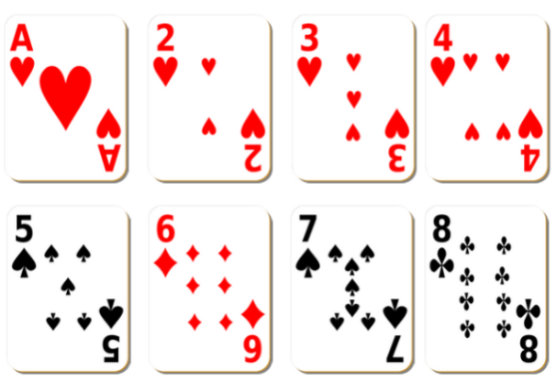
Images sourced from Canva and used in accordance with the Canva Content License Agreement.
- Students play in pairs with one student from the pair choosing a secret number between one and 8.
- Lay all the cards facing upwards as in Figure 13.
- The other student must guess the secret number.
- The student with the secret number will say whether their number is more or less than each guess. Students take cards away as they are ruled out as the secret number.
- Students try to guess the secret number in the fewest number of guesses possible.
- Ask students:
- What strategy did you use to guess your number?
- What did you notice?
- What would you do differently to guess your number faster?

Daily number sense: Bigger, smaller! (Stage 1) – 15 minutes
- Using Resource 13: Zero to nine, Stage 1 students pick up 2 cards. Students arrange the digits on the 2 cards to make the largest number possible. For example, the biggest number a student could make with cards 2 and 9 is 92 and the smallest number that can be made with 0 and 7 is 7. Select students to share strategies. For example, placing the biggest digit in the tens place and the smallest digit in the units place. Ask students to identify and record the numbers before and after the number they made. Students share responses and discuss.
- Repeat the process, but this time make the smallest number possible with the 2 cards drawn.
- Repeat the previous step, using 3 cards instead of 2. Students play the game in pairs while teacher observes.
The table below details assessment opportunities and differentiation ideas.
Assessment opportunities | Too hard? | Too easy?
What to look for:  - Can students use place value to make the largest or smallest possible numbers? (MAO-WM-01, MA1-RWN-01)  - Can students identify the number before or after two-digit and three-digit numbers? (MAO-WM-01, MA1-RWN-01)  What to collect:  - observational records (MAO-WM-01, MA1-RWN-01)  - recordings or photographs of student responses. (MAO-WM-01, MA1-RWN-01) | Students cannot make the largest or smallest possible numbers or identify numbers before and after.  - Provide students with their own digit cards and model how to make the largest possible number by placing the largest digit first, followed by the other digit.  - Students use a number chart to locate the number they made, then the numbers before and after.  - Model the process again but for how to make the smallest number possible each time. | Students accurately make the largest or smallest possible numbers and identify the numbers before and after.  - Students use 4 cards instead of 2 or 3.  - Students make the largest and smallest numbers, then find the difference.

Tricky party bags – 40 minutes
This lesson has been adapted from 'Tricky party bags’ by McDonough et al. (2013).
- In small groups, students order Resource 14: Mass discussion cards from heaviest to lightest.
- Discuss ideas as a class and develop a working definition for mass using comparative language.
- In pairs, students select 3 objects from the classroom. Place the objects in paper bags to create 3 sealed bags of different masses to be ordered by hefting. Challenge the students to make their bags ‘tricky’, by deliberately making them different in size but similar in mass. Label the bags A, B and C.
Hefting: Testing the weight of an object by lifting and/or balancing it.
- Once each pair has filled and sealed their bags, challenge another pair to predict/estimate the order of the bags from heaviest to lightest by looking only. Record predictions/estimations with reasons. For example, this bag is really small so it will be the lightest or this bag is really tall so I think it will be the heaviest.
- In pairs, students order the bags by hefting. Students still cannot look inside. After testing predictions/estimations using only hefting, students can revise or confirm their thinking based on new evidence.
- As a class, discuss what students have observed so far in relation to mass. Students should be able to explain that mass cannot be measured just by looking; the objects needed to be picked up. Explain that mathematicians call this hefting.
- Ask questions, such as:
- What do you notice about your predictions/estimations?
- Was it possible to accurately order your party bags just by looking and thinking?
- Why do you think it is difficult to predict/estimate the mass of an object without picking it up?
- Ask students if they could compare mass with their eyes closed. Students turn and talk to discuss.
- Add new ideas to the working definition of mass. Students should justify reasoning. Ask students to explain how mass is different to other measurable attributes such as length and area.
- Early Stage 1 students use predicting and hefting to find 3 classroom objects that weigh the same as each of the party bags. They then find other classroom objects and make their own tricky party bags to use with the hefting process and questions.
- Ask Stage 1 students if they found it hard to order the bags by hefting. Discuss why hefting is not always an accurate measure. Ask students if they can think of a tool that might be more accurate when checking the mass of the bags.
- Students check the order of the tricky party bags using an equal-arm balance. Represent findings by drawing mathematical diagrams of the equal-arm balance to prove their comparisons.
- Students identify relationships between the masses of the bags by reasoning about comparisons. For example, A is heavier than B and C is lighter than B so C must also be lighter than A. Use questioning to support reasoning about relationships between objects and discuss how the equal-arm balance helped them to compare and order the objects. Ask each group to communicate the strategy they used to prove their bags were ordered correctly.
Note: You may prepare 3 party bags equivalent in mass that look different to provide an explicit example if masses if student party bags are too easy to heft and order. Party bags that are equivalent or similar in mass will create a need for using the equal-arm balances.
The table below details assessment opportunities and differentiation ideas.
Assessment opportunities | Too hard? | Too easy?
What to look for:  - Can students use comparative language when comparing the mass of objects? (MAO-WM-01, MAE-NSM-01, MA1-NSM-01)  - Can students estimate, order and check the mass of objects by hefting and/or using an equal-arm balance? (MAO-WM-01, MAE-NSM-01, MA1-NSM-01)  What to collect:  - student work samples (MAO-WM-01, MAE-NSM-01, MA1-NSM-01)  - observational records (MAO-WM-01, MAE-NSM-01, MA1-NSM-01) | Students think that the bigger an object is, the heavier it is.  - Model hefting, making sure that some objects are bigger and lighter, and some are smaller but heavier. For example, a big box with a piece of paper and a small box full of rocks.  - Students find an object that is lighter and an object that is heavier than a party bag.  - Students compare 2 party bags. | Students accurately predict/estimate, measure and order objects according to their weight.  - Ask students to find objects in the room that are about the same weight as their party bags.  - Students brainstorm a list of objects that are small but heavy.  - Students brainstorm a list of objects that are large but light.

Consolidation and meaningful practice: Tricky party bags discussion – 10 minutes
- Discuss the following with students:
- Does the size of the bag help you predict/estimate the heaviest or lightest bag?
- How do we know when our party bags have the same mass or are equivalent?
- Were your predictions/estimations accurate?
- Revise that mathematicians create diagrams that include the most important mathematical information. Select Stage 1 pairs to share their diagrams and ask questions such as:
- Did your diagrams help you to compare and order the mass of your bags? Why or why not?
- How does the equal-arm balance help you to be more precise?
- Did your results remain the same or did they change when you used the equal-arm balance? Revise the working definition of mass to include new ideas and reasoning.

Lesson 8: Heavier, lighter or the same?
Core concept: Mass can be compared and recorded using diagrams, pictures and words.
The table below contains suggested learning intentions and success criteria. These are best co-constructed with students.
Learning intentions | Success criteria
All students are learning that:  - predicting/estimating and hefting and/or measuring allows them to compare, order and match mass  - comparative language can be used to explain reasoning.  Stage 1 students are learning that:  - choice of measuring unit affects accuracy when measuring mass  - mass remains the same even if the object changes shape. | All students can:  - predict/estimate and heft to compare, order and match mass  - use comparative language to describe mass.  In addition, students working towards Early Stage 1 outcomes can:  - recognise that objects can be small but heavy, or large but light  - predict and explain why an object might weigh about the same as another.  In addition, students working towards Stage 1 outcomes can:  - estimate what will happen to an equal-arm balance before placing objects into each side  - use an equal-arm balance to compare mass and find equivalence.

Daily number sense: Teacher choice – 10 minutes
- From a class need surfaced through formative assessment data, identify a short, focused activity that targets students’ knowledge, understanding and skills. Example activities may be drawn from the following resources:
- Thinking mathematically Early Stage 1
- Thinking mathematically Stage 1
- Universal Resources Hub.

Supermarket hefting (Early Stage 1) – 40 minutes
- Ask students to think about a time they helped their family do the grocery shopping and if they noticed any heavy or light items.
- Display items such as washing powder, a box of tissues, chips, a can of food, bag of sugar and so on. Ask students which item is the:
- biggest? Why do you think this?
- smallest? Why do you think this?
- heaviest? Why do you think this?
- lightest? Why do you think this?
- Ask students what words they can use to describe the mass of objects.
- Explain to students that they will be investigating the weight of shopping items and ordering them from lightest to heaviest.
- Show students supermarket items. Ask students to visualise and record their predictions of weight from lightest to heaviest on Resource 15: Recording weight.
Note: Display items that are heavy and large, light and small, heavy and small, large but lighter than a smaller item.
- Remind students that they can compare an item’s weight by hefting. Revise that students can also test the mass of an object by lifting or holding the item and balancing it against another object.
- Allow students time to heft and order.
- Students revisit predictions on Resource 15: Recording weight and draw a picture to record their results.

The table below details assessment opportunities and differentiation ideas.
Assessment opportunities | Too hard? | Too easy?
What to look for:  - Can students compare masses directly by hefting? (MAO-WM-01, MAE-NSM-01)  - Can students describe and identify objects that are heavy or light? (MAO-WM-01, MAE-NSM-01)  What to collect:  - observational records of students as they participate and engage in learning activities (MAO-WM-01, MAE-NSM-01)  - samples of Resource 9: Recording weight (MAO-WM-01, MAE-NSM-01) | Students cannot compare masses by hefting.  - Students visually compare 2 objects and predict which is the heaviest.  - Place items on a student's lap to determine if an item is heavy or light.  Students cannot describe and identify objects that are heavy or light.  - Support language with visual aids to represent unfamiliar vocabulary.  - Explicitly teach different forms of comparative adjectives, for example, the use of ‘er’ in taller. | Students can compare masses directly by hefting.  - Students explore weight using an equal-arm balance.  - Students identify 2 items that have the same weight.  Students can describe and identify objects that are heavy or light.  - Students compare objects that are the same size but have different weight and describe what they feel.  - Use extending prompts, for example, convince me that your ordering is correct.

Weighing balls and worms (Stage 1) – 40 minutes
This activity is adapted from Seesaws from NZ Maths (2022) and links well into STEM teaching. Alternatively, an equal-arm balance may be used.
- Revise Tricky party bags (Lesson 7) and ask how the mass of 2 objects can be compared. Explain that a seesaw can be used as an equal-arm balance and that students will make their own to compare mass.
- Students work in small groups. Provide each group with an aluminium can, water bottle or other cylindrical object. Fix it to a flat surface using tape or balls of modelling clay. Use a shoebox lid, lunchbox lid or similar item, ensuring the lid has sides so objects being weighed will not fall off (see Figure 14).
Figure 14 – Handmade seesaw
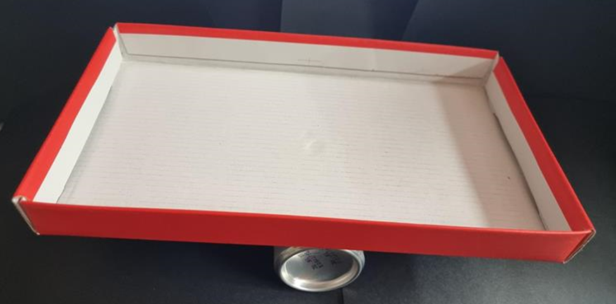
- See if students can balance the lid on top of the can. Attach the lid to the can with tape.
- Give each student some modelling clay to roll into 2 balls. In their groups, each student attempts to balance the seesaw using their 2 balls. Demonstrate if necessary. Students may need to remove some modelling clay from one of the balls in order to balance the seesaw.
- Students use their modelling clay to make an object of choice. Ask groups if their objects will have the same mass, prompting students to explain why or why not. Check predictions using the seesaw.
- Ask students to use their modelling clay to make the longest worm that they can. Predict which worm will be the heaviest and check using the seesaw. Ask questions such as:
- Which worm is the longest?
- Which worm is the heaviest?
- How can you check?
- Why do the worms have the same mass?
- Ask some students to make their worm into a few different sized balls. Work with 2 students at a time and ask:
- Who has made the most balls?
- Which ball is the heaviest? Check your estimation.
- If each student puts their balls together on either side of the seesaw, what do you think will happen? Check estimations.
- What do you notice?
- Why is the seesaw balanced?
The table below details assessment opportunities and differentiation ideas.
Assessment opportunities | Too hard? | Too easy?
What to look for:  - Can students use an equal-arm balance to compare the mass of 2 objects? (MAO-WM-01, MA1-NSM-01)  - Can students explain why a ball of modelling clay can be made into 2 different shapes but still have the same mass? (MAO-WM-01, MA1-NSM-01)  What to collect:  - teacher observations and recordings of student responses (MAO-WM-01, MA1-NSM-01)  - photographs of student work (MAO-WM-01, MA1-NSM-01) | Students do not understand equivalence of conservation of mass.  - Students use hefting to estimate mass and equivalence of their clay in a ball and then in a worm.  - Show students conservation with different units of measurement. For example, 2 pieces of string the same length with one straight and one curled up. | Students understand equivalence of conservation of mass.  - Students explore equivalence with an interactive equal-arm balance using Are You Well Balanced? from NRICH.  - Each group puts all their modelling clay together in one ball and finds an object in the classroom with equivalent mass.

Consolidation and meaningful practice: Comparing and ordering – 15 minutes
- Early Stage 1 students form small groups and undertake play-based exploration with clay and equal-arm balances.
- Stage 1 students revise how beads or blocks were used to measure length of jumps in ‘Jump, jump, jump!’ (Lesson 1). Ask how beads or blocks could be used to compare and order modelling clay balls. Revise that beads can be used as a uniform informal unit. Ask students to estimate how many beads or blocks would be required to balance their modelling clay. In small groups, students use the seesaw or an equal-arm balance to check estimates. Order the balls in order from lightest to heaviest.
- Ask students:
- How close was your estimate?
- How many beads or blocks did it take for you to balance the seesaw and then your partner?
- Can you find someone who needed more beads or blocks than you or less beads or blocks than you? Explain why that was.
- Were beads or blocks an appropriate unit of measurement? Why or why not?
- Can you think of another unit of measurement that could be used?
This table details assessment opportunities and differentiation ideas.
Assessment opportunities | Too hard? | Too easy?
What to look for:  - Can students describe objects using vocabulary of mass, for example, heavier, lighter, the same as? (MAO-WM-01, MA1-NSM-01)  - Can students use a consistent unit to measure mass so that objects can be compared and ordered? (MAO-WM-01, MA1-NSM-01)  What to collect:  - teacher observations and recordings of student responses (MAO-WM-01, MA1-NSM-01)  - photographs of student work (MAO-WM-01, MA1-NSM-01) | Students cannot find equivalence using the equal-arm balance or seesaw.  - Model placing the clay ball on one side and adding one bead or block at a time to the other side until equivalence is found.  - Students work with a small clay ball to begin with and then a bigger ball.  - Students play with placing beads or blocks on each side to explore equivalence. | Students accurately compare and order masses.  - Students repeat process with classroom objects.  - Students use Seesaw Shenanigans from NRICH to explore equivalence.

Resource 1: Number line 1-30
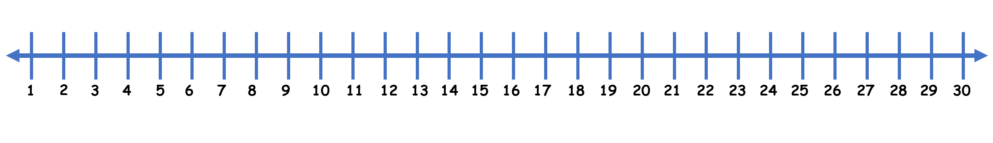

Resource 2: Mug and Monkey!
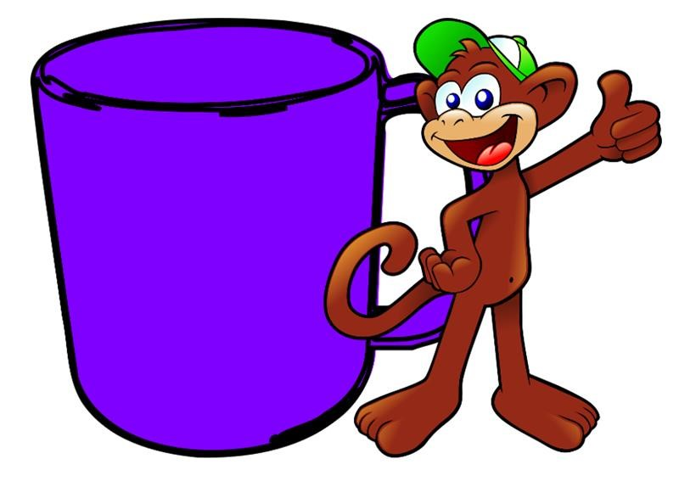
Images sourced from Pixabay and used in accordance with the Pixabay License.

Resource 3: Race to write
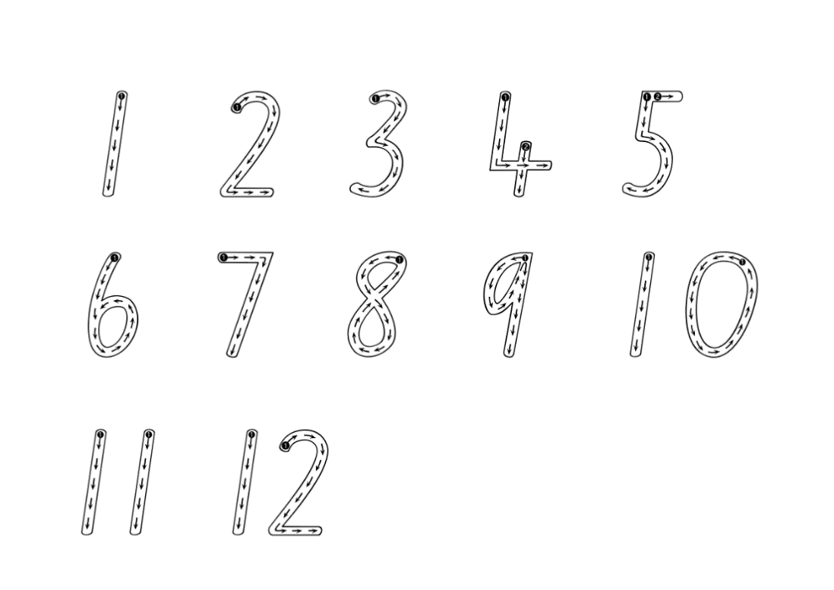

Resource 4: Array cards
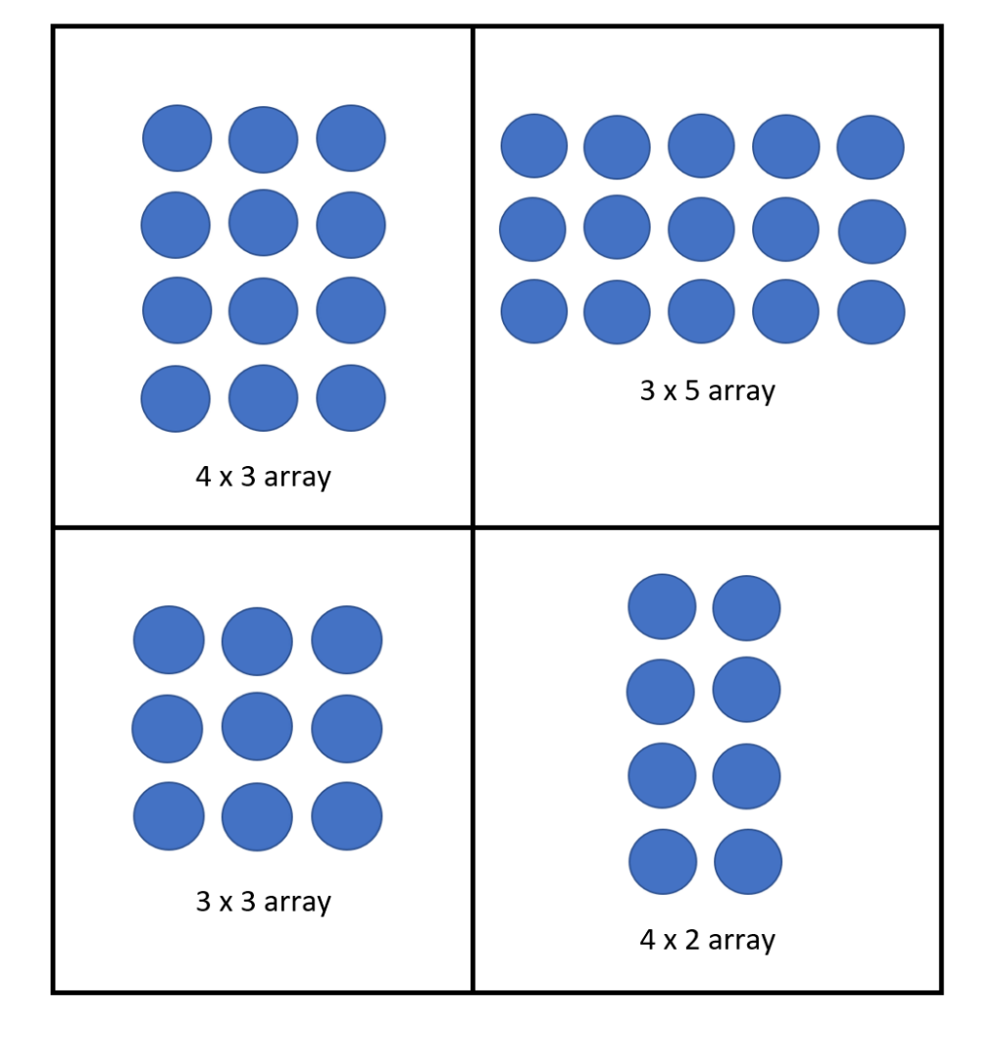

Resource 5: Pencil case
“Pencil Case Isolated Icon” by Giuseppe Ramos S sourced from Canva and used in accordance with the Canva Content License Agreement.

Resource 6: Number chart A
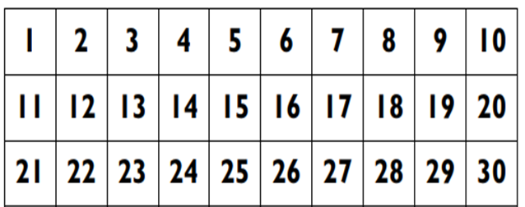

Resource 7: Number chart B
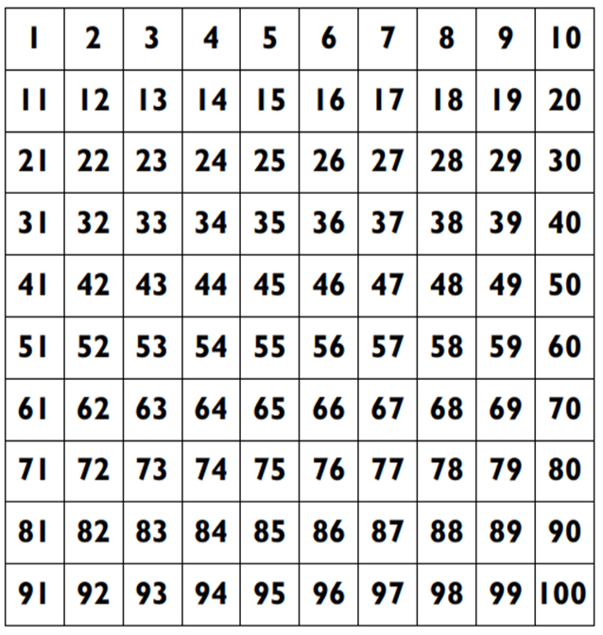

Resource 8: Thirsty picture cards
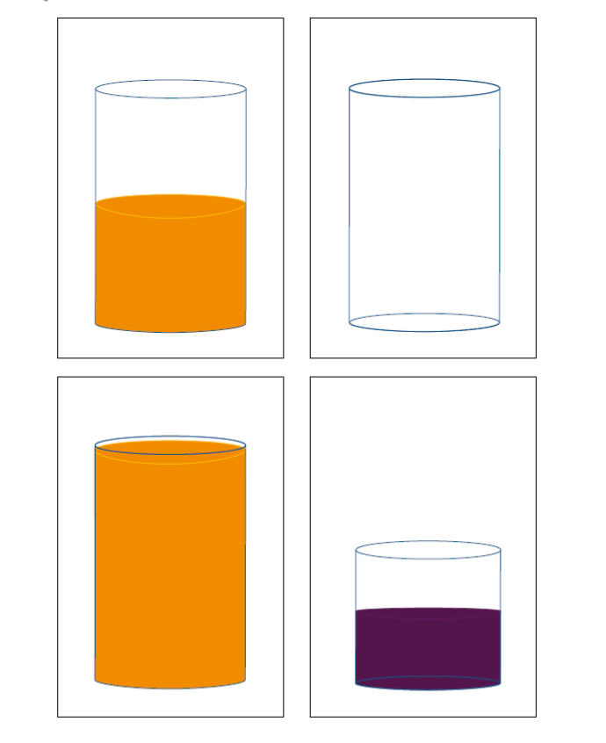
“Thirsty" by © University of Cambridge is licensed under CC-BY-NC 4.0.
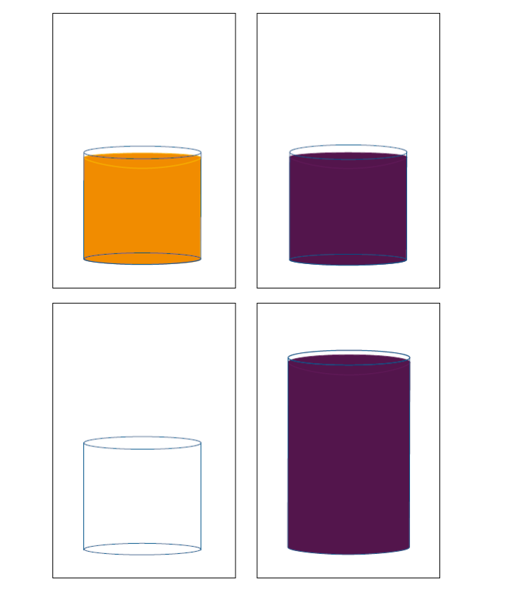
“Thirsty" by © University of Cambridge is licensed under CC-BY-NC 4.0.

Resource 9: Thirsty clue cards
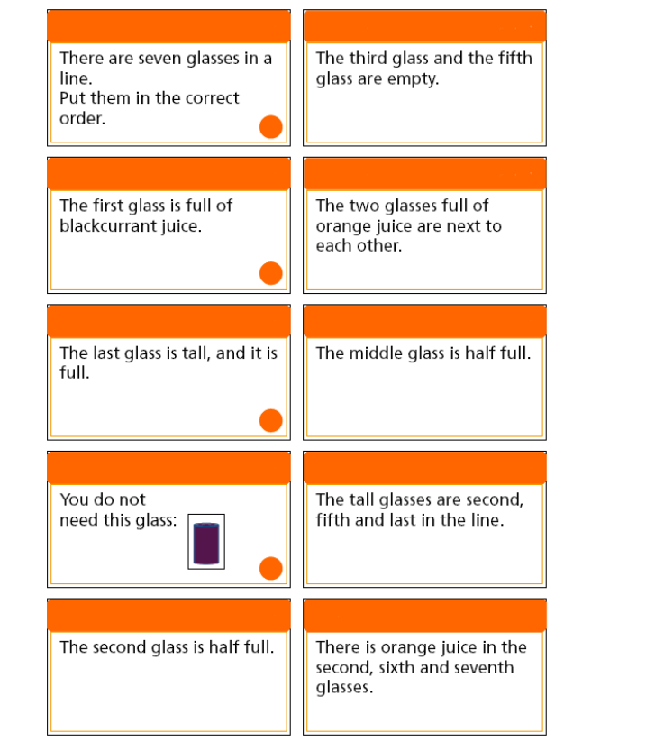
“Thirsty" by © University of Cambridge is licensed under CC-BY-NC 4.0.

Resource 10: Thirsty easy clues
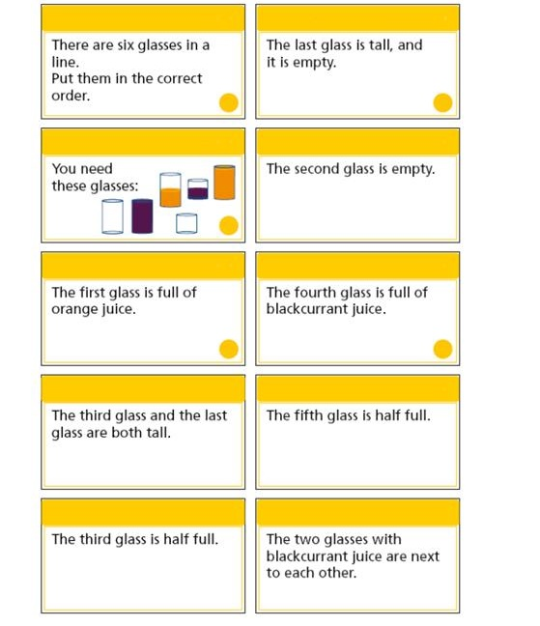
“Thirsty" - Teachers' Resources by © University of Cambridge is licensed under CC-BY-NC 4.0.

Resource 11: Place markers
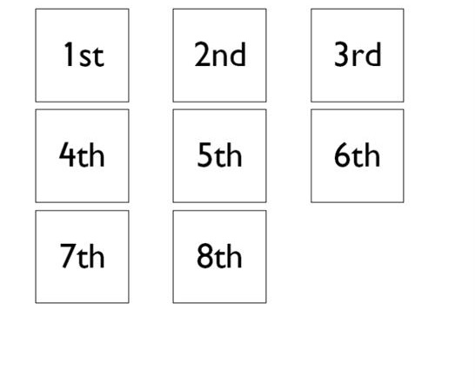
“Thirsty" - Teachers' Resources by © University of Cambridge is licensed under CC-BY-NC 4.0.

Resource 12: Thirsty hard clues
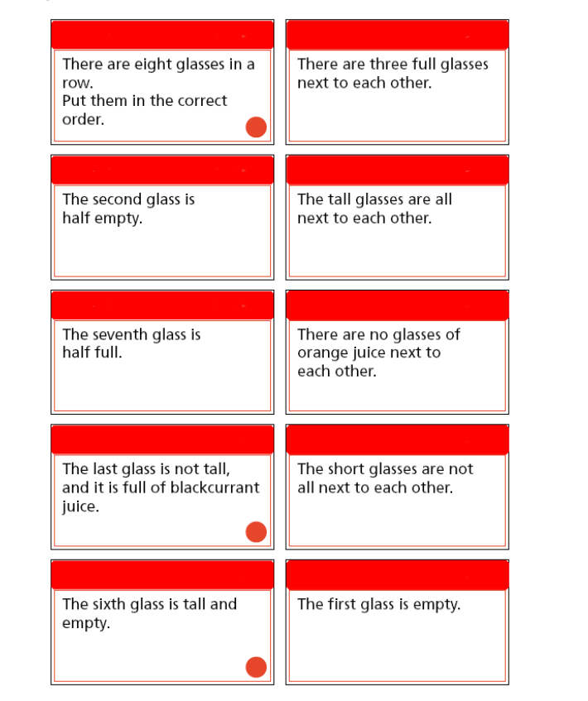
“Thirsty" - Teachers' Resources by © University of Cambridge is licensed under CC-BY-NC 4.0.

Resource 13: Zero to nine
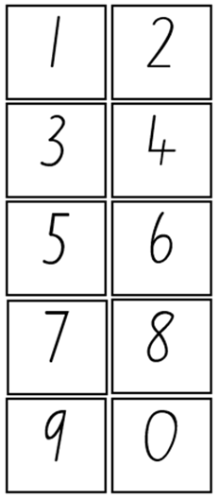

Resource 14: Mass discussion cards
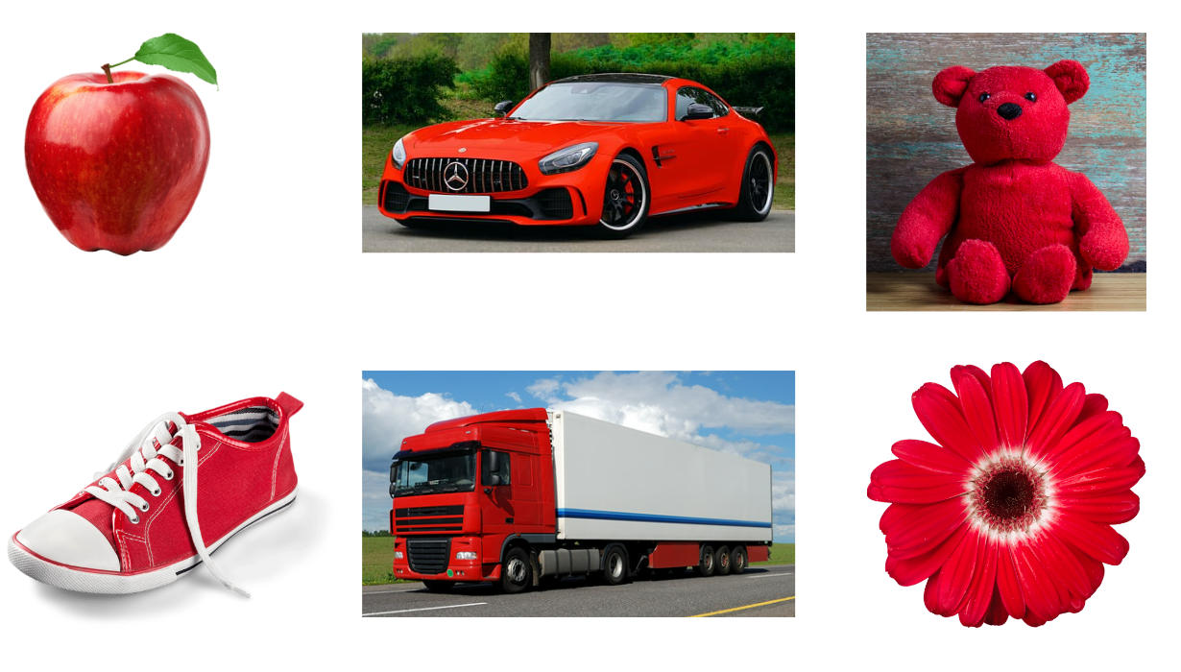
Images sourced from Canva and used in accordance with the Canva Content License Agreement.

Resource 15: Recording weight
Question 1
Look at the 5 shopping items.
Draw a picture of your prediction from lightest to heaviest.
Label your picture if you can.
Results
Measure the weight of the shopping items by hefting.
Draw and label a picture of the result.

Syllabus outcomes and content
The table below outlines the syllabus outcomes and range of relevant syllabus content covered in this unit. Content is linked to National Numeracy Learning Progression version (3).
Focus area and outcomes | Content groups and content points | Lessons
Representing whole numbers  MAO-WM-01  MAE-RWN-01, MA1-RWN-01  MA1-RWN-01, MA1-RWN-02 | Early Stage 1  Instantly name the number of objects within small collections  - instantly recognise (subitise) the number of items in small groups of up to four items without counting (NPV1, CPr1)  - identify the number of items in different arrangements (CPr2) | 7
Representing whole numbers (cont) | Early Stage 1  Use the counting sequence of ones flexibly  - count forwards to at least 30 and state the number after or before a given number, without needing to count from one (CPr4)  - count backwards from a given number 20 or less (CPr5)  - identify the number before as 'one less' and the number after as 'one more’ than a given number | 1, 2, 6
Representing whole numbers  (cont) | Early Stage 1  Connect counting and numerals to quantities  - count with one-to-one correspondence, recognising that the last number name represents the total number in the collection (CPr3, CPr5)  - count out a specified number of objects (from 5 to 20) from a larger collection, keeping track of the count (CPr4-CPr5)  - make correspondences between collections  - read numerals to at least 20, including zero (NPV3)  - represent numbers as quantities to at least 20 using objects (such as fingers), number words and numerals (NPV2-NPV4, CPr3)  - compare and order numbers to 20 (NPV2, NPV3)  - use the term ‘is the same as’ to express equality of groups (CPr4-CPr5, MuS1) | 3, 4, 7
Representing whole numbers A | Stage 1  Use counting sequences of ones with two-digit numbers and beyond  - identify the number before and after a given two-digit number (CPr5)  - count forwards and backwards by ones from a given number to at least 120 (CPr6) | 7
Representing whole numbers A  (cont) | Stage 1  Represent numbers on a line  - sequence numbers and arrange them on a line by considering the order and size of those numbers (CPr5)  - locate the approximate position of multiples of 10 on a model of a number line from 0 to 100 (CPr5) | 1, 2
Representing whole numbers A  (cont) | Stage 1  Represent the structure of groups of ten in whole numbers  - recognise that ten ones is the same as one ten (NPV2, NPV4)  - use 10 as a reference in forming numbers from 11 to 20 (CPr7)  - count large sets of objects by systematically grouping in tens (CPr7) | 5
Representing whole numbers B  (cont) | Stage 1  Use counting sequences of ones and tens flexibly  - identify the number before and after a given three-digit number  - count forwards and backwards by tens, on and off the decade, with two-and three-digit numbers (CPr7)  - identify how many more to the next multiple of ten within two- and three-digit numbers | 7
Representing whole numbers B  (cont) | Stage 1  Form, regroup, and rename three-digit numbers  - use models such as base 10 material and interlocking cubes to represent and explain grouping (CPr7) | 1
Combining and separating quantities  MAO-WM-01  MAE-CSQ-01, MAE-CSQ-02  MA1-CSQ-01 | Early Stage 1  Model additive relations and compare quantities  - use concrete materials or fingers to model and solve addition and subtraction questions, counting forwards or backwards by ones as necessary (AdS1-AdS2, NPV3)  - compare two groups of objects to determine how many more (NPV1, AdS2) | 1
Combining and separating quantities  (cont) | Early Stage 1  Identify part-whole relationships in numbers up to 10  - use five as a reference in forming numbers from six to ten  - count by ones to find the total or difference (AdS2-AdS3) | 5
Combining and separating quantities A (cont)  NOTE – There is only one combining and separating quantities outcome for Stage 1. | Stage 1  Use advanced count-by-one strategies to solve addition and subtraction problems  - apply the terms ‘add’, ‘plus’, ‘equals’, ‘is equal to’, ‘is the same as’, ‘take away’, ‘minus’ and ‘the difference between’ to describe combining and separating quantities (AdS1, AdS6)  - fluently use advanced count-by-one strategies including counting on and counting back to solve addition and subtraction problems involving one-and two-digit numbers (AdS3-AdS5) | 1
Forming groups  MAO-WM-01, MAE-FG-01  MA1-FG-01, MAE-FG-02 | Early Stage 1  Copy, continue and create patterns  - copy, continue and create repeating patterns using shapes, objects, images or pictures (NPA1-NPA2)  Investigate and form equal groups by sharing  - distribute a group of familiar objects into smaller groups and recognise whether the number in each group is equal or not (MuS1-MuS2)  - group and share concrete materials by distributing objects one by one or using another method (MuS1-MuS2) | 3
Forming groups B  NOTE – There is only one forming groups outcome for Stage 1. | Stage 1  Represent and explain multiplication as the combining of equal groups  - use objects, diagrams, images or actions to model multiplication as accumulating equal groups (MuS4)  - solve multiplication problems using repeated addition (MuS4)  - form arrays of equal rows and equal columns (MuS5)  - determine and distinguish between the number of rows/columns and the number in each row/column when describing collections of objects (MuS5)  - model the commutative property of multiplication, using an array (MuS6)  - model division by deconstructing an array equally into a given number of rows or columns | 3, 4
Geometric measure  MAO-WM-01  MAE-GM-01, MA1-GM-01  MAE-GM-02, MA1-GM-02  MAE-GM-03, MA1-GM-03 | Early Stage 1  Length: Use direct and indirect comparisons to decide which is longer  - identify the attribute of 'length' as the measure of an object from end to end  - use comparative language to describe length (UuM2)  - compare lengths directly by placing objects side by side and aligning the ends (UuM2)  - explain why the length of a piece of string remains unchanged whether placed in a straight line or a curve  - compare lengths indirectly by copying a length (UuM3) | 1, 2
Geometric measure A (cont) | Stage 1  Length: Measure the lengths of objects using uniform informal units  - use uniform informal units to measure lengths and distances by placing the units end to end without gaps or overlaps (UuM2)  - select appropriate uniform informal units to measure lengths and distances (UuM3)  - recognise and explain the relationship between the size of a unit and the number of units needed  - record lengths and distances by referring to the number and type of unit used (UuM4)  - use a single informal unit repeatedly (iteratively) to measure length (UuM4)  Length: Compare lengths using uniform informal units  - compare the lengths of two or more objects using appropriate uniform informal units and check by placing the objects side by side and aligning the ends (UuM2-UuM3)  - explain why the length of an object remains constant when rearranged  - estimate lengths, indicating the number and type of unit used and check by measuring (UuM3) | 1, 2
Geometric measure B (cont) | Stage 1  Length: Compare and order lengths, using appropriate uniform informal units  - compare the lengths of two or more objects that cannot be moved or aligned  - record length comparisons using drawings, numerals and words, and by referring to the uniform informal unit used | 2
Two-dimensional spatial structure  MAO-WM-01  MAE-2DS-01, MA1-2DS-01  MAE-2DS-02, MA1-2DS-02 | Early Stage 1  Represent shapes  - make pictures and designs using a selection of shapes | 2, 4
Two-dimensional spatial structure (cont) | Early Stage 1  Identify and compare area  - make closed shapes and identify the attribute of area as the measure of the amount of surface  - use comparative language to describe areas (UuM2)  - predict which of two surfaces will have the larger area and justify the answer  - compare areas of two similar shapes directly by drawing, tracing, or cutting and pasting (UuM3-UuM4) | 2, 3, 4
Two-dimensional spatial structure A (cont) | Stage 1  2D shapes: Recognise and classify shapes using obvious features  - Explore, manipulate and describe features of polygons (UGP3)  - Compare, sort and classify polygons according to the number of sides or vertices (UGP3-UGP4) | 4
Two-dimensional spatial structure A (cont) | Stage 1  Area: Measure areas using uniform informal units  - explore area using uniform informal units to cover the surface in rows or columns without gaps or overlaps (UuM5)  - measure area by selecting and using appropriate uniform informal units  - explain the relationship between the size of a unit and the number of units needed to measure an area  - explain why the area remains constant when units are rearranged  - record areas by referring to the number and type of uniform informal unit used  - identify any parts of units left over when counting uniform informal units to measure area  - estimate areas by referring to the number and type of uniform informal unit used and check by measuring (UuM3) | 3, 4
Two-dimensional spatial structure B (cont) | Stage 1  Area: Compare rectangular areas using uniform square units of an appropriate size in rows and columns  - cover rectangular surfaces by creating repeated rows of square tiles (UuM5)  - use the structure of repeated units to find the area of a rectangle (UuM5) | 3, 4
Three-dimensional spatial structure  MAO-WM-01  MAE-3DS-01, MA1-3DS-01  MAE-3DS-02, MA1-3DS-02 | Early Stage 1  Volume: Explore familiar three-dimensional objects  - make and describe a variety of three-dimensional models (UGP3)  - predict the stacking capabilities of various three-dimensional objects | 5
Three-dimensional spatial structure (cont) | Early Stage 1  Volume: Compare internal volume by filling and packing  - fill and empty containers using materials such as water or sand  - use the terms ‘full’, ‘empty’ and ‘about half full’  - compare the internal volumes (capacities) of two containers directly by filling one and pouring into the other (UuM2)  - compare the internal volumes of two containers indirectly by pouring their contents into two other identical containers and observing the level reached in each (UuM3)  - establish that containers of different shapes may hold the same amount  - stack and pack blocks into defined spaces (UuM5) | 5, 6
Three-dimensional spatial structure (cont) | Early Stage 1  Volume: Compare volume by building  - identify the attribute of volume as the amount of space an object or substance occupies  - compare the volumes of two objects made from blocks or connecting cubes directly by deconstructing one object and using its parts to construct a copy of the other object  - use comparative language to describe volume (UuM2) | 5
Three-dimensional spatial structure A (cont) | Stage 1  3D objects: Recognise familiar three-dimensional objects  - use the term ‘three-dimensional’ to describe a range of objects (UGP2-UGP3)  - distinguish between objects, which are three-dimensional (3D) and shapes which are two-dimensional (2D)  - identify and name familiar three-dimensional objects, including cubes, cylinders, spheres and rectangular prisms | 5
Three-dimensional spatial structure A (cont) | Stage 1  Volume: Measure and compare the internal volumes (capacities) of containers by filling  - recognise and explain the relationship between the size of a unit and the number of units needed  - compare the internal volumes of two or more containers using appropriate uniform informal units (UuM3)  - recognise and explain why containers of different shapes may have the same internal volume  - estimate how much a container holds by referring to the number and type of uniform informal unit used and check by measuring (UuM3-UuM4) | 5, 6
Three-dimensional spatial structure A (cont) | Stage 1  Volume: Measure the internal volumes (capacities) of containers by packing  - pack cubic units (eg blocks) into rectangular containers so that there are no gaps  - recognise that cubes pack better than other objects in rectangular containers  - estimate and measure the internal volume of a container by filling the container with uniform informal units and counting the number of units used  - explain that if there are gaps when packing and stacking, this will affect the accuracy of measuring the internal volume | 5
Three-dimensional spatial structure B (cont) | Stage 1  Volume: Compare containers based on internal volume (capacity) by filling and packing  - compare, order and record the internal volumes (capacities) of two or more containers by measuring each container in uniform informal units (UuM3-UuM4)  - estimate internal volume (capacity) by referring to the number and type of uniform informal unit used (UuM3)  Volume: Compare volumes using uniform informal units  - compare models with different appearances, recognising when they have the same volume  - record the results of volume comparisons using drawings, numerals and words, referring to the units used | 5
Non-spatial measure  MAO-WM-01  MAE-NSM-01, MA1-NSM-01  MAE-NSM-02, MA1-NSM-02 | Early Stage 1  Mass: Identify and compare mass using weight  - identify that objects can be heavy or light (UuM2)  - compare two masses directly by hefting (UuM3)  - predict which object would be heavier than, lighter than, or have about the same weight as another object and explain reasons for this prediction | 7, 8
Non-spatial measure A (cont) | Stage 1  Mass: Investigate mass using an equal-arm balance  - predict the action of an equal arm-balance before placing particular objects in each pan  - compare and order the masses of two or more objects by hefting and check using an equal-arm balance | 7
Non-spatial measure B (cont) | Stage 1  Mass: Compare the masses of objects using an equal-arm balance  - use uniform informal units to measure the mass of an object by counting the number of units needed to obtain a level balance on an equal-arm balance (UuM3)  - select an appropriate uniform informal unit to measure the mass of an object and justify the choice (UuM3)  - explain the relationship between the mass of a unit and the number of units needed units  - compare the masses of two or more objects using the same informal (UuM3)  - estimate mass by referring to the number and type of uniform informal unit used and check by measuring (UuM3-UuM4)  - recognise that mass is conserved | 7, 8

References
Links to third-party material and websites
Please note that the provided (reading/viewing material/list/links/texts) are a suggestion only and implies no endorsement, by the New South Wales Department of Education, of any author, publisher, or book title. School principals and teachers are best placed to assess the suitability of resources that would complement the curriculum and reflect the needs and interests of their students.
If you use the links provided in this document to access a third-party's website, you acknowledge that the terms of use, including licence terms set out on the third-party's website apply to the use which may be made of the materials on that third-party website or where permitted by the Copyright Act 1968 (Cth). The department accepts no responsibility for content on third-party websites.
Except as otherwise noted, all material is © State of New South Wales (Department of Education), 2023 and licensed under the Creative Commons Attribution 4.0 International License. All other material (third-party material) is used with permission or under licence. Where the copyright owner of third-party material has not licensed their material under a Creative Commons or similar licence, you should contact them directly for permission to reuse their material.
Mathematics K–10 Syllabus © 2022 NSW Education Standards Authority (NESA) for and on behalf of the Crown in right of the State of New South Wales.
© 2022 NSW Education Standards Authority. This document contains NSW Curriculum and syllabus content. The NSW Curriculum is developed by the NSW Education Standards Authority. This content is prepared by NESA for and on behalf of the Crown in right of the State of New South Wales. The material is protected by Crown copyright.
Please refer to the NESA Copyright Disclaimer for more information.
NESA holds the only official and up-to-date versions of the NSW Curriculum and syllabus documents. Please visit the NSW Education Standards Authority (NESA) website and the NSW Curriculum website.
National Numeracy Learning Progression © Australian Curriculum, Assessment and Reporting Authority (ACARA) 2010 to present, unless otherwise indicated. This material was downloaded from the Australian Curriculum website (National Numeracy Learning Progression) (accessed 23 February 2023) and was not modified. The material is licensed under CC BY 4.0. Version updates are tracked in the ‘Curriculum version history’ section on the 'About the Australian Curriculum' page of the Australian Curriculum website.
ACARA does not endorse any product that uses the Australian Curriculum or make any representations as to the quality of such products. Any product that uses material published on this website should not be taken to be affiliated with ACARA or have the sponsorship or approval of ACARA. It is up to each person to make their own assessment of the product, taking into account matters including, but not limited to, the version number and the degree to which the materials align with the content descriptions and achievement standards (where relevant). Where there is a claim of alignment, it is important to check that the materials align with the content descriptions and achievement standards (endorsed by all education Ministers), not the elaborations (examples provided by ACARA).
Australian Government Department of Education (2022) ‘Measurement: Jump!’, Teaching resources, reSolve: Maths by Inquiry website, accessed 23 February 2023.
Boaler J, Munson J and William C (2021) Mindset Mathematics: Visualizing and Investigating Big Ideas, Grade 1, Jossey-Bass, New Jersey.
New Zealand Ministry of Education (2022) ‘Seesaws’, Resource Finder, NZ Maths website, accessed 23 February 2023.
Sullivan P and Lilburn P (2017) Open-ended Maths Activities: Using ‘Good’ Questions to Enhance Learning in Mathematics, Revised edn, Oxford University Press ANZ, Great Britain.University of Cambridge (Faculty of Mathematics) (2022), Brush Loads, NRICH website, accessed 23 February 2023.
University of Cambridge (Faculty of Mathematics) (2022) Dicey Array, NRICH website, accessed 23 February 2023.
University of Cambridge (Faculty of Mathematics) (2022) Little Man, NRICH website, accessed 23 February 2023.
University of Cambridge (Faculty of Mathematics) (2022) Number Lines, NRICH website, accessed 23 February 2023.
University of Cambridge (Faculty of Mathematics) (2022) Seesaw Shenanigans, NRICH website, accessed 23 February 2023.
University of Cambridge (Faculty of Mathematics) (2022) Thirsty?, NRICH website, accessed 23 February 2023.
University of Cambridge (Faculty of Mathematics) (2022) Triple Cubes, NRICH website, accessed 23 February 2023.
University of Cambridge (Faculty of Mathematics) (2022) Wrapping Presents, NRICH website, accessed 23 February 2023.

