Mathematics – K-2 multi-age – Year A – Unit 13
Contents
Unit description and duration 4
Student prior learning 4
Lesson overview and resources 5
Lesson 1: Number visuals 20
Daily number sense – 10 minutes 21
Number visuals – 40 minutes 21
Lesson 2: A group of friends 24
Daily number sense: Number talk – 15 minutes 25
A group of friends – 35 minutes 26
Consolidation and meaningful practice: Thinking multiplicatively – 15 minutes 29
Lesson 3: Thinking multiplicatively 30
Daily number sense: Spatial structuring of 2D arrays – 15 minutes 31
Array talks – 30 minutes 31
Lesson 4: True or false? 35
Daily number sense: Balancing numbers - 20 minutes 36
True or false – 30 minutes 36
Consolidation and meaningful practice: Number talk – 10 minutes 41
Lesson 5: Chanel’s garden 41
Daily number sense: Sharing collections – 10 minutes 42
Chanel’s garden – 40 minutes 42
Lesson 6: Multiplication toss – Part 1 46
Daily number sense: Multiples of 10 – 10 minutes 47
Multiplication toss – 40 minutes 47
Lesson 7: Multiplication toss – Part 2 51
Daily number sense: 3 tens in a row – 15 minutes 52
Multiplication toss revisited – 40 minutes 52
Consolidation and meaningful practice: Reflection – 10 minutes 55
Lesson 8: Secret prisms 56
Daily number sense: Rectangular prisms ‘notice’ and ‘wonder’ – 10 minutes 57
Secret prisms – 50 minutes 57
Consolidation and meaningful practice: Reflection – 10 minutes 61
Resource 1: Number visuals 1 62
Resource 2: Number visuals 2 63
Resource 3: Ball arrays 64
Resource 4: A group of friends 65
Resource 5: An array of friends 66
Resource 6: Partially covered array 67
Resource 7: Array talk 68
Resource 8: Array puzzle 69
Resource 9: Equal-arm balance 70
Resource 10: True or false arrays 71
Resource 11: Basketball array 73
Resource 12: Rectangular prisms ‘notice’ and ‘wonder’ 74
Syllabus outcomes and content 75
References 89

Unit description and duration
This two-week unit introduces students to making and using equal groups. Students are provided opportunities to:
- model and use equal groups of objects to represent multiplication
- use arrays to distinguish between the number of groups and the number in each group when describing collections of objects
- solve multiplication and division problems using objects, diagrams, images and actions.
Mathematics K–10 Syllabus © 2022 NSW Education Standards Authority (NESA) for and on behalf of the Crown in right of the State of New South Wales.

Student prior learning
Before engaging in these teaching and learning activities, students would benefit from prior experience with:
- recognising, describing, and continuing repeating patterns
- forming equal groups by sharing and counting collections of objects
- describing and comparing areas of similar shapes.

Lesson overview and resources
The table below outlines the sequence and approximate timing of lessons; syllabus focus areas and content groups; and resources.
Lesson | Syllabus focus area and content groups | Resources
Lesson 1: Number visuals  50 minutes  There are smaller quantities inside of larger quantities. | Representing whole numbers  Early Stage 1  - Instantly name the number of objects within small collections  - Use the counting sequence of ones flexibly  - Connect counting and numerals to quantities  Stage 1 – Part A  - Use counting sequences of ones with two-digit numbers and beyond  - Represent the structure of groups of ten in whole numbers  Combining and separating quantities  Early Stage 1  - Model additive relations and compare quantities  - Identify part–whole relationships in numbers up to 10  Stage 1 – Part A  - Use flexible strategies to solve addition and subtraction problems  Forming groups  Early Stage 1  - Record grouping and sharing using drawings, words and numerals and explain their thinking  Stage 1 – Part A  - Count in multiples using rhythmic and skip counting  - Use skip counting patterns | - Resource 1: Number visuals 1  - Resource 2: Number visuals 2  - Video: youcubed – Number Visuals (5:21)  - Coloured tiles  - Writing materials
Lesson 2: A group of friends  65 minutes  Numbers can be represented in different ways. | Representing whole numbers  Early Stage 1  - Use the counting sequence of ones flexibly  - Connect counting and numerals to quantities  Stage 1 – Part A  - Use counting sequences of ones with two-digit numbers and beyond  - Represent the structure of groups of ten in whole numbers  Forming groups  Early Stage 1  - Investigate and form equal groups by sharing  - Record grouping and sharing  Stage 1 – Part A  - Count in multiples using rhythmic and skip counting  - Use skip counting patterns  - Model and use equal groups of objects to represent multiplication  Stage 1 – Part B  - Represent and explain multiplication as the combining of equal groups  - Represent multiplication and division problems | - Resource 3: Ball arrays  - Resource 4: A group of friends  - Resource 5: An array of friends  - Video: Handfuls – thinking multiplicatively (11:04)  - Counters/blocks, mini whiteboard and markers  - Writing materials
Lesson 3: Thinking multiplicatively  45 minutes  Numbers can be composed and decomposed using the structure of an array. | Representing whole numbers  Early Stage 1  - Use the counting sequence of ones flexibly  - Connect counting and numerals to quantities  Stage 1 – Part A  - Use counting sequences of ones with two-digit numbers and beyond  - Represent the structure of groups of ten in whole numbers  Combining and separating quantities  Early Stage 1  - Identify part–whole relationships in numbers up to 10  - Model additive relations and compare quantities  Stage 1 – Part A  - Use flexible strategies to solve addition and subtraction problems  Forming groups  Early Stage 1  - Investigate and form equal groups by sharing  - Record grouping and sharing  Stage 1 – Part A  - Count in multiples using rhythmic and skip counting  - Model and use equal groups of objects to represent multiplication  Stage 1 – Part B  - Represent and explain multiplication as the combining of equal groups  - Represent multiplication and division problems | - Resource 6: Partially covered array  - Resource 7: Array talk  - Resource 8: Array puzzle  - Counters/blocks  - Tiles  - Writing materials
Lesson 4: True or false?  60 minutes  Equal means the same. | Representing whole numbers  Early Stage 1  - Use the counting sequence of ones flexibly  - Connect counting and numerals to quantities  Stage 1 – Part A  - Use counting sequences of ones with two-digit numbers and beyond  - Represent the structure of groups of ten in whole numbers  Combining and separating quantities  Early Stage 1  - Model additive relations and compare quantities  - Identify part–whole relationships in numbers up to 10  Stage 1 – Part A  - Use flexible strategies to solve addition and subtraction problems  - Represent equality  Forming groups  Early Stage 1  - Investigate and form equal groups by sharing  - Record grouping and sharing  Stage 1 – Part A  - Count in multiples using rhythmic and skip counting  - Model and use equal groups of objects to represent multiplication  Stage 1 – Part B  - Represent and explain multiplication as the combining of equal groups  Non-spatial measure  Early Stage 1  - Mass: Identify and compare mass using weight  Stage 1 – Part A  - Mass: Investigate mass using an equal-arm balance | - Resource 9: Equal-arm balance  - Resource 10: True or false arrays  - Video: Balancing numbers: Part 1 (0:41)  - A variety of manipulatives including connecting cubes, 1 cm grid paper and counters  - Writing materials
Lesson 5: Chanel’s garden  50 minutes  Division is the equal distribution of objects. | Representing whole number  Early Stage 1  - Use the counting sequence of ones flexibly  - Connect counting and numerals to quantities  Stage 1 – Part A  - Use counting sequences of ones with two-digit numbers and beyond  - Represent the structure of groups of ten in whole numbers  Forming groups  Early Stage 1  - Investigate and form equal groups by sharing  - Record grouping and sharing  Stage 1 – Part A  - Recognise and represent division  Stage 1 – Part B  - Represent and explain multiplication as the combining of equal groups  - Represent multiplication and division problems | - Video: Sharing collections: Part 1 (4:02)  - A variety of manipulatives including modelling dough, connecting cubes, blocks and counters  - Writing materials
Lesson 6: Multiplication toss – Part 1  50 minutes  Arrays are a uniform informal measure of area. | Representing whole numbers  Early Stage 1  - Connect counting and numerals to quantities  Stage 1 – Part A  - Use counting sequences of ones with two-digit numbers and beyond  Forming groups  Early Stage 1  - Investigate and form equal groups by sharing  - Record grouping and sharing  Stage 1 – Part A  - Count in multiples using rhythmic and skip counting  Stage 1 – Part B  - Represent and explain multiplication as the combining of equal groups  Two-dimensional spatial structure  Early Stage 1  - 2D shapes: Sort, describe and name familiar shapes  - 2D shapes: Represent shapes  - Area: Identify and compare area  Stage 1 – Part A  - 2D shapes: Recognise and classify shapes using obvious features  - Area: Measure areas using uniform informal units  Stage 1 – Part B  - 2D shapes: Represent, combine and separate two-dimensional shapes  - Area: Compare rectangular areas using uniform square units of an appropriate size in rows and columns | - Resource 11: Basketball array  - Video: Multiplication toss (5:38)  - 1 cm grid paper and dice  - Writing materials
Lesson 7: Multiplication toss – Part 2  65 minutes  When a shape is rotated the area remains constant. | Representing whole numbers  Early Stage 1  - Connect counting and numerals to quantities  Stage 1 – Part A  - Use counting sequences of ones with two-digit numbers and beyond  Forming groups  Early Stage 1  - Investigate and form equal groups by sharing  - Record grouping and sharing  Stage 1 – Part A  - Count in multiples using rhythmic and skip counting  Stage 1 – Part B  - Represent and explain multiplication as the combining of equal groups  Two-dimensional spatial structure  Early Stage 1  - 2D shapes: Sort, describe and name familiar shapes  - 2D shapes: Represent shapes  - Area: Identify and compare area  Stage 1 – Part A  - 2D shapes: Recognise and classify shapes using obvious features  - Area: Measure areas using uniform informal units  Stage 1 – Part B  - 2D shapes: Represent, combine and separate two-dimensional shapes  - Area: Compare rectangular areas using uniform square units of an appropriate size in rows and columns | - Video: 3 tens in a line (2:29)  - 1 cm grid paper and dice  - Coloured tiles  - Writing materials
Lesson 8: Secret prisms  70 minutes  Volume can be represented with a 3D spatial structure. | Representing whole numbers  Early Stage 1  - Connect counting and numerals to quantities  Stage 1 – Part A  - Use counting sequences of ones with two-digit numbers and beyond  - Represent the structure of groups of ten in whole numbers  Three-dimensional spatial structure  Early Stage 1  - 3D objects: Explore familiar three-dimensional objects  - Volume: Compare volume by building  Stage 1 – Part A  - 3D objects: Recognise familiar three-dimensional objects  - 3D objects: Sort and describe three-dimensional objects  - Volume: Construct volumes using cubes  Stage 1 – Part B  - Volume: Compare volumes using uniform informal units | - Resource 12: Rectangular prisms ‘notice’ and ‘wonder’  - 30 cubes for each group  - Writing materials

Lesson 1: Number visuals
Core concept: There are smaller quantities inside of larger quantities.
The table below contains suggested learning intentions and success criteria. These are best co-constructed with students.
Learning intentions | Success criteria
All students are learning that:  - smaller groups of numbers (units) can be found hiding inside larger numbers  - there is a difference between the number of groups and the number in each group  - mathematicians can record their thinking using words, symbols, drawings and numerals. | All students can:  - find smaller groups of numbers inside of larger numbers  - identify and colour code patterns  - record their thinking about numbers using drawings, words and numerals.  In addition, students working towards Early Stage 1 outcomes can:  - share a collection into smaller groups and recognise whether each group is equal or not  - use visuals to show numbers and to help with counting.  In addition, students working towards Stage 1 outcomes can count the number of groups and the number in each group, for example, 3 groups with 4 inside each group.

Daily number sense – 10 minutes
- Identify a class need through formative assessment data and complete a short, focused activity that targets students’ knowledge, understanding and skills. Example activities may be drawn from the following resources:
- Thinking Mathematically Stage 1
- Universal Resources Hub

Number visuals – 40 minutes
This lesson was adapted from Boaler et al. (2021).
- Watch video Number Visuals (5:21).
- Display Resource 1: Number visuals 1 on the board.
- Give students time to review the image. Students turn and talk to a partner about what they can see. Ask students what they notice and what patterns they see to stimulate further discussion.
- Provide a copy of Resource 2: Number visuals 2 to each student. In groups of 4, students look for patterns then share what they notice. Groups then share ideas as a class group. Students write the number represented by each pattern on their copy of Resource 2: Number visuals 2. Explain that there are different ways to express numbers, as shown on the number visuals sheet. Explain that visual representations of numbers show what a number is composed of. For example, the number visual for 4 shows 4 individual circles. Ask:
- Can you also see the number 2 inside of 4?
- How many ways can you see numbers inside of 4?
- Students explore the number visuals and record ways that each could be made up of other numbers. Several students share their discoveries with the class.
The table below details assessment opportunities and differentiation ideas.
Assessment opportunities | Too hard? | Too easy?
What to look for:  - Can students share a group of objects into smaller groups, then recognise if the number in each group is equal? (MAE-FG-02)  - Do students record their thinking using words, symbols, drawings, and numerals? (MAO-WM-01, MAE-FG-02, MA1-FG-01)  - Are students able to recognise and explain collections of objects as groups of? (MAO-WM-01, MAE-FG-02, MA1-FG-01)  - Are students able to recognise patterns across the visual? (MAO-WM-01, MAE-FG-01, MA1-FG-01)  - Are students able to count and distinguish between the number of groups and the number in each group? (MA1-FG-01)  What to collect:  - annotated work sample – Number visuals (MAO-WM-01, MAE-FG-02, MA1-FG-01)  - recordings of classroom discussions. (MAO-WM-01, MAE-FG-02, MA1-FG-01) | Students are unable to count the visual representations.  - Support students to count using one-to-one correspondence, recognising that the last number represents the total amount.  - Use materials to recreate the pattern and support students to use them to aid the counting.  Students are unable to identify patterns across the visual.  - Fold the number visual paper to only show first 2 rows of images. Give students coloured tiles to recreate the pattern so they can see the connections.  - Identify one pattern in the image and ask students to identify a pattern that matches. For example, highlight 4 and 8 and have them search for another image that is similar, for example, 12. Students then identify the next one in the pattern. | Students can identify patterns across the visual.  - Ask students to explore the following questions: What do you think 29 might look like? What could 30 look like?  - Give students objects to arrange, such as coloured tiles, to create each image or have them draw the image.  - Have students create their own visuals to represent numbers 1 to 28.

Lesson 2: A group of friends
Core concept: Numbers can be represented in different ways.
The table below contains suggested learning intentions and success criteria. These are best co-constructed with students.
Learning intentions | Success criteria
All students are learning that:  - numbers can be represented in many ways  - collections of objects can be quantified using a range of strategies  - arrays can be used to share a collection into equal-sized groups  - objects, arrays, diagrams, or actions can be used to solve problems involving equal groups  - mathematicians can record their thinking using words, symbols, drawings, and numerals. | All students can:  - find (determine) the total of a collection of objects  - explain strategies used to quantify numbers  - record their thinking about sharing and grouping using drawings, symbols, words, or numerals.  In addition, students working towards Early Stage 1 outcomes can:  - distribute objects into smaller groups and recognise whether the number in each group is equal or not  - group and share objects by distributing them one by one or using another method.  In addition, students working towards Stage 1 outcomes can:  - form arrays of equal rows and equal columns  - describe collections of objects using the number of rows/columns and the number in each row/column  - show division by sharing an array equally into a given number of groups.

Daily number sense: Number talk – 15 minutes
- Build understanding of representing numbers by displaying Resource 3: Ball arrays. Ask students what they notice. Early Stage 1 students find the total of volleyballs and Stage 1 students find the total of basketballs.
- Share a range of strategies for determining how many dots there are in total. Explain that an array is an arrangement of objects, organised into an equal number of rows and columns.
Note: Early Stage 1 students are not expected to use the array structure of rows and columns to find the total. When using arrays in this unit, Early Stage 1 students can count the total using count-by-one strategy. Using counters, blocks or other manipulatives can support the accuracy of their count.
Array: One of several arrangements that can model multiplicative situations involving whole numbers. An array is made by arranging a set of objects – such as counters or pictures – into equal columns and equal rows.
- Each column must contain the same number of items as the other columns.
- Each row much contain the same number of items as the other rows.
- Ask how many ways the number 12 could be represented. Explain that 12 can be shown in many ways, including 6 twos, 2 sixes, 3 fours, 4 threes, or by cutting and re-arranging them into an array. Students may share other ways including numbers, base 10 blocks, one ‘ten’ and 2 ‘ones’.
Note: Students should focus on using groups of, before progressing to rows of and columns of. Although the array is a powerful mathematical model, it requires students to identify groups in 2 directions. Coordinating between columns and rows is more difficult than using groups of with repeated addition.

A group of friends – 35 minutes
Note: The use of arrays and manipulatives, such as counters, are important learning tools for all students, not only those requiring additional support. All learners benefit from a range of experiences using arrays and manipulatives to support multiplicative thinking.
- Display Resource 4: A group of friends. Introduce the story, ‘Chanel and some friends are at the park for a birthday party’. Ask students to work out how many friends in total are at the party. Prompt students to explain how they know.
- Show Resource 5: An array of friends and ask, which group is more efficient to count between Resources 4 and 5. Prompt students to explain their thinking.
- Students work with a partner and a copy of Resource 5: An array of friends, counters, a mini whiteboard and marker. Show how sharing an amount into equal groups is a way of dividing. Use examples from the lesson to record combinations as division equations.
- Explain that Chanel’s friends will be playing some games. They need to work out all the ways they could be divided into equally sized teams. Ask what these equal-sized groups might look like and how many ways these teams could be grouped.
- Early Stage 1 students work with a partner and use blocks/counters to find how many friends would be in 2 teams, then 4 teams.
- Stage 1 students work out all the possible ways the friends could be divided into equal-sized teams.
Note: If Stage 1 students have not structured Chanel’s friends as an array, model this using Resource 5: An array of friends.
- Invite selected students to share their thinking with the class. Make connections to the concept that numbers can be represented in different ways.
Note: For leading more powerful classroom discussions, see ‘The Five Practices in Practice: Successfully Orchestrating Mathematics Discussions in Your Elementary Classroom’ (Smith et al. 2019).
- In pairs, students determine how many friends would be in 4 equal teams. Explain that Chanel and her friends will be playing other games that need more than 4 equal groups/teams. Student pairs find other ways to divide the 24 friends into groups and record their thinking.
The table below details assessment opportunities and differentiation ideas.
Assessment opportunities | Too hard? | Too easy?
What to look for:  - Are students able to distribute a collection of objects into smaller groups and explain if each group is equal or not? (MAO-WM-01, MAE-FG-02)  - Are students able to group and share by distributing objects one by one or using another method? (MAE-FG-02)  - Can students create and describe different arrays? (MAO-WM-01, MA1-FG-01)  - Can students use rhythmic and skip counting to find the total of a collection? (MA1-FG-01)  What to collect:  - work samples/drawings (MAO-WM-01, MAE-FG-02, MA1-FG-01, MA1-2DS-01)  - evidence of student manipulation of materials (MAO-WM-01, MAE-FG-02, MA1-FG-01, MA1-2DS-01)  - recordings of students during counting, discussions, and tasks. (MAO-WM-01, MAE-FG-02, MA1-FG-01, MA1-2DS-01) | Students are having difficulty counting.  - Support students to count using one-to-one correspondence, recognising that the last number represents the total amount.  - Use a scaffold such as a hundreds chart to connect concrete materials with number names.  Students are unable to distribute the 24 counters into groups. Support students with a scaffold to identify the groups. For example, draw circles on a piece of paper and use one-to-one counting to place objects onto the scaffold.  Students are not able to use skip counting or repeated addition to find the total:  - Support students to create groups, identify the amount in each group and model skip counting.  - Ask students what they could do to make the groups equal. For example, if there were 4 in each group, what would that look like?  - Model the use of manipulatives to coordinate the identification of groups in an array. | Students skip count and use repeated addition fluently to find the total of an amount of an array. Explain, at another party there were 36 guests (or a larger number). Ask students to find different ways the 36 guests could be grouped in equal teams. Students use counters and whiteboards to record their thinking and explain their findings.

Consolidation and meaningful practice: Thinking multiplicatively – 15 minutes
- Play the game from the video Handfuls (thinking multiplicatively) (11:04).
- Students think about groups of twos, such as pairs of socks; or groups of fours, such as the bears, where each bear has 4 paws.

Lesson 3: Thinking multiplicatively
Core concept: Numbers can be composed and decomposed using the structure of an array.
The table below contains suggested learning intentions and success criteria. These are best co-constructed with students.
Learning intentions | Success criteria
All students are learning that:  - numbers can be composed and decomposed in different ways using partially covered arrays  - the same number can be represented in different arrays  - skip counting patterns help count larger collections  - mathematicians use a range of different representations to communicate ideas. | All students can:  - count the number of shaded squares in a rectangle  - find the total of an array by separating the units into groups.  In addition, students working towards Early Stage 1 outcomes can:  - count by ones to find the total or difference  - show grouping and sharing using drawings, words and numerals, and explain their thinking.  In addition, students working towards Stage 1 outcomes can:  - display numbers using arrays  - make arrays of equal rows and equal columns  - count and identify the number of rows/columns and the number in each row/column when describing objects in an array  - recognise more than one way to count the total of an array, including skip counting and repeated addition.

Daily number sense: Spatial structuring of 2D arrays – 15 minutes
This has been adapted from Battista et al. (1998).
- Build student understanding of forming arrays by using a row-by-column structure.
- Display Resource 6: Partially covered array on the board. Students view the image and suggest how many squares in the rectangle might be hidden. Record this prediction for later reference.
- Provide Resource 6: Partially covered array to each student and ask them to draw where they think the squares would be located behind the covering rectangle, then count how many squares were needed. Early Stage 1 students can overlay counters/blocks on the array to support their count.
- Discuss predictions and ask how they arrived at their prediction.

Array talks – 30 minutes
This lesson has been adapted from Boaler et al. (2022).
- Display Resource 7: Array talk on the board. Give students time to review the image.
- Students count the shaded squares. Early Stage 1 students are encouraged to count by ones and Stage 1 students are encouraged to use a more efficient counting strategy.
- Students then turn and talk with a partner. Responses may include:
- I counted by ones and the total was 15.
- I can see 3 vertical groups of 4 plus an extra group of 3, (4 + 4 + 4 + 3), which equals 15.
- I can see one horizontal row of 6 and 3 rows of 3, (6 + 3 + 3 + 3), which equals 15.
- I can see 2 groups of 6 arranged like dice, one on top of the other, plus an extra additional group of 3, (6 + 6 + 3), which equals 15.
- I can see that the whole array contains 24 squares and if I take away the 9 unshaded squares it equals 15, (24 − 9 = 15).
- As students share solutions, they make connections to strategies involving equivalence. For example, 24 − 9 = 12 + 3 sees the array as 24 with 9 squares removed, then recognises it is equal to seeing the shaded part as 12 plus another 3 squares.
- Give each student a copy of Resource 8: Array puzzle. Early Stage 1 students can overlay counters/blocks on the array to support their count.
- Students turn and talk to a partner using the following questions:
- How many squares are coloured?
- What different strategies can you use to find out how many squares are shaded?
- How can you represent your thinking using numbers and symbols on the puzzle?
Note: Resource 8: Array puzzle has multiple copies of the same puzzle. This allows students to show use of different strategies. Tiles or coloured pencils can be used to record and share their ‘working out’.
This table details assessment opportunities and differentiation ideas.
Assessment opportunities | Too hard? | Too easy?
What to look for:  - Are students using count-by-ones to find the total or difference? (MAO-WM-01, MAE-CSQ-01)  - Can students record grouping using drawings, words and numerals, and explain their thinking? (MAO-WM-01, MAE-FG-02)  - Are students using advanced count-by-one strategies to find the number of coloured squares? (MAO-WM-01, MA1-CSQ-01, MA1-FG-01)  - Are students using the strategy of focusing on the shaded squares and decomposing these to count the total? (MAO-WM-01, MA1-FG-01)  - Are students finding the amount of the whole array, then subtracting the unshaded squares to find the total? (MAO-WM-01, MA1-FG-01, MA1-CSQ-01)  What to collect:  - annotated work samples of the array puzzle sheets (MA1-FG-01) | Students have difficulty counting the number of shaded squares. Support counting with one-to-one correspondence of shaded squares, crossing off each square to maintain the count.  Students have difficulty finding equivalence connections, particularly where they involve addition and subtraction. Discuss the meaning of the equals sign and the value of each side. For example, 24 − 9 has the same value as 12 + 3. | Students use several strategies to count the coloured squares and recognise totals that are equivalent. Students use grid paper to design their own array puzzle. They share this with a partner, who finds as many ways as possible to determine the number of coloured squares.

Lesson 4: True or false?
Core concept: Equal means the same.
The table below contains suggested learning intentions and success criteria. These are best co-constructed with students.
Learning intentions | Success criteria
All students are learning that:  - when something is balanced it means it is equivalent  - the equals sign means ‘is the same as’  - skip counting patterns help count large collections  - multiplication can be represented using equal groups  - arrays show the commutative property of multiplication  - mathematicians compare their thinking with the thinking of others  - mathematicians use others’ ideas to refine and extend their ideas. | All students can:  - describe the equals sign as meaning ‘is the same as’  - use cubes or counters to show the 2 sides of the array equation.  In addition, students working towards Early Stage 1 outcomes can:  - count with one-to-one correspondence to find the total  - compare 2 arrays to find the difference between them.  In addition, students working towards Stage 1 outcomes can:  - use skip counting patterns and repeated addition to count the value of an array  - make arrays of equal rows and equal columns  - recognise that when an array of 4 rows with 5 dots in each row is rotated, the value (product) remains the same.

Daily number sense: Balancing numbers - 20 minutes
This activity is based on the work of Dan Meyer.
- Build student understanding of equivalence by engaging with Balancing numbers 1: Part 1 (0:41).
- Watch Balancing numbers 1 – Part 1 (0:41), Part 2 (1:19) and Part 3 (4.42).
- Students create a drawing to answer the question: How many bears are equivalent in mass to the Hulk?

True or false – 30 minutes
This lesson has been adapted from Boaler et al. (2021).
- Display Resource 9: Equal-arm balance on the board. Use 'Talk moves' to facilitate student discussion in response to the following questions:
- What does the equals sign mean?
- How many are on each side of the equal-arm balance?
- Are the 2 sides equal? How do you know?
- Can you show your understanding with manipulatives?
- Is the statement 3 + 2 = 1 + 5 true or false? Can you create a drawing to show your reasoning? (For Early Stage 1, model using concrete materials).
Note: Correct any misconceptions about the equals sign as a series of steps. For example, 3 + 2 is equal to 5 then we add 1 more. This activity can consolidate the understanding that the equals sign means the same as.
- Provide students with a copy of Resource 10: True or false arrays and tools for modelling (cubes, grid paper and/or other manipulatives).
- In pairs, Early Stage 1 students use counters/blocks to find the total of each array, then find if each pair of arrays are equal or not. An equal-arm balance can support them to sort the array equations into true or false categories.
- In pairs, Stage 1 students model, reason about and sort the array equations into true or false categories.
Note: Arrays are an effective tool for modelling the commutative property of multiplication. For example, 4 × 5 has the same product as 5 × 4. Figure 1 shows 4 rows of 5 dots rotated to demonstrate it is the same amount as 5 rows of 4 dots.
Figure 1 – Commutative arrays
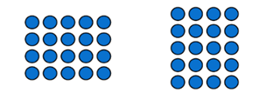
Commutative property: (of addition or multiplication) means that 2 numbers can be added or multiplied in any order and the solution will be the same. Commutative law, commutativity and turn-around facts are interchangeable terms.
- Ask all students the following questions to guide their thinking:
- What is the total value of each side of the equation? What strategy are you using to count them? Is there a more efficient way to count than by ones?
- How can you show if the 2 sides are equal?
- Is the equation true or false? Why? How do you know?
- What evidence can you share with your partner to explain your thinking?
- Combine pairs of students with another pair to discuss the strategies they used to sort the array equations. Ask students:
- What strategies did you and your partner use to decide whether an equation was true or false?
- What models did you make that were helpful?
- What evidence did you find convincing?
- What challenges did you face?
- In addition, ask Stage 1 students:
- Is there an equation you changed your mind about?
- What made you change your mind?
- Discuss the array equations that the class found challenging. Display these equations on the board and ask:
- Why might this be true? Why might this be false?
- How can we prove whether it is true or false?
Note: Highlight the evidence that students present, focusing on the models they create. An equal-arm balance will help students prove their reasonings.
The table below details assessment opportunities and differentiation ideas.
Assessment opportunities | Too hard? | Too easy?
What to look for:  - Can students count with one-to-one correspondence to find the value of the array? (MAE-RWN-01)  - Can students determine how many more in each array? (MAE-CSQ-01)  - Are students thinking about the value of the 2 sides of the equation? (MAO-WM-01, MAE-CSQ-01, MA1-CSQ-01)  - Can students identify and use skip counting patterns to find the value of the arrays? (MA1-FG-01)  - Are students creating models to show multiplication can be represented using equal groups? (MAO-WM-01, MA1-FG-01)  - Are students able to identify and explain the commutative property of multiplication? For example, 3 fours is the same value as 4 threes (MAO-WM-01, MA1-FG-01)  What to collect:  - students' work samples (MAO-WM-01, MAE-FG-01, MA1-FG-01)  - evidence of students using materials to show they understand the concept of arrays (MAO-WM-01, MA1-FG-01)  - recordings of observations of students during game-based play. (MAO-WM-01, MAE-CSG-01, MA1-FG-01) | Students are unable to determine how many more in each array. Support students to use counters to recreate the arrays and identify the difference between them.  Students cannot create models showing multiplication as equal groups or identify the commutative property.  - Support students to use manipulatives to recreate the arrays and use count-by-one strategies to find the value. Use colour-coded connecting cubes to assist with direct comparison.  - Model and use an equal-arm balance to assist students to visualise equivalence. | Students create models showing multiplication as equal groups and identify the commutative property.  - In pairs, students design their own true or false cards for others to use. Students can use arrays to design their equations.  - Encourage students to create a variety of true or false cards, before testing them with a partner.

Consolidation and meaningful practice: Number talk – 10 minutes
- Select and display one of the true or false arrays from Resource 10: True or false arrays, or one that a student has created.
- Ask students why the equation is true or false and how we can prove our thinking.

Lesson 5: Chanel’s garden
Core concept: Division is the equal distribution of objects.
The table below contains suggested learning intentions and success criteria. These are best co-constructed with students.
Learning intentions | Success criteria
All students are learning that:  - division is distributing a collection of objects equally into a given number of groups to determine how many are in each group  - arrays are a structure used to model multiplicative situations involving whole numbers  - there can be parts left over when a collection cannot be distributed equally using a given group size  - mathematicians can record their thinking using words, symbols, drawings and numerals. | All students can:  - recognise that dividing means to share equally  - share from the array into equal groups  - identify the part left over when sharing into groups  - record their thinking about sharing and grouping using a poster with drawings, symbols, words or numerals.  In addition, students working towards Early Stage 1 outcomes can group and share by distributing one by one.  In addition, students working towards Stage 1 outcomes can share into equal groups using an array.

Daily number sense: Sharing collections – 10 minutes
- Build student understanding of multiplicative thinking by viewing Sharing collections: Part 1 (4:02) and pause at 1:07. Students identify differences between the 2 images in the video and record their responses using images, words and symbols.
- Continue playing the video and pause at 3.03. Students identify what is the same between the 2 images in the video and record their responses using images, words and symbols.
- Discuss students’ responses as a class and continue watching the video to build on students’ thinking.

Chanel’s garden – 40 minutes
- Explain that Chanel has 20 flowers in her garden. Ask students to use an array to help Chanel plant her flowers in equal groups.
- Give students a variety of manipulatives including modelling dough, connecting cubes and blocks and ask them to draw, create models and visualise the garden.
- Guide the learning through the following questions:
- How can you share the flowers equally into groups?
- Can you use the structure of an array to arrange the flowers?
- How do you know you have planted all the flowers?
- For Stage 1, ask students:
- How many ways could Chanel plant the flowers? How do you know if you have found all the solutions?
- Are there any solutions that do not form equal groups? Why?
- Students create posters using drawings, symbols and words with annotations to display what Chanel’s garden might look like. Students annotate their posters and justify their solutions. For example, ‘I made 4 rows of flowers with 5 in each row’.
- As a class, discuss some of the posters, noticing the commutative property of multiplication. Discuss the different ways students made equal groups for the number 20.
- Pose the problem: Chanel’s friends have given her an extra 2 flowers for her garden. Can she make 5 equal rows in her garden? Allow time for students to investigate and record their thinking using images, words and symbols.
- Ask students:
- How many flowers does Chanel have altogether?
- How can we use manipulatives to show a solution?
- Are there any other solutions we can try?
- How can we explain how to represent the parts that were left over?
- Share students’ ideas and ask them to prove their thinking using manipulatives. Using students’ work samples, explicitly identify that Chanel cannot have 5 equal rows as there will be 2 left over. Therefore, it is not possible to form 5 equal groups with 22.
- Ask students whether Chanel could redesign her garden so that the 22 flowers can be shared equally into groups. Prompt students to consider what this might look like. Select some students to share their evidence of sharing 22 equally.
This table details assessment opportunities and differentiation ideas.
Assessment opportunities | Too hard? | Too easy?
What to look for:  - Are students able to distribute objects into equal groups? (MAE-FG-01, MA1-FG-01)  - Can students form an array to create the garden? (MA1-FG-01)  - Are students able to identify and explain the difference between the number of groups and the number in each group? (MAO-WM-01, MA1-FG-01)  - Can students model division? (MAO-WM-01, MAE1-FG-01) (MA1-FG-01)  - Can students identify a part left over and explain why the collection cannot be divided equally? (MAO-WM-01, MA1-FG-01)  - Can students record grouping and sharing use words, symbols, drawings and numerals? (MAO-WM-01, MAE-FG-01, MA1-FG-01)  What to collect:  - students’ posters (MAO-WM-01, MAE-FG-01, MA1-FG-01)  - recordings of students' discussions. (MAO-WM-01, MAE-FG-02, MA1-FG-01) | Students are unable to distribute objects into equal groups. Support students by providing a scaffold to identify the groups. For example, draw circles on a piece of paper. Support students to use one to one counting to place objects onto the scaffold.  Students are unable to form arrays or model division with a given group size.  - Support students to divide the flowers into equal groups. Model how to arrange the flowers into arrays.  - Revise the structure of arrays using a graphic organiser such as a blank hundreds chart. | Students can form arrays and model division with a given group size.  - Students work out a new array, limiting Chanel’s garden to a maximum of 6 rows.  - Students identify the different array combinations if there were 32 flowers.

Lesson 6: Multiplication toss – Part 1
Core concept: Arrays are a uniform informal measure of area.
The table below contains suggested learning intentions and success criteria. These are best co-constructed with students.
Learning intentions | Success criteria
All students are learning that:  - area is the measure of the amount of surface  - area is the measure of the units inside a shape  - arrays are a uniform informal measure of area  - the same shape can be presented in different orientations. | All students can:  - describe area as measuring the surface inside a shape  - explain why units of measurement need to be the same size  - recognise that even when rotated, a shape will have the same area.  In addition, students working towards Early Stage 1 outcomes can count the total area of a rectangle using one-to-one correspondence.  In addition, students working towards Stage 1 outcomes can:  - count the total area of a rectangle using skip counting or repeated addition  - measure area using arrays of equal rows and columns.

Daily number sense: Multiples of 10 – 10 minutes
- Build student understanding of the properties of groups within a larger collection using an array.
- Display Resource 11: Basketball array and ask students how many basketballs they can see. Prompt students to explain how they arrived at their answer and how they saw the array. Ask if there is another way to find the number of basketballs.
- Students record their responses and share their thinking.

Multiplication toss – 40 minutes
Note: This task has been adapted from Siemon et al. (2020) for Stage 1 students. It can be used to emphasise the difference between ‘how many’ and ‘how much’, for example, 6 fours.
- Watch Multiplication toss (5:38) and discuss how to use the structure of an array to measure the area of a rectangle. The area of the rectangle is the space inside of the shape.
- Explain that the squares are uniform in size, and this ensures a more accurate measure of area.
- Play the game. In pairs, players take turns to roll 2 dice.
- Players make a rectangle on 1 cm grid paper using the 2 numbers. For example, if a 3 and 6 are rolled, the player can draw either a rectangle of 3 rows of 6 (3 sixes) or 6 rows of 3 (6 threes). Rectangles must be drawn and labelled accurately before the next player’s turn.
- Early Stage 1 students are encouraged to identify the area using comparative language. For example, ‘This rectangle is bigger than this rectangle because it has more square counters.’
- As the game continues, students monitor their rectangles to ensure no areas overlap.
- Eventually the unused space on the grid paper becomes limited (see Figure 2).
Figure 2 – Multiplication toss example
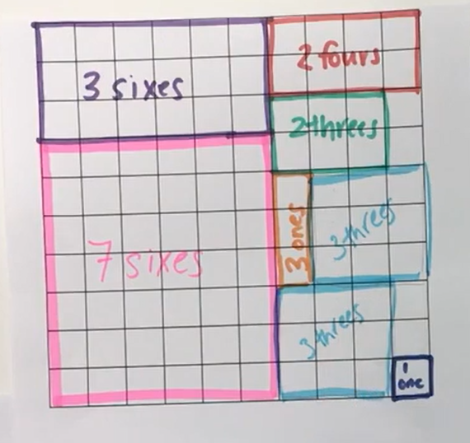
- The game ends when either player cannot complete their turn because the 1 cm grid is full. The winner is the player with the most squares covered.
- Students play several rounds of ‘Multiplication toss’ with their partner.
- Discuss with students their strategies while playing the game. For example, place the larger rectangles in the corner position to allow more space on the board or rotate the rectangle to fit the available space. Rotating the rectangle highlights the commutative property of an array.
This table details assessment opportunities and differentiation ideas.
Assessment opportunities | Too hard? | Too easy?
What to look for:  - Are students using comparative language to describe the area? (MAO-WM-01, MAE-2DS-01)  - Can students use count-by-ones to determine the total number of squares covered? (MAE-CSQ-01)  - Do students form arrays of equal rows and equal columns? (MA1-FG-01)  - Can students find the area of the rectangle using skip counting or repeated addition? (MAO-WM-01, MA1-FG-01)  - Can students explain that the area remains constant when the units are rearranged? (MAO-WM-01, MA1-2DS-02)  What to collect:  - students' work samples – rectangles on 1 cm grid (MAO-WM-01, MA1-FG-01, MA1-2DS-01)  - photographs of students manipulating materials to demonstrate conceptual understanding of arrays (MAO-WM-01, MA1-FG-01, MA1-2DS-01)  - recordings of students during discussions and game-based play. (MAO-WM-01, MA1-FG-01, MA1-2DS-01) | Students are not able to use comparative language to describe area. Select 2 objects in the classroom to model comparative language. For example, ‘This book has an area that is smaller than the whiteboard.’  Students have difficulty counting the number of shaded squares. Support students to count using one-to-one correspondence. Students cross out each square as they count.  Students are not able to create an array using manipulatives or recognise the connection between multiplication and area.  - Support students to create simple arrays such as 2 rows of 3 columns.  - Play ‘Multiplication toss’. Model the use of skip counting through building arrays and recording on grid paper. | Students can create an array using manipulatives and recognise the connection between multiplication and area.  - Students play ‘Multiplication toss’ with larger numbered dice and with a larger grid.  - Challenge students to fill unused spaces by reconstructing arrays. For example, students could reconstruct a 4 cm × 6 cm array to create a 12 cm × 2 cm rectangle.

Lesson 7: Multiplication toss – Part 2
Core concept: When a shape is rotated the area remains constant.
This lesson has been adapted from Siemon et al. (2020).
The table below contains suggested learning intentions and success criteria. These are best co-constructed with students.
Learning intentions | Success criteria
All students are learning that:  - area is the measure of the units inside a shape  - arrays are a uniform informal measure of area  - when a shape is rotated the area remains constant  - two shapes can have the same area but look different. | All students can:  - count the number of units within the area of a shape using skip counting or repeated addition  - explain why units of measurement need to be the same size  - form different arrays using the same number of coloured tiles  - recognise that a rotated rectangle has the same area  - rotate a rectangle and identify the new width and length.  In addition, students working towards Early Stage 1 outcomes can count the total area of a rectangle using count-by-ones strategy.  In addition, students working towards Stage 1 outcomes can:  - form arrays with equal rows and equal columns  - count the total area of a rectangle using skip counting or repeated addition  - measure area using arrays of equal rows and columns.

Daily number sense: 3 tens in a row – 15 minutes
- Build student understanding of number bonds to 10 by playing the game 3 tens in a line (2:29).
- Students play the game in pairs.

Multiplication toss revisited – 40 minutes
- Students should be familiar with Multiplication toss (5:38) from the previous lesson. Revisit the instructions for students who may require additional support. Revise that the squares are uniform in size and that this ensures a more accurate measure of area.
- In pairs, students play one round of the game. Early Stage 1 students continue to play the game, alternating partners after several rounds.
- For Stage 1, model the rotation of a rectangle to create a new rectangle. Discuss with students that the length and the width have changed. Highlight that the number of internal squares (the area) has remained the same.
- Students cut out the rectangles they created on the 1 cm grid paper (there should be a range of different sizes).
- Students choose one rectangle and overlay it with one coloured tile in each square to ensure the total number of tiles matches the array.
- Students make as many different arrays as they can using the same number of coloured tiles. For example, if the cut-out rectangle is 3 rows of 6 (3 sixes), students can make a rectangle out of tiles that is 2 rows of 9 (2 nines), 9 rows of 2 (9 twos), 6 rows of 3 (6 threes), 1 row of 18 (1 eighteen) or 18 rows of 1 (18 ones).
- Students repeat this process with each of their rectangle cut-outs.
- Pair up students from both stages. Stage 1 students display their arrays and Early Stage 1 students arrange them in order. Students arrange them first by total number of tiles, then by length of each array. Finally, ask students if any arrays had the same total but looked different. Stage 1 students check to see the accuracy of the arrangements each time.
The table below details assessment opportunities and differentiation ideas.
Assessment opportunities | Too hard? | Too easy?
What to look for:  - Are students using comparative language to describe the area? (MAO-WM-01, MAE-2DS-01)  - Can students use count-by-ones to determine the total number of squares covered? (MAE-CSQ-01)  - Can students find the total using skip counting? (MA1-FG-01)  - Can students solve multiplication problems using repeated addition? (MA1-FG-01)  - Do students use objects, diagrams, images, or actions to compare, order and match attributes? (MAO-WM-01, MA1-FG-01)  - Are students able to form arrays of equal rows and equal columns? (MA1-FG-01)  - Do students identify shapes presented in different orientations? (MAO-WM-01, MA1-2DS-01)  What to collect:  - work samples (MAO-WM-01, MAE-FG-02, MA1-FG-01, MA1-2DS-01)  - evidence including photographs of student manipulation of coloured tiles demonstrating arrays and area (MAO-WM-01, MAE-FG-02, MA1-FG-01, MA1-2DS-01)  - observations during discussions and game-based play. (MAO-WM-01, MAE-FG-02, MA1-FG-01, MA1-2DS-01) | Students are not able to use comparative language to describe area. Using 2 arrays, show how to use comparative language to describe different sizes. For example, ‘This array has an area of 6 squares, and this is smaller than this array which has 8 squares.’  Students have difficulty counting the number of shaded squares. Support students to count using one-to-one correspondence. Students cross out each square to maintain the count.  Students are not able to identify the total number of objects by comparing, ordering, and matching attributes.  - Support students to create simple arrays.  - Play ‘Multiplication toss’. Model the use of skip counting through building arrays and recording them on grid paper. | Students can identify the total number of objects by comparing, ordering, and matching attributes.  - Students play ‘Multiplication toss’ with larger numbered dice and with a larger grid.  - Students use the cut-out rectangles to estimate, measure and compare the area of surfaces in the classroom. For example, a desk or book.

Consolidation and meaningful practice: Reflection – 10 minutes
- Lead a guided discussion by using the following questions:
- Is there anything else that you noticed while playing the game?
- Do you have any other wonderings?
- How can 2 rectangles have the same number of squares but look different?
- What strategies and ways of organising your work did you find most helpful?

Lesson 8: Secret prisms
Core concept: Volume can be represented with a 3D spatial structure.
The table below contains suggested learning intentions and success criteria. These are best co-constructed with students.
Learning intentions | Success criteria
All students are learning that:  - volume is the amount of space an object occupies  - mathematicians compare volumes of objects using comparative language  - different rectangular prisms can be made from a given number of cubes  - stacking layers of cubes with no gaps can form a rectangular prism  - volumes can be recorded by referring to the number and type of uniform informal unit used. | All students can:  - identify volume as the space an object occupies  - find the volume of a rectangular prism  - investigate different rectangular prisms made from a collection of cubes  - share their ideas for stacking and counting cubes to make a rectangular prism.  In addition, students working towards Early Stage 1 outcomes can compare volumes using words such as ‘this object takes up more space’.  In addition, students working towards Stage 1 outcomes can:  - use the structure of an array to find the volume of a rectangular prism  - record volumes by counting the number of cubes used.

Daily number sense: Rectangular prisms ‘notice’ and ‘wonder’ – 10 minutes
- Build student understanding of the volume of shapes by pondering the properties of rectangular prisms.
- Revise the properties of a rectangular prism with the class.
- Show Resource 12: Rectangular prisms ‘notice’ and ‘wonder’ with the same number of cubes in different orientations (2 layers of 6 and 1 layer of 12).
- Ask what students notice or wonder and record their thinking on an anchor chart.
Note: This activity can provide insights into students’ understanding of arrays and their length, width, height, volume and surface area, and their visualisation of a 3D image.

Secret prisms – 50 minutes
This lesson has been adapted from Stanford University’s ’30 Cubes’ (2021).
- Launch the activity by dividing the class into pairs and provide each pair with a different number of cubes.
- Ask students to create a secret rectangular prism using some of the cubes. Ask students not to tell other students in the class the number of cubes they used.
- Discuss with the class that we are going to identify the volume of our secret prisms.
Rectangular prism: A three-dimensional object with 6 rectangular faces, 8 vertices (corners – the point where 3 or more faces meet) and 12 straight edges (the line segment where 2 or more faces meet). It has length, width, and height.
Volume: The amount of space an object or substance occupies.
- Students determine the volume of their prisms. Encourage Stage 1 students to notice the array structure of the cubes. Use the array structure to identify skip counting patterns or to use repeated addition.
- Join a pair of students with another pair of students and ask them to compare their rectangular prisms. Guide the discussion with the following questions:
- What do you notice about the 2 rectangular prisms?
- How are they similar? How are they different?
- Which object takes up more space? How do you know?
- Can you use one of the prisms to compare the volume of the other prism? What could this look like?
- How can we record the volume of the 2 prisms?
Note: Students should be deconstructing one object and using its parts to construct a copy of the other object to compare the volumes.
- In the group of 4, students deconstruct their prisms and gather a total of 30 cubes.
- Students construct new rectangular prisms by adding one cube at a time. For each cube added, students must construct a rectangular prism.
- Continue creating rectangular prisms until each group has used all 30 cubes.
- Guide the investigation by asking:
- How many different prisms can you build with 2 cubes? What about with 3 cubes?
- How many different rectangular prisms can you build using 30 cubes?
- What makes rectangular prisms different from each other?
- Can you find any patterns or connections?
- While investigating, groups must:
- record findings (by drawing, colour coding, and describing their work) so others can understand their discoveries
- identify any connections or patterns in their findings.
- Provide groups with adequate time to complete the task.
- Groups share their results, focusing on the process they used. Highlight any connections that students have made with previous learning, particularly the use of repeated addition of arrays to construct the layers of blocks in a prism.
This table details assessment opportunities and differentiation ideas.
Assessment opportunities | Too hard? | Too easy?
What to look for:  - Can students identify volume as the amount of space an object occupies? (MAO-WM-01, MAE-3DS-01) (MA1-3DS-01)  - Can students compare the volumes of 2 objects? (MAO-WM-01, MAE-3DS-01) (MA1-3DS-01)  - Can students create different rectangular prisms from a given number of cubes? (MAE-3DS-01) (MA1-3DS-01, MA1-3DS-02)  - Are students able to devise and explain strategies for stacking and counting units to form a rectangular prism? (MAO-WM-01, MAE-3DS-01) (MA1-3DS-01, MA1-3DS-02)  - Are students recording volumes by referring to uniform informal units? (MA1-3DS-02)  What to collect:  - recordings of student discussions during the task (MAO-WM-01, MAE-3DS-01) (MA1-3DS-01, MA1-3DS-02)  - students’ work samples (MAO-WM-01, MA1-3DS-01, MA1-3DS-02)  - evidence including photographs of students using the cubes to create different prisms. (MAO-WM-01, MAE-3DS-01) (MA1-3DS-01, MA1-3DS-02) | Students are not able to compare the volume of 2 objects. Deconstruct one of the rectangular prisms. Support students to recreate the other rectangular prism using the deconstructed blocks.  Students are not able to create a rectangular prism using cubes.  - Support students to create a rectangular prism using a smaller number of cubes. For example, use 2 to 4 cubes and record how they are used to make the object.  - Model how to describe the number of cubes in each layer/array to find the total number of cubes. | Students create and describe a range of rectangular prisms using cubes. Encourage students to analyse and explain their findings. Ask questions such as:  - Which number of cubes can make the greatest number of rectangular prisms?  - If you double this number of cubes, how many rectangular prisms could you make? Can you find a way to prove this?

Consolidation and meaningful practice: Reflection – 10 minutes
- Facilitate reflection on learning in this lesson by asking:
- Is there anything else that you noticed while working with 30 cubes?
- What makes a rectangular prism different from another one that is built from the same number of cubes?
- What tools and ways of organising your work did you find most helpful?
- Do you have any other wonderings?

Resource 1: Number visuals 1
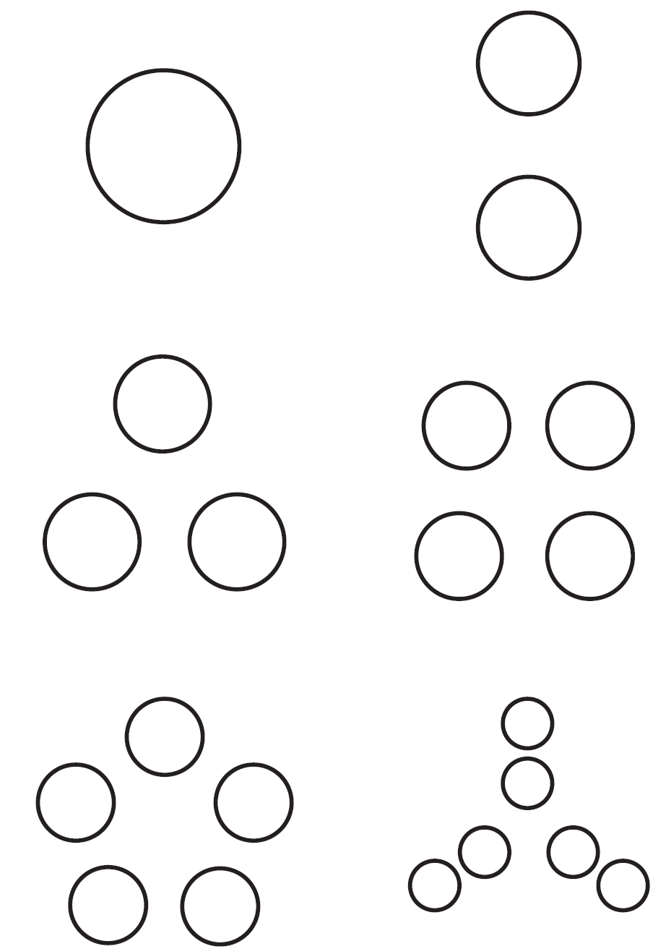
‘Number visuals (1-2)’ by youcubed is licensed under CC BY 4.0.

Resource 2: Number visuals 2
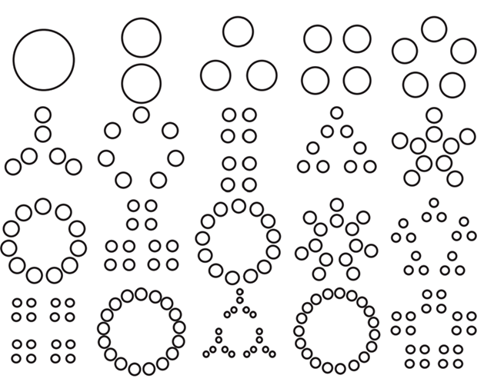
‘Number visuals (1-2)’ by youcubed is licensed under CC BY 4.0.

Resource 3: Ball arrays
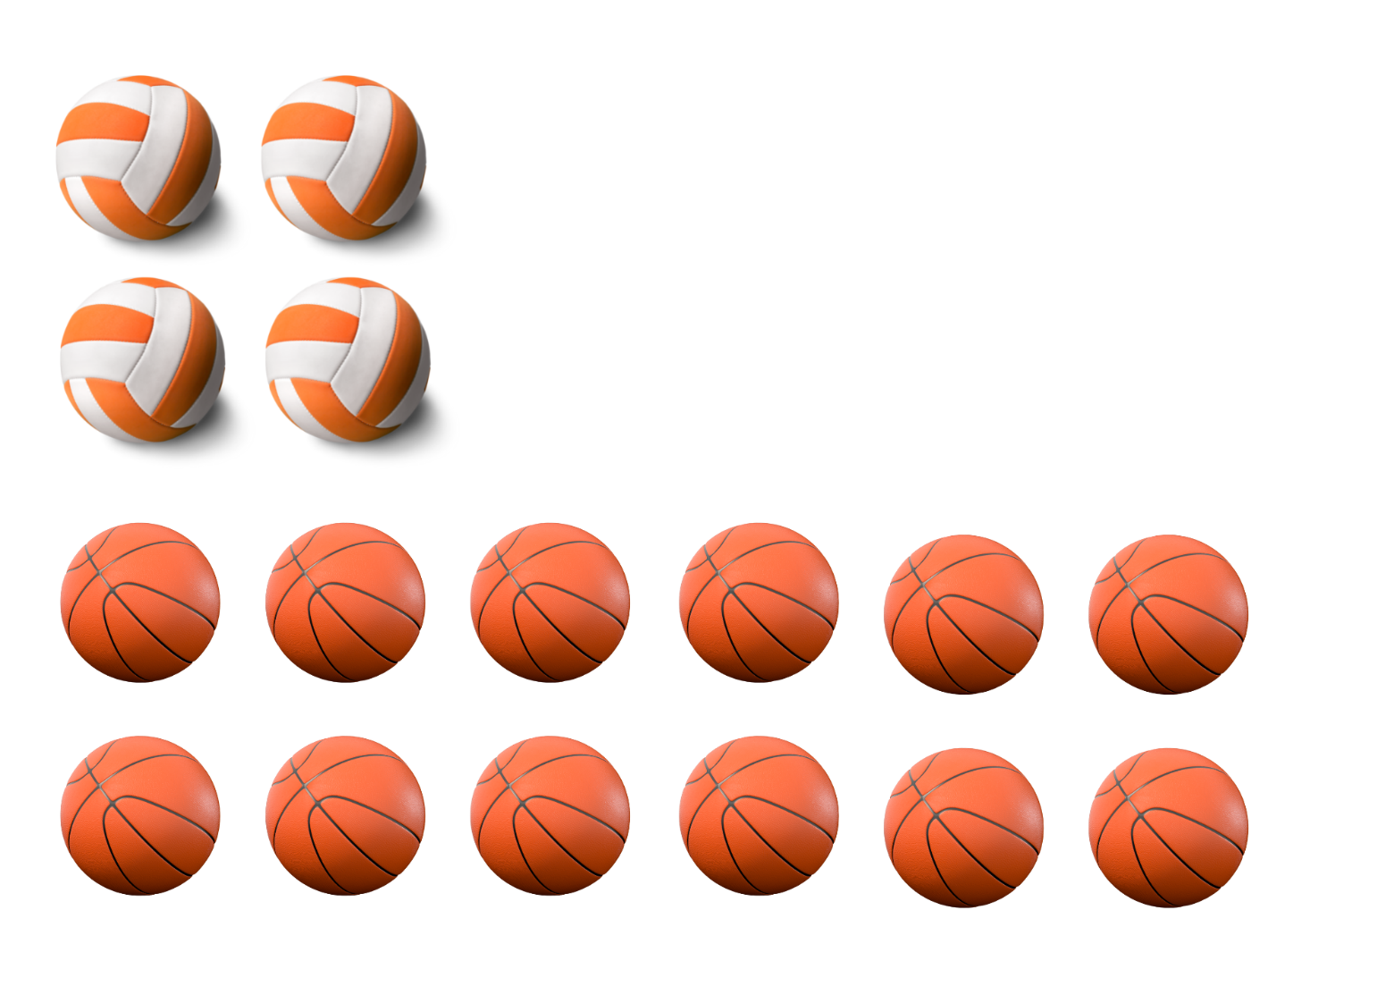
‘Volleyball Ball’ by Billion Photos and ‘Basketball 3D’ by rafiico-creative are licensed in accordance with the Canva Content License Agreement.

Resource 4: A group of friends
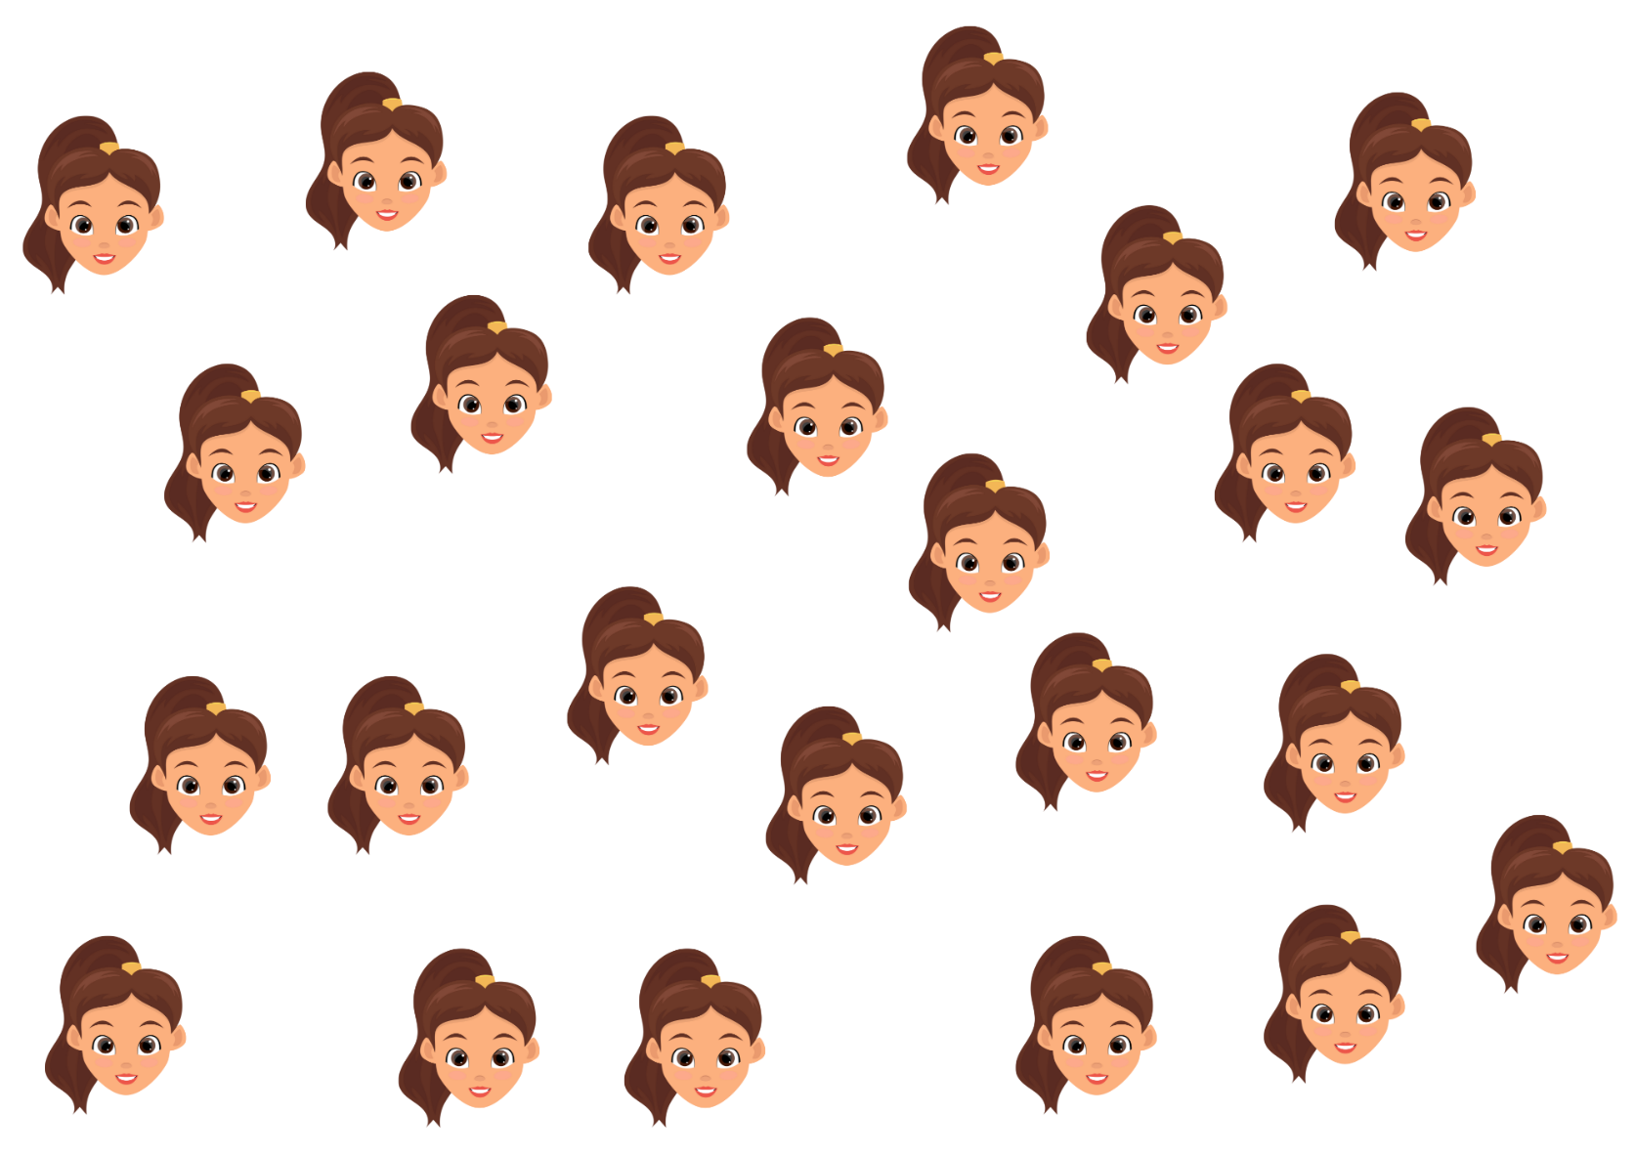
‘Happy Girl Face’ by EmilTimplaru is licensed in accordance with the Canva Content License Agreement.

Resource 5: An array of friends
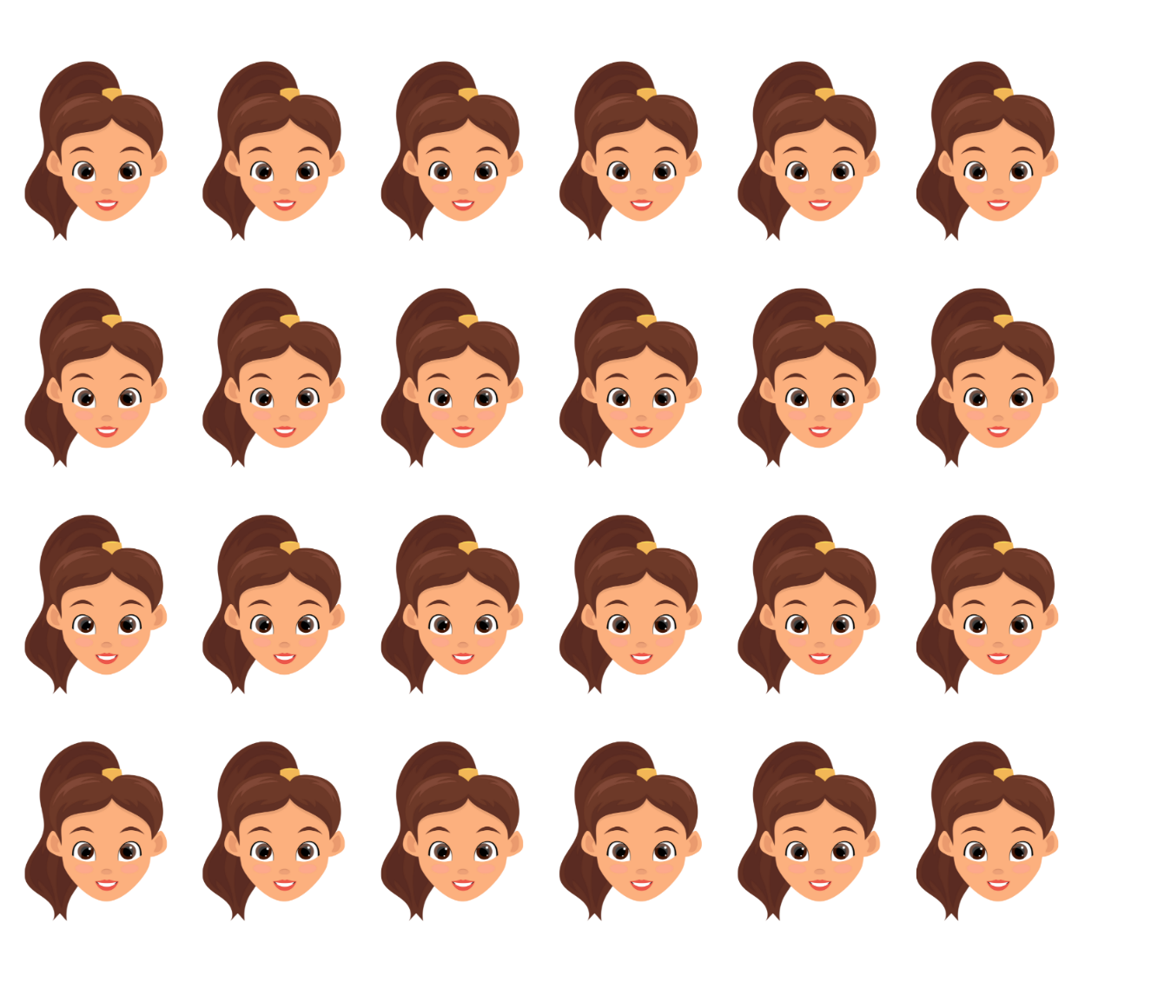
‘Happy Girl Face’ by EmilTimplaru is licensed in accordance with the Canva Content License Agreement.

Resource 6: Partially covered array
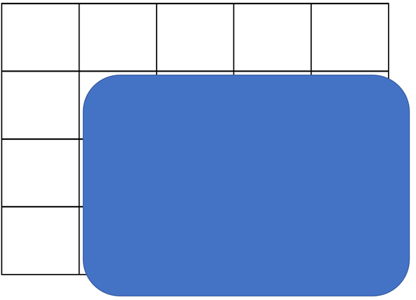
Adapted from Battista et al. (1998).

Resource 7: Array talk
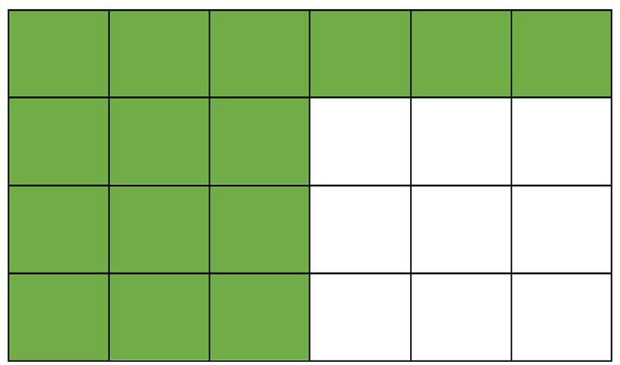

Resource 8: Array puzzle
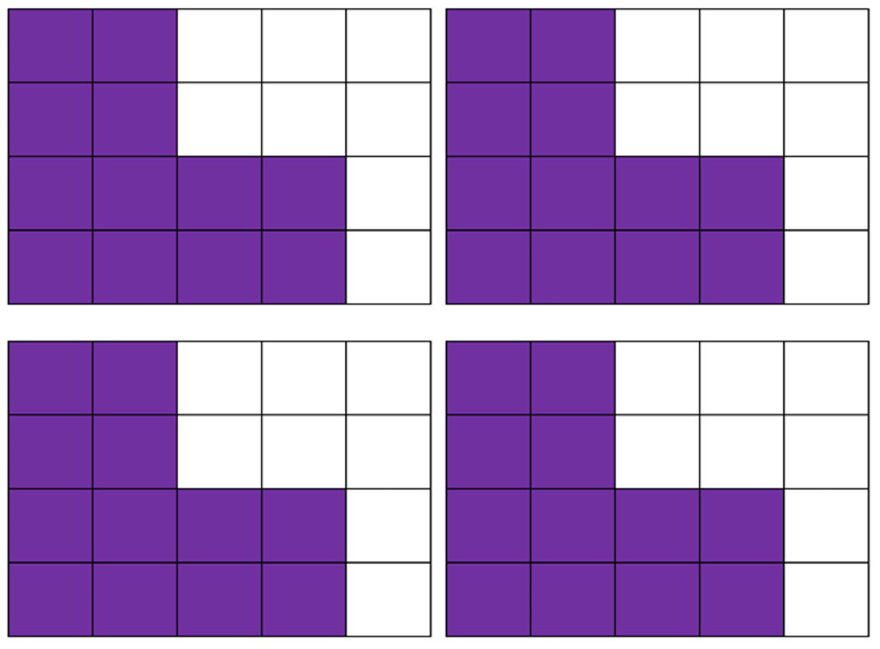

Resource 9: Equal-arm balance
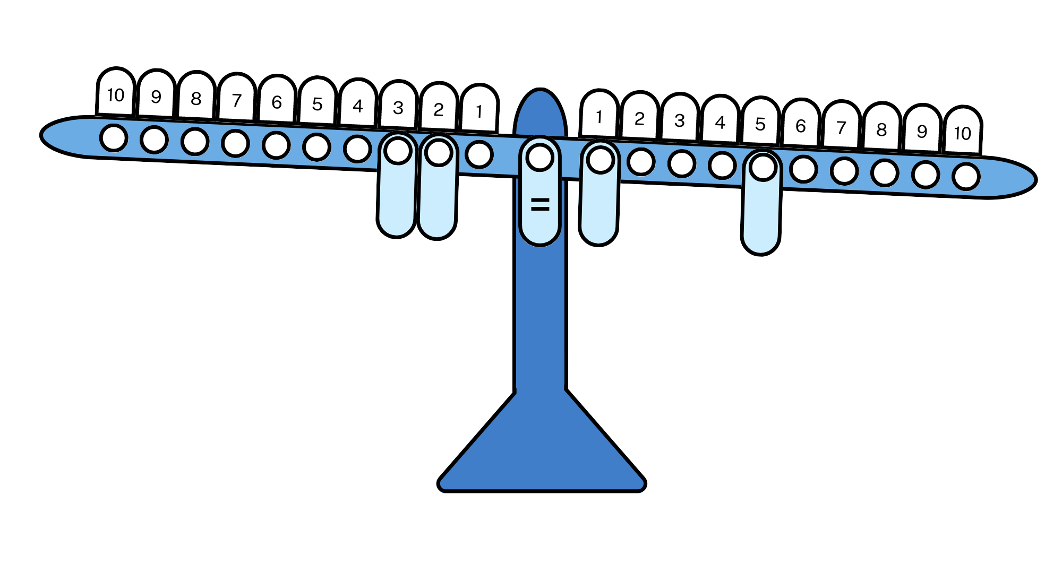

Resource 10: True or false arrays
These arrays have an equal number of squares shaded – True or false?
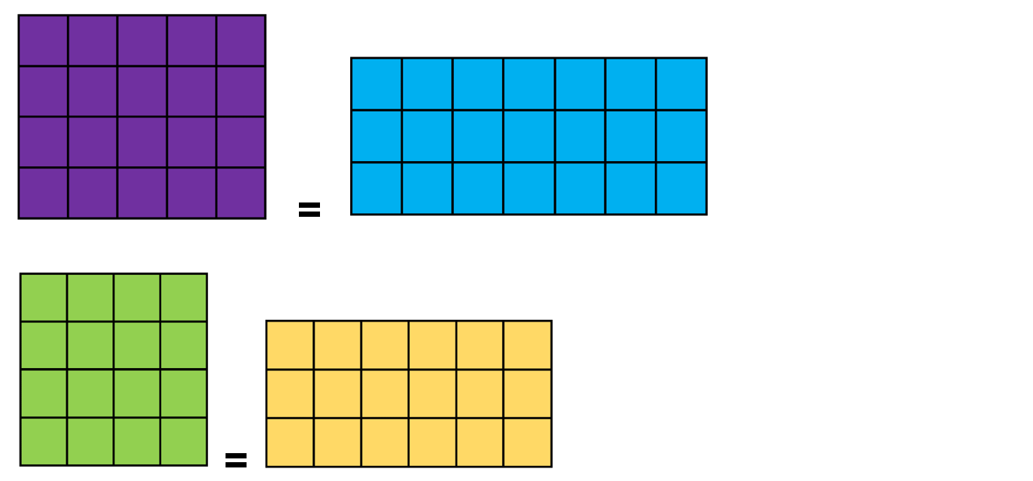
These arrays have an equal number of squares shaded – True or false?
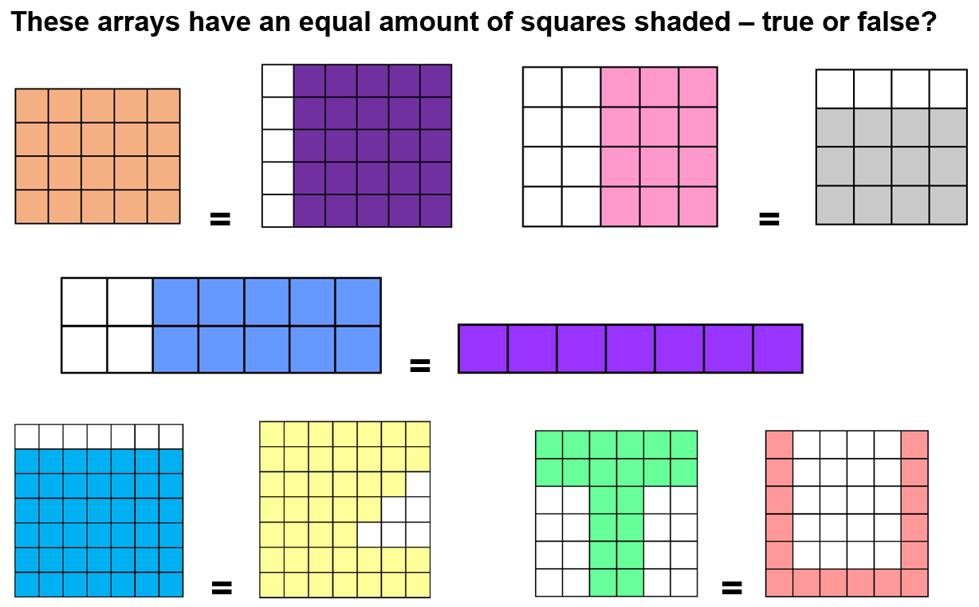

Resource 11: Basketball array
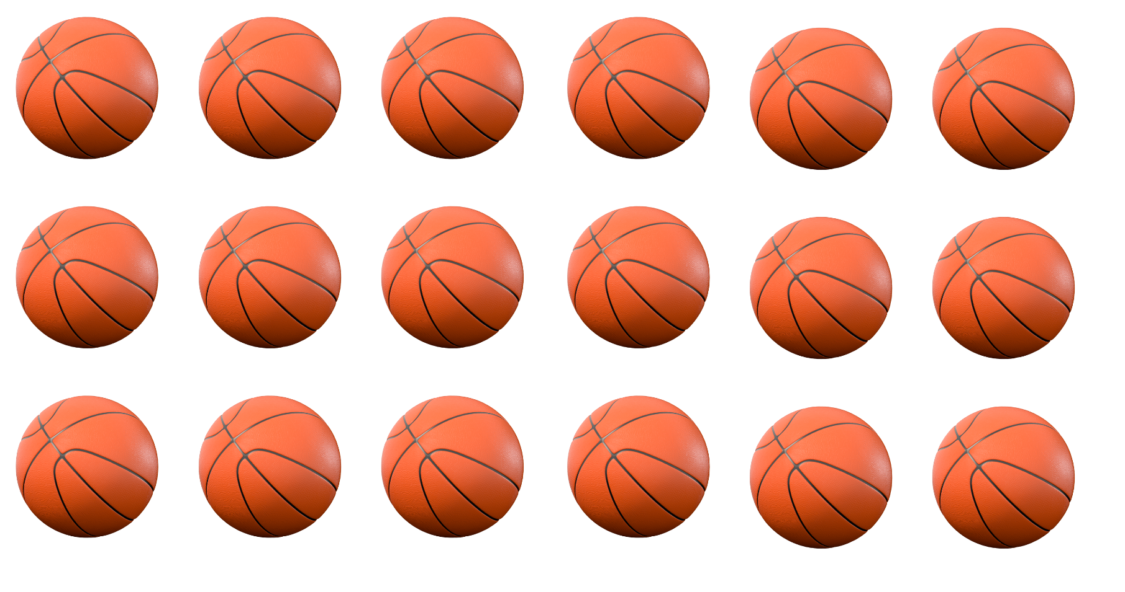
‘Basketball 3D’ by rafiico-creative is licensed in accordance with the Canva Content License Agreement.

Resource 12: Rectangular prisms ‘notice’ and ‘wonder’
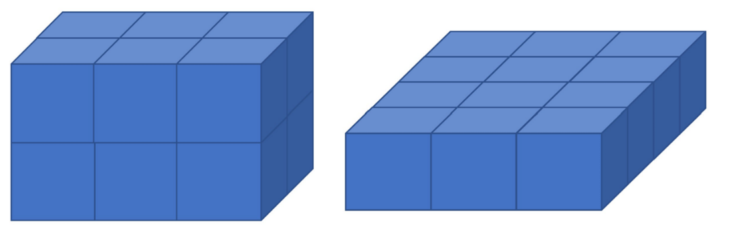
This resource is adapted from the task ‘30 cubes’ by youcubed.

Syllabus outcomes and content
The table below outlines the syllabus outcomes and range of relevant syllabus content covered in this unit. Content is linked to National Numeracy Learning Progression version (3).
Focus area and outcomes | Content groups and content points | Lessons
Representing whole numbers  MAO-WM-01  MAE-RWN-01, MAE-RWN-01  MAE-RWN-02 | Early Stage 1  Instantly name the number of objects within small collections  - identify the number of items in different arrangements (CPr2) | 1
Representing whole numbers (cont.) | Early Stage 1  Use the counting sequence of ones flexibly  - count forwards to at least 30 and state the number after or before a given number, without needing to count from one (CPr4)  - count backwards from a given number 20 or less (CPr5)  - identify the number before as 'one less' and the number after as 'one more’ than a given number | 1–5
Representing whole numbers (cont.) | Early Stage 1  Connect counting and numerals to quantities  - count with one-to-one correspondence, recognising that the last number name represents the total number in the collection (CPr3, CPr5)  - count out a specified number of objects (from 5 to 20) from a larger collection, keeping track of the count (CPr4-5)  - make correspondences between collections  - represent numbers as quantities to at least 20 using objects (such as fingers), number words and numerals (NPV2-NPV4, CPr3)  - compare and order numbers to 20 (NPV2-NPV3)  - use the term ‘is the same as’ to express equality of groups (CPr4-5, MuS1) | 1–8
Representing whole numbers A | Stage 1  Use counting sequences of ones with two-digit numbers and beyond  - identify the number before and after a given two-digit number (CPr5)  - count forwards and backwards by ones from a given number to at least 120 (CPr6) | 1–8
Representing whole numbers A (cont.) | Stage 1  Represent the structure of groups of ten in whole numbers  - recognise that ten ones is the same as one ten (NPV2, NPV4)  - count large sets of objects by systematically grouping in tens (CPr7)  - partition two-digit numbers to show quantity values (NPV4). | 1–5, 8
Combining and separating quantities  MAO-WM-01  MAE-CSQ-01, MA1-CSQ-01  MAE-CSQ-02  NOTE – there is only one combining and separating quantities outcome for Stage 1. | Early Stage 1  Model additive relations and compare quantities  - compare two groups of objects to determine how many more (NPV1, AdS2) | 1, 3, 4
Combining and separating quantities (cont.) | Early Stage 1  Identify part–whole relationships in numbers up to 10  - use visual representations of numbers to assist with combining and separating quantities, identifying the relationship between the quantities (NPV2, NPA2, AdS2-AdS3)  - describe the action of combining, separating and comparing (AdS1)  - count by ones to find the total or difference (AdS2-AdS3) | 1, 3, 4
Combining and separating quantities A | Stage 1  Use advanced count-by-one strategies to solve addition and subtraction problems  - apply the terms ‘add’, ‘plus’, ‘equals’, ‘is equal to’, ‘is the same as’, ‘take away’, ‘minus’ and ‘the difference between’ to describe combining and separating quantities (AdS1, AdS6)  - recognise and use the symbols for plus (+), minus (−) and equals (=)  - record number sentences in a variety of ways using drawings, words, numerals and symbols (AdS6)  - fluently use advanced count-by-one strategies including counting on and counting back to solve addition and subtraction problems involving one- and two-digit numbers (Reasons about relations) (AdS3-AdS5) | 1, 3
Combining and separating quantities A (cont.) | Stage 1  Use flexible strategies to solve addition and subtraction problems  - use non-count-by-one strategies such as using doubles for near doubles and combining numbers that add to ten (AdS6)  - represent addition and subtraction using structured materials such as a bead string or similar model (AdS6-AdS7)  - select and apply strategies using number bonds to solve addition and subtraction problems with one- and two-digit numbers by partitioning numbers using quantity value and bridging to 10 (AdS6-AdS7)  Represent equality  use the equals sign to record equivalent number sentences involving addition, and to mean 'is the same as', rather than as an indication to perform an operation (NPA3) | 1, 3, 4
Forming groups  MAO-WM-01  MAE-FG-01, MA1-FG-01  MAE-FG-02  NOTE – there is only one forming groups outcome for Stage 1. | Early Stage 1  Investigate and form equal groups by sharing  - distribute a group of familiar objects into smaller groups and recognise whether the number in each group is equal or not (MuS1-MuS2)  - group and share concrete materials by distributing objects one by one or using another method (MuS1-MuS2) | 2–8
Forming groups (cont.) | Early Stage 1  Record grouping and sharing  - label the number of objects in a group  - record grouping and sharing using drawings, words and numerals, and explain their thinking (MuS2) | 1–8
Forming groups A | Stage 1  Count in multiples using rhythmic and skip counting  - count by twos, threes, fives and tens using rhythmic counting and skip counting (MuS2, CPr6) | 1–4, 6-8
Forming groups A (cont.) | Stage 1  Use skip counting patterns  - identify and describe patterns when skip counting forwards or backwards by twos, fives and tens (NPA3, NPA4) | 1, 2, 8
Forming groups A (cont.) | Stage 1  Model and use equal groups of objects to represent multiplication  - model and describe collections of objects as groups of (MuS2)  - determine and distinguish between the number of groups and the number in each group when describing collections of objects (Reasons about relations)  - find the total number of objects using skip counting of equal groups of a known size (MuS2- MuS3) | 2–4, 8
Forming groups A (cont.) | Stage 1  Recognise and represent division  - model sharing division by distributing a collection of objects equally into a given number of groups to determine how many in each group (InF2, MuS5)  - model grouping division by determining the number of groups of a given size that can be formed (MuS5)  - describe the part left over when a collection cannot be distributed equally using the given group size (MuS6) | 1, 5–8
Forming groups B (cont.) | Stage 1  Represent and explain multiplication as the combining of equal groups  - use objects, diagrams, images or actions to model multiplication as accumulating equal groups (MuS4)  - solve multiplication problems using repeated addition (MuS4)  - form arrays of equal rows and equal columns (MuS5)  - count and identify the number of rows/columns and the number in each row/column when describing objects in an array (MuS5)  - model the commutative property of multiplication, using an array (MuS6)  - model division by deconstructing an array equally into a given number of rows or columns | 1–8
Forming groups B (cont.) | Stage 1  Represent multiplication and division problems  - solve multiplication and division problems using objects, diagrams, images and actions (MuS6-MuS7)  - record answers to multiplication and division problems (including those with remainders) using drawings, words and numerals (MuS6) | 1–3, 5–8
Two-dimensional spatial structure  MAO-WM-01  MAE-2DS-01, MA1-2DS-01  MAE-2DS-02, MA1-2DS-02 | Early Stage 1  2D shapes: Sort, describe and name familiar shapes  - describe shapes, including circles, squares, triangles and rectangles (UGP1-UGP2)  2D shapes: Represent shapes  - turn shapes to fit into or match a given space  - identify and draw lines and curves | 6, 7
Two-dimensional spatial structure (cont.) | Early Stage 1  Area: Identify and compare area  - make closed shapes and identify the attributes of area as the measure of the amount of surface  - use comparative language to describe areas (UuM2)  - predict which of two surfaces will have the larger area and justify the answer  - compares areas of two similar shapes directly by drawing, tracing, or cutting and pasting (UuM3-UuM4) | 6, 7
Two-dimensional spatial structure A | Stage 1  2D shapes: Recognise and classify shapes using obvious features  - identify shapes presented in different orientations [UGP2] (UGP2)  Area: Measure areas using uniform informal units  - explore area using uniform informal units to cover the surface in rows or columns without gaps or overlaps (UuM5)  - explain why the area remains constant when units are rearranged (Reasons about relations)  - estimate areas by referring to the number and type of uniform informal unit used and check by measuring (UuM3) | 6, 7
Two-dimensional spatial structure B (cont.) | Stage 1  2D shapes: Represent, combine and separate two-dimensional shapes  - make representations of two-dimensional shapes and combinations of shapes in different orientations  Area: Compare rectangular areas using uniform square units of an appropriate size in rows and columns  - use a single square to create the array structure of area in rows and columns  - use the structure of repeated units to find the area of a rectangle  - explain how the grid structure of rows and columns helps to find the area (Reasons about spatial structure)  - compare the areas of two or more surfaces that cannot be moved, or superimposed, by measuring in uniform informal units  - record comparisons of area using drawings, numerals and words, and by referring to the uniform informal unit used | 6, 7
Three-dimensional spatial structure  MAO-WM-01  MAE-3DS-01, MA1-3DS-01  MAE-3DS-02, MA1-3DS-02 | Early Stage 1  3D objects: Explore familiar three-dimensional objects  - describe the features of familiar objects (UGP1)  - make and describe a variety of three-dimensional models (UGP3)  - predict the stacking capabilities of various three-dimensional objects  Volume: Compare volume by building  - identify the attribute of volume as the amount of space an object or substance occupies  - compare the volumes of two objects made from blocks or connecting cubes directly by deconstructing one object and using its parts to construct a copy of the other object  - use comparative language to describe volume (UuM2) | 8
Three-dimensional spatial structure A | Stage 1  3D objects: Recognise familiar three-dimensional objects  - identify and name familiar three-dimensional objects, including cubes, cylinders, spheres and rectangular prisms  3D objects: Sort and describe three-dimensional objects  - manipulate and describe familiar three-dimensional objects (UGP2)  Volume: Construct volumes using cubes  - explore different rectangular prisms that can be made from a given number of cubes  - devise and explain strategies for stacking and counting units to form a rectangular prism (Reasons about spatial structure)  - record volumes, referring to the number and type of uniform informal unit used | 8
Three-dimensional spatial structure B (cont.) | Stage 1  Volume: Compare volumes using uniform informal units  - compare models with different appearances, recognising when they have the same volume (Reasons about spatial structure)  - record the results of volume comparisons using drawings, numerals and words, referring to the units used | 8
Non-spatial measure  MAO-WM-01  MAE-NSM-01, MA1-NSM-01  MAE-NSM-02, MA1-NSM-02 | Early Stage 1  Mass: Identify and compare mass using weight  - identify that objects can be heavy or light (UuM2)  - predict which object would be heavier than, lighter than, or have about the same weight as another object and explain reasons for this prediction | 4
Non-spatial measure A | Stage 1  Mass: Investigate mass using an equal-arm balance  - place objects on either side of an equal-arm balance to obtain a level balance  - use a balance to find two collections of objects that have the same mass (UuM2) | 4

References
Links to third-party material and websites
Please note that the provided (reading/viewing material/list/links/texts) are a suggestion only and implies no endorsement, by the New South Wales Department of Education, of any author, publisher, or book title. School principals and teachers are best placed to assess the suitability of resources that would complement the curriculum and reflect the needs and interests of their students.
If you use the links provided in this document to access a third-party's website, you acknowledge that the terms of use, including licence terms set out on the third-party's website apply to the use which may be made of the materials on that third-party website or where permitted by the Copyright Act 1968 (Cth). The department accepts no responsibility for content on third-party websites.
Except as otherwise noted, all material is © State of New South Wales (Department of Education), 2023 and licensed under the Creative Commons Attribution 4.0 International License. All other material (third-party material) is used with permission or under licence. Where the copyright owner of third-party material has not licensed their material under a Creative Commons or similar licence, you should contact them directly for permission to reuse their material.
Mathematics K–10 Syllabus © 2022 NSW Education Standards Authority (NESA) for and on behalf of the Crown in right of the State of New South Wales.
© 2022 NSW Education Standards Authority. This document contains NSW Curriculum and syllabus content. The NSW Curriculum is developed by the NSW Education Standards Authority. This content is prepared by NESA for and on behalf of the Crown in right of the State of New South Wales. The material is protected by Crown copyright.
Please refer to the NESA Copyright Disclaimer for more information.
NESA holds the only official and up-to-date versions of the NSW Curriculum and syllabus documents. Please visit the NSW Education Standards Authority (NESA) website and the NSW Curriculum website.
National Numeracy Learning Progression © Australian Curriculum, Assessment and Reporting Authority (ACARA) 2010 to present, unless otherwise indicated. This material was downloaded from the Australian Curriculum website (National Numeracy Learning Progression) (accessed 22 November 2022) and was not modified. The material is licensed under CC BY 4.0. Version updates are tracked in the ‘Curriculum version history’ section on the 'About the Australian Curriculum' page of the Australian Curriculum website.
ACARA does not endorse any product that uses the Australian Curriculum or make any representations as to the quality of such products. Any product that uses material published on this website should not be taken to be affiliated with ACARA or have the sponsorship or approval of ACARA. It is up to each person to make their own assessment of the product, taking into account matters including, but not limited to, the version number and the degree to which the materials align with the content descriptions and achievement standards (where relevant). Where there is a claim of alignment, it is important to check that the materials align with the content descriptions and achievement standards (endorsed by all education Ministers), not the elaborations (examples provided by ACARA).
Battista MT, Clements DH, Arnoff J, Battista K and Van Auken Borrow C (1998) ‘Students' Spatial Structuring of 2D Arrays of Squares’, Journal for Research in Mathematics Education, 29(5):503–532, doi:10.2307/749731, accessed 1 August 2022.
Boaler J, Munson J and Williams C (2021) Mindset Mathematics: Visualizing and Investigating Big Ideas, Grade 1, Jossey-Bass Inc, New York.
Boaler J, Munson J and Williams C (2022) Mindset Mathematics: Visualizing and Investigating Big Ideas, Grade 2, Jossey-Bass Inc, New York.
Siemon D, Warren E, Beswick K, Faragher R, Miller J, Horne M, Jazby D, Breed M, Clark J and Brady K (2020) Teaching Mathematics: Foundations to Middle Years, 3rd edn, Oxford University Press Australia and New Zealand.
Smith MP, Bill VL and Gamoran Sherin M (2019) The Five Practices in Practice: Successfully Orchestrating Mathematics Discussions in Your Elementary Classroom, Corwin Press, Inc and NCTM (National Council of Teachers of Mathematics), United States.
Stanford University (n.d.) ‘30 Cubes’, Tasks, youcubed website, accessed 22 November 2022.
Stanford University (n.d.) ‘Number Visuals (K-12)’, Resources, youcubed website, accessed 22 November 2022.
Stanford University (n.d.) youcubed [website], accessed 22 November 2022.

