Mathematics – K-2 multi-age – Year A – Unit 12
Contents
Unit description and duration 4
Student prior learning 4
Lesson overview and resources 5
Lesson 1: Translating patterns 21
Daily number sense: Dot talk – 10 minutes 22
Translating patterns – 40 minutes 22
Consolidation and meaningful practice: Sharing our patterns – 10 minutes 25
Lesson 2: Shrinking patterns 1 26
Daily number sense: Choral counting – Counting forwards by ones – 20 minutes 27
Shrinking patterns – 40 minutes 29
Consolidation and meaningful practice: Representing patterns in different ways – 10 minutes 34
Lesson 3: Shrinking patterns 2 35
Daily number sense: Choral counting – Counting backwards by ones – 20 minutes 36
Identifying and representing shrinking patterns – 40 minutes 38
Lesson 4: Growing patterns 1 42
Daily number sense: Counting sounds – 20 minutes 43
Representing growing patterns – 50 minutes 44
Lesson 5: Growing patterns 2 48
Daily number sense – 15 minutes 49
Sticky Triangles – 45 minutes 49
Lesson 6: Patterns in the number chart 54
Daily number sense: Pasta counting – 20 minutes 55
Number pattern detectives – 30 minutes 57
Consolidation and meaningful practice: Discuss and connect the mathematics – 10 minutes 60
Lesson 7: Weaving patterns 61
Daily number sense: Guess my pattern – 15 minutes 61
Weaving patterns – 45 minutes 62
Consolidation and meaningful practice: Discuss and connect the mathematics – 10 minutes 66
Lesson 8: Number chart investigation 67
Daily number sense: Buzzy Bee – 20 minutes 68
Number chart investigation – 40 minutes 69
Consolidation and meaningful practice: Connecting the mathematics – 10 minutes 71
Resource 1: Dot talk 72
Resource 2: AB pattern 73
Resource 3: ABC pattern 74
Resource 4: ABB pattern 75
Resource 5: Graphic organiser 76
Resource 6: Monkey images 77
Resource 7: Triangle growing pattern 78
Resource 8: Cube growing pattern 79
Resource 9: Bottom-up number chart 80
Resource 10: Number puzzles 1 81
Resource 11: Number puzzles 2 82
Resource 12: Woven basket 83
Resource 13: Centimetre number chart 84
Resource 14: Buzzy Bee’s honeycomb 85
Resource 15: Number chart 86
Syllabus outcomes and content 87
References 96
Further reading 98

Unit description and duration
This two-week unit develops student knowledge, understanding, and skills in patterning. Students are provided opportunities to:
- understand that patterns repeat, and this repetition is referred to as the repeating core
- understand that some patterns can increase (grow) or decrease (shrink) by the same amount in each subsequent term
- develop an understanding of patterns in the place value system.
Mathematics K–10 Syllabus © 2022 NSW Education Standards Authority (NESA) for and on behalf of the Crown in right of the State of New South Wales.

Student prior learning
Before engaging in these teaching and learning activities, students would benefit from prior experience with:
- recognising a pattern
- copying and continuing simple repeating patterns using sounds, shapes, objects, images, or actions
- number charts and counting.

Lesson overview and resources
The table below outlines the sequence and approximate timing of lessons; syllabus focus areas and content groups; and resources.
Lesson | Syllabus focus area and content groups | Resources
Lesson 1: Translating patterns  60 minutes  A pattern core can be created in different forms. | Representing whole numbers  Early Stage 1  - Instantly name the number of objects within small collections  - Use the counting sequence of ones flexibly  - Connect counting and numerals to quantities  Stage 1 – Part A  - Use counting sequences of ones with two-digit numbers and beyond  - Continue and create number patterns  - Represent the structure of groups of ten in whole numbers  Forming groups  Early Stage 1  - Copy, continue and create patterns  Stage 1 – Part A  - Count in multiples using rhythmic and skip counting | - Resource 1: Dot talk  - Resource 2: AB pattern  - Resource 3: ABC pattern  - Resource 4: ABB pattern  - Resource 5: Graphic organiser  - Video: Eddie Woo on Play School (4 of 4: Pattern matching) (4:24)  - Concrete materials  - Writing materials
Lesson 2: Shrinking patterns 1  70 minutes  Shrinking patterns get smaller by the same quantity each time. | Representing whole numbers  Early Stage 1  - Instantly name the number of objects within small collections  - Use the counting sequence of ones flexibly  - Connect counting and numerals to quantities  Stage 1 – Part A  - Use counting sequences of ones with two-digit numbers and beyond  - Continue and create number patterns  - Represent the structure of groups of ten in whole numbers  Stage 1 – Part B  - Use counting sequences of ones and tens flexibly  Combining and separating quantities  Early Stage 1  - Model additive relations and compare quantities  - Identify part–whole relationships in numbers up to 10  Stage 1 – Part A  - Use advanced count-by-one strategies to solve addition and subtraction problems  - Recognise and recall number bonds up to ten  - Use flexible strategies to solve addition and subtraction problems  Forming groups  Early Stage 1  - Copy, continue and create patterns  Stage 1 – Part A  - Count in multiples using rhythmic and skip counting  - Use skip counting patterns  Stage 1 – Part B  - Model and use equal groups of objects to represent multiplication  Data  Early Stage 1  - Respond to questions, collect information and discuss possible outcomes of activities  - Organise objects into simple data displays and interpret the displays  Stage 1 – Part A  - Ask questions and gather data  - Represent data with objects and drawings and describe the displays  Stage 1 – Part B  - Identify a question of interest and gather relevant data  - Create displays of data and interpret them | - Resource 5: Graphic organiser  - Resource 6: Monkey images  - Video: 5 Little Monkeys (2:23)  - Concrete materials  - Writing materials
Lesson 3: Shrinking patterns 2  60 minutes  Shrinking patterns can be represented in different ways. | Representing whole numbers  Early Stage 1  - Instantly name the number of objects within small collections  - Use the counting sequence of ones flexibly  - Connect counting and numerals to quantities  Stage 1 – Part A  - Use counting sequences of ones with two-digit numbers and beyond  - Continue and create number patterns  - Represent the structure of groups of ten in whole numbers  Stage 1 – Part B  - Use counting sequences of ones and tens flexibly  Combining and separating quantities  Early Stage 1  - Model additive relations and compare quantities  - Identify part–whole relationships in numbers up to 10  Stage 1 – Part A  - Use advanced count-by-one strategies to solve addition and subtraction problems  - Recognise and recall number bonds up to ten  - Use flexible strategies to solve addition and subtraction problems  Forming groups  Early Stage 1  - Copy, continue and create patterns  Stage 1 – Part A  - Count in multiples using rhythmic and skip counting  - Use skip counting patterns  Stage 1 – Part B  - Model and use equal groups of objects to represent multiplication  Data  Early Stage 1  - Respond to questions, collect information and discuss possible outcomes of activities  - Organise objects into simple data displays and interpret the displays  Stage 1 – Part A  - Ask questions and gather data  - Represent data with objects and drawings and describe the displays  Stage 1 – Part B  - Identify a question of interest and gather relevant data  - Create displays of data and interpret them | - Counters  - Writing materials
Lesson 4: Growing patterns 1  70 minutes  Growing patterns get bigger by the same quantity each time. | Representing whole numbers  Early Stage 1  - Instantly name the number of objects within small collections  - Use the counting sequence of ones flexibly  - Connect counting and numerals to quantities  Stage 1 – Part A  - Use counting sequences of ones with two-digit numbers and beyond  - Continue and create number patterns  Combining and separating quantities  Early Stage 1  - Model additive relations and compare quantities  - Identify part–whole relationships in numbers up to 10  Stage 1 – Part A  - Use advanced count-by-one strategies to solve addition and subtraction problems  - Recognise and recall number bonds up to ten  - Use flexible strategies to solve addition and subtraction problems  Forming groups  Early Stage 1  - Copy, continue and create patterns  Stage 1 – Part A  - Count in multiples using rhythmic and skip counting  - Use skip counting patterns  Stage 1 – Part B  - Model and use equal groups of objects to represent multiplication  Data  Stage 1 – Part A  - Ask questions and gather data  - Represent data with objects and drawings and describe the displays  Stage 1 – Part B  - Identify a question of interest and gather relevant data  - Create displays of data and interpret them | - Resource 7: Triangle growing pattern  - Resource 8: Cube growing pattern  - Video: Counting sounds: number talk (11:50)  - Concrete materials  - Writing materials
Lesson 5: Growing patterns 2  60 minutes  Growing patterns can be represented in different ways. | Representing whole numbers  Early Stage 1  - Instantly name the number of objects within small collections  - Use the counting sequence of ones flexibly  - Connect counting and numerals to quantities  Stage 1 – Part A  - Use counting sequences of ones with two-digit numbers and beyond  - Continue and create number patterns  Combining and separating quantities  Early Stage 1  - Model additive relations and compare quantities  - Identify part–whole relationships in numbers up to 10  Stage 1 – Part A  - Use advanced count-by-one strategies to solve addition and subtraction problems  - Recognise and recall number bonds up to ten  - Use flexible strategies to solve addition and subtraction problems  Forming groups  Early Stage 1  - Copy, continue and create patterns  Stage 1 – Part A  - Count in multiples using rhythmic and skip counting  - Use skip counting patterns  Data  Stage 1 – Part A  - Ask questions and gather data  - Represent data with objects and drawings and describe the displays  Stage 1 – Part B  - Identify a question of interest and gather relevant data  - Create displays of data and interpret them | - Craft sticks  - Equilateral triangular pattern blocks  - Writing materials
Lesson 6: Patterns in the number chart  60 minutes  Number patterns can be identified within number charts. | Representing whole numbers  Early Stage 1  - Instantly name the number of objects within small collections  - Use the counting sequence of ones flexibly  - Connect counting and numerals to quantities  Stage 1 – Part A  - Use counting sequences of ones with two-digit numbers and beyond  - Continue and create number patterns  - Represent the structure of groups of ten in whole numbers  Combining and separating quantities  Stage 1 – Part A  - Use advanced count-by-one strategies to solve addition and subtraction problems  - Recognise and recall number bonds up to ten  - Use flexible strategies to solve addition and subtraction problems  Forming groups  Early Stage 1  - Copy, continue and create patterns  Stage 1 – Part A  - Count in multiples using rhythmic and skip counting  - Use skip counting patterns | - Resource 9: Bottom-up number chart  - Resource 10: Number puzzles 1  - Resource 11: Number puzzles 2  - Containers filled with pasta shells or counters  - Writing materials
Lesson 7: Weaving patterns  70 minutes  A number pattern can be represented in different ways. | Representing whole numbers  Early Stage 1  - Instantly name the number of objects within small collections  - Use the counting sequence of ones flexibly  - Connect counting and numerals to quantities  Stage 1 – Part A  - Use counting sequences of ones with two-digit numbers and beyond  - Continue and create number patterns  - Represent the structure of groups of ten in whole numbers  Stage 1 – Part B  - Use counting sequences of ones and tens flexibly  Combining and separating quantities  Stage 1 – Part A  - Use advanced count-by-one strategies to solve addition and subtraction problems  - Recognise and recall number bonds up to ten  - Use flexible strategies to solve addition and subtraction problems  Forming groups  Early Stage 1  - Copy, continue and create patterns  Stage 1 – Part A  - Count in multiples using rhythmic and skip counting  - Use skip counting patterns | - Resource 9: Bottom-up number chart  - Resource 12: Woven basket  - Resource 13: Centimetre number chart  - Coloured rods  - Concrete materials  - Writing materials
Lesson 8: Number chart investigation  70 minutes  Number charts can be used to explore patterning. | Representing whole numbers  Early Stage 1  - Instantly name the number of objects within small collections  - Use the counting sequence of ones flexibly  - Connect counting and numerals to quantities  Stage 1 – Part A  - Use counting sequences of ones with two-digit numbers and beyond  - Continue and create number patterns  - Represent the structure of groups of ten in whole numbers  Combining and separating quantities  Stage 1 – Part A  - Use advanced count-by-one strategies to solve addition and subtraction problems  - Recognise and recall number bonds up to ten  - Use flexible strategies to solve addition and subtraction problems  Forming groups  Early Stage 1  - Copy, continue and create patterns  Stage 1 – Part A  - Count in multiples using rhythmic and skip counting  - Use skip counting patterns | - Resource 9: Bottom-up number chart  - Resource 14: Buzzy Bee’s honeycomb  - Resource 15: Number chart  - Concrete materials  - Writing materials

Lesson 1: Translating patterns
Core concept: A pattern core can be created in different forms.
The table below contains suggested learning intentions and success criteria. These are best co-constructed with students.
Learning intentions | Success criteria
Students are learning that:  - patterns have something that repeats over and over and over again  - in repeating patterns, the part that repeats is called the repeating core  - a pattern core can be created in different forms. | Students can:  - create repeating patterns  - find the core of a repeating pattern.  In addition, students working towards Early Stage 1 outcomes can copy and continue repeating patterns using sounds and actions.  In addition, students working towards Stage 1 outcomes can:  - create the same repeating core in different ways  - describe the pattern core by the number of parts. For example, ‘This is a three-part pattern’  - describe the pattern core using letters such as AB, ABC, ABB, AABBCC.

Daily number sense: Dot talk – 10 minutes
This activity has been adapted from Dot talks from Boaler et al. (2021).
- Build student understanding of subitising, composing and decomposing numbers by engaging in a dot talk.
- Display Resource 1: Dot talk for a few seconds. Ask students how many dots they saw. Students turn and talk to a partner about how they saw the dots.
- Students share their thinking by showing or describing the different clusters they saw. Colour code the different groups they saw to help others see their thinking (see Figure 1).
Figure 1 – Example of dot talk responses
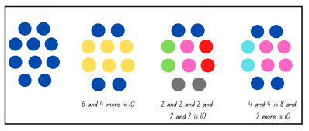

Translating patterns – 40 minutes
- Revise prior learning on patterning. Highlight that patterns need to have a core that is repeated over and over and over again. Explain that mathematicians often describe the repeating core of a pattern using letters.
- Display Resource 2: AB pattern. Identify the repeating core and explain that it is an AB pattern. Demonstrate how to follow the pattern using body percussion and have students continue the pattern.
- Explain that a pattern can be represented in more than one form. For example, this pattern was translated into body percussion by assigning a movement to each colour.
- Display Resource 3: ABC pattern. Identify the repeating core and explain that it is an ABC pattern. Demonstrate how to follow the pattern using body percussion and have students continue the pattern.
- Display Resource 4: ABB pattern. Identify the repeating core and explain that it is an ABB pattern. Demonstrate how to follow the pattern using body percussion and have students continue the pattern.
- Watch the video Pattern matching (4:24). Ask students to turn and talk to a partner and identify the pattern core. Record the pattern core on a whiteboard and label the pattern using letters.
- The structure of Eddie Woo’s first pattern is AABBC. Ask students how many different ways they can find to translate the same pattern.
- Using ‘Talk moves’, have students identify a variety of forms that could be used to represent a pattern. This could include physical movements, instruments, numbers, drawings, symbols, or by using concrete materials.
- Early Stage 1 students create their own simple patterns using sounds or actions. Students show their pattern to a partner who then continues the pattern.
- Stage 1 students create their own repeating patterns using coloured counters and choose different forms to translate their pattern. Students can record translations using Resource 5: Graphic organiser.
This table details assessment opportunities and differentiation ideas.
Assessment opportunities | Too hard? | Too easy?
What to look for:  - Can students create repeating patterns? (MAO-WM-01, MAE-FG-01, MA1-RWN-01, MA1-RWN-02)  - Can students copy and continue repeating patterns using sounds and/or actions? (MAO-WM-01, MAE-FG-01)  - Are students able to find the core of a repeating pattern? (MAO-WM-01)  - Can students describe the pattern core by the number of parts? For example, ‘This is a three-part pattern’ (MAO-WM-01)  - Do students describe the pattern core using letters such as AB, ABC, ABB, AABBCC? (MAO-WM-01)  - Can students translate the same repeating core in different ways? (MAO-WM-01)  What to collect:  - observations of students creating patterns and translating patterns (MAO-WM-01)  - work sample – Resource 5: Graphic organiser (MAO-WM-01, MA1-RWN-01, MA1-RWN-02) | Students are unable to create a repeating pattern.  - Provide opportunities for students to mirror a simple clapping and clicking pattern.  - Provide concrete materials in simple AB pattern formations for students to explore and continue.  Students are unable to translate the same repeating core in different ways.  - Provide visuals to assist in translating, for example, use colours, pictures or signals.  - Support students with a simple AB pattern and model translating with simple body percussion. | Students can translate the same repeating core in different ways.  - Increase the complexity of the core.  - Extend the length of the pattern core.

Consolidation and meaningful practice: Sharing our patterns – 10 minutes
- Invite students to share their patterns with the class.
- Ask the following questions to stimulate a rich discussion:
- Can you identify the pattern core?
- How could you describe your pattern?
- How many ways were you able to translate the pattern?
- What did you find challenging?
- Can you demonstrate your pattern using body percussion?

Lesson 2: Shrinking patterns 1
Core concept: Shrinking patterns get smaller by the same quantity each time.
The table below contains suggested learning intentions and success criteria. These are best co-constructed with students.
Learning intentions | Success criteria
Students are learning that:  - counting sequences have patterns  - a shrinking pattern gets smaller by the same quantity each time  - an array is one way to model multiplicative thinking involving whole numbers  - mathematicians represent data with tables. | Students can:  - identify patterns in numbers when choral counting  - identify a shrinking pattern and explain the repeating core.  In addition, students working towards Early Stage 1 outcomes can:  - count forwards by ones to at least 30  - count with one-to-one correspondence  - copy, continue, and create repeating patterns using shapes, objects, images, or pictures  - compare the sizes of groups of limbs by counting  - arrange monkey images to create a data display.  In addition, students working towards Stage 1 outcomes can:  - represent a shrinking pattern in different ways  - use an array model to skip count  - draw a table showing a shrinking pattern.

Daily number sense: Choral counting – Counting forwards by ones – 20 minutes
This activity has been adapted from Franke, Kazemi and Turrou (2018).
- Build student understanding of counting patterns and fluency in counting sequences through choral counting.
- Have students count aloud by ones, starting from 1 up to 42. Record counting sequence on the board (see Figure 2).
Figure 2 – Choral counting chart
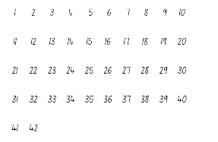
- Ask students what they notice and wonder about the numbers using the following prompts.
The table below outlines stimulus prompts to generate conversation about the topic, along with anticipated responses from students.
Prompts | Anticipated student responses
- What do you notice about the numbers?  - Which numbers are the two-digit numbers?  - What do you notice about the numbers in this column? For example, 6, 16, 26, 36.  - Who can tell us what number will come next? How do you know?  - Does someone have another way to know the next number? | - There is a pattern of ones in each column. For example, for the numbers 11, 21, 31, 41, all have a ones digit that says ‘one’.  - Student points to each column and says: ‘These have one, these have 2, these have 3, and these have 4, and so on. All of the tens numbers have the same in each column.’
- Record observations and patterns on the board (see Figure 3).
Figure 3 – Annotated choral counting chart
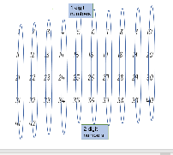
- During the discussion, explicitly highlight the patterns in the numbers. Select one pattern to count, for example, 10, 20, 30, 40. Students continue counting by tens up to 120. For Early Stage 1 students, identify numbers before and after a given number and use the language of one more and one less to identify the number. For Stage 1 students, select a pattern that increases by tens off the decade, for example, 7, 17, 27, 37, and continue counting on.

Shrinking patterns – 40 minutes
This activity has been adapted from the activity Gecko feet by NZ Maths.
- Watch the video 5 Little Monkeys (2:23) Revise that there were 5 monkeys at the beginning of the song and each monkey has 4 limbs. Ask students how many limbs there were all together.
- Give students the opportunity to turn and talk with a partner and to record their thinking using drawing, words, or numbers.
- Using the structure of an array, model a solution to the problem to students (see Figure 4).
Figure 4 – Array structure
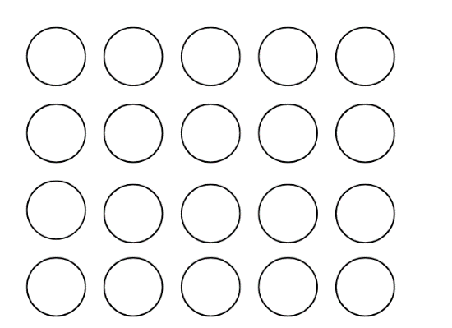
Array: One of several different arrangements that can be used to model multiplicative situations involving whole numbers. An array is made by arranging a set of objects, such as counters or pictures, into columns and rows. Each column must contain the same number of items as the other columns and each row much contain the same number of items as the other rows.
- Ask students what they notice about the array. Draw attention to the number in each column, the number of columns, and how this represents 20.
- For Early Stage 1 students, have them count with one-to-one correspondence, recognising that the last number name represents the total number in the collection.
- For Stage 1 students, model skip counting by fives to find the total.
- Watch the video 5 Little Monkeys (2:23) again. Pause the video when one monkey jumps off the bed and ask students how they could represent this using the structure of an array.
- Give students the opportunity to create a model using counters. Press play and continue creating arrays each time a monkey jumps off the bed (see Figure 5).
Figure 5 – Decreasing array structure
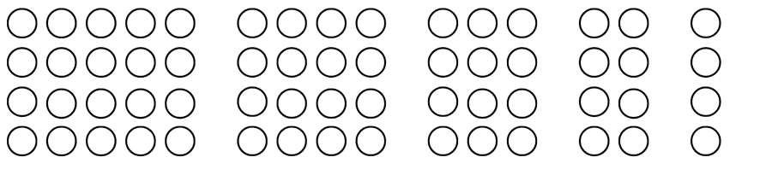
- Ask students to explain the pattern core using words. Highlight that it is a shrinking pattern, as it subtracts 4 each time. The quantity of limbs shrinks or gets smaller as each monkey falls off the bed – the pattern shrinks by 4 limbs each time.
- Discuss with students that mathematicians record data or information using tables. Tables help organise mathematical information.
Note: Representing an object with a different object, picture, or drawing is an abstraction. It is important that each object in a (one-to-one) data display represents one object. Aligning the rows or columns of tables can make comparisons easier.
- Have Early Stage 1 students compare the sizes of each array by counting by ones. Give students copies of Resource 6: Monkey images. Students arrange the monkeys into a data display (see Figure 6).
Figure 6 – Monkey data display
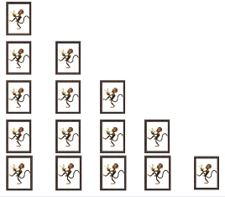
Images sourced from Canva and used in accordance with the Canva Content License Agreement.
- For Stage 1 students, model drawing and reading a table to represent the shrinking pattern (see Figure 7). Draw students’ attention to the table structure and information recorded.
Figure 7 – Example of table
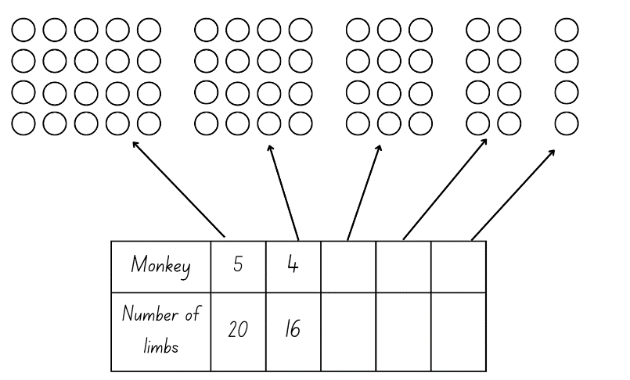
This table details assessment opportunities and differentiation ideas.
Assessment opportunities | Too hard? | Too easy?
What to look for:  - Are students able to count with one-to-one correspondence? (MAO-WM-01, MAE-RWN-01, MAE-RWN-02)  - Are students able to skip count by fives to find the total number in an array? (MA1-FG-01)  - Can students identify the core element of repeat in the shrinking pattern? (MAO-WM-01, MAE-RWN-01, MAE-RWN-02, MA1-RWN-01, MA1-RWN-02, MAE-CSQ-01, MAE-CSQ-02, MA1-CSQ-01)  - Can students use the structure of an array to model a shrinking pattern? (MAO-WM-01, MA1-FG-02)  - Can students arrange objects to form a data display? (MAO-WM-01, MAE-DATA-01)  - Can students draw a table to show the shrinking pattern? (MA1-CSQ-01, MA1-DATA-01, MA1-DATA-02)  What to collect:  - student observations (MAO-WM-01, MAE-RWN-01, MAE-RWN-02, MAE-CSQ-01, MAE-CSQ-02, MA1-FG-01, MA1-RWN-01, MA1-RWN-02, MA1-DATA-01, MA1-DATA-02)  - photographs of data displays (MAO-WM-01, MAE-DATA-01)  - work sample – table in workbooks. (MA1-CSQ-01, MA1-DATA-01, MA1-DATA-02) | Students are unable to count with one-to-one correspondence.  - Say, gesture, or sign ‘one’ in response to a single item or action.  - Use concrete materials to represent the group and support students to identify or move one, 2, or 3 items from the group.  Students are unable to skip count by fives to find the total of the array.  - Provide concrete materials such as counters to represent the monkey limbs. Have students use the counters to form groups and count by ones.  - Support skip counting with a visual, for example, a number chart. | Students can count with one-to-one correspondence.  - Support students to count by twos.  - Model skip counting using a visual representation such as a number chart.  Students can identify the missing elements in the table.  - Ask students to create a table to represent the data if there were 20 monkeys.  - Ask students to create a table to represent the data if there were 50 monkeys.

Consolidation and meaningful practice: Representing patterns in different ways – 10 minutes
- Ask students if they could represent the monkey’s limbs using letters or actions. Students may use AAAA to describe the repeating core or 4 claps.
- Model an example of the pattern as a sound. Students sit in a circle. First student claps 20 times, next student claps 16 times, next student claps 12 times, and so on.
- In pairs, ask students to represent this pattern in a different form. Students can record their representation using Resource 5: Graphic organiser. Early Stage 1 students can be paired with a Stage 1 student.
- Students present their representations to the class.

Lesson 3: Shrinking patterns 2
Core concept: Shrinking patterns can be represented in different ways.
The table below contains suggested learning intentions and success criteria. These are best co-constructed with students.
Learning intentions | Success criteria
Students are learning that:  - counting sequences have patterns  - a shrinking pattern gets smaller by the same quantity each time  - an array is one way to model multiplicative thinking involving whole numbers  - mathematicians represent data with tables. | Students can:  - identify patterns in numbers when choral counting  - identify a shrinking pattern and explain the repeating core.  In addition, students working towards Early Stage 1 outcomes can:  - count backwards by ones from 20  - copy, continue, and create repeating patterns using pictures  - compare the sizes of groups of objects by counting  - arrange images to create a data display.  In addition, students working towards Stage 1 outcomes can:  - represent a shrinking pattern in different ways  - use an array model to skip count  - draw a table showing a shrinking pattern.

Daily number sense: Choral counting – Counting backwards by ones – 20 minutes
This activity has been adapted from Franke, Kazemi and Turrou (2018).
- Build student understanding of counting patterns and build fluency of counting sequences through choral counting.
- Have students count aloud backwards by ones, starting from 42. For Early Stage 1, provide students a visual number chart to support the count higher than 20. Record counting sequence on the board (see Figure 8).
Figure 8 – Choral counting chart
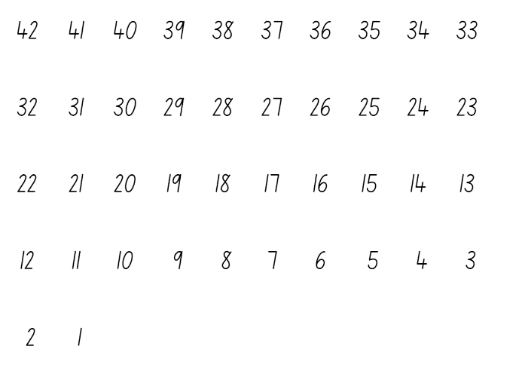
- Ask students what they notice about the numbers using the following prompts:
The table below outlines stimulus prompts to generate conversation about the topic, along with anticipated responses from students.
Prompts | Anticipated student responses
- What do you notice about the numbers?  - Which numbers are the two-digit numbers?  - What do you notice about the numbers in this column? (point) For example, 6, 16, 26, 36.  - Who can tell us what number will come next? How do you know?  - Does someone have another way to know the next number? | - There is a pattern of ones in each column. For example, for the numbers 11, 21, 31, 41, all have a ones digit that says ‘1’.  - Student points to each column and says: ‘These have one, these have 2, these have 3 and these have 4, and so on. All of the tens numbers have the same in each column.’
- Using ‘Talk moves’ invite students to share their thinking. Record observations and patterns on the board (see Figure 9).
Figure 9 – Annotated choral counting chart
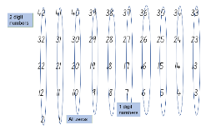
- During the discussion, highlight the patterns in the numbers. Select one pattern to count, for example, 40, 30, 20, 10. Students continue counting backwards by tens from 120.
- For Early Stage 1 students, identify numbers before and after a given number and use the language of one more and one less to identify the number.
- For Stage 1 students, select a pattern that decreases by tens off the decade, for example, 87, 77, 67, 57, and continue counting back.

Identifying and representing shrinking patterns – 40 minutes
- Revise shrinking patterns from Lesson 2.
- Tell students that they will be investigating shrinking patterns through a story.
- Select one of the following stories below based on student’s individual needs and interests:
- Ones – There were 10 snails in the garden. One by one they slid away.
- Twos – There were 6 emus in the outback. Each emu has 2 legs. One by one they walked away.
- Fours – There were 5 frogs sat on a lily pad. Each frog has 4 legs. One by one they jumped off.
- Fives – There were 4 flowers in a garden. Each flower has 5 petals. One by one the flowers were picked.
- Sixes – There were 4 ants on a log. Each ant has 6 legs. One by one they walked away.
- Eights – There were 3 spiders in a web. Each spider has 8 legs. One by one they walked away.
- Give students a selection of counters to create a model of the shrinking pattern. Remind students to use the structure of the array.
- Ask students the following questions to guide their thinking:
- How could you organise your counters to represent the total?
- How does the structure of an array help support the count?
- Can you identify the repeating core?
- Students share their model with a partner and explain their thinking.
- Have Early Stage 1 students draw a data display with pictures of the snails.
- Have Stage 1 students create a table to represent their shrinking pattern using the table structure from Lesson 2.
- Select students to present their models and tables to the class. Identify the key features and revise the concept that a shrinking pattern gets smaller.
This table details assessment opportunities and differentiation ideas.
Assessment opportunities | Too hard? | Too easy?
What to look for:  - Are students able to count using one to one correspondence? (MAO-WM-01, MAE-RWN-01, MAE-RWN-02)  - Are students able to skip count to find the total number in an array? (MA1-FG-01)  - Are students able to represent shrinking patterns using counters or arrays? (MAO-WM-01, MAE-CSQ-01, MAE-CSQ-02, MAE-FG-01, MA1-CSQ-01, MA1-FG-02)  - Can students identify the core/element of repeat in the shrinking pattern? (MAE-RWN-01, MAE-RWN-02, MAE-CSQ-01, MAE-CSQ-02, MA1-RWN-01, MA1-RWN-02, MA1-CSQ-01)  - Can students create a data display using pictures? (MAO-WM-01, MAE-DATA-02)  - Can students draw a table to show the shrinking pattern? (MA1-CSQ-01, MA1-DATA-01, MA1-DATA-02)  What to collect:  - student observations (MAE-RWN-01, MAE-RWN-02, MAE-CSQ-01, MAE-CSQ-02, MA1-RWN-01, MA1-RWN-02, MA1-CSQ-01)  - Work sample – table in workbooks (MA1-CSQ-01, MA1-DATA-01, MA1-DATA-02)  - observational data (MAO-WM-01, MAE-RWN-01, MAE-RWN-02, MAE-CSQ-01, MAE-CSQ-02, MA1-FG-01, MA1-RWN-01, MA1-RWN-02, MA1-DATA-01, MA1-DATA-02)  - photographs of data displays (MAO-WM-01, MAE-DATA-01)  - work sample – table in workbooks (MA1-CSQ-01, MA1-DATA-01, MA1-DATA-02) | Students are unable to represent shrinking patterns using counters and arrays.  - Scaffold students’ thinking by having them organise their counters in groups.  - Model creating an array structure, revise equal rows and columns.  - Provide a visual template to support the array structure.  Students are unable to identify the repeating core in the shrinking pattern.  - Have students use different colour counters to represent each animal or object to aid in identifying the pattern core.  - Provide students with the opportunity to act out simple repeating patterns with sounds or body movements. | Students can represent shrinking patterns using counters and arrays. Ask students what would happen if 2 went away each time. Have students record their thinking using the structure of an array.  Students can draw a table to represent the shrinking pattern.  - Have students represent the data in a picture graph using a baseline, equal spacing, and same-sized symbols.  - Have students label the data in a picture graph.

Lesson 4: Growing patterns 1
Core concept: Growing patterns get bigger by the same quantity each time.
The table below contains suggested learning intentions and success criteria. These are best co-constructed with students.
Learning intentions | Success criteria
Students are learning that:  - counting sequences have patterns  - a growing pattern gets bigger by the same quantity each time  - identifying the rule or generalisation in a pattern can determine what comes next  - mathematicians represent data with tables. | Students can:  - identify a growing pattern and explain the repeating core  - create a growing pattern.  In addition, students working towards Early Stage 1 outcomes can:  - count backwards by ones from 20  - count forwards by ones to at least 30  - count with one-to-one correspondence  - copy, continue, and create repeating patterns using objects  - compare the sizes of groups of objects by counting.  In addition, students working towards Stage 1 outcomes can:  - identify the next number in a pattern  - draw a table showing a growing pattern.

Daily number sense: Counting sounds – 20 minutes
- Build student understanding of counting sequence through counting sounds activity.
- Watch the video Counting sounds: number talk (11:50) and pause video at 1:35.
- Have students draw what they think the collection looks like.
- Play video and pause again at 2:58. Discuss with students what the collection may look like. Have students share their ideas and drawings.
- Play the video to the end to see the different visual representations and to discuss and connect the mathematics.
- In pairs, have one student use clapping to represent a forward or backward counting sequence. The other student draws a representation of the collection. Students check solutions and swap roles.

Representing growing patterns – 50 minutes
This activity has been adapted from Van de Walle et al. (2019).
- Display Resource 7: Triangle growing pattern. Ask students the following questions:
- What do you notice about the images?
- Can you identify a pattern? Explain how you see the images changing?
- Can you identify the pattern core?
- Are the patterns increasing or decreasing in size? How do you know?
- How are numbers related to the visual images? Explain your thinking.
- How many triangles are there in total? How do you know?
- Discuss with students that this is a growing pattern. The quantity is growing or getting bigger by 3 triangles each time. Make a class anchor chart about growing patterns.
- Ask students to turn and talk to a partner to discuss what would be the next sequence in the pattern. Invite students to share their thinking to the class. For Early Stage 1 students, provide triangle pattern blocks to support students with counting.
- Model creating a table to reflect this pattern (see Figure 10).
Figure 10 – Example table for recording data.
- Explain to students that growing patterns can be represented in different forms and look very different.
- Display Resource 8: Cube growing pattern. Have students identify the pattern core. Compare this pattern to Resource 7: Triangle growing pattern and discuss similarities and differences.
- Provide students with a variety of concrete materials for example, counters, craft sticks, paper clips, markers, building blocks, pattern blocks, or natural materials and ask students to create their own growing pattern.
- Provide students with time to explore and create their growing patterns with their chosen material. Observe students and ask the following questions to guide their thinking:
- What is your repeating core?
- How are you representing the pattern growing?
- Are there any structures you could use to help you organise your thinking?
- Early Stage 1 students work in pairs and copy and continue their partner’s pattern using concrete materials. Stage 1 students represent their pattern using a table structure similar to the ones created in previous lessons. Remind students as this is a growing pattern, the numbers will increase.
- Students participate in a gallery walk to see how others have represented their growing pattern in tables and how students have created patterns using concrete materials.
This table details assessment opportunities and differentiation ideas.
Assessment opportunities | Too hard? | Too easy?
What to look for:  - Are students able to count using one to one correspondence? (MAO-WM-01, MAE-RWN-01, MAE-RWN-02)  - Are students able to skip count to find the totals in a pattern sequence? (MA1-FG-01)  - Can students identify a growing pattern and explain the repeating core? (MAE-RWN-01, MAE-RWN-02, MAE-CSQ-01, MAE-CSQ-02, MA1-RWN-01, MA1-RWN-02, MA1-CSQ-01)  - Can students create a growing pattern using concrete materials? (MAO-WM-01, MAE-CSQ-01, MAE-CSQ-02, MAE-FG-01, MA1-CSQ-01, MA1-FG-02)  - Are students able to identify the next number in a growing pattern? (MAO-WM-01, MAE-RWN-01, MAE-RWN-02, MA1-RWN-01, MA1-RWN-02, MA1-CSQ-01)  - Are students able to draw a table showing a growing pattern? (MA1-CSQ-01, MA1-DATA-01, MA1-DATA-02)  What to collect:  - observation of students creating a growing pattern (MAO-WM-01, MAE-CSQ-01, MAE-CSQ-02, MAE-FG-01 MA1-RWN-01, MA1-CSQ-01, MA1-FG-01)  - work sample – table in workbooks. (MA1-CSQ-01, MA1-DATA-01, MA1-DATA-02) | Students are unable to count using one-to-one correspondence.  - Say, gesture, or sign ‘one’ in response to a single item or action.  - Use concrete materials to represent the group and support students to identify or move one, 2, or 3 items from the group.  Students are unable to create a growing pattern.  - Revise with students the choral counting chart and relate how the numbers are increasing.  - Model a simple growing pattern, increasing by ones. Ask students to complete next sequence in the pattern. | Students can count with one-to-one correspondence.  - Support students to count by twos.  - Model skip counting using a visual representation such as a number chart.  Students can create a growing pattern and identify repeating core.  - Ask students to represent a pattern that doubles each sequence. Students create this using concrete materials.  - Ask students to create a table to show a pattern that doubles each sequence.

Lesson 5: Growing patterns 2
Core concept: Growing patterns can be represented in different ways.
The table below contains suggested learning intentions and success criteria. These are best co-constructed with students.
Learning intentions | Success criteria
Students are learning that:  - counting sequences have patterns  - a growing pattern gets bigger by the same quantity each time  - identifying the rule or generalisation in a pattern can determine what comes next  - mathematicians represent data with tables. | Students can:  - identify a growing pattern and explain the repeating core  - create a growing pattern using craft sticks.  In addition, students working towards Early Stage 1 outcomes can:  - count forwards by ones to at least 30  - count with one-to-one correspondence  - copy, continue, and create repeating patterns using shapes, objects, images, or pictures  - compare the sizes of groups of triangles by counting.  In addition, students working towards Stage 1 outcomes can:  - draw a table showing a growing pattern  - use information from a table to recognise, continue, and record a pattern.

Daily number sense – 15 minutes
- From a class need surfaced through formative assessment data, identify a short, focused activity that targets students’ knowledge, understanding, and skills. Example activities may be drawn from the following resources:
- Thinking Mathematically Stage 1
- Universal Resources Hub.

Sticky Triangles – 45 minutes
This activity has been adapted from Sticky Triangles by NRICH.
- Revise growing patterns from previous lesson.
- Create a triangle using 3 craft sticks or drawn lines and display for students (see Figure 11).
Figure 11 – Triangle with craft sticks
- Model how to add more craft sticks to create 4 small triangles in 2 rows (see Figure 12).
Figure 12 – Triangle growing pattern
- Ask students how many more craft sticks were added and how many have been used altogether.
- Invite students to predict how many more craft sticks will be needed for another row in the pattern. As a class, select some students to share how they visualised the pattern and identify the repeating core.
- Discuss with students how this information could be recorded in a table like the previous lessons. Draw an example of how the data could be recorded on the board (see Figure 13).
Figure 13 – Data table
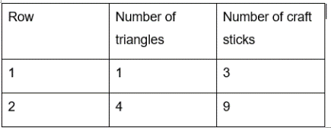
- Give Early Stage 1 students equilateral triangular pattern blocks to create rows. Have students record the total number of triangles.
- For Stage 1 students, provide a selection of craft sticks and ask them to create the next few sequences in the pattern.
- Ask the following questions:
- Can you see why the number of craft sticks increased by that amount when you added that row?
- Can you predict how many craft sticks or triangles the tenth row will need? How do you know?
- Can you see a link between the number of rows and the total number of craft sticks?
- Can you see a link between the number of small triangles and the total number of craft sticks?
- How would you describe the pattern?
This table details assessment opportunities and differentiation ideas.
Assessment opportunities | Too hard? | Too easy?
What to look for:  - Can students identify a growing pattern and explain the repeating core? (MAO-WM-01, MAE-RWN-01, MAE-RWN-02, MAE-CSQ-01, MAE-CSQ-02, MAE-FG-01, MA1-RWN-01, MA1-RWN-02, MA1-CSQ-01, MA1-FG-01)  - Are students able to create a growing pattern using craft sticks or triangle images? (MAO-WM-01, MAE-RWN-01, MAE-RWN02, MA1-RWN-01, MA1-CSQ-01, MA1-FG-01)  - Can students draw a table showing a growing pattern? (MA1-CSQ-01, MA1-DATA-01, MA1-DATA-02)  - Can students respond to questions about the information collected? (MAE-DATA-01)  - Can students use information from a table to recognise, continue and record a pattern? (MAO-WM-01, MA1-RWN-01, MA1-RWN-02, MA1-CSQ-01)  What to collect:  - observational data of students creating a growing pattern (MAO-WM-01, MAE-RWN-01, MAE-RWN-02, MAE-CSQ-01, MAE-CSQ-02, MAE-FG-01, MA1-RWN-01, MA1-RWN-02, MA1-CSQ-01, MA1-FG-01)  - work sample – table in workbooks. (MA1-CSQ-01, MA1-FG-01, MA1-DATA-01, MA1-DATA-02) | Students are unable to create a growing pattern.  - Revise the feature of growing patterns and provide additional visual examples of growing patterns.  - Support students to create one row at a time and count craft sticks individually for each row. | Students can create a growing pattern.  - Have students look more carefully at the number patterns involved, rather than simply counting craft sticks each time.  - Ask students to work out the total number of craft sticks for 27 rows of triangles.

Lesson 6: Patterns in the number chart
Core concept: Number patterns can be identified within number charts.
The table below contains suggested learning intentions and success criteria. These are best co-constructed with students.
Learning intention | Success criteria
Students are learning that number patterns can be identified within a number chart. | Students can:  - describe and identify patterns in a bottom-up number chart  - identify the missing numbers in a number pattern  - determine the location of missing numbers in a number chart puzzle.  In addition, students working towards Early Stage 1 outcomes can:  - count forwards to 30  - count backwards from 20  - identify numbers one more and one less.  In addition, students working towards Stage 1 outcomes can:  - skip count by twos, threes, fives and tens  - count backwards by twos  - identify numbers one more, one less, 10 more and 10 less than a given number.

Daily number sense: Pasta counting – 20 minutes
This activity has been adapted from Counting with understanding up to 20 (4:36) from Thinking Mathematically.
- Build student understanding of counting and skip counting by engaging in a pasta counting activity.
- Provide students with containers filled with pasta shells or counters. Provide Early Stage 1 students with up to 30 pasta shells in each container. Provide Stage 1 students with more than 30 pasta shells.
- Ask students to look carefully at their collection. Students estimate the total number of pasta shells. Select students to read their number aloud.
- Ask students to empty their containers and count the number of pasta shells.
- For Early Stage 1 students, focus the count on one-to-one correspondence, recognising that the last number stated represents the total in the collection.
- Encourage Stage 1 students to skip count using known structures. For example, they could structure their pasta shells into a ten-frame structure or dice patterns.
- Have students compare their estimate with the total collection.
- Have students count backwards to return the pasta to the containers.
- For Early Stage 1 students, focus the count on one-to-one correspondence.
- Encourage Stage 1 students to skip count backwards by twos.
- Ask students to explain the total amount inside their containers.
- Explain to students that they can connect the number words to items as they count by counting both forwards and backwards, and checking the total they have quantified in the collection. Once a collection is quantified, it does not matter how the pasta is then spread out, the count can be trusted.
Assessment opportunities | Too hard? | Too easy?
What to look for:  - Can students count with one-to-one correspondence? (MAO-WM-01, MAE-RWN-01, MAE-RWN-02)  - Can students count forwards by ones to at least 30? (MAO-WM-01, MAE-RWN-01, MAE-RWN-02)  - Can students count backwards from at least 20? (MAO-WM-01, MAE-RWN-01, MAE-RWN-02)  - Can students skip count by twos, threes, fives or tens? (MAO-WM-01, MA1-RWN-01, MA1-RWN-02, MA1-FG-01)  - Can students count backwards from twos (MAO-WM-01, MA1-RWN-01, MA1-RWN-02, MA1-FG-01)  What to collect:  - observational data (MAO-WM-01, MAE-RWN-01, MAE-RWN-02, MA1-RWN-01, MA1-RWN-02, MA1-FG-01) | Students are unable to count forwards by ones to 30.  - Say ‘one’ or sign, gesture, or point to one dot or numeral ‘1’ when given or shown a single item.  - Look at, point to, or touch objects as they are being counted.  - Provide opportunities to participate in counting games and songs. | Students can count forwards by ones to 30.  - Provide students with containers with larger quantities of pasta shells.  - Have students put the pasta shells into groups of twos and support skip counting by twos to find the total.

Number pattern detectives – 30 minutes
- Display Resource 9: Bottom-up number chart. Ask students:
- What do you notice about this number chart?
- How is it different to other number charts?
- How is it like other number charts?
- Can you identify any patterns?
- How do number charts help us count?

Note: A bottom-up number chart allows students to use language to accurately capture what is happening to the size of the numbers. For example, going up on the chart correlates to the number also going up. By inverting the chart and starting with zero at the bottom, students can explain that when the number increases by 10, it gets larger/taller/bigger/greater which are all modelled when they move ‘up’.
- Students share their observations with the class. Using coloured markers, annotate student responses. Highlight relationships of one more, one less, 10 more, and 10 less, as well as directionality.
- Display the number chart in the classroom for students to access.
- Provide Early Stage 1 students with a copy of Resource 10: Number puzzles 1 and Stage 1 students with Resource 11: Number puzzles 2. Students identify missing numbers using their knowledge of patterning and the bottom-up number chart.
- Students share their solutions with a partner and discuss their reasoning.
This table details assessment opportunities and differentiation ideas.
Assessment opportunities | Too hard? | Too easy?
What to look for:  - Can students describe and identify patterns in a bottom-up number chart? (MAO-WM-01, MA1-RWN-01, MA1-RWN-02, MAE-FG-01, MA1-RWN-01, MA1-RWN-02, MA1-FG-01)  - Are students able to identify numbers one more and one less? (MAO-WM-01, MAE-RWN-01, MAE-RWN-02, MA1-CSQ-01, MAE-CSQ-02, MA1-RWN-01, MA1-RWN-02, MA1-CSQ-01)  - Are students able to identify ten more and ten less than a given number? (MA1-RWN-01, MA1-RWN-02, MA1-CSQ-01)  - Can students identify the missing numbers in a number pattern? (MAO-WM-01, MAE-RWN-01, MAE-RWN-02, MAE-CSQ-01, MAE-CSQ-02, MAE-FG-01, MA1-RWN-01, MA1-RWN-02, MA1-CSQ-01, MA1-FG-01)  What to collect:  - work sample – Resource 10 Number puzzles 1 (MAO-WM-01, MA1-RWN-01, MA1-RWN-02, MA1-CSQ-01, MA1-FG-01)  - work sample – Resource 11: Number Puzzles 2 (MAO-WM-01, MAE-RWN-01, MAE-RWN-02, MAE-CSQ-01, MAE-FG-01) | Students are unable to identify the missing numbers in a number chart puzzle.  - Provide students their own bottom-up number chart to support locating the missing numbers.  - Provide Stage 1 students with one number before and one number less puzzles.  - Provide concrete materials to identify the number before and after. | Students can identify the missing numbers in a number chart puzzle.  - Provide students their own copy of a bottom-up number chart. Students highlight skip counting patterns including twos, fives and tens.  - Provide students with a blank number chart and have them create their own number pattern puzzles.  - Provide Early Stage 1 students with Resource 11: Number puzzles 2.

Consolidation and meaningful practice: Discuss and connect the mathematics – 10 minutes
- As a class, summarise the lesson together drawing out key mathematical ideas. Ask students:
- How did you work out what numbers were missing?
- Could you work out the numbers without the use of the number chart? How?
- What patterns helped you determine the missing numbers?
- Were you able to explain your reasoning?

Lesson 7: Weaving patterns
Core concept: A number pattern can be represented in different ways.
The table below contains suggested learning intentions and success criteria. These are best co-constructed with students.
Learning intentions | Success criteria
Students are learning that:  - a pattern core can be described using letters  - patterns can be identified in number charts  - patterns can be represented by numbers. | Students can:  - create a pattern using coloured rods  - identify numerical patterns in a number chart  - replicate a pattern into a number chart.  In addition, students working towards Early Stage 1 outcomes can identify numbers one more and one less.  In addition, students working towards Stage 1 outcomes can describe the pattern core using letters such as AB, ABC, ABB, AABBCC.

Daily number sense: Guess my pattern – 15 minutes
This activity has been adapted from Boaler et al. (2021).
- Build student understanding of number patterns by playing ‘Guess my pattern’.
- In pairs, provide students with a copy of laminated Resource 9: Bottom-up number chart and coloured markers.
- Partners sit across from each other with a barrier between them such as a book or file to ensure they cannot see the other player’s chart.
- For Early Stage 1: Player 1 creates a number chart using 5 different coloured counters. Player 1 reads the pattern out loud using number names or colours. Player 2 then copies and continues the pattern with their 5 coloured counters. Player 1 shows their partner their chart and they check the solution together.
- For Stage 1: Player 1 creates a number pattern on their number chart and reads aloud the first few numbers in their pattern to their partner. Player 2 marks the numbers on their own chart to keep track of the pattern. Player 2 then guesses the next number in the pattern and describes the pattern. For example, the next number is 12 and it is skip counting by threes. Player 2 can ask for additional numbers in the pattern to be read before taking a guess. Player 1 shows their partner their chart to confirm or check solutions.
- After students have had the chance to play a few rounds, discuss the following questions:
- What information was needed to determine the pattern?
- What clues were useful?
- Explain your strategy for identifying the next number in the pattern.

Weaving patterns – 45 minutes
This activity has been adapted from Boaler et al. (2021).
- Display Resource 12: Woven basket on the board. Discuss with students that basket weaving involves lots of mathematical ideas.
- Have students turn and talk to a partner about what they notice and what patterns they can see.
- Invite students to come up and point to the patterns they notice. Encourage students to use precise language to describe the pattern such as vertical, horizontal, diagonal, and repeating. Highlight to students that the basket is woven in a wrapped spiral using different coloured material.
- Explain to students that they will explore how to make a weaving pattern on a number chart using coloured rods. The coloured rods will be the bands of colours like those in the basket.
- Provide students the coloured rods and have them make observations about them. Students should notice that they come in different lengths and colours, and that they can be associated with numerical values.
- In pairs, students can make repeating patterns such as AB or AAB (see Figure 14).
Figure 14 – Coloured rod patterns
- Display Resource 13: Centimetre number chart. Select one of the students’ patterns and ask the class how this pattern could be represented on the number chart. Students turn and talk to a partner to discuss possible solutions.
- Invite some students to share their ideas and demonstrate how they could use colours to mark the pattern (see Figure 15).
Figure 15 – Bottom-up chart example
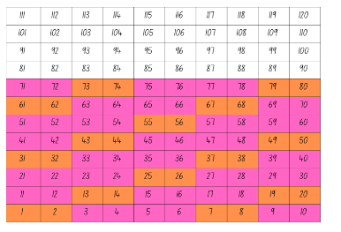
Images sourced from Canva and used in accordance with the Canva Content License Agreement.
- In pairs, provide students with Resource 13: Centimetre number chart, coloured markers, and a selection of coloured rods. Students create a new pattern with their coloured rods. Guide students thinking by asking the following questions:
- How can this pattern be transferred to the number chart?
- What can you do when you come to the end of a row? How can you continue the pattern?
- Once you have coloured your pattern on the hundreds chart, what do you notice?
- Do you notice any patterns with the numbers? Explain your thinking.
- What are you wondering about weaving patterns?
- Have students make different patterns with different coloured rods. Discuss with their partner the most interesting patterns.

This table details assessment opportunities and differentiation ideas.
Assessment opportunities | Too hard? | Too easy?
What to look for:  - Can students describe the pattern core using letters such as AB, ABC, ABB, AABBCC? (MAO-WM-01)  - Can students create a pattern using coloured rods? (MAO-WM-01, MAE-FG-01, MA1-RWN-01, MA1-RWN-02)  - Are students able to identify numerical patterns in a number chart? (MA1-RWN-01, MA1-RWN-02, MA1-CSQ-01, MA1-FG-02)  - Can students replicate a coloured rod pattern into a number chart? (MAO-WM-01, MAE-RWN-01, MAE-RWN-02, MAE-FG-01, MA1-RWN-01, MA1-RWN-02, MA1-CSQ-01, MA1-FG-02)  What to collect:  - work sample – Resource 13: Centimetre number chart (MAO-WM-01, MAE-RWN-01, MAE-RWN-02, MA1-RWN-01, MA1-RWN-02, MA1-CSQ-01, MA1-FG-02) | Students are unable to create a pattern using coloured rods.  - Model to students creating a simple AB pattern with coloured rods.  - Explicitly identify the repeating pattern core to support continuation of the pattern.  Students are unable to identify numerical patterns in a number chart.  - Use a simplified AB pattern to support students’ understanding of patterning.  - Ask students to focus on what they see and highlight the connections between the rods and the number pattern. | Students can identify numerical patterns in a number chart.  - Ask students if they have seen woven patterns before. Discuss what mathematical ideas are important when creating woven baskets. Share your thinking with a partner.  - Have students draw a variety of woven patterns and discuss mathematical ideas with a partner.

Consolidation and meaningful practice: Discuss and connect the mathematics – 10 minutes
- Ask students to conduct a gallery walk to review other students’ patterns. Ask the following questions:
- How is each pattern constructed? What is the pattern?
- What kinds of patterns with rods and numbers make diagonal patterns?
- What kinds of patterns with rods and numbers make vertical patterns?
- Which patterns did you find most interesting and why?
- Were there any patterns that did not look like patterns? Why or why not?

Lesson 8: Number chart investigation
Core concept: Number charts can be used to explore patterning.
The table below contains suggested learning intentions and success criteria. These are best co-constructed with students.
Learning intentions | Success criteria
Students are learning that:  - the structure of a number chart can be used to explore relationships between numbers  - numerical patterns can be identified within number charts. | Students can:  - identify vertical and horizontal number patterns  - use positional language to identify, such as ‘on top of’, ‘below’, ‘next to’, ‘left’ and ‘right’  - describe patterns in a standard number chart  - communicate their thinking giving reasons and evidence.  In addition, students working towards Early Stage 1 outcomes can:  - count forwards to 30  - identify numbers one more and one less.  In addition, students working towards Stage 1 outcomes can:  - skip count by twos, threes, fives, and tens  - identify numbers one more, one less, 10 more, and 10 less than a given number.

Daily number sense: Buzzy Bee – 20 minutes
This activity has been adapted from Buzzy Bee by NRICH.
- Build student understanding of number sequences and patterns by engaging in a mathematical investigation.
- Tell students that Buzzy Bee was building a honeycomb. She decided to decorate the honeycomb with a pattern using numbers. Display Resource 14: Buzzy Bee’s honeycomb.
- Give students time to look closely at the honeycomb. Ask students to turn and talk to a partner and discuss where another number could be placed on the honeycomb.
- Invite one pair to write a suggestion on the honeycomb. Have students explain their reasoning. Ask the following questions to guide their thinking:
- What number could follow on from this?
- What number could come before this?
- What number could come between these 2 numbers?
- Does that number fit with the pattern in this part of the honeycomb too?
Note: In this instance, students may not give the correct number to go in that position and the students will only realise this when there are more numbers on the honeycomb. It is important for students to use a system of trial and error on this investigation.
- In pairs, give students a copy of Resource 14: Buzzy Bee’s honeycomb to annotate their full solutions.
- As a class, share some solutions and reasonings.

Number chart investigation – 40 minutes
This activity has been adapted from Boaler et al. (2020).
- Display Resource 15: Number chart on the board and compare this number chart to Resource 9: Bottom-up number chart. Discuss the differences between these 2 charts. Identify the similarities and consistencies between the 2 charts.
- Explain to students that today, they are going to identify as many different patterns as possible in the number chart.
Note: This activity could be used as a summative assessment opportunity or culminating task, as it applies the knowledge and skills taught from across the previous lessons.
- Invite students to turn and talk to a partner about the patterns they notice on the number chart. Have students share their ideas with the class.
- Using one of the students' examples, model how to annotate or colour code the number chart to show the pattern. Connect the learning in previous lesson with colouring the bottom-up number chart. Discuss positional language, for example, ‘on top of’, ‘below’, ‘next to’, ‘left’ and ‘right’.
- Make a class vocabulary chart for students to refer to when communicating their ideas about patterns in the number chart.
- In pairs, provide students with multiple copies of Resource 15: Number chart. Students identify and colour code different patterns on the number chart. Encourage students to annotate their patterns using mathematical vocabulary.
- As a class, discuss the patterns identified and ask the following questions:
- What patterns did you notice?
- How can we describe these patterns?
- How did you show those patterns on the number chart?
- Can you identify the repeating core?
- What is something you found interesting about the number chart?
This table details assessment opportunities and differentiation ideas.
Assessment opportunities | Too hard? | Too easy?
What to look for:  - Can students identify vertical and horizontal number patterns? (MAO-WM-01, MA1-RWN-01, MA1-RWN-02, MAE-FG-01, MA1-RWN-01, MA1-RWN-02, MA1-FG-01)  - Can students describe a pattern in a standard number chart? (MAO-WM-01, MA1-RWN-01, MA1-RWN-02, MAE-FG-01, MA1-RWN-01, MA1-RWN-02, MA1-FG-01)  - Are students able to communicate their thinking giving reasons and evidence? (MAO-WM-01)  What to collect:  - work sample – Resource 15: Number chart (MAO-WM-01, MA1-RWN-01, MA1-RWN-02, MAE-FG-01, MA1-RWN-01, MA1-RWN-02, MA1-FG-01) | Students are unable to identify patterns in the number chart.  - Provide a smaller section of the number chart, for example 1-30.  - Model some noticing's in the number chart with students, for example ‘I notice that in this row all the numbers start with 2.’  Students are unable to describe patterns in a number chart.  - Revise positional language on class chart.  - Model using correct language a pattern within the number chart to support students understanding | Students can identify patterns in the number chart  - Provide students with a number chart up to 500. Ask students to check if the same patterns apply.  - Students share ways that they could check their thinking.

Consolidation and meaningful practice: Connecting the mathematics – 10 minutes
- Have students form groups of 3 or 4. Provide each group with an enlarged copy of Resource 15: Number chart.
- Give each group one of the previously identified patterns. Students colour this pattern on the number chart. Students write an explanation of the pattern and the repeating core using words, symbols, and numerals.
- Display the patterns and explanations in the classroom.

Resource 1: Dot talk

Resource 2: AB pattern
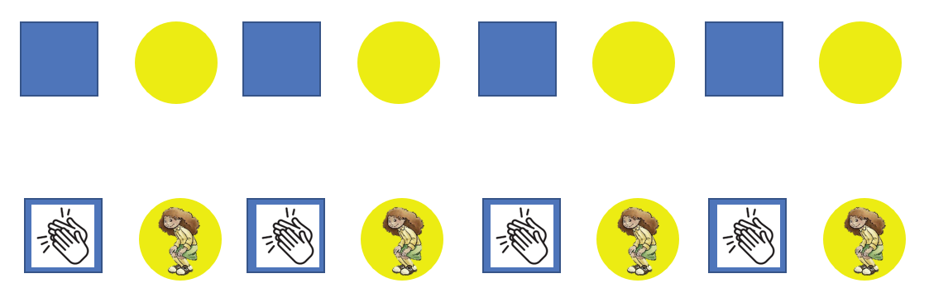

Resource 3: ABC pattern
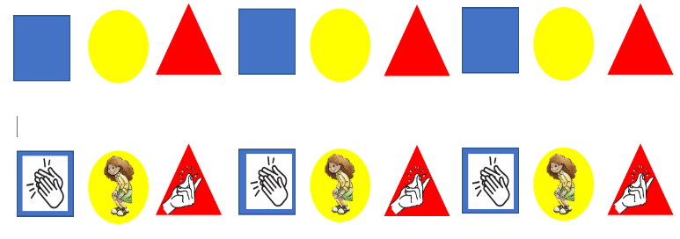

Resource 4: ABB pattern
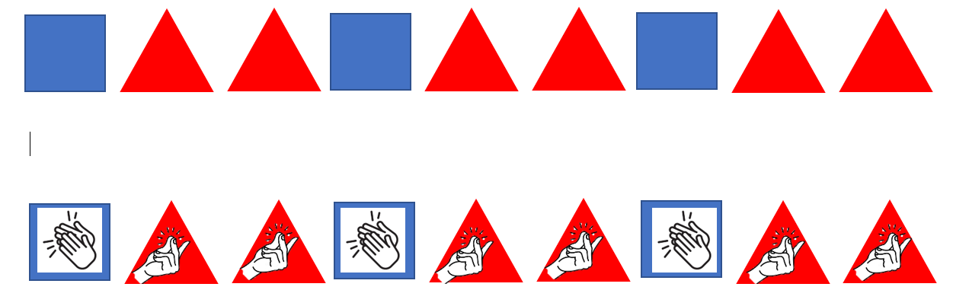

Resource 5: Graphic organiser
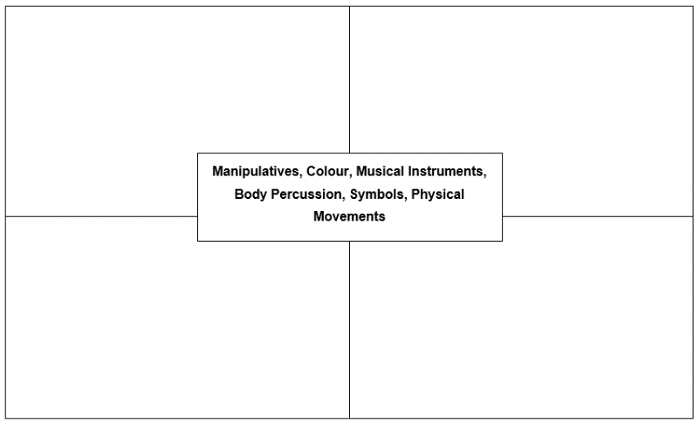

Resource 6: Monkey images
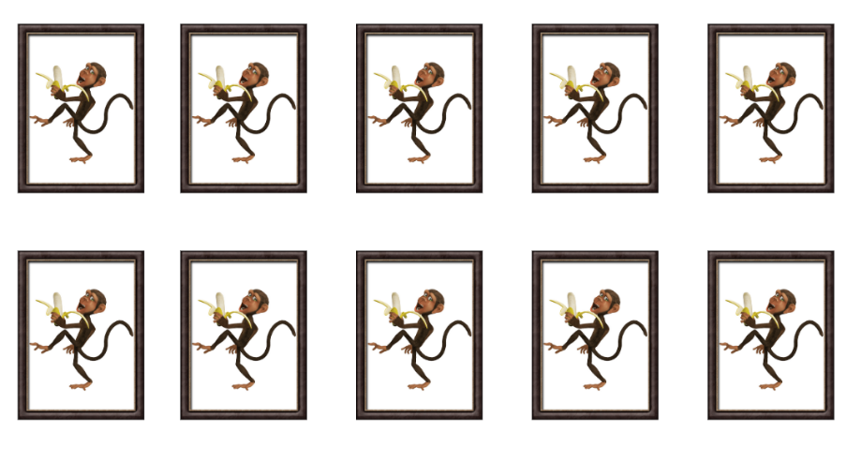
Images sourced from Canva and used in accordance with the Canva Content License Agreement.

Resource 7: Triangle growing pattern
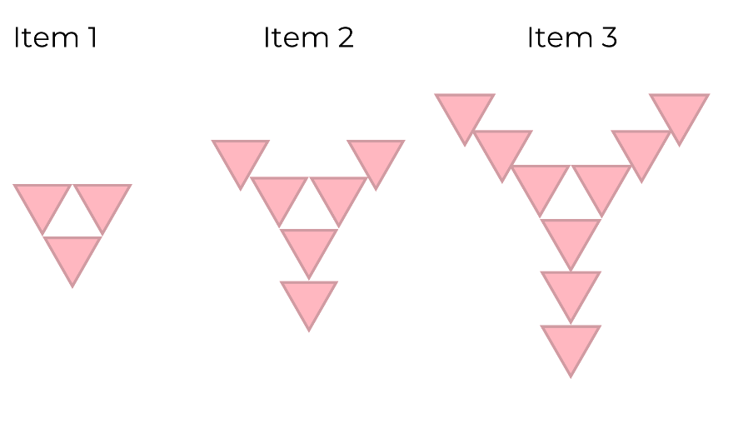

Resource 8: Cube growing pattern
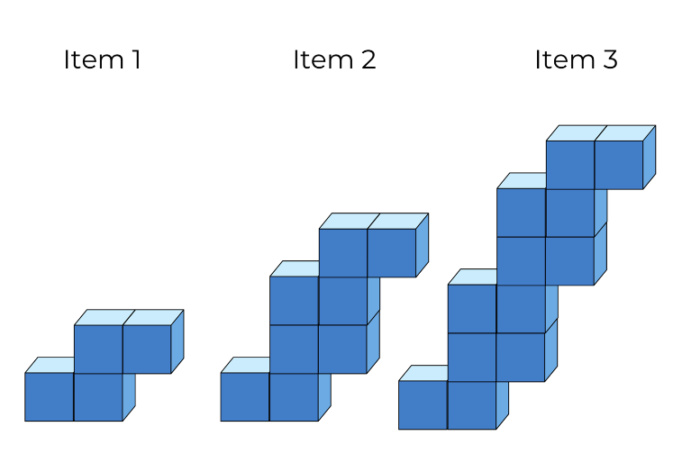

Resource 9: Bottom-up number chart
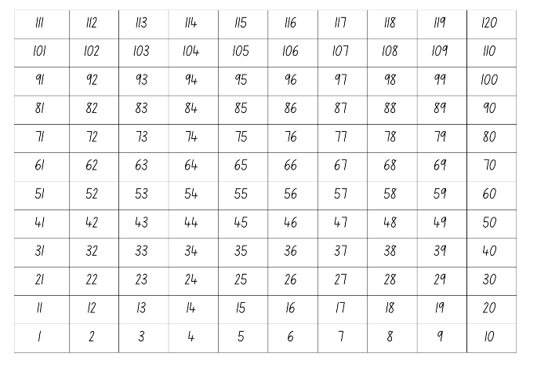

Resource 10: Number puzzles 1
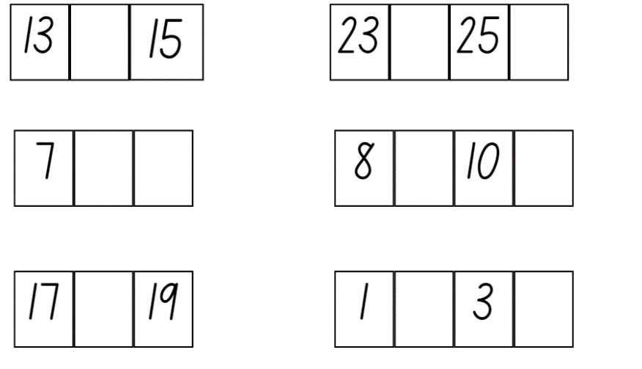

Resource 11: Number puzzles 2
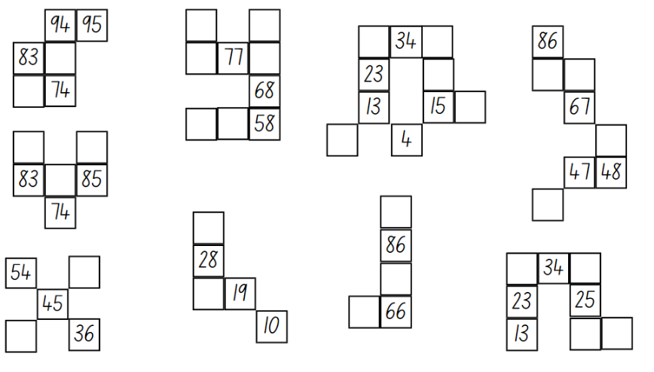

Resource 12: Woven basket
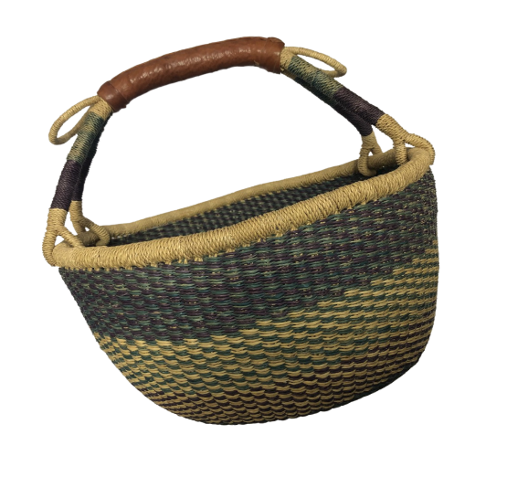

Resource 13: Centimetre number chart
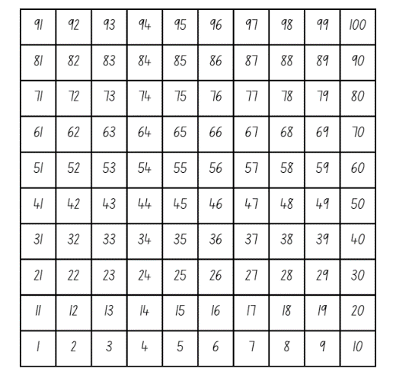

Resource 14: Buzzy Bee’s honeycomb
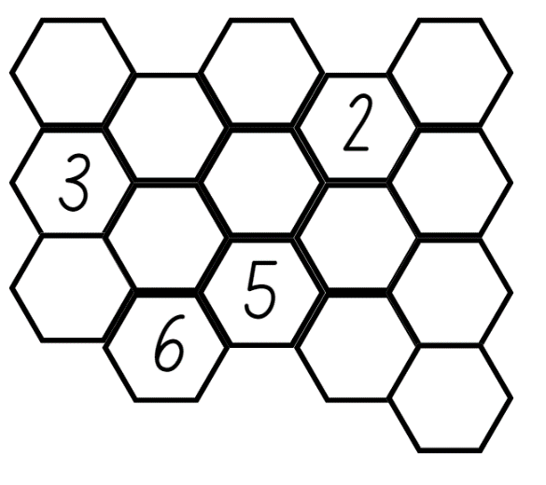

Resource 15: Number chart
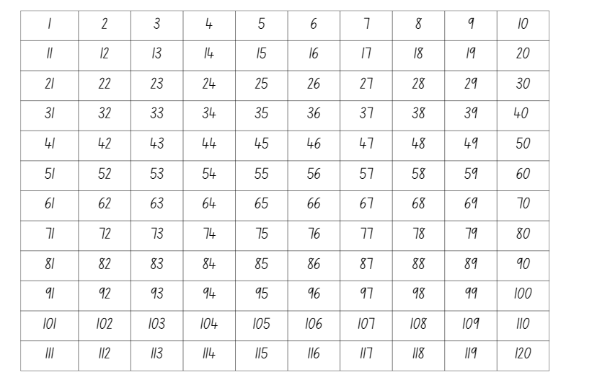

Syllabus outcomes and content
The table below outlines the syllabus outcomes and range of relevant syllabus content covered in this unit. Content is linked to National Numeracy Learning Progression version (3).
Focus area and outcomes | Content groups and content points | Lessons
Representing whole numbers  MAO-WM-01  MAE-RWN-01, MA1-RWN-01  MAE-RWN-02, MA1-RWN-02 | Early Stage 1  Instantly name the number of objects within small collections  - instantly recognise (subitise) the number of items in small groups of up to four items without counting (NPV1, CPr1)  - identify the number of items in different arrangements (CPr2)  Use the counting sequence of ones flexibly  - count forwards to at least 30 and state the number after or before a given number, without needing to count from one (CPr4)  - identify and distinguish the ‘teen’ numbers from multiples of ten with the same initial sounds (NPV3)  - count backwards from a given number 20 or less (CPr5)  - identify the number before as 'one less' and the number after as 'one more’ than a given number  Recognise number patterns  - recognise dice and domino dot patterns (NPA1, NPV2, CPr2)  - recognise different finger patterns for the same number (NPA2)  Connect counting and numerals to quantities  - count with one-to-one correspondence, recognising that the last number name represents the total number in the collection (CPr3, CPr5)  - make correspondences between collections (Reasons about quantity)  - read numerals to at least 20, including zero (NPV3)  - represent numbers as quantities to at least 20 using objects (such as fingers), number words and numerals (NPV2-NPV4, CPr3) | 1–8
Representing whole numbers A | Stage 1  Using counting sequence of ones with two-digit numbers and beyond  - identify the number before and after a given two-digit number (CPr5)  - count forwards and backwards by ones from a given number to at least 120 (CPr6)  Continue and create number patterns  - model and describe ‘odd’ and ‘even’ numbers using items paired in two rows  - count forwards and backwards by twos from any starting point (CPr6-CPr7, MuS2)  Represent the structure of groups of ten in whole numbers  - partition two-digit numbers to show quantity values (NPV4) | 1–8
Representing whole numbers B | Stage 1  Use counting sequences of ones and tens flexibly  - identify the number before and after a given three-digit number  - count forwards and backwards by tens, on and off the decade, with two-and three-digit numbers (CPr7) | 2, 3, 6–8
Combining and separating quantities  MAO-WM-01  MAE-CSQ-01, MA1-CSQ-01  MAE-CSQ-02 | Early Stage 1  Model additive relations and compare quantities  - combine two or more groups of objects to model addition, identifying the relationship between the parts and the whole (AdS1-AdS2)  - separate and take away part of a group of objects to model subtraction (AdS1-AdS2)  - use concrete materials or fingers to model and solve addition and subtraction questions, counting forwards or backwards by ones as necessary (AdS1-AdS2, NPV3)  Identify part–whole relationships in numbers up to 10  - use visual representations of numbers to assist with combining and separating quantities, identifying the relationship between the quantities (NPV2, NPA2, AdS2-AdS3)  - count by ones to find the total or difference (AdS2-AdS3)  - use drawings, words and numerals to record addition and subtraction, and explain their thinking (Reasons about relations) (AdS2) | 2–5
Combining and separating quantities A  NOTE – There is only one combining and separating quantities outcome for Stage 1. | Stage 1  Use advanced count-by-one strategies to solve addition and subtraction problems  - apply the terms ‘add’, ‘plus’, ‘equals’, ‘is equal to’, ‘is the same as’, ‘take away’, ‘minus’ and ‘the difference between’ to describe combining and separating quantities (AdS1, AdS6)  - record number sentences in a variety of ways using drawings, words, numerals and symbols (AdS6)  - fluently use advanced count-by-one strategies including counting on and counting back to solve addition and subtraction problems involving one- and two-digit numbers (Reasons about relations) (AdS3-AdS5)  Recognise and recall number bonds up to ten  - recognise, recall and record combinations of two numbers that add up or bond to form 10 (AdS2, AdS6)  - model and record patterns for individual numbers up to ten by making all possible whole-number combinations (Reasons about patterns)  - describe combinations for numbers using words such as more than, less than and double (Reasons about relations) (AdS6)  Use flexible strategies to solve addition and subtraction problems  - select and apply strategies using number bonds to solve addition and subtraction problems with one- and two-digit numbers by partitioning numbers using quantity value and bridging to 10 (Reasons about relations) (AdS6-AdS7) | 1–8
Forming groups  MAO-WM-01  MAE-FG-01, MA1-FG-01  MAE-FG-02 | Early Stage 1  Copy, continue and create patterns  - copy and continue repeating patterns using sounds and/or actions (NPA1-NPA2)  - copy, continue and create repeating patterns using shapes, objects, images or pictures (Reasons about patterns) (NPA1-NPA2) | 1–8
Forming groups A  NOTE – There is only one forming groups outcome for Stage 1. | Stage 1  Count in multiples using rhythmic and skip counting  - count by twos, threes, fives and tens using rhythmic counting and skip counting (MuS2, CPr6)  Use skip counting patterns  - identify and describe patterns when skip counting forwards or backwards by twos, fives and tens (NPA3- NPA4)  - determine a missing number in a number pattern with a constant difference  - describe how the missing number in a number pattern was determined (Reasons about relations) | 1–8
Forming groups B | Stage 1  Model and use equal groups of objects to represent multiplication  - model and describe collections of objects as groups of (MuS2)  - find the total number of objects using skip counting of equal groups of a known size (MuS2-MuS3)  Represent and explain multiplication as the combining of equal groups  - use objects, diagrams, images or actions to model multiplication as accumulating equal groups (MuS4)  - form arrays of equal rows and equal columns (MuS5)  - determine and distinguish between the number of rows/columns and the number in each row/column when describing collections of objects (MuS5) | 2–4
Data  MAO-WM-01  MAE-DATA-01, MA1-DATA-01  MA1-DATA-02  NOTE – There is only one data outcome for Early Stage 1. | Early Stage 1  Respond to questions, collect information and discuss possible outcomes of activities  - predict possible responses to a question  - collect information from their peers and about their environment (IRD1)  - pose and respond to questions about the information collected (IRD1)  Organise objects into simple data displays and interpret the displays  - group objects according to characteristics (IRD1)  - compare the sizes of groups of objects by counting (Reasons about relations)  - arrange objects according to a characteristic to form a data display (IRD1)  - interpret information presented in a data display to answer questions (Reasons about quantity) (IRD1) | 2–3
Data A | Stage 1  Ask questions and gather data  - gather data and track what has been counted by using concrete materials, tally marks, lists or symbols (IRD3)  Represent data with objects and drawings and describe the displays  - use concrete materials or pictures of objects as symbols to create data displays where one object or picture represents one data value (IRD2)  - use comparative language to describe information presented in a display, such as ‘more than' and ‘less than’ | 2–5
Data B | Stage 1  Identify a question of interest and gather relevant data  - collect data on familiar topics (IRD2)  Create displays of data and interpret them  - organise collected data into lists and tables to display information (IRD2)  - interpret information presented in tables and picture graphs (Reasons about relations) (IRD2) | 2–5

References
Links to third-party material and websites
Please note that the provided (reading/viewing material/list/links/texts) are a suggestion only and implies no endorsement, by the New South Wales Department of Education, of any author, publisher, or book title. School principals and teachers are best placed to assess the suitability of resources that would complement the curriculum and reflect the needs and interests of their students.
If you use the links provided in this document to access a third-party's website, you acknowledge that the terms of use, including licence terms set out on the third-party's website apply to the use which may be made of the materials on that third-party website or where permitted by the Copyright Act 1968 (Cth). The department accepts no responsibility for content on third-party websites.
Except as otherwise noted, all material is © State of New South Wales (Department of Education), 2023 and licensed under the Creative Commons Attribution 4.0 International License. All other material (third-party material) is used with permission or under licence. Where the copyright owner of third-party material has not licensed their material under a Creative Commons or similar licence, you should contact them directly for permission to reuse their material.
Mathematics K–10 Syllabus © 2022 NSW Education Standards Authority (NESA) for and on behalf of the Crown in right of the State of New South Wales.
© 2022 NSW Education Standards Authority. This document contains NSW Curriculum and syllabus content. The NSW Curriculum is developed by the NSW Education Standards Authority. This content is prepared by NESA for and on behalf of the Crown in right of the State of New South Wales. The material is protected by Crown copyright.
Please refer to the NESA Copyright Disclaimer for more information.
NESA holds the only official and up-to-date versions of the NSW Curriculum and syllabus documents. Please visit the NSW Education Standards Authority (NESA) website and the NSW Curriculum website.
National Numeracy Learning Progression © Australian Curriculum, Assessment and Reporting Authority (ACARA) 2010 to present, unless otherwise indicated. This material was downloaded from the Australian Curriculum website (National Numeracy Learning Progression) (accessed 20 October 2022) and was not modified. The material is licensed under CC BY 4.0. Version updates are tracked in the ‘Curriculum version history’ section on the 'About the Australian Curriculum' page of the Australian Curriculum website.
ACARA does not endorse any product that uses the Australian Curriculum or make any representations as to the quality of such products. Any product that uses material published on this website should not be taken to be affiliated with ACARA or have the sponsorship or approval of ACARA. It is up to each person to make their own assessment of the product, taking into account matters including, but not limited to, the version number and the degree to which the materials align with the content descriptions and achievement standards (where relevant). Where there is a claim of alignment, it is important to check that the materials align with the content descriptions and achievement standards (endorsed by all education Ministers), not the elaborations (examples provided by ACARA).
ABC (Australian Broadcasting Corporation) (5 January 2022) 'Eddie Woo on Play School (4 of 4: Pattern matching)' [video], Eddie Woo, YouTube, accessed 18 October 2022.
Boaler J, Munson J and Williams C (2021) Mindset Mathematics: Visualising and Investigating Big Ideas, Grade K, Jossey-Bass, New Jersey.
Boaler J, Munson J and Williams C (2021) Mindset Mathematics: Visualising and Investigating Big Ideas, Grade 1, Jossey-Bass, New Jersey.
Franke ML, Kazemi E and Chan Turrou A (2018) Choral Counting and Counting Collections: Transforming the PreK-5 Math Classroom, Stenhouse Publishers, United States.
Little BoBo Nursery Rhymes – FlickBox Studios (24 October 2013) ‘Five Little Monkeys Jumping On The Bed’ [video], Little BoBo Nursery Rhymes – FlickBox Studios, YouTube, accessed 18 October 2022.
New Zealand Ministry of Education (2020) ‘Gecko feet’, Resource Finder, NZ Maths website, accessed 10 October 2022.
University of Cambridge (Faculty of Mathematics) (2022) Buzzy Bee, NRICH website, accessed 18 October 2022.
University of Cambridge (Faculty of Mathematics) (2022) Sticky Triangles, NRICH website, accessed 18 October 2022.
Van de Walle J, Karp K, Bay-Williams JM, Brass A, Bentley B, Ferguson S, Goff W, Livy S, Marshman M, Martin D, Pearn C, Prodromou T, Symons D and Wilkie K (2019) Primary and Middle Years Mathematics: Teaching Developmentally, 1st Australian edn, Pearson Australia, Melbourne.

Further reading
Randolph W and Jeffers V (1974) ‘A new look for the hundreds chart’, The Arithmetic Teacher, 21(3): 203-208.

