Mathematics – K-2 multi-age – Year A – Unit 9
Contents
Unit description and duration 5
Student prior learning 6
Lesson overview and resources 6
Lesson 1: Symbols can be used to tell a mathematical story 17
Daily number sense: Number placement – 10 minutes 17
Symbol sort – 10 minutes 18
Mathematical story – 15 minutes 18
Problematise – 20 minutes 21
Discuss and connect the mathematics – 10 minutes 23
Lesson 2: Plus, minus and equals symbols 24
Daily number sense: Number counting – 10 minutes 25
Let's meet some symbols – 40 minutes 25
Discuss and connect the mathematics – 10 minutes 29
Lesson 3: Commutative property 31
Consolidation and meaningful practice: Showing the story – 10 minutes 31
Number story addition – 20 minutes 32
Subtraction story – 20 minutes 35
Discuss and connect the mathematics – 10 minutes 36
Lesson 4: Part-part-whole 38
Daily number sense: Dot card talk– 15 minutes 39
Snakes and turtles – how many of each? – 35 minutes 41
Discuss and connect the mathematics – 10 minutes 44
Lesson 5: Equivalence 45
Daily number sense – 10 minutes 46
Modifying the problem – 40 minutes 46
Discuss and connect the mathematics – 10 minutes 50
Lesson 6: Finding the missing part of a mathematical story 52
Daily number sense: Splat! – 10 minutes 52
Consolidation and meaningful practice: Sarah’s blocks – 10 minutes 53
How can we work out the changes? – 20 minutes 53
Subtraction stories – 20 minutes 58
Discuss and connect the mathematics – 10 minutes 58
Lesson 7: Uncovering related facts 60
Daily number sense: What’s the same? What’s different? – 10 minutes 61
Consolidation and meaningful practice: Array Problems – 40 minutes 61
Discuss and connect the mathematics – 10 minutes 64
Lesson 8: Related number facts can help us uncover missing information 66
Daily number sense: Choose a Splat! – 10 minutes 67
Monkeys in the trees! – 40 minutes 67
Discuss and connect the mathematics – 20 minutes 72
Resource 1: Familiar and unfamiliar symbols 75
Resource 2: +, − and = cards 82
Resource 3: Stage 1 Dot talk 83
Resource 4: Early Stage 1 Dot talk 84
Resource 5: Diffy towers 85
Resource 6: Missing addend 86
Resource 7: Dots in Array 88
Resource 8: Array problems 89
Resource 9: Early Stage 1 Thinking bubbles 90
Resource 10: Stage 1 Thinking bubbles 91
Resource 11: Mathematical stories to solve 92
Syllabus outcomes and content 93
References 103

Unit description and duration
This two-week unit develops student knowledge, understanding, and skills of combining and separating quantities. Students are provided opportunities to:
- represent combining situations in different ways through the use of gesture, enactment, drawings, numbers and words
- use symbols to describe mathematical quantities, actions, and relationships in efficient ways
- understand that the order in which 2 quantities are combined does not change the result
- recognise that when 2 collections have the same total, they are described as ‘equivalent in value’. Words such as ‘equal’, ‘equivalent’, and ‘is the same as’ can also be used
- use different strategies, such as counting on and counting back, to work out the total when combining and separating quantities
- record equations (number sentences) in different ways using drawings, words, numerals, and symbols
- model the inverse relation between addition and subtraction using concrete materials and drawings
- use knowledge of related facts (number bonds) to determine a missing quantity
- understand that repeated addition involves the structure of equal groups; for example, 2 + 2 + 2 is equivalent in value to 3 twos
- use mathematical tools, such as an equal-am balance, to determine if the mass of a collection is equivalent.
Mathematics K–10 Syllabus © 2022 NSW Education Standards Authority (NESA) for and on behalf of the Crown in right of the State of New South Wales.

Student prior learning
Before engaging in these teaching and learning activities, students would benefit from prior experience with:
- counting small collections of items to find a total
- describing the actions of combining, separating, and comparing
- modelling and recognising combinations for numbers up to 10
- using drawings, words, and numbers to record their thinking
- hefting with everyday objects.

Lesson overview and resources
The table below outlines the sequence and approximate timing of lessons; syllabus focus areas and content groups; and resources.
Lesson | Syllabus focus area and content groups | Resources
Lesson 1: Symbols can be used to tell a mathematical story  65 minutes  A mathematical story can be told using symbols. | Representing whole number  Early Stage 1  - Connect counting and numerals to quantities  Combining and separating quantities  Early Stage 1  - Model additive relations and compare quantities  - Identify part-whole relationships in numbers up to 10  Stage 1 – Part A  - Use advanced count-by-one strategies to solve addition and subtraction problems  - Use flexible strategies to solve addition and subtraction problems  Forming groups  Stage 1 – Part A  - Count in multiples using rhythmic and skip counting | - Resource 1: Familiar and unfamiliar symbols  - Counters  - Writing materials
Lesson 2: Plus, minus and equals symbols!  60 minutes  Mathematical symbols are universal and can describe quantities, actions, and relationships. | Representing whole number  Early Stage 1  - Use the counting sequence of ones flexibly  Stage 1 – Part A  - Continue and create number patterns  - Represent numbers on a line  Combining and separating quantities  Early Stage 1  - Model additive relations and compare quantities  - Identify part-whole relationships in numbers up to 10  Stage 1 – Part A  - Use advanced count-by-one strategies to solve addition and subtraction problems  - Represent equality  Non-spatial measure  Early Stage 1  - Mass: Identify and compare mass using weight  Stage 1 – Part A  - Mass: Investigate mass using an equal-arm balance  Stage 1 – Part B  - Mass: Compare the masses of objects using an equal-arm balance | - Resource 2: +, – and = cards  - Concrete materials to strengthen counting with understanding  - Counters (different colours), MAB blocks, and craft sticks  - Equal-arm balance  - Interlocking cubes or weights  - Writing materials
Lesson 3: Commutative property  60 minutes  Commutative property – the order in which quantities are combined does not change the result. | Combining and separating quantities  Early Stage 1  - Model additive relations and compare quantities  - Identify part-whole relationships in numbers up to 10  Stage 1 – Part A  - Use advanced count-by-one strategies to solve addition and subtraction problems  - Use flexible strategies to solve addition and subtraction problems  - Represent equality  Stage 1 – Part B  - Represent and reason about additive relations  - Use knowledge of equality to solve related problems | - 0-9 sided dice  - Concrete materials to strengthen counting with understanding  - Counters in different colours  - Writing materials
Lesson 4: Part-part-whole  60 minutes  A quantity is made up of smaller parts that in turn, can form part of a larger quantity. | Representing whole number  Early Stage 1  - Instantly name the number of objects within small collections  - Recognise number patterns  Combining and separating quantities  Early Stage 1  - Model additive relations and compare quantities  - Identify part-whole relationships in numbers up to 10  Stage 1 – Part A  - Use advanced count-by-one strategies to solve addition and subtraction problems  - Use flexible strategies to solve addition and subtraction problems  Stage 1 – Part B  - Represent and reason about additive relations  - Use knowledge of equality to solve related problems  Forming groups  Stage 1 – Part A  - Count in multiples using rhythmic and skip counting  - Model and use equal groups of objects to represent multiplication  Non-spatial measure  Stage 1 – Part A  - Mass: Investigate mass using an equal-arm balance | - Resource 3: Stage 1 Dot talk  - Resource 4: Early Stage 1 Dot talk  - Resource 5: Diffy towers  - Concrete materials to strengthen counting with understanding  - Dice  - Equal-arm balance  - Interlocking cubes  - Writing materials
Lesson 5: Equivalence  60 minutes  Compensation is a change that can return equivalence to an equation. | Representing whole number  Early Stage 1  - Use the counting sequence of ones flexibly  Stage 1 – Part A  - Use counting sequences of ones with two-digit numbers and beyond  Combining and separating quantities  Early Stage 1  - Model additive relations and compare quantities  - Identify part-whole relationships in numbers up to 10  Stage 1 – Part A  - Represent equality  Stage 1 – Part B  - Represent and reason about additive relations  Non-spatial measure  Stage 1 – Part A  - Mass: Investigate mass using an equal-arm balance  Stage 1 – Part B  - Mass: Compare the masses of objects using an equal-arm balance | - 10- and 20-sided dice  - 10 or 20 frames  - A5 sheets of paper  - Concrete materials to strengthen counting with understanding  - Counters  - Equal-arm balance  - Interlocking cubes  - Writing materials
Lesson 6: Finding the missing part of a mathematical story  70 minutes  Commutative property and equivalence can help find the missing parts of a mathematical story. | Representing whole number  Early Stage 1  - Instantly name the number of objects within small collections  - Recognise number patterns  Combining and separating quantities  Early Stage 1  - Model additive relations and compare quantities  - Identify part-whole relationships in numbers up to 10  Stage 1 – Part A  - Use advanced count-by-one strategies to solve addition and subtraction problems  - Use flexible strategies to solve addition and subtraction problems  - Represent equality  Stage 1 – Part B  - Represent and reason about additive relations  Non-spatial measure  Stage 1 – Part A  - Mass: Investigate mass using an equal-arm balance  Stage 1 – Part B  - Mass: Compare the masses of objects using an equal-arm balance | - Resource 6: Missing addend  - Video: Splat! (conceptual subitising to 10) (7:32)  - Concrete materials to strengthen counting with understanding  - Counters  - Dice  - Equal-arm balance  - Interlocking cubes  - Small pieces of paper  - Writing materials
Lesson 7: Uncovering related facts  60 minutes  One number fact uncovers related number facts. | Combining and separating quantities  Early Stage 1  - Model additive relations and compare quantities  - Identify part-whole relationships in numbers up to 10  Stage 1 – Part A  - Use advanced count-by-one strategies to solve addition and subtraction problems  - Use flexible strategies to solve addition and subtraction problems  - Represent equality  Stage 1 – Part B  - Represent and reason about additive relations  Forming groups  Stage 1 – Part A  - Model and use equal groups of objects to represent multiplication  Stage 1 – Part B  - Represent and explain multiplication as the combining of equal groups | - Resource 2: +, - and = cards  - Resource 7: Dots in Array  - Resource 8: Array problems  - Concrete materials to strengthen counting with understanding  - Equal-arm balance  - Interlocking cubes  - Writing materials
Lesson 8: Related number facts can help us uncover missing information  70 minutes  Commutative property, equivalence and related number facts help find the missing parts of a mathematical story. | Representing whole number  Early Stage 1  - Instantly name the number of objects within small collections  - Recognise number patterns  Combining and separating quantities  Early Stage 1  - Model additive relations and compare quantities  - Identify part-whole relationships in numbers up to 10  Stage 1 – Part A  - Use advanced count-by-one strategies to solve addition and subtraction problems  - Use flexible strategies to solve addition and subtraction problems  - Represent equality  Stage 1 – Part B  - Represent and reason about additive relations | - Resource 9: Early Stage 1 Thinking bubbles  - Resource 10: Stage 1 Thinking bubbles  - Resource 11: Mathematical stories to solve  - Splat! Set 1.1 [PPT 590KB]  - Splat! Set 1.2 [PPT 590KB]  - Blank number lines  - Concrete materials to strengthen counting with understanding

Lesson 1: Symbols can be used to tell a mathematical story
Core concept: A mathematical story can be told using symbols. Symbols are simple drawings that have meaning.
Note: Storytelling is an effective way for students to conceptualise mathematical ideas, to construct a rich understanding of mathematical operations, and assist students to recognise the purposeful nature of mathematics in real-world contexts through actions, gestures, and manipulation of concrete materials. (Lemonidis C and Kaiafa I 2019, Cooper TJ et. al, 2007, Van de Walle, et. al, 2019)
The table below contains suggested learning intentions and success criteria. These are best co-constructed with students.
Learning intentions | Success criteria
All students are learning that:  - mathematicians use symbols to efficiently describe ideas  - symbols are simple drawings that have meaning  - symbols can represent quantity or an action in mathematics. | All students can:  - use simple drawings or symbols to represent a mathematical story  - use symbols to represent and create their own mathematical stories with a start, a change, and a result  - retell their own mathematical stories to others.

Daily number sense: Number placement – 10 minutes
- Build student understanding of number placement by having students draw a 0-20 number line on their individual whiteboards.
- Select 3-5 numbers for students to place on the number line and give reasons for their placement.

Symbol sort – 10 minutes
- Provide students with Resource 1: Familiar and unfamiliar symbols. Have students identify and sort symbols into those that they know and those they do not. Discuss the meaning of the symbols that students know. Ask students to suggest or draw other familiar symbols and explain their meaning.
Note: Maths as Story Telling (MAST) [PDF 892KB] was developed for the Minjerribah Math Project. Working from the storytelling world of the Indigenous student, it enables students to bring their everyday world of symbols into mathematics and the formal world of algebra. When completing Resource 1: Familiar and unfamiliar symbols, choose to include symbols from your local and Aboriginal and Torres Strait Islander context. Involve students and their culture in discussions and allow them to share and explain personal symbols and to create symbols that have personal meaning.
- Look at the unfamiliar symbols in the collection and discuss possible meanings. Encourage students to explain their thinking. Share some information about the origin of these symbols and their meaning.
- Jointly define a symbol as a simple drawing that has a meaning.
- Discuss that, while some symbols in mathematics represent quantity, the collection can look and be different. For example, the symbol of 7 can be used to represent 7 friends, 7 days, 7 years, 7 dots on a ten-frame, 7 hundred dollars and so on.

Mathematical story – 15 minutes
Elements of this lesson have been adapted from Matthews (2019).
- Explain that symbols, such as numerals and numbers, can be used to tell a mathematical story. A mathematical story is made up of a start, a change, and a result (or ending). For example, ‘In this story our characters are 4 and 2. We start with 4, then we have 2 more. At the end of our story, we have 6’.
- Invite students to act out the story, showing the 2 smaller groups separately then combining them to create a larger group. For example, ‘We start with a group of 4 students, then 2 more students come along (that’s the change) and now we have 6 students’.
- Ask students: ‘What are some other things that the 4 and 2 could represent? What could the 4 be? What could the 2 be?’ Explain that changing what the 4 and 2 represent will also define what the 6 represents. For example:
- There were 4 dogs playing and 2 more dogs joined them. That means there are now 6 dogs playing.
- There were 4 dogs walking in the park. They found 2 cats laying in the sun. Now there are 6 animals altogether.
- Prompt students to consider what would change if there were 5 birds and 9 birds. Ask: ‘What this would look like using the counters?’
Note: In ‘addition’ stories, students sometimes add the same 'thing'. For example, adding frogs with more frogs in a pond. Other times, students will join 2 different things to create a new category. For example, when adding bananas and apples, the new category formed is fruit. Students may need support to recognise the joining of items from different categories.
- Explain that mathematicians also use simple symbols and drawings, for example, Figure 1, to record stories. Share another mathematical story and ask students to use their own simple symbols to represent it.
Figure 1 – 8 sheep
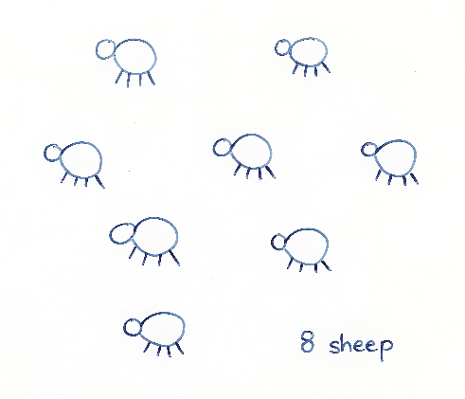
Note: Remind students that symbols are simple drawings and that they should avoid adding complicated features that might be distracting.
- Students choose 2 one-digit numbers to create a mathematical story. Students turn and talk with a partner to share their story and then draw symbols to represent it. Listen to student stories to ensure that students are combining both small groups, rather than separating them.
Note: One-digit numbers allow students to work within a number range they are comfortable with, to explore deep concepts.

Problematise – 20 minutes
Note: Universal symbols are used to represent quantities (numbers), actions (+, -, ×, ÷), and relationships such as equivalence (=). These symbols are used to record mathematical ideas efficiently and can be used with their own symbols to create and interpret mathematical stories.
- Prompt students to reflect on their mathematical stories. Ask: ‘What parts are there in your story (start, change, and result)? What happened to the parts (what was the change and what was the result amount)?
- Remind students that it is important that all the parts of the story are represented and not just the result (ending). Refer to a familiar book and ask if students would only read the end of this book. Explain that they would not know what happened to the characters at the beginning of the story, or how the ending came to be. For example, see Figure 2.
Figure 2 – 11 fish
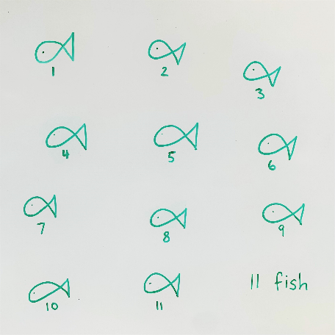
- Use Figure 3 to illustrate the importance of including all the parts in a mathematical story and not just the result (ending). Emphasise the importance of knowing the start amount and the change amount to understand the result amount (end of the story).
Figure 3 – Apples story
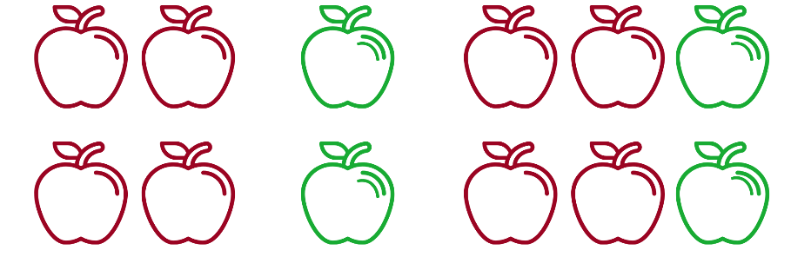
Images sourced from Canva and used in accordance with the Canva Pro Content Licence.
- Students revise how they could represent the start, change, and result of their own mathematical stories to ensure that all parts are represented. Invite students to share their mathematical stories with a peer. Select several students to share their stories with the class. Draw students’ attention to the symbols that represent the different parts of their mathematical stories.
The table below details assessment opportunities and differentiation ideas.
Assessment opportunities | Too hard? | Too easy?
What to look for?  - Are students listening to other mathematical stories and able to retell their own stories to others? (MAO-WM-01)  What to collect:  - simple drawings/symbols that represent the parts of a mathematical story (MAE-CSQ-01, MA1-CSQ-01)  - students own mathematical stories with symbols showing a start, a change and a result. (MAE-CSQ-01, MA1-CSQ-01) | Students are finding the given numbers too difficult to combine. Support students to follow a story using red and green concrete materials to match Figure 3. If 4 and 2 is a challenging number range, use 2 and 1. | Students comprehend the concept and show advanced interest in symbols. Share A Story about Absolutely Nothing from NRICH which explores the origins of number systems and the symbols used. Support students to represent 4 and 2 using one or more number systems, for example, hieroglyphs and Roman numerals. Ask students to compare and then record similarities and differences between number systems for numbers 1-10.

Discuss and connect the mathematics – 10 minutes
- Summarise the lesson together, drawing out some key mathematical ideas with students, including that:
- Mathematicians use simple drawings/symbols to describe ideas efficiently.
- Mathematical stories need to show the start, the change, and the result (end of the story).

Lesson 2: Plus, minus and equals symbols
Core concept: Mathematical symbols are universal and can describe quantities, actions, and relationships.
The table below contains suggested learning intentions and success criteria. These are best co-constructed with students.
Learning intentions | Success criteria
All students are learning that:  - joining 2 or more collections to create a new total is a way of combining collections  - adding is combining a starting amount with a change amount  - modelling and representing mathematical stories can help to make sense of them. | All students can:  - combine 2 smaller collections of objects to find a result  - use counters and blocks to model mathematical stories  - use hefting and an equal-arm balance to show equivalence in mathematical stories.  In addition, students working towards Early Stage 1 outcomes can talk or draw mathematical stories using their own symbols to represent + and =.  In addition, students working towards Stage 1 outcomes can talk or write about mathematical stories using symbols (+, −, =) and words (join, combine, add, is equal to, is equivalent in value to).

Daily number sense: Number counting – 10 minutes
- Build student understanding of number sequences by counting forwards/backwards by ones, tens, twos, on and off the decade. Use tools to strengthen counting with understanding, for example: hundreds chart, number line, bead strings, or materials such as counters, MABs, or craft sticks.

Let's meet some symbols – 40 minutes
Elements of this part of the lesson have been adapted from Boaler (2021) and Matthews (2019).
- Select a story from the previous lesson and ask students to think about how the story started. Invite students to model the starting quantity using concrete materials. Select a student to model what happens next in the story using manipulatives.
- Place a piece of paper in between the 2 quantities (see Figure 4). Ask students if anyone knows of any symbols (maybe in another language) that could represent coming together/combining.
Figure 4 – Hidden symbols
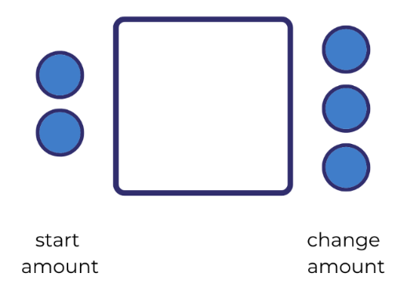
- Early Stage 1 students use a whiteboard to design their own symbol to represent the action of coming together or combining. Discuss the + symbol with Stage 1 students and explain that, although people may use different words around the world, everyone understands that it is a symbol representing the action of coming together or combining.
- Early Stage 1 students show and explain their symbol to the class. Ask students ‘Why did you choose this symbol? How does it represent coming together?
- Have the whole class suggest some other words that could be used to describe combining. For example, 2 combined with 3, 2 joined with 3, 2 and 3, or 2 plus 3.
- Discuss that students now have a symbol to represent 2 parts or groups combining 2 or more collections. Place a piece of paper in between the ‘change’ part of the story and the result (Figure 5). Ask: ‘How do we show what happened at the end of the story? Is there a symbol we could use?’
Figure 5 – Hidden result
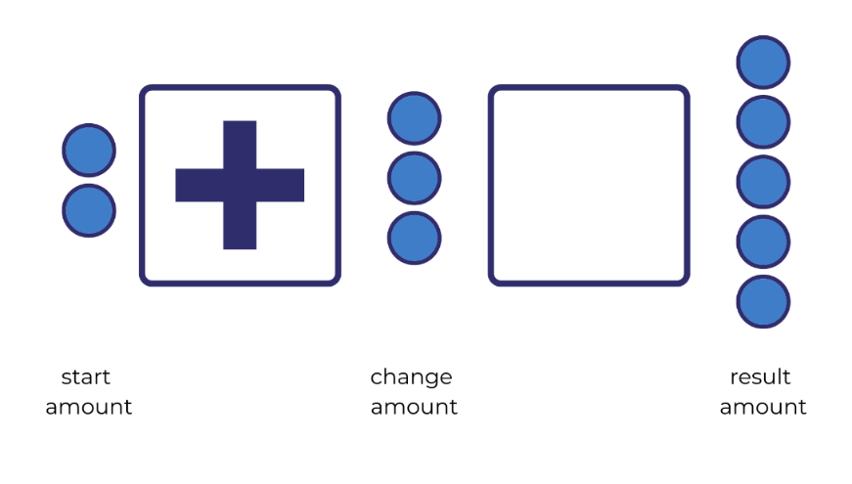
- Early Stage 1 students design their own symbol to represent the action of creating a result. Discuss the = symbol with Stage 1 students and explain how, although people may use different words around the world, everyone understands that it is a symbol representing the action of the result.
- Early Stage 1 students show and explain their symbol. Ask the class what words they can use to read this symbol. For example, 2 and 3 are equal to 5, 2 and 3 are the same as 5, 2, and 3 are equivalent in value to 5.
- Share some simple, real-life mathematical stories. For example, ‘In your lunchbox you have 6 grapes and 4 blueberries. How many pieces of fruit are there?’
- Students create their own story, representing it using concrete materials, and verbalising what happens as they combine groups. Early Stage 1 students use the symbols they created to represent coming together/combining and the action of creating a result. Provide Stage 1 students with Resource 2: +, − and = cards to use in their story as well as concrete materials such as interlocking cubes. Invite students to retell their mathematical stories to a peer. See Figure 6.
Figure 6 – Stage 1: A number story with blocks
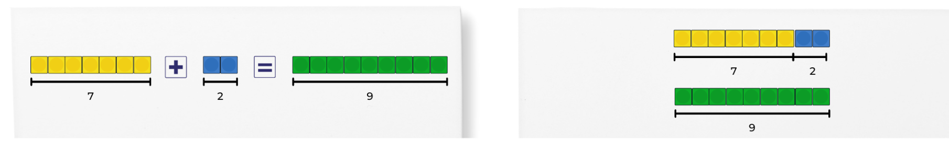
Figure 7 – Early Stage 1: A number story with symbols and blocks
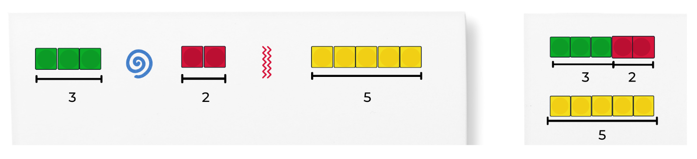
- Ask students what they notice and wonder about the representation. Draw attention to the fact that students need the same number of blocks for the start and change amount, as the result amount. For example, see Figure 6 and Figure 7.
- Explain that one way of checking if the parts of an equation (number sentence) are equivalent, is by using an equal-arm balance. Have students heft the units (for example, interlocking cubes) used for the story to check that the equation is in balance. Explain, because the units are the same mass, they can be used to see if the quantities on either side of the equal-arm balance are equivalent.
- Highlight that each side of the equal-arm balance represents a part of the students’ story: one side of the equal-arm balance represents the start and change amounts, the other side represents the result amount. Have students use interlocking cubes to represent the start and change amounts on one side of the equal-arm balance and then place interlocking cubes on the other side to represent the result amount.
- Invite students to share their findings by asking: ‘What do you notice about the equal-arm balance? Why do you think this has happened? Do you think if we chose another mathematical story with different numbers that it would also balance?’
- Students turn and talk before sharing their thoughts with the class. Students then test their ideas using another mathematical story.

Discuss and connect the mathematics – 10 minutes
- Ask students to reflect on their exploration of mathematical stories. Guide students to notice that:
- When we join 2 or more collections together to create a new total, we are combining collections.
- When adding, a start amount is combined with a change amount.
- There are lots of different words and phrases to describe combining.
- Modelling mathematical stories can help to make sense of them.
- We can check if an equation is equivalent by using mathematical tools, such as an equal-arm balance.
Note: Use tools, such as equal-arm balances and number lines, to support student understanding. If ideas are introduced too quickly, students may struggle with sense-making, especially if they do not yet understand how to combine and separate quantities in different ways (Lowrie, et.al. 2018)
The table below details assessment opportunities and differentiation ideas.
Assessment opportunities | Too hard? | Too easy?
What to look for:  - Can students use concrete materials to model mathematical stories where two smaller collections are combined? (MAE-CSQ-01, MA1-CSQ-01)  - Can students use hefting and an equal-arm balance to compare the masses of objects? (MAE-NSM-01, MA1-NSM-01)  - Are students using drawings to record addition and explain their thinking for their symbol? (MAE-CSQ-01)  - Are students using words and symbols to represent two collections being combined with symbols (+, −, =)? (MA1-CSQ-01)  - Are students using vocabulary such as join, combine, add, is equal to, is equivalent in value to, to retell their stories? (MA1-CSQ-01, MAO-WM-01) | Students have not experienced hefting. Provide opportunities to heft different daily objects, then concrete mathematical materials.  Concept of addition is not clearly understood. Explain simple addition using real world materials. For example, Sally has one biscuit and David has 2. How many biscuits do they have if they add them together? | Students demonstrate a deep understanding of concepts from the main activity.  - Practice using starting numbers that go over the decade, for example, starting with 9 and adding 2, 3, or 4 and then look for patterns.  - Use the resource A Story about Absolutely Nothing from NRICH which explores the origins of number systems and symbols used. Students identify similarities and differences in how number systems communicate numbers greater than one.  - Develop own number system and communicate it to others. Ask students what symbols they chose and why.

Lesson 3: Commutative property
Core concept: Commutative property says that the order in which quantities are combined does not change the result.
The table below contains suggested learning intentions and success criteria. These are best co-constructed with students.
Learning intentions | Success criteria
All students are learning that:  - mathematicians think of ideas and investigate them  - the order in which 2 quantities are combined does not change the result  - different words and phrases can describe combining and separating collections. | All students can investigate whether the order in which we add 2 collections together changes the result.  In addition, students working towards Early Stage 1 outcomes can talk or draw mathematical stories using their own symbols to represent + and =.  In addition, students working towards Stage 1 outcomes can talk or write about mathematical stories using symbols (+, −, =) and words (join, combine, add, is equal to, is equivalent in value to).

Consolidation and meaningful practice: Showing the story – 10 minutes
- To consolidate understanding of mathematical storytelling, display Figure 8.
Figure 8 – Bees
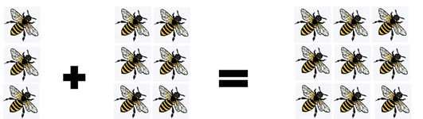
Adapted from ‘Bees’ by SisterJoBangles and used in accordance with the Pixabay License.
- Ask students to consider the different ways to tell this story. For example, 3 bees were in the hive and 6 bees joined them. There were 9 bees sitting in the hive.
- Students share their story with a partner and whole class.

Number story addition – 20 minutes
- Sitting in a circle with a whiteboard, divide counters into 2 easily quantifiable groups and cover (see Figure 9). Uncover both groups at the same time so students do not get a sense of which quantity comes first in the story.
Figure 9 – Groups of 4 and 8 counters
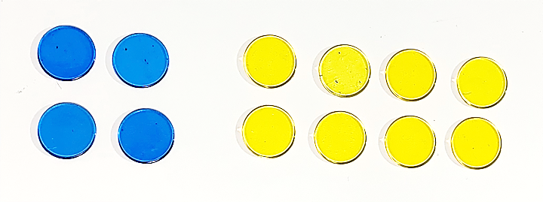
- Tell students that, in this story, the counters represent bees. On your whiteboard, write the story using words or symbols and include the result (the conclusion of the story).
- Highlight the differences in order within the stories to launch an investigation into the commutative property.
The table below outlines stimulus prompts to generate conversation about the topic, along with anticipated responses from students.
Prompts | Anticipated student responses
- What is happening?  - Why do some students have 8 bees as the starting amount, but then others have 4? | - Depending on where they are sitting, students will write, ‘8 bees were on a flower and 4 joined them’, or ‘4 bees were sitting on a flower and 8 joined them’. Some students may use symbols to represent their story.  - Some students may notice that the viewpoint of the counters influenced which number came first in the story.
- As a class, rotate the whiteboard so that students can see the problem from the opposite side.
- Ask students, ‘What do you notice is different now? What do you notice about the result? Does it change?
- From your new position, write the story using words or symbols and include the result.
- Ask students, ‘What happens if we don’t move but the start and the change amounts do?’ Link the idea that when students moved their bodies to see the collection from different viewpoints, they were commuting. Explain that when the quantities in the mathematical story move, they are commuting as well.
- Give students the prompt: ‘If the quantities commute (change position), does it make a difference to the result when we use other numbers?’ Students investigate using counters on paper plates (See Figure 10). Students look at the pair of plates from position one and write the story using words or symbols and include the result. Students then move to position 2 and write the story using words or symbols and include the result.
- Students roll a 0-9-sided dice to introduce new numbers to each plate. Students write stories to match the new number combinations.
Figure 10 – Counters on paper plates
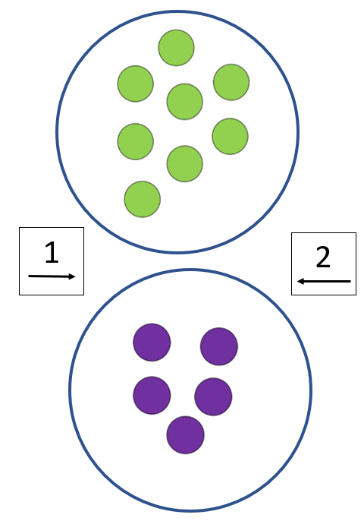
- Look at the mathematical stories that students have investigated. Ask questions such as:
- When we add 2 numbers together, does the order matter?
- Is this always the case? Why or why not?
- Do you need to test this out further with other numbers?
- Are you convinced that this always works when we are adding 2 numbers?’
- Focus on the idea that, just as people can commute, amounts being combined can also commute. Explain that this is called a ‘commutative property’.

Subtraction story – 20 minutes
- Share the subtraction story: ‘11 bees were in the garden and 7 flew away. How many bees stayed in the garden?’
- Students act out being the bees, starting with 11 then taking away 7 to work out the result. Record what is happening using an equation ‘11 − 7 = 4’
- Have students consider if the commutative property will work for this number story when we use subtraction. Ask what that would look like. Change the position of the 11 and the 7 in the equation.
- Start with 7 students and attempt to take away 11.
The table below outlines stimulus prompts to generate conversation about the topic, along with anticipated responses from students.
Prompts | Anticipated student responses
What do you notice? | - It does not work.  - It cannot be done.
- Explain that mathematicians can make a conjecture that the commutative property does not work for subtraction. However, one example is not enough evidence to determine whether the conjecture is true. Explain that further investigation is needed.
- Students turn and talk to create subtraction mathematical stories and use concrete materials to represent them. Students investigate whether the order of the start and change amounts can be rearranged when solving a subtraction problem (by asking if they can commute). Students can use mathematical tools and/or drawings to explore.

Discuss and connect the mathematics – 10 minutes
- Students share their mathematical stories and justify why or why not they believe the conjecture to be true.
- Discuss the initial conjecture, that the commutative property does not work for subtraction. Students decide whether they think they have enough evidence with all the examples investigated, to say that their conjecture is a mathematical regularity. If students do not feel they have enough evidence, provide time for further investigation.
- Guide students to understand that:
- in addition, the order of the start and change amount can be rearranged. This is called the commutative property.
- in subtraction, the position of the start and change amount cannot be rearranged. The commutative property does not work for subtraction.
The table below details assessment opportunities and differentiation ideas.
Assessment opportunities | Too hard? | Too easy?
What to look for:  - Can students use mathematical materials to investigate their ideas? (MAE-CSQ-01, MA1-CSQ-01, MAO-WM-01)  - Can students listen to and build onto the ideas of others? (MAO-WM-01)  - Can students use drawings and concrete materials to model addition? (MAE-CSQ-01)  - Can students use words such as join, combine, add, is equal to, is equivalent in value to, part, whole, and symbols such as +, -, =, to represent combined and separated collections, and describe concrete and symbolic models? (MA1-CSQ-01)  What to collect:  - work samples of student stories. (MA1-CSQ-01, MAO-WM-01) | Students find given numbers too difficult to compute mentally (bridging across the decade). Use more familiar combinations of numbers, for example, friends of 10 (6 and 4, 2 and 8).  Concept of commutation is too abstract:  - Provide concrete materials for students to use/manipulate.  - Encourage students to move materials around to view commutative property.  - Use other students to represent numbers instead of counters. Students can move around to view the quantities from different angles. | Students demonstrate sound understanding of commutation involving simple numbers. Ask students:  - Is the commutative property still true if they separate an amount into 3 or 4 parts instead of 2?  - If the result is the same when students combine the parts in a different order?  - Students use one-digit and then two-digit numbers to explore their ideas.

Lesson 4: Part-part-whole
Core concept: A quantity is made up of smaller parts that, in turn, can form part of a larger quantity.
The table below contains suggested learning intentions and success criteria. These are best co-constructed with students.
Learning intentions | Success criteria
All students are learning that:  - visual methods can help to solve addition stories  - when 2 collections have the same total, they are described as equivalent in value. | All students can identify the start and change amounts that combine to make a result.  In addition, students working towards Early Stage 1 outcomes can use drawings to record addition stories.  In addition, students working towards Stage 1 outcomes can:  - use hefting and an equal-arm balance to show equivalence in mathematical stories  - use rhythmic and skip counting with knowledge of equal groups to effectively count a group or a collection of groups.

Daily number sense: Dot card talk– 15 minutes
- Build student understanding of subitising by quickly sharing a collection of dots and asking them how many dots they see. Let students know that they will not have time to count the dots one at a time. As mathematicians they will need to visualise what they see to help them work it out.
- Show Stage 1 students Resource 3: Stage 1 Dot talk and Early Stage 1 students Resource 4: Early Stage 1 Dot talk for 2-3 seconds and then hide it. Ask questions such as:
- How many dots did you see?
- How did you see them?
- Provide individual thinking time and then time for students to share their ideas. Monitor student conversations, preparing to ask some students to share how they saw the collection of dots.
- Reveal the dot card and invite selected students to share their thoughts with the class. Record student thinking. For example, see Figure 11 and Figure 12.
Figure 11 – Stage 1 Possible responses
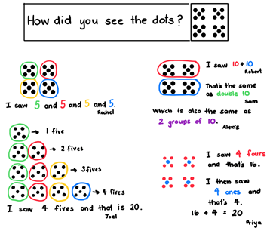
Figure 12 – Early Stage 1 Possible responses
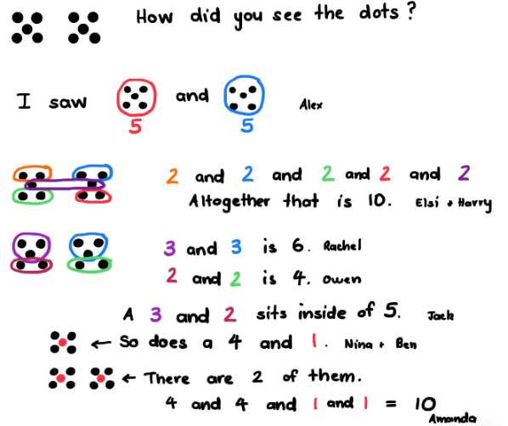
The table below details assessment opportunities and differentiation ideas.
Assessment opportunities | Too hard? | Too easy?
What to look for:  - Can students recognise dot patterns? (MAE-RWN-01)  - Can students use their knowledge of equal groups to identify the total? For example, 4 lots of 5, or 4 lots of 4 added to 4 lots of 1. (MA1-FG-01, MAO-WM-01)  - Can students use rhythmic or skip counting to identify the total? (MA1-FG-01) | Students find 4 groups of 5 are too many to build understanding through this method. Use fewer groups of 5 (or smaller numbers) to scaffold the visual thinking method. | Students accurately identify one or more methods. Ask students to find all possible answers and prove that they are correct.

Snakes and turtles – how many of each? – 35 minutes
Note: Combining and separating quantities provides students with opportunities to develop an understanding of how mathematicians use their knowledge of related number facts to solve problems in efficient ways. Mathematicians use their knowledge of equivalence to work out an unknown quantity that can sometimes be the result amount, the change amount, or the start amount.
- Share the following story with students: One sunny day, there were some snakes and turtles sitting on a rock. Altogether there were (Early Stage 1) 10 and (Stage 1) 14 of them. Ask students, ‘What does this mathematical story look like to you? Can you draw it using symbols and words?’
Note: Early Stage 1 students continue to use their own symbols for the plus and equals symbols. Remind students to keep their drawings simple so they are not distracting.
- Have students identify the result, start, and change amounts in their stories by sharing visual representations.
- Students display their work and go on a gallery walk. Ask students to focus on what they notice is different about the stories. Draw attention to the fact that there is more than one way to represent this story. For example, some Stage 1 students might draw 6 snakes and 8 turtles, others might draw 10 snakes and 4 turtles.
- Discuss what is the same about all the stories (the result amount) and what is different (the start and the change amounts).
- Stage 1 students use their whiteboard to look at all the examples and record all the different equations which are equivalent in value to 14. Have students consider if there are any missing. While Stage 1 students are completing this task, provide Early Stage 1 students with the rules to play Diffy towers. Use Resource 5: Diffy towers for students to record each round.
- Early Stage 1 students continue to play Diffy towers, while Stage 1 students share all the equations they found that are equivalent to 14. Discuss the idea of equivalence.
- Stage 1 students model equivalence using an equal-arm balance using the example 6 + 8 = 14. Place 14 interlocking cubes on one side of the equal-arm balance and 6 on the other. Students will notice that the 2 sides are not balanced. Add the 8 to the 6 and watch it balance. Discuss that the change is what makes the 2 arms balance.
- Stage 1 students investigate other equations equivalent to 14 using an equal-arm balance. This could lead to further investigation and discussion about the equivalence of number equations (not just the 2 parts being equivalent in value to the whole). For example, 8 + 4 = 10 + 2.
This table details assessment opportunities and differentiation ideas.
Assessment opportunities | Too hard? | Too easy?
What to look for:  - Can students use drawings and concrete materials to model addition? (MAE-CSQ-01)  - Can students identify and compare the size of quantities (part-part whole) in number sentences? (MA1-CSQ-01)  - Are students able to identify the different parts (start and change amounts) that combine to make a whole (result amount) in mathematical stories? (MA1-CSQ-01)  - Are students using their knowledge of equivalent number sentences to find unknown quantities? (MA1-CSQ-01, MAO-WM-01)  - Can students use hefting or an equal-arm balance to check if equations are equivalent? (MA1-NSM-01)  What to collect:  - work samples of student stories. (MAE-CSQ-01, MA1-CSQ-01) | Students find it ‘too hard’ to represent problems with drawings/symbols. Have students represent 14 snakes and turtles using concrete materials (for example, 2 different coloured counters). | Student has achieved mastery of commutation with simple numbers. Build on the ‘Too easy’ activity from the previous lesson, which was to ask students if the commutative property still exists if they split an amount, for example, 8 into 3 or 4 groups instead of 2. Ask, ‘Does the final number remain the same?’  Students investigate how many possibilities there are to make 8 and prove that they have found all possibilities. Students can test their working hypothesis on another number.  Ask, ‘Does this work for all numbers? How can you prove this?’  Students explore these questions with numerals or manipulatives.

Discuss and connect the mathematics – 10 minutes
- Stage 1 students share their exploration of equivalent equations using the equal-arm balance. Ask what students noticed about all the ways to create 14. Discuss how students knew when collections were equivalent in value and/or mass. Guide students to the understanding that:
- When a starting collection is divided into 2 or more smaller collections, we are separating a collection.
- When 2 collections have the same total, they are ‘equivalent in value’.
- Quantities can be ‘more than,’ ‘less than’, or ‘equivalent’ to other quantities.
- We can see when the quantity and/or mass of collections are equivalent by using an equal-arm balance.
- Early Stage 1 students share strategies from Diffy towers. Ask students:
- What counting method did you use to determine the total?
- How did you work out who had the most in their tower?
- What does the word ‘difference’ mean?

Lesson 5: Equivalence
Core concept: Compensation is a change that can return equivalence to the equation.
The table below contains suggested learning intentions and success criteria. These are best co-constructed with students.
Learning intentions | Success criteria
Students working towards Early Stage 1 outcomes are learning that subtraction is taking away from the largest number.  Students working towards Stage 1 outcomes are learning that:  - the = sign shows equivalence  - when an equation is changed, it might stop being true if (either side of the = sign is not equivalent)  - compensation is a change that can make an equation stay equivalent. | Students working towards Early Stage 1 outcomes can take away from the largest number.  Students working towards Stage 1 outcomes can:  - identify and compare the size of quantities  - explain one change that could be made to keep a problem equivalent  - check if equations are equivalent using manipulatives.

Daily number sense – 10 minutes
- Identify a class need through formative assessment data and complete a short, focused activity that targets students’ knowledge, understanding and skills. Example activities may be drawn from the following resources:
- Thinking mathematically Stage 1
- Universal Resources Hub

Modifying the problem – 40 minutes
This lesson has been adapted from Matthews et al (2007).
- Share the following problem with Stage 1 students: There were 3 dogs running in the park and 4 more dogs joined them.
- Students use counters and A5 sheets of paper with + and = symbols to represent the 3 dogs joining 4 dogs to make 7 dogs playing in the park. For example, Figure 13.
Figure 13 – 3 + 4 = 7
Note: The numbers are intentionally chosen to be numbers that the students find easy to compute. This is so students can focus on equivalence and compensation.
- While Stage 1 students are independently representing the problem, provide Early Stage 1 with the rules for Race to Zero.
Note: The focus for Early Stage 1 students is subtraction. Race to Zero – provide each student with a 10 or 20 frame. Students cover the frame with counters. They take turns rolling the dice and subtracting the corresponding number of counters until the first player reaches zero. The first player to get to zero receives a point. The player to get to 10 points is the winner. Students need to focus on counting back and record how many they removed and how many they have left.
- Early Sage 1 students continue to independently play Race to Zero until step 16. Direct Stage 1 students to remove one of the counters from the 3 in the equation.
- Ask students, ‘Is this equation still correct?’ and then discuss why it is not. Ask, ‘What can we do to make the equation equivalent?’
- Provide time for students to think individually and discuss their ideas with a peer. Invite students to model how they could make the equation equivalent and record their thinking.
- Ask students, ‘How can we check to see if the equation is equivalent?’ Use different mathematical tools to check for equivalence, for example, number balances or interlocking cubes. See anticipated student responses in Figure 14 below.
Figure 14 – Student anticipated responses
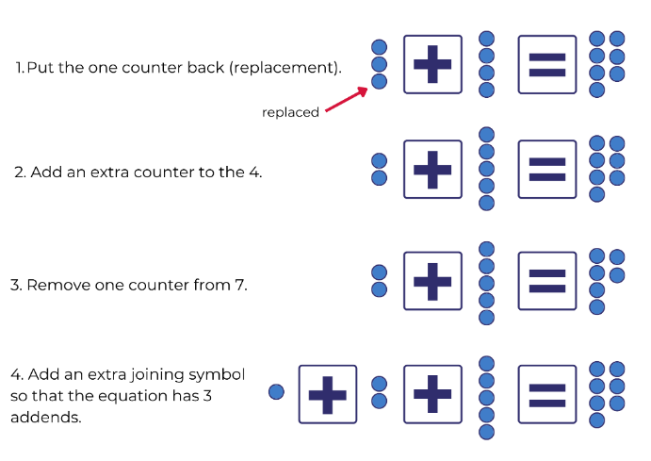
- Students turn and talk about what they notice has happened in each version of the story. Explain that all these options are ‘equivalent’ to the original story. Continue to ask questions, prompting until all possibilities are given whilst highlighting the strategy.
- Repeat the above steps for a new story: Jess had 3 fish in her tank and then she bought 5 more fish to join them so now she has 8 fish.
- This time, ask students to remove 2 counters from the 3.
- Discuss how this makes the story wrong and propose ways to make the story true again. Draw out as many ways as possible.
- Return counters to represent the original story of Jess and her fish but, this time, remove the 2 counters from the 5. Ask, ‘What is the same and what is different in the story?’
- Return counters to represent the original fish story but this time, add 2 counters to the 5. Ask, ‘What is the same and what is different?’ Discuss how adding counters is different to removing them.
- Stage 1 students work together using concrete materials to create mathematical stories that maintain equivalence. Students roll a 10- or 20-sided dice to provide a target number. Each student writes at least 4 number sentences that maintain equivalence for the target number. Students may use symbols, pictures, and words to record different ways to maintain equivalence. Students check the equivalence using an equal-arm balance. Encourage students to identify patterns or rules to follow but if students cannot identify the pattern/rule, provide more examples. Stage 1 continues to work on maintaining equivalence.
- Work with Early Stage 1 students to create subtraction stories using concrete materials and acting out. For example, if a student made 9 muffins and gave 3 away, how many muffins would they have left?
- Students act out being muffins, starting with 9 and then taking away 3. Record what happens using simple pictures. For example, Figure 15.
Figure 15 – Muffins
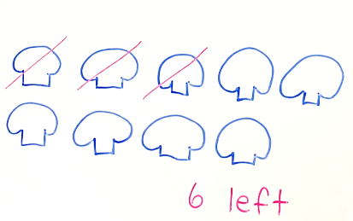
- Ask students what will happen if they change the order of the start and change amount. Start with 3 students and attempt to take away 9.
Prompts | Anticipated student responses
What do you notice? | - It’s not possible.  - There are not enough muffins.  - You can’t subtract from a smaller number.
- Discuss with students that changing the order of the start and change amount does not work for subtraction and the largest number must be the start amount. Continue to provide subtraction stories for students to act out and record using simple pictures.

Discuss and connect the mathematics – 10 minutes
- Guide Stage 1 students to understand that:
- the = sign shows equivalence
- when an equation is not equal, something needs to be changed to make it equivalent
- when a change is made to an equation, it might stop being true (either side of the = sign is not equivalent)
- compensation is a change that we can make so that our equation stays equivalent.
- Allow Early Stage 1 students to perform and explain a subtraction story to the rest of the class, highlighting how the start amount must be the largest number.
This table details assessment opportunities and differentiation ideas.
Assessment opportunities | Too hard? | Too easy?
What to look for:  - Can students take away part of a group of objects to model subtraction? (MAE-CSQ-01)  - Can students use compensation to change the problem to maintain equivalence? (MA1-CSQ-01)  - Can students explain any change that could be made to make the modified problem equivalent? (MA1-CSQ-01, MAO-WM-01)  - Are students checking if equations are equivalent using concrete materials with the equal-arm balance? (MA1-NSM-01)  What to collect:  - work samples of students recording different ways to maintain equivalence. (MA1-CSQ-01, MAO-WM-01) | Students struggle to use specific vocabulary around equivalence.  - Introduce specific language (equivalent, equation) by creating a definition using pictures, numbers and words.  - Support students to identify the equivalence pattern. Use smaller numbers and concrete materials to demonstrate equivalence. Support students with subtraction.  - Use two 6-sided dice and concrete materials to provide opportunities for students to practice subtraction using smaller numbers. | Students have demonstrated deep understanding of addition using simple numbers and need to extend their thinking about equivalence.  - Have students complete Equivalent Pairs interactive online activity from NRICH which explores equivalence using different operations.  - Students use The Interactive Balance at NRICH to explore equivalence on a balance scale and make links between mathematical and scientific concepts. This resource can be accessed at several levels of complexity for students as needed.

Lesson 6: Finding the missing part of a mathematical story
Core concept: Commutative property and equivalence can help find the missing parts of a mathematical story.
The table below contains suggested learning intentions and success criteria. These are best co-constructed with students.
Learning intentions | Success criteria
Students working towards Early Stage 1 outcomes are learning that subtraction is taking away from the largest number.  Students working towards Stage 1 outcomes are learning that:  - equations (number sentences) tell mathematical stories and the information they contain can be used to work out a missing part  - the commutative property can be used to solve unknown and change unknown problems. | Students working towards Early Stage 1 outcomes can take away from the largest number.  Students working towards Stage 1 outcomes can:  - tell mathematical stories where the result is known but other parts are missing  - use concrete materials to identify and check the missing number in a mathematical story.

Daily number sense: Splat! – 10 minutes
- Build student understanding of subitising by watching Splat! (conceptual subitising to 10) (7:13).
- Throughout the video, pause to discuss and answer question prompts.

Consolidation and meaningful practice: Sarah’s blocks – 10 minutes
Elements of this lesson have been adapted from Van der Walle et. al. (2019).
- Share a concrete or visual representation of Figure 16 using counters or symbols.
Figure 16 – Tell the story of Sarah's blocks
- Explain that the story is about Sarah having some blocks and then getting some more from George. Ask Stage 1 students to turn and talk to tell this story using words to a partner. While Stage 1 students are telling their story, provide instruction to Early Stage 1 to play Building towers (7:22). Early Stage 1 continues with Building towers (7:22) until the next portion of the lesson, Subtraction stories.
- Ask several students to share their mathematical stories with the class. For example, Sarah had 8 blocks and George gave her 4 more so now she has 12 blocks.

How can we work out the changes? – 20 minutes
- Cover part of the concrete representation so that it now looks like Figure 17. The challenge will be to use words to tell the story with some information missing.
Note: The missing number in an equation is called 'change unknown.’
Figure 17 – Story with missing information = change unknown
- Students turn and talk to discuss how they would tell the story now. For example, Sarah had 8 blocks and George gave her some more and now she has 12. Make explicit that these kinds of problems refer to ‘change unknown’ because we know there is a change, but we do not know what the change is.
- Share a concrete or visual representation of Figure 18. Use counters or symbols to explain that the story is about Oscar buying bananas and apples.
Figure 18 – Oscar bought bananas and apples
Note: The numbers are intentionally chosen to be numbers that students find easy to compute. Students should focus on discovering patterns rather than computation.
The table below outlines stimulus prompts to generate conversation about the topic, along with anticipated responses from students.
Prompts | Anticipated student responses
- What do you know about this story?  - What do you want to know?  - How could you find out how many bananas Oscar bought?  - Can you think of more than one way to work this out? | - Oscar bought 3 bananas.  - Oscar bought apples, but we don't know how many.  - Using equal-arm balances with 3 counters on one side and 8 on the other and counting as they add to the 3 until the arms are balanced.  - Crossing out or removing 3 of the blue circles or counters, since 3 of them must be apples.
- Give students time to use materials such as equal-arm balances, interlocking cubes, counters, drawings, and other methods to prove their thinking.
- Select responses that highlight the above strategies and other ways of thinking that may contribute to student understanding.
- Students modify their own stories from previous lessons to become 'change unknown' stories. In small groups, students can use a variety of methods to find the missing addend of each other's stories.
- Revisit the story of Sarah, George and their blocks, covering a different part of the story. Challenge students to use words to tell the story with the missing information. Change concrete representation so that it now looks like Figure 19.
Figure 19 – How can we tell the story now?
- Students turn and talk to discuss how they would tell the story now. For example, Sarah had some blocks, then George gave her 4 more. Now she has 12 blocks.
- Explain that these kinds of problems are known as ‘start unknown’ problems. Say, ‘This is because we know there is a change, and we know the result, but the start is unknown and that is what we need to work out’.
- Share a concrete or visual representation of Figure 20 using counters or symbols with students.
Figure 20 – Charlie saving money
- Encourage students to share what the story might be. For example:
- Charlie had some money and then his parents gave him $6. Now he has $11.
- Charlie had some money and then he received $6 for washing the car. Now he has $11.
Note: The more examples that students create and share, the more exposure they will have to written word problems, which will help them learn to focus on what the critical information is.
The table below outlines stimulus prompts to generate conversation about the topic, along with anticipated responses from students.
Prompts | Anticipated student responses
- How could you find out how much money Charlie had at the beginning of the story?  - Can you think of more than one way of finding out this information? | - Students might reference the commutative property from Lesson 3.  - Using equal-arm balances with 6 counters on one side and 11 on the other and counting as they add to the 6 until the arms are balanced (this will require students to apply the commutative property).  - Using equal-arm balances with 6 counters on one side and 11 on the other, then taking away from the 11 and counting to work out how many more than 6 had been there.  - Cross out 6 of the blue counters, since they must be the dollars that Charlie already had.  - Using one row of 11 interlocking cubes to show the total and then 2 colours, one to represent the dollars Charlie started with and one to represent the money that he later received.
- Stage 1 students independently use a variety of methods to find the missing addend of each task card in Resource 6: Missing addend. Give students resources to use such as equal-arm balances, interlocking cubes, counters, drawings, and other methods.

Subtraction stories – 20 minutes
- Early Stage 1 students sit in a circle and roll 2 dice. Students identify the largest number rolled as the start amount and collect the corresponding number of counters. Then students identify the change amount as the smallest number rolled and take away. Discuss the result of this subtraction problem.
- Continue to roll dice and students solve subtraction problems using concrete materials.
Note: To further develop understanding, students can act out problems and represent using simple drawings with a focus on the largest number being the start amount.

Discuss and connect the mathematics – 10 minutes
- Stage 1 students discuss what is similar about finding a ‘start unknown’ and finding a ‘change unknown’. Discuss what is different. Ask, ‘What do you notice about these problems? Is there anything you wonder?’
- Refer to Lesson 6 and ask, ‘How can we work out the changes?’ Suggest that to explore the idea further, students could go back to the Sarah and George story and change the amounts. For example:
- What would the story be if Sarah started with 7 blocks?
- How could you work out how many blocks George gave her so that the story is still true?
- What about if Sarah had 13 blocks at the end of the story?
- Ask students to reflect on their exploration of mathematical stories. Revise that:
- equations (number sentences) tell mathematical stories
- sometimes we know the end of the story (the result), but part of the story is missing
- the commutative property can help solve start unknown and change unknown problems.
- Early Stage 1 students demonstrate subtraction by rolling 2 dice and taking away from the largest number.
The table below details assessment opportunities and differentiation ideas.
Assessment opportunities | Too hard? | Too easy?
What to look for:  - Can students take away part of a group of objects to model subtraction? (MAE-CSQ-01)  - Can students explain the concept of subtraction? (MAO-WM-01)  - Can students solve mathematical stories where the result is known but other parts of the story are unknown? (MA1-CSQ-01)  - Can students use concrete materials with commutation to identify and check the missing part of their mathematical story? (MA1-CSQ-01, MA1-NSM-01, MAO-WM-01)  What to collect:  - work samples of students finding missing parts of the story. (MA1-CSQ-01, MAO-WM-01) | Students have difficulty with the language demands and/or cognitive load. Provide students with a model story when exploring change/start unknown problems.  Students have difficulty understanding the concept of a missing addend. Provide students with problems that use bonds to 10. Provide students addition problems without missing addends.  Students need support with subtraction. Use two 6-sided dice and concrete materials to provide opportunities with smaller numbers. | Students easily identify missing numbers.  - Challenge students to identify as many patterns as possible using Sweetie Box.  - Challenge students to explore different possibilities for a number sentence with a missing number using What Could It Be?

Lesson 7: Uncovering related facts
Core concept: One number fact uncovers related number facts.
The table below contains suggested learning intentions and success criteria. These are best co-constructed with students.
Learning intentions | Success criteria
All students are learning that mathematical problems can have related addition and subtraction facts. | All students can:  - rearrange parts of an equation in a mathematical story to get the same answer  - select mathematical materials and tools to represent thinking  - apply strategies to solve combining and separating problems.

Daily number sense: What’s the same? What’s different? – 10 minutes
- Build student understanding of arrays by displaying Resource 7: Dots in Array.
- Ask students to compare both pictures, looking for similarities. Students think individually, turn and talk with a peer, and then select several students to share thinking with the class.
The table below outlines stimulus prompts to generate conversation about the topic, along with anticipated responses from students.
Prompts | Anticipated student responses
- What do you notice about the picture?  - What is the same?  - What is different? | - Picture A shows 2 and 2 and 2 and 2. Picture B shows 4 and 4.  - Picture A has 4 rows of 2 and Picture B shows 2 rows of 4.  - They are the same picture, but one is sideways.  - The story for this one might be… The story for that one might be….

Consolidation and meaningful practice: Array Problems – 40 minutes
- Display Resource 8: Array problems and ask, ‘What symbols would I need to make this true? Remind Early Stage 1 students that they created their own symbols to represent the action of coming together/combining and the result. On an individual whiteboard Early Stage 1 students draw their symbols and design a symbol to represent subtraction. See Figure 21.
Figure 21 – Anticipated Stage 1 student responses
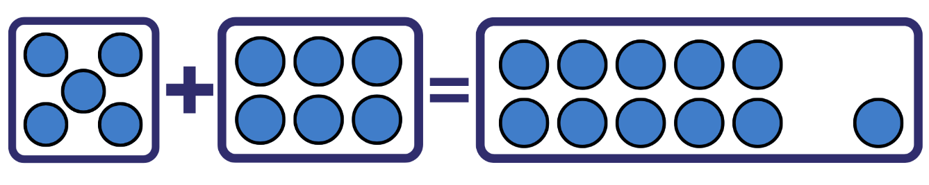
The table below outlines stimulus prompts to generate conversation about the topic, along with anticipated responses from students.
Prompts | Anticipated student responses
- Can we move the pieces around and have the equation still be true?  - Discuss what stories the equation could represent and how it changes when students move the addends around. | - If I move the 5 and 6 around the equation will still be balanced.
- Say, ‘I wonder if we can use the – symbol rather than the + symbol? Is there a way they could arrange the pieces to make the equation true?’
- In small groups, students move pieces around to create all equations possible with Resource 8: Array problems and Resource 2: +, − and = cards. Students record these equations using pictures, symbols, and words. Provide concrete materials for students to verify that the equations are still balanced using equal-arm balances and other concrete materials.
- Students create their own mathematical story. Early Stage 1 students use numbers under 10, and Stage 1 students use numbers under 20. Students rewrite their mathematical stories to rearrange the parts into 3 related number sentences.
- Example of how Stage 1 students could rearrange the story: 3 birds were sitting in a tree and 4 joined them, making them 7 birds in the tree (3 + 4 = 7).
- Related stories:
- 4 birds were sitting in a tree and 3 joined them, making them 7 birds in the tree (4 + 3 = 7).
- 7 birds were sitting in a tree and 3 flew away, so there were 4 birds left in the tree (7 – 3 = 4).
- 7 birds were sitting in a tree and 4 flew away, so there were 3 birds left in the tree (7 – 4 = 3).
- Early Stage 1 students choose a mathematical story and use pictures and symbols to show all related stories. See Figure 22.
Figure 22 – Early Stage 1 anticipated response
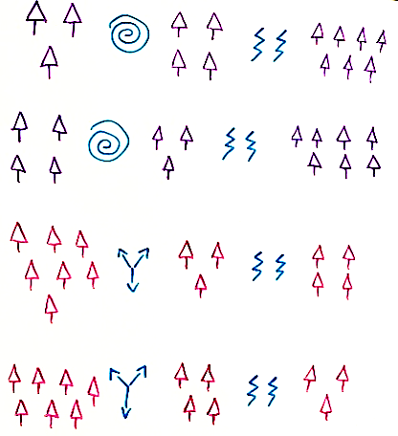
- Students verify that the stories are still equivalent using mathematical tools and show their thinking in a variety of ways. Students continue to solve stories or create their own.

Discuss and connect the mathematics – 10 minutes
- Students select and share stories with representations that illustrate the relationship between addition and subtraction.
- Guide student discussion to focus on:
- understanding that combining quantities and separating quantities ‘undo’ each other
- mathematicians use what they know about one number fact to uncover related facts.
The table below details assessment opportunities and differentiation ideas.
Assessment opportunities | Too hard? | Too easy?
What to look for:  - Can students select mathematical symbols, drawings and vocabulary to represent their thinking? (MAE-CSQ-01, MAE-CSQ-02, MA1-CSQ-01, MAO-WM-01)  - Are students applying appropriate strategies to solve combining and separating problems? (MAE-CSQ-01, MAE-CSQ-02, MA1-CSQ-01, MAO-WM-01)  - Can students rearrange parts of an equation to create equivalent related facts? For example, 2 plus 5 is equal to 3 plus 4 (MA1-CSQ-01)  - Can students use related facts in their mathematical stories? (MA1-CSQ-01)  What to collect:  - work samples of students solving addition and subtraction problems using concrete materials or drawings (MAE-CSQ-01, MAE-CSQ-02, MAO-WM-01)  - work samples of student recordings of equivalent related facts using mathematical tools, symbols, drawings and vocabulary (on paper or photos/film). (MA1-CSQ-01, MA1-NSM-01, MAO-WM-01) | Students need support making explicit links to prior learning. Recap mathematical symbols during lesson introduction and provide vocabulary support, for example, by defining 'equation'.  Students have difficulty computing the problem. Adjust the model problem to a more familiar number relationship, for example, friends of 10 or friends of 20. Provide students with scaffolds for mathematical stories.  Students have difficulty identifying related facts. Adjust activity so that students are solving simple addition and subtraction problems. | Students demonstrate understanding of concepts and skills to a high degree. Use numbers that cross decades to write related number sentences. Explore related number facts and patterns using activities from Number Facts in NRICH.

Lesson 8: Related number facts can help us uncover missing information
Core concept: Commutative property, equivalence and related number facts help find the missing parts of a mathematical story.
The table below contains suggested learning intentions and success criteria. These are best co-constructed with students.
Learning intentions | Success criteria
All students are learning that:  - mathematicians use their knowledge of related facts to help change and solve problems in efficient ways  - problems can be represented by selecting concrete materials, mathematical tools and/or drawings. | All students can:  - select mathematical materials and tools to represent their thinking  - reflect on strategies used to solve a problem.  In addition, students working towards Early Stage 1 outcomes can solve subtraction problems using drawings and materials.  In addition, students working towards Stage 1 outcomes can use different strategies (counting back, manipulatives, diagrams) to find the difference between two quantities.

Daily number sense: Choose a Splat! – 10 minutes
- Build student understanding of subitising by choosing a Splat! from Steve Wyborney's blog:
- Splat! Set 1.1 [PPT 590KB]
- Splat! Set 1.2 [PPT 590KB].
- Display the shapes for 3-5 seconds and then cover with the splat. Follow the question prompts so students consider the items in different arrangements.

Monkeys in the trees! – 40 minutes
- Present these 2 problems to the class:
- Explain that a Year 1 class were asked to solve the following problem mentally: 19 monkeys were swinging in the tree branches. It started to rain, so 17 of them left the trees to go into the nearby cave. How many monkeys were now swinging in the rain?
- Explain that a Kindy class were asked to solve the following problem mentally: 9 monkeys were swinging in the tree branches. It started to rain, so 8 of them left the tree to go into the nearby cave. How many monkeys were now swinging in the rain?
- Display and read the 2 speech bubbles in Resource 9: Early Stage 1 Thinking bubbles and Resource 10: Stage 1 Thinking bubbles to share how 2 students, Daniel and Babsy, solved the problem. Explain that there was another student named Peter who was a bit confused by how Daniel and Babsy solved the problem. Ask, ‘Is there a way to help Peter make sense of these 2 strategies?’
- Invite students to talk in pairs and devise how they would help Peter to make sense of Daniel and Babsy's strategies. Provide concrete materials, mathematical tools and/or drawing materials to help students demonstrate the thinking behind the 2 strategies.
- Select some students to share how they would explain Daniel and Babsy's strategies and if anyone else used a different strategy.
The table below outlines stimulus prompts to generate conversation about the topic, along with anticipated responses from students.
Prompts | Anticipated student responses
How have you explained Daniel and Babsy’s strategies? | - Start with 19 counters and take 17 (1 ten and 7 ones) away to represent the 2 monkeys that are left.  - Start with 17 counters and add 2 more counters, so that there are 19 counters to represent the monkeys.  - Start with 9 counters and take away 8 counters to represent the one monkey left.  - Start with 8 counters and add one more counter, so that there are 9 counters to represent the monkeys.
- Align both models and ask, ‘What is the same and what is different?’
- Early Stage 1 students independently play Diffy towers.
- Explain to Stage 1 students that these strategies can also be modelled using a number line. Draw a number line from 0-20. Students direct the teacher to show Daniel’s thinking on the number line by starting at 19 and jumping back by one 10, then 7 ones as in Figure 23.
Figure 23 – Number line showing Daniel's strategy
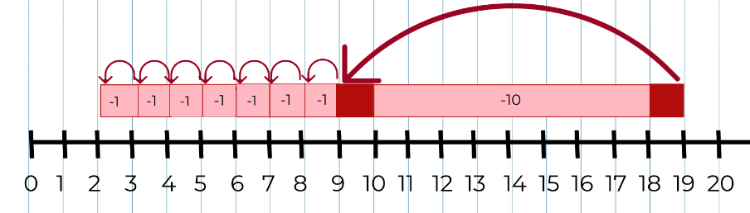
- Ask students, ‘How many monkeys does Daniel think are still in the trees? Where can you see this on Daniel's number line?’
- Discuss that Daniel maintained this problem to be a result unknown (see Figure 24).
Figure 24 – As a result unknown problem
- Explain that Daniel started with 19 and counted back 17, which meant there were 2 left.
- Next to Daniel’s number line, draw another 0-20 number line to show Babsy's thinking. Students direct the teacher to show this by starting at 17, and count on 2 ones to get to 19 (see Figure 25).
Figure 25 – Number line showing Babsy's strategy
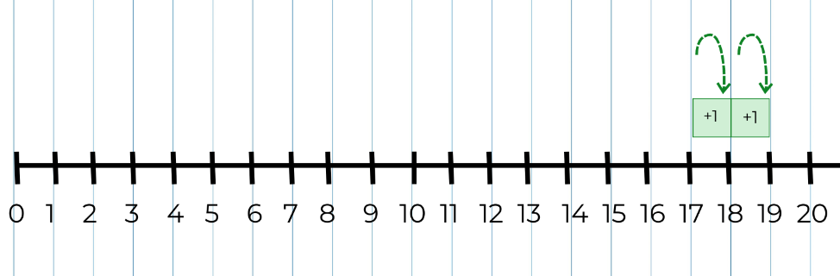
- Ask students, ‘How many monkeys does Babsy think are still in the trees? Where can you see this on her number line?’
- Discuss that Babsy has changed the problem to a 'change unknown' problem, see Figure 26. The steps on the number line that represent the changes are now the result (+ 1 + 1). For example, see Figure 27. Explain that Babsy used her knowledge of related facts to change the problem.
Figure 26 – The monkey's problem as a change unknown problem
Figure 27 – This is how the steps represent the answer in Babsy's number line
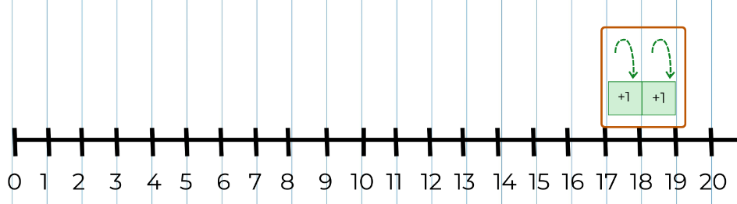
- Allow time for students to look at both number lines.
The table below outlines stimulus prompts to generate conversation about the topic, along with anticipated responses from students.
Prompts | Anticipated student responses
What do you notice? | - Daniel counted back by tens and ones, but Babsy counted on by ones.  - There are common amounts in both: 19, 17 and 2.  - It took Daniel 8 steps to solve the problem, but it only took Babsy 2 steps.  - When you count back to find the result, the jumps on the number line go to the left.  - When you count on, the jumps go to the right.
- Discuss the idea that mathematicians use what they know about related number facts to help them to solve problems. Share with Stage 1 students some mathematical stories that represent a variety of problem types from Resource 11: Mathematical stories for students to solve. In pairs, students select a problem and discuss what it is about and what the unknown information is. Stage 1 students solve the problem mentally and share with each other how they worked out the unknown information.
- Students use concrete materials and/or a number line to model how they solved the problem. As students are representing their strategies, strategically select students to share their modelling strategies with the class.
- Have students draw on what they know about related facts to solve the problem in a different way.
- While Stage 1 students independently complete their mathematical stories, work with Early Stage 1 students as they create their own subtraction stories. Students use words, drawings and symbols to record their thinking. Prompt students to explain their thinking by asking questions such as:
- What have you discovered?
- Why do you think that?
- Have you thought of another way this could be done?’

Discuss and connect the mathematics – 20 minutes
- Invite selected Stage 1 students to share their strategies for solving each problem.
- Discuss the following questions:
- How does the model/number line match the mathematical story?
- What questions do you have about what they did?
- Why does it make sense? Or not?
- Encourage Stage 1 students to make connections, and to compare their ways of thinking.
- Early Stage 1 students share their mathematical stories with the class with a focus on being able to explain the steps of subtraction.
- Support all students to reflect on their choice of strategies and reasons for using them and ask:
- When did you find it beneficial to change the problem?
- How did your knowledge of related facts help you to solve the problem in a different way?
- Is it always beneficial to change the problem?
- Explain that:
- mathematicians use their knowledge of related facts to help solve problems in efficient ways
- mathematicians can choose to change the problem so that it is easier to work with. For example, we can convert a 'change unknown' problem into a 'result unknown' problem if we think it will be easier to work with
- we can convert a subtraction problem into an addition problem, and this can sometimes reduce the number of steps
- ways of thinking about problems can be represented using concrete materials, mathematical tools or drawings
- we used number lines to represent Daniel and Babsy's thinking, and we identified where on the number line we could find the answer to our problem.
This table details assessment opportunities and differentiation ideas.
Assessment opportunities | Too hard? | Too easy?
What to look for:  - Can students represent the difference between 2 numbers using concrete materials, number lines and diagrams? (MAE-CSQ-01, MA1-CSQ-01)  - Are students using mathematical vocabulary to reflect on strategies when solving problems? (MAO-WM-01)  - Can students use drawings, words and materials to model subtraction by separating and taking away part of a group? (MAE-CSQ-01, MAE-CSQ-02)  - Can students apply knowledge of related addition and subtraction facts to help solve problems? (MA1-CSQ-01)  - Can students use a number line to count back to find the difference between two quantities? (MA1-CSQ-01)  What to collect:  - work samples of mathematical stories (MAE-CSQ-01, MAE-CSQ-02)  - work samples of responses to Resource 11: Mathematical stories for students to solve (MA1-CSQ-01, MAO-WM-01) | Students find it ‘too hard’ when working with a number line of 0-20. Use smaller numbers (for example, 9 and 7) on a 0-10 number line that is big enough to be used with concrete materials.  Students need support with subtraction. Use two 6-sided dice and concrete materials to provide opportunities with smaller numbers.  Students have difficulty reading and understanding mathematical stories. Provide students with a number sentence to reflect the story. | Students are confident in using numbers on a 0-20 number line. Use 0-50 or 0-100 number lines and explore numbers of choice; then explain their findings to another student. Encourage students to partition numbers and use most efficient counting strategy on the number line to solve problems.

Resource 1: Familiar and unfamiliar symbols
“Pirate skull crossed bones” by Clker-Free-Vector-Images used in accordance with the Pixabay License.
“Traffic sign stop road” by OpenClipart-Vectors used in accordance with the Pixabay License.
“Emoji smilies” by Pixaline used in accordance with the Pixabay License.
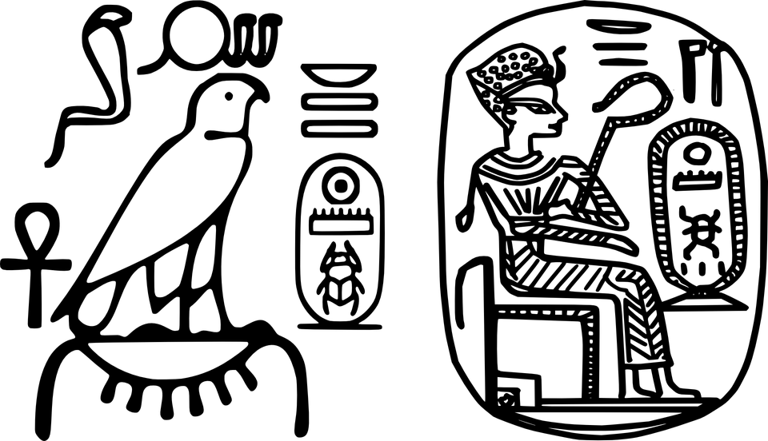
“Egyptian hieroglyphics king plaque” by OpenClipart-Vectors used in accordance with the Pixabay License.
“Omega Greek Ohm letter symbols” by Clker-Free-Vector-Images used in accordance with the Pixabay License.
“Health Medicine Serpent Wings” by Clker-Free-Vector-Images used in accordance with the Pixabay License.

Resource 2: +, − and = cards

Resource 3: Stage 1 Dot talk
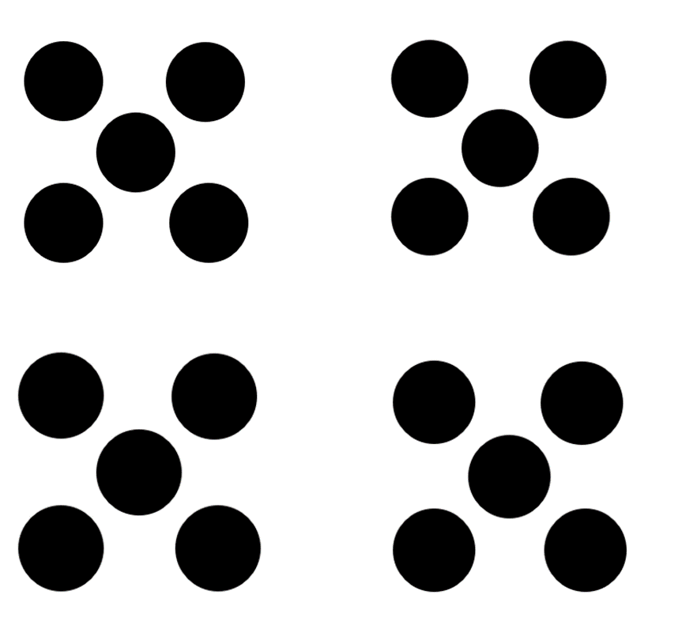

Resource 4: Early Stage 1 Dot talk

Resource 5: Diffy towers
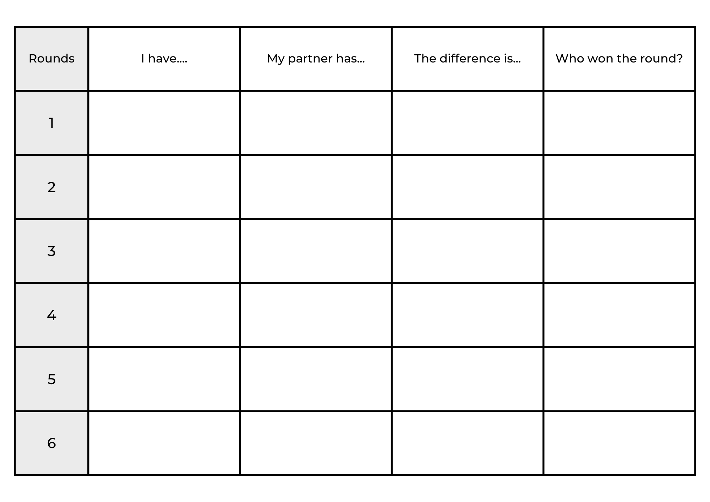

Resource 6: Missing addend
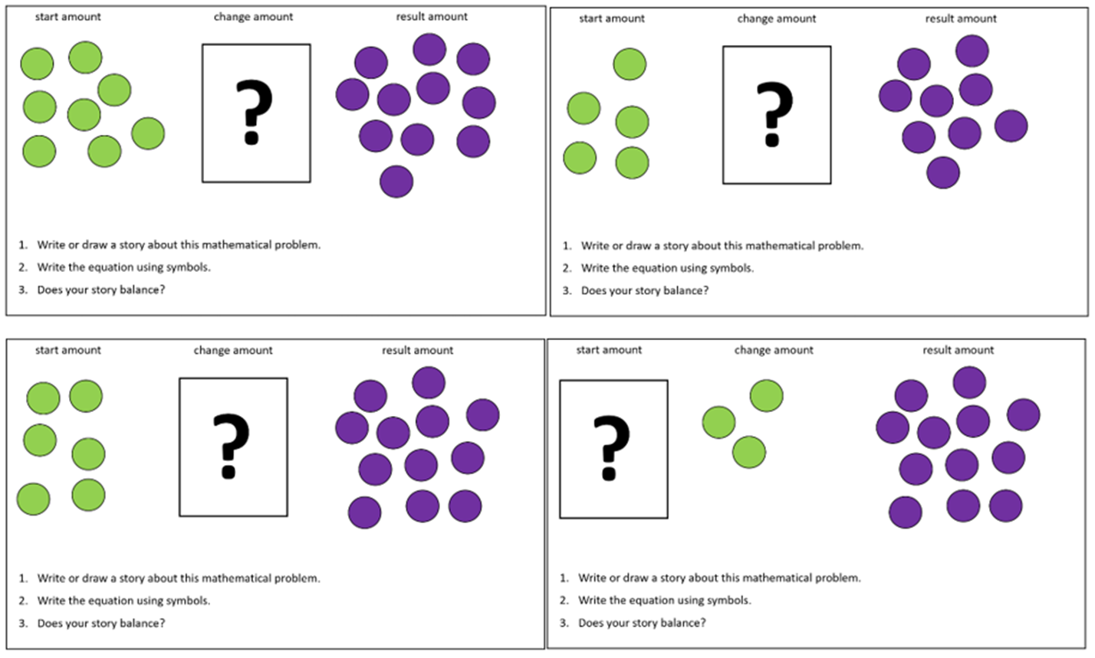
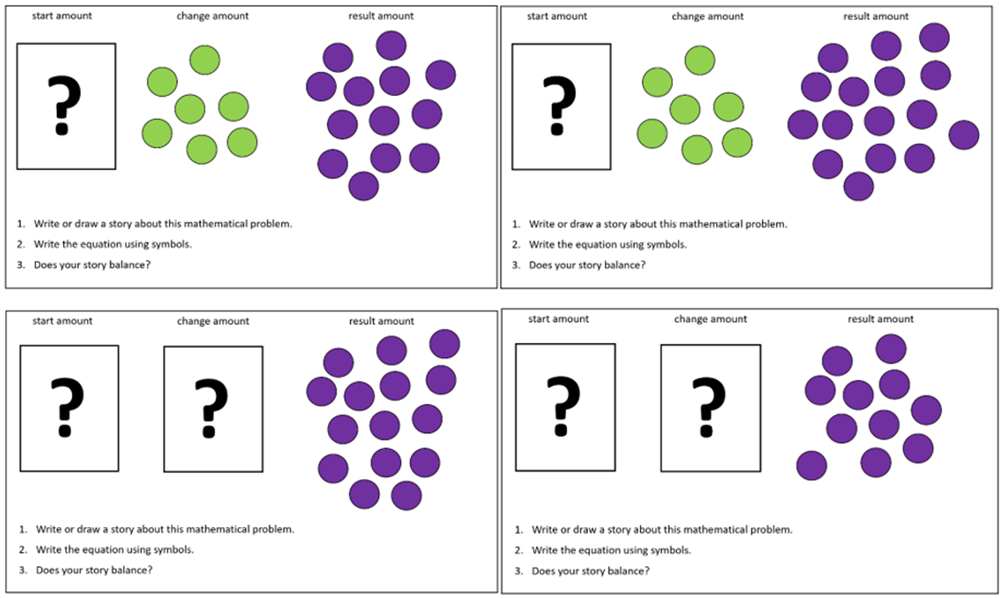

Resource 7: Dots in Array
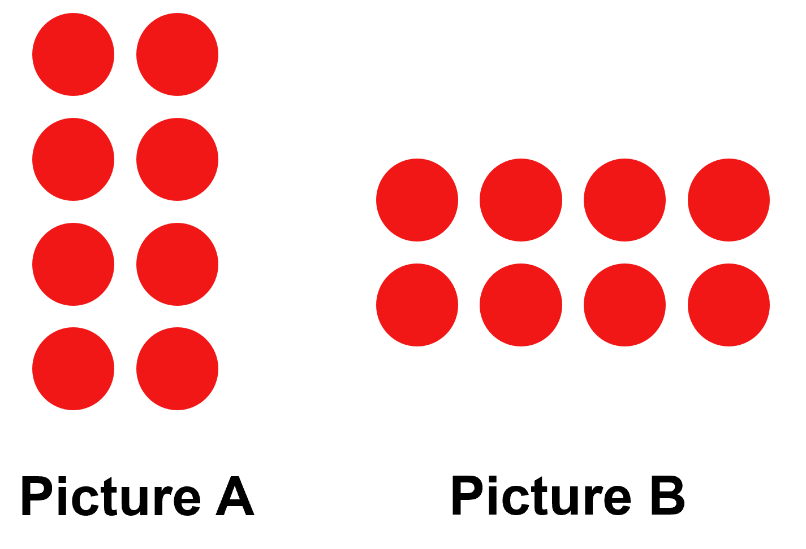

Resource 8: Array problems
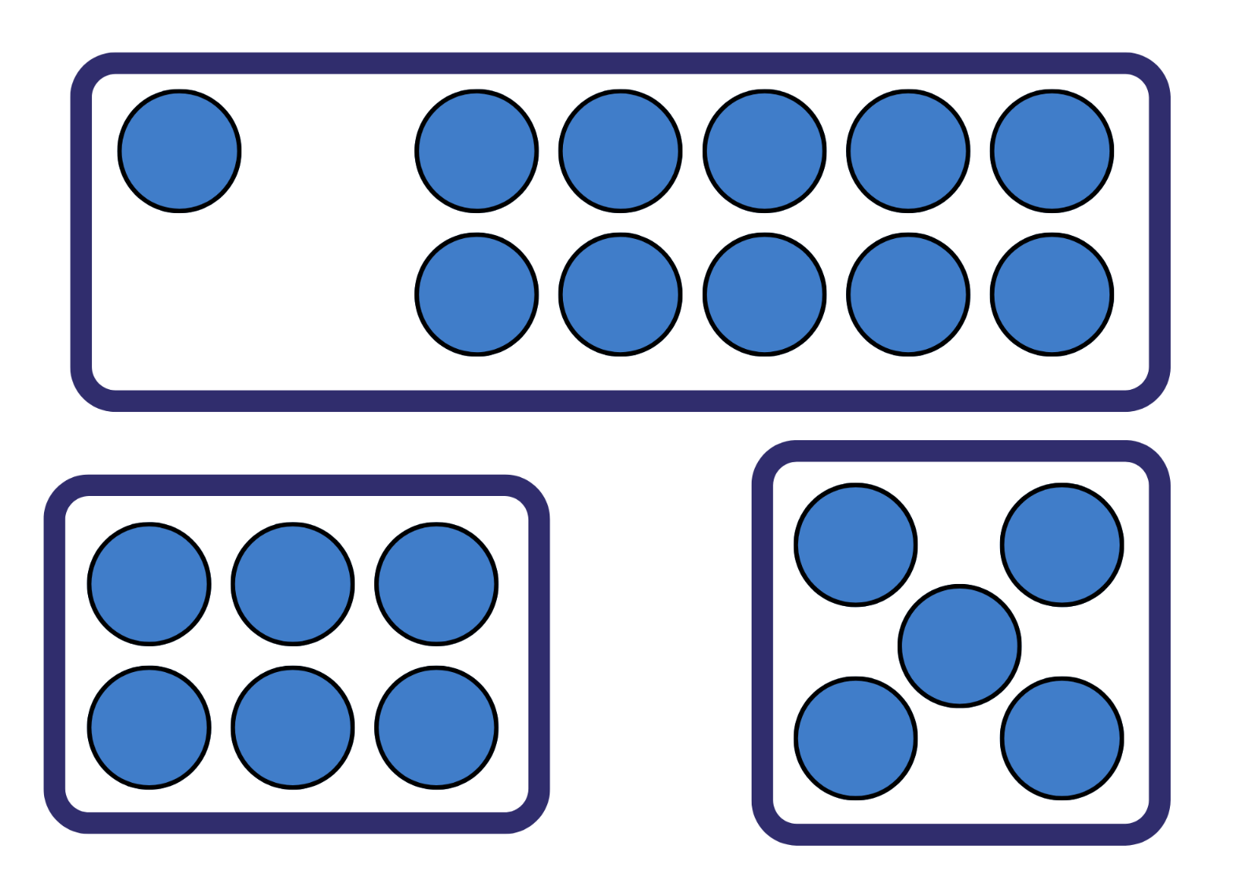

Resource 9: Early Stage 1 Thinking bubbles
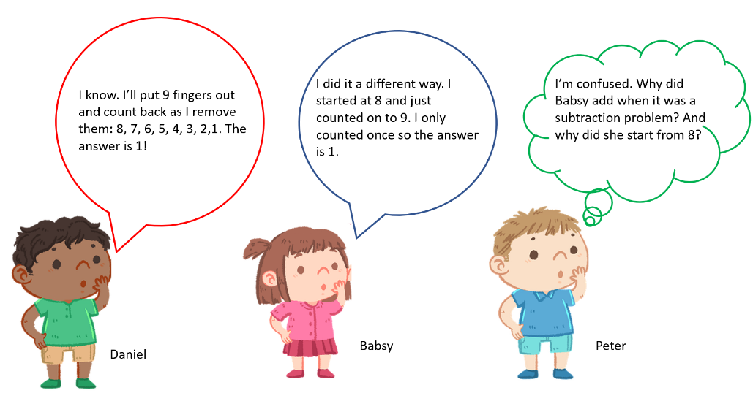
“Boy thinking thought bubble child”, “Girl thinking thought bubble child” and “Boy thinking thought bubble child 5888240” by Biistudio21 are used in accordance with the Pixabay License.

Resource 10: Stage 1 Thinking bubbles
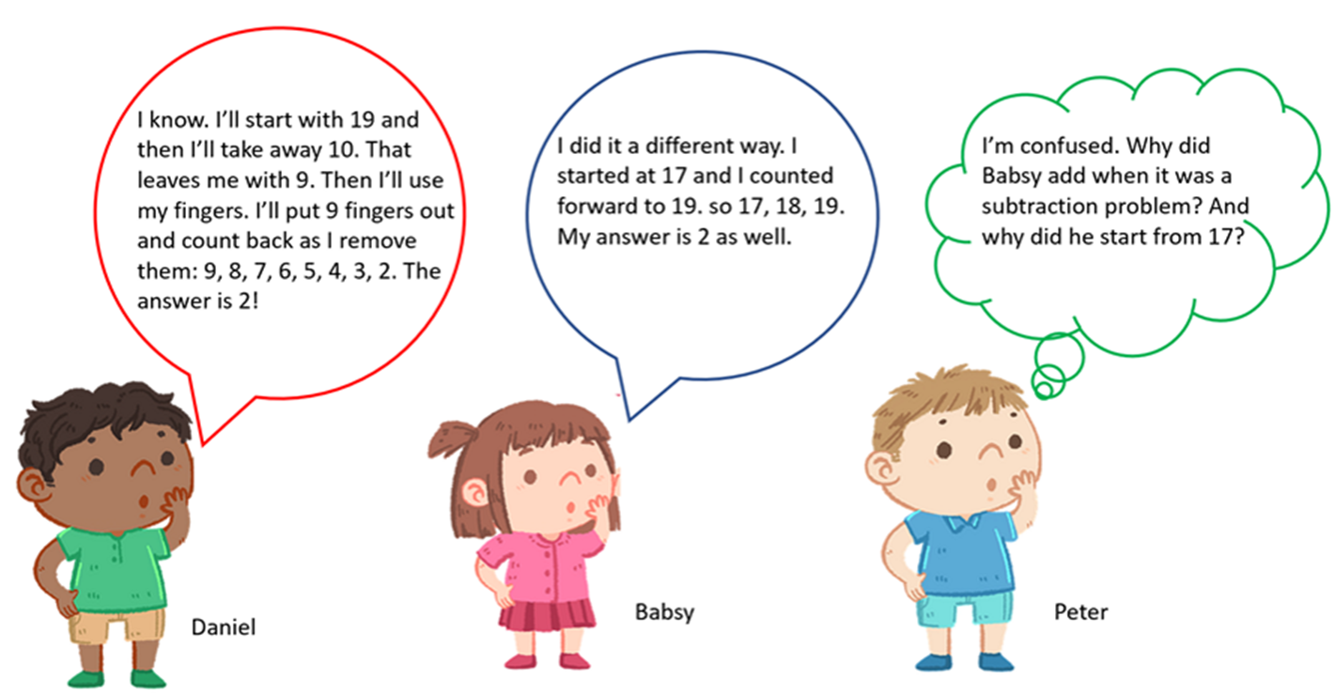
“Boy thinking thought bubble child”, “Girl thinking thought bubble child” and “Boy thinking thought bubble child 5888240” by Biistudio21 are used in accordance with the Pixabay License.

Resource 11: Mathematical stories to solve
Result unknown | Result unknown | Change unknown
Sam has 12 pencils. His sister took 5 of these pencils to use. How many pencils does Sam have now? | There were 16 chocolates in the box. Rita ate 8 of them. How many chocolates are left? | 15 children were playing in the park. Then some children went home. Now there are 11 children in the park. How many children went home?
Helen borrowed 12 books from the school library. She took 10 of them home and left the others at school. How many books were left at school? | Amanda had 17 toy dinosaurs, but 14 of them went missing. How many dinosaurs does Amanda have left? | Ifrad had 15 counters in his hand but then he dropped some on the floor. He now has 9 counters. How many counters did Ifrad drop?
Amira picked 17 flowers but gave 4 of them to her friends. How many flowers does she have now? | Michael had 13 cars in his shed. He sold 4 of them on the weekend. How many cars does he have left? | There were 11 cats in the shed. Then some cats ran away. Now there are only 8 cats in the shed. How many cats ran away?

Syllabus outcomes and content
The table below outlines the syllabus outcomes and range of relevant syllabus content covered in this unit. Content is linked to National Numeracy Learning Progression version (3).
Focus area and outcomes | Content groups and content points | Lessons
Representing whole numbers  MAO-WM-01  MAE-RWN-01, MA1-RWN-01  MAE-RWN-02, MA1-RWN-02 | Early Stage 1  Instantly name the number of objects within small collections  - instantly recognise (subitise) the number of items in small groups of up to four items without counting (NPV1, CPr1)  - identify the number of items in different arrangements (CPr2) | 4, 6, 8
Representing whole numbers (cont) | Early Stage 1  Use the counting sequence of ones flexibly  - count forwards to at least 30 and state the number after or before a given number, without needing to count from one (CPr4)  - count backwards from a given number 20 or less (CPr5) | 2, 5
Representing whole numbers (cont) | Early Stage 1  Recognise number patterns  - recognise dice and domino dot patterns (NPA1, NPV2, CPr2) | 4, 6, 8
Representing whole numbers (cont) | Early Stage 1  Connect counting and numerals to quantities  - count with one-to-one correspondence, recognising that the last number name represents the total number in the collection (CPr3, CPr5)  - count out a specified number of objects (from 5 to 20) from a larger collection, keeping track of the count (CPr4-CPr5)  - make correspondences between collections (Reasons about quantity)  - read numerals to at least 20, including zero (NPV3)  - represent numbers as quantities to at least 20 using objects (such as fingers), number words and numerals (NPV2-NPV4, CPr3)  - compare and order numbers to 20 (NPV2-NPV3)  - use the term ‘is the same as’ to express equality of groups (Reasons about quantity) (CPr4-CPr5, MuS1) | 1
Representing whole numbers A (cont) | Stage 1  Use counting sequences of ones with two-digit numbers and beyond  - identify the number before and after a given two-digit number (CPr5) | 5
Representing whole numbers A (cont) | Stage1  Continue and create number patterns  - count forwards and backwards by twos from any starting point (CPr6) | 2
Representing whole numbers A (cont) | Stage1  Represent numbers on a line  - sequence numbers and arrange them on a line by considering the order and size of those numbers (CPr5) | 2
Combining and separating quantities  MAO-WM-01  MAE-CSQ-01, MA1-CSQ-01  MAE-CSQ-02  NOTE – there is only one combining and separating quantities outcome for Stage 1. | Early Stage 1  Model additive relations and compare quantities  - identify situations in which addition and subtraction may be applied (AdS1-AdS2)  - combine two or more groups of objects to model addition, identifying the relationship between the parts and the whole (AdS1-AdS2)  - separate and take away part of a group of objects to model subtraction (AdS1-AdS2)  - use concrete materials or fingers to model and solve addition and subtraction questions, counting forwards or backwards by ones as necessary (AdS1-AdS2, NPV3)  - compare two groups of objects to determine how many more (Reasons about quantity) (NPV1, AdS2) | 1–8
Combining and separating quantities (cont) | Early Stage 1  Identify part–whole relationships in numbers up to 10  - use visual representations of numbers to assist with combining and separating quantities, identifying the relationship between the quantities (NPV2, NPA2, AdS2-AdS3)  - describe the action of combining, separating and comparing (AdS1)  - create, model and recognise combinations for numbers up to ten (Reasons about relations)  - count by ones to find the total or difference (AdS2-AdS3)  - use drawings, words and numerals to record addition and subtraction, and explain their thinking (Reasons about relations) (AdS2) | 1–8
Combining and separating quantities A (cont) | Stage 1  Use advanced count-by-one strategies to solve addition and subtraction problems  - recognise and use the symbols for plus (+), minus (–) and equals (=)  - record number sentences in a variety of ways using drawings, words, numerals and symbols (AdS6)  - apply the terms ‘add’, ‘plus’, ‘equals’, ‘is equal to’, ‘is the same as’, ‘take away’, ‘minus’ and ‘the difference between’ to describe combining and separating quantities (AdS1, AdS6)  - fluency use advanced count-by-one strategies including counting on and counting back to solve addition and subtraction problems involving one- and two- digit numbers (Reasons about relations) (AdS3-AdS5) | 1–8
Combining and separating quantities A (cont) | Stage 1  Use flexible strategies to solve addition and subtraction problems  - select and apply strategies using number bonds to solve addition and subtraction problems with one- and two-digit numbers by partitioning numbers using quantity value and bridging to 10 (Reasons about relations) (AdS6-AdS7)  - represent addition and subtraction using structured materials such as a bead string or similar model (AdS6-AdS7) | 1, 3–4, 6–8
Combining and separating quantities A (cont) | Stage 1  Represent equality  - use the equals sign to record equivalent number sentences involving addition, and to mean 'is the same as', rather than as an indication to perform an operation (Reasons about relations) (NPA3)  - model the commutative property for addition and apply it to aid the recall of addition facts (Reasons about relations) (AdS7)  - recall related addition and subtraction facts for numbers to at least 10 (Reasons about relations) (AdS6) | 2–8
Combining and separating quantities B (cont) | Stage 1  Represent and reason about additive relations  - create, record and recognise combinations of two numbers that add to numbers from 11 up to and including 20 (AdS7)  - create, model and solve word problems, using number sentences  - represent the difference between two numbers using concrete materials and diagrams (AdS6)  - model how addition and subtraction are inverse operations using concrete materials, drawings and diagrams [AdS6] (AdS7) | 3–8
Combining and separating quantities B (cont) | Stage 1  Use knowledge of equality to solve related problems  - use number knowledge to solve related problems (NPA4, AdS7)  - use number bonds to determine a missing number (AdS6, NPA3-NPA4)  - use a variety of ways of writing number sentences (NPA3-NPA4)  use number bonds to solve equality problems (NPA3-NPA4) | 3–4
Forming groups A  MAO-WM-01, MA1-FG-01  NOTE – there is only one forming groups outcome for Stage 1. | Stage 1  Count in multiples using rhythmic and skip counting  - count by twos, threes, fives and tens using rhythmic counting and skip counting (MuS2, CPr6) | 1, 4
Forming groups A (cont) | Stage 1  Model and use equal groups of objects to represent multiplication  - determine and distinguish between the number of groups and the number in each group when describing collections of objects (Reasons about relations)  - model and describe collections of objects as groups of (MuS2)  - find the total number of objects using skip counting of equal groups of a known size (MuS2-MuS3) | 4, 7
Forming groups B (cont) | Stage 1  Represent and explain multiplication as the combining of equal groups  model the commutative property of multiplication, using an array (Reasons about relations) (MuS6) | 7
Non-spatial measure  MAO-WM-01  MAE-NSM-01, MA1-NSM-01 | Early Stage 1  Mass: Identify and compare mass using weight  - compare two masses directly by hefting (UuM3) | 2, 4
Non-spatial measure A (cont) | Stage 1  Mass: Investigate mass using an equal-arm balance  - place objects on either side of an equal-arm balance to obtain a level balance  - compare and order the masses of two or more objects by hefting, and check using an equal-arm balance [UuM3] (UuM2)  - use a balance to find two collections of objects that have the same mass (UuM2) | 2, 4, 5, 6
Non-spatial measure B (cont) | Stage 1  Mass: Compare the masses of objects using an equal-arm balance  use uniform informal units to measure the mass of an object by counting the number of units needed to obtain a level balance on an equal-arm balance (UuM3) | 2, 5, 6

References
Links to third-party material and websites
Please note that the provided (reading/viewing material/list/links/texts) are a suggestion only and implies no endorsement, by the New South Wales Department of Education, of any author, publisher, or book title. School principals and teachers are best placed to assess the suitability of resources that would complement the curriculum and reflect the needs and interests of their students.
If you use the links provided in this document to access a third-party's website, you acknowledge that the terms of use, including licence terms set out on the third-party's website apply to the use which may be made of the materials on that third-party website or where permitted by the Copyright Act 1968 (Cth). The department accepts no responsibility for content on third-party websites.
Except as otherwise noted, all material is © State of New South Wales (Department of Education), 2021 and licensed under the Creative Commons Attribution 4.0 International License. All other material (third-party material) is used with permission or under licence. Where the copyright owner of third-party material has not licensed their material under a Creative Commons or similar licence, you should contact them directly for permission to reuse their material.
Mathematics K–10 Syllabus © 2022 NSW Education Standards Authority (NESA) for and on behalf of the Crown in right of the State of New South Wales.
© 2022 NSW Education Standards Authority. This document contains NSW Curriculum and syllabus content. The NSW Curriculum is developed by the NSW Education Standards Authority. This content is prepared by NESA for and on behalf of the Crown in right of the State of New South Wales. The material is protected by Crown copyright.
Please refer to the NESA Copyright Disclaimer for more information.
NESA holds the only official and up-to-date versions of the NSW Curriculum and syllabus documents. Please visit the NSW Education Standards Authority (NESA) website and the NSW Curriculum website.
National Numeracy Learning Progression © Australian Curriculum, Assessment and Reporting Authority (ACARA) 2010 to present, unless otherwise indicated. This material was downloaded from the Australian Curriculum website (National Numeracy Learning Progression) (accessed 23 November 2022) and was not modified. The material is licensed under CC BY 4.0. Version updates are tracked in the ‘Curriculum version history’ section on the 'About the Australian Curriculum' page of the Australian Curriculum website.
ACARA does not endorse any product that uses the Australian Curriculum or make any representations as to the quality of such products. Any product that uses material published on this website should not be taken to be affiliated with ACARA or have the sponsorship or approval of ACARA. It is up to each person to make their own assessment of the product, taking into account matters including, but not limited to, the version number and the degree to which the materials align with the content descriptions and achievement standards (where relevant). Where there is a claim of alignment, it is important to check that the materials align with the content descriptions and achievement standards (endorsed by all education Ministers), not the elaborations (examples provided by ACARA).
AITSL (Australian Institute for Teaching and School Leadership) (2017) ‘The no-language method’, Tools & Resources, AITSL website, accessed 23 November 2022.
Boaler J, Munson J and Williams C (2020) Mindset Mathematics: Visualizing and Investigating Big Ideas, Grade K, Jossey-Bass, New Jersey.
Cooper TJ, Cassady T, Matthews, CJ, Phillips T, Grenfell M, Surha A (2007) MAST (Maths as Story Telling) Additive-Principles Lessons Booklet for Prep. Trial: using created symbols to develop Addition stories, and exploring the principles of compensation and balance [PDF 892.24KB], Minjerribah Math Project, Queensland University of Technology YuMi Deadly Centre, accessed 23 November 2022.
Lemonidis C and Kaiafa I (2019) ‘The Effect of Using Storytelling Strategy on Students’ Performance in Fractions’, Journal of Education and Learning, 8 (2): 165, doi:10.5539/jel.v8n2p165
Lowrie T, Logan T and Patahuddin (2018) ‘A learning design for developing mathematics understanding: The ELPSA framework, Australian Mathematics Teacher, 74 (4): 26-31, https://search.informit.org/doi/10.3316/INFORMIT.209943391982726
Matthews C, Cooper T and Baturo, A (2007) ‘Creating Your Own Symbols: Beginning Algebraic Thinking With Indigenous Students’, in Woo J, Lew H, Seo D and Park K (eds) Proceedings of the 31st Conference of the International Group for the Psychology of Mathematics Education, The Korea Society of Educational Studies in Mathematics, Korea.
Matthews, C (2019), Stronger, Smarter Institute: ‘Maths as Storytelling’, in Price, K (eds) Aboriginal and Torres Strait Islander Education, Cambridge University Press, Great Britain.
University of Cambridge (Faculty of Mathematics) (2022) Equivalent Pairs, NRICH website, accessed 23 November 2022.
University of Cambridge (Faculty of Mathematics) (2022) Interactive Balance, NRICH website, accessed 23 November 2022.
University of Cambridge (Faculty of Mathematics) (2022) Number Facts, NRICH website, accessed 23 November 2022.
University of Cambridge (Faculty of Mathematics) (2022) Sweetie Box, NRICH website, accessed 23 November 2022.
University of Cambridge (Faculty of Mathematics) (2022) Welcome to the Primary Teacher homepage, NRICH website, accessed 23 November 2022.
University of Cambridge (Faculty of Mathematics) (2022) What Could It Be?, NRICH website, accessed 23 November 2022.
Van De Walle J, Karp K, Bay-Williams J.M, Brass A and Bentley B (2019) Primary and Middle Years Mathematics: Teaching Developmentally, 1st edn, Pearson, Melbourne.
Wyborney S (n.d.) Splat! Set 1.1 [PPT 590KB], Steve Wyborney, accessed 23 November 2022.
Wyborney S (n.d.) Splat! Set 1.2 [PPT 590KB], Steve Wyborney, accessed 23 November 2022.

