Mathematics – K-2 multi-age – Year A – Unit 8
Contents
Unit description and duration 3
Student prior learning 3
Lesson overview and resources 4
Lesson 1: Measuring with units: Long, longer or longest? 18
Daily number sense: Seeing double – 10 minutes 19
Measuring with units: Long, longer, longest – 50 minutes 20
Lesson 2: What’s the difference? 25
Daily number sense: Domino flip – 10 minutes 26
How long is this? – 50 minutes 26
Lesson 3: Messy lengths 33
Daily number sense: Number talk – 20 minutes 34
Messy lengths – 50 minutes 35
Lesson 4: Cut me a fair share 42
Daily number sense: Equal, not equal – 15 minutes 43
Cut me a fair share – 45 minutes 43
Lesson 5: Eating toast 47
Daily number sense: A sharing story – 20 minutes 48
Eating toast – 50 minutes 50
Consolidation and meaningful practice: Handfuls – Thinking multiplicatively – 10 minutes 53
Lesson 6: Paper bugs 55
Daily number sense: 10 minutes 56
Exploring paper bugs – 40 minutes 56
Consolidation and meaningful practice: Double or halve – 20 minutes 59
Lesson 7: Noticing the clock 60
Daily number sense: Doubles fill – 20 minutes 61
Wonky clocks – 40 minutes 61
Lesson 8: Walking the clock 64
Daily number sense: Choral counting – 15 minutes 65
A human clock – 45 minutes 65
Resource 1: Ten-frame 70
Resource 2: Measuring lengths 71
Resource 3: Folded paper 72
Resource 4: Four paper sections 73
Resource 5: Paper bugs 74
Syllabus outcomes and content 75
References 86

Unit description and duration
This two-week unit develops student knowledge, understanding and skills of the attributes of length as well as the concept of partial measures. Students are provided opportunities to:
- explore units that can be used to measure our world
- reason why the number of units changes depending on the size of the unit used
- describe lengths of objects that include partial measures
- explore the relationships between parts and a whole when describing fractions.
Mathematics K–10 Syllabus © 2022 NSW Education Standards Authority (NESA) for and on behalf of the Crown in right of the State of New South Wales.

Student prior learning
Before engaging in these teaching and learning activities, students would benefit from prior experience with:
- estimating to determine how much longer or shorter a length of measure is when comparing 2 or more objects
- using direct comparison to compare lengths
- describing division as an equal number of shares
- representing fractions as equal parts of a whole or a group.

Lesson overview and resources
The table below outlines the sequence and approximate timing of lessons; syllabus focus areas and content groups; and resources.
Lesson | Syllabus focus area and content groups | Resources
Lesson 1: Measuring with units: Long, longer or longest  60 minutes  Lengths can be compared and ordered with informal units. | Representing whole numbers  Early Stage 1  - Use the counting sequence of ones flexibly  Stage 1  - Use counting sequences of ones with two-digit numbers and beyond  Combining and separating quantities  Early Stage 1  - Model additive relations and compare quantities  - Identify part-whole relationships in numbers up to 10  Stage 1 – Part A  - Recognise and recall number bonds up to 10  Stage 1 – Part B  - Represent and reason about additive relations  Geometric measure  Early Stage 1  - Use direct and indirect comparisons to decide which is longer  Stage 1 – Part A  - Length: Measure the lengths of objects using uniform informal units  - Length: Compare lengths using uniform informal units  Stage 1 – Part B  - Length: Compare and order lengths using appropriate uniform informal units | - Resource 1: Ten-frame  - Blocks or cubes (all equal size)  - Strips of paper various lengths  - Writing materials
Lesson 2: What’s the difference?  60 minutes  A range of informal units can be used to measure accurately. | Representing whole numbers  Early Stage 1  - Use the counting sequence of ones flexibly  Stage 1 – Part A  - Use counting sequences of ones with two-digit numbers and beyond  - Represent the structure of groups of ten in whole numbers  Combining and separating quantities  Early Stage 1  - Model additive relations and compare quantities  - Identify part-whole relationships in numbers up to 10  Stage 1 – Part A  - Recognise and recall number bonds up to ten  Stage 1 – Part B  - Represent and reason about additive relations  Geometric measure  Early Stage 1  - Length: Use direct and indirect comparisons to decide which is longer  Stage 1 – Part A  - Length: Measure the lengths of objects using uniform informal units  - Length: Compare lengths using uniform informal units | - A3 paper  - Classroom objects to measure  - Coloured rods  - Counters  - Different coloured pieces of string or wool  - Dominoes  - String  - Writing materials
Lesson 3: Messy lengths  70 minutes  Mathematicians estimate lengths and account for leftovers. | Representing whole numbers  Early Stage 1  - Use the counting sequence of ones flexibly  Stage 1 – Part A  - Use counting sequences of ones with two-digit numbers and beyond  - Represent the structure of groups of ten in whole numbers  Combining and separating quantities  Early Stage 1  - Model additive relations and compare quantities  - Identify part-whole relationships in numbers up to 10  Stage 1 – Part A  - Recognise and recall number bonds up to ten  Stage 1 – Part B  - Represent and reason about additive relations  Geometric measure  Early Stage 1  - Length: Use direct and indirect comparisons to decide which is longer  - Length: Create half a length  Stage 1 – Part A  - Length: Measure the lengths of objects using uniform informal units  - Length: Compare lengths using uniform informal units  - Length: Subdivide lengths to find halves and quarters | - Resource 2: Measuring lengths  - 10 cm strips of paper (green)  - 16 cm strips of paper (orange)  - Paper strips of various sizes  - Pieces of string  - Various 2 × 4 sized building bricks  - Various 2 × 8 sized building bricks  - Writing materials
Lesson 4: Cut me a fair share  60 minutes  Lengths can be partitioned into fractions. | Representing whole numbers  Early Stage 1  - Use the counting sequence of ones flexibly  Stage 1 – Part A  - Use counting sequences of ones with two-digit numbers and beyond  Combining and separating quantities  Early Stage 1  - Identify part-whole relationships in numbers up to 10  Stage 1 – Part A  - Recognise and recall number bonds up to ten  Forming groups  Stage 1 – Part A  - Recognise and represent division  Geometric measure  Early Stage 1  - Length: Create half a length  Stage 1 – Part A  - Length: Subdivide lengths to find halves and quarters | - Resource 3: Folded paper  - Resource 4: Four paper sections  - Paper strips  - Writing materials
Lesson 5: Eating toast  70 minutes  2D shapes can be partitioned. | Representing whole numbers  Early Stage 1  - Use the counting sequence of ones flexibly  Stage 1 – Part A  - Use counting sequences of ones with two-digit numbers and beyond  Combining and separating quantities  Early Stage 1  - Identify part-whole relationships in numbers up to 10  Stage 1 – Part A  - Recognise and recall number bonds up to ten  Geometric measure  Early Stage 1  - Length: Create half a length  Stage 1 – Part A  - Length: Subdivide lengths to find halves and quarters | - Video: Handfuls (thinking multiplicatively) (11:04)  - A3 paper  - Different coloured paper squares  - Writing materials
Lesson 6: Paper bugs  70 minutes  Doubling and halving can be used to create fractions. | Representing whole numbers  Early Stage 1  - Use the counting sequence of ones flexibly  Stage 1 – Part A  - Use counting sequences of ones with two-digit numbers and beyond  Combining and separating quantities  Early Stage 1  - Identify part-whole relationships in numbers up to 10  Stage 1 – Part A  - Recognise and recall number bonds up to ten  Forming groups  Stage 1 – Part A  - Recognise and represent division  - Model doubling and halving with fractions  Geometric measure  Early Stage 1  - Length: Create half a length  Stage 1 – Part A  - Length: Subdivide lengths to find halves and quarters | - Resource 5: Paper bugs  - Video: Double or halve? – Stage 1 (7:37)  - Blank hundreds chart  - Dice  - Writing materials
Lesson 7: Noticing the clock  60 minutes  Connections can be made between the number line and clock. | Representing whole numbers  Early Stage 1  - Use the counting sequence of ones flexibly  Stage 1 – Part A  - Use counting sequences of ones with two-digit numbers and beyond  - Represent numbers on a line  Combining and separating quantities  Early Stage 1  - Identify part-whole relationships in numbers up to 10  Stage 1 – Part A  - Recognise and recall number bonds up to ten  Non-spatial measure  Early Stage 1  - Time: Tell time on the hour on analog and digital clocks  Stage 1 – Part A  - Time: Tell time to the half-hour  Stage 1 – Part B  - Time: Tell time to the quarter-hour using the language of ‘past’ and ‘to’  - Time: Describe duration using units of time  Geometric measure A  - Subdivide lengths to find halves and quarters | - Video: Doubles fill (8:10)  - ‘Doubles fill’ gameboard  - 1-9 spinner or dice  - Analog clock  - Doubles spinner  - Paperclips  - Strips of paper  - Writing materials
Lesson 8: Walking the clock  60 minutes  Connections can be made between fractions and the clock. | Representing whole numbers  Early Stage 1  - Use the counting sequence of ones flexibly  Stage 1 – Part A  - Use counting sequences of ones with two-digit numbers and beyond  - Represent numbers on a line  Combining and separating quantities  Early Stage 1  - Identify part-whole relationships in numbers up to 10  Stage 1 – Part A  - Recognise and recall number bonds up to ten  Two-dimensional spatial structure  Stage 1 – Part B  - 2D shapes: identify and describe the orientation of shapes using quarter turns  Non-spatial measure  Early Stage 1  - Time: Tell time on the hour on analog and digital clocks  Stage 1 – Part A  - Time: Tell time to the half-hour  Stage 1 – Part B  - Time: Tell time to the quarter-hour using the language of ‘past’ and ‘to’  - Time: Describe duration using units of time | - 2 large ropes  - Analog clock  - Hundreds chart  - Number cards 1-12  - Paper strips  - Writing materials

Lesson 1: Measuring with units: Long, longer or longest?
Core concept: Lengths can be compared and ordered with informal units.
The table below contains suggested learning intentions and success criteria. These are best co-constructed with students.
Learning intentions | Success criteria
All students are learning that:  - when measuring, it is important to state the type and number of units to accurately describe length  - measuring allows the comparison and ordering of lengths  - when measuring, it is important to be accurate and precise  - when recording ideas, use pictures, words, and symbols. | All students can:  - compare lengths using the words long, short, longer than, shorter than, the same  - order, compare and match lengths by lining up strips of paper next to each other.  In addition, students working towards Early Stage 1 outcomes can describe length as the measure of an object from end to end.  In addition, students working towards Stage 1 outcomes can:  - estimate ‘how long’ a strip of paper is by seeing, thinking, and checking their reasoning against an informal unit  - use what is known about numbers to describe how much longer or shorter one length is compared to another. For example, ‘This book is one extra red strip of paper longer than that book.’

Daily number sense: Seeing double – 10 minutes
- Build student understanding of subitising through the game ‘Seeing double’. Remind students that subitising includes spatial patterns and structures that help to build strong mental images and supports us to visualise quantities.
- Display Resource 1: Ten-frame on the board with the dots temporarily concealed.
- Reveal the dots for 3 seconds and ask, ‘How many dots are there? How do you know?’.
- Students turn and talk with a partner about how they saw the dots. Monitor for anticipated strategies that can be shared with the class.
- Discuss the different ways that dots were seen, and the strategies students used to determine how many dots were present. Provide multiple copies of Resource 1: Ten-frame to support the discussion. A teacher or student annotates the publicly displayed ten-frames. Create a representation to show how students created chunks of meaning to determine how many dots there were.
- Use ‘Talk moves’ to support meaningful discussion and to help students make sense of mathematical ideas that emerge.
The table below outlines stimulus prompts to generate conversation about the topic, along with anticipated student responses from students.
Prompts | Anticipated student responses
- What did you see? How did you see the dots?  - Can you imagine the dots moving in different ways that would help you to find out how many there are?  - Can you think of another strategy to find out how many dots there are?  - Can you use what you know to find out how many dots there are?  - Sometimes it can be helpful to look at what is missing as well as the dots we can see to find the total. | - Imagining dots moving – ‘I imagined 2 dots moving from the bottom ten-frame to the top ten-frame to make a 10. That makes 10 and 5 more.’  - Noticing doubles – ‘I imagined that one dot was taken away from the 8 to show 7 dots. Double 7 is 14, and 1 more is 15.’  - Noticing near doubles – ‘I know that double 8 is 16 and 1 less is 15.’  - Noticing the missing dots – ‘I noticed 2 missing dots on one and 3 missing dots on the other. That means that 5 dots are missing altogether. I know that 20 − 5 is 15.’

Measuring with units: Long, longer, longest – 50 minutes
This activity has been adapted from 'Early Math Resources for Teacher Educators' (Stanford University, n.d).
Note: This activity connects with prior learning about exploring length as an attribute of measurement.
- Use ‘Talk moves’ to discuss what students remember about measuring lengths. Ask selected pairs to share their thinking with the class.
- Explain that, when describing length, it is important to use direct comparison. Show students the strips of paper (see Figure 1).
Figure 1 – Strips of paper with various lengths
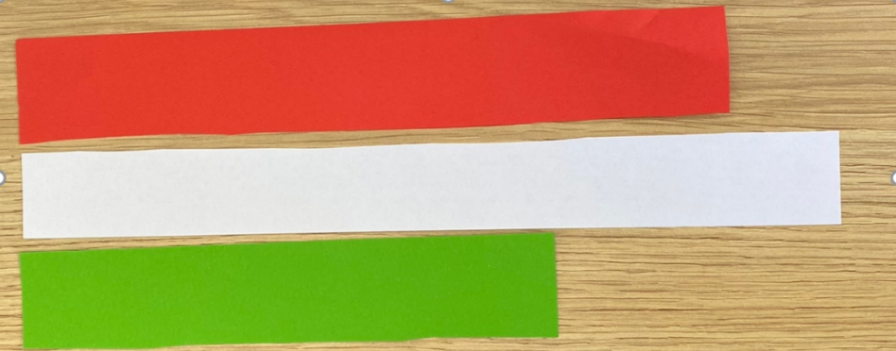
- Ask a student to order the strips using direct comparison. Ask for their reasoning and justification.
The table below outlines stimulus prompts to generate conversation about the topic, along with anticipated responses from students.
Prompts | Anticipated student responses
- Which strip of paper is the longest? How do you know?  - I’m wondering how much longer the white strip is compared to the other strips of paper. How can we find out? | - White is the longest because it is longer at the end.  - Estimates: ‘The white strip is about double the length of the green strip’ or ‘I noticed the white strip is about this much bigger’ (student indicates with fingers or lays the paper strips on top of each other for comparison).
Note: Early Stage 1 students require many experiences with direct comparison. As Stage 1 students move onto measuring with units, it may be beneficial for Early Stage 1 students to continue using direct comparison to find objects longer, shorter and the same as the strips of paper. Students can record their findings by drawing pictures.
- Ask students to estimate how many cubes they think will be needed to measure the strips. Have students record their estimates.
- Students measure the length of one strip using cubes. Explain that, when measuring lengths accurately, there are no gaps or overlaps and units are in straight lines from end to end. If students do not demonstrate the intended learning, pause the lesson and demonstrate how to accurately measure the length of the paper strips. As students measure the strips, ask them to record findings beside their estimations.
- After measuring the length of the first strip of paper, ask students if they would like to revise their other estimates.
- Students participate in a gallery walk to see how others have recorded their results. Briefly discuss the features of images and diagrams. Allow time for students to revise their recordings.
- Ask students:
- How can we use the information to compare the lengths of paper?
- How many cubes long is the white strip of paper?
- How many cubes long is the green strip of paper?
- How many cubes long is the red piece of paper?
- How many cubes longer is the white strip of paper compared to the other paper strips?
- Students explore strategies to find out how much longer or shorter the strips of paper are using the language of comparison. Students may use words, symbols, images, or concrete materials to determine and record the difference between the lengths. They may also use known facts to determine the difference. For example, ‘I know the white strip is 15 cubes long and the green strip is 10 cubes long. So, the white paper strip is 5 cubes longer than the green strip of paper’ (see Figure 2).
Figure 2 – Comparing lengths with cubes
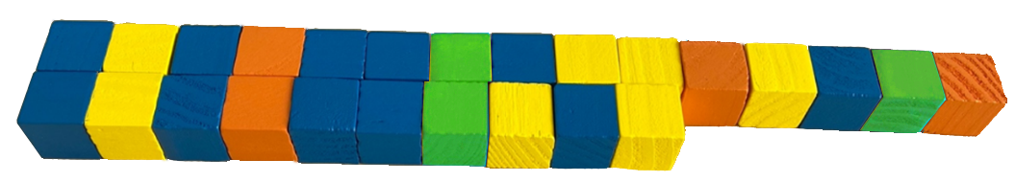
- Display the paper strips on a larger piece of paper. Share a range of student strategies for exploring the difference in lengths. To support the conversation, ask:
- Which object is the longest? How do you know?
- How much longer is the white strip compared to the red/green? How can we be sure?
- What helped you find out how many more or fewer cubes there were in each length?
- How did you make sure you were measuring the paper strips accurately?
This table details assessment opportunities and differentiation ideas.
Assessment opportunities | Too hard? | Too easy?
What to look for:  - Do students estimate lengths and revise estimations when provided with more information? (MAO-WM-01, MAE-GM-02, MA1-GM-02)  - What strategies are students using to record lengths? Is there a combination of symbols, words, pictures and/or diagrams? (MAO-WM-01, MAE-GM-02, MA1-GM-02)  - Are students using measuring techniques such as end to end and in a straight line with no gaps, when comparing lengths? (MAO-WM-01, MAE-GM-02, MA1-GM-02)  - Can students compare and order lengths? (MAO-WM-01, MAE-GM-02, MA1-GM-02)  - Are students describing lengths by describing the number of units used? (MAO-WM-01, MA1-GM-02)  - Can students compare and order lengths by describing how many cubes longer or shorter or quantify the difference? (MAO-WM-01, MA1-CSQ-02, MA1-GM-02)  What to collect:  - student estimations and recording of lengths. (MAO-WM-01, MAE-GM-02, MA1-CSQ-02, MA1-GM-02) | Students do not understand how to line up objects for direct comparison.  - Demonstrate how to line up objects using the edge of a desk to ensure that the objects being compared have the same starting point.  - Three students pretend that they are strips of paper and stand next to each other to directly compare their heights. Explain that this is an accurate method because their feet are at the same starting place. It would not be accurate if one student was standing on a step.  Students may not understand that units need to be lined up end to end with no gaps or overlaps.  - Help students to compare lengths by lining cubes end to end.  - Show students how to line up the cubes end to end and ask whether a strip of paper is really 5 cubes long if there are big gaps between the cubes. | Students can directly compare the length of 2 or more objects.  - Measure lengths of string and flexible objects and discuss how the measures can be accurately compared.  - Draw straight, curved, and wiggly lines and discuss how to compare lengths.  Students can describe how they ordered lengths and discuss a variety of strategies that can be used to determine the difference in lengths.  - Ask students to create a new strip of paper that is 5 cubes longer than the longest strip of paper, without using cubes.  - Students can estimate the length using visualisation, and then check using cubes.

Lesson 2: What’s the difference?
Core concept: A range of informal units can be used to measure accurately.
The table below contains suggested learning intentions and success criteria. These are best co-constructed with students.
Learning intentions | Success criteria
All students are learning that:  - to measure length accurately, there must be no gaps or overlaps and units are to be placed in straight lines  - numbers and units help accurately describe how big, tall, or long something is  - the unit of measurement affects how many are needed  - mathematicians use a range of representations to communicate ideas. | All students can use words, symbols, pictures, and drawings to compare different lengths.  In addition, students working towards Early Stage 1 outcomes can use a piece of string to group objects that are shorter, longer and the same as the piece of string.  In addition, students working towards Stage 1 outcomes can:  - position rods accurately to count the number of informal units needed to measure a chosen object  - recognise that the longer the unit of measurement the fewer units will be needed  - use a prepared table to record findings  - explain why some rods work better than others. For example, some rods might work better because when they were repeated there were no leftovers.

Daily number sense: Domino flip – 10 minutes
- Build student understanding of quantities through comparison using a domino game.
- Teams flip over one domino each and compare the quantities. The highest (or lowest) quantity wins that round. Players take one counter each time they win a round. The player with the most counters at the end of 10 rounds wins.
- Variations: record the difference; the student with the largest (or smallest) difference at the end of 5 (or another chosen number) of rounds is the winner. Vary the domino number range.

How long is this? – 50 minutes
This activity has been adapted from Boaler et al. (2021).
- Remind students that, in the previous lesson, they used units to measure strips of paper. Students reflect on strategies for measuring with units that were successful and unsuccessful. Explain that they will be using coloured rods to measure lengths.
- Display a collection of objects to be measured and allow students to contribute additional objects. Tell students that they will be answering the question ‘How long is this?’ by measuring the length of different objects using different coloured rods (see Figure 3).
Figure 3 – Example of classroom item to measure
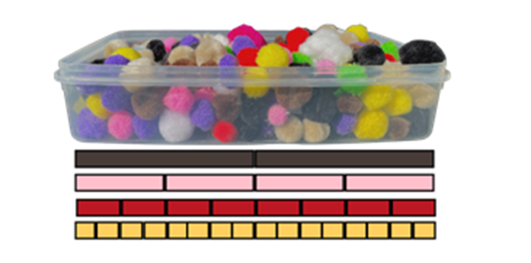
- In pairs, students choose 4 objects from the collection and use coloured rods to measure them. At this point, Early Stage 1 students could use a piece of string or wool to measure and group objects that are shorter, longer and the same as the piece of string or wool and record their findings. Allowing students to use different lengths and colours of string or wool could promote further thinking and discussion.
- As the Early Stage 1 students measure, ask:
- Which length and colour of string or wool did you choose?
- Why did you choose that length and colour?
- What happens when you choose a different length and colour?
- Can you order the objects you have measured from shortest to longest and describe how you know?
- Stage 1 Students measure the length of the object by lining different coloured rods along the object’s length and record their findings beside the estimation (see Figure 4.)
Figure 4 – Table to record data
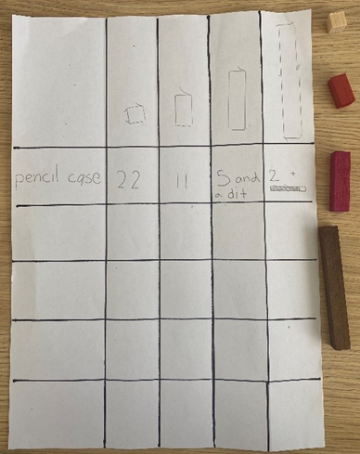
- Monitor for students attending to the relationship between the length of the rods and the number of rods needed as they make their estimations. Students may use pictures, symbols or words to record their estimations and can also use classroom technology to record their responses.
- Monitor for students measuring in a fair and accurate way (using the same-coloured rod for each measure, end on end, without gaps or overlaps). If students are not measuring accurately, pause the lesson or work with small groups to explicitly address the intended learning for measuring lengths accurately.
- As students measure with the rods, ask:
- Which rod did you use to measure your object?
- Why did you choose to use that rod?
- How many red/brown rods long is your object?
- What happens when you choose a different coloured rod to measure your object?
- How can you record your findings so you can share them with others?
- Can you order the objects you have measured from shortest to longest and describe how you know?
- Bring students together to share their findings. Make explicit the intended learning, that the size of the unit affects how many units are needed. Explain that mathematicians use diagrams and tables to help communicate their ideas. Ask:
- Is there a way to publish our findings that would help us compare the size of the units and the number of units we needed?
- What information would be important to record?
- How could we set up a table so we can see how many rods we need of each colour to measure our object?
Note: Paper folding can be used to create a table. Fold the left side of the paper over a third, then halve and halve again to create 5 sections. This creates one large column on the left to write the object measured, and 4 columns on the right to record how many rods are needed. Use the lines as a guide to rule the table. You could also have a large version of the table that includes all the different coloured rods to record different findings (see Figure 4).
- Using a piece of A3 paper, demonstrate how paper can be folded to create a table for displaying mathematical findings. In pairs, students create their own table and enter their results.
- In pairs, students record anything they notice about the size of the unit and the number of units needed. Ask whether they thought some rods were more difficult to measure with than others.
- Select students to share their results and what they noticed about the relationship between the size of the unit and the number of units needed. As students share their findings, annotate their work samples to make the learning intentions explicit. Photos of objects measured with the rods lined up underneath support student understanding. Ask students:
- What happened when we used different rods to measure the length of our objects?
- Were some rods easier to measure than others?
- How can we say how long something is if the rods have a bit left over at the end?
- How did the table help you to compare the units used to measure the objects?
- When information is recorded in a table, do you notice any patterns? (Students may articulate that 2 pink rods together are the same length as one brown rod)
This table details assessment opportunities and differentiation ideas.
Assessment opportunities | Too hard? | Too easy?
What to look for:  - Are students reflecting and adopting ideas and strategies as they listen to others, and how do they communicate so that others can understand? (MAO-WM-01)  - Can students compare and group lengths using direct comparison? (MAO-WM-01, MAE-GM-02)  - Are students using the comparative language to describe the lengths? (MAO-WM-01, MAE-GM-02)  - Are students using measuring techniques such as end to end, no gaps or overlaps, measuring in a straight line? (MAO-WM-01, MA1-GM-02)  - What strategies do students use when estimating lengths and revising estimates when provided with more information? (MAO-WM-01, MA1-GM-02)  - How do students describe the relationship between the size of the unit and the number of units needed? (MAO-WM-01, MA1-GM-02)  - Did students notice that some units are more accurate than others, some units have leftovers and some line up neatly? How did they explain it? (MAO-WM-01, MA1-GM-02)  What to collect:  - photographs of Early Stage 1 students measuring objects (MAE-GM-02, MAE-GM-02)  - work sample of the table that students used to record data (MAO-WM-01, MA1-GM-02)  - observation checklist for students demonstrating correct measurement. (MAE-GM-02, MA1-GM-02) | Students do not understand how to line up objects for direct comparison. Demonstrate how to line up objects using the edge of a desk to ensure that the objects being compared have the same starting point.  Students may not recognise the need to measure length with consistent informal units.  - Support students to use correct measurement techniques when lining up units end to end without gaps or overlaps.  - Explain that, when using different units, it is difficult to describe how long our object is. For example, the length of the scissors can be described as one green, 2 blue and 3 red rods long. It is easier to describe when all the units are the same. | Students can articulate the relationship between the size of the rods and the number of rods. Give students another item in the classroom and have them estimate its length using specific-coloured rods. For example, how many white rods and how many red rods are needed to measure the same object? Ask students to justify their answers. For example, if the red rods are double the length of the white rods, students will need double the number of white rods for each red rod.  Students estimate and justify how many rods they would need to measure objects outside the classroom. Ask whether the rods provided are the best way of doing this, or if there is a different informal unit that could be used.

Lesson 3: Messy lengths
Core concept: Mathematicians estimate lengths and account for leftovers.
The table below contains suggested learning intentions and success criteria. These are best co-constructed with students.
Learning intentions | Success criteria
All students are learning that:  - to measure length accurately, there should be no gaps or overlaps, and the units should be in straight lines  - numbers and units help accurately describe how big, tall, or long something is  - the unit of measurement chosen affects how many units are needed  - ‘getting our eye in’ helps create reasonable estimations  - mathematicians explain their thinking so it makes sense to others. | All students can communicate their thinking and reasoning coherently and clearly.  In addition, students working towards Early Stage 1 outcomes can:  - use pieces of string to determine halfway, more than halfway, and less than halfway  - divide a length into 2 equal parts.  In addition, students working towards Stage 1 outcomes can:  - measure lengths accurately using one building brick, and mark and move without leaving gaps or spaces  - describe how, the smaller the unit, the more building bricks will be needed and the longer the unit, the fewer building bricks will be needed  - change estimates when provided with more information.

Daily number sense: Number talk – 20 minutes
- Build student understanding of additive relationships through a number talk.
- Display Resource 2: Measuring lengths. Explain that Phil and Silvia have been measuring the length of 2 pieces of string using building bricks and found that, when they combined their building bricks, they had a total of 17. Phil knew his string was 9 building bricks long. Ask students:
- How many building bricks long was Silvia’s string?
- What different ways are there to prove how many building bricks long Silvia’s string was?
- What do you notice about the numbers on the diagram?
- How can you use what you know to find out what you do not know?
The table below outlines stimulus prompts to generate conversation about the topic, along with anticipated responses from students.
Prompts | Anticipated student responses
- What do you notice about the numbers on the diagram?  - How can you use what you know to find out what you do not know?  - How many different ways can we find out the total number of missing building bricks? | - Take away by ones: students use fingers to keep track of the number taken away  - Landmark numbers: ‘I can partition 9 into 7 and 2 to help me get to the nearest landmark number. 17 − 7 = 10, 10 − 2 = 8, so 17 − 9 = 8.’  - Near doubles: ‘Double 9 is 18 so it must be 9 and 8.’  - Think addition: ‘I can use what I know about how many more. 9 + something = 17.’  - Known fact: ‘10 and 7 is 17, so 9 and 8 must also be 17.’

Messy lengths – 50 minutes
This activity has been adapted from Bruce et al. (2016).
- Give Early Stage 1 students a 16 cm strip of orange paper and a 10 cm strip of green paper fixed in different orientations as shown in Figure 5.
Figure 5 – Green and orange strips of paper in different orientations
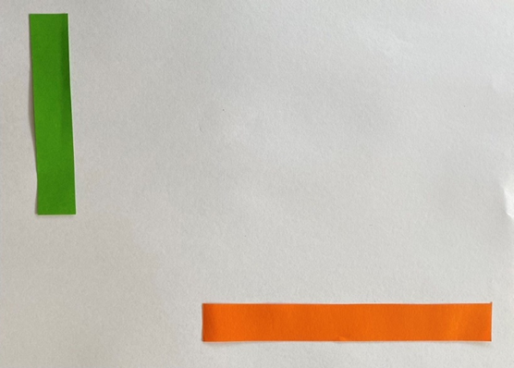
Note: Different orientations mean that students cannot use direct comparison.
- Students experiment with pieces of string and differently sized paper strips to find strategies to discover which strip is longer. Use turn and talk to justify reasoning.
- Ask students:
- Which strip of paper is longer?
- How do you know?
- Is there another strategy that you could have used?
- How do you know that you were measuring accurately?
- Ask students to find objects that are shorter than and longer than the piece of string or strip of paper that they have created. Students then draw a picture to display their findings.
- Show Stage 1 students a 16 cm strip of orange paper and ask them to estimate how many 2 × 8 sized building bricks long the strip is. Record students' estimations. Show the 2 × 8 building brick on top of the orange strip and ask if they would like to revise their estimation now that they see the building brick’s size in relation to the size of the orange strip.
- Provide students with one 16 cm strip of orange paper and one 2 × 8 sized building brick to measure the strip’s length. Students find how many 2 × 8 building bricks are needed to measure the length. Monitor for students describing how to measure the length using only one building brick and using the brick to measure end to end with no gaps or overlaps. Observe references to partial measures describing the equal sized parts of the last 2 × 8 building brick, describing 2 whole building bricks and some more, 2 whole building bricks and half, or 2 whole building bricks and 8 studs. See Figure 6.
Figure 6 – Strips of paper and coloured bricks
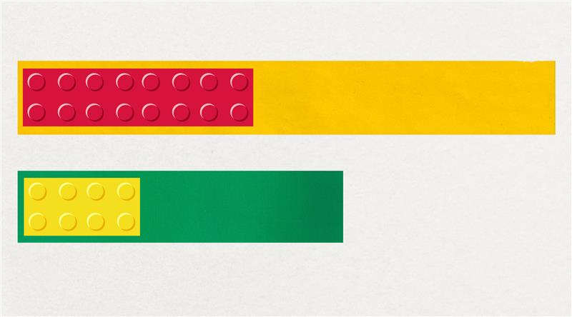
Note: If students do not measure carefully or find a different number of building bricks for the length, pause the lesson and explicitly address the intended learning for measuring. Show students the results that some groups were using and demonstrate the actions of a good measure. Reinforce the intended learning: that measuring accurately means marking the ends with no gaps or overlaps.
- Annotate the publicly shown orange strip of paper to record student ideas. Select students to share their thinking and ask:
- How did you know how many building bricks to use when you only had one brick?
- Did you find a strategy to make sure you were measuring accurately?
- How many building bricks do we need to measure the orange strip of paper?
- How much do you think is left over?
- Display the 10 cm strip of green paper and ask students to estimate how many 2 × 4 sized building bricks long the strip of paper is. Students record their estimations. Hold the building brick up to the paper and invite students to revise their estimation with a partner using turn and talk. Listen for students articulating the intended learning of ‘getting their eye in’ to make reasonable estimations and visualising the building brick moving along the length. Invite students to share their reasoning (see Figure 6).
- Students determine the length of the green strip of paper with one 2 × 4 sized building brick. Observe students accurately using the building brick to measure the length, marking the length of each single building brick. Listen for students articulating the intended learning of partial measures. If the building bricks do not line up exactly, ask students how they can describe the part that hangs over the end. Students may describe the leftover bit as less than half, a little bit, 2 studs of the brick, or a quarter.
- Select students to discuss their findings. Ask the questions above to reinforce the intended learning while annotating the green strip of paper to record the class findings.
- Ask students if they could use a different sized building brick to measure the lengths of paper so there are no bits leftover.
- Allow students time to explore the different building bricks. Ask students which building bricks will make a tidy measure with no leftovers. Students may articulate that they can use the 2 × 4 sized building bricks for the orange strip; that when they line the 2 × 4 sized building brick under the 2 × 8 sized building brick they need 2 of the smaller bricks to make the same length; or that 2 × 4 is half the length of 2 × 8, which means that students will need two 2 × 8 sized building bricks or four 2 × 4 sized building bricks to create the length of the orange paper strip.
- Ask how students could use what they know about the length of the building bricks to make a new green strip of paper that is the same length as the orange strip of paper.
- Students investigate how much longer the orange paper strip is compared to the green paper strip using a variety of building bricks. Ask questions to support students to notice the difference in length of the different strips of paper:
- How many 2 × 4, 2 × 2, or 2 × 1 sized building bricks would we need to make the strips the same length?
- Can we make the lengths the same using a 2 × 8 sized building brick?
- How could we describe how much longer the orange paper strip is?
- Select students to share their findings about which building bricks can be used to measure the length of the paper strips without leftovers. Have students describe the relationship between the building bricks. Ask questions to guide student thinking toward the intended learning:
- What happened when you measured the paper strips with different sized building bricks?
- Were some units better than others?
- What patterns did you notice when you lined up the building bricks?
- How can we name the part leftover?
This table details assessment opportunities and differentiation ideas.
Assessment opportunities | Too hard? | Too easy?
What to look for:  - Are students reflecting and adopting ideas and strategies as they listen to others, and how do they communicate so that others can understand? (MAO-WM-01)  - Are students using words or diagrams to show the relationship between parts and the whole? (MAO-WM-01, MAE-GM-03, MA1-GM-03)  - Are students using indirect comparison to decide which is longer? (MAO-WM-01, MAE-GM-02)  - Are students comparing lengths indirectly by copying a length? (MAO-WM-01, MAE-GM-02)  - Are students recognising and describing lengths as being divided into halves of a length? (MAO-WM-01, MAE-GM-03)  - Are students using measuring techniques such as end to end, no gaps or overlaps, and measuring in a straight line? (MAO-WM-01, MAE-GM-02, MA1-GM-02)  - Do students estimate lengths and revise estimates when provided with more information? (MAO-WM-01, MA1-GM-02)  - How do students describe the relationship between the size of the unit and the number of units needed? (MAO-WM-01, MA1-GM-02)  - Are students recognising and describing lengths as being divided into halves or quarters of a length? (MAO-WM-01, MA1-GM-03)  What to collect:  - observational data. (MAO-WM-01, MAE-GM-03, MA1-GM-03) | Students are unable to determine which strip of paper is longer due to the different orientation. Create a strip of paper the length of the orange strip of paper. Have students use direct comparison to measure the coloured strips of paper. Explain that the 16 cm strip of paper is the same length as the orange strip but longer than the green strip. This means that the orange strip is longer than the green strip.  Students do not recognise or know how to describe the additional half length.  - Explain that it is ok to have parts of a measure and that these parts can be named using what we know about parts of a whole.  - Create a strip of paper the length of the building brick. Have students fold the piece of paper and describe how we can name the parts. For example, 2 equal parts tells us we have halves.  - Discuss the number of studs on the building brick. Explain how this can help us to describe the leftover part. | Students recognise that we can use the part of the unit to describe the length using the language of fractions.  - Draw students’ attention to the relationship between the 2 strips. Ask what they notice about the length of the paper strips, and how many of each building brick is needed to measure the strips’ length.  - Create a third strip of paper that is double the length of the first. Ask students to estimate how many building bricks they will need using what they know about the length of the current strip.  - Students could explore doubling and halving further using the Different Sizes activity at NRICH.

Lesson 4: Cut me a fair share
Core concept: Lengths can be partitioned into fractions.
The table below contains suggested learning intentions and success criteria. These are best co-constructed with students.
Learning intentions | Success criteria
All students are learning that:  - a whole length can be broken up into equally sized parts known as fractions  - the number of equal parts a length is broken into helps to name the fractions that have been created  - the same idea can be represented in different ways  - mathematicians compare their thinking with the thinking of others to refine and extend ideas. | All students can recognise that the more equal parts the whole is divided into, the smaller each part becomes.  In addition, students working towards Early Stage 1 outcomes can use direct comparison to determine if an object has been halved.  In addition, students working towards Stage 1 outcomes can:  - divide a whole into equal sized pieces to represent fractions  - use direct comparison to determine if an object has been halved or quartered  - use repeated halving to create quarters.

Daily number sense: Equal, not equal – 15 minutes
- Build student understanding of fractions by investigating examples and non-examples of halves (Early Stage 1) and quarters (Stage 1).
- Display Resource 3: Folded paper into 2 sections and Resource 4: Four paper sections into 4 sections and ask which shapes are divided into equal parts.
- Students use ‘Talk moves’ to justify which examples show equal parts and which do not. While students are talking, listen for reasoning to highlight in a class discussion.

Cut me a fair share – 45 minutes
This activity has been adapted from Van de Walle et al. (2019).
- Explain that students will plan a picnic lunch. The students will be sharing long salad rolls and need to make sure there will be a fair share of servings for everyone. Pose the problem: ‘4 friends want to share 6 long salad rolls so that each person gets the same amount. How much will each person get?’
- Provide students with paper strips to represent each of the long salad rolls. In groups, students explore the different ways they can partition the rolls to determine how much each person will receive.
- Observe students experimenting with paper folding and partitioning the paper strips. Monitor for students describing the intended learning (that lengths can be partitioned into equally sized parts). If students are not creating equal shares, pause the lesson and ask questions such as:
- I notice this roll has been partitioned into 2 parts but, when I hold them up, they don’t look like a fair share. Is it fair if I take this big bit and X gets the small bits? How can we create a fair share?
- How can we be sure that our shares are fair?
- How can we prove that our parts are equal?
- Does anyone have a strategy to make sure we are sharing the rolls equally between the students?
- If students arrive at a solution, provide them with more paper strips and challenge them to find another way to share the rolls fairly between group members. Encourage students to record their findings using words, images, and symbols.
- Pose the next problem: ‘When the friends opened the bag of salad rolls, there were actually 8 salad rolls. Ask how students can share the 8 rolls fairly with the 4 friends?’ Provide students with additional paper strips to represent the new number of 8 rolls. Variation for Stage 1 students: use 7 rolls instead of 8 to create quarters.
- Observe students describing the intended learning (that length can be partitioned into equally sized parts). Encourage students to name the fractions they have created and discuss how they know what fractions were created. If students are unsure how to name the fractions, pause the lesson and demonstrate how to notice and describe fractions by attending to the whole, the number of parts, and the relationship between the parts and the whole. Create an anchor chart for students to reference.
Note for variation: Students do not need to identify the portion of salad rolls that each person will receive as ‘1 and 3 quarters’ to be successful. Instead, students may say that each person gets 1 whole roll, 1 half of a roll, and 1 quarter of a roll. If students do notice the relationship between halves and quarters, they may rename the halves as 2 quarters, then add on the other quarter to show the 3 quarters. This can be explored using the partitioned strips of paper.
- Select groups of students to share their evidence of partitioning. Students demonstrate the fair shares by aligning the parts on top of each other and naming them. Compare partitioning strategies to show different ways of solving the problem.
- Ask questions such as:
- What was the most efficient way of sharing the rolls?
- How do you know you have created halves/quarters?
- What do you notice about the parts you have made?
- How are they the same? How are they different?
Note: Students should notice the difference between the whole rolls, the rolls partitioned into halves, and the rolls partitioned into quarters. Use students’ observations about these differences to create an anchor chart for future lessons. For example, students may articulate that, when they see quarters, the parts are smaller than the halves or the whole.
This table details assessment opportunities and differentiation ideas.
Assessment opportunities | Too hard? | Too easy?
What to look for:  - What range of strategies are students exploring to share the rolls equally between the friends? (MAO-WM-01, MAE-GM-03, MA1-GM-03)  - Are students describing the relationship of the parts to the whole length? (MAO-WM-01, MAE-GM-03, MA1-GM-03)  - Do students recognise and explain how rolls have been partitioned into halves (Early Stage 1 and Stage 1) or quarters (Stage 1) and then describe how they can prove they are equal parts? (MAO-WM-01, MAE-GM-03, MA1-GM-03)  - How do students explain that as they created more parts, the smaller the parts became? (MAO-WM-01, MAE-GM-03, MA1-GM-03)  - Are students articulating that there is more than one way to partition the rolls and making connections between their own partitioning strategies and those of others? (MAO-WM-01, MA1-GM-03)  What to collect:  - observational data. (MAO-WM-01, MAE-GM-03, MA1-GM-03) | Students have shared the rolls unevenly or the rolls are partitioned into unequal parts.  - Explain that, when we make fractions, it is important to make sure the parts of the roll are the same size. This will help us to make sure that everyone gets a fair and equal share.  - Demonstrate fair/unfair partitioning of paper strips. Ask students to attend to the features that help them notice if they have made halves or not halves, quarters or not quarters. | Students have found a way to partition the rolls to provide an equal share and are able to articulate how much each person will receive.  - Ask if there are other ways that the rolls can be shared equally. Provide more paper strips for the students to find other ways the rolls can be partitioned.  - Support students to create a diagram that shows the different ways that the rolls can be partitioned. Ask if students can describe how this way is similar or different to the first way.  - Ask students whether they can find all of the ways to partition the rolls. Students justify their thinking.

Lesson 5: Eating toast
Core concept: 2D shapes can be partitioned.
The table below contains suggested learning intentions and success criteria. These are best co-constructed with students.
Learning intentions | Success criteria
All students are learning that:  - an object can be broken up into equally sized parts known as fractions  - a fraction describes the relationship between the whole and the equal parts it has been broken into  - the same part can be described in different ways  - mathematicians use images and diagrams to communicate with others and prove their thinking. | All students can:  - divide a whole into equal sized pieces to represent fractions  - recognise that the more equal parts the whole is divided into, the smaller each part becomes  - create drawings to show how objects can be partitioned.  In addition, students working towards Early Stage 1 outcomes can:  - use direct comparison to determine if an object has been halved  - rebuild a whole using 2 halves.  In addition, students working towards Stage 1 outcomes can:  - use direct comparison to determine if an object has been halved or quartered  - use repeated halving to create quarters  - recognise halves and quarters  - rebuild a whole using 2 halves or 4 quarters.

Daily number sense: A sharing story – 20 minutes
- Build student understanding of division by distributing a collection of objects equally into a given number of groups to determine how many objects are in each group.
- Pose the problem: ‘2 children are planning to share 12 lollies. Everyone must get a fair share. How many lollies will each person get?’
- Provide students with time to solve the problem. Students may use hand signals to show how many ways they can think of to solve the problem.
- Use ‘Talk moves’ to discuss the ways students are solving the problem and monitor for any of the anticipated responses to highlight during the class discussion. Strategically select students to share their thinking and record on a public display to assist others to understand.
- Pose the follow up problem: ‘2 children are planning to share 24 lollies. Everyone must get a fair share. How many lollies would each person get?’
The table below outlines stimulus prompts to generate conversation about the topic, along with anticipated responses from students.
Prompts | Anticipated student responses
- What is the problem asking us to do?  - How do you know?  - If you have thought of one way to solve the problem, can you think of another?  - Is sharing the only strategy that would work?  - What do you notice about the numbers in the problem? How could we use that to find how many each person gets? | - Sharing by ones: students may keep track of how many they have given out using their fingers.  - Use of forming groups strategy: ‘I know that 2 × 5 is 10, and then there are 2 left to share.’  - Trial and error: ‘If I give them 3 each, that is 3, 6, 9, 12. That’s not enough, so it must be more than 3. I could try using fours’.  - Repeated halving: ‘I know half of 24 is 12, but I need to share them with four people not 2. If I half again I will have 4 groups and half of 12 is 6 so they must get 6 each.’

Eating toast – 50 minutes
This activity has been adapted from Askew (2015).
- Pose the problem: ‘On Wednesday, I made a piece of toast and cut it horizontally into 2 equal pieces. I ate one piece. On Thursday, I made another piece of toast and cut it diagonally into 2 equal pieces. Did I eat more toast on Wednesday or Thursday?
- At this point, Early Stage 1 students can independently cut paper squares to represent the toast and use ‘Talk moves’ to justify their reasoning.
- With Stage 1 students pose the problem: ‘On Friday I made my toast, but this time I cut it into 4 equal sized pieces. I only ate 2 of the pieces. Did I eat more toast on Wednesday, Thursday, or Friday?’
- Give students talk time. Provide students with 4 different coloured paper squares that represent the toast. Instruct the students to explore the problem with paper to build evidence to justify their thinking.
- Monitor students discussing and experimenting with the paper by folding and partitioning. If students are not creating equal parts, pause the lesson or speak with individual students by asking questions such as:
- How can we create equal parts with the paper?
- How can we prove that our parts are equal?
- Monitor students as they describe the parts. They should identify the Wednesday/Thursday toast as halves and the Friday toast as quarters. It may be beneficial to lay an extra square underneath students’ paper folding and partitioning so that they can see the half and quarters in relation to the whole.
- Identify students who were able to prove on which day you ate more toast. Ask them to share their strategy for determining the answer. For example, laying the 2 pieces from Thursday on top of the one piece from Wednesday to show they were the same. If students have partitioned one piece of toast on the diagonal and the other straight down the middle, discuss how to compare the 2 different cuts.
- Once students have had enough time, provide them with A3 paper to create a poster to convince their audience of the solution. Students may want to draw a diagram or glue their partitioned shapes to the paper.
- Conduct a gallery walk and then allow time for students to revise their poster.
- Pair groups of students together to convince their audience (one another) of their argument using the evidence from their poster.
- Select students to share their proof with the class. Revise the question: ‘Did I eat more toast on Wednesday, Thursday, or Friday?’ Ask if everyone agrees. While the students are sharing their evidence, ask questions to clarify or extend student thinking:
- What do you notice about the parts you have made?
- How are they the same? How are they different?
- What language can we use to describe the parts?
- How can it be that when you ate one piece on Wednesday, you ate the same amount as the day you ate 2 pieces? Isn’t 2 more than one?
This table details assessment opportunities and differentiation ideas.
Assessment opportunities | Too hard? | Too easy?
What to look for?  - What range of strategies did students explore to partition the toast into equal parts? (MAO-WM-01, MAE-GM-03, MA1-GM-03)  - How did students describe and communicate the relationship of the parts to the whole? (MAO-WM-01, MAE-GM-03, MA1-GM-03)  - Are students recognising and explaining how squares have been partitioned into halves (Early Stage 1 and Stage 1) or quarters (Stage 1) and describing how they can prove they are equal parts? (MAO-WM-01, MAE-GM-03, MA1-GM-03)  - How do students explain what they noticed? As we created more parts, the smaller the parts became? (MAO-WM-01, MAE-GM-03, MA1-GM-03)  - Are students creating quarters by repeated halving? (MAO-WM-01, MA1-GM-03)  - How are students justifying that 2 quarters of the toast is the same amount as one half of the toast? (MAO-WM-01, MA1-GM-03)  What to collect:  - recording of gallery walk (MAO-WM-01, MAE-GM-03, MA1-GM-03)  - A3 posters. (MAO-WM-01, MAE-GM-03, MA1-GM-03) | Students may think that the teacher will eat more on Thursday because the triangular pieces look larger than the rectangular pieces. Students use overlaying and cutting strategies to explore conservation of area and how 2 halves make a whole.  Students may think that the teacher will eat more on Friday because they ate 2 pieces.  - Ask the student to show you how each of the pieces of toast are partitioned using paper folding. Cut paper into halves and layer them on a whole square so you can see the 2 parts sitting on top. Do the same with the quarters. Ask the student to get the part that you ate on Wednesday and move it below, doing the same for the Friday toast. Ask students what they notice about the parts that had been eaten.  - If students need further support, lay the 2 quarters on top of the half and explain that although you ate 2 pieces on Wednesday, when you lay the 2 quarters on top of the half, they are the same amount. Ask if students can see that there are no gaps or overlaps. Revise that this means the pieces are the same size. | Students have solved the problem and are able to use their evidence to articulate the intended learning. Extend this thinking into halves and quarters of a collection. For example, ‘I had a bag of 12 treats and ate half one day, and the next I had 24 and I ate 2 quarters of them. Which day did I eat the most?’

Consolidation and meaningful practice: Handfuls – Thinking multiplicatively – 10 minutes
Note: Teacher could view the following resource prior to the lesson Handfuls (thinking multiplicatively) (11:04).
- Gather a collection of items for students, for example, animals or mini figurines. Items need 2 or 4 legs to enable multiplicative thinking.
- First player takes a handful of items and the second player estimates how many the first player has.
- First player arranges the items into a known pattern. For example, dominoes, dice, ten-frame.
- Second player identifies the number of items.
- Second player then calculates the number of legs/paws by counting by twos or fours.
- Students can rearrange items into different known patterns to support multiplicative thinking.

Lesson 6: Paper bugs
Core concept: Doubling and halving can be used to create fractions.
The table below contains suggested learning intentions and success criteria. These are best co-constructed with students.
Learning intentions | Success criteria
All students are learning that:  - a length or object can be broken up into equally sized parts known as fractions  - a fraction describes the relationship between the whole and the equal parts it has been broken into  - the same part can be described in different ways, for example, 2 quarters or one half. | All students can:  - divide a whole into equal sized parts to represent fractions  - use direct comparison to determine the relationship between the whole and the parts  - recognise that the more equal parts the whole is divided into, the smaller each part becomes.  In addition, students working towards Early Stage 1 outcomes can use the vocabulary doubling and halving.  In addition, students working towards Stage 1 outcomes can use repeated halving to create quarters and eighths.

Daily number sense: 10 minutes
- Identify a short, focused activity that targets students’ knowledge, understanding and skills. Example activities may be drawn from the following resources:
- Thinking mathematically
- Universal Resources Hub

Exploring paper bugs – 40 minutes
This activity has been adapted from Bruce et al. (2016).
- Provide pairs or small groups of students with multiple copies of Resource 5: Paper bugs. Explain to students that paper bugs are special mathematical creatures that can grow and shrink. Ask the following questions:
- What do you notice about each of the different bugs?
- How could we describe their lengths?
- Is there a way that we can show how their lengths are related?
- Observe students as they describe the different lengths of the paper bugs. Monitor for students using direct comparison and language such as double and half, to describe the lengths. If students do not attend to the doubling and halving relationship, ask:
- I am thinking that the blue bug is double the length of the red bug. Do you agree?
- What do you notice if we halve the green, blue, and red bugs?
- Is there a way we can make the green bug the same length as a red bug?
- Discuss and share findings as a group.
Note: Students should notice that the paper bugs can be doubled or halved to become equal in length. It may be beneficial to create a chart that shows how each bug can be doubled or halved to create the same length as another bug.
- Explain that, just as smaller paper bugs were hiding inside bigger paper bugs, smaller numbers also hide inside bigger numbers. Use think-alouds to model language to students. For example, ‘We noticed before that if we double the length of a red bug, it becomes the same length as a blue bug. This means that we can see 2 red bugs hiding inside a blue bug.’
- Ask students:
- Can you find other ways smaller bugs are hiding inside bigger bugs?
- Can we find all the bugs hiding inside the green bug?
- Can we find out how many times bigger the green bug is in relation to the other bugs?
- Students investigate the different ways to see and describe paper bugs hiding inside of each other. Students record their findings by drawing or using the paper bugs to show the parts of the whole.
- Gather students to share findings. Draw students’ attention to the relationship between the number of parts and the size of the whole. For example, ’By using repeated halving we can create halves, quarters then eighths. We know that there are 8 white bugs hiding inside a green bug, and that the white bug is one eighth the length of the green bug. This means that the green bug is 8 times larger than the white bug.’
This table details assessment opportunities and differentiation ideas.
Assessment opportunities | Too hard? | Too easy?
What to look for?  - Are students reflecting and adopting ideas and strategies as they listen to others, and how do they communicate so that others can understand? (MAO-WM-01)  - Can students recognise and explain how lengths can be doubled or halved to create new lengths? (MAO-WM-01, MAE-GM-03, MA1-FG-01, MA1-GM-03)  - What relational reasoning strategies are students using when comparing 2 measures? (MAO-WM-01, MAE-GM-02, MA1-GM-02)  - Are students using language to describe the size of the part in relation to the whole? (MAO-WM-01, MAE-GM-03, MA1-FG-01, MA1-GM-03)  What to collect:  - recordings of student discussions (MAO-WM-01, MAE-GM-03, MA1-FG-01, MA1-GM-03) | Students don’t understand the concepts of doubling and halving. Use concrete materials such as dough or blocks to reinforce the concepts of doubling and halving.  Students don’t recognise or know how to describe the relationship between bugs:  - Prompt students to notice that, if they double or halve certain bugs, the bugs become the same length. For example, double the white bug, or place 2 white bugs next to one another, and see if there is another bug that is the same length.  - Prompt students to use paperfolding and direct comparison to notice the relationship between the bugs. | Students recognise that the name of the fraction tells us its relationship to the whole.  - Have students use what they already know about the relationship between the bugs to create a new bug.  - Ask students if more than one type of bug is hiding inside a green bug. For example, ‘Inside a green bug is one blue bug and 2 red bugs. We can say that one half plus 2 quarters is equal to one whole.’  - Students investigate how many ways there are to make each bug size and look for patterns.

Consolidation and meaningful practice: Double or halve – 20 minutes
- View Double or halve? – Stage 1 (7:37).
- Choose a target number between 10 and 99.
- Write your target number on your blank hundreds chart.
- The first player rolls the dice and chooses whether to double or halve the number.
- Record the roll on the game board, by shading the number of squares.
- Players record the running total to the side of their hundreds chart game board.
- Players take turns to roll the dice. If they can’t go, they miss a turn.
- The winner is the player who reaches the target number exactly.

Lesson 7: Noticing the clock
Core concept: Connections can be made between the number line and clock.
The table below contains suggested learning intentions and success criteria. These are best co-constructed with students.
Learning intentions | Success criteria
All students are learning that:  - an analog clock is made by curving a number line from 1-12 around the outside of a circle  - mathematical terms are used to describe the position of the hands on an analog clock  - a fraction describes the relationship between the whole and the parts it has been broken into. | All students can:  - use a number line and paper folding to construct an accurate analog clock  - use mathematical terms to describe the position of the hands on an analog clock.  In addition, students working towards Early Stage 1 outcomes can describe the position of the hour and minute hands on an analog clock for ‘o’clock’ times.  In addition, students working towards Stage 1 outcomes can explain how and why the words half past, quarter to, and quarter past are used to describe time accurately.

Daily number sense: Doubles fill – 20 minutes
- Build students fluency with double facts and mathematical metalanguage through the game Doubles fill (8:10).
- Players take turns spinning the 1-9 spinner (or roll dice) and spin the doubles fill spinner.
- If a player spins a 6 and spins ‘double’, they double 6 to make 12. Students explain their thinking to their partner, who records the number sentence.
- The player then colours in a corresponding array on the ‘Doubles fill’ gameboard.
- Players swap roles.
- If there is no space on the grid, players miss a turn.
- Play continues until no one can add another array.
- Players then calculate the number of squares they covered and the person with the largest area is the winner.

Wonky clocks – 40 minutes
This activity has been adapted from Boaler et al. (2021).
- In pairs, have students draw a clock. Bring students back together and have them compare their clocks to a real-life or an image of an accurate, round analog clock. Ask students to compare the clock they drew with the display clock.
- Explain that students can use a strip of paper to check how accurate their clocks are by wrapping it around the edge of the clock and marking where the numbers are. Model this process to students, marking each number on the strip of paper. Provide students with strips of paper and have them create their own strip to check the accuracy of their clock.
- Once students have marked their clocks on the strip of paper, have them discuss and compare their strip to the one modelled, asking questions such as:
- Where have we seen numbers arranged like this before?
- What do you notice about the numbers on your strip compared to the accurate one we made?
- What do you notice about the spaces between each number?
Note: As students are drawing their clock number line, they may have the numbers bunched up in sections. An opportunity to refine this will come in the next part of the lesson when you use paperfolding to notice the position of the number on a clock. Draw students’ attention to the relationship between the strip of paper and a number line, and the clock being a curved number line.
- Provide students with new strips of paper of the same length. Explain that we can use what we know about number lines and numbers to help us create an accurate clock. For example, ‘We know that 6 is half of 12 and if we fold our number line in half that is where 6 should be positioned’. Have students fold their number line and mark where the 6 should be located. Ask ‘Is there a way that we can keep folding our paper to find where any other numbers may sit on the clock number line?’. Students use 'Talk moves' to explore.
- Bring students together to discuss their thinking. Draw students’ attention to creating quarters and the relationship between 3 and 9 as being positioned at ‘quarter past’ and ‘quarter to’ on the clock.
This table details assessment opportunities and differentiation ideas.
Assessment opportunities | Too hard? | Too easy?
What to look for:  - How are students explaining their findings as they make connections between a number line and the position of the numbers on a clock? (MAO-WM-01, MAE-NSM-02, MA1-NSM-02)  - Are students revising their thinking about the number line and the clock to create accurate representations? (MAO-WM-01, MAE-NSM-02, MA1-NSM-02)  - What strategies are students using to describe the position of the numbers on a clock number line and relating the position to being quarter to, half past or quarter past? (MAO-WM-01, MA1-NSM-02, MA1-FG-01)  What to collect:  - observations of students manipulating materials to demonstrate conceptual understanding. (MAO-WM-01, MAE-NSM-02, MA1-NSM-02, MA1-FG-01) | Students do not recognise or know how to use paper folding to find where other numbers should be positioned on the number line.  - Ask students to show you how they folded their strip of paper to create half. Explain that we can use what we know about halves to find half of our half.  - Prompt students to think about how they could find out where 3 and 9 should be on the number line.  - If students are still unsure, cut the strip of paper in half and have them half the halves. Lay the 4 quarters on top of the strip of paper and explain that this section represents 6, gesturing to the first 2 quarters. Ask how students can use what they know about halves and the number 6 to help them find another number for the clock. | Students make connections to quarters and the relationship between 3 and 9 as being positioned at quarter past and quarter to on the clock.  - Ask students, ‘How can we find out if all our numbers on our number line clock are evenly spaced?’  - ‘How does knowing where quarter past and quarter to are positioned on a clock help us describe time?’  Students describe different aspects of the day using the language quarter to, half past, and quarter past, as well as the position of the minute hand. For example, ’We eat lunch at half past 12, which means that the minute hand will be pointing to the 6.’  Students have demonstrated full understanding of concepts and can investigate how many different ways there are to split the numbers 1 to 12 into equal groups and describe how they know they have found all of the answers.

Lesson 8: Walking the clock
Core concept: Connections can be made between fractions and the clock.
The table below contains suggested learning intentions and success criteria. These are best co-constructed with students.
Learning intentions | Success criteria
All students are learning that:  - an analog clock is made by curving a number line from 1-12 around the outside of a circle  - the minute hand shows how many minutes past or how many minutes to the hour it is  - the hour and the minute hand are always moving  - the minute hand helps to be more precise when telling the time. | All students can:  - create an analog clock and describe the position of the numbers as being like a number line  - coordinate and describe the movement of the hour and minute hands on a clock.  In addition, students working towards Early Stage 1 outcomes can describe the position of the hour and minute hands on an analog clock when reading hour time.  In addition, students working towards Stage 1 outcomes can:  - describe the relationship between the position of the hands on a clock  - describe the movement of the minute hand on a clock using the language of quarter and half turn.

Daily number sense: Choral counting – 15 minutes
- Build student understanding of counting forwards from different numbers by creating a counting pattern.
- Select the number range based on the needs of the class.
- Students say each number in the sequence collectively as the teacher records the number on a hundred chart. Record the numbers counted aloud, such as counting by twos, starting at any number.
- Ask students what patterns were created in the choral count. Circle and annotate the patterns that students identify after counting. ‘Wait time’ gives students the opportunity to notice patterns, as well as identify the next numbers in the sequence using their knowledge of addition, subtraction and counting in multiples.

A human clock – 45 minutes
This activity has been adapted from Yumi Deadly Maths: Measurement Prep to Year 9 (Yumi Deadly Centre – QUT, 2016).
- In a large open space, students form a human clock by making a circle and using a post with 2 ropes. Begin by placing one student at the 12 position and have students discuss where the other numbers on the clock should be positioned.
- Encourage students to make connections to the previous lesson where they used a number line to determine where 3, 6 and 9 are positioned on a clock, then filling in the remaining numbers. For example:
- We know 6 is halfway around the clock face and is opposite number 12.
- We know that 3 is a quarter of the clock's number line, which means it is halfway between 12 and 6, because half of a half is a quarter.
- We know 9 is 3 quarters of the length of the clock's number line, which means it is positioned halfway between the 6 and the 12.
- The numbers one and 2 for example, need to be evenly spaced between the 12 and 3.
Note: Early Stage 1 students are only required to understand the relationship between the hour and minute hands for ‘o’clock’ times.
- Have students represent the numbers on a clock by holding cards showing the numbers 1 to 12, while 2 students hold the ropes becoming the minute and hour hands. Beginning with both hands positioned at the 12, have students discuss and help their peers to make the minute and hour hand move in coordination with each other. Encourage generalisations such as:
- Every time the minute hand moves one full rotation, the hour hand moves toward the next number.
- When the minute hand is pointing toward 6 it has made a half turn around the clock.
- When the minute hand is pointing toward 3 it has made a quarter turn around the clock.
- When the minute hand is pointing toward nine there is one quarter turn needed to complete the hour.
- When the minute hand is showing half past, or pointing toward the 6, the hour hand moves halfway between the numbers on a clock to show half past.
- In small groups, students create their own walkable clock. Call out times using the language of quarter past, half past, and quarter to the hour. Provide students with the opportunity to embody both the minute and hour hands on the clock.
- Once students can move the minute and hour hand in coordination with each other, ask students to position themselves at a specific time and move forward in quarter or half hour increments. For example, students could begin at half past 3 and move forward half an hour. Repeat using a variety of times. Have students discuss the position of the hands in relation to turns, connecting the movement of the minute hand in half or quarter turns, to the passing of a half or quarter of an hour, and the position of the hands on a clock at those times.
- Discuss the experience of walking around the clock with students. Have students describe the relationship between the hour and minute hand, when it moves, and their role. Ask questions to prompt student thinking such as:
- What did you notice about the movements of the hands?
- What did you have to think about when moving the hour/minute hand?
- Was there anything hard about moving like the hands of a clock?
- How does the turning of the hands on a clock help us describe the position of the hands?
This table details assessment opportunities and differentiation ideas.
Assessment opportunities | Too hard? | Too easy?
What to look for?  - How are students communicating and describing the position of the hands on a clock for the half-hour and relating this to half turns (MAO-WM-01, MAE-NSM-02, MA1-NSM-02)  - Are students reflecting and adopting ideas and strategies as they listen to others, and how do they communicate so that others can understand? (MAO-WM-01)  - Are students making connections between the number line and the clock? (MAO-WM-01, MAE-NSM-02, MA1-NSM-02)  - Are students using the term ‘o'clock’ when describing time? (MAO-WM-01, MAE-NSM-02)  - Are students using the language quarter past, half past and quarter to when describing time? (MAO-WM-01, MA1-NSM-02, MA1-FG-01)  What to collect:  - photographs of human clock role play. (MAE-NSM-02, MA1-NSM-02) | Students do not understand the relationship between the hour and minute hands for ‘o’clock’ times. Demonstrate on a real clock.  Students can’t coordinate the movement of the minute and hour hands.  - Explain that each full turn the minute hand makes is equal to one hour in time. Remind students that the minute hand shows how many minutes have passed in the hour.  - Discuss why the hour hand on a clock is halfway between hour-markers when the minute hand shows the half-hour. | Early Stage 1 students describe the position of the hands for ‘o’clock’ times. Give students problems using elapsed time. For example, ‘lunch starts at one ‘o’clock and finishes one hour later so what is the time now and what does this look like on the clock?’  Students make connections between the position of the hands in relation to half and quarter turns.  - Have students position themselves at, for example, half past 3 and then move to 5 o’clock. Ask students ‘How did you know where to stand at the beginning? How did you know when to stop? How can you describe the turns you took when moving both the minute and hour hands?’  - Have students estimate the duration of everyday events and show this time moving on the clock. For example, lunch is half an hour. It starts at quarter past 12, so students will need to make a half turn to show quarter to one.

Resource 1: Ten-frame
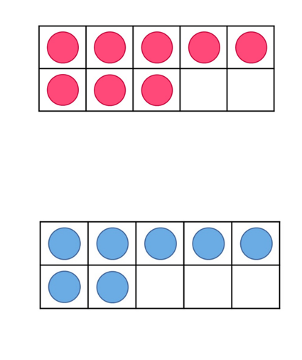

Resource 2: Measuring lengths

Resource 3: Folded paper
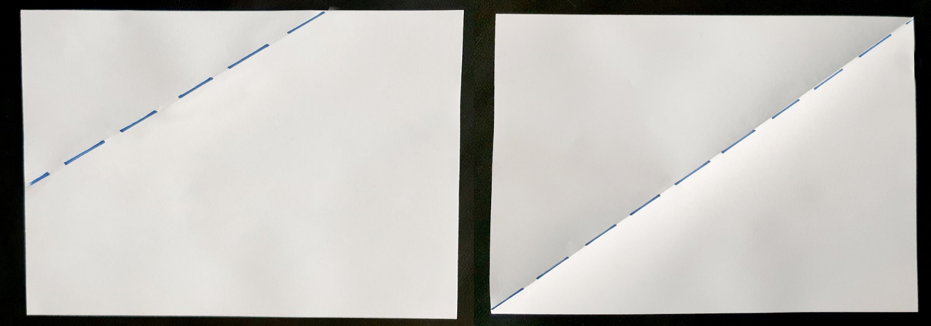

Resource 4: Four paper sections
: 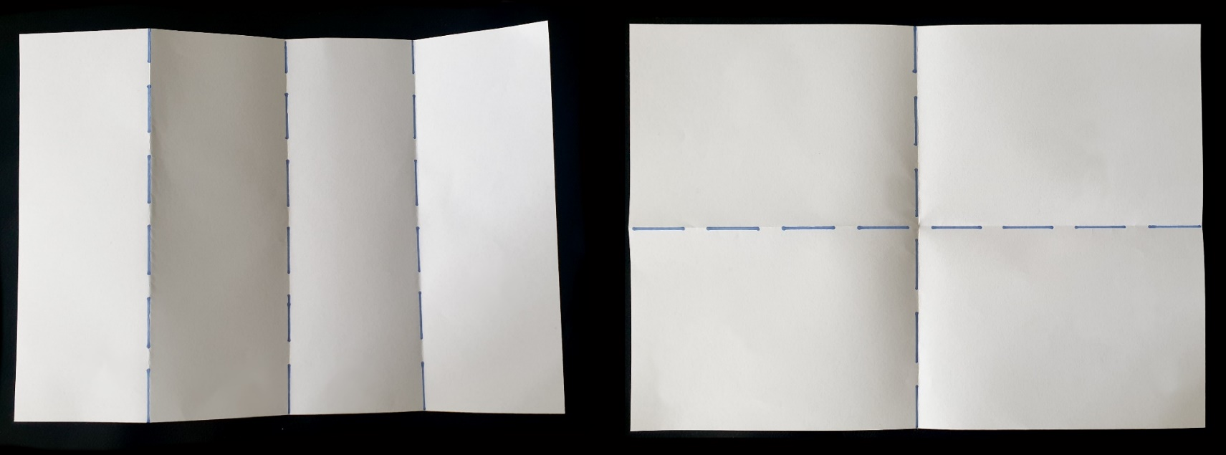
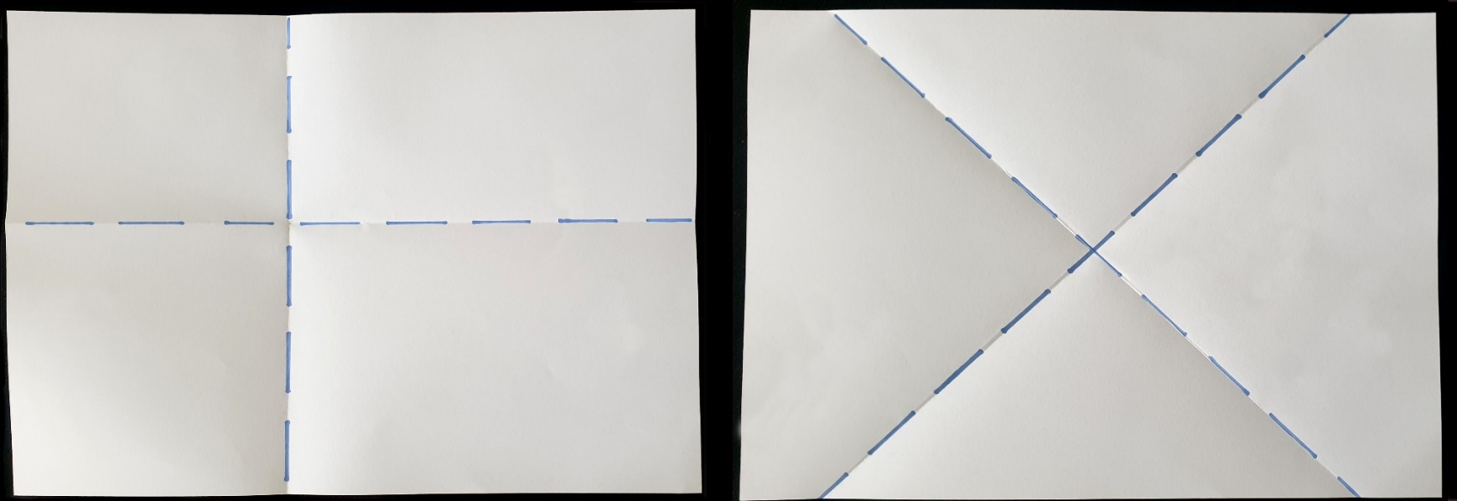

Resource 5: Paper bugs
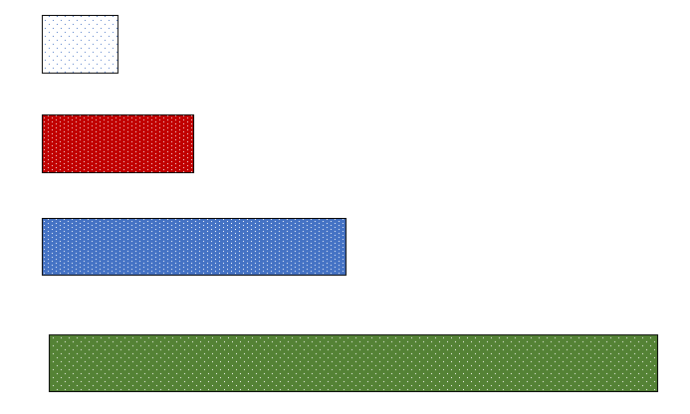

Syllabus outcomes and content
The table below outlines the syllabus outcomes and range of relevant syllabus content covered in this unit. Content is linked to National Numeracy Learning Progression version (3).
Focus area and outcomes | Content groups and content points | Lessons
Representing whole numbers  MAO-WM-01  MAE-RWN-01, MA1-RWN-01  MAE-RWN-02, MA1-RWN-02 | Early Stage 1  Use the counting sequence of ones flexibly  - count forwards to at least 30 and state the number before or after a given number, without needing to count from one (CPr4)  - count backwards from a given number 20 or less (CPr5)  - identify the number before as ‘one less’ and the number after as ‘one more’ than a given number | 1–8
Representing whole numbers A (cont) | Stage 1  Use counting sequences of ones with two-digit numbers and beyond  - identify the number before and after a given two-digit number (CPr5)  - count forwards and backwards by ones from a given two-digit number (CPr6) | 1–8
Representing whole numbers A (cont) | Stage 1  Represent numbers on a line  - sequence numbers and arrange them on a line by considering the order and size of those numbers (CPr5) | 7–8
Combining and separating quantities  MAO-WM-01  MAE-CSQ-01, MA1-CSQ-01  MAE-CSQ-02  NOTE: there is only one combining and separating quantities outcome for Stage 1. | Early Stage 1  Model additive relations and compare quantities  - identify situations in which addition and subtraction may be applied (AdS1-AdS2)  - combine two or more groups of objects to model addition, identifying the relationship between the parts and the whole (AdS1-AdS2)  - separate and take away part of a group of objects to model subtraction (AdS1, AdS2)  - use concrete materials or fingers to model and solve addition and subtraction questions, counting forwards or backwards by ones as necessary (AdS1- AdS2, NPV3)  - compare two groups of objects to determine how many more (Reasons about quantity) (NPV1, AdS2) | 1–3
Combining and separating quantities (cont) | Early Stage 1  Identify part-whole relationships in numbers up to 10  - use visual representations of numbers to assist with combining and separating quantities, identifying the relationship between the quantities (NPV2, NPA2, AdS2-AdS3)  - describe the action of combining, separating and comparing (AdS1)  - create, model, and recognise combinations for numbers up to ten (AdS2)  - count by ones to find the total or difference (AdS2-AdS3) | 1–8
Combining and separating quantities (cont) | Stage 1  Uses advanced count-by-ones strategies to solve addition and subtraction problems  - apply the terms ‘add’, ‘plus’, ‘equals’, ‘is equal to’, ‘is the same as’, ‘take away’, ‘minus’ and ‘the difference between’ to describe combining and separating quantities (AdS1, AdS6)  - recognise and use the symbols for plus (+), minus (−) and equals (=)  - record number sentences in a variety of ways using drawings, words, numerals, and symbols (AdS6) | 2
Combining and separating quantities A (cont) | Stage 1  Recognise and recall number bonds up to ten  - describe combinations for numbers using words such as more than, less than and double (Reasons about relations) (AdS6) | 1–8
Combining and separating quantities B (cont) | Stage 1  Represent and reason about additive relations  - represent the difference between two numbers using concrete materials and diagrams (AdS6)  - recall and use related addition and subtraction number facts to at least 20 (AdS7) | 3
Forming groups A  MAO-WM-01  MA1-FG-01 | Stage 1  Recognise and represent division  - use concrete materials to model a half of a collection and show the relation between the half and the whole (InF1)  - model sharing division by distributing a collection of objects equally into a given number of groups to determine how many in each group (InF2, MuS5)  - model grouping division by determining the number of groups of a given size that can be formed (MuS5)  - describe the part left over when a collection cannot be distributed equally using the given group size (MuS6) | 4, 6
Forming groups B (cont) | Stage 1  Model doubling and halving with fractions  - model doubling and halving groups and the relation between the processes (MuS6, InF2)  - re-create the whole given half (InF3)  - use concrete materials to model a half, a quarter or an eighth of a collection, and explain their thinking (InF2, InF3) | 6
Two-dimensional special structures B  MAO-WM-01  MA1-2DS-02 | Stage 1  2D shapes: Identify and describe the orientation of shapes using quarter turns  - identify and describe directions of turns as ‘left turn’, ‘right turn’, ‘clockwise’ or ‘anti-clockwise’ (UuM4)  - connect the use of quarter and half turns to the turn of the minute hand on a clock for the passing of quarter and half-hours (Reasons about relations) | 8
Geometric measure  MAO-WM-01  MAE-GM-02, MA1-GM-02 | Early Stage 1  Length: Use direct and indirect comparisons to decide which is longer  - identify the attribute of ‘length’ as the measure of an object from end to end  - use comparative language to describe length (UuM2)  - compare lengths directly by placing objects side by side and aligning the ends (UuM2)  - explain why the length of a piece of string remains unchanged whether placed in a straight line or a curve  - compare lengths indirectly by copying a length (Reasons about relations) (UuM3) | 1–3
Geometric measure (cont) | Early Stage 1  Length: Create half a length  - divide a length into two equal parts (Reasons about relations) (InF1)  - distinguish between the halfway point and half a length  - describe positions as ‘about halfway’, ‘more than halfway’ or ‘less than halfway’ (InF2) | 3–6
Geometric measure A (cont) | Stage 1  Length: Measure the lengths of objects using uniform informal units  - use uniform informal units to measure lengths and distances by placing the units end to end without gaps or overlaps (UuM2)  - select appropriate uniform informal units to measure lengths and distances (UuM3)  - count informal units to measure lengths or distances and describe the part left over (UuM4)  - record lengths and distances by referring to the number and type of unit used (UuM4) | 3
Geometric measure A (cont) | Stage 1  Length: Compare lengths using uniform informal units  - compare the lengths of two or more objects using appropriate uniform informal units and check by placing the objects side by side and aligning the ends (UuM2-UuM3)  - explain why the length of an object remains constant when rearranged (Reasons about relations)  - estimate lengths, indicating the number and type of unit used and check by measuring (UuM3) | 1–3
Geometric measure A (cont) | Stage 1  Length: Subdivide lengths to find halves and quarters  - use concrete materials to model both half and quarters of a whole length, highlighting the length (InF2)  - identify two equal lengths and the relationship of the parts to the whole length, linking words and images (InF2)  - recognise when lengths have or have not been divided into halves and quarters (InF2) | 3-7
Geometric measure B (cont) | Stage 1  Length: Compare and order lengths, using appropriate uniform informal units  - record length comparisons using drawings, numerals and words, and by referring to the uniform informal unit used | 1–2
Non-spatial measure  MAO-WM-01  MAE-NSM-01, MA1-NSM-01  MAE-NSM-02, MA1-NSM-02 | Early Stage 1  Time: Tell time on the hour on analog and digital clocks  - create the layout of an analog clock (MeT2)  - read analog and digital clocks to the hour using the term ‘o’clock’ (MeT2-MeT3)  - describe the position of the hour and minute hands on an analog clock when reading hour time (MeT2) | 7–8
Non-spatial measure (cont) | Stage 1  Time: Tell time to the half-hour  - read analog clocks to the half-hour using the terms ‘o'clock’ and ‘half past’ (MeT2)  - describe the position of the hands on a clock for the half-hour (MeT2)  - connect the use of half turns to the turn of the minute hand for the passing of the half-hour | 7–8
Non-spatial measure B (cont) | Stage 1  Time: Tell time to the quarter-hour using the language of ‘past’ and ‘to’  - read analog clocks to the quarter-hour using the terms ‘past’ and ‘to’ (MeT2)  - describe the position of the hands on a clock for quarter past and quarter to and relate this to quarter turns | 7, 8
Non-spatial measure B (cont) | Stage 1  Time: Describe duration using units of time  - use the terms ‘hour’, ‘minute’ and second’ (MeT2-MeT3) | 7, 8

References
Links to third-party material and websites
Please note that the provided (reading/viewing material/list/links/texts) are a suggestion only and implies no endorsement, by the New South Wales Department of Education, of any author, publisher, or book title. School principals and teachers are best placed to assess the suitability of resources that would complement the curriculum and reflect the needs and interests of their students.
If you use the links provided in this document to access a third-party's website, you acknowledge that the terms of use, including licence terms set out on the third-party's website apply to the use which may be made of the materials on that third-party website or where permitted by the Copyright Act 1968 (Cth). The department accepts no responsibility for content on third-party websites.
Except as otherwise noted, all material is © State of New South Wales (Department of Education), 2021 and licensed under the Creative Commons Attribution 4.0 International License. All other material (third-party material) is used with permission or under licence. Where the copyright owner of third-party material has not licensed their material under a Creative Commons or similar licence, you should contact them directly for permission to reuse their material.
Mathematics K–10 Syllabus © 2022 NSW Education Standards Authority (NESA) for and on behalf of the Crown in right of the State of New South Wales.
© 2022 NSW Education Standards Authority. This document contains NSW Curriculum and syllabus content. The NSW Curriculum is developed by the NSW Education Standards Authority. This content is prepared by NESA for and on behalf of the Crown in right of the State of New South Wales. The material is protected by Crown copyright.
Please refer to the NESA Copyright Disclaimer for more information.
NESA holds the only official and up-to-date versions of the NSW Curriculum and syllabus documents. Please visit the NSW Education Standards Authority (NESA) website and the NSW Curriculum website.
National Numeracy Learning Progression © Australian Curriculum, Assessment and Reporting Authority (ACARA) 2010 to present, unless otherwise indicated. This material was downloaded from the Australian Curriculum website (National Numeracy Learning Progression) (accessed 28 November 2022) and was not modified. The material is licensed under CC BY 4.0. Version updates are tracked in the ‘Curriculum version history’ section on the 'About the Australian Curriculum' page of the Australian Curriculum website.
ACARA does not endorse any product that uses the Australian Curriculum or make any representations as to the quality of such products. Any product that uses material published on this website should not be taken to be affiliated with ACARA or have the sponsorship or approval of ACARA. It is up to each person to make their own assessment of the product, taking into account matters including, but not limited to, the version number and the degree to which the materials align with the content descriptions and achievement standards (where relevant). Where there is a claim of alignment, it is important to check that the materials align with the content descriptions and achievement standards (endorsed by all education Ministers), not the elaborations (examples provided by ACARA).
This resource contains images and content obtained from Canva, and their use outside of this resource is subject to Canva’s Content License Agreement. If you wish to use them separately from the resource, please go to Canva.
Askew M (2015) A Practical Guide to Transforming Primary Mathematics: Activities and tasks that really work, 1st edn, Routledge, New York.
Boaler J, Munson J and Williams C (2021) Mindset Mathematics: Visualizing and Investigating Big Ideas, Grade 1, Jossey-Bass, New Jersey.
Bruce C, Flynn T and Bennett S (2016) ‘A Focus on Exploratory Tasks in Lesson Study: The Canadian "Math for Young Children" Project’, ZDM: The International Journal on Mathematics Education, 48(4):541–554, doi:10.1007/s11858-015-0747-7.
Queensland University of Technology (2016) Yumi Deadly Maths: Measurement Prep to Year 9, prepared by the Yumi Deadly Centre, Queensland, accessed 28 November 2022.
Stanford University (n.d.) 'Early Math Resources for Teacher Educators', Projects, DREME (Development and Research in Early Math Education) website, accessed 28 November 2022.
University of Cambridge (Faculty of Mathematics) (2022) Different Sizes, NRICH website, accessed 28 November 2022.
University of Cambridge (Faculty of Mathematics) (2022) NRICH [website], accessed 28 November 2022.
Van de Walle J, Karp K, Bay-Williams JM, Brass A, Bentley B (2019) Primary and Middle Years Mathematics: Teaching Developmentally, 1st Australian edn, Pearson Education Australia, Melbourne.

