Mathematics – K-2 multi-age – Year A – Unit 6

Contents
Unit description and duration 4
Student prior learning 4
Lesson overview and resources 5
Lesson 1: Language of equivalence 16
Daily number sense: Number match – 20 minutes 17
Language of equivalence – 40 minutes 18
Consolidation and meaningful practice: Equal or not? – 20 minutes 22
Lesson 2: Equivalent stories 24
Daily number sense: Caterpillar counting – 15 minutes 25
Equivalent stories – 40 minutes 25
Consolidation and meaningful practice: Sharing mathematical stories – 15 minutes 30
Lesson 3: Number bonds 31
Daily number sense: Number match – 15 minutes 32
Addition table patterns – 40 minutes 32
Lesson 4: Same but different 38
Daily number sense: Caterpillar counting – 15 minutes 39
Constant difference – 30 minutes 40
Consolidation and meaningful practice: Think board – 20 minutes 43
Lesson 5: Creating balance 47
Daily number sense: 3 sixes/tens/hundreds in a row – 15 minutes 48
Creating balance – 40 minutes 48
Consolidation and meaningful practice: Noticing and wondering – 15 minutes 52
Lesson 6: Hungry, hungry monsters! 53
Daily number sense: Number balance talk – 15 minutes 54
Hungry, hungry monsters! – 30 minutes 55
Consolidation and meaningful practice: Summarising the learning – 15 minutes 57
Lesson 7: Pigs versus wolf! 58
Daily number sense: Revisiting 3 sixes/tens/hundreds in a row – 15 minutes 59
Pigs versus wolf! – 30 minutes 60
Consolidation and meaningful practice: Summarising the learning – 10 minutes 62
Lesson 8: Who balanced the boat? 63
Daily number sense: Assessment and Number match – 20 minutes 64
Who balanced the boat? Part 1 – 15 minutes 65
Who balanced the boat? Part 2 – 25 minutes 67
Consolidation and meaningful practice: Summarising the learning – 10 minutes 70
Resource 1: Number match 71
Resource 2: Number cards 10 79
Resource 3: Number cards 20 80
Resource 4: Number talk 81
Resource 5: Addition table 82
Resource 6: Extended addition table 83
Resource 7: Tower talk 84
Resource 8: Constant difference concentration 85
Resource 9: Think board 88
Resource 10: Number balance talk 89
Resource 11: Number balance puzzles 90
Resource 12: Balance puzzles 2 92
Resource 13: Number balance questions 95
Resource 14: Number balance scaffold 96
Resource 15: Pigs vs. wolf rules 97
Resource 16: Pigs vs. wolf gameboard 1 98
Resource 17: Pigs vs. wolf gameboard 2 99
Resource 18: Who balanced the boat? 100
Syllabus outcomes and content 101
References 110

Unit description and duration
This two-week unit develops student knowledge, understanding and skills of equality. Students are provided opportunities to:
- use balance to explore, prove and check equivalence using the language of equality to record equivalence in different ways
- identify different combinations of numbers that bond to form up to 20 and identify the constant difference between numbers
- identify the equals sign and its purpose and use equivalence to solve problems.
Mathematics K–10 Syllabus © 2022 NSW Education Standards Authority (NESA) for and on behalf of the Crown in right of the State of New South Wales.

Student prior learning
Before engaging in these teaching and learning activities, students would benefit from prior experience with:
- using words to describe mass, including ‘heavy’ and ‘light’
- comparing 2 masses directly by hefting
- using drawings, words or numerals to record addition and subtraction.

Lesson overview and resources
The table below outlines the sequence and approximate timing of lessons; syllabus focus areas and content groups; and resources.
Lesson | Syllabus focus area and content groups | Resources
Lesson 1: Language of equivalence  80 minutes  Language assists in describing equivalent and non-equivalent situations. | Representing whole numbers  Early Stage 1  - Instantly name the number of objects within small collections  - Use the counting sequence of ones flexibly  - Recognise number patterns  - Connect counting and numerals to quantities  Stage 1 – Part A  - Use counting sequences of ones with two-digit numbers and beyond  - Represent numbers on a line  Combining and separating quantities  Early Stage 1  - Model additive relations and compare quantities  - Identify part–whole relationships in numbers up to 10  Stage 1 – Part A  - Use advanced count-by-one strategies to solve addition and subtraction problems  - Recognise and recall number bonds up to ten  - Use flexible strategies to solve addition and subtraction problems  - Represent equality  Non-spatial measure  Early Stage 1  - Mass: Identify and compare mass using weight  Stage 1  - Mass: Investigate mass using an equal-arm balance | - Resource 1: Number match  - Classroom items to balance  - Concrete materials  - Counters  - Equal-arm balances (Stage 1)  - Writing materials
Lesson 2: Equivalent stories  70 minutes  Mathematicians can record equivalence using mathematical stories. | Representing whole numbers  Early Stage 1  - Instantly name the number of objects within small collections  - Use the counting sequence of ones flexibly  - Recognise number patterns  - Connect counting and numerals to quantities  Stage 1 – Part A  - Use counting sequences of ones with two-digit numbers and beyond  Combining and separating quantities  Early Stage 1  - Model additive relations and compare quantities  - Identify part–whole relationships in numbers up to 10  Stage 1 – Part A  - Use advanced count-by-one strategies to solve addition and subtraction problems  - Recognise and recall number bonds up to ten  - Use flexible strategies to solve addition and subtraction problems  - Represent equality | - Shuffled sets of Resource 2: Number cards 10  - Shuffled sets of Resource 3: Numbers cards 20  - Resource 4: Number talk  - Counters  - Writing materials
Lesson 3: Number bonds  55 minutes  Different combinations of numbers can add to form a given number. | Representing whole numbers  Early Stage 1  - Instantly name the number of objects within small collections  - Use the counting sequence of ones flexibly  - Recognise number patterns  - Connect counting and numerals to quantities  Stage 1 – Part A  - Use counting sequences of ones with two-digit numbers and beyond  Combining and separating quantities  Early Stage 1  - Model additive relations and compare quantities  - Identify part–whole relationships in numbers up to 10  Stage 1 – Part A  - Use advanced count-by-one strategies to solve addition and subtraction problems  - Recognise and recall number bonds up to ten  - Use flexible strategies to solve addition and subtraction problems  - Represent equality  Combining and separating quantities B  - Represent and reason about additive relations  - Use knowledge of equality to solve related problems | - Resource 1: Number match  - Resource 5: Addition table  - Resource 6: Extended addition table  - Counters  - Writing materials
Lesson 4: Same but different  65 minutes  A constant difference can be identified between pairs of numbers. | Representing whole numbers  Early Stage 1  - Use the counting sequence of ones flexibly  - Connect counting and numerals to quantities  Stage 1 – Part A  - Use counting sequences of ones with two-digit numbers and beyond  - Represent numbers on a line  Combining and separating quantities  Early Stage 1  - Model additive relations and compare quantities  - Identify part–whole relationships in numbers up to 10  Stage 1 – Part A  - Use advanced count-by-one strategies to solve addition and subtraction problems  - Recognise and recall number bonds up to ten  - Use flexible strategies to solve addition and subtraction problems  - Represent equality  Stage 1 – Part B  - Represent and reason about additive relations  - Use knowledge of equality to solve related problems | - Resource 2: Number cards 10  - Resource 3: Numbers cards 20  - Resource 7: Tower talk  - Resource 8: Constant difference concentration  - Resource 9: Think board  - Dice  - Interconnecting cubes  - Writing materials
Lesson 5: Creating balance  70 minutes  Mathematicians think of equivalence as balance. | Representing whole numbers  Early Stage 1  - Use the counting sequence of ones flexibly  - Connect counting and numerals to quantities  Stage 1 – Part A  - Use counting sequences of ones with two-digit numbers and beyond  Combining and separating quantities  Early Stage 1  - Model additive relations and compare quantities  - Identify part–whole relationships in numbers up to 10  Stage 1 – Part A  - Use advanced count-by-one strategies to solve addition and subtraction problems  - Recognise and recall number bonds up to ten  - Use flexible strategies to solve addition and subtraction problems  - Represent equality  Stage 1 – Part B  - Represent and reason about additive relations  - Use knowledge of equality to solve related problems  Non-spatial measure  Early Stage 1  - Mass: Identify and compare mass using weight  Stage 1 – Part A  - Mass: Investigate mass using an equal-arm balance | - Video: 3 tens in a line (2:29)  - Video: Creating balance – part 1 (5:08)  - Number balances or digital arm balances  - 10-sided dice  - Classroom items for weighing  - Shopping bags  - Writing materials
Lesson 6: Hungry, hungry monsters!  60 minutes  Equality represents a relationship, not an action. | Representing whole numbers  Early Stage 1  - Use the counting sequence of ones flexibly  - Connect counting and numerals to quantities  Stage 1 – Part A  - Use counting sequences of ones with two-digit numbers and beyond  Combining and separating quantities  Early Stage 1  - Model additive relations and compare quantities  - Identify part–whole relationships in numbers up to 10  Stage 1 – Part A  - Use advanced count-by-one strategies to solve addition and subtraction problems  - Recognise and recall number bonds up to ten  - Use flexible strategies to solve addition and subtraction problems  - Represent equality | - Resource 10: Number balance talk  - Copies of Resource 11: number balance puzzles  - Copies of Resource 12: Balance puzzles 2  - Resource 13: Number balance questions  - Resource 14: Number balance scaffold  - Counters  - Number arm balance  - Ten-frames  - Writing materials
Lesson 7: Pigs versus wolf!  55 minutes  Mathematicians recognise when two quantities are equal or different. | Representing whole numbers  Early Stage 1  - Use the counting sequence of ones flexibly  - Connect counting and numerals to quantities  Stage 1 – Part A  - Use counting sequences of ones with two-digit numbers and beyond  - Represent the structures of groups of ten  Combining and separating quantities  Early Stage 1  - Model additive relations and compare quantities  - Identify part–whole relationships in numbers up to 10  Stage 1 – Part A  - Use advanced count-by-one strategies to solve addition and subtraction problems  - Recognise and recall number bonds up to ten  - Use flexible strategies to solve addition and subtraction problems  - Represent equality | - Resource 15: Pigs vs. wolf rules  - Copies of Resource 16: Pigs vs. wolf gameboard 1  - Copies of Resource 17: Pigs vs. wolf gameboard 2  - 6-sided and 10-sided dice  - Writing materials
Lesson 8: Who balanced the boat?  70 minutes  Mathematicians use equivalence to solve different problems in our world. | Representing whole numbers  Early Stage 1  - Use the counting sequence of ones flexibly  - Connect counting and numerals to quantities  Stage 1 – Part A  - Use counting sequences of ones with two-digit numbers and beyond  Non-spatial measure  Early Stage 1  - Mass: Identify and compare mass using weight  Stage 1 – Part A  - Mass: Investigate mass using an equal-arm balance | - Allen P (1988) Who Sank the Boat?, Picture Puffin, Australia. ISBN: 9780140509403  - Resource 18: Who balanced the boat?  - Adhesive tape  - Modelling clay  - Paper, cardboard or paper plates  - Writing materials

Lesson 1: Language of equivalence
Core concept: Language assists in describing equivalent and non-equivalent situations.
The table below contains suggested learning intentions and success criteria. These are best co-constructed with students.
Learning intentions | Success criteria
All students are learning that:  - two things are equivalent if they have the same value  - language assists in describing equivalent and non-equivalent situations  - balance can be used to explore, prove, and check equivalence. | All students can:  - make predictions about an objects weight  - reason and explain why a set is considered balanced.  In addition, students working towards Early Stage 1 outcomes can:  - compare the weight of various objects by hefting  - use the correct language to compare the weight of objects that are ‘heavier’, ‘lighter’ or ‘about the same as’.  In addition, students working towards Stage 1 outcomes can:  - use words, for example, not equal, non-equivalent, different from and not balanced, when describing equal and unequal sets  - use an equal-arm balance to create a level balance  - record equivalence using concrete materials, correct vocabulary, drawings, and diagrams.

Daily number sense: Number match – 20 minutes
- Build student understanding of connecting counting to numerals and quantities by playing number match.
- Provide each student with a gameboard from Resource 1: Number match and a collection of counters. Allow time for students to look carefully at their gameboard and identify all the number representations.
Note: Number match game was introduced in Unit 4. You can use the laminated cards from that unit or print game cards from the resources section of this unit.
- Call out a number between zero and 20 and record it on the board. If a student has the corresponding number on their gameboard they place a counter over it.
- Continue to call out and record numbers between zero and 20. When a student covers all their number representations, they call out ‘Number Match!’.
- Students can play again with a different gameboard.
Note: Provide Stage 1 students with the gameboards with a range to 20.

Language of equivalence – 40 minutes
Note: This lesson has been adapted from Warren et al. (2009).
- Show students 2 classroom items of about the same mass but of a differing size.
Note: Mass is not a spatial measure. Objects with the same volume can have different masses. Students need experiences with objects that are light and large, heavy and large, light and small, heavy and small and large but lighter than a smaller object.
- Ask students to predict which object would be heavier than, lighter than, or have about the same weight as the other object and explain reasons for their prediction.
- Ask students how they could check their predictions. Make a class list of students’ suggestions.
- Provide Early Stage 1 students with 2 objects of about the same weight and ask them to heft the objects. Ask the students to explain what they notice about the weight of the objects. Guide students to use the language ‘about the same as’ to describe the equal weight of the objects.
- For Stage 1 students, use an equal-arm balance and model placing objects on either side of the balance until they are balanced or equal. Discuss what happens to the equal-arm balance when it is equal. Have students demonstrate this with their arms outstretched.
- Ask students to turn and talk and discuss what it means if something is ‘equal’ or ‘the same as’ and what words can be used to describe something as equal.
Note: In Early Stage 1, the terms ‘weigh’ and ‘weight’ are more common in everyday usage than ‘mass’. When working with Early Stage 1 students, ‘weight’ is an acceptable description for mass. Early Stage 1 students should become familiar and confident with hefting and using the vocabulary ‘about the same as’ to describe equivalence before they are introduced to ‘equals’ in Stage 1.
- Students share their thinking. Create a class list of ideas and words that students identify as meaning equal. Add additional words if students do not provide them such as ‘about the same as’, ‘equal’, ‘balanced’ and ‘equivalent’. Discuss the meaning of the word ‘equivalent’.
Note: When exploring equivalence in the early years, there are 4 key areas that students should explore. These include developing the comparative language that assists in describing equivalent and non-equivalent situations, developing an understanding that equals means 2 expressions are equivalent, representing equations in a variety of different formats and using the ‘balance principle’ to find unknowns (Warren et al., 2009).
Equivalent: Two things are equivalent if they have the same value.
- Show students 2 classroom items of differing mass that about the same size. Ask students to make predictions about which item is heavier or lighter. Have students explain their reasoning.
- Provide Early Stage 1 students with the 2 objects and ask them to heft the objects. Ask the student to explain what they notice about the weight of the objects. Guide the student to use the language heavier or lighter to describe the different weight of the objects.
- For Stage 1 students, use the equal-arm balance to model placing 2 objects on either side of the balance until they are not balanced. Discuss what happens to the equal-arm balance when it is not equal. Have students demonstrate this with their arms outstretched.
- Ask students to turn and talk and discuss what it means if something is not equal or ‘not the same as’ and what words can be used to describe when something is not equal.
- Have students share their thinking and create a class list of ideas and words that students identify as meaning not equal. Add additional words if students do not provide them such as different from, more than, less than, not equal, unbalanced, non-equivalent.
- Display class list for students to refer to during the investigation.
- Explain to Early Stage 1 students that they will be exploring the weight of objects and will use their arms as a balance scale. Ask students to find items in the classroom they think will have about the same weight and items that will have a different weight and have them heft them to determine if they are about the same as or are lighter or heavier.
- In pairs, Early Stage 1 students work with their partner to heft the objects and use the correct language to explain to their partner their reasoning. Students record their findings in their workbook, drawing themself and the objects. If possible, students can label their image using the correct language.
- For Stage 1 students, provide pairs with an equal-arm balance, a variety of concrete materials or classroom items and pieces of paper. Ask students to investigate if they can make their equal-arm balance using concrete materials and also make their equal-arm unbalance using concrete materials. Ask students to record their investigation in their workbook labelling their images using the correct language.
- Ask students to explain why their sets were the same or balanced and have students conduct a gallery walk for students to view each other's representations in their workbooks. Ask students:
- What did you notice about your set that was different from other groups sets? What was the same?
- Did all balances have the same number of items on both sides? Why or why not?
- What did you notice about the different number of items used?
- What problems did you have trying to get an equal or same as balance? How did you solve this problem?
- Is there another word you could use to describe your set?
- As a class discuss the language used and highlight the importance of being able to explain why the sets were the same or not the same.
This table details assessment opportunities and differentiation ideas.
Assessment opportunities | Too hard? | Too easy?
What to look for:  - Are students able to make predictions about an objects mass? (MAO-WM-01, MAE-NSM-01, MA1-NSM-01)  - Do students use appropriate language to describe the sets? (MAO-WM-01, MAE-NSM-01, MA1-NSM-01)  - Are students able to heft objects to compare the mass of 2 objects? (MAO-WM-01, MAE-NSM-01)  - Are students able to use an equal-arm balance to create a level balance? (MAO-WM-01, MA1-NSM-01)  - Can students identify equivalent sets? (MAO-WM-01, MA1-CSQ-01, MA1-NSM-01)  What to collect:  - work samples – recordings in workbooks (MAO-WM-01, MA1-NSM-01)  - observational data. (MAO-WM-01, MAE-NSM-01) | Students do not use appropriate language to describe equal and not equal sets.  - Revise class list of vocabulary and match the words with images of equal and not equal sets.  - Select 2 vocabulary choices for students to use. For example, equal and not equal.  Students are unable to heft items to find 2 objects that are about the same as in mass.  - Support students by asking which object is heavier and having them point to the object.  - Have students heft objects that are very different in mass first to identify very different masses. | Students use appropriate language and identify equivalent sets.  - Ask students to draw a mathematical story to represent their set using images, words, and symbols.  - Students brainstorm other words that can be used to describe equal and not equal.  - Students write a reflection to explain what it means if 2 things are equivalent.  Students are able to use an equal-arm balance to create a level balance. Have students identify collections of objects with similar mass but differing sizes or amounts.

Consolidation and meaningful practice: Equal or not? – 20 minutes
- Have Early Stage 1 students choose items that could be described as having the same weight and items with different weights from the classroom. Students display the items.
- Have Stage 1 students choose items that could be described as equivalent and non-equivalent. For example, 2 even stacks of blocks, 2 uneven containers of water, 2 stacks of books.
- Place students into small groups and assign a display to each group. Have students discuss whether the display is the same as or different. Students record their thinking and reasoning on the piece of paper. Encourage Stage 1 students to use the language of equivalence when annotating.
- Rotate groups to a different display and repeat the discussion and recording on the pieces of paper. Continue rotating students until they have seen all displays.
- As a class discuss the groups different ideas and reasonings. Connect the language used to explain equal and not equal sets and add any additional vocabulary to the class lists.

Lesson 2: Equivalent stories
Core concept: Mathematicians can record equivalence using mathematical stories.
The table below contains suggested learning intentions and success criteria. These are best co-constructed with students.
Learning intentions | Success criteria
All students are learning that:  - mathematicians record their thinking in different ways  - two things are equivalent if they have the same value  - language assists in describing equivalent situations. | All students can:  - create a mathematical story to show equivalence  - explain their mathematical story to a partner  - combine 2 numbers together to determine a total.  In addition, students working towards Early Stage 1 outcomes can:  - create, model and recognise combinations for numbers up to 10  - use words such as the same as to describe equal sets.  In addition, students working towards Stage 1 outcomes can:  - identify equivalence on an equal-arm balance  - use words such as equal, equivalent, same as, balanced when describing equal sets.

Daily number sense: Caterpillar counting – 15 minutes
This lesson has been adapted from ‘Activities to support Forward and backward number word sequences’, DENS (2022).
- Build student understanding of forward and backward counting by sequencing numerals.
- In pairs, provide Early Stage 1 students with a shuffled set of Resource 2: Number cards 10. Provide Stage 1 students with a shuffled set of Resource 3: Numbers cards 20.
- Explain that students need to make a caterpillar out of cards in order from smallest to largest and count to check the order.
- Students identify numbers by pointing to a card. Ask:
- What number is that?
- What is the number one less?
- What is the number one more?
- Have students reshuffle the cards and ask them to place them in a backwards counting sequence. Have students count out loud to check their order.

Equivalent stories – 40 minutes
This lesson has been adapted from Warren et al. (2009).
- Revise the term equivalence from previous lesson and review the class list of words that mean equal.
- Discuss with students that we can use what we know about balance to identify numbers that are also the same as or equal.
- Display Resource 4: Number talk. Have students turn and talk about what they notice and wonder about the image.
- As a class discuss the image. Stimulate discussion by asking:
- Are the 2 sides the same? How do you know?
- How could we represent this using numbers and words?
- What is the value of each side? How can we represent this?
- Model equivalence with different combinations of smaller numbers using a bar model. Explain 2 sides of the balance are equivalent as they both have the value of 6 (see Figure 1).
Figure 1 – Number balance
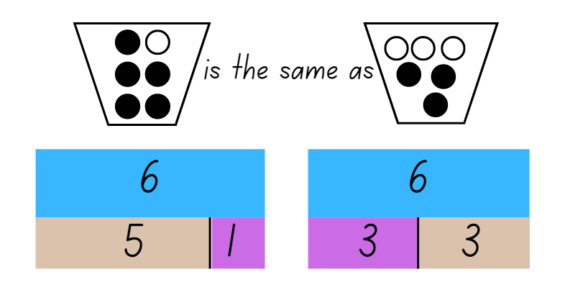
Images sourced from Canva and used in accordance with the Canva Content License Agreement.
- Explain that mathematicians record their thinking about equivalence in different ways. One way to demonstrate an understanding of equivalence is by using a mathematical story.
Note: Storytelling is an effective way for students to conceptualise and communicate mathematical ideas, such as combining and separating quantities, and assists students to recognise the purposeful nature of mathematics in real-world contexts. Mathematics as storytelling can support the engagement and achievement of Aboriginal students and all students.
- Give students a choice of materials to create an equivalent story. For example, paint, paper, playdough, pencils, images.
- Encourage students to use a real-world example to show their understanding of equivalence or the same as. For example, they may use birds in a nest, spots on dalmatians or lollies in a lolly jar (see Figure 2).
Figure 2 – Birds in a nest
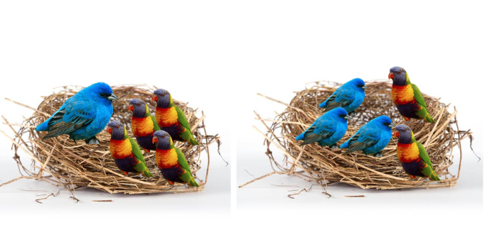
Images sourced from Canva and used in accordance with the Canva Content License Agreement.
- Have Early Stage 1 students demonstrate the same as with a number range up to 10. Have Stage 1 students demonstrate equivalence up to 20 depending on students’ needs
- Encourage students to verbalise their mathematical stories to a partner.
Note: The more experience students have at expressing their ideas, the more competent they may become in using the language of mathematics to describe different story contexts (Warren et al., 2009).
- Have students write their mathematical story using words to support their picture (see Figure 3). Early Stage 1 students may also be able to verbally explain their story and record using a digital device.
Figure 3 – Equivalent story
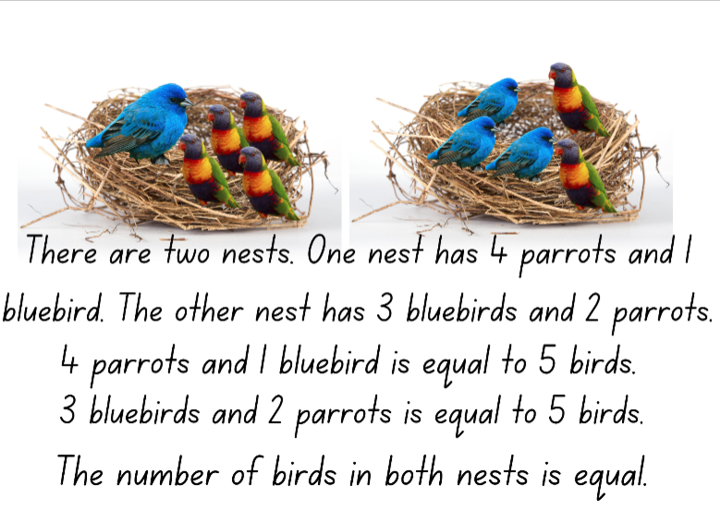
Images sourced from Canva and used in accordance with the Canva Content License Agreement.
This table details assessment opportunities and differentiation ideas.
Assessment opportunities | Too hard? | Too easy?
What to look for:  - Can students create a mathematical story to demonstrate equivalence? (MAO-WM-01, MAE-RWN-01, MAE-RWN-02, MAE-CSQ-02, MA1-CSQ-01)  - Do students use appropriate language to explain their story? (MAO-WM-01, MAE-CSQ-01, MAE-CSQ-02, MA1-CSQ-01)  - Can students combine quantities to determine a total? (MAO-WM-01, MAE-CSQ-01, MAE-CSQ-02, MA1-CSQ-01)  What to collect:  - mathematical equivalent stories. (MAO-WM-01, MAE-CSQ-01, MAE-CSQ-01, MA1-CSQ-01) | Students are unable to create a mathematical story.  - Provide students with up to 10 concrete materials, for example, counters. Have students arrange the counters to show 2 equal sets.  - Students can count the sets using one-to-one correspondence to determine equivalence.  - Support students use of language by referring to class list of equivalent vocabulary and providing an additional word bank to support writing. | Students can create a mathematical story.  - Provide students with the following statement and have them create a drawing to support their understanding of the statement: In one lolly jar there are 2 different types of lollies, red frogs and jellybeans. In the second lolly jar there are 4 types of lollies red frogs, jellybeans, chocolate beans and pineapples. Both lolly jars have the same number of lollies inside.  - Have students write a number sentence to demonstrate their understanding.

Consolidation and meaningful practice: Sharing mathematical stories – 15 minutes
- Invite another class to visit the classroom to share the mathematical stories.
- In partners or small groups, have students verbalise their stories to other students and discuss and connect the mathematics of equivalence.
- Display mathematical stories in classroom.

Lesson 3: Number bonds
Core concept: Different combinations of numbers can add together to form a given number.
The table below contains suggested learning intentions and success criteria. These are best co-constructed with students.
Learning intentions | Success criteria
All students are learning that:  - different combinations of numbers can add up or bond to form a given number  - there are ways to model and record patterns when identifying number combinations for a given number  - different strategies can be used to combine quantities. | All students can identify patterns in combinations of numbers.  In addition, students working towards Early Stage 1 outcomes can:  - create, model and recognise combinations for numbers up to 10  - use drawings, words, and numerals to record number combinations up to 10.  In addition, students working towards Stage 1 outcomes can:  - recognise, recall and record number bonds to 20  - identify patterns within an addition table  - record number sentences in a variety of ways  - select and apply strategies such as counting on and back, doubles and near doubles or using concrete materials to solve addition problems.

Daily number sense: Number match – 15 minutes
- Build student understanding of connecting counting to numerals and quantities by playing ‘Number match’.
- Provide each student with a gameboard from Resource 1: Number match and a collection of counters. Allow time for students to look carefully at their gameboard and identify all the number representations.
- Call out a number between zero and 20 and record it on the board. If a student has the corresponding number on their gameboard they place a counter over it.
- Continue to call out and record numbers between zero and 20. When a student covers all their number representations, they call out ‘Number match’.
- Students can play again with a different gameboard.
Note: Provide Stage 1 students with the gameboards with a range to 20.

Addition table patterns – 40 minutes
This lesson has been adapter from Boaler et al (2021) and Snap it (2020).
- Display Resource 5: Addition table on the board. Ask students to turn and talk and discuss what they notice and what the table shows.
- Invite students to share their thinking with the class and develop a shared understanding that the table displays the combination of numbers that add to 10. Provide concrete materials to students to explore the connections between the combinations of numbers.
Note: Interpreting this table may be challenging. Spend time ensuring students understand the purpose and parts of the table. Particularly drawing attention to what the rows, columns and intersection points mean. (Boaler et al., 2021).
- In pairs, provide partners with Resource 5: Addition table, coloured highlighters and concrete materials such as square tiles, interlocking cubes or coloured bricks.
- Have students explore the following questions:
- What patterns can you see?
- What makes these patterns?
- What connections can you make between numbers?
- How can you show these patterns using the concrete materials?
- Students, explore, highlight and annotate the table with the different patterns they find.
Note: Students may need more than one sheet to record the various patterns so their annotations do not become mixed up.
- Provide Stage 1 students with copies of Resource 6: Extended addition table and ask students if the patterns would continue if you extended the table. Give Stage 1 students time to discuss with a partner to make predictions about their patterns by exploring the empty cells. Ask students to make predictions and test their ideas by combining the quantities and entering numbers into the empty cells. Encourage students to use count by one strategies including counting on and also strategies such as doubles and near doubles where appropriate.
- While Stage 1 students are making predictions, explain ‘Snap It’ to Early Stage 1 students. Show students a stick of interlocking cubes 4-10 cubes long. Allow students time to look at the full stick and identify how many cubes make up the stick. Then snap the stick into 2 sections. Students observe the 2 sections and identify how many cubes are in each piece and how many cubes there were altogether. Record the information about the stick, drawing a line to show how it was snapped and label the parts and the whole. Join the stick back together, identifying the total number again and then snap the stick into 2 different sections (see Figure 4).
Figure 4 – Snap It
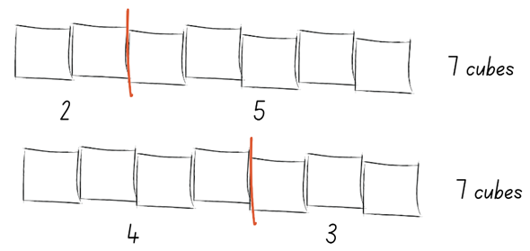
- Discuss and record the information about the sticks, drawing students' attention that 2 and 5 is the same as 4 and 3 and they both total 7.
- Provide pairs of Early Stage 1 students with a collection of interlocking cubes and their workbook. Students each create a stick of 4-10 interlocking cubes, partners must have the same size stick. At the same time, the pair of students snap their stick and compare what is similar and different about their snap. Students record their own snap in their workbook. Pairs do 3 snaps each time recording in their workbook and discussing their snap. Then they create another stick of a different value and complete the process again.
- Discuss Stage 1 students’ predictions and solutions with them. During the discussion, encourage students to use increasingly precise language for what they notice. Stimulate the discussion with the following questions:
- Will these patterns continue forever? Why or why not?
- How did you test your ideas? What did you find?
- What questions do you have now about the addition table?
This table details assessment opportunities and differentiation ideas.
Assessment opportunities | Too hard? | Too easy?
What to look for:  - Can students identify patterns within an addition table? (MAO-WM-01, MAE-CSQ-01, MAE-CSQ-02, MA1-CSQ-01)  - Do students create, model and recognise combinations for numbers up to 10? (MAO-WM-01, MAE-CSQ-01)  - Can students recognise, recall and record number bonds to 20? (MAO-WM-01, MA1-CSQ-01)  - Do students create, model and recognise combinations for numbers up to 10? (MAO-WM-01, MAE-CSQ-01, MAE-CSQ-02)  - Are students able to use drawings, words, and numerals to record number combinations up to 10? (MAO-WM-01, MAE-CSQ-01, MAE-CSQ-02)  - Can students record number sentences in a variety of ways? (MAO-WM-01, MA1-CSQ-01)  - Can students select and apply strategies such as counting on and back, doubles and near doubles or using concrete materials to solve addition problems? (MAO-WM-01, MA1-CSQ-01)  What to collect:  - work samples – Resource 5: Addition table (MAO-WM-01, MAE-CSQ-01, MAE-CSQ-02, MA1-CSQ-01)  - Stage 1 – Resource 6: Extended addition table. (MAO-WM-01, MA1-CSQ-01) | Students are unable to identify patterns within the addition table.  - Provide students with a ten-frame and a selection of red and yellow counters to make combinations.  - Model the combinations on the ten-frame and highlight them on the addition table.  Students are unable to recognise, recall and record number bonds to 10.  - Provide students with concrete materials such as counters, to identify number bonds up to 5.  - Support students using a visual chart, such as a completed addition table to identify number bonds to 20. | Students can recognise, recall and record number bonds to 20.  - Ask students what would happen if the table extended to 20 plus 20. Prompt them to consider what tools they would need to continue this investigation.  - Provide students grid paper to extend the table and identify the patterns.

Lesson 4: Same but different
Core concept: A constant difference can be identified between pairs of numbers.
The table below contains suggested learning intentions and success criteria. These are best co-constructed with students.
Learning intentions | Success criteria
All students are learning that:  - numbers can be represented on a line  - the difference between 2 numbers can be represented using concrete materials and diagrams  - a same constant difference can be identified between different pairs of numbers  - different strategies can be used to separate quantities  - mathematicians record their thinking in different ways. | All students can use concrete materials to represent the difference between 2 numbers.  In addition, students working towards Early Stage 1 outcomes can:  - count by ones to find the difference between 2 towers  - compare 2 towers to determine how many more  - use drawings, words and numerals to record addition and subtraction, and explain their thinking.  In addition, students working towards Stage 1 outcomes can:  - identify the position of numbers on a number line  - identify the difference between 2 numbers for numbers up to 20  - Identify and represent the constant difference between 2 pairs of numbers  - use count by one strategies to solve subtraction problems including counting on and counting back  - represent the constant difference using a think board.

Daily number sense: Caterpillar counting – 15 minutes
This lesson has been adapted from ‘Activities to support Forward and backward number word sequences’, DENS (2022).
- Build student understanding of forward and backward counting by sequencing numerals.
- In pairs, provide Early Stage 1 students with a shuffled set of Resource 2: Number cards 10. Provide Stage 1 students with a shuffled set of Resource 3: Numbers cards 20.
- Explain that students need to make a caterpillar out of cards in order from smallest to largest and count to check the order.
- Ask the students to identify numbers by pointing to a card and asking:
- What number is that?
- What is the number one less?
- What is the number one more?
- Have students reshuffle the cards and ask them to place them in a backwards counting sequence. Have students count out loud to check their order.

Constant difference – 30 minutes
This activity has been adapted from Diffy towers by DENS (2021).
- Display Resource 7: Tower talk. Ask student what they wonder and notice about the 2 towers.
- Have students turn and talk and share their thinking.
- As a class discuss and record what students’ notice about the towers.
- If students have not identified that there is a difference between the tower's pairs, highlight this using counting strategies.
- Tell students that by identifying a difference between 2 sets of numbers they can separate quantities.
- Provide pairs of students with up to 20 interlocking cubes and have them create 2 towers of difference. During the activity, identify different strategies to determine the difference including the count by one strategy.
- Invite students to share their tower differences and their strategies for determining the difference.
- In pairs, provide Early Stage 1 students with a dice and interconnecting cubes. Have the first student roll a die, take a corresponding number of blocks from a central pile and build them into a tower. The second student then rolls the dice and repeats the process.
- Students then compare their 2 towers to see who has the most blocks and determine the difference between the 2 towers. The player with the larger number of blocks keeps the difference and all other blocks are returned to the central pile. The activity continues until one student accumulates a total of 10 blocks.
- For Stage 1 students, identify 2 pairs that had the same difference. For example, 8 and 4 and 9 and 5.
- Discuss that students can identify pairs of numbers with the same constant difference using their knowledge of numbers one more and one less and using a number line.
- Model one more, one less, and constant difference on a number line (see Figure 5).
Figure 5 – Constant difference
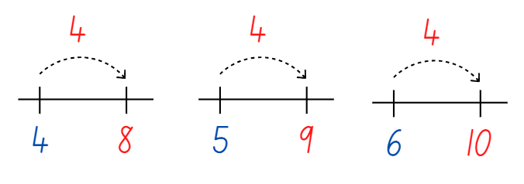
- Provide pairs of students with a number line and interlocking cubes. Give students a copy of Resource 8: Constant difference concentration.
- As students play concentration, they can use the number line and interlocking cubes to test their thinking. Ask students the following questions to guide their thinking:
- What strategy are you using to determine the difference between the numbers? Is there a more efficient strategy?
- What patterns or connections can be made between the numbers? Explain your thinking.
- Which questions do you find challenging? Why?
This table details assessment opportunities and differentiation ideas.
Assessment opportunities | Too hard? | Too easy?
What to look for:  - Can students identify the difference between 2 numbers for numbers? (MAO-WM-01, MAE-CSQ-01, MAE-CSQ-01, MAE-CSQ-02, MA1-CSQ-01)  - Are students able to identify the constant difference between 2 pairs of numbers (MAO-WM-01, MA1-CSQ-01)  - Can students compare 2 towers to determine how many more? (MAO-WM-01, MAE-CSQ-01)  - Can students represent the constant difference using interlocking cubes and number lines? (MAO-WM-01, MA1-CSQ-01)  - Are students able to count by ones to find the difference between 2 towers? (MAO-WM-01, MAE-CSQ-02)  - Do students use count by one strategies to solve subtraction problems including counting on and counting back? (MAO-WM-01, MA1-CSQ-01)  What to collect:  - observational data. (MAO-WM-01, MAE-CSQ-01, MAE-CSQ-02, MA1-CSQ-01) | Students are unable to identify the difference between 2 numbers.  - Students use one-to-one correspondence to find the difference between the 2 towers.  - Provide a scaffold such as a bar model to support students thinking.  - Students find the difference between numbers up to 5. | Students can identify the constant difference between 2 numbers for numbers up to 20.  - Give students blank cards to create their own constant difference concentration cards.  - Ask how students could represent the difference between 299 and 123. Give students the opportunity to record their thinking.

Consolidation and meaningful practice: Think board – 20 minutes
- For Early Stage 1 students, have them choose one of the tower differences from the previous activity. Have students record in their workbook images of the towers and record the quantity difference in numbers.
- Display Resource 9: Think board. Explain to students that they are going to use the think board to represent their understanding of constant difference between numbers.
- Identify and explain each quadrant of the think board. See a completed example in Figure 6.
Figure 6 – Think board example
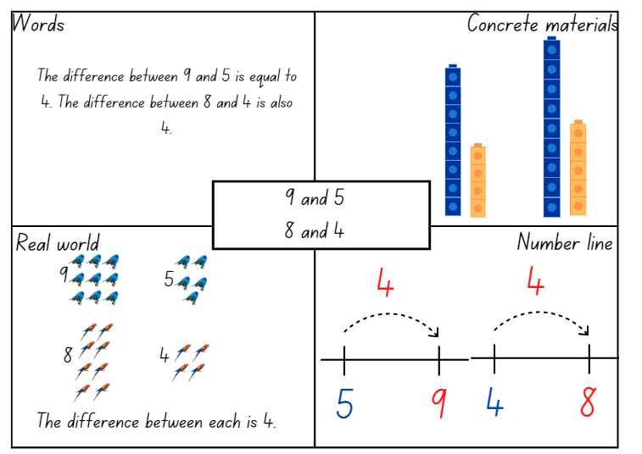
Images sourced from Canva and used in accordance with the Canva Content License Agreement.
- Have students choose 2 pairs of numbers that have a constant difference and record them in the centre of the think board.
- Students complete the think board and share their ideas with a partner.
This table details assessment opportunities and differentiation ideas.
Assessment opportunities | Too hard? | Too easy?
What to look for:  - Can students identify the difference between 2 numbers for numbers? (MAO-WM-01, MAE-CSQ-01, MAE-CSQ-02, MA1-CSQ-01)  - Can students identify a constant difference between different pairs of numbers? (MAO-WM-01, MA1-CSQ-01)  - Can students use drawings, words and numerals to record addition and subtraction, and explain their thinking? (MAO-WM-01, MAE-CSQ-02)  - Are students able to represent their thinking using a think board? (MAO-WM-01, MA1-CSQ-01)  What to collect:  - work sample – Resource 9: Think board (MAO-WM-01, MA1-CSQ-01)  - work sample – drawing in workbook showing tower difference. (MAO-WM-01, MAE-CSQ-02) | Students are unable to represent their thinking using a drawing.  - Students use interlocking cubes and verbally explain their thinking to a partner.  - Record students explaining their thinking using a digital device.  - Students create a drawing using numbers up to 5 or 10.  - Students only complete one or 2 sections of the think board. | Students can represent their thinking using a drawing.  - Ask students if there is another way to represent the constant difference for their numbers and to record their thinking.  - Ask students can they identify some generalisations or patterns when identifying constant differences in numbers up to 20.

Lesson 5: Creating balance
Core concept: Mathematicians think of equivalence as balance.
The table below contains suggested learning intentions and success criteria. These are best co-constructed with students.
Learning intentions | Success criteria
All students are learning that:  - recognising number combinations is helpful for solving problems efficiently  - hefting is used to compare if two masses are heavier, lighter or the same  - a level balance of objects on either side of an equal-arm balance creates equivalence  - if one part of the total number increases while the other part decreases by the same amount, the total remains the same. | All students can create, record and recognise combinations of 2 numbers that add up to 10.  In addition, students working towards Early Stage 1 outcomes can:  - predict which object would be heavier, lighter, or about the same weight as another object and explain why  - compare 2 masses directly by hefting.  In addition, students working towards Stage 1 outcomes can:  - place objects on either side of an equal-arm balance to obtain a level balance and show equivalence  - use the ‘one more, one less’ strategy with numbers on either side of an equal-arm balance to maintain equivalence.

Daily number sense: 3 sixes/tens/hundreds in a row – 15 minutes
- Build student understanding of number bonds by identifying different combinations in variations of the game 3 tens in a line (2:29).
- As a class, view the video that explains how to play.
- Students draw a 3 × 3 grid as a game board (like noughts and crosses game board).
- Stage 1 students take turns to roll a 10-sided dice with numbers 0-9 and write the number in one of their boxes. The goal is to be able to write 2 numbers in each box that combine to make 10. Players continue taking turns until a player has been the first to make 3 tens in a row.
- Early Stage 1 students play the game with 6-sided dice. The goal is to be able to write 2 numbers in each box that combine to make 6. Players continue taking turns until a player has been the first to make 3 sixes in a row.
- As an extra challenge, Stage 1 students can play 3 hundreds in a row, by rolling a dice using multiples of 10. The goal is to be able to write 2 numbers in each box that combine to make 100. Players continue taking turns until a player has been the first to make 3 hundreds in a row.

Creating balance – 40 minutes
Note: Stage 1 students can participate in this discussion as revision before undertaking their activity.
- Explain to Early Stage 1 students that they will be exploring the weight of objects and will use the shopping bags and their arms as a balance scale. Ask students to suggest words that could be used to explain weight. Create a vocabulary word bank ensuring the words light, heavy, heavier than or lighter than are included.
- Demonstrate to Early Stage 1 students how to place various objects from around the room in the shopping bags and heft them to determine which is lighter or heavier.
- Provide pairs of Early Stage 1 students with 2 shopping bags and their workbook. Students work with their partner to heft the objects and use the correct language to explain to their partner their reasoning. Students record their findings in their workbook, drawing themself and the objects in each bag. If possible, students can label their image using the correct language (see Figure 7).
Figure 7 – Hefting shopping bags
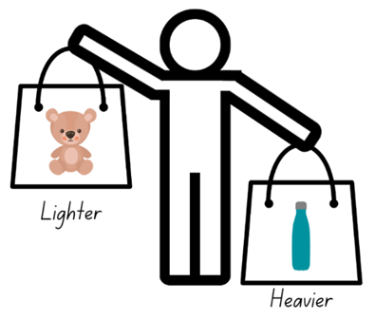
Images sourced from Canva and used in accordance with the Canva Content License Agreement.
- While Early Stage 1 students are working with their partner, explain to Stage 1 students that equivalence can be thought of as balance.
Note: The video could be viewed before the lesson or use the video as a resource during the lesson.
- Watch Creating balance – part 1 (5:08). Pause at 0:42 and ask what students notice about the right side of the balance.
- Continue watching the video and compare the students’ noticings to those in the video.
- Pause again at 3:27 and ask students what would need to happen on the left of the balance to make both sides equal.
- Continue watching the video and compare the students’ noticings to the findings in the video.
- Explain to students that their task is to find some different ways to make the arms balance. First, they must choose one of the numbers from the right side of the balance (10, 5 or 7) to stay the same on the left side. Students must use that number with 2 different numbers to make the left arm balance with the right arm.
- In pairs, students use number arm balances or a digital arm balance to find as many possible number combinations on the left side that will balance with the 10, 5 and 7 on the right side. Students draw pictures to record their thinking.
Note: At this point, support Early Stage 1 students with their measurement task. If they are looking for an additional challenge, you could ask them to find a way they could balance their shopping bags, by adding some smaller objects to the lighter bag. In this way, they are trying to make the weight of the bags the same.
- Watch Creating balance – part 2 (5:41) with Stage 1 students. Pause at 1:34 and discuss the ‘one more, one less’ strategy. Ask students to predict some other combinations of 3 numbers on the left arm that would balance the 10, 5 and 7 on the right arm using the ‘one more, one less’ strategy. For example, the 8 could gain one more to make 9, while the 4 could have one less and become 3.
- Continue the video to see the number combinations made by the animals, comparing them to the combinations made by the students. Pause the video again at 4:39.
- Ask students to think of how they could make the arms balance using 4 tags. In their pairs, students use balance arms to find combinations of 4 tags on the left that balance the 10, 5 and 7 on the right side. Students draw pictures of each new combination to record their thinking.
- Watch the rest of Creating balance – part 2 (5:41) from 4:39 to summarise some of the mathematics explored.
This table details assessment opportunities and differentiation ideas.
Assessment opportunities | Too hard? | Too easy?
What to look for:  - Can students compare the weight of various objects by hefting? (MAO-WM-01, MAE-NSM-01)  - Do students use the correct language to compare the weight of objects? (MAE-NSM-01)  - Do students find other combinations that balance the 10, 5 and 7 on the right arm? (MAO-WM-01, MA1-RWN-01, MA1-CSQ-01, MA1-NSM-01)  - Can students explain how the ‘one more, one less’ strategy to find equivalent number combinations? (MAO-WM-01, MA1-CSQ-01)  What to collect:  - observations and work samples of balanced number combinations. (MAO-WM-01, MAE-NSM-01, MA1-RWN-01, MA1-CSQ-01, MA1-NSM-01) | Students are unable to compare the weight of items by hefting or use the correct language.  - Students sit and place objects on their lap to feel the resistance against their body to determine if the object is light or heavy.  - Provide students with 2 objects that are very different in weight. Have students use a firm grip to heft and identify if it is lighter or heavier.  Students are unable to use balance arms to find or record combinations that balance the 10, 5 and 7 on the right side.  - Support students to experiment with combinations of tags that achieve balance between the arms. Record this combination and encourage students to change the combination on one side using the ‘one more, one less’ strategy.  - Support students to record their combinations accurately. | Students confidently use balance arms to find combinations that balance the 10, 5 and 7 on the right side.  - Ask students to see how many combinations they can balance using 5 tags. Suggest they use the ‘one more, one less’ strategy and record their thinking.  - Students draw a number balance combination for another student to solve.

Consolidation and meaningful practice: Noticing and wondering – 15 minutes
- Select several student pictures to display that show their thinking of different number combinations. Ask Early Stage 1 students:
- What did you notice during the activity?
- Were there any results that you found surprising?
- Were you able to balance any shopping bags? What did you use?
- Ask Stage 1 students:
- How could you be sure you have all the possible combinations?
- What other ways could you make the arms balance if you could use any numbers?
- Is there anything that you are still wondering?
- Summarise the lesson by highlighting that equivalence can be thought of as balance.

Lesson 6: Hungry, hungry monsters!
Core concept: Equality represents a relationship, not an action.
Note: Students often interpret the equals sign as ‘makes’, or ‘find the answer’. This often leads students to think that ‘equal’ means to execute an operation, like hitting the Enter key on an internet search. Instead, equal indicates a relationship. The 2 quantities on either side of the equals sign, regardless of their differences in appearance, have the same value. (Boaler, 2021).
The table below contains suggested learning intentions and success criteria. These are best co-constructed with students.
Learning intentions | Success criteria
All students are learning that:  - numbers can be represented as quantities to at least 20 using objects (such as fingers), number words and numerals  - the term ‘is the same as’ is used to express the equality of groups.  In addition, students working towards Stage 1 outcomes are learning that:  - the equals sign means ‘is the same as’, rather than an indication to perform an operation  - the quantities on either side of the equals sign have the same value  - the equals sign can be used to identify an unknown quantity in a number sentence. | All students can:  - represent numbers as quantities to at least 10 using objects.  - identify the number of missing dots to balance both sides of the number sentence  - use the term ‘is the same as’ to express equality of groups.  In addition, students working towards Stage 1 outcomes can:  - identify that the amounts on both sides of an equals sign are equivalent, or the same  - explain their thinking about balancing both sides of the number sentence.

Daily number sense: Number balance talk – 15 minutes
This lesson has been adapted from ‘Hungry, hungry monsters!’ (Boaler, 2021).
- Build student understanding that the equals sign represents a relationship, not an action, by solving a balance puzzle.
- Show Resource 10: Number balance talk and tell students that the equals sign in the centre means that the value of the 2 sides is the same, even when they do not look the same. Use a number balance from Lesson 5 as an example, that the equals sign is like a balance and the 2 sides need the same value to balance. Explain that it does not mean ‘find the answer’.
- Explain that some of the dots have been eaten by the monster in the image. Ask how many dots students think have been eaten and why they think this. Draw attention to the equals sign and how many dots are needed on each side so they have the same value.
- Ask where students would add the dots. Model that there is not one correct answer for placing the dots if the total is correct. Students may see the numbers differently and imagine the dots in specific places. Encourage multiple ways of seeing the dots.
- Record student thinking. For example, after drawing the new dots where students wanted to place them, label that group as 6 or choose to label it 3 and 3, because there were 3 dots and students added 3 more. Once the dots are labelled, explain to students how it makes sense.

Hungry, hungry monsters! – 30 minutes
- Explain that now students will work with a partner to solve some balance puzzles of their own.
- Provide Early Stage 1 students copies of Resource 11: Number balance puzzles writing materials, ten-frames and counters.
- Provide Stage 1 students copies of Resource 12: Balance puzzles 2, writing materials and counters.
- For each puzzle, partners work together to find out how many dots each monster has eaten. Display Resource 13: Number balance questions, as these can be used to prompt students during the activity:
- How do you see the dots in the puzzle?
- How many dots are hidden by the monsters? How do you know?
- How can you balance the 2 sides so that they are equal?
- Where do you think the dots could be added?
- How can you record your thinking so that others can see what you see?
- In pairs, students work on the puzzles recording their thinking as they go. Support students to focus their conversation on the quantities and the value of each side of the number sentence.
This table details assessment opportunities and differentiation ideas.
Assessment opportunities | Too hard? | Too easy?
What to look for:  - Do students recognise that the amounts on both sides of an equals sign are equivalent, or the same? (MAO-WM-01, MAE-RWN-01, MAE-CSQ-01, MA1-RWN-01, MA1-CSQ-01)  - Can students identify the number of missing dots to balance both sides of the number sentence? (MAO-WM-01, MA1-RWN-01, MA1-CSQ-01)  - Are students able to explain their thinking about balancing both sides of the number sentence? (MAO-WM-01, MA1-RWN-01, MA1-CSQ-01)  What to collect:  - observations and work samples of students identifying amounts that are equivalent, or the same. (MAO-WM-01, MAE-RWN-01, MAE-CSQ-01, MA1-RWN-01, MA1-CSQ-01) | Students cannot recognise that the amounts on both sides of an equals sign are equivalent, or the same.  - View Resource 10: Number balance talk, revising how the number of dots were the same on both sides of the equals sign.  - Use a number arm balance to explain that the equals sign is like the balance and the amounts on both sides need to have the same total.  Students are unable to identify the number of missing dots to balance both sides of the equation. Use counters to model the dots shown in each number balance puzzle. Support students to use the counters to find the missing amount ‘eaten’ by the monster to achieve a balance of counters on both sides. | Students confidently identify the number of missing dots to balance both sides of the equation.  - Students use Resource 14: Number balance scaffold to create their own number balance puzzles.  - Students share their number puzzles with other students.

Consolidation and meaningful practice: Summarising the learning – 15 minutes
- Invite students to share how they solved the puzzles by discussing the following questions:
- How did you know how many dots were eaten? How did you see it?
- How did the equals sign help you?
- Where did you add the dots? Why?
- Did you and your partner think differently about any of the puzzles? How were you each thinking?
- Were any of the puzzles challenging? What questions do you have, or how did you work through the challenge?
- As you discuss the different puzzles that partners solved, return to the big idea that the 2 sides of the equation must have the same value.
- Conclude the lesson by asking the Stage 1 student what the equals sign means. Ask students to explain, using an example if necessary.

Lesson 7: Pigs versus wolf!
Core concept: Mathematicians recognise when 2 quantities are equal or different.
Note: A critical aspect of students’ mathematical thinking is developing a relational understanding of the equals sign. This involves students interpreting this symbol as meaning ‘the same as’, rather than simply ‘the answer’. This discovery can be promoted through contrasting the concept of equivalence with the concept of inequality (for example, 'more than’ or ‘less than’) early in a student’s mathematical development (Russo, 2016).
The table below contains suggested learning intentions and success criteria. These are best co-constructed with students.
Learning intentions | Success criteria
All students are learning that:  - numbers can be represented as quantities to at least 20 using objects (such as fingers), number words and numerals  - the term ‘is the same as’ is used to express the equality of groups.  In addition, students working towards Stage 1 outcomes are learning that:  - the equals sign means ‘is the same as’, rather than an indication to perform an operation  - the quantities on either side of the equals sign have the same value  - the equals sign can be used to identify an unknown quantity in a number sentence. | All students can:  - represent numbers as quantities to at least 10 using objects  - identify the number of missing dots to balance both sides of the number sentence  - use the term ‘is the same as’ to express equality of groups.  In addition, students working towards Stage 1 outcomes can:  - identify that the amounts on both sides of an equals sign are equivalent, or the same  - explain their thinking about balancing both sides of the number sentence.

Daily number sense: Revisiting 3 sixes/tens/hundreds in a row – 15 minutes
- Build student understanding of number bonds by identifying different combinations in variations of the game 3 tens in a line (2:29).
- As a class, revise the rules of the game from Daily Number Sense, Lesson 5. Students draw a 3 × 3 grid as a game board (like noughts and crosses game board).
- Early Stage 1 students play the game with 6-sided dice. The goal is to be able to write 2 numbers in each box that combine to make 6. Players continue taking turns until a player has been the first to make 3 sixes in a row. Some students may feel confident playing the game where they make combinations of 10.
- Stage 1 students take turns to roll a 10-sided dice with numbers 0-9 and write the number in one of their boxes. The goal is to be able to write 2 numbers in each box that combine to make 10. Players continue taking turns until a player has been the first to make 3 tens in a row.
- As an extra challenge, Stage 1 students can play 3 hundreds in a row, by rolling a dice using multiples of 10. The goal is to be able to write 2 numbers in each box that combine to make 100. Players continue taking turns until a player has been the first to make 3 hundreds in a row.

Pigs versus wolf! – 30 minutes
This lesson is based on the work of Russo (2016).
- Build student understanding of the balancing numbers by exploring inequalities in this dice game, built around the familiar fairy-tale The Three Little Pigs and The Big Bad Wolf.
Note: You may wish to read a version of the fairy-tale prior to the activity, to engage students before introducing them to the game.
- Introduce the game by displaying Resource 15: Pigs vs. wolf rules. Model how to play the game, using dice and Resource 16: Pigs vs. wolf gameboard 1. The rules of the game are:
- Rule 1: In pairs, one student plays the pigs and the other student the wolf.
- For Early Stage 1, the player representing the pigs has two 6-sided dice while the wolf uses a 10-sided dice. Early Stage 1 students use Resource 16: Pigs vs. wolf gameboard 1.
- For Stage 1, the player representing the pigs has three 6-sided dice while the wolf uses a 10-sided dice. Stage 1 students use Resource 17: Pigs vs. wolf gameboard 2.
- Rule 2: Students roll the dice and students calculate their score for that roll. For example, the player representing the pigs would add their 6-sided dice together for their total, while the wolf uses the number they rolled on their 10-sided dice for their total. The player with the higher score records the number sentence and earns a ‘house’. The winning student can record their house as a drawing on their paper or using a multi-link cube.
- Rule 3: The first to 5 houses wins.
- Students play the game in pairs, using the gameboard. Before long, students will encounter the problem of what to do if they get the same score. When this first happens, pause the lesson and discuss possible solutions with the class. Then, introduce Rule 4.
- Rule 4: This rule is a secret. If both players get the same score, they both earn a house!
- Students continue playing the game using the new rule.
This table details assessment opportunities and differentiation ideas.
Assessment opportunities | Too hard? | Too easy?
What to look for:  - Do students describe amounts using words such as ‘more than’, ‘less than’ and ‘equal’? (MAO-WM-01, MA1-RWN-01, MA1-CSQ-01)  - Do students recognise or use the equals sign to show that 2 amounts are the same? (MAO-WM-01, MA1-RWN-01, MA1-CSQ-01)  What to collect:  - observational data (MAO-WM-01, MA1-RWN-01, MA1-CSQ-01)  - student work samples. (MAO-WM-01, MA1-RWN-01, MA1-CSQ-01) | Students are unable to describe amounts using words such as more than, less than and equal.  - Use counters to compare and describe collections that are more than, less than and equal.  - Write the words more than, less than and equal on sticky notes for students to refer to.  Students cannot recognise or use the equals sign to show that 2 amounts are the same. Support students to use counters to model the quantities they roll on their turn. Compare the pigs’ counters to the wolf’s counters to determine. | Students confidently use words and the equals sign to describe and compare amounts.  - Students try playing with 6 little pigs (6 × 6-sided dice) vs 3 big bad wolves (3 × 10-sided dice).  - Ask students to return to their gameboard and ask them to try and share the scores rolled into 2 even groups, recording their thinking. If there is a remainder, ask them what they could do to share this equally.

Consolidation and meaningful practice: Summarising the learning – 10 minutes
- Summarise the learning by using these discussion points with the class:
- What did you notice when you were playing the game?
- Why was rule 4 important?
- Why is the equals sign important for mathematicians?
- Is there anything else that you are still wondering about?
- Conclude by highlighting that the equals sign is used to show when 2 quantities are equal.

Lesson 8: Who balanced the boat?
Core concept: Mathematicians use equivalence to solve different problems in our world.
The table below contains suggested learning intentions and success criteria. These are best co-constructed with students.
Learning intentions | Success criteria
All students are learning that:  - predictions can be made which object would be heavier than, lighter than, or have about the same weight  - objects can be identified as heavy or light  - masses can be compared directly by hefting.  In addition, students working towards Stage 1 outcomes are learning that:  - objects with equivalent masses can be balanced  - mathematical reasoning is used to solve problems, for example, by experimenting with ways to balance equivalent masses  - mathematicians communicate their reasoning clearly to help others share their thinking. | All students can:  - predict which object would be heavier than, lighter than, or have about the same weight as another object  - identify that objects can be heavy or light  - compare 2 masses directly by hefting.  In addition, students working towards Stage 1 outcomes can:  - identify objects with equivalent masses  - experiment with rearranging different objects to form equivalent masses  - communicate their mathematical reasoning clearly to help others share their thinking.

Daily number sense: Assessment and Number match – 20 minutes
- Consolidate Stage 1 students’ understanding of connecting counting to numerals and quantities, by replaying Number match from Lesson 1.
- Provide each Stage 1 student with a gameboard from Resource 1: Number match and a collection of counters. Revise the rules of the game, then Stage 1 students play the game with a partner.
- Assess Early Stage 1 students’ understanding of counting forwards by ordering number cards and counting out loud.
- Give each student Resource 3: Number cards 20. Students shuffle the cards and place them in order from one to 20. Ask students to count the number sequence aloud and continue past 20, up to at least 30.
Note: Early Stage 1 students are expected to count to at least 30 and be able to identify a number before or after up to 30. They are also expected to order numbers up to 20.
- Ask students to identify the number before or after a given number. Students can check their answers using the sequenced cards.
- Have students glue their number cards in order inside their workbook. Students can work with a partner to check their sequence is correct.
This table details assessment opportunities and differentiation ideas.
Assessment opportunities | Too hard? | Too easy?
What to look for:  - Can students order numbers to 20? (MAO-WM-01, MAE-RWN-01)  - Can students count forwards to at least 30 and state the number after or before a given number, without needing to count from one? (MAO-WM-01, MAE-RWN-01, MAE-RWN-02)  What to collect:  - work samples – number cards in workbooks (MAE-RWN-01, MAE-RWN-02)  - observational data. (MAO-WM-01, MAE-RWN-01, MAE-RWN-02) | Students are unable to count forwards to 30 and state the number before or after a given number.  - Provide students with concrete materials and support students to count using one-to-one correspondence.  - Have students look at, point to or touch objects as they are being counted. | Students are unable to count forwards to 30 and state the number before or after a given number.  - Have students count forwards to 120.  - Have students identify he number before or after a given two-digit number.

Who balanced the boat? Part 1 – 15 minutes
This lesson is based on Using Picture Story Books to Discover and Explore the Concept of Equivalence by Russo (2016).
- Build student understanding of equivalence by investigating how different masses can achieve balance.
Note: You may wish to read Who Sank the Boat? by Pamela Allen to engage students prior to the activity.
- Identify that, in the story Who Sank the Boat? one of the reasons the boat stayed afloat for so long is because the animals worked out how to balance their weights across the boat. Just as numbers can be shared equally, weight can be shared equally, too.
- Introduce 2 balls of modelling clay of the same size. Ask students:
- What do you notice?
- What do you wonder?
- What attributes can you see that are the same?
- If we were to check that the balls have the same weight, what would you expect to feel when hefting?
- Place the modelling clay balls in each hand to demonstrate the same weight. Explain that if you feel the same push on your arms, we know the items have the same weight. If objects have the same weight, we can say the clay balls are the same or equivalent in weight.
Note: Stage 1 students could also explore the placement of mass at different points on an equal-arm balance.
- Ask students to predict what will happen to the weight of the clay balls if one stays the same, while the other is made into 4 smaller clay balls.
- Discuss that, even though one of the balls changed shape, the weight remains the same. Explain that objects which are the same can be partitioned and still be the same weight. Their mass is equivalent.

Who balanced the boat? Part 2 – 25 minutes
Note: It may be beneficial to prepare the animal models out of modelling clay for each pair of students prior to the lesson, as in Figure 8. This could support students to focus on the core concept of the lesson, if creating the animal models accurately will be too challenging for them.
- Display Resource 18: Who balanced the boat? and introduce the problem. Display 5 balls of modelling clay (see Figure 8). Explain that the image and the clay models represent the animals. The cow and the donkey have an equivalent mass, but they are both heavier than the pig and the sheep. The pig and the sheep have an equivalent mass, but they are both heavier than the mouse.
Figure 8 – Modelling clay
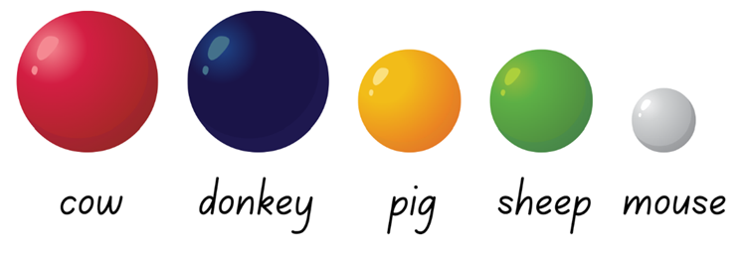
- Explain that students will work in pairs to make a boat out of cardboard and animals from modelling clay. They will then see if they can balance their boat with their animals on it.
- In pairs, students create a boat using paper, cardboard or paper plates and adhesive tape.
- Students represent the animals using modelling clay. They use the information on Resource 18: Who balanced the boat? as a guide. They need to ensure that the cow and sheep have the same size and mass as each other, they are equivalent. The pig and sheep also need to be the same size and mass, they are also equivalent. The mouse alone has a unique size and mass.
- In pairs, students discuss and make predictions about ways of arranging the animals on their boat so that it will successfully stay afloat.
Note: Mathematical reasoning and critical thinking can be supported by saying that a solution may only be recorded when all group members agree that a particular configuration of animals would balance the boat. If agreement cannot be reached by the group, consider photographing it and exploring it further during the whole class discussion. It may provide an opportunity to address a misconception or provide an example where there is genuine confusion about whether the boat would be balanced.
- Students use their animal models and boat to explore possible solutions to the problem. They balance them on water in a sink or container (see Figure 9). Students record their successful solutions by drawing them on paper as students discover them.
Figure 9 – Examples of balance
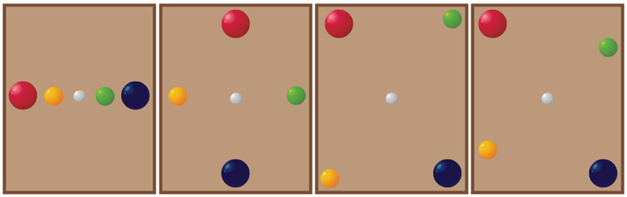
Note: There are many solutions to this challenge, some of which are displayed in Figure 9. Examples of balancing the boat. However, the key insight into the problem is realising that the mouse needs to be exactly in the middle of the boat.
This table details assessment opportunities and differentiation ideas.
Assessment opportunities | Too hard? | Too easy?
What to look for:  - Do students experiment with arranging their modelling clay animals in their boat in ways that balance the weight equally on water? (MAO-WM-01, MA1-NSM-01)  - Are students able to explain how their arrangement of animals in their boat balances the weight equally? (MAO-WM-01, MA1-NSM-01)  - Do students develop more than one solution to the problem? (MAO-WM-01, MA1-NSM-01)  What to collect:  - observations and students’ work samples of solutions to the problem. (MAO-WM-01, MA1-NSM-01) | Students are unable to organise their animals to balance on the water.  - Support students in a small group and model one way to arrange the animals on the boat. Test if the boat balances, then ask students to reflect on whether the arrangement worked.  - Ask students to think of another arrangement to test. | Students find several ways to balance the weight of their animals on the water.  - Provide students with another piece of modelling clay to represent a second mouse. Students try to find a way to balance the boat with this extra mouse.  - Challenge students to think about how they could balance the animals in 2 boats. Ask them to consider if they would need the second mouse to help.

Consolidation and meaningful practice: Summarising the learning – 10 minutes
- Bring the class together and ask:
- Did you notice some things that were equal, or had equivalence, during this activity?
- Did you notice some things that were not equal, or didn’t have equivalence, during this activity?
- What challenges were there in this task? How did you solve them?
- What were some solutions to the problem that you discovered?
- If the mouse got onto the boat on his own, where would he need to stand to balance the boat?
- What if the mouse was in the middle of the boat? Would this help you solve the problem?
- Is there anything that you are still wondering?
- Summarise the learning by highlighting that, just like the animals on the boat, students use equivalence to solve problems in their world.

Resource 1: Number match
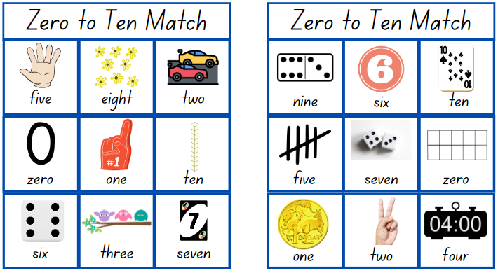
Images sourced from Canva and used in accordance with the Canva Content License Agreement.
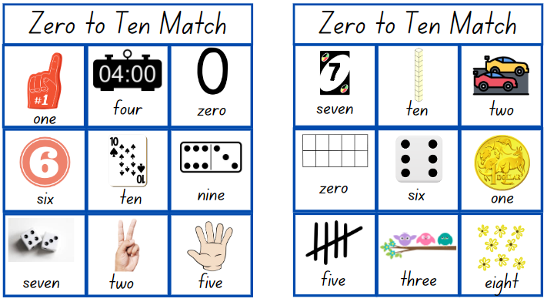
Images sourced from Canva and used in accordance with the Canva Content License Agreement.
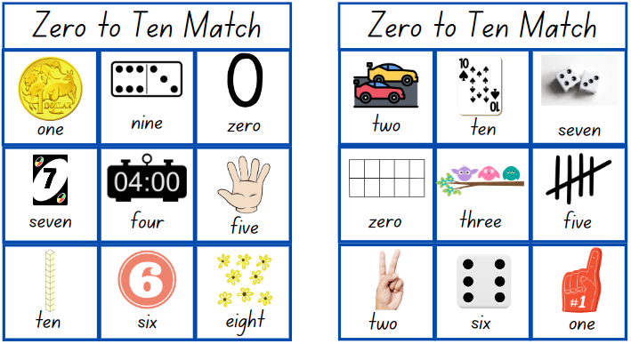
Images sourced from Canva and used in accordance with the Canva Content License Agreement.
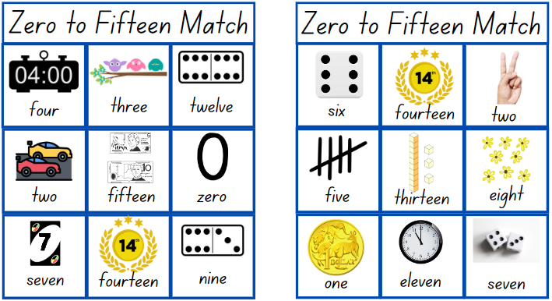
Images sourced from Canva and used in accordance with the Canva Content License Agreement.
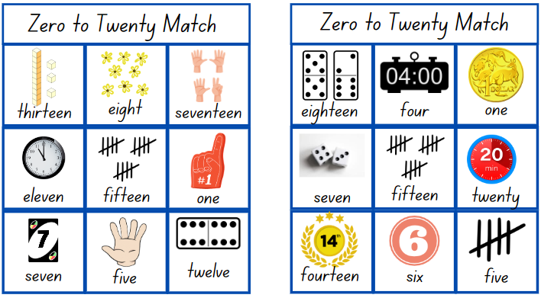
Images sourced from Canva and used in accordance with the Canva Content License Agreement.
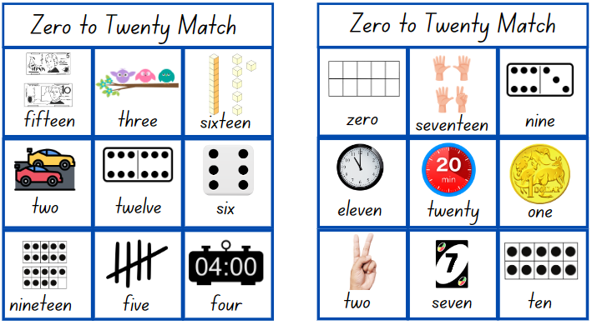
Images sourced from Canva and used in accordance with the Canva Content License Agreement.
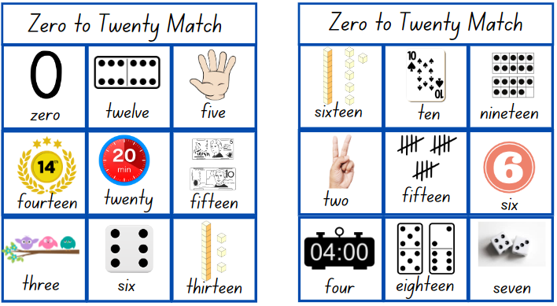
Images sourced from Canva and used in accordance with the Canva Content License Agreement.
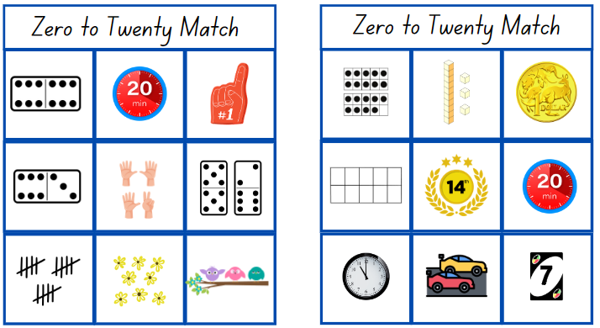
Images sourced from Canva and used in accordance with the Canva Content License Agreement.

Resource 2: Number cards 10
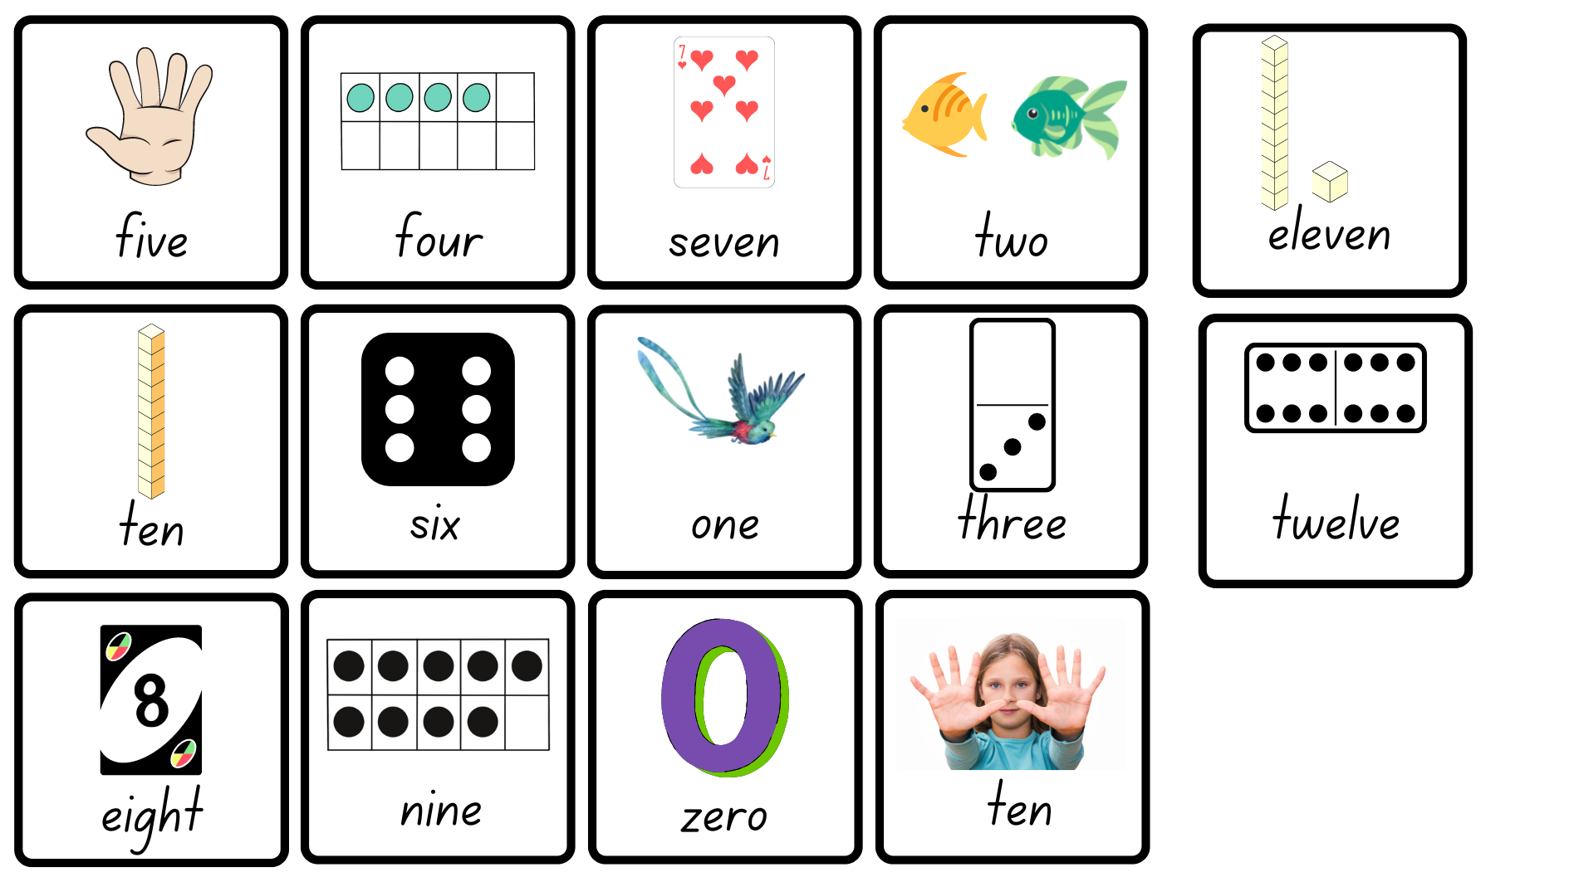
Images sourced from Canva and used in accordance with the Canva Content License Agreement.

Resource 3: Number cards 20
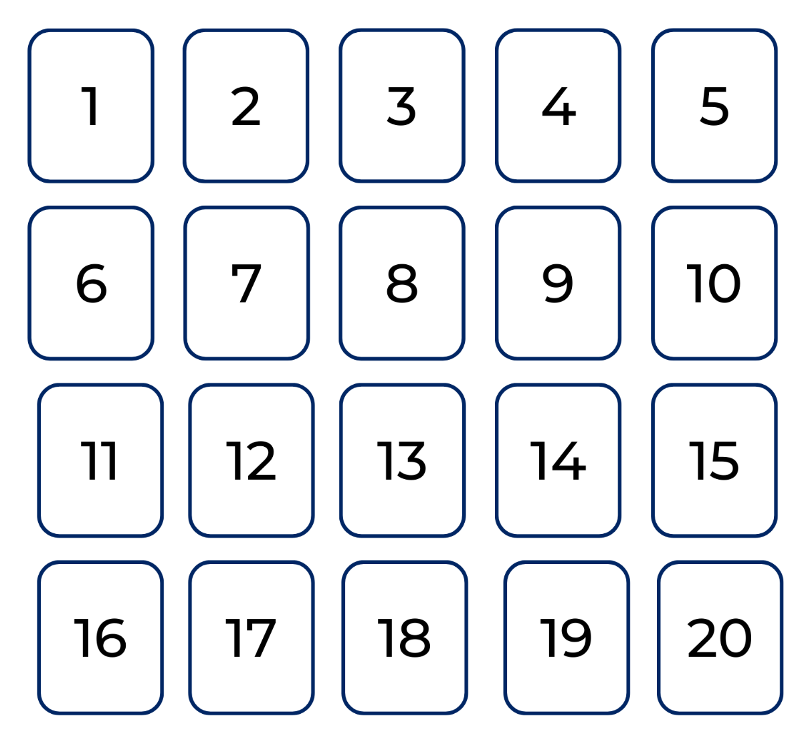

Resource 4: Number talk
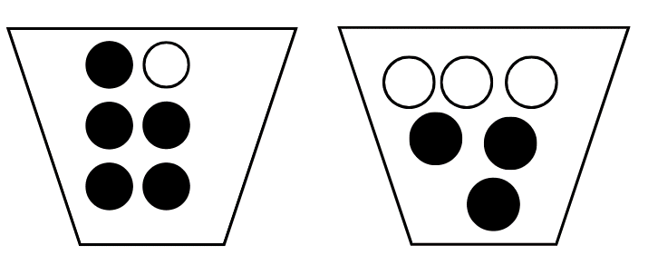

Resource 5: Addition table
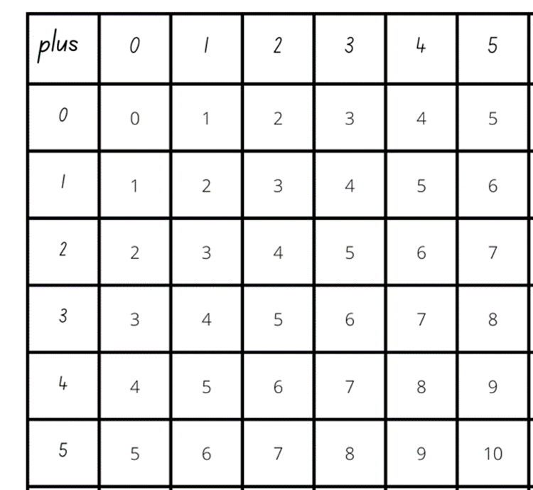

Resource 6: Extended addition table
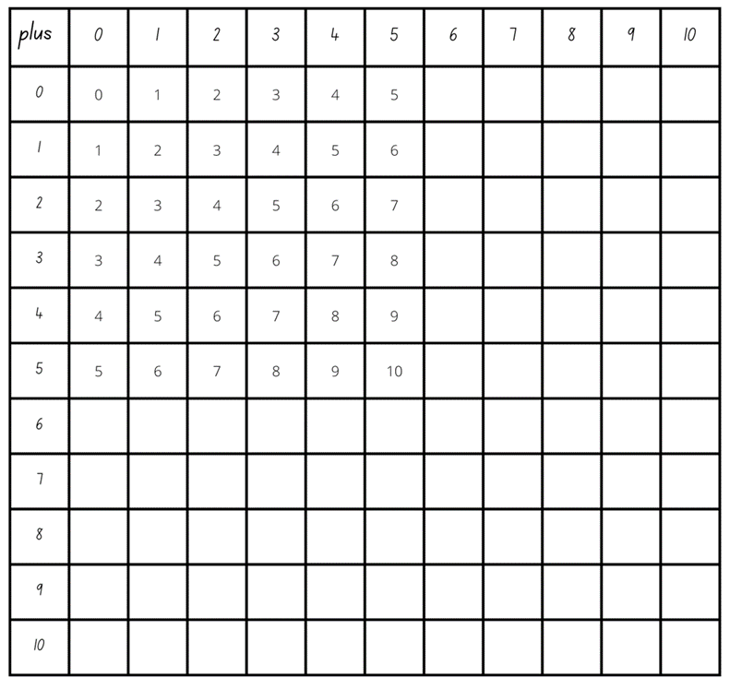

Resource 7: Tower talk
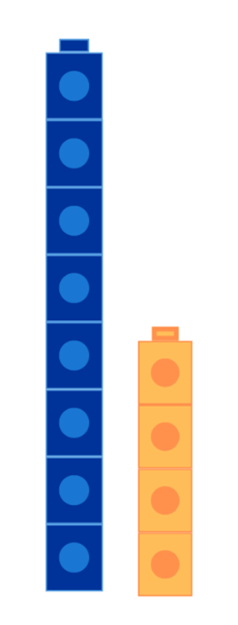
Images sourced from Canva and used in accordance with the Canva Content License Agreement.

Resource 8: Constant difference concentration
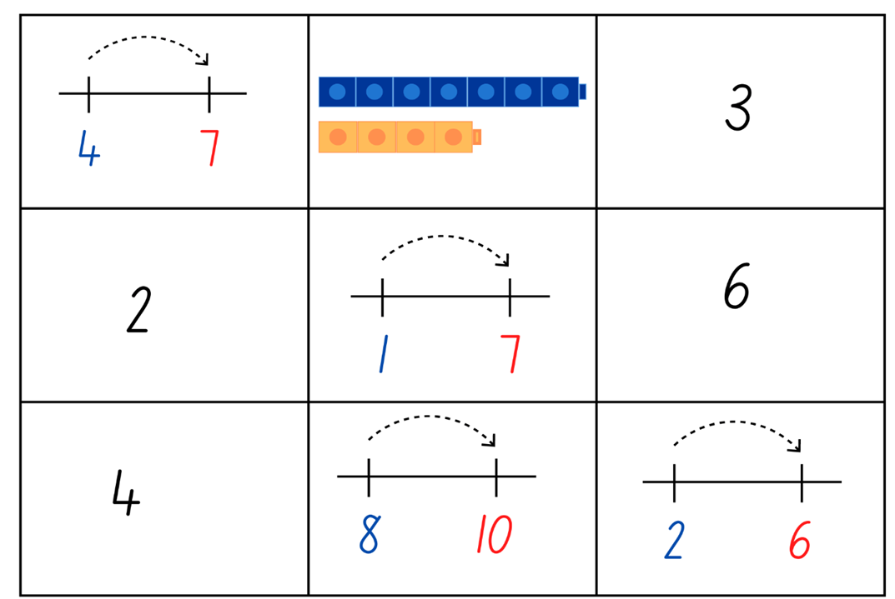
Images sourced from Canva and used in accordance with the Canva Content License Agreement.
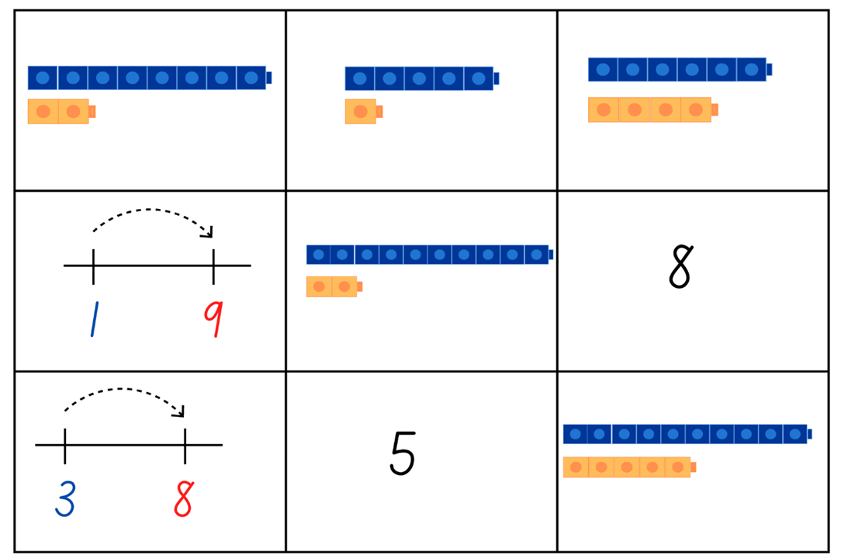
Images sourced from Canva and used in accordance with the Canva Content License Agreement.
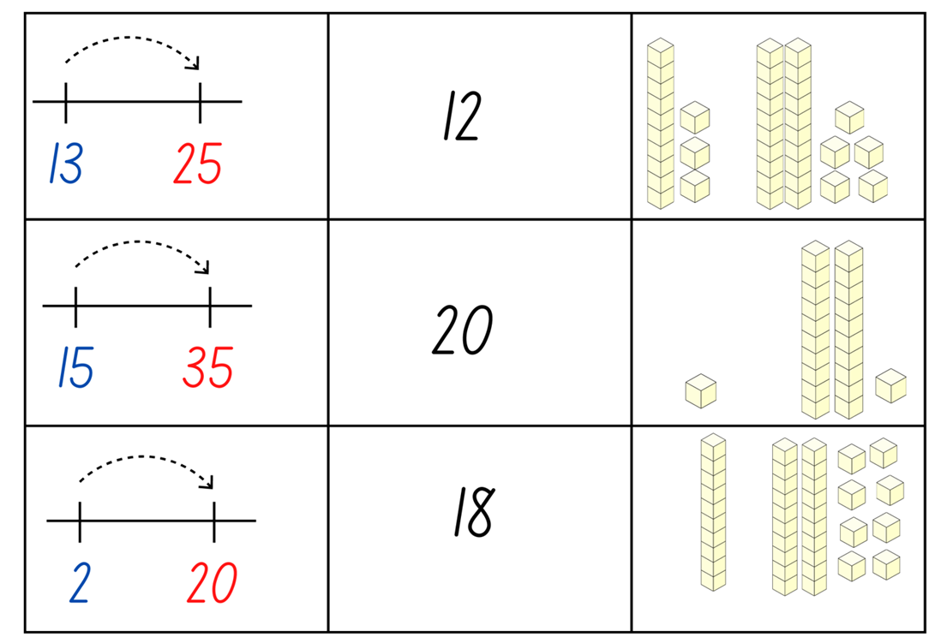
Images sourced from Canva and used in accordance with the Canva Content License Agreement.

Resource 9: Think board
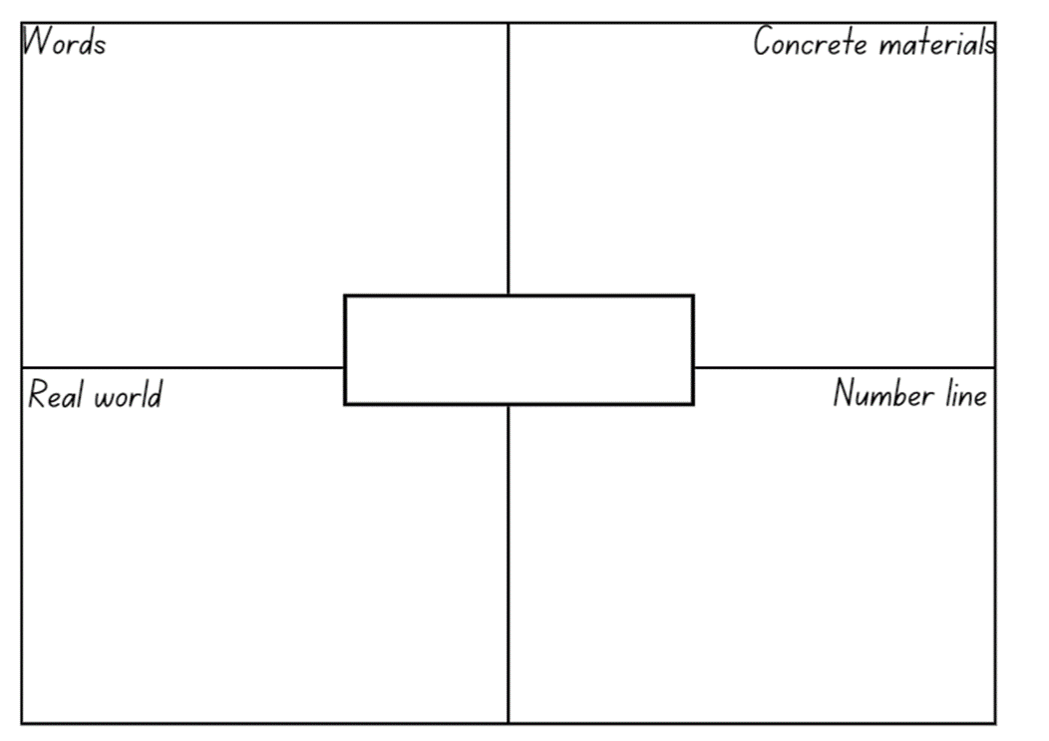

Resource 10: Number balance talk
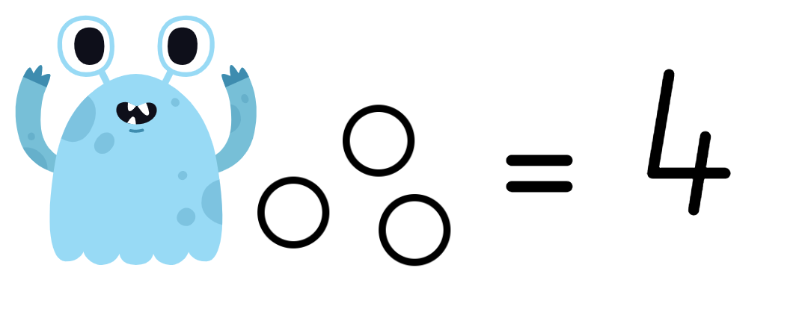
Images sourced from Canva and used in accordance with the Canva Content License Agreement.

Resource 11: Number balance puzzles
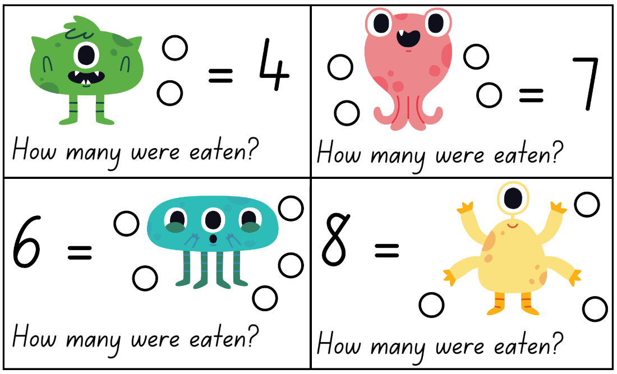
Images sourced from Canva and used in accordance with the Canva Content License Agreement.
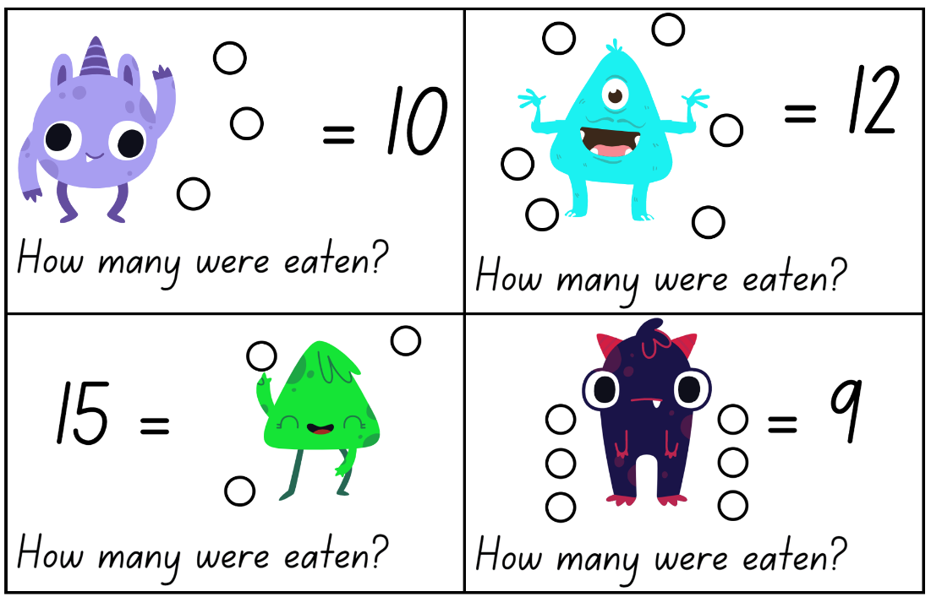
Images sourced from Canva and used in accordance with the Canva Content License Agreement.

Resource 12: Balance puzzles 2
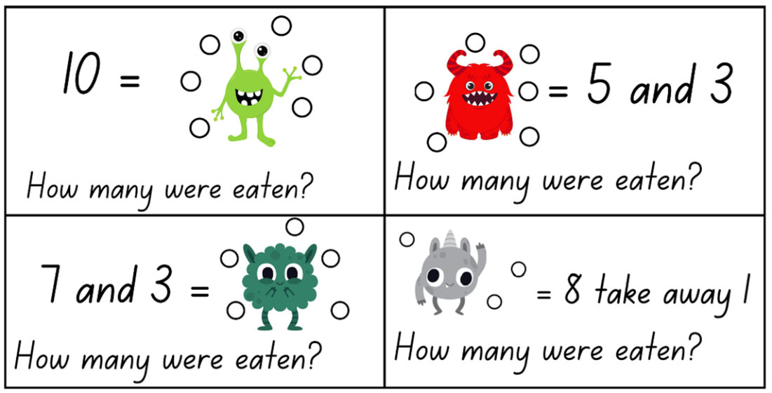
Images sourced from Canva and used in accordance with the Canva Content License Agreement.
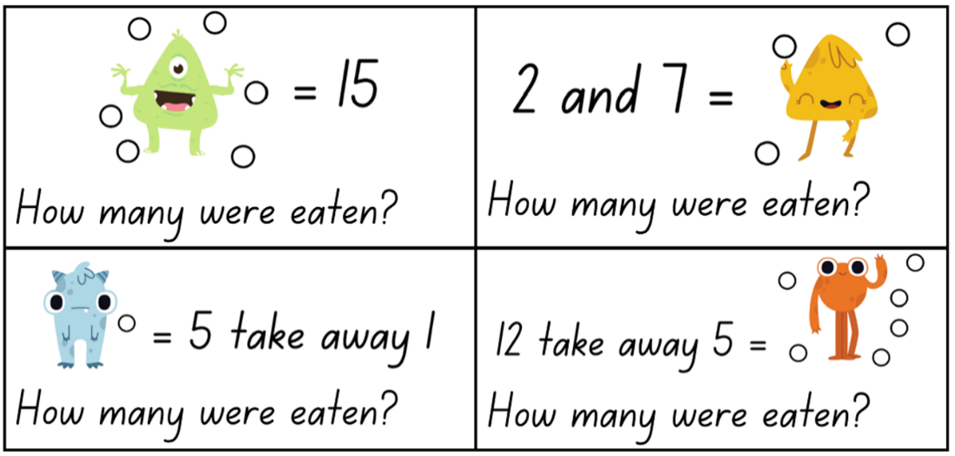
Images sourced from Canva and used in accordance with the Canva Content License Agreement.
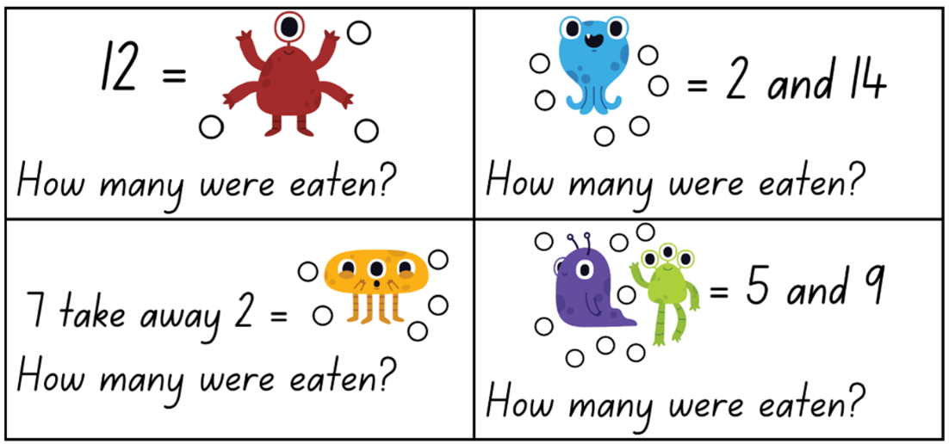
Images sourced from Canva and used in accordance with the Canva Content License Agreement.

Resource 13: Number balance questions
- How do you see the dots in the puzzle?
- How many dots are hidden by the monsters? How do you know?
- How can you balance the 2 sides so that they are equal?
- Where do you think the dots could be added?
- How can you record your thinking so that others can see what you see? (For example, using a bar model from Lesson 2).

Resource 14: Number balance scaffold
Images sourced from Canva and used in accordance with the Canva Content License Agreement.

Resource 15: Pigs vs. wolf rules
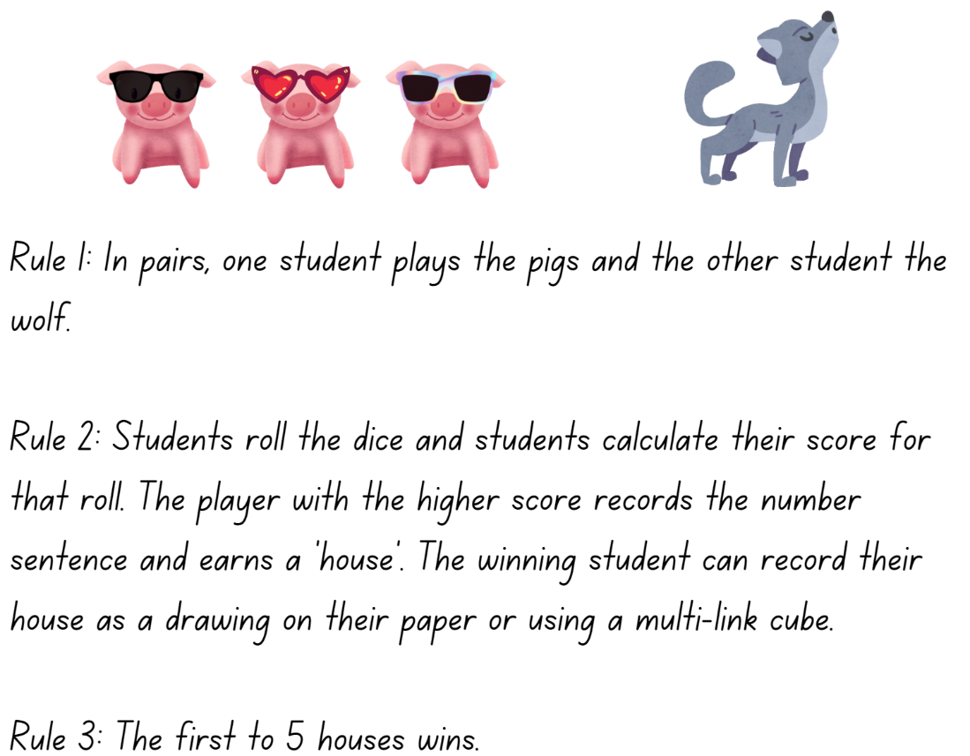
Images sourced from Canva and used in accordance with the Canva Content License Agreement.

Resource 16: Pigs vs. wolf gameboard 1
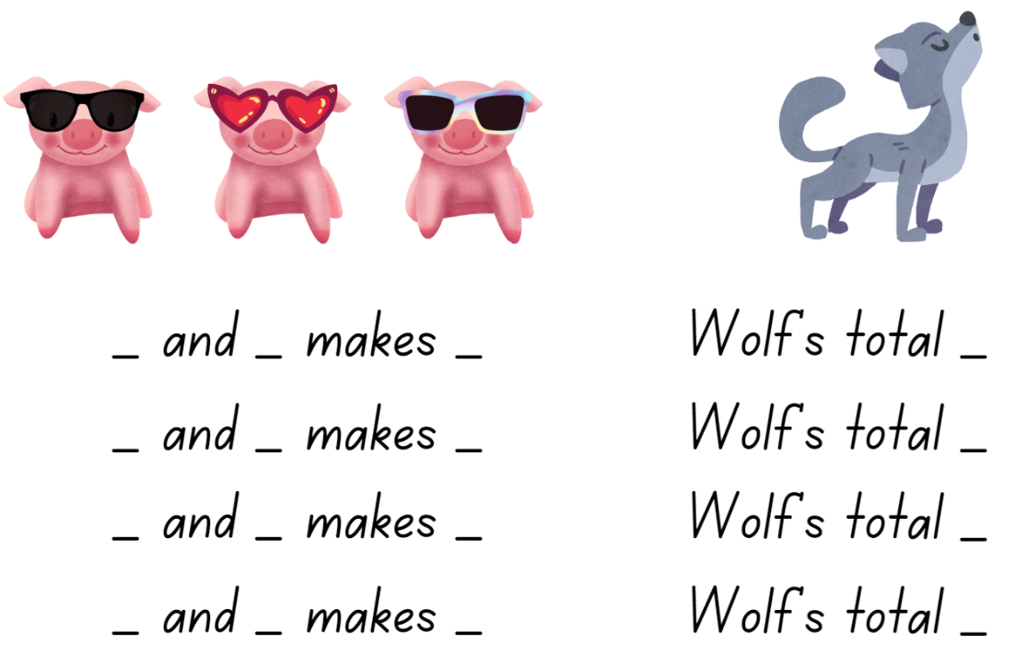
Images sourced from Canva and used in accordance with the Canva Content License Agreement.

Resource 17: Pigs vs. wolf gameboard 2
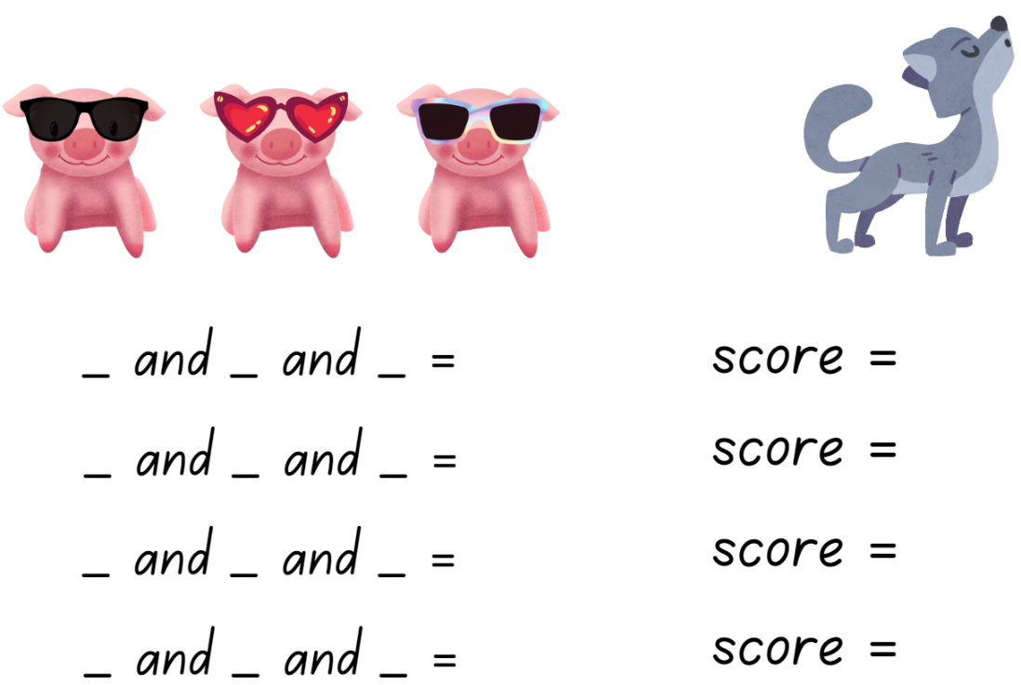
Images sourced from Canva and used in accordance with the Canva Content License Agreement.

Resource 18: Who balanced the boat?
Can you find a way to get all 5 animals, including the mouse, to distribute their weight across the boat so that the boat is balanced and stays afloat? Here is some important information about the weight of the animals to help solve the problem:
- The cow weighs the same as the donkey. They are balanced.
- The pig weighs the same as the sheep. They are balanced.
The cow and the donkey are both heavier than the pig and the sheep. They are not balanced with the pig and the sheep.
- The pig and the sheep are both heavier than the mouse. They are not balanced to the mouse.
See how many ways the problem can be solved.
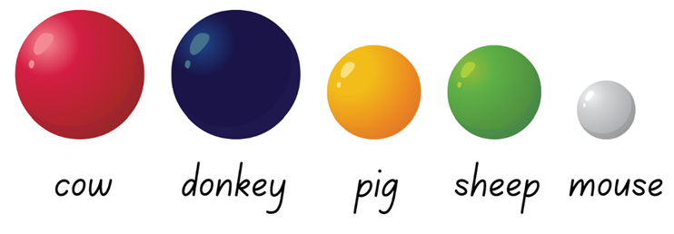

Syllabus outcomes and content
The table below outlines the syllabus outcomes and range of relevant syllabus content covered in this unit. Content is linked to National Numeracy Learning Progression version (3).
Focus area and outcomes | Content groups and content points | Lessons
Representing whole numbers  MAO-WM-01  MAE-RWN-01, MA1-RWN-01  MAE-RWN-02, MA1-RWN-02 | Early Stage  Instantly name the number of objects within small collections  - instantly recognise (subitise) the number of items in small groups of up to four items without counting (NPV1, CPr1)  - identify the number of items in different arrangements (CPr2) | 1, 3
Representing whole numbers (cont) | Early Stage 1  Use the counting sequence of ones flexibly  - count forwards to at least 30 and state the number after or before a given number, without needing to count from one (CPr4)  - count backwards from a given number 20 or less (CPr5)  - identify the number before as 'one less' and the number after as 'one more’ than a given number | 1–8
Representing whole numbers (cont) | Early Stage 1  Recognise number patterns  - recognise dice and domino dot patterns (NPA1, NPV2, CPr2)  - recognise different finger patterns for the same number (NPA2) | 1, 3
Representing whole numbers (cont) | Early Stage 1  Connect counting and numerals to quantities  - count with one-to-one correspondence, recognising that the last number name represents the total number in the collection (CPr3, CPr5)  - count out a specified number of objects (from 5 to 20) from a larger collection, keeping track of the count (CPr4-CPr5)  - make correspondences between collections  - read numerals to at least 20, including zero (NPV3)  - represent numbers as quantities to at least 20 using objects (such as fingers), number words and numerals (NPV2-NPV4, CPr3)  - compare and order numbers to 20 (NPV2-NPV3)  - use the term ‘is the same as’ to express equality of groups (Reasons about quantity (CPr4-CPr5, MuS1) | 1–8
Representing whole numbers A | Stage 1  Use counting sequences of ones with two-digit numbers and beyond  - identify the number before and after a given two-digit number (CPr5)  - count forwards and backwards by ones from a given number to at least 120 (CPr6) | 1–8
Representing whole numbers A (cont) | Stage 1  Represent numbers on a line  - sequence numbers and arrange them on a line by considering the order and size of those numbers (CPr5) | 4
Representing whole numbers A (cont) | Stage 1  Represent the structure of groups of ten in whole numbers  - recognise that ten ones is the same as one ten (NPV2, NPV4) | 7
Combining and separating quantities  MAO-WM-01  MAE-CSQ-01, MA1-CSQ-01  MAE-CSQ-02 | Early Stage 1  Model additive relations and compare quantities  - identify situations in which addition and subtraction may be applied (AdS1-AdS2)  - combine two or more groups of objects to model addition, identifying the relationship between the parts and the whole (AdS1-AdS2)  - separate and take away part of a group of objects to model subtraction (AdS1-AdS2)  - use concrete materials or fingers to model and solve addition and subtraction questions, counting forwards or backwards by ones as necessary (AdS1-AdS2, NPV3)  - compare two groups of objects to determine how many more (AdS2, NPV1) | 1–7
Combining and separating quantities (cont) | Early Stage 1  Identify part–whole relationships in numbers up to 10  - use visual representations of numbers to assist with combining and separating quantities, identifying the relationship between the quantities (NPV2, NPA2, AdS2-AdS3)  - describe the action of combining, separating and comparing (AdS1)  - use five as a reference in forming numbers from six to ten  - create, model and recognise combinations for numbers up to ten (AdS2)  - count by ones to find the total or difference (AdS2-AdS3)  - use drawings, words and numerals to record addition and subtraction, and explain their thinking (AdS2) | 1–7
Combining and separating quantities A  NOTE – There is only one combining and separating quantities outcome for Stage 1. | Stage 1  Use advanced count-by-one strategies to solve addition and subtraction problems  - apply the terms ‘add’, ‘plus’, ‘equals’, ‘is equal to’, ‘is the same as’, ‘take away’, ‘minus’ and ‘the difference between’ to describe combining and separating quantities (AdS1, AdS6)  - recognise and use the symbols for plus (+), minus (–) and equals (=)  - record number sentences in a variety of ways using drawings, words, numerals and symbols (AdS6)  - fluently use advanced count-by-one strategies including counting on and counting back to solve addition and subtraction problems involving one- and two-digit numbers (AdS3-AdS5) | 1–7
Combining and separating quantities A (cont) | Stage 1  Recognise and recall number bonds up to ten  - recognise, recall and record combinations of two numbers that add up or bond to form 10 (AdS2, AdS6  - model and record patterns for individual numbers up to ten by making all possible whole-number combinations  - create, recall and recognise combinations of two numbers that add up to numbers less than 10 (AdS2, AdS6)  - describe combinations for numbers using words such as more than, less than and double (AdS6) | 1–7
Combining and separating quantities A (cont) | Stage 1  Use flexible strategies to solve addition and subtraction problems  - use non-count-by-one strategies such as using doubles for near doubles and combining numbers that add to ten (AdS6)  - represent addition and subtraction using structured materials such as a bead string or similar model (AdS6-AdS7) | 1–7
Combining and separating quantities A (cont) | Stage 1  Represent equality  - use the equals sign to record equivalent number sentences involving addition, and to mean 'is the same as', rather than as an indication to perform an operation (NPA3)  - recall related addition and subtraction facts for numbers to at least 10 (AdS6) | 1–7
Combining and separating quantities B | Stage 1  Represent and reason about additive relations  - create, record and recognise combinations of two numbers that add to numbers from 11 up to and including 20 (AdS7)  - create, model and solve word problems, using number sentences  - represent the difference between two numbers using concrete materials and diagrams (AdS6)  - represent a constant difference between pairs of numbers | 3–5
Combining and separating quantities B (cont) | Stage 1  Use knowledge of equality to solve related problems  - use number bonds to determine a missing number (AdS6, NPA3-NPA4)  - use number knowledge to solve related problems (AdS7, NPA4)  - use a variety of ways of writing number sentences (NPA3-NPA4)  - use number bonds to solve equality problems (NPA3-NPA4) | 3–5
Non-spatial measure  MAO-WM-01  MAE-NSM-01, MA1-NSM-01  MAE-NSM-02, MA1-NSM-02 | Early Stage 1  Mass: Identify and compare mass using weight  - identify that objects can be heavy or light (UuM2)  - compare two masses directly by hefting (UuM3)  - predict which object would be heavier than, lighter than, or have about the same weight as another object and explain reasons for this prediction | 1, 5, 8
Non-spatial measure A | Stage 1  Mass: Investigate mass using an equal-arm balance  - place objects on either side of an equal-arm balance to obtain a level balance  - use an equal-arm balance to compare the masses of two objects and record, which is heavier or lighter (UuM2)  - predict the action of an equal-arm balance before placing particular objects in each pan  - use a balance to find two collections of objects that have the same mass (UuM2)  - compare and order the masses of two or more objects by hefting, and check using an equal-arm balance (UuM2) | 1, 5, 8

References
Links to third-party material and websites
Please note that the provided (reading/viewing material/list/links/texts) are a suggestion only and implies no endorsement, by the New South Wales Department of Education, of any author, publisher, or book title. School principals and teachers are best placed to assess the suitability of resources that would complement the curriculum and reflect the needs and interests of their students.
If you use the links provided in this document to access a third-party's website, you acknowledge that the terms of use, including licence terms set out on the third-party's website apply to the use which may be made of the materials on that third-party website or where permitted by the Copyright Act 1968 (Cth). The department accepts no responsibility for content on third-party websites.
Except as otherwise noted, all material is © State of New South Wales (Department of Education), 2021 and licensed under the Creative Commons Attribution 4.0 International License. All other material (third-party material) is used with permission or under licence. Where the copyright owner of third-party material has not licensed their material under a Creative Commons or similar licence, you should contact them directly for permission to reuse their material.
Mathematics K–10 Syllabus © 2022 NSW Education Standards Authority (NESA) for and on behalf of the Crown in right of the State of New South Wales.
© 2022 NSW Education Standards Authority. This document contains NSW Curriculum and syllabus content. The NSW Curriculum is developed by the NSW Education Standards Authority. This content is prepared by NESA for and on behalf of the Crown in right of the State of New South Wales. The material is protected by Crown copyright.
Please refer to the NESA Copyright Disclaimer for more information.
NESA holds the only official and up-to-date versions of the NSW Curriculum and syllabus documents. Please visit the NSW Education Standards Authority (NESA) website and the NSW Curriculum website.
National Numeracy Learning Progression © Australian Curriculum, Assessment and Reporting Authority (ACARA) 2010 to present, unless otherwise indicated. This material was downloaded from the Australian Curriculum website (National Numeracy Learning Progression) (accessed 1 December 2022) and was not modified. The material is licensed under CC BY 4.0. Version updates are tracked in the ‘Curriculum version history’ section on the 'About the Australian Curriculum' page of the Australian Curriculum website.
ACARA does not endorse any product that uses the Australian Curriculum or make any representations as to the quality of such products. Any product that uses material published on this website should not be taken to be affiliated with ACARA or have the sponsorship or approval of ACARA. It is up to each person to make their own assessment of the product, taking into account matters including, but not limited to, the version number and the degree to which the materials align with the content descriptions and achievement standards (where relevant). Where there is a claim of alignment, it is important to check that the materials align with the content descriptions and achievement standards (endorsed by all education Ministers), not the elaborations (examples provided by ACARA).
This resource contains images and content obtained from Canva, and their use outside of this resource is subject to Canva’s Content License Agreement. If you wish to use them separately from the resource, please go to Canva.
Allen P (1988) Who Sank the Boat? Picture Puffin, Australia.
Boaler J, Munson J and Williams C (2021) Mindset Mathematics: Visualizing and Investigating Big Ideas, Grade 1, Jossey-Bass, New Jersey.
Boaler J, Munson J and Williams C (2020) Mindset Mathematics: Visualizing and Investigating Big Ideas, Grade K, Jossey-Bass, New Jersey.
Russo J (2016) ‘Using picture story books to discover and explore the concept of equivalence’, Australian Primary Mathematics Classroom, 21(2):26-31.
State of New South Wales, Department of Education (n.d.) ‘Activities to Support Forward and Backward Number Word Sequences’, Developing Efficient Numeracy Strategies One website, accessed 1 December 2022.
Warren E, Mollinson A and Oestrich K (2009) ‘Equivalence and Equations in Early Years Classrooms’, Australian Primary Mathematics Classroom, 14(1):10-15.

