Mathematics – K-2 multi-age – Year A – Unit 4
Contents
Unit description and duration 4
Student prior learning 5
Lesson overview and resources 6
Lesson 1: Counting 15
Daily number sense: Benchmark numbers – 10 minutes 15
Forwards and backwards counting – 15 minutes 17
Counting – 15 minutes 19
Consolidation and meaningful practice: Real counting – 20 minutes 20
Lesson 2: Rekenrek numbers 24
Daily number sense: Ordering numbers – 20 minutes 25
Rekenreks – 30 minutes 27
Discuss and connect the mathematics – 10 minutes 30
Lesson 3: Domino numbers 33
Daily number sense: Rekenrek numbers – 15 minutes 33
Part whole dominoes – 30 minutes 35
Consolidation and meaningful practice: Number match – 15 minutes 38
Lesson 4: Bar model 40
Daily number sense: Number patterns – 10 minutes 40
Building towers – 30 minutes 41
Consolidation and meaningful practice: Bar model – 20 minutes 45
Lesson 5: Domino triangles 46
Daily number sense: Dot talk 1 – 15 minutes 46
Domino triangles – 35 minutes 48
Discuss and connect the mathematics – 10 minutes 52
Lesson 6: Number facts 53
Daily number sense: Dot talk 2 – 10 minutes 53
Looking at numbers – 15 minutes 54
Doubles memory – 25 minutes 57
Discuss and connect the mathematics – 10 minutes 59
Lesson 7: Exploring numbers 61
Daily number sense: Rekenrek number talk – 10 minutes 62
Near doubles – 20 minutes 62
Consolidation and meaningful practice: Game play – 35 minutes 64
Lesson 8: Power dot pro 67
Daily number sense: Counting strategies – 15 minutes 68
Power dot pro – 30 minutes 70
Consolidation and meaningful practice – 15 minutes 72
Resource 1: Number formation 74
Resource 2: Numbers cards 1 75
Resource 3: Numbers cards 2 76
Resource 4: Early Stage 1 recording sheet 77
Resource 5: Stage 1 recording sheet 78
Resource 6: Rekenrek problems 79
Resource 7: Numbers cards 3 81
Resource 8: Number match 83
Resource 9: Bar model 91
Resource 10: Dot talk 1 93
Resource 11: Domino triangles 1 94
Resource 12: Domino triangles 2 95
Resource 13: Ten-frame 96
Resource 14: Dot talk 2 97
Resource 15: Early Stage 1 memory 98
Resource 16: Doubles memory 99
Resource 17: Rekenrek number talk 101
Resource 18: Near doubles 1 102
Resource 19: Near doubles 2 103
Resource 20: Recording table 104
Resource 21: Graphic organiser 105
Resource 22: Numbers cards 4 106
Syllabus outcomes and content 107
References 112

Unit description and duration
This two-week unit provides opportunities to further develop student knowledge, understanding and skills of combinations of numbers that add up to a given number. Students are provided opportunities to:
- count out a given number of objects from a larger collection
- represent numbers as quantities using objects and numbers
- create, model and recognise number combinations for numbers up to 10
- count on from the largest number to find the total of 2 numbers
- recognise and recall different combinations of 2 numbers that add up to a given number
- identify patterns to find all combinations for a given number
- use the bar model to represent parts of a number
- identify and combine numbers which make doubles facts
- describe combinations for numbers using words such as ‘more than’, and ‘less than’, and ‘double’
- find smaller numbers inside larger numbers
- identify near doubles by doubling the smaller number and adding one more or doubling the larger number and subtracting one less
- recognise and record numbers in different representations including words, numerals and known structures such as dice, rekenreks and ten-frames.
Mathematics K–10 Syllabus © 2022 NSW Education Standards Authority (NESA) for and on behalf of the Crown in right of the State of New South Wales.

Student prior learning
Before engaging in these teaching and learning activities, students would benefit from prior experience with:
- recognising and representing numerals to 10
- counting small collections of objects
- identifying combinations of 2 numbers that add up to numbers less than 10
- representing numbers 0-20 with drawings, numerals, symbols, and words
- counting with one-to-one correspondence, recognising that the last number name represents the total number in the collection
- using a ten-frame to represent smaller parts of a number
- exposure to representing numbers on a rekenrek.

Lesson overview and resources
The table below outlines the sequence and approximate timing of lessons; syllabus focus areas and content groups; and resources.
Lesson | Syllabus focus area and content groups | Resources
Lesson 1: Counting  60 minutes  Count-by-one strategies help to solve addition problems. | Representing whole numbers  Early Stage 1  - Use the counting sequence of ones flexibly  - Connect counting and numerals to quantities  Stage 1 – Part A  - Use counting sequences of ones with two-digit numbers and beyond  - Represent numbers on a line  Combining and separating quantities  Stage 1 – Part A  - Use advanced count-by-one strategies to solve addition and subtraction problems  - Recognise and recall number bonds up to ten | - Resource 1: Number formation  - Resource 2: Numbers cards 1  - Resource 3: Numbers cards 2  - Resource 4: Early Stage 1 recording sheet  - Resource 5: Stage 1 recording sheet  - Collection of various objects, for example, shells, cars, marbles, pompoms  - Counters  - Playing cards/number cards 0-9  - Writing materials
Lesson 2: Rekenrek numbers  60 minutes  Patterns help to identify number combinations. | Representing whole numbers  Early Stage 1  - Use the counting sequence of ones flexibly  - Connect counting and numerals to quantities  Stage 1 – Part A  - Represent numbers on a line  Combining and separating quantities  Early Stage 1  - Identify part-whole relationships in numbers up to 10  Stage 1 – Part A  - Use advanced count-by-one strategies to solve addition and subtraction problems  - Recognise and recall number bonds up to ten  - Use flexible strategies to solve addition and subtraction problems | - Resource 6: Rekenrek problems  - Resource 7: Numbers cards 3  - Class set of rekenreks  - Writing materials
Lesson 3: Domino numbers  60 minutes  Patterns help to identify number combinations. | Representing whole numbers  Early Stage 1  - Use the counting sequence of ones flexibly  - Recognise number patterns  - Connect counting and numerals to quantities  Combining and separating quantities  Early Stage 1  - Identify part-whole relationships in numbers up to 10  Stage 1 – Part A  - Use advanced count-by-one strategies to solve addition and subtraction problems  - Recognise and recall number bonds up to ten  - Use flexible strategies to solve addition and subtraction problems | - Resource 7: Numbers cards 3  - Resource 8: Number match  - Class set of rekenreks  - Counters  - Large collection of dominoes  - Writing materials
Lesson 4: Bar model  60 minutes  Concrete materials help to represent the smaller numbers which make up larger numbers. | Representing whole numbers  Early Stage 1  - Use the counting sequence of ones flexibly  Stage 1 – Part A  - Continue and create patterns  Combining and separating quantities  Early Stage 1  - Model additive relations and compare quantities  - Identify part-whole relationships in numbers up to 10  Stage 1 – Part A  - Use advanced count-by-one strategies to solve addition and subtraction problems  - Recognise and recall number bonds up to ten  - Use flexible strategies to solve addition and subtraction problems | - Resource 9: Bar model  - Dice  - Interlocking cubes  - Sticky notes  - Writing materials
Lesson 5: Domino triangles  60 minutes  A quantity can be described by talking about its smaller parts. | Representing whole numbers  Early Stage 1  - Instantly name the number of objects within small collections  - Connect counting and numerals to quantities  Stage 1 – Part A  - Use counting sequences of ones with two-digit numbers and beyond  - Represent the structure of groups of ten in whole numbers  Combining and separating quantities  Early Stage 1  - Model additive relations and compare quantities  - Identify part-whole relationships in numbers up to 10  Stage 1 – Part A  - Use advanced count-by-one strategies to solve addition and subtraction problems  - Recognise and recall number bonds up to ten  - Use flexible strategies to solve addition and subtraction problems | - Resource 10: Dot talk 1  - Resource 11: Domino triangles 1  - Resource 12: Domino triangles 2  - Resource 13: Ten-frame  - Dominoes  - Double-sided counters  - Writing materials
Lesson 6: Number facts  60 minutes  Numbers can bond together to form a larger number. Doubles facts are an efficient way to combine quantities. | Representing whole numbers  Early Stage 1  - Instantly name the number of objects within small collections  - Connect counting and numerals to quantities  Stage 1 – Part A  - Use counting sequences of ones with two-digit numbers and beyond  - Represent the structure of groups of ten in whole numbers  Combining and separating quantities  Early Stage 1  - Model additive relations and compare quantities  - Identify part-whole relationships in numbers up to 10  Stage 1 – Part A  - Use advanced count-by-one strategies to solve addition and subtraction problems  - Recognise and recall number bonds up to ten  - Use flexible strategies to solve addition and subtraction problems | - Resource 14: Dot talk 2  - Resource 15: Early Stage 1 memory  - Resource 16: Doubles memory  - Writing materials
Lesson 7: Exploring numbers  65 minutes  Numbers can bond together to form a larger number. Near doubles are an efficient way to combine quantities. | Representing whole numbers  Early Stage 1  - Connect counting and numerals to quantities  Stage 1 – Part A  - Use counting sequences of ones with two-digit numbers and beyond  Combining and separating quantities  Early Stage 1  - Model additive relations and compare quantities  - Identify part-whole relationships in numbers up to 10  Stage 1 – Part A  - Use advanced count-by-one strategies to solve addition and subtraction problems  - Recognise and recall number bonds up to ten  - Use flexible strategies to solve addition and subtraction problems | - Resource 13: Ten-frame  - Resource 17: Rekenrek number talk  - Resource 18: Near doubles 1  - Resource 19: Near doubles 2  - Resource 20: Recording table  - Counters  - Dice  - Playing cards  - Writing materials
Lesson 8: Power dot pro  60 minutes  There are many ways to combine quantities to find a total. | Representing whole numbers  Early Stage 1  - Instantly name the number of objects within small collections  - Use the counting sequence of ones flexibly  - Connect counting and numerals to quantities  Stage 1 – Part A  - Use counting sequences of ones with two-digit numbers and beyond  Combining and separating quantities  Early Stage 1  - Model additive relations and compare quantities  - Identify part-whole relationships in numbers up to 10  Stage 1 – Part A  - Use advanced count-by-one strategies to solve addition and subtraction problems  - Recognise and recall number bonds up to ten  - Use flexible strategies to solve addition and subtraction problems | - Resource 7: Numbers cards 3  - Resource 21: Graphic organiser  - Resource 22: Numbers cards 4  - Video: Power dot pro (6:47)  - Tiny Polka Dot starter kit or dominoes

Lesson 1: Counting
Core concept: Count-by-one strategies help to solve addition problems.
The table below contains suggested learning intentions and success criteria. These are best co-constructed with students.
Learning intentions | Success criteria
All students are learning that numbers have a sequence from any given number.  In addition, students working towards Early Stage 1 are learning that numbers can be connected to quantities of objects.  In addition, students working towards Stage 1 are learning that count-by-one strategies like counting on helps to solve addition problems. | All students can count forwards and backwards by ones from any given number.  In addition, students working towards Early Stage 1 outcomes can:  - count out a given number of objects from a larger collection  - represent numbers as quantities using objects and numbers.  In addition, students working towards Stage 1 outcomes can count on from the largest number to find the total of 2 numbers.

Daily number sense: Benchmark numbers – 10 minutes
- Build student understanding of number relationships by locating the position of them on a number line or connecting quantities to numbers.
- Provide Early Stage 1 students with a collection of counters and an individual whiteboard. Explicitly model number formation for 0-10 and display Resource 1: Number formation for students to refer to. Students write 0-10 on their whiteboard and collect the corresponding number of counters. They continue choosing numbers in this range in sequence, out of sequence, in descending order, writing the number and collecting the corresponding counters.
Note: For additional practice print and put Resource 1: Number formation in a reusable sleeve.
- Stage 1 students draw a blank number line on their individual whiteboard with the benchmark numbers 5 and 10 at either end. Ask students to plot the number 7. Students share where they plotted the number 7 and justify its placement.
- Stage 1 students then work out how many more from 5 to 7 and how many less from 10 to 7. Choose students to share their responses and how they worked it out.
- Stage 1 students draw another blank number line with the benchmark numbers 15 and 20 at either end. Ask students to plot the number 17. Students share where they plotted the number 17 and justify its placement.
- Stage 1 students then work out how many more from 15 t o17 and how many less from 20 to 17. Choose students to share their responses and if they can draw any links between the 2 number lines (see Figure 1).
Figure 1 – Benchmark numbers
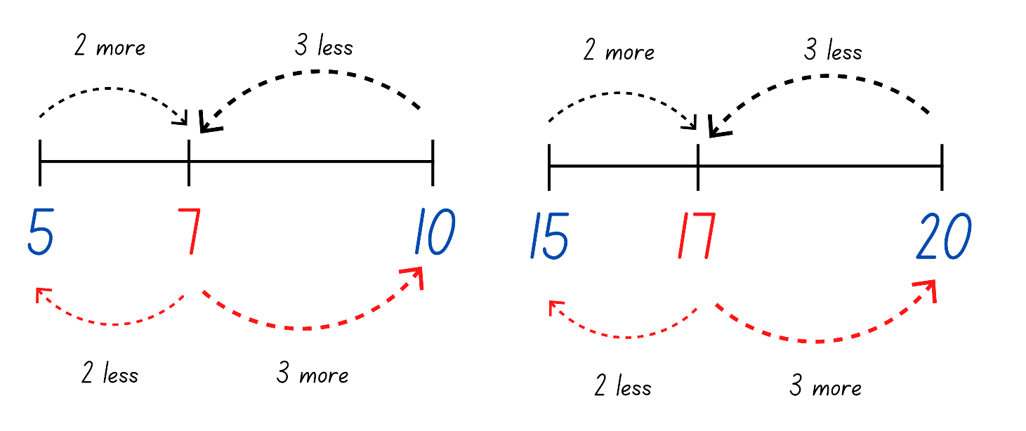
Note: Highlight to Stage 1 students that if it is 2 more from 5 to 7, it is also 2 less from 7 to 5. Students should start to see the pattern between numbers which end in 7.
- Challenge Stage 1 students to complete the same activity and plot the number 37.

Forwards and backwards counting – 15 minutes
This activity has been adapted from Forwards and Backwards Counting by Van de Walle et al. (2019).
- Stand students in a circle. Choose a target number between 0-10.
- Students take turns to count forwards to the target number, sitting down as they say a number. Once the target has been reached, the student who said the target number then stands back up and the count goes back down. Each student stands up again as they say a number.
- Continue to choose different target numbers and different students to start from within the circle.
Note: Early Stage 1 students focus on counting forwards and backwards from 0-10 and Stage 1 students up to 120. Have students start their count at numbers other than zero.
The table below details assessment opportunities and differentiation ideas.
Assessment opportunities | Too hard? | Too easy?
What to look for:  - Are students able to count forwards and backwards by ones from a given number? (MAE-RWN-01, MA1-RWN-01)  What to collect:  - observational data. (MAE-RWN-01, MA1-RWN-01) | Students are not confident counting forwards or backwards from a given number.  - Display a number chart for students to reference while counting.  - Provide students with number cards to correctly order. | Students are confident counting forwards and backwards by ones from a given number.  - Increase the number range for Early Stage 1 students to at least 30.  - Challenge students to count by twos from a given number.  - Provide opportunity for students to count forwards and backwards by ones from a given three-digit number.  - Students count forwards and backwards by tens on and off the decade.

Counting – 15 minutes
- Provide Early Stage 1 students with a collection of counters/objects and display for the whole class, Resource 2: Numbers cards 1.
- Ask Early Stage 1 students to count out counters/objects from their larger collection for the amounts represented by the numbers in Resource 2: Numbers cards 1. Challenge students to identify the larger number.
- Ask Stage 1 students how they would work out the total for Resource 2: Numbers cards 1. Provide thinking time and then students turn and talk to discuss their strategy.
- Select Stage 1 students to share and model their strategy.
- If a Stage 1 student models counting on from the largest number, focus on this strategy and the explicit steps they undertook. If a student does not model this, explicitly demonstrate counting on.
Counting on: Counts on from the larger number to find the total of 2 numbers.
Note: The first advanced count-by-one strategies students use for addition and subtraction are counting on and counting back.
- Display for the whole class Resource 3: Numbers cards 2.
- Ask Early Stage 1 students to count out counters/objects from their larger collection for the amounts represented by the numbers in Resource 3: Numbers cards 2. Challenge students to identify the larger number.
- Ask Stage 1 students to use counting on to work out the total for Resource 3: Numbers cards 2. Students may use fingers, counters or an individual whiteboard to keep track when counting on.
- Choose a Stage 1 student to model how they found the total, highlighting the counting on strategy and correcting any misconceptions.

Consolidation and meaningful practice: Real counting – 20 minutes
This activity has been adapted from Real Counting On by Van de Walle et al. (2019).
- Have a deck of cards (0-9), Resource 4: Early Stage 1 recording sheet and Resource 5: Stage 1 recording sheet and counters/objects. Sitting in a circle, choose Early Stage 1 and Stage 1 students to play against.
- Turn over a card and place the indicated number of counters/objects in the red circle and place the card above the circle. Then the student turns over a card and places the indicated number of counters/objects in the blue circle and places the card above.
- Together, determine which number is the largest.
- Early Stage 1 students record the numeral before clearing the board and playing again (see Figure 2).
- Stage 1 students count on from the larger number and calculate and record the total (see Figure 2). Then they clear the board and turn over new cards.
Figure 2 – Game play
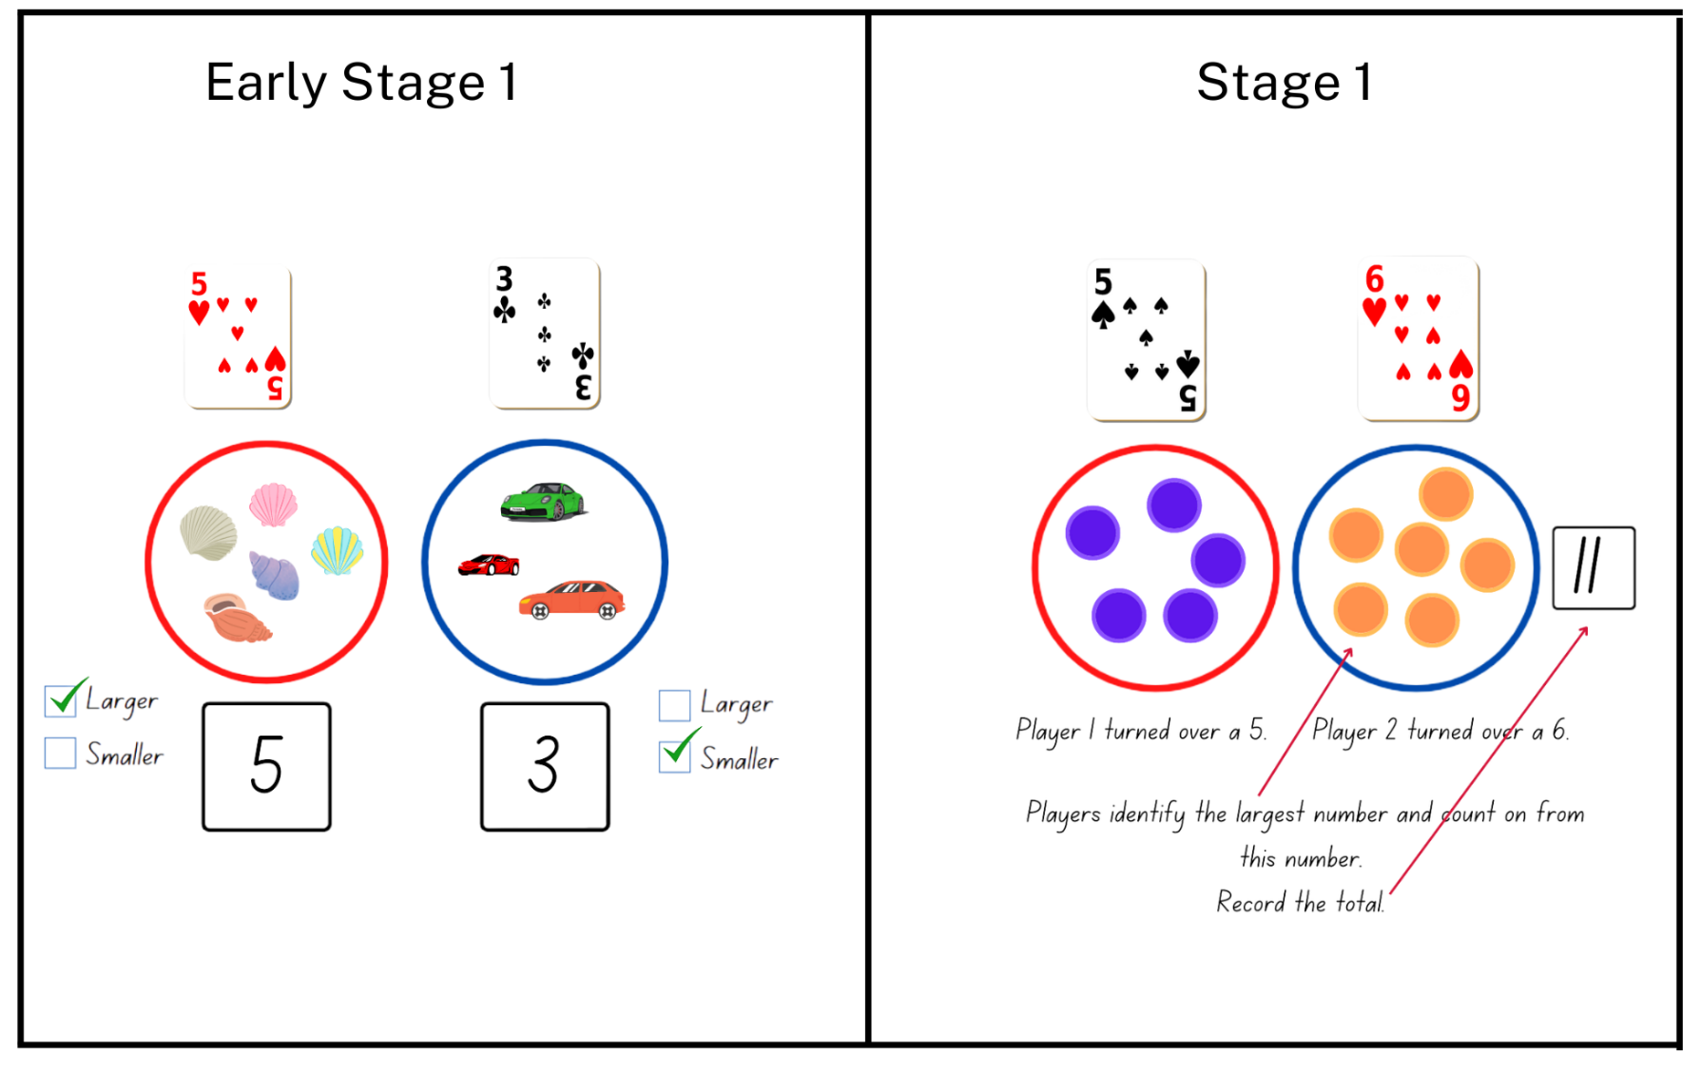
Images from Canva are licensed under Canva Content License Agreement.
- Once students are confident with the activity, provide pairs of students with a deck of cards (0-9), Early Stage 1 students with Resource 4: Early Stage 1 recording sheet, Stage 1 students with Resource 5: Stage 1 recording sheet and counters/objects. Students play with their partner.
Note: Using a reusable sleeve with Resource 4: Early Stage 1 recording sheet and Resource 5: Stage 1 recording sheet will allow for continual use. An ace can represent a zero.
- While students are playing, ask:
- How are you calculating the total?
- How do you know your total is correct?
- What number are you counting on from?
- How do you know it is the larger number?
- How do you know it is the smaller number?
- Do you use any strategies when counting objects?
The table below details assessment opportunities and differentiation ideas.
Assessment opportunities | Too hard? | Too easy?
What to look for:  - Can students count out a given number of objects from a larger collection? (MAE-RWN-02)  - Can students represent numbers as quantities using objects and numerals? (MAE-RWN-02)  - Can students identify the largest number between 2 given numbers? (MA1-RWN-01)  - Are students able to count on from the largest number to find the total? (MA1-CSQ-01)  What to collect:  - observational data (MAO-WM-01, MAE-RWN-01, MA1-RWN-01, MA1-CSQ-01) | Students are not confident counting out a specific number of objects from a larger collection.  - Provide students with the same number of counters represented in Resource 2: Numbers cards 1 for them to count with one-to-one correspondence.  - Provide students with cards within the range of 1-5 to reduce the number of items being counted and collected.  Students are not confident counting on from the largest number.  - Work with students to arrange the cards on Resource 5: Stage 1 recording sheet so that the largest number is first. Model putting the largest number in your head and then touching each counter in the second circle as you count on.  - Students continue to develop their confidence by counting from one to find the total. | Students are confident counting out a specific number of objects from a larger collection to match the given number.  - Students count the number of objects and then combine the 2 groups counting with one-to-one correspondence to find the total.  - Provide students with number cards from 0-20 to provide opportunity to count a larger collection of items.  Students are confident counting on from the largest number.  - Provide opportunities for students to count on with a one-digit number from a two-digit number.  - Students use strategies to bridge to 10 to solve problems. Students use their counters to demonstrate the partitioning of numbers.

Lesson 2: Rekenrek numbers
Core concept: Patterns help to identify number combinations.
The table below contains suggested learning intentions and success criteria. These are best co-constructed with students.
Learning intentions | Success criteria
All students are learning that:  - numbers have a sequence based on their value  - different combinations of numbers can add up or bond to represent a given number.  In addition, Stage 1 students are learning that there are ways to model and record patterns when identifying number combinations for a given number. | Students working towards Early Stage 1 outcomes can:  - order numbers from 0-5  - represent a given number by using concrete materials to show the different parts.  Students working towards Stage 1 outcomes can:  - sequence given numbers and identify missing numbers on a number line  - model and record number sentences using words and drawings  - create and recall combinations of 2 numbers that add up to numbers less than 10  - identify patterns for numbers up to 10 by making all possible combinations.

Daily number sense: Ordering numbers – 20 minutes
- Build student understanding of numeral identification and order by correctly sequencing numbers.
- For Early Stage 1 students, write on the board 0-5 in a random order. Using their individual whiteboards, ask students to order these numbers from smallest to largest.
- For Stage 1 students, write on the board 9, 11, 15, 17 and 20 in a random order. Using their individual whiteboards, ask students to order these numbers from smallest to largest on a blank number line.
- Choose students to share how they ordered or where they placed their numbers and justify the position of their placement.
Note: For Stage 1 students, it is important to look at the placement of numbers on the number line. Check if students have considered the missing numbers or placed all the numbers together.
- Ask Stage 1 students to identify and add the missing numbers.
- Repeat the above steps for Early Stage 1 students with numbers of a different range in both ascending and descending order and a different collection of numbers for Stage 1 students.
The table below details assessment opportunities and differentiation ideas.
Assessment opportunities | Too hard? | Too easy?
What to look for:  - Are students able to order numbers from 0-5? (MAE-RWN-01, MAE-RWN-02)  - Can students sequence given numbers and arrange them on a number line? (MA1-RWN-01)  What to collect:  - observational data. (MAO-WM-01, MAE-RWN-01, MAE-RWN-02, MA1-RWN-01) | Students are not confident writing and ordering numbers from 0-5.  - Provide students with Resource 7: Numbers cards 3, choosing only 0-5 for students to physically move and order.  - Provide students with a number chart to reference when ordering numbers.  Students are not confident ordering numbers on a number line.  - Provide students with Resource 7: Numbers cards 3 to sequence in ascending and descending order.  - Provide students with 0-10 number cards with 2 or 3 cards missing. Students order the cards in ascending and descending order and identify the missing cards.  - Provide benchmark numbers to assist students in ordering the placement of numbers on a number line. | Students are confident writing and ordering numbers from 0-5.  - Provide students with a number range between 0-20 to write and order.  - Provide students with a collection of numbers between 0-20 to order and identify missing numbers.  Students are confident ordering a collection of numbers on a number line.  - Provide students with a blank number line with 47 and 67 at either end. Have students determine the placement of 52. Choose different number ranges.  - Challenge students with different three-digit number ranges.

Rekenreks – 30 minutes
This activity has been adapted from Introducing rekenreks (11:53) and Rekenrek duel level 1 (4:23) from Thinking Mathematically. Watch Introducing rekenreks (11:53) prior to teaching this lesson.
- Display a 20-Bead rekenrek and ask students what they notice.
The table below outlines prompts to generate conversation about the topic, along with anticipated responses from students.
Prompts | Anticipated student responses
What do you notice about the rekenrek? | - Different coloured beads.  - Each colour represents a collection of 5.  - 2 fives on the top row and 2 fives on the bottom row.  - 10 on the top row and 10 on the bottom row.  - 20 beads in total.
- Provide pairs with a 20-bead rekenrek. Explain that beads are moved across to represent quantities.
Note: Find out How to make a rekenrek (5:29) or access a digital rekenrek.
- Challenge students to represent 4 on their rekenrek. Look for different representations and choose students to explain how they represented 4. Record the different representations and draw attention to the pattern of the numbers (see Figure 3).
Figure 3 – Rekenrek pattern
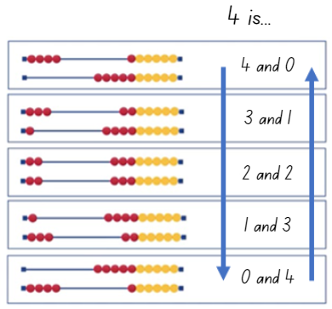
Images from Canva are licensed under Canva Content License Agreement.
- Choose different numbers for students to represent and share with the class. Continue to record and look for patterns.
Note: The focus for Early Stage 1 students is to use the visual representation of a rekenrek to represent numbers and identify the relationship between the parts of the number and the whole. Students may be exposed to the concept of patterns within number combinations.
- Display and read Resource 6: Rekenrek problems. Stage 1 students work in pairs to find as many solutions as possible using their rekenrek for both problems. Students record all their solutions (see Figure 4).
Figure 4 – Stage 1 rekenrek student working
Images from Canva are licensed under Canva Content License Agreement.
- While Stage 1 students are solving their rekenrek problems, provide instruction to Early Stage 1 students on how to play rekenrek duel.
- Provide Early Stage 1 pairs with a rekenrek each and Resource 7: Numbers cards 3. Students turn over a card to see the number represented.
- Students turn back-to-back and create the number they saw using one or both lines on the rekenrek.
- Students face each other and show the number representation they have made. Then they share one thing they notice about the way their partner represented the given number.
- Play continues as Early Stage 1 students turn over duel cards and represent different numbers.

Discuss and connect the mathematics – 10 minutes
- Summarise the lesson together, drawing out some key mathematical ideas. Ask students:
- How did the rekenrek help you to represent a number?
- Can a number be represented in different ways? If so, how?
- How did the rekenrek help to solve the problem?
- How do you know you have all the solutions?
- How do patterns help to solve problems?
- How did you work like a mathematician today?
Note: When discussing whether Stage 1 students have represented all the solutions, focus on the structure of the pattern. The pattern and order of combinations might not come naturally. Support Stage 1 students to understand where to start and end.
The table below details assessment opportunities and differentiation ideas.
Assessment opportunities | Too hard? | Too easy?
What to look for:  - Are students able to represent a given number by using concrete materials to show the different parts? (MAE-RWN-01, MAE-RWN-02, MAE-CSQ-01, MAE-CSQ-02)  - Can students create and recall combinations of 2 numbers that add up to numbers less than 10? (MA1-CSQ-01)  - Are students able to model and record number sentences using words and drawings? (MAO-WM-01, MA1-CSQ-01)  - Can students identify patterns for numbers up to 10 by making all possible whole-number combinations? (MA1-CSQ-01)  What to collect:  - student work samples (MAO-WM-01, MA1-CSQ-01)  - observational data. (MAO-WM-01, MAE-RWN-01, MAE-RWN-02, MAE-CSQ-01, MAE-CSQ-02, MA1-CSQ-01) | Students are not confident identifying patterns or creating combinations of 2 numbers that add up to less than 10.  - Provide students with interlocking cubes to model the pattern using different coloured cubes for the 2 parts of the whole number.  - Provide opportunities for students to count smaller collections of objects. Students share them into different sized groups and count the groups again. This helps students to understand the conservation principle that a set of objects remains the same, no matter if they are spread out or close together. | Students are confident identifying patterns and combining 2 numbers that add up to a number less than 10.  - Provide students with a target number to make on the rekenrek. Students need to create that number within a set amount of moves. For example, the target number is 17 and students have 3 moves. Students might move 10, 5 and 2 beads to represent 17. Students record their working.  - Provide students with a target number and they must use at least one combination to 10. For example, the target number is 17 and students have 3 moves. Students might move 6, 4 and 7 beads to represent 17. Students record their working.

Lesson 3: Domino numbers
Core concept: Patterns help to identify number combinations.
The table below contains suggested learning intentions and success criteria. These are best co-constructed with students.
Learning intentions | Success criteria
All students are learning that:  - different combinations of numbers can add up or bond to form a given number  - there are ways to model and record patterns when identifying number combinations for a given number. | All students can:  - recognise different combinations of 2 numbers that add up to a given number  - record number sentences using words, pictures or numbers.  In addition, students working towards Early Stage 1 outcomes can recognise domino patterns.  In addition, students working towards Stage 1 outcomes can identify patterns to find all combinations for a given number.

Daily number sense: Rekenrek numbers – 15 minutes
This activity has been adapted from Doubling from Beadstring Mathematics by Swan (2020)
- Build student understanding of parts of a number or doubles by representing numbers on a rekenrek.
- Provide each student with a rekenrek and ask Early Stage 1 students to represent 8 and Stage 1 students to represent double 4.
- Students share their representation and explain how they see the number. Record student responses (see Figure 5).
Figure 5 – Student working
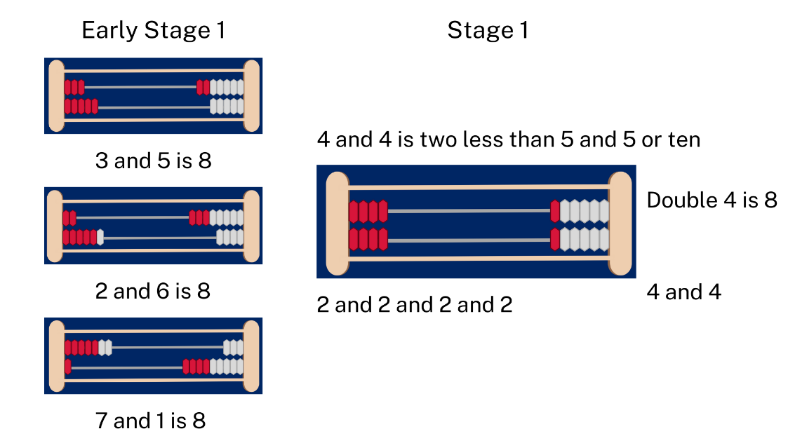
Images sourced from Canva and used in accordance with the Canva Content License Agreement.
- Provide other numbers under 10 for Early Stage 1 students to represent the parts of the number and Stage 1 students to represent as doubles.

Part whole dominoes – 30 minutes
This activity has been adapted from Representing part whole with dominoes.
- Provide Early Stage 1 pairs with Resource 7: Numbers cards 3 and a large collection of dominoes, around 20. Students arrange Resource 7: Numbers cards 3 from 0-10. Then students work together to find dominoes with a total that matches the number cards. Students arrange the dominoes below the cards.
- Provide Stage 1 pairs with a large collection of dominoes, more than 20. Students work together to organise their collection to find dominoes that form combinations for a given number.
Note: Explain to students they may not have all combinations for numbers 0-10, or they may have repeated dominoes due to the random selection. There may also be dominoes over 10. Students may order these or put them in a discard pile.
- When the dominoes have been organised, Early Stage 1 students choose one number and the matching dominoes to focus on. In their workbook, students record all the combinations they found for that number, using words, pictures or numbers (see Figure 6).
- When Stage 1 students have organised their dominoes, students select one number and write in their workbook all the possible combinations including the ones they found and any missing ones, Figure 6.
Figure 6 – Domino patterns
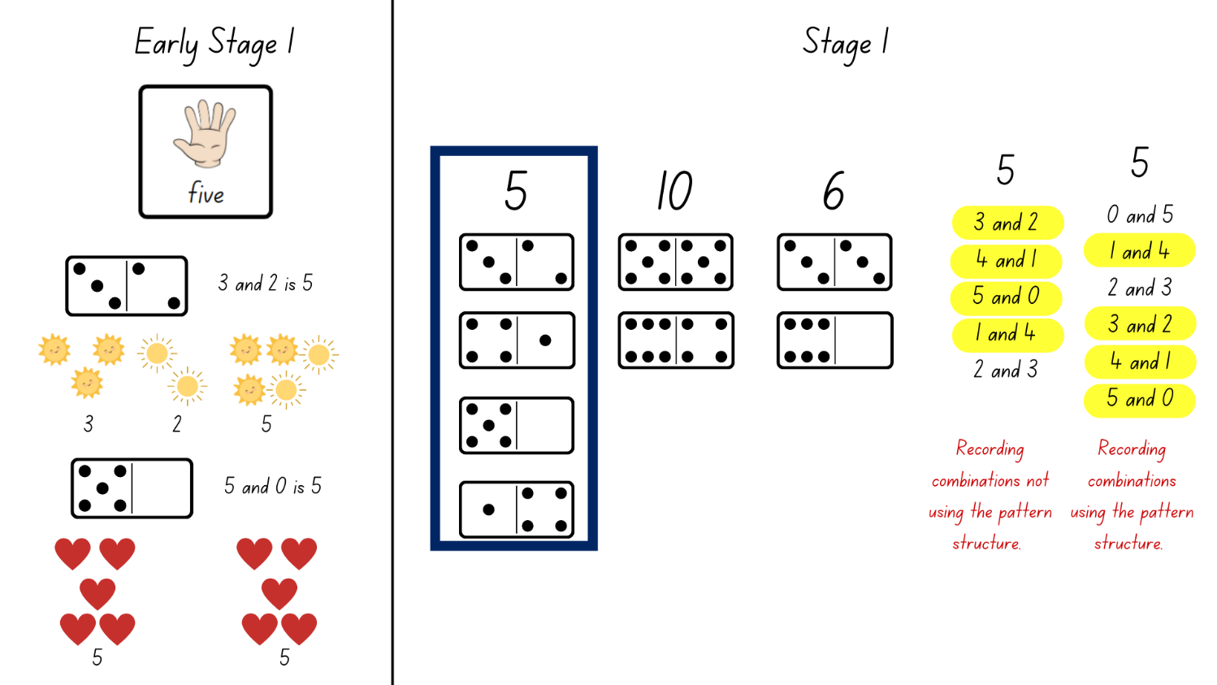
Images from Canva are licensed under Canva Content License Agreement.
Note: In Lesson 2 Stage 1 students were exposed to the concept of a pattern to represent all combinations. Stage 1 students may naturally organise their thinking using a systematic pattern, however, do not prompt students to do this at this stage of the lesson.
- All students display their work and go on a gallery walk to look at how others have structured their combinations. Ask Stage 1 students how they can be confident that they have all the combinations.
Note: Through class discussion, students consider the idea of a pattern and reflect on their work to see if they have applied this. Being able to flexibly partition numbers is critical for building number sense. Combining numbers in set patterns helps with the recall of mental calculations.
- Stage 1 students reflect on their working and make changes to reflect the pattern. Students share their working with the class.
- While Stage 1 students are completing this, Early Stage 1 students revise recognising domino patterns. In their pairs, the first student holds up a domino and shows their partner the top formation of dots for 2-3 seconds. Then they hide the domino. Their partner recalls the number of dots they saw. The first student confirms if their partner is correct. Students take turns with different dominoes.
This table details assessment opportunities and differentiation ideas.
Assessment opportunities | Too hard? | Too easy?
What to look for:  - Are students able to recognise different combinations of 2 numbers that add up to a given number? (MAE-CSQ-01, MAE-CSQ-02, MA1-CSQ-01)  - Are students able to record number sentences using words, pictures or numbers? (MAE-CSQ-01, MAE-CSQ-02, MA1-CSQ-01)  - Are students able to recognise domino patterns? (MAE-RWN-01, MAE-RWN-02)  - Can students identify and use a systematic pattern to find all combinations for a given number? (MAO-WM-01, MA1-CSQ-01)  What to collect:  - student work samples (MAO-WM-01, MAE-CSQ-01, MAE-CSQ-02, MA1-CSQ-01) | Students are not confident combining domino patterns to identify the total.  - Students count with one-to-one correspondence and collect a counter each time they say a number out loud. Students then count the total.  - Students order Resource 7: Numbers cards 3 and collect counters to represent each number, strengthening their understanding that the last number name represents the total number in the collection.  Students are not confident identifying and using a systematic pattern to combine numbers to represent a given number.  - Provide students with a collection of dominoes that have all the combinations for a given number under 5. Students order these to reflect the systematic pattern.  - Provide students with interlocking cubes to model the pattern, using different coloured cubes for the 2 parts of the given number. | Students are confident identifying and using a systematic pattern or combining 2 numbers to create a given number.  - Challenge students to combine 3 numbers to make the total of the given number.  - Students identify any missing combinations for the given numbers and record them.  - In pairs, the first student calls out a number between 1 and 12, and the second student identifies 3 numbers that combine to make that number.

Consolidation and meaningful practice: Number match – 15 minutes
- Provide each student with a gameboard from Resource 8: Number match and a collection of counters. Allow time for students to look carefully at their gameboard and identify all the number representations.
Note: Laminating Resource 8: Number match or placing it in a reusable sleeve will allow for it to be used in subsequent units.
- Call out a number between 0 and 20 and record it on the board. If a student has the corresponding number on their gameboard they place a counter over it.
- Continue to call out and record numbers between 0 and 20. When a student covers all their number representations, they call out ‘number match’.
- Students can play again with a different gameboard.
Note: Provide Stage 1 students with the gameboards with a range to 20.

Lesson 4: Bar model
Core concept: Concrete materials help to represent the smaller numbers which make up larger numbers.
The table below contains suggested learning intentions and success criteria. These are best co-constructed with students.
Learning intentions | Success criteria
All students are learning that:  - different combinations of numbers can add up or bond to form a given number  - structured materials help to represent and solve number problems. | Students working towards Early Stage 1 outcomes can:  - use objects to create combinations of numbers to represent a given number  - count by ones to find the total.  Students working towards Stage 1 outcomes can:  - recognise and recall different combinations of numbers to identify how many more to build a given number  - use the bar model to represent parts of a number.

Daily number sense: Number patterns – 10 minutes
This lesson has been adapted from Open-Ended Maths Activities by Sullivan and Lilburn (2017).
- Build student understanding of numbers by identifying patterns.
- Tell Early Stage 1 students you are thinking of all the numbers between 0 and 5. Students record the numbers between 0 and 5 on their individual whiteboard.
- Tell Stage 1 students you are thinking of a number between 20 and 30. It is even. Students record any possible responses on their individual whiteboards.
- Students share their responses.
Note: Look at how Stage 1 students record numbers, haphazardly or using a systematic pattern.
- For Early Stage 1 students, repeat with other number ranges up to 20. For Stage 1 students, repeat with numbers on and off the decade as well as odd numbers.

Building towers – 30 minutes
This activity has been adapted from Building towers (7:22) from Thinking mathematically.
- On 4 sticky notes, have the numbers 5, 3, 11, and 7 written on a set for the class and on another set to model playing against the class.
Note: Watch Building towers (7:22) for an example of how to play the game.
- Take turns with students rolling the die and taking the corresponding number of interlocking cubes. Consider where to place the interlocking cubes to build a tower. The aim is for every number on the sticky note to have a tower made up of the same number of interlocking cubes. Model thinking aloud with students about how to separate the number rolled to create the given numbers on the sticky notes. Have Stage 1 students consider how many more are needed to get to the target number.
- When towers have been completed, reflect on the combinations of interlocking cubes used to build the tower and record.
- Once students are confident with the understanding of the game, put students with a partner. Students divide their individual whiteboard into quarters and write the same 4 numbers as their partner. Guide Early Stage 1 students to choose 4 numbers under 10 and Stage 1 to choose 4 numbers under 15.
- Provide students with a collection of interlocking cubes and a die. Students take turns to play the game.
- Students reflect and record the combination of numbers in each tower (see Figure 7).
Figure 7 – Student towers and recording
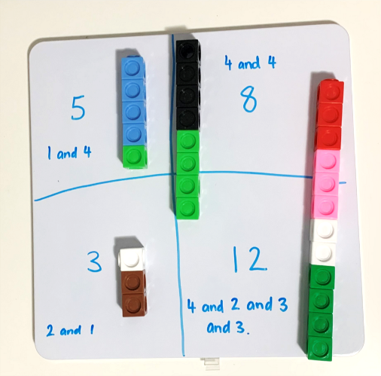
- Regroup as a class. Students should keep their whiteboard and one of their towers. Ask students to turn their tower on the side and create a bar model representation (see Figure 8).
Figure 8 – Student bar model
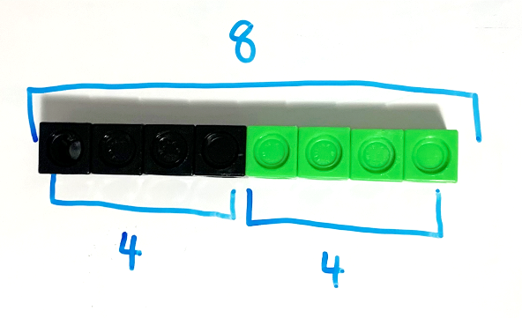
Note: Part-whole bar model involves one whole divided into 2 or more parts using bars to represent part or whole numbers.
- Students share examples of their bar model. Ask students what the bar model might remind them of. Students Think-Pair-Share.
Note: Through discussion, draw the link between the bar model and a number line.
The table below details assessment opportunities and differentiation ideas.
Assessment opportunities | Too hard? | Too easy?
What to look for:  - Can students use objects to create combinations of numbers to represent a given number? (MAO-WM-01, MAE-RWN-01, MAE-RWN-02, MAE-CSQ-02)  - Are students able to count by ones to find the total? (MAE-RWN-01, MAE-CSQ-01)  - Are students able to identify parts of a number and identify how many more to form a given number? (MAO-WM-01, MA1-CSQ-01)  - Can students use the bar model to identify and represent parts of a number? (MA1-CSQ-01)  What to collect:  - observational data (MAO-WM-01, MAE-RWN-01, MAE-RWN-02, MAE-CSQ-01, MAE-CSQ-02, MA1-CSQ-01) | Students are not confident creating combinations to form a given number.  - Provide students with a number range of 5 and under.  - Build towers of the identified numbers so that students can use the concrete representation of the number to assist them with identifying how many more. | Students are confident identifying how many more to form a given number.  - When playing Building towers (7:22), challenge students to build towers with only 2 or 3 number combinations.  - Provide students with two-digit numbers, for example, 23, 17, 34, 39. Challenge students to use bridging to 10 when making combinations.

Consolidation and meaningful practice: Bar model – 20 minutes
- Display the first task card for Stage 1 students from Resource 9: Bar model and ask students to represent 9 using interlocking cubes and their whiteboard (see Figure 8). Stage 1 students share their representation of 9 and discuss how they have represented it using the bar model.
- Display other tasks cards for Stage 1 students from Resource 9: Bar model. Stage 1 students complete these using interlocking cubes to represent the bar model and then draw their working in their workbook.
- While Stage 1 students are working through their problems, Early Stage 1 students play Real Counting from Lesson 1 or rekenrek duel from Lesson 2. Revise the rules of the game.

Lesson 5: Domino triangles
Core concept: A quantity can be described by talking about its smaller parts.
The table below contains suggested learning intentions and success criteria. These are best co-constructed with students.
Learning intention | Success criteria
All students are learning that they can recognise, recall and record combinations of numbers that add up or bond to form a given number. | All students can find smaller numbers inside larger numbers.  In addition, students working towards Early Stage 1 outcomes can create, model and recognise number combinations for numbers up to 10.  In addition, students working towards Stage 1 outcomes can:  - create number combinations of dominoes that make a given number  - describe combinations for numbers using words such as ‘more than’ and ‘less than’.

Daily number sense: Dot talk 1 – 15 minutes
This activity has been adapted from Seeing spots by Boaler et al. (2020).
- Build student understanding of subitising, composing and decomposing numbers by engaging in a dot talk.
- Display Resource 10: Dot talk 1 for a few seconds. Ask students how many dots they saw. Students turn and talk to a partner about how they saw the dots.
- Students share their thinking by showing or describing the different clusters they saw. Colour code the different groups to help others see their thinking (see Figure 9).
Figure 9 – Recording dot talk
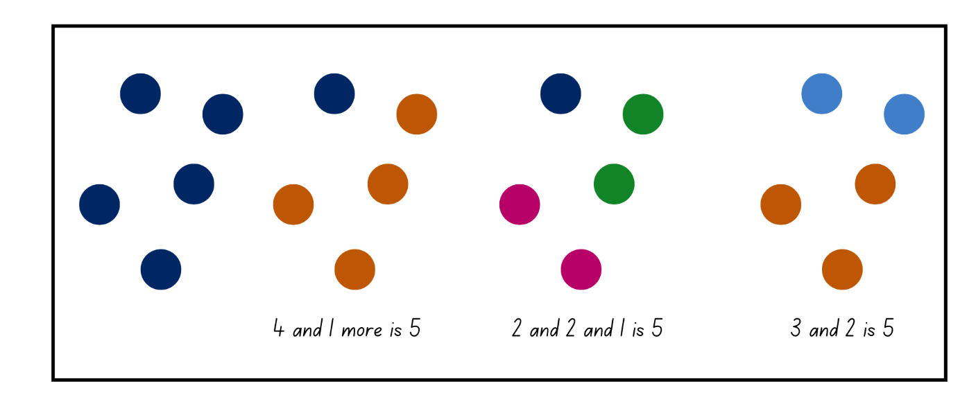
Note: Students may use the symmetry of the dots, their knowledge of dice patterns, decompose in rows, or other strategies. These connections support students thinking visually about number and making the connection between the physical objects and the number used to represent them.

Domino triangles – 35 minutes
This activity has been adapted from Domino Squares from Domino Deductions: Developing Mathematics from Dominoes by Swan (2001).
- Display Resource 11: Domino triangles 1. Explain to students that the 3 dominoes must add up to the number in the middle, for example, 8.
- Allow students thinking time to work out possible solutions using their individual whiteboards. Students share how they have represented the number 8. If needed, model some additional solutions (see Figure 10).
Figure 10 – Representing 8
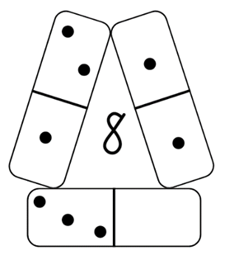
- Remind students that all numbers are composed of smaller numbers and smaller numbers make up larger numbers.
Note: Encourage Early Stage 1 students to use the language of ‘makes’, ‘joins’, ‘combines with’ or ‘altogether’. Stage 1 students use the language of ‘more than’ or ‘less than’. For example, 10 is 2 more than 8 or 9 is one less than 10.
- Discuss, when a ten-frame is full, the total is always 10. Fill the digital ten-frame with red counters and change one of the counters to yellow. Ask the students what the total is, how many red and how many yellow. Continue this a few times changing the counters and discussing the combinations.
- Provide Stage 1 students with dominoes and Resource 12: Domino triangles 2. These may be cut into 3 separate strips of single dominoes, double dominoes, and triple dominoes.
- Stage 1 students use their understanding of combinations of numbers that add up to 10 and record different solutions (see Figure 11).
Figure 11 – Dominoes
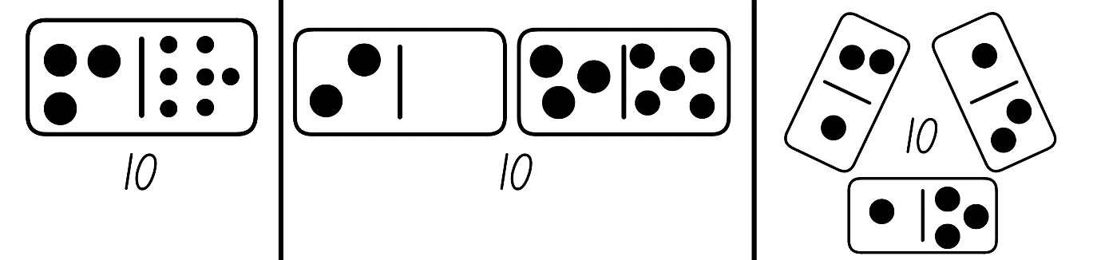
- Demonstrate to Early Stage 1 students with Resource 13: Ten-frame and 10 double-sided counters how to play shake, rattle, drop.
- Shake the counters and drop them on the floor. Separate them into a red and yellow pile. Place the red counters into the ten-frame first and then the yellow counters, counting each group and discussing the parts that make up 10 (see Figure 12).
- Model to Early Stage 1 students how to record the part-whole relationships created using numbers, pictures or words (see Figure 12).
Figure 12 – Shake, rattle, drop
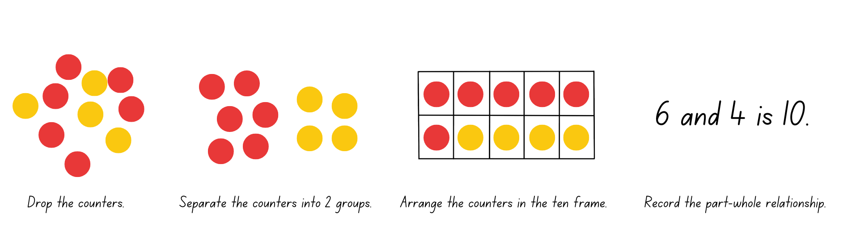
- Once Early Stage 1 students are confident with the activity, provide students with a blank ten-frame and 10 double-sided counters. Students play independently, recording the part-whole relationships in their workbooks.
This table details assessment opportunities and differentiation ideas.
Assessment opportunities | Too hard? | Too easy?
What to look for:  - Are students able to find smaller numbers inside larger numbers? (MAO-WM-01, MAE-CSQ-01, MAE-CSQ-02, MA1-RWN-01, MA1-CSQ-01)  - Can students create, model and recognise number combinations for numbers up to 10? (MAO-WM-01, MAE-RWN-02, MAE-CSQ-01, MAE-CSQ-02, MA1-RWN-01, MA1-CSQ-01)  - Do students describe combinations for numbers using words such as more than or less than? (MA1-CSQ-01)  What to collect:  - student work samples. (MAO-WM-01, MAE-RWN-02, MAE-CSQ-01, MAE-CSQ-02, MA1-RWN-01, MA1-CSQ-01) | Students are not confident creating and recording number combinations to 10.  - Provide students with a five-frame and 5 double-sided counters. Students strengthen their understanding of combinations to 5.  - Support students recording number combinations by providing a device to photograph combinations created.  Students are not confident with recalling and recording number combinations to 10 with dominoes.  - Support students by providing a ten-frame and a collection of double-sided counters to create combinations to 10.  - Provide students with a small collection of dominoes. Students use count-by-one strategies to find a collection of dominoes which adds up to 10. | Students are confident with recalling and recording number combinations to 10.  - Ask students to identify number combinations up to 20 and have them explain the pattern in relation to combinations to 10.  - Challenge students to represent 20 on 4 dominoes.

Discuss and connect the mathematics – 10 minutes
- Summarise the lesson together, drawing out some key mathematical ideas. Students share and explain their work. Ask:
- Did you create and record all combinations to 10? How do you know?
- Did you check your solution? How?
- How many possible solutions did you find?
- Could there be any other solutions? How do you know?

Lesson 6: Number facts
Core concept: Numbers can bond together to form a larger number. Doubles facts are an efficient way to combine quantities.
The table below contains suggested learning intentions and success criteria. These are best co-constructed with students.
Learning intentions | Success criteria
Early Stage 1 students are learning that they can recognise, recall and record combinations of numbers that add up or bond to form a given number.  Stage 1 students are learning that doubles facts are an efficient way to combine quantities. | All students can find and represent smaller numbers inside larger numbers.  In addition, students working towards Early Stage 1 outcomes can create, model and recognise number combinations for numbers up to 10.  In addition, students working towards Stage 1 outcomes can:  - identify and combine numbers which make doubles facts  - describe combinations of numbers using the word ‘double’.

Daily number sense: Dot talk 2 – 10 minutes
This activity has been adapted from Dot talks by Boaler et al. (2020).
- Build student understanding of subitising, composing and decomposing numbers by engaging in a dot talk.
- Display Resource 14: Dot talk 2 for a few seconds. Ask students how many dots they saw. Students turn and talk to a partner about how they saw the dots.
- Students share their thinking by showing or describing the different clusters they saw. Students colour code the different groups they saw to help others see their thinking.
Note: Students may use the symmetry of the dots, their knowledge of dice patterns, decompose in rows, or other strategies. These connections support students to think visually about numbers and make the connection between the physical objects and the number used to represent them.

Looking at numbers – 15 minutes
This activity has been adapted from Concentration (doubles facts).
- Ask Early Stage 1 students to create a poster in their workbooks about all the different ways that 7 can be represented. Explain that they can draw or write their representations (see Figure 13).
Figure 13 – Student poster
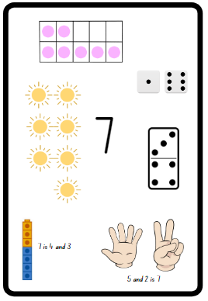
Images from Canva are licensed under Canva Content License Agreement.
Note: Remind Early Stage 1 students the different ways numbers have been represented in the previous lessons.
- While Early Stage 1 students are creating their posters, use 2 digital ten-frames, to demonstrate to Stage 1 students doubles facts from 0-9 (see Figure 14).
Figure 14 – Doubles ten-frames
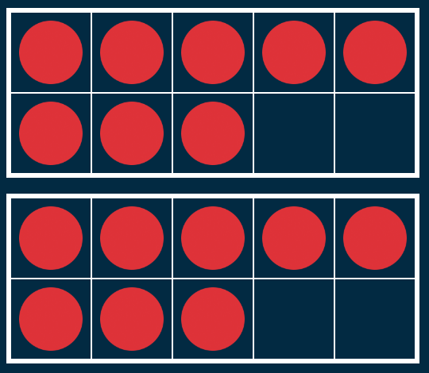
- For each of the representations displayed, ask:
- What do you see?
- How can you use what you know about the ten-frame structure to help you determine the total?
- Can you explain your strategy?
- Is there another way to find the total?
- Encourage Stage 1 students to visualise moving the counters between the 2 ten-frames to firstly make 10 before adding any additional counters in the second ten-frame (see Figure 15). Demonstrate this to students using different coloured counters to show how the amounts have been partitioned and joined.
Figure 15 – Counting on
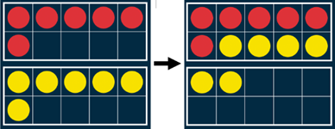

Doubles memory – 25 minutes
- In small groups, Early Stage 1 students are provided with Resource 15: Early Stage 1 memory and Stage 1 students are provided with Resource 16: Doubles memory. Students shuffle the cards and lay them out in an array, face down.
Note: Printing Resource 15: Early Stage 1 memory and Resource 16: Doubles memory on coloured cardboard will allow the game to be played again and reduce the student's ability to see through the card.
- Students turn over 2 cards, looking for a pair. If they are correct, they collect the cards. If the cards do not match, students turn them back over. Play continues until all possible matches are found.
- Once the game has finished, Early Stage 1 students represent their ten-frame matches using pictures and/or words in their workbooks (see Figure 16).
Figure 16 – ES1 representation
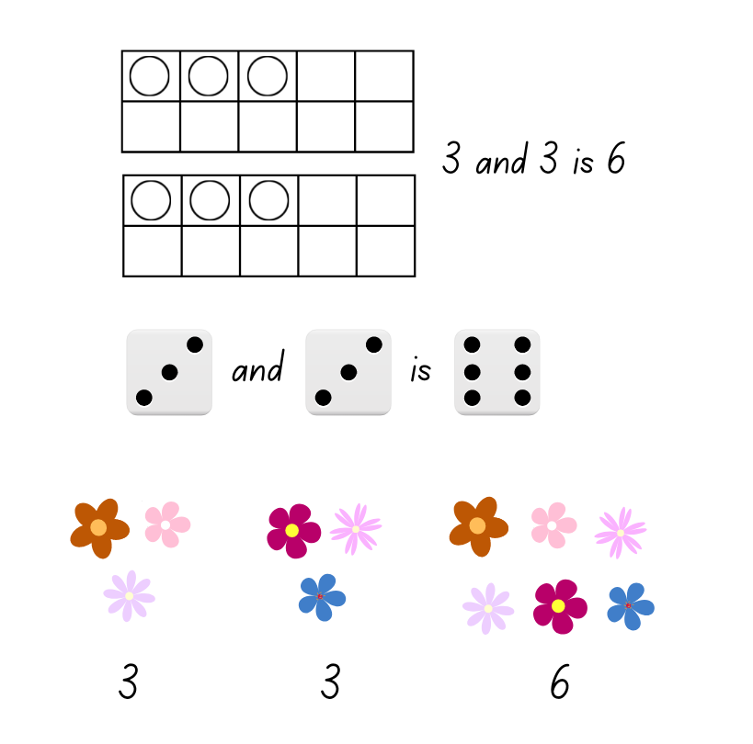
Images from Canva are licensed under Canva Content License Agreement.
- In their workbooks, Stage 1 students record the doubles they matched and the strategy they used to find the total (see Figure 17).
Figure 17 – Stage 1 student doubles facts
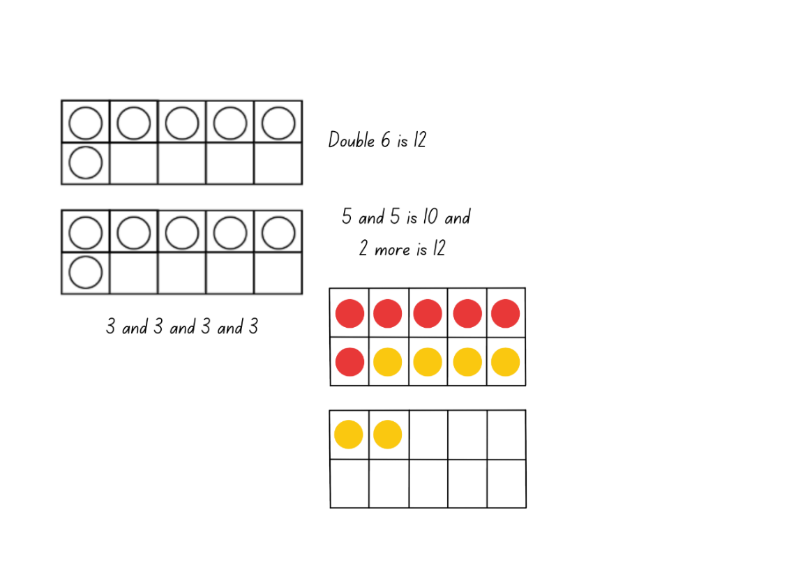

Discuss and connect the mathematics – 10 minutes
- As a class, students show and explain their work and how they represented the given numbers. Ask:
- What strategy did you use to find the total?
- Are there other strategies you could use to find the total?
- Did you use bridging to 10 to help you find the total?
- How did you work like a mathematician today?
This table details assessment opportunities and differentiation ideas.
Assessment opportunities | Too hard? | Too easy?
What to look for:  - Are students able to find and represent smaller numbers inside larger numbers? (MAO-WM-01, MAE-RWN-01, MAE-RWN-02, MAE-CSQ-01, MAE-CSQ-02, MA1-RWN-01, MA1-CSQ-01)  - Can students identify and use doubles for combining numbers? (MA1-RWN-01, MA1-CSQ-01)  - Can students describe combinations for numbers using the term doubles? (MAO-WM-01, MA1-CSQ-01)  What to collect:  - student work samples (MAO-WM-01, MAE-RWN-01, MAE-RWN-02, MAE-CSQ-01, MAE-CSQ-02, MA1-RWN-01, MA1-CSQ-01)  - observational data (MAO-WM-01, MAE-RWN-01, MAE-RWN-02, MAE-CSQ-01, MAE-CSQ-02, MA1-RWN-01, MA1-CSQ-01) | Students are not confident representing the number 7.  - Allow students to create a poster in the number range of 2-5 to strengthen their understanding of combinations of numbers to 5.  - Use various concrete materials to represent the number 7. For example, a ten-frame, counters and interlocking cubes.  Students are not confident identifying and using doubles for combining numbers.  - Students roll a die, for example 4. Then they put 4 red counters and 4 yellow counters in a ten-frame and count the total.  - Support students to use the correct vocabulary by having the students say double 4 is 8 when they put the counters in the ten-frame. | Students are confident representing the number 7.  - Students need to create the representation of 7 with at least 3 parts. For example, 2 dots and 2 dots and 3 birds.  - Challenge students to create a poster for a number within the range of 10-20.  Students can identify and use doubles for combining numbers.  - Students investigate why 2 odd numbers always equal an even number.  - Provide students with larger two-digit numbers, for example 36. Students draw their working to explain how they got to this number using doubles.

Lesson 7: Exploring numbers
Core concept: Numbers can bond together to form a larger number. Near doubles are an efficient way to combine quantities.
The table below contains suggested learning intentions and success criteria. These are best co-constructed with students.
Learning intentions | Success criteria
Early Stage 1 students are learning that they can recognise, recall and record combinations of numbers that add up or bond to form a given number.  Stage 1 students are learning that:  - doubles and near doubles facts are an efficient way to combine quantities  - near doubles are one more or one less than the doubles fact. | Students working towards Early Stage 1 outcomes can create, model and recognise number combinations for numbers up to 10.  Students working towards Stage 1 outcomes can:  - identify doubles and near doubles  - double the smaller number and add one more  - double the larger number and subtract one less.

Daily number sense: Rekenrek number talk – 10 minutes
- Build student understanding of number combinations by looking at how the beads are represented on a rekenrek.
- Display Resource 17: Rekenrek number talk and students use individual whiteboards to record how they see the representation.
- As students share their work, ask:
- What do you notice in the image?
- What strategy did you use to work out the total?
- Can you see a pattern?
- Is your solution different to others? Why/why not?

Near doubles – 20 minutes
- Ask Early Stage 1 students to create a poster about all the different ways that 10 can be represented. Explain that they can draw or write their representations (see Figure 13 for an example of the representation of 7).
- While Early Stage 1 students are creating their poster, revise doubles facts from Lesson 6 with Stage 1 students by displaying a digital rekenrek with different doubles facts displayed. For example, 7 beads on the top line and 7 beads on the bottom line.
- Display Resource 18: Near doubles 1 for Stage 1 students. They then turn and talk to determine the total using their knowledge of doubles. Choose students to share their strategy with the class. Highlight the use of near doubles as a strategy.
- Explain that the strategy is to double the smaller number and add one, or to double the larger number and take away one. Model using the example 6 and 7 (see Figure 18).
Note: Near doubles facts can be built upon the idea of one more or one less. For example, 5 and 4, think double 5 is 10 and one less is 9 or for 7 and 8, think double 7 is 14 and one more is 15 (Siemon et al. 2020).
Figure 18 – Near doubles cards
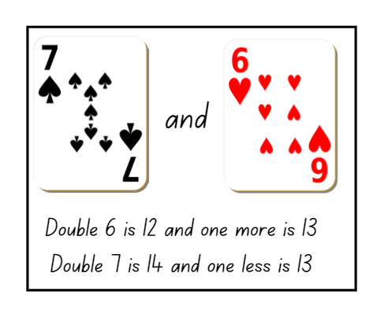
Images from Canva are licensed under Canva Content License Agreement.
Note: When displaying Resource 18: Near doubles 1, draw students’ attention to the number 6 playing card and how it can also look like a 9. Remind students to read the number in the top left corner, count the number of hearts and demonstrate rotating the card to show how the 9 turns into a 6.
- Using playing cards, select examples of near doubles and model the strategy for different combinations.

Consolidation and meaningful practice: Game play – 35 minutes
This activity has been adapted from 10 or bust (additive strategies) (6:23) from Thinking mathematically and from Finding known facts from Developing Efficient Numeracy Strategies One.
- Display Resource 19: Near doubles 2 for Stage 1 students. They then use their individual whiteboard to solve the problem and show the strategy of doubling the smaller number and adding one or doubling the larger number and taking one away.
- While Stage 1 students are solving their problem, explain the rules of 10 or bust (additive strategies) (6:23) to Early Stage 1 students. Provide pairs of students with Resource 13: Ten-frame, dice and a collection of coloured counters. Students have up to 3 rolls each to try and fill their ten-frame. Each player uses different coloured counters to represent each roll. After students have placed their counters on the ten-frame, they count how many more are needed to make 10 before the next player has their turn. Students can choose to pass on their third roll, roll and possibly win, or go bust by having more than 10 counters. Early Stage 1 students play against their partners.
- Stage 1 share their working for Resource 19: Near doubles 2.
- In pairs, provide Stage 1 students with a packet of playing cards, removing the picture cards, and Resource 20: Recording table.
- Stage 1 students take turns to deal 4 cards to each other. Students turn over their cards and look for any known facts they can see. For example, combinations to 10, doubles and near doubles.
- For every known fact a student finds, they explain their thinking to their partner who records the information on Resource 20: Recording table. Their partner checks and confirms their working on Resource 20: Recording table and gives a counter for each correct fact they find (see Figure 19).
Figure 19 – Recording table
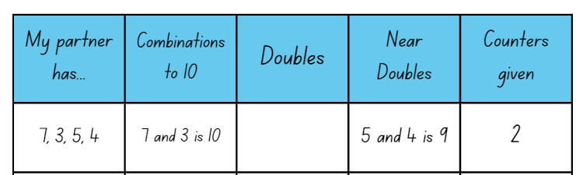
- Stage 1 students take turns and complete 5 rounds each. The student with the largest number of counters at the end is the winner.
- While students are playing, move around the groups and ask:
- Are you using a strategy so that you do not go bust?
- What is the smallest possible number of counters that could be in your ten-frame?
- If you roll a 4 and take 2 more rolls, what numbers would you like to roll?
- Which strategy are you most confident with when you are looking for known facts?
- Why is it important to know near doubles?
- Have you had 4 cards where you could record known facts in each column?
The table below details assessment opportunities and differentiation ideas.
Assessment opportunities | Too hard? | Too easy?
What to look for:  - Are students able to create, model and recognise combinations for numbers up to10? (MAO-WM-01, MAE-RWN-01, MAE-RWN-02, MAE-CSQ-01, MAE-CSQ-02)  - Are students able to double the smaller number and add one more? (MA1-RWN-01, MA1-CSQ-01)  - Are students able to double the larger number and subtract one? (MA1-RWN-01, MA1-CSQ-01)  - Can students record number combinations in a table? (MAO-WM-01, MA1-CSQ-01)  What to collect:  - Resource 20: Recording table (MAO-WM-01, MA1-CSQ-01)  - observational data (MAO-WM-01, MAE-RWN-01, MAE-RWN-02, MAE-CSQ-01, MAE-CSQ-02, MA1-RWN-01, MA1-CSQ-01) | Students are not confident playing 10 or bust.  - Provide students with Resource 13: Ten-frame, counters and a die. Students roll the die and fill the ten-frame with the corresponding number of counters. They then identify how many more to 10. Students clear the board and roll again.  - Support students to build towers of 10 interlocking cubes. They use different coloured interlocking cubes to represent the different parts of the number.  Students are not confident identifying doubles and near doubles.  - Provide students with a visual representation of doubles and near doubles, for example, a doubles chart or a rekenrek.  - Have students create doubles facts using counters and ten-frame structures. Encourage the count-by-one strategy to determine the total. | Students are confident playing 10 or bust.  - Provide students with 2 ten-frames and students can make up to 5 rolls of the die to try and collect 20 counters before going bust.  - Students use interlocking cubes and number markings to represent a number line and record their working.  Students can identify doubles and near doubles.  - Have students identify a doubles fact greater than 20. For example, 15 and 15 is 30.  - Students write as many number sentences as they can using larger facts and the idea of one more and one less.

Lesson 8: Power dot pro
Core concept: There are many ways to combine quantities to find a total.
The table below contains suggested learning intentions and success criteria. These are best co-constructed with students.
Learning intentions | Success criteria
All students are learning that:  - different strategies can be used to combine quantities  - numbers can be represented in different ways. | All students can recognise numbers in different representations including words, numerals, and known structures such as dice and ten-frames.  In addition, students working towards Early Stage 1 outcomes can:  - state the number before and after numbers up to 10  - use visual representations to combine quantities.  In addition, students working towards Stage 1 outcomes can:  - use a variety of strategies including counting on, number bonds to 10, doubles and near doubles to solve problems  - record their thinking using drawings, words, numerals or symbols.

Daily number sense: Counting strategies – 15 minutes
- Build student understanding of numbers by providing opportunities for students to consolidate their understanding.
- Provide pairs of Early Stage 1 students with Resource 7: Numbers cards 3. Students place the cards in a pile and take turns flipping a card and saying the number that comes before and after the card flipped. Students continue to play against each other.
- Provide Stage 1 students with Resource 21: Graphic organiser to allow students the opportunity to consolidate and explain their understanding of how smaller numbers make up larger numbers.
- Revise with Stage 1 students the strategies they have learned over the previous lessons including:
- counting on
- number bonds to 10
- doubles and near doubles.
- Display Resource 22: Numbers cards 4 and provide students with another copy of Resource 21: Graphic organiser. Stage 1 students use drawings, numerals or words to show how they have solved the problem using known strategies.
- As a class discuss solutions and share working.
This table details assessment opportunities and differentiation ideas.
Assessment opportunities | Too hard? | Too easy?
What to look for:  - Are students able to identify and state the number that comes before and after a given number? (MAO-WM-01, MAE-RWN-01, MAE-RWN-02)  - Can students use a variety of strategies including counting on, number bonds to 10, doubles and near doubles to solve a given problem? (MAO-WM-01, MA1-RWN-01, MA1-CSQ-01)  - Can students record their thinking using drawings, words, numerals or symbols? (MAO-WM-01, MA1-CSQ-01)  What to collect:  - Resource 21: Graphic organiser (MAO-WM-01, MA1-RWN-01, MA1-CSQ-01)  - observational data (MAO-WM-01, MAE-RWN-01, MAE-RWN-02, MA1-RWN-01, MA1-CSQ-01) | Students are not confident stating the number before and after a given number.  - Provide students with a number chart to reference when they turn over their number card.  - Students order Resource 7: Numbers cards 3 from 1-10 in ascending and descending order.  Students are not confident using a variety of strategies to solve a given problem.  - Students use concrete materials to model and solve the given problem, and focus on counting on by ones from the larger number.  - Provide students with a visual representation of doubles and near doubles, for example, a doubles chart or a rekenrek. | Students can use a variety of strategies to solve a given problem.  - Provide students with a two-digit number to apply the different strategies to.  - Ask students if they can demonstrate any other strategy to combine the quantities. Draw a representation of the strategy.

Power dot pro – 30 minutes
This activity has been adapted from Power dot pro (6:47) by Thinking mathematically. This game can be played with Tiny Polka Dot starter kit or dominoes. Watch the Power dot pro (6:47) video to learn how to play.
- Model Power dot pro (6:47) to the whole class by playing against a small group. Share the tiny polka dot cards evenly amongst players.
- To start, turn over 2 cards. As students become more confident with the game, they can increase the number of cards they turn over.
- All players turn over the assigned number of cards from their deck. Each player combines the total of their cards and the player with the largest total wins the round. The winner of the round places their used cards at the bottom of their pile. The other players put their cards in a discard pile. If there is a tie, each player turns over another card and adds it to their previous total.
- The game is over when a player runs out of cards.
- When students are confident with understanding the rules, divide them into small groups with a collection of tiny polka dot cards.
Note: Print cards on cardboard so that they can be reused in future maths activities.
- During the game, ask students:
- How did you know what number was represented?
- How did you see the representation?
- Which colour of cards/structures are the easiest to combine for you? Why?
- What do you think is the highest total you could get in this round? Why?
This table details assessment opportunities and differentiation ideas.
Assessment opportunities | Too hard? | Too easy?
What to look for:  - Can students use a variety of strategies including counting on, number bonds to 20, doubles and near doubles to combine numbers? (MAO-WM-01, MA1-RWN-01, MA1-CSQ-01)  - Are students able to recognise and combine 2 or more groups to model addition? (MAO-WM-01, MAE-RWN-01, MAE-RWM-02, MAE-CSQ-01)  What to collect:  - observational data. (MAO-WM-01, MAE-RWN-01, MAE-RWM-02, MAE-CSQ-01, MA1-RWN-01, MA1-CSQ-01) | Students are not confident combining cards to find the total.  - Reduce the number of cards dealt so that students are only combining 2 numbers.  - Students use concrete materials to model and solve the given problem. Focus on counting on by ones from the larger number.  - Support students to match the different number representations on the cards.  - Students order and match the cards from smallest to largest. | Students are confident combining multiple playing cards to find the total.  - Increase the number of cards students are dealt to allow greater opportunity to use a variety of strategies.  - Challenge students to complete a pyramid puzzle by using 10 cards. Students use 10 cards to make a pyramid so that each number is the sum of the 2 below it. For example, the 9 ten-frame card is on top and below it are the ten-frame cards, 4 and 5.

Consolidation and meaningful practice – 15 minutes
- As a whole class, select 3 tiny polka dot cards from the deck. Do not show students the cards.
- Ask students, ‘If we were to combine the quantities represented on these 3 cards’:
- What is the smallest possible total?
- What is the largest possible total?
- What do you think the total might be?
- Reveal one card and ask students:
- Has your prediction changed?
- What might the total be now?
- Would you revise your thinking? Why or why not?
- Reveal another card and ask the same questions before revealing the total. Students reflect on their prediction and the final total.

Resource 1: Number formation
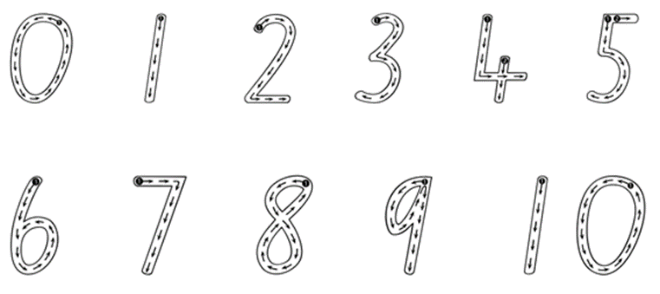

Resource 2: Numbers cards 1
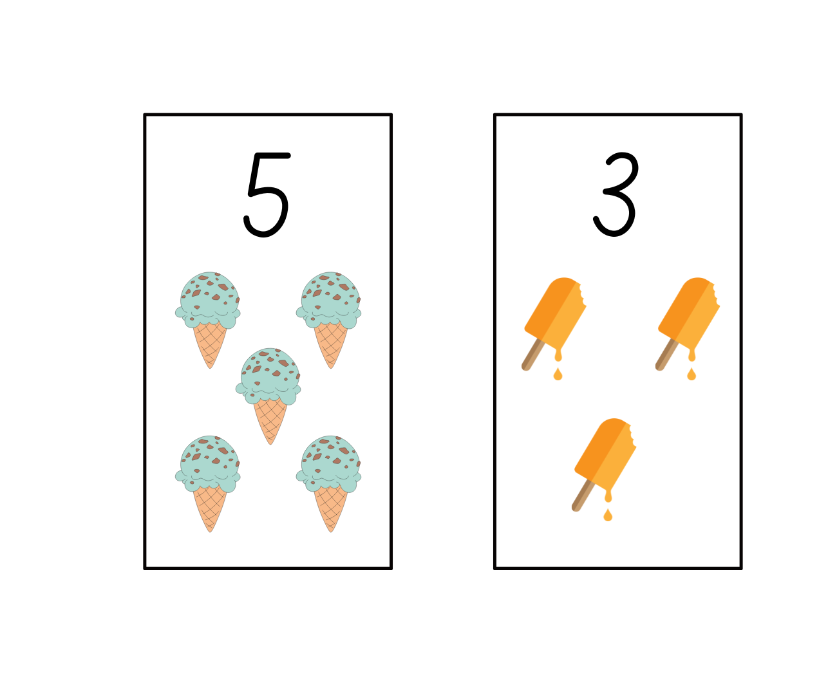
Images from Canva are licensed under Canva Content License Agreement.

Resource 3: Numbers cards 2
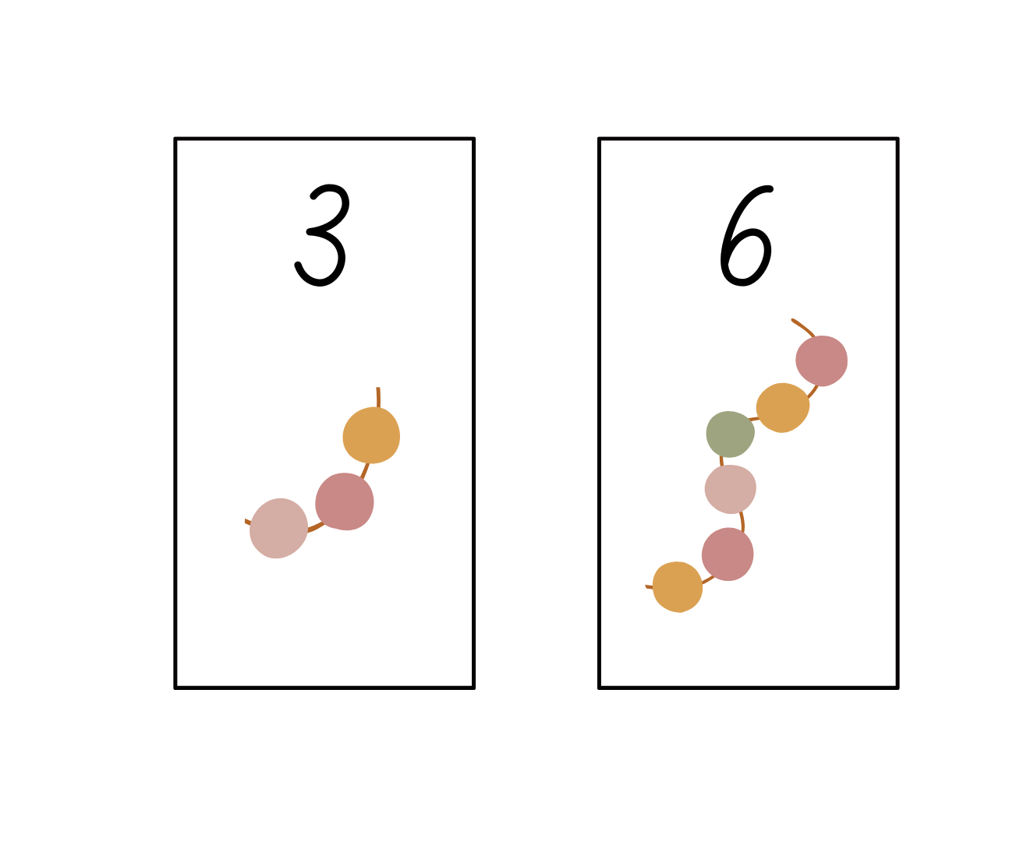
Images from Canva are licensed under Canva Content License Agreement.

Resource 4: Early Stage 1 recording sheet
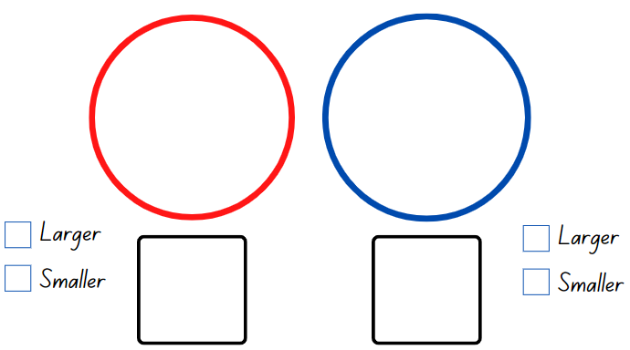

Resource 5: Stage 1 recording sheet

Resource 6: Rekenrek problems
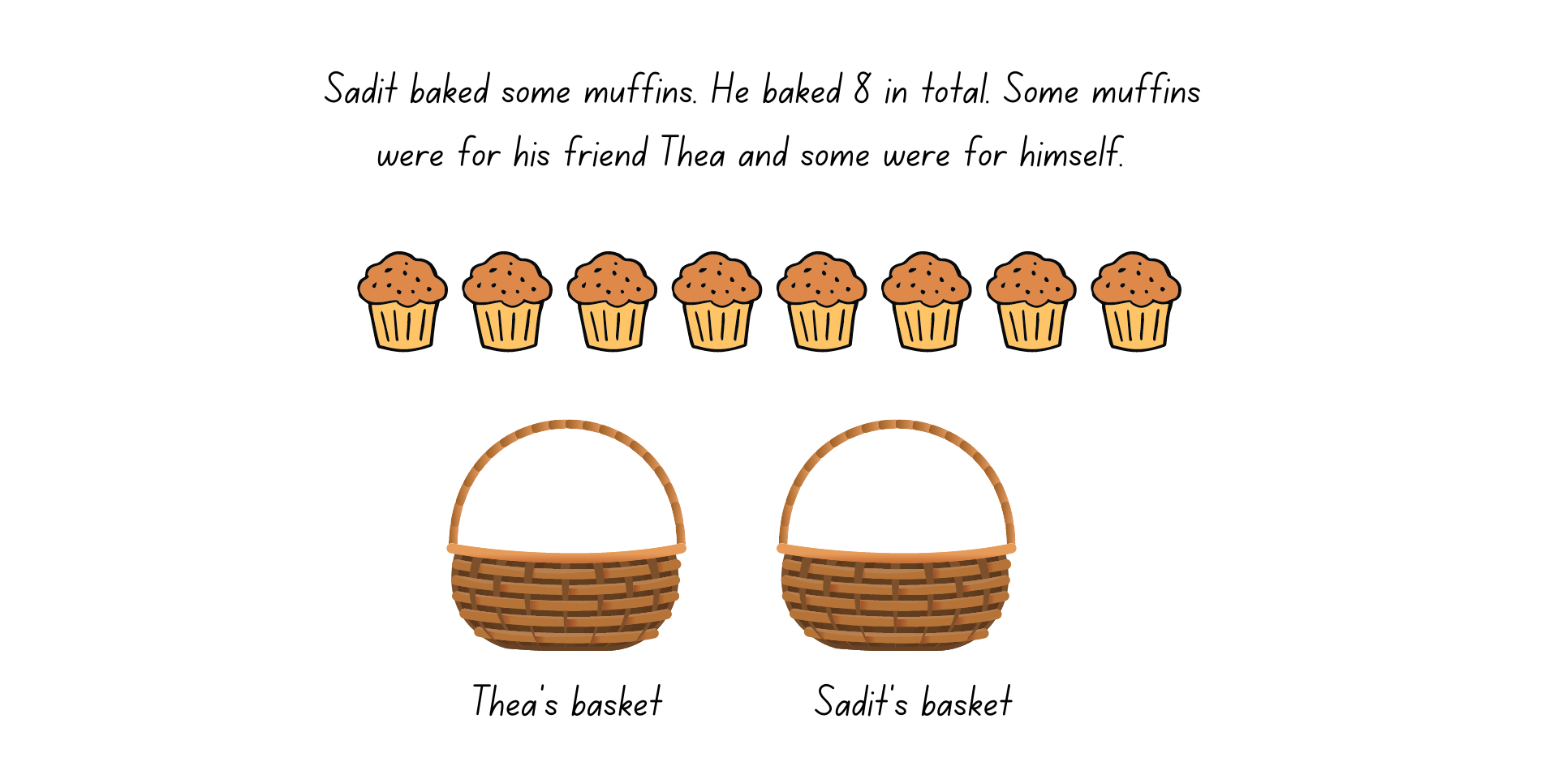
Images from Canva are licensed under Canva Content License Agreement.
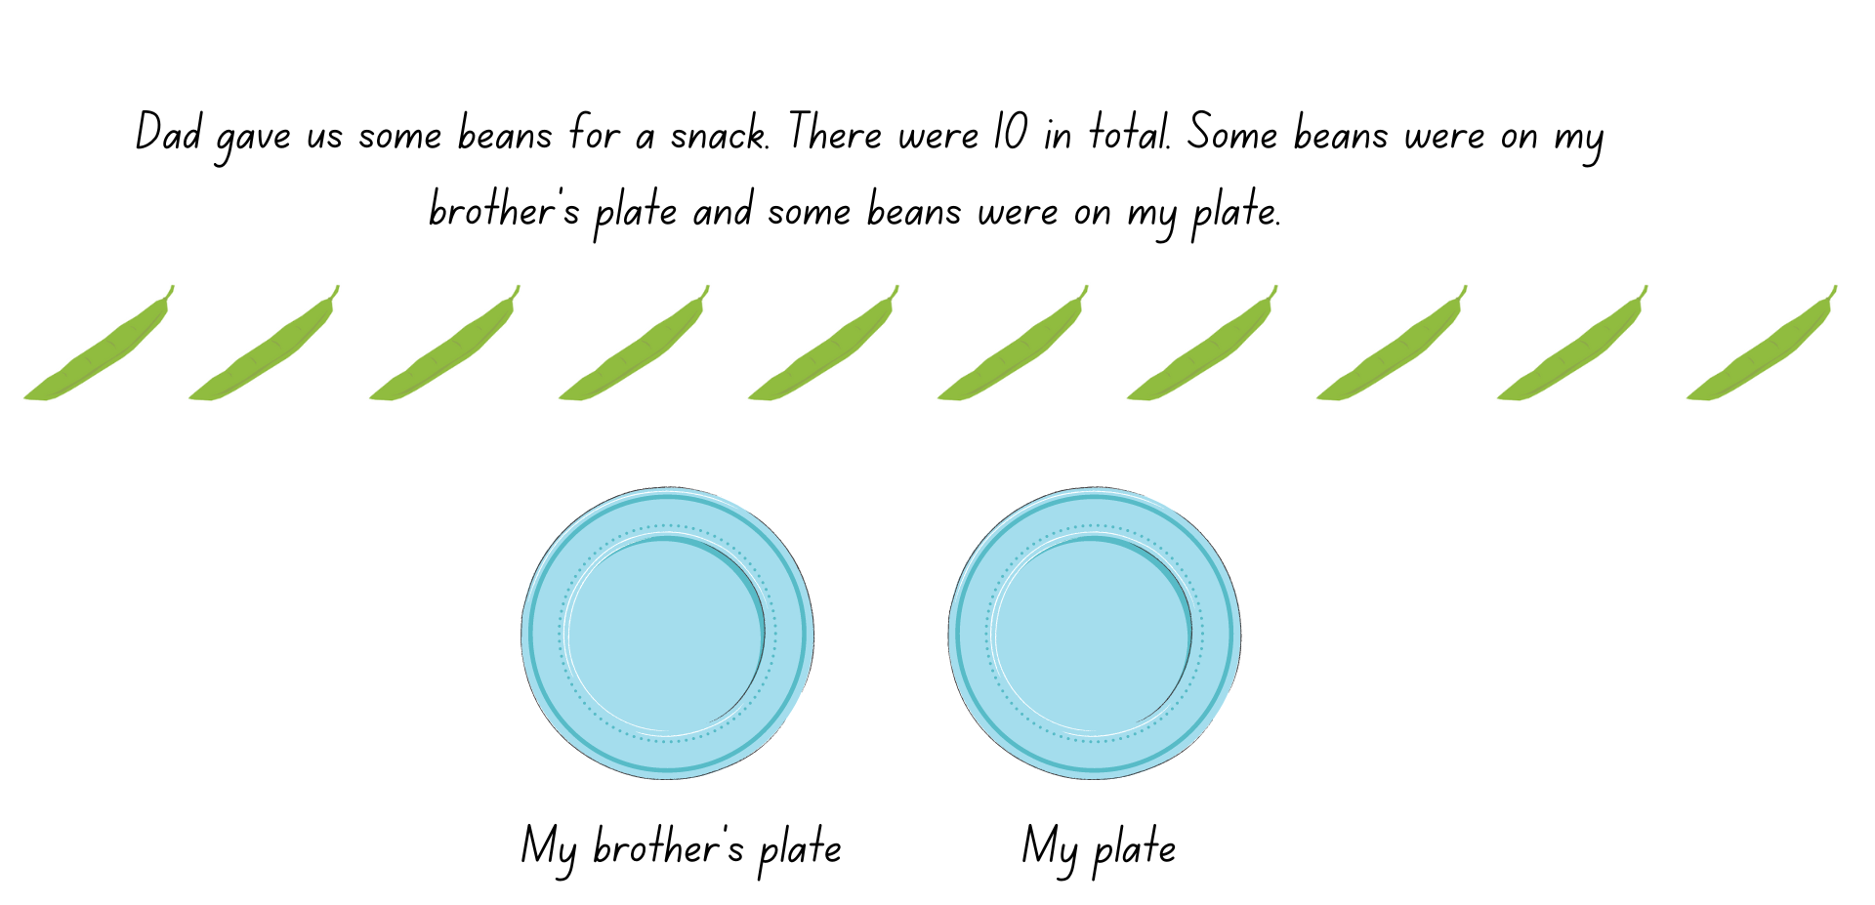
Images from Canva are licensed under Canva Content License Agreement.

Resource 7: Numbers cards 3
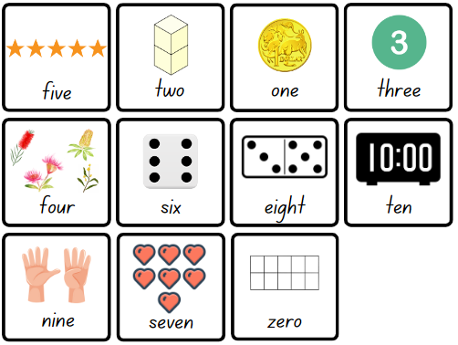
Images from Canva are licensed under Canva Content License Agreement.
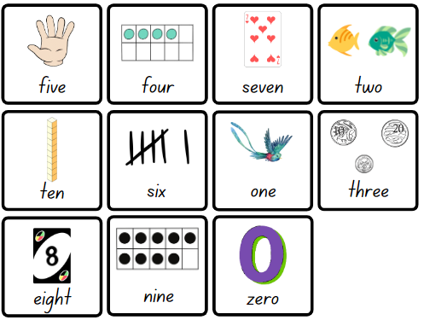
Images from Canva are licensed under Canva Content License Agreement.

Resource 8: Number match
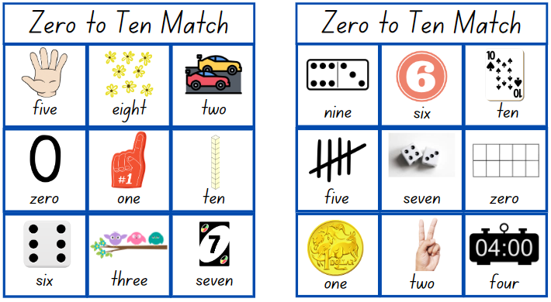
Images from Canva are licensed under Canva Content License Agreement.
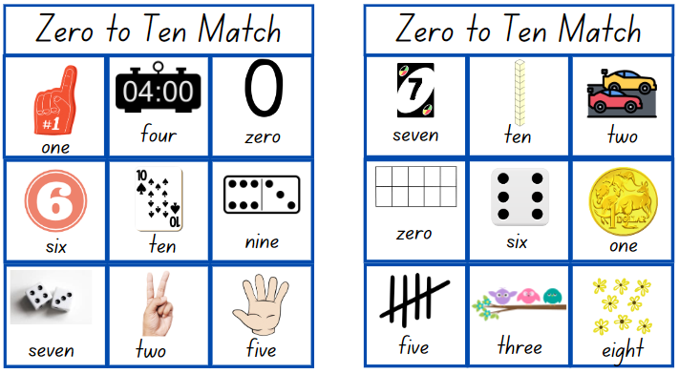
Images from Canva are licensed under Canva Content License Agreement.
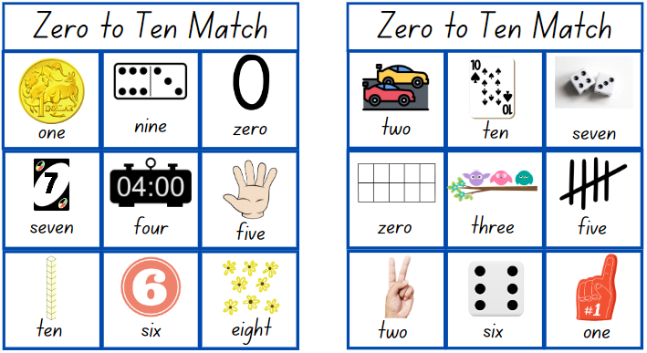
Images from Canva are licensed under Canva Content License Agreement.
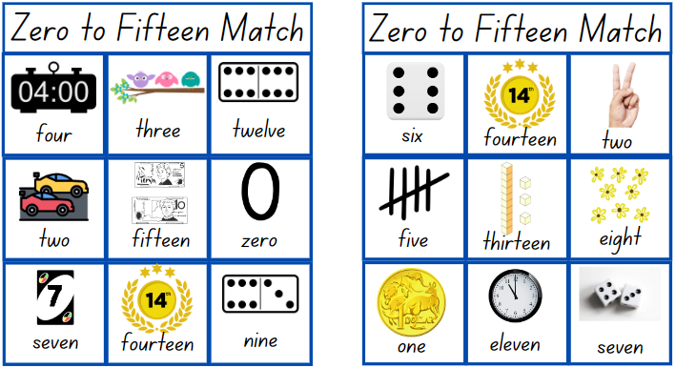
Images from Canva are licensed under Canva Content License Agreement.
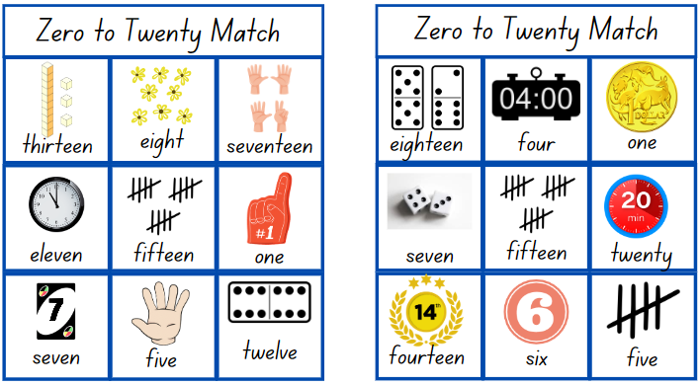
Images from Canva are licensed under Canva Content License Agreement.
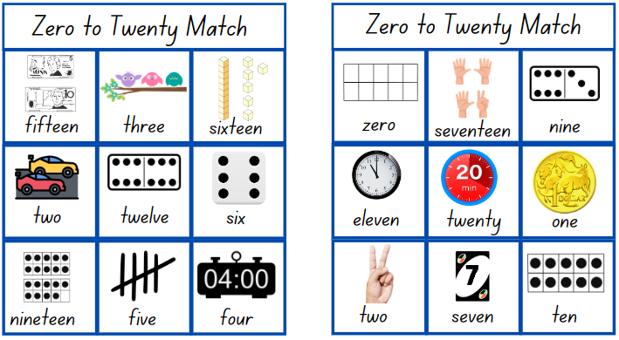
Images from Canva are licensed under Canva Content License Agreement.
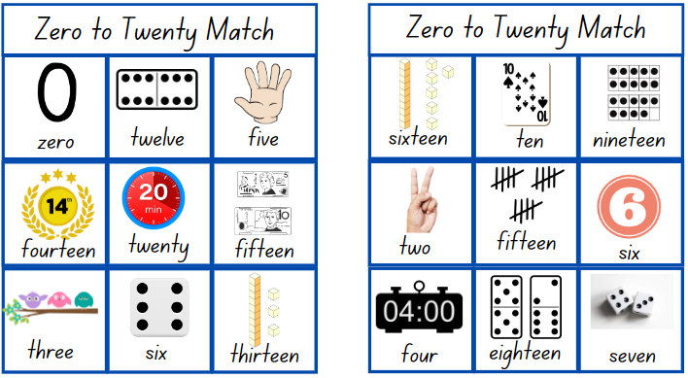
Images from Canva are licensed under Canva Content License Agreement.
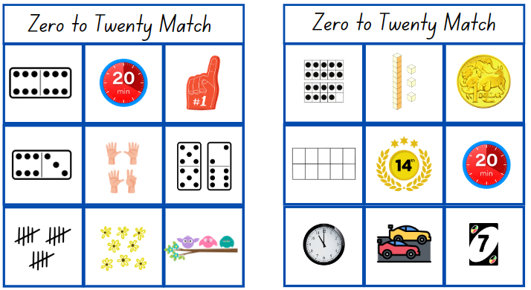
Images from Canva are licensed under Canva Content License Agreement.

Resource 9: Bar model
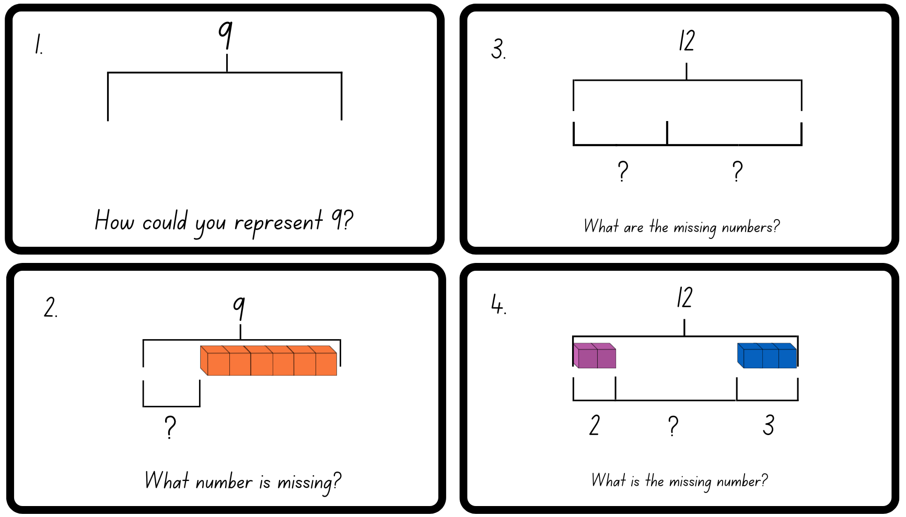
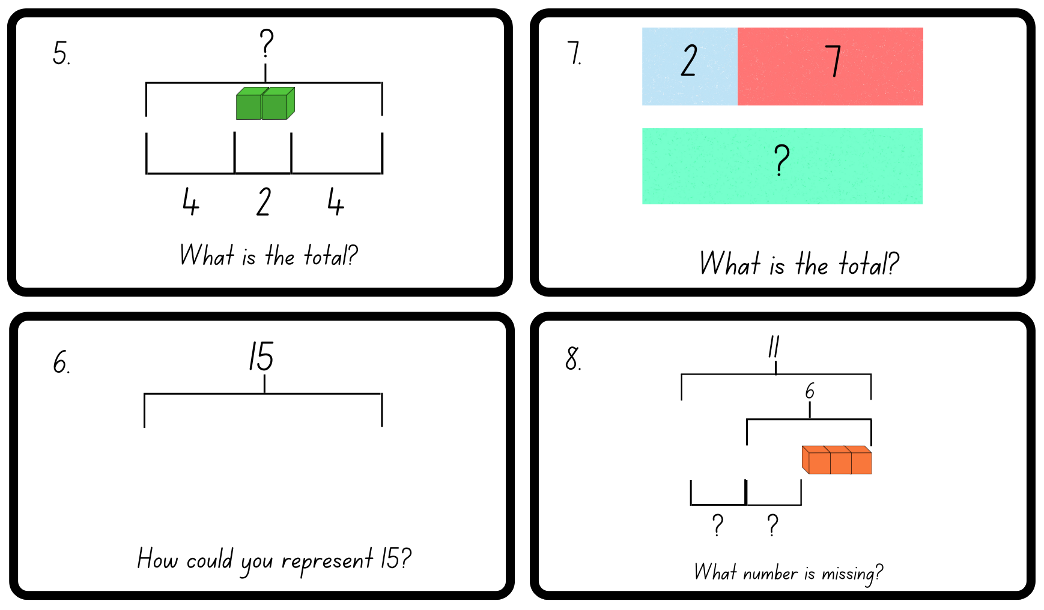

Resource 10: Dot talk 1

Resource 11: Domino triangles 1
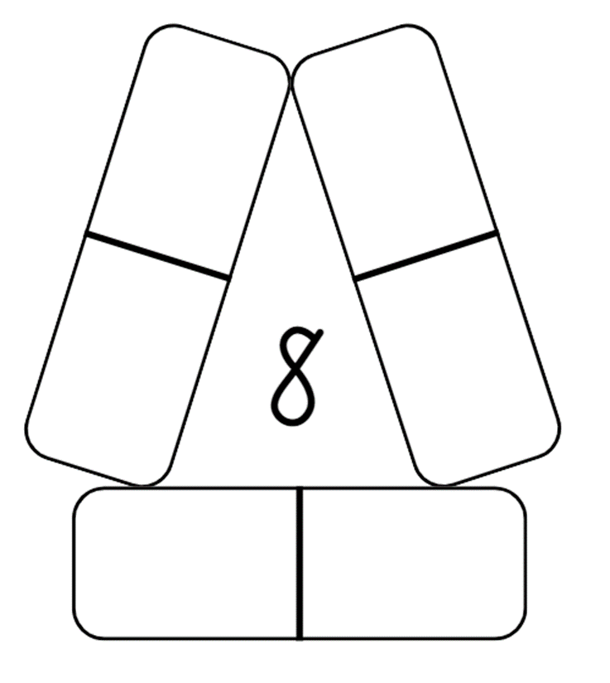

Resource 12: Domino triangles 2
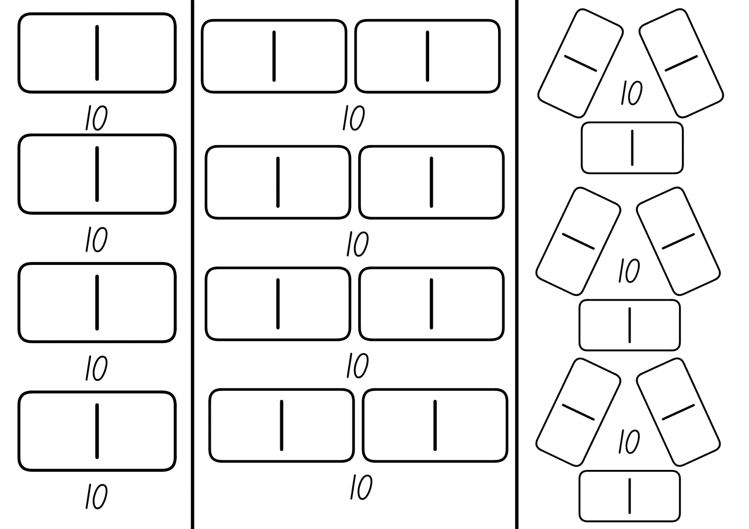
Images from Canva are licensed under Canva Content License Agreement.

Resource 13: Ten-frame
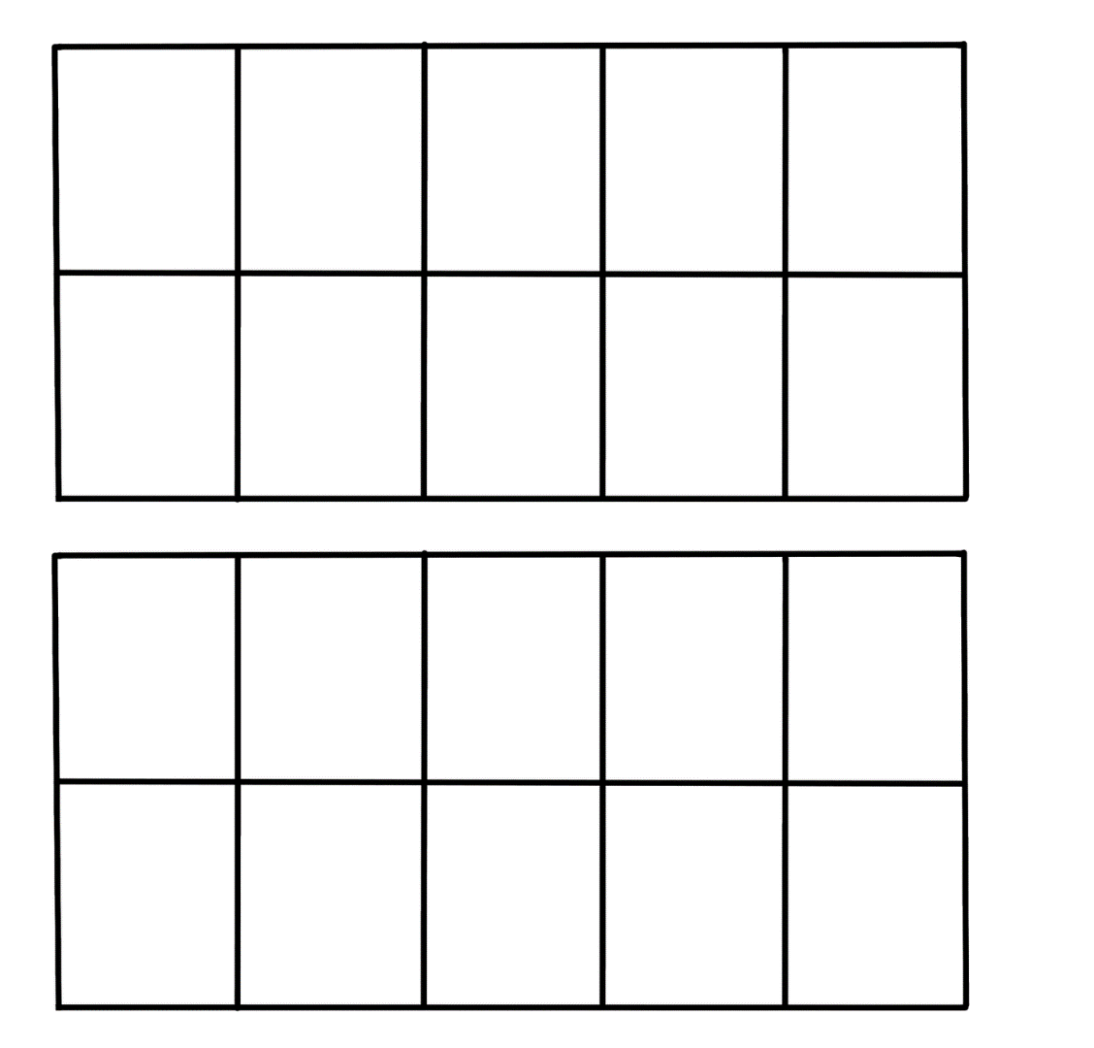

Resource 14: Dot talk 2

Resource 15: Early Stage 1 memory
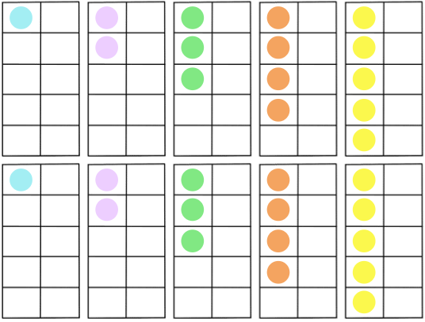

Resource 16: Doubles memory
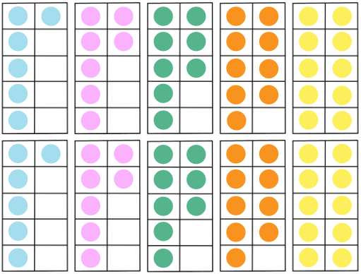

Resource 17: Rekenrek number talk
Images sourced from Canva and used in accordance with the Canva Content License Agreement.

Resource 18: Near doubles 1
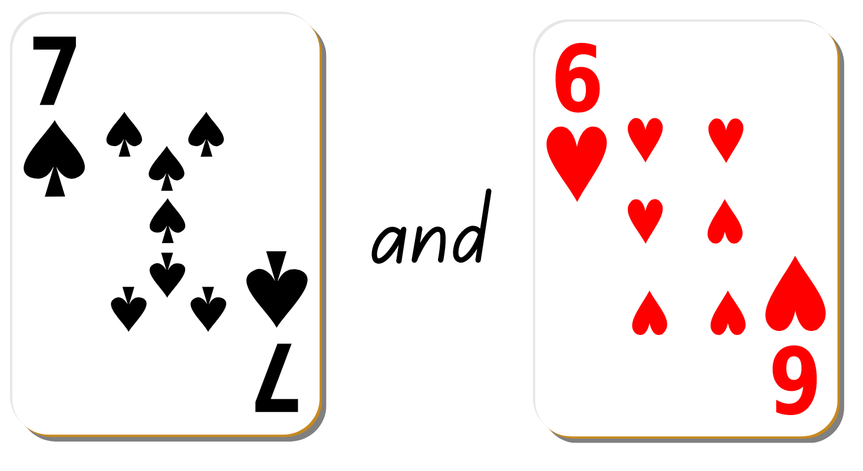
Images from Canva are licensed under Canva Content License Agreement.

Resource 19: Near doubles 2
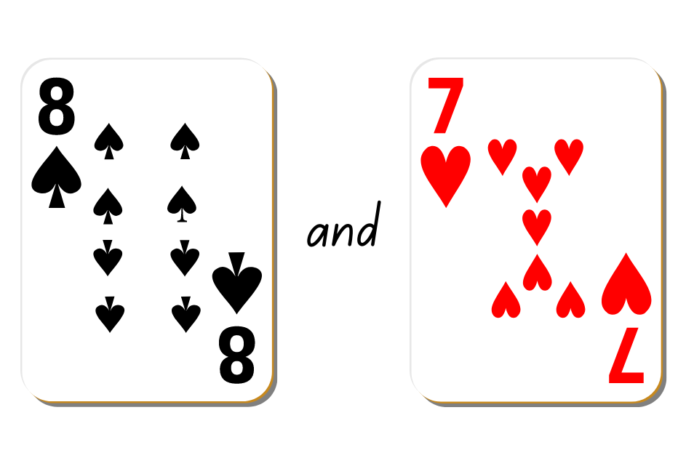
Images from Canva are licensed under Canva Content License Agreement.

Resource 20: Recording table
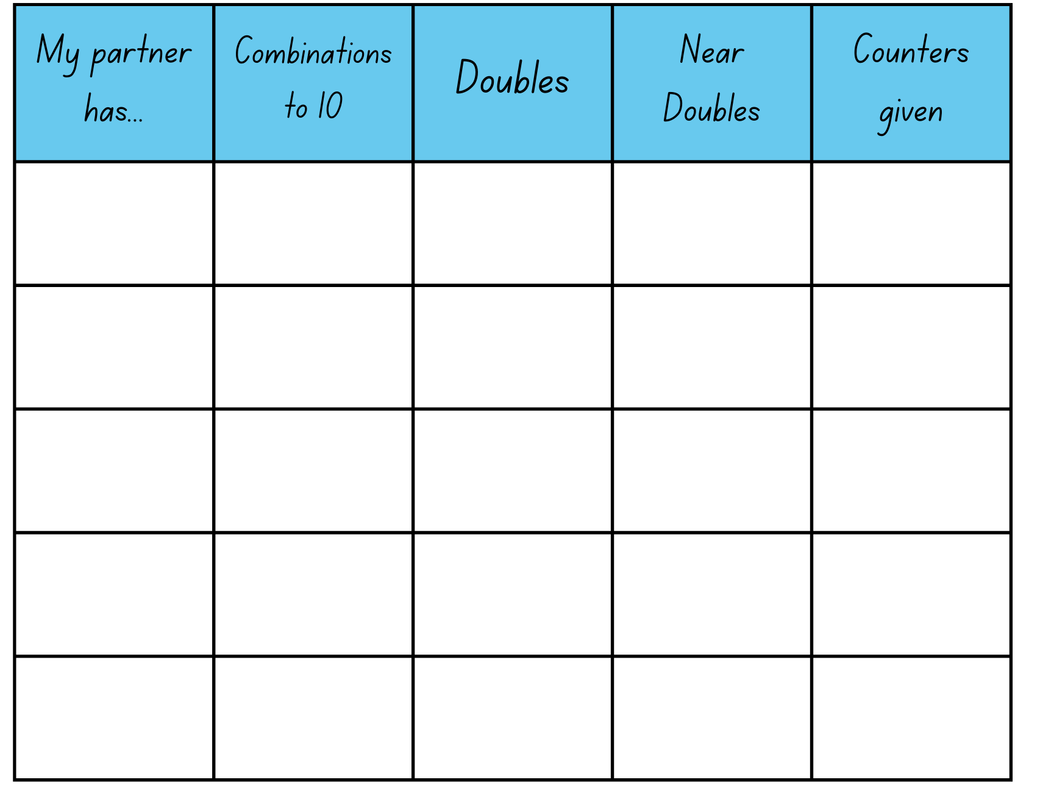

Resource 21: Graphic organiser
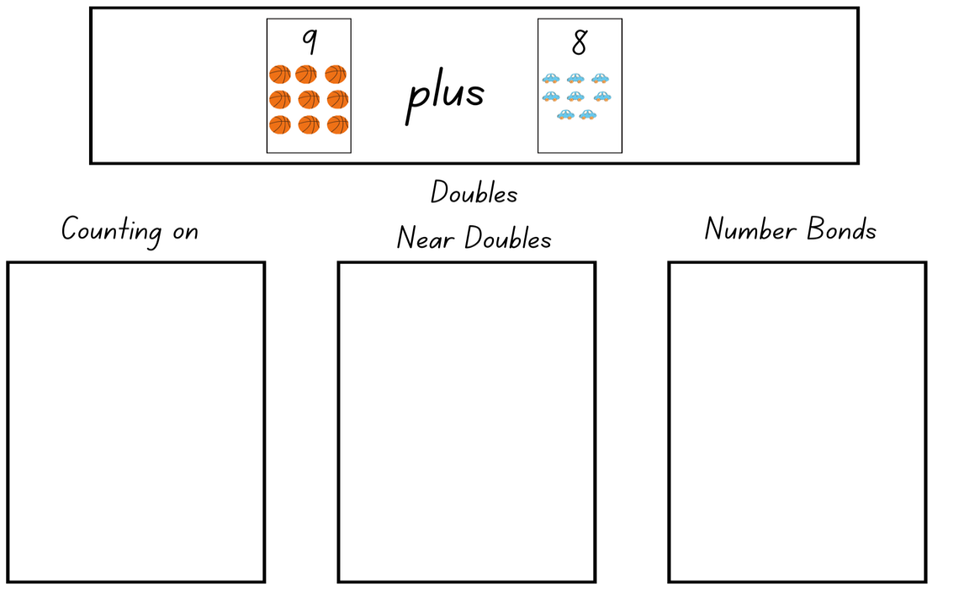
Images from Canva are licensed under Canva Content License Agreement.

Resource 22: Numbers cards 4
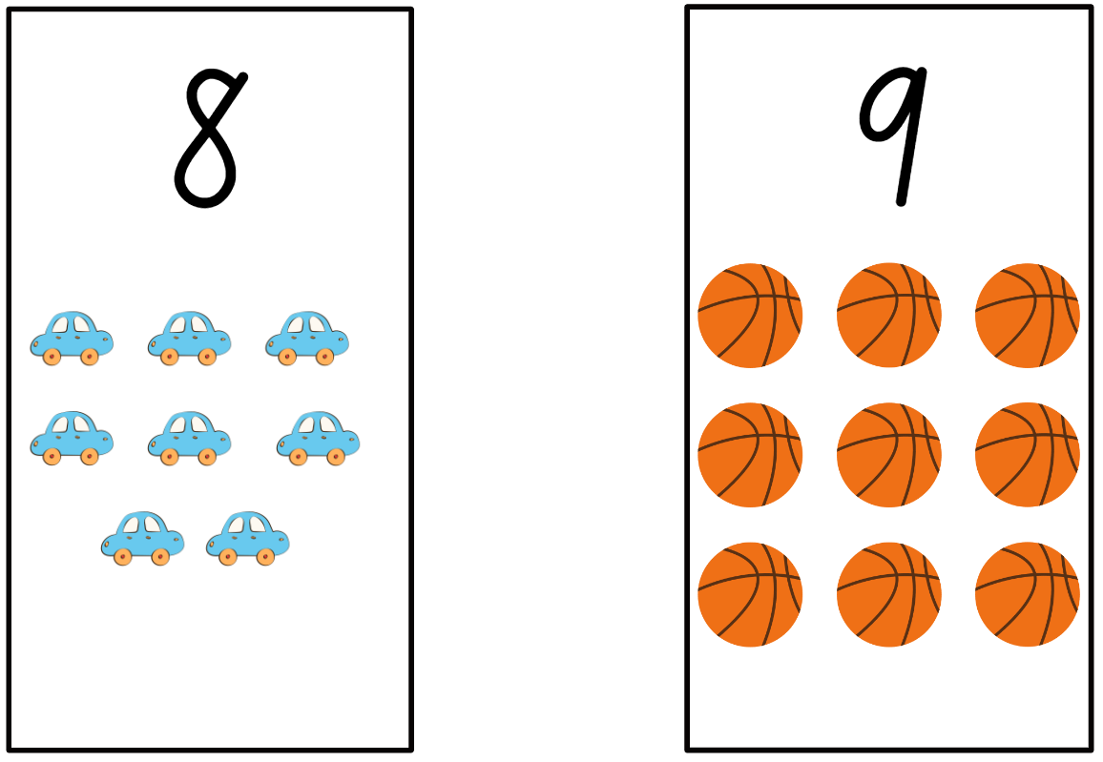
Images from Canva are licensed under Canva Content License Agreement.

Syllabus outcomes and content
The table below outlines the syllabus outcomes and range of relevant syllabus content covered in this unit. Content is linked to National Numeracy Learning Progression version (3).
Focus area and outcomes | Content groups and content points | Lessons
Representing whole numbers  MAO-WM-01  MAE-RWN-01, MA1-RWN-01  MAE-RWN-02, MA1-RWN-02 | Early Stage 1  Instantly name the number of objects within small collections  - instantly recognise (subitise) the number of items in small groups of up to four items without counting (NPV1, CPr1)  - identify the number of items in different arrangements (CPr2) | 5–6, 8
Representing whole numbers (cont) | Early Stage 1  Use the counting sequence of ones flexibly  - count forwards to at least 30 and state the number after or before a given number, without needing to count from one (CPr4)  - count backwards from a given number 20 or less (CPr5) | 1–4, 7–8
Representing whole numbers (cont) | Early Stage 1  Recognise number patterns  - recognise dice and domino dot patterns (NPA1, NPV2, CPr2) | 3
Representing whole numbers (cont) | Early Stage 1  Connect counting and numerals to quantities  - count with one-to-one correspondence, recognising that the last number name represents the total number in the collection (CPr3, CPr5)  - count out a specified number of objects (from 5 to 20) from a larger collection, keeping track of the count (CPr4-CPr5)  - represent numbers as quantities to at least 20 using objects (such as fingers), number words and numerals (NPV2-NPV4, CPr3) | 1, 3, 5–8
Representing whole numbers A (cont) | Stage 1  Use counting sequences of ones with two-digit numbers and beyond  - count forwards and backwards by ones from a given number to at least 120 (CPr6) | 1, 5–8
Representing whole numbers A (cont) | Stage 1  Continue and create number patterns  - model and describe ‘odd’ and ‘even’ numbers using items paired in two rows | 4
Representing whole numbers A (cont) | Stage 1  Represent numbers on a line  - sequence numbers and arrange them on a line by considering the order and size of those numbers (CPr5) | 1–2
Representing whole numbers A (cont) | Stage 1  Represent the structure of groups of ten in whole numbers  - recognise that ten ones is the same as one ten (NPV2, NPV4)  - use 10 as a reference in forming numbers from 11 to 20 (CPr7) | 5–6
Combining and separating quantities  MAO-WM-01  MAE-CSQ-01, MA1-CSQ-01  MAE-CSQ-02 | Early Stage 1  Model additive relations and compare quantities  - combine two or more groups of objects to model addition, identifying the relationship between the parts and the whole (AdS1-AdS2)  - use concrete materials or fingers to model and solve addition and subtraction questions, counting forwards or backwards by ones as necessary (AdS1-AdS2, NPV3) | 4–8
Combining and separating quantities (cont) | Early Stage 1  Identify part–whole relationships in numbers up to 10  - use visual representations of numbers to assist with combining and separating quantities, identifying the relationship between the quantities (NPV2, AdS2-AdS3, NPA2)  - create, model and recognise combinations for numbers up to ten (AdS2)  - count by ones to find the total or difference (AdS2-AdS3)  - use drawings, words and numerals to record addition and subtraction, and explain their thinking (AdS2) | 2–8
Combining and separating quantities A (cont)  NOTE – There is only one combining and separating quantities outcome for Stage 1. | Stage 1  Use advanced count-by-one strategies to solve addition and subtraction problems  - record number sentences in a variety of ways using drawings, words, numerals and symbols (AdS6)  - fluently use advanced count-by-one strategies including counting on and counting back to solve addition and subtraction problems involving one- and two-digit numbers (AdS3-AdS5) | 1–8
Combining and separating quantities A (cont) | Stage 1  Recognise and recall number bonds up to ten  - recognise, recall and record combinations of two numbers that add up or bond to form 10 (AdS2, AdS6)  - model and record patterns for individual numbers up to ten by making all possible whole-number combinations  - create, recall and recognise combinations of two numbers that add up to numbers less than 10 (AdS2, AdS6)  - describe combinations for numbers using words such as more than, less than and double (AdS6) | 1–8
Combining and separating quantities A (cont) | Stage 1  Use flexible strategies to solve addition and subtraction problems  - use non-count-by-one strategies such as using doubles for near doubles and combining numbers that add to ten (AdS6)  - represent addition and subtraction using structured materials such as a bead string or similar model (AdS6-AdS7) | 2–8

References
Links to third-party material and websites
Please note that the provided (reading/viewing material/list/links/texts) are a suggestion only and implies no endorsement, by the New South Wales Department of Education, of any author, publisher, or book title. School principals and teachers are best placed to assess the suitability of resources that would complement the curriculum and reflect the needs and interests of their students.
If you use the links provided in this document to access a third-party's website, you acknowledge that the terms of use, including licence terms set out on the third-party's website apply to the use which may be made of the materials on that third-party website or where permitted by the Copyright Act 1968 (Cth). The department accepts no responsibility for content on third-party websites.
Except as otherwise noted, all material is © State of New South Wales (Department of Education), 2021 and licensed under the Creative Commons Attribution 4.0 International License. All other material (third-party material) is used with permission or under licence. Where the copyright owner of third-party material has not licensed their material under a Creative Commons or similar licence, you should contact them directly for permission to reuse their material.
Mathematics K–10 Syllabus © 2022 NSW Education Standards Authority (NESA) for and on behalf of the Crown in right of the State of New South Wales.
© 2022 NSW Education Standards Authority. This document contains NSW Curriculum and syllabus content. The NSW Curriculum is developed by the NSW Education Standards Authority. This content is prepared by NESA for and on behalf of the Crown in right of the State of New South Wales. The material is protected by Crown copyright.
Please refer to the NESA Copyright Disclaimer for more information.
NESA holds the only official and up-to-date versions of the NSW Curriculum and syllabus documents. Please visit the NSW Education Standards Authority (NESA) website and the NSW Curriculum website.
National Numeracy Learning Progression © Australian Curriculum, Assessment and Reporting Authority (ACARA) 2010 to present, unless otherwise indicated. This material was downloaded from the Australian Curriculum website (National Numeracy Learning Progression) (accessed 13 October 2022) and was not modified. The material is licensed under CC BY 4.0. Version updates are tracked in the ‘Curriculum version history’ section on the 'About the Australian Curriculum' page of the Australian Curriculum website.
ACARA does not endorse any product that uses the Australian Curriculum or make any representations as to the quality of such products. Any product that uses material published on this website should not be taken to be affiliated with ACARA or have the sponsorship or approval of ACARA. It is up to each person to make their own assessment of the product, taking into account matters including, but not limited to, the version number and the degree to which the materials align with the content descriptions and achievement standards (where relevant). Where there is a claim of alignment, it is important to check that the materials align with the content descriptions and achievement standards (endorsed by all education Ministers), not the elaborations (examples provided by ACARA).
This resource contains images and content obtained from Canva, and their use outside of this resource is subject to Canva’s Content License Agreement. If you wish to use them separately from the resource, please go to Canva.
Australian Government Department of Education (2022) The Bar Model Method, reSolve: Maths by Inquiry website, accessed 13 October 2022.
Boaler J, Munson J and Williams C (2020) Mindset Mathematics: Visualizing and Investigating Big Ideas, Grade K, Jossey-Bass, New Jersey.
Siemon D, Warren E, Beswick K, Faragher R, Miller J, Horne M, Jazby D, Breed M, Clark J and Brady K (2020) Teaching Mathematics: Foundations to Middle Years, 3rd edn, Oxford University Press Australia and New Zealand.
State of New South Wales, Department of Education (n.d.) ‘Activities to Support Early Arithmetical Strategies’, Counting on-and-back Strategies, Developing Efficient Numeracy Strategies One website, accessed 13 October 2022.
Sullivan P and Lilburn P (2017) Open-ended Maths Activities: Using ‘Good’ Questions to Enhance Learning in Mathematics, Revised edn, Oxford University Press ANZ, Great Britain.
Swan P (2001) Domino Deductions: Developing Mathematics from Dominoes, Self-published, Australia.
Swan P (2020) Beadstring Mathematics, Self-published, Australia.
Van de Walle J, Karp K, Bay-Williams JM, Brass A, Bentley B, Ferguson S, Goff W, Livy S, Marshman M, Martin D, Pearn C, Prodromou T, Symons D and Wilkie K (2019) Primary and Middle Years Mathematics: Teaching Developmentally, 1st Australian edn, Pearson Australia, Melbourne.

