Mathematics – K-2 multi-age – Year A – Unit 2
Contents
Unit description and duration 4
Student prior learning 5
Lesson overview and resources 6
Lesson 1: Repeating patterns 1 17
Daily number sense: Quick counting! – 10 minutes 18
Finding different repeating patterns – 50 minutes 19
Consolidation and meaningful practice: What’s this pattern about? – 5 minutes 25
Lesson 2: Repeating patterns 2 26
Daily number sense: Dinner time! – 15 minutes 27
A pattern core is very helpful – 40 minutes 28
Discuss and connect the mathematics – 5 minutes 34
Lesson 3: Dice dots everywhere! 35
Daily number sense: Spot the Spots! – 20 minutes 36
Going dotty! How can dots help us to see numbers? – 40 minutes 37
Consolidation and meaningful practice: Matching Numbers – 10 minutes 41
Lesson 4: Smaller numbers inside bigger numbers 42
Daily number sense: Counting patterns – 10 minutes 43
What’s hiding inside? – 50 minutes 44
Consolidation and meaningful practice: What have we learned about growing and shrinking patterns? – 5 minutes 48
Lesson 5: Number facts have patterns too 49
Daily number sense – 15 minutes 50
Thinking and reasoning – 10 minutes 50
Mathematical regularity – 45 minutes 51
Discuss and connect the mathematics – 5 minutes 53
Lesson 6: Place value patterns 54
Daily number sense: Counting on counting – 15 minutes 55
Quantifying collections – 50 minutes 56
Consolidation and meaningful practice: What patterns did we find? – 5 minutes 61
Lesson 7: Growing and shrinking patterns 62
Daily number sense: 3 tens in a row – 10 minutes 63
How can patterns grow and shrink? – 45 minutes 66
Consolidation and meaningful practice: How do patterns grow and shrink? – 15 minutes 73
Lesson 8: Repeating, growing, and shrinking! 76
Daily number sense: What number comes next? Choral counting by twos – 15 minutes 77
Building patterns – 15 minutes 78
How can patterns grow? – 10 minutes 79
Making our own staircase pattern – 15 minutes 80
Shrinking patterns – 10 minutes 82
Creating a shrinking pattern – 5 minutes 82
Consolidation and meaningful practice: how do patterns grow and shrink – 5 minutes 84
Resource 1: Shape train 85
Resource 2: AB patterns 86
Resource 3: What’s this pattern about? 87
Resource 4: Dot card 88
Resource 5: Organised partitions of 10 89
Resource 6: Counting on counting gameplay assessment 90
Resource 7: Number chart 91
Resource 8: Number charts 92
Resource 9: Number cards 93
Syllabus outcomes and content 95
References 107
Further reading 109

Unit description and duration
This two-week unit provides opportunity to further develop students’ knowledge, skills and understanding of patterns. Students are provided opportunities to:
- describe repeating patterns made from shapes by referring to their distinguishing features such as colour, size, and shape
- understand that patterns have an element of repetition, meaning something repeats over and over and over again
- recognise that the element of repeat in a repeating pattern can sometimes be referred to as the repeating core
- use the pattern core to create their own patterns, extend the patterns of others and identify the missing elements within patterns
- develop an understanding that number bonds and dice structures are also forms of mathematical patterns that we come to trust
- understand that some patterns can grow (the pattern increases by the same amount in each subsequent term) and shrink (where the pattern decreases by the same amount in each subsequent term)
- instantly recognise (subitise) small collections of objects without counting
- identify, describe, and create patterns when counting forwards or backwards in twos, fives, and tens
- create, model, and recognise combinations for numbers up to 10
- apply knowledge of counting sequences to solve problems involving equal groups.
Mathematics K–10 Syllabus © 2022 NSW Education Standards Authority (NESA) for and on behalf of the Crown in right of the State of New South Wales.

Student prior learning
Before engaging in these teaching and learning activities, students would benefit from prior experience with:
- identifying repeating patterns and how they repeat over and over and over again
- recognising that a group of objects and shapes can be sorted and classified in different ways
- using everyday language to describe and compare the attributes and features of shapes and objects
- continuing a repeating pattern made from shapes by referring to distinguishing features, such as colour or size
- using concrete materials to model two-part combinations of a quantity.

Lesson overview and resources
The table below outlines the sequence and approximate timing of lessons; syllabus focus areas and content groups; and resources.
Lesson | Syllabus focus area and content groups | Resources
Lesson 1: Repeating patterns 1  65 minutes  Patterns have a core that repeats over and over and over again. | Representing whole numbers  Early Stage 1  - Use the counting sequence of ones flexibly  - Recognise number patterns  Stage 1 – Part A  - Use counting sequences of ones with two-digit numbers and beyond  - Continue and create number patterns  Two-dimensional spatial structure  Early Stage 1  - 2D shapes: Sort, describe and name familiar shapes  Stage 1 – Part A  - 2D shapes: Recognise and classify shapes using obvious features | - Resource 1: Shape train  - Resource 2: AB patterns  - Resource 3: What’s this pattern about?  - 2D geometric shapes  - A variety of counters or objects  - Concrete materials  - Mini whiteboards  - Digital tablet
Lesson 2: Repeating patterns 2  60 minutes  Identifying the repeating core of a pattern is a strategy which assists with determining a missing element. | Representing whole numbers  Early Stage 1  - Recognise number patterns  - Connect counting and numerals to quantities  Stage 1 – Part A  - Continue and create number patterns  - Represent the structure of groups of ten in whole numbers  Two-dimensional spatial structure  Early Stage 1  - 2D shapes: Sort, describe and name familiar shapes  - 2D shapes: Represent shapes  Stage 1 – Part A  - 2D shapes: Recognise and classify shapes using obvious features  Stage 1 – Part B  - Represent, combine and separate two-dimensional shapes | - 2D geometric shapes  - Concrete materials  - Counters  - Interlocking cubes  - Sticky notes  - Writing materials
Lesson 3: Dice dots everywhere!  70 minutes  Arrangements of dots can be used to quantify small and large collections. | Representing whole numbers  Early Stage 1  - Recognise number patterns  - Connect counting and numerals to quantities  Stage 1 – Part A  - Continue and create number patterns  - Represent numbers on a line  - Represent the structure of groups of ten in whole numbers  Combining and separating quantities  Early Stage 1  - Model additive relations and compare quantities  - Identify part–whole relationships in numbers up to 10  Stage 1 – Part A  - Recognise and recall number bonds up to ten  Stage 1 – Part B  - Represent and reason about additive strategies  Forming groups  Early Stage 1  - Copy, continue and create patterns  Stage 1 – Part A  - Count in multiples using rhythmic and skip counting  - Use skip counting patterns | - Resource 4: Dot card  - Video: Subitising 6 (one less than) (6:06)  - Numerals and expressions: Dots 1-6 [PDF 28KB] (NZ Maths)  - Counters  - Dotted dice  - Mini whiteboards  - Number line for each student  - Poster paper and markers  - Writing materials
Lesson 4: Smaller numbers inside bigger numbers  65 minutes  Using smaller ‘chunks’ and familiar dice patterns help to work out a total. | Representing whole numbers  Early Stage 1  - Use the counting sequence of ones flexibly  - Connect counting and numerals to quantities  Stage 1 – Part A  - Use counting sequences of ones with two-digit numbers and beyond  Stage 1 – Part B  - Use counting sequences of ones and tens flexibly  Combining and separating quantities  Early Stage 1  - Model additive relations and compare quantities  - Identify part–whole relationships in numbers up to 10  Stage 1 – Part A  - Use advanced count-by-one strategies to solve addition and subtraction problems  - Recognise and recall number bonds up to ten  Stage 1 – Part B  - Represent and reason about additive strategies | - Resource 5: Organised partitions of 10  - Camera/tablet (teacher only)  - Interlocking cubes  - Number chart  - Number line  - Picture book related to counting  - Transparent coloured counters  - Writing materials
Lesson 5: Number facts have patterns too  75 minutes  When number sequences are related, they can be arranged and repeated to create a number pattern. | Representing whole numbers  Early Stage 1  - Recognise number patterns  Stage 1 – Part A  - Continue and create number patterns  Combining and separating quantities  Early Stage 1  - Model additive relations and compare quantities  - Identify part–whole relationships in numbers up to 10  Stage 1 – Part A  - Use advanced count-by-one strategies to solve addition and subtraction problems  Stage 1 – Part B  - Use knowledge of equality to solve related problems | - A4 paper  - A variety of concrete materials  - Dot cards  - Models or photographs from activity 13 in Lesson 4  - Writing materials
Lesson 6: Place value patterns  70 minutes  Place value can be used to explore and create number patterns. | Representing whole numbers  Early Stage 1  - Connect counting and numerals to quantities  Stage 1 – Part A  - Represent numbers on a line  - Represent the structure of groups of ten in whole numbers  Stage 1 – Part B  - Form, regroup, and rename three-digit numbers  Combining and separating quantities  Early Stage 1  - Identify part–whole relationships in numbers up to 10  Stage 1 – Part A  - Recognise and recall number bonds up to ten  Forming groups  Early Stage 1  - Investigate and form equal groups by sharing  - Record grouping and sharing  Stage 1 – Part A  - Model and use equal groups of objects to represent multiplication  Stage 1 – Part B  - Represent and explain multiplication as the combining of equal groups | - Resource 6: Counting on counting gameplay assessment  - Resource 7: Number chart  - Video: Quantifying collections – Ice cream sticks 1 – number talk (7:50)  - Video: Frog animation (1:42) (NZ Maths)  - Interactive hundreds chart (Toy Theater)  - Odd one out cards (NZ Maths)  - Concrete materials  - Craft sticks  - Mini whiteboards  - Number line  - Writing materials
Lesson 7: Growing and shrinking patterns  70 minutes  A repeating core can make a pattern grow or shrink. | Representing whole numbers  Early Stage 1  - Recognise number patterns  Stage 1 – Part A  - Continue and create number patterns  Combining and separating quantities  Early Stage 1  - Model additive relations and compare quantities  Stage 1 – Part B  - Represent and reason about additive strategies  Forming groups B  Early Stage 1  - Investigate and form equal groups by sharing  Stage 1 – Part B  - Represent and explain multiplication as the combining of equal groups  Data  Early Stage 1  - Respond to questions, collect information and discuss possible outcomes of activities  - Organise objects into simple data displays and interpret the displays  Stage 1 – Part A  - Ask questions and gather data  - Represent data with objects and drawings and describe the displays  Stage 1 – Data B  - Create displays of data and interpret them | - Resource 8: Number charts  - 2D geometric shapes  - Counters  - Dice and gameboard  - Interlocking cubes  - Multiple 9-sided dice  - Writing materials
Lesson 8: Repeating, growing and shrinking!  75 minutes  There are a variety of number patterns on a number chart when you count in various sequences. | Representing whole numbers  Early Stage 1  - Connect counting and numerals to quantities  - Recognise number patterns  Stage 1 – Part A  - Continue and create number patterns  Combining and separating quantities  Early Stage 1  - Model additive relations and compare quantities  Stage 1 – Part B  - Represent and reason about additive strategies  - Use knowledge of equality to solve related problems  Forming groups  Early Stage 1  - Copy, continue and create patterns  Stage 1 – Part A  - Count in multiples using rhythmic and skip counting  - Use skip counting patterns  Stage 1 – Part B  - Represent and explain multiplication as the combining of equal group | - Resource 9: Number cards  - Williams S (1992) I Went Walking (Vivas J illus.), Harcourt Brace & Co, US. ISBN: 9780152380113  - Dale P (2013) Ten in the Bed, Walker Books Australia, Sydney. ISBN: 9781406353099  - Linking cubes – 30  - Number line  - Selection of plastic farm animals or images of farm animals  - Tablet or camera  - Writing materials

Lesson 1: Repeating patterns 1
Core concept: Patterns have a core that repeats over and over and over again.
The table below contains suggested learning intentions and success criteria. These are best co-constructed with students.
Learning intentions | Success criteria
All students are learning that:  - patterns have a core that repeats over and over and over again  - a pattern core can be described as a two-part pattern or a three-part pattern and can be described using letters or symbols such as AB, ABC, ABB, or ABA  - the repeating core helps to extend a pattern. | All students can:  - identify the core of a repeating pattern  - create patterns with a core that repeats over and over and over again  - describe the repeating core as a two-part repeating core pattern, for example, AB and so on.  In addition, students working towards Early Stage 1 outcomes can:  - create and describe a pattern by using and naming features, such as colour, size, shape, and so on  - describe a repeating pattern as having a two-part repeating core pattern  - use what they know about a repeating core and extend a pattern.  In addition, students working towards Stage 1 outcomes can:  - describe a repeating pattern as having a two-part (AB) repeating core pattern, a three-part (for example ABC ABB) repeating core pattern, and so on  - create and extend repeating core patterns  - use what they know about a repeating core to create a vertical pattern.

Daily number sense: Quick counting! – 10 minutes
- Build student understanding of grouping a collection and skip counting by displaying Resource 1: Shape train.
Note: To support Early Stage 1 students, cover and reveal the carriages of the train as needed. Use concrete materials, such as 2D geometrical shapes to model and name the shapes seen on the train. Optional: When counting, use the 2D geometrical shapes, pointing to each as they are grouped and counted.
- Ask students to discuss an accurate way to count the total number of the same shape, such as counting the total number of circles or the total number of triangles.
- Select some students to draw the quantity of one chosen shape seen on the shape train. For example, one student may draw 4 triangles and another 24 circles. Allow time for all students to view the drawings and ask if drawing a collection of the same shape helps to count the total number of shapes.
- Continue the discussion with the following questions:
- What are some counting strategies we can use?
- Is it easier to count smaller collections? Why?
- Is it easier to count larger collections when they are arranged in a certain way? Why?
- How can we make sure we are accurate?
- Present a variety of counters or objects in large groups to encourage counting by ones and skip counting by twos, fives, and tens. Ask students to re-arrange the displays to improve counting efficiency and accuracy.
- Revisit the shape train and ask students to discuss an accurate way to count and record the total number of all the different shapes on the shape train. Suggest strategies such as skip counting or grouping by twos, fives or tens and strategies for recording such as using tally marks, a collection of counters or creating a table. Clarify with students how to check that the final total is accurate.

Finding different repeating patterns – 50 minutes
- Tell students that patterns are everywhere. Invite students in small groups to discuss and brainstorm examples. Prompt students to think about patterns they have seen, heard, and felt as this encourages mathematical language and exploration of various features and patterns. Students record their ideas on paper or a mini whiteboard to be shared with the class.
- Create patterns, like those in Figure 1. Ask students if the images are patterns, prompting students to share how they know.
Figure 1 – What is different? What is the same?
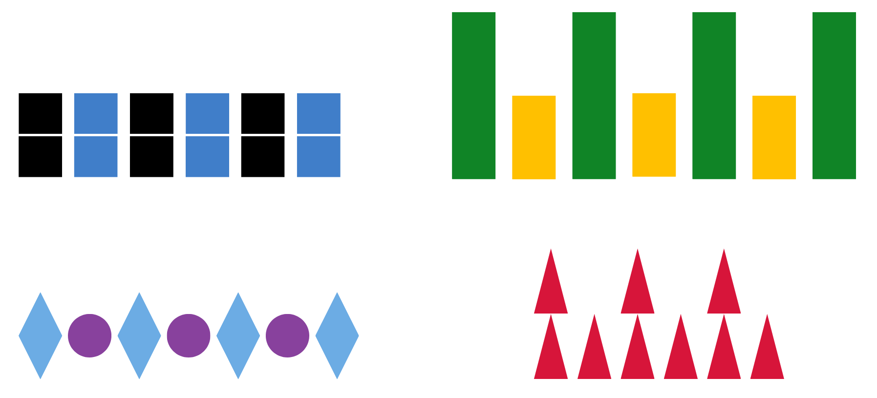
- Explain that when mathematicians describe repeating patterns, they look at different features, such as colour, size, number, and shape. Note that sometimes words can also be used to describe patterns, such as black, blue, black, blue, black, blue; or tall, short, tall, short, tall, short, and so on.
- Referring to Figure 1, ask students to think of more than one way to describe each pattern. Prompt students by asking them to think about colour, shape, size, and number to describe the parts of the patterns.
- Select students to share their thinking. This will provide an insight into what students know about patterns and the language they are using to explain their thinking. Encourage students to make comparisons between the patterns by asking them what is different and what is the same. Students turn and talk, sharing their comparisons.
- Explain that a pattern needs to have a core that is repeated over and over and over again (about 3 times) to trust that there is a regularity. Mathematicians describe the repeating core of a pattern using letters. For example, the patterns in Figure 2 can be described as having an AB core that has 2 parts. The first pattern has 2 parts that can be described as A (green) and B (orange). The second pattern also has an AB core that can be described as A (tall) and B (short).
Figure 2 – AB patterns
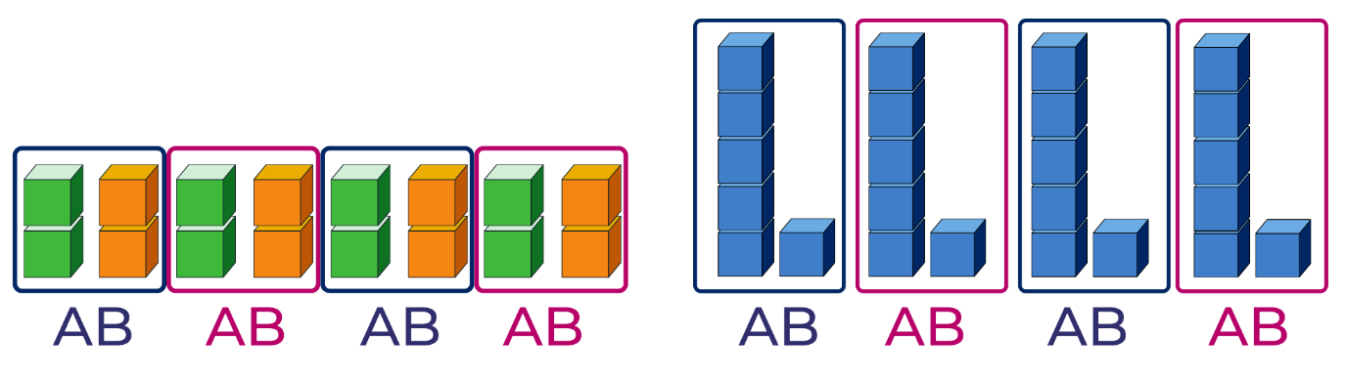
- Tell students that AB patterns can also be represented in different ways if there are 2 parts to the core. For example, using a body percussion pattern such as clap, click; a movement pattern such as jump, hop; or a position pattern such as up and down. Model some simple AB body percussion patterns, such as hop, clap, hop, clap, hop, clap. As a class, name the first part as A and the second part as B to develop a clear understanding of an AB repeating pattern.
- With a partner, students explore creating 2 parts or an AB pattern involving body percussion. Select students to share their pattern with the class and to clearly identify the A and B parts.
- Display Resource 2: AB patterns and ask students to identify what features are repeated in the pattern core, what features would be repeated next in the pattern and how to label the repeated AB pattern.
- In small groups, students use concrete materials, 2D geometric shapes, body percussion, sounds and/or movement to create a repeating AB pattern. Explain that they need to record and clearly label the AB repeating core of their pattern by drawing, using a tablet to video/photograph or representing using concrete materials.
- Have students do a gallery walk to view other students’ ideas, recordings and representations of patterns. Discuss what was interesting, similar, and different.
- To further advance Stage 1 students, reveal that there are different kinds of repeating patterns, such as AAB or ABC or ABAB, and so on.
- For Early Stage 1 students, use concrete materials to create and display a variety of repeating patterns which include AB and AAB repeating cores. Support students as they reproduce, extend, and build familiarity with both simple and more complex samples. Encourage students to explain their thinking and to apply mathematical vocabulary when describing the features of their repeating patterns.
- Create the AAB pattern seen in Figure 3 and ask students to identify and describe the core of the pattern. Discuss that sometimes when the core has more than 2 parts, the core may be difficult to find.
Figure 3 – Horizontal AAB pattern
- Explicitly model how to identify the repeating three-part core of a pattern by manipulating and vertically aligning its parts.
- Ask students to describe the pattern using words, colour, shape name, features, or letters. The pattern would be described as having an AAB core. Break the pattern apart to identify the repeating core as seen in Figure 4.
Figure 4 – Separated core of an AAB pattern
- Explain that the repeating core of this AAB pattern can be seen more clearly when the pattern core is organised vertically. This alignment will also highlight that the pattern does repeat over and over and over again as in Figure 5. Ask students to describe what they notice.
Figure 5 – AAB pattern aligned vertically
- Co-create various core pattern structures, such as AAB, AABBB, ABBA by using different concrete materials to represent A and B. Manipulate and use vertical alignment to identify the repeating core. Use the think aloud strategy to model the process of trial and error when aligning the core, noting when something has been moved incorrectly. Discuss and label the core using letters.
- Provide students with concrete materials and 2D geometric shapes to create a range of AB patterns. Encourage students to record their patterns using pictures and labelling the core with letters. Invite students to share their pattern ideas, describing the repeating core.
This table details assessment opportunities and differentiation ideas.
Assessment opportunities | Too hard? | Too easy?
What to look for:  - Can students identify and name circles, squares, triangles and rectangles in a range of contexts? (MAO-WM-01, MAE-2DS)  - Can students describe the features of circles, squares, triangles and rectangles? (MAO-WM-01, MAE-2DS)  - Are students able to use 2D geometric shapes to create a simple repeating pattern? (MAO-WM-01, MAE-2DS-01)  - Can students identify, describe and name features that are repeated in the core of a pattern? (MAO-WM-01, MAE-2DS-01, MA1-2DS-01)  - Can students create a repeated pattern and label the core? (MAO-WM-01, MAE-2DS-01, MA1-2DS-01)  - What strategies are students using to record their pattern? (MAO-WM-01, MAE-2DS-01, MA1-2DS-01)  - Can students identify and describe an incorrect element that does not belong in a repeated pattern? (MAO-WM-01, MAE-2DS-01, MA1-2DS-01)  What to collect:  - observations and recordings of vocabulary used by students (MAO-WM-01, MAE-2DS-01, MA1-2DS-01, MA1-2DS-01)  - photos, drawings or videos of vertical and horizontal patterns (MAO-WM-01, MAE-2DS-01, MA1-2DS-01) | Students require support creating repeating patterns.  - Provide time for students to play a patterning game using a variety of 2D geometrical shapes or Chain of Changes to explore features of shapes.  - Model how to make a three-part, AAB core repeating pattern using a variety of concrete materials and ask students to continue the pattern. Ensure students are naming each part of the core and identifying the repeating core.  Students understand the concept of the core but find it challenging to create a repeating pattern using the core.  - Limit the variety of available concrete materials to have only one attribute such as red squares and red circles.  - Explicitly model to students how to identify the repeating core of a pattern by manipulating and vertically aligning its parts. Create a variety of simple bead or block patterns for students to view. | Students can easily identify and create two-part and three-part patterns and represent these horizontally and vertically.  - Create four-part and five-part patterns incorporating a variety of features using concrete materials, movement, and body percussion.  - Create patterns that include a variety of more complex features such as animals that can be pets, have fur or have 4 legs.

Consolidation and meaningful practice: What’s this pattern about? – 5 minutes
- Display Resource 3: What’s this pattern about? and ask students to identify the repeating features and core pattern. After the discussion, ask students what would happen to the pattern if you added a picture of, for example, a dog after each bird? Ask students to explain the pattern.

Lesson 2: Repeating patterns 2
Core concept: Identifying the repeating core of a pattern is a strategy which assists with determining a missing element.
The table below contains suggested learning intentions and success criteria. These are best co-constructed with students.
Learning intentions | Success criteria
All students are learning that:  - patterns have a core and that is the part that repeats  - identifying the repeating core helps to extend and fix missing elements in a pattern  - symbols, such as letters, can be used to describe repeating patterns  - there are different strategies to solve problems. | All students can:  - use symbols or letters such as AB, ABC, ABB, or ABA to describe a repeating pattern  - identify a missing part in a pattern  - use knowledge of 2D shapes and properties to solve problems when making repeating patterns.  In addition, students working towards Early Stage 1 outcomes can:  - create patterns with a core that repeats over and over and over again  - describe the parts in a pattern  - use what they know about a repeating core to extend a pattern  - use what they know about a repeating core to identify a missing element.  In addition, students working towards Stage 1 outcomes can:  - create patterns with a core that repeats over and over and over again and use this knowledge to extend a pattern  - use symbols and words to explain the formation of a pattern.

Daily number sense: Dinner time! – 15 minutes
- Build student understanding of how to effectively solve a problem by applying a variety of strategies to find the best solution.
- Explain to students that there are 6 guests coming for dinner and they will be seated around a rectangular table (the number of guests can be modified to 4 guests, to address the needs of students). In pairs, students use a mini whiteboard to draw a rectangle and use 6 counters as the guests. Ask students the following questions:
- How many different ways can the 6 guests sit around the table?
- If another guest arrives, how can 7 guests sit around the table?
- If we joined 2 rectangular tables together and there are 10 guests, how many different ways can the 10 guests sit around the 2 tables?
- Provide time for students to share their problem-solving strategies. Discuss if one strategy was more effective than another. Ask students to explain how they knew that their solution was accurate.
- Students may use concrete materials such as a rectangular piece of paper and 4 counters to model and help solve the problem.

A pattern core is very helpful – 40 minutes
- Display or model a two-part core pattern used in the previous lesson and prompt students to identify the repeated core of the pattern. Ask students to label each part A and B.
- Make a two-part core pattern using concrete materials. Display the pattern vertically aligned showing the core as seen in Figure 6.
Figure 6 – Two-part core aligned vertically
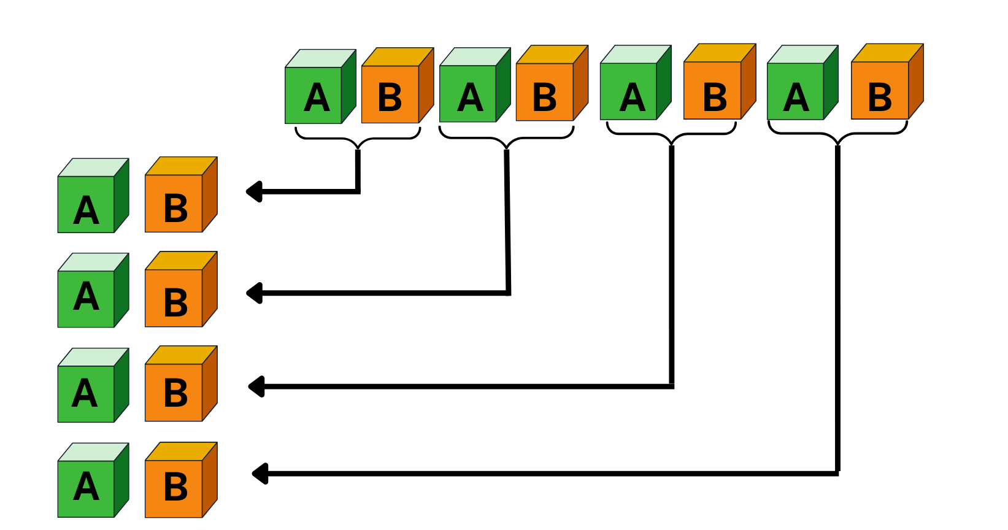
- Explain to students that identifying the repeating core of a pattern is helpful to extend the pattern as this ensures that the core repeats over and over and over again. Ask students to suggest what would come next in this pattern and how they know. Invite students to continue the pattern.
- Make a pattern with a three-part core using concrete materials, see Figure 7.
Figure 7 – Three-part core aligned vertically
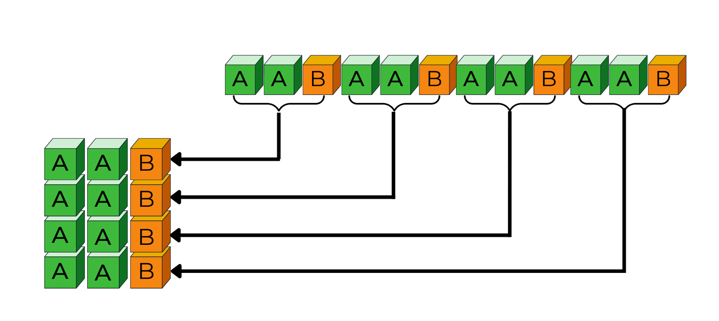
- Ask students to identify the core and explain how they know. Ask students to identify what comes next in the pattern and explain how they know this is correct. Invite students to continue the pattern. Model how to check, using vertical alignment of the core and parts.
- With a partner, students use a variety of concrete materials to create repeating patterns with a three-part core. Each student takes a turn to identify the core and extend the created patterns, while their partner checks the result using vertical alignment. Encourage students to refine their thinking if their initial attempts are not accurate.
- Students draw and label each of their patterns, identifying the core structure as an AAB pattern.
- Explain to students that identifying the repeating core of a pattern is also helpful to work out any missing parts. Create a linear three-part repeating core pattern using 2D geometric shapes as in Figure 8.
Figure 8 – A repeating three-part core shape pattern
- Students view the pattern. Then ask students to close their eyes and visualise the pattern. While their eyes are closed, cover part of the pattern, (see Figure 9). Ask students to look and work out which part of the pattern is missing. Encourage students to justify their thinking and check that suggestions do correspond with the hidden part. Discuss how to extend the pattern now that they can see the whole pattern. Repeat the process several times using a variety of 2D geometric shape patterns and ask students to focus specifically on identifying and naming the shape features being concealed and repeated.
Figure 9 – Covering part of a pattern
- Provide small groups with a variety of 2D geometric shapes and instruct students to sort the shapes using the features of sides, vertices, and size. Ask students to get into pairs within their group. Each pair creates a linear pattern using 2 or 3 shapes. Encourage students to prove their pattern design by discussing with their partner the repeating core features.
- Re-joining their group, each pair of students covers one part of their pattern with a piece of paper. Students allow time for other group members to identify the missing part of the pattern before asking them to extend the pattern. Students need to vertically align the core to check that it repeats over and over and over again.
- Students go on a gallery walk to view the other groups’ patterns. They discuss the core of each pattern with their partner and identify the pattern structure, for example ABB.
- Encourage students to provide feedback about the pattern verbally or on a sticky note. This feedback can be a positive comment and/or provide a question for the creators to think about. When students return to their own patterns, they can make adjustments if needed based on the feedback.
This table details assessment opportunities and differentiation ideas.
Assessment opportunities | Too hard? | Too easy?
What to look for:  - Can students describe the core of a two-part repeating pattern? (MAO-WM-01, MAE-2DS-01, MA1-2DS-01)  - Can students describe the core of a three-part repeating pattern? (MAO-WM-01, MA1-2DS-01)  - Can students describe a pattern using letters or symbols such as AB, ABC, ABB? (MAO-WM-01, MAE-2DS-01, MA1-2DS-01)  - Can students create and record repeating patterns using shapes in different orientations? (MAO-WM-01, MAE-2DS-01, MA1-2DS-01)  - Can students identify a missing part of a pattern? (MAO-WM-01, MAE-2DS-01, MA1-2DS-01)  What to collect:  - annotated work samples and photographs of student-created patterns (MAE-2DS-01, MA1-2DS-01)  - observations and recordings of group discussions (MAO-WM-01, MAE-2DS-01, MA1-2DS-01) | Students need further support to describe and name features of 2D shapes.  - Limit the 2D shapes to squares and rectangles.  - Model thinking about a maximum of 2 features, for example, colour and number of sides.  Students create their own simple repeating patterns but find it challenging to identify the repeating core of patterns made by others and to also extend the pattern.  - Students view Exploring Patterns 2 (5:31). Pause the video and ask students to identify the repeating core and co-construct the core using concrete materials.  - Students work with a partner and take turns to create and extend repeating patterns using concrete materials.  - Model how to make a two-part repeating pattern and ask students to look and talk about the pattern and decide if it is correctly extended. Encourage students to refine their thinking if their initial attempts were not accurate.  - Students draw a representation of their pattern and use letters to label the parts.  Students find it challenging to identify the missing element in a pattern. Create a two-part core pattern with the students using concrete materials. Say the pattern together with the students using colour, shape, or size words. Ask students to close their eyes and cover one part. Reveal and ask students to work out which part of the pattern is covered and to justify their thinking. | Students can confidently sort and categorise shapes and explain their thinking as they create repeating patterns.  - Introduce polygons such as octagons, trapeziums, and rhombuses to be used in their patterns.  - Students create own ‘problematise’ shape pattern challenge with a missing element for another student to solve.

Discuss and connect the mathematics – 5 minutes
- Create an anchor chart with students displaying diagrams, vocabulary or drawings of shared ideas and findings as you summarise the lesson together. Draw out the key mathematical ideas by asking questions such as:
- Which features did you think about when creating your shape pattern?
- How did you arrange the shapes in your repeating core so that it was more challenging to work out the missing element?
- Refer to the gallery walk and ask students which patterns they thought had an interesting repeating core. Prompt students to explain how they would describe this pattern to a mathematician.

Lesson 3: Dice dots everywhere!
Core concept: Arrangements of dots can be used to quantify small and large collections.
The table below contains suggested learning intentions and success criteria. These are best co-constructed with students.
Learning intentions | Success criteria
All students are learning that:  - dice have a mathematical regularity, a pattern, which means they can trust how many dots there are every time they see them  - dice patterns help to see smaller numbers inside of bigger numbers  - subitising helps to answer the question, ‘How many?’ | All students can:  - subitise a collection of dots by looking for dice patterns within the collection  - create and represent whole numbers using objects, drawings, words, and symbols.  In addition, students working towards Early Stage 1 outcomes can:  - use counting by ones to count a small collection  - subitise dice patterns 1 to 4  - look for known dice patterns within a collection.  In addition, students working towards Stage 1 outcomes can:  - subitise dice patterns 1 to 6  - create, describe, and represent whole numbers using objects, drawings, words, and symbols  - describe part-part-whole combinations using objects, drawings, words, and symbols.

Daily number sense: Spot the Spots! – 20 minutes
This lesson has been adapted from Numerals and Expression – Spot the Spots by NZ Maths.
Note: Subitising is the ability to recognise collections without counting. For Early Stage 1 students, begin with subitising dot patterns up to 3 and then increase up to 5 and if appropriate up to 6. If you want to learn more about the role of subitising and quantifying collections, you can search for ‘Becoming mathematicians: Quantifying collections’ in the ‘Browse Learning’ section on MyPL.
- Build student understanding of subitising a collection of spots by watching the video Subitising 6 (one less than) (6:06).
- Pause the video at selected reveals. Allow time for students to share their answers about what one less would be, as well as the strategy they used to work it out. Ask students to share their ideas of how the number line was helpful with problem-solving the answer.
- Explain to students that they are going to play a game called Spot the Spots! Print and prepare the spot cards (see numerals and expressions 1a [PDF 28KB] from Numerals and expressions on NZ Maths), ensuring there are enough cards to be used in small groups. Decide the complexity of the spot collection based on students’ needs and subitising abilities.
- In small groups, each student will have a turn briefly revealing a spot card before turning it back over.
- Stage 1 students use a mini whiteboard and the number line to record the number (numeral or a drawing), as well as one less than the quantity of spots they saw.
- Early Stage 1 students use a mini whiteboard and marker to record the dot pattern they saw.
- After playing several games, have students work out what one more than the quantity of spots would be.
- After playing several games, ask students:
- What strategy did you use to remember the hidden quantity of spots?
- When the collection of spots was small, was it easier to remember one less than?
- Was it easier to remember one more than or one less than? Explain your ideas.
- How did you use the number line to assist you with your answers?

Going dotty! How can dots help us to see numbers? – 40 minutes
Note: Explicitly discuss the position of dots representing each number from 1 to 6 by displaying various dotted dice and dot cards for students to visually see the consistency in appearance. Refer to the exact position, for example, stating a dot in the top corner, bottom corner and one in the centre makes 3. Draw attention to the relationship between the dot positions of one number to another, for example, 5 on a dice is shown as 5 dots, one in each corner and one dot in the middle.
- Display the same-coloured counters (dots) arranged as in Figure 10 for 2-3 seconds and then hide it. (Adjust the selection of dot cards depending on students’ needs.) Ask students to identify how many dots they could see and describe how they saw the collection of dots.
Figure 10 – Dot arrangement 1
- Reveal the dots and invite selected students to share their thinking with the class. Record student thinking.
- Repeat this process using examples such as in Figure 11, encouraging students to recognise that others may notice different parts of the collection of dots. Emphasise that there can be many solutions. As students are sharing, highlight solutions which include standard dice dot patterns.
Figure 11 – Dot arrangements 2, 3 and 4
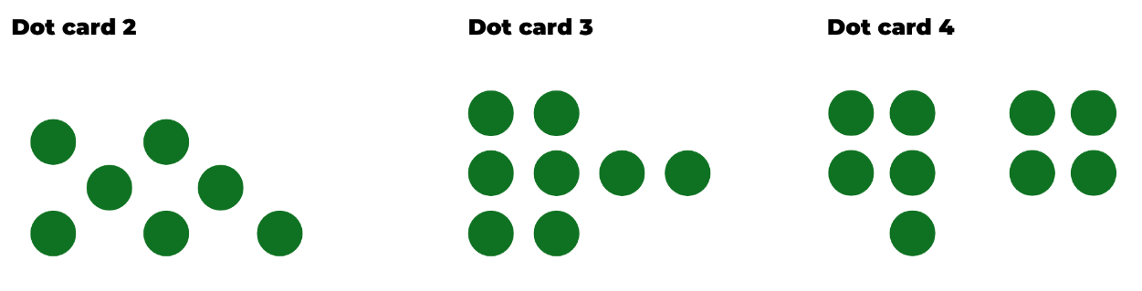
- Discuss whether everyone saw the collection of dots in the same way and share some of the recorded thinking with the class. Explain that some students use what they know about dice patterns to help them work out the total number of dots. This is an effective strategy when there is a large collection. Looking for a pattern helps to see chunks or parts within that collection.
- Discuss how dots on dice are a pattern because they are a mathematical regularity. For example, 4 always represents a collection of 4 no matter what other features change. Show students a variety of dice, including different colours, shapes, and sizes. Discuss how, although other features may change, the quantity of 4 remains the same, as well as the way 4 is shown in a pattern of dots. Display a 1 to 6 dice to show that all quantities are a type of pattern.
- Show students Resource 4: Dot card for 2-3 seconds and then hide the card, asking the students how many dots they saw and how did they see them. Ask if they can see a dice pattern hiding that helped them to work out how many dots there are altogether.
- Display the card again and invite students to share responses, while co-constructing an anchor chart to record thinking and reasoning. Model how to represent the different ways that students see the dots using pictures, words, and symbols. Record the groups of dots that students see using a coloured marker. This helps to make visible the smaller numbers that combine and are equivalent to the larger number (see Figure 12).
Figure 12 – Anchor chart: How did you see the dots?
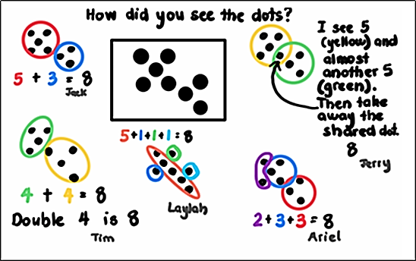
This table details assessment opportunities and differentiation ideas.
Assessment opportunities | Too hard? | Too easy?
What to look for:  - Can students communicate how the dice dot pattern assisted them with determining how many dots altogether? (MAE-RWN-01, MA1-RWN-01)  - Can students recognise and create combinations of numbers to 10? (MAO-WM-01, MAE-CSQ-01, MA1-CSQ-01)  - What strategies are students using to count the dots? For example, by ones, twos or recognising dice dot patterns and counting on? (MAE-RWN-01, MAE-FG-01, MA1-RWN-01, MA1-FG-01)  What to collect:  - student work samples (MAO-WM-01, MAE-RWN-01, MA1-RWN-01)  - observations of discussions and problem-solving strategies applied to identify the dice dot patterns (MAO-WM-01, MAE-CSQ-01, MA1-CSQ-01) | Students are not able to recall the displayed and concealed pattern of dots.  - Provide students with a dice and cards that display the dot patterns 1-4. Students roll the dice and find the matching card, counting the dots and then calling out how many dots they see. (Increase to 1 to 6 when appropriate.)  - Provide students with counters so they can reproduce the dot pattern they see on the dice or displayed card, and then point and count the total of dots. | Students confidently subitise the dice dot patterns and count efficiently.  - Ask students to record different patterns of dots to represent the same number quantity.  - Students use 2 dice, roll, and add the quantity. They then use dots to represent the quantity in the easiest way to subitise. Students need to prove that their representation is the easiest way to subitise.

Consolidation and meaningful practice: Matching Numbers – 10 minutes
This activity has been adapted from Matching Numbers by NRICH.
- This game provides an opportunity for students to further develop their ability to count using various strategies, subitise, and think flexibly about numbers and the part-part-whole combinations to 10.
- Introduce students to the game (optional to play on the screen or use printable version [PDF 142KB]).

Lesson 4: Smaller numbers inside bigger numbers
Core concept: Using smaller ‘chunks’ and familiar dice patterns help work out a total.
The table below contains suggested learning intentions and success criteria. These are best co-constructed with students.
Learning intentions | Success criteria
All students are learning that:  - parts of numbers can be combined to make a new number  - growing patterns are given that name because there is something (an element) that gets bigger by the same amount each time  - shrinking patterns are given that name because there is something (an element) that gets smaller by the same amount each time  - patterns of quantities can be hidden and are not always obvious. | All students can:  - create models to show the different ways that a quantity can be split (partitioned/decomposed) into 2 parts  - record ideas in a range of different ways  - identify a growing pattern and explain that an element gets bigger by the same amount each time  - identify a shrinking pattern and explain that an element gets smaller by the same amount each time.  In addition, students working towards Early Stage 1 outcomes can:  - identify that big numbers are made up of smaller numbers  - identify and describe growing patterns and shrinking patterns when they count.  In addition, students working towards Stage 1 outcomes can problem-solve and find all combinations to make a certain quantity.

Daily number sense: Counting patterns – 10 minutes
- Build student understanding of patterns by counting and skip counting forwards and backwards.
- Display a number line from 1-10. Use transparent coloured counters to track the count as students say each number counting forwards and backwards. Display a number line from 1-20 and repeat.
- Refer to the 1-20 number line and tell students that there are transparent counters covering some numbers, which still exist on the number line. However, students will not be saying that number out loud during the count. Explain that mathematicians call this skip counting. Ask students to suggest when and why skip counting is a useful counting strategy.
- Explain that there are various skip counting patterns, such as counting by twos, fives, and tens. Ensure that students understand that during a skip count the numbers in between remain and exist.
- Display the 1-20 number line and ask students to view the transparent counters and ask if they can see a pattern. Discuss.
- Students skip count forwards and backwards by twos using the number line as a reference. It is optional to add an action, such as a clap for the numbers not used in the count.
- Display a number chart and ask students to suggest what numbers should be covered with a counter when skip counting by tens. Ask students if they can see a pattern, and what is similar and/or different about this pattern when comparing it to the pattern made when skip counting by twos. Students start counting by tens to 100 forwards and backwards. It is optional to move or point to the counters in order to track the count.

What’s hiding inside? – 50 minutes
Note: As required, adjust the number of fish in the fish tank. For example, begin the narrative with only 5 goldfish and students problem-solve all number combinations to 5. If appropriate, then suggest that 5 more goldfish were added to the tank, making 10 goldfish.
- Describe the following narrative: My sister has a fish tank with 10 goldfish and 2 caves, a blue cave, and an orange cave. Some fish like to hide in the blue cave and other fish like to hide in the orange cave, so sometimes she can’t see the fish at all. She isn’t sure how many fish are in each cave, so she took a photo for us to help her. See Figure 13.
Figure 13 – Combinations created for 10
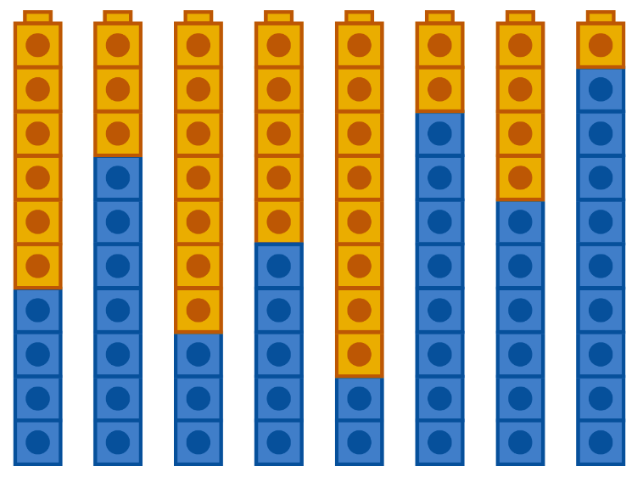
Images sourced from Canva and used in accordance with the Canva Content License Agreement.
- Explain that there are 10 interlocking cubes representing the 10 goldfish. Orange cubes represent fish in the orange cave and blue cubes represent fish in the blue cave. Make one tower of 10, for example 5 orange and 5 blue cubes, illustrating that there could be 5 fish hiding in the orange cave and 5 fish hiding in the blue cave.
- State that now the sister wants to know if there are other possibilities.
- Discuss how to find all the possible ways the 10 hidden fish could be hiding. Ask for suggestions, adjusting the model to reflect student thinking. Look for suggestions that putting the cubes in order helps determine the possibilities. Prompt student thinking if required. Give students interlocking cubes to experiment making different combinations of 10 using 2 colours.
- Discuss that it might help to label the numbers and record a number sentence. Explain that there may be a pattern and ask students if they can see a mathematical regularity that repeats over and over and over again.
- Students think about what they are seeing and then turn and talk. Use this time to listen in to conversations and invite students to share their thinking with the class. Draw students’ attention to the growing and shrinking patterns that can be seen in the cubes and in the recorded number sentences. Ask students to identify where they can see things getting bigger (growing) by one each time and where can they see things getting smaller (or shrinking) by one each time (see Figure 14). Students record their number sentences. Take photos of student models.
Note: Photographs of models or the models made by students in this lesson will be required in Lesson 5.
Figure 14 – Organised partitions of 10
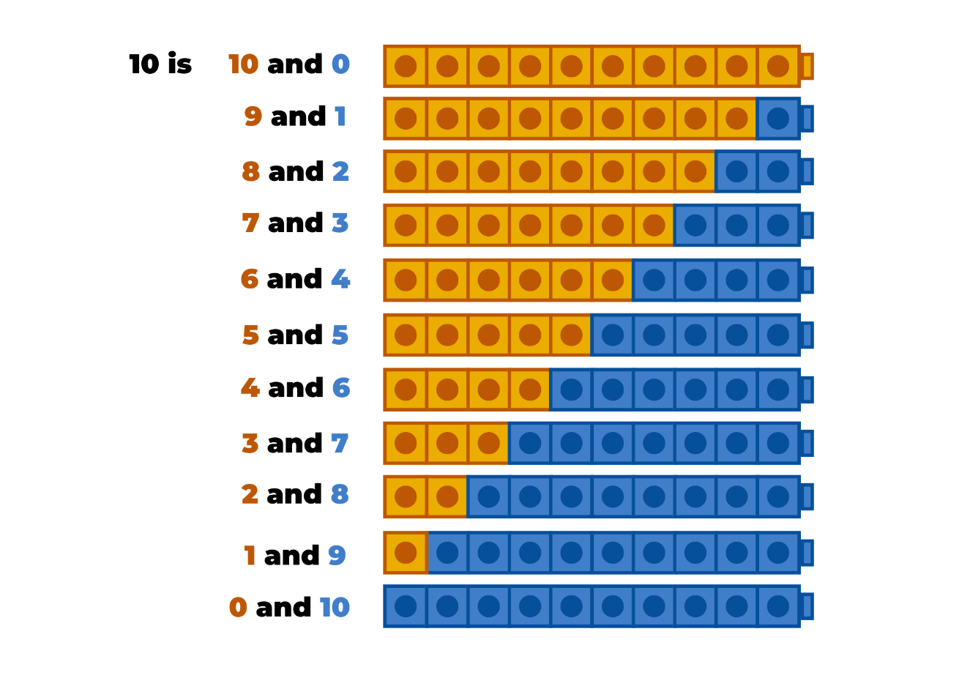
Images sourced from Canva and used in accordance with the Canva Content License Agreement.
- Display Resource 5: Organised partitions of 10 and draw students’ attention to the growing pattern in the cubes. State that you have made a mathematical connection and are thinking about the counting sequence by ones. Allow time for thinking. Explain that the number word goes up by one each time and so does the number of cubes, so they both must be growing patterns. Identify that the same, but opposite, is happening when students count backwards, so they both must be shrinking patterns too.
- Use your favourite picture book related to counting.
Note: Examples of picture books related to counting include None the number by Oliver Jeffers, Count the Monkeys by Mac Barnett, Sixteen Runaway Pumpkins by Dianne Ochiltree, or Ten Sly Piranhas by William Wise.
- Read the book and discuss if there was a growing and shrinking pattern in the counting sequence. Read the book again to prove students’ thinking.
- Explain to students that they will use interlocking cubes to make each collection as the book is read to see if it increases or decreases by the same amount each time. Explain to students that the book will now be read backwards to check if the pattern grows or shrinks as it is read backwards.
This table details assessment opportunities and differentiation ideas.
Assessment opportunities | Too hard? | Too easy?
What to look for:  - Can students communicate that smaller numbers can be combined (added together) to make a new larger number (a total)? (MAO-WM-01, MAE-CSQ-01, MA1-CSQ-01)  - Are students using addition and subtraction strategies to identify and create growing and shrinking patterns? (MAO-WM-01, MAE-CSQ-01, MA1-CSQ-01)  What to collect:  - observations and recordings of verbal addition and subtraction strategies used to create patterns (MAO-WM-01, MAE-CSQ-01, MA1-CSQ-01) | Students need support to combine or partition numbers to 10.  - Modify the fish story to have only 5 hiding fish and provide opportunities for students to create number combinations to 5.  - When reading the picture book, use a display of counters to model how the number pattern is growing and then shrinking.  - When reading the picture book a second time, provide students with counters so they can create the number pattern as the quantity increases by one and then decreases by one. | Students are confident when combining or partitioning numbers to 10.  - Modify the story to now having 3 caves, an orange, green, and blue cave where the 10 fish are hiding. Ask what combinations can be made.  - Increase the number of fish to 20 and have 3 caves, an orange, blue, and green cave.

Consolidation and meaningful practice: What have we learned about growing and shrinking patterns? – 5 minutes
- Students share and discuss what happened each time one was added or taken away from the collection in the picture book. Encourage students to describe the growing and shrinking patterns they noticed in the picture book and in the fish tank problem. Add the appropriate explanations and vocabulary to the class patterns anchor chart.

Lesson 5: Number facts have patterns too
Core concept: When number sequences are related, they can be arranged and repeated to create a number pattern.
The table below contains suggested learning intentions and success criteria. These are best co-constructed with students.
Learning intentions | Success criteria
All students are learning that:  - number facts, like 8 + 2 = 10, are a special kind of pattern because when 8 of something is combined with 2 of something, there will be 10 of something. This kind of pattern is sometimes called a combinatorial pattern  - thinking systematically can help to find the different ways of partitioning (decomposing) a number into 2 parts. For example, 10 is 7 and 3, 6 and 4, 5 and 5, and so on  - concrete materials are useful to justify thinking and support explanations. | All students can:  - use concrete materials and visual representations to model number combinations  - communicate their thinking and reasoning using words, concrete materials, or visual representations  - organise concrete models to find all part-part-whole combinations for a given quantity.  In addition, students working towards Early Stage 1 outcomes can:  - make a simple model to help when finding solutions to problems  - explain the steps used to get to a solution.  In addition, students working towards Stage 1 outcomes can explain and justify thinking by using concrete materials or drawings to support solutions.

Daily number sense – 15 minutes
- From a class need surfaced through formative assessment data, identify a short, focused activity that targets students’ knowledge, understanding and skills. Example activities may be drawn from the following resources:
- Thinking Mathematically Stage 1
- Universal Resources Hub

Thinking and reasoning – 10 minutes
- Show a dot card for 3 seconds and ask students how many dots they could see and how they saw them.
- Provide students with thinking time and then Think-Pair-Share to share ideas. Use ‘Talk moves’ to support discussion and make sense of emerging mathematical ideas.
- Select students to share their thinking and record reasoning using pictures, numbers, and words to co-construct a ‘number facts’ anchor chart. Record parts in colour to make visible smaller numbers inside a larger number and include numbers and words to represent student thinking.

Mathematical regularity – 45 minutes
Note: Combinatorial patterns are the focus for this lesson as students explore the patterns in number facts. For example, when 8 is combined with 2, it is always equivalent in value to 10. This is a pattern worth knowing as it builds trust in number facts. For Early Stage 1 students, begin with combinatorial patterns to 5, for example, introduce that 4 and 1 or 1 and 4 will always make 5. Use counters and other concrete materials to prove the regularity, no matter what concrete materials are used.
- Display 3 or 4 different models or photos from the previous lesson showing the growing and shrinking patterns that can be seen when partitioning 10 into 2 parts. Explain that one of the ways Ebony and Jacob created a combination of 10 was with 6 fish in the orange cave and 4 fish in the blue cave. Jed and Bianca used a similar combination putting 6 fish in the blue cave and 4 in the orange cave. Marcus and Emily also had a combination of 4 and 6 that was equal to 10 fish in total. Luca and Olivia used the same strategy. No one combined 6 and 7, or 6 and 2, or 6 and 6. Draw attention to the fact that only 6 and 4 combined to make 10.
- Students Think-Pair-Share as they view the models.
- Revise that you have seen repeating patterns where the repeating part (the core) might be AB, for example, left, right, left, right, left, right; or tall, short, tall, short, tall, short. Revise that you have also seen growing and shrinking patterns where one more is added or taken away each time. Explain that using 2 numbers to create 10 also creates a pattern. For example, if the goal is to create 10 with either a 6 or a 4, you can only join 6 with 4 or 4 with 6, otherwise the total will be different. That is called a mathematical regularity, or a pattern.
- Students choose a number combination, such as 8 and 2, and explore if it always totals 10. Using concrete materials, discuss if this is true. Stage 1 students need to find number combinations to 10 and Early Stage 1 students need to find number combinations to 5.
- Students investigate another combination equivalent to 10, for example, 7 and 3 or 6 and 4. Have students explore using different concrete materials to see if it is always equivalent to 10. For example, what does it look like on their fingers, on a ten-frame, on dice, on dominoes, on a bead string and/or with real-life objects such as oranges and pencils and so on.
- Stage 1 students select one of the number combinations to 10 and create a poster showing the multiple representations for that number. Encourage students to represent the number combination in a variety of ways such as using dice patterns, dominoes, ten-frames, and words to prove that their chosen number combination is equivalent to 10. Encourage students to draw and use words and numbers to record their number sentences, including by using the symbols +, −, and =.
- Early Stage 1 students work with you to jointly create a poster similar to Stage 1.
- Provide time for students to go on a gallery walk to observe and discuss the posters. Ask students the following questions:
- Was there any time that you couldn't prove that your chosen number combination was equivalent to 10?
- Can you convince me that, for example 8 and 2 is 10 and 2 and 8 is 10?
This table details assessment opportunities and differentiation ideas.
Assessment opportunities | Too hard? | Too easy?
What to look for:  - Are students recalling and recognising combinations of numbers to 5? (MAO-WM-01, MAE-CSQ-01)  - Are students recalling and recognising combinations of numbers to 10? (MAO-WM-01, MA1-CSQ-01)  - Can students represent their understanding using a variety of materials? (MAO-WM-01, MAE-CSQ-01, MA1-CSQ-01)  - Are students using the counting on strategy to make 10? (MAO-WM-01, MA1-CSQ-01)  What to collect:  - annotated work samples of the posters (MAO-WM-01, MAE-CSQ-01, MA1-CSQ-01) | Students have difficulty combining 2 numbers to 10.  - Students combine 2 numbers to make 5.  - Provide a set of dominoes and ask students to sort the pieces that have 10 dots altogether.  - Students can try Domino Patterns from NRICH. | Students successfully use several strategies and create a variety of representations of combinatorial numbers to 10. Ask students to explore combinatorial numbers to 15 and 18. Ask students to determine if there are more combinatorial numbers when the number is odd, such as 15, or even, such as 18.

Discuss and connect the mathematics – 5 minutes
- Review the posters and display these on a gallery wall. With students, co-construct a statement that could be added to each wall display, explaining that combinatorial patterns are a mathematical regularity that students can trust. For example, 8 of something and 2 of something is always 10 of something, and so on.

Lesson 6: Place value patterns
Core concept: Place value can be used to explore and create number patterns.
The table below contains suggested learning intentions and success criteria. These are best co-constructed with students.
Learning intentions | Success criteria
All students are learning that:  - in a collection of 10, the 10 ones can be regrouped and renamed as one ten  - there is a growing pattern every time they rename and regroup beyond a collection of 10 – 20 ones as 2 tens, 30 ones as 3 tens, 40 ones as 4 tens, and so on  - on a number chart, the numbers in each square will increase or decrease by one ten each time they move up or down. The digit in the ones column will increase or decrease by one when they move left or right. | All students can:  - model what happens to a quantity when they add one more  - model what happens to a quantity when they take away one.  In addition, students working towards Early Stage 1 outcomes can:  - count forwards and say it is a growing pattern  - count backwards and say it is a shrinking pattern.  In addition, students working towards Stage 1 outcomes can:  - rename and regroup beyond a collection of 10  - model what happens to a quantity when they add 10 more  - model what happens to a quantity when they take away 10  - understand that on a hundreds chart the numbers in each square will increase or decrease by one ten each time they move up or down, and the digit in the ones column will increase or decrease by one when they move left or right.

Daily number sense: Counting on counting – 15 minutes
This activity has been adapted from Counting on Counting by NZ Maths.
- Further build student understanding of subitising and counting forwards and backwards by exploring various visual representations of quantities and numbers.
- View the frog animation (1:42) clip from Learning to count on the NZ Maths website and encourage students to predict the new quantity when one more frog is added to the various quantities in the bucket. Pause the clip and ask what the quantity would be if 2 more frogs jumped in, or if 2 frogs jumped out.
- Revise that students previously used dot patterns and subitising to recognise and count a quantity of dots. Display the Odd one out [PDF 724KB] cards from ‘Learning to count’ on the NZ Maths website and ask students to apply subitising or skip counting strategies to count the collections and work out the odd one out.
This table details assessment opportunities and differentiation ideas.
Assessment opportunities | Too hard? | Too easy?
What to look for:  - How are students counting objects? For example, by ones, twos or tens? (MAE-RWN-01, MAE-FG-01, MA1-RWN-01, MA1-FG-01)  - Do students understand that 10 ones are the same as one ten? (MA1-RWN-01, MA1-RWN-02)  - What strategies are students using to calculate the total? (MAO-WM-01, MAE-FG-01, MA1-FG-01)  What to collect:  - Resource 6: Counting on counting gameplay assessment (MAO-WM-01) | Students are not confident when mentally grouping the number of objects seen on the cards.  - Students use a mini whiteboard to track how many frogs jump in or out during the count to determine one more or one less.  - Students use counters to track the number of objects displayed on the cards. | Students apply efficient counting strategies and can subitise.  - Students are challenged to add a further 10 frogs to each count.  - Students use dominoes to record how many different ways they can make numbers such as 29, 34, 55 and 60.

Quantifying collections – 50 minutes
- Prior to viewing the clip, Quantifying collections – Ice cream sticks 1 – number talk (7:50), ask students to look for the patterns they notice as the collection of craft sticks is quantified.
- After viewing the clip, provide time for students to Think-Pair-Share. Use ‘Talk Moves’ to support meaningful discussion and to help make sense of emerging mathematical ideas. Select some students to share thinking with the class and record ideas on a whiteboard.
The table below outlines stimulus prompts to generate conversation about the topic, along with anticipated responses from students.
Prompts | Anticipated student responses
- Was this a growing or shrinking pattern? Explain.  - How did the pattern grow as the craft sticks were placed in the cups?  - How did the pattern shrink? Explain.  - Why were the craft sticks bundled together as 10 ones? Why were they regrouped and renamed?  - Did you see another pattern? | - The pattern grew each time a craft stick was put into the cup. We started at 1, 2, 3, 4 and all the way to 24. The number got bigger.  - I knew it was a growing pattern because one more craft stick was added over and over and over again.  - When the craft sticks were taken away and the person counted backwards, the numbers were shrinking so the pattern was shrinking too.  - Every time there were 10 craft sticks, the person bundled them together. They went into another cup because altogether there were now 10 craft sticks so you could just say 10.  - I saw a pattern when there was one bundle of 10 and 3 more to make 13.
Note: Explicitly explain what a hundreds chart is and how it is structured. Make necessary adjustments to the lesson by providing number charts which are suitable for the students' needs.
- Using Resource 7: Number chart or a digital number chart locate the numbers 1-24. Illustrate on the chart what happened each time one craft stick was added to the collection – the quantity of the collection grew by one. Discuss what happened each time one craft stick was removed from the collection – it shrunk by one.
- Pose the following scenario for a number chart pattern: Rebecca noticed a pattern on the number chart. She noticed that if you choose any number, the number to the right of it is always one more and if you move to the left, it is always one less. Ask students the following questions:
- Is this always true?
- Can you find an example when this doesn’t happen?
- In pairs, provide students with a mini whiteboard. Ask students to choose their own numbers from the number chart to investigate Rebecca’s idea. Explain that they need to use a model or drawing to share their evidence and thinking.
Note: Provide Stage 1 students with a 1-100 number chart and Early Stage 1 students with a 1-10 or 1-20 number chart.
- Invite selected students to share their thinking, using a number chart and drawings to justify their findings. Record student thinking with visual examples.
- Ask students to look at the decade numbers column on the number chart, paying particular attention to how these numbers are growing and shrinking when you go up or down from a particular decade number. Ask students to share what they see happening to the digits in the tens place and the ones place as they move up and down the same column. Look at other columns on the number chart and ask students if they can see a pattern there too.
- Pose the following scenario for a number chart pattern: Matthew thinks he noticed something. No matter what number he chose on the number chart, when he moved down, each number was 10 more. When he moved up, each number was 10 less. Ask if this is always true.
- In pairs, students use a mini whiteboard to investigate what Matthew noticed. Students record a number from the number chart and model adding and taking away 10 using concrete materials. Ask students the following questions:
- What happens to the number when you add 10 more?
- What happens when you take 10 away from the original number?
Note: If students are counting their concrete materials by ones to find the total, ask them to think about how the craft sticks were bundled in the video to make counting more efficient. Ask, ‘Would it help to regroup and rename the 10 ones to make one ten in your model?’
- Students check to see if their models match what they see above and below their original number on the number chart. Compare this pattern to a number line. Ask what students notice. Continue to explore using different numbers to see if this is always true.
This table details assessment opportunities and differentiation ideas.
Assessment opportunities | Too hard? | Too easy?
What to look for:  - Can students identify the number before and after a number to 10? (MAE-RWN-01)  - Can students identify the number before and after a two-digit number? (MA1-RWN-01)  - Do students name the teen numbers correctly and understand the language connection which makes up the teen numbers? (MAO-WM-01, MAE-RWN-01)  - Can students state the value of digits in two-digit and three-digit numbers? (MA1-RWN-01, MA1-RWN-02)  - Can students count forwards and backwards by ones to 10? (MAE-RWN-01)  - Can students count forwards and backwards by ones and tens, on and off the decade? (MA1-RWN-01, MA1-RWN-02)  What to collect:  - observations and recordings of investigations into their own number pattern (MAO-WM-01, MAE-RWN-01, MA1-RWN-01, MA1-CSQ-01, MA1-CSQ-02) | Students cannot identify the number before or after a number.  - Support students to count from one to identify the number before or after.  - Display a number chart for students to refer to. | Students have completed an investigation of one column in depth.  - Students investigate if there are any diagonal number patterns on the number chart.  - Students discuss and justify their findings.  - Students try the Hundred Square problem from NRICH.

Consolidation and meaningful practice: What patterns did we find? – 5 minutes
- Select students to share what they think about the pattern that Matthew noticed on the number chart. Discuss what happens to the quantity of the number when they go to the number above it and the number below it. Count up and down selected columns together so that students hear the pattern that is emerging. For example, 24, 34, 44, 54, and so on, or 2 tens and 4 ones, 3 tens and 4 ones, 4 tens and 4 ones, 5 tens and 4 ones, and so on. Note the pattern that repeats over and over and over again.
- Ask students what happens when they go 2 above and below the number, or 3 above and below the number. Ask if this is a pattern that repeats over and over and over again with every number on the chart. Ask students how they think the number patterns will continue beyond 100.
Note: Support students to use place value language and model the use of this language throughout the lesson. If students are referring to the tens and ones as the first and second number, you can clarify this by asking, ‘When you say the first number, are you talking about this digit in the tens place?’

Lesson 7: Growing and shrinking patterns
Core concept: A repeating core can make a pattern grow or shrink.
The table below contains suggested learning intentions and success criteria. These are best co-constructed with students.
Learning intentions | Success criteria
All students are learning that:  - when counting by twos, the next number word in the counting sequence is 2 more than the number before. This makes a growing pattern  - taking away 2 items at a time or counting backwards by 2 creates a shrinking pattern (when the quantity decreases). | All students can:  - count a collection and name the number before and after correctly  - explain how a pattern grows when something is added every time the sequence repeats  - explain how a pattern shrinks when something is taken away every time the sequence repeats.  In addition, students working towards Early Stage 1 outcomes can:  - create a growing pattern and explain how it grows  - create a shrinking pattern and explain how it shrinks.  In addition, students working towards Stage 1 outcomes can:  - create a growing pattern with the constant difference of 2  - count a collection of objects by twos.

Daily number sense: 3 tens in a row – 10 minutes
Note: This game can be adjusted for Early Stage 1 students by using dotted dice and a gameboard as seen in Figure 15. Students need to make 3 in a row of the same dice dot pattern. Students roll the dice and draw the dot pattern in a square.
Figure 15 – Adjusted gameboard 3 in a row
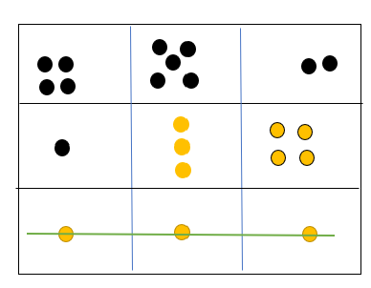
- Build student understanding of subitising and the part-part-whole combinations to 10 by using 3 tens in a line (2:29).
- After watching the video, re-watch and pause at 1:52. Discuss with students why rolling a one would result in someone winning the game.
- Explain to students that they will be playing the game and will need to think about numbers strategically and problem-solve using part-part-whole combinations to 10. Discuss and share ideas of strategies that can be used to count on and check that the combined total is 10 (counters can be used here to assist students if needed).
- Students will draw a 3 × 3 game board (like noughts and crosses) on a mini whiteboard or paper. Students take turns to roll a 9-sided dice and write the number in one of the gameboard’s squares. The goal of this game is to write 2 numbers in each box that combine to make 10 (see Figure 16). Players take turns and write the number they roll either in a blank section or in a section with an existing number if the total will make 10. Continue until one player makes 3 tens in a row, vertically, horizontally, or diagonally.
Figure 16 – Gameboard for 3 tens in a line
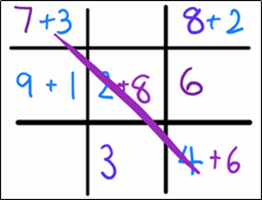
The table below outlines stimulus prompts to generate conversation about the topic, along with anticipated responses from students.
Prompts | Anticipated student responses
- What combination of numbers make 5 (or 10)? How did you work it out?  - When you have a 2 and a 3 is that the same or equivalent to having a 3 and a 2?  - When you have a 6 and a 4 is that the same or equivalent to having a 4 and a 6?  - Is there another number you can put with 2 to make 5? Why or why not?  - Is there another number you can put with 6 to make 10? Why or why not?  - Do the numbers that you add together to make 5 (or 10) always have to be smaller than 5 (or 10)? Explain. | - Look at the biggest number and then count on from the smallest number to get to 10.  - Take one counter and take some more until you get to 5. I needed 4 more counters to make 5.  - I had 2 counters and then I took one extra counter and I had 3. I kept taking one counter until I had 5. I needed an extra 3 counters to get to 5.  - If both numbers are bigger than 5 then I knew I had more than 10.  - It is the same because you are just swapping them around when adding them together.  - You would need 2 more numbers with 6 to make 10, for example a 3, 1 and 6, not just one more number.  - Yes, because you need to get to 10, not more than 10.

How can patterns grow and shrink? – 45 minutes
Note: This part of the lesson can be adjusted to address students’ needs by playing the game Blast Off in 5, adapted from NZ Maths. This activity provides students with an opportunity to develop knowledge and a recognition of number patterns to 5. Students can then be provided with the opportunity to explore number patterns to 10.
- Using interlocking cubes, create the pattern seen in Figure 17. Ask students what they notice and if the pattern reminds them of something they may have seen.
Figure 17 – Odd and even patterns
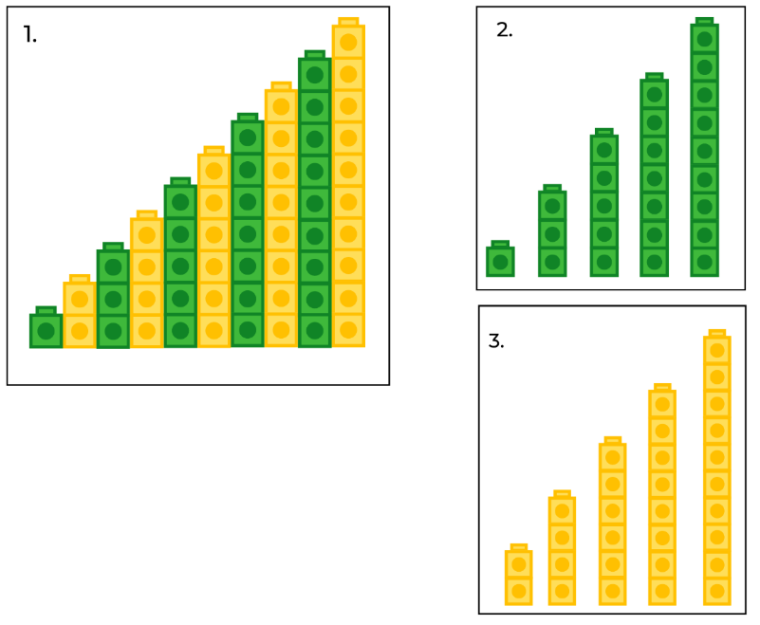
Images sourced from Canva and used in accordance with the Canva Content License Agreement.
Note: It may be required to model a growing pattern that grows by one each time to 5 so that all students can revise their understanding of a growing pattern. See Figure 18.
Figure 18 – Add one at a time to make a growing pattern to 5
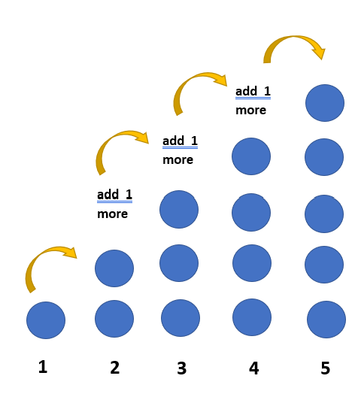
- Students Think-Pair-Share. Use ‘Talk moves’ to support meaningful discussion and help make sense of emerging mathematical ideas. If students notice just the colour pattern, direct their attention to the quantity (how many) in each tower and how this changes each time one more tower is added to the sequence.
- Select some students to share their thinking with the class and record observations on a whiteboard.
The table below outlines stimulus prompts to generate conversation about the topic, along with anticipated responses from students.
Prompts | Anticipated student responses
- Is this a pattern? How can you convince me?  - What does this pattern remind you of?  - Is this a growing or shrinking pattern? How do you know?  - What is different in the pattern in picture 2 and 3 (in Figure 17)? | - Picture 1 has a colour pattern, the yellow and the green repeat over and over and over again like an AB pattern.  - The tower in picture 1 is getting bigger, it’s growing by one each time.  - I can see each tower grows from 1, 2, 3, 4…10.  - In picture 2 the tower quantities are 1, 3, 5, 7 and 9. This pattern is getting bigger by 2 each time.  - In picture 3 the tower quantities are 2, 4, 6, 8 and 10. This pattern is also getting bigger by 2 each time.  - Both these towers are a growing pattern because they are growing by 2 each time but they start at a different number.
- Using counters, model what is happening each time a pattern grows by 2. Start with 2 and build up an array of counters by repeatedly adding 2 over and over and over again. Use different colours for each pair, continuing to 5 pairs. Start with 2 blue counters, add 2 red, 2 yellow, and so on to create an array as seen in Figure 19. Ask students to count aloud as each pair is added to the array ending at 10.
Figure 19 – Multi-coloured array
- Record the sequence of the array by writing under each column of counters (each colour pair) the numerals 2, 4, 6, 8, and 10. Count together the quantity in the sequence.
- Refer to the model and ask students what they know about the numbers 2, 4, 6, 8 and 10. Ask students what is happening to each part of the sequence and encourage them to recognise that a growing pattern must have a rule (a description of how the sequence grows each time a new element of the pattern is added). In this example, the rule is to add 2 every time the sequence repeats.
Note: To support understanding, add the corresponding number of counters to the numeral as seen in Figure 20.
Figure 20 – Representation of a growing pattern
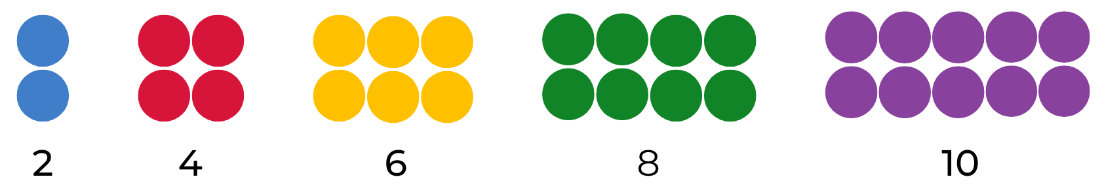
- Stage 1 students use 2D geometric shapes to create their own models to explore patterns that grow by 2. Students start by making a model of 2, and then continuing to grow their pattern by 2 after that, until they get to 10.
- Early Stage 1 students use 2D geometric shapes to create their own models to explore patterns that grow by 1. Students focus on counting forwards and backwards by ones and represent one-to-one correspondence through drawings.
- Provide Stage 1 students with writing materials and in pairs ask students to draw and record their findings. Student recordings may look like Figure 21.
Figure 21 – Student recordings of a growing pattern
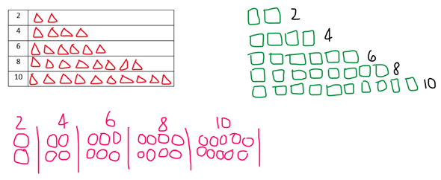
- Ask students what happens when 2 counters are taken away every time – the pattern shrinks. Discuss that growing and shrinking patterns are a pattern if the rule repeats over and over and over again. In pairs, students draw and record their findings of a shrinking pattern. See Figure 22.
Figure 22 – Student recordings of a shrinking pattern
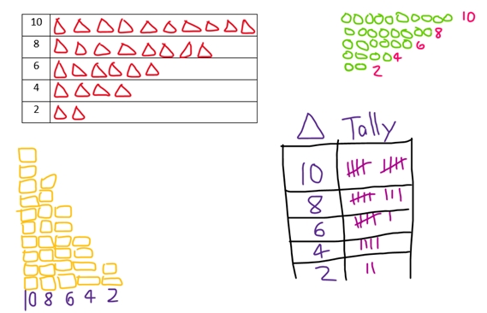
- Explain to students that mathematicians make predictions. Write a range of numbers on the board such as 1, 2, 3, 4, 5, 10 and 11, and ask students to select one of those to be their starting number to count by twos. Explain that counting by twos doesn’t always have to start from zero.
- Provide mini whiteboards for students to investigate. Ask students to Think-Pair-Share about what would come next in their sequence and explain how they know this.
- Prompt students to predict what the tenth number in their sequence might be. Students extend the sequence each time to check if their predictions are correct.
- Discuss with the students that, as mathematicians, they are using what they know about their growing pattern to work out what comes next.
This table details assessment opportunities and differentiation ideas.
Assessment opportunities | Too hard? | Too easy?
What to look for:  - Can students count forwards and backwards by ones? (MAO-WM-01, MAE-RWN-01, MAE-CSQ-01)  - Can students count forwards and backwards by twos? (MAO-WM-01, MA1-RWN-01, MA1-CSQ-01)  - Are students demonstrating an understanding that when counting by ones or twos, forwards and backwards, the next number in the sequence increases or decreases by 1 or 2 every time? (MAO-WM-01, MAE-RWN-01, MAE-FG-01, MA1-RWN-01, MA1-FG-01)  - Can students collect data to describe how a pattern grows and shrinks? (MAO-WM-01, MAE-DATA-01, MA1-DATA-01)  What to collect:  - observations of discussions and problem-solving strategies applied to identify the growing and shrinking patterns (MAO-WM-01, MAE-CSQ-01, MA1-CSQ-01)  - work samples and photos of data collection (MAE-FG-01, MA1-FG-01) | Students are unable to count forwards and backwards by ones to 10.  - In pairs, students use 5 counters to count forwards and backwards to 5 (increase to 6-10 as needed).  - Provide students with counters and a number line from 0 to 5 and then from 0 to 10. Ask students to count forwards and backwards and place a counter on the correct number.  Students are unable to create a growing or shrinking pattern displayed as an array.  - In pairs, students copy a model of a growing pattern to 5 and create their own explaining that it grows by one over and over and over again to 5 (increase to 6 to 10 as needed).  - In pairs, students create a growing pattern using counters and a five-frame or ten-frame. Students then repeat this task and create a shrinking pattern using the five-frame or ten-frame. | Students confidently identify the growing and shrinking pattern when counting by 2.  - Students create their own growing or shrinking number pattern, identifying the rule, and proving it is growing and shrinking. Students draw a representation and prove their reasoning.  - Students create a growing or shrinking number pattern with a missing element and a partner needs to solve the rule and continue the pattern.

Consolidation and meaningful practice: How do patterns grow and shrink? – 15 minutes
- Optional: With a partner, students explore Mary’s garden (adapted from Mary, Mary, Quite Contrary, NZ Maths). Students design a pattern of flowers or vegetables that grows by ones or twos to display on a poster. Students then create a shrinking pattern by twos as vegetables or flowers are picked. Students record their growing and shrinking patterns using Resource 8: Number charts to show their findings (see Figure 23). Display posters on a gallery wall and prompt student discussion, highlighting their findings and numerical patterns explored.
Figure 23 – Sample student poster of a growing pattern
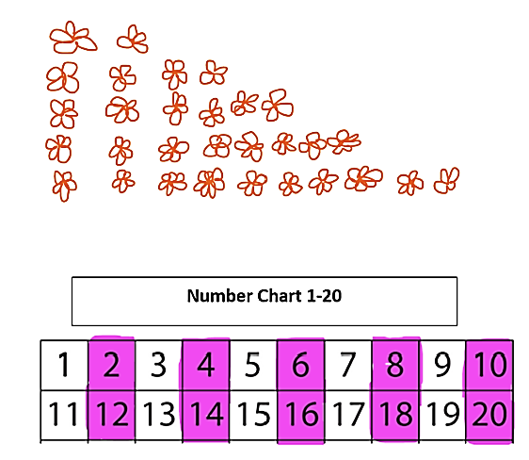
- Optional: To connect the concrete representation of a growing pattern to the numerical system, use one of the students’ recordings of a growing pattern that starts with an even number and place transparent counters on the corresponding numbers on a number chart, (Figure 24) and continue to place counters on each number of the growing pattern.
Figure 24 – Skip counting by twos
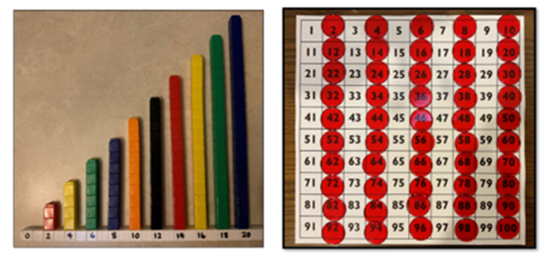
- Ask students what they notice when comparing the model and the number chart. Prompt students to explain why the pattern would look the same or different with a different starting number. Invite students to represent their growing models on the number chart and discuss findings. Photograph the number chart with counters for use in Lesson 8.
- Ask students to model a shrinking pattern. Discuss what happens to the quantity in each part of the pattern and the order of the numbers.

Lesson 8: Repeating, growing, and shrinking!
Core concept: A repeating core can make a pattern grow or shrink.
The table below contains suggested learning intentions and success criteria. These are best co-constructed with students.
Learning intentions | Success criteria
All students are learning that when they count forwards it is a growing pattern and when they count backwards it is a shrinking pattern.  In addition, Early Stage 1 students are learning that numbers can be represented in different ways.  In addition, Stage 1 students are learning that:  - when counting forwards by twos, each number in the sequence increases in quantity by 2, making it a growing pattern  - when skip counting backwards, each number in the sequence decreases in quantity by 2, making it a shrinking pattern. | All students can count forwards and backwards by ones to and from a certain number.  In addition, students working towards Early Stage 1 outcomes can:  - count forwards and backwards by ones to 10  - create a model that is a growing pattern  - create a model that is a shrinking pattern.  In addition, students working towards Stage 1 outcomes can create a model showing a skip counting pattern by twos.

Daily number sense: What number comes next? Choral counting by twos – 15 minutes
- Provide pairs of Early Stage 1 students with Resource 9: Number cards. Students place the cards in a pile and take turns flipping a card and saying the number and the number that comes before and after the card flipped. Students continue to play against each other. Invite students to draw pictures to represent numbers 1-5 in a variety of ways.
- Build Stage 1 student understanding of skip counting by choral counting adapted from Choral Counting at Teacher Education by Design.
- Display a number line from 1-10. Explain that students will be counting and clapping every time a number is said, and that they will be skip counting by twos. Using the number line and counters, ask students to suggest what the counting might look like. Place counters on the numbers students will say when skip counting by twos.
- Explain that during the count by twos, students will count and clap for each of the identified numbers 2, 4, 6, 8 and 10. Optional to continue the count to 20. Ask students to explain what they noticed. Record the numbers for a later discussion.
- Invite students to now choral count forwards by twos up to 10, 20 and/or 50. As they count, use colour to record in horizontal rows with 5 numbers in each row. Ask students to look at the numbers and discuss any patterns they notice. Record student ideas as seen in Figure 25.
Figure 25 – Record of choral counting by twos
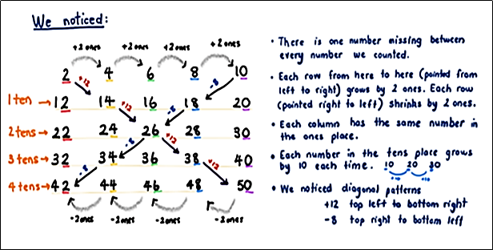
- An optional challenge is to combine choral counts to look for patterns, for example, 2 and 4.

Building patterns – 15 minutes
- Read the picture book I Went Walking by Sue Williams. Display an animal figure or image each time a new animal is introduced in the story. Ask students how many animals were added to the display each time. Explain that each new page adds just one more animal and that this is a type of number pattern. Remove the animals from the display and reintroduce them one at a time as students count the collection of animals together.
- Sing ‘Old MacDonald had a farm’ and build the song 5 times, adding an animal to each verse. Ask students how they knew the order of the animals as they sang the song each time. Use students’ responses to further develop understanding that building by one is a pattern.

How can patterns grow? – 10 minutes
- In preparation for this part of the lesson, watch Staircase patterns – Early Stage 1 and Staircase patterns Stage 1.
- Pre-build a model from linking cubes as displayed in Figure 26. Show students the model and ask what they noticed.
Figure 26 – Example of a staircase pattern
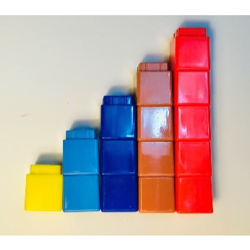
- Give students time to first think individually, and then turn and talk to share their ideas with a partner. Use ‘Talk moves’ to support meaningful discussion and to help make sense of emerging mathematical ideas. If students notice just the colour pattern, direct their attention to the quantity (how many) in each tower and how the quantity changes each time one more tower is added to the sequence.
- Select some students to share thinking with the class and record noticings on a whiteboard.
The table below outlines stimulus prompts to generate conversation about the topic, along with anticipated responses from students.
Prompts | Anticipated student responses
What do you notice about this pattern? | - It looks like a staircase going up.  - The colours are an AB pattern, repeating over and over and over again.  - The tower gets bigger (grows) by one each time and that repeats over and over and over again. I can see 1, 2, 3, 4, 5.

Making our own staircase pattern – 15 minutes
- Explain that students will be making their own staircase pattern.
- Develop success criteria together for creating a staircase pattern increasing by one each time for Early Stage 1 students or 2 each time for Stage 1 students. Provide a variety of stackable materials at stations around the room for students to create their own staircase pattern. Suggested materials could be:
- blocks
- linking cubes
- stacking chairs
- books.
- As students are working, circulate around the room and discuss students’ thinking with questions such as:
- How did you work out how to make the staircase?
- Can you tell me about how this is a pattern?
- What would come next in your pattern?
- How can you check if your pattern is right?
Note: You may like to take photographs or videos of students’ work as assessment data.
- Invite some students to share their staircase pattern with the class, describing how they created it and what they notice about their pattern.
This table details assessment opportunities and differentiation ideas.
Assessment opportunities | Too hard? | Too easy?
What to look for:  - What strategies did students use to build a staircase pattern? (MAE-FG-01, MA1-FG-01)  - How do students explain the growing pattern of a staircase model? (MAE-FG-01, MA1-FG-01)  - Can students identify and describe patterns when skip counting forwards and backwards by twos? (MAO-WM-01, MA1-FG-01)  What to collect:  - photographs and videos of students’ work (MAE-FG-01, MA1-FG-01) | Students find it difficult to create an accurate staircase model.  - Reduce the number of stairs to 3.  - Create a foundation of 5 items. Ask students to build consecutive towers to match numbers 1, 2, 3, 4 and 5.  Students find it difficult to explain the growing pattern of a staircase model.  - Use guiding questions to scaffold students’ thinking.  - Restate attempts at explaining to model correct vocabulary. | Students quickly and accurately create and describe the growing pattern for a staircase of 5.  - Ask students to extend the staircase to 10 or beyond.  - Ask students to create a staircase increasing each step by 5.  - Ask students to compare how many items were needed to create a staircase growing by one and how many were needed for a staircase growing by 2 or 5.

Shrinking patterns – 10 minutes
- Read or sing the picture book Ten in the bed by Penny Dale. Ask students if they notice a pattern. Use student responses to establish that the pattern decreases (or shrinks) by one each time.
- Use fingers to model the rhyme ‘Ten little monkeys’ to model the shrinking pattern by one. Start the rhyme again from a different number to provide students with the chance to count back from a different starting point.
- Ask Stage 1 students what they now know about patterns. Use student responses to consolidate understanding of key features of repeating, growing, and shrinking patterns.

Creating a shrinking pattern – 5 minutes
- Show students the model of the linking cube staircase increasing by one. Use your finger to label each part of the pattern by counting 1, 2, 3, 4, 5. Ask students what they think would happen if you continued this pattern by taking away one at a time. Invite students to indicate with a show of fingers how many they think will be in the next tower. This will provide a formative assessment opportunity to ascertain where students’ understanding is at.
- Ask Stage 1 students to increase the pattern by twos. Provide opportunity for students to draw their predictions on the whiteboard.
- Invite a student to come and build each new part of the descending staircase pattern using linking cubes as shown in Figure 27.
Figure 27 – Alternative staircase pattern
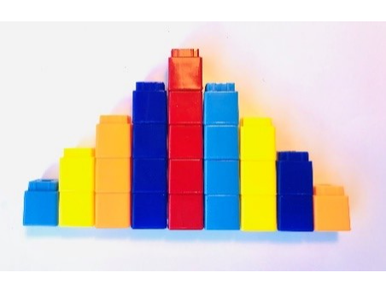
- Ask students what they notice. Invite student responses to develop a shared understanding of growing and shrinking patterns.
This table details assessment opportunities and differentiation ideas.
Assessment opportunities | Too hard? | Too easy?
What to look for:  - Are students able to accurately predict the next element when taking away one in a shrinking pattern? (MAE-FG-01)  - How do students describe their observations of a growing and shrinking pattern? (MAE-FG-01)  - Do students confidently count forwards and backwards by twos, fives and tens? (MA1-FG-01) | Students have difficulty predicting or describing a shrinking pattern.  - Using linking cubes, remove one and invite students to count how many are left.  - Restate attempts at explaining to model correct vocabulary. | Student quickly and accurately predict and describe a shrinking pattern.  - Ask students to predict what the shrinking pattern would be if they took away 2 each time.  - Ask students to predict what the shrinking pattern would be if they took away 5 each time.  - Ask students to predict what the shrinking pattern would be if they took away 10 each time.

Consolidation and meaningful practice: how do patterns grow and shrink – 5 minutes
- Ask students what they now know about patterns. Use student responses to consolidate understanding of key features of repeating, growing, and shrinking patterns.
- Consider adding photos of students building a growing staircase pattern or images that show growing and shrinking patterns to reflect extended understanding of patterns.

Resource 1: Shape train
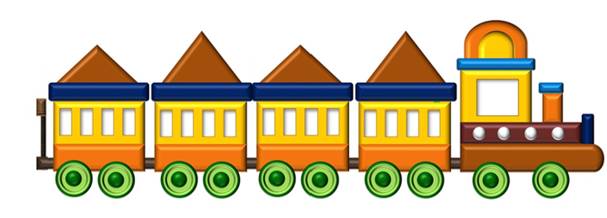
“Cartoon Train” by gyathanarts and used in accordance with the Pixabay Licence.

Resource 2: AB patterns
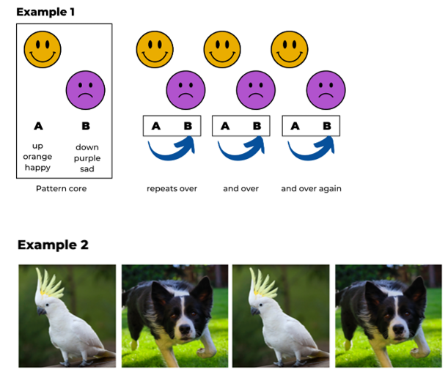
Images sourced from Canva and used in accordance with the Canva Content License Agreement.

Resource 3: What’s this pattern about?
Images sourced from Canva and used in accordance with the Canva Content License Agreement.

Resource 4: Dot card

Resource 5: Organised partitions of 10
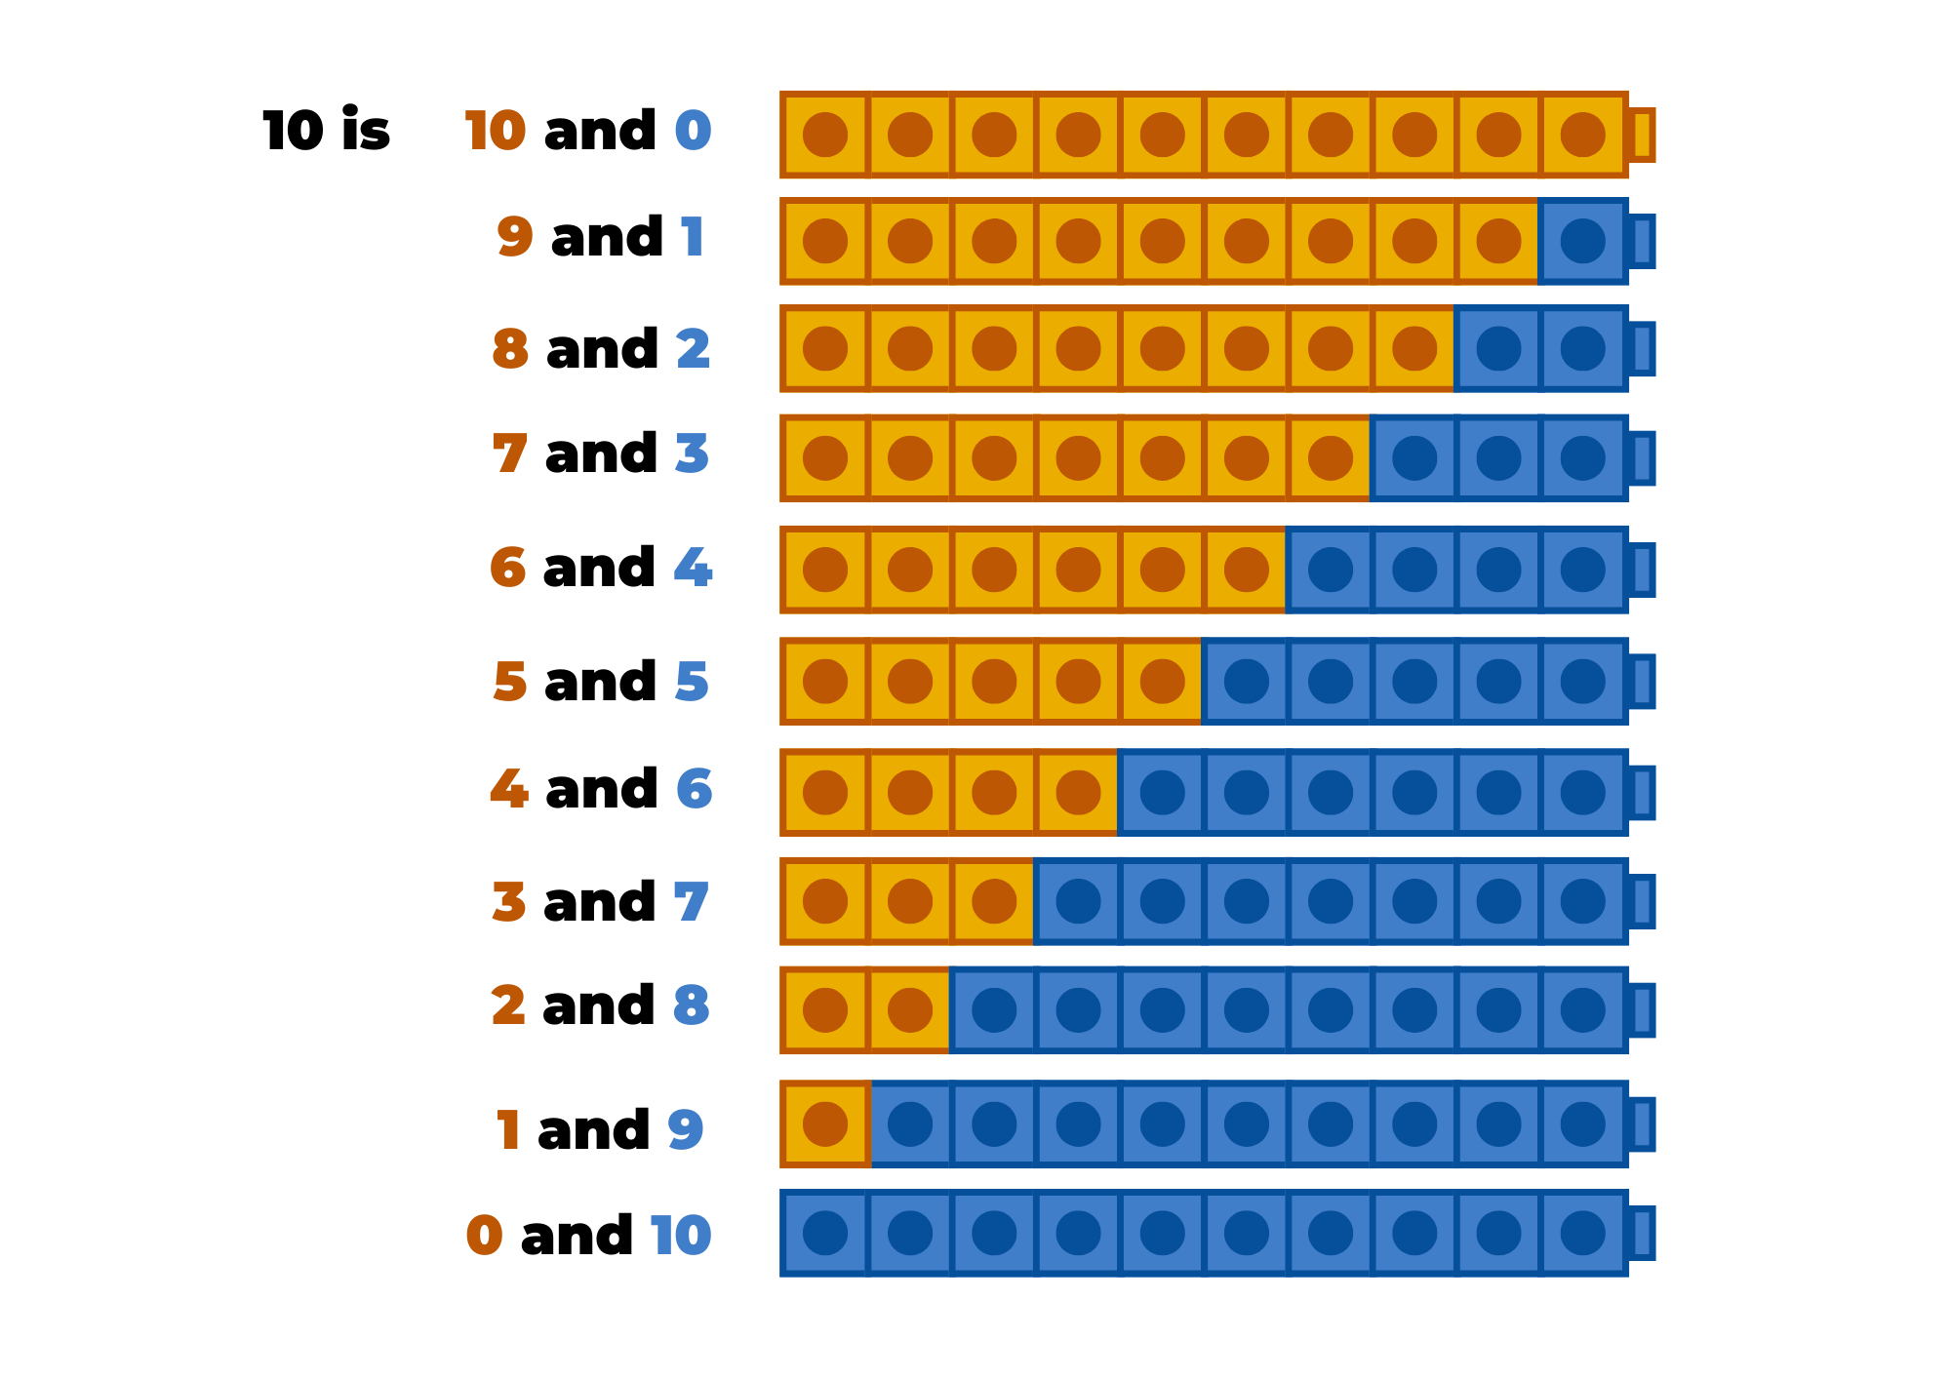

Resource 6: Counting on counting gameplay assessment
Focus | Listen, watch, and think | Ask
Accuracy | Are they getting correct answers? | ‘What answer did you get?’
Efficiency and strategy selection | Are they applying the strategy in a reasonable timeframe?  Do they seem to be labouring or a little stuck? | ‘How did you solve it?’  ‘Was there a more efficient strategy you could have used or was this strategy most efficient?’
Flexibility and strategy selection | Are they using different strategies?  Can they apply them with the same confidence? | ‘Why did you pick that strategy?’  ‘Is there another strategy that you could use for that problem?’  ‘When do you like to use ___________ strategy instead of ________________ strategy?’
Adapted from Bay-Williams J and Kling G (2019).

Resource 7: Number chart
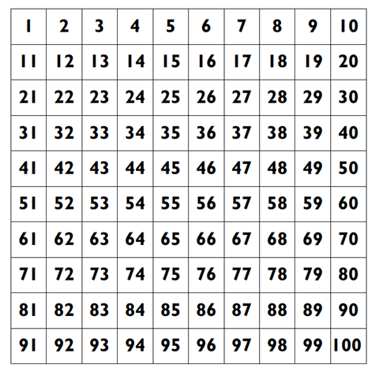

Resource 8: Number charts
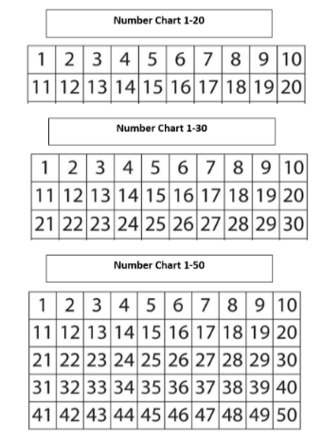

Resource 9: Number cards
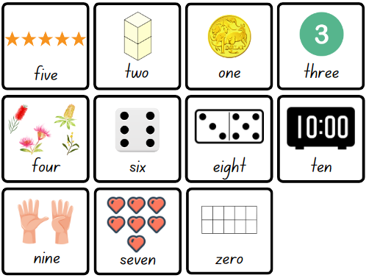
Images sourced from Canva and used in accordance with the Canva Content License Agreement.
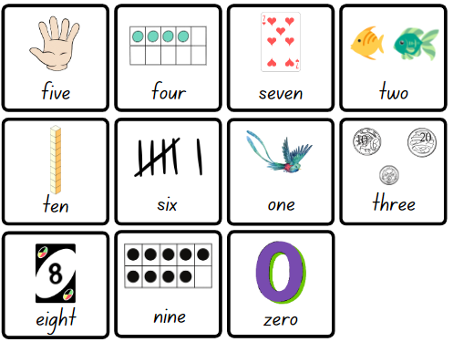
Images sourced from Canva and used in accordance with the Canva Content License Agreement.

Syllabus outcomes and content
The table below outlines the syllabus outcomes and range of relevant syllabus content covered in this unit. Content is linked to National Numeracy Learning Progression version (3).
Focus area and outcomes | Content groups and content points | Lessons
Representing whole numbers  MAO-WM-01  MAE-RWN-01, MA1-RWN-01  MAE-RWN-02, MA1-RWN-02 | Early Stage 1  Use the counting sequence of ones flexibly  - Count forwards to at least 30 and state the number after or before a given number, without needing to count from one  - Identify and distinguish the ‘teen’ numbers from multiples of ten with the same initial sounds  - Count backwards from a given number 20 or less  - Identify the number before as 'one less' and the number after as 'one more’ than a given number  Recognise number patterns  - Recognise dice and domino dot patterns  Connect counting and numerals to quantities  - Count with one-to-one correspondence, recognising that the last number name represents the total number in the collection  - Count out a specified number of objects (from 5 to 20) from a larger collection, keeping track of the count  - Make correspondences between collections (Reasons about quantity)  - Read numerals to at least 20, including zero  - Represent numbers as quantities to at least 20 using objects (such as fingers), number words and numerals  - Compare and order numbers to 20  - Use the term ‘is the same as’ to express equality of groups (Reasons about quantity) | 1–8
Representing whole numbers A (cont) | Stage 1  Use counting sequences of ones with two-digit numbers and beyond  - Identify the number before and after a given two-digit number (CPr5)  - Count forwards and backwards by ones from a given number to at least 120 (CPr6)  Continue and create number patterns  - Model and describe 'odd' and 'even' numbers using items paired in two rows  - Count forwards and backwards by twos from any starting point (CPr6, CPr7, MuS2)  Represent numbers on a line  - Sequence numbers and arrange them on a line by considering the order and size of those numbers (CPr5)  Represent the structure of groups of ten in whole numbers  - Recognise that ten ones is the same as one ten (NPV2, NPV4)  - Count large sets of objects by systematically grouping in tens (CPr7)  - Partition two-digit numbers to show quantity values (NPV4) | 1–8
Representing whole numbers B (cont) | Stage 1  Use counting sequences of ones and tens flexibly  - Count forwards and backwards by tens, on and off the decade, with two- and three-digit numbers (CPr7)  Form, regroup, and rename three-digit numbers  - Use models such as base 10 material and interlocking cubes to represent and explain grouping  - Estimate, to the nearest hundred, the number of objects in a collection and check by grouping and counting | 4, 6
Combining and separating quantities  MAO-WM-01  MAE-CSQ-01, MA1-CSQ-01  MAE-CSQ-02  NOTE – there is only one combining and separating quantities outcome for Stage 1. | Early Stage 1  Model additive relations and compare quantities  - Identify situations in which addition and subtraction may be applied  - Combine two or more groups of objects to model addition, identifying the relationship between the parts and the whole  - Separate and take away part of a group of objects to model subtraction  - Use concrete materials or fingers to model and solve addition and subtraction questions, counting forwards or backwards by ones as necessary  - Compare two groups of objects to determine how many more (Reasons about quantity)  Identify part–whole relationships in numbers up to 10  - Use visual representations of numbers to assist with combining and separating quantities, identifying the relationship between the quantities  - Describe the action of combining, separating and comparing  - Use five as a reference in forming numbers from six to ten  - Create, model and recognise combinations for numbers up to ten (Reasons about relations)  - Count by ones to find the total or difference  - Use drawings, words and numerals to record addition and subtraction, and explain their thinking (Reasons about relations) | 3, 5, 7, 8
Combining and separating quantities A (cont) | Stage 1  Use advanced count-by-one strategies to solve addition and subtraction problems  - Recognise and use the symbols for plus (+), minus (–) and equals (=)  - Record number sentences in a variety of ways using drawings, words, numerals and symbols (AdS6)  - Fluently use advanced count-by-one strategies including counting on and counting back to solve addition and subtraction problems involving one- and two-digit numbers (Reasons about relations) (AdS3-AdS5)  Recognise and recall numbers bonds up to ten  - Recognise, recall and record combinations of two numbers that add up or bond to form 10 (AdS2, AdS6)  - Model and record patterns for individual numbers up to ten by making all possible whole-number combinations (Reasons about patterns)  - Create, recall and recognise combinations of two numbers that add up to numbers less than 10 (AdS2, AdS6)  - Describe combinations for numbers using words such as more than, less than and double (Reasons about relations) (AdS6) | 3–6
Combining and separating quantities B (cont) | Stage 1  Represent and reason about additive strategies  - Create, model and solve word problems, using number sentences (AdS7)  - Represent the difference between two numbers using concrete materials and diagrams (AdS5, AdS6)  - Represent a constant difference between pairs of numbers (AdS6)  Use knowledge of equality to solve related problems  - Use number knowledge to solve related problems (AdS6, AdS7)  - Use number bonds to determine a missing number  - Use a variety of ways of writing number sentences  - Use number bonds to solve equality problems | 3, 5, 7, 8
Forming groups  MAO-WM-01  MAE-FG-01, MA1-FG-01  MAE-FG-02  NOTE – there is only one forming groups outcome for Stage 1. | Early Stage 1  Copy, continue and create pattern  - Copy and continue repeating patterns using sounds and/or actions  - Copy, continue and create repeating patterns using shapes, objects, images or pictures (Reasons about patterns)  Record grouping and sharing  - Label the number of objects in a group  - Record grouping and sharing using drawings, words and numerals, and explain their thinking (Reasons about relations) | 3, 6, 8
Forming groups (cont) | Early Stage 1  Investigate and form equal groups by sharing  - Distribute a group of familiar objects into smaller groups and recognise whether the number in each group is equal or not  - Group and share concrete materials by distributing objects one by one or using another method | 6, 7, 8
Forming groups A | Stage 1  Count in multiples using rhythmic and skip counting  - Count by twos, threes, fives and tens using rhythmic counting and skip counting (MuS2, CPr6)  Use skip counting patterns  - Identify and describe patterns when skip counting forwards or backwards by twos, fives and tens (NPA3, NPA4)  - Determine a missing number in a number pattern with a constant difference  - Describe how the missing number in a number pattern was determined (Reasons about relations) | 3, 6, 8
Forming groups A | Stage 1  Model and use equal groups of objects to represent multiplication  - Model and describe collections of objects as groups of (MuS2)  - Determine and distinguish between the number of groups and the number in each group when describing collections of objects (Reasons about relations)  - Find the total number of objects using skip counting of equal groups of a known size (MuS2- MuS3) | 6, 7, 8
Forming groups B | Stage 1  Represent and explain multiplication as the combining of equal groups  - Use objects, diagrams, images or actions to model multiplication as accumulating equal groups (MuS4)  - Solve multiplication problems using repeated addition (MuS4) | 6, 7, 8
Two-dimensional spatial structure  MAO-WM-01  MAE-2DS-01, MA1-2DS-01  MAE-2DS-02 MA1-2DS-02 | Early Stage 1: 2D shapes: Sort, describe and name familiar shapes  - Identify familiar shapes in a range of contexts  - Describe shapes, including circles, squares, triangles and rectangles  - Ask and respond to questions that help identify and name a particular shape | 1–2
Two-dimensional spatial structure (cont) | Early Stage 1: 2D shapes: Represent shapes  - Manipulate circles, squares, triangles and rectangles, and describe their features | 2
Two-dimensional spatial structure A | Stage 1  2D shapes: Recognise and classify shapes using obvious features  - Explore, manipulate and describe features of polygons (UGP3)  - Use the terms ‘side’, ‘vertex’ and ‘two-dimensional’ to describe plane (flat) shapes (UGP1, UGP2)  - Create repeating linear patterns with shapes, including two-shape and three-shape patterns  - Compare, sort and classify polygons according to the number of sides or vertices (UGP3, UGP4) | 1–2
Two-dimensional spatial structure B | Stage 1  Represent, combine and separate two-dimensional shapes  - Make representations of two-dimensional shapes and combinations of shapes in different orientations (UGP2) | 2
Data  MAO-WM-01  MAE-DATA-01, MA1-DATA-01, MA1-DATA-02  NOTE – there is only one data outcome for Early Stage 1. | Early Stage 1  Respond to questions, collect information and discuss possible outcomes of activities  - Predict possible responses to a question  - Collect information from their peers and about their environment  - Pose and respond to questions about the information collected  Organise objects into simple data displays and interpret the displays  - Arrange objects according to a characteristic to form a data display  - Interpret information presented in a data display to answer questions (Reasons about quantity) | 7
Data A | Stage 1  Ask questions and gather data  - Investigate a topic of interest by choosing suitable questions to obtain appropriate data (IRD2)  - Gather data and track what has been counted by using concrete materials, tally marks, lists or symbols (IRD3)  Represent data with objects and drawings and describe the displays  - Use concrete materials or pictures of objects as symbols to create data displays where one object or picture represents one data value (IRD1)  - Describe information presented in one-to-one data displays (Reasons about relations) | 7
Data B | Stage 1  Create displays of data and interpret them  - Organise collected data into lists and tables to display information (IRD2)  - Represent data in a picture graph using a baseline, equal spacing and same-sized symbols (IRD2) | 7

References
Links to third-party material and websites
Please note that the provided (reading/viewing material/list/links/texts) are a suggestion only and implies no endorsement, by the New South Wales Department of Education, of any author, publisher, or book title. School principals and teachers are best placed to assess the suitability of resources that would complement the curriculum and reflect the needs and interests of their students.
If you use the links provided in this document to access a third-party's website, you acknowledge that the terms of use, including licence terms set out on the third-party's website apply to the use which may be made of the materials on that third-party website or where permitted by the Copyright Act 1968 (Cth). The department accepts no responsibility for content on third-party websites.
Except as otherwise noted, all material is © State of New South Wales (Department of Education), 2021 and licensed under the Creative Commons Attribution 4.0 International License. All other material (third-party material) is used with permission or under licence. Where the copyright owner of third-party material has not licensed their material under a Creative Commons or similar licence, you should contact them directly for permission to reuse their material.
Mathematics K–10 Syllabus © 2022 NSW Education Standards Authority (NESA) for and on behalf of the Crown in right of the State of New South Wales.
© 2022 NSW Education Standards Authority. This document contains NSW Curriculum and syllabus content. The NSW Curriculum is developed by the NSW Education Standards Authority. This content is prepared by NESA for and on behalf of the Crown in right of the State of New South Wales. The material is protected by Crown copyright.
Please refer to the NESA Copyright Disclaimer for more information.
NESA holds the only official and up-to-date versions of the NSW Curriculum and syllabus documents. Please visit the NSW Education Standards Authority (NESA) website and the NSW Curriculum website.
National Numeracy Learning Progression © Australian Curriculum, Assessment and Reporting Authority (ACARA) 2010 to present, unless otherwise indicated. This material was downloaded from the Australian Curriculum website (National Numeracy Learning Progression) (accessed 29 September 2022) and was not modified. The material is licensed under CC BY 4.0. Version updates are tracked in the ‘Curriculum version history’ section on the 'About the Australian Curriculum' page of the Australian Curriculum website.
ACARA does not endorse any product that uses the Australian Curriculum or make any representations as to the quality of such products. Any product that uses material published on this website should not be taken to be affiliated with ACARA or have the sponsorship or approval of ACARA. It is up to each person to make their own assessment of the product, taking into account matters including, but not limited to, the version number and the degree to which the materials align with the content descriptions and achievement standards (where relevant). Where there is a claim of alignment, it is important to check that the materials align with the content descriptions and achievement standards (endorsed by all education Ministers), not the elaborations (examples provided by ACARA).
This resource contains images and content obtained from Canva, and their use outside of this resource is subject to Canva’s Content License Agreement. If you wish to use them separately from the resource, please go to Canva.
Bay-Williams J and Kling G (2019) ‘Interview Prompts for Assessing During Game Play’, Chapter 7. Assessing Derived Fact Strategies and All Facts, Math Fact Fluency, Association for Supervision and Curriculum Development, United States.
Dale P (2013) Ten in the Bed, Walker Books Australia, Sydney.
New Zealand Ministry of Education (n.d.) ‘Blast Off in 5’, NZ Maths, New Zealand Ministry of Education website, accessed 29 September 2022.
New Zealand Ministry of Education (n.d.) Numerals and Expression – Spot the Spots, NZ Maths, New Zealand Ministry of Education website, accessed 29 September 2022.
New Zealand Ministry of Education (n.d.) Frog Animation, NZ Maths, New Zealand Ministry of Education website, accessed 29 September 2022.
New Zealand Ministry of Education (n.d.) Mary, Mary, Quite Contrary, nzmaths, New Zealand Ministry of Education website, accessed 29 September 2022.
New Zealand Ministry of Education (n.d.) Odd One Out, nzmaths, New Zealand Ministry of Education website, accessed 29 September 2022.
State of Victoria (Department of Education and Training) (2018) Modelling through think alouds, Literacy Teaching Toolkit, Department of Education and Training website, accessed 29 September 2022.
Teacher Education by Design (2014) Choral Counting, Teacher Education by Design website, accessed 29 September 2022.
Toy Theater (2022) ‘Interactive Hundreds Chart’, Number Chart Manipulatives, Toy Theater website, accessed 29 September 2022.
University of Cambridge (Faculty of Mathematics) (2022) Hundred Square, NRICH website, accessed 19 September 2022.
University of Cambridge (Faculty of Mathematics) (2022) Matching numbers, NRICH website, accessed 19 September 2022.
University of Cambridge (Faculty of Mathematics) (2022) Domino Patterns, NRICH website, accessed 19 September 2022.
Williams S (1991) I Went Walking (Vivas J illus.), Harcourt Brace & Co, US.

Further reading
Boaler J, Munson J & Williams C (2021). Mindset Mathematics: Visualising and Investigating Big Ideas, Grade 1, Jossey-Bass, US.
Education Development Center (2021) Same Rule, Different Stuff, Pattern Games, Young Mathematicians website, accessed 07 August 2022.
Franke M, Kazemi E & Chan Turrou A (2018) Choral counting and counting collections: Transforming the PreK-5 Math Classroom, Stenhouse Publishers, US.

