Mathematics – K-2 multi-age – Year A – Unit 1
Contents
Unit description and duration 4
Student prior learning 4
Lesson overview and resources 5
Lesson 1: Mathematicians have superpowers! 16
Daily number sense: Investigating the ten-frame – 15 minutes 17
Mathematicians have superpowers! – 30 minutes 17
Consolidation and meaningful practice: Attribute Anna – 15 minutes 21
Lesson 2: How many do you see? 24
Daily number sense: 3 tens in a row – 15 minutes 25
How many do you see? – 30 minutes 27
Consolidation and meaningful practice: How many dots do you see? Part 2 – 15 minutes 30
Lesson 3: Attributes of shapes 32
Daily number sense: Shape talk – 10 minutes 33
Shape sort – 30 minutes 33
Consolidation and meaningful practice: Shape scavenger hunt – 25 minutes 38
Lesson 4: Attribute shape patterns 41
Daily number sense: Count and match dot patterns – 15 minutes 42
Attribute patterns – 30 minutes 42
Consolidation and meaningful practice: Reflecting on the sorts – 10 minutes 46
Lesson 5: Numbers have attributes too 46
Daily number sense: Sorting dominoes – 20 minutes 47
Numbers have attributes too – 20 minutes 48
Consolidation and meaningful practice: Connecting and discussing some of the mathematics – 20 minutes 52
Lesson 6: Organising and counting a collection 53
Daily number sense: Ten-frame filler – 20 minutes 54
Organising and counting a collection – 20 minutes 54
Consolidation and meaningful practice: How can we organise and count? – 15 minutes 58
Lesson 7: How many dots? 60
Daily number sense: Part-whole combinations – 10 minutes 61
How many dots? – 20 minutes 61
Count the dots – 20 minutes 62
Consolidation and meaningful practice – 10 minutes 64
Lesson 8: Boxes of pencils 66
Daily number sense: 15 minutes 67
Boxes of pencils – 20 minutes 67
Consolidation and meaningful practice – 20 minutes 70
Resource 1: Example anchor chart 71
Resource 2: Attribute Anna’s animals 72
Resource 3: How many? – Part 1 73
Resource 4: How many? – Part 2 74
Resource 5: How many? – Part 3 75
Resource 6: Shape talk 76
Resource 7: Scavenger hunt 1 77
Resource 8: Scavenger hunt 2 78
Resource 9: Domino patterns 79
Resource 10: Dice patterns cards 80
Resource 11: Shapes to sort 1 81
Resource 12: Shapes to sort 2 82
Resource 13: What do you notice? 83
Resource 14: Numbers to sort 1 84
Resource 15: Numbers to sort 2 85
Resource 16: Number cards 86
Resource 17: Ten-frame gameboard 87
Resource 18: Boxes of pencils 88
Resource 19: A group needs… 89
Resource 20: A class needs… 90
Syllabus outcomes and content 91
References 103

Unit description and duration
This two-week unit develops student knowledge, understanding, and place value skills, and how attributes can be used to sort objects. Students are provided opportunities to:
- recognise, classify, and sort shapes using obvious features
- visualise, play with, and investigate the base 10 numerical system
- ask questions, gather, and represent data with objects and drawings.
Mathematics K–10 Syllabus © 2022 NSW Education Standards Authority (NESA) for and on behalf of the Crown in right of the State of New South Wales.

Student prior learning
Before engaging in these teaching and learning activities, students would benefit from prior experience with:
- noticing, wondering, and asking questions about objects and collections
- collecting and playing informally with objects, such as pattern blocks and counters. Students could try stacking, rolling, building, deconstructing, filling, emptying, and so on
- counting collections of objects.

Lesson overview and resources
The table below outlines the sequence and approximate timing of lessons; syllabus focus areas and content groups; and resources.
Lesson | Syllabus focus area and content groups | Resources
Lesson 1: Mathematicians have superpowers!  60 minutes  Mathematicians solve problems and communicate their thinking. | Representing whole numbers  Early Stage 1  - Instantly name the number of objects within small collections  - Use the counting sequence of ones flexibly  Stage 1 – Part A  - Use counting sequences of ones with two-digit numbers and beyond  Combining and separating quantities  Early Stage 1  - Model additive relations and compare quantities  - Identify part-whole relationships in numbers up to 10  Stage 1 – Part A  - Use advanced count-by-one strategies to solve addition and subtraction problems  - Recognise and recall number bonds up to ten  - Represent equality  Stage 1 – Part B  - Represent and reason about additive relations  Two-dimensional spatial structure  Early Stage 1  - 2D shapes: Sort, describe and name familiar shapes | - Resource 1: Example anchor chart  - Resource 2: Attribute Anna's animals  - Video: Investigating teen numbers with 10 frames (14:49)  - Video: Your brain is like a muscle (2:37)  - A4 paper for poster  - Class set of ‘mathemagician wands’ (See Figure 2)  - Treasure box containing loose items such as a rock, leaf, shell, seedpod, stick and gumnut  - Writing materials
Lesson 2: How many do you see?  60 minutes  Mathematicians reason, convince others and ask questions. | Representing whole numbers  Early Stage 1  - Connect counting and numerals to quantities  Stage 1 – Part A  - Use counting sequences of ones with two-digit numbers and beyond  Combining and separating quantities  Early Stage 1  - Identify part–whole relationships in numbers up to 10  Stage 1 – Part A  - Use advance count-by-one strategies to solve addition and subtraction problems  - Recognise and recall number bonds up to ten  - Represent equality  Stage 1 – Part B  - Represent and reason about additive relations | - Resource 3: How many? – Part 1  - Resource 4: How many? – Part 2  - Resource 5: How many? – Part 3  - Video: 3 tens in a line (2:29)  - Writing materials
Lesson 3: Attributes of shapes  65 minutes  Shapes can be recognised and classified by their features. | Two-dimensional spatial structure  Early Stage 1  - 2D shapes: Sort, describe and name familiar shapes  Stage 1 – Part A  - 2D shapes: Recognise and classify shapes using obvious features  Stage 1 – Part B  - 2D shapes: Represent, combine and separate two-dimensional shapes  Data  Stage 1 – Part A  - Represent data with objects and drawings and describe the displays | - Resource 6: Shape talk  - Resource 7: Scavenger hunt 1  - Resource 8: Scavenger hunt 2  - Pattern blocks  - Writing materials
Lesson 4: Attribute shape patterns  55 minutes  Repeating linear patterns can be created with shapes. | Two-dimensional spatial structure  Early Stage 1  - 2D shapes: Sort, describe and name familiar shapes  - 2D shapes: Represent shapes  Stage 1 – Part A  - 2D shapes: Recognise and classify shapes using obvious features  Data  Stage 1 – Part A  - Ask questions and gather data  - Represent data with objects and drawings and describe the displays  Stage 1 – Part B  - Identify a question of interest and gather relevant data | - Resource 9: Domino patterns  - Resource 10: Dice patterns cards  - Resource 11: Shapes to sort 1  - Resource 12: Shapes to sort 2  - Pattern blocks  - Pegs  - Writing materials
Lesson 5: Numbers have attributes too  60 minutes  Numbers can be sorted according to their attributes. | Representing whole numbers  Early Stage 1  - Connect counting and numerals to quantities  Stage 1 – Part A  - Use counting sequences of ones with two-digit numbers and beyond  Combining and separating quantities  Early Stage 1  - Identify part–whole relationships in numbers up to 10  Stage 1 – Part A  - Use advanced count-by-one strategies to solve addition and subtraction problems  Stage 1 – Part B  - Represent and reason about additive relations  Data  Early Stage 1  - Respond to questions, collect information and discuss possible outcomes of activities  - Organise objects into simple data displays and interpret the displays  Stage 1 – Part A  - Ask questions and gather data  - Represent data with objects and drawings and describe the displays  Stage 1 – Part B  - Identify a question of interest and gather relevant data | - Resource 9: Domino patterns  - Resource 10: Dice patterns cards  - Resource 13: What do you notice?  - Resource 14: Numbers to sort 1  - Resource 15: Numbers to sort 2  - Resource 16: Number cards  - Video: Sorting dominoes (13:27)  - Wooden pegs  - Writing materials
Lesson 6: Organising and counting a collection  55 minutes  Organising objects into groups is a useful way to count larger numbers. | Representing whole numbers  Early Stage 1  - Use the counting sequence of ones flexibly  - Connect counting and numerals to quantities  Stage 1 – Part A  - Use counting sequences of ones with two-digit numbers and beyond  - Represent the structure of groups of ten in whole numbers  Combining and separating quantities  Early Stage 1  - Model additive relations and compare quantities  - Identify part–whole relationships in numbers up to 10  Stage 1 – Part A  - Use advance count-by-one strategies to solve addition and subtraction problems  - Recognise and recall number bonds up to ten  - Represent equality  Stage 1 – Part B  - Represent and reason about additive relations  - Form multiples of ten when adding and subtracting two-digit numbers | - Resource 17: Ten-frame gameboard  - Video: Ten-frame filler (10:40)  - 6-sided dice  - Collections of 20 to100 objects such as buttons, counters, or cubes  - Small containers such as cupcake liners, paper cups or bowls  - Writing materials
Lesson 7: How many dots?  60 minutes  Organising objects into groups is a useful way to count larger numbers. | Representing whole numbers  Early Stage 1  - Instantly name the number of objects within small collections  - Use the counting sequence of ones flexibly  - Connect counting and numerals to quantities  Stage 1 – Part A  - Represent the structure of groups of ten in whole numbers  Stage 1 – Part B  - Use counting sequences of ones and tens flexibly  - Combining and separating quantities A  - Recognise and recall number bonds up to ten | - Dice:10 to 20 per group or interactive dice  - Digital spinner  - Writing materials (whiteboard)
Lesson 8: Boxes of pencils  55 minutes  Large collections can be quantified, organised and represented in different ways. | Representing whole numbers  Early Stage 1  - Recognise number patterns  - Connect counting and numerals to quantities  Stage 1 – Part A  - Represent the structure of groups of ten in whole numbers  - Use counting sequences of ones with two-digit numbers and beyond  Stage 1 – Part B  - Use counting sequences of ones and tens flexibly  Combining and separating quantities  Early Stage 1  - Model additive relations and compare quantities  - Identify part–whole relationships in numbers up to 10  Stage 1 – Part A  - Use advanced count-by-one strategies to solve addition and subtraction problems  - Recognise and recall number bonds up to ten  - Represent equality  Stage 1 – Part B  - Represent and reason about additive relations  - Form multiples of ten when adding and subtracting two-digit numbers | - Resource 18: Boxes of pencils  - Resource 19: A group needs...  - Resource 20: A class needs...  - Writing materials

Lesson 1: Mathematicians have superpowers!
Core concept: Mathematicians solve problems and communicate their thinking.
The table below contains suggested learning intentions and success criteria. These are best co-constructed with students.
Learning intentions | Success criteria
All students are learning that:  - mathematicians share their thinking with words, symbols, or pictures  - mathematicians solve problems using concrete materials  - addition problems can be solved using advanced count-by-one strategies. | All students can:  - discuss the superpowers of mathematicians  - communicate how to work with other students during maths activities  - record ideas using words, symbols or pictures  - work with others to solve Attribute Anna's animals using concrete materials.  In addition, students working towards Early Stage 1 outcomes can:  - contribute to a class discussion/experience about the attributes of a mathematician  - communicate that mathematics is a part of everyday life  - identify familiar shapes including circles, squares, triangles, and rectangles.  In addition, students working towards Stage 1 outcomes can:  - count on and back to solve addition  - count by twos.

Daily number sense: Investigating the ten-frame – 15 minutes
- Build student understanding of quantities and numbers using a mathematical representation; the ten-frame.
- Watch the video Investigating ten-frames (14:49).
- Pause the video at 4:12 and have students draw their own ten-frame.
- Play the video again and pause at 6:15. Students draw their representation of 4.
- Play the video again and pause at 9:11. Students draw their representation of 6.
- Play the video again and pause at 13:22. Students draw 6 in as many different representations as possible.

Mathematicians have superpowers! – 30 minutes
This lesson has been adapted from Boaler et al (2021).
- Watch the video The brain is like a muscle (2:38).
Note: An anchor chart is a display that ‘holds onto’ students’ ideas and is referred to across lessons. It has a title with images and text to support students’ understanding of the concept taught. An anchor chart summarises concepts, makes connections, and identifies mathematical language. It is added to over the sequence of learning as students learn more about the concept.
- Discuss with students what they like about mathematics and how they feel about mathematical investigations. Encourage students to think about the superpowers mathematicians have and record answers on a class anchor chart. For example, strong, resilient, solve problems, use concrete materials. See Figure 1 and use Resource 1: Example anchor chart.
Figure 1 – Example of anchor chart
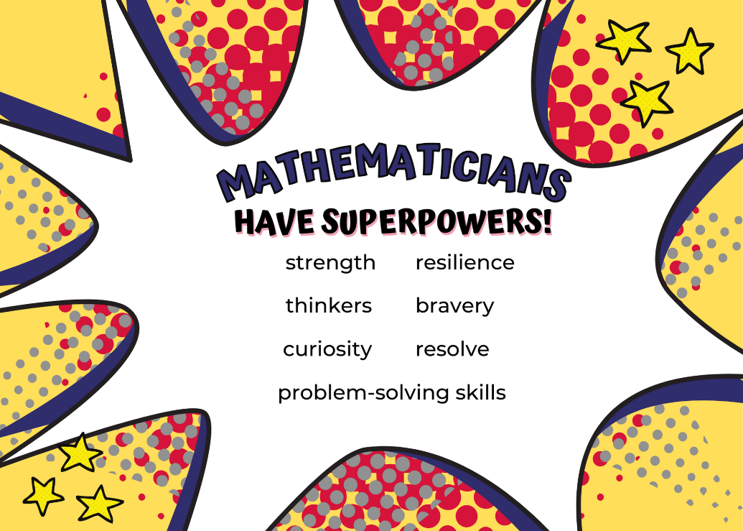
Images sourced from Canva and used in accordance with the Canva Content License Agreement.
- In groups of 3 or 4, students reflect on the things they do not like people to say or do when working on maths problems together. Students may come up with ideas such as people telling them the answer or ignoring other people’s ideas. Students record their ideas using pictures, symbols, or words on a poster.
- Students brainstorm things they like people to say or do when working together. Students may come up with ideas such as listening to each other or working as a team to solve the problem. Students record their ideas using pictures, symbols, or words on a poster.
- As a class, groups share their posters and display these in the classroom. They can be referred to and built upon throughout the year.
This table details assessment opportunities and differentiation ideas.
Assessment opportunities | Too hard? | Too easy?
What to look for:  - Can students discuss the qualities of a mathematician? (MAO-WM-01)  - Are students able to identify the skills required to participate in mathematical group tasks? (MAO-WM-01)  - Can students communicate their thinking through drawings, words and symbols? (MAO-WM-01)  What to collect:  - students’ posters (MAO-WM-01) | Students are unable to identify the skills required to participate in mathematical group tasks.  - Provide a real classroom experience where the group works together to solve a riddle. Pause the class to highlight the skills being modelled.  - Using role play, model the skills required and pause the role play to discuss at key points. | Students are able to identify the skills required to participate in mathematical group tasks. Ask students what they could do to make sure all group members are involved in the task.
- Students use ‘mathemagician wands’ to explore and investigate the classroom and the mathematics that exists all around them. Encourage students to stop at specific areas to have conversations about mathematics. Lead students on an exploration to identify common mathematical shapes, the number of objects, and the repetition of coloured objects. See Figure 2.
Figure 2 – Mathemagician wand
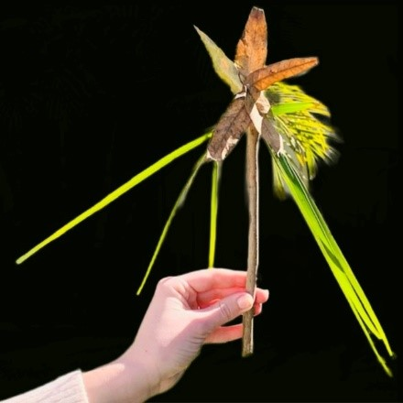
The table below outlines stimulus prompts to generate conversation about the topic, along with anticipated responses from students.
Prompts | Anticipated student responses
- What do you notice? What do you wonder?  - Describe what you can you see.  - Can you find numbers?  - Can you see any shapes?  - Is this mathematics? Why do you think this?  - Are you being mathematicians? Why do you think this way? | - A circle (pointing to the centre of the Aboriginal flag).  - There is the number one (classroom door).  - A window shape is a square.  - That looks like my lunchbox shape.  - That’s a round rock, that is wheel shape, that is a circle.  - I see 2 sticks,1 bird, I can see 1, 2, 3, 4, 5, 10 trees.  - The number 5. I am 5.  - Mathematics is all around us.  - Mathematicians are thinkers.
- Stop at an area in the classroom or garden within the school grounds that has a range of natural loose objects such as rocks, sticks and leaves. Invite students to collect loose objects to add to a class treasure box. Ask students to make a picture out of the loose objects and take photographs for the classroom display. See Figure 3.
Figure 3 – Familiar shapes from loose objects
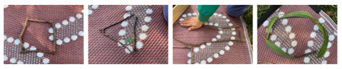

Consolidation and meaningful practice: Attribute Anna – 15 minutes
This lesson has been adapted from NRICH (2022).
- For Stage 1 students, display Resource 2: Attribute Anna's animals.
- Explain that maths superhero Attribute Anna has a problem she needs help to solve. She is creating a mathematical zoo and has invited all the animals to come and stay. Unfortunately, her superhero mask fell when the animals were entering the zoo so she could only see their legs. She counted 12 legs.
- How many animals could she have seen?
- How many different answers can you find?
- Can you show your thinking with numbers, pictures, words, or symbols?
- Students work in groups to find a solution to Attribute Anna’s animals. They use a variety of materials including blocks, counters, connecting cubes or natural loose objects such as rocks, leaves and sticks. Take photographs for the classroom display.
- Students record their thinking using numbers, words, symbols, or pictures.
- Draw attention to the anchor charts about working effectively in mathematical groups. Highlight groups who model effective group work strategies.
- Students conduct a gallery walk to see other solutions to the problem.
- All students return as a class. Invite Early Stage 1 students to recall their experience and describe the mathematics that exists around them, what they noticed, and what they wondered. Discuss and reflect on the pictures created. Invite questions from Stage 1 students to prompt further discussion about the attributes of a mathematician and to recognise that mathematics is part of their everyday life. In pairs, students turn and talk to share their reasoning.
- As a class, create a mathematical vocabulary anchor chart from terms used in the lesson. Students contribute to a definition of each term using words, symbols, or pictures. For example, ‘mathematics’, ‘investigate’ and ‘attribute’. Refer to the anchor chart in later lessons. Add new words to the chart and display anchor chart in classroom.
This table details assessment opportunities and differentiation ideas.
Assessment opportunities | Too hard? | Too easy?
What to look for:  - Can students contribute to a class discussion/experience about the attributes of a mathematician? (MAO-WM-01, MAE-RWN-01, MAE-2DS-01)  - Can students recognise that mathematics is a part of their everyday life? (MAE-RWN-01, MAE-2DS-01)  - Can students communicate their thinking through drawings, words and symbols? (MAO-WM-01)  - Are students working effectively together in the group? (MAO-WM-01)  - Can students use concrete materials to help solve the problem? (MAO-WM-01)  - Are students able to use flexible strategies to solve addition problems? (MA1-CSQ-01)  What to collect:  - work samples and observations of group discussions (MAE-RWN-01, MAE-2DS-01, MAO-WM-01) | Students are not able to identify mathematics in their everyday life.  - Guide students to find mathematics in the environment using a ‘mathemagician wand’ or a decorative stick. Trace around objects and identify familiar shapes.  - Use images of familiar shapes on a lanyard to help students find similar examples around the school environment.  Students are not listening to others or working effectively in their group.  - Pause the lesson and review the posters made in the previous lesson.  - Model asking questions that involve all students’ ideas. | Students who recognise that mathematics is part of their everyday life.  - Ask students if they can see mathematics around them. Scaffold using a ‘mathemagician wand’ to trace around maths objects (for example, instantly name familiar shapes and numbers, number of objects in a small collection) in their environment.  - Invite students to engage in conversations about the display of mathematics learning with a peer.  Students are working effectively together in the group task.  - Explain that Anna counted again and there were actually 20 legs. Ask what that could look like.  - Students work out what would happen if there were an odd number of legs. Students explain their thinking on paper.

Lesson 2: How many do you see?
Core concept: Mathematicians reason, convince others, and ask questions.
The table below contains suggested learning intentions and success criteria. These are best co-constructed with students.
Learning intentions | Success criteria
All students are learning that:  - mathematicians reason, convince others and pose questions  - combining 2 or more groups of objects is called ‘addition’  - there are combinations of 2 numbers (0 to 10) that, when added together, form 10.  In addition, students in Stage 1 are learning that:  - the commutative property helps to recall addition facts  - the symbol + means ‘add’ and the symbol = means ‘is equal to’  - addition problems can be solved using advanced count-by-one strategies. | All students can:  - convince other students of their thinking about how many  - ask questions to understand the thinking of others  - combine 2 or more groups of objects to show addition  - use materials or their fingers to solve addition and subtraction questions, counting forwards or backwards by ones.  In addition, students working towards Stage 1 outcomes can:  - make all groups of 2 numbers that add up to 10  - recognise and use the + and = sign  - identify that 6 + 4 is the same as 4 + 6  - count a collection using counting on.

Daily number sense: 3 tens in a row – 15 minutes
- Build student understanding of number bonds up to ten by playing 3 tens in a row.
- Watch the video 3 tens in a line (2:29).
- Students play several rounds of the game in pairs. Early Stage 1 students can use counters to support their counting.
This table details assessment opportunities and differentiation ideas.
Assessment opportunities | Too hard? | Too easy?
What to look for:  - Do students combine 2 or more groups of objects to model addition, identifying the relationship between the parts and the whole? (MAE-CSQ-01)  - Can students recognise, recall and record of 2 numbers that add up or bond to form 10? (MAE-CSQ-02, MA1-CSQ-01)  - Are students able to recognise and use the symbols for plus (+) and equals (=)? (MA1-CSQ-01)  - Do students apply the commutative property to addition facts? (MA1-CSQ-01)  - Can students record number sentences in a variety of ways using drawings, words, numerals and symbols? (MA1-CSQ-01)  What to collect:  - observation of students during the game (MAE-CSQ-01, MAE-CSQ-02, MA1-CSQ-01) | Students cannot recognise, recall and record number that add up to 10.  - Use visual representations of numbers to assist with combining and separating quantities. For example, a ten-frame and counters.  - Model the action of combining and separating quantities using counters or blocks.  - Model forming numbers from 6-10 using 5 as a reference. | Students recognise, recall and record numbers that add up to 10.  - Students play the game with a larger dice (0-20) and make 3 twenties in a row.  - Students play the game with a larger dice (0-20) and explore larger combinations of numbers.

How many do you see? – 30 minutes
This lesson has been adapted from Boaler et al (2021).
- Revise the anchor chart about the superpowers of mathematicians and mathematical vocabulary. Remind students that if they hear a new mathematical word, it can be added to the anchor chart.
- Tell students that as mathematicians they have some important jobs to do. Explain to students that mathematicians have 3 very important jobs:
- mathematicians reason and share their thinking with others
- mathematicians explain, show, or give evidence to convince others
- mathematicians listen and ask questions to make sense of the thinking of others' ideas.
- Add these to the class anchor chart from previous day.
- Tell students they are going to see an image that has lots of different things on it. They are going to be mathematician superheroes and figure out how many they see.
- Display Resource 3: How many? – Part 1. Ask Early Stage 1 students how many they see. Give students time to think and wonder.
- Display Resource 4: How many? – Part 2. Ask Stage 1 students how many they see. Give students time to think and wonder.
- Select some students to share their thinking about what they saw. Explain that if they do not understand someone else’s thinking, it is their job to ask a question. This helps people to explain their ideas and convince others of their thinking.
- Students share the quantities they saw, being specific about what they counted and the total amount.
- Ask questions to support students in explaining what they saw and how they saw it. For example, ask students where they saw the 5, or what did they see 5 of.
- Record students’ thinking on the image, labelling the number, the unit, and how they saw the quantity. Encourage students to ask questions and provide reasoning for their thinking.
- Revise the 3 important jobs mathematicians have: reasoning, convincing and posing questions. The class shares examples or provides evidence of thinking, offering ideas or asking questions. Explain that this is what a mathematician superhero does.
This table details assessment opportunities and differentiation ideas.
Assessment opportunities | Too hard? | Too easy?
What to look for:  - Are students able to give reasons for their mathematical thinking about how many they saw? (MAO-WM-01)  - Can students convince others with evidence of their mathematical thinking? (MAE-CSQ-01, MAO-WM-01)  - Are students able to ask questions to clarify their understanding of others' ideas? (MAO-WM-01)  - Do students use concrete materials or fingers to model and solve addition and subtraction questions, counting forwards or backwards by ones as necessary? (MAE-CSQ-02)  - Can students use advanced count-by-one strategies including counting on to solve addition and subtraction problems? (MA1-CSQ-01)  What to collect:  - observations of student discussions (MAO-WM-01, MAE-CSQ-01, MA1-CSQ-01) | Students are unable to explain or reason about how many they saw.  - Encourage students to circle groups of vegetables on the image with recognisable patterns. For example, group the carrots, then group the capsicums. Model using one to one counting patterns to determine how many.  - Create a model of the image using concrete materials. Students use one-to-one correspondence to determine how many. | Students are able to explain or reason about how many they saw.  - Students create their own image using resources in the classroom and ask a partner how many they see.  - Ask students to manipulate the objects to explain their thinking.

Consolidation and meaningful practice: How many dots do you see? Part 2 – 15 minutes
- Place Stage 1 students in groups of 3 or 4 and provide them with a copy of Resource 5: How many? – Part 3. Early Stage 1 students also form groups of 3 or 4 and are provided with a copy of Resource 4: How many? – Part 2.
- Students identify how many they see, explaining their thinking to the group.
- Students ask questions to understand others’ thinking. Students respond, providing reasoning and convincing evidence to support their ideas.
- Add additional mathematical language to the anchor chart. For example, reasoning, convincing, quantities and numbers.
This table details assessment opportunities and differentiation ideas.
Assessment opportunities | Too hard? | Too easy?
What to look for:  - Are students able to use their mathematical thinking about how many they saw? (MAO-WM-01)  - Can students convince others with evidence of their mathematical thinking? (MAO-WM-01)  - Are students able to ask questions to clarify their understanding of others' ideas? (MAO-WM-01)  - Can students use advanced count-by-one strategies including counting on to solve addition and subtraction problems? (MA1-CSQ-01)  What to collect:  - student annotated images. (MAO-WM-01, MA1-CSQ-01) | Students are unable to explain or reason about how many they saw.  - Support students to circle groups of vegetables on the image with recognisable patterns. For example, group the carrots, then group the capsicums. Model using one-to-one counting patterns to determine how many.  - Create a model of the image using concrete materials and have students use one-to-one correspondence to determine how many. | Students are able to explain or reason about how many they saw.  - Provide Early Stage 1 students with a copy of Resource 5: How many? – Part 3. Students identify how many they see, explaining their thinking to the group.  - Students create their own image using resources in the classroom and ask a partner how many they see.

Lesson 3: Attributes of shapes
Core concept: Shapes can be recognised and classified by their features.
The table below contains suggested learning intentions and success criteria. These are best co-constructed with students.
Learning intentions | Success criteria
All students are learning that:  - shapes can be recognised and named by their features  - polygons can be sorted and classified according to the number of sides they have  - objects can be organised into simple data displays to share information  - mathematicians reason, convince others and pose questions  - mathematicians communicate their thinking with words, symbols, or pictures.  In addition, students working towards Stage 1 outcomes are learning that:  - polygons are closed 2D shapes with more than 3 sides  - shapes can be identified by describing specific features including their vertices  - a table can be used to represent ways objects can be sorted. | All students can:  - recognise and name 2D shapes (circle, triangle, square and rectangle)  - sort shapes by the number of sides and vertices  - find 2D shapes in the playground  - create data displays to share information about the objects  - reason and explain their thinking about their sort  - ask questions to understand the thinking of others.  In addition, students working towards Stage 1 outcomes can:  - recognise, name and sort 2D shapes (including pentagon, hexagon, octagon, polygons, and non-polygons)  - use the words ‘side’, ‘vertex’ and ‘two-dimensional’ to describe shapes  - make a table to show how shapes can be sorted.

Daily number sense: Shape talk – 10 minutes
- Build student understanding of the attributes of 2D shapes by exploring and reasoning in a shape talk activity.
- Display Resource 6: Shape talk on the board. Allow students to turn and talk to a partner to discuss which one does not belong.
- Students reason or convince their partner of their thinking. For example, the circle does not belong as it is the only one with curved lines.
- As a class, discuss some of the responses and highlight that there is more than one solution.

Shape sort – 30 minutes
- Revise the anchor chart about the superpowers of mathematicians and mathematical vocabulary. Remind students if they hear a new mathematical word, it can be added to the anchor chart.
- Refer to the shape talk and remind students that they can sort and classify objects using their attributes.
Attributes: Attributes are the traits or the properties of a shape or an object. The attributes of shapes help to define the characteristics of the shape both visually, for example colour, and mathematically, for example the length of the sides.
- Give Early Stage 1 students a selection of pattern blocks including circles, squares, triangles, and rectangles. Stage 1 students are also given pentagons, hexagons, and octagons. Explain to students what a polygon is.
Polygon: A polygon is a flat two-dimensional shape with 3 or more straight sides that are fully closed. The sides must be straight, not curved.
- Ask students to sort their collection of pattern blocks into 2 groups: polygons and non-polygons. Students name the shapes as they sort and explain their thinking. For example, this square is a polygon; it has 4 straight sides and is fully closed.
- As a class revise the sort, identifying the key features of polygons.
- Discuss that polygons can be further sorted using visual attributes. These include number of sides, vertices, size, and colour. Using a pattern block, identify the sides and vertices of a rectangle.
Vertex: A vertex is where 2 straight sides of a two-dimensional shape meet.
Side: A side is the line segment joining 2 vertices of a two-dimensional shape.
- In pairs or groups, students explore how to further sort the polygons. Students then discuss and reason about their sort.
- Students group polygons and record their thinking in a table, see Figure 4.
Figure 4 – Sample table structure
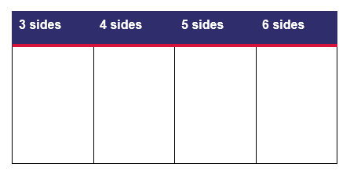
- Discuss with students. Ask questions such as:
- How did you sort your polygons? Explain your reasoning.
- Do some polygons fit more than one sort? Why or why not?
- Can you identify any other features of your shapes?
- Can you think of another way to sort your polygons?
- How did you record your thinking?
- Students share their grouping with the class. Support students to reason and convince others of their mathematical thinking. Encourage students to ask questions to further their understanding of other classification choices.
- Record additional words on the anchor chart. For example, polygon, side, vertex, attributes, non-polygons, square, rectangle, circle, hexagon, and pentagon.
This table details assessment opportunities and differentiation ideas.
Assessment opportunities | Too hard? | Too easy?
What to look for:  - Can students identify the attributes of shapes? (MAE-2DS-01, MA1-2DS-01)  - Do students recognise and name 2D shapes? (MAE-2DS-01, MA1-2DS-01)  - Are students using the words ‘side’, ‘vertex’ and ‘two-dimensional’ to describe shapes? (MAE-2DS-01, MA1-2DS-01)  - Can students sort shapes into polygons and non-polygons and by number of sides and vertices? (MAE-2DS-01, MA1-2DS-01)  - Can students explain their thinking about their sort? (MAO-WM-01, MA1-2DS-01)  - Can students record their data in a table? (MAO-WM-01, MA1-DATA-01, MA1-DATA-02)  What to collect:  - observations during students’ discussions (MAO-WM-01, MAE-2DS-01, MA1-2DS-01)  - photographs of attribute sort (MAE-2DS-01, MA1-2DS-01)  - students work samples; table recording data of 2D shapes (MAO-WM-01, MAE-2DS-01, MAE-DATA-01, MA1-2DS-01, MA1-DATA-01, MA1-DATA-02) | Students are unable to recognise and name 2D shapes.  - Revise shape names and features.  - Use additional pictorial representation of shapes.  Students cannot sort shapes by attributes.  - Revise attributes including size, side, vertices.  - Support students to use one to one correspondence to count the shapes sides and vertices. | Students are able to name 2D shapes and can sort them by attributes.  - Students are given square coloured paper to cut into 2 triangles. Then, cut one triangle into 2 triangles. Students use the 3 shapes to create as many different 2D shapes. See Figure 5.  - Discuss that rectangles and squares can be further classified as quadrilaterals. A quadrilateral is a polygon having 4 sides, 4 angles, and 4 vertices. Have students sort their pattern blocks into quadrilaterals and non-quadrilaterals.
Figure 5 – Triangle folding

Consolidation and meaningful practice: Shape scavenger hunt – 25 minutes
- Discuss that shapes can be found in the environment. Make a class list of shapes in the classroom, for example, a book has a rectangle on the front cover.
- In pairs, Early Stage 1 students complete an outdoor scavenger hunt for natural resources to create polygons and non-polygons. For example, students can use fallen leaves and sticks to make squares, triangles, rectangles, and circles. See Figure 3.
- Alternatively, Early Stage 1 students can work in pairs to complete an outdoor scavenger hunt for polygons using Resource 7: Scavenger hunt 1.
- In pairs, Stage 1 students conduct an outdoor scavenger hunt for polygons and non-polygons and complete Resource 8: Scavenger hunt 2. If devices are available, students could take a photograph and annotate the image. Figure 6.
Figure 6 – Annotation of an outdoor polygon hunt
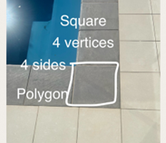
- As a class, students share their scavenger hunt findings. This information could be recorded on a whole class table.
This table details assessment opportunities and differentiation ideas.
Assessment opportunities | Too hard? | Too easy?
What to look for:  - Can students identify 2D shapes in the playground? (MAE-2DS-01, MA1-2DS-01)  - Can students identify the attributes of shapes? (MAE-2DS-01, MA1-2DS-01)  - Do students recognise and name 2D shapes? (MAE-2DS-01, MA1-2DS-01)  - Are students using the words ‘side’, vertex’ and ‘two-dimensional’ to describe shapes? (MAE-2DS-01, MA1-2DS-01)  - Can students sort shapes into polygons and non-polygons and by number of sides and vertices? (MAO-WM-01, MAE-2DS-01, MA1-2DS-01)  What to collect:  - a completed work sample of Resource 7: Scavenger hunt 1, Resource 8: Scavenger hunt 2 or an annotated digital image (MAO-WM-01, MAE-2DS-01, MAE-DATA-01, MA1-2DS-01, MA1-DATA-01, MA1-DATA-02) | Students are unable to identify shapes by their features. Use a resource, such as a pattern block or printed shape, to take into the playground as a scaffold. Have the students refer to the shape and compare it to objects in the playground. Highlight similar features, for example, the number of sides. | Students can identify features of shapes.  - Students identify three-dimensional objects in the playground and identify the two-dimensional shapes hiding inside these objects.  - Students create their own examples of polygons and non-polygons that they could not find using natural resources. For example, students create pentagons, hexagons and non-examples using leaves and sticks to share with the class.

Lesson 4: Attribute shape patterns
Core concept: Patterns can be made with the features of shapes.
The table below contains suggested learning intentions and success criteria. These are best co-constructed with students.
Learning intentions | Success criteria
All students are learning that:  - shapes have attributes that can be used to describe and sort them  - shapes can be different but share attributes  - some attributes are mathematical, and some are not  - information (data) can be presented in different ways  - the same shapes can be sorted in different ways. | All students can:  - name and describe shapes  - re-sort shapes based on a different attribute  - sort objects according to an attribute in a data display.  In addition, students working towards Early Stage 1 outcomes can:  - identify familiar shapes  - sort shapes, such as by size and shape  - explain how a group of shapes has been sorted.  In addition, students working towards Stage 1 outcomes can:  - sort shapes based on more than one attribute  - explain the attributes used for a two-way sort.

Daily number sense: Count and match dot patterns – 15 minutes
- Provide Stage 1 students with a copy of Resource 9: Domino patterns and pegs.
- Provide Early Stage 1 students with a set of Resource 10: Dice patterns cards and pegs.
- Model counting out 2 pegs to attach to the number 2 dice dot pattern. Students explore the dot patterns by attaching the corresponding number of pegs to each card.
- Provide opportunities for students to work with a peer to explain how they counted and attached their pegs to their dice dot pattern.

Attribute patterns – 30 minutes
- Revise the anchor chart about the superpowers of mathematicians and mathematical vocabulary. Remind students if they hear a new mathematical word, it can be added to the anchor chart.
- Print and cut out Resource 11: Shapes to sort 1 and display for students. Ask how they would categorise or sort the shapes, prompting students to explain their thinking. Provide independent thinking time, then turn and talk with a partner. Strategically select students to share their thinking with the class.
- Ask if any of the other shapes share attributes. Prompt students to organise the shapes to show the relationships, referencing the table in the previous lesson. In small groups, students explore other ways they can sort their shapes. Students go on a gallery walk to see the ways that other students have sorted their shapes.
- Demonstrate a two-way sort using shape blocks or pictures by identifying 2 attributes for the sort (see Figure 7).
Note: A two-way sort occurs when students identify 2 distinct attributes to categorise objects by. Figure 7 shows shapes sorted by the number of sides which results in 2 groups. Figure 8 repeats this initial sort and then uses a second attribute, colour, to sort these shapes again. This two-way sort results in the 4 groups, sorted by sides and colour.
Figure 7 – Shapes sorted into 2 categories
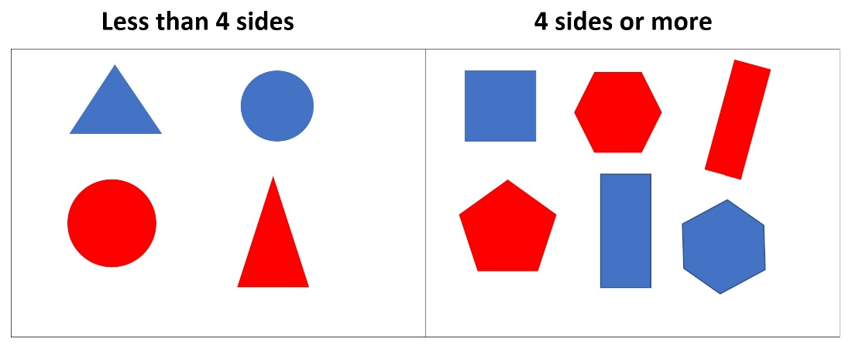
Figure 8 – A two-way sort of shapes
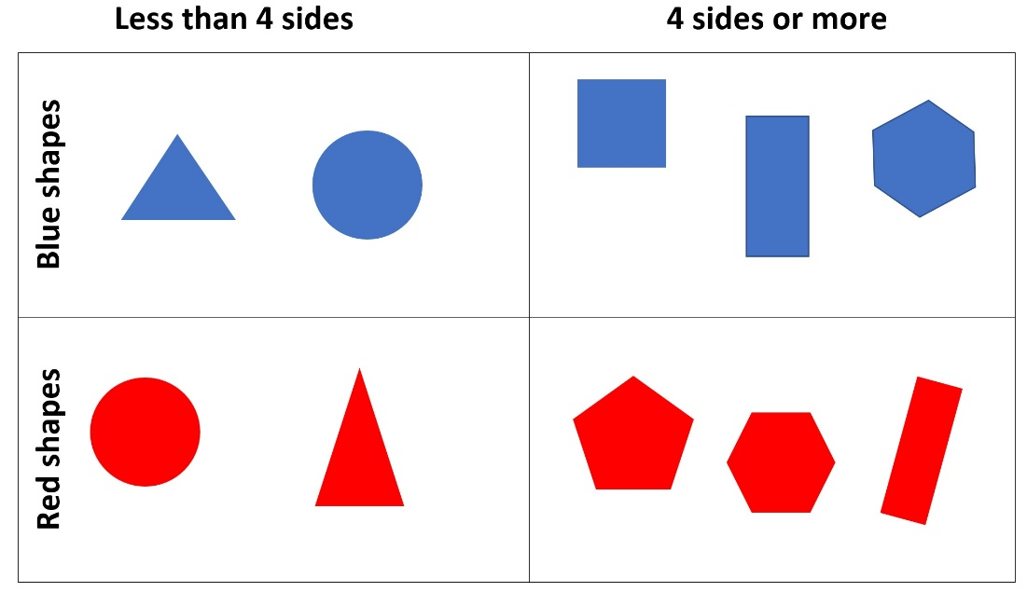
- In pairs, Early Stage 1 students use a copy of Resource 11: Shapes to sort 1 to complete an attribute sort or a two-way sort, depending on their level of understanding.
- In pairs, Stage 1 students sort a collection of shapes in a two-way sort, by using 2 or more attributes and Resource 12: Shapes to sort 2.
- After students organise their shapes into a two-way sort, ask:
- What attributes are shared?
- Is it possible to organise your collection into another two-way sort using different attributes?
- How can this be represented visually, using pictures and symbols?
This table details assessment opportunities and differentiation ideas.
Assessment opportunities | Too hard? | Too easy?
What to look for:  - Are students able to identify the attributes of shapes? (MAO-WM-01, MAE-2DS-01, MA1-2DS-01)  - Are students able to sort the shapes based on different attributes? (MAO-WM-01, MAE-2DS-01)  - Are students able to complete a two-way sort? (MAO-WM-01, MA1-2DS-01)  What to collect:  - observations and photographs that capture the strategies used to sort (MAO-WM-01, MAE-2DS-01, MAE-DATA-01, MA1-2DS-01, MA1-DATA-01, MA1-DATA-02) | Students cannot identify the attributes of shapes and/or the categories.  - Support students to identify attributes by selecting several shapes. Ask what is similar and different about the 2 shapes.  - Provide labels for the sections of the table according to their response. Ask students where the other shapes belong, assisting them to complete the attribute sort. | Students sort shapes and can explain the relationships between categories and objects.  - Ask students to find another way to organise the shapes, showing which ones belong to more than one category.  - Students investigate how many ways there are to sort their chosen shapes based on the attributes.

Consolidation and meaningful practice: Reflecting on the sorts – 10 minutes
- Display a selection of the students’ two-way sorts. Highlight a mix of attributes which have been used to sort. For example: number of sides, colour, size. Add additional words to the mathematics vocabulary anchor chart.

Lesson 5: Numbers have attributes too
Core concept: Numbers can be sorted according to their attributes.
Note: Number sense refers to ‘a well organised conceptual framework of number information that enables a person to understand numbers and number relationships’ (Bobis 1996). These are the attributes of numbers. In this lesson, students will explore some of the attributes of numbers and how numbers might be sorted according to their attributes.
The table below contains suggested learning intentions and success criteria. These are best co-constructed with students.
Learning intentions | Success criteria
All students are learning that:  - some attributes are mathematical, and some are not  - numbers have attributes which can be used to describe and sort them  - numbers can be different but share attributes  - the same numbers can be sorted or categorised in different ways. | All students can:  - communicate that numbers have mathematical attributes  - organise numeral cards demonstrating their shared attributes  - explain why numbers can be sorted (or categorised) into more than one category.  In addition, students working towards Early Stage 1 outcomes can:  - communicate that numbers can be sorted in different ways  - describe ways to compare numbers up to 10.  In addition, students working towards Stage 1 outcomes can describe numbers by their parts and their relationship with other numbers.

Daily number sense: Sorting dominoes – 20 minutes
- Build student understanding in identifying the attributes of numbers, including doubles, by using Sorting dominoes (13:27).
- Stage 1 students watch the start of the video and pause at 0:31, or use Resource 13: What do you notice? Students use paper or individual whiteboards to record what they noticed about the way the dominoes are sorted.
- Students share their pictures to show the attributes they identified from the dominoes, explaining why they think the dominoes were sorted this way.
- Provide Early Stage 1 students with a set of Resource 10: Dice patterns cards or Resource 9: Domino patterns.
- In pairs, give students time to explore the dominoes or cards and use their mathematical imagination to notice ways the dominoes can be sorted. Students share their mathematical thinking with a peer and explain why they sorted this way.
- As a class, Early Stage 1 students invite Stage 1 students to view how they sorted the dominoes. Encourage Stage 1 students to use their mathematical thinking to notice and prove why the dominoes have been sorted this way.

Numbers have attributes too – 20 minutes
- Revise the anchor chart from previous lesson and remind students if they hear a new mathematical word, it can be added to the chart.
- For Early Stage 1 students, print, cut, and display Resource 14: Numbers to sort 1.
- For Stage 1 students, print, cut, and display Resource 15: Numbers to sort 2.
- Ask students how they could sort these numbers and have them explain their thinking. Provide time for independent thinking and opportunities to share with a partner. Strategically select groups of students to share their thinking with the class, see Figure 9 for Stage 1, and Figure 10 for Early Stage 1.
Figure 9 – Sorting and labelling random numbers
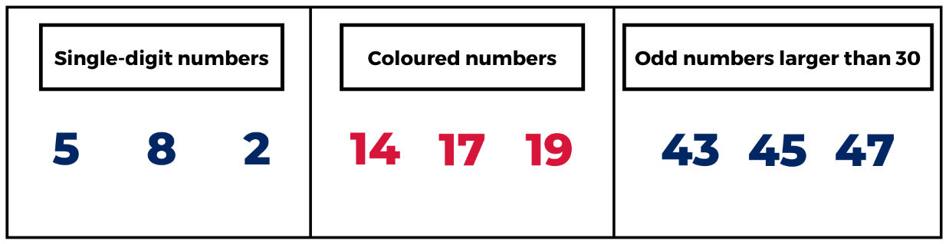
Figure 10 – Sorting and labelling smaller numbers
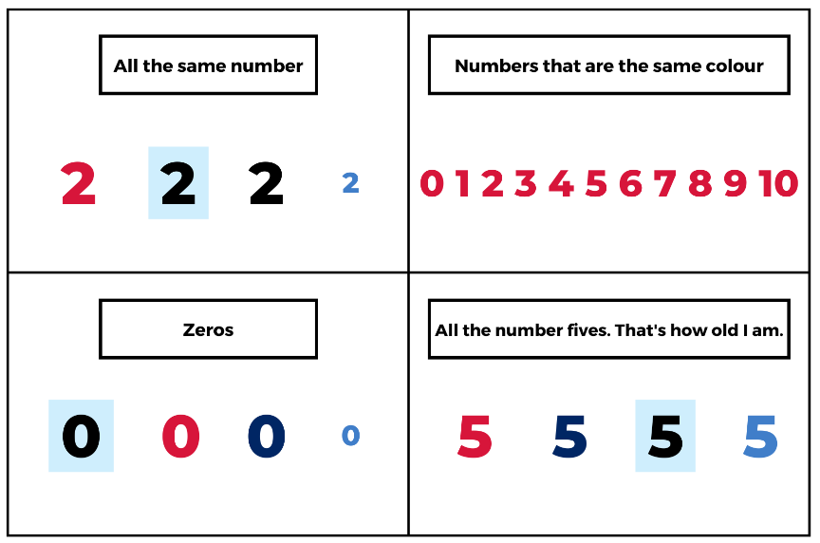
- In small groups students create their own number categories using Resource 16: Number cards. See Figure 11.
Note: Teachers may choose to conduct a gallery walk to allow students to explore other sorting strategies. Collect photographs of the categories created by students to use in the ‘consolidation and meaningful practice’ part of the lesson.
Figure 11 – Examples of sorting numbers into categories
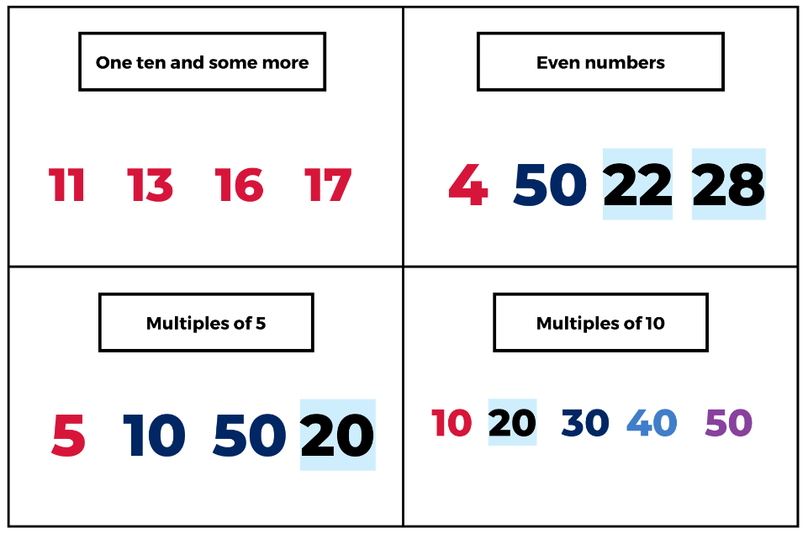
This table details assessment opportunities and differentiation ideas.
Assessment opportunities | Too hard? | Too easy?
What to look for:  - Are students able to describe numbers by their parts? (MAE-RWN-01, MA1-RWN-01, MA1-RWN-02)  - Can students recognise number patterns? (MAE-RWN-01 MA1-RWN-01, MA1-RWN-02)  - Are students able to use their knowledge of number bonds to create sort categories? (MA1-CSQ-01)  - Do students organise their data into displays and tables? (MAE-DATA-01, MA1-DATA-01, MA1-DATA-02)  What to collect:  - work sample of the number tables. (MAE-RWN-01, MA1-RWN-01, MA1-RWN-02, MAE-CSQ-01, MAE-CSQ-01, MA1-CSQ-01, MAE-DATA-01, MA1-DATA-01, MA1-DATA-02)  - Observations of students' discussions (MAO-WM-01, MAE-CSQ-01, MA1-CSQ-01) | Students are unable to identify a suitable category in which to place a number.  - Select a number and ask students what they know about the number? For example, 8 is 2 fours, 2 less than 10, it is even.  - Ask students to name any other numbers that are also even. | Students can sort numbers and describe categories according to their mathematical properties.  - Prompt students to use a two-way sort structure from previous lessons.  - Ask students to identify numbers that could belong to more than one category and explain their thinking.

Consolidation and meaningful practice: Connecting and discussing some of the mathematics – 20 minutes
- Strategically select examples of how students have categorised numbers to share with the class.
- Add additional words to the mathematics vocabulary anchor chart.
The table below outlines stimulus prompts to generate conversation about the topic, along with anticipated responses from students.
Prompts | Anticipated student responses
- What do you notice about the ways these numbers have been sorted or categorised?  - Is there anything that is the same?  - Is there anything that is different?  - Are there any other numbers that could also be in 2 categories?  - What categories do they belong to? | - I noticed that some numbers have been used more than once. For example, 10 is included as a multiple of 5 and as a multiple of 10.  - Even though the numbers are different and represent different amounts, they share attributes. For example, 10, 15, 20, and 5 are all multiples of 5.
- Explain to students that, just like shapes, numbers can be different and still share attributes.

Lesson 6: Organising and counting a collection
Core concept: Organising objects into groups is a useful way to count larger numbers.
The table below contains suggested learning intentions and success criteria. These are best co-constructed with students.
Learning intentions | Success criteria
All students are learning that:  - a large collection of objects can be organised into groups to support the count  - organising a large collection of objects into groups of 10 is an efficient way to count larger quantities  - groups of objects can be used to form a visual representation of an amount. | All students can:  - organise objects into smaller groups to count how many there are  - use groups of 10 to organise and count large amounts  - group objects to display an amount.  In addition, students working towards Early Stage 1 outcomes can:  - organise objects into different arrangements and identify how many in each group  - instantly recognise number of items in small groups of up to 4 items  - count out 5 to 20 objects from a larger collection keeping track of the count.  In addition, students working towards Stage 1 outcomes can:  - recognise and record different combinations of 2 numbers that add up to 10  - use language such as more than, less than and double to describe combinations for numbers.

Daily number sense: Ten-frame filler – 20 minutes
- Build student understanding of numbers by representing them as quantities.
- Introduce the ten-frame to the class. Students play Ten-frame filler (4:40), based on the work of Siemon et al. (2021). Students take turns rolling a six-sided dice. On Resource 17: Ten-frame gameboard, students record the number they rolled using a ten-frame.
- Students fill in part of the ten-frame on each turn. The player who completes a ten-frame (for example, rolling a 3 and there is a ten-frame with 7 already filled), claims it by writing their initials on top of it.
- If there is no ten-frame with enough space, the player misses a turn. The player with the most ten-frames at the end is the winner.
- Have students reflect on the game by asking about the strategies that helped to win the game and the numbers that students felt were the best to roll and why.

Organising and counting a collection – 20 minutes
- Revise the anchor chart and remind students that new mathematical language can be added to the chart.
- Show students a collection of 20 to 30 objects, such as natural loose objects, buttons, counters, or cubes. Explain that you want to organise the objects to know how many there are.
- Students turn and talk to a partner about strategies they could use to organise the objects and find the total.
- Students share their thinking. Highlight that there are many ways to organise the objects. Discuss that some ways are more efficient than others.
- Tell students that they will be creating ways of organising objects in collections to make it easier to count and see how many there are.
Note: This is an opportunity to go on a nature walk in the school grounds. Students count out and collect an assortment of natural loose objects such as rocks, sticks, seedpods and leaves.
- Provide pairs of Early Stage 1 students with 20 to 30 objects and tools for organising the groups. These may include for example, cupcake liners, paper cups, bowls, recycled containers, sectional sorting trays.
- Provide pairs of Stage 1 students with between 20 to 100 objects each. Provide students tools for organising the groups. For example, cupcake liners, paper cups or bowls, recycled containers, sectional sorting trays. See Figure 12.
Figure 12 – Loose objects on a sectional sorting tray
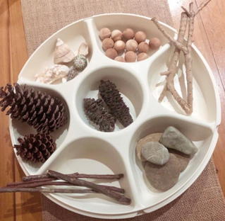
- After experimenting to find the total by organising objects in collections, discuss as a class:
- How many objects are in your collection?
- How can you organise the objects to see and count how many there are?
- How does your organisation help you count?
- I wonder how can you record on paper how you organised and counted the collection?
- Provide opportunities for partners to work with multiple collections as they develop systems for organising and counting. Students record their work through drawings and labels to share with others.
- During the activity, asks pairs to explain their systems of counting. Ask how their system supports accuracy in counting. Taking photographs of the collections before and after sorting can show how organising objects into groups is a useful way to count larger numbers.
This table details assessment opportunities and differentiation ideas.
Assessment opportunities | Too hard? | Too easy?
What to look for:  - Can students organise a large collection of objects into groups to support the count? (MAE-RWN-01, MA1-RWN-01, MAE-RWN-02, MAE-CSQ-01, MA1-CSQ-01)  - Are students organising large collections of objects into groups of ten as an efficient way to count larger quantities? (MA1-RWN-01, MA1-RWN-02, MA1-CSQ-01)  - Do students use groups of objects to form visual representations of amounts? (MAE-DATA-01, MA1-DATA-01, MA1-DATA-02)  What to collect:  - photographs of collections and student work samples. (MAE-RWN-01, MA1-RWN-01, MAE-RWN-02, MA1-RWN-02, MAE-CSQ-01, MA1-CSQ-01, MAE-DATA-01, MA1-DATA-01, MA1-DATA-02). | Students do not organise a collection of objects into groups to support the count.  - Use a smaller collection of objects to model forming groups.  - Support students in the use of tools to form groups of objects.  Students do not use groups of objects to form a visual representation of an amount.  - After forming groups, model how they can be arranged to represent the amount, such as by putting the groups in a row.  Stage 1 students do not organise a large collection into groups of 10.  - Model how to form groups of 10 objects.  - Support students to count the groups using rhythmic and skip counting. | Students are able to organise a large collection of objects into groups to support the count.  - Encourage students to organise their collections using tens and ones, explaining that this can be the most useful way to organise collections.  - Ask students how organising in groups of 10 helped them count, how they knew they had 10 in each group and how they counted the leftover objects.

Consolidation and meaningful practice: How can we organise and count? – 15 minutes
- The table below outlines stimulus prompts to generate conversation about the topic, along with anticipated responses from students. As a class discuss:
Prompts | Anticipated student responses
- How did you organise your objects for counting?  - How did you use tools, such as cupcake liners, paper cups or bowls, to help you organise?  - Once you had organised your objects, how did you count?  - Which ways of organising helped your count? Why?  - How did you and your partner agree on how many objects were in each collection? | - I organised all the same objects into groups. I made groups of 2 and 5 and 10.  - I used the cups and bowls to sort objects into smaller groups.  - I counted out 10 leaves for each cup. Then I could count them all together 10, 20, 30 (pointing to each cup while counting).  - I put 5 rocks in each section of the sorting tray. I could see 5 in each section when I counted.  - First, I counted the shells and put 10 in each bowl. Then my partner counted the shells I put in the bowl to check we counted out the same number of shells.
- Invite students to share the ways they organised the objects. Photographs taken of the collections before and after sorting can show how organising objects into groups is a useful way to count larger numbers.
- Draw attention to the ways that students grouped objects and how these groups connect to counting, such as counting by twos, fives, or tens. Ask:
- How does grouping objects make it easier to count them?
- How did you decide what size your objects would be?

Lesson 7: How many dots?
Core concept: Tens and ones are a useful way to organise groups.
The table below contains suggested learning intentions and success criteria. These are best co-constructed with students.
Learning intentions | Success criteria
All students are learning that:  - small groups of up to 4 items can be instantly recognised (subitised) without counting  - a number can be represented in different ways  - using objects (such as fingers), number words and numerals can help identify quantities to at least 20.  In addition, Stage 1 students are learning that:  - patterns inside of numbers help quantify collections, for example, number bonds. | All students can:  - identify combinations (patterns) of numbers to 10.  - instantly recognise (subitise) small groups of items without counting  - count to at least 20 using objects (such as fingers), number words and numerals.  In addition, students working towards Stage 1 outcomes can:  - describe why counting in tens and ones is efficient  - group the dice collections to make groups of 10.

Daily number sense: Part-whole combinations – 10 minutes
- Build student understanding of part-whole combinations to 10 by providing them with a target number and having them recall and record combinations.
- Spin the digital spinner to provide the target number. A second spinner could be used with a smaller total for Early Stage 1 students.
- Students record combinations for that number on their individual whiteboards. For example, if 5 is spun, a student may write 3 and 2 or 3 + 1 + 1. Select students to provide combinations for the target number and record these on the board.
Note: If the same number is spun, challenge students to come up with different combinations.

How many dots? – 20 minutes
This lesson has been adapted from Boaler et al. (2021).
- Roll 5 dice. Looking at the dice, ask Early Stage 1 students to identify how many dots there are on each. Ask Stage 1 students how the dice can be organised to make it easier to count the total.
- Students turn and talk about efficient and effective strategies for organising the dice to count the total of dots.
- Students present their ideas of organising the dice to the class.
Note: Choose students who have grouped in different ways. For example, similar numbers, and have them justify their strategy. If a pair has grouped by 10, use their combination to lead into the next part of the lesson.
- Early Stage 1 students repeat the activity, identifying the individual dice values and the total number of dots.
- Roll 10 dice for Stage 1 students to view. Students reflect on the efficient and effective strategies they used to count large collections of objects in lessons 1 and 2.
- Students turn and talk to determine the most efficient and effective way to organise and count the number of dots, see Figure 13.
Figure 13 – Organising dots
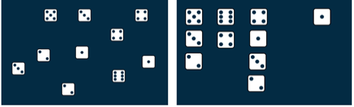
- All students share the ways they structured the dice to count the total number of dots effectively and efficiently. Draw attention to organising the dice in groups that add up to 10 and revise the concept that 10 ones is the same as one 10.

Count the dots – 20 minutes
- Provide small groups of Early Stage 1 students with a collection of 4 to 6 dice and each group an individual whiteboard to record the total count. Students roll the dice, working together to accurately count the total number of dots.
- Provide small groups of Stage 1 students with a collection of 10 to 20 dice and an individual whiteboard to record the total count. Students roll the dice, working together to organise the dice efficiently and effectively to count the dots.
- As Early Stage 1 students play, ask:
- How did you count the number of dots accurately?
- How could you double check your answer?
- What is the largest number of dots you rolled? How do you know?
- As Stage 1 students play, ask:
- How can you organise these dice to help you count?
- How might groups of 10 help you count the dots?
- What is the largest number of dots you rolled? How do you know?
Note: Take photographs of the ways students have organised their dice for the ‘consolidation and meaningful practice’ part of the lesson.
This table details assessment opportunities and differentiation ideas.
Assessment opportunities | Too hard? | Too easy?
What to look for:  - Can students instantly recognise (subitise) the number of items in small groups of up to four items without counting? (MAE-RWN-01, MAE-CSQ-01)  - Do students create, model and recognise combinations for numbers up to ten? (MAE-CSQ-01)  - Can students count large collections of objects by systematically grouping in tens? (MA1-CSQ-01)  - Do students understand that 10 ones are the same as 1 ten? (MA1-RWN-01, MA1-RWN-02)  What to collect:  - photographs of how students arranged the dice (MAE-CSQ-01, MA1-CSQ-01, MA1-RWN-01) | Students cannot instantly recognise (subitise) the number of items in small groups of up to 4 items without counting.  - Use counters to support students recreate and count the dot patterns.  Students cannot create, recall, and recognise combination of numbers up to 10.  - Model combinations of 10 using coloured interlocking cubes.  - Support students to track the dots from the dice by providing counters and a ten-frame. | Students are able to organise the dice using an efficient counting method. Ask students how to check they have made all the combinations to 10. Students record all combinations and record a method to check their working.

Consolidation and meaningful practice – 10 minutes
- Summarise the lesson together. Draw out the key mathematical ideas with students by asking questions, such as:
- How did you count the number of dots accurately?
- How did you organise your dice to see how many dots there were?
- How did your strategies change as you played?
- What patterns did you notice that helped you to organise the dice?
- How did you count the dots without counting each dot individually?
- Are there any new words to add to our mathematical vocabulary chart?
- Display the pictures and ask:
- How could you double check your answer?
- How did you organise your dice?
- How many dots are there?
- How did the organisation help you to count?
- What other ways could the dice be organised?

Lesson 8: Boxes of pencils
Core concept: Large collections can be quantified, organised, and represented in different ways.
The table below contains suggested learning intentions and success criteria. These are best co constructed with students.
Learning intentions | Success criteria
All students are learning that:  - the same collection of objects can be represented in different ways  - mathematicians communicate their thinking using words, symbols, pictures, and numbers. | All students can explain how they counted objects.  In addition, students working towards Early Stage 1 outcomes can:  - count the number of objects in a larger collection, keeping track of the amount  - use fives to count amounts from 6 to 10  - make and recognise combinations for numbers up to 10.  In addition, students working towards Stage 1 outcomes can:  - use boxes of 10 pencils to organise a larger collection of objects  - describe why counting in tens and ones is a good strategy.

Daily number sense: 15 minutes
- From a class need surfaced through formative assessment data, identify a short, focused activity that targets students’ knowledge, understanding and skills. Example activities may be drawn from the following resources:
- Thinking Mathematically Stage 1
- Universal Resources Hub

Boxes of pencils – 20 minutes
This lesson has been adapted from Boaler et al. (2021).
- Show Resource 18: Boxes of pencils. Explain that pencils often come in packs of 5 or 10. If student know how many pencils the class needs, ask:
- How can we figure out the number of boxes of 5 pencils we have to buy?
- How can we figure out the number of boxes of 10 pencils we have to buy?
- Students turn and talk to a partner to discuss possible strategies to use.
Note: Monitor for students' use of strategies and the idea of grouping by packs of 5 or 10 pencils.
- Students share their strategies for working out the number of boxes and loose pencils needed.
- Provide Early Stage 1 students with a copy of Resource 19: A group needs... In pairs, Early Stage 1 students answer the following questions about the needs of each group listed on the resource:
- How many boxes can you make?
- How many loose pencils are left over?
- How can you check that you have the correct number of pencils each class needs?
- Provide Stage 1 students with a copy of Resource 20: A class needs... In pairs, Stage 1 students answer the following questions about the needs of each class listed on the resource:
- How many boxes can you make?
- How many loose pencils are left over?
- How can you check that you have the correct number of pencils each class needs?
- Partners draw in their workbooks how they packed the pencils.
- Students complete a gallery walk. Collect photographs of the different structures students have created.
- Show photographs and have students explain their strategies. Focus on groups that used the structure of tens. Highlight efficient strategies and patterns between the images. For example, students might draw 10 pencils or draw a box with the number 10 on it.
This table details assessment opportunities and differentiation ideas.
Assessment opportunities | Too hard? | Too easy?
What to look for:  - Can students count with one-to-one correspondence, recognising that the last number name represents the total number in the collection? (MAE-RWN-02)  - Do students count out a specified number of objects (from 5 to 20) from a larger collection, keeping track of the count? (MAE-RWN-02)  - Can students represent numbers as quantities to at least 20 using objects, number words and numerals? (MAE-RWN-02)  - Do students recognise that 10 ones are the same as 1 ten by linking boxes of pencils to individual pencils? (MA1-RWN-01, MA1-RWN-02)  - Can students group in hundreds, tens and ones? (MA1-RWN-02)  - Are students communicating their reasoning behind their counting strategies? (MAO-WM-01)  What to collect:  - photographs of students work from the gallery walk (MAE-RWN-01, MA1-RWN-01)  - student work samples (MA1-RWN-01) | Students do not recognise that 10 ones are the same as one 10. Students use concrete materials to represent 10 ones as one 10. Support students to translate this concrete representation into a drawing. | Students recognise that 10 ones are the same as one 10.  - Ask students what the strategy would look like as a mathematical drawing and how they would structure their drawing, so they do not rely on one-to-one counting.  - Ask students what they could do if they had 1000 pencils. Students draw a picture to show their thinking.

Consolidation and meaningful practice – 20 minutes
- Edit Resource 19: A group needs... and Resource 20: A class needs... by entering new numbers of pencils required. Students consolidate their knowledge by repeating steps 7 and 8.
- Summarise the lesson together, drawing out some key mathematical ideas. Ask questions, such as:
- How did you figure out how many boxes of 10 and how many loose pencils you had?
- Did you notice any patterns as you worked?
- Are there any words that can be added to the mathematical vocabulary chart?

Resource 1: Example anchor chart
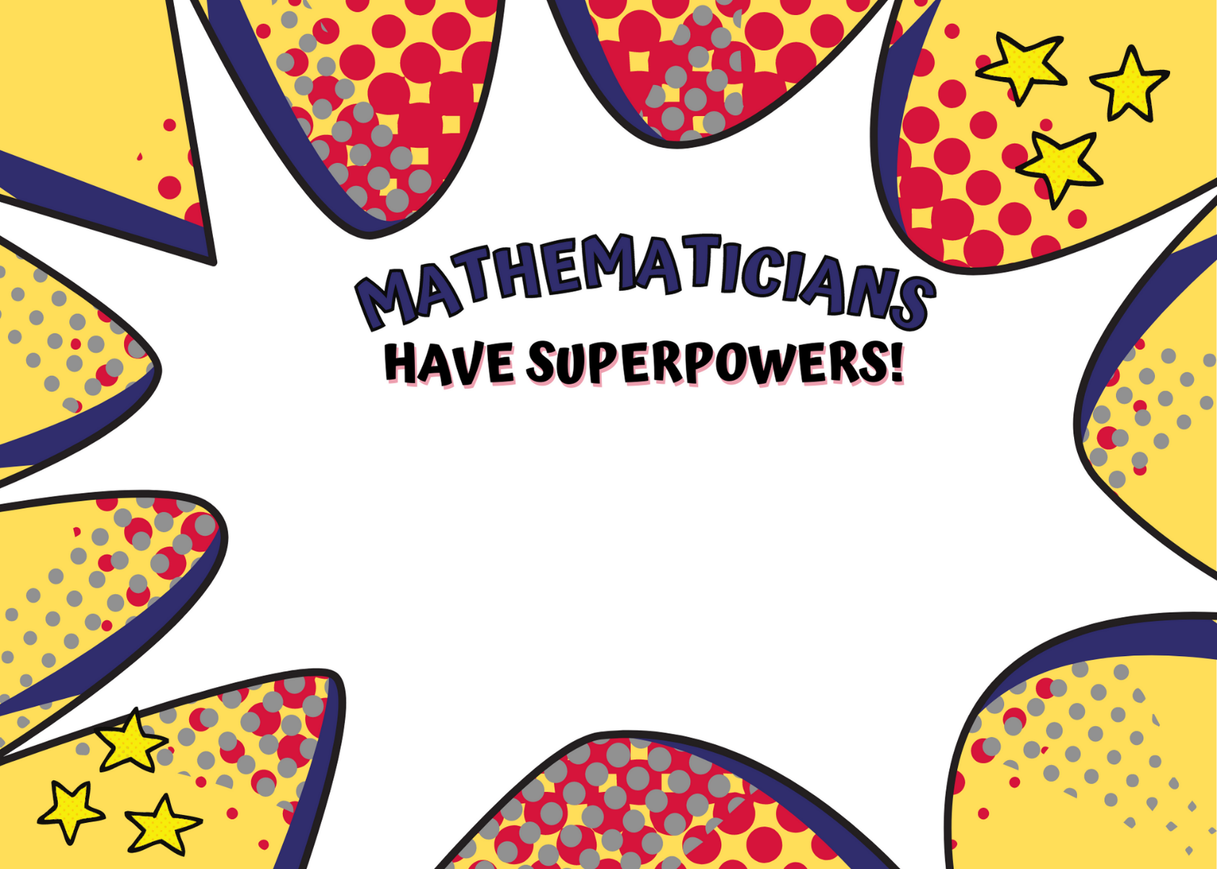
Images sourced from Canva and used in accordance with the Canva Content License Agreement.

Resource 2: Attribute Anna’s animals
Attribute Anna saw 12 legs walk past at the zoo. How many creatures could she have seen?
How many different answers can you find? Can you explain how you found out these answers?
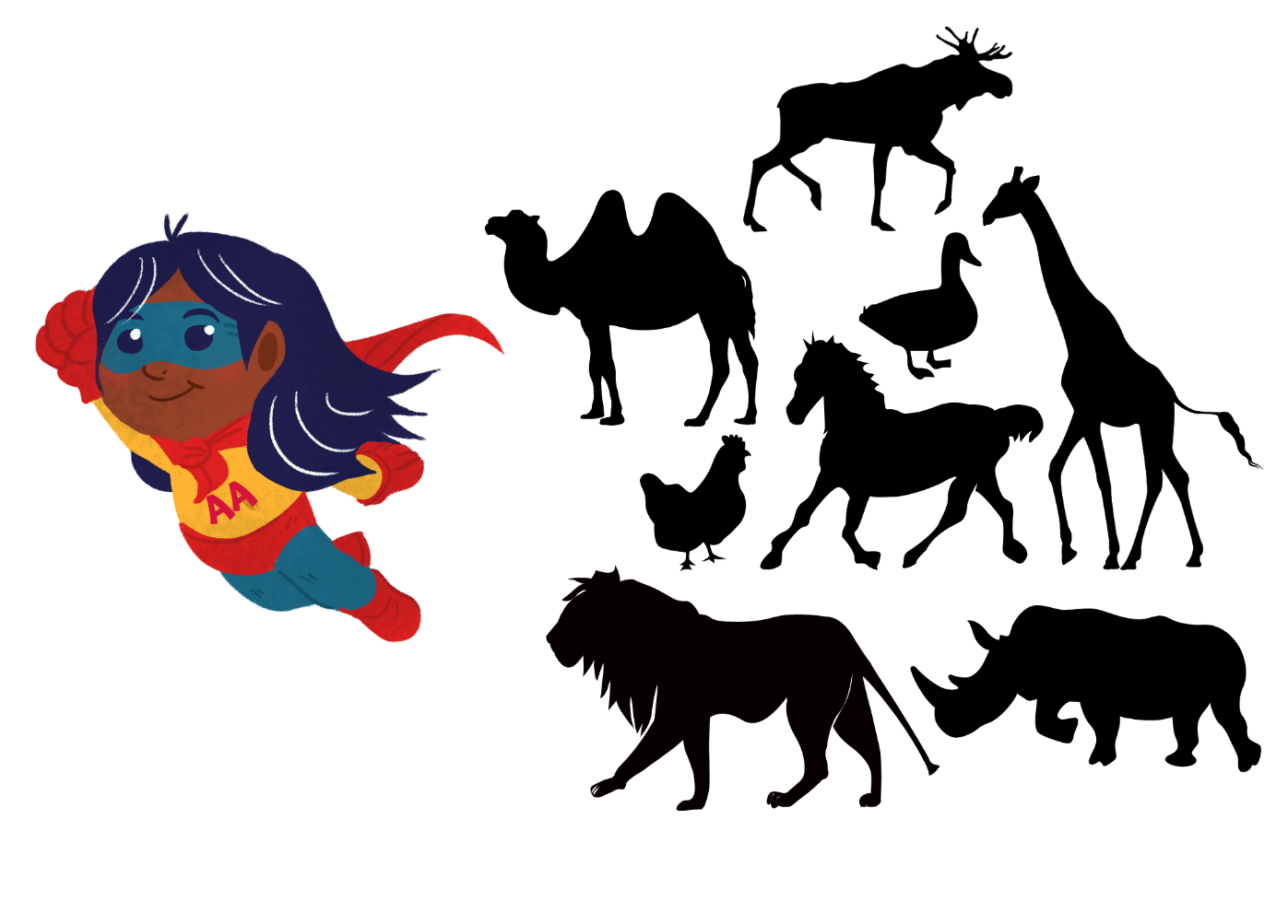
Images sourced from Canva and used in accordance with the Canva Content License Agreement.

Resource 3: How many? – Part 1
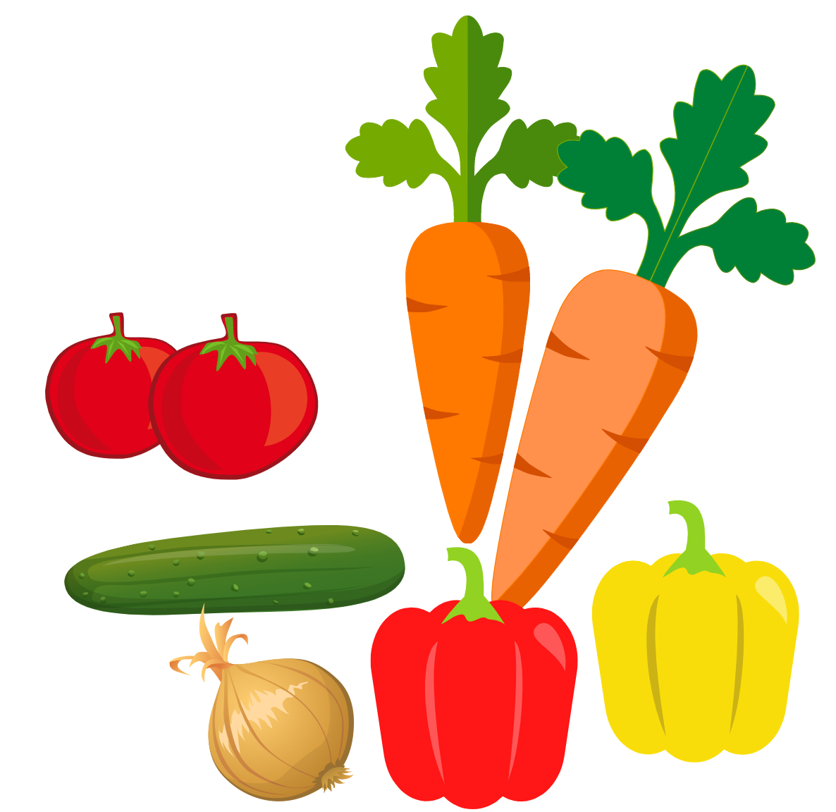
Images sourced from Canva and used in accordance with the Canva Content License Agreement.

Resource 4: How many? – Part 2
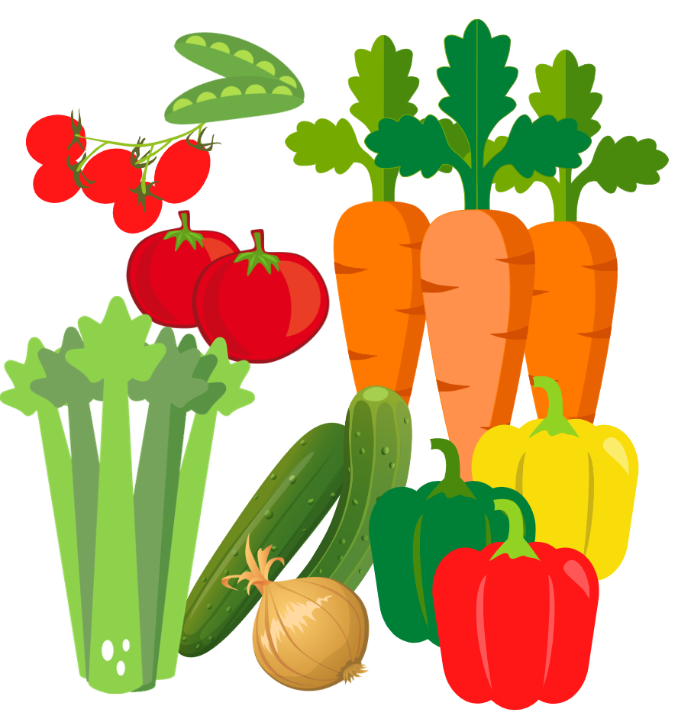
Images sourced from Canva and used in accordance with the Canva Content License Agreement.

Resource 5: How many? – Part 3
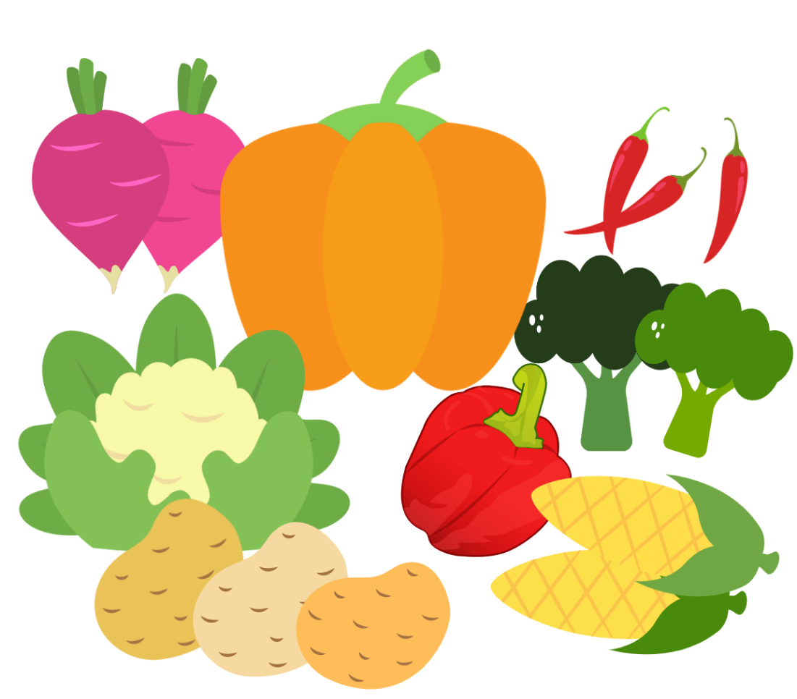
Images sourced from Canva and used in accordance with the Canva Content License Agreement.

Resource 6: Shape talk

Resource 7: Scavenger hunt 1
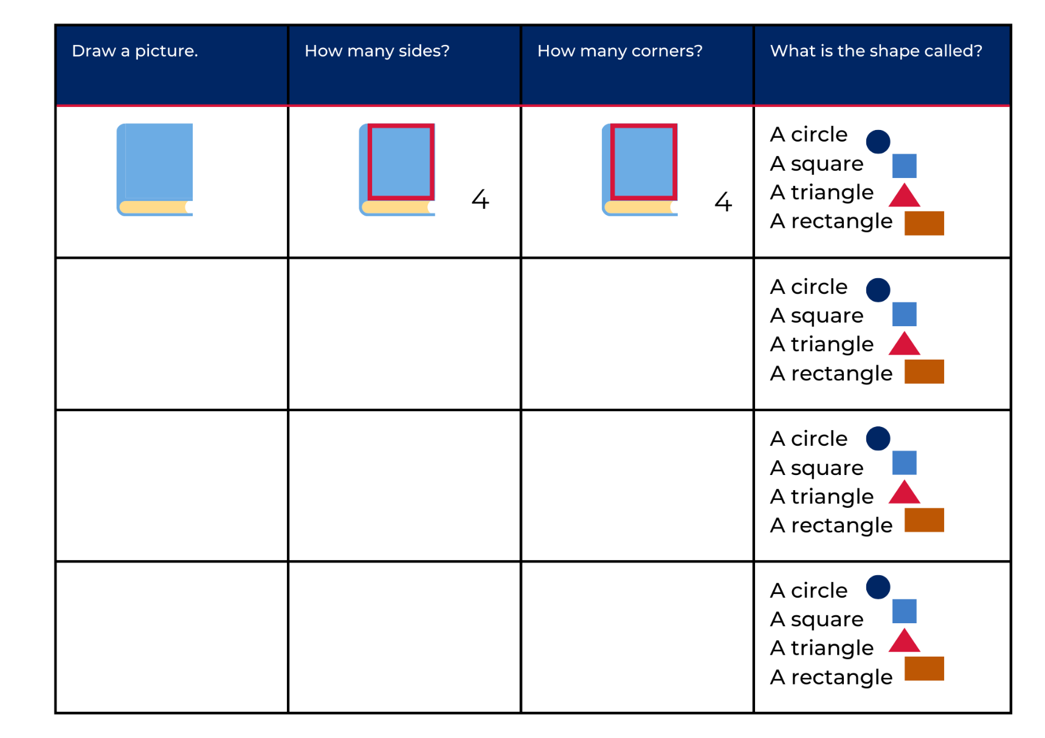
Images sourced from Canva and used in accordance with the Canva Content License Agreement.

Resource 8: Scavenger hunt 2
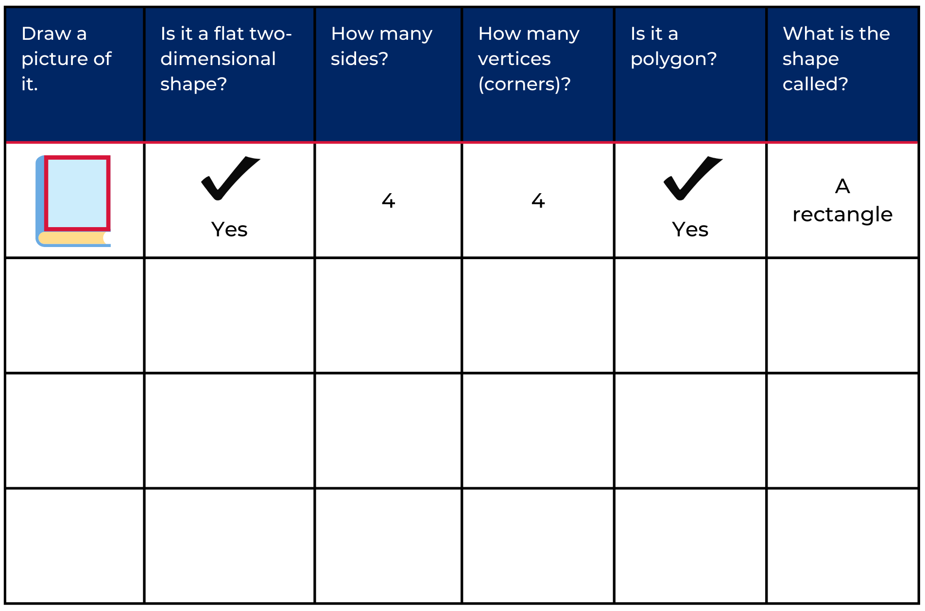
Images sourced from Canva and used in accordance with the Canva Content License Agreement.

Resource 9: Domino patterns
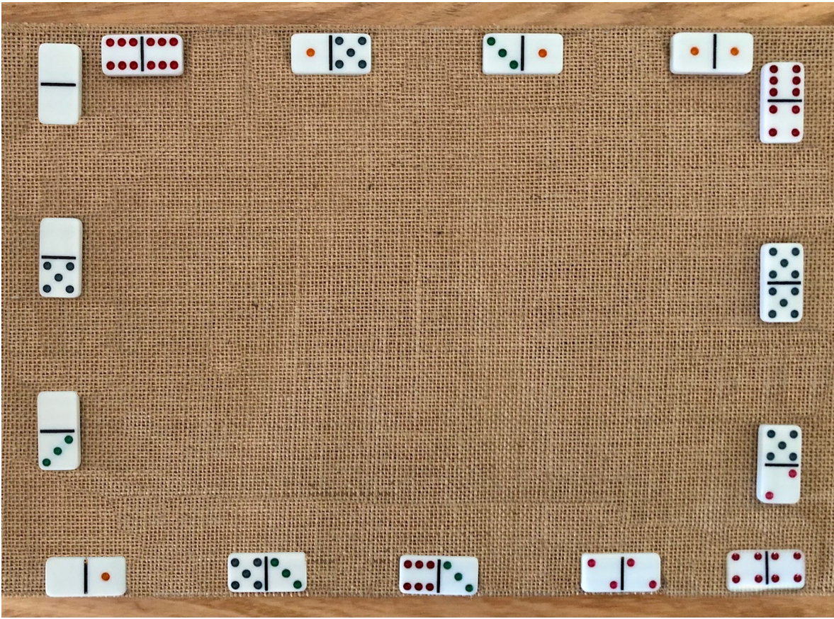

Resource 10: Dice patterns cards
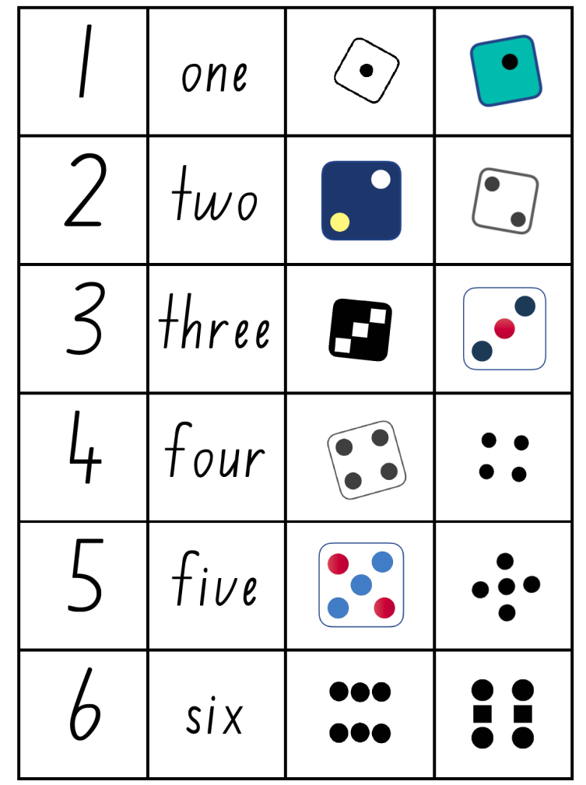

Resource 11: Shapes to sort 1
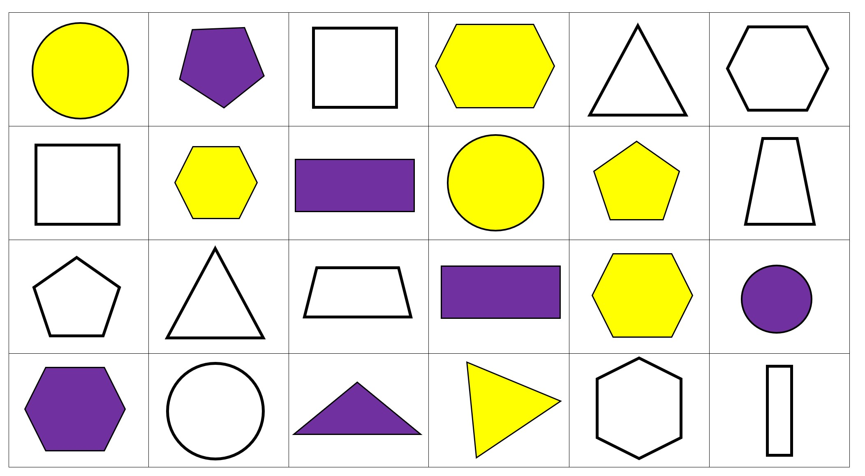

Resource 12: Shapes to sort 2
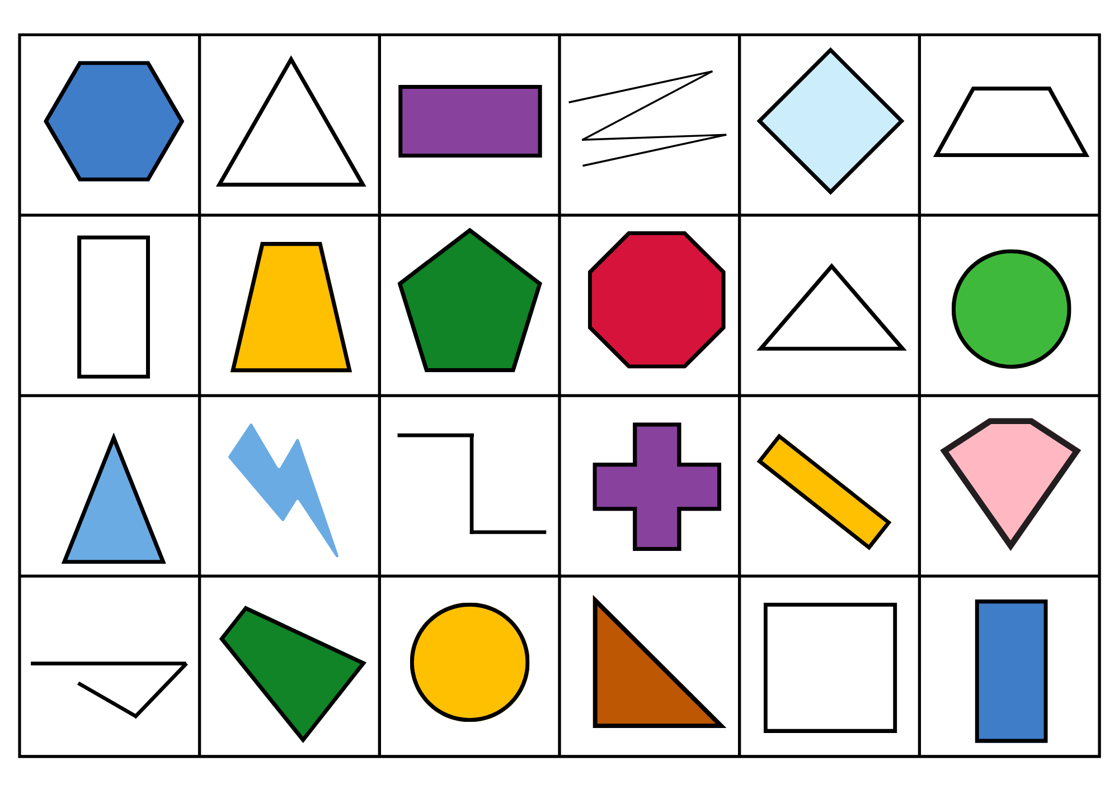

Resource 13: What do you notice?
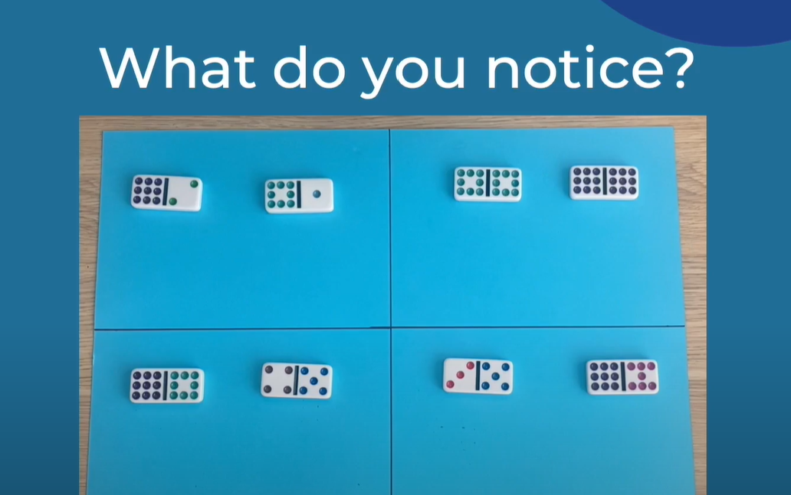

Resource 14: Numbers to sort 1
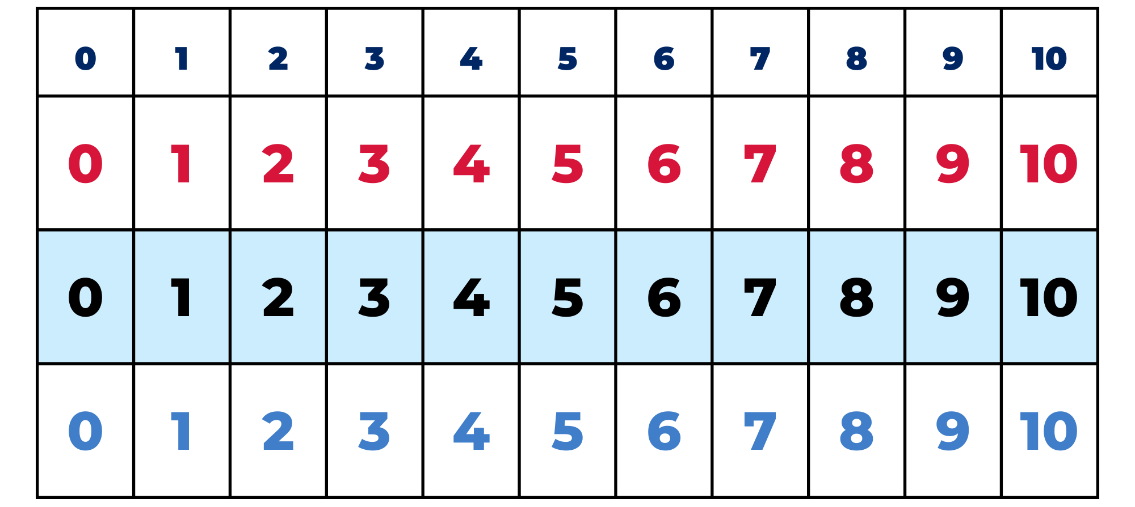

Resource 15: Numbers to sort 2
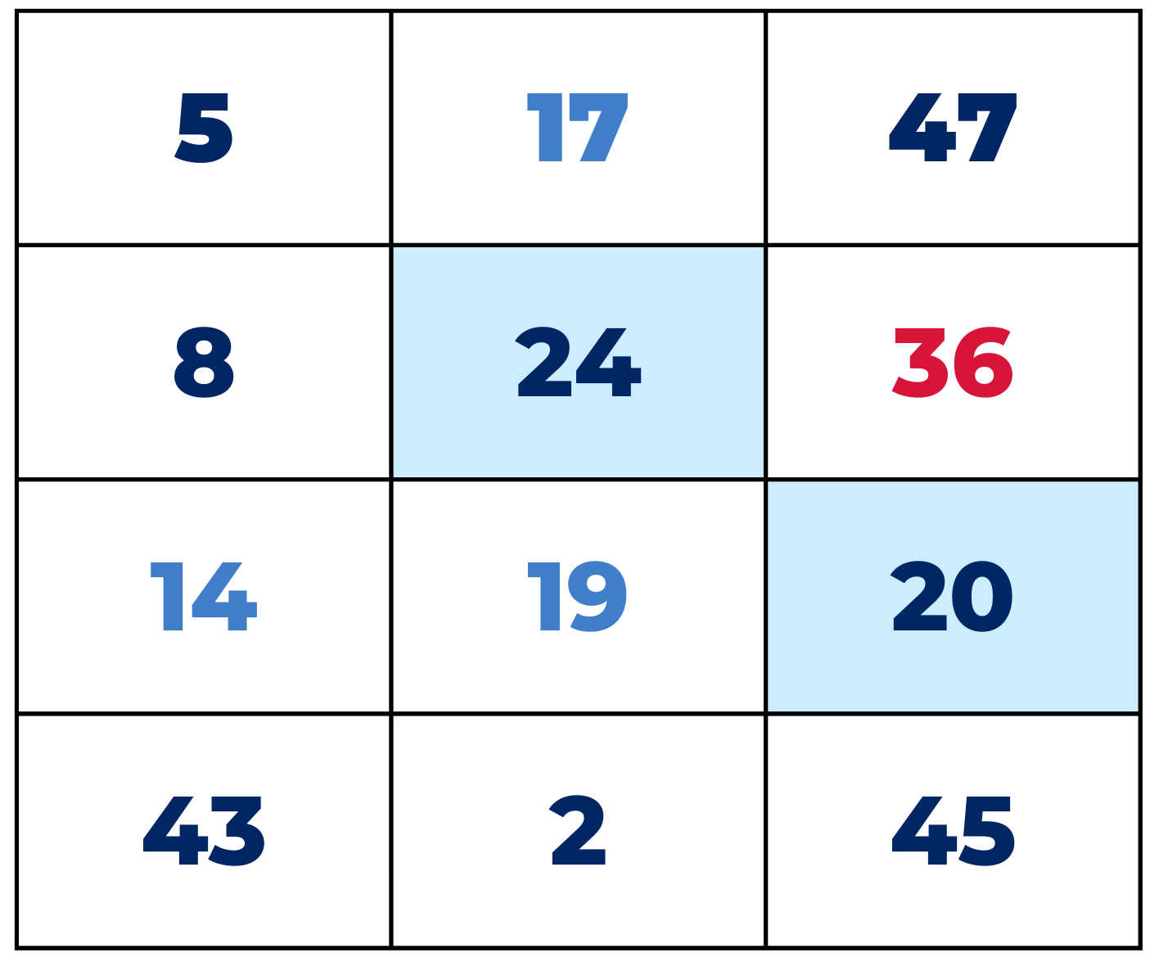

Resource 16: Number cards
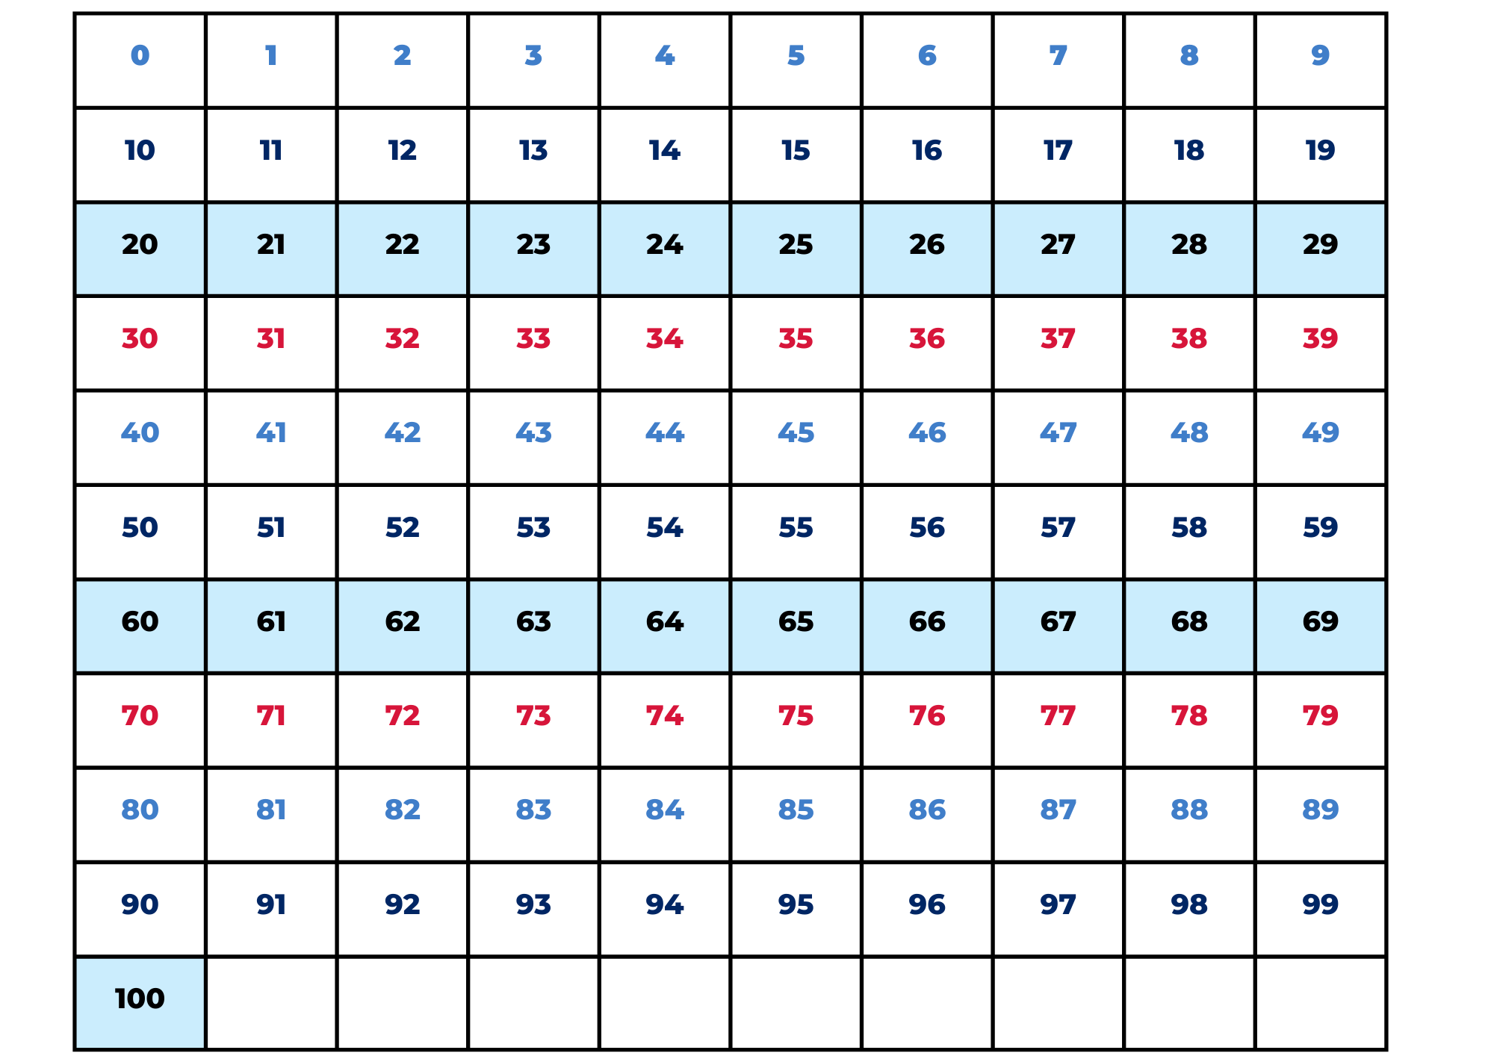

Resource 17: Ten-frame gameboard
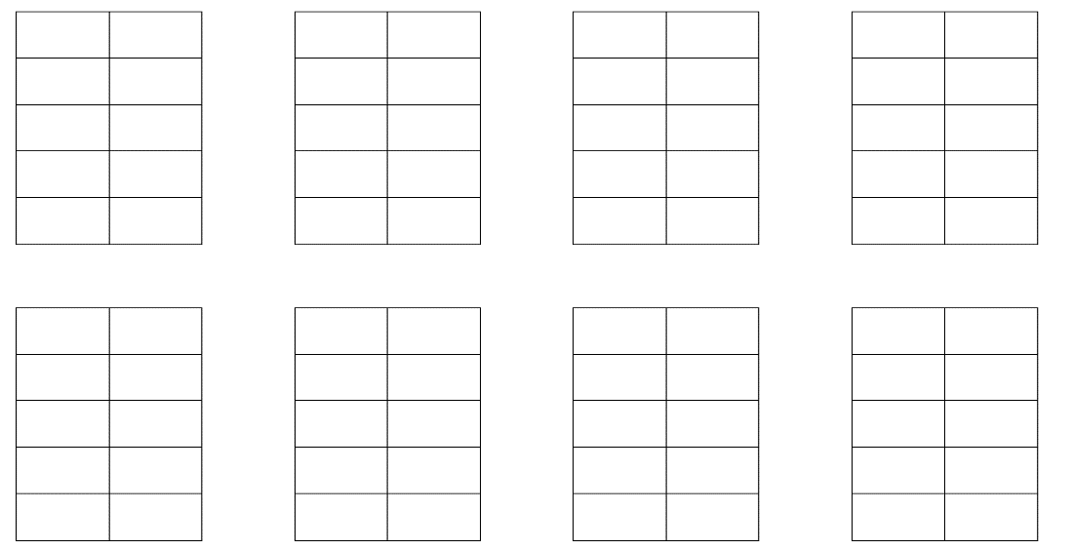

Resource 18: Boxes of pencils
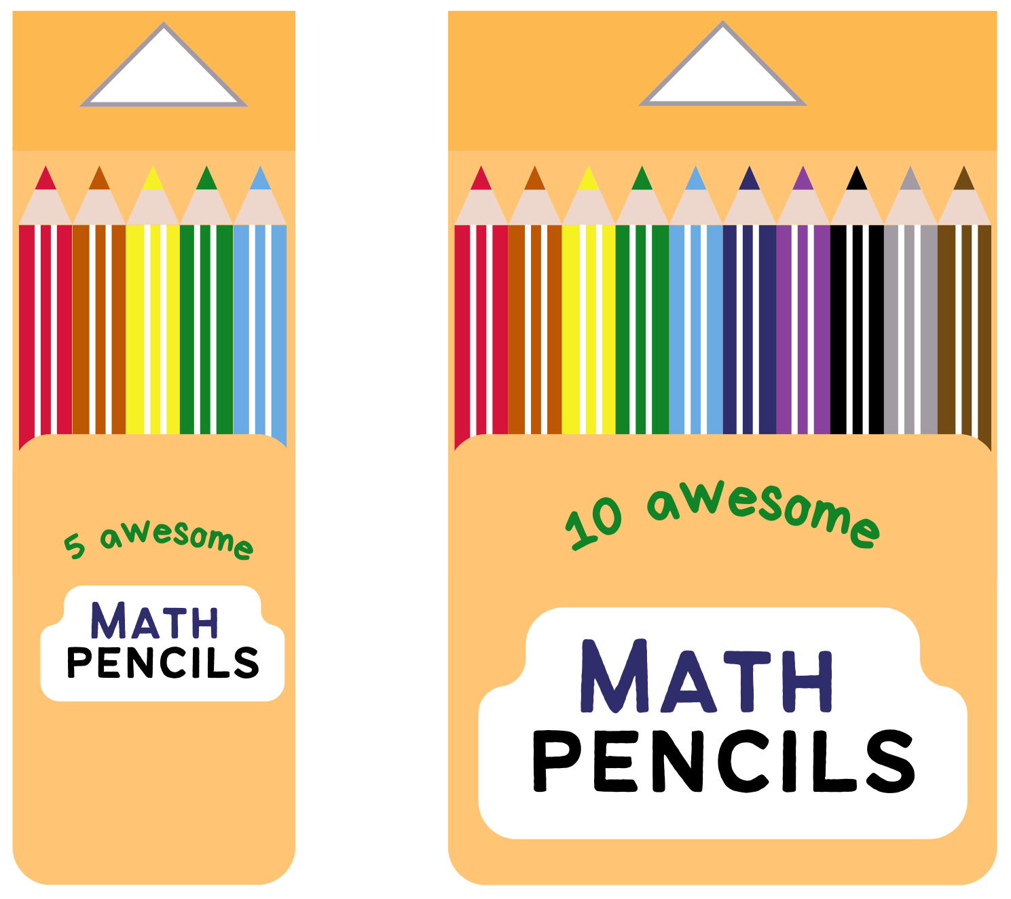
This image contains content obtained from Canva, and its use outside of this resource is subject to Canva’s Content License Agreement. If you wish to use it separately from the resource, please go to Canva.

Resource 19: A group needs…
A group needs… | How many boxes can you make? | How many loose pencils are left over?
7 pencils
12 pencils
8 pencils
15 pencils
4 pencils
19 pencils
24 pencils
26 pencils
Adapted from Boaler et al. (2021).

Resource 20: A class needs…
A class needs… | How many full boxes can you make? | How many loose pencils are left over?
26 pencils
46 pencils
55 pencils
60 pencils
73 pencils
81 pencils
93 pencils
63 pencils
67 pencils
18 pencils
Adapted from Boaler et al. (2021).

Syllabus outcomes and content
The table below outlines the syllabus outcomes and range of relevant syllabus content covered in this unit. Content is linked to National Numeracy Learning Progression version (3).
Focus area and outcomes | Content groups and content points | Lessons
Representing whole numbers  MAO-WM-01  MAE-RWN-01, MA1-RWN-01  MAE-RWN-02, MA1-RWN-02 | Early Stage 1  Instantly name the number of objects within small collections  - instantly recognise (subitise) the number of items in small groups of up to four items without counting (NPV1, CPr1)  - identify the number of items in different arrangements (CPr2)  Use the counting sequence of ones flexibly  - count forwards to at least 30 and state the number after or before a given number, without needing to count from one (CPr4) | 1 and 2, 5–8
Representing whole numbers A (cont) | Stage 1  Use counting sequences of ones with two-digit numbers and beyond  - identify the number before and after a given two-digit number (CPr5)  - count forwards and backwards by ones from a given number to at least 120 (CPr6)  Represent the structure of groups of ten in whole numbers  - recognise that ten ones is the same as one ten (NPV2, NPV4)  - use 10 as a reference in forming numbers from 11 to 20 (CPr7)  - count large sets of objects by systematically grouping in tens (CPr7)  - estimate, to the nearest ten, the number of objects in a collection and check by counting in groups of ten (CPr7, NPV6) | 1 and 2, 5–8
Combining and separating quantities  MAO-WM-01  MAE-CSQ-01, MA1-CSQ-01  MAE-CSQ-02  Note – There is only one combining and separating quantities outcome for Stage 1. | Early Stage 1  Model additive relations and compare quantities  - identify situations in which addition and subtraction may be applied (AdS1-AdS2)  - use concrete materials or fingers to model and solve addition and subtraction questions, counting forwards or backwards by ones as necessary (AdS1-AdS2, NPV3)  Identify part–whole relationships in numbers up to 10  - use visual representations of numbers to assist with combining and separating quantities, identifying the relationship between the quantities (NPV2, AdS2-AdS3, NPA2)  - describe the action of combining, separating and comparing (AdS1)  - use five as a reference in forming numbers from six to ten  - create, model and recognise combinations for numbers up to ten (AdS2)  - count by ones to find the total or difference (AdS2-AdS3) | 1 and 2, 5–8
Combining and separating quantities A (cont) | Stage 1  Use advanced count-by-one strategies to solve addition and subtraction problems  - apply the terms ‘add’, ‘plus’, ‘equals’, ‘is equal to’, ‘is the same as’, ‘take away’, ‘minus’ and ‘the difference between’ to describe combining and separating quantities (AdS2-AdS6)  - recognise and use the symbols for plus (+), minus (–) and equals (=)  - record number sentences in a variety of ways using drawings, words, numerals and symbols (AdS6)  - fluently use advanced count-by-one strategies including counting on and counting back to solve addition and subtraction problems involving one- and two-digit numbers (AdS3-AdS5)  Recognise and recall number bonds up to ten  - recognise, recall and record combinations of two numbers that add up or bond to form 10 (AdS2, AdS6)  - model and record patterns for individual numbers up to ten by making all possible whole-number combinations  - create, recall and recognise combinations of two numbers that add up to numbers less than 10 (AdS2, AdS6)  - describe combinations for numbers using words such as more than, less than and double (AdS6)  Use flexible strategies to solve addition and subtraction problems  - use non-count-by-one strategies such as using doubles for near doubles and combining numbers that add to ten (AdS6)  - represent addition and subtraction using structured materials such as a bead string or similar model (AdS6-AdS7)  - select and apply strategies using number bonds to solve addition and subtraction problems with one- and two-digit numbers by partitioning numbers using quantity value and bridging to 10 (AdS6-AdS7)  Represent equality  - model the commutative property for addition and apply it to aid the recall of addition facts (AdS7)  - recall related addition and subtraction facts for numbers to at least 10 (AdS6) | 1 and 2, 5–8
Combining and separating quantities B (cont) | Stage 1  Represent and reason about additive relations  - create, record and recognise combinations of two numbers that add to numbers from 11 up to and including 20 (AdS7)  - create, model and solve word problems, using number sentences  - represent the difference between two numbers using concrete materials and diagrams (AdS6)  - represent a constant difference between pairs of numbers  - recall and use related addition and subtraction number facts to at least 20 (AdS7)  Form multiples of ten when adding and subtracting two-digit numbers  - use quantity values to separate tens and ones for addition (only) (AdS7-AdS8)  Use knowledge of equality to solve related problems  - use number bonds to determine a missing number (AdS6, NPA3-NPA4)  - use number knowledge to solve related problems (AdS7, NPA4)  - use a variety of ways of writing number sentences (NPA3-NPA4)  - use number bonds to solve equality problems (NPA3-NPA4) | 1 and 2, 5–8
Two-dimensional spatial structure  MAO-WM-01  MAE-2DS-01, MA1-2DS-01  MAE-2DS-02, MA1-2DS-02 | Early Stage 1  2D shapes: Sort, describe and name familiar shapes  - identify familiar shapes in a range of contexts  - sort shapes according to features such as size and shape (UGP1-UGP2)  - recognise and explain how a group of shapes has been sorted  - describe shapes, including circles, squares, triangles and rectangles (UGP1-UGP2)  - ask and respond to questions that help identify and name a particular shape  2D shapes: Represent shapes  - manipulate circles, squares, triangles and rectangles, and describe their features (UGP2-UGP3)  - make representations of shapes in a variety of ways, using paint, paper, movements or technology (UGP3)  - make pictures and designs using a selection of shapes | 1, 3, and 4
Two-dimensional spatial structure A (cont) | Stage 1  2D shapes: Recognise and classify shapes using obvious features  - explore, manipulate and describe features of polygons (UGP3)  - use the terms ‘side’, ‘vertex’ and ‘two-dimensional’ to describe plane (flat) shapes (UGP1-UGP2)  - compare, sort and classify polygons according to the number of sides or vertices (UGP3-UGP4)  - select and name a shape from a description of its features, identifying triangles, quadrilaterals, pentagons, hexagons and octagons  - recognise that shapes with the same name may have sides of equal or different lengths  - identify shapes presented in different orientations (UGP2) | 1, 3, and 4
Two-dimensional spatial structure B (cont) | Stage 1  2D shapes: Represent, combine and separate two-dimensional shapes  - make representations of two-dimensional shapes and combinations of shapes in different orientations  - combine and split single shapes and arrangements of shapes to form new shapes | 1, 3, and 4
Data  MAO-WM-01  MAE-DATA-01, MA1-DATA-01  MA1-DATA-02  Note – There is only one data outcome for Early Stage 1. | Early Stage 1  Organise objects into simple data displays and interpret the displays  - group objects according to characteristics (IRD1)  - interpret information presented in a data display to answer questions (IRD2) | 3–5
Data A (cont) | Stage 1  Ask questions and gather data  - investigate a topic of interest by choosing suitable questions to obtain appropriate data (IRD2)  - gather data and track what has been counted by using concrete materials, tally marks, lists or symbols (IRD3)  Represent data with objects and drawings and describe the displays  - use concrete materials or pictures of objects as symbols to create data displays where one object or picture represents one data value (IRD2)  - describe information presented in one-to-one data displays (IRD2)  - use comparative language to describe information presented in a display, such as ‘more than' and ‘less than’  - interpret a data display and identify the biggest or smallest values (IRD2) | 3–5
Data B (cont) | Stage 1  Identify a question of interest and gather relevant data  - pose suitable questions where the answers form categories, and predict the likely responses (IRD2)  - collect data on familiar topics (IRD2)  - sort data into relevant categories (IRD2)  Create displays of data and interpret them  - organise collected data into lists and tables to display information (IRD2)  - represent data in a picture graph using a baseline, equal spacing and same-sized symbols (IRD2)  - interpret information presented in tables and picture graphs (IRD2)  - record answers to questions using the information in tables and picture graphs (IRD2) | 3–5

References
Links to third-party material and websites
Please note that the provided (reading/viewing material/list/links/texts) are a suggestion only and implies no endorsement, by the New South Wales Department of Education, of any author, publisher, or book title. School principals and teachers are best placed to assess the suitability of resources that would complement the curriculum and reflect the needs and interests of their students.
If you use the links provided in this document to access a third-party's website, you acknowledge that the terms of use, including licence terms set out on the third-party's website apply to the use which may be made of the materials on that third-party website or where permitted by the Copyright Act 1968 (Cth). The department accepts no responsibility for content on third-party websites.
Except as otherwise noted, all material is © State of New South Wales (Department of Education), 2021 and licensed under the Creative Commons Attribution 4.0 International License. All other material (third-party material) is used with permission or under licence. Where the copyright owner of third-party material has not licensed their material under a Creative Commons or similar licence, you should contact them directly for permission to reuse their material.
Mathematics K–10 Syllabus © 2022 NSW Education Standards Authority (NESA) for and on behalf of the Crown in right of the State of New South Wales.
© 2022 NSW Education Standards Authority. This document contains NSW Curriculum and syllabus content. The NSW Curriculum is developed by the NSW Education Standards Authority. This content is prepared by NESA for and on behalf of the Crown in right of the State of New South Wales. The material is protected by Crown copyright.
Please refer to the NESA Copyright Disclaimer for more information.
NESA holds the only official and up-to-date versions of the NSW Curriculum and syllabus documents. Please visit the NSW Education Standards Authority (NESA) website and the NSW Curriculum website.
National Numeracy Learning Progression © Australian Curriculum, Assessment and Reporting Authority (ACARA) 2010 to present, unless otherwise indicated. This material was downloaded from the Australian Curriculum website (National Numeracy Learning Progression) (accessed 8 September 2022) and was not modified. The material is licensed under CC BY 4.0. Version updates are tracked in the ‘Curriculum version history’ section on the 'About the Australian Curriculum' page of the Australian Curriculum website.
ACARA does not endorse any product that uses the Australian Curriculum or make any representations as to the quality of such products. Any product that uses material published on this website should not be taken to be affiliated with ACARA or have the sponsorship or approval of ACARA. It is up to each person to make their own assessment of the product, taking into account matters including, but not limited to, the version number and the degree to which the materials align with the content descriptions and achievement standards (where relevant). Where there is a claim of alignment, it is important to check that the materials align with the content descriptions and achievement standards (endorsed by all education Ministers), not the elaborations (examples provided by ACARA).
This resource contains images and content obtained from Canva, and their use outside of this resource is subject to Canva’s Content License Agreement. If you wish to use them separately from the resource, please go to Canva.
Boaler J, Munson J and William C (2021) Mindset Mathematics: Visualizing and Investigating Big Ideas, Grade 1, Jossey-Bass, New Jersey.
Bobis J (1996) ‘Visualisation and the development of number sense with kindergarten children’, in Mulligan J and Mitchelmore M (eds.) Children's Number Learning: A Research Monograph of the Mathematics Education Group of Australasia and the Australian Association of Mathematics Teachers, Adelaide: AAMT.
ClassDojo, Inc (n.d.) 'Your brain is like a muscle' [video], Growth Mindset, ClassDojo website, accessed 8 September 2022.
Siemon D, Warren E, Beswick K, Faragher R, Miller J, Horne M, Jazby D, Breed M, Clark J and Brady K (2020) Teaching Mathematics: Foundations to Middle Years, 3rd edn, Oxford University Press Australia and New Zealand.
University of Cambridge (Faculty of Mathematics) (2022) Noah, NRICH website, accessed 8 September 2022.

