Mathematics – Early Stage 1 – Unit 14
Contents
Unit description and duration 4
Student prior learning 4
Lesson overview and resources 5
Lesson 1: My hug 10
Daily number sense: Comparing numbers to 10 – 15 minutes 10
How long is your hug? – 40 minutes 12
Consolidation and meaningful practice: Discuss and connect the mathematics – 10 minutes 14
Lesson 2: Snail trails 15
Daily number sense: Basketball toss – 15 minutes 15
A snail’s journey – 30 minutes 17
Consolidation and meaningful practice: Discuss and connect the mathematics – 10 minutes 19
Lesson 3: Paper area 20
Daily number sense: Guess my number – 10 minutes 21
Paper area – 40 minutes 23
Consolidation and meaningful practice: How similar are these? – 10 minutes 26
Lesson 4: Shape prints 27
Daily number sense – 10 minutes 27
Prints – 40 minutes 28
Consolidation and meaningful practice: Sharing the artwork – 10 minutes 31
Lesson 5: Class shop 32
Daily number sense: Matching numbers – 10 minutes 32
Shopping – 40 minutes 34
Consolidation and meaningful practice: Discuss and connect the mathematics – 10 minutes 36
Lesson 6: Pouring and packing 37
Daily number sense: Race to write – 10 minutes 37
Packaging – 40 minutes 38
Lesson 7: Sandcastle investigation 42
Daily number sense: Robots – 10 minutes 42
Which sandcastle is the biggest? – 40 minutes 44
Consolidation and meaningful practice: Discuss and connect the mathematics – 10 minutes 47
Lesson 8: Measuring attributes 48
Daily number sense: Hopscotch counting – 10 minutes 48
What am I? – 30 minutes 50
Consolidation and meaningful practice: Discuss and connect the mathematics – 10 minutes 53
Resource 1: Butterflies and flowers 54
Resource 2: Butterflies and flowers 2 55
Resource 3: Ten-frame 56
Resource 4: Recording hugs 57
Resource 5: Frayer model 58
Resource 6: Squiggly lines 59
Resource 7: Matching numbers 60
Resource 8: Word cline 62
Resource 9: Recording weight 63
Resource 10: Race to write 64
Resource 11: Sandcastles 65
Resource 12: Recording volume 66
Resource 13: Attribute sorting 67
Resource 14: Attribute sorting 2 68
Syllabus outcomes and content 69
References 74

Unit description and duration
This two-week unit develops student knowledge, understanding and skills of measurement and units of measurement. Students are provided opportunities to:
- measure length by direct and indirect comparison
- identify and compare area and mass
- compare internal volume by filling and packing.
Mathematics K–10 Syllabus © 2022 NSW Education Standards Authority (NESA) for and on behalf of the Crown in right of the State of New South Wales.

Student prior learning
Before engaging in these teaching and learning activities, students would benefit from prior experience with:
- using everyday language to compare length, mass, area and volume
- sorting and organising objects based on attributes in everyday situations
- awareness of measurement in everyday life such as pouring cups of water, comparing size and shapes.

Lesson overview and resources
The table below outlines the sequence and approximate timing of lessons; syllabus focus areas and content groups; and resources.
Lesson | Syllabus focus area and content groups | Resources
Lesson 1: My hug  65 minutes  ‘Longer’ or ‘shorter’ are used to make comparisons of length. | Representing whole numbers  - Instantly name the number of objects within small collections  - Use the counting sequence of ones flexibly  - Recognise number patterns  - Connect counting and numerals to quantities  Geometric measure  - Length: Use direct and indirect comparisons to decide which is longer | - Resource 1: Butterflies and flowers  - Resource 2: Butterflies and flowers 2  - Resource 3: Ten-frame (one per student)  - Resource 4: Recording hugs (one per student)  - Resource 5: Frayer model  - Dice (one per student)  - Counters (in 2 different colours)  - Objects to measure against arm span
Lesson 2: Snail trails  55 minutes  We can compare lengths directly and indirectly. | Representing whole numbers  - Instantly name the number of objects within small collections  - Use the counting sequence of ones flexibly  - Recognise number patterns  - Connect counting and numerals to quantities  Geometric measure  - Length: Use direct and indirect comparisons to decide which is longer | - Resource 3: Ten-frame (per pair)  - Resource 6: Squiggly lines (one per student)  - Basket/bucket/container  - Chalk or starting line  - Counters  - Rolled up socks or ball (per pair)  - Scissors  - String  - Tape  - Writing materials
Lesson 3: Paper area  60 minutes  Area measures the space inside a two-dimensional region. | Representing whole numbers  - Instantly name the number of objects within small collections  - Use the counting sequence of ones flexibly  - Recognise number patterns  - Connect counting and numerals to quantities  Two-dimensional spatial structure  - Area: Identify and compare area | - A4 paper (one sheet per student)  - Classroom items to superimpose  - Deck of cards (per pair)  - Workbooks  - Writing materials
Lesson 4: Shape prints  60 minutes  Spatial reasoning includes the ability to visualise and compare area. | Representing whole numbers  - Instantly name the number of objects within small collections  - Use the counting sequence of ones flexibly  - Recognise number patterns  - Connect counting and numerals to quantities  Two-dimensional spatial structure  - Area: Identify and compare area | - Resource 5: Frayer model  - Two contrasting colours of paint  - Art paper (one per student)  - Paintbrush  - Treasure box of objects whose surfaces can be printed, including potato pieces, pattern blocks, jar lid, and so on.  - Writing materials
Lesson 5: Class shop  60 minutes  It is difficult to estimate an object’s mass by looking and thinking. | Representing whole numbers  - Instantly name the number of objects within small collections  - Use the counting sequence of ones flexibly  - Recognise number patterns  - Connect counting and numerals to quantities  Non-spatial measure  - Mass: Identify and compare mass using weight | - Resource 7: Matching numbers (one per pair)  - Resource 8: Word cline  - Resource 9: Recording weight  - Matching Numbers  - Shopping items such as tissue box, washing powder, can of food, bag of chips, bag of sugar, and so on  - Writing materials
Lesson 6: Pouring and packing  50 minutes  Objects can look different but still have the same internal volume. | Representing whole numbers  - Instantly name the number of objects within small collections  - Use the counting sequence of ones flexibly  - Recognise number patterns  - Connect counting and numerals to quantities  Three-dimensional spatial structure  - Volume: Compare internal volume by filling and packing | - Resource 10: Race to write  - Cup (per pair)  - Dice (2 per pair)  - Large number of beads (or substitute)  - Packaging examples such as bottles, jars, containers  - Writing materials
Lesson 7: Sandcastle investigation  60 minutes  Internal volume (capacity) is a measure of how much a container can hold. | Three-dimensional spatial structure  - Volume: Compare internal volume by filling and packing  - Volume: Compare volume by building | - Resource 11: Sandcastles  - Resource 12: Recording volume  - 10 connecting cubes (per student)  - Sand  - Variety of sandcastle moulds (or containers)
Lesson 8: Measuring attributes  50 minutes  We can compare things by how much of a particular attribute each has. | Representing whole numbers  - Instantly name the number of objects within small collections  - Use the counting sequence of ones flexibly  - Recognise number patterns  - Connect counting and numerals to quantities  Geometric measure  - Length: Use direct and indirect comparisons to decide which is longer  Two-dimensional spatial structure  - Area: Identify and compare area  Three-dimensional spatial structure  - Volume: Compare volume by building  Non-spatial measure  - Mass: Identify and compare mass using weight | - Resource 13: Attribute sorting  - Resource 14: Attribute sorting 2  - Chalk to draw number track  - Counters  - Objects to sort, including toys, glue sticks, drink bottles, fruit, and so on  - Writing materials

Lesson 1: My hug
Core concept: ‘Longer’ or ‘shorter’ are used to make comparisons of length.
The table below contains suggested learning intentions and success criteria. These are best co-constructed with students.
Learning intentions | Success criteria
Students are learning that:  - the attribute of length is measured from end to end  - comparative language is used to describe length. | Students can:  - compare lengths using direct comparison  - explain which is longer or shorter.

Daily number sense: Comparing numbers to 10 – 15 minutes
- Build student understanding of whole number by comparing the number of butterflies and flowers in each collection.
- Display Resource 1: Butterflies and flowers and tell students they will be counting the collections of butterflies and flowers. As the class counts out aloud, circle each butterfly with a marker. Repeat the counting process with the flowers.
- Display Resource 2: Butterflies and flowers 2 and repeat the process of counting the collections of butterflies and flowers aloud as a class.
- Ask students:
- How did you know the collections were the same or equal?
- Which collection has more? How do you know?
- Provide each student with a die and a handful of counters in 2 different colours. Ask students to roll their die and collect the number of counters that appears on their die in the same colour.
- Ask students to roll their die again and collect the number of counters that appear on their die in a different colour.
- Ask students to compare quantities by asking:
- Which one has more?
- How many more are there?
- How do you know?
- Ask students to share their strategy for counting their collection.
- Ask students how they could arrange their collections of counters to make counting easier.
- Discuss that even though their collection of counters is in a different arrangement, it is still the same quantity.
- Ask students to visualise how many more counters are needed to make the collections the same.
- Ask students to check their estimation by adding counters to make the 2 collections the same.
Note: Use Resource 3: Ten-frame to help students visualise and count collections.

How long is your hug? – 40 minutes
This activity has been adapted from ‘Gorilla arms’ from Teaching Measurement Early Stage 1 to Stage 1 by the NSW Department of Education.
- Ask students what some people refer to when they describe a big hug.
- Explain that, in this lesson, students will investigate who in the class has the longest arm span from end-to-end. Ask students what is at the end of their arms. Explain that when measuring arm span, students must measure fingertips to fingertips.
- Ask students to stretch their arms out straight.
- Have students look around the room and see if they can predict something that is the same length as their outstretched arms.
- Ask students to turn and talk to discuss their prediction, then draw it on Resource 4: Recording hugs.
- Discuss what to remember when comparing lengths. This includes making sure one fingertip end aligns to the object end and then noticing where the item ends. Students need to ensure arms are straight for a fair measurement.
- Demonstrate comparing a classroom item, such as a table length. Place fingertips, aligned to one end and notice where the table ends against your body. Ask students to describe what they see.
- Students revisit predictions on Resource 4: Recording hugs. Ask students to measure the items against their arm span and draw a picture to record their results.
- Use ‘Talk moves’ to discuss what they discovered when comparing lengths.
- Record students’ language when describing length on Resource 5: Frayer model.
Note: Students may need practise with the language of length in a variety of contexts. Young students often use general terms such as ‘big’ when they mean ‘long’.
- Ask students to form groups of 3.
- Have students stretch their arms out and visualise the order of arm spans from shortest to longest.
- Ask students to turn and talk to discuss their prediction.
- Students compare arm span length and then order the group from smallest to longest arm span.
- Use ‘Talk moves’ to support students to explain their method for comparing and ordering the lengths.
- Encourage the use of comparative language such as, longer, higher, taller than, shorter or lower than, the same as, longest, shortest.
This table details assessment opportunities and differentiation ideas.
Assessment opportunities | Too hard? | Too easy?
What to look for:  - Can the students compare lengths using direct comparison? (MAO-WM-01, MAE-GM-02)  - Can the students explain which is longer or shorter? (MAO-WM-01, MAE-GM-02)  What to collect:  - Completed Resource 4: Recording hugs and observations of student investigation (MAO-WM-01, MAE-GM-02) | Students cannot use direct comparison of arm spans.  - Get students to compare objects where the difference in lengths is very noticeable, for example, the table is longer than the pencil.  - Make sure students are aligning the ends when comparing the length of 2 objects.  Students cannot explain which arm span is longer or shorter.  - Model your arm span against the student’s arm span and highlight the fact that both ends are aligned. Ask whose arms are longer.  - Compare object lengths by lining them up correctly and getting students to tell you which one is longer or shorter. | Students can use direct comparison of arm spans.  - Have students compare lengths of their arm spans when ends are not aligned and see if they can still tell which is longer.  - Ask students to find as many things in the room as they can that are longer than their arm span.  Students can explain which arm span is longer or shorter.  - Have students explain why the length of an object remains constant when ends are not aligned (Reasons about relations).  - Ask students to look at the arm span of other students without comparing and predict if their arm span is longer or shorter.

Consolidation and meaningful practice: Discuss and connect the mathematics – 10 minutes
- Summarise the lesson, drawing out key mathematical ideas about estimation and measuring length. Ask students:
- How did you visualise your lengths?
- Were your predictions close to your measurement? Why or why not?
- Would you do something different if you were to do this again? Explain your reasons.
- Did you have any challenges measuring and comparing the lengths? How did you solve these challenges?
- How could you explain what you have learnt about measuring length to others?

Lesson 2: Snail trails
Core concept: We can compare lengths directly and indirectly.
The table below contains suggested learning intentions and success criteria. These are best co-constructed with students.
Learning intentions | Success criteria
Students are learning that:  - an object’s length remains the same whether it is in a straight or curvy line  - mathematicians record length comparisons using drawings, numerals and words. | Students can:  - measure the length of curved lines using string  - record length comparisons.

Daily number sense: Basketball toss – 15 minutes
This activity has been adapted from Basketball toss from Thinking Mathematically by the NSW Department of Education.
- Build student understanding of comparing quantities by playing basketball toss.
- Ask students:
- Have you ever played basketball?
- What mathematics do you need to play basketball?
- Ask students to see how many times they can successfully shoot a pair of rolled-up socks into a basket.
- In pairs, students mark a clear starting line using chalk for the basketball toss.
- Ask students to take 3 big steps back from the starting line and place a basket, bucket or container at the end.
- Ask one student to stand at the starting line and throw the rolled-up socks into the basket. Ask the other student to keep track of the score by adding a counter to Resource 3: Ten-frame.
- Instruct students to repeat this 10 times with their left hand and then 10 times with their right hand.
Note: In Early Stage 1, students learn to use the terms ‘left’ and ‘right’ to describe position in relation to themselves. You can assist students’ understanding of left and right by modelling and the use of visual cues. The terms ‘left’ and ‘right’ depend on the frame of reference (which way an individual is facing) and can be a source of confusion for several years.
- Ask students to reflect on learning by discussing:
- How many baskets did you get when you used your left hand?
- How many baskets did you get when you used your right hand?
- Which hand was more accurate?
- How did you compare quantities?
- How many did you get altogether?
- Students swap places so the thrower becomes the scorer.

A snail’s journey – 30 minutes
This activity has been adapted from ‘Snail trails’, from First Steps in Mathematics: Measurement – book 1 by the Department of Education Western Australia.
- Display Resource 6: Squiggly lines or draw 4 curved lines on the board.
- Ask students to discuss:
- What do you notice about these lines?
- What do you wonder about these lines?
- Pose the scenario: A silly snail has gone on an adventure. These are the different paths. Can you tell which is the longest path?
- Ask students to turn and talk to discuss:
- How can you measure the length of the lines?
- What advice can you give to someone when comparing and measuring curved lines?
- Ask students if they can predict which path is longest by looking and thinking.
- Ask students to explain their reasoning and record predictions by drawing a picture.
- Measure by curving the string along the lines and cutting the string at the end of each line.
- Give each student Resource 6: Squiggly lines and some string.
- Ask students to measure the 4 squiggly lines so that they have 4 strings.
Note: Students may need support from each other or an adult to accurately cut the string.
- When students have 4 lengths, ask students:
- How could you compare the length of the lines?
- How do you ensure a fair measurement?
- Discuss the importance of lining the ends up of and pulling them straight.
- Compare the strings by lining up the ends and pulling them straight to work out which is the longest.
Note: Students can use tape to ensure securing of the end of the string.
- Gather students in a fishbowl to observe methods of measuring the length. Trial different strategies.
- Ask students to explain their findings and record by adding more detail to their picture.
- Ask students what they needed to change in their diagram.
This table details assessment opportunities and differentiation ideas.
Assessment opportunities | Too hard? | Too easy?
What to look for:  - Can the students measure length of curved lines using string? (MAO-WM-01, MAE-GM-02)  - Can the students record length comparisons? (MAO-WM-01, MAE-GM-02)  What to collect:  - Observation of measuring techniques and their worksheets (MAO-WM-01, MAE-GM-02) | Students cannot measure length of curved lines using string.  - Have students use modelling clay instead of string to measure 2 squiggly lines and then compare the 2.  - Make sure the ends of the strings are lined up correctly by using tape to secure the ends.  Students cannot record length comparison.  - Use enabling prompt such as ‘Can you draw 2 of the lengths and order them?’ and ‘Where would you place the next length?’  - Encourage students to work with a partner to record their thinking, using gallery walks to promote thinking. | Students can measure length of curved lines using string.  - Use a third length to make comparisons between the snail paths.  - Students create their own squiggly snail path and measure using string.  Students can record length comparison.  - Use extending prompts, such as what would change if the path was in a spiral or how could they record this.  - Ask what would happen if the snail only went halfway. Prompt students to explain how they could work out half of the length and how they could record this.

Consolidation and meaningful practice: Discuss and connect the mathematics – 10 minutes
- Summarise the lesson, drawing out key mathematical ideas about estimation and measuring length using string. Ask students:
- What did you notice about measuring curvy lengths?
- How did you visualise the lengths?
- What strategy did you use to measure the curvy length?
- How did you ensure it was an accurate measurement?
- What would you do differently next time when measuring curved lines with string?

Lesson 3: Paper area
Core concept: Area measures the space inside a two-dimensional region.
The table below contains suggested learning intentions and success criteria. These are best co-constructed with students.
Learning intentions | Success criteria
Students are learning that:  - area can be compared by placing one shape on top of another  - comparative language is used to describe area  - quantities can be estimated and compared. | Students can:  - compare areas by superposing paper and surfaces  - use comparative language like bigger or smaller to describe area  - explore comparative relationships between numbers to 10.

Daily number sense: Guess my number – 10 minutes
This activity has been adapted from Guess my number from Thinking Mathematically by the NSW Department of Education.
- Build student understanding of whole number by reasoning about quantities.
- Use playing cards or write cards with the numbers from 1 to 8.
Figure 1 – Number cards
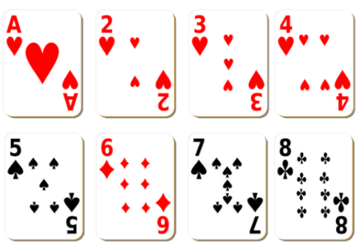
Images sourced from Canva and used in accordance with the Canva Content License Agreement.
- Students play in pairs with one student from the pair choosing a secret number between one and 8.
- Lay all the cards facing upwards from 1 to 8 (see Figure 1).
- The other student must guess the secret number.
- The student with the secret number will say whether their number is more or less than. Cards are taken away as they are ruled out as the secret number.
- Students try to guess the secret number in the fewest number of guesses possible.
- Ask students:
- What strategy did you use to guess your number?
- What did you notice?
- What would you do differently to guess your number faster?
This table details assessment opportunities and differentiation ideas.
Assessment opportunities | Too hard? | Too easy?
What to look for:  - Can students explore comparative relationships between numbers 1 to 10? (MAO-WM-01, MAE-RWN-01, MAE-RWN-02)  What to collect:  - Observation of students playing games and discussion of strategies used (MAO-WM-01, MAE-RWN-01, MAE-RWN-02) | Students cannot explore comparative relationships between numbers 1 to 10.  - Represent the numbers using blocks to visually support comparing quantity.  - Use a number track to visually support. | Students can explore comparative relationships between numbers 1 to 10.  - Increase numbers to 20.  - Students try to guess the number with 3 guesses only.

Paper area – 40 minutes
- Ask students, what it means when items are described as big and small.
- Ask students to point out big and small items in the classroom.
- Explain that, when describing size, objects need to be compared using language like bigger or smaller, otherwise the description of big and small may not be accurate.
- Discuss that, when referring to big and small, students could be talking about length, area or mass.
- Explain that sometimes, when using big and small, students are talking about an object’s area.
- Display a book and a toy. Model comparing the area of different objects by superimposing.
- Ask students:
- What do you notice about the area?
- Which is bigger? How do you know?
- Which is smaller? How do you know?
- Explain that today’s lesson will be about investigating and comparing the sizes of different surfaces.
- Ask students if they can think of ways they can measure and compare surfaces with their piece of paper. Record student suggestions.
- Explain to students that the 2 main strategies used when comparing area by placing one object on top of another are superimposing and superposing (see Figure 2).
Note: Superimposing is when one area is placed on top of the other, whilst superposing is aligning the edges or corners of 2 areas when one is placed on top of the other.
Figure 2 – Superimposing and superposing
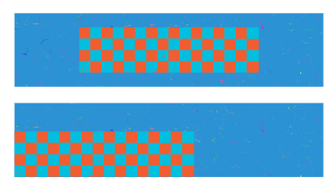
- Working in pairs, students are given a piece of paper and search the classroom for a surface that has an area that is the same as, smaller than and bigger than their piece of paper. Explain to students that the attribute of area is the inside part of the shape.
- Remind students that when looking for surfaces in the classroom they must consider the following:
The table below outlines stimulus prompts to generate conversation about the topic, along with anticipated responses from students.
Prompts | Anticipated student responses
- How will you know if a surface has the same area as your piece of paper?  - What does it tell me if I have gaps around the sides of my paper?  - What does it tell me if my paper hangs over the sides? | - When I put my paper on top of the surface, it is the same size and I don’t have any gaps on the sides.  - The paper does not hang over the edges of the surface.  - It tells you that the paper is smaller than the surface.  - It tells you that the paper is bigger than the surface.
- Encourage students to explain to one another what they must consider when covering a surface in the same way.
- Once students have found surfaces that are the same as, smaller than and bigger than the area of a piece of paper, they must draw a picture of these objects in their workbooks.
This table details assessment opportunities and differentiation ideas.
Assessment opportunities | Too hard? | Too easy?
What to look for:  - Can students use comparative language like bigger than, smaller than and same as when comparing areas? (MAO-WM-01, MAE-2DS-02)  What to collect:  - Drawings of objects that are the same as, smaller than and bigger than their piece of paper (MAO-WM-01, MAE-2DS-02) | Students cannot use comparative language like bigger than, smaller than and same as when comparing areas.  - Give students 2 pieces of paper with the same shape but different areas and model the small piece inside the bigger one.  - Model placing 2 pieces of paper with the same area and shape and explain that they are the same. | Students can use comparative language like bigger than, smaller than and same as when comparing areas.  - Give students the opportunity to compare shapes with similar areas that cannot be superimposed on each other.  - Have students explore shapes around the room and predict if they do or do not have the same area.

Consolidation and meaningful practice: How similar are these? – 10 minutes
- Have students pick 2 objects in the room that they think will have the same area.
- Ask students to trace around both objects and then cut these shapes out.
- Students take these shapes and compare their areas by using the strategies of superimposing or superposing.
- If the shapes do not have the same area, students share with the class which shape is smaller and larger in area, justifying their reasoning.

Lesson 4: Shape prints
Core concept: Spatial reasoning includes the ability to visualise and compare area.
The table below contains suggested learning intentions and success criteria. These are best co-constructed with students.
Learning intentions | Success criteria
Students are learning that:  - shapes can be visualised to estimate and compare area  - areas can be compared by aligning the edges (or corners) of 2 areas when one is placed on top of the other. | Students can:  - predict which of 2 surfaces will have the larger area  - compare areas of shapes by aligning corners and directly printing on top of each other.

Daily number sense – 10 minutes
- From a class need surfaced through formative assessment data, identify a short, focused activity that targets students’ knowledge, understanding and skills. Example activities may be drawn from the following resources:
- Thinking Mathematically Early Stage 1
- Universal Resources Hub

Prints – 40 minutes
- Explain that today, students will be creating a piece of artwork by covering a sheet of paper with prints. These prints will be made from objects from a treasure box (for example, potato pieces, pattern blocks, jar lids) as stamps.
- Ask students to predict which objects have a smaller area and would fit inside another object’s area.
- Students visualise and sort the objects based on the size of their areas. Ask students:
- Which object has the largest area?
- Which object has the smallest area?
- What will I see if I print a larger area on top of a smaller area?
- What will I see if I print a smaller area onto of a larger area?
- What will I see if the areas are the same?
- Using a paint brush, lightly cover the surface of an object and print this in rows (see Figure 3).
Note: When painting the surface of an object, students must cover the entire surface area lightly. Too much paint will obscure the shape and make it hard to compare the shapes.
- On the first row, print an object with a smaller surface over the top with a different colour.
- On the second row, print an object with a larger surface over the top with a different colour (see Figure 3).
Figure 3 – Potato prints
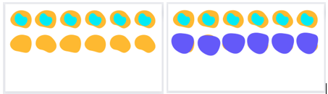
- Ask students to describe what they notice.
- Highlight that the print cannot be seen at all when the item is bigger, or that the larger item’s colour can be seen on the outside edges.
- Ask students to predict objects from the treasure box that will have ‘the same as’ areas.
- Explain, when items are close in size it is important that they are accurate when comparing areas.
- Explain that mathematicians align the corners or edges to help see the difference in shapes. To superpose shapes, align the edges (or corners) of 2 areas and place one on top of the other.
- Demonstrate superposing 2 shapes by print the first surface, aligning the corners or edges and printing the second object’s surface.
Note: Use contrasting colours of paint to notice the different areas of objects.
- Students create artwork by printing objects.
- Encourage students to superpose and superimpose shapes and then describe and compare the size of the prints.
Note: Students may need to manipulate shapes by turning to align edges and corners.
- Have students look at the shapes created by prints and ask:
- Which shape is the biggest? How do you know?
- Which shape is the smallest? How do you know?
- Which shape could fit inside another shape?
- Explain that mathematicians communicate their thinking using drawings and words.
- Ask students what words are used to describe area of shapes. Use Resource 5: Frayer model to explore the words related to area.
- Ask pairs of students to record their thinking by drawing the order of the shape areas from smallest to largest.
- Ask students to label their drawings using the words from Resource 5: Frayer model.
This table details assessment opportunities and differentiation ideas.
Assessment opportunities | Too hard? | Too easy?
What to look for:  - Can the students predict which of 2 surfaces with have the larger area? (MAO-WM-01, MAE-2DS-02)  - Can the students compare areas of shapes by aligning corners and directly printing on top of each other? (MAO-WM-01, MAE-2DS-02)  What to collect:  - Student artwork print which demonstrates understanding (MAO-WM-01, MAE-2DS-02) | Student cannot predict which of 2 surfaces with have the larger area.  - Model comparative language to compare areas and support visualisation.  - Students continue to sort and label objects as big and small.  Student cannot compare areas of shapes by aligning corners and directly printing on top of each other.  - Provide further experiences covering the surface of objects.  - Provide manipulative shapes which students can physically place on top of each other. | Student can predict which of 2 surfaces with have the larger area.  - Use a Frayer model to further explore Mathematical language to describe area including words such as surface, boundary, features, and so on.  - Provide examples and non-examples of shapes (such a triangles) and predict and compare areas.  Student can compare areas of shapes by aligning corners and directly printing on top of each other.  - Compare shapes with similar areas that cannot be superimposed on each other.  - Predict and find 2 shapes that might have the same area.

Consolidation and meaningful practice: Sharing the artwork – 10 minutes
- Students conduct a gallery walk of all the artwork prints created by students.
- As a class, discuss what strategies were used to compare the areas of the prints they created.
- Ask students the following:
- Did the position of each shape help you see the difference in area?
- How did you ensure an accurate measure?

Lesson 5: Class shop
Core concept: It is difficult to estimate an object’s weight simply by looking and thinking.
The table below contains suggested learning intentions and success criteria. These are best co-constructed with students.
Learning intentions | Success criteria
Students are learning that:  - objects with the same volume can be different weights  - comparative language is used to describe weight  - numbers can be represented in different ways. | Students can:  - compare masses directly by hefting  - describe and identify objects that are heavy or light  - identify different representations of numbers.

Daily number sense: Matching numbers – 10 minutes
This activity has been adapted from Matching Numbers by NRICH.
- Build student understanding of connecting quantities by matching numbers in different forms.
- Display Matching Numbers on an interactive board.
- Click on a card to turn it over. Then click on another card. If the cards match quantities, they will stay face up. If the cards do not match, they will return to being face-down. The game ends when all cards have been matched as the same quantities.
- While playing the game, use ‘Talk moves’ and ask students:
- How do you know when a card matches?
- What can help you recognise the number quickly?
- Provide pairs a set of Resource 7: Matching numbers and place cards face down.
- Turn over a pair of cards and notice if the 2 quantities match.
- If the cards match, the player can have another turn.
- Continue to play until all matches have been completed.
This table details assessment opportunities and differentiation ideas.
Assessment opportunities | Too hard? | Too easy?
What to look for:  - Can the students identify many representations of numbers? (MAO-WM-01, MAE-RWN-01)  What to collect:  - Observations of participation in the game and individual questioning (MAO-WM-01, MAE-RWN-01) | Students cannot identify different representations of number.  - Play the game with the cards face up to remove the memory aspect of the game.  - Explicitly model counting with understanding by counting with one-to-one correspondence to express the quantity. | Students can identify different representations of number.  - Play alternatives of the game in which you match pairs against the clock or use a scoring system.  - Students could make their own card game with different number representations.

Shopping – 40 minutes
- Ask students to think about a time they helped their family do the grocery shop. Ask:
- Which items were heavy?
- Which items were light?
- Display items such as washing powder, a box of tissues, chips, a can of food, bag of sugar, and so on. Ask students:
- Which item is the biggest? How do you know?
- Which item is the smallest? How do you know?
- Which item is the heaviest? How do you know?
- Which item is the lightest? How do you know?
- Ask students, what words are used to describe the weight of objects.
- Use Resource 8: Word cline to explore the meaning heavy, heavier and heaviest.
- Explain that today, students will be investigating the weight of shopping items and ordering them from lightest to heaviest.
- Ask students to visualise and record their predictions of weight of shopping items from lightest to heaviest on Resource 9: Recording weight.
Note: Display items that are heavy and large, light and small, heavy and small, large but lighter than a smaller item.
- Explain that an item’s weight can be compared by hefting.
Hefting: Testing the weight of an object by lifting or holding and balancing it. Where possible, students can use their bodies to balance two objects and compare the weight of each, for example, holding one object in each hand.
- Provide groups of students shopping items and allow students time to heft and order.
- Students revisit predictions on Resource 9: Recording weight, and draw a picture to record their results.
This table details assessment opportunities and differentiation ideas.
Assessment opportunities | Too hard? | Too easy?
What to look for:  - Can the students compare masses directly by hefting? (MAO-WM-01, MAE-NSM-01)  - Can the students describe and identify objects that are heavy or light? (MAO-WM-01, MAE-NSM-01)  What to collect:  - Observation of students as they participate and engage in learning activities and Resource 9: Recording weight (MAO-WM-01, MAE-NSM-01) | Student cannot compare masses directly by hefting.  - Compare 2 objects directly and select the heavy object.  - Place items on a student’s lap to determine if an item is heavy or light.  Student cannot describe and identify objects that are heavy or light.  - Support language with visual aids of the vocabulary.  - Explicitly teach different forms of comparative adjectives, for example, the use of ‘-er’ in taller. | Student can compare masses directly by hefting.  - Explore the weight on an equal-arm balance.  - Identify 2 items which have the same weight.  Student can describe and identify objects that are heavy or light.  - Give students the opportunity to compare objects that are the same size and different weight and describe what they feel.  - Use extending prompts, such as ‘Convince me that the ordering is correct.’

Consolidation and meaningful practice: Discuss and connect the mathematics – 10 minutes
- Ask students and turn and talk to discuss whether 2 things will have the same weight if they are the same size.
- Summarise the lesson, drawing out some key mathematical ideas about estimation and comparing weight. Ask students:
- What did you notice about the shopping items?
- What did you wonder about the shopping items?
- What would you do differently next time?
- Explain that weight is not a spatial measure – just because an item is large, does not mean it is heavy. Students must feel an object to understand its weight.

Lesson 6: Pouring and packing
Core concept: Objects can look different but still have the same internal volume.
The table below contains suggested learning intentions and success criteria. These are best co-constructed with students.
Learning intentions | Success criteria
Students are learning that:  - volume can be described using comparative language  - the internal volume or capacity is only used in relation to containers and generally refers to liquid measurement. | Students can:  - use comparative language such as holds more, holds less, full, empty, more than, less than, the same as, to describe containers  - compare capacity directly by pouring and packing the contents of one container into another.

Daily number sense: Race to write – 10 minutes
This activity has been adapted from Race to Write from Thinking Mathematically by the NSW Department of Education.
- Build student understanding of connecting counting and numerals by playing ‘Race to write’.
- Print and laminate Resource 10: Race to write.
- In pairs, students take turns to roll 2 dice (0–6) and combine quantities.
- Students trace over the matching total numeral on game board.
- If the number is already covered, students miss a turn.
- The first player to complete their gameboard wins the race.
- Ask students:
- Which number was the easiest to roll? Why do you think that is?
- Which number was the hardest to roll? Why do you think that is?
- If you played the game again tomorrow, what would you do differently? Why?
Note: For further support in explicit handwriting, please refer to Explicit handwriting instruction by the NSW Department of Education.

Packaging – 40 minutes
- Build student understanding of volume by reasoning about capacity.
- Display lots of packaging examples, including bottles, jars and containers (see Figure 4).
Figure 4 – Bottles and containers
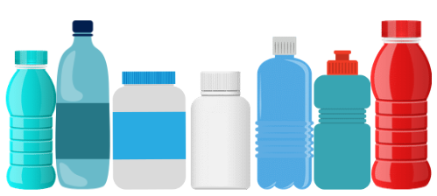
Images sourced from Canva and used in accordance with the Canva Content License Agreement.
- Discuss with students how they think these containers are organised in a supermarket.
- Invite small groups of students to try different arrangements based on attributes such as height, capacity, mass, brand, flavour of drink and colour.
- Working in pairs, give students 2 containers, a cup and a bowl of beads.
Note: If beads are not available, any collection of small objects may be used.
- Students use their cup to fill their containers with beads.
Note: Students may need to use a funnel for containers with smaller openings.
- Encourage students to experiment with the containers by filling them up, emptying them and filling them to about half full.
- Have students draw pictures of their containers being full, empty and about half full.
- Encourage students to use the terms ‘full’, ‘overflowing’, ‘empty’, ‘not very full’, ‘some left over’ and ‘needs more’.
- Ask students:
- Which item is the largest? How do you know?
- Which item is the smallest? How do you know?
- How could we compare the internal volume of 2 containers?
- How would we know if one was larger in volume than another?
- How would we know if one was smaller in volume than another?
- Which container do you predict is the largest in volume? Why?
- In pairs, have students compare the internal volumes of the containers by filling one up and then pouring the contents into the other.
- Ask students:
- What did you notice happened to the beads when one container was larger than the other?
- What did you notice happened to the beads when one container was smaller than the other?
- Was your prediction accurate? Why?
This table details assessment opportunities and differentiation ideas.
Assessment opportunities | Too hard? | Too easy?
What to look for:  - Can the students compare the internal volumes of 2 containers by filling one and pouring into the other? (MAO-WM-01, MAE-3DS-02)  - Can the students fill and empty containers using different materials such as water and/or beads? (MAO-WM-01, MAE-3DS-02)  - Are students using terms like full, empty and about half full? (MAO-WM-01, MAE-3DS-02)  What to collect:  - Workbooks with their drawings of full, empty and half full containers (MAO-WM-01, MAE-3DS-02) | Students cannot compare the internal volumes of 2 containers by filling one and pouring into the other.  - Give students hands-on experience with containers that are shorter and hold more and taller and hold less to see that height doesn’t reflect capacity.  - Give students hands-on experience of pouring into containers that look different but have the same volume. | Students can compare the internal volumes of 2 containers by filling one and pouring into the other.  - Have students look at containers and estimate which ones have the same volume but look different.  - Have students explain the reasoning around their estimation.

Lesson 7: Sandcastle investigation
Core concept: Internal volume (capacity) is a measure of how much a container can hold.
The table below contains suggested learning intentions and success criteria. These are best co-constructed with students.
Learning intentions | Success criteria
Students are learning that:  - the attribute of volume is the amount of space occupied by an object or substance.  - containers that have different shapes may hold the same amount. | Students can:  - use comparative language to describe volume of sandcastles.  - compare volume of sandcastle moulds by filling one and pouring into another mould.

Daily number sense: Robots – 10 minutes
- Build student understanding of comparing volume by building robots.
- Ask students to make a robot out of 10 connecting cubes (see Figure 5).
Figure 5 – Example robot
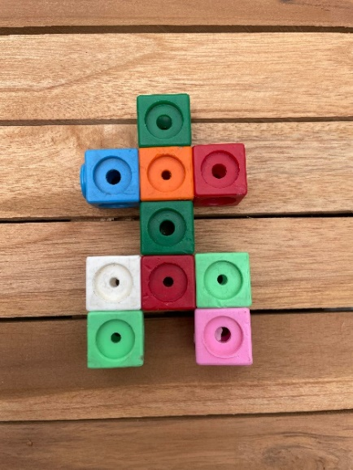
- Place all robots together and compare by asking:
- What do you notice?
- Which robot is the biggest? Why do you think that?
- Which robot is the smallest? Why do you think that?
- Remind students that rearranging the cubes does not change the volume. The volume stays the same, as everyone used 10 connecting cubes. The volume is the same because we haven’t added or taken away any cubes. The volume is the same, but they look different.
- Ask students how they could prove that all the robots have the same volume.
- In pairs, students use a method to convince the other that the volume is the same.
- Ask students to find all the possibilities of what the robot could look like using 10 connecting cubes.

Which sandcastle is the biggest? – 40 minutes
This activity has been adapted from ‘Measuring volume’ from First Steps in Mathematics: Measurement – book 1 by the Department of Education Western Australia.
- Display Resource 11: Sandcastles and ask students:
- What do you notice about the sandcastles?
- What do you wonder about the sandcastles?
- Which sandcastle has the largest volume? How do you know?
- Which sandcastle has the smallest volume? How do you know?
- Which sandcastles have the same volume? How do you know?
- Ask students to turn and talk to investigate which sandcastle has the largest volume.
- Display a variety of sandcastle moulds or containers, including tall, short wide and thin (see Figure 6).
Figure 6 – Sandcastle moulds
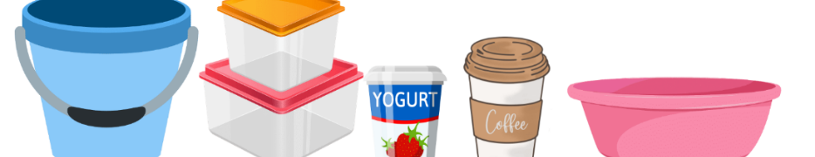
Images sourced from Canva and used in accordance with the Canva Content License Agreement.
- Ask what words are used to describe the volume of objects. Record these ideas on an anchor chart.
- Ask students to predict which mould will create the sandcastle which holds the most amount of sand.
- Ask students to visualise the order and record their predictions from containers holding less to holding more on Resource 12: Recording volume.
- Explain that students can compare volume by pouring sand from one mould to another. Ask students:
The table below outlines stimulus prompts to generate conversation about the topic, along with anticipated responses from students.
Prompts | Anticipated student responses
- What will happen to the sand if the container it is poured into holds less than the container it is already in?  - What will happen to the sand if the container it is poured into holds more than the container it is already in?  - What will happen if the containers have the same volume?  - What do we need to do as mathematicians to ensure it is a fair measurement? | - The sand will fall out over the sides and not fit in the container.  - All the sand will fit in the new container and there will be room for more sand.  - The sand will fit easily into both the containers.  - We need to make sure we use sand for all the measurements.  - Put a tray under the containers so we don’t lose any sand when pouring from one container to another.  - Make sure there are no gaps when we are filling the containers with sand.
- Allow students time to order their moulds by filling with sand and pouring from one mould to another.
- Order the moulds from holding the least amount of sand to holding the most amount.
- Students revisit predictions on Resource 12: Recording volume and draw a picture to record their results.
This table details assessment opportunities and differentiation ideas.
Assessment opportunities | Too hard? | Too easy?
What to look for:  - Can the students use comparative language to describe volume of sandcastles? (MAO-WM-01, MAE-3DS-02)  - Can the students compare volume of sandcastle moulds by filling one and pouring into another mould? (MAO-WM-01, MAE-3DS-02)  What to collect:  - Observation of students ordering moulds and Resource 12: Recording volume (MAO-WM-01, MAE-3DS-02) | Students cannot use comparative language to describe volume of sandcastles.  - Support students to acknowledge when containers are full and empty.  - Use visual representations of mathematical vocabulary such as empty, full, about half full.  Students cannot compare volume of sandcastle moulds by filling one and pouring into another mould.  - Provide opportunities to observe and narrate other student methods for comparing volume.  - Model and narrate comparing the volume of 2 by pouring one into the other. | Students can use comparative language to describe volume of sandcastles.  - Have students look at containers and estimate which ones have the same volume but look different.  - Have students explain the reasoning around their estimation.  Students can compare volume of sandcastle moulds by filling one and pouring into another mould.  - Use extending prompts, such as ‘Convince me that the ordering is correct.’  - Ask students how you could find out how many smaller moulds would fit into a larger mould.

Consolidation and meaningful practice: Discuss and connect the mathematics – 10 minutes
- Summarise the lesson, drawing out some key mathematical ideas about estimation and comparing volume. Ask students:
- What did you notice about the sandcastles?
- What did you wonder when measuring the moulds?
- What did you learn about the volume of different moulds?
- What strategy did you use to compare the volume? Was it effective and why?
- What new questions do you have?
- What would you do differently next time?

Lesson 8: Measuring attributes
Core concept: We can compare objects through their attributes.
The table below contains suggested learning intentions and success criteria. These are best co-constructed with students.
Learning intentions | Success criteria
Students are learning that:  - different attributes are measured using different tools  - mathematicians explain their thinking so it makes sense to others. | Students can:  - measure different attributes of an object  - explain and record the measurement attributes of classroom items.

Daily number sense: Hopscotch counting – 10 minutes
This activity has been adapted from ‘Hopscotch Counting’ in Home education by the Queensland Department of Education.
- Build student understanding of counting forwards and backwards by counting quantities.
- Have students count forwards and backwards to and from 20.
- Students can create movement sequences as they count forwards and backwards. Movements may include placing hands on heads then shoulders as students count.
- Ask students:
- What happened to the numbers when you were counting forwards?
- What happened to the numbers when you were counting backwards?
- Explain to students, there are times when we count forwards or backwards and do not begin at one.
- Using chalk, draw a number track on the floor from one to 20 (see Figure 7).
Figure 7 – Number track
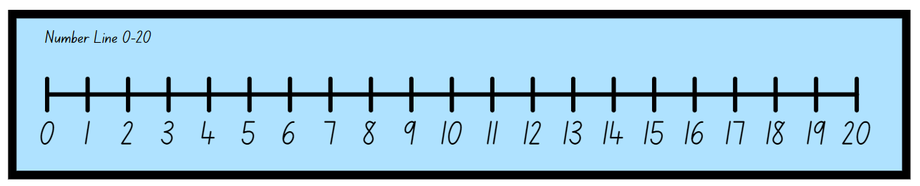
- Have students practise counting by:
- jumping forwards and counting. On hearing ‘stop’, students must jump backwards and count backwards.
- tossing a counter onto a number on the number track and counting forwards and backwards.
- jumping forwards and counting. On hearing ‘stop’, students must say which number comes before or after the number they have landed on.
- begin at a different number and students count forwards or backwards from the number.
- Ask the students:
- How many more jumps do you think you will need to reach 20?
- How many steps have you taken altogether? How did you work it out?

What am I? – 30 minutes
This activity has been adapted from ‘Attribute sorting’ from First Steps in Mathematics: Measurement – book 1 by the Department of Education Western Australia.
- Display Resource 13: Attribute sorting.
- Ask student to turn and talk to discuss:
- Which one doesn’t belong? Why?
- Is there a different answer?
- Use ‘Talk moves’ to discuss student responses and many ways of thinking.
- Record student thinking.
- Repeat the process with Resource 14: Attribute sorting 2.
- Ask students:
- What did you notice about sorting the objects?
- Was there more than one way of thinking?
- Students could choose 4 items.
- Display items with a variety of attributes. Objects may include toys, glue sticks, dice, drink bottles and so on (see Figure 8).
Figure 8 – Example of classroom objects
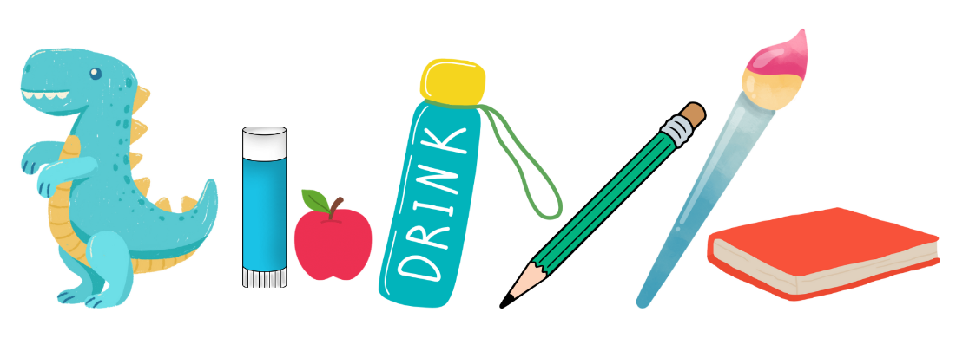
Images sourced from Canva and used in accordance with the Canva Content License Agreement.
- Ask students:
- What do you notice?
- What attributes can you use to sort the objects?
- How could you label your sort?
- Ask student to draw a picture of how they would sort the objects based on attributes.
- Gallery walk to see a variety of responses. Ask students to guess which attribute the items are sorted by.
- Ask students to return to their sorting and revise their sort if required.
- Place all the items into a box.
- Invite students to play ‘What am I?’ using measurement language. Ask student to select an item from the ‘treasure box’ and describe its features. For example,’ I am heavier than a pencil, but lighter than a glue stick, what am I?’, ‘I am longer than a sharpener but shorter than a bucket, what am I?’
- Encourage students to ask questions to help their thinking.
- Organise students into groups and allow them to play ‘What am I?’ using a ‘treasure box’ of items.
This table details assessment opportunities and differentiation ideas.
Assessment opportunities | Too hard? | Too easy?
What to look for:  - Can the students sort and measure different attributes of an object? (MAO-WM-01, MAE-GM-02, MAE-2DS-02, MAE-3DS-02, MAE-NSM-01)  What to collect:  - Observation of students sorting attributes and describing attributes (MAO-WM-01, MAE-GM-02, MAE-2DS-02, MAE-3DS-02, MAE-NSM-01) | Students cannot sort items based on different measurable attributes.  - Use enabling prompts, such as ‘Notice the length?’; ‘What is visible?’  - Revisit Frayer models and visual charts to support language describing measurable attributes. | Students can sort items based on different measurable attributes.  - Use extending prompts, such as ‘Can you prove how the objects have been sorted?’  - Allow students to complete a two-way sort of objects.

Consolidation and meaningful practice: Discuss and connect the mathematics – 10 minutes
- Summarise the lesson, drawing out some key mathematical ideas about comparing attributes. Ask students:
- What have you learnt about comparing length, mass, area and volume?
- When do you sort and organise objects based on attributes in everyday situations?

Resource 1: Butterflies and flowers
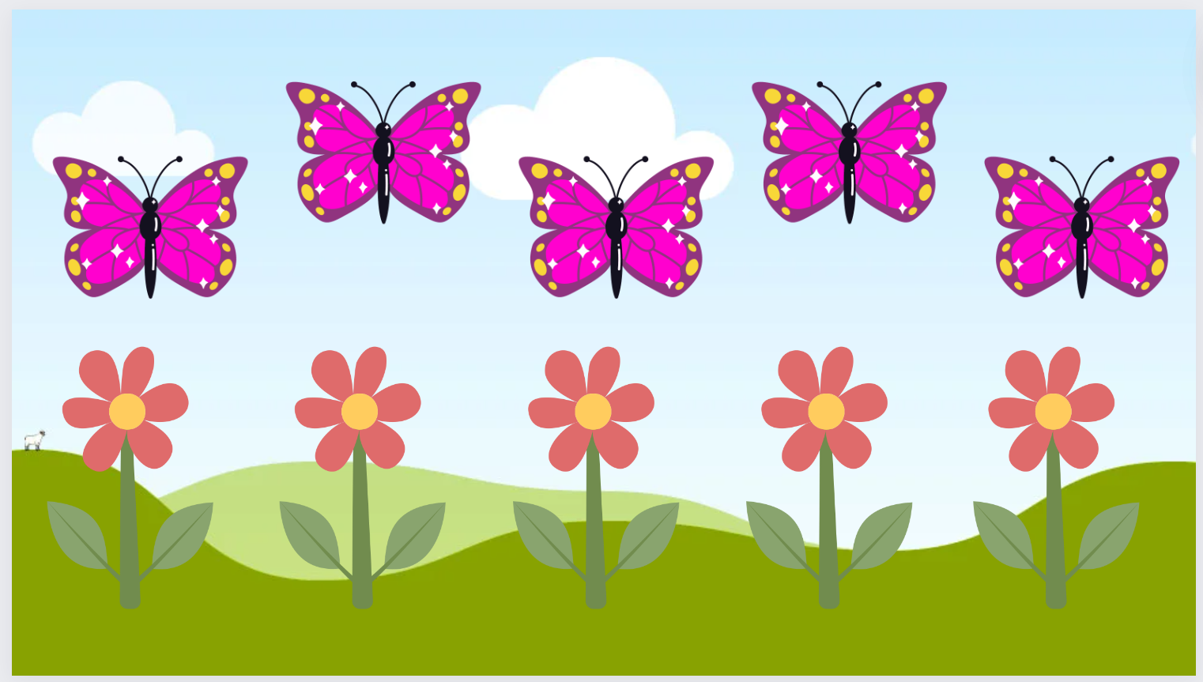
This image contains content obtained from Canva, and its use outside of this resource is subject to Canva’s Content License Agreement. If you wish to use it separately from the resource, please go to Canva.

Resource 2: Butterflies and flowers 2
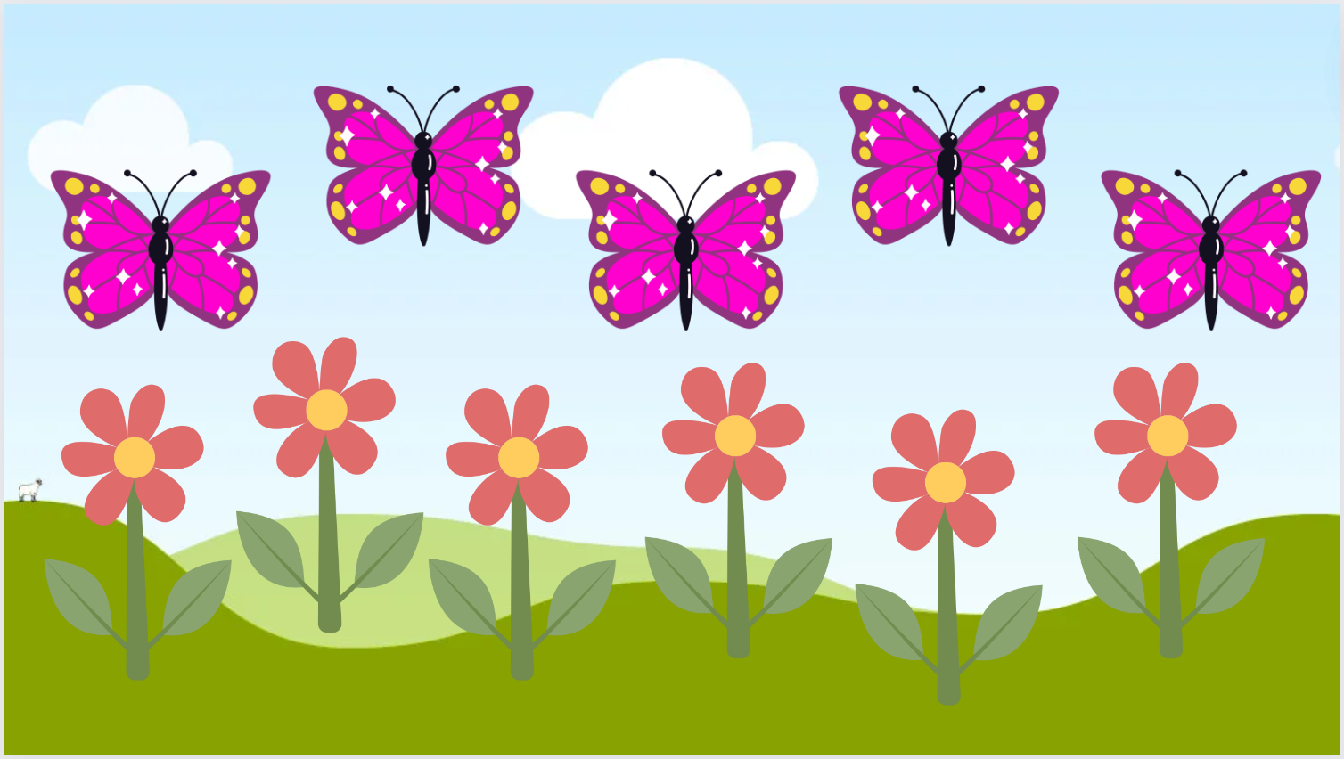
This image contains content obtained from Canva, and its use outside of this resource is subject to Canva’s Content License Agreement. If you wish to use it separately from the resource, please go to Canva.

Resource 3: Ten-frame

Resource 4: Recording hugs
Question 1
Look around the room, find something that is the same length as your arms outstretched.
Draw a picture of your prediction.
Label your picture if you can.
Results
Measure the classroom item in the room against your arm span.
Draw and label a picture of the result.

Resource 5: Frayer model
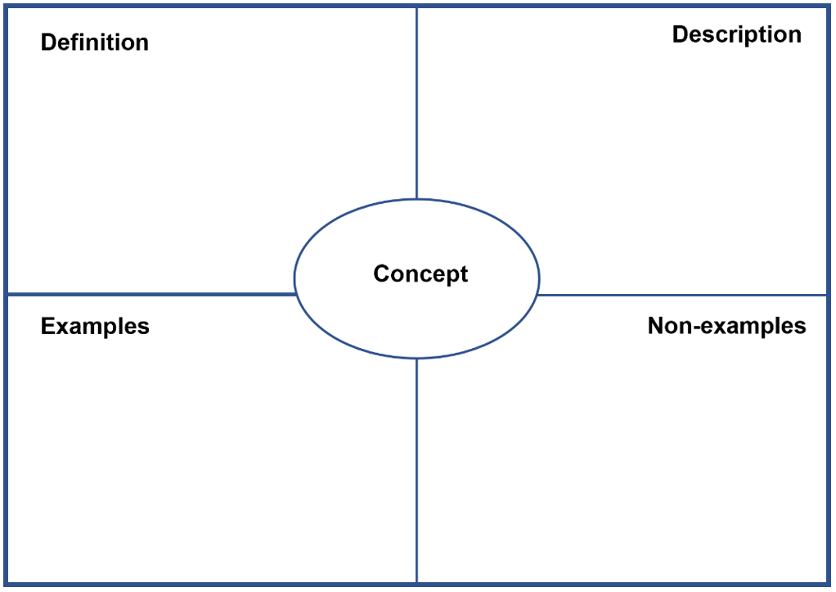

Resource 6: Squiggly lines
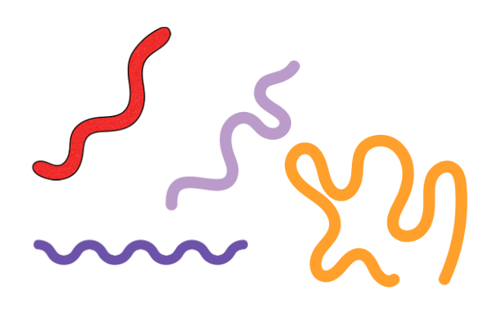
Images sourced from Canva and used in accordance with the Canva Content License Agreement.

Resource 7: Matching numbers
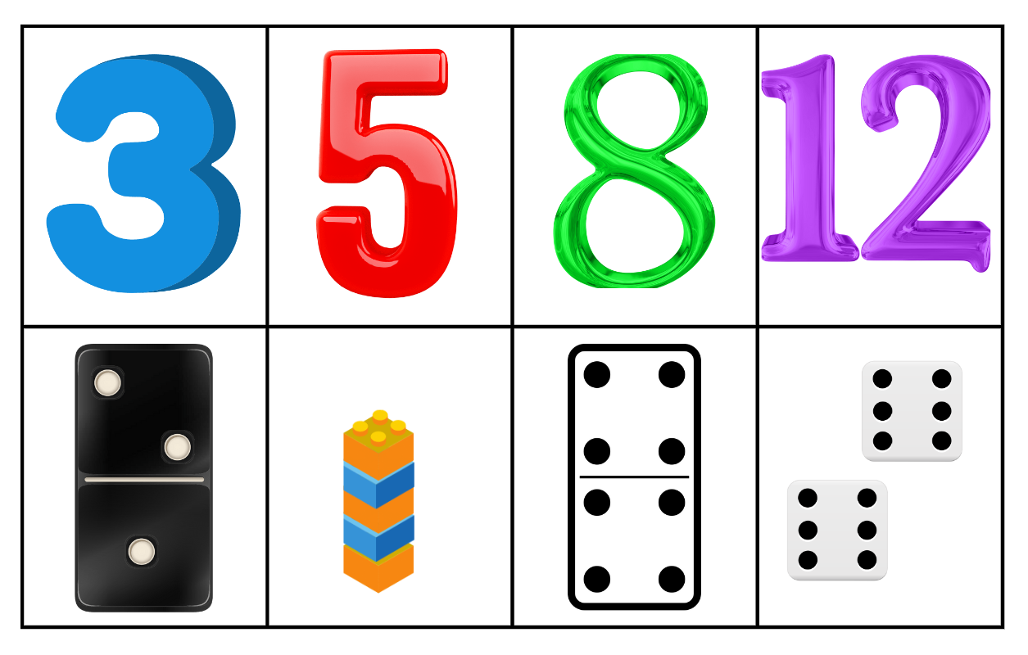
Images sourced from Canva and used in accordance with the Canva Content License Agreement.
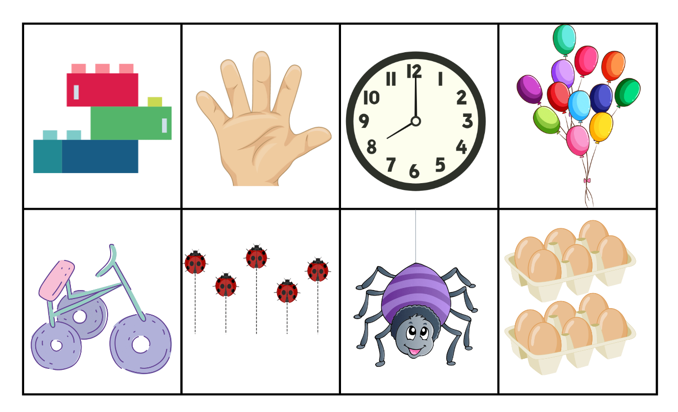
Images sourced from Canva and used in accordance with the Canva Content License Agreement.

Resource 8: Word cline
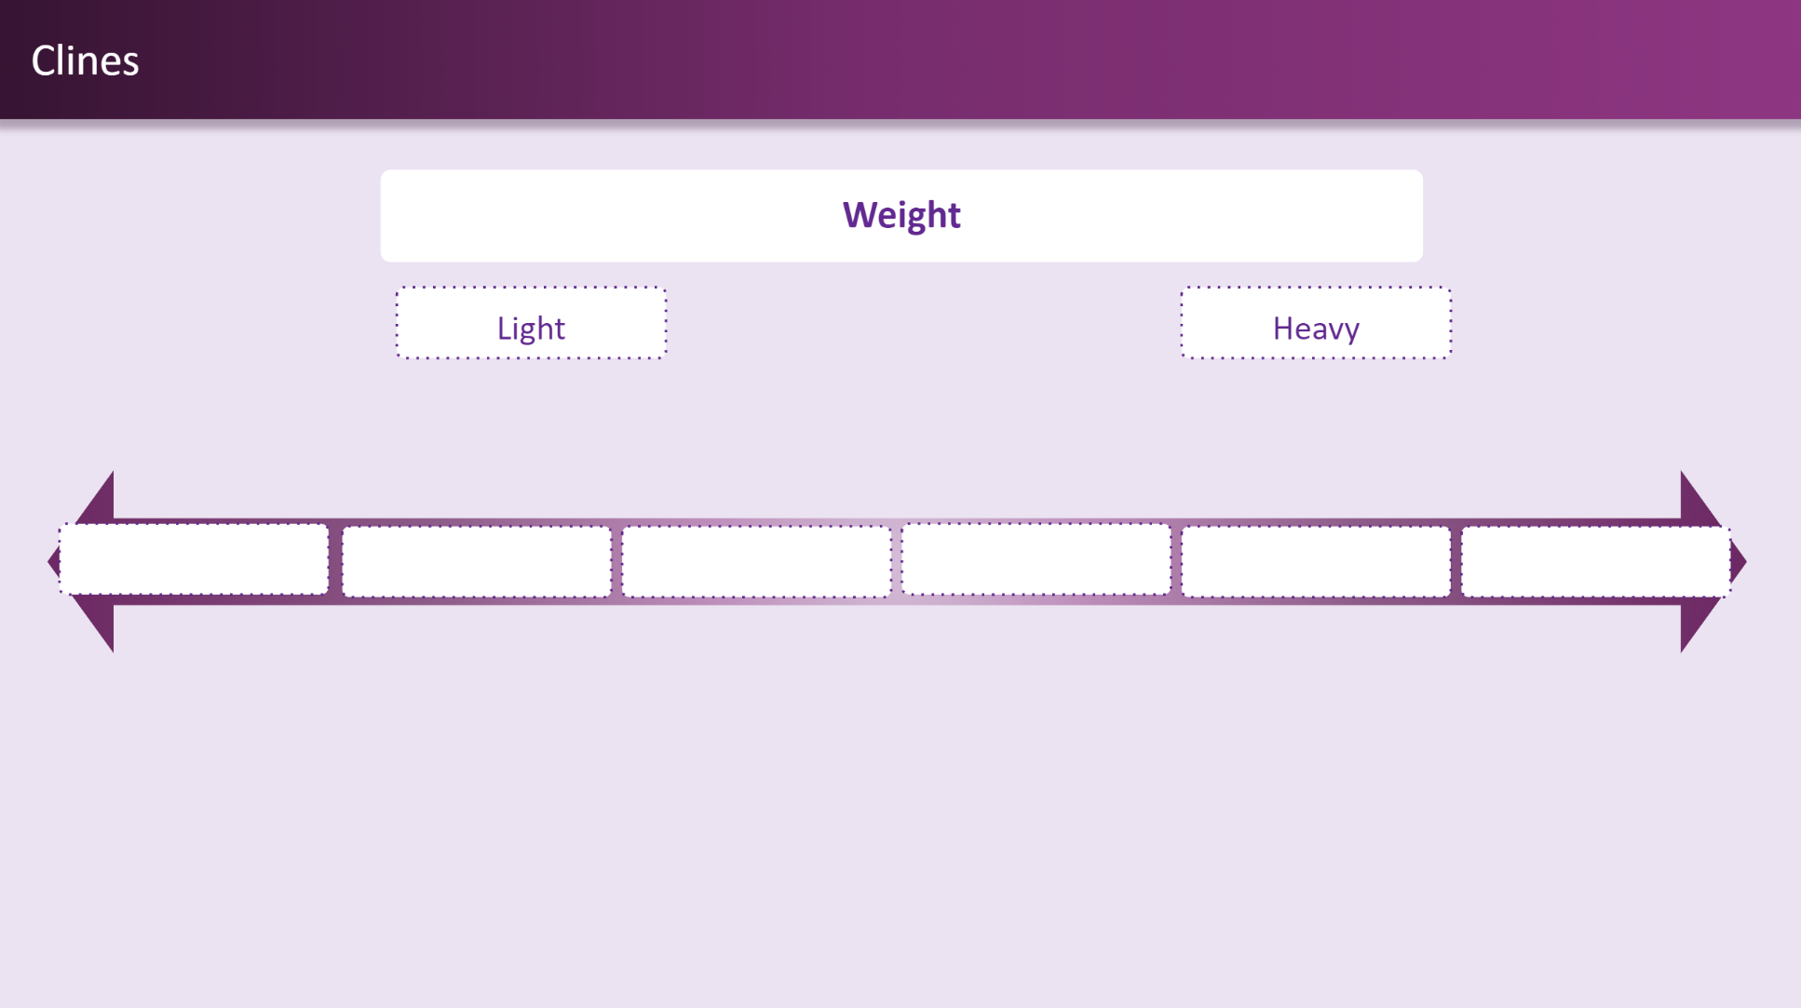

Resource 9: Recording weight
Question 1
Look at the 5 shopping items.
Draw a picture of your prediction from lightest to heaviest.
Label your picture if you can.
Results
Measure the weight of the shopping items by hefting.
Draw and label a picture of the result.

Resource 10: Race to write
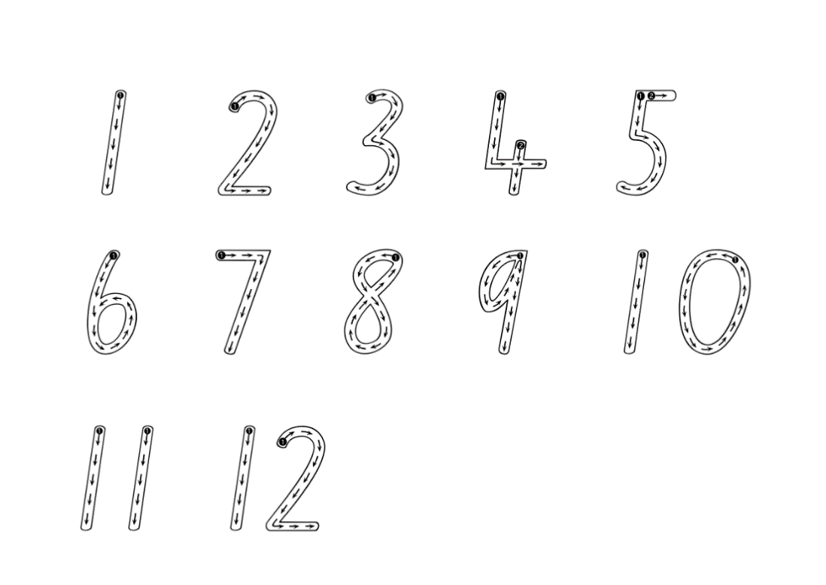

Resource 11: Sandcastles
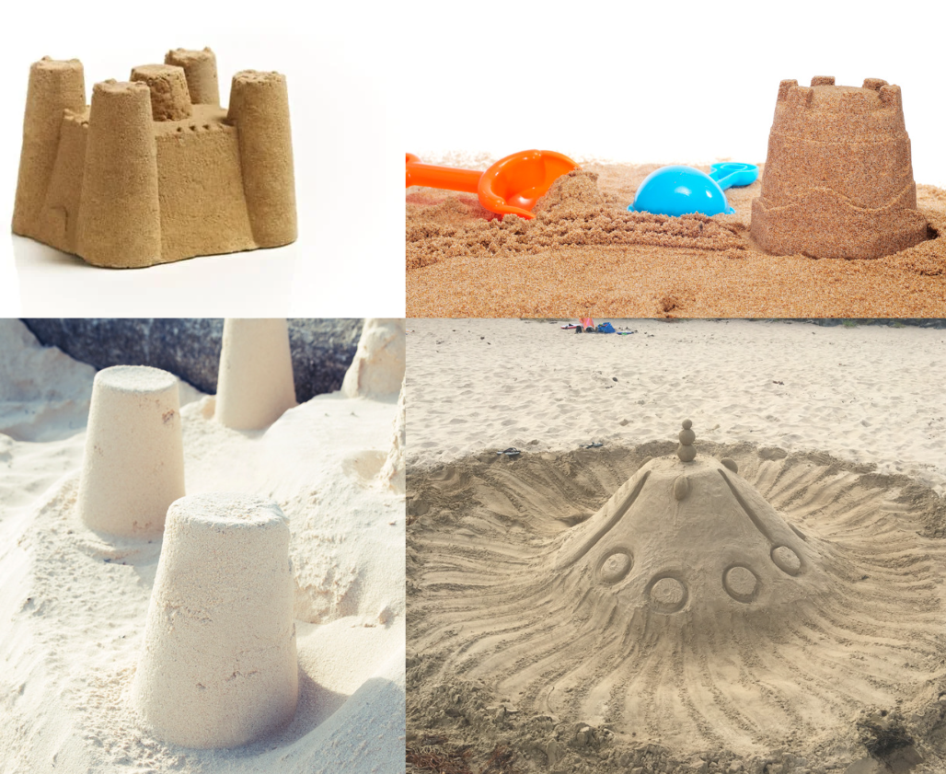
Images sourced from Canva and used in accordance with the Canva Content License Agreement.

Resource 12: Recording volume
Question
Look at the sandcastle moulds.
Draw a picture of your predictions of volume from which mould holds less sand to which mould holds the most amount of sand.
Label your picture if you can.
Results
Measure the volume of the moulds by pouring sand directly from one mould to another.
Draw and label a picture of the result.

Resource 13: Attribute sorting
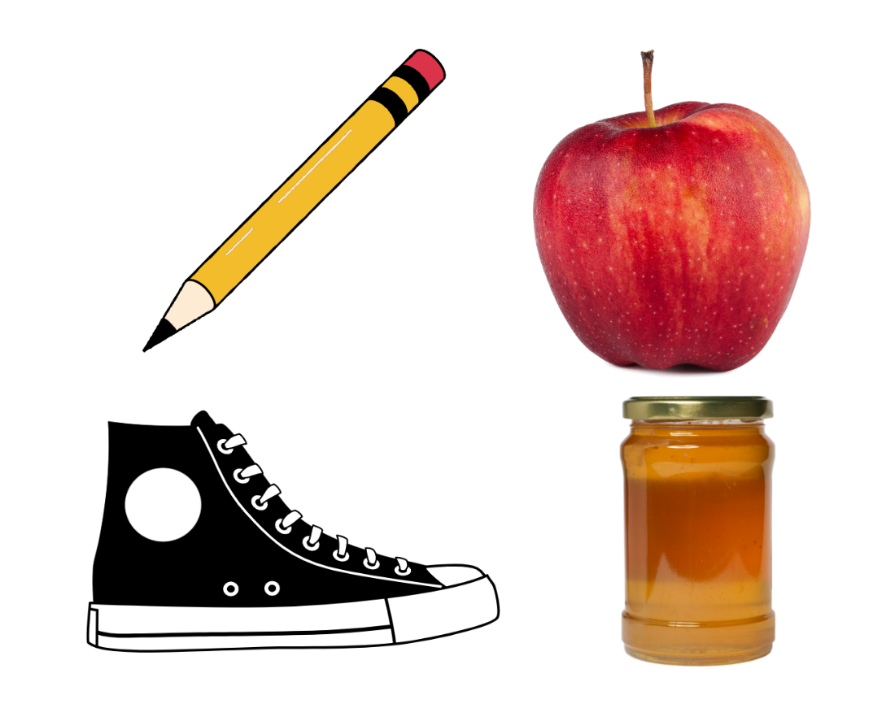
Images sourced from Canva and used in accordance with the Canva Content License Agreement.

Resource 14: Attribute sorting 2
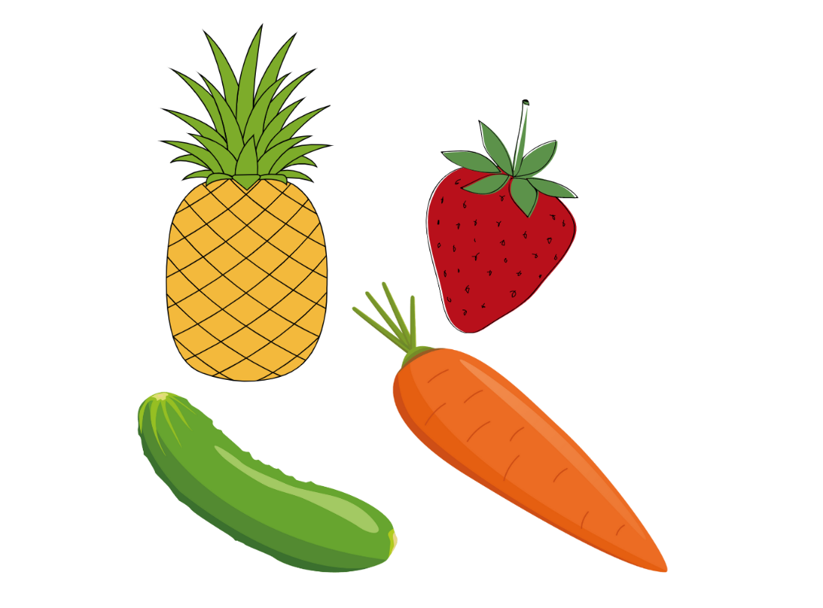
Images sourced from Canva and used in accordance with the Canva Content License Agreement.

Syllabus outcomes and content
The table below outlines the syllabus outcomes and range of relevant syllabus content covered in this unit. Content is linked to National Numeracy Learning Progression version (3).
Focus area and outcomes | Content groups and content points | Lessons
Representing whole numbers  MAO-WM-01  MAE-RWN-01  MAE-RWN-02 | Instantly name the number of objects within small collections  - instantly recognise (subitise) the number of items in small groups of up to four items without counting (NPV1, CPr1)  - identify the number of items in different arrangements (CPr2)  Use the counting sequence of ones flexibly  - count forwards to at least 30 and state the number after or before a given number, without needing to count from one (CPr4)  - identify and distinguish the ‘teen’ numbers from multiples of ten with the same initial sounds (NPV3)  - count backwards from a given number 20 or less (CPr5)  - identify the number before as 'one less' and the number after as 'one more’ than a given number  Recognise number patterns  - recognise dice and domino dot patterns (NPA1, NPV2, CPr2)  - recognise different finger patterns for the same number (NPA2)  Connect counting and numerals to quantities  - count with one-to-one correspondence, recognising that the last number name represents the total number in the collection (CPr3, CPr5)  - count out a specified number of objects (from 5 to 20) from a larger collection, keeping track of the count (CPr4, CPr5)  - make correspondences between collections (Reasons about quantity)  - read numerals to at least 20, including zero (NPV3)  - represent numbers as quantities to at least 20 using objects (such as fingers), number words and numerals (NPV2, NPV3, NPV4, CPr3)  - compare and order numbers to 20 (NPV2, NPV3)  - use the term ‘is the same as’ to express equality of groups (Reasons about quantity) (CPr4, CPr5, MuS1) | 1–8
Geometric measure  MAO-WM-01  MAE-GM-01  MAE-GM-02  MAE-GM-03 | Length: Use direct and indirect comparisons to decide which is longer  - identify the attribute of 'length' as the measure of an object from end to end  - use comparative language to describe length (UuM2)  - compare lengths directly by placing objects side by side and aligning the ends (UuM2)  - explain why the length of a piece of string remains unchanged whether placed in a straight line or a curve  - compare lengths indirectly by copying a length (Reasons about relations (UuM3) | 1, 2, 8
Two-dimensional spatial structure  MAO-WM-01  MAE-2DS-01  MAE-2DS-02 | Identify and compare area  - make closed shapes and identify the attribute of area as the measure of the amount of surface  - use comparative language to describe areas (UuM2)  - predict which of two surfaces will have the larger area and justify the answer (Reasons about spatial relations)  - compare areas of two similar shapes directly by drawing, tracing, or cutting and pasting (UuM3, UuM4) | 3, 4, 8
Three-dimensional spatial structure  MAO-WM-01  MAE-3DS-01  MAE-3DS-02 | Volume: Compare internal volume by filling and packing  - fill and empty containers using materials such as water or sand  - use the terms ‘full’, ‘empty’ and ‘about half full’  - compare the internal volumes (capacities) of two containers directly by filling one and pouring into the other  - compare the internal volumes of two containers indirectly by pouring their contents into two other identical containers and observing the level reached in each (UuM2)  - establish that containers of different shapes may hold the same amount  - stack and pack blocks into defined spaces (UuM5)  Volume: Compare volume by building  - identify the attribute of volume as the amount of space an object or substance occupies  - compare the volumes of two objects made from blocks or connecting cubes directly by deconstructing one object and using its parts to construct a copy of the other object  - use comparative language to describe volume (UuM2) | 6–8
Non-spatial measure  MAO-WM-01  MAE-NSM-01  MAE-NSM-02 | Mass: Identify and compare mass using weight  - identify that objects can be heavy or light (UuM2)  - compare two masses directly by hefting (UuM3)  - predict which object would be heavier than, lighter than, or have about the same weight as another object and explain reasons for this prediction (Reasons about relations) | 6, 8

References
Links to third-party material and websites
Please note that the provided (reading/viewing material/list/links/texts) are a suggestion only and implies no endorsement, by the New South Wales Department of Education, of any author, publisher, or book title. School principals and teachers are best placed to assess the suitability of resources that would complement the curriculum and reflect the needs and interests of their students.
If you use the links provided in this document to access a third-party's website, you acknowledge that the terms of use, including licence terms set out on the third-party's website apply to the use which may be made of the materials on that third-party website or where permitted by the Copyright Act 1968 (Cth). The department accepts no responsibility for content on third-party websites.
Except as otherwise noted, all material is © State of New South Wales (Department of Education), 2023 and licensed under the Creative Commons Attribution 4.0 International License. All other material (third-party material) is used with permission or under licence. Where the copyright owner of third-party material has not licensed their material under a Creative Commons or similar licence, you should contact them directly for permission to reuse their material.
Mathematics K–10 Syllabus © 2022 NSW Education Standards Authority (NESA) for and on behalf of the Crown in right of the State of New South Wales.
© 2022 NSW Education Standards Authority. This document contains NSW Curriculum and syllabus content. The NSW Curriculum is developed by the NSW Education Standards Authority. This content is prepared by NESA for and on behalf of the Crown in right of the State of New South Wales. The material is protected by Crown copyright.
Please refer to the NESA Copyright Disclaimer for more information.
NESA holds the only official and up-to-date versions of the NSW Curriculum and syllabus documents. Please visit the NSW Education Standards Authority (NESA) website and the NSW Curriculum website.
National Numeracy Learning Progression © Australian Curriculum, Assessment and Reporting Authority (ACARA) 2010 to present, unless otherwise indicated. This material was downloaded from the Australian Curriculum website (National Numeracy Learning Progression) (accessed 7 February 2023 and was not modified. The material is licensed under CC BY 4.0. Version updates are tracked in the ‘Curriculum version history’ section on the 'About the Australian Curriculum' page of the Australian Curriculum website.
ACARA does not endorse any product that uses the Australian Curriculum or make any representations as to the quality of such products. Any product that uses material published on this website should not be taken to be affiliated with ACARA or have the sponsorship or approval of ACARA. It is up to each person to make their own assessment of the product, taking into account matters including, but not limited to, the version number and the degree to which the materials align with the content descriptions and achievement standards (where relevant). Where there is a claim of alignment, it is important to check that the materials align with the content descriptions and achievement standards (endorsed by all education Ministers), not the elaborations (examples provided by ACARA).
This resource contains images and content obtained from Canva, and their use outside of this resource is subject to Canva’s Content License Agreement. If you wish to use them separately from the resource, please go to Canva.
Department of Education, Western Australia (2013) ‘First Steps in Mathematics: Measurement – book 1’, Education Resources, Department of Education Western Australia, accessed 7 February 2023.
State of Queensland, (Department of Education) (2023) ‘Home education’, Other education types, Queensland Department of Education website, accessed 7 February 2023.
State of Queensland, (Department of Education) (2023) Queensland Department of Education [website], accessed 7 February 2023.
University of Cambridge (Faculty of Mathematics) (1997-2023) Matching Numbers, NRICH website, accessed 7 February 2023.
University of Cambridge (Faculty of Mathematics) (1997-2023) NRICH [website,] accessed 7 February 2023.

