Mathematics – Early Stage 1 – Unit 13
Contents
Unit description and duration 4
Student prior learning 4
Lesson overview and resources 5
Lesson 1: Let’s share to be fair 10
Daily number sense: Chicken Scramble – 20 minutes 10
Let’s share to be fair: Part 1 – 20 minutes 12
Consolidation and meaningful practice: Let’s share to be fair: Part 2 – 10 minutes 14
Lesson 2: Birthday sharing 16
Daily number sense: Building towers – 15 minutes 16
Birthday Party – 35 minutes 18
Consolidation and meaningful practice: Just share them – 10 minutes 21
Lesson 3: Biscuits 22
Daily number sense: 15 minutes 22
The doorbell rang – 40 minutes 23
Consolidation and meaningful practice: Pop stick sharing – 10 minutes 24
Lesson 4: Sharing lair 25
Daily number sense: Pepperoni Pizza – 10 minutes 25
Lair of Shares – 30 minutes 26
Consolidation and meaningful practice: Building towers – 10 minutes 28
Lesson 5: Patterns 30
Daily number sense: Sharing problems – 15 minutes 30
Patterns – 30 minutes 31
Consolidation and meaningful practice: Summarise and connect the mathematics – 10 minutes 35
Lesson 6: Dealing and grouping 37
Daily number sense: 15 minutes 37
Outdoor sharing – 40 minutes 38
Consolidation and meaningful practice – Connect and summarise the mathematics – 10 minutes 40
Lesson 7: Pair patterns 41
Daily number sense: Domino carpark – 15 minutes 41
Pairs of Legs – 30 minutes 43
Consolidation and meaningful practice: Feet under the table – 15 minutes 45
Lesson 8: Bunches of jellybeans 46
Daily number sense: Musical groups – 15 minutes 46
Bunches of jellybeans – 35 minutes 47
Consolidation and meaningful practice: Toy Shop – 15 minutes 50
Resource 1: The doorbell rang 52
Resource 2: Toy cars 53
Resource 3: Two toy cars 54
Resource 4: Toy car pattern 55
Resource 5: Parking template 56
Resource 6: Animal cards 57
Resource 7: Ten-frame 58
Syllabus outcomes and content 59
References 62

Unit description and duration
This two-week unit develops student knowledge, understanding and skills of making and using equal groups. Students are provided opportunities to:
- recognise equal and unequal groups
- share collections by forming equal groups
Mathematics K–10 Syllabus © 2022 NSW Education Standards Authority (NESA) for and on behalf of the Crown in right of the State of New South Wales.

Student prior learning
Before engaging in these teaching and learning activities, students would benefit from prior experience with:
- recognising, describing and continuing repeating patterns.
- everyday situations that require sharing and distribution of materials such as art resources, or pretend food in a home corner, and so on
- sharing objects by dealing out to themselves and a friend one at a time.

Lesson overview and resources
The table below outlines the sequence and approximate timing of lessons; syllabus focus areas and content groups; and resources.
Lesson | Syllabus focus area and content groups | Resources
Lesson 1: Let’s share to be fair  50 minutes  Sharing is distributing objects one by one until the supply is exhausted. | Representing whole numbers  - Use the counting sequences of ones flexibly  - Connect counting and numerals to quantities  Forming groups  - Investigate and form equal groups by sharing  - Recording grouping and sharing | - Video: Let’s share to be fair – part 1 (8:20)  - Video: Let’s share to be fair – part 2 (1:45)  - 10 pegs – per pair  - 12 counters – per pair  - 20 beads – per pair  - 5 plates – per pair  - Large pile of linking cubes  - One bowl – per pair  - Paper for an anchor chart
Lesson 2: Birthday sharing  60 minutes  Everyday situations and stories require sharing and distributing of materials. | Representing whole numbers  - Instantly name the number of objects within small collections  - Use the counting sequences of ones flexibly  - Recognise dice patterns  - Connect counting and numerals to quantities  Forming groups  - Investigate and form equal groups by sharing  - Recording grouping and sharing | - Anchor chart  - Counters  - Dice – per pair  - Linking cubes or bricks  - Modelling clay  - Plates – one per student  - Playing boards – one per student  - Writing materials
Lesson 3: Biscuits  65 minutes  Equal sharing is distributing items one at time into a set number of groups. | Representing whole numbers  - Instantly name the number of objects within small collections  - Connect counting and numerals to quantities  Forming groups  - Investigate and form equal groups by sharing  - Recording grouping and sharing | - Resource 1: The doorbell rang  - Hutchins P (1989) The Doorbell Rang, HarperCollins Publishers, United States. ISBN: 9780688092344  - 12 craft sticks per student  - 3 cups per students  - Counters  - Writing materials
Lesson 4: Sharing lair  50 minutes  Problems can be solved by forming groups. | Representing whole numbers  - Instantly name the numbers of objects within small collections  - Use the counting sequences of ones flexibly  - Recognise number patterns  - Connect counting and numerals to quantities  Forming groups  - Investigate and form equal groups by sharing  - Record grouping and sharing | - Video: Lair of Shares (5:00)  - Counters  - Dice  - Interlocking cubes – 20 per student  - Paper plates  - Writing materials
Lesson 5: Patterns  55 minutes  A pattern structure includes a repeating core. | Representing whole numbers  - Use the counting sequences of ones flexibly  - Connect counting and numerals to quantities  Forming groups  - Copy and continue patterns  - Record grouping and sharing | - Resource 2: Toy car  - Resource 3: Two toy cars  - Resource 4: Toy car pattern  - Basket of toy cars  - Counters  - Linking cubes  - Writing materials
Lesson 6: Dealing and grouping  65 minutes  Equal groups can be formed as countable units. | Representing whole numbers  - Use the counting sequences of ones flexibly  - Connect counting and numerals to quantities  Forming groups  - Investigate and form equal groups by sharing  - Record grouping and sharing | - 12 small rocks per student  - Counters  - Natural materials such as stones, sticks, seed pods  - Recording device such as camera  - Small hoops  - Writing materials
Lesson 7: Pair patterns  60 minutes  Thinking in equal groups makes counting easier. | Representing whole numbers  - Use the counting sequences of ones flexibly  - Recognise number patterns  - Connect counting and numerals to quantities  Forming groups  - Copy, continue and create patterns.  - Investigate and form equal groups by sharing  - Record grouping and sharing | - Resource 5: Parking template – one per pair  - Resource 6: Animal cards – one per student  - Basket of 6 pairs of socks  - Writing materials
Lesson 8: Bunches of jellybeans  65 minutes  Smaller groups of numbers can be found hiding inside larger numbers. | Representing whole numbers  - Use the counting sequences of ones flexibly  - Connect counting and numerals to quantities  Forming groups  - Investigate and form equal groups by sharing  - Record grouping and sharing | - Resource 7: Ten-frame  - Toy shop  - 18 jellybeans or other manipulatives  - Counters  - Music  - Writing materials

Lesson 1: Let’s share to be fair
Core concept: Sharing is distributing objects one by one until the supply is exhausted.
The table below contains suggested learning intentions and success criteria. These are best co-constructed with students.
Learning intentions | Success criteria
Students are learning that:  - numbers can be used flexibly when counting  - an equal share is when all groups have the same amount  - a collection of objects can be shared by giving out pieces one at a time. | Students can:  - connect counting with a quantity of objects  - recognise when groups of objects are the same (equal) and not the same (unequal)  - distribute items one by one until the collection is exhausted.

Daily number sense: Chicken Scramble – 20 minutes
This lesson has been adapted from Chicken Scramble [PDF 506KB] from the Thinking while Moving learning resources.
- Build student understanding of representing whole numbers by counting flexibly.
- Place a pile of counters in the centre of the room and have students prepare to collect their grain. Explain that, when they hear ‘Go chicken, go’, students should move on their knees to the middle, collect a handful of grain, and return it to their nest. Continue for 2 minutes.
- Ask the students to estimate how many pieces of grain they have just by looking and thinking.
- Ask students to count their collection and, when they know their total, put a silent thumb up next to their chest.
- Ask students to turn and talk and share their thinking about the following questions:
- How many do you have?
- How do you know?
- How did you arrange your objects to help you count?
- Make a list of efficient ways to count the collections.
- Return counters into the middle of the circle and play again to consolidate.
This table details assessment opportunities and differentiation ideas.
Assessment opportunities | Too hard? | Too easy?
What to look for:  - Can the students count out a specified number of objects keeping track of the count? (MAO-WM-01, MAE-RWN-02)  What to collect:  - student reflections on the counting processes used and teacher observation (MAO-WM-01, MAE-RWN-02). | Students cannot count the collection of objects.  - Practise counting manipulatives with one-to-one correspondence, emphasising the last word in the count.  - When practising counting, have students move counted objects to the side so that they are not counted twice. | Students can count the collection of objects.  - Encourage students to look for patterns and try to group the objects to make counting easier.  - Focus on teen numbers in words. Ensure commonly confused similar sounding numerals are correctly articulated.

Let’s share to be fair: Part 1 – 20 minutes
This lesson has been adapted from Let’s share to be fair from Thinking Mathematically.
- View Let’s share to be fair – part 1 (0:28-1:40).
- Ask students to turn and talk and discuss how the teacher in the video can share the strawberries equally with her brother. Record student responses on an anchor chart.
Note: An anchor chart is an artefact of classroom learning; it holds the teacher’s and students' ideas and process. Anchor charts can be referenced in future learning.
- Display 2 plates and count out 12 counters to represent the strawberries. Model dealing out counters onto plates. Explain and model ‘one for me, one for my brother Sam’. Continue until all strawberries are exhausted.
- Ask students:
- How many do I have?
- How many does Sam have?
- Are they the same?
- Can you find another way to put the strawberries the plates, so there is the same amount?
- How many are there altogether?
- Explain that there are 12 strawberries altogether and they have been split into 2 equal shares.
- Explain that dealing the strawberries ensures both plates have equal shares.
- Return all counters to the middle and explain that 2 cousins have just arrived. Display 2 extra plates (4 plates in total).
- In pairs, students use 12 counters and 4 plates to share strawberries equally between all plates.
- Use ‘Talk moves’ to observe learning and ask the students:
- How many are in each plate now?
- How many does Sam have?
- How many do the cousins have?
- Are they equal shares or the ‘same as’? How do you know?
- How do you know these are shared fairly?
- Did you share one at a time?
- What is the number of serves and how many are on each plate?
- How many equal shares are there?
Note: Remind students to keep going until there are no pieces of fruit left.
- After students have shared objects equally, the process can be reversed, putting the shared objects back together to form one collection. Ask students how many strawberries there are altogether if there are 4 plates with 3 strawberries on each plate.

Consolidation and meaningful practice: Let’s share to be fair: Part 2 – 10 minutes
- View Let’s share to be fair – part 2 (0:05-1:13).
- Explain that Sam has dropped and squished 2 of his strawberries and that his sister, Mel, wants some strawberries and grapes as well. Another plate needs to be added and the strawberries and grapes must be shared again.
- Put the 10 strawberries (pegs) and 20 grapes (counters) altogether in one bowl. Spread out the 5 plates and ask pairs of students to share the strawberries equally (see Figure 1).
Figure 1 – Plates and fruit
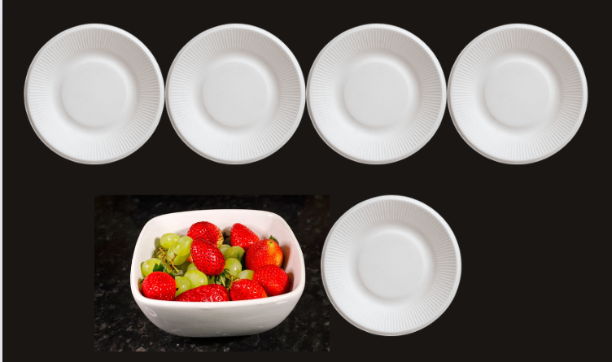
Images from Canva are licensed under Canva Content License Agreement.
- Summarise the lesson together, drawing out key mathematical ideas about separating into equal shares with students. Ask students:
- How many will each person get now?
- Is it an equal or fair share? How do you know?
- How did you ensure there were equal shares?
This table details assessment opportunities and differentiation ideas.
Assessment opportunities | Too hard? | Too easy?
What to look for:  - Recognise when groups of objects are equal and unequal. (MAO-WM-01, MAE-FG-02)  - Distribute items one by one until the collection is exhausted. (MAO-WM-01, MAE-FG-02)  What to collect:  - observations of student participation in demonstration and sharing of manipulatives on plates (MAO-WM-01, MAE-FG-02). | Students cannot recognise when groups of objects are equal and unequal.  - Use one-to-one matching of objects to support visual comparison.  - Provide explicit modelling and multiple opportunities for guided and independent practise to compare ‘same as’ quantities with familiar objects.  Students cannot distribute items one by one until the collection is exhausted.  - Manipulate familiar concrete materials to distribute.  - Use real life examples of sharing and storytelling to scaffold learning. | Students can recognise when groups of objects are equal and unequal.  - Pose further problems or questions that can be solved by forming groups.  - Repeat with different numbers of children and food.  Students can distribute items one by one until the collection is exhausted.  - Have students form equal groups to represent a number in different ways, for example, 12 as 3 groups of 4, 4 groups of 3, 6 groups of 2, or 2 groups of 6.  - Model and describe the collections as groups of.

Lesson 2: Birthday sharing
Core concept: Everyday situations and stories require sharing and distributing of materials.
The table below contains suggested learning intentions and success criteria. These are best co-constructed with students.
Learning intentions | Success criteria
Students are learning that:  - an equal share is when all groups have the same amount  - a collection of objects can be shared by giving out pieces one at a time. | Students can:  - recognise groups of objects that are the same (equal)  - distribute items one by one until the collection is exhausted.

Daily number sense: Building towers – 15 minutes
This activity has been adapted from Building towers at Thinking Mathematically.
- Build student understanding of representing whole numbers by combining and separating blocks in towers.
- Students work in pairs and choose 4 numbers to build as their towers (for example, 5, 7, 11 and 3) and record. Each student has their own playing board (see Figure 2).
Figure 2 – Tower game
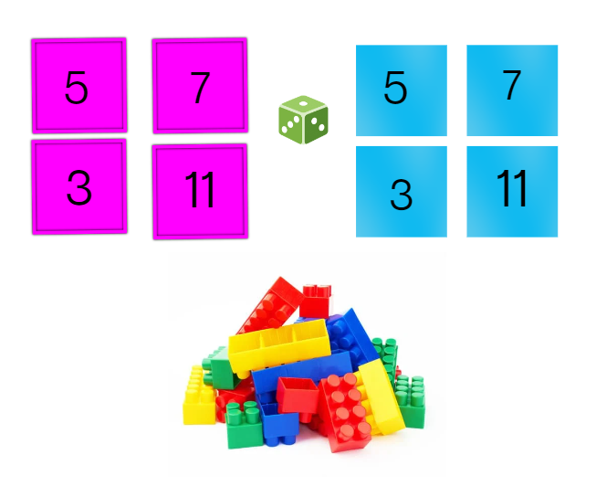
Images from Canva are licensed under Canva Content License Agreement.
- Students take turns to roll a die and use the number of bricks to build up a tower. For example, if a student rolls a 4, they must build a tower of 4 and place it in one of the boxes. If the student places this tower on the number 5, they then need to add one more brick to complete the tower. Towers can be built up in any way and combinations that students choose.
- Take turns to roll the die and build up towers until one player gets the exact roll to complete the last tower.
- Ask the students:
- How many blocks do you have?
- How many more do you need to get to your target number?
- What strategy did you use to build your tower and work out how many more you needed to complete the tower?
- An alternative to this game is:
- Build the towers and play in reverse, taking away bricks.
- Change the number of towers students build.
- Change the number of blocks needed for each tower.
- Ask the students to describe one thing to do differently if they were to play the game again tomorrow. Prompt students to explain their thinking.

Birthday Party – 35 minutes
This activity has been adapted from Birthday Sharing at NRICH.
- In groups of 4, provide students with 4 plates and a ball of modelling clay. Ask the students to make a plate of biscuits from the modelling clay then share with each other. Observe the students’ abilities to share equally. Ask the students:
- What do you notice?
- What do you wonder?
- Can you describe the group?
- Do the people you shared with have the same amount?
- Is it fair or equal? Why?
- Explain that it is Sahlia’s birthday and she is having a party. Display 6 counters and 2 plates. Ask students how the biscuits should be handed out equally between Sahlia and her friend at the party.
- Using 2 plates and counters, model sharing unequal groups onto each of the plates. Ask the students:
- What do you notice?
- What do you wonder?
- Place the counters back together and ask the students to draw a picture of what the plates would look like to be fair or equal.
Note: The process of sharing objects equally and putting shared objects back together to form one collection develops students’ later understanding of the link between multiplication and division and provides the foundation for a conceptual understanding of their inverse relationship.
- Share students’ records and ask students to explain their thinking. Ask students:
- Can you find another way to put the biscuits on the plates so that it is equal?
- Can you show me how they are equal or the ‘same as’?
- Model sharing of counters into equal groups by dealing counters ‘one for you, one for me, one for you, one for me’, until the collection is exhausted.
- Ask the students if the groups are equal or the ‘same as’ now. Prompt students to explain their thinking.
- Explain that there are 3 biscuits on one plate (point to plate) and 3 on the other plate (point to other plate). There are 2 groups of 3 biscuits. Place the biscuits back together and explain there are 6 biscuits altogether.
- Explain that Sahlia also has 18 cupcakes to share equally onto 2 plates for the table. Ask how many cakes will go on each plate. In pairs students count out 18 counters and use 2 paper plates to show a way of dividing the cupcakes equally.
- Use ‘Talk moves’ to support student reasoning. Ask students:
- How do you know you have 18? Can you prove it?
- Have a look at __'s plate. Are they the same? How can you prove it?
- Have a look at __’s plate. What makes that one different? How do you know?
Note: Pay attention to students’ ability to communicate the equal shares and how many are in each group.
- Explain that Sahlia has invited 9 friends to her party and they will play a game in pairs. Each pair will need a balloon. Ask students to work out how many balloons Sahlia will need, using counters or a drawing.
- Use 'Talk moves’ to support students’ reasoning. Ask the students:
- How are you working this out?
- How did you know what to do first?
This table details assessment opportunities and differentiation ideas.
Assessment opportunities | Too hard? | Too easy?
What to look for:  - Can the students recognise equal (same) and unequal groups? (MAO-WM-01, MAE-FG-02)  - Can the students distribute items one by one until the collection is exhausted? (MAO-WM-01, MAE-FG-02)  What to collect:  - answers to strategic questioning to determine individual level of understanding and recording of sharing (MAO-WM-01, MAE-FG-02). | Students cannot recognise equal and unequal groups.  - Use small toys and dolls so students can enact the story.  - Provide multiple opportunities for students to complete guided and independent practise comparing ‘same as’ quantities.  Students cannot distribute items one by one until the collection is exhausted.  - Use concrete materials, gestures (such as nodding) or body tallying to indicate the count  - Provide multiple opportunities for students to complete guided and independent practise to further develop counting principles. | Students can recognise equal and unequal groups.  - Change the problem to ask what would happen if another child joined the party.  - Repeat with different numbers of children and objects at the party.  Students can distribute items one by one until the collection is exhausted.  - Draw attention to the number of groups and the number in each group.  - Ask the student to find another way of distributing items equally such as equal grouping.

Consolidation and meaningful practice: Just share them – 10 minutes
- Summarise the lesson together, drawing out some key mathematical ideas about equal shares with students. Ask students:
- What does it mean when you are told to ‘just share them’?
- When is a time you must share equally?
- What do we need to remember when sharing?
- Record student thinking on an anchor chart.

Lesson 3: Biscuits
Core concept: Equal sharing is distributing items one at time into a set number of groups.
The table below contains suggested learning intentions and success criteria. These are best co-constructed with students.
Learning intentions | Success criteria
Students are learning that:  - an equal share is when all groups have the same amount  - when sharing, the number of groups and the number in each group is discussed. | Students can:  - distribute biscuits equally between guests  - create equal (same) groups of biscuits for each guest.

Daily number sense: 15 minutes
- From a class need surfaced through formative assessment data, identify a short, focused activity that targets students’ knowledge, understanding and skills. Example activities may be drawn from the following resources:
- Thinking Mathematically Early Stage 1
- Universal Resources Hub.

The doorbell rang – 40 minutes
This lesson has been adapted from Sharing Cookies – A Division Lesson Plan based on ‘The Doorbell Rang' from Australian Curriculum Lessons.
- Show the book, The Doorbell Rang by Pat Hutchins. Predict what might happen in the story then read the book.
- Give each student 12 counters and Resource 1: The doorbell rang.
- Ask students to use counters to model the first 3 scenarios and draw their findings. Use ‘Talk moves’ to discuss:
- How can you make sure each person has the same share of biscuits?
- How do you know everyone has the same share?
- How do you know how many biscuits there are altogether?
- Discuss that students can share items equally by distributing the items one by one (equally sharing) or by forming groups (equal grouping).
- Pose the problem: Grandma arrived with a plate full of biscuits, but she does not know how many biscuits there are in total. Grandma says each person is only allowed 2 cookies and there are 6 children altogether. Ask how many cookies Grandma will need.
- Give students time to use counters to act out the problem and record their results on Resource 1: The doorbell rang.
This table details assessment opportunities and differentiation ideas.
Assessment opportunities | Too hard? | Too easy?
What to look for:  - Can the student create equal groups of biscuits for each guest? (MAO-WM-01, MAE-FG-02)  What to collect:  - completed Resource 1: The doorbell rang worksheets (MAO-WM-01, MAE-FG-02). | Students cannot create equal groups of biscuits.  - Start off with a smaller number of objects to be shared and a smaller number to share it amongst.  - Have students count aloud whilst they share objects one by one. | Students can create equal groups of biscuits.  - Distribute the objects by twos instead of counting out one by one.  - Students share a group of objects that cannot be shared equally and discuss the idea of leftovers.

Consolidation and meaningful practice: Pop stick sharing – 10 minutes
- Explain how students will make fair shares of items. Students will use equal sharing by distributing items using a 1:1 ratio, into a set number of groups. Remind students that they won’t know how many are in each group until all the objects have been distributed.
- Give each student 12 craft sticks and 3 cups and ask students to share the craft sticks into the cups one at a time. Explain that this is called equal sharing.
- Ask students to describe what they see in terms of groups and how many there are in each group.
- Explain that sometimes, when creating fair shares, students might only know how many are in each group, but not how many groups there are. This is called equal grouping.
- Display a pile of 12 craft sticks.
- Ask students to make groups of 4 craft sticks, until there are none left.
- Ask students to describe what they see in terms of groups and how many there are in each group.

Lesson 4: Sharing lair
Core concept: Problems can be solved by forming groups.
The table below contains suggested learning intentions and success criteria. These are best co-constructed with students.
Learning intentions | Success criteria
Students are learning that:  - collections can be shared equally in different ways  - when sharing, it is important to discuss the number of groups and the number in each group. | Students can:  - use equal sharing or equal grouping to share gems  - explain and label the number of objects in groups.

Daily number sense: Pepperoni Pizza – 10 minutes
This lesson has been adapted from Pepperoni Pizza at youcubed.
- Students roll a die twice. The first roll is how many pizzas are needed (paper plates), the second roll is how many pieces of pepperoni to put on each pizza (counters) (see Figure 3).
- Ask students to describe how many pieces of pepperoni there are altogether.
- Students explain how many groups are made and how many are in each group. Students then count how many there are altogether.
Figure 3 – Example of pizza
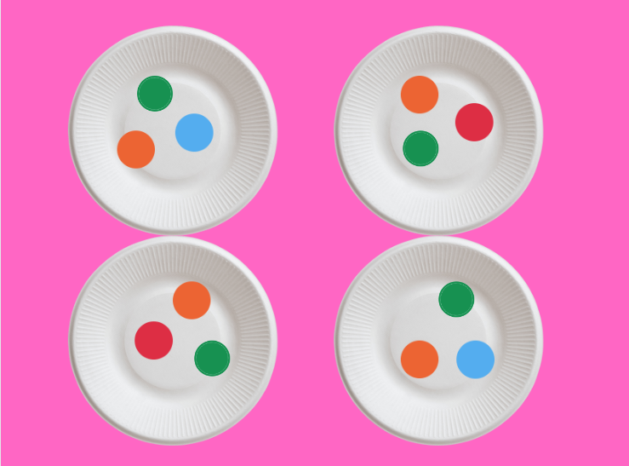
Images from Canva are licensed under Canva Content License Agreement.

Lair of Shares – 30 minutes
- Watch Lair of Shares (0:24-1:22) on ABC iView.
- Ask students to help the genie find all the gems. Students must share the gems equally between 2 plates. Ask students how to put the same number of gems on each plate without knowing how many gems there are.
- Organise students into groups of 4. Display 2 plates and allocate a colour to each group. In turns, students collect 12 coloured gems (counters) from the pile and share the counters between the 2 plates using the sharing strategy.
- Ask students to describe the equal shares and then how many gems there are altogether.
- Return all counters to the pile.
- Watch Lair of Shares (2:31-2:55).
- Explain that the genie of water needs the students’ help. Students share the 15 water gems between the 3 plates. Ask students if there is a faster way to share the gems, as distributing using a 1:1 ratio will be too slow.
- Give groups 3 plates and ask students to collect 15 of their coloured counters to share equally by distributing the same amount into each plate.
- Ask students to describe the equal shares. Return all counters to the pile.
- Watch Lair of Shares (3:36-3:55).
- Explain that the genie of fire needs the students’ help to share 20 gems between 4 paper plates.
- Give groups 4 plates and ask students to collect 20 of their coloured counters to share equally by distributing the same amount into each plate.
- Ask students to turn and talk to discuss:
- What strategy did you use to make equal shares?
- How can you check that groups are equal or the same?
- Can you describe your groups?
- Congratulate students on conquering the Lair of Shares.

Consolidation and meaningful practice: Building towers – 10 minutes
- Provide students with a pile of 20 interlocking cubes.
- Ask students to make 5 towers with 3 blocks in each tower (see Figure 4).
- Ask students:
- How many towers do you have?
- How many blocks in each tower?
- How many are there altogether?
Figure 4 – Towers of blocks
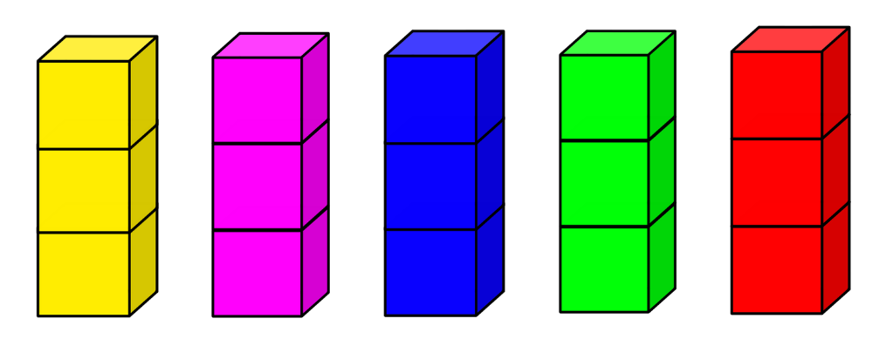
- Students record their learning with symbols, numerals or words.
This table details assessment opportunities and differentiation ideas.
Assessment opportunities | Too hard? | Too easy?
What to look for:  - Can the students explain and label the number of objects in groups? (MAO-WM-01, MAE-FG-02)  What to collect:  - pictures of their towers (MAO-WM-01, MAE-FG-02). | Students cannot explain and label the number of objects in groups.  - Use enabling prompts to help students create equal groups, such as ‘start with counting this part of your collection’.  - Use equipment such as egg cartons, muffin trays or ten-frames to help group and count objects. | Students can explain and label the number of objects in groups.  - Explore forming equal groups to represent a number in different ways, for example, 12 as 3 groups of 4, 4 groups of 3, 6 groups of 2, or 2 groups of 6.  - Have students explain their understanding of representing a number in different ways to a peer.

Lesson 5: Patterns
Core concept: A pattern structure includes a repeating core.
The table below contains suggested learning intentions and success criteria. These are best co-constructed with students.
Learning intentions | Success criteria
Students are learning that:  - patterns have a core that repeats over and over and over again  - knowing the core can help to continue the repeated pattern. | Students can:  - identify the core of a pattern and reproduce it using linking cubes  - continue repeating patterns using drawings, clapping, and linking cubes.

Daily number sense: Sharing problems – 15 minutes
- Tell students there are 12 teddies that need to be shared equally between 2 students. In pairs, provide students with a collection of 12 items that must be shared equally between the 2 students. Select students to share their thinking and grouping strategies.
- Ask students what the groups would look like if there were more than 2 friends sharing the 12 teddies. Ask students to find as many combinations as possible of equal groups using the 12 teddies.
- Use ‘Talk moves’ to discuss:
- How did you determine the number of groups?
- How did you make sure each group has the same amount?
- How do you know you have found all possible solutions?
- What solutions didn’t work? Explain why.

Patterns – 30 minutes
This lesson has been adapted from Talking about patterns and algebra.
- Create an AB pattern using a sequence of different sounds or actions, such as clap, stamp, clap, stamp, clap, stamp.
- Ask the students to continue the pattern and describe it in words.
- Ask the students to use linking cubes to represent the actions (see Figure 5).
- Repeat activity using different sounds or actions, such as tap, click, tap, click, tap, click.
- Ask the students to continue the pattern and use linking cubes to represent the pattern. See Figure 5 for examples.
Figure 5 – Cubes in patterns
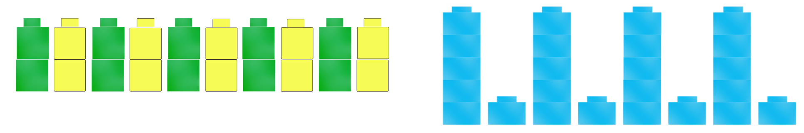
- Provide students time to think independently, then turn and talk to a partner to share. Ask students:
- What is the same? What is different?
- How do you know this is a pattern?
- What part of the pattern is repeated?
- Explain that a pattern has a core that is repeated over and over and over again. This helps to determine what comes next. Ask students to identify the core in each of the patterns.
- Explain that a two-part pattern can be described as having an AB pattern. Demonstrate that A is the first element, and B is the second element; the core are these 2 parts combined which repeat.
- Repeat the activity, but this time ask students what an ABB pattern might look like in actions or sounds. Model an AAB pattern and then ask students to create an ABB pattern with linking cubes. Ask the students to describe the part of the pattern that is repeated.
Note: It is important to model the words repeat, repeated, and repeating. For example, make an AAB pattern and ask what parts students would repeat to continue the pattern. Early Stage 1 students develop strategies for forming groups based on the structure and pattern of numbers as countable units.
- Remove or cover the linking cubes pattern and ask students to draw the pattern from memory.
- Ask students to explain how they remembered the pattern.
The table below outlines stimulus prompts to generate conversation about the topic, along with anticipated responses from students.
Prompt | Anticipated student responses
What did you notice that helped you remember the pattern? | - I remembered the elements in the pattern and just repeated them.  - I looked at the core and repeated it.  - I labelled the core with numbers to remember.
- Demonstrate making an AB Pattern using digital linking cubes (see Figure 6).
Figure 6 – AB pattern
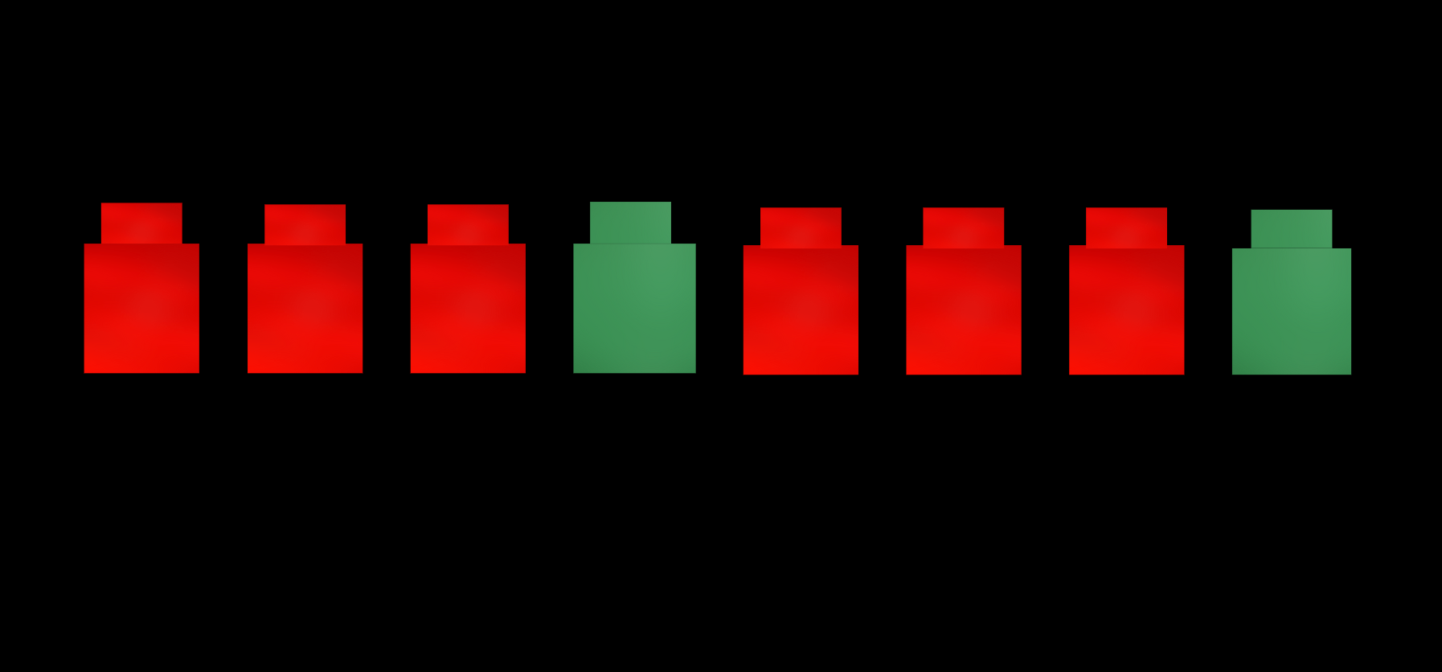
- Alternative: Repeat activity using dice dot patterns.
This table details assessment opportunities and differentiation ideas.
Assessment opportunities | Too hard? | Too easy?
What to look for:  - Can the students identify the core of a pattern? (MAO-WM-01, MAE-FG-01)  - Can the students copy, continue, and create repeating patterns? (MAO-WM-01, MAE-FG-01)  What to collect:  - observations of students creating patterns and record of patterns (MAO-WM-01, MAE-FG-01). | Students cannot identify the core of a pattern.  - Use patterns made from concrete materials to identify the core and move one core underneath another until each core is aligned.  - Support visual discrimination by making space and separating the repeating core.  Students cannot copy, continue and create repeating patterns.  - Provide patterns with 2 elements for students to copy and continue.  - Provide a missing part activity with only one missing element to solve. | Students can identify the core of a pattern.  - Ask students to circle the core without aligning it vertically.  - Have peers clap out a pattern or make a pattern with blocks and students must identify the core of the pattern.  Students can copy, continue and create repeating patterns.  - Provide circular, vertical or diagonal patterns to continue or fix.  - Provide a missing part activity with several missing elements to solve.

Consolidation and meaningful practice: Summarise and connect the mathematics – 10 minutes
This lesson has been adapted from Cars, cars, cars from NZ Maths.
- Explain that grouping sets of objects can help to count collections.
- Display Resource 2: Toy cars. Ask students to count the wheels on the toy car. Explain that there are actually 4 wheels but only 2 wheels are seen in the picture. Record the number 4 on the board.
- Display Resource 3: Two toy cars. Explain there is one group of 4 wheels and another group of 4 wheels, so there are 8 wheels altogether. The pattern is growing as the core of 4 wheels is repeating. Ask how many wheels there would be if another car joined, just by looking and thinking.
- Create a toy car pattern or display Resource 4: Toy car pattern. Ask students:
- What do you notice?
- How many cars are there?
- How many wheels are there?
- In groups, display a basket of toy cars. Ask students how many wheels there are altogether.
- Ask students to record the car pattern using numbers, symbols or words (see Figure 7). Use ‘Talk moves’ to support mathematical reasoning.
Figure 7 – Counting wheels
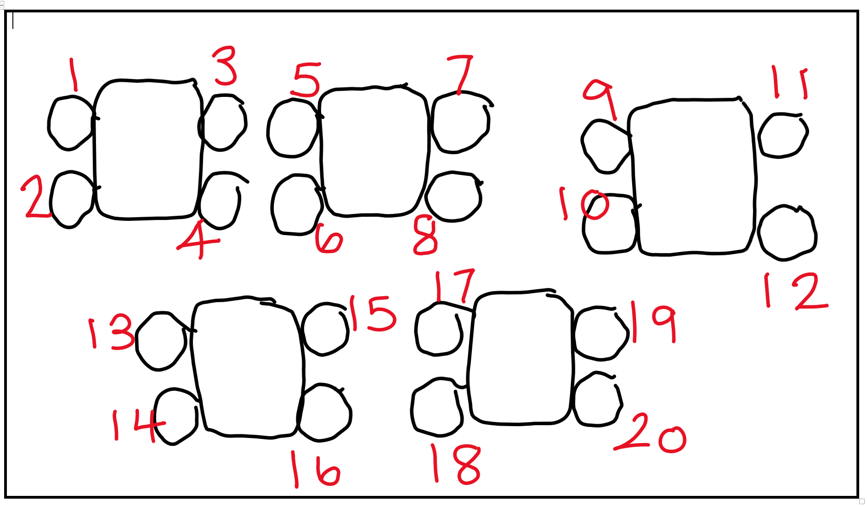
The table below outlines stimulus prompts to generate conversation about the topic, along with anticipated responses from students.
Prompts | Anticipated student responses
- What patterns have you noticed in your count?  - Can you tell me what will come next in this pattern?  - What would the pattern look like with motorbikes and not cars?  - What have you found out?  - Describe your picture. | - I am adding 4 every time.  - If you add 4 you will get 24.  - Motorbikes only have 2 wheels so you would need to add 2 each time instead of 4.  - I found that there are 20 wheels all together.  - I saw that in the basket there were 5 cars, so I drew them all. On each car, I drew 4 wheels.
- Have students complete a gallery walk to observe what other students have drawn.

Lesson 6: Dealing and grouping
Core concept: Equal groups can be formed as countable units.
The table below contains suggested learning intentions and success criteria. These are best co-constructed with students.
Learning intentions | Success criteria
Students are learning that:  - forming groups of objects with the same number of elements helps represent numbers in different ways  - there is a difference between the number of groups and the number (units) in each group. | Students can:  - distribute the same number of items into an unknown number of groups  - find the number of groups and how many are in each group.

Daily number sense: 15 minutes
- From a class need surfaced through formative assessment data, identify a short, focused activity that targets students’ knowledge, understanding and skills. Example activities may be drawn from the following resources:
- Thinking Mathematically Early Stage 1
- Universal Resources Hub

Outdoor sharing – 40 minutes
This lesson has been adapted from Messy Maths: A Playful, Outdoor Approach for Early Years by Robertson (2008).
- Explain that examples of equal groups can be found all around, including in nature.
- Take students outside to collect a variety of natural materials such as stones, sticks, shells, seed pods and more. Give students 2 minutes to collect these.
Note: A collection of natural materials readily available in the classroom can also be used to sort.
- Ask students to share the objects between 2 friends. Draw 2 circles in the dirt or use small hula hoops and share the materials between the 2 circles (see Figure 8).
Figure 8 – Hula hoop sharing
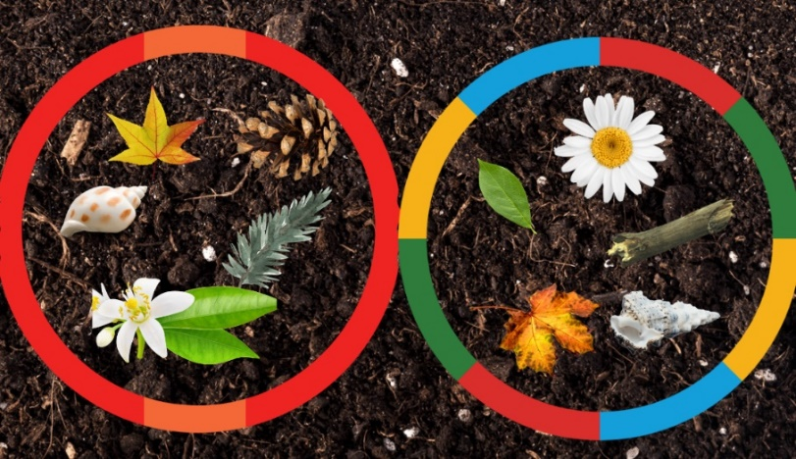
Images sourced from Canva and used in accordance with the Canva Content License Agreement.
- While students are sharing, ask:
- Is each circle equal or the same?
- How did you distribute the objects equally in the groups?
- How many in each group?
- How many altogether?
- In pairs, ask each student to go on a treasure hunt to find as many leaves as possible in 30 seconds.
- On return, ask students to share the collection equally into 2 groups and then find the total. Remind students to distribute the items one by one until the collection has been exhausted.
Note: Early Stage 1 students do not need to discuss leftover items. If groups are uneven, students should collect one more item to ensure the groups are equal.
- Ask students to collect 16 small items. Explain that students can also distribute the same number of items into unknown groups.
- Ask students to find out all the different ways to share 16 small items, so the groups are equal.
- Ask students to record all the different methods by drawing.
- Repeat with other natural materials such as flowers, sticks, leaves and so on.
This table details assessment opportunities and differentiation ideas.
Assessment opportunities | Too hard? | Too easy?
What to look for:  - Can the students distribute the same number of items into an unknown number of groups? (MAO-WM-01, MAE-FG-02)  What to collect:  - photos of the shared materials in the circles (MAO-WM-01, MAE-FG-02). | Students cannot distribute the same number of items into an unknown number of groups.  - Students begin by forming amounts which create 2 equal groups.  - Use enabling prompts to support students to communicate what they notice when sharing into equal groups. | Students can distribute the same number of items into an unknown number of groups.  - Pose problems or questions that can be solved by forming groups.  - Students use understanding of forming groups to explore representing numbers in different ways.

Consolidation and meaningful practice – Connect and summarise the mathematics – 10 minutes
- Summarise the lesson together, drawing out some key mathematical ideas about equal shares. Use a fishbowl to demonstrate student methods. Ask students:
- What strategy did you use to share the items equally?
- How is your strategy the same or different?
- Has anyone revised their thinking or strategy for sharing? Why or why not?
- Record student thinking on an anchor chart.
Note: In a fishbowl discussion, students seated inside the ‘fishbowl’ share their methods and thinking out loud. Other students observe and listen to practice. You then use ‘Talk moves’ to reflect on what strategy and discussion was observed. Students may swap roles.

Lesson 7: Pair patterns
Core concept: Thinking in equal groups makes counting easier.
The table below contains suggested learning intentions and success criteria. These are best co-constructed with students.
Learning intentions | Success criteria
Students are learning that:  - a pair is a group of 2  - numbers can repeat in predictable ways  - known patterns help to count. | Students can:  - use pairs to solve number problems  - recognise number patterns on dominos  - count collections by grouping.

Daily number sense: Domino carpark – 15 minutes
This lesson has been adapted from Dominoes Parking Lot Game at The Robertson Program for Inquiry-based Teaching in Mathematics and Science.
- Build student understanding of representing whole number by subitising dominoes in different arrangements.
- Display a domino from a collection. Ask students to count the total number of dots and record.
- Display Resource 5: Parking template. Demonstrate that each domino will be placed into a parking spot based on its total number of dots. For example, a domino with one dot on top and 2 dots on the bottom will go into the number 3 spot. Explain this is a race against the clock.
- Organise students into groups. Provide a gameboard for each player and place all dominoes facing down. Students take turns to flip over a domino and place in the correct spot on gameboard.
Note: If the parking spot is full, the player places the domino back into the pile and the player’s turn is over.
- Continue taking turns until one player has filled their board and won the game.
- Ask students to explain their thinking like mathematicians and share their counting strategies. Ask how students ‘see’ the total.
This table details assessment opportunities and differentiation ideas.
Assessment opportunities | Too hard? | Too easy?
What to look for:  - Recognise patterns and groups in large numbers of dots (MAO-WM-01, MAE-RWN-01).  What to collect:  - observation of students' thinking during game-based learning opportunities (MAO-WM-01, MAE-RWN-01). | Students cannot recognise patterns and groups in large numbers of dots.  - Face the dominos up correctly to allow more time for counting.  - Allow students to touch each dot when counting. | Students can recognise patterns and groups in large numbers of dots.  - Discuss the pattern structure both known and unknown of the dots.  - Encourage students to instantly recognise one side of the domino and count on.

Pairs of Legs – 30 minutes
This lesson has been adapted from Pair of Legs from NRICH.
- Provide each student with a cut-up set of Resource 6: Animal cards.
- Ask students:
- What do you notice?
- What do you wonder?
- What do you notice about the legs the animals have?
- Provide time for students to match the animal to the number of legs it has. Ask students to put a silent thumb up next to their chest when they are done.
- Ask the students what their strategy was for counting the legs.
- Ask students if there is another way to count the legs and have them keep a thumb against their chest if a different strategy was used.
- Repeat process, until a student mentions counting by pairs. Using a marker, circle the groups of legs in pairs. Explain that this is one group of 2, this is another group of 2, and so on.
Note: Check that students are familiar with groups of 2, highlighting that these are called pairs.
- Ask students to think of anything else that comes in pairs, other than legs. Suggestions may include sets of ears, eyes, shoes, earrings, and so on.
Note: Use this opportunity to pose problems or questions that can be solved by forming groups.
- Display a basket of socks (5 pairs). In groups, ask the students to form groups of 2 socks and explain how many there are altogether. Students should record their grouping using a drawing, words and numerals and explain how they worked out the total.
- Ask students:
- What would happen if I added another pair of socks?
- Can you represent this in your drawing?
- How many groups are there now?
- How many in each group?
- How many altogether?
- Ask students to represent the groups of socks using counters.

Consolidation and meaningful practice: Feet under the table – 15 minutes
This lesson has been adapted from Feet Under the Table from youcubed.
- Have students sit in groups of 4 around a table. Ask students to work out how many feet are under the table, without looking. Students may use counters to help work it out.
- Students record their thinking using drawings, symbols, and words.
- Use ‘Talk moves’ to share students thinking and how they represented the feet under the table.
- Ask students how their picture would change if another person joined the table.
- Summarise the lesson together, drawing out some key mathematical ideas about using pairs or groups of 2 to count efficiently.
This table details assessment opportunities and differentiation ideas.
Assessment opportunities | Too hard? | Too easy?
What to look for:  - Can the student use pairs to count collections? (MAO-WM-01, MAE-FG-01, MAE-FG-02)  What to collect:  - drawings of feet and sock pairs (MAO-WM-01, MAE-FG-01, MAE-FG-02). | Students cannot use pairs to count collections.  - Provide familiar everyday practical experience of pairing.  - Provide colour matching experiences. For example, match the blue block with another blue block. | Students can use pairs to count collections.  - Encourage students to skip count by twos to find total  - Encourage students to describe the collections as ‘groups of’.

Lesson 8: Bunches of jellybeans
Core concept: Smaller groups of numbers can be found hiding inside larger numbers.
The table below contains suggested learning intentions and success criteria. These are best co-constructed with students.
Learning intentions | Success criteria
Students are learning that:  - there is a difference between the number of groups and number in each group  - mathematicians record their ideas. | Students can:  - label the number of groups and the number of objects in groups  - record grouping and sharing using drawing, words and numerals.

Daily number sense: Musical groups – 15 minutes
- Build student understanding of forming groups by combining people into groups.
- Students spread out around the room.
Note: You may like to use background music and pause the music.
- Ring a bell or pause music, then call out a number.
- Ask the students to make groups of that size.
- Ask students:
- Are all the groups equal?
- How many are in each group?
- How many groups are there?

Bunches of jellybeans – 35 minutes
This lesson has been adapted from Bunches of balloons Early Stage 1 (13:36) from Thinking Mathematically.
- Display 18 jellybeans or other manipulatives (see Figure 9).
Figure 9 – Equal groups
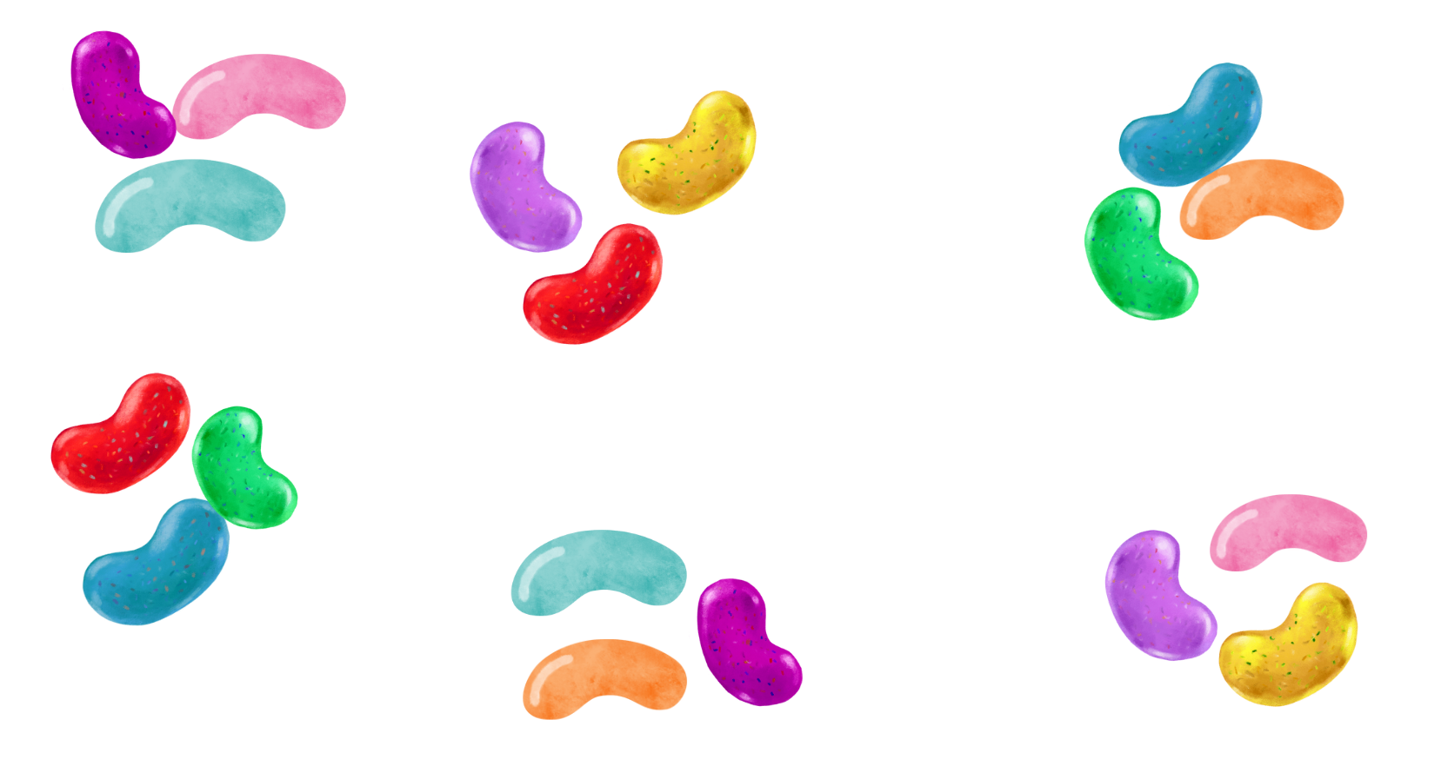
Images sourced from Canva and used in accordance with the Canva Content License Agreement.
- Ask students:
- Just by looking and noticing, how many jellybeans are there?
- Is there another way to arrange the jellybeans to find the total?
- Model arranging the jellybeans on a ten-frame using Resource 7: Ten-frame.
- Ask students:
- What do you notice?
- Is it easier to use a structure like the ten-frame to count the jellybeans?
- Is there a way that you can put the jellybeans in equal bunches or equal groups?
Note: In Early Stage 1, reasoning about relations between pattern units involves recognising the pattern unit and being able to continue the pattern (Samara and Clements 2009).
- Students use counters to discover how many ways they can bunch the jellybeans. Explain each bunch must have the same number of beans. Explain that students don’t yet know how many bunches there are or how many will be in each bunch.
- Ask students to use pictures, symbols, and numerals to record mathematical ideas and thinking.
The table below outlines stimulus prompts to generate conversation about the topic, along with anticipated responses from students.
Prompts | Anticipated student responses
- What are all the different ways you can use your 18 jellybeans to make equal groups?  - Could you make groups of 5?  - What do you notice when you make groups of 5?  - What are you wondering?  - Can you try equal groups of 6 this time? | - I can make lots of groups of 2. There are 9 groups of 2.  - I cannot make groups of 5 as I have 3 leftovers that are not fair shares.  - When I make groups of 5, I don’t have enough to make equal groups.  - I can make 4 groups of 6.
- Ask students to record all solutions by drawing pictures, numbers, and symbols.
- Share by encouraging students to explore different strategies and work produced by taking students on a gallery walk.
This table details assessment opportunities and differentiation ideas.
Assessment opportunities | Too hard? | Too easy?
What to look for:  - Students label the number of groups and the number of objects in groups. (MAO-WM-01, MAE-FG-01, MAE-FG-02)  What to collect:  - observation of manipulating beads and recordings of bunches of balloons (MAO-WM-01, MAE-FG-01, MAE-FG-02). | Students cannot label the number of groups and the number of objects in groups.  - Display concrete and visual displays of equal and unequal groups.  - Use enabling prompts to support student to communicate what they notice about equal groups. | Students can label the number of groups and the number of objects in groups.  - Explore, notice, and record multiple equal and unequal groups.  - Explore a variety of visual representations for the same number. Encourage students to subitise amounts in groups.

Consolidation and meaningful practice: Toy Shop – 15 minutes
This lesson has been adapted from Toy Shop from Learning and Teaching with Learning Trajectories.
- Display the interactive Toy Shop.
- Listen to problem one: ‘I would like to buy 6 cars for my 2 nephews’.
- Ask students to use their mathematical imagination and turn and talk to discuss the following questions:
- What will this look like?
- What strategy did you use?
- Would anyone change their strategy? Why or why not?
- How many cars are there altogether?
- Use the interactive display to deal the 12 cars between the 2 boxes.
- Repeat with other problems on the Toy Shop.

Resource 1: The doorbell rang
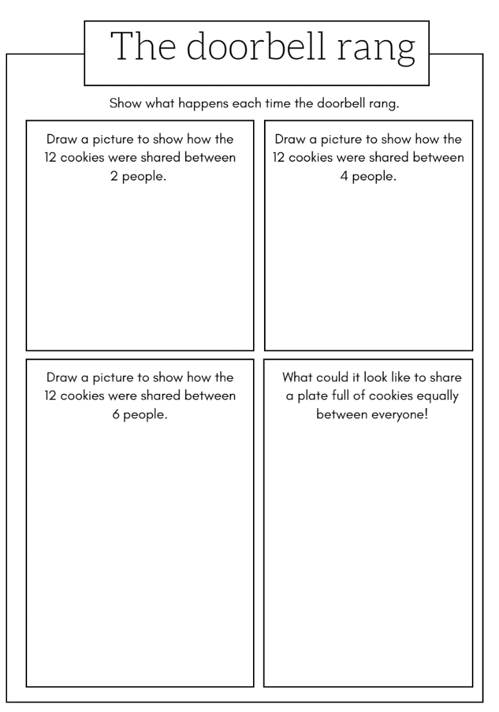

Resource 2: Toy cars
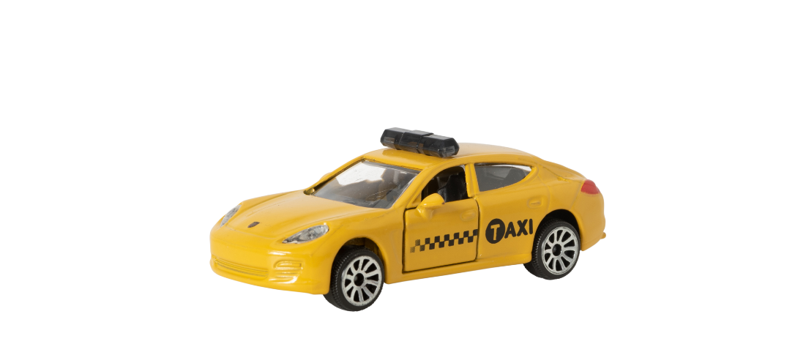
“Yellow toy car” is licensed under the Canva Content License Agreement.

Resource 3: Two toy cars
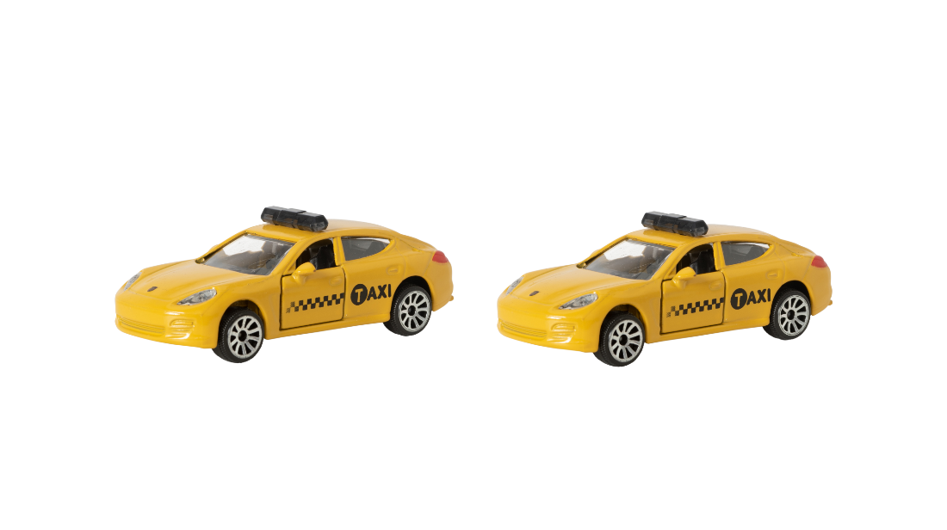
“Yellow toy car” is licensed under the Canva Content License Agreement.

Resource 4: Toy car pattern
“Yellow toy car” is licensed under the Canva Content License Agreement.

Resource 5: Parking template
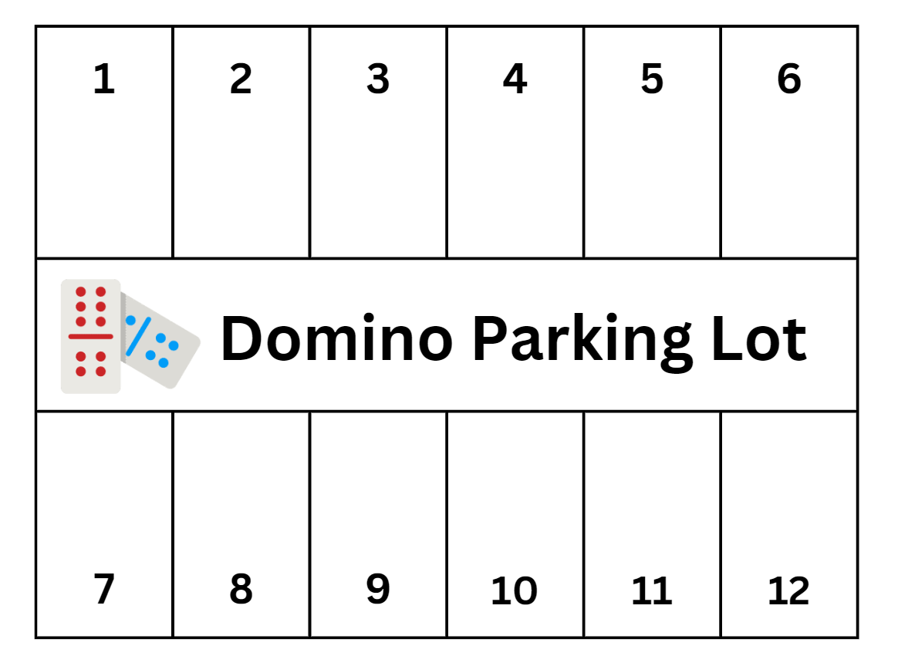
“Domino” by photo3idea is licensed under the Canva Content License Agreement.

Resource 6: Animal cards
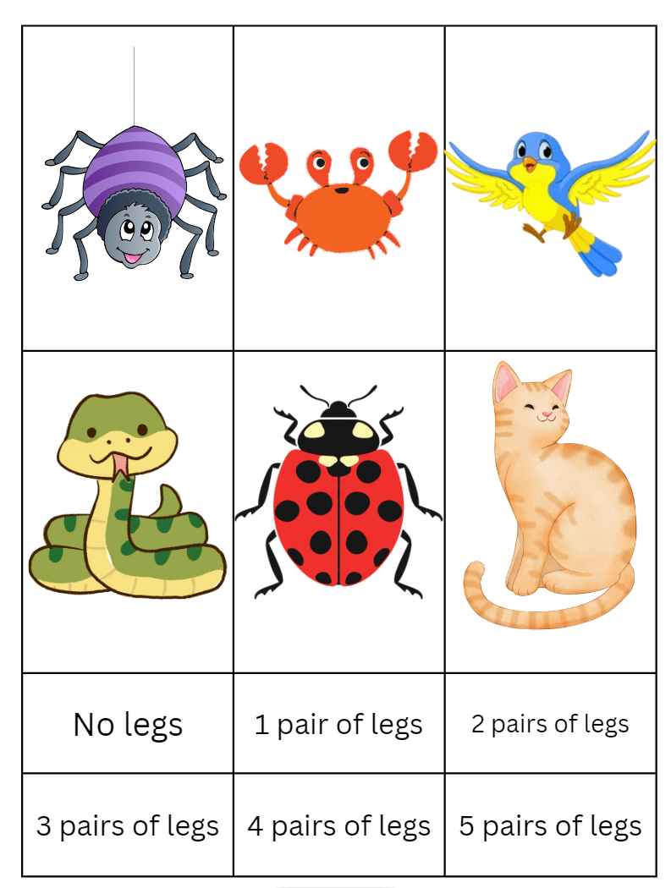
Images sourced from Canva and used in accordance with the Canva Content License Agreement.

Resource 7: Ten-frame

Syllabus outcomes and content
The table below outlines the syllabus outcomes and range of relevant syllabus content covered in this unit. Content is linked to National Numeracy Learning Progression version (3).
Focus area and outcomes | Content groups and content points | Lessons
Representing whole numbers  MAO-WM-01  MAE-RWN-01  MAE-RWN-02 | Instantly name the number of objects within small collections  - instantly recognise (subitise) the number of items in small groups of up to four items without counting (NPV1, CPr1)  - identify the number of items in different arrangements (CPr2)  Use the counting sequence of ones flexibly  - count forwards to at least 30 and state the number after or before a given number, without needing to count from one (CPr4)  Recognise number patterns  - recognise dice and domino dot patterns (NPA1, NPV2, CPr2)  Connect counting and numerals to quantities  - count with one-to-one correspondence, recognising that the last number name represents the total number in the collection (CPr3, CPr5)  - count out a specified number of objects (from 5 to 20) from a larger collection, keeping track of the count (CPr4-CPr5)  - make correspondences between collections  - represent numbers as quantities to at least 20 using objects (such as fingers), number words and numerals (NPV2-NPV4, CPr3)  - compare and order numbers to 20 (NPV2-NPV3)  - use the term ‘is the same as’ to express equality of groups (CPr4-CPr5, MuS1) | 1–8
Forming groups  MAO-WM-01  MAE-FG-01  MAE-FG-02 | Copy, continue and create patterns  - copy and continue repeating patterns using sounds and/or actions (NPA1-NPA2)  - copy, continue and create repeating patterns using shapes, objects, images or pictures (NPA1-NPA2)  Investigate and form equal groups by sharing  - distribute a group of familiar objects into smaller groups and recognise whether the number in each group is equal or not (MuS1-MuS2)  - group and share concrete materials by distributing objects one by one or using another method (MuS1-MuS2)  Record grouping and sharing  - label the number of objects in a group  - record grouping and sharing using drawings, words and numerals, and explain their thinking (MuS2) | 1–8

References
Links to third-party material and websites
Please note that the provided (reading/viewing material/list/links/texts) are a suggestion only and implies no endorsement, by the New South Wales Department of Education, of any author, publisher, or book title. School principals and teachers are best placed to assess the suitability of resources that would complement the curriculum and reflect the needs and interests of their students.
If you use the links provided in this document to access a third-party's website, you acknowledge that the terms of use, including licence terms set out on the third-party's website apply to the use which may be made of the materials on that third-party website or where permitted by the Copyright Act 1968 (Cth). The department accepts no responsibility for content on third-party websites.
Except as otherwise noted, all material is © State of New South Wales (Department of Education), 2023 and licensed under the Creative Commons Attribution 4.0 International License. All other material (third-party material) is used with permission or under licence. Where the copyright owner of third-party material has not licensed their material under a Creative Commons or similar licence, you should contact them directly for permission to reuse their material.
Mathematics K–10 Syllabus © 2022 NSW Education Standards Authority (NESA) for and on behalf of the Crown in right of the State of New South Wales.
© 2022 NSW Education Standards Authority. This document contains NSW Curriculum and syllabus content. The NSW Curriculum is developed by the NSW Education Standards Authority. This content is prepared by NESA for and on behalf of the Crown in right of the State of New South Wales. The material is protected by Crown copyright.
Please refer to the NESA Copyright Disclaimer for more information.
NESA holds the only official and up-to-date versions of the NSW Curriculum and syllabus documents. Please visit the NSW Education Standards Authority (NESA) website and the NSW Curriculum website.
National Numeracy Learning Progression © Australian Curriculum, Assessment and Reporting Authority (ACARA) 2010 to present, unless otherwise indicated. This material was downloaded from the Australian Curriculum website (National Numeracy Learning Progression) (accessed 15 December 2022) and was not modified. The material is licensed under CC BY 4.0. Version updates are tracked in the ‘Curriculum version history’ section on the 'About the Australian Curriculum' page of the Australian Curriculum website.
ACARA does not endorse any product that uses the Australian Curriculum or make any representations as to the quality of such products. Any product that uses material published on this website should not be taken to be affiliated with ACARA or have the sponsorship or approval of ACARA. It is up to each person to make their own assessment of the product, taking into account matters including, but not limited to, the version number and the degree to which the materials align with the content descriptions and achievement standards (where relevant). Where there is a claim of alignment, it is important to check that the materials align with the content descriptions and achievement standards (endorsed by all education Ministers), not the elaborations (examples provided by ACARA).
Australian Curriculum Lessons (2019) Australian Curriculum Lessons [website], accessed 15 December 2022.
Clements DH and Sarama J (2017/2019) Learning and Teaching with Learning Trajectories [LT]2 [website], accessed 15 December 2022.
Clements DH and Sarama J (2017/2019) ‘Toy Shop’, Games, Learning and teaching with learning trajectories [LT]2 website, accessed 15 December 2022.
Elliot J (2019) ‘Lair of Shares’ [television program], Numberblocks (season 4, episode 18), ABC iView, Australia, accessed 15 December 2022.
Hutchins P (1989) The Doorbell Rang, HarperCollins Publishers, United States.
Jdobbin86 (2014) ‘Sharing Cookies – A Division Lesson Plan based on ‘The Doorbell Rang’’, Featured for Members, Australian Curriculum Lessons website, accessed 15 December 2022.
New Zealand Ministry of Education (n.d.) ‘Cars, cars, cars’, Resource Finder, NZ Maths website, accessed 15 December 2022.
New Zealand Ministry of Education (n.d.) NZ Maths [website], accessed 15 December 2022.
Robertson J (2017) Messy Maths: A Playful, Outdoor Approach for Early Years, Crown House Publishing, Great Britain.
Sarama J and Clements D (2008) ‘Mathematics in early childhood’, in Saracho O and Spodek B (eds) Contemporary Perspectives on Mathematics in Early Childhood Education, Information Age Publishing Inc, Charlotte, North Carolina.
Stanford University (n.d.) ‘Feet Under the Table’, Tasks, youcubed website, accessed 15 December 2022.
Stanford University (n.d.) ‘Pepperoni Pizza’, Tasks, youcubed website, accessed 15 December 2022.
Stanford University (n.d.) youcubed [website], accessed 15 December 2022.
University of Cambridge (Faculty of Mathematics) (2022) Birthday Sharing, NRICH website, accessed 15 December 2022.
University of Cambridge (Faculty of Mathematics) (n.d.) NRICH [website], accessed 15 December 2022.
University of Cambridge (Faculty of Mathematics) (2022) Pair of Legs, NRICH website, accessed 15 December 2022.
University of Toronto, Ontario Institute for Students in Education (n.d.) Dominoes Parking Lot Game, The Robertson Program for Inquiry-based Teaching in Mathematics and Science website, accessed 15 December 2022.
University of Toronto, Ontario Institute for Students in Education (n.d.) The Robertson Program for Inquiry-based Teaching in Mathematics and Science [website], accessed 15 December 2022.

