Mathematics – Early Stage 1 – Unit 11
Contents
Unit description and duration 4
Student prior learning 4
Lesson overview and resources 6
Lesson 1: Smart spiders 13
Daily number sense: Stick tapping – 15 minutes 13
Sanctuary for spiders – 30 minutes 15
Consolidation and meaningful practice: Go hunt for prey – 15 minutes 17
Lesson 2: How spiders work 19
Daily number sense: Pouncing on prey – 15 minutes 19
Spider segments – 30 minutes 21
Consolidation and meaningful practice: Try for a total of ten – 15 minutes 23
Lesson 3: Nesting numbers 24
Daily number sense: Numbering nests – 15 minutes 24
Natural nests – 25 minutes 26
Consolidation and meaningful practice: Trusting ten – 20 minutes 28
Lesson 4: Like a lyrebird 31
Daily number sense: Zap zero – 10 minutes 31
Lyrebird lair – 30 minutes 32
Consolidation and meaningful practice: Building and balancing – 20 minutes 35
Lesson 5: Connecting to Country 38
Daily number sense: Collecting in nature – 15 minutes 38
Aboriginal artefacts – 25 minutes 40
Consolidation and meaningful practice: Position picture – 20 minutes 41
Lesson 6: Ready, set, go 43
Daily number sense: How many jumps – 15 minutes 44
Soaring spiders – 20 minutes 45
Consolidation and meaningful practice: The great Australian race – 25 minutes 46
Lesson 7: Time tracking 49
Daily number sense: Name the number – 10 minutes 50
Time on the track – 30 minutes 51
Consolidation and meaningful practice: What’s the time, dingo? – 20 minutes 53
Lesson 8: Ranger, reporting for duty 54
Daily number sense: Park ranger station – 15 minutes 54
Time line-up – 30 minutes 56
Consolidation and meaningful practice: Human clocks – 15 minutes 58
Resource 1: Random number cards 60
Resource 2: Number tracks (0-30) 62
Resource 3: Garden orb-weaving spider 63
Resource 4: Ten-frame 64
Resource 5: Jumping spider gameboard 65
Resource 6: Parts of a spider 66
Resource 7: Spider segments 67
Resource 8: Lyrebird 68
Resource 9: 10 nests 69
Resource 10: Visual scaffold 70
Resource 11: Woomera or miss 71
Resource 12: Finger hopscotch 72
Resource 13: Positional language dice 73
Resource 14: Position book cover 74
Resource 15: Animal photo cards 75
Resource 16: Number chart 76
Resource 17: Dingo 77
Resource 18: Park ranger tasks 78
Syllabus outcomes and content 79
References 84

Unit description and duration
This two-week unit develops student knowledge and understanding that skills of collections of 10 are really useful. Students are provided opportunities to:
- represent numbers in a variety of ways
- reason about the way numbers can be combined and separated
- use positional language both in a physical world context and in more abstract contexts
- compare the weight of different materials by hefting
- understand time in everyday contexts and tell time on analog and digital clocks
- explain their thinking so it makes sense to others.
Mathematics K–10 Syllabus © 2022 NSW Education Standards Authority (NESA) for and on behalf of the Crown in right of the State of New South Wales.

Student prior learning
Before engaging in these teaching and learning activities, students would benefit from prior experience with:
- using language to communicate thinking about quantities to describe features of objects and collections, and to explain mathematical ideas
- opportunities to demonstrate an increasing understanding of symbol systems, for example, letters, numbers, spatial sense and measurement
- noticing and predicting the patterns of regular routines and the passing of time
- contributing constructively to mathematical discussions and arguments.

Lesson overview and resources
The table below outlines the sequence and approximate timing of lessons; syllabus focus areas and content groups; and resources.
Lesson | Syllabus focus area and content groups | Resources
Lesson 1: Smart spiders  60 minutes  Numbers are symbols that help us to represent quantities. | Representing whole numbers  - Use the counting sequence of ones flexibly  - Connect counting and numerals to quantities  Combining and separating quantities  - Model additive relations and compare quantities  - Identify part–whole relationships in numbers up to 10  Geometric measure  - Position: Describe position and movement of oneself | - Resource 1: Random number cards  - Resource 2: Number tracks (0-30)  - Resource 3: Garden orb-weaving spider  - Resource 4: Ten-frame  - Bark  - Decks of playing cards  - Modelling clay  - Sticks  - String  - 10-sided dice  - Writing materials
Lesson 2: How spiders work  60 minutes  Number relations help us to understand that a whole number is made up of parts. | Representing whole numbers  - Recognise number patterns  - Connect counting and numerals to quantities  Combining and separating quantities  - Identify part–whole relationships in numbers up to 10 | - Resource 2: Number tracks (0-30)  - Resource 4: Ten-frame  - Resource 5: Jumping spider gameboard  - Resource 6: Parts of a spider  - Resource 7: Spider segments  - Decks of playing cards  - Dice  - 6-sided number dice  - Small wooden blocks  - Sticks  - Writing materials
Lesson 3: Nesting numbers  60 minutes  There are many ways to make 10. | Representing whole numbers  - Recognise number patterns  - Connect counting and numerals to quantities  Combining and separating quantities  - Model additive relations and compare quantities  - Identify part–whole relationships in numbers up to 10 | - Resource 4: Ten-frame  - Resource 8: Lyrebird  - Resource 9: 10 nests  - Resource 10: Visual scaffold  - Concrete materials  - Paper cups  - Seed pods  - 10-sided dice  - Writing materials
Lesson 4: Like a lyrebird  60 minutes  We can make connections between collections. | Representing whole numbers  - Instantly name the number of objects within small collections  - Use the counting sequence of ones flexibly  - Connect counting and numerals to quantities  Non-spatial measure  - Mass: Identify and compare mass using weight | - Resource 2: Number tracks (0-30)  - Resource 4: Ten-frame  - Brown paper bags  - Concrete materials  - Feathers  - Palm leaves  - Paper cups  - Recycled sectional sorting trays  - Rubber bands  - Sticks  - Writing materials
Lesson 5: Connecting to country  60 minutes  Mathematicians use language to describe position and movement. | Representing whole numbers  - Recognise number patterns  - Connect counting and numerals to quantities  Combining and separating quantities  - Identify part–whole relationships in numbers up to 10  Geometric measure  - Position: Describe position and movement of oneself | - Resource 4: Ten-frame  - Resource 11: Woomera or miss  - Dividers  - Gumnuts  - Natural materials  - Puppet or soft toy  - 6-sided dice  - Sticks  - Writing materials
Lesson 6: Ready, set, go  60 minutes  We can use positional language to describe movement and ordinals. | Representing whole numbers  - Recognise number patterns  - Connect counting and numerals to quantities  Combining and separating quantities  - Identify part–whole relationships in numbers up to 10  Geometric measure  - Position: Describe position and movement of oneself | - Resource 4: Ten-frame  - Resource 12: Finger hopscotch  - Resource 13: Positional language dice  - Resource 14: Position book cover  - Resource 15: Animal photo cards  - Dice  - Leaves  - Natural materials  - Pegs  - Rocks  - 6-sided number dice  - Spider figurine  - String  - Writing materials
Lesson 7: Time tracking  60 minutes  Students can use their number knowledge to tell time. | Representing whole numbers  - Use the counting sequence of ones flexibly  - Connect counting and numerals to quantities  Combining and separating quantities  - Identify part–whole relationships in numbers up to 10  Geometric measure  - Position: Describe position and movement of oneself  Non-spatial measure  - Time: Tell time on the hour on analog and digital clocks | - Resource 2: Number tracks (0-30)  - Resource 16: Number chart  - Resource 17: Dingo  - Chalk  - 6-sided number dice  - 10-sided dice
Lesson 8: Ranger, reporting for duty  60 minutes  Storytelling helps us to solve real-world problems. | Representing whole numbers  - Connect counting and numerals to quantities  Combining and separating quantities  - Identify part–whole relationships in numbers up to 10  Geometric measure  - Position: Describe position and movement of oneself  Non-spatial measure  - Time: Compare and order the duration of events using the language of time  - Time: Tell time on the hour on analog and digital clocks | - Resource 4: Ten-frame  - Resource 18: Park ranger tasks  - Coloured wooden sticks  - Pegs  - String  - 10-sided dice  - Writing materials

Lesson 1: Smart spiders
Core concept: Numbers are symbols that help us to represent quantities.
The table below contains suggested learning intentions and success criteria. These are best co-constructed with students.
Learning intentions | Success criteria
Students are learning that:  - using rhythm and movement can help to understand that whole numbers indicate quantity  - counting by ones can help to find the total of 2 or more groups of concrete materials that have been combined  - visual representations of numbers can assist in combining and separating quantities up to 10. | Students can:  - read numerals and move forwards and backwards while counting from a given number to the rhythm  - combine 2 or more groups of objects to find the total  - create, model and recognise visual patterns for numbers up to 10.

Daily number sense: Stick tapping – 15 minutes
This lesson has been adapted from Robertson (2017).
- Build student understanding of forward and backward counting sequences by reading numerals to at least 20. Represent numbers as quantities through rhythm and movement.
- Lead students to the playground and form a straight line.
- Explain that students will be playing a counting game by slowly tapping 2 sticks on the ground in time to each number said aloud. Encourage all students to chorally count aloud and work on developing a steady rhythm.
- Display a card from Resource 1: Random number cards and allow time for students to read the numeral and say aloud. Commence counting and moving forwards to a given number to the rhythm of stick tapping.
- Challenge students to begin by counting forwards until you call out ‘switch’. When they hear the word, students change direction and count backwards. When counting forwards, students slowly tap their body from their toes up to their head and, when counting backwards, students slowly tap their body from their head down to their toes.
- Repeat multiple times by displaying different cards from Resource 1: Random number cards.
Note: Consider incorporating local Indigenous language or the languages of the diverse cultures within the class into counting.
The table below details assessment opportunities and differentiation ideas.
Assessment opportunities | Too hard? | Too easy?
What to look for:  - Can students read numerals and move forwards and backwards while counting from a given number to the rhythm? (MAO-WM-01, MAE-RWN-01, MAE-RWN-02, MAE-GM-01)  What to collect:  - observations from game-based learning opportunity (MAO-WM-01, MAE-RWN-01, MAE-RWN-02, MAE-GM-01). | Students need further support to read numerals and move forwards and backwards while counting from a given number to the rhythm.  - Provide students with Resource 2: Number tracks (0-30) and model tapping a stick along the number track as they count forward and backward.  - Clap hands or hop to the rhythm of choral counting. | Students confidently read numerals and move forwards and backwards while counting from a given number to the rhythm.  - Tap 2 sticks alternately on the ground.  - Students say the number before and after a given number.

Sanctuary for spiders – 30 minutes
- Display Resource 3: Garden-orb weaving spider as a visual stimulus.
- Explain that spiders are found in dry open forest and woodlands, coastal sand dune shrubland and mangrove habitats. Garden orb-weaving spiders make webs in openings between trees and shrubs where insects are likely to fly.
- Encourage students to use their imagination to create a habitat for the garden orb-weaving spider using modelling clay, string, sticks and bark from a collection of natural materials.
- Model creating a body for the spider using modelling clay. Explain that students will take turns rolling a 10-sided dice to determine how many objects will form the web, and the number of prey creatures in the web. For example, if the dice shows the numeral 6, students will determine how many more they need to make 10 and use that number of objects to make the web or prey. They will count out a specified number of objects for the web, body and prey. Count by ones to find the total (see Figure 1). The only fixed number in this activity is 8. If students roll the number 8 they must add 8 legs to the spider.
Figure 1 – Spider habitat
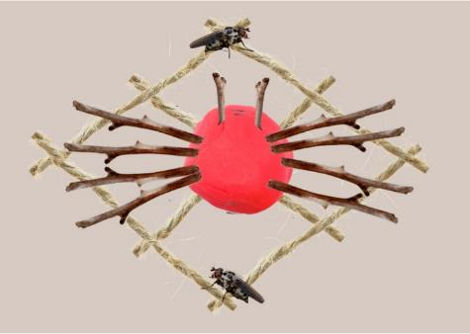
Images from Canva are licensed under Canva Content License Agreement.
- Students create ‘sanctuary for spiders’ in pairs.
- Showcase student spider sanctuary creations through a gallery walk and have students describe the features, for example, the garden orb-weaving spider has 11 body parts, the web is made from 6 pieces of string and 4 insects are caught in the web, which is a total of 21 objects.
The table below details assessment opportunities and differentiation ideas.
Assessment opportunities | Too hard? | Too easy?
What to look for:  - Can students combine 2 or more groups of objects to find the total? (MAO-WM-01, MAE-CSQ-01).  What to collect:  - student participation in gallery walk and recording of language used in group discussion (MAO-WM-01, MAE-CSQ-01). | Students need further support to combine 2 or more groups of objects to find the total.  - Provide students with Resource 2: Number tracks (0-30).  - Model counting leaves using one-to-one correspondence. | Students confidently combine 2 or more groups of objects to find the total.  - Students roll an additional dice to determine how many eyes to add to their garden orb-weaving spider and find the total number of objects.  - Students draw their spider sanctuary creation and label each part with a numeral as well as the total number of objects.

Consolidation and meaningful practice: Go hunt for prey – 15 minutes
This activity has been adapted from Go Fish 10 by NZ Maths.
- Build student understanding of forming combinations to 10 by playing ‘go hunt for prey’.
- Students play ‘go hunt for prey’ in pairs to find combinations of 10 insects for a hungry huntsman spider. A student will deal out a deck of playing cards with all picture and number 10 cards removed from the deck. Students look through their cards and make pairs of cards that have a total of 10. These pairs are placed face up in front of each student (see Figure 2).
Figure 2 – Combinations to 10
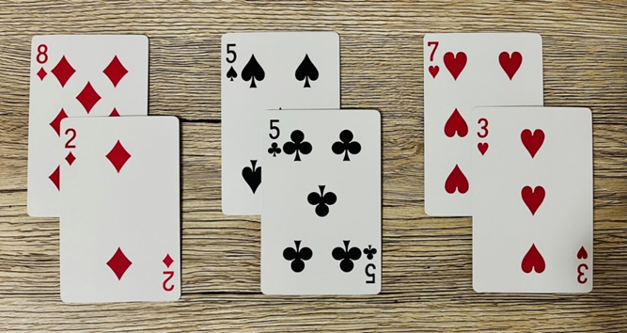
- Students take turns asking one another for a card that they can use to make 10 with a card in their hand. If the student asked has the card, they must give it to their peer. The aim of the game is to get the most pairs that have a total of 10.
The table below details assessment opportunities and differentiation ideas.
Assessment opportunities | Too hard? | Too easy?
What to look for:  - Can students create, model and recognise visual patterns for numbers up to 10? (MAO-WM-01, MAE-CSQ-02)  What to collect:  - record student’s voice during game-based learning opportunity (MAO-WM-01, MAE-CSQ-02). | Students need further support to create, model and recognise visual patterns for numbers up to 10.  - Provide students with Resource 4: Ten-frame and concrete materials to support addition.  - Model counting on when counting the visual patterns on 2 playing cards with one-to-one correspondence. | Students confidently create, model and recognise visual patterns for numbers up to 10.  - Challenge students to combine 3 cards to make combinations to 10.  - Challenge students to look for combinations to 20.

Lesson 2: How spiders work
Core concept: Number relations help us to understand that a whole number is made up of parts.
The table below contains suggested learning intentions and success criteria. These are best co-constructed with students.
Learning intentions | Success criteria
Students are learning that:  - dice dot patterns are symbols that represent a quantity of objects  - visual representations of numbers can assist in combining and separating quantities up to 10. | Students can:  - represent the total shown on dice dot patterns by counting out objects  - create, model and recognise combinations for numbers up to 10.

Daily number sense: Pouncing on prey – 15 minutes
- Build student understanding of counting with one-to-one correspondence by connecting number names, numerals and quantities.
- Explain that students will play a counting game about making collections of prey for jumping spiders. Describe how jumping spiders make sudden leaps and pounce on prey instead of building webs.
- Display Resource 5: Jumping spider gameboard.
- Model how to play ‘pouncing on prey’ by rolling 2 dice and locating a square on the gameboard that matches the total number of dots on both dot dice patterns combined. Build a tower of prey using small wooden blocks on top of the chosen square. If there are no vacant squares available to match a number rolled, roll 2 dice again. Continue playing ‘pouncing on prey’ until all the gameboard squares have been filled with matching towers.
- Provide time for students to play ‘pouncing on prey’ independently.
The table below details assessment opportunities and differentiation ideas.
Assessment opportunities | Too hard? | Too easy?
What to look for:  - Can students represent the total shown on dice dot patterns by counting out objects? (MAO-WM-01, MAE-RWN-01, MAE-RWN-02)  What to collect:  - student manipulation of materials to demonstrate conceptual understanding (MAO-WM-01, MAE-RWN-01, MAE-RWN-02). | Students need further support to represent the total shown on dice dot patterns by counting out objects.  - Provide students with Resource 2: Number tracks (0-30).  - Model counting small wooden blocks with one-to-one correspondence. | Students confidently represent the total shown on dice dot patterns by counting out objects.  - Start the game with matching number towers on all the gameboard squares. Roll the dice and remove a tower with that number of blocks. Continue until all towers have been removed.  - Students play the game in pairs, taking turns to build towers of prey using small coloured wooden blocks. Once all the gameboard squares have matching towers, each player counts how many blocks in their colour are on the board to determine who has a larger collection.

Spider segments – 30 minutes
- Display Resource 6: Parts of a spider to show that spiders have 4 legs on the left, 4 legs on the right and 2 fangs up the top. Ask students to find the total number of legs and fangs on a spider.
- Show students Resource 7: Spider segments.
- Model how to play ‘spider segments’ using Resource 7: Spider segments by rolling a 6-sided number dice and drawing the corresponding dice pattern in the first box. Add the corresponding number of legs to the thorax using sticks to represent the number shown on the dice. Use additional sticks to find out how many more sticks are needed to make 10 parts, legs and fangs for the spider and write the numeral in the second box (see Figure 3).
Figure 3 – Legs and fangs
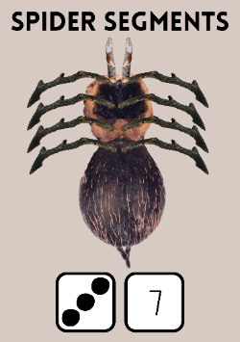
Images from Canva are licensed under Canva Content License Agreement.
- Provide time to play ‘spider segments’ independently, repeating the game multiple times.
- In pairs, students turn and talk to share their reasoning.
The table below details assessment opportunities and differentiation ideas.
Assessment opportunities | Too hard? | Too easy?
What to look for:  - Can students create, model and recognise combinations for numbers up to 10? (MAO-WM-01, MAE-CSQ-02)  What to collect:  - student manipulation of materials to demonstrate conceptual understanding (MAO-WM-01, MAE-CSQ-02). | Students need further support to create, model and recognise combinations for numbers up to 10.  - Provide students with Resource 2: Number tracks (0-30).  - Provide students with Resource 4: Ten-frame. | Students confidently create, model and recognise combinations for numbers up to 10.  - Record different ways to make 10 using tally marks.  - Challenge students to find 3 numbers with a total of 10.

Consolidation and meaningful practice: Try for a total of ten – 15 minutes
- Students play ‘try for a total of 10’ in small groups. Students will lay out a deck of playing cards face up in rows and columns with all picture and number 10 cards removed from the deck. Ace cards represent the number one (see Figure 4).
Figure 4 – Rows and columns
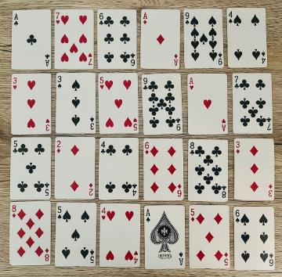
- Model removing sets of cards that have a total of 10 and explain that the aim of the game is to eliminate all cards.
- Provide time for students to play ‘try for a total of 10’ focusing on the reasoning provided for combining the symbols or numerals on playing cards to 10.

Lesson 3: Nesting numbers
Core concept: There are many ways to make 10.
The table below contains suggested learning intentions and success criteria. These are best co-constructed with students.
Learning intentions | Success criteria
Students are learning that:  - concrete materials assist in combining and separating quantities up to 10  - items arranged in different visual and symbolic patterns can equal the same number  - drawings, words and numerals can help to explain number combinations to 10. | Students can:  - create, model and recognise combinations for numbers up to 10  - identify the number of items in different arrangements  - use drawings, words and numerals to record number combinations to 10 and explain their thinking.

Daily number sense: Numbering nests – 15 minutes
- Build student understanding of different combinations for numbers to 10 by separating parts that form the whole.
- Place 10 paper cups in a triangular shape to represent lyrebird eggs in their nests on the ground.
- Explain to students that the lyrebird is a ground-dwelling Australian bird who live in forests, especially rainforests. It is the female lyrebird who builds a dome-shaped nest on the ground, within tree stumps or in caves. They rarely build nests in trees.
- Show students an image of a lyrebird. See Resource 8: Lyrebird.
- Model counting the nests set up in a triangular shape with one-to-one correspondence.
- Tell students that they need to check the lyrebird nests to find out how many chicks have hatched. Explain that students will do this by rolling a seed pod and seeing how many nests tip over to reveal a lyrebird and how many stay upright.
- Model rolling the seed pod towards the nests and counting how many nests were tipped over and how many stayed upright. Record the numbers that combine to make 10 (see Figure 5).
Figure 5 – Nests to make 10
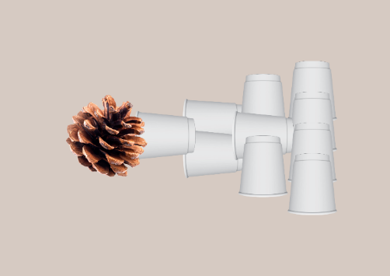
Images from Canva are licensed under Canva Content License Agreement.
- Explain that students can check their answers by counting the number of nests tipped over and the number of nests still standing and arrive at the number 10.
- Provide time to play ‘numbering nest’ in small groups.
The table below details assessment opportunities and differentiation ideas.
Assessment opportunities | Too hard? | Too easy?
What to look for:  - Can students create, model and recognise combinations for numbers up to 10? (MAO-WM-01, MAE-CSQ-02)  What to collect:  - student manipulation of materials to demonstrate conceptual understanding (MAO-WM-01, MAE-CSQ-02). | Students need further support to create, model and recognise combinations for numbers up to 10.  - Provide students with Resource 4: Ten-frame.  - Model counting with one-to-one correspondence. | Students confidently create, model and recognise combinations for numbers up to 10.  - Arrange paper cups in dice dot patterns.  - Identify different finger patterns to correspond with the collections of paper cups.

Natural nests – 25 minutes
- Build student understanding of different ways to make 10 by viewing items arranged in different visual and symbolic patterns.
- Display Resource 9: 10 nests as a visual stimulus.
- Ask questions such as:
- How many nests do you see?
- Does anyone see something different?
- How did you know how many nests there are?
- Does this strategy make it easier to see how many nests there are?
- Will this strategy always work?
- Why did you find it easier?
- As a class, identify different combinations that make 10. Encourage students to draw the small groups of items they instantly recognised without counting by circling groups of nests.
- Guide students to discover that combining numbers such as 6 and 4 will always make 10. Explain to students that it does not matter what type of objects they are counting, or the order in which they combine the numbers; the total will always be 10.
- Explain that mathematicians test their ideas and justify their thinking using concrete examples to support their thinking. Revise that 6 and 4 always make 10 and ask if there could be other combinations of 2 numbers that can be combined to make 10.
- Explain that students are going to explore and test if there are different numbers that combine to make 10 using a variety of concrete materials, such as dominoes, dice and natural materials.
- Students work in pairs to identify different combinations of 2 numbers that, when combined, make 10. Students record their ideas on a whiteboard.
The table below details assessment opportunities and differentiation ideas.
Assessment opportunities | Too hard? | Too easy?
What to look for:  - Can students identify the number of items in different arrangements? (MAO-WM-01, MAE-RWN-01, MAE-CSQ-01, MAE-CSQ-02)  What to collect:  - student manipulation of materials to demonstrate conceptual understanding (MAO-WM-01, MAE-RWN-01, MAE-CSQ-01, MAE-CSQ-02). | Students need further support to identify the number of items in different arrangements.  - Provide students with Resource 4: Ten-frame.  - Show different ways to make 10 by creating finger patterns with a peer. | Students confidently identify the number of items in different arrangements.  - Arrange items in dice dot patterns.  - Create a number story about numbers that combine to make 10 using concrete materials.

Consolidation and meaningful practice: Trusting ten – 20 minutes
- Introduce ‘trusting 10’ by displaying Resource 10: Visual scaffold.
- Model how to play ‘trusting 10’ by rolling a 10-sided dice. Explain to students that if the dice shows the numeral 8, they will need to find how many more to make 10. Reinforce that 8 and 2 always makes 10, no matter how the 8 and 2 are represented.
- Provide students with Resource 10: Visual scaffold to create a poster that communicates a number bond to 10 in as many ways as possible, including ten-frames, dice patterns, drawings and images (see Figure 6).
Figure 6 – 8 and 2
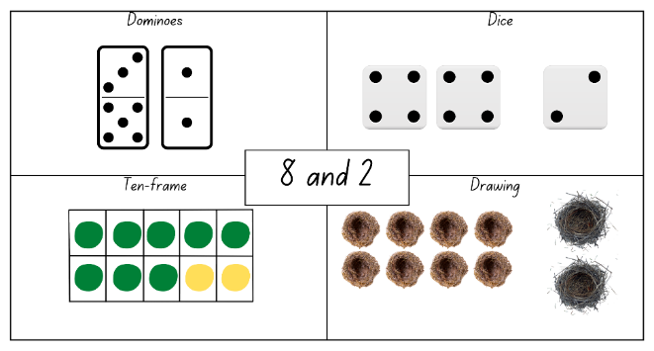
Images from Canva are licensed under Canva Content License Agreement.
- Provide time to play ‘trusting 10’ independently.
- Showcase student posters through a gallery walk and have students verbally explain their representations.
- Reinforce that numbers can be represented in different ways, emphasising that 8 of something with 2 of something will always be 10 of something. Explain that these mathematical regularities help when combining quantities together.
The table below details assessment opportunities and differentiation ideas.
Assessment opportunities | Too hard? | Too easy?
What to look for:  - Can students use drawings, words and numerals to record number combinations to 10 and explain their thinking? (MAO-WM-01, MAE-RWN-01, MAE-RWN-02, MAE-CSQ-01, MAE-CSQ-02)  What to collect:  - work sample of visual representations of numbers (MAO-WM-01, MAE-RWN-01, MAE-RWN-02, MAE-CSQ-01, MAE-CSQ-02). | Students need further support to use drawings, words and numerals to record number combinations to 10 and explain their thinking.  - Provide students with Resource 4: Ten-frame and concrete materials to support making number combinations.  - Show different ways to make 10 by creating finger patterns with a peer. | Students confidently use drawings, words and numerals to record number combinations to 10 and explain their thinking.  - Students create a visual representation of a number bond to 20.  - Challenge students to label their poster with numbers and/or words.

Lesson 4: Like a lyrebird
Core concept: We can make connections between collections.
The table below contains suggested learning intentions and success criteria. These are best co-constructed with students.
Learning intentions | Success criteria
Students are learning that:  - using rhythm can help to understand the counting sequence  - organising larger collections of objects up to 20 into smaller collections can help to find the total number in the collection  - collections of 2 different objects with the same total can have different masses. | Students can:  - count backwards from 20 to the rhythm  - find the total of a larger collection by organising objects into smaller collections  - predict and compare the weight of 2 masses by hefting.

Daily number sense: Zap zero – 10 minutes
This lesson has been adapted from Zap from Developing efficient numeracy strategies [PDF 9.1MB].
- Build student understanding of number word sequences by counting backwards from 20.
- Ask students to gather in a circle as a whole class.
- Explain to students that they will be counting backwards from 20 to zero.
- Have each student call out one number in the sequence. When the number sequence reaches zero, the student who says ‘zero’ is zapped and sits down. Continue the game with students commencing the backward count from 20 again.
- This process continues until one student remains standing.
The table below details assessment opportunities and differentiation ideas.
Assessment opportunities | Too hard? | Too easy?
What to look for:  - Can students count backwards from 20 to the rhythm? (MAO-WM-01, MAE-RWN-01).  What to collect:  - observations of game-based learning opportunity (MAO-WM-01, MAE-RWN-01). | Students need further support to count backwards from 20 to the rhythm.  - Provide students with Resource 2: Number tracks (0-30).  - Model counting backwards by ones. | Students confidently count backwards from 20 to the rhythm.  - Start counting backwards from 30.  - Students work in pairs to show the finger pattern for each number once they have been zapped.

Lyrebird lair – 30 minutes
- Ask students to gather in a circle as a whole class.
- Tell a story about a lyrebird named Lowanna who needs 20 natural materials to make a nest for egg laying. Reinforce that the lyrebird is a ground-dwelling Australian bird that builds a dome-shaped nest which is made from sticks, feathers and pieces of palm leaf.
- Show students a large collection of natural materials such as sticks, feathers and pieces of palm leaf. Explain that they need to organise the objects to make it easier to show the total count. Ask students to select a type of natural material and count out 20 objects from a larger collection in pairs.
- Students turn and talk with a partner to identify strategies they could use to organise the objects to make it easier to find the total number in the collection.
- Ask students to first show groups of 10 (see Figure 7).
Figure 7 – Groups of 10
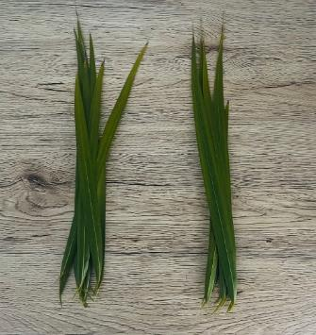
- Ask students to create different ways of organising objects into collections to make it easier to count and find the total number in the collection. Reinforce that there are many ways to organise objects and some ways are more efficient than others.
- Provide pairs with tools for organising the groups. These may include paper cups, recycled sectional sorting trays or rubber bands (see Figure 8).
Figure 8 – Collections of objects
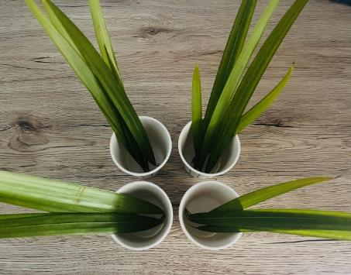
- During the activity, ask pairs to explain their strategy of organising objects. Ask how their strategy supports accuracy in counting. Take photographs of the collections before and after sorting to show how organising objects into groups is a useful way to count larger numbers.
- After experimenting to find the total by organising objects in collections, discuss the following questions:
- How many objects are in your collection?
- How can you organise the objects to see and count how many there are?
- How does your organisation help you count?
- How can you record on paper how you organised and counted the collection?
The table below details assessment opportunities and differentiation ideas.
Assessment opportunities | Too hard? | Too easy?
What to look for:  - Can students find the total of a larger collection by organising objects into smaller collections? (MAO-WM-01, MAE-RWN-01, MAE-RWN-02)  What to collect:  - student manipulation of materials to demonstrate conceptual understanding (MAO-WM-01, MAE-RWN-01, MAE-RWN-02). | Students need further support to find the total of a larger collection by organising objects into smaller collections.  - Provide students with copies of Resource 4: Ten-frame and concrete materials to support making small collections.  - Model counting with one-to-one correspondence using the objects organised into smaller collections. | Students confidently find the total of a larger collection by organising objects into smaller collections.  - Create a number story about the collections created.  - Challenge students to record their collections through drawings and labels.

Consolidation and meaningful practice: Building and balancing – 20 minutes
- Provide time for students to make a nest in pairs using the 20 natural materials selected and a brown paper bag. Demonstrate rolling the top edge of the bag outward and continue rolling down to the bottom of the bag (see Figure 9).
Figure 9 – Brown bag nest
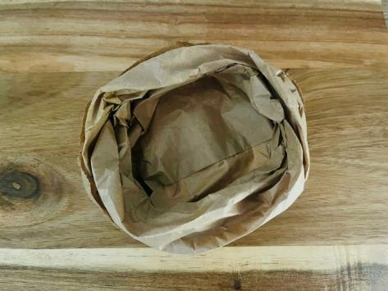
- Reinforce that mass is how heavy something is. Ask students to predict which nest would be heavier than, lighter than, or have about the same weight as another object and explain reasons for this prediction. For example, the palm leaves are bigger than the sticks so they could be heavier.
- Demonstrate seesaw arms or hefting by holding one object in each hand and with arms outstretched model which object feels heavier (pulls arms down) or lighter (pulls arm up) or about the same (even arms).
- Compare 2 masses directly by hefting. Ask students to hold the nest they created, and the nest created by another pair made of a different natural material to compare their mass. Support students to use comparative language when hefting using words such as light, lighter, lightest, heavy, heavier, heaviest.
- Use ‘Talk moves’ to facilitate class discussion.
The table below details assessment opportunities and differentiation ideas.
Assessment opportunities | Too hard? | Too easy?
What to look for:  - Can students predict and compare the weight of 2 masses by hefting? (MAO-WM-01, MAE-NSM-01).  What to collect:  - record verbal and non-verbal responses to reflect their thinking and problem solving (MAO-WM-01, MAE-NSM-01). | Students need further support to predict and compare the weight of 2 masses by hefting.  - Provide time for students to compare 2 objects that are quite different in mass.  - Model how to show and describe the difference between masses when hefting. | Students confidently predict and compare the weight of 2 masses by hefting.  - Order nests from lightest to heaviest.  - Students locate objects within the classroom that are lighter than, heavier than and about the same as the nest they created by hefting.

Lesson 5: Connecting to Country
Core concept: Mathematicians use language to describe position and movement.
The table below contains suggested learning intentions and success criteria. These are best co-constructed with students.
Learning intentions | Success criteria
Students are learning that:  - keeping track of the count helps to connect numerals to quantities  - the position of objects does not change the total number in the collection  - the position of an object in relation to another object can be described using positional language. | Students can:  - count out a number of items collected on Country and follow directional language instructions  - describe the location of a number of objects using positional language  - follow simple directions to position objects.

Daily number sense: Collecting in nature – 15 minutes
This lesson has been adapted from Robertson (2017).
- Build student understanding of keeping track of the count by counting out a specific number of objects and using these to follow simple directions using proximity terms and referring to frames of reference (near, between, next to, in front of, behind) to position objects.
Country is ‘used to describe a specific area of a nation or clan including physical, linguistic and spiritual features. Aboriginal communities’ cultural associations with their Country may include or relate to languages, cultural practices, knowledge, songs, stories, art, paths, landforms, flora, fauna and minerals. These cultural associations may include custodial relationships with particular landscapes such as land, sea, sky, rivers as well as the intangible places associated with the Dreaming(s). Custodial relationships are extremely important in determining who may have the capacity to authentically speak for their Country.’
Place is ‘a space mapped out by physical or intangible boundaries that individuals or groups of Torres Strait Islander Peoples occupy and regard as their own. It is a space with varying degrees of spirituality.’
From: Aboriginal Studies Years 7-10 Syllabus (2020)
- Lead students to the playground and explain they will be finding and collecting natural materials.
Note: While outside there may be opportunity to explain the term ‘on Country’.
- After finding and collecting a number of objects, ask students to gather in a circle with their collection in front of them.
- Call out different actions such as:
- Stand next to your collection.
- Place 5 objects near your foot.
- Swap places with someone standing next to you.
- Hold 8 objects behind your back.
- Sit down in front of 3 objects.
- Once students understand the game, they can also be selected to call out instructions.

Aboriginal artefacts – 25 minutes
- Show students an image of a spear thrower which is commonly known as a woomera. Explain that the woomera is a unique Aboriginal invention designed to make spear throwing more accurate and extend the distance travelled.
- As a class, create a position anchor chart using positional language such as in, on, under, up, down, near, between, next to, in front of, behind, left and right and featuring a woomera to support the game ‘woomera or miss’.
- Explain to students that the game ‘woomera or miss’ is played in pairs. Ask 2 students to model sitting across from one another and open a large book or place a book box between them to keep their gameboards hidden. Students will each use Resource 11: Woomera or miss as a gameboard which features Australian landmarks.
- Model rolling a 6-sided number dice and place the corresponding number of sticks to represent woomeras onto Resource 11: Woomera or miss in a formation of their choice. Students then take turns to ask each other questions using proximity terms to try to discover the placement of the other player’s woomeras.
- Students ask questions such as:
- Is there a woomera to the left of the tree?
- Is there a woomera under the number 5?
- Is there a woomera on the lake?
- Students place a circle in the box when they miss the position of the other player’s woomeras or a cross when they locate the position of a woomera.
- Explain that the aim of the game ‘woomera or miss’ is to find the location of all woomeras. When all woomeras have been located, the student calls out ‘woomera’ and they place gumnuts or counters in the spaces to determine how many more to make 10. Record combination for 10 by writing the numeral corresponding to the dot dice pattern and the numeral to reflect how many gumnuts or counters were added in the spaces (see Figure 10).
Figure 10 – Hit or miss gameplay
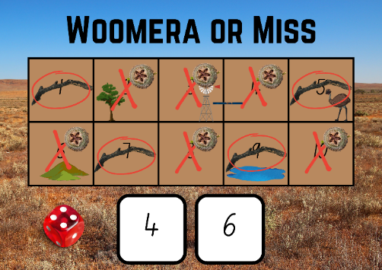
Images from Canva are licensed under Canva Content License Agreement.

Consolidation and meaningful practice: Position picture – 20 minutes
- Explain that students will be listening and following directions to draw an Australian bush landscape including some native Australian animals.
- Guide students through step-by-step directions to draw an Australian bush landscape such as:
- Draw a hill on the left.
- Draw a lake on the right.
- Draw a track between the hill and the lake.
- Draw a windmill in front of the hill.
- Draw a tree behind the lake with 4 branches.
- Draw 5 emus near the lake.
- Draw a woomera next to the emus.
- Ask students to combine and find the total by placing sticks on Resource 4: Ten-frame to represent the branches on the tree, emus and woomera in the drawing.
The table below details assessment opportunities and differentiation ideas.
Assessment opportunities | Too hard? | Too easy?
What to look for:  - Can students follow simple directions to position objects? (MAO-WM-01, MAE-CSQ-02, MAE-GM-01)  What to collect:  - students’ visual representation after following simple directions to position objects (MAO-WM-01, MAE-CSQ-02, MAE-GM-01). | Students need further support to follow simple directions to position objects.  - Model and describe the position of a puppet or soft toy.  - Ask students to find objects around the classroom using positional language. | Students confidently follow simple directions to position objects.  - Brainstorm other objects that may appear in the Australian bush landscape drawing that have a total of 10.  - In pairs, students provide step-by-step directions using positional language for a peer to follow and complete a drawing.

Lesson 6: Ready, set, go
Core concept: We can use positional language to describe movement and ordinals.
The table below contains suggested learning intentions and success criteria. These are best co-constructed with students.
Learning intentions | Success criteria
Students are learning that:  - there are many combinations of numbers that make 10  - every time they see a dot dice pattern arrangement, they know they represent a particular quantity  - ordinal number words represent a position in a sequence. | Students can:  - recognise dot dice patterns and determine how many more to make 10  - make connections between dot dice patterns and positional language  - use the ordinal names to describe order of position.

Daily number sense: How many jumps – 15 minutes
This lesson has been adapted from Robertson (2017).
- Build student understanding of recognising dot dice patterns and determining combinations for numbers to 10.
- Lead students to the playground and explain to students that they will be playing hopscotch in small groups.
- Use chalk to draw multiple hopscotch courts. See Resource 12: Finger hopscotch for design.
Note: Resource 12: Finger hopscotch is also provided as an alternate way to play the game or to consolidate combinations for numbers to 10 after playing in the playground.
- Tell a story about a jumping spider named Jarrah. Explain that Jarrah likes to count how many jumps taken when playing a game of hopscotch. Jarrah rolls a die with dot dice patterns up to 6 but cannot work out how many more jumps are needed to get up to 10.
- Students take turns to roll a die and jump the corresponding number of spaces on the hopscotch court. Students then determine how many more jumps to 10 using a spider figurine and record the combination of numbers.
The table below details assessment opportunities and differentiation ideas.
Assessment opportunities | Too hard? | Too easy?
What to look for:  - Can students recognise dot dice patterns and determine how many more to make 10? (MAO-WM-01, MAE-RWN-01, MAE-CSQ-02)  What to collect:  - observations of game-based learning opportunity (MAO-WM-01, MAE-RWN-01, MAE-CSQ-02). | Students need further support to recognise dot dice patterns and determine how many more to make 10.  - Provide students with Resource 4: Ten-frame.  - Model counting with one-to-one correspondence. | Students confidently recognise dot dice patterns and determine how many more to make 10.  - Create a number story about combinations to 10.  - Use natural materials to show different combinations to 10.

Soaring spiders – 20 minutes
- Revise the positional language used to create a position anchor chart such as in, on, under, up, down, near, between, next to, in front of, behind, left and right.
- Explain that students will be using a spider figurine, Resource 13: Positional language dice, and a 6-sided number dice to describe the position of an object in the playground in relation to another object. For example, in, on, under; as well as proximity terms such as near, between and next to.
- Model rolling the Resource 13: Positional language dice to determine the position that the spider needs to be placed. In small groups, students roll the 6-sided number dice to determine how many positions they need to find for the spider.
- Provide time for students to play ‘soaring spiders’ in small groups.
- Students record the different positions the spider was placed in the playground by drawing a map.
- Photograph spider positions to create a class ‘Spiders are everywhere!’ book. See Resource 14: Position book cover.
The table below details assessment opportunities and differentiation ideas.
Assessment opportunities | Too hard? | Too easy?
What to look for:  - Can students make connections between dot dice patterns and positional language? (MAO-WM-01, MAE-RWN-01, MAE-GM-01)  What to collect:  - photographs of student manipulation of materials and work sample to demonstrate conceptual understanding (MAO-WM-01, MAE-RWN-01, MAE-GM-01). | Students need further support to make connections between dot dice patterns and positional language.  - Model counting dice dot patterns using one-to-one correspondence.  - Model rolling Resource 13: Positional language dice and move and describe the position of the spider figurine. | Students confidently make connections between dot dice patterns and positional language.  - Challenge students to create an alternate game using a spider figurine, Resource 13: Positional language dice and a 6-sided number dice.  - In pairs, students provide step-by-step directions using positional language for a peer to follow and complete a map drawing of the school playground.

Consolidation and meaningful practice: The great Australian race – 25 minutes
- Place a collection of up to 10 identical objects such as rocks in a line.
- Model describing the position of each object using ordinal numbers. Cover the objects with a scarf. While the objects are covered, replace one of the objects with a different object. For example, show 10 white rocks and then replace one with a green leaf. Uncover the items and ask students to describe which object is different using ordinal numbers (see Figure 11).
Figure 11 – Ordinal rocks and leaf
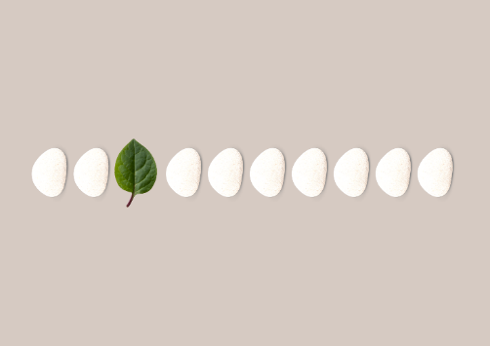
Images from Canva are licensed under Canva Content License Agreement.
- Tell a story about 3 Australian animal friends who challenged each other to a race. The first animal to cross the finish line was an albatross, which is a large seabird. The second animal to cross the finish line was an endangered burrowing marsupial, a bilby. The third animal to cross the finish line was a jumping spider who pounces to catch prey.
- Display Resource 15: Animal photo cards by pegging them to a piece of string.
- Ask students to recall what happened in the story about 3 Australian animal friends who challenged each other to a race and have them rearrange the cards in order from first to third (see Figure 12).
Figure 12 – Animal cards ordered
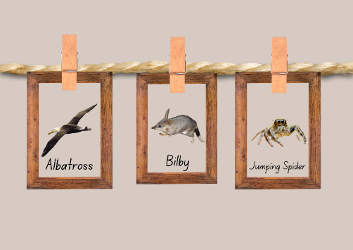
Images from Canva are licensed under Canva Content License Agreement.
- In small groups, students engage in brainstorming to think about 2 animals that may be slower than a jumping spider to come in fourth and fifth position in the race.
- Students record their thinking by drawing the animals in order from first to third adding the fourth and fifth animals based on their ideas.
The table below details assessment opportunities and differentiation ideas.
Assessment opportunities | Too hard? | Too easy?
What to look for:  - Can students use the ordinal names to describe order of position? (MAO-WM-01, MAE-GM-01)  What to collect:  - work sample from problem-solving activity (MAO-WM-01, MAE-GM-01). | Students need further support to use the ordinal names to describe order of position.  - Provide students with a collection of objects and describe their position in a line using ordinal language.  - Refer students to a visual timetable to show the sequence of tasks from first to third. | Students confidently use the ordinal names to describe order of position.  - Challenge students to create an alternate ordinal number story.  - Students make a line and describe their position using ordinal numbers.

Lesson 7: Time tracking
Core concept: Students can use their number knowledge to tell time.
The table below contains suggested learning intentions and success criteria. These are best co-constructed with students.
Learning intentions | Success criteria
Students are learning that:  - positional language helps to follow and give directions  - the order of numbers helps to tell the time  - there are many combinations of numbers that make 10. | Students can:  - describe and locate numbers by asking mathematical questions  - describe the position of the hour and minute hands on an analog clock when reading hour time  - recognise dot dice patterns and determine how many more to make 10.

Daily number sense: Name the number – 10 minutes
- Build student understanding of how to describe and locate numbers by asking mathematical questions to find numbers on a number chart.
- Use digital Number Chart 1 to 30, colour all squares and select a mystery number. Explain that students will ask questions to find the mystery number. Set a goal of uncovering the mystery number in 10 questions or less.
- Students may ask questions such as:
- Is the number more than…?
- Is the number less than…?
- Is the number between…?
- Does the number end in zero?
- Record questions to encourage reflection on which questions eliminated the highest number of possibilities.
- After each question, clear the board of the relevant numbers until the mystery number remains.
The table below details assessment opportunities and differentiation ideas.
Assessment opportunities | Too hard? | Too easy?
What to look for:  - Can students describe and locate numbers by asking mathematical questions? (MAO-WM-01, MAE-RWN-01, MAE-RWN-02)  What to collect:  - record questions asked during game-based learning opportunity (MAO-WM-01, MAE-RWN-01, MAE-RWN-02). | Students need further support to describe and locate numbers by asking mathematical questions.  - Provide students with Resource 2: Number tracks (0-30).  - Identify and read numbers on Number Chart 1 to 30 when provided with a given number. | Students confidently describe and locate numbers by asking mathematical questions.  - Provide students with Resource 16: Number chart to play ‘name the number’ with numbers beyond 30.  - Practise counting by tens.

Time on the track – 30 minutes
- Ask students to make a line and describe their position using ordinal numbers.
- Lead students to the playground and explain that they will be playing a time game in small groups.
- Draw multiple number tracks from 1 to 12 using chalk.
- Explain to students that they will take turns to stand on a number track from 1 to 12 and represent a given time on the hour by rolling 2 6-sided number dice.
- Use proximity language to ask students questions about the number track, such as near, between and next to.
- Ask questions such as:
- What numbers are near 5?
- What number is between 7 and 9?
- What numbers are next to 10?
- Ask students to draw a large chalk circle and label the clock with numbers from 1 to 12. Explain and ask 2 students to model using their bodies to make the hour and minute hands while describing the position of the hands (see Figure 13).
Figure 13 – Body clock
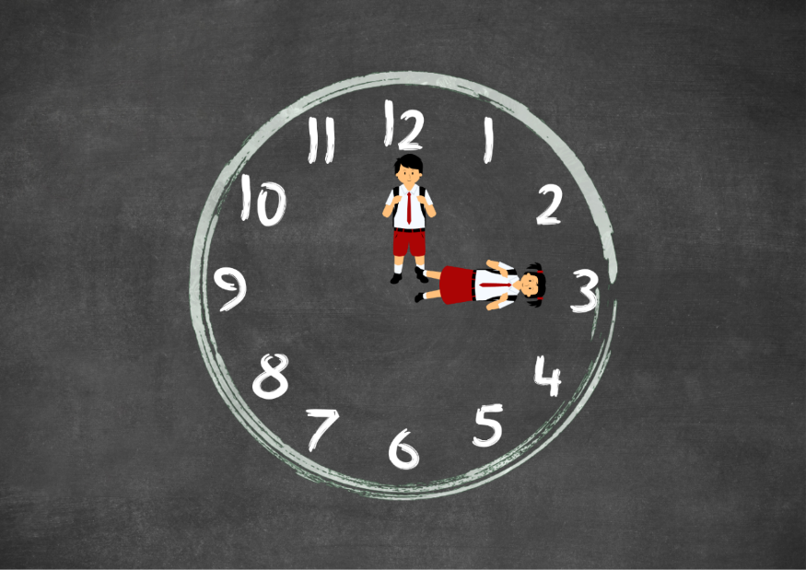
Images from Canva are licensed under Canva Content License Agreement.
- Repeat this game multiple times with students rotating between standing on the number line and making the analog clock with their bodies.
The table below details assessment opportunities and differentiation ideas.
Assessment opportunities | Too hard? | Too easy?
What to look for:  - Can students describe the position of the hour and minute hands on an analog clock when reading hour time? (MAO-WM-01, MAE-GM-01, MAE-NSM-02)  What to collect:  - observation of individual responses as they participate and engage in practical activities (MAO-WM-01, MAE-GM-01, MAE-NSM-02). | Students need further support to describe the position of the hour and minute hands on an analog clock when reading hour time.  - Model using positional language to describe the position of the hour and minute hands on an analog clock.  - Provide students with Resource 2: Number tracks (0-30) to support understanding of the position of numbers. | Students confidently describe the position of the hour and minute hands on an analog clock when reading hour time.  - Students write the time in digital form to reflect the hour time on the analog clock.  - Students tell a story about one or more of these times.

Consolidation and meaningful practice: What’s the time, dingo? – 20 minutes
This activity has been adapted from Robertson (2017).
- Explain that students will be playing an alternate version of ‘What’s the time, Mr Wolf?’. But, instead of a wolf, students will be playing the role of a dingo. Display Resource 17: Dingo and describe a dingo as a wild dog that is native to Australia.
- The student playing the role of the dingo will roll a 10-sided dice to determine the time to tell the class.
- Explain that if the dingo says, for example, ‘it is 4 o’clock’ students need to think about how many more to make 10. The difference is 6, meaning students will take 6 steps forward.

Lesson 8: Ranger, reporting for duty
Core concept: Storytelling helps us to solve real-world problems.
The table below contains suggested learning intentions and success criteria. These are best co-constructed with students.
Learning intentions | Success criteria
Students are learning that:  - there are many combinations of numbers that make 10  - storytelling helps to compare and order events using the language of time  - when the time is on the hour, the shorter hand is pointing to the hour and the longer (minute) hand is pointing to the 12. | Students can:  - recognise dot dice patterns and determine how many more to make 10  - order events in everyday contexts using the language of time  - describe the position of the hour and minute hands on an analog clock when reading hour time.

Daily number sense: Park ranger station – 15 minutes
- Build student understanding of recognising dot dice patterns and determining combinations for numbers to 10.
- Tell a story about a park ranger. A new park ranger station is being built in one of the national parks in New South Wales. This is where park rangers plan for projects in the park and acts as a site for them to provide visitor information and community assistance in the park.
- Provide students with a triangle shaped piece of paper, 10-sided dice and a collection of 2 different coloured wooden sticks to create a ranger station. Model rolling a 10-sided dice to determine how many green wooden sticks to place horizontally underneath the triangle. If a 6 is rolled, students will need to determine how many yellow wooden sticks to place horizontally to combine to make 10. See Figure 14.
Figure 14 – Park ranger station
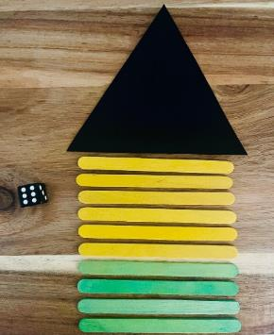
- Students use drawings, words and numerals to record combinations of numbers to 10 and explain their thinking.
- Repeat the game multiple times.
The table below details assessment opportunities and differentiation ideas.
Assessment opportunities | Too hard? | Too easy?
What to look for:  - Can students recognise dot dice patterns and determine how many more to make 10? (MAO-WM-01, MAE-RWN-01, MAE-CSQ-02)  What to collect:  - photographs of student manipulation of materials to demonstrate conceptual understanding (MAO-WM-01, MAE-RWN-01, MAE-CSQ-02). | Students need further support to recognise dot dice patterns and determine how many more to make 10.  - Provide students with Resource 4: Ten-frame.  - Model counting wooden sticks with one-to-one correspondence. | Students confidently recognise dot dice patterns and determine how many more to make 10.  - Record a range of dice dot and finger patterns to 10.  - Roll 2 dice and create a ranger station with 20 wooden sticks.

Time line-up – 30 minutes
This activity has been adapted from Robertson (2017).
- Continue to tell a story about a park ranger by describing the tasks that the park ranger needs to complete in a day's work.
- Explain to students that they must listen carefully as they will need to sequence the events in time order. When storytelling, use terms such as daytime, night-time, morning, afternoon, today, tomorrow, yesterday, before, after and next, for example:
- Yesterday, the park ranger needed to give a person first aid when they hurt themself.
- In the morning, the park ranger puts on a uniform and hat to protect their skin from the sun.
- In the daytime, the park ranger rescues and cares for endangered koalas.
- In the afternoon, the park ranger helps people visiting the park by giving them some information.
- In the night-time, the park ranger helps with search and rescue missions.
- Tomorrow, the park ranger will talk to some Kindergarten students on an excursion.
- Compare and discuss the duration of time it takes to put on a uniform to helping with a search and rescue mission. Ask students to explain why they think the duration of one event may take longer than the other.
- Display Resource 18: Park ranger tasks by pegging them to a piece of string.
- Ask students to recall the tasks that the park ranger needs to complete in a day's work and have them rearrange the cards in order from first to sixth. See Figure 15.
Figure 15 – Park ranger tasks ordered
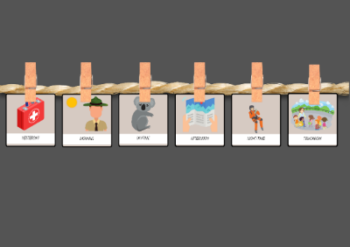
Images from Canva are licensed under Canva Content License Agreement.
The table below details assessment opportunities and differentiation ideas.
Assessment opportunities | Too hard? | Too easy?
What to look for:  - Can students order events in everyday contexts using the language of time? (MAO-WM-01, MAE-GM-01, MAE-NSM-02)  What to collect:  - problem-solving discussion and student manipulation of materials (MAO-WM-01, MAE-GM-01, MAE-NSM-02). | Students need further support to order events in everyday contexts using the language of time.  - Provide students with a collection of objects and describe their position in a line using ordinal language.  - Refer students to a visual timetable to show the sequence of tasks from first to third. | Students confidently order events in everyday contexts using the language of time.  - Challenge students to create an alternate ordinal number story.  - Students make a line and describe their position using ordinal numbers.

Consolidation and meaningful practice: Human clocks – 15 minutes
This activity has been adapted from Robertson (2017).
- Explain to students that to play this game they will become human clocks using their body to create different times on the hour.
- Demonstrate how students can stretch their arms up and out to the side to feel the position of the hour and minute hands.
- Encourage students to rock from foot to foot while slowly chanting ‘tick, tock, tick, tock, I’m a ticking human clock. What time is it?’ before a given time is called out.
- Refer to Resource 18: Park ranger tasks cards when calling out a time on the hour for students to make with their arms, showing the position of the hour and minute hands. For example, at 7 o’clock the park ranger puts on a uniform and hat to protect their skin from the sun (see Figure 16).
Figure 16 – Human clocks
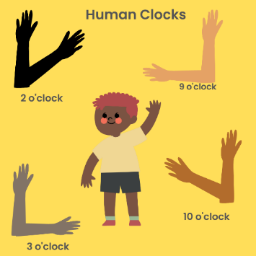
Images from Canva are licensed under Canva Content License Agreement.
Note: Remember it will look back to front if you are standing in front of students.
- Repeat this game multiple times and continue to ask students how many more hours to get to 10 o’clock to refer to combinations of numbers to 10.
- Provide students with a clock face to check or correct their answers.
Note: This activity can also be played in pairs with one student moving the arms of their partner to the correct position.

Resource 1: Random number cards
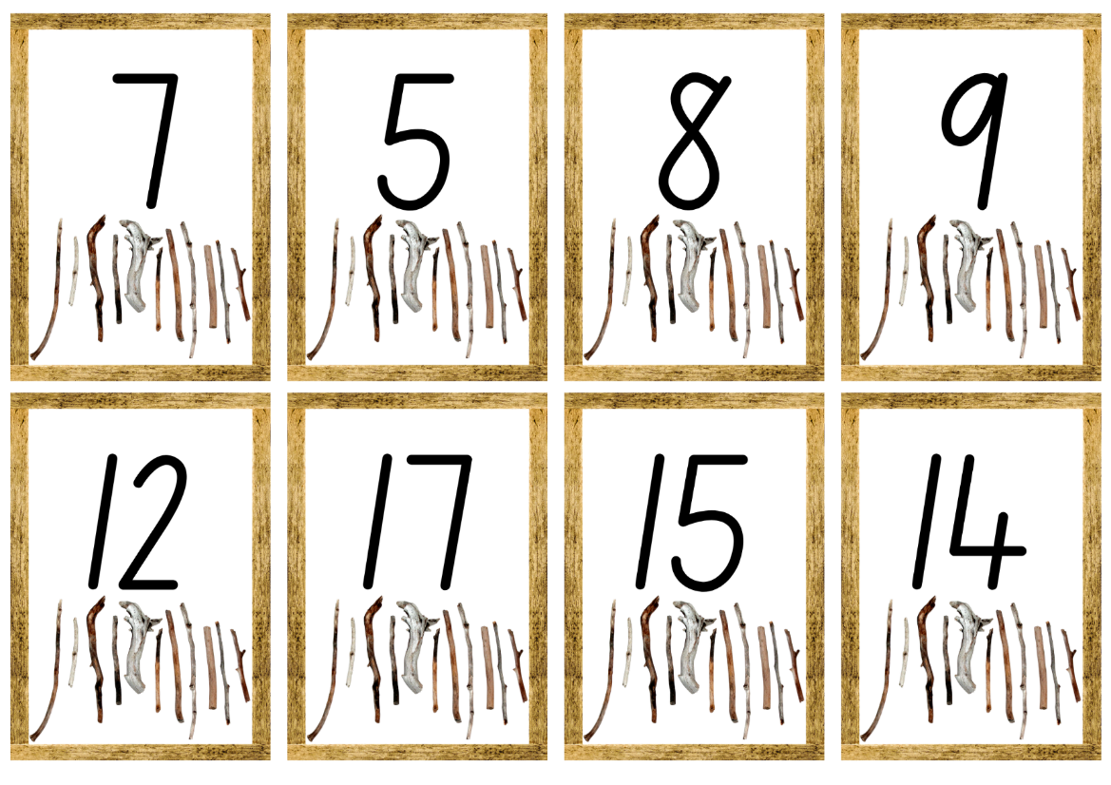
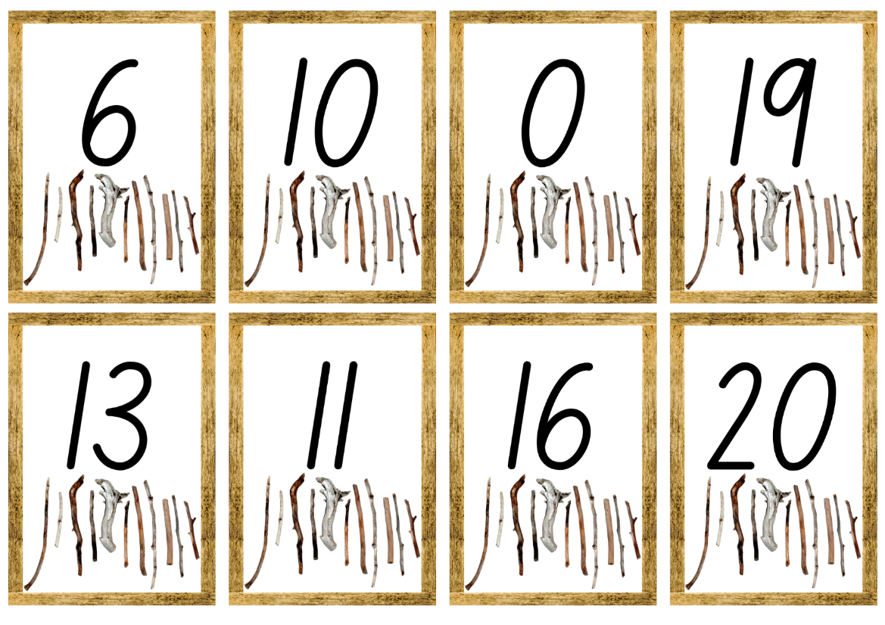
Images from Canva are licensed under Canva Content License Agreement.

Resource 2: Number tracks (0-30)
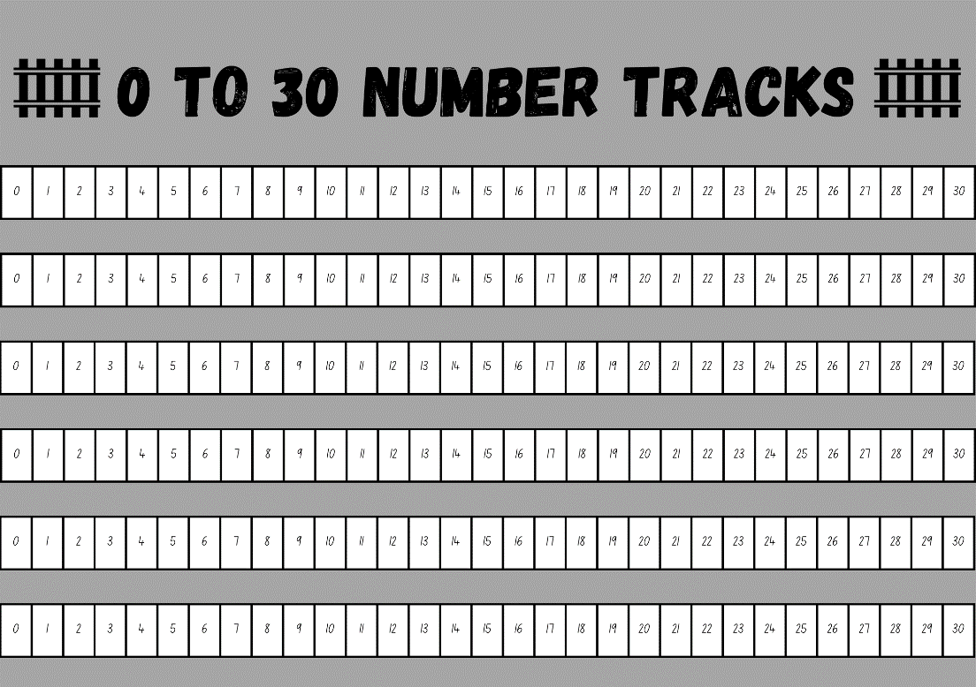
Images from Canva are licensed under Canva Content License Agreement.

Resource 3: Garden orb-weaving spider
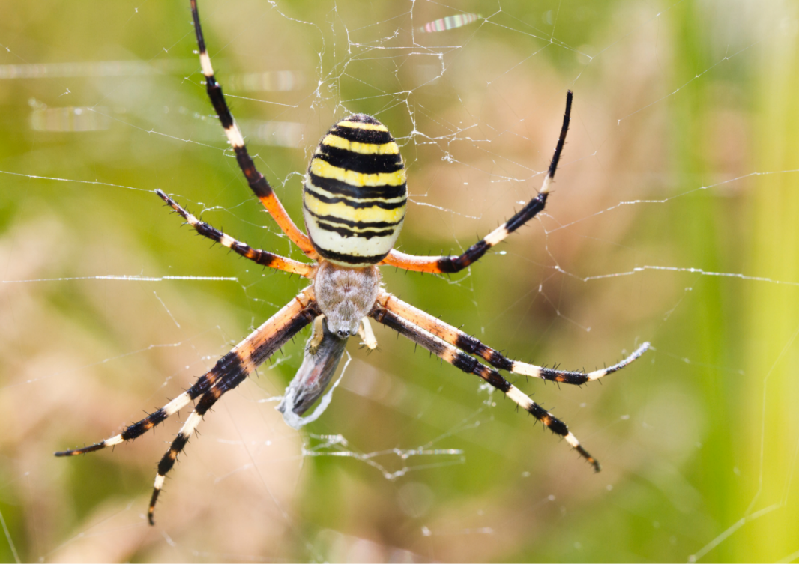
“Orb-weaving Spider” by membio is licensed under Canva’s Content License Agreement.

Resource 4: Ten-frame
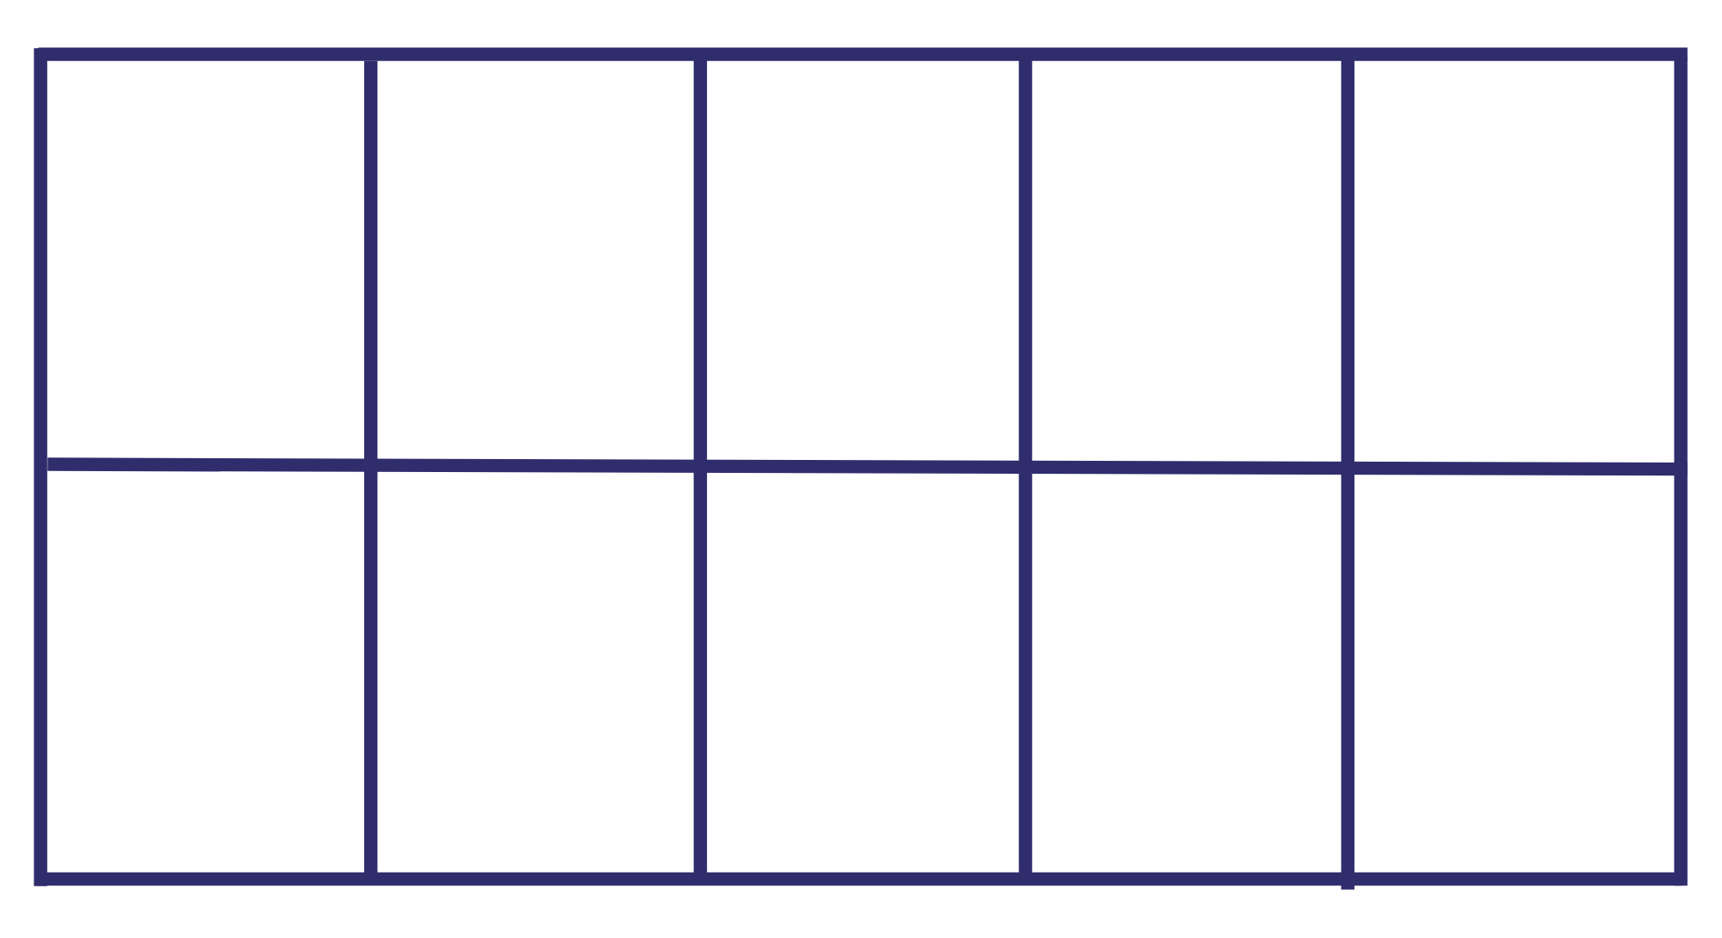

Resource 5: Jumping spider gameboard
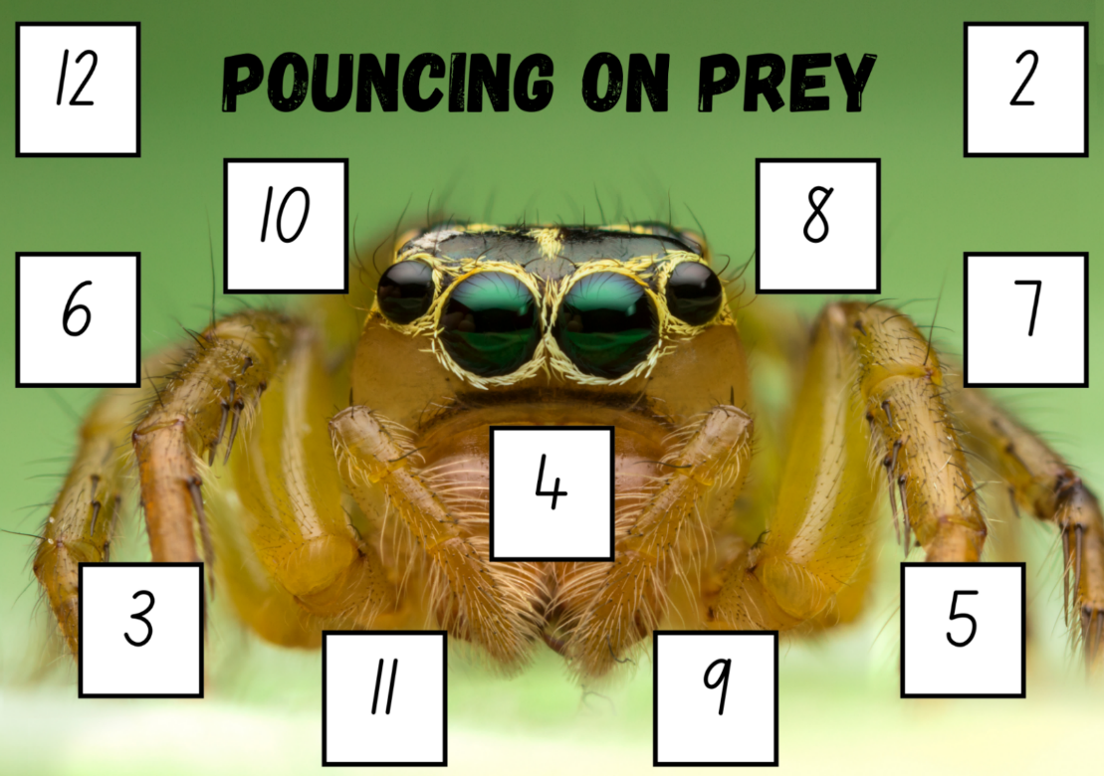
Images from Canva are licensed under Canva Content License Agreement.

Resource 6: Parts of a spider
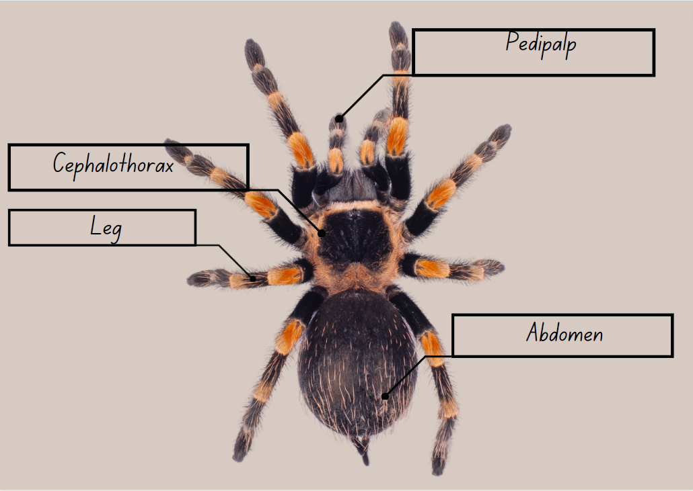
Images from Canva are licensed under Canva Content License Agreement.

Resource 7: Spider segments
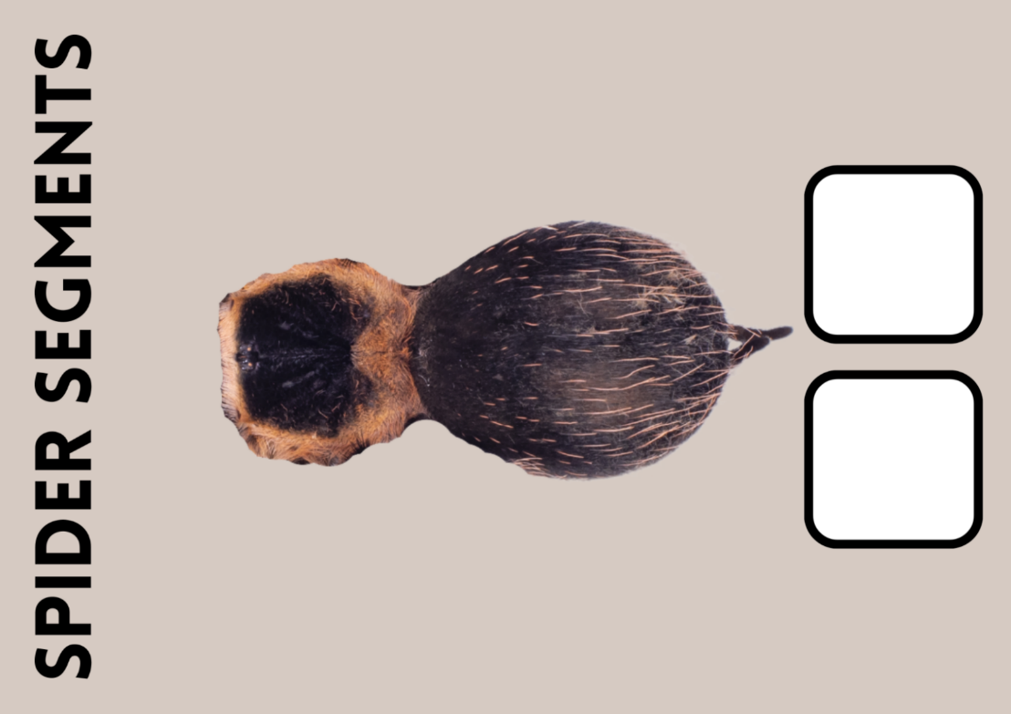
Images from Canva are licensed under Canva Content License Agreement.

Resource 8: Lyrebird
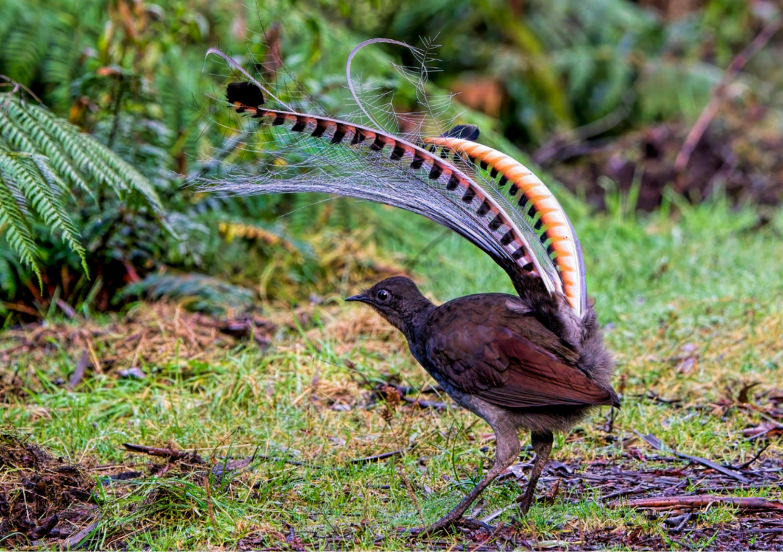
“Superb Lyrebird” by tracielouise is licensed under Canva’s Content License Agreement.

Resource 9: 10 nests
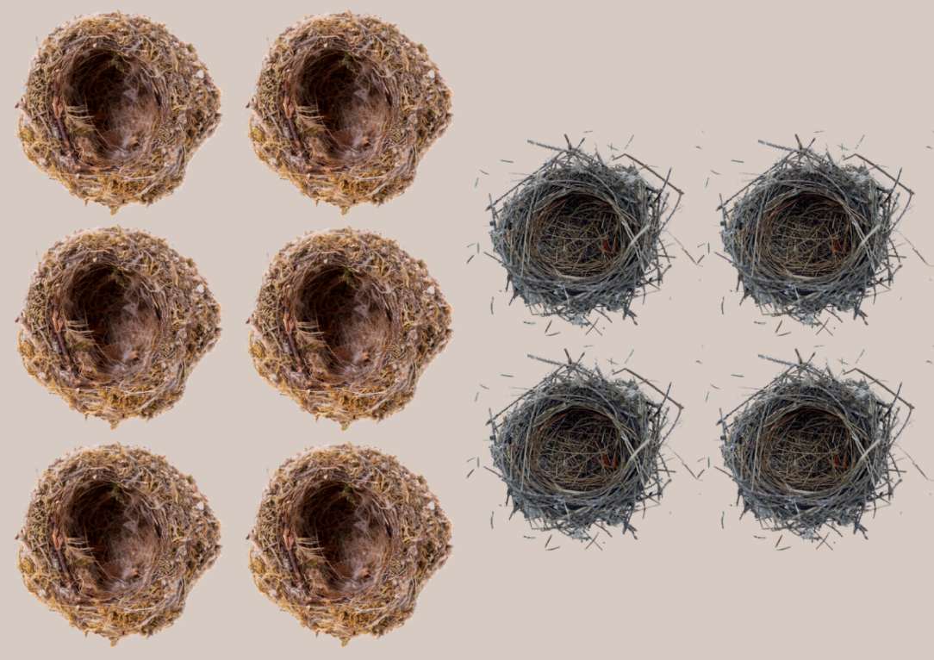
Images from Canva are licensed under Canva Content License Agreement.

Resource 10: Visual scaffold
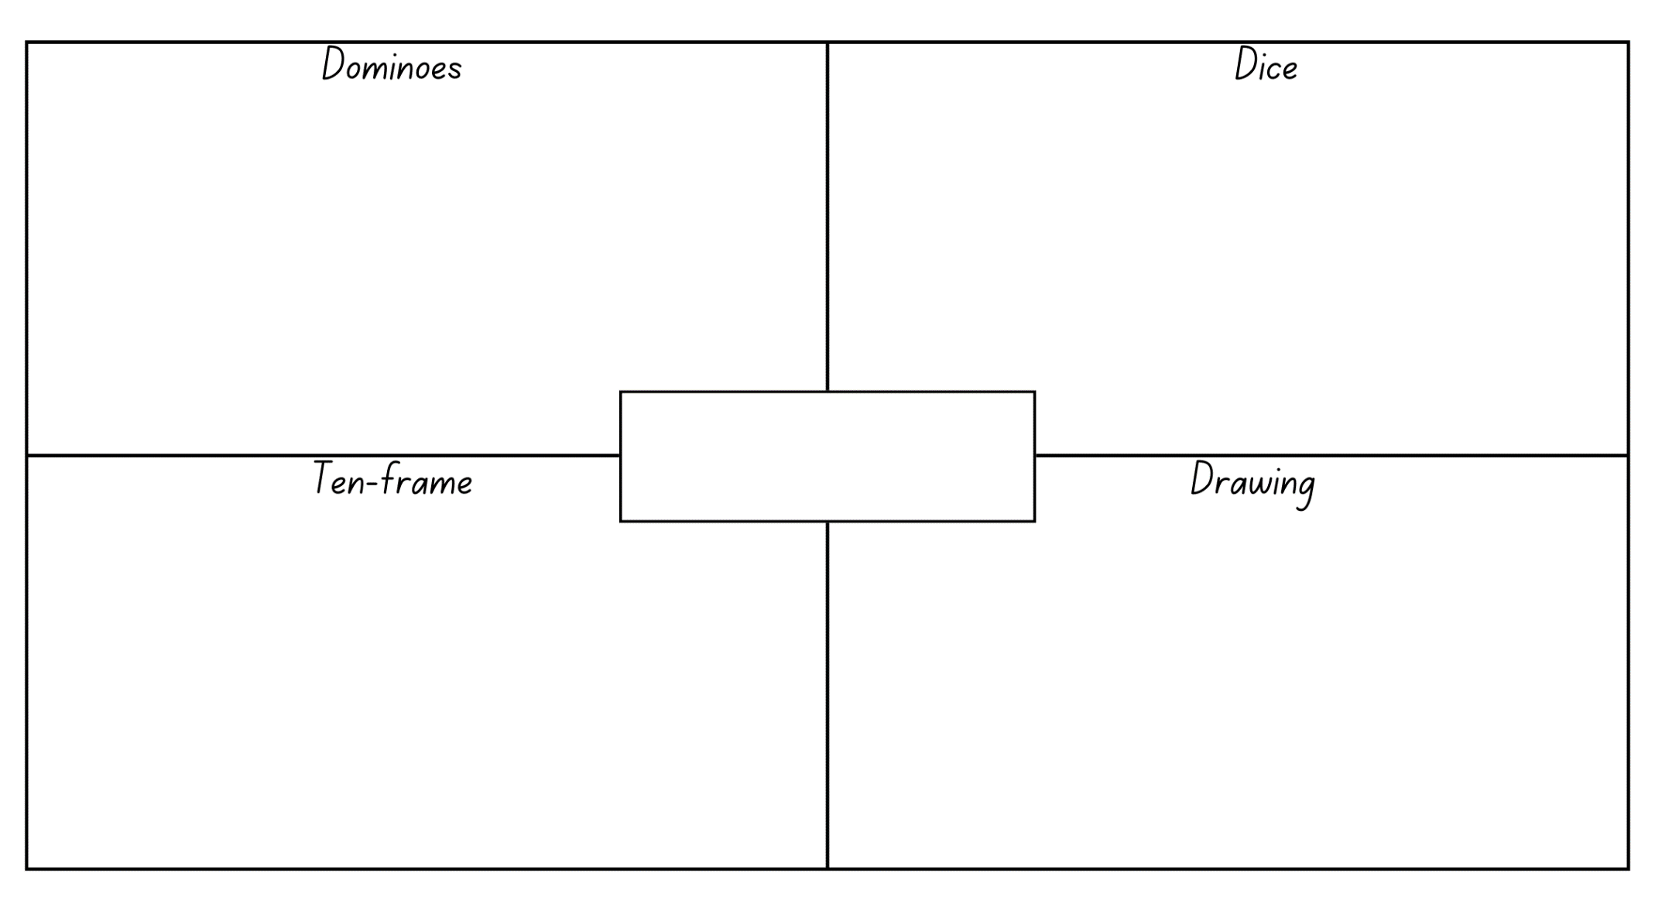

Resource 11: Woomera or miss
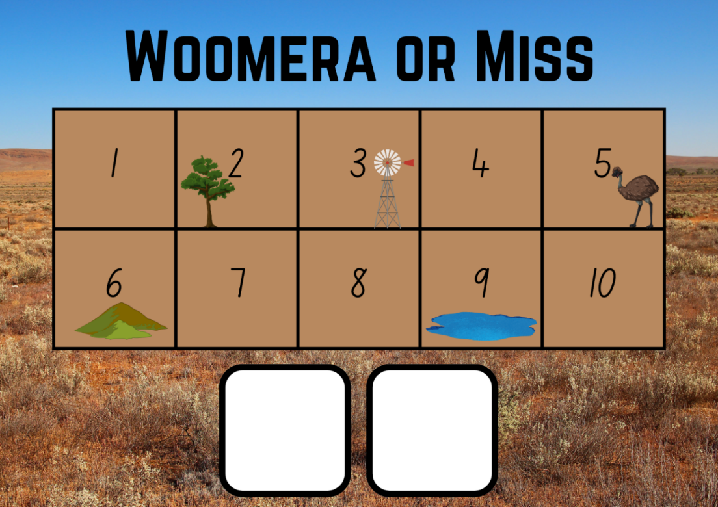
Images from Canva are licensed under Canva Content License Agreement.

Resource 12: Finger hopscotch
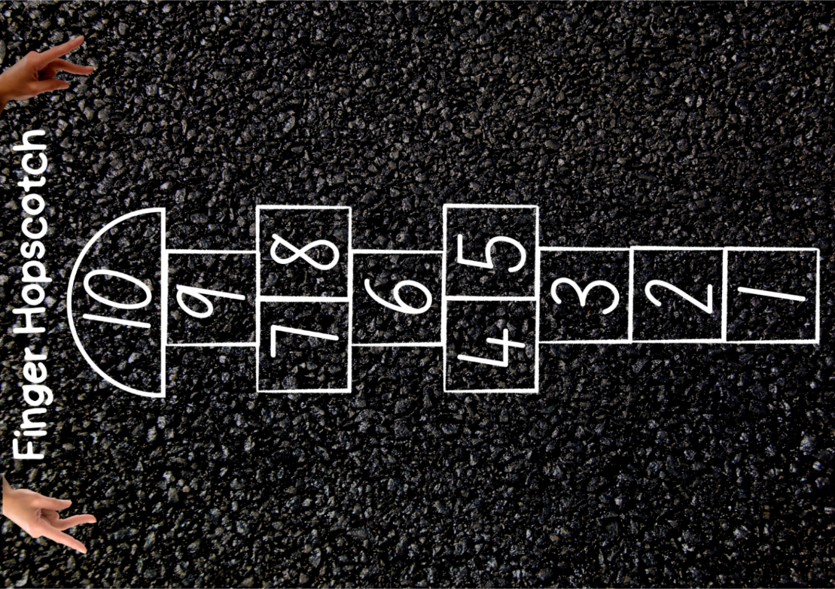
Images from Canva are licensed under Canva Content License Agreement.

Resource 13: Positional language dice
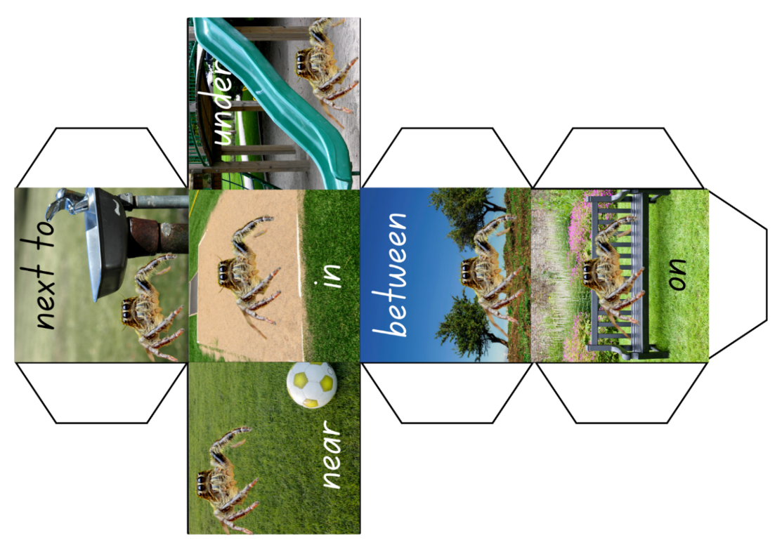
Images from Canva are licensed under Canva Content License Agreement.

Resource 14: Position book cover
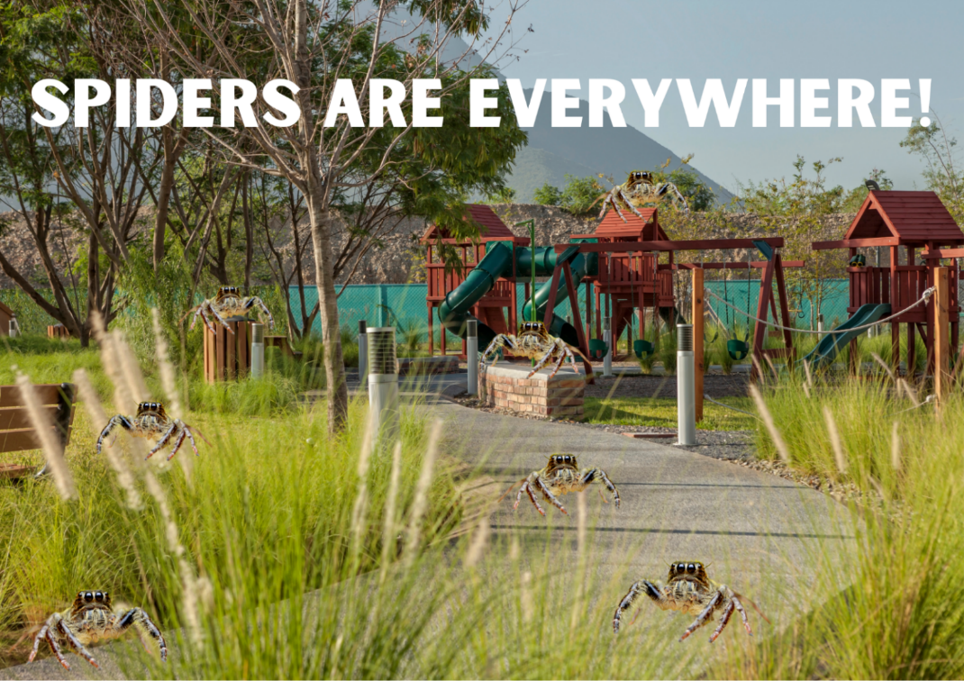
Images from Canva are licensed under Canva Content License Agreement.

Resource 15: Animal photo cards
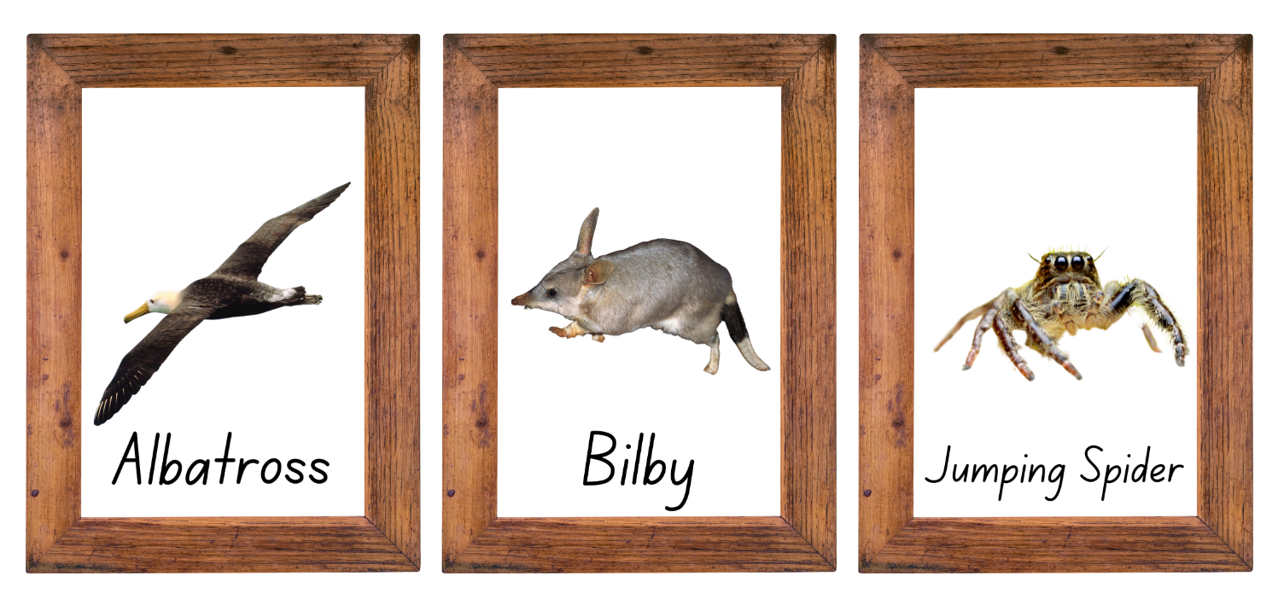
Images from Canva are licensed under Canva Content License Agreement.

Resource 16: Number chart
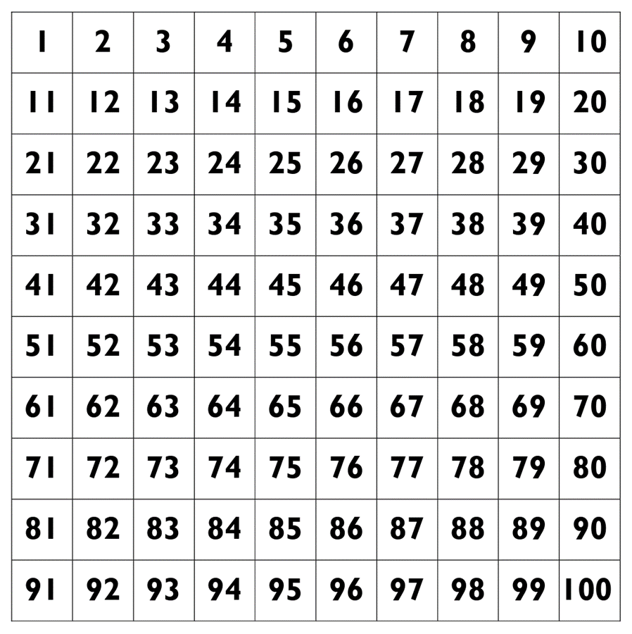

Resource 17: Dingo
“Dingo” by Oliver Koch is licensed under Canva’s Content License Agreement.

Resource 18: Park ranger tasks
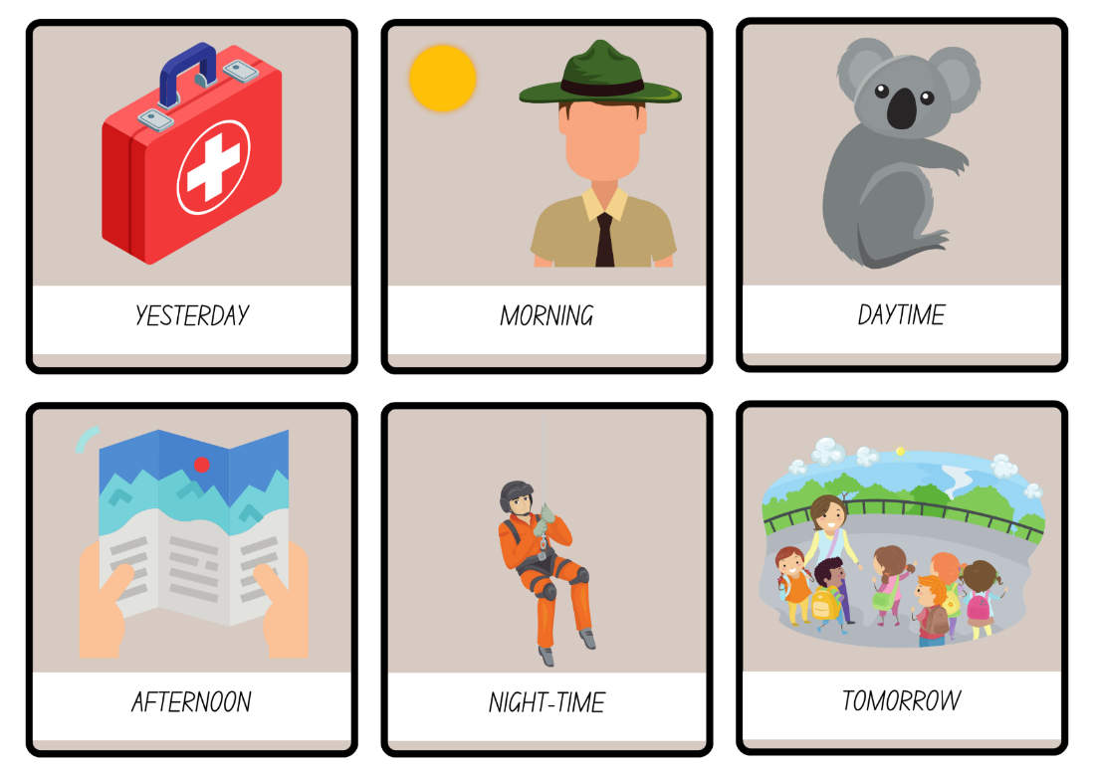
Images from Canva are licensed under Canva Content License Agreement.

Syllabus outcomes and content
The table below outlines the syllabus outcomes and range of relevant syllabus content covered in this unit. Content is linked to National Numeracy Learning Progression version (3).
Focus area and outcomes | Content groups and content points | Lessons
Representing whole numbers  MAO-WM-01  MAE-RWN-01  MAE-RWN-02 | Instantly name the number of objects within small collections  - instantly recognise (subitise) the number of items in small groups of up to four items without counting (NPV1, CPr1)  - identify the number of items in different arrangements (CPr2)  Use the counting sequence of ones flexibly  - count forwards to at least 30 and state the number after or before a given number, without needing to count from one (CPr4)  - identify and distinguish the ‘teen’ numbers from multiples of ten with the same initial sounds (NPV3)  - count backwards from a given number 20 or less (CPr5)  - identify the number before as 'one less' and the number after as 'one more’ than a given number  Recognise number patterns  - recognise dice and domino dot patterns (NPA1, NPV2, CPr2)  - recognise different finger patterns for the same number (NPA2)  Connect counting and numerals to quantities  - count with one-to-one correspondence, recognising that the last number name represents the total number in the collection (CPr3, CPr5)  - count out a specified number of objects (from 5 to 20) from a larger collection, keeping track of the count (CPr4-CPr5)  - make correspondences between collections  - read numerals to at least 20, including zero (NPV3)  - represent numbers as quantities to at least 20 using objects (such as fingers), number words and numerals (NPV2-NPV4, CPr3)  - compare and order numbers to 20 (NPV2-NPV3)  - use the term ‘is the same as’ to express equality of groups (CPr4-CPr5, MuS1) | 1–8
Combining and separating quantities  MAO-WM-01  MAE-CSQ-01  MAE-CSQ-02 | Model additive relations and compare quantities  - identify situations in which addition and subtraction may be applied (AdS1-AdS2)  - combine two or more groups of objects to model addition, identifying the relationship between the parts and the whole (AdS1-AdS2)  - separate and take away part of a group of objects to model subtraction (AdS1-AdS2)  - use concrete materials or fingers to model and solve addition and subtraction questions, counting forwards or backwards by ones as necessary (AdS1-AdS2, NPV3)  - compare two groups of objects to determine how many more (NPV1, AdS2)  Identify part–whole relationships in numbers up to 10  - use visual representations of numbers to assist with combining and separating quantities, identifying the relationship between the quantities (NPV2, NPA2, AdS2-AdS3)  - describe the action of combining, separating and comparing (AdS1)  - use five as a reference in forming numbers from six to ten  - create, model and recognise combinations for numbers up to ten (AdS2) | 1–3, 5–8
Geometric measure  MAO-WM-01  MAE-GM-01 | Position: Describe position and movement of oneself  - give and follow simple directions to position themselves or objects (PoL1)  - describe the position of an object in relation to another object, such as in, on, under as well as the directions up and down (PoL1)  - describe the position of an object using proximity terms and referring to frames of reference (PoL2)  - use the ordinal names to at least third to describe order of position  - begin to describe the positions of objects in relation to themselves using the terms ‘left’ and ‘right’ (PoL2) | 1, 5–8
Non-spatial measure  MAO-WM-01  MAE-NSM-01  MAE-NSM-02 | Mass: Identify and compare mass using weight  - identify that objects can be heavy or light (UuM2)  - compare two masses directly by hefting (UuM3)  - predict which object would be heavier than, lighter than, or have about the same weight as another object and explain reasons for this prediction  Time: Compare and order the duration of events using the language of time  - use terms such as 'daytime', 'night-time', 'morning', 'afternoon', 'today', 'tomorrow', 'yesterday', 'before', 'after' and 'next' (MeT1)  - sequence events in time (MeT1)  - compare the duration of two events (MeT1)  Time: Tell time on the hour on analog and digital clocks  - create the layout of an analog clock (MeT2)  - read analog and digital clocks to the hour using the term ‘o'clock’ (MeT2-MeT3)  - describe the position of the hour and minute hands on an analog clock when reading hour time (MeT2) | 4, 7–8

References
Links to third-party material and websites
Please note that the provided (reading/viewing material/list/links/texts) are a suggestion only and implies no endorsement, by the New South Wales Department of Education, of any author, publisher, or book title. School principals and teachers are best placed to assess the suitability of resources that would complement the curriculum and reflect the needs and interests of their students.
If you use the links provided in this document to access a third-party's website, you acknowledge that the terms of use, including licence terms set out on the third-party's website apply to the use which may be made of the materials on that third-party website or where permitted by the Copyright Act 1968 (Cth). The department accepts no responsibility for content on third-party websites.
Except as otherwise noted, all material is © State of New South Wales (Department of Education), 2023 and licensed under the Creative Commons Attribution 4.0 International License. All other material (third-party material) is used with permission or under licence. Where the copyright owner of third-party material has not licensed their material under a Creative Commons or similar licence, you should contact them directly for permission to reuse their material.
Mathematics K–10 Syllabus © 2022 NSW Education Standards Authority (NESA) for and on behalf of the Crown in right of the State of New South Wales.
Aboriginal Studies Years 7-10 Syllabus © 2020 NSW Education Standards Authority (NESA) for and on behalf of the Crown in right of the State of New South Wales.
© 2022 NSW Education Standards Authority. This document contains NSW Curriculum and syllabus content. The NSW Curriculum is developed by the NSW Education Standards Authority. This content is prepared by NESA for and on behalf of the Crown in right of the State of New South Wales. The material is protected by Crown copyright.
Please refer to the NESA Copyright Disclaimer for more information.
NESA holds the only official and up-to-date versions of the NSW Curriculum and syllabus documents. Please visit the NSW Education Standards Authority (NESA) website and the NSW Curriculum website.
National Numeracy Learning Progression © Australian Curriculum, Assessment and Reporting Authority (ACARA) 2010 to present, unless otherwise indicated. This material was downloaded from the Australian Curriculum website (National Literacy Learning Progression) (accessed 14 December 2022) and was not modified. The material is licensed under CC BY 4.0. Version updates are tracked in the ‘Curriculum version history’ section on the 'About the Australian Curriculum' page of the Australian Curriculum website.
ACARA does not endorse any product that uses the Australian Curriculum or make any representations as to the quality of such products. Any product that uses material published on this website should not be taken to be affiliated with ACARA or have the sponsorship or approval of ACARA. It is up to each person to make their own assessment of the product, taking into account matters including, but not limited to, the version number and the degree to which the materials align with the content descriptions and achievement standards (where relevant). Where there is a claim of alignment, it is important to check that the materials align with the content descriptions and achievement standards (endorsed by all education Ministers), not the elaborations (examples provided by ACARA).
New Zealand Ministry of Education (n.d.) 'Go Fish 10', Resource, nzmaths website, accessed 14 December 2022.
Robertson J (2017) Messy Maths. A Playful, Outdoor Approach for Early Years, Crown House Publishing, UK.
State of New South Wales (2002) Developing efficient numeracy strategies [PDF 9.1MB], Department of Education and Training, accessed 14 December 2022.
Toy Theater (2022) 'Number Chart 1 to 30', Teacher Tools, Toy Theater website, accessed 14 December 2022.

