Mathematics – Early Stage 1 – Unit 10

Contents
Unit description and duration 4
Student prior learning 4
Lesson overview and resources 5
Lesson 1: Nifty numbers 10
Daily number sense: Stick tapping – 15 minutes 10
Quoll-ity counting – 30 minutes 12
Consolidation and meaningful practice: Keep counting – 15 minutes 14
Lesson 2: Connecting collections 15
Daily number sense: Hunting hopscotch – 20 minutes 15
Quick quokkas – 30 minutes 17
Consolidation and meaningful practice: Deadly dominoes – 15 minutes 18
Lesson 3: Talking about 10 20
Daily number sense: Ways to make 10 – 10 minutes 21
Picture Sticks – 30 minutes 22
Consolidation and meaningful practice: Lots of legs – 20 minutes 25
Lesson 4: Combining collections 27
Daily number sense: Spiralling snail – 15 minutes 27
Minibeast making – 30 minutes 29
Consolidation and meaningful practice: Counting cards – 15 minutes 31
Lesson 5: Lots of ladybugs 32
Daily number sense: Lots of dots – 15 minutes 32
Longing ladybugs – 30 minutes 34
Consolidation and meaningful practice: Labelled ladybugs – 15 minutes 35
Lesson 6: Bush birthday 37
Daily number sense: Bush tucker birthday – 15 minutes 37
Chain challenge – 25 minutes 40
Consolidation and meaningful practice: Creating cards – 20 minutes 43
Lesson 7: Clever quokka 46
Daily number sense: Quiet quokka – 15 minutes 46
Directed drawing – 30 minutes 48
Consolidation and meaningful practice: Quiet quokka says – 15 minutes 51
Lesson 8: The very busy spider 51
Daily number sense: Counting in nature – 15 minutes 52
A MAZE-ing maze – 30 minutes 53
Consolidation and meaningful practice: Spiders’ webs – 15 minutes 55
Resource 1: Number tracks (0-30) 56
Resource 2: Spotted-tail quoll 57
Resource 3: Quoll counting 58
Resource 4: Finger hopscotch 59
Resource 5: Quokka 60
Resource 6: Random number cards 61
Resource 7: Domino template 63
Resource 8: 10 rocks 64
Resource 9: 10 sticks 65
Resource 10: Ten-frame 66
Resource 11: Caterpillar body 67
Resource 12: Minibeast poster 68
Resource 13: Aphids 69
Resource 14: Lemon myrtle tree 70
Resource 15: Think board 71
Resource 16: Left or right 72
Syllabus outcomes and content 73
References 78

Unit description and duration
This two-week unit develops student knowledge, understanding and skills of the concept that sometimes things move and change location. Students are provided opportunities to:
- represent numbers in a variety of ways
- reason about the way numbers can be combined and separated
- share objects equally and put shared objects back together to form one collection
- use positional language both in a physical world context and in more abstract contexts.
Mathematics K–10 Syllabus © 2022 NSW Education Standards Authority (NESA) for and on behalf of the Crown in right of the State of New South Wales.

Student prior learning
Before engaging in these teaching and learning activities, students would benefit from prior experience with:
- opportunities to demonstrate an increasing understanding of measurement and number using vocabulary to describe position, length, and names of numbers
- mathematical language to describe spatial sense, structure and pattern, number, measurement, data, connections
- contributing constructively to mathematical discussions.

Lesson overview and resources
The table below outlines the sequence and approximate timing of lessons; syllabus focus areas and content groups; and resources.
Lesson | Syllabus focus area and content groups | Resources
Lesson 1: Nifty numbers  60 minutes  Numbers can be represented in a variety of ways. | Representing whole numbers  - Instantly name the number of objects within small collections  - Use the counting sequence of ones flexibly  - Recognise number patterns  - Connect counting and numerals to quantities  Geometric measure  - Position: Describe position and movement of oneself | - Resource 1: Number tracks (0-30)  - Resource 2: Spotted-tail quoll  - Resource 3: Quoll counting  - 6-sided number dice  - Dice  - Game pieces  - Natural materials  - Sticks
Lesson 2: Connecting collections  60 minutes  We can make connections between collections. | Representing whole numbers  - Instantly name the number of objects within small collections  - Use the counting sequence of ones flexibly  - Recognise number patterns  - Connect counting and numerals to quantities  Geometric measure  - Position: Describe position and movement of oneself | - Resource 1: Number tracks (0-30)  - Resource 4: Finger hopscotch  - Resource 5: Quokka  - Resource 6: Random number cards  - Resource 7: Domino template  - 10-sided dice  - Cloths  - Dominoes  - Leaves  - Natural materials  - Writing materials
Lesson 3: Talking about 10  60 minutes  There are many ways to make 10. | Representing whole numbers  - Connect counting and numerals to quantities  Combining and separating quantities  - Model additive relations and compare quantities  - Identify part–whole relationships in numbers up to 10  Geometric measure  - Position: Describe position and movement of oneself | - Resource 8: 10 rocks  - Resource 9: 10 sticks  - Resource 10: Ten-frame  - Resource 11: Caterpillar body  - Baskets  - Natural materials  - Sticks  - Writing materials
Lesson 4: Combining collections  60 minutes  Combining objects helps us to understand that whole numbers are made up of parts. | Representing whole numbers  - Use the counting sequence of ones flexibly  - Recognise number patterns  - Connect counting and numerals to quantities  Combining and separating quantities  - Model additive relations and compare quantities  - Identify part–whole relationships in numbers up to 10  Geometric measure  - Position: Describe position and movement of oneself | - Resource 1: Number tracks (0-30)  - Resource 10: Ten-frame  - Resource 12: Minibeast poster  - Concrete materials  - Decks of playing cards  - Dice  - Game pieces  - Gumnuts  - Leaves  - Modelling clay  - Natural materials  - Sticks  - Writing materials
Lesson 5: Lots of ladybugs  60 minutes  We can share objects to make equal groups. | Representing whole numbers  - Recognise number patterns  - Connect counting and numerals to quantities  Forming groups  - Record grouping and sharing  Geometric measure  - Position: Describe position and movement of oneself | - Resource 1: Number tracks (0-30)  - Resource 10: Ten-frame  - 6-sided number dice  - Dice  - Gumnuts  - Large dice  - Leaves  - Modelling clay  - Plastic lids  - Writing materials
Lesson 6: Bush birthday  60 minutes  Objects can be shared to form equal groups. | Representing whole numbers  - Recognise number patterns  - Connect counting and numerals to quantities  Combining and separating quantities  - Model additive relations and compare quantities  Forming groups  - Record grouping and sharing  Geometric measure  - Position: Describe position and movement of oneself | - Resource 10: Ten-frame  - Resource 14: Lemon myrtle tree  - Concrete materials  - Finger gloves  - Glue  - Modelling clay  - Paper  - Scissors  - Sticks  - Supermarket catalogues  - Writing materials
Lesson 7: Clever quokka  60 minutes  Mathematicians use positional language to describe the location of an object. | Representing whole numbers  - Connect counting and numerals to quantities  Geometric measure  - Position: Describe position and movement of oneself  - Length: Use direct and indirect comparisons to decide which is longer | - Resource 15: Think board  - Resource 16: Left or right  - Dice  - Leaves  - Natural materials  - Puppet or soft toy  - String  - Writing materials
Lesson 8: The very busy spider  60 minutes  We can describe the same location and direction in different ways. | Representing whole numbers  - Connect counting and numerals to quantities  Geometric measure  - Position: Describe position and movement of oneself  - Length: Use direct and indirect comparisons to decide which is longer | - Video: A MAZE-ing! (1:07)  - Natural materials  - Spider figurines  - String  - Writing materials

Lesson 1: Nifty numbers
Core concept: Numbers can be represented in a variety of ways.
The table below contains suggested learning intentions and success criteria. These are best co-constructed with students.
Learning intentions | Success criteria
Students are learning that:  - using rhythm and movement can help to understand the counting sequence and positional language  - the number before is one less and the number after is one more than a given number. | Students can:  - count and move forwards to 30 and backwards from 20 without needing to count from one  - find a number that is one less and one more.

Daily number sense: Stick tapping – 15 minutes
This lesson has been adapted from Robertson (2017).
- Build student understanding of forward and backward counting sequences by creating rhythm and movement.
- Lead students to the playground for this lesson.
- Explain to students that they will be playing a counting game by slowly tapping 2 sticks on the ground in time to each number said aloud. Encourage all students to chorally count aloud and work on developing a steady rhythm.
- Begin by counting and moving forwards to 30 and then backwards from 20 to the rhythm of stick tapping from different starting points.
Note: Consider incorporating local Indigenous language or the languages of the diverse cultures within the class into counting.
- Vary the game by raising 2 sticks in the air as a signal for students to say the number before and the number after a given number.
- Challenge students to begin by counting forwards until you call out ‘switch’. When they hear the word, students change direction and count backwards. When counting forwards, students slowly tap their body from their toes up to their head and, when counting backwards, students slowly tap their body from their head down to their toes.
Note: Emphasise the big idea ‘sometimes things move and change location’ by using positional language such as ‘forward’ and ‘backward’ to describe student movements while counting.
The table below details assessment opportunities and differentiation ideas.
Assessment opportunities | Too hard? | Too easy?
What to look for:  - Can students count and move forwards to 30 and backwards from 20 without needing to count from one? (MAO-WM-01, MAE-RWN-01, MAE-GM-01)  What to collect:  - observations of game-based learning opportunity (MAO-WM-01, MAE-RWN-01, MAE-GM-01) | Students need further support to count and move forwards to 30 and backwards from 20 without needing to count from one.  - Provide students with Resource 1: Number tracks (0-30) and model tapping a stick along the number track as we count forward and backward.  - Clap hands or hop to the rhythm of choral counting. | Students count and move forwards to 30 and backwards from 20 without needing to count from one.  - Tap sticks alternately on the ground.  - Say 2 numbers before and after a given number.

Quoll-ity counting – 30 minutes
- Show students an image of a spotted-tail quoll. See Resource 2: Spotted-tail quoll.
- Tell a story about a spotted-tail quoll named Quade. Explain that Quade lives in a den made from a hollow log in a forest. Quade loves to count the birds, reptiles, and insects in his environment. Quade has also tried counting the spots on his fur, but unfortunately, he has not had much success.
- Show students Resource 3: Quoll counting .and demonstrate a count using the dots on the picture.
- Students use Resource 3: Quoll counting to keep track of the count by placing a finger on the number one and finger trace numbers as they count forwards to 30. Emphasise the final sounds ‘ty’ and ‘teen’ to distinguish the ‘teen’ numbers from multiples of 10 with the same initial sounds such as 13 from 30.
- Students find and place a finger on number 20. Students finger trace numbers as they count backwards from 20.
- Vary the game by counting forwards to 30 and then backwards from 20 from different starting points. Students finger trace numbers as they count. Once students understand the game, they can also be selected to choose a number to count forwards to 30 or backwards from 20.
- Model choosing a number between 0 to 30 by placing a finger on a given number. Identify the number before as 'one less' and the number after as 'one more’ than a given number (see Figure 1).
Figure 1 – Before and after
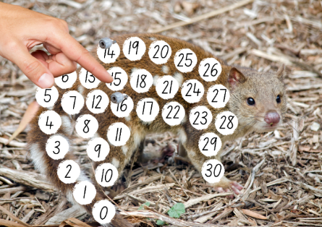
Images sourced from Canva and used in accordance with the Canva Content License Agreement.
- Provide time to play ‘quoll-ity counting’ in pairs focusing on finding a number that is ‘one less’ and ‘one more’.
The table below details assessment opportunities and differentiation ideas.
Assessment opportunities | Too hard? | Too easy?
What to look for:  - Can students find a number that is one less and one more? (MAO-WM-01, MAE-RWN-01)  What to collect:  - observations of game-based learning opportunity (MAO-WM-01, MAE-RWN-01) | Students need further support to find a number that is one less and one more.  - Provide students with Resource 1: Number tracks (0-30).  - Model counting forwards or backwards by ones and locating the number before and after using natural materials as markers. | Students can find a number that is one less and one more.  - Count backwards from 30.  - Challenge students to identify 2 numbers more or less.

Consolidation and meaningful practice: Keep counting – 15 minutes
- Continue to use Resource 3: Quoll counting as a game board.
- In pairs, students take turns to roll a 6-sided number dice and dice with dot patterns. Once they have a number and dot pattern showing on the dice, they move their game piece forward to reflect the 6-sided number dice and continue counting on by the number of dots shown on the dice dot pattern by moving a game piece (see Figure 2).
Figure 2 – Quoll game play
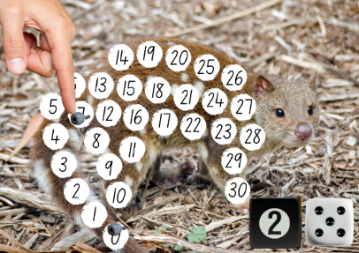
Images sourced from Canva and used in accordance with the Canva Content License Agreement.
- Provide time to play ‘keep counting’ in pairs. The aim of the game is to practise counting on from a given number without needing to count from one.

Lesson 2: Connecting collections
Core concept: We can make connections between collections.
The table below contains suggested learning intentions and success criteria. These are best co-constructed with students.
Learning intentions | Success criteria
Students are learning that:  - the number before is one less and the number after is one more than a given number  - objects from a larger collection can be counted and compared. | Students can:  - find a number that is one less and one more  - keep track of the count to find which collection has more.

Daily number sense: Hunting hopscotch – 20 minutes
This lesson has been adapted from Robertson (2017).
- Build student understanding of the number before as one less and the number after as one more than a given number by playing hopscotch.
- Prior to lesson, arrange for the school Year 6 leadership team to draw 4 chalk hopscotch courts in the playground. See Resource 4: Finger hopscotch for design.
- Lead students to the playground and explain that they will play hopscotch in 4 small groups.
Note: Resource 4: Finger hopscotch is also provided as an alternate way to play the game inside, or to consolidate one less and one more after playing in the playground.
- Roll a 10-sided dice and peers determine if they are to hop one less or one more than the dot dice pattern revealed.
- Allow time for each student to have a turn.
- Students call out their number as one more or one less, then hop to that number.
- After each student has hopped, ask the class to find and collect small natural materials and put the correct number of objects in each square.
The table below details assessment opportunities and differentiation ideas.
Assessment opportunities | Too hard? | Too easy?
What to look for:  - Can students find a number that is one less and one more? (MAO-WM-01, MAE-RWN-01)  What to collect:  - observations of game-based learning opportunity. (MAO-WM-01, MAE-RWN-01) | Students need support to find a number that is one less and one more.  - Model counting forwards or backwards by ones.  - Provide students with Resource 1: Number tracks (0-30). | Students find a number that is one less and one more.  - Challenge students to create an alternate game using the hopscotch court and a 10-sided dice.  - Represent numbers in a variety of ways using finger patterns.

Quick quokkas – 30 minutes
- Introduce students to 2 quokkas named Quinn and Quincy and show the image of a quokka from Resource 5: Quokka.
- Explain that quokkas are a small marsupial native to Australia and are herbivores that eat native grasses and leaves, especially leaves of wattle trees.
- Show Resource 6: Random number cards. Ask 2 students to select a random number card and model counting out the specified number of leaves from a larger collection to feed Quinn and Quincy.
- Gather in a circle as a whole class to count and compare collections of leaves to determine which has more.
- Ask how many more leaves are needed to ensure both quokkas have the same number of leaves for lunch.
- Model using the term ‘is the same as’ to express equality of groups when leaves have been added.
- Students use Resource 6: Random number cards and repeat the game in pairs.
- Students record their thinking using drawings, words, and numerals to show the problem presented.
The table below details assessment opportunities and differentiation ideas.
Assessment opportunities | Too hard? | Too easy?
What to look for:  - Can students keep track of the count to find which collection has more? (MAO-WM-01, MAE-RWN-01)  What to collect:  - student manipulation of materials to demonstrate conceptual understanding. (MAO-WM-01, MAE-RWN-01) | Students need further support to keep track of the count to find which collection has more.  - Provide students with Resource 1: Number tracks (0-30) and model keeping track of the count.  - Model counting leaves using one-to-one correspondence. | Students can keep track of the count to find which collection has more.  - Draw how the total could appear on dice or domino dot patterns.  - Identify different finger patterns to correspond with their collection of objects.

Consolidation and meaningful practice: Deadly dominoes – 15 minutes
- Introduce ‘deadly dominoes’ by displaying Resource 7: Domino template.
- Model how to play ‘deadly dominoes’ by facing the set of dominoes upwards and select a domino from a larger collection. Find the total of the domino dot pattern by subitising or counting with one-to-one correspondence. Find another domino that ‘is the same as’ or has the same total number of dots. Find another 2 dominoes, one less and one more than the given number (see Figure 3).
Figure 3 – Domino game play
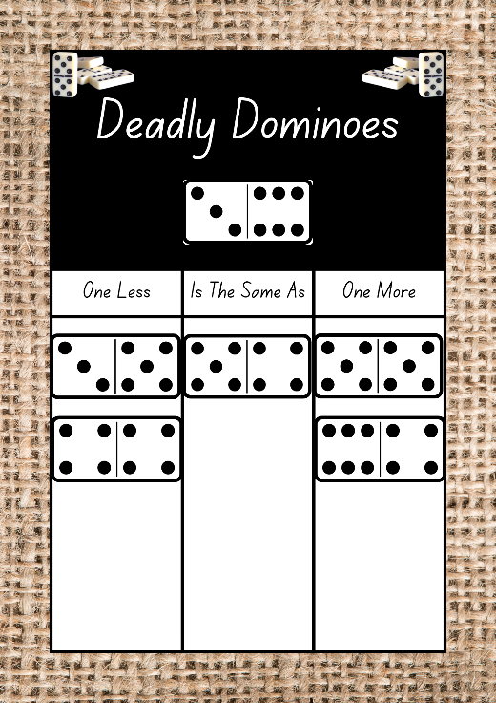
Images sourced from Canva and used in accordance with the Canva Content License Agreement.
Note: Emphasise the big idea ‘sometimes things move and change location’ when giving instructions by using positional language such as ‘place the domino in the box’ or ‘place the second domino under the first domino’ to describe the placement of the dominoes during game play.
- Provide time to play ‘deadly dominoes’ independently.
- Students turn and talk to compare their answers.

Lesson 3: Talking about 10
Core concept: There are many ways to make 10.
The table below contains suggested learning intentions and success criteria. These are best co-constructed with students.
Learning intentions | Success criteria
Students are learning that:  - items arranged in different visual and symbolic patterns can equal the same number  - concrete materials assist in combining and separating quantities up to 10. | Students can:  - identify the number of items in different arrangements  - create, model, and describe the position of objects for numbers up to 10.

Daily number sense: Ways to make 10 – 10 minutes
- Build student understanding of different ways to make 10 by viewing items arranged in different visual and symbolic patterns.
- Gather in a circle and display Resource 8: 10 rocks as a visual stimulus. Ask students if they think 10 rocks will fit in their hand.
- Provide time for students to count out and experiment with 10 rocks.
- Display Resource 9: 10 sticks as a visual stimulus. Ask students if they think 10 sticks will fit in their hand.
- Provide time for students to experiment with 10 sticks.
- Regroup in a circle and ask questions such as:
- What will fill this basket, 10 gumnuts or 10 seed pods?
- Which pile looks smaller, 10 leaves or 10 rocks?
- What does 10 look like?
- Model responses to the questions above using baskets and natural materials.
- Students experiment with natural materials to show different ways to make 10.
The table below details assessment opportunities and differentiation ideas.
Assessment opportunities | Too hard? | Too easy?
What to look for:  - Can students identify the number of items in different arrangements? (MAO-WM-01, MAE-RWN-01)  What to collect:  - student manipulation of materials to demonstrate conceptual understanding (MAO-WM-01, MAE-RWN-01) | Students need further support to identify the number of items in different arrangements.  - Provide students with Resource 10: Ten-frame.  - Model counting with one-to-one correspondence. | Students can identify the number of items in different arrangements.  - Arrange items in dice dot patterns.  - Record different ways to make 10.

Picture Sticks – 30 minutes
This lesson has been adapted from Robertson (2017).
- Lead students to the playground and form a circle.
- Practise singing ‘Making 10’ to the tune of Frère Jacques or similar:
‘10 and 0
9 and 1
8 and 2 (repeat: 8 and 2)
7 and 3
6 and 4
5 and 5 (repeat: 5 and 5).’
Note: Consider incorporating local Aboriginal and/or Torres Strait Islander language or the languages of the diverse cultures within the class into the song.
- Explain to students that they will be finding and collecting an agreed number of sticks, for example, 10 sticks.
- After finding and collecting 10 sticks, ask students to return to the circle and place the collection in front of them.
- Challenge students to create a picture using 10 sticks, for example, a fence or a house (see Figure 4).
Figure 4 – Stick pictures
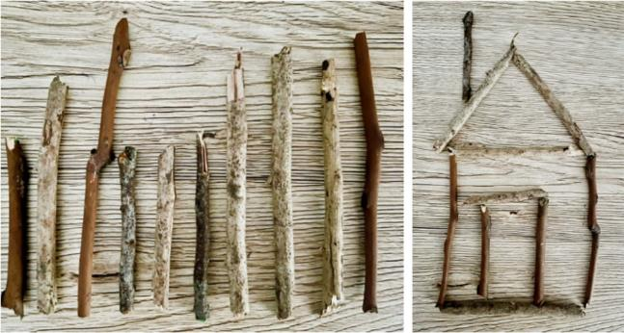
- Model using positional language to describe the structure of the house, for example, the door is between 2 walls, the chimney is on the roof and the roof is up the top of the house.
- Conduct a gallery walk to view student stick pictures and have students use positional language to describe, for example, in, on, under, as, up, down, near, between, next to, in front of and behind.
The table below outlines stimulus prompts to generate conversation about the topic, along with anticipated responses from students.
Prompts | Anticipated student responses
- Which picture has more/less?  - How could you represent 10 differently?  - Even though the pictures look different, how do we know there are still 10 sticks?  - I wonder what would happen if you combined 2 pictures together?  - Can you describe the position of the door?  - How could you describe the position of the chimney?  - Where is the roof located? | - The fence has the same number of sticks as the house.  - I could have made 2 people, each with 5 sticks.  - I can see that the roof of the house is made from 4 sticks and the walls and the door from 6 sticks which makes 10.  - I know my picture has 10 sticks, so I kept counting by ones to a total of 20.  - The door is between 2 walls.  - The chimney is on the roof.  - The roof is up on top of the house.
- Students record their visual representations using drawings, words, and numerals to show different ways to make 10.
The table below details assessment opportunities and differentiation ideas.
Assessment opportunities | Too hard? | Too easy?
What to look for:  - Can students create, model and describe the position of objects for numbers up to 10? (MAO-WM-01, MAE-CSQ-01, MAE-CSQ-02, MAE-GM-01)  What to collect:  - student manipulation of materials to demonstrate conceptual understanding (MAO-WM-01, MAE-CSQ-01, MAE-CSQ-02, MAE-GM-01) | Students need further support to create, model and describe the position of objects for numbers up to 10.  - Provide students with Resource 10: Ten-frame.  - Model counting with one-to-one correspondence. | Students can create, model, and describe the position of objects for numbers up to 10.  - Create a number story about the picture created with sticks.  - Create pictures with more than 10 sticks.

Consolidation and meaningful practice: Lots of legs – 20 minutes
- Return to the classroom with the 10 sticks they collected and gather in a circle with their collection in front of them.
- Show students Resource 11: Caterpillar body.
- Model how to play ‘lots of legs’ using Resource 11: Caterpillar body by rolling a 6-sided number dice and drawing the corresponding dice pattern in the first box. Add the corresponding number of legs using sticks to represent the number shown on the dice. Use additional sticks to find out how many more sticks are needed to make 10 legs for the caterpillar and write the numeral in the second box (see Figure 5).
Figure 5 – Caterpillar legs
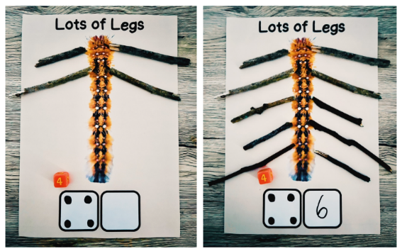
- Provide time to play ‘lots of legs’ independently.
- In pairs, students turn and talk to share their reasoning.
- At the end of the lesson, explain the importance of returning sticks to the garden. This could be done as a group or by the teacher at a later time.

Lesson 4: Combining collections
Core concept: Combining objects helps us to understand that whole numbers are made up of parts.
The table below contains suggested learning intentions and success criteria. These are best co-constructed with students.
Learning intentions | Success criteria
Students are learning that:  - the total number in a collection can be found by counting forwards from a given number  - counting by ones can help to find the total of 2 or more groups of concrete materials that have been combined. | Students can:  - count on from a given number without needing to count from one  - combine 2 or more groups of objects to find the total and describe using positional language.

Daily number sense: Spiralling snail – 15 minutes
- Build student understanding of counting forwards from a given number to find the total number in a collection by playing spiralling snail.
- Introduce ‘spiralling snail’ by explaining that this game will be played in small groups. Remove all picture cards from the deck and create a spiral shape (see Figure 6).
Figure 6 – Spiral shape
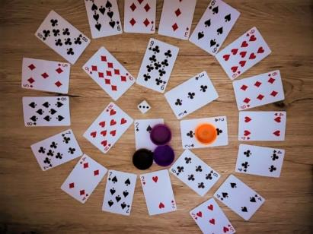
Note: Emphasise the big idea ‘sometimes things move and change location’ by asking students to demonstrate moving forwards and moving in a spiral shape.
- Students place a game piece at the start (in the middle of the spiral).
- The students take turns to roll the dice and once they have a number showing on the dice, they add this number to the number on the card that their game piece is on. If they are correct, they can move the number of spaces on the dice. If they are incorrect, they skip a turn. The aim of the game is to count on from a given number without needing to count from one.
The table below details assessment opportunities and differentiation ideas.
Assessment opportunities | Too hard? | Too easy?
What to look for:  - Can students count on from a given number without needing to count from one? (MAO-WM-01, MAE-RWN-01, MAE-RWN-02)  What to collect:  - record student’s voice during game-based learning opportunity (MAO-WM-01, MAE-RWN-01, MAE-RWN-02) | Students need further support to count on from a given number without needing to count from one.  - Provide students with Resource 10: Ten-frame and concrete materials to support addition.  - Model counting on when counting the visual patterns on 2 playing cards with one-to-one correspondence. | Students can count on from a given number without needing to count from one.  - Roll an additional dice.  - Say the number before and after the total.

Minibeast making – 30 minutes
- Display Resource 12: Minibeast poster as a visual stimulus. Explain that minibeasts are small creatures such as an insect or spider.
- Encourage students to use their mathematical imagination to create a unique minibeast using modelling clay, sticks and other natural materials.
- Model creating a body for the insect using modelling clay. Explain that students will take turns to roll a die to determine how many sticks, gumnuts and leaves to count out from a larger collection to form legs, eyes and wings. Count by ones to show how to find the total number of body parts (see Figure 7).
Figure 7 – Beetle fly
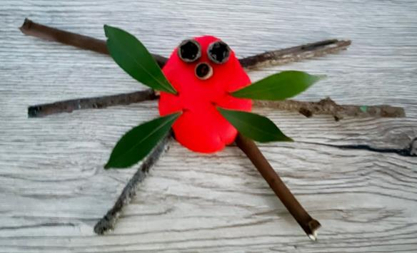
- Students play ‘minibeast making’ in pairs.
- Showcase student minibeasts creations through a gallery walk and have students name and describe the features using positional language, for example, the ‘beetle fly’ has 3 legs on the left and 3 legs on the right, 3 eyes in the middle and 4 wings above the legs which is a total of 13 body parts.
The table below details assessment opportunities and differentiation ideas.
Assessment opportunities | Too hard? | Too easy?
What to look for:  - Can students combine 2 or more groups of objects to find the total and describe using positional language? (MAO-WM-01, MAE-CSQ-01, MAE-GM-01)  What to collect:  - student participation in a gallery walk and recording of language used in group discussion. (MAO-WM-01, MAE-CSQ-01, MAE-GM-01) | Students need further support to combine 2 or more groups of objects to find the total and describe using positional language.  - Provide students with Resource 1: Number tracks (0-30).  - Model counting leaves using one-to-one correspondence. | Students can combine 2 or more groups of objects to find the total and describe using positional language.  - Roll an additional dice to determine how many antennae to add to their minibeast and find the total number of body parts.  - Draw minibeast creation and label each group of body parts with a numeral as well as the total.

Consolidation and meaningful practice: Counting cards – 15 minutes
- Introduce ‘counting cards’ by explaining that this game will be played in pairs. Remove all picture cards from the deck and place the deck of cards face down.
- Model how to play ‘counting cards’ by explaining to students that they will take turns to flip a card over and roll a die. The challenge is to start counting from the number shown on the card and count on by the number of dots shown on the die (see Figure 8).
Figure 8 – Counting on
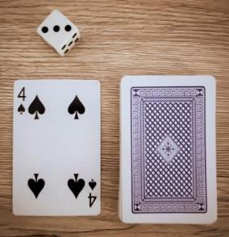

Lesson 5: Lots of ladybugs
Core concept: We can share objects to make equal groups.
The table below contains suggested learning intentions and success criteria. These are best co-constructed with students.
Learning intentions | Success criteria
Students are learning that:  - numbers can be compared, ordered and described using positional language  - equality is when groups of objects have the same number of elements  - drawings can be created to help explain their thinking about grouping and sharing. | Students can:  - record, order and describe numbers to 20 using positional language  - share objects one at a time to form equal groups  - explain their thinking by recording grouping and sharing using drawings.

Daily number sense: Lots of dots – 15 minutes
- Build student understanding of representing numbers as quantities and ordering visual representations of numbers up to 6.
- Introduce ‘lots of dots’ by explaining that this game will be played in pairs. Explain that students will take turns to roll a 6-sided number dice. Students will then record the dice dot patterns to represent the number shown on the dice onto a plastic lid to appear like a ladybug.
- Model rolling a 6-sided number dice and then drawing and describing the position of the dots for the dice dot pattern that corresponds to that number onto a plastic lid. For example, the positions of the dots for the dot dice pattern for the number 5 could be described as 2 dots up the top, 2 dots down the bottom and one dot in the middle. Repeat this process 5 times and record the dice dot patterns onto plastic lids. Compare and order the dice dot patterns by placing the lids in ascending order (see Figure 9).
Figure 9 – Dice dot ladybugs
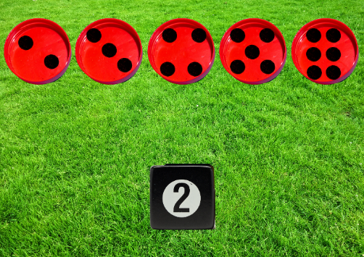
Images sourced from Canva and used in accordance with the Canva Content License Agreement.
The table below details assessment opportunities and differentiation ideas.
Assessment opportunities | Too hard? | Too easy?
What to look for:  - Can students record, order and describe numbers to 20 using positional language? (MAO-WM-01, MAE-RWN-01, MAE-GM-01)  What to collect:  - photographs of student manipulation of materials to demonstrate conceptual understanding. (MAO-WM-01, MAE-RWN-01, MAE-GM-01) | Students need further support to record, order and describe numbers to 20 using positional language.  - Provide large dice to support dice dot pattern formations.  - Provide students with Resource 1: Number tracks (0-30). | Students can record, order and describe numbers to 20 using positional language.  - Roll an additional dice and record domino dice patterns.  - Challenge students to arrange dice dot patterns in descending order.

Longing ladybugs – 30 minutes
- Ask the class to form a circle.
- Tell a story about 2 hungry ladybugs named Yarran and Minjarra. Yarran and Minjarra the ladybugs, collected a group of aphids to eat and they need to work out how to share the aphids to form equal groups. Explain to students that aphids are small insects that ladybugs are said to eat 50 or more a day.
- Display Resource 13: Aphids as a visual stimulus.
Note: Yarran is a Wiradjuri word for the acacia or wattle tree. Minjarra is the name for a bush plum which grows on Ngarrawanji land in the Kimberley region of Western Australia.
- Model rolling 2 dice and counting out the specified number of gumnuts from a larger collection to represent aphids for the ladybugs to eat. Share the total number of aphids one at a time between 2 leaves to form equal groups (see Figure 10).
Figure 10 – Sharing aphids
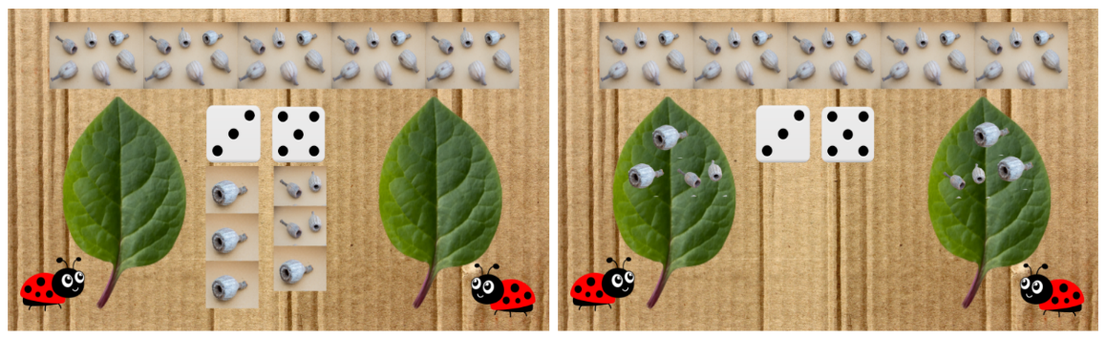
Images sourced from Canva and used in accordance with the Canva Content License Agreement.
- Repeat the game multiple times in pairs.
- Students label the number of aphids in each group by writing the numeral on the leaves.

Consolidation and meaningful practice: Labelled ladybugs – 15 minutes
- Provide time for students to record the grouping and sharing of aphids for the 2 hungry ladybugs, Yarran and Minjarra using drawings, words and numerals (see Figure 11).
Figure 11 – Drawing equal groups
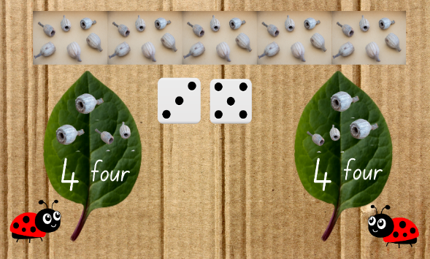
Images sourced from Canva and used in accordance with the Canva Content License Agreement.
- Showcase student recordings through a gallery walk and have students explain their thinking.
The table below details assessment opportunities and differentiation ideas.
Assessment opportunities | Too hard? | Too easy?
What to look for:  - Can students explain their thinking by recording grouping and sharing using drawings? (MAO-WM-01, MAE-FG-02)  What to collect:  - student participation in a gallery walk and recording of voice when explaining their thinking (MAO-WM-01, MAE-FG-02) | Students need further support to explain their thinking by recording grouping and sharing using drawings.  - Provide students with 2 copies of Resource 10: Ten-frame to visualise equal groups.  - Provide modelling clay to make aphids to share between 2 leaves. | Students can explain their thinking by recording grouping and sharing using drawings.  - Roll additional dice to share grouping and sharing of larger totals of aphids.  - Challenge students to share aphids between a larger number of ladybugs.

Lesson 6: Bush birthday
Core concept: Objects can be shared to form equal groups.
The table below contains suggested learning intentions and success criteria. These are best co-constructed with students.
Learning intentions | Success criteria
Students are learning that:  - equality is when groups of objects have the same number of elements  - drawings can be created to help explain thinking about grouping and sharing. | Students can:  - share objects one at a time to from equal groups and put the shared objects back together to form one collection  - explain their thinking by recording grouping and sharing using drawings.

Daily number sense: Bush tucker birthday – 15 minutes
- Build student understanding of sharing objects to form equal groups.
- Tell the story about 4 Kindergarten friends who are turning 5 and have decided they would like a lemon myrtle bush tucker cake to share with their peers to celebrate.
Note: Consider incorporating alternate local Indigenous bush tucker or the foods of the diverse cultures within the class into the lesson.
- Display Resource 14: Lemon myrtle tree as a visual stimulus.
- Explain to students that lemon myrtle trees have been used by Indigenous Australians for 40,000 years as a bush medicine to treat coughs, colds and headaches and to flavour food and drinks such as fish and tea.
- Students use modelling clay and 20 sticks to represent candles to make a small lemon myrtle bush tucker cake for each friend who is celebrating a birthday. Model placing the candles in a dot dice pattern and describing using positional language (see Figure 12).
Figure 12 – Small cakes
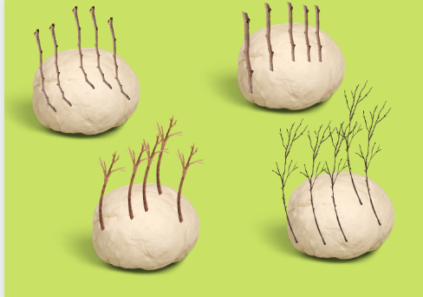
Images sourced from Canva and used in accordance with the Canva Content License Agreement.
- Ask questions such as:
- How many candles will we need on each cake?
- How many candles will there be on 2 cakes?
- How many candles will there be on 3 cakes?
- How many candles are there in total?
- Model and ask students to show the number of candles on each cake using finger patterns.
- In pairs, students use finger patterns to show how many candles in total.
- Student pairs combine with another pair and Think-Pair-Share to show different ways to make 5, 10, 15 and 20.
- Provide time for students to put shared objects back together to form one large cake to represent the total number of candles (see Figure 13).
Figure 13 – Large cake
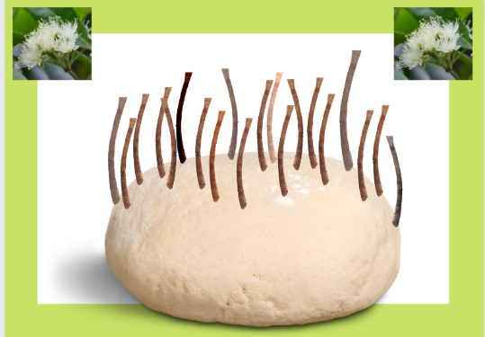
Images sourced from Canva and used in accordance with the Canva Content License Agreement.
The table below details assessment opportunities and differentiation ideas.
Assessment opportunities | Too hard? | Too easy?
What to look for:  - Can students share objects one at a time to from equal groups and put the shared objects back together to form one collection? (MAO-WM-01, MAE-FG-02)  What to collect:  - photographs of student manipulation of materials to demonstrate conceptual understanding. (MAO-WM-01, MAE-FG-02) | Students need further support to share objects one at a time to from equal groups and put the shared objects back together to form one collection.  - Model sharing sticks to each of the small cakes one at a time.  - Provide finger gloves to support finger pattern formations.  - Provide students with 2 copies of Resource 10: Ten-frame to visualise equal groups. | Students can share objects one at a time to from equal groups and put the shared objects back together to form one collection.  - Challenge students to identify how many more candles would be needed for a 7th birthday.  - Draw the small lemon myrtle bush tucker cakes with candles and then draw the cakes combined as one large cake with candles.

Chain challenge – 25 minutes
- Explain to students that they will be playing a ‘chain challenge’ by making paper chains for the bush tucker birthday. Show students the resources required for the challenge.
- Model counting out 4 sheets of paper, one for each student in the group. Explain to students that we will need 5 strips of paper to play the chain challenge.
- Ask questions such as:
- How can we make 5 strips from one piece of paper?
- How can we do this?
- What else could we use?
- How can we check we all have the same number of strips?
- Discuss responses and draw students’ attention to equality of paper strips.
- Model tearing or cutting a piece of paper into 5 strips. Select a student to keep track of the count by counting with one-to-one correspondence.
- Explain to students that they will need to number each strip from 1-5. Model or select students to write the numerals 1-5 on each strip.
- Demonstrate and describe how to join the ends of the paper strip together using positional language such as roll the strip of paper labelled ‘1’ under to form a link for the chain.
- Ask students to think about different ways to join the paper strips before testing their ideas.
- In small groups of 4, each student will cut or tear 5 strips of paper and number them from 1-5.
- Provide time for students to make, number and join the first 4 paper chains together by placing the strip of paper through each link.
Note: Emphasise the big idea ‘sometimes things move and change location’ by using positional language such as ‘under’ and ‘through’ to describe the instructions to creating a paper chain.
- Explain they will need to save the strip labelled ‘5’ to complete the challenge.
- Students' problem-solve ways to connect their individual chains to make one long chain with 20 links.
- Showcase paper chains through a gallery walk and have students explain their thinking (see Figure 14).
Figure 14 – Chain challenge
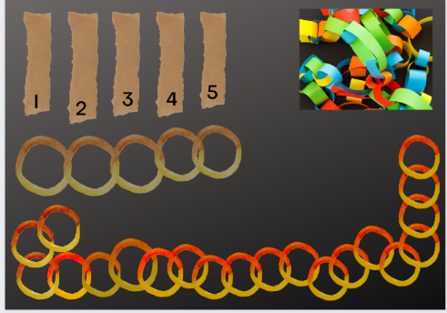
Images sourced from Canva and used in accordance with the Canva Content License Agreement.
- As a class, invite students to problem solve how to display their ‘chain challenge’ for the bush tucker birthday.
The table below details assessment opportunities and differentiation ideas.
Assessment opportunities | Too hard? | Too easy?
What to look for:  - Can students share objects one at a time to form equal groups and put the shared objects back together to form one collection? (MAO-WM-01, MAE-FG-02)  What to collect:  - record student’s voice during game-based learning opportunity. (MAO-WM-01, MAE-FG-02) | Students need further support to share objects one at a time to form equal groups and put back together.  - Model tearing paper into strips, count strips one at a time and distribute into 2 equal groups.  - Demonstrate how strips of paper shared into equal groups can be put back together to form one collection in the form of a paper chain. | Students can share objects one at time to form equal groups and put back together to form one collection.  - Challenge students to make 2 equal groups of paper strips using recycled paper or supermarket catalogues to make 2 paper chains.  - Work with a peer to count out a specified number of objects from a larger collection. Share objects into equal groups and use these to create a pattern or design a picture. Students record their pattern or design.

Consolidation and meaningful practice: Creating cards – 20 minutes
- Students remain in small groups of 4.
- Explain to students they will be creating a birthday card for one of their peers celebrating a 5th birthday.
Note: You may choose to model this or use as a directed drawing activity.
- Explain to students that they will need to:
- Draw a cake at the bottom of the card.
- Draw 5 candles on the cake.
- Number each candle 1 to 5 from left to right.
- Draw 20 rings of a paper chain up the top of the card.
- Provide time for students to create a card and sing Happy Birthday to their 4 peers (see Figure 15).
Figure 15 – Birthday card
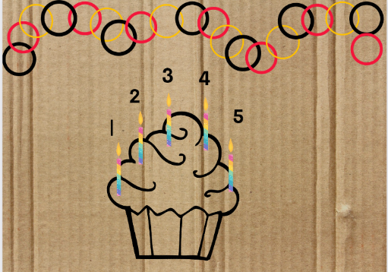
Images sourced from Canva and used in accordance with the Canva Content License Agreement.
Note: Consider incorporating local Indigenous language or the languages of the diverse cultures within the class into the ‘Happy Birthday’ song.
The table below details assessment opportunities and differentiation ideas.
Assessment opportunities | Too hard? | Too easy?
What to look for:  - Can students explain their thinking by recording grouping and sharing using drawings? (MAO-WM-01, MAE-FG-02)  What to collect:  - photographs of the birthday cards to show how students represent and record their thinking and understanding (MAO-WM-01, MAE-FG-02) | Students need further support to explain their thinking by recording grouping and sharing using drawings.  - Draw a birthday cake, add one candle at a time to model and use mathematical language to explain thinking.  - Use modelling clay to make a birthday cake, add one candle or stick at a time to explore ways to explain thinking. | Students can explain their thinking by recording grouping and sharing using drawings.  - Challenge students to make a birthday card for another friend but this time draw the cake, 5 candles and 20 chains a different way.  - Swap cards with a partner and challenge each other to explain how they have recorded and grouped.

Lesson 7: Clever quokka
Core concept: Mathematicians use positional language to describe the location of an object.
The table below contains suggested learning intentions and success criteria. These are best co-constructed with students.
Learning intentions | Success criteria
Students are learning that:  - numbers can be represented visually to show their thinking when problem solving quantities to at least 20  - the position of an object in relation to another object can be described using positional language such as in, on, under, as well as the directions up, down, left and right  - length can be compared by aligning the ends and can be described using comparative language. | Students can:  - show numbers as quantities to at least 20 in a variety of ways  - give and follow simple directions to position objects  - compare and describe length using language such as longer than, shorter than, the same as.

Daily number sense: Quiet quokka – 15 minutes
- Build student understanding of visually representing numbers to 20 to show their thinking.
- Tell a story about a quiet quokka named Quinn. Quinn was such a quiet quokka that no one heard how quickly Quinn collected leaves for breakfast.
- Show students Resource 15: Think board and ask them to recall how they used a think board in Early Stage 1 Unit 8.
- Explain to students how they will be representing the dice dot pattern rolled in a variety of ways to feed Quinn that number of leaves.
- Model rolling 3 dice, writing the numeral and number word in the centre of Resource 15: Think board. Next, write the numeral on the line in the centre of the before and after section and write the numeral before and after. Model completing the ten-frame section drawing leaves and using natural materials to represent the leaves to feed Quinn the quiet quokka (see Figure 16).
Figure 16 – Quokka think board
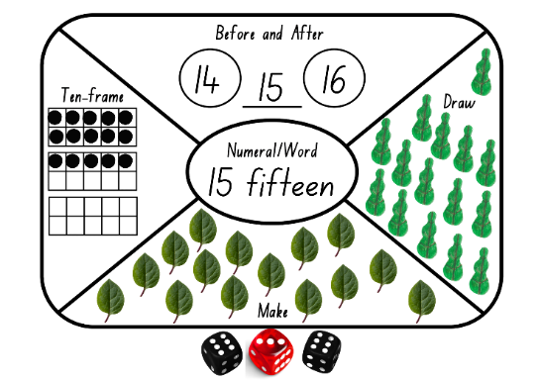
Images sourced from Canva and used in accordance with the Canva Content License Agreement.
- Provide time to play ‘quiet quokka’ independently.
- In pairs, students turn and talk to share their reasoning.
The table below details assessment opportunities and differentiation ideas.
Assessment opportunities | Too hard? | Too easy?
What to look for:  - Can students show numbers as quantities to at least 20 in a variety of ways? (MAO-WM-01, MAE-RWN-01)  What to collect:  - observations of students composing visual representations of numbers. (MAO-WM-01, MAE-RWN-01) | Students need further support to show numbers as quantities to at least 20 in a variety of ways.  - Model counting dice dot patterns using one-to-one correspondence.  - Use less dice.  - Represent the total using a finger pattern. | Students can show numbers as quantities to at least 20 in a variety of ways.  - Roll additional dice to represent larger numbers.  - Draw tally marks to represent the total.

Directed drawing – 30 minutes
- Continue to tell the story about a quiet quokka named Quinn. Quinn is learning to describe the positions of objects in relation to themself using the terms ‘left’ and ‘right’.
- Show students the stimulus Resource 16: Left or right.
- Explain that the hand with the green letter ‘L’ represents left. Ask students to hold up their left hand and make an ‘L’ shape.
- Ask questions such as:
- Is the green leaf in Quinn’s left or right hand?
- Is the ladybug on the left or right of Quinn?
- How would you describe the position of the rock?
- What hand do you hold your pencil to write with?
- Explain to students that they will be listening and following directions to draw the environment where Quinn the quokka lives.
- Explain that many quokkas live on an island called Rottnest Island on the other side of Australia in another state called Western Australia. The quokka is one of the smallest wallabies. It is a marsupial and can climb trees.
- Guide students through step-by-step directions to draw the environment of a quokka such as:
- Draw a sun at the top on the left.
- Draw a tree under the sun.
- Draw a quokka on the ground looking for leaves to eat.
- Draw a joey in her pouch.
- Draw a bird up in the sky.
- Draw a cloud at the top on the right.
- Draw a spider hanging down from the tree.
- Compare the length of the tree drawn by cutting a piece of string the same length as the tree and placing it on the tree of a peer to decide which is longer using comparative language such as ‘longer than’, ‘shorter than’, ‘the same as’. Repeat with other objects in the drawing.
The table below details assessment opportunities and differentiation ideas.
Assessment opportunities | Too hard? | Too easy?
What to look for:  - Can students give and follow simple directions to position objects? (MAO-WM-01, MAE-GM-01)  - Can students compare and describe length using language such as longer than, shorter than, the same as? (MAO-WM-01, MAE-GM-02)  What to collect:  - students’ visual representation after following simple directions to position objects. (MAO-WM-01, MAE-GM-01, MAE-GM-02) | Students need further support to give and follow simple directions to position objects.  - Model and describe the position of a puppet or soft toy.  - Ask students to describe the position of specific objects around the classroom.  Students need further support to compare and describe length using language such as longer than, shorter than, the same as.  - Use a piece of string to model finding objects that can be described as ‘longer than’ and ‘shorter than’.  - Find an object that is longer than and shorter than the string. | Students can give and follow simple directions to position objects.  - In pairs, provide step-by-step directions using positional language for a peer to follow and complete a drawing.  - Describe the position of objects in relation to themself around the classroom using the terms ‘left’ and ‘right’.  Students can compare and describe length using language such as longer than, shorter than, the same as.  - Draw a plant that is shorter than the tree and compare and describe lengths using language.  - Move independently around the classroom and identify 3 objects that are longer or shorter than themself. Record by drawing and labelling.

Consolidation and meaningful practice: Quiet quokka says – 15 minutes
- Use a puppet or soft toy, such as a quokka, to give students simple instruction using a whispering voice. For example, ‘quiet quokka says move 2 steps to the left’, or ‘now stretch your arms up’. If quiet quokka does not give the instruction, then students must not follow the action.
- This can be extended to working in pairs. As students become more proficient at playing the game, the instructions can become more complex, such as ‘quiet quokka says move down from your partner’ and ‘move to the left of your partner’.

Lesson 8: The very busy spider
Core concept: We can describe the same location and direction in different ways.
The table below contains suggested learning intentions and success criteria. These are best co-constructed with students.
Learning intentions | Success criteria
Students are learning that:  - keeping track of the count helps to connect numerals to quantities  - the position of an object in relation to another object can be described using positional language such as in, on, under, as well as the directions up, down, left and right  - the length of a piece of string remains unchanged whether placed in a straight line or a curve. | Students can:  - count out a number of items  - give and follow simple directions to position objects  - explain why the length of a piece of string placed in a straight line is the same as a curve.

Daily number sense: Counting in nature – 15 minutes
Note: This lesson has been adapted from Robertson (2017).
- Build student understanding of keeping track of the count by counting out a specific number of objects and using these to follow simple directions using directional language (left, right, in, on, under, up, down) to describe proximity to other objects.
- Lead students to the playground and explain they will be finding and collecting natural materials.
Note: While outside there may be opportunity to explain the term ‘on-Country’.
‘Country is used to describe a specific area of a nation or clan including physical, linguistic and spiritual features. Aboriginal communities’ cultural associations with their Country may include or relate to languages, cultural practices, knowledge, songs, stories, art, paths, landforms, flora, fauna and minerals. These cultural associations may include custodial relationships with particular landscapes such as land, sea, sky, rivers as well as the intangible places associated with the Dreaming(s). Custodial relationships are extremely important in determining who may have the capacity to authentically speak for their Country.
Place is a space mapped out by physical or intangible boundaries that individuals or groups of Torres Strait Islander Peoples occupy and regard as their own. It is a space with varying degrees of spirituality’. (NESA 2022)
- After finding and collecting a number of objects, ask students to gather in a circle with their collection in front of them.
- Call out different actions such as:
- Stand up next to/near your collection.
- Place one item on top of/behind your head.
- Swap places with someone standing next to you.
- Hold one item in your right/left hand.
- Stand on one leg and balance an object on your right/left knee.
- Sit down and hide 2 objects under your left hand.
- Once students understand the game, they can also be selected to call out instructions.

A MAZE-ing maze – 30 minutes
- Reinforce positional language by viewing A MAZE-ing! (1:07).
- Explain that in pairs, students will use the natural materials to create an amazing maze for a spider.
- Tell a story about a sad spider named Sage, using a figurine. Sage the spider is lost and cannot find its way back to the spiderlings in the web.
- Provide time for students to create a maze using string and spider figurines to represent Sage the spider and the spiderlings in the web (see Figure 17).
Figure 17 – Nature maze
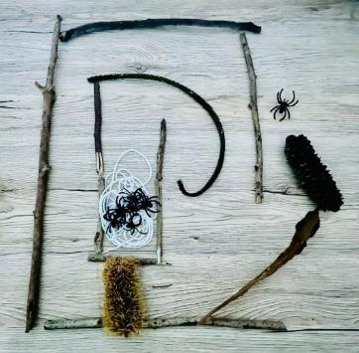
- Reinforce positional language such as in, on, under as well as the directions up and down.
- Give simple directions for a peer to follow and reach Sage’s spiderlings in the web.
The table below details assessment opportunities and differentiation ideas.
Assessment opportunities | Too hard? | Too easy?
What to look for:  - Can students give and follow simple directions to position objects? (MAO-WM-01, MAE-GM-01)  What to collect:  - student manipulation of materials to demonstrate conceptual understanding. (MAO-WM-01, MAE-GM-01) | Students need further support to give and follow simple directions to position objects.  - Model and describe the position of natural materials in the playground.  - Ask students to describe the position of objects around the playground. | Students can give and follow simple directions to position objects.  - Challenge students to write or draw instructions of how to get through the maze using directional words.  - Ask a peer to write, draw or tell you how to get through the course following a different path.

Consolidation and meaningful practice: Spiders’ webs – 15 minutes
This lesson has been adapted from Robertson (2017).
- Remain in the playground and show students a length of string. Thread the string so it looks like a three-dimensional spider web.
- Explain to students that they will move left, right, in, on, under, up and down through the strands and describe the position of themselves when moving through the string web.
- Provide additional string for students to make their own spiders’ web in small groups.
- Retrieve the curved string used to make a spider web and lay it out straight.
- Ask students to explain why the length of a piece of string remains unchanged whether placed in a straight line or a curve like a spider web.

Resource 1: Number tracks (0-30)
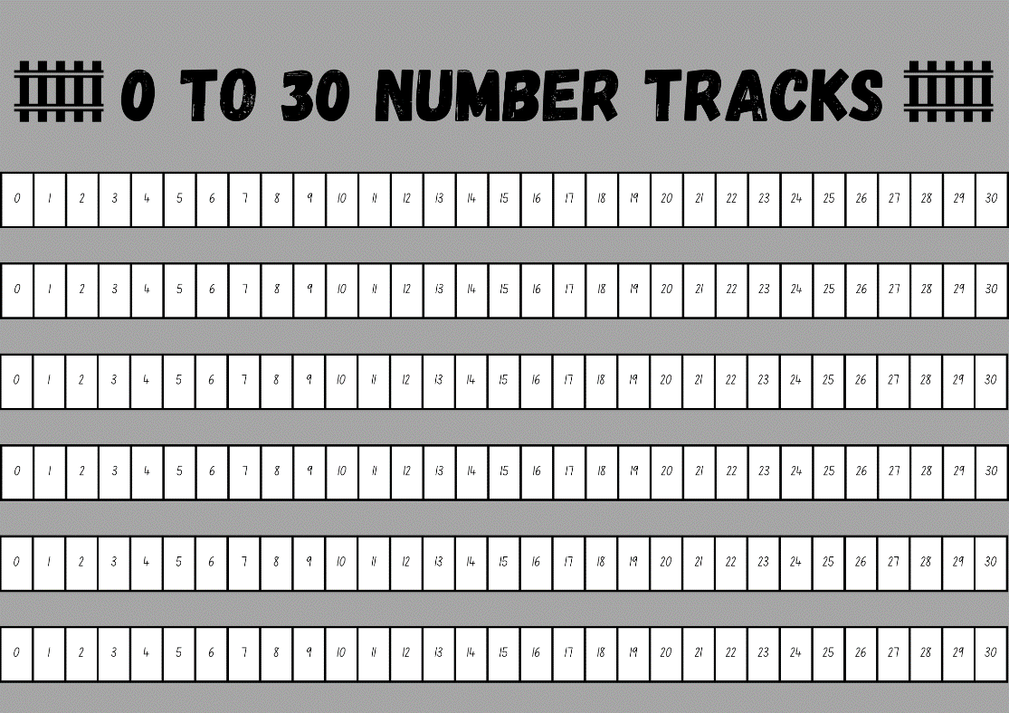
Images sourced from Canva and used in accordance with the Canva Content License Agreement.

Resource 2: Spotted-tail quoll
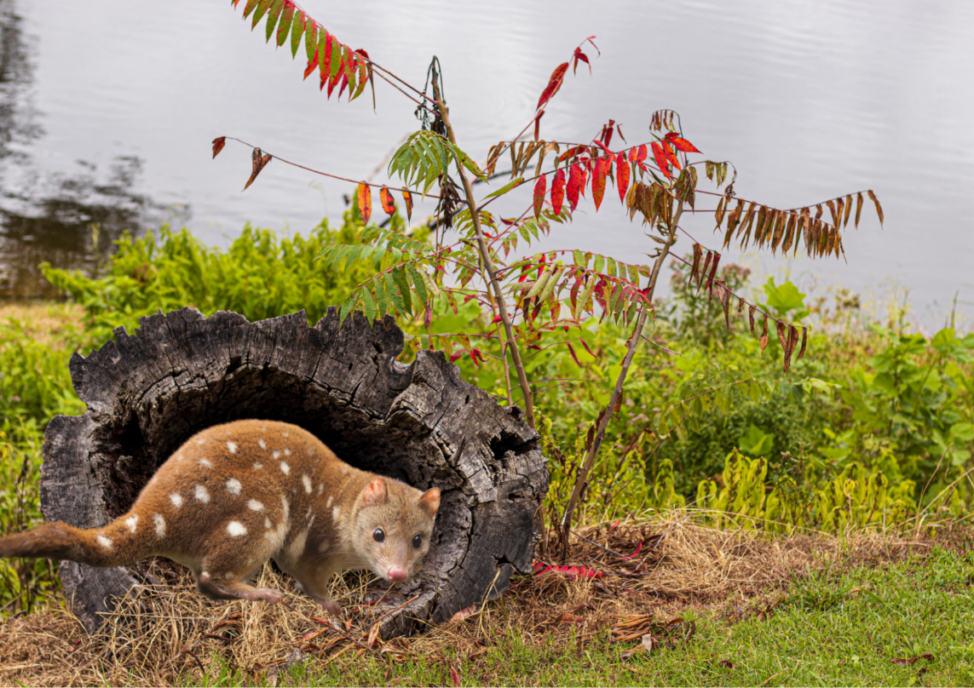
Images sourced from Canva and used in accordance with the Canva Content License Agreement.

Resource 3: Quoll counting
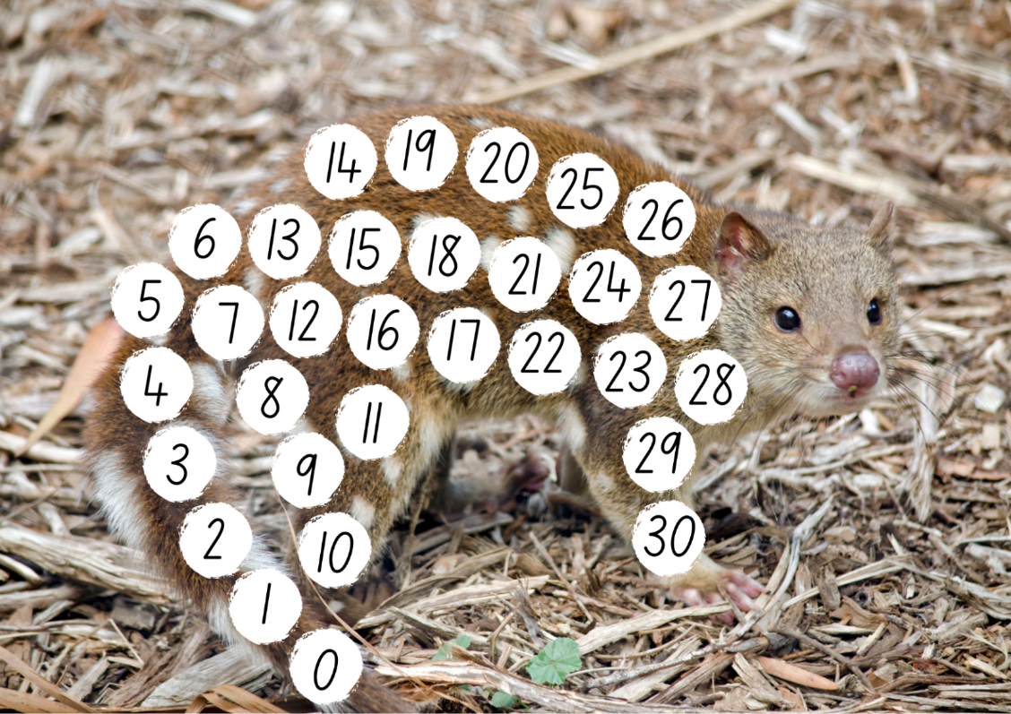
Images sourced from Canva and used in accordance with the Canva Content License Agreement.

Resource 4: Finger hopscotch
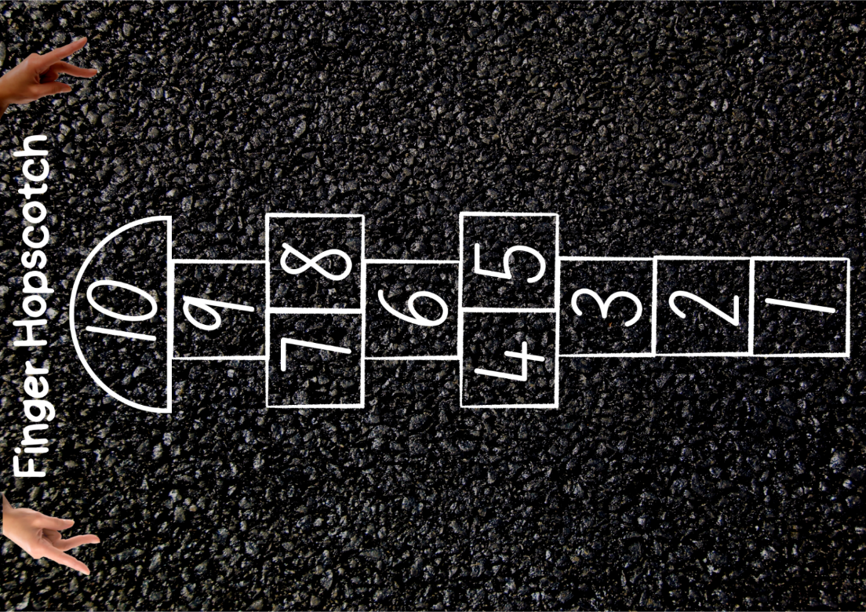
Images sourced from Canva and used in accordance with the Canva Content License Agreement.

Resource 5: Quokka
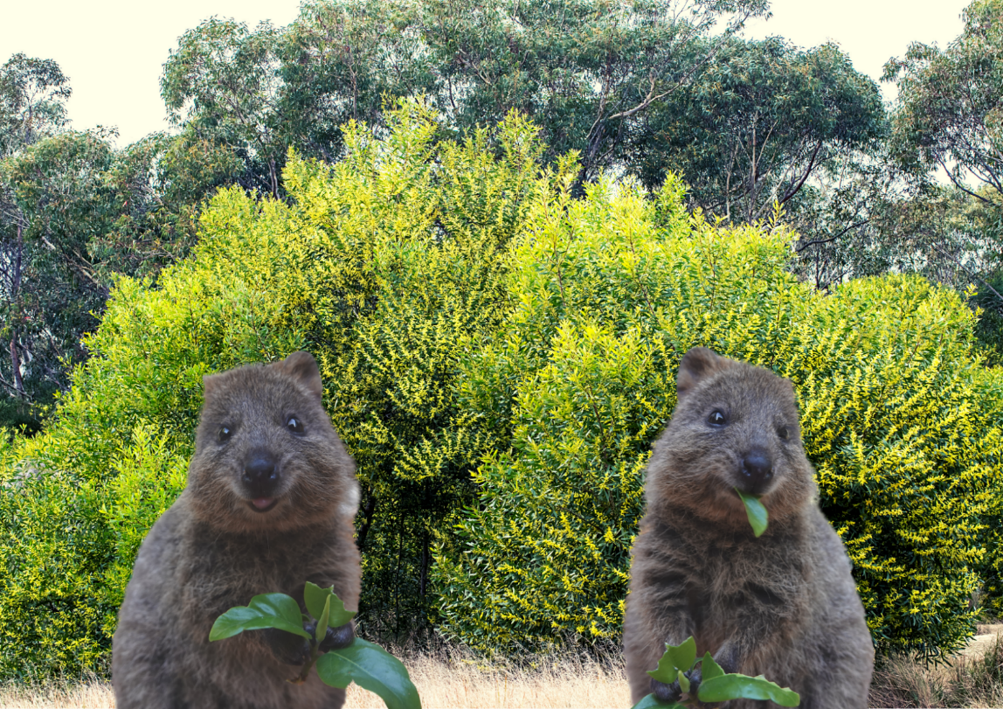
Images sourced from Canva and used in accordance with the Canva Content License Agreement.

Resource 6: Random number cards
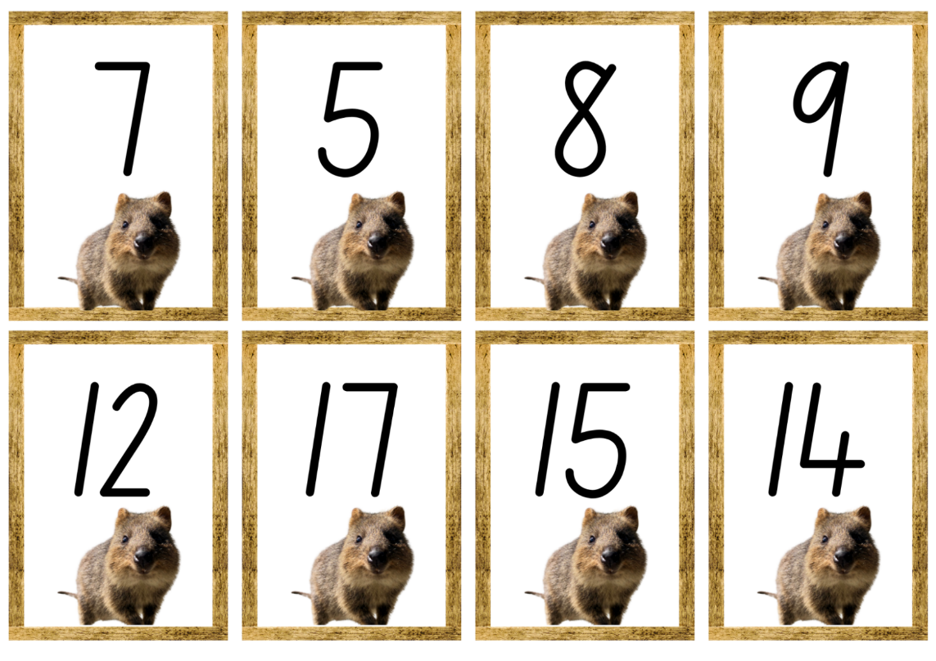
Images sourced from Canva and used in accordance with the Canva Content License Agreement.
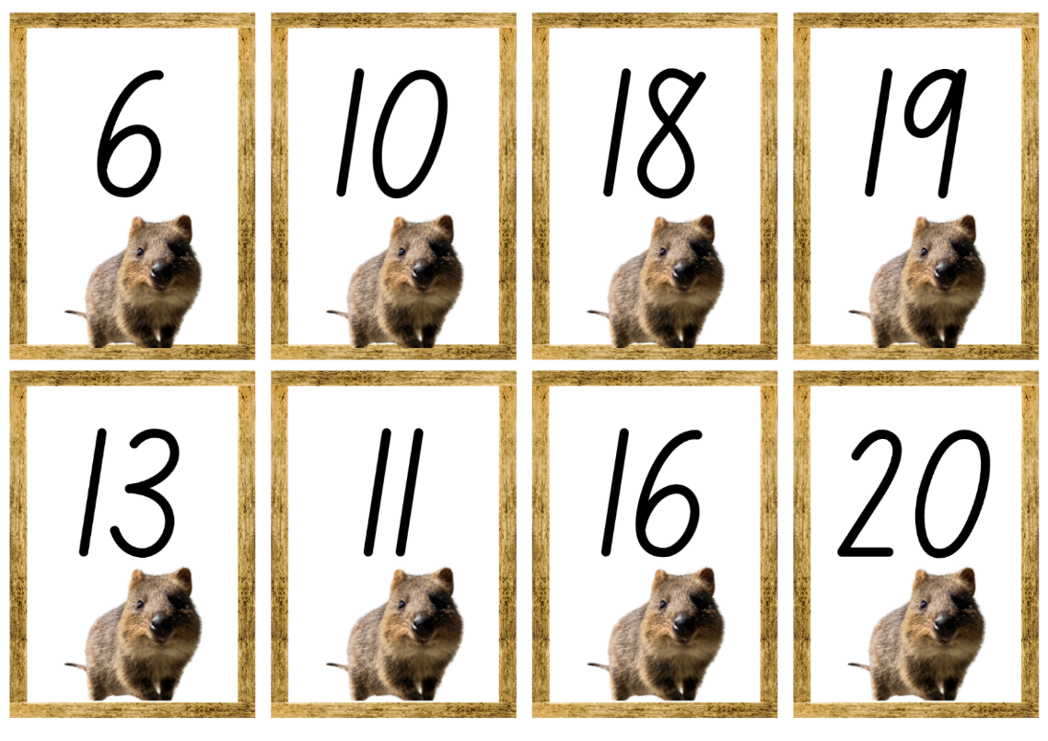
Images sourced from Canva and used in accordance with the Canva Content License Agreement.

Resource 7: Domino template
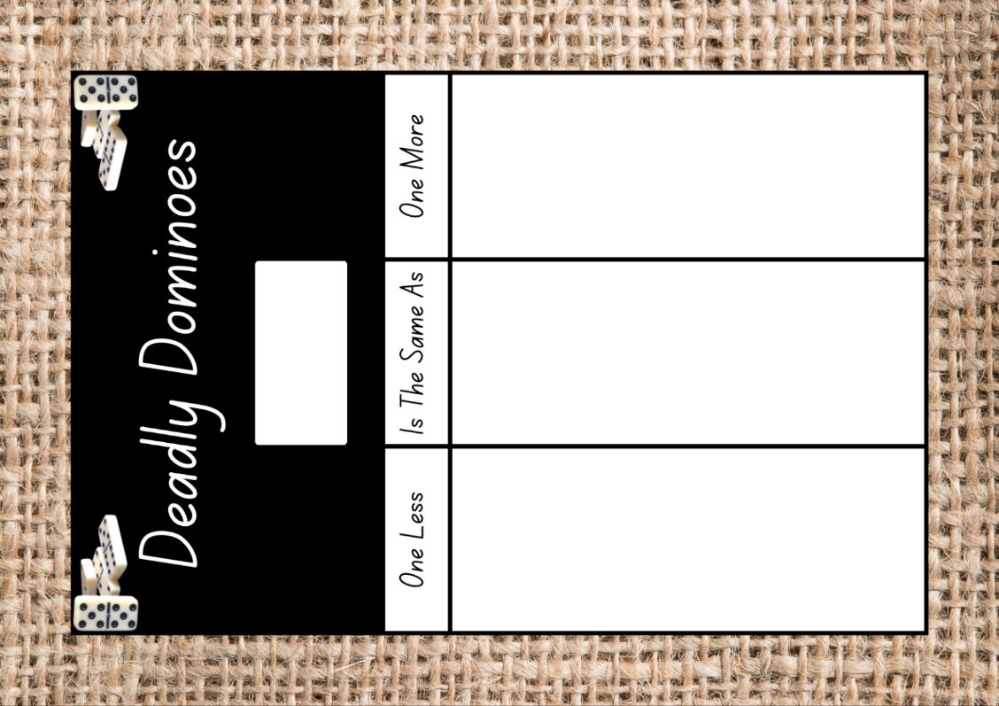
Images sourced from Canva and used in accordance with the Canva Content License Agreement.

Resource 8: 10 rocks
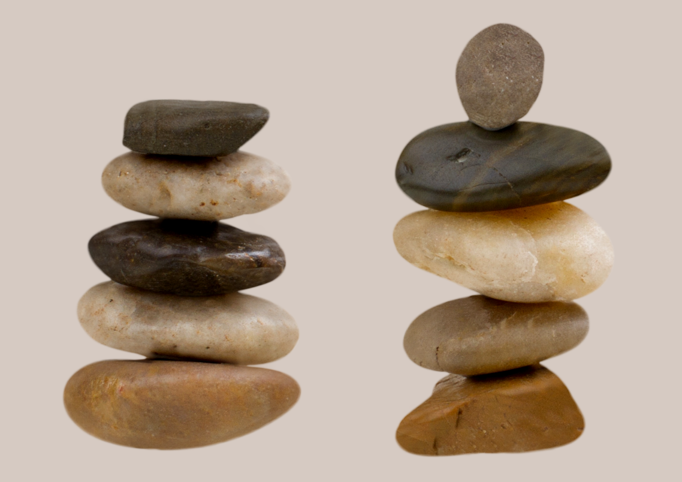
Images sourced from Canva and used in accordance with the Canva Content License Agreement.

Resource 9: 10 sticks
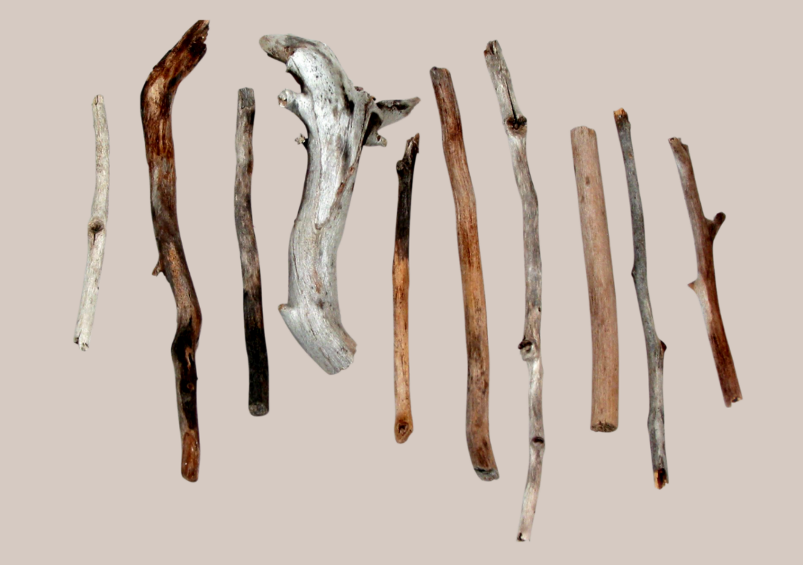
Images sourced from Canva and used in accordance with the Canva Content License Agreement.

Resource 10: Ten-frame
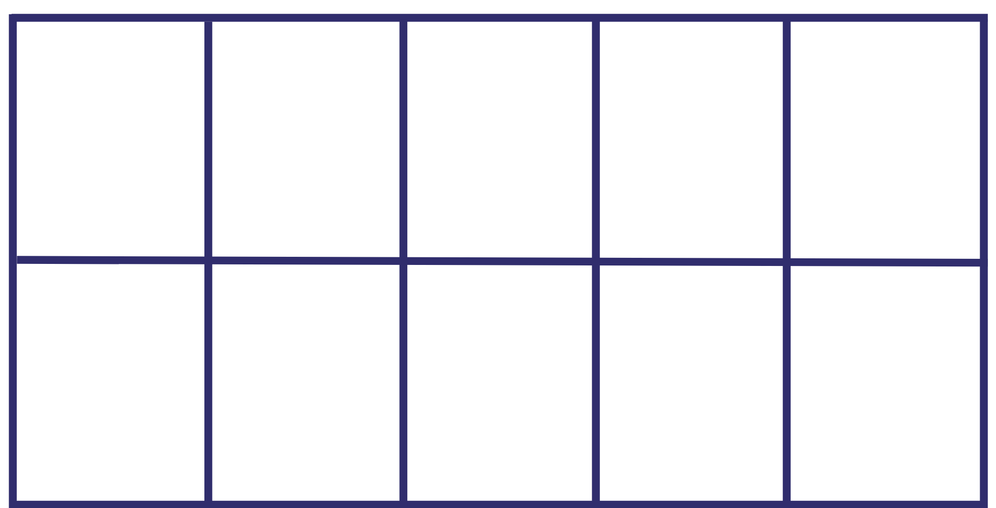

Resource 11: Caterpillar body
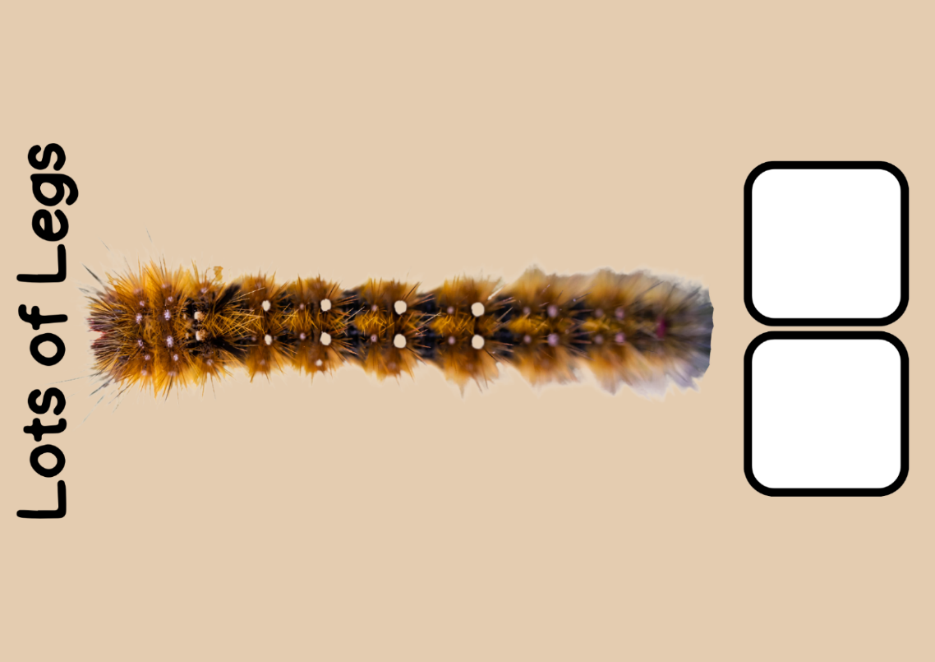
Images sourced from Canva and used in accordance with the Canva Content License Agreement.

Resource 12: Minibeast poster
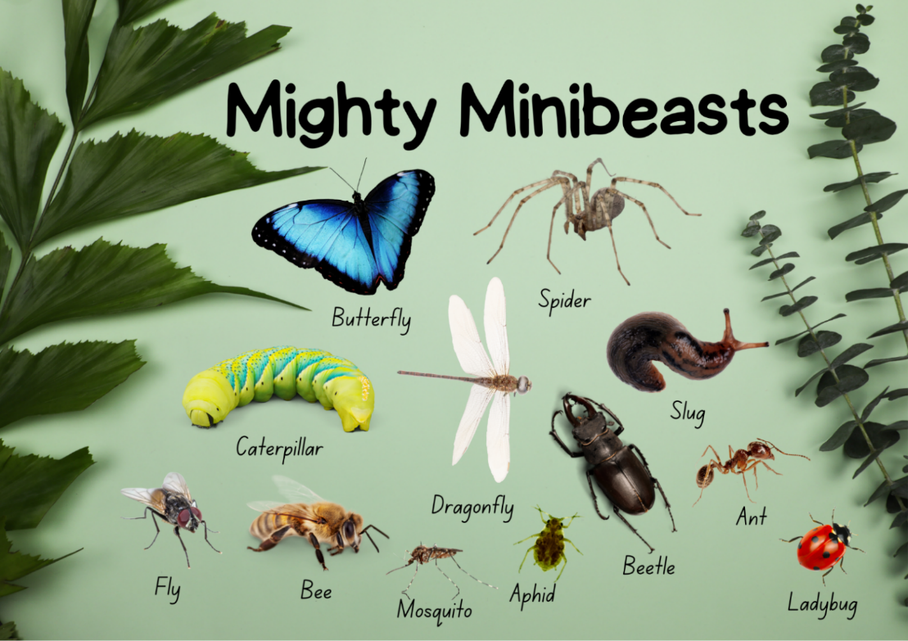
Images sourced from Canva and used in accordance with the Canva Content License Agreement.

Resource 13: Aphids
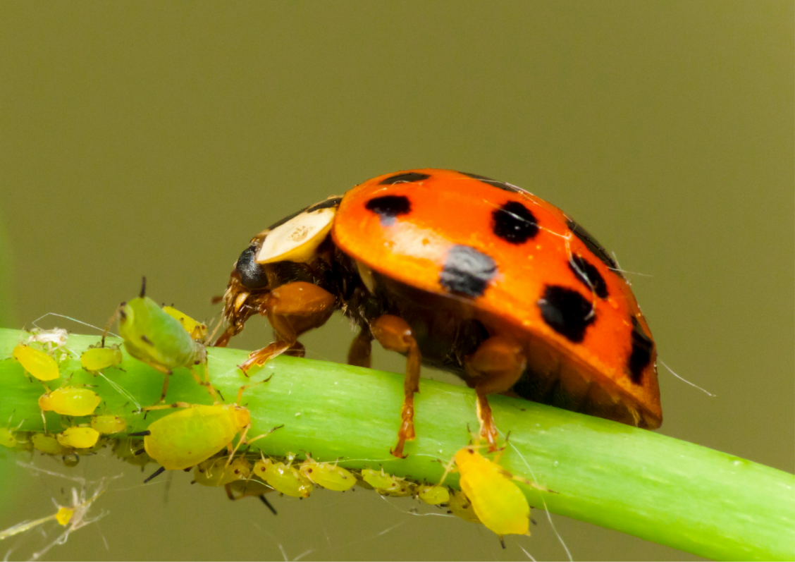
Images sourced from Canva and used in accordance with the Canva Content License Agreement.

Resource 14: Lemon myrtle tree
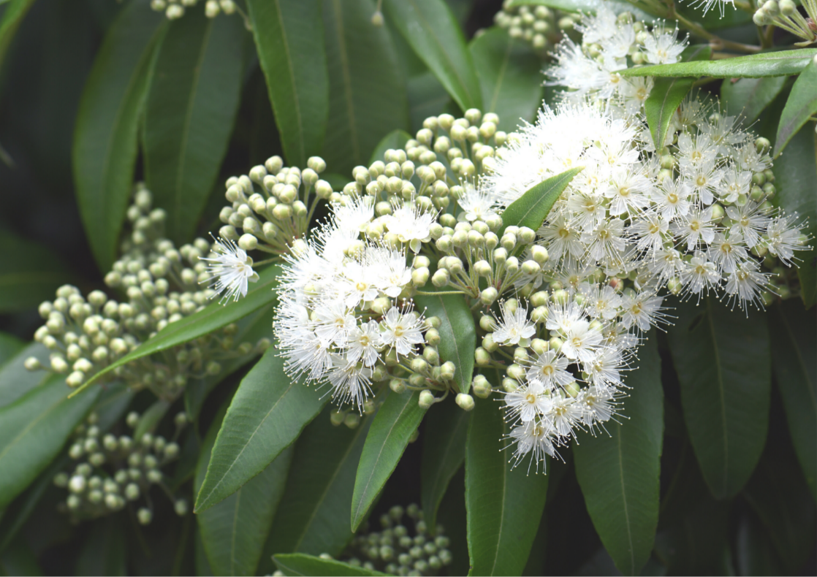
Images sourced from Canva and used in accordance with the Canva Content License Agreement.

Resource 15: Think board
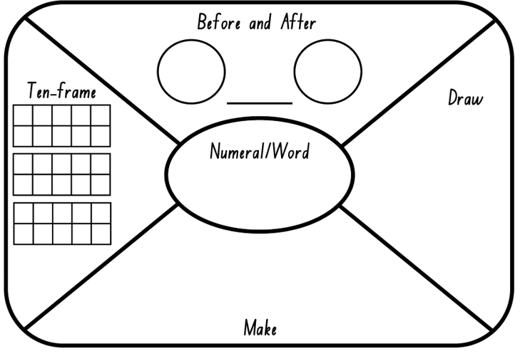

Resource 16: Left or right
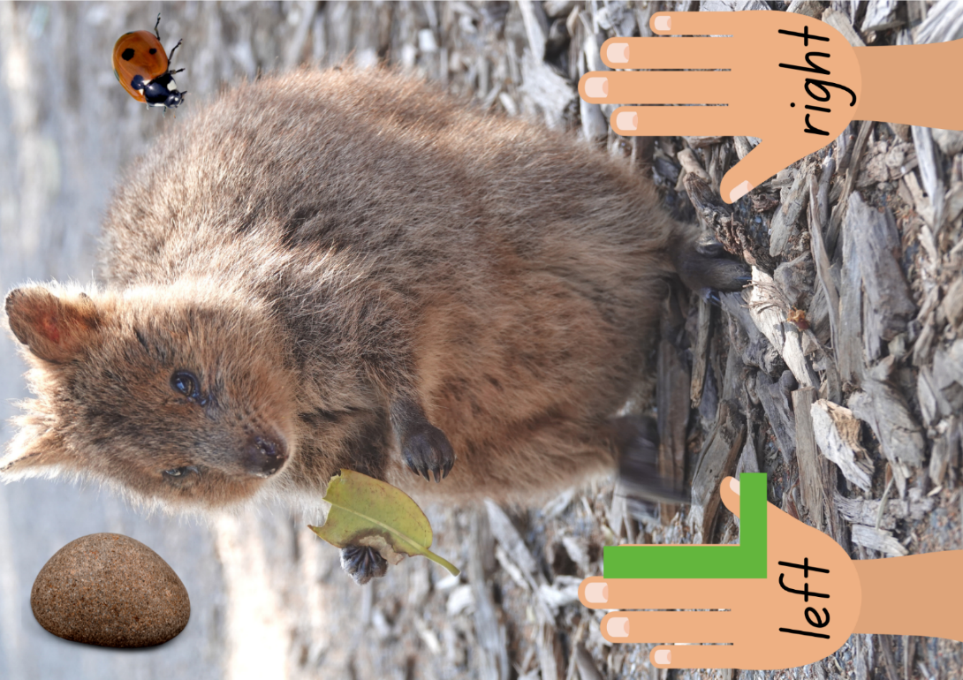
Images sourced from Canva and used in accordance with the Canva Content License Agreement.

Syllabus outcomes and content
The table below outlines the syllabus outcomes and range of relevant syllabus content covered in this unit. Content is linked to National Numeracy Learning Progression version (3).
Focus area and outcomes | Content groups and content points | Lessons
Representing whole numbers  MAO-WM-01  MAE-RWN-01  MAE-RWN-02 | Instantly name the number of objects within small collections  - instantly recognise (subitise) the number of items in small groups of up to four items without counting (NPV1, CPr1)  - identify the number of items in different arrangements (CPr2)  Use the counting sequence of ones flexibly  - count forwards to at least 30 and state the number after or before a given number, without needing to count from one (CPr4)  - identify and distinguish the ‘teen’ numbers from multiples of ten with the same initial sounds (NPV3)  - count backwards from a given number 20 or less (CPr5)  - identify the number before as 'one less' and the number after as 'one more’ than a given number  Recognise number patterns  - recognise dice and domino dot patterns (NPA1, NPV2, CPr2)  - recognise different finger patterns for the same number (NPA2)  Connect counting and numerals to quantities  - count with one-to-one correspondence, recognising that the last number name represents the total number in the collection (CPr3, CPr5)  - count out a specified number of objects (from 5 to 20) from a larger collection, keeping track of the count (CPr4-CPr5)  - make correspondences between collections  - read numerals to at least 20, including zero (NPV3)  - represent numbers as quantities to at least 20 using objects (such as fingers), number words and numerals (NPV2-NPV4, CPr3)  - compare and order numbers to 20 (NPV2-NPV3)  - use the term ‘is the same as’ to express equality of groups (CPr4-CPr5, MuS1) | 1–8
Combining and separating quantities  MAO-WM-01  MAE-CSQ-01  MAE-CSQ-02 | Model additive relations and compare quantities  - identify situations in which addition and subtraction may be applied (AdS1-AdS2)  - combine two or more groups of objects to model addition, identifying the relationship between the parts and the whole (AdS1-AdS2)  - separate and take away part of a group of objects to model subtraction (AdS1-AdS2)  - use concrete materials or fingers to model and solve addition and subtraction questions, counting forwards or backwards by ones as necessary (AdS1-AdS2, NPV3)  - compare two groups of objects to determine how many more (NPV1, AdS2)  Identify part–whole relationships in numbers up to 10  - use visual representations of numbers to assist with combining and separating quantities, identifying the relationship between the quantities (NPV2, NPA2, AdS2-AdS3)  - describe the action of combining, separating and comparing (AdS1)  - use five as a reference in forming numbers from six to ten  - create, model and recognise combinations for numbers up to ten (AdS2)  - count by ones to find the total or difference (AdS2-AdS3)  - use drawings, words and numerals to record addition and subtraction, and explain their thinking (AdS2) | 3–4, 6
Forming groups  MAO-WM-01  MAE-FG-02 | Record grouping and sharing  - label the number of objects in a group  - record grouping and sharing using drawings, words and numerals, and explain their thinking (MuS2) | 5–6
Geometric measure  MAO-WM-01  MAE-GM-01  MAE-GM-02 | Position: Describe position and movement of oneself  - give and follow simple directions to position themselves or objects (PoL1)  - describe the position of an object in relation to another object, such as in, on, under as well as the directions up and down (PoL1)  - describe the position of an object using proximity terms and referring to frames of reference (PoL2)  - use the ordinal names to at least third to describe order of position  - begin to describe the positions of objects in relation to themselves using the terms ‘left’ and ‘right’ (PoL2)  Length: Use direct and indirect comparisons to decide which is longer  - identify the attribute of 'length' as the measure of an object from end to end  - use comparative language to describe length (UuM2)  - compare lengths directly by placing objects side by side and aligning the ends (UuM2)  - explain why the length of a piece of string remains unchanged whether placed in a straight line or a curve  - compare lengths indirectly by copying a length (UuM3) | 1–8

References
Links to third-party material and websites
Please note that the provided (reading/viewing material/list/links/texts) are a suggestion only and implies no endorsement, by the New South Wales Department of Education, of any author, publisher, or book title. School principals and teachers are best placed to assess the suitability of resources that would complement the curriculum and reflect the needs and interests of their students.
If you use the links provided in this document to access a third-party's website, you acknowledge that the terms of use, including licence terms set out on the third-party's website apply to the use which may be made of the materials on that third-party website or where permitted by the Copyright Act 1968 (Cth). The department accepts no responsibility for content on third-party websites.
Except as otherwise noted, all material is © State of New South Wales (Department of Education), 2021 and licensed under the Creative Commons Attribution 4.0 International License. All other material (third-party material) is used with permission or under licence. Where the copyright owner of third-party material has not licensed their material under a Creative Commons or similar licence, you should contact them directly for permission to reuse their material.
Mathematics K–10 Syllabus © 2022 NSW Education Standards Authority (NESA) for and on behalf of the Crown in right of the State of New South Wales.
© 2022 NSW Education Standards Authority. This document contains NSW Curriculum and syllabus content. The NSW Curriculum is developed by the NSW Education Standards Authority. This content is prepared by NESA for and on behalf of the Crown in right of the State of New South Wales. The material is protected by Crown copyright.
Please refer to the NESA Copyright Disclaimer for more information.
NESA holds the only official and up-to-date versions of the NSW Curriculum and syllabus documents. Please visit the NSW Education Standards Authority (NESA) website and the NSW Curriculum website.
National Numeracy Learning Progression © Australian Curriculum, Assessment and Reporting Authority (ACARA) 2010 to present, unless otherwise indicated. This material was downloaded from the Australian Curriculum website (National Literacy Learning Progression) (accessed 28 November 2022) and was not modified. The material is licensed under CC BY 4.0. Version updates are tracked in the ‘Curriculum version history’ section on the 'About the Australian Curriculum' page of the Australian Curriculum website.
ACARA does not endorse any product that uses the Australian Curriculum or make any representations as to the quality of such products. Any product that uses material published on this website should not be taken to be affiliated with ACARA or have the sponsorship or approval of ACARA. It is up to each person to make their own assessment of the product, taking into account matters including, but not limited to, the version number and the degree to which the materials align with the content descriptions and achievement standards (where relevant). Where there is a claim of alignment, it is important to check that the materials align with the content descriptions and achievement standards (endorsed by all education Ministers), not the elaborations (examples provided by ACARA).
Robertson J (2017) Messy Maths: A Playful, Outdoor Approach to Early Years, Crown House Publishing, Great Britain.
Wernik S (director) (2020) ‘A MAZE-ing!’ [television program], One, Two, Threebies! (season 1, episode 2), ABCiView, accessed 28 November 2022.

