Mathematics – Early Stage 1 – Unit 9
Contents
Unit description and duration 4
Student prior learning 4
Lesson overview and resources 5
Lesson 1: Getting to know numbers 0 to 10 13
Daily number sense: Finger Ears – 15 minutes 13
Moving parts – 15 minutes 15
Consolidation and meaningful practice: Matching parts – 15 minutes 18
Funny monsters – 25 minutes 19
Lesson 2: Looking inside numbers 20
Daily number sense: Rekenreks – 15 minutes 20
Skittles – 20 minutes 23
Fishing for numbers – 20 minutes 24
Consolidation and meaningful practice: Making 11 – 15 minutes 25
Lesson 3: Humpty Dumpty 26
Daily number sense: Teacher identified activity – 10 minutes 27
Stories about apples – 15 minutes 27
Humpty Dumpty – 40 minutes 28
Lesson 4: Modelling and drawing stories 32
Daily number sense: Number stories – 15 minutes 32
Problem solving stories – 15 minutes 33
Possibilities within a story– 30 minutes 35
Lesson 5: Stories about equal groups 38
Daily number sense: Number tree – 15 minutes 39
Sharing oranges – 25 minutes 40
Noticing equal groups – 15 minutes 42
Consolidation and meaningful practice: Sharing grapes – 15 minutes 43
Lesson 6: Combining quantities 46
Daily number sense: Number salad – 15 minutes 46
Combining dots – 15 minutes 48
Roll the dice – 35 minutes 49
Lesson 7: Stories about disappearing 52
Daily number sense: Find a number – 15 minutes 52
What do I see? – 30 minutes 53
Consolidation and meaningful practice: Disappearing items – 15 minutes 55
Lesson 8: Café play 58
Daily number sense: Teacher identified activity – 10 minutes 58
Guess who’s coming to tea – 40 minutes 59
Consolidation and meaningful practice: Design a café meal – 20 minutes 62
Resource 1: Zero to 10 64
Resource 2: Sea creatures 65
Resource 3: Body parts 66
Resource 4: Fishing cards 67
Resource 5: Maths actions 68
Resource 6: Numeral cards 69
Resource 7: Teen representations 70
Resource 8: Dice dots 71
Resource 9: Dice graph 72
Resource 10: Collecting poem 73
Transcript – Yellow plastic bucket 74
Resource 11: Café meal 75
Resource 12: List of items 76
Syllabus outcomes and content 77
References 81

Unit description and duration
This two-week unit introduces students to solving problems by comparing, combining and separating quantities. Students are provided opportunities to:
- combine 2 or more groups to identify the relationship between the parts and the whole
- compare 2 or more groups to determine equality or how many more
- separate and take away part of a group to determine how many.
Mathematics K–10 Syllabus © 2022 NSW Education Standards Authority (NESA) for and on behalf of the Crown in right of the State of New South Wales.

Student prior learning
Before engaging in these teaching and learning activities, students would benefit from prior experience with:
- counting with one-to-one correspondence to 10, recognising that the last number name represents the total in the collection
- identifying the parts within a whole under 5
- instantly recognising (subitising) quantities up to 4.

Lesson overview and resources
The table below outlines the sequence and approximate timing of lessons; syllabus focus areas and content groups; and resources.
Lesson | Syllabus focus area and content groups | Resources
Lesson 1: Getting to know numbers 0 to 10  70 minutes  A quantity remains the same no matter how it is arranged. | Representing whole numbers  - Instantly name the number of objects within small collections  - Use the counting sequence of ones flexibly  - Recognise number patterns  - Connect counting and numerals to quantities  Combining and separating quantities  - Model additive relations and compare quantities  - Identify part-whole relationships in numbers up to 10 | - Resource 1: Zero to 10 – one set per group  - Resource 2: Sea creatures – one set per group  - Resource 3: Body parts – one set per group  - Tiny Polka Dot starter kit  - 4 counters  - 4 paper circles of different sizes  - Dice – one per group  - Loose items: googly eyes, craft sticks, string, pompoms  - One lump of modelling clay per student  - Sticky putty
Lesson 2: Looking inside numbers  70 minutes  There are smaller parts within a quantity. | Representing whole numbers  - Instantly name the number of objects within small collections  - Use the counting sequence of ones flexibly  - Recognise number patterns  - Connect counting and numerals to quantities  Combining and separating quantities  - Model additive relations and compare quantities  - Identify part-whole relationships in numbers up to 10 | - Resource 1: Zero to 10 – one set per group  - Resource 4: Fishing cards – one set per group  - Merriam E (1996) 12 ways to get to 11 (Karlin B, illus.), Aladdin, US. ISBN: 9780689808920  - Loose items  - Magnet tied to a 30 cm length of string – one per group  - Digital rekenrek  - Paperclips – one per fishing card  - Rekenrek – one per student  - Skittles and ball – one set per group
Lesson 3: Humpty Dumpty  65 minutes  Mathematical stories can be modelled to show thinking. | Representing whole numbers  - Instantly name the number of objects within small collections  - Use the counting sequence of ones flexibly  - Recognise number patterns  - Connect counting and numerals to quantities  Combining and separating quantities  - Model additive relations and compare quantities  - Identify part-whole relationships in numbers up to 10 | - Resource 5: Maths actions  - Song: Five Apples In The Apple Tree (1:48)  - Video: Humpty Dumpty (Act 1) (0:21)  - Image: Humpty Dumpty Act 2  - Image: Humpty Dumpty Act 3  - Winer Y, (1987) Mr Brown’s Magnificent Apple Tree (Winters M, illus.), Scholastic Australia. ISBN: 9780868963037  - 5 magnetic counters  - Digital device – teacher use  - Egg carton  - Loose items, concrete materials  - Writing materials
Lesson 4: Modelling and drawing stories  60 minutes  Mathematical stories can be told, modelled and drawn to find solutions. | Representing whole numbers  - Instantly name the number of objects within small collections  - Use the counting sequence of ones flexibly  - Connect counting and numerals to quantities  Combining and separating quantities  - Model additive relations and compare quantities  - Identify part-whole relationships in numbers up to 10  Forming groups  - Investigating and form groups by sharing  - Record grouping and sharing | - Baker J (2006) One Hungry Spider. Scholastic Australia. ISBN 9781865046570  - Digital devices – one per student  - Five-frames  - Loose items  - Writing materials
Lesson 5: Stories about equal groups  70 minutes  Equal groups can be formed by sharing. | Representing whole numbers  - Instantly name the number of objects within small collections  - Use the counting sequence of ones flexibly  - Recognise number patterns  - Connect counting and numerals to quantities  Combining and separating quantities  - Model additive relations and compare quantities  - Identify part-whole relationships in numbers up to 10  Forming groups  - Investigating and form groups by sharing  - Record grouping and sharing | - Resource 6: Numeral cards  - Giganti Jr P (1999) Each Orange Had 8 Slices (Crews D, illus.), HarperCollins, US. ISBN: 9780688139858  - Craft sticks  - Digital device – teacher use  - Knife and chopping board – teacher use  - Loose items and concrete materials  - Modelling clay  - Oranges – at least 3  - Patty pans, muffin trays, paper cups  - Small shrub or branches in a bucket  - Sticky notes  - String attached to each numeral card  - Writing materials
Lesson 6: Combining quantities  65 minutes  There are different ways to combine quantities to find the total. | Representing whole numbers  - Instantly name the number of objects within small collections  - Use the counting sequence of ones flexibly  - Recognise number patterns  - Connect counting and numerals to quantities  Combining and separating quantities  - Model additive relations and compare quantities  - Identify part-whole relationships in numbers up to 10  Data  - Respond to questions, collect information and discuss possible outcomes of activities  - Organise objects into simple data displays and interpret the displays | - Resource 6: Numeral cards  - Resource 7: Teen representations  - Resource 8: Dice dots  - Resource 9: Dice graph  - 2 large standard dice  - 4 cones  - Dice – one per student  - Writing materials
Lesson 7: Stories about disappearing  60 minutes  Part of a group can be taken away to model subtraction. | Representing whole numbers  - Instantly name the number of objects within small collections  - Use the counting sequence of ones flexibly  - Recognise number patterns  - Connect counting and numerals to quantities  Combining and separating quantities  - Model additive relations and compare quantities  - Identify part-whole relationships in numbers up to 10 | - Resource 10: Collecting poem  - Haji-Ali F and Haji-Ali L (2017) On the way to Nana’s (Hardy D, illus.) Magabala Books, Broome. ISBN: 9781925360301  - 15 counters  - A paper or piece of cloth – one per pair and one for teacher  - Buckets or bags – one per student  - Collection of up to 10 items – one per student and one for teacher  - Writing materials
Lesson 8: Café play  70 minutes  Comparing, combining, separating and forming equal groups can be used in everyday situations. | Representing whole numbers  - Instantly name the number of objects within small collections  - Use the counting sequence of ones flexibly  - Recognise number patterns  - Connect counting and numerals to quantities  Combining and separating quantities  - Model additive relations and compare quantities  - Identify part-whole relationships in numbers up to 10  Forming groups  - Investigating and form groups by sharing  - Record grouping and sharing | - Resource 11: Café meal  - Resource 12: List of items  - A range of items to create a pretend café: 3 tables, 6 chairs, 3 small tablecloths, 6 plates, 6 teacups, 3 vases, 9 artificial flowers, 1 packet of 10 serviettes, 3 platters, 6 teaspoons, 3 teapots, 6 pretend scones, 12 pretend strawberries, 3 pretend bowls of cream, 3 pretend bowls of jam  - Writing materials

Lesson 1: Getting to know numbers 0 to 10
Core concept: A quantity remains the same no matter how it is arranged.
The table below contains suggested learning intentions and success criteria. These are best co-constructed with students.
Learning intentions | Success criteria
Students are learning that:  - quantities contain smaller parts that combine to make a whole  - a quantity remains constant no matter how it is arranged  - numerals represent quantities. | Students can:  - represent numbers zero to 10 with visuals, numbers and words  - explain that a quantity remains the same no matter how the parts are represented  - identify smaller parts within quantities 2 to 10  - match quantities in different arrangements with each other and with numerals.

Daily number sense: Finger Ears – 15 minutes
- Build student understanding of combinations within 10 by playing Finger Ears.
- Ask students to use their fingers to show the quantity one. Use student responses to compare and ask if one volunteer can show the quantity one, using a different finger.
- Ask students to turn and talk and discuss different ways to show one using their fingers. Share responses and model with fingers to establish there are 10 different ways to represent one with fingers.
- Show students the quantity 2 with one finger on each hand. Explain that the fingers on each hand are going to be like ears on a kangaroo and place each hand near the top of your head like kangaroo ears. The total number of fingers showing must show the quantity called out. Fingers can be all on one hand or a combination on both hands.
- Demonstrate hands as finger ears to show a range of different quantities from 0 to 10 with varying combinations of fingers and ask students to call out the quantity represented when the quantity on both hands is combined.
- Ask students to create finger ears to show the total quantity for 3. Students hold fingers above their heads.
- Continue to call out different quantities from 0 to 10 as students use fingers to create combinations that represent the total quantity and hold them up like kangaroo ears.
- Observe students’ fingers and record assessment data. Pause at different points during the game to select 2 or 3 students to compare different combinations that make the same quantity and use these solutions as discussion points.
This table details assessment opportunities and differentiation ideas.
Assessment opportunities | Too hard? | Too easy?
What to look for:  - Are students able to accurately represent quantities up to 10 with fingers? (MAE-RWN-01, MAE-CSQ-02, MAO-WM-01)  - Are students able to recognise quantities up to 10 represented with different combinations of smaller parts? (MAE-RWN-01, MAE-CSQ-02, MAO-WM-01)  What to collect:  - observation data. (MAE-RWN-01, MAE-CSQ-02, MAO-WM-01) | Students require support to represent or recognise combinations to 10.  - Allow students to hold fingers in front of them where they can see and check finger representations.  - Provide students with quantities under 5 to represent or recognise.  - Count the total represented and adjust the representation to match the stated quantity. | Students accurately represent combinations to 10 using fingers.  - Ask students to create several different representations for the same quantity.  - Students work in pairs to create quantities between 0 and 20 using finger formations.

Moving parts – 15 minutes
- Display 4 counters and ask students how many they see and how they see them.
- Cover the counters with a piece of card and rearrange in several different ways and ask students how many they see and how they see them for each new arrangement, as shown in Figure 1.
Figure 1 – Different arrangements of 4 counters
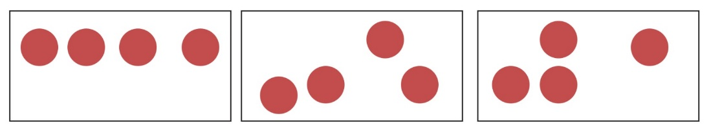
- Stick different sized circles of paper onto each counter using sticky putty and ask students how many dots they see, as shown in Figure 2.
Figure 2 – 4 different sized circles
- Ask students what they notice. Use student responses to develop a shared understanding of the constancy of the quantity, despite the changing arrangements or sizes of the items.
- Ask students which numeral represents the quantity on display. Model writing 4 and ask students to air-write the numeral.
- Model writing the word ‘four’ on the board and point to the word and read together.
- Students work in small groups. Provide groups with Resource 1: Zero to 10 and loose items.
- Students shuffle the cards and place them face down. Students turn over one numeral card. Each student uses loose items to represent the quantity on the card with loose items. Students compare arrangements and take photos of at least 2 different arrangements for the same quantity.
- Repeat for several more numerals.
- Circulate and observe students’ work and record assessment data. Ask students questions, such as:
- How many have you modelled?
- How do you see them?
- Is there a different way you can arrange them?
- Does the quantity stay the same or change when you move the parts?
This table details assessment opportunities and differentiation ideas.
Assessment opportunities | Too hard? | Too easy?
What to look for:  - Are students able to read numerals zero to 10? (MAE-RWN-02)  - Are students able to accurately represent numbers as quantities using objects? (MAE-RWN-01, MAE-CSQ-02, MAO-WM-01)  - Are students able to recognise quantities represented with different combinations of smaller parts? (MAE-RWN-01, MAE-CSQ-02, MAO-WM-01)  - Are students able to recognise that quantity remains constant no matter how it is arranged? (MAE-RWN-01, MAO-WM-01)  What to collect:  - student records and observation data. (MAE-RWN-01, MAE-CSQ-02, MAO-WM-01). | Students require support to read numerals.  - Read the numeral for the student.  - Provide students with numerals zero to 5.  Students require further support with representing and counting quantities.  - Provide students with smaller quantities to represent.  - Count the total represented each time.  - Support students to point to items one at a time as you count aloud in unison.  - Move items from one place to another as you count to support one-to-one correspondence. | Students accurately read numerals zero to 10 and represent quantities.  - Ask student to represent all possible arrangements.  - Provide students with numerals zero to 20 and ask them to represent the quantities in different arrangements.

Consolidation and meaningful practice: Matching parts – 15 minutes
This game is based on Tiny Polka Dot by Dan Finkel and Katherine Cook at Math for Love
- Students work in small groups using the Tiny Polka Dot starter kit and one set of Resource 2: Sea creatures printed on cards of matching size.
- Students turn all the cards face down and spread them out. Students take turns turning over 2 cards and if the 2 quantities are a matching pair, they keep the pair of cards. The student with the highest number of matching pairs at the end of the game is the winner.

Funny monsters – 25 minutes
- Students work in small groups. Provide each student with a small lump of modelling clay, a set of Resource 3: Body parts cards, a die and a central collection of loose items, such as googly eyes, matchsticks, craft pom poms, small craft sticks, pieces of string, shells and other items.
- Students take turns rolling the die and turning over a body part card. Each student selects loose items to represent the quantity of the nominated body part using the lump of modelling clay as the base for the body.
- When all body parts have been represented, students take photographs of the funny monsters created.
- Circulate as students work and observe students as they count out quantities and represent body parts. Use questions to generate further discussion, such as:
- How have you arranged the eyes on your monster?
- Does your monster have the same number of body parts as the other monsters created by the group?
- How is your arrangement of body parts the same or different to others?

Lesson 2: Looking inside numbers
Core concept: There are smaller parts within a quantity.
The table below contains suggested learning intentions and success criteria. These are best co-constructed with students.
Learning intentions | Success criteria
Students are learning that:  - a quantity can be represented in different ways using the smaller parts within the whole  - stories help mathematicians to explain and solve problems. | Students can:  - represent a quantity using different combinations of smaller parts  - identify the smaller parts within the whole  - combine smaller parts to make the whole  - tell a story to explain and solve a mathematical problem.

Daily number sense: Rekenreks – 15 minutes
- Build student understanding of combinations that represent the same quantity by using a rekenrek.
Note: A digital rekenrek can be used as a model for students in this lesson. Alternatively, a larger version of a rekenrek can be made as a model for students.
- Use a model of a rekenrek to display the quantity 6, using only the beads on the top row. Ask students:
- How many are there?
- How do you see it?
- Provide students with an individual rekenrek. Review how to represent quantities on a rekenrek by pushing the beads to the left side. Ask students to copy the same representation of 6 on their own rekenrek.
- Ask the students to represent 6 on their rekenreks in a different way. Use student responses to record all the different possibilities.
- Continue to ask students to represent a range of quantities under 10 using the rekenrek. Discuss the different possibilities each time, to build a shared understanding that a quantity can be represented in different ways.
- Create a representation of 5 on your rekenrek without the students seeing it.
- Ask students to predict how you represented 5 on your rekenrek and show their prediction using their own rekenrek. Reveal your rekenrek and select individual students to describe the arrangement. Provide feedback to indicate whether it matches or not.
- When a student shares a matching representation, ask that student to create a new hidden representation and lead the class to find a match.
Note: Observing how students move beads along the rows of the rekenrek will provide useful insights into the way students count. Some students may move one bead at a time and count by ones. Other students may slide a group of beads together to represent quantities and subitise groups.
This table details assessment opportunities and differentiation ideas.
Assessment opportunities | Too hard? | Too easy?
What to look for:  - Are students able to move beads to the left to represent quantities? (MAO-WM-01, MAE-RWN-01, MAE-CSQ-02)  - Can students match a rekenrek arrangement? (MAE-RWN-01, MAE-CSQ-02)  - Can students match a quantity using a different arrangement on their rekenrek? (MAO-WM-01, MAE-RWN-01, MAE-CSQ-02)  What to collect:  - observation data. (MAO-WM-01, MAE-RWN-01, MAE-CSQ-02) | Students require further support to accurately represent quantities on a rekenrek.  - Practise representing 5 or 10 by sliding sets of beads in groups on the top or bottom line to support understanding of the rekenrek structure.  - Model how to represent the quantity by counting the beads and moving them across on a rekenrek and ask students to imitate on their own rekenrek. | Students confidently create representations of quantities using a rekenrek.  - Ask students to think of more than one way to represent the quantity on their rekenrek.  - Ask students to draw their different representations.

Skittles – 20 minutes
Note: Skittles can be made from plastic bottles, cardboard rolls, tall blocks or other objects. Any small ball can be used to knock skittles down.
- Place a set of 10 skittles in 2 rows of 5. Ask students:
- What do you notice?
- What do you wonder?
- Explain that you will roll a ball towards the skittles. Ask students to predict how many could get knocked down. Students turn and talk to share predictions.
- Roll a ball towards the skittles and ask students if it is easier to see the skittles standing or those that are knocked down.
- Observe how many skittles are still standing and ask students to model that number with their fingers. Use finger models to check the quantity that have been knocked down.
- Provide small groups of students with a set of skittles. Ask students to set up their skittles in a new arrangement. Provide each group the opportunity to share a description of the way the skittles have been arranged to explain the smaller parts within the whole.
- Provide each group with a small ball. Students take turns rolling the ball towards the skittles and recording how many are standing and how many are knocked down in each new turn.
- After all skittles have been knocked down, ask students to set up the skittles in a new arrangement and play again.

Fishing for numbers – 20 minutes
- Students work in small groups. Provide groups with Resource 1: Zero to 10 and Resource 4: Fishing cards. Each fishing card should have a paperclip attached to one end. Provide each group with a magnet tied to the end of a string as a fishing rod.
- Place the numeral cards in a pile facing down. Spread the fishing cards out in a space on the floor facing up.
- Students turn over a numeral card. The aim of the game is to match the quantity on the displayed numeral card with combined quantities of dots or squiggly lines on the fishing cards. The fishing cards can be selected by dangling the magnet near the paperclip to catch the cards.
- When students have each had a turn, they turn over another numeral card and take turns collecting sets of fishing cards to match the quantity.
- Students repeat for several numeral cards until the fish cards are depleted and then the fish cards can be returned to the floor to continue with further turns.
Note: The skittles and fishing game activities can be run concurrently to reduce the number of resources required.
This table details assessment opportunities and differentiation ideas.
Assessment opportunities | Too hard? | Too easy?
What to look for:  - Are students able to match quantities by combining smaller parts within the whole? (MAE-CSQ-02, MAE-RWN-01, MAE-RWN-02, MAO-WM-01)  - What language do students use to explain the different combinations of smaller parts within a whole? (MAE-CSQ-02, MAE-RWN-01, MAE-RWN-02, MAO-WM-01)  What to collect:  - observation data. (MAE-CSQ-02, MAE-RWN-01, MAE-RWN-02, MAO-WM-01) | Students require further support to accurately match quantities by combining smaller parts within a whole.  - Provide students with quantities under 5 to manipulate and describe.  - Remove numeral cards and use visual representations or dice patterns.  - Provide students with visual tools to support thinking, such as two-sided counters, ten-frames and rekenreks. | Students accurately match quantities by combining smaller parts within a whole.  - Provide students with quantities 11-20 to manipulate and describe.  - Ask students to model more than 2 parts that combine to make a whole.  - Ask students to draw solutions to different combinations within a whole.

Consolidation and meaningful practice: Making 11 – 15 minutes
- Begin by reading 12 ways to get to 11 by Eve Merriam. Pause throughout the reading of the book to discuss the different ways the quantity 11 can be represented. Use items or drawings to model the events in the story to help students visualise the combinations that create a total of 11.
- Discuss the way a story is told for each new way to make 11. Explain that telling stories is an important part of being a mathematician.
- Ask students to work with a partner and use loose items to create a thirteenth way to get to 11.
- Take students on a gallery walk and invite each pair to share the story of the thirteenth way to get to 11 as modelled with their loose items.

Lesson 3: Humpty Dumpty
Core concept: Mathematical stories can be modelled to show thinking.
The table below contains suggested learning intentions and success criteria. These are best co-constructed with students.
Learning intentions | Success criteria
Students are learning that:  - stories that combine, separate and compare quantities use addition and subtraction to solve the problems  - concrete materials can help visualise the story and find a solution  - mathematical language can be used to describe stories that combine, separate and compare. | Students can:  - identify the actions of combining, separating and comparing in a mathematical story  - model a story using addition and subtraction to find a solution  - explain the actions in a story using mathematical language which describes combining, separating and comparing quantities.

Daily number sense: Teacher identified activity – 10 minutes
- From a class need surfaced through formative assessment data, identify a short, focused activity that targets students’ knowledge, understanding and skills. Example activities may be drawn from the following resources:
- Thinking Mathematically Early Stage 1
- Universal Resources Hub.

Stories about apples – 15 minutes
- In preparation for this lesson, display Resource 5: Maths actions anchor chart. As students share ideas and use language which describes combining and separating quantities, add words that describe mathematical actions to the chart.
- Draw a large shape of a tree and place 5 magnetic counters on the tree image to represent apples. Read Mr Brown’s Magnificent Apple Tree by Yvonne Winer. Ask students to predict the outcome of each new event in the story as the story unfolds. Remove the counters as each apple is eaten and note the change to the quantity as each new event takes place.
- Ask students to describe what happened in the story. Refer to the images in the story and use the illustrated apples and question marks in place of the apples to generate further discussion. Add language that describes mathematical actions to the anchor chart.
- Model how to make an apple tree with your arm and each finger representing an apple hanging on a tree. Sing Five Apples In The Apple Tree (1:48) with students. As students sing, ask them to shake their arm and use finger actions to remove apples and keep track of the changing number of apples in the song.

Humpty Dumpty – 40 minutes
Note: The stories described in this lesson can be changed and adapted to your context. Stories that are relevant to students provide an authentic platform for engaging students in meaningful mathematical thinking.
- Begin by singing the nursery rhyme Humpty Dumpty. Discuss the story in the song.
- Show students an egg carton. Explain that they will be investigating a story about some eggs that break.
- Explain that students will watch a video and be asked what they notice and what they wonder after watching the video. Show the Humpty Dumpty Act 1 (00:21) video twice.
Note: Some student ideas will be mathematical, and others will not. Accept all responses. Use responses to highlight mathematical observations and questions to develop a shared understanding of mathematical investigation.
The table below outlines stimulus prompts to generate conversation about the topic, along with anticipated responses from students.
Prompts | Anticipated student responses
- What do you notice?  - What do you wonder? | - The eggs fell out of the fridge.  - The box is on its side and we can’t see the eggs.  - The eggs seem to still be in the carton.  - I wonder how many eggs were in the carton?  - I wonder how many eggs were broken?  - I wonder how many eggs didn’t break?
- Record students’ ideas and guide students to develop a question to investigate how many eggs were broken.
- Ask students what information they would need to answer the question. Use student ideas to develop a deeper understanding of the story that is unfolding from the initial video.
- After thinking about the information needed to investigate the problem, provide the clue that there were 9 eggs in the carton when the carton fell from the fridge.
- Provide students the opportunity to adjust the model and represent the new information.
- Ask students questions to further investigate thinking, such as:
- Is this enough information to work out how many eggs are broken?
- Why do you think that?
- Does anyone have a different opinion?
- What else would you need to know?
- Show students the Humpty Dumpty Act 2 image and show the eggs that were not broken.
- Provide each student with loose items to model the eggs in the carton and use the information in the image to find out how many eggs were broken.
- Observe how students model the problem, describe what happened and use the model to find an answer to the question. Record student work using a digital device.
- Select students to share how they used a model to act out the story and arrive at an answer. Use ‘Talk moves’ to facilitate conversation about mathematical thinking.
- Reveal the end of the story by showing the Humpty Dumpty Act 3 image. Ask students to compare this with their model to confirm or clarify their solution.
This table details assessment opportunities and differentiation ideas.
Assessment opportunities | Too hard? | Too easy?
What to look for:  - Are students able to clearly communicate what they need to find a solution to a question? (MAO-WM-01)  - Are students able to use information to accurately model an addition and subtraction question to find a clear solution? (MAO-WM-01, MAE-CSQ-01)  - How clearly can students explain their thinking about the relations between quantities? (MAO-WM-01, MAE-CSQ-01)  What to collect:  - record of student work on digital device (MAO-WM-01, MAE-CSQ-01)  - observation data. (MAO-WM-01, MAE-CSQ-01) | Students require support to follow the story to model it accurately.  - Work with the students to match each aspect of the story with concrete materials as you tell the story step by step.  - Retell the story after the problem has been solved to reinforce the information that contributed to the final solution.  - Adapt the story to create a similar series of acts using smaller quantities. | Students follow the story and model it to find an accurate solution.  - Ask students to solve the same problem but with different quantities.  - Ask students to model and tell another story showing combining and separating quantities about a topic of interest.

Lesson 4: Modelling and drawing stories
Core concept: Mathematical stories can be told, modelled and drawn to find solutions.
The table below contains suggested learning intentions and success criteria. These are best co-constructed with students.
Learning intentions | Success criteria
Students are learning that:  - the information in mathematical problems can be modelled or drawn to find solutions  - 5 is a useful reference  - models allow us to combine, separate and compare quantities. | Students can:  - listen to a mathematical story and represent the actions in the story with a model or drawing  - use a five-frame to support comparison of quantities  - use a five-frame to combine small parts within the whole under 10  - describe the smaller parts within the whole up to 12.

Daily number sense: Number stories – 15 minutes
- Build student understanding of one more and one less by comparing quantities through a story.
Note: This activity can be completed using any picture book which features counting by ones.
- Read One Hungry Spider by Jeannie Baker. Use the images in the story to practise counting quantities on various pages.
- Select the page depicting 8 butterflies and represent this quantity on the board by drawing a row of simple shapes to represent 8 butterflies. Draw a comparison of the quantities of illustrated butterflies and the simple drawing of 8. Explain that the purpose of drawing in mathematics is to help keep track of the quantity, rather than visually represent the item.
- Show the illustration of the wasps. Ask students to nominate a simple shape or line to represent the wasps. Use a different colour marker to draw 9 simple shapes to represent the wasps, aligned underneath the butterfly shapes, so that the ninth shape stands alone at the end.
- Ask students what they notice when they compare the 2 quantities represented with the drawings. Use student responses to establish there is one more wasp than the group of butterflies or one less butterfly than the group of wasps.
- Select 2 alternative sequential pages in the book and select a student to represent the quantity of one page on the board using a simple shape or line and select another student to represent the second page with a simple shape or line. Compare these quantities as one more and one less.
- Provide each student with writing materials and ask students to represent the quantities on two sequential pages in the book.
- Ask students to share how they have depicted the quantities. Invite students to describe the difference between the 2 quantities.

Problem solving stories – 15 minutes
Note: The structure of the sample story in this lesson can be adapted to suit the students in your context.
- Tell a story about 2 siblings whose parents send them on a treasure hunt in their yard for chocolate gold coins. They are told to collect what they find and bring it back to count and share fairly between them. One sister finds 4 gold coins and her brother finds 3 gold coins. Ask students to use loose items to model the story and work out how many they found altogether.
- Discuss the way students modelled the story and the way in which 2 quantities have been combined to find a total quantity.
- Ask students how to share the coins fairly between the 2 siblings. Students share thinking and possible solutions.
- When students have established that the quantity cannot be formed into equal groups, reveal the next part of the story. Explain that there was one more coin hiding in the yard and the siblings found it and added it to their collection.
- Ask students to adjust the model to reflect the next step in the story and ask what will happen if the coins are shared fairly with the additional coin. Use student responses to establish that 8 can be shared fairly.
- Tell the story again, using five-frames to demonstrate the combining of 2 parts. Display 2 five-frames and place 4 loose items in one five-frame and 3 loose items in the other five-frame.
- Ask students what they notice. Use student responses to draw attention to the comparison between 4 and 3 as one more or one less than the other. Record student observation of equality of different combinations within 7, as shown in Figure 3.
Figure 3 – Comparing 4 and 3 in five-frames
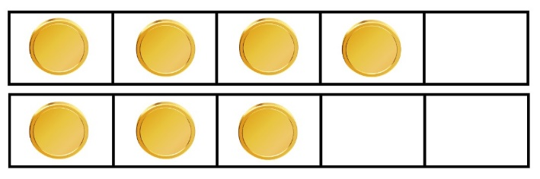
- Continue to model the story to the final step, adding one more loose part to the model in the five-frame, as shown in Figure 4.
Figure 4 – Demonstrating equality of groups with five-frames
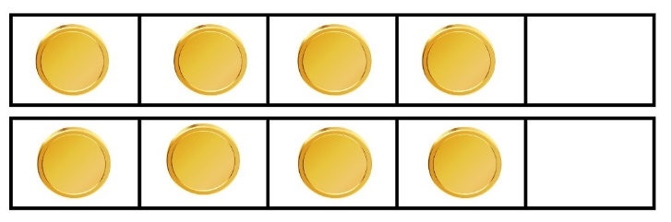
- Ask students what they notice. Use student responses to record observations of equality of different combinations within 8. Move one loose part to depict 4 and 4 in the five-frames and add this to the observations of equality of combinations within 8, as shown in Figure 5.
Figure 5 – Alternative arrangement of 8 in 2 five-frames
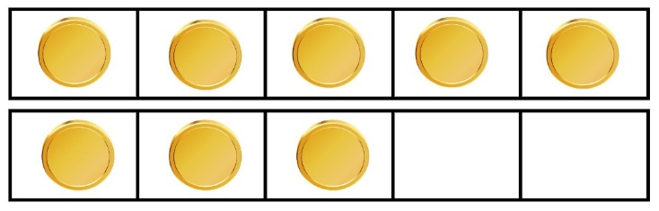
- Discuss the way the five-frames supported instant recognition of the parts within the whole and equal groups.

Possibilities within a story– 30 minutes
- Explain that mathematicians visually represent the information revealed in stories to work out their solutions. This has been demonstrated in previous activities through drawing, modelling with loose items and using mathematical tools such as five-frames.
Note: Ensure students have ongoing access to mathematical tools, writing materials and loose items that allow them to model or draw thinking as a regular mathematical habit of learning.
- Pose the following problem to students: There are 12 students and 2 tables in the classroom. What are the possible seating arrangements for the students using both tables?
- Invite students to explore the possible solutions to the problem by using the chairs and tables, or by drawing their ideas. Provide students with digital devices to record their solutions. Allow students time to explore solutions.
- Collect observations of student work to assess their thinking and understanding. Ask students questions such as:
- What have you discovered?
- How are you showing your thinking?
- Ask students to share the way they have modelled a solution. Compare possible solutions and emphasise that there are multiple possible solutions to the problem.
- Ask students if they think they can discover all the possible solutions to the problem. Provide students with a few more minutes to explore further solutions.
- When students indicate they have exhausted the possibilities, gather students together and invite different students to share the range of possible solutions.
- Record all solutions and ask students if there is any way to check if all solutions have been found. Use student responses to notice patterns in the ideas generated and add any further solutions to the record.
This table details assessment opportunities and differentiation ideas.
Assessment opportunities | Too hard? | Too easy?
What to look for:  - Are students able to combine and separate quantities using a model or drawing to solve a problem? (MAE-RWN-01, MAE-CSQ-01, MAE-CSQ-02, MAE-FG-02, MAO-WM-01)  - What strategies do students use to work out the solutions to a problem expressed through a story? (MAE-RWN-01, MAE-CSQ-01, MAE-CSQ-02, MAE-FG-02, MAO-WM-01)  - Are students able to identify a range of different solutions to an open-ended problem? (MAE-RWN-01, MAE-CSQ-01, MAE-CSQ-02, MAE-FG-02, MAO-WM-01)  - What strategies do students use to count quantities? (MAE-RWN-01, MAE-CSQ-01, MAE-CSQ-02, MAE-FG-02, MAO-WM-01)  What to collect:  - observation data (MAE-RWN-01, MAE-CSQ-01, MAE-CSQ-02, MAE-FG-02, MAO-WM-01)  - records of student work. (MAE-RWN-01, MAE-CSQ-01, MAE-CSQ-02, MAE-FG-02, MAO-WM-01) | Students require support in accurately drawing, modelling and counting to find solutions to story problems.  - Provide students with objects to model stories and tell the story as students manipulate the objects.  - Adapt the stories to include smaller quantities.  - Suggest students use five-frames or ten-frames to support thinking. | Students find all solutions to the problem with models or drawings.  - Ask students if they notice a pattern in the solutions and invite them to order the solutions to reveal the pattern.  - Adapt the table sharing story to seat students across 3 tables.

Lesson 5: Stories about equal groups
Core concept: Equal groups can be formed by sharing.
The table below contains suggested learning intentions and success criteria. These are best co-constructed with students.
Learning intentions | Success criteria
Students are learning that:  - equal groups can be combined to find a total  - a group of objects can be shared to create smaller equal groups  - mathematicians use models and drawings to find solutions to stories about grouping and sharing. | Students can:  - combine equal groups to find a total  - share objects to create smaller equal groups  - accurately model or draw a mathematical story about grouping or sharing to find the solution to a problem.

Daily number sense: Number tree – 15 minutes
Note: This lesson has been adapted from Robertson (2017). A number tree can utilise a small shrub or tree in an outdoor space or can be created with a collection of branches in a bucket. The numbers on the tree can be adapted to stimulate number conversations for any purpose.
- Build student understanding of accurately reading the ‘teen’ and multiples of 10 with the same initial sounds by reading numbers on a number tree.
- In preparation for this lesson, use Resource 6: Numeral cards to print numbers 13 to 19 on one colour card and 30 to 90 on a different colour card. Punch a hole in each card and tie each card onto a small outdoor shrub or collection of branches in a bucket of sand indoors.
- Provide students with the opportunity to look carefully at the number tree. Ask students:
- What do you notice about what is hanging in the tree?
- What do you wonder?
- What can you tell me about it?
- Read each card together, ensuring that students are clearly and accurately articulating the pronunciation of each number name. Ask students what similarities and differences they notice in the collection of numbers.
- Use student responses to establish the relationship between the groups of numbers represented by different coloured cards and the similarity between pronunciations of numbers.
- Use opportunities in the discussion to select specific cards to re-read and highlight the correct pronunciation of similar number names, for example, 19 and 90 or 16 and 60.
Note: This activity provides the opportunity to notice the similarity in the structure of the spoken words and compare that with the numeral structure. ‘Teen’ number words differ in structure to number words for multiples of 10 as the first part of the word is represented by the second digit in the numeral, whereas multiples of 10 lead with the word that matches the first digit in the numeral.

Sharing oranges – 25 minutes
- Prepare a safe space for cutting an orange into slices with a knife on a chopping board.
- Show students a whole orange and explain that you would like to share the orange with others. Ask students to predict how many pieces of orange there will be if the orange were cut down the middle and invite students to provide reasons for their thinking.
- Cut the orange down the middle. Ask students to explain how many people could share the orange and how many pieces each person would receive.
- Repeat the process of predicting, cutting and discussing the possibilities for sharing as you cut the orange into 4 pieces and then 8 pieces.
- Show students pages 12-13 of Each Orange Had 8 Slices by Paul Giganti Jr. Discuss the 3 questions posed in the book and ask students to use modelling clay and craft sticks to investigate a solution for the first 2 questions.
- Observe how students model the story to find solutions. Ask questions, such as:
- How have you modelled the story?
- How many whole oranges did you create from the modelling clay to begin with?
- How many times did you need to cut the orange to match the number of pieces in the story?
- How many pieces of orange do you have now?
- How many people could you share your orange pieces with, so each person has one piece?
- How many people could you share your orange pieces with, so each person has 2 pieces?
- After students have created a model to solve the first 2 questions in the book, ask students to share the way they have modelled the story to answer the questions. Use ‘Talk moves’ to share different approaches to solving the problems.
- Ask students what they could use to model the seeds in the oranges to work out the answer to the third question in the book.
- Provide students with loose items to investigate the third question and invite students to share what they have discovered.
Note: Use the experience of cutting a piece of fruit into 8 pieces to work out how many pieces of fruit are needed so that each student in the class gets one piece. At the end of the lesson, offer pieces of fruit as appropriate, with each member of the class.
This table details assessment opportunities and differentiation ideas.
Assessment opportunities | Too hard? | Too easy?
What to look for:  - Are students able to accurately model a mathematical story to find the answer to a question? (MAO-WM-01, MAE-FG-02)  - Are students able to combine 2 equal groups to find a total quantity? (MAO-WM-01, MAE-RWN-01, MAE-FG-02)  - How do students distribute pieces of modelling clay to equally share a collection? (MAO-WM-01, MAE-RWN-01, MAE-FG-02)  What to collect:  - observation data. (MAO-WM-01, MAE-RWN-01, MAE-FG-02) | Students require support to accurately represent the story using modelling clay.  - Explain each step in the story one step at a time to support the process of modelling.  - Support students to create manageable balls of modelling clay to be able to be cut into 8 pieces.  Students require support to accurately count quantities and identify equal groups.  - Align groups in rows and columns to show matching quantities in each new group.  - Reduce the quantities in the story so the oranges are only cut into 4 pieces. | Students model the story accurately using modelling clay and loose items.  - Ask students to work out how many ways the 16 pieces of orange can be shared equally.  - Ask students to represent the answers to the questions in the story through drawing.

Noticing equal groups – 15 minutes
- Show students the illustration on the first page of Each Orange Had 8 Slices. Cover the words on the page with sticky notes and ask students to describe what they see in the illustrations. Use student responses to identify the different items depicted on the page and the equal groups of flower petals and black bugs on each petal. Ask students what mathematical questions could be investigated from the image.
- Remove the sticky notes and read the text on the page. Use the illustration to support students to count and find the answers for each question posed in the book and any additional questions posed by students.
- Continue turning the pages of the book, covering the text with sticky notes to allow students time to notice the equal groups represented in each illustration. Ask students to describe the groups they see.
- After discussing the illustrations, read the text on each page. Select questions from the book to investigate through the illustrations.
- Discuss the connections between the mathematics in the book and in the spaces around students. Ask students to find equal groups in the immediate surroundings. Ask students to describe how many groups and how many are in each group, such as seats at tables, windows in classrooms and pencils in tins.

Consolidation and meaningful practice: Sharing grapes – 15 minutes
- Provide students with writing materials, a variety of loose items, concrete materials and tools to support sharing such as patty pans, muffin trays and paper cups.
Note: The following mathematical story can be adapted to suit the interests of the students in your context.
- Describe this mathematical story to students: My Aunty bought a bunch of grapes. There were 16 grapes in the bunch for 2 people to share equally. How many grapes would each of us get?
- Ask students to use the materials provided to model or draw the story and answer the question.
- Observe the way students solve the problem and the methods they use to distribute the objects in equal groups. Use questions to elicit student thinking, such as:
- How many people are you sharing the grapes between?
- How are you keeping track of sharing the grapes fairly?
- What is a way you can check how many grapes you get each?
- Select a few students to share the way they modelled or drew the story and how they worked out a solution to the question.
- Introduce a new character to the story. Explain that your cousin joined you and now the grapes need to be shared between the 3 of you. Provide students time to explore how to share 16 grapes between 3 people.
- Pause and ask students what they have noticed. Use student responses to highlight that not all of the groups are equal. Discuss how many more grapes would be needed to form 3 equal groups. Compare the process of sharing 16 between 2 to build a shared understanding that the number of possible equal groups differs for different quantities.
- Provide students with time to model the new aspect of the story. Observe how students model or draw the problem and listen to the language used to describe the outcome. Photograph or video students’ work.
- Select a number of students to share the way they modelled or drew the story and how they worked out the solution to the question. Use student responses to highlight the uneven groups.
This table details assessment opportunities and differentiation ideas.
Assessment opportunities | Too hard? | Too easy?
What to look for:  - Are students able to distribute objects into equal groups? (MAO-WM-01, MAE-RWN-01, MAE-FG-02)  - What methods do students use to share objects into equal groups? (MAO-WM-01, MAE-RWN-01, MAE-FG-02)  - Are students able to recognise whether the number in a group is equal or not? (MAO-WM-01, MAE-RWN-01, MAE-FG-02)  - What language do students use to explain their thinking as they record grouping and sharing? (MAO-WM-01, MAE-FG-02)  What to collect:  - observation data (MAO-WM-01, MAE-RWN-01, MAE-FG-02)  - student work samples. (MAO-WM-01, MAE-RWN-01, MAE-FG-02) | Students require support to model a story about sharing a collection equally with accuracy.  - Adapt the story and reduce the initial group of items to a smaller quantity.  - Explain each step in the story, one step at a time, to support the process of modelling.  - Provide a verbal prompt such as, ‘One to Aunty, one to me’ to repeat as students share the items one at a time. | Students model a story about sharing a collection equally with accuracy.  - Ask students to label a drawing of the story with numerals that indicate the quantities in each group.  - Ask students to work out all the possibilities for sharing all 16 grapes fairly.

Lesson 6: Combining quantities
Core concept: There are different ways to combine quantities to find the total.
The table below contains suggested learning intentions and success criteria. These are best co-constructed with students.
Learning intentions | Success criteria
Students are learning that:  - quantities can be represented by numerals, visual representations and words  - different strategies can be used to combine 2 quantities  - 2 smaller quantities can be counted by ones to find the total  - information can be arranged in a data display and interpreted to answer questions. | Students can:  - match numbers 13 to 19 with visual representations and numerals  - use strategies to combine 2 quantities to find the total  - explain the strategies they use to combine 2 quantities to find the total  - arrange information in a data display and interpret the information to answer questions.

Daily number sense: Number salad – 15 minutes
- Build student understanding of recognising and reading quantities and numerals 13-19 by playing number salad.
Note: This game can be adjusted to meet the physical needs of your students.
- Use an open space in which students can run safely. Seat students in 2 rows facing one another. Place a cone at beginning and end of each line of students.
- Use numeral cards 13 to 19 from Resource 6: Numeral cards and cards from Resource 7: Teen representations. Ensure cards are at least half of an A4 page so students can see them clearly from where they sit.
- Allocate pairs of students seated opposite one another with a number from 13 to 19. Stand at the top of the 2 lines in view of all students. Hold up one card at a time. Students with the matching number stand up, run through the middle and around the back of their line and back through the middle to be seated in their original place, as shown in Figure 6.
Figure 6 – Diagram for number salad set-up
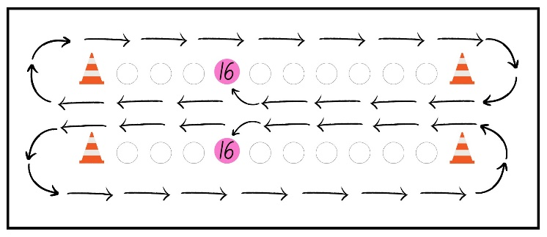
Images sourced from Canva and used in accordance with the Canva Content License Agreement.
- At various intervals, call out ‘number salad’ and all students stand up and run around the 2 cones at the ends of their line, before being seated back in their original order.
This table details assessment opportunities and differentiation ideas.
Assessment opportunities | Too hard? | Too easy?
What to look for:  - Are students able to connect the spoken numerals 13 to 19 with the written numeral? (MAE-RWN-02)  - Are students able to connect the spoken numerals 13 to 19 with a visual representation? (MAE-RWN-02)  What to collect:  - observation data. (MAE-RWN-02) | Students require further support with recognising the written numeral or visual representations of 13 to 19.  - Ask the group to call out the numeral or visual representation each time a new card is displayed.  - After students return to their places, discuss the structure of the visual representation or numeral and say the quantity together.  - Pair students with a knowledgeable peer. | Students recognise the written numeral or visual representation of 13 to 19.  - Show 2 cards at a time.  - Show a card and verbally say a different number but require only students whose number matches the card to run.  - Provide addition or subtraction stories, instead of cards, for students to work out and match to their number.

Combining dots – 15 minutes
- Display Resource 8: Dice dots and record the numeral 6 on the board. Ask students to turn and talk and identify 2 dice that could combine to match the numeral written on the board.
- Ask students to indicate how many possibilities they found with their fingers. Select several students to share possible combinations and record all possible combinations under the numeral 6.
Note: Some students may select the same combination of dots. Ensure these are displayed in a different order left to right and use this opportunity to discuss the commutative property.
- Repeat this process for the numeral 3 and record the possible combinations under the numeral. Compare the possible combinations of 6 and 3. Ask students what they notice and to share their reasoning for why the possibilities differ between the 2 quantities.

Roll the dice – 35 minutes
This lesson has been adapted from Boaler J et al. (2020).
- Display a copy of Resource 9: Dice graph. Roll 2 dice and ask students to combine the 2 quantities to find the total. Ask students to think about how they work out the number of dots there are altogether.
- Roll 2 large standard dice. Ask students to indicate with a thumbs up when they have worked out the total. Select a student to share the way they worked out the total. Ask if any other students worked out the total in a different way. Use ‘Talk moves’ to allow students to share thinking, reasoning and discuss the more efficient methods of combining quantities.
- Demonstrate how to colour a box on the graph to match the total, beginning with the square at the bottom of the grid.
- Roll the dice several more times. Ask students to call out the total and select one student to colour the box on the dice graph display which matches the total, ensuring boxes are coloured from the bottom up.
- Students work in pairs. Provide each pair with a copy of Resource 9: Dice graph, 2 dice and writing materials. Students take turns to roll both dice, combining the quantities for each roll to find a total and colour a box in the matching column on the dice graph.
- Allow students time to generate some possibilities on the dice graph.
- Pause the game and ask students the following questions:
- Which number on your graph has the most boxes coloured?
- Are there any numbers you have not yet coloured on your graph?
- Has anyone coloured at least one of each number on the graph?
- Students resume the game and continue for several more minutes.
- Circulate amongst students to observe the strategies used to combine quantities and record on the graph.
- Display all the student graphs and ask students:
- What do you notice?
- Which number was most often coloured on the graph?
- Which number was least often coloured on the graph?
- Are there any graphs the same?
- Why do you think the results were like this?
- Select students to share how they combined the quantities on the dice to find the total.
- Use Resource 8: Dice dots to display 2 quantities at a time. Cover dice to practise subitising quantities. Practise combining quantities by counting on from the larger quantity as a class. Use other strategies explained by students to demonstrate and practise together.
This table details assessment opportunities and differentiation ideas.
Assessment opportunities | Too hard? | Too easy?
What to look for:  - What strategies do students use to combine 2 quantities? (MAO-WM-01, MAE-CSQ-01, MAE-RWN-01)  - Are students able to colour a corresponding box to match a total quantity on a graph? (MAO-WM-01, MAE-CSQ-01, MAE-RWN-01, MAE-DATA-01)  - Are students able to compare groups and interpret the information on a graph? (MAO-WM-01, MAE-CSQ-01, MAE-RWN-01, MAE-DATA-01)  What to collect:  - observation data. (MAO-WM-01, MAE-CSQ-01, MAE-RWN-01, MAE-DATA-01) | Students require support to accurately count to combine 2 quantities.  - Ask students to focus on combining quantities under a total of 6.  - Ask students to subitise one dice and point to each dot on the second dice as you count on with them.  Students require support to accurately create and interpret a graph.  - Provide students with cups marked with numbers 2 to 12. After each roll of the dice, students place a counter in the cup with the matching total. Line up counters at the end and photograph the object graph.  - Cover categories to only focus on 2 groups at a time when comparing quantities in the graph. | Students accurately combine 2 quantities to record on a graph and interpret the results.  - Monitor students’ strategies and use questioning to develop more efficient strategies such as counting on and using known patterns to make connections.  - Ask students to use dice pattern images to consider possibilities for combinations of each number and predict the likelihood of results for the graph.  - Ask students to explain the possible reasons for varying results in the information presented on the graph.

Lesson 7: Stories about disappearing
Core concept: Part of a group can be taken away to model subtraction.
The table below contains suggested learning intentions and success criteria. These are best co-constructed with students.
Learning intentions | Success criteria
Students are learning that:  - quantities can be separated into smaller parts  - subtraction is used to model a story where a part is taken away from a larger quantity  - there are different ways to find the solution to subtraction stories. | Students can:  - take away a smaller part from a whole to solve a subtraction problem  - explain how a solution is found for a subtraction story  - use different ways to find the solution for subtraction stories.

Daily number sense: Find a number – 15 minutes
This lesson has been adapted from Robertson J (2017).
- Build student understanding of counting and comparing small collections by playing ‘Find a number’.
- Teach students the poem in Resource 10: Collecting poem. Explain how to collect items in our own pretend yellow plastic bucket. Invite students to create their own stanzas for the poem, using a similar structure to the ‘Yellow plastic bucket’ poem.
- Provide each student with a bucket or bag. Take students on a walk around an outdoor space and invite students to collect natural items to place in the bucket or bag.
- Seat students in a circle and ask them to arrange the items on the ground in front of them. Ask students to count the items in their collection. Select students to share the quantity and discuss the largest and smallest quantities across the class group.
Note: The actions and associated skills suggested can be adapted to suit your context. It can be played indoors or outdoors. Students may contribute ideas for instructions after the game is established.
- Call out different actions, such as:
- Stand up if you have fewer than 4 objects.
- Swap places with someone if you have only one object.
- Stand on one leg if you have between 3 and 7 objects.
- Find someone with an object that matches one of yours and find the total number of both of your collections of objects.
- Share your objects equally with a friend.

What do I see? – 30 minutes
- Explain that you will read students the story On the way to Nana’s by Frances and Lindsay Haji-Ali.
- Read the picture book, pausing to allow students to notice the quantities represented on each page through illustrations and numerals. At various intervals throughout the reading, count images together and invite students to share what they notice.
- Use student observations from the story to establish the pattern of counting backwards.
- Represent 15 on a display using counters. Re-read the story and remove one counter as each new page is read. Ask students to predict what number they will see before each new page is revealed. Continue to remove one counter at a time and check the remaining quantity to reinforce the pattern of counting backwards as removing one at a time from a count.
- Show students the image representing 12 in the story. Ask students what they notice about the fish. Use student responses to establish there are 10 fish in the water and 2 which have been caught. Use the illustration to explain that there are 12 fish altogether but 2 have been caught, so now there are 10 remaining in the water.
- Place 12 items on the floor to represent fish. Teach students the following rhyme:
Twelve fat fish swimming in the creek,
Along came hungry brolga
With her long sharp beak
She gobbled up five
Delicious fat fish
Now how many fat fish are swimming in the creek?
- Repeat the rhyme several times together, selecting a student to nominate the quantity of fish eaten by the hungry brolga and remove them as the class chants the rhyme.
This table details assessment opportunities and differentiation ideas.
Assessment opportunities | Too hard? | Too easy?
What to look for:  - Are students able to count backwards by one from any given number under 15? (MAO-WM-01, MAE-CSQ-01, MAE-RWN-01)  - Are students able to model a subtraction story to find a solution? (MAO-WM-01, MAE-CSQ-01, MAE-RWN-01)  - What ways do students solve subtraction problems? (MAO-WM-01, MAE-CSQ-01, MAE-RWN-01)  What to collect:  - observation data. (MAO-WM-01, MAE-CSQ-01, MAE-RWN-01) | Students require further support to model a subtraction story to find a solution.  - Ask students to work on counting backwards by one from quantities under 10.  - Explain each step in the story one step at a time to support the process of modelling. | Students can model a subtraction story to find a solution.  - Ask students to model the story to find a solution using drawings or symbols.  - Ask students to explain the way they solve subtraction problems.  - Use a larger number of fish to say the rhyme and subtract quantities.

Consolidation and meaningful practice: Disappearing items – 15 minutes
- Arrange a group of 10 items on a surface. Cover the items and explain that you will briefly show the items and you would like to know how many they see.
- Reveal the items for 3 to 4 seconds before covering them again. Ask students to share how many they saw and how they saw them. Select a few students to share what they saw. Reveal the items and check the number of items by counting in unison.
- Ask students if there is another way to arrange the collection that would allow us to recognise 10 easily. Invite students to arrange items and explain their reasoning for their ideas.
- Cover the items and discreetly remove a few items. Reveal the remaining items and ask students:
- How many items are there?
- How many disappeared?
- Select students to share their responses. Use ‘Talk moves’ to allow students to share their ideas and reasoning. Discuss the methods students use to work out the missing amount, such as modelling on fingers or using the visual arrangement of the items to support their thinking. Reveal how many had disappeared to confirm the answer.
- Students work in pairs. Provide each pair with a collection of up to 10 random items and a barrier to cover the items. Students take turns to arrange the items on a surface, cover the items and discreetly remove a few. Each partner needs to count how many items remain and work out how many were taken before the items removed are revealed.
- Gather students together. Show students the items on your tray and count how many are on display. Cover the items and remove a few items. Show students the items you have removed and count the quantity together. Ask students to turn and talk to work out how many items are still under the cover. Encourage students to use modelling or drawing to work out their answers.
- Select students to share their solutions and explain the way they worked out their answers. Use ‘Talk moves’ to allow students the opportunity to clarify thinking and adjust their ideas.
- Reveal the items under the cover to confirm the answer to the question.
This table details assessment opportunities and differentiation ideas.
Assessment opportunities | Too hard? | Too easy?
What to look for:  - Are students able to explain the strategies they use to solve stories with a part unknown? (MAO-WM-01, MAE-CSQ-01, MAE-CSQ-02)  - What strategies do students use to find the solution to a part unknown in a story? (MAO-WM-01, MAE-CSQ-01, MAE-CSQ-02)  What to collect:  - observation data. (MAO-WM-01, MAE-CSQ-01, MAE-CSQ-02) | Students require support to solve subtraction problems with a part unknown.  - Use a collection of items under 5 to complete the activity.  - Arrange the items in a ten-frame before removing a group of items and use the structure of the ten-frame to support understanding of the parts that form the whole.  - Remove the cover and have the items in view as you remove a set of items. Ask students to count how many remain. | Students use a range of strategies to solve subtraction stories with a part unknown.  - Ask students to model the story to find a solution using drawings or symbols.  - Ask students to describe an alternative way of working out the solution to check their answer is correct.

Lesson 8: Café play
Core concept: Comparing, combining, separating and forming equal groups can be used in everyday situations.
The table below contains suggested learning intentions and success criteria. These are best co-constructed with students.
Learning intentions | Success criteria
Students are learning that:  - quantities can be compared and adjusted through combining and separating  - items can be shared equally by distributing one by one or using other methods  - mathematical language helps describe the actions used to solve problems  - mathematical problems can be solved in everyday situations. | Students can:  - find a solution by comparing, combining and separating  - create equal groups of items by sharing items one by one or with other methods  - explain thinking and reasoning with clear mathematical language  - solve problems through modelling an everyday situation through play.

Daily number sense: Teacher identified activity – 10 minutes
- From a class need surfaced through formative assessment data, identify a short, focused activity that targets students’ knowledge, understanding and skills. Example activities may be drawn from the following resources:
- Thinking Mathematically Early Stage 1
- Universal Resources Hub.

Guess who’s coming to tea – 40 minutes
Note: This lesson explores quantities through imaginative play. The items can be represented with any available materials or loose items. The ideas suggested in this activity can be adapted to suit the cultural contexts of the class.
- The following items will be displayed during the lesson: 3 small tablecloths, 4 plates, 2 teacups, one vase, 7 flowers, a packet of 10 serviettes, 3 platters, 4 scones, 12 strawberries, one bowl of cream, 3 small bowls of jam, 2 teaspoons and 2 teapots. Prior to the lesson, place 2 plates, 4 teacups, 2 vases, 2 flowers, 2 scones, 2 bowls of cream, 4 teaspoons and one teapot in a shopping bag and hide it ready for later in the lesson.
- Explain that 6 guests will visit the café and all the items are prepared for the event. Display the items above and ask students to help work out if anything else is needed.
- Ask students how many tables and chairs are needed for 6 people if they have 3 tablecloths and would like the same number of people to sit at each table. Students turn and talk and share their ideas.
- Count how many tables are in the room and discuss how many will need to be pushed aside and how many will need to be positioned in the café space. Use student responses to reach agreement on a solution and ask students to work together to set up the tables and tablecloths.
- Gather students together and display the plates, cups, serviettes, vases and flowers. Count each set and compare the quantity with the number of guests.
- Use ‘Talk moves’ to give all students an opportunity to engage with addition and subtraction strategies. Guide students to agree on which items match the quantity needed. Identify which items do not match the quantity needed. Support students to use strategies to work out how many more or less are needed for each item. Write a shopping list for the items still needed, based on students’ responses.
- Draw a picture of the food and describe the quantities that will be provided for one table. Explain that one table will receive a platter including: 2 scones, 4 strawberries, one bowl of cream, one small bowl of jam, a teaspoon for each bowl and a pot of tea. Explain that the bowl of cream, the bowl of jam and the tea in the pot will be shared between the 2 guests at the table.
- Ask students to work out what one person will eat and drink if these items are shared between 2. Students turn and talk and invite student responses to establish what one serving will be for each guest at the café.
- Display the food items and ask students to check if there is enough food and drink for each table. Use ‘Talk moves’ to check each item and to provide students the opportunity to apply addition and subtraction strategies.
- Support students as they discuss which items match the quantity needed. Identify which items do not match the quantity needed and support students to use strategies to work out how many more or less are needed for each item. Add necessary additional items to the shopping list.
- Pretend that you are going shopping and retrieve the shopping bag of items from the hidden place.
- Lay out all the items and ask students to work together in small groups to set up the platters and tables in preparation for the guests. Have pretend guests such as teddies or invite other members of the school to join as guests at the play café.
This table details assessment opportunities and differentiation ideas.
Assessment opportunities | Too hard? | Too easy?
What to look for:  - Are students able to compare quantities and apply addition and subtraction strategies to create equal groups? (MAO-WM-01, MAE-RWN-01, MAE-CSQ-01, MAE-FG-02)  - Are students able to distribute items to form equal groups? (MAO-WM-01, MAE-RWN-01, MAE-CSQ-01, MAE-FG-02)  - What strategies do students use to solve problems in the play café scenario? (MAO-WM-01, MAE-RWN-01, MAE-CSQ-01, MAE-FG-02)  - What language do students use to explain their thinking and reasoning to solve mathematical problems? (MAO-WM-01, MAE-RWN-01, MAE-CSQ-01, MAE-FG-02)  What to collect:  - observation data. (MAO-WM-01, MAE-RWN-01, MAE-CSQ-01, MAE-FG-02) | Students require support to accurately model and solve problems posed in the play café scenario.  - Set up a concrete example of what is required and compare it with what is available to make a one-to-one match and work out what is still needed.  - Focus on the requirements for only one table.  Students require support explaining their thinking and reasoning to solve a mathematical problem.  - Ask specific questions to elicit explanations about one quantity at a time.  - Model mathematical language by explaining specific examples for comparing quantities and ask the students to repeat. | Students clearly articulate thinking and reasoning to accurately solve problems posed in the play café scenario.  - Ask students to develop a list of required items for an additional table of 2.  - Ask students to add more items to the menu for the café scenario and add the required quantities to the list.

Consolidation and meaningful practice: Design a café meal – 20 minutes
- Ask students to imagine a meal that could be served at the café, and to draw it on Resource 11: Café meal. Ask students to carefully draw how many of each food item will be served on one plate.
- Provide students time to draw a meal.
- Gather students and explain that the meal they have designed is going to be served to 2 café guests. They need to work out how many of each food item is needed and write it on a list. Provide students with Resource 12: List of items. Ask students to write or draw each item on the list and record the total number of each item required.
This table details assessment opportunities and differentiation ideas.
Assessment opportunities | Too hard? | Too easy?
What to look for:  - Are students able to add matching amounts to find the total? (MAO-WM-01, MAE-CSQ-01, MAE-FG-02)  What to collect:  - student work samples. (MAO-WM-01, MAE-CSQ-01, MAE-FG-02) | Students require support adding matching amounts to find and record a total.  - Provide concrete materials to model each set of items.  - Video or photograph students working out how many items are required for 2 guests using concrete materials. | Students accurately find and record the total for each item required.  - Ask students to label the original drawing with the quantities for each item on the plate.  - Ask students to find the total for each item for a larger number of people.

Resource 1: Zero to 10
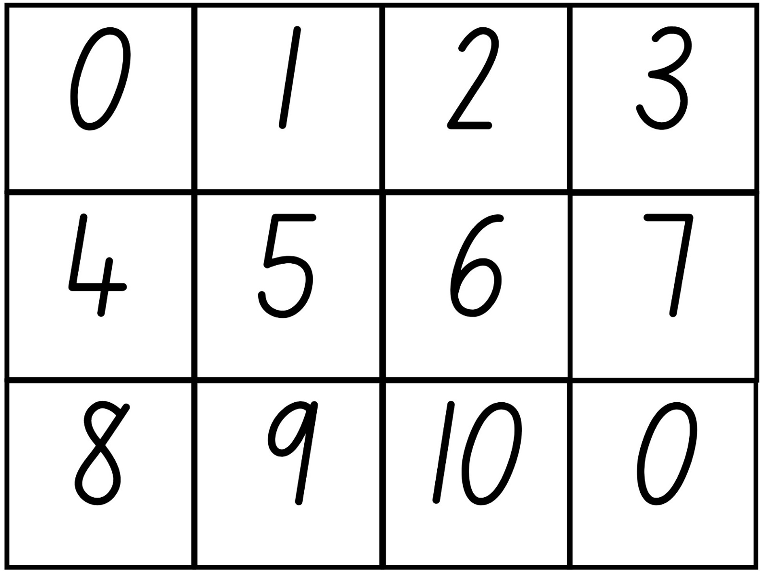

Resource 2: Sea creatures
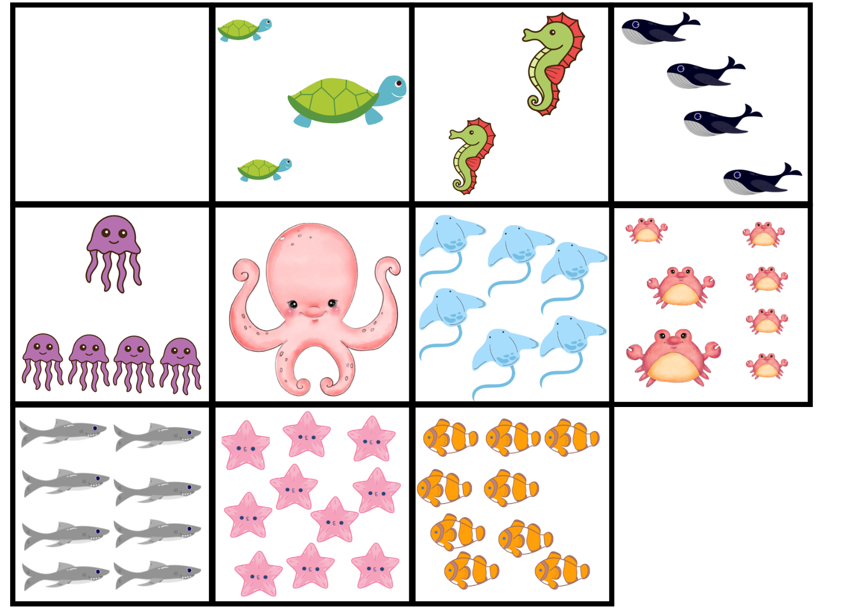
Images sourced from Canva and used in accordance with the Canva Content License Agreement.

Resource 3: Body parts
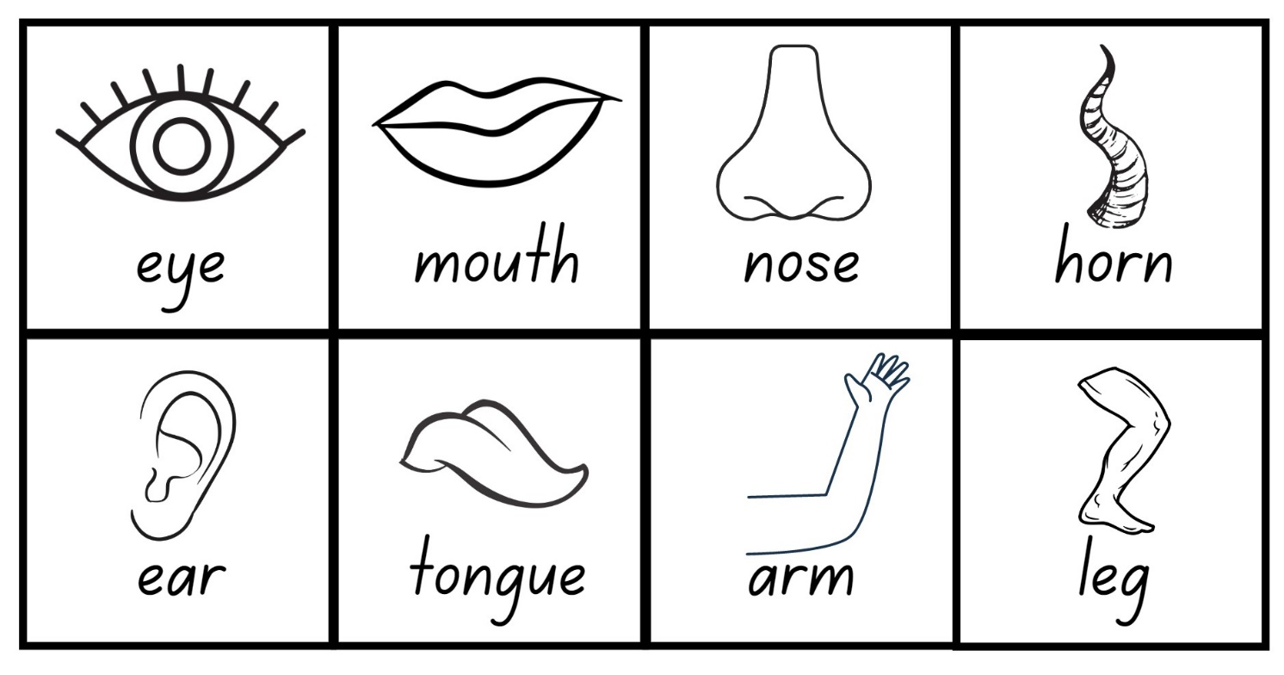
Images sourced from Canva and used in accordance with the Canva Content License Agreement.

Resource 4: Fishing cards
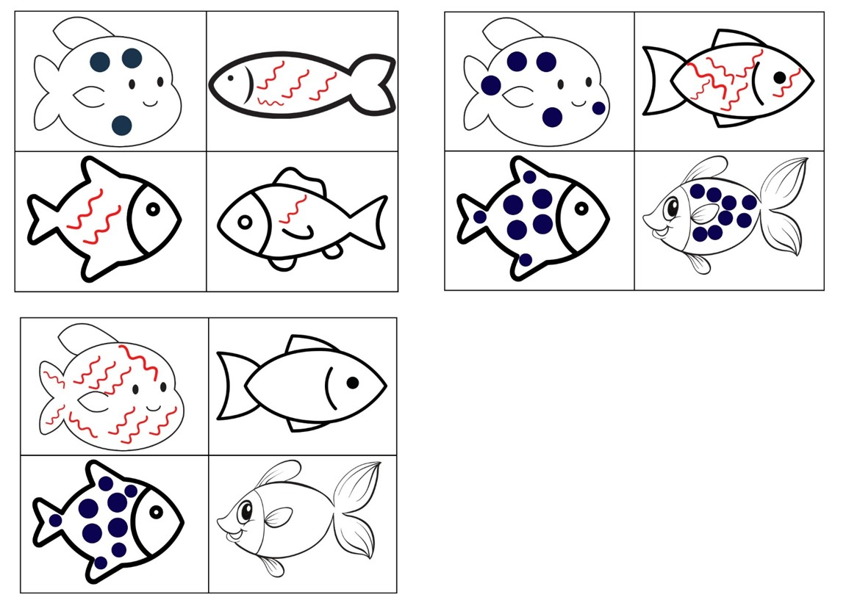
Images sourced from Canva and used in accordance with the Canva Content License Agreement.

Resource 5: Maths actions
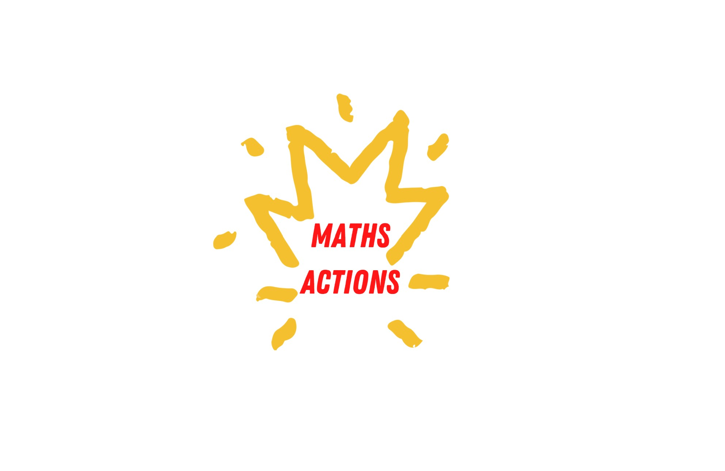

Resource 6: Numeral cards
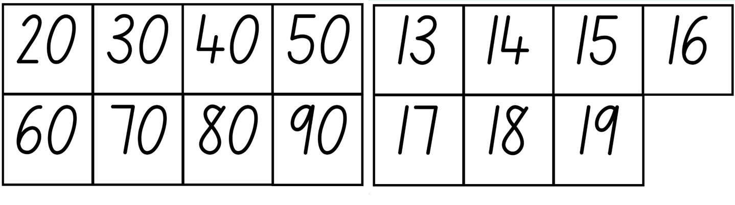

Resource 7: Teen representations
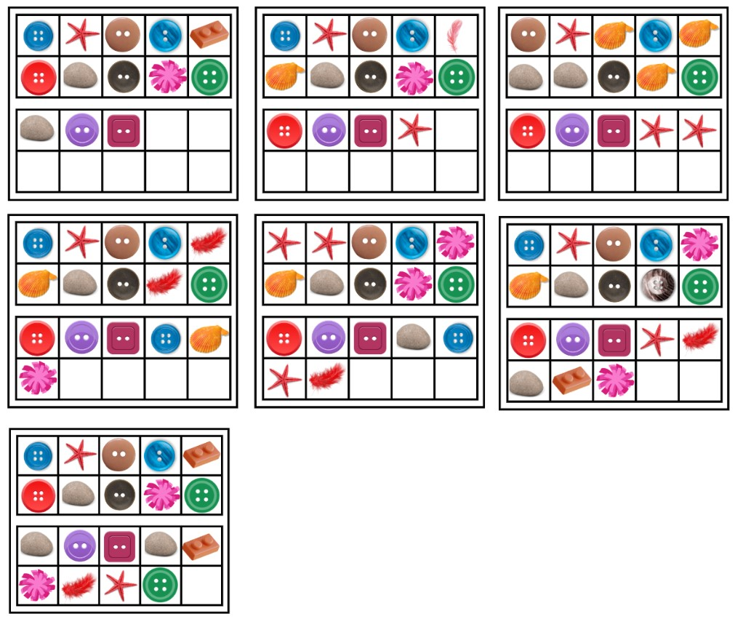
Images sourced from Canva and used in accordance with the Canva Content License Agreement.

Resource 8: Dice dots
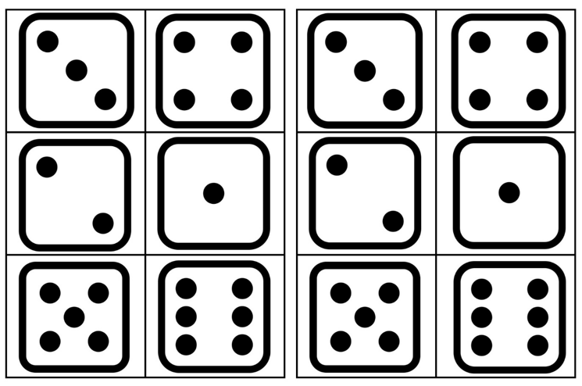

Resource 9: Dice graph

Resource 10: Collecting poem
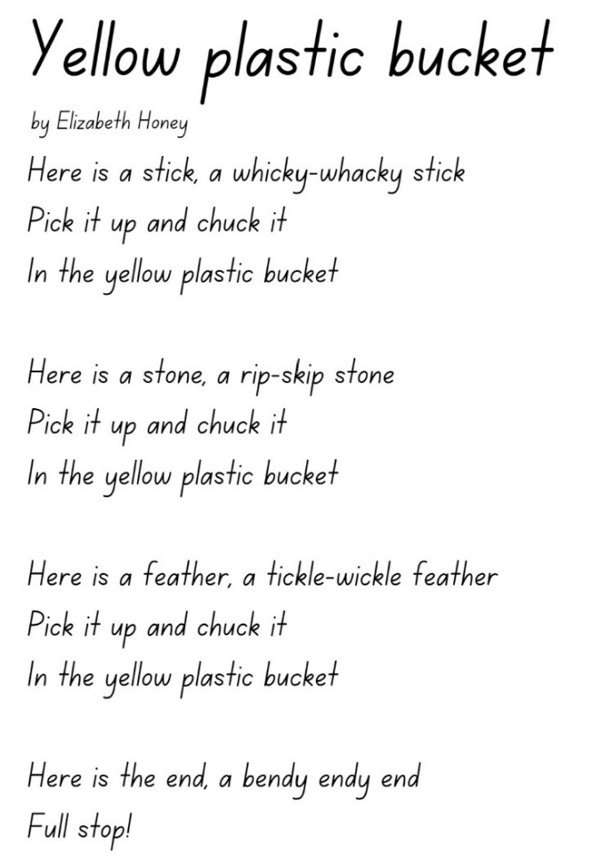
Adapted from Honey E (2002).
Extract from ‘Yellow plastic bucket’ from Teaching poetry for pleasure and purpose by Sally Murphy (2021).
This material has been copied and communicated to you in accordance with the educational use provisions of the Copyright Act. Any further reproduction or communication of this material by you may be the subject of copyright protection under the Act. Do not remove this notice – 17 May 2022.

Transcript – Yellow plastic bucket
by Elizabeth Honey
Here is a stick, a whicky-whacky stick
Pick it up and chuck it
In the yellow plastic bucket
Here is a stone, a rip-skip stone
Pick it up and chuck it
In the yellow plastic bucket
Here is a feather, a tickle-wickle feather
Pick it up and chuck it
In the yellow plastic bucket
Here is the end, a bendy endy end
Full stop!

Resource 11: Café meal
Images sourced from Canva and used in accordance with the Canva Content License Agreement.

Resource 12: List of items
Images sourced from Canva and used in accordance with the Canva Content License Agreement.

Syllabus outcomes and content
The table below outlines the syllabus outcomes and range of relevant syllabus content covered in this unit. Content is linked to National Numeracy Learning Progression version (3).
Focus area and outcomes | Content groups and content points | Lessons
Representing whole numbers  MAO-WM-01  MAE-RWN-01  MAE-RWN-02 | Instantly name the number of objects within small collections  - instantly recognise (subitise) the number of items in small groups of up to four items without counting (NPV1, CPr1)  - identify the number of items in different arrangements (CPr2)  Use the counting sequence of ones flexibly  - count forwards to at least 30 and state the number after or before a given number, without needing to count from one (CPr4)  - identify and distinguish the ‘teen’ numbers from multiples of ten with the same initial sounds (NPV3)  - count backwards from a given number 20 or less (CPr5)  - identify the number before as ‘one less’ and the number after as ‘one more’ than a given number  Recognise number patterns  - recognise dice and domino dot patterns (NPA1, NPV2, CPr2)  - recognise different finger patterns for the same number (NPA2)  Connect counting and numerals to quantities  - count with one-to-one correspondence, recognising that the last number name represents the total number in the collection (CPr3, CPr5)  - make correspondences between collections  - read numerals to at least 20, including zero (NPV3)  - represent numbers as quantities to at least 20 using objects (such as fingers), number words and numerals (NPV2-NPV4, CPr3) | 1–8
Combining and separating quantities  MAO-WM-01  MAE-CSQ-01  MAE-CSQ-02 | Model additive relations and compare quantities  - identify situations in which addition and subtraction may be applied (AdS1-AdS2)  - combine two or more groups of objects to model addition, identifying the relationship between the parts and the whole (AdS1-AdS2)  - separate and take away part of a group of objects to model subtraction (AdS1-AdS2)  - use concrete materials or fingers to model and solve addition and subtraction questions, counting forwards or backwards by ones as necessary (AdS1-AdS2, NPV3)  - compare two groups of objects to determine how many more (NPV1, AdS2)  Identify part–whole relationships in numbers up to 10  - use visual representations of numbers to assist with combining and separating quantities, identifying the relationship between the quantities (NPV2, NPA2, AdS2-AdS3)  - describe the action of combining, separating and comparing (AdS1)  - use five as a reference in forming numbers from six to ten  - create, model and recognise combinations for numbers up to ten (AdS2)  - count by ones to find the total or difference (AdS2-AdS3)  - use drawings, words and numerals to record addition and subtraction, and explain their thinking (AdS2) | 1–8
Forming groups  MAO-WM-01  MAE-FG-02 | Investigate and form equal groups by sharing  - distribute a group of familiar objects into smaller groups and recognise whether the number in each group is equal or not (MuS1-MuS2)  - group and share concrete materials by distributing objects one by one or using another method (MuS1-MuS2)  Record grouping and sharing  - label the number of objects in a group  - record grouping and sharing using drawings, words and numerals, and explain their thinking (MuS2) | 4–5, 8
Data  MAO-WM-01  MAE-DATA-01 | Respond to questions, collect information and discuss possible outcomes of activities  - predict possible responses to a question  - collect information from their peers about their environment (IRD1)  - pose and respond to questions about the information collected (IRD1)  Organise objects into simple data displays and interpret the displays  - interpret information presented in a data display to answer questions (IRD2) | 6

References
Links to third-party material and websites
Please note that the provided (reading/viewing material/list/links/texts) are a suggestion only and implies no endorsement, by the New South Wales Department of Education, of any author, publisher, or book title. School principals and teachers are best placed to assess the suitability of resources that would complement the curriculum and reflect the needs and interests of their students.
If you use the links provided in this document to access a third-party's website, you acknowledge that the terms of use, including licence terms set out on the third-party's website apply to the use which may be made of the materials on that third-party website or where permitted by the Copyright Act 1968 (Cth). The department accepts no responsibility for content on third-party websites.
Except as otherwise noted, all material is © State of New South Wales (Department of Education), 2021 and licensed under the Creative Commons Attribution 4.0 International License. All other material (third-party material) is used with permission or under licence. Where the copyright owner of third-party material has not licensed their material under a Creative Commons or similar licence, you should contact them directly for permission to reuse their material.
Mathematics K–10 Syllabus © 2022 NSW Education Standards Authority (NESA) for and on behalf of the Crown in right of the State of New South Wales.
© 2022 NSW Education Standards Authority. This document contains NSW Curriculum and syllabus content. The NSW Curriculum is developed by the NSW Education Standards Authority. This content is prepared by NESA for and on behalf of the Crown in right of the State of New South Wales. The material is protected by Crown copyright.
Please refer to the NESA Copyright Disclaimer for more information.
NESA holds the only official and up-to-date versions of the NSW Curriculum and syllabus documents. Please visit the NSW Education Standards Authority (NESA) website and the NSW Curriculum website.
National Numeracy Learning Progression © Australian Curriculum, Assessment and Reporting Authority (ACARA) 2010 to present, unless otherwise indicated. This material was downloaded from the Australian Curriculum website (National Literacy Learning Progression) (accessed 24 November 2022) and was not modified. The material is licensed under CC BY 4.0. Version updates are tracked in the ‘Curriculum version history’ section on the 'About the Australian Curriculum' page of the Australian Curriculum website.
ACARA does not endorse any product that uses the Australian Curriculum or make any representations as to the quality of such products. Any product that uses material published on this website should not be taken to be affiliated with ACARA or have the sponsorship or approval of ACARA. It is up to each person to make their own assessment of the product, taking into account matters including, but not limited to, the version number and the degree to which the materials align with the content descriptions and achievement standards (where relevant). Where there is a claim of alignment, it is important to check that the materials align with the content descriptions and achievement standards (endorsed by all education Ministers), not the elaborations (examples provided by ACARA).
Baker J (2006) One Hungry Spider, Scholastic Australia.
Boaler J, Munson J and Williams C (2020) Mindset Mathematics Visualizing and Investigating Big Ideas. Grade K, Jossey-Bass, New Jersey.
Finkel D and Cook K (1 May 2020) ‘Free printable Tiny Polka Dot starter deck’, Math for Love, accessed 24 November 2022.
Fletcher G (27 September 2015) ‘Humpty Dumpty’, 3 Act Task File Cabinet, GFletchy [website], accessed 24 November 2022.
Giganti Jr P (1999) Each Orange Had 8 Slices (Crews D, illus.), HarperCollins, US.
Haji-Ali F and Haji-Ali L (2017) On the way to Nana’s (Hardy D, illus.), Magabala Books, Broome, WA.
Merriam E (1996) 12 ways to get to 11 (Karlin B, illus.), Aladdin, US.
Murphy S (2021) Teaching Poetry for Pleasure and Purpose. Primary English Teaching Association Australia.
Robertson J (2017) Messy Maths: A Playful, Outdoor Approach for Early Years. Independent Thinking Press, UK.
The Kiboomers (4 March 2016) ‘Five Apples In The Apple Tree Lyric Video’ [video], The Kiboomers - Kids Music Channel, YouTube, accessed 24 November 2022.
Winer Y (1987) Mr Brown’s Magnificent Apple Tree. (Winters M, illus.), Scholastic Australia.

