Mathematics – Early Stage 1 – Unit 8
Contents
Unit description and duration 4
Student prior learning 4
Lesson overview and resources 6
Lesson 1: Neat numbers 11
Daily number sense: Stick tapping – 10 minutes 11
Incey Wincey – 35 minutes 13
Consolidation and meaningful practice: One more one less snap – 15 minutes 15
Lesson 2: Connecting counting 16
Daily number sense: Roll, write, count, make – 15 minutes 16
Caterpillar parts – 30 minutes 18
Consolidation and meaningful practice: Up and down – 15 minutes 21
Lesson 3: Solving frog problems 23
Daily number sense: Feed the frog – 15 minutes 23
Frogs in a bucket – 30 minutes 25
Consolidation and meaningful practice: Hopping frogs – 15 minutes 27
Lesson 4: Making and breaking numbers 28
Daily number sense: Go fish 10 – 15 minutes 28
Under the flowerpot – 25 minutes 30
Consolidation and meaningful practice: Spinning spiders – 20 minutes 31
Lesson 5: Flower fun 34
Daily number sense: Petra’s dice pattern game – 15 minutes 34
Lou’s garden surprise – 25 minutes 37
Consolidation and meaningful practice: Straight and curved lines – 20 minutes 39
Lesson 6: Harvesting half 41
Daily number sense: How many seeds? – 15 minutes 41
Packing for a picnic – 30 minutes 43
Consolidation and meaningful practice: Paring picnic pieces – 15 minutes 45
Lesson 7: Telling time 46
Daily number sense: Collecting on Country – 20 minutes 46
Telling the time – 25 minutes 48
Consolidation and meaningful practice: Human clocks – 15 minutes 50
Lesson 8: Rock clocks 52
Daily number sense: Number memory – 15 minutes 52
Clock challenge – 30 minutes 54
Consolidation and meaningful practice: Which one doesn’t belong? – 15 minutes 56
Resource 1: Number tracks 59
Resource 2: Game board 60
Resource 3: Ten-frame 61
Resource 4: Caterpillar ordering 62
Resource 5: Think board 63
Resource 6: Hopping frogs 64
Resource 7: How many seeds? 65
Resource 8: About halfway 66
Resource 9: More than halfway 67
Resource 10: Less than halfway 68
Resource 11: Picnic drawing 69
Resource 12: Clay clocks 70
Resource 13: Analog clocks 71
Resource 14: Digital clocks 72
Syllabus outcomes and content 73
References 78

Unit description and duration
This two-week unit develops student knowledge, understanding and skills of what you want to describe decides the unit of measure you use. Students are provided opportunities to:
- compare, describe, and understand the world around us when measuring
- think about how much longer, shorter, or the same something is in comparison to something else
- experiment with object’s length in different positions or locations
- tell time on analog and digital clocks
- explain their thinking so it makes sense to others.
Mathematics K–10 Syllabus © 2022 NSW Education Standards Authority (NESA) for and on behalf of the Crown in right of the State of New South Wales.

Student prior learning
Before engaging in these teaching and learning activities, students would benefit from prior experience with:
- opportunities to demonstrate an increasing understanding of measurement and number using vocabulary to describe size, length, and names of numbers
- noticing and predicting the patterns of regular routines and the passing of time
- discussions contributing constructively to mathematical discussions and arguments about symbol systems, for example, letters, numbers, and time
- use language to communicate thinking about quantities to describe features of objects and collections, and to explain mathematical ideas.

Lesson overview and resources
The table below outlines the sequence and approximate timing of lessons; syllabus focus areas and content groups; and resources.
Lesson | Syllabus focus area and content groups | Resources
Lesson 1: Neat numbers  60 minutes  We can use rhythm and movement to understand the counting sequence. | Representing whole numbers  - Use the counting sequence of ones flexibly  - Recognise number patterns | - Resource 2: Game board  - Chalk  - Concrete materials  - Decks of playing cards  - Large dice  - Spider figurines  - Sticks  - Writing materials
Lesson 2: Connecting counting  60 minutes  There are patterns in our number system. | Representing whole numbers  - Recognise number patterns  - Connect counting and numerals to quantities | - Resource 4: Caterpillar ordering  - Concrete materials  - Dice  - Finger gloves  - Gumnuts  - Plastic lids  - Sticks  - Writing materials
Lesson 3: Solving frog problems  60 minutes  Mathematicians use numbers to count and solve problems. | Representing whole numbers  - Connect counting and numerals to quantities  Combining and separating quantities  - Model additive relations and compare quantities  - Identify part-whole relationships in numbers up to 10 | - Resource 3: Ten-frame  - Resource 5: Think board  - Resource 6: Hopping frogs  - Video: Frog animation (1:42)  - Buckets  - Frog figurines  - Writing materials
Lesson 4: Making and breaking numbers  60 minutes  Number relationships help us to understand that a whole number is made up of parts. | Combining and separating quantities  - Model additive relations and compare quantities  - Identify part-whole relationships in numbers up to 10 | - Cardboard tubes  - Concrete materials  - Decks of playing cards  - Flowerpots  - Rocks  - Spider figurines  - String  - Writing materials
Lesson 5: Flower fun  60 minutes  Different lengths can be measured by using comparisons. | Representing whole numbers  - Recognise number patterns  Geometric measure  - Length: Use direct and indirect comparisons to decide which is longer | - Crowe C and Australian Broadcasting Corporation (ABC), Play School (2021) Lou’s Garden Surprise, ABC Kids Early Education.  - Finger gloves  - Large dice  - Pebbles  - Sticks  - String  - Writing materials
Lesson 6: Harvesting half  60 minutes  We can create half a length by dividing objects into 2 equal parts. | Representing whole numbers  - Connect counting and numerals to quantities  - Use the counting sequence of ones flexibly  Geometric measure  - Length: Create half a length | - Resource 7: How many seeds?  - Resource 8: About halfway  - Resource 9: More than halfway  - Resource 10: Less than halfway  - Resource 11: Picnic drawing  - Craft sticks  - Dice  - Frog figurines  - Modelling clay  - Sticks  - Writing materials
Lesson 7: Telling time  60 minutes  Mathematicians use analog and digital clocks to tell time on the hour. | Representing whole numbers  - Connect counting and numerals to quantities  Non spatial measure  - Time: Tell time on the hour on analog and digital clocks | - Resource 12: Clay clocks  - Video: The Sticky Gang: Episode 7 Telling the Time (1:03)  - Modelling clay  - Natural materials  - Sticks
Lesson 8: Rock clocks  60 minutes  We can use items on Country to create the layout of an analog clock. | Combining and separating quantities  - Identify part-whole relationships in numbers up to 10  Non spatial measure  - Time: Tell time on the hour on analog and digital clocks | - Resource 12: Clay clocks  - Resource 13: Analog clocks  - Resource 14: Digital clocks  - Video: Go Wild for Maths: Clock Challenge (2:12)  - 12 rocks numbered 1-12  - 2 sticks one longer than the other  - Decks of playing cards  - Dilly bag or similar  - Writing materials

Lesson 1: Neat numbers
Core concept: We can use rhythm and movement to understand the counting sequence.
The table below contains suggested learning intentions and success criteria. These are best co-constructed with students.
Learning intentions | Success criteria
Students are learning that:  - using rhythm and movement can help to understand the counting sequence  - recognising dice patterns can help determine how many times to move forwards or backwards  - the number before is one less and the number after is one more than a given number. | Students can:  - count forwards to 30 and backwards from 20 to the rhythm  - make connections between the number of dots on a dice and counting actions  - find a number that is one less and one more from a given number.

Daily number sense: Stick tapping – 10 minutes
This activity has been adapted from Robertson (2017).
- Build student understanding of forward and backward counting sequences by creating rhythm and movement.
- Lead students to the playground and gather in a circle.
- Explain to students that they will be playing a counting game by slowly tapping a stick on the ground in time to each number said aloud. Encourage all students to chorally count aloud and work on developing a steady rhythm.
- Begin by counting forwards to 30 and then backwards from 20 to the rhythm of stick tapping.
- Vary the game by having students count forwards and backwards from different starting points.
- Develop a ‘switch’ and challenge students to begin by counting forwards and then when you call out ‘switch’, students change direction and count backwards.
This table details assessment opportunities and differentiation ideas.
Assessment opportunities | Too hard? | Too easy?
What to look for:  - Can students count forwards to 30 and backwards from 20 to the rhythm? (MAO-WM-01, MAE-RWN-01)  What to collect:  - observations of game-based learning opportunity. (MAO-WM-01, MAE-RWN-01) | Students need further support to count forwards to 30 and backwards from 20 to the rhythm.  - Provide students with Resource 1: Number tracks and model tapping a stick along the number track as we count forward and backward.  - Clap hands or hop to the rhythm of choral counting. | Students confidently count forwards to 30 and backwards from 20 to the rhythm.  - Use 2 sticks and tap with alternate sticks on the ground.  - Say the number before and the number after a given number.

Incey Wincey – 35 minutes
This activity has been adapted from Incey Wincey by NRICH.
- Remain in the playground and use chalk to draw multiple drainpipes (see Resource 2: Game board).
Note: Resource 2: Game board is also provided as an alternate way to play the game or to consolidate counting forward and backward after playing in the playground.
- Practise singing nursery rhyme and fingerplay ‘Incey Wincey Spider’:
‘Incey wincey spider climbed up the waterspout.
Down came the rain
And washed the spider out.
Out came the sun
And dried up all the rain
And the incey wincey spider climbed up the spout again.’
Note: Consider incorporating local Indigenous language or the languages of the diverse cultures within the class into the nursery rhyme.
- In pairs, students will choose to be either the sun or the rain. Students take turns to throw the dice and move the spider up or down the drainpipe according to their roll. Students use a large dice to determine how many jumps to take and direct the 'spider', counting each time they land. The game is played until either the sun or the rain reaches the end of the drainpipe.
The table below outlines stimulus prompts to generate conversation about the topic, along with anticipated responses from students.
Prompts | Anticipated student responses
- How many jumps did you take?  - What do you think will happen? Why?  - How many more jumps to get to the end?  - Why do you think the sun/rain won? | - When I rolled the dice, I counted 3 dots, so I jumped 3 times.  - I think the sun is going to win because I counted 6 dots.  - I counted 2 jumps to get to the sun, but it might go 6 jumps backward to the rain.  - The rain was the winner because bigger numbers mean jumping further.
This table details assessment opportunities and differentiation ideas.
Assessment opportunities | Too hard? | Too easy?
What to look for:  - Can students make connections between the number of dots on a dice and counting actions? (MAO-WM-01, MAE-RWN-01)  What to collect:  - strategic questioning to determine individual level of understanding. (MAO-WM-01, MAE-RWN-01) | Students need further support to make connections between the number of dots on a dice and counting actions.  - Provide students with Resource 1: Number tracks  - Model counting dice dot patterns using one-to-one correspondence. | Students confidently make connections between the number of dots on a dice and counting actions.  - Challenge students to create an alternate game using dice and counting actions.  - Challenge students to record the dice dot patterns thrown or explain to someone what they learned from the game.

Consolidation and meaningful practice: One more one less snap – 15 minutes
This activity has been adapted from F-2 Remote maths: One More One Less Snap [PDF 398KB] by Mathematical Association of Victoria.
- Return to the classroom and gather in a circle as a whole class.
- Introduce students to an alternate version of the card game ‘Snap’. Model how to play ‘One more one less snap’ by explaining that a snap can only occur if the card is one more, or one less than the number of the previous card.
- A student will deal out a deck of playing cards with all picture cards removed from the deck, keeping the ace. The ace is now considered one.
- Encourage students to convince their peer that their number is one more or less than the previous. For example, by comparing the symbols on the cards or representing the 2 sums using concrete materials.

Lesson 2: Connecting counting
Core concept: There are patterns in our number system.
The table below contains suggested learning intentions and success criteria. These are best co-constructed with students.
Learning intentions | Success criteria
Students are learning that:  - dice dot and finger patterns are symbols that represent a quantity of objects  - numbers can be compared and ordered to 20. | Students can:  - represent the total shown on dice dot patterns in a variety of ways  - order and compare numbers to 20.

Daily number sense: Roll, write, count, make – 15 minutes
- Build student understanding of subitising by representing numbers in a variety of ways.
- Students play ‘roll, write, count, make’ game by rolling a dice and subitising or counting the number of dots in the dice dot pattern. They write the numeral and use finger gloves to represent a finger pattern that corresponds with the dice dot pattern. Students then use sticks to make the numeral.
- Model rolling the dice, writing the numeral, counting using finger gloves, and making the numeral using sticks (see Figure 1).
Figure 1 – Roll, write, count, make
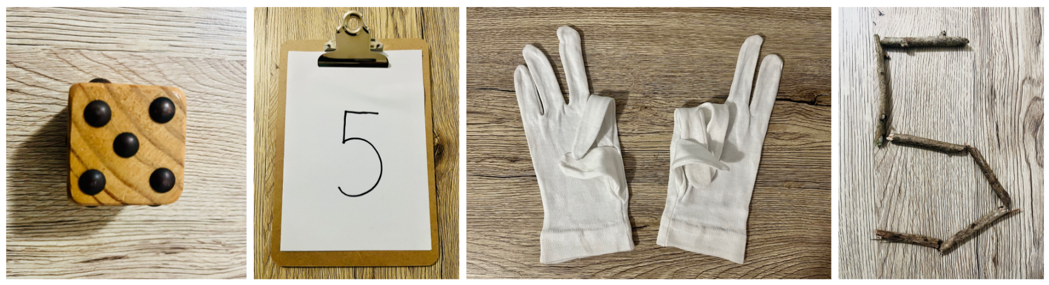
- Provide time to play ‘roll, write, count, make’ independently.
- In pairs, students turn and talk to share their reasoning.
This table details assessment opportunities and differentiation ideas.
Assessment opportunities | Too hard? | Too easy?
What to look for:  - Can students represent the total shown on dice dot patterns in a variety of ways? (MAO-WM-01, MAE-RWN-01)  What to collect:  - observations of students composing visual representations of numbers. (MAO-WM-01, MAE-RWN-01) | Students need further support to represent the total shown on dice dot patterns in a variety of ways.  - Model counting dice dot patterns using one-to-one correspondence.  - Show the total on a ten-frame using Resource 3: Ten-frame. | Students confidently represent the total shown on dice dot patterns in a variety of ways.  - Add dice and finger gloves to represent larger numbers.  - Draw how the total could appear on domino dot patterns.

Caterpillar parts – 30 minutes
- Tell a story about a caterpillar named Camilla. Explain that, unfortunately, Camila was having trouble finding enough bush tucker to fill her stomach. To find out how much bush tucker Camilla needs to fill her stomach students will need to roll 3 dice 5 times.
- Show students the stimulus Resource 4: Caterpillar ordering.
- Model completing Resource 4: Caterpillar ordering by rolling 3 dice and finding the total of the dice dot patterns combined. Repeat this process 5 times and write the numerals on plastic lids. Compare these numerals by placing the lids in ascending order (see Figure 2).
Figure 2 – Lids ordered
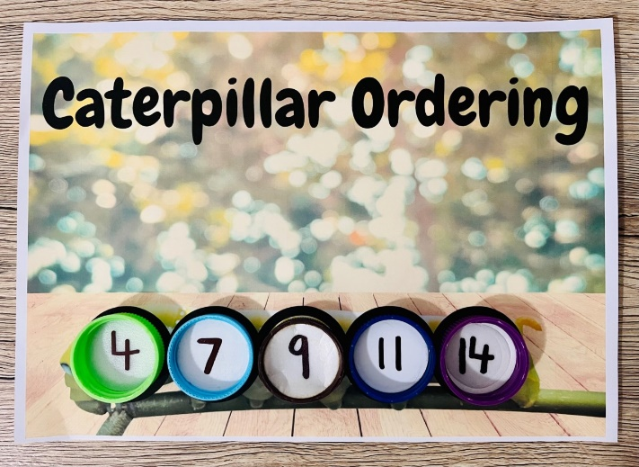
Images sourced from Canva and used in accordance with the Canva Content License Agreement.
- Students use Resource 4: Caterpillar ordering in pairs with one peer flipping 2 of the 5 lids over when the other is not looking. The other peer will need to determine a number that could fit into the missing space. Both peers take turns to flip 2 of the 5 lids over (see Figure 3).
Figure 3 – Flip lids
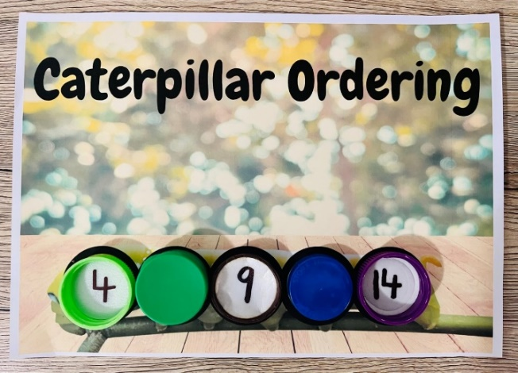
Images sourced from Canva and used in accordance with the Canva Content License Agreement.
- Next, students flip the lids back over and count out gumnuts to fill the lids corresponding to the written numeral (see Figure 4).
Figure 4 – Gumnut filling
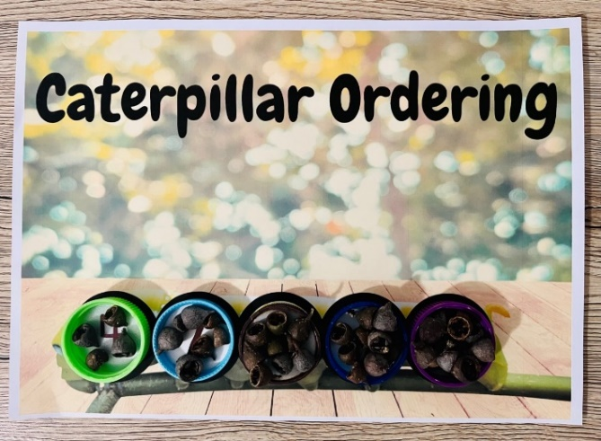
Images sourced from Canva and used in accordance with the Canva Content License Agreement.
This table details assessment opportunities and differentiation ideas.
Assessment opportunities | Too hard? | Too easy?
What to look for:  - Can students order and compare numbers to 20? (MAO-WM-01, MAE-RWN-01, MAE-RWN-02)  What to collect:  - student manipulation of materials to demonstrate conceptual understanding. (MAO-WM-01, MAE-RWN-01, MAE-RWN-02) | Students need further support to order and compare numbers to 20.  - Provide students with Resource 1: Number tracks.  - March while choral counting.  - Face a peer, one person says ‘one’, the next ‘2’ and keep counting. | Students confidently order and compare numbers to 20.  - Challenge students to say the number before and after each numeral recorded.  - Roll additional dice to represent larger numbers.

Consolidation and meaningful practice: Up and down – 15 minutes
This activity has been adapted from F-2 Remote Maths: Up and Down [PDF 528KB] by Mathematical Association of Victoria.
- Introduce ‘Up and Down’ by explaining that this game will be played in small groups. A student will deal out 4 cards face up to each player with all picture cards removed from the deck. The remaining cards are placed in a pack in the middle of the table.
- Model how to play ‘Up and Down’ by showing the aim of the game is to be the first player to arrange your cards in either ascending or descending order. The order does not need to be in consecutive order. For example, 1, 2, 3, 4. It could be 1, 3, 4, 7 (see Figure 5).
Figure 5 – Ascending or descending cards
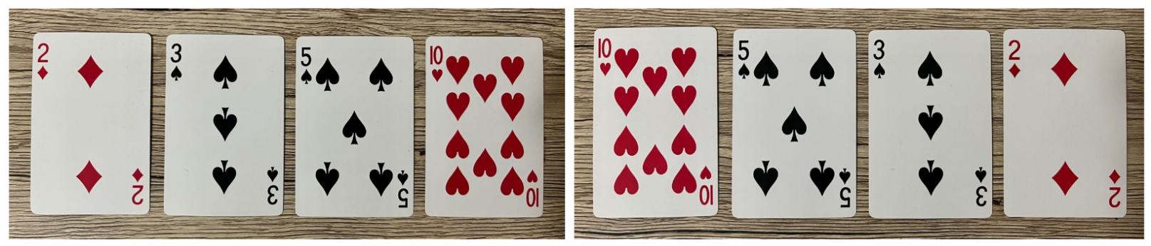
- The first player to arrange their cards in order is the winner of that round.

Lesson 3: Solving frog problems
Core concept: Mathematicians use numbers to count and solve problems.
The table below contains suggested learning intentions and success criteria. These are best co-constructed with students.
Learning intentions | Success criteria
Students are learning that:  - numbers can be represented visually to show their thinking when problem solving quantities to at least 20  - counting with one-to-one correspondence helps to keep track of the count when adding or subtracting one from a given collection  - visual representations of numbers up to 10 can be created using a ten-frame. | Students can:  - visually represent numbers to at least 20 in a variety of ways  - keep track of the count by using concrete materials or fingers to solve addition and subtraction questions  - create, model, and recognise combinations for numbers up to 10.

Daily number sense: Feed the frog – 15 minutes
- Build student understanding of subitising by representing numbers in a variety of ways.
- Tell a story about a very hungry frog named Frank. Explain that, unfortunately, Frank the frog is getting old and is no longer able to catch his favourite food, flies, as he is too slow and cannot catch them.
- Show students Resource 5: Think board.
- Explain that they will be representing the dice dot pattern rolled in a variety of ways to feed Frank the frog that number of flies.
- Model rolling 3 dice and writing the numeral and number word in the centre of Resource 5: Think board. Next, write the numeral on the line in the centre of the before and after section and write the numeral before and after. Model completing the ten-frame section, drawing flies and using natural materials to represent the flies to feed Frank the frog (see Figure 6).
Figure 6 – Frog think board
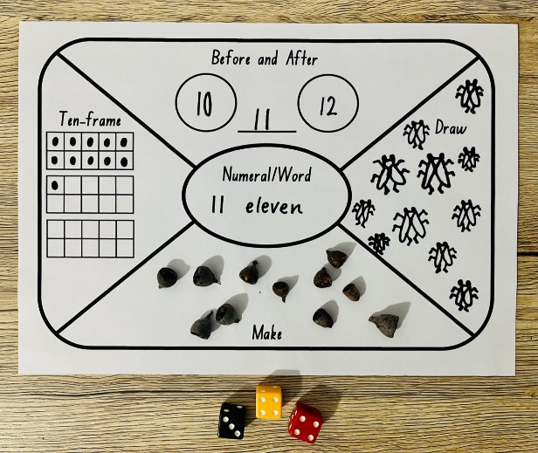
- Provide time to play ‘feed the frog’ independently.
- In pairs, students turn and talk to share their reasoning.
This table details assessment opportunities and differentiation ideas.
Assessment opportunities | Too hard? | Too easy?
What to look for:  - Can students visually represent numbers to at least 20 in a variety of ways? (MAO-WM-01, MAE-RWN-01)  What to collect:  - observations of students composing visual representations of numbers. (MAO-WM-01, MAE-RWN-01) | Students need further support to visually represent numbers to at least 20 in a variety of ways.  - Model counting dice dot patterns using one-to-one correspondence.  - Use less dice.  - Represent the total using a finger pattern. | Students confidently visually represent numbers to at least 20 in a variety of ways.  - Roll additional dice to represent larger numbers.  - Draw tally marks to represent the total.

Frogs in a bucket – 30 minutes
This activity has been adapted from Counting on Counting by NZ Maths.
- Reinforce the number before and after a given number by viewing the Frog Animation (1:42).
- Ask students to gather in a circle as a whole class.
- Model different stories about frogs jumping into a pond using frog figurines and a bucket filled with water to make a splash sound. The frog animation gives an example of this with frogs in a bucket. For example, we had 10 frogs and one jumped out. Ask how many frogs are in the bucket now.
- Increase the number of objects in the container beyond 10 so that students attend to the one more/one less principle rather than image actions inside the container. Avoid putting in the objects one at a time after 10. Throw them in as imaginary groups. For example, 8 frogs and one more, 17 frogs and one more, 29 frogs and one more or 7 frogs and one less, 15 frogs and one less, 27 frogs and one less.
- Students play the same game in small groups, using frog figurines and a bucket following the rules used above.
This table details assessment opportunities and differentiation ideas.
Assessment opportunities | Too hard? | Too easy?
What to look for:  - Can students keep track of the count by using concrete materials or fingers to solve addition and subtraction questions? (MAO-WM-01, MAE-RWN-01, MAE-CSQ-01)  What to collect:  - recording of group discussion. (MAO-WM-01, MAE-RWN-01, MAE-CSQ-01) | Students need further support to keep track of the count by using concrete materials or fingers to solve addition and subtraction questions.  - Provide students with Resource 1: Number tracks.  - Model counting forwards or backwards by ones. | Students confidently keep track of the count by using concrete materials or fingers to solve addition and subtraction questions.  - Extend the problems to 2 more/less, 3 more/less and beyond.  - Throw frogs in as imaginary groups beyond 30.

Consolidation and meaningful practice: Hopping frogs – 15 minutes
This lesson has been adapted from Jumping Beans by NZ Maths.
- Display Resource 6: Hopping frogs as a visual stimulus.
- Ask students:
- How many frogs are in the ten-frame on the lily pad?
- How many frogs are outside the ten-frame on the rock?
- Now imagine the frogs jumping in. How many frogs are there altogether?
- How did you solve this?
- Students use Resource 3: Ten-frame and some frog figurines to repeat different scenarios to encourage students to know the number of frogs by visualising them.
- Describe different scenarios for students to model, for example, there are 8 frogs in total. If 3 are sitting on the rock, how many are sitting on the lily pad? Students turn and talk to compare their answers.

Lesson 4: Making and breaking numbers
Core concept: Number relationships help us to understand that a whole number is made up of parts.
The table below contains suggested learning intentions and success criteria. These are best co-constructed with students.
Learning intentions | Success criteria
Students are learning that:  - visual and symbolic patterns for numbers up to 10 can be recognised without counting  - visual representations of numbers can assist in combining and separating quantities up to 10. | Students can:  - create, model, and recognise visual patterns for numbers up to 10  - explain their thinking using drawings, words, and numerals to record addition and subtraction strategies.

Daily number sense: Go fish 10 – 15 minutes
This activity has been adapted from Go Fish 10 by NZ Maths.
- Build student understanding of forming combinations to 10 by playing ‘Go fish 10’.
- Students play ‘Go fish 10’ in pairs. A student will deal out a deck of playing cards with all picture and number 10 cards removed from the deck. Students look through their cards and make pairs of cards that have a total of 10. Students place these pairs face up in front of them (see Figure 7).
Figure 7 – Go fish 10
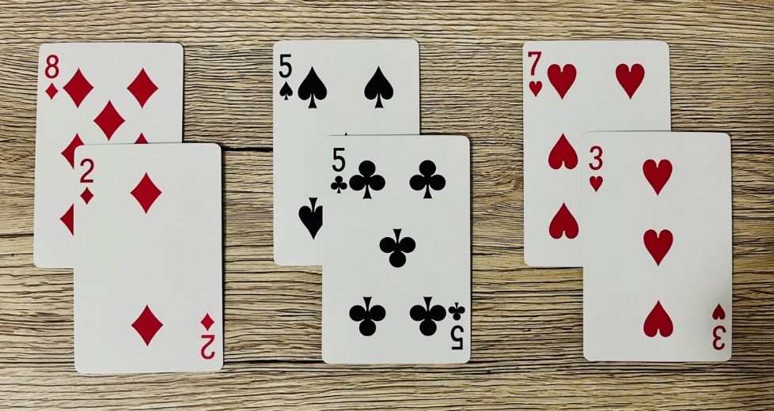
- Students take turns asking each other for a card that they can use to make 10 with a card in their hand. If the student asked has the card, they must give it to their peer. The aim of the game is to get the most pairs that have a total of 10.
This table details assessment opportunities and differentiation ideas.
Assessment opportunities | Too hard? | Too easy?
What to look for:  - Can students create, model and recognise visual patterns for numbers up to 10? (MAO-WM-01, MAE-CSQ-01, MAE-CSQ-02)  What to collect:  - record student’s voice during game-based learning opportunity. (MAO-WM-01, MAE-CSQ-01, MAE-CSQ-02) | Students need further support to create, model and recognise visual patterns for numbers up to 10.  - Provide students with Resource 3: Ten-frame and concrete materials to support addition.  - Model counting on when counting the visual patterns on 2 playing cards using one-to-one correspondence. | Students confidently create, model, and recognise visual patterns for numbers up to 10.  - Challenge students to combine 3 cards to make combinations to 10.  - Challenge students to look for combinations to 20.

Under the flowerpot – 25 minutes
This activity has been adapted from Robertson (2017).
- Ask students to gather in a circle as a whole class.
- Model playing ‘under the flowerpot’ using a flowerpot and some rocks that will fit underneath.
- Count the number of rocks with students first. Next, students close their eyes whilst objects are hidden under the flowerpot. Have students open their eyes and predict how many objects are under the flowerpot.
- Discuss how many objects are still present before revealing the hidden objects.
- Students repeat the game in small groups to allow each student to have a go at hiding some rocks.
- Students record their thinking using drawings, words, and numerals to show the problem presented.
This table details assessment opportunities and differentiation ideas.
Assessment opportunities | Too hard? | Too easy?
What to look for:  - Can students explain their thinking using drawings, words, and numerals to record addition and subtraction strategies? (MAO-WM-01, MAE-CSQ-01, MAE-CSQ-02)  What to collect:  - written and spoken responses explaining their thinking. (MAO-WM-01, MAE-CSQ-01, MAE-CSQ-02) | Students need further support to explain their thinking using drawings, words, and numerals to record addition and subtraction strategies.  - Provide a cloth to hide the rocks underneath where they can check their answer by feeling before responding.  - Provide Resource 1: Number tracks. | Students confidently explain their thinking using drawings, words, and numerals to record addition and subtraction strategies.  - Challenge students to create problems with more than 10 rocks.  - Create a story about the problem presented.

Consolidation and meaningful practice: Spinning spiders – 20 minutes
This activity has been adapted from Cars in garages by NZ Maths.
- Pose the problem, there are 5 spiders and a large downpipe. If you can see 2 spiders in a web, how many are hiding in the downpipe? Ask how many different ways the spiders could be in the web or downpipe.
- Read the first part of the problem to students to ensure that they understand that they are working with 5 spiders.
- Brainstorm ways to solve the problem.
- Provide time for students to solve the problem and to explain how they know the number of spiders in the downpipe.
- Ask students:
- How did you know how many spiders are in the downpipe?
- Tell us about your thinking?
- Could there be any other number of spiders in the downpipe? How do you know?
- Read the second part of the problem and have students solve this in small groups using spider figurines, string to represent a web and a cardboard tube to represent the downpipe (see Figure 8).
Figure 8 – Visual representation
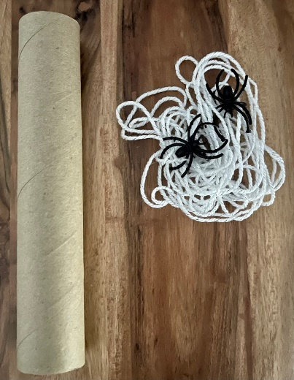
- Use ‘Talk moves’ to facilitate class discussion.
The table below outlines stimulus prompts to generate conversation about the topic, along with anticipated responses from students.
Prompts | Anticipated student responses
- How do you know how many spiders are inside the downpipe?  - Does there always have to be a spider in the downpipe or in the web?  - How do you know that you have found all the ways that the spiders can be in the web or downpipe?  - How are you recording your thinking? | - I used 5 fingers and took 2 fingers away because there are 2 spiders in the web.  - There could be 5 spiders in the downpipe and no spiders in the web.  - I could draw all of the different ways the spiders could be in the web or downpipe.  - By writing numbers next to the pictures I draw.
- Students record their solutions.

Lesson 5: Flower fun
Core concept: Different lengths can be measured by using comparisons.
The table below contains suggested learning intentions and success criteria. These are best co-constructed with students.
Learning intentions | Success criteria
Students are learning that:  - a collection of objects can be represented as dice dot and finger patterns  - length can be compared by aligning the ends and described using comparative language  - the length of a piece of string remains unchanged whether placed in a straight line or a curve. | Students can:  - create dice dot and finger patterns using a collection of objects  - compare and describe length using language such as longer than, shorter than, the same as  - explain why the length of a piece of string placed in a straight line is the same as a curve.

Daily number sense: Petra’s dice pattern game – 15 minutes
This activity has been adapted from Robertson (2017).
- Build student understanding of subitising by creating dice dot and finger patterns.
- Explain to students that you are going to throw a collection of pebbles onto the ground (see Figure 9).
Figure 9 – Collection of pebbles
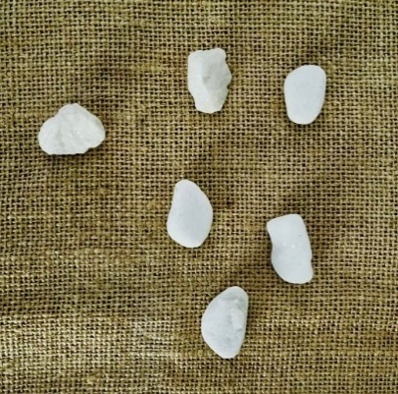
- Ask students to find the total by instantly recognising (subitising) or counting with one-to-one correspondence.
- As a class, ask students to count the collection of pebbles aloud, pointing to each pebble to support counting with one-to-one correspondence.
- Ask students to show a corresponding finger pattern.
- A student is then selected to put the pebbles into the layout of a dice dot pattern. Check the layout of the dice pattern created using a large dice (see Figure 10).
Figure 10 – Dice dot pattern
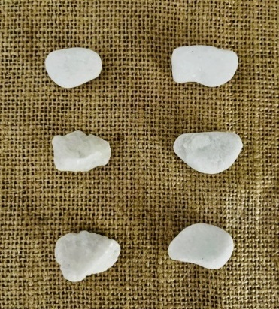
- Repeat the game multiple times as a class or in small groups.
This table details assessment opportunities and differentiation ideas.
Assessment opportunities | Too hard? | Too easy?
What to look for:  - Can students create dice dot and finger patterns using a collection of objects? (MAO-WM-01, MAE-RWN-01)  What to collect:  - photographs of student manipulation of materials to demonstrate conceptual understanding. (MAO-WM-01, MAE-RWN-01) | Students need further support to create dice dot and finger patterns using a collection of objects.  - Provide large dice to support dice dot pattern formations.  - Provide finger gloves to support finger pattern formations. | Students confidently create dice dot and finger patterns using a collection of objects.  - Throw a larger collection of objects and create multiple dice dot pattern formations.  - Record dice dot and finger patterns.

Lou’s garden surprise – 25 minutes
- Reinforce counting and comparing lengths of flowers as they grow by reading Lou's Garden Surprise [PDF 20.1MB] by Clodagh Crowe and the Australian Broadcasting Corporation (ABC).
- Model retrieving a stick from a collection and draw a sunflower the same length as the stick on a piece of paper.
- Next, draw a sunflower that is longer than and shorter than the stick making sure that the bottom of each stem is aligned along the edge of the paper (see Figure 11).
Figure 11 – Sunflower drawing
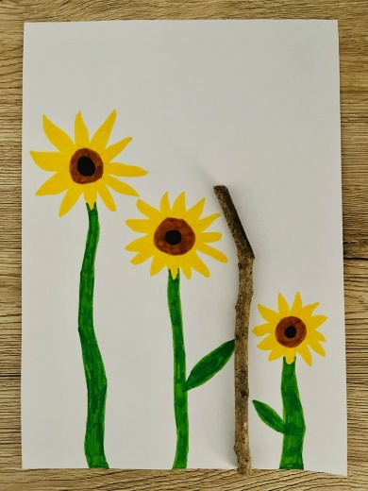
- Model using comparative language to describe the length of the sunflowers drawn, for example, this sunflower is longer than the stick.
- Provide time for students to draw a sunflower that is the same length as a stick alongside a sunflower that is longer than and shorter than the stick.
- Showcase student drawings through a gallery walk and have students use comparative language to describe length, for example, longer than, shorter than, the same as to describe the sunflowers drawn.
This table details assessment opportunities and differentiation ideas.
Assessment opportunities | Too hard? | Too easy?
What to look for:  - Can students compare and describe length using language such as longer than, shorter than, the same as? (MAO-WM-01, MAE-GM-02)  What to collect:  - student participation in a gallery walk and recording of language used in group discussion. (MAO-WM-01, MAE-GM-02) | Students need further support to compare and describe length using language such as longer than, shorter than, the same as.  - Provide 3 additional sticks of different lengths to model longer than, shorter than, the same as (see Figure 12).  - Find an object that is longer than and shorter than the stick. | Students confidently compare and describe length using language such as longer than, shorter than, the same as.  - Draw a tree that is longer than the longest sunflower and compare and describe lengths using language.  - Move independently around the classroom and identify 3 objects that are taller than or shorter than themselves. Record by drawing and labelling.
Figure 12 – Additional sticks of different lengths
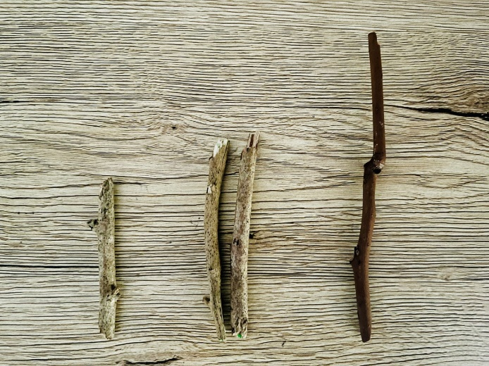

Consolidation and meaningful practice: Straight and curved lines – 20 minutes
- Have students cut a piece of string the same length as the stick.
- Encourage students to wrap, move and shake the string like a snake and again compare with their drawing to reinforce that the string remains the same length.
- Ask students to consider if they created a curved stem for their flower instead of a straight stem would they be the same length.
- Students then straighten and align the ends of their pieces of string in small groups to order by length (see Figure 13).
Figure 13 – Shortest to longest
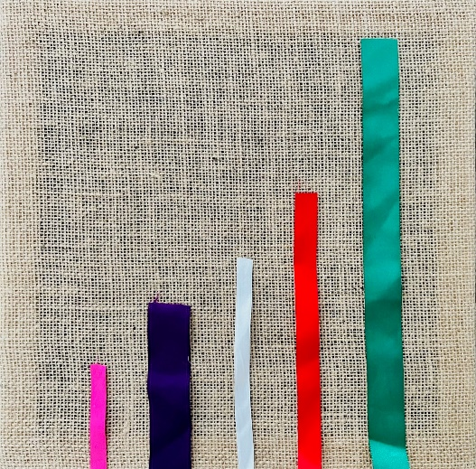
- Create an anchor chart with students by brainstorming straight and curved lines in their world, for example, pencils and a skipping rope (see Figure 14).
Figure 14 – Lines anchor chart
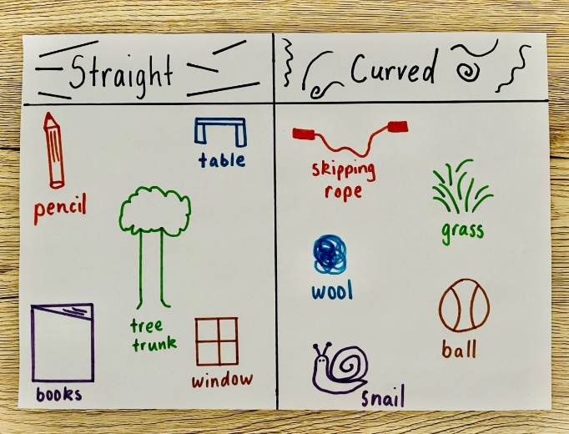

Lesson 6: Harvesting half
Core concept: We can create half a length by dividing objects into 2 equal parts.
The table below contains suggested learning intentions and success criteria. These are best co-constructed with students.
Learning intentions | Success criteria
Students are learning that:  - keeping track of the count helps to identify the number before and after a given number  - when a length has been divided into 2 equal parts, the parts are called halves  - the position lengths have been divided into can be described as about halfway, more than halfway or less than halfway. | Students can:  - count out objects and identify the number before as one less and the number after as one more  - divide a length into halves  - describe positions as about halfway, more than halfway or less than halfway.

Daily number sense: How many seeds? – 15 minutes
- Build student understanding of the number before as ‘one less' and the number after as 'one more’ than a given number by counting out a number of objects.
- Show Resource 7: How many seeds?
- Model the game by rolling 2 dice, writing the numeral, and then making the corresponding number of seeds with modelling clay using Resource 7: How many seeds? (see Figure 15).
Figure 15 – Making seeds
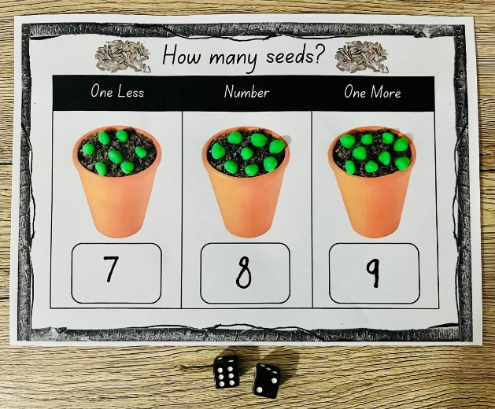
Images sourced from Canva and used in accordance with the Canva Content License Agreement.
- Provide time for students to play the game independently.
Note: Consider planting some seeds in the school garden beds or in individual pots to observe growth.
This table details assessment opportunities and differentiation ideas.
Assessment opportunities | Too hard? | Too easy?
What to look for:  - Can students count out objects and identify the number before as one less and the number after as one more? (MAO-WM-01, MAE-RWN-01)  What to collect:  - strategic questioning and observation to determine individual level of understanding. (MAO-WM-01, MAE-RWN-01) | Students need further support to count out objects and identify the number before as one less and the number after as one more.  - Provide students with Resource 1: Number tracks.  - Model making and counting seeds from modelling clay. | Students confidently count out objects and identify the number before as one less and the number after as one more.  - Roll additional dice to represent larger numbers.  - Draw how the total could appear on domino dot patterns.

Packing for a picnic – 30 minutes
- Tell a story about 2 frog friends going on a picnic using frog figurines. Flora and Forest the frogs, collected some fruits and vegetables that they harvested from their garden to eat. They harvested a cucumber, carrot, and a banana. When they arrived at the lake for their picnic, they realised that they had forgotten to cut the fruits and vegetables to share. Flora uses a knife from the picnic basket to cut the fruits and vegetables.
- Show students the stimulus Resource 8: About halfway.
- Ask students what they notice about where the knife is going to cut the cucumber.
- Explain that when a length has been divided into 2 equal parts, the parts are called halves.
- Encourage students to describe the positions of the length when Flora cuts the carrot and banana into parts.
- Show students the stimulus Resource 9: More than halfway.
- Ask students how they would describe the position of where the carrot has been cut.
- Explain that when a length has been divided like the carrot it can be described as more than halfway.
- Show students the stimulus Resource 10: Less than halfway.
- Ask students how they would describe the position of where the banana has been cut.
- Explain that when a length has been divided like the banana it can be described as less than halfway.
- Provide modelling clay to some students to roll a fruit or vegetable shape and ask them to show where they would cut it in half to show equal parts using the side of their hand.
- Ask students to visualise and then draw Flora and Forest the frogs having a picnic at the lake. Tell students to draw how Flora cut the cucumber, carrot, and banana by drawing a dotted line through the fruits and vegetables. See Resource 11: Picnic drawing.
- Ask students to describe the position lengths have been divided into, for example, about halfway, more than halfway or less than halfway.
This table details assessment opportunities and differentiation ideas.
Assessment opportunities | Too hard? | Too easy?
What to look for:  - Can students describe positions as about halfway, more than halfway or less than halfway? (MAO-WM-01, MAE-GM-03)  What to collect:  - work sample and spoken responses. (MAO-WM-01, MAE-GM-03) | Students need further support to describe positions as about halfway, more than halfway or less than halfway.  - Model dividing sticks into positions and describing as about halfway, more than halfway or less than halfway.  - Provide time for students to divide sticks into equal parts to make halves. | Students confidently describe positions as about halfway, more than halfway or less than halfway.  - Draw 3 additional picnic foods divided into parts to describe.  - Create a drawing and tell a different story about lengths that can be described as about halfway, more than halfway or less than halfway.

Consolidation and meaningful practice: Paring picnic pieces – 15 minutes
- Provide time for students to make a cucumber, carrot, and banana from modelling clay (see Figure 16). Use a craft stick to cut the fruits and vegetables and describe the position lengths have been divided into, for example, about halfway, more than halfway or less than halfway.
Figure 16 – Modelling clay picnic food
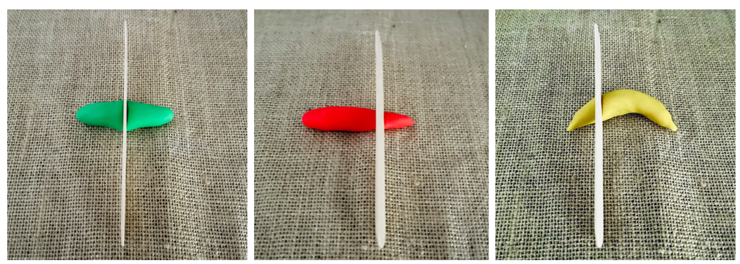

Lesson 7: Telling time
Core concept: Mathematicians use analog and digital clocks to tell time on the hour.
The table below contains suggested learning intentions and success criteria. These are best co-constructed with students.
Learning intentions | Success criteria
Students are learning that:  - keeping track of the count helps to connect numerals to quantities  - the term o’clock is used to read analog and digital clocks on the hour  - when the time is on the hour, the shorter hand is pointing to the hour and the longer (minute) hand is pointing to the 12. | Students can:  - count out a number of items collected on Country  - read and describe the time on analog and digital clocks to the hour as o’clock  - describe the position of the hour and minute hands on an analog clock when reading time to the hour.

Daily number sense: Collecting on Country – 20 minutes
This activity has been adapted from Robertson (2017).
- Build student understanding of keeping track of the count by counting out a specified number of objects from a larger collection.
- Lead students to the playground and explain to students that they will be finding and collecting natural materials on Country.
- After finding and collecting a number of objects, ask students to gather in a circle with their collection in front of them.
- Call out different actions such as:
- Sit down if you have less than 4 objects.
- Swap places with someone if you have more than 10 objects.
- Stand on one leg if you have between 8 and 12 objects.
- Find someone with the same number of objects as you.
- Share your objects equally with a friend.
- Once students understand the game, they can also be selected to call out instructions.
This table details assessment opportunities and differentiation ideas.
Assessment opportunities | Too hard? | Too easy?
What to look for:  - Can students count out a number of items collected on Country? (MAO-WM-01, MAE-RWN-01)  What to collect:  - observation of students as they participate and engage in a practical counting game. (MAO-WM-01, MAE-RWN-01) | Students need further support to count out a number of items collected on Country.  - Model counting using a stick to tap each object with one-to-one correspondence.  - Show the total on a ten-frame using Resource 3: Ten-frame. | Students confidently count out a number of items collected on Country.  - Create dice dot patterns using their collection of objects.  - Identify different finger patterns to correspond with their collection of objects.

Telling the time – 25 minutes
- Reinforce times of the day by viewing The Sticky Gang: Episode 7 Telling the Time (1:03).
- Ask students what they noticed or wondered about the different times of the day such as breakfast before playtime, dinner after homework, playtime at 9 o’clock.
- Provide time for students to think about their favourite time of day and why and share with a partner.
- Encourage students to use their mathematical brains to think about the clocks they saw and to describe what they noticed such as I saw numbers 1 to 12, I saw 2 zeros on some of the clocks, the number 12 is at the top of the clock and where they may have seen clocks like these before (for example, in the classroom, school hall, at home, on the microwave oven, bedside table).
- Explain that students saw 2 different types of clocks in the video and these are called analog and digital clocks. Draw students’ attention to the features of each.
- Ask students:
- Why is time important?
- What would happen if we didn’t have clocks?
- How would we know when to get up and go to sleep?
- How do we use clocks to tell the time?
- Use Clock Demonstrator to introduce features of analog and digital clock such as the clock face, counting and ordering numbers 1 to 12, identifying hour/minute hand, 9 o’clock is the same as 9:00 and 3 o’clock is the same as 3:00.
- Show students Resource 12: Clay clocks.
- Explain that to play this game students will need a game board, 2 dice, playdough of 2 different colours, a marker, and a partner.
- Explain that students will take turns to roll and count 2 dice to determine what time to make on the analog and digital clock using modelling clay and a marker. For example, a student rolls 5 and 4 to make 9 o’clock/9:00 on the game board (see Figure 17).
Figure 17 – Modelling clay clocks
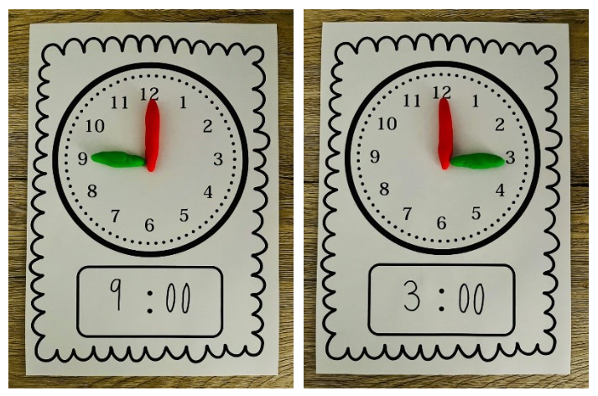
This table details assessment opportunities and differentiation ideas.
Assessment opportunities | Too hard? | Too easy?
What to look for:  - Can students read and describe the time on analog and digital clocks to the hour as o’clock? (MAO-WM-01, MAE-RWN-01, MAE-NSM-02)  - Can students describe the position of the hour and minute hands on an analog clock when reading time to the hour? (MAO-WM-01, MAE-RWN-01, MAE-NSM-02)  What to collect:  - observation of individual responses as they participate and engage in practical activities. (MAO-MW-01, MAE-RWN-01, MAE-NSM-02) | Students need further support to read and describe the time on analog and digital clocks to the hour.  - Model game with students using Resource 12: Clay Clocks taking turns to copy, read, and describe time to the hour.  - Provide time for students to revisit and play Resource 12: Clay Clocks to explore ways to read and describe the time on analog and digital clocks. | Students can confidently read and describe the time on analog and digital clocks to the hour.  - Students draw or use recycled materials to design and create a digital and analog clock that show time on the hour. Display in the classroom.  - Tell a story about one or more of these times.  - Encourage students to notice when the classroom clock shows time on the hour throughout the day.

Consolidation and meaningful practice: Human clocks – 15 minutes
This activity has been adapted from Robertson (2017).
- Explain that to play this game students will become human clocks, using their body to create different times on the hour.
- Demonstrate how to stretch your arms up and out to the side to feel the position of the hour and minute hands.
- Encourage students to rock from foot to foot while slowly chanting Tick, tock, tick, tock. I’m a ticking human clock. What time is it?
- Call out a time. Students make that time with their arms showing the position of the hour and minute hands (see Figure 18).
Figure 18 – Human clocks
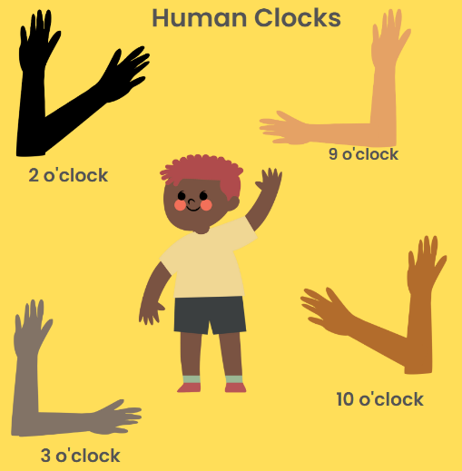
Images sourced from Canva and used in accordance with the Canva Content License Agreement.
Note: Remember it will look back to front if you are standing in front of students.
- Ensure you have a clock face on hand so students can check and correct their answers.
- Repeat chant before calling out each time.
Note: This also works as an activity undertaken in pairs with one student moving the arms of their partner to the correct position.
- As students become familiar with the game, they can be invited to call out a time for the class to make.

Lesson 8: Rock clocks
Core concept: We can use items on Country to create the layout of an analog clock.
The table below contains suggested learning intentions and success criteria. These are best co-constructed with students.
Learning intentions | Success criteria
Students are learning that:  - visual representations of numbers can assist in combining and separating quantities up to 10  - the layout of an analog clock can be created using items on Country. | Students can:  - match numbers to numbers or numbers to symbols.  - create the layout of an analog clock.

Daily number sense: Number memory – 15 minutes
- Build student understanding of forming combinations to 10 by playing number memory.
- Students play ‘number memory’ in small groups. Students will lay out a deck of cards face down in rows and columns with all picture and number 10 cards removed from the deck (see Figure 19).
Figure 19 – Rows and columns
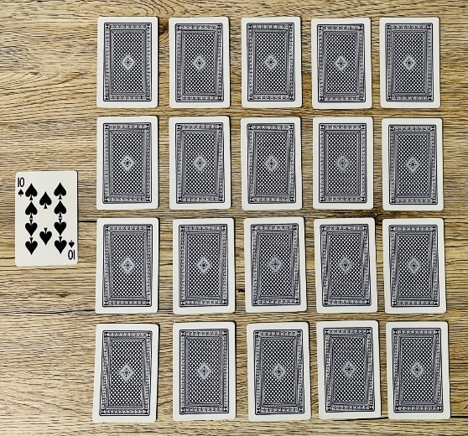
- Provide time for students to play memory by turning over 2 cards at a time to see if they can make a match for the target number of 10.
- Focus on the reasoning students provide for the match and for students to build connections between concepts.
This table details assessment opportunities and differentiation ideas.
Assessment opportunities | Too hard? | Too easy?
What to look for:  - Can students match numbers to numbers or numbers to symbols? (MAO-WM-01, MAE-CSQ-01, MAE-CSQ-02)  What to collect:  - strategic questioning to determine individual level of understanding. (MAO-WM-01, MAE-CSQ-01, MAE-CSQ-02) | Students need further support to match numbers to numbers or numbers to symbols.  - Provide students with Resource 3: Ten-frame and concrete materials to support addition.  - Model counting on when counting the visual patterns on 2 playing cards with one-to-one correspondence. | Students confidently match numbers to numbers or numbers to symbols.  - Challenge students to combine 3 cards to make combinations to 10.  - Challenge students to look for combinations to 20.

Clock challenge – 30 minutes
- Reinforce how to make an analog clock using items collected on Country by viewing Go Wild for Maths: Clock Challenge (2:12).
Note: Prior to this lesson collect items on Country and place in dilly bag. You may decide to take your class to the playground/sandpit for this activity.
- Students sit in a circle like a large round clock.
- Explain that students are accepting the clock challenge to make their own Kindergarten rock clock using natural materials.
- Introduce dilly bag (or treasure bag) filled with items.
- Invite students to recall items collected in the video to make the clock.
- Use student responses to reveal items and place in the centre of the circle.
- After all items have been revealed, use the analog clock (on hand) to count and check that we can see all the items students need in the centre of the circle.
- Ask students:
- How many rocks do we have? Count each to check.
- How many sticks do we need to make the hour and minute hands? Count to check.
- Invite students to assist in creating the rock clock using the analog clock on hand to check the positions of the numbers (see Figure 20).
Figure 20 – Analog rock clock
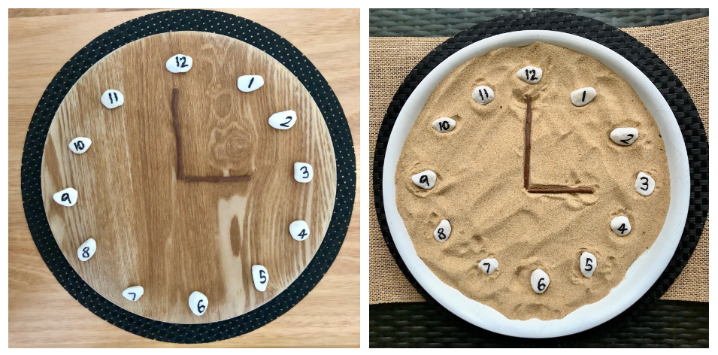
- After making the analog rock clock, use Resource 12: Clay clocks or mini whiteboard to write a digital time. Invite individual students to match the digital time on the analog clock by moving the hour and minute hands.
This table details assessment opportunities and differentiation ideas.
Assessment opportunities | Too hard? | Too easy?
What to look for:  - Can students create the layout of an analog clock? (MAO-WM-01, MAE-RWN-01, MAE-NSM-02)  What to collect:  - observations of student engagement and participation during clock challenge and recordings of individual responses to questioning. (MAO-WM-01, MAE-RWN-01, MAE-NSM-01) | Students need support to create the layout of an analog clock.  - Provide time for students to manipulate the natural materials using an analog clock model to explore ways to create the layout of an analog clock.  - Provide students with Resource 12: Clay clocks, 12 rocks numbered 1 to 12 and 2 sticks to count and match the numbers and hour/minute hand on the analog clock to show something o’clock. | Students can confidently create the layout of an analog clock.  - Collect and use a variety of natural or recycled materials to create their own clock challenge.  - Share their clock challenge with a partner describing the materials they to create their analog clock. Display in classroom to support further discussion with others.

Consolidation and meaningful practice: Which one doesn’t belong? – 15 minutes
- Highlight how mathematicians use analog and digital clocks to tell the time on the hour.
- Show Resource 13: Analog clocks and Resource 14: Digital clocks.
- Explain that we are going to challenge our mathematical eyes and brains to play the game ‘Which one doesn’t belong’.
- Encourage students to look at each resource and then point to the analog clocks using their fingers to count out how many analog clocks they can see.
- Challenge students to look more closely at each of the analog clocks and ask which one doesn’t belong. Encourage students to share why they think this.
- Students turn and talk with a partner to share their thinking.
- Regroup as a class and invite students to identify which one doesn’t belong and why and if their partner had the same or different idea.
- Record student responses to display in classroom with Resource 13: Analog clocks.
- Repeat for digital clocks. Ask students to point to the digital clocks and use their fingers to count out how many they can see.
- Challenge students to look closely at each of the digital clocks and ask which one doesn’t belong. Encourage students to share why they think this.
- Student turn and talk with a partner to share their ideas.
- Regroup as a class and ask student to discuss which one doesn’t belong and why and if their partner had the same or different idea.
- Record student responses to display with Resource 14: Digital clocks.
The table below outlines stimulus prompts to generate conversation about the topic, along with anticipated responses from students.
Prompts | Anticipated student responses
- What does an analog clock look like?  - How can we read an analog clock and tell time on the hour?  - What does a digital clock look like?  - How can we read a digital clock to tell time on the hour?  - How do we know it’s 5 o’clock on the analog clock? Where is the hour hand? Minute hand?  - How do you know it is 5 o’clock on the digital clock?  - How do we know that telling the time on the hour is always the same on every analog clock? How about on a digital clock? | - It has 12 numbers you can always see. Number 12 is always at the top of the clock and number 6 is at the bottom.  - The long hand points up to number 12. The short hand points to the number. That tells us it’s something o’clock.  - It only has numbers and 2 dots in the middle. It doesn’t have any hands. It looks like the microwave. You can see numbers 0 to 12. The analog clock doesn’t have zero.  - The long hand points up to the 12 and the short hand points to the 5. That says 5 o’clock.  - You can see 5 then 2 dots and 2 zeros. That means it’s 5 o’clock if you can see 2 zeros.  - The long hand always points to the number 12, just like when we made our own analog clocks. That means it’s something o’clock. You can always see 2 zeros after the 2 dots on digital clocks. That tells you it’s something o’clock. The first number says what hour it is.

Resource 1: Number tracks
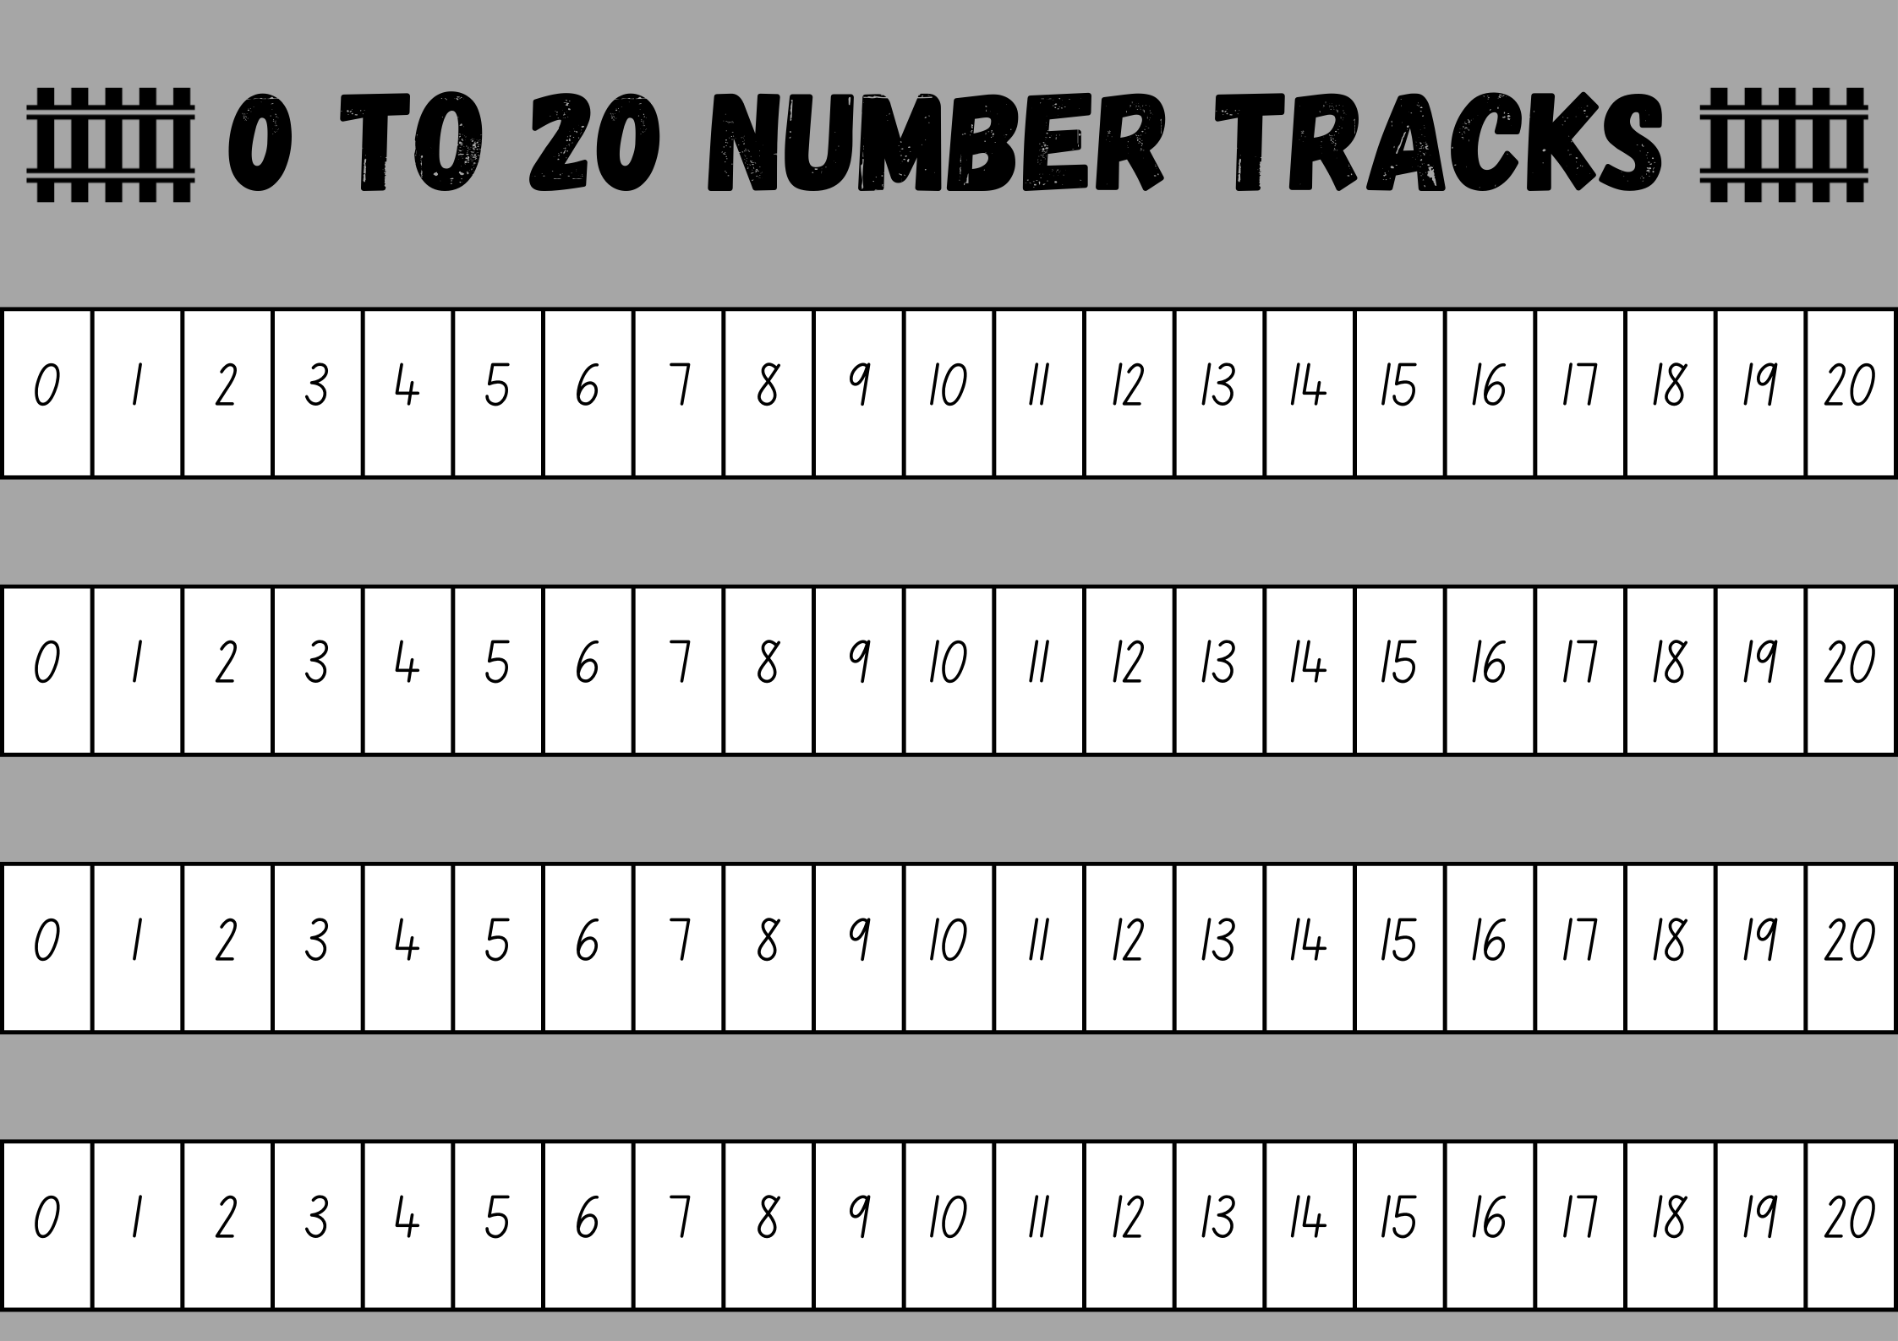
Images sourced from Canva and used in accordance with the Canva Content License Agreement.

Resource 2: Game board
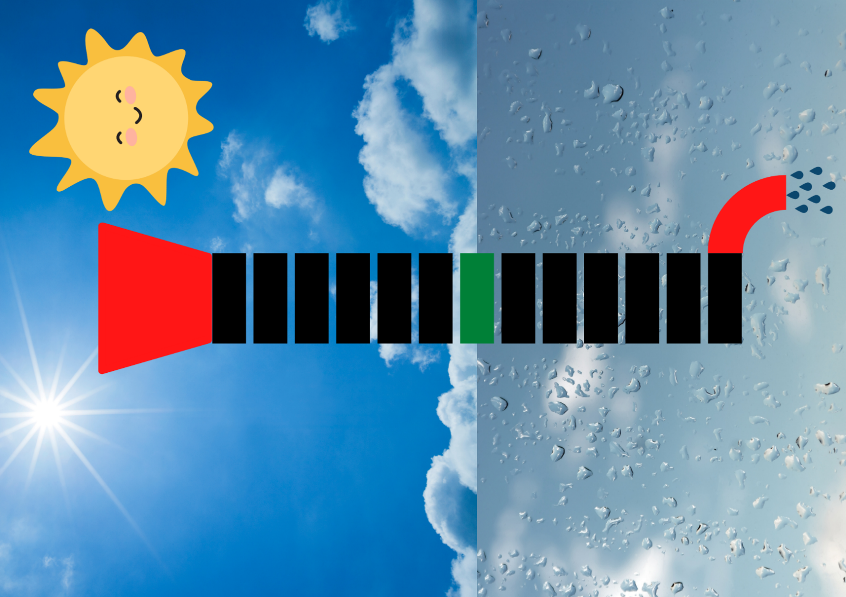
Images sourced from Canva and used in accordance with the Canva Content License Agreement.

Resource 3: Ten-frame
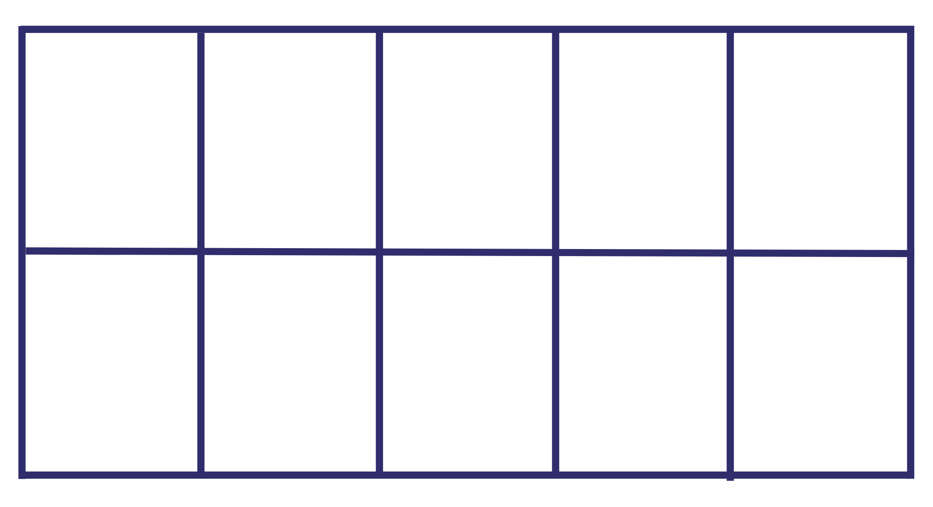

Resource 4: Caterpillar ordering
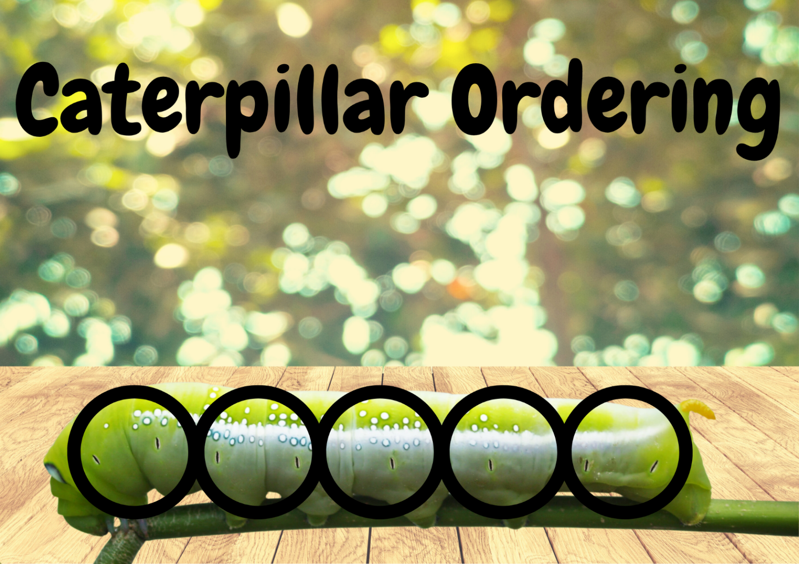
Images sourced from Canva and used in accordance with the Canva Content License Agreement.

Resource 5: Think board
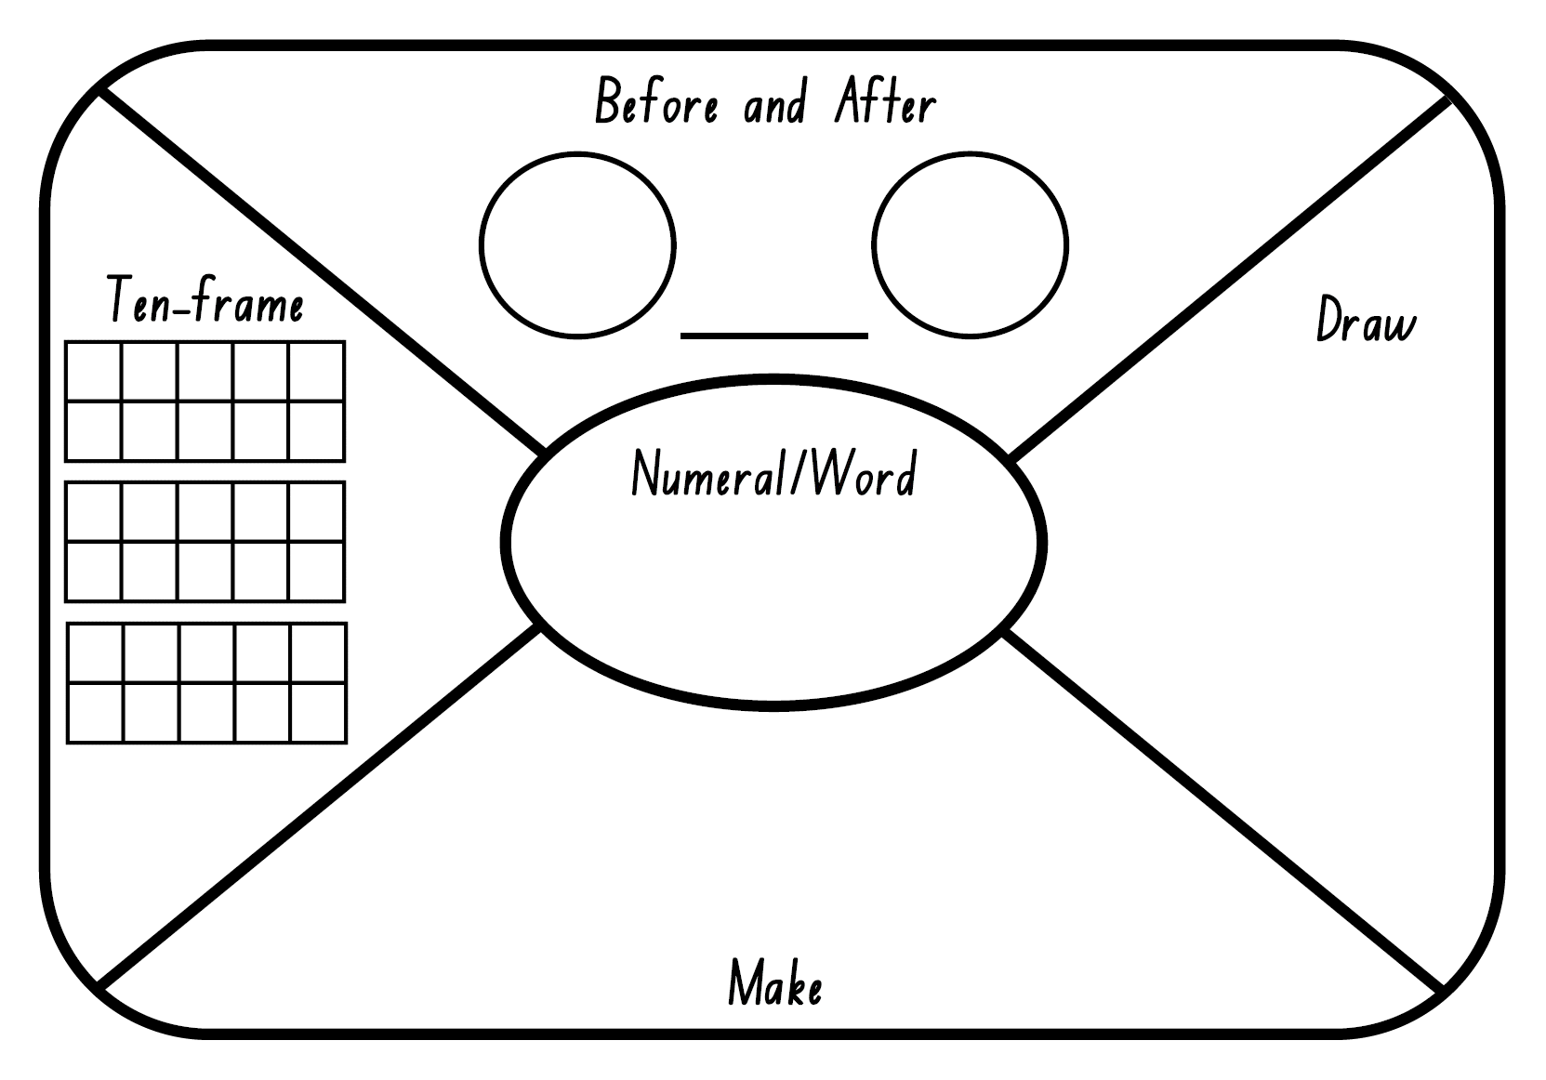

Resource 6: Hopping frogs
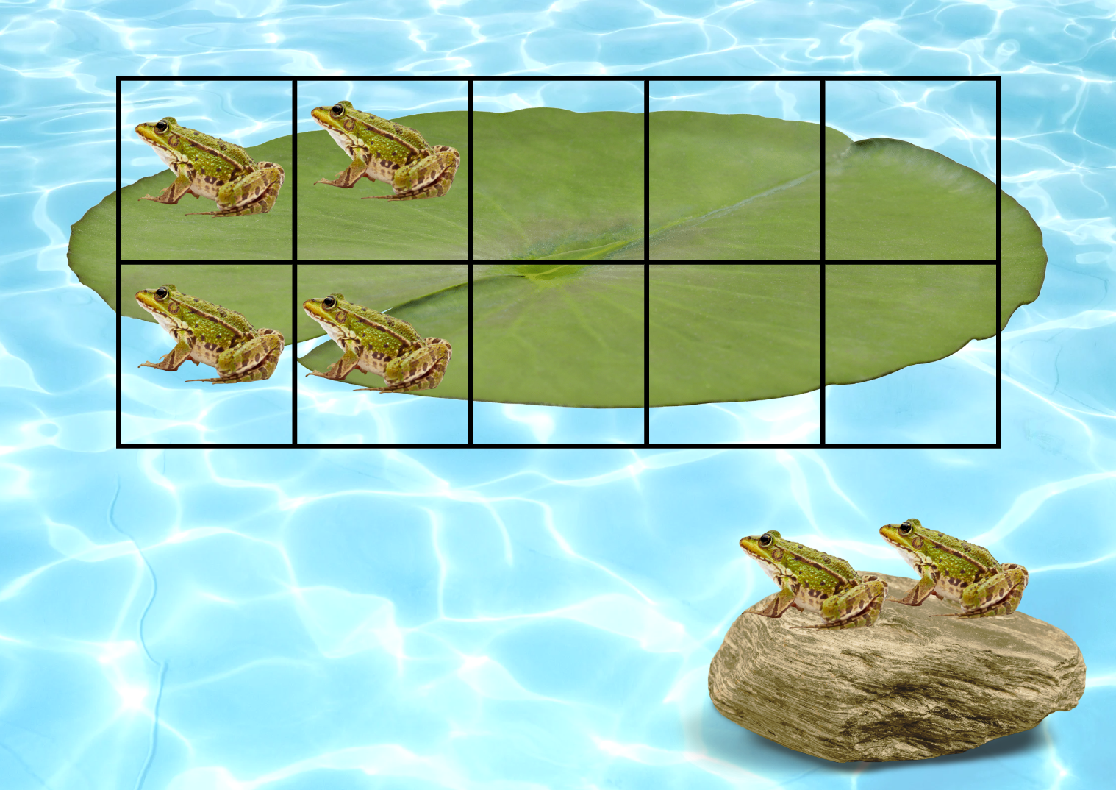
Images sourced from Canva and used in accordance with the Canva Content License Agreement.

Resource 7: How many seeds?
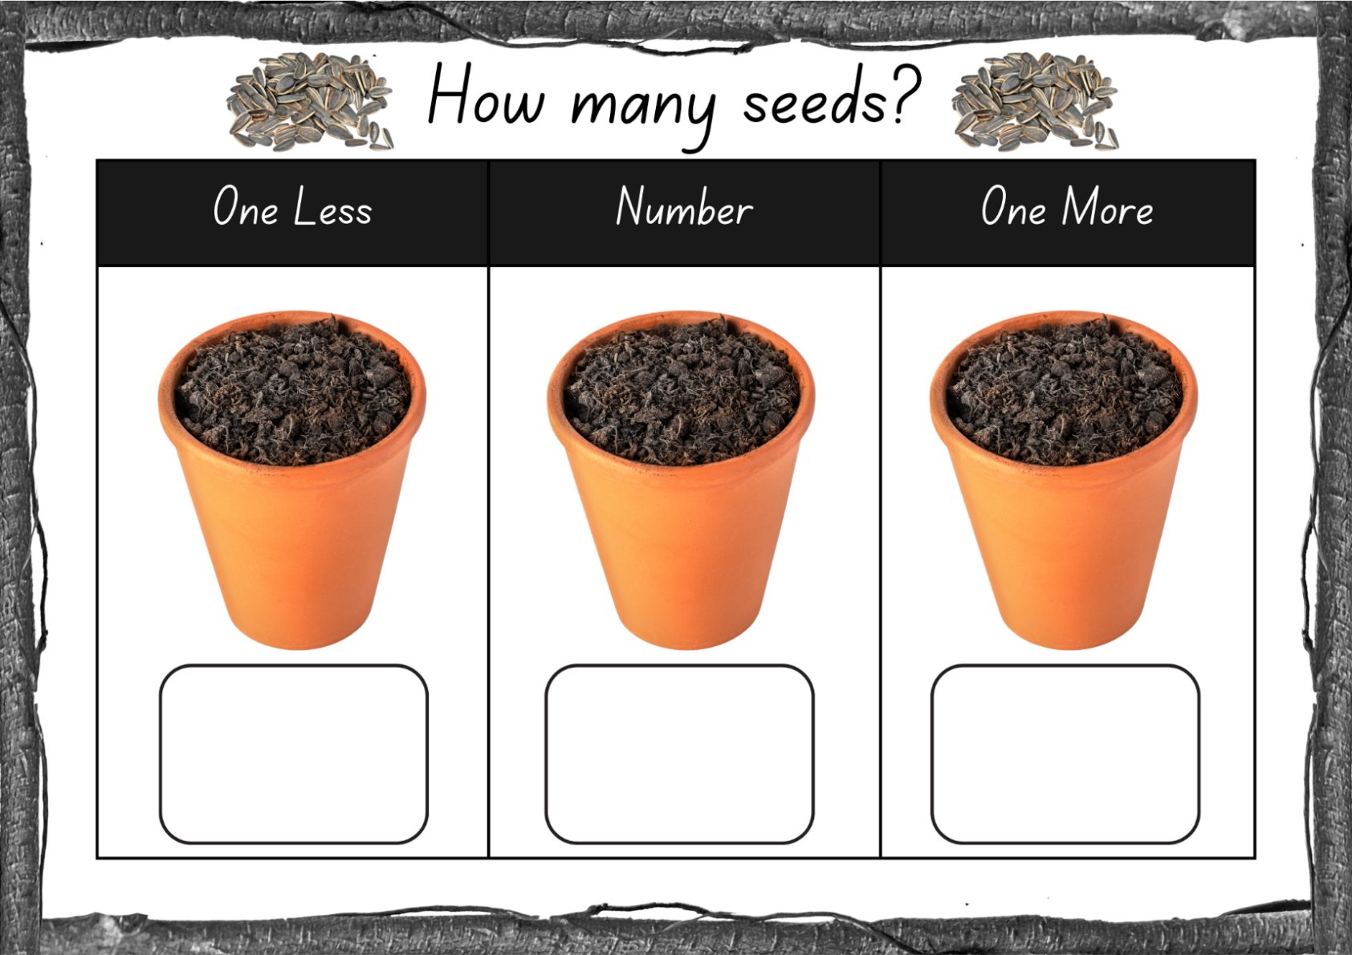
Images sourced from Canva and used in accordance with the Canva Content License Agreement.

Resource 8: About halfway
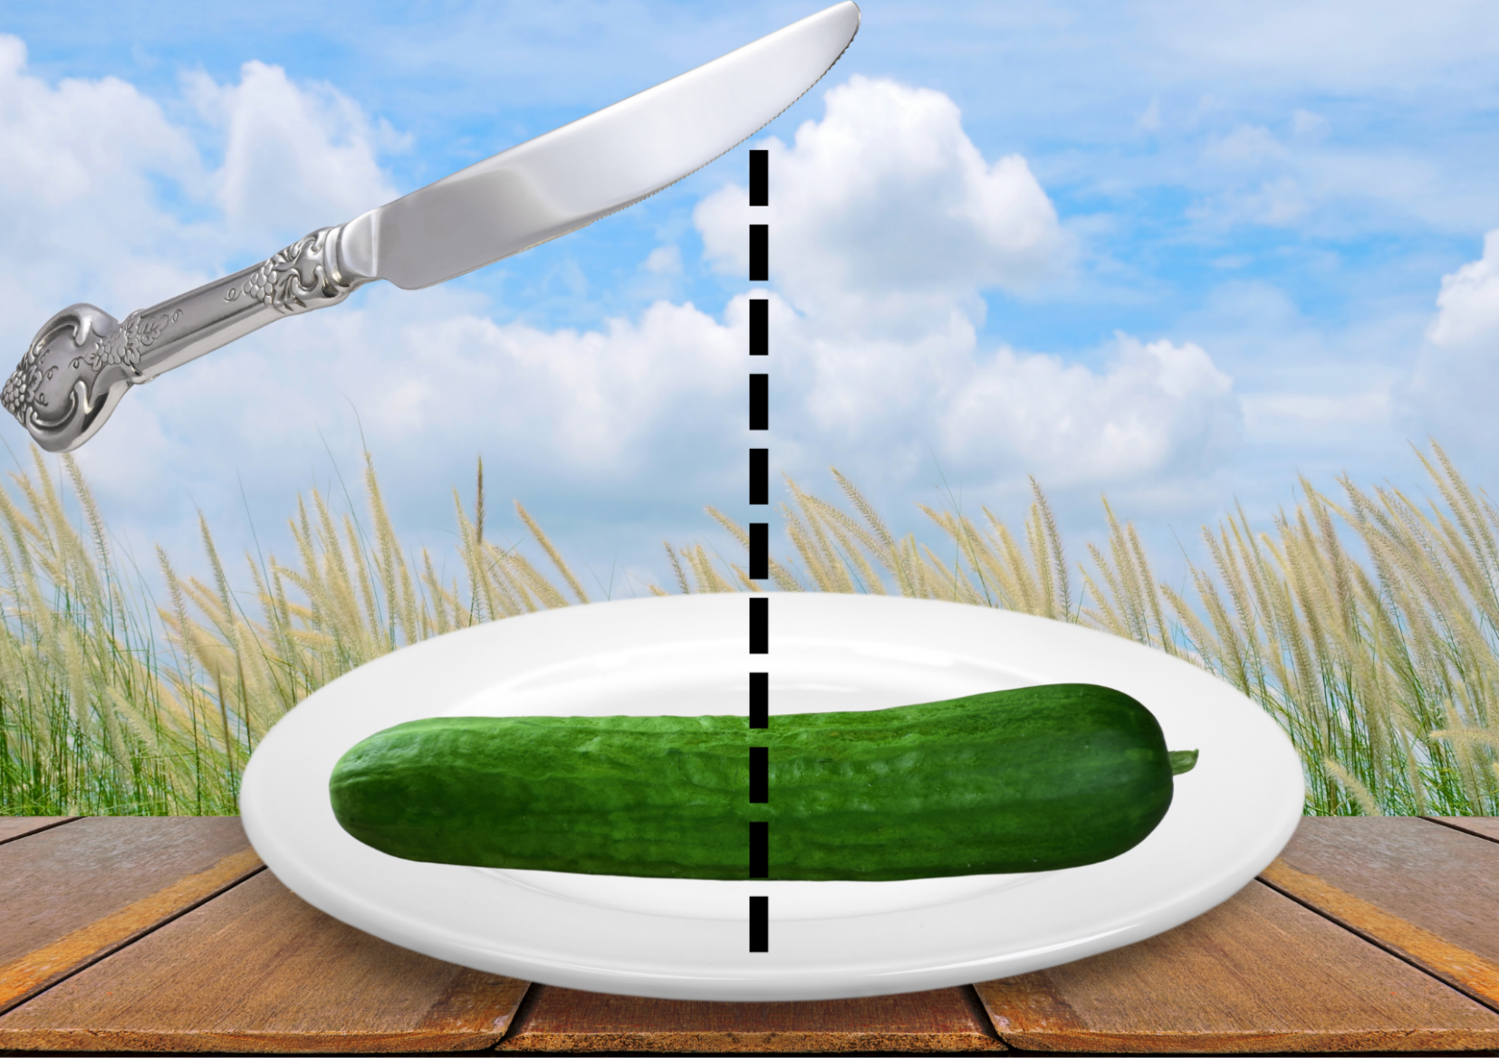
Images sourced from Canva and used in accordance with the Canva Content License Agreement.

Resource 9: More than halfway
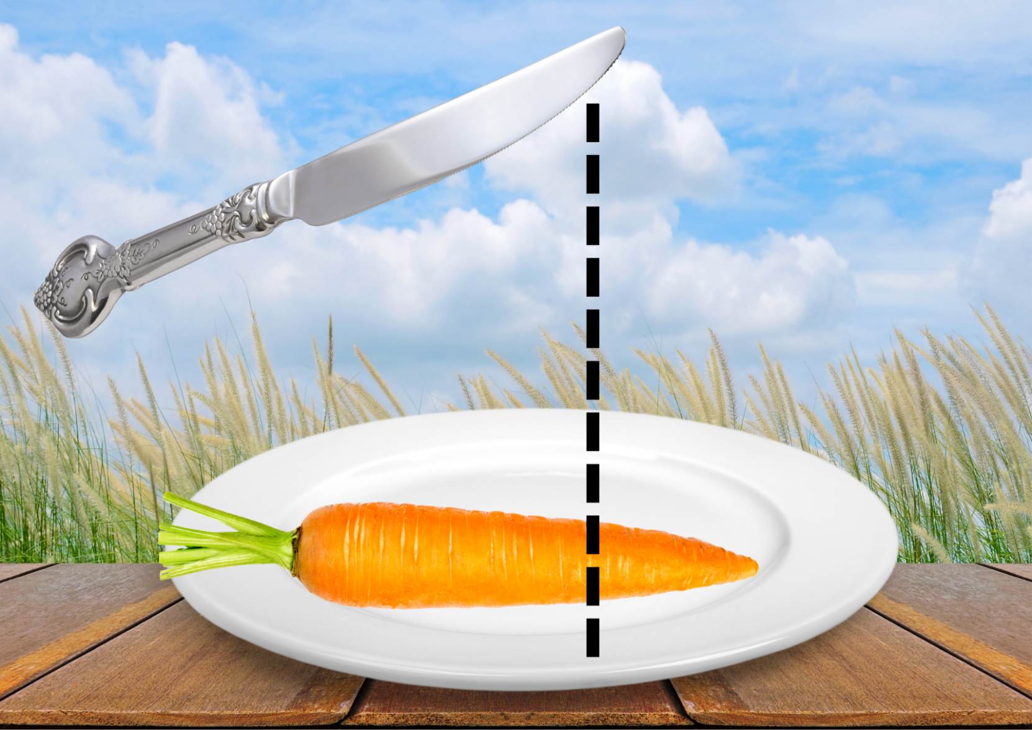
Images sourced from Canva and used in accordance with the Canva Content License Agreement.

Resource 10: Less than halfway
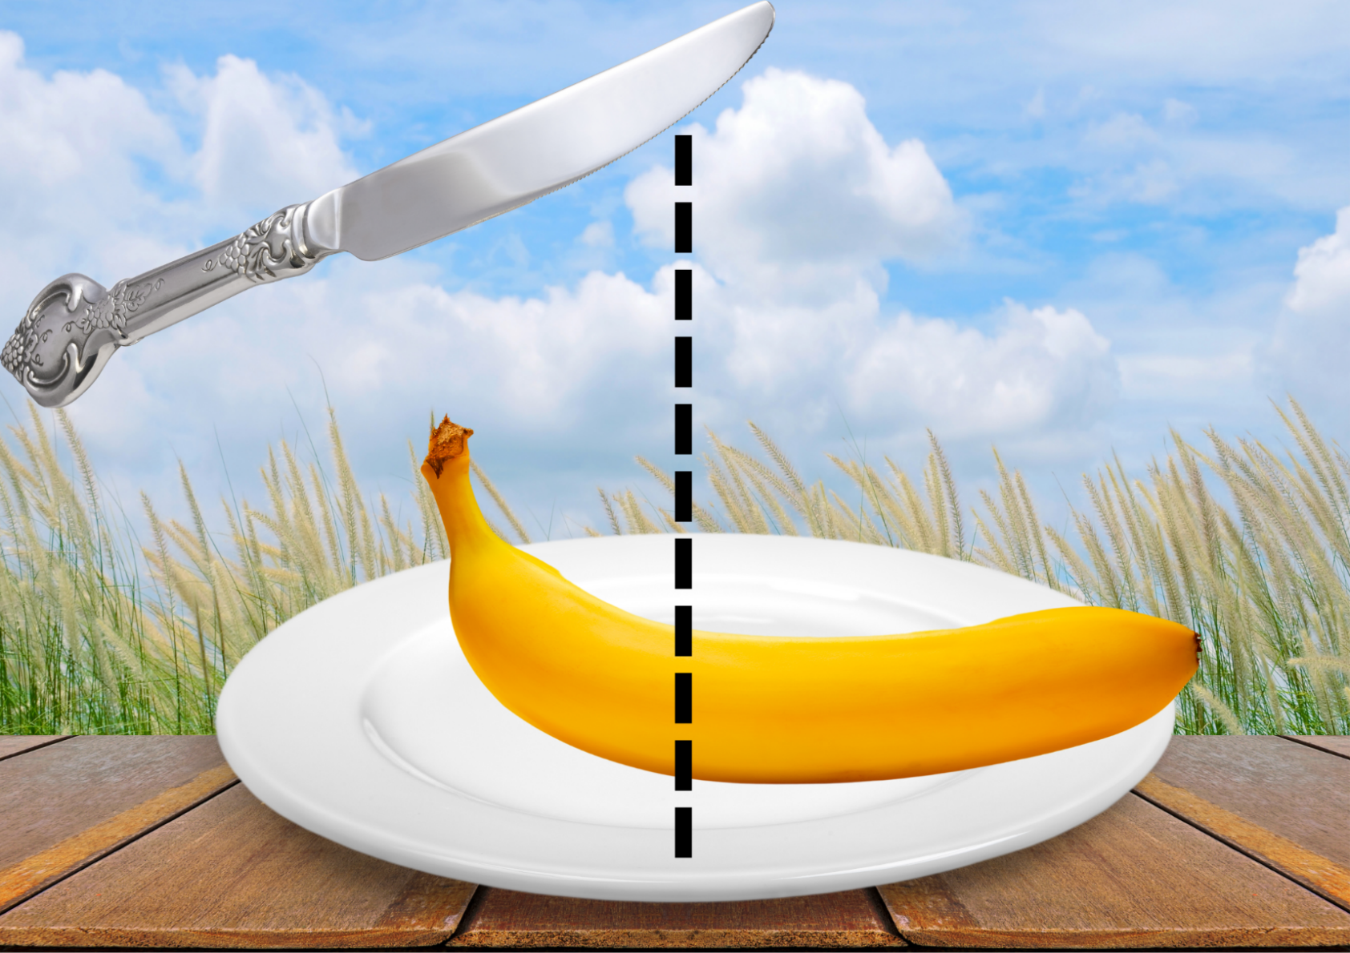
Images sourced from Canva and used in accordance with the Canva Content License Agreement.

Resource 11: Picnic drawing
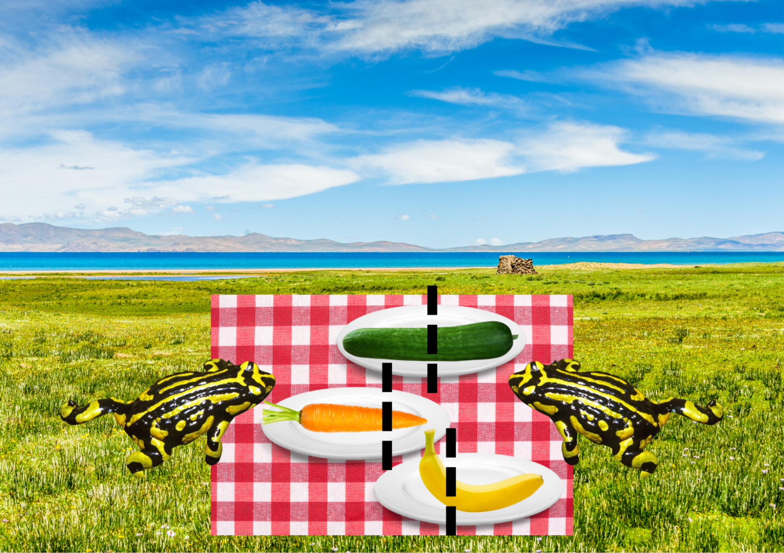
Images sourced from Canva and used in accordance with the Canva Content License Agreement.

Resource 12: Clay clocks
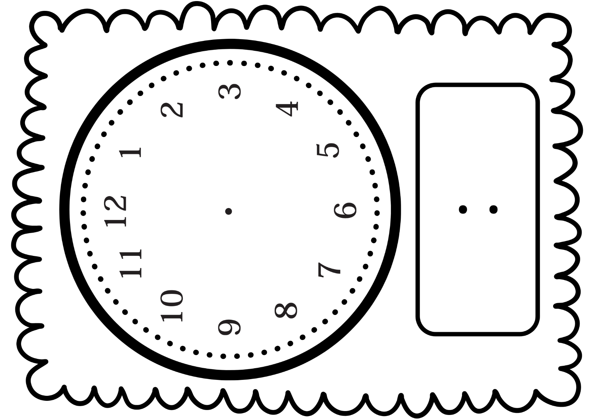

Resource 13: Analog clocks
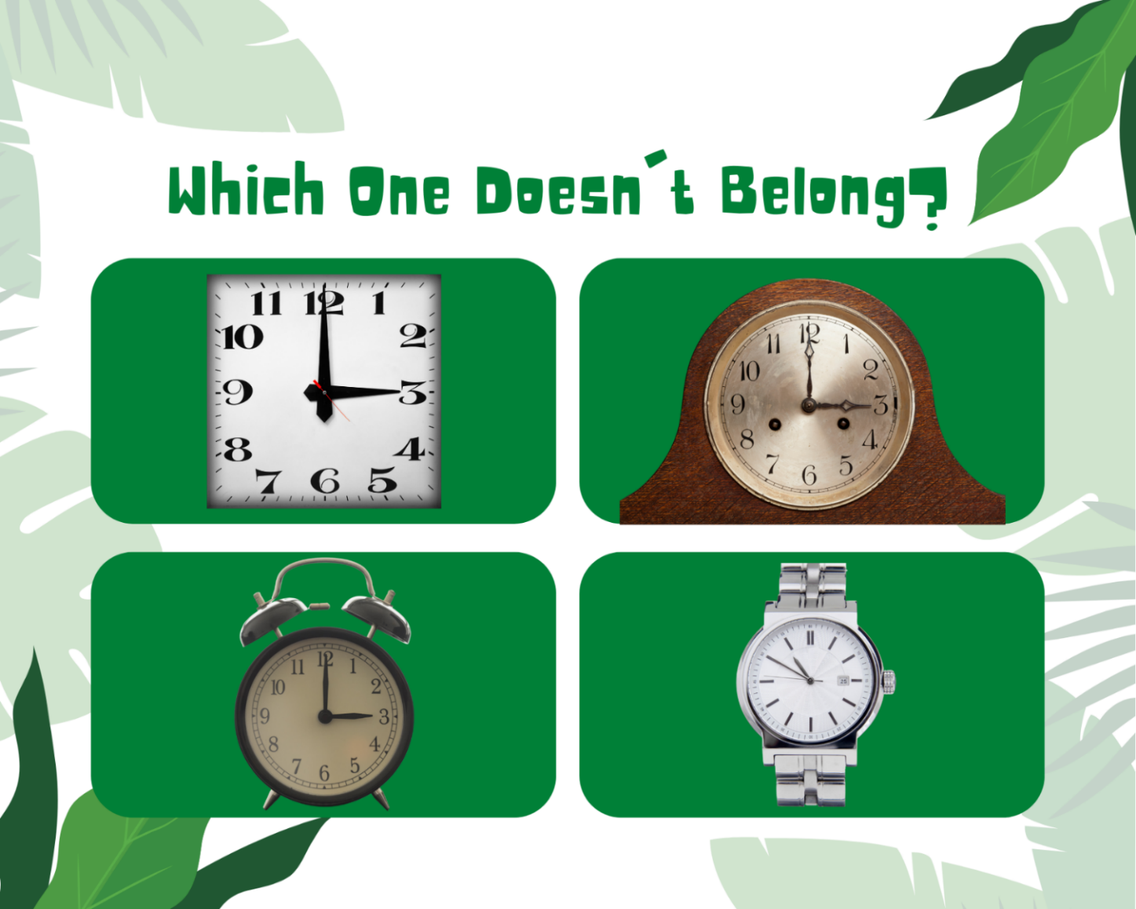
Images sourced from Canva and used in accordance with the Canva Content License Agreement.

Resource 14: Digital clocks
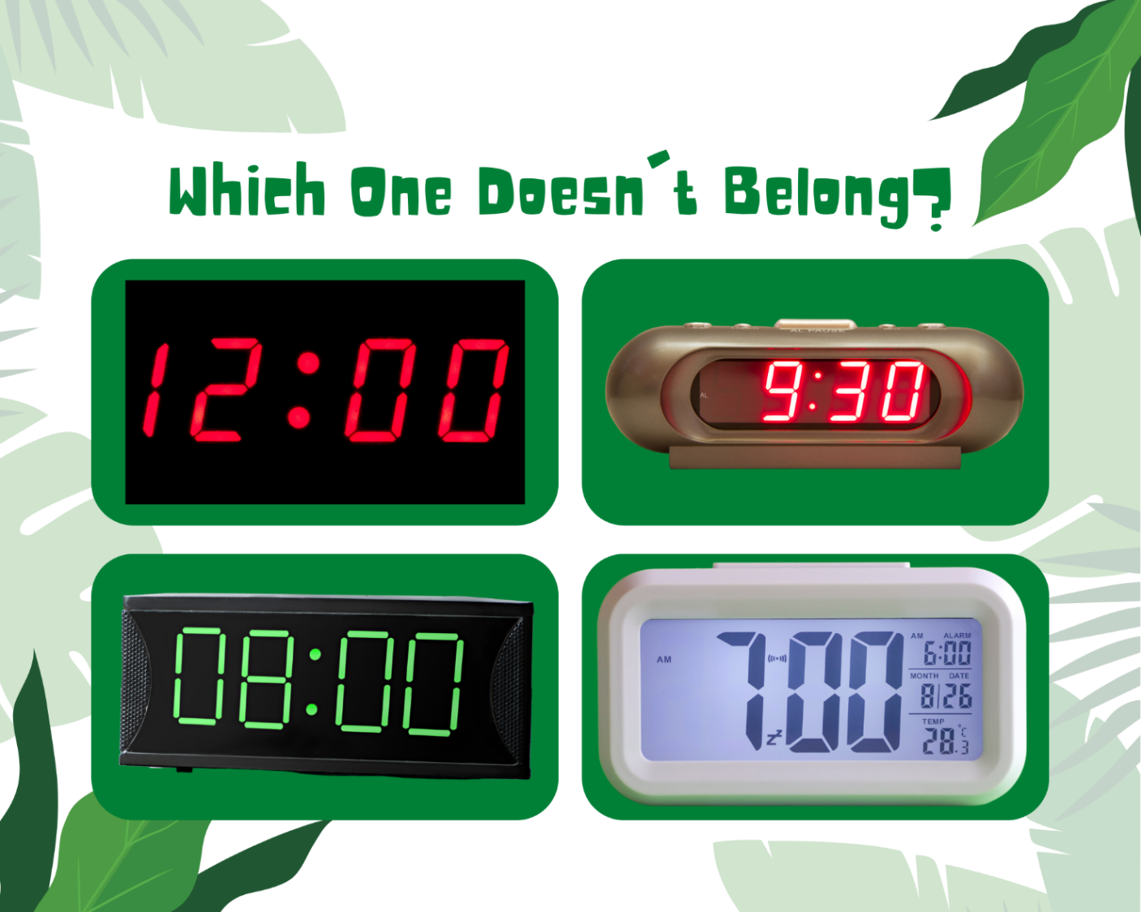
Images sourced from Canva and used in accordance with the Canva Content License Agreement.

Syllabus outcomes and content
The table below outlines the syllabus outcomes and range of relevant syllabus content covered in this unit. Content is linked to National Numeracy Learning Progression version (3).
Focus area and outcomes | Content groups and content points | Lessons
Representing whole numbers  MAO-WM-01  MAE-RWN-01  MAE-RWN-02 | Instantly name the number of objects within small collections  - instantly recognise (subitise) the number of items in small groups of up to four items without counting (NPV1, CPr1)  - identify the number of items in different arrangements (CPr2)  Use the counting sequence of ones flexibly  - count forwards to at least 30 and state the number after or before a given number, without needing to count from one (CPr4)  - identify and distinguish the ‘teen’ numbers from multiples of ten with the same initial sounds (NPV3)  - count backwards from a given number 20 or less (CPr5)  - identify the number before as 'one less' and the number after as 'one more’ than a given number  Recognise number patterns  - recognise dice and domino dot patterns (NPA1, NPV2, CPr2)  - recognise different finger patterns for the same number (NPA2)  Connect counting and numerals to quantities  - count with one-to-one correspondence, recognising that the last number name represents the total number in the collection (CPr3, CPr5)  - count out a specified number of objects (from 5 to 20) from a larger collection, keeping track of the count (CPr4-CPr5)  - make correspondences between collections  - read numerals to at least 20, including zero (NPV3)  - represent numbers as quantities to at least 20 using objects (such as fingers), number words and numerals (NPV2-NPV4, CPr3)  - compare and order numbers to 20 (NPV2-NPV3)  - use the term ‘is the same as’ to express equality of groups (CPr4-CPr5, MuS1) | 1–3, 5–7
Combining and separating quantities  MAO-WM-01  MAE-CSQ-01  MAE-CSQ-02 | Model additive relations and compare quantities  - identify situations in which addition and subtraction may be applied (AdS1-AdS2)  - combine two or more groups of objects to model addition, identifying the relationship between the parts and the whole (AdS1-AdS2)  - separate and take away part of a group of objects to model subtraction (AdS1-AdS2)  - use concrete materials or fingers to model and solve addition and subtraction questions, counting forwards or backwards by ones as necessary (AdS1-AdS2, NPV3)  - compare two groups of objects to determine how many more (NPV1, AdS2)  Identify part–whole relationships in numbers up to 10  - use visual representations of numbers to assist with combining and separating quantities, identifying the relationship between the quantities (NPV2, NPA2, AdS2-AdS3)  - describe the action of combining, separating and comparing (AdS1)  - use five as a reference in forming numbers from six to ten  - create, model and recognise combinations for numbers up to ten (AdS2)  - count by ones to find the total or difference (AdS2-AdS3)  - use drawings, words and numerals to record addition and subtraction, and explain their thinking (AdS2) | 3–4, 8
Geometric measure  MAO-WM-01  MAE-GM-02  MAE-GM-03 | Length: Use direct and indirect comparisons to decide which is longer  - identify the attribute of 'length' as the measure of an object from end to end  - use comparative language to describe length (UuM2)  - compare lengths directly by placing objects side by side and aligning the ends (UuM2)  - explain why the length of a piece of string remains unchanged whether placed in a straight line or a curve  - compare lengths indirectly by copying a length (UuM3)  Length: Create half a length  - divide a length into two equal parts (InF1)  - distinguish between the halfway point and half a length  - describe positions as 'about halfway', 'more than halfway' or 'less than halfway' (InF2) | 5–6
Non-spatial measure  MAO-WM-01  MAE-NSM-02 | Time: Tell time on the hour on analog and digital clocks  - create the layout of an analog clock (MeT2)  - read analog and digital clocks to the hour using the term ‘o'clock’ (MeT2-MeT3)  - describe the position of the hour and minute hands on an analog clock when reading hour time (MeT2) | 7–8

References
Links to third-party material and websites
Please note that the provided (reading/viewing material/list/links/texts) are a suggestion only and implies no endorsement, by the New South Wales Department of Education, of any author, publisher, or book title. School principals and teachers are best placed to assess the suitability of resources that would complement the curriculum and reflect the needs and interests of their students.
If you use the links provided in this document to access a third-party's website, you acknowledge that the terms of use, including licence terms set out on the third-party's website apply to the use which may be made of the materials on that third-party website or where permitted by the Copyright Act 1968 (Cth). The department accepts no responsibility for content on third-party websites.
Except as otherwise noted, all material is © State of New South Wales (Department of Education), 2021 and licensed under the Creative Commons Attribution 4.0 International License. All other material (third-party material) is used with permission or under licence. Where the copyright owner of third-party material has not licensed their material under a Creative Commons or similar licence, you should contact them directly for permission to reuse their material.
Mathematics K–10 Syllabus © 2022 NSW Education Standards Authority (NESA) for and on behalf of the Crown in right of the State of New South Wales.
© 2022 NSW Education Standards Authority. This document contains NSW Curriculum and syllabus content. The NSW Curriculum is developed by the NSW Education Standards Authority. This content is prepared by NESA for and on behalf of the Crown in right of the State of New South Wales. The material is protected by Crown copyright.
Please refer to the NESA Copyright Disclaimer for more information.
NESA holds the only official and up-to-date versions of the NSW Curriculum and syllabus documents. Please visit the NSW Education Standards Authority (NESA) website and the NSW Curriculum website.
National Numeracy Learning Progression © Australian Curriculum, Assessment and Reporting Authority (ACARA) 2010 to present, unless otherwise indicated. This material was downloaded from the Australian Curriculum website (National Numeracy Learning Progression) (accessed 4 November 2022) and was not modified. The material is licensed under CC BY 4.0. Version updates are tracked in the ‘Curriculum version history’ section on the 'About the Australian Curriculum' page of the Australian Curriculum website.
ACARA does not endorse any product that uses the Australian Curriculum or make any representations as to the quality of such products. Any product that uses material published on this website should not be taken to be affiliated with ACARA or have the sponsorship or approval of ACARA. It is up to each person to make their own assessment of the product, taking into account matters including, but not limited to, the version number and the degree to which the materials align with the content descriptions and achievement standards (where relevant). Where there is a claim of alignment, it is important to check that the materials align with the content descriptions and achievement standards (endorsed by all education Ministers), not the elaborations (examples provided by ACARA).
This resource contains images and content obtained from Canva, and their use outside of this resource is subject to Canva’s Content License Agreement. If you wish to use them separately from the resource, please go to Canva.
ABC (Australian Broadcasting Corporation) (2020) ‘Clock Challenge’ [television program], Go Wild for Maths (season 1, episode 8), ABC iView, Australia, accessed 4 November 2022.
Barrett J (2022) Clock Demonstrator, ICT Games website, access 13 October 2022.
Browning S (2020) ‘Telling the Time’ [television program], The Stickie Gang (season 1, episode 7), ABC iView, Australia, accessed 2 November 2022.
Crowe C and Australian Broadcasting Corporation (ABC), Play School (2021) Lou’s Garden Surprise, ABC Kids Early Education, accessed 2 November 2022.
Mathematical Association of Victoria (2020) F-2: Remote Maths: Edition 4 [PDF 398KB], The Mathematical Association of Victoria, accessed 2 November 2022.
Mathematical Association of Victoria (2020) F-2: Remote Maths: Edition 18 [PDF 528KB], The Mathematical Association of Victoria, accessed 2 November 2022.
New Zealand Ministry of Education (n.d.) ‘Cars in garages’, Resource Finder, NZ Maths website, accessed 2 November 2022.
New Zealand Ministry of Education (n.d.) ‘Counting on Counting’, Resource Finder, NZ Maths website, accessed 2 November 2022.
New Zealand Ministry of Education (n.d.) ‘Go Fish 10’, Resource Finder, NZ Maths website, accessed 2 November 2022.
New Zealand Ministry of Education (n.d.) ‘Jumping Beans’ Resource Finder, NZ Maths website, accessed 2 November 2022.
New Zealand Ministry of Education (n.d.) NZ Maths [website], accessed 2 November 2022.
Robertson J (2017) Messy Maths: A Playful, Outdoor Approach to Early Years, Crown House Publishing, GB.
University of Cambridge (Faculty of Mathematics) (2022) Incey Wincey, NRICH website, accessed 2 November 2022.
University of Cambridge (Faculty of Mathematics) (2022) NRICH [website], accessed 2 November 2022.

