Mathematics – Early Stage 1 – Unit 7
Contents
Unit description and duration 4
Student prior learning 4
Lesson overview and resources 5
Lesson 1: Tumbling toys 13
Daily number sense: Counting collections – 15 minutes 13
Toy tumbles: Part 1 – 10 minutes 16
Toy tumbles: Part 2 – 30 minutes 17
Consolidation and meaningful practice: Toys on display – 15 minutes 18
Lesson 2: Shake and drop display 20
Daily number sense: Rekenrek teens – 15 minutes 21
What’s in the bag? – 15 minutes 24
Shake and drop data – 30 minutes 24
Consolidation and meaningful practice: What can we see about quantities in a grid? – 10 minutes 27
Lesson 3: Collections as data 28
Daily number sense: Modelling teens – 20 minutes 28
Organising a collection into a data display – 45 minutes 32
Lesson 4: The passing of time 34
Daily number sense: Choral counting – 15 minutes 35
Timer challenge – 15 minutes 39
How long? – 25 minutes 40
Consolidation and meaningful practice: Sorting events by duration – 15 minutes 41
Lesson 5: Sequencing events 43
Daily number sense: Spot the difference – 10 minutes 43
Comparing ‘when’ – 20 minutes 44
Sequencing on a timeline – 30 minutes 45
Lesson 6: Playing with analog clocks 48
Daily number sense: Reading and ordering numerals – 15 minutes 48
Teddy bear says – 5 minutes 50
Bending the numbers – 15 minutes 50
Make a plate clock – 25 minutes 55
Lesson 7: Clock connections 58
Daily number sense: Reading and reordering numerals – 15 minutes 58
O’clock on analog clocks – 15 minutes 60
Consolidation and meaningful practice: Modelling hour time – 15 minutes 62
Hour time on digital clocks – 10 minutes 63
Sorting and matching clocks – 15 minutes 64
Lesson 8: Invisible data made visible 66
Daily number sense: Teacher identified activity – 10 minutes 66
Different feelings – 10 minutes 67
Would you rather? – 15 minutes 67
Emoji expressions – 25 minutes 69
Consolidation and meaningful practice: Data faces – 10 minutes 71
Resource 1: Graph grid 74
Resource 2: Time talk 75
Resource 3: Daily events 76
Resource 4: Numeral cards 77
Resource 5: Clock numerals 78
Resource 6: Digital clocks 79
Resource 7: Hour time 80
Resource 8: Emojis 82
Syllabus outcomes and content 83
References 89
Further reading 91

Unit description and duration
This two-week unit introduces students to methods of displaying and interpreting sorted data, measuring the duration of time and reading and representing hour time.
Students are provided opportunities to:
- collect, sort and organise data into displays
- interpret data through posing and responding to questions
- compare the duration of time and sequence events
- read hour time on analog and digital clocks.
Mathematics K–10 Syllabus © 2022 NSW Education Standards Authority (NESA) for and on behalf of the Crown in right of the State of New South Wales.

Student prior learning
Before engaging in these teaching and learning activities, students would benefit from prior experience with:
- play-based opportunities to sort collections based on common characteristics
- recognising small quantities without counting (subitising)
- counting collections of items up to 10 with one-to-one correspondence
- sequencing steps in a simple, familiar process.

Lesson overview and resources
The table below outlines the sequence and approximate timing of lessons; syllabus focus areas and content groups; and resources.
Lesson | Syllabus focus area and content groups | Resources
Lesson 1: Tumbling toys  70 minutes  A group of items can be sorted in different ways. | Representing whole numbers  - Instantly name the number of objects within small collections  - Use the counting sequence of ones flexibly  - Recognise number patterns  - Connect counting and numerals to quantities  Data  - Respond to questions, collect information and discuss possible outcomes of activities  - Organise objects into simple data displays and interpret the displays | - Levine S (2020) The Animals Would Not Sleep! (Miguéns MA, illus.), Random House, U.S, ISBN: 9781623541972  - Collection of toys from home  - Number charts  - Sets of counting collections –between 15-30  - Ten-frames, patty pans, cups, bowls, rubber bands – about 40  - Writing materials
Lesson 2: Shake and drop display  70 minutes  Items can be organised in a display to see groups clearly. | Representing whole numbers  - Instantly name the number of objects within small collections  - Use the counting sequence of ones flexibly  - Recognise number patterns  - Connect counting and numerals to quantities  Combining and separating quantities  - Model additive relations and compare quantities  - Identify part-whole relationships in numbers up to ten  Data  - Respond to questions, collect information and discuss possible outcomes of activities  - Organise objects into simple data displays and interpret the displays | - Resource 1: Graph grid – one per pair and one for teacher  - A bag of mixed items  - Coloured paper  - Cups – one per pair  - Digital device with camera  - Rekenreks – one per student  - Sheets of paper  - Two-sided counters – 10 per student  - Writing materials
Lesson 3: Collections as data  65 minutes  Data displays make it easy to compare and quantify groups. | Representing whole numbers  - Instantly name the number of objects within small collections  - Use the counting sequence of ones flexibly  - Connect counting and numerals to quantities  Combining and separating quantities  - Model additive relations and compare quantities  - Identify part-whole relationships in numbers up to ten  Data  - Respond to questions, collect information and discuss possible outcomes of activities  - Organise objects into simple data displays and interpret the displays | - Different sized ten-frames  - Variety of loose items  - Writing materials
Lesson 4: The passing of time  70 minutes  The duration of time can be measured and compared. | Representing whole numbers  - Use the counting sequence of ones flexibly  - Connect counting and numerals to quantities  Non-spatial measure  - Time: Compare and order the duration of events using the language of time  Data  - Respond to questions, collect information and discuss possible outcomes of activities  - Organise objects into simple data displays and interpret the displays | - Resource 2: Time talk  - Resource 3: Daily events  - Markers – at least 5 different colours  - Materials for timed activities  - One-minute sand timers – one per group  - Writing materials
Lesson 5: Sequencing events  60 minutes  Events can be sequenced according to when they take place. | Representing whole numbers  - Instantly name the number of objects within small collections  - Using the counting sequence of ones flexibly  - Recognise number patterns  - Connect counting and numerals to quantities  Combining and separating quantities  - Model additive relations and compare quantities  Non-spatial measure  - Time: Compare and order the duration of events using the language of time  - Time: Connect days of the week to familiar events and actions  Data  - Respond to questions, collect information and discuss possible outcomes of activities  - Organise objects into simple data displays and interpret the displays | - Resource 2: Time talk  - Head, shoulders, knees and toes (3:09)  - Dodd L (1983) Hairy Maclary from Donaldson’s Dairy, Penguin UK, ISBN: 9780723278054  - 20 pegs  - Collection of 10 interesting items  - String  - Visual barrier  - Writing materials
Lesson 6: Playing with analog clocks  60 minutes  The hour hand on an analog clock indicates the hour. | Representing whole numbers  - Instantly name the number of objects within small collections  - Using the counting sequence of ones flexibly  - Recognise number patterns  - Connect counting and numerals to quantities  Non-spatial measure  - Time: Tell time on the hour on analog and digital clocks | - Resource 4: Numeral cards  - Resource 5: Clock numerals  - 21 pegs  - An analog clock  - Counters  - Net curtain wire or garden trimmer nylon cord  - Paper plates with a dot draw in the centre – one per student  - Short ice-cream sticks – one per student  - String  - Teddy bear  - Writing materials
Lesson 7: Clock connections  70 minutes  Hour time can be read on analog and digital clocks. | Representing whole numbers  - Use the counting sequence of ones flexibly  - Connect counting and numerals to quantities  Non-spatial measure  - Time: Tell time on the hour on analog and digital clocks  Data  - Respond to questions, collect information and discuss possible outcomes of activities  - Organise objects into simple data displays and interpret the display | - Resource 4: Numeral cards  - Resource 6: Digital clocks  - Resource 7: Hour time  - 2 pieces of string  - Analog clock  - Long ice-cream sticks – one per student  - Paper clocks  - Pegs  - Rekenreks  - Short ice-cream sticks – one per student  - Ten-frames  - Writing materials
Lesson 8: Invisible data made visible  70 minutes  Information can be collected, represented and interpreted in a data display. | Representing whole numbers  - Instantly name the number of objects within small collections  - Use the counting sequence of ones flexibly  - Recognise number patterns  - Connect counting and numerals to quantities  Combining and separating quantities  - Model additive relations and compare quantities  - Identify part-whole relationships in numbers up to ten  Data  - Respond to questions, collect information and discuss possible outcomes of activities  - Organise objects into simple data displays and interpret the displays | - Resource 8: Emojis  - Morgan M (2010) Brave Mouse (Cartlidge M, illus.), Frances Lincoln Children’s Books, UK, ISBN-10:1847801102  - Sticky putty  - Writing materials

Lesson 1: Tumbling toys
Core concept: A group of items can be sorted in different ways.
The table below contains suggested learning intentions and success criteria. These are best co-constructed with students.
Learning intentions | Success criteria
Students are learning that:  - collections can be organised and counted in different ways and the quantity remains constant  - items can be sorted in different ways  - sorting and displaying a group of items allows information about the group to be seen clearly. | Students can:  - organise and count a collection up to 30 accurately  - sort a collection of items in a range of different ways  - notice information about the group of items in a data display  - ask and respond to questions about a group of sorted items.

Daily number sense: Counting collections – 15 minutes
This lesson has been adapted from Boaler et al. (2021) and Counting Collections by Teacher Education by Design (TEDD).
Note: Counting collections is an instructional activity which provides a structured opportunity for students to explore methods of counting, organising and recording a count for a collection of items. Students can apply counting to a context and explore and discuss the base-ten structure of the counting system and develop efficient skills in counting.
- Build student understanding of how to count by organising and counting a collection.
- Provide students with collections of 15-30 and a selection of tools that might support counting, such as sets of ten-frames, patty pans, cups, bowls, rubber bands, grids and number charts.
Note: Counting collections are sets of items which can be stored in snap-lock bags or boxes. The quantity of items varies in each collection to suit the counting range being explored by students. A selection of items such as natural materials, craft materials, recycled items and stationery products, stored for regular counting routines, supports ongoing counting investigations.
- Students work in pairs and select a collection to count. Ask students to estimate how many may be in the count and record it. This provides useful assessment data to indicate the accuracy of student understanding of quantity.
- Select 1 or 2 students to share their estimation.
- Ask students:
- How did you come to that estimation?
- Who agrees with that estimation?
- Who thinks it may be more and why?
- Who thinks it may be less and why?
- Ask students to count their collection and organise it as they count to support keeping track of the count.
- Students record what they have counted to share with others after the count.
- Circulate amongst students to observe and record the strategies students use to count, organise and record the collection as they count. Ask questions, such as:
- Why have you decided to count your collection that way?
- How are you keeping track of what you have already counted?
- Bring students back together to discuss counting, organising and recording strategies. Select students to share the methods used. Ask questions, such as:
- What was your estimation and how close was it to the actual count?
- Can you describe the way you arranged the items as you counted?
- How did you count your collection and why?
- How did you record your count?
This table details assessment opportunities and differentiation ideas.
Assessment opportunities | Too hard? | Too easy?
What to look for:  - How close are the students’ estimations of the quantity prior to counting? (MAO-WM-01, MAE-RWN-01)  - What strategies do students use to count the collection? (MAO-WM-01, MAE-RWN-01)  - Are students able to use the counting sequence to label the count? (MAO-WM-01, MAE-RWN-01)  - Are students accurately counting the quantities in their collections? (MAO-WM-01, MAE-RWN-01)  What to collect:  - observation data (MAO-WM-01, MAE-RWN-01)  - student work samples. (MAO-WM-01, MAE-RWN-01) | Students need further support to organise the collection and count accurately.  - Suggest students move items from one place to another when counting to support tracking the count.  - Demonstrate the tools available for supporting the count and discuss ways these tools could support the organisation of the count.  - Reduce the number of items to count. | Students arrange items to keep track of counting accurately.  - Provide students with a larger collection of items and encourage them to group items in tens.  - Ask students to describe how they can prove the quantity they have counted is correct.

Toy tumbles: Part 1 – 10 minutes
- Read students The Animals Would Not Sleep! by Sara Levine.
- As the story progresses, ask students to predict if there is another way of solving the problem by sorting the toys in a different way.
- At the end of the story, look through the images of the picture book a second time and discuss the different ways the toys were sorted.
Note: This picture book provides an engaging story which demonstrates that a collection can be sorted in different ways. An alternative activity to reading this book could be to model how to sort a collection of mixed items, such as toys, in different ways.

Toy tumbles: Part 2 – 30 minutes
Note: This lesson can be arranged as part of a special day when students can bring in a few of their favourite toys for a mathematics investigation. Students need to be notified in advance of the lesson to bring toys to school. Alternatively, provide students with a collection of 15-20 mixed items per group, which can be sorted.
- Begin with the whole class. Select one toy from a collection and discuss the characteristics of the toy. Ask students what they notice about that toy. Ask students if there is another toy that shares a characteristic common to the selected toy. For example, a toy with 4 legs may have this characteristic in common with another toy.
- Ask if there is another toy that shares a different characteristic to the selected toy. Use this modelling to explain the process of finding characteristics that are the same and different to sort the collection of toys.
- Students work in small groups to sort a collection of at least 15 toys into groups. Ask students to negotiate the categories they could use to sort the toys based on the characteristics they notice are the same and different amongst the toys.
- Pause when each group has completed a sort and do a gallery walk to look at each group’s toy sort. Ask students who were not part of the group to identify the categories that were used to sort the collection of toys. Repeat for each group and take photographs of each group’s sorted collection.
- Students combine the toys again and negotiate a new way to sort the same collection of toys. Circulate amongst the groups to record observations of the strategies students use to sort the collections of toys.
This table details assessment opportunities and differentiation ideas.
Assessment opportunities | Too hard? | Too easy?
What to look for:  - Are students able to maintain focus on a constant characteristic throughout the process of sorting all items? (MAO-WM-01, MAE-DATA-01)  - What strategies do students use to sort the collections of items? (MAO-WM-01, MAE-DATA-01)  What to collect:  - observation data. (MAO-WM-01, MAE-DATA-01) | Students need further support to sort items using a consistent characteristic.  - Provide students with a smaller collection of items to sort.  - Model an example of sorting of items based on one characteristic whilst sharing your thinking.  - Discuss the possible characteristics that could be used to sort the items to scaffold the sort. | Students quickly and accurately sort the collection of items.  - Ask students to consider using characteristics that are not visible on the items. For example, animals that eat grass, eat meat or eat both.  - Add further items to the collection to create a more diverse or larger collection.  - Ask students to record information about the groups in the sorted collection and the quantity in each collection.

Consolidation and meaningful practice: Toys on display – 15 minutes
- Gather the class together. Select one sorted collection and use hoops to arrange the items in each category in separate hoops.
- Explain to students that the way items are sorted in categories helps to understand information about the collection and this information is called data. Explain that the data can be displayed to help to see interesting ideas clearly.
- Arrange items in a standard dice pattern in each hoop to allow the opportunity to practise subitising items.
- Ask students to justify the way they have sorted the toys with questions such as:
- What characteristics have you used to sort the toys here?
- Why did you choose to sort the toys in this way?
- Can you explain how this toy belongs in this group?
- Were there any toys that could have belonged in more than one group?
Note: Justification of decisions in mathematics is an important aspect of developing mathematical thinking and communication. Supporting students to explain why they select methods to solve problems supports confidence in mathematical processes and encourages students’ ownership of sense-making.
- Ask students to look at the sorted collection and Think-Pair-Share to discuss the questions:
- What do you notice?
- What do you wonder?
- Select a student from each pair to share something they have noticed or wondered in looking at the data display.
Note: Questioning skills are an important part of mathematical investigations. Consider modelling examples of posing questions to prompt students to wonder, in order to explore further ideas.
- Use questions generated through the student wondering routine to allow students to interpret the data displayed, for example:
- What is the most common or least common group?
- Why do you think this is the case?

Lesson 2: Shake and drop display
Core concept: Items can be organised in a display to see groups clearly.
The table below contains suggested learning intentions and success criteria. These are best co-constructed with students.
Learning intentions | Success criteria
Students are learning that:  - the sequence of numbers 11 to 19 increase by one, beginning with a group of 10  - the information they know helps to make possible predictions about the future  - arranging objects in a grid allows information to be easily visible  - data displayed in a grid supports exploring, questioning and comparing information. | Students can:  - count beads on a rekenrek in sequence from zero to 20, moving one bead for each number  - use information to make simple predictions  - organise consistently sized objects in a grid  - describe observations in a data display  - pose and answer questions about data in a display.

Daily number sense: Rekenrek teens – 15 minutes
- Build student understanding of numbers 10-20 by exploring quantities on a rekenrek.
Note: Rekenreks are a useful tool for exploring combinations of numbers to 20. Rekenreks can be constructed by students following the instructions in How to make a rekenrek by Thinking Mathematically Early Stage1.
- Provide each student with a rekenrek. Discuss the features of a rekenrek and how quantities are represented, by shifting the beads across to the left side.
- Ask students to represent zero, 5 and 8 on the rekenrek. Select a few students to share the different ways they have represented 5 and 8 to reinforce the various combinations.
- Ask students to create 10 and discuss the different combinations to make 10. Ask students to identify which representation of 10 is the easiest to immediately recognise as shown in Figure 1.
Figure 1 – Rekenreks representing 10
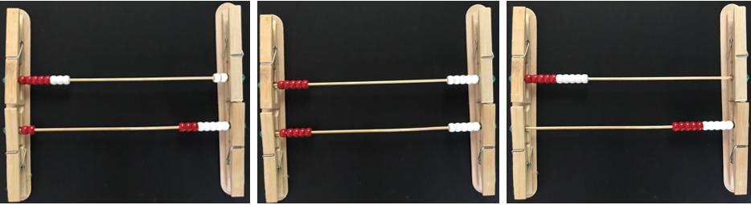
- Discuss why these 2 combinations (pictured on the right) help us to see 10 easily. Explain that this is a useful feature of the rekenrek in helping us represent quantities.
- Ask students if they can represent 11 using beads on only one row or in only one colour. Allow students time to investigate this challenge and discuss why it is not possible. Draw attention to the structure of the rekenrek which uses 10 as a base to build on.
- Ask students to represent 10 using one row or one colour. Discuss what they need to add to 10, to represent 11.
- Count each bead represented in unison from 1 to 11 to reinforce the quantity.
- Ask students to represent 12 and discuss how they added one more to 11 to create 12. Discuss how 12 is 2 more than 10, which can be seen clearly on the rekenrek.
- Show students a model rekenrek displaying 12 and slide one extra bead over to the left. Ask students what quantity is now represented. Discuss that the rekenrek shows clearly that 13 is 10 and 3 more.
- Use the model to slide one more bead across to create 14 and clearly articulate the word fourteen, emphasising the ending syllable ‘teen’. Students repeat the number name.
- Continue moving beads across one at a time and modelling the articulation of each word until you reach 20.
- Count through the sequence of 11 to 20 one more time modelling the quantity on the rekenrek and the number name to be repeated by students throughout the counting sequence.
- Students set up their rekenreks with 10 on one line or in one colour. Ask students to move one bead at a time and count in unison from 11 to 20 as they model each new number in the sequence.
- Circulate amongst students and listen to the articulation of numbers to gather assessment data.
This table details assessment opportunities and differentiation ideas.
Assessment opportunities | Too hard? | Too easy?
What to look for:  - Are students able to say the counting sequence with one-to-one correspondence from 1 to 20? (MAO-WM-01, MAE-RWN-02)  - Are students able to accurately articulate numbers 13 to 19? (MAO-WM-01, MAE-RWN-02)  - Are students able to model quantities on the rekenrek? (MAO-WM-01, MAE-RWN-02)  What to collect:  - observation data. (MAO-WM-01, MAE-RWN-02) | Students are not proficient in accurately saying the counting sequence from 1 to 20.  - Model and practise the counting sequence using a shorter sequence.  - Ask the student to practise sliding one bead at a time and say the number names in unison.  - Work with individual students to develop accurate articulation of numbers 13 to 19, using modelled quantities on the rekenrek.  Students require support to accurately model quantities on the rekenrek.  - Place a small piece of coloured paper underneath the rekenrek on the left side to indicate where the beads are moved to represent a quantity.  - Work with individual students to move smaller quantities of beads to represent a number using a rekenrek. | Students accurately count in sequence and represent quantities 1 to 20 on a rekenrek.  - Ask students to represent a quantity between 11 and 19 in different ways using a rekenrek.  - Ask students to draw a representation of a quantity between 11 and 19.

What’s in the bag? – 15 minutes
- Display a selection of interesting items such as stuffed toys, sports equipment, stationery items and natural materials. Place each item in an opaque bag.
- Ask students to predict if something was pulled out of the bag what might it be. Ask student to turn and talk to share what they think may be the first item pulled from the bag.
- Reach in and select one item. Ask students to put their hand up if their partner predicted that item would be selected first.
- Place that item on a table to display and ask students to predict which item may be pulled out of the bag next. Students turn and talk to share what they think may next be pulled from the bag.
- Ask students if anyone predicted that the item already on the table may be the next thing to be pulled from the bag. Invite student responses and ask students to explain why or why not.
- Pull another item out of the bag and place it on the table. Ask students to put their hand up if their partner predicted that item.
- Continue this activity a few more times. Use questions to provide students with the opportunity to explain their reasoning for predictions based on what they know to be true.

Shake and drop data – 30 minutes
- Place 10 × 2-sided counters in a cup. Shake the counters in the cup and drop them onto a surface. Spread the counters out gently to reveal which colour is facing up for each counter.
- Cover the counters with a sheet of paper and ask students how many of each colour they saw.
- Reveal the counters. Ask a student to use colour to sort the counters into 2 groups.
- Cover the counters with a sheet of paper again and ask students how many of each colour they saw.
- Use Resource 1: Graph grid to arrange the counters into 2 columns and ask students how many of each colour they saw.
- Discuss which arrangement of the counters made it easiest to see how many of each colour there were.
- Collect the counters into the cup again.
- Provide each student with 10 × 2-sided counters. Ask students to use the counters to show their prediction for another round of shake and drop.
- Select a few students to share their predictions with the class.
- Ask students:
- Is it possible for everyone to be correct?
- Is it possible for someone to be correct?
- Is it possible for nobody to be correct?
- Ask students if it is possible for a third colour to drop from the cup. Use student responses to build a shared understanding of the information we know about the counters and how this helps us to predict the future.
- Shake the counters in the cup and drop them on a surface. Arrange counters into the grid with one counter per square to create an object graph of counters by colour. Explain that both columns of counters must start at the same starting point to compare the 2 groups clearly.
- Compare the result with the student models of predictions.
- Provide pairs of students with a cup, and a copy of Resource 1: Graph grid. Pairs of students combine their 2-sided counters in the cup. Ask students to generate an object display for shake and drop. Students take turns shaking, dropping and arranging the counters and photographing the display using a digital device. Students count the 2 columns in the display.
This table details assessment opportunities and differentiation ideas.
Assessment opportunities | Too hard? | Too easy?
What to look for:  - Are students able to use available information to inform a possible prediction? (MAE-DATA-01)  - Are students able to arrange the counters within the grid starting at the same point? (MAE-DATA-01)  - What strategies do students use to count the counters in the columns for each group? (MAE-RWN-01)  What to collect:  - records of student work. (MAE-DATA-01) | Students require support to accurately arrange and count the counters in the grid.  - Model where to begin each row of counters in the grid and how to place one counter per square.  - Ask students to touch each counter as they say the number names to practice one-to-one correspondence.  - Use a collection of 10 counters to complete the shake and drop activity. | Students accurately create and count displays of counters in grids.  - Ask students to record the numeral for each column before photographing the display.  - Ask students what they notice about the markings on the grid and ask if they can use the markings to assist with more efficient counting.

Consolidation and meaningful practice: What can we see about quantities in a grid? – 10 minutes
- Gather students together and select one student’s photograph of an example of a shake and drop display to share with the class. Briefly show the example for 2-3 seconds and ask students which column had more. Discuss how the arrangement in the grid allows us to see information quickly.
- Show the same example and ask students questions, such as:
- How many are in each column?
- Are the quantities the same or different?
- How can we be sure that there are still 20 counters altogether?
- Students look at a photograph of one of their own data displays and compare it with the example shared with the class.
- Ask students:
- Does anyone have the same results as this example?
- How many are in your tallest column?
- Does anyone have the same colour showing the most on their data display?
- Does anyone have the opposite colour showing the most on their data display?
- Did anyone have the same quantity of both colours?
- Did anyone have one colour only?
- Discuss the way the data displays support comparing 2 groups. Explain that data displays make it easy to find out information about a collection when it is arranged in a grid.

Lesson 3: Collections as data
Core concept: Data displays make it easy to compare and quantify groups.
The table below contains suggested learning intentions and success criteria. These are best co-constructed with students.
Learning intentions | Success criteria
Students are learning that:  - quantities from 11 to 19 are composed of one group of 10 and a collection of ones  - arranging objects in a grid ensures quantities are matched with one-to-one comparison  - data displays make information easy to see and compare. | Students can:  - model quantities 13 to 19 using ten-frames  - describe the link between the name of numbers 13 to 19 and the model of the quantity  - arrange objects of varied sizes in a grid  - describe and compare data displayed in a grid.

Daily number sense: Modelling teens – 20 minutes
- Build student understanding of teen numbers by organising and counting a collection.
Note: Providing a variety of different sized ten-frames for students to choose from allows a wider selection of loose items to be organised and counted.
- Explain to students that you are going to drop a collection of loose items onto the ground.
- As you place each item in a ten-frame, ask students to count the items aloud. Pause when the first group of 10 is formed and ask students what they notice. Use student responses to build a shared understanding of the representation of one full ten-frame as one group of 10.
- Use the second ten frame to continue placing each loose part in the frame continuing the count from 10, as shown in Figure 2.
Figure 2 – 14 represented in ten-frames
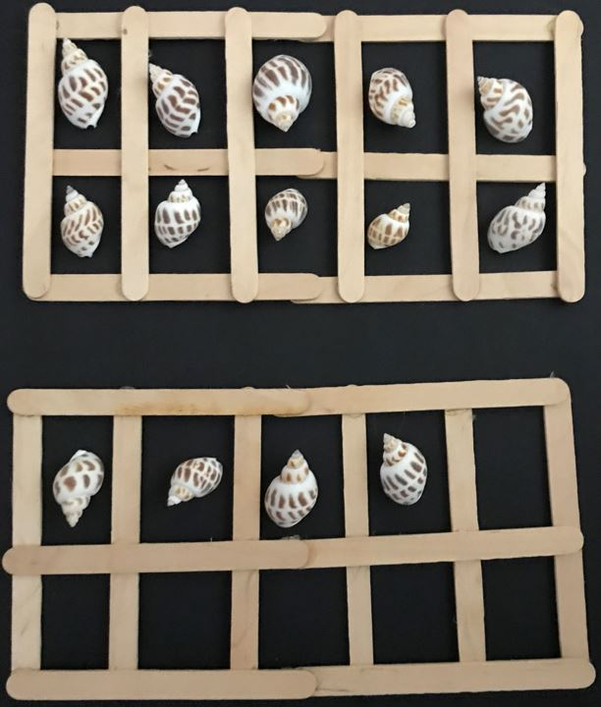
- Say the word fourteen in syllables, representing each syllable with a fist. Focus on the second syllable and carefully articulate this syllable in unison, emphasising the ‘n’ sound on the end.
- Explain that the syllable ‘teen’ at the end of a number comes from the word ten and provides a clue that the quantity has one group of 10 included in the total.
- Ask students if they can spy the ten that is called ‘teen’ in the modelled quantity of 14.
- Ask students if they hear another number word hidden in the word fourteen that can be spotted in the ten-frames. Use the model to explicitly demonstrate the combined quantities of 4 and 10 as 14.
- Provide students with loose items and 2 ten-frames. Say and write the word sixteen and ask students if they can hear any clues in the number name that may help them to model the number in the ten-frames. Ask students to model the quantity 16 with loose items and the ten-frames.
- Observe students as they work to collect assessment data.
- Repeat for the numbers 17, 18 and 19.
- Gather students together and model the quantity 15 in the ten-frames. Ask students:
- How many are represented?
- How did you work that out?
- Can you hear a clue within the word fifteen that can be spotted in this model?
- Point to the collection of 5 in the ten-frame and ask how many are represented. Say the word fifteen in 2 syllables and make the distinction between the syllable ‘fif’ and the word ‘five’.
- Repeat for thirteen, highlighting the distinction between the syllable ‘thir’ and the word ‘three’.
- Explain that there are 2 more quantities that include one group of 10 and an additional small amount which don’t fit the pattern. Model and write the quantities 11 and 12 to explicitly explain that these special numbers are the only 2 numbers in the counting system that break the word pattern.
This table details assessment opportunities and differentiation ideas.
Assessment opportunities | Too hard? | Too easy?
What to look for:  - Are students able to model quantities 11 to 19 using ten-frames? (MAE-RWN-01, MAE-RWN-02, MAO-WM-01)  - Are students able to accurately articulate the number names between 11 and 19? (MAE-RWN-02)  - Are students able to describe the connections between the number names 13 to 19 and groupings of tens and ones? (MAE-RWN-02, MAO-WM-01)  What to collect:  - observation data. (MAO-WM-01, MAE-RWN-01, MAE-RWN-02) | Students need further support to accurately model quantities 13 to 19 in ten-frames.  - Use three-dimensional ten-frames such as a modified ice cube tray to support one-to-one correspondence.  - Count in unison as students place each object in ten-frames.  Students find it difficult to accurately articulate and describe connections with models for numbers 13 to 19.  - Model the articulation of each number by saying each word in unison in syllables followed by the whole word.  - Focus on 14, 16, 17, 18 and 19. Arrange ten-frames with the ones on the left and the tens on the right. Point and say from left to right, for example 4 and 10 more is 14. | Students accurately count the sequence from 11 to 19 and model correctly in ten-frames.  - Ask students to explain and represent how the number 40 is similar and different to 14.  - Use a tool such as a rekenrek to represent numbers 11 to 19 in different ways and describe observations.

Organising a collection into a data display – 45 minutes
Note: For this activity consider using loose items which differ slightly in size and characteristics. Each object in the collection needs to fit in the grid for developing a data display. Consider using natural items, stationery items, craft materials or similar.
- Students work in small groups or pairs. Provide students with a collection of mixed loose items. Ask students to work together to sort the collection.
- Circulate and observe students as they work together to categorise the collection.
- When students have sorted their collections ask students if they can arrange the items to see the groups more clearly.
- Take students on a gallery walk to observe the various ways the sorted collections have been displayed.
- Use student samples to highlight the ways in which data can be helpful or misleading in a visual representation. For example, items lined up end-to-end may be visually compared by length which may not accurately reflect the quantity in each group, and this could be misleading. Alternatively, groups of items that are aligned with the corresponding quantities in other groups are easy to compare.
- Introduce a grid and ask students what they notice about the structure of the grid. Draw attention to the useful ways the structure can support lining up items to compare quantities. Support students to begin at the same starting point to arrange each group of objects next to one another in columns or rows, placing one object in each square.
- Look at the completed grid together and discuss the ease with which the quantities of each group can be seen. Ask students what they notice about the information visible in the display.
- Provide small groups of students with a grid to arrange their collections into a data display. Record student work including observations students make about the data in the display they have created.
This table details assessment opportunities and differentiation ideas.
Assessment opportunities | Too hard? | Too easy?
What to look for:  - What strategies do students use to count and compare the number of objects in each column or row? (MAE-DATA-01, MAE-RWN-01, MAO-WM-01)  - Can students organise objects into simple data displays using a grid? (MAE-DATA-01, MAO-WM-01)  What to collect:  - records of student work (MAE-DATA-01, MAE-RWN-01) | Students need further support to count and compare the number of objects.  - Count in unison using one-to-one correspondence.  - Support visualising how many more by covering the parts of columns or rows that have an equal quantity, so the additional objects are clearly visible.  - Use fingers to point to the objects in 2 columns simultaneously whilst counting aloud to compare matching quantities. | Students confidently create data displays and compare results.  - Ask students to categorise the same objects with a different characteristic and photograph different types of data displays using the same collection.  - Provide students with a blank piece of paper to arrange a data display which accurately represents comparisons.

Lesson 4: The passing of time
Core concept: The duration of time can be measured and compared.
The table below contains suggested learning intentions and success criteria. These are best co-constructed with students.
Learning intentions | Success criteria
Students are learning that:  - the patterns in the counting sequence from zero to 30 support understanding of quantities  - the passing of time can be described  - the passing of time in 2 events can be compared. | Students can:  - accurately count by ones in sequence from zero to 30 with correct articulation of numbers  - describe patterns in a recorded count from zero to 30.

Daily number sense: Choral counting – 15 minutes
This lesson has been adapted from Franke et al. (2018) and Choral Counting by Teacher Education by Design (TEDD).
- Build student understanding of the structure of ‘teen’ numerals by choral counting.
Note: Choral counting activities involve the whole class counting with you as you record the count in a strategic way to support student discussion of emerging patterns in the count. To establish an effective choral counting routine, lead students to count in unison to match the pace of a visible, written record of the count. Students make observations of patterns in the recorded count and these are annotated.
- Write the numeral zero on the chart and ask students what this numeral represents. Use student responses to establish a shared understanding that it signifies nothing. Ask students to represent the quantity zero with fingers.
- Write the numeral one to the right of the zero and ask students what this numeral represents. Use student responses to establish an understanding of the quantity of one. Ask students to represent with fingers the quantity one and reinforce with visual examples in the environment around you. Repeat for quantities 2 and 3.
- Explain to students that you will be continuing to count together at a pace that allows you to write each numeral as it is spoken. Establish a signal which asks students to stop counting and explain that, at times, the count will be paused to discuss thinking.
- Ask students to think quietly in their minds which 3 numbers will follow what has been recorded already. Provide students a short moment to think and indicate with thumbs up when they are ready to count aloud.
- Read through from the beginning and continue counting and recording each numeral as it is spoken in unison, taking a new line to write the numeral 10, as shown in Figure 3.
Figure 3 – Recording of numerals 0-10 for choral count
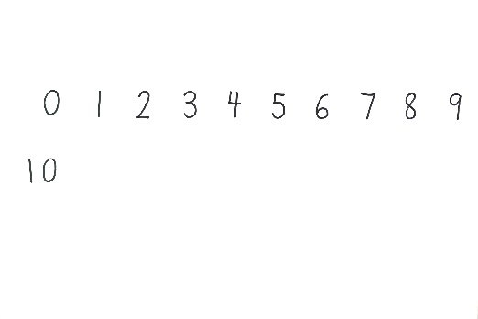
- Signal students to stop at 10. Ask students what they notice.
- Invite students to continue counting in unison and record each numeral as it is spoken. Signal for students to stop at 14. Ask students what they notice. Draw a box in the space for 19 and ask students which numeral will go in this box, as shown in Figure 4.
Figure 4 – Recording of choral count showing prediction marker
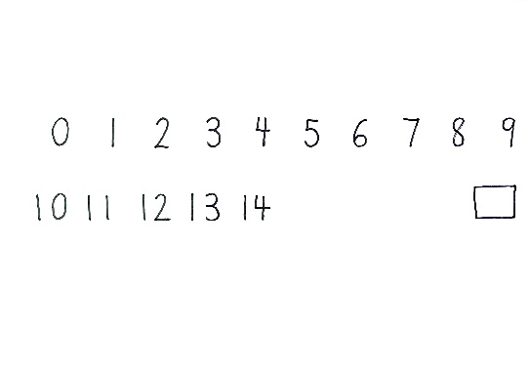
- Use student responses to observe the connections students make with the pattern structure of the count.
- Invite students to continue counting in unison, recording numerals to 30. Signal for students to stop. Draw attention to the 13 and the 30. Sound each word in syllables and draw attention to the second syllable, articulating it carefully and noticing the ‘n’ at the end of ‘thirteen’. Point randomly at each numeral several times as students read each aloud.
- Ask students to describe the quantity each numeral represents.
- Ask students to share what patterns they notice and use coloured markers to mark and annotate student observations on the recorded count, similar to Figure 5.
Figure 5 – Annotated choral count for 0-30
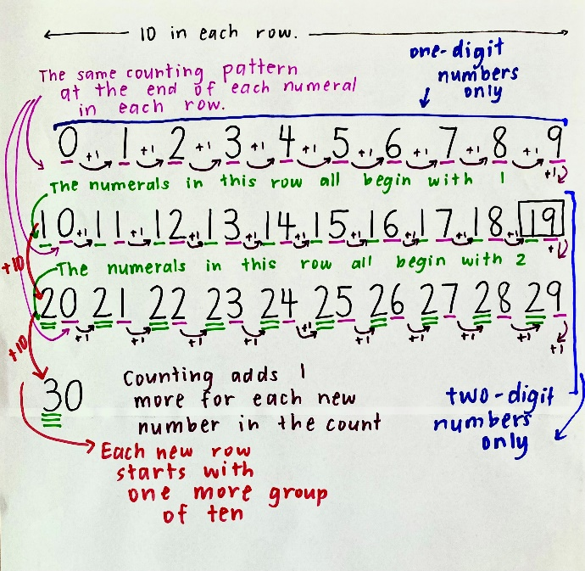
This table details assessment opportunities and differentiation ideas.
Assessment opportunities | Too hard? | Too easy?
What to look for:  - Are students able to count in unison from 0-30? (MAE-RWN-01)  - What patterns do students observe and explain in the structure of the count? (MAO-WM-01, MAE-RWN-01)  - What language do students use to describe the connections they make between numerals and quantities? (MAO-WM-01, MAE-RWN-01)  What to collect:  - recorded and annotated count (MAE-RWN-01, MAO-WM-01)  - observation data. (MAE-RWN-01, MAO-WM-01) | Students require support to accurately count by ones in sequence to 30.  - Ask students to count a shorter sequence.  - Adapt questioning to support thinking skills at an appropriate level, for example, which number will come next.  - Re-read in unison over the sections of the count in which students were not accurately counting in unison. | Students confidently and accurately count to 30 in sequence.  - Ask students to predict a numeral further along in the count and explain their reasoning.  - Select one column of the count and ask students to count from the top of the column, reading down the column beyond the limit of 30.

Timer challenge – 15 minutes
Note: Provide groups of students with one-minute sand timers for investigation. Sand timers can be easily constructed using recycled plastic bottles and sand or salt.
- Gather students together and provide small groups of students with a sand timer. Allow students some time to explore the sand timer.
- Ask students:
- What do you notice?
- What do you wonder?
- What do you think this tool is used for?
- Ask students to set sand timers ready to begin and turn over in unison. Students observe what happens and discuss what they noticed about the time that passed.
- Set up stations with 2 or 3 activities for completion. Activities will need to be carefully selected to demonstrate varying lengths of time passing. Some suggestions could be:
- doing up shoes
- completing a simple puzzle
- building a tower with 20 blocks
- finding an image in a book.
- Students consider each task and record a prediction for each one, indicating whether the task will be shorter, longer or the same as the one-minute sand timer. Ask students to take turns turning the sand-timer over whilst another student begins a new task. All other students observe the sand-timer to see if the task is completed before, after or at the same time as the sand has run through.
- Students record the result. Repeat this process for the next task until all tasks are completed.
- Gather students together to discuss the length of time each task took. Introduce Resource 2: Time talk anchor chart to record the language used to describe time passing.
- Ask students:
- Is it possible to do the tasks more quickly?
- Is it possible to do the tasks more slowly?
- Would the task take the same amount of time if it was repeated?
- Which tasks took the longest or the shortest time to complete?

How long? – 25 minutes
- Discuss the events in the school day and make a list of the events that regularly take place, such as reading a book, sharpening a pencil, eating lunch, assembly and putting bags away. Use Resource: 3 Daily events to model how to create a line drawing of an event in the day and label it.
- Provide students with a copy of Resource: 3 Daily events and ask students to draw an image of an event at school and an event at home. Support students to label each drawing.
Note: Facilitate students to portray and describe events which are a part of their daily lives. This allows students to make meaningful connections about the passing of time through their own experiences.

Consolidation and meaningful practice: Sorting events by duration – 15 minutes
- Gather students together and select a few students to share what they have drawn and describe how long the event takes. Add language to Resource 2: Time talk anchor chart as new words are introduced in the discussion. Introduce the word duration as the umbrella term to describe how long events take.
- Ask students what they have noticed about the similarities and differences between the duration of different events. Use student responses to record the language used to describe differences. Ask students if the differences described could be used as categories for sorting similar events.
- Work together to sort the drawings using the labels describing duration.
- Display the sorted events and ask students what they notice and what they wonder.
Note: The students’ illustrations will be used in subsequent lessons and will need to be collected and stored at the conclusion of this lesson.

This table details assessment opportunities and differentiation ideas.
Assessment opportunities | Too hard? | Too easy?
What to look for:  - What language are students using to describe the passing of time? (MAE-NSM-02, MAO-WM-01)  - Are students able to compare the duration of events? (MAE-NSM-02, MAO-WM-01)  What to collect:  - student work samples (MAE-NSM-02, MAO-WM-01)  - observation data. (MAE-NSM-02, MAO-WM-01) | Students need additional support to represent and describe the duration of a familiar event.  - Annotate student drawing to provide clear information for the intent of the illustration.  - Use shared school events to describe duration using modelled language. | Students describe the duration of events with some accurate language.  - Model comparative language and invite students to describe the duration of several events with comparative language.  - Introduce more complex descriptions of duration such as lengthy, drawn-out or brief.

Lesson 5: Sequencing events
Core concept: Events can be sequenced according to when they take place in time.
The table below contains suggested learning intentions and success criteria. These are best co-constructed with students.
Learning intentions | Success criteria
Students are learning that:  - events can be described with specific language according to when they occur  - the sequence of events can be described with specific language. | Students can:  - describe when an event occurs using time language  - describe when an event occurs in relation to other events.

Daily number sense: Spot the difference – 10 minutes
- Build student understanding of one more and one less up to 10 by increasing and decreasing the quantity of items in an arrangement.
- Use a collection of up to 10 items that are of interest to students in your class. Create a visual barrier between you and the students which can easily be removed and replaced.
- Arrange 4 items in a dice pattern. Reveal the items for 2 to 3 seconds and ask students how many they saw and how they saw them. Show the items again and use student responses to check and look at the different ways students saw the arrangement to subitise.
- Replace the visual barrier and add or remove an item and briefly reveal the arrangement for 2 to 3 seconds. Ask students:
- How many did you see?
- How did you see them?
- How was it different to the previous arrangement?
- Use student responses to identify that the quantity is one more or one less than the previous arrangement.
- Continue this process of changing the arrangement and asking students to identify how many and what changed.

Comparing ‘when’ – 20 minutes
- Sing Heads, Shoulders, Knees and Toes (3:09) with the actions a few times through. Gradually omit one word at a time in each round of the song, replacing it with a hum, whilst continuing with the actions throughout the song. After replacing all body part words with a hum sing the whole song through with all the words for a final sing-along.
Note: Consider teaching this song in an alternative language relevant to your context.
- Ask students how they knew which action came next when the words were omitted. Use student responses to introduce the word ‘sequence’, which describes the order in which events occur. Add this to Resource 2: Time talk anchor chart.
- Review the illustrations of events produced by students in the previous lesson. Discuss the way the events were sorted in the previous lesson, based on differences in the length of time each event took.
- Select 6 illustrations from the collection and work together to sequence the events in order of when they occur. Add words to the anchor chart which describe when events occur.
- Provide students with time to look at the illustrations and ask if there are other differences and similarities they notice about when the events occur. Use student responses to record the language used to describe differences. Identify groups which would be interesting to use as categories to sort the illustrations, such as morning and afternoon, day and night, yesterday, today and tomorrow, or the days of the week.
Note: The days of the week are a time sequence. Build familiarity with this time sequence through daily classroom routines and link regular school events with the sequence of days each week.
- Display the sorted events and ask students what they notice and what they wonder.
- Ask students to select a different set of categories to sort the illustrations in a different way.
- Discuss students’ observations about the sorted events and compare the information with the previous sort.

Sequencing on a timeline – 30 minutes
- Read Hairy Maclary from Donaldson’s Dairy by Lynley Dodd. Cue students to notice the sequence of events that take place during the journey of Hairy Maclary throughout the story.
- Select a page in the story to generate discussion about which event came before, which event will come after, and which will be next after that.
- Provide each student with the illustrations they created in Lesson 4.
- Use a piece of string long enough to peg each illustration created by students for display. Tie the line between 2 tables or chairs to make it taut.
- Discuss the model of a timeline using the string. Walk along the string from left to right to demonstrate the passing of time represented along the line. Describe the ordering of events, showing that the event that happened first begins on the far left of the line, and events that happen after follow along to the right of the line.
- Select 2 students to display one of their images to the class. Lead a discussion with students to ascertain which event would come first and which would be next. Provide students with pegs to attach the illustrations to the line in sequence from left to right and discuss the positioning of these images as before and after according to the sequence in which they occurred.
- Ask students to select one of their illustrations and consider where they would peg it in relation to the 2 images already on the timeline. Select one student to add their illustration to the timeline and ask them to explain why they placed the illustration in that position. Ask students if they agree or disagree with the decision and use ‘Talk moves’ to reason or add-on, consolidating a shared understanding of sequencing events on the timeline.
- Repeat with 2 more students’ illustrations. Use the illustrations in place on the timeline to identify specific points in time. Invite 2 or 3 students at a time to contribute an illustration to each part of the timeline.
- Observe students as they decide where to place their illustration on the timeline and ask students to explain reasoning to gather further assessment data about student understanding of sequencing events.
This table details assessment opportunities and differentiation ideas.
Assessment opportunities | Too hard? | Too easy?
What to look for:  - What language are students using to describe when events occur? (MAE-NSM-02, MAO-WM-01)  - Are students able to describe and order events using the language of time? (MAE-NSM-02, MAO-WM-01)  What to collect:  - observation data. (MAE-NSM-02, MAO-WM-01) | Students require further support in developing vocabulary to accurately describe when events occur.  - Use digital images for concepts such as day and night, linked with students’ illustrations of daily events, to support understanding of when events occur.  - Act out key daily events such as sleeping, waking up in the morning and playing with friends at school and link with the language of time occurrence.  Students require further support to accurately sequence events.  - Ask students to describe 2 familiar events using the language before, after or next.  - Provide students with images of the steps in a familiar task and ask them to sequence the steps in order. | Students readily use the language of time to order events.  - Ask students to order a selection of events based on a longer period of time, such as last week, this week and next week.  - Introduce more complex descriptions comparing when events occur, such as later, earlier and soon after.

Lesson 6: Playing with analog clocks
Core concept: The hour hand on an analog clock indicates the hour.
The table below contains suggested learning intentions and success criteria. These are best co-constructed with students.
Learning intentions | Success criteria
Students are learning that:  - an analog clock has a circular structure  - numbers 1 to 12 are positioned around the outside of an analog clock  - the hour hand points directly to the hour to indicate hour time. | Students can:  - arrange numbers 1 to 12 in order around a circle with equal spacing to model an analog clock  - identify the number the hour hand is pointing to  - identify that the hour hand points directly at a number to show hour time.

Daily number sense: Reading and ordering numerals – 15 minutes
- Build student understanding of the counting sequence zero to 20 by reading and ordering numbers on a line.
- Use a piece of string long enough to peg all numerals in Resource 4: Numeral cards. Tie the line between 2 tables or chairs to make it taut.
- Display numeral cards zero to 5. Use counters to show an irregular dot pattern of 3. Select students to come and choose the card which matches the quantity on display. Ask the class if they agree that it is the numeral that matches the quantity represented and use ‘Talk moves’ to clarify understanding. Invite students to read the quantity on the card and air write the numeral in the air.
- Ask a student to peg the numeral on the line. Repeat for the quantity 4 and discuss whether 4 is more or less than 3. Review the structure of a line as a way of ordering a sequence. Count from zero to 4 to reinforce that 4 comes after 3. Demonstrate that 4 would be pegged to the right of the 3 as it comes after the 3 in the counting sequence.
- Repeat for the quantity 2, demonstrating that 2 would be pegged to the left of 3 as it comes before 3 in the counting sequence.
- Select students to place one, zero and 5 in the counting sequence, using ‘Talk moves’ to provide opportunities for reasoning and adding on.
- Ask students to count the sequence displayed as you point to each numeral and continue to peg numerals on for 6 and 7.
- Signal for students to pause and hold up numerals 8 and 9. Ask students which numeral comes next. Ask students to indicate with a thumbs-up sign on their left or right to match the numeral they think should come next. Ask students to explain their thinking and provide opportunities to reason. Use student responses to select 8, then 9 to peg in order.
- Students count from zero as you point to each numeral and peg 10 on the line as they read it. Ask students what they notice is similar and different for this numeral, compared with all the other numerals in the sequence so far. Use student responses to support understanding of the two-digit structure of the numeral 10.
- Continue to peg numerals 11, 12, 13, 14 and 15 as students continue to count the sequence. Display the numerals 16, 17, 18 and 19 in a random order. Ask students to turn and talk to discuss what they notice about the numerals remaining and which order they may come in. Select a few students to share ideas with the class. Provide opportunities for students to select the next card to peg onto the line. Ask students to share their reasoning for each selection.
- Peg 20 on the end of the line and ask students what they notice about this numeral. Use student responses to make connections with the structure of numerals.
- Read through all the numerals from zero to 20 in unison. Point at random numerals in the sequence to read in isolation and read through the numerals in order from left to right a second time.

Teddy bear says – 5 minutes
- Display a teddy bear and explain that you will point to different body parts of the teddy bear. Students place their hands on the matching part of their bodies. Students stand up and play the game as you point to the teddy bear.
- Repeat the game using a stick as a pointer to indicate the body parts to place their hands on.
- Explain that the hand and the stick do a similar job by directing our attention to a specific point.

Bending the numbers – 15 minutes
Note: In preparation for this lesson, create 12 tabs with folded pieces of masking tape, evenly spaced along a length of sturdy, flexible cord such as net curtain wire or garden trimmer nylon cord. Use a marker to write numerals 1 to 12 on tabs, ensuring the numeral is written on both sides of each tab, as shown in Figure 6.
- Display the number line cord as a straight line, as shown in Figure 6.
Figure 6 – Both sides of a flexible number line with number tabs
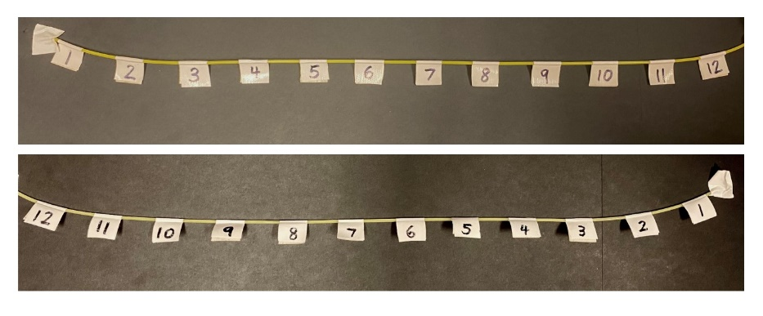
The table below outlines stimulus prompts to generate conversation about the topic, along with anticipated responses from students.
Prompts | Anticipated student responses
- What do you notice?  - What are you wondering? | - The line displays each number from 1 to 12.  - The numbers are spaced the same distance apart along the line.  - Zero is not displayed at the beginning of the line.  - The far left is the beginning of the line and the far right is the end of the line.  - One is near the beginning and 12 is at the end.  - The line is bendy.  - I wonder why zero is not included?  - I wonder why the numbers stop at 12?
Note: A pointer such as an ice-cream stick should be used to point to places along the line. The pointer helps students make links with the hand on a clock. The hour hand on the clock points to the exact numeral to indicate hour time.
- Point to random numbers along the line as shown in Figure 7.
Figure 7 – Pointer indicating the number 8
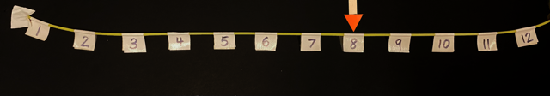
- Ask students to read the numbers aloud as the pointer is placed on each new number.
- Point to a number and ask students which number comes before and after.
- Point to a space just before or after a number on the line.
- Ask students:
- Is the pointer pointing to a number?
- Which number is it near?
- Which number comes before the pointer?
- Which number comes after the pointer?
- Point to each number as students count in unison from 1 to 12. Repeat a couple of times.
- Explain to students that this number line is special because it can do a trick. Bend the number line into a circle and flip it over so that the numbers are in a clockwise order to represent a clockface, as shown in Figure 8.
Figure 8 – Flexible number line representing an analog clock
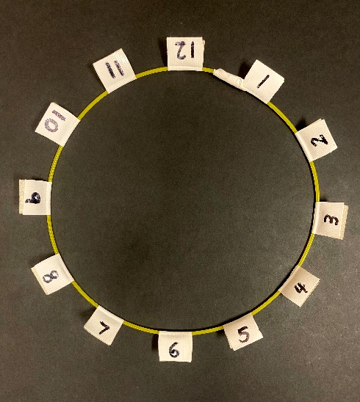
The table below outlines stimulus prompts to generate conversation about the topic, along with anticipated responses from students.
Prompts | Anticipated student responses
- What do you notice?  - What are you wondering? | - The line is now a round shape.  - The line never ends because it is a circle.  - One is the lowest number and 12 is the highest number.  - It looks like a clock.  - Some numbers are upside down.  - I wonder why zero is not included.  - I wonder why the numbers stop at 12.
Note: After discussing observations of the circular clock formation using the number line, transfer to an image of a clock with a removable hour hand for the continuation of the lesson. This ensures the numerals can be read clearly.
- Place the pointer so that the end sits at the centre of the circle, and it points directly at one. Ask students to count in unison as the pointer points to each number going around the circle from 1 to 12. Continue to count around the circle a second time without pausing.
- Pause and ask students if they have noticed a similar structure in the environment around them. Use student responses to make connections with a display of an analog clock. Explain that they have made a model of a clock using a number line and a pointer. The name we give to a pointer on an analog clock is a hand.
Note: Students may notice that a clock has 2 or 3 hands pointing to numbers. Use this opportunity to explain that the pointer you are using represents the hour hand which is the shortest hand on an analog clock.
- Ask students if it might work to point the hand at a different starting point and start the count from there. Point the hand at number 4 and move the hand around the circle in a clockwise direction saying each number in unison.
- Move the hand to point at random numbers around the circle. Ask students to call out which number the hand is pointing to.
- Move the hand to point at spaces between numbers. Ask students to describe whether the hand is pointing at a number or near a number. Use the counting sequence going clockwise around the clock to establish the numbers before or after the position that the hand is pointing to.

Make a plate clock – 25 minutes
- Provide each student with a paper plate with a dot drawn in the centre and Resource 5: Clock numerals.
- Ask students what connections they can make between the items they have and the displayed clock. Use student responses to suggest that an analog clock can be made by arranging numbers 1 to 12 in a circle.
- Reference the top and bottom of the clock to guide students in placing 12 and 6 on their plates.
- Use the analog clock on display and draw students’ attention to the numbers on the far left and right of the clock. Ask students to select and match numbers 3 and 9 to place on the far left and right sides of the plate.
- Ask students what they notice as they compare their plate models with the clock on display. Use student responses to establish the positioning and sequence of the remaining numbers. Students arrange the remaining numbers on their clocks.
- Circulate amongst students as they work, to observe the way in which students attend to the structure of the clock, discuss the way they create the model, and sequence and position the numbers. Record assessment data with photographs, video or notes.
- Provide each student with a short ice-cream stick and ask students to position it as the hour hand on a clock, lining up the end with the dot in the centre of the plate.
- Review the position of the hour hand to point directly at a number. Ask students to move the hour hand to point to a variety of random numbers.
- Observe students to collect assessment data.
- Students glue numbers onto the rim of the paper plate, once numbers are accurately in place as shown in Figure 9.
Figure 9 – Paper plate clock with hour hand
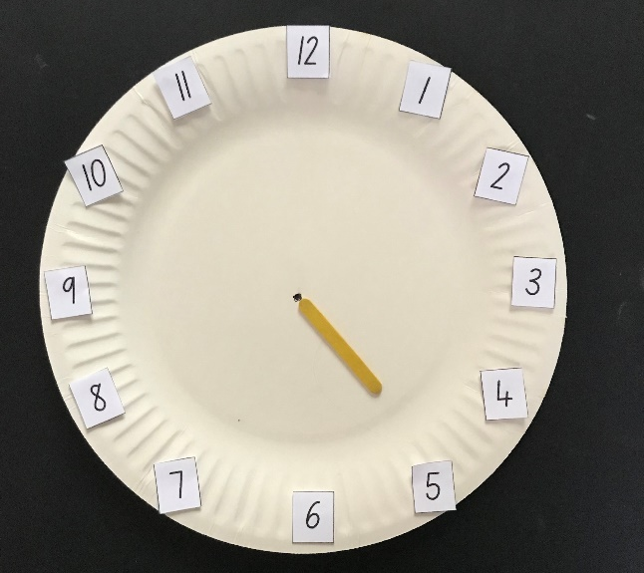
This table details assessment opportunities and differentiation ideas.
Assessment opportunities | Too hard? | Too easy?
What to look for:  - Can students accurately create a model of an analog clock with correct ordering and spacing of numbers? (MAO-WM-01, MAE-NSM-01)  - Are students able to use the hour hand to accurately point at a number? (MAO-WM-01, MAE-NSM-01)  What to collect:  - students' models of clocks (MAO-WM-01, MAE-NSM-01)  - observation data. (MAO-WM-01, MAE-NSM-01) | Students require further support to accurately create a model of an analog clock and position the hour hand to indicate o’clock.  - Lay out the numbers in order from 1-12 to support students to identify each number.  - Place a mark on the paper plate to indicate spacing for each number.  - Model how to directly point the hour hand at a number and ask students to mimic the same action.  - Glue a triangle on the end of the hour hand to create a defined point. | Students competently create a model of an analog clock and accurately position the hour hand.  - Cover number 1 on the model clock and ask students to use the hour hand to point at the position for 1.  - Cover 1 and 2 on the model clock and ask students to use the hour hand to point at the position for 2.

Lesson 7: Clock connections
Core concept: Hour time can be read on analog and digital clocks.
The table below contains suggested learning intentions and success criteria. These are best co-constructed with students.
Learning intentions | Success criteria
Students are learning that:  - hour time can be represented on an analog clock and on a digital clock  - the hour hand points directly to the hour to indicate hour on the analog clock  - the minute hand points to 12 to indicate hour time on an analog clock  - hour time on the digital clock begins with the hour followed by a colon and 2 zeros and is read from left to right. | Students can:  - read hour time on analog and digital clocks  - describe the position of the minute and hour hands for hour time on analog clocks  - describe the position of the numbers which represent hour time on digital clocks  - sort clocks representing different hour times to match similar types of clocks or representations of time.

Daily number sense: Reading and reordering numerals – 15 minutes
- Build student understanding of the counting sequence zero to 20 by ordering numbers on a line.
- Begin the lesson with a piece of string tied between 2 tables or chairs to make it taut. Peg the numerals zero to 20 from Resource 4: Numeral cards along the line from left to right, omitting 4 random numerals from the sequence and leaving a space in those positions. Tie a second length of string below the first line to create 2 parallel lines.
- Ask students to turn and talk to discuss which numerals are missing from the sequence. Invite students to share their thinking. Use ‘Talk moves’ to facilitate a discussion. Use shared reasoning to peg the missing numerals in place. Check the accuracy of the sequenced numbers by reading the numbers in unison from the beginning.
Note: The focus of this activity is on the connections between the structure of the numerals. It would be beneficial to support student understanding further by using a visual representation, such as a rekenrek or ten-frames.
- Draw students’ attention to the line underneath the top line. Explain that you have noticed a connection between 2 numbers and you are going to move a card to show the connection. Peg numeral 14 directly underneath numeral 4.
- Ask students what they notice about the connection between 4 and 14. Use student responses to support a shared understanding of 14 as one group of 10 represented by the 1 and 4 more represented by the 4. Name the 2 numerals 4 and 14.
- Peg the numeral 10 directly underneath the numeral zero.
- Ask students:
- What do you notice?
- What do you wonder?
- Use student responses to establish a clear shared understanding of the meaning of zero in each of these numbers. Read each number.
- Ask students if they notice another set of numerals that have a similar connection. Select a student to describe a connection and move the two-digit numeral underneath the one-digit numeral explaining their reasoning.
- Continue this process until all numerals 10 to 19 are lined up underneath the one-digit numerals.
- Select 20 from the line and ask students where they see a connection for this numeral. Use student responses to elicit understanding of patterns in structuring the count in this way. Hold the numeral 20 underneath zero and 10 to demonstrate that a third line could begin and continue the pattern for arranging the count.
- Point to each numeral and ask students to read in unison from zero to 20.

O’clock on analog clocks – 15 minutes
Note: This activity requires a functional analog clock. A knob to move the mechanism, which moves the minute and hour hands in unison, is required to show that the minute hand moves the hour hand from one number to the next.
- Display a functional analog clock. Draw students’ attention to the sequence of numbers on the face of the clock. Count from 1 to 12 in unison around the clock a couple of times to reinforce the continual count in the circular structure of a clock.
- Use the mechanism on the back of the analog clock to turn the hands of the clock clockwise so that the minute hand rotates through several hours. Pause and ask students the following questions.
The table below outlines stimulus prompts to generate conversation about the topic, along with anticipated responses from students.
Prompts | Anticipated student responses
- What did you notice about the hands on the clock?  - What did you wonder? | - I noticed there are 2 hands on this clock.  - One hand is longer than the other.  - I noticed them moving around the clock.  - The hands moved past the numbers in order from 1 to 12.  - The longer hand moved faster than the shorter hand.  - The shorter hand moved from one number to the next after the longer hand had gone all the way around from 12 and back again.  - The shorter hand only points directly at a number when the longer hand is pointing at the 12.
- Use student responses to guide a shared understanding of the position of the hands when hour time is indicated. Explain that the shorter hand is called the hour hand and the longer hand is called the minute hand.
- Explain to students that when the minute hand points to 12 and the hour hand points to a number, it is read as o’clock. Model 3 o’clock to demonstrate an example. Model further examples of o’clock for different hours and ask students to read the time as o’clock.
Note: Use regular opportunities throughout the year to read hour time on a classroom clock to provide regular reinforcement of this skill.

Consolidation and meaningful practice: Modelling hour time – 15 minutes
- Provide students with the model analog clocks made in the previous lesson. Provide each student with a short ice-cream stick and a long ice-cream stick to use as hour and minute hands.
- Ask students to position the long ice-cream stick in the position for hour time. Explain that the minute hand always points to 12 to indicate hour time, which is read as o’clock.
- Review the moving position of the short ice-cream stick as it functions as the hour hand. Model the hour hand moving to show a few examples of hour time and read each time as __ o’clock and ask students to copy.
- Call it out 2 or 3 further examples of hour time for students to model on their clocks by moving the hour hand.
- Circulate amongst the students and observe student work and record assessment data.
- Play a modified game of ‘What’s the time Mr Wolf?’ Select a student to be the wolf and say the hour times. Students call and respond:
Students: What’s the time Mr Wolf?
Wolf: __ o’clock.
- Students model o’clock times on their model clocks and place their hands on their shoulders as soon as they have modelled the correct time. When the student playing the wolf calls ‘Dinnertime’ all students stand up and rub their stomachs. The student playing the wolf selects the next wolf.
This table details assessment opportunities and differentiation ideas.
Assessment opportunities | Too hard? | Too easy?
What to look for:  - Are students able to represent and read hour time on an analog clock? (MAE-NSM-02)  - How do students describe the position of the hour hand and minute hand for hour time? (MAE-NSM-02, MAO-WM-01)  What to collect:  - observations of students reading and representing hour time on an analog clock. (MAE-NSM-02) | Students need further support reading and representing hour time on an analog clock.  - Use sticky putty to secure the minute hand in place allowing the student to move only the hour hand.  - Use examples which allow students to model hour time using numerals that they can independently read.  - Hold up a numeral card indicating a numeral 1 to 12. Say the numeral and ask the student to point the hour hand at the matching numeral and name the time represented. | Students readily read and represent hour time on an analog clock.  - Students work in pairs and take turns to say an hour time, which their partner makes on their model clock before swapping roles.  - Ask students to model the hour before or after a given hour time.

Hour time on digital clocks – 10 minutes
- Gather students together. Hold up a digital display of time on something such as a digital device. Explain that this representation of time is another way they can read time and it is called digital time. Ask students to share places they may have noticed time represented in this way.
- Show Resource 6: Digital clocks. Ask students what they notice and use student responses to point out key features of the digital representation of time.
- Model reading one example of hour time on a digital clock. Point out the hour at the beginning and the 2 zeros following the colon which represent hour time. Model the same time on the analog clock and explain that both times represent the same time.
- Show 2 further examples of hour time on a digital clock and ask students to read the time.
- Display the remaining 3 examples from Resource 6: Digital clocks. Model one matching example on the analog clock and ask students to identify which digital clock matches the time represented on the analog clock.
- Repeat for another example and read the final example all together.

Sorting and matching clocks – 15 minutes
- Show students images of analog and digital representations of time in different environments using Resource 7: Hour time. Name each image as analog or digital representations of hour time.
Note: Students may need explicit explanation of the word watch to understand that it is a noun describing a type of clock that people wear.
- Select 6 images of clocks from Resource 7: Hour time, including some analog and digital clocks and at least 2 clocks displaying matching times. Display the selection of images and ask students what they notice is the same or different amongst the images.
- Use student responses to explore different ways of sorting the images, such as matching representations of time or analog and digital representations of time.
- Students work in small groups. Provide each small group with a set of Resource 7: Hour time. Students work together to negotiate ways to sort the images.
- Circulate amongst students and observe the way they sort images. Select digital images of time from the collection and ask students to read the time represented. Record assessment data for each student.
This table details assessment opportunities and differentiation ideas.
Assessment opportunities | Too hard? | Too easy?
What to look for:  - Are students able to read hour time on a digital clock? (MAE-NSM-02)  - How do students sort the images of hour time represented on different types of clocks? (MAE-NSM-02, MAE-DATA-01)  - What language are students using to read time? (MAE-NSM-02, MAO-WM-01)  What to collect:  - observation data. (MAE-NSM-02, MAE-DATA-01, MAO-WM-01) | Students need further support reading a digital clock and matching digital time to analog time.  - Use examples which allow students to read familiar numerals.  - Say the numeral first and ask the student to repeat and point to the numeral before saying ‘o’clock’ as you point to the double zero that follows.  - Select fewer examples of clock images to sort and compare. | Students readily read a digital clock and match digital time to analog time.  - Students work in pairs and take turns to say an hour time which their partner makes on their model clock before swapping roles.  - Ask students to model the hour before or after a given hour time.

Lesson 8: Invisible data made visible
Core concept: Information can be collected, represented and interpreted in a data display.
The table below contains suggested learning intentions and success criteria. These are best co-constructed with students.
Learning intentions | Success criteria
Students are learning that:  - people's opinions and feelings are a type of information that can be collected  - the way questions are posed can help to find out the information they are looking for  - data displays help reveal interesting information about a problem  - interpreting information from a data display helps us answer questions. | Students can:  - respond to questions about opinions and feelings  - pose a question that helps find out useful information to investigate a problem  - arrange images in rows and columns to create a clear data display  - interpret information from a data display to answer questions.

Daily number sense: Teacher identified activity – 10 minutes
- From a class need surfaced through formative assessment data, identify a short, focused activity that targets students’ knowledge, understanding and skills. Example activities may be drawn from the following resources.
- Thinking Mathematically Early Stage 1
- Universal Resources Hub.

Different feelings – 10 minutes
- Begin by asking children if they have a favourite piece of play equipment they like to play on in a playground or park. Accept all student responses and suggest that there also may be some students who don’t enjoy any of the play equipment at a playground or park.
- Read the picture book Brave Mouse by Michaela Morgan. At the end of the story show students the illustration of the playground and discuss the different feelings each character had about their preferences for play equipment.
- Explain that people have different opinions and feelings about many different topics which makes us all unique. Sometimes people have the same opinions and feelings about a topic and sometimes they have a different opinion or feeling about a topic, and this can be interesting to investigate as mathematicians.

Would you rather? – 15 minutes
Note: Consider the accessibility requirements of the students in your class and adapt the physical movements required for these activities to include everyone.
- Select a space where students can safely move to 2 distinct places opposite one another, in response to questions asked.
- Ask students age-appropriate, engaging questions which elicit a response and indicate with your hands which direction students should move to show their preference. Some suggestions could be:
- Would you rather play with your toys or ride your bike?
- Would you rather eat a plate of spaghetti or a bowl of chocolates?
- Would you rather be able to slide down a rainbow or jump on the clouds?
- Discuss the different opinions and feelings held by students in the class. Explain that people’s opinions and feelings are a type of information that can be collected and sorted.
- Ask students to find their own space and remain still. Explain that you will ask a question that requires a yes or no response. Students will respond to indicate yes with hands on heads and no with hands on hips. Ask students questions that elicit a yes or no response such as:
- Do you like Vegemite?
- Do you have a pet?
- Have you seen a koala in real life?
- Ask students to be seated and repeat this activity but ask students to indicate yes with thumbs up and no with thumbs down. Select questions that are personally relevant to students in your context.
- Ask students if there were questions in which yes or no did not completely represent their accurate opinion. For example, if you asked someone if they like eating, their response may depend on what the food is and whether they are hungry. Discuss ways that hand gestures could be used to indicate a neutral answer or mixed opinion.
- Introduce additional hand signals and ask further questions for students to respond to, using an agreed range of hand signals to indicate opinions.

Emoji expressions – 25 minutes
Note: The scenario for this activity should ideally be centred around an authentic problem, which is engaging and relevant to the students in your context. The scenario should ideally elicit a range of different responses to find out information to better understand a problem. The information collected may provide possible solutions to the problem or open possibilities for further questions to investigate. The imagined scenario described below is an alternative that could be used.
- Create a scenario in which the school principal would like to know how to spend money to improve the playground at school. The principal would like to know if a giant slide would be something students enjoy.
- Ask students what question would help the principal to find out if the slide would be a good addition to the playground. Students turn and talk to discuss ideas. Circulate amongst students to listen to the questions they pose and record observations for assessment data.
- Ask students to share responses. Use student responses to generate a question which allows students to collect a range of opinions about how students feel about a giant slide.
- Show students emoji images from Resource 8: Emojis, one at a time. Ask students what feelings each emoji communicates. Use student responses to label each face with words that describe emotions, providing further language to support students’ vocabulary development.
- Provide each student with a copy of Resource 8: Emojis and prepare a space such as a whiteboard to display students’ responses.
- Students select the emoji that represents how they feel about the question.
- Students cut out the image that best represents their response. Ask students to place it anywhere on the group display using sticky putty.
- Ask students to look at all the emoji images representing students’ responses and suggest ways they could be sorted. Select students to sort the images into groups and arrange the images in rows and columns to allow quantities to be easily seen and compared.
Note: A grid may help support the clear alignment of images if students have cut out their own images.
This table details assessment opportunities and differentiation ideas.
Assessment opportunities | Too hard? | Too easy?
What to look for:  - Are students able to pose a useful question to collect relevant information to understand a problem? (MAE-DATA-01, MAO-WM-01)  - How do students arrange images to form a data display? (MAE-DATA-01, MAO-WM-01)  What to collect:  - observation data. (MAE-DATA-01, MAO-WM-01) | Students require further support to pose questions which would help investigate a problem.  - Scaffold key vocabulary around the problem to support understanding.  - Use a sentence stem to support posing of a question.  Students require support in sorting and clearly arranging images in columns and rows for a data display.  - Reduce the number of images to compare when sorting.  - Point out specific features of emoji faces for direct comparison to support sorting.  - Use a grid to support clear alignment of images in rows and columns. | Students readily pose questions to investigate a problem.  - Use student responses and refine the wording for precise meaning.  - Ask students who else would need to be consulted to collect information and what they should be asked.  Students readily sort and clearly arrange images for data display.  - Ask students how the emoji images that are not selected by any students can be included and represented accurately in a data display.  - Ask students to re-arrange the data to clearly display the information in a different way, such as quantities in ascending or descending order.

Consolidation and meaningful practice: Data faces – 10 minutes
- Ask students which group represents the least number of responses. Cover the quantity with a piece of card and asks students how many there were in the group. Use ‘Talk moves’ to allow students to explain how they instantly knew what the quantity was and explain how they saw the arrangement.
- Use the data display to guide a shared investigation comparing quantities, identifying how many more in one group than another, and the total quantity for each group and combinations of groups.
- Ask students what the data display says about the opinions of the class. Use student responses to make connections with the data display and the information it provides in helping us to solve the problem.
- Ask students further questions, for example:
- Are most of the students positive or negative about the giant slide?
- What information does this data display give us about how long the slide should be?
- Does the data display give us information about what the slide should be made from?
- Ask students if the data display answers all their questions and has it made them wonder about new questions that they would like to investigate further.
This table details assessment opportunities and differentiation ideas.
Assessment opportunities | Too hard? | Too easy?
What to look for:  - Are students able to quantify how many in each group? (MAE-RWN-01, MAO-WM-01)  - Are students able to answer questions about quantities in the data display by comparing and combining groups? (MAE-CSQ-01, MAO-WM-01)  - How do students interpret the information in the data display to answer questions? (MAE-DATA-01, MAO-WM-01)  What to collect:  - observation data. (MAO-WM-01, MAE-DATA-01) | Students require support in quantifying, combining and/or comparing amounts.  - Ask students to point at each image and count in unison to model one-to-one correspondence.  - Ask students to mark on the data display the point between 2 groups that shows the same amount and count the additional images beyond the mark to compare quantities.  Students require support in interpreting information in the data display to answer questions.  - Reduce the amount of data by covering with a piece of card and focus on one or 2 sets of information at a time.  - Use guiding questions to elicit specific information available in the data display to make connections with the problem. | Students easily quantify, combine and/or compare amounts.  - Ask students to combine all groups and compare with the number of students who responded.  - Ask students to compare 2 quantities where the visual representation is separated by other groups.  Students readily interpret information in the data display to answer questions.  - Ask students to provide reasons for the ideas they suggest are displayed in the data.  - Ask students if the data presented in the display has led to further questions to ask and list these questions.

Resource 1: Graph grid
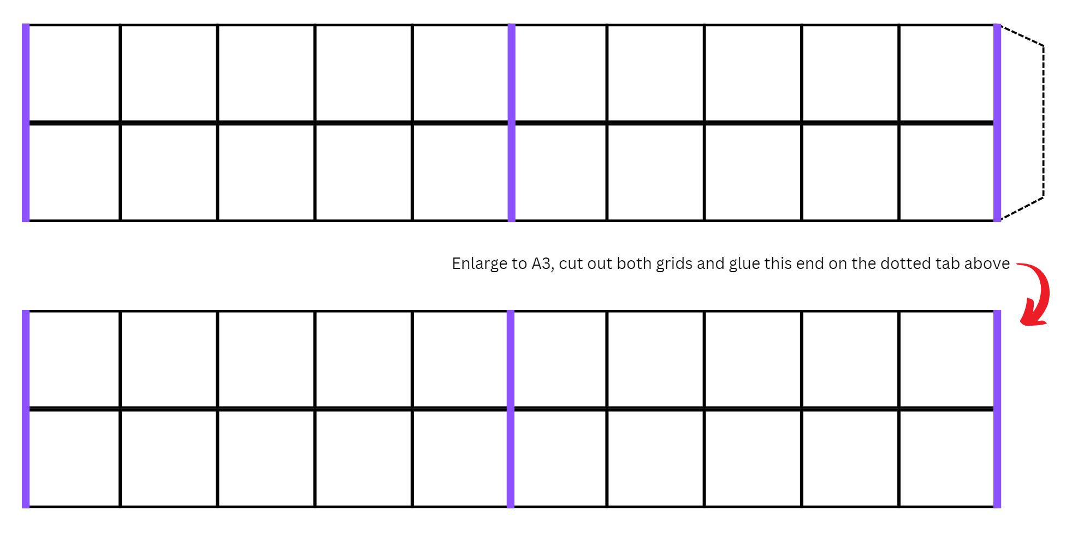
Images sourced from Canva and used in accordance with the Canva Content License Agreement.

Resource 2: Time talk
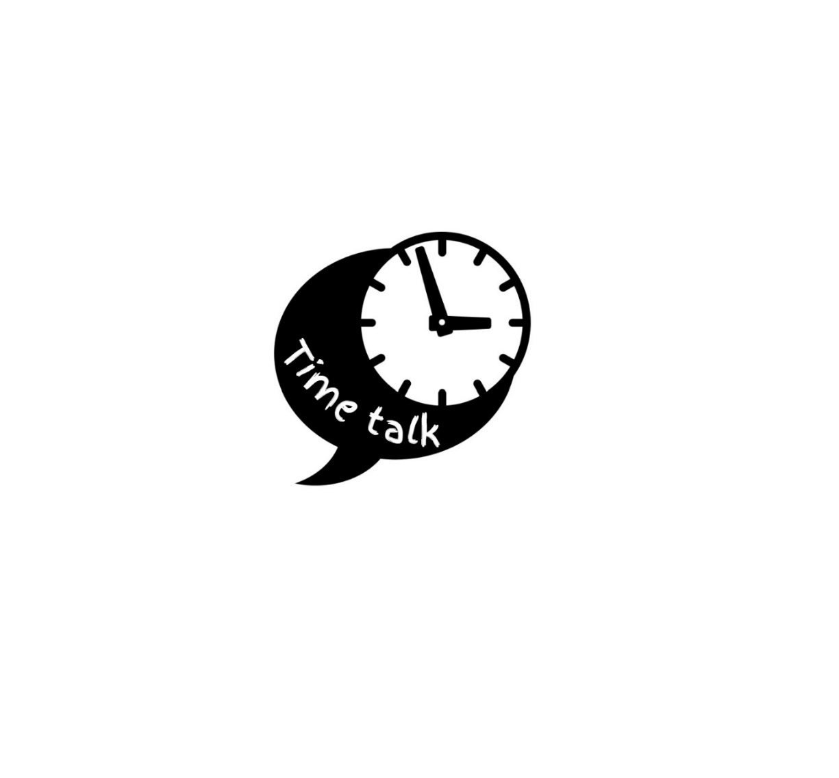
Images sourced from Canva and used in accordance with the Canva Content License Agreement.

Resource 3: Daily events
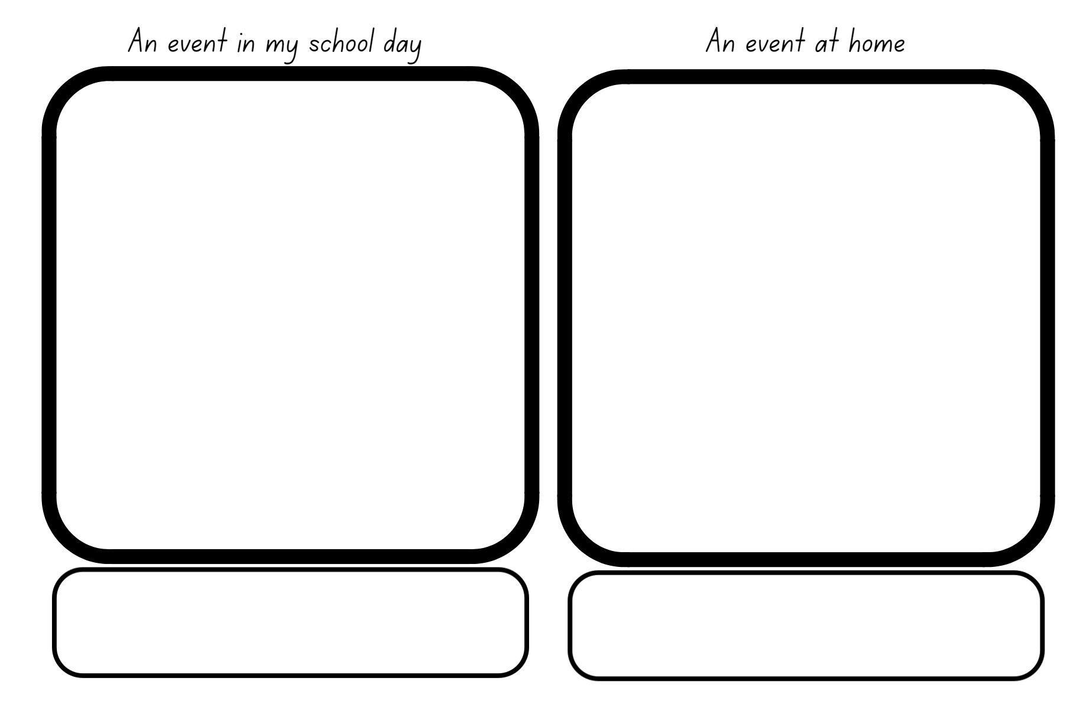

Resource 4: Numeral cards
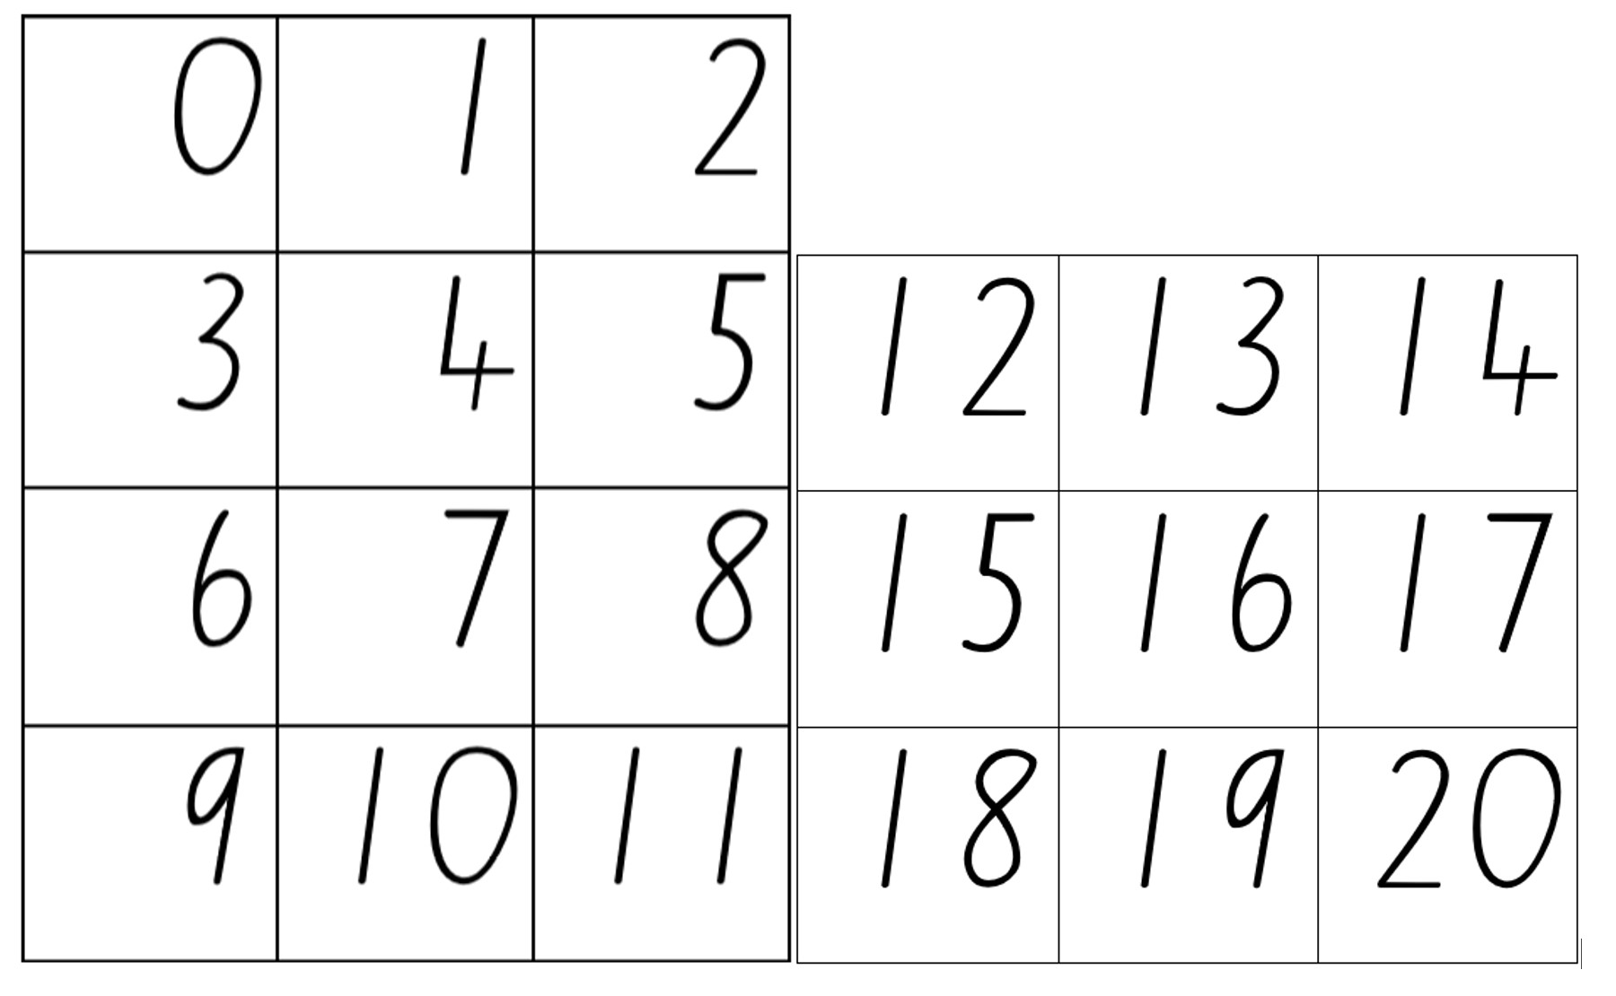

Resource 5: Clock numerals
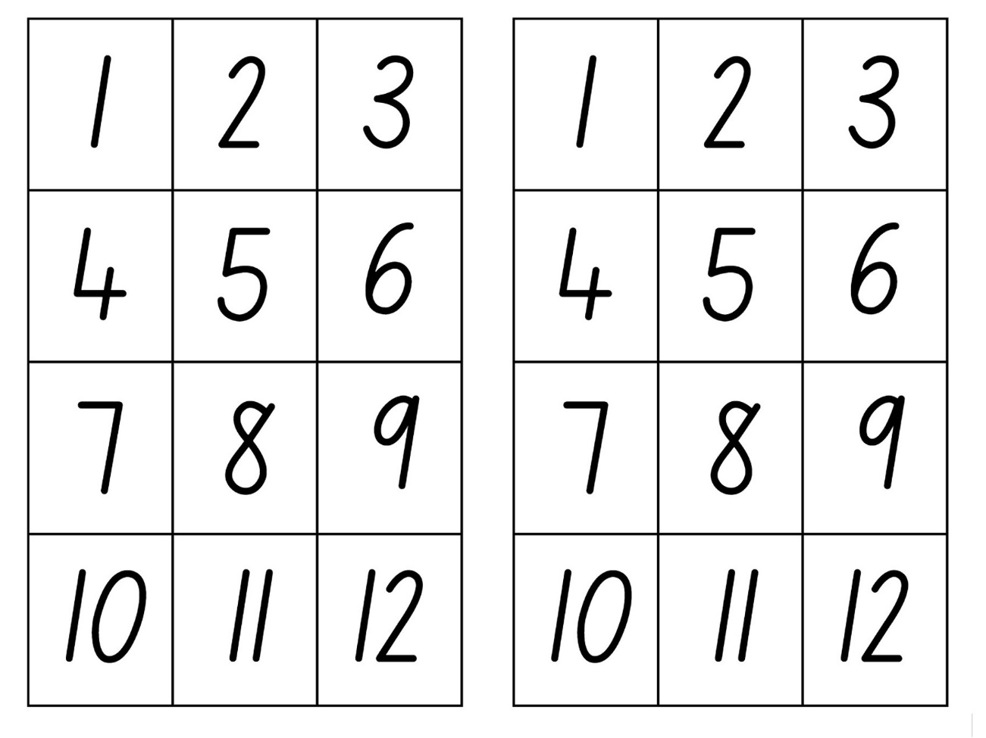

Resource 6: Digital clocks
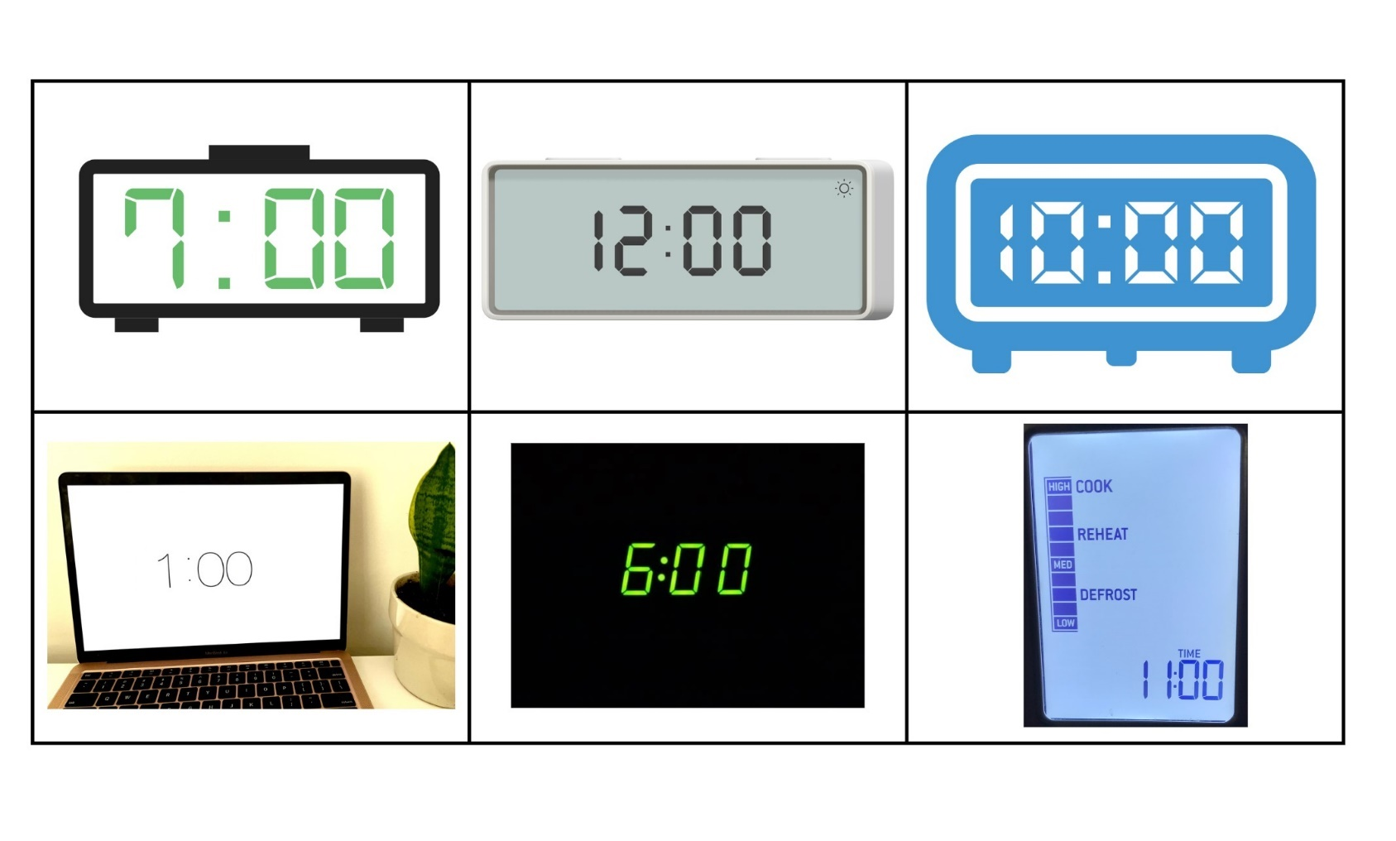
Images sourced from Canva and used in accordance with the Canva Content License Agreement.

Resource 7: Hour time
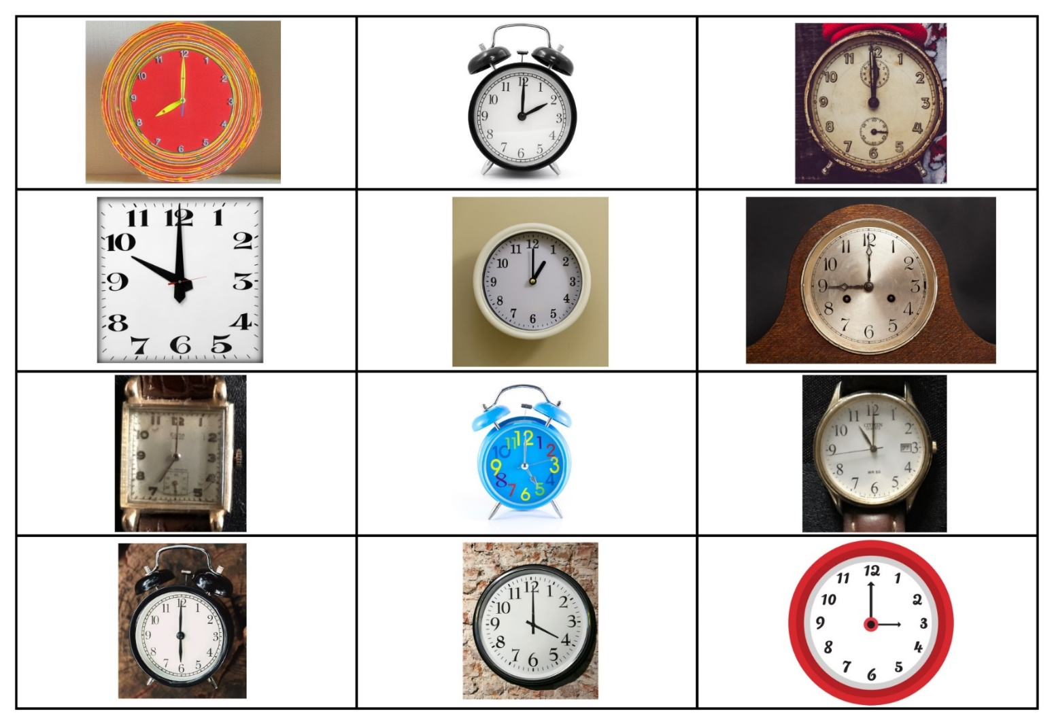
Images sourced from Canva and used in accordance with the Canva Content License Agreement.
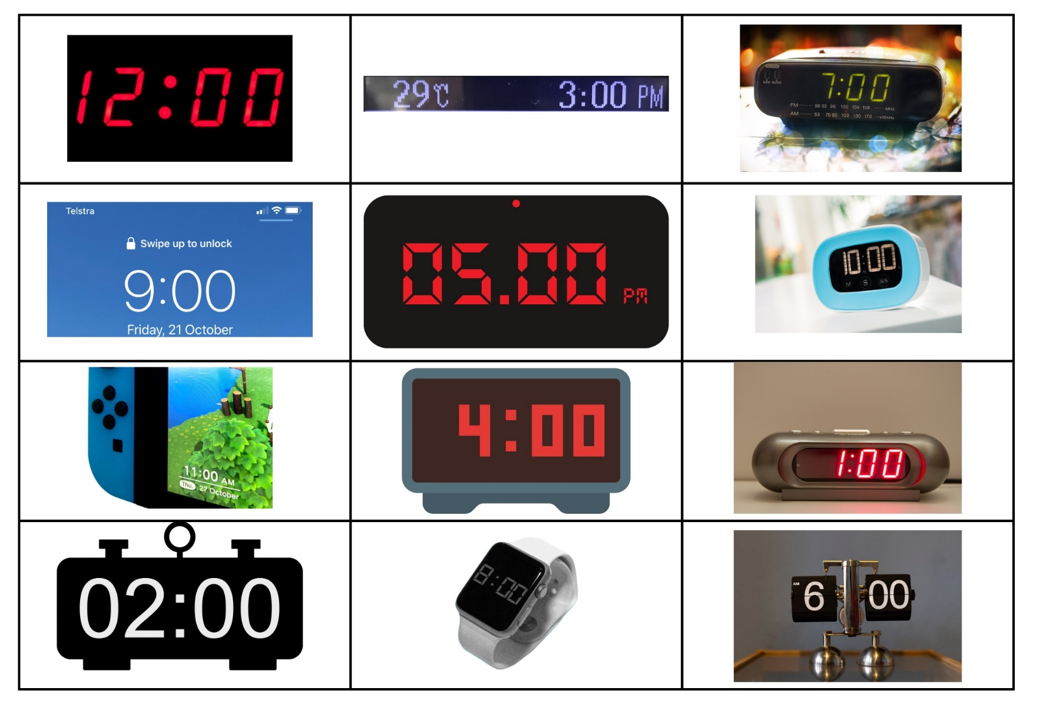
Images sourced from Canva and used in accordance with the Canva Content License Agreement.

Resource 8: Emojis
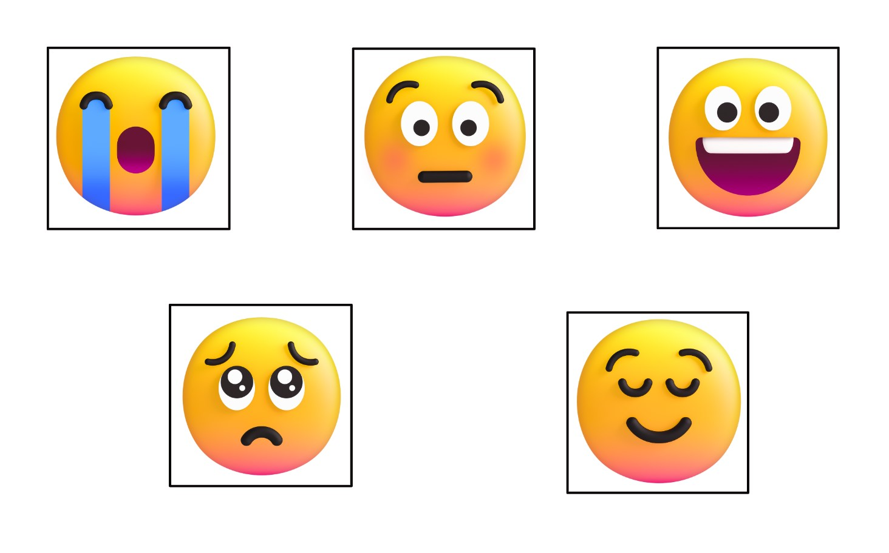
Images sourced from Canva and used in accordance with the Canva Content License Agreement.

Syllabus outcomes and content
The table below outlines the syllabus outcomes and range of relevant syllabus content covered in this unit. Content is linked to National Numeracy Learning Progression version (3).
Focus area and outcomes | Content groups and content points | Lessons
Representing whole numbers  MAO-WM-01  MAE-RWN-01  MAE-RWN-02 | Instantly name the number of objects within small collections  - instantly recognise (subitise) the number of items in small groups of up to four items without counting (NPV1, CPr1)  - identify the number of items in different arrangements (CPr2)  Use the counting sequence of ones flexibly  - count forwards to at least 30 and state the number after or before a given number, without needing to count from one (CPr4)  - identify and distinguish the ‘teen’ numbers from multiples of ten with the same initial sounds (NPV3)  - count backwards from a given number 20 or less (CPr5)  - identify the number before as ‘one less’ and the number after as ‘one more’ than a given number  Recognise number patterns  - recognise dice and domino dot patterns (NPA1, NPV2, CPr2)  - recognise different finger patterns for the same number (NPA2)  Connect counting and numerals to quantities  - count with one-to-one correspondence, recognising that the last number name represents the total number in the collection (CPr3, CPr5)  - make correspondences between collections  - read numerals to at least 20, including zero (NPV3)  - represent numbers as quantities to at least 20 using objects (such as fingers), number words and numerals (NPV2-NPV4, CPr3) | 1–8
Combining and separating quantities  MAO-WM-01  MAE-CSQ-01  MAE-CSQ-02 | - model additive relations and compare quantities  - identify situations in which addition and subtraction may be applied (AdS1-AdS2)  - combine two or more groups of objects to model addition, identifying the relationship between the parts and the whole (AdS1-AdS2)  - separate and take away part of a group of objects to model subtraction (AdS1-AdS2)  - use concrete materials or fingers to model and solve addition and subtraction questions, counting forwards or backwards by ones as necessary (AdS1-AdS2, NPV3)  - compare two groups of objects to determine how many more (NPV1, AdS2)  - identify part–whole relationships in numbers up to 10  - use visual representations of numbers to assist with combining and separating quantities, identifying the relationship between the quantities (NPV2, NPA2, AdS2-AdS3)  - describe the action of combining, separating and comparing (AdS1)  - use five as a reference in forming numbers from six to ten  - create, model and recognise combinations for numbers up to ten (AdS2)  - count by ones to find the total or difference (AdS2-AdS3)  - use drawings, words and numerals to record addition and subtraction, and explain their thinking (AdS2) | 2, 3, 5, 8
Non-spatial measure  MAO-WM-01  MAE-NSM-01  MAE-NSM-02 | Time: Compare and order the duration of events using the language of time  - use terms such as ‘daytime’, ‘night-time’, ‘morning’, ‘afternoon’, ‘today’, ‘tomorrow’, ‘yesterday’, ‘before’, ‘after’ and ‘next’ (MeT1)  - sequence events in time (MeT1)  - compare the duration of two events (MeT1)  Time: Connect days of the week to familiar events and actions  - identify events that occur daily and relate events to a particular day or time of day (MeT1)  Time: Tell time on the hour on analog and digital clocks  - create the layout of an analog clock (MeT2)  - read analog and digital clocks to the hour using the term ‘o'clock’ (MeT2-MeT3)  - describe the position of the hour and minute hands on the analog clock when reading hour time (MeT2) | 4–7
Data  MAO-WM-01  MAE-DATA-01 | Respond to questions, collect information and discuss possible outcomes of activities  - predict possible responses to a question  - collect information from their peers and about their environment (IRD1)  - pose and respond to questions about the information collected (IRD1)  Organise objects into simple data displays and interpret the displays  - group objects according to characteristics (IRD1)  - compare the sizes of groups of objects by counting  - arrange objects according to a characteristic to form a data display (IRD1)  - interpret information presented in a data display to answer questions (IRD2) | 1–5, 7, 8

References
Links to third-party material and websites
Please note that the provided (reading/viewing material/list/links/texts) are a suggestion only and implies no endorsement, by the New South Wales Department of Education, of any author, publisher, or book title. School principals and teachers are best placed to assess the suitability of resources that would complement the curriculum and reflect the needs and interests of their students.
If you use the links provided in this document to access a third-party's website, you acknowledge that the terms of use, including licence terms set out on the third-party's website apply to the use which may be made of the materials on that third-party website or where permitted by the Copyright Act 1968 (Cth). The department accepts no responsibility for content on third-party websites.
Except as otherwise noted, all material is © State of New South Wales (Department of Education), 2021 and licensed under the Creative Commons Attribution 4.0 International License. All other material (third-party material) is used with permission or under licence. Where the copyright owner of third-party material has not licensed their material under a Creative Commons or similar licence, you should contact them directly for permission to reuse their material.
Mathematics K–10 Syllabus © 2022 NSW Education Standards Authority (NESA) for and on behalf of the Crown in right of the State of New South Wales.
© 2022 NSW Education Standards Authority. This document contains NSW Curriculum and syllabus content. The NSW Curriculum is developed by the NSW Education Standards Authority. This content is prepared by NESA for and on behalf of the Crown in right of the State of New South Wales. The material is protected by Crown copyright.
Please refer to the NESA Copyright Disclaimer for more information.
NESA holds the only official and up-to-date versions of the NSW Curriculum and syllabus documents. Please visit the NSW Education Standards Authority (NESA) website and the NSW Curriculum website.
National Numeracy Learning Progression © Australian Curriculum, Assessment and Reporting Authority (ACARA) 2010 to present, unless otherwise indicated. This material was downloaded from the Australian Curriculum website (National Numeracy Learning Progression) (accessed 11 November 2022) and was not modified. The material is licensed under CC BY 4.0. Version updates are tracked in the ‘Curriculum version history’ section on the 'About the Australian Curriculum' page of the Australian Curriculum website.
ACARA does not endorse any product that uses the Australian Curriculum or make any representations as to the quality of such products. Any product that uses material published on this website should not be taken to be affiliated with ACARA or have the sponsorship or approval of ACARA. It is up to each person to make their own assessment of the product, taking into account matters including, but not limited to, the version number and the degree to which the materials align with the content descriptions and achievement standards (where relevant). Where there is a claim of alignment, it is important to check that the materials align with the content descriptions and achievement standards (endorsed by all education Ministers), not the elaborations (examples provided by ACARA).
ABC Kids (31 August 2021) ‘Heads, Shoulders, Knees and Toes’ [video], ABC Kids, YouTube, accessed 11 November 2022.
Boaler J, Munson J and William C (2021) Mindset Mathematics: Visualising and Investigating Big Ideas, Grade 1, Jossey-Bass, United States.
Dodd L (1983) Hairy Maclary from Donaldson’s Dairy, Penguin, United Kingdom.
Franke ML, Kazemi E and Turrou AC (2018) Choral Counting & Counting Collections: Transforming the PreK-5 Math classroom, Stenhouse Publishers, United States.
Levine S (2020) The Animals Would Not Sleep! (Miguéns MA, illus.), Random House, United States.
Morgan M (2010) Brave Mouse (Cartlidge M, illus.), Frances Lincoln Children’s Books, United Kingdom.
Teacher Education by Design (TEDD), University of Washington (2014) Counting Collections, Math Activities, TEDD website, accessed 11 November 2022.
University of Washington (2014) Choral Counting, Math Activities, TEDD website, accessed 11 November 2022.

Further reading
Boaler J, LaMar T and Williams C (2021) ‘Making Sense of a Data-Filled World’ [PDF 11.3MB], Mathematics Teacher: Learning and Teaching PK-12, 114(7): 508-517, doi: 10.5951/MTLT.2021.0026.

